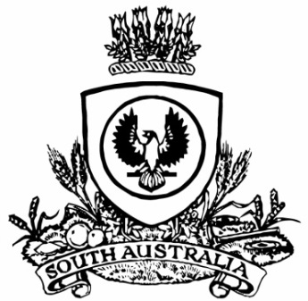
No. 6 403
SUPPLEMENTARY GAZETTE
THE SOUTH AUSTRALIAN
GOVERNMENT GAZETTE
Published by Authority

Adelaide, Thursday, 25 January 2018

APPOINTMENT
Corrigendum
On 23 January 2018, His Excellency the Governor in Executive Council made appointments to the Minister’s Advisory Committee pursuant to the Return to Work Act 2014. Due to an administrative oversight, one of these appointments was omitted. In addition to the members listed (Government Gazette No. 5 of 2018, page 204), His Excellency was also pleased to appoint:
Presiding Member: from 23 January 2018 until 30 November 2020
Michelle Maria Atchison
By command,
Ian Keith Hunter
for Premier
MIR0038/17CS

