
THE SOUTH AUSTRALIAN
GOVERNMENT GAZETTE
Published by Authority

Adelaide, Thursday, 14 June 2018

Contents

Act Assented To 2134
Appointments, Resignations, Etc. 2134
Corporations and District Councils—Notices 2172
Land Tax Act 1936—Notices 2134
Local Government Act 1999—Notices 2135
Mental Health Act 2009—Notice 2136
Mining Act 1971—Notice 2136
Mount Gambier Circuit Court—Notice 2136
National Parks and Wildlife (National Parks)
Regulations 2016—Notice 2137
Natural Resources Management Act 2004—Notices 2137
Petroleum and Geothermal Energy Act 2000—Notice 2142
Proclamations 2149
Public Sector Act 2009—Notice 2142
Regulations
Work Health and Safety Act 2012—(No. 71 of 2018) 2156
Children's Services Act 1985—(No. 72 of 2018) 2158
Rail Safety National Law (South Australia) Act 2012—
(No. 73 of 2018) 2160
Fences Act 1975—(No. 74 of 2018) 2162
Return to Work Act 2014—Notice 2146
Return to Work Corporation of South Australia Act 1994—
Notice 2146
Rules of Court
Magistrates Court Rules 1992—(Amendment 67) 2163
Training and Skills Development Act 2008—Notice 2147
Trustee Act 1936—Administration of Estates 2173

Department of the Premier and Cabinet
Adelaide, 14 June 2018
His Excellency the Governor directs it to be notified for general information that he has in the name and on behalf of Her Majesty The Queen, this day assented to the undermentioned Act passed by the Legislative Council and House of Assembly in Parliament assembled, viz.:
No. 1 of 2018—Disability Inclusion Act 2018. An Act to promote the full inclusion in the community of people with disability; to assist people with disability to achieve their full potential as equal citizens; to promote improved access to mainstream supports and services by people with disability; to provide for the screening of persons who want to work or volunteer with people with disability and to prohibit those who pose an unacceptable risk to people with disability from working or volunteering with them; to provide for a community visitor scheme; to provide for responsibilities of the State during and following the transition to the National Disability Insurance Scheme; and for other purposes.
By command,
Steven Spence Marshall
Premier

Department of the Premier and Cabinet
Adelaide, 14 June 2018
His Excellency the Governor in Executive Council has been pleased to appoint the undermentioned to the HomeStart Finance Board of Management, pursuant to the provisions of the Urban Renewal Act 1995:
Member: from 28 June 2018 until 27 June 2021
Christopher John WARD
By command,
Steven Spence Marshall
Premier
MTIL18/010CS

Department of the Premier and Cabinet
Adelaide, 14 June 2018
His Excellency the Governor in Executive Council has been pleased to appoint the Honourable Robert Ivan Lucas, MLC, Treasurer to be also Acting Deputy Premier for the period from 15 June 2018 to 25 June 2018 inclusive, during the absence of the Honourable Vickie Ann Chapman, MP.
By command,
Steven Spence Marshall
Premier
AGO0053-18CS

Department of the Premier and Cabinet
Adelaide, 14 June 2018
His Excellency the Governor in Executive Council has been pleased to appoint the Honourable John Anthony William Gardner, MP, Minister for Education to be also Acting Attorney-General for the period from 15 June 2018 to 25 June 2018 inclusive, during the absence of the Honourable Vickie Ann Chapman, MP.
By command,
Steven Spence Marshall
Premier
AGO0053-18CS

Department of the Premier and Cabinet
Adelaide, 14 June 2018
His Excellency the Governor in Executive Council has been pleased to appoint Bronwyn Anne Killmier to the position of Commissioner for Victims' Rights for a period of five years commencing on 1 August 2018 and expiring on 31 July 2023, pursuant to the provisions of the Victims of Crime Act 2001.
By command,
Steven Spence Marshall
Premier
AGO00057-18CS

LAND TAX ACT 1936
Change in Site Values and Index Value for the 2018-2019 Financial Year
I, Delfina Lanzilli, the Deputy Valuer-General, as required by section 8A(6) of the Land Tax Act 1936 hereby give notice that the average percentage change in site values for the 2018-2019 financial year is 4.6% and the Index Value for the 2018-2019 financial year is 1.231.
Dated: 7 June 2018
Delfina Lanzilli
Deputy Valuer-General

LAND TAX ACT 1936
Land Tax Thresholds for the 2018-2019 Financial Year
I, Julie-anne Holmes, the Acting Commissioner of State Taxation, as required by section 8A(7) of the Land Tax Act 1936, hereby give notice that the land tax thresholds that will apply with respect to the 2018-2019 financial year are:
Threshold A $ 369 000
Threshold B $ 677 000
Threshold C $ 985 000
Threshold D $ 1 231 000
Dated: 7 June 2018
Julie-anne Holmes
A/Commissioner of State Taxation

LOCAL GOVERNMENT ACT 1999
2018 Freeling Stormwater Management Plan
Notice is hereby given in accordance with clause 19(4) of Schedule 1A of the Local Government Act 1999 that the 2018 Freeling Stormwater Management Plan prepared by the Light Regional Council was approved by the Stormwater Management Authority on 6 June 2018.
Dated: 6 June 2018
Executed for and on behalf of the Stormwater Management Authority by its Presiding Member pursuant to a resolution of the Board and in the presence of:
Stephen Hains
Presiding Member
Witness:
David Trebilcock
General Manager

LOCAL GOVERNMENT ACT 1999
2018 Greenock Stormwater Management Plan
Notice is hereby given in accordance with clause 19(4) of Schedule 1A of the Local Government Act 1999 that the 2018 Greenock Stormwater Management Plan prepared by the Light Regional Council was approved by the Stormwater Management Authority on 6 June 2018.
Dated: 6 June 2018
Executed for and on behalf of the Stormwater Management Authority by its Presiding Member pursuant to a resolution of the Board and in the presence of:
Stephen Hains
Presiding Member
Witness:
David Trebilcock
General Manager

LOCAL GOVERNMENT ACT 1999
2018 Kapunda Stormwater Management Plan
Notice is hereby given in accordance with clause 19(4) of Schedule 1A of the Local Government Act 1999 that the 2018 Kapunda Stormwater Management Plan prepared by the Light Regional Council was approved by the Stormwater Management Authority on 6 June 2018.
Dated: 6 June 2018
Executed for and on behalf of the Stormwater Management Authority by its Presiding Member pursuant to a resolution of the Board and in the presence of:
Stephen Hains
Presiding Member
Witness:
David Trebilcock
General Manager

LOCAL GOVERNMENT ACT 1999
2018 Lefevre Peninsula Stormwater Management Plan
Notice is hereby given in accordance with clause 19(4) of Schedule 1A of the Local Government Act 1999 that the 2018 Lefevre Peninsula Stormwater Management Plan prepared by the City of Port Adelaide Enfield was approved by the Stormwater Management Authority on 6 June 2018.
Dated: 6 June 2018
Executed for and on behalf of the Stormwater Management Authority by its Presiding Member pursuant to a resolution of the Board and in the presence of:
Stephen Hains
Presiding Member
Witness:
David Trebilcock
General Manager

MENTAL HEALTH ACT 2009
Authorised Mental Health Professionals
NOTICE is hereby given in accordance with Section 94(1) of the Mental Health Act 2009, that the Chief Psychiatrist has determined the following persons as Authorised Mental Health Professionals commencing from date of Gazettal:
Edward Hedges
Braden Hill
Trent Hopkins
Raymon Joseph
Jasmin Parnell
A person’s determination will expire three years after the date of Gazettal.
Dr J Brayley
Chief Psychiatrist

Mining Act 1971
Notice pursuant to Section 28(5) of the Mining Act 1971
Notice is hereby given in accordance with Section 28(5) of the Mining Act 1971 that the delegate of the Minister for Mineral Resources and Energy intends to grant Exploration Licences over the areas described below.
Applicant: Havilah Resources Limited
Location: Watson Bore area – approx. 130 km northeast of Olary
Pastoral Lease: Mulyungarie
Term: Two years
Area in km²: 243
Reference number: 2018/00090
Plans and co-ordinates can be found on the Department of the Premier and Cabinet website:
http://www.minerals.dpc.sa.gov.au/exploration/public_notices or by contacting Mineral Tenements on 08 8463 3103.
Community information on mineral exploration licence processes and requirements under the Mining Act 1971 is available from: http://www.minerals.dpc.sa.gov.au/land_access/community_information or hard copy on request to Mineral Tenements.
J Martin
Mining Registrar
Department of the Premier and Cabinet
Delegate of the Minister for Energy and Mining

THE DISTRICT COURT OF SOUTH AUSTRALIA
Mount Gambier Circuit Court
Sheriff’s Office, Adelaide, 9 July 2018
IN pursuance of a precept from the District Court to me directed, I do hereby give notice that the said Court will sit as a Court of Oyer and Terminer and General Gaol Delivery at the Courthouse at Mount Gambier on the day and time undermentioned and all parties bound to prosecute and give evidence and all jurors summoned and all others having business at the said Court are required to attend the sittings thereof and the order of such business will be unless a Judge otherwise orders as follows:
Tuesday 9 July 2018 at 10 a.m. on the first day of the sittings the only business taken will be the arraignment of prisoners in gaol and the passing of sentences on prisoners in gaol committed for sentence; the surrender of prisoners on bail committed for sentence; the surrender of persons in response to ex officio informations or of persons on bail and committed for trial who have signified their intentions to plead guilty and the passing of sentences for all matters listed for disposition by the District Court.
Juries will be summoned for 9 July 2018 and persons will be tried on this and subsequent days of the sittings.
Prisoners in H.M. Gaol and on bail for sentence and for trial at the sittings
of the Mount Gambier Courthouse, commencing 9 July 2018.
Bonython, Tara |  | Possess drug (not cannabis) for supply to another person (2) | On bail
Brooks, Leslea Ann |  | Theft/aggravated serious criminal trespass in a place of residence/damage property | On bail
Catalano, Giorgio |  | Indecent assault/procure a child for sexual activity | On bail
Dellaney, Christy Marie Dellaney, Matthew David |  | Aggravated assault | On bail
Ghidarca, Jonothon Wayne |  | Application for enforcement of a breached bond | On bail
Isaacson, Stephen Thomas Ross |  | Cultivating controlled plants for sale/trafficking in a commercial quantity of a controlled drug/possessing prescribed equipment | On bail
Jones, Ashley Frederick |  | Application for enforcement of a breached bond | On bail
Lindner, Gary Ian |  | Maintaining an unlawful sexual relationship with a child (2) | On bail
Millowick, Kelly Anne |  | Application for enforcement of a breached bond | On bail
Moore, David Andrew Eric |  | Application for enforcement of a breached bond | On bail
Naughton, Mathew John |  | Assault (3)/contravene term of Intervention Order/aggravated assault/aggravated threaten to kill or endanger life | In gaol
Nyuon, Witchthiel William |  | Rape | On bail
Peressin, Mark Christian |  | Aggravated assault (2)/aggravated assault causing harm/aggravated threatening life | On bail
Ross, Brenton James |  | Possess child exploitation material/disseminate child exploitation material/engage in sexual intercourse with a person without consent (2) | On bail
Steer, Brenton Edward |  | Maintaining an unlawful sexual relationship with a child | On bail
Torres, Antonio |  | Aggravated assault | In gaol
Uphill, Adam Scott |  | Rape/aggravated serious criminal trespass in a place of residence | On bail
Warne, Leigh Geoffrey |  | Assault causing harm/possessing a firearm without a licence/aggravated threatening life/aggravated assault (3) | On bail
Wimshurst-Quin, Harley David |  | Aggravated serious criminal trespass in a place of residence (2)/aggravated robbery/theft/aggravated assault/aggravated act likely to cause harm | In gaol
Wright, Lynette Kay |  | Application for enforcement of a breached bond | On bail
Prisoners on bail must surrender at 10 a.m. of the day appointed for their respective trials. If they do not appear when called upon their recognizances and those of their bail will be estreated and a bench warrant will be issued forthwith.
By order of the Court,
S. Ferguson
A/Sheriff

NATIONAL PARKS AND WILDLIFE (NATIONAL PARKS) REGULATIONS 2016
Closure of the Chowilla Game Reserve, Chowilla Regional Reserve, Danggali Conservation Park,
Danggali Wilderness Protected Area, Pooginook Conservation Park, Cooltong Conservation Park,
Caroona Creek Conservation Park, Redbanks Conservation Park and Mimbara Conservation Park
PURSUANT to Regulations 7(3) (a) and 7(3) (d) of the National Parks and Wildlife (National Parks) Regulations 2016, I, Stuart Paul, A/Director, Regional Programs, Parks and Regions Group, authorised delegate of the Director of National Parks and Wildlife, close to the public, the whole of Chowilla Game Reserve, Chowilla Regional Reserve, Danggali Conservation Park, Danggali Wilderness Protected Area, Pooginook Conservation Park, Cooltong Conservation Park, Caroona Creek Conservation Park, Redbanks Conservation Park and Mimbara Conservation Park from:
6am on Friday, 15 June 2018 until 6pm on Thursday, 21 June 2018.
The purpose of the closure is to ensure the safety of the public during a pest control program within the reserves during the period indicated.
Dated: 7 May 2018
Stuart Paul
A/Director
Regional Programs, Parks and Regions Group
Department of Environment and Water

NATURAL RESOURCES MANAGEMENT ACT 2004
Section 106
Notice of Assessment of Quantity of Water Taken when Meter Readings are Not Used
I, DAVID SPEIRS, Minister for Environment and Water, hereby declare pursuant to Section 106 (3) of the Natural Resources Management Act 2004 (the Act) that, if meter readings are not used, the quantity of water taken during the 2018-2019 water use year will be determined on the basis and the method set out in Schedule 1.
Schedule 1
Basis
1. For the purpose of Section 106(1)(c) of the Act, the quantity of water taken will be assessed:
(a) on the basis of crop area;
(b) if the Minister is satisfied that crop area is not a reasonable basis to determine the quantity of water taken, on the basis of pump capacity;
(c) if the Minister is satisfied that pump capacity is not a reasonable basis to determine the quantity of water taken, on the basis of historical usage;
(d) if the Minister is satisfied that historical usage is not a reasonable basis to determine the quantity of water taken, on the basis of usage data; or
(e) if the Minister is satisfied that usage data is not a reasonable basis to determine the quantity of water taken, on the basis of the water allocation.
2. Where the Minister has granted an exemption from the requirement to install a meter on a water source, the quantity of water taken will be assessed on the basis of the water allocation.
Method
3. The method that will be used in assessing the quantity of water on the basis of crop area will be as follows:
The estimation of water requirements for crops will be based on the methodology in Crop Evaporation - Guidelines for Computing Crop Water Requirements - Food and Agriculture Organisation of the United Nations Irrigation and Drainage Paper 56 (Allen, Pereira et al, 1998, ISBN No 92-5-104219-5). Local data (including rainfall and evaporation data) will be used in the estimation of the quantity of water taken. Water usage to account for irrigation system efficiency and for specific crop production process will be added where appropriate.
4. The method that will be used in assessing the quantity of water on the basis of pump capacity will be as follows:
Details of the duration of pumping and the normal operating capacity of the pump used to take water will be used to determine the quantity of water taken. The duration of pumping will be multiplied by the normal operating capacity of the pump.
The maximum capacity of the pump will be used if the Minister is satisfied that the normal operating capacity of the pump is not a reasonable basis to determine the quantity of water taken.
5. The method that will be used in assessing the quantity of water on the basis of historical usage will be as follows:
The average of metered usage over the preceding two water use years, providing that the Minister is satisfied that the water was being used during that period for a similar purpose and in a similar manner, and is a reliable estimate of the quantity of water taken.
6. The method that will be used in assessing the quantity of water on the basis of usage data will be as follows:
Details of the usage data (including system operating times and flow rates, and/or the number of transfer tanks or dams filled used to take water) from the infrastructure used.
This notice has effect in relation to the financial year commencing on 1 July 2018.
Dated: 31 May 2018
David Speirs MP
Minister for Environment and Water

Natural Resources Management Act 2004
Section 92
Notice of Contribution in 2018-19 by Constituent Councils
in the Adelaide and Mount Lofty Ranges Natural Resources Management Region
I, David Speirs, Minister for Environment and Water, having determined the shares of councils pursuant to subsection 92(4) and having submitted them to the Governor pursuant to subsection 92(6) and the Governor having approved those shares on 14 June 2018 hereby advise, pursuant to subsection 92 (7) that the shares of the constituent councils in the Adelaide and Mount Lofty Ranges Natural Resources Management Region will be as follows:
Council | Contribution 2018-19
Adelaide City Council | $1,681,521
Adelaide Hills Council | $959,634
Adelaide Plains Council | $174,777
Alexandrina Council | $177,527
The Barossa Council | $465,170
The City of Burnside | $1,647,295
Campbelltown City Council | $1,172,568
City of Charles Sturt | $2,858,446
Town of Gawler | $361,432
City of Holdfast Bay | $1,233,808
Light Regional Council | $324,381
City of Marion | $1,918,392
City of Mitcham | $1,684,538
Mount Barker District Council | $108,645
The City of Norwood, Payneham & St Peters | $1,280,330
City of Onkaparinga | $2,873,647
City of Playford | $1,092,793
City of Port Adelaide Enfield | $2,645,576
City of Prospect | $564,966
City of Salisbury | $2,014,099
City of Tea Tree Gully | $1,762,475
City of Unley | $1,337,669
City of Victor Harbor | $398,671
Corporation of the Town of Walkerville | $310,485
City of West Torrens | $1,472,440
District Council of Yankalilla | $195,018
Total | $30,716,303
Dated: 14 June 2018
David Speirs MP
Minister for Environment and Water

Natural Resources Management Act 2004
Section 92
Notice of Contribution in 2018-19 by Constituent Councils
in the Eyre Peninsula Natural Resources Management Region
I, David Speirs, Minister for Environment and Water, having determined the shares of councils pursuant to subsection 92(4) and having submitted them to the Governor pursuant to subsection 92(6) and the Governor having approved those shares on 14 June 2018 hereby advise, pursuant to subsection 92 (7) that the shares of the constituent councils in the Eyre Peninsula Natural Resources Management Region will be as follows:

Council | Contribution 2018-19
District Council of Ceduna | $172,572
District Council of Cleve | $108,361
District Council of Elliston | $97,229
District Council of Franklin Harbour | $82,411
District Council of Kimba | $67,745
District Council of Lower Eyre Peninsula | $341,459
City of Port Lincoln | $648,799
District Council of Streaky Bay | $158,780
District Council of Tumby Bay | $179,069
City of Whyalla | $882,694
District Council of Wudinna | $72,266
Total | $2,811,385
Dated: 14 June 2018
David Speirs MP
Minister for Environment and Water

Natural Resources Management Act 2004
Section 92
Notice of Contribution in 2018-19 by Constituent Councils
in the Kangaroo Island Natural Resources Management Region
I, David Speirs, Minister for Environment and Water, having determined the share of the Kangaroo Island Council, pursuant to subsection 92(4) and having submitted it to the Governor pursuant to subsection 92(6) and the Governor having approved that share on 14 June 2018 hereby advise, pursuant to subsection 92(7) that the share of the Council, as the sole constituent council in the Kangaroo Island Natural Resources Management Region will be as follows:
Council | Contribution 2018-19
Kangaroo Island Council | $394,625
Total | $394,625
Dated: 14 June 2018
David Speirs MP
Minister for Environment and Water

Natural Resources Management Act 2004
Section 92
Notice of Contribution in 2018-19 by Constituent Councils
in the Northern and Yorke Natural Resources Management Region
I, David Speirs, Minister for Environment and Water, having determined the shares of councils pursuant to subsection 92(4) and having submitted them to the Governor pursuant to subsection 92(6) and the Governor having approved those shares on 14 June 2018 hereby advise, pursuant to subsection 92 (7) that the shares of the constituent councils in the Northern and Yorke Natural Resources Management Region will be as follows:
Council | Contribution 2018-19
Barunga West Council | $211,279
Clare and Gilbert Valleys Council | $502,657
District Council of Copper Coast | $625,318
The Flinders Ranges Council | $44,412
Goyder Regional Council | $85,386
District Council of Mount Remarkable | $118,083
Northern Areas Council | $280,073
District Council of Orroroo Carrieton | $35,030
District Council of Peterborough | $33,364
Port Augusta City Council | $273,931
Port Pirie Regional Council | $416,574
Wakefield Regional Council | $368,260
District Council of Yorke Peninsula | $1,040,840
Total | $4,035,207
Dated: 14 June 2018
David Speirs MP
Minister for Environment and Water

Natural Resources Management Act 2004
Section 92
Notice of Contribution in 2018-19 by Constituent Councils
in the South Australian Arid Lands Natural Resources Management Region
I, David Speirs, Minister for Environment and Water, having determined the shares of councils pursuant to subsection 92(4) and having submitted them to the Governor pursuant to subsection 92(6) and the Governor having approved those shares on 14 June 2018 hereby advise, pursuant to subsection 92 (7) that the shares of the constituent councils in the South Australian Arid Lands Natural Resources Management Region will be as follows:
Council | Contribution 2018-19
District Council of Coober Pedy | $97,012
Municipal Council of Roxby Downs | $114,818
Total | $211,830
Dated: 14 June 2018
David Speirs MP
Minister for Environment and Water

Natural Resources Management Act 2004
Section 92
Notice of Contribution in 2018-19 by Constituent Councils
in the South Australian Murray-Darling Basin Natural Resources Management Region
I, David Speirs, Minister for Environment and Water, having determined the shares of councils pursuant to subsection 92(4) and having submitted them to the Governor pursuant to subsection 92(6) and the Governor having approved those shares on 14 June 2018 hereby advise, pursuant to subsection 92 (7) that the shares of the constituent councils in the South Australian Murray-Darling Basin Natural Resources Management Region will be as follows:
Council | Contribution 2018-19
Adelaide Hills Council | $6,271
Alexandrina Council | $1,350,816
The Barossa Council | $64,565
Berri Barmera Council | $313,688
Coorong District Council | $196,451
Regional Council of Goyder | $180,051
District Council of Karoonda East Murray | $64,977
District Council of Loxton Waikerie | $453,953
Mid Murray Council | $543,684
Mount Barker District Council | $1,410,418
Rural City of Murray Bridge | $734,454
City of Onkaparinga | $4,530
Renmark Paringa Council | $330,145
Southern Mallee District Council | $109,140
City of Victor Harbor | $3,856
Total | $5,767,000
Dated: 14 June 2018
David Speirs MP
Minister for Environment and Water

Natural Resources Management Act 2004
Section 92
Notice of Contribution in 2018-19 by Constituent Councils
in the South East Natural Resources Management Region
I, David Speirs, Minister for Environment and Water, having determined the shares of councils pursuant to subsection 92(4) and having submitted them to the Governor pursuant to subsection 92(6) and the Governor having approved those shares on 14 June 2018 hereby advise, pursuant to subsection 92 (7) that the shares of the constituent councils in the South East Natural Resources Management Region will be as follows:
Council | Contribution 2018-19
Coorong District Council | $174,738
District Council of Grant | $581,205
Kingston District Council | $225,587
City of Mount Gambier | $1,086,828
Naracoorte Lucindale Council | $671,002
District Council of Robe | $213,570
Tatiara District Council | $538,306
Wattle Range Council | $967,282
Total | $4,458,518
Dated: 14 June 2018
David Speirs MP
Minister for Environment and Water

Natural Resources Management Act 2004
Notice of Levy Payable in 2018-19 by Persons who Occupy Land Outside Council Areas
in the Eyre Peninsula Natural Resources Management Region
- Pursuant to section 97 of the Natural Resources Management Act 2004 (“the Act”) I, David Speirs, Minister for Environment and Water, having determined the levy payable by persons who occupy land outside council areas in the Eyre Peninsula Natural Resources Management Region, and having received, as required by section 97(1) of the Act, the approval of His Excellency the Governor, hereby declare:
  - a fixed charge levy amount of $83.33 on all rateable land.
- The approval of this Declaration was granted by His Excellency the Governor in Executive Council on 14 June 2018
Dated: 14 June 2018
David Speirs MP
Minister for Environment and Water

Natural Resources Management Act 2004
Notice of Levy Payable in 2018-19 by Persons who Occupy Land Outside Council Areas
in the South Australian Arid Lands Natural Resources Management Region
- Pursuant to section 97 of the Natural Resources Management Act 2004 (“the Act”) I, David Speirs, Minister for Environment and Water, having determined the levy payable by persons who occupy land outside council areas in the South Australian Arid Lands Natural Resources Management Region, and having received, as required by section 97(1) of the Act, the approval of His Excellency the Governor in Executive Council, hereby declare:
  - a fixed rate of
  - $61.40 per rateable property <10 ha
  - $204.80 per rateable property >10 ha - <100 ha
  - $409.60 per rateable property >100 ha - <100,000 ha
  - $716.90 per rateable property >100,000 ha
- The approval of this Declaration was granted by His Excellency the Governor in Executive Council on 14 June 2018
Dated: 14 June 2018
David Speirs MP
Minister for Environment and Water

NATURAL RESOURCES MANAGEMENT ACT 2004
Revocation of Notice of Authorisation to Take Water
PURSUANT to Section 128(5) and clause 54(3) of Schedule 4 of the Natural Resources Management Act 2004 (the Act), I, David Speirs, Minister for Environment and Water (the Minister) in the State of South Australia and the Minister to whom the administration of the Act is committed, hereby revoke the Notice of Authorisation to take water dated 23 May 2003 and published in the Government Gazette (page 2082) on 29 May 2003.
Dated: 7 June 2018
David Speirs
Minister for Environment and Water

PETROLEUM AND GEOTHERMAL ENERGY ACT 2000
Statement of Environmental Objectives
PURSUANT to section 104(1) of the Petroleum and Geothermal Energy Act 2000 (the Act) I Barry Goldstein, Executive Director Energy Resources Division, Department of the Premier and Cabinet do hereby publish the following document as having been approved as a statement of environmental objectives under the Act.
Documents:
- APA Group, Riverland Pipeline (Pipeline License 6) and Berri to Mildura Pipeline (Pipeline License 11) Operations - Statement of Environmental Objectives, August 2017
This document is available for public inspection on the Environmental Register section of the following webpage - (www.petroleum.statedevelopment.sa.gov.au/legislation_and_compliance/environmental_register) or at the Public Office determined pursuant to section 107 (1) of the Act to be at:
Energy Resources Division
Customer Services
Level 7
101 Grenfell Street
Adelaide SA 5000
Dated: 12 June 2018
Barry Goldstein
Executive Director
Energy Resources Division
Department of the Premier and Cabinet
Delegate of the Minister for Energy and Mining

South Australia
Public Sector (Reorganisation of Public Sector
Operations) Notice 2018
under section 9(1) of the Public Sector Act 2009
1—Short title
This notice may be cited as the Public Sector (Reorganisation of Public Sector Operations) Notice 2018.
2—Commencement
This notice will come into operation on 1 July 2018.
3—Transfer of employees
- The employees listed in column 1 of the table below are transferred to employment in the public sector agency listed in column 2 opposite the reference to the employee on the same basis of engagement as applied before the transfer.
- A reference to a business unit in column 1 includes any employees of that business unit who are:
  - Currently working on a term basis in another public sector agency and who have a right of return to duties pursuant to regulation 6 of the Public Sector Regulations 2010
  - Absent from their substantive duties on any form of paid or unpaid leave and who have a right of return at the conclusion of such leave to return to their duties.
Employee | Public sector agency
All employees of the business unit known as Aboriginal Affairs and Reconciliation within the Department of State Development immediately before 1 July 2018 | Department of the Premier and Cabinet
All employees of the business unit known as Arts South Australia (including the Art Gallery of South Australia, the State Library of South Australia, the South Australian Museum, and the Carrick Hill Trust) within the Department of State Development immediately before 1 July 2018 | Department of the Premier and Cabinet
The following employees of the Department of Human Services:  Dinah Bond  Eloise Dreimanis  Holly Butler  Justine Kennedy  Leonie Miller  Linda Velzeboer  Marisa La False  Robert Bria  Roger Lean  Sara Allen  Susan Cawood | Department of the Premier and Cabinet
All employees of the business unit known as Veterans SA within the Department of Treasury and Finance immediately before 1 July 2018 | Department of the Premier and Cabinet
All employees of the business unit known as the Office of Recreation and Sport within the Department of Planning, Transport and Infrastructure immediately before 1 July 2018 | Office for Recreation, Sport and Racing
All employees of the business unit known as SafeWork SA within the Attorney-General’s Department immediately before 1 July 2018 | Department of Treasury and Finance
All employees of the business unit known as Shared Services SA within the Department of the Premier and Cabinet immediately before 1 July 2018 | Department of Treasury and Finance
All employees of the business unit known as Electorate Services within the Department of the Premier and Cabinet immediately before 1 July 2018 | Department of Treasury and Finance
All employees of the business unit known as Fleet Services (Ministerial Chauffers) within the Department of the Premier and Cabinet immediately before 1 July 2018 | Department of Treasury and Finance
The following employees of the business unit known as Economic Priorities within the Department of the Premier and Cabinet:  Antonia Koutrikas  Brad Gay  David Cripps  Matthew Winefield  Rohan Callaghan  Tina Hosie | Department of Treasury and Finance
The following employees of the business unit known as the Office of the Chief Procurement Officer within the Department of the Premier and Cabinet:  Jason Schell  Lisa McKay | Department of Treasury and Finance
The following employees of the Department of the Premier and Cabinet:  Allison Rawlinson  Allyson Fahy  Amanda Cooper  Amy Baric  Angela Hansford  Anita Fizulic  Ann Pataki  Annette Williamson  Brett Quilliam  David Sharpe  Filomena Berlangieri  Georgia Hassiotis  Gloria Brewer  Inthira Stocker  Jan Lu  Jessica McFarlane  Justin Jones  Kristy Carter  Kyla Llorando  Laura Harris  Lorraine Dilag  Lorraine Lemmens  Marc Malerba  Martin Gould  Maxine Moran  Melissa Giuffreda  Patricia Lynch  Robert Gulley  Serena Badenoch  Sharon Hallal  Tara Pearce  Tracey Snoad  Yogesh Iyengar  Yvette Calabria  Yvette Keanie | Department of Treasury and Finance
All employees of the business unit known as ICT Transformation within the Department of the Premier and Cabinet immediately before 1 July 2018 | Department of Treasury and Finance
All employees of the business unit known as Policy Standards and Governance within the Department of the Premier and Cabinet immediately before 1 July 2018 | Department of Treasury and Finance
All employees of the business unit known as Strategic Procurement within the Department of the Premier and Cabinet immediately before 1 July 2018, excluding the following employees:  Jennie Rodrigues  Skye Ridgway | Department of Treasury and Finance
All employees of the business unit known as the Office for the Public Sector within the Department of the Premier and Cabinet immediately before 1 July 2018, excluding employees performing duties in the areas known as:  Return to Work Services  Industrial Relations | Office of the Commissioner for Public Sector Employment
All employees performing duties immediately before 1 July 2018 in the business unit known as the Office for the Public Sector within the Department of the Premier and Cabinet in the areas known as:  Return to Work Services  Industrial Relations | Department of Treasury and Finance
All employees of the business unit known as the Office of the Registrar-General within the Department of Treasury and Finance immediately before 1 July 2018 | Department of Planning, Transport and Infrastructure
All employees of the business unit known as the Office of the Valuer-General or the State Valuation Office within the Department of Treasury and Finance immediately before 1 July 2018 | Department of Planning, Transport and Infrastructure
All employees of the business unit known as Service SA within the Department of the Premier and Cabinet immediately before 1 July 2018 | Department of Planning, Transport and Infrastructure
The following employees of the Department of the Premier and Cabinet:  Bianca Swan  David Hann  Jake Ellul  Joanne Milton  Kerry Ford  Michael Kruk  Qiaoxia (Helen) Wang  Sam Baker  Sue Dadswell | Department of Planning, Transport and Infrastructure
Made by the Premier
on 14 June 2018

DPC18/030CS

RETURN TO WORK CORPORATION OF SOUTH AUSTRALIA ACT 1994
RETURN TO WORK ACT 2014
Return to Work Premium Review Determination 2018
THE Board of the Return to Work Corporation of South Australia (‘the Corporation’) determines as follows pursuant to Section 17 of the Return to Work Corporation of South Australia Act 1994, Section 157 of the Return to Work Act 2014 (‘the Act’) and all other enabling powers:
Part 1—Preliminary Matters
- This determination may be cited as the Return to Work Premium Review Determination 2018.
- This determination commences on 1 July 2018 (‘Commencement Date’) and applies to an application for review lodged under Section 157 of the Act after the Commencement Date.
Return to Work Premium Review Panel
- The Return to Work Premium Review Panel (the Panel) continued by the Board’s determination of 29 May 2017 (see South Australian Government Gazette, 7 June 2017, page 2035) will be substituted by an Independent Review Officer pursuant to this determination.
Functions and Powers under Section 157 of the Act
- The function of the Independent Review Officer shall be to perform the functions of the Board under Section 157 of the Act as delegate of the Board under that section in reviewing decisions of the Corporation pursuant to Section 140 (2), Sections 141 (2), 141 (3), and 141 (4), Section 145 (1), Sections 147 (1), 147 (2), 147 (3) (a), (b) and (c), Section 147 (4), Section 149 (3) (a), Section 150 (3), Section 151 (1), Section 152 (1), Section 154 (1), (2), (3) and (4), Section 155 (1) and 155 (3) of the Act and subject to the proceeding clauses of this determination, the powers of the Board under Section 157 of the Act (other than the power to review a decision of the Corporation on a matter of law going to the validity of that decision) are delegated to the Independent Review Officer for that purpose.
Part 2— Independent Review Officer
- The Independent Review Officer shall be a legal practitioner (wherever in Australia admitted).
- Where either the anticipated volume of work necessitates or where the Independent Review Officer is unable to sit, an additional person may be appointed by the Board to fulfil the functions of the Independent Review Officer on such terms and conditions as determined by the Board.
- An additional person appointed pursuant to clause 6 of this determination has the powers and obligations of the position held by the Independent Review Officer.
Part 3—Indemnity of Independent Review Officer
- Any liability attaching to the Independent Review Officer for an act or omission by them, in good faith and in the exercise or purported exercise of a power or function, or in a discharge or purported exercise of a duty, of the Independent Review Officer is assumed by the Corporation.
Part 4—Tenure of Independent Review Officer
- The Independent Review Officer shall be appointed for a period determined by the Board.
- An Independent Review Officer whose appointment has expired may sit as Independent Review Officer for the purpose of completing the hearing and determination of part-heard proceedings in which they were involved.
Part 5—Reconsideration and Conciliation
- Upon receipt of any application lodged under Section 157 (1) of the Act, the registry of the Independent Review Officer will forward a copy to the Corporation.
- Upon receipt of any application lodged in accordance with section 157(5)(a) or (b), the Corporation will, within 21 days of receipt, reconsider the disputed decision and notify the registry of the Independent Review Officer of the result of the reconsideration.
- Upon receipt of any application lodged out of time:
  - If the application is lodged within 8 months of the employer being given notice of the decision, the Corporation will reconsider its decision within 21 days, setting out its position on the application for the extension of time and notify the registry of the Independent Review Officer of the reconsideration outcome;
  - If the application is lodged more than 8 months after the employer was given notice of the decision, the request for reconsideration will be referred to the Independent Review Officer for consideration of whether it should be accepted on the basis that compelling reasons exist to allow an extension of time for making the application and the Corporation will not be unreasonably disadvantaged because of the delay in lodging the application.
- If the Independent Review Officer, after being referred a request for reconsideration under clause 13.2 of this determination, accepts the request for an extension of time, the Corporation will reconsider the disputed decision within 21 days and notify the registry of the Independent Review Officer of the reconsideration outcome.
- The Independent Review Officer will not consider an extension of time made in respect of a decision made more than three years after the employer was given notice of that decision.
- If the Corporation, on reconsideration of a decision under review:
  - confirms the decision; or
  - varies the decision and the applicant expresses dissatisfaction with the variation,
the registry of the Independent Review Officer must refer the application for review for conciliation by a conciliator who will use his or her best endeavours to bring the applicant and the Corporation to an agreed resolution of the matters referred to in the application, and the Independent Review Officer may not hear and determine any application unless he or she is satisfied that conciliation has been attempted and failed or that such attempts have no realistic prospects of success.
- The reconsideration of a decision under review under clauses 12 or 13 of this determination should not unduly delay proceedings before the Independent Review Officer and the Independent Review Officer must, so far as is reasonably practicable, undertake his or her processes pending the outcome of the reconsideration (including by listing the matter, setting up or conducting any conference or taking other such steps).
- If, during the hearing of any matter, it appears to the Independent Review Officer that there is a realistic prospect of a negotiated outcome being achieved, he or she may refer the matter back for further conciliation or the Independent Review Officer may make such other attempts to promote conciliation as they think appropriate.
- In this Part ‘conciliation’ includes counselling, mediation, neutral evaluation, case appraisal, conciliation or any combination and the format of conciliation in any particular case shall be at the discretion of the conciliator in consultation with the parties.
- Any information provided during conciliation will be withheld from the Independent Review Officer if the provider of that information so requests.
Part 6—Principles of Operation of Independent Review Officer
- The Independent Review Officer shall be bound by and is hereby directed to follow the principles of natural justice.
- Subject to Clause 21, the Independent Review Officer:
  - shall act according to equity, good conscience and the substantial merits of the case, without regard to technicalities and legal forms; and
  - is not bound by the rules of evidence, but may inform themselves by such means and such material as they think fit; and
  - shall act as expeditiously as the circumstances of a particular case permit.
- The Independent Review Officer must ascertain whether the parties to any proceedings desire to be heard by way of oral evidence or submissions and must in that event give at least 14 days notice of the date, time and place of hearing, but if both parties to particular proceedings wish to have the application determined on the documents, the Independent Review Officer need not hold a hearing but must give the parties at least 14 days notice to make final written submissions before proceeding to make it a determination.
- If only one party to proceedings desires to submit oral evidence or submissions, the Independent Review Officer must give the other party at least 14 days notice of the hearing and inform that party that, there is a danger that at the hearing the Independent Review Officer may hear things from the first party that the other party will be unable to respond to if it does not attend.
- A party may appear at a conciliation or hearing (including a directions hearing):
  - if the party is a natural person or partnership, in person or by one or more of the parties or by an employee of that party who has the authority to make binding decisions on behalf of the party; or
  - if the party is an incorporated body, by a proper officer or by an employee who has the authority to make binding decisions on behalf of the party;
and may be represented by a legal practitioner or by a duly appointed and authorised agent, but a person described in Clause 25.1 or 25.2 must also appear unless the person presiding over the conciliation conference or hearing (as the case may be) has agreed in advance to dispense with this requirement.
- A party engaging representation will do so at its own cost.
Part 7—Powers of Independent Review Officer
- The Independent Review Officer, or a person appointed under Clause 6 acting in that office may, while so acting, exercise the powers of, and is hereby appointed as, an authorised officer under the Act. For the purposes of this Part, operating units of the Corporation and its agents are directed to comply with any requirements of the Independent Review Officer or a person appointed under Clause 6 as though they were subject to Section 183 of the Act.
Part 8—Reservation of Board’s Discretion to Decide
- Subject to the terms of this determination the Independent Review Officer is required to determine all applications that fail to resolve through reconsideration or at conciliation, unless the Corporation advises the Board that the particular dispute is of unusual significance and the Board or its relevant Board Committee, prior to the hearing of the application by the Independent Review Officer, serves notice on the Independent Review Officer and the applicant that the Independent Review Officer is to make a recommendation only and refer the matter to the Board or relevant Board Committee.
Part 9—Revocation and Transitional Provision
- The Return to Work Premium Review Panel Determination of 29 May 2017 (see South Australian Government Gazette, 7 June 2017, page 2035) (the Revoked Determination) is revoked, but an Application for Review lodged before the Commencement Date will be determined under the Revoked Determination.
- Unless the Board determines otherwise, any Application for Review lodged before the Commencement Date which has not been determined by 1 July 2019 will be dealt with under this Return to Work Premium Review Determination 2018.
I confirm that this is a true and correct record of the decision of the Board of the Corporation made on 30 May 2018.
Dated: 30 May 2018
J. Denley
Board Chairman

TRAINING AND SKILLS DEVELOPMENT ACT 2008
Part 4 – Apprenticeships/Traineeships
PURSUANT to the provision of the Training and Skills Development Act 2008, the Training and Skills Commission (TaSC) gives notice that determines the following Trades or Declared Vocations in addition to the Gazette notices of:
- 25 September 2008 | - 23 October 2008 | - 13 November 2008 | - 4 December 2008
- 18 December 2008 | - 29 January 2009 | - 12 February 2009 | - 5 March 2009
- 12 March 2009 | - 26 March 2009 | - 30 April 2009 | - 18 June 2009
- 25 June 2009 | - 27 August 2009 | - 17 September 2009 | - 24 September 2009
- 9 October 2009 | - 22 October 2009 | - 3 December 2009 | - 17 December 2009
- 4 February 2010 | - 11 February 2010 | - 18 February 2010 | - 18 March 2010
- 8 April 2010 | - 6 May 2010 | - 20 May 2010 | - 3 June 2010
- 17 June 2010 | - 24 June 2010 | - 8 July 2010 | - 9 September 2010
- 23 September 2010 | - 4 November 2010 | - 25 November 2010 | - 16 December 2010
- 23 December 2010 | - 17 March 2011 | - 7 April 2011 | - 21 April 2011
- 19 May 2011 | - 30 June 2011 | - 21 July 2011 | - 8 September 2011
- 10 November 2011 | - 24 November 2011 | - 1 December 2011 | - 8 December 2011
- 16 December 2011 | - 22 December 2011 | - 5 January 2012 | - 19 January 2012
- 1 March 2012 | - 29 March 2012 | - 24 May 2012 | - 31 May 2012
- 7 June 2012 | - 14 June 2012 | - 21 June 2012 | - 28 June 2012
- 5 July 2012 | - 12 July 2012 | - 19 July 2012 | - 2 August 2012
- 9 August 2012 | - 30 August 2012 | - 13 September 2012 | - 4 October 2012
- 18 October 2012 | - 25 October 2012 | - 8 November 2012 | - 29 November 2012
- 13 December 2012 | - 25 January 2013 | - 14 February 2013 | - 21 February 2013
- 28 February 2013 | - 7 March 2013 | - 14 March 2013 | - 21 March 2013
- 28 March 2013 | - 26 April 2013 | - 23 May 2013 | - 30 May 2013
- 13 June 2013 | - 20 June 2013 | - 11 July 2013 | - 1 August 2013
- 8 August 2013 | - 15 August 2013 | - 29 August 2013 | - 6 February 2014
- 12 June 2014 | - 28 August 2014 | - 4 September 2014 | - 16 October 2014
- 23 October 2014 | - 5 February 2015 | - 26 March 2015 | - 16 April 2015
101. 27 May 2015 | 102. 18 June 2015 | 103. 3 December 2015 | 104. 7 April 2016
105. 30 June 2016 | 106. 28 July 2016 | 107. 8 September 2016 | 108. 22 September 2016
109. 27 October 2016 | 110. 1 December 2016 | 111. 15 December 2016 | 112. 7 March 2017
113. 21 March 2017 | 114. 23 May 2017 | 115. 13 June 2017 | 116. 18 July 2017
117. 19 September 2017 | 118. 26 September 2017 | 119. 17 October 2017 | 120. 3 January 2018
121. 23 January 2018 | 122. 14 March 2018 | 123. 14 June 2018
Trades or Declared Vocations and Required Qualifications and Training Contract Conditions
for the Animal Care and Management Training Package ACM
*Trade/ #Declared Vocation/ Other Occupation | Qualification Code | Qualification  Title | Nominal Term of Training Contract | Probationary Period
Animal Attendant # | ACM20117 | Certificate II in Animal Studies | 12 Months | 60 Days
Animal Attendant # | ACM30117 | Certificate III in Animal Studies | 24 Months | 60 Days
Animal Technician # | ACM30217 | Certificate III in Animal Technology | 24 Months | 60 Days
Animal Attendant # | ACM30317 | Certificate III in Captive Animals | 24 Months | 60 Days
Animal Attendant # | ACM30417 | Certificate III in Companion Animal Studies | 24 Months | 60 Days
Farriery * | ACM30517 | Certificate III in Farriery | 48 Months | 90 Days
Animal Management Officer # | ACM40117 | Certificate IV in Animal Control and Regulation | 36 Months | 90 Days
Animal Attendant # | ACM40217 | Certificate IV in Captive Animals | 36 Months | 90 Days
Animal Attendant # | ACM40317 | Certificate IV in Companion Animal Services | 36 Months | 90 Days
Animal Technician # | ACM50117 | Diploma of Animal Technology | 48 Months | 90 Days
Trades or Declared Vocations and Required Qualifications and Training Contract Conditions
for the Food, Beverage and Pharmaceutical Training Package FBP
*Trade/ #Declared Vocation/ Other Occupation | Qualification Code | Qualification  Title | Nominal Term of Training Contract | Probationary Period
General Foods Processing # | FBP20117 | Certificate II in Food Processing | 18 Months | 60 Days
General Foods Processing # | FBP30117 | Certificate III in Food Processing | 24 Months | 60 Days
General Foods Processing # | FBP30217 | Certificate III in Plant Baking | 24 Months | 60 Days
Bread Baker * | FBP30417 | Certificate III in Bread Baking | 48 Months | 90 Days
Bread Baker and Pastry Cook * | FBP30517 | Certificate III in Baking | 48 Months | 90 Days
Pastry Cook * | FBP30317 | Certificate III in Cake and Pastry | 48 Months | 90 Days

South Australia
Adelaide Festival Centre Trust (Designation of Employing Authority) Proclamation 2018
under section 4 of the Adelaide Festival Centre Trust Act 1971
1—Short title
This proclamation may be cited as the Adelaide Festival Centre Trust (Designation of Employing Authority) Proclamation 2018.
2—Commencement
This proclamation will come into operation on 1 July 2018.
3—Designation of employing authority
The person for the time being holding or acting in the position of Chief Executive of the Department of the Premier and Cabinet is designated as being the employing authority for the purposes of the definition of employing authority in section 4(1) of the Adelaide Festival Centre Trust Act 1971.
Schedule 1—Revocation of proclamation
The Adelaide Festival Centre Trust (Designation of Employing Authority) Proclamation 2014 (Gazette 26.6.2014 p3022) is revoked.
Made by the Governor
with the advice and consent of the Executive Council
on 14 June 2018
DPC18/030CS

South Australia
Adelaide Festival Corporation (Designation of Employing Authority) Proclamation 2018
under section 3 of the Adelaide Festival Corporation Act 1998
1—Short title
This proclamation may be cited as the Adelaide Festival Corporation (Designation of Employing Authority) Proclamation 2018.
2—Commencement
This proclamation will come into operation on 1 July 2018.
3—Designation of employing authority
The person for the time being holding or acting in the position of Chief Executive of the Department of the Premier and Cabinet is designated as being the employing authority for the purposes of the definition of employing authority in section 3(1) of the Adelaide Festival Corporation Act 1998.
Schedule 1—Revocation of proclamation
The Adelaide Festival Corporation (Designation of Employing Authority) Proclamation 2014 (Gazette 26.6.2014 p3023) is revoked.
Made by the Governor
with the advice and consent of the Executive Council
on 14 June 2018
DPC18/030CS

South Australia
Administrative Arrangements (Administration of Work, Health and Safety Act) Proclamation 2018
under section 5 of the Administrative Arrangements Act 1994
1—Short title
This proclamation may be cited as the Administrative Arrangements (Administration of Work, Health and Safety Act) Proclamation 2018.
2—Commencement
This proclamation will come into operation on 1 July 2018.
3—Administration of Act committed to Treasurer
The administration of the Work Health and Safety Act 2012 is committed to the Treasurer.
Made by the Governor
with the advice and consent of the Executive Council
on 14 June 2018
DPC18/030CS

South Australia
History Trust of South Australia (Designation of Employing Authority) Proclamation 2018
under section 2 of the History Trust of South Australia Act 1981
1—Short title
This proclamation may be cited as the History Trust of South Australia (Designation of Employing Authority) Proclamation 2018.
2—Commencement
This proclamation will come into operation on 1 July 2018.
3—Designation of employing authority
The person for the time being holding or acting in the position of Chief Executive of the Department of the Premier and Cabinet is designated as being the employing authority for the purposes of the definition of employing authority in section 2(1) of the History Trust of South Australia Act 1981.
Schedule 1—Revocation of proclamation
The History Trust of South Australia (Designation of Employing Authority) Proclamation 2014 (Gazette 26.6.2014 p3026) is revoked.
Made by the Governor
with the advice and consent of the Executive Council
on 14 June 2018
DPC18/030CS

South Australia
Public Sector (Establishment of Attached Offices) Proclamation 2018
under sections 27 and 28 of the Public Sector Act 2009
1—Short title
This proclamation may be cited as the Public Sector (Establishment of Attached Offices) Proclamation 2018.
2—Commencement
This proclamation will come into operation on 1 July 2018.
3—Establishment of Office of the Commissioner for Public Sector Employment and designation of responsible Minister
(1) An attached office is established and assigned the title Office of the Commissioner for Public Sector Employment.
(2) The office is attached to the Department of Treasury and Finance.
(3) The Treasurer is designated as the administrative unit's Minister with responsibility for the unit.
4—Establishment of Office for Recreation, Sport and Racing and designation of responsible Minister
(1) An attached office is established and assigned the title Office for Recreation, Sport and Racing.
(2) The office is attached to the Department of the Premier and Cabinet.
(3) The Minister for Recreation, Sport and Racing is designated as the administrative unit's Minister with responsibility for the unit.
Made by the Governor
with the advice and consent of the Executive Council
on 14 June 2018
DPC18/030CS

South Australia
South Australian Country Arts Trust (Designation of Employing Authority) Proclamation 2018
under section 3 of the South Australian Country Arts Trust Act 1992
1—Short title
This proclamation may be cited as the South Australian Country Arts Trust (Designation of Employing Authority) Proclamation 2018.
2—Commencement
This proclamation will come into operation on 1 July 2018.
3—Designation of employing authority
The person for the time being holding or acting in the position of Chief Executive of the Department of the Premier and Cabinet is designated as being the employing authority for the purposes of the definition of employing authority in section 3(1) of the South Australian Country Arts Trust Act 1992.
Schedule 1—Revocation of proclamation
The South Australian Country Arts Trust (Designation of Employing Authority) Proclamation 2014 (Gazette 26.6.2014 p3028) is revoked.
Made by the Governor
with the advice and consent of the Executive Council
on 14 June 2018
DPC18/030CS

South Australia
South Australian Film Corporation (Designation of Employing Authority) Proclamation 2018
under section 4 of the South Australian Film Corporation Act 1972
1—Short title
This proclamation may be cited as the South Australian Film Corporation (Designation of Employing Authority) Proclamation 2018.
2—Commencement
This proclamation will come into operation on 1 July 2018.
3—Designation of employing authority
The person for the time being holding or acting in the position of Chief Executive of the Department of the Premier and Cabinet is designated as being the employing authority for the purposes of the definition of employing authority in section 4(1) of the South Australian Film Corporation Act 1972.
Schedule 1—Revocation of proclamation
The South Australian Film Corporation (Designation of Employing Authority) Proclamation 2014 (Gazette 26.6.2014 p3029) is revoked.
Made by the Governor
with the advice and consent of the Executive Council
on 14 June 2018
DPC18/030CS

South Australia
State Opera of South Australia (Designation of Employing Authority) Proclamation 2018
under section 2 of the State Opera of South Australia Act 1976
1—Short title
This proclamation may be cited as the State Opera of South Australia (Designation of Employing Authority) Proclamation 2018.
2—Commencement
This proclamation will come into operation on 1 July 2018.
3—Designation of employing authority
The person for the time being holding or acting in the position of Chief Executive of the Department of the Premier and Cabinet is designated as being the employing authority for the purposes of the definition of employing authority in section 2(1) of the State Opera of South Australia Act 1976.
Schedule 1—Revocation of proclamation
The State Opera of South Australia (Designation of Employing Authority) Proclamation 2014 (Gazette 26.6.2014 p3030) is revoked.
Made by the Governor
with the advice and consent of the Executive Council
on 14 June 2018
DPC18/030CS

South Australia
State Theatre Company of South Australia (Designation of Employing Authority) Proclamation 2018
under section 2 of the State Theatre Company of South Australia Act 1972
1—Short title
This proclamation may be cited as the State Theatre Company of South Australia (Designation of Employing Authority) Proclamation 2018.
2—Commencement
This proclamation will come into operation on 1 July 2018.
3—Designation of employing authority
The person for the time being holding or acting in the position of Chief Executive of the Department of the Premier and Cabinet is designated as being the employing authority for the purposes of the definition of employing authority in section 2(1) of the State Theatre Company of South Australia Act 1972.
Schedule 1—Revocation of proclamation
The State Theatre Company of South Australia (Designation of Employing Authority) Proclamation 2014 (Gazette 26.6.2014 p3031) is revoked.
Made by the Governor
with the advice and consent of the Executive Council
on 14 June 2018
DPC18/030CS
South Australia
Work Health and Safety (Prescription of Fee) Variation Regulations 2018
under the Work Health and Safety Act 2012

Contents
Part 1—Preliminary
1 Short title
2 Commencement
3 Variation provisions
Part 2—Variation of Work Health and Safety Regulations 2012
4 Variation of regulation 707—Prescription of fee

Part 1—Preliminary
1—Short title
These regulations may be cited as the Work Health and Safety (Prescription of Fee) Variation Regulations 2018.
2—Commencement
These regulations will come into operation on 1 July 2018.
3—Variation provisions
In these regulations, a provision under a heading referring to the variation of specified regulations varies the regulations so specified.
Part 2—Variation of Work Health and Safety Regulations 2012
4—Variation of regulation 707—Prescription of fee
(1) Regulation 707—delete "2017/2018" wherever occurring and substitute in each case:
2018/2019
(2) Regulation 707(1)—delete "$20 033 911" and substitute:
$20 534 759
Note—
As required by section 10AA(2) of the Subordinate Legislation Act 1978, the Minister has certified that, in the Minister's opinion, it is necessary or appropriate that these regulations come into operation as set out in these regulations.
Made by the Governor
with the advice and consent of the Executive Council
on 14 June 2018
No 71 of 2018
T&F18/037CS
South Australia
Children's Services (Registered Children's Services Centres) Regulations 2018
under the Children's Services Act 1985

Contents
1 Short title
2 Commencement
3 Interpretation
4 Children's services centres (section 3)
Schedule 1—Revocation of Children's Services (Registered Children's Services Centres) Regulations 2003
1 Revocation of Children's Services (Registered Children's Services Centres) Regulations 2003

1—Short title
These regulations may be cited as the Children's Services (Registered Children's Services Centres) Regulations 2018.
2—Commencement
These regulations will come into operation on 1 September 2018.
3—Interpretation
In these regulations, unless the contrary intention appears—
Act means the Children's Services Act 1985.
4—Children's services centres (section 3)
For the purposes of the definition of children's services centre in section 3 of the Act, a prescribed establishment is an establishment that provides any of the following services:
(a) a playgroup;
(b) a toy library;
(c) care of children out of school hours or during school vacations;
(d) care of children on a casual basis;
(e) care, guidance and support of children with special needs.
Schedule 1—Revocation of Children's Services (Registered Children's Services Centres) Regulations 2003
1—Revocation of Children's Services (Registered Children's Services Centres) Regulations 2003
The Children's Services (Registered Children's Services Centres) Regulations 2003 are revoked.
Note—
As required by section 10AA(2) of the Subordinate Legislation Act 1978, the Minister has certified that, in the Minister's opinion, it is necessary or appropriate that these regulations come into operation as set out in these regulations.
Made by the Governor
with the advice and consent of the Executive Council
on 14 June 2018
No 72 of 2018
ME18/009
South Australia
Rail Safety National Law National Regulations (Fees) Variation Regulations 2018
under the Rail Safety National Law (South Australia) Act 2012

Contents
Part 1—Preliminary
1 Short title
2 Commencement
3 Variation provisions
Part 2—Variation of Rail Safety National Law National Regulations 2012
4 Variation of Schedule 3—Fees

Part 1—Preliminary
1—Short title
These regulations may be cited as the Rail Safety National Law National Regulations (Fees) Variation Regulations 2018.
2—Commencement
These regulations will come into operation on 1 July 2018.
3—Variation provisions
In these regulations, a provision under a heading referring to the variation of specified regulations varies the regulations so specified.
Part 2—Variation of Rail Safety National Law National Regulations 2012
4—Variation of Schedule 3—Fees
Schedule 3, Part 2, clause 1(1), table—delete the table in clause 1(1) and substitute:

 | ACT | NSW | NT | QLD | SA | TAS | VIC | WA
Rate per kilometre of track managed by a rail infrastructure manager ($/km) (RT) | 211.03 | 211.03 | 49.22 | 144.04 | 120.79 | 73.13 | 136.37 | 89.53
Rate per kilometre travelled by trains of a rolling stock operator ($/km) (Rt) | 0.070 | 0.070 | 0.137 | 0.079 | 0.098 | 0.195 | 0.045 | 0.044
Made by the Governor
on the unanimous recommendation of the responsible Ministers and with the advice and consent of the Executive Council
on 14 June 2018
No 73 of 2018
MTIL18/006CS
South Australia
Fences Regulations 2018
under the Fences Act 1975

Contents
1 Short title
2 Commencement
3 Exempt classes of Land
Schedule 1—Revocation of Fences Regulations 2003

1—Short title
These regulations may be cited as the Fences Regulations 2018.
2—Commencement
These regulations come into operation on the day on which they are made.
3—Exempt classes of Land
Pursuant to section 20(3) of the Fences Act 1975, the following classes of land are exempt from the provisions of that Act:
(a) land held by the Commissioner of Highways or any council for the purposes of controlling access to a road or proposed road from land abutting the road or proposed road;
(b) land of, or used by, the Crown, an instrumentality or agency of the Crown or a council that is used solely or principally for the purpose of drainage.
Schedule 1—Revocation of Fences Regulations 2003
The Fences Regulations 2003 are revoked.
Note—
As required by section 10AA(2) of the Subordinate Legislation Act 1978, the Minister has certified that, in the Minister's opinion, it is necessary or appropriate that these regulations come into operation as set out in these regulations.
Made by the Governor
with the advice and consent of the Executive Council
on 14 June 2018
No 74 of 2018
AGO0049-18CS
RULES OF COURT
Magistrates Court of South Australia
Amendment 67 to the Magistrates Court Rules 1992
PURSUANT to section 49 of the Magistrates Court Act 1991 and all other enabling powers, we, the undersigned, do hereby make the following amendments to the Magistrates Court Rules 1992 as amended.
- These Rules may be cited as the ‘Magistrates Court Rules 1992 (Amendment 67)’.
- The Magistrates Court Rules 1992 (‘the Rules’) as amended by these amendments apply to and govern all actions commenced in the criminal division of the Court on and after the date on which these amendments are gazetted.
- Rule 21.01 is deleted and replaced with the following:
A defendant seeking to have their matter called on for the purpose of entering a guilty plea must notify the Court using Form 9B within the period of 4 weeks after the committal appearance pursuant to s 110(3) of the Act.
- Rule 28.01 is amended to insert ‘45D(2) or’ prior to ‘47IAA(2)’, and insert ‘45D(6) or’ prior to ‘47IAA(7a)(a)’.
- Rule 28.02 is amended to insert at the end of the rule ‘An application to have the disqualification or suspension lifted under section 45E shall comply with Form 79A.’
- Rule 28.03 is deleted and replaced with the following:
Once an application to have the disqualification or suspension lifted or reduced is filed it shall be listed for a directions hearing before a magistrate immediately. If no magistrate is available in the registry where it is filed the directions hearing may be heard by a magistrate by telephone.
- Rule 41.06 is amended to insert the following above ‘Section 71(1)’:
Section 47(3), (7) Application to Fix or Extend a Non-Parole Period Form S22
- Rule 47.04 is amended to insert ‘and the issuing authority’ after ‘Chief Recovery Officer’.
- Rule 47.06 is deleted.
- Rule 47.07 is renumbered Rule 47.06.
- Rule 47.08 is renumbered Rule 47.07.
- Form 15 is deleted and replaced with Form 15.
- Form 55 is deleted and replaced with Form 55.
- Form 79A is inserted.
- Form 136 is inserted.
- Form S22 is inserted.
Signed on the 7th day of June 2018
Andrew James Cannon
A/Chief Magistrate
Briony Kennewell
Magistrate
Paul Marvin Foley
Magistrate
Gregory Charles Fisher
Magistrate


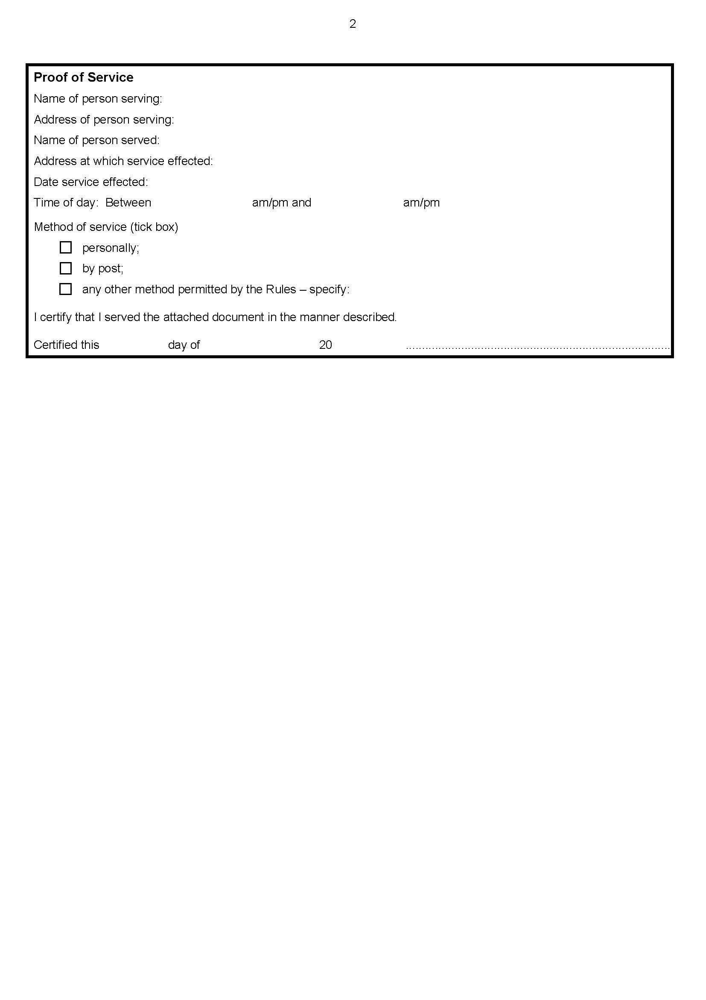

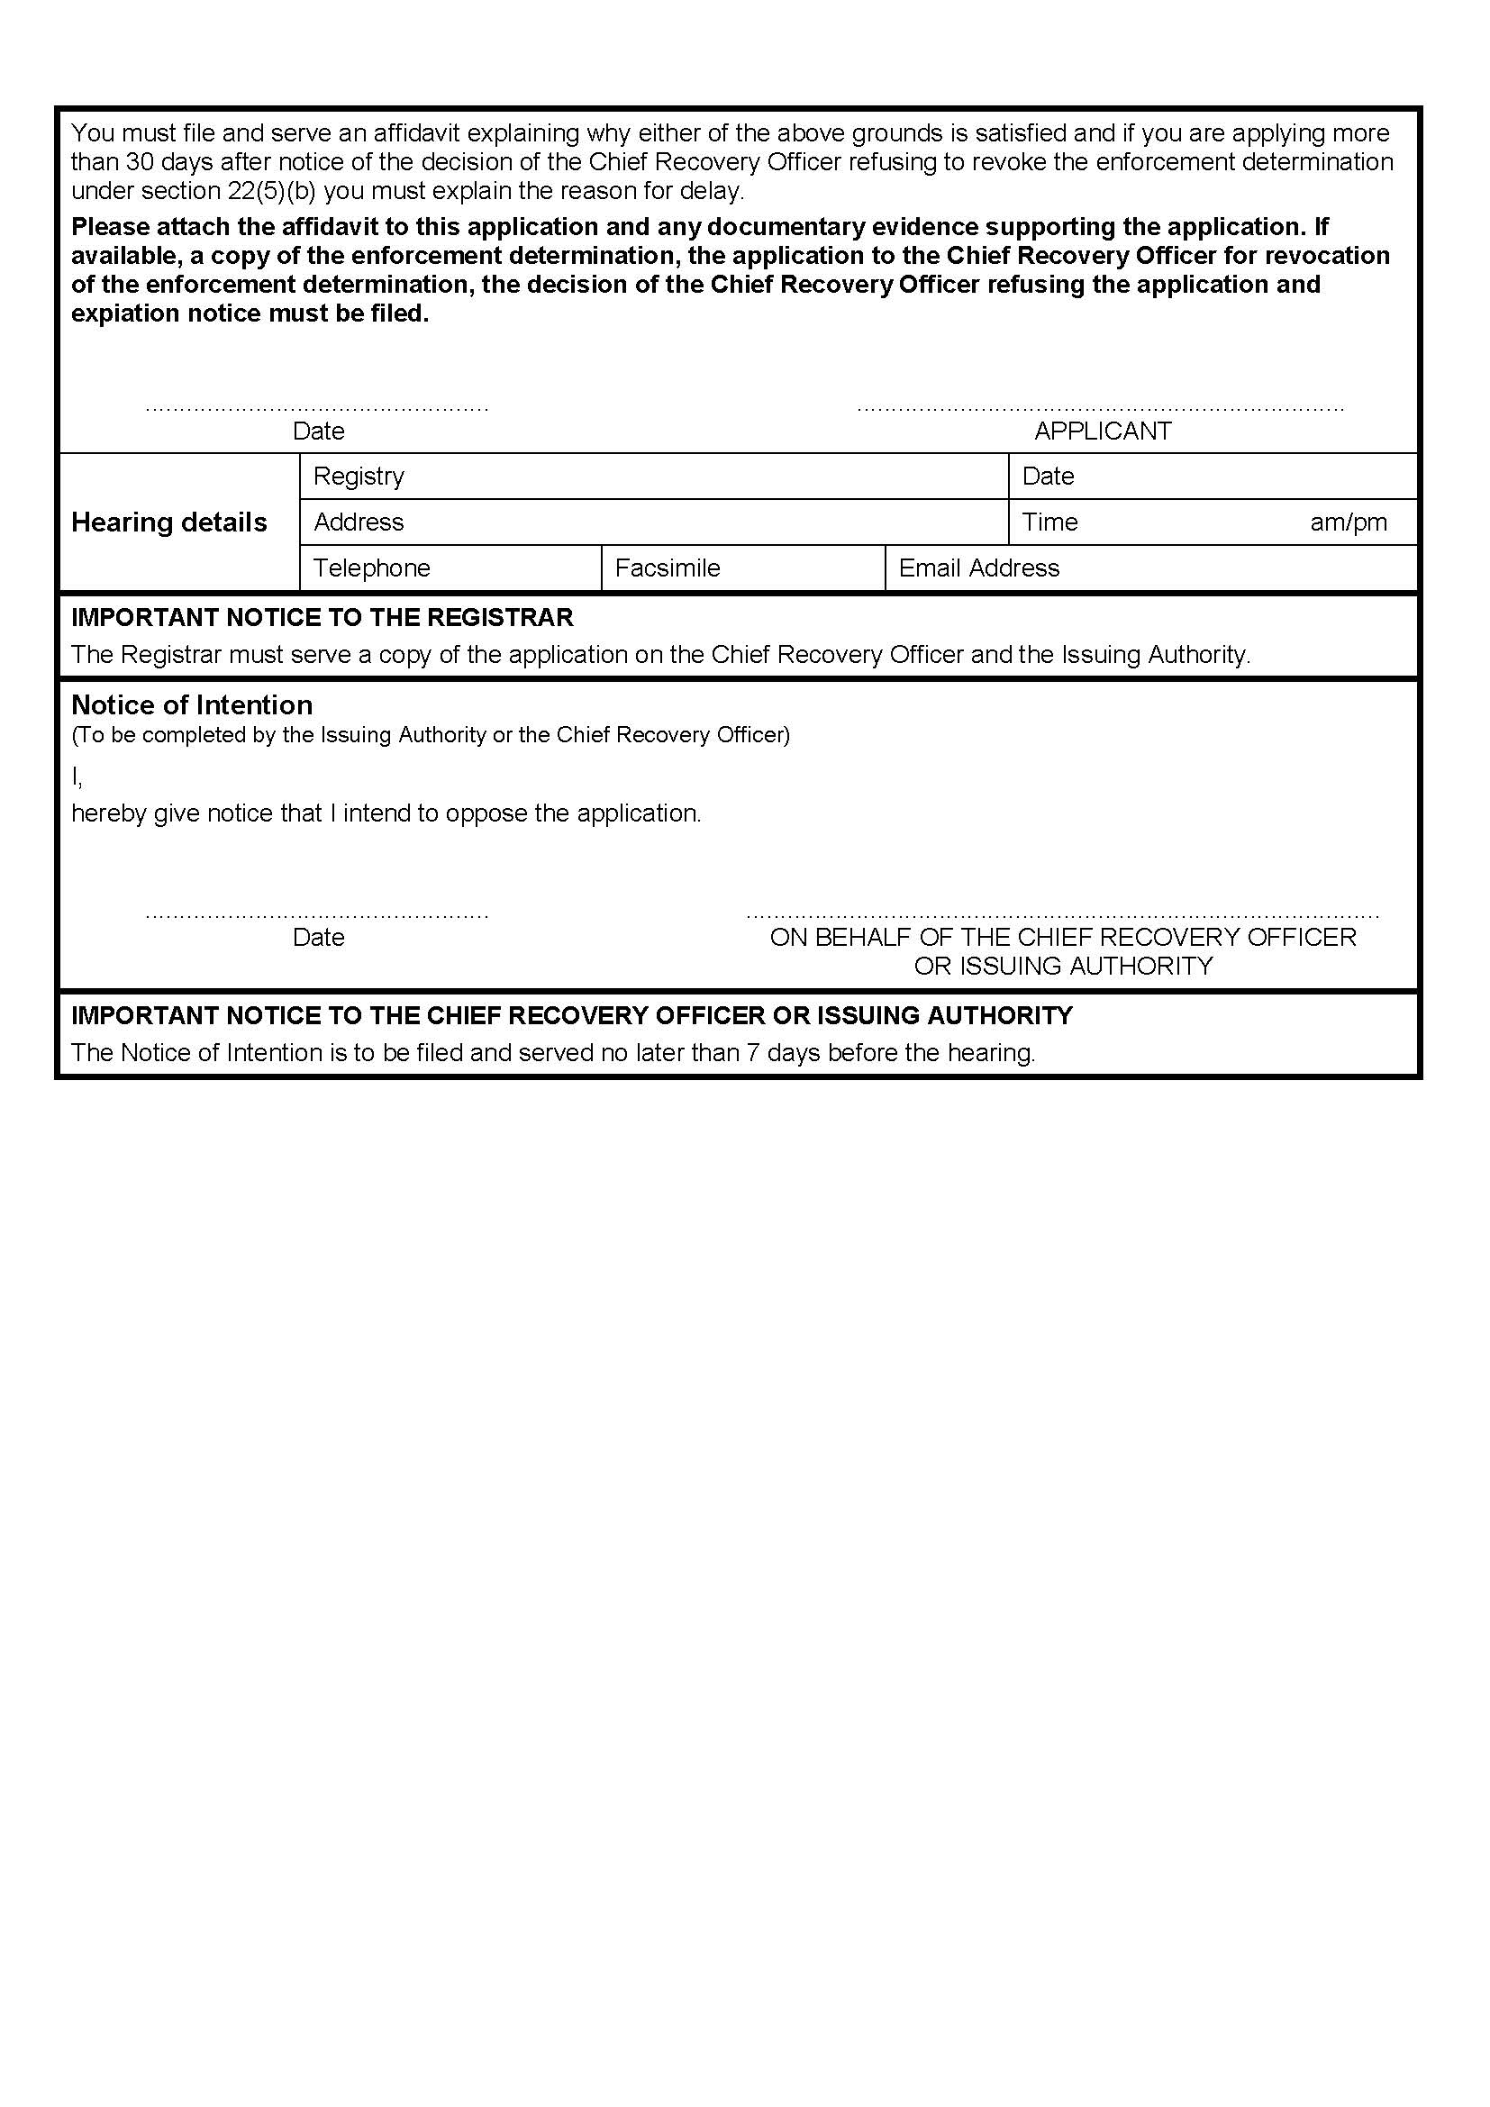


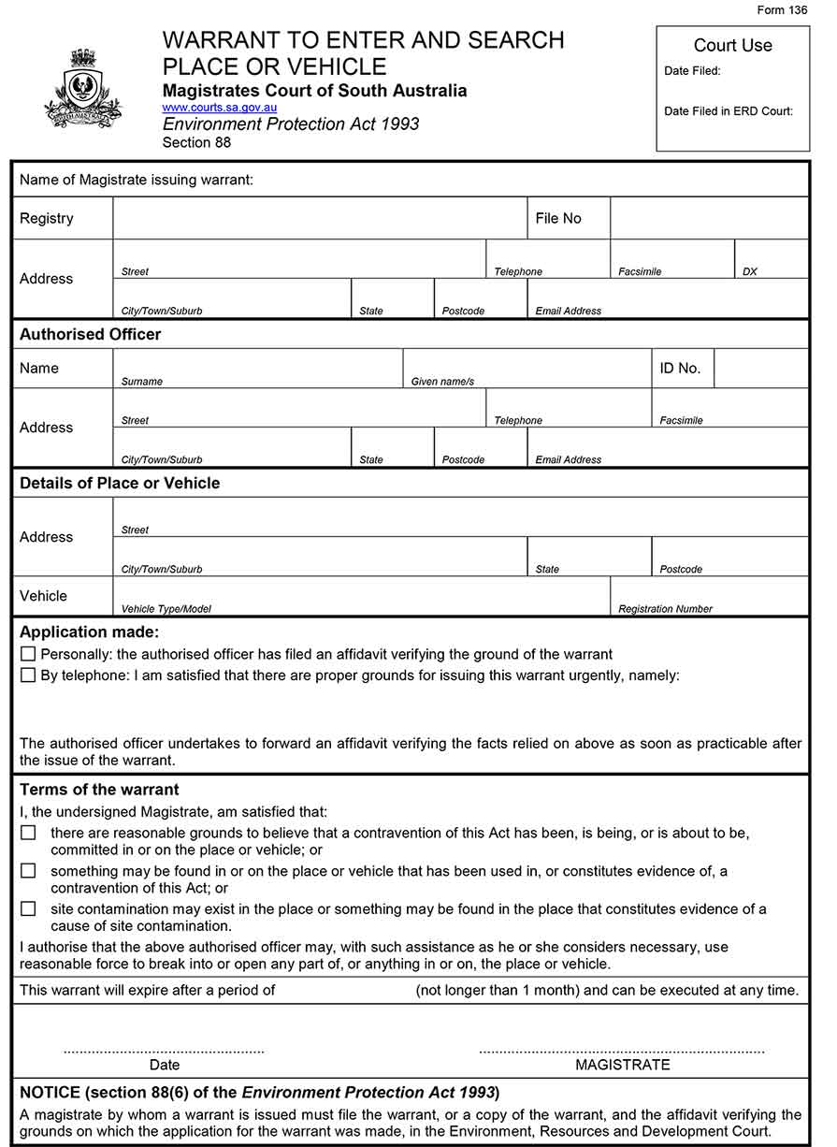

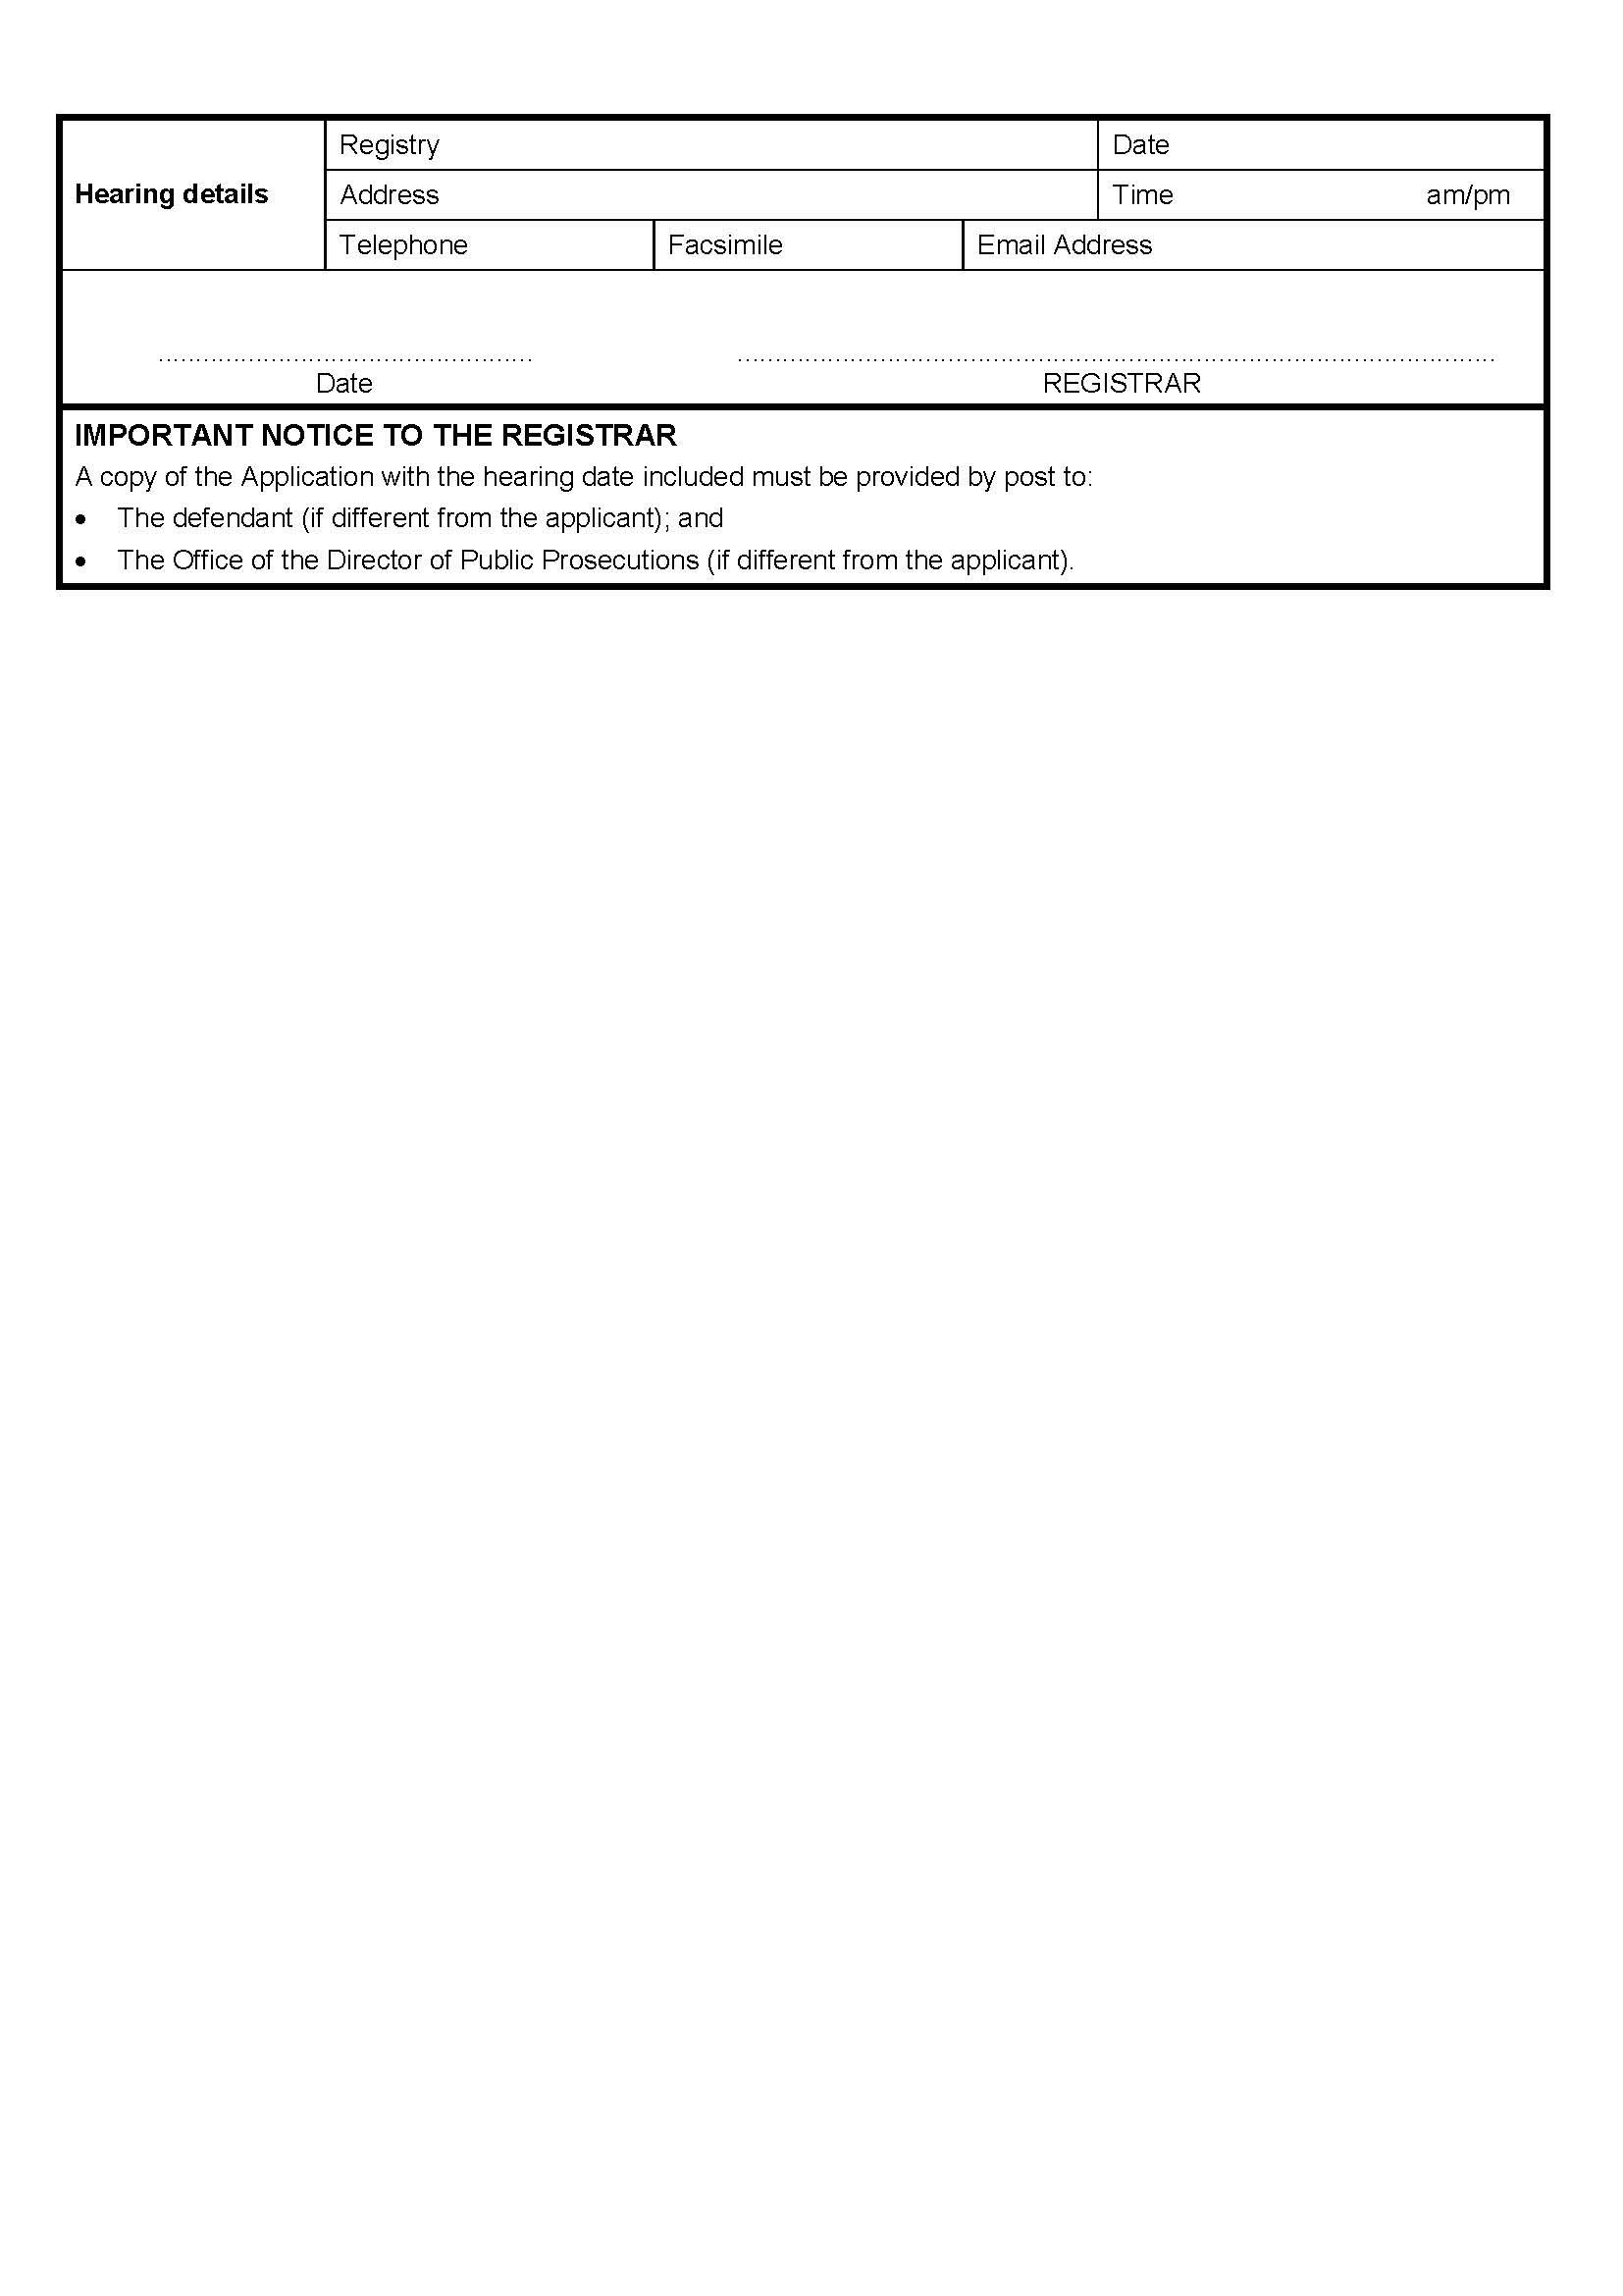

CITY OF WEST TORRENS
Corrigendum
Declaration of Public Road
IN Government Gazette No. 35 published on Thursday, 24 May 2018, a notice on page 2055, being the second notice appearing, was published with an error included. That notice should be replaced by the following:
NOTICE is hereby given that the City of West Torrens, at its meeting of 1 May 2018, pursuant to Section 210 of the Local Government Act 1999 declared the private road described as Elm Avenue in Deposited Plan 2422 in the area named Mile End, Hundred of Adelaide, and contained within Certificate of Title Register Book Volume 1074 Folio 77, a public road.
Terry Buss, PSM
Chief Executive Officer

CLARE AND GILBERT VALLEYS COUNCIL
Roads (Opening and Closing) Act 1991
Road Closure – Roberts Road, Armagh
Notice is hereby given, pursuant to section 10 of the Roads (Opening and Closing) Act 1991, that the Clare and Gilbert Valleys Council proposes to make a Road Process Order to close and merge that portion of Roberts Road adjacent Section 249, Hundred of Clare with said section, as delineated and lettered ‘A’ on the Preliminary Plan No.18/0015.
A copy of the plan and a statement of persons affected are available for public inspection at the Council Office at 4 Gleeson Street, Clare SA 5453 and the Adelaide Office of the Surveyor-General during normal office hours.
Any application for easement or objection must set out the full name, address and details of the submission and must be fully supported by reasons.
The application for easement or objection must be made in writing to the Council, 4 Gleeson Street, Clare SA 5453 within 28 days of this notice and a copy must be forwarded to the Surveyor-General at GPO Box 1354 Adelaide 5001. Where a submission is made, the Council will give notification of a meeting at which the matter will be considered.
Dated: 14 June 2018
Dr Helen Macdonald
Chief Executive Officer

THE COPPER COAST COUNCIL
Roads (Opening and Closing) Act 1991
Road Closure – Public Road, Cunliffe
Notice is hereby given, pursuant to section 10 of the Roads (Opening and Closing) Act 1991, that the Copper Coast Council proposes to make a Road Process Order
To close and merge with sections 510 and 514, the portion of public road adjoining sections 509 and 510, Hundred of Kadina, more particularly delineated and lettered ‘A’ on the Preliminary Plan No. 18/0014.
To close and merge with section 518 the portion of public road adjacent sections 518 and 525, Hundred of Kadina, more particularly delineated and lettered ‘B’ on the above Preliminary Plan.
To close and merge with sections 511, 512, 515, 519 and 526, Hundred of Kadina, those portions of public road adjacent said sections, more particularly delineated and lettered ‘C’ on the above Preliminary Plan.
A copy of the plan and a statement of persons affected are available for public inspection at the Council Office, 51 Taylor Street, Kadina, S.A. 5554 and the Adelaide Office of the Surveyor-General during normal office hours.
Any application for easement or objection must set out the full name, address and details of the submission and must be fully supported by reasons.
The application for easement or objection must be made in writing to the Council, P.O. Box 396, Kadina, S.A. 5554, within 28 days of this notice and a copy must be forwarded to the Surveyor-General at G.P.O. Box 1354, Adelaide, S.A. 5001. Where a submission is made, the Council will give notification of a meeting at which the matter will be considered.
Peter Harder
Chief Executive Officer

NARACOORTE LUCINDALE COUNCIL
Chief Executive Officer Appointment
NOTICE is hereby given that at its meeting held on 27 March 2018, the Council, pursuant to Section 96 of the Local Government Act 1999, appointed Mr Trevor Smart as the Chief Executive Officer of the Naracoorte Lucindale Council for a contract period of five (5) years commencing on 16 April 2018. Pursuant to the provision of Section 260(1) of the Local Government Act 1999, Mr Trevor Smart was appointed as an Authorised Officer of the Naracoorte Lucindale Council and pursuant to the provisions of Section 26(1)(b) of the Dog and Cat Management Act 1995, Mr Trevor Smart, was appointed as the Registrar for the Naracoorte Lucindale Council.
Trevor Smart
Chief Executive Officer

DISTRICT COUNCIL OF STREAKY BAY
Roads (Opening and Closing) Act 1991
Road Opening and Closing—Little Islands Road, Streaky Bay
NOTICE is hereby given, pursuant to Section 10 of the Roads (Opening and Closing) Act 1991, that the District Council of Streaky Bay hereby gives notice of its intent to implement a Road Process Order to:
Open as road portions of land contained within D70067 and D116950 more particularly delineated and numbered 1, 2, 3 on Preliminary Plan No. 18/0020.
AND
Close portions of Public Road, shown delineated as ‘A’ and ‘B’ on Preliminary Plan No. 18/0020.
A copy of the plan and a statement of persons affected are available for public inspection at the office of the Council at 29 Alfred Terrace, Streaky Bay and the Adelaide Office of the Surveyor-General during normal office hours, or can be viewed on the Council’s website www.streakybay.sa.gov.au.
Any application for easement or objection must set out the full name, address and details of the submission and must be fully supported by reasons. The application for easement or objection must be made in writing to the Council, P.O. Box 179, Streaky Bay, SA 5680 within 28 days of this notice and a copy must be forwarded to the Surveyor-General, G.P.O. Box 1354, Adelaide, S.A. 5001. Where a submission is made, the Council will give notification of a meeting at which the matter will be considered.
Dated: 12 June 2018
Ms J. Hentschke
Chief Executive Officer

Trustee Act 1936
Public Trustee
Estates of Deceased Persons
In the matter of the estates of the undermentioned deceased persons:
GILES Merion Elizabeth late of 8 Martindale Street Para Hills Milliner who died 21 January 2018
MATTHIESSEN Gwenda Ivy late of 43 High Street Strathalbyn of no occupation who died 16 March 2018
MURDOCH Florence Maud late of 22 Harrow Terrace Kingswood of no occupation who died 19 February 2017
PAGE Brian George late of Mill Street Laura Retired Prison Officer who died 19 October 2017
PAGE Sheila late of 1 Centre Street Gladstone Home Duties who died 27 July 2017
SICKERDICK Davina Mary late of 6 Warwick Avenue Kurralta Park Public Servant who died 11 March 2018
SLATER Gerritje Hendrika late of 7 Partridge Street Goolwa Retired Chiropractor who died 29 June 2017
SMITH Gwendoline Maude late of 550 Portrush Road Glen Osmond of no occupation who died 24 January 2018
THOMASON Amy Catherine late of 31 Myrtle Road Hawthorndene Home Duties who died 25 October 2017
Notice is hereby given pursuant to the Trustee Act 1936, the Inheritance (Family Provision) Act 1972 and the Family Relationships Act 1975 that all creditors, beneficiaries, and other persons having claims against the said estates are required to send, in writing, to the office of Public Trustee at GPO Box 1338, Adelaide, 5001, full particulars and proof of such claims, on or before the 13 July 2018 otherwise they will be excluded from the distribution of the said estate; and notice is also hereby given that all persons indebted to the said estates are required to pay the amount of their debts to the Public Trustee or proceedings will be taken for the recovery thereof; and all persons having any property belonging to the said estates are forthwith to deliver same to the Public Trustee.
Dated: 14 June 2018
N S Rantanen
Acting Public Trustee

Notice Submission

Notices for publication must be submitted before 4 p.m. Tuesday, the week of intended gazettal.
Proofs of formatted content are supplied for all notice submissions. Alterations must be returned before 4 p.m. Wednesday.
The SA Government Gazette is compiled and published each Thursday. Requests to withdraw submitted notices must be received before 10 a.m. on the day of publication.

Gazette notices should be emailed as Word files—and signed PDF files if applicable—
in the following format:
- Title (name of the governing legislation/department/organisation)
- Subtitle (description of notice)
- A structured body of text
- Date of authorisation
- Name, position, and department/organisation of the authorising person

Please provide the following information in your email:
- Date of intended gazettal
- Details that may impact on publication of the notice
- Email address and phone number of the person authorising the submission
- Name of the person and organisation to be charged for the notice, if applicable
- Request for a quote, if required
- Purchase order, if required

Email: governmentgazettesa@sa.gov.au
Phone: (08) 8207 1025
Website: www.governmentgazette.sa.gov.au

Printed and published weekly by authority of W. Hunter, Government Printer, South Australia
$7.35 per issue (plus postage), $370.00 per annual subscription—GST inclusive
Online publications: www.governmentgazette.sa.gov.au

