
THE SOUTH AUSTRALIAN
GOVERNMENT GAZETTE
Published by Authority

Adelaide, Tuesday, 6 March 2018

Contents

Appointments, Resignations, Etc. 1090
Aquaculture Act 2001—Notice 1090
Children and Young People (Safety)
Regulations 2017—Notice 1090
Corporations and District Councils—Notices 1105
Equal Opportunity Act 1984—Notices 1090
Fisheries Management Act 2007—Notices 1091
Fisheries Management (Prawn Fisheries)
Regulations 2017—Notices 1092
Housing Improvement Act 2016—Notices 1092
Mining Act 1971—Notices 1093
National Electricity Law—Notice 1108
National Energy Retail Law—Notice 1109
National Parks and Wildlife (National Parks)
Regulations 2016—Notice 1096
Notice to Mariners—Notice 1096
Petroleum and Geothermal Energy Act 2000—Notice 1096
Plant Health Act 2009—Notice 1097
Police Act 1998—Notice 1103
Proof of Sunrise and Sunset Act 1923—Notice 1103
Roads (Opening and Closing) Act 1991—Notice 1104
Trustee Act 1936—Administration of Estates 1109

Department of the Premier and Cabinet
Adelaide, 1 March 2018
His Excellency the Governor directs it to be notified that he is pleased to approve the retention of the title ‘The Honourable’ by:
Mr Martin Hamilton-Smith MP.
By command,
Jay Weatherill
Premier

Department of the Premier and Cabinet
Adelaide, 1 March 2018
His Excellency the Governor directs it to be notified that he is pleased to approve the retention of the title ‘The Honourable’ by:
The Hon Gail Gago MLC.
By command,
Jay Weatherill
Premier

AQUACULTURE ACT 2001
Grant of Aquaculture Lease
Pursuant to the provisions of section 22 of the Aquaculture Act 2001, notice is hereby given of the grant of the following leases for the purposes of aquaculture in the waters of the state:
LA00413
LA00414
LA00415
Further details are available for the above leases on the Aquaculture Public Register; which can be found at http://www.pir.sa.gov.au/aquaculture/public_register or by contacting Aquaculture Leasing & Licensing on 8226 0900.
Chilali Piek
Aquaculture Leasing & Licensing Officer

CHILDREN AND YOUNG PEOPLE (SAFETY) REGULATIONS 2017
PURSUANT to Regulation 2 (2) of the Children and Young People (Safety) Regulations 2017 I, the Minister for Education and Child Development, fix the day on which this notice is published in the Government Gazette as the day on which Regulation 34 of the Children and Young People (Safety) Regulations 2017 will come into operation.
Dated: 2 March 2018
Susan Close
Minister for Education and Child Development

EQUAL OPPORTUNITY ACT 1984
South Australian Employment Tribunal
No: 44/2018
Notice of an Exemption
Before Deputy President Judge Farrell
I HEREBY certify that on 28 February 2018, the South Australian Employment Tribunal, on the application of the Quick Steps School of Dance Pty Ltd made the following orders for exemption:
- Pursuant to section 92 of the Equal Opportunity Act 1984 Quick Steps School of Dance Pty Ltd is exempt from complying with the obligation under the Equal Opportunity Act 1984, Part 3 Division 2 of the Act insofar as that Part extends to the advertising for and recruitment of male ballroom dance teachers.
- The exemption application is granted for 3 years from 28 February 2018 to 28 February 2021.
- Any advertisement placed in relation to the above position should refer to this judgment (i.e. see Quick Steps School of Dance Pty Ltd [2018] SAET 33).
Dated: 28 February 2018
A Lindsay
A/Registrar
South Australian Employment Tribunal

EQUAL OPPORTUNITY ACT 1984
South Australian Employment Tribunal
No: 5957/2017
Notice of an Exemption
Before Deputy President Judge Farrell
I HEREBY certify that on 23 February 2018, the South Australian Employment Tribunal, on the application of the Courts Administration Authority of South Australia made the following orders for exemption:
- Pursuant to section 92 of the Equal Opportunity Act 1984 the Courts Administration Authority of South Australia is exempt from complying with the obligation under the Equal Opportunity Act 1984, Part 3 Division 2 Section 30 of the Act insofar as that Part extends to the advertising for and recruitment of participants in the Courts Administration Authority’s ‘Step Up to the Bar’ employment program for female legal practitioners.
- The exemption application is granted for 3 years from 13 April 2018 to 13 April 2021.
- Any advertisement placed in relation to the above position should refer to this judgment (i.e. see Courts Administration Authority [2018] SAET 30).
Dated: 27 February 2018
A Lindsay
A/Registrar
South Australian Employment Tribunal

FISHERIES MANAGEMENT ACT 2007
Section 115
Variation Ministerial Exemption ME9902946
TAKE NOTICE that the Ministerial Exemption notice ME9902946 dated 28 June 2017, being the first notice published on page 2718 of the South Australian Government Gazette dated 4 July 2017, issued to David Corston, is HEREBY VARIED by deleting clause 4 of schedule 1 and replacing it with the following:
4. The exempted activity may only be conducted by David Corston or one of the following permitted agents of the exemption holder, Mr Reece Gynell, Mr Joe Gynell and Mr Tony Lee. Only one person may undertake the exempted activity at any one time.
Dated: 26 February 2018
Sean Sloan
Executive Director
Fisheries and Aquaculture
Delegate of the Minister for Agriculture, Food and Fisheries

FISHERIES MANAGEMENT ACT 2007
Section 115
Ministerial Exemption ME9902988
TAKE NOTICE that pursuant to section 115 of the Fisheries Management Act 2007, Garry Warrick of 1979 Kingston Road, NEW RESIDENCE SA 5333 (the ‘exemption holder’), holder of River Fishery licence number R27, is exempt from sections 53(2) and 70 of the Fisheries Management Act 2007 and regulation 5 clause 6 of Schedule 6 and Schedule 7 of the Fisheries Management (General) Regulations 2017 but only insofar as he may use the devices described in schedule 1 to take Carp, Redfin and other non-native species in the areas specified in schedule 2 for the purpose of trade or business, or native species for immediate relocation (the ‘exempted activity’), subject to the conditions set out in schedule 3, from 28 February 2018 until 28 November 2018, unless varied or revoked earlier.
Schedule 1
- 3 Dab Nets
- 1 Haul Net
- 30 Carp Nets (Kangaroo Creek Dam only)
Schedule 2
De-watering locations
- Teal Flat | - Caurnamont
- Teal Flat Hut | - North Caurnamont
- Big Bend | - Silver Lea
- Sugar Shack | - Donald Flat
- Irwin Flat | - Pyap Horseshoe
- Goat Island | - Woolenook Bend
- Murtho Park
SA Water requested location
- Kangaroo Creek Dam
Schedule 3
- The exemption holder may only engage in the exempted activity when also fishing pursuant to River Fishery licence number R27, and may only use a boat to engage in the exempted activity if that boat is registered by endorsement on River Fishery licence number R27.
- The exemption holder must not cause or permit a person to act as his agent when engaging in the exempted activity unless that person may lawfully act as an agent for the exemption holder in relation to River Fishery licence number R27.
- All native fish (excluding Bony Bream and Yabbies) taken in the course of the exempted activity must be returned to the adjacent water immediately.
- Immediately prior to commencing the exempted activity, the exemption holder must contact the PIRSA Fishwatch on 1800 065 522 and provide the following details:
- The licence number and person(s) conducting the activity;
- The exact location(s) of the fishing activities;
- The number of dab nets being used
- Exemption number ME9902988
- While engaging in the exempted activity, the exemption holder must be in possession of a copy of this notice. Such notice must be produced to a Fisheries Officer as requested.
- The exemption holder must not contravene or fail to comply with the Fisheries Management Act 2007 or any regulations made under that Act, except where specifically exempted by this notice.
Dated: 28 February 2018
Sean Sloan
Executive Director
Fisheries and Aquaculture
Delegate of the Minister for Agriculture, Food and Fisheries

FISHERIES MANAGEMENT (PRAWN FISHERIES) REGULATIONS 2017
Temporary Prohibition on Fishing Activities in the Spencer Gulf Prawn Fisheries
TAKE notice that pursuant to regulation 10 of the Fisheries Management (Prawn Fisheries) Regulations 2017, the activities of the class specified in Schedule 1 are prohibited in the waters of the Spencer Gulf Prawn Fishery during the period specified in Schedule 2 unless this notice is varied or revoked.
Schedule 1
The act of taking or an act preparatory to or involved in the taking of King Prawns (Melicertus latisulcatus) pursuant to a Spencer Gulf Prawn Fishery Licence.
Schedule 2
From 1800 hours on 21 March 2018 to 1800 hours on 21 March 2019.
Dated: 28 February 2018
Steve Shanks
Prawn Fishery Manager
Delegate of the Minister for Agriculture, Food and Fisheries

FISHERIES MANAGEMENT (PRAWN FISHERIES) REGULATIONS 2017
Temporary Prohibition on Fishing Activities in the West Coast Prawn Fisheries
TAKE notice that pursuant to regulation 9A of the Fisheries Management (Prawn Fisheries) Regulations 2017, the activities of the class specified in Schedule 1 are prohibited in the waters of the West Coast Prawn Fishery during the period specified in Schedule 2 unless this notice is varied or revoked.
Schedule 1
The act of taking or an act preparatory to or involved in the taking of King Prawns (Melicertus latisulcatus) pursuant to a West Coast Prawn Fishery Licence.
Schedule 2
From 1800 hours on 21 March 2018 to 1800 hours on 21 March 2019.
Dated: 27 February 2018
Steve Shanks
Prawn Fishery Manager
Delegate of the Minister for Agriculture, Food and Fisheries

HOUSING IMPROVEMENT ACT 2016
Rent Control
The Minister for Social Housing Delegate in the exercise of the powers conferred by the Housing Improvement Act 2016, does hereby fix the maximum rental per week which shall be payable subject to Section 55 of the Residential Tenancies Act 1995, in respect of each house described in the following table. The amount shown in the said table shall come into force on the date of this publication in the Gazette.
Address of Premises | Allotment  Section | Certificate of Title  Volume/Folio | Maximum Rental  per week payable
31 Adelaide Road, Pinnaroo SA 5304 | Allotment 44 Deposited Plan 3032 Hundred of Pinnaroo | CT5302/275 | $0.00
Dated: 6 March 2018
John Herrmann
Housing Regulator and Registrar
Office of Housing Regulation
Housing SA
Delegate of Minister for Social Housing

HOUSING IMPROVEMENT ACT 2016
Rent Control Revocations
Whereas the Minister for Social Housing Delegate is satisfied that each of the houses described hereunder has ceased to be unsafe or unsuitable for human habitation for the purposes of the Housing Improvement Act 2016, notice is hereby given that, in exercise of the powers conferred by the said Act, the Minister for Social Housing does hereby revoke the said Rent Control in respect of each property.
Address of Premises | Allotment  Section | Certificate of Title  Volume/Folio
2604 Templeton Road, EVERARD CENTRAL SA 5461 (AKA Lot 4) (AKA Snowtown Road) (PKA Government Road) | Allotment 4 Filed Plan 100487 Hundred of Everard | CT5099/700
31 Bloomfield Crescent, Elizabeth Downs SA 5113 | Allotment 785 Deposited Plan 7225 Hundred of Munno Para | CT6138/512
Dated: 6 March 2018
John Herrmann
Housing Regulator and Registrar
Office of Housing Regulation
Housing SA
Delegate of Minister for Social Housing

MINING ACT 1971
Native Title (South Australia) Act 1994
Notice is hereby given in accordance with Section 35A (1) of the Mining Act 1971 and Part 5 of the Native Title (South Australia) Act 1994, that nine applications for Extractive Minerals Leases over the undermentioned mineral claims have been received:
Applicant: OZ Minerals Carrapateena Pty Ltd; OZM Carrapateena Pty Ltd
Claim Number: 4440
Location: Allotment 2, Deposited Plan 47746, Out of Hundreds (Torrens)
(Oakden Hills area, approx. 39 km southeast of Woomera)
Area: 16.00 hectares approximately
Purpose: Dolomite, Limestone, Quartzite, Shale, Sandstone and Siltstone
Reference: 2017/0955 1
Applicant: OZ Minerals Carrapateena Pty Ltd; OZM Carrapateena Pty Ltd
Claim Number: 4441
Location: Allotment 2, Deposited Plan 47706, Out of Hundreds (Torrens)
(Pernatty area, approx. 38 km east-southeast of Woomera)
Area: 10.50 hectares approximately
Purpose: Dolomite, Limestone, Quartzite, Shale, Sandstone and Siltstone
Reference: 2017/0955 2
Applicant: OZ Minerals Carrapateena Pty Ltd; OZM Carrapateena Pty Ltd
Claim Number: 4442
Location: Allotment 2, Deposited Plan 47706, Out of Hundreds (Torrens)
(Pernatty area, approx. 42 km east-southeast of Woomera)
Area: 15.37 hectares approximately
Purpose: Dolomite, Limestone, Quartzite, Shale, Sandstone and Siltstone
Reference: 2017/0955 3
Applicant: OZ Minerals Carrapateena Pty Ltd; OZM Carrapateena Pty Ltd
Claim Number: 4443
Location: Allotment 2, Deposited Plan 47706, Out of Hundreds (Torrens)
(Pernatty area, approx. 45 km east-southeast of Woomera)
Area: 6.07 hectares approximately
Purpose: Dolomite, Limestone, Quartzite, Shale, Sandstone and Siltstone
Reference: 2017/0955 4
Applicant: OZ Minerals Carrapateena Pty Ltd; OZM Carrapateena Pty Ltd
Claim Number: 4444
Location: Allotment 2, Deposited Plan 47706, Out of Hundreds (Torrens)
(Pernatty area, approx. 47 km east-southeast of Woomera)
Area: 15.20 hectares approximately
Purpose: Dolomite, Limestone, Quartzite, Shale, Sandstone and Siltstone
Reference: 2017/0955 5
Applicant: OZ Minerals Carrapateena Pty Ltd; OZM Carrapateena Pty Ltd
Claim Number: 4445
Location: Allotment 2, Deposited Plan 47706, Out of Hundreds (Torrens)
(Pernatty area, approx. 49 km east-southeast of Woomera)
Area: 15.99 hectares approximately
Purpose: Dolomite, Limestone, Quartzite, Shale, Sandstone and Siltstone
Reference: 2017/0955 6
Applicant: OZ Minerals Carrapateena Pty Ltd; OZM Carrapateena Pty Ltd
Claim Number: 4446
Location: Allotment 2, Deposited Plan 47706, Out of Hundreds (Torrens)
(Pernatty area, approx. 53 km east-southeast of Woomera)
Area: 15.19 hectares approximately
Purpose: Dolomite, Limestone, Quartzite, Shale, Sandstone and Siltstone
Reference: 2017/0955 7
Applicant: OZ Minerals Carrapateena Pty Ltd; OZM Carrapateena Pty Ltd
Claim Number: 4447
Location: Allotment 2, Deposited Plan 47706, Out of Hundreds (Torrens)
(Pernatty area, approx. 53 km east-southeast of Woomera)
Area: 13.73 hectares approximately
Purpose: Dolomite, Limestone, Quartzite, Shale, Sandstone and Siltstone
Reference: 2017/0955 8
Applicant: OZ Minerals Carrapateena Pty Ltd; OZM Carrapateena Pty Ltd
Claim Number: 4448
Location: Allotment 2, Deposited Plan 47706, Out of Hundreds (Torrens)
(Pernatty area, approx. 56 km east-southeast of Woomera)
Area: 14.99 hectares approximately
Purpose: Dolomite, Limestone, Quartzite, Shale, Sandstone and Siltstone
Reference: 2017/0955 9
Details of the proposals may be inspected at the Department of the Premier and Cabinet, Mineral Resources Division, Level 7, 101 Grenfell Street, ADELAIDE SA 5000.
An electronic copy of the proposals can be found on the Department of the Premier and Cabinet website: http://minerals.dpc.sa.gov.au/mining/public_notices_mining.
Written submissions in relation to these applications are invited to be received at the Department of the Premier and Cabinet, Mining Regulation, Attn: Business Support Officer, GPO Box 320 ADELAIDE SA 5001 by no later than 22 March 2018.
The delegate of the Minister for Mineral Resources and Energy is required to have regard to these submissions in determining whether to grant or refuse the applications and, if granted, the terms and conditions on which they should be granted.
When you make a written submission, that submission becomes a public record. Your submission will be provided to the applicant and may be made available for public inspection unless confidentiality is requested.
J Martin
Mining Registrar
Department of the Premier and Cabinet
Delegate of the Minister for Mineral Resources and Energy

MINING ACT 1971
Notice pursuant to Section 29(1a) and 29(5)(b)(ii) of the Mining Act 1971
NOTICE is hereby given that the Notice under the Mining Act 1971 (“the Act”) published on 12 July 2012 in the South Australian Government Gazette (“the Gazette”) at pages 3084 - 3085, is revoked in respect of land identified in the Schedule.
NOTICE is further hereby given that the land identified in the Schedule is subject to a Section 15 notice pursuant to subsections 15(1), 15(5) and 15(7) of the Act. Notification was published on 27 February 2018 in the Gazette at page 1063.
This notice becomes effective 1 March 2018.
The Schedule
EL No | Locality | Area (km²)
5295 | Mount Wallaby area – approx. 105 km NE of Streaky Bay | 47
5310 | Yartoo area – approx. 80km NE of Streaky Bay | 367
5457 | Kokatha area – approx. 100km SE of Tarcoola | 583
5466 | Nuckulla Hill area – approx. 100 km SSE of Tarcoola | 204
5552 | Lake Gairdner area – approx. 90km SSE of Tarcoola | 81
5620 | Mount John area – approx. 110 km NE of Ceduna | 376
5664 | Kondoolka area – approx. 90km ENE of Ceduna | 233
5665 | Yellabinna area – approx. 80km NE of Ceduna | 350
5679 | Yarranna Hill area – approx. 110km NE of Ceduna | 478
5954 | Pureba area – approx. 90 km east of Ceduna | 409
5955 | Yantanabie area – approx. 60 km NE of Streaky Bay | 93
Dated: 1 March 2018
J Martin
Mining Registrar
Mineral Resources
Department of the Premier and Cabinet
Delegate of the Minister for Mineral Resources and Energy

Mining Act 1971
Public Notice
Notification of Airborne Geophysical Survey in Northern South Australia
The South Australian Government, through the Geological Survey of South Australia, is about to commence an airborne geophysical survey over Regions 5, 6A, 6B, 7 and 9B,on the attached map, which are within a geological region known as the Gawler Craton.
The survey is a scientific investigation that is being undertaken in accordance with section 15 of the Mining Act 1971. The survey is scheduled to begin in March 2018 and will take up to 5 months to complete.
The survey will be performed by one of several models of fixed-wing Cessna, with a single propeller engine. The aircraft will fly approximately 60m above the ground along east-west and north-south oriented flight lines spaced 200m apart. As this is an airborne survey, there will be no on ground data collection or sampling.
The aircraft use sensors that will capture magnetic intensity, radiometric and elevation data. This information will provide a greater understanding of the composition of rocks at and beneath the earth’s surface that will help to inform natural resources management, resource potential and water research activities in the region.
The survey is being led by the South Australian Government in partnership with Geoscience Australia (part of the Federal Government’s Department of Industry, Innovation and Science). This survey is a key program of the Plan for Accelerating Exploration (PACE) Copper Initiative, which is part of South Australia’s Copper Strategy.
A dedicated website www.minerals.dpc.sa.gov.au/gcas has been developed to inform the community about the Gawler Craton Airborne Survey. The website will provide information about aircraft activity during the survey and allows the community to subscribe to email updates on the progress of the survey.
For further information, please contact Laszlo Katona (Project Leader – Gawler Craton Airborne Survey) on 08 8204 2853 or Laz.Katona@sa.gov.au

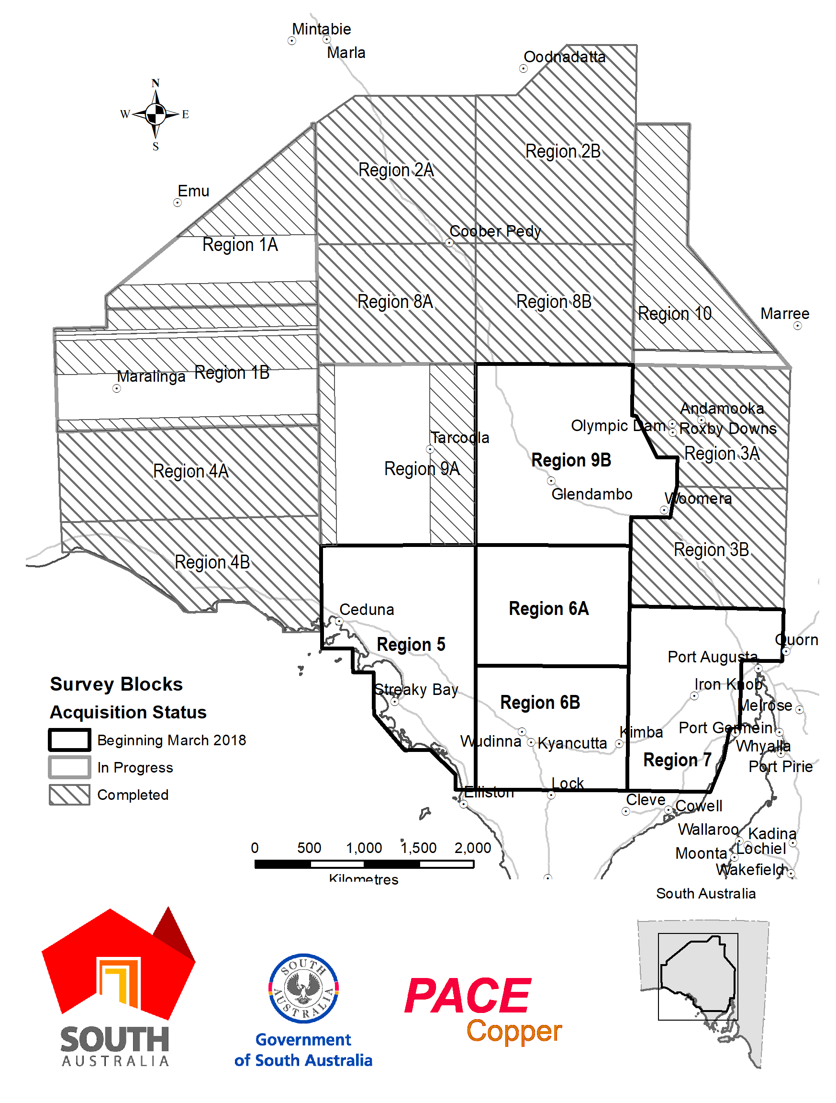

NATIONAL PARKS AND WILDLIFE (NATIONAL PARKS) REGULATIONS 2016
Temporary Closure of a Portion of Coorong National Park
PURSUANT to Regulations 7(3) (a) and 7(3) (d) of the National Parks and Wildlife (National Parks) Regulations 2016, I, John Erwin Schutz, Director of National Parks and Wildlife, temporarily close to the public a portion of Coorong National Park defined as:
- All of CR 6024/502, Plan Parcel H410500S33
- All of CR 5775/ 155, Plan Parcel H410500S31
- All of CR 5747/636, Plan Parcel H410500S85
- A 200m strip of CR 5775/155 Plan Parcel H410500S31 that adjoins the drain corridor for the extent of the drain corridor.
from:
6am on Friday 16 March 2018 until 6pm on Friday 29 June 2018.
The purpose of the closure is to ensure the safety of the public during the upgrade of the Salt Creek spillway as part of the South East Flows Restoration Project during the period indicated.
Dated: 27 February 2018
J. E. Schutz
Director
National Parks & Wildlife

Notice to Mariners
No 8 of 2018
Kangaroo Island – Kingscote – Changes to Navigation Beacons
Mariners are advised of the following modifications to navigation beacons in the vicinity of Kingscote, Kangaroo Island.
- The existing unlit port beacon in position 35° 38’ 06.12” S, 137° 38’ 39.15” E at the entrance to Bay of Shoals has been removed and replaced with a new lit port beacon in position 35° 37’ 58.53” S, 137° 38’ 33.14” E, Fl R 2s, range 2 nautical miles.
- The existing beacon in position 35° 38’ 25.32” S, 137° 41’ 41.52” E east of the Beatrice Islets has been changed to an east cardinal marker, Q(3)W 10s, range 3 nautical miles.
- The existing beacon in position 35° 40’ 01.30” S, 137° 41’ 14.80” E south of the Beatrice Islets has been changed to a south cardinal marker, Q(6)+LFl W 15s, range 3 nautical miles.
- The existing unlit port buoy in position 35° 38’ 58.18” S, 137° 38’ 48.76” E north of the Kingscote Fishermen’s Jetty has been removed.
Mariners are advised to navigate with extreme caution in the vicinity.
Chart affected: Aus 129
Gordon Panton
Manager Marine Operations
Department of Planning, Transport & Infrastructure
DPTI 2017/02277/01
www.dpti.sa.gov.au

Petroleum and Geothermal Energy Act 2000
Partial Surrender of Petroleum Production Licence
PPL 21
Notice is hereby given that I have accepted the partial surrender of the abovementioned petroleum production licence under the provisions of the Petroleum and Geothermal Energy Act 2000, pursuant to delegated powers dated 31 March 2017 -
No of Licence | Licensee | Locality | Effective Date  of Surrender | Approximate area surrendered in km² | Reference
PPL 21 | Air Liquide Australia Limited | Otway Basin | 19/02/2018 | 143.94 | F2012/000736
Description of Licence Area Remaining
All that part of the State of South Australia, bounded as follows:-
Commencing at a point being the intersection of latitude 37°56'10"S GDA94 and longitude 140°54'09"E GDA94, thence east to longitude 140°54'50"E GDA94, south to latitude 37°56'43"S GDA94, west to longitude 140°54'09"E GDA94, and north to point of commencement.
AREA: 1.02 square kilometres approximately.
Date: 26 February 2018
Nick Panagopoulos
Executive Director
Energy Resources Division
Department of the Premier and Cabinet
Delegate of the Minister for Mineral Resources and Energy

PLANT HEALTH ACT 2009
Ministerial Notice
PURSUANT to the Plant Health Act 2009, I, Leon Bignell MP, Minister for Agriculture, Food and Fisheries, make the following notice:
1. Application
All previous notices made pursuant to Sections 4, 5, 7, 8 and 59 of the Plant Health Act 2009 are hereby revoked.
2. Interpretation
In this notice:
- “the Act” means the Plant Health Act 2009
- “fruit fly outbreak suspension area” means an area that has been declared, in accordance with the Code of Practice for Queensland fruit fly published by the Interstate Plant Health Regulation Working Group, 1996, or in accordance with the Draft National Code of Practice for the Management of Mediterranean Fruit Fly, 2008 (as updated or amended from time to time), as a suspension area in relation to a fruit fly outbreak
- “inspector” means an inspector appointed pursuant to section 41 of the Act
- “soil” means the upper, outermost layer of soil, usually the top 20 centimetres consisting of rock and mineral particulates that may be mixed with organic matter and in which plants grow or are grown
- “the Standard” means the document published by Primary Industries and Regions South Australia entitled the “Plant Quarantine Standard South Australia”
3. Declaration of Pests - Pursuant to Section 4 of the Act
3.1 The following are declared to be pests for the purposes of the Act:
- The pests specified by common name and scientific name immediately below:
Common Name(s) | Scientific Name(s)
African citrus psyllid | Trioza erytreae
Asian citrus psyllid | Diaphorina citri
Asian longicorn beetle | Anaplophora glabripennis
Asian subterranean termite | Cryptotermes gestroi
Australian plague locust | Chortoicetes terminifera
Bacterial wilt of potato | Ralstonia solanacearum Race 3
Barley stem gall midge | Mayetiola hordei
Barley stripe rust | Puccinia striiformis f. sp. hordei
Blueberry rust | Thekospora minima
Boil smut of maize | Ustilago maydis
Brown marmorated stink bug | Halyomorpha halys
Browsing ant | Lepisiota frauenfeldi
Burning moth | Hylesia nigricans
Chestnut blight | Cryphonectria parasitica
Citrus blight | - (unknown causal agent)
Citrus canker | Xanthomonas citri subsp. citri
Citrus longicorn beetle | Anaplophora chinensis
Citrus red mite | Panonychus citri
Citrus tristeza virus – sweet orange stem pitting strain | Citrus tristeza closterovirus – sweet orange stem pitting strain
Citrus variegated chlorosis | Xylella fastidiosa
Cucumber green mottle mosaic virus (CGMMV) | Cucumber green mottle mosaic tobamovirus
Drywood termite | Cryptotermes dudleyi
Electric ant | Wasmannia auropunctata
Exotic gypsy moth | Lymantria spp. (L. dispar and sub-species, L. monacha)
European House Borer | Hylotrupes bajulus
Fire blight | Erwinia amylovora
Fruit flies | Pest species of Tephritidae family
Fusarium wilt of tomatoes | Fusarium oxysporum f.sp. lycopersicon Race 3
Giant African snail | Lissachatina fulica
Giant pine scale | Marchalina hellenica
Glabrous cabinet beetle | Trogoderma glabrum
Glassy-winged sharpshooter | Homalodisca vitripennis
Golden apple snail | Pomacea canaliculata
Grapevine leaf rust | Phakopsora euvitis
Grapevine pinot gris virus | Grapevine pinot gris Trichovirus
Green snail | Cantareus apertus
Hessian fly | Mayetiola destructor
Huanglongbing disease of citrus | ‘Candidatus liberibacter’ spp.
Karnal bunt | Tilletia indica
Khapra beetle | Trogoderma granarium
Melon necrotic spot virus (MNSV) | Melon necrotic spot carmovirus
Melon thrips | Thrips palmi
Myrtle rust | Puccinia psidii (syn. Uredo rangelii)
Onion Smut | Urocystis cepulae
Parlatoria date scale | Parlatoria blanchardii
Phoney peach disease | Xylella fastidiosa
Phylloxera | Daktulosphaira vitifolliae
Phytophthora blight | Phytophthora kernoviae
Pierce’s disease of grapevines | Xylella fastidiosa
Potato blackleg and soft rot | Dickeya spp. including D. dianthicola, D. dadantii and D. solani
Potato cyst nematode | Globodera pallida
Potato cyst nematode | Globodera rostochiensis
Potato spindle tuber viroid (PSTVd) | Potato spindle tuber pospiviroid
Pine wilt nematode | Bursaphelenchus spp. including B. xylophilus
Potato late blight | Phytophthora infestans (A2 mating type)
Pyriform scale | Protopulvinaria pyriformis
Red imported fire ant | Solenopsis invicta
Sawyer beetles | Monochamus spp. including  M. alternatus, M. galloprovincialis,  M. scutellatus, M. titillator
Sharka | Plum pox potyvirus
Small plague grasshopper | Austroicetes cruciata
Spotted-winged drosophila (fruit fly) | Drosophila suzukii
Subterranean termite | Cryptotermes formosanus
Sudden oak death | Phytophthora ramorum
Tarnished plant bug | Lygus lineolaris
Tomato-potato psyllid | Bactericera cockerelli
Tropical fire ant | Solenopsis geminata
West Indian drywood termite | Cryptotermes brewis
Western plant bug | Lygus hesperus
Wheat stem rust | Puccinia graminis f. sp. tritici (exotic strains)
Wheat stem sawfly | Cephus spp. (C. cinctus, C. pygmeaus)
Yellow crazy ant | Anoplolepis gracilipes
Zebra chip | ‘Candidatus Liberibacter solanacearum'
- Any emergent pest that warrants immediate application of the Act and subsequent declaration under sub-paragraph (1).
4. Quarantine Stations - Pursuant to Section 5 of the Act
The following places are declared to be quarantine stations in which a plant or plant related product may, subject to the Act, be held, examined, disinfected, destroyed or otherwise disposed of:
(1) Biosecurity SA  Ceduna Quarantine Inspection Station  Eyre Highway, Ceduna  (2) Biosecurity SA  Oodla Wirra Quarantine Inspection Station  Barrier Highway, Oodla Wirra  (3) Biosecurity SA  Pinnaroo Quarantine Inspection Station  Mallee Highway, Pinnaroo  (4) Biosecurity SA  Yamba Quarantine Inspection Station  Sturt Highway, Yamba  (5) Primary Industries and Regions SA  Prosser Street, Port Augusta  (6) Primary Industries and Regions SA  Riddoch Highway  Struan  (7) Primary Industries and Regions SA  Krummel Street, Mount Gambier  (8) Primary Industries and Regions SA  Loxton Research Centre  Bookpurnong Road, Loxton  (9) Biosecurity SA  33 Flemington Street  Glenside  (10) Primary Industries and Regions SA  Research and Advisory Centre  Research Road, Nuriootpa | (11) Biosecurity SA  Adelaide Produce Market  Diagonal Road, Pooraka  (12) Primary Industries and Regions SA  Hindmarsh St, Port Lincoln  (13) Post- Entry Plant Quarantine Station  SARDI Plant Research Centre  Hartley Grove, Urrbrae  (14) SARDI Entomology  Waite Quarantine Insectary  Waite Road, Urrbrae  (15) Compartments 2 and 3  Glasshouse 109  Division of Plant Industry  Commonwealth, Scientific and Industrial Research Organisation  Hartley Grove, Urrbrae  (16) Scotts Refrigerated Freight Way  Comley Street  Export Park  Adelaide Airport, West Beach  (17) Swire Cold Storage Pty Ltd  4 Bradford Way, Cavan  (18) Woolworths Pty Ltd  599 Main North Road, Gepps Cross  (19) St George Produce  469 Waterloo Corner Road, Burton  (20) Adelaide Produce Market Ltd  Diagonal Road, Pooraka
5. Prohibition on Introducing Pest Affected Plants or Plant Related Products - Pursuant to Section 7 of the Act
5.1 A prohibition applies to the importation or introduction into the State of the following:
(1) any pest declared under this Notice;
(2) any fruit, plant or soil affected by such a pest and in particular those fruits, plants and products specified in Section 5-3.5 of the Standard;
(3) packaging in which any fruit or plant affected by such a pest has been packed;
(4) goods with which any fruit or plant affected by such a pest has come into contact.
5.2 The items below must not be imported or introduced into the State unless the provisions of the Standard have been complied with:
(1) the following host fruits of fruit flies being, in my opinion, fruit of species that are likely to introduce fruit fly into the State:
Common Name | Scientific Name
Abiu | Pouteria caimito
Acerola | Malpighia glabra
Achachairu | Garcinia humilis
Apple | Malus domestica
Apricol | Prunus armeniaca
Avocado | Persea americana
Babaco | Carica pentagona
Banana | Musa acuminata
Blackberry | Rubus fruiticosus
Black Sapote | Diospyros ebenum
Blueberry | Vaccinium corymbosum
Brazil Cherry | Eugenia uniflora
Breadfruit | Artocarpus altilis
Caimito | Chrysophyllum cainito
Cape Gooseberry | Physalis peruviana
Capsicum | Capsicum annuum var. grossum
Carambola | Averrhoa carambola
Cashew Apple | Anacardium occidentale
Casimiroa | Casimiroa edulis
Cherimoya | Annona cherimolia
Cherry | Prunus avium
Chilli | Capsicum annuum var. acuminatum
Citron | Citrus medica
Coffee berry | Coffea species
Custard apple | Annona squamosa
Date | Phoenix dactylifera
Dragon Fruit | Hyloscereus undatus
Durian | Durio zibethinus
Eggplant | Solanum melongena
Feijoa | Feijoa sellowiana
Fig | Ficus carica
Granadilla | Passiflora quadrangularis
Grapefruit | Citrus x paradisi
Grapes | Vitis species
Grumichama | Eugenia braziliensis
Guava | Psidium species
Hog Plum | Spondias mombin
Jaboticaba | Myrciaria cauliflora
Jackfruit | Artocarpus heterophyllus
Jambu | Syzygium cumini
Kiwifruit | Actinidia deliciosa
Kumquat | Fortunella japonica
Lemon | Citrus meyeri  Citrus limon x citrus chinese
Lime - West Indian Lime | Citrus aurantiifolia
Lime - Tahitian Lime | Citrus latifolia
Lime - Rangpur lime | Citrus reticulata var. austera
Loganberry | Rubus loganobaccus
Longan | Euphoria longan
Loofa, Smooth | Luffa cylindrica
Loquat | Eriobotrya japonica
Lychee | Litchii chinensis
Mandarin | Citrus reticulata
Mango | Mangifera indica
Mangosteen | Garcinia mangostana
Mulberry | Morus nigra
Nashi | Pyrus pyrifolia var. culta
Nectarine | Prunus persicae var. nectarina
Olive | Olea europaea
Orange | Citrus aurantium  Citrus sinensis
Passionfruit | Passiflora spp.
Papaw | Carica papaya
Peach | Prunus persica
Peacharine | Prunus nucipersica
Pear | Pyrus communis
Pepino | Solanum muricatum
Persimmon | Diospyros kaki
Plum | Prunus domestica
Plumcot | Prunus domestica x Prunus armeniaca
Pomegranate | Punica granatum
Prickly Pear | Opuntia stricta or O. ficus indica
Pummelo | Citrus grandis
Quince | Cydonia oblonga
Rambutan | Nephelium lappaceum
Raspberry | Rubus idaeus
Rollinia | Rollinia deliciosa
Rose Apple | Syzygium jambos
Santol | Sandoricum indicum
Sapodilla | Manilkara zapota
Sapote | Sapote
Soursop | Annona muricata
Strawberry | Fragaria ananassa
Sweetsop | Annona squamosa
Tamarillo | Cyphomandra betacea
Tangelo | Citrus reticulata x C. paradise
Tangor | Citrus reticulata × C. sinensis
Tomato | Lycopersicon esculentum
Water Apple | Syzygium samarangense
Wax Jambu | Eugenia jambos
(2) the following other fruit, vegetables, plants and plant products being, in my opinion, fruit, vegetables, plants and plant products of species that are likely to introduce a pest into the State:
Allium spp (onion, spring onion, garlic, chives, leek, shallots, etc)
Apple (fruit and plants)
Avocado (fruit and plants)
Babaco
Banana
Beans
Capsicum
Chilli
Carambola
Casimiroa (white sapote)
Citrus (fruit and plants)
Cucumbers
Cucurbits
Custard apple
Cut Flowers
Date Palm (fruit and plants)
Dragon fruit
Durian
Eggplant
Feijoa
Fig
Fire Blight hosts
Fodder / Hay
Gourd, bitter
Grapes and grape products (marc, must and juice)
Grapevines (cuttings, rootlings, plants/plant parts and tissue cultures)
Guava
Jackfruit
Kiwi fruit (Chinese gooseberry)
Leaf vegetables
Lettuce
Loofa (smooth)
Longan
Loquat
Lychee (or Litchi Lichi)
Maize seed
Mango
Mangosteen
Medlar
Melons (watermelon, rockmelon, honeydew, etc)
Miscellaneous host fruits of fruit flies (Tephriditae family)
Myrtaceae Family
Okra
Olive
Passionfruit
Papaw
Peas
Persimmon
Pinus plants
Plant nursery stock
Pome fruits
Pomegranate
Potatoes (tubers and plants)
Prickly pear
Pumpkin
Quince
Rambutan
Raspberry
Rooted plants and cuttings
Root vegetables
Sapodilla
Sapote, black
Silverbeet
Soursop
Spinach
Squash
Star apple
Stone fruits
Strawberry
Tamarillo
Timber
Tobacco
Tomatoes
Turf
(3) soil;
(4) any plant growing in soil or to which soil is adhering;
(5) any equipment (including, but not restricted to) any harvested machinery, tools, bulk bins, containers or posts that has been used in the production or manipulation of grapes or grapevines in the States of New South Wales, Queensland or Victoria;
(6) any used agricultural machinery;
(7) plant diagnostic samples.
5.3 Sub-paragraph 5.2 does not apply in relation to any item for which importation or introduction is prohibited under sub-paragraph 5.1.
6. Quarantine Areas – Pursuant to Section 8 of the Act
6.1 The following portions of the State are declared to be quarantine areas:
(1) in respect of the pest Onion Smut;
(i) Hundred of Forster – that part registered in Certificate of Title volume 290 folio 4 and defined by the following coordinates:
Latitude Longitude
S340 50’ 48.6” E1390 36’ 44.6”
S340 50’ 52.5” E1390 36’ 42.9”
S340 50’ 49.4” E1390 36’ 36.1”
S340 50’ 45.6” E1390 36’ 38.3”
(2) in respect of the pest fruit flies, any area within 1.5 kilometres radius of the centre of a fruit fly outbreak (as described in the Standard), the centre being the point where eggs, larvae or adults of fruit flies have been detected.
(3) in respect of the pest fruit flies, for the purpose of excluding fruit flies from the Riverland of South Australia
(i) the County of Hamley, and
(ii) the Hundreds of Bookpurnong, Cadell, Gordon, Holder, Katarapko, Loveday, Markaranka, Moorook, Murtho, Parcoola, Paringa, Pooginook, Pyap, Stuart, Waikerie, Eba, Fisher, Forster, Hay, Murkbo, Nildottie, Paisley, Ridley, and Skurray.
(4) the whole of Kangaroo Island with respect to the declared diseases of potato, namely bacterial wilt (Ralstonia solanacearum Race 3) and potato cyst nematodes (Globodera rostochinesis and Globodera pallida). This quarantine area is to be known as the ‘Kangaroo Island Protected Production Area’.
6.2 The quarantine areas established under sub-paragraph 6.1(1) and indexed by Roman numerals cease to exist on the following dates:
Subparagraph (i) on 3 October 2017
6.3 Measures to be taken in Quarantine Areas
(1) The owner of any commercial premises within a portion of the State declared to be a quarantine area in respect of the pest Onion Smut must take the measures prescribed in the Standard for eradication of that disease.
(2) The owner of any commercial premises within a portion of the State declared to be a quarantine area in respect of the pest fruit flies must take the measures prescribed in the Standard for the eradication of such flies.
(3) The owner of any commercial premises within the ‘Kangaroo Island Protected Production Area’ established under sub-paragraph 6.1(4) must take the measures prescribed in the Standard for eradication of the declared diseases of potato.
6.4 Measures for the exclusion of fruit flies from the Riverland of South Australia (“the Riverland Fruit Fly Quarantine Areas”):
(1) Host fruits of fruit flies (“host fruits”) as defined in paragraph 5.2 (1) are prohibited and must not be imported or introduced into the quarantine areas declared in paragraph 6.1 (3) (“the Riverland Fruit Fly Quarantine Areas”) unless:
(i) if the host fruit was produced in a State or Territory other than South Australia: the host fruit complies with the provisions of the Standard.
(ii) if the host fruit was produced in any part of South Australia outside the Riverland Fruit Fly Quarantine Areas: the host fruit has been certified by an inspector under the Act as having been either:
- grown in an area free of fruit flies as defined by the Standard;
or
- treated against fruit flies by a method set out in the Standard.
(iii) if the host fruit was originally produced in the Riverland Fruit Fly Quarantine Areas, but has moved outside those areas and is now proposed to be re-introduced into those areas, the produce must either be:
- be certified by an inspector that it has been maintained in an area free of fruit flies or treated against fruit flies by a method set out in the Standard;
or
- moved under an accreditation arrangement as approved by the Minister under Part 4 Division 2 of the Act and regulation 7 of the Plant Health Regulations 2009.
(2) Subparagraph (1) (ii) does not apply to host fruit grown for the purpose of sale if that fruit was grown within a fruit fly outbreak suspension area.
(3) Subparagraph (1) does not apply to host fruits that have been purchased within South Australia and are accompanied by an itemised retail purchase docket applicable to that produce.
7. Incorporation of Codes and Standards - Pursuant to Section 59 of the Act
7.1 The Plant Quarantine Standard South Australia (the Standard) as in force from time to time is hereby adopted under Section 59 of the Act and provides the basis on which declared pests under 3.1 of this notice are specified, and items listed under 5.2 of this notice may be imported into the State. In addition to being available under Section 59 (2)(a) of the Act, the Standard will be available from the PIRSA website http://pir.sa.gov.au or by phoning Biosecurity SA – Plant Health on (08) 8207 7820.
7.2 The Plant Health - Plague Locust Control Plan as maintained as part of Primary Industries and Regions South Australia’s Emergency Management Documents as in force from time to time is hereby adopted under Section 59 of the Act.
Dated: 26 February 2018
Hon Leon Bignell MP
Minister for Agriculture, Food and Fisheries

POLICE ACT 1998
I, GRANT STEVENS, Commissioner of Police, do hereby notify that on and from 27 February 2018 the following persons were authorised by the Commissioner of Police to take urine samples for the purposes of the Police Act 1998.
PD Number Officer Name
76535 Keane, Simon
37457 Huddy, David
79460 Murrie, Leigh
78533 Cox, Mark
76056 Elsegood, Mark
72221 Miller, Karen-Lea
79623 Brown, Adam
Grant Stevens
Commissioner of Police
Reference PCO 16/0445

Proof of Sunrise and Sunset Act 1923
Almanac for April, May and June 2018
Pursuant to the requirements of the Proof of Sunrise and Sunset Act, 1923, I Michael Francis Deegan, Chief Executive, Department of Planning, Transport and Infrastructure at the direction of the Honourable the Minister for Transport, publish in the Schedule hereto an almanac setting out the times of sunrise and sunset on every day for the three calendar months April, May and June 2018.
Dated: 2 March 2018
M F Deegan
Chief Executive
Department of Planning, Transport and Infrastructure

The Schedule
Sunrise & Sunset times for Adelaide 2018, Latitude: South 34˚ 56', Longitude: East 138˚ 36', GMT +9.50 hours (Daylight saving GMT +10.5 hours)
 | April |  |  |  |  |  | May |  |  |  |  |  | June
 | Rise |  |  | Set |  |  | Rise |  |  | Set |  |  | Rise |  |  | Set
Date | hr | min |  | hr | min |  | hr | min |  | hr | min |  | hr | min |  | hr | min
*1 | 06 | 28 |  | 18 | 11 |  | 06 | 52 |  | 17 | 34 |  | 07 | 14 |  | 17 | 12
2 | 06 | 29 |  | 18 | 09 |  | 06 | 52 |  | 17 | 33 |  | 07 | 15 |  | 17 | 12
3 | 06 | 29 |  | 18 | 08 |  | 06 | 53 |  | 17 | 32 |  | 07 | 16 |  | 17 | 12
4 | 06 | 30 |  | 18 | 07 |  | 06 | 54 |  | 17 | 31 |  | 07 | 16 |  | 17 | 11
5 | 06 | 31 |  | 18 | 05 |  | 06 | 55 |  | 17 | 30 |  | 07 | 17 |  | 17 | 11
6 | 06 | 32 |  | 18 | 04 |  | 06 | 55 |  | 17 | 29 |  | 07 | 17 |  | 17 | 11
7 | 06 | 33 |  | 18 | 03 |  | 06 | 56 |  | 17 | 28 |  | 07 | 18 |  | 17 | 11
8 | 06 | 33 |  | 18 | 01 |  | 06 | 57 |  | 17 | 27 |  | 07 | 18 |  | 17 | 11
9 | 06 | 34 |  | 18 | 00 |  | 06 | 58 |  | 17 | 26 |  | 07 | 19 |  | 17 | 11
10 | 06 | 35 |  | 17 | 59 |  | 06 | 59 |  | 17 | 25 |  | 07 | 19 |  | 17 | 11
11 | 06 | 36 |  | 17 | 57 |  | 06 | 59 |  | 17 | 24 |  | 07 | 20 |  | 17 | 11
12 | 06 | 36 |  | 17 | 56 |  | 07 | 00 |  | 17 | 23 |  | 07 | 20 |  | 17 | 11
13 | 06 | 37 |  | 17 | 55 |  | 07 | 01 |  | 17 | 23 |  | 07 | 21 |  | 17 | 11
14 | 06 | 38 |  | 17 | 53 |  | 07 | 02 |  | 17 | 22 |  | 07 | 21 |  | 17 | 11
15 | 06 | 39 |  | 17 | 52 |  | 07 | 02 |  | 17 | 21 |  | 07 | 21 |  | 17 | 11
16 | 06 | 40 |  | 17 | 51 |  | 07 | 03 |  | 17 | 20 |  | 07 | 22 |  | 17 | 11
17 | 06 | 40 |  | 17 | 50 |  | 07 | 04 |  | 17 | 20 |  | 07 | 22 |  | 17 | 11
18 | 06 | 41 |  | 17 | 48 |  | 07 | 05 |  | 17 | 19 |  | 07 | 22 |  | 17 | 11
19 | 06 | 42 |  | 17 | 47 |  | 07 | 05 |  | 17 | 18 |  | 07 | 23 |  | 17 | 11
20 | 06 | 43 |  | 17 | 46 |  | 07 | 06 |  | 17 | 18 |  | 07 | 23 |  | 17 | 11

21 | 06 | 44 |  | 17 | 45 |  | 07 | 07 |  | 17 | 17 |  | 07 | 23 |  | 17 | 11
22 | 06 | 44 |  | 17 | 44 |  | 07 | 08 |  | 17 | 17 |  | 07 | 23 |  | 17 | 12
23 | 06 | 45 |  | 17 | 42 |  | 07 | 08 |  | 17 | 16 |  | 07 | 24 |  | 17 | 12
24 | 06 | 46 |  | 17 | 41 |  | 07 | 09 |  | 17 | 15 |  | 07 | 24 |  | 17 | 12
25 | 06 | 47 |  | 17 | 40 |  | 07 | 10 |  | 17 | 15 |  | 07 | 24 |  | 17 | 13
26 | 06 | 48 |  | 17 | 39 |  | 07 | 10 |  | 17 | 14 |  | 07 | 24 |  | 17 | 13
27 | 06 | 48 |  | 17 | 38 |  | 07 | 11 |  | 17 | 14 |  | 07 | 24 |  | 17 | 13
28 | 06 | 49 |  | 17 | 37 |  | 07 | 12 |  | 17 | 14 |  | 07 | 24 |  | 17 | 14
29 | 06 | 50 |  | 17 | 36 |  | 07 | 12 |  | 17 | 13 |  | 07 | 24 |  | 17 | 14
30 | 06 | 51 |  | 17 | 35 |  | 07 | 13 |  | 17 | 13 |  | 07 | 24 |  | 17 | 14
31 |  |  |  |  |  |  | 07 | 14 |  | 17 | 12
*NOTE: Daylight Saving Time is subject to change.
Sunrise and Sunset times calculated on 17/11/17
Dated: 2 March 2018
M F Deegan
Chief Executive
Department of Planning, Transport and Infrastructure

ROADS (OPENING AND CLOSING) ACT 1991
Section 24
Notice of Confirmation of Road Process Order
Road Closure—Unmade Public Road, Thrington
BY Road Process Order made on 8 February 2018, the Copper Coast Council ordered that:
1. The whole of unmade Public Road, situated between Section 624 and Section 625 Hundred of Kadina, more particularly delineated and lettered ‘A’ in Preliminary Plan 17/0026 be closed.
2. Transfer the whole of the land subject to closure to RT Harris Nominees Pty Ltd in accordance with the Agreement for Transfer dated 11 January 2018 entered into between the Copper Coast Council and RT Harris Nominees Pty Ltd.
On 1 March 2018 that order was confirmed by the Minister for Transport and Infrastructure conditionally upon the deposit by the Registrar-General of Deposited Plan 117873 being the authority for the new boundaries.
Pursuant to section 24(5) of the Roads (Opening and Closing) Act 1991, NOTICE of the Order referred to above and its confirmation is hereby given.
Dated: 6 March 2018
M. P. Burdett
Surveyor-General
DPTI: 2017/08855/01

City of Tea Tree Gully
Election Results
Supplementary Election of Councillor for Steventon Ward
Conducted on Monday 26 February 2018
Formal Ballot Papers – 2746 | Informal Ballot Papers – 15 |  | Quota – 1374
Candidates | First Preference Votes | Elected / Excluded | Votes at Election/ Exclusion | Count
KING, Amy | 350 | Excluded | 385 | 5
GARVEY, John | 410 |  | 498
HARRIS, Luke | 141 | Excluded | 149 | 3
McLAFFERTY, Chris | 1316 | Elected | Quota | 5
STEWART, Jason | 92 | Excluded | 92 | 2
BENNETT, Justin | 437 |  | 558
Mick Sherry
Returning Officer

ADELAIDE HILLS COUNCIL
Passing of Councillor
Notice is hereby giving in accordance with section 54(6) of the Local Government Act 1999 that a vacancy has occurred in the office of Councillor for the Onkaparinga Valley Ward, due to the passing of Councillor Valerie Hall, effective from Tuesday 20 February 2018.
A Aitken
Chief Executive Officer

CLARE AND GILBERT VALLEYS COUNCIL
Declaration of Public Roads – Notice of Intention
Notice is hereby given, pursuant to Section 210 (2) (b) of the Local Government Act 1999, that the Clare and Gilbert Valleys Council intends to declare the private roads delineated on Enrolled Plan GRO Book 23 Page 2 and known as Kite Street, Young Street, Hill Street, Church Street, Stein Street, Short Street, Mill Street and Wakefield Street, Mintaro to be public roads.
Dr H Macdonald
Chief Executive Officer

The Flinders Ranges Council
Election Results
Supplementary Election for two Area Councillors
Conducted on Tuesday 27 February 2018
Formal Ballot Papers – 681 | Informal Ballot Papers – 3 |  | Quota – 228
Candidates | First Preference Votes | Elected / Excluded | Votes at Election/ Exclusion | Count
WISEMAN, Pat | 98 | Excluded | 116 | 5
SMITH, Andrew John | 237 | Elected | Quota | 1
TAYLOR, Steven | 149 |  | 192 | 8
TILBROOK, Sonja | 29 | Excluded | 29 | 3
REYNOLDS, Patsy | 168 | Elected | 224 | 8
Mick Sherry
Returning Officer

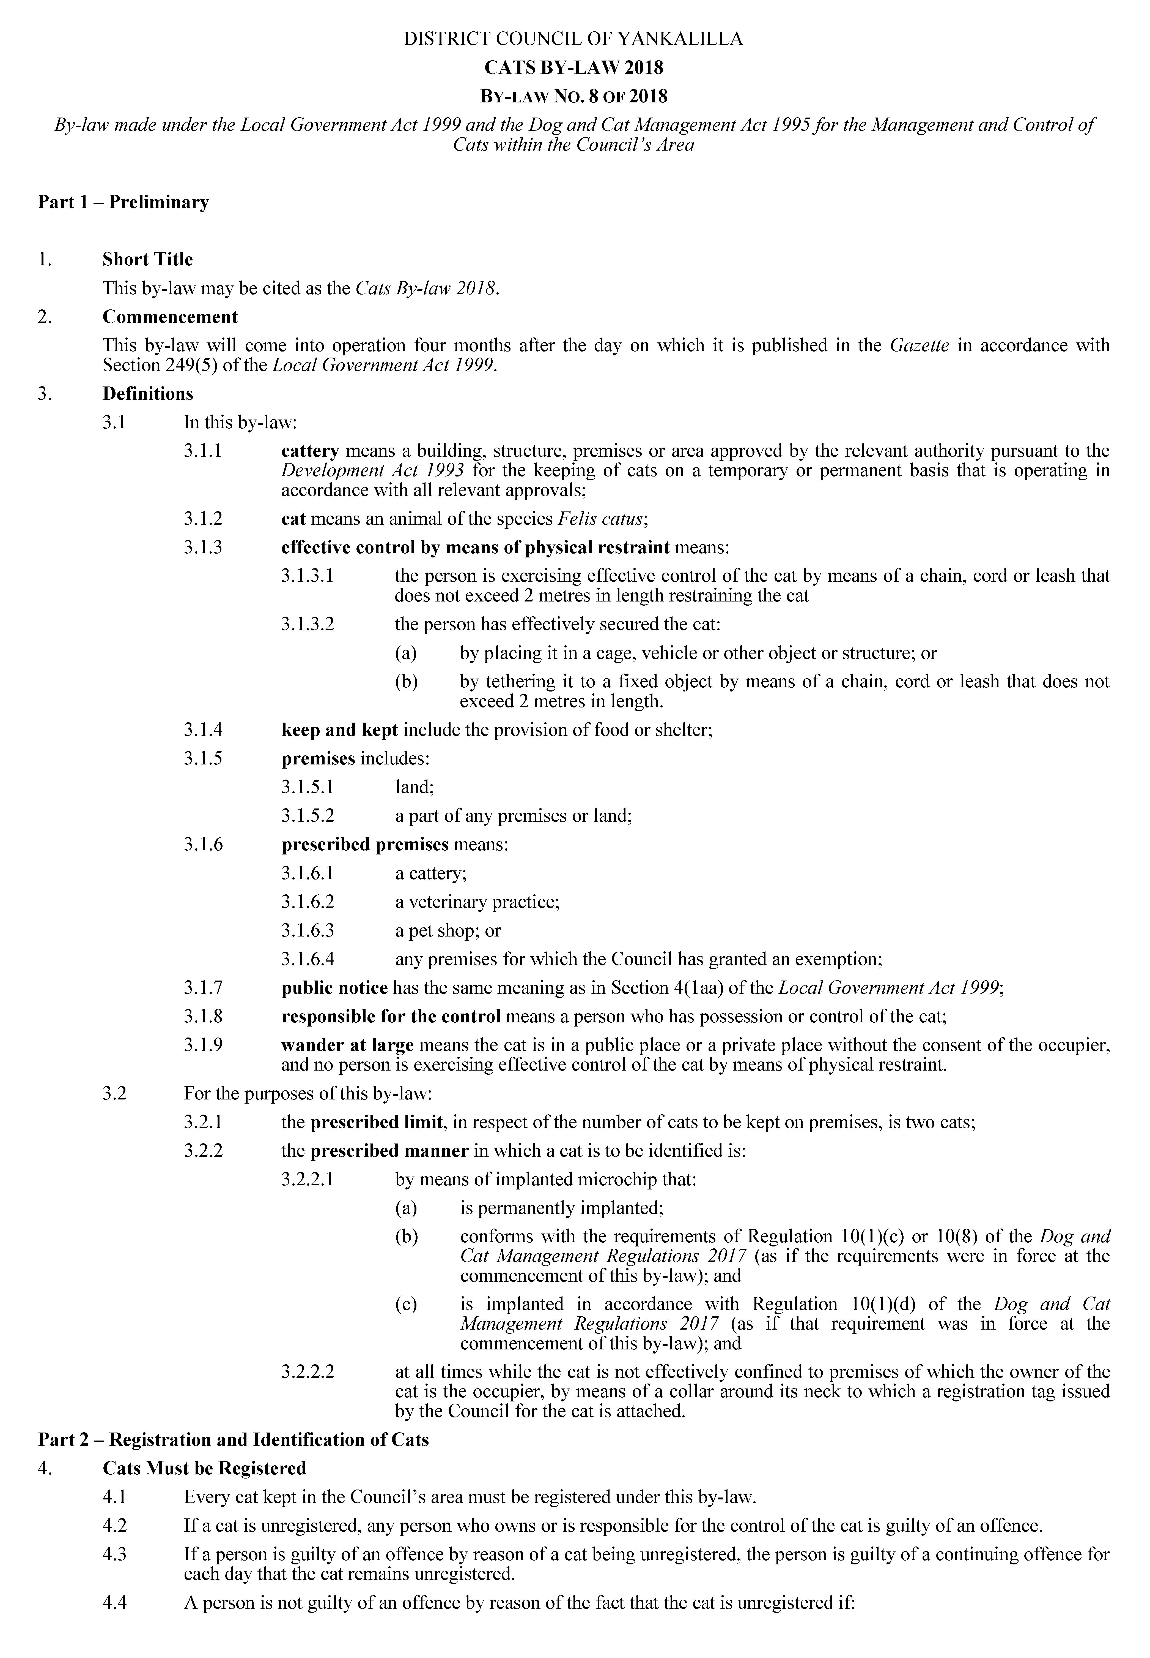
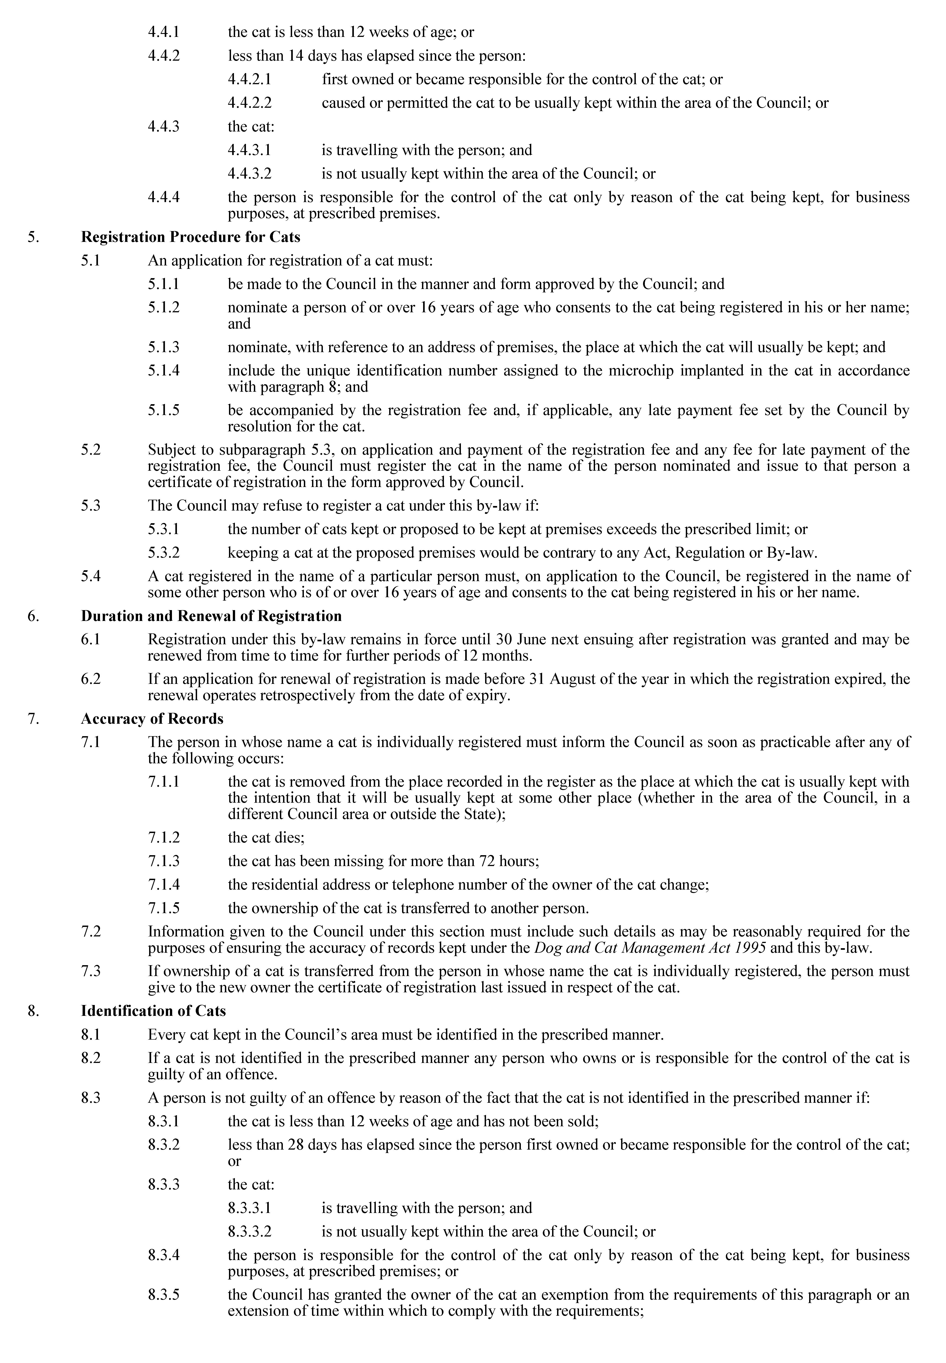
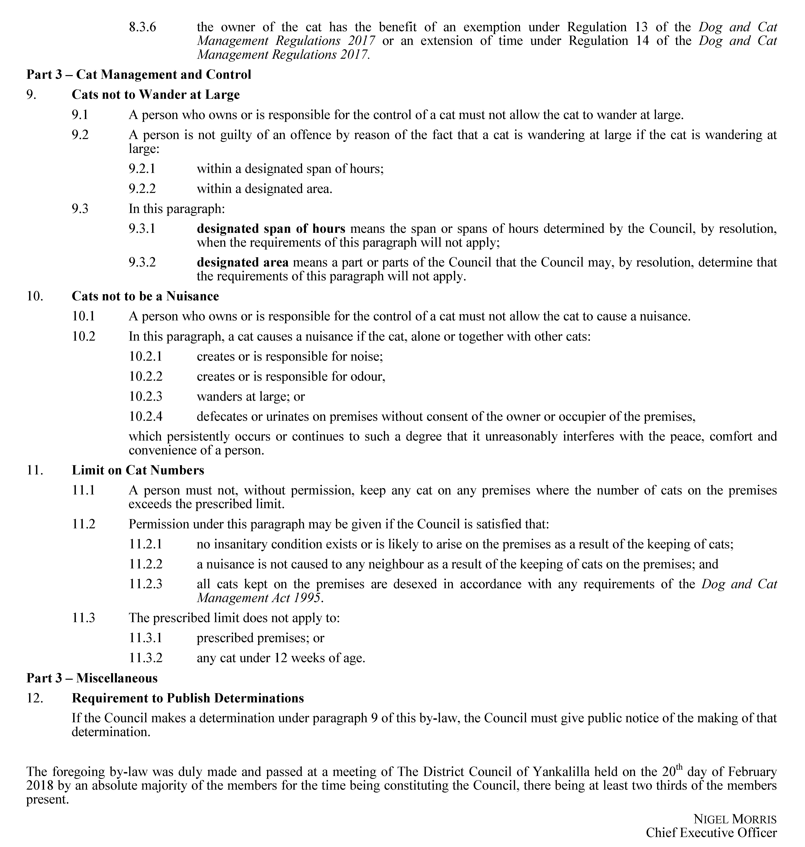

National Electricity Law
The Australian Energy Market Commission (AEMC) gives notice under the National Electricity Law as follows:
Under s 95, COAG Energy Council has requested the Register of distributed energy resources (Ref. ERC0227) proposal. The proposal seeks to improve the collection and sharing of information about distributed energy resources in the NEM. Submissions must be received by 17 April 2018.
Submissions can be made via the AEMC’s website. Before making a submission, please review the AEMC’s privacy statement on its website. Submissions should be made in accordance with the AEMC’s Guidelines for making written submissions on Rule change proposals. The AEMC publishes all submissions on its website, subject to confidentiality.
Written requests should be sent to submissions@aemc.gov.au and cite the reference in the title. Before sending a request, please review the AEMC’s privacy statement on its website.
Documents referred to above are available on the AEMC’s website and are available for inspection at the AEMC’s office.
Australian Energy Market Commission
Level 6, 201 Elizabeth Street
Sydney NSW 2000
Telephone: (02) 8296 7800
www.aemc.gov.au
Dated: 6 March 2018

National Energy Retail Law
The Australian Energy Market Commission (AEMC) gives notice under the National Energy Retail Law as follows:
Under s 251, COAG Energy Council has requested the Register of distributed energy resources (Ref. RRC0011) proposal. The proposal seeks to improve the collection and sharing of information about distributed energy resources in the NEM. Submissions must be received by 17 April 2018.
Submissions can be made via the AEMC’s website. Before making a submission, please review the AEMC’s privacy statement on its website. Submissions should be made in accordance with the AEMC’s Guidelines for making written submissions on Rule change proposals. The AEMC publishes all submissions on its website, subject to confidentiality.
Written requests should be sent to submissions@aemc.gov.au and cite the reference in the title. Before sending a request, please review the AEMC’s privacy statement on its website.
Documents referred to above are available on the AEMC’s website and are available for inspection at the AEMC’s office.
Australian Energy Market Commission
Level 6, 201 Elizabeth Street
Sydney NSW 2000
Telephone: (02) 8296 7800
www.aemc.gov.au
Dated: 6 March 2018

Trustee Act 1936
Public Trustee
Estates of Deceased Persons
In the matter of the estates of the undermentioned deceased persons:
ARTHUR Ila Amy late of 16 West Terrace Wirrabara Home Duties who died 21 September 2017
ATKINSON Geoffrey late of 15 Vaughan Place Adelaide Accountant/Publican who died 1 August 2017
BATHGATE Alastair Iian Richard late of 6A Dianne Street Klemzig Retired Steel Worker who died 31 December 2017
BEARE Cynthia Joan late of 61 Light Terrace Thebarton of no occupation who died 29 January 2018
COULTER Brenton Thomas late of 8 East Terrace Gawler East of no occupation who died 8 October 2017
CROWHURST John Samuel late of 14 Southwest Terrace Beachport Retired Teacher who died 20 February 2017
FISHER Gwenyth Ruth late of 9 Luhrs Road Payneham South Retired Public Servant who died 7 December 2017
FODOR Andrew Thomas late of 112 Old Coach Road Maslin Beach of no occupation who died 8 December 2012
GILLAM Kathleen Ann late of 20 - 36 Gardenia Drive Parafield Gardens Retired Care Worker who died 12 May 2017
GILLIES Valda Doreen late of 67 Joyce Street Murray Bridge of no occupation who died 31 August 2017
GUSTINCIC Davorina late of 307 Flinders Road Flinders Park Home Duties who died 26 June 2017
HORNSEY Iris Neta late of 15 Conder Street Weston ACT Retired Salesperson who died 5 August 2017
HOUSE Arthur John late of 80 Moseley Street Glenelg South Retired Engineer who died 31 October 2017
HUA Lai late of 18 Trafford Street Angle Park of no occupation who died 7 October 2017
KRIEG Edith Joyce late of 25 Roopena Street Ingle Farm of no occupation who died 12 November 2017
LARSEN Jacob late of 19 Henry Street Clare of no occupation who died 23 January 2017
LITTLE Margaret May late of 67 Porter Street Salisbury Retired Shop Assistant who died 1 January 2018
NELSON Wilfred John late of 67 Joyce Street Murray Bridge Timber Worker who died 28 June 2016
RICHARDS Vickie late of 17 Rockville Avenue Daw Park of no occupation who died 13 July 2017
STEINBORNER Melanie Kim late of 18 Fairbanks Drive Paralowie Housecleaner who died 21 August 2017
STRATFORD Shirley Dawn late of 19 Aldersey Street McLaren Vale of no occupation who died 23 September 2017
THOMPSON Coralie Meryl late of 1 Weston Street Goodwood of no occupation who died 11 September 2000
Notice is hereby given pursuant to the Trustee Act 1936, the Inheritance (Family Provision) Act 1972 and the Family Relationships Act 1975 that all creditors, beneficiaries, and other persons having claims against the said estates are required to send, in writing, to the office of Public Trustee at GPO Box 1338, Adelaide, 5001, full particulars and proof of such claims, on or before the 6 April 2018 otherwise they will be excluded from the distribution of the said estate; and notice is also hereby given that all persons indebted to the said estates are required to pay the amount of their debts to the Public Trustee or proceedings will be taken for the recovery thereof; and all persons having any property belonging to the said estates are forthwith to deliver same to the Public Trustee.
Dated: 6 March 2018
D A Contala
Public Trustee

Notice Submission

The weekly South Australian Government Gazette is issued on Tuesday afternoon, except where Executive Council meets on Wednesday, wherein publishing will occur on that day.
The next scheduled publication date is displayed on the website: www.governmentgazette.sa.gov.au.

Notices for gazettal, along with enquiries, can be directed to:

Email governmentgazettesa@sa.gov.au
Phone (08) 8207 1025

Gazette notices should be emailed in the following formats:

• Notices as individual Word files
• Maps, images, and diagrams as single, complete objects within the Word files
• Content containing official signatures for authorisation—notices as Word files and the signed documentation as PDF files

Please provide the following information in your email:

• Date the notice is to be gazetted
• Email address and phone number of the person authorising the submission
• Notification of whether a quote is required for chargeable notices
• Name of the person and organisation to be charged for the notice, if applicable
• A purchase order if required
• Details that may impact on publication of the notice

Notices must be submitted before 4 p.m. Friday, the week preceding intended gazettal.
Proofs of formatted content are supplied for all notices, with necessary alterations to be returned before 4 p.m. on the day preceding publication.
Submitted notices will be gazetted unless notification is received before 10 a.m. on the day of publication.

Printed and published weekly by authority of Wayne Hunter, Government Printer, South Australia
$7.35 per issue (plus postage), $370.00 per annual subscription—GST inclusive
Online publications: www.governmentgazette.sa.gov.au

