
THE SOUTH AUSTRALIAN
GOVERNMENT GAZETTE
Published by Authority

Adelaide, Thursday, 1 November 2018

Contents

Acts Assented To 3888
Appointments, Resignations, Etc. 3888
Associations Incorporation Act 1985—Notice 3889
Building Work Contractors Act 1995—Notices 3889
Corporations and District Councils—Notice 3927
Development Act 1993—Notices 3890
Fisheries Management Act 2007—Notices 3898
Fisheries Management (Prawn Fisheries)
Regulations 2017—Notices 3899
Housing Improvement Act 2016—Notice 3900
Justices of the Peace Act 2005—Notice 3900
Land Acquisition Act 1969—Notices 3901
Late Payment of Government Debts (Interest)
Act 2013—Notice 3903
Liquor Licensing Act 1997—Notice 3906
Mining Act 1971—Notice 3912
Motor Vehicles Act 1959—
Notice 3912
Republished 3915
Mutual Recognition Act 1992—Notice 3917
National Gas Law—Notice 3927
Native Vegetation Regulations 2017—Notice 3920
Plumbers, Gas Fitters and Electricians Act 1995—Notice 3889
Proclamation 3924
Regulations
Superannuation Funds Management Corporation of
South Australia Act 1995—(No. 224 of 2018) 3925
Supreme Court of South Australia—Notice 3920
Training and Skills Development Act 2008—Notice 3920
Trans-Tasman Mutual Recognition Act 1997—Notice 3921
Trustee Act 1936—Administration of Estates 3927

Department of the Premier and Cabinet
Adelaide, 1 November 2018
His Excellency the Governor directs it to be notified for general information that he has in the name and on behalf of Her Majesty The Queen, this day assented to the undermentioned Acts passed by the Legislative Council and House of Assembly in Parliament assembled, viz.:
No. 22 of 2018—Terrorism (Police Powers) (Use of Force) Amendment Act 2018
An Act to amend the Terrorism (Police Powers) Act 2005
No. 23 of 2018—National Gas (South Australia) (Capacity Trading and Auctions) Amendment Act 2018
An Act to amend the National Gas (South Australia) Act 2008
No. 24 of 2018—Petroleum and Geothermal Energy (Ban on Hydraulic Fracturing) Amendment Act 2018
An Act to amend the Petroleum and Geothermal Energy Act 2000
By command,
Steven Spence Marshall
Premier

Department of the Premier and Cabinet
Adelaide, 1 November 2018
His Excellency the Governor in Executive Council has been pleased to appoint the undermentioned to the South Australian Forestry Corporation Board, pursuant to the provisions of the South Australian Forestry Corporation Act 2000:
Director: from 1 November 2018 until 31 March 2019
Scott William Ashby
Director: from 1 November 2018 until 1 August 2020
Grant Anthony Pelton
By command,
Steven Spence Marshall
Premier
MPI18/0017CS

Department of the Premier and Cabinet
Adelaide, 1 November 2018
His Excellency the Governor in Executive Council has been pleased to appoint the undermentioned to the State Planning Commission, pursuant to the provisions of the Planning, Development and Infrastructure Act 2016:
Member: from 30 May 2020 until 31 October 2021
Michael Andrew Lennon
By command,
Steven Spence Marshall
Premier
MPL18/008CS

Department of the Premier and Cabinet
Adelaide, 1 November 2018
His Excellency the Governor in Executive Council has been pleased to appoint Jane Alyson Meegan to the position of Community Visitor for a period of 1 year commencing on 1 November 2018 and expiring on 31 October 2019 - pursuant to the provisions of the Mental Health Act 2009.
By command,
Steven Spence Marshall
Premier
HEAC-2018-00064

Department of the Premier and Cabinet
Adelaide, 1 November 2018
His Excellency the Governor in Executive Council has been pleased to appoint Craig Andrew Holden as a Member of the State Planning Commission for a term commencing on 1 November 2018 and expiring on 31 October 2021 - pursuant to the provisions of the Planning, Development and Infrastructure Act 2016.
By command,
Steven Spence Marshall
Premier
MPL18/008CS

Department of the Premier and Cabinet
Adelaide, 1 November 2018
His Excellency the Governor in Executive Council has been pleased to appoint Helen Louise Dyer as a Member of the State Planning Commission for a term commencing on 1 November 2018 and expiring on 31 October 2021 - pursuant to the provisions of the Planning, Development and Infrastructure Act 2016.
By command,
Steven Spence Marshall
Premier
MPL18/008CS

ASSOCIATIONS INCORPORATION ACT 1985
Section 43A
Deregistration of Associations
NOTICE is hereby given that the Corporate Affairs Commission approves the applications for deregistration received from the associations named below pursuant to section 43A of the Associations Incorporation Act, 1985. Deregistration takes effect on the date of publication of this notice.
AFL Country Power Supporters Group SA Incorporated
Association of Major Community Organisations (SA) Incorporated
Birds of a Feather Collectors Club of South Australia Incorporated
City Care Network Incorporated
Cheltenham Baptist Church Incorporated
Christies Beach Contract Bridge Club Incorporated
Flinders Housing Co-operative Incorporated
Hallmont Estate Residents Association Incorporated
Hope: Preventing Euthanasia and Assisted Suicide Incorporated
Karunda Chapter No 191 Order of the Eastern Star Incorporated
Lefevre Baptist Church Incorporated
O.S.C.A.R.S. Incorporated
Rotary Club of Prospect Sunrise Incorporated
Semaphore Park Residents Action Group Incorporated
South Australian Law Students’ Council Incorporated
Summerhill Incorporated
The Probus Club of Beefacres Combined Incorporated
Tumbleweed Active Playgroup Incorporated
Dated: 23 October 2018
Rosalba Aloi
A Delegate of the Corporate Affairs Commission

Building Work Contractors Act 1995
Exemption
TAKE notice that, pursuant to section 45 of the Building Work Contractors Act 1995, I, Dini Soulio, Commissioner for Consumer Affairs, do hereby exempt the licensee named in Schedule 1 from the application of Division 3 of Part 5 of the above Act in relation to domestic building work described in Schedule 2 and subject to the conditions specified in Schedule 3.
Schedule 1
STEPHEN MONZ (BLD 236665)
Schedule 2
Construction of a single storey dwelling on land situated at Allotment 1664 in Deposited Plan 65101 being a portion of the land described in Certificate of Title Volume 5922 Folio 584, more commonly known as Hindmarsh Island, Hundred of Nangkita.
Schedule 3
- This exemption is limited to domestic building work personally performed by the licensee in relation to the building work described in Schedule 2.
- This exemption does not apply to any domestic building work the licensee contracts to another building work contractor, for which that contractor is required by law to hold building indemnity insurance.
- That the licensee does not transfer his interest in the land prior to five years from the date of completion of the building work the subject of this exemption, without the prior authorisation of the Commissioner for Consumer Affairs. Before giving such authorisation, the Commissioner for Consumer Affairs may require the licensee to take any reasonable steps to protect the future purchaser(s) of the property, including but not limited to:
- Providing evidence that an adequate policy of building indemnity insurance is in force to cover the balance of the five-year period from the date of completion of the building work the subject of this exemption;
- Providing evidence of an independent expert inspection of the building work the subject of this exemption;
- Making an independent expert report available to prospective purchasers of the property;
- Giving prospective purchasers of the property notice of the absence of a policy of building indemnity insurance.
Dated: 22 October 2018
Dini Soulio
Commissioner for Consumer Affairs
Delegate for the Attorney-General
Ref: 610/14-00116

Building Work Contractors Act 1995
Plumbers, Gas Fitters and Electricians Act 1995
Exemption
TAKE notice that, pursuant to section 45 of the Building Work Contractors Act 1995 and Section 29 of the Plumbers, Gas Fitters and Electricians Act 1995, I, Dini Soulio, Commissioner for Consumer Affairs, do hereby exempt Sonnen Australia Pty Ltd from the application of section 6 of the Building Work Contractors Act 1995 and Section 6 of the Plumbers, Gas Fitters and Electricians Act 1995 subject to the following conditions:
- The only building or electrical work performed in South Australia is the installation, maintenance or repair of solar photovoltaic systems or batteries; and
- All building or electrical work performed in South Australia is limited to arranging for contracts for the work to be entered into between a customer and an installer that is appropriately licensed to perform that work; making arrangements for that work to be carried out; or performing work under a warranty or guarantee in relation to products manufactured or imported by Sonnen Australia Pty Ltd or an associated company.
Dated: 26 October 2018
Dini Soulio
Commissioner for Consumer Affairs
Delegate for the Attorney-General

DEVELOPMENT ACT 1993
Section 28(5) Notice
Declaration of Cessation of Interim Operation of Adelaide Hills Council
Local Heritage – Public Places Development Plan Amendment
Preamble
On 24 October 2017, the Minister for Planning, under Section 28(1), declared the Adelaide Hills Council Local Heritage – Public Places Development Plan Amendment as an amendment to come into operation on an interim basis on that day. The Adelaide Hills Council Development Plan, consolidated on 24 October 2017, incorporated the provisions of the Local Heritage – Public Places Development Plan Amendment.
The Adelaide Hills Council Local Heritage – Public Places Development Plan Amendment has not been approved by the Minister under Section 25(17) within the required 12 months period.
NOTICE
Pursuant to Section 28(4)(c) of the Development Act 1993, I proclaim that the Adelaide Hills Council Local Heritage – Public Places Development Plan Amendment has ceased to operate.
From 25 October 2018 (the date of cessation), the Adelaide Hills Council Local Heritage – Public Places Development Plan Amendment ceases to apply to the Adelaide Hills Council Development Plan.
Dated: 18 October 2018
Stephan Knoll
Minister for Planning

DEVELOPMENT ACT 1993
Section 29
Amendment to the Barossa Council Development Plan
Preamble
It is necessary to amend the Barossa Council Development Plan (the Plan) dated 11 August 2016 pursuant to section 29 (2)(b)(ii) of the Development Act 1993. I amend the Plan as follows:
- Insert the contents of ‘ATTACHMENT A’ at the end of Table Baro/2 - Historic Conservation Guidelines.
- Fix the day on which this notice is published in the Gazette as the day on which the section 29 Amendment will come into operation.
Dated: 29 October 2018
Sally Smith
General Manager
Planning and Development
Development Division
Department of Planning, Transport and Infrastructure
as Delegate of Stephan Knoll, Minister for Planning

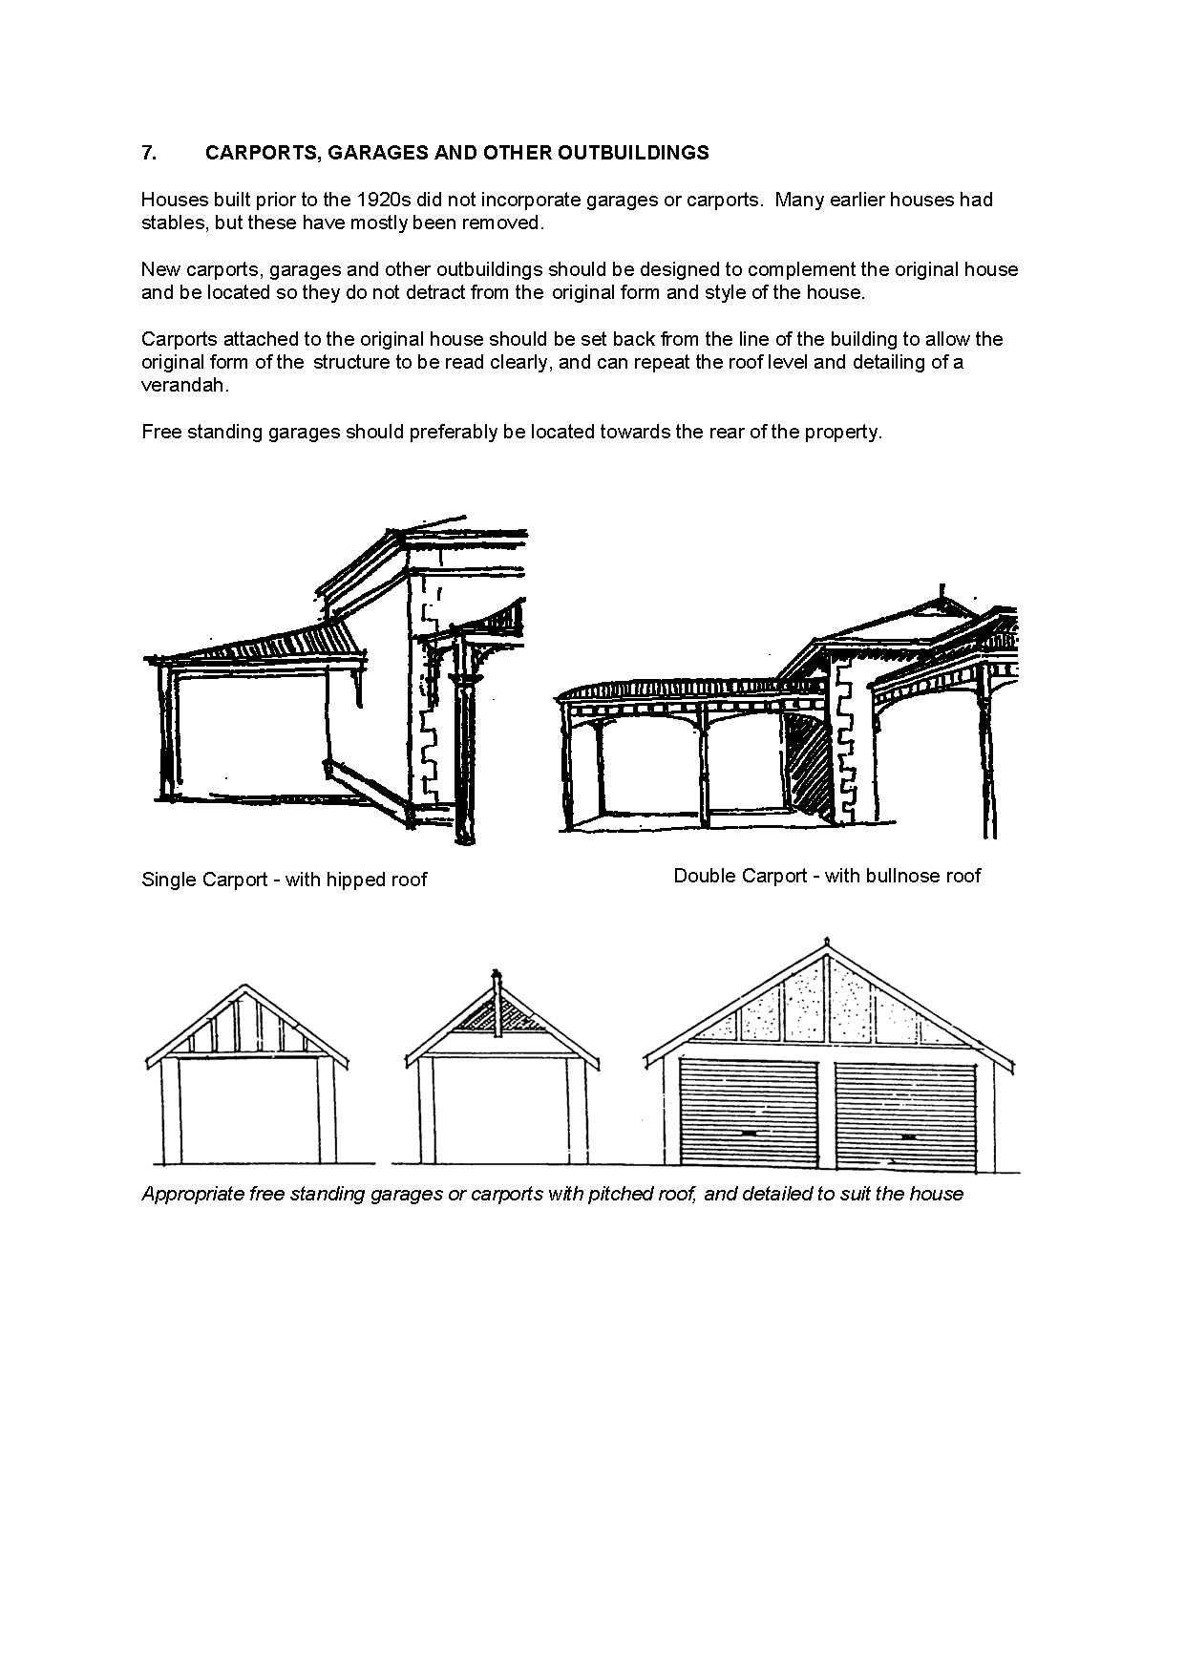
Attachment A

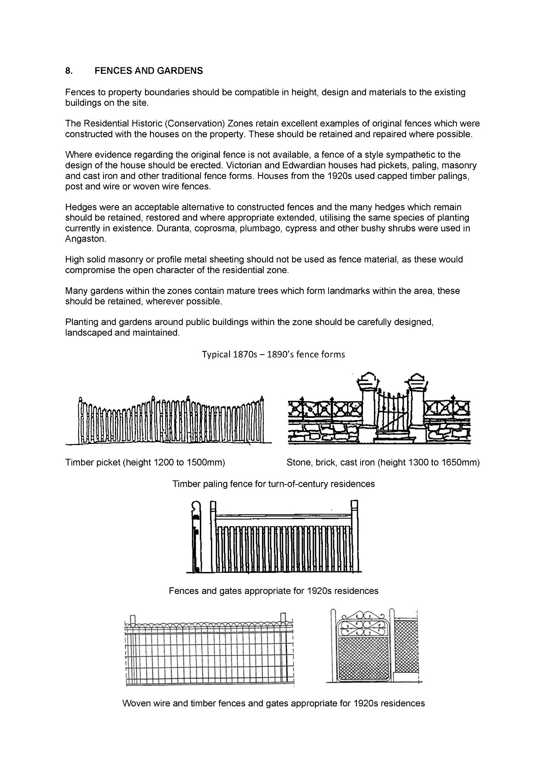

DEVELOPMENT ACT 1993
Section 29
Amendment to the Southern Mallee District Council Development Plan
Preamble
It is necessary to amend the Southern Mallee District Council Development Plan (the Plan) dated 12 December 2017.
PURSUANT to section 29 (2)(b)(ii) of the Development Act 1993, I amend the Plan as follows:
- Replace Zone Map SoMa/4 with the contents of ‘ATTACHMENT A’
- Fix the day on which this notice is published in the Gazette as the day on which the section 29 Amendment will come into operation.
Dated: 29 October 2018
Sally Smith
General Manager
Planning and Development
Development Division
Department of Planning, Transport and Infrastructure
as Delegate of Stephan Knoll, Minister for Planning

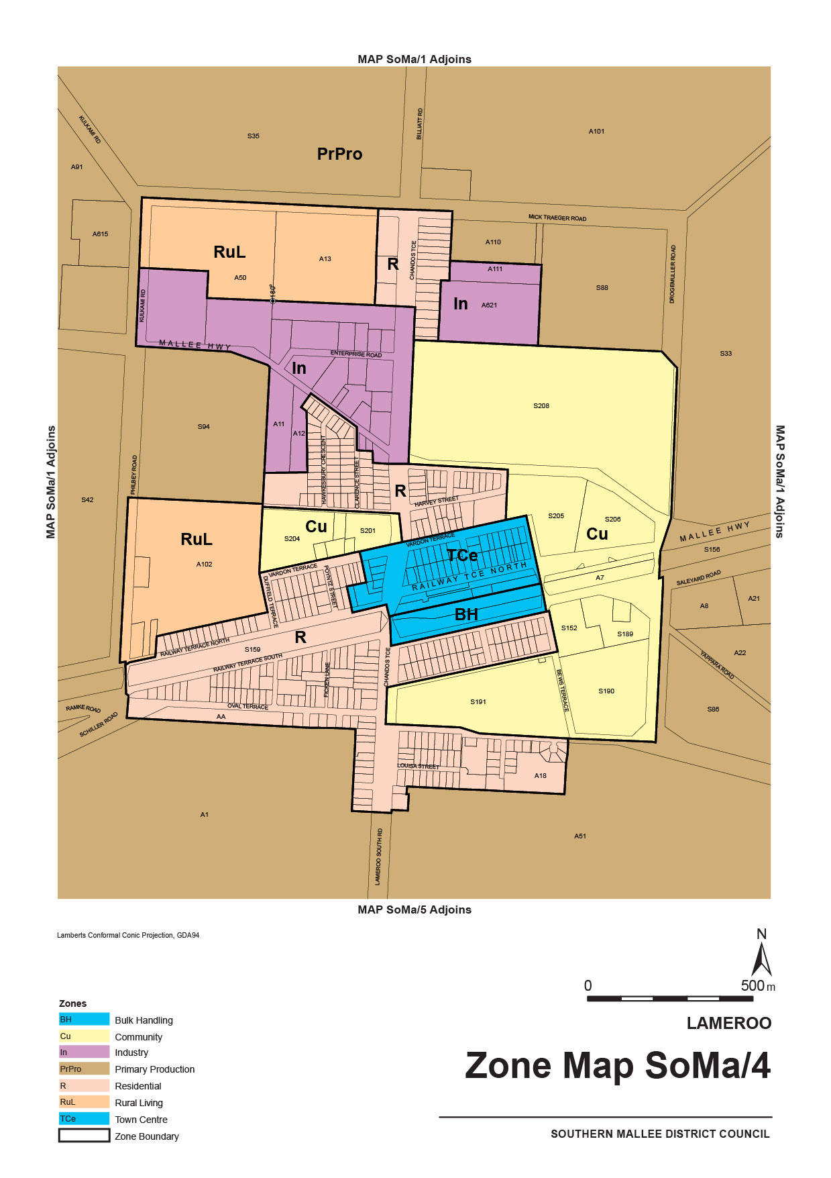
Attachment A

DEVELOPMENT ACT 1993
Section 48
Decision by the State Commission Assessment Panel
Preamble
1. The decision of the Governor under Section 48 of the Development Act 1993, to approve the development of the solid waste landfill (Northward Fill Landfill Depot) at Inkerman, was published in the South Australian Government Gazette on 21 January 1999.
2. The proposal has been the subject of an Environmental Impact Statement and an Assessment Report under Section 46 and 46B of the Development Act 1993.
3. The development was the subject of further applications to amend the development authorisation, and associated amendments to the Environmental Impact Statement were made under Section 47 of the Development Act 1993.
4. Variations to the development authorisation were notified in the South Australian Government Gazette on 17 June 2004 at p 2191 (for an alteration to the method of waste transport and transfer to the disposal area, alteration of the maintenance workshop and removal of the long haul vehicle fuel storage area) , 14 October 2004 at p 3847 (related to the landfill lining and leachate collection system), 13 April 2006 at p 1036 (related to the leachate collection system and a change to the operating hours), 20 September 2007 at p 3727 (for the receipt of additional waste materials), 5 June 2008 at p 1827 (related to the recycling of waste materials), 20 August 2009 at p 3676 (to allow the receipt of low level contaminated waste at the approved landfill and disposal of these wastes into cells that are separate from those used to dispose of solid wastes), 4 March 2010 at p 930 (for the receival and disposal of non-metropolitan construction and demolition waste that is not required to go through a waste recovery and waste transfer facility; and an updated design of the liner system for low level contaminated waste cells) and 8 December 2011 at 4802 (for a modification to the design of the existing maintenance shed).
5. On 8 June 2018, Cleanaway Waste Management Ltd, the company now having the benefit of the development authorisation, applied for a variation to the development authorisation comprising an increase of the final landfill height from the approved height of 27 metres AHD to a new height of 32 metres AHD – an increase of 5 metres. The variation application was the subject of an Amended Environmental Impact Statement (dated June 2018) under Section 47 of the Development Act 1993.
6. The State Commission Assessment Panel has, in considering the application for a variation of the development authorisation, had regard to all relevant matters under Section 48 (5) of the Development Act 1993.
7. For ease of reference, the State Commission Assessment Panel has decided to revoke all conditions and substitute therefore the conditions contained herein. Requirements that pertain to the variation have been added to Condition 1.
Decision
PURSUANT to Section 48 of the Development Act 1993, the State Commission Assessment Panel, as delegate of the Governor:
(a) vary the development authorisation granted to Cleanaway Waste Management Ltd on 8 December 2011 by:
(i) revoking all conditions of approval attached to the provisional development authorisation published in the South Australian Government Gazette on 8 December 2011; and
(ii) attaching the conditions of approval set out in this notice below;
(b) specify all matters relating to this development authorisation (as varied) as matters in respect of which conditions of this authorisation may be varied or revoked, or new conditions attached.
Part A: Conditions of Development Authorisation
General Conditions
1. Except where minor amendments may be required by other legislation, or by conditions imposed herein, the proposed Major Development shall be undertaken in strict accordance with the following documents:
- Application and letter from Transpacific Industries Group Inc. to the Development Assessment Commission dated 30 November 2009 (except to the extent that it may be varied by a subsequent document in this paragraph).
- Application and letter (including accompanying plans) from Transpacific Industries Group Inc. to the Development Assessment Commission dated 20 January 2010 (except to the extent that it may be varied by a subsequent document in this paragraph).
- Transpacific Waste Management, Northward Fill—EIS Amendment to Accommodate Additional Waste Types (dated 19 September 2008). Prepared by QED Pty Ltd (except to the extent that it may be varied by a subsequent document in this paragraph).
- Proponent’s response to submissions—Letter from QED Pty Ltd (on behalf of Transpacific Waste Management Pty Ltd) to the Department of Planning and Local Government dated 1 April 2009 (Ref: 10786) (except to the extent that it may be varied by a subsequent document in this paragraph).
- Letter from MSP Constructions, on behalf of the Transpacific Industries Group Inc., to the Department of Planning dated 26 August 2011 (except to the extent that it may be varied by a subsequent document in this paragraph).
- Application letter from Cleanaway Waste Management Ltd to the Department of Planning, Transport and Infrastructure dated 8 June 2018.
- Northward Fill Landfill, Increase in Finished Landform Height – Amendment Environmental Impact Statement, Cleanaway Waste Management Ltd (dated June 2018). Prepared by Tonkin Consulting.
- Proponent’s response to submissions—Letter from Cleanaway Waste Management Ltd to the Department of Planning, Transport and Infrastructure dated 29 August 2018.
2. Before any building work is undertaken on the site, the building work is to be certified by a private certifier, or by some person determined by the Minister for Planning, as complying with the provisions of the Building Rules (or the Building Rules as modified according to criteria prescribed by the Regulations).
Low Level Contaminated Waste/Treatment Plant Residues Cells
3. Prior to the construction of the Low Level Contaminated Waste/Treatment Plant Residues Cell (LLCW/TPRC), the Licensee shall submit to the Environment Protection Authority for assessment and approval a revised Landfill Environmental Management Plan (LEMP) incorporating the design, construction, technical specifications, environmental and post-closure management of the LLCW/TPRC.
4. The Licensee shall, no less than three months prior to construction of any LLCW/TPRC at the Premises:
(a) provide to the Environment Protection Authority a specification document that provides a detailed design for the relevant cell; and
(b) not construct any cell unless written approval has been received from the Environment Protection Authority.
5. The Licensee shall prior to receiving, storing, treating or disposing of any waste within the LLCW/TPRC, provide to the Environment Protection Authority:
(a) an ‘As Constructed Report’ certifying compliance with the approved design for the lining system, including a Construction Quality Assurance (CQA) for the liner and the Level 1 Supervision Report; and
(b) not receive any LLCW/TPR without written approval from the Environment Protection Authority.
Groundwater
6. Monitoring shall be undertaken over two successive winter seasons to determine the maximum seasonal watertable level for that period starting prior to the landfill operations starting.
7. An internal leachate-level monitoring bore network within each stage of the landfill shall be established to allow early identification of any problem with the leachate collection system before excessive leachate heads develop.
8. Groundwater monitoring bores shall be established down gradient of the leachate collection ponds to the satisfaction of the Environment Protection Authority.
Leachate Management
9. The ‘As Constructed Report’ shall include a certification from a geotechnical consultant that the liner and drainage system has been constructed in accordance with the design principles together with in-situ testing to demonstrate that the required permeability has been achieved prior to operations commencing, except as varied by Conditions (a), (b), (c) and (d).
(a) the high density polyethylene (HDPE) membrane and geotextile portion of the liner shall extend a minimum of 5 m laterally from the sump (measured from the toe of the sump side slope to the outer edge of the lining system) and the underlying clay outside the sump area must have a minimum thickness of 1 m;
(b) the drainage slopes towards drainage lines and along drainage lines shall be a minimum of 2% and 1% respectively;
(c) construction of the landfill liner and polylock system shall be undertaken and certified in accordance with Level 1 supervision and Construction Quality Assurance (CQA) procedures. A report documenting the results of the Level 1 supervision and construction quality control tests for the compacted clay liner, HDPE membrane and polylock system shall be prepared to the reasonable satisfaction of the Environment Protection Authority;
(d) appropriate procedures and controls shall be implemented on site to address potential risks or damage which may compromise the integrity of the leachate extraction system, including from vehicle traffic, Ultraviolet Radiation, and any movements of the overland pipework including interim flexible pipework used while cells are operational;
(e) contingency procedures shall be developed to address the potential for and response to any pipe rupture and leachate emission from the leachate pipes and extraction system; and
(f) the LEMP shall be updated to incorporate Conditions (d) and (e).
Landfill Gas
10. Landfill gas extraction wells shall be installed progressively as filling of the cell proceeds, to the satisfaction of the Environment Protection Authority.
11. All fire control measures proposed at the site shall be approved by the Country Fire Service prior to operations commencing.
Buffers and Landscaping
12. The maximum height of the landfill including rehabilitation shall be restricted to 27 m AHD (generally 7 m above the existing natural surface) to be consistent with the existing maximum topographic levels in the region.
13. All perimeter plantings shall be started as early as practicable after the date of this approval to achieve maximum amelioration of visual impacts.
14. Screening by suitable plantings where adequate natural screening is not provided, shall be provided for the perimeter fence, all built structures, stockpiles and internal roads (where practicable) using suitable species in accordance with the Vegetation Management and Revegetation Plan proposed as part of the Landfill Environmental Management Plan (LEMP).
Noise and Dust
15. The proponent shall comply with the provisions of the Environment Protection (Industrial Noise) Policy (1994, SA Government).
16. —
(a) the maximum hours of operation shall be 6 a.m. to 7.30 p.m. seven days per week and waste shall only be received between 6 a.m. and 7 p.m.;
(b) the Applicant shall ensure that close proximity and low impact directional reverse beepers are installed and utilised on all mobile plant associated with waste disposal operations; and
(c) noise levels shall not exceed 40 dB(A) in accordance with EPA Fact Sheet 424/04 between the hours of 10 p.m. and 7 a.m.
Infrastructure
17. The proponent shall pay all reasonable costs of the detailed design and construction of any public road works made necessary by this development and to the satisfaction of Transport SA.
Building Rules
18. Work constituting building work under the Development Act 1993, shall be certified by the Wakefield Regional Council or a private certifier, as complying with the Building Rules. Copies of the relevant certification documentation shall be provided to the Minister for Planning, as outlined in Regulation 64 of the Development Act 1993. No building works shall commence until a favourable decision has been notified in writing to the applicant by the Development Assessment Commission, as delegate of the Governor.
Heritage
19. The party with the benefit of this approval shall ensure that operators and construction personnel are made aware of the requirements under the Aboriginal Heritage Act 1988 that any burial site skeletal material or significant artefact discovery is reported to the Department of Premier and Cabinet (Aboriginal Affairs and Reconciliation).
Wastes
20. No Listed Waste as prescribed in Schedule 1, Part B of the Environment Protection Act 1993, or contaminated soil and material or asbestos containing material, shall be permitted to be disposed of without further development authorisation except as varied by the conditions listed below.
21. The proponent may receive and dispose of wastes from different regions as follows:
(a) waste from the Adelaide Metropolitan Area that has gone through a Resource Recovery and Waste Transfer Facility; or
(b) waste from regional areas outside the Metropolitan area that:
- has been through a kerbside recycling service comprising at least 2 mobile garbage bins with a maximum 140 litre weekly waste collection and a minimum 240 litre fortnightly recycling collection;
- has been through a mobile garbage bin kerbside recycling system that yields at least 4 kg per household per week for recycling, excluding contamination;
- has been processed through a resource recovery facility/transfer station for the purposes of removing recyclable material prior to being transported for disposal; or
- comprises construction and demolition waste that does not contain recyclable materials.
22. The proponent may receive and dispose of the following additional wastes:
(a) shredded tyres with other approved waste for a period of three years after which the proponent must apply for additional development approval;
(b) non-friable asbestos subject to handling and disposal procedures for non-friable asbestos, including the Environmental Management procedures as discussed in detail in Appendix F of the variation proposal; and
(c) quarantine waste subject to approval from AQIS to receive and dispose of quarantine waste. In addition, the proponent shall:
(i) receive quarantine waste that is accompanied by a completed Quarantine Waste Form developed by the Licensee;
(ii) dispose of quarantine waste immediately upon receipt;
(iii) ensure a minimum of 2 m of cover is placed over the waste immediately after disposal;
(iv) dispose of waste in accordance with requirements of AQIS (including supervision, deep burial and tracking);
(v) maintain records that describe details for each load of quarantine waste received and disposed including the following items:
- Location of disposal;
- Date and time of receipt and disposal;
- Volume of waste;
- Type of waste;
- Producer of the waste;
- Transporter of the waste and driver name; and
- Name of person supervising disposal of waste.
(vi) maintain procedures for the notification, handling, supervision, records management and disposal of quarantine waste and tracking systems to prevent the re-excavation of quarantine wastes.
(d) foundry sands—the proponent shall:
(i) assess the Used Foundry Sand in accordance with EPA Guidelines for Used Foundry Sand (UFS)—classification and disposal (EPA 329/03—September 2003);
(ii) ensure that the Used Foundry Sands have been classified prior to disposal according to the maximum concentrations in mg/kg (dry weight), and the maximum leachate concentration in mg/L, of the contaminants listed in the above referenced Guideline; and
(iii) ensure that only Used Foundry Sand classified and certified as Class 1 (or with lower contaminant levels) is received and disposed at the Premises,
(e) Low Level Contaminated Waste that meet the relevant Environment Protection Authority Low Level Contaminated Waste Criteria;
(f) construction and demolition waste from non-metropolitan areas—the proponent shall:
(i) maintain procedures and records, to the reasonable satisfaction of the Environment Protection Authority, that describe details for each load of waste received and disposed to ensure it does not contain recyclable materials.
Part B: Notes to Proponent
Building Rules
- The proponent must obtain a Building Rules assessment and certification for any building work from either the Wakefield Regional Council or a private certifier (at the proponent’s option) and forward to the Minister for Planning all relevant certification documents as outlined in Regulation 64 of the Development Regulations 2008.
- Pursuant to Development Regulation 64, the proponent is especially advised that the Wakefield Regional Council or private certifier conducting a Building Rules assessment must:
- provide to the Minister for Planning a certification in the form set out in Schedule 12A of the Development Regulations 2008 in relation to the building works in question; and
- to the extent that may be relevant and appropriate:
(i) issue a Schedule of Essential Safety Provisions under Division 4 of Part 12;
(ii) assign a classification of the building under these regulations; and
(iii) ensure that the appropriate levy has been paid under the Construction Industry Training Fund 1993.
- Regulation 64 of the Development Regulations 2008 provides further information about the type and quantity of all Building Rules certification documentation for Major Developments required for referral to the Minister for Planning. The Wakefield Regional Council or private certifier undertaking Building Rules assessments must ensure that the assessment and certification are consistent with this development authorisation (including its Conditions and Notes).
EPA Licensing and General Environmental Duty of Care
- The applicant is reminded of its general environmental duty, as required by Section 25 of the Environment Protection Act 1993, to take all reasonable and practical measures to ensure that the activities on the whole site, including during both construction and operation, do not pollute the environment in a way which causes or may cause environmental harm.
- Environmental authorisation in the form of an amended licence may be required for the construction and/or operation of this development. The applicant is advised to contact the Environment Protection Authority before acting on this approval to ascertain licensing requirements.
- The Environment Protection Authority will require the proponent to review and amend where necessary the current Landfill Environmental Management Plan (LEMP) to satisfy the Authority’s licensing requirements. Such a plan will be required to include provisions for the review, from time to time, of waste treatment and disposal methods to facilitate implementation of continuous improvement programs. The LEMP will be required to incorporate specific plans in relation to groundwater, leachate and, surface water management. It will also be required to include provisions for implementation of corrective actions in the event of any failure of the leachate and groundwater management systems.
- Control over the types of waste to be received at the site will be exercised by the Environment Protection Authority. This will be done through conditions of environmental authorisation or requirements under a relevant Environment Protection Policy rather than through conditions of development authorisation.
- It is likely that as a condition of such a license the Environment Protection Authority will require the licensee to carry out specified environmental monitoring of air and water quality and to make reports of the results of such monitoring to it.
- A financial assurance in accordance with the provisions of Section 51 of the Environment Protection Act 1993 will be required by the Environment Protection Authority as a condition of license.
- In regard to Conditions of Development Authorisation 3-5, a Geosynthetic Clay Liner may be used in the construction of a liner for a low level contaminated waste cell (such as in place of an upper 600 mm compacted clay liner) provided it has a specification equivalent to ELCOSEAL X3000 made by Geofabrics Australia or its equivalent.
Dated: 27 September 2018
Simone Fogarty
Presiding Member
State Commission Assessment Panel

FISHERIES MANAGEMENT ACT 2007
Section 79
TAKE notice that it is hereby declared that it shall be unlawful for any person to engage in the class of fishing activity specified in Schedule 1 during the period specified in Schedule 2.
Schedule 1
The act of taking or an act preparatory to or involved in the taking of Snapper (Chrysophrys auratus) in all waters of the State.
Schedule 2
1200 hours on 1 November 2018 until 1200 hours on 15 December 2018.
Dated: 24 October 2018
Sean Sloan
Executive Director
Fisheries and Aquaculture
Delegate of the Minister for Primary Industries and Regional Development

FISHERIES MANAGEMENT ACT 2007
Section 115
Ministerial Exemption Number ME9903022
TAKE NOTICE that pursuant to section 115 of the Fisheries Management Act 2007, all holders of a Blue Crab Fishery licence allowing access to the waters of Gulf St Vincent (the ‘exemption holders’), and their registered masters are exempt from section 70 of the Fisheries Management Act 2007, and regulation 5, clause 36 of Schedule 6 of the Fisheries Management (General) Regulations 2017 but only insofar as they may take prescribed crustacean species during the period commencing 12:01 am on 1 November 2018 and ending 11:59 pm on 15 January 2019 (the ‘exempted activity’) for the purpose of trade or business, in the waters described in Schedule 1 and subject to the conditions set out in Schedule 2 unless varied or revoked earlier.
Schedule 1
- The exempted activity may only be undertaken within the Gulf St Vincent Blue Crab Fishing Zone as prescribed under the Fisheries Management (Blue Crab Fishery) Regulations 2013 excluding the following areas -
  - All waters east of the line commencing at the seaward end of the southern Outer Harbor breakwater closest to latitude 34°47.316′S, longitude 138°28.002′E, then westerly along the geodesic to the point near Entrance beacon closest to latitude 34°47.202′S, longitude 138°24.9′E, then south south-easterly along the geodesic to a point closest to latitude 35°2.514′S, longitude 138°29.274′E, then east to Mean High Water Springs at latitude 35°2.514′S, longitude 138°30.624′E.
  - All waters east of the line commencing at the seaward end of the northern Outer Harbor breakwater closest to latitude 34°47.042′S, longitude 138°28.202′E, then north-westerly along the geodesic to the point near Spoil Ground Pole closest to latitude 34°44.851′S, longitude 138°26.680′E, then north-easterly along the geodesic to Mean High Water Springs between St Kilda and Gawler Point at latitude 34°41.614′S, longitude 138°28.406′E.
  - All waters landward of a line commencing closest to latitude 34°43.722′S, longitude 138°27.282′E following a line counter-clockwise around northern Gulf St Vincent extending 2 nautical miles to the seaward from Mean High Water Springs to a point closest to latitude 34°56.212′S, longitude 137°49.959′E then westerly to along the geodesic to Mean High Water Springs at latitude 34°56.137′S, longitude 137°47.123′E
Schedule 2
- The Exemption holders may only take up to a maximum of fifteen (15) per cent of the total of the 2018/19 annual quota entitlement endorsed on their licence in Gulf St Vincent.
- Exemption holders must complete and submit the South Australian Blue Crab Fishery Catch and Effort Return forms for all crustaceans taken pursuant to this notice, consistent with the Fisheries Management (Blue Crab Fishery) Regulations 2013 and fill in any additional form provided by the South Australian Research and Development Institute.
- Exemption holders must comply with all licence conditions when undertaking the exempted activity, except where specifically exempted by this notice.
- While engaging in the exempted activity, exemption holders must be in possession of a copy of this notice. This notice must be produced to a Fisheries Officer if requested.
- The exemption holders must not contravene or fail to comply with the Fisheries Management Act 2007 or any regulations made under that Act, except where specifically exempted by this notice.
This notice does not purport to override the provisions or operation of any other Act including, but not limited to, the Marine Parks Act 2007 and the Defence Act 1903 (Cwlth). The exemption holder and his/her agents must comply with any relevant prohibitions, restrictions, regulations, permits, requirements and directions from the Department for Environment and Water when undertaking activities within a marine park.
Dated: 29 October 2018
Sean Sloan
Executive Director
Fisheries and Aquaculture
Delegate of the Minister for Primary Industries and Regional Development

FISHERIES MANAGEMENT (PRAWN FISHERIES) REGULATIONS 2017
Fishing Run for the West Coast Prawn Fishery
TAKE notice that pursuant to regulation 10 of the Fisheries Management (Prawn Fisheries) Regulations 2017, the notice dated 27 February 2018 on page 1092 of the South Australian Government Gazette of 6 March 2018 prohibiting fishing activities in the West Coast Prawn Fishery is HEREBY varied such that it will not be unlawful for a person fishing pursuant to a West Coast Prawn Fishery licence to use prawn trawl nets in the areas specified in Schedule 1, during the period specified in Schedule 2, and under the conditions specified in Schedule 3.
Schedule 1
The waters of Ceduna and Coffin Bay within the waters of the West Coast Prawn Fishery.
Schedule 2
Commencing at sunset on 1 November 2018 and ending at sunrise on 17 November 2018.
Schedule 3
- Each licence holder must ensure that a representative sample of catch (a ‘bucket count’) is taken at least 3 times per night during the fishing activity.
- Each ‘bucket count’ sample must be accurately weighed to 7kg where possible and the total number of prawns contained in the bucket must be recorded on the daily catch and effort return.
- Fishing must cease if one of the following limits is reached:
  - A total of 14 nights of fishing are completed
  - The average catch per vessel, per night (for all 3 vessels) drops below 300 kg for two consecutive nights
  - The average ‘bucket count’ for all vessels exceeds 270 prawns per bucket on any single fishing night in the Ceduna area
  - The average ‘bucket count’ for all vessels exceeds 240 prawns per bucket on any single fishing night in the Coffin Bay area
- The fleet must nominate a licence holder to provide a daily update by telephone or SMS message to the Prawn Fishery Manager on 0477 396 367, to report the average prawn catch and the average prawn ‘bucket count’ for all vessels operating in the fishery.
- No fishing activity may be undertaken after the expiration of 30 minutes from the prescribed time of sunrise and no fishing activity may be undertaken before the prescribed time of sunset for Adelaide (as published in the South Australian Government Gazette pursuant to the requirements of the Proof of Sunrise and Sunset Act 1923) during the period specified in Schedule 2.
Dated: 29 October 2018
Steve Shanks
Prawn Fisheries Manager
Delegate of the Minister for Primary Industries and Regional Development

FISHERIES MANAGEMENT (PRAWN FISHERIES) REGULATIONS 2017
Surveying in the West Coast Prawn Fishery
TAKE notice that pursuant to regulation 10 of the Fisheries Management (Prawn Fisheries) Regulations 2017, the notice dated 21 March 2017 on page 945 of the South Australian Government Gazette of 28 March 2017 prohibiting fishing activities in the West Coast Prawn Fishery is HEREBY varied such that it will not apply to the holders of a West Coast Prawn Fishery licence issued pursuant to the Fisheries Management (Prawn Fisheries) Regulations 2017 listed in Schedule 1 or their register master insofar as they may use prawn trawl nets in accordance with the conditions of their fishery licence for the purpose of undertaking a prawn survey during the period specified in Schedule 2, subject to the conditions contained in Schedule 3 unless this notice is varied or revoked.
Schedule 1
Licence Number | Licence Holder | Boat Name | Trawl Survey Area
D03 | Paleologoudias Konstantine | Limnos | Venus Bay
Schedule 2
Commencing at sunset on 31 October 2018 and ending at sunrise on 1 November 2018.
Schedule 3
- The licence holders listed in Schedule 1 or their register master must operate within the trawl survey area nominated in the table in Schedule 1.
- For the purposes of this notice the trawl survey areas cannot include any waters of a habitat protection zone or a sanctuary zone of a marine park established under the Marine Parks Act 2007.
- The registered master must keep a ‘skippers log’ to record catch information during the survey.
- All fish, other than King Prawns, Southern Calamari, Gould’s Squid, Scallops, Octopus and Balmain Bugs taken during the exempted activity for survey purposes, are to be returned to the water immediately after capture.
- The licence holders listed in Schedule 1 or their register master must comply with all regulations and conditions that apply to fishing activities undertaken pursuant to their licence, in addition to the conditions imposed by this exemption.
- While engaged in fishing activities or unloading the survey catch, the licence holder listed in Schedule 1 or their register master must have a copy of this notice on board the boat or near his person. This notice must be produced to a Fisheries Officer if requested.
- The licence holders listed in Schedule 1 or their register master must not contravene or fail to comply with the Fisheries Management Act 2007, or any other regulations made under that Act except where specifically exempted by this notice.
This notice does not purport to override the provisions or operation of any other Act including, but not limited to, the Marine Parks Act 2007. The notice holder and his agents must comply with any relevant regulations, permits, requirements and directions from the Department of Environment, Water and Natural Resources when undertaking activities within a marine park.
Dated: 29 October 2018
Steve Shanks
Prawn Fishery Manager
Delegate of the Minister for Primary Industries and Regional Development

HOUSING IMPROVEMENT ACT 2016
Section 25
Rent Control Revocations
I am satisfied that each of the houses described hereunder has ceased to be unsafe or unsuitable for human habitation for the purposes of the Housing Improvement Act 2016, notice is hereby given that, in exercise of the powers conferred by the said Act, the Minister for Human Services Delegate does hereby revoke the said Rent Control in respect of each property.
Address of Premises | Allotment  Section | Certificate of Title  Volume/Folio
132 Silver Lake Road, Mylor SA 5153 (AKA Lot 2) | Allotment 2 Filed Plan 159279 Hundred of Noarlunga | CT5718/976
Dated: 1 November 2018
John Herrmann
Housing Regulator and Registrar
Office of Housing Regulation, Housing SA
Delegate of Minister for Human Services

Justices of the Peace Act 2005
Section 4
Appointment of Justices of the Peace for South Australia
Notice by the Commissioner for Consumer Affairs
I, Dini Soulio, Commissioner for Consumer Affairs, delegate of the Attorney-General, pursuant to section 4 of the Justices of the Peace Act 2005, do hereby appoint the people listed as Justices of the Peace for South Australia as set out below:
For a period of ten years for a term commencing on 6 November 2018 and expiring on 5 November 2028:
David Robert COCKER
Trudy-Anne GREGORY
Marlene Natasha HAESE
Suzanne Mary KELLOW
Matthew Grant KRUSCHEL
James Heinz Jurgen LANGE
Ann Louise PARKER
Joylene Cheryl POTTER
Christopher PROCTER
Nicholas Edward Halsall SEAGER
Judith Dian SUTTON
For a period of ten years for a term commencing on 13 November 2018 and expiring on 12 November 2028:
Ian Ross BAGSHAW
Lynette Anne BRADLEY
Donald James CRANWELL
John Thomas McKenzie FAKES
David Hugh KERR
Toby Daniel MILLER
Heather MURPHY
Norma Catherine PANELLA
Gary Thomas SIMPSON
Roger Allen VATER
Peter Leslie WILLISS
Alison Marie WILSON
For a period of ten years for a term commencing on 20 November 2018 and expiring on 19 November 2028:
Rocco Luigi CALLISTO
Graham Kenneth COULTER
Brent Andrew FLETCHER
Margaret FOSTER
Susan Marie HAYLOCK
Jamieson James MCCLURG
For a period of ten years for a term commencing on 27 November 2018 and expiring on 26 November 2028:
Karyn Anne BRADFORD
Peter Thomas CHAMBERS
Debra Kay COOPER
Belinda Kaye DOWLING
Liam Derek Bertram GOLDING
Richard John Shaiel GOSLING
Lyn GREGORY
Anthony James HILL
Robert Mark LARKING
Jason Paul SARGENT
Suzanne Marguerite SUAREZ
Shane TONGERIE
Garry WHITELOCK
Dated: 24 October 2018
Dini Soulio
Commissioner for Consumer Affairs
Delegate of the Attorney-General

LAND ACQUISITION ACT 1969
Section 16
Form 5—Notice of Acquisition
1. Notice of acquisition
The Commissioner of Highways (the Authority), of 50 Flinders Street, Adelaide SA 5000, acquires the following interests in the following land:
Comprising an unencumbered estate in fee simple in that piece of land being portion of Allotment 18 in Filed Plan No 157753 comprised in Certificate of Title Volume 5297 Folio 471, and being the whole of the land identified as Allotment 2 in D119445 lodged in the Land Titles Office.
This notice is given under section 16 of the Land Acquisition Act 1969.
2. Compensation
A person who has or had an interest in the land that is divested or diminished by the acquisition or the enjoyment of which is adversely affected by the acquisition who does not receive an offer of compensation from the Authority may apply to the Authority for compensation.
3. Inquiries
Inquiries should be directed to:
Carlene Russell
GPO Box 1533
Adelaide SA 5001
Telephone: (08) 8343 2512
Dated: 30 October 2018
The Common Seal of the COMMISSIONER OF HIGHWAYS was hereto affixed by authority of the Commissioner in the presence of:
Mohammed Elgazzar
Manager, Property Portfolio & Strategy
(Authorised Officer)
Department of Planning, Transport and Infrastructure
DPTI: 2018/10925/01

LAND ACQUISITION ACT 1969
Section 16
Form 5—Notice of Acquisition
1. Notice of acquisition
The Commissioner of Highways (the Authority), of 50 Flinders Street, Adelaide SA 5000, acquires the following interests in the following land:
Comprising an unencumbered estate in fee simple in that piece of land being portion of Section 477 in the Hundred of Tungkillo comprised in Certificate of Title Volume 5424 Folio 484, and being the whole of the land identified as Allotment 21 in D119394 lodged in the Land Titles Office.
This notice is given under section 16 of the Land Acquisition Act 1969.
2. Compensation
A person who has or had an interest in the land that is divested or diminished by the acquisition or the enjoyment of which is adversely affected by the acquisition who does not receive an offer of compensation from the Authority may apply to the Authority for compensation.
3. Inquiries
Inquiries should be directed to:
Carlene Russell
GPO Box 1533
Adelaide SA 5001
Telephone: (08) 8343 2512
Dated: 30 October 2018
The Common Seal of the COMMISSIONER OF HIGHWAYS was hereto affixed by authority of the Commissioner in the presence of:
Mohammed Elgazzar
Manager, Property Portfolio & Strategy
(Authorised Officer)
Department of Planning, Transport and Infrastructure
DPTI: 2018/10930/01

LAND ACQUISITION ACT 1969
Section 16
Form 5—Notice of Acquisition
1. Notice of acquisition
The Commissioner of Highways (the Authority), of 50 Flinders Street, Adelaide SA 5000, acquires the following interests in the following land:
Comprising an unencumbered estate in fee simple in that piece of land being the whole of Allotment 316 in Deposited Plan No 3422 comprised in Certificate of Title Volume 5718 Folio 191
This notice is given under section 16 of the Land Acquisition Act 1969.
2. Compensation
A person who has or had an interest in the land that is divested or diminished by the acquisition or the enjoyment of which is adversely affected by the acquisition who does not receive an offer of compensation from the Authority may apply to the Authority for compensation.
3. Inquiries
Inquiries should be directed to:
Petrula Pettas
GPO Box 1533
Adelaide SA 5001
Telephone: (08) 8343 2619
Dated: 30 October 2018
The Common Seal of the COMMISSIONER OF HIGHWAYS was hereto affixed by authority of the Commissioner in the presence of:
Mohammed Elgazzar
Manager, Property Portfolio & Strategy
(Authorised Officer)
Department of Planning, Transport and Infrastructure
DPTI 2018/13331/01

LAND ACQUISITION ACT 1969
Section 16
Form 5—Notice of Acquisition
1. Notice of acquisition
The Commissioner of Highways (the Authority), of 50 Flinders Street, Adelaide SA 5000, acquires the following interests in the following land:
Comprising an unencumbered estate in fee simple in that piece of land being the whole of Allotment 840 in Deposited Plan No 3504 comprised in Certificate of Title Volume 5373 Folio 697
This notice is given under section 16 of the Land Acquisition Act 1969.
2. Compensation
A person who has or had an interest in the land that is divested or diminished by the acquisition or the enjoyment of which is adversely affected by the acquisition who does not receive an offer of compensation from the Authority may apply to the Authority for compensation.
3. Inquiries
Inquiries should be directed to:
Petrula Pettas
GPO Box 1533
Adelaide SA 5001
Telephone: (08) 8343 2619
Dated: 30 October 2018
The Common Seal of the COMMISSIONER OF HIGHWAYS was hereto affixed by authority of the Commissioner in the presence of:
Mohammed Elgazzar
Manager, Property Portfolio & Strategy
(Authorised Officer)
Department of Planning, Transport and Infrastructure
DPTI 2018/13334/01

LAND ACQUISITION ACT 1969
Section 16
Form 5—Notice of Acquisition
1. Notice of acquisition
The Commissioner of Highways (the Authority), of 50 Flinders Street, Adelaide SA 5000, acquires the following interests in the following land:
Comprising an unencumbered estate in fee simple in that piece of land being the whole of Allotment 702 in Deposited Plan No 110172 comprised in Certificate of Title Volume 6159 Folio 701
This notice is given under section 16 of the Land Acquisition Act 1969.
2. Compensation
A person who has or had an interest in the land that is divested or diminished by the acquisition or the enjoyment of which is adversely affected by the acquisition who does not receive an offer of compensation from the Authority may apply to the Authority for compensation.
3. Inquiries
Inquiries should be directed to:
Petrula Pettas
GPO Box 1533
Adelaide SA 5001
Telephone: (08) 8343 2619
Dated: 30 October 2018
The Common Seal of the COMMISSIONER OF HIGHWAYS was hereto affixed by authority of the Commissioner in the presence of:
Mohammed Elgazzar
Manager, Property Portfolio & Strategy
(Authorised Officer)
Department of Planning, Transport and Infrastructure
DPTI 2016/16133/01

South Australia
Late Payment of Government Debts (Public Authority Listing) Notice 2018
under the Late Payment of Government Debts (Interest) Act 2013
1—Short title
This notice may be cited as the Late Payment of Government Debts (Public Authority Listing) Notice 2018.
2—Commencement
This notice will come into operation on 1 November 2018.
3—Repeal of previous notice
The notice issued by the Treasurer on 20 February 2014 is repealed.
4—Public authorities brought within ambit of Act
The following public authorities are brought within the definition of ‘public authority’ under section 3 of the Late Payment of Government Debts (Interest Act) 2013:
Aboriginal Lands Trust
Adelaide Cemeteries Authority
Adelaide Festival Centre Trust
Adelaide Festival Corporation
Adelaide Venue Management Corporation
Art Gallery Board
Attorney-General’s Department
Auditor-General’s Department
Australian Children's Performance Arts Company
Australian Energy Market Commission
Carrick Hill Trust
Central Adelaide Local Health Network
Commissioner of Children and Young People
Construction Industry Training Board
Country Health SA Local Health Network
Courts Administration Authority
CTP Insurance Regulator
Dairy Authority of SA
Defence SA
Department for Child Protection
Department for Education (excluding public schools)
Department for Energy and Mining
Department for Environment and Water
Department for Health and Wellbeing
Department for Industry and Skills
Department for Trade, Tourism and Investment
Department of Correctional Services
Department of Human Services
Department of Planning, Transport and Infrastructure
Department of Primary Industries and Regions SA
Department of the Premier and Cabinet
Department of Treasury and Finance
Distribution Lessor Corporation
Education and Early Childhood Registration and Standards Board
Electoral Commission of South Australia
Environment Protection Authority
Essential Services Commission
Generator Lessor Corporation
Green Industries SA
History Trust of South Australia
HomeStart Finance
Industry Advocate
Legal Services Commission of South Australia
Libraries Board of South Australia
Lifetime Support Authority
Local Government Finance Authority of South Australia
Lotteries Commission of South Australia
Motor Accident Commission of South Australia
Museum Board
Northern Adelaide Local Health Network
Office for Recreation, Sport and Racing
Office of the Commissioner for Public Sector Employment
Public Trustee
ReturnToWorkSA
SA Ambulance Service
South Australian Tourism Commission
South Australian Water Corporation
SACE Board of SA
Small Business Commissioner
South Australia Police
South Australian Country Arts Trust
South Australian Country Fire Services
South Australian Film Corporation
South Australian Fire and Emergency Services Commission
South Australian Forestry Corporation
South Australian Government Financing Authority
South Australian Housing Authority
South Australian Mental Health Commission
South Australian Metropolitan Fire Services
South Australian State Emergency Service
Southern Adelaide Local Health Network
State Governor's Establishment
State Opera of South Australia
State Theatre Company of South Australia
Study Adelaide
Superannuation Funds Management Corporation of SA
TAFE SA
Teachers' Registration Board
TechInSA
Transmission Lessor Corporation
Urban Renewal Authority
West Beach Trust
Women’s and Children's Local Health Network

Made by the Treasurer
on 1 November 2018

South Australia
Liquor Licensing (Dry Areas) Notice 2017
under section 131(1a) of the Liquor Licensing Act 1997
1—Short title
This notice may be cited as the Liquor Licensing (Dry Areas) Notice 2017.

2—Commencement
This notice comes into operation on 28 December 2018.

3—Interpretation
(1) In this notice—
principal notice means the Liquor Licensing (Dry Areas) Notice 2015 published in the Gazette on 5.1.15, as in force from time to time.
(2) Clause 3 of the principal notice applies to this notice as if it were the principal notice.

4—Consumption etc of liquor prohibited in dry areas
(1) Pursuant to section 131 of the Act, the consumption and possession of liquor in the area described in the Schedule is prohibited in accordance with the provisions of the Schedule.
(2) The prohibition has effect during the periods specified in the Schedule.
(3) The prohibition does not extend to private land in the area described in the Schedule.
(4) Unless the contrary intention appears, the prohibition of the possession of liquor in the area does not extend to—
(a) a person who is genuinely passing through the area if—
(i) the liquor is in the original container in which it was purchased from licensed premises; and
(ii) the container has not been opened; or
(b) a person who has possession of the liquor in the course of carrying on a business or in the course of his or her employment by another person in the course of carrying on a business; or
(c) a person who is permanently or temporarily residing at premises within the area or on the boundary of the area and who enters the area solely for the purpose of passing through it to enter those premises or who enters the area from those premises for the purpose of leaving the area.
Schedule—Robe Area 1

1—Extent of prohibition
The consumption of liquor is prohibited and the possession of liquor is prohibited.

2—Period of prohibition
From 12 noon on 28 December 2018 to 12 noon on 1 January 2019.

3—Description of area
The area in and adjacent to Robe bounded as follows: commencing at the western end of the northern boundary of Dawson Drive, then in a straight line by the shortest route to the low water mark of Guichen Bay on the eastern side of the entrance to Fox's Lake, then in a straight line by the shortest route (across the entrance) to the low water mark on the western side of the entrance, then generally westerly along the low water mark to the eastern side of the entrance to Lake Butler, then in a straight line by the shortest route (across the entrance) to the eastern boundary of the breakwater on the western side of the entrance to the lake, then northerly, north-easterly, westerly and south-westerly around the outer boundary of the breakwater back to the low water mark on the shore on the western side of the breakwater, then generally north-westerly and southerly along the low water mark to the point at which it is intersected by the prolongation in a straight line of the southern boundary of Evans Cave Road (the northern boundary of Section 363 Hundred of Waterhouse), then generally easterly along that prolongation and boundary of Evans Cave Road, and the prolongation in a straight line of that boundary, to the eastern boundary of Robe Street, then northerly along that boundary of Robe Street to the southern boundary of Beacon Hill Road, then generally easterly along that boundary of Beacon Hill Road to the point at which it meets the north-eastern boundary of Lot 5 of DP 78111, then generally south-easterly and easterly along that boundary of Lot 5 and easterly and north-easterly along the northern boundary of Section 289 Hundred of Waterhouse to the eastern boundary of Section 289, then in a straight line by the shortest route to the south-western corner of Lot 11 of DP 64831, then easterly along the southern boundary of Lot 11 and the prolongation in a straight line of that boundary to the point at which the prolongation intersects the eastern boundary of Nora Creina Road, then northerly along that boundary of Nora Creina Road to the point at which it meets the southern boundary of Wildfield Road, then generally easterly along that boundary of Wildfield Road and the prolongation in a straight line of that boundary to the point at which the prolongation intersects the northern boundary of Southern Ports Highway, then generally north-westerly and south-westerly along that boundary of Southern Ports Highway and the northern boundary of Main Road to the eastern boundary of Dawson Drive, then generally north-westerly and westerly along that boundary of Dawson Drive to the point of commencement. The area includes any wharf, jetty, boat ramp, breakwater or other structure projecting below low water mark from within the area described above (as well as any area beneath such a structure).

Schedule—Robe Area 2

1—Extent of prohibition
The consumption of liquor is prohibited and the possession of liquor is prohibited.

2—Period of prohibition
From 12 noon on 28 December 2018 to 12 noon on 1 January 2019.

3—Description of area
The area in and adjacent to Robe bounded as follows: commencing at the western end of the northern boundary of Dawson Drive, then in a straight line by the shortest route to the low water mark of Guichen Bay on the eastern side of the entrance to Fox's Lake, then generally north-easterly along the low water mark to the point at which it is intersected by the prolongation in a straight line of the northern boundary of Section 573 Hundred of Waterhouse, then easterly along that prolongation and boundary of Section 573 to the eastern boundary of the Section, then generally southerly and south-westerly along that boundary of Section 573 to the north-eastern boundary of Section 390 Hundred of Waterhouse, then south-easterly along that boundary of Section 390 to the point at which it is intersected by the prolongation in a straight line of the northern boundary of Dennis Avenue, then easterly along that prolongation and boundary of Dennis Avenue, and the prolongation in a straight line of that boundary, to the point at which the prolongation intersects the western boundary of Lot 223 of FP 205569, then generally south-westerly and southerly along that boundary of Lot 223 and the prolongation in a straight line of that boundary to the point at which the prolongation intersects the south-eastern boundary of Southern Ports Highway, then south-westerly along that boundary to the western boundary of Lot 2 of FP 9707, then southerly along that boundary of Lot 2 to the southern boundary of the Lot, then generally north-westerly and south-westerly along the northern boundary of Southern Ports Highway and the northern boundary of Main Road to the eastern boundary of Dawson Drive, then generally north-westerly and westerly along that boundary of Dawson Drive to the point of commencement.
Made by the Liquor and Gambling Commissioner
On 26 October 2018

Mining Act 1971
Notice pursuant to Section 28(5) of the Mining Act 1971
Notice is hereby given in accordance with Section 28(5) of the Mining Act 1971 that the delegate of the Minister for Mineral Resources and Energy intends to grant Exploration Licences over the areas described below.
Applicant: Murray Zircon Pty Ltd
Location: Halidon area approximately 140km east of Adelaide
Term: Two years
Area in km²: 913
Reference number: 2017/00200
Applicant: Metal 27 Pty Ltd
Location: Wilmington area approximately 50km southeast of Port Augusta
Term: Two years
Area in km²: 131
Reference number: 2018/00085
Applicant: Carthew, Lindsay Murray & Janes, Martin Simon
Location: Martins Well area approximately 130km southeast of Leigh Creek
Pastoral Leases: Mannawarra, Martins Well, Willippa, Wirrealpa
Term: Two years
Area in km²: 614
Reference number: 2018/00099
Applicant: Red Metal Limited
Location: Oakden Hills area approximately 45km southeast of Woomera
Pastoral Leases: Pernatty, Oakden Hills
Term: Five years
Area in km²: 73
Reference number: 2018/00156
Applicant: Hillgrove Resources Limited
Location: Wynarka area approximately 100km east-southeast of Adelaide
Term: Three years
Area in km²: 972
Reference number: 2018/00158
Applicant: SA Cobalt Pty Ltd
Location: Lake Torrens area approximately 50km southwest of Leigh Creek
Pastoral Leases: Beltana, Nilpena, Witchelina
Term: Two years
Area in km²: 976
Reference number: 2018/00159
Applicant: Kelaray Pty Ltd
Location: Andamooka Station area approximately 85km northeast of Woomera
Pastoral Leases: Andamooka, Bosworth
Term: Two years
Area in km²: 198
Reference number: 2018/00160
Plans and co-ordinates can be found on the Department for Energy and Mining website:
http://www.minerals.dpc.sa.gov.au/exploration/public_notices or by contacting Mineral Tenements on 08 8429 2572.
Community information on mineral exploration licence processes and requirements under the Mining Act 1971 is available from: http://energymining.sa.gov.au/minerals/exploration/public_notices/exploration_licence_applications or hard copy on request to Mineral Tenements.
J Martin
Mining Registrar
Department for Energy and Mining
Delegate of the Minister for Energy and Mining

South Australia

Motor Vehicles (ADVI IDVS3 Summit Trials) Notice 2018

under Part 4A of the Motor Vehicles Act 1959

1 Short Title

This Notice may be cited as the Motor Vehicles (ADVI IDVS3 Summit Trials) Notice 2018.

2 Commencement and operation

This Notice will come into operation at 12:01 am on 28 October 2018, and will expire at 11:59 pm on 3 November 2018.
3 Interpretation

In this Notice―

Act means the Motor Vehicles Act 1959 (SA);
Adelaide City Council means The Corporation of the City of Adelaide;
ARRB means ARRB Group Ltd ACN 004 620 651;
Aurrigo means Aurrigo Pty Ltd ACN 620 928 565;
authorised vehicle means:
Aurrigo Autonomous Pod AM0008,
Lincoln MKZ 2017 sedan, registration number COHDA 1, VIN 3LN6L5LU1HR643865,
Lincoln MKZ 2017 sedan, registration number COHDA 2, VIN 3LN6L5LU9HR655410,
Navya Arma DL4, VIN VG9A2CB2CHV019061;
Cohda Wireless means Cohda Wireless Pty Ltd ACN 107 936 309;
Flinders University means the body corporate established under the Flinders University Act 1966.

4 Authorisation

I hereby authorise, under section 134D of the Act, ARRB, Aurrigo, Cohda Wireless, Navya, Flinders University, the owners of the authorised vehicles and any individuals authorised by ARRB, Aurrigo, Cohda Wireless, Navya, Flinders University or the vehicle owner(s), to undertake a trial of automotive technology in accordance with Part 4A of the Act and the exemptions herein, subject to the conditions herein. The nature and scope of the trial is to increase awareness of driverless vehicle technologies on road-related areas open to the public.

5 Exemptions

5.1 I hereby exempt, under section 134E of the Act, the authorised vehicles from the following legislative requirements:

Road Traffic Act 1961 section 110B – Motor vehicle must bear vehicle identification plate
Road Traffic (Light Vehicles Standards) Rules 2018

5.2 Subject to clause 5.3, I hereby exempt ARRB, Aurrigo, Cohda Wireless, Navya, Flinders University, the owners of the authorised vehicles and any authorised individuals from the following legislative requirements:

Motor Vehicles Act 1959 section 9 – Duty to register a vehicle
Road Traffic Act 1961 section 110C – Offences regarding vehicle identification plate
Road Traffic Act 1961 section 117 – Liability of driver for breach of light vehicle standards
Road Traffic Act 1961 section 118 – Liability of operator for breach of light vehicle standards
Australian Road Rule 129 – Keeping to the far left side of the road
Australian Road Rules Part 12 – Restrictions on stopping and parking
Australian Road Rule 288(1) – Driving on a path

5.3 The exemption from the requirements of sections 117 and 118 of the Road Traffic Act 1961 does not extend to the requirement to maintain the vehicle in a safe condition within the meaning of section 116 of that Act.

6 Conditions

6.1 The authorised vehicles may only operate within the Adelaide City Council area designated in the Schedule to this Notice.

6.2 The authorised vehicle must operate in accordance with the Safe Work Method Statement and Traffic Management Plan as agreed from time to time between ARRB, Adelaide City Council and the Department of Planning, Transport and Infrastructure.

7 Execution

HON STEPHAN KNOLL MP
Minister for Transport, Infrastructure and Local Government

Dated: 22 October 2018
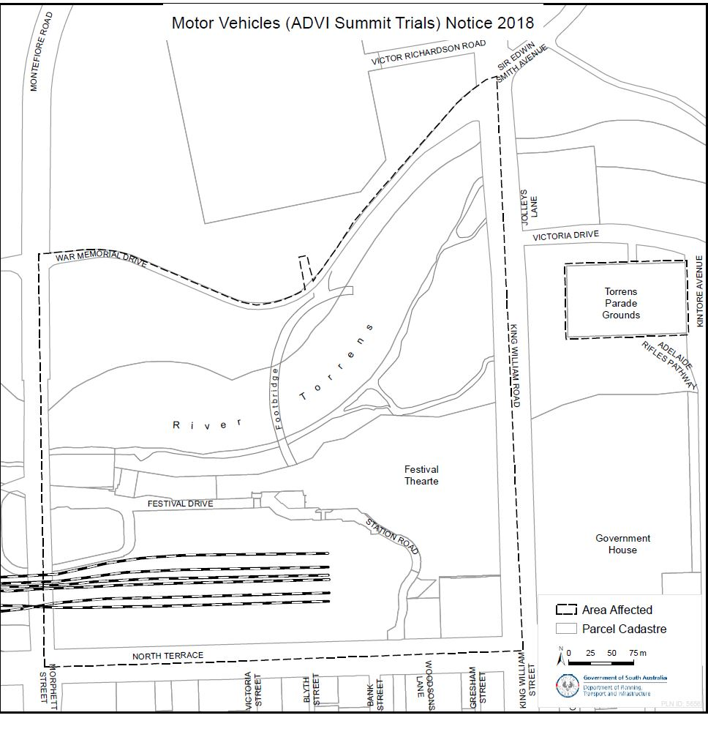

[Republished]

South Australia

Motor Vehicles (Local Motors Autonomous Vehicle Glenelg Trial) Notice 2018

under Part 4A of the Motor Vehicles Act 1959

1 Short Title

This Notice may be cited as the Motor Vehicles (Local Motors AV Glenelg Trial) Notice 2018.

2 Commencement and operation

This Notice will come into operation at 12:01 am on the day after this Notice is published, and will expire at 11:59 pm on 30 June 2019.

3 Interpretation

In this Notice―

Act means the Motor Vehicles Act 1959 (SA);
Council means the City of Holdfast Bay ABN 62 551 270 492;
authorised vehicle means the Local Motors Olli Shuttle, VIN 1L9LOCAL2JA571003;
Local Motors means Local Motors Australia Pty Ltd ACN 623 739 006;
Sage Automation means Sage Automation Pty Ltd ACN 104 119 833.

4 Authorisation

I hereby authorise, under section 134D of the Act, Local Motors, Sage Automation, the City of Holdfast Bay, the owner(s) of the authorised vehicle and any individuals authorised by Local Motors, Sage Automation, Council or the vehicle owner(s), to undertake a trial of automotive technology in accordance with Part 4A of the Act and the exemptions herein, subject to the conditions herein. The nature and scope of the trial is to test the interoperability of the authorised vehicle with a smart bus stop on shared paths open to the public.

5 Exemptions

5.1 I hereby exempt, under section 134E of the Act, the authorised vehicle from the following legislative requirements:

Road Traffic Act 1961 section 110B – Motor vehicle must bear vehicle identification plate
Road Traffic (Light Vehicles Standards) Rules 2018

5.2 Subject to clause 5.3, I hereby exempt Local Motors, Sage Automation, Council, the owner(s) of the authorised vehicle and any authorised individuals from the following legislative requirements:

Local Government Act 1999 sections 199, 200 and 202 – Management, use and consultation regarding community land
Motor Vehicles Act 1959 section 9 – Duty to register a vehicle
Passenger Transport Act 1994
Road Traffic Act 1961 section 110C – Offences regarding vehicle identification plate
Road Traffic Act 1961 section 117 – Liability of driver for breach of light vehicle standards
Road Traffic Act 1961 section 118 – Liability of operator for breach of light vehicle standards
Australian Road Rules Part 12 – Restrictions on stopping and parking
Development Regulations 2008 schedule 2 clause 8 – Advertising displays
Council By-Law 3: Local Government Land clause 3.5 – Causing an obstruction

5.3 The exemption from the requirements of sections 117 and 118 of the Road Traffic Act 1961 does not extend to the requirement to maintain the vehicle in a safe condition within the meaning of section 116 of that Act.

6 Conditions

6.1 The authorised vehicle may only operate within the Council area designated in the Schedule to this Notice.

6.2 The authorised vehicle must operate in accordance with the Safe Work Method Statement and Traffic Management Plan as agreed from time to time between Local Motors, Council and the Department of Planning, Transport and Infrastructure.

7 Execution

HON STEPHAN KNOLL MP
Minister for Transport, Infrastructure and Local Government

Dated: 17 October 2018

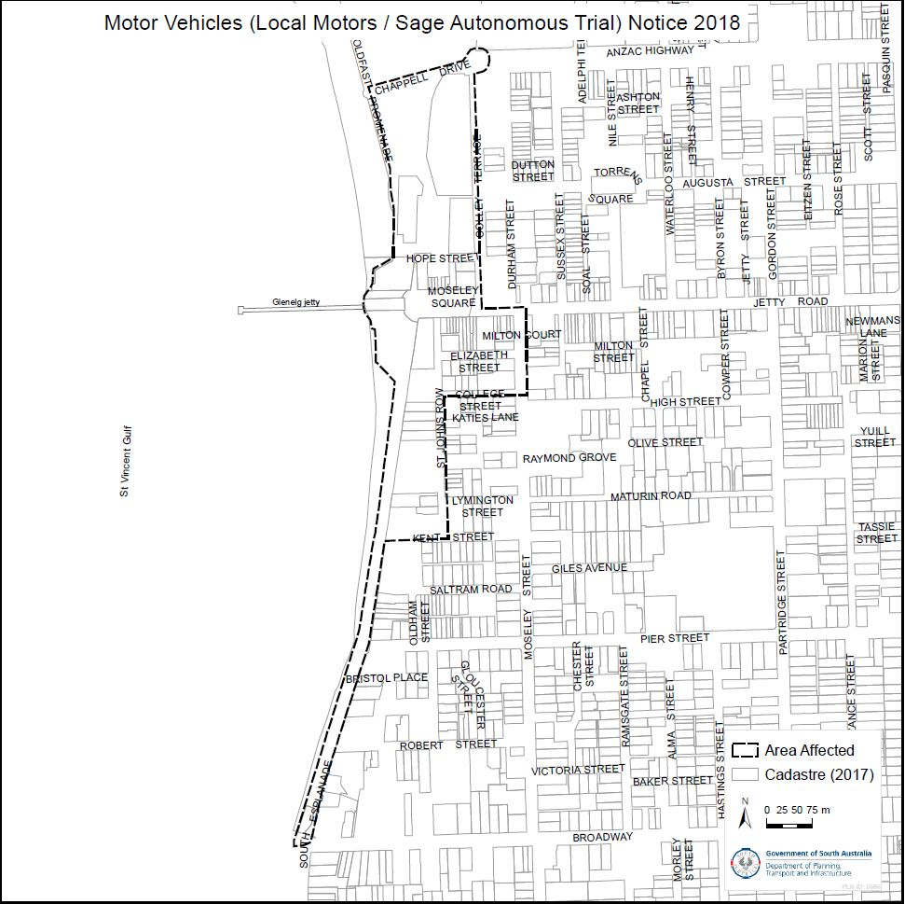

South Australia
Mutual Recognition (ACT Container Deposit Scheme) Notice 2018
under section 47 of the Mutual Recognition Act 1992 of the Commonwealth as adopted by section 4 of the Mutual Recognition (South Australia) Act 1993
1—Short title
This notice may be cited as the Mutual Recognition (ACT Container Deposit Scheme) Notice 2018.
2—Commencement
This notice comes into operation on the day on which it is made.
3—Request for regulations to be made
For the purposes of section 47 of the Mutual Recognition Act 1992 of the Commonwealth, it is requested that the proposed regulations set out in Schedule 1 be made.
Schedule 1—Proposed regulations
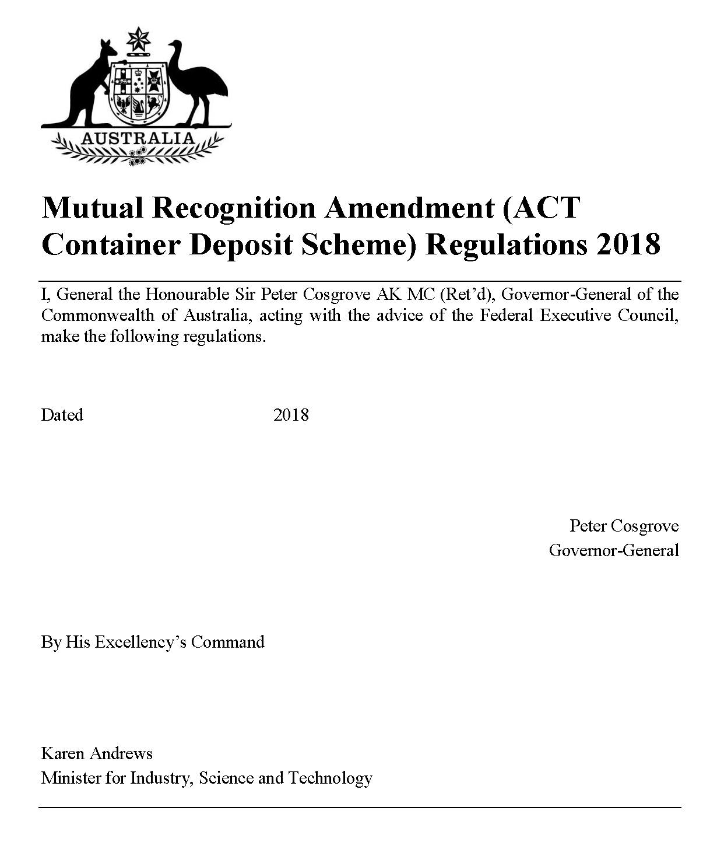
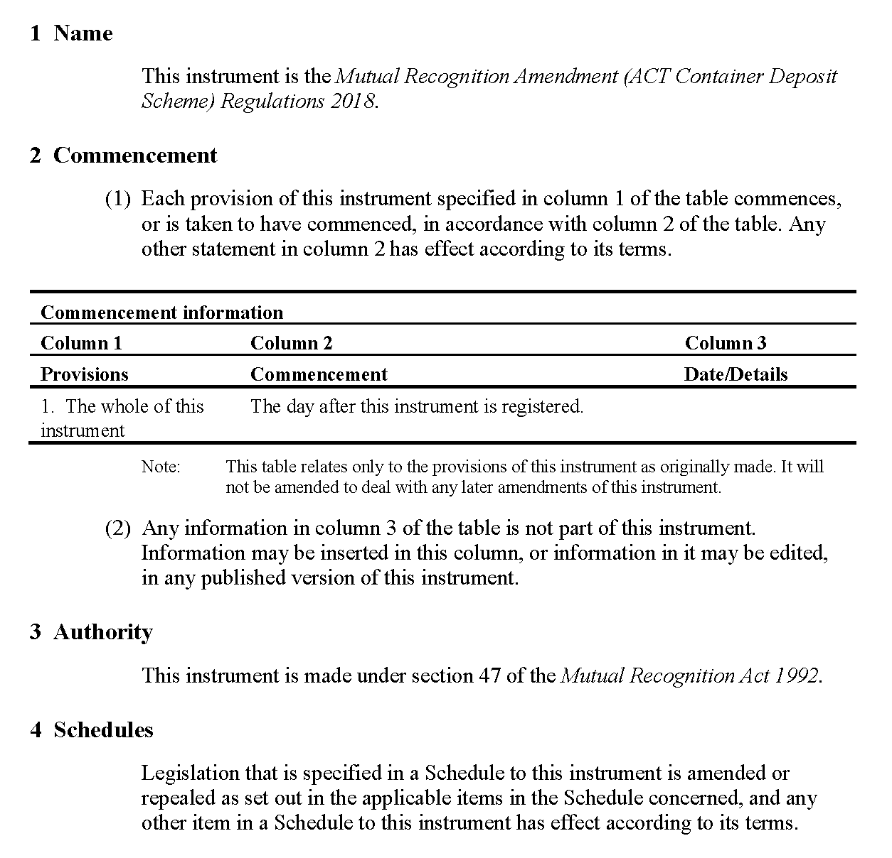
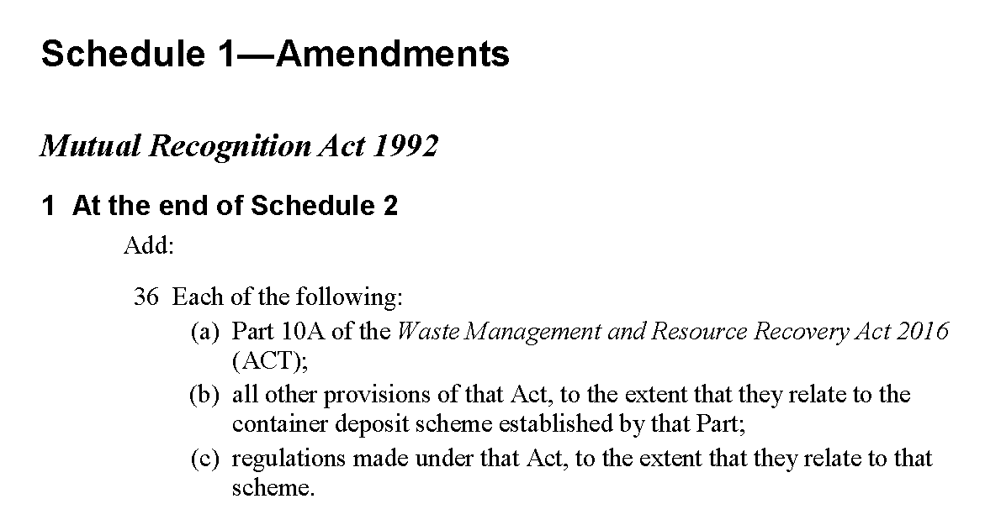
Made by the Governor
with the advice and consent of the Executive Council
on 1 November 2018
18EWEPACS0007

NATIVE VEGETATION REGULATIONS 2017
Public Consultation on the Interim Guidelines for the Management of Roadside Vegetation
NOTICE is hereby given, pursuant to Section 25 of the Native Vegetation Act 1991, that members of the public are invited to make comment to the Native Vegetation Council on matters relating to the Interim Guidelines for the Management of Roadside Vegetation under Regulation 11(23).
Copies of the Interim Guidelines for the Management of Roadside Vegetation, the Fact Sheet and Operational Review Form can be obtained:
- From website: https://www.environment.sa.gov.au/topics/native-vegetation/consultation-under-way, or
- Visit www.yoursay.sa.gov.au, or
- Request to: Native Vegetation Branch, Department for Environment and Water, GPO Box 1047, Adelaide, SA 5001, during normal business hours.
Enquiries and comments in relation to the Interim Guidelines must be made in writing to the Coordinator Governance and Policy, Native Vegetation Branch, Department for Environment and Water, GPO Box 1047, Adelaide, SA 5001 or nvc@sa.gov.au no later than 31 December 2018.
Emily Jenke
Presiding Member
Native Vegetation Council

SUPREME COURT OF SOUTH AUSTRALIA
Notice Pursuant to Part 12 of the Supreme Court Civil Supplementary Rules 2014 (SA)
PURSUANT to Part 12 of the Supreme Court Civil Supplementary Rules 2014 (SA), I give notice that on the 22nd October 2018 I appointed the following persons as Senior Counsel:
- Mr Heath BARKLAY SC
- Mr Michael BURNETT SC
- Dr Rachael GRAY SC
- Mr Alan LINDSAY SC
- Mr Dominic PETRACCARO SC
Dated: 26 October 2018
The Honourable Chris Kourakis
Chief Justice of South Australia

TRAINING AND SKILLS DEVELOPMENT ACT 2008
Part 4 – Apprenticeships/Traineeships
PURSUANT to the provision of the Training and Skills Development Act 2008, the Training and Skills Commission (TaSC) gives notice that determines the following Trades or Declared Vocations in addition to the gazette notices of:
- 25 September 2008 | - 23 October 2008 | - 13 November 2008 | - 4 December 2008
- 18 December 2008 | - 29 January 2009 | - 12 February 2009 | - 5 March 2009
- 12 March 2009 | - 26 March 2009 | - 30 April 2009 | - 18 June 2009
- 25 June 2009 | - 27 August 2009 | - 17 September 2009 | - 24 September 2009
- 9 October 2009 | - 22 October 2009 | - 3 December 2009 | - 17 December 2009
- 4 February 2010 | - 11 February 2010 | - 18 February 2010 | - 18 March 2010
- 8 April 2010 | - 6 May 2010 | - 20 May 2010 | - 3 June 2010
- 17 June 2010 | - 24 June 2010 | - 8 July 2010 | - 9 September 2010
- 23 September 2010 | - 4 November 2010 | - 25 November 2010 | - 16 December 2010
- 23 December 2010 | - 17 March 2011 | - 7 April 2011 | - 21 April 2011
- 19 May 2011 | - 30 June 2011 | - 21 July 2011 | - 8 September 2011
- 10 November 2011 | - 24 November 2011 | - 1 December 2011 | - 8 December 2011
- 16 December 2011 | - 22 December 2011 | - 5 January 2012 | - 19 January 2012
- 1 March 2012 | - 29 March 2012 | - 24 May 2012 | - 31 May 2012
- 7 June 2012 | - 14 June 2012 | - 21 June 2012 | - 28 June 2012
- 5 July 2012 | - 12 July 2012 | - 19 July 2012 | - 2 August 2012
- 9 August 2012 | - 30 August 2012 | - 13 September 2012 | - 4 October 2012
- 18 October 2012 | - 25 October 2012 | - 8 November 2012 | - 29 November 2012
- 13 December 2012 | - 25 January 2013 | - 14 February 2013 | - 21 February 2013
- 28 February 2013 | - 7 March 2013 | - 14 March 2013 | - 21 March 2013
- 28 March 2013 | - 26 April 2013 | - 23 May 2013 | - 30 May 2013
- 13 June 2013 | - 20 June 2013 | - 11 July 2013 | - 1 August 2013
- 8 August 2013 | - 15 August 2013 | - 29 August 2013 | - 6 February 2014
- 12 June 2014 | - 28 August 2014 | - 4 September 2014 | - 16 October 2014
- 23 October 2014 | - 5 February 2015 | - 26 March 2015 | - 16 April 2015
101. 27 May 2015 | 102. 18 June 2015 | 103. 3 December 2015 | 104. 7 April 2016
105. 30 June 2016 | 106. 28 July 2016 | 107. 8 September 2016 | 108. 22 September 2016
109. 27 October 2016 | 110. 1 December 2016 | 111. 15 December 2016 | 112. 7 March 2017
113. 21 March 2017 | 114. 23 May 2017 | 115. 13 June 2017 | 116. 18 July 2017
117. 19 September 2017 | 118. 26 September 2017 | 119. 17 October 2017 | 120. 3 January 2018
121. 23 January 2018 | 122. 14 March 2018 | 123. 14 June 2018 | 124. 5 July 2018
125. 2 August 2018 | 126. 9 August 2018 | 127. 16 August 2018 | 128. 30 August 2018
129. 27 September 2018 | 130. 4 October 2018 | 131. 18 October 2018 | 132. 1 November 2018

New Declared Vocations and Training Contract Conditions for the
Certificate IV in Cyber Security
*Trade/ #Declared Vocation/  Other Occupation | Qualification Code | Qualification Title | Nominal Term of Training Contract | Probationary Period
Cyber Security Support Officer # | 22334VIC | Certificate IV in Cyber Security | 24 Months | 60 Days
Network Operations Centre Analyst # | 22334VIC | Certificate IV in Cyber Security | 24 Months | 60 Days
Network Security Support Officer # | 22334VIC | Certificate IV in Cyber Security | 24 Months | 60 Days
Security Penetration Tester # | 22334VIC | Certificate IV in Cyber Security | 24 Months | 60 Days
Systems Security Administrator # | 22334VIC | Certificate IV in Cyber Security | 24 Months | 60 Days

South Australia
Trans-Tasman Mutual Recognition (ACT Container Deposit Scheme) Notice 2018
under section 43 of the Trans-Tasman Mutual Recognition Act 1997 of the Commonwealth as adopted by section 4 of the Trans-Tasman Mutual Recognition (South Australia) Act 1999
1—Short title
This notice may be cited as the Trans-Tasman Mutual Recognition (ACT Container Deposit Scheme) Notice 2018.
2—Commencement
This notice comes into operation on the day on which it is made.
3—Endorsement of regulations
The proposed regulations set out in Schedule 1 are endorsed for the purposes of section 45 of the Trans-Tasman Mutual Recognition Act 1997 of the Commonwealth.
Schedule 1—Proposed regulations
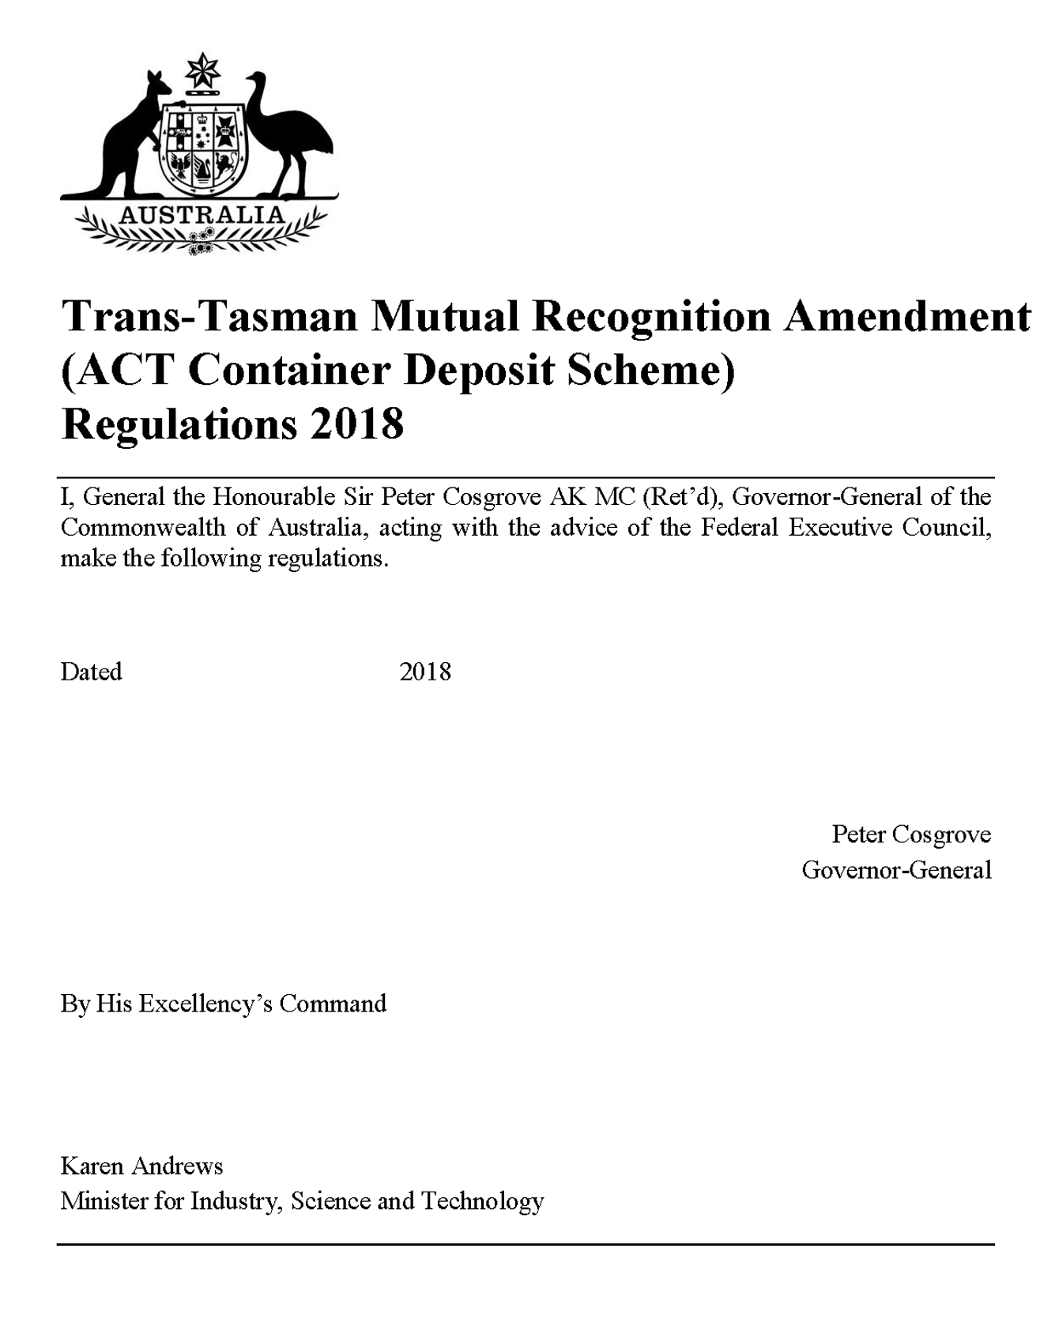
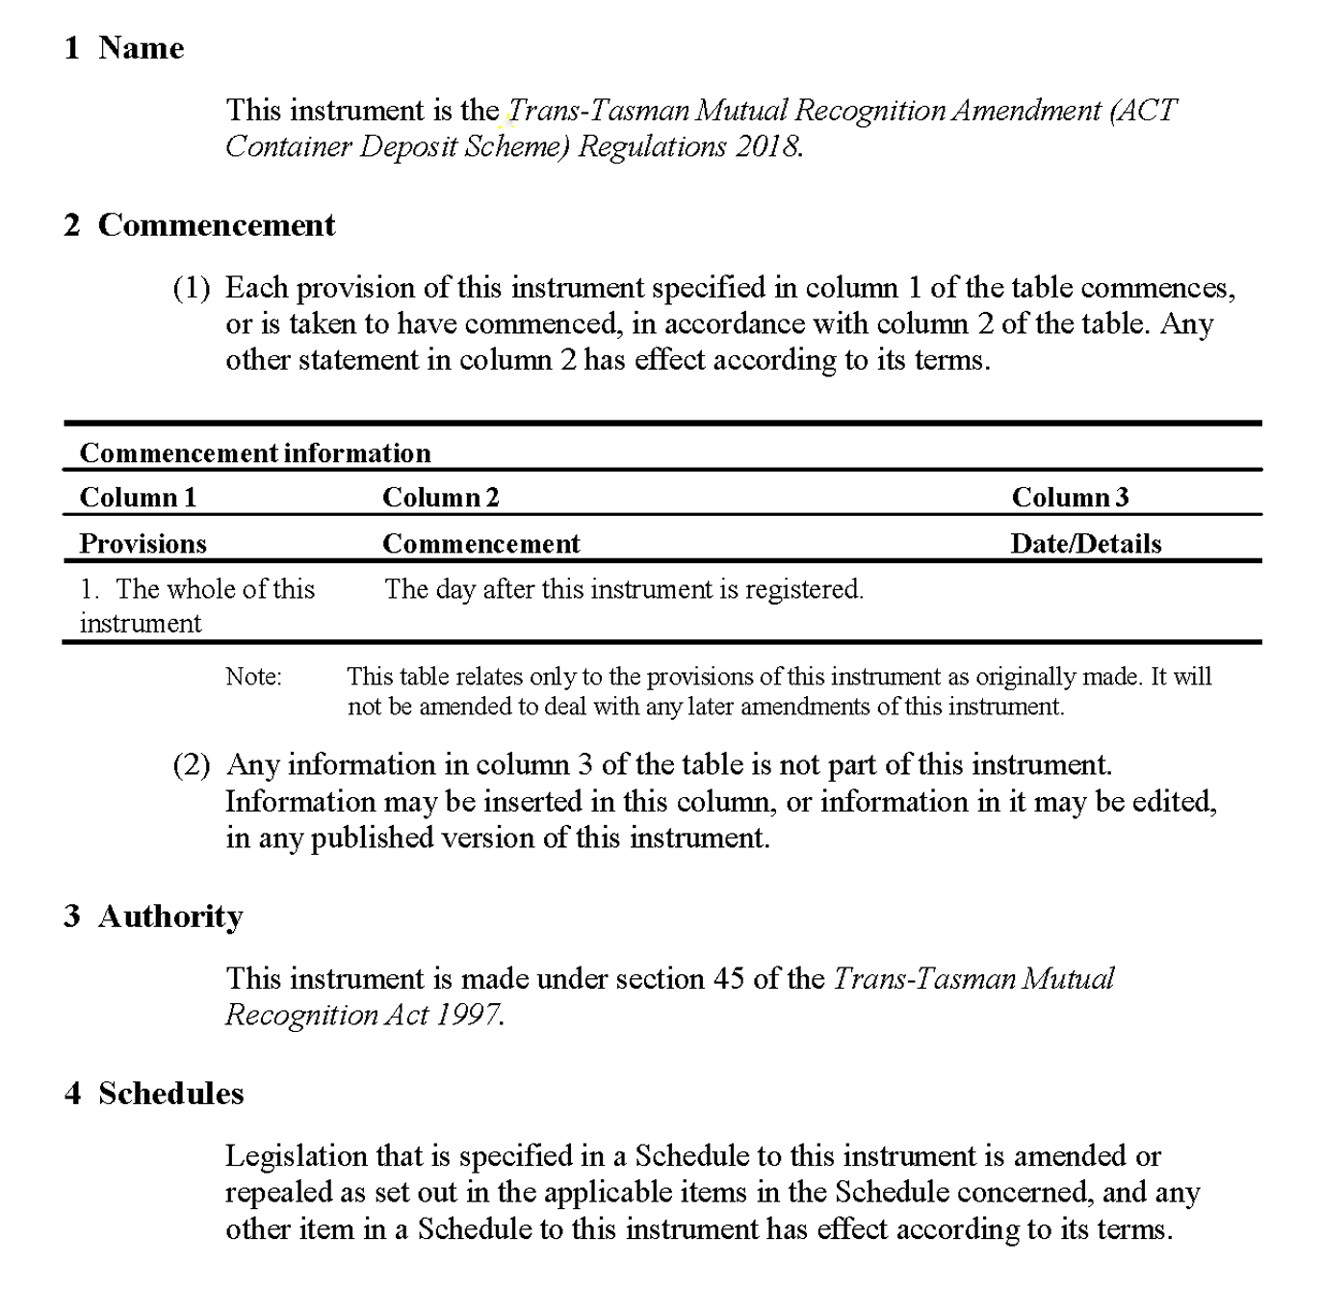
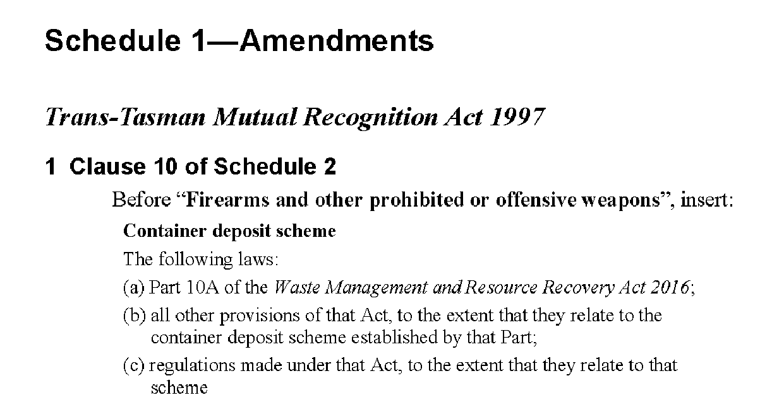
Made by the Governor
with the advice and consent of the Executive Council
on 1 November 2018
18EWEPACS0007

South Australia
Late Payment of Government Debts (Interest) (Automatic Payment of Interest) Amendment Act (Commencement) Proclamation 2018
1—Short title
This proclamation may be cited as the Late Payment of Government Debts (Interest) (Automatic Payment of Interest) Amendment Act (Commencement) Proclamation 2018.
2—Commencement of Act
The Late Payment of Government Debts (Interest) (Automatic Payment of Interest) Amendment Act 2018 (No 19 of 2018) will come into operation on 1 November 2018.
Made by the Governor
with the advice and consent of the Executive Council
on 1 November 2018
T&F18/110CS
South Australia
Superannuation Funds Management Corporation of South Australia (Legal Services Commission) Variation Regulations 2018
under the Superannuation Funds Management Corporation of South Australia Act 1995

Contents
Part 1—Preliminary
1 Short title
2 Commencement
3 Variation provisions
Part 2—Variation of Superannuation Funds Management Corporation of South Australia Regulations 2010
4 Variation of regulation 17—Prescribed public authorities

Part 1—Preliminary
1—Short title
These regulations may be cited as the Superannuation Funds Management Corporation of South Australia (Legal Services Commission) Variation Regulations 2018.
2—Commencement
These regulations will come into operation on the day immediately following the day on which the time for disallowance of these regulations has passed (see section 3(6) of the Superannuation Funds Management Corporation of South Australia Act 1995).
3—Variation provisions
In these regulations, a provision under a heading referring to the variation of specified regulations varies the regulations so specified.
Part 2—Variation of Superannuation Funds Management Corporation of South Australia Regulations 2010
4—Variation of regulation 17—Prescribed public authorities
Regulation 17—after paragraph (f) insert:
(g) Legal Services Commission.
Note—
As required by section 10AA(2) of the Subordinate Legislation Act 1978, the Minister has certified that, in the Minister's opinion, it is necessary or appropriate that these regulations come into operation as set out in these regulations.
Made by the Governor
with the advice and consent of the Executive Council
on 1 November 2018
No 224 of 2018
T&F18/103CS
City of Victor Harbor
Revocation of Community Land Classification
Notice is hereby given that the City of Victor Harbor at its meeting held on 22 October 2018, resolved that pursuant to Section 194 (3) (b) of the Local Government Act 1999, that Allotment 52 Greenhills Road, in Deposited Plan 58904 Certificate of Title Volume 5892 Folio 181 to have its classification as Community Land revoked.
Dated: 22 October 2018
V MacKirdy
Chief Executive Officer

National Gas Law
The Australian Energy Market Commission (AEMC) gives notice under the National Gas Law as follows:
Under s 303, COAG Energy Council has requested the Regulation of covered pipelines (Ref. GRC0048) proposal. The proposal seeks to make improvements to regulation of covered pipelines. Under s 305, the AEMC has decided to use the fast track rule change process for this proposal.
Australian Energy Market Commission
Level 6, 201 Elizabeth Street
Sydney NSW 2000
Telephone: (02) 8296 7800
www.aemc.gov.au
Dated: 1 November 2018

Trustee Act 1936
Public Trustee
Estates of Deceased Persons
In the matter of the estates of the undermentioned deceased persons:
ARCHER Maria Edna late of 30 Shillabeer Road Elizabeth Park of no occupation who died 3 January 2018
BATTYE Mary Julia late of 4 Sylvan Way Grange of no occupation who died 10 August 2018
BUTLER Geoffrey Charles late of 1A Mount Barker Road Hanhdorf Teacher who died 16 February 2018
GUMMOW George William late of 25A Fuss Street Moonta Bay of no occupation who died 28 July 2018
MIJIC Petar late of Van Brugge Street Coober Pedy Sugar Cane Cutter who died 21 December 2017
MOLDE Winifred late of 7 - 31 Shackleton Avenue Ingle Farm of no occupation who died 16 June 2018
TOROS Morris late of 2 Jelley Street Woodville of no occupation who died 3 March 2018
WARD Kathleen Josephine late of 172 Trimmer Parade Seaton First Aid Officer who died 29 May 2018
Notice is hereby given pursuant to the Trustee Act 1936, the Inheritance (Family Provision) Act 1972 and the Family Relationships Act 1975 that all creditors, beneficiaries, and other persons having claims against the said estates are required to send, in writing, to the office of Public Trustee at GPO Box 1338, Adelaide, 5001, full particulars and proof of such claims, on or before the 30 November 2018 otherwise they will be excluded from the distribution of the said estate; and notice is also hereby given that all persons indebted to the said estates are required to pay the amount of their debts to the Public Trustee or proceedings will be taken for the recovery thereof; and all persons having any property belonging to the said estates are forthwith to deliver same to the Public Trustee.
Dated: 1 November 2018
N S Rantanen
Acting Public Trustee

Notice Submission

Notices for publication must be submitted before 4 p.m. Tuesday, the week of intended gazettal.
Proofs of formatted content are supplied for all notice submissions. Alterations must be returned before 4 p.m. Wednesday.
The SA Government Gazette is compiled and published each Thursday. Requests to withdraw submitted notices must be received before 10 a.m. on the day of publication.

Gazette notices should be emailed as Word files—and signed PDF files if applicable—
in the following format:
- Title (name of the governing legislation/department/organisation)
- Subtitle (description of notice)
- A structured body of text
- Date of authorisation
- Name, position, and department/organisation of the authorising person

Please provide the following information in your email:
- Date of intended gazettal
- Details that may impact on publication of the notice
- Email address and phone number of the person authorising the submission
- Name of the person and organisation to be charged for the notice, if applicable
- Request for a quote, if required
- Purchase order, if required

Email: governmentgazettesa@sa.gov.au
Phone: (08) 8207 1025
Website: www.governmentgazette.sa.gov.au

Printed and published weekly by authority of S. Rodrigues, Government Printer, South Australia
$7.50 per issue (plus postage), $378.15 per annual subscription—GST inclusive
Online publications: www.governmentgazette.sa.gov.au

