
THE SOUTH AUSTRALIAN
GOVERNMENT GAZETTE
Published by Authority

Adelaide, Thursday, 22 November 2018

Contents

Acts Assented To 3980
Appointments, Resignations, Etc. 3980
Corporations and District Councils—Notices 4019
Republished 4019
Dangerous Substances Act 1979—Notices 3981
Development Act 1993—Notices 3981
Fisheries Management Act 2007—Notices 3993
Housing Improvement Act 2016—Notices 3994
Land Acquisition Act 1969—Notices 3995
Mental Health Act 2009—Republished 3998
National Gas (South Australia) Act 2008—Notices 3998
Pastoral Land Management and Conservation
Act 1989—Notice 3999
Petroleum and Geothermal Energy Act 2000—Notice 3999
Police Act 1998—Notice 3999
Proclamations 4010
Regulations
National Gas (South Australia) Act 2008—
(No. 226 of 2018) 4012
Schedule of Aeronautical Charges—
Adelaide Airport Ltd 4020
South Australian Housing Trust Regulations 2010—
Notice 3999
South Australian Motor Sport Act 1984—Notices 4000
South Australian Motor Sport Regulations 2014 (SA)—
Notice 4001
South Australian Public Health Act 2011—Notice 4002
State Lotteries Act 1966—Notice 4002
Summary Offences Act 1953—Notice 4007
Training and Skills Development Act 2008—Notice 4009
Trustee Act 1936—Administration of Estates 4021

Department of the Premier and Cabinet
Adelaide, 22 November 2018
His Excellency the Governor directs it to be notified for general information that he has in the name and on behalf of Her Majesty The Queen, this day assented to the undermentioned Acts passed by the Legislative Council and House of Assembly in Parliament assembled, viz.:
No. 31 of 2018—Judicial Conduct Commissioner (Miscellaneous) Amendment Act 2018
An Act to amend the Judicial Conduct Commissioner Act 2015.
No. 32 of 2018—Statutes Amendment (Drug Offences) Act 2018
An Act to amend the Controlled Substances Act 1984 and the Sentencing Act 2017.
No. 33 of 2018—Statutes Amendment (National Energy Laws) (Binding Rate of Return Instrument) Act 2018
An Act to amend the National Electricity (South Australia) Act 1996 and the National Gas (South Australia) Act 2008.
No. 34 of 2018—Office for the Ageing (Adult Safeguarding) Amendment Act 2018
An Act to amend the Office for the Ageing Act 1995.
No. 35 of 2018—Statutes Amendment and Repeal (Budget Measures) Act 2018
An Act to make amendments to various Acts, and to repeal various Acts, for the purposes of the 2018 State Budget.
By command,
Steven Spence Marshall
Premier

Department of the Premier and Cabinet
Adelaide, 22 November 2018
His Excellency the Governor in Executive Council has been pleased to appoint the undermentioned to the Adelaide Festival Corporation Board, pursuant to the provisions of the Adelaide Festival Corporation Act 1998:
Member: from 6 December 2018 until 5 December 2021
Ian Robert McRae
By command,
Steven Spence Marshall
Premier
DPC18/069CS

Department of the Premier and Cabinet
Adelaide, 22 November 2018
His Excellency the Governor in Executive Council has been pleased to appoint the undermentioned to the South Australian Film Corporation, pursuant to the provisions of the South Australian Film Corporation Act 1972:
Member: from 2 December 2018 until 1 December 2021
Peter Hanlon
Anton Andreacchio
Presiding Member: from 2 December 2018 until 1 December 2021
Peter Hanlon
By command,
Steven Spence Marshall
Premier
18IS/0023CS

Department of the Premier and Cabinet
Adelaide, 22 November 2018
His Excellency the Governor in Executive Council has been pleased to appoint Her Honour Justice Ann Marie Vanstone, a Puisne Judge of the Supreme Court of South Australia as Acting Chief Justice for the period commencing on 6 December 2018 and expiring on 20 December 2018 - pursuant to Section 10 of the Supreme Court Act 1935.
By command,
Steven Spence Marshall
Premier
AGO0131-18CS

Department of the Premier and Cabinet
Adelaide, 22 November 2018
His Excellency the Governor in Executive Council has been pleased to appoint Joseph John Ullianich as Fund Administrator of the State Emergency Relief Fund for a term commencing on 29 November 2018 and expiring on 31 March 2019, pursuant to Section 68 of the Constitution Act 1934.
By command,
Steven Spence Marshall
Premier
DHSCS18022

Department of the Premier and Cabinet
Adelaide, 22 November 2018
His Excellency the Governor in Executive Council has been pleased to appoint Veronica Margaret Faggotter as Fund Administrator of the State Emergency Relief Fund for a term of three years commencing on 1 April 2019 and expiring on 31 March 2022, pursuant to Section 68 of the Constitution Act 1934.
By command,
Steven Spence Marshall
Premier
DHSCS18022

Department of the Premier and Cabinet
Adelaide, 22 November 2018
His Excellency the Governor in Executive Council has been pleased to appoint the people listed as Board Members of the Central Adelaide Local Health Network Transition, commencing on 22 November 2018 and expiring on 30 June 2019, or until the appointments to the positions of member of the governing board of the Central Adelaide Local Health Network are made pursuant to the Health Care Act 2008, whichever is the sooner - pursuant to section 68 of the Constitution Act 1934:
- Alexandra Mary Cockram
- Justin John Beilby
- Judith Dwyer
- Kim Morey, and
- Naomi Margaret James.
By command,
Steven Spence Marshall
Premier
HEAC-2018-00082

DANGEROUS SUBSTANCES ACT 1979
Appointment of Authorised Officers
I, Martyn Antony Campbell, Executive Director, SafeWork SA, hereby appoint the following persons as Authorised Officers for the purposes of the Dangerous Substances Act 1979 pursuant to section 7(1) of that Act:
- Imogen SELLEY
- Alexandre Maxime BURGUN
Dated: 14 November 2018
Martyn Campbell
Executive Director
SafeWork SA

DANGEROUS SUBSTANCES ACT 1979
Revocation of Appointment of Authorised Officers
I, Martyn Antony Campbell, Executive Director, SafeWork SA, hereby revoke the appointment of the following persons as Authorised Officers for the purposes of the Dangerous Substances Act 1979 pursuant to section 7(4) of that Act:
- Anthony William Parletta
- David James Symons
- David Osborne
- Phillip Edward Miles
- Chor Shoon Wong
- Gary James Clark
- Murray Reginald Slee
- Stephen Maurice De Musso
Dated: 14 November 2018
Martyn Campbell
Executive Director
SafeWork SA

DEVELOPMENT ACT 1993
Notice under Section 25(17)
Wudinna District Council—Wudinna Industry Zone Development Plan Amendment
Preamble
- The Wudinna Industry Zone Development Plan Amendment (the Amendment) by the Wudinna District Council has been finalised in accordance with the provisions of the Development Act 1993.
- The Minister for Planning has decided to approve the Amendment.
PURSUANT to section 25 of the Development Act 1993, I –
- approve the Amendment; and
- fix the day on which this notice is published in the Gazette as the day on which the Amendment will come into operation.
Dated: 17 November 2018
Hon Stephan Knoll MP
Minister for Transport, Infrastructure and Local Government
Minister for Planning

DEVELOPMENT ACT 1993
Notice under Section 26(9)
Southern Innovation Area—Development Plan Amendment Part 2
Preamble
- The ‘Southern Innovation Area Development Plan Amendment Part 2’ (the Amendment) has been finalised in accordance with the provisions of the Development Act 1993.
- The Minister for Planning has decided to approve the Amendment.
PURSUANT to section 26 of the Development Act 1993, I –
  - approve the Amendment; and
  - fix the day on which this notice is published in the Gazette as the day on which the Amendment will come into operation.
Dated: 17 November 2018
Hon Stephan Knoll MP
Minister for Planning

DEVELOPMENT ACT 1993
Notice under Section 27 (5)
Adelaide Plains Council (Formerly District Council of Mallala)
Northern Food Bowl Protection Areas Development Plan Amendment
Preamble
Pursuant to Section 27 (3)(b) of the Development Act 1993, the Environment, Resources and Development Committee of Parliament has suggested amendments to the Mallala Council Development Plan, after receipt of the approved Northern Food Bowl Protection Areas Development Plan Amendment.
After considering the suggested amendments, pursuant to Section 27 (5)(a), I, Stephan Knoll, being the Minister Administering the Act, am proceeding to make such amendments to the Mallala Council Development Plan dated 20 February 2018.
NOTICE
PURSUANT to Section 27 (5) of the Development Act 1993, I amend the Mallala Council Development Plan dated 20 February 2018 as follows:
- within the third paragraph of the Primary Production Zone Desired Character Statement, delete the words ‘(excluding where located within Precinct 5 Horticulture)’.
- within the Primary Production Zone, Principle of Development Control 6, delete part (f) in its entirety.
- within the first paragraph of the Horticulture Policy Area 3 Desired Character Statement, delete the words ‘(excluding Precinct 5 Horticulture)’.
- within the Primary Production Zone non-complying development list, replace the row ‘Dwelling where it is located within Horticulture Policy Area 3 and Precinct 5 Horticulture’ with the contents of ‘Attachment A’.
- fix the day on which this notice is published in the Gazette as the day on which the amendment will come into operation.
Dated: 7 November 2018
Stephan Knoll
Minister for Planning

Attachment A
Within the Primary Production Zone non-complying development list, replace the following row:
Dwelling where it is located within Horticulture Policy Area 3 and Precinct 5 Horticulture | Except where it is a detached dwelling and all of the following applies:  - it is located on an allotment that was created prior to 1 April 2017  - it is not located within the High Flood Hazard Risk Area, as shown on Overlay Maps – Development Constraints  - it does not require access to it by road across land located within the High Flood Hazard Risk Area, as shown on Overlay Maps – Development Constraints.
With:
Dwelling where it is located within Precinct 5 Horticulture | Except where it is a detached dwelling and all of the following applies:  - it is not located within the High Flood Hazard Risk Area, as shown on Overlay Maps – Development Constraints  - it does not require access to it by road across land located within the High Flood Hazard Risk Area, as shown on Overlay Maps – Development Constraints  - it achieves (i) or (ii):  - it is located on an allotment that was created prior to 1 April 2017  - it is located on allotment that was created after 1 April 2017 and it achieves both (A) and (B):  - it is a care-taker’s / manager’s residence  - the allotment is at least 4 hectares in area.

DEVELOPMENT ACT 1993
Section 29
Amendment to the Clare and Gilbert Valleys Council Development Plan
Preamble
It is necessary to amend the Clare and Gilbert Valleys Council Development Plan (the Plan) dated 10 November 2016.
PURSUANT to section 29 (2)(b)(ii) of the Development Act 1993, I —
  - Amend the Plan as follows:
- Replace the following row in Table CGV/5 – Local Heritage Places:
Old Blyth Road ARMAGH | Former Armagh School (Hall) |  |  | LT C/40 |  | 14518
with:
17 Dame Street, ARMAGH | Former Armagh School (Hall) | A681 | F211467 | CT 5883/905 |  | 14518
- Replace Overlay Map CGV/4 Heritage with the contents of ‘ATTACHMENT A’.
  - Fix the day on which this notice is published in the Gazette as the day on which the section 29 Amendment will come into operation.
Dated: 12 November 2018
Sally Smith
General Manager, Planning and Development
Development Division
Department of Planning, Transport and Infrastructure
as Delegate of Stephan Knoll, Minister for Planning

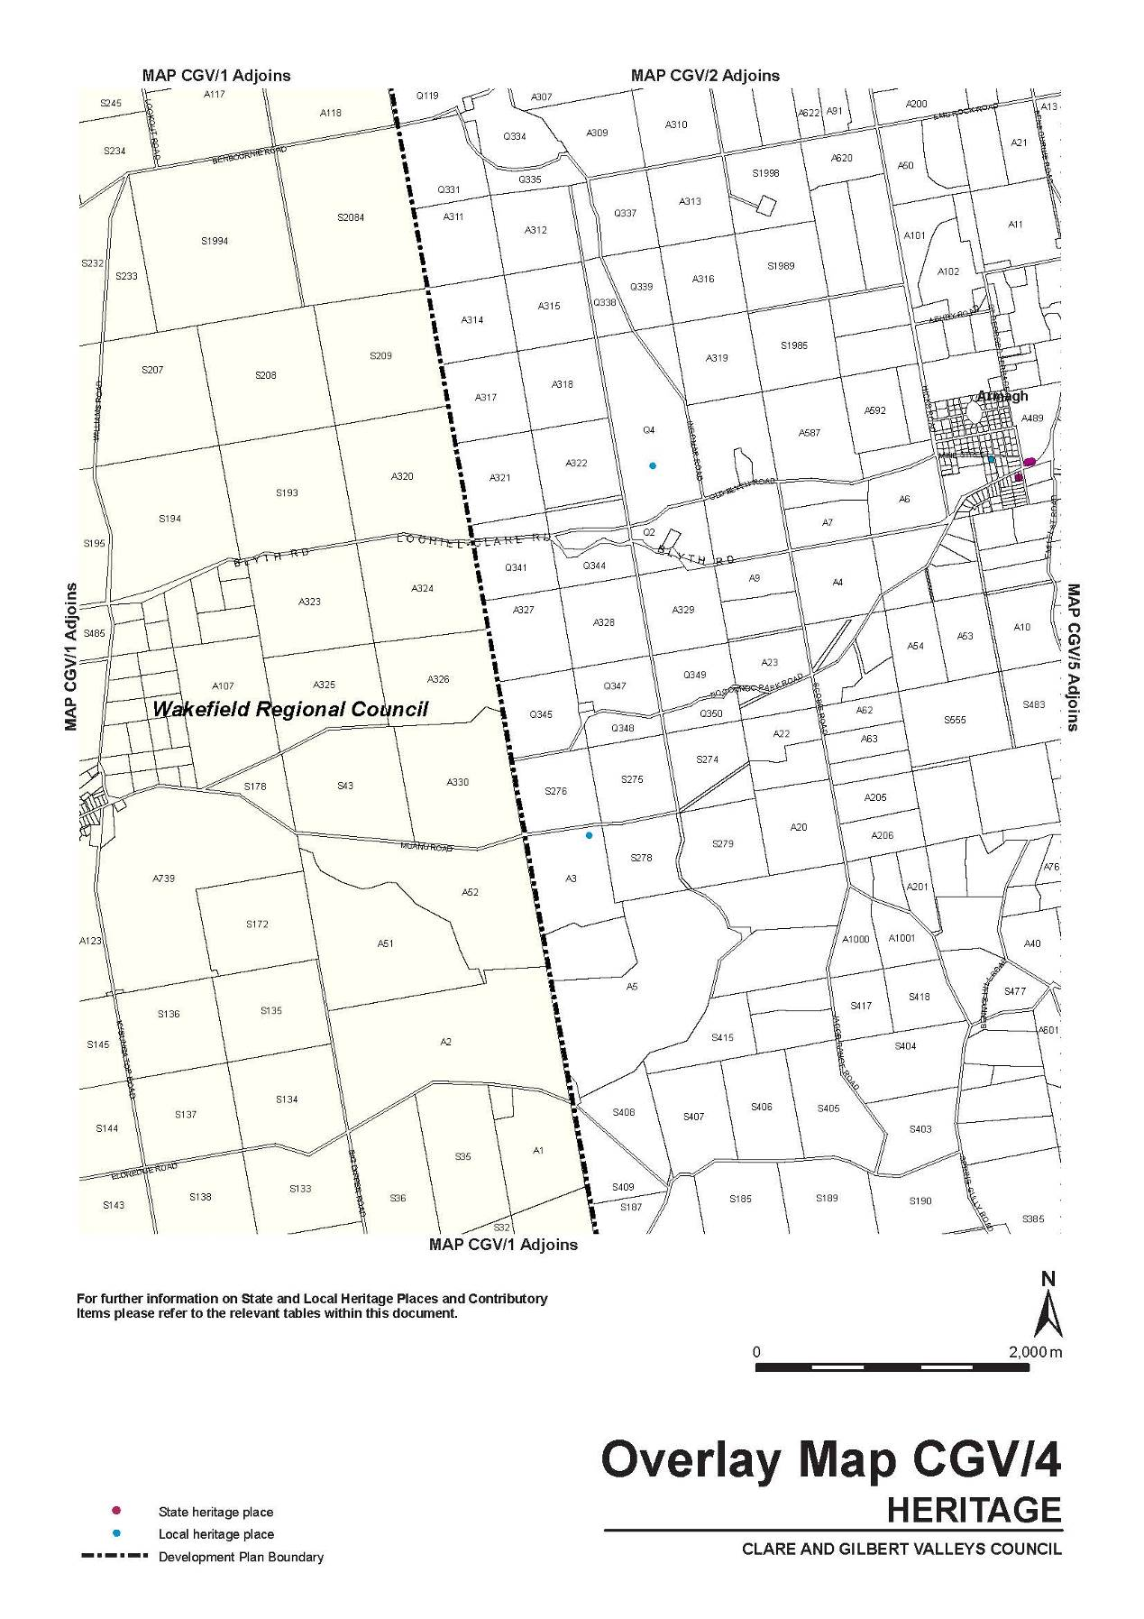
Attachment A

DEVELOPMENT ACT 1993
Section 29
Amendment to the Onkaparinga Council Development Plan
Preamble
It is necessary to amend the Onkaparinga Council Development Plan (the Plan) dated 20 February 2018.
PURSUANT to section 29 (2)(b)(i) of the Development Act 1993, I amend the Plan as follows:
- Replace Location Maps Onka/71, Onka/78, Onka/88, Onka/91, Onka/92, Onka/93 and Onka/100 with the contents of ‘ATTACHMENT A’.
- Fix the day on which this notice is published in the Gazette as the day on which the section 29 Amendment will come into operation.
Dated: 8 November 2018
Sally Smith
General Manager, Property and Development
Development Division
Department of Planning, Transport and Infrastructure
as Delegate of Stephan Knoll, Minister for Planning

Attachment A
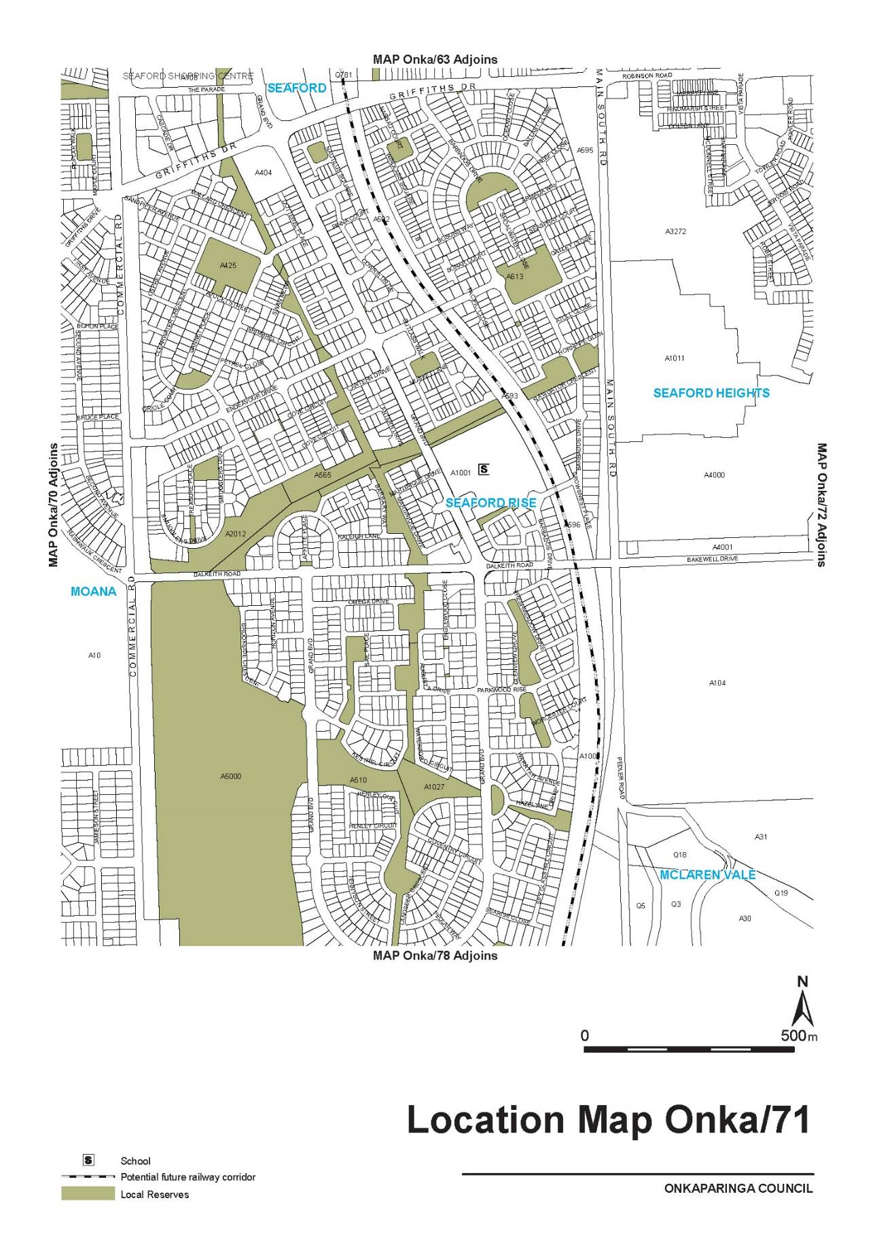
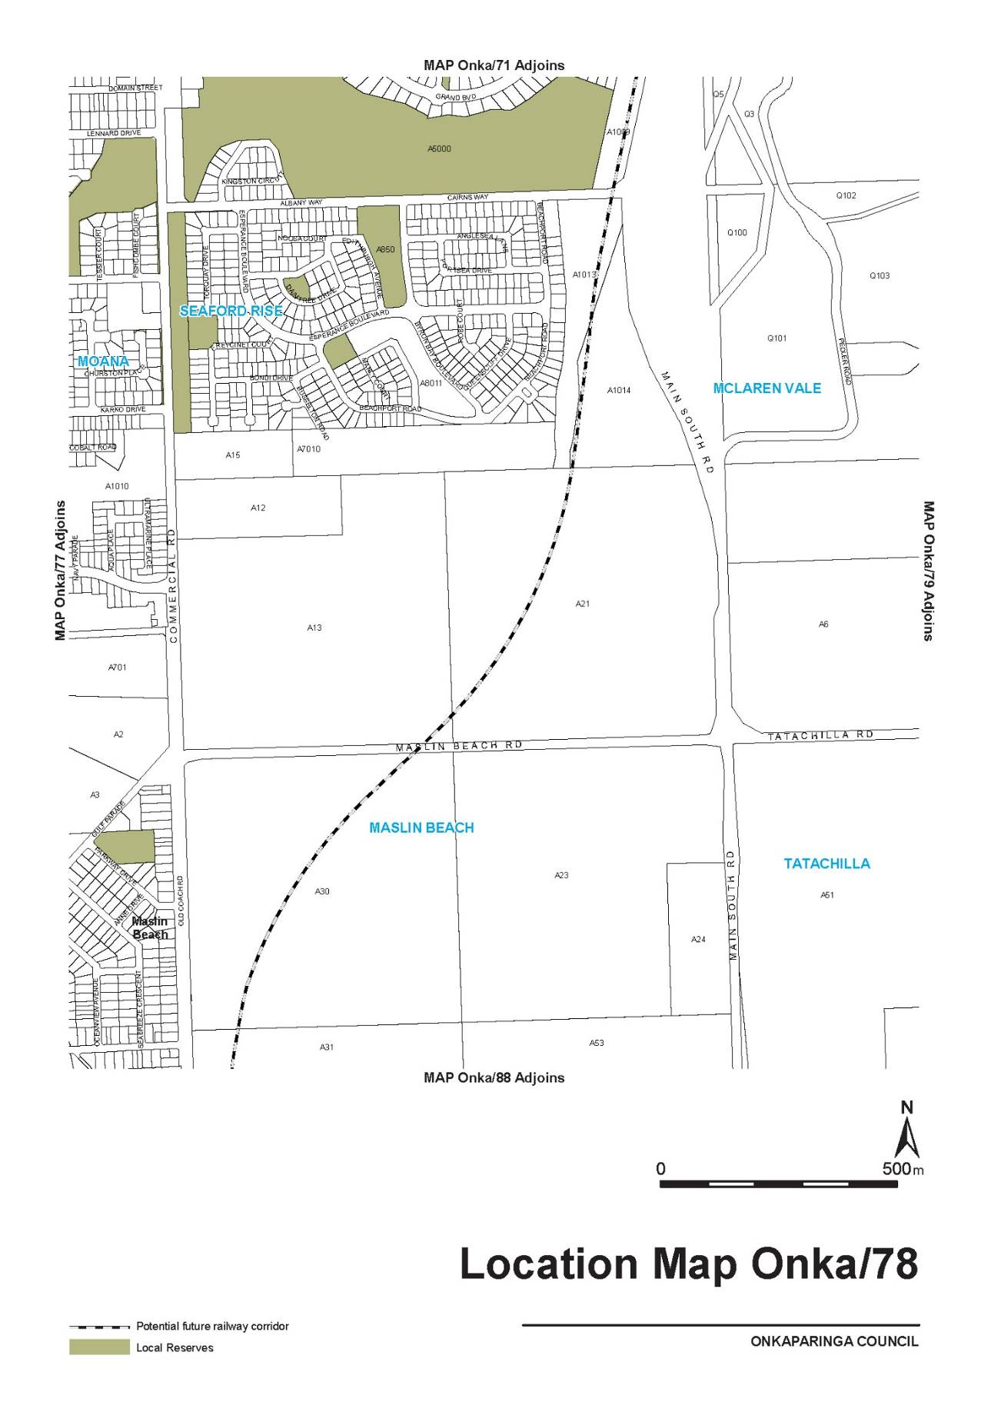
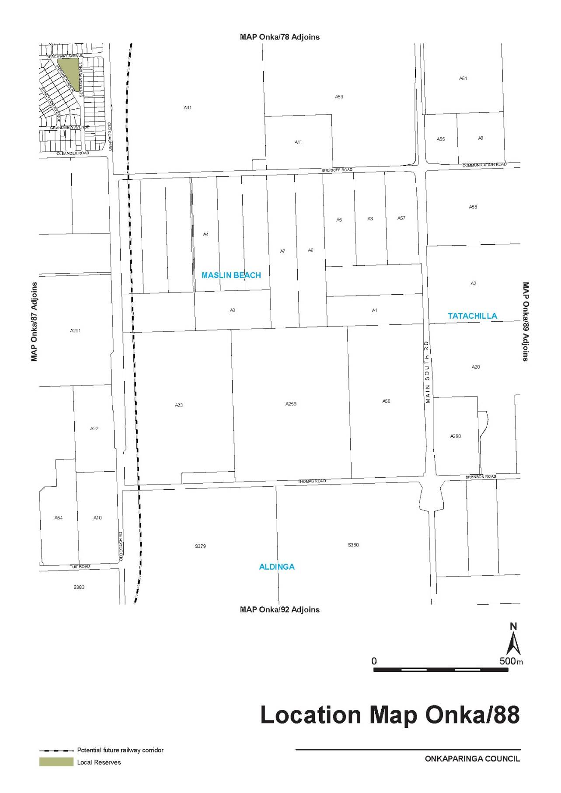
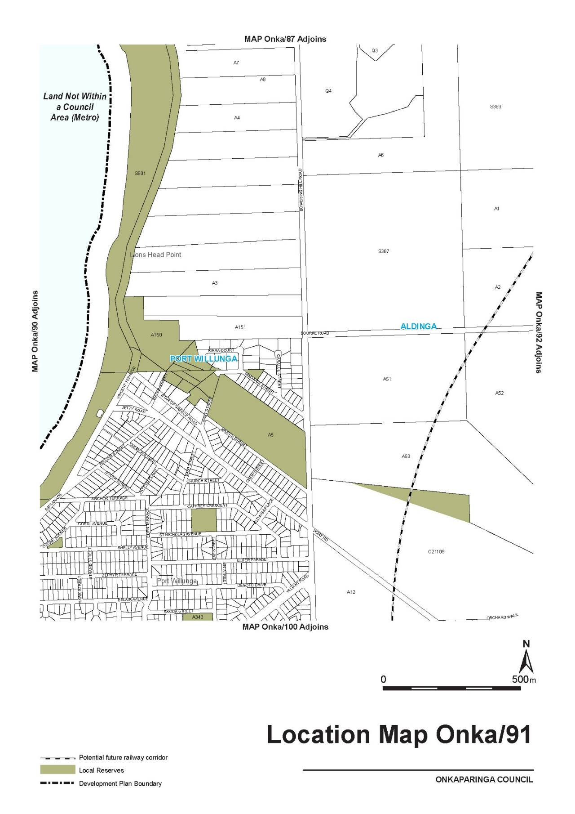
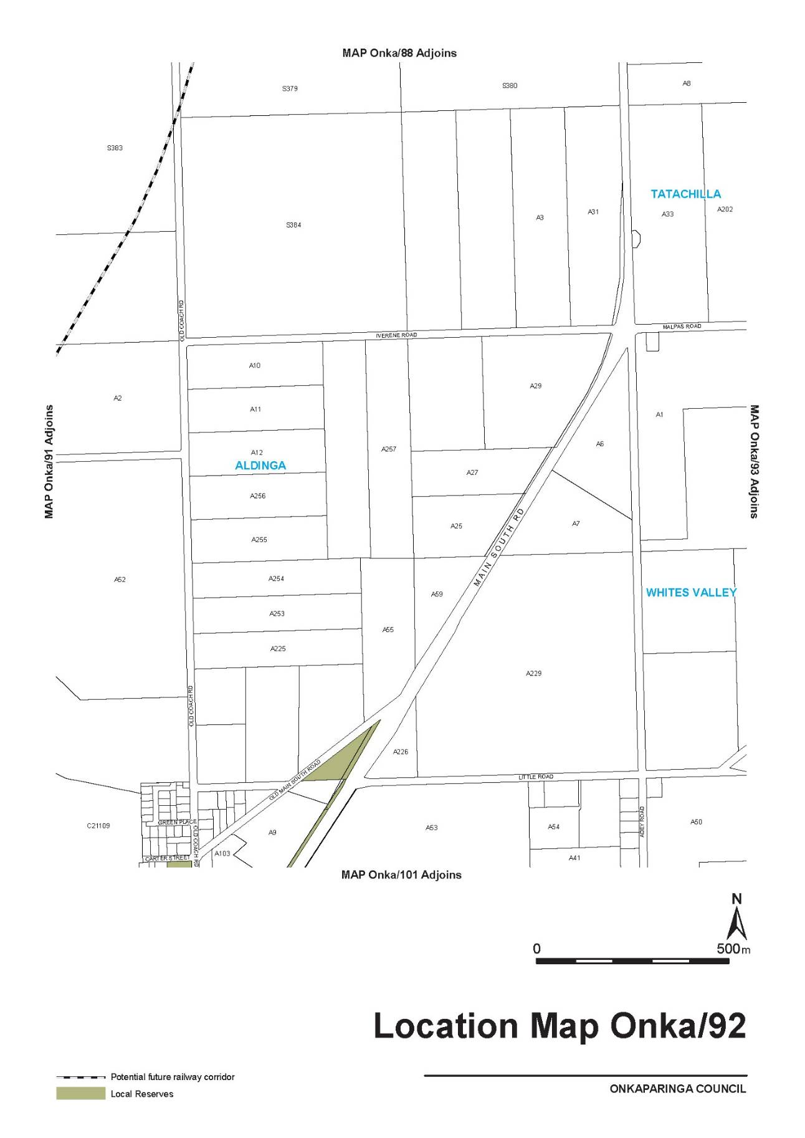
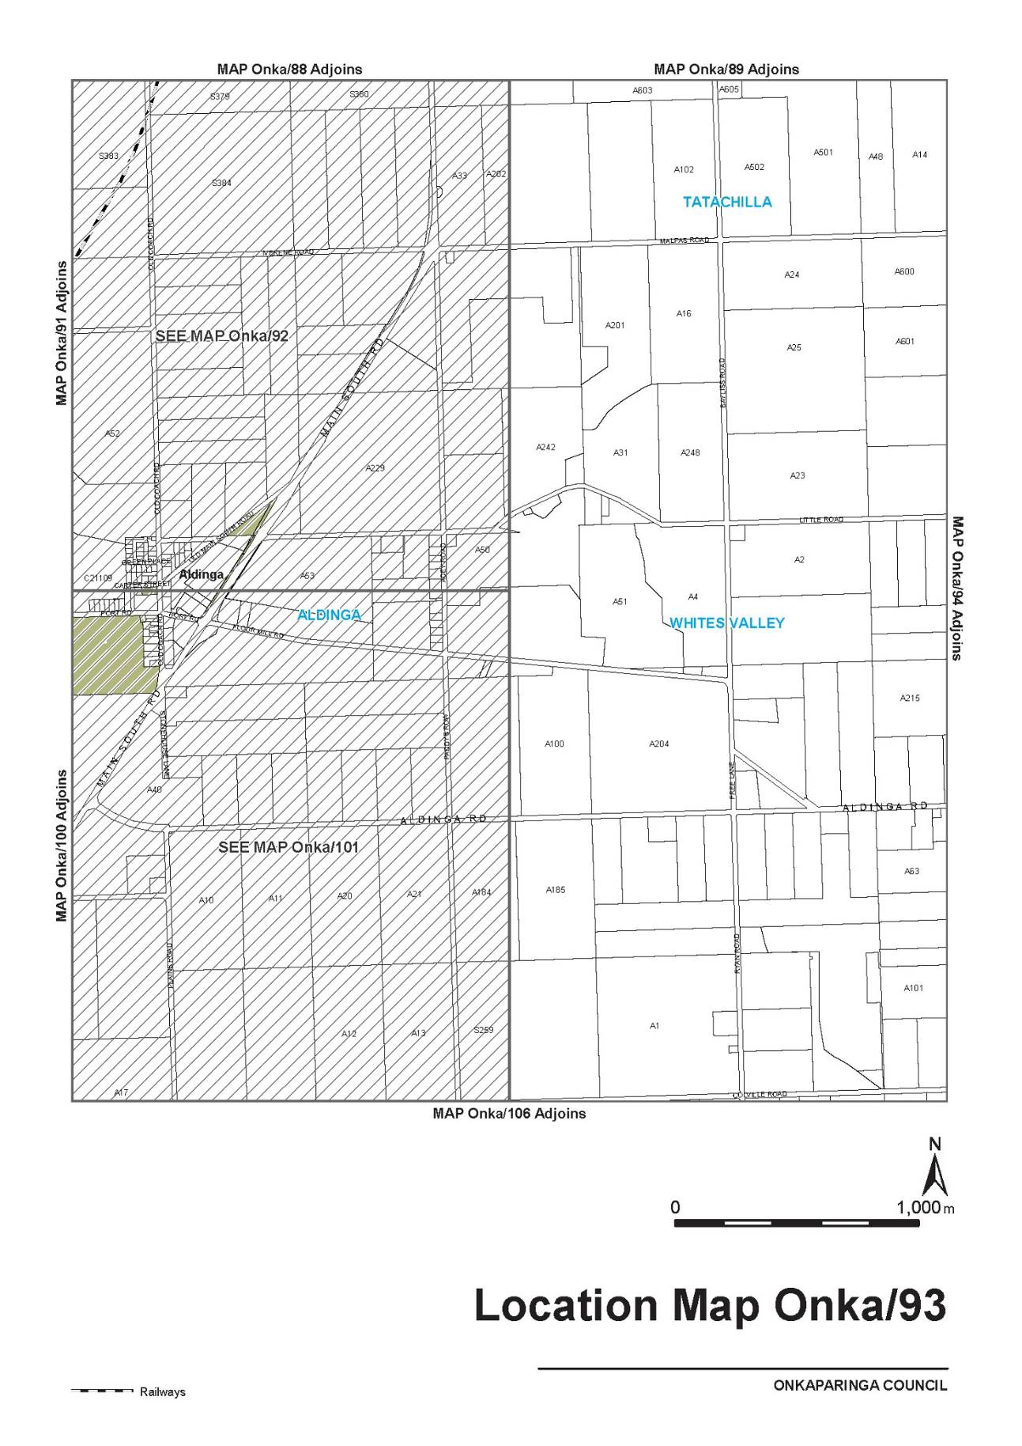
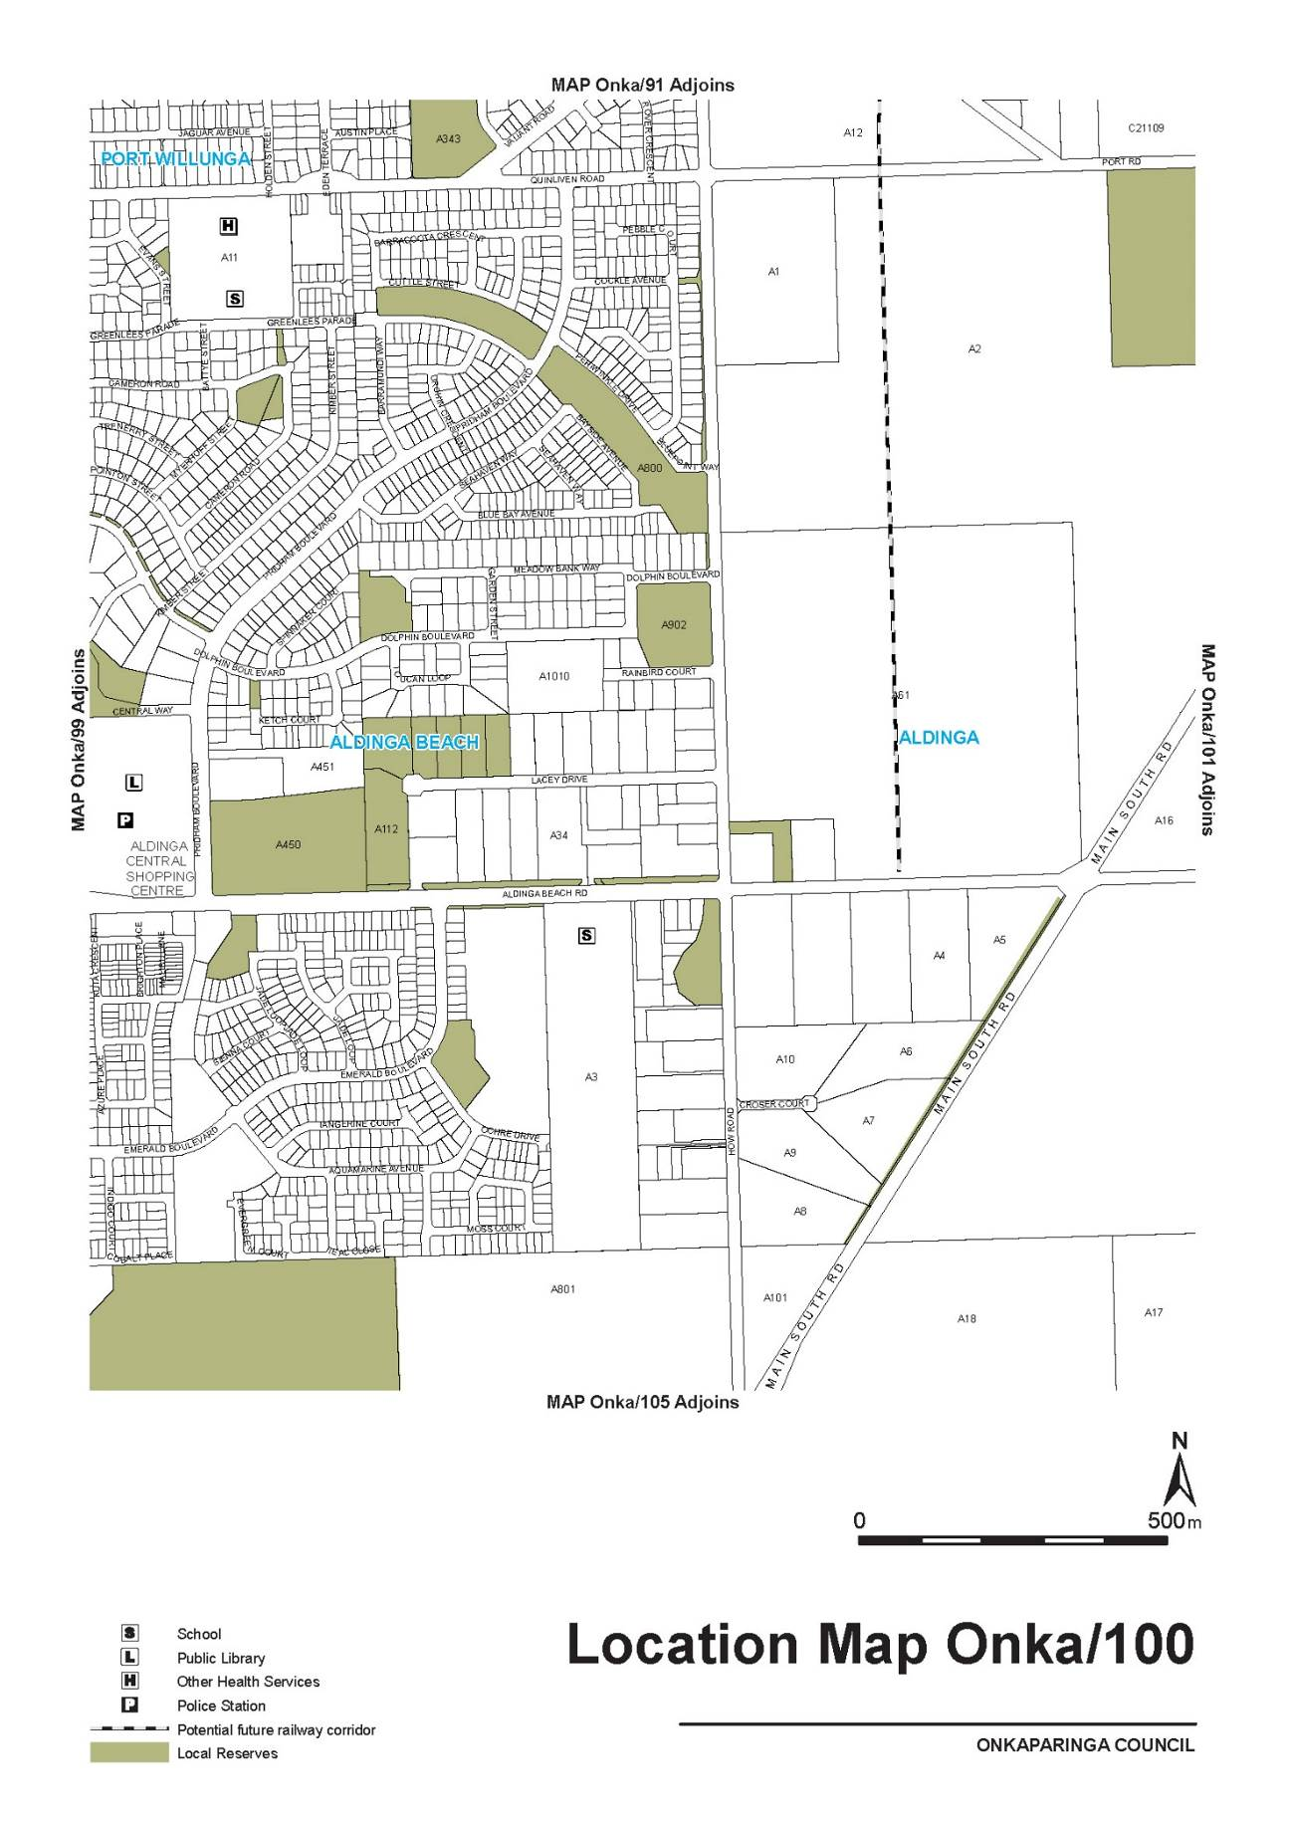

FISHERIES MANAGEMENT ACT 2007
Section 115
Exemption Number ME9903014
TAKE NOTICE that pursuant to section 115 of the Fisheries Management Act 2007, Dr Peter Gill of Blue Whale Study Inc. of 25 Priestly Road, TYRENDARRA VIC 3285 (the ‘exemption holder’) is exempt from sections 71(1) and 71(2) of the Fisheries Management Act 2007 but only insofar as the exemption holder is permitted, in the areas specified in Schedule 1, to undertake the activities described in Schedule 2, subject to the conditions set out in Schedule 3, from 16 November 2018 until 15 November 2019, unless varied or revoked earlier.
Schedule 1
The exempted activity is permitted in all South Australian marine waters excluding aquatic reserves, the Adelaide Dolphin Sanctuary and sanctuary or restricted access zones of marine parks (unless otherwise authorised under the Marine Parks Act 2007).
Schedule 2
The taking of tissue biopsies and attachment of satellite and suction-cup dive-logger tags to:
- 25 Blue whales (Balaenoptera musculus)
- 5 Fin Whales (Balaenoptera physalus)
- 5 Sei Whales (Balaenoptera borealis)
- 25 Humpback Whales (Megaptera novaeangliae)
- 5 Sperm Whales (Physeter macrocephalus)
- 20 Common Dolphins (Delphinus)
- 20 Bottlenose Dolphins (Tursiops)
- 20 Dusky Dolphins (Lagenorhynchus obscurus)
Schedule 3
- The specimens collected by the exemption holder are for scientific and research purposes only and must not be sold.
- The exemption holder must take all reasonable steps to minimise the extent of injury, damage or harm to cetaceans when undertaking the research activity.
- Before undertaking the exempted activity pursuant to this notice, the exemption holder must contact PIRSA FISHWATCH on 1800 065 522 and answer a series of questions about the exempted activity. The exemption holder will need to have a copy of the exemption at the time of making the call and be able to provide information about the area and time of the exempted activity, the vehicles and/or boats involved and other related questions.
- The exemption holder must provide a report in writing detailing the outcomes of the research and collection of tissue biopsies pursuant to this notice to the Executive Director, Fisheries and Aquaculture (GPO Box 1625, ADELAIDE SA 5001) within 30 days of the final collection (the exempted activity) with the following details:
      - the date, time and location of sampling; and
      - any other information deemed relevant or of interest that is able to be volunteered.
- While engaging in the exempted activity, the exemption holder must be in possession of a copy of this notice. Such notice must be produced to a Fisheries Officer if requested.
- The exemption holder must not contravene or fail to comply with the Fisheries Management Act 2007 or any regulations made under that Act, except where specifically exempted by this notice.
This notice does not purport to override the provisions or operation of any other Act including but not limited to the Marine Parks Act 2007.
Dated: 15 November 2018
Sean Sloan
Executive Director
Fisheries and Aquaculture
Delegate of the Minister for Primary Industries and Regional Development

FISHERIES MANAGEMENT ACT 2007
Section 115
Ministerial Exemption ME9903017
TAKE NOTICE that pursuant to section 115 of the Fisheries Management Act 2007 (‘the Act’), a registered master fishing pursuant to a Northern Zone Rock Lobster Fishery licence (the ‘exemption holder’) is exempt from regulation 5 and clause 18(1)(c) of schedule 6 of the Fisheries Management (General) Regulations 2017 but only insofar as the exemption holder, or a person acting as their agent, may take Southern Rock Lobster (Jasus edwardsii) pursuant to their licence using rock lobster pots that do not have escape gaps (‘the exempted activity’), subject to the conditions in Schedule 1, during the period 15 November 2018 until 31 October 2019, unless varied or revoked earlier.
Schedule 1
- A person fishing pursuant to a Northern Zone Rock Lobster Fishery licence may only undertake the exempted activity when an independent observer is on board the boat and that observer is undertaking catch sampling for research purposes, in accordance with the SA Northern Zone Rock Lobster Fishery 2018/19 Pot Sampling Strategy agreed to by the South Australian Northern Zone Rock Lobster Fishermen’s Association and PIRSA in the 2018/19 cost recovery program.
- Data generated from the exempted activity must be forwarded directly to SARDI Aquatic Sciences. Data may not be copied or provided to additional parties.
- The independent observers, for the purpose of this exemption, must be either Mr Mark Barwick of 48 St Andrews Terrace, Port Lincoln, South Australia, 5606 or an employee of SARDI.
- Escape gaps may only be closed on more than three rock lobster pots while an observer is on board the boat undertaking the exempted activity.
- With the exception of three rock lobster pots, all escape gaps on rock lobster pots on board the boat must be open when no independent observer is present or as soon as the independent observer leaves the boat.
- Before conducting the exempted activity, the exemption holder must contact the PIRSA FISHWATCH on 1800 065 522 and answer a series of questions about the exempted activity. You will need to have a copy of your exemption with you at the time of making the call, and be able to provide the following details:
  - name of the person making the call;
  - licence number;
  - name of the boat and its registration number;
  - the name of the Registered Master on board the boat;
  - port of departure;
  - number of days at sea
- While engaged in the exempted activity, the exemption holder must have in their possession a copy of this notice and produce a copy of this notice if requested by a Fisheries Officer.
- The exemption holder shall not contravene or fail to comply with the Fisheries Management Act 2007 or any regulations made under that Act, except where specifically exempted by this notice.
This notice does not purport to override the provisions or operation of any other Act including, but not limited to, the Marine Parks Act 2007. The exemption holder and his agents must comply with any relevant regulations, permits, requirements and directions from the Department of Environment and Water when undertaking activities within a marine park.
Dated: 14 November 2018
Sean Sloan
Executive Director
Fisheries and Aquaculture
Delegate of the Minister for Primary Industries and Regional Development

HOUSING IMPROVEMENT ACT 2016
Section 25
Rent Control
In the exercise of the powers conferred by the Housing Improvement Act 2016, I hereby fix the maximum rental per week which shall be payable subject to Section 55 of the Residential Tenancies Act 1995, in respect of each house described in the following table. The amount shown in the said table shall come into force on the date of this publication in the Gazette.
Address of Premises | Allotment  Section | Certificate of Title  Volume/Folio | Maximum Rental  per week payable
18 Hoods Road, Northfield SA 5085 | Allotment 95 Filed Plan 112349  Hundred of Yatala | CT5469/415 | $140.00
Dated: 22 November 2018
John Herrmann
Housing Regulator and Registrar
Office of Housing Regulation, Housing SA
Delegate of Minister for Human Services

HOUSING IMPROVEMENT ACT 2016
Section 25
Rent Control Revocations
I am satisfied that each of the houses described hereunder has ceased to be unsafe or unsuitable for human habitation for the purposes of the Housing Improvement Act 2016, notice is hereby given that, in exercise of the powers conferred by the said Act, the Minister for Human Services Delegate does hereby revoke the said Rent Control in respect of each property.
Address of Premises | Allotment  Section | Certificate of Title  Volume/Folio
12 Rose Street, Mile End SA 5031 | Allotment 13 Filed Plan 106612  Hundred of Adelaide | CT5175/275
41 Belmore Tce, Woodville Park SA 5011 | Allotment 68 Filed Plan 123761  Hundred of Yatala | CT2741/128, CT5265/683
49 Vincent Street, Hendon SA 5014  PKA Lot 92 part of Lot 93 part of Section 425 | Allotment 1 Filed Plan 106328  Hundred of Yatala | CT5170/712
16 George Main RD, Victor Harbor SA 5211 | Allotment 34 Town Plan 150301  Hundred of Encounter Bay | CT4346/435, CT5900/898
96 Churchett Road, Paracombe SA 5132  (AKA Lot 1 Churchett Rd Houghton) | Allotment 1 Filed Plan 132581  Hundred of Yatala | CT5359/718, CT6121/228
4/17 Davison Street, Mount Gambier SA 5290 | UN 4 Strata Plan 4803  Hundred of Blanche | CT5059/925
8 Collins Street, Jamestown SA 5491 | Allotment 2 Filed Plan 142964  Hundred of Belalie | CT5263/344
43 Zephyr Street, Port Willunga SA 5173 | Allotment 52 Deposited Plan 4756  Hundred of Willunga | CT5174/110
19 Stirling Road, Nairne SA 5252 (PKA 12 Mais Street) | Allotment 242 Deposited Plan 93050 Hundred of Kanmantoo | CT5407/486, CT6134/854
7 Cuming Street, Mile End SA 5031 | Allotment 56 Filed Plan 144084  Hundred of Adelaide | CT5814/766
Dated: 22 November 2018
John Herrmann
Housing Regulator and Registrar
Office of Housing Regulation, Housing SA
Delegate of Minister for Human Services

LAND ACQUISITION ACT 1969
Section 16
Form 5—Notice of Acquisition
1. Notice of acquisition
The Commissioner of Highways (the Authority), of 50 Flinders Street, Adelaide SA 5000, acquires the following interests in the following land:
Comprising an unencumbered estate in fee simple in that piece of land being the whole of Allotment 580 in Deposited Plan No 3504 comprised in Certificate of Title Volume 5446 Folio 276
This notice is given under section 16 of the Land Acquisition Act 1969.
2. Compensation
A person who has or had an interest in the land that is divested or diminished by the acquisition or the enjoyment of which is adversely affected by the acquisition who does not receive an offer of compensation from the Authority may apply to the Authority for compensation.
3. Inquiries
Inquiries should be directed to:
Rob Gardner
GPO Box 1533
Adelaide SA 5001
Telephone: (08) 8343 2567
Dated: 20 November 2018
The Common Seal of the COMMISSIONER OF HIGHWAYS was hereto affixed by authority of the Commissioner in the presence of:
Mohammed Elgazzar
Manager, Property Portfolio & Strategy
(Authorised Officer)
Department of Planning, Transport and Infrastructure
DPTI 2016/16144/01

LAND ACQUISITION ACT 1969
Section 16
Form 5—Notice of Acquisition
1. Notice of acquisition
The Commissioner of Highways (the Authority), of 50 Flinders Street, Adelaide SA 5000, acquires the following interests in the following land:
Comprising an unencumbered estate in fee simple in that piece of land being the whole of Allotment 927 in Deposited Plan No 4524 comprised in Certificate of Title Volume 5174 Folio 907
This notice is given under section 16 of the Land Acquisition Act 1969.
2. Compensation
A person who has or had an interest in the land that is divested or diminished by the acquisition or the enjoyment of which is adversely affected by the acquisition who does not receive an offer of compensation from the Authority may apply to the Authority for compensation.
3. Inquiries
Inquiries should be directed to:
Rob Gardner
GPO Box 1533
Adelaide SA 5001
Telephone: (08) 8343 2567
Dated: 20 November 2018
The Common Seal of the COMMISSIONER OF HIGHWAYS was hereto affixed by authority of the Commissioner in the presence of:
Mohammed Elgazzar
Manager, Property Portfolio & Strategy
(Authorised Officer)
Department of Planning, Transport and Infrastructure
DPTI 2016/16146/01

LAND ACQUISITION ACT 1969
Section 16
Form 5—Notice of Acquisition
1. Notice of acquisition
The Commissioner of Highways (the Authority), of 50 Flinders Street, Adelaide SA 5000, acquires the following interests in the following land:
Comprising an unencumbered estate in fee simple in that piece of land being the whole of Allotment 926 in Deposited Plan No 4524 comprised in Certificate of Title Volume 5677 Folio 100
This notice is given under section 16 of the Land Acquisition Act 1969.
2. Compensation
A person who has or had an interest in the land that is divested or diminished by the acquisition or the enjoyment of which is adversely affected by the acquisition who does not receive an offer of compensation from the Authority may apply to the Authority for compensation.
3. Inquiries
Inquiries should be directed to:
Rob Gardner
GPO Box 1533
Adelaide SA 5001
Telephone: (08) 8343 2567
Dated: 20 November 2018
The Common Seal of the COMMISSIONER OF HIGHWAYS was hereto affixed by authority of the Commissioner in the presence of:
Mohammed Elgazzar
Manager, Property Portfolio & Strategy
(Authorised Officer)
Department of Planning, Transport and Infrastructure
DPTI 2016/16147/01

LAND ACQUISITION ACT 1969
Section 16
Form 5—Notice of Acquisition
1. Notice of acquisition
The Commissioner of Highways (the Authority), of 50 Flinders Street, Adelaide SA 5000, acquires the following interests in the following land:
Firstly: Comprising an unencumbered estate in fee simple in that piece of land being the whole of Allotment 344 in Deposited Plan No 3423 comprised in Certificate of Title Volume 5559 Folio 451
Secondly: Comprising an unencumbered estate in fee simple in that piece of land being the whole of Allotment 343 in Deposited Plan No 3423 comprised in Certificate of Title Volume 5559 Folio 452
This notice is given under section 16 of the Land Acquisition Act 1969.
2. Compensation
A person who has or had an interest in the land that is divested or diminished by the acquisition or the enjoyment of which is adversely affected by the acquisition who does not receive an offer of compensation from the Authority may apply to the Authority for compensation.
3. Inquiries
Inquiries should be directed to:
Ric Lohmeyer
GPO Box 1533
Adelaide SA 5001
Telephone: (08) 8343 2554
Dated: 20 November 2018
The Common Seal of the COMMISSIONER OF HIGHWAYS was hereto affixed by authority of the Commissioner in the presence of:
Mohammed Elgazzar
Manager, Property Portfolio & Strategy
(Authorised Officer)
Department of Planning, Transport and Infrastructure
DPTI 2016/16158/01

LAND ACQUISITION ACT 1969
Section 16
Form 5—Notice of Acquisition
1. Notice of acquisition
The Commissioner of Highways (the Authority), of 50 Flinders Street, Adelaide SA 5000, acquires the following interests in the following land:
Firstly: Comprising an unencumbered estate in fee simple in that piece of land being the whole of Allotment 427 in Deposited Plan No 3421 comprised in Certificate of Title Volume 5283 Folio 539
Secondly: Comprising an unencumbered estate in fee simple in that piece of land being the whole of Allotment 428 in Deposited Plan No 3421 comprised in Certificate of Title Volume 5283 Folio 543
This notice is given under section 16 of the Land Acquisition Act 1969.
2. Compensation
A person who has or had an interest in the land that is divested or diminished by the acquisition or the enjoyment of which is adversely affected by the acquisition who does not receive an offer of compensation from the Authority may apply to the Authority for compensation.
3. Inquiries
Inquiries should be directed to:
Ric Lohmeyer
GPO Box 1533
Adelaide SA 5001
Telephone: (08) 8343 2554
Dated: 20 November 2018
The Common Seal of the COMMISSIONER OF HIGHWAYS was hereto affixed by authority of the Commissioner in the presence of:
Mohammed Elgazzar
Manager, Property Portfolio & Strategy
(Authorised Officer)
Department of Planning, Transport and Infrastructure
DPTI 2016/16158/01

LAND ACQUISITION ACT 1969
Section 16
Form 5—Notice of Acquisition
1. Notice of acquisition
The Commissioner of Highways (the Authority), of 50 Flinders Street, Adelaide SA 5000, acquires the following interests in the following land:
Comprising an unencumbered estate in fee simple in that piece of land being portion of Allotment 1000 in Deposited Plan No 54686 comprised in Certificate of Title Volume 5906 Folio 52, and being the whole of the land identified as Allotment 1002 in DP 119376 lodged in the Lands Titles Office
This notice is given under section 16 of the Land Acquisition Act 1969.
2. Compensation
A person who has or had an interest in the land that is divested or diminished by the acquisition or the enjoyment of which is adversely affected by the acquisition who does not receive an offer of compensation from the Authority may apply to the Authority for compensation.
3. Inquiries
Inquiries should be directed to:
Carlene Russell
GPO Box 1533
Adelaide SA 5001
Telephone: (08) 8343 2512
Dated: 19 November 2018
The Common Seal of the COMMISSIONER OF HIGHWAYS was hereto affixed by authority of the Commissioner in the presence of:
Mohammed Elgazzar
Manager, Property Portfolio & Strategy
(Authorised Officer)
Department of Planning, Transport and Infrastructure
DPTI: 2017/23961/01

LAND ACQUISITION ACT 1969
Section 16
Form 5—Notice of Acquisition
1. Notice of acquisition
The Commissioner of Highways (the Authority), of 50 Flinders Street, Adelaide SA 5000, acquires the following interests in the following land:
Comprising an unencumbered estate in fee simple in that piece of land being the whole of Allotment 1 in Deposited Plan No 83740 comprised in Certificate of Title Volume 6061 Folio 574
This notice is given under section 16 of the Land Acquisition Act 1969.
2. Compensation
A person who has or had an interest in the land that is divested or diminished by the acquisition or the enjoyment of which is adversely affected by the acquisition who does not receive an offer of compensation from the Authority may apply to the Authority for compensation.
3. Inquiries
Inquiries should be directed to:
Rob Gardner
GPO Box 1533
Adelaide SA 5001
Telephone: (08) 8343 2567
Dated: 20 November 2018
The Common Seal of the COMMISSIONER OF HIGHWAYS was hereto affixed by authority of the Commissioner in the presence of:
Mohammed Elgazzar
Manager, Property Portfolio & Strategy
(Authorised Officer)
Department of Planning, Transport and Infrastructure
DPTI 2018/11296/01

LAND ACQUISITION ACT 1969
Section 16
Form 5—Notice of Acquisition
1. Notice of acquisition
The Commissioner of Highways (the Authority), of 50 Flinders Street, Adelaide SA 5000, acquires the following interests in the following land:
Comprising an unencumbered estate in fee simple in that piece of land being the whole of Allotment 21 in Deposited Plan No 44043 comprised in Certificate of Title Volume 5301 Folio 494, subject to the free and unrestricted right of way over the land marked A (created by RE 7992582).
This notice is given under section 16 of the Land Acquisition Act 1969.
2. Compensation
A person who has or had an interest in the land that is divested or diminished by the acquisition or the enjoyment of which is adversely affected by the acquisition who does not receive an offer of compensation from the Authority may apply to the Authority for compensation.
3. Inquiries
Inquiries should be directed to:
Frank Romano
GPO Box 1533
Adelaide SA 5001
Telephone: (08) 7109 7812
Dated: 20 November 2018
The Common Seal of the COMMISSIONER OF HIGHWAYS was hereto affixed by authority of the Commissioner in the presence of:
Mohammed Elgazzar
Manager, Property Portfolio & Strategy
(Authorised Officer)
Department of Planning, Transport and Infrastructure
DPTI 2018/11298/01

[Republished]
On 8 November 2018, the MENTAL HEALTH ACT 2009 notice published on page 3937 of the South Australian Government Gazette listed the name of the facility incorrectly. The notice should be replaced with the following:
MENTAL HEALTH ACT 2009
Mental Health Assessment Unit
NOTICE is hereby given in accordance with Section 96 of the Mental Health Act 2009, that the Chief Psychiatrist has determined from 8 November 2018 that:
The Mental Health Assessment Unit will become part of the Lyell McEwin Health Service located at Flinders Drive, Haydown Road, Elizabeth Vale SA 5112
Dated: 8 November 2018
Dr John Brayley
Chief Psychiatrist

National Gas (South Australia) Act 2008
Notice of Making of National Gas (Capacity Trading and Auctions) Amendment Rule 2018
National Gas (South Australia) Law – Section 294DA
I, Daniel Cornelis van Holst Pellekaan, Minister for Energy and Mining for the Crown in right of the State of South Australia, as the Minister administering the National Gas (South Australia) Act 2008 of South Australia, hereby make the National Gas (Capacity Trading and Auctions) Amendment Rule under section 294DA(1) of the National Gas (South Australia) Law on the recommendation of the Council of Australian Governments’ Energy Council sitting as the Ministerial Council on Energy for the purposes of that section.
The National Gas (Capacity Trading and Auctions) Amendment Rule 2018 commences operation on 22 November 2018, unless otherwise specified below and will, from commencement, be publicly available on the Australian Energy Market Commission website: www.aemc.gov.au
Schedule 4 of the National Gas (Capacity Trading and Auctions) Amendment Rule 2018 will commence operation on 1 March 2019.
Schedule 5 of the National Gas (Capacity Trading and Auctions) Amendment Rule 2018 will commence operation on 1 October 2019.
Schedule 7 of the National Gas (Capacity Trading and Auctions) Amendment Rule 2018 will commence operation on 1 October 2019.
Dated: 22 November 2018
Hon Daniel Cornelis van Holst Pellekaan MP
Minister for Energy and Mining

National Gas (South Australia) Act 2008
Notice of Making of Operational Transportation Service Code
National Gas (South Australia) Law – Section 294DA
I, Daniel Cornelis van Holst Pellekaan, Minister for Energy and Mining for the Crown in right of the State of South Australia, as the Minister administering the National Gas (South Australia) Act 2008 of South Australia, hereby make the Operational Transportation Service Code under section 294DA(1d) of the National Gas (South Australia) Law on the recommendation of the Council of Australian Governments’ Energy Council sitting as the Ministerial Council on Energy for the purposes of that section.
This Code has been signed by me for the purposes of identification as the initial Operational Transportation Service Code and commences operation on 22 November 2018 and will, from commencement, be publicly available on the Australian Energy Regulator website: www.aer.gov.au
Dated: 22 November 2018
Hon Daniel Cornelis van Holst Pellekaan MP
Minister for Energy and Mining

PASTORAL LAND MANAGEMENT AND CONSERVATION ACT 1989
Public Access Route Closures
Notice of Intent to Temporarily Close Public Access Route Number 16, named Walkers Crossing
Notice is hereby given of the intent to temporarily close the Walkers Crossing Public Access Route from the Birdsville Track to the Innamincka Regional Reserve, from 16 November 2018 until further notice, pursuant to section 45 (7) of the Pastoral Land Management and Conservation Act 1989. Notification of the re-opening of the Public Access Route will be provided on the Department of Planning, Transport and Infrastructure’s Outback Road Warnings website at www.dpti.sa.gov.au/OutbackRoads/outback_road_conditions/special_notices
Dated: 16 November 2018
Jodie Gregg-Smith
Pastoral Board delegate of section 45 (7) of the Pastoral Land Management and Conservation Act 1989
A/Regional Director
SA Arid Lands Region
Department for Environment and Water

Petroleum and Geothermal Energy Act 2000
Surrender of Petroleum Exploration Licence PEL 71
Notice is hereby given that I have accepted the surrender of the abovementioned petroleum exploration licence under the provisions of the Petroleum and Geothermal Energy Act 2000, pursuant to delegated powers dated 29 June 2018 -
No. of Licence | Licensee | Locality | Effective Date of Surrender | Reference
PEL 71 | Pontia Pty Ltd | Cooper Basin | 30/10/2018 | MER-2016/1143
Dated: 15 November 2018
Barry A. Goldstein
Executive Director
Energy Resources Division
Department for Energy and Mining
Delegate of the Minister for Energy and Mining

Police Act 1998
Appointment—Police Review Tribunal
Appointment of a Deputy to the Presiding Officer of the Police Review Tribunal
The Police Act 1998 establishes the Police Review Tribunal. Mr Frederick Robert Field has been appointed as Deputy to the Presiding Officer of the Police Review Tribunal for the purposes of proceedings in respect of selection decisions under Part 8 Division 3 of the Police Act 1998. Mr Field has been appointed for a three year term commencing on 13 November 2018 and expiring on 12 November 2021.
Dated: 13 November 2018
Hon Corey Wingard MP
Minister for Police, Emergency Services and Correctional Services

SOUTH AUSTRALIAN HOUSING TRUST REGULATIONS 2010
Notice under Regulation 4
Determination of Criteria for the Purposes of the Concept of Affordable Housing
1. Application
This Notice applies to:
(a) applications for development authorisation under the Development Act 1993 (SA); and
(b) policies under Development Plans pursuant to the Development Act 1993 (SA).
2. Determination of Criteria
(1) Land or a dwelling that is the subject of an application or policy to which this Notice applies will fall within the concept of affordable housing for the purposes of the South Australian Housing Trust Regulations 2010 (SA) if:
(a) the Dwelling is to be offered for sale to an Eligible Buyer (as described in paragraph 2(2) of this Notice) either at or below the price described in row two in the table set out below (having regard to the location of the Dwelling as described in column two and three of that table) (‘Price’), or at a price approved under clause 2(3) of this Notice in accordance with the terms of a legally binding agreement referred to in paragraph 2(1)(d); or
(b) the Land is a Torrens Title allotment and is offered for sale to an Eligible Buyer at or below the price described in row three in the table set out below (having regard to the location of the Land as described in column two and three of that table) (‘Price’); or
(c) the Land or Dwelling is purchased by an Eligible Buyer described in paragraphs 2(2)(b), 2(2)(c), or 2(2)(d) for more than the Price; or
(d) the Dwelling is to be provided for affordable lease or rent; or
(e) the Minister responsible for administering the South Australian Housing Trust Regulations 2010 (SA) otherwise determines, in the Minister’s absolute discretion, that the Land or Dwelling constitutes affordable housing for the purposes of the South Australian Housing Trust Regulations 2010 (SA); and
(f) in the case of an application for a development authorisation—a legally binding agreement between the developer/owner and a Minister, or instrumentality of the Crown in right of the State or Council (constituted under the Local Government Act 1999 (SA)), is in place to ensure that the sale and/or purchase of the Land or Dwelling complies with the requirements set out in this Notice.
Affordability Indicators (July 2018) | Greater Adelaide* | Rest of State#
Dwelling or house and land purchase price (inclusive of GST) | $354,000 | $288,000
Land purchase price (inclusive of GST) | $159,300 | $129,600
* ‘Greater Adelaide’ means Greater Adelaide as defined in Map D1 the 30 Year Plan for Greater Adelaide, a volume of the South Australian Planning Strategy published in 2010.
# ‘Rest of State’ means all areas in the State of South Australia excluding Greater Adelaide.
(2) An Eligible Buyer is:
(a) a person who is assessed as being eligible by the SA Housing Trust;
(b) the South Australian Housing Trust or a registered housing association or a registered housing co-operative under the South Australian Co-operative and Community Housing Act 1991 (SA);
(c) a person (natural or corporate) approved to provide affordable rental under the ‘National Rental Affordability Scheme’;
(d) a person (natural or corporate) subject to an affordable housing facilitation agreement with a Minister, or instrumentality of the Crown in right of the State; or
(e) any class of persons, declared from time to time by the Minister responsible for administering the South Australian Housing Trust Regulations 2010 (SA).
(3) If a Dwelling:
(a) has features which make it more energy efficient and environmentally sustainable; or
(b) is on a small allotment within close proximity of public transport; or
(c) is offered for sale in conjunction with a financing product that increases an Eligible Buyers purchasing capacity
as outlined in the industry guidelines published from time to time by the SA Housing Trust, the developer/owner may seek approval from the Minister with applications for approval directed to the Chief Executive, SA Housing Trust for a variation of the Price by up to 15%.
Dated: 31 October 2018
Michelle Lensink
Minister for Human Services

SOUTH AUSTRALIAN MOTOR SPORT ACT 1984
Section 20 (1)
Declaration of Area, Period and Prescribed Works Period—Notice by the Minister
PURSUANT to Section 20 (1) of the South Australian Motor Sport Act 1984 (the Act), I, the Minister to whom the administration of the Act has been committed, in respect of the motor sport event promoted by the South Australian Tourism Commission under the name ‘2019 Superloop Adelaide 500’, acting on the recommendation of the Commission, declare:
- that the area delineated on the plan in the schedule will be the declared area under the Act for the purposes of the event;
- that the period commencing on 27 February 2019 and ending on 3 March 2019 (both days inclusive) will be the declared period under the Act for the purposes of the event; and
- that the prescribed works period in respect of works necessary for the purpose of staging the Superloop Adelaide 500, be the period commencing on 10 December 2018 and concluding on 29 April 2019 inclusive.
Dated: 14 November 2018
Hon David Wickham Ridgway MLC
Minister for Trade, Tourism and Investment

SOUTH AUSTRALIAN MOTOR SPORT ACT 1984
Section 26
Availability of Plans for Public Inspection—Notice by the Minister
PURSUANT to Section 26 of the South Australian Motor Sport Act 1984 (the Act), I, the Minister to whom the administration of the Act has been committed, hereby designates the offices of the South Australian Tourism Commission, Level 9, 250 Victoria Square, Adelaide, South Australia 5000, as the place at which may be inspected by members of the public plans of all works proposed to be carried out by the South Australian Tourism Commission in relation to the event known as the ‘Superloop Adelaide 500’.
Dated: 14 November 2018
Hon David Wickham Ridgway MLC
Minister for Trade, Tourism and Investment

SOUTH AUSTRALIAN MOTOR SPORT REGULATIONS 2014 (SA)
Regulation 11—Permits etc. May be Subject to Conditions
Conditions Imposed on Permits, Authorisations and Tickets 2019—Superloop Adelaide 500
Notice by the South Australian Tourism Commission (SATC)
PURSUANT to regulation 11 of the South Australian Motor Sport Regulations 2014 (SA), the Minister to whom the administration of the South Australian Motor Sport Act 1984 (SA) (the Act) has been committed hereby imposes the following conditions in respect of a permit, authorisation or ticket (collectively, Ticket) sold or granted by the SATC allowing entry to the motor sport event known as the Adelaide 500 (Event), in addition to any term stated or referred to in the Ticket. Every Ticket allowing entry to the Event is subject to: (a) these conditions, as amended by the SATC from time to time (displayed at Event entrances and available at www.superloopADL500.com.au); (b) the Act and regulations made under the Act; and (c) any reasonable direction issued by SATC, its employees, officers, agents, professional advisers, or any person appointed as an authorised person pursuant to regulation 20 under the Act (Authorised Person), (collectively, Conditions). Any person who, at any time, holds or purchases or otherwise acquires a Ticket (Patron) to enter the Event accepts and understands as binding the Conditions and any accompanying risks, obligations and responsibilities. It is each Patron’s responsibility to inform themselves of all the Conditions.
- Motor Sport Activities are inherently dangerous recreational activities and there is significant risk of injury, disability or death. If you do not wish to be exposed to such risks, then you should not attend or participate in Motor Sport Activities.
WARNING: If you participate in these activities your rights to sue the supplier under the Competition and Consumer Act 2010 if you are killed or injured because the activities were not supplied with due care and skill or were not reasonably fit for their purpose, are excluded, restricted or modified in the way set out in these Conditions.
In exchange for being able to attend or participate in the Motor Sport Activities, you agree:
- To release the SATC, the Crown in the right of South Australia, the Confederation of Australia Motor Sport Ltd (CAMS) and the Entities* to the extent that any or all of them are providing Recreational Services from all liability for: a) your death; b) any physical or mental injury (including the aggravation, acceleration or recurrence of such an injury); c) the contraction, aggravation or acceleration of a disease; d) the coming into existence, the aggravation, acceleration or recurrence of any other condition, circumstance, occurrence, activity, form of behaviour, course of conduct or state of affairs: i. that is or may be harmful or disadvantageous to you or the community; or ii. that may result in harm or disadvantage to you or the community, howsoever arising from your participation in or attendance at the Motor Sport Activities;
- To indemnify and hold harmless and keep indemnified the SATC, the Crown in the Right of South Australia, CAMS and each of the Entities to the maximum extent permitted by law in respect of any Claim by any person; and
- To attend at or participate in the Motor Sport Activities at your own risk.
NOTE: The change to your rights, as set out in these Conditions, does not apply if your death or injury is due to reckless conduct on the supplier's part. "Reckless Conduct" means conduct where the supplier of the recreational services is aware, or should reasonably have been aware, of a significant risk that the conduct could result in personal injury to another person and engages in the conduct despite the risk and without adequate justification. See section 139A of the Competition and Consumer Act 2010.
* ‘Entities’ means event and competition organisers/promoters/managers, land and track owners/managers/administrators/lessees, CAMS affiliated clubs, state and territory governments and insured listed in CAMS’ public/product/professional indemnity insurance policies and each of their related bodies corporate (including their related bodies corporate) and each of their organs and agencies, officers/president/directors/executives, employees, servants, agents, partners, providers, members, competitors, drivers, co-drivers, navigators, officials, crew members, pit crew, delegates, licence holders, representatives, commissions, committees, advisers, trustees, councils, panels, shareholders, volunteers, officials, appointees, delegated bodies and sponsors.
- At the Event, Patrons must not, without the prior written consent of the SATC: (a) post, stick or place any poster, placard, bill, banner, print, paper or any advertising material on any building, structure, fence or tree; (b) promote any advertising or promotional material, samples of goods or services or any other matter or thing or otherwise engage in ambush marketing; (c) disrupt, interrupt or behave in any manner that may disrupt or interrupt any official or employee or contractor of the SATC, or any race, event or activity; (d) act or conduct oneself in such a way as to hinder, obstruct or interfere with a driver of any vehicle taking part in a race or to adversely affect the safety of the public; (e) deliberately obstruct the view of any Patron seated in a seat in the immediate vicinity, or cause unreasonable inconvenience to any Patron, official or employee or contractor of the SATC, or interfere with the comfort of any Patron or their enjoyment of the Event; (f) use racist, indecent or obscene language or threatening or insulting words or otherwise behave in a threatening, abusive, riotous, indecent or insulting manner; (g) interfere with, obstruct or hinder the SATC or an Authorised Person in the exercise of their powers, functions or duties; (h) ignite any flare or firework, explosive of smoke bomb; (i) become intoxicated, use banned drugs or supply alcohol to minors; (j) smoke in a designated ‘no smoking’ area; or (k) refuse to follow any reasonable direction issued by the SATC.
- Patrons must not, without the prior written consent of the SATC, have in their possession at the Event, or bring into the Event any: (a) alcoholic beverage (unless purchased at the Event); (b) glass bottle or glass container (unless purchased at the Event); (c) beverage container with the manufacturer’s seal broken (unless purchased at the Event); (d) hard cased esky or ice box (polystyrene eskies and cooler bags acceptable); (e) chair, lounge, bench or stool, other than a folding chair or folding stool; (f) clothing bearing any racist, indecent or obscene language or images, patch, insignia or logo (“colours”); (g) prohibited or controlled weapon, firearm, or any dangerous goods; (h) animal, other than an assistance dog; (i) flare, firework, laser pointer, or distress signal; or (j) item the possession of which does not have an ordinary and reasonable use by a Patron at the Event and which may be used to damage or deface property, buildings or any part of the area used for the Event (including without limitation any spray paint), disrupt or interrupt the Event, hinder, obstruct or interfere with any driver taking part in the Event, adversely affect public safety, excavate any part of the area used for the Event or erect any structure.
- The SATC may, at any time, require a Patron to open for inspection any vehicle, bag, basket or other receptacle, or turn out their pockets. Patrons who fail to comply with such a request may be refused entry or directed to leave the Event.
- The SATC may direct any Patron at any time at the Event to produce a valid Ticket.
- At all times, Tickets remain the property of the SATC.
- The SATC may set aside (a) certain areas as reserved areas; (b) certain blocks of seats as reserved blocks of seats; and (c) certain seats as reserved seats. A person who is not the holder of a Ticket conferring an entitlement to: (a) enter and remain in a reserved area; or (b) occupy a seat in a reserved block of seats; or (c) occupy a reserved seat, must not enter or remain in that area or occupy that seat.
- Each Patron must keep his or her Ticket safe and in good condition, as the SATC is not obliged to replace any Ticket under any circumstances, including but not limited to loss or theft – however the SATC may, in its sole and absolute discretion, replace a Ticket which has been lost or stolen (and may charge a fee for that replacement).
- Each Patron’s entry to the Event is not transferable. If a Patron is exiting the Event and seeks re-entry, the Patron must produce a valid Ticket for that day and/or the Patron’s hand must be stamped to regain entry on the same day. The stamp must be shown together with a valid Ticket for that day to regain entry.
- Patrons holding a concession ticket must provide identification confirming concession status at the time of entry.
- Unless otherwise authorised by the SATC, every child entering the Event must have a Ticket. The child Patron must be accompanied by an adult Patron (18 years of age or over) at all times during attendance at the Event. The SATC or its representatives may require evidence of the child Patron’s age or make a reasonable assessment of the Patron’s age in which case SATC’s or its representative’s assessment will be final and determinative. If the SATC (or its representative) assesses any Patron bearing a Children’s Ticket to be older than the age applicable to the Ticket, the SATC may: (a) refuse entry or direct the Patron to leave the Event without refund; or (b) direct the person to purchase a Ticket that is available to persons of that age. Patrons who accompany children at the Event are responsible for the care, conduct and supervision of those children and must keep those children within sight at all times. Children may not be permitted to enter certain areas at the Event as determined or advised by the SATC in its absolute discretion.
- The SATC reserves the right to add, withdraw or substitute any drivers, performers or activities including any concerts or other entertainment associated with the Event, vary programs, other conveniences and attractions and audience capacity from time to time.
- The SATC will not be liable to any Patron for any loss or damage (including indirect or consequential loss or damage) suffered as a result of or arising from or in any way connected to cancellation, postponement or change to the Event (or any part of the Event).
- The SATC will refund payments made by Patrons to the SATC for Tickets only if the entire Event is cancelled and cannot be rescheduled.
- Patrons must not, without the written approval of the SATC: (a) broadcast, telecast or transmit by any means whatsoever any sound or moving image of the Event or any part of the Event; or (b) make any sound recording or any visual record or moving images of the Event or any part of the Event for profit or gain, from within or outside the Event area.
- Patrons acknowledge that the SATC and third parties authorised by the SATC may make, create, store, record, transmit, reproduce or use recordings and images or any likenesses at or in relation to the Event (including, without limitation, of Patrons). Each Patron grants the SATC and third parties authorised by it, permission to use any recordings, images or likenesses of the Patron in any media world-wide and for any purpose without identification, compensation or payment of any kind.
- The SATC, its representatives, including any Authorised Person, may refuse entry to any Patron or direct any Patron to leave the Event. Any person who does not comply with the Conditions may be refused entry or directed to leave the Event.
- Patrons acknowledge and agree that any part or parts of these Conditions that is illegal or unenforceable may be severed from these Conditions and the remaining part or parts of the Conditions continue in force.
- A person who contravenes or fails to comply with these Conditions is subject to a maximum penalty of $1,250.
- These Conditions are governed by, and are to be construed in accordance with, the law of the state of South Australia.
Dated: 14 November 2018
Hon David Wickham Ridgway MLC
Minister for Trade, Tourism and Investment

SOUTH AUSTRALIAN PUBLIC HEALTH ACT 2011
Notice by the Minister for Health and Wellbeing
Section 51 (23) (b) – Appointments
TAKE notice that I, Stephen Wade, Minister for Health and Wellbeing, pursuant to section 51 (23) (b) of the South Australian Public Health Act 2011, do hereby declare the undermentioned entities as Public Health Partner Authorities:
- The Council on the Ageing SA (COTA SA)
- Primary Health Networks (Adelaide Primary Health Network and Country SA Primary Health Network)
- The Department for Education
Dated: 14 November 2018
Stephen Wade
Minister for Health and Wellbeing

STATE LOTTERIES ACT 1966
Lotteries (Saturday X Lotto) Rules
- Preliminary
  - These Rules may be cited as the Lotteries (Saturday X Lotto) Amendment Rules, 2018 (No. 1).
  - The Lotteries (Saturday X Lotto) Rules made under the State Lotteries Act, 1966 and published in the Government Gazette on 27 October 2016 are hereinafter referred to as the “Principal Rules”.
  - The Principal Rules are hereby amended effective from 23 November 2018 and these Rules will take effect immediately thereafter, except as provided in these Rules.
- Amendment of Rules
The Principal Rules are deleted and the Rules as annexed are to be substituted therefor.
The Common Seal of the Lotteries Commission of South Australia was affixed pursuant to a resolution of the Commissioner:
Dated: 13 November 2018
David Graeme Hardy
Commissioner
Approved by:
Robert Lucas
Treasurer

STATE LOTTERIES ACT 1966
Lotteries (Saturday X Lotto) Rules
This consolidation includes amendments as at 23 November 2018. It is provided for convenient reference only and regard should be had to the full text of the Lottery Rules and amendments as published in the South Australian Government Gazette from time to time.
Arrangement
- Preliminary
  - Citation
  - Commencement
  - Lotteries (General) Rules
  - Application
- Interpretation
  - Definitions
- Ordinary Entry
  - Creation
  - Participation of ordinary entry
  - Minimum number of games
  - Maximum number of games
  - Advance entry
  - Methods of requesting entry
  - Marking a coupon
- Multi-Week Entry
  - Creation
  - Rules governing ordinary entries apply
- System/Pick Entry
  - Creation
  - Methods of requesting entry
  - Marking a coupon
  - Picks 4 and 5
  - Formula for picks 4 or 5
  - Creating pick 4 entry
  - Creating pick 5 entry
  - Formula for systems 7 to 20
  - Maximum number of system/pick entries on coupon
  - Multi-week system/pick entry
  - Price of system/pick entry
- QuickPick Entry
  - Creation
  - Limitations when using a coupon
  - Generation of entry
- Supervision of Draw
  - Supervision and finality of draw
  - Announcement of prize pool
- Determination of Winning Numbers
  - Draw number
  - Drawing equipment
  - Balls to be drawn
  - Winning numbers and supplementary numbers
  - Prize divisions
- Publication of Results
  - Publication
  - Content
- Prize Pool Structure
  - Single prize
  - Creation of prize pool
  - Aggregation of prize pool
  - Distribution between divisions
  - Apportionment between winners in a division
  - Notification of change in prize pool distribution
  - Allocation to other divisions
  - Rounding out
- Prize Reserve Fund
  - Creation
  - Distribution
  - Agreement with Bloc members
  - Assignment
- Jackpots
  - Creation
  - Augmentation of Division 1
- Prize Claims
  - Division 1
  - Other than Division 1
  - Lodgement of claim
  - Requirements for lodgement of claim
  - SALC’s discretion
- Ticket Checkers
  - Location
  - Use
  - Validation of ticket
- Special Draw
  - Division 1
Schedule
Date of commencement

- Preliminary
  - These Rules may be cited as the Lotteries (Saturday X Lotto) Rules.
  - These Rules will come into operation on the date specified in the Schedule to these Rules.
  - These Rules are to be read in conjunction with and are subject to the Lotteries (General) Rules.
  - These Rules apply only to the lottery known as “X Lotto” as played on a Saturday or such other day as determined by the Bloc members.
- Interpretation
  - In these Rules and in each part of these Rules unless the contrary intention appears:
“Bloc members” means the parties from time to time to the Bloc Agreement entered into by SALC with other lottery operators for the promotion, conduct and sale of tickets in inter alia the game drawn generally each Saturday night on a joint basis with a common winning number determination and a declaration of common dividends based on the equal participation of all players in the aggregated prize pool;
“claim period” means the period commencing at midnight on the day of determination of the draw results (“relevant day”) and ending on the 14th day thereafter;
“drawing equipment” means equipment operated by the Bloc members for ascertaining the winning numbers;
“QuickPick entry” means a nomination made by a player indicating that the player wishes to make a QuickPick selection in accordance with Rule 6 of these Rules.
“Special Draw” means a Saturday X Lotto draw with a guaranteed Division 1 prize for a maximum number of winners conducted in accordance with Rule 15.
“X Lotto” means a lottery drawn on a Saturday or such other day or days as the Bloc members determine in which a player is required to forecast 6 numbers to be drawn from the range of numbers 1 to 45 inclusive.
- Ordinary Entry
  - To create an ordinary entry, a player must forecast or cause to be forecast 6 numbers.
  - An ordinary entry will provide participation for the number of games selected and paid for in one (1) draw only.
  - The minimum number of games that must be completed will be four (4) or such number as otherwise determined by the Master Agent.
  - There will be a limit to the maximum number of games that can be played, including that in any one draw:
    - the Master Agent may decline to issue more than 1,000 entries to a player; and
    - a player can be issued with no more than 201,000 equivalent games.
  - A player may request that an entry be issued in advance of a current draw. The maximum number of advance draws in which an entry can be issued will be notified to players by the Master Agent, following determination by SALC.
  - Subject to Rule 6, a player may enter a draw by:
    - submitting a coupon provided for that purpose from time to time by the Master Agent, together with an Easiplay Club membership card if applicable; or
    - making a verbal or electronic request at the selling point, together with providing an Easiplay Club membership card if applicable.
  - In the case of a coupon:
    - a player’s forecast must be marked with a cross mark in the centre of the square, a vertical mark in the centre of the square or such other mark as the Master Agent determines. No other mark will be accepted. All marks on a coupon must be legible and if a coupon cannot be read by a selling point terminal, it will be rejected. A coupon must not be marked in red.
    - the relevant "system/pick" box must be left blank.
    - a player who marks a “top up games” box will be taken to have authorised the selling point terminal operator to generate a random forecast of a sufficient quantity of numbers to complete the game, the coupon or the nominated number of games, as the case may be.
    - if a player marks more than the specified number of squares in any game, a ticket will not issue until the player has either nominated the number(s) to be deleted or nominated a system/pick entry. The player may be required to complete another coupon.
    - if a player marks fewer than the specified number of squares in any game and does not mark the relevant “top up games” box, a ticket will not issue until the player has either nominated the number(s) to be added or nominated a top up games entry or a system/pick entry.
- Multi-Week Entry
  - A player may enter their number forecasts for a series of consecutive draws by marking the appropriate square in the “multi-week” box on a coupon or by verbally or electronically requesting such an entry at the selling point. The maximum number of consecutive draws that may be entered in this way will be notified to players by the Master Agent following determination by SALC.
  - The Rules governing ordinary entries will apply to every multi-week entry.
- System/Pick Entry
  - A player may create a system/pick entry by forecasting or causing to be forecast 4, 5 or from 7 to 20 numbers, rather than the 6 to be forecast in the case of an ordinary entry.
  - In the case of a coupon, a system/pick entry must be completed by marking the relevant “system/pick” box and forecasting or causing to be forecast the quantity of numbers corresponding to the system/pick to be entered by the player. (Thus, to play system 7, 7 numbers are forecast; to play system 8, 8 numbers are forecast and so on to a maximum of 20 numbers forecast to play a system 20 entry.) In all other instances, a system/pick entry is created by verbally or electronically requesting such an entry at the selling point. Ordinary and system/pick entry participation will be accepted if completed on the same coupon and more than one system/pick entry type can be played on the one coupon.
  - In the case of a coupon, if more numbers are marked in any game than the requested system/pick requires, a ticket will not issue until the player has nominated the number(s) to be deleted. If fewer numbers are marked in any game than the requested system/pick requires and the relevant “top up games” box is not marked, a ticket will not issue until the player has either nominated the number(s) to be added or selected a top up games entry.
  - Picks 4 and 5 are entries in which the quantity of numbers forecast is less than 6 numbers.
  - A pick 4 or 5 entry will be equivalent to playing a certain number of separate games of 6 numbers as determined by the following formula:
(45 – P)! | (where P = pick number)
39! x (6-P)!
  - A player who seeks to participate in a pick 4 entry must forecast or cause to be forecast any 4 numbers. These 4 numbers will be combined with all combinations of 2 numbers from the remaining unforecast numbers. This pick entry will be equivalent to playing 820 games of 6 numbers.
  - A player who seeks to participate in a pick 5 entry must forecast or cause to be forecast any 5 numbers. These 5 numbers will be combined with each of the remaining unforecast numbers in turn. This pick entry will be equivalent to playing 40 games of 6 numbers.
  - A player who seeks to participate in a system 7 to 20 entry inclusive must forecast or cause to be forecast the quantity of numbers according to the system number to be played. These numbers will be combined with one another in all possible combinations of 6 numbers. This system entry will be equivalent to playing a certain number of separate games of 6 numbers as determined by the following formula:
S! | (where S = system number)
6! x (S-6)!
  - Subject to Rule 3.4, a player may enter up to 18 games of any type of system/pick entry on the one coupon or such other number as the Master Agent determines.
  - A system/pick entry may be entered for multi-week participation, in which case the Rules relating to multi-week and QuickPick entries will also apply.
  - The price of a system/pick entry will be as determined by the Master Agent from time to time.
- QuickPick Entry
  - A player can play by means of a QuickPick nomination at the selling point whereby the selling point terminal will process the information nominated by the player to generate a forecast of the type nominated by the player. Such entries will be limited to such number of games for an ordinary entry, and subject to Rule 3.4, such number of any type of system or pick entry, as the Master Agent determines.
  - When using a coupon, QuickPick entries can be played by marking the appropriate ‘top up games’ box or the ‘top up selection’ box (if this option is available) and will be limited to 6, 12, 14, 18, 25, 36 or 50 games (of 6 numbers) for an ordinary entry, and subject to Rule 3.4, such number of any type of system/pick entry as the Master Agent determines.
  - The QuickPick forecast will be generated by the selling point terminal, and the generated selections will be deemed to be those selections nominated by the player as if they were marked on a coupon by the player in accordance with these Rules.
- Supervision of Draw
  - The selection of winning numbers and supplementary numbers will be conducted in such manner as agreed by the Bloc members and:
    - should be conducted and supervised in accordance with the requirements of the relevant regulatory body for the State in which the draw is conducted; and
    - will be final for the purpose of determining the prize winners in that draw.
  - The total amount of the prize pool will be announced at each draw.
- Determination of Winning Numbers
  - Each draw will be identified by a number.
  - Each draw will be conducted using drawing equipment agreed by the Bloc members.
  - For each draw, the Bloc members will cause 8 numbered balls to be drawn from the drawing equipment.
  - The first 6 balls drawn will be the winning numbers and the final 2 balls will be the supplementary numbers.
  - There will be 6 prize winning divisions in each draw:
Division 1 — player(s) who correctly forecast the 6 winning numbers in any one game.
Division 2 — player(s) who correctly forecast any 5 of the 6 winning numbers and either one of the supplementary numbers in any one game.
Division 3 — player(s) who correctly forecast any 5 of the 6 winning numbers in any one game.
Division 4 — player(s) who correctly forecast any 4 of the 6 winning numbers in any one game.
Division 5 — player(s) who correctly forecast any 3 of the 6 winning numbers and either one of the supplementary numbers in any one game.
Division 6 — player(s) who correctly forecast any 1 of the 6 winning numbers and both of the supplementary numbers in any one game.
- Publication of Results
  - The Master Agent will publish the results of each draw as soon as practicable after each draw.
  - The information published may include:
    - the winning numbers;
    - the amount of the prize pool allocated to each division;
    - the number of prize winners or provisional prize winners in each division;
    - the value or provisional value of each prize in each division;
    - the dates when prizes will be paid;
    - the date the claim period expires; and
    - the guaranteed or estimated Division 1 prize pool in the next draw.
- Prize Pool Structure
  - Only one prize can be won by any one ordinary entry in a game.
  - 60% of the total entry fees received for each draw (or such greater amount as SALC determines in consultation with Bloc members) will be allocated as the prize pool.
  - Each of the Bloc members must contribute the same percentage of the total entry fees received by them into the prize pool.
  - The total prize pool will be distributed between the prize divisions in accordance with the determination of SALC, after consultation with the Bloc members.
  - The prize money allocated to each division will be apportioned in equal shares between the winners in that division.
  - Any variation to the prize divisions or the prize pool distributions between the prize divisions, as determined by SALC, will be advised to players by way of the Master Agent’s website and at all selling points, at least fourteen (14) days prior to their operational date.
  - If there is no winner in any of Divisions 2, 3, 4 or 5 of any draw, the prize money allocated to that division will be added to the prize money allocated to the next lower division in which there is a winner.
  - Notwithstanding any other Rule, the Master Agent may, at its discretion round out the amount of any prize other than a Division 1 prize to the nearest five cents above or below the actual prize otherwise payable. The resulting surplus or deficit will be added to or deducted from the Division 1 prize pool.
- Prize Reserve Fund
  - From time to time, SALC may set aside a proportion of the total amount received from entry fees to any draw and, in respect of that draw, the distribution of prizes will be reduced pro rata in all prize winning divisions. The amount set aside will be accumulated by SALC to constitute a pool called the Prize Reserve Fund.
  - The Prize Reserve Fund will be applied from time to time for or towards the payment of any of the following:
    - prizes in respect of missed prize entries for lotteries conducted by SALC through its Master Agent;
    - additional or increased prizes in subsequent lotteries conducted by SALC through its Master Agent;
in such amount(s) and to such player(s) as SALC in its absolute discretion determines.
  - The amounts to be set aside and the amounts to be distributed must be agreed with the Bloc members.
  - In the event that the game of X Lotto as played on a Saturday is replaced, enhanced, renamed or otherwise varied, the Prize Reserve Fund as constituted by this Rule 11 shall be assigned to the game replacing, enhancing, renaming or otherwise varying the game of X Lotto as played on a Saturday.
- Jackpots
  - If there is no Division 1 prize winner, that portion of the prize pool that would have been payable to a single Division 1 winner in that draw will be added to or jackpotted with the Division 1 prize money in the next draw, except in the case of a Special Draw in which case Rule 15.1.3 will apply . This jackpotting will continue for no more than 4 consecutive draws. If there is no Division 1 prize winner in the next (or 5th) consecutive draw, the total amount of the jackpot and the Division 1 prize that would have been payable to a single winner in that 5th draw will be added to the prize money allocated to the next lower division in which there is a winner.
  - If the Master Agent guarantees a minimum prize payout in Division 1 of any draw, the amount by which the Master Agent has augmented the portion of the prize pool allocated to Division 1 in that draw will not be taken into account in determining the amount of any jackpot subsequently paid in respect of that division.
- Prize Claims
  - In the case of a Division 1 prize:
    - prize money will be distributed after the claim period has elapsed;
    - claims lodged within the claim period and determined by the central computer system to be prize winning tickets and any tickets subsequently identified as prize winning tickets will share equally in the prize pool available to winners in their respective division;
    - any player who claims to be entitled to a prize won on a printed ticket must lodge a claim at Head Office; and
    - prizes payable on an electronic ticket will be paid electronically in accordance with the terms upon which the electronic ticket was issued, following the elapsing of the claim period.
  - In the case of prizes other than a Division 1 prize:
    - prize money will be paid as soon as practicable after the draw either at Head Office or an Agent’s place of business upon presentation of the printed ticket, or as otherwise determined by the Master Agent, subject to these Rules;
    - prizes payable on an electronic ticket will be paid electronically in accordance with the terms upon which the electronic ticket was issued, as soon as practicable after the draw; and
    - if a printed or electronic ticket includes a game that has won a prize in Division 2 or a lower division in addition to a Division 1 prize then the lower division prize will not be paid until the Division 1 prize is payable.
  - Any player who claims to be entitled to a prize but:
    - whose ticket has not been identified by the central computer system as a prize winning ticket;
    - considers that their ticket has been incorrectly evaluated; or
    - has not obtained confirmation that their ticket has won a prize after its evaluation by the central computer system
must lodge a claim with the Master Agent in the case of a printed ticket and with the provider of the electronic ticket in the case of an electronic ticket.
  - A claim under Rule 13.1.3 or 13.3:
    - may be lodged with the Master Agent either personally or by registered mail;
    - must reach the Master Agent within 12 months of the relevant day; and
    - must be accompanied by the printed ticket in respect of which the claim is made, clearly endorsed with the claimant’s full name and address, and/or proof of purchase.
  - SALC:
    - will not be obliged to recognise any claim not identified as a prize winning ticket by the central computer system and not lodged within 12 months of the relevant day; and
    - may in its absolute discretion accept or refuse to accept any claim in whole or in part.
- Ticket Checkers
  - Ticket checkers are located at all selling points except an internet site and are linked to the central computer system via the selling point terminal.
  - A player can obtain the prize status of a printed ticket by inserting the bar code of each printed ticket into the scanning device.
  - A prize winning ticket must be identified by the central computer system as a prize winning ticket before payment of the prize is made.
15. Special Draw
15.1 The Master Agent may, from time to time declare a Saturday X Lotto draw to be a Special Draw with a guaranteed Division 1 prize for a maximum number of winners as determined by the Master Agent prior to the conduct of the declared draw. The following provisions will apply:
15.1.1 If the total number of Division 1 prize winners is less than or equal to the maximum number of winners as determined by the Master Agent, then each prize winner will receive a guaranteed Division 1 prize.
15.1.2 If the total number of Division 1 prize winners is greater than the maximum number of winners as determined by the Master Agent, then the total of all guaranteed Division 1 prizes will be apportioned in equal shares between the winners in accordance with Rule 10.5.
15.1.3 If there is no Division 1 prize winner in a Special Draw, the portion of the prize pool that would have been payable to Division 1 in the Special Draw will be added to the Prize Reserve Fund and applied in accordance with Rule 11.2.
15.1.4 If the total of all Division 1 prizes payable in a Special Draw is less than the Division 1 prize pool, then the balance of the Division 1 prize pool that has not been won in the Special Draw will be added to the Prize Reserve Fund and applied in accordance with Rule 11.2.
Schedule
Date of operation of these Rules: 23 November 2018
© The Crown in right of the State of South Australia 2018

SUMMARY OFFENCES ACT 1953
Declared Public Precincts
Notice of Ministerial Declaration
I, VICKIE CHAPMAN, Attorney-General in the State of South Australia, being the Minister responsible for the administration of Part 14B – Declared Public Precincts of the Summary Offences Act 1953, DO HEREBY DECLARE pursuant to the provisions of section 66N of the said Act that the area, comprised of more than one public place, within the following boundaries:
- North Eastern boundary of Eyre Terrace
- Eastern boundary of Flinders Parade, including the beachfront to the waterline
- Southern boundary of Esplanade, including Soldiers Memorial Gardens and the beachfront to the waterline
- Eastern boundary of the continuation of Franklin Parade including Kent Reserve beachfront to the waterline
- South Western boundary of Harbour View Terrace
- North Western side of Bay Road
- Northern side of Victoria Street
- Northern side of Albert Place
- Western side of Ocean Street
- North Western side of Torrens Street
will be a declared public precinct for a period of nine (9) hours from 6:00pm Friday 23 November 2018 until 3:00am Saturday 24 November 2018; nine (9) hours from 6:00pm Saturday 24 November 2018 until 3:00am Sunday 25 November 2018 and nine (9) hours from 6:00pm Sunday 25 November 2018 until 3:00am Monday 26 November 2018, local time.
I am satisfied that there is, during the periods specified in this declaration, a reasonable likelihood of conduct posing a risk to public order and safety in the area specified.
I am satisfied that the inclusion of each public place in the area is reasonable having regard to that identified risk.
Dated: 19 November 2018
Vickie Chapman
Attorney-General

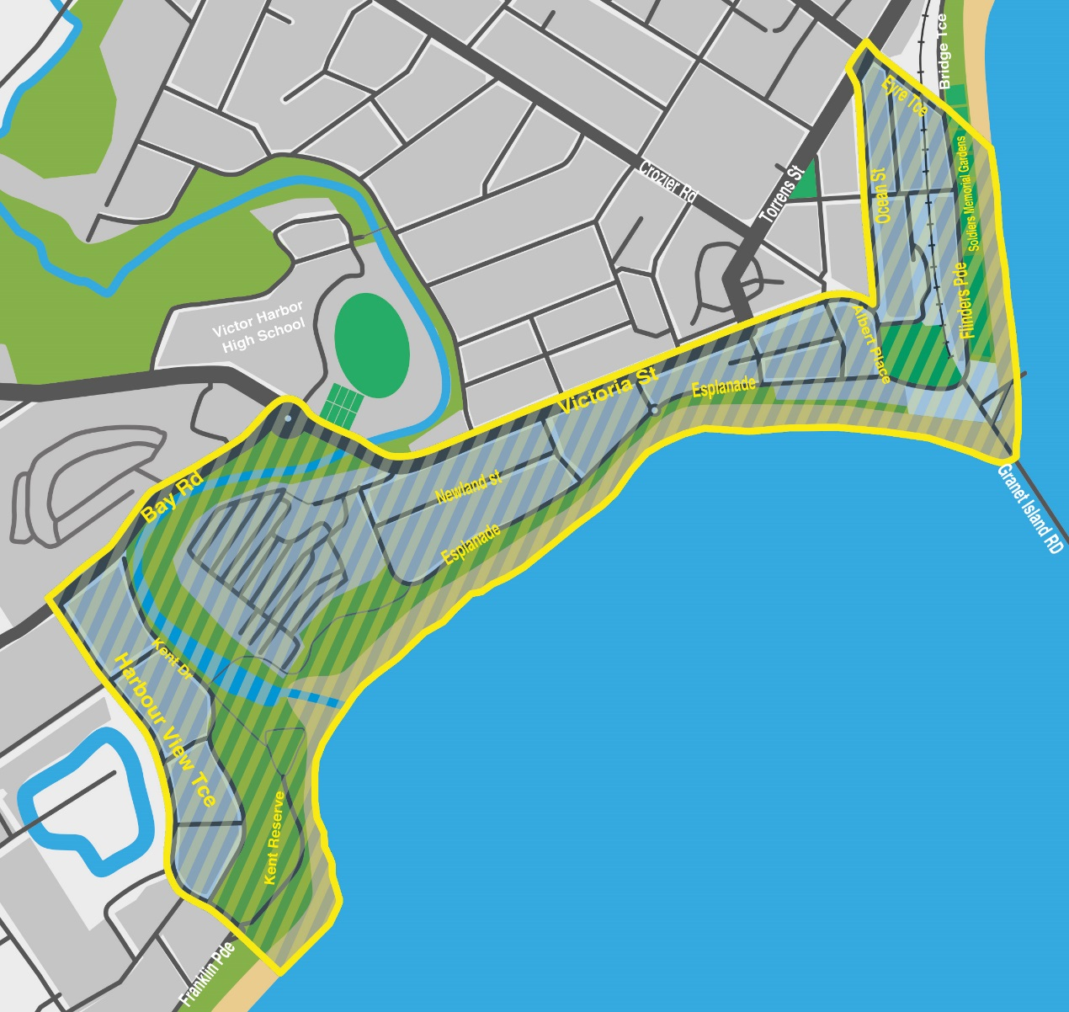

TRAINING AND SKILLS DEVELOPMENT ACT 2008
Part 4 – Apprenticeships/Traineeships
PURSUANT to the provision of the Training and Skills Development Act 2008, the Training and Skills Commission (TaSC) gives notice that determines the following Trades or Declared Vocations in addition to the gazette notices of:
- 25 September 2008 | - 23 October 2008 | - 13 November 2008 | - 4 December 2008
- 18 December 2008 | - 29 January 2009 | - 12 February 2009 | - 5 March 2009
- 12 March 2009 | - 26 March 2009 | - 30 April 2009 | - 18 June 2009
- 25 June 2009 | - 27 August 2009 | - 17 September 2009 | - 24 September 2009
- 9 October 2009 | - 22 October 2009 | - 3 December 2009 | - 17 December 2009
- 4 February 2010 | - 11 February 2010 | - 18 February 2010 | - 18 March 2010
- 8 April 2010 | - 6 May 2010 | - 20 May 2010 | - 3 June 2010
- 17 June 2010 | - 24 June 2010 | - 8 July 2010 | - 9 September 2010
- 23 September 2010 | - 4 November 2010 | - 25 November 2010 | - 16 December 2010
- 23 December 2010 | - 17 March 2011 | - 7 April 2011 | - 21 April 2011
- 19 May 2011 | - 30 June 2011 | - 21 July 2011 | - 8 September 2011
- 10 November 2011 | - 24 November 2011 | - 1 December 2011 | - 8 December 2011
- 16 December 2011 | - 22 December 2011 | - 5 January 2012 | - 19 January 2012
- 1 March 2012 | - 29 March 2012 | - 24 May 2012 | - 31 May 2012
- 7 June 2012 | - 14 June 2012 | - 21 June 2012 | - 28 June 2012
- 5 July 2012 | - 12 July 2012 | - 19 July 2012 | - 2 August 2012
- 9 August 2012 | - 30 August 2012 | - 13 September 2012 | - 4 October 2012
- 18 October 2012 | - 25 October 2012 | - 8 November 2012 | - 29 November 2012
- 13 December 2012 | - 25 January 2013 | - 14 February 2013 | - 21 February 2013
- 28 February 2013 | - 7 March 2013 | - 14 March 2013 | - 21 March 2013
- 28 March 2013 | - 26 April 2013 | - 23 May 2013 | - 30 May 2013
- 13 June 2013 | - 20 June 2013 | - 11 July 2013 | - 1 August 2013
- 8 August 2013 | - 15 August 2013 | - 29 August 2013 | - 6 February 2014
- 12 June 2014 | - 28 August 2014 | - 4 September 2014 | - 16 October 2014
- 23 October 2014 | - 5 February 2015 | - 26 March 2015 | - 16 April 2015
101. 27 May 2015 | 102. 18 June 2015 | 103. 3 December 2015 | 104. 7 April 2016
105. 30 June 2016 | 106. 28 July 2016 | 107. 8 September 2016 | 108. 22 September 2016
109. 27 October 2016 | 110. 1 December 2016 | 111. 15 December 2016 | 112. 7 March 2017
113. 21 March 2017 | 114. 23 May 2017 | 115. 13 June 2017 | 116. 18 July 2017
117. 19 September 2017 | 118. 26 September 2017 | 119. 17 October 2017 | 120. 3 January 2018
121. 23 January 2018 | 122. 14 March 2018 | 123. 14 June 2018 | 124. 5 July 2018
125. 2 August 2018 | 126. 9 August 2018 | 127. 16 August 2018 | 128. 30 August 2018
129. 27 September 2018 | 130. 4 October 2018 | 131. 18 October 2018 | 132. 1 November 2018
133. 15 November 2018 | 134. 22 November 2018
Trades or Declared Vocations and Required Qualifications and Training Contract Conditions for the
Animal Care and Management Package ACM
*Trade/ #Declared Vocation/ Other Occupation | Qualification Code | Qualification Title | Nominal Term of Training Contract | Probationary Period
Farming # | ACM30717 | Certificate III in Horse Breeding | 36 Months | 90 Days

South Australia
Limitation of Actions (Child Abuse) Amendment Act (Commencement) Proclamation 2018
1—Short title
This proclamation may be cited as the Limitation of Actions (Child Abuse) Amendment Act (Commencement) Proclamation 2018.
2—Commencement of Act
The Limitation of Actions (Child Abuse) Amendment Act 2018 (No 14 of 2018) will come into operation on 1 February 2019.
Made by the Governor
with the advice and consent of the Executive Council
on 22 November 2018
AGO0133-18CS

South Australia
National Gas (South Australia) (Capacity Trading and Auctions) Amendment Act (Commencement) Proclamation 2018
1—Short title
This proclamation may be cited as the National Gas (South Australia) (Capacity Trading and Auctions) Amendment Act (Commencement) Proclamation 2018.
2—Commencement
The National Gas (South Australia) (Capacity Trading and Auctions) Amendment Act 2018 (No 23 of 2018) will come into operation on 22 November 2018.
Made by the Governor
with the advice and consent of the Executive Council
on 22 November 2018
MEM18-021CS
South Australia
National Redress Scheme for Institutional Child Sexual Abuse (Commonwealth Powers) Act (Commencement) Proclamation 2018
1—Short title
This proclamation may be cited as the National Redress Scheme for Institutional Child Sexual Abuse (Commonwealth Powers) Act (Commencement) Proclamation 2018.
2—Commencement of Act
The National Redress Scheme for Institutional Child Sexual Abuse (Commonwealth Powers) Act 2018 (No 15 of 2018) will come into operation on 22 November 2018.
Made by the Governor
with the advice and consent of the Executive Council
on 22 November 2018
AGO0134-18CS

South Australia
Administrative Arrangements (Administration of National Redress Scheme for Institutional Child Sexual Abuse (Commonwealth Powers) Act) Proclamation 2018
under section 5 of the Administrative Arrangements Act 1994
1—Short title
This proclamation may be cited as the Administrative Arrangements (Administration of National Redress Scheme for Institutional Child Sexual Abuse (Commonwealth Powers) Act) Proclamation 2018.
2—Commencement
This proclamation comes into operation on the day on which it is made.
3—Administration of Act committed to Attorney-General
The administration of the National Redress Scheme for Institutional Child Sexual Abuse (Commonwealth Powers) Act 2018 is committed to the Attorney-General.
Made by the Governor
with the advice and consent of the Executive Council
on 22 November 2018
AGO0134-18CS
South Australia
National Gas (South Australia) (Capacity Trading and Auctions) Variation Regulations 2018
under the National Gas (South Australia) Act 2008

Contents
Part 1—Preliminary
1 Short title
2 Commencement
3 Variation provisions
Part 2—Variation of National Gas (South Australia) Regulations
4 Insertion of regulation 5A
5A Definition of designated compression service facility
5 Variation of regulation 10—Maximum civil monetary liabilities
6 Insertion of regulation 18
18 Deferral of capacity auctions for Northern Territory facilities
7 Insertion of Schedule 2A
Schedule 2A—Designated compression service facilities
8 Variation of Schedule 3—Civil penalties
9 Variation of Schedule 4—Conduct provisions

Part 1—Preliminary
1—Short title
These regulations may be cited as the National Gas (South Australia) (Capacity Trading and Auctions) Variation Regulations 2018.
2—Commencement
These regulations will come into operation on the day on which the National Gas (South Australia) (Capacity Trading and Auctions) Amendment Act 2018 comes into operation.
3—Variation provisions
In these regulations, a provision under a heading referring to the variation of specified regulations varies the regulations so specified.
Part 2—Variation of National Gas (South Australia) Regulations
4—Insertion of regulation 5A
After regulation 5 insert:
5A—Definition of designated compression service facility
For the purposes of the definition of designated compression service facility in section 2 of the NGL, a facility described in Schedule 2A is prescribed as a designated compression service facility.
5—Variation of regulation 10—Maximum civil monetary liabilities
(1) Regulation 10(1)—after "sections 91FED," insert:
91FEH,
(2) Regulation 10(1)—after paragraph (db) insert:
(dc) the maximum amount of each person’s civil monetary liability with respect to giving capacity auction information to AEMO in its capacity as the operator of a capacity auction to each person who suffers loss as a result of a relevant event is, in respect of that event, $400 000;
(dd) however, if the amount of a person’s civil monetary liability with respect to giving capacity auction information to AEMO in respect of that event (as affected, if at all, by paragraph (dc)) exceeds the prescribed amount in respect of the relevant event, the maximum amount of the person’s civil monetary liability to a person in respect of that event is the prescribed amount;
(3) Regulation 10(1)(e)—delete “(a) to (db)” and insert:
“(a) to (dd)”
(4) Regulation 10(2)—after "Bulletin Board information" wherever occurring insert:
or capacity auction information
(5) Regulation 10(3), definition of “prescribed amount”—after paragraph (c) insert:
(d) in relation to a person who gives capacity auction information to AEMO—the amount obtained by deducting from $20 million the aggregate of the amounts already paid by the person in discharge of the person’s civil monetary liabilities to persons suffering losses as a result of relevant events occurring during the same prescribed 12 month period as that in which the relevant event occurred;
(6) Regulation 10(3), definition of “relevant event”, (a)—after subparagraph (iia) insert:
(iib) AEMO’s capacity auction functions;
(7) Regulation 10(3), definition of “relevant event”—after paragraph (ba) insert:
(bb) in relation to a person who gives capacity auction information to AEMO—a negligent act or omission, or a series of negligent acts or omissions, in giving capacity auction information to AEMO;
6—Insertion of regulation 18
After regulation 17 insert:
18—Deferral of capacity auctions for Northern Territory facilities
(1) This regulation applies to NT transportation facilities, other than any transportation facility (or part of a transportation facility) located wholly or partly in the Northern Territory that is declared by the Northern Territory Minister by notice in the Northern Territory Government Gazette to be an NT transportation facility to which this regulation does not apply.
(2) Until the expiration day—
(a) transportation capacity for use of a transportation service provided by means of an NT transportation facility to which this regulation applies must not be made available for purchase through a capacity auction; and
(b) section 91BRQ(1) of the NGL does not require a person to comply with the Capacity Transfer and Auction Procedures relating to the conduct and operation of a capacity auction to the extent the capacity auction is making available for purchase transportation capacity provided by means of an NT transportation facility to which this regulation applies; and
(c) section 91FEE(1) of the NGL does not apply to a person of the kind specified in that subsection in respect of capacity auction information relating to an NT transportation facility to which this regulation applies; and
(d) the refusal by a transportation service provider to offer a transportation service for use of an NT transportation facility to which this regulation applies through a capacity auction is not, for the purposes of section 228K(1) of the NGL, engaging in conduct for the purpose of preventing or hindering access; and
(e) the refusal by a transportation service provider to offer a transportation service for use of an NT transportation facility to which this regulation applies through a capacity auction is not, for the purposes of section 228L(1) of the NGL, engaging in price discrimination; and
(f) a standard OTSA for an NT transportation facility to which this regulation applies is not required to include auction services provided by means of the NT transportation facility.
(3) The MCE is to determine the day that is the expiration day for the purposes of this regulation.
(4) The MCE is to make the determination on a day that is after the fifth anniversary of the day on which the Capacity Trading and Auction amendments commence.
(5) The MCE is to cause notice of the expiration day to be published on AEMO’s website and in the South Australian Government Gazette.
(6) This regulation expires on the expiration day.
(7) This regulation has effect despite any provision of the NGL, these regulations, the National Gas Rules, the Capacity Transfer and Auction Procedures or the Operational Transportation Services Code.
(8) In this regulation—
auction service means a transportation service provided by means of transportation capacity that has been bought in a capacity auction;
Capacity Trading and Auction amendments means the amendments made to the NGL by the National Gas (South Australia) (Capacity Trading and Auctions) Amendment Act 2018;
expiration day is the day determined under subregulation (3);
NT transportation facility means a transportation facility (or part of a transportation facility) located wholly or partly in the Northern Territory.
7—Insertion of Schedule 2A
After Schedule 2 insert:
Schedule 2A—Designated compression service facilities
In this Schedule—
CGP means the transmission pipeline between Ballera in South West Queensland and Mount Isa in Queensland;
QSN Link means the section of the gas transmission pipeline between Ballera in Queensland and Moomba in South Australia known as the QSN Link;
SWQP means the gas transmission pipeline between Wallumbilla in South East Queensland and Moomba in South Australia, including the section between Wallumbilla and Ballera in Queensland and the section known as the QSN Link between Ballera and Moomba.

Location of prescribed facility | Description of prescribed facility
Ballera, Queensland | Facilities for compressing natural gas and related and incidental pipework, plant and equipment located at the Ballera gas centre, situated at Ballera in Queensland at the Ballera end of the CGP.
Iona, Victoria | Facilities for compressing natural gas and related and incidental pipework, plant and equipment located at the Iona Gas Processing Plant situated at Waarre in Victoria.
Moomba, South Australia | Facilities for compressing natural gas and related and incidental pipework, plant and equipment located at the QSN Link compound, situated at Moomba in South Australia at the Moomba end of the QSN Link section of the SWQP.
Wallumbilla, Queensland | Facilities for compressing natural gas and related and incidental pipework, plant and equipment located at the Wallumbilla compound situated at Wallumbilla in Queensland at the Wallumbilla end of the SWQP (other than facilities for compressing natural gas located on Lot 33 on Survey Plan 212840 in the area of Maranoa, title reference 50904738).
8—Variation of Schedule 3—Civil penalties
(1) Schedule 3—after the heading to Schedule 3 insert:
Provisions of the Act
Section 83C
Section 91BRQ(5)
Section 91BRR(1)
Section 91FEE
Section 223A
Section 228B
Section 228C
Section 228K
Section 228L
(2) Schedule 3—after the heading "Provisions of the Rules" insert in numerical order:
Rule 158A(1)
Rule 158A(2)
Rule 158B(1)
Rule 158B(2)
Rule 158B(5)
Rule 543A(1)—(2)
Rule 593(4)
Rule 611(10)
Rule 612(2)
Rule 621(3)
Rule 621(4)
Rule 634(3)
Rule 634(4)
Rule 634(5)
Rule 636(1)
Rule 636(4)
Rule 638(1)
Rule 638(3)
Rule 639(2)
Rule 639(5)
Rule 640(1)
Rule 644(2)
Rule 644(3)
Rule 649(1)
Rule 649(2)
Rule 650(2)
Rule 650(3)
Rule 655(3)
Rule 660(2)
Rule 661(1)
Rule 661(2)
Rule 661(3)
Rule 662(1)
Rule 662(2)
Rule 662(3)
Rule 663(1)—(3)
Rule 665(1)
Rule 665(6)
Rule 666(1)—(2)
Rule 666(4)
Rule 672(4)
Rule 674(1)
Schedule 5, Part 3, rule 4(4)
Schedule 5, Part 3, rule 5(2)
Schedule 5, Part 3, rule 9(1)
Schedule 5, Part 4, rule 4(5)
Schedule 5, Part 4, rule 5(2)
Schedule 5, Part 4, rule 5(4)
Schedule 5, Part 4, rule 6(1)—(2)
Schedule 5, Part 5, rule 3(1)
Schedule 5, Part 5, rule 3(2)
Schedule 5, Part 5, rule 3(3)
9—Variation of Schedule 4—Conduct provisions
(1) Schedule 4—after the heading to Schedule 4 insert:
Provisions of the Act
Section 228C
Section 228J
Section 228K
Section 228L
(2) Schedule 4—after the heading "Provisions of the Rules" insert in numerical order:
Rule 543A(1)—(2)
Rule 593(4)
Rule 634(3)
Rule 634(4)
Rule 634(5)
Rule 636(1)
Rule 636(4)
Rule 638(1)
Rule 638(3)
Rule 639(2)
Rule 639(5)
Rule 640(1)
Rule 641(1)
Rule 641(2)
Rule 643(5)
Rule 643(6)
Rule 643(9)
Rule 644(2)
Rule 644(3)
Rule 649(1)
Rule 650(2)
Rule 650(3)
Rule 655(3)
Rule 661(1)
Rule 661(2)
Rule 661(3)
Rule 662(1)
Rule 662(2)
Rule 662(3)
Rule 672(4)
Rule 674(1)
Schedule 5, Part 3, rule 9(1)
Made by the Governor
on the unanimous recommendation of the Ministers of the participating jurisdictions and with the advice and consent of the Executive Council
on 22 November 2018
No 226 of 2018
MEM18-021CS

CITY OF ONKAPARINGA
Declaration of Public Road
NOTICE is hereby given pursuant to Section 208(4) of the Local Government Act 1999 that Council, at its meeting held on 6 November 2018, declared the private roads comprising Allotments 7 and 8 in Deposited Plan 7917 contained in Certificate of Title Volume 5558 Folio 348 as Public Road.
Dated: 6 November 2018
M. Dowd
Chief Executive Officer

[Republished]
On 15 November 2018, the fourth notice published on page 3973 of the South Australian Government Gazette referenced the incorrect section of the Liquor Licensing Act 1997. The notice should be replaced with the following:
City of Port Adelaide Enfield
Short Term Dry Area-Semaphore Road
Notice is hereby given that the City of Port Adelaide Enfield pursuant to 131(1ab) of the Liquor Licensing Act 1997 that Council declares Short Term Dry Areas on the following dates and times.
- From 12 noon on 31 December 2018 to 12 noon on 1 January 2019
- From 12 noon on 26 January 2019 to 12 noon on 27 January 2019
- Pursuant to section 131 of the Act, the consumption and possession of liquor in the area described in the Schedule is prohibited in accordance with the provisions of the Schedule.
- The prohibition has effect during the periods specified in the Schedule.
- The prohibition does not extend to private land in the area described in the Schedule.
- Unless the contrary intention appears, the prohibition of the possession of liquor in the area does not extend to-
- A person who is genuinely passing through the areas if-
- The liquor is in the original container in which it was purchased from licensed premises; and
- The container has not been opened; or
- A person who has possession of the liquor in the course of carrying on a business or in the course of his or her employment by another person in the course of carrying on a business; or
- A person who is permanently or temporarily residing at premises within the area or on the boundary of the area and who enters the area solely for the purpose of passing through it to enter those premises or who enters the area from those premises for the purpose of leaving the area.
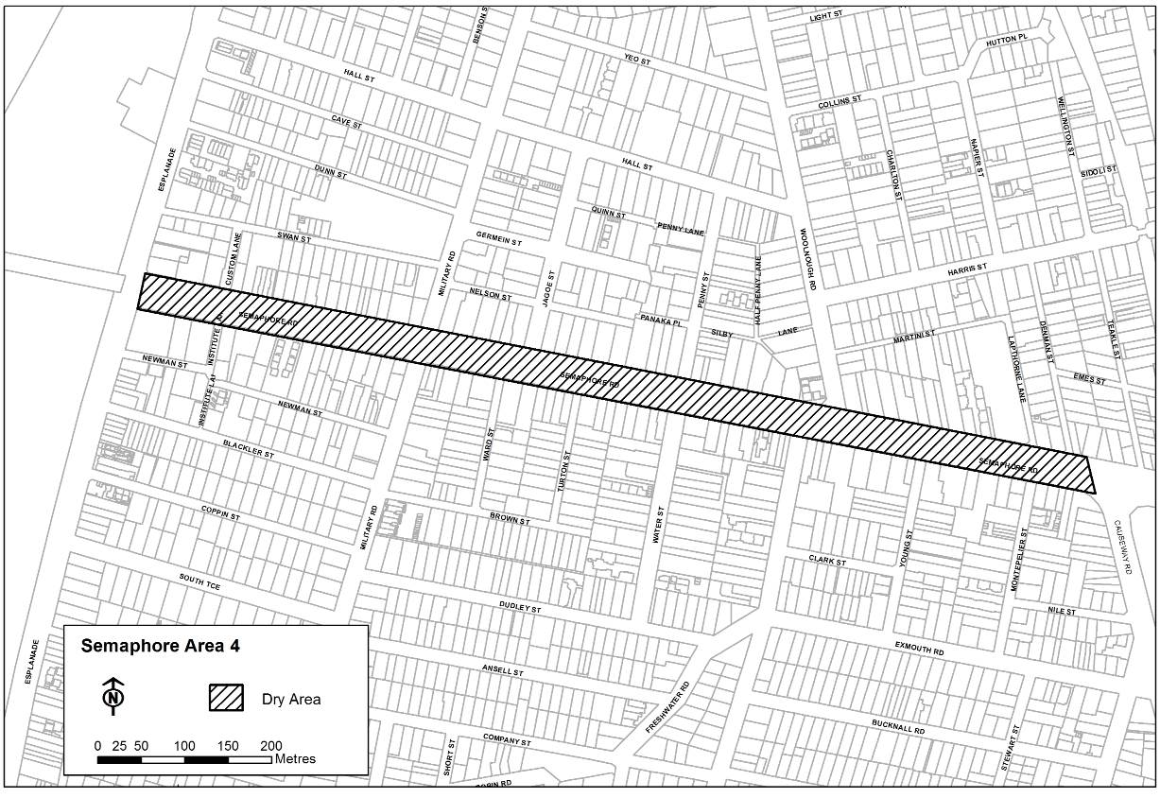
Description of area: The area in Semaphore and Exeter comprising Semaphore Road between the eastern boundary of the Esplanade and the prolongation in a straight line of the marked centre line of Causeway Road.
Mark Withers
Chief Executive Officer

Renmark Paringa Council
Roads (Opening and Closing) Act 1991
Road Closure - Public Roads, Mundic Creek
NOTICE is hereby given, pursuant to section 10 of the Roads (Opening and Closing) Act 1991, that the Renmark Paringa Council proposes to make a Road Process Order to close the Public Roads adjoining Sections 77, 273, 274, 275, 276 & 323 in the Hundred of Paringa, shown more particularly delineated and lettered ‘A’, ‘B’, ‘C’, ‘D’, ‘E’, ‘F’ & ‘G’ on the Preliminary Plan No. 18/0053.
Closed Road ‘A’ is to be merged with adjoining Section 323.
Closed Road ‘B’ & ‘E’ are to be merged with adjoining Section 77.
Closed Road ‘C’ is to be merged with adjoining Section 274.
Closed Road ‘D’ is to be merged with adjoining Section 275.
Closed Road ‘F’ is to be merged with adjoining Section 273.
Closed Road ‘G’ is to be merged with adjoining Section 276.
A copy of the plan and a statement of persons affected are available for public inspection at the offices of the Renmark Paringa Council, 61 Eighteenth Street, Renmark and the Adelaide office of the Surveyor-General during normal office hours.
Any application for easement or objection must set out the full name, address and details of the submission and must be fully supported by reasons.
The application for easement or objection must be made in writing to the Council at Renmark Paringa Council, PO Box 730, Renmark, 5341 WITHIN 28 DAYS OF THIS NOTICE and a copy must be forwarded to the Surveyor-General at GPO Box 1354, Adelaide 5001. Where a submission is made, the Council will give notification of a meeting at which the matter will be considered.
Dated: 22 November 2018
Tony Siviour
Chief Executive Officer

SCHEDULE OF AERONAUTICAL CHARGES
Adelaide Airport Ltd (“AAL”)
The prices shown in this schedule are inclusive of GST. Effective 17 February 2019.
Service | Charge Base (see note i)
Service | Charge per Passenger |  | Passenger Charge Applies to (see Charge Rules) |  | Charge per  1,000 kg MTOW (pro-rata)
International RPT Services
Landing Charges | $14.77 |  | (1)
Passenger Facility Charge (“PFC”) - see note iv | $9.38 |  | (1)
Government Mandated Charges | $8.31 |  | (3)
Government Mandated Charges for international transit passengers | $2.25 |  | (5)
Domestic RPT Services (Aircraft weighing more than 20,000 kg MTOW)
Landing Charges | $5.33 |  | (2) |  | $18.92
Passenger Facility Charge (“PFC”) - see note iv | $6.76 |  | (2)
Government Mandated Charges | $5.03 |  | (4)
Regional RPT Services (Aircraft weighing less than 20,000 kg MTOW)
Landing Charges |  | $3.12 |  | (2) |  | $8.89
Passenger Facility Charge (“PFC”) - see note iv |  | $1.62 |  | (2)
Government Mandated Charges |  | $5.03 |  | (4)
Landing Charges for Diversions
International RPT services |  |  |  |  |  | $12.04
Domestic RPT services |  |  |  |  |  | $8.93
General Aviation (minimum charges apply, see note ii)
Freight aircraft |  |  |  |  |  | $8.16
Fixed wing aircraft not operating RPT services |  |  |  |  |  | $8.16
Rotary wing aircraft and unpowered aircraft |  |  |  |  |  | $4.09
Aircraft Parking Charges
General aviation aircraft parked longer than two hours in designated general aviation parking areas and aircraft will incur a charge of $17.79 per day or any part of a day.
Code “B” or greater - the charges for parking of Aircraft in the category of Code "B" or greater is by arrangement with AAL from time to time.
Definitions
- Government Mandated Services means those services which AAL provides to RPT Operators and other users of the Airport which are mandated by the Commonwealth Government (in applicable legislation and ministerial or Commonwealth Department directions) or other lawful authority and includes (but are not limited to) the following services:
  - Terminal passenger checked bag screening; and
  - Terminal passenger screening; and
  - airside inspections; and
  - other services required by the Commonwealth Government or other lawful authority.
- Infant means children less than 2 years old, not occupying a seat.
- Landing Charge means the amount from time to time charged by AAL to an aircraft operator in respect of the use by an aircraft of AAL’s runways, taxiways and aprons. The Landing Charge is a single charge made on each arrival (landing) of an aircraft.
- MTOW means maximum take-off weight as specified by the manufacturer.
- Passenger Facility Charge (“PFC”) means the amount from time to time charged by AAL to an RPT Operator in respect of its Passengers using a Terminal for the purpose of recovering costs relating to the Terminals.
- RPT (Regular Public Transport) Operation means an operation of an Aircraft for the purposes of the carriage of people, or both people and goods, of an air service that:
  - is provided for a fee payable by persons using the service; and
  - is conducted in accordance with fixed schedules to or from fixed terminals over specific routes; and
  - is available to the general public on a regular basis.
Per Passenger Charge Rules
- Applies to all arriving and departing passengers and excludes transit passengers, infants and positioning crew.
- Applies to all arriving, departing and transit passengers and excludes infants and positioning crew.
- Applies to departing passengers only and excludes infants and positioning crew.
- Applies to departing passengers and departing transit passengers and excludes infants and positioning crew.
- Applies to all transit passengers excluding infants arriving from a port outside Australia.
Notes
- Charge Base An Aircraft Operator may elect, by agreement with AAL, and entirely at AAL’s discretion, to incur Aeronautical Charges on a MTOW or Passenger basis, which basis is then fixed for the ensuing twelve (12) month period.
- Minimum charge: a minimum charge applies to all General Aviation customers as follows:
  - Fixed Wing Aircraft $47.72 per landing
  - Rotary Wing Aircraft $23.84 per landing
- AAL has a growth incentive scheme which provides discount on the landing charges indicated above for airlines which exceed a target growth rate for the year. Details of this scheme are available to airlines on request.
- The PFC will be adjusted annually by the increase in the Consumer Price Index (All Groups Weighted Average of Eight Capital Cities) on the anniversary date of the commencement of charging for the PFC (17 February 2006). The PFC will be reviewed every five years; the next review date is 17 February 2021.
Adelaide Airport Limited
ABN 78 075 176 653
1 James Schofield Drive, Adelaide Airport SA 5950
www.adelaideairport.com.au

Trustee Act 1936
Public Trustee
Estates of Deceased Persons
In the matter of the estates of the undermentioned deceased persons:
ANDERSEN Erik late of 14 Lancelot Drive Daw Park Computer Programmer who died 23 August 2018
BEAUCHAMP Christine Phoebe late of 50 Gulfview Road Christies Beach of no occupation who died 8 August 2018
CARROLL Joan Patricia late of 1 Fulton Street Gilles Plains Home Duties who died 23 July 2018
DOUGLASS Peter Noel late of 12 Grenache Avenue Berri Mechanical Serviceman who died 21 May 2018
WILLIS Graham late of 17 Breage Street Risdon Park Retired Plant Operator who died 6 April 2017
WILSON Beryl Dorothy late of 18 Trafford Street Angle Park Home Duties who died 20 July 2018
Notice is hereby given pursuant to the Trustee Act 1936, the Inheritance (Family Provision) Act 1972 and the Family Relationships Act 1975 that all creditors, beneficiaries, and other persons having claims against the said estates are required to send, in writing, to the office of Public Trustee at GPO Box 1338, Adelaide, 5001, full particulars and proof of such claims, on or before the 21 December 2018 otherwise they will be excluded from the distribution of the said estate; and notice is also hereby given that all persons indebted to the said estates are required to pay the amount of their debts to the Public Trustee or proceedings will be taken for the recovery thereof; and all persons having any property belonging to the said estates are forthwith to deliver same to the Public Trustee.
Dated: 22 November 2018
N S Rantanen
Acting Public Trustee

Notice Submission

Notices for publication must be submitted before 4 p.m. Tuesday, the week of intended gazettal.
Proofs of formatted content are supplied for all notice submissions. Alterations must be returned before 4 p.m. Wednesday.
The SA Government Gazette is compiled and published each Thursday. Requests to withdraw submitted notices must be received before 10 a.m. on the day of publication.

Gazette notices should be emailed as Word files—and signed PDF files if applicable—
in the following format:
- Title (name of the governing legislation/department/organisation)
- Subtitle (description of notice)
- A structured body of text
- Date of authorisation
- Name, position, and department/organisation of the authorising person

Please provide the following information in your email:
- Date of intended gazettal
- Details that may impact on publication of the notice
- Email address and phone number of the person authorising the submission
- Name of the person and organisation to be charged for the notice, if applicable
- Request for a quote, if required
- Purchase order, if required

Email: governmentgazettesa@sa.gov.au
Phone: (08) 8207 1025
Website: www.governmentgazette.sa.gov.au

Printed and published weekly by authority of S. Rodrigues, Government Printer, South Australia
$7.50 per issue (plus postage), $378.15 per annual subscription—GST inclusive
Online publications: www.governmentgazette.sa.gov.au

