
No. 59 3739
SUPPLEMENTARY GAZETTE
THE SOUTH AUSTRALIAN
GOVERNMENT GAZETTE
Published by Authority

Adelaide, Friday, 5 October 2018

Contents

Rules of Court
Magistrates Court (Civil) Rules 2013—
(Amendment 22) 3740
Magistrates Court Rules 1992—
(Amendment 68) 3753

RULES OF COURT
Magistrates Court of South Australia
Amendment 22 to the Magistrates Court (Civil) Rules 2013
PURSUANT to section 49 of the Magistrates Court Act 1991 and all other enabling powers, we, the undersigned, do hereby make the following amendments to the Magistrates Court (Civil) Rules 2013 as amended.
- These Rules may be cited as the ‘Magistrates Court (Civil) Rules 2013 (Amendment 22)’.
- The Magistrates Court (Civil) Rules 2013 (‘the Rules’) as amended by these amendments apply to and govern all actions commenced in the civil division of the Court on and after the date on which these amendments are gazetted.
- Rule 24(1)(c) is amended to delete the word ‘pretrial’.
- Rule 37(1) is amended to delete:
Marriage Act 1961 (Cth) Form as approved by the Attorney General (Cth)
and replace it with:
Marriage Act 1961 (Cth) Form 7
- Rule 37(2) is amended to delete ‘An application’ and replace it with ‘Any application’.
- The following is inserted after rule 37(2):
(3) An application pursuant to section 56B of the Criminal Assets Confiscation Act 2005 must also annex all certificates of record required to show that a person is a prescribed drug offender.
(4) An application pursuant to section 219 of the Criminal Assets Confiscation Act 2005 must also annex draft minutes of order.
- Rule 37(3) is renumbered Rule 37(5).
- Rule 37(4) is renumbered Rule 37(6).
- Rule 37(5) is renumbered Rule 37(7).
- Rule 37(6) is renumbered Rule 37(8).
- Rule 37(7) is renumbered Rule 37(9).
- Rule 37(8) is renumbered Rule 37(10).
- Rule 37(9) is renumbered Rule 37(11).
- Rule 37(10) is renumbered Rule 37(12).
- Rule 37(11) is renumbered Rule 37(13).
- The following is inserted after Rule 37(13):
(14) An application pursuant to sections 12 or 16 of the Marriage Act 1961 (Cth) must comply with the requirements of part 2 of the Marriage Regulations 2017 (Cth).
- Rule 51 is amended to delete ‘Division 3 of the Supreme Court Civil Rules 2006’ and replace it with ‘with the rules in the Supreme Court Civil Rules 2006 that deal with service under that convention’.
- Form 2 is deleted and replaced with Form 2.
- Form 3 is deleted and replaced with Form 3.
- Form 3G is deleted and replaced with Form 3G.
- Form 9A is deleted and replaced with Form 9A.
- Form 51 is deleted and replaced with Form 51.
- Form 53 is deleted and replaced with Form 53.
Dated: 27 September 2018
Mary-Louise Hribal
Chief Magistrate
Brett Jonathon Dixon
Magistrate
Gregory Charles Fisher
Magistrate
Simon Hugh Milazzo
Magistrate

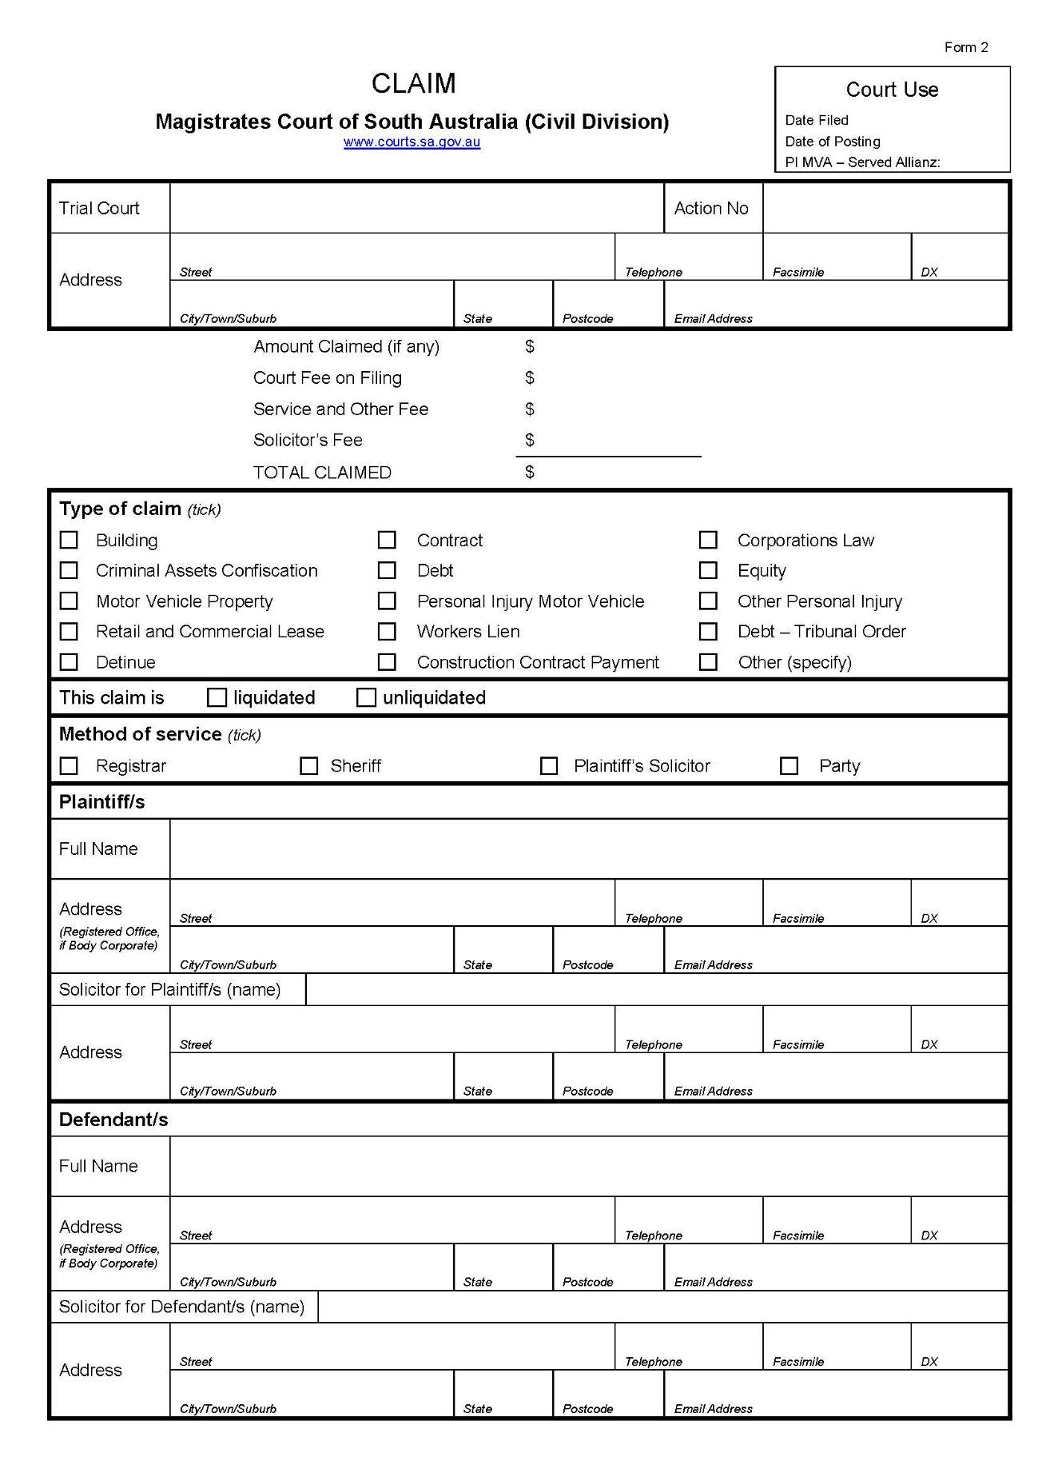
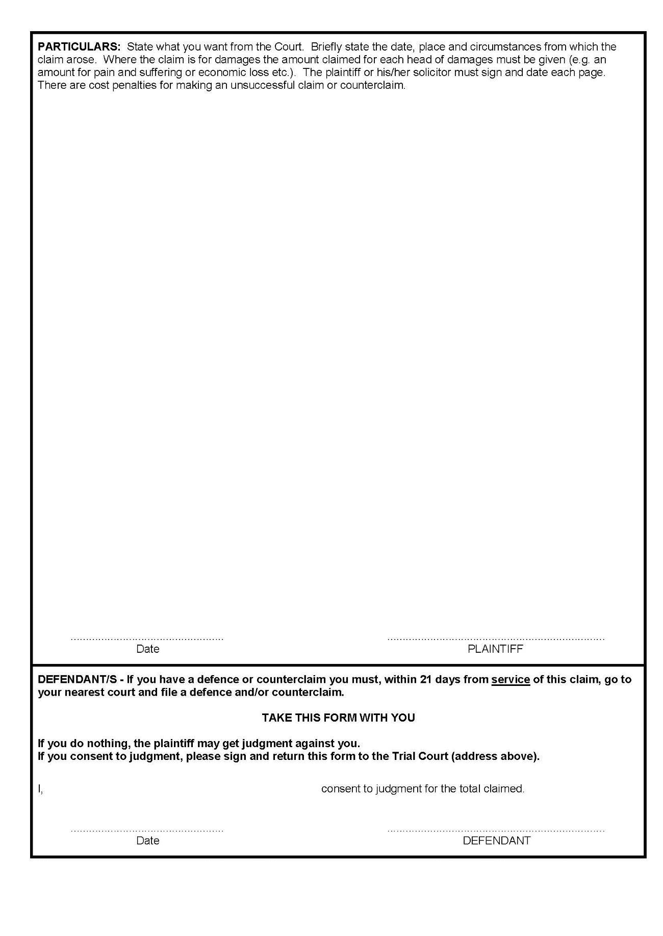
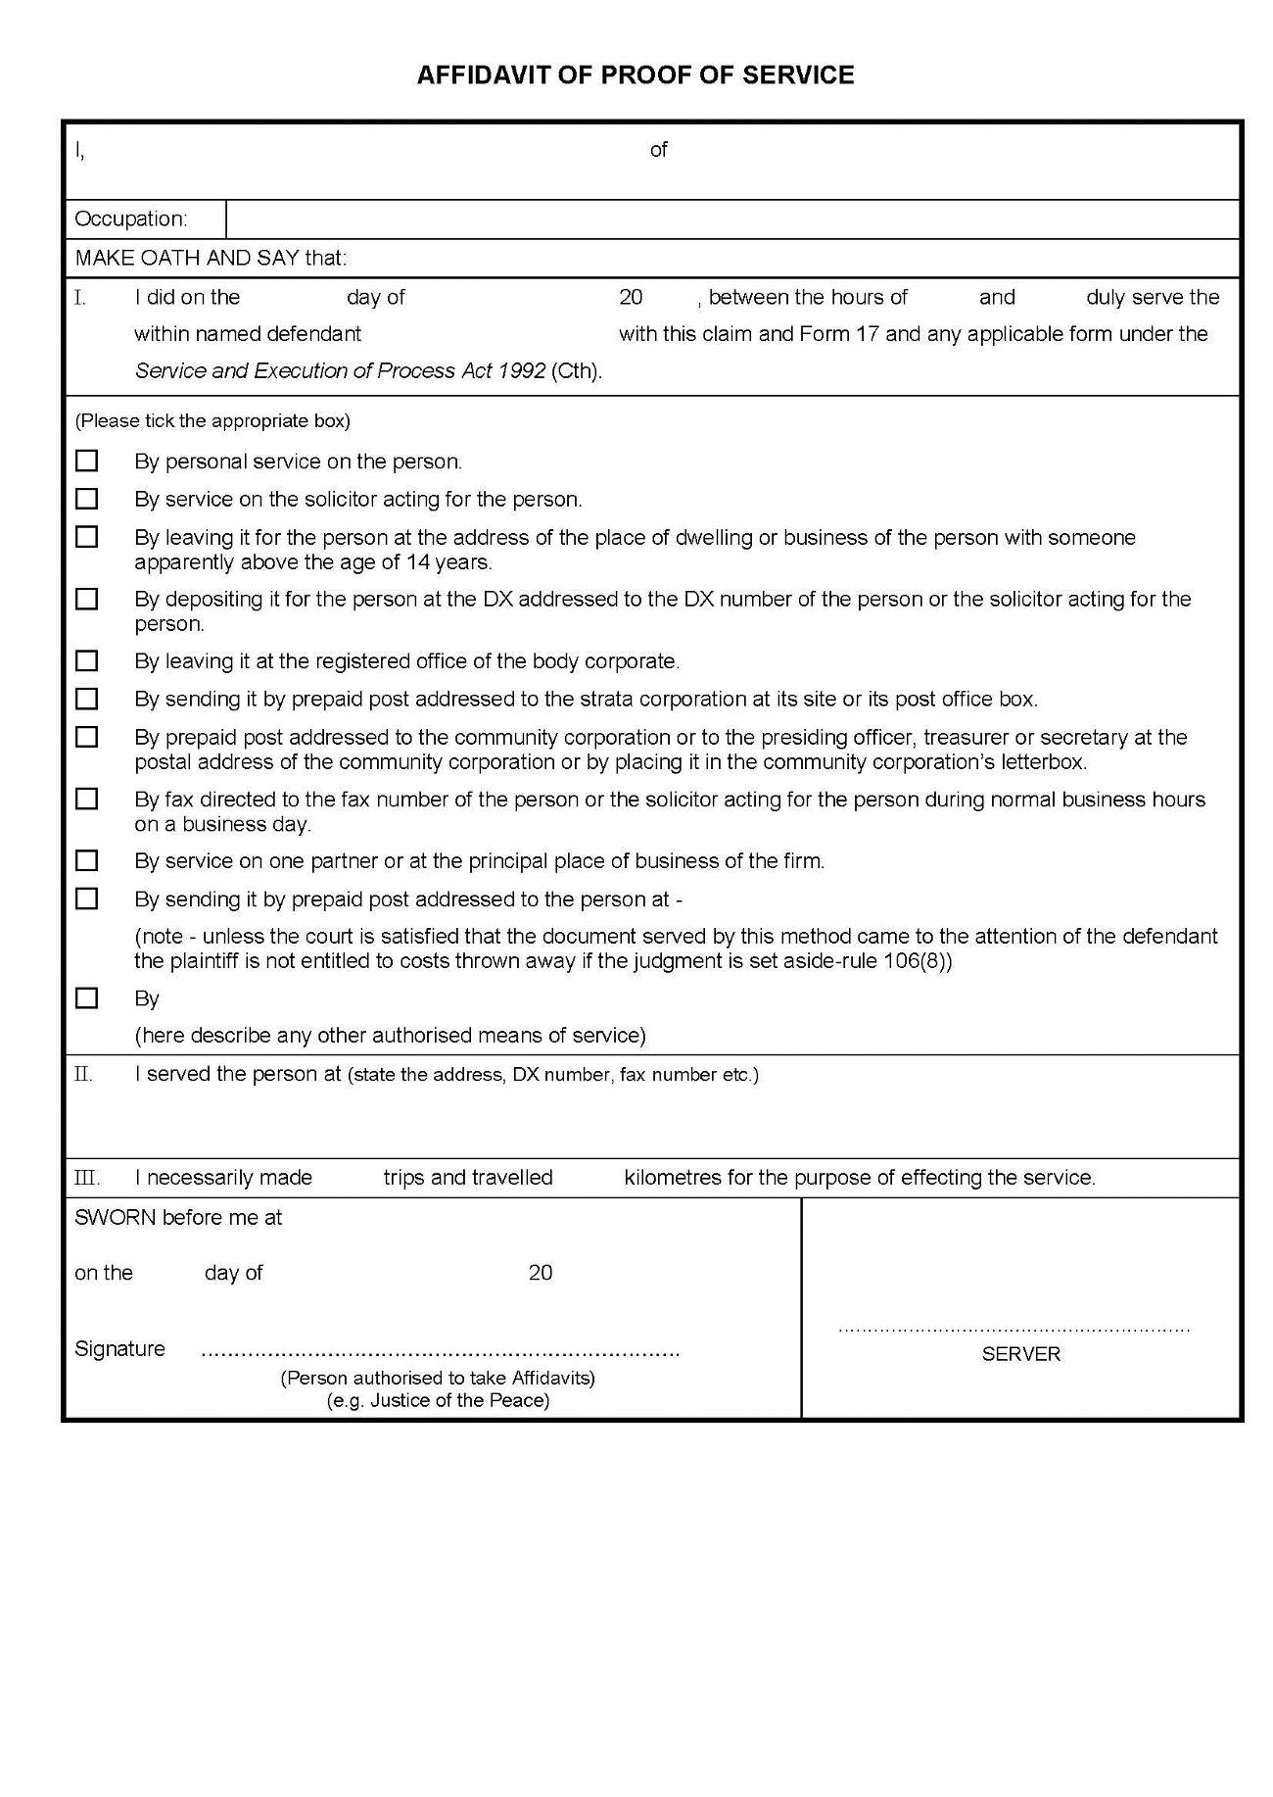
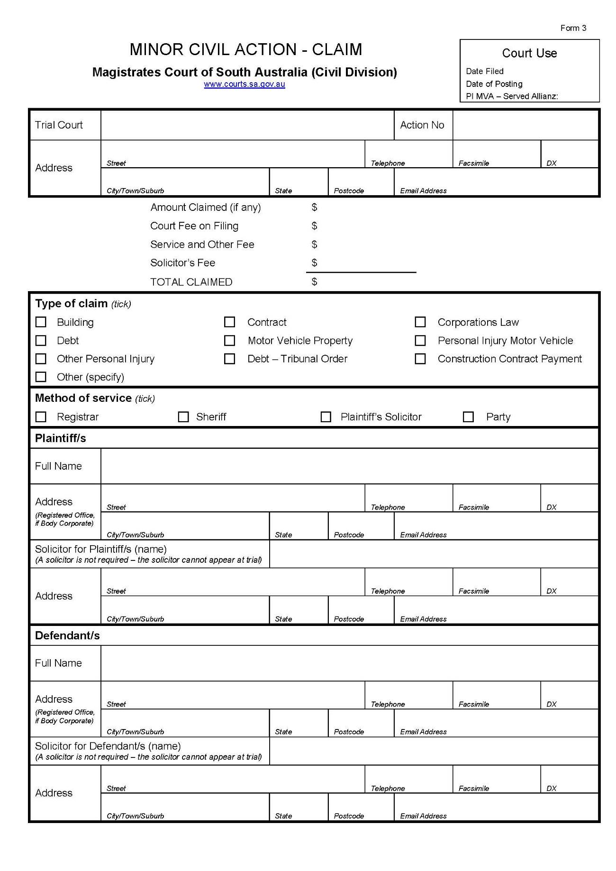
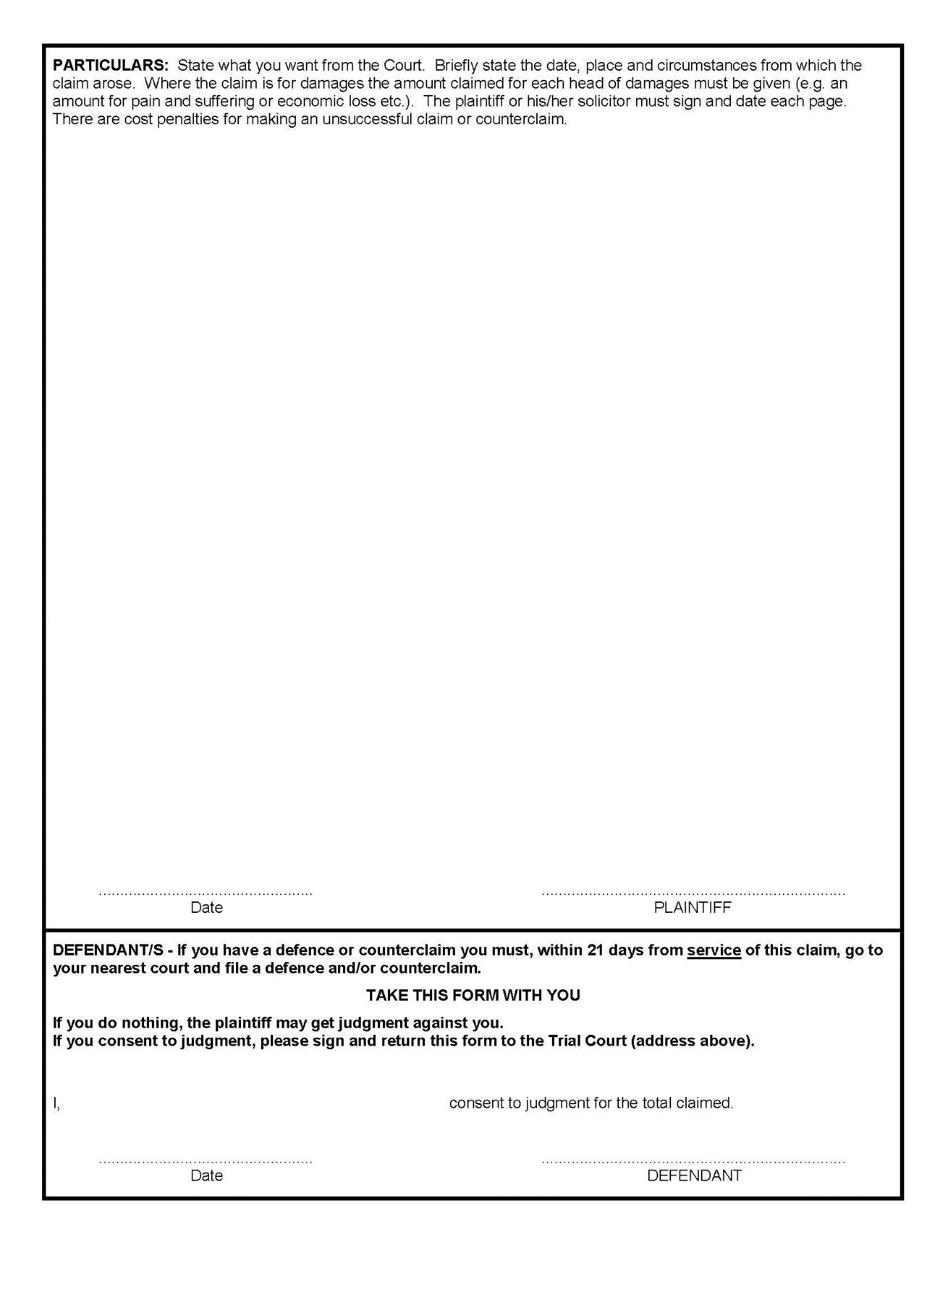
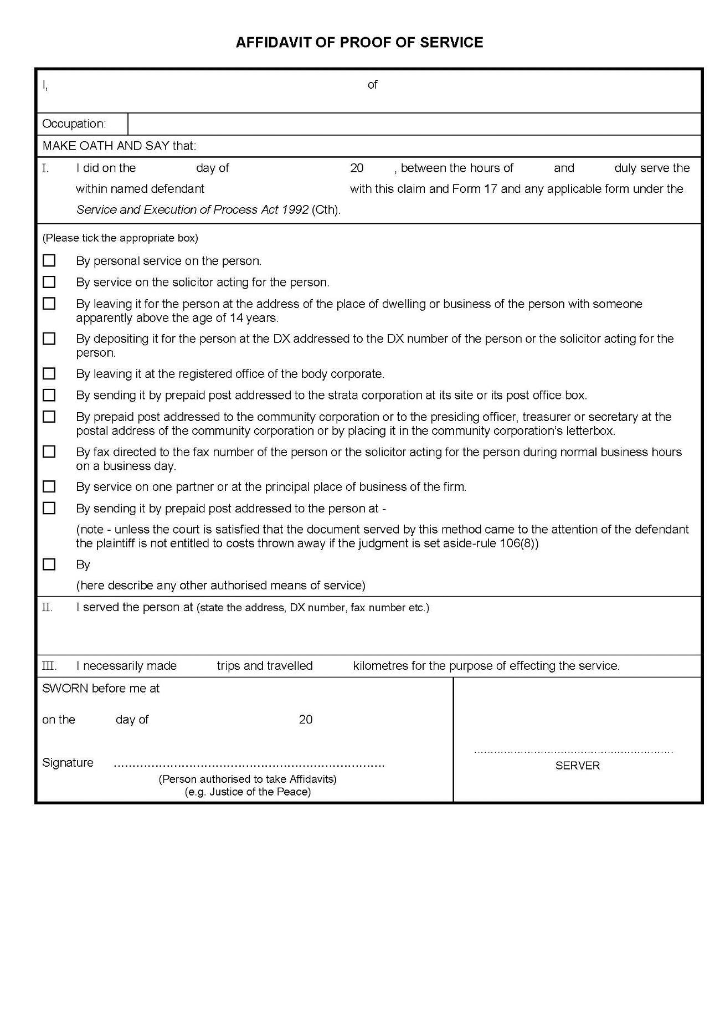
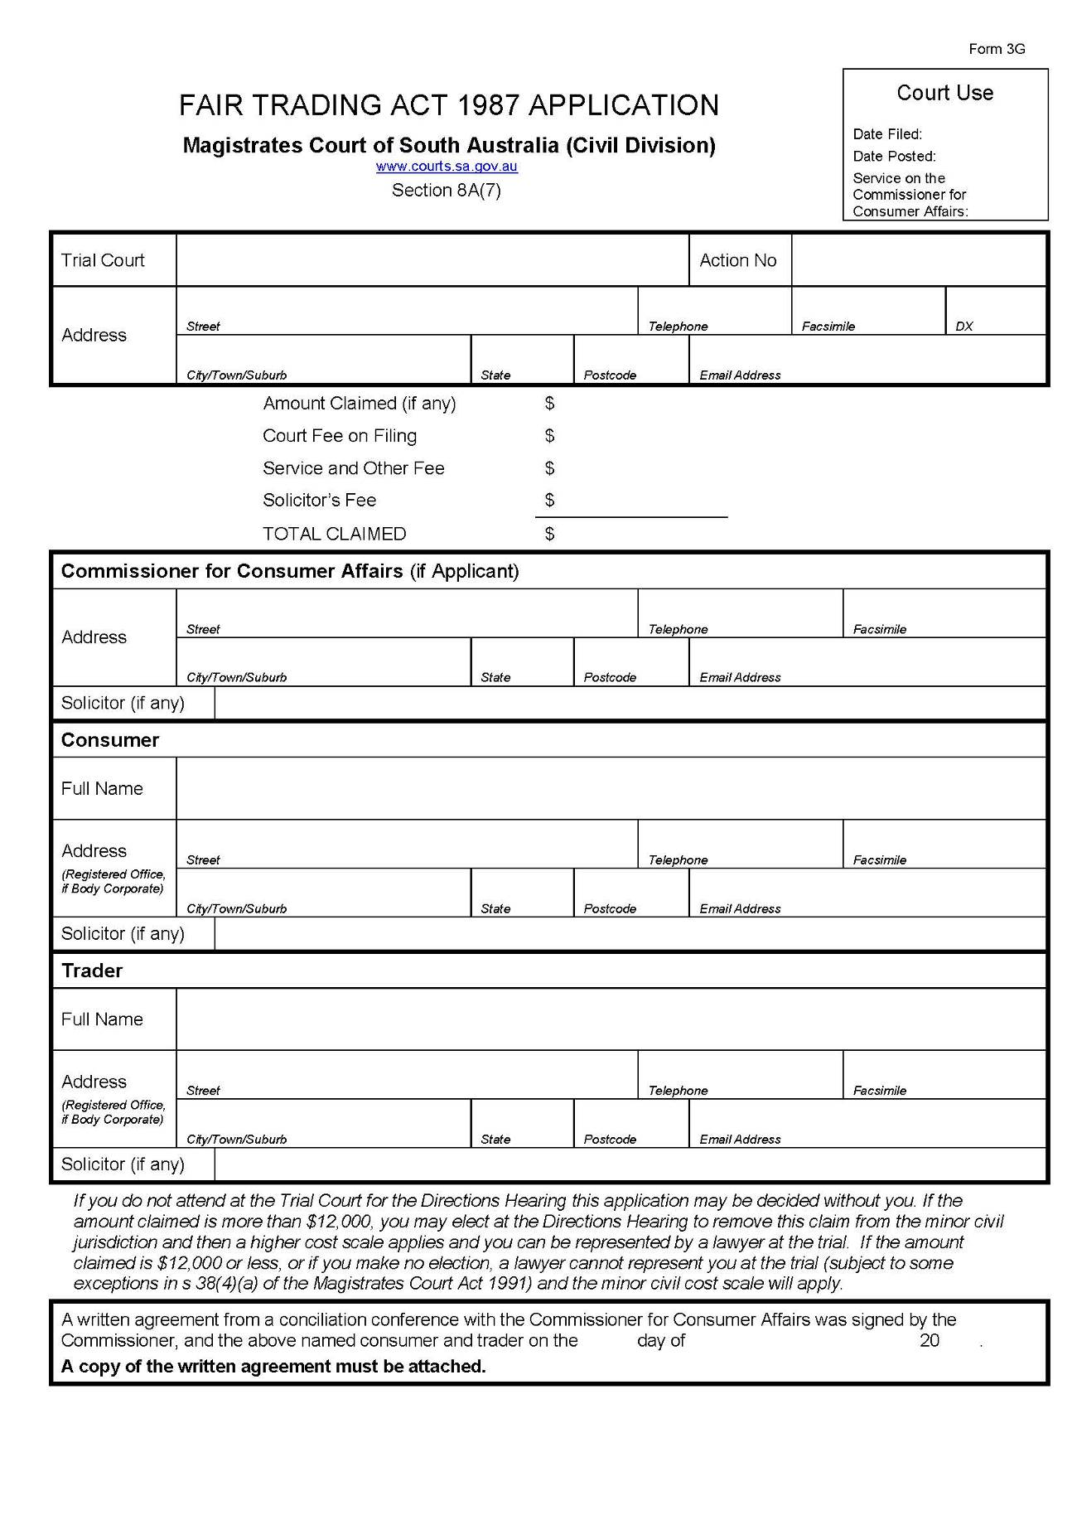

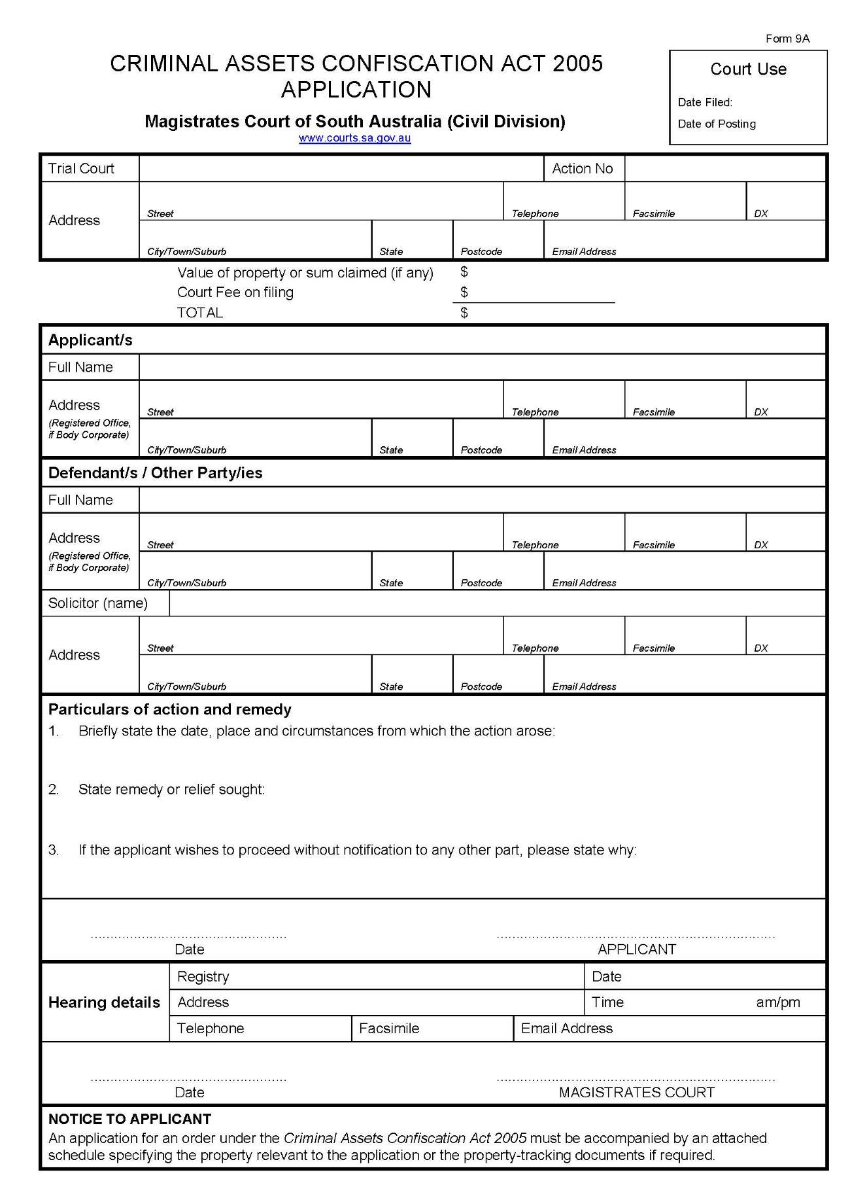
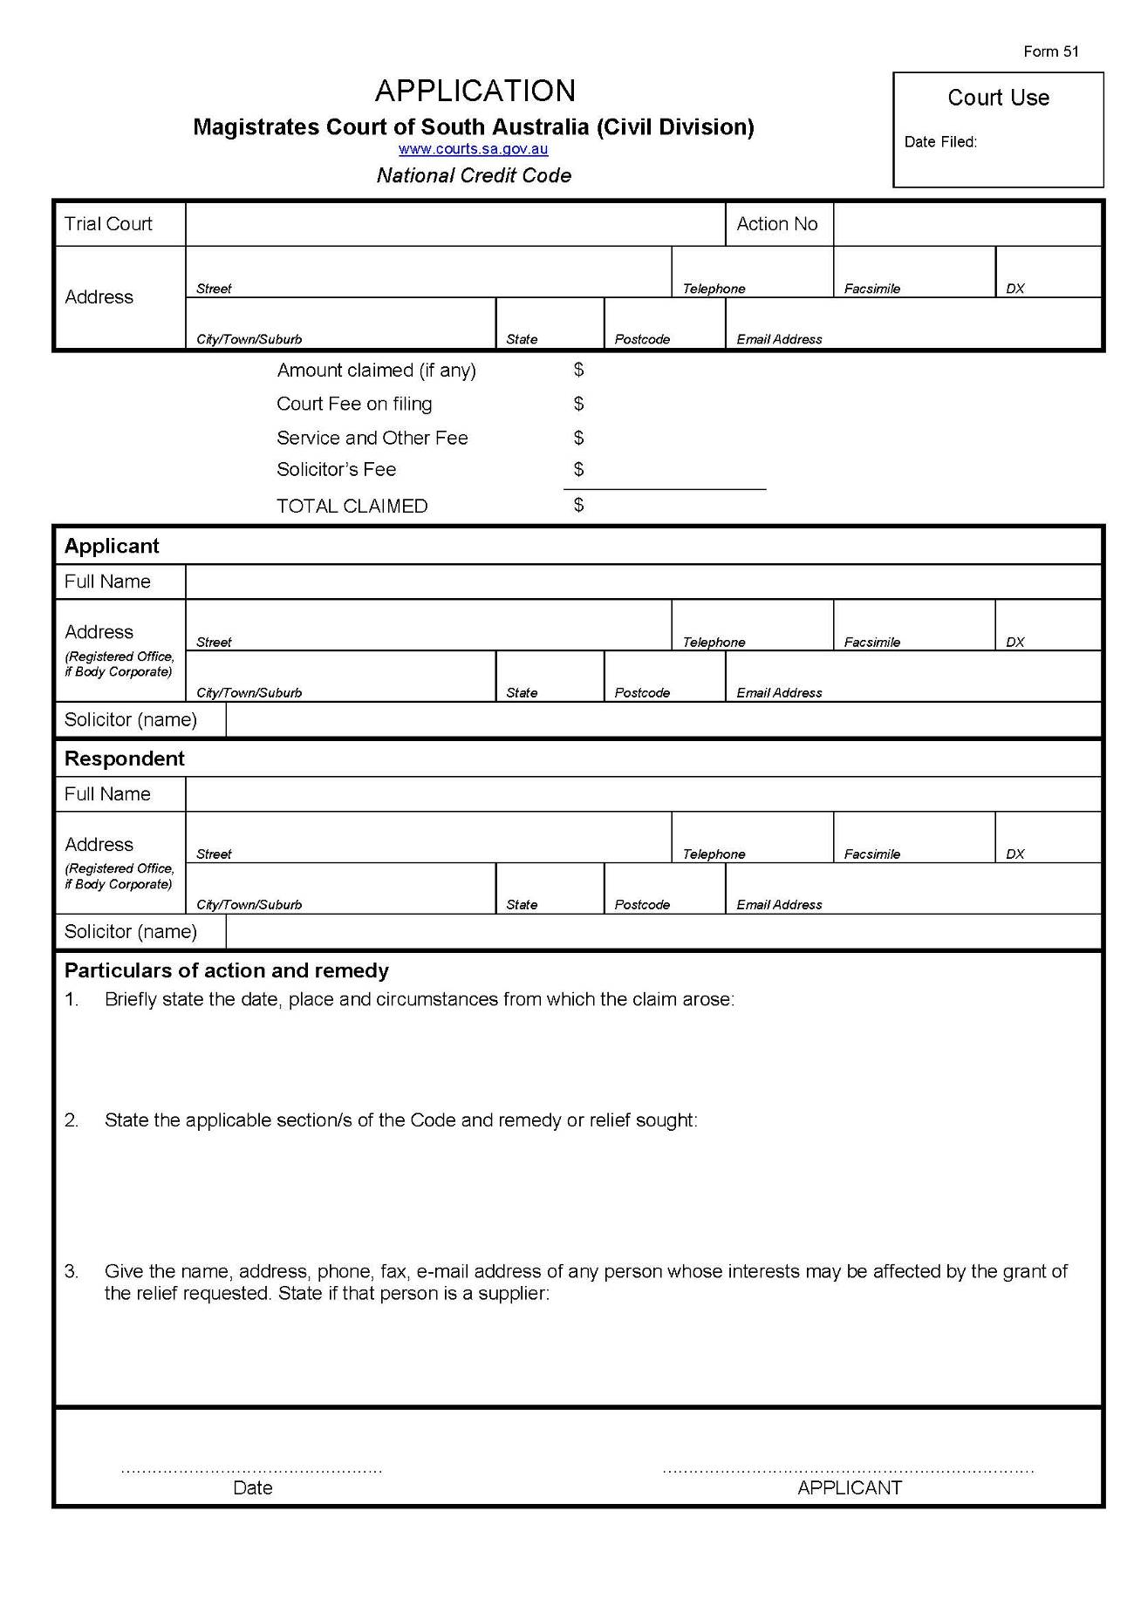
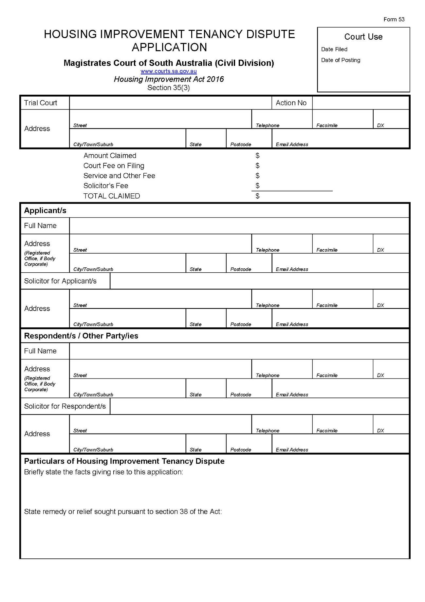
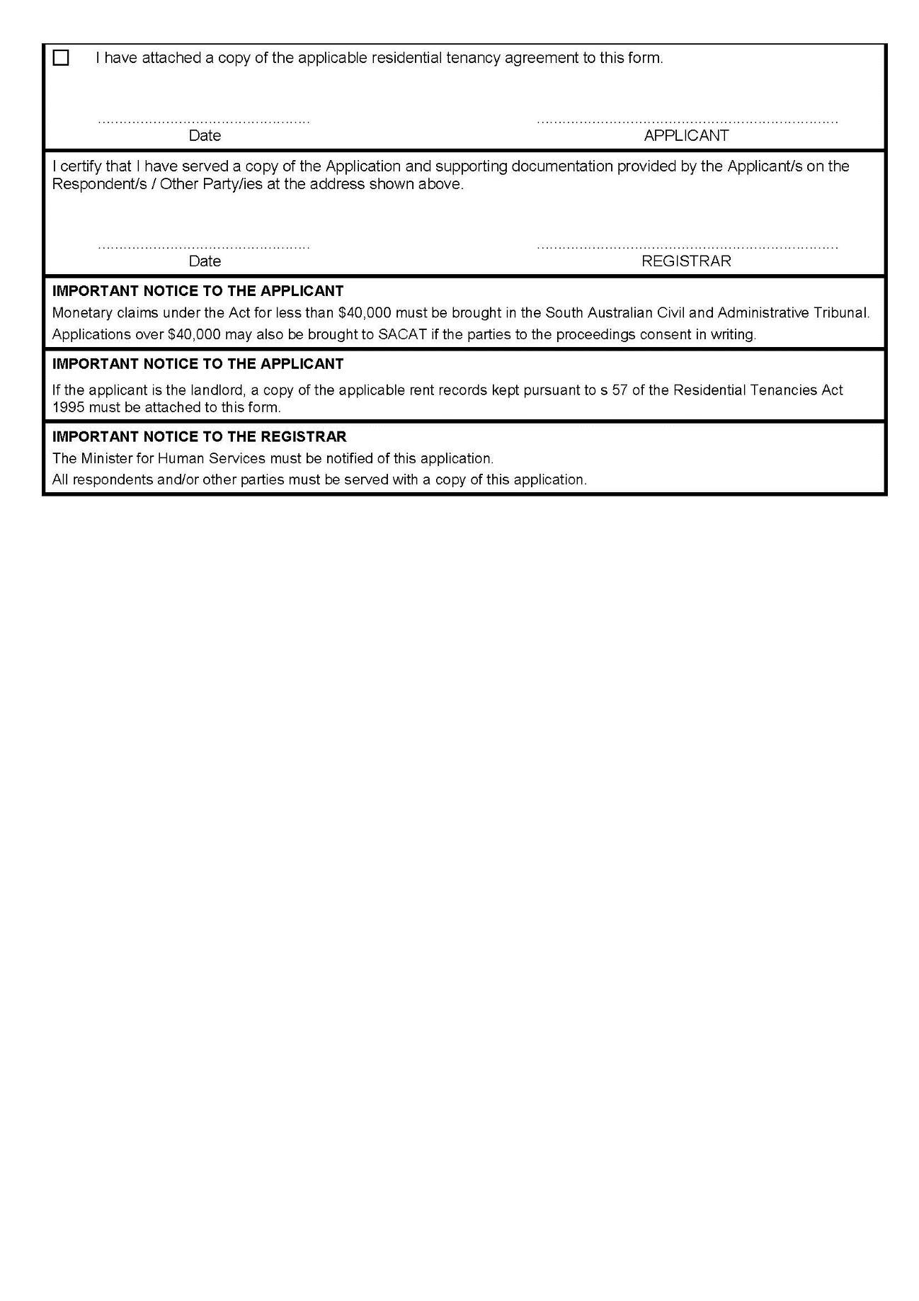

RULES OF COURT
Magistrates Court of South Australia
Amendment 68 to the Magistrates Court Rules 1992
PURSUANT to section 49 of the Magistrates Court Act 1991 and all other enabling powers, we, the undersigned, do hereby make the following amendments to the Magistrates Court Rules 1992 as amended.
- These Rules may be cited as the ‘Magistrates Court Rules 1992 (Amendment 68)’.
- The Magistrates Court Rules 1992 (‘the Rules’) as amended by these amendments apply to and govern all actions commenced in the criminal division of the Court on and after the date on which these amendments are gazetted.
- The following is inserted after rule 27.01:
27A.00 POLICE ISSUED SUMMONSES
27A.01 A summons to a defendant to attend the Magistrates Court in relation to a summary offence may be issued by a member of SA Police acting in the execution of his or her duty.
27A.02 A summons issued by a member of SA Police must be in triplicate and comply with Form 4A. The summons must be completed by the issuing member of SA Police. The copies of the summons must be distributed as follows:
- one copy must be retained by SA Police; and
- one copy must be personally served on the defendant; and
- one copy must be filed in the Court no later than 10 working days prior to the hearing date on the summons.
27A.03 An information complying with rule 12 relating to the offence(s) listed in the summons and a Certificate of Service must be filed at the same time as the copy of the summons in the Court.
27A.04 The hearing date and location on the summons will be selected by SA Police from a set of dates and locations that have been provided by the Registrar to SA Police. The hearing date selected will be no less than 1 month and no more than 3 months from the date of issue of the summons.
27A.05 Any summons purportedly issued with a hearing date and location that has not been provided by the Registrar will be void and of no effect.
27A.06 The number of summonses issued by SA Police bearing the same hearing date and location must not be more than 20.
- Rule 41.08 is amended to delete ‘Minister for Correctional Services’ and replace it with ‘Minister for Police, Emergency Services and Correctional Services’.
- The following is inserted after rule 47.06:
47.07 The issuing authority or Chief Recovery Officer is not required to attend the hearing if the applicant has not applied for a review of the enforcement determination with the Chief Recovery Officer pursuant to section 22 of the Fines Enforcement and Debt Recovery Act 2017 on the grounds specified in section 22(10)(b) or 22(10)(c) of the Fines Enforcement and Debt Recovery Act 2017.
47.08 If the issuing authority or Chief Recovery Officer does not attend the hearing pursuant to rule 47.07, it must file an affidavit complying with Form 115 outlining the reasons for its non-attendance.
- Rule 47.07 is renumbered Rule 47.09.
- Rule 61.04 is amended to delete ‘Minister for Children’s Protection’ and replace it with ‘Minister for Child Protection’.
- Rule 61.05 is amended to delete ‘Minister for Disabilities’ and replace it with ‘Minister for Human Services’.
- Rules 63 and 64 are renumbered to appear as follows:
63.00 RECORDING EVENTS IN COURT
63.01 Subject to this rule and to any contrary direction of the Court, the making of a record of persons, things, or events in court is not permitted.
63.02 Rule 63.01 does not apply to Courts Administration Authority staff acting in the course of their office or employment.
63.03 Despite rule 63.01:
(a) a party to a proceeding which is being heard by the Court, a legal practitioner, law clerk, student or a bona fide member of the media may make a handwritten or electronic note of persons, things or events in court; and
(b) a bona fide member of the media may make an audio recording of proceedings for the sole purpose of verifying notes and for no other purpose.
63.03a A party to proceedings must seek leave of the Court prior to using an electronic device.
63.04 Any record made in court permitted by this rule must:
(a) be made in a manner which does not interfere with court decorum, not be inconsistent with court functions, not impede the administration of justice, and not interfere with the proceedings;
(b) not interfere with the Court’s sound system or other technology; and
(c) not generate sound or require speaking into a device.
63.05 Any audio recording made by a member of the media under rule 63.03(b):
(a) must not record any private conversation occurring in court;
(b) must not be made available to any other person or used for any other purpose; and
(c) must be erased entirely within 48 hours of the recording.
63.06 For the purpose of this Rule, ‘record’ means a record by any means whatsoever, including by handwriting, other physical means, audio and/or visual recording or electronic record.
63.07 For the purpose of this Rule, ‘electronic note’ means a text based note.
64.00 ELECTRONIC COMMUNICATIONS IN COURT
64.01 Subject to this rule and to any contrary direction of the Court, communication by means of an electronic device to and from a court room during the conduct of proceedings is not permitted.
64.02 Rule 64.01 does not apply to Courts Administration Authority staff acting in the course of their office or employment.
64.03 Despite rule 64.01 and subject to rules 64.04 and 64.05, a party to a proceeding which is being heard by the Court, a legal practitioner or a bona fide member of the media may communicate by means of an electronic device to and from a court room during the conduct of proceedings.
64.04 Any electronic communication permitted by this rule must:
(a) be made in a manner which does not interfere with court decorum, not be inconsistent with court functions, not impede the administration of justice, and not interfere with the proceedings;
(b) not interfere with the Court’s sound system or other technology; and
(c) not generate sound or require speaking into a device.
64.05 A communication of evidence adduced or a submission made in proceedings, whether in full or in part, must not be made until at least 15 minutes have elapsed since the evidence or submission in question, or until the Court has ruled on any application for suppression or objection made in relation to the evidence or submission within that period of 15 minutes, whichever occurs last.
64.06 For the purpose of this rule, ‘electronic device’ means any device capable of transmitting and/or receiving information, audio, video or other matter (including, cellular phones, computers, personal digital assistants, digital or analogue audio and/or visual cameras or similar devices).
- The following is inserted after rule 76:
77.00 CRIMINAL ASSETS CONFISCATION ACT 2005
77.01 An application pursuant to s 59A of the Criminal Assets Confiscation Act 2005 shall comply with Form 23.
77.02 An affidavit complying with Form 115 must be filed with the application.
77.03 A copy of the Declaration of the Deemed Forfeiture Order obtained by the Director of Public Prosecutions must also be filed with the application, if available.
77.04 Where practicable, the application will be listed before the Criminal Magistrate who imposed the conviction for the conviction offence.
77.05 If the Director of Public Prosecutions wishes to contest the application, it must file and serve on the applicant a copy of the Declaration of the Deemed Forfeiture Order, if it has not already been filed by the applicant.
- Form 4A is inserted.
- Form 9 is deleted and replaced with Form 9.
- Form 55 is deleted and replaced with Form 55.
- Form 62 is deleted and replaced with Form 62.
- Form 73 is deleted and replaced with Form 73.
- Form 110 is deleted and replaced with Form 110.
- Form 123 is deleted and replaced with Form 123.
- Form S15 is deleted and replaced with Form S15.
Dated: 27 September 2018
Mary-Louise Hribal
Chief Magistrate
Brett Jonathon Dixon
Magistrate
Gregory Charles Fisher
Magistrate
Simon Hugh Milazzo
Magistrate

