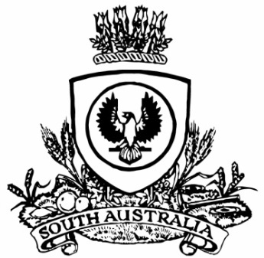
No. 38 2931
SUPPLEMENTARY GAZETTE
THE SOUTH AUSTRALIAN
GOVERNMENT GAZETTE
Published by Authority

Adelaide, Friday, 2 August 2019

Department of the Premier and Cabinet
Adelaide, 2 August 2019
His Excellency the Governor in Executive Council has removed Ester Huxtable, Wayne Thomas Hanson and Mary Patetsos as Directors of the Adelaide Cemeteries Authority Board, effective from 2 August 2019 - pursuant to section 13 of the Adelaide Cemeteries Authority Act 2001.
By command,
David Gregory Pisoni
for Premier
MPL19/014CS

Department of the Premier and Cabinet
Adelaide, 2 August 2019
His Excellency the Governor in Executive Council has been pleased to appoint the undermentioned to the Adelaide Cemeteries Authority Board, pursuant to the provisions of the Adelaide Cemeteries Authority Act 2001:
Director: from 2 August 2019 until 1 August 2023
Tristan Ashley Just
Joanna Louise Andrew
Johnathon Peter Matthews
Kimberley Willits
Luisa Greco
Chair: from 2 August 2019 until 1 August 2023
Tristan Ashley Just
By command,
David Gregory Pisoni
for Premier
MPL19/014CS

