
THE SOUTH AUSTRALIAN
GOVERNMENT GAZETTE
Published by Authority

Adelaide, Thursday, 8 August 2019

Contents

Acts Assented To 2934
Administrative Arrangements Act 1994—Notice 2934
Appointments, Resignations, Etc. 2934
Aquaculture Act 2001—Notice 2934
Corporations and District Councils—Notices 2954
Development Act 1993—Notices 2935
Environment Protection Act 1993—Notice 2935
Harbors and Navigation Act 1993—Notice 2938
Housing Improvement Act 2016—Notices 2939
Justices of the Peace Act 2005—Notice 2939
Mental Health Act 2009—Notices 2940
Mining Act 1971—Notice 2940
National Electricity Law—Notice 2954
National Parks and Wildlife (National Parks)
Regulations 2016—Notice 2940
Natural Resources Management Act 2004—Notice 2940
Notice to Mariners—Notices 2941
Petroleum and Geothermal Energy Act 2000—
Notices 2941
Proclamation 2948
Roads (Opening and Closing) Act 1991—Notices 2942
Rules of Court
Magistrates Court Rules 1992—(Amendment 76) 2949
Service SA Price List—Notice 2943
Survey Act 1992—Notice 2943
Training and Skills Development Act 2008—Notice 2946
Trustee Act 1936—Administration of Estates 2955

Department of the Premier and Cabinet
Adelaide, 8 August 2019
His Excellency the Governor directs it to be notified for general information that he has in the name and on behalf of Her Majesty The Queen, this day assented to the undermentioned Acts passed by the Legislative Council and House of Assembly in Parliament assembled, viz.:
No. 18 of 2019—Director of Public Prosecutions (Pension Entitlements) Amendment Act 2019
An Act to amend the Director of Public Prosecutions Act 1991
No. 19 of 2019—Education and Children’s Services Act 2019
An Act to provide for preschool, primary and secondary education in this State, to provide for children’s services, to constitute the teaching service in this State and for other purposes
No. 20 of 2019—Fire and Emergency Services (Volunteer Charters) Amendment Act 2019
An Act to amend the Fire and Emergency Services Act 2005
By command,
Vickie Ann Chapman
For Premier

Department of the Premier and Cabinet
Adelaide, 8 August 2019
His Excellency the Governor in Executive Council has been pleased to appoint Professor Brenda Wilson as Governor’s Deputy of South Australia for the period from 6.00pm on Thursday, 8 August 2019 until 4.30pm on Friday, 9 August 2019.
By command,
Vickie Ann Chapman
For Premier

Department of the Premier and Cabinet
Adelaide, 8 August 2019
His Excellency the Governor in Executive Council has been pleased to appoint the Honourable Vickie Ann Chapman, MP, Deputy Premier and Attorney-General to be also Acting Minister for Human Services for the period from 12 August 2019 to 21 August 2019 inclusive, during the absence of the Honourable Jacqueline Michelle Ann Lensink, MLC.
By command,
Vickie Ann Chapman
For Premier
DHSCS19011

Department of the Premier and Cabinet
Adelaide, 8 August 2019
His Excellency the Governor in Executive Council has been pleased to appoint the Honourable Stephen Graham Wade, MLC, Minister for Health and Wellbeing to be also Acting Minister for Human Services for the period from 22 August 2019 to 23 August 2019 inclusive, during the absence of the Honourable Jacqueline Michelle Ann Lensink, MLC.
By command,
Vickie Ann Chapman
For Premier
DHSCS19011

Department of the Premier and Cabinet
Adelaide, 8 August 2019
His Excellency the Governor in Executive Council has been pleased to appoint Elizabeth Christina Olsson to the office of Master of the District Court of South Australia effective from 12 August 2019 - pursuant to Section 12 of the District Court Act 1991.
By command,
Vickie Ann Chapman
For Premier
AGO0099-19CS

ADMINISTRATIVE ARRANGEMENTS ACT 1994
Delegation of Powers and Functions
I, STEPHAN KNOLL, Minister for Planning, pursuant to section 9 of the Administrative Arrangements Act 1994, delegate to the Honourable Robert Ivan Lucas, Treasurer, my powers and functions under sections 25 and 27 of the Development Act 1993, in relation to the Nuriootpa (Sturt Highway Service Centre) Development Plan Amendment proposed by The Barossa Council for the land located on the corner of Belvidere Road and the Sturt Highway, Nuriootpa (including any consequential amendments to the relevant Development Plan to give effect to proposed amendments), as depicted in Zone Map Baro/2 in The Barossa Council Development Plan.
Dated: 6 August 2019
Stephan Knoll
Minister for Planning

AQUACULTURE ACT 2001
Grant of Aquaculture Lease
Pursuant to the provisions of section 22 of the Aquaculture Act 2001, notice is hereby given of the grant of the following leases for the purposes of aquaculture in the waters of Coffin Bay, South Australia:
LA00457
LA00458
Further details are available for the above leases on the Aquaculture Public Register; which can be found at http://www.pir.sa.gov.au/aquaculture/aquaculture_public_register or by contacting Aquaculture Leasing & Licensing on 8226 0900.
Dated: 8 August 2019
Jasmine Pedicini
Leasing & Licensing Officer

DEVELOPMENT ACT 1993
Notice under Section 25(17)
City of Marion Housing Diversity Development Plan Amendment (Part 1)
Preamble
- The Housing Diversity Development Plan Amendment (Part 1) (the Amendment) by the City of Marion has been finalised in accordance with the provisions of the Development Act 1993.
- The Minister for Planning has decided to approve the Amendment.
PURSUANT to section 25 of the Development Act 1993, I –
- approve the Amendment; and
- fix the day on which this notice is published in the Gazette as the day on which the Amendment will come into operation.
Dated: 1 August 2019
Stephan Knoll
Minister for Planning

DEVELOPMENT ACT 1993
Notice under Section 25(17)
Adelaide Hills Council—Local Heritage Public Places Development Plan Amendment
Preamble
- The Local Heritage – Public Places Development Plan Amendment (the Amendment) by the Adelaide Hills Council has been finalised in accordance with the provisions of the Development Act 1993.
- The Minister for Planning has decided to approve the Amendment.
PURSUANT to section 25 of the Development Act 1993, I –
- approve the Amendment; and
- fix the day on which this notice is published in the Gazette as the day on which the Amendment will come into operation.
Dated: 6 August 2019
Stephan Knoll
Minister for Planning

Environment Protection Act 1993
Section 68
Approval of Category B Containers
I, ANDREA KAYE WOODS, Team Leader, Container Deposit Legislation and Delegate of the Environment Protection Authority (‘the Authority’), pursuant to section 68 of the Environment Protection Act, 1993 (SA) (‘the Act’) hereby:
Approval of Category B Containers:
Approve as Category B Containers, subject to the conditions in subclauses 1, 2, 3 and 4 below, each of the classes of containers identified by reference to the following matters described in the first 4 columns of Schedule 1 of this Notice which are sold in South Australia:
(a) the product which each class of containers shall contain;
(b) the size of the containers;
(c) the type of containers;
(d) the name of the holders of these approvals.
1. That containers of the class to which the approval relates must bear the refund marking specified by the Authority for containers of that class. The Authority specifies the following refund markings for Category B containers:
(1) "10c refund at collection depots when sold in SA", or
(2) "10c refund at SA/NT collection depots in State/Territory of purchase", or
(3) "10c refund at collection depots/points in participating state/territory of purchase"
2. The holder of the approval must have in place an effective and appropriate waste management arrangement in relation to containers of that class. For the purpose of this approval notice the company named in column 5 of Schedule 1 of this Notice is the nominated super collector.
3. In the case of an approval in relation to category B containers that the waste management arrangement must require the holder of the approval to provide specified super collectors with a declaration in the form determined by the Authority in relation to each sale of such containers by the holder of the approval as soon as practicable after the sale”;
4. The holder of these approvals must ensure that if a sticker bearing the refund marking has been approved, and is applied to the container, then the sticker must not be placed on any portion of the opening mechanism or in any other place that would require complete or partial removal of the sticker before the contents may be consumed.
Dated: 8 August 2019
Andrea Kaye Woods
Delegate of the Environment Protection Authority

Column 1 | Column 2 | Column 3 | Column 4 | Column 5
Product  Name | Container Size | Container Type | Approval  Holder | Collection Arrangements
4 Pines Keller Door Mango Pineapple NEIPA | 500 ml | Glass | 4 Pines Brewing Company Wholesale Pty Ltd | Marine Stores Ltd
4 Pines Keller Door Red XPA | 500 ml | Glass | 4 Pines Brewing Company Wholesale Pty Ltd | Marine Stores Ltd
Brookvale Union Vodka & Peach Iced Tea | 330 ml | Can - Aluminium | 4 Pines Brewing Company Wholesale Pty Ltd | Marine Stores Ltd
Botanica Living Fresh Beetroot | 250 ml | PET | Botanica Brands Pty Ltd | Statewide Recycling
Botanica Living Fresh Bondi | 250 ml | PET | Botanica Brands Pty Ltd | Statewide Recycling
Botanica Living Fresh Cloudy Apple | 250 ml | PET | Botanica Brands Pty Ltd | Statewide Recycling
Botanica Living Fresh Green | 250 ml | PET | Botanica Brands Pty Ltd | Statewide Recycling
Botanica Living Fresh Lemonade | 250 ml | PET | Botanica Brands Pty Ltd | Statewide Recycling
Botanica Living Fresh Orange | 250 ml | PET | Botanica Brands Pty Ltd | Statewide Recycling
Botanica Living Fresh Watermelon | 250 ml | PET | Botanica Brands Pty Ltd | Statewide Recycling
Brown Brothers King Valley Prosecco | 250 ml | Can - Aluminium | Brown Brothers Milawa Vineyard | Statewide Recycling
Brown Brothers Moscato One | 250 ml | Can - Aluminium | Brown Brothers Milawa Vineyard | Statewide Recycling
Brown Brothers Spritzed Moscato Rose One | 250 ml | Can - Aluminium | Brown Brothers Milawa Vineyard | Statewide Recycling
Jack Daniels Tennessee Whiskey & Ginger Beer | 330 ml | Glass | Brown Forman | Statewide Recycling
Barista Bros Dark Chocolate | 500 ml | PET | Coca Cola Amatil (Aust) Pty Ltd | Statewide Recycling
Coca Cola No Sugar | 500 ml | Can - Aluminium | Coca Cola Amatil (Aust) Pty Ltd | Statewide Recycling
Mother Epic Swell Twisted Apple Flavour | 500 ml | Can - Aluminium | Coca Cola Amatil (Aust) Pty Ltd | Statewide Recycling
Mother Epic Swell Twisted Apple Flavour | 500 ml | Can - Aluminium | Coca Cola Amatil (Aust) Pty Ltd | Statewide Recycling
Powerade ION 4 Four Electrolytes Strawberry & Lemon | 600 ml | PET | Coca Cola Amatil (Aust) Pty Ltd | Statewide Recycling
Coopers Sparkling Ale | 375 ml | Can - Aluminium | Coopers Brewery Limited | Marine Stores Ltd
Coopers XPA | 375 ml | Can - Aluminium | Coopers Brewery Limited | Marine Stores Ltd
Divas Diamond Passion Passionfruit | 330 ml | Glass | Divas Beverages (Wholesale) Pty Ltd | Statewide Recycling
Divas Retro Ruby Raspberry | 330 ml | Glass | Divas Beverages (Wholesale) Pty Ltd | Statewide Recycling
Divas Sapphire Blueberry | 330 ml | Glass | Divas Beverages (Wholesale) Pty Ltd | Statewide Recycling
Balter Lager | 375 ml | Can - Aluminium | Emencee Pty Ltd t/as Balter Brewing | Statewide Recycling
Famous Soda Co Blood Orange Zero Sugar | 330 ml | Glass | Famous Soda Pty Ltd | Marine Stores Ltd
Famous Soda Co Ginger Beer Zero Sugar | 330 ml | Glass | Famous Soda Pty Ltd | Marine Stores Ltd
Famous Soda Co Lemon Zero Sugar | 330 ml | Glass | Famous Soda Pty Ltd | Marine Stores Ltd
Famous Soda Co Pink Lemonade Zero Sugar | 330 ml | Glass | Famous Soda Pty Ltd | Marine Stores Ltd
Feral Draught | 375 ml | Can - Aluminium | Feral Brewing Company Pty Ltd | Statewide Recycling
Forktree Brewing Eclipse Ale Porter | 330 ml | Glass | Forktree Brewing Co Pty Ltd | Statewide Recycling
Tread Softly Prosecco | 250 ml | Can - Aluminium | Fourth Wave Wine Partners Pty Ltd | Statewide Recycling
Aloe Born | 1.5 ml | Glass | Griun Pty Ltd t/as Tong Il Trading | Statewide Recycling
Body Ade Yogurt Drink Peach | 195 ml | PET | Griun Pty Ltd t/as Tong Il Trading | Statewide Recycling
Body Ade Yogurt Drink Plain | 195 ml | PET | Griun Pty Ltd t/as Tong Il Trading | Statewide Recycling
Body Ade Yogurt Drink Strawberry | 195 ml | PET | Griun Pty Ltd t/as Tong Il Trading | Statewide Recycling
Chateul Soorok Lychee | 360 ml | Glass | Griun Pty Ltd t/as Tong Il Trading | Statewide Recycling
Chum Churum Apple | 360 ml | Glass | Griun Pty Ltd t/as Tong Il Trading | Statewide Recycling
Chum Churum Citron | 360 ml | Glass | Griun Pty Ltd t/as Tong Il Trading | Statewide Recycling
Chum Churum Grape | 360 ml | Glass | Griun Pty Ltd t/as Tong Il Trading | Statewide Recycling
Chum Churum Orginal Flavour Rice Wine | 360 ml | Glass | Griun Pty Ltd t/as Tong Il Trading | Statewide Recycling
Chum Churum Peach | 360 ml | Glass | Griun Pty Ltd t/as Tong Il Trading | Statewide Recycling
Chum Churum Strawberry | 360 ml | Glass | Griun Pty Ltd t/as Tong Il Trading | Statewide Recycling
Chum Churum Yogurt | 360 ml | Glass | Griun Pty Ltd t/as Tong Il Trading | Statewide Recycling
Good Day | 360 ml | Glass | Griun Pty Ltd t/as Tong Il Trading | Statewide Recycling
Good Day Blue Blueberry | 360 ml | Glass | Griun Pty Ltd t/as Tong Il Trading | Statewide Recycling
Good Day Calamansi | 360 ml | Glass | Griun Pty Ltd t/as Tong Il Trading | Statewide Recycling
Good Day Cherry | 360 ml | Glass | Griun Pty Ltd t/as Tong Il Trading | Statewide Recycling
Good Day Grapefruit | 360 ml | Glass | Griun Pty Ltd t/as Tong Il Trading | Statewide Recycling
Good Day Green Grape | 360 ml | Glass | Griun Pty Ltd t/as Tong Il Trading | Statewide Recycling
Good Day Pineapple | 360 ml | Glass | Griun Pty Ltd t/as Tong Il Trading | Statewide Recycling
Good Day Pink Peach | 360 ml | Glass | Griun Pty Ltd t/as Tong Il Trading | Statewide Recycling
Good Day Red Pomegranate | 360 ml | Glass | Griun Pty Ltd t/as Tong Il Trading | Statewide Recycling
Good Day Strawberry | 360 ml | Glass | Griun Pty Ltd t/as Tong Il Trading | Statewide Recycling
Good Day Tocksoda Tropical Sparkling | 360 ml | Glass | Griun Pty Ltd t/as Tong Il Trading | Statewide Recycling
Good Day Watermelon | 360 ml | Glass | Griun Pty Ltd t/as Tong Il Trading | Statewide Recycling
Good Day Yellow Citron | 360 ml | Glass | Griun Pty Ltd t/as Tong Il Trading | Statewide Recycling
Jinro Chamisul Fresh | 360 ml | Glass | Griun Pty Ltd t/as Tong Il Trading | Statewide Recycling
Jinro Grapefruit | 360 ml | Glass | Griun Pty Ltd t/as Tong Il Trading | Statewide Recycling
Jinro Green Grape | 360 ml | Glass | Griun Pty Ltd t/as Tong Il Trading | Statewide Recycling
Jinro Plum | 360 ml | Glass | Griun Pty Ltd t/as Tong Il Trading | Statewide Recycling
Lets Be Mild Coffee | 175 ml | Can - Aluminium | Griun Pty Ltd t/as Tong Il Trading | Statewide Recycling
Lets Be Mocha Latte | 175 ml | Can - Aluminium | Griun Pty Ltd t/as Tong Il Trading | Statewide Recycling
Pororo The Little Penguin Apple Flavour | 235 ml | PET | Griun Pty Ltd t/as Tong Il Trading | Statewide Recycling
Pororo The Little Penguin Blueberry Flavour | 235 ml | PET | Griun Pty Ltd t/as Tong Il Trading | Statewide Recycling
Pororo The Little Penguin Milk Flavour | 235 ml | PET | Griun Pty Ltd t/as Tong Il Trading | Statewide Recycling
Pororo The Little Penguin Strawberry Flavour | 235 ml | PET | Griun Pty Ltd t/as Tong Il Trading | Statewide Recycling
Woorisool Rice Makgeolli | 750 ml | PET | Griun Pty Ltd t/as Tong Il Trading | Statewide Recycling
Bavaria Holland Premium Beer | 660 ml | Glass | High Spirits Wholesale Pty Ltd | Statewide Recycling
Table of Plenty Probiotic Kefir Fermented Yoghurt Natural | 148 g | HDPE | Hofesh Plus Pty Ltd Trading As Table of Plenty | Flagcan Distributors
Table of Plenty Probiotic Kefir Live Fermented Yoghurt Blueberry | 148 g | HDPE | Hofesh Plus Pty Ltd Trading As Table of Plenty | Flagcan Distributors
Table of Plenty Probiotic Kefir Live Fermented Yoghurt Mango | 148 g | HDPE | Hofesh Plus Pty Ltd Trading As Table of Plenty | Flagcan Distributors
Table of Plenty Probiotic Kefir Live Fermented Yoghurt Natural | 1000 g | HDPE | Hofesh Plus Pty Ltd Trading As Table of Plenty | Flagcan Distributors
Dare Iced Coffee White Choc Mocha | 750 ml | HDPE | Lion Dairy & Drinks Pty Ltd | Marine Stores Ltd
Dare Iced Cofffee White Choc Mocha | 500 ml | HDPE | Lion Dairy & Drinks Pty Ltd | Marine Stores Ltd
3D Energy Drink Blue | 473 ml | Can - Aluminium | Menjo Investments Pty Ltd | Statewide Recycling
3D Energy Drink Green | 473 ml | Can - Aluminium | Menjo Investments Pty Ltd | Statewide Recycling
3D Energy Drink Orange | 473 ml | Can - Aluminium | Menjo Investments Pty Ltd | Statewide Recycling
3D Energy Drink Purple | 473 ml | Can - Aluminium | Menjo Investments Pty Ltd | Statewide Recycling
3D Energy Drink Red | 473 ml | Can - Aluminium | Menjo Investments Pty Ltd | Statewide Recycling
3D Energy Drink White | 473 ml | Can - Aluminium | Menjo Investments Pty Ltd | Statewide Recycling
Merica Energy Red White & Boom Merican Classic | 480 ml | Can - Aluminium | Menjo Investments Pty Ltd | Statewide Recycling
Merica Energy Red White & Boom Victory | 480 ml | Can - Aluminium | Menjo Investments Pty Ltd | Statewide Recycling
Shine + Brighter Wild Tropical Flavour | 400 ml | Glass | Mind Water Pty Ltd | Statewide Recycling
Shine + Brightest Wild Tropical Flavour Low Sugar | 400 ml | Glass | Mind Water Pty Ltd | Statewide Recycling
Shine + Decaffeinated Caffeine Free Wild Tropical Flavour | 400 ml | Glass | Mind Water Pty Ltd | Statewide Recycling
Smart Drink Shine + Ginger Lemon Shot | 100 ml | Glass | Mind Water Pty Ltd | Statewide Recycling
Ministry of Beer Barrel Aged Saison | 375 ml | Glass | Ministry of Beer | Marine Stores Ltd
Ministry of Beer Guava Neipa | 330 ml | Glass | Ministry of Beer | Marine Stores Ltd
Ministry of Beer Milk Stout | 330 ml | Glass | Ministry of Beer | Marine Stores Ltd
Ministry of Beer Shiraz Barrel Stout | 330 ml | Glass | Ministry of Beer | Marine Stores Ltd
Ministry of Beer The Old Timer 2019 | 375 ml | Glass | Ministry of Beer | Marine Stores Ltd
Dhishoom Masala | 250 ml | Can - Aluminium | Ostindo International Pty Ltd | Statewide Recycling
Frio Lemon | 250 ml | Can - Aluminium | Ostindo International Pty Ltd | Statewide Recycling
Frooti Mango Drink | 2000 ml | PET | Ostindo International Pty Ltd | Statewide Recycling
Moo Brew Untropical Island IPA | 375 ml | Can - Aluminium | Samuel Smith & Son Pty Ltd | Statewide Recycling
Just Lime Water Lime Infused Springwater | 500 ml | LPB - Aseptic | Slades Beverages Pty Ltd | Statewide Recycling
Brew Room Kombucha Organic With Live Probiotics Blueberry Low Sugar | 750 ml | Glass | Soulfresh Group Pty Ltd | Statewide Recycling
Brew Room Kombucha Organic With Live Probiotics Cherry Plum Low Sugar | 330 ml | Glass | Soulfresh Group Pty Ltd | Statewide Recycling
Brew Room Kombucha Organic With Live Probiotics Peach & Ginger Low Sugar | 330 ml | Glass | Soulfresh Group Pty Ltd | Statewide Recycling
Organic Kombucha Ginger & Lemon | 750 ml | Glass | Soulfresh Group Pty Ltd | Statewide Recycling
Organic Kombucha Raspberry & Lemon Kombucha | 750 ml | Glass | Soulfresh Group Pty Ltd | Statewide Recycling
A Rock And A Hard Place Adelaide Hills Sparkling Spring Water | 750 ml | Glass | The Dog The Springs The Bottle Pty Ltd | Marine Stores Ltd
A Rock And A Hard Place Adelaide Hills Still Spring Water | 750 ml | Glass | The Dog The Springs The Bottle Pty Ltd | Marine Stores Ltd
Australian Ducks Lane Crisp Lager | 330 ml | Glass | Tribe Brands Pty Ltd | Statewide Recycling
Australian Ducks Lane Crisp Lager with Lime | 330 ml | Glass | Tribe Brands Pty Ltd | Statewide Recycling
Ceda Lime Creaming Soda | 1250 ml | PET | Tru Blu Beverages Pty Limited | Flagcan Distributors
Ceda Lime Creaming Soda | 475 ml | PET | Tru Blu Beverages Pty Limited | Flagcan Distributors
Ceda Orange Creaming Soda | 475 ml | PET | Tru Blu Beverages Pty Limited | Flagcan Distributors
Ceda Passion Creaming Soda | 475 ml | PET | Tru Blu Beverages Pty Limited | Flagcan Distributors
Diet Rite Crisp Apple Zero Sugar | 1250 ml | PET | Tru Blu Beverages Pty Limited | Flagcan Distributors
Yankee Ginger Beer | 330 ml | Glass | Tru Blu Beverages Pty Limited | Flagcan Distributors
Utonic Kombucha & Hemp Sparkling Ginger & Turmeric | 350 ml | PET | Utonic Beverages Pty Ltd | Statewide Recycling
Utonic Kombucha Sparkling Ginger & Turmeric | 800 ml | PET | Utonic Beverages Pty Ltd | Statewide Recycling
Utonic Kombucha Sparkling Mixed Berry | 800 ml | PET | Utonic Beverages Pty Ltd | Statewide Recycling
Utonic Kombucha Sparkling Pomegranate | 800 ml | PET | Utonic Beverages Pty Ltd | Statewide Recycling
Utonic Komucha & Hemp Sparkling Coconut & Lime | 350 ml | PET | Utonic Beverages Pty Ltd | Statewide Recycling
Utonic Sparkling Prebiotic Apple With Apple Cider Vinegar Zero Sugar | 350 ml | PET | Utonic Beverages Pty Ltd | Statewide Recycling
Utonic Sparkling Prebiotic Mango with Apple Cider Vinegar Zero Sugar | 350 ml | PET | Utonic Beverages Pty Ltd | Statewide Recycling
Vok Espresso Martini | 500 ml | Glass | Vok Beverages Pty Ltd | Statewide Recycling
Wild One Organic Juice Apple | 360 ml | Glass | Wild One Holdings Pty Ltd | Marine Stores Ltd
Wild One Organic Juice Apple & Guava | 360 ml | Glass | Wild One Holdings Pty Ltd | Marine Stores Ltd
Wild One Organic Juice Banana, Mango & Apple | 360 ml | Glass | Wild One Holdings Pty Ltd | Marine Stores Ltd
Wild One Organic Juice Lean & Green Kiwi Banana Mango & Mixed Greens | 360 ml | Glass | Wild One Holdings Pty Ltd | Marine Stores Ltd
Wild One Organic Juice Pineapple | 360 ml | Glass | Wild One Holdings Pty Ltd | Marine Stores Ltd
Wild one Organic Juice Orange | 360 ml | Glass | Wild One Holdings Pty Ltd | Marine Stores Ltd
The Original Sailor Jerry Spiced Caribbean Rum & Cola | 375 ml | Can - Aluminium | William Grant & Sons Australia Pty Ltd | Marine Stores Ltd
The Original Sailor Jerry Spiced Caribbean Rum & Dry | 375 ml | Can - Aluminium | William Grant & Sons Australia Pty Ltd | Marine Stores Ltd
Young Henrys Motorcycle Oil Delicious Hoppy Porter | 375 ml | Can - Aluminium | Young Henrys Brewing Company Pty Ltd | Statewide Recycling
Young Henrys Rye IPA | 375 ml | Can - Aluminium | Young Henrys Brewing Company Pty Ltd | Statewide Recycling

HARBORS AND NAVIGATION ACT 1993
Fishing Industry Facilities Schedule of Fees and Charges pursuant to Section 31
Effective from 1 July 2019
Fees for storage, slipping, straddle carrier use and boat movements in boat yards at Port MacDonnell, Beachport and Kingscote are charged to recover some of the costs associated with the operation and administration of these facilities.
All of the fees and charges listed below are inclusive of GST.
Port MacDonnell Boat Yard
A boat yard fee is to be charged at the Port MacDonnell boat yard for all boats or trailers as follows:
- $799.00 per boat or trailer for 12 months, or
- $200.00 per boat or trailer per month or part thereof.
The fee entitles recipients to boat or trailer storage and unlimited use of the dirty work area for the period paid.
Beachport Boat Yard
A boat yard fee is to be charged at the Beachport boat yard for all boats at $4 586 per boat for one year or part thereof. This fee entitles the recipient to boat storage, 4 slippages, 4 yard shifts using the straddle carrier and unlimited use of the dirty work area for one year.
A casual boat storage fee is to be charged at the Beachport boat yard for all boats at $690.00 per month or part thereof.
A casual slipping fee (up to two hours) is to be charged at the Beachport boat yard for all boats at $432.00.
A casual yard shift fee is to be charged for use of the straddle carrier to move a boat in one operation within the boat yard for all boats at $285.00.
Additional to the above and only when applicable, an after hours yard shift fee or an after hours slipping fee of $158.00 may apply.
Dated: 1 August 2019
Hon Stephan Knoll MP
Minister for Transport, Infrastructure and Local Government

HOUSING IMPROVEMENT ACT 2016
Rent Control
The Minister for Human Services Delegate in the exercise of the powers conferred by the Housing Improvement Act 2016, does hereby fix the maximum rental per week which shall be payable subject to Section 55 of the Residential Tenancies Act 1995, in respect of each house described in the following table. The amount shown in the said table shall come into force on the date of this publication in the Gazette.
Address of Premises | Allotment  Section | Certificate of Title  Volume/Folio | Maximum Rental  per week payable
46 Weigall Street, Eudunda SA 5374  (AKA 48 Weigall Street, Eudunda) | Allotment 785 Filed Plan 176857 Hundred of Neales | CT5782/932 | $85.00
17 Tollerdown Street, Davoren Park SA 5113 | Allotment 5 Plan 50747  Hundred of Munno Para | CT5632/972 | $100.00
5 Bengtell Close, Port Augusta West SA 5700 | Allotment 22 Deposited Plan 57759 Hundred of Copley | CT5858/568 | $100.00
23 Old Tapleys Hill Road, Glenelg North SA 5045 See X-REF with H.I 15984 | Unit 1 Strata Plan 4993  Hundred of Noarlunga | CT 5950/489 | $266.25
Dated: 8 August 2019
Craig Thompson
Acting Housing Regulator and Registrar
Housing Safety Authority, SAHA
Delegate of Minister for Human Services

HOUSING IMPROVEMENT ACT 2016
Rent Control Revocations
Whereas the Minister for Human Services Delegate is satisfied that each of the houses described hereunder has ceased to be unsafe or unsuitable for human habitation for the purposes of the Housing Improvement Act 2016, notice is hereby given that, in exercise of the powers conferred by the said Act, the Minister for Human Services Delegate does hereby revoke the said Rent Control in respect of each property.
Address of Premises | Allotment  Section | Certificate of Title  Volume/Folio
16 Newbon Street, Nailsworth SA 5083 | Allotment 9 Deposited Plan 2763 Hundred of Yatala | CT4208/214, CT5476/974
78 Beulah Road, Norwood SA 5067 | Allotment 13 Filed Plan 100197 Hundred of Adelaide | CT5090/791
Dated: 8 August 2019
Craig Thompson
Acting Housing Regulator and Registrar
Housing Safety Authority, SAHA
Delegate of Minister for Human Services

Justices of the Peace Act 2005
Section 4
Notice of Appointment of Justices of the Peace for South Australia by the Commissioner for Consumer Affairs
I, Dini Soulio, Commissioner for Consumer Affairs, delegate of the Attorney-General, pursuant to section 4 of the Justices of the Peace Act 2005, do hereby appoint the people listed as Justices of the Peace for South Australia as set out below for a period of ten years commencing from 12 August 2019 and expiring on 11 August 2029 it being a condition of appointment that the Justices of the Peace must take the oaths required of a justice under the Oaths Act 1936 and return the oaths of office form to Justice of the Peace Services within three months after the date of appointment:
Tracey Lee Alexander
Hashem BAHMANZADAH
Jennifer Louise Brewis
David Allan Bridges
Linda Marjorie CARUSO
Claudio Dametto
Matthew Lee DOMMENZ
Oliver Albert DOUGLAS
Roma HARNAL
Renee Eileen Harrold
Arunamarie Manuelrayan
Julie Ann Meeking Obst
Penny Jane Quinn
Troy Ramsey Axelsson
Inge Kirsten RORKE
Eugenia Fanoula SCOUNOS
Robin Scott SIMOUNDS
Jessica Anne Stevens
Melissa WEGENER
Brent Stephen Willsmore
Dated: 1 August 2019
Dini Soulio
Commissioner for Consumer Affairs
Delegate of the Attorney-General

MENTAL HEALTH ACT 2009
Authorised Community Mental Health Facilities
NOTICE is hereby given, in accordance with Section 97A of the Mental Health Act 2009, that the Chief Psychiatrist has determined from 8th August 2019 that:
The Borderline Personality Disorder Collaborative, 100 Greenhill Road, Unley SA 5061, will be an Authorised Community Mental Health Facility.
Dated: 8 August 2019
Dr John Brayley
Chief Psychiatrist

MENTAL HEALTH ACT 2009
Authorised Mental Health Professionals
NOTICE is hereby given in accordance with Section 94(1) of the Mental Health Act 2009, that the Chief Psychiatrist has determined the following persons as Authorised Mental Health Professionals commencing from date of Gazettal:
Alan Baird
Lesley Langford
Jenny Sadler
David West
A person’s determination will expire three years after the date of Gazettal.
Dated: 8 August 2019
Dr J Brayley
Chief Psychiatrist

MINING ACT 1971
Notice pursuant to Section 29(1a) and 29(5)(b)(ii)
NOTICE is hereby given that the Notice under the Mining Act 1971 (“the Act”) published on 29 November 2018 in the South Australian Government Gazette (“the Gazette”) at page 4047, is revoked in respect of land identified in the Schedule.
This notice becomes effective 8 August 2019.
The Schedule
EL No | ERA | Locality | Area (km²)
6182 | 1080 | Oulnina Park area approximately 250km north-northeast of Adelaide | 603
Dated: 8 August 2019
J Martin
Mining Registrar
Delegate of the Minister for Energy and Mining

NATIONAL PARKS AND WILDLIFE (NATIONAL PARKS) REGULATIONS 2016
Temporary Closure of Loch Luna Section of the Loch Luna Game Reserve
PURSUANT to Regulations 7(3) (a) and 7(3) (d) of the National Parks and Wildlife (National Parks) Regulations 2016, I, Stuart Anthony Maxwell Paul, Director, Regional Operations, National Parks and Wildlife Service, authorised delegate of the Director of National Parks and Wildlife Service, close to the public, Loch Luna Section of Loch Luna Game Reserve from:
9.00am on Friday 16th August 2019 until 6.00pm on Sunday 18th August 2019.
The purpose of the closure is to ensure the safety of the public during an approved event.
Dated: 1 August 2019
S. A. M. Paul
Director, Regional Operations
National Parks and Wildlife Service
Department for Environment and Water

NATURAL RESOURCES MANAGEMENT ACT 2004
Notice of Volume of Water Available for Allocation from the River Murray Consumptive Pool
PURSUANT to Section 146 (4) of the Natural Resources Management Act 2004 (‘the Act’), I, Ben Bruce, delegate of the Minister for Environment and Water and Minister to whom the Act is committed, hereby determine the volume of water available for allocation from each of the River Murray Prescribed Watercourse‘s Consumptive Pools to water access entitlement holders for the period 1 July 2019 to 30 June 2020, as set out in Schedule 1 below:
Schedule 1
Consumptive Pool | Classes | Volume of water available for allocation | Water Access Entitlement | Water Allocation Rate as % of Nominal Maximum Water Allocation Rate of 1 kL/unit share
 |  | kL | unit share | (%)
Metropolitan Adelaide | Class 6 | 37,700,000 | 130,000,000 | 29
All Purpose | Class 1 | 8,368,662 | 8,368,662 | 100
All Purpose | Class 2 | 34,000,000 | 50,000,000 | 68
All Purpose | Class 3 | 303,899,106 | 607,798,212 | 50
All Purpose | Class 5 | 5,568,841 | 5,568,841 | 100
All Purpose | Class 8 | 11,100,000 | 22,200,000 | 50
All Purpose | Sub Total | 362,936,609 | 693,935,715
Wetland | Class 9 | 38,953,915 | 38,953,915 | 100
Environmental | *Class 9 | 7,244,800 | 7,244,800 | 100
 | Total | 446,835,324 | 870,134,430
* Riverine Recovery Program
This Notice will remain in effect until 30 June 2020, unless earlier varied.
Dated: 31 July 2019
Ben Bruce
Executive Director
Water and River Murray
Department for Environment and Water
Delegate of the Minister for Environment and Water

Notice to Mariners
No. 25 of 2019
South Australia – Goolwa Barrage – New Beacons
Mariners are advised that four new unlit navigation beacons have been installed immediately upstream of the Goolwa Barrage to guide vessels to the barrage lock. Positions of the four new beacons are provided in the table below.
Type | Latitude | Longitude
Port | 35° 31’ 38.10” S | 138° 48’ 26.96” E
Starboard | 35° 31’ 30.10” S | 138° 48’ 26.77” E
Special | 35° 31’ 27.09” S | 138° 48’ 26.96” E
Special | 35° 31’ 23.28” S | 138° 48’ 27.94” E
Mariners are advised to navigate with caution in the area.
Dated: 1 August 2019
Gordon Panton
Manager Maritime Safety
Department of Planning, Transport and Infrastructure
2017/02277/01
www.dpti.sa.gov.au

Notice to Mariners
No. 26 of 2019
South Australia – Spencer Gulf – Fairway Bank – Installation of Measuring Instruments
Mariners are advised that instruments measuring currents, temperature, salinity and the presence of tagged fish have been installed near Fairway Bank south of Port Bonython in position 33° 06’ 39.0” S, 137° 42’ 31.1” E.
The instruments are located on the seabed in approximately 17m of water and are approximately 1.5m high and 1.5m in diameter.
The instruments will be deployed for approximately 5 years.
Mariners should avoid anchoring or net trawling in this area.
Charts affected: Aus 136 and 778
Dated: 1 August 2019
Gordon Panton
Manager Maritime Safety
Department of Planning, Transport and Infrastructure
2017/02277/01
www.dpti.sa.gov.au

Petroleum and Geothermal Energy Act 2000
Suspension of Petroleum Exploration Licence PEL 112
Pursuant to section 90 of the Petroleum and Geothermal Energy Act 2000, notice is hereby given that the abovementioned Licence has been suspended for the period from 1 August 2019 until 31 July 2020 inclusive, pursuant to delegated powers dated 29 June 2018.
The expiry date of PEL 112 is now determined to be 10 January 2022.
Dated: 2 August 2019
Barry A. Goldstein
Executive Director
Energy Resources Division
Department for Energy and Mining
Delegate of the Minister for Energy and Mining

Petroleum and Geothermal Energy Act 2000
Suspension of Petroleum Exploration Licence PEL 444
Pursuant to section 90 of the Petroleum and Geothermal Energy Act 2000, notice is hereby given that the abovementioned Licence has been suspended for the period from 1 August 2019 until 31 July 2020 inclusive, pursuant to delegated powers dated 29 June 2018.
The expiry date of PEL 444 is now determined to be 12 January 2023.
Dated: 2 August 2019
Barry A. Goldstein
Executive Director
Energy Resources Division
Department for Energy and Mining
Delegate of the Minister for Energy and Mining

ROADS (OPENING AND CLOSING) ACT 1991
Section 24
Notice of Confirmation of Road Process Order
Road Closure – Public Road, Sevenhill
BY Road Process Order made on 19 June 2019, the Clare and Gilbert Valleys Council ordered that:
- The whole of the Public Road, Sevenhill, situated between Pieces 98 and 102 in Filed Plan 170286, Hundred of Clare, more particularly delineated and marked ‘B’ in Preliminary Plan 18/0054 be closed.
- Transfer the whole of land subject to closure to James Aldridge Hackett in accordance with the Agreement for Transfer dated 26 September 2018 entered into between the Clare and Gilbert Valleys Council and James Aldridge Hackett.
- The following easement is to be granted over portion of the land subject to closure:
Grant to the South Australian Water Corporation an easement for water supply purposes over the land marked ‘B’ in Deposited Plan 121670.
On 6 August 2019 that order was confirmed by the Minister for Transport, Infrastructure and Local Government conditionally upon the deposit by the Registrar-General of Deposited Plan 121670 being the authority for the new boundaries.
Pursuant to section 24 of the Roads (Opening and Closing) Act 1991, NOTICE of the order referred to above and its confirmation is hereby given.
Dated: 8 August 2019
M. P. Burdett
Surveyor-General
DPTI: 2018/22199/01

ROADS (OPENING AND CLOSING) ACT 1991
Section 24
Notice of Confirmation of Road Process Order
Road Closure – Public Road, Spring Gully
BY Road Process Order made on 16 April 2019, the Clare and Gilbert Valleys Council ordered that:
- Portion of Public Road, Spring Gully, situated adjacent to the intersection of Spring Gully Road and Fitzgerald Road, Spring Gully, more particularly delineated and lettered ‘A’ in Preliminary Plan 18/0030 be closed.
- Transfer the whole of the land subject to closure to Michael James Collins and Annette Louise Collins in accordance with the Agreement for Transfer dated 7 August 2018 entered into between the Clare and Gilbert Valleys Council and Michael James Collins and Annette Louise Collins.
On 6 August 2019 that order was confirmed by the Minister for Transport, Infrastructure and Local Government conditionally upon the deposit by the Registrar-General of Deposited Plan 121347 being the authority for the new boundaries.
Pursuant to section 24 of the Roads (Opening and Closing) Act 1991, NOTICE of the Order referred to above and its confirmation is hereby given.
Dated: 8 August 2019
M. P. Burdett
Surveyor-General
DPTI: 2018/19287/01

service SA PRICE LIST
8 August 2019–30 June 2020
Legislation, Government Publications and South Australian Government Gazette Rates
Legislation
Annual Subscriptions | $ Excl. GST | $ Incl. GST |  | Bound Legislation | $ Excl. GST |  | $ Incl. GST
Acts | 264.73 | 291.20 |  | Statutes—each volume | 294.27 |  | 323.70
Bills as laid | 637.09 | 700.80 |  | Statutes Index—each volume | 147.59 |  | 162.35
Regulations and Rules | 637.09 | 700.80
Parliamentary Papers | 637.09 | 700.80 |  | Legislation on Disc | $ Excl. GST |  | $ Incl. GST
 |  |  |  | Complete database | 4089.27 |  | 4498.20
Legislation Standing Orders | $ Excl. GST | $ Incl. GST |  | Annual subscription issued fortnightly | 1257.05 |  | 1382.75
1–50 pages | 5.32 | 5.85 |  | Legislation updates—single document |  | 6.45 | 7.10
51–100 pages | 9.64 | 10.60 |  | multiple documents⎯20% discount applies to total price |  | 6.45 | 7.10
101–200 pages | 16.09 | 17.70
201–300 pages | 23.50 | 25.85
301+ pages | 32.14 | 35.35
Government Publications
Compendium | $ Excl. GST | $ Incl. GST |  | Hansard |  | $ Excl. GST | $ Incl. GST
Complete archive | 2663.27 | 2929.60 |  | Each copy |  | 19.32 | 21.25
Annual subscription issued fortnightly | 940.45 | 1034.50 |  | Annual subscription issued weekly |  | 550.45 | 605.50
 |  |  |  | Annual subscription issued daily |  | 550.45 | 605.50
Government Gazette | $ Excl. GST | $ Incl. GST |  | Bound Sittings—each volume |  | 237.14 | 260.85
Each copy | 7.00 | 7.70
Annual subscription issued weekly | 352.36 | 387.60
Email subscription issued weekly | 30.77 | 33.85
Postage Rates
Domestic Oceania Zone | $ Excl. GST | $ Incl. GST |  | International |  | $ GST Exempt
1–125 grams | 2.00 | 2.20 |  | 1–125 grams |  | 2.20
126–500 grams | 3.00 | 3.30 |  | 126–500 grams |  | 3.30
501–750 grams | 5.00 | 5.50 |  | 501–750 grams |  | 5.45
751–1000 grams | 10.00 | 11.00 |  | 751–1000 grams |  | 10.95
1001+ grams | 14.95 | 16.45 |  | 1001+ grams |  | 16.45
South Australian Government Gazette Notices
Estates | $ Excl. GST | $ Incl. GST |  | Businesses |  | $ Excl. GST | $ Incl. GST
Assigned | 37.64 | 41.40 |  | Dissolution of partnership |  | 37.64 | 41.40
Deceased persons⎯single creditor | 63.82 | 70.20 |  | Unclaimed moneys—single name |  | 37.64 | 41.40
each subsequent creditor | 12.95 | 14.25 |  | each subsequent name |  | 12.95 | 14.25
Deceased persons⎯single estate | 37.64 | 41.40 |  | Sale of land by public auction |  | 64.27 | 70.70
each subsequent estate | 1.73 | 1.90
Public Trustee—each estate | 12.95 | 14.25 |  | Page Rates |  | $ Excl. GST | $ Incl. GST
Selling of probate | 50.95 | 56.05 |  | Each line |  | 3.59 | 3.95
 |  |  |  | ¼ page notice |  | 150.45 | 165.50
 |  |  |  | ½ page notice |  | 300.91 | 331.00
 |  |  |  | Full page notice |  | 589.50 | 648.45
Dated: 8 August 2019
Shannon Smith
Government Printer

Survey Act 1992
South Australia
Register of Surveyors
It is hereby notified for general information that the names of the undermentioned persons are duly registered or licensed under the above Act.
List of Licensed Surveyors
 | Licensed Surveyor’s Name | Licensed Surveyor’s Address | Date of Licence
 | Abbott, Richard Poole | 366 Halifax Street, Adelaide SA 5000 | 30/03/1978
 | Afnan, Ruhi | 19 Dunn Street, Bridgewater SA 5155 | 9/04/1992
Non-Practising | Allen, Scott Lewis | GPO Box 2471, Adelaide SA 5001 | 8/05/1986
 | Anderson, Ralph Ian | 26 Evans Street, Renmark SA 5341 | 10/05/1990
 | Andrew, Robert Lindsay | 29 Fowler Street, Seaview Downs SA 5049 | 23/10/1974
 | Arnold, Timothy | PO Box 27, Hove SA 5048 | 9/12/2010
 | Aslanidis, Nicholas Peter | 9A The Parkway, Holden Hill SA 5088 | 20/09/2012
 | Bacchus, Scott John | PO Box 1345, Dawesley SA 5252 | 6/08/2003
 | Licensed Surveyor’s Name | Licensed Surveyor’s Address | Date of Licence
 | Baker, Trevor John | PO Box 708 Stirling SA 5152 | 18/05/2017
 | Barnes, Lyall Bruce | 7 Boronia Court, Paradise SA 5075 | 14/04/1994
 | Barwick, Craig | PO Box 1000, Kent Town SA 5071 | 15/11/2001
 | Bennett, Mark Nicholas | 15 Military Road, Tennyson SA 5022 | 18/11/2004
 | Bested, Antony John | 362 Magill Road, Kensington Park SA 5068 | 1/01/1992
 | Bevan, Matthew John | PO Box 80, Oaklands Park SA 5046 | 21/02/2013
 | Bleeze, Denis Robert | 130 Range Road South, Houghton SA 5131 | 30/08/1981
 | Blok, Timothy | 5 Seventh Avenue, Hove SA 5048 | 13/09/1990
 | Blundell, Marc John Pole | PO Box 1354, Adelaide SA 5001 | 17/07/2003
 | Brinkley, Peter James | PO Box 1354, Adelaide SA 5001 | 19/08/2010
 | Brogden, Damian John | 176 Prospect Road, Prospect SA 5082 | 13/07/1989
 | Burdett, Michael Paul | PO Box 1354, Adelaide SA 5001 | 12/08/1982
 | Burgess, Gregory Stephen | 18A Cameron Road, Mount Barker SA 5251 | 6/07/1995
 | Burgess, Kevin Trevor | 46 Second Avenue, St Peters SA 5069 | 8/07/1982
 | Cameron, Michael Leigh | 8 Robinson Street, Mount Gambier SA 5290 | 20/04/2006
 | Carn, Brenton Allen | 16 Chester Street, Henley Beach SA 5022 | 19/09/1996
 | Castelanelli, Carmelo | 25 Hardys Road, Underdale SA 5032 | 11/03/1993
 | Cavallo, Rocco | 9 George Street, Hindmarsh SA 5007 | 19/09/1990
 | Christie, Brenton Andrew | 4 Topaz Court, Hope Valley SA 5090 | 21/07/2005
 | Ciccarello, Mark Alexander | 1 Vines Court, Oakden SA 5086 | 16/11/2015
 | Clarke, Matthew James | 69 Heather Road, Heathfield SA 5153 | 19/11/2009
 | Cooper, Daniel Charles | 19 Belmont Crescent, Mount Barker SA 5251 | 20/06/2013
 | Crowe, Simon John | PO Box 1000, Kent Town SA 5071 | 17/03/2012
 | Curnow, James | PO Box 1000, Kent Town SA 5071 | 10/12/1976
 | D’Aloia, Giuseppe | 9 Cassia Crescent, Kidman Park SA 5025 | 20/06/2002
 | Dellatorre, Wade Christopher | 19 Willard Street, Moonta Bay SA 5558 | 16/05/2002
 | Donaghey, Shaun Bernard | 1 Leak Avenue, Glenelg North SA 5045 | 17/10/2002
 | Driver, Malcolm John | PO Box 1000, Kent Town SA 5071 | 9/08/1984
 | Ednie, Mark David | 11 Shackell Street, Coburg VIC 3058 | 18/06/2009
 | Eiternick, Paul | 5 Gulfview Road, Blackwood SA 5051 | 17/10/2013
 | Falkenberg, Andrew John | PO Box 1354, Adelaide SA 5001 | 6/12/1990
Non-Practising | Filmer, Michael Shaun | 3/45-47 Somerset St, East Victoria Park WA 6101 | 3/08/2006
 | Filmer, Scott John | 1 Railway Place, Mount Barker SA 5251 | 16/08/2007
 | Forster, Geoffrey | 29 Greengable Court, Croyden Hills VIC 3136 | 5/09/2014
 | Frankiw, Jaroslaw | 73 Northumberland Street, Tusmore SA 5065 | 4/06/1975
 | Fudge, Jeffrey Charles | 55 Lewistone Street, Seaton SA 5023 | 11/08/1978
 | Gathercole, Dylan Luke | 22 Chancery Lane, Adelaide SA 5000 | 16/02/2012
 | Gehren, Noel Ralfe | 19 Branch Road, Aldgate SA 5154 | 13/12/2007
 | Gilbert, Peter Mark | PO Box 32, Fullarton SA 5063 | 8/09/1994
 | Georgiou, Kristan Michael | 2 Elm Grove, Lobethal SA 5241 | 19/06/2016
 | Gluis, Joel Mark | PO Box 182, Aldinga Beach SA 5173 | 17/03/2011
 | Grear, Michael Stuart | 24B Willunga Street, Eden Hills SA 5050 | 1/01/1992
 | Harmer, Michael William | 4 Tay Road, Woodforde SA 5072 | 18/11/2010
 | Heinrich, Chad Anthony | 17B Whiteleaf Crescent, Glengowrie SA 5044 | 16/08/2018
 | Henley, John Edward | PO Box 2099, Magill North SA 5072 | 12/10/1989
 | Hennig, Shayne Bryan | 275 Marion Road, North Plympton SA 5037 | 14/06/1990
 | Hillyard, Tyson Peter | 108 Turners Avenue, Hawthorndene SA 5051 | 15/11/2012
 | Holland, Damian John | 2 Porter Terrace, Rostrevor SA 5073 | 01/12/2016
 | Hopkins, Michael Jessop | 3 Glenrowan Avenue, Myrtle Bank SA 5064 | 17/04/1984
 | Hordacre, Glenn Ian | PO Box 1000, Kent Town SA 5071 | 12/11/1992
 | Hynes, Matthew David | 43 Edward Street, Norwood SA 5067 | 20/05/2004
 | Jeanes, Peter Ian | PO Box 387, Daw Park SA 5041 | 3/02/1982
 | Jeffrey, Thomas Samuel | 6 Todd Street, Port Adelaide SA 5015 | 18/06/2013
 | Jericho, David Allan | 48 Lawrence Street, Kadina SA 5554 | 11/03/1993
 | Kennedy, Ross Alexander | 20 Sizer Street, Lower Mitcham SA 5062 | 14/05/1992
 | Klau, Timothy David | 7 Bunker Court, Port Hughes SA 5558 | 18/05/2006
 | Klitscher, Simon Martin | PO Box 226, Brooklyn Park SA 5032 | 15/06/2000
 | Lambis, Haralambos Michael | PO Box 358, Prospect SA 5082 | 21/04/2005
 | Licensed Surveyor’s Name | Licensed Surveyor’s Address | Date of Licence
 | Lane, Gregory Charles | 4 Light Road, Coromandel Valley SA 5051 | 15/06/2006
 | Lange, Robert Harry | PO Box 422, Port Adelaide SA 5015 | 13/09/1984
 | Langman, James Stephen | 72 Rapid Avenue, Northgate SA 5085 | 18/03/2010
 | Leaker, Martin John | 24 Richardson Avenue, Glenelg North SA 5045 | 11/10/1994
 | Leith, Grantley David | 30 College Road, Somerton Park SA 5044 | 10/05/1990
 | Liebelt, Michael John | 6 Graves Street, Kadina SA 5554 | 11/06/1992
 | Linsell, John Thomas | 23 Sydenham Road, Norwood SA 5067 | 20/08/2009
 | Lock, Craig James | 5 Sturt Street, Glenelg North SA 5043 | 8/03/1984
 | Lock, Michael Grant | 87 Springbank Road, Clapham SA 5062 | 13/02/1986
 | Loechel, Robin Everard | 16 St. Andrews Terrace, Willunga SA 5172 | 12/03/1979
 | Mann, Grant Glenn | 11 Island View Crescent, Victor Harbor SA 5211 | 11/03/1993
 | Mattsson, Jeffrey Ian | 10 Braeside Ave, Seacombe Heights SA 5047 | 10/11/1985
 | McCarthy, Alan John | 196 Research Road, Tanunda SA 5352 | 17/04/1984
 | Millett, Christopher John | Level 1/124 South Terrace, Adelaide SA 5000 | 1/01/1992
 | Neale, Graeme Edward | 27 Dover Street, Malvern SA 5061 | 15/05/1980
 | Nietschke, Michael Dean | 13 Michael Street, Lockleys SA 5032 | 16/10/1997
 | North, Ashley Linton | 178 Main Road, McLaren Vale SA 5171 | 20/08/2009
 | O’Callaghan, Michael Patrick | L/ 5 Riverside Cntr Nth Terrace, Adelaide SA 5000 | 14/03/1985
 | Oldfield, Mark Howard | 2 Quandong Avenue, Athelstone SA 5076 | 11/09/1986
 | Paull, Gregory John | PO Box 1354, Adelaide SA 5001 | 21/03/2013
 | Pennino, Damiano | PO Box 917, Salisbury SA 5108 | 20/06/2013
 | Petrilli, Kevin John | 64 Gladstone Road, Nth Brighton SA 5048 | 19/07/1990
 | Phillips, David Graham | PO Box 1818, Renmark SA 5341 | 24/05/1972
 | Phillips, Perry Mark | 2/110 Victoria Street, Victor Harbor SA 5211 | 13/12/1984
 | Pittman, Mark Roger | 6 Moore Street, Somerton Park SA 5044 | 21/08/1997
 | Pohl, Henry Michael | 23 Sydenham Road, Norwood SA 5067 | 31/03/1983
 | Pyper, David Edward | 5 Wokurna Avenue , Mitcham SA 5062 | 1/01/1991
 | Rea, Franco | PO Box 1000, Kent Town SA 5071 | 15/06/2000
 | Retallack, Richard Alan | 25 Narinna Avenue, Cumberland Park SA 5041 | 9/04/1992
 | Richardson, Brett John | 67 Francis Forde Boulevard, Forde ACT 2914 | 17/03/2011
 | Rigon, Dario | 26 Woodcroft Drive, Morphett Vale SA 5162 | 10/03/1998
 | Rosko, Sime | PO Box 1354, Adelaide SA 5001 | 9/07/1987
 | Ryan, Kane Benjamin | PO Box 1000, Kent Town SA 5071 | 18/03/2010
 | Sayer, Max Alfred Michael | 176 Prospect Road, Prospect SA 5082 | 12/10/1989
 | Seskis, Samuel Thomas | 22 Chancery Lane, Adelaide SA 5000 | 16/06/2015
 | Shepherd, Ben | 18 Leslie Crescent, Crafers SA 5152 | 21/04/2016
 | Slape, Bradley James | GPO Box 1354, Adelaide SA 5001 | 20/04/2006
 | Smith, Trevor John Gee | PO Box 1354, Adelaide SA 5001 | 14/06/1984
 | Stolz, Peter Georg Hermann | PO Box 1354, Adelaide SA 5001 | 1/01/1991
 | Struthers, David Barrie | PO Box 510 North Adelaide SA 5006 | 16/04/2015
 | Summers, Clayton Myles | 9 St Georges Street, Willunga SA 5172 | 12/06/1986
 | Teakle, Mark Ronald Bray | PO Box 981, Mount Gambier SA 5290 | 8/11/1984
 | Tennant, Alistair Charles | 220 Henley Beach Road, Torrensville SA 5031 | 13/10/1983
 | Thorley, Beau | PO Box 1000, Kent Town SA 5071 | 17/11/2011
 | Townsend, Steven James | 8 Beaver Court, Port Lincoln SA 5606 | 18/08/2005
 | Tripodi, Alfredo | 10 Paula Street, Athelstone SA 5076 | 15/03/2007
 | Turnbull, Shaun William | 176 Prospect Road Prospect SA 5082 | 15/02/2007
 | Tucker, Paul | 3 Bruce Road Barmera SA 5345 | 31/05/1973
 | Turner, George Joseph | C/- Jacobs 121 King William Street Adelaide SA 5000 | 19/05/2011
 | van Senden, Geoffrey Clifton | 11 Chapel Street, Strathalbyn SA 5255 | 11/10/1990
 | Waye, Rowan Samuel | 33 Maughan Avenue, Redwood Park SA 5097 | 19/06/2016
 | Weber, John Leslie | PO Box 536, Mannum SA 5253 | 12/03/1979
 | Weston, David Arthur Giles | 78 Castle Street, Parkside SA 5063 | 12/03/1992
 | Whitford, Mark Kenneth | 4 Wycliff Street, Fullarton SA 5063 | 21/11/2013
 | Wiggins, Adam Michael | 33 The Boulevard, Parafield Gardens SA 5107 | 16/06/2015
 | Williams, Mark Antony Peter | PO Box 1000, Kent Town SA 5071 | 17/06/2004
 | Window, Ashley Greg | 9 Dorene Street, St Marys SA 5042 | 13/03/2008
 | Wood, Adam Browning | 24 Hakea Avenue, Athelstone SA 5076 | 17/08/2006
List of Registered Surveyors
 | Registered Surveyor’s Name | Registered Surveyor’s Address | Date of Registration
Registered | Grose, Michelle Elaine | 113 Mead Street, Peterhead SA 5016 | 19/07/2018
Registered | Latham, James Stephen | GPO Box 1354, Adelaide SA 5001 | 1/01/1998
Registered | McFarlane, John Alexander | 7 Prince Street, Alberton SA 5014 | 19/07/2007
Registered | Pickett, Richard Bruce | 3A Fuller Street, Parkside SA 5063 | 1/01/2000
Dated: 31 July 2019
S. Medlow Smith
Registrar

TRAINING AND SKILLS DEVELOPMENT ACT 2008
Part 4 – Apprenticeships/Traineeships
PURSUANT to the provision of the Training and Skills Development Act 2008, the Training and Skills Commission (TaSC) gives notice that determines the following Trades or Declared Vocations in addition to the gazette notices of:
- 25 September 2008 | - 23 October 2008 | - 13 November 2008 | - 4 December 2008
- 18 December 2008 | - 29 January 2009 | - 12 February 2009 | - 5 March 2009
- 12 March 2009 | - 26 March 2009 | - 30 April 2009 | - 18 June 2009
- 25 June 2009 | - 27 August 2009 | - 17 September 2009 | - 24 September 2009
- 9 October 2009 | - 22 October 2009 | - 3 December 2009 | - 17 December 2009
- 4 February 2010 | - 11 February 2010 | - 18 February 2010 | - 18 March 2010
- 8 April 2010 | - 6 May 2010 | - 20 May 2010 | - 3 June 2010
- 17 June 2010 | - 24 June 2010 | - 8 July 2010 | - 9 September 2010
- 23 September 2010 | - 4 November 2010 | - 25 November 2010 | - 16 December 2010
- 23 December 2010 | - 17 March 2011 | - 7 April 2011 | - 21 April 2011
- 19 May 2011 | - 30 June 2011 | - 21 July 2011 | - 8 September 2011
- 10 November 2011 | - 24 November 2011 | - 1 December 2011 | - 8 December 2011
- 16 December 2011 | - 22 December 2011 | - 5 January 2012 | - 19 January 2012
- 1 March 2012 | - 29 March 2012 | - 24 May 2012 | - 31 May 2012
- 7 June 2012 | - 14 June 2012 | - 21 June 2012 | - 28 June 2012
- 5 July 2012 | - 12 July 2012 | - 19 July 2012 | - 2 August 2012
- 9 August 2012 | - 30 August 2012 | - 13 September 2012 | - 4 October 2012
- 18 October 2012 | - 25 October 2012 | - 8 November 2012 | - 29 November 2012
- 13 December 2012 | - 25 January 2013 | - 14 February 2013 | - 21 February 2013
- 28 February 2013 | - 7 March 2013 | - 14 March 2013 | - 21 March 2013
- 28 March 2013 | - 26 April 2013 | - 23 May 2013 | - 30 May 2013
- 13 June 2013 | - 20 June 2013 | - 11 July 2013 | - 1 August 2013
- 8 August 2013 | - 15 August 2013 | - 29 August 2013 | - 6 February 2014
- 12 June 2014 | - 28 August 2014 | - 4 September 2014 | - 16 October 2014
- 23 October 2014 | - 5 February 2015 | - 26 March 2015 | - 16 April 2015
101. 27 May 2015 | 102. 18 June 2015 | 103. 3 December 2015 | 104. 7 April 2016
105. 30 June 2016 | 106. 28 July 2016 | 107. 8 September 2016 | 108. 22 September 2016
109. 27 October 2016 | 110. 1 December 2016 | 111. 15 December 2016 | 112. 7 March 2017
113. 21 March 2017 | 114. 23 May 2017 | 115. 13 June 2017 | 116. 18 July 2017
117. 19 September 2017 | 118. 26 September 2017 | 119. 17 October 2017 | 120. 3 January 2018
121. 23 January 2018 | 122. 14 March 2018 | 123. 14 June 2018 | 124. 5 July 2018
125. 2 August 2018 | 126. 9 August 2018 | 127. 16 August 2018 | 128. 30 August 2018
129. 27 September 2018 | 130. 4 October 2018 | 131. 18 October 2018 | 132. 1 November 2018
133. 15 November 2018 | 134. 22 November 2018 | 135. 29 November 2018 | 136. 6 December 2018
137. 20 December 2018 | 138. 24 January 2019 | 139. 14 February 2019 | 140. 30 May 2019
141. 6 June 2019 | 142. 13 June 2019 | 143. 20 June 2019 | 144. 27 June 2019
145. 11 July 2019 | 146. 8 August 2019

*Trade/ #Declared Vocation/ Other Occupation | Qualification Code | Qualification Title | Nominal Term of Training Contract | Probationary Period
Leading Hand – Dry Cleaning # | MST30719 | Certificate III in Dry Cleaning Operations | 36 Months | 90 Days
Trades or Declared Vocations and Required Qualifications and Training Contract Conditions for the
Textiles, Clothing and Footwear Training Package MST

Trades or Declared Vocations and Required Qualifications and Training Contract Conditions for the
Public Safety Training Package PUA
*Trade/ #Declared Vocation/ Other Occupation | Qualification Code | Qualification Title | Nominal Term of Training Contract | Probationary Period
Firefighter and Emergency Operator # | PUA20619 | Certificate II in Public Safety (Firefighting and Emergency Operations) | 12 Months | 60 Days
Firefighter and Emergency Operator # | PUA30619 | Certificate III in Public Safety (Firefighting and Emergency Operations) | 36 Months | 90 Days
Firefighting Supervisor # | PUA40319 | Certificate IV in Public Safety (Firefighting Supervision) | 48 Months | 90 Days
Firefighting Manager # | PUA50519 | Diploma of Public Safety (Firefighting Management) | 48 Months | 90 Days

South Australia
Statutes Amendment (SACAT) Act (Commencement) Proclamation 2019
1—Short title
This proclamation may be cited as the Statutes Amendment (SACAT) Act (Commencement) Proclamation 2019.
2—Commencement of Act and suspension of certain provisions
(1) The Statutes Amendment (SACAT) Act 2019 (No 14 of 2019) comes into operation on 9 August 2019.
(2) The operation of the following provisions of the Act is suspended until a day or time or days or times to be fixed by subsequent proclamation or proclamations:
(a) Parts 2 to 15 (inclusive);
(b) Parts 17 to 19 (inclusive);
(c) Parts 21 to 25 (inclusive);
(d) Parts 27 to 31 (inclusive).
Made by the Governor
with the advice and consent of the Executive Council
on 8 August 2019

RULES OF COURT
Magistrates Court of South Australia
Amendment 76 to the Magistrates Court Rules 1992
PURSUANT to section 49 of the Magistrates Court Act 1991 and all other enabling powers, we, the undersigned, do hereby make the following amendments to the Magistrates Court Rules 1992 as amended.
- These Rules may be cited as the ‘Magistrates Court Rules 1992 (Amendment 76)’.
- The Magistrates Court Rules 1992 (‘the Rules’) as amended by these amendments apply to and govern all actions commenced in the criminal division of the Court on and after the date on which these amendments are gazetted.
- Rule 61.04 is deleted.
- Form 110 is deleted and replaced with Form 110.
- Form 111 is deleted and replaced with Form 111.
Dated: 6 August 2019
Mary-Louise Hribal
Chief Magistrate
Brett Jonathon Dixon
Magistrate
Kym Andrew Millard
Magistrate
Briony Kennewell
Magistrate

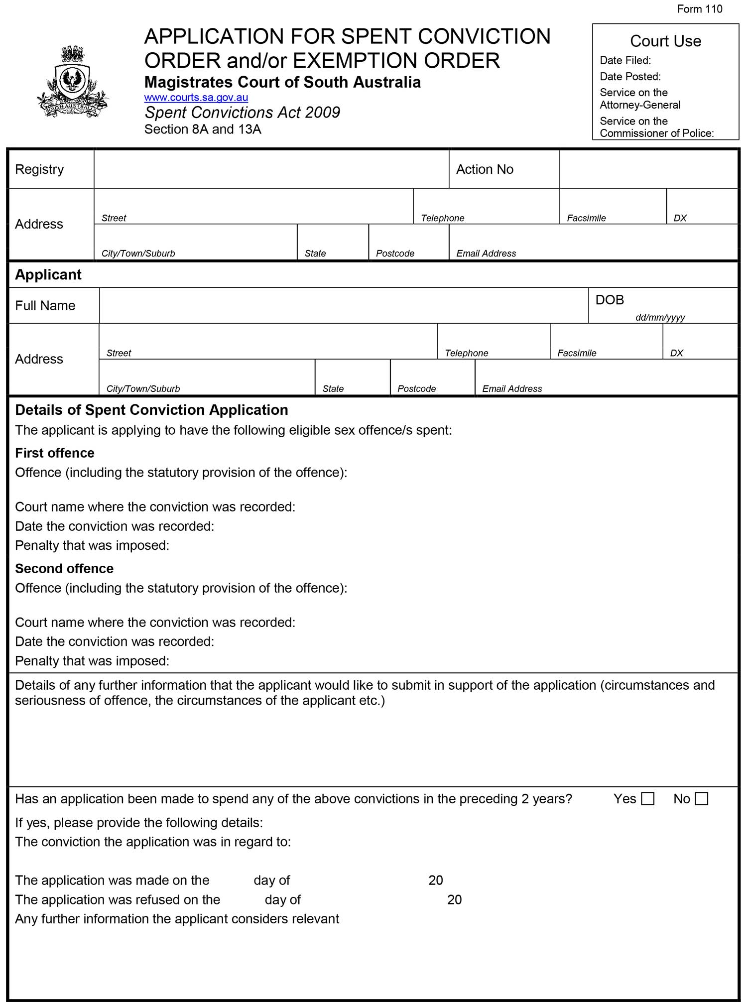
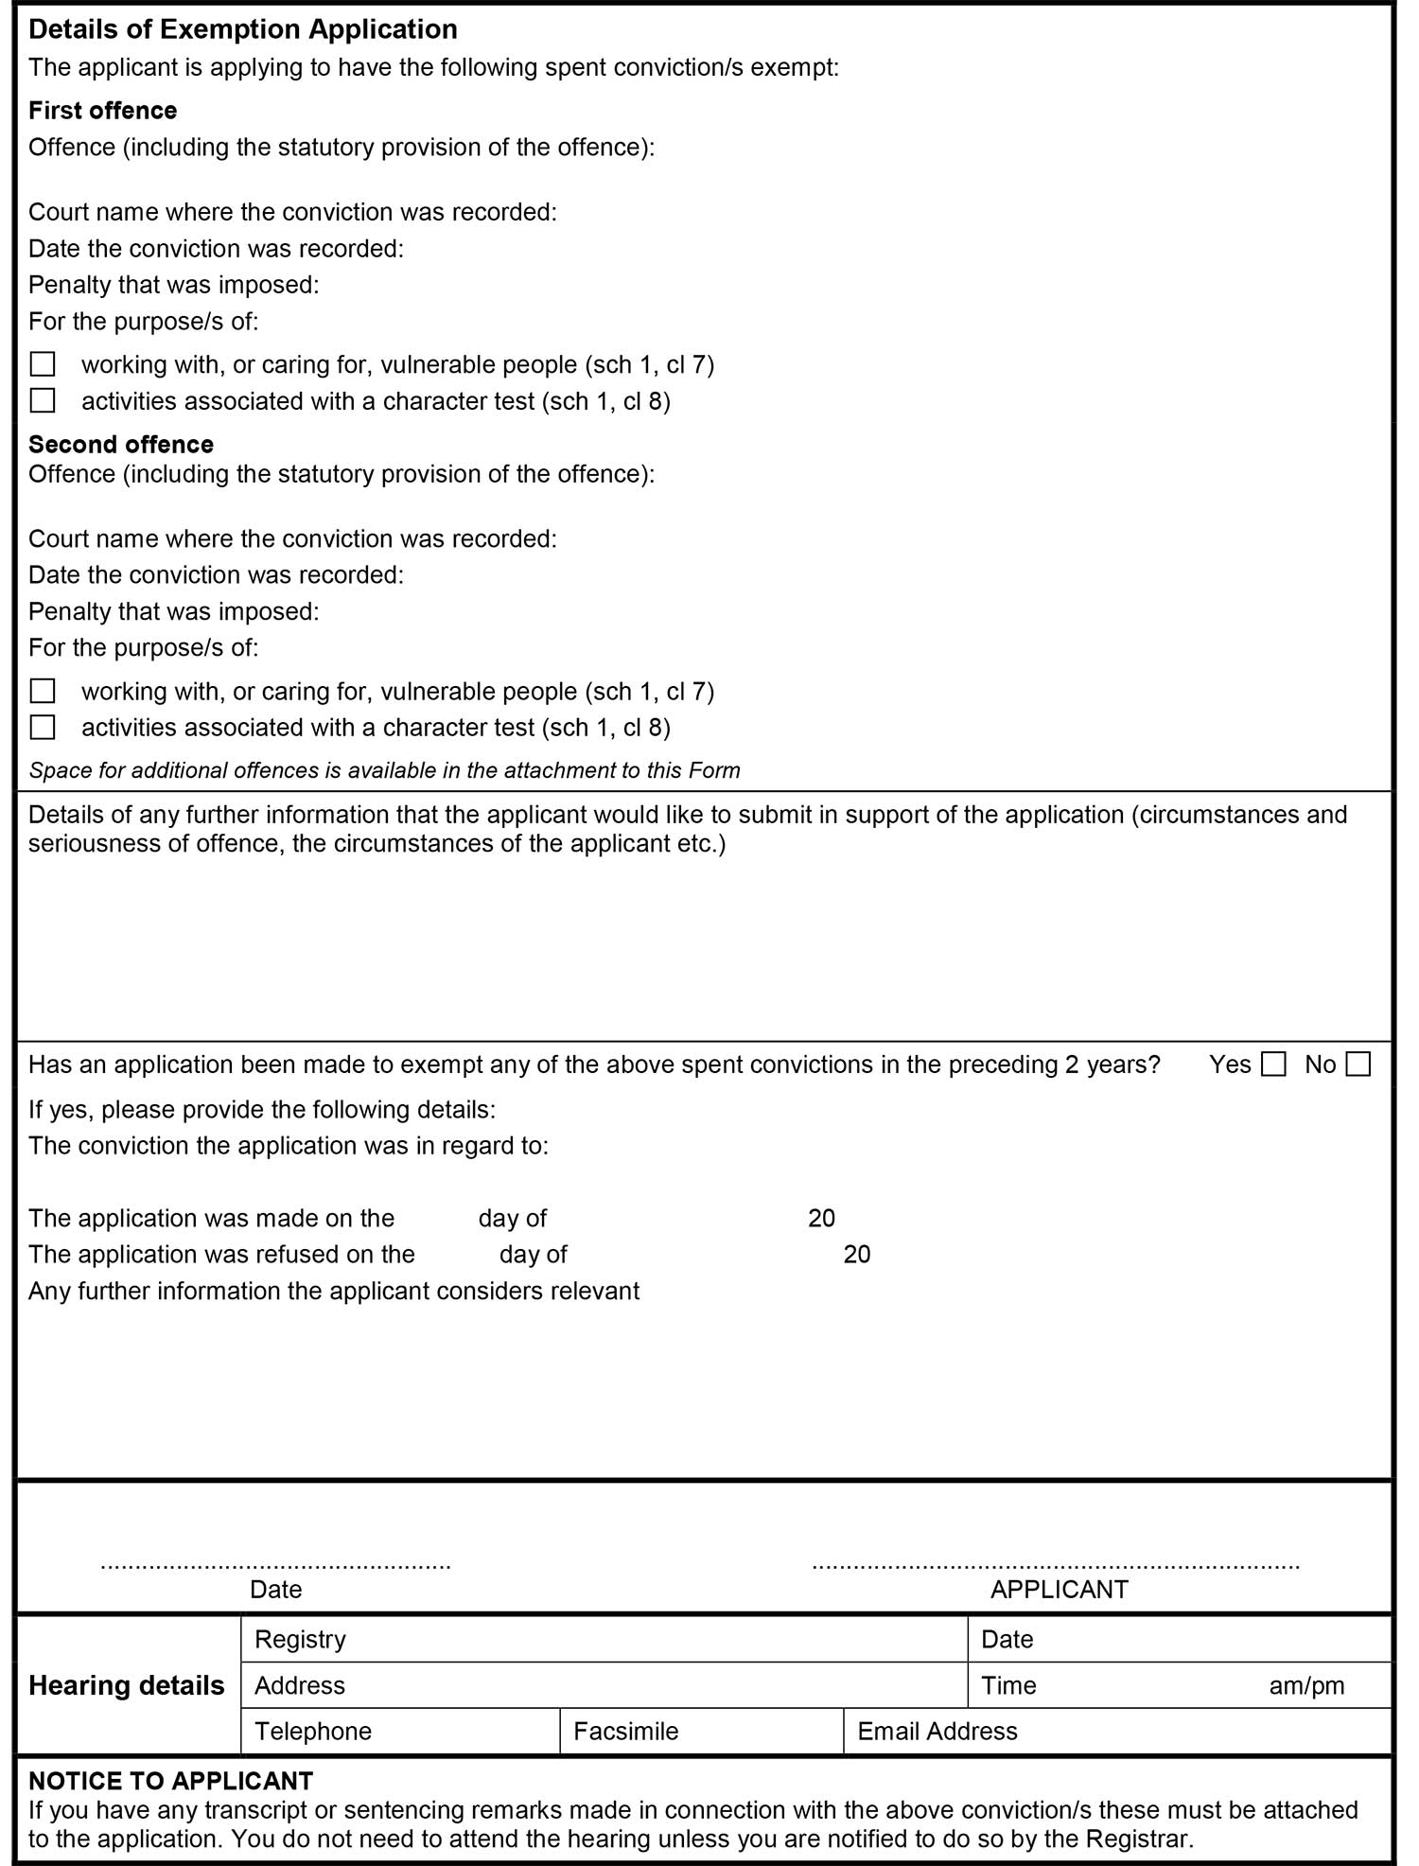
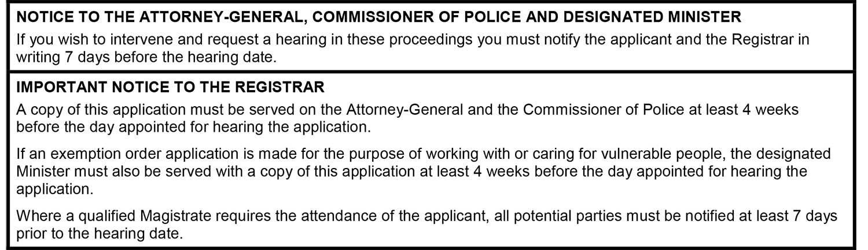
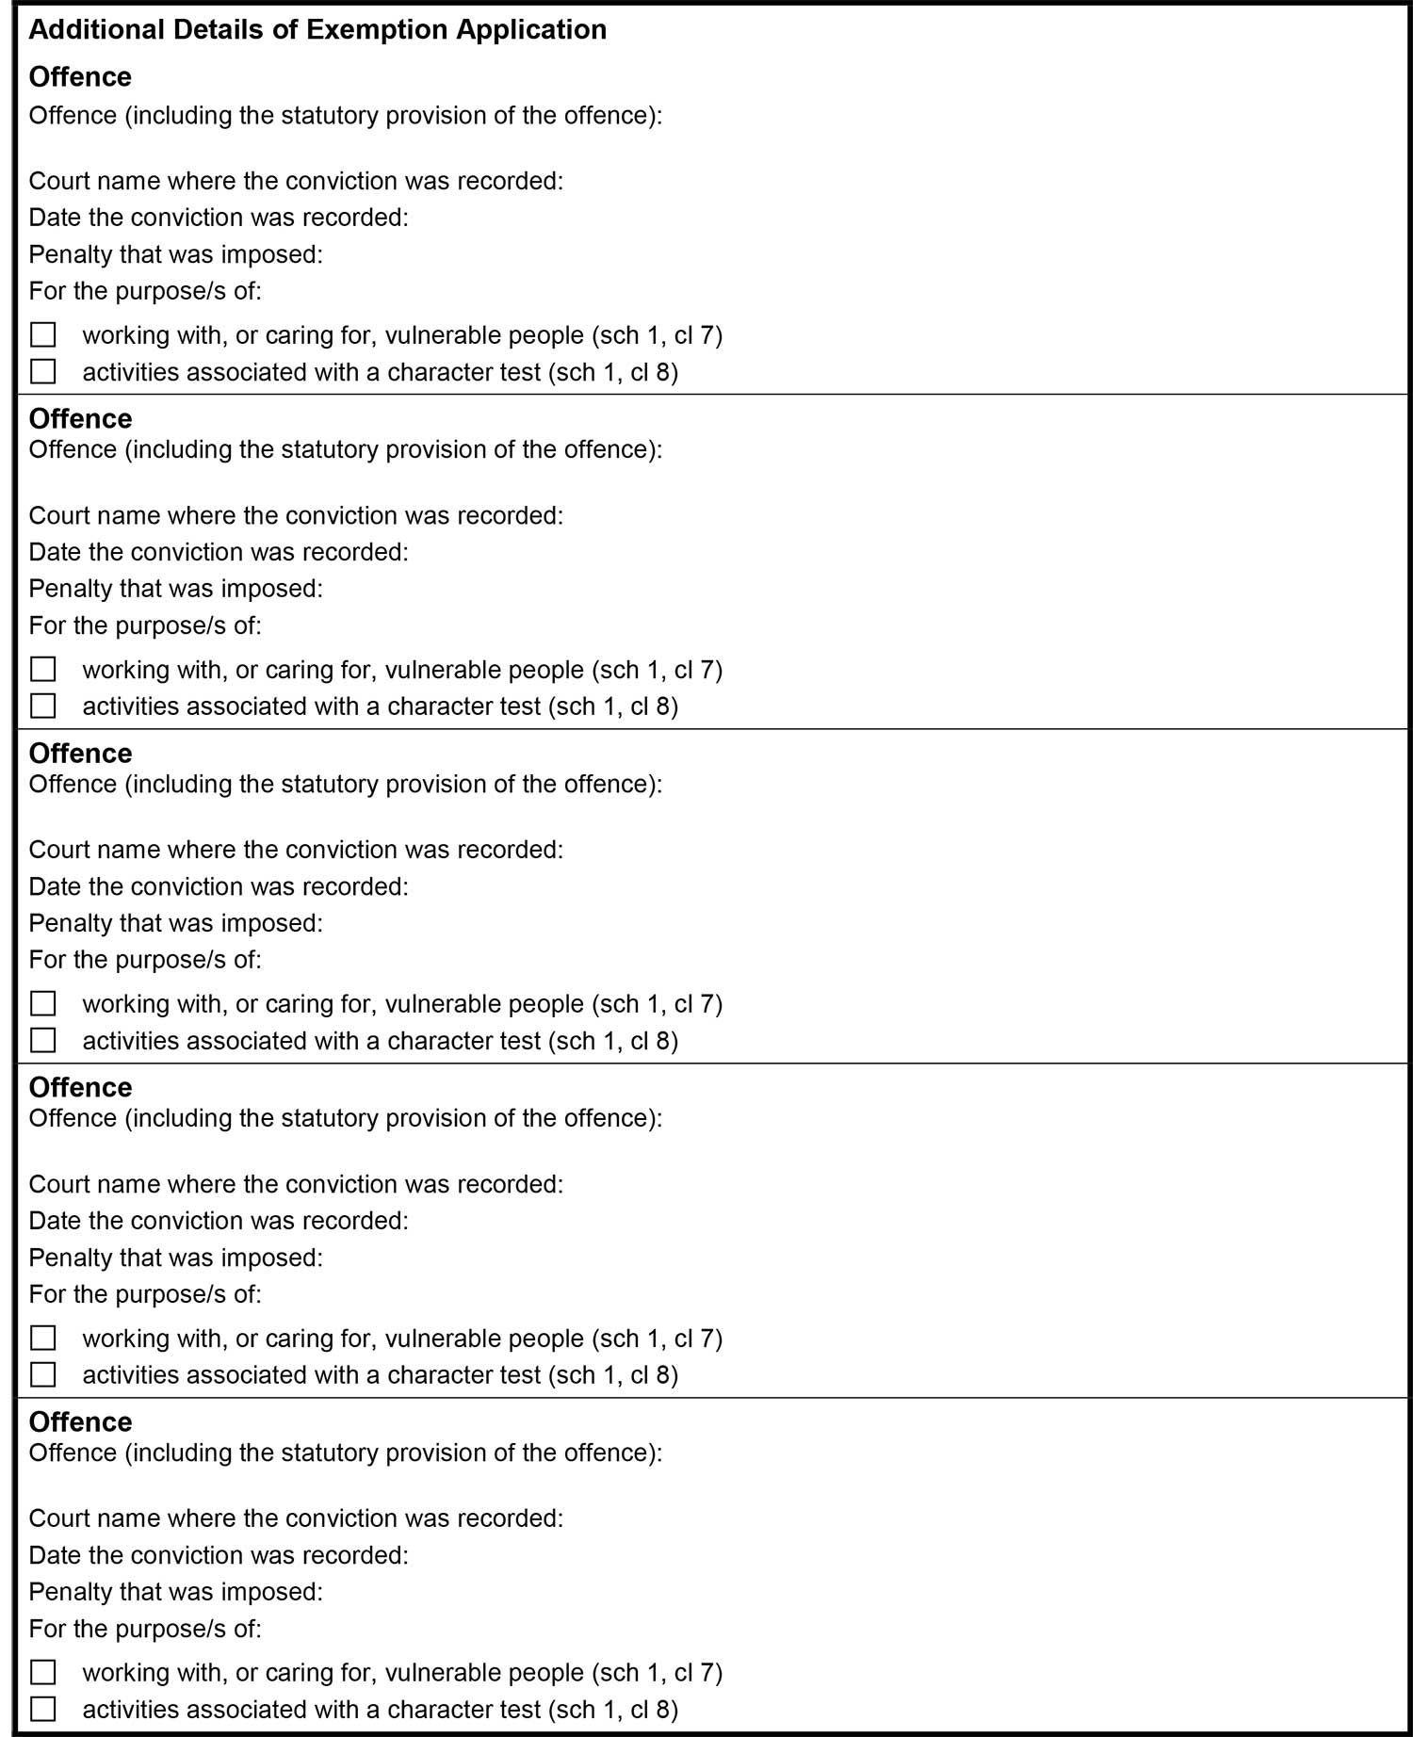

TOWN OF GAWLER
Declaration to Preserve Easement over Public Road
NOTICE is hereby given that the Town of Gawler resolved, pursuant to section 208(3) of the Local Government Act 1999, to preserve the existing Point Campbell to Adelaide High-Pressure Gas Pipeline Easement granted in favour of South East Australia Gas Pty Ltd ACN 096 437 900, Rest Sea Gas SPV1 Pty Ltd ACN 095 483 444, APT SPV2 Pty Ltd ACN 095 483 453, APT SPV3 Pty Ltd ACN 095 483 462, Rest Sea Gas SPV2 Pty Ltd ACN 099 332 331, ANP Sea Gas SPV2 Pty Ltd ACN 099 332 368 and ANP Sea Gas SPV3 Pty Ltd ACN 099 332 395 within all future road crossings associated with the Gawler East Development Area, being those portions of land contained within Development Application No. 490/208/17 (Deposited Plan 119115) to be vested in the Council’s ownership as public roads. Motion No: 2017:09:311
Dated: 8 August 2019
H Inat
Chief Executive Officer

DISTRICT COUNCIL OF KAROONDA EAST MURRAY
Adoption of Valuation and Declaration of Rates for 2019/2020
NOTICE is hereby given that the District Council of Karoonda East Murray at its Special Meeting held on 18 July 2019, resolved the following:
Adoption of Valuations
That pursuant to the provisions of Section 167(2)(a) of the Local Government Act 1999, the Council adopts for rating purposes the most recent valuations of the Valuer-General available to the Council, of the capital value of land within the Council’s area totalling $291,954,220 for the 2019/2020 financial year and of which $283,590,220 is the total valuation of rateable land.
Declaration of General Rates
That pursuant to Section 153(1)(a) of the Local Government Act 1999, the Council declare a general rate of 0.4708 cents in the dollar on the capital value of all rateable land within the whole council area for the 2019/2020 financial year.
Minimum Amount Payable
That pursuant to Section 158(1)(a) of the Local Government Act 1999, Council declare a minimum rate of $325.00 to be fixed for rateable land within the whole of the council area for the 2019/2020 financial year.
Service Charges
Community Wastewater Management Scheme (CWMS) Service Charge
That pursuant to Section 155 of the Local Government Act 1999, Council declare a service charge for the Community Wastewater Management System of $445.00 per occupied unit and $420.00 per vacant allotment in Karoonda for properties serviced by the system for the 2019/2020 financial year.
Kerbside Waste Management Collection Charge
That pursuant to Section 155 of the Local Government Act 1999, Council declare a service charge for Kerbside Waste Management Collection of $100.00 per annum, to provide for the collection of one general waste bin collected weekly to each property in the collection zone for the 2019/2020 financial year.
Payment of Rates
That pursuant to Section 181(1) of the Local Government Act 1999, Council approve the quarterly rates payment due dates of 19 September 2019, 19 December 2019, 19 March 2020 and 19 June 2020.
Natural Resources Management Levy – Declaration of Separate Rate
That pursuant to Section 95 of the Natural Resources Management Act 2004 and Section 154 of the Local Government Act 1999, in order to reimburse Council, the amount contributed to the South Australian Murray Darling Basin Natural Resources Management Board being $64,535 and that Council declares a separate rate of 0.02304 cents in the dollar, based on the capital value of all rateable land in the Council’s area for the 2019/2020 financial year.
Dated: 18 July 2019
Matthew Morgan
Chief Executive Officer

National Electricity Law
The Australian Energy Market Commission (AEMC) gives notice under the National Electricity Law as follows:
Under ss 102 and 103, the making of the National Electricity Amendment (Five minute settlement and global settlement implementation amendments) Rule 2019 No. 7 (Ref. ERC0267) and related final determination. Schedules 1 and 6 commence on 12 August 2019, schedule 2 commences on 1 July 2021 and schedules 3, 4 and 5 commence on 6 February 2022.
Documents referred to above are available on the AEMC’s website and are available for inspection at the AEMC’s office.
Australian Energy Market Commission
Level 6, 201 Elizabeth Street
Sydney NSW 2000
Telephone: (02) 8296 7800
www.aemc.gov.au
Dated: 8 August 2019

Trustee Act 1936
Public Trustee
Estates of Deceased Persons
In the matter of the estates of the undermentioned deceased persons:
ARBON Ronald Raymond late of 10 South Terrace Meningie Retired Process Worker who died 23 April 2019
BOWN Mary Lorraine late of 53 Austral Terrace Morphettville of no occupation who died 24 September 2019
BRAMMER Robert George late of 61 - 63 Oxford Terrace Port Lincoln Retired Carpenter who died 10 September 2018
BURNS Rae Pauline late of 3 Grant Avenue Gilles Plains Receptionist Consultant who died 17 February 2019
DESOUSA Joao Cesar Moreira late of 20 Blake Road Elizabeth South of no occupation who died 29 March 2018
FINLAY Grace late of 25 Roopena Street Ingle Farm of no occupation who died 7 December 2018
KELLY Patrick Joseph late of 40 Fullerton Crescent Port Augusta Retired Truck Driver who died 3 May 2018
MARSHALL Darren Scott late of 7 Pattison Crescent Moonta Bay of no occupation who died 21 February 2019
MICHAEL Joan late of 21 Seaview Crescent Normanville of no occupation who died 8 March 2019
SLAVIN-MOLLOY Cherie Thea late of 2 McDonnell Terrace Evanston Gardens Retired Dry Cleaning Presser who died 2 March 2019
STACEY Barbara Joy late of 61 - 63 Oxford Terrace Port Lincoln of no occupation who died 19 October 2018
SWIFT Doris Norma late of 2 Cardigan Street Angle Park Retired Salvation Army Officer who died 17 May 2019
YOUNG Michael John late of 66 Sturt Street Adelaide Retired Factory Hand who died 19 May 2019
YOUNG Oliver James late of 2 Harold Road Salisbury North of no occupation who died 7 May 2018
Notice is hereby given pursuant to the Trustee Act 1936, the Inheritance (Family Provision) Act 1972 and the Family Relationships Act 1975 that all creditors, beneficiaries, and other persons having claims against the said estates are required to send, in writing, to the office of Public Trustee at GPO Box 1338, Adelaide, 5001, full particulars and proof of such claims, on or before the 6 September 2019 otherwise they will be excluded from the distribution of the said estate; and notice is also hereby given that all persons indebted to the said estates are required to pay the amount of their debts to the Public Trustee or proceedings will be taken for the recovery thereof; and all persons having any property belonging to the said estates are forthwith to deliver same to the Public Trustee.
Dated: 8 August 2019
N S Rantanen
Acting Public Trustee

Notice Submission

Notices for publication must be submitted before 4 p.m. Tuesday, the week of intended gazettal.
Proofs of formatted content are supplied for all notice submissions. Alterations must be returned before 4 p.m. Wednesday.
The SA Government Gazette is compiled and published each Thursday. Requests to withdraw submitted notices must be received before 10 a.m. on the day of publication.

Gazette notices should be emailed as Word files—and signed PDF files if applicable—
in the following format:
- Title (name of the governing legislation/department/organisation)
- Subtitle (description of notice)
- A structured body of text
- Date of authorisation
- Name, position, and department/organisation of the authorising person

Please provide the following information in your email:
- Date of intended gazettal
- Details that may impact on publication of the notice
- Email address and phone number of the person authorising the submission
- Name of the person and organisation to be charged for the notice, if applicable
- Request for a quote, if required
- Purchase order, if required

Email: governmentgazettesa@sa.gov.au
Phone: (08) 8207 1025
Website: www.governmentgazette.sa.gov.au

Printed and published weekly by authority of S. Smith, Government Printer, South Australia
$7.50 per issue (plus postage), $378.15 per annual subscription—GST inclusive
Online publications: www.governmentgazette.sa.gov.au

