
THE SOUTH AUSTRALIAN
GOVERNMENT GAZETTE
Published by Authority

Adelaide, Thursday, 14 November 2019

Contents

Appointments, Resignations, Etc. 3844
Children and Young People (Oversight and
Advocacy Bodies) Act 2016—Notice 3844
Corporations and District Councils—Notices 3865
Corrigendum 3866
Development Act 1993—Notice 3844
Geographical Names Act 1991—Notice 3845
Health Care Act 2008—Notices 3845
Housing Improvement Act 2016—Notice 3846
Land Acquisition Act 1969—Notice 3846
Liquor Licensing Act 1997—Notices 3847
Mental Health Act 2009—Notice 3859
Mining Act 1971—Notices 3859
National Electricity Law—Notice 3873
National Gas Law—Notice 3873
Natural Resources Management Act 2004—Notice 3860
Petroleum and Geothermal Energy Act 2000—Notices 3860
Roads (Opening and Closing) Act 1991—Notices 3862
Training and Skills Development Act 2008—Notice 3864
Trustee Act 1936—Administration of Estates 3873

Department of the Premier and Cabinet
Adelaide, 14 November 2019
His Excellency the Governor in Executive Council has been pleased to appoint the undermentioned to the State Opera of South Australia Board, pursuant to the provisions of the State Opera of South Australia Act 1976:
Member: from 17 November 2019 until 16 November 2022
John Irving
Beatrice Maria Byok
Presiding Member: from 17 November 2019 until 16 November 2022
John Irving
By command,
Vickie Ann Chapman
For Premier
DPC19/070CS

Department of the Premier and Cabinet
Adelaide, 14 November 2019
His Excellency the Governor in Executive Council has been pleased to appoint Professor Brenda Wilson as Governor’s Deputy of South Australia for the period from 12.01pm on Wednesday, 20 November 2019 until 12.00pm on Wednesday, 27 November 2019.
By command,
Vickie Ann Chapman
For Premier

Department of the Premier and Cabinet
Adelaide, 14 November 2019
His Excellency the Governor in Executive Council has been pleased to appoint Martin Gerard Hinton QC as the Director of Public Prosecutions for a term of 7 years commencing on 18 November 2019 and expiring on 17 November 2026, pursuant to section 4 of the Director of Public Prosecutions Act 1991.
By command,
Vickie Ann Chapman
For Premier
AGO0151-9CS

CHILDREN AND YOUNG PEOPLE (OVERSIGHT AND ADVOCACY BODIES) ACT 2016
Outcomes Framework for Children and Young People
PURSUANT to the provisions of Part 6, Division 2, section 57 (6) and (7) of the Children and Young People (Oversight and Advocacy Bodies) Act 2016, I, John Gardner, Minister for Education, hereby approve the Outcomes Framework for Children and Young People prepared by the Child Development Council: https://childrensa.sa.gov.au/outcomes-framework/.
The Outcomes Framework for Children and Young People will come into effect from the date this notice is published in the South Australian Government Gazette.
Dated: 29 October 2019
John Gardner
Minister for Education

DEVELOPMENT ACT 1993
Notice under Section 25(17)
Port Pirie Regional Council—Abattoirs Road Development Plan Amendment
Preamble
- The Abattoirs Road Development Plan Amendment (the Amendment) by the Port Pirie Regional Council has been finalised in accordance with the provisions of the Development Act 1993.
- The Minister for Planning has decided to approve the Amendment.
PURSUANT to section 25 of the Development Act 1993, I –
- approve the Amendment; and
- fix the day on which this notice is published in the Gazette as the day on which the Amendment will come into operation.
Dated: 7 November 2019
Hon Stephan Knoll MP
Minister for Planning

GEOGRAPHICAL NAMES ACT 1991
For Public Consultation
Notice of Intent to Assign a Name to a Place
NOTICE is hereby given pursuant to the provisions of the above Act, that the Minister for Transport, Infrastructure and Local Government seeks public comment on a proposal to assign the name NARRUNG PENINSULA to the peninsula located on the 1:50,000 Mapsheet Narrung (6726-4), Hundred of Baker and bound by the waters of The Coorong on the south-west, Lake Albert on the east and Lake Alexandrina on the north-west.
Submissions in writing regarding this proposal may be lodged with the Surveyor-General, G.P.O. Box 1354, Adelaide, S.A. 5001, within one month of the publication of this notice.
The plan for this naming proposal can be viewed on the Land Services website located at www.sa.gov.au/placenameproposals
Dated: 14 November 2019
Michael Burdett
Surveyor-General
Department of Planning, Transport and Infrastructure
DPTI: 2019/01761/01

HEALTH CARE ACT 2008
Declaration of Authorised Quality Improvement Activity and Authorised Person under Section 64
Notice by the Minister
TAKE notice that I, Stephen Wade, Minister for Health and Wellbeing, pursuant to sections 64 (1) (a) (i) and (b) (i) do hereby:
DECLARE the Activities described in the Schedule to this declaration (the Activities) to be authorised quality improvement activities to which Part 7 of the Act applies, and
DECLARE the Person or group of Persons (including a group formed as a committee) described in the Schedule to this declaration (the Persons) to be an authorised entity for the purposes of carrying out the authorised quality improvement activities to which Part 7 of the Act applies,
being satisfied that:
    - the performance of the activities within the ambit of the declaration and the functions or activities of the person or group of persons within the ambit of the declaration, would be facilitated by the making of the declaration; and
    - that the making of the declaration is in the public interest.
Dated: 6 November 2019
Stephen Wade
Minister for Health and Wellbeing

Schedule
Declaration of Authorised Quality Improvement Activity and Authorised Person under Section 64
Activity | Person or Group of Persons
Clinical Adverse Event Review for Quality Improvement | North Eastern Community Hospital Clinical Adverse Event Review for Quality Improvement Committee

HEALTH CARE ACT 2008
Declaration of Authorised Research Activity and Authorised Person under Section 64
Notice by the Minister
TAKE notice that I, Stephen Wade, Minister for Health and Wellbeing, pursuant to sections 64 (1) (a) (ii) and (b) (ii) do hereby:
DECLARE the Activities described in the Schedule to this declaration (the Activities) to be authorised research activities to which Part 7 of the Act applies, and
DECLARE the Person or group of Persons (including a group formed as a committee) described in the Schedule to this declaration (the Persons) to be an authorised entity for the purposes of carrying out the authorised research activities to which Part 7 of the Act applies,
being satisfied that:
- the performance of the activities within the ambit of the declaration and the functions or activities of the person or group of persons within the ambit of the declaration, would be facilitated by the making of the declaration; and
- that the making of the declaration is in the public interest.
Dated: 6 November 2019
Stephen Wade
Minister for Health and Wellbeing

Schedule
Declaration of Authorised Research Activity and Authorised Person under Section 64
Activity | Person or Group of Persons
Road Trauma Analysis | University of Adelaide Centre for Automotive Safety Research, Road Trauma Analysis Committee

HOUSING IMPROVEMENT ACT 2016
Rent Control Revocations
Whereas the Minister for Human Services Delegate is satisfied that each of the houses described hereunder has ceased to be unsafe or unsuitable for human habitation for the purposes of the Housing Improvement Act 2016, notice is hereby given that, in exercise of the powers conferred by the said Act, the Minister for Human Services Delegate does hereby revoke the said Rent Control in respect of each property.
Address of Premises | Allotment  Section | Certificate of Title  Volume/Folio
297 Edwards Road, Loxton North SA 5333  (AKA Section 580, Kelliher Road) | Section 580 Hundred Plan 710300 Hundred of Gordon | CL1188/28; CL6210/832
3 Malaga Terrace, Berri SA 5343 | Allotment 183 Town Plan 740201 Hundred of Berri IA | CL993/26, CT5929/722
26 Creswell Terrace, Moonta Mines SA 5558  (AKA 8, AKA Section 2346) | Section 2346 Hundred Plan 211100 Hundred of Wallaroo | CT5432/615
12 Jennifer Terrace, Parafield Gardens SA 5107 | Allotment 33 Deposited Plan 6422 Hundred of Yatala | CT5236/30
51 Seaview Road, Tennyson SA 5022 | Allotment 40 Filed Plan 124913 Hundred of Yatala | CT 5894/434
Dated: 14 November 2019
Craig Thompson
Acting Housing Regulator and Registrar
Housing Safety Authority, SAHA
Delegate of Minister for Human Services

LAND ACQUISITION ACT 1969
Section 16
Form 5—Notice of Acquisition
1. Notice of acquisition
The Commissioner of Highways (the Authority), of 50 Flinders Street, Adelaide SA 5000, acquires the following interests in the following land:
First: Comprising an unencumbered estate in fee simple in that piece of land being the whole of Allotment 51 in Filed Plan No 13555 comprised in Certificate of Title Volume 5105 Folio 177
Secondly: Comprising an unencumbered estate in fee simple in that piece of land being the whole of Allotment 52 in Filed Plan No 13555 comprising in Certificate of Title Volume 5105 Folio 178
This notice is given under section 16 of the Land Acquisition Act 1969.
2. Compensation
A person who has or had an interest in the land that is divested or diminished by the acquisition or the enjoyment of which is adversely affected by the acquisition who does not receive an offer of compensation from the Authority may apply to the Authority for compensation.
3. Inquiries
Inquiries should be directed to:
Petrula Pettas
GPO Box 1533
Adelaide SA 5001
Telephone: (08) 8343 2619
Dated: 12 November 2019
The Common Seal of the COMMISSIONER OF HIGHWAYS was hereto affixed by authority of the Commissioner in the presence of:
Mohammed Elgazzar
Manager
Property Portfolio & Strategy
(Authorised Officer)
Department of Planning, Transport and Infrastructure
DPTI 2019/02975/01

South Australia
Liquor Licensing (Dry Areas) Notice 2019
under section 131(1a) of the Liquor Licensing Act 1997
1—Short title
This notice may be cited as the Liquor Licensing (Dry Areas) Notice 2019.

2—Commencement
This notice comes into operation on 26 December 2019.

3—Interpretation
(1) In this notice—
principal notice means the Liquor Licensing (Dry Areas) Notice 2015 published in the Gazette on 5.1.15, as in force from time to time.
(2) Clause 3 of the principal notice applies to this notice as if it were the principal notice.

4—Consumption etc of liquor prohibited in dry areas
(1) Pursuant to section 131 of the Act, the consumption and possession of liquor in the area described in the Schedule is prohibited in accordance with the provisions of the Schedule.
(2) The prohibition has effect during the periods specified in the Schedule.
(3) The prohibition does not extend to private land in the area described in the Schedule.
(4) Unless the contrary intention appears, the prohibition of the possession of liquor in the area does not extend to—
(a) a person who is genuinely passing through the area if—
(i) the liquor is in the original container in which it was purchased from licensed premises; and
(ii) the container has not been opened; or
(b) a person who has possession of the liquor in the course of carrying on a business or in the course of his or her employment by another person in the course of carrying on a business; or
(c) a person who is permanently or temporarily residing at premises within the area or on the boundary of the area and who enters the area solely for the purpose of passing through it to enter those premises or who enters the area from those premises for the purpose of leaving the area.
Schedule— Beachport Area 1
1—Extent of prohibition
The consumption of liquor is prohibited and the possession of liquor is prohibited.

2—Period of prohibition
Between the hours of 12:01 AM to 7 AM on each day from Thursday 26 December 2019 (inclusive) to Tuesday 31 December 2019.

3—Description of area
The area in Beachport, generally known as Centennial Park, comprising Lot 2 DP 41193.
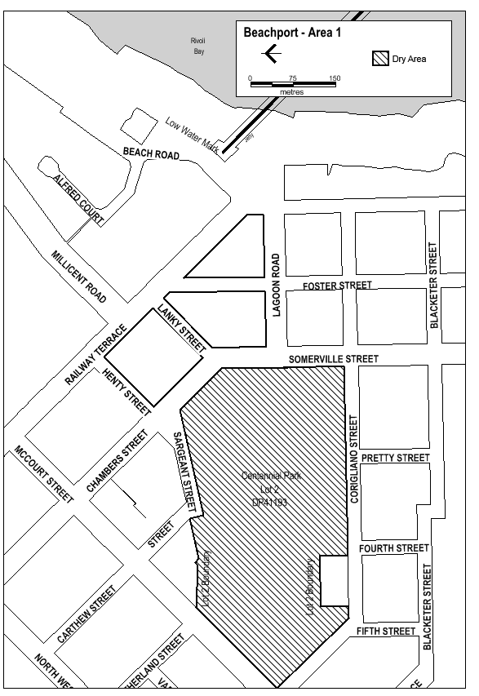
Made on behalf of the Liquor and Gambling Commissioner
on 8 November 2019

South Australia
Liquor Licensing (Dry Areas) Notice 2019
under section 131(1a) of the Liquor Licensing Act 1997
1—Short title
This notice may be cited as the Liquor Licensing (Dry Areas) Notice 2019.

2—Commencement
This notice comes into operation on 26 December 2019.

3—Interpretation
(1) In this notice—
principal notice means the Liquor Licensing (Dry Areas) Notice 2015 published in the Gazette on 5.1.15, as in force from time to time.
(2) Clause 3 of the principal notice applies to this notice as if it were the principal notice.

4—Consumption etc of liquor prohibited in dry areas
(1) Pursuant to section 131 of the Act, the consumption and possession of liquor in the area described in the Schedule is prohibited in accordance with the provisions of the Schedule.
(2) The prohibition has effect during the periods specified in the Schedule.
(3) The prohibition does not extend to private land in the area described in the Schedule.
(4) Unless the contrary intention appears, the prohibition of the possession of liquor in the area does not extend to—
(a) a person who is genuinely passing through the area if—
(i) the liquor is in the original container in which it was purchased from licensed premises; and
(ii) the container has not been opened; or
(b) a person who has possession of the liquor in the course of carrying on a business or in the course of his or her employment by another person in the course of carrying on a business; or
(c) a person who is permanently or temporarily residing at premises within the area or on the boundary of the area and who enters the area solely for the purpose of passing through it to enter those premises or who enters the area from those premises for the purpose of leaving the area
Schedule— Beachport Area 2

1—Extent of prohibition
The consumption of liquor is prohibited and the possession of liquor is prohibited.

2—Period of prohibition
From 12 PM on Thursday 26 December 2019 to 12 PM on Thursday 2 January 2020

3—Description of area
The area in and adjacent to Beachport comprising the following roads and other areas:
- Railway Terrace between the south-eastern boundary of McCourt Street and the north-western boundary of Beach Road;
- Chambers Street and Somerville Street between the south-eastern boundary of McCourt Street and the southern boundary of Lagoon Road;
- Lagoon Road between the eastern boundary of Somerville Street and the western boundary of Beach Road;
- Henty Street;
- Lanky Street;
- Foster Street between Railway Terrace and the southern boundary of Lagoon Road;
- the area commencing at the point at which the prolongation in a straight line of the southern boundary of Lagoon Road intersects the low water mark on the western side of Rivoli Bay,
then westerly along that prolongation to the western boundary of Beach Road, then generally northerly, north-easterly and northerly along that boundary of Beach Road to the southern boundary of Alfred Court, then along the prolongation in a straight line of that southern boundary of Alfred Court to the low water mark on the western side of Rivoli Bay, then generally south-westerly along the low water mark to the point of commencement.

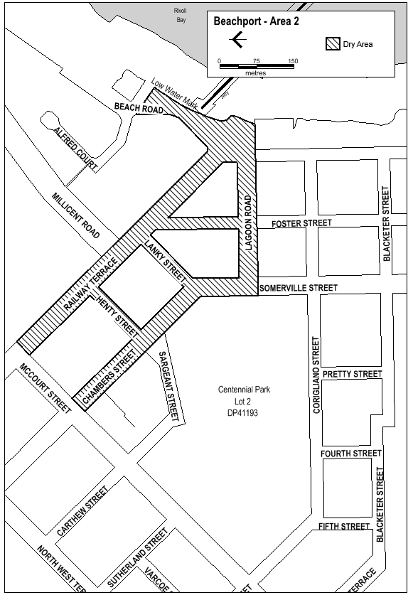
Made on behalf of the Liquor and Gambling Commissioner
on 8 November 2019

South Australia
Liquor Licensing (Dry Areas) Notice 2019
under section 131(1a) of the Liquor Licensing Act 1997
1—Short title
This notice may be cited as the Liquor Licensing (Dry Areas) Notice 2019.

2—Commencement
This notice comes into operation on 27 December 2019.

3—Interpretation
(1) In this notice—
principal notice means the Liquor Licensing (Dry Areas) Notice 2015 published in the Gazette on 5.1.15, as in force from time to time.
(2) Clause 3 of the principal notice applies to this notice as if it were the principal notice.

4—Consumption etc of liquor prohibited in dry areas
(1) Pursuant to section 131 of the Act, the consumption and possession of liquor in the area described in the Schedule is prohibited in accordance with the provisions of the Schedule.
(2) The prohibition has effect during the periods specified in the Schedule.
(3) The prohibition does not extend to private land in the area described in the Schedule.
(4) Unless the contrary intention appears, the prohibition of the possession of liquor in the area does not extend to—
(a) a person who is genuinely passing through the area if—
(i) the liquor is in the original container in which it was purchased from licensed premises; and
(ii) the container has not been opened; or
(b) a person who has possession of the liquor in the course of carrying on a business or in the course of his or her employment by another person in the course of carrying on a business; or
(c) a person who is permanently or temporarily residing at premises within the area or on the boundary of the area and who enters the area solely for the purpose of passing through it to enter those premises or who enters the area from those premises for the purpose of leaving the area.
Schedule— Robe Area 1

1—Extent of prohibition
The consumption of liquor is prohibited and the possession of liquor is prohibited.

2—Period of prohibition
From 12 PM on Friday 27 December 2019 to 12 PM on Thursday 2 January 2020.

3—Description of area
The area in and adjacent to Robe bounded as follows: commencing at the western end of the northern boundary of Dawson Drive, then in a straight line by the shortest route to the low water mark of Guichen Bay on the eastern side of the entrance to Fox's Lake, then in a straight line by the shortest route (across the entrance) to the low water mark on the western side of the entrance, then generally westerly along the low water mark to the eastern side of the entrance to Lake Butler, then in a straight line by the shortest route (across the entrance) to the eastern boundary of the breakwater on the western side of the entrance to the lake, then northerly, north-easterly, westerly and south-westerly around the outer boundary of the breakwater back to the low water mark on the shore on the western side of the breakwater, then generally north-westerly and southerly along the low water mark to the point at which it is intersected by the prolongation in a straight line of the southern boundary of Evans Cave Road (the northern boundary of Section 363 Hundred of Waterhouse), then generally easterly along that prolongation and boundary of Evans Cave Road, and the prolongation in a straight line of that boundary, to the eastern boundary of Robe Street, then northerly along that boundary of Robe Street to the southern boundary of Beacon Hill Road, then generally easterly along that boundary of Beacon Hill Road to the point at which it meets the north-eastern boundary of Lot 5 of DP 78111, then generally south-easterly and easterly along that boundary of Lot 5 and easterly and north-easterly along the northern boundary of Section 289 Hundred of Waterhouse to the eastern boundary of Section 289, then in a straight line by the shortest route to the south-western corner of Lot 11 of DP 64831, then easterly along the southern boundary of Lot 11 and the prolongation in a straight line of that boundary to the point at which the prolongation intersects the eastern boundary of Nora Creina Road, then northerly along that boundary of Nora Creina Road to the point at which it meets the southern boundary of Wildfield Road, then generally easterly along that boundary of Wildfield Road and the prolongation in a straight line of that boundary to the point at which the prolongation intersects the northern boundary of Southern Ports Highway, then generally north-westerly and south-westerly along that boundary of Southern Ports Highway and the northern boundary of Main Road to the eastern boundary of Dawson Drive, then generally north-westerly and westerly along that boundary of Dawson Drive to the point of commencement. The area includes any wharf, jetty, boat ramp, breakwater or other structure projecting below low water mark from within the area described above (as well as any area beneath such a structure).

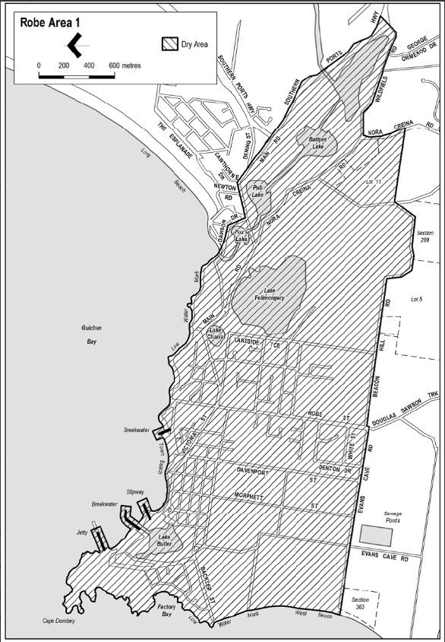
Made on behalf of the Liquor and Gambling Commissioner
Dated: 8 November 2019

South Australia
Liquor Licensing (Dry Areas) Notice 2019
under section 131(1a) of the Liquor Licensing Act 1997
1—Short title
This notice may be cited as the Liquor Licensing (Dry Areas) Notice 2019.

2—Commencement
This notice comes into operation on 27 December 2019.

3—Interpretation
(1) In this notice—
principal notice means the Liquor Licensing (Dry Areas) Notice 2015 published in the Gazette on 5.1.15, as in force from time to time.
(2) Clause 3 of the principal notice applies to this notice as if it were the principal notice.

4—Consumption etc of liquor prohibited in dry areas
(1) Pursuant to section 131 of the Act, the consumption and possession of liquor in the area described in the Schedule is prohibited in accordance with the provisions of the Schedule.
(2) The prohibition has effect during the periods specified in the Schedule.
(3) The prohibition does not extend to private land in the area described in the Schedule.
(4) Unless the contrary intention appears, the prohibition of the possession of liquor in the area does not extend to—
(a) a person who is genuinely passing through the area if—
(i) the liquor is in the original container in which it was purchased from licensed premises; and
(ii) the container has not been opened; or
(b) a person who has possession of the liquor in the course of carrying on a business or in the course of his or her employment by another person in the course of carrying on a business; or
(c) a person who is permanently or temporarily residing at premises within the area or on the boundary of the area and who enters the area solely for the purpose of passing through it to enter those premises or who enters the area from those premises for the purpose of leaving the area
Schedule— Robe Area 2

1—Extent of prohibition
The consumption of liquor is prohibited and the possession of liquor is prohibited.

2—Period of prohibition
From 12 PM on Friday 27 December 2019 to 12 PM on Thursday 2 January 2020.

3—Description of area
The area in and adjacent to Robe bounded as follows: commencing at the western end of the northern boundary of Dawson Drive, then in a straight line by the shortest route to the low water mark of Guichen Bay on the eastern side of the entrance to Fox's Lake, then generally north-easterly along the low water mark to the point at which it is intersected by the prolongation in a straight line of the northern boundary of Section 573 Hundred of Waterhouse, then easterly along that prolongation and boundary of Section 573 to the eastern boundary of the Section, then generally southerly and south-westerly along that boundary of Section 573 to the north-eastern boundary of Section 390 Hundred of Waterhouse, then south-easterly along that boundary of Section 390 to the point at which it is intersected by the prolongation in a straight line of the northern boundary of Dennis Avenue, then easterly along that prolongation and boundary of Dennis Avenue, and the prolongation in a straight line of that boundary, to the point at which the prolongation intersects the western boundary of Lot 223 of FP 205569, then generally south-westerly and southerly along that boundary of Lot 223 and the prolongation in a straight line of that boundary to the point at which the prolongation intersects the south-eastern boundary of Southern Ports Highway, then south-westerly along that boundary to the western boundary of Lot 2 of FP 9707, then southerly along that boundary of Lot 2 to the southern boundary of the Lot, then generally north-westerly and south-westerly along the northern boundary of Southern Ports Highway and the northern boundary of Main Road to the eastern boundary of Dawson Drive, then generally north-westerly and westerly along that boundary of Dawson Drive to the point of commencement.

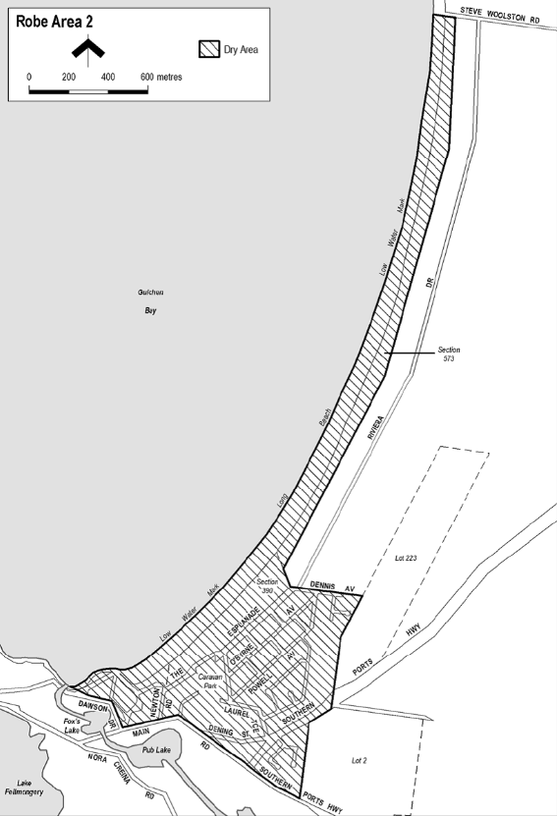
Made on behalf of the Liquor and Gambling Commissioner
Dated: 8 November 2019

MENTAL HEALTH ACT 2009
Authorised Mental Health Professionals
NOTICE is hereby given in accordance with Section 94(1) of the Mental Health Act 2009, that the Chief Psychiatrist has determined the following person as an Authorised Mental Health Professional commencing from date of Gazettal:
Michael Joseph Ryan
A person’s determination as an Authorised Mental Health Professional expires three years after the commencement date.
Dated: 14 November 2019
Dr J Brayley
Chief Psychiatrist

Mining Act 1971
Notice pursuant to Section 28(5)
Notice is hereby given in accordance with Section 28(5) of the Mining Act 1971 that the delegate of the Minister for Energy and Mining intends to grant an Exploration Licence over the area described below.
Applicant: Resource Holdings Pty Ltd
Location: Wilgena area - approximately 150km northeast of Ceduna
Pastoral Leases: Wilgena, North Well
Term: One year
Area in km²: 119
Reference number: 2019/00132
Plan and co-ordinates can be found on the Department for Energy and Mining website:
http://energymining.sa.gov.au/minerals/exploration/public_notices/exploration_licence_applications or by contacting Mineral Tenements on 08 8429 2572.
Community information on mineral exploration licence processes and requirements under the Mining Act 1971 is available from:
http://energymining.sa.gov.au/minerals/exploration/public_notices/exploration_licence_applications or hard copy on request to Mineral Tenements.
C Buttfield
A/Mining Registrar as delegate for the Minister for Energy and Mining
Department for Energy and Mining

MINING ACT 1971
Notice pursuant to Section 29 (1a) and 29 (5) (b) (ii)
NOTICE is hereby given that the notice under the Mining Act 1971 (the Act) published on 28 November 2017 in the South Australian Government Gazette at page 4733, is varied in respect of land referred to in the Schedule.
Notice is further hereby given that:
- Pursuant to subsection 29 (1a) of the Act no applications may be made for corresponding licences over land identified in Columns 1, 2, 3 and 6 of the Schedule during the succeeding period listed in Column 4 of the Schedule.
- Applications for corresponding licences may be made during the period listed in Column 5 of the Schedule and during that period, pursuant to subsection 29 (5) (b) (ii) of the Act, subsection 29 (4) of the Act will not apply in relation to any such applications. (See Note 1).
- Plans and coordinates for the land identified in Columns 1, 2, 3 and 6 of the Schedule can be obtained at the Department for Energy and Mining (DEM) Minerals website http://energymining.sa.gov.au/minerals/exploration/public_notices or by phoning Mineral Tenements on (08) 8463 3103.
- This Notice becomes effective on 14 November 2019.
The Schedule
Column 1  ERA No | Column 2  Locality | Column 3  Area (km²) | Column 4  Moratorium Period | Column 5  Application Open Dates | Column 6  Specific criteria
1105 | Minlaton area approximately 100km west-northwest of Adelaide | 509 | 21/01/2018 to 02/02/2020 | 03/02/2020  to 07/02/2020 | -
Dated: 14 November 2019
C Buttfield
Acting Mining Registrar
Delegate of the Minister for Energy and Mining
NOTE 1: The effect of this notice is that:
- No applications for a corresponding licence may be made during the succeeding period.
- The succeeding period will always expire on a Sunday. From the immediately following Monday to the immediately following Friday, applications for a corresponding licence may be made (the application week).
- Applications made in the application week will not be dealt with under subsection 29(4) i.e., on a first come first served basis, but under subsection 29(6) i.e., on a merits basis.
- If no applications are made in the application week, the land in question will cease to be subject to the notice and any applications for an exploration licence made after that time will be dealt with under subsection 29(4).

NATURAL RESOURCES MANAGEMENT ACT 2004
Declaration of Penalty in Relation to the Unauthorised or Unlawful Taking of Water from the River Murray Prescribed Watercourse
I, DAVID SPEIRS, Minister for Environment and Water, to whom administration of the Natural Resources Management Act 2004 (the Act) is committed, hereby declare that pursuant to Section 115 of the Act, the following penalties are payable in relation to the unauthorised or unlawful taking or use of water during the consumption period that corresponds to the accounting period defined in column 1 of Schedule 1:
- Where a person who is the holder of a water allocation takes water from the River Murray Prescribed Watercourse in excess of the amount available under the allocation, the penalty declared pursuant to Section 115 (1) (a) is:
- the corresponding rate in column 2 of Schedule 1 to this notice for all water taken in excess of the amount available under the allocation endorsed on the relevant instrument under the terms of the water licence to which the allocation is attributable, up to and including a quantity equal to 10 percent of the amount available under the allocation;
- the corresponding rate in column 3 of Schedule 1 to this notice for all water taken in excess of the quantity of water referred to in paragraph (a) up to and including a quantity equal to 25 percent; and
- the corresponding rate in column 4 of Schedule 1 to this notice for all water taken in excess of the quantity of water referred to in paragraph (b).
- Where water is taken from the River Murray Prescribed Watercourse by a person who is not the holder of a water management authorisation or who is not authorised under Section 128 of the Act to take the water, the penalty declared under Section 115(1)(cb) is the corresponding rate in column 5 of Schedule 1 to this notice per kilolitre of water determined or assessed to have been taken in accordance with Section 106 of the Act.
- Where a person takes water from the River Murray Prescribed Watercourse in excess of the amount authorised for use by a notice under Section 132 of the Act the penalty declared pursuant to Section 115(1)(d) is:
- the corresponding rate in Column 2 of Schedule 1 to this notice for all water taken in excess of the amount authorised for use by a notice under Section 132 of the Act, up to and including a quantity equal to 10 percent of the amount authorised by the notice;
- the corresponding rate in Column 3 of Schedule 1 to this notice for all water taken in excess of the quantity referred to in paragraph (a) up to and including a quantity equal to 25 percent of the amount authorised for use by a notice under Section 132 of the Act; and
- the corresponding rate in Column 4 of Schedule 1 of this notice for all water taken in excess of the quantity of water referred to in paragraph (b).
- Where water is taken from the River Murray Prescribed Watercourse subject to a notice under Section 132 of the Act by a person who is not authorised to use the water the penalty declared under Section 115(1)(d) is the corresponding rate in Column 5 of Schedule 1 to this notice per kilolitre of water determined or assessed to have been taken in accordance with Section 106 of the Act.
- Where a person may be subject to more than one penalty under Section 115, the penalty that is the greater shall be imposed.
Schedule 1
Penalties for overuse from the River Murray Prescribed Watercourse 1 October 2019 to 31 December 2019 inclusive:
Column 1 | Column 2 | Column 3 | Column 4 | Column 5
Accounting Period | Penalty for overuse for first 10 per cent | Penalty for overuse above 10 per cent and up to and including 25 per cent | Penalty for overuse above 25 per cent | Penalty for unlawful taking or use of water
1 October 2019 to 31 December 2019 | $ 2.37/kL | $ 5.53/kL | $ 9.48/kL | $ 13.43/kL
Unit of measure kL is the abbreviation of kilolitre.
For the purposes of this notice:
‘the River Murray Prescribed Watercourse’ means the watercourses and lakes declared to be the River Murray Proclaimed Watercourse by proclamation under Section 25 of the Water Resources Act 1976 (see Gazette 10 August 1978, p. 467)
‘accounting period’ is part of a financial year, in respect of which a levy (including a penalty charge for water taken in excess of allocation) is payable.
‘consumption period’ means a period of approximately the same length as the accounting period that commences or terminates during the accounting period and in respect of which the quantity of water is measured by meter readings.
Words used in this notice that are defined in the Act shall have the meanings as set out in the Act.
Dated: 12 November 2019
David Speirs MP
Minister for Environment and Water

Petroleum and Geothermal Energy Act 2000
Suspension of Petroleum Retention Licences PRLs 207, 208 and 209
Pursuant to section 90 of the Petroleum and Geothermal Energy Act 2000, notice is hereby given that the abovementioned Petroleum Retention Licences have been suspended for the period 28 October 2019 to 27 October 2020 inclusive, pursuant to delegated powers dated 29 June 2018.
The expiry date of these licences is now determined to be 7 December 2022.
Dated: 7 November 2019
Barry A. Goldstein
Executive Director
Energy Resources Division
Department for Energy and Mining
Delegate of the Minister for Energy and Mining

PETROLEUM and Geothermal Energy Act 2000
Application for Grant of Associated Activities Licence AAL 276
Pursuant to section 65(6) of the Petroleum and Geothermal Energy Act 2000 (the Act) and Delegation dated 29 June 2018, notice is hereby given that an application for the grant of an associated activities licence over the area described below has been received from:
Beach Energy Limited
Great Artesian Oil and Gas Pty Ltd
The application will be determined on or after 12 December 2019.
Description of Application Area
All that part of the State of South Australia, bounded as follows:
All coordinates MGA94, Zone 54
337330.01mE 6922843.52mN  337322.48mE 6922842.93mN  337314.93mE 6922843.10mN  337307.44mE 6922844.03mN  337300.07mE 6922845.71mN  337292.91mE 6922848.11mN  337286.03mE 6922851.23mN  337279.50mE 6922855.03mN  337273.38mE 6922859.46mN  337267.74mE 6922864.48mN  337262.63mE 6922870.05mN  337258.11mE 6922876.10mN  337254.22mE 6922882.58mN  337251.01mE 6922889.41mN  337248.49mE 6922896.53mN  337246.71mE 6922903.87mN  337245.67mE 6922911.35mN  337245.39mE 6922918.90mN  337245.87mE 6922926.44mN  337285.56mE 6923272.73mN  337286.46mE 6923278.55mN  337287.81mE 6923284.28mN  337289.61mE 6923289.89mN  337382.70mE 6923545.13mN  337376.47mE 6923870.38mN  337295.87mE 6924481.41mN  337030.28mE 6925177.86mN  337027.94mE 6925185.12mN  337026.35mE 6925192.59mN  337025.53mE 6925200.19mN  337025.48mE 6925207.83mN  337026.22mE 6925215.43mN  337027.73mE 6925222.92mN  337029.99mE 6925230.21mN  337032.98mE 6925237.24mN  337036.68mE 6925243.92mN  337041.04mE 6925250.20mN  337017.91mE 6925288.26mN  337014.43mE 6925294.67mN  337011.59mE 6925301.39mN  337009.41mE 6925308.36mN  337007.92mE 6925315.50mN  337011.75mE 6925547.55mN | 337011.77mE 6925549.13mN  337023.91mE 6925549.29mN  337160.77mE 6925551.14mN  337164.91mE 6925243.36mN  337211.93mE 6925244.00mN  337212.09mE 6925242.57mN  337212.30mE 6925240.69mN  337212.40mE 6925233.45mN  337211.80mE 6925226.23mN  337210.51mE 6925219.11mN  337208.54mE 6925212.14mN  337205.90mE 6925205.39mN  337202.62mE 6925198.93mN  337198.74mE 6925192.82mN  337194.28mE 6925187.11mN  337189.29mE 6925181.86mN  337439.16mE 6924526.66mN  337441.02mE 6924521.13mN  337442.45mE 6924515.48mN  337443.44mE 6924509.74mN  337525.73mE 6923885.83mN  337525.98mE 6923883.74mN  337526.36mE 6923877.46mN  337532.95mE 6923534.01mN  337532.76mE 6923527.10mN  337531.94mE 6923520.24mN  337530.49mE 6923513.48mN  337528.42mE 6923506.88mN  337433.57mE 6923246.83mN  337394.90mE 6922909.36mN  337393.64mE 6922901.81mN  337391.61mE 6922894.42mN  337388.85mE 6922887.28mN  337385.37mE 6922880.46mN  337381.21mE 6922874.03mN  337376.42mE 6922868.05mN  337371.05mE 6922862.60mN  337365.14mE 6922857.72mN  337358.77mE 6922853.47mN  337352.00mE 6922849.89mN  337344.90mE 6922847.02mN  337337.55mE 6922844.89mN  337330.01mE 6922843.52mN
AREA: 0.42 square kilometres approximately
Dated: 12 November 2019
Barry A. Goldstein
Executive Director
Energy Resources Division
Department for Energy and Mining
Delegate of the Minister for Energy and Mining

Petroleum and Geothermal Energy Act 2000
Temporary Cessation of Suspension Petroleum Retention Licence PRL 124
Pursuant to section 90 of the Petroleum and Geothermal Energy Act 2000, notice is hereby given that the suspension of PRL 124 dated 4 October 2019 has been temporarily ceased under the provisions of the Petroleum and Geothermal Energy Act 2000, for the period 7 November 2019 to 9 November 2019 inclusive, pursuant to delegated powers dated 29 June 2018.
The expiry date of PRL 124 remains as 24 February 2021.
Dated: 4 November 2019
Barry A. Goldstein
Executive Director
Energy Resources Division
Department for Energy and Mining
Delegate of the Minister for Energy and Mining

Petroleum and Geothermal Energy Act 2000
Grant of Petroleum Production Licence PPL 268
Pursuant to section 92(1) of the Petroleum and Geothermal Energy Act 2000, notice is hereby given that the undermentioned Petroleum Production Licence has been granted under the provisions of the Petroleum and Geothermal Energy Act 2000, pursuant to delegated powers dated 29 June 2018.
No of Licence | Licensee | Locality | Area in km² | Reference
PPL 268 | Victoria Oil Exploration (1977) Pty Ltd  Acer Energy Pty Limited | Cooper Basin | 1.80 | MER-2019/1254
Description of Area
All that part of the State of South Australia, bounded as follows:-
Commencing at a point being the intersection of latitude 27° 19' 25" S GDA94 and longitude 140° 18' 10" E GDA94, thence east to longitude 140° 18' 30" E GDA94,
south to latitude 27° 19' 30" S GDA94, east to longitude 140° 18' 35" E GDA94,
south to latitude 27° 19' 45" S GDA94, east to longitude 140° 18' 40" E GDA94,
south to latitude 27° 20' 10" S GDA94, west to longitude 140° 18' 05" E GDA94,
north to latitude 27° 20' 05" S GDA94, west to longitude 140° 18' 00" E GDA94,
north to latitude 27° 20' 00" S GDA94, west to longitude 140° 17' 50" E GDA94,
north to latitude 27° 19' 55" S GDA94, west to longitude 140° 17' 40" E GDA94,
north to latitude 27° 19' 35" S GDA94, east to longitude 140° 17' 45" E GDA94,
north to latitude 27° 19' 30" S GDA94, east to longitude 140° 18' 10" E GDA94 and north to the point of commencement.
AREA: 1.80 square kilometres approximately.
Dated: 6 November 2019
Barry A. Goldstein
Executive Director
Energy Resources Division
Department for Energy and Mining
Delegate of the Minister for Energy and Mining

PETROLEUM AND GEOTHERMAL ENERGY ACT 2000
Statement of Environmental Objectives
PURSUANT to section 104(1) of the Petroleum and Geothermal Energy Act 2000 (the Act) I, Barry Goldstein, Executive Director Energy Resources Division, Department for Energy and Mining do hereby publish the following document as having been approved as a statement of environmental objectives under the Act.
Documents:
- Leigh Creek Energy Limited, Geophysical Operations in Petroleum Exploration License 650 - Statement of Environmental Objectives, October 2019
This document is available for public inspection on the Environmental Register section of the following webpage - (www.energymining.sa.gov.au/petroleum/legislation_and_compliance/environmental_register) or at the Public Office determined pursuant to section 107 (1) of the Act to be at:
Energy Resources Division
Customer Services
Level 4
11 Waymouth Street
Adelaide SA 5000
Dated: 6 November 2019
Barry A. Goldstein
Executive Director
Energy Resources Division
Department for Energy and Mining
Delegate of the Minister for Energy and Mining

ROADS (OPENING AND CLOSING) ACT 1991
Section 24
Notice of Confirmation of Road Process Order
Road Closure—Public Road adjacent Neldner Road, Templers
BY Road Process Order made on 24 September 2019, the Light Regional Council ordered that:
- The whole of the Public Road adjacent Neldner Road, Templers, situated adjoining the western boundary of Section 163, Hundred of Light, more particularly delineated and marked ‘A’ in Preliminary Plan 19/0009 be closed.
- Transfer the whole of land subject to closure to Barry Gerald Goulter and Suzanne Lorraine Goulter in accordance with the Agreement for Transfer dated 4 September 2019 entered into between the Light Regional Council and Barry Gerald Goulter and Suzanne Lorraine Goulter.
- The following easement is to be granted over portion of the land subject to closure:
Grant to the South Australian Water Corporation an easement for water supply purposes over the land marked ‘A’ in Deposited Plan 122401.
On 14 November 2019 that order was confirmed by the Minister for Transport, Infrastructure and Local Government conditionally upon the deposit by the Registrar-General of Deposited Plan 122401 being the authority for the new boundaries.
Pursuant to section 24 of the Roads (Opening and Closing) Act 1991, NOTICE of the order referred to above and its confirmation is hereby given.
Dated: 14 November 2019
M. P. Burdett
Surveyor-General
DPTI: 2019/05307/01

ROADS (OPENING AND CLOSING) ACT 1991
Section 24
Notice of Confirmation of Road Process Order
Road Closure—Public Road, Salter Springs
BY Road Process Order made on 16 September 2019, the Clare and Gilbert Valleys Council ordered that:
- The Public Road situated adjoining the western boundary of Sections 13, 14, 15 and 133, Hundred of Alma, more particularly delineated and lettered ‘B’, ‘C’, ‘D’ and ‘E’ in Preliminary Plan 19/0004 be closed.
- Transfer portions of the land subject to closure lettered ‘B’ and ‘D’ to CO & PH Hocking Super Fund Pty Ltd in accordance with the Agreement for Transfer dated 28 August 2019 entered into between the Clare and Gilbert Valleys Council and CO & PH Hocking Super Fund Pty Ltd.
- Transfer portions of the land subject to closure lettered ‘C’ and ‘E’ to Henrys Pty Ltd in accordance with the Agreement for Transfer dated 28 August 2019 entered into between the Clare and Gilbert Valleys Council and Henrys Pty Ltd.
On 14 November 2019 that order was confirmed by the Minister for Transport, Infrastructure and Local Government conditionally upon the deposit by the Registrar-General of Deposited Plan 122292 being the authority for the new boundaries.
Pursuant to section 24 of the Roads (Opening and Closing) Act 1991, NOTICE of the Order referred to above and its confirmation is hereby given.
Dated: 14 November 2019
M. P. Burdett
Surveyor-General
DPTI: 2019/02850/01

TRAINING AND SKILLS DEVELOPMENT ACT 2008
Part 4 – Apprenticeships/Traineeships
PURSUANT to the provision of the Training and Skills Development Act 2008, the Training and Skills Commission (TaSC) gives notice that determines the following Trades or Declared Vocations in addition to the gazette notices of:
- 25 September 2008 | - 23 October 2008 | - 13 November 2008 | - 4 December 2008
- 18 December 2008 | - 29 January 2009 | - 12 February 2009 | - 5 March 2009
- 12 March 2009 | - 26 March 2009 | - 30 April 2009 | - 18 June 2009
- 25 June 2009 | - 27 August 2009 | - 17 September 2009 | - 24 September 2009
- 9 October 2009 | - 22 October 2009 | - 3 December 2009 | - 17 December 2009
- 4 February 2010 | - 11 February 2010 | - 18 February 2010 | - 18 March 2010
- 8 April 2010 | - 6 May 2010 | - 20 May 2010 | - 3 June 2010
- 17 June 2010 | - 24 June 2010 | - 8 July 2010 | - 9 September 2010
- 23 September 2010 | - 4 November 2010 | - 25 November 2010 | - 16 December 2010
- 23 December 2010 | - 17 March 2011 | - 7 April 2011 | - 21 April 2011
- 19 May 2011 | - 30 June 2011 | - 21 July 2011 | - 8 September 2011
- 10 November 2011 | - 24 November 2011 | - 1 December 2011 | - 8 December 2011
- 16 December 2011 | - 22 December 2011 | - 5 January 2012 | - 19 January 2012
- 1 March 2012 | - 29 March 2012 | - 24 May 2012 | - 31 May 2012
- 7 June 2012 | - 14 June 2012 | - 21 June 2012 | - 28 June 2012
- 5 July 2012 | - 12 July 2012 | - 19 July 2012 | - 2 August 2012
- 9 August 2012 | - 30 August 2012 | - 13 September 2012 | - 4 October 2012
- 18 October 2012 | - 25 October 2012 | - 8 November 2012 | - 29 November 2012
- 13 December 2012 | - 25 January 2013 | - 14 February 2013 | - 21 February 2013
- 28 February 2013 | - 7 March 2013 | - 14 March 2013 | - 21 March 2013
- 28 March 2013 | - 26 April 2013 | - 23 May 2013 | - 30 May 2013
- 13 June 2013 | - 20 June 2013 | - 11 July 2013 | - 1 August 2013
- 8 August 2013 | - 15 August 2013 | - 29 August 2013 | - 6 February 2014
- 12 June 2014 | - 28 August 2014 | - 4 September 2014 | - 16 October 2014
- 23 October 2014 | - 5 February 2015 | - 26 March 2015 | - 16 April 2015
101. 27 May 2015 | 102. 18 June 2015 | 103. 3 December 2015 | 104. 7 April 2016
105. 30 June 2016 | 106. 28 July 2016 | 107. 8 September 2016 | 108. 22 September 2016
109. 27 October 2016 | 110. 1 December 2016 | 111. 15 December 2016 | 112. 7 March 2017
113. 21 March 2017 | 114. 23 May 2017 | 115. 13 June 2017 | 116. 18 July 2017
117. 19 September 2017 | 118. 26 September 2017 | 119. 17 October 2017 | 120. 3 January 2018
121. 23 January 2018 | 122. 14 March 2018 | 123. 14 June 2018 | 124. 5 July 2018
125. 2 August 2018 | 126. 9 August 2018 | 127. 16 August 2018 | 128. 30 August 2018
129. 27 September 2018 | 130. 4 October 2018 | 131. 18 October 2018 | 132. 1 November 2018
133. 15 November 2018 | 134. 22 November 2018 | 135. 29 November 2018 | 136. 6 December 2018
137. 20 December 2018 | 138. 24 January 2019 | 139. 14 February 2019 | 140. 30 May 2019
141. 6 June 2019 | 142. 13 June 2019 | 143. 20 June 2019 | 144. 27 June 2019
145. 11 July 2019 | 146. 8 August 2019 | 147. 22 August 2019 | 148. 12 September 2019
149. 19 September 2019 | 150. 14 November 2019
Trades or Declared Vocations and Required Qualifications and Training Contract Conditions
for the Property Services Training Package CPP
*Trade/ #Declared Vocation/ Other Occupation | Qualification Code | Qualification Title | Nominal Term of Training Contract | Probationary Period
Real Estate Consultant # | CPP41419 | Certificate IV in Real Estate Practice | 12 Months | 60 Days
Trades or Declared Vocations and Required Qualifications and Training Contract Conditions for the
Sport, Fitness and Recreation Training Package SIS
*Trade/ #Declared Vocation/ Other Occupation | Qualification Code | Qualification Title | Nominal Term of Training Contract | Probationary Period
Recreation Industry Worker # | SIS20419 | Certificate II in Outdoor Recreation | 12 Months | 60 Days
Recreation Industry Worker # | SIS30619 | Certificate III in Outdoor Leadership | 24 Months | 60 Days
Recreation Industry Worker # | SIS40619 | Certificate IV in Outdoor Leadership | 24 Months | 60 Days
Recreation Industry Worker # | SIS50319 | Diploma of Sport | 24 Months | 60 Days
Recreation Industry Worker # | SIS50419 | Diploma of Outdoor Leadership | 36 Months | 90 Days

City of Marion
Supplementary Election of Councillor for Woodlands Ward
Close of Nominations
Nominations Received
At the close of nominations at 12 noon on Thursday 7 November 2019 the following people were accepted as candidates and are listed in the order in which they will appear on the ballot paper.
Councillor for Woodlands Ward - 1 Vacancy
MILLER, Ian
THOMPSON, Julian
VERRALL, Franklin Charles
MIDZI, Jaison
LITHGOW, Kirsty
TAYLOR, Matt
MASON, Sasha
Postal Voting
The election will be conducted by post. Ballot papers and pre-paid envelopes for each voting entitlement will be posted between Tuesday 19 November 2019 and Monday 25 November 2019 to every person, or designated person of a body corporate or group listed on the voters roll at roll close on Monday 30 September 2019. Voting is voluntary.
A person who has not received voting material by Monday 25 November 2019 and believes they are entitled to vote should contact the Deputy Returning Officer on 1300 655 232.
Completed voting material must be returned to reach the Returning Officer no later than 12 noon on Monday 9 December 2019.
A ballot box will be provided at the Council Office, 245 Sturt Road, Sturt for electors wishing to hand deliver their completed voting material during office hours.
Vote Counting Location
The scrutiny and counting of votes will take place at Council Office, 245 Sturt Road, Sturt as soon as practicable after 12 noon on Monday 9 December 2019. A provisional declaration will be made at the conclusion of the election count.
Campaign Donations Return
All candidates must forward a Campaign Donations Return to the Council Chief Executive Officer within 30 days after the conclusion of the election.
Dated: 7 November 2019
Mick Sherry
Returning Officer

CITY OF UNLEY
Norman Terrace Everard Park Regeneration Development Plan Amendment
Draft for Public Consultation
The City of Unley has prepared a Development Plan Amendment (DPA) pursuant to sections 24 and 25 of the Development Act 1993 to amend the Unley (City) Development Plan. Changes proposed include:
  - Replacement of Residential B350 and Residential Streetscape (Built Form) Zones with Residential Regeneration Zone (Norman Terrace Policy Area);
  - An increased density and diversity of residential and aged accommodation development and supporting ancillary uses;
  - Increased building heights from 2 storey at the local road interfaces up to 5 stories adjacent to Norman Terrace;
  - Associated specific development design policy, in addition to existing general development design policy;
  - Limit public notification relative to primary land uses, building height and road or boundary setback policy criteria;
  - Consequential edits to maps and overlays.
The DPA will be on consultation from 14 November 2019 until 16 January 2020.
For further information:
View the DPA (or purchase a copy for $10) and associated explanatory information at the Council office (181 Unley Road, Unley during business hours), or at yoursay.unley.sa.gov.au
Attend an Information Session at the Clarence Park Community Centre. Drop in anytime between:
  - 5.30 – 7.30pm, Thursday 28 November 2019
  - 1 – 3pm, Saturday 30 November 2019.
To comment on the DPA:
Provide a written submission by 16 January 2020.
Complete an online Feedback Sheet at yoursay.unley.sa.gov.au or post any written comments to “Submission – Norman Terrace DPA” the City of Unley, PO Box 1, Unley SA 5061, email pobox1@unley.sa.gov.au
Copies of all submissions received will be available for inspection by interested persons at the Council office from 22 January 2020 until the Public Meeting.
A Public Meeting will be held from 6.30pm on Monday 10 February 2020 before the City Strategy and Development Committee (as delegate of the Council) at the Unley Civic Centre, Oxford Terrace, Unley. Within submission it should be indicated if there is a wish to speak at the Public Meeting. The Public Meeting may not be held if no submission makes a request to be heard.
Dated: 14 November 2019
P. Tsokas
Chief Executive Officer

City of Victor Harbor
Corrigendum
Liquor Licensing (Dry Areas) Notice 2019
In the South Australian Government Gazette No 52, dated 31 October 2019 on page 3678 the words “under Section 131(1a) of the Liquor Licensing Act 1997”, should read “under Section 131 (1ab) of the Liquor Licensing Act 1997”.
Dated: 14 November 2019
Karen Rokicinski
Director Corporate and Customer Service

Adelaide Hills Council
South Australia
Liquor Licensing (Dry Areas) Notice 2019
under section 131(1) of the Liquor Licensing Act 1997
1—Short title
This notice may be cited as the Liquor Licensing (Dry Areas) Notice 2019.

2—Commencement
This notice comes into operation on 1 December 2019.

3—Interpretation
(1) In this notice—
principal notice means the Liquor Licensing (Dry Areas) Notice 2015 published in the Gazette on 5.1.15, as in force from time to time.
(2) Clause 3 of the principal notice applies to this notice as if it were the principal notice.

4—Consumption etc of liquor prohibited in dry areas
(1) Pursuant to section 131 of the Act, the consumption and possession of liquor in the area described in the Schedule is prohibited in accordance with the provisions of the Schedule.
(2) The prohibition has effect during the periods specified in the Schedule.
(3) The prohibition does not extend to private land in the area described in the Schedule.
(4) Unless the contrary intention appears, the prohibition of the possession of liquor in the area does not extend to—
(a) a person who is genuinely passing through the area if—
(i) the liquor is in the original container in which it was purchased from licensed premises; and
(ii) the container has not been opened; or
(b) a person who has possession of the liquor in the course of carrying on a business or in the course of his or her employment by another person in the course of carrying on a business; or
(c) a person who is permanently or temporarily residing at premises within the area or on the boundary of the area and who enters the area solely for the purpose of passing through it to enter those premises or who enters the area from those premises for the purpose of leaving the area.
Schedule—Stirling Area 1

1—Extent of prohibition
The consumption of liquor is prohibited and the possession of liquor is prohibited.

2—Period of prohibition
From 2:00pm to 11:59pm on 1 December 2019.

3—Description of area
The area in Stirling bounded as follows:
Commencing at the point at which the eastern boundary of Milan Terrace intersects the Northern boundary of Avenue Road, at the western corner of Lot 100 which is on the corner of Avenue Road and Ayers Hill Road, then north-easterly along that boundary of Avenue Road, across Mount Barker Road to the western boundary of Pomona Road, until being in line with the eastern boundary of Lot 57 Pomona Road (between Lot 57 & Lot 40), although coming from the opposite side of Pomona Road), then south along the eastern boundary of Lot 51, then the south western boundary of Lot 4 Alta Crescent, then north east along the end of Alta Crescent, turning south at lot 34, to contain all of Alta Crescent, till meeting the north western side of Merion Terrace, then traversing Merion Terrace at the eastern corner of Lot 28 Merion Terrace, to Lot 1 Garrod Crescent, along its northern boundary to traverse across Garrod Crescent, then go along the northern boundary of Golding Road, until meeting Gould Road, at which point it crosses Gould Road to the corner of Lot 1 and Lot 2 Gould Road, then south along the eastern boundary of Gould Road, then south along the eastern boundary of Gould Lane, traversing across Mount Barker Road, recommencing at the corner of Mount Barker Road and Twin Street, then along the eastern side of Twin Street, to the southernmost point of Twin Street, which is the north western corner of Lot 2 Milan Terrace, then across the intersection of Twin Street, Branch Road and Milan Terrace, then along the south western side of Milan Terrace all the way, till the commencement point at the corner of Milan Terrace, Avenue Road, and Ayres Hill Road.
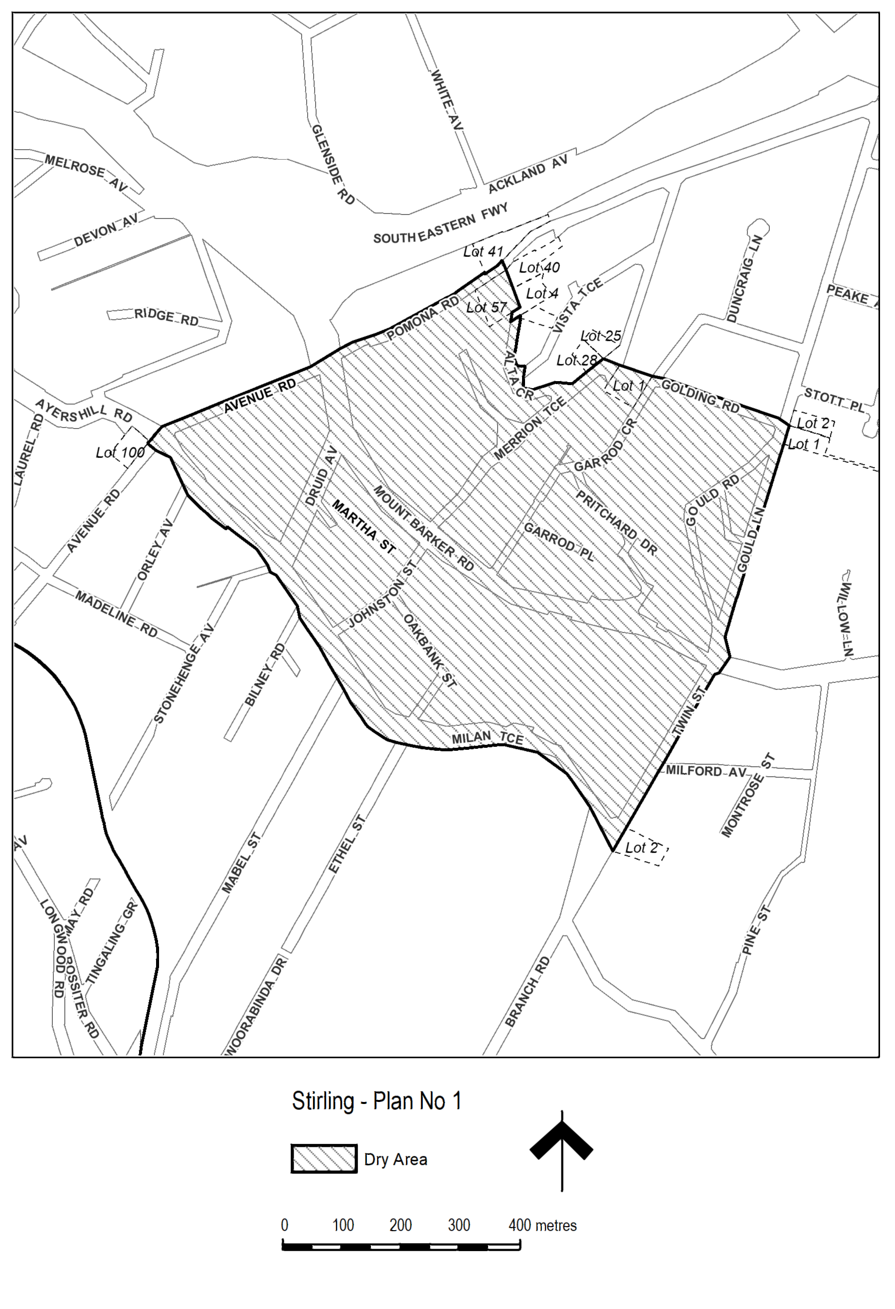
Made by Andrew Atiken, Chief Executive Order, Adelaide Hills Council
On 5 November 2019

Adelaide Hills Council
Roads (Opening and Closing) Act 1991
Road closure – Public Road, Longwood, South Australia
NOTICE is hereby given, pursuant to Section 10 of the Roads (Opening and Closing) Act 1991, that the ADELAIDE HILLS COUNCIL proposes to make a Road Process Order to close and merge with 307 Scott Creek Road, Longwood the Public Road adjoining 307 Scott Creek Road, Longwood, more particularly delineated and lettered A on Preliminary Plan 19/0047.
A copy of the plan and a statement of persons affected are available for public inspection at the offices of the Council at 63 Mt Barker Road, Stirling, between the hours of 8.30am and 5.00pm, Monday to Friday, or at the Adelaide office of the Surveyor-General during normal office hours.
The Preliminary Plan can also be viewed at http://www.sa.gov.au/roadsactproposals
Any application for easement or objection must set out the full name, address and details of the submission and must be fully supported by reasons.
The application for easement or objection must be made in writing to the Council at PO Box 44, Woodside SA 5244 WITHIN 28 DAYS OF THIS NOTICE and a copy must be forwarded to the Surveyor-General at GPO Box 1354, Adelaide 5001. Where a submission is made, the Council will give notification of a meeting at which the matter will be considered.
Dated: 14 November 2019
A. Aitken
Chief Executive Officer

District Council of Ceduna
Supplementary Election of Area Councillor
Close of Nominations
Nominations Received
At the close of nominations at 12 noon on Thursday 7 November 2019 the following people were accepted as candidates and are listed in the order in which they will appear on the ballot paper.
Area Councillor - 1 Vacancy
NICHOLLS, Anthony William
MAYNARD, Ken
Postal Voting
The election will be conducted by post. Ballot papers and pre-paid envelopes for each voting entitlement will be posted between Tuesday 19 November 2019 and Monday 25 November 2019 to every person, or designated person of a body corporate or group listed on the voters roll at roll close on Monday 30 September 2019. Voting is voluntary.
A person who has not received voting material by Monday 25 November 2019 and believes they are entitled to vote should contact the Deputy Returning Officer on 1300 655 232.
Completed voting material must be returned to reach the Returning Officer no later than 12 noon on Monday 9 December 2019.
A ballot box will be provided at the Ceduna Council Chamber, 44 O’Loughlin Terrace, Ceduna for electors wishing to hand deliver their completed voting material during office hours.
Vote Counting Location
The scrutiny and counting of votes will take place at the Electoral Commission SA, Level 6, 60 Light Square, Adelaide as soon as practicable after 12 noon on Tuesday 10 December 2019. A provisional declaration will be made at the conclusion of the election count.
Campaign Donations Return
All candidates must forward a Campaign Donations Return to the Council Chief Executive Officer within 30 days after the conclusion of the election.
Dated: 7 November 2019
Mick Sherry
Returning Officer

REGIONAL COUNCIL OF GOYDER
Roads (Opening and Closing) Act 1991
Road Closing—Public Road, Hallett (Readvertised)
NOTICE is hereby given, pursuant to section 10 of the Roads (Opening and Closing) Act 1991, that the Regional Council of Goyder proposes to make a Road Process Order to close portion of the Public Road situated between Section 537 Hundred of Hallett and merge with the adjoining Section 537, more particularly delineated and lettered ‘A’ on Preliminary Plan 17/0046.
A copy of the plan and a statement of persons affected are available for public inspection at the offices of the Regional Council of Goyder at 1 Market Square, Burra SA 5417 and the Adelaide Office of the Surveyor-General during normal office hours.
Any application for easement or objection must set out the full name, address and details of the submission and must be fully supported by reasons.
The application for easement or objection must be made in writing to the Regional Council of Goyder, 1 Market Square, Burra SA 5417 WITHIN 28 DAYS OF THIS NOTICE and a copy must be forwarded to the Surveyor-General at GPO Box 1354, Adelaide 5001. Where a submission is made, the Council will give notification of a meeting at which the matter will be considered.
Dated: 14 November 2019
David Stevenson
Chief Executive Officer

District Council of Grant
Supplementary Election of Councillor for Central Ward
Close of Nominations
Nominations Received
At the close of nominations at 12 noon on Thursday 7 November 2019 the following people were accepted as candidates and are listed in the order in which they will appear on the ballot paper.
Councillor for Central Ward - 1 Vacancy
NEWMAN, Jason
DUNCAN, Peter
FERGUSON, Adrian
Postal Voting
The election will be conducted by post. Ballot papers and pre-paid envelopes for each voting entitlement will be posted between Tuesday 19 November 2019 and Monday 25 November 2019 to every person, or designated person of a body corporate or group listed on the voters roll at roll close on Monday 30 September 2019. Voting is voluntary.
A person who has not received voting material by Monday 25 November 2019 and believes they are entitled to vote should contact the Deputy Returning Officer on 1300 655 232.
Completed voting material must be returned to reach the Returning Officer no later than 12 noon on Monday 9 December 2019.
A ballot box will be provided at the Council Office, 324 Commercial Street West, Mount Gambier for electors wishing to hand deliver their completed voting material during office hours.
Vote Counting Location
The scrutiny and counting of votes will take place at Electoral Commission SA, Level 6/60 Light Square, Adelaide as soon as practicable after 12 noon on Tuesday 10 December 2019. A provisional declaration will be made at the conclusion of the election count.
Campaign Donations Return
All candidates must forward a Campaign Donations Return to the Council Chief Executive Officer within 30 days after the conclusion of the election.
Dated: 7 November 2019
Mick Sherry
Returning Officer

Mount Barker District Council
Development Act 1993
Kanmantoo Copper Mine Development Plan Amendment—Public Consultation
Notice is hereby given that the Mount Barker District Council, pursuant to sections 24 and 25 of the Development Act 1993, has prepared a Development Plan Amendment Report (DPA) to amend its Development Plan.
The DPA seeks to rezone a portion of the larger Kanmantoo Copper Mine site held by Hillgrove Resources (‘Hillgrove’) from Primary Production Zone to Urban Employment Zone to allow for industrial/employment generating purposes, following the cessation of large scale mining operations on the site in the first half of 2019.
The DPA report will be on public consultation from Thursday 14 November 2019 until Thursday 23 January 2020.
There will be one public information session as follows:
Where: Kanmantoo Hall
9 Princes Highway, Kanmantoo
When: Thursday 5 December 2019 4.00pm to 7.00pm
For more information and to view the DPA online visit: www.mountbarker.sa.gov.au/discover/exploremap/kanmantoo
Copies of the DPA are available for purchase or viewing at the following locations:
- Mount Barker Council Offices Level 1, 6 Dutton Road, Mount Barker
- Mount Barker Community Library Dumas Street, Mount Barker,
To comment on the DPA please provide a written submission marked Kanmantoo Copper Mine DPA and sent to:
Andrew Stuart, Chief Executive Officer
Mount Barker District Council
PO BOX 54 Mount Barker SA 5251.
Written submissions regarding the DPA should be received no later than 5.00 pm on Thursday 23 January 2020.
Your submission should clearly indicate whether you wish to be heard in support of your submission at the public hearing. If you wish to lodge your submission electronically, please email it to KCMDPA@mountbarker.sa.gov.au
Copies of all submissions will be available for inspection at the Mount Barker District Council Chambers 6 Dutton Road, Mount Barker from 24 January 2020 until the conclusion of the public hearing.
A public hearing will be held on Monday 3 February 2020 at 5.30pm at the Mount Barker District Council Chambers, 6 Dutton Road, Mount Barker at which time interested persons may be heard in relation to the DPA and the submissions. The public hearing will not be held if no submissions are received or if no submission makes a request to be heard.
If you would like further information about the DPA, contact Glenn Searle, 8391 7291 or gsearle@mountbarker.sa.gov.au.
Dated: 14 November 2019
Andrew Stuart
Chief Executive Officer

District Council of Mount Remarkable
Supplementary Election of Councillor for Willochra Ward
Close of Nominations
Nominations Received
At the close of nominations at 12 noon on Thursday 7 November 2019 the following people were accepted as candidates and are listed in the order in which they will appear on the ballot paper.
Councillor for Willochra Ward - 1 Vacancy
MORGAN, Ed
PRESTRIDGE, Greg
Postal Voting
The election will be conducted by post. Ballot papers and pre-paid envelopes for each voting entitlement will be posted between Tuesday 19 November 2019 and Monday 25 November 2019 to every person, or designated person of a body corporate or group listed on the voters roll at roll close on Monday 30 September 2019. Voting is voluntary.
A person who has not received voting material by Monday 25 November 2019 and believes they are entitled to vote should contact the Deputy Returning Officer on 1300 655 232.
Completed voting material must be returned to reach the Returning Officer no later than 12 noon on Monday 9 December 2019.
A ballot box will be provided at the Council Office, 3 Stuart Street, Melrose for electors wishing to hand deliver their completed voting material during office hours.
Vote Counting Location
The scrutiny and counting of votes will take place at Electoral Commission SA, Level 6/60 Light Square, Adelaide as soon as practicable after 12 noon on Tuesday 10 December 2019. A provisional declaration will be made at the conclusion of the election count.
Campaign Donations Return
All candidates must forward a Campaign Donations Return to the Council Chief Executive Officer within 30 days after the conclusion of the election.
Dated: 7 November 2019
Mick Sherry
Returning Officer

Wattle Range Council
Short Term Dry Area—Beachport
Notice is hereby given that the Wattle Range Council pursuant to 31 (1a) of the Liquor Licensing Act 1997 that Council declares a Short Term Dry Area commencing from 12 noon on Tuesday 31 December 2019 to 12 noon Thursday 2 January 2020.
(1) Pursuant to section 131 of the Act, the consumption and possession of liquor in the area described in the Schedule is prohibited in accordance with the provisions of the Schedule.
(2) The prohibition has effect during the periods specified in the Schedule.
(3) The prohibition does not extend to private land in the area described in the Schedule.
(4) Unless the contrary intention appears, the prohibition of the possession of liquor in the area does not extend to-
(a) a person who is genuinely passing through the area if-
(i) the liquor is in the original container in which it was purchased from licensed premises; and
(ii) the container has not been opened; or
(b) a person who has possession of the liquor in the course of carrying on a business or in the course of his or her employment by another person in the course of carrying on a business; or
(c) a person who is permanently or temporarily residing at premises within the area or on the boundary of the area and who enters the area solely for the purpose of passing through it to enter those premises or who enters the area from those premises for the purpose of leaving the area.

Description of Area
The area in Beachport generally known as Centennial Park, comprising Lot 2 DP 41193.
Dated: 30 October 2019
Ben Gower
Chief Executive Officer

National Electricity Law
The Australian Energy Market Commission (AEMC) gives notice under the National Electricity Law as follows:
Under s 99, the making of a draft determination and related draft rule on the Transmission loss factors proposal (Ref. ERC0251). Written requests for a pre-determination hearing must be received by 21 November 2019. Submissions must be received by 16 January 2020.
Under s 96(5), the proposed National Electricity Amendment (Victorian jurisdictional derogation – RERT contracting) Rule will be made under the standard rule making process in accordance with Part 7 Division 3 (other than section 96) of the NEL, rather than through an expedited process (Project Ref. ERC0283).
Submissions can be made via the AEMC’s website. Before making a submission, please review the AEMC’s privacy statement on its website. Submissions should be made in accordance with the AEMC’s Guidelines for making written submissions on Rule change proposals. The AEMC publishes all submissions on its website, subject to confidentiality.
Written requests should be sent to submissions@aemc.gov.au and cite the reference in the title. Before sending a request, please review the AEMC’s privacy statement on its website.
Documents referred to above are available on the AEMC’s website and are available for inspection at the AEMC’s office.
Australian Energy Market Commission
Level 6, 201 Elizabeth Street
Sydney NSW 2000
Telephone: (02) 8296 7800
www.aemc.gov.au
Dated: 14 November 2019

National Gas Law
The Australian Energy Market Commission (AEMC) gives notice under the National Gas Law as follows:
Under s 317, the time for the making of the final determination on the DWGM simpler wholesale price rule (Ref. GRC0049) proposal has been extended to 12 March 2020.
Under s 317, the time for the making of the final determination on the DWGM improvement to AMDQ regime rule (Ref. GRC0051) proposal has been extended to 12 March 2020.
Documents referred to above are available on the AEMC’s website and are available for inspection at the AEMC’s office.
Australian Energy Market Commission
Level 6, 201 Elizabeth Street
Sydney NSW 2000
Telephone: (02) 8296 7800
www.aemc.gov.au
Dated: 14 November 2019

Trustee Act 1936
Public Trustee
Estates of Deceased Persons
In the matter of the estates of the undermentioned deceased persons:
COOK Sidney Walter late of 11 Waratah Crescent Fannie Bay Northern Territory Retired Supervisor who died 22 May 2019
FARQUHARSON Jean Esther Doreen late of 150 Adams Road Craigmore of no occupation who died 12 May 2019
FAZACKERLEY Eric late of 4 Kangaroo Thorn Road Trott Park Retired Woodwork Instructor who died 13 July 2019
HARVEY Kevin James late of 12 Rothesay Avenue Hazelwood Park Retired Clinical Psychologist who died 12 June 2019
JONES Colin Charles late of 24A Elgin Avenue Warradale Retired Commonwealth Public Servant who died 22 June 2019
LITTLE Kevin Oliver late of 6 Ellis Street Enfield Retired Security Guard who died 22 June 2019
SARAJLIC Sakib late of 419 Fitzgerald Road Coober Pedy of no occupation who died 22 July 2019
VARTTO Kaisu Inkeri late of 83 Cartwright Road Lower Inman Valley of no occupation who died 8 November 2018
WHITFORD Florence Alayne late of 8 Fletcher Road Mount Barker of no occupation who died 10 March 2019
WOOD Barbara Jessie late of 86 Oaklands Road Glengowrie Retired Factory Worker who died 2 March 2019
WORK Norman Charles late of 200-208 Adams Road Craigmore Retired Compositor who died 31 August 2019
Notice is hereby given pursuant to the Trustee Act 1936, the Inheritance (Family Provision) Act 1972 and the Family Relationships Act 1975 that all creditors, beneficiaries, and other persons having claims against the said estates are required to send, in writing, to the office of Public Trustee at GPO Box 1338, Adelaide, 5001, full particulars and proof of such claims, on or before the 13 December 2019 otherwise they will be excluded from the distribution of the said estate; and notice is also hereby given that all persons indebted to the said estates are required to pay the amount of their debts to the Public Trustee or proceedings will be taken for the recovery thereof; and all persons having any property belonging to the said estates are forthwith to deliver same to the Public Trustee.
Dated: 14 November 2019
N S Rantanen
Acting Public Trustee

Notice Submission

Notices for publication must be submitted before 4 p.m. Tuesday, the week of intended gazettal.
Proofs of formatted content are supplied for all notice submissions. Alterations must be returned before 4 p.m. Wednesday.
The SA Government Gazette is compiled and published each Thursday. Requests to withdraw submitted notices must be received before 10 a.m. on the day of publication.

Gazette notices should be emailed as Word files—and signed PDF files if applicable—
in the following format:
- Title (name of the governing legislation/department/organisation)
- Subtitle (description of notice)
- A structured body of text
- Date of authorisation
- Name, position, and department/organisation of the authorising person

Please provide the following information in your email:
- Date of intended gazettal
- Details that may impact on publication of the notice
- Email address and phone number of the person authorising the submission
- Name of the person and organisation to be charged for the notice, if applicable
- Request for a quote, if required
- Purchase order, if required

Email: governmentgazettesa@sa.gov.au
Phone: (08) 8207 1025
Website: www.governmentgazette.sa.gov.au

Printed and published weekly by authority of S. Smith, Government Printer, South Australia
$7.70 per issue (plus postage), $387.60 per annual subscription—GST inclusive
Online publications: www.governmentgazette.sa.gov.au

