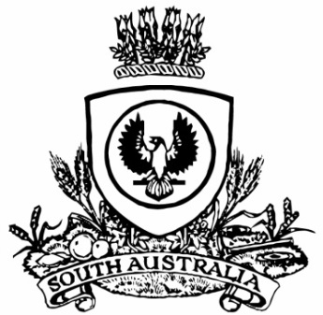
No. 56 3875
SUPPLEMENTARY GAZETTE
THE SOUTH AUSTRALIAN
GOVERNMENT GAZETTE
Published by Authority

Adelaide, Friday, 15 November 2019

Contents

Summary Offences Act 1953—Notice 3876

SUMMARY OFFENCES ACT 1953
Declared Public Precincts
Notice of Ministerial Declaration
I, VICKIE CHAPMAN, Attorney-General in the State of South Australia, being the Minister responsible for the administration of
Part 14B – Declared Public Precincts of the Summary Offences Act 1953, DO HEREBY DECLARE pursuant to the provisions of section 66N of the said Act that the area, comprised of more than one public place, within the following boundaries:
- Northern boundary of North Terrace to western boundary of West Terrace; and
- Western boundary of West Terrace to southern boundary of Currie Street; and
- Southern boundary of Currie Street to eastern boundary of King William Street; and
- Eastern boundary of King William Street to northern boundary of North Terrace
will be a declared public precinct for a period of 12 hours from 6.00pm on each Friday and for a period of 12 hours from 6.00pm on each Saturday commencing on Friday 22 November 2019, local time and reoccurring for each described day and time of the week until declared otherwise or until 6.00am on Sunday 22 November 2020, whichever occurs sooner.
I am satisfied that there is, during the period specified in this declaration, a reasonable likelihood of conduct posing a risk to public order and safety in the area specified.
I am satisfied that the inclusion of each public place in the area is reasonable having regard to that identified risk.
This declaration is related to and replaces that published in the Government Gazette 3808 on 13 October 2018.

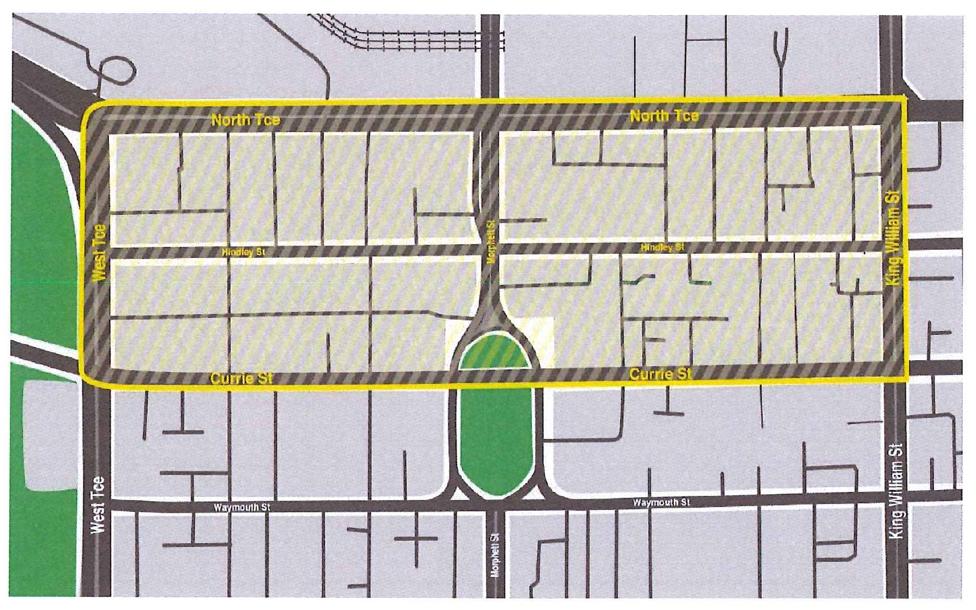
‘City West’ Declared Public Precinct
MADE at Adelaide on this 13th day of November 2019.
Vickie Chapman
Attorney-General

