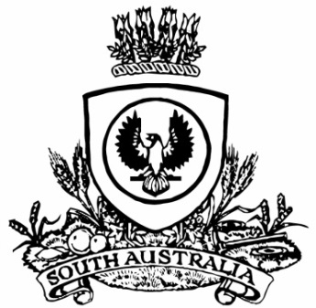
No. 28 p. 691
SUPPLEMENTARY GAZETTE
THE SOUTH AUSTRALIAN
GOVERNMENT GAZETTE
Published by Authority

Adelaide, Friday, 3 April 2020

State Government Instruments
South Australian Public Health Act 2011
Declaration under Sections 63(2) and 70(2)
Declaration of a Notifiable and a Controlled Notifiable Condition—Notice by the Minister
TAKE notice that, I Hon Stephen Wade MLC, Minister for Health and Wellbeing, pursuant to section 63(2) and 70(2) of the South Australian Public Health Act 2011, being satisfied that it is necessary in the interests of public health because of urgent circumstances, do hereby declare –
human coronavirus disease (COVID-19) to be a notifiable and a controlled notifiable condition.
Dated: 3 April 2020
Stephen Wade
Minister for Health and Wellbeing

