THE SOUTH AUSTRALIAN
GOVERNMENT GAZETTE
Published by Authority

Adelaide, Thursday, 27 August 2020

Contents

Governor’s Instruments
Appointments 4404
Regulations—
Fisheries Management (Marine Scalefish Fisheries)
(Quota) Variation Regulations 2020—
No. 260 of 2020 4405
Fisheries Management (Blue Crab Fishery) (Quota)
Variation Regulations 2020—No. 261 of 2020 4408
Fisheries Management (Lakes and Coorong Fishery)
(Quota) Variation Regulations 2020—
No. 262 of 2020 4410
Fisheries Management (Rock Lobster Fisheries)
(Quota) (No 2) Variation Regulations 2020—
No. 263 of 2020 4412
Rules of Court
Youth Court of South Australia 4414
State Government Instruments
Administrative Arrangements Act 1994 4469
Aquaculture Act 2001 4469
Building Work Contractors Act 1995 4469
Development Act 1993 4470
Fisheries Management Act 2007 4476
Housing Improvement Act 2016 4476
Justices of the Peace Act 2005 4476
Land Acquisition Act 1969 4477
Mental Health Act 2009 4478
Mining Act 1971 4478
Petroleum and Geothermal Energy Act 2000 4480
South Australian Civil and Administrative Tribunal 4482
Local Government Instruments
City of Adelaide 4484
City of Charles Sturt 4484
City of Mitcham 4484
City of Port Lincoln 4485
City of Unley 4485
Barunga West Council 4485
Berri Barmera Council 4487
District Council of Grant 4502
Yorke Peninsula Council 4503
Public Notices
Trustee Act 1936 4504
Sale of Property 4504

Governor’s Instruments

Appointments
Department of the Premier and Cabinet
Adelaide, 27 August 2020
His Excellency the Governor in Executive Council has been pleased to appoint the Honourable Robert Ivan Lucas, MLC, Treasurer to be also Acting Minister for Health and Wellbeing for the period from 28 August 2020 to 31 August 2020 inclusive, during the absence of the Honourable Stephen Graham Wade, MLC.
By command,
Steven Spence Marshall
Premier
HEAC-2020-00045

Department of the Premier and Cabinet
Adelaide, 27 August 2020
His Excellency the Governor in Executive Council has been pleased to appoint Ian Nightingale to the position of Industry Advocate, for a term of three years commencing on 1 January 2021 and expiring on 31 December 2023 - pursuant to the provisions of the Industry Advocate Act 2017.
By command,
Steven Spence Marshall
Premier
T&F20/071CS

Department of the Premier and Cabinet
Adelaide, 27 August 2020
His Excellency The Honourable Hieu Van Le, Companion in the Order of Australia, Governor in and over the State of South Australia:
To
Air Chief Marshal Mark Donald Binskin AC (Retd)
The Honourable Dr Annabelle Claire Bennett AC SC
Professor Andrew Kerr Macintosh
Greeting:
WHEREAS I, the Governor, did on 5 March 2020 appoint you under the Royal Commissions Act 1917 to be Commissioners and require and authorise you to inquire into certain matters, and require you to submit to me a report of the results of your inquiry, and your recommendations, not later than 31 August 2020;
AND WHEREAS it is desirable that the Commission be varied to require you to submit to me a report of the results of your inquiry, and your recommendations, not later than 28 October 2020;
NOW I, the Governor, with the advice and consent of the Executive Council and under the Royal Commissions Act 1917, DO HEREBY DECLARE that the Commission will have effect as follows:
(a) by omitting from the final paragraph (m) of the Commission “31 August 2020” and substituting “28 October 2020.”
GIVEN under my hand and the Public Seal of South Australia, at Adelaide this 27th day of August 2020.
By command,
Steven Spence Marshall
Premier
Recorded in Register of Commissions,
Letters Patent, Etc., Vol. XXIX
Louise Russell
Clerk of Executive Council
GOD SAVE THE QUEEN!

Regulations
South Australia

Fisheries Management (Marine Scalefish Fisheries) (Quota) Variation Regulations 2020
under the Fisheries Management Act 2007

Contents
Part 1—Preliminary
1 Short title
2 Commencement
3 Variation provisions
Part 2—Variation of Fisheries Management (Marine Scalefish Fisheries) Regulations 2017
4 Variation of regulation 14—Individual vongole catch quota system
5 Variation of regulation 15—Individual pipi catch quota system
6 Variation of regulation 16—Individual blue crab catch quota system

Part 1—Preliminary
1—Short title
These regulations may be cited as the Fisheries Management (Marine Scalefish Fisheries) (Quota) Variation Regulations 2020.
2—Commencement
These regulations come into operation on the day on which they are made.
3—Variation provisions
In these regulations, a provision under a heading referring to the variation of specified regulations varies the regulations so specified.
Part 2—Variation of Fisheries Management (Marine Scalefish Fisheries) Regulations 2017
4—Variation of regulation 14—Individual vongole catch quota system
(1) Regulation 14(1)—after the definition of quota period insert:
quota period 2019-2020 means the quota period that ended on 30 June 2020;
quota period 2020-2021 means the quota period ending on 30 June 2021;
quota period 2021-2022 means the quota period ending on 30 June 2022;
(2) Regulation 14(3)—after paragraph (d) insert:
(da) if the total catch of vongole taken by the holder of a licence in respect of a marine scalefish fishery subject to a condition fixing a vongole quota entitlement in respect of a particular vongole fishing zone during the quota period 2019-2020 is less than the vongole quota entitlement under the licence for that fishing zone and that quota period, the Minister may vary the conditions of the licence so as to increase the vongole quota entitlement in respect of that fishing zone for the quota periods 2020-2021 and 2021-2022 by up to 1 kilogram of vongole for each kilogram by which the catch fell short of the vongole quota entitlement for the quota period 2019-2020;
(3) Regulation 14—after subregulation (3) insert:
(3a) In determining whether to vary the conditions of a licence under subregulation (3)(da) so as to increase the vongole quota entitlement under the licence for a particular vongole fishing zone and the quota period 2021-2022, the Minister must take into account—
(a) the total catch of vongole taken by the holder of the licence in that fishing zone during the quota period 2020-2021; and
(b) any increase in the vongole quota entitlement under the licence in respect of that fishing zone for the quota period 2020-2021.
5—Variation of regulation 15—Individual pipi catch quota system
(1) Regulation 15(1)—after the definition of quota period insert:
quota period 2019-2020 means the quota period that ended on 30 June 2020;
quota period 2020-2021 means the quota period ending on 30 June 2021;
quota period 2021-2022 means the quota period ending on 30 June 2022;
(2) Regulation 15(3)—after paragraph (b) insert:
(ba) if the total catch of pipi taken by the holder of a licence in respect of the Marine Scalefish Fishery subject to a condition fixing a pipi quota entitlement during the quota period 2019-2020 is less than the pipi quota entitlement under the licence for that quota period, the Minister may vary the conditions of the licence so as to increase the pipi quota entitlement for the quota periods 2020-2021 and 2021-2022 by up to 1 kilogram of pipi for each kilogram by which the catch fell short of the pipi quota entitlement for the quota period 2019-2020;
(3) Regulation 15—after subregulation (3) insert:
(3a) In determining whether to vary the conditions of a licence under subregulation (3)(ba) so as to increase the pipi quota entitlement under the licence for the quota period 2021-2022, the Minister must take into account—
(a) the total catch of pipi taken by the holder of the licence during the quota period 2020-2021; and
(b) any increase in the pipi quota entitlement under the licence for the quota period 2020-2021.
6—Variation of regulation 16—Individual blue crab catch quota system
(1) Regulation 16(1)—after the definition of quota period insert:
quota period 2019-2020 means the quota period that ended on 30 June 2020;
quota period 2020-2021 means the quota period ending on 30 June 2021;
(2) Regulation 16(3)—after paragraph (d) insert:
(da) if the total blue crab catch taken by the holder of a licence in respect of a marine scalefish fishery subject to a condition fixing a blue crab quota entitlement in respect of a particular blue crab fishing zone during the quota period 2019-2020 is less than the blue crab quota entitlement under the licence for that fishing zone and that quota period, the Minister may vary the conditions of the licence so as to increase the blue crab quota entitlement in respect of that fishing zone for the quota period 2020-2021 by up to 1 kilogram of blue crab for each kilogram by which the catch fell short of the blue crab quota entitlement for the quota period 2019-2020;
Note—
As required by section 10AA(2) of the Subordinate Legislation Act 1978, the Minister has certified that, in the Minister's opinion, it is necessary or appropriate that these regulations come into operation as set out in these regulations.
Made by the Governor
with the advice and consent of the Executive Council
on 27 August 2020
No 260 of 2020

South Australia

Fisheries Management (Blue Crab Fishery) (Quota) Variation Regulations 2020
under the Fisheries Management Act 2007

Contents
Part 1—Preliminary
1 Short title
2 Commencement
3 Variation provisions
Part 2—Variation of Fisheries Management (Blue Crab Fishery) Regulations 2013
4 Variation of regulation 10—Individual blue crab catch quota system

Part 1—Preliminary
1—Short title
These regulations may be cited as the Fisheries Management (Blue Crab Fishery) (Quota) Variation Regulations 2020.
2—Commencement
These regulations come into operation on the day on which they are made.
3—Variation provisions
In these regulations, a provision under a heading referring to the variation of specified regulations varies the regulations so specified.

Part 2—Variation of Fisheries Management (Blue Crab Fishery) Regulations 2013
4—Variation of regulation 10—Individual blue crab catch quota system
(1) Regulation 10(2)—after paragraph (d) insert:
(da) if the total catch of blue crab taken by the holder of a licence in respect of the Blue Crab Fishery subject to a condition fixing a blue crab quota entitlement in respect of a particular blue crab fishing zone during the quota period 2019-2020 is less than the blue crab quota entitlement under the licence for that fishing zone and that quota period, the Minister may vary the conditions of the licence so as to increase the blue crab quota entitlement in respect of that fishing zone for the quota period 2020-2021 by up to 1 kilogram of blue crab for each kilogram by which the catch fell short of the blue crab quota entitlement for the quota period 2019-2020;
(2) Regulation 10—after subregulation (3) insert:
(4) In this regulation—
quota period 2019-2020 means the quota period that ended on 30 June 2020;
quota period 2020-2021 means the quota period ending on 30 June 2021.
Note—
As required by section 10AA(2) of the Subordinate Legislation Act 1978, the Minister has certified that, in the Minister's opinion, it is necessary or appropriate that these regulations come into operation as set out in these regulations.
Made by the Governor
with the advice and consent of the Executive Council
on 27 August 2020
No 261 of 2020

South Australia

Fisheries Management (Lakes and Coorong Fishery) (Quota) Variation Regulations 2020
under the Fisheries Management Act 2007

Contents
Part 1—Preliminary
1 Short title
2 Commencement
3 Variation provisions
Part 2—Variation of Fisheries Management (Lakes and Coorong Fishery) Regulations 2009
4 Variation of regulation 10—Individual pipi catch quota system

Part 1—Preliminary
1—Short title
These regulations may be cited as the Fisheries Management (Lakes and Coorong Fishery) (Quota) Variation Regulations 2020.
2—Commencement
These regulations come into operation on the day on which they are made.
3—Variation provisions
In these regulations, a provision under a heading referring to the variation of specified regulations varies the regulations so specified.
Part 2—Variation of Fisheries Management (Lakes and Coorong Fishery) Regulations 2009
4—Variation of regulation 10—Individual pipi catch quota system
(1) Regulation 10(1)—after the definition of quota period insert:
quota period 2019-2020 means the quota period that ended on 30 June 2020;
quota period 2020-2021 means the quota period ending on 30 June 2021;
quota period 2021-2022 means the quota period ending on 30 June 2022;
(2) Regulation 10(3)—after paragraph (d) insert:
(da) if the total catch of pipi taken by the holder of a licence in respect of the fishery subject to a condition fixing a pipi quota entitlement during the quota period 2019-2020 is less than the pipi quota entitlement under the licence for that quota period, the Minister may vary the conditions of the licence so as to increase the pipi quota entitlement for the quota periods 2020-2021 and 2021-2022 by up to 1 kilogram of pipi for each kilogram by which the catch fell short of the pipi quota entitlement for the quota period 2019-2020;
(3) Regulation 10—after subregulation (3) insert:
(3a) In determining whether to vary the conditions of a licence under subregulation (3)(da) so as to increase the pipi quota entitlement under the licence for the quota period 2021-2022, the Minister must take into account—
(a) the total catch of pipi taken by the holder of the licence during the quota period 2020-2021; and
(b) any increase in the pipi quota entitlement under the licence for the quota period 2020-2021.
Note—
As required by section 10AA(2) of the Subordinate Legislation Act 1978, the Minister has certified that, in the Minister's opinion, it is necessary or appropriate that these regulations come into operation as set out in these regulations.
Made by the Governor
with the advice and consent of the Executive Council
on 27 August 2020
No 262 of 2020

South Australia

Fisheries Management (Rock Lobster Fisheries) (Quota) (No 2) Variation Regulations 2020
under the Fisheries Management Act 2007

Contents
Part 1—Preliminary
1 Short title
2 Commencement
3 Variation provisions
Part 2—Variation of Fisheries Management (Rock Lobster Fisheries) Regulations 2017
4 Variation of regulation 13—Individual vongole catch quota system
5 Variation of regulation 16—Individual rock lobster catch quota system—Southern Zone

Part 1—Preliminary
1—Short title
These regulations may be cited as the Fisheries Management (Rock Lobster Fisheries) (Quota) (No 2) Variation Regulations 2020.
2—Commencement
These regulations come into operation on the day on which they are made.
3—Variation provisions
In these regulations, a provision under a heading referring to the variation of specified regulations varies the regulations so specified.
Part 2—Variation of Fisheries Management (Rock Lobster Fisheries) Regulations 2017
4—Variation of regulation 13—Individual vongole catch quota system
(1) Regulation 13(1)—before the definition of vongole quota entitlement or quota entitlement insert:
quota period 2019-2020 means the quota period that ended on 30 June 2020;
quota period 2020-2021 means the quota period ending on 30 June 2021;
quota period 2021-2022 means the quota period ending on 30 June 2022;
(2) Regulation 13(3)—after paragraph (d) insert:
(da) if the total catch of vongole taken by the holder of an eligible rock lobster fishery licence subject to a condition fixing a vongole quota entitlement in respect of a particular vongole fishing zone during the quota period 2019-2020 is less than the vongole quota entitlement under the licence for that fishing zone and that quota period, the Minister may vary the conditions of the licence so as to increase the vongole quota entitlement in respect of that fishing zone for the quota periods 2020-2021 and 2021-2022 by up to 1 kilogram of vongole for each kilogram by which the catch fell short of the vongole quota entitlement for the quota period 2019-2020;
(3) Regulation 13—after subregulation (3) insert:
(3a) In determining whether to vary the conditions of a licence under subregulation (3)(da) so as to increase the vongole quota entitlement under the licence for a particular vongole fishing zone and the quota period 2021-2022, the Minister must take into account—
(a) the total catch of vongole taken by the holder of the licence in that fishing zone during the quota period 2020-2021; and
(b) any increase in the vongole quota entitlement under the licence in respect of that fishing zone for the quota period 2020-2021.
5—Variation of regulation 16—Individual rock lobster catch quota system—Southern Zone
(1) Regulation 16(1), definition of quota period—delete the definition and substitute:
quota period—a quota period for the fishery means—
(a) the period that commenced on 1 October 2019 and ends on 14 September 2020; or
(b) the period commencing on 15 September 2020 and ending on 30 September 2021; or
(c) the period of 12 months commencing on 1 October 2021 or on 1 October in any subsequent year;
(2) Regulation 16(1), definition of quota period 2019-2020—delete "30 September 2020" and substitute:
14 September 2020
Note—
As required by section 10AA(2) of the Subordinate Legislation Act 1978, the Minister has certified that, in the Minister's opinion, it is necessary or appropriate that these regulations come into operation as set out in these regulations.
Made by the Governor
with the advice and consent of the Executive Council
on 27 August 2020
No 263 of 2020

Rules of Court

Youth Court of South Australia
Rules amending the Youth Court (General) Rules 2016
BY virtue and in pursuance of section 32 of the Youth Court Act 1993 and all other enabling powers, we, the Judge of the Court and the Magistrates who are members of the principal judiciary of the Court, make the following rules of the Court.
Part 1 – Preliminary
1 – Citation
These Rules may be cited as the Youth Court (General) Rules 2016 (Amendment No 2).
2 – Commencement
These rules will come into operation on 1 September 2020.
3 – Amendment of principal rules
The Youth Court (General) Rules 2016 are amended in the manner set out in Part 2.
4 – Transitional provision
(1) In this rule —
commencement date means 1 September 2020.
(2) Unless the Court otherwise orders —
(a) the Youth Court (General) Rules 2016 as amended by these rules (the current rules) apply to —
(i) a proceeding commenced; and
(ii) a step in proceedings taken,
on or after the commencement date; and
(b) the Youth Court (General) Rules 2016 before they were amended by these rules (the former rules) continue to govern a step in proceedings taken before the commencement date.
(3) If the time to commence or take a step in proceedings under the former rules has not expired as at the commencement date, the time to commence or take a step in the proceedings continues to be governed by the former rules (unless the current rules provide for a longer time).
Part 2 – Amendment of Youth Court (General) Rules 2016
5 – Amendment of rule 3 – Interpretation
Rule 3(1), definition of surrogacy jurisdiction – delete the definition and substitute:
surrogacy jurisdiction of the Court means the jurisdiction of the Court under the Surrogacy Act 2019;
6 – Amendment of rule 15A – Warrant or summons to produce person in custody
Rule 15A(2) – delete subrule (2) and substitute:
(2) A summons to produce a person held in custody in the State to give evidence or attend at a hearing of a proceeding is to be in the prescribed form.
Prescribed form—
Form G5 Summons to Produce Person in Custody
Note—
Section 21 of the Youth Court Act 1993 empowers the Court to issue a summons or warrant that a person held in custody be brought before the Court for examination.
Section 28(2) of the Correctional Services Act 1982 provides that where a prisoner is required to attend before a court as a party to the proceedings or as a witness, the Court may, by order, direct the Chief Executive to cause the prisoner to be brought before the Court in accordance with the order.
7 – Amendment of rule 25 – Authority to enter and inspect
Rule 25 – after “of the Act” insert “to enter or inspect”.
8 – Substitution of rule 26
Rule 26 – delete rule 26 and substitute:
26—Appeals
(1) An appeal under section 22(2)(a) or (b)(ii) or (iii) of the Act must be instituted by filing in the Principal Registry of the Supreme Court, and serving on all parties, the appropriate Notice of Appeal.
(2) A Notice of Appeal under section 22(2)(b)(i) of the Act must be in the prescribed form.
Prescribed form—
Form G6 Appeal from Interlocutory Judgment of Magistrate/ Special Justice
(3) An appeal under section 22(2)(b)(i) of the Act must be instituted within 14 days from the giving of the interlocutory judgment complained of, or such extended time as the Court may fix.
(4) The Judge may give such directions as the Judge thinks fit for the conduct of an appeal under section 22(2)(b)(i) of the Act.
9 – Substitution of Part 4
Part 4 – delete the Part and substitute:
Part 3—Surrogacy applications
27—Orders as to parentage of a child
(1) An application to the Court under section 18 of the Surrogacy Act 2019 must be made in the prescribed form.
Prescribed form—
Form S1 Application for an Order of the Court (Surrogacy)
(2) An application for an order under section 18(1) of the Act must be accompanied by a copy of the lawful surrogacy agreement.
(3) An application under subrule (1) must be supported by an affidavit or affidavits in the prescribed form that sufficiently set out the evidence on which the application is based after taking into account the nature and effect of the order or orders that are being sought from the Court.
Prescribed form—
Form S6 Affidavit
(4) If the information required for the purposes of section 18(3) of the Surrogacy Act 2019 is not provided to the Court as part of the application under subrule (1), the information must be filed at the Court, and served on any other party to the proceedings, at least 5 business days before the next date set for the hearing of the proceedings (unless the Court allows or directs otherwise).
(5) Unless the applicant is seeking the Court’s consent to dispense with the requirement for the surrogate mother’s consent under section 18(5)(c) of the Surrogacy Act 2019, an application under section 18(1) of the Surrogacy Act 2019 must also be accompanied by an affidavit of the surrogate mother in the prescribed form.
Prescribed form—
Form S6 Affidavit
(6) Without limiting the requirements under subrules (3) and (5), the applicant or applicants for an order under section 18(1)(a) of the Surrogacy Act 2019 must ensure that each of the requirements of section 10 of the Surrogacy Act 2019 are addressed by affidavit filed in the Court (subject to any order of the Court under section 18(7) of that Act).
28—Court may dispense with consent of surrogate mother
The Court may dispense with the requirement for the surrogate mother’s consent under section 18(5)(c) of the Surrogacy Act 2019 on its own initiative if the Court is satisfied as to a matter under section 18(6) of the Surrogacy Act 2019.
29—Assessment by accredited counsellor
(1) An assessment by an accredited counsellor for the purposes of section 18(10) of the Surrogacy Act 2019 must be in writing.
(2) The party required to provide the assessment must ensure that a copy of the assessment is filed at the Court, and served on any other party to the proceedings, at least 5 business days before the next date set for the hearing of the proceedings (unless the Court allows or directs otherwise).
30—Order to revoke an order
(1) An application to the Court under section 19(1) of the Surrogacy Act 2019 must be made in the prescribed form.
Prescribed form—
Form S2 Application to Revoke Order (Surrogacy)
(2) An application under subrule (1) must be supported by an affidavit in the prescribed form that sufficiently sets out the evidence on which the application is based.
Prescribed form—
Form S6 Affidavit
31—Application to intervene
(1) An application for leave to intervene in proceedings under section 19(4) of the Surrogacy Act 2019 must be made in the prescribed form.
Prescribed form—
Form S3 Application for Leave to Intervene
(2) An application under subrule (1) must be supported by an affidavit in the prescribed form that sufficiently sets out the evidence on which the application is based.
Prescribed form—
Form S6 Affidavit
32—Responses
(1) This rule applies to an application to the Court for an order under section 19 of the Surrogacy Act 2019.
(2) A party to an application who opposes the application in whole or part must file a response in the prescribed form.
Prescribed form—
Form S4 Response to Application to Revoke Order
(3) A response —
(a) must state clearly the grounds of objection; and
(b) should be supported by material that provides evidence of any matter that is relevant to the ground or grounds of objection.
(4) Material in support of a response may be in the form of—
(a) an affidavit (including annexures); or
(b) expert reports; or
(c) subject to a direction of the Court, other documentary evidence.
(5) The response, and material in support of the response, must be filed in the Court and, served on the other parties, at least 5 business days before the date set for the hearing of the proceedings (unless the Court allows or directs otherwise).
(6) Leave to file further material may be sought orally and at any stage of the proceedings and served on the other parties at least 2 business days before the date set for the hearing of the proceedings (unless the Court allows or directs otherwise).
33—Supporting material—other requirements
(1) The Court may direct a party to file further particulars or materials to assist in the Court’s determination of the outcome that is in the best interests of the child or as to any other matter directed by the Court.
(2) The Court may direct that any further particulars must be supported by an affidavit in the prescribed form.
Prescribed form—
Form S6 Affidavit
(3) Material in support of an application under this rule must be filed in the Court and, served on the other parties, at least 5 business days before the next date set for the hearing of the proceedings (unless the Court allows or directs otherwise).
(4) After the expiration of the period that applies under subrule (3), material in support of an application may only be filed in the Court with leave and on such terms or conditions as the Court directs.
(5) Leave to file further material may be sought orally and at any stage of the proceedings and served on the other parties at least 2 business days before the next date set for the hearing of the proceedings (unless the Court allows or directs otherwise).
34—Interlocutory applications
(1) This rule does not apply to an application of a kind excluded by the Court by practice direction.
(2) An interlocutory application must be made in the prescribed form and supported by an affidavit in the prescribed form.
Prescribed form—
Form S5 Interlocutory Application
Form S6 Affidavit
(3) Nothing prevents an interlocutory application from being combined with an application for a final order of the Court.
(4) The applicant must serve a copy of the application (and accompanying documents) on the other parties as soon as practicable after it is filed in the Court, but not later than 2 business days before the next date set for the hearing of the proceedings (unless the Court allows or directs otherwise).
(5) The Court may, on conditions the Court considers appropriate, dispense with a requirement of this rule—
(a) if the urgency of the case requires; or
(b) by consent of the parties; or
(c) if for any other reason the Court considers it appropriate to do so.
(6) The Court may determine an interlocutory application without hearing oral submissions from the parties if—
(a) the urgency of the case requires; or
(b) the application is not contentious; or
(c) the Court decides on the application of a party to determine the application on the basis of written submissions.
(7) On an interlocutory application, the Court may give directions relating to the proceedings irrespective of whether the applicant has asked for such directions in the application.
35—Directions hearings
(1) This rule applies to an application under section 18(1) or 19(1) of the Surrogacy Act 2019.
(2) An application may be listed for a directions hearing at a time determined by the Court.
(3) At a directions hearing, the Court may give 1 or more of the following directions:
(a) limiting the issues to be determined at the hearing of the application;
(b) requiring or relating to the discovery, inspection and copying of evidentiary material;
(c) arranging for the calling of witnesses;
(d) arranging for the preparation, provision or production of any report;
(e) any other direction that may facilitate the hearing of the application before the Court
(4) Nothing in this rule limits any directions that may, in any event, be given before or at the hearing of an application.
36—Proof of service
(1) If an application or other document is required to be served on another party for the purposes of this Part, the Court may decline to consider the application or document until proof of service of the application has been filed in, or produced to, the Court.
(2) Proof of service of an application or document may consist of an affidavit made by the person who served the application or document setting out—
(a) the date, time and place of service; and
(b) how the person to be served was identified; and
(c) how service was effected.
(3) The Court may, however, require or permit oral evidence of service.
(4) An affidavit of proof of service must be in the prescribed form.
Prescribed form—
Form G10A Affidavit of proof of service
10 – Amendment of Schedule
- Form “G2 – Witness Summons Criminal” is deleted and substituted with the corresponding form published below.
- Form “G11 – Warrant to Apprehend a Youth” is deleted and substituted with the corresponding form published below.
- Form “G12 – Mandate Remanding a Youth” is deleted and substituted with the corresponding form published below.
- Form “G13 – Notice for the Payment of Money” is inserted.
- Forms S1 – S81 are deleted and substituted with the following forms published below:
- S1 – Application for an Order of the Court (Surrogacy)
- S2 – Application to Revoke Order
- S3 – Application for Leave to Intervene
- S4 – Response to Application to Revoke Order
- S5 – Interlocutory Application
- S6 – Affidavit
- S7 – Order
- S8 – Notice to Births, Deaths and Marriages
- S81 – Record of Outcome

Forms G2, G11, G12, G13 and S1 – S81 are published below:

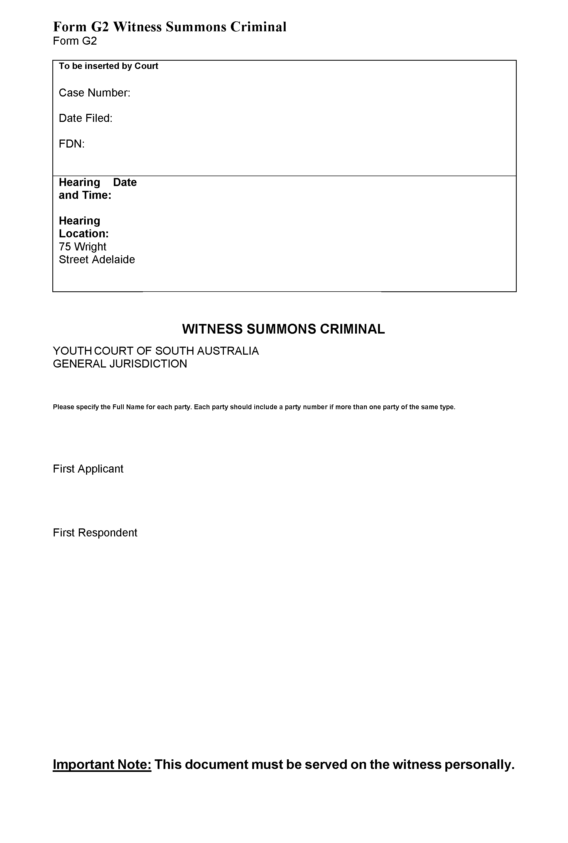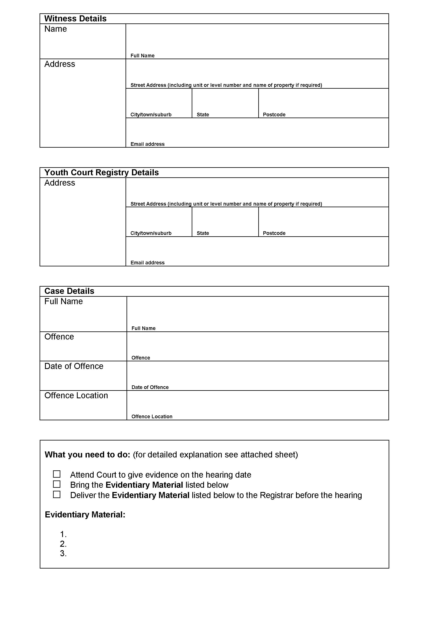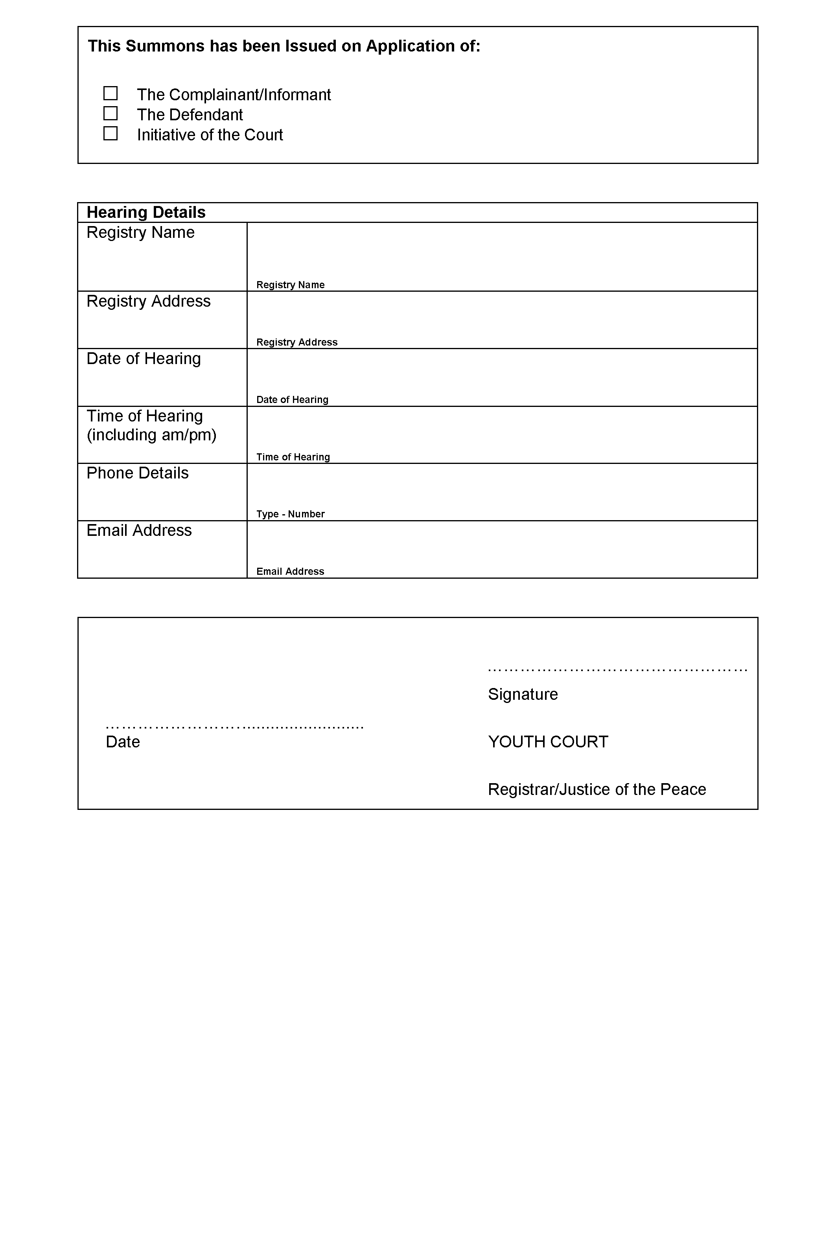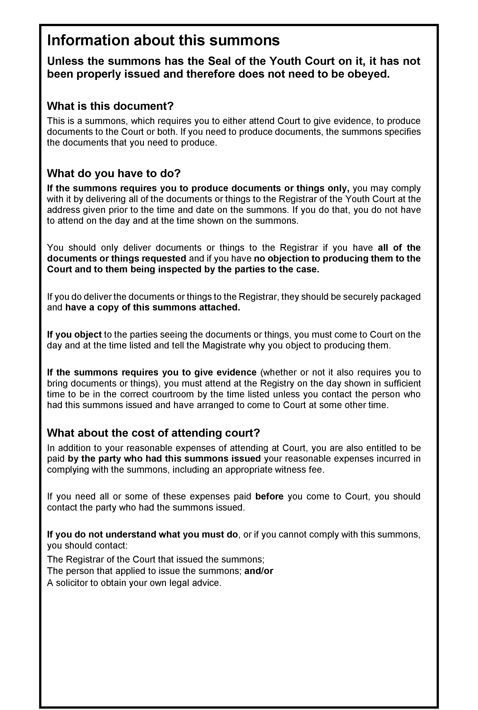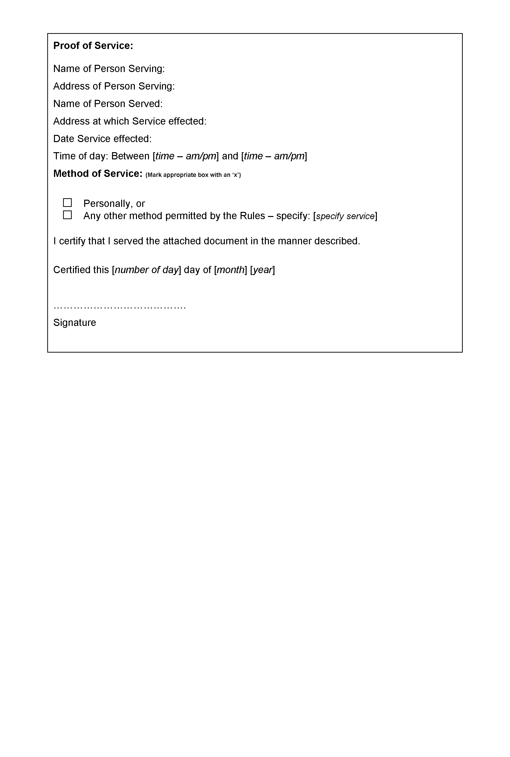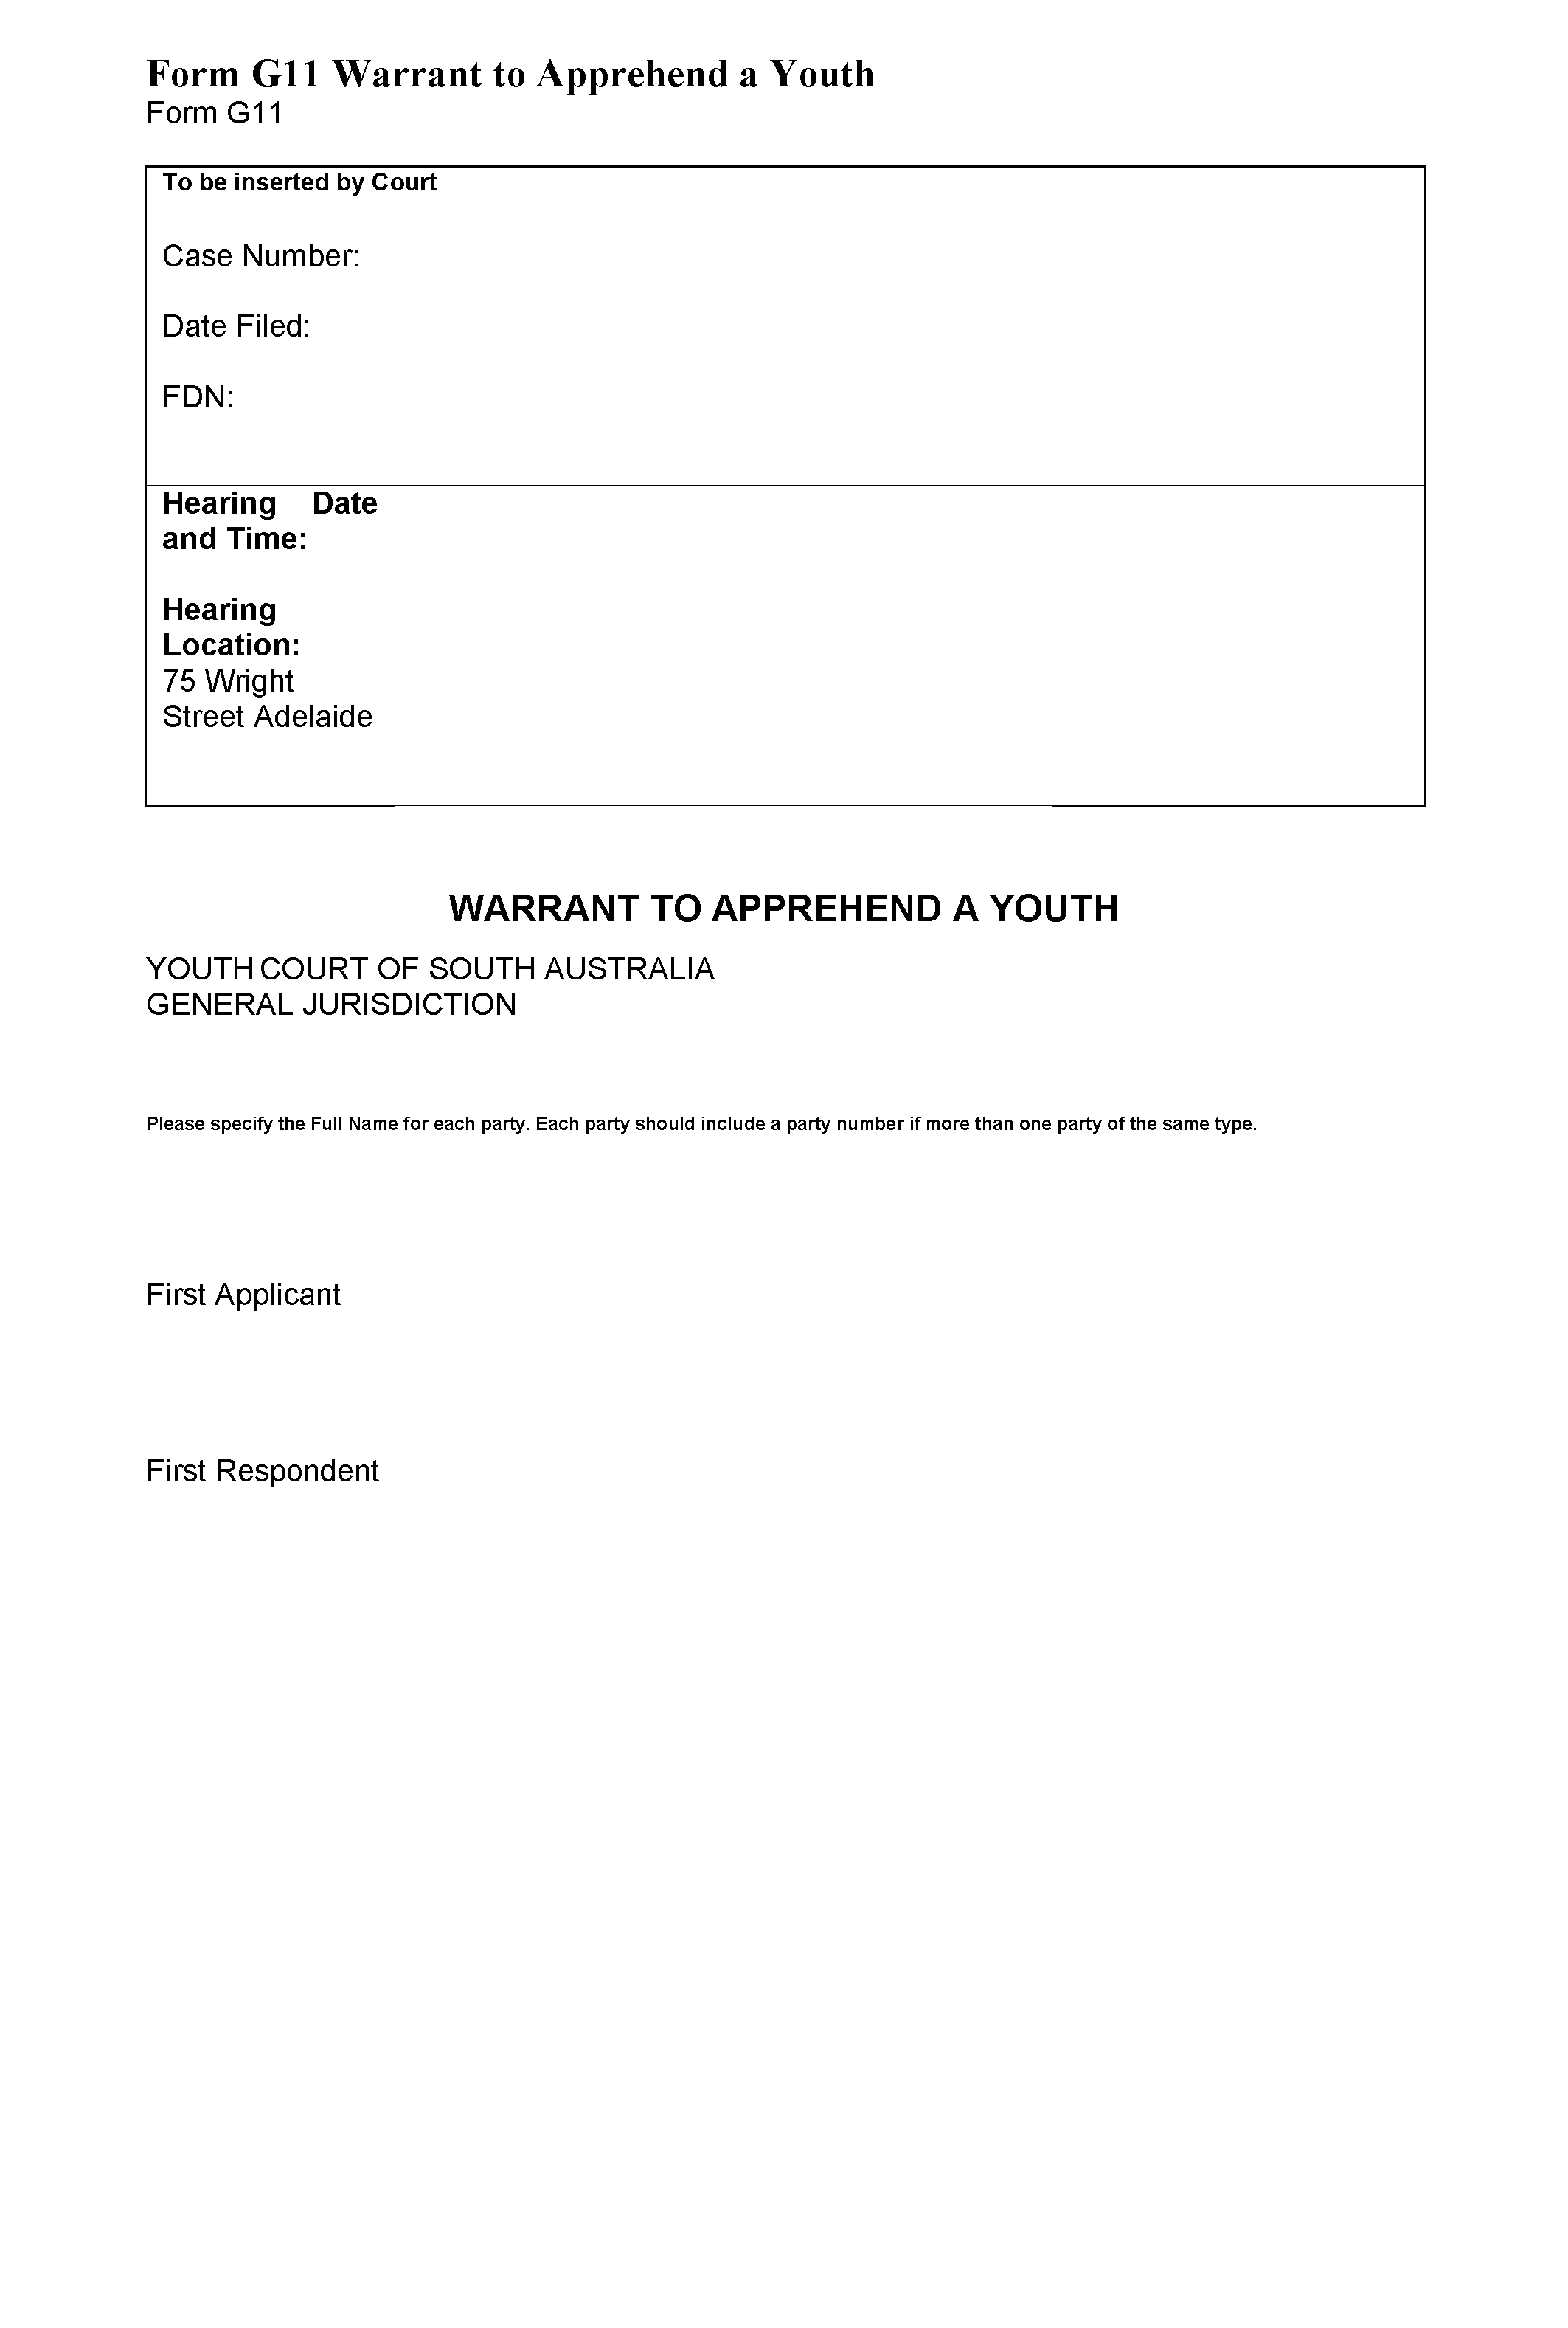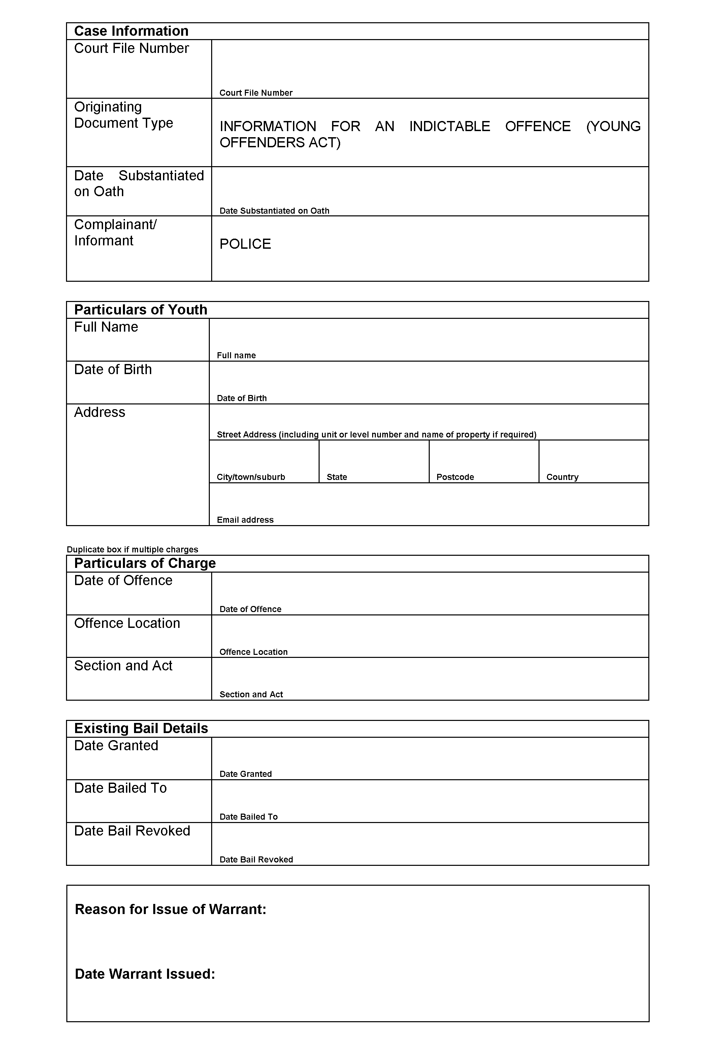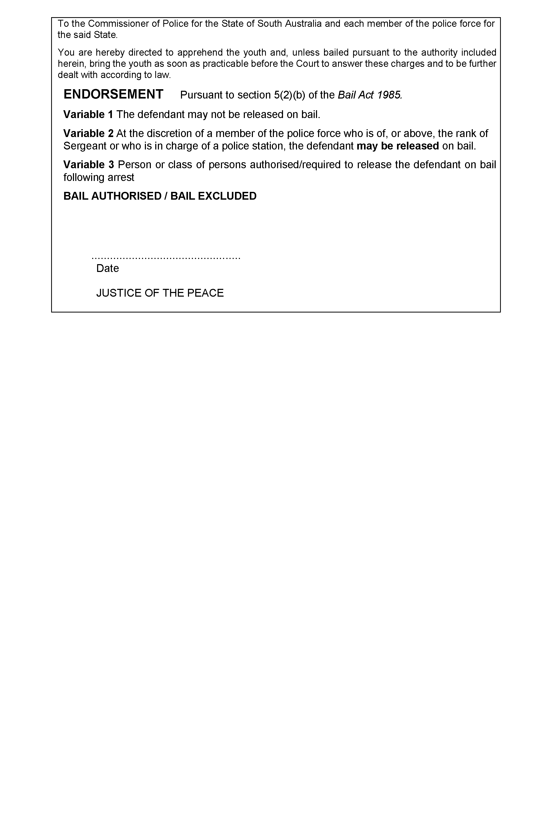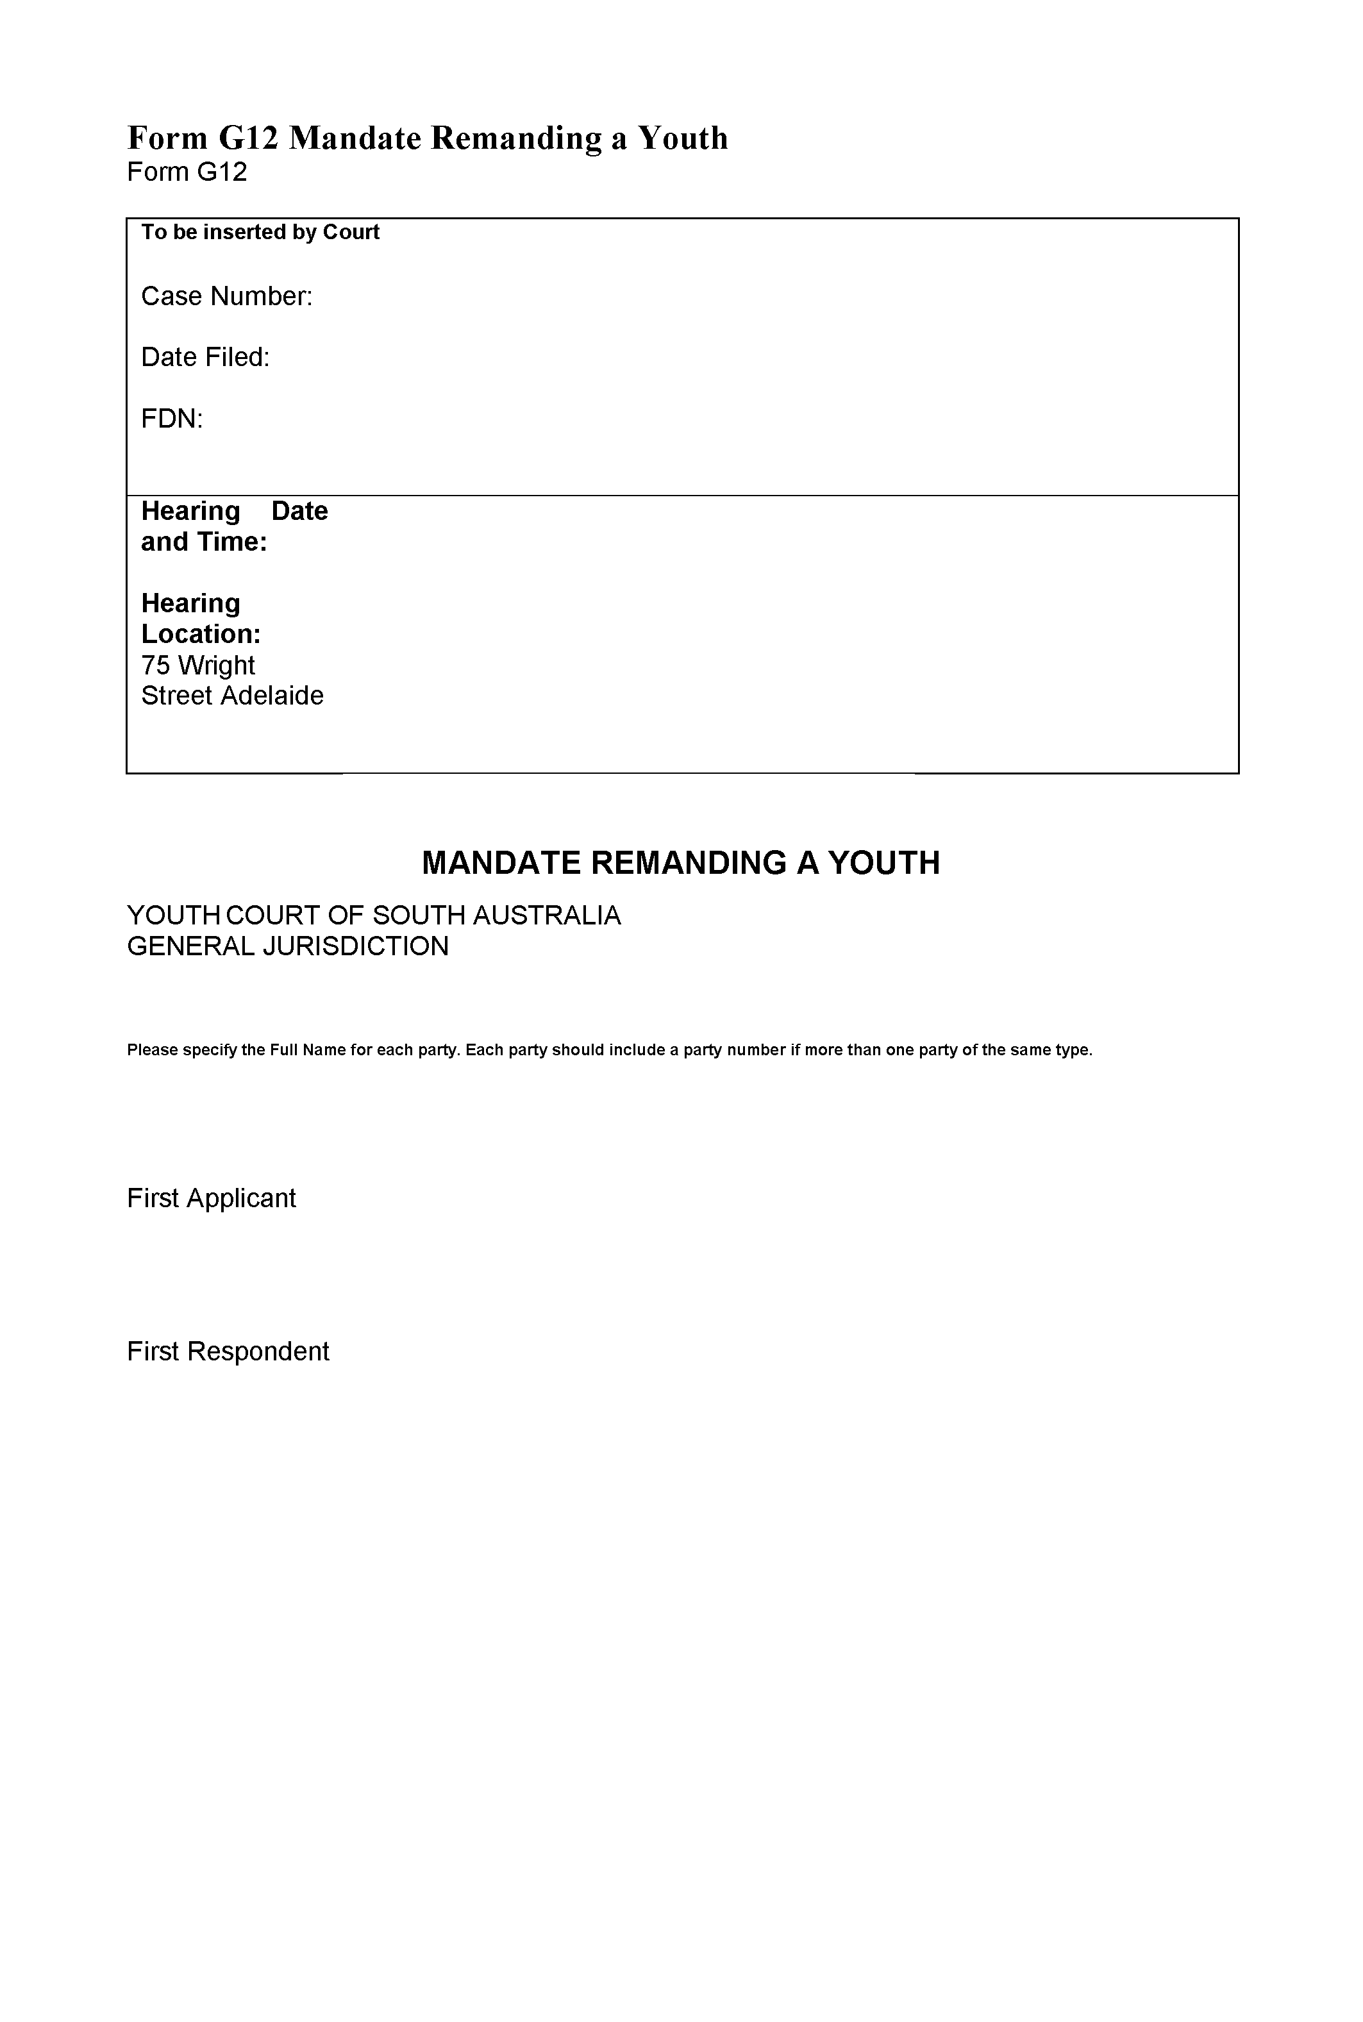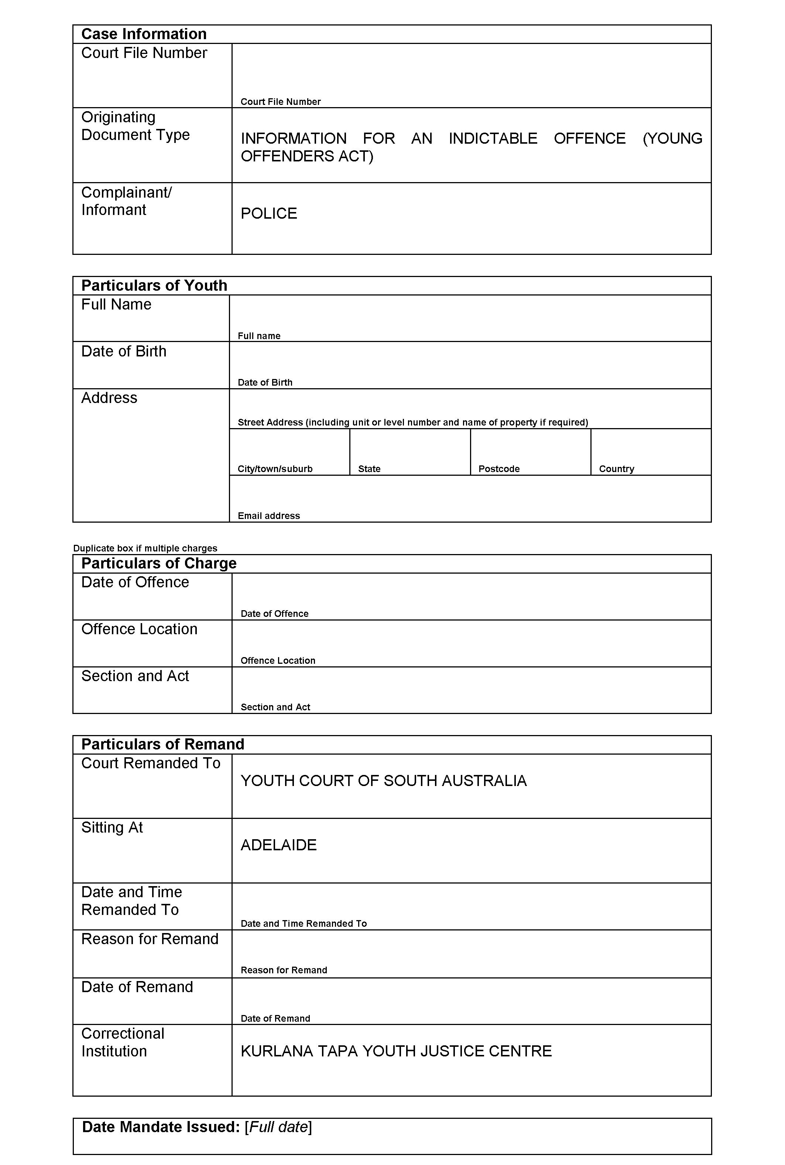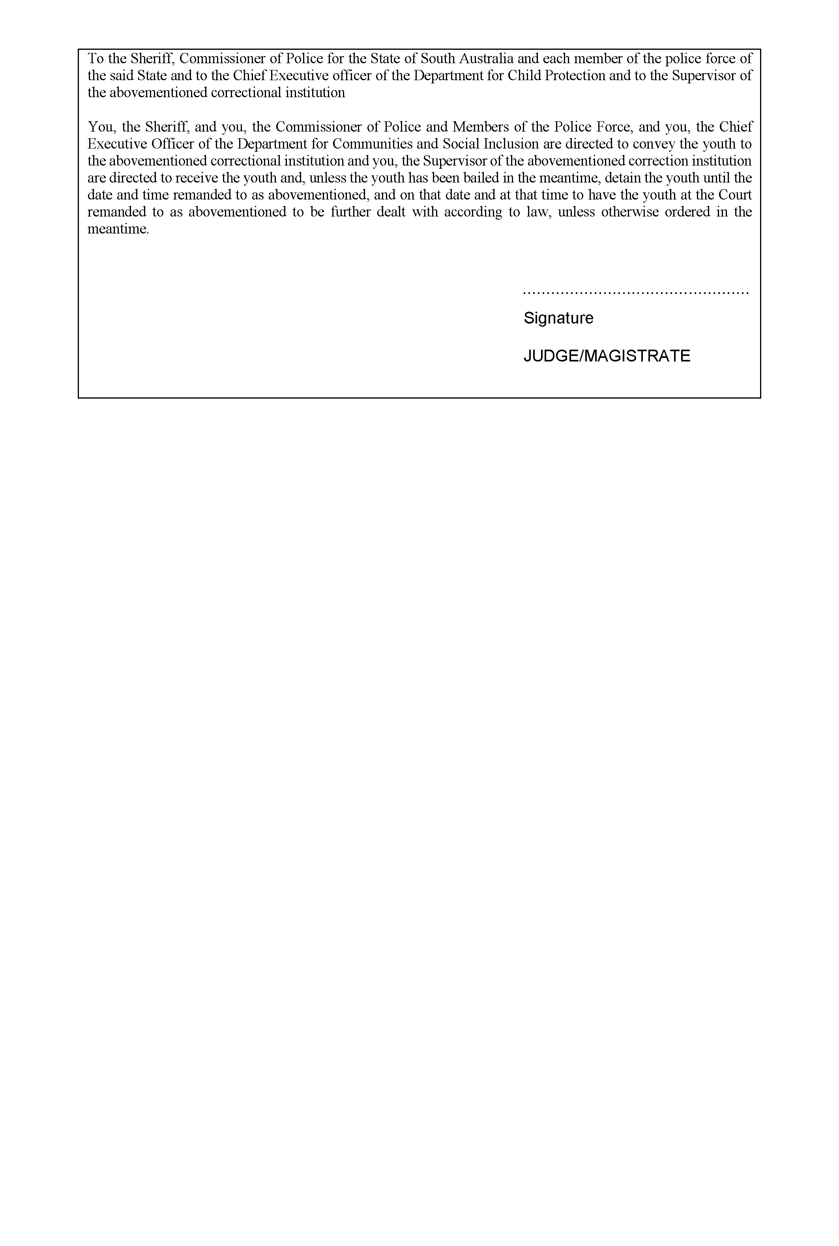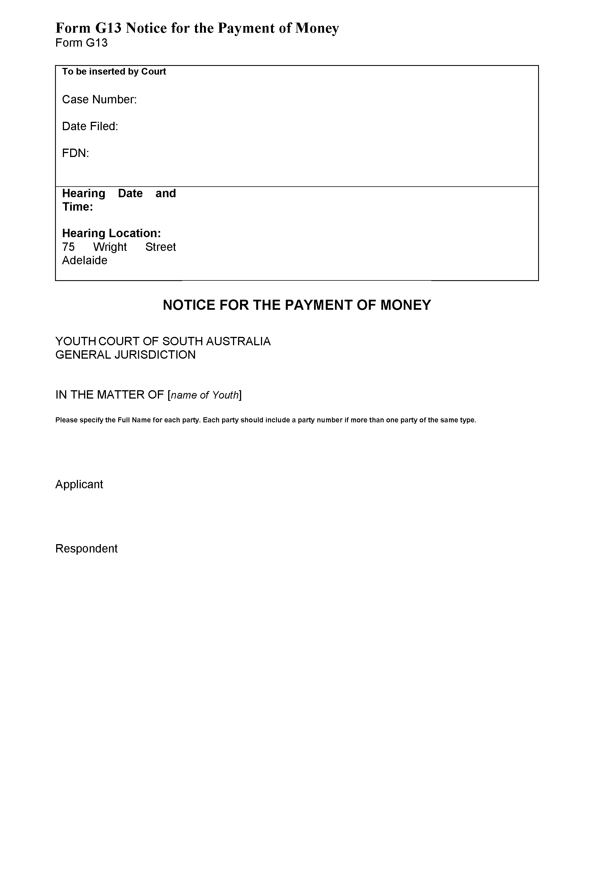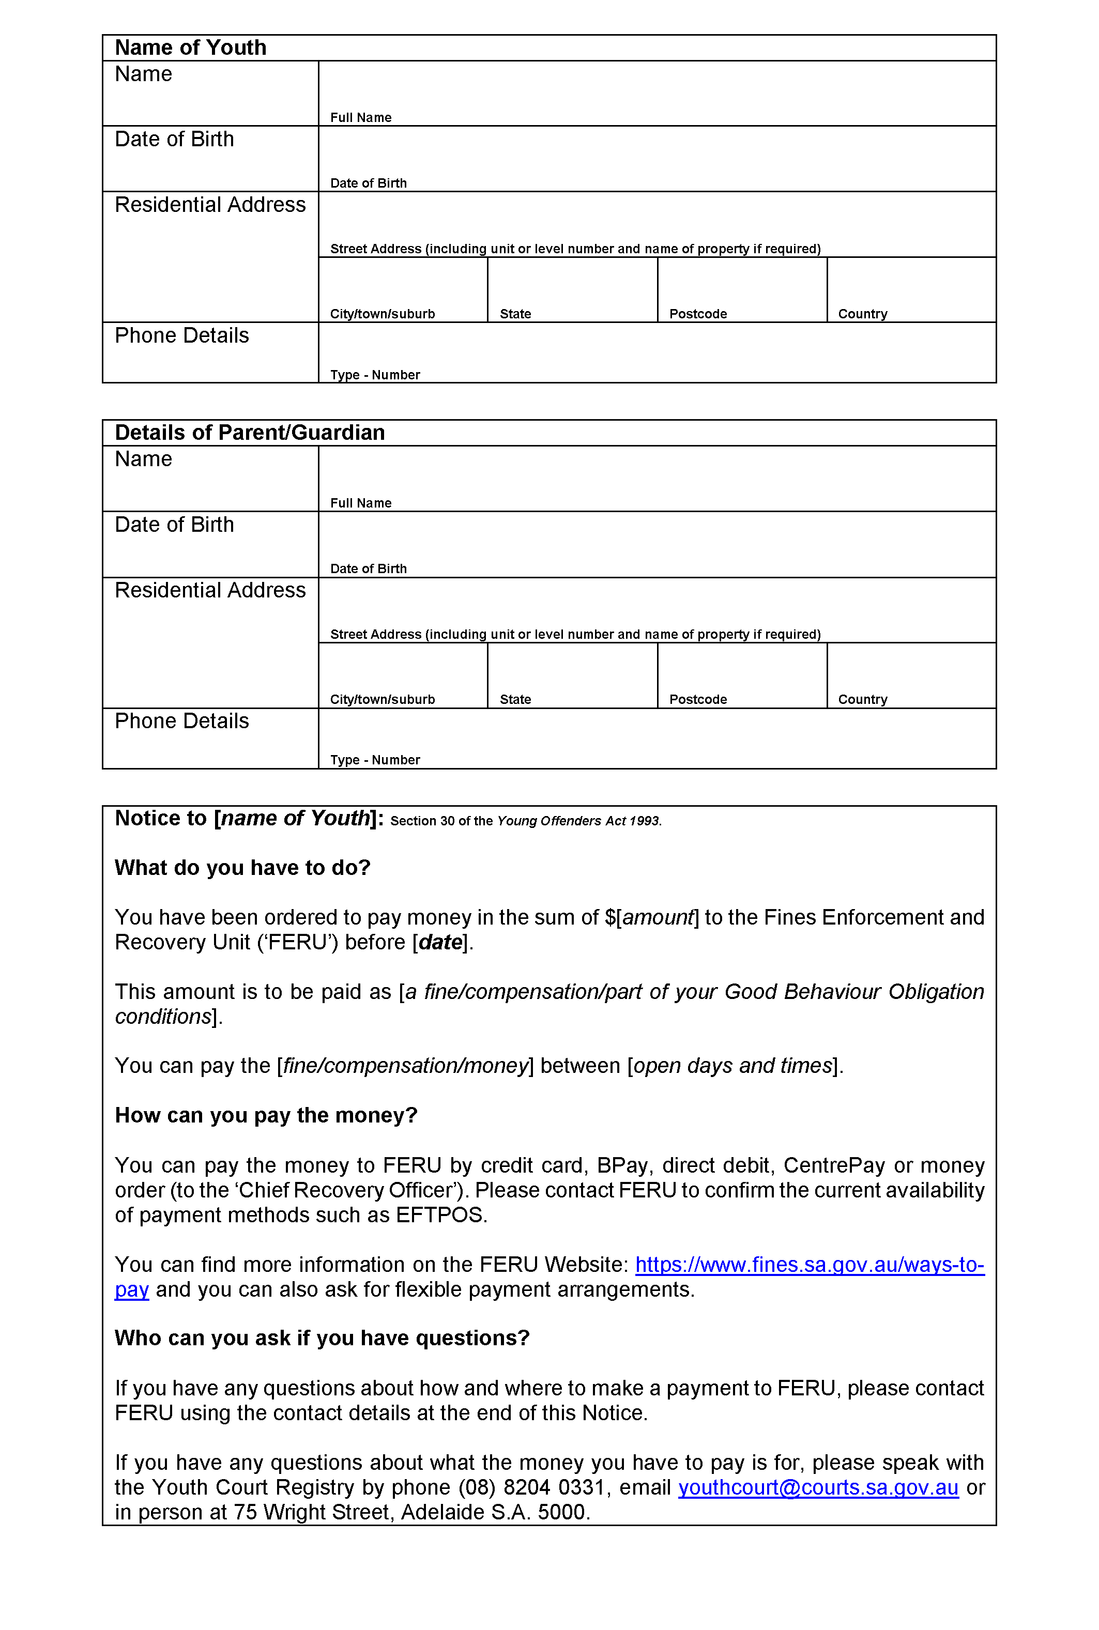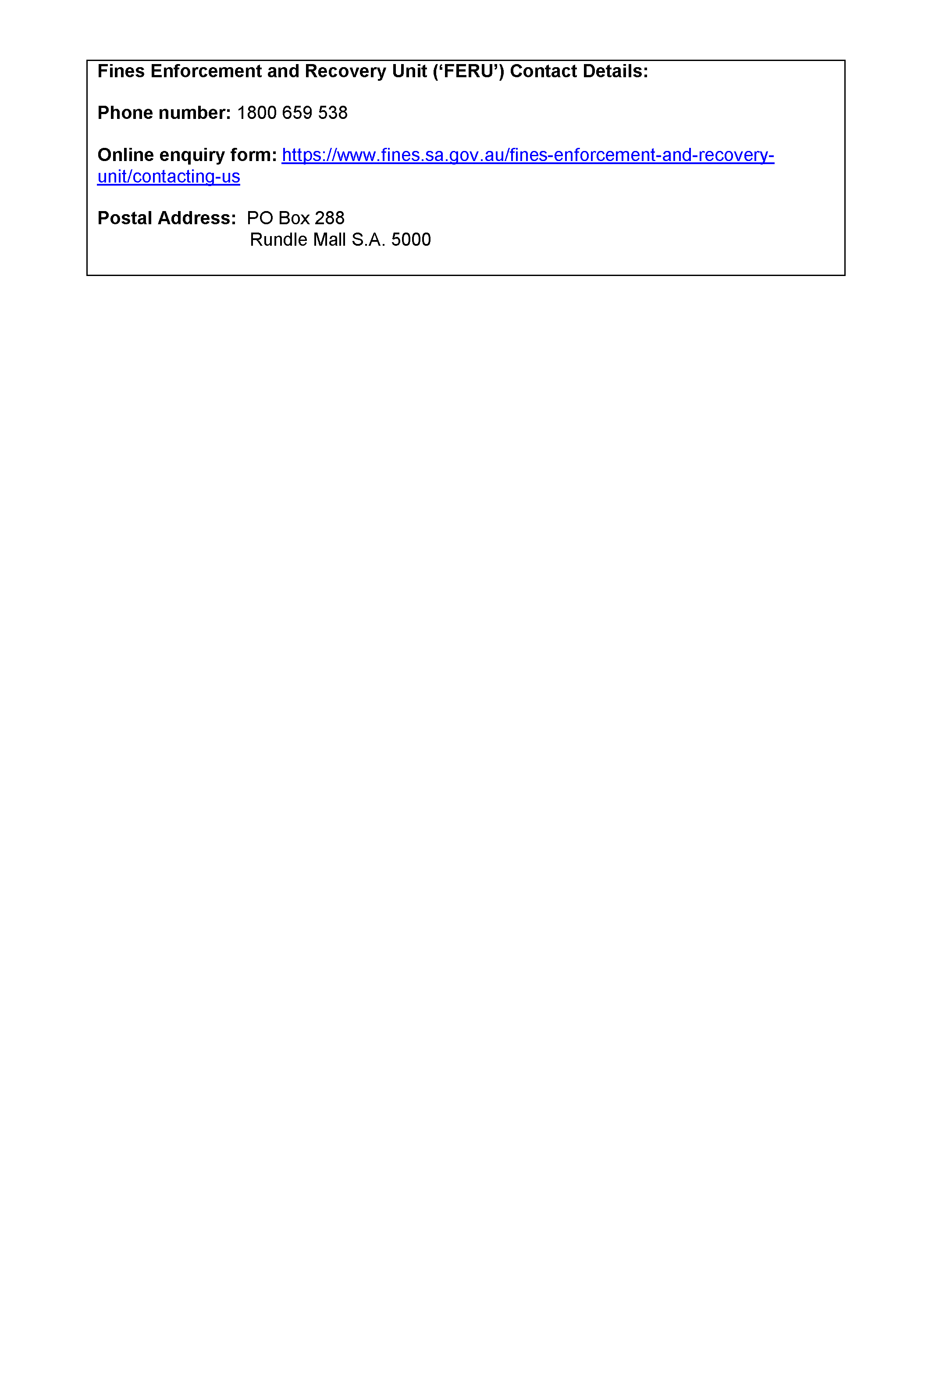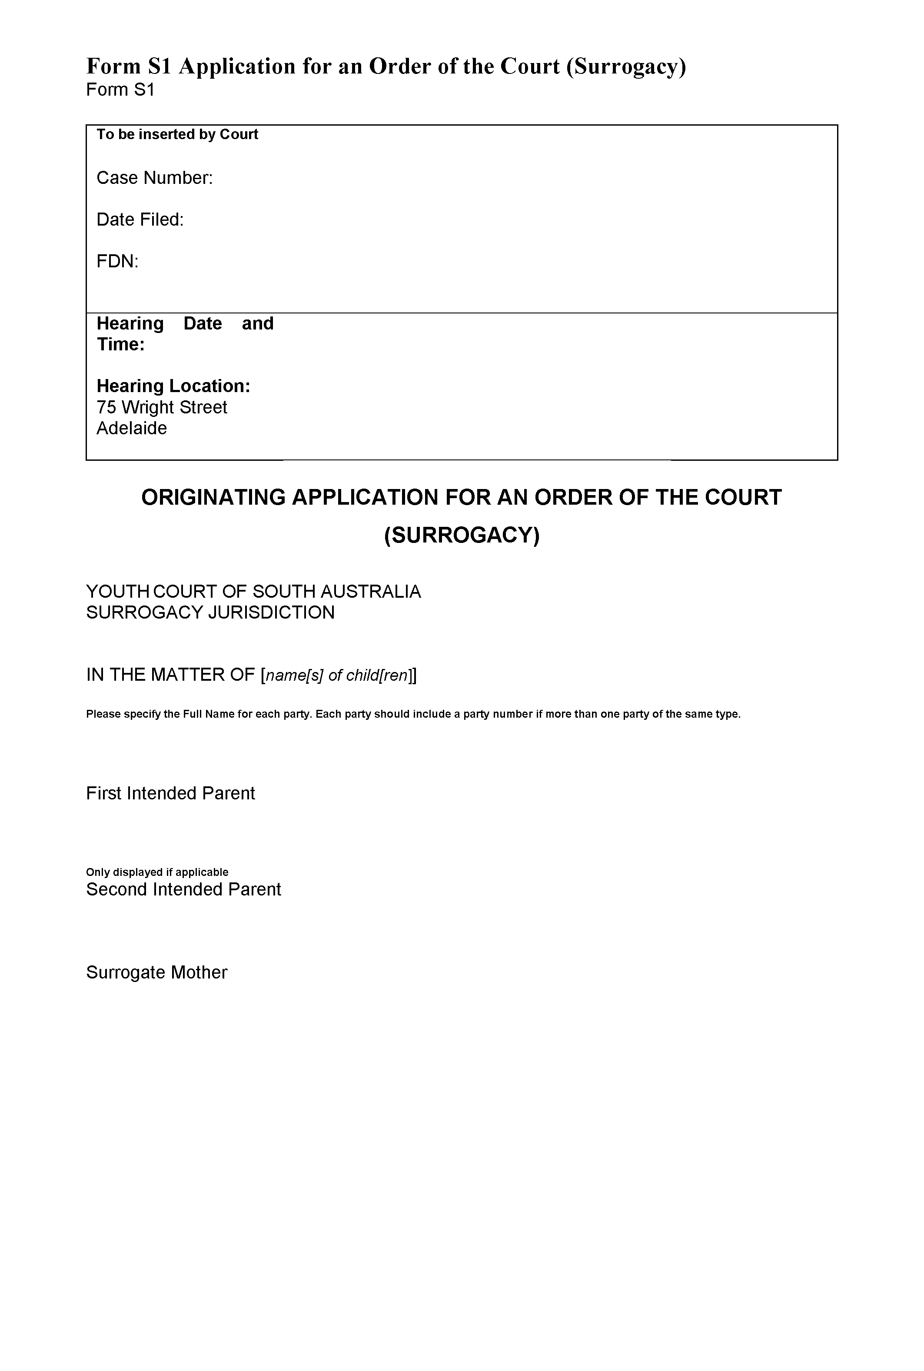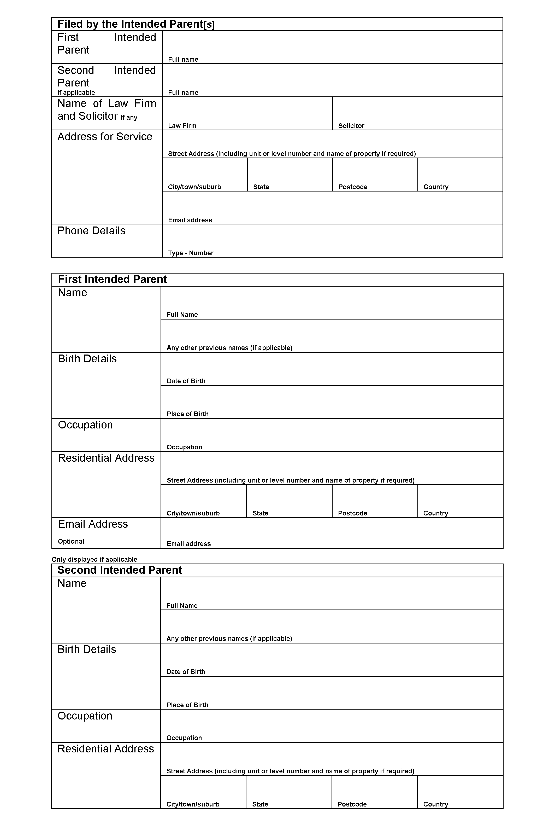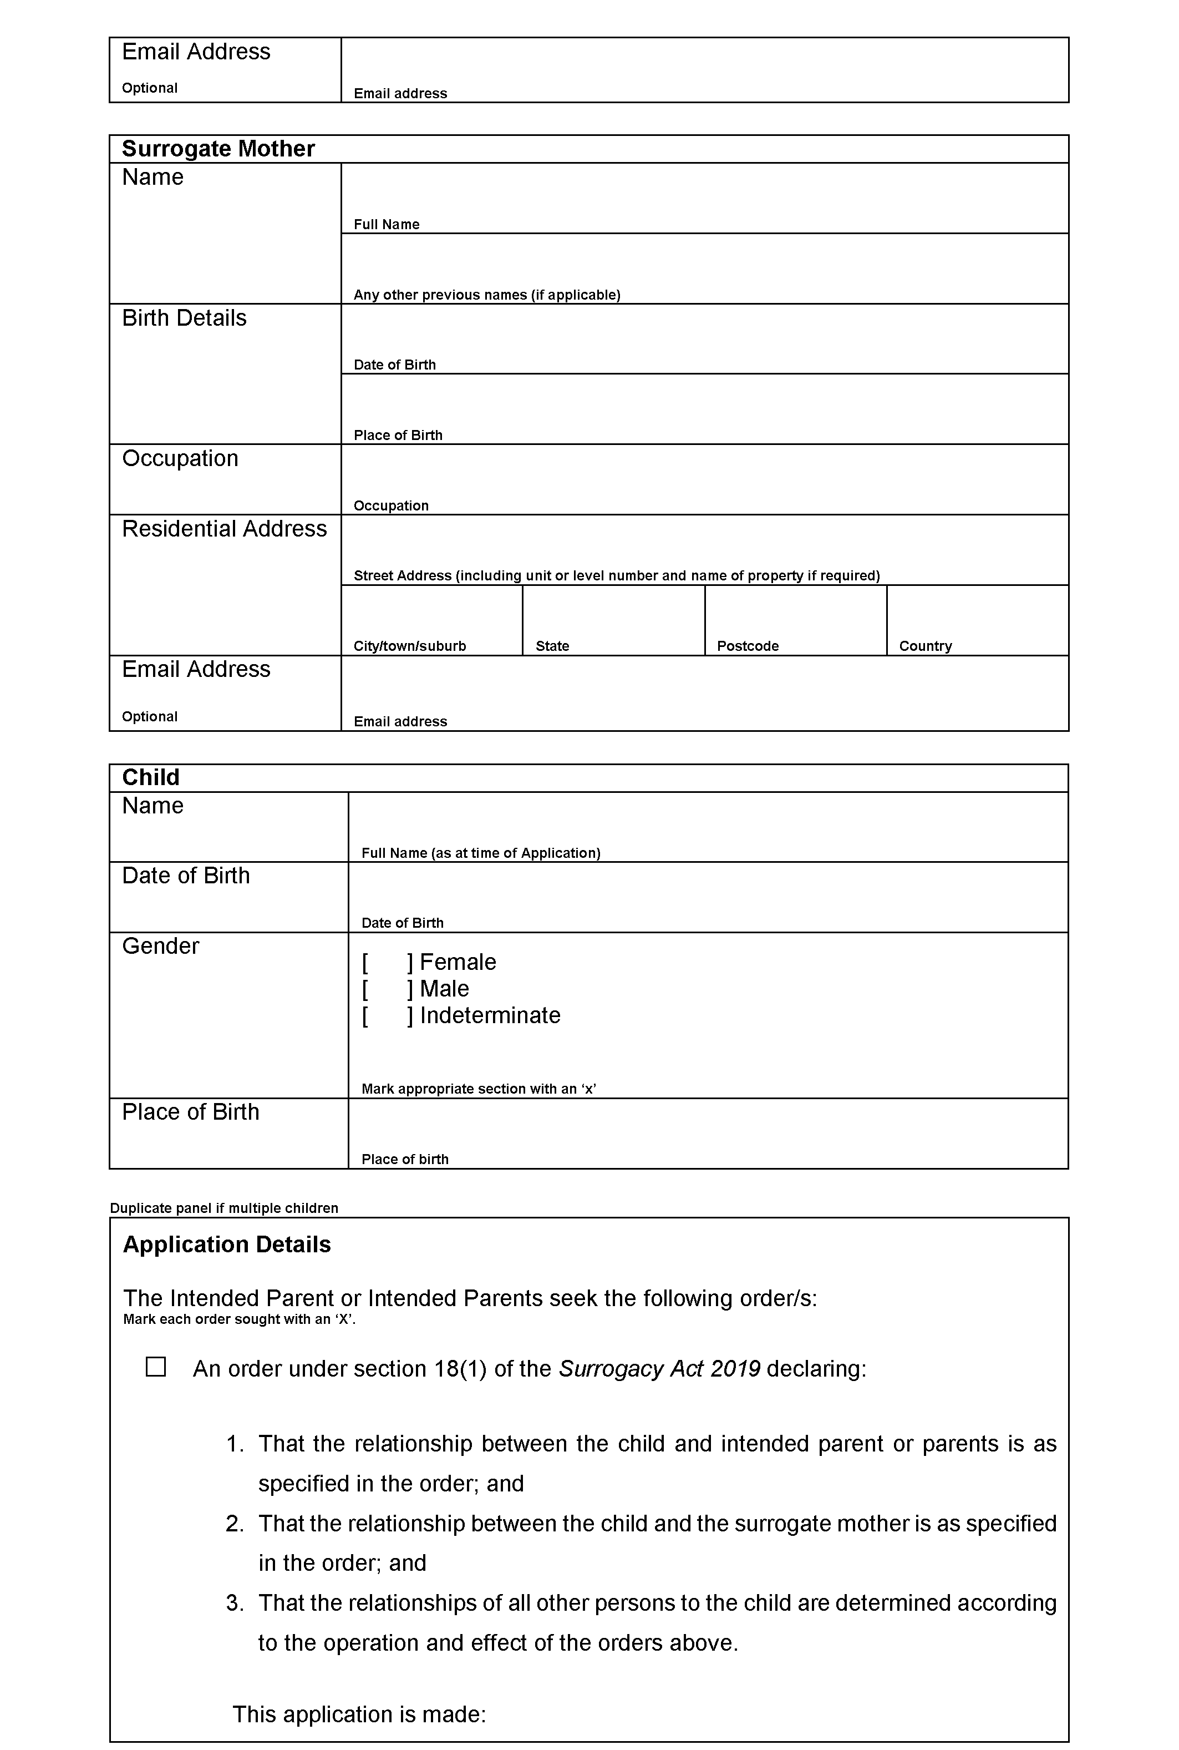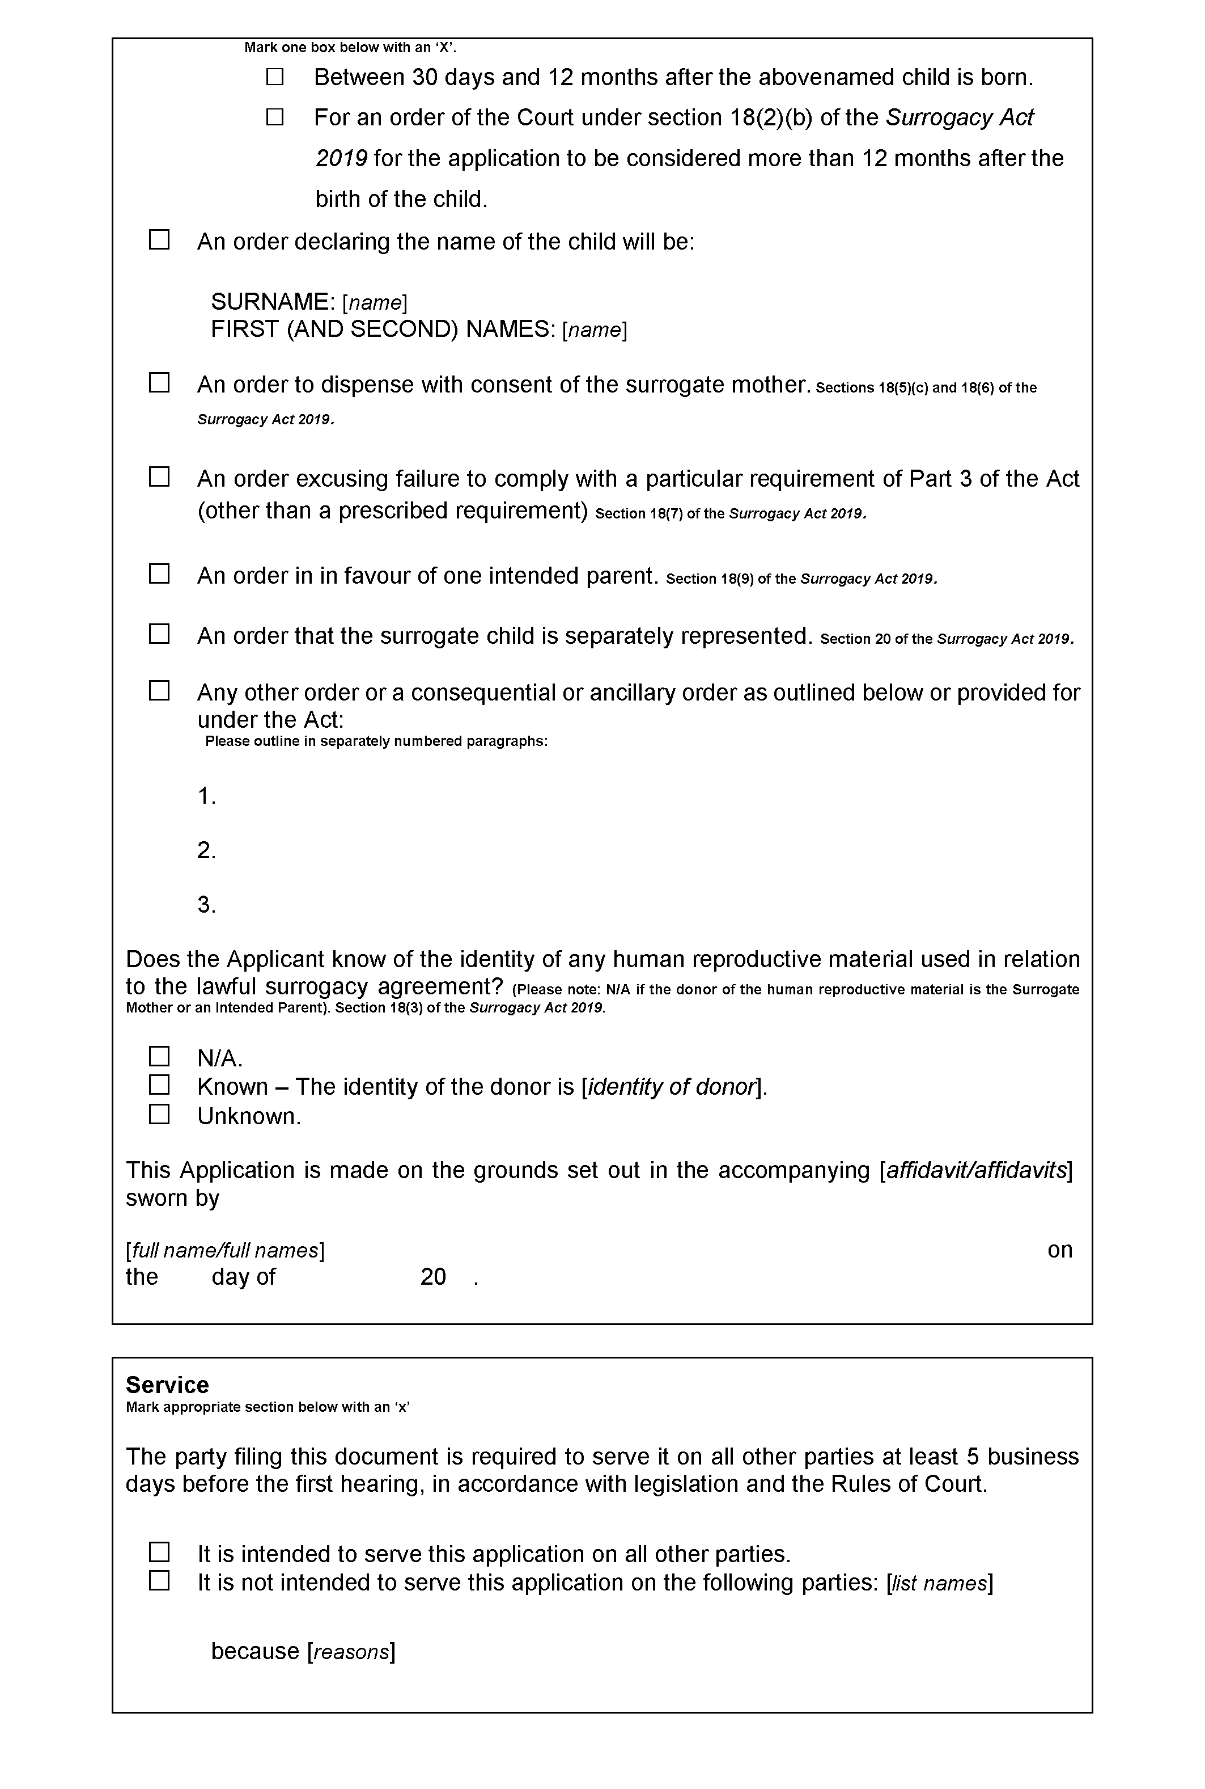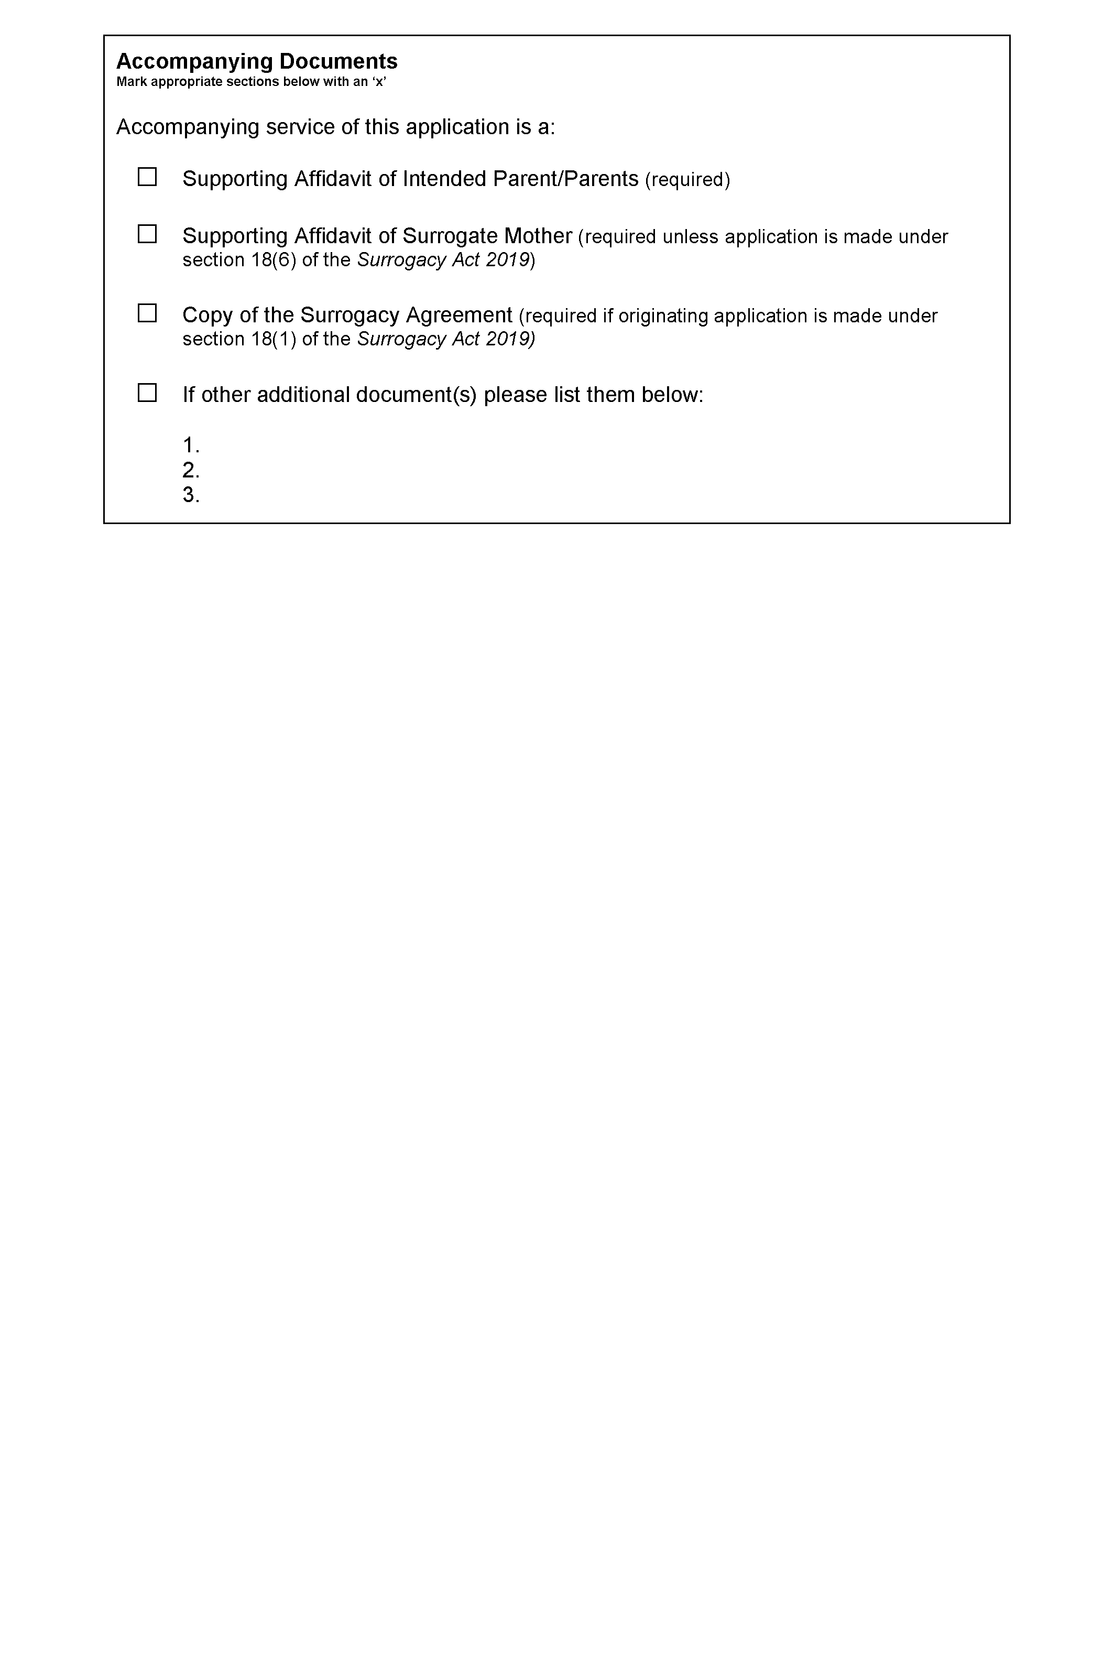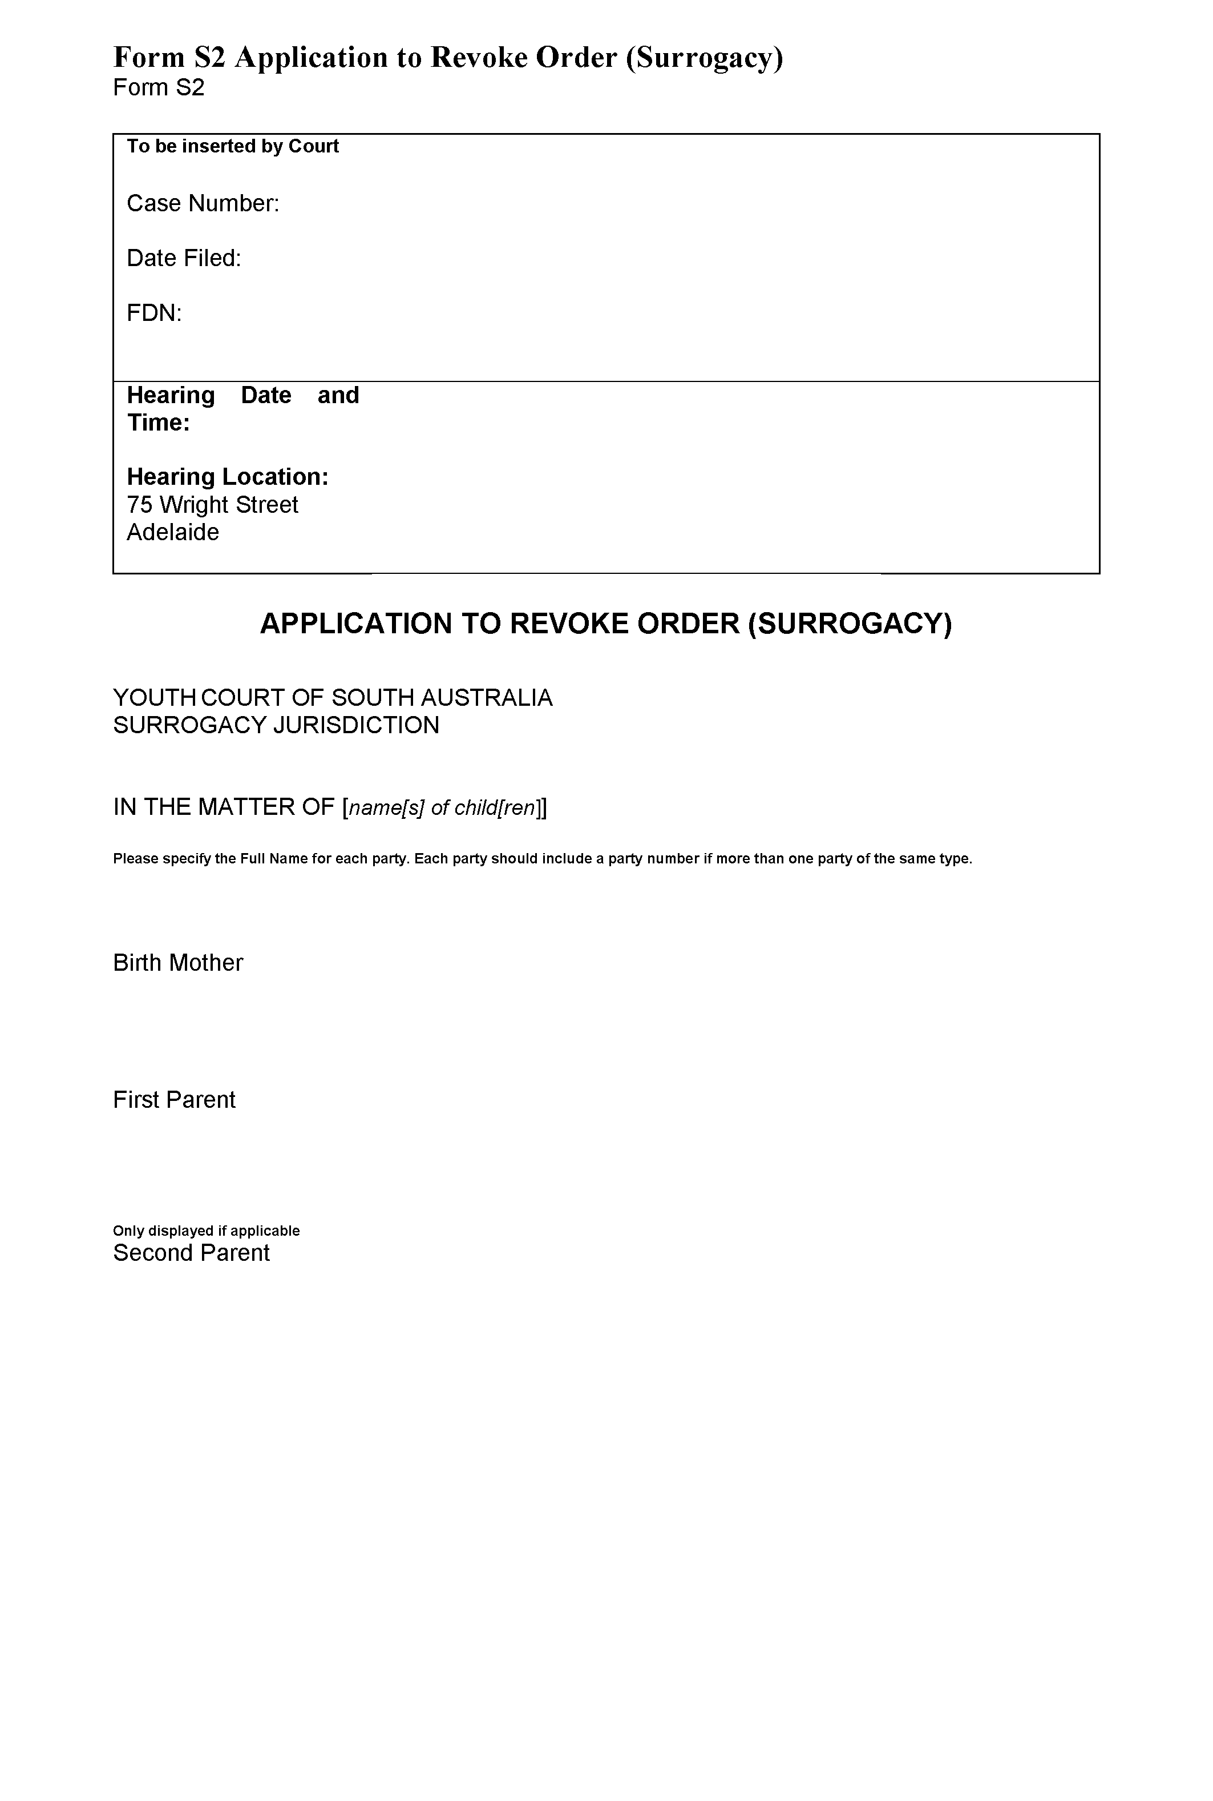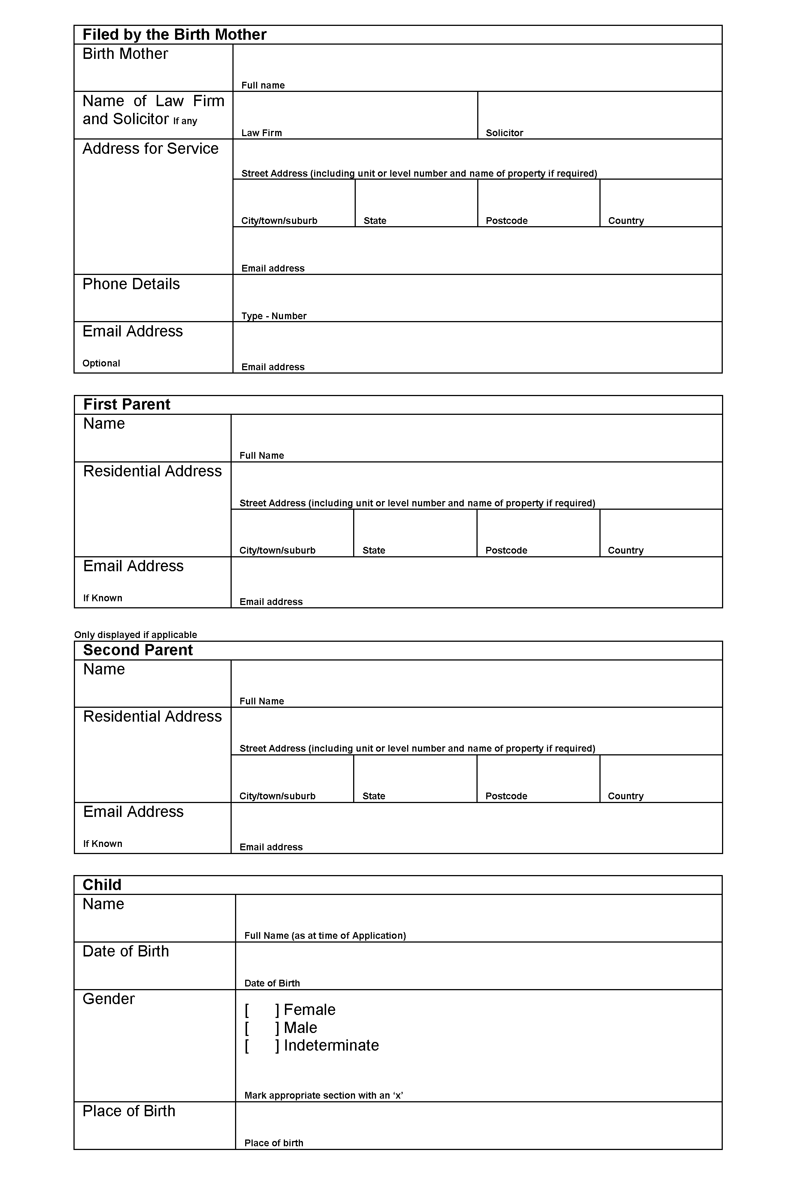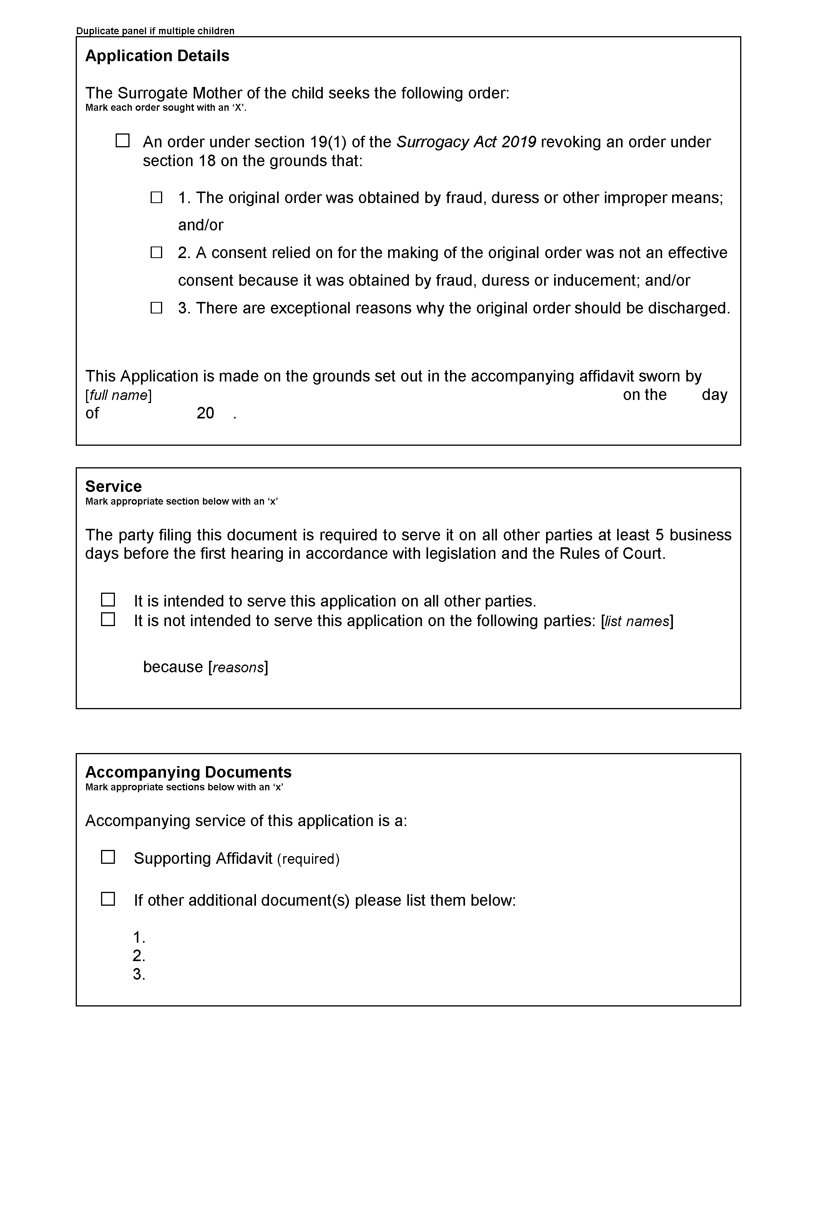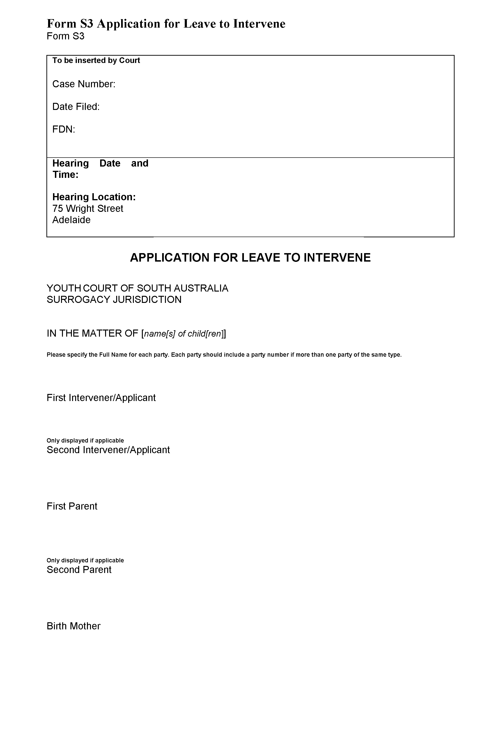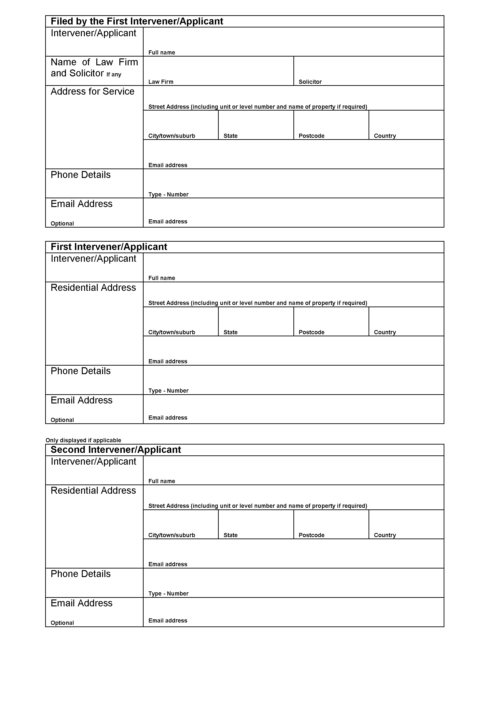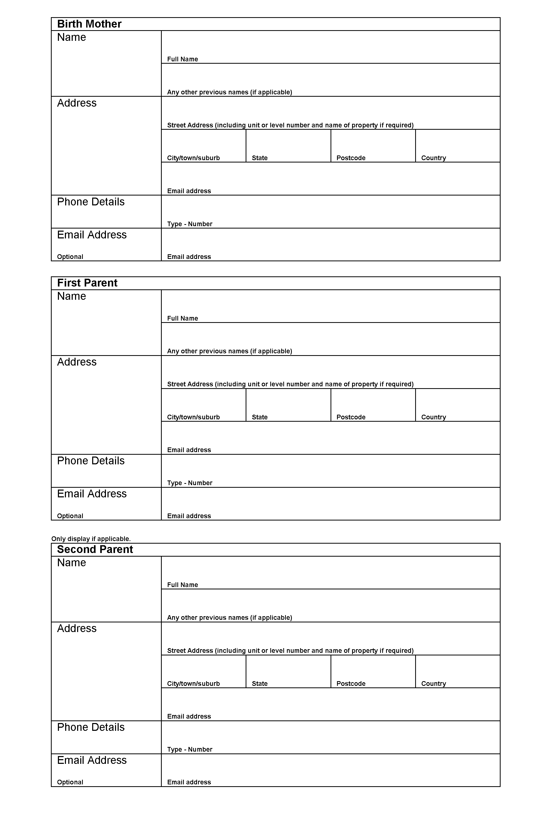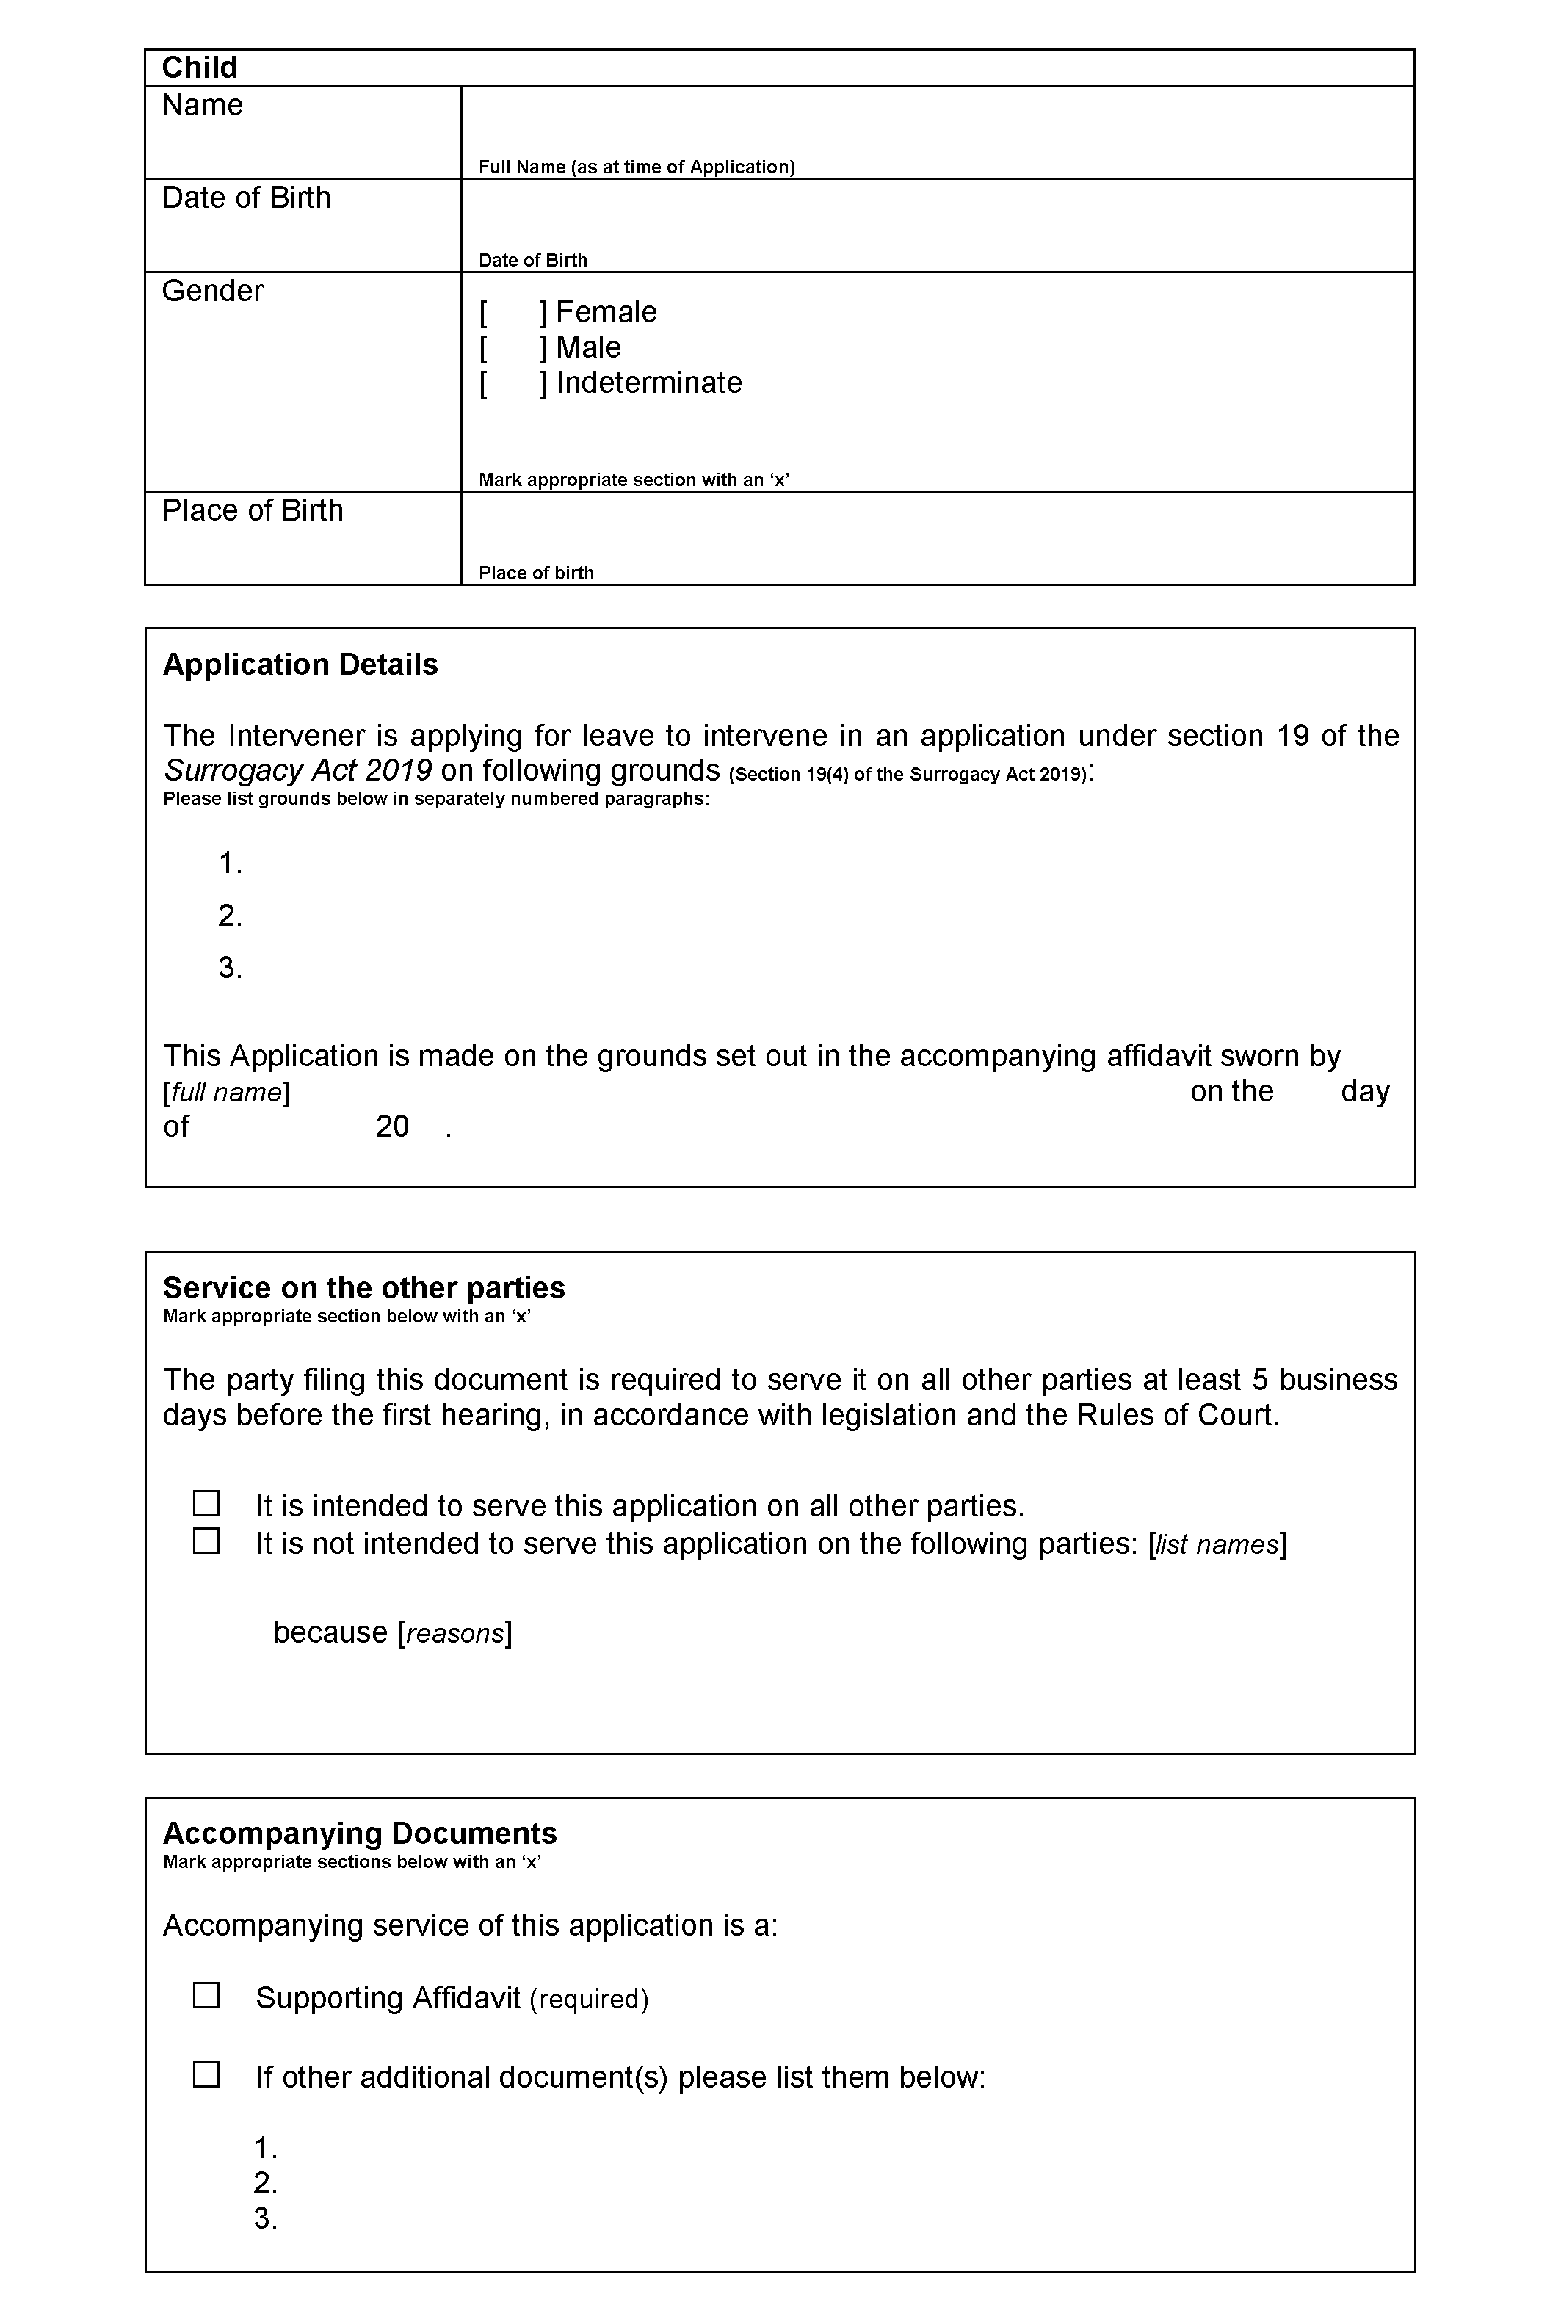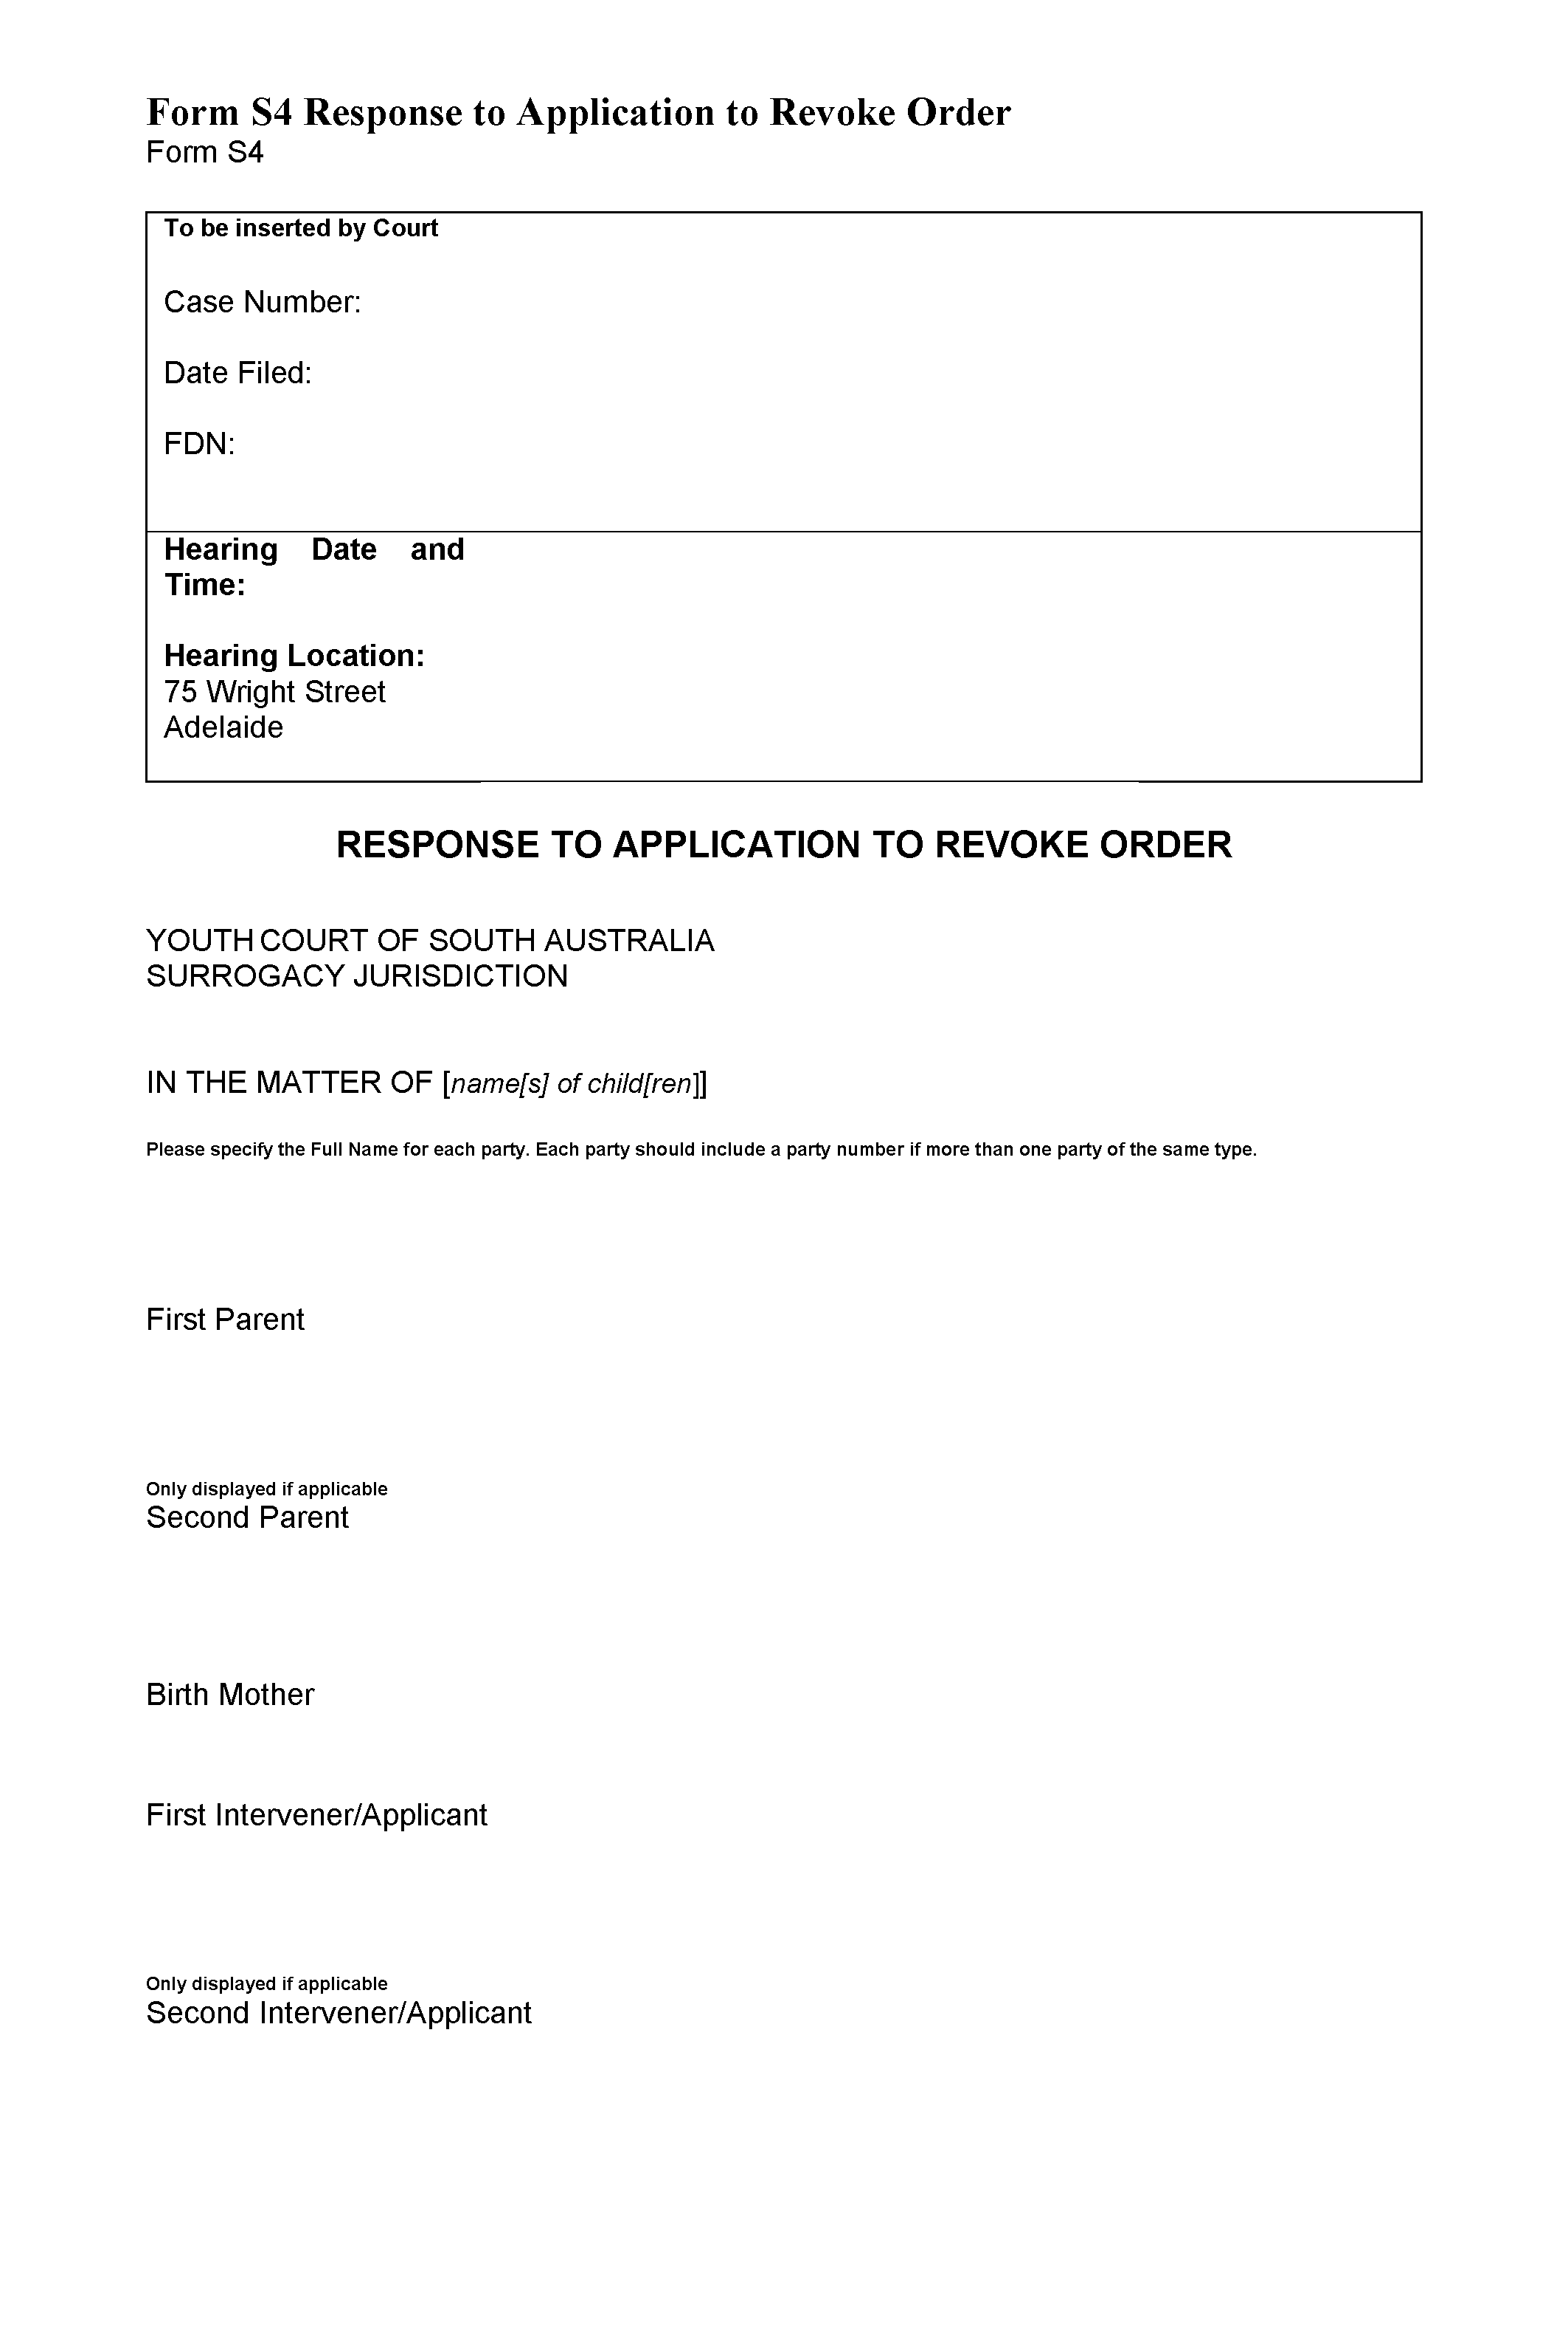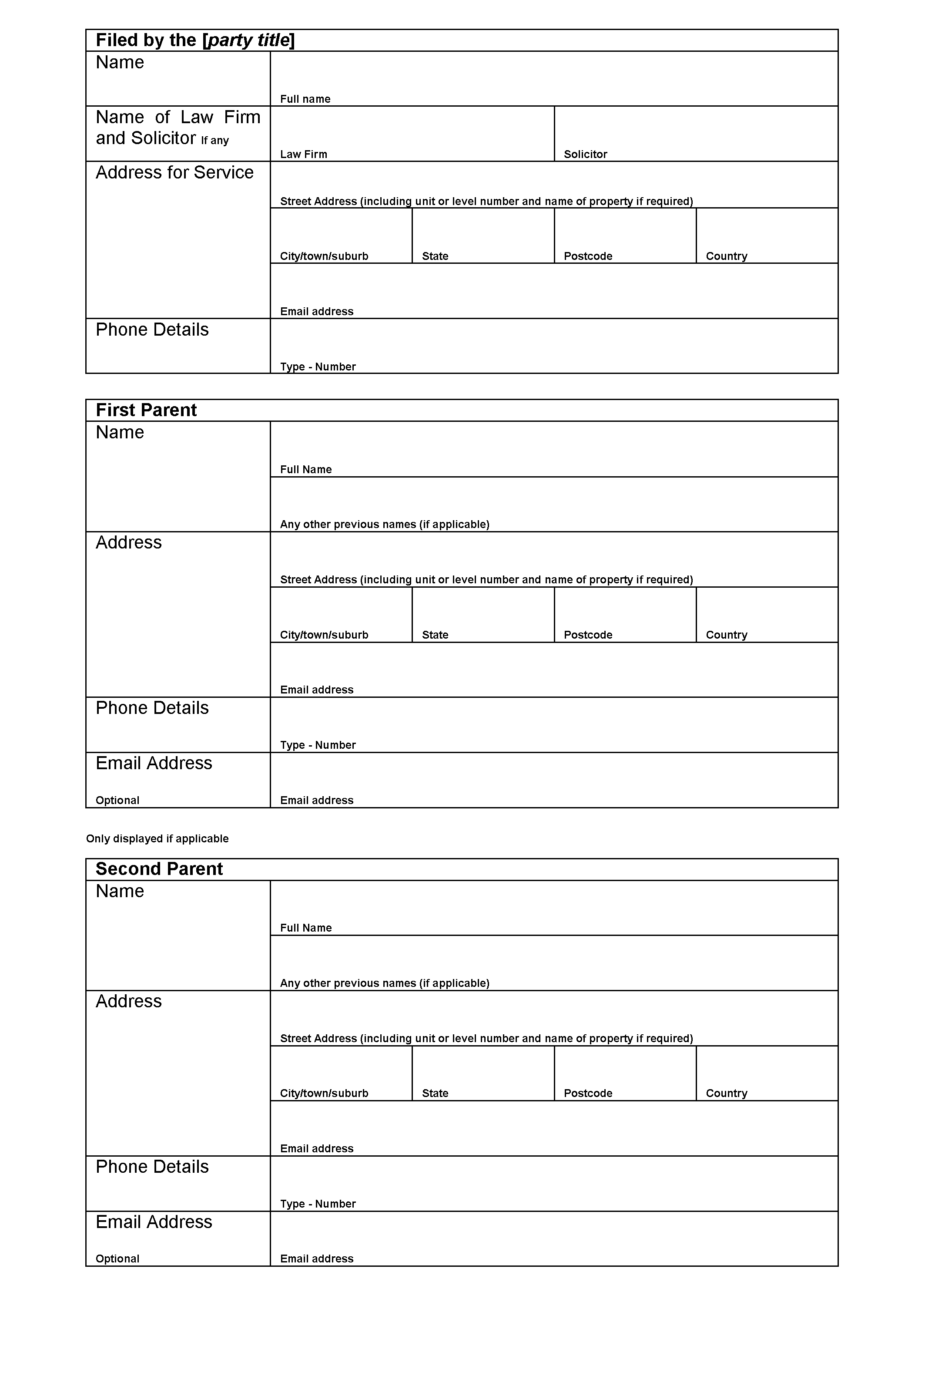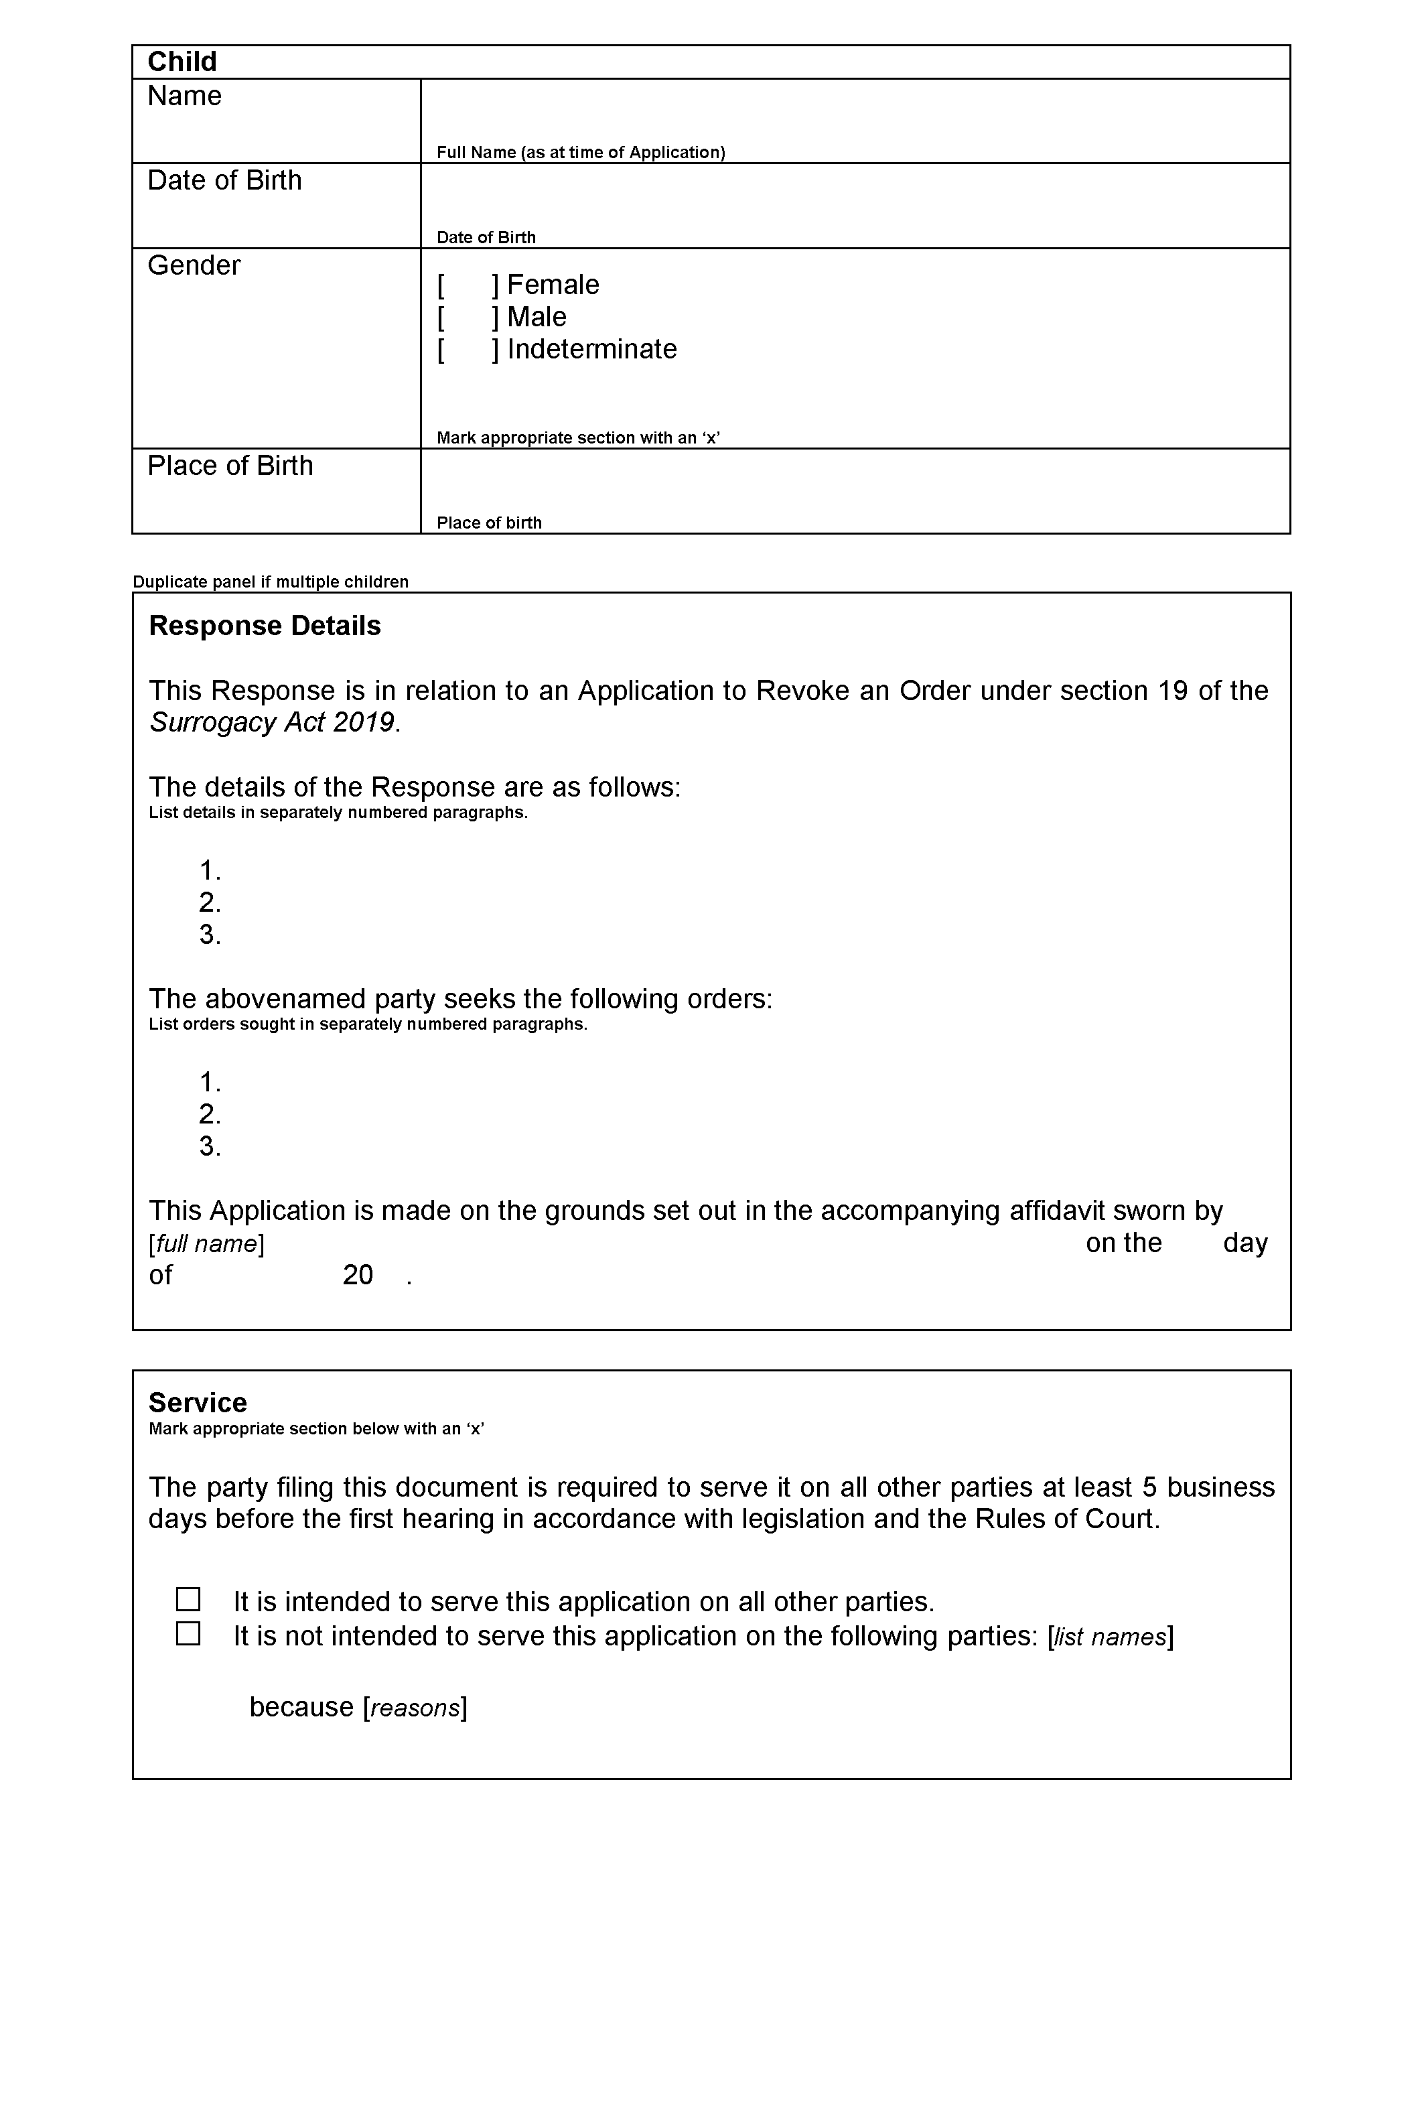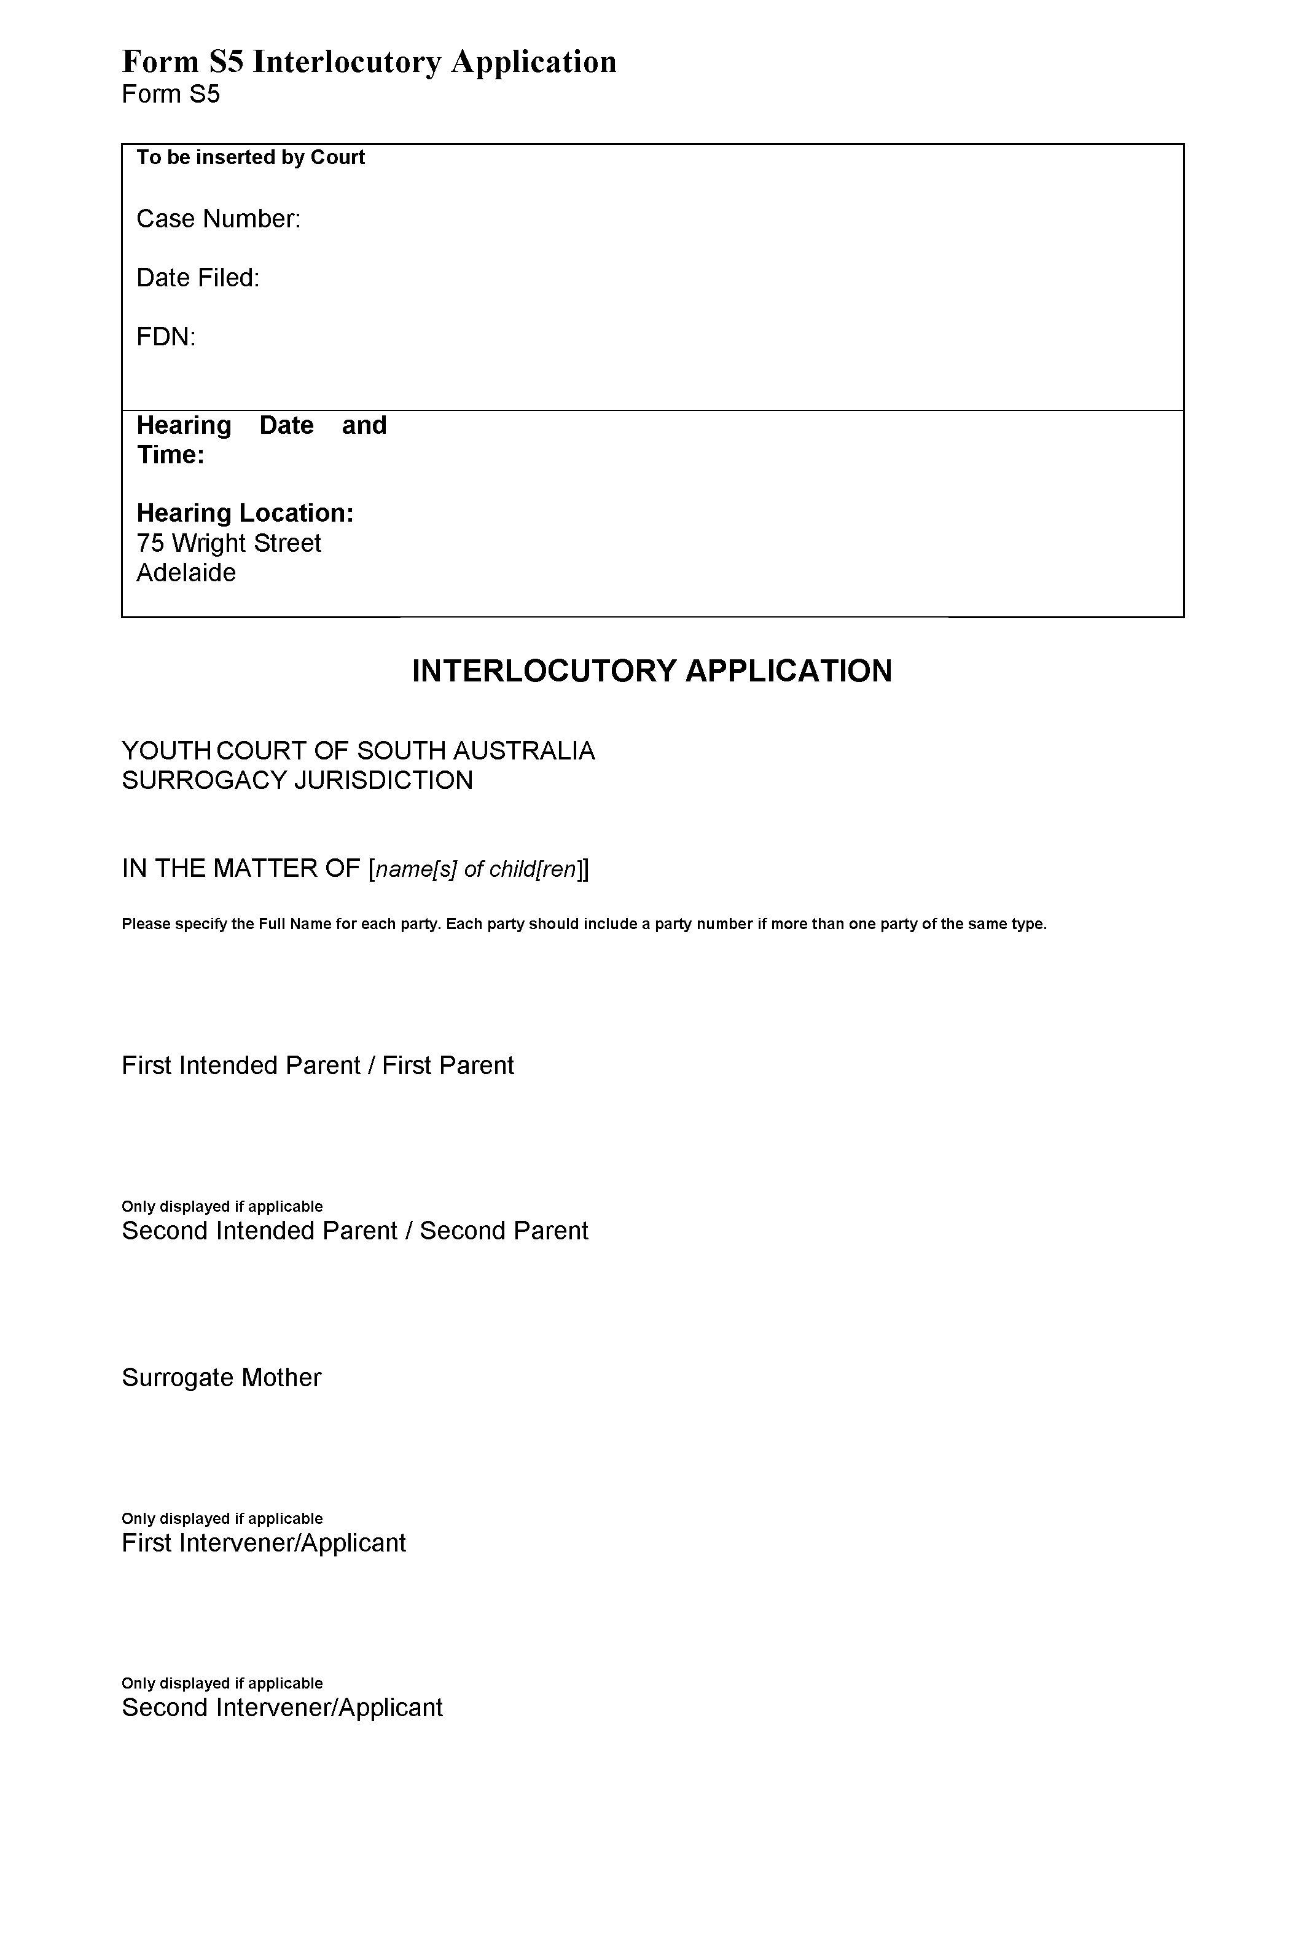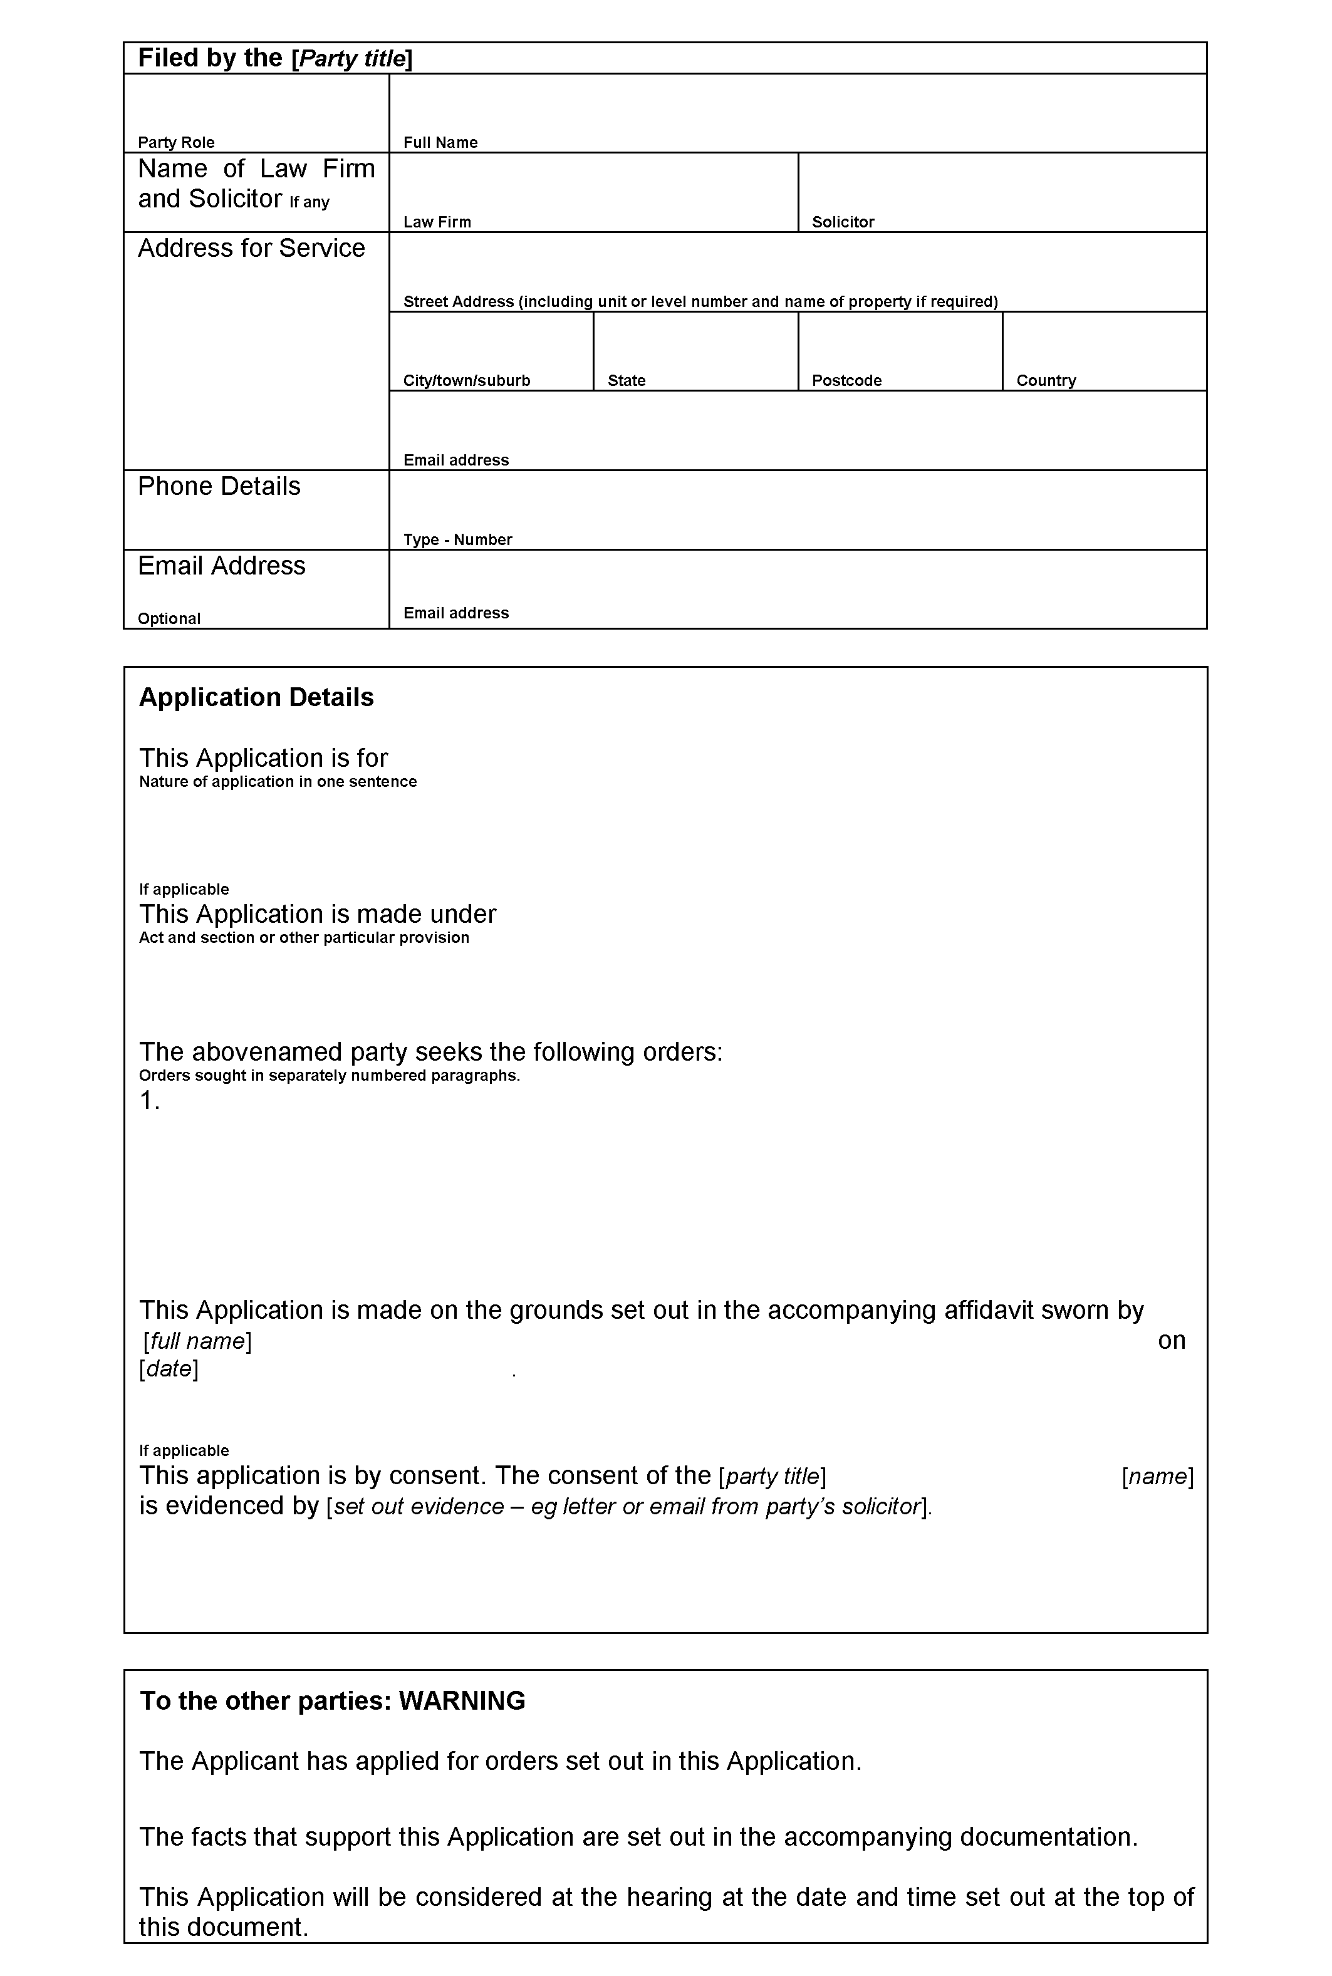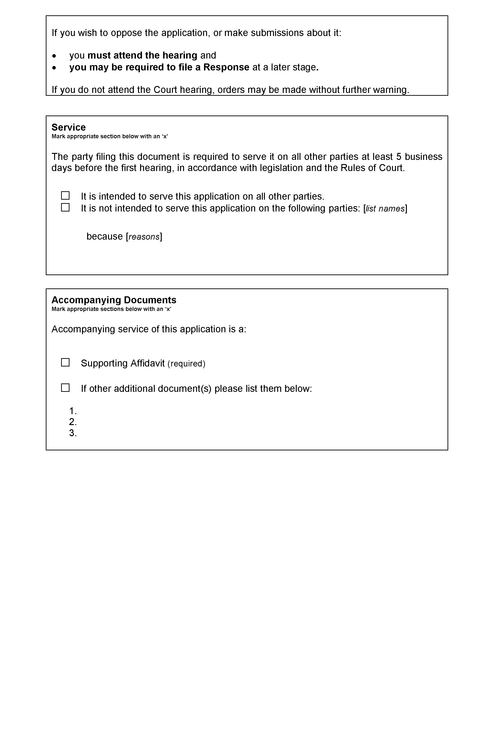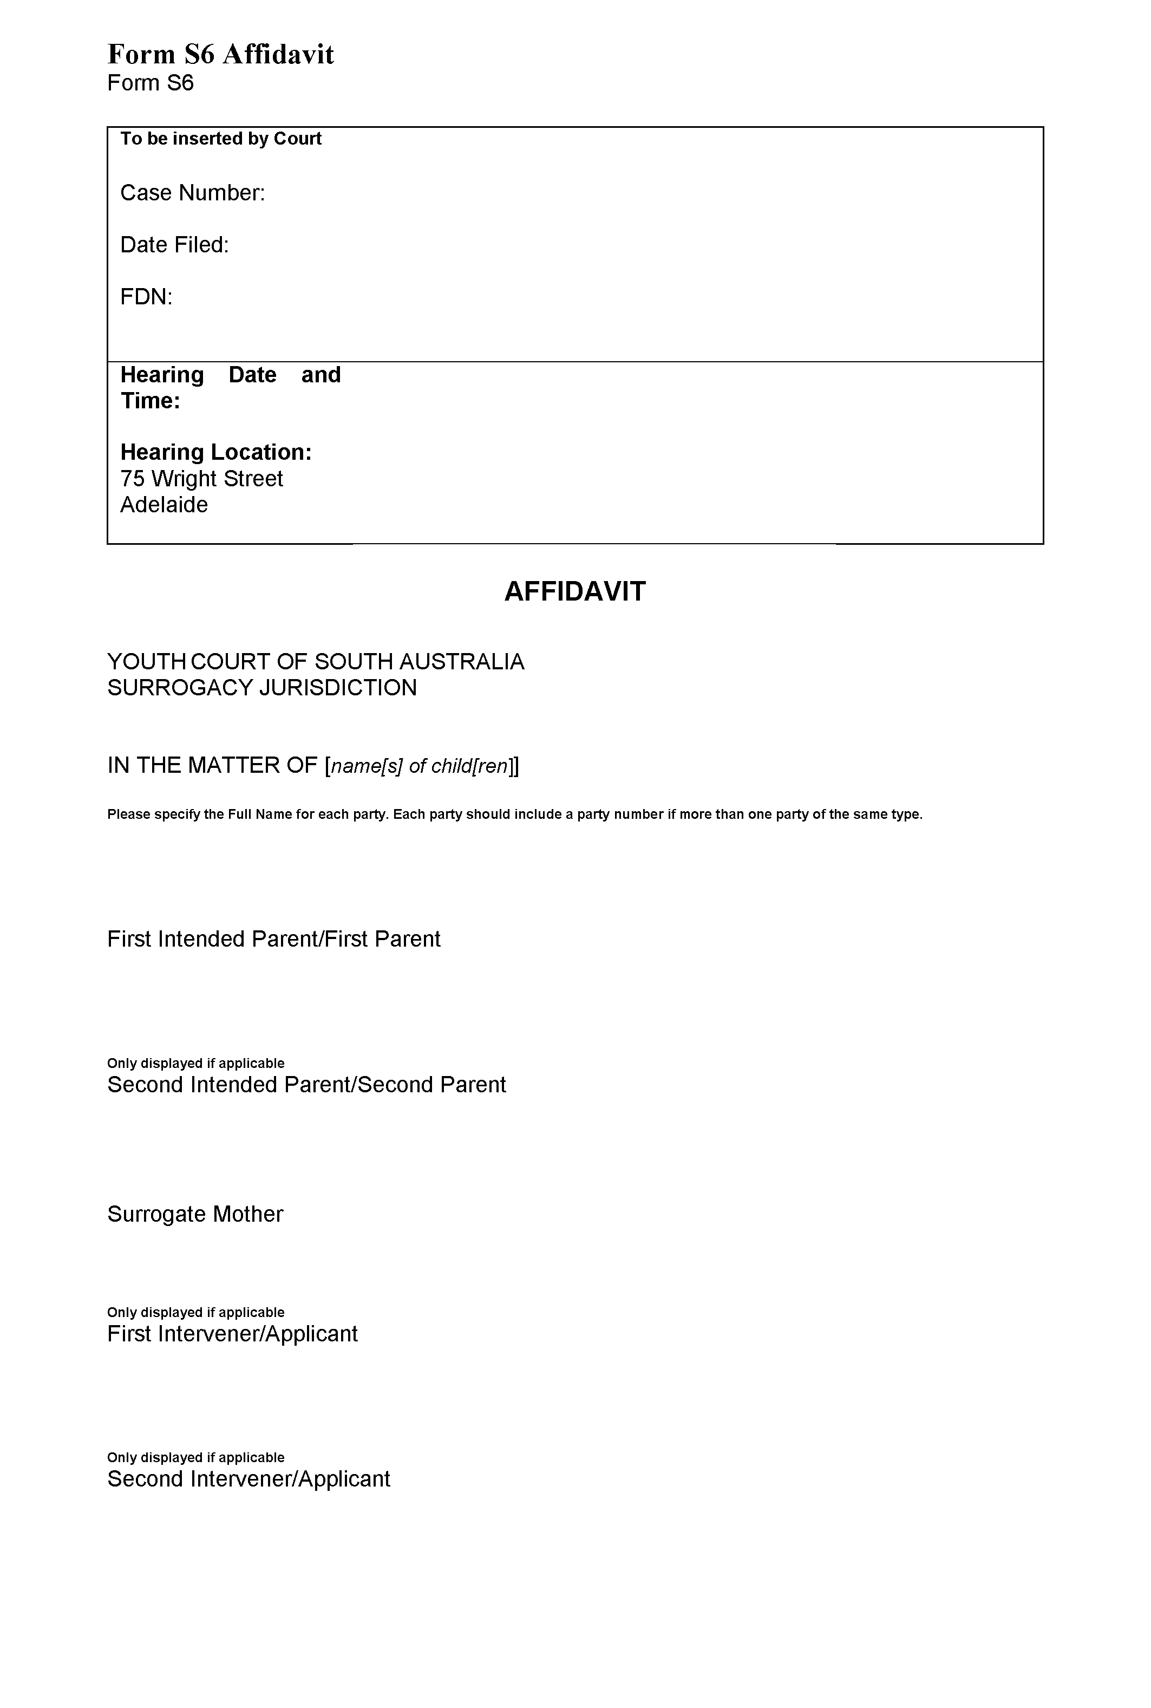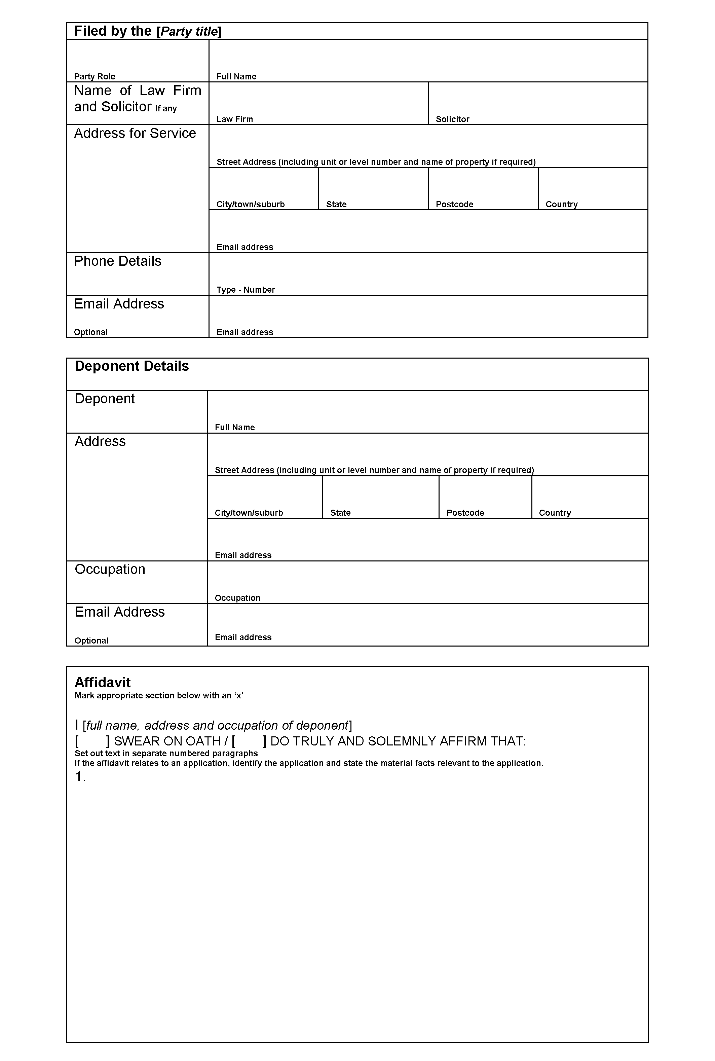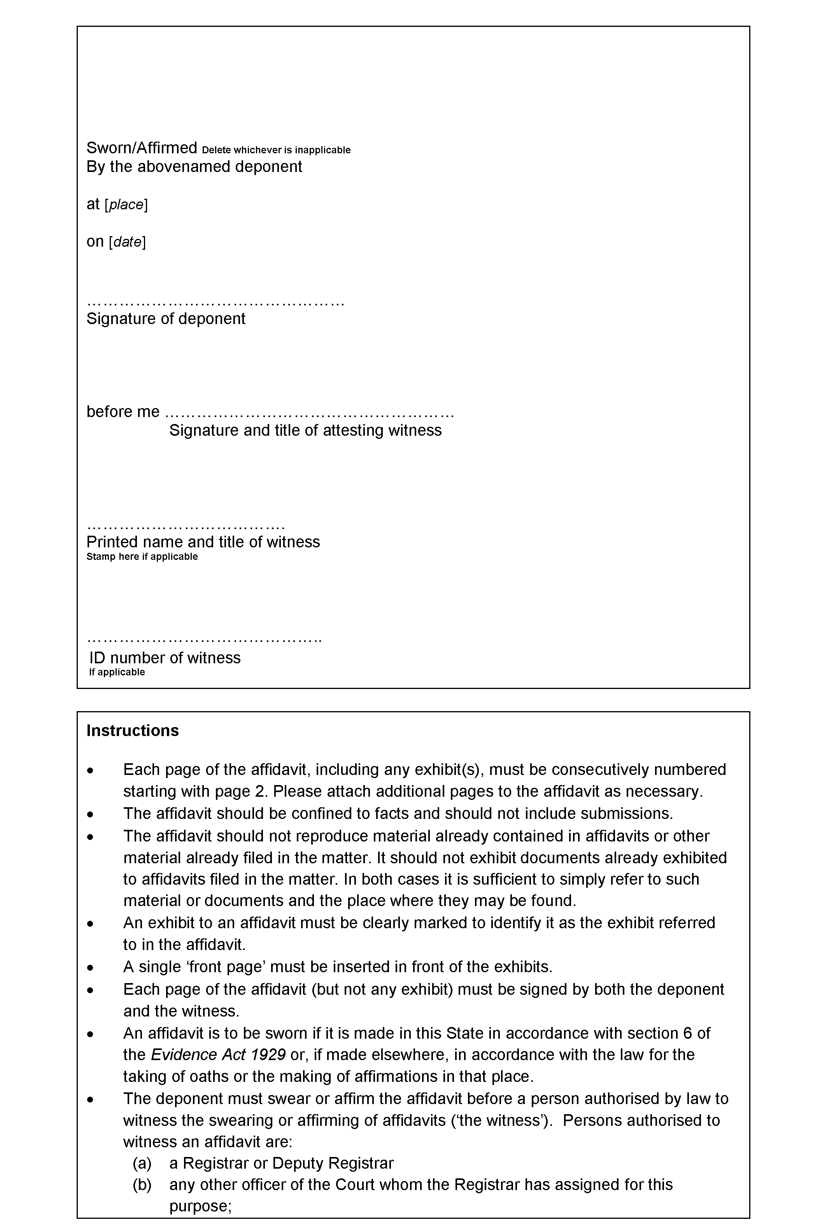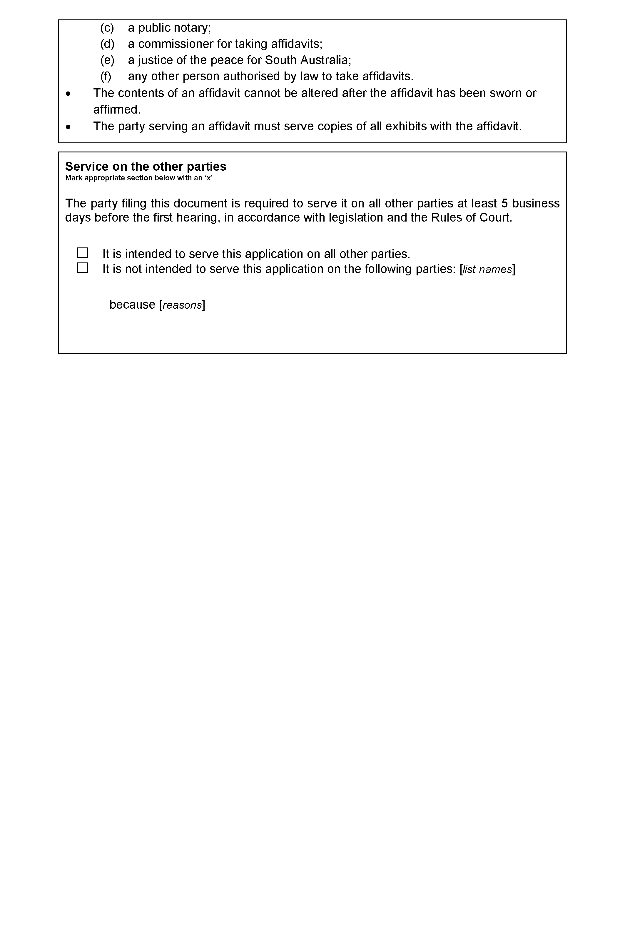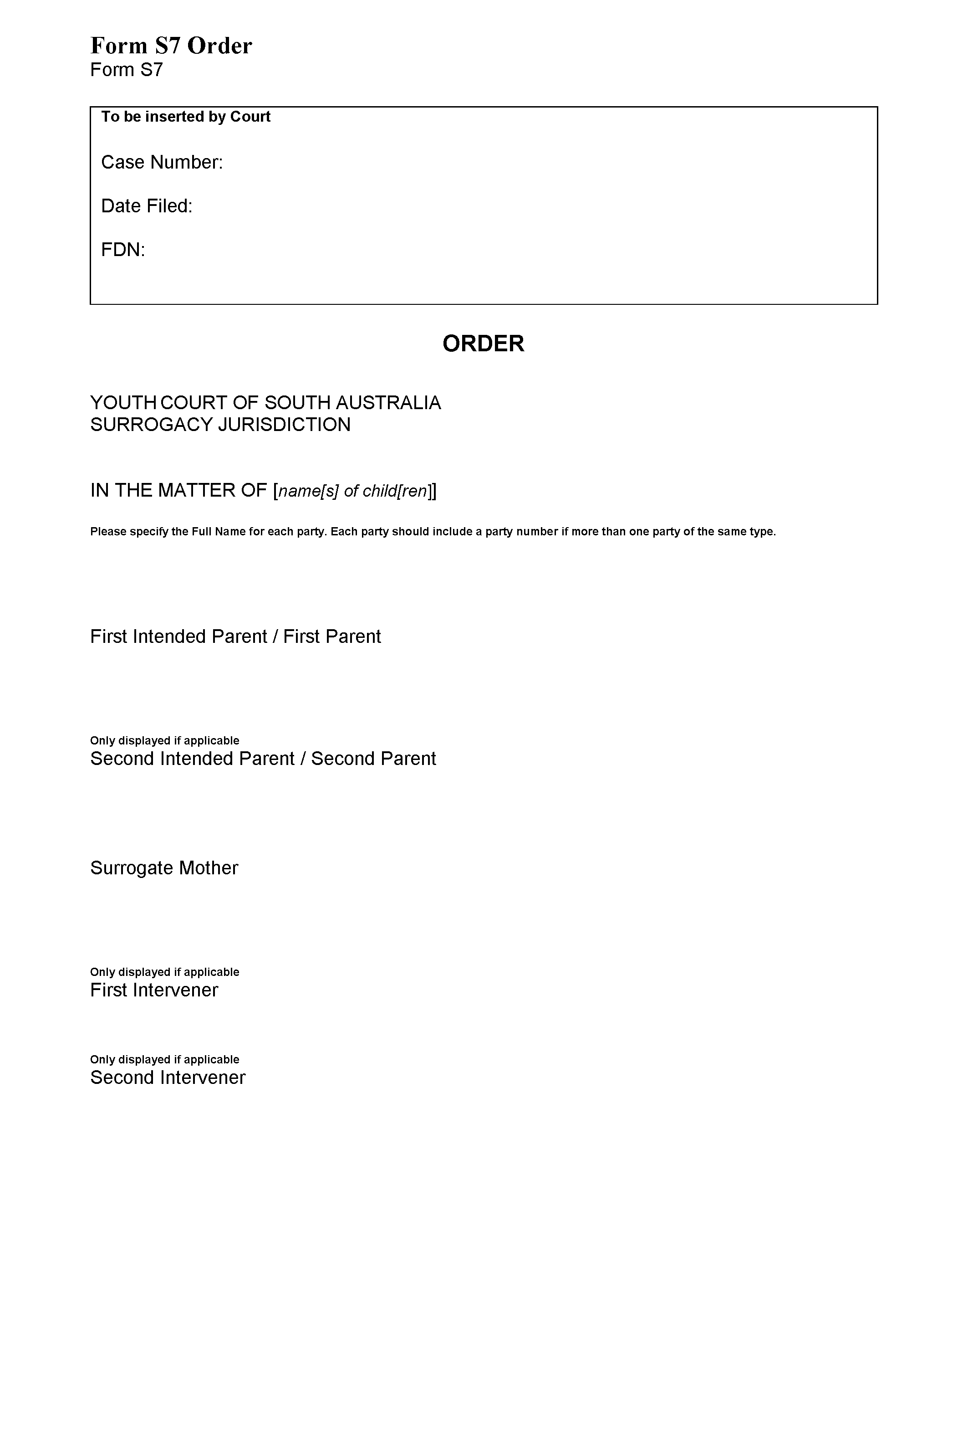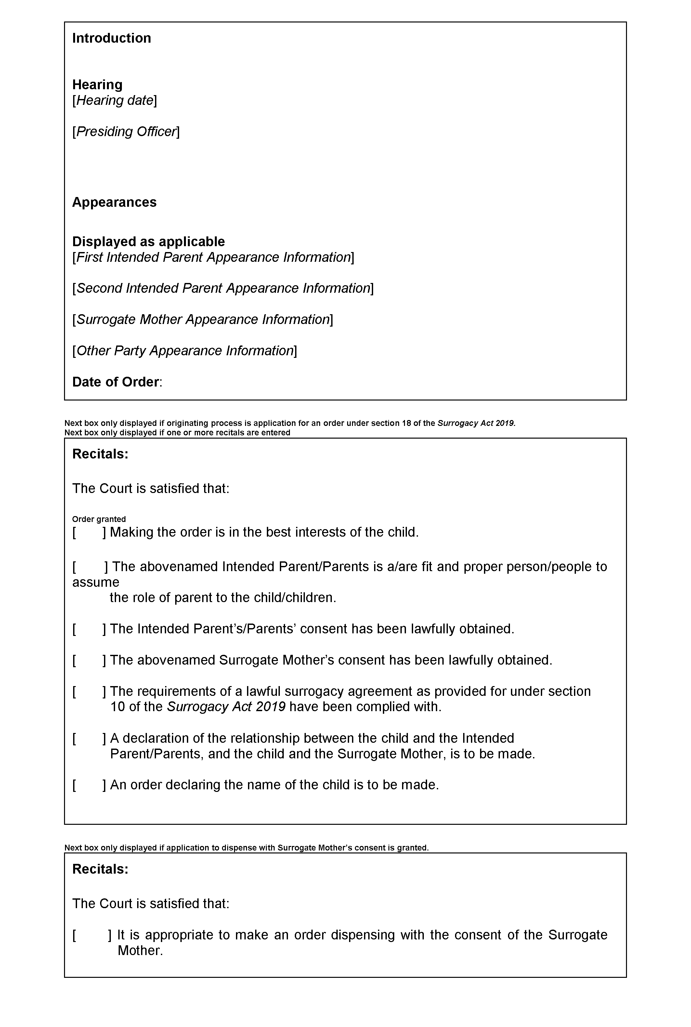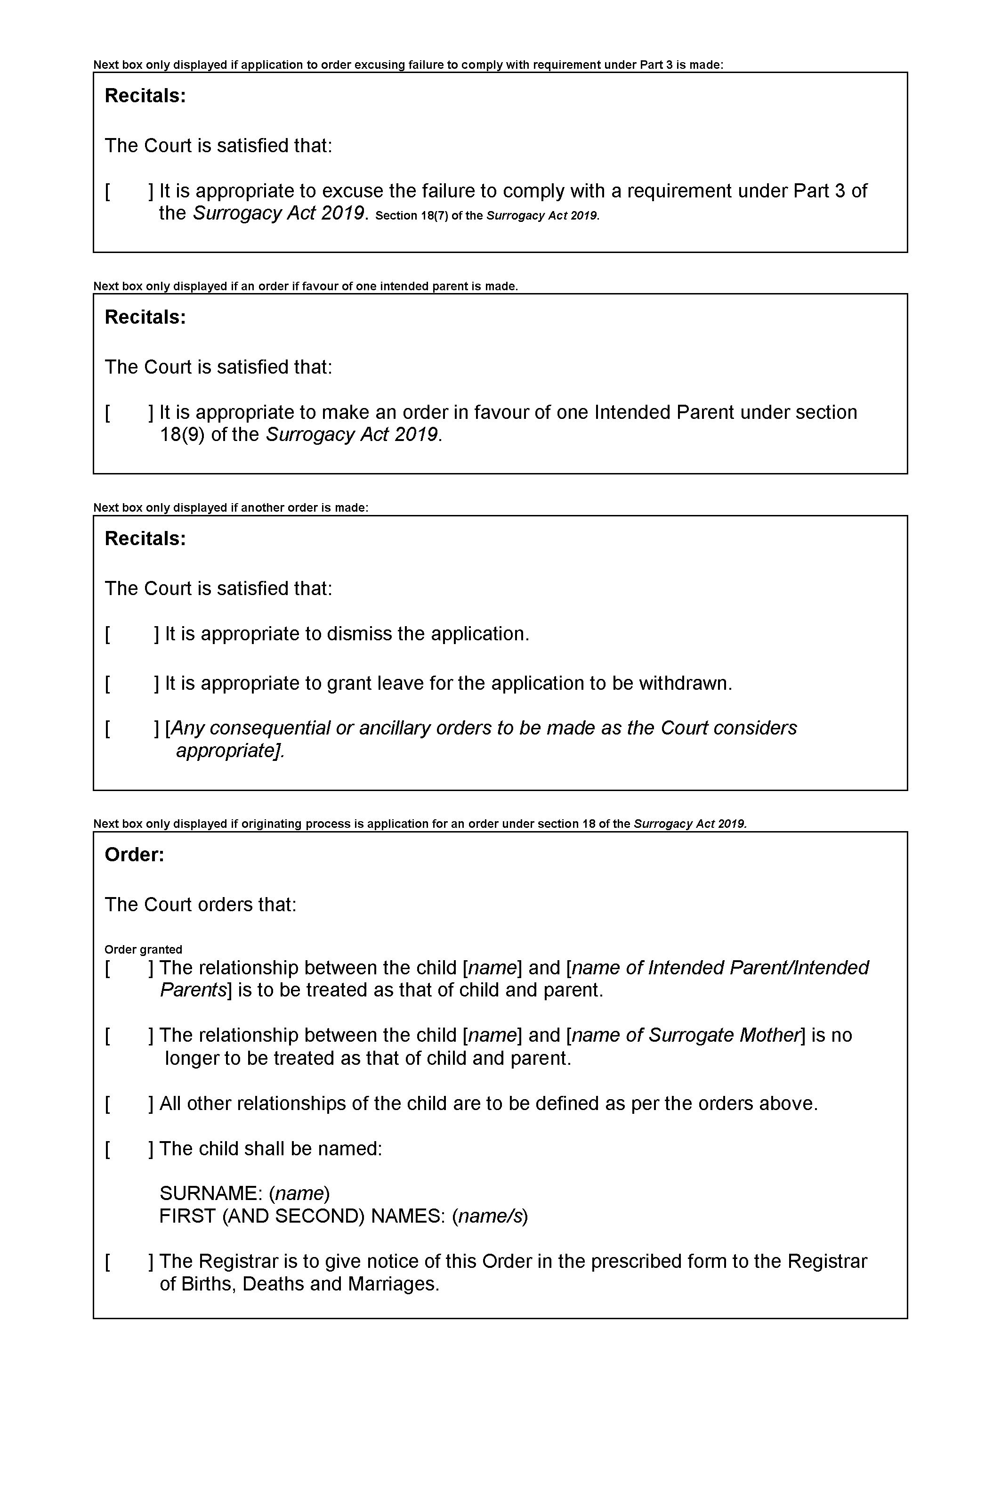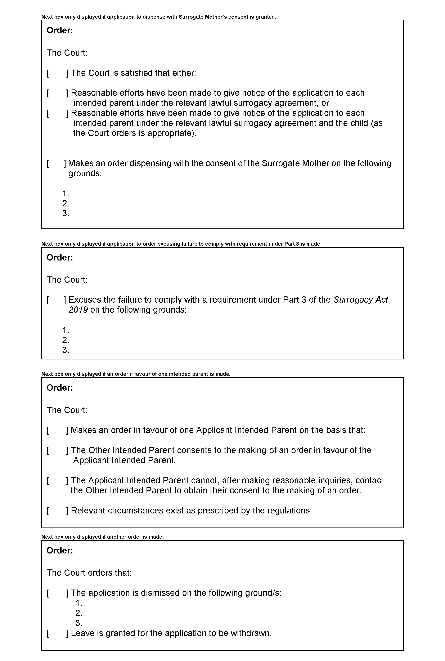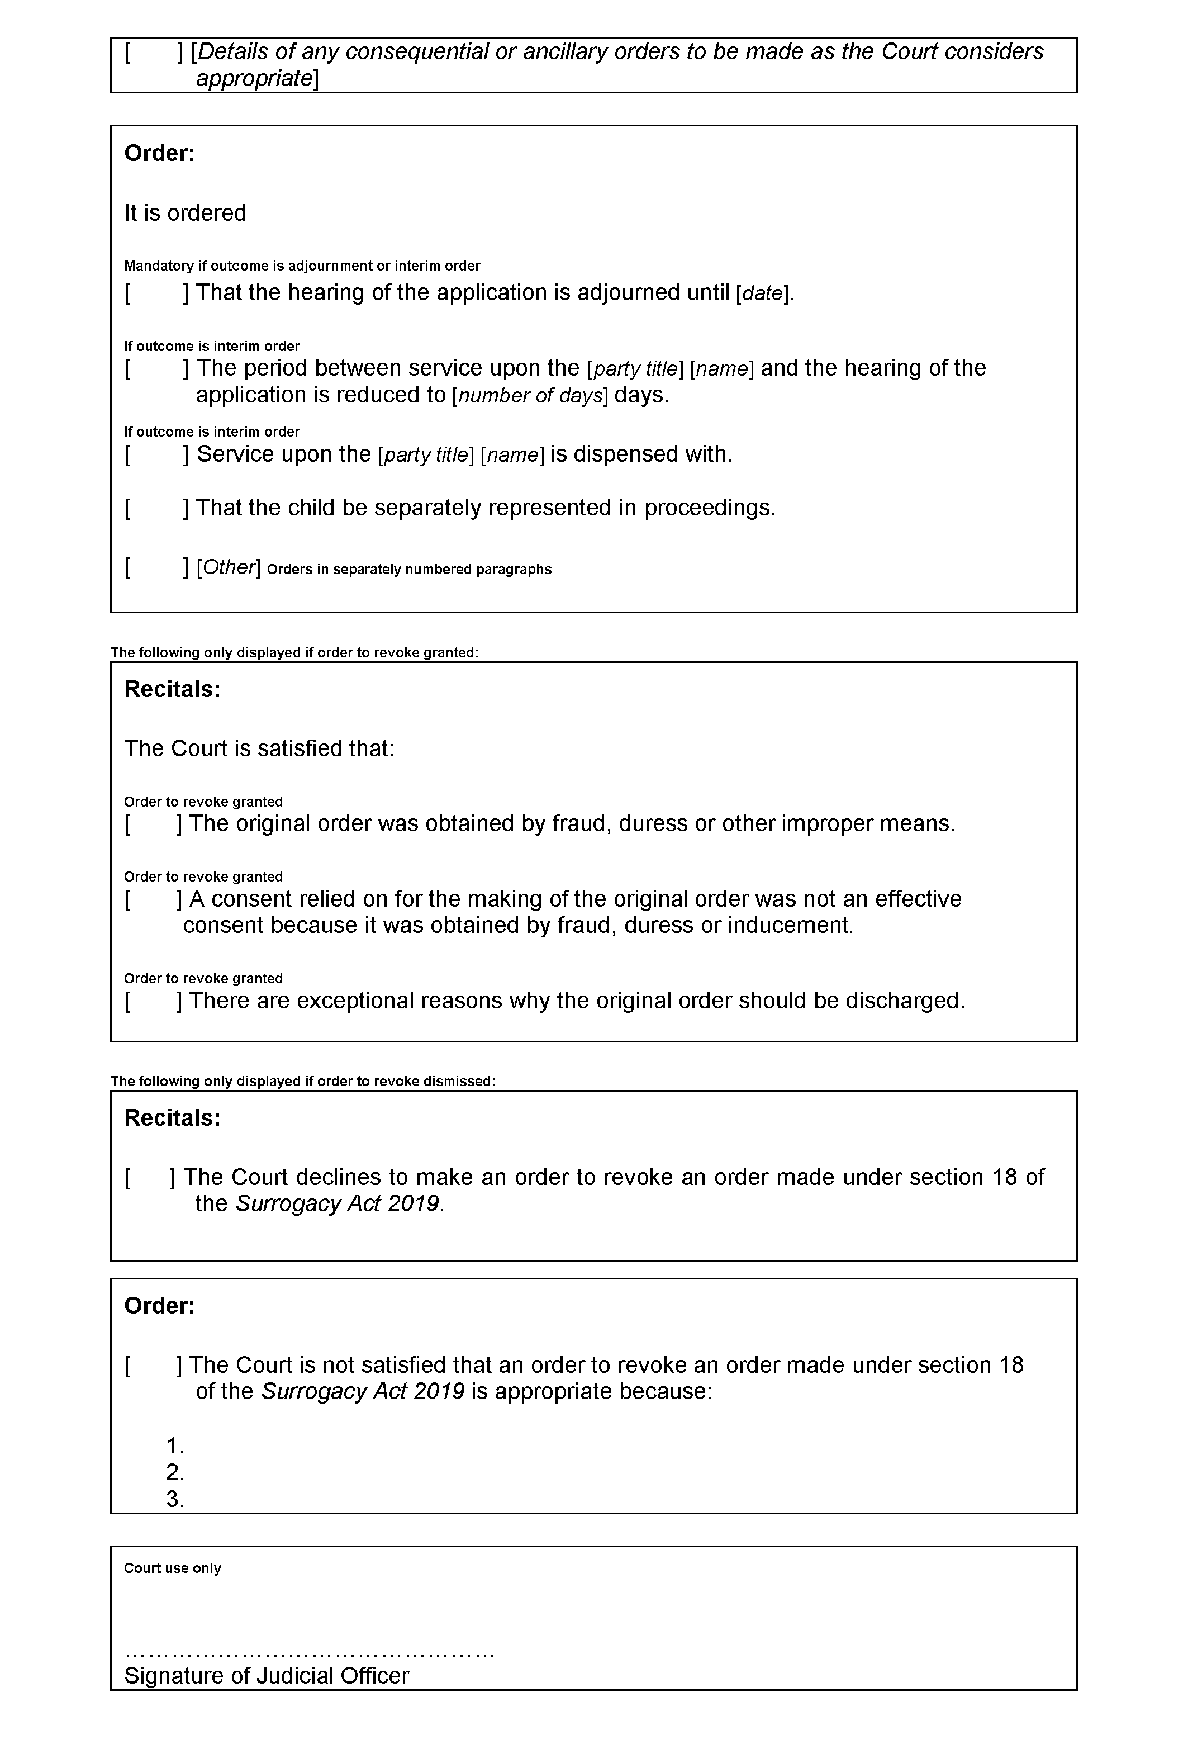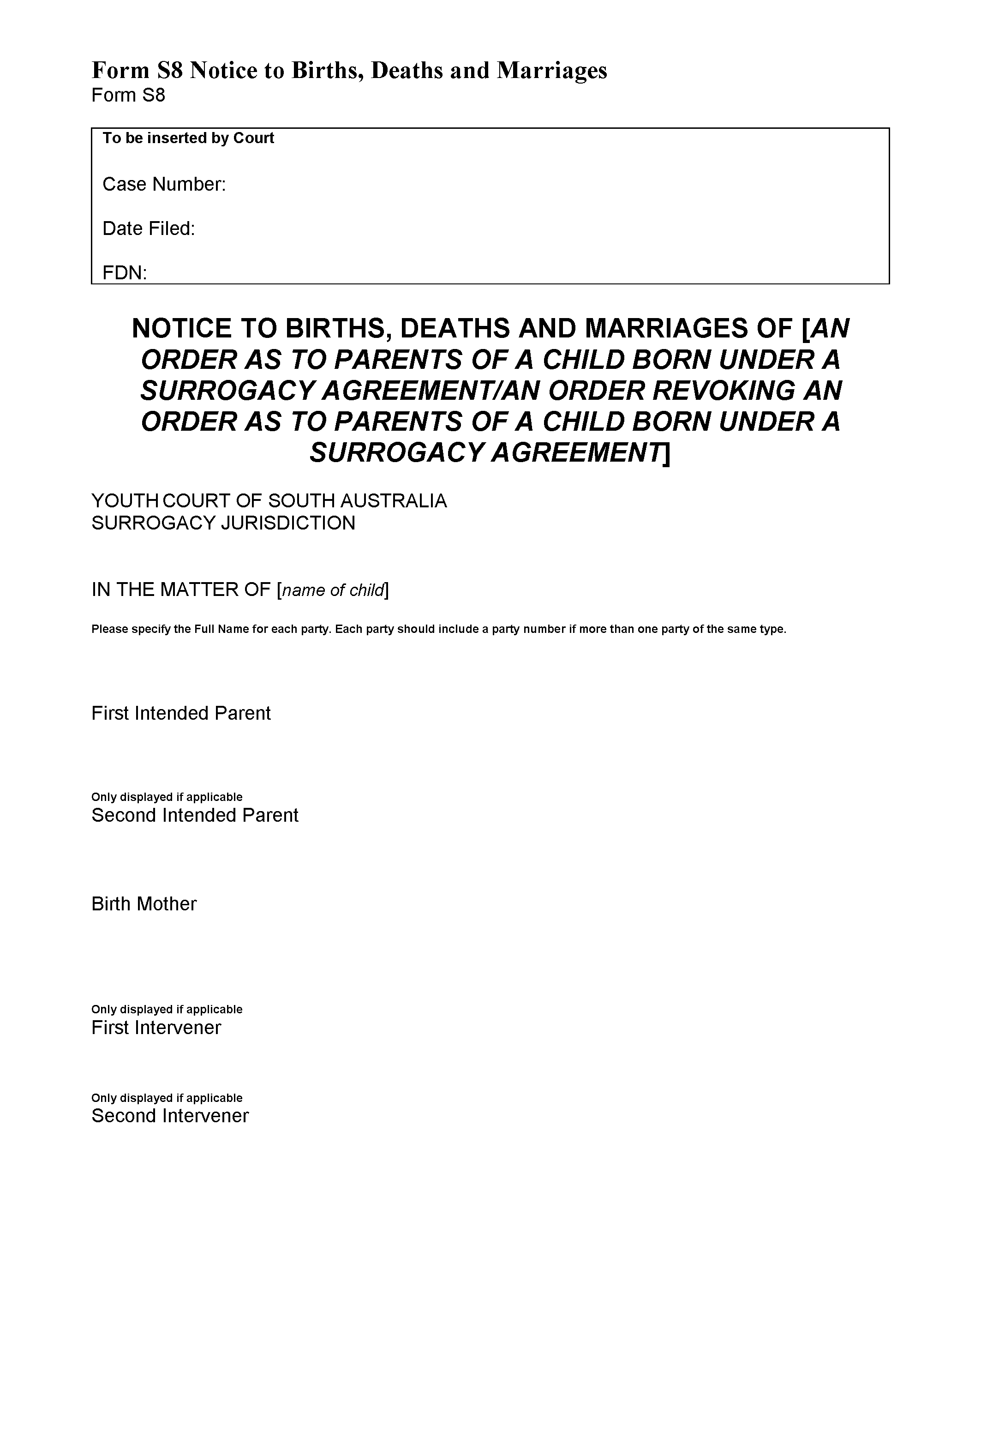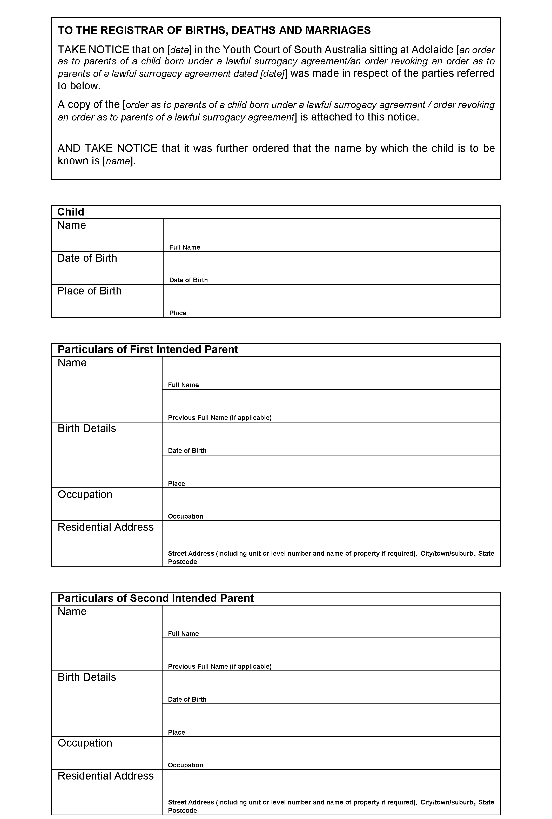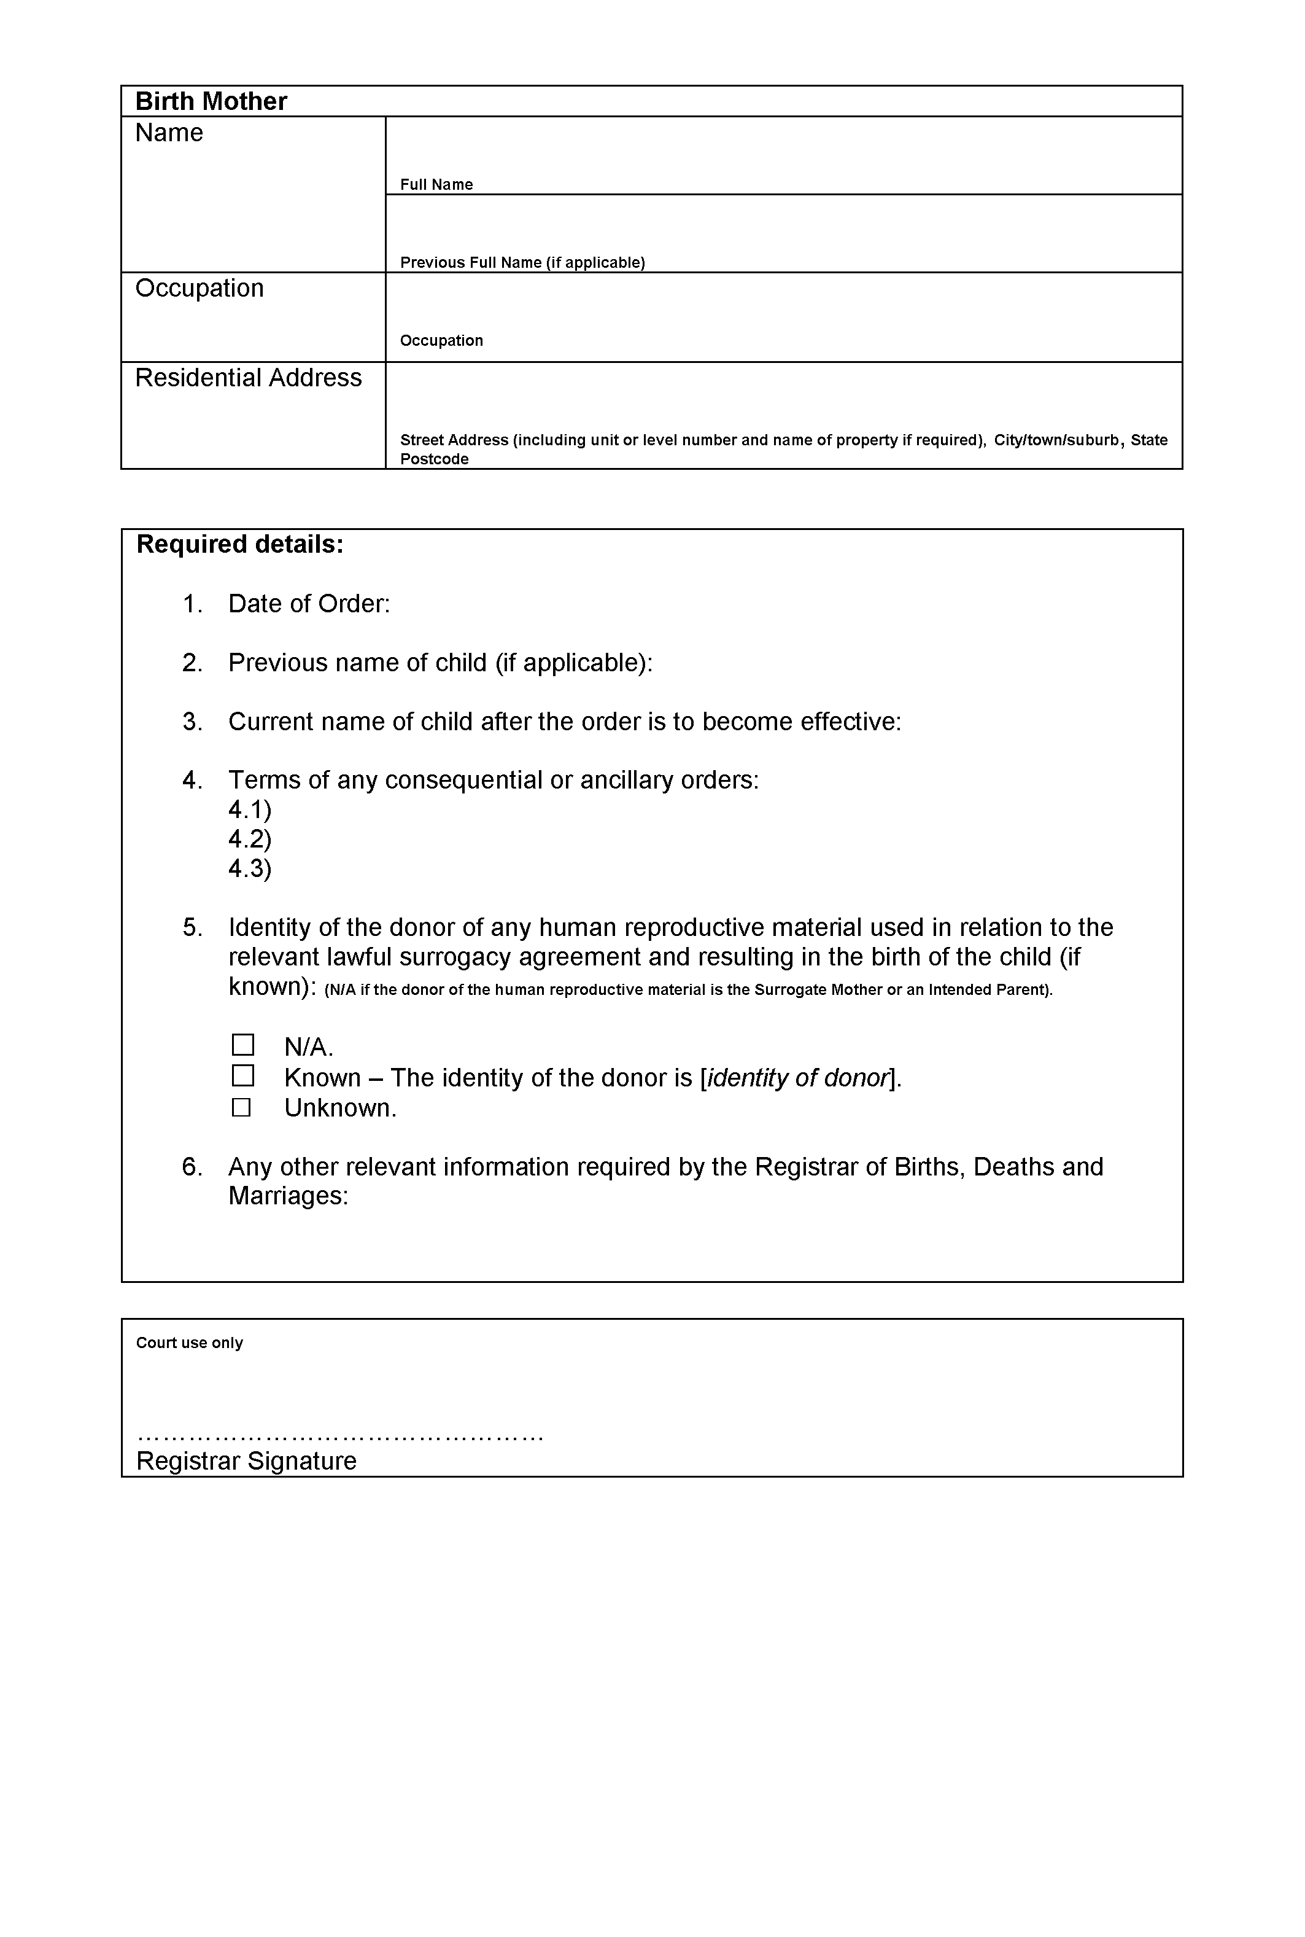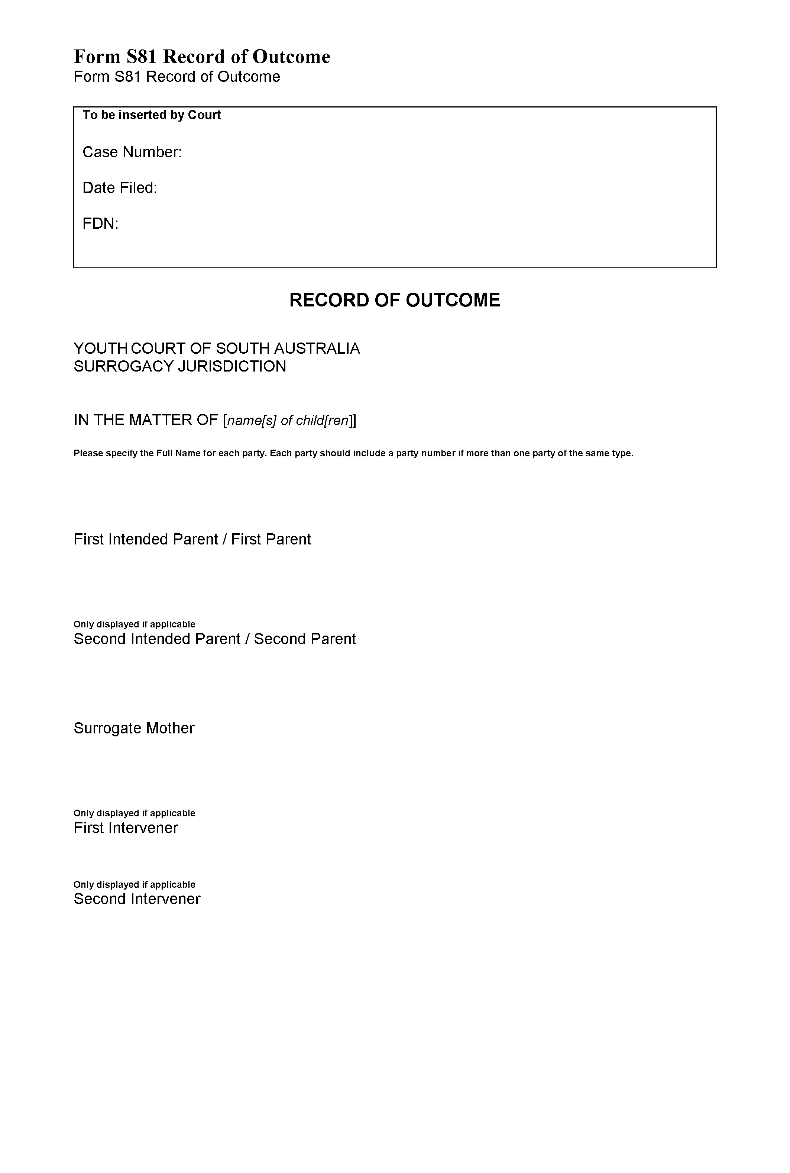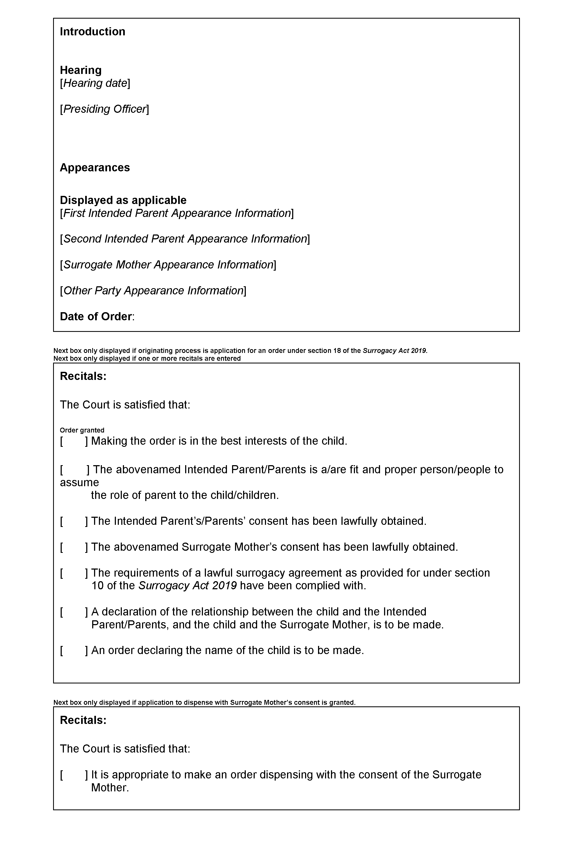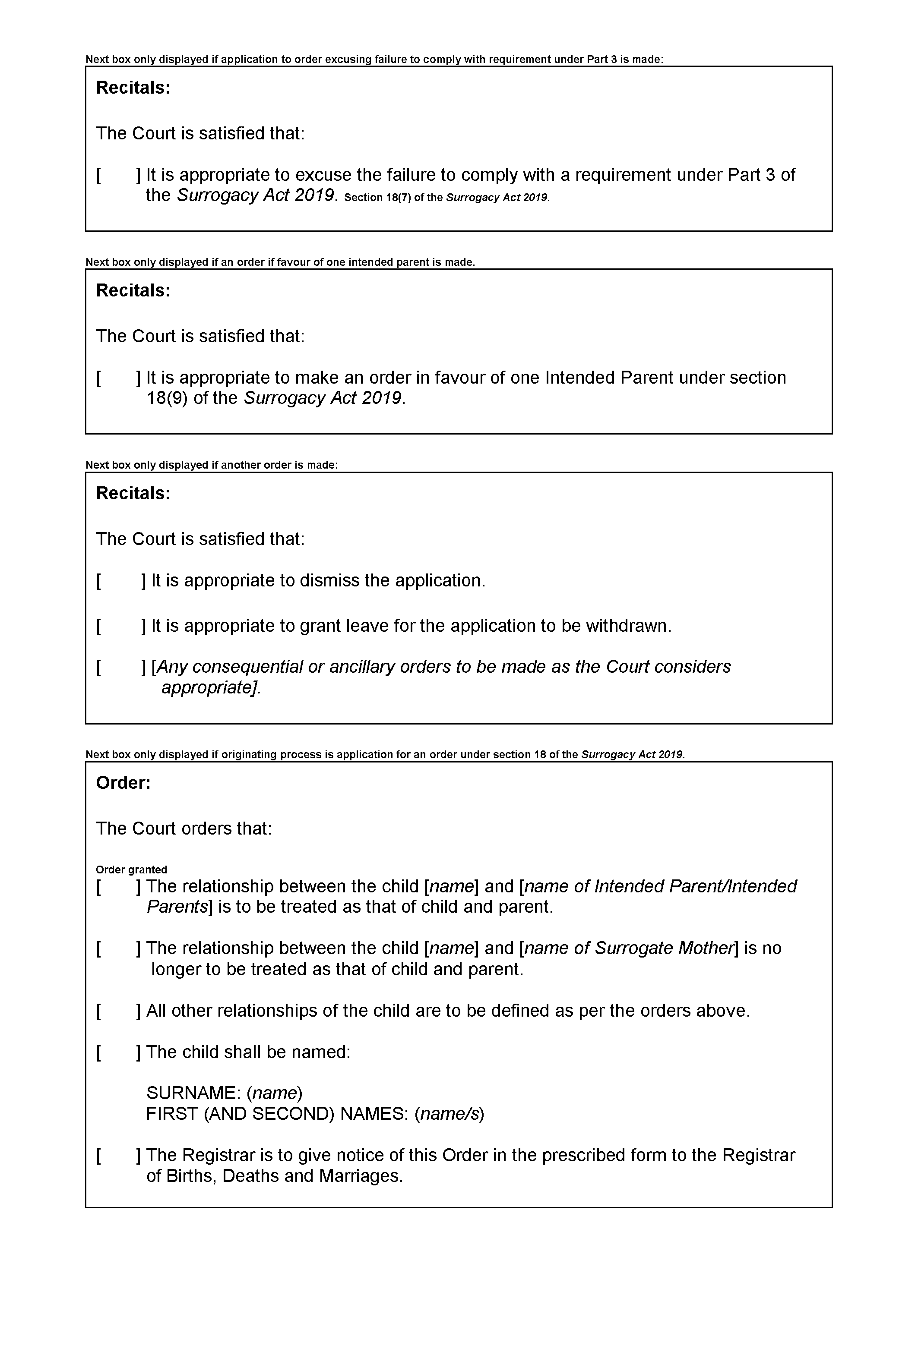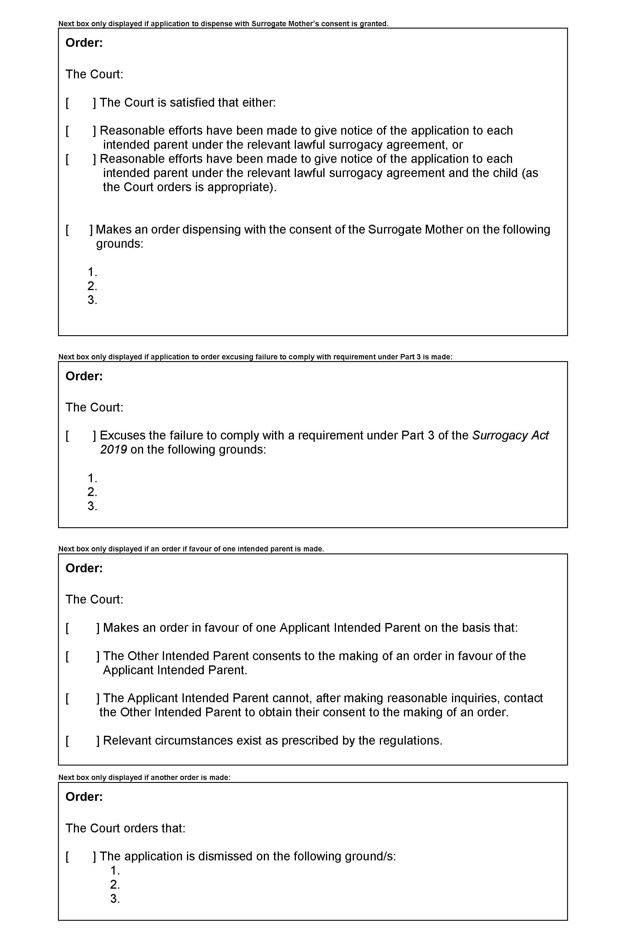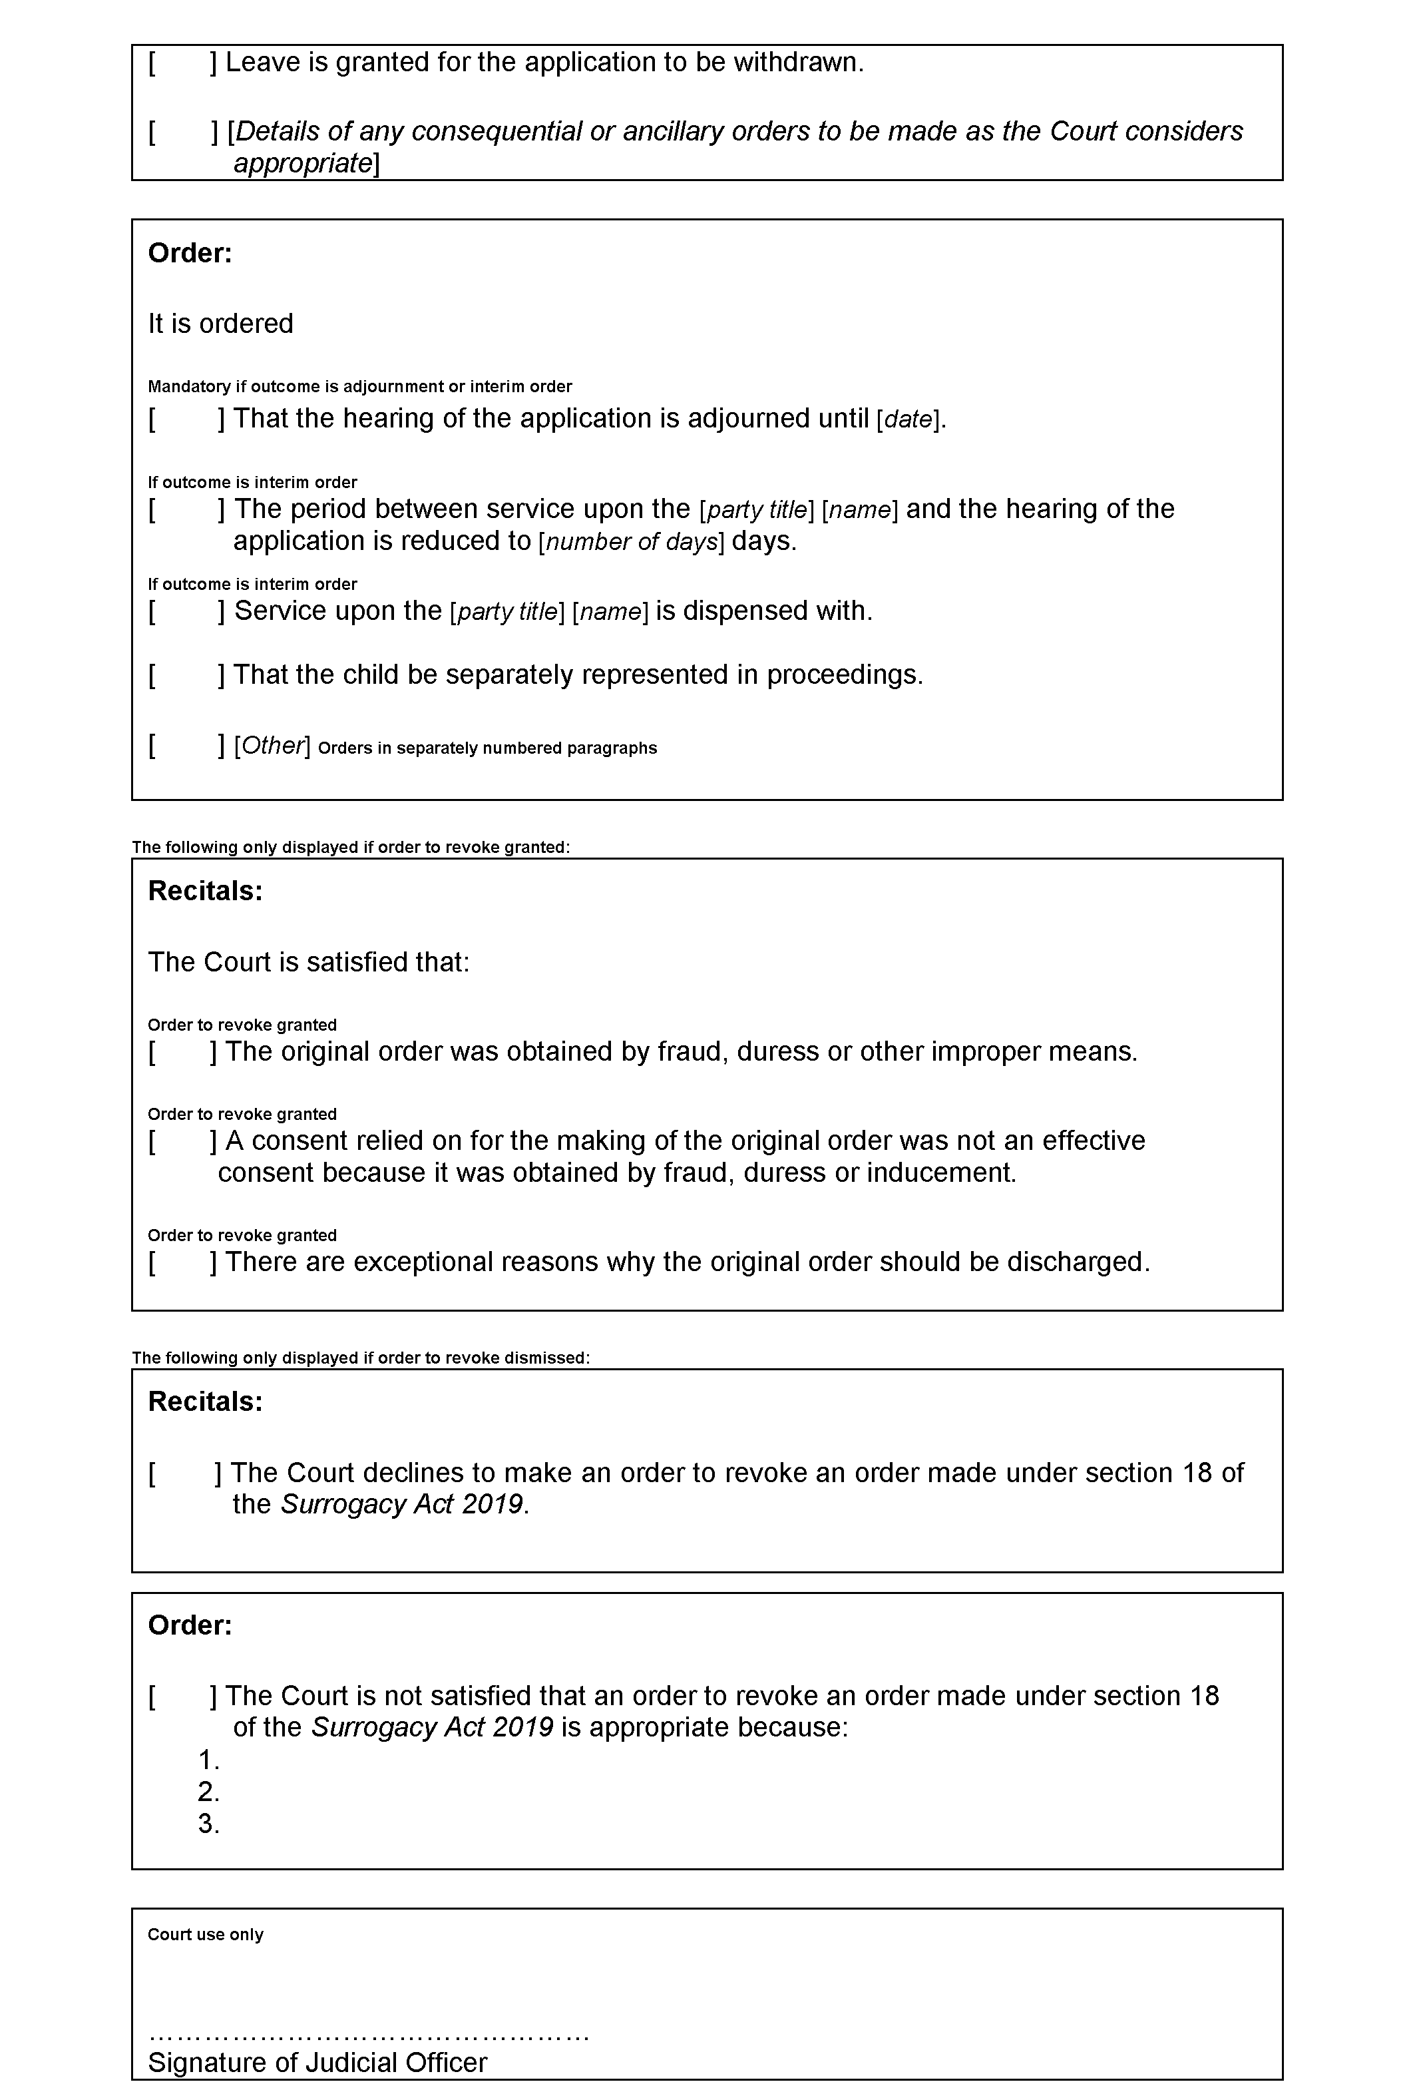
Made by the Judge and the Magistrates who are members of the principal judiciary of the Youth Court of South Australia on this 24th day of August 2020.

Judge P. Eldridge
Magistrate L. Davis
Magistrate D. White
Magistrate O. Koehn

State Government Instruments

Administrative Arrangements Act 1994
Delegation of Functions and Powers by a Minister
PURSUANT to Section 9 of the Administrative Arrangements Act 1994, I, Vickie Chapman, Minister for Planning and Local Government, delegate to the Honourable Michelle Lensink, Minister for Human Services, my powers and functions under Section 25 of the Development Act 1993 in relation to whether to approve the Local Heritage in Transition Statement of Intent to amend a Development Plan prepared by the City of Burnside.
This delegation takes effect from the date of publication in the Government Gazette.
Dated: 20 August 2020
Vickie Chapman MP
Minister for Planning and Local Government

Aquaculture Act 2001
Grant of Aquaculture Lease
Pursuant to the provisions of Section 22 of the Aquaculture Act 2001, notice is hereby given of the grant of the following lease for the purposes of aquaculture in the waters of Louth Bay, South Australia:
LA00475
Further details are available for the above lease on the Aquaculture Public Register; which can be found at http://www.pir.sa.gov.au/aquaculture/aquaculture_public_register or by contacting Aquaculture Leasing & Licensing on 8207 5332.
Dated: 11 August 2020
Jasmine Pedicini
Leasing & Licensing Officer

Building Work Contractors Act 1995
Exemption
TAKE notice that, pursuant to section 45 of the Building Work Contractors Act 1995, I, John Doran as a delegate for the Attorney-General, do hereby exempt the licensee named in Schedule 1 from the application of Division 3 of Part 5 of the above Act in relation to domestic building work described in Schedule 2 and subject to the conditions specified in Schedule 3.
Schedule 1
DOMINION HOMES AUSTRALASIA PTY LTD (BLD 269120)
Schedule 2
Construction of a single, three storey residential dwelling at Allotment 32 in Deposited Plan 143296 being a partial portion of the land described in Certificate of Title Volume 5916 Folio 612, more commonly known as Lot 101 (Unit 1), 16 Divett Street, Port Adelaide SA 5015.
Schedule 3
1. This exemption is limited to domestic building work personally performed by the licensee in relation to the building work described in Schedule 2.
2. This exemption does not apply to any domestic building work the licensee contracts to another building work contractor, for which that contractor is required by law to hold building indemnity insurance.
3. That the licensee may transfer his interest in the land prior to five years from the date of completion of the building work the subject of this exemption to Antonio Luvera only.
4. That the licensee does not transfer his interest in the land [other than to the person named in schedule 3.3] prior to five years from the date of completion of the building work the subject of this exemption, without the prior authorisation of Consumer and Business Services (CBS). Before giving such authorisation, CBS may require the licensee to take any reasonable steps to protect the future purchaser(s) of the property, including but not limited to:
- Providing evidence that an adequate policy of building indemnity insurance is in force to cover the balance of the five-year period from the date of completion of the building work the subject of this exemption;
- Providing evidence of an independent expert inspection of the building work the subject of this exemption;
- Making an independent expert report available to prospective purchasers of the property;
- Giving prospective purchasers of the property notice of the absence of a policy of building indemnity insurance.
Dated: 20 August 2020
John Doran
General Manager, Licensing
Delegate for the Attorney-General

Building Work Contractors Act 1995
Exemption
TAKE notice that, pursuant to section 45 of the Building Work Contractors Act 1995, I, John Doran as a delegate for the Attorney-General, do hereby exempt the licensee named in Schedule 1 from the application of Division 3 of Part 5 of the above Act in relation to domestic building work described in Schedule 2 and subject to the conditions specified in Schedule 3.
Schedule 1
DOMINION HOMES AUSTRALASIA PTY LTD (BLD 269120)
Schedule 2
Construction of a single, three storey residential dwelling at Allotment 32 in Deposited Plan 143296 being a partial portion of the land described in Certificate of Title Volume 5916 Folio 612, more commonly known as Lot 102 (Unit 2), 14 Divett Street, Port Adelaide SA 5015.
Schedule 3
1. This exemption is limited to domestic building work personally performed by the licensee in relation to the building work described in Schedule 2.
2. This exemption does not apply to any domestic building work the licensee contracts to another building work contractor, for which that contractor is required by law to hold building indemnity insurance.
3. That the licensee may transfer his interest in the land prior to five years from the date of completion of the building work the subject of this exemption to Anthony Logozzo only.
4. That the licensee does not transfer his interest in the land [other than to the person named in schedule 3.3] prior to five years from the date of completion of the building work the subject of this exemption, without the prior authorisation of Consumer and Business Services (CBS). Before giving such authorisation, CBS may require the licensee to take any reasonable steps to protect the future purchaser(s) of the property, including but not limited to:
- Providing evidence that an adequate policy of building indemnity insurance is in force to cover the balance of the five-year period from the date of completion of the building work the subject of this exemption;
- Providing evidence of an independent expert inspection of the building work the subject of this exemption;
- Making an independent expert report available to prospective purchasers of the property;
- Giving prospective purchasers of the property notice of the absence of a policy of building indemnity insurance.
Dated: 20 August 2020
John Doran
General Manager, Licensing
Delegate for the Attorney-General

Building Work Contractors Act 1995
Exemption
TAKE notice that, pursuant to section 45 of the Building Work Contractors Act 1995, I, John Doran as a delegate for the Attorney-General, do hereby exempt the licensee named in Schedule 1 from the application of Division 3 of Part 5 of the above Act in relation to domestic building work described in Schedule 2 and subject to the conditions specified in Schedule 3.
Schedule 1
MATTHEW BOX (BLD 241098)
Schedule 2
Construction of a single, two storey detached dwelling at Allotment 34 in Filed Plan 8593 being at the rear portion of the land described in Certificate of Title Volume 5786 Folio 938, more commonly known as 51A Garfield Avenue, Kurralta Park SA 5037.
Schedule 3
1. This exemption is limited to domestic building work personally performed by the licensee in relation to the building work described in Schedule 2.
2. This exemption does not apply to any domestic building work the licensee contracts to another building work contractor, for which that contractor is required by law to hold building indemnity insurance.
3. That the licensee does not transfer his interest in the land prior to five years from the date of completion of the building work the subject of this exemption, without the prior authorisation of Consumer and Business Services (CBS). Before giving such authorisation, CBS may require the licensee to take any reasonable steps to protect the future purchaser(s) of the property, including but not limited to:
- Providing evidence that an adequate policy of building indemnity insurance is in force to cover the balance of the five-year period from the date of completion of the building work the subject of this exemption;
- Providing evidence of an independent expert inspection of the building work the subject of this exemption;
- Making an independent expert report available to prospective purchasers of the property;
- Giving prospective purchasers of the property notice of the absence of a policy of building indemnity insurance.
Dated: 20 August 2020
John Doran
General Manager, Licensing
Delegate for the Attorney-General

Development Act 1993
Section 46(2)(B)
Variation of Undertaking
To: BHP Billiton Olympic Dam Corporation Pty Ltd (“BHP”)
1. Pursuant to section 46(2)(b) of the Development Act 1993, BHP has been given an undertaking that Division 2 of Part 4 of the Development Act 1993 will not apply to certain development that would otherwise be within the ambit of a declaration that was published in the Gazette on 14 February 2019 at p.461 pursuant to section 46(1) of the Development Act 1993, as subsequently varied by notice published in the Gazette on 19 September 2019 at pp.3307-3308 pursuant to section 46(4) of the Development Act 1993 (“the major development declaration”). The undertaking was published in the Gazette on 19 September 2019 at p.3306 (“the Undertaking”).
2. I have further varied the major development declaration by notice published in the Gazette on or about the date of this notice pursuant to section 46(4) of the Development Act 1993 to recognize that the scope of the Olympic Dam Resource Development Strategy has been revised down from a maximum production rate of 350,000 tonnes per annum (tpa) of copper (Cu) and associated products to 300,000 tpa Cu and associated products.
3. At BHP’s request, I have agreed to vary the Undertaking so that it expressly refers to the further variation of the major development declaration, and to the revised maximum production rate referred to in the major development declaration, as further varied.
4. Pursuant to such powers as are vested in me, including by section 46(2)(b) of the Development Act 1993 and section 37 of the Acts Interpretation Act 1915 (and to the extent it is necessary that I rely on such powers), I hereby vary the Undertaking as follows:
4.1 by deleting “(as varied by a notice published in the Gazette on or about the date of this Undertaking pursuant to section 46(4) of the Development Act 1993)” in the first paragraph and substituting:
“(as varied by a notice published in the Gazette on 19 September 2019 pursuant to section 46(4) of the Development Act 1993, and as further varied by a notice published in the Gazette pursuant to section 46(4) of the Development Act 1993 contemporaneously with the notice that varied this Undertaking (inter alia) to refer to the revised maximum production rate of 300,000 tonnes per annum of copper and associated products)”; and
4.2 by deleting “350,000” in the first paragraph and substituting:
“300,000”.
5. A reference in this notice to the Development Act 1993 is a reference to that Act as affected by the Roxby Downs (Indenture Ratification) Act 1982 and the Indenture as defined in that Act.
6. For convenient reference, the Undertaking, as varied, is set out in full in the Schedule below.
Dated: 25 August 2020
Vickie Chapman
Minister for Planning and Local Government

Schedule—Varied Undertaking
UNDERTAKING
for the purposes of section 46(2)(b) of the Development Act 1993
To: BHP Billiton Olympic Dam Corporation Pty Ltd
By a notice published in the Gazette on 14 February 2019 pursuant to section 46(1) of the Development Act 1993 (as varied by a notice published in the Gazette on 19 September 2019 pursuant to section 46(4) of the Development Act 1993, and as further varied by a notice published in the Gazette pursuant to section 46(4) of the Development Act 1993 contemporaneously with the notice that varied this Undertaking (inter alia) to refer to the revised maximum production rate of 300,000 tonnes per annum of copper and associated products), I have declared that section 46 of the Development Act 1993 applies to development on land other than land identified in clause 28 of the Olympic Dam and Stuart Shelf Indenture (“the Indenture”) for the purposes of the production of up to 300,000 tonnes per annum of copper and associated products at Olympic Dam (“the major development declaration”).
I note that, without limiting the scope of development which might be the subject of this undertaking, the following works and activities associated with Olympic Dam’s ongoing operations and repair and maintenance are currently proposed to be commenced before the date of publication in the Gazette of a notice of a decision on the development application made pursuant to s48(2)(b) of the Development Act 1993 on the major development declaration (“the Decision Date”):
i. upgrades to the Olympic Dam airport to satisfy current business needs and to meet regulatory requirements set by the Civil Aviation Safety Authority;
ii. utilising, upgrading and expanding industrial allotments located adjacent to the Olympic Dam Village required to enable ongoing operations;
iii. utilising, upgrading and expanding the accommodation within the current Olympic Dam and Roxby Downs Village complexes;
iv. works or activities to utilise, upgrade, replace, amend or expand existing facilities, services, infrastructure and operations associated with Olympic Dam’s ongoing operations;
v. any new facilities, services, infrastructure, operations or studies associated with ongoing production and works; and
vi. repairs or maintenance related to any of the preceding purposes.
Pursuant to s46(2)(b) of the Development Act 1993, I hereby undertake that Division 2 of Part 4 of the Development Act 1993 will not apply to development identified in paragraphs (i) to (vi) above (to which the major development declaration would otherwise apply) that is commenced before the Decision Date.
A reference in this Undertaking to the Development Act 1993 is a reference to that Act as affected by the Roxby Downs (Indenture Ratification) Act 1982 and the Indenture.
Dated: 17 September 2019
Hon Stephan Knoll MP
Minister for Planning

DEVELOPMENT ACT 1993
Section 46 (4)
Variation of Olympic Dam Major Development Declaration
Preamble
1. Clause 28 (2) of the Olympic Dam and Stuart Shelf Indenture (the Indenture) in the Schedule to the Roxby Downs (Indenture Ratification) Act 1982 provides that, in relation to the land referred to in Clause 28 (1), references to the ‘Minister’ in Division 2 of Part 4 of the Development Act 1993, are to be taken to be references to the Minister responsible for Energy and Mining (the Indenture Minister). Subsection (1) of section 46 of the Development Act 1993, therefore enables the Indenture Minister to apply that section to a specified kind of development or project on the relevant land if the Indenture Minister is of the opinion that a declaration under that section is appropriate or necessary for the proper assessment of a development or a project of major environmental, social or economic importance. On 12 February 2019 the Indenture Minister made a declaration under section 46 (1) in relation to certain development on the relevant land proposed as part of the Olympic Dam Development Strategy (as described in the declaration) (the Clause 28 Declaration). The Clause 28 Declaration was published in the Gazette on 14 February 2019 at pp.461-462.
2. Concurrently, on 12 February 2019 the Minister for Planning made a declaration under section 46 (1) and (1a) of the Development Act 1993 in relation to certain development proposed as part of the Olympic Dam Resource Development Strategy on land other than land identified in clause 28 (1) of the Indenture (the Declaration). The Declaration was published in the Gazette on 14 February 2019 at p.461.
3. On 16 September 2019 the Indenture Minister varied the Clause 28 Declaration by notice under section 46 (4) of the Development Act 1993. The notice was published in the Gazette on 19 September 2019 at pp.3309-3310. On 17 September 2019 the Minister for Planning varied the Declaration by notice under section 46 (4) of the Development Act 1993 (the First Variation Notice). The First Variation Notice was published in the Gazette on 19 September 2019 at pp.3307-3308.
4. The Indenture Minister has now further varied the Clause 28 Declaration to recognize that the scope of the Olympic Dam Resource Development Strategy has been revised down from a maximum production rate of 350,000 tonnes per annum (tpa) of copper (Cu) and associated products to 300,000 tpa Cu and associated products, and to continue to facilitate a single, comprehensive assessment of the Olympic Dam Resource Development Strategy that meets the requirements of both the Development Act 1993 of the State and the Environment Protection and Biodiversity Conservation Act 1999 of the Commonwealth, and the Minister for Planning and Local Government is of the opinion that it is appropriate to further vary the Declaration to achieve the same objectives.
Notice
PURSUANT to section 46 (4) of the Development Act 1993, I vary the Declaration (as varied by the First Variation Notice) as follows:
1. Preamble, paragraph 2 – delete “350,000” and substitute:
300,000
2. Preamble, paragraph 2 – delete “a proposal to increase”
3. Preamble, paragraph 2 – delete “sourced”
4. Preamble, paragraph 2 - delete “from the volumes for which impacts were assessed in the 1997 “Olympic Dam Expansion Project Environmental Impact Statement”,”
5. Preamble, paragraph 2 – delete “50” and substitute:
42
6. Schedule, first paragraph – delete “350,000” and substitute:
300,000
7. Schedule, exclusion, paragraph (a) – delete “350,000” and substitute:
300,000
8. Note – delete “contemporaneously with the notice under section 46 (4) that varied this declaration by, inter alia, inserting this note,” and substitute:
on 19 September 2019 at p.3306 (as varied by a notice published in the Gazette contemporaneously with the notice under section 46 (4) that varied this declaration, inter alia, to refer to the revised maximum production rate of 300,000 tpa Cu and associated products) is not and
The Declaration, as varied by the First Variation Notice and as further varied by this notice, is set out in full in the Schedule.
Dated: 25 August 2020
Vickie Chapman
Minister for Planning and Local Government

Schedule—Varied Declaration
DEVELOPMENT ACT 1993
Section 46 (1)
Olympic Dam Major Development Declaration
Preamble
1. The Olympic Dam and Stuart Shelf Indenture (the Indenture) in the Schedule to the Roxby Downs (Indenture Ratification) Act 1982, provides comprehensively for mining developments in the Olympic Dam Area and the Selected Areas (as defined therein) and for associated treatment and transportation facilities and related infrastructure in connection therewith.
2. Pursuant to Clause 28 of the Indenture, the Minister for Energy and Mining has made a declaration under section 46 (1) of the Development Act 1993 in relation to certain kinds of development to the extent they are undertaken on land referred to in Clause 28 (1) of the Indenture as part of the Olympic Dam Resource Development Strategy (being the project or projects to be carried out pursuant to one or more Subsequent Project Notices given or to be given under Clause 9 (2) of the Indenture) involving the production of up to 300,000 tonnes per annum (tpa) of copper (Cu) and associated products, including extraction of water from the Great Artesian Basin up to a total maximum of 42 megalitres per day (ML/d) annual average.

Notice
PURSUANT to section 46 sub-sections (1) and (1a) of the Development Act 1993, being of the opinion that a declaration is appropriate for the proper assessment of a development or project of major environmental, social or economic importance, I declare that section 46 of the Act applies to any development of a kind specified in the Schedule, to the extent that it is undertaken:
(a) as part of the Olympic Dam Resource Development Strategy; and
(b) on land other than the land identified in Clause 28 (1) of the Indenture.
BUT not so as to exclude the application of Part 4, Division 1 of the Development Act 1993 to development of the kind specified in the Schedule prior to the date of determination of an application for development approval under this declaration.
Schedule—Specified Kinds of Development
Development to utilise, upgrade, replace, amend or expand existing, or develop new, facilities, services, infrastructure and operations to support the production of up to 300,000 tpa Cu and associated products at Olympic Dam (including by staged increases in production), including for any or all of the following purposes:
- industrial development located in the vicinity of the Olympic Dam Village and the Roxby Downs township;
- airport facilities and parking associated with the Olympic Dam airport;
- workers’ accommodation (with the exception of dwellings) in the vicinity of the Olympic Dam Village or in the vicinity of the Roxby Downs township;
- land division for industrial, airport and residential purposes associated with (a), (b) and (c) above;
- the undertaking of works for the purposes of, or otherwise related to: services such as roads, parking, stormwater, water supply, power supply, telecommunications and effluent treatment in connection with the development;
- any change in the use of land associated with any development within the ambit of the preceding paragraphs; and
- facilities, services, infrastructure, operations and development (including excavation and filling) related or ancillary to development within the ambit of the preceding paragraphs.
But excluding:
- any investigation activities relating to the assessment of development to support the production of up to 300,000 tpa Cu and associated products.
NOTE: Development the subject of the undertaking given by the Minister for Planning pursuant to section 46 (2)(b) of the Development Act 1993 and published in the Gazette on 19 September 2019 at p.3306 (as varied by a notice published in the Gazette contemporaneously with the notice under section 46 (4) that varied this declaration, inter alia, to refer to the revised maximum production rate of 300,000 tpa Cu and associated products) is not and will not be the subject of this declaration.
Dated: 12 February 2019
Stephan Knoll
Minister for Planning

Development Act 1993
Section 46(2)(B)
Variation of Undertaking
To: BHP Billiton Olympic Dam Corporation Pty Ltd (“BHP”)
1. Pursuant to section 46(2)(b) of the Development Act 1993, I have given BHP an undertaking that Division 2 of Part 4 of the Development Act 1993 will not apply to certain development that would otherwise be within the ambit of a declaration that was published in the Gazette on 14 February 2019 at pp.461-462 pursuant to section 46(1) of the Development Act 1993, as subsequently varied by notice published in the Gazette on 19 September 2019 at pp.3309-3310 pursuant to section 46(4) of the Development Act 1993 (“the major development declaration”). The undertaking was published in the Gazette on 19 September 2019 at p.3308 (“the Undertaking”).
2. I have further varied the major development declaration by notice published in the Gazette on or about the date of this notice pursuant to section 46(4) of the Development Act 1993 to recognize that the scope of the Olympic Dam Resource Development Strategy has been revised down from a maximum production rate of 350,000 tonnes per annum (tpa) of copper (Cu) and associated products to 300,000 tpa Cu and associated products.
3. At BHP’s request, I have agreed to vary the Undertaking so that it expressly refers to the further variation of the major development declaration, and to the revised maximum production rate referred to in the major development declaration, as further varied.
4. Pursuant to such powers as are vested in me, including by section 46(2)(b) of the Development Act 1993 and section 37 of the Acts Interpretation Act 1915 (and to the extent it is necessary that I rely on such powers), I hereby vary the Undertaking as follows:
4.1 by deleting “(as varied by a notice published in the Gazette on or about the date of this Undertaking pursuant to section 46(4) of the Development Act 1993)” in the first paragraph and substituting:
“(as varied by a notice published in the Gazette on 19 September 2019 pursuant to section 46(4) of the Development Act 1993, and as further varied by a notice published in the Gazette pursuant to section 46(4) of the Development Act 1993 contemporaneously with the notice that varied this Undertaking (inter alia) to refer to the revised maximum production rate of 300,000 tonnes per annum of copper and associated products)”; and
4.2 by deleting “350,000” in the first paragraph and substituting:
“300,000”.
5. A reference in this notice to the Development Act 1993 is a reference to that Act as affected by the Roxby Downs (Indenture Ratification) Act 1982 and the Indenture as defined in that Act.
6. For convenient reference, the Undertaking, as varied, is set out in full in the Schedule below.
Dated: 24 August 2020
Daniel Cornelis Van Holst Pellekaan
Minister for Energy and Mining

Schedule—Varied Undertaking
UNDERTAKING
for the purposes of section 46(2)(b) of the Development Act 1993
To: BHP Billiton Olympic Dam Corporation Pty Ltd
By a notice published in the Gazette on 14 February 2019 pursuant to section 46(1) of the Development Act 1993 (as varied by a notice published in the Gazette on 19 September 2019 pursuant to section 46(4) of the Development Act 1993, and as further varied by a notice published in the Gazette pursuant to section 46(4) of the Development Act 1993 contemporaneously with the notice that varied this Undertaking (inter alia) to refer to the revised maximum production rate of 300,000 tonnes per annum of copper and associated products), I have declared that section 46 of the Development Act 1993 applies to development on land identified in clause 28 of the Olympic Dam and Stuart Shelf Indenture (“the Indenture”) for the purposes of the production of up to 300,000 tonnes per annum of copper and associated products at Olympic Dam (“the major development declaration”).
I note that, without limiting the scope of development which might be the subject of this undertaking, the following works and activities associated with Olympic Dam’s ongoing operations and repair and maintenance are currently proposed to be commenced before the date of publication in the Gazette of a notice of a decision on the development application made pursuant to s48(2)(b) of the Development Act 1993 on the major development declaration (“the Decision Date”):
i. projects associated with the progress of mining activities into the Southern Mine Area (SMA), including development of underground activities and surface infrastructure such as additional declines and stockpiling of mined material including ore and waste rock;
ii. waste treatment, storage and disposal including, but not limited to, Tailings Storage Facility 6, Evaporation Pond 6, additional cells for the contaminated waste disposal facility, expansion of the general waste landfill and development of a low-level radioactive waste storage facility;
iii. demolition and replacement of plant and equipment, including, but not limited to, the pilot plant, Smelter 1, Calciner, old solvent extraction plant, Clarifier 2, storage bin upgrades;
iv. provision of ancillary infrastructure to support mining and production operations, including, but not limited to, sewage treatment plant upgrade, dam barrier wall, Clarke Shaft hoist and transfer system upgrade, new ore stacker and M6 pipeline upgrade/replacement;
v. ongoing operations and repair and maintenance, including, but not limited to, the smelter campaign maintenance 2021 program;
vi. works or activities to utilise, upgrade, replace, amend or expand existing facilities, services, infrastructure and operations associated with Olympic Dam’s ongoing operations.
vii. any new facilities, services, infrastructure, and operations associated with enabling ongoing production;
viii. works, repairs or maintenance related to any of the preceding purposes; and
ix. any activities ancillary to those referred to in (i) to (viii) above.
Pursuant to section 46(2)(b) of the Development Act 1993, I hereby undertake that Division 2 of Part 4 of the Development Act 1993 will not apply to development identified in paragraphs (i) to (ix) above (to which the major development declaration would otherwise apply) that is commenced before the Decision Date.
A reference in this Undertaking to the Development Act 1993 is a reference to that Act as affected by the Roxby Downs (Indenture Ratification) Act 1982 and the Indenture.
Dated 16 September 2019
Daniel Cornelis Van Holst Pellekaan
Minister for Energy and Mining

DEVELOPMENT ACT 1993
Section 46 (4)
Variation of Olympic Dam Major Development Declaration
Preamble
1. Clause 28 (2) of the Olympic Dam and Stuart Shelf Indenture (the Indenture) in the Schedule to the Roxby Downs (Indenture Ratification) Act 1982 provides that, in relation to the land referred to in Clause 28 (1), references to the ‘Minister’ in Division 2 of Part 4 of the Development Act 1993, are to be taken to be references to the Minister responsible for Energy and Mining (the Indenture Minister). Subsection (1) of section 46 of the Development Act 1993, therefore enables the Indenture Minister to apply that section to a specified kind of development or project on the relevant land if the Indenture Minister is of the opinion that a declaration under that section is appropriate or necessary for the proper assessment of a development or a project of major environmental, social or economic importance.
2. On 12 February 2019 the Indenture Minister made a declaration under section 46 (1) of the Development Act 1993 in relation to certain development on the relevant land proposed as part of the Olympic Dam Resource Development Strategy (the Declaration). The Declaration was published in the Gazette on 14 February 2019 at pp.461-462.
3. On 16 September 2019 the Indenture Minister varied the Declaration by notice under section 46 (4) of the Development Act 1993 (the First Variation Notice). The First Variation Notice was published in the Gazette on 19 September 2019 at pp.3309-3310.
4. The Indenture Minister is now of the opinion that it is appropriate to further vary the Declaration to recognize that the scope of the Olympic Dam Resource Development Strategy has been revised down from a maximum production rate of 350,000 tonnes per annum (tpa) of copper (Cu) and associated products to 300,000 tpa Cu and associated products, and to continue to facilitate a single, comprehensive assessment of the Olympic Dam Resource Development Strategy that meets the requirements of both the Development Act 1993 of the State and the Environment Protection and Biodiversity Conservation Act 1999 of the Commonwealth.
Notice
PURSUANT to section 46 (4) of the Development Act 1993, I vary the Declaration (as varied by the First Variation Notice) as follows:
1. Declaration, paragraph (a) – delete “350,000” and substitute:
300,000
2. Declaration, paragraph (a) – delete “a proposal to increase”
3. Declaration, paragraph (a) – delete “sourced”
4. Declaration, paragraph (a) – delete “from the volumes for which impacts were assessed in the 1997 “Olympic Dam Expansion Project Environmental Impact Statement”,”
5. Declaration, paragraph (a) – delete “50” and substitute:
42
6. Schedule, first paragraph – delete “350,000” and substitute:
300,000
7. Schedule, paragraph (a) – delete “sourced”
8. Schedule, paragraph (a) – delete “from the volume for which impacts were assessed in the 1997 “Olympic Dam Expansion Project Environmental Impact Statement”,”
9. Schedule, paragraph (a) – delete “50” and substitute:
42
10. Schedule, exclusion, paragraph (a) – delete “350,000” and substitute:
300,000
11. Note – delete “contemporaneously with the notice under section 46 (4) that varied this declaration by, inter alia, inserting this note,” and substitute:
on 19 September 2019 at p.3308 (as varied by a notice published in the Gazette contemporaneously with the notice under section 46 (4) that varied this declaration, inter alia, to refer to the revised maximum production rate of 300,000 tpa Cu and associated products) is not and
The Declaration, as varied by the First Variation Notice and as further varied by this notice, is set out in full in the Schedule.
Dated: 24 August 2020
Daniel Cornelis van Holst Pellekaan
Minister for Energy and Mining

Schedule—Varied Declaration
DEVELOPMENT ACT 1993
Section 46 (1)
Olympic Dam Major Development Declaration
Preamble
Clause 28 (2) of the Olympic Dam and Stuart Shelf Indenture (the Indenture) in the Schedule to the Roxby Downs (Indenture Ratification) Act 1982 provides that, in relation to the land referred to in Clause 28 (1), references to the ‘Minister’ in Division 2 of Part 4 of the Development Act 1993, are to be taken to be references to the Minister responsible for Energy and Mining (the Indenture Minister). Section (1) of section 46 of the Development Act 1993, therefore enables the Indenture Minister to apply that section to a specified kind of development or project on the relevant land if the Indenture Minister is of the opinion that a declaration under that section is appropriate or necessary for the proper assessment of a development or a project of major environmental, social or economic importance.
Notice
PURSUANT to section 46 (1) of the Development Act 1993, being of the opinion that a declaration is appropriate for the proper assessment of a development or project of major environmental, social or economic importance, I declare that section 46 of the Act applies to any development of a kind specified in the Schedule to the extent that it is undertaken:
(a) as part of the Olympic Dam Resource Development Strategy (being the project or projects to be carried out pursuant to one or more Subsequent Project Notices given or to be given under Clause 9 (2) of the Indenture) involving the production of up to 300,000 tonnes per annum (tpa) of copper (Cu) and associated products, including extraction of water from the Great Artesian Basin up to a total maximum of 42 megalitres per day (ML/d) annual average; and
(b) on land identified in Clause 28 (1) of the Indenture.
Schedule—Specified Kinds of Development
Development to utilise, upgrade, replace, amend or expand existing, or develop new, facilities, services, infrastructure and operations to support the production of up to 300,000 tpa Cu and associated products at Olympic Dam (including by staged increases in production), including development of the following kinds:
- any augmented or new water supply pipeline from the Great Artesian Basin along with any other wellfield, including any related bores or pumps for the proposed purpose of increasing or monitoring the extraction of water from the Great Artesian Basin up to a total maximum of 42 ML/d annual average;
- works to increase the rate of underground mining and the installation of materials handling infrastructure, such as mechanised hoists and/or additional declines, to transport mined material to the surface;
- works to increase the capacity of surface infrastructure to support increased production from the mine, including, but not limited to, ventilation, cooling, backfill (cement or paste), crushers, quarries, borrow pits, concrete batch plants and stockpiles for run of mine ore, low-grade ore and waste rock;
- works to increase surface production capacity, with some changes to the processing methods, including milling, hydrometallurgical plant, smelter, acid plant(s) and refinery;
- works to increase capacity of facilities and operations for waste treatment, storage and disposal;
- works to increase capacity of facilities and operations for tailings storage, evaporation ponds, waste rock storage, low grade ore storage and water dams within the Special Mine Lease;
- utilising, expanding, replacing, demolishing and amending facilities, services, transport, infrastructure and operations for the purpose of enabling development identified in paragraphs (a) – (f);
- new facilities, services, infrastructure and operations for the above purposes;
- any related or ancillary development associated with development within the ambit of the preceding paragraphs including but not limited to transport, laydown areas, electricity and other services.
But excluding:
- any investigation activities relating to the assessment of development to support the production of up to 300,000 tpa Cu and associated products.
NOTE: Development the subject of the undertaking given by the Minister for Energy and Mining pursuant to section 46 (2)(b) of the Development Act 1993 and published in the Gazette on 19 September 2019 at p.3308 (as varied by a notice published in the Gazette contemporaneously with the notice under section 46 (4) that varied this declaration, inter alia, to refer to the revised maximum production rate of 300,000 tpa Cu and associated products) is not and will not be the subject of this declaration.
Dated: 12 February 2019
Daniel Cornelis van Holst Pellekaan
Minister for Energy and Mining

Fisheries Management Act 2007
Section 115
Exemption Number ME9903121
TAKE NOTICE that pursuant to section 115 of the Fisheries Management Act 2007, the holder of a fishery licence in respect of the Spencer Gulf Prawn Fishery constituted under the Fisheries Management (Prawn Fisheries) Regulations 2017 as at 27 August 2020 are exempt from the provisions of section 54(1)(c) and (4) of the Fisheries Management Act 2007 but only insofar as they may apply pursuant to section 54 of the Fisheries Management Act 2007 for a new fishery licence in respect of the Spencer Gulf Prawn Fishery during the period 27 August 2020 until 23 October 2020 unless varied or revoked earlier.
Dated: 27 August 2020
Prof Gavin Begg
A/Executive Director
Fisheries and Aquaculture
Delegate of the Minister for Primary Industries and Regional Development

Fisheries Management Act 2007
Section 115
Exemption Number ME9903122
TAKE NOTICE that pursuant to section 115 of the Fisheries Management Act 2007, a person applying for a Fish Processor registration under the Fisheries Management (Fish Processors) Regulations 2017 is exempt from the provisions of section 64(1)(d) and (4) of the Fisheries Management Act 2007 but only insofar as they may apply for a Fish Processor registration pursuant to section 64 of the Fisheries Management Act 2007 during the period 27 August 2020 until 30 June 2021, unless varied or revoked earlier.
Dated: 27 August 2020
Prof Gavin Begg
A/Executive Director
Fisheries and Aquaculture
Delegate of the Minister for Primary Industries and Regional Development

HOUSING IMPROVEMENT ACT 2016
Rent Control Revocations
Whereas the Minister for Human Services Delegate is satisfied that each of the houses described hereunder has ceased to be unsafe or unsuitable for human habitation for the purposes of the Housing Improvement Act 2016, notice is hereby given that, in exercise of the powers conferred by the said Act, the Minister for Human Services Delegate does hereby revoke the said Rent Control in respect of each property.
Address of Premises | Allotment  Section | Certificate of Title  Volume/Folio
28A Cardwell Street, Adelaide SA 5000 | Allotment 734 Filed Plan 181576  Hundred of Adelaide | CT2111/150  CT4381/247  CT5436/313
23 Kate Court, Adelaide SA 5000 | Allotment 818 Filed Plan 182470  Hundred of Adelaide | CT3559/160  CT5590/687
78 Beulah Road, Norwood SA 5067 | Allotment 13 Filed Plan 100197  Hundred of Adelaide | CT5090/791
Dated: 27 August 2020
Craig Thompson
Acting Housing Regulator and Registrar
Housing Safety Authority, SAHA
Delegate of Minister for Human Services

Justices of the Peace Act 2005
Section 4
Notice of Appointment of Justices of the Peace for South Australia by the Commissioner for Consumer Affairs
I, Dini Soulio, Commissioner for Consumer Affairs, delegate of the Attorney-General, pursuant to Section 4 of the Justices of the Peace Act 2005, do hereby appoint the people listed as Justices of the Peace for South Australia as set out below. It being a condition of appointment that the Justices of the Peace must take the oaths required of a justice under the Oaths Act 1936 and return the oaths of office form to Justice of the Peace Services within three months after the date of appointment:
For a period of ten years for a term commencing on 31 August 2020 and expiring on 30 August 2030:
Kathleen Faye WILLIAMS
Peter Anthony SIMS
Alison Louise SCHUTZ
Andrew SCHEER
Maria Rita MIRUS
Angela MERCURIO
Deborah Ann LILLEY
Peter KARTABANI
Georgia Rose HONAN
Christine Anne HAVERLAND
Brian Charles GEORGE
Joanne Louise CROSS
Harpreet Singh CHHOKAR
Bhavesh Amrutbhai CHAUDHARI
Lynette Dianne BEINKE
Jacqueline Kaye AMOR
Dated: 20 August 2020
Dini Soulio
Commissioner for Consumer Affairs
Delegate of the Attorney-General

Justices Of The Peace Act 2005
Section 4
Notice of Appointment of Justices of the Peace for South Australia, by the Commissioner for Consumer Affairs
I, Dini Soulio, Commissioner for Consumer Affairs, delegate of the Attorney-General, pursuant to section 4 of the Justices of the Peace Act 2005, do hereby appoint the people listed as Justices of the Peace for South Australia as set out below.
For a period of ten years for a term commencing on 9 September 2020 and expiring on 8 September 2030:
Michael Andrew ZIERSCH
Christine Grace WORDEN
Derek John WILLIAMSON
Ashley John WILKIN
Susan Margaret WHITINGTON
Marina Emily WHITHAM
Karen Lee SHAW
Helen Amy PHELAN
Ian James NEALE
Louise Fitzgerald MRDJEN
Robin Milton MITCHELL
Grant Douglas MCCRACKEN
Melanie Lee MCANANEY
Christine Joy LUBCKE
Alan Spencer LOGUE
Robert John KLOSE
Donna Carmel JENNINGS
Jeffrey Frank HILL
James Stephen HALDANE
Jean David GLATTER
Hasan Yazdan EMAD
Martin Roger ELING
Stephen John EDWARDS
Eve DOBBINS
Francesca Maria DEAN
Brenton James DAULBY
Charles Franklin CUSTER
Megan Adair COX
Cathryn Anne COUZNER
Penelope Anne BRISCOE
Kali Jaye ATKINS
Dated: 25 August 2020
Dini Soulio
Commissioner for Consumer Affairs
Delegate of the Attorney-General

Land Acquisition Act 1969
Section 16
Form 5—Notice of Acquisition
Erratum
Recital
By Notice of Acquisition (reference DIT: 2019/18642/01) published in The South Australian Government Gazette of 13 August 2020 at page 4325 (“Notice”), the Commissioner of Highways:
Acquired an unencumbered estate in fee simple in that piece of land being portion of Allotment 23 in Deposited Plan No 5132 comprised in Certificate of Title Volume 5333 Folio 681, and portion of Allotment 24 in Deposited Plan 5132 comprised in Certificate of Title Volume 5359 Folio 607, and being the whole of the land identified as Allotment 60 in D12400 lodged in the Lands Titles Office.
The Notice was incorrect in the following respects:
The land identified as Allotment 60 in D12400 lodged in the Lands Titles Office, was described as being acquired in D12400 and is missing a “0” and should read D124000.
Erratum
The Notice is to be read as if the land being acquired was defined as follows:
The whole of the land identified as Allotment 60 in D124000 lodged in the Lands Titles Office.

In all other respects the Notice remains unchanged.
Dated: 24 August 2020
The Common Seal of the COMMISSIONER OF HIGHWAYS was hereto affixed by authority of the Commissioner in the presence of:
Rocco Caruso
Manager, Property Acquisition
(Authorised Officer)
Department for Infrastructure and Transport
DIT 2019/18642/01

MENTAL HEALTH ACT 2009
Authorised Mental Health Professional
NOTICE is hereby given in accordance with Section 94(1) of the Mental Health Act 2009, that the Chief Psychiatrist has determined the following persons as an Authorised Mental Health Professional:
Philip Waugh
Russell Smythe
A person’s determination as an Authorised Mental Health Professional expires three years after the commencement date.
Dated: 27 August 2020
Dr J Brayley
Chief Psychiatrist

MINING ACT 1971
Notice pursuant to Sections 15(5) and 15(7) of the Mining Act 1971
Pursuant to Section 15(5) of the Mining Act 1971 (the Act), I advise that the Mineral Resources Division of the Department for Energy and Mining, will be undertaking geoscientific investigations commencing from the 1 September 2020 and concluding on the 30 June 2023.
The area of interest is approximately 7,109 km² and is located predominantly over the Pinnaroo and Renmark map sheets.
Pursuant to Section 15(7) of the Act, the Minister may refuse to receive or consider an application for a mining tenement in respect of the land described in the notice until the completion date of 30 June 2023.
Please note that the completion date may be extended and/or the area may be altered by further notice in the Gazette. A copy of the plan can be obtained by telephoning Mineral Tenements on (08) 8463 3103.
Description of Area
ALAWOONA AREA, bounded as follows:
Commencing at a point being the intersection of latitude 34°30′S and longitude 139°47′E, then east to the border of the State of South Australia, then south along said border to latitude 35°09′S, west to longitude 139°47′E, and north to the point of commencement, but excluding Bakara Conservation Park, Peebinga Conservation Park, Karte Conservation Park, and Billiatt Wilderness Protection Area.
Unless otherwise specified, all lines are geodesics and expressed in terms of the Australian Geodetic Datum as defined on p. 4984 of Commonwealth Gazette number 84 dated October 6, 1966 (AGD66).
AREA: 7,109 square kilometres approximately.
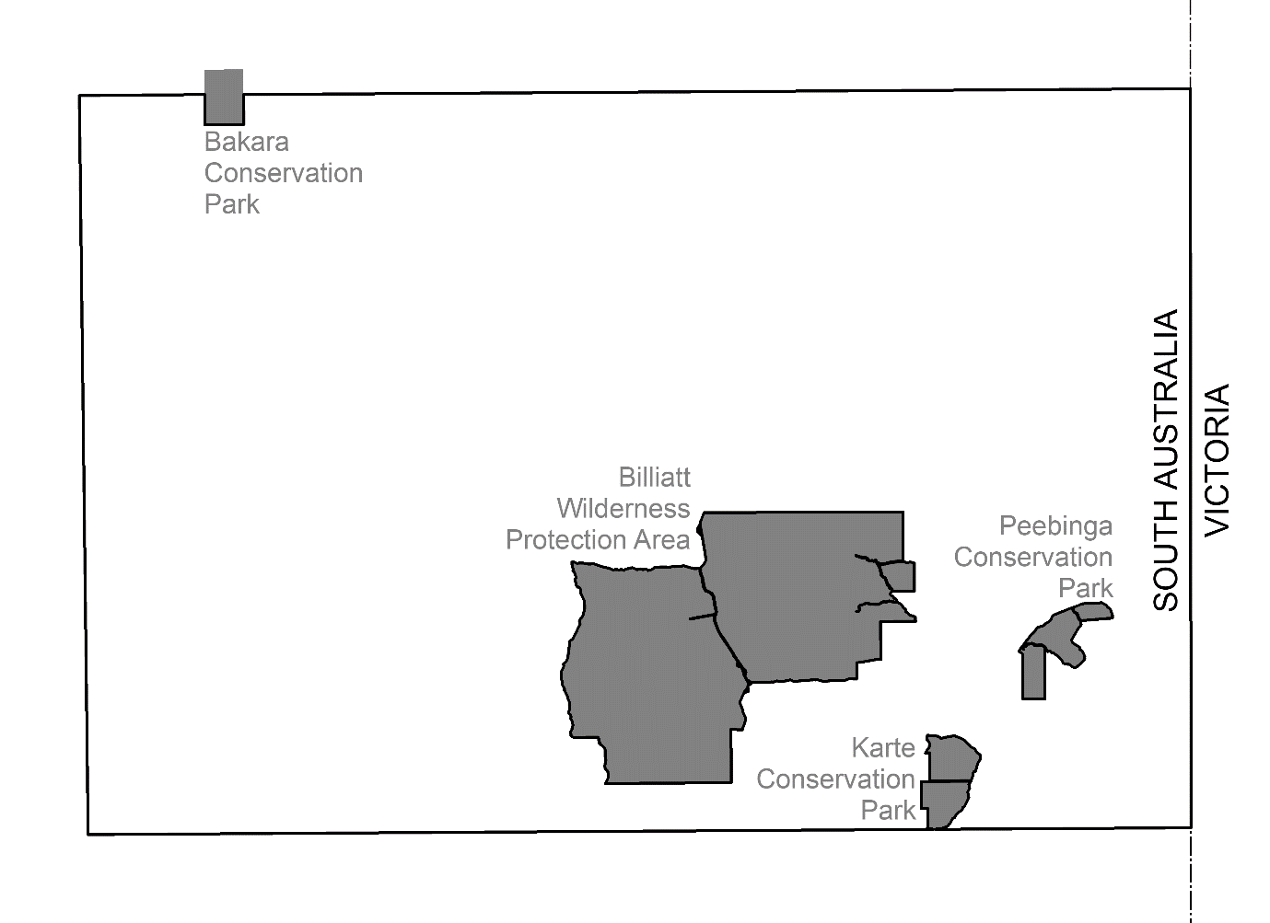
Map of Area
Dated: 27 August 2020
J. Martin
Mining Registrar as Delegate for the Minister for Energy and Mining
Department for Energy and Mining

MINING ACT 1971
Notice pursuant to Sections 15(5) and 15(7) of the Mining Act 1971
Pursuant to Section 15(5) of the Mining Act 1971 (the Act), I advise that the Mineral Resources Division of the Department for Energy and Mining, will be undertaking geoscientific investigations commencing from the 1 September 2020 and concluding on the 30 June 2023.
The area of interest is approximately 10,074 km² and is located predominantly over the Olary, Chowilla and Renmark map sheets.
Pursuant to Section 15(7) of the Act, the Minister may refuse to receive or consider an application for a mining tenement in respect of the land described in the notice until the completion date of 30 June 2023.
Please note that the completion date may be extended and/or the area may be altered by further notice in the gazette. A copy of the plan can be obtained by telephoning Mineral Tenements on (08) 8463 3103.
Description of Area
QUONDONG VALE AREA, bounded as follows:
Commencing at a point being the intersection of latitude 32°28′S and longitude 140°46′E, then east to longitude 140°51′E, south to latitude 32°29′S, east to longitude 140°52′E, south to latitude 32°30′S, east to longitude 140°53′E, south to latitude 32°31′S, west to longitude 140°51′E, south to latitude 32°32′S, west to longitude 140°50′E, south to latitude 32°33′S, west to longitude 140°49′E, south to latitude 32°34′S, west to longitude 140°48′E, south to latitude 32°35′S, east to longitude 140°51′E, north to latitude 32°34′S, east to longitude 140°53′E, north to latitude 32°33′S, east to longitude 140°55′E, north to latitude 32°32′S, east to longitude 140°56′E, north to latitude 32°31′S, east to longitude 140°57′E, north to latitude 32°30′S, east to the border of the State of South Australia, then south along said border to the boundary of Danggali Wilderness Protection Area, then beginning westerly along said boundary to the boundary of Calperum Station, then beginning westerly along said boundary to the boundary of Gluepot, then beginning southerly along said boundary to the boundary of Taylorville Station, then beginning southerly along said boundary to latitude 34°01′S, then west to longitude 139°36′E, north to latitude 33°14′S, east to longitude 139°37′E, north to latitude 33°12′S, east to longitude 139°38′E, south to latitude 33°15′S, east to longitude 139°41′E, north to latitude 33°14′S, east to longitude 139°42′E, north to latitude 33°12′S, west to longitude 139°39′E, north to latitude 33°10′S, east to longitude 139°52′E, north to latitude 33°05′S, west to longitude 139°51′E, north to latitude 33°04′S, west to longitude 139°50′E, north to latitude 33°00′S, east to longitude 139°52′E, north to latitude 32°59′S, east to longitude 139°58′E, south to latitude 33°00′S, east to longitude 140°12′E, north to latitude 32°57′S, east to longitude 140°13′E, north to latitude 32°56′S, east to longitude 140°14′E, north to latitude 32°55′S, east to longitude 140°15′E, north to latitude 32°54′S, east to longitude 140°18′E, north to latitude 32°53′S, east to longitude 140°19′E, north to latitude 32°52′S, east to longitude 140°20′E, north to latitude 32°51′S, east to longitude 140°22′E, north to latitude 32°50′S, west to longitude 140°14′E, north to latitude 32°49′S, west to longitude 140°12′E, south to latitude 32°50′S, west to longitude 140°07′E, north to latitude 32°49′S, east to longitude 140°09′E, north to latitude 32°48′S, east to longitude 140°12′E, north to latitude 32°46′S, east to longitude 140°17′E, north to latitude 32°45′S, east to longitude 140°25′E, south to latitude 32°46′S, east to longitude 140°31′E, north to latitude 32°44′S, east to longitude 140°32′E, north to latitude 32°32′S, east to longitude 140°33′E, south to latitude 32°35′S, east to longitude 140°39′E, north to latitude 32°34′S, east to longitude 140°45′E, north to latitude 32°30′S, east to longitude 140°46′E, and north to the point of commencement, but excluding White Dam Conservation Park.
Unless otherwise specified, all lines are geodesics and expressed in terms of the Australian Geodetic Datum as defined on p. 4984 of Commonwealth Gazette number 84 dated October 6, 1966 (AGD66).
AREA: 10,074 square kilometres approximately.

Map of Area
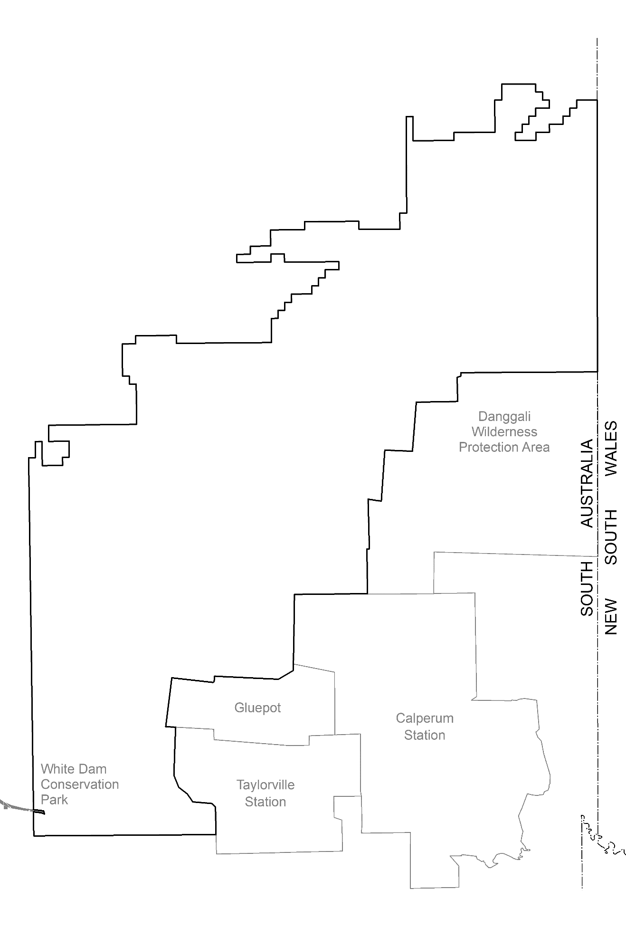
Dated: 27 August 2020
J. Martin
Mining Registrar as Delegate for the Minister for Energy and Mining
Department for Energy and Mining

Petroleum and Geothermal Energy Act 2000
Suspension of Petroleum Retention Licences—PRLs 28, 29, 31, 111, 112, 113, 114 and 115
Associated Activities Licences—AALs 195 and 280
Pursuant to Section 90 of the Petroleum and Geothermal Energy Act 2000, notice is hereby given that the abovementioned Licences have been suspended for the period 31 July 2020 to 30 July 2021 inclusive, pursuant to delegated powers dated 29 June 2018.
• PRL 28 and AAL 195 will now expire on 9 September 2023.
• PRL 29 will now expire on 10 October 2023.
• PRL 31 will now expire on 7 January 2024.
• PRLs 111, 112, 113, 114 and 115 will now expire on 18 June 2025.
• AAL 280 will now expire on 18 June 2025.
Dated: 19 August 2020
Barry A. Goldstein
Executive Director
Energy Resources Division
Department for Energy and Mining
Delegate of the Minister for Energy and Mining

Petroleum and Geothermal Energy Act 2000
Application for Grant of Associated Activities Licence—AAL 292
Pursuant to section 65(6) of the Petroleum and Geothermal Energy Act 2000 (the Act) and Delegation dated 29 June 2018, notice is hereby given that an application for the grant of an associated activities licence over the area described below has been received from:
Leigh Creek Operations Pty Ltd
The application will be determined on or after 25 September 2020.
Description of application area
All that part of the State of South Australia, being within Out of Hundreds (Copley), bounded as follows:
Commencing a point on the south-western boundary of Section 416, Out of Hundreds (Copley) to its intersection with a straight line, or prolongation of such, westerly between Longitude 138.385778 East, Latitude 30.474531 South and Longitude 138.389586 East, Latitude 30.473794 South; then in straight lines passing through the following coordinate points:
Longitude East | Latitude South
138.389586 | 30.473794
138.391747 | 30.473900
138.397772 | 30.474669
138.399247 | 30.474692
138.400092 | 30.474808
138.401200 | 30.475122
138.402442 | 30.475519
138.405161 | 30.476681
138.406639 | 30.477117
138.407703 | 30.477475
138.409156 | 30.477850
138.409778 | 30.478150
138.411897 | 30.478900
138.413317 | 30.479544
138.414358 | 30.479833
138.417283 | 30.482606
138.418658 | 30.484003
138.419358 | 30.485342
138.420722 | 30.488408
138.421261 | 30.488217
138.421986 | 30.487219
138.422742 | 30.485942
138.423317 | 30.485300
138.424342 | 30.485006
138.425011 | 30.485111
138.426411 | 30.485961
138.427978 | 30.486672
138.430108 | 30.484714
138.428653 | 30.481786
138.426442 | 30.479319
138.424867 | 30.477744
138.423383 | 30.476692
138.420017 | 30.474806
138.418364 | 30.471833
138.417553 | 30.469903
138.403858 | 30.469058
138.394714 | 30.468047
138.389542 | 30.467711
138.386181 | 30.467850
138.386181 | 30.467847
138.383114 | 30.468508
then westerly in a straight line, or prolongation of such, between Longitude 138.383114 East, Latitude 30.468508 South and Longitude 138.379764 East, Latitude 30.469419 South to its intersection with the south-western boundary of Section 416, Out of Hundreds (Copley); then south-easterly along the south-western boundary of said Section 416 to the point of commencement.
Excluded areas
Sections 486, Out of Hundreds (Copley)
Reference datum
Geographical coordinates are referenced to the Geocentric Datum of Australia 2020 (GDA2020), in decimal degrees.
AREA: 3.91 square kilometres approximately.
Dated: 25 August 2020
Barry A. Goldstein
Executive Director
Energy Resources Division
Department for Energy and Mining
Delegate of the Minister for Energy and Mining

Petroleum and Geothermal Energy Act 2000
Suspension of Petroleum Retention Licence—PRL 124
Pursuant to section 90 of the Petroleum and Geothermal Energy Act 2000, notice is hereby given that the abovementioned Licence has been suspended for the period from 24 July 2020 until 23 July 2021 inclusive, pursuant to delegated powers dated 29 June 2018.
• The expiry date of PRL 124 is now determined to be 26 May 2022.
Dated: 25 August 2020
Barry A. Goldstein
Executive Director
Energy Resources Division
Department for Energy and Mining
Delegate of the Minister for Energy and Mining

South Australian Civil and Administrative Tribunal
SACAT Reference Number: 2020/SA001990
Notice of Renewal of Exemption
Before Tribunal Member Ashley Files
I HEREBY certify that on the 20th August 2020, the South Australian Civil and Administrative Tribunal, on application of BAE SYSTEMS AUSTRALIA LIMITED, BAE SYSTEMS AUSTRALIA DEFENCE PTY LTD and ASC SHIPBUILDING PTY LIMITED, made the following orders for renewal of an exemption:
- Pursuant to section 92 of the Equal Opportunity Act 1984 (SA) (the Act), the Applicants are exempted from compliance with the provisions of sections 52, 54 and 103(1) of the Act to the extent that they may:
- request nationality and place of birth information from existing and potential employees and contractors;
- take a person’s nationality and place of birth into account in determining who should be offered employment or contract work in areas requiring access to ITAR controlled material and Export Administration Regulations (EAR) controlled material (together, USA export controlled materials) and when making decisions as to the participation of employees or contractors in such work;
- maintain records of the nationalities and places of birth of all employees and contractors who have or may have access to USA export controlled materials;
- ensure that USA export controlled materials are disclosed only to persons who are authorised by ITAR controls or EAR controls to receive it;
- impose limitations or prohibitions on persons of particular nationalities or places of birth having access to USA export controlled materials;
- disclose to the ADF the nationalities and places of birth of all employees and contractors who will have access to USA export controlled materials in the performance of their work;
- disclose to USA-based contractors for whom the Applicants perform work under subcontract and to the USA government, the nationalities and places of birth of all employees and contractors who will have access to USA export controlled materials in the performance of their work;
- establish security systems which will prevent the unauthorised re-export or re-transfer of USA export controlled materials.
- This order does not permit the Applicants to terminate any employee’s employment on the grounds of nationality or place of birth.
- The exemption is granted for a period of three years commencing from 26 August 2020, but will be subject to the following conditions:
- It will apply only to conduct by the Applicants where:
    - that conduct is necessary to enable it to enter into and/or perform contractual undertakings requiring access to USA export controlled materials; and
    - it has taken all steps that are reasonably available (including steps which might be taken in negotiating and performing the terms of its agreements with contractors in the USA) to avoid the necessity for engaging in conduct which would otherwise be in breach of sections 52, 54 and/or 103(1) of the Act.
- Where, in the exercise of this exemption, an employee or contract worker is moved from a project involving the use of USA export controlled materials to any other work controlled by the Applicants or any of their related entities, the Applicants must through a duly authorised officer explain to the person why he or she is being transferred and must otherwise take all reasonable steps to avoid or limit harm or loss to that person.
- Where the Applicants use systems of security passes to reflect the fact of access to USA export controlled materials or levels of access to any security sensitive material by employees and contract workers, the passes may be coded but not in such a way as to identify the nationality or place of birth of the person or the reasons for that person’s level of access.
- All information relating to security passes, security clearance levels and access to USA export controlled materials shall be restricted to the Applicants’ Chief Counsel, its Head of Export Controls and Security and to their properly appointed nominees on a “need to know” basis.
- The Applicants’ employment policies shall refer to the terms of this exemption, including all conditions attaching to it, and to make it clear that the request for information regarding nationality and place of birth is made solely for the purposes of compliance with the laws of the USA.
- The Applicants will report to the Commissioner for Equal Opportunity on an annual basis on the following matters:
- the training and education provided to new and existing employees on these Orders and their implementation;
- the steps taken by the Applicants to implement these Orders;
- how the Applicants monitor compliance with these Orders;
- the number of persons affected by these Orders and the nature of those effects;
- the steps taken by the Applicants to address any adverse effects on existing employees as a result of these Orders; and
- the steps taken by the Applicants to minimise the impact of these Orders on current and future employees.
- In these Orders, the Applicants means each of:
- BAE Systems Australia Limited;
- BAE Systems Australia Defence Pty Ltd; and
- ASC Shipbuilding Pty Limited.
- The above exemption is to remain in force for a period of 3 years commencing on 26th August 2020.
Dated: 21 August 2020
Anne Lindsay
Principal Registrar
South Australian Civil and Administrative Tribunal

Local Government Instruments

City of Adelaide
Adoption of Valuations and Declaration of Rates
NOTICE is hereby given that the Council of the Corporation of the City of Adelaide at its meeting held on 13 August 2020 and for the year ending 30 June 2020:
1. Adopted for rating purposes the valuations prepared by Valuers employed by the City of Adelaide of annual values applicable to land within the Council area totalling $1,155,134,560 of which $902,589,700 is for rateable land.
2. Declared differential general rates based upon the use of land as follows:
2.1 0.1149 rate in the dollar for all rateable land with a residential land use; and
2.2 0.1408 rate in the dollar for all other rateable land in the Council area.
3. Declared a separate rate of 0.00209 rate in the dollar (the Regional Landscape Levy (formerly the NRM Levy)) on all rateable land in the Council area to recover the amount of $1,789,125 payable to the Green Adelaide Board (formerly the Adelaide and Mount Lofty Ranges Natural Resource Management Board).
4. Declared a separate rate of 0.03582 rate in the dollar (the Rundle Mall Differential Separate Rate) on all rateable land except that with a residential land use within the ‘Rundle Mall Precinct’ (as defined) to fund marketing and management of the precinct, including actions and initiatives to promote Rundle Mall as a destination for shopping and to enhance the vibrancy of the precinct.
Dated: 27August 2020
M. Goldstone
Chief Executive Officer

City of Adelaide
Notice of Resolution to Reconfigure Field Street to a One-Way Street
NOTICE is hereby given, that the council of the Corporation of the City of Adelaide, at its meeting held on 14 July 2020, passed, inter alia, the following resolution:
Approves that, pursuant to Section 32 of the Road Traffic Act 1961, the closure of Field Street to northbound motor vehicle traffic between Wright Street and Gouger Street as set out in Attachment A to Item 10.2 on the Agenda for the meeting of the Council held on 14 July 2020, to all motor vehicles other than City of Adelaide authorised vehicles, emergency service vehicles and bicycles to be implemented as part of the proposed upgrade works for Field Street.
Dated: 27August 2020
M. Goldstone
Chief Executive Officer

CITY OF CHARLES STURT
Adoption of Valuations and Declaration of Rates
NOTICE is hereby given that at its meeting held on 10 August 2020, the Council for the financial year ending 30 June 2021:
1. Adopted the most recent valuations of the Valuer-General available to the Council of the Capital Value of land within the Council’s area, totalling $33,538,692,760 (of which $32,040,699,486 is for rating purposes).
2. Declared differential general rates as follows:
(a) 0.257272454 cents in the dollar on rateable land of Category 1;
(b) 0.8278720620 cents in the dollar on rateable land of Categories 2, 3 and 4;
(c) 1.1125520240 cents in the dollar on rateable land of Categories 5 and 6;
(d) 0.6273817034 cents in the dollar on rateable land of Category 7;
(e) 0.924203242 cents in the dollar on rateable land of Category 8;
(f) 0.4072823630 cents in the dollar on rateable land of Category 9.
3. Declared a minimum amount payable by way of general rates of $1,095.
4. Declared a separate rate of 0.0096560 cents in the dollar on all rateable land in the Council area in respect of the Regional Landscape Levy.
Dated: 27 August 2020
P. Sutton
Chief Executive Officer

City of Mitcham
Adoption of Valuations and Declaration of Rates
NOTICE is hereby given that at a meeting of the Council held on 18th August 2020, the Council resolved for the financial year commencing 1st July 2020 as follows:
Adoption of Assessment
To adopt the capital valuations made by the Valuer-General for the Council area, being $19,306,178,700 in relation to the whole area of the Council (of which $18,132,178,837 represents rateable land).
Declaration of Differential General Rates
To declare differential general rates, as follows:
(a) 0.287891 cents in the dollar on the capital value of rateable land of Residential, Primary Production and Other land;
(b) 0.591267 cents in the dollar on the capital value of rateable land of Commercial-Shop, Commercial –Office, Commercial – Other, Industrial-Light, Industrial-Other and Vacant land uses; and
(c) To fix a minimum amount payable by way of the general rates of $1,097.00.
Declaration of Landscape Levy
To declare a separate rate of 0.009630 cents in the dollar on the capital value of rateable land in the Council area within the Green Adelaide Board area.
Dated: 18 August 2020
M Pears
Chief Executive Officer

City of Port Lincoln
Adoption of Valuations and Declaration of Rates 2020-2021
Notice is hereby given that at its meeting on 17 August 2020, the City of Port Lincoln Council resolved for the year ending 30 June 2021 as follows:
• to adopt (effective from 1 July 2020) the valuations made by the Valuer-General of Site Values of all land within the area of the Council valued at $1,119,457,600 that are to apply for rating purposes;
• to declare:
(i) a General Rate of 0.7857 cents in the dollar; and
(ii) a Fixed Charge of $455.00 in respect of all rateable land;
• to declare a Waste Annual Service Charge of $265.80 based on the nature of the service;
• to declare a Recycling Annual Service Charge of $53.80 based on the nature of the service (excludes vacant land and marina berths);
• to declare a separate rate based on a fixed charge, which will be determined by land use as follows:
• $78.70 fixed charge for Residential, Other and Vacant Land;
• $118.05 fixed charge for Commercial and Industrial Land;
• $157.40 fixed charge for Primary Producers;
on all rateable land within the Council area and the area of the Eyre Peninsula Landscape Board in order to reimburse the Council the amount contributed to the Eyre Peninsula Landscape Board.
Dated: 27 August 2020
R. Donaldson
Acting Chief Executive Officer

CITY OF UNLEY
Roads (Opening and Closing) Act 1991
Road Closing—Roberts Street, Unley
NOTICE is hereby given, pursuant to section 10 of the Roads (Opening and Closing) Act 1991, that the City of Unley proposes to make a Road Process Order to close and sell to the adjoining owner a portion of Roberts Street road adjoining allotment 33 in F12738 more particularly delineated and lettered ‘A’ on Preliminary Plan 20/0033.
The Preliminary Plan and Statement of Persons Affected is available for public inspection at the offices of the City of Unley at 181 Unley Road Unley, and the Adelaide Office of the Surveyor-General during normal office hours. The Preliminary Plan can also be viewed at www.sa.gov.au/roadsactproposals.
Any application for easement or objection must set out the full name, address and details of the submission and must be fully supported by reasons. The application for easement or objection must be made in writing to the City of Unley at PO Box 1 Unley SA 5061, WITHIN 28 DAYS OF THIS NOTICE and a copy must be forwarded to the Surveyor-General at GPO Box 1354, Adelaide 5001.
Where a submission is made, the Council will give notification of a meeting at which the matter will be considered.
Enquiries relating to this proposal can be directed to Alana Faber, Property Services, on 8372 5403.
Dated: 27 August 2020
Peter Tsokas
Chief Executive Officer

Barunga West Council
Adoption of Valuations and Declarations of Rates 2020-2021
NOTICE is hereby given that the Barunga West Council, at a meeting held on 13 August 2020, resolved for the year ending 30 June 2021 as follows:
Adoption of Valuations
That pursuant to Section 167(2) of the Local Government Act 1999, to adopt for rating purposes the Capital Valuations of the Valuer-General, dated 5 July 2020, that are to apply for the area of rating purposes for the 2020/21 financial year, being Capital Valuations totalling $1,444,806,320 comprising $1,419,590,608 for rateable land and $25,215,712 for non-rateable land.
Declaration of Differential General Rates
To declare general rates based upon the capital value:
• On rateable land with a category of Residential, Commercial—Shop and Commercial–Office, a rate of 0.3468 cents in the dollar;
• On rateable land with a category of Commercial—Other, Industrial—Light and Industrial-Other a rate of 0.3815 cents in the dollar;
• On rateable land with a category of Primary Production a rate of 0.2428 cents in the dollar;
• On rateable land with a category of Vacant a rate of 0.4162 cents in the dollar;

Maximum Increase in General Rates
That pursuant to the provisions of Section 153(3) of the Local Government Act 1999, rebates shall be granted to ensure a 0% increase in rates from the previous years’ general rates raised (FY2019/20), except where the increase is the result of, changes in rebates or concessions, or change in land use, or sub-division or amalgamation of properties, or new building work or development activity, or changes to adjoining properties or Single Farm Enterprise arrangements.
Declaration of Fixed Charge
Pursuant to Sections 151 and 152 (1)(c) of the Local Government Act 1999, a fixed charge of $350 be imposed on each separate piece of rateable land within the Council area.
Adoption of Community Wastewater Management Scheme Annual Service Charges
That pursuant to Section 155 of the Local Government Act 1999, Council adopted a service charge on each assessment of rateable and
non-rateable land within the Council area to which land Council makes available a Community Wastewater Management System:
• In respect of each effluent unit applying to occupied allotments a charge of $450 per unit;
• In respect of each vacant allotment, a charge of $220 per unit.
Declaration of Separate Rates—Regional Landscape Levy Valuations
That pursuant to the new Landscape South Australia Act 2019 formerly the Natural Resources Management Act 2004 and Section 154 of the Local Government Act 1999, the Council declares, in respect of the year ending 30 June 2021 a separate rate of 0.01600 cents in the dollar on all rateable land in the Council’s area, to raise an amount of $226,839 payable to the Northern and Yorke Natural Resources Management Board.
Payment of Rates
That all rates imposed in respect of the year ending 30 June 2021 will fall due in four equal or approximately equal instalments and will fall due as follows:
• 30 September 2020;
• 15 December 2020;
• 15 March 2021; and
• 15 June 2021.
Dated: 27 August 2020
Maree Wauchope
Chief Executive Officer

Berri Barmera Council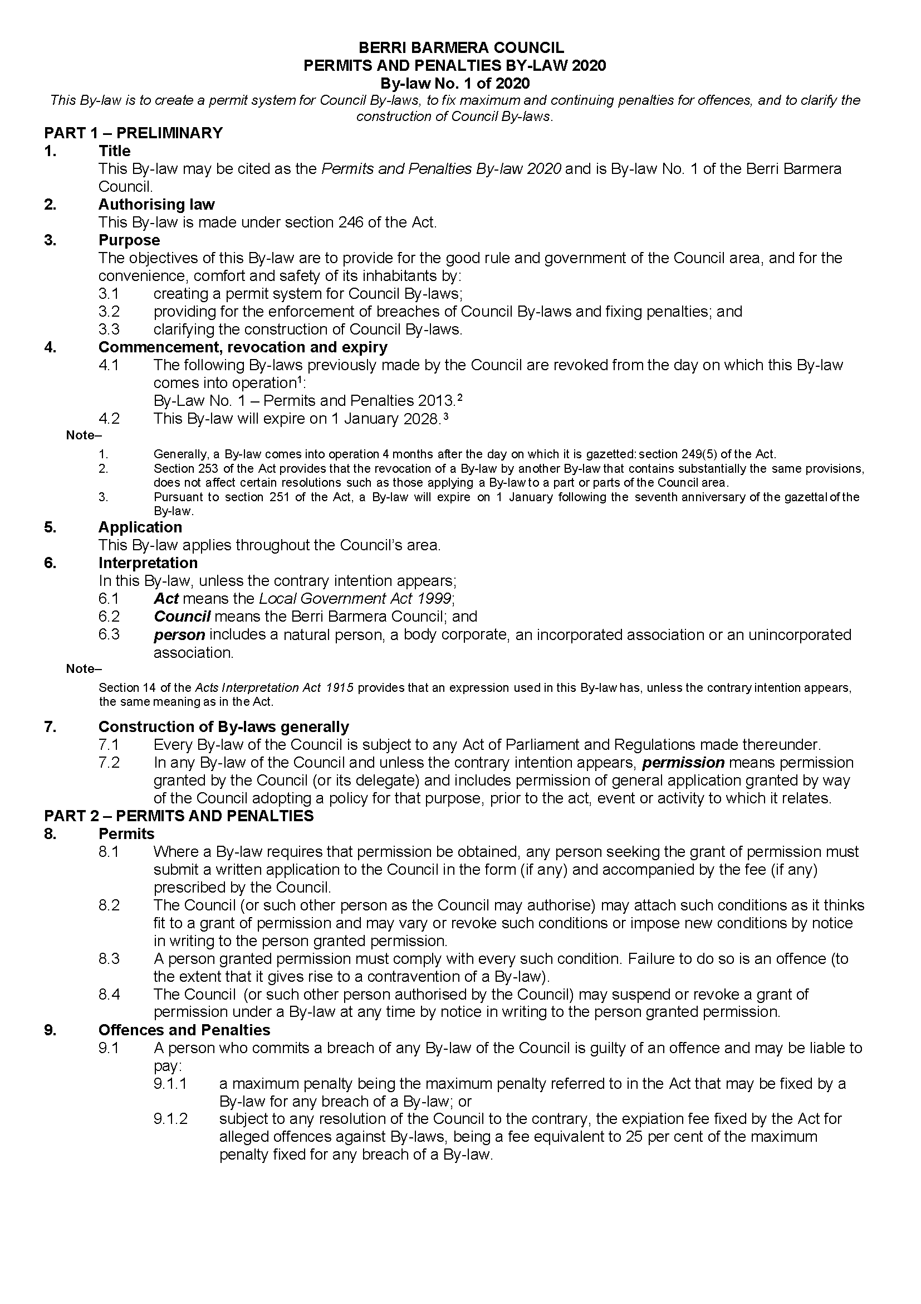

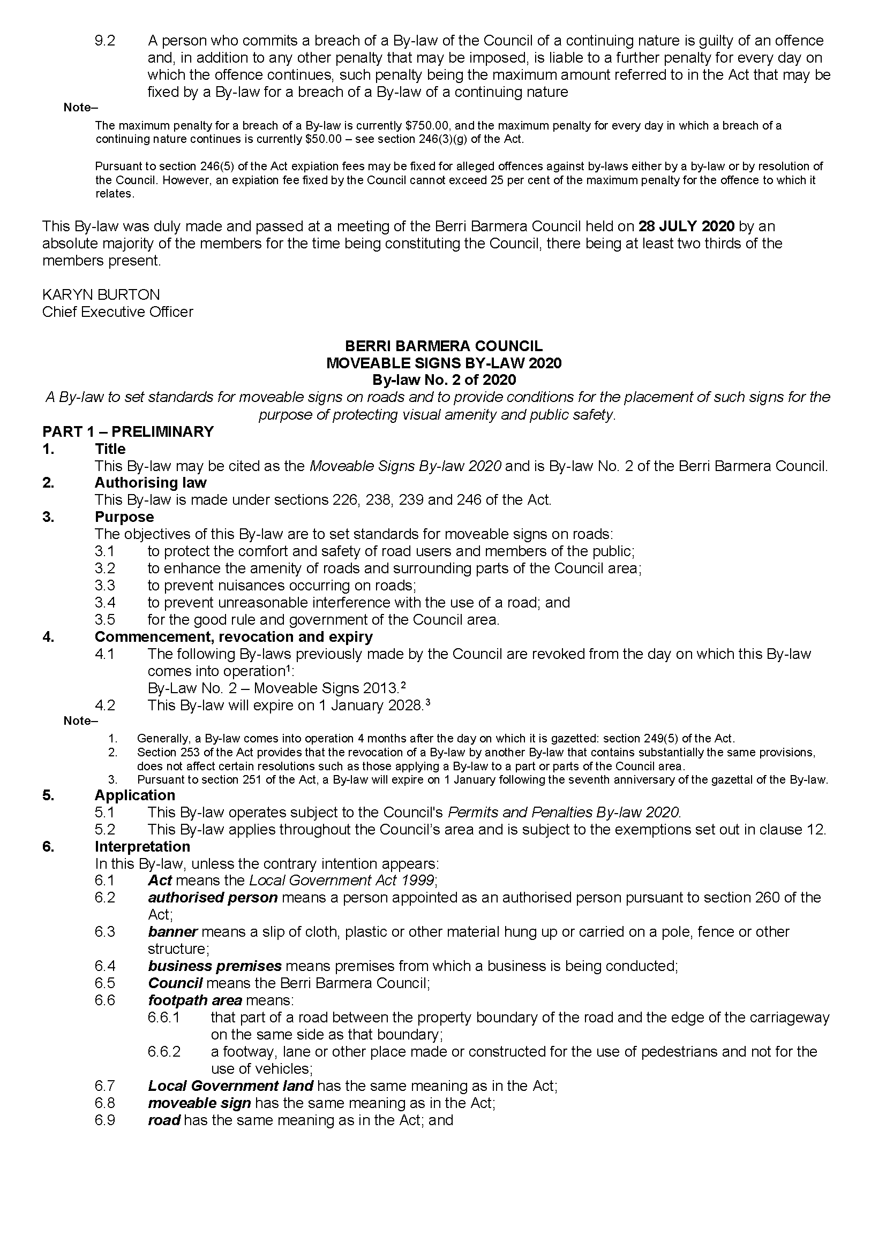

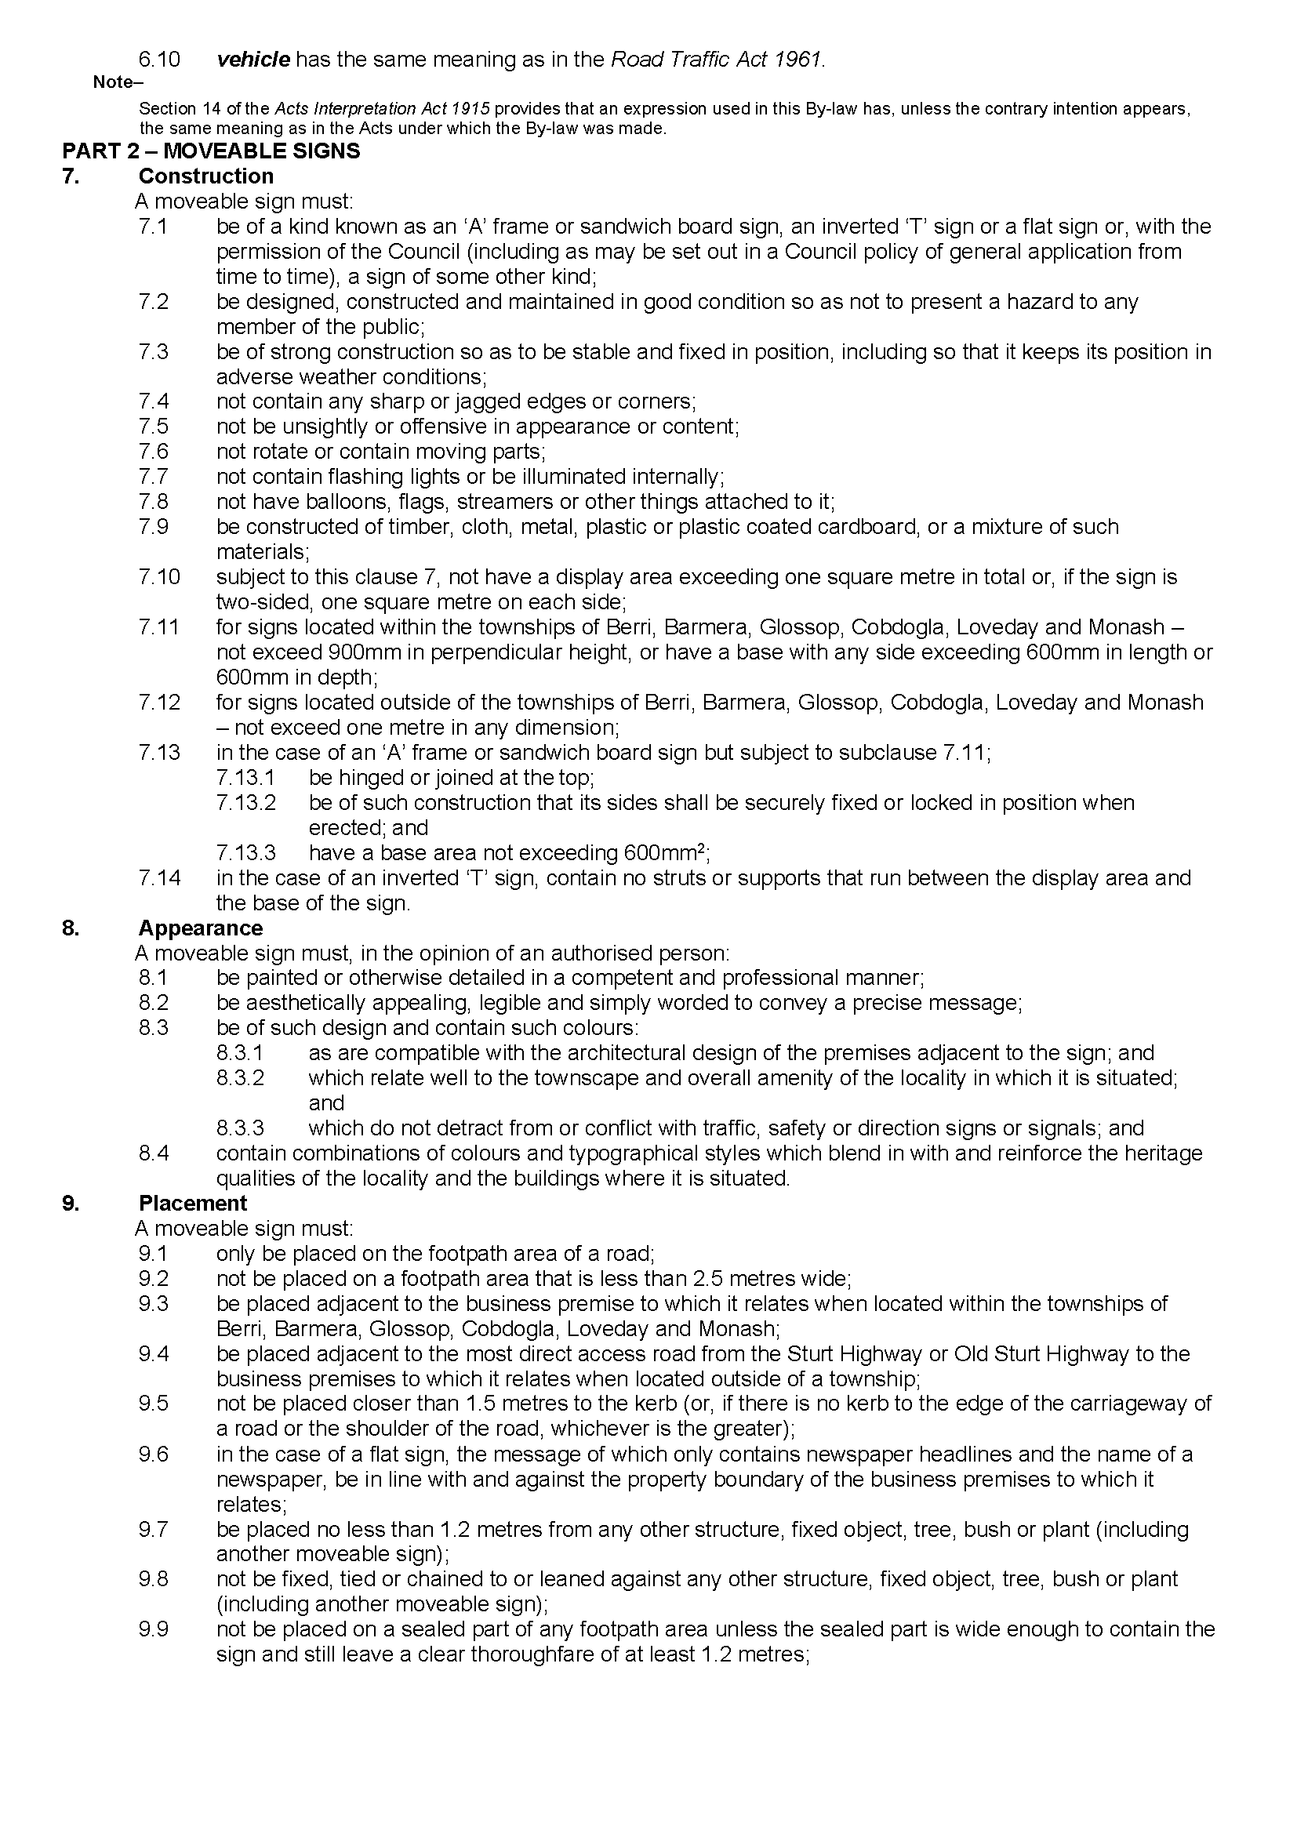

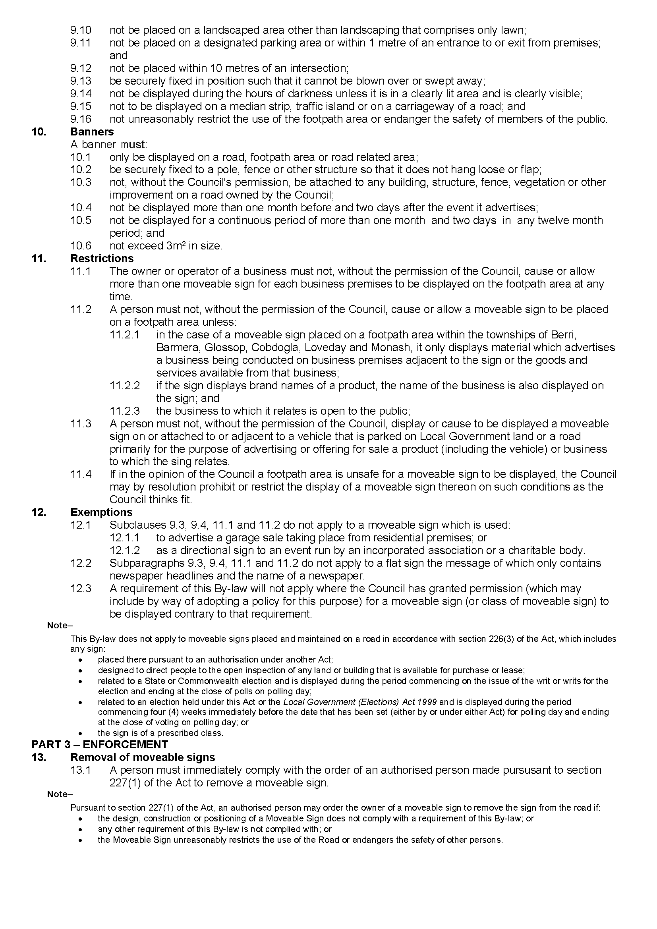

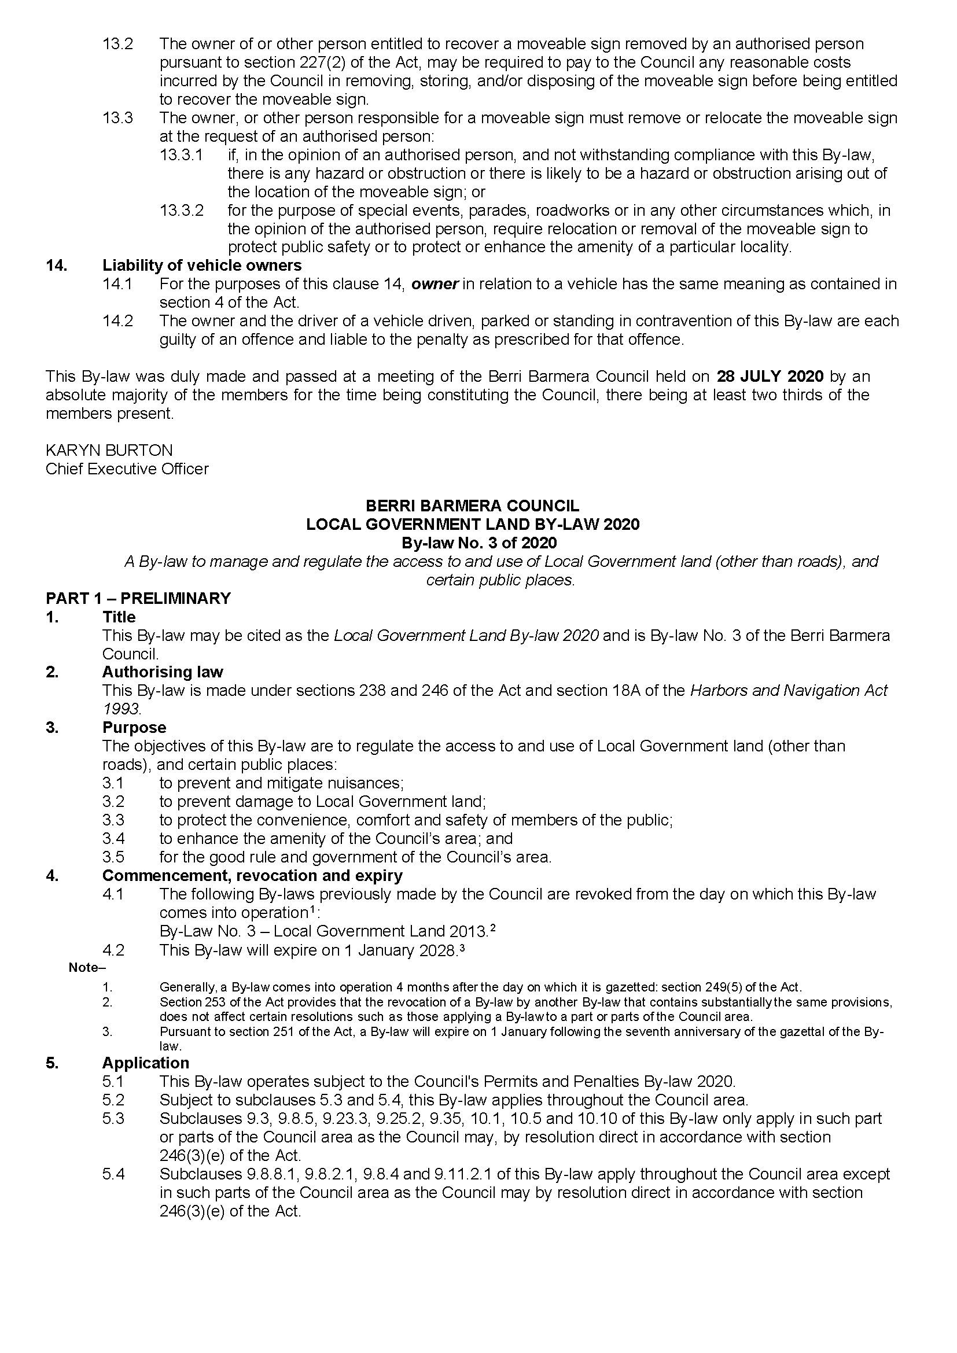

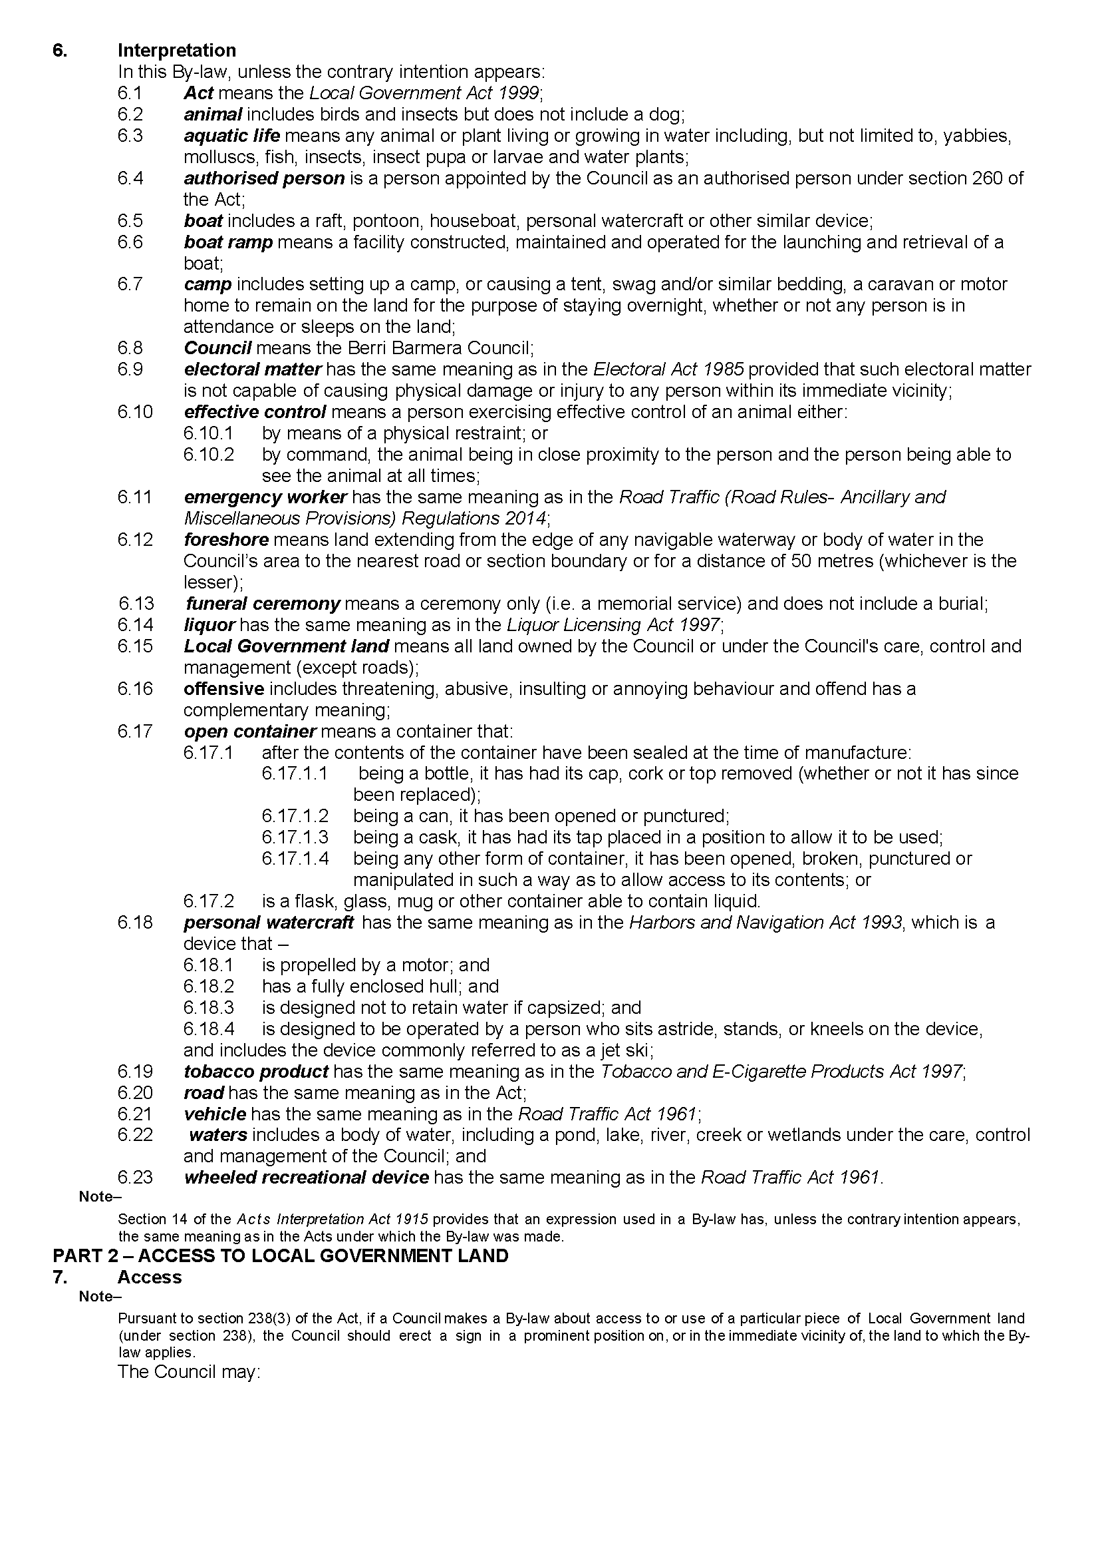

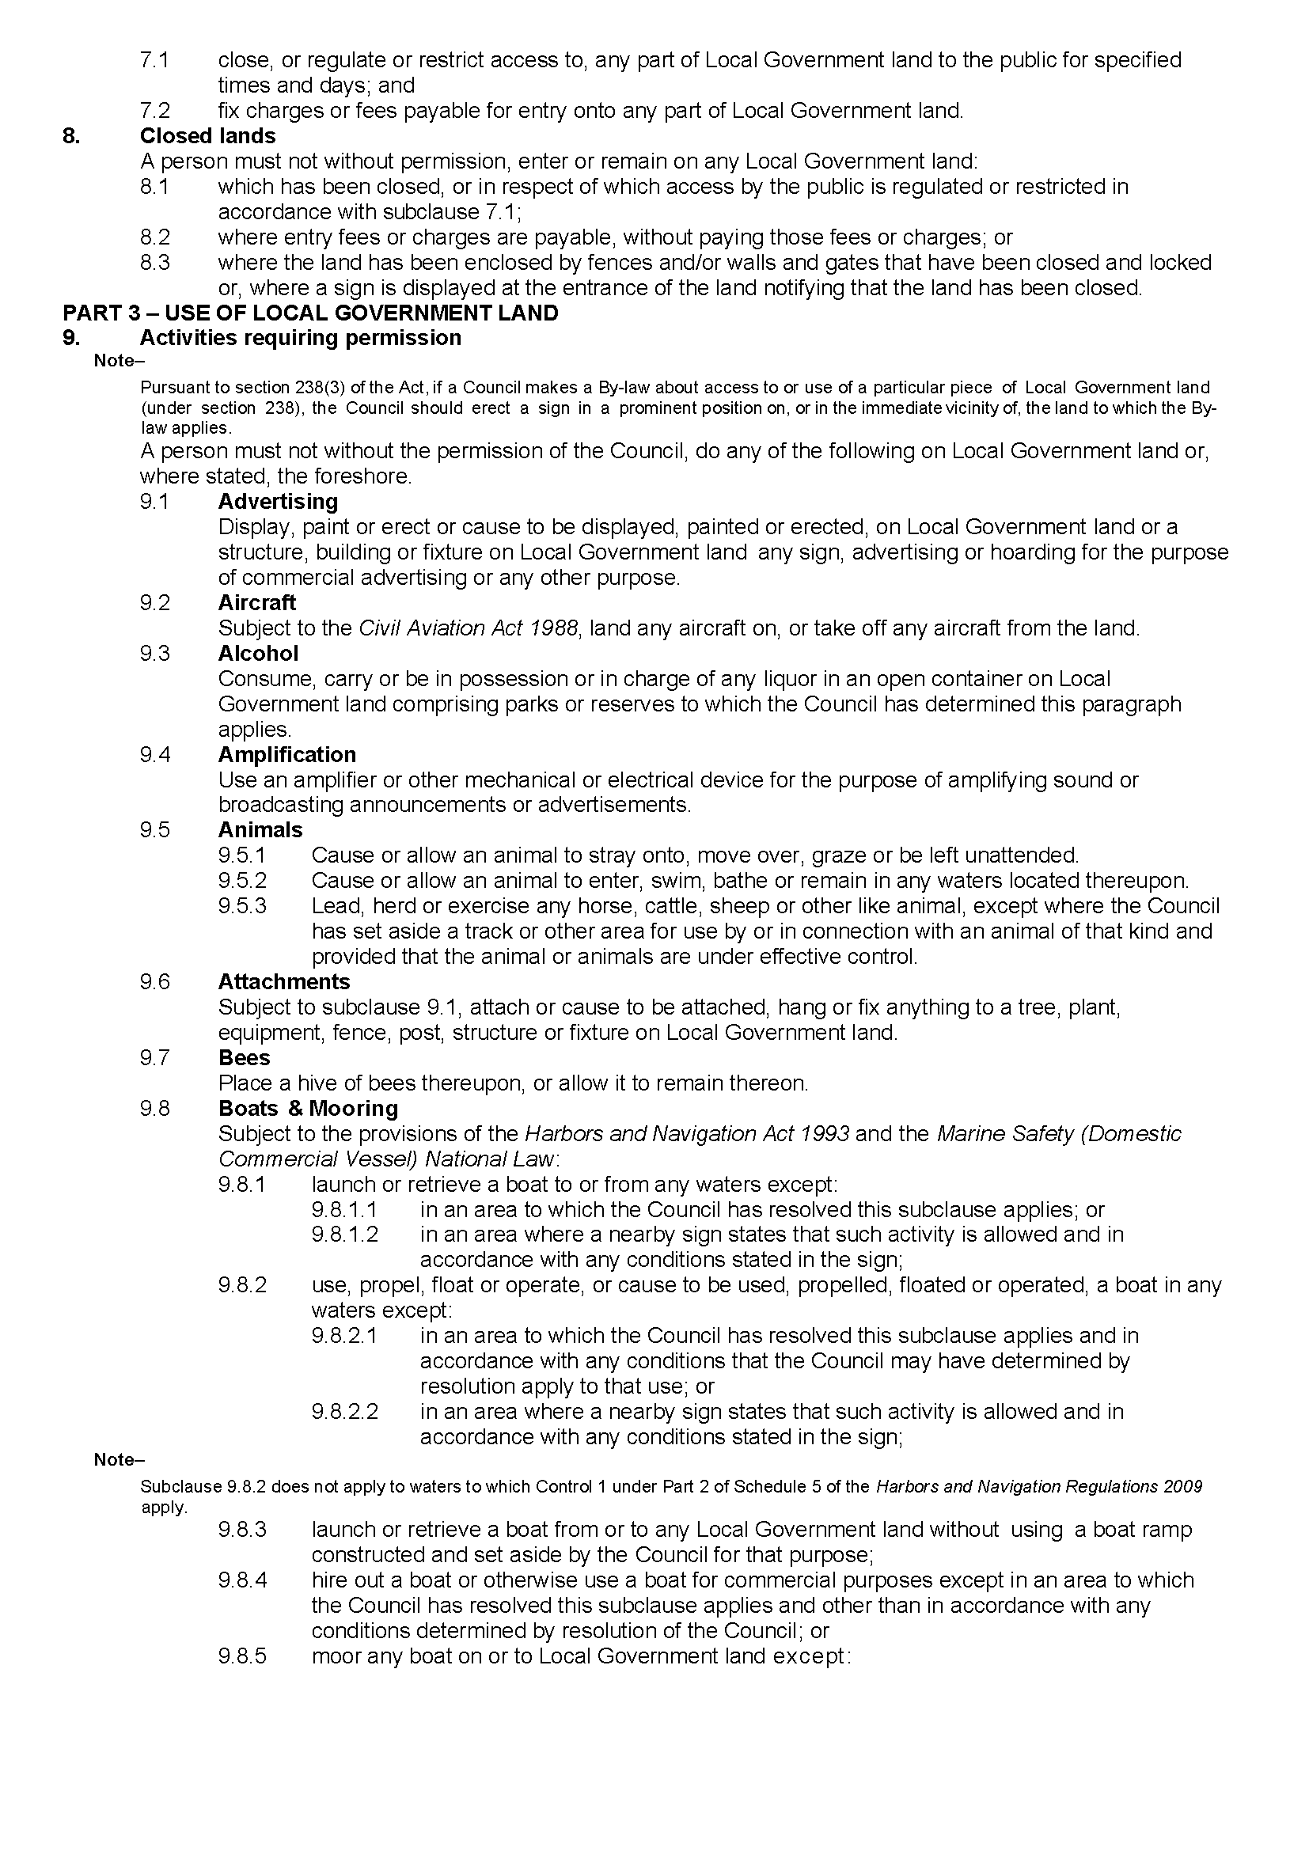

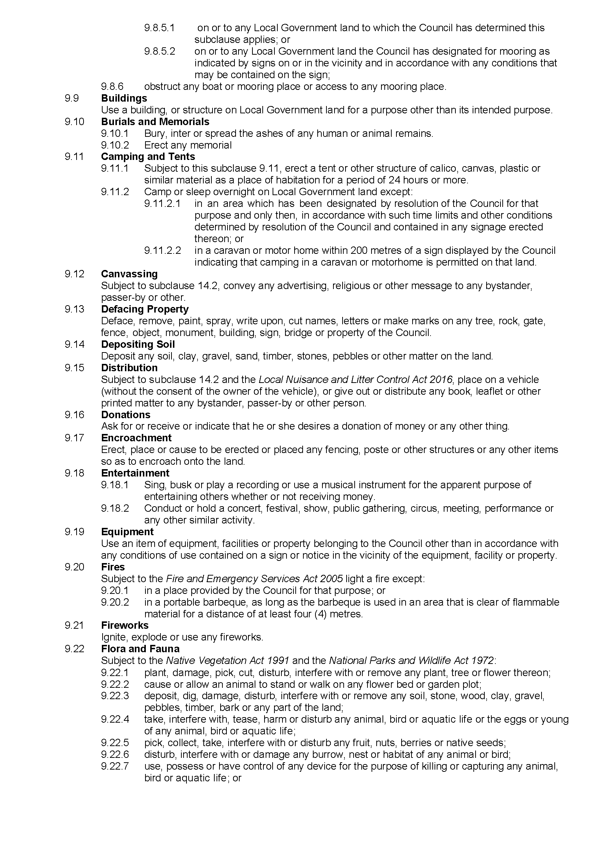

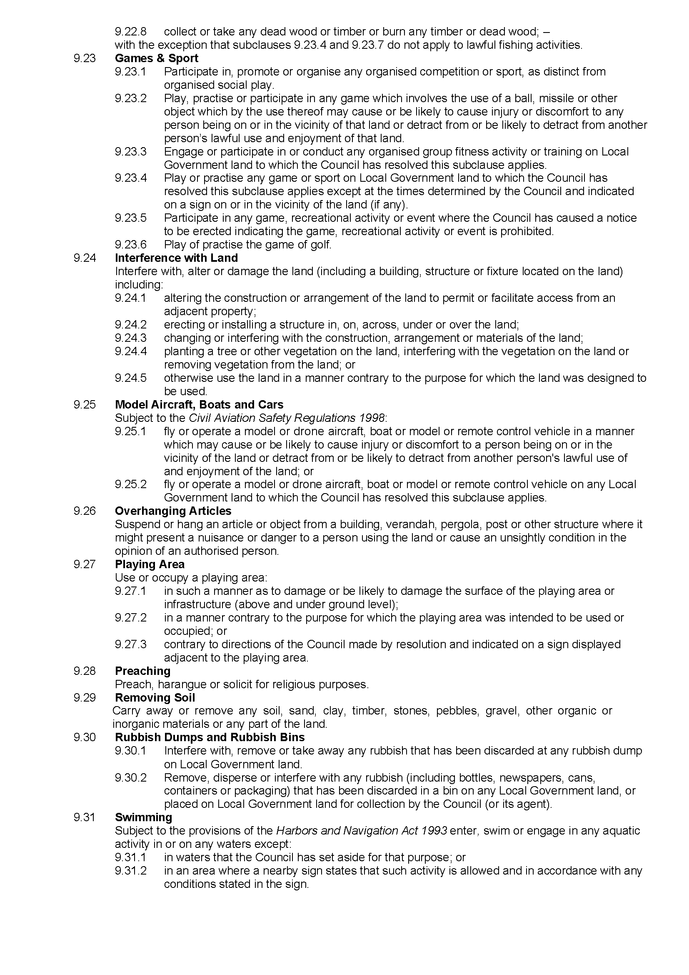

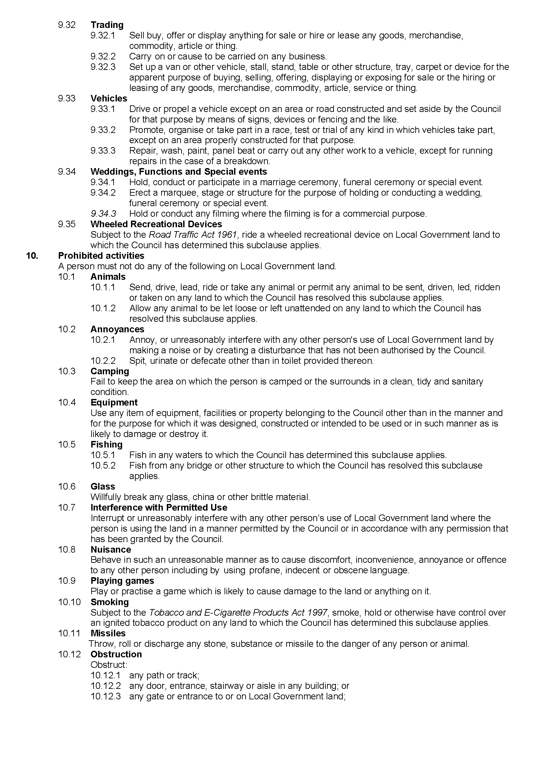

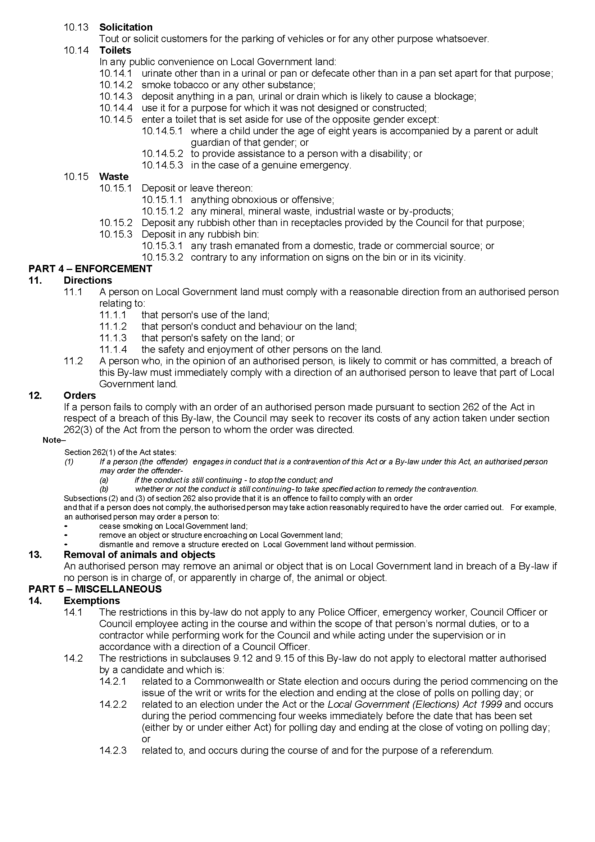

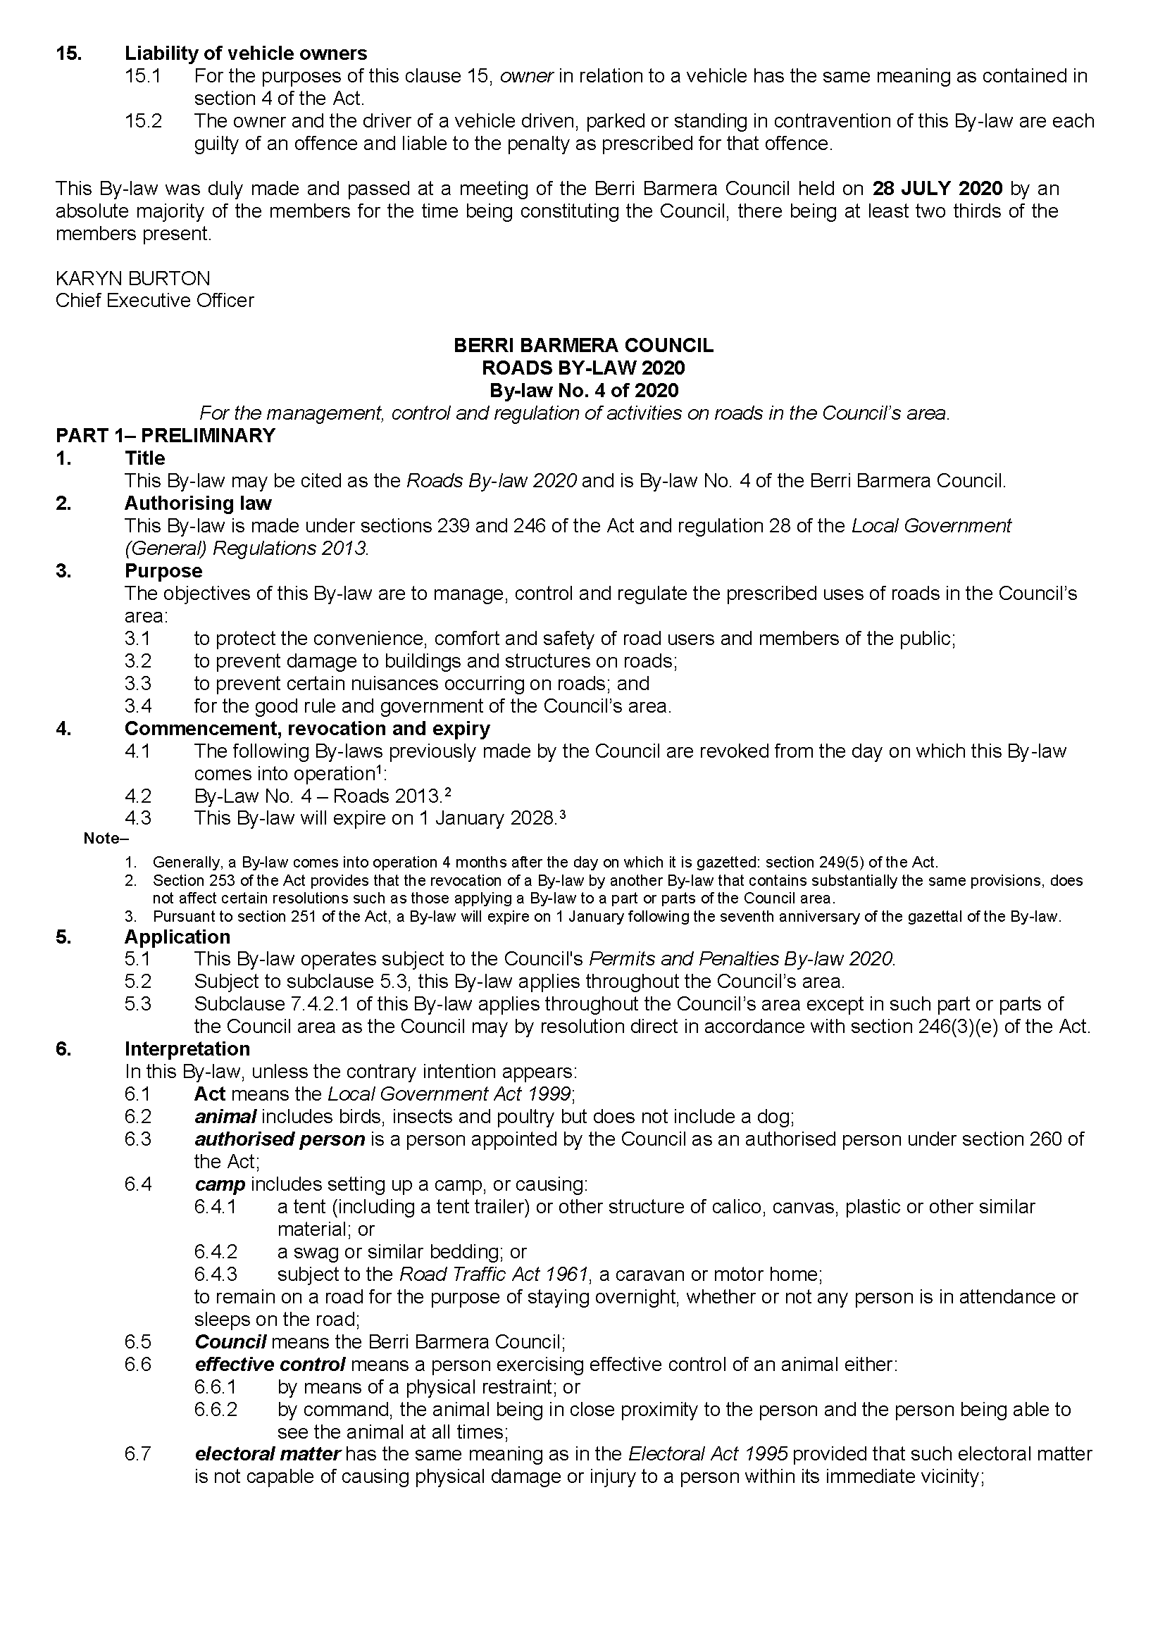

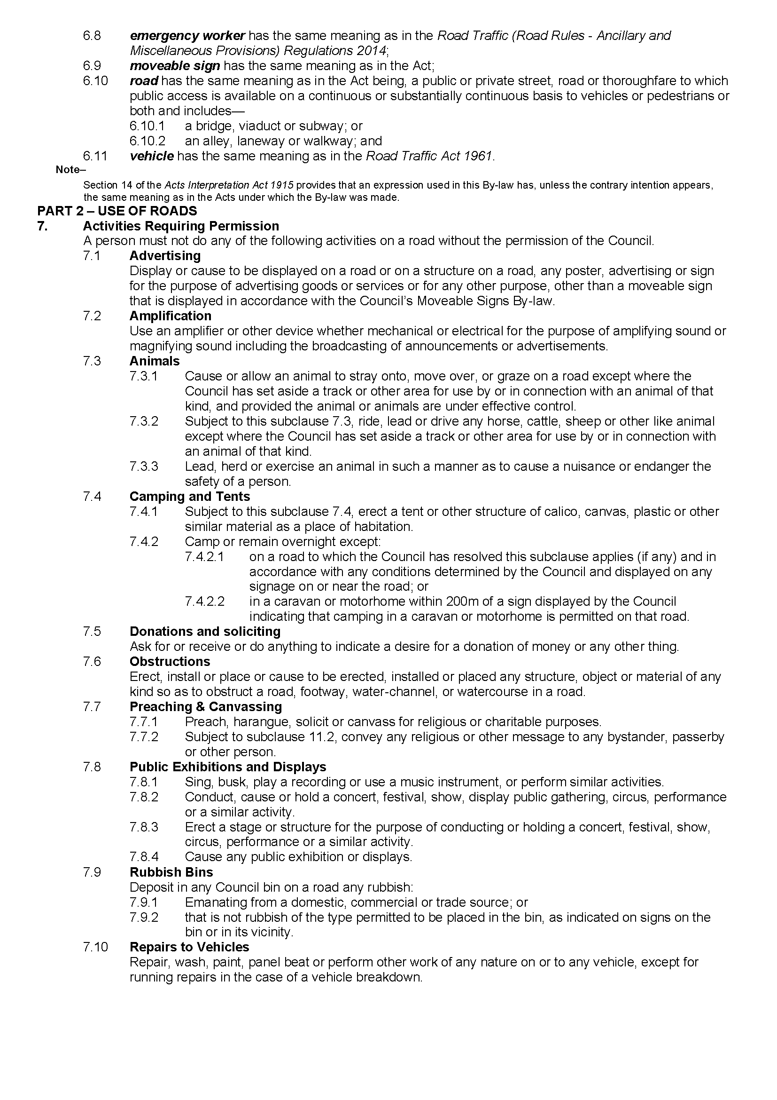

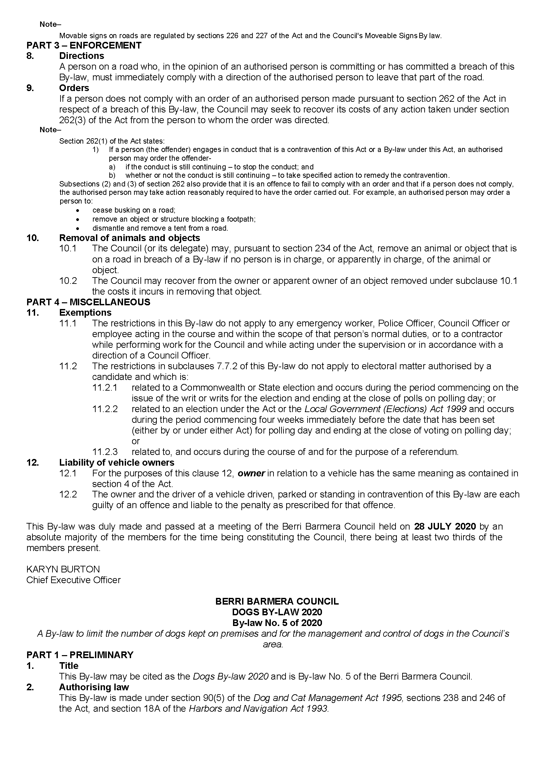

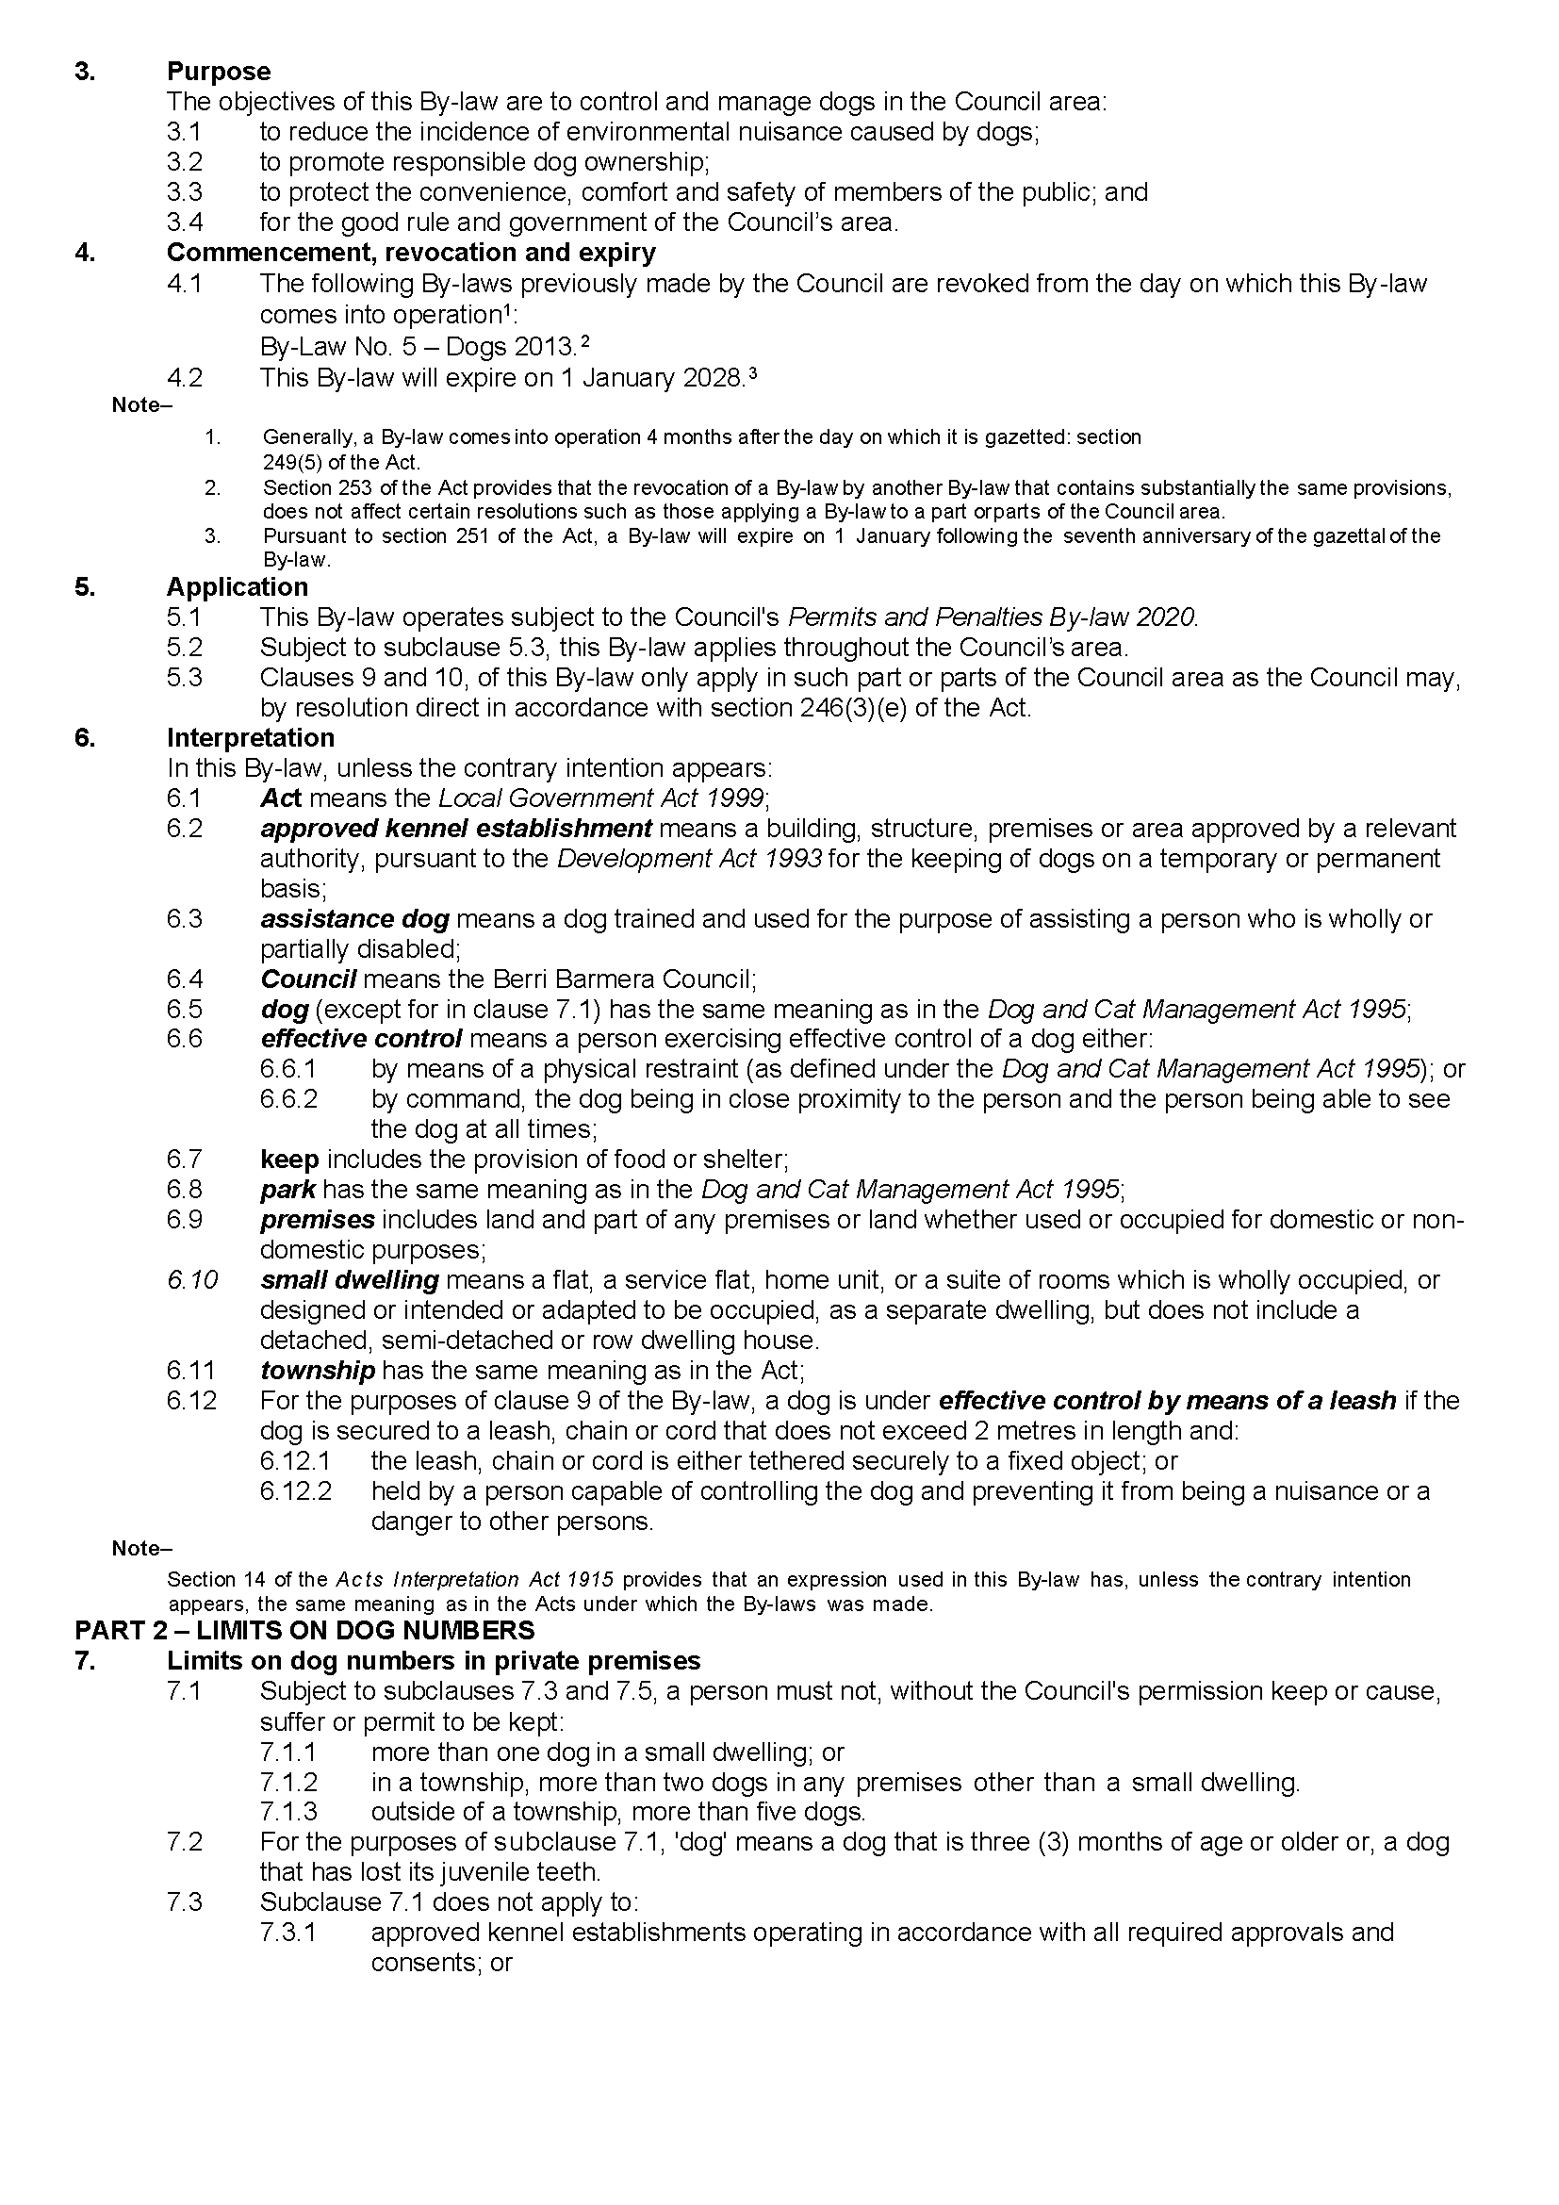

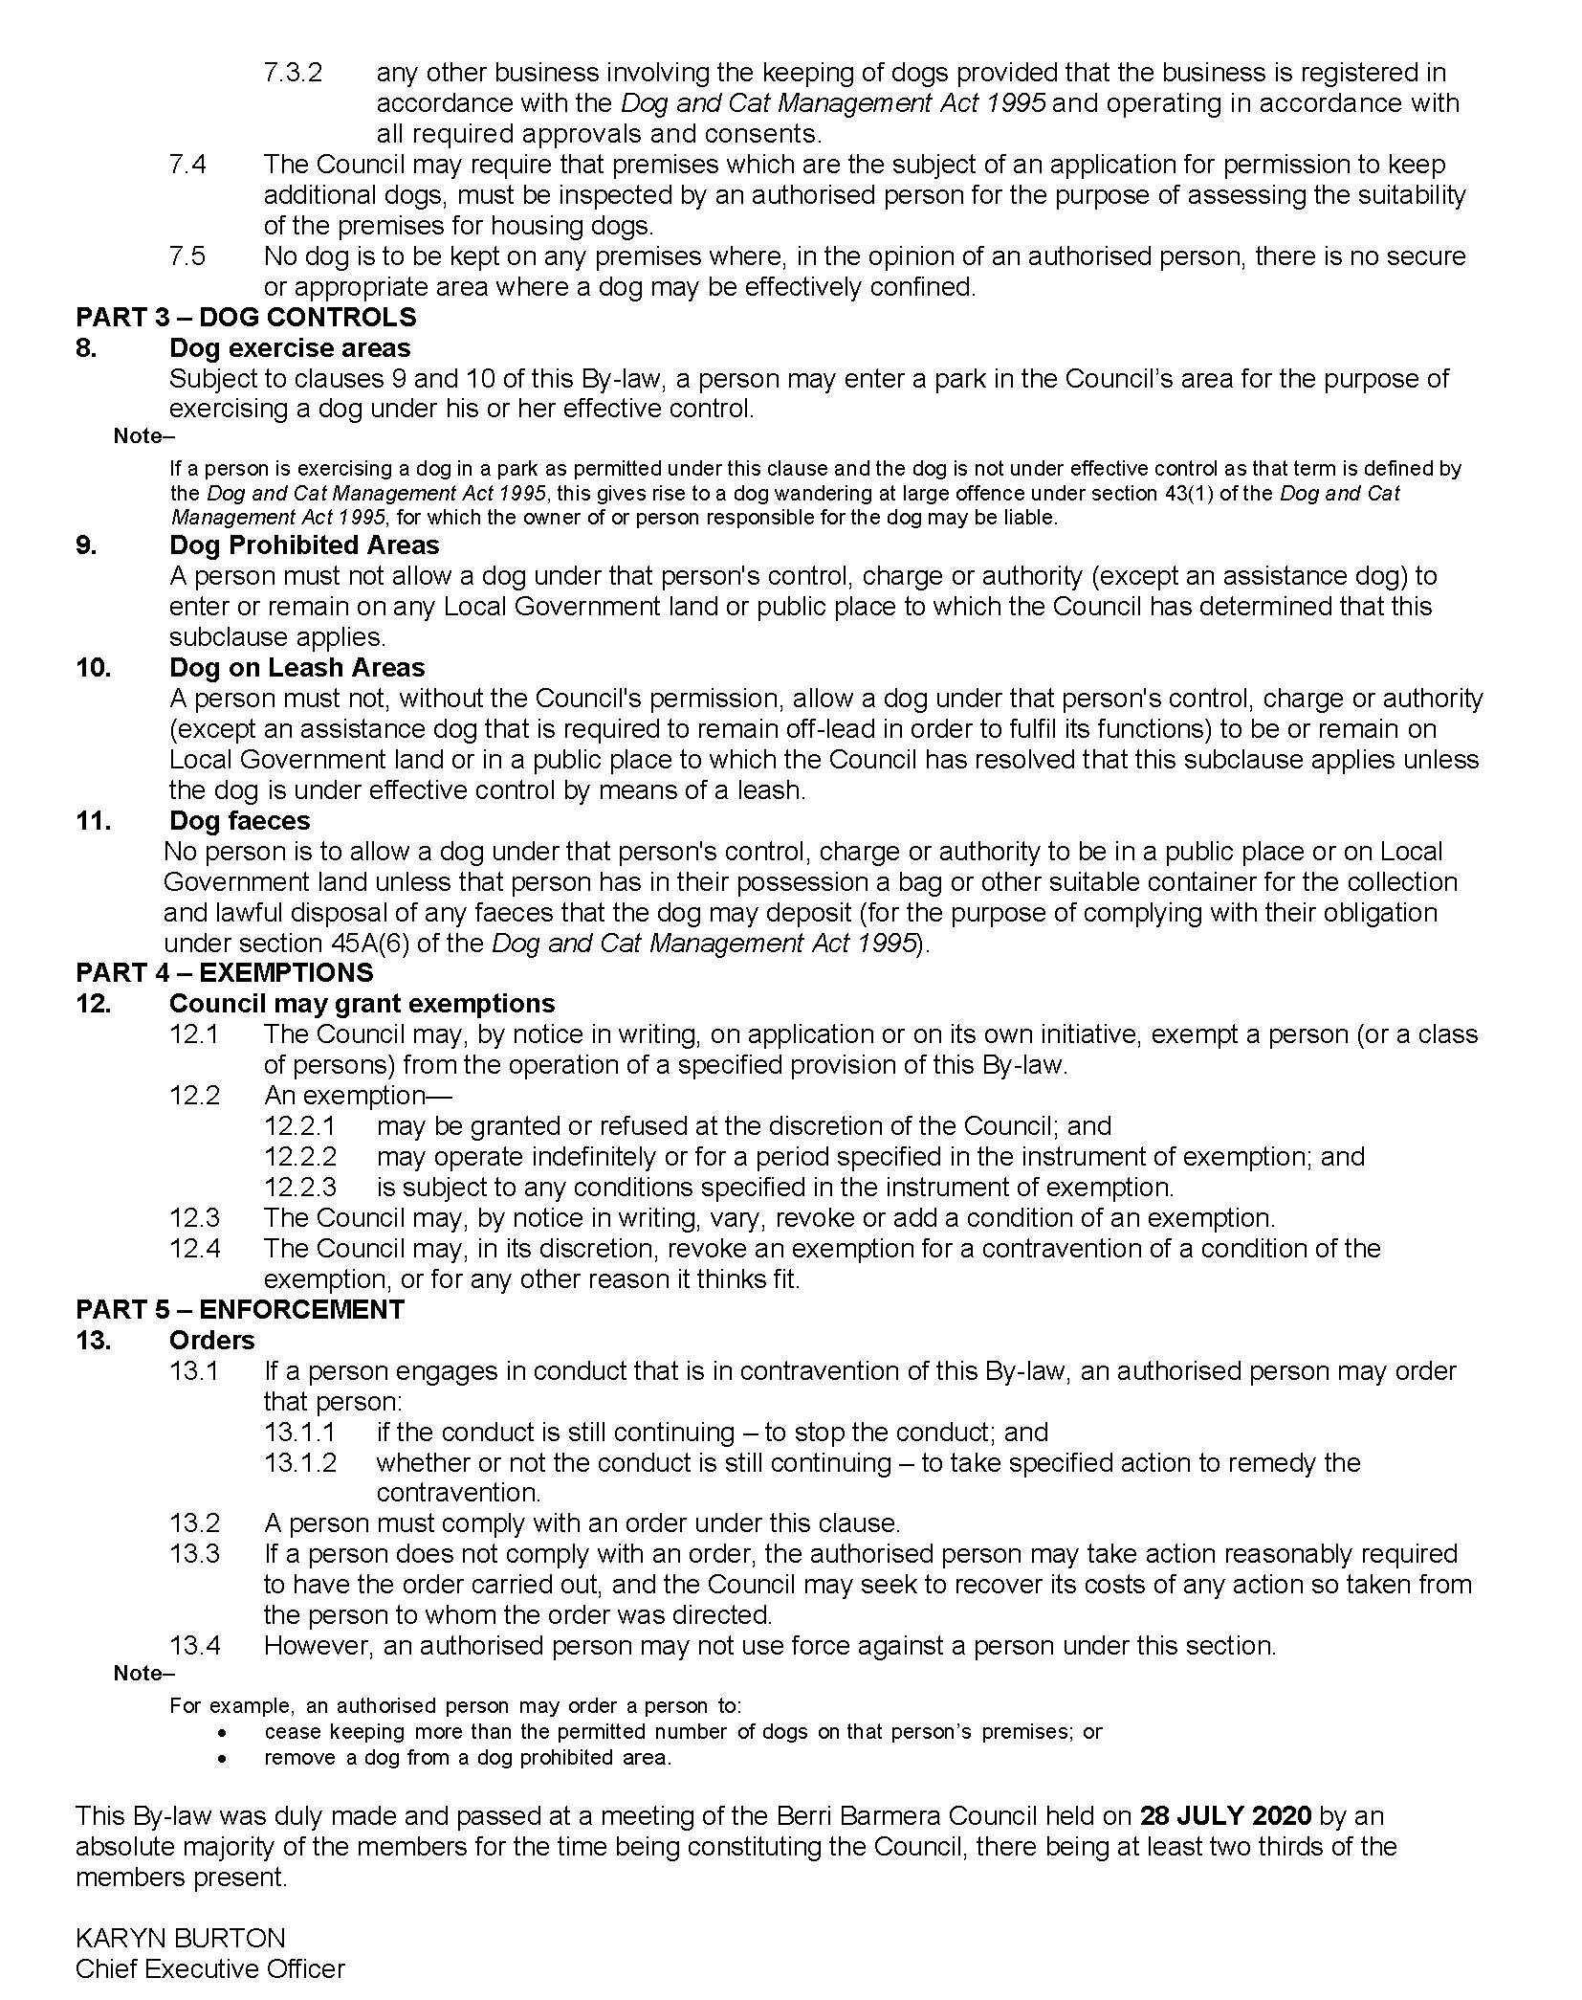

District Council of Grant
Supplementary Election of Councillor for Central Ward
Call for Nominations
Nominations to be a candidate for election as a member of the District Council of Grant will be received between Thursday, 27 August 2020 and 12 noon Thursday, 10 September 2020. Candidates must submit a profile of not more than 150 words with their nomination form and may also provide a photograph, predominantly head and shoulders, taken within the previous 12 months.
Nomination kits are available from the Council Office, 324 Commercial Street West, Mount Gambier. Nomination forms and guides will also be available for download from the Electoral Commission SA website www.ecsa.sa.gov.au.
Intending candidates are advised that an interactive online briefing session will be held through Microsoft Teams at 5.30pm on Monday, 31 August 2020.
Register your interest by emailing your full name and council to ecsa.elections@sa.gov.au by 5pm Friday, 28 August 2020 and a link with further instructions will be provided.
Dated: 20 August 2020
Mick Sherry
Returning Officer

Yorke Peninsula Council
Assumption of Care, Control and Management of Land
Notice is hereby given that at its Meeting held on 12th August 2020 resolved to assume care, control and management of Section 379 Cunningham Road, HD Maitland, Certificate of Title Volume 5591 Folio 724 (Yorke Valley Dam Site) as Community Land, under a Category 3—Community Land Management Plan, Public and Community Facilities pursuant to Section 192 and 196 of the Local Government Act 1999.
Dated: 27 August 2020
Andrew Cameron
Chief Executive Officer

Public Notices

Trustee Act 1936
Public Trustee
Estates of Deceased Persons
In the matter of the estates of the undermentioned deceased persons:
CASANOVA John late of 181-193 Days Road Regency Park of no occupation who died 02 June 2019
CHILD Steven James late of 134 Morphett Road Novar Gardens Storeman who died 06 February 2020
CLARK Claire late of 75 William Street Norwood Retired Librarian who died 10 May 2019
DOUGLASS Gillian Evelyn late of 24 Elgin Avenue Warradale Retired Nurse who died 10 December 2019
FRASER Alexander Mark late of 32 Riddoch Avenue Mount Burr of no occupation who died 08 September 2019
GREENHALGH Norma late of 1A Mount Barker Road Hahndorf of no occupation who died 01 February 2019
HURST Rita late of 67 Porter Street Salisbury of no occupation who died 12 March 2020
RANKIN Bernice Rosa late of 7 Lancelot Drive Daw Park of no occupation who died 31 March 2020
RUSSELL William late of 18 Cross Road Myrtle Bank of no occupation who died 07 October 2018
SIMMONS David Anthony late of 5 Woodburn Avenue Hawthorndene of no occupation who died 20 June 2017
WALKER Jeanette Margaret late of 1A Mount Barker Road Hahndorf of no occupation who died 25 May 2019
Notice is hereby given pursuant to the Trustee Act 1936, the Inheritance (Family Provision) Act 1972 and the Family Relationships Act 1975 that all creditors, beneficiaries, and other persons having claims against the said estates are required to send, in writing, to the office of Public Trustee at GPO Box 1338, Adelaide, 5001, full particulars and proof of such claims, on or before the 25 September 2020 otherwise they will be excluded from the distribution of the said estate; and notice is also hereby given that all persons indebted to the said estates are required to pay the amount of their debts to the Public Trustee or proceedings will be taken for the recovery thereof; and all persons having any property belonging to the said estates are forthwith to deliver same to the Public Trustee.
Dated: 27 August 2020
N S Rantanen
Acting Public Trustee

Sale of Property
Warrant of Sale
Auction Date: Thursday 3 September 2020 at 11.00am
Location: 455-463 South Road, Keswick
Notice is hereby given that on the above date at the time and place stated, by virtue of the Warrant of Sale issued out of the Magistrates Court of South Australia, Action No. AMCCI 3282 of 2011 directed to the Sheriff of South Australia in an action wherein Colin D Field T/As Colin D Field Psychologist is the Plaintiff and Peter Nash is the Defendant, I Steve Ferguson, Sheriff of the State of South Australia, will by my auctioneers, Klemich Real Estate, make sale of the estate, right, title or interest whatsoever it may be of the Defendant, Peter Nash the registered proprietor of an estate in fee simple in the following:-
That piece of land situated in the area named Keswick, being 455-463 South Road, Keswick, Hundred of Adelaide, being the property comprised in Certificate of Title Register Book Volume 5935 Folio 451.
Further particulars from the auctioneers.
Richard Hayward
Klemich Real Estate
85 King William Street
KENT TOWN SA 5067
Telephone 0418 825 455
Dated: 27 August 2020
Steve Ferguson
Sheriff of the State of South Australia

Sale of Property
Warrant of Sale
Auction Date: Friday 11 September 2020 at 11.30am
Location: 74 Littler Drive, Fairview Park, South Australia
Notice is hereby given that on the above date at the time and place stated, by virtue of the Warrant of Sale issued out of the District Court of South Australia, Action No. 235 of 2019 directed to the Sheriff of South Australia in an action wherein Melissa Snelling is the Plaintiff and Robert Kingsley Snelling is the Defendant, I Steve Ferguson, Sheriff of the State of South Australia, will by my auctioneers, Mark Griffin Real Estate, make sale of the estate, right, title or interest whatsoever it may be of the Defendant, Robert Kingsley Snelling the registered proprietor of an estate in fee simple in the following:-
That piece of land situated in the area named Fairview Park, being 74 Littler Drive, Fairview Park, Hundred of Yatala, being the property comprised in Certificate of Title Register Book Volume 6234 Folio 261.
Further particulars from the auctioneers.
Mark Griffin
Griffin Real Estate
22 Greenhill Road
WAYVILLE SA 5034
Telephone 0413 214 858
Dated: 27 August 2020
Steve Ferguson
Sheriff of the State of South Australia

Notice Submission

The South Australian Government Gazette is compiled and published each Thursday.
Notices must be submitted before 4 p.m. Tuesday, the week of intended publication.
All submissions are formatted per the gazette style and proofs are supplied as soon as possible. Alterations must be returned before 4 p.m. Wednesday.
Requests to withdraw submitted notices must be received before 10 a.m. on the day of publication.

Gazette notices should be emailed as Word files in the following format:
- Title—name of the governing Act/Regulation
- Subtitle—brief description of the notice
- A structured body of text
- Date of authorisation
- Name, position, and government department/organisation of the person authorising the notice

Please provide the following information in your email:
- Date of intended publication
- Contact details of at least two people responsible for the notice content
- Name of the person and organisation to be charged for the publication (Local Council and Public notices)
- Request for a quote, if required
- Purchase order, if required

Email: governmentgazettesa@sa.gov.au
Phone: (08) 7109 7760
Website: www.governmentgazette.sa.gov.au

All instruments appearing in this gazette are to be considered official, and obeyed as such

Printed and published weekly by authority of S. Smith, Government Printer, South Australia
$7.70 per issue (plus postage), $387.60 per annual subscription—GST inclusive
Online publications: www.governmentgazette.sa.gov.au

