THE SOUTH AUSTRALIAN
GOVERNMENT GAZETTE
Published by Authority

Adelaide, Thursday, 25 June 2020

Contents

Governor’s Instruments
Acts—No. 18–19 of 2020 3495
Appointments 3495
Emergency Services Funding Act 1998 3497
Proclamations—
Landscape South Australia Act (Commencement) Proclamation 2020 3502
Rail Safety National Law (South Australia) (Rail Safety
Work) Amendment Act (Commencement)
Proclamation 2020 3504
Summary Offences (Trespass on Primary Production
Premises) Amendment Act (Commencement) Proclamation 2020 3505
Administrative Arrangements (Transfer of Assets to
State Owned Generators Leasing Co Pty Ltd) Proclamation 2020 3506
Administrative Arrangements (Transfer of Assets to
Treasurer) Proclamation 2020 3507
Landscape South Australia (Designated Day)
Proclamation 2020 3508
Regulations—
Emergency Services Funding (Remissions—Land) (Miscellaneous) Variation Regulations 2020—
No. 219 of 2020 3509
Emergency Services Funding (Remissions—
Motor Vehicles and Vessels) (Miscellaneous)
Variation Regulations 2020—No. 220 of 2020 3511
National Energy Retail Law (Local Provisions)
(Application of Rules) Variation Regulations 2020—
No. 221 of 2020 3513
Landscape South Australia (General) Regulations 2020—
No. 222 of 2020 3515
Landscape South Australia (Water Management) Regulations 2020—No. 223 of 2020 3538
Public Sector (Regional Landscape Boards) Variation Regulations 2020—No. 224 of 2020 3554
COVID-19 Emergency Response (Section 14) (No 2)
Variation Regulations 2020—No. 225 of 2020 3556
COVID-19 Emergency Response (Section 16) (No 1)
Variation Regulations 2020—No. 226 of 2020 3558
Rules of Court
Youth Court (Care and Protection) Rules 2018 3560
State Government Instruments
Casino Act 1997 3593
Controlled Substances (Poisons) Regulations 2011 3597
COVID-19 Emergency Response Act 2020 3598
Education and Children's Services Act 2019 3598
Essential Services Commission Act 2002 3599
Evidence Act 1929 3600
Fisheries Management (Prawn Fisheries) Regulations 2017 3600
Fisheries Management Act 2007 3602
Gaming Machines Act 1992 3607
Health Care Act 2008—Corrigendum 3607
Health Care Act 2008 3608
Housing Improvement Act 2016 3610
Land Acquisition Act 1969 3610
Landscape South Australia Act 2019 3613
Legal Practitioners Act 1981 3625
Mental Health Act 2009 3626
Mining Act 1971 3626
Motor Vehicles Act 1959 3627
Natural Resources Management Act 2004 3647
Petroleum and Geothermal Energy Act 2000 3650
Planning, Development and Infrastructure (General)
Regulations 2017 3650
Planning, Development and Infrastructure Act 2016 3655
Public Sector Act 2009 3655
South Australian Civil and Administrative Tribunal 3658
South Australian Water Corporation 3658
Training and Skills Development Act 2008 3676
Work Health and Safety Regulations 2012 3676

Local Government Instruments
Rural City of Murray Bridge 3678
District Council of Elliston 3679
Regional Council of Goyder 3679
District Council of Grant 3680
Mount Barker District Council 3680
Yorke Peninsula Council 3681
Public Notices
National Electricity Law 3682
National Energy Retail Law 3682

Governor’s Instruments

ACTS
Department of the Premier and Cabinet
Adelaide, 25 June 2020
His Excellency the Governor directs it to be notified for general information that he has in the name and on behalf of Her Majesty The Queen, this day assented to the undermentioned Acts passed by the Legislative Council and House of Assembly in Parliament assembled, viz.:
No. 18 of 2020—Labour Hire Licensing (Miscellaneous) Amendment Act 2020
An Act to amend the Labour Hire Licensing Act 2017
No. 19 of 2020—Liquor Licensing (Liquor Production and Sales Licence) Amendment Act 2020
An Act to amend the Liquor Licensing Act 1997
By command,
Steven Spence Marshall
Premier

APPOINTMENTS
Department of the Premier and Cabinet
Adelaide, 25 June 2020
His Excellency the Governor in Executive Council has been pleased to appoint the undermentioned to the South Australian Water Corporation Board, pursuant to the provisions of the South Australian Water Corporation Act 1994:
Director: from 25 July 2020 until 24 July 2022
Susan Mary Filby
Director: from 3 August 2020 until 2 August 2023
Christopher John Ford
By command,
Steven Spence Marshall
Premier
20EWSAWCS0001

Department of the Premier and Cabinet
Adelaide, 25 June 2020
His Excellency the Governor in Executive Council has been pleased to appoint the undermentioned to the Board of the Environment Protection Authority, pursuant to the provisions of the Environment Protection Act 1993:
Member: from 1 July 2020 until 30 June 2023
Christopher Xenophon Stathy
Christine Louise Trenorden
Carolina Johanna Gerada Kerkhof
By command,
Steven Spence Marshall
Premier
20EWEPACS0005

Department of the Premier and Cabinet
Adelaide, 25 June 2020
His Excellency the Governor in Executive Council has been pleased to appoint the undermentioned to the South Eastern Water Conservation and Drainage Board, pursuant to the provisions of the South Eastern Water Conservation and Drainage Act 1992:
Member: from 25 June 2020 until 24 June 2024
Alexander Cameron Thamm
By command,
Steven Spence Marshall
Premier
20EWDEWCS0017

Department of the Premier and Cabinet
Adelaide, 25 June 2020
His Excellency the Governor in Executive Council has been pleased to appoint Anthony Braxton-Smith, Chief Executive, Department of Planning, Transport and Infrastructure, as State Coordinator-General for the purposes of the Renewing our Streets and Suburbs Stimulus Program and to perform any other functions, or exercise any other powers, conferred on the State Coordinator-General for a term commencing on 1 July 2020 and expiring on 31 December 2020 - pursuant to Section 68 of the Constitution Act 1934.
By command,
Steven Spence Marshall
Premier
MPL20/017CS

Department of the Premier and Cabinet
Adelaide, 25 June 2020
His Excellency the Governor in Executive Council has been pleased to appoint Sally Janet Smith and Jason Cattonar as Assistant State Coordinators-General for a term commencing on 1 July 2020 and expiring on 31 December 2020 - pursuant to Section 68 of the Constitution Act 1934.
By command,
Steven Spence Marshall
Premier
MPL20/017CS

Department of the Premier and Cabinet
Adelaide, 25 June 2020
His Excellency the Governor in Executive Council has been pleased to appoint Wayne Buckerfield, Judith Formston and Robert James Kleeman as Assistant State Coordinators-General for a term commencing on 25 June 2020 and expiring on 31 December 2020 - pursuant to Section 68 of the Constitution Act 1934.
By command,
Steven Spence Marshall
Premier
MPL20/017CS

Department of the Premier and Cabinet
Adelaide, 25 June 2020
His Excellency the Governor in Executive Council has been pleased to approve a further extension for a period of 28 days commencing at 1300 hours on 28 June 2020, of the declaration of a Major Emergency for the Coronavirus disease (COVID-19) made in Executive Council on 28 May 2020 - pursuant to Section 23(2) of the Emergency Management Act 2004.
By command,
Steven Spence Marshall
Premier
DPC20/063CS

Emergency Services Funding Act 1998
South Australia
Emergency Services Funding (Declaration of Levy and Area and Land Use Factors) Notice 2020
under section 10 of the Emergency Services Funding Act 1998
1—Short title
This notice may be cited as the Emergency Services Funding (Declaration of Levy and Area and Land Use Factors) Notice 2020.
2—Commencement
This notice comes into operation on the day on which it is made.
3—Interpretation
In this notice—
Act means the Emergency Services Funding Act 1998.
4—Declaration of levy
The levy under Part 3 Division 1 of the Act for the 2020/2021 financial year comprises—
(a) an amount of 0.1304 cents in respect of each dollar of the value of land subject to assessment; and
(b) a fixed charge of $50 for each piece, section or aggregation of contiguous or non-contiguous land subject to separate assessment.
5—Declaration of area factors
The area factors for each of the emergency services areas for the 2020/2021 financial year are as follows:
(a) Regional area 1—0.8;
(b) Regional area 2—0.5;
(c) Regional area 3—0.2;
(d) Regional area 4—1.0.
6—Declaration of land use factors
The land use factors for each of the land uses referred to in section 8(1) of the Act for the 2020/2021 financial year are as follows:
(a) commercial—1.044;
(b) industrial—1.815;
(c) residential—0.4;
(d) rural—0.3;
(e) all other uses—0.5.
7—Relevant day
The relevant day for the purposes of section 8 of the Act in respect of the 2020/2021 financial year is 30 June 2020.
8—Required statement of amount and description of method used to determine amount
The following information is provided in accordance with section 10(6) of the Act:
(a) the Minister has determined under section 10(4)(a) of the Act that $287.2 million needs to be raised by the levy on land under Part 3 Division 1 of the Act to fund emergency services in the 2020/2021 financial year;
(b) the method used for determining the amount referred to in paragraph (a) is as follows:
(i) a strategic and business planning process was undertaken to establish a strategic context for assessing amounts to be expended for the kinds of emergency services and other purposes referred to in section 28(4) of the Act;
(ii) the amount to be raised from the levy under Part 3 Division 1 of the Act was determined on the basis of—
(A) forward estimates of expenditure for emergency services during the 2020/2021 financial year, excluding any expenditure carried over from prior years; and
(B) the shortfall between projected 2020/2021 emergency services expenditure and projected 2020/2021 revenue from the levy under Part 3 Division 2 of the Act, the projected decrease in the balance of the Community Emergency Services Fund and non-levy revenue (such as interest earnings) paid into the Community Emergency Services Fund.
Made by the Governor
on the recommendation of the Treasurer and with the advice and consent of the Executive Council
on 25 June 2020

Emergency Services Funding Act 1998
South Australia
Emergency Services Funding (Declaration of Levy for Vehicles and Vessels) Notice 2020
under section 24 of the Emergency Services Funding Act 1998
1—Short title
This notice may be cited as the Emergency Services Funding (Declaration of Levy for Vehicles and Vessels) Notice 2020.
2—Commencement
This notice comes into operation on the day on which it is made.
3—Financial year to which notice applies
This notice applies in relation to the 2020/2021 financial year.
4—Declaration of levy in respect of vehicles and vessels
For the purposes of section 24 of the Act—
(a) motor vehicles are—
(i) divided into classes; and
(ii) grouped into tiers and exempt motor vehicles,
as set out in Schedule 1; and
(b) the amount of the levy in respect of the tiers of motor vehicles is as follows:
(i) Tier 1—$32;
(ii) Tier 2—$12;
(iii) Tier 3—$8; and
(c) the amount of the levy in respect of vessels is $12.
Note—
The Minister may, by notice in the Gazette under section 25 of the Act, exempt motor vehicles or vessels of a class specified in the notice from the imposition of a levy.
Schedule 1—Classes of motor vehicles

Tier 1—
 | 1—District 1 | Private passenger
 | 2—District 1 | Goods carrying: light
 | 3—District 1 | Goods carrying: medium
 | 4—District 1 | Goods carrying: primary producers
 | 5—District 1 | Taxis: metropolitan
 | 5—District 2 | Taxis: metropolitan
 | 6—District 1 | Hire car
 | 7—District 1 | Public passenger: small
 | 8—District 1 | Public passenger: medium
 | 9—District 1 | Public passenger: heavy
 | 10—District 1 | Public passenger: no fare
 | 15—District 1 | Motorcycles: light
 | 16—District 1 | Motorcycle: medium
 | 20—District 1 | Motorcycles: heavy
 | 21—District 1 | Goods carrying: heavy
 | 22—District 1 | Car carriers: light
 | 23—District 1 | Car carriers: medium
 | 24—District 1 | Car carriers: heavy
 | 25—District 1 | Car carriers: trailer
 | 29—District 1 | Special purpose vehicles
 | 32—District 1 | Public passenger: omnibus
 | 32—District 2 | Public passenger: omnibus
 | 48—District 1 | Rideshare
 | 51—District 2 | Private passenger
 | 52—District 2 | Goods carrying: light
 | 53—District 2 | Goods carrying: medium
 | 55—District 1 | Taxis: country
 | 55—District 2 | Taxis: country
 | 56—District 2 | Hire car
 | 57—District 2 | Public passenger: small
 | 58—District 2 | Public passenger: medium
 | 59—District 2 | Public passenger: heavy
 | 66—District 2 | Motorcycle: medium
 | 70—District 2 | Motorcycle: heavy
 | 71—District 2 | Goods carrying: heavy
 | 72—District 2 | Car carriers: light
 | 73—District 2 | Car carriers: medium
 | 74—District 2 | Car carriers: heavy
 | 98—District 2 | Rideshare
Tier 2—
 | 14—District 1 | Motorcycles: ultra light
 | 54—District 2 | Goods carrying: primary producer
 | 60—District 2 | Public passenger no fare
 | 64—District 2 | Motorcycle: ultra light
 | 65—District 2 | Motorcycle: light
 | 75—District 2 | Car carriers: trailer
 | 79—District 2 | Special purpose vehicles
Tier 3—
 | 11—District 1 | Trailers
 | 19—District 1 | Historic and left hand drive vehicles
 | 61—District 2 | Trailers
 | 69—District 2 | Historic and left hand drive vehicles
Exempt motor vehicles (vehicles of a class exempt from imposition of levy by Minister by notice under section 25 of Act)—
 | 12—District 1 | Motor Trade Plates
 | 17—District 1 | Unregistered vehicle permits
 | 18—District 1 | Tractors
 | 62—District 2 | Motor trade plate
 | 67—District 2 | Unregistered vehicle permit
 | 68—District 2 | Tractors
Made by the Governor
on the recommendation of the Treasurer and with the advice and consent of the Executive Council
on 25 June 2020

Proclamations
South Australia

Landscape South Australia Act (Commencement) Proclamation 2020
1—Short title
This proclamation may be cited as the Landscape South Australia Act (Commencement) Proclamation 2020.
2—Commencement of suspended provisions
The following provisions of the Landscape South Australia Act 2019 (No 33 of 2019) come into operation on 1 July 2020:
(a) sections 8 to 10 (inclusive);
(b) sections 25 to 27 (inclusive);
(c) sections 30 to 33 (inclusive);
(d) section 40;
(e) sections 42 to 50 (inclusive);
(f) sections 52 to 65 (inclusive);
(g) sections 67 and 68;
(h) section 70;
(i) sections 72 to 75 (inclusive);
(j) sections 77 to 87 (inclusive);
(k) sections 90 to 92 (inclusive);
(l) section 93(1) and (2);
(m) section 93(4) to (8) (inclusive);
(n) sections 94 to 101 (inclusive);
(o) sections 103 to 222 (inclusive);
(p) sections 224 to 241 (inclusive);
(q) sections 243 and 244;
(r) section 249;
(s) Schedule 2 clause 2;
(t) Schedule 3;
(u) Schedule 4 clauses 1 to 5 (inclusive);
(v) Schedule 4 clause 6(a) to (d) (inclusive);
(w) Schedule 4 clause 6(g);
(x) Schedule 4 clause 7;
(y) Schedule 4 clauses 16 to 20 (inclusive);
(z) Schedule 5 clauses 1 to 87 (inclusive).
Made by the Governor
with the advice and consent of the Executive Council
on 25 June 2020

South Australia

Rail Safety National Law (South Australia) (Rail Safety Work) Amendment Act (Commencement) Proclamation 2020
1—Short title
This proclamation may be cited as the Rail Safety National Law (South Australia) (Rail Safety Work) Amendment Act (Commencement) Proclamation 2020.
2—Commencement of Act
The Rail Safety National Law (South Australia) (Rail Safety Work) Amendment Act 2020 (No 17 of 2020) comes into operation on 1 July 2020.
Made by the Governor
with the advice and consent of the Executive Council
on 25 June 2020

South Australia

Summary Offences (Trespass on Primary Production Premises) Amendment Act (Commencement) Proclamation 2020
1—Short title
This proclamation may be cited as the Summary Offences (Trespass on Primary Production Premises) Amendment Act (Commencement) Proclamation 2020.
2—Commencement
The Summary Offences (Trespass on Primary Production Premises) Amendment Act 2020 (No 10 of 2020) comes into operation on 9 July 2020.
Made by the Governor
with the advice and consent of the Executive Council
on 25 June 2020

South Australia

Administrative Arrangements (Transfer of Assets to State Owned Generators Leasing Co Pty Ltd) Proclamation 2020
under section 7 of the Administrative Arrangements Act 1994
1—Short title
This proclamation may be cited as the Administrative Arrangements (Transfer of Assets to State Owned Generators Leasing Co Pty Ltd) Proclamation 2020.
2—Commencement
This proclamation comes into operation on 30 June 2020, immediately after the Administrative Arrangements (Transfer of Assets to Treasurer) Proclamation 2020 comes into operation.
3—Transfer of certain assets to State Owned Generators Leasing Co Pty Ltd
The assets, rights and liabilities transferred to the Treasurer under clause 3 of the Administrative Arrangements (Transfer of Assets to Treasurer) Proclamation 2020 are transferred to the State Owned Generators Leasing Co Pty Ltd.
Made by the Governor
with the advice and consent of the Executive Council
on 25 June 2020

South Australia

Administrative Arrangements (Transfer of Assets to Treasurer) Proclamation 2020
under section 7 of the Administrative Arrangements Act 1994
1—Short title
This proclamation may be cited as the Administrative Arrangements (Transfer of Assets to Treasurer) Proclamation 2020.
2—Commencement
This proclamation comes into operation on 30 June 2020.
3—Transfer of certain assets to Treasurer
The assets, rights and liabilities of the Minister for Energy and Mining specified in Schedule 1 are transferred to the Treasurer.
Schedule 1—Assets and equipment transferred to Treasurer
All of the present and future rights, title and interests of the Minister for Energy and Mining in and to—
(a) the electricity generators, transformers, ancillary equipment, spare parts, consumables, special tools and other things referred to in—
(i) Schedules 2 and 4 to Annexure A of Annexure 1 of the Agreement to Lease between the Treasurer and Infigen Energy SAGT Pty Limited dated 28 August 2019; and
(ii) Schedule 2 to the Agreement to Lease between the Treasurer and Port Adelaide Energy Pty Ltd dated 28 August 2019; and
(b) any and all other transformers, ancillary equipment, spare parts, consumables, special tools and other things used or to be used in connection with, or otherwise related to, the electricity generators referred to in paragraph (a); and
(c) any and all replacements of anything referred to in paragraph (a) or (b).
Made by the Governor
with the advice and consent of the Executive Council
on 25 June 2020

South Australia

Landscape South Australia (Designated Day) Proclamation 2020
under the Landscape South Australia Act 2019
1—Short title
This proclamation may be cited as the Landscape South Australia (Designated Day) Proclamation 2020.
2—Commencement
This proclamation comes into operation on 1 July 2020.
3—Appointment of designated day
1 July 2020 is appointed as the designated day for the purposes of the following provisions of the Landscape South Australia Act 2019:
(a) Schedule 5 clause 89(8);
(b) Schedule 5 clause 90(2);
(c) Schedule 5 clause 93;
(d) Schedule 5 clause 97(1) and (2);
(e) Schedule 5 clauses 98 and 99;
(f) Schedule 5 clause 101;
(g) Schedule 5 clauses 104 and 105;
(h) Schedule 5 clauses 110, 111 and 112;
(i) Schedule 5 clause 114.
Made by the Governor
with the advice and consent of the Executive Council
on 25 June 2020

Regulations
South Australia

Emergency Services Funding (Remissions—Land) (Miscellaneous) Variation Regulations 2020
under the Emergency Services Funding Act 1998

Contents
Part 1—Preliminary
1 Short title
2 Commencement
3 Variation provisions
Part 2—Variation of Emergency Services Funding (Remissions—Land) Regulations 2014
4 Variation of regulation 3—Interpretation
5 Variation of regulation 3B—Amount of remission
6 Variation of regulation 3D—Amount of remission
7 Revocation of regulation 4
8 Variation of regulation 6—Remissions for concession holders
9 Variation of regulation 7—Amount of remission
10 Variation of regulation 8D—Amount of remission
11 Variation of regulation 10—Amount of remission
12 Variation of regulation 10D—Amount of remission

Part 1—Preliminary
1—Short title
These regulations may be cited as the Emergency Services Funding (Remissions—Land) (Miscellaneous) Variation Regulations 2020.
2—Commencement
These regulations come into operation on 1 July 2020.
3—Variation provisions
In these regulations, a provision under a heading referring to the variation of specified regulations varies the regulations so specified.
Part 2—Variation of Emergency Services Funding (Remissions—Land) Regulations 2014
4—Variation of regulation 3—Interpretation
Regulation 3, definition of relevant financial year—delete "2019/2020" and substitute:
2020/2021
5—Variation of regulation 3B—Amount of remission
Regulation 3B—delete "0.001145" and substitute:
0.001237
6—Variation of regulation 3D—Amount of remission
Regulation 3D—delete "0.001145" and substitute:
0.001237
7—Revocation of regulation 4
Regulation 4—delete the regulation
8—Variation of regulation 6—Remissions for concession holders
Regulation 6(5)(h)(ii)—delete "newstart allowance" and substitute:
jobseeker payment
9—Variation of regulation 7—Amount of remission
(1) Regulation 7(1)—delete "regulations 4 and 5" and substitute:
regulation 5
(2) Regulation 7(1a)—delete "0.000418" and substitute:
0.000452
10—Variation of regulation 8D—Amount of remission
(1) Regulation 8D(1)—delete "0.000770" and substitute:
0.000831
(2) Regulation 8D(2)—delete "0.000683" and substitute:
0.000737
11—Variation of regulation 10—Amount of remission
Regulation 10(3)—delete "0.000858" and substitute:
0.000927
12—Variation of regulation 10D—Amount of remission
Regulation 10D—delete "0.000770" and substitute:
0.000831
Note—
As required by section 10AA(2) of the Subordinate Legislation Act 1978, the Minister has certified that, in the Minister's opinion, it is necessary or appropriate that these regulations come into operation as set out in these regulations.
Made by the Governor
on the recommendation of the Treasurer and with the advice and consent of the Executive Council
on 25 June 2020
No 219 of 2020

South Australia

Emergency Services Funding (Remissions—Motor Vehicles and Vessels) (Miscellaneous) Variation Regulations 2020
under the Emergency Services Funding Act 1998

Contents
Part 1—Preliminary
1 Short title
2 Commencement
3 Variation provisions
Part 2—Variation of Emergency Services Funding (Remissions—Motor Vehicles and Vessels) Regulations 2014
4 Variation of regulation 4—Remission of levy on metropolitan goods carrying primary producers vehicles
5 Variation of regulation 5—Remission of levy on trailers

Part 1—Preliminary
1—Short title
These regulations may be cited as the Emergency Services Funding (Remissions—Motor Vehicles and Vessels) (Miscellaneous) Variation Regulations 2020.
2—Commencement
These regulations come into operation on 1 July 2020.
3—Variation provisions
In these regulations, a provision under a heading referring to the variation of specified regulations varies the regulations so specified.
Part 2—Variation of Emergency Services Funding (Remissions—Motor Vehicles and Vessels) Regulations 2014
4—Variation of regulation 4—Remission of levy on metropolitan goods carrying primary producers vehicles
Regulation 4—delete "(primary production—goods ITC entitled) or 44 (goods carrying, primary producers No ITC entitlement)" and substitute:
(goods carrying: primary producers)
5—Variation of regulation 5—Remission of levy on trailers
Regulation 5—delete ", 31, 61 or 81 (trailer)" and substitute:
or 61 (trailers)
Note—
As required by section 10AA(2) of the Subordinate Legislation Act 1978, the Minister has certified that, in the Minister's opinion, it is necessary or appropriate that these regulations come into operation as set out in these regulations.
Made by the Governor
on the recommendation of the Treasurer and with the advice and consent of the Executive Council
on 25 June 2020
No 220 of 2020

South Australia

National Energy Retail Law (Local Provisions) (Application of Rules) Variation Regulations 2020
under the National Energy Retail Law (South Australia) Act 2011

Contents
Part 1—Preliminary
1 Short title
2 Commencement
3 Variation provisions
Part 2—Variation of National Energy Retail Law (Local Provisions) Regulations 2013
4 Variation of regulation 14—Variation of National Energy Retail Rules

Part 1—Preliminary
1—Short title
These regulations may be cited as the National Energy Retail Law (Local Provisions) (Application of Rules) Variation Regulations 2020.
2—Commencement
These regulations come into operation on the day on which they are made.
3—Variation provisions
In these regulations, a provision under a heading referring to the variation of specified regulations varies the regulations so specified.
Part 2—Variation of National Energy Retail Law (Local Provisions) Regulations 2013
4—Variation of regulation 14—Variation of National Energy Retail Rules
Regulation 14(b), inserted subrule (5)—delete "30 June 2020" and substitute:
30 June 2025

Note—
As required by section 10AA(2) of the Subordinate Legislation Act 1978, the Minister has certified that, in the Minister's opinion, it is necessary or appropriate that these regulations come into operation as set out in these regulations.
Made by the Governor
with the advice and consent of the Executive Council
on 25 June 2020
No 221 of 2020

South Australia

Landscape South Australia (General) Regulations 2020
under the Landscape South Australia Act 2019

Contents
Part 1—Preliminary
1 Short title
2 Commencement
3 Interpretation
Part 2—Legislative definitions
4 Definition of animal
5 Definition of animal-proof fence
6 Definition of plant
Part 3—Regional landscape boards and plans
Division 1—Regional landscape boards
7 Notice of meetings (section 23 of Act)
8 Annual reports (section 39 of Act)
9 Assignment of responsibility for infrastructure (section 42(3) of Act)
Division 2—Annual business plans
10 Annual business plans (section 51 of Act)
Part 4—Levies
Division 1—Levies in respect of land within council areas
11 Interest payable by councils (section 67 of Act)
12 Imposition of levy by councils (section 69 of Act)
13 Refunds to councils in relation to unpaid regional landscape levies (section 69(10) of Act)
14 Costs of councils (section 70 of Act)
15 Contributions by constituent councils—rateable land divided by boundaries of 2 or more landscape management regions or councils (section 73 of Act)
Division 2—Levies in respect of land outside council areas
16 Exclusions of certain land from operation of section 71 of Act
17 Outside council areas—differential levies (section 71 of Act)
18 Remissions—contiguous land
19 Remissions—single farm enterprises
Division 3—Special provisions
20 Interest payable in cases of default (section 83 of Act)
21 Regional landscape levy first charge on land (section 85 of Act)
Part 5—Statutory funds
22 The Landscape Administration Fund (section 90 of Act)
Part 6—Control of plants and animals
Division 1—Control provisions
23 Sale of produce or goods carrying plants
24 Destruction of dingoes and wild dogs
25 Measures for control and treatment of animals and plants (section 192(3) of Act)
Division 2—Permits
26 Permits
Part 7—Exemptions
27 Movement of animals and plants
28 Sale of wool or grain etc carrying plants
29 Release of animals
Part 8—Miscellaneous
30 Review of notices
31 Applications for warrants (sections 31 and 204 of Act)
32 Reimbursement of expenses (section 204(13) of Act)
33 Service of notices or other documents
34 Criminal jurisdiction of ERD Court (section 231 of Act)
35 Exemption of part of State from certain provisions of the Act
36 Correction of certain errors
37 Cultana Training Area
38 Fees
39 Amendment of landscapes affecting activities control policies
Schedule 1—Prescribed requirements for animal-proof fences
1 Prescribed requirements for dog-proof fences
2 Prescribed requirements for rabbit-proof fences

Part 1—Preliminary
1—Short title
These regulations may be cited as the Landscape South Australia (General) Regulations 2020.
2—Commencement
These regulations come into operation on 1 July 2020.
3—Interpretation
In these regulations, unless the contrary intention appears—
Act means the Landscape South Australia Act 2019.
Part 2—Legislative definitions
4—Definition of animal
(1) The following classes of animals are excluded from the definition of animal in section 3(1) of the Act:
(a) fish;
(b) invertebrates.
(2) Subregulation (1) only applies for the purposes of Part 9 of the Act.
(3) In this regulation—
fish has the same meaning as in the Fisheries Management Act 2007.
5—Definition of animal-proof fence
For the purposes of the definition of animal-proof fence in section 3(1) of the Act, the requirements set out in Schedule 1 are prescribed for fences of a kind specified in that Schedule.
6—Definition of plant
(1) The following classes of vegetation or material are excluded from the definition of plant in section 3(1) of the Act:
(a) non-living plant products including processed timber, food or medicinal products;
(b) bacteria, fungi, algae and micro-organisms.
(2) Subregulation (1) only applies for the purposes of Part 9 of the Act.
Part 3—Regional landscape boards and plans
Division 1—Regional landscape boards
7—Notice of meetings (section 23 of Act)
(1) A notice under section 23(2) of the Act must be given by a regional landscape board by—
(a) publishing the notice on the board's website; or
(b) in such other manner determined by the regional landscape board.
(2) The requirement to give notice is dispensed with if—
(a) the only matters on the agenda for the relevant meeting relate to the receipt, discussion or consideration of information or matter specified in subregulation (3); and
(b) the presiding member of the regional landscape board (or their delegate) has determined that there is a reasonable likelihood that the board will close the whole of the meeting to the public.
(3) For the purposes of section 23(5) of the Act, the following information or matters are prescribed:
(a) information the disclosure of which would involve the unreasonable disclosure of information concerning the personal affairs of any person (living or dead);
(b) information the disclosure of which—
(i) could reasonably be expected to confer a commercial advantage on a person, or to prejudice the commercial position of a person; and
(ii) would, on balance, be contrary to the public interest;
(c) information the disclosure of which would reveal a trade secret;
(d) commercial information of a confidential nature (not being a trade secret) the disclosure of which—
(i) could reasonably be expected to prejudice the commercial position of the person who supplied the information, or to confer a commercial advantage on a third party; and
(ii) would, on balance, be contrary to the public interest;
(e) matters affecting the safety or security of any person or property;
(f) information the disclosure of which could reasonably be expected to prejudice the maintenance of law, including by affecting (or potentially affecting) the prevention, detection or investigation of a criminal offence or the right to a fair trial;
(g) matters that must be considered in confidence in order to ensure that the regional landscape board does not breach any law, order or direction of a court or tribunal constituted by law, any duty of confidence or other legal obligation or duty;
(h) legal advice;
(i) information relating to actual litigation, or litigation that the regional landscape board believes on reasonable grounds will take place;
(j) information the disclosure of which—
(i) would divulge information provided on a confidential basis by or to a Minister of the Crown, or another public authority or official; and
(ii) would, on balance, be contrary to the public interest;
(k) tenders for the supply of goods, the provision of services or the carrying out of works;
(l) information relating to a proposed amendment to a Development Plan under the Development Act 1993 or the Planning and Design Code under the Planning, Development and Infrastructure Act 2016.
8—Annual reports (section 39 of Act)
The annual report of a regional landscape board under section 39 of the Act must include the following information:
(a) an assessment of the extent to which the board has succeeded in implementing its annual business plan, and any water allocation plan, landscapes affecting activities control policy and water affecting activities control policy for which the board is responsible or that applies in the board's region;
(b) the number of meetings (if any) that each member of the board has failed to attend during the relevant year and the reason given by each member for the failure;
(c) the persons or bodies to whom or to which the board has delegated functions or powers under section 37 of the Act, and the nature of the functions or powers delegated to each person or body;
(d) a report on any functions assigned to the board by the Minister.
9—Assignment of responsibility for infrastructure (section 42(3) of Act)
(1) An agreement under section 42 of the Act must—
(a) be in writing; and
(b) describe the infrastructure with reasonable particularity; and
(c) set out the responsibilities that are being assigned to the relevant person; and
(d) comply with any instruction issued by the Registrar-General for the purposes of section 42(5) of the Act.
(2) Subregulation (1) does not limit or affect the ability to include other provisions, terms or conditions in an agreement under section 42 of the Act.
Division 2—Annual business plans
10—Annual business plans (section 51 of Act)
(1) For the purposes of section 51(5)(b) of the Act, a regional landscape board must—
(a) provide information relating to the proposal to each constituent council; and
(b) invite the council to provide it with written submissions in relation to the proposal within a specified period (which must be at least 21 days); and
(c) comply with any guidelines specified by the Minister for the purposes of consultation under section 51(5).
(2) For the purposes of section 51(16) of the Act, the approval of the Minister is required in relation to an adjustment to an annual business plan of a regional landscape board in the following circumstances:
(a) if the adjustment is inconsistent with the board's regional landscape plan;
(b) if the adjustment is to include a proposal of kind referred to in section 51(4) of the Act.
Part 4—Levies
Division 1—Levies in respect of land within council areas
11—Interest payable by councils (section 67 of Act)
Interest accrues under section 67(1) of the Act from the date on which the instalment was payable under that section at the prime bank rate for the relevant financial year, calculated in respect of each month (or part of a month) for which the relevant amount remains unpaid.
12—Imposition of levy by councils (section 69 of Act)
(1) Pursuant to section 69(5) of the Act, the following purposes for which rateable land is used are prescribed:
(a) Residential comprising the use of land for a detached dwelling, group dwelling, multiple dwelling, residential flat building, row dwelling or semi-detached dwelling within the meaning of a prescribed instrument;
(b) Commercial—Shop comprising the use of land for a shop within the meaning of a prescribed instrument;
(c) Commercial—Office comprising the use of land for an office within the meaning of a prescribed instrument;
(d) Commercial—Other comprising any other commercial use of land not referred to in the categories specified in paragraph (b) or (c);
(e) Industry—Light comprising the use of land for a light industry within the meaning of a prescribed instrument;
(f) Industry—Other comprising any other industrial use of land not referred to in the category specified in paragraph (e);
(g) Primary Production comprising—
(i) farming within the meaning of a prescribed instrument; or
(ii) horticulture within the meaning of a prescribed instrument; or
(iii) the use of land for horse keeping, intensive animal keeping or intensive animal husbandry within the meaning of a prescribed instrument; or
(iv) in respect of a dairy situated on a farm—the use of land for a dairy within the meaning of a prescribed instrument; or
(v) commercial forestry;
(h) Vacant land comprising the non-use of vacant land;
(i) Other comprising any other use of land not referred to in a previous category.
(2) Pursuant to section 69(3)(d) of the Act, the operation of section 152(2) of the Local Government Act 1999 is modified—
(a) as if it extended to a separate rate as well as a fixed charge; and
(b) as if—
(i) section 152(2)(c) provided that if a separate rate is a fixed charge based on a factor referred to in section 69(3)(a)(ii) or (iii) of the Landscape South Australia Act 2019 and is imposed in respect of 2 or more pieces of contiguous rateable land (being land that is owned by the same owner and occupied by the same occupier), then only 1 fixed charge may be imposed against the whole of the land; and
(ii) section 152(2)(d) provided that if a separate rate is a fixed charge based on the factor referred to in section 69(3)(a)(ii) of the Landscape South Australia Act 2019 and is imposed in respect of land constituting a single farm enterprise, then only 1 fixed charge may be imposed against the whole of the land.
(3) Pursuant to section 69(3)(d) of the Act, the operation of section 159(9) of the Local Government Act 1999 is modified—
(a) so as to not require a council that grants to a person or body a rebate of general rates under section 166 of the Local Government Act 1999 to grant a comparable rebate of a regional landscape levy to the person or body; and
(b) so as to allow a council to grant to a person or body a rebate of a regional landscape levy under section 166 of the Local Government Act 1999 that is different to a rebate of general rates granted to the person or body.
(4) In this regulation—
prescribed instrument means—
(a) the Development Regulations 2008; or
(b) the Planning and Design Code under the Planning, Development and Infrastructure Act 2016.
13—Refunds to councils in relation to unpaid regional landscape levies (section 69(10) of Act)
(1) For the purposes of section 69(10) of the Act, an application by a council for refund of monies in respect of a debt written off by the council constituted of unpaid regional landscape levy (or part of a levy) must—
(a) be made to the regional landscape board by 31 March in a given year; and
(b) contain the following information:
(i) certification by the council that the debt has been written off under section 143 of the Local Government Act 1999;
(ii) the name of the person liable for the payment of the landscape levy constituting the debt;
(iii) a copy of the certificate of title of the land to which the unpaid landscape levy constituting the debt relates;
(iv) the amount of the debt constituted by the unpaid landscape levy;
(v) the period of time for which the landscape levy constituting the debt has been unpaid;
(vi) if the landscape levy constituting the debt has been unpaid for less than 3 years—a statement of the grounds relied on by the council in acting under section 143 of the Local Government Act 1999.
(2) A council that does not submit an application under subregulation (1) by 31 March in a particular year may submit it after that date (to be considered in the next round of applications).
(3) If—
(a) a council writes off a debt constituted by an unpaid regional landscape levy (or part of a levy); and
(b) a refund is made to the council under section 69(10) of the Act in relation to the unpaid levy; and
(c) the council subsequently recovers an amount (the relevant amount) with respect to the unpaid levy as part of steps taken by the council to recover rates in arrears under the Local Government Act 1999,
the council must pay the relevant amount to the regional landscape board that made the refund under section 69(10) of the Act.
14—Costs of councils (section 70 of Act)
(1) This regulation makes provision with respect to the operation of section 70 of the Act.
(2) In this regulation—
transitional financial year means—
(a) a transitional financial year under Schedule 5 clause 95 of the Act; and
(b) the 2023/2024 financial year and the 2024/2025 financial year.
(3) For the purposes of this regulation—
(a) establishment costs are fair costs directly associated with—
(i) a council being required to impose a regional landscape levy on rateable land within its area (or part of its area) in a particular financial year after not being required to impose such a levy or a regional NRM levy under the repealed Act in the immediately preceding financial year; and
(ii) a council being required to impose a regional landscape levy on rateable land within its area (or part of its area) in a particular financial year on a basis under section 69(3)(a) of the Act that is different to the basis that applied with respect to the immediately preceding financial year (either under the Act or the repealed Act), other than where any additional costs incurred by the council on account of the change to the basis for the levy are not significant;
(b) ongoing costs are fair annual costs directly associated with a council imposing and collecting a regional landscape levy, other than costs that a council would incur in any event on account of the imposition and collection of rates under the Local Government Act 1999;
(c) transitional costs are fair costs incurred by a council, in relation to a transitional financial year, with respect to—
(i) changing the name of the relevant levy from regional NRM levy to regional landscape levy in connection with imposing a levy under section 69 of the Act; or
(ii) a change in the boundaries of any region located within its area in connection with the imposition of a regional landscape levy; or
(iii) making any amendments to the council's rating system on account of the introduction of the regional landscape levy; or
(iv) conducting any tests involving the council's rating system on account of the introduction of the regional landscape levy; or
(v) setting up and assigning new codes within the council's rating system on account of the introduction of the regional landscape levy.
(4) Subject to this regulation, the costs that a council may recover with respect to a particular financial year will be determined according to whether the council is claiming—
(a) establishment costs; or
(b) ongoing costs; or
(c) transitional costs; or
(d) any combination of these costs.
(5) Subject to this regulation, the amount that a council may recover as establishment costs will be—
(a) fair costs incurred by a council with respect to—
(i) consulting with the relevant regional landscape board in relation to the basis for the regional landscape levy; and
(ii) establishing the ability of the council's rating system to deal with the regional landscape levy; and
(iii) making any amendments to the council's rating system on account of the imposition of the regional landscape levy; and
(iv) conducting any tests involving the council's rating system on account of the imposition of the regional landscape levy; and
(v) setting up and assigning codes within the council's rating system on account of the imposition of the regional landscape levy; and
(vi) obtaining any new assessment or valuation information on account of the imposition of the regional landscape levy; and
(vii) confirming the imposition of the appropriate levy with respect to rateable land in the area of the council; or
(b) $10 848 (indexed), plus 71 cents (indexed) for each assessment of levy against a piece of rateable land, adjusted, if necessary, under subregulation (6).
(6) If a council is claiming establishment costs under paragraph (b) of subregulation (5) from 2 or more regional landscape boards with respect to a particular financial year, the component under that paragraph represented by $10 848 (indexed) will be reduced, with respect to the payment to each regional landscape board, to 60% of the amount that would otherwise apply.
(7) Subject to this regulation, the amount that a council may recover as ongoing costs will be—
(a) fair costs as described in subregulation (3)(b); or
(b) $2 532 (indexed), plus 25 cents (indexed) for each assessment of levy against a piece of rateable land.
(8) If a council is claiming transitional costs from 2 or more regional landscape boards with respect to a particular financial year, the respective shares of those boards will be as agreed between them or, in default of an agreement, as determined by the Minister.
(9) Subject to subregulation (11), a council seeking to recover any costs with respect to a particular financial year, other than the 2020/2021 financial year, should, as a preliminary step, furnish to the relevant regional landscape board or boards, a reasonable estimate of the costs that the council expects to claim under this regulation.
(10) An estimate under subregulation (9) should comply with any requirements determined by the Minister for the purposes of this regulation and be furnished before the regional landscape board or boards finalise their draft budgets for inclusion in their draft annual business plans for the relevant financial year.
(11) In relation to ongoing costs, if—
(a) a council is anticipated to be imposing a regional landscape levy in an ensuing financial year; and
(b) the council has not furnished, in accordance with subregulation (9), an estimate of its ongoing costs for that financial year by 31 January in the year in which the financial year will commence,
it will be conclusively presumed that the council will be recovering costs under subregulation (7)(b).
(12) A regional landscape board must, after taking into account any information furnished by a council under subregulation (9) or the operation of subregulation (11), include in its annual business plan for the relevant financial year the amount that it appears to be a reasonable estimate of its liability to the council under this regulation for that financial year.
(13) A council must, after declaring the relevant levy, furnish to any regional landscape board from which it is seeking to recover costs, an invoice that sets out the amount that the council is claiming, and the calculations used by the council to determine the amount.
(14) A council should, except in a case involving extraordinary administrative difficulty, furnish an invoice under subregulation (13) by 31 March in the financial year with respect to which the relevant regional landscape levy is imposed (starting with March 2021).
(15) A regional landscape board must, within 30 days after receiving an invoice under subregulation (13) (treating each category of costs claimed separately)—
(a) pay the amount claimed by the council; or
(b) if the board considers that a claim is excessive and should therefore be reviewed—refer the matter to the Minister so that the Minister may determine what is a reasonable claim taking into account the scheme set out in this regulation.
(16) The Minister must make a determination within 60 days after a matter is referred under subregulation (15) (and a determination of the Minister will have effect as a determination of the fair costs of the relevant council).
(17) An assessment of levy under subregulation (5)(b) or (7)(b) will be determined according to assessments as they exist at the time that the council declares its levy with respect to the relevant financial year.
(18) An amount specified by this regulation that is followed by the word (indexed) must be adjusted with respect to each financial year, beginning with the 2021/2022 financial year, by multiplying the amount by a proportion obtained by dividing the CPI for the September quarter of the immediately preceding financial year by the CPI for the September quarter 2019, on the basis that the quotient used for the purposes of the adjustment will be calculated to 2 decimal places and that the amount obtained from the adjustment will be rounded—
(a) in the case of an amount specified in dollars—to the nearest dollar; and
(b) in the case of an amount expressed in cents—to the nearest cent.
15—Contributions by constituent councils—rateable land divided by boundaries of 2 or more landscape management regions or councils (section 73 of Act)
(1) The following scheme applies for the purposes of section 73 of the Act:
(a) if a piece of rateable land within the area of a council is divided by the boundaries of 2 or more landscape management regions, the whole of the land will be taken to be assigned to the landscape management region in which the larger (or, in the case of more than 2 landscape management regions, the largest) portion of the land is located (the assigned landscape management region);
(b) if—
(i) a piece of rateable land is divided by the boundaries of 2 or more councils; and
(ii) the regional landscape levy imposed by at least 1 of those councils is based on a fixed charge under section 69(3) of the Act,
the whole of the land will be taken to be assigned to the council area in which the larger (or, in the case of more than 2 council areas, the largest) portion of the land is located (the assigned council area);
(c) if, in the opinion of the Minister, the application of a preceding paragraph (or both) has, in a particular case, resulted in—
(i) uncertainty or disagreement as to which council area is the assigned council area or which landscape management region is the assigned landscape management region; or
(ii) an excessively disproportionate burden falling on the council for the assigned council area,
the Minister may make a determination as to the assignment on such basis, and following such consultation (if any) with the Valuer-General or any other person or body, as the Minister thinks fit.
(2) For the purposes of this regulation, a reference to a piece of rateable land includes a reference to 2 or more pieces of contiguous rateable land owned by the same owner and occupied by the same occupier.
Division 2—Levies in respect of land outside council areas
16—Exclusions of certain land from operation of section 71 of Act
Pursuant to section 71(3) of the Act, land outside council areas of the following classes is excluded from the operation of section 71 of the Act:
(a) unalienated Crown land;
(b) land used or held by the Crown or an instrumentality of the Crown for a public purpose (including an educational purpose), except any such land that is held or occupied by the Crown or instrumentality under a lease or licence;
(c) land that is exempt from rates or taxes under the Recreation Grounds Rates and Taxes Exemption Act 1981;
(d) land occupied or held by an emergency services organisation under the Fire and Emergency Services Act 2005;
(e) land that is exempt from the operation of section 71 under another Act;
(f) land that constitutes less than the whole of a single allotment.
17—Outside council areas—differential levies (section 71 of Act)
For the purposes of section 71(5) of the Act, differential levies may be declared, in relation to an area of rateable land referred to in section 71(4)(d) of the Act, by multiplying the factor specified in column 2 of the following table for the area of rateable land specified in column 1 with such minimum amount payable by way of a levy as may be fixed by a regional landscape board under section 71(7) of the Act.

Area of rateable land | Factor (with which the minimum amount is to be multiplied)
Less than 10 hectares | 1
10 or more hectares but less than 100 hectares | 3.5
100 or more hectares but less than 100 000 hectares | 7
100 000 or more hectares | 12
18—Remissions—contiguous land
If OC levies based on a factor referred to in section 71(4)(b) or (c) of the Act are declared by a regional landscape board in respect of 2 or more pieces of contiguous rateable land (being land that is owned by the same owner and occupied by the same occupier), the board must remit the levies in respect of all but 1 piece of rateable land.
19—Remissions—single farm enterprises
(1) If OC levies based on the factor referred to in section 71(4)(b) of the Act are declared by a regional landscape board in respect of a single farm enterprise, the board must remit the levies in respect of all but 1 piece of rateable land forming part of the single farm enterprise.
(2) Subregulation (1) only applies if the regional landscape board is satisfied, on application to the board and by provision of such information or evidence as the board may reasonably require, that the relevant land is a single farm enterprise.
(3) If the grounds on which the relevant land is taken to be a single farm enterprise cease to exist, the person liable to pay an OC levy in respect of the land must inform the regional landscape board of that fact as soon as is reasonably practicable.
Maximum penalty: $7 000.
(4) For the purposes of this regulation, a reference to a single farm enterprise is a reference to 2 or more pieces of rateable land—
(a) which—
(i) are farm land; and
(ii) are farmed as a single enterprise; and
(iii) are occupied by the same person or persons,
whether or not the pieces of land are contiguous; or
(b) which—
(i) as to all the pieces except 1, are farm land farmed as a single enterprise occupied by the same person or persons; and
(ii) as to 1 piece contiguous with at least 1 of the other pieces, is the principal place of residence of that person or 1 of those persons.
(5) In this regulation—
farm land has the same meaning as in the Local Government Act 1999.
Division 3—Special provisions
20—Interest payable in cases of default (section 83 of Act)
(1) Interest accrues on an unpaid levy and on an unpaid instalment of levy under section 83 of the Act from the date stated for payment of the levy or instalment in the notice imposing the levy or instalment.
(2) Interest accrues on unpaid interest under section 83 of the Act at 6 monthly intervals from the date referred to in subregulation (1).
(3) Any interest—
(a) that accrues under subregulation (1) or (2); or
(b) that is liable to be paid under section 99(16), 193(10), 194(4), 208(5)(a), 210(5)(a) or 211(9)(a) of the Act,
will be interest equal to the prime bank rate for the relevant financial year, calculated in respect of each month (or part of a month) for which the relevant amount remains unpaid.
21—Regional landscape levy first charge on land (section 85 of Act)
A charge created by section 85 of the Act will—
(a) in the case of an OC levy—correspond to a mortgage in favour of the relevant regional landscape board over the land in respect of which the levy has been imposed that ranks ahead of any registered mortgage, encumbrance or charge; and
(b) in the case of a water levy—correspond to a mortgage in favour of the Minister over the land where the water is used or applied that ranks ahead of any registered mortgage, encumbrance or charge.
Part 5—Statutory funds
22—The Landscape Administration Fund (section 90 of Act)
For the purposes of section 90(2)(f) of the Act, the prescribed percentage is 100%.
Part 6—Control of plants and animals
Division 1—Control provisions
23—Sale of produce or goods carrying plants
(1) For the purposes of assisting to prevent the sale of any animal, plant, soil, vehicle, farming implement or other produce, goods, material or other thing carrying a prescribed plant in contravention of section 188(2) of the Act, the person making the sale may provide to the purchaser a declaration in the form approved by the Minister.
(2) A person must not make a statement that is false or misleading in a material particular in a declaration provided under subregulation (1).
Maximum penalty: $7 000.
(3) In subregulation (1)—
prescribed plant means a plant to which section 188(2) of the Act applies.
24—Destruction of dingoes and wild dogs
(1) A person required to destroy dingoes or wild dogs pursuant to a declaration made for the purposes section 192(1) of the Act, must destroy the dingoes or wild dogs by use of baits in the manner, and in accordance with the requirements, determined by the Chief Executive by notice in the Gazette.
(2) The Chief Executive may vary or revoke a determination made for the purposes of subregulation (1) at any time by subsequent notice in the Gazette.
25—Measures for control and treatment of animals and plants (section 192(3) of Act)
(1) For the purposes of section 192(3)(a) of the Act, the prescribed manner for specifying measures for the control of a class of animals or plants to which section 192(3) applies is by notice of the Chief Executive in the Gazette.
(2) For the purposes of section 192(3)(b) of the Act, the prescribed manner for specifying measures for requiring that land or anything present on land be subjected to specified treatment is by notice of the Chief Executive in the Gazette.
Division 2—Permits
26—Permits
For the purposes of section 197(8)(b) of the Act, the following amounts are prescribed:
(a) in the case of a natural person—$1 250;
(b) in the case of a body corporate—$12 500.
Part 7—Exemptions
27—Movement of animals and plants
(1) An authorised officer is exempt from the operation of section 186 of the Act while acting in the course of official duties.
(2) A person is exempt from the operation of section 186(1), (2)(a) and (3)(a) of the Act in respect of a plant that is being carried by wool, grain or any other produce or goods (other than excluded produce or goods) if the wool, grain or other produce or goods—
(a) are being transported or moved to a place for cleaning, milling, or other processing, in a manner that renders the plant no longer viable; and
(b) are transported or moved to that place—
(i) using the most direct route reasonably practicable; and
(ii) in such manner so as to reasonably secure the plant against it's spread, escape or release into the surrounding environment.
(3) A person is exempt from the operation of section 186(2)(b) and (3)(b) of the Act in respect of wool, grain or any other produce or goods (other than excluded produce or goods) carrying a plant of a class to which section 186(2) or (3) of the Act applies if the wool, grain or other produce or goods—
(a) are being transported or moved on a public road to a place for cleaning, milling, or other processing, in a manner that renders the plant no longer viable; and
(b) are transported or moved to that place—
(i) using the most direct route reasonably practicable; and
(ii) in such manner so as to reasonably secure the plant against it's spread, escape or release into the surrounding environment.
(4) For the purposes of subregulations (2) and (3), excluded produce or goods are produce or goods, or produce or goods of a class, determined by the Chief Executive by notice in the Gazette, to be excluded from the operation of either or both of those subregulations (as specified in the notice).
(5) A determination of the Chief Executive under subregulation (4) may be varied or revoked by the Chief Executive at any time by subsequent notice in the Gazette.
(6) A person is exempt from subsections (1), (2) or (3) of section 186 of the Act in respect of a plant of a class to which subsections (1), (2) or (3) apply if the person is transporting or moving a plant of that class for the purpose of releasing a biological control agent approved by the Chief Executive by notice in the Gazette for the control of plants of that class for the purposes of this subregulation.
(7) An approval for the purposes of subregulation (6) may—
(a) be subject to such conditions as may be specified by the Chief Executive in the notice; and
(b) be varied or revoked by the Chief Executive at any time by subsequent notice in the Gazette.
(8) A person is exempt from section 186(1), (2) and (3) of the Act in respect of an animal if the person is transporting or moving the animal for the purpose of its humane destruction by a veterinary surgeon or a person acting for or on behalf of an animal welfare organisation.
(9) In this regulation—
animal welfare organisation has the same meaning as under the Dog and Cat Management Act 1995;
veterinary surgeon means a person registered as a veterinary surgeon under the Veterinary Practice Act 2003.
28—Sale of wool or grain etc carrying plants
(1) A person who sells—
(a) wool or grain; or
(b) any other produce or goods, or produce or goods of a class, determined by the Chief Executive by notice in the Gazette for the purposes of this regulation,
carrying a plant of a class to which section 188(2) of the Act applies is exempt from that section if, at the time of the sale, the person believes on reasonable grounds that the purchaser will remove, or arrange for the removal of, that plant from the wool or grain, or produce or goods in relation to which a determination has been made under paragraph (b), before any re-sale of the wool, grain, produce or goods (as the case requires).
(2) A determination under subregulation (1)(b) may—
(a) be subject to such conditions as may be specified by the Chief Executive in the notice; and
(b) be varied or revoked by the Chief Executive at any time by subsequent notice in the Gazette.
29—Release of animals
(1) A person is exempt from subsection (1) or (2) of section 189 of the Act in respect of the release of an animal of a class to which subsections (1) or (2) applies if the Chief Executive has, by notice in writing to the person, approved that release—
(a) for the purposes of research relating to the control of animals of that class; or
(b) for the purposes of control of animals of that class,
and the release is in accordance with the conditions specified by the Chief Executive in the notice under subregulation (2) (if any).
(2) An approval under subregulation (1) may be given subject to such conditions as the Chief Executive thinks fit and specifies in the notice.
(3) The Chief Executive may, by notice in writing, vary or revoke an approval under this regulation.
Part 8—Miscellaneous
30—Review of notices
An application under the following provisions of the Act must be made in writing and must set out clearly the grounds on which the applicant seeks the review:
(a) section 87(8);
(b) section 99(3);
(c) section 99(9);
(d) section 195(5).
31—Applications for warrants (sections 31 and 204 of Act)
(1) The grounds for an application for a warrant under section 31 or 204 of the Act made personally must be verified by affidavit.
(2) If an application for a warrant is made under section 31 or 204 of the Act by telephone—
(a) the applicant must inform the magistrate of the applicant's name and identify the position that the person holds for the purposes of the Act, and the magistrate, on receiving that information, is entitled to assume, without further inquiry, that the applicant holds that position; and
(b) the applicant must inform the magistrate of the purpose for which the warrant is required and the grounds on which it is sought; and
(c) if it appears to the magistrate from the information given by the applicant that there are reasonable grounds to issue a warrant (taking into account the requirements of the Act), the magistrate must inform the applicant of the facts that justify, in the magistrate's opinion, the issue of the warrant, and must not proceed to issue the warrant unless the applicant undertakes to make an affidavit verifying those facts; and
(d) if the applicant gives such an undertaking, the magistrate may then make out and sign a warrant, noting on the warrant the facts that justify, in the magistrate's opinion, the issue of the warrant; and
(e) the warrant is taken to have been issued, and comes into force, when signed by the magistrate; and
(f) the magistrate must inform the applicant of the terms of the warrant; and
(g) the applicant must, as soon as practicable after the issue of the warrant, forward to the magistrate an affidavit verifying the facts referred to in paragraph (c).
(3) A magistrate by whom a warrant is issued must file the warrant, or a copy of the warrant, and the affidavit verifying the grounds on which the application for the warrant was made, in the Magistrates Court.
32—Reimbursement of expenses (section 204(13) of Act)
(1) An application for reimbursement under section 204(13) of the Act must—
(a) be made to the Department in writing; and
(b) include reasonable details concerning the costs or expenses that have been incurred; and
(c) comply with any other requirement determined by the Chief Executive.
(2) The reimbursement is to be made by electronic funds transfer to an account with a financial institution nominated by the person in the application.
(3) The reimbursement should be made within 20 business days after a valid application is received under subregulation (1).
33—Service of notices or other documents
If a notice or other document is to be served on, or given to, a person under section 222(1)(d) of the Act, the person acting under that section must—
(a) seal the notice or document in a clear wrapper that is reasonably waterproof; and
(b) fix the notice or document, as wrapped, to a conspicuous part of the land (including by fixing it to a post and then by fixing the post into the ground in a conspicuous place on the land).
34—Criminal jurisdiction of ERD Court (section 231 of Act)
For the purposes of section 231 of the Act, an offence against any of the following sections of the Act lies within the criminal jurisdiction of the ERD Court:
(a) section 99;
(b) section 104;
(c) sections 107 to 109 (inclusive);
(d) sections 119 and 120;
(e) section 175;
(f) sections 186 to 191 (inclusive);
(g) section 193;
(h) sections 196 and 197;
(i) section 199;
(j) sections 200 and 201;
(k) section 207;
(l) section 209;
(m) section 234;
(n) section 236.
35—Exemption of part of State from certain provisions of the Act
Pursuant to section 247 of the Act, the following provisions of the Act do not apply in relation to the part of the State extending seawards from the low water mark:
(a) Part 7;
(b) sections 191 to 195 (inclusive);
(c) Part 10 Division 2 Subdivision 1.
36—Correction of certain errors
Pursuant to section 247 of the Act, section 101(6), (7), (8) and (9) of the Act do not apply in relation to the variation of a regulation under section 101(1) or (2) that is being made in order to address an incorrect reference to a plan deposited in the General Registry Office, or to correct some other form of error.
37—Cultana Training Area
(1) Pursuant to section 247 of the Act, the Act does not apply to or in relation to any act or activity carried out within the Cultana Training Area by or on behalf of, or with the authority or permission of, the Commonwealth Department of Defence or an arm of the Australian Defence Force.
(2) In this regulation—
Cultana Training Area means the land comprised by the following:
(a) the Allotment comprising Pieces 81, 82 and 83 in Deposited Plan 85852 Out of Hundreds (Port Augusta);
(b) Allotment 6 in Deposited Plan 88907 Hundred of Handyside County of Manchester and Out of Hundreds (Port Augusta);
(c) Sections 4, 13, 14 and 15, Hundred of Jenkins County of Manchester;
(d) Allotment 7 in Deposited Plan 29397 Out of Hundreds (Port Augusta);
(e) the Allotment comprising the Pieces 8, 9, 10 and 11 in Deposited Plan 29397 Out of Hundreds (Port Augusta);
(f) Allotment 68 in Deposited Plan 85851 Hundred of Cultana County of York;
(g) Allotment 72 in Deposited Plan 85851 Hundred of Cultana County of York;
(h) the Allotment comprising Pieces 30, 31 and 32 in Deposited Plan 85850 Out of Hundreds (Whyalla), Out of Hundreds (Port Augusta) and Hundred of Cultana County of York;
(i) Allotment 67 in Deposited Plan 93251, Hundred of Cultana County of York and Out of Hundreds (Port Augusta).
38—Fees
(1) The Minister may, on application or on the Minister's own initiative, in the Minister's discretion, waive payment of the whole or a part of a fee prescribed for the purposes of the Act (and the regulations under the Act).
(2) The following applications made for the purposes of the Act are exempt from fees prescribed under the Act in relation to such applications:
(a) an application for a water licence that is to be an environmental donations entitlement (where the applicant has already obtained the necessary accreditation from the relevant regional landscape board);
(b) an application made by the holder of a water licence or a water allocation, and granted by the Minister, to vary the conditions attached to the licence or water allocation so that the licence or water allocation will become an environmental donations entitlement;
(c) an application to transfer a water licence (either absolutely or for a limited period) where the relevant regional landscape board is satisfied that the transfer constitutes the donation of the licence in order to establish an environmental donations entitlement (and where the board is satisfied that an accreditation should be issued);
(d) an application to transfer a water access entitlement, or part of a water access entitlement, under a water licence to the holder of another water licence that is an environmental donations entitlement (for water to be used for environmental purposes);
(e) an application to transfer the whole or a part of a water allocation where the relevant regional landscape board is satisfied—
(i) that the transfer constitutes the donation of the water allocation; and
(ii) that the water will be used for environmental purposes under or in connection with an environmental donations entitlement.
39—Amendment of landscapes affecting activities control policies
Pursuant to Schedule 2 clause 4(8)(b) of the Act, the provisions of Schedule 2 clause 4 do not apply to an amendment of a landscapes affecting activities control policy by a prescribed authority if the amendment is—
(a) to correct an error in the policy; or
(b) to make a change of form (not involving a change of substance) in the policy.
Schedule 1—Prescribed requirements for animal-proof fences
1—Prescribed requirements for dog-proof fences
For the purposes of the definition of animal-proof fence in section 3(1) of the Act, a dog-proof fence is a fence that consists of—
(a) strainers that—
(i) are not less than 150mm in diameter; and
(ii) are placed 100m apart, 0.85m under the ground and protrude 1.55m above the ground; and
(b) posts that are placed 5m apart, 0.3m under the ground and protrude 1.5m above the ground; and
(c) wire netting that—
(i) has a gauge of 1.8mm; and
(ii) has a width of 1.8m; and
(iii) has a maximum mesh of 100mm; and
(iv) is erected on the outside of the fence so that 1.5m of the netting is above the ground with a ground lap of 0.3m that is held in place and secured by means of a 0.3m x 25mm x 5mm flat iron pin every metre, with a hole drilled 25mm from the top, driven into the ground for a depth of 0.27m at the outer edge of the ground lap with one 2.5mm gauge galvanised wire well strained and the wire and wire netting secured to the pin by not less than 2.5mm gauge galvanised wire; and
(d) 4 plain wires—
(i) each of which is made of galvanised iron and is not less than 2.5mm in diameter; and
(ii) that are placed at 50mm, 0.5m, 1.0m and 1.5m intervals above the ground and secured at equal intervals to each 5m panel securing the netting to the 3 bottom wires at not more than 0.75m intervals and to the top wire at not more than 0.5m intervals.
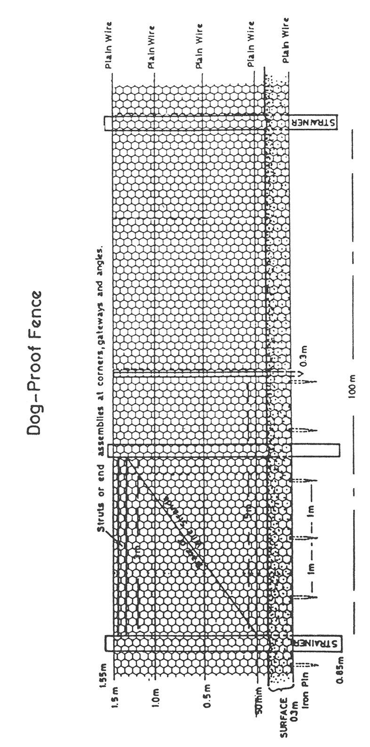
2—Prescribed requirements for rabbit-proof fences
For the purposes of the definition of animal-proof fence in section 3(1) of the Act, a rabbit-proof fence is a fence that consists of—
(a) strainers that—
(i) are not less than 150mm in diameter and not more than 200mm in diameter; and
(ii) are placed 150m apart, 1.1m under the ground and protrude 1.2m above the ground; and
(b) posts that—
(i) are at least 100mm in diameter but not more than 125mm in diameter; and
(ii) are placed 10m apart, 0.7m in the ground and protrude 1.1m above the ground; and
(c) droppers at 3.3m intervals between the posts; and
(d) 4 plain fence wires—
(i) each of which is 2.4mm in diameter; and
(ii) that are placed at intervals of 50mm, 0.45m, 0.9m and 1.0m above the ground; and
(e) 1 barbed wire that is placed 1.1m above the ground; and
(f) wire netting that—
(i) has a gauge of at least 1.4mm; and
(ii) has a width of 1.05m; and
(iii) has a maximum mesh of 30mm; and
(iv) 150mm of which is placed under the ground and 0.9m of which protrudes above the ground; and
(v) is secured to the lower 3 plain fence wires with galvanised tie iron or galvanised steel tie wire with a minimum 1.44mm in diameter and not more than 0.5m apart on the highest of the 3 wires and not more than 0.75m apart on the lower 2 wires; and
(g) struts on the corner strainers that are either—
(i) single diagonal struts (on which are placed barriers to prevent the entry of rabbits if the struts are placed outside the netting); or
(ii) double post and brace rail struts.
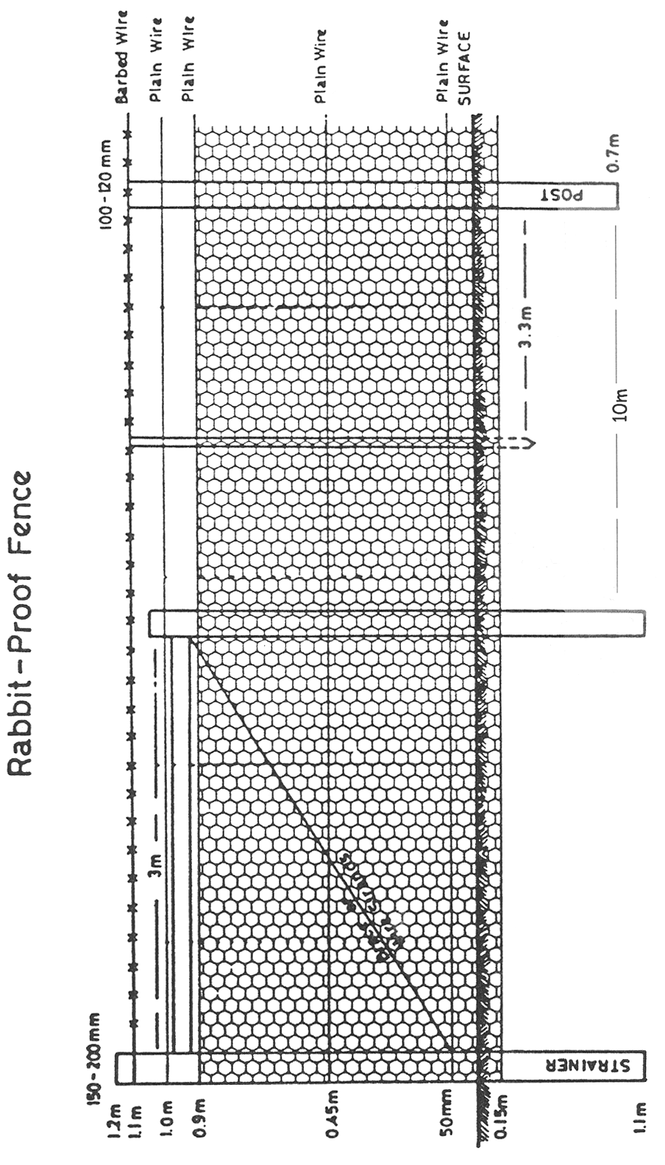

Note—
As required by section 10AA(2) of the Subordinate Legislation Act 1978, the Minister has certified that, in the Minister's opinion, it is necessary or appropriate that these regulations come into operation as set out in these regulations.
Made by the Governor
with the advice and consent of the Executive Council
on 25 June 2020
No 222 of 2020

South Australia

Landscape South Australia (Water Management) Regulations 2020
under the Landscape South Australia Act 2019

Contents
Part 1—Preliminary
1 Short title
2 Commencement
3 Interpretation
Part 2—Legislative definitions
4 Definition of Mount Lofty Ranges Watershed
Part 3—Water allocation plans
5 Consultation associated with proposed amendment
Part 4—Levies in respect of water
6 Recovery costs
7 Refund of levies (section 87 of Act)
8 Recovery of penalty under section 88(6) of Act
Part 5—Meters
9 Supply and installation of meters
10 Meters owned by Minister
11 Meters owned by other persons
12 Provisions applying to meters generally
13 Requirements as to installation, repair, testing etc of meters
14 Testing requirements
15 Minister's specifications
16 Compliance with Part
Part 6—General management, administration and protection provisions
17 Rate at which drinking water may be taken
18 Activities subject to the operation of a plan or policy
19 Water affecting activities (section 104(5) and (6) of Act)
20 Expiation fees (section 104(7) of Act)
21 Prescribed date (section 111(1) of Act)
22 Notice to be given by relevant authority (section 113, 137 and 144 of Act)
23 Requirements as to representations under section 113, 137 or 144 of Act
24 Time for response by applicant
25 Well drillers' licences—prescribed conditions
26 Cancellation of water resource works approval—prescribed scheme (section 138 of Act)
27 Cancellation of site use approval—prescribed scheme (section 145 of Act)
Part 7—Specific provisions relating to consumptive pools, water access entitlements and allocations
28 Transfers between consumptive pools
29 Classification of water access entitlements
30 Variation of water licences—policies and principles specified by water allocation plan
31 Water allocation plans—priorities for allocation according to management zones
32 Tagged interstate water trades
33 Joint applications to vary water take or use limits on water licence or approval
Part 8—Forest water licences
34 Interpretation—harvesting (section 164 of Act)
35 Provision of notice to Minister (section 166 of Act)
36 Variations—allocations—prescribed period (section 168 of Act)
37 Approval for transfer of allocations—prescribed circumstances (section 169 of Act)
38 Variation—conditions—prescribed period (section 171 of Act)
39 Surrender of licences—prescribed circumstances (section 173 of Act)
40 Offences—prescribed rate (section 175 of Act)
Part 9—Miscellaneous
41 Prescribed period (section 184 of Act)
42 Availability of representations (section 113 of Act)
43 Requirement to provide information to Minister
44 Amendment of water affecting activities control policies
45 The Water Register

Part 1—Preliminary
1—Short title
These regulations may be cited as the Landscape South Australia (Water Management) Regulations 2020.
2—Commencement
These regulations come into operation on 1 July 2020.
3—Interpretation
(1) In these regulations, unless the contrary intention appears—
Act means the Landscape South Australia Act 2019;
validate—see subregulation (2).
(2) For the purposes of these regulations, a reference to the validation of a meter is a reference to undertaking a set of steps to determine whether the meter and its installation comply with any specifications determined or approved by the Minister under these regulations.
Part 2—Legislative definitions
4—Definition of Mount Lofty Ranges Watershed
For the purposes of the definition of Mount Lofty Ranges Watershed in section 3(1) of the Act, the area identified as the Mount Lofty Ranges Watershed in General Registry Plan No 001/2005 is prescribed.
Part 3—Water allocation plans
5—Consultation associated with proposed amendment
(1) For the purposes of section 55(3)(b) of the Act, the holders of licences must be given a notice in writing which—
(a) provides information about the nature and effect of the relevant proposal; and
(b) sets out details about how, and by when, a submission in relation to the proposed amendment must be made.
(2) The period within which a submission may be made under subregulation (1) must be at least 2 months from the time that the notice is given to a holder of a licence.
Part 4—Levies in respect of water
6—Recovery costs
(1) The Minister may from time to time, by notice in the Gazette, determine a charge that may be imposed on account of any steps that may be taken by the Department in the administration of the Act if a person fails to pay a water levy in accordance with the requirements of the Act.
(2) The charge must not exceed the Minister's determination of the reasonable costs to the Department of taking the relevant steps.
(3) The charge will be recoverable as a debt due to the Crown.
7—Refund of levies (section 87 of Act)
(1) In this regulation—
donation means a gift for no consideration;
environmental donations entitlement means a water licence or water allocation—
(a) that relates to water in a water resource that is subject to a water levy in respect of a particular financial year; and
(b) that is subject to conditions to the effect—
(i) that any water taken under or in connection with the licence or water allocation may only be used for an environmental purpose in a manner accredited by the regional landscape board specified in the condition; and
(ii) that the person who is the holder of the licence or water allocation is accredited by the regional landscape board specified in the condition to receive, transfer or use donations of water for environmental purposes recognised by that board for the purposes of this regulation.
(2) In connection with the operation of subregulation (1), a regional landscape board must, in deciding whether to issue an accreditation for the purposes of a water licence or water allocation being recognised as an environmental donations entitlement, apply any criteria determined by the Minister.
(3) For the purposes of section 87 of the Act—
(a) the donation of the whole or a part of a water access entitlement or water allocation to the holder of an environmental donations entitlement (for water to be used for environmental purposes); and
(b) the variation of conditions attached to a water licence or water allocation so that the licence or the water allocation will become an environmental donations entitlement,
are recognised as natural resources management practices on which an application for a refund of a water levy may be based.
(4) The maximum proportion of a water levy that may be subject to a refund (the eligible levy amount) is equal to the proportion of the allocation or water access entitlement donated, or within the ambit of the relevant condition, in the manner contemplated by subregulation (3).
(5) The amount of any refund will be determined according to the following table:

Date within the relevant financial year on which the donation or variation of conditions takes effect | Percentage of eligible levy amount payable
1 July—10 July | 100
11 July—31 October | 75
1 November—31 January | 50
1 February—31 March | 25
1 April—30 June | 0
8—Recovery of penalty under section 88(6) of Act
Pursuant to section 88(6) of the Act, the following sections of Part 5 of the Act are prescribed:
(a) section 77(10) and (12);
(b) sections 78, 79 and 80;
(c) section 83;
(d) sections 85 and 86;
(e) section 89.
Part 5—Meters
9—Supply and installation of meters
(1) In order to determine the quantity of water taken for the purposes of the Act the Minister may—
(a) supply, install or seal a meter; or
(b) by written notice, direct a person to supply or install a meter.
(2) The Minister may require—
(a) an owner of land on which a meter supplied by the Minister is installed; or
(b) a person who is the holder of a water management authorisation, or who has the benefit of a water management authorisation, in respect of which any volume of water is to be measured by a meter supplied by the Minister (if not the owner of the relevant land),
to pay any costs involved with the supply, installation or sealing of the meter, which will then become a debt due by the owner of land under paragraph (a) or the person under paragraph (b) (as the case requires) to the Crown.
(3) A meter supplied by the Minister remains the property of the Minister unless all relevant costs are paid under subregulation (2) or the Minister transfers property in the meter to another person.
10—Meters owned by Minister
(1) A person who is the holder of a water management authorisation, or who has the benefit of a water management authorisation, in respect of which a meter owned by the Minister is to be used to measure the quantity of water taken or used in connection with the water management authorisation, is liable for rent for the meter comprised of the prescribed fee.
(2) The Minister may enter land on which a meter owned by the Minister is installed to read, inspect, service, test, validate, maintain, seal, repair or replace the meter.
(3) In this regulation—
prescribed fee means the fee prescribed under the Act for the purposes of rent for a meter.
11—Meters owned by other persons
(1) The Minister may enter land on which a meter owned by a person other than the Minister is installed to read, inspect or seal the meter.
(2) The Minister may, by notice in writing, direct a person to service, test, validate, maintain, repair, replace or adjust a meter being used by the person if in the Minister's opinion such action is necessary.
12—Provisions applying to meters generally
(1) Where a meter is used to measure the quantity of water taken or used in a particular place—
(a) a person must not take water except through the meter; and
(b) a person must not adjust or alter the meter, or tamper with a seal fixed to the meter, without the authority of the Minister; and
(c) a person must not damage or destroy the meter; and
(d) a person must not—
(i) cut through or into a pipe to which this paragraph applies under subregulation (2); or
(ii) install a fitting providing access to the inside of a pipe to which this paragraph applies under subregulation (2); or
(iii) change the configuration of, remove, or interfere in any other way with, a pipe to which this paragraph applies under subregulation (2),
without the authority of the Minister.
(2) Subregulation (1)(d) applies to—
(a) the pipe connecting the water resource from which the water is taken to the meter; and
(b) the pipe on the other side of the meter to (and including) the S bend in the pipe or, where there is no S bend, the first T junction or elbow in the pipe, or any other distance of pipe determined in accordance with a specification determined or approved by the Minister.
(3) A person must not—
(a) remove a meter without the authority of the Minister; or
(b) replace a meter without the authority of the Minister.
(4) In addition, any responsible person in relation to a meter—
(a) must not permit sand, soil or any other material to be deposited on or around the meter; and
(b) must not permit deposits of sand, soil or any other material to build up around the meter; and
(c) must keep vegetation cleared away from the meter.
(5) If a meter or its associated infrastructure is damaged or destroyed, a responsible person in relation to the meter must, at the written direction of the Minister, repair or replace the meter or its associated infrastructure.
(6) In this regulation—
associated infrastructure means any infrastructure, pipe or connecting part related to a meter that the Minister determines to be necessary to maintain the accuracy of a meter;
responsible person in relation to a meter means—
(a) an owner of land on which the meter is installed, other than the Crown or an agency or instrumentality of the Crown; and
(b) the person who is the holder of the water management authorisation, or who has the benefit of the water management authorisation, in relation to which a meter is required.
13—Requirements as to installation, repair, testing etc of meters
(1) If a person is required to comply with a direction under this Part to supply and install a meter or to replace a meter, the new meter must—
(a) be rated by the manufacturer to an accuracy of at least plus or minus 2.5%; and
(b) meet any other specifications determined or approved by the Minister.
(2) If a person is required to comply with a direction under this Part to install a meter, the meter must be installed in accordance with any specifications determined or approved by the Minister.
(3) If a person is required to comply with a direction under this Part to service, test, validate, repair, replace or adjust a meter or its associated infrastructure, the person must engage a competent person approved by the Minister to do the testing, verification or other work and the testing, verification or other work must be done in accordance with specifications determined or approved by the Minister.
(4) A person who is required to comply with a direction under this Part to service or repair a meter must ensure that only parts that are supplied or approved by the manufacturer of the meter are used.
(5) If a person is required to comply with a direction under this Part to maintain a meter, the person must maintain the meter in accordance with any specification determined or approved by the Minister.
(6) In this regulation—
associated infrastructure means any infrastructure, pipe or connecting part related to a meter that the Minister determines to be necessary to maintain the accuracy of a meter.
14—Testing requirements
(1) The following requirements are prescribed for the purposes of section 79(5) of the Act.
(2) A person must not remove a meter for testing without the authority of the Minister.
(3) The security seals attached to a meter may only be removed by a person approved by the Minister.
(4) A meter must be read—
(a) by a person approved by the Minister; or
(b) by the relevant person,
immediately before it is removed.
(5) A reading obtained under subregulation (4) must be provided in writing to the Minister within a period determined by the Minister.
(6) A meter must be tested by a competent person approved by the Minister.
(7) A meter must be tested and reinstalled, or a replacement meter must be installed, within 28 days after the Minister gives approval under subregulation (2) for the meter to be removed, or within a longer period determined or approved by the Minister.
(8) A meter must be tested in accordance with any specifications determined or approved by the Minister.
(9) A certificate relating to the testing must be provided to the Minister within 14 days after the meter is tested or within a longer period determined or approved by the Minister.
(10) The certificate must be in a form determined or approved by the Minister.
(11) If a meter is found to be outside an accuracy rating of plus or minus 4%, the meter must not be reinstalled unless or until—
(a) the meter is refurbished in accordance with a specification determined or approved by the Minister; and
(b) the Minister is provided with a certificate of accuracy (certifying the accuracy of the meter to plus or minus 4%).
(12) A meter must be reinstalled in accordance with specifications determined or approved by the Minister.
(13) If the security seal that connects the meter register to the meter body is broken at any stage relating to the removal, testing, refurbishment or reinstallation of a meter, the seal must be replaced by a person approved by the Minister.
(14) A meter must be read—
(a) by a person approved by the Minister; or
(b) by the relevant person,
immediately after it is installed.
(15) A reading obtained under subregulation (14) must be provided in writing to the Minister within a period determined by the Minister.
(16) Despite a preceding subregulation—
(a) a meter may, with the approval of the Minister, be tested without being removed; and
(b) any such testing of a meter on site must be conducted in accordance with any specification determined or approved by the Minister (including, without limitation, as to the accuracy rating of the meter); and
(c) if a meter tested under this subregulation is found to be outside the accuracy rating specified by the Minister under paragraph (b)—
(i) the meter must be refurbished in accordance with specifications determined or approved by the Minister; and
(ii) if the meter is removed as part of its refurbishment—the meter must be reinstalled in accordance with specifications determined or approved by the Minister; and
(iii) the Minister must, after the refurbishment of the meter, be provided with a certificate of accuracy (certifying the accuracy of the meter to within an accuracy rating set out in specifications determined or approved by the Minister).
(17) In this regulation—
relevant person means the person who is liable to pay the relevant levy, as contemplated by section 79(5) of the Act.
15—Minister's specifications
For the purposes of this Part, specifications determined or approved by the Minister may be of general, limited or varied application according to—
(a) whether the meter is tested on site or following the meter's removal; and
(b) any other specified circumstances or factor to which the specifications are expressed to apply.
16—Compliance with Part
(1) A person who fails to comply with a direction of the Minister under this Part, or who contravenes or fails to comply with a provision of this Part, is guilty of an offence.
Maximum penalty: $7 000.
Expiation fee: $350.
(2) Subregulation (1) does not apply in relation to regulation 12 (which is subject to enforcement under section 79(5) of the Act).
(3) If a person fails to comply with a direction of the Minister under this Part or contravenes or fails to comply with a provision of this Part, the Minister may enter the land concerned and take such action as the Minister thinks fit to remedy the contravention or failure and the Minister's costs will be a debt due to the Crown by the person who has contravened or failed to comply with the provision or failed to comply with the direction.
Part 6—General management, administration and protection provisions
17—Rate at which drinking water may be taken
The rate of 100 litres per day is prescribed for the purposes of section 100(7) of the Act.
18—Activities subject to the operation of a plan or policy
Using water in the course of carrying on a business in a landscape management region at a rate that exceeds the rate prescribed by a water allocation plan or a water affecting activities control policy applying in relation to that region (or a relevant part of the region), if the water has been brought from a water resource in some other part of the region specified in the plan or policy (as the case may be) by means of a pipe or channel, is prescribed as an activity under section 104(4)(l) of the Act.
19—Water affecting activities (section 104(5) and (6) of Act)
(1) A person is exempt from the operation of paragraph (a) of section 104(5) of the Act if the water allocation plan for the relevant water resource provides that a water resource works approval is not required in the relevant case.
(2) A person is exempt from the operation of paragraph (b) of section 104(5) of the Act if the water allocation plan for the relevant water resource provides that a site use approval is not required in the relevant case.
(3) A water allocation plan may, in making provision for the purposes of subregulation (1) or (2), provide that a person must not construct, maintain or operate works, or use water or surface water, unless authorised by a water licence and must, in doing so, comply with the conditions of the water licence and any relevant water allocation.
(4) Subject to subregulation (5), a person is exempt from the operation of paragraph (a) or (b) of section 104(5) of the Act if the person may lawfully take water from the prescribed watercourse, lake or well or surface water prescribed area under the Act without holding a water allocation that relates to the relevant water resource.
(5) Subregulation (4) does not apply in relation to a prescribed watercourse, lake or well or surface water prescribed area to the extent that the water allocation plan for the relevant water resource requires a water resource works approval or site use approval in the relevant case.
20—Expiation fees (section 104(7) of Act)
For the purposes of the imposition of an expiation fee under section 104(7) of the Act, any condition of a water management authorisation or permit is prescribed.
21—Prescribed date (section 111(1) of Act)
For the purposes of section 111(1) of the Act, the prescribed date is 2 July 1997.
22—Notice to be given by relevant authority (section 113, 137 and 144 of Act)
(1) The notices referred to in section 113(2)(a), 137(a)(i) and 144(a)(i) of the Act must be given by the relevant authority or Minister in accordance with section 222 of the Act.
(2) The notices referred to in section 113(2)(c), 137(a)(iii) and 144(a)(iii) must be given by the relevant authority or Minister in such manner as the relevant authority or Minister (as the case may be) determines to be appropriate, after giving due consideration to the extent to which a particular form of publication may be effective in bringing the notice to the attention of persons who are most likely to have a particular interest in the notice (without requiring personal service).
(3) A notice under this regulation must—
(a) set out the relevant particulars of the application; and
(b) identify the land that will be affected by the grant or refusal of the application to which the notice relates; and
(c) include an address at which a copy of the application may be inspected during normal office hours; and
(d) set out the text of regulation 23.
23—Requirements as to representations under section 113, 137 or 144 of Act
A representation under section 113(3), 137(b) or 144(b) of the Act must—
(a) be in writing; and
(b) be made within 20 business days after the notice referred to in regulation 22(1) is given to the person making the representation or, in the case of a member of the public, within 20 business days after notice is given by the relevant authority or Minister (as the case may be) under regulation 22(2); and
(c) state the name and address of the person making the representation; and
(d) if 2 or more persons make the same representation, nominate 1 of them to represent the others for procedural purposes; and
(e) state whether or not the person making the representation wishes to appear before the relevant authority or Minister (as the case requires) to be heard in support of the representation.
24—Time for response by applicant
(1) 10 business days is prescribed for the purposes of sections 113(5), 137(d) and 144(d) of the Act.
(2) The period referred to in subregulation (1) may be increased by the relevant authority or Minister (as the case requires) if, in the opinion of the relevant authority or Minister in the circumstances of the particular case, that period is too short.
25—Well drillers' licences—prescribed conditions
The following are prescribed under section 115(3) of the Act in relation to well drillers' licences:
(a) the licensee must keep such records as the Chief Executive directs in such manner and for such period as the Chief Executive directs;
(b) the licensee must, at the direction of the Chief Executive or an authorised officer, produce records referred to in paragraph (a) to the Chief Executive or authorised officer for inspection or copying;
(c) the licensee must not, in pursuance of the licence, commence an activity that requires a permit or water resource works approval under the Act unless the licensee has sighted the permit or approval;
(d) the licensee must, at the direction of the Chief Executive or an authorised officer, take samples of water or other material from a well being drilled by the licensee and must submit the samples to the Chief Executive or authorised officer for inspection and analysis;
(e) the licensee must comply with directions given by the Chief Executive in relation to drilling, plugging, backfilling or sealing a well or to the repair, replacement or alteration of the casing, lining or screen of a well if those directions are given to the licensee by the Chief Executive or published in the Gazette;
(f) the licensee must comply with the terms of any condition, permit or approval under the Act that relates to, or authorises, the work that the licensee is performing.
26—Cancellation of water resource works approval—prescribed scheme (section 138 of Act)
(1) Subject to this regulation, the Minister may cancel a water resource works approval—
(a) if works within the ambit of the approval are not constructed or substantially completed within 2 years from the date of issue of the water resource works approval; or
(b) if works within the ambit of the approval are not used because the works have been removed and have not, within 1 year of the date of the removal, been replaced by the construction of similar works; or
(c) on the application of the holder of a water resource works approval—if works within the ambit of the approval are not used, or used to any significant degree, over a continuous period of 1 year or more; or
(d) if—
(i) over a continuous period of 5 years or more, works within the ambit of the approval have not been used, or used to any significant degree; and
(ii) after consulting with the holder of the approval, the Minister considers that the works will not be used, or used to any significant degree, in the manner specified in the approval.
(2) The Minister must, at least 1 month before cancelling a water resource works approval under subregulation (1)(a) or (b), notify the holder of the water resource works approval of the Minister's intention to cancel the water resource works approval.
(3) The Minister must not cancel a water resource works approval under this regulation if it appears to the Minister that the cancellation would have an unreasonable impact on a water resource or other form of natural resource.
27—Cancellation of site use approval—prescribed scheme (section 145 of Act)
(1) Subject to this regulation, the Minister may cancel a site use approval in the following circumstances:
(a) on the application of the holder of a site use approval;
(b) if, as a result of the provisions of a relevant water allocation plan, the Minister considers that the site use approval is no longer required;
(c) if the Minister considers it necessary or appropriate to cancel the site use approval as a result of a division of land, or the acquisition of land by an agency or instrumentality of the Crown or a council;
(d) if—
(i) there has been no water use of the kind specified in the site use approval for at least 5 years; and
(ii) after consulting with the holder of the site use approval, the Minister considers that the purpose or purposes for which the site use approval was granted will not be carried out at that place in the future.
(2) The Minister must not cancel a site use approval under this regulation if it appears to the Minister that the cancellation would have an unreasonable impact on a water resource or other form of natural resource.
Part 7—Specific provisions relating to consumptive pools, water access entitlements and allocations
28—Transfers between consumptive pools
(1) A water allocation plan may determine (subject to the provisions of the water allocation plan) that a portion of the water within a consumptive pool will be available for the purposes of any transfer of—
(a) a water access entitlement, or part of a water access entitlement; or
(b) a water allocation,
where the transfer is to occur between 2 consumptive pools with the same prescribed water resource, or between 2 consumptive pools for 2 prescribed water resources that are both managed under the water allocation plan.
(2) A share of water available in the consumptive pools will take into account the extent to which transfers may be allowed under subregulation (1).
(3) A water allocation plan should only provide for transfers under subregulation (1) if—
(a) there is a reasonable connection (including from a management perspective) between the consumptive pools, as set out in the water allocation plan; and
(b) there is sufficient capacity within the relevant consumptive pool (as determined under the water allocation plan, or by the Minister in accordance with the provisions of the water allocation plan) for water to be taken from the water resource on account of any such transfers.
29—Classification of water access entitlements
(1) For the purposes of section 121 of the Act and without limiting the factors that may be specified by a water allocation plan, access to a share of water in a consumptive pool, as represented by a water access entitlement, may be classified according to 1 or more of the following characteristics:
(a) the purpose for which the water is used;
(b) the priority or reliability of allocations (with reliability being the frequency with which water allocated under a water access entitlement is able to be supplied in full);
(c) tradability;
(d) entitlement to any carry-overs;
(e) association with a management zone;
(f) any other characteristic identified in the water allocation plan.
(2) For the purposes of Schedule 4 clause 6(g) of the Act, information relating to the class and reliability of a water access entitlement is prescribed.
30—Variation of water licences—policies and principles specified by water allocation plan
(1) For the purposes of section 53(1)(k) of the Act, a water allocation plan may specify polices and principles that are relevant to the Minister making a decision under section 124 of the Act in relation to the variation of a water licence.
(2) Without limiting subregulation (1), those policies or principles may provide for—
(a) the conversion of water access entitlements on account of any transfer; and
(b) the reclassification of water access entitlements, including on account of changes in reliability.
31—Water allocation plans—priorities for allocation according to management zones
(1) For the purposes of section 53(1)(k) of the Act, a water allocation plan may set out a framework or scheme for how water in a consumptive pool that is available for allocation is to be prioritised for allocation to different classes of entitlement within the consumptive pool.
(2) Without limiting subregulation (1), a water allocation plan may—
(a) specify different principles for the reduction or variation of water access entitlements; or
(b) specify different principles for the allocation of water, or for the reduction or variation of water allocations,
according to management zones established by the water allocation plan.
32—Tagged interstate water trades
(1) If—
(a) a transfer of a water allocation is being undertaken (or is proposed to be undertaken) under an Interstate Water Entitlements Transfer Scheme; and
(b) the transfer is (or is proposed to be) part of a series of transfers (including a series of 2) to occur under that scheme; and
(c) the person who is to obtain the benefit of each transfer—
(i) is the same person each time; and
(ii) holds an entitlement under a corresponding law of another jurisdiction (being an entitlement that is relevant to the transfer of the water allocation either by giving rise to the water allocation or by receiving the benefit of the water allocation); and
(d) the scheme under which the transfer of allocation is occurring is supported by an intergovernmental agreement that, under a determination of the Minister, is recognised for the purposes of this regulation,
then—
(e) a fee (being the fee prescribed under the Act) is payable in relation to an application to register the transfers (or proposed transfers) under the scheme; but
(f) no fee is payable, in relation to any transfers in the series once the registration has occurred.
(2) Nothing in subregulation (1) derogates from any other requirement under the Act—
(a) to provide information, or a notice or other document or instrument, in connection with the provision, delivery or receipt of water (or an entitlement to water); or
(b) to hold a water resource works approval or a site use approval in an appropriate case.
33—Joint applications to vary water take or use limits on water licence or approval
(1) A joint application may be made by the holders of—
(a) 2 or more water licences; or
(b) 2 or more water resource works approvals; or
(c) 2 or more site use approvals,
for a variation prescribed under subregulation (2).
(2) The following variations are prescribed:
(a) the variation of conditions of water licences, water resource works approvals or site use approvals (as the case may be), so that a volume of water that may be taken, collected, used, diverted or extracted under the licences or approvals (as applies in the appropriate case) may be reduced under 1 or more instruments and increased under the other instrument or instruments;
(b) the variation of maximum volumes of water under section 135(1)(b) or 142(1)(b) of the Act in relation to water resource works approvals or site use approvals (as the case may be), so that a volume of water that may be taken, collected, used, diverted or extracted under the approvals (as applies in the appropriate case) may be reduced under 1 or more instruments and increased under the other instrument or instruments.
(3) A variation under subregulation (1) must be consistent with section 124(3), 136(4) or 143(3) of the Act (as the case requires).
Part 8—Forest water licences
34—Interpretation—harvesting (section 164 of Act)
(1) For the purposes of section 164 of the Act, a reference to harvesting does not include the following activities:
(a) forest thinning;
(b) salvage operations following instances of pest incursion, wind-throw, fire or other such harmful or damaging events to forest vegetation;
(c) an activity specified in the water allocation plan relating to the declared forestry area as an activity that does not constitute harvesting.
(2) In this regulation—
forest thinning means the selective removal of a proportion of the trees from a commercial forest, primarily undertaken to improve the growth rate or health of the remaining trees in the forest, but does not include clear-felling.
35—Provision of notice to Minister (section 166 of Act)
(1) Notice of a transfer under section 166(6) of the Act must be furnished to the Minister in a manner and form and within a period determined by the Minister.
(2) Notice of an assignment under section 166(7) of the Act must be furnished to the Minister in a manner and form and within a period determined by the Minister.
36—Variations—allocations—prescribed period (section 168 of Act)
For the purposes of section 168((1)(b) of the Act, the period of 18 months is prescribed.
37—Approval for transfer of allocations—prescribed circumstances (section 169 of Act)
(1) For the purposes of section 169(7)(d) of the Act, the Minister must refuse an application for a transfer if the applicant has not paid a water levy, or a part of a water levy, and the Minister thinks that it is appropriate to refuse the application on the basis of the non-payment.
(2) For the purposes of section 169(9) of the Act, the forest manager may not deal with a water allocation attached to the licence if the result would be that the water allocation attached to the licence would fall below the water required to offset the impact of the forest on the relevant water resource (as determined under the relevant water allocation plan).
38—Variation—conditions—prescribed period (section 171 of Act)
For the purposes of section 171(1)(b) of the Act, the period of 18 months is prescribed.
39—Surrender of licences—prescribed circumstances (section 173 of Act)
For the purposes of section 173 of the Act, a licensee may surrender a forest water licence in circumstances where the commercial forest the subject of the forest water licence has been permanently removed.
40—Offences—prescribed rate (section 175 of Act)
For the purposes of section 175(2)(a)(i) of the Act, the prescribed rate is $25 per kilolitre.
Part 9—Miscellaneous
41—Prescribed period (section 184 of Act)
For the purposes of section 184(3) of the Act, the period of 3 months from the date of application is prescribed.
42—Availability of representations (section 113 of Act)
(1) For the purposes of section 113 of the Act, the relevant authority must ensure that a copy of any representation made under section 113(3) of the Act, and of any response made under section 113(4) of the Act, is available for inspection by members of the public for at least 12 months after the relevant authority gives it decision on the application.
(2) No fee is payable to inspect a representation while it is to be available under subregulation (1).
43—Requirement to provide information to Minister
(1) SA Water and all other persons who provide reticulated water supply or sewerage services and all persons who provide water drainage services must, at the request of the Minister, provide the Minister with the following information:
(a) the location of the infrastructure used by the person to provide those services;
(b) the materials used in the construction of the infrastructure;
(c) the capacity of the infrastructure;
(d) in the case of SA Water or any other person who provides reticulated water supply services—
(i) the source, volume and quantity of the water flowing into reservoirs and other storage facilities used by SA Water or the other person; and
(ii) the volume and quality of water held in storage; and
(iii) the volume of water lost to evaporation or leakage from storage facilities; and
(iv) the volume and quality of water discharged from storage facilities for supply to customers or for any other purpose;
(e) in the case of SA Water or any other person who provides sewerage or other water drainage services—
(i) the volume and quality of water in the sewerage or water drainage system; and
(ii) the volume and quality of water discharged from the sewerage or water drainage system;
(f) such other information as the Minister may determine.
(2) Section 9(3) of the Act applies to the kinds of information referred to in subregulation (1) including information requested by the Minister under subregulation (1)(f).
44—Amendment of water affecting activities control policies
Pursuant to Schedule 2 clause 4(8)(b) of the Act, the provisions of Schedule 2 clause 4 do not apply to an amendment of a water affecting activities control policy by a prescribed authority if the amendment is—
(a) to correct an error in the policy; or
(b) to make a change of form (not involving a change of substance) in the policy.
45—The Water Register
For the purposes of clause 7(2)(a) of Schedule 4 of the Act, the Minister will give effect to the transfer by approving the transfer under Part 8 of the Act.
Note—
As required by section 10AA(2) of the Subordinate Legislation Act 1978, the Minister has certified that, in the Minister's opinion, it is necessary or appropriate that these regulations come into operation as set out in these regulations.
Made by the Governor
with the advice and consent of the Executive Council
on 25 June 2020
No 223 of 2020

South Australia

Public Sector (Regional Landscape Boards) Variation Regulations 2020
under the Public Sector Act 2009

Contents
Part 1—Preliminary
1 Short title
2 Commencement
3 Variation provisions
Part 2—Variation of Public Sector Regulations 2010
4 Variation of regulation 13—Application of Part 7 of Act (section 41 of Act)

Part 1—Preliminary
1—Short title
These regulations may be cited as the Public Sector (Regional Landscape Boards) Variation Regulations 2020.
2—Commencement
These regulations come into operation on 1 July 2020.
3—Variation provisions
In these regulations, a provision under a heading referring to the variation of specified regulations varies the regulations so specified.
Part 2—Variation of Public Sector Regulations 2010
4—Variation of regulation 13—Application of Part 7 of Act (section 41 of Act)
Regulation 13—after subregulation (2m) insert:
(2n) Part 7 of the Act, as modified by subregulation (2o), applies in relation to a member of the staff of a regional landscape board who is employed under section 35(4) of the Landscape South Australia Act 2019 on or after 1 July 2020 if the employee is employed in duties that, on 1 July 2020, are classified in a classification contained in—
(a) the S.A. Public Sector Salaried Employees Interim Award (or any award made in substitution for that award); or
(b) the South Australian Modern Public Sector Enterprise Agreement: Salaried 2017 (or any enterprise agreement made in substitution for that enterprise agreement).
(2o) For the purposes of subregulation (2n), Part 7 of the Act is modified as follows:
(a) sections 42, 43, 44, 45(3), 46, 53(2) and 54(3) do not apply to an employee referred to in that subregulation;
(b) section 48 is taken to be modified such that each employee referred to in that subregulation is, when engaged as an employee of the employing authority, at first on probation for 12 months, unless the employing authority determines that no probation is required or determines a lesser period of probation.
Note—
As required by section 10AA(2) of the Subordinate Legislation Act 1978, the Minister has certified that, in the Minister's opinion, it is necessary or appropriate that these regulations come into operation as set out in these regulations.
Made by the Governor
with the advice and consent of the Executive Council
on 25 June 2020
No 224 of 2020

South Australia

COVID-19 Emergency Response (Section 14) (No 2) Variation Regulations 2020
under the COVID-19 Emergency Response Act 2020

Contents
Part 1—Preliminary
1 Short title
2 Commencement
3 Variation provisions
Part 2—Variation of COVID-19 Emergency Response (Section 14) Regulations 2020
4 Insertion of regulation 11
11 Motor Vehicles Act 1959

Part 1—Preliminary
1—Short title
These regulations may be cited as the COVID-19 Emergency Response (Section 14) (No 2) Variation Regulations 2020.
2—Commencement
These regulations come into operation on the day on which they are made.
3—Variation provisions
In these regulations, a provision under a heading referring to the variation of specified regulations varies the regulations so specified.
Part 2—Variation of COVID-19 Emergency Response (Section 14) Regulations 2020
4—Insertion of regulation 11
After regulation 10 insert:
11—Motor Vehicles Act 1959
(1) In accordance with section 14 of the Act, the period of 90 days referred to in paragraph (a) of the definition of prescribed period in section 19A(3) of the Motor Vehicles Act 1959 is, to the extent necessary, extended from the time at which the period would otherwise have ended until the designated day.
(2) In accordance with section 14 of the Act, the period of 3 months referred to in section 97A(1)(b)(i)(A) of the Motor Vehicles Act 1959 is extended from the time at which the period would otherwise have ended until the designated day.
(3) In accordance with section 14 of the Act, the period of 3 months referred to in section 97A(1)(b)(ii) of the Motor Vehicles Act 1959 is extended from the time at which the period would otherwise have ended until the designated day.
(4) In accordance with section 14 of the Act, the period of operation of an instructor's licence issued under section 98A(3) of the Motor Vehicles Act 1959 before 1 June 2020 and in force on the commencement of this subregulation is extended by a period of 52 days (from the time at which that licence would otherwise have expired).
(5) In this regulation—
designated day means the day on which all relevant declarations relating to the outbreak of the human disease named COVID-19 within South Australia have ceased.
Note—
As required by section 10AA(2) of the Subordinate Legislation Act 1978, the Minister has certified that, in the Minister's opinion, it is necessary or appropriate that these regulations come into operation as set out in these regulations.
Made by the Governor
with the advice and consent of the Executive Council
on 25 June 2020
No 225 of 2020

South Australia

COVID-19 Emergency Response (Section 16) (No 1) Variation Regulations 2020
under the COVID-19 Emergency Response Act 2020

Contents
Part 1—Preliminary
1 Short title
2 Commencement
3 Variation provisions
Part 2—Variation of COVID-19 Emergency Response (Section 16) Regulations 2020
4 Insertion of regulations 5 and 6
5 Real Property Act 1886
6 Motor Vehicles Act 1959

Part 1—Preliminary
1—Short title
These regulations may be cited as the COVID-19 Emergency Response (Section 16) (No 1) Variation Regulations 2020.
2—Commencement
These regulations come into operation on the day on which they are made.
3—Variation provisions
In these regulations, a provision under a heading referring to the variation of specified regulations varies the regulations so specified.
Part 2—Variation of COVID-19 Emergency Response (Section 16) Regulations 2020
4—Insertion of regulations 5 and 6
After regulation 4 insert:
5—Real Property Act 1886
(1) The following requirements under section 128 of the Real Property Act 1886 are suspended:
(a) the requirement under section 128(5)(a) that the Registrar-General be satisfied that a corresponding mortgage has been executed by the mortgagee;
(b) the requirement under section 128(1) as it relates to the execution of the corresponding mortgage by the mortgagee.
(2) The requirement to witness the signing of an instrument in accordance with section 267 of the Real Property Act 1886 is suspended.
6—Motor Vehicles Act 1959
The requirement in section 79A(1)(a)(ii)(A) of the Motor Vehicles Act 1959 to produce to the Registrar a logbook will be taken to be satisfied if the applicant sends an electronic copy of the logbook to the Registrar in accordance with any requirements of the Registrar.
Note—
The regulations inserted by this regulation expire in accordance with section 6 of the COVID-19 Emergency Response Act 2020.
Note—
As required by section 10AA(2) of the Subordinate Legislation Act 1978, the Minister has certified that, in the Minister's opinion, it is necessary or appropriate that these regulations come into operation as set out in these regulations.
Made by the Governor
with the advice and consent of the Executive Council
on 25 June 2020
No 226 of 2020

Rules of Court

Youth Court (Care and Protection) Rules 2018
South Australia
(Schedule of Forms)
By virtue and in pursuance of section 32 of the Youth Court Act 1993 and all other enabling powers, we, the Judge of the Court and the Magistrates who are members of the principal judiciary of the Court, approve the following Youth Court (Care and Protection) Rules 2018 Schedule of Forms.
- The current Schedule to the Youth Court (Care and Protection) Rules 2018 is deleted and the following Schedule is substituted:

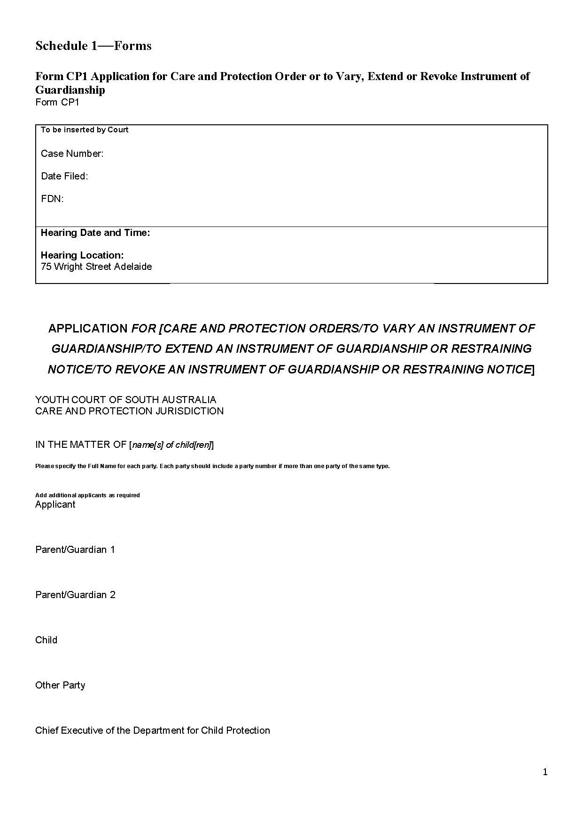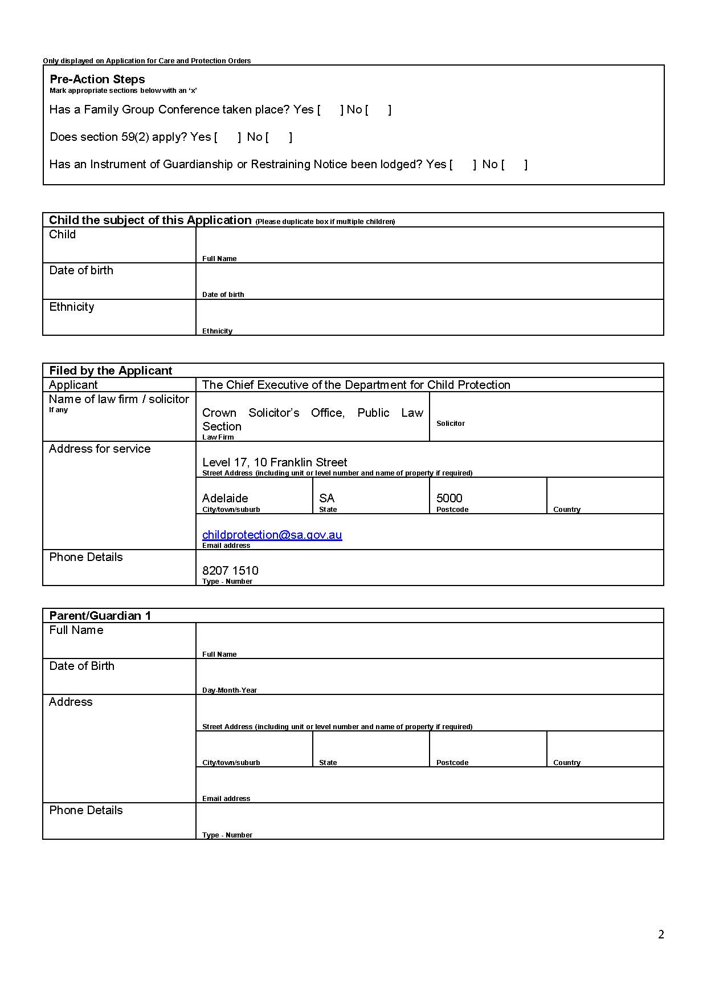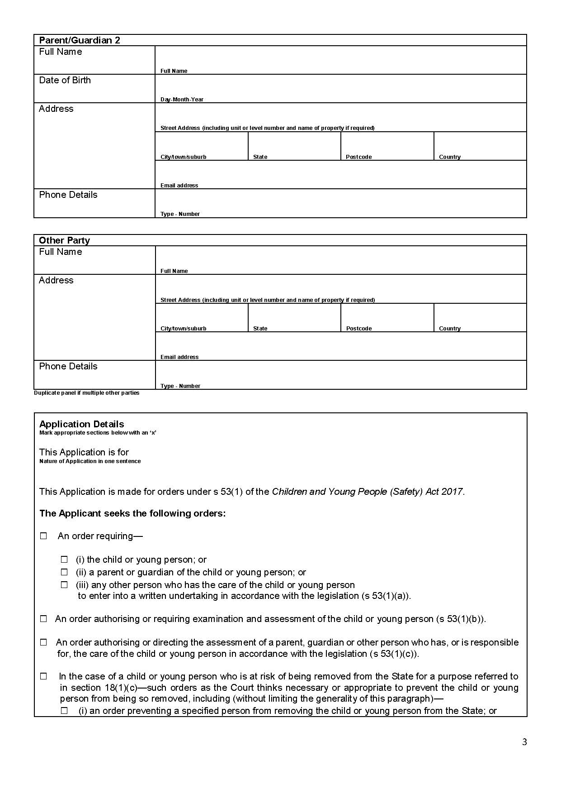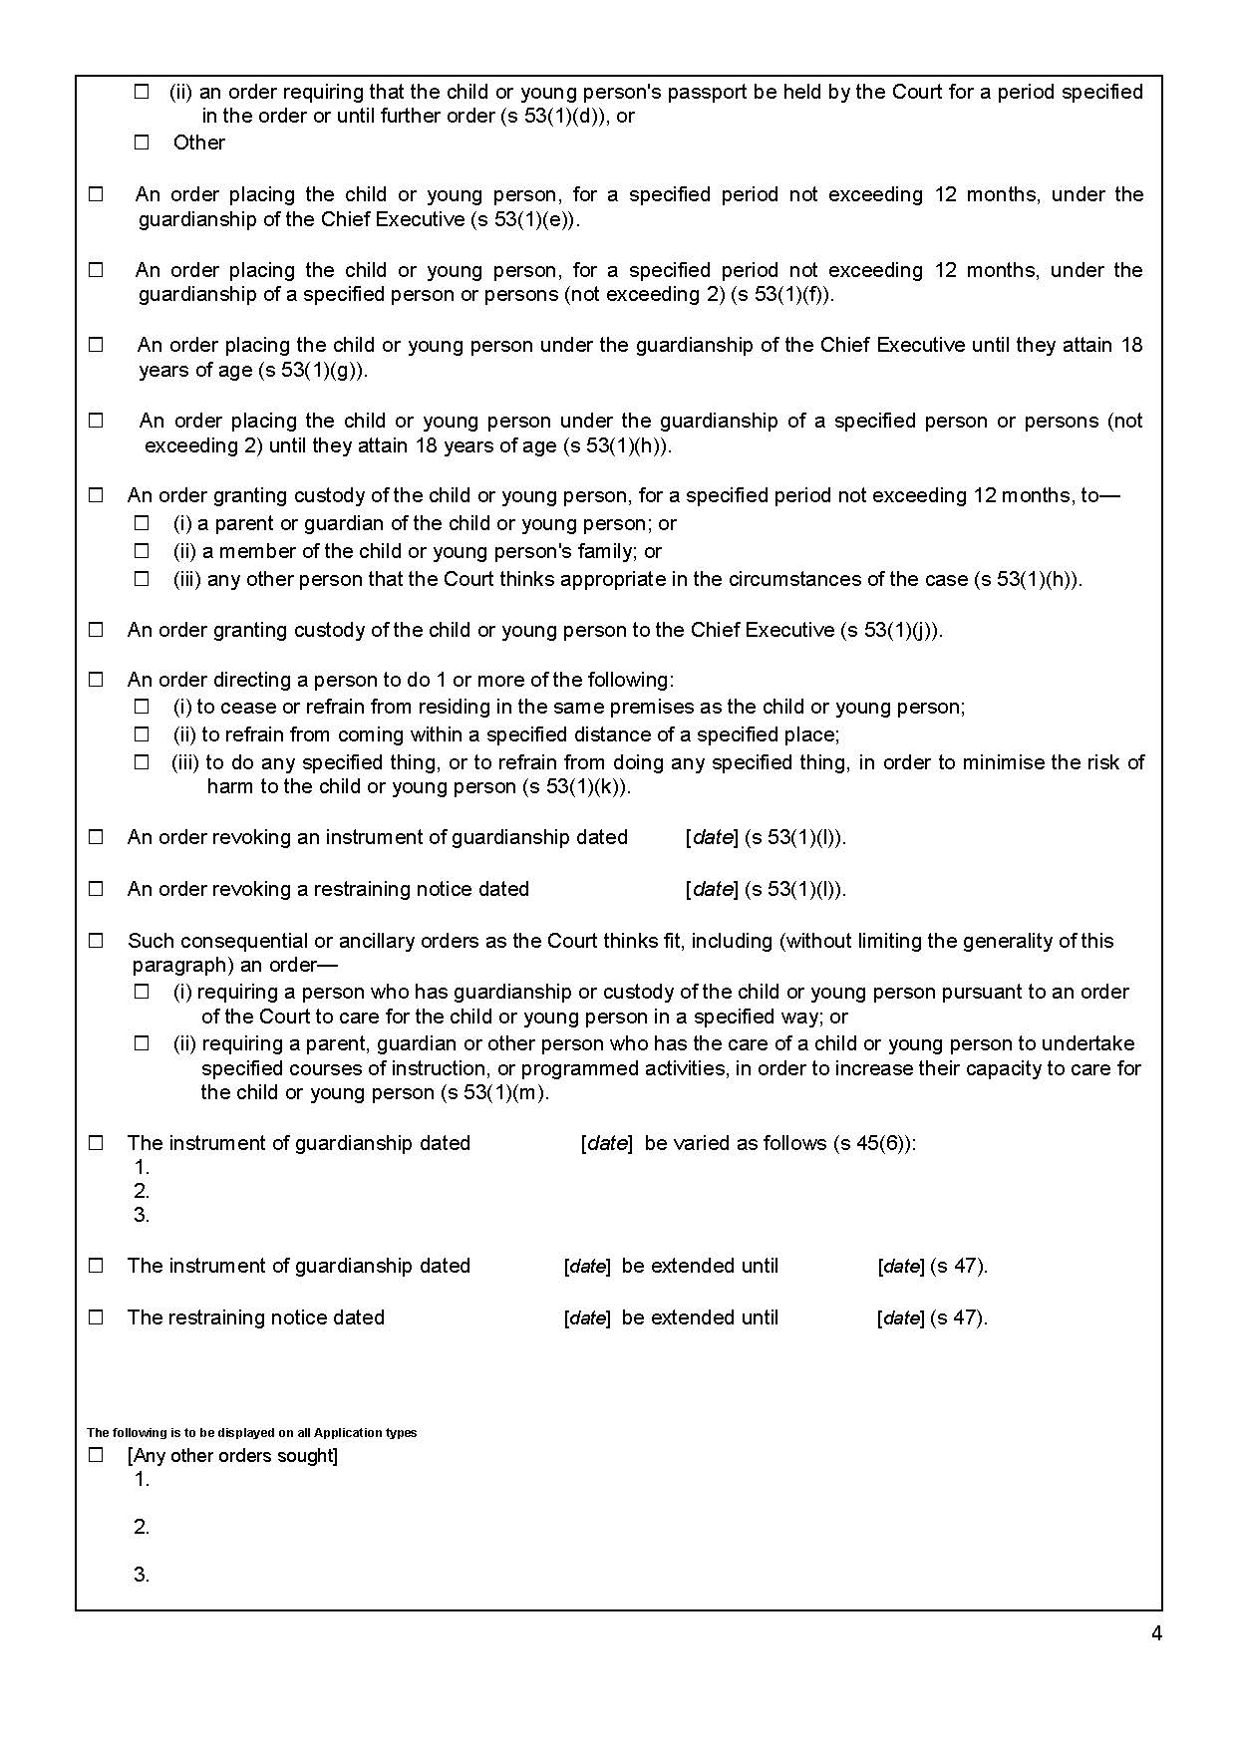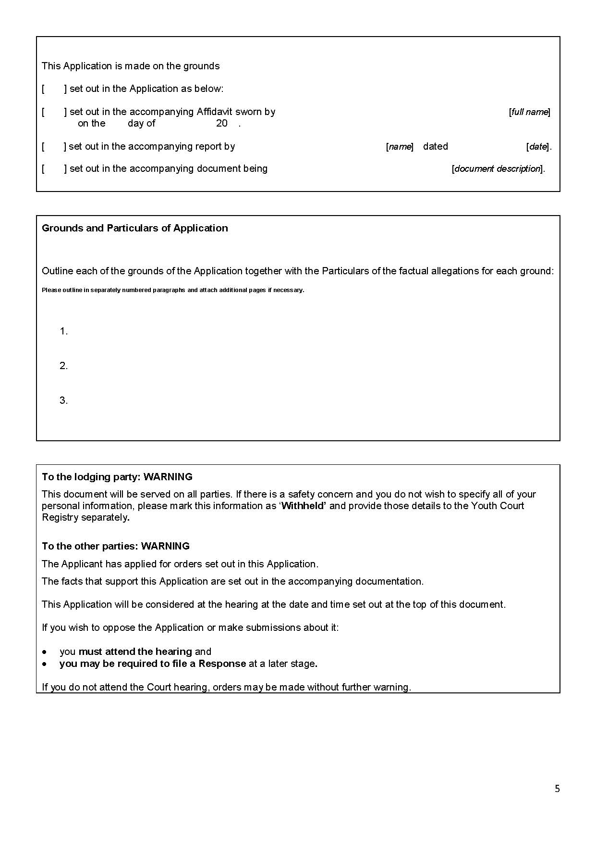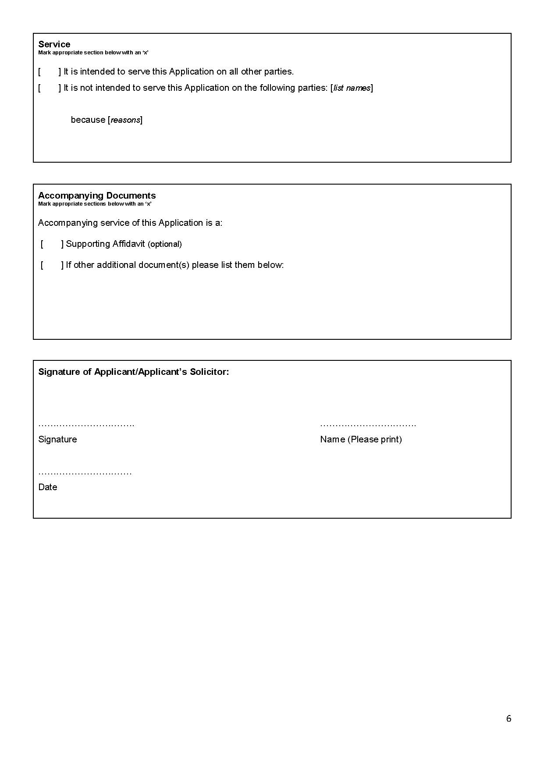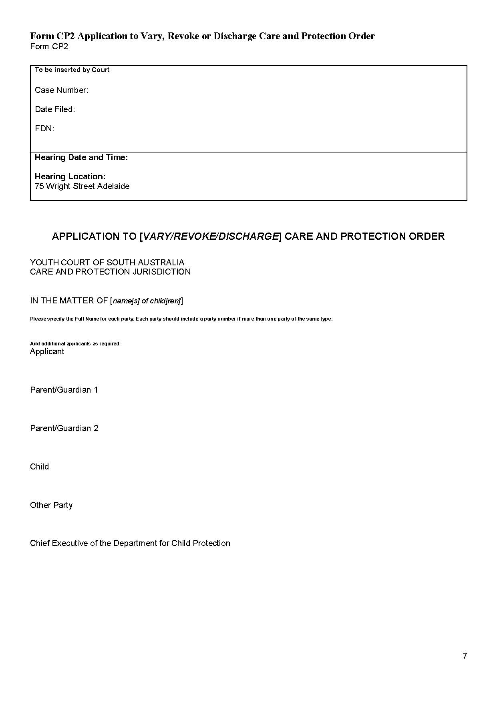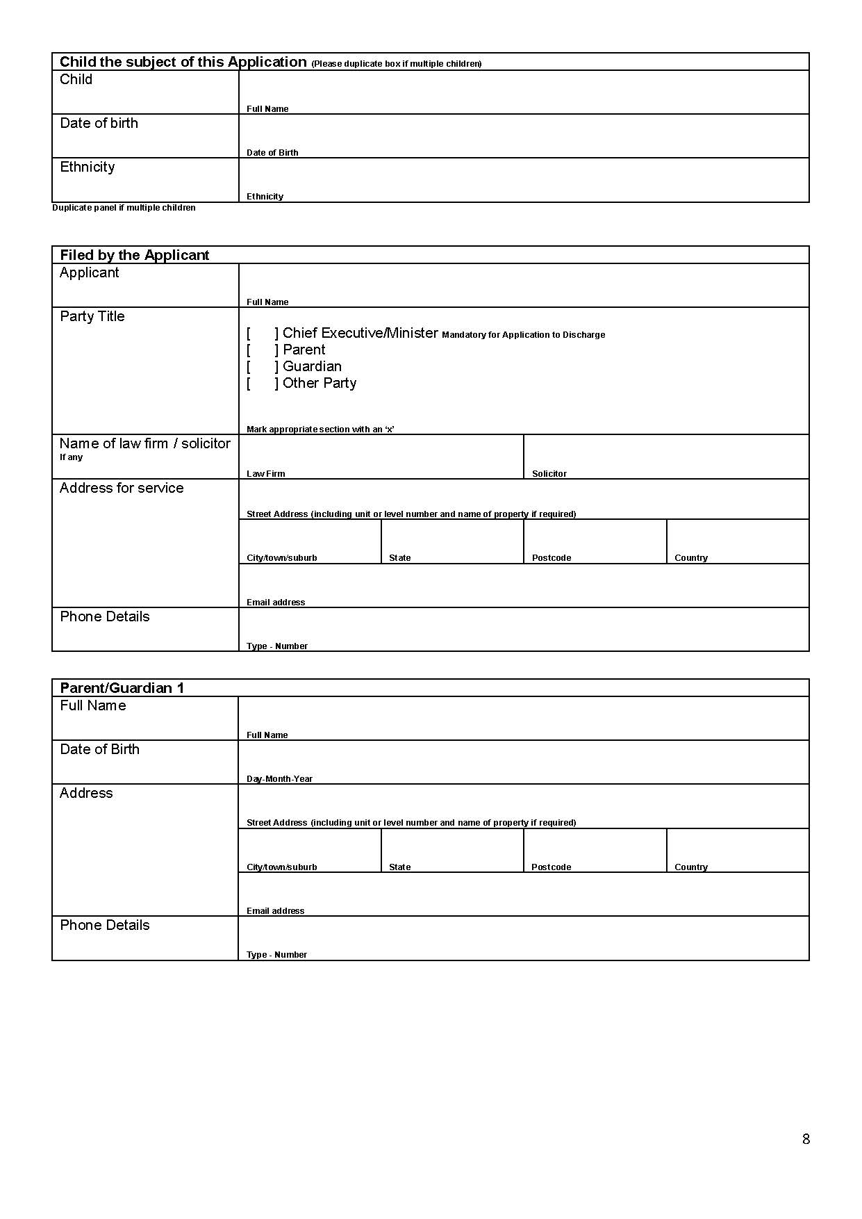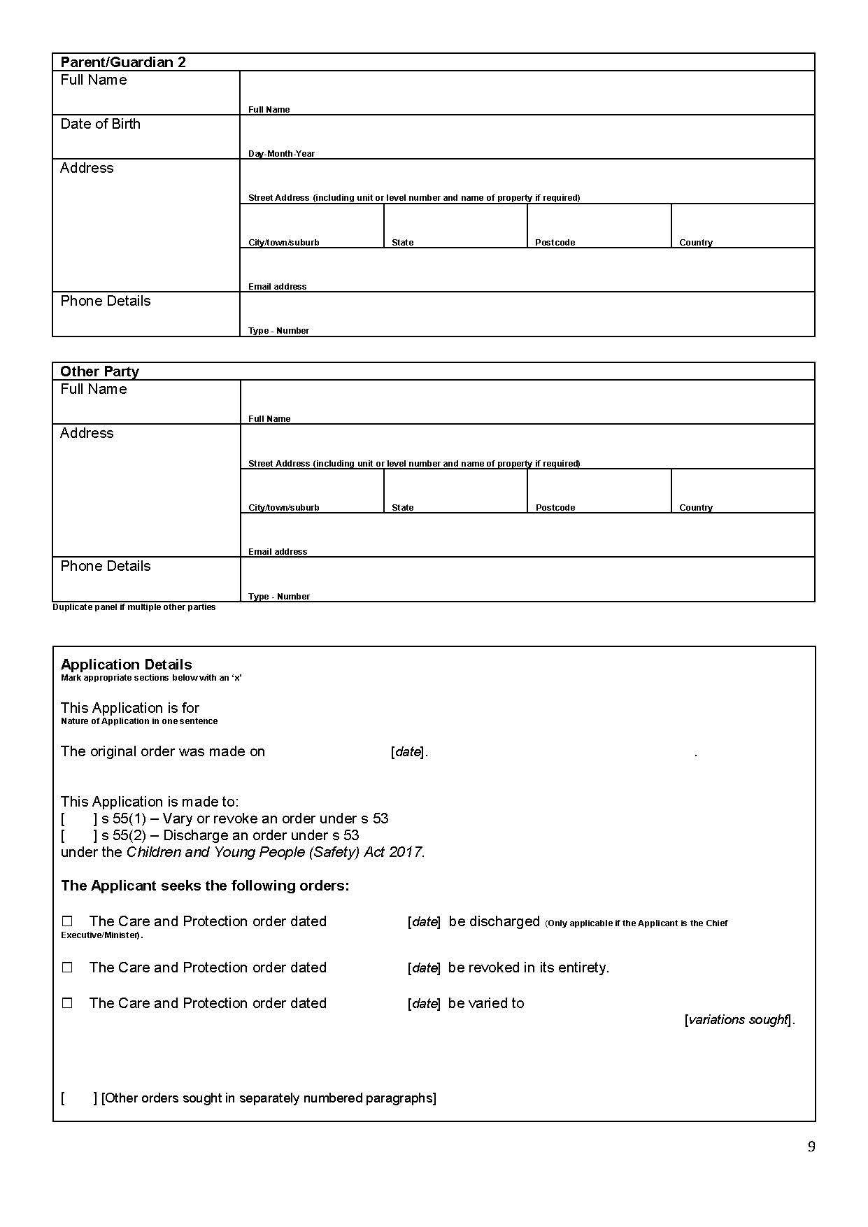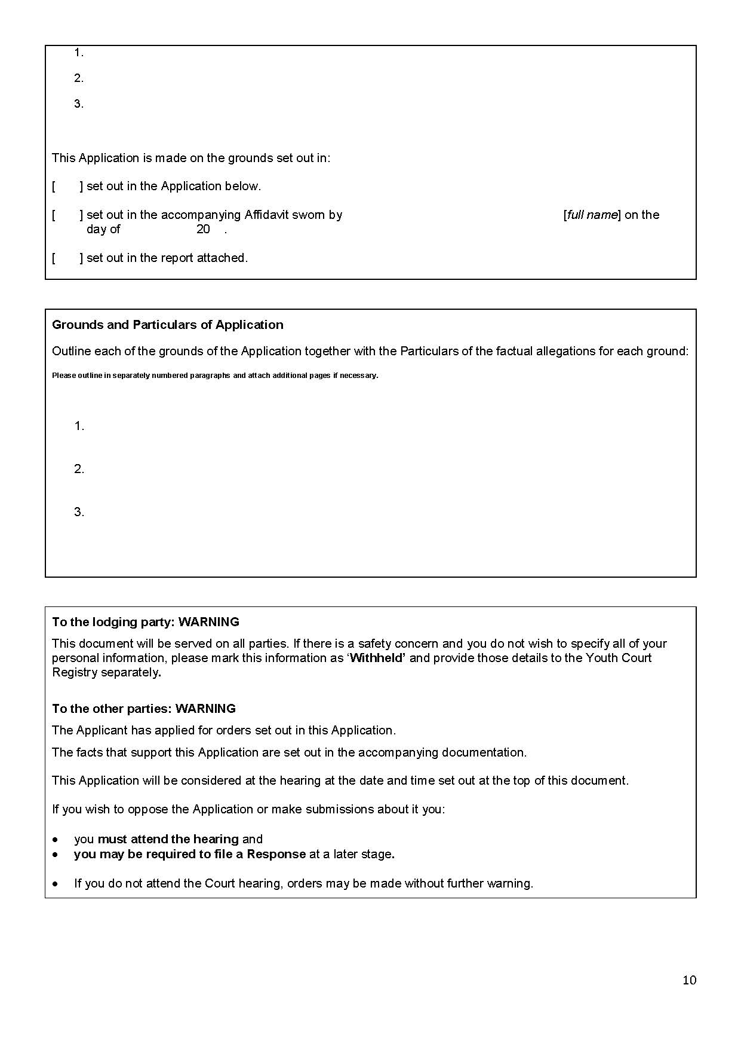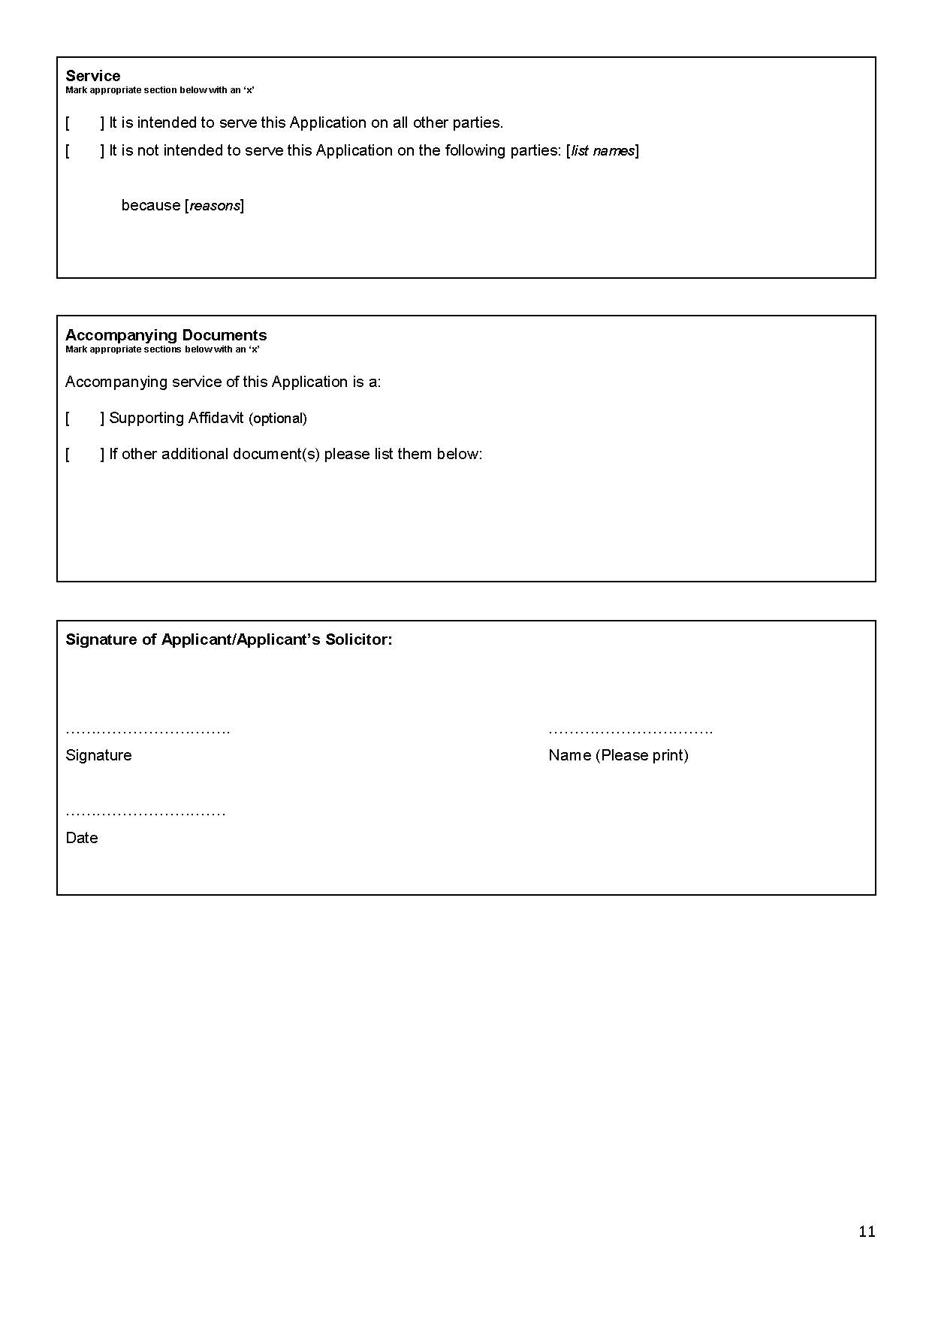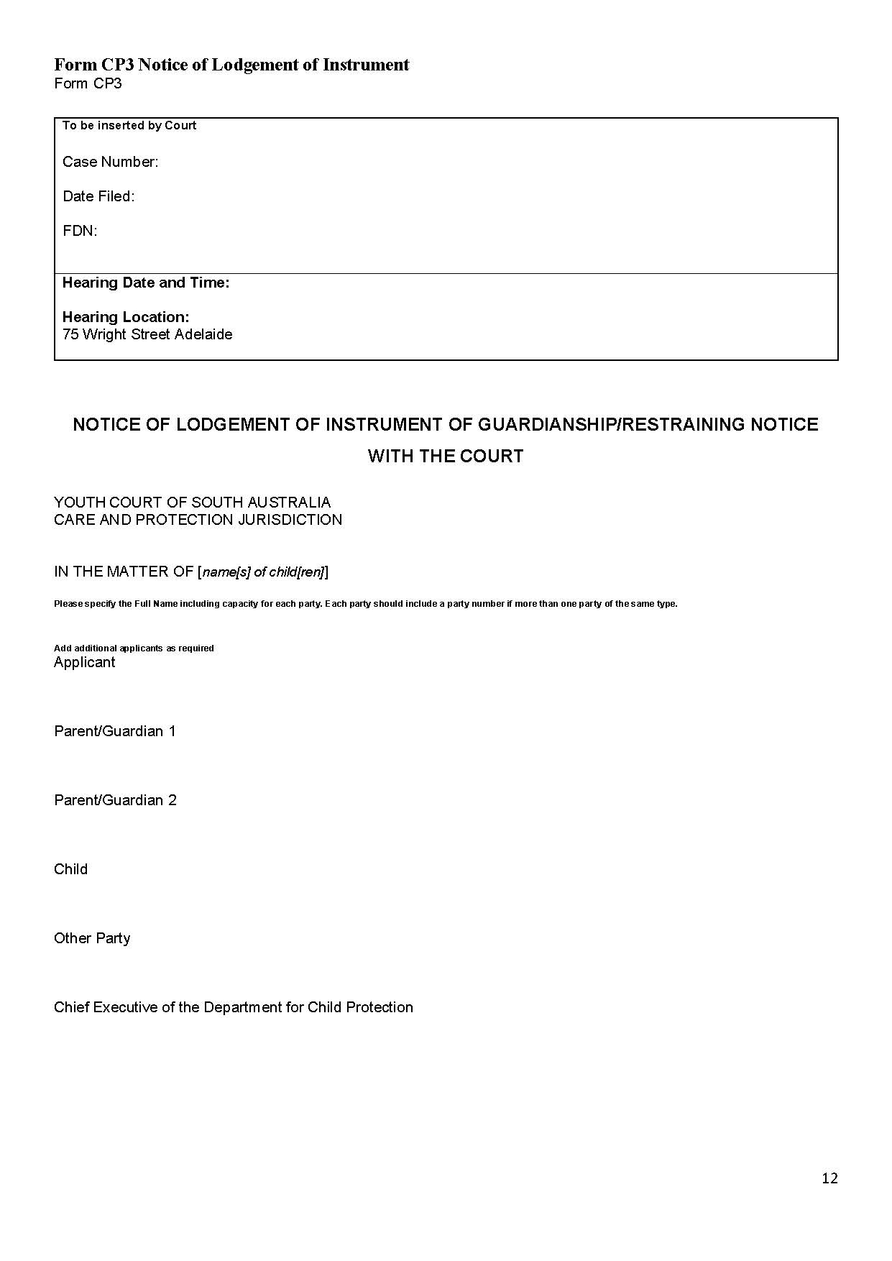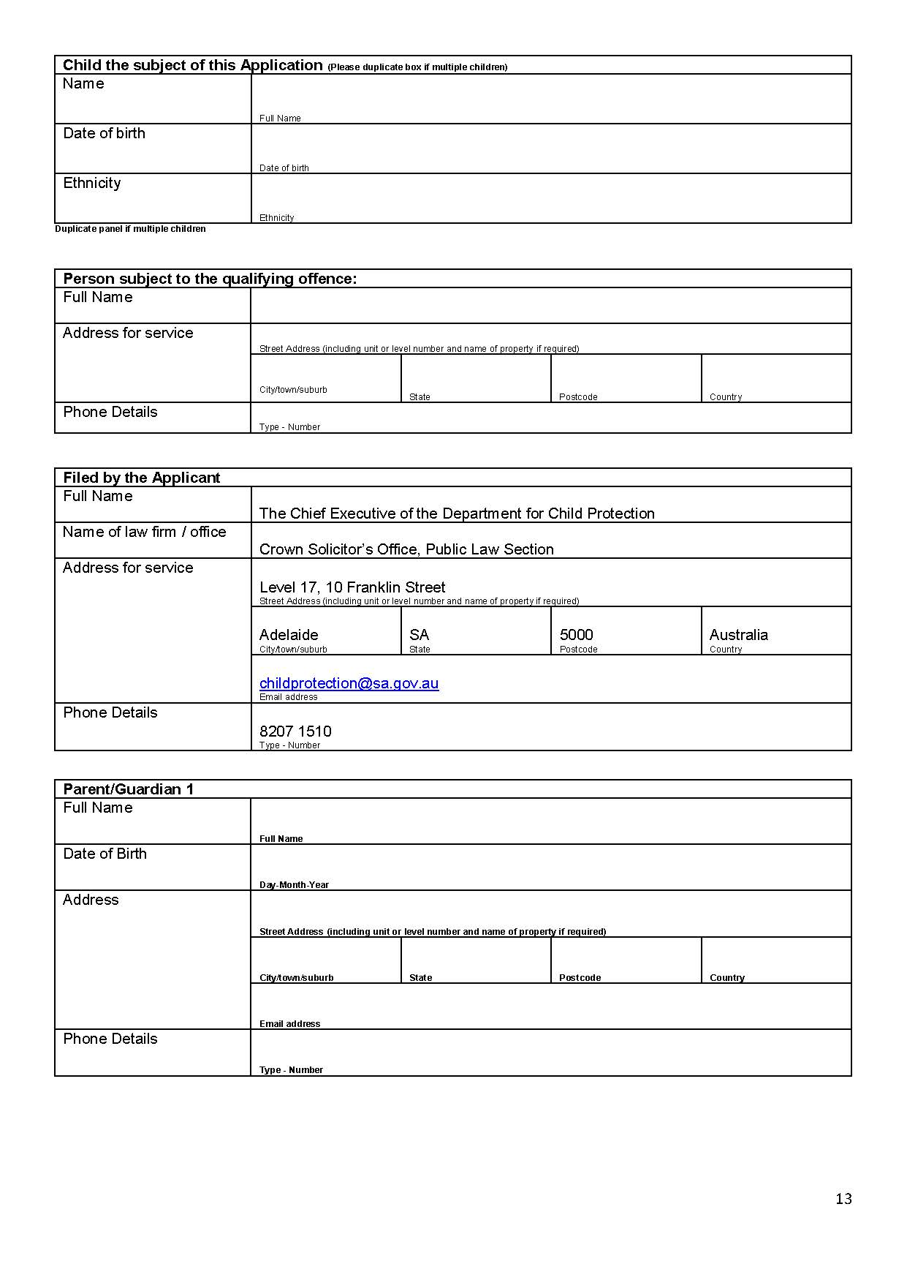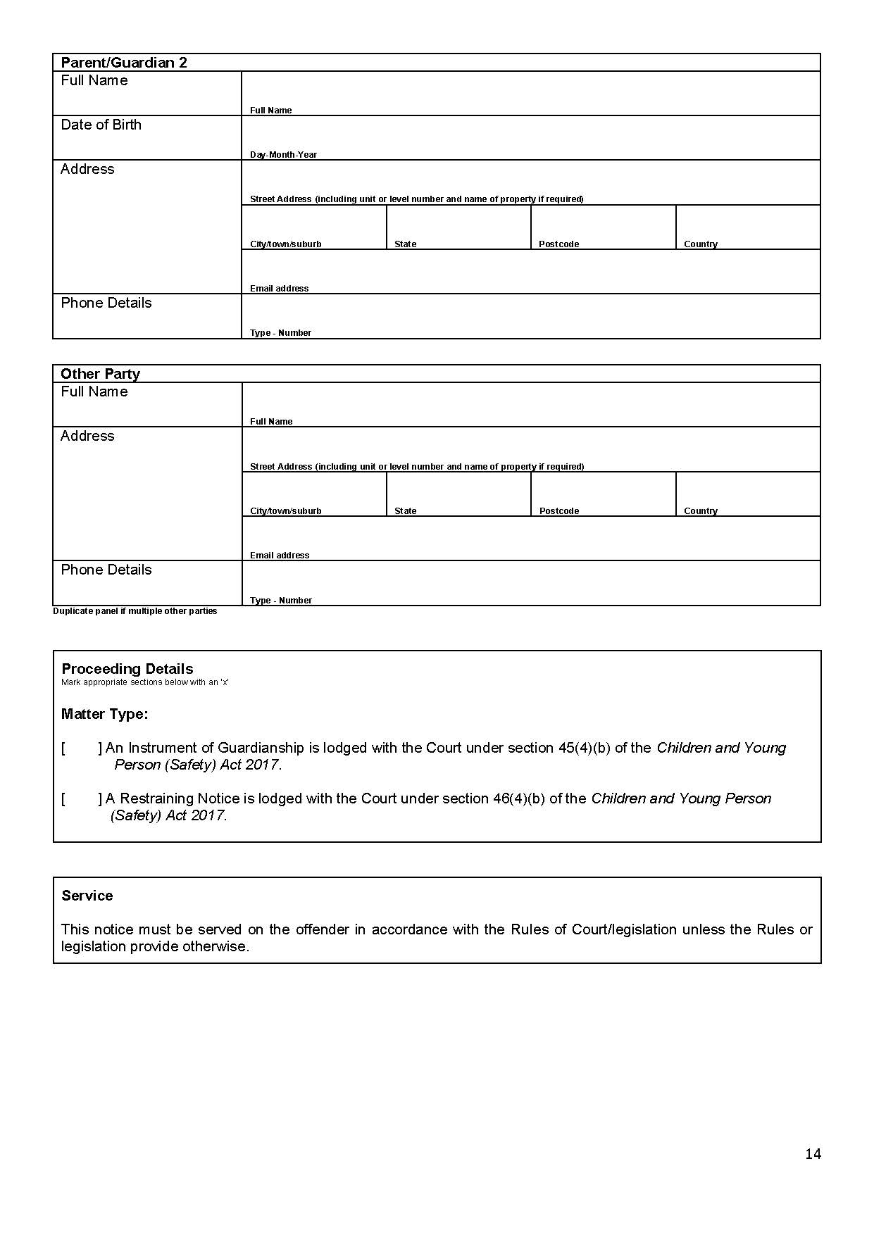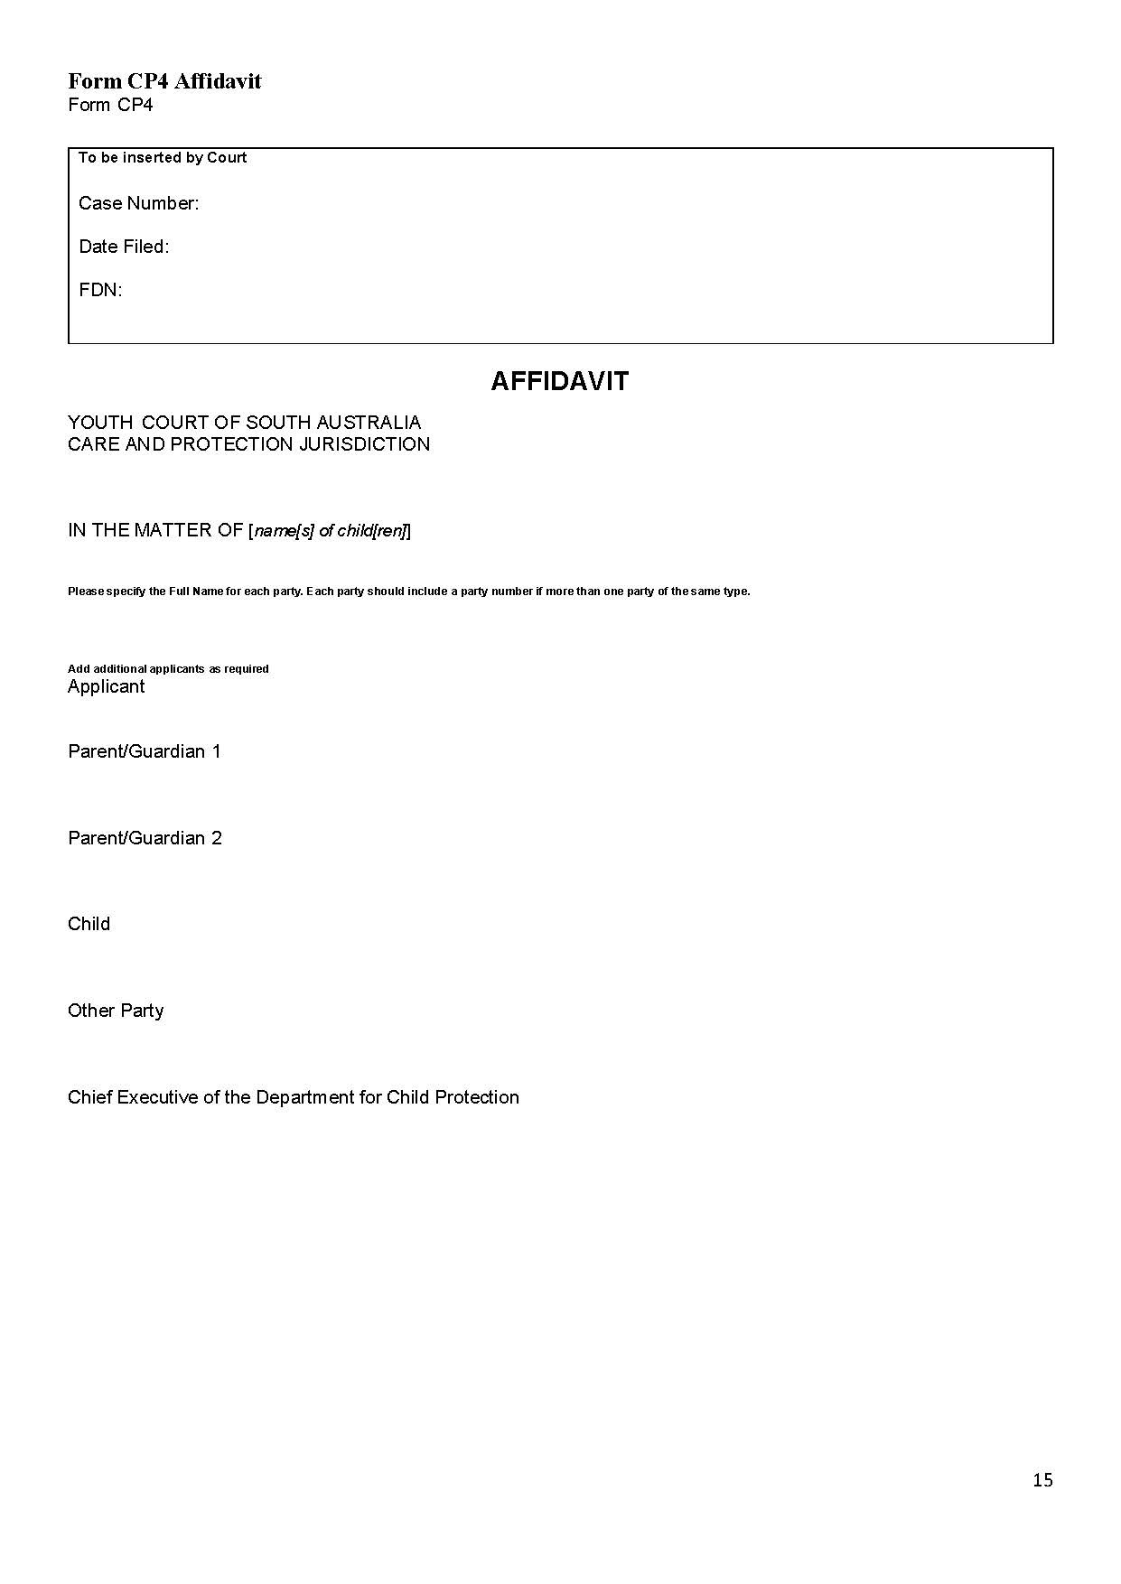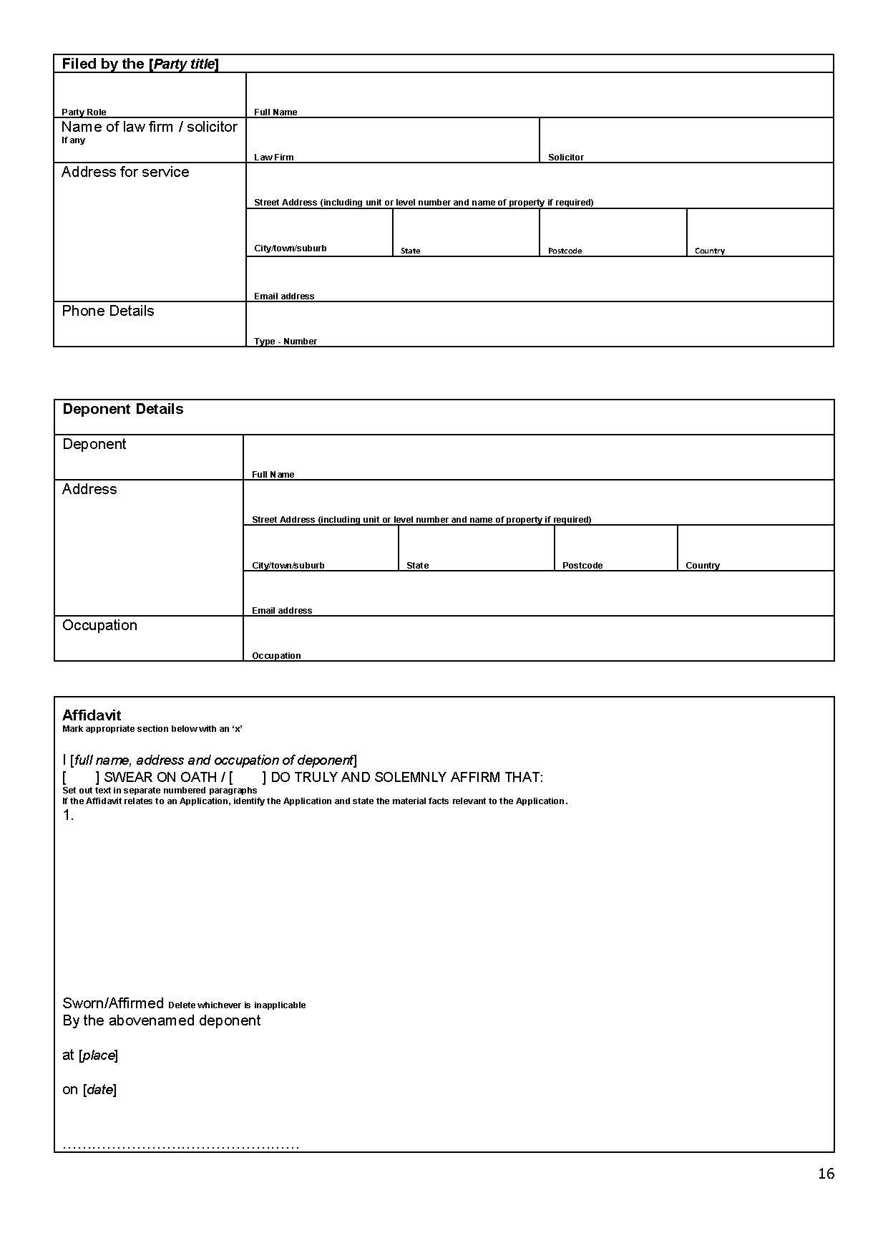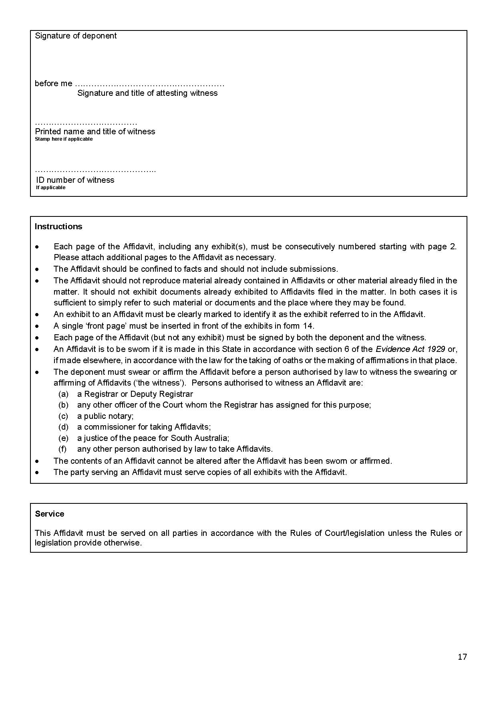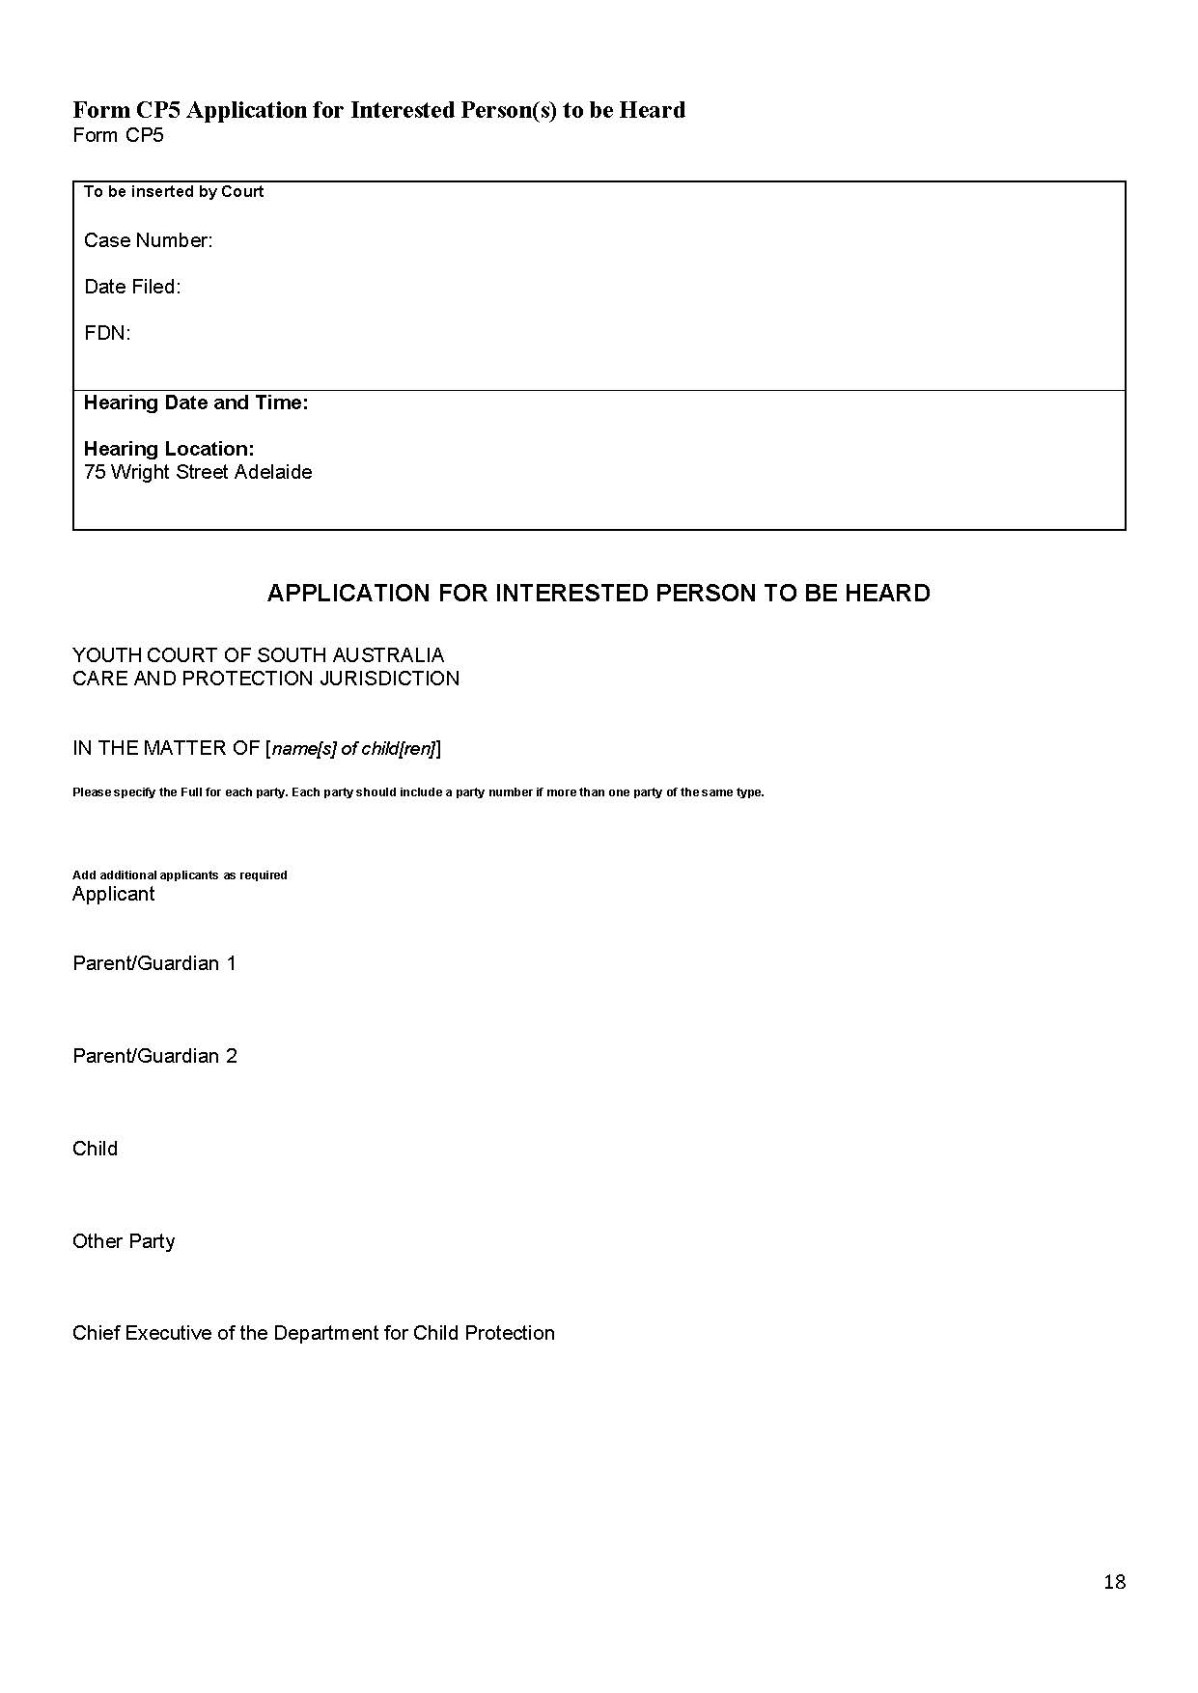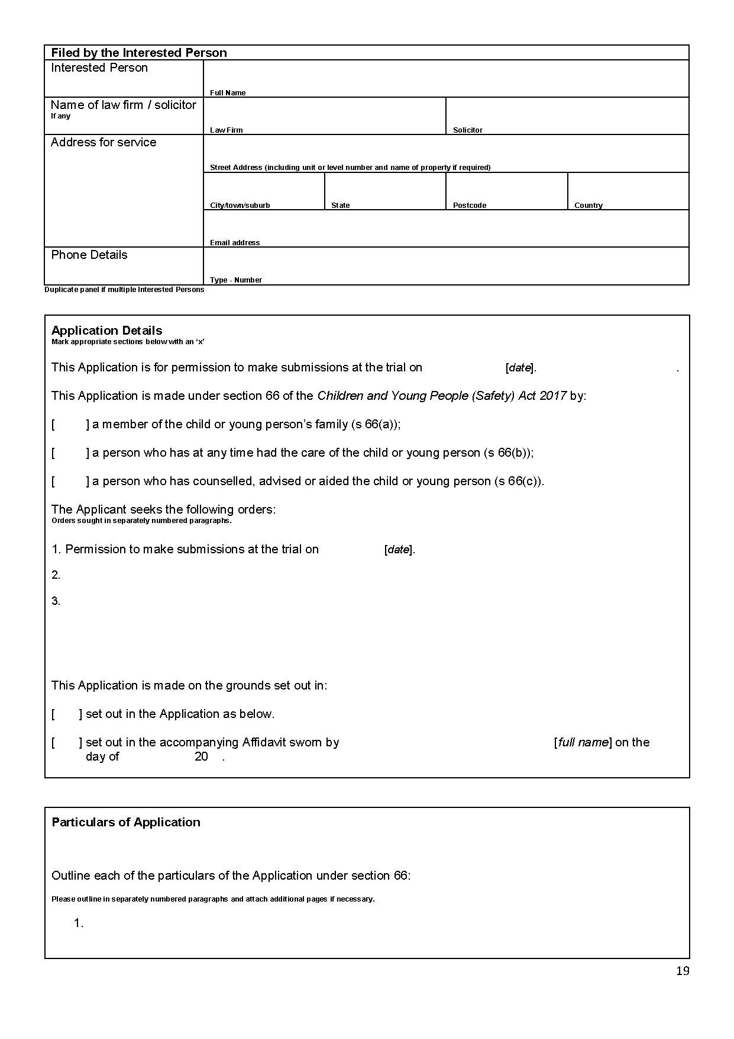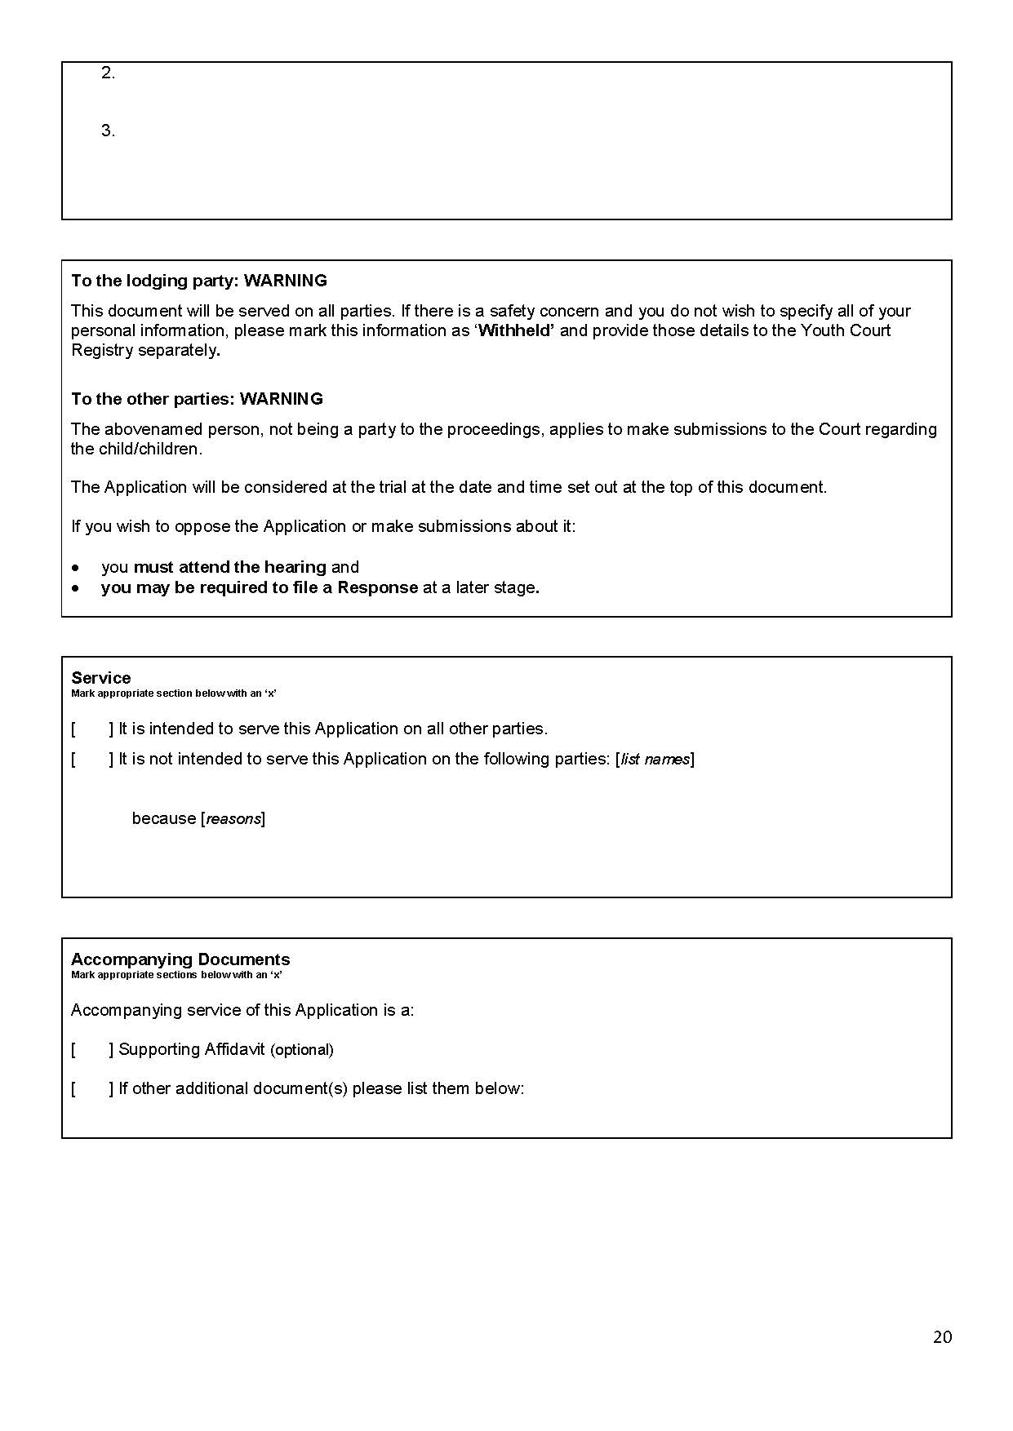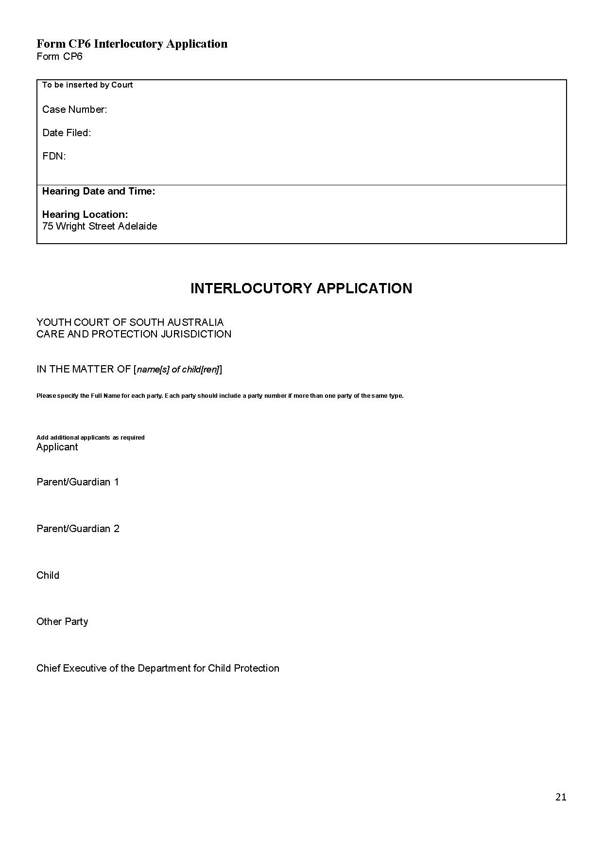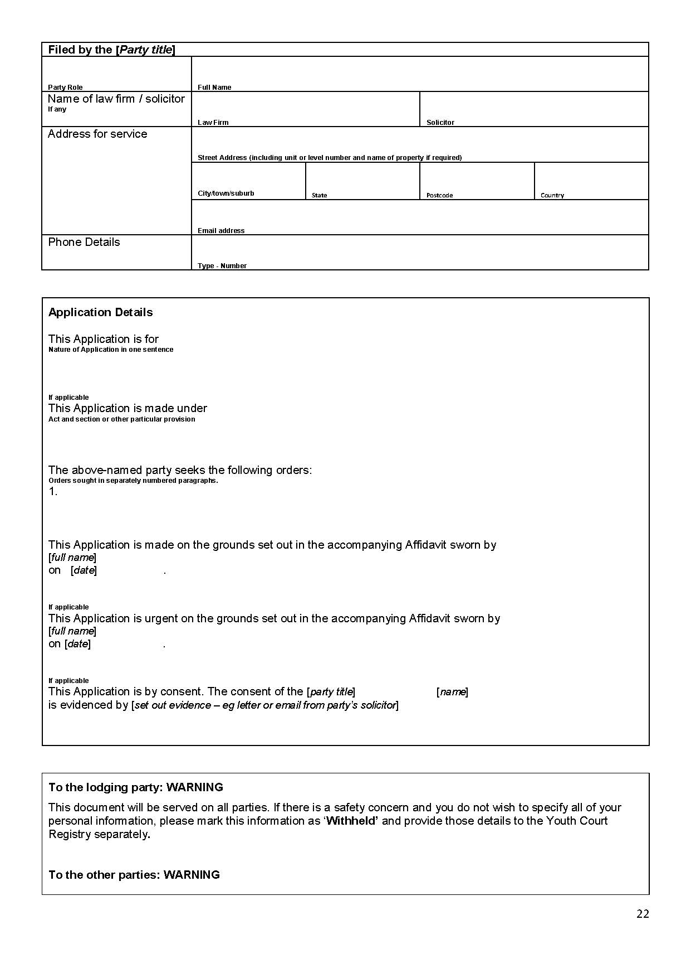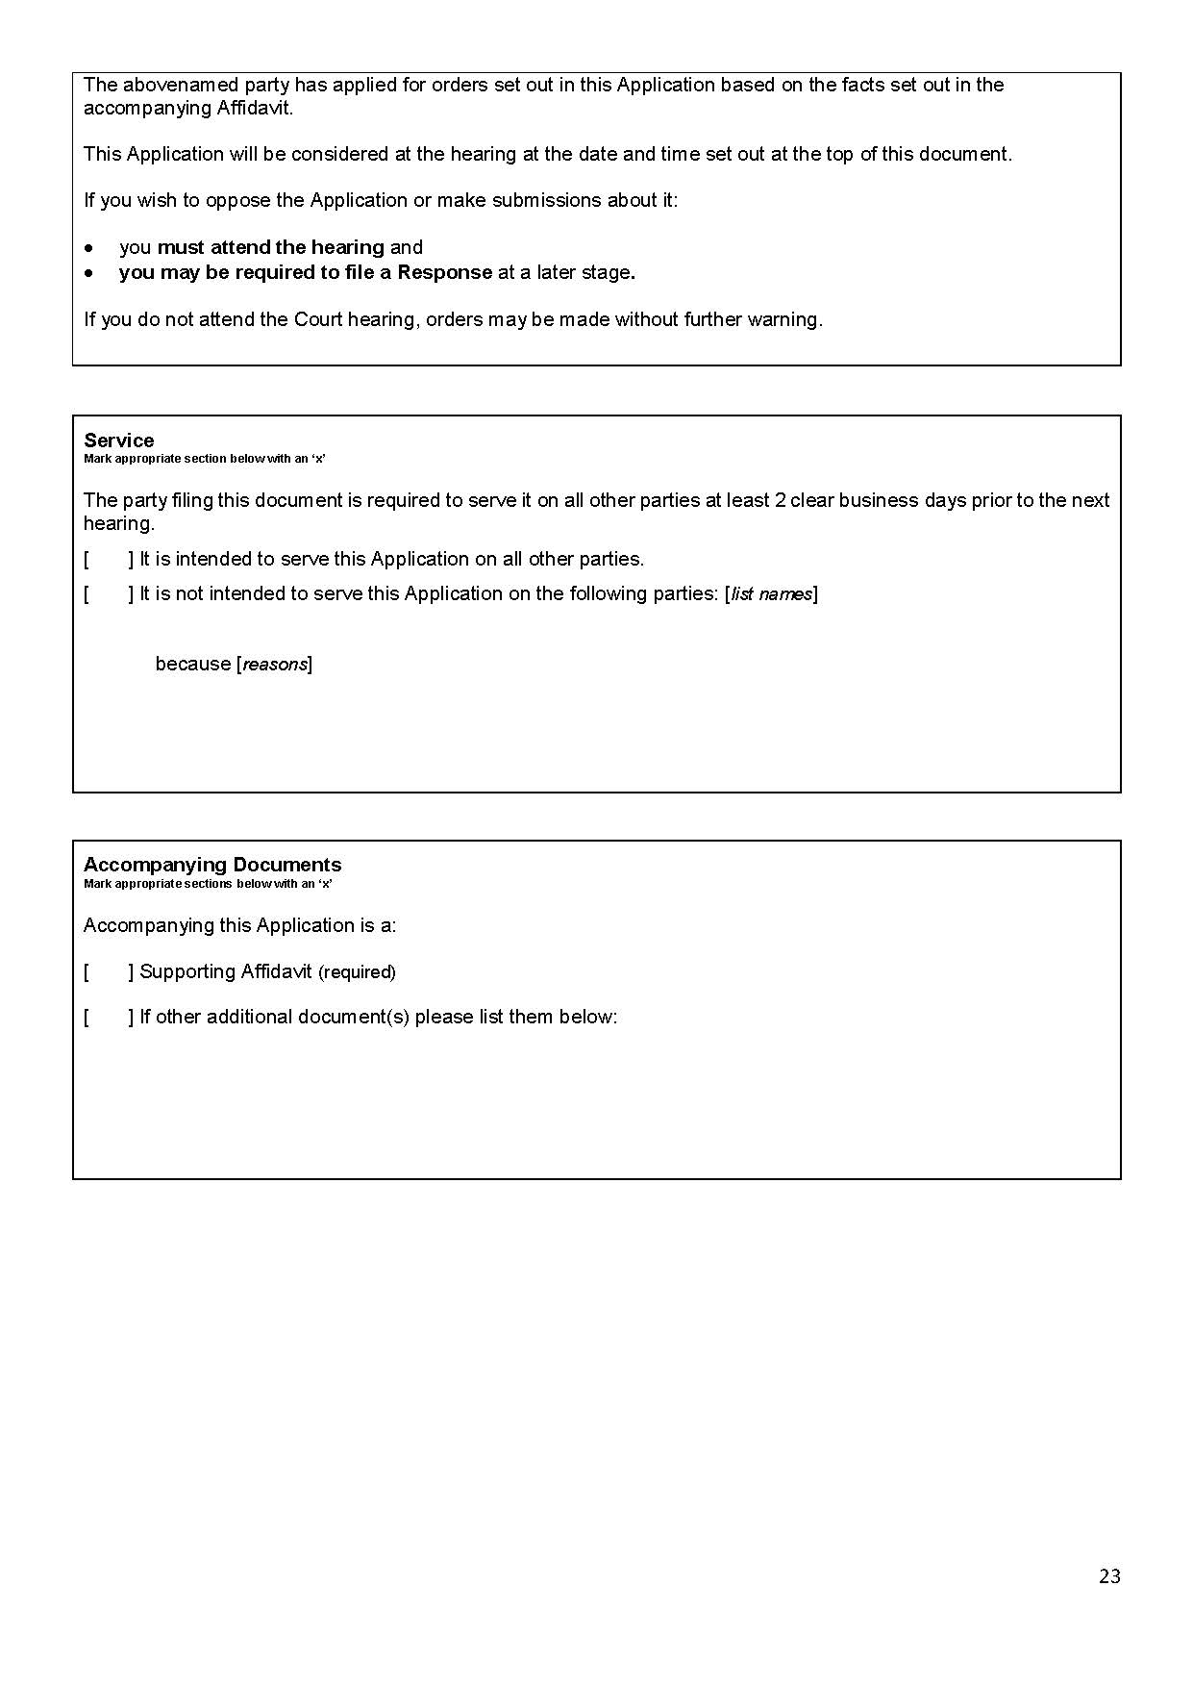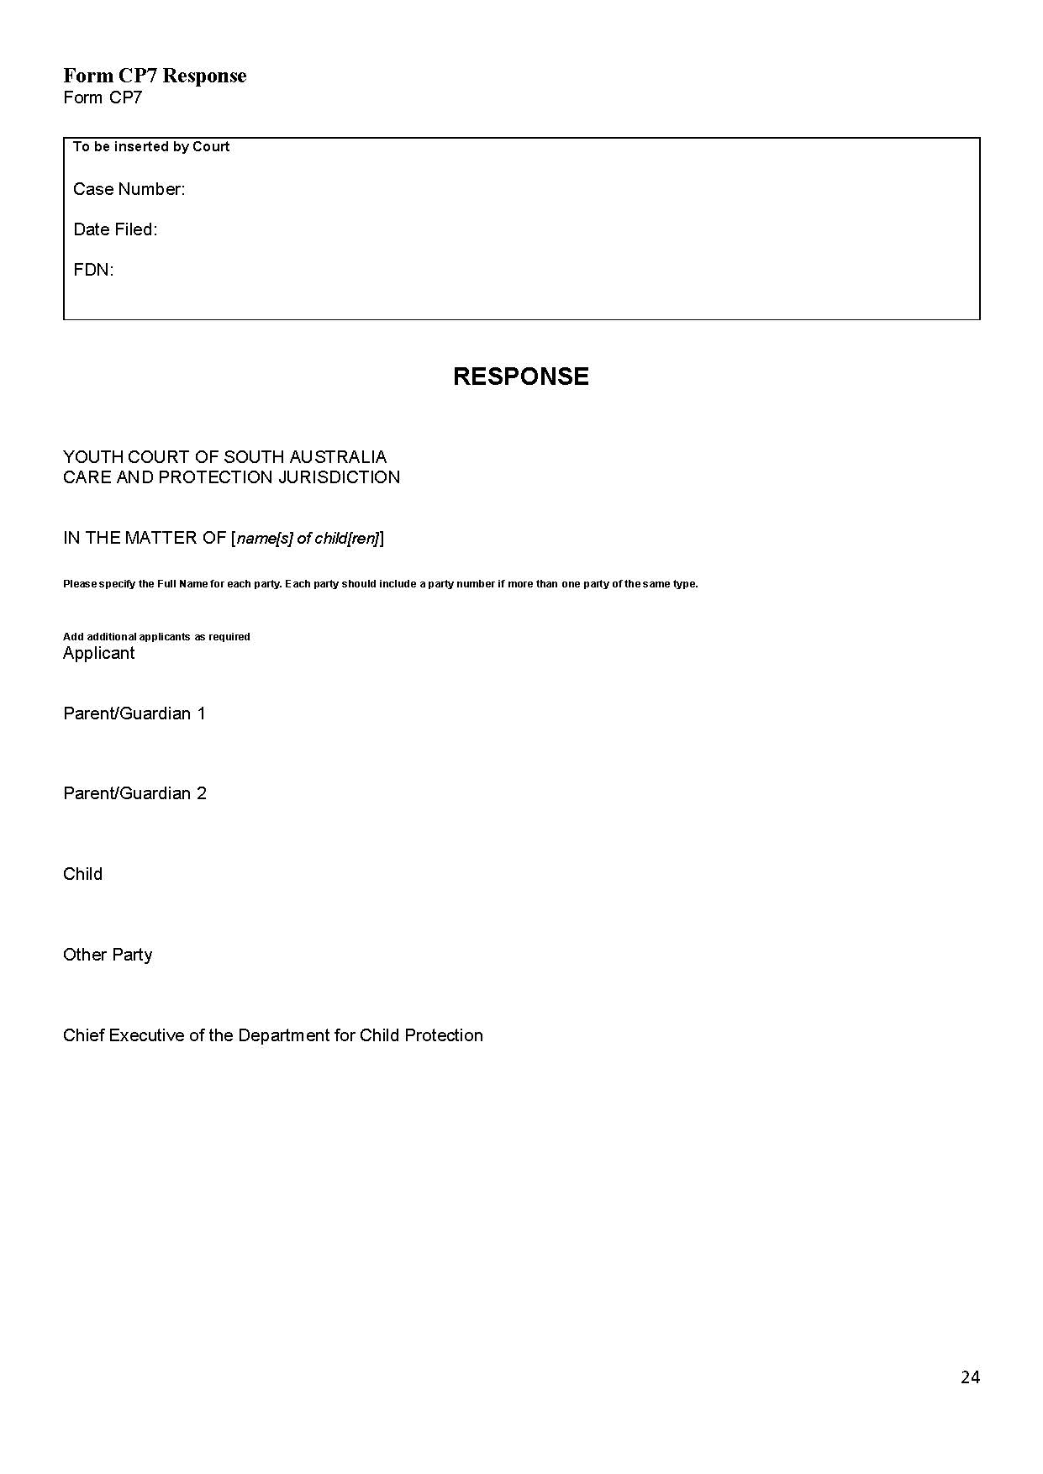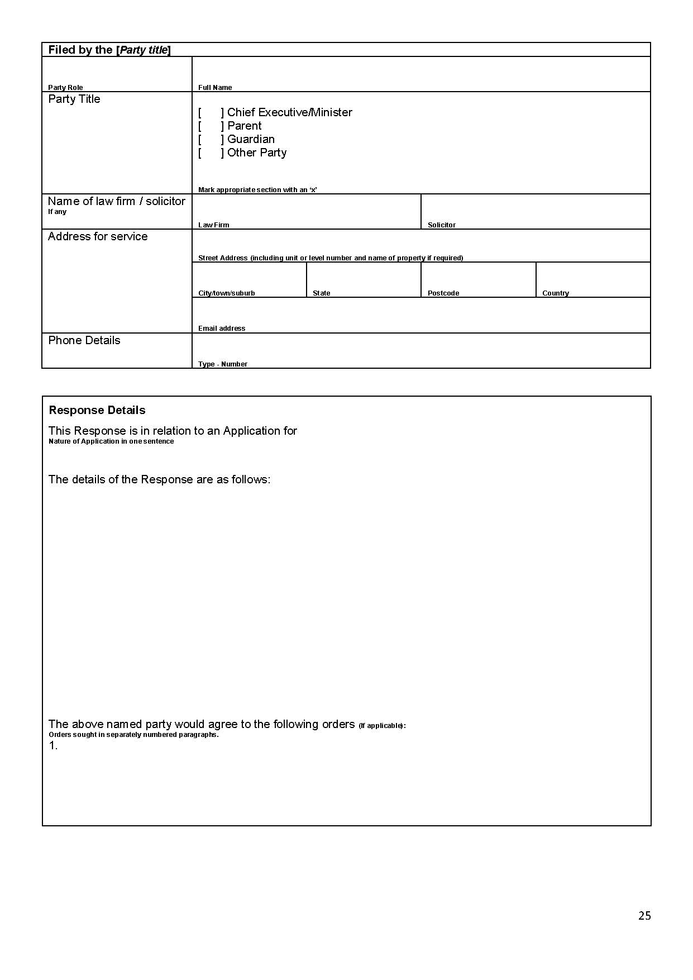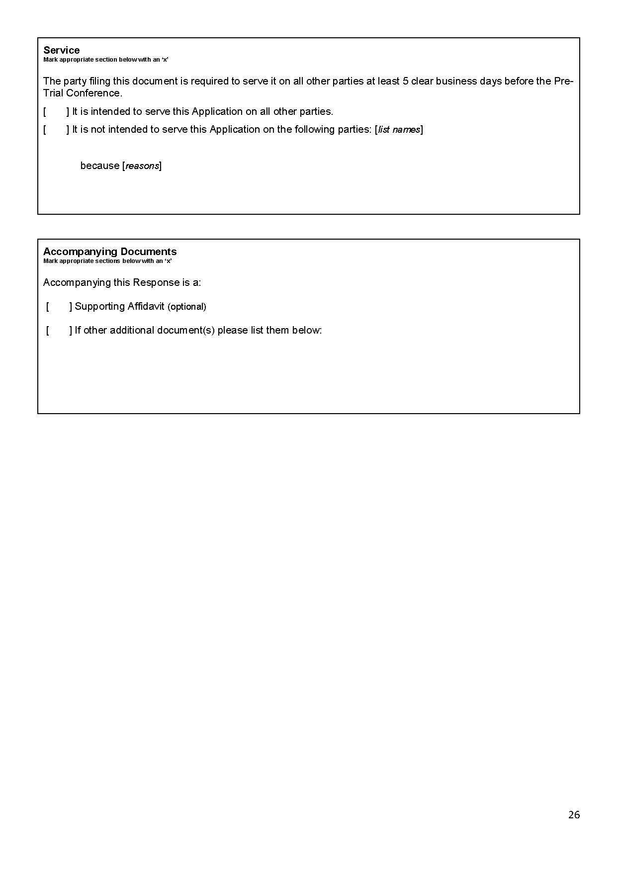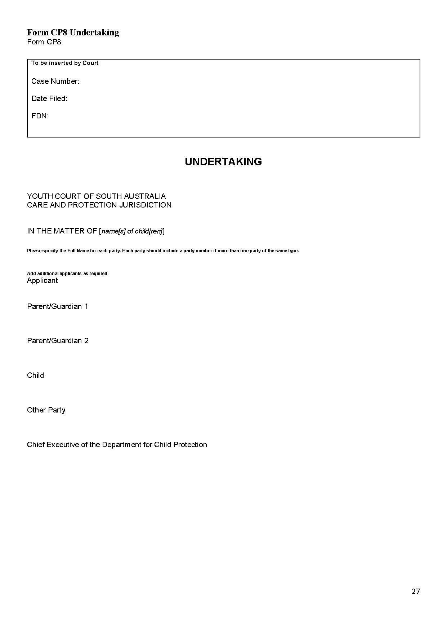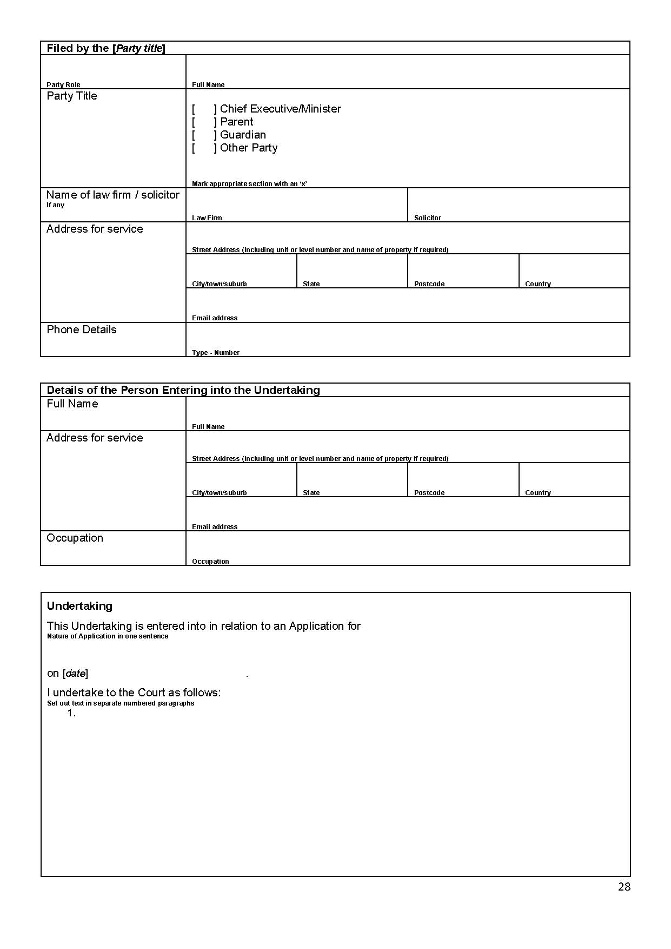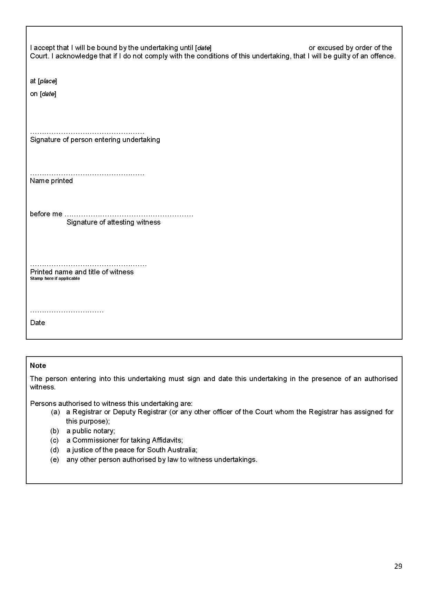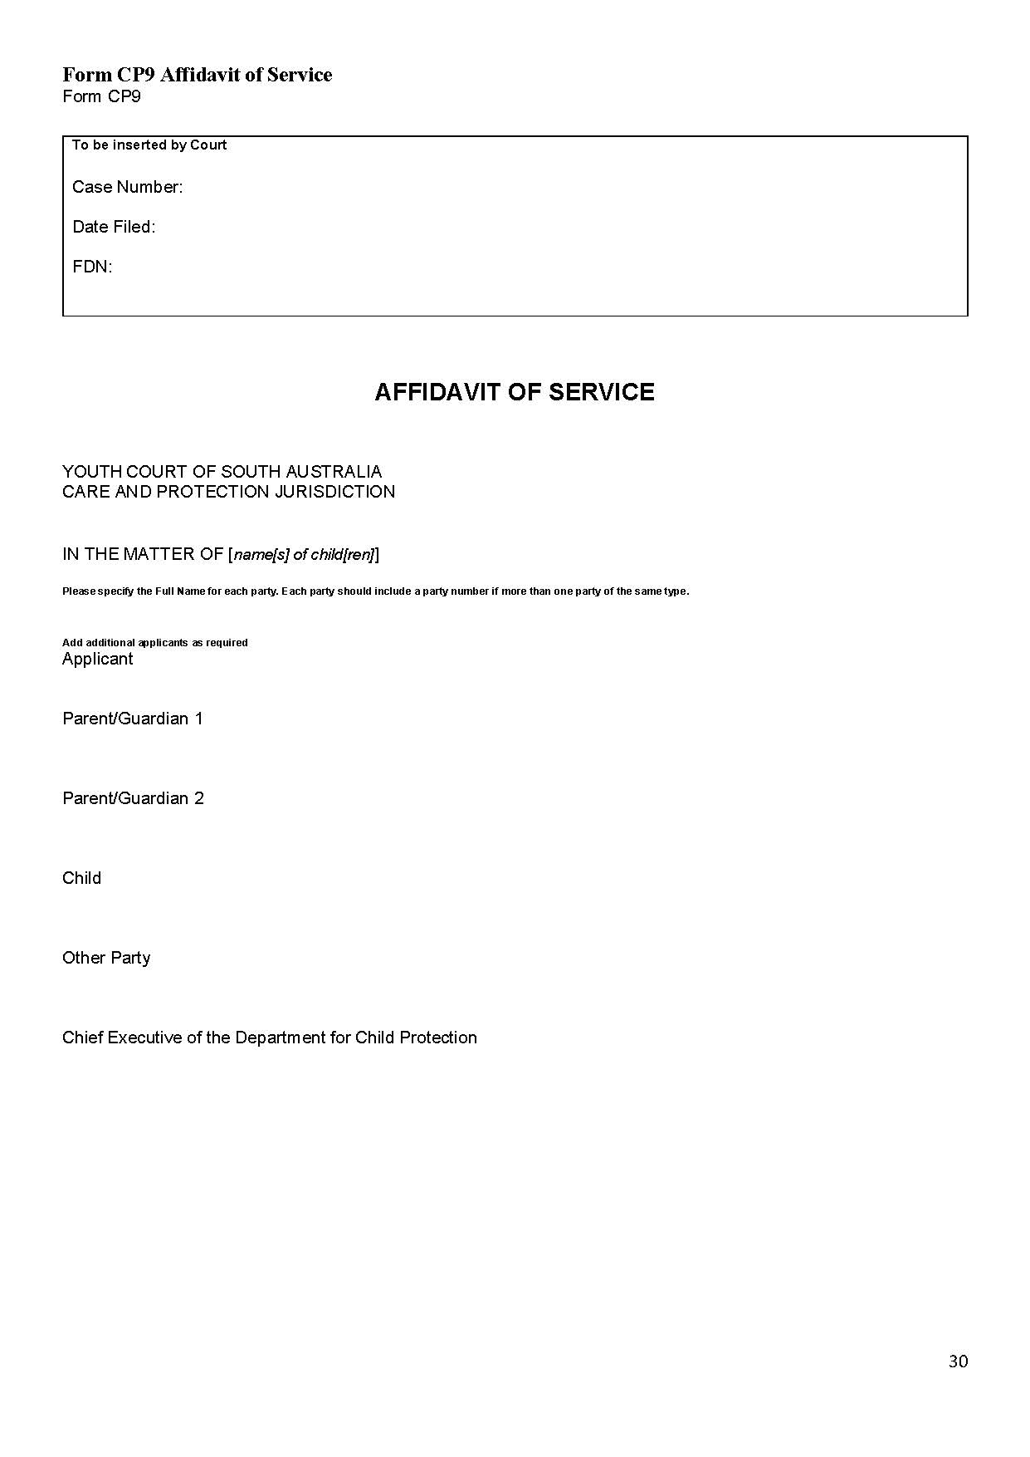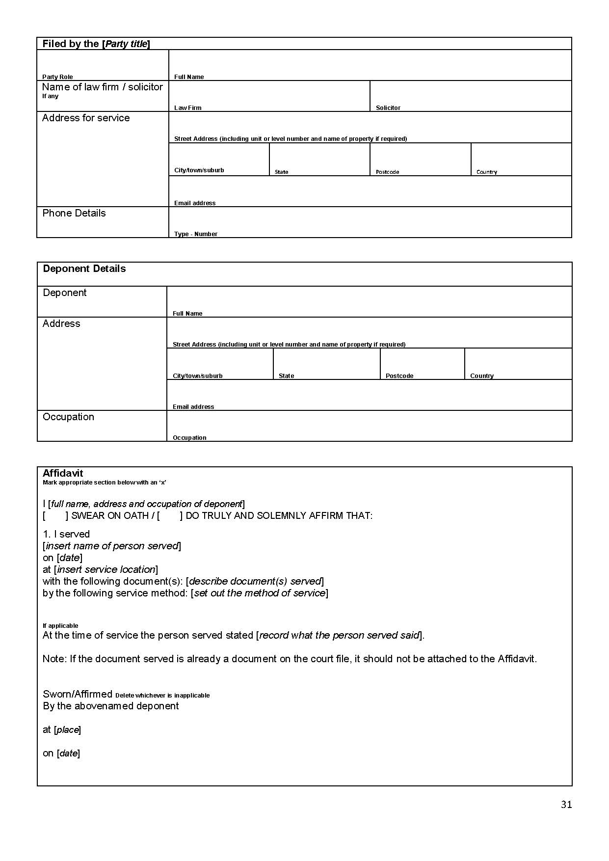
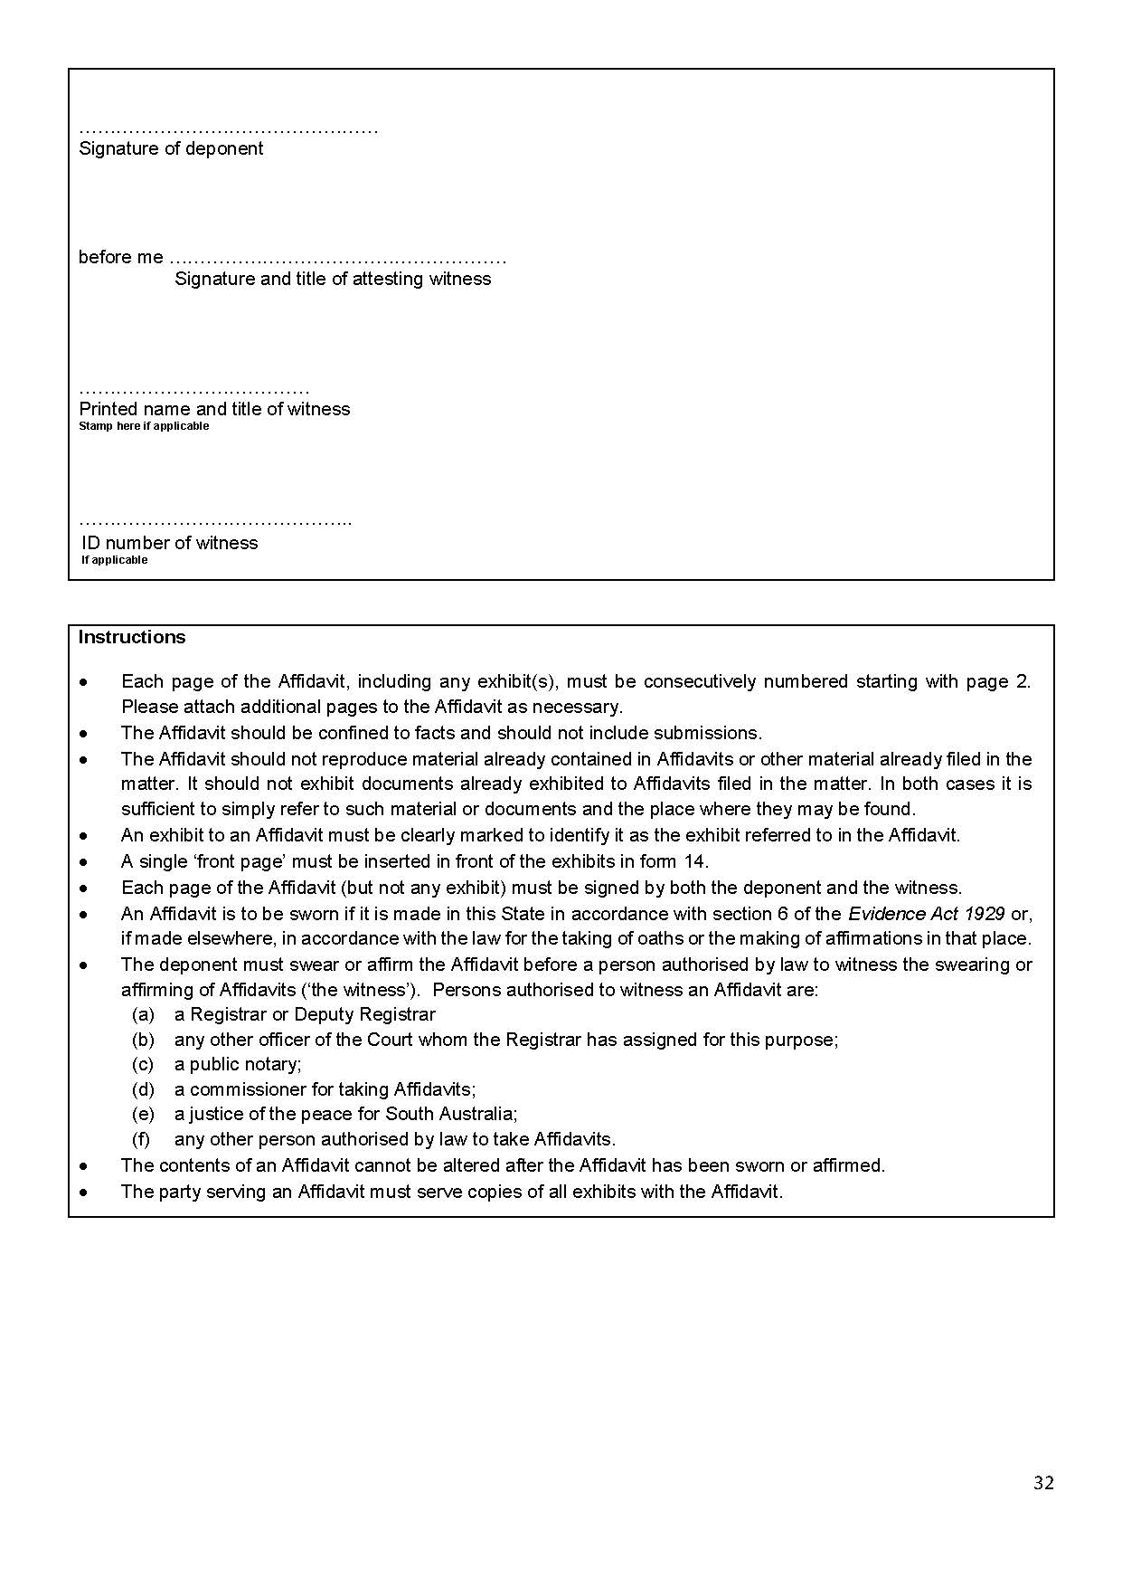Dated: 17 June 2020
Eldridge P.
Davis L.
White D.
Koehn O.

State Government Instruments

Casino Act 1997
Notice Under Section 3(1)
Definition of Gaming Areas
TAKE notice that pursuant to Section 3(1) of the Casino Act 1997, the “Gaming Areas” defined as being a gaming area or part of a gaming area within the casino premises will as from 1 July 2020 be re-defined by the Liquor and Gambling Commissioner.
The following plans indicate such parts of the casino premises (previously defined by his Excellency the Governor in Executive Council and depicted by a purple line for information purposes only) which are to be regarded as being a gaming area, or part of a gaming area (previously defined and depicted by an orange line), and premium gaming area that is set aside for premium customers and depicted by a light blue line which shall only be accessible to other customers in accordance with Clause 8.7 of the Adelaide Casino Approved Licensing Agreement.
Dated: 23 June 2020
Dini Soulio
Liquor and Gambling Commissioner

Schedule 1
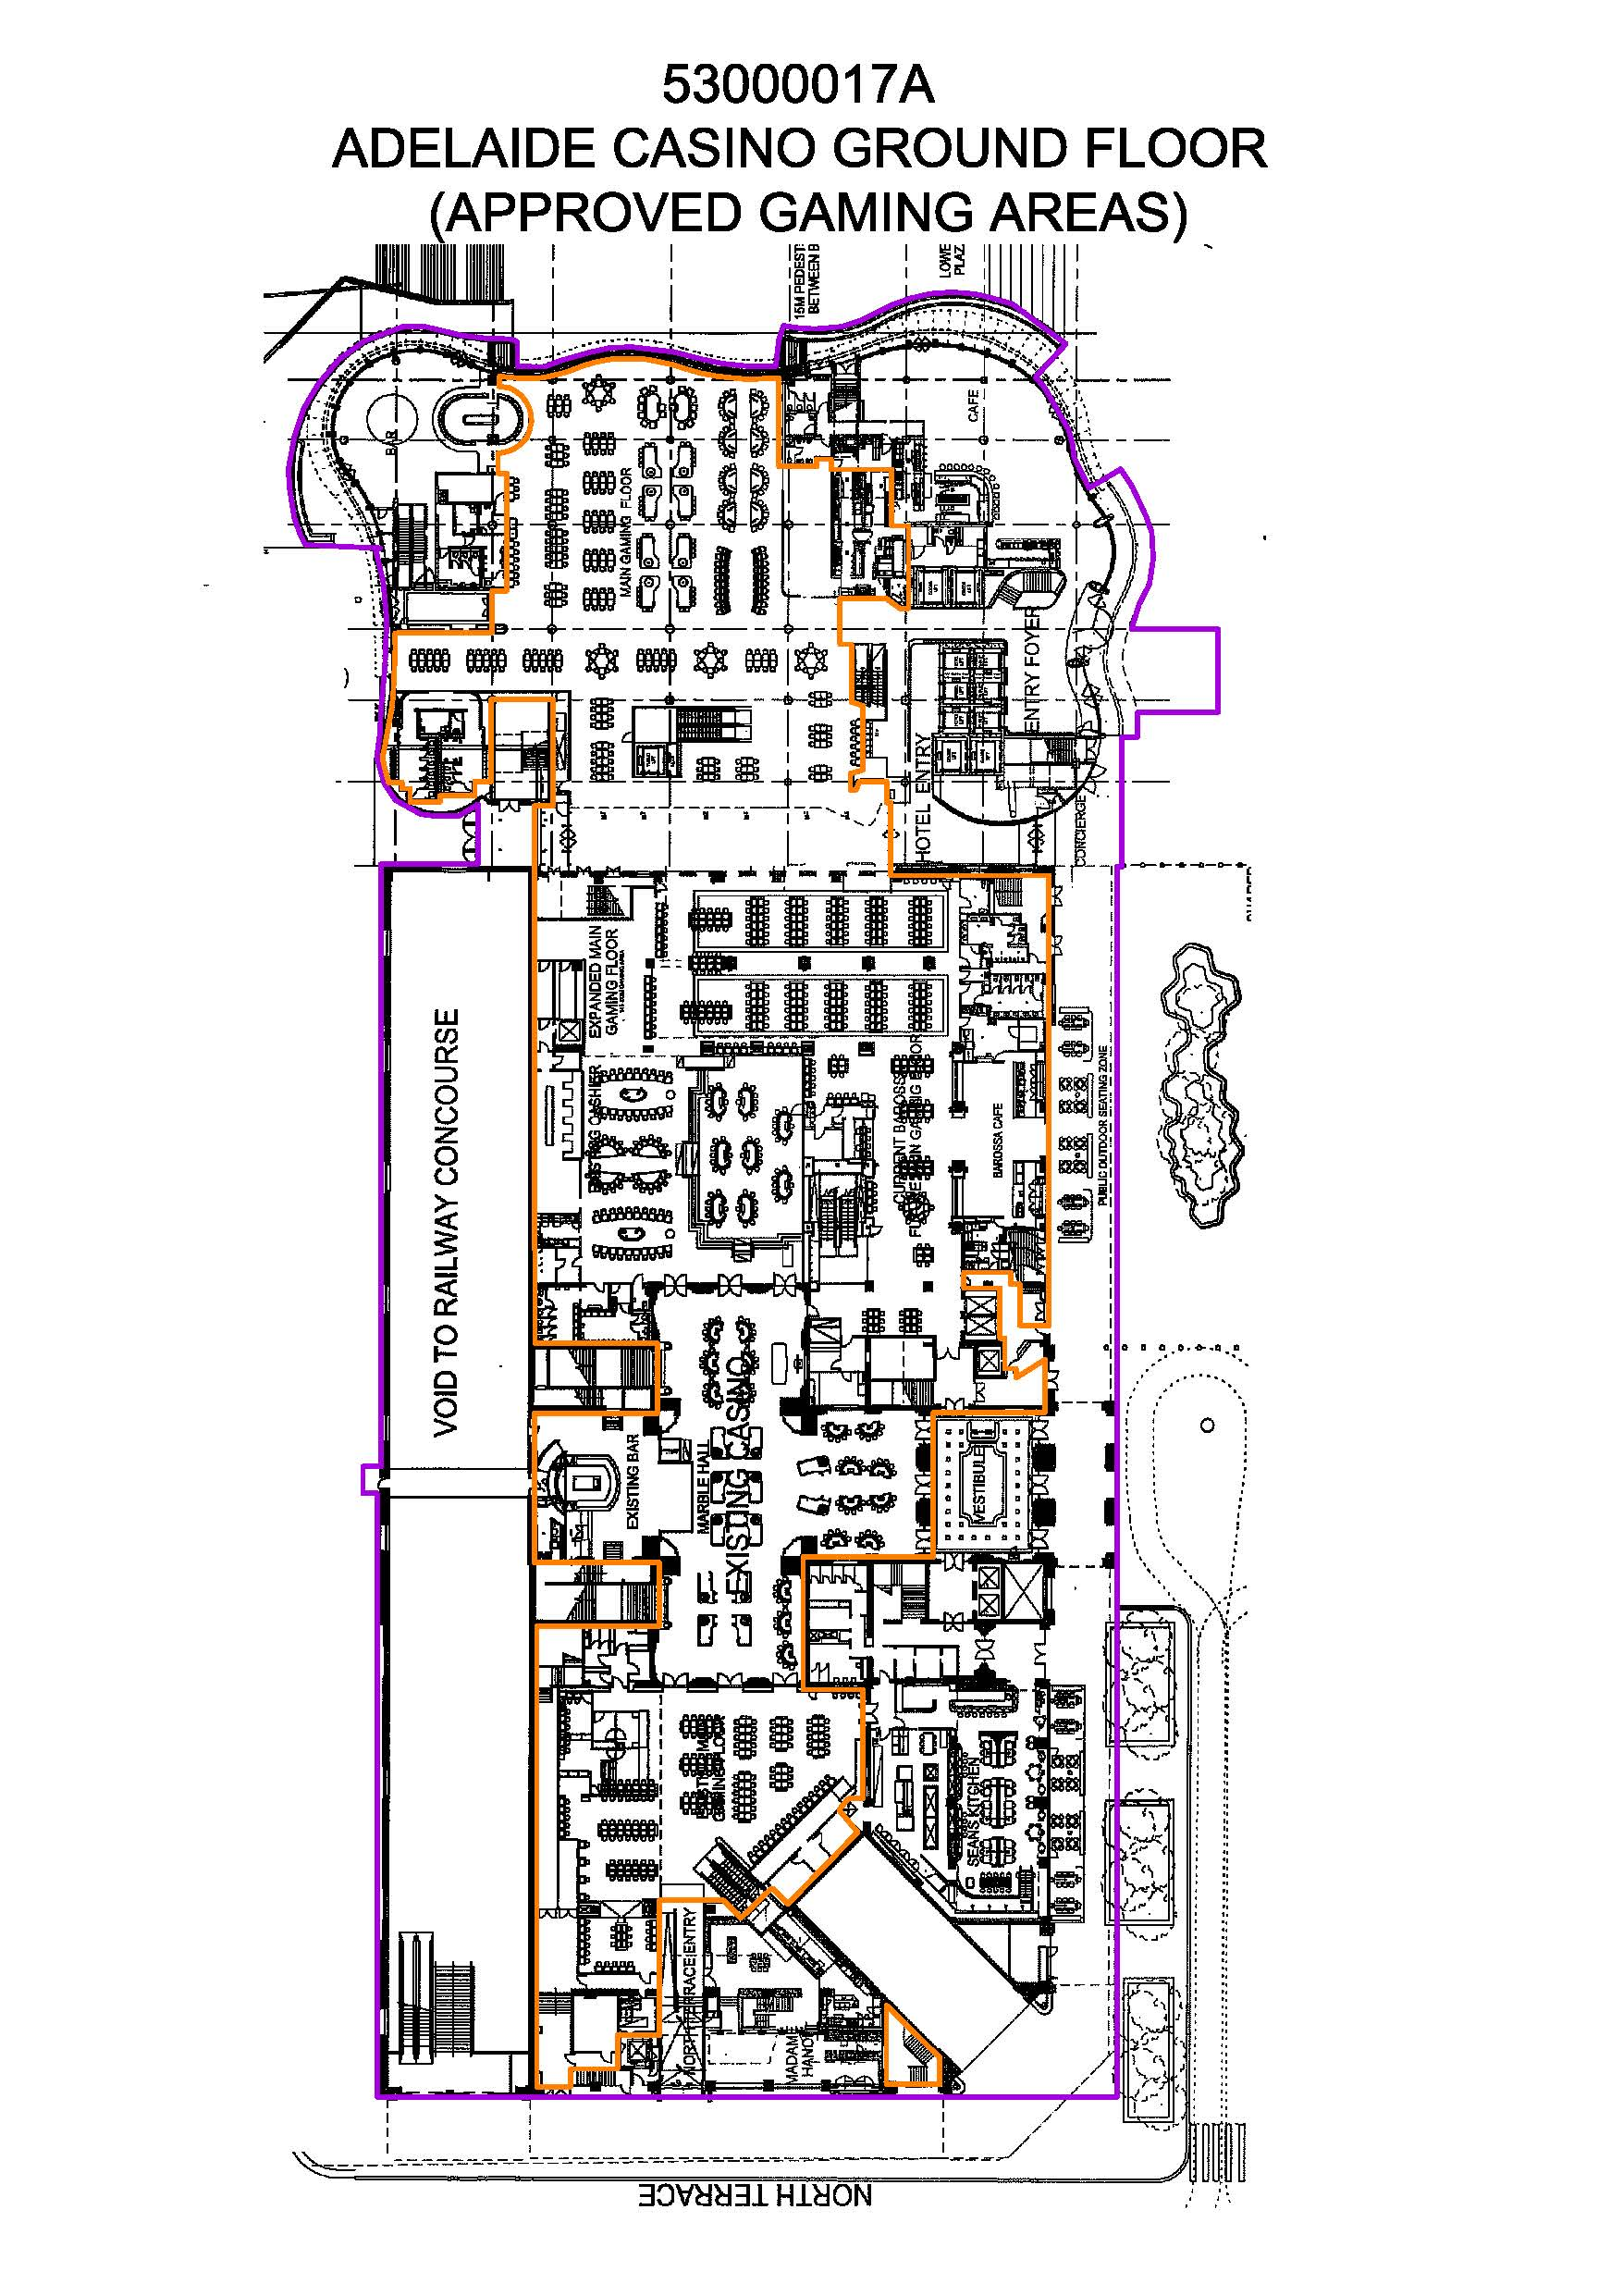

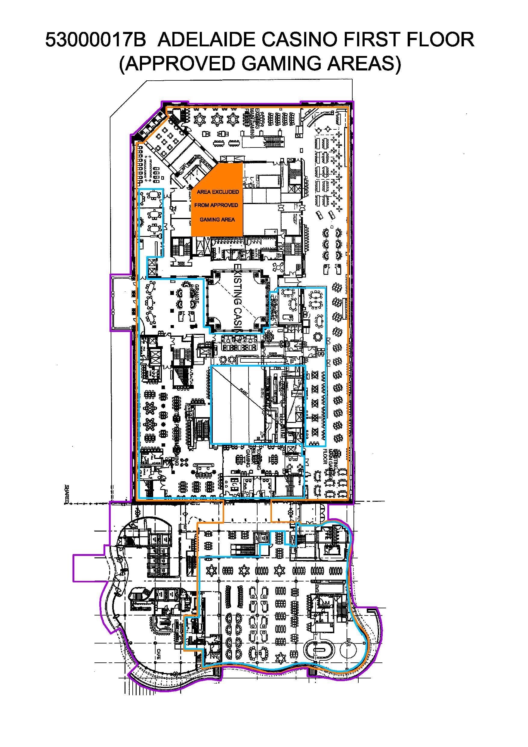

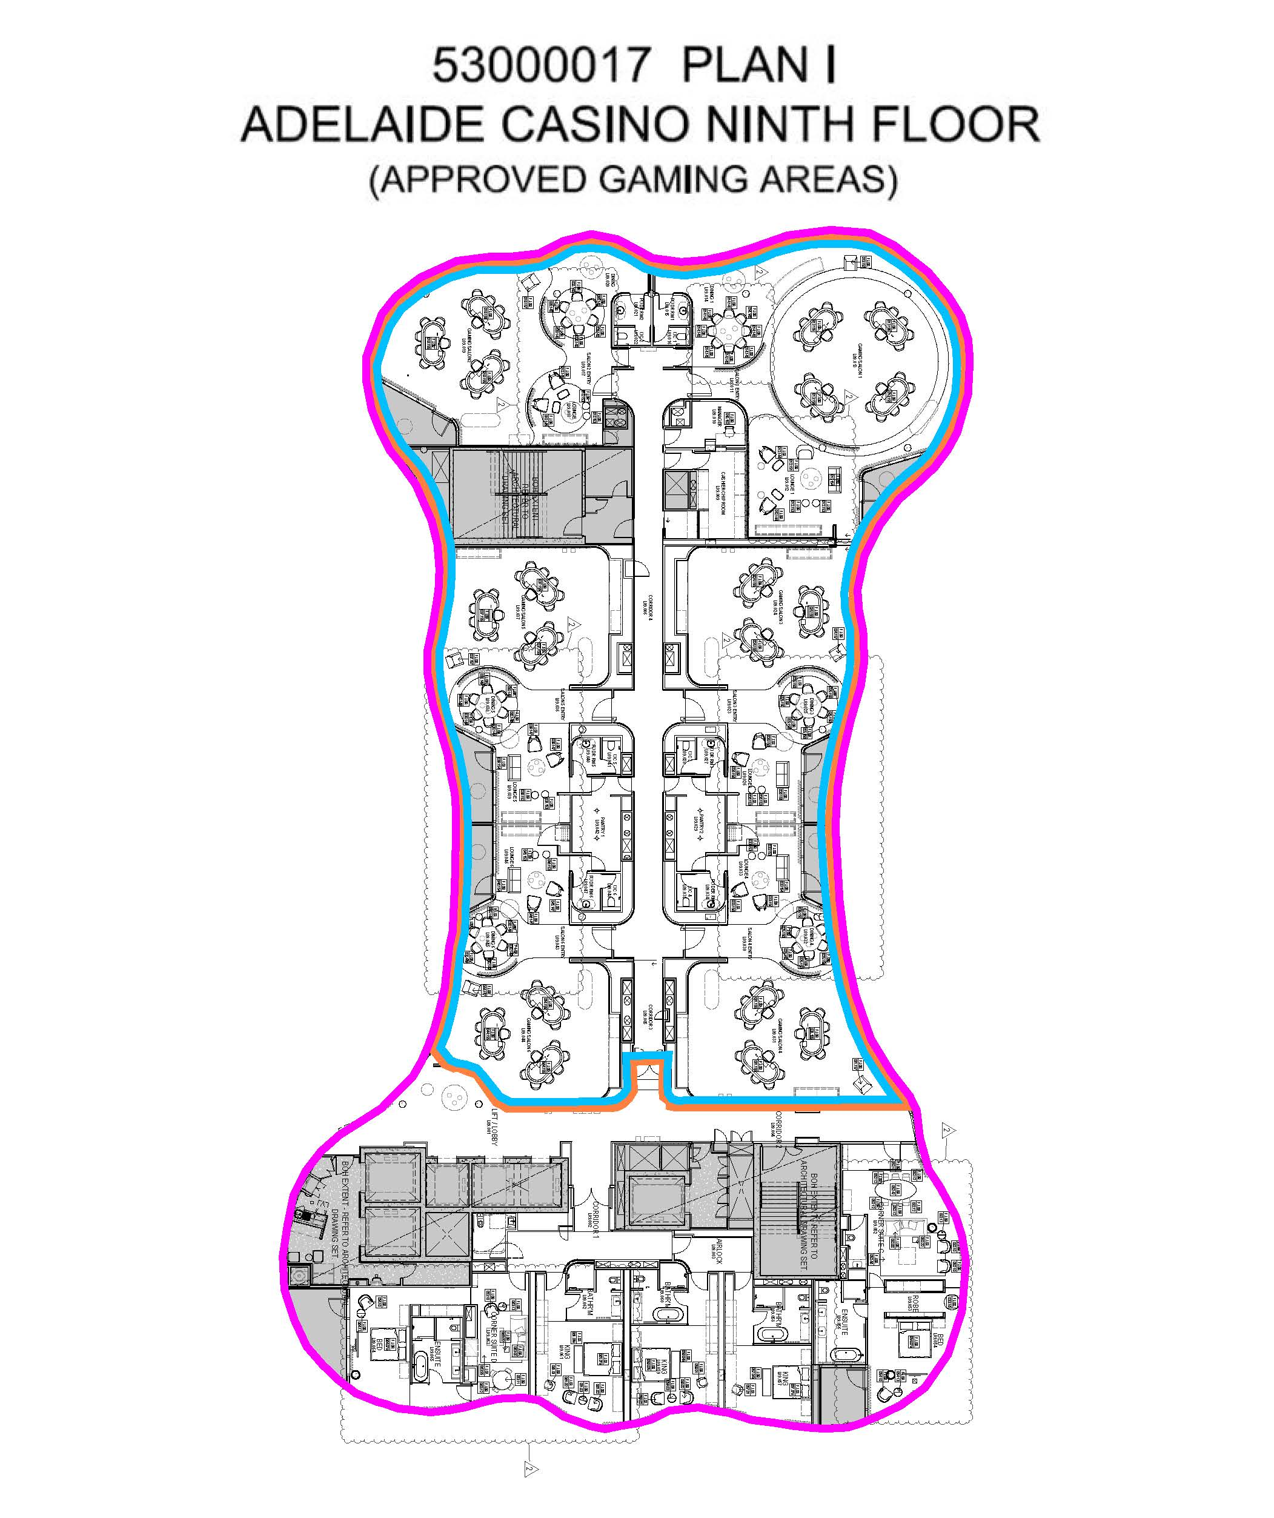

Controlled Substances (Poisons) Regulations 2011
Regulation 33(2)(c)
Approved Electronic Communication—Digital Image of Prescription
I, Stephen Wade, MLC, Minister for Health and Wellbeing:
1. Pursuant to regulation 3(1) of the Controlled Substances (Poisons) Regulations 2011, hereby determine that the electronic transmission of a digital image of a prescription is an approved electronic communication for the purpose of the definition of this term in the Regulations.
2. Pursuant to regulation 33(10) of the Controlled Substances (Poisons) Regulations 2011, hereby determine that the following requirements must be complied with by a prescriber if the prescriber gives a pharmacist a prescription by an approved electronic communication which is an electronic transmission of a digital image of the prescription:
a. The prescription can only be for a patient prescribed a Schedule 4 medicine as the result of a telehealth attendance or phone attendance.
b. The prescription given to the pharmacist by electronic transmission must be a digital image of the prescription.
c. The prescription must be given directly to the pharmacist by the prescriber (or an employee acting in accordance with the instruction of the prescriber) and cannot be given via the patient or any other intermediary.
d. The provisions of the National Health (COVID-19 Supply of Pharmaceutical Benefits) Special Arrangement 2020 made under section 100 of the National Health Act 1953 (Cth) must be complied with by the prescriber (whether or not the drug is a pharmaceutical benefit).
e. The original prescription must be retained by the prescriber for two years.
f. The original prescription must be produced by the prescriber at the request of an authorised officer under the Controlled Substances Act 1984.
For the purposes of this Instrument:
• digital image of a prescription means an unaltered photo image of the original prescription or an unaltered photo image of a copy of the original prescription
• phone attendance has the same meaning as in section 5 of the Health Insurance (Section 3C General Medical Services – COVID-19 Telehealth and Telephone Attendances) Determination 2020 made under subsection 3C(1) of the Health Insurance Act 1973 (Cth).
• telehealth attendance has the same meaning as in section 5 of the Health Insurance (Section 3C General Medical Services – COVID-19 Telehealth and Telephone Attendances) Determination 2020 made under subsection 3C(1) of the Health Insurance Act 1973 (Cth).
This Instrument comes into effect on the day on which it is made and continues in force until midnight on 30 September 2020 unless earlier revoked.
Dated: 18 June 2020
Hon Stephen Wade MLC
Minister for Health and Wellbeing

Controlled Substances (Poisons) Regulations 2011
Regulation 33(5)
Revocation of Exemption—Electronic Transmission of Digital Image of Prescription
I, Naomi Burgess, Interim Chief Pharmacist, System Leadership and Design, Department for Health and Wellbeing
exercising the power of the Minister delegated to the Chief Executive, Department for Health and Wellbeing by instrument dated 27 November 2019, and further delegated to me by the Chief Executive, Department for Health and Wellbeing by instrument dated 24 February 2020;
pursuant to section 62A of the Controlled Substances Act 1984 and Regulations 33(5) and 56 of the Controlled Substances (Poisons) Regulations 2011;
hereby revoke the exemption to prescribers from the requirement in Regulation 33(3)(c)(ii) to forward the written prescription to the pharmacist as soon as practicable after giving a prescription by electronic transmission granted on 9 April 2020.
The revocation of this exemption comes into effect at midnight on 18 June 2020.
Dated: 18 June 2020
Naomi Burgess
Chief Pharmacist
System Leadership and Design
Department of Health and Wellbeing

COVID-19 Emergency Response Act 2020
South Australia
COVID-19 Emergency Response Supported Residential Facilities Expiry Notice 2020
under section 6(1)(a) of the COVID-19 Emergency Response Act 2020

1—Short title
This notice may be cited as the COVID-19 Emergency Response Supported Residential Facilities Expiry Notice 2020.
2—Commencement
This notice has effect on the day on which it is made.
3—Interpretation
In this notice, unless the contrary intention appears—
Act means the COVID-19 Emergency Response Act 2020.
4—Expiry
Section 10(1)(i) of part 2 of the Act will expire on the commencement of this notice.

Signed by the Attorney-General
on 24 June 2020

Education and Children's Services Act 2019
South Australia
Education and Children's Services (Fees) Notice 2020
under the Education and Children's Services Act 2019

1—Short title
This notice may be cited as the Education and Children's Services (Fees) Notice 2020.
Note—
This is a fee notice made in accordance with the Legislation (Fees) Act 2019.
2—Commencement
This notice has effect on 1 July 2020.
3—Interpretation
- In this notice, unless the contrary intention appears—
Act means the Education and Children's Services Act 2019;
CPI means the Consumer Price Index (All Groups) for the City of Adelaide published by the Australian Bureau of Statistics;
relevant indexation factor means—
  - 1; or
  - the quotient obtained by dividing the CPI for the quarter ending 30 June in the year immediately preceding the year for which a particular fee is payable by the CPI for the quarter ending 30 June 2019,
whichever is the greater.
- For the purposes of this notice, if the amount of a prescribed fee purports to be indexed, the amount of that prescribed fee will be taken to be—
  - until 30 June 2021—the amount so prescribed; and
  - in relation to the period of 12 months commencing on 1 July 2021 or any subsequent year—the amount of the prescribed fee for the preceding period of 12 months ending on 30 June multiplied by the relevant indexation factor.
4—Fees
For the purposes of the Act, the fees set out in Schedule 1 are prescribed.
- The Minister or the Board may waive or remit the whole or any part of a fee payable under the Act.

Schedule 1—Fees

Registration as a student exchange organisation—section 85(2)(c) of the Act | $2500
Annual registration fee—section 86(1) of the Act | $300 (indexed)

Made by the Minister for Education
on 11 June 2020

Essential Services Commission Act 2002
Electricity Distribution Code
NOTICE is hereby given that:
1. Pursuant to section 28(2) of the Essential Services Commission Act 2002, the Essential Services Commission has varied the Electricity Distribution Code (designated as EDC/13) to apply to the electricity industry, a regulated industry under the Electricity Act 1996.
2. The Electricity Distribution Code, as varied, will take effect on and from 1 July 2020.
3. A copy of the Electricity Distribution Code as varied may be inspected or obtained from the Essential Services Commission, Level 1, 151 Pirie Street, Adelaide and is also available at www.escosa.sa.gov.au.
4. Queries in relation to the variation to the Electricity Distribution Code may be directed to the Essential Services Commission, Level 1, 151 Pirie Street, Adelaide. Telephone (08) 8463 4444, Freecall 1800 633 592 or email escosa@escosa.sa.gov.au.
Execution:
The varied Electricity Distribution Code was executed by the Chief Executive Officer of the Essential Services Commission with due authority on 22 June 2020.
A. Wilson
Chief Executive Officer
Authorised signatory
Essential Services Commission

Essential Services Commission Act 2002
Price Determination, Water Retail Code—Major retailers and Water Industry Rule No. 1—Excluded Retail Services
NOTICE is hereby given that:
1. Pursuant to section 25(1) of the Essential Services Commission Act 2002, the Essential Services Commission has made a price determination, as authorised by section 35 of the Water Industry Act 2012 (Price Determination). The Price Determination:
(a) applies to the South Australian Water Corporation, established under the South Australian Water Corporation Act 1994, for the period 1 July 2020 to 30 June 2024, and
(b) sets:
(i) a four year revenue cap for drinking water retail services
(ii) a four year revenue cap for sewerage retail services, and
(iii) specifies pricing principles that must be complied with in setting prices for excluded retail services.
2. Pursuant to section 28(2) of the Essential Services Commission Act 2002, the Essential Services Commission has varied the Water Retail Code – Major Retailers (designated as WRC-MR/03) to apply to the water industry, a regulated industry under the Water Industry Act 2012. The Water Retail Code – Major retailers, as varied, will take effect on and from 1 July 2020.
3. Pursuant to section 28(2) of the Essential Services Commission Act 2002, the Essential Services Commission has revoked the Water Industry Rule No. 1 – Excluded Retail Services (designated as WIR/01), such revocation to take effect on and from 1 July 2020.
4. Copies of the Price Determination and Water Retail Code - Major retailers may be inspected or obtained from the Essential Services Commission, Level 1, 151 Pirie Street, Adelaide and are also available at www.escosa.sa.gov.au.
5. Queries in relation to the Price Determination, Water Retail Code - Major retailers or the revocation of Water Industry Rule No. 1– Excluded Retail Services, may be directed to the Essential Services Commission, Level 1, 151 Pirie Street, Adelaide. Telephone (08) 8463 4444, Freecall 1800 633 592 or email escosa@escosa.sa.gov.au.
Execution:
The Price Determination and Water Retail Code – Major retailers were executed by the Chief Executive Officer of the Essential Services Commission with due authority on 22 June 2020.
A. Wilson
Chief Executive Officer
Authorised signatory
Essential Services Commission

Evidence Act 1929
Section 4(1)
Communication Partners
TAKE notice that pursuant to section 4(1) of the Evidence Act 1929, a person from the class specified in Schedule 1 is approved for the purposes of providing assistance in proceedings to a witness with complex communication needs.
Schedule 1
1. Speech pathologists with Certified Practising Speech Pathologist membership of Speech Pathology Australia;
2. Registered occupational therapists;
3. Psychologists with general registration status with the Psychology Board of Australia;
4. Developmental educators with full membership of Developmental Educators Australia Incorporated; and
5. Social workers with membership with the Australian Association of Social Workers.
In addition to holding the relevant qualifications, the person must have a minimum of five years’ relevant experience working with people with complex communication needs and must have agreed in writing to comply with the relevant Code of Conduct.
Dated: 21 June 2020
Vickie Ann Chapman
Attorney-General

Fisheries Management (Prawn Fisheries) Regulations 2017
Fishing Run for the West Coast Prawn Fishery
TAKE NOTE that pursuant to regulation 10 of the Fisheries Management (Prawn Fisheries) Regulations 2017, the notice dated 26 March 2019 on page 986 of the South Australian Government Gazette on 04 April 2019 prohibiting fishing activities in the West Coast Prawn Fishery is HEREBY varied such that it will not be unlawful for a person fishing pursuant to a West Coast Prawn Fishery licence to use prawn trawl nets in the areas specified in Schedule 1, during the period specified in Schedule 2, and under the conditions specified in Schedule 3.
Schedule 1
The waters of the West Coast Prawn Fishery.
Schedule 2
Commencing at sunset on 19 June 2020 and ending at sunrise on 28 June 2020.
Schedule 3
- Each licence holder must ensure that a representative sample of catch (a 'bucket count') is taken at least 3 times per night during the fishing activity.
- Each 'bucket count' sample must be accurately weighed to 7kg where possible and the total number of prawns contained in the bucket must be recorded on the daily catch and effort return.
- Fishing must cease if one of the following limits is reached:
  - A total of 14 nights of fishing are completed
  - The average catch per vessel, per night (for all 3 vessels) drops below 300 kg for two consecutive nights
  - The average 'bucket count' for all vessels exceeds 240 prawns per bucket on any single fishing night in the Coffin Bay area
  - The average 'bucket count' for all vessels exceeds 240 prawns per bucket on any single fishing night in the Venus Bay area.
- The fleet must nominate a person to provide a daily update by telephone or SMS message to the Prawn Fishery Manager on 0477 396 367, to report the average prawn catch and the average prawn 'bucket count' for all vessels operating in the fishery.
- No fishing activity may be undertaken after the expiration of 30 minutes from the prescribed time of sunrise and no fishing activity may be undertaken before the prescribed time of sunset for Adelaide (as published in the South Australian Government Gazette pursuant to the requirements of the Proof of Sunrise and Sunset Act 1923) during the period specified in Schedule 2.
Dated: 18 June 2020
Steve Shanks
Prawn Fisheries Manager
Delegate of the Minister for Primary Industries and Regional Development

Fisheries Management (Prawn Fisheries) Regulations 2017
Variation to Prohibition for the Spencer Gulf Prawn Fishery
TAKE NOTE that pursuant to regulation 10 of the Fisheries Management (Prawn Fisheries) Regulations 2017, the notice dated 14 March 2020 on page 567 of the South Australian Government Gazette on 19 March 2020 prohibiting fishing activities in the Spencer Gulf Prawn Fishery, is hereby varied such that it will not be unlawful for a person fishing pursuant to a Spencer Gulf Prawn Fishery licence to use prawn trawl nets in the areas specified in Schedule 1, during the period specified in Schedule 2, and under the conditions specified in Schedule 3.
Schedule 1
The waters of the Spencer Gulf Prawn Fishery:
1. Except the northern closure area, which is defined as the area north of the following index points:
1. 33 ° 39.00 S 137 ° 11.00 E
2. 33 ° 39.00 S 137 ° 32.00 E
3. 33 ° 37.00 S 137 ° 33.00 E
4. 33 ° 46.00 S 137 ° 44.00 E
2. Except the area (Wallaroo Closure) within the following index points:
1. 33 ° 49.30 S 137 ° 30.30 E
2. 33 ° 50.60 S 137 ° 32.60 E
3. 33 ° 55.00 S 137 ° 29.10 E
4. 33 ° 54.00 S 137 ° 27.00 E
Then back to 1
3. Except the southern closure area, which is defined as the area north of the following index points, except part b) below:
1. 33 ° 41.00 S 137 ° 06.00 E
2. 33 ° 52.00 S 137 ° 15.00 E
3. 33 ° 54.00 S 137 ° 09.00 E
4. 33 ° 57.00 S 137 ° 13.00 E
5. 34 ° 14.00 S 136 ° 57.00 E
6. 34 ° 23.00 S 136 ° 57.00 E
7. 34 ° 36.00 S 136 ° 44.00 E
8. 34 ° 36.00 S 136 ° 34.00 E
9. 34 ° 19.00 S 136 ° 38.50 E
10. 34 ° 17.00 S 136 ° 42.00 E
11. 34 ° 05.00 S 136 ° 48.00 E
12. 34 ° 03.00 S 136 ° 51.50 E
13. 33 ° 52.00 S 136 ° 40.00 E
4. Except the Wardang Closure area, which is defined as the waters contained within the following index points:
1. 34 ° 10.00 S 137 ° 28.00 E
2. 34 ° 21.00 S 137 ° 12.00 E
3. 34 ° 45.00 S 137 ° 15.00 E
4. 34 ° 48.53 S 137 ° 09.45 E
5. 34 ° 48.53 S 137 ° 06.00 E
6. 34 ° 50.75 S 137 ° 06.00 E
7. 34 ° 54.00 S 137 ° 01.00 E
5. Except the Corny closure area, which is defined as the waters within and bounded by the following closure index points:
1. 34 ° 27.00 S 136 ° 53.00 E
2. 34 ° 27.00 S 137 ° 02.00 E
3. 34 ° 35.00 S 136 ° 56.00 E
4. 34 ° 48.60 S 136 ° 52.00 E
5. 34 ° 54.00 S 136 ° 52.00 E
6. 34 ° 54.00 S 136 ° 48.50 E
7. 34 ° 49.50 S 136 ° 48.50 E
8. 34 ° 49.50 S 136 ° 40.50 E
9. 34 ° 39.50 S 136 ° 40.50 E
Then back to point 1
6. Except the Jurassic Park closure area, which is defined as the waters contained within the following closure index points:
1. 33 ° 54.90 S 137 ° 17.60 E
2. 33 ° 54.40 S 137 ° 19.40 E
3. 33 ° 54.70 S 137 ° 19.60 E
4. 33 ° 55.20 S 137 ° 17.80 E
Then back to point 1
Schedule 2
Commencing at sunset on 17 June 2020 and ending at sunrise on 29 June 2020.
Schedule 3
1. The coordinates in Schedule 1 are defined as degrees decimal minutes and are based on the World Geodetic System 1984 (WGS 84).
2. No fishing activity may be undertaken between the prescribed times of sunrise and sunset for Adelaide (as published in the South Australian Government Gazette pursuant to the requirements of the Proof of Sunrise and Sunset Act 1923) during the period specified in Schedule 2.
3. Based on the best information available from the fleet, fishing must cease in an area in the Mid/North Gulf if the average prawn bucket count exceeds 260 prawns per 7kg; or in an area in the Southern Gulf if the average prawn bucket count exceeds 260 prawns/7kg.
4. No fishing activity may occur without the authorisation of Coordinator at Sea, Paul Watson, or other nominated Coordinator at Sea appointed by the Spencer Gulf and West Coast Prawn Fishermen’s Association.
5. The authorisation of the Coordinator at Sea must be in writing, signed and record the day, date and permitted fishing area within the waters of Schedule 1 in the form of a notice sent to the fishing fleet or vary an earlier authorisation issued by the Coordinator at Sea.
6. The Coordinator at Sea must cause a copy of any authorisation for fishing activity or variation of same, made under this notice to be emailed to the Prawn Fisheries Manager immediately after it is made.
7. The Spencer Gulf and West Coast Prawn Fishermen’s Association must keep records of all authorisations issued pursuant to this notice.
Dated 17 June 2020
Simon Clark
Executive Officer
Spencer Gulf and West Coast Prawn Fishermen’s Association
Delegate of the Minister for Primary Industries and Regional Development

Fisheries Management Act 2007
Section 44(10)
Management Plan for the South Australian Commercial Southern Zone Rock Lobster Fishery
TAKE notice that on 20 June 2020 I adopted the replacement Management Plan for the South Australian Commercial Southern Zone Rock Lobster Fishery pursuant to Section 44(7) of the Fisheries Management Act 2007, and for the purposes of Section 44(11) of this Act I fix the date of 1 July 2020 as the date on which this plan will take effect.
Date: 20 June 2020
Hon Tim Whetstone MP
Minister for Primary Industries and Regional Development

Fisheries Management Act 2007
South Australia
Fisheries Management (Fishery Licence and Boat and Device Registration Application and Annual Fees) Notice 2020
under the Fisheries Management Act 2007
1—Short title
This notice may be cited as the Fisheries Management (Fishery Licence and Boat and Device Registration Application and Annual Fees) Notice 2020.
Note—
This is a fee notice made in accordance with the Legislation (Fees) Act 2019.
2—Commencement
This notice has effect from the day on which it is published in the Gazette.
3—Interpretation
In this notice, unless the contrary intention appears—
Act means the Fisheries Management Act 2007.
4—Fees
The Fees set out in Schedule 1 are prescribed for the purposes of the Act, as set out in the Schedule.
Schedule 1—Fees
Part 1—Commercial fishing—fishery licence application and
annual fees

Application or annual fees payable for a fishery licence (section 54(1)(c) and 56(5)(a) of Act)
1 | For a licence in respect of the Central Zone Abalone Fishery—
 | (a) base fee | $17 317
 | (b) additional fee for each abalone unit of the abalone quota entitlement under the licence | $693
2 | For a licence in respect of the Southern Zone Abalone Fishery—
 | (a) base fee | $16 495
 | (b) additional fee for each abalone unit of the abalone quota entitlement under the licence | $297
3 | For a licence in respect of the Western Zone Abalone Fishery—
 | (a) base fee | $13 491
 | (b) additional fee for each abalone unit of the abalone quota entitlement under the licence | $513
4 | For a licence in respect of the Blue Crab Fishery—
 | (a) base fee | $3 215
 | (b) additional fee for each blue crab unit of the blue crab quota entitlement under the licence | $27
5 | For a licence in respect of the Charter Boat Fishery | $3 208
6 | For a licence in respect of the Lakes and Coorong Fishery—
 | (a) base fee | $2 724
 | (b) additional fee—
 | (i) for a gill net entitlement under the licence | $1 674
 | (ii) for each gill net to be registered for use under the licence | $175
 | (iii) for a pipi quota entitlement under the licence | $4 342
 | (iv) for each pipi unit of the pipi quota entitlement under the licence | $276
7 | For a licence in respect of the Marine Scalefish Fishery or Restricted Marine Scalefish Fishery—
 | (a) base fee—
 | (i) for a vongole quota entitlement under the licence relating to the Coffin Bay vongole fishing zone | $4 906
 | (ii) for a vongole quota entitlement under the licence relating to the Port River vongole fishing zone | no fee
 | (iii) for a vongole quota entitlement under the licence relating to the West Coast vongole fishing zone | $4 906
 | (iv) if there is no vongole quota entitlement under the licence | $2 947
 | (b) additional fee for each blue crab unit of the blue crab quota entitlement under the licence | $29.75
 | (c) additional fee for each pipi unit of the pipi quota entitlement under the licence | $276
 | (d) additional fee for each vongole unit of the vongole quota entitlement under the licence—
 | (i) for a vongole quota entitlement relating to the Coffin Bay vongole fishing zone | $88
 | (ii) for a vongole quota entitlement relating to the Port River vongole fishing zone | no fee
 | (iii) for a vongole quota entitlement relating to the West Coast vongole fishing zone | $33
8 | For a licence in respect of the Miscellaneous Fishery with a giant crab quota entitlement—
 | (a) base fee | $5 896
 | (b) additional fee for each giant crab unit of the giant crab quota entitlement under the licence | $24.40
9 | For a licence in respect of the Miscellaneous Fishery without a giant crab quota entitlement—
 | (a) base fee—
 | (i) if the licence authorises the taking of aquatic resources in the Lake Eyre Basin | no fee
 | (ii) in any other case | $5 896
 | (b) additional fee if the licence authorises the taking of aquatic resources in the Lake Eyre Basin | no fee
 | (c) additional fee if a prescribed fishing activity (as defined in the Fisheries Management (Vessel Monitoring Scheme) Regulations 2017) is to be engaged in under the licence | $900
10 | For a licence in respect of the Gulf St. Vincent Prawn Fishery | $40 991
11 | For a licence in respect of the Spencer Gulf Prawn Fishery | $27 049
12 | For a licence in respect of the West Coast Prawn Fishery | $27 221
13 | For a licence in respect of the River Fishery | $200
14 | For a licence in respect of the Northern Zone Rock Lobster Fishery subject to a condition limiting the holder of the licence to the taking of Southern Rock Lobster, Octopus and Giant Crab and a condition authorising the holder to take, for the purpose of bait only, any aquatic resources of a class (other than Octopus or Giant Crab) prescribed by Schedule 1 of the Fisheries Management (Rock Lobster Fisheries) Regulations 2017 that are incidentally caught in rock lobster pots—
 | (a) base fee | $3 582
 | (b) additional fee for each rock lobster unit of the rock lobster quota entitlement under the licence | $11.80
 | (c) additional fee for each giant crab unit of the giant crab quota entitlement under the licence | $24.40
 | (d) additional fee if the licence is subject to a condition limiting the number of Giant Crab that may be taken on each boat trip | $7.10
15 | For a licence in respect of the Northern Zone Rock Lobster Fishery subject to a condition limiting the holder to the taking of Southern Rock Lobster, Octopus and Giant Crab and limiting the holder to the taking of aquatic resources of a class (other than Octopus or Giant Crab) prescribed by Schedule 1 of the Fisheries Management (Rock Lobster Fisheries) Regulations 2017 for the purpose of bait only—
 | (a) base fee | $4 082
 | (b) additional fee for each rock lobster unit of the rock lobster quota entitlement under the licence | $11.80
 | (c) additional fee for each giant crab unit of the giant crab quota entitlement under the licence | $24.40
 | (d) additional fee if the licence is subject to a condition limiting the number of Giant Crab that may be taken on each boat trip | $7.10
16 | For a licence in respect of the Northern Zone Rock Lobster Fishery not subject to a condition limiting the classes of aquatic resources that may be taken or the purpose for which aquatic resources may be taken—
 | (a) base fee | $6 214
 | (b) additional fee for each rock lobster unit of the rock lobster quota entitlement under the licence—
 | (i) relating to the Northern Zone Inner Region | $11.80
 | (ii) relating to the Northern Zone Outer Region | $11.80
 | (c) additional fee for each giant crab unit of the giant crab quota entitlement under the licence | $24.40
 | (d) additional fee if the licence is subject to a condition limiting the number of Giant Crab that may be taken on each boat trip | $7.10
17 | For a licence in respect of the Southern Zone Rock Lobster Fishery subject to a condition limiting the holder of the licence to the taking of Southern Rock Lobster, Octopus and Giant Crab and a condition authorising the holder to take, for the purpose of bait only, any aquatic resources of a class (other than Octopus or Giant Crab) prescribed by Schedule 1 of the Fisheries Management (Rock Lobster Fisheries) Regulations 2017 that are incidentally caught in rock lobster pots—
 | (a) base fee | $7 609
 | (b) additional fee for each rock lobster pot of the rock lobster pot entitlement under the licence | $175
 | (c) additional fee for each giant crab unit of the giant crab quota entitlement under the licence | $24.40
 | (d) additional fee if the licence is subject to a condition limiting the number of Giant Crab that may be taken on each boat trip | $7.10
18 | For a licence in respect of the Southern Zone Rock Lobster Fishery subject to a condition limiting the holder to the taking of Southern Rock Lobster, Octopus and Giant Crab and limiting the holder to the taking of aquatic resources of a class (other than Octopus or Giant Crab) prescribed by Schedule 1 of the Fisheries Management (Rock Lobster Fisheries) Regulations 2017 for the purpose of bait only—
 | (a) base fee | $8 109
 | (b) additional fee for each rock lobster pot of the rock lobster pot entitlement under the licence | $175
 | (c) additional fee for each giant crab unit of the giant crab quota entitlement under the licence | $24.40
 | (d) additional fee if the licence is subject to a condition limiting the number of Giant Crab that may be taken on each boat trip | $7.10
19 | For a licence in respect of the Southern Zone Rock Lobster Fishery not subject to a condition limiting the classes of aquatic resources that may be taken or the purpose for which aquatic resources may be taken—
 | (a) base fee | $10 241
 | (b) additional fee for each rock lobster pot of the rock lobster pot entitlement under the licence | $175
 | (c) additional fee for each giant crab unit of the giant crab quota entitlement under the licence | $24.40
 | (d) additional fee if the licence is subject to a condition limiting the number of Giant Crab that may be taken on each boat trip | $7.10
Part 2—Commercial fishing—boat and device registration fees

Application or annual fees for the registration of a device under a fishery licence (section 54(1)(c) and 56(5)(a) of Act)
1 | For registration of 1 or more swinger nets to be used under a licence in respect of the Lakes and Coorong Fishery | no fee
2 | For registration of 1 or more fish nets (other than swinger nets) under a licence in respect of the Lakes and Coorong Fishery under which the holder may take aquatic resources prescribed in Schedule 1 of the Fisheries Management (Marine Scalefish Fisheries) Regulations 2017 | $2 632
3 | For registration of 1 or more fish nets under a licence in respect of the Northern Zone Rock Lobster Fishery or Southern Zone Rock Lobster Fishery | $2 632
4 | For registration of 1 or more sardine nets under a licence in respect of the Marine Scalefish Fishery | $57,874
5 | For registration of 1 or more fish nets (other than sardine nets) under a licence in respect of the Marine Scalefish Fishery, Restricted Marine Scalefish Fishery or Miscellaneous Fishery | $5 264
6 | For registration of 1 or more sand crab pots under a licence in respect of the Marine Scalefish Fishery | no fee
7 | For registration of a fish net used solely to take fish for bait provided that the bait is not for sale | no fee
Application or annual fees payable for the registration of a boat under a fishery licence (section 54(1)(c) and 56(5)(a) of Act)
8 | For registration of a boat under a licence in respect of the Charter Boat Fishery—
 | (a) if the certificate of survey in force in respect of the boat specifies that the boat may carry up to unberthed 6 passengers | $802
 | (b) if the certificate of survey in force in respect of the boat specifies that the boat may carry up to unberthed 12 passengers | $1 604
 | (c) if the certificate of survey in force in respect of the boat specifies that the boat may carry more than unberthed 12 passengers | $3 208
Schedule 2—Transitional and saving provisions
1—Transitional and saving provisions
(1) The licence and registration application fees prescribed by Schedule 1 of this notice apply where a licence or registration is to take effect on or after 1 July 2020.
(2) The licence and registration annual fees prescribed by Schedule 1 of this notice, apply in respect of the period of 12 months commencing on 1 July 2020.
(3) Despite the fees prescribed by Schedule 1 of this notice—
(a) the licence and registration application fees prescribed by Schedules 1 and 3 of the Fisheries Management (Fees) Regulations 2017, as in force immediately before this notice has effect, continue to apply where a licence or registration is to take effect before 1 July 2020;
(b) the licence and registration annual fees prescribed by Schedules 1 and 3 of the Fisheries Management (Fees) Regulations 2017, as in force immediately before this notice has effect, continue to apply in respect of the period of 12 months that commenced on 1 July 2019.

Dated: 18 June 2020

Hon Tim Whetstone MP
Minister for Primary Industries and Regional Development

Gaming Machines Act 1992
GR Notice No. 4 of 2020
Gaming Machines—HITsa Further Advanced Training via Instructure
Canvas and Webex meeting Webinar Platforms—Recognition Notice 2020
I, Martha Savva, Delegate of the Liquor and Gambling Commissioner, publish this notice under section 10B of the Gaming Machines Act 1992:
1. Preliminary
(1) This notice may be cited as the Gaming Machines—HITsa Further Advanced Training via Instructure Canvas and Webex meeting Webinar platforms—Recognition Notice 2020.
(2) This notice is authorised by section 10B(1)(b) of the Gaming Machines Act 1992.
2. Recognised course of training
(1) This notice applies to the further advanced training course via Instructure Canvas and Webex meeting Webinar platforms described in an application made by HITsa ABN 39 258 716 484 held on File No. 14/0065.
(2) The course of training identified in the table is recognised as further advanced training for provision from the date indicated until a period of time determined by the Commissioner as a result of the coronavirus (COVID-19).
(3) In setting the end date, the Commissioner will take into account whether face-to-face training can practicably and safely occur having regard to social distancing requirements and any directions in place at the time.
TABLE
Course documentation description | Date of first provision
Email dated 11 May 2020 with subsequent amendments  Validation Mapping Matrix further advanced May 2020  TAS further advanced training v2 07.05.2020  NEW Further Advanced Gaming – webinar case studies v1 07.05.2020  Advanced Gaming – student manual v4 11.06.2020 | 25 June 2020
Dated: 25 June 2020
Martha Savva
Delegate of the Liquor and Gambling Commissioner

[Corrigendum]
Health Care Act 2008
Fees and Charges
In Government Gazette No. 48 on page 3180, the two tables under Schedule 2 were incorrectly titled. They should be replaced as follows:
Schedule 2—Incorporated Hospitals and Public Hospital Sites: Fees for Admitted Patients
who are Not Medicare Patients
1—Standard fee for all admitted patients except obstetric patients
Fee for treatment, care and accommodation at a public hospital site of an admitted patient who is not a Medicare patient and who is not an obstetric patient – per day or part day.
Admitted Fee Classification | Internal Classification Label | Fee
Admitted Sub Acute and Non Acute services | Sub Acute | $2,220
Admitted Surgical Interventions | I | $3,905
Admitted Medical Interventions | M | $2,220
2—Standard fee for all admitted obstetric patients
Fee for treatment, care and accommodation at a public hospital site of an admitted obstetric patient who is not a Medicare patient – per day or part day.

Admitted Fee Classification | Internal Classification Label | Fee
Admitted Births / Deliveries | Birth / Delivery | $3,110
Dated: 29 May 2020
Hon Stephen Wade MLC
Minister for Health and Wellbeing

Health Care Act 2008
Fees and Charges
I, STEPHEN WADE, Minister for Health and Wellbeing, hereby give notice pursuant to section 44 of the Health Care Act 2008, of the fees in the list attached to apply to a Medicare patient who is not a compensable patient:
These fees will operate from 1 July 2020 until I make a further Notice under section 44 of the Act.
Dated: 11 June 2020
Hon Stephen Wade MLC
Minister for Health And Wellbeing

1— Interpretation
(1) unless the contrary intention appears –
admitted patient means a patient of a public hospital site who has undergone the formal admission process of the public hospital site;
Australian Government Department of Health Schedule of Fees and Charges for Residential and Home Care is a schedule issued by the Australian Government Department of Health which contains the maximum daily fees for residential care and for home care (in an accredited aged care facility), in addition to income thresholds and caps on income tested care fees;
Commonwealth benefit, in relation to a patient, means the aggregate of the following amounts:
- the maximum amount (expressed on a daily basis) payable as an age pension under the Social Security Act 1991 of the Commonwealth to a person who is not a member of a couple within the meaning of that Act, excluding the amount of any pharmaceutical allowance payable under that Act; and
- —
(i) if the patient receives rent assistance under that Act—the amount (expressed on a daily basis) received; or
(ii) if the patient is not entitled to an age pension or disability support pension under that Act—the maximum amount (expressed on a daily basis) payable as rent assistance under that Act;
hospital in the home service, in relation to a public hospital site, means treatment or care provided by the public hospital site to a patient at a location outside of the public hospital site’s premises (being treatment or care provided as a direct substitute for treatment or care that would normally be provided as an inpatient service on the public hospital site’s premises);
Hospital Nursing Home Service patient means a patient who is transitioning accommodation from accredited aged care residential facilities to a public hospital facility for reasons other than for specific clinically required hospital treatment or a patient who is admitted to an SA Health hospital site having been assessed and determined as in need of aged care residential services consistent with those typically provided by an accredited aged care facility. These patients are not long-stay patients and should be charged from their first day in the facility;
incorporated hospital means a hospital incorporated under the Health Care Act 2008;
long stay patient means a patient who has been an admitted patient in a public hospital site for a continuous period exceeding 35 days;
Medicare patient means a patient who is an eligible person for the purpose of receiving medical benefits under the Health Insurance Act 1973 of the Commonwealth;
overnight stay patient means an admitted patient of a public hospital site who remains an admitted patient of the public hospital site until a day subsequent to the day of his or her admission;
patient means a person to whom a public hospital site provides medical or diagnostic services or other treatment or care and includes a person to whom a public hospital site provides outreach services;
private, in relation to a patient, connotes that the patient receives medical or diagnostic services from a medical practitioner selected by the patient;
public, in relation to a patient, connotes that the patient receives medical or diagnostic services from a medical practitioner selected by the public hospital site;
public hospital site means a hospital facility which is operated by and is part of an incorporated hospital and which can have buildings and facilities at more than one location in the State;
same day patient means an admitted patient of a public hospital site who, on the same day, is both admitted to and leaves the care of the public hospital site (whether on formal discharge by the public hospital site or voluntary discharge by the patient);
single room, in relation to the accommodation of a patient, means the accommodation of the patient in a room in which he or she is the only patient.
(2) a patient will be regarded as being acutely ill during a particular period if a medical practitioner has certified that the patient will require extensive medical treatment and supervision during that period.
(3) A certificate referred to in subsection (2) remains in force for the period specified in the certificate (not exceeding 30 days) or, if no period is specified, for a period of 30 days.
1—Fees for services provided to Medicare patients
(1) The fee to be charged by a public hospital site for a service of a kind set out in the Schedule provided to a Medicare patient who is not a compensable patient is as set out in the Schedule.
(2) A person who is—
- a resident of a State or Territory of the Commonwealth other than South Australia; or
- a member of the armed forces of the Commonwealth; or
- entitled to a benefit under the Veterans' Entitlements Act 1986 of the Commonwealth, may, with the approval of the Minister, be released from liability to pay the fees contained in the schedule.
(3) A public hospital site may discount payment of, or remit, the whole or any part of a fee payable to it.
Schedule—Fees for services provided to Medicare patients by incorporated hospitals and public hospital sites
Fee (per day)
- For the accommodation, maintenance, care and treatment at a no fee
public hospital site of a public overnight stay patient
For the accommodation, maintenance and care at a public
hospital site of a private overnight stay patient—
- where the patient requests and subsequently receives single $638.00
room accommodation (maximum fee/day)
- in any other case $370.00

- For the accommodation, maintenance, care and treatment at a no fee
public hospital site of a public patient who is a same day patient

- For the accommodation, maintenance and care at a public hospital
site of a private patient who is a same day patient—

- for gastro-intestinal endoscopy or other minor surgical and $268.00
non-surgical procedures that do not normally require an
anaesthetic (Band 1)

- for procedures (other than Band 1 procedures) carried out $308.00
under local anaesthetic with no sedation given where the
actual time in the theatre is less than one hour (Band 2)

- for procedures (other than Band 1 procedures) carried out $338.00
under general or regional anaesthesia or intravenous sedation
where the actual time in the theatre is less than one hour (Band 3)

- for any procedures carried out under general or regional $370.00
anaesthesia or intravenous sedation where the actual time
in the theatre is one hour or more (Band 4)

- For the accommodation, maintenance, care and treatment at a no fee
public hospital site of a public long stay patient who is acutely ill

- For the accommodation, maintenance, care and treatment at a 87.5 per cent
public hospital site of a public long stay patient who is not acutely of the
ill, excluding category 8 Commonwealth Benefit

Fee (per day)

- For the accommodation, maintenance, care and treatment at a $125.00
public hospital site of a private long stay patient who is not plus 87.5
acutely ill per cent of the
Commonwealth Benefit

- For Hospital Nursing Home Service patients. These patients equivalent to the
are not long-stay patients and should be charged from their ‘Australian
first day at the public hospital site. Government
Department of Health
Schedule of Fees and
Charges for Residential
And Home Care’

- For hospital in the home services provided by a public $191.00
hospital site to a private patient (maximum fee/day)

- Pharmaceutical Reform arrangements
Under the agreement between the South Australian and the Australian Government the following fees apply for pharmaceuticals provided to admitted patients on discharge:

- For the supply of Pharmaceutical Benefit Scheme items
(per item)
the community co-payment rate for pharmaceuticals
as set under the Commonwealth National
Health Act 1953 each year on 1 January.
- For the supply of non-Pharmaceutical Benefit Scheme items
(per item)
an amount that is the cost to the
public hospital (using a full cost
recovery principle) for supply of that item.

Health Care Act 2008
Sections 58(1)(d) and 62—Exemptions
Notice by the Minister
TAKE notice that I, Dr Fay Jenkins, Minister’s Delegate for Health and Wellbeing, pursuant to sub-section 58(1)(d) and section 62 of the Health Care Act 2008, do hereby exempt the persons named in Column A of the Schedule from the application of Part 6 – Division 2 and Division 3, section 59 of the Health Care Act 2008, in relation to the non-emergency ambulance services specified in Column B of the Schedule, and on the conditions (if any) specified in Column C of the Schedule, with effect on and from 1 July 2020 and for the period expiring on 30 June 2021.
Schedule
Column A | Column B | Column C
Southern Adelaide Local Health Network Inc | Non-emergency ambulance services provided for patients of the Repatriation General Hospital, Flinders Medical Centre and the Noarlunga Hospital. | Nil.
Dated: 18 June 2020
Dr Fay Jenkins
A/Executive Director, Health Protection & Licensing
Minister's Delegate

HOUSING IMPROVEMENT ACT 2016
Rent Control Revocations
Whereas the Minister for Human Services Delegate is satisfied that each of the houses described hereunder has ceased to be unsafe or unsuitable for human habitation for the purposes of the Housing Improvement Act 2016, notice is hereby given that, in exercise of the powers conferred by the said Act, the Minister for Human Services Delegate does hereby revoke the said Rent Control in respect of each property.
Address of Premises | Allotment  Section | Certificate of Title  Volume/Folio
11 George Street, Mount Gambier SA 5290 | Allotment 101 Deposited Plan 58698 Hundred of Blanche | CT5866/492
14 Barwell Street, Eudunda SA 5374 | Allotment 66 Deposited Plan 561 Hundred of Neales | CT5494/636
Dated: 25 June 2020
Craig Thompson
Acting Housing Regulator and Registrar
Housing Safety Authority, SAHA
Delegate of Minister for Human Services

LAND ACQUISITION ACT 1969
Section 16
Form 5—Notice of Acquisition
1. Notice of acquisition
The Commissioner of Highways (the Authority), of 50 Flinders Street, Adelaide SA 5000, acquires the following interests in the following land:
Comprising an unencumbered estate in fee simple in that piece of land being the whole of Allotment 8 in Filed Plan No 107758 comprised in Certificate of Title Volume 5186 Folio 622.
This notice is given under section 16 of the Land Acquisition Act 1969.
2. Compensation
A person who has or had an interest in the land that is divested or diminished by the acquisition or the enjoyment of which is adversely affected by the acquisition who does not receive an offer of compensation from the Authority may apply to the Authority for compensation.
3. Inquiries
Inquiries should be directed to:
Petrula Pettas
GPO Box 1533
Adelaide SA 5001
Telephone: (08) 8343 2619

Dated: 22 June 2020
The Common Seal of the COMMISSIONER OF HIGHWAYS was hereto affixed by authority of the Commissioner in the presence of:
Rocco Caruso
Manager, Property Acquisition
Authorised Officer
Department of Planning, Transport and Infrastructure
DPTI 2019/11308/01

LAND ACQUISITION ACT 1969
Section 16
Form 5—Notice of Acquisition
1. Notice of acquisition
The Commissioner of Highways (the Authority), of 50 Flinders Street, Adelaide SA 5000, acquires the following interests in the following land:
Comprising an unencumbered estate in fee simple in that piece of land being the whole of Allotment 12 in Deposited Plan No 3266 comprised in Certificate of Title Volume 5332 Folio 623.
This notice is given under section 16 of the Land Acquisition Act 1969.
2. Compensation
A person who has or had an interest in the land that is divested or diminished by the acquisition or the enjoyment of which is adversely affected by the acquisition who does not receive an offer of compensation from the Authority may apply to the Authority for compensation.
3. Inquiries
Inquiries should be directed to:
Rob Gardner
GPO Box 1533
Adelaide SA 5001
Telephone: (08) 8343 2567
Dated: 22 June 2020
The Common Seal of the COMMISSIONER OF HIGHWAYS was hereto affixed by authority of the Commissioner in the presence of:
Rocco Caruso
Manager, Property Acquisition
Authorised Officer
Department of Planning, Transport and Infrastructure
DPTI 2019/18688/01

LAND ACQUISITION ACT 1969
Section 16
Form 5—Notice of Acquisition
1. Notice of acquisition
The Commissioner of Highways (the Authority), of 50 Flinders Street, Adelaide SA 5000, acquires the following interests in the following land:
Comprising an unencumbered estate in fee simple in that piece of land being the whole of Allotment 13 in Deposited Plan No 3266 comprised in Certificate of Title Volume 5456 Folio 767.
This notice is given under section 16 of the Land Acquisition Act 1969.
2. Compensation
A person who has or had an interest in the land that is divested or diminished by the acquisition or the enjoyment of which is adversely affected by the acquisition who does not receive an offer of compensation from the Authority may apply to the Authority for compensation.
3. Inquiries
Inquiries should be directed to:
Rob Gardner
GPO Box 1533
Adelaide SA 5001
Telephone: (08) 8343 2567
Dated: 22 June 2020
The Common Seal of the COMMISSIONER OF HIGHWAYS was hereto affixed by authority of the Commissioner in the presence of:
Rocco Caruso
Manager, Property Acquisition
Authorised Officer
Department of Planning, Transport and Infrastructure
DPTI 2019/18687/01

LAND ACQUISITION ACT 1969
Section 16
Form 5—Notice of Acquisition
1. Notice of acquisition
The Commissioner of Highways (the Authority), of 50 Flinders Street, Adelaide SA 5000, acquires the following interests in the following land:
Comprising an estate in fee simple in that piece of land being the whole of Unit 1 in Strata Plan No 1250 comprised in Certificate of Title Volume 5052 Folio 765, expressly excluding the free and unrestricted right(s) of way over the land marked A on SP1250.
This notice is given under section 16 of the Land Acquisition Act 1969.
2. Compensation
A person who has or had an interest in the land that is divested or diminished by the acquisition or the enjoyment of which is adversely affected by the acquisition who does not receive an offer of compensation from the Authority may apply to the Authority for compensation.
3. Inquiries
Inquiries should be directed to:
Rob Gardner
GPO Box 1533
Adelaide SA 5001
Telephone: (08) 8343 2567
Dated: 22 June 2020
The Common Seal of the COMMISSIONER OF HIGHWAYS was hereto affixed by authority of the Commissioner in the presence of:
Rocco Caruso
Manager, Property Acquisition
Authorised Officer
Department of Planning, Transport and Infrastructure
DPTI 2019/18672/01

LAND ACQUISITION ACT 1969
Section 16
Form 5—Notice of Acquisition
1. Notice of acquisition
The Commissioner of Highways (the Authority), of 50 Flinders Street, Adelaide SA 5000, acquires the following interests in the following land:
Comprising an unencumbered estate in fee simple in that piece of land being the whole of Unit 2 in Strata Plan No 839 comprised in Certificate of Title Volume 5050 Folio 488.
This notice is given under section 16 of the Land Acquisition Act 1969.
2. Compensation
A person who has or had an interest in the land that is divested or diminished by the acquisition or the enjoyment of which is adversely affected by the acquisition who does not receive an offer of compensation from the Authority may apply to the Authority for compensation.
3. Inquiries
Inquiries should be directed to:
Petrula Pettas
GPO Box 1533
Adelaide SA 5001
Telephone: (08) 8343 2619
Dated: 22 June 2020
The Common Seal of the COMMISSIONER OF HIGHWAYS was hereto affixed by authority of the Commissioner in the presence of:
Rocco Caruso
Manager, Property Acquisition
Authorised Officer
Department of Planning, Transport and Infrastructure
DPTI 2019/18646/01

Landscape South Australia Act 2019
South Australia
Landscape South Australia Act (Levies) (Transitional Scheme) Variation Notice 2020
under the Landscape South Australia Act 2019
Part 1—Preliminary
1—Short title
This notice may be cited as the Landscape South Australia Act (Levies) (Transitional Scheme) Variation Notice 2020.
2—Commencement
This notice comes into operation on the day on which it is published in the Gazette.
3—Variation provisions
In this notice, a provision under a heading referring to the variation of a specified notice varies the notice so specified.
Part 2—Variation of Landscape South Australia Act (Levies) (Transitional Scheme) Notice 2020
Note—
The notice was published on 16 April 2020 (Gazette 16.4.2020 p788).
4—Variation of clause 6—Contributions by other councils
Clause 6(2)—delete "the council's contribution as a constituent council imposed under "this Subdivision" were a reference to the total amount of the council's contribution as a constituent council" and substitute:
the constituent councils' contribution imposed under this Subdivision for the immediately preceding financial year were a reference to the total amount of the councils' contribution
Made by the Minister for Environment and Water
on 22 June 2020

Landscape South Australia Act 2019
South Australia
Landscape South Australia (Fees) Notice 2020
under the Landscape South Australia Act 2019
1—Short title
This notice may be cited as the Landscape South Australia (Fees) Notice 2020.
Note—
This is a fee notice made in accordance with the Legislation (Fees) Act 2019.
2—Commencement
This notice has effect on 1 July 2020.
3—Interpretation
In this notice, unless the contrary intention appears—
Act means the Landscape South Australia Act 2019.
4—Fees
The fees set out in Schedule 1 are prescribed for the purposes of the Act and the regulations under the Act.
Schedule 1—Fees
Part 1—Preliminary
1—Preliminary
(1) Unless the contrary intention appears, words and expressions used in this notice have the same respective meanings as in the Act or the regulations under the Act.
(2) For the purposes of Part 2 clause 2 of this Schedule, a prescribed water resource will be taken to be unbundled if water access entitlements have been granted in relation to it pursuant to section 121 of the Act and clause 102 of Schedule 5 of the Act does not apply to the prescribed water resource.
Part 2—Fees
2—General fees for purposes of Act

1 | Application for a permit under Part 8 of the Act, other than an application for a permit to drill a well or to undertake work on a well | $60.00
2 | Application for a permit to drill a well or to undertake work on a well | $95.50 plus a technical assessment fee of an amount not exceeding $163.00 determined by the Minister after taking into account any advice from the Department about the costs associated with assessing the application
3 | Application for a well driller's licence—
 | (a) for a new licence | $282.00
 | (b) for the renewal of a licence | $146.00
4 | Application for the variation of a well driller's licence | $214.00
5 | Application for a water licence | $254.00
6 | Application to transfer a water licence | $471.00 plus a technical assessment fee of $317.00
7 | Application to transfer a water allocation or a quantity of water which is taken to constitute a water access entitlement, other than in relation to an unbundled prescribed water resource, and no technical assessment is required | $471.00
8 | Application to transfer a water allocation or a quantity of water which is taken to constitute a water access entitlement, other than in relation to an unbundled prescribed water resource, and a technical assessment is required | $471.00 plus a technical assessment fee of $317.00
9 | In relation to an unbundled prescribed water resource—
 | (a) application to transfer a water access entitlement | $471.00
 | (b) application to vary a water allocation | $277.00
 | (c) application to transfer a water allocation | $277.00
 | (d) application for a water resource works approval  Note—  If an application for approval relates to more than 1 form of works, a single fee is payable under this paragraph in respect of those works unless the Minister determines that a separate application is required in relation to a particular works (and an additional fee will be payable under this paragraph for an application in relation to those works). | $471.00 plus a technical assessment fee of an amount not exceeding $317.00 determined by the Minister after taking into account any advice from the Department about the costs associated with assessing the application
 | (e) application to vary a water resource works approval  Note—  A single fee is payable in respect of a joint application for a variation of a kind prescribed by regulation 33 of the Landscape South Australia (Water Management) Regulations 2020. | $471.00 plus a technical assessment fee of an amount not exceeding $317.00 determined by the Minister after taking into account any advice from the Department about the costs associated with assessing the application
 | (f) application for a site use approval | $471.00 plus a technical assessment fee of an amount not exceeding $317.00 determined by the Minister after taking into account any advice from the Department about the costs associated with assessing the application
 | (g) application to vary a site use approval  Note—  A single fee is payable in respect of a joint application for a variation of a kind prescribed by regulation 33 of the Landscape South Australia (Water Management) Regulations 2020. | $471.00 plus a technical assessment fee of an amount not exceeding $317.00 determined by the Minister after taking into account any advice from the Department about the costs associated with assessing the application
10 | Additional fee where Minister directs an assessment by an expert under the Act (and the expenses of the assessment are to be paid by the applicant in addition to this fee) | $208.00
11 | Application to vary a water licence for any other reason  Note—  A single fee is payable in respect of a joint application for a variation of a kind prescribed by regulation 33 of the Landscape South Australia (Water Management) Regulations 2020. | $471.00 plus a technical assessment fee of $317.00
12 | Application for a permit under section 197 of the Act—
 | (a) in relation to a Category 1 or Category 2 animal | $394.00
 | (b) in relation to a Category 1 or Category 2 plant | $110.00
 | (c) in relation to a Category 3 animal or plant | $110.00
13 | Application for notation on Landscape Scheme Register or for the removal of a notation | $9.80
14 | Fee for providing information required by the Land and Business (Sale and Conveyancing) Act 1994 | $28.00
15 | Application for a forest water licence | $254.00
16 | Application to vary a water allocation attached to a forest water licence | $471.00 plus a technical assessment fee of $317.00
17 | Application to transfer the whole or a part of the water allocation attached to a forest water licence | $471.00 plus a technical assessment fee of $317.00
18 | Application to vary a condition to a forest water licence | $471.00 plus a technical assessment fee of $317.00
Note—
Regulation 38 of the Landscape South Australia (General) Regulations 2020 sets out certain applications that are exempt from fees specified in this clause.
3—Fees relating to meters owned by Minister

1 | Rent for meter owned by Minister for a period of 12 months or less ending on 30 June (regulation 10 of the Landscape South Australia (Water Management) Regulations 2020)—
 | Nominal size of meter—
 | (a) less than 50 mm | $232.00
 | (b) 50 to 100 mm | $335.00
 | (c) 150 to 175 mm | $495.00
 | (d) 200 to 380 mm | $566.00
 | (e) 407 to 610 mm | $679.00
2 | Testing meter under section 79(4) of the Act | Estimated cost determined by the Minister
3 | Reading meter at request of licensee | Estimated cost determined by the Minister
4—Tagged interstate water trades

1 | Application to register a transfer of a water allocation undertaken under an Interstate Water Entitlements Transfer Scheme (regulation 32(1) of Landscape South Australia (Water Management) Regulations 2020) | $277.00
Made by the Minister for Environment and Water
On 11 June 2020

Landscape South Australia Act 2019
South Australia
Landscape South Australia (Vesting of Property, Assets, Rights and Liabilities) Notice 2020
under Schedule 5 clause 91 of the Landscape South Australia Act 2019
Part 1—Preliminary
1—Short title
This notice may be cited as the Landscape South Australia (Vesting of Property, Assets, Rights and Liabilities) Notice 2020.
2—Commencement
This notice comes into operation on 1 July 2020.
3—Interpretation
(1) In this notice—
commencement day means 1 July 2020.
(2) In this notice—
(a) a reference to a specified regional NRM board means the regional NRM board of that name established under the Natural Resources Management Act 2004; and
(b) a reference to a specified regional landscape board means the regional landscape board of that name established under the Landscape South Australia Act 2019.
Part 2—Vesting of certain property, assets, rights and liabilities
4—Vesting of land
The land comprised in Certificate of Title Register Book Volume 6091 Folio 635, being land held by the South Australian Murray Darling Basin NRM Board, is vested in the Northern and Yorke Landscape Board.
5—Alinytjara Wilurara NRM Board
The property, assets, rights or liabilities of the Alinytjara Wilurara NRM Board, as in existence immediately before the commencement day, are vested in or attached to the Alinytjara Wilurara Landscape Board.
6—Eyre Peninsula NRM Board
The property, assets, rights or liabilities of the Eyre Peninsula NRM Board, as in existence immediately before the commencement day, are vested in or attached to the Eyre Peninsula Landscape Board.
7—Adelaide and Mount Lofty Ranges NRM Board
The property, assets, rights or liabilities of the Adelaide and Mount Lofty Ranges NRM Board, as in existence immediately before the commencement day, are vested or attached in accordance with the following:
(a) any property, assets, rights or liabilities of the Adelaide and Mount Lofty Ranges NRM Board that fall within the functions and responsibilities of the Hills and Fleurieu Landscape Board are vested in or attached to the Hills and Fleurieu Landscape Board;
(b) any property, assets, rights and liabilities of the Adelaide and Mount Lofty Ranges NRM Board that fall within the functions and responsibilities of the Northern and Yorke Landscape Board are vested in or attached to the Northern and Yorke Landscape Board;
(c) any other property, assets, rights or liabilities of the Adelaide and Mount Lofty Ranges NRM Board that do not fall within the ambit of paragraph (a) or (b) are vested in or attached to the Green Adelaide Board.
8—Kangaroo Island NRM Board
The property, assets, rights or liabilities of the Kangaroo Island NRM Board, as in existence immediately before the commencement day, are vested in or attached to the Kangaroo Island Landscape Board.
9—South East NRM Board
The property, assets, rights or liabilities of the South East NRM Board, as in existence immediately before the commencement day, are vested in or attached to the Limestone Coast Landscape Board.
10—South Australian Murray Darling Basin NRM Board
The property, assets, rights or liabilities of the South Australian Murray Darling Basin NRM Board (other than the land referred to in clause 4), as in existence immediately before the commencement day, are vested or attached in accordance with the following:
(a) any property, assets, rights or liabilities of the South Australian Murray Darling Basin NRM Board that fall within the functions and responsibilities of the Hills and Fleurieu Landscape Board are vested in or attached to the Hills and Fleurieu Landscape Board;
(b) any property, assets, rights or liabilities of the South Australian Murray Darling Basin NRM Board that fall within the functions and responsibilities of the Northern and Yorke Landscape Board are vested in or attached to the Northern and Yorke Landscape Board;
(c) any property, assets, rights or liabilities of the South Australian Murray Darling Basin NRM Board that do not fall within the ambit of paragraph (a) or (b) are vested in or attached to the Murraylands and Riverland Landscape Board.
11—Northern and Yorke NRM Board
The property, assets, rights or liabilities of the Northern and Yorke NRM Board, as in existence immediately before the commencement day, are vested in or attached in accordance with the following:
(a) any property, assets, rights or liabilities of the Northern and Yorke NRM Board that fall within the functions and responsibilities of the South Australian Arid Lands Landscape Board are vested in or attached to the South Australian Arid Lands Landscape Board;
(b) any property, assets, rights or liabilities of the Northern and Yorke NRM Board that do not fall within the ambit of paragraph (a) are vested in or attached to the Northern and Yorke Landscape Board.
12—South Australian Arid Lands NRM Board
The property, assets, rights or liabilities of the South Australian Arid Lands NRM Board, as in existence immediately before the commencement day, are vested in or attached to the South Australian Arid Lands Landscape Board.
Made by the Minister for Environment and Water
on 22 June 2020

Landscape South Australia Act 2019
Notice of Assessment of Quantity of Water Taken when Meter Readings are Not Used
I, DAVID SPEIRS, Minister for Environment and Water, hereby declare pursuant to Section 79(2) of the Landscape South Australia Act 2019 (the LSA Act), that, if meter readings are not used, the quantity of water taken during the 2020-2021 water use year will be determined on the basis and the method set out in Schedule 1.
Schedule 1
Basis
1. For the purpose of Section 79(2) of the LSA Act, the quantity of water taken will be assessed:
(a) on the basis of crop area;
(b) if the Minister is satisfied that crop area is not a reasonable basis to determine the quantity of water taken, on the basis of pump capacity;
(c) if the Minister is satisfied that pump capacity is not a reasonable basis to determine the quantity of water taken, on the basis of historical usage;
(d) if the Minister is satisfied that historical usage is not a reasonable basis to determine the quantity of water taken, on the basis of usage data; or
(e) if the Minister is satisfied that usage data is not a reasonable basis to determine the quantity of water taken, on the basis of the water allocation.
2. Where the Minister has granted an exemption from the requirement to install a meter on a water source, the quantity of water taken will be assessed on the basis of the water allocation.
Method
3. The method that will be used in assessing the quantity of water on the basis of crop area will be as follows:
The estimation of water requirements for crops will be based on the methodology in
Crop Evapotranspiration - Guidelines for Computing Crop Water Requirements - Food and Agriculture Organisation of the United Nations Irrigation and Drainage Paper 56 (Allen, Pereira et al, 1998, ISBN No 92-5-104219-5). Local data (including rainfall and evaporation data), will be used in the estimation of the quantity of water taken. Water usage to account for irrigation system efficiency and for specific crop production process will be added where appropriate.
4. The method that will be used in assessing the quantity of water on the basis of pump capacity will be as follows:
Details of the duration of pumping and the normal operating capacity of the pump used to take water will be used to determine the quantity of water taken. The duration of pumping will be multiplied by the normal operating capacity of the pump.
The maximum capacity of the pump will be used if the Minister is satisfied that the normal operating capacity of the pump is not a reasonable basis to determine the quantity of water taken.
5. The method that will be used in assessing the quantity of water on the basis of historical usage will be as follows:
The average of metered usage over the preceding two water use years, providing that the Minister is satisfied that the water was being used during that period for a similar purpose and in a similar manner, and is a reliable estimate of the quantity of water taken.
6. The method that will be used in assessing the quantity of water on the basis of usage data will be as follows:
Details of the usage data (including system operating times and flow rates, and/or the number of transfer tanks or dams filled used to take water) from the infrastructure used.
This notice has effect commencing on 1 July 2020 and will remaining in effect unless varied or revoked pursuant to Section 79(3) of the LSA Act.
Dated: 17 June 2020
David Speirs MP
Minister for Environment and Water

Landscape South Australia Act 2019
Notice of Establishment of Water Levy for the Angas Bremer Prescribed Wells Area
Pursuant to section 76 of the Landscape South Australia Act 2019, I, David Speirs, Minister for Environment and Water, hereby declare the following levy payable by persons authorised by a water licence to take water from prescribed wells within the Angas Bremer Prescribed Wells Area:
1) A levy of 0.675 cents per kilolitre of water allocated as endorsed on the water licence; or
2) A levy of $200
whichever is the greater.
The levy does not apply where the water is taken for domestic purposes or for the watering of stock not subject to intensive farming.
This notice has effect in relation to the financial year commencing on 1 July 2020.
Dated: 19 June 2020
David Speirs MP
Minister for Environment and Water

Landscape South Australia Act 2019
Notice of Establishment of Water Levies for the Barossa Prescribed Water Resources Area
Pursuant to section 76 of the Landscape South Australia Act 2019, I, David Speirs, Minister for Environment and Water, hereby declare the following levies, payable by persons authorised by a water licence, to take or hold water from the prescribed surface water resources, wells and watercourses within the Barossa Prescribed Water Resources Area:
1) A levy of 0.628 cents per kilolitre of water allocated as endorsed on the water licence.
The levy does not apply where the water is taken for domestic purposes or for the watering of stock not subject to intensive farming.
This notice has effect in relation to the financial year commencing on 1 July 2020.
Dated: 19 June 2020
David Speirs MP
Minister for Environment and Water

Landscape South Australia Act 2019
Notice of Establishment of Water Levy for the Clare Valley Prescribed Water Resources Area
Pursuant to section 76 of the Landscape South Australia Act 2019, I, David Speirs, Minister for Environment and Water, hereby declare the following water levies payable by persons authorised by a water licence to take or hold water from prescribed wells or watercourses in the Clare Valley Prescribed Water Resources Area or to take or hold surface water in the Clare Valley Prescribed Water Resources Area:
1) A levy of $101.90 as a fixed amount per water licence; and
2) A levy of 3.636 cents per kilolitre of water allocated as endorsed on the water licence.
These levies do not apply where the water is taken for domestic purposes or for the watering of stock not subject to intensive farming.
This notice has effect in relation to the financial year commencing on 1 July 2020.
Dated: 19 June 2020
David Speirs MP
Minister for Environment and Water

Landscape South Australia Act 2019
Notice of Establishment of Water Levy for the Eastern Mount Lofty Ranges Prescribed Water Resources Area
Pursuant to section 76 of the Landscape South Australia Act 2019, I, David Speirs, Minister for Environment and Water, hereby declare a levy payable by persons authorised by a water licence to take water from the Eastern Mount Lofty Ranges Prescribed Water Resources Area:
1) Subject to paragraphs (2) and (3), a levy per kilolitre of water of:
(i) 0.675 cents per kilolitre where the water allocation endorsed on the licence is specified as an annual volume in kilolitres; or
(ii) A levy of $200;
whichever is the greater (except for a water allocation endorsed on the licence as a Taking Lower Angas Bremer Allocation (LABA) (Flood) in which case paragraph (2) below applies).
2) A levy per kilolitre for a water allocation endorsed on the licence of 0.161 cents per kilolitre of water allocated as Taking LABA (Flood).
3) No levy will be applied where:
(i) the water allocation is endorsed on the licence as Taking LABA (Flood Delivery);
(ii) water is taken for domestic purposes; or
(iii) water is taken for the watering of stock not subject to intensive farming.
For the purpose of this Notice:
“Taking LABA (Flood)” means an allocation granted to take water sourced from a watercourse in surface water management zones 426AR026 and/or 426BR062, or that flows from these zones, and to be taken by means of a pump or flood gate for the purpose of flood irrigation.
“Taking LABA (Flood Delivery)” means an allocation granted to take water sourced from a watercourse in surface water management zones 426AR026 and/or 426BR062, or that flows from these zones, and to be taken by means of a pump or flood gate as a delivery supplement for the purpose of flood irrigation.
“Eastern Mount Lofty Ranges Prescribed Water Resources Area” means the watercourses and wells prescribed by the Natural Resources Management (Eastern Mount Lofty Ranges—Prescribed Watercourses and Surface Water Prescribed Area) Regulations 2005 and the wells prescribed by the Natural Resources Management (Eastern Mount Lofty Ranges—Prescribed Wells Area) Regulations 2005.
This notice has effect in relation to the financial year commencing on 1 July 2020.
Dated: 19 June 2020
David Speirs MP
Minister for Environment and Water

Landscape South Australia Act 2019
Notice of Establishment of Water Levies for the Far North Prescribed Wells Area
Pursuant to section 76 of the Landscape South Australia Act 2019, I, David Speirs, Minister for Environment and Water, hereby declare the following water levies, payable by persons authorised by a water licence to take water from the prescribed wells within the Far North Prescribed Wells Area:
1) A levy of 4.39 cents per kilolitre of water allocated for the purpose of providing a public water supply;
2) A levy of 6.81 cents per kilolitre of water allocated to the mining, energy, gas and petroleum sector;
3) A levy of 4.39 cents per kilolitre of water allocated for the operation of tourist parks and associated irrigation activities;
4) A levy of 3.77 cents per kilolitre for water allocated for the co-production of water during gas and oil extraction.
The amount of levy payable is based on the water allocation as endorsed on the water licence.
The levy does not apply where:
5) the water is taken for domestic purposes or for the watering of stock not subject to intensive farming; or
6) the water is allocated for bore-fed wetlands.
This notice has effect in relation to the financial year commencing on 1 July 2020.
Dated: 19 June 2020
David Speirs MP
Minister for Environment and Water

Landscape South Australia Act 2019
Notice of Establishment of Water Levies in the Lower Limestone Coast, Padthaway,
Tintinara Coonalpyn and Tatiara Prescribed Wells Areas
Pursuant to section 76 of the Landscape South Australia Act 2019, I, David Speirs, Minister for Environment and Water, hereby declare the following water levies payable by persons authorised by a water licence to take water from the prescribed wells in the Lower Limestone Coast, Padthaway, Tintinara Coonalpyn and Tatiara Prescribed Wells Areas:
(1) A levy of $203.80 as a fixed charge per water licence; and
(2) A levy per kilolitre of water allocated as endorsed on the water licence of:
(i) 1.650 cents per kilolitre of water allocated in the Lower Limestone Coast, Padthaway and Tatiara Prescribed Wells Areas where water is allocated for the supply of water by means of reticulated systems by the South Australian Water Corporation established pursuant to the South Australian Water Corporation Act 1994 or where a water allocation on a water licence is specified as a public water supply;
(ii) 0.260 cents per kilolitre of water allocated in the Lower Limestone Coast, Padthaway, Tatiara and Tintinara Coonalpyn Prescribed Wells Areas where the water allocation on a water licence is for specified as a water taking allocation (excluding delivery supplements);
(iii) 0.343 cents per kilolitre of water allocated in the Lower Limestone Coast, Padthaway, Tatiara and Tintinara Coonalpyn Prescribed Wells Areas where the water allocation on a water licence is specified as an industrial, aquaculture, industrial-dairy, intensive animal keeping, environmental, Pulp and Paper mill operations and recreational allocation;
(iv) 0.260 cents per kilolitre of water allocated in the Lower Limestone Coast, Padthaway, Tatiara and Tintinara Coonalpyn Prescribed Wells Areas, where the water allocation on a water licence is specified as a water (holding) allocation;
(v) 0.026 cents per kilolitre of water allocated in the Lower Limestone Coast, Padthaway, Tatiara and Tintinara Coonalpyn Prescribed Wells Areas, where the water allocation from the unconfined aquifer is specified as a delivery supplement allocation;
(vi) 0.260 cents per kilolitre of water allocated in the Lower Limestone Coast, Padthaway, Tatiara and Tintinara Coonalpyn Prescribed Wells Areas, where the water allocation from the confined aquifer on a water licence is specified as a delivery supplement allocation;
(vii) 0.260 cents per kilolitre of water allocated in the Lower Limestone Coast, Padthaway, Tatiara and Tintinara Coonalpyn Prescribed Wells Areas, where the water allocation on a water licence is specified as a specialised production requirement allocation (excluding Specialised production requirement-frost allocations in the Lower Limestone Coast);
(viii) 0.087 cents per kilolitre of water allocated in the Lower Limestone Coast Prescribed Wells Areas, where the water allocation is specified as a specialised production requirement frost allocation;
(ix) 0.260 cents per kilolitre of water allocated in the Lower Limestone Coast Prescribed Wells Areas, where the water allocation on a licence is specified as a forest water allocation.
The levies do not apply where the water is taken for domestic purposes or for the watering of stock not subject to intensive farming.
This notice has effect in relation to the financial year commencing on 1 July 2020.
Dated: 19 June 2020
David Speirs MP
Minister for Environment and Water

Landscape South Australia Act 2019
Notice of Establishment of Water Levies for the Mallee Prescribed Wells Area
Pursuant to section 76 of the Landscape South Australia Act 2019, I, David Speirs, Minister for Environment and Water hereby declare the following levies payable by persons authorised by a water licence to take water from the prescribed wells in the Mallee Prescribed Wells Area:
1) A levy per kilolitre of water allocated as endorsed on the water licence of:
(i) 2.098 cents per kilolitre of water allocated for the purpose of providing a reticulated water supply; or
(ii) 0.675 cents per kilolitre of water allocated where the water allocation on the licence is not for the purpose of providing a reticulated water supply; or
2) A levy of $200;
whichever is the greater.
The levy does not apply where the water is taken for domestic purposes or for the watering of stock not subject to intensive farming.
This notice has effect in relation to the financial year commencing on 1 July 2020.
Dated: 19 June 2020
David Speirs MP
Minister for Environment and Water

Landscape South Australia Act 2019
Notice of Establishment of Water Levy for the Marne Saunders Prescribed Water Resources Area
Pursuant to section 76 of the Landscape South Australia Act 2019, I, David Speirs, Minister for Environment and Water, hereby declare a levy payable by persons authorised by a water licence to take or hold water from prescribed wells or watercourses in the Marne Saunders Prescribed Water Resources Area or to take or hold surface water in the Marne Saunders Prescribed Water Resources Area:
1) A levy of 0.675 cents per kilolitre of water allocated as endorsed on the water licence; or
2) A levy of $200;
whichever is the greater.
The levy does not apply where the water is taken for domestic purposes or for the watering of stock not subject to intensive farming.
This notice has effect in relation to the financial year commencing on 1 July 2020.
Dated: 19 June 2020
David Speirs MP
Minister for Environment and Water

Landscape South Australia Act 2019
Notice of Establishment of Water Levies for the McLaren Vale Prescribed Wells Area
Pursuant to section 76 of the Landscape South Australia Act 2019, I, David Speirs, Minister for Environment and Water, hereby declare the following levies, payable by persons authorised by a water licence, to take or hold water from the prescribed wells within the McLaren Vale Prescribed Wells Area:
1) A levy of 0.628 cents per kilolitre of water allocated as endorsed on the water licence.
The levy does not apply where the water is taken for domestic purposes or for the watering of stock not subject to intensive farming.
This notice has effect in relation to the financial year commencing on 1 July 2020.
Dated: 19 June 2020
David Speirs MP
Minister for Environment and Water

Landscape South Australia Act 2019
Notice of Establishment of Water Levy for the Morambro Creek and Nyroca Channel Prescribed Water Resources
Pursuant to section 76 of the Landscape South Australia Act 2019, I, David Speirs, Minister for Environment and Water, hereby declare the following levies payable by persons authorised by a water licence to take or hold water from the Morambro Creek and Nyroca Channel Prescribed Watercourses including Cockatoo Lake and the Prescribed Surface Water Area:
(1) A levy as endorsed on the water licence of
(i) $22.69 per percentage share; and
(2) A levy of $203.80 as a fixed charge per water licence.
The levy does not apply where the water is taken for domestic purposes or for the watering of stock not subject to intensive farming.
This notice has effect in relation to the financial year commencing on 1 July 2020.
Dated: 19 June 2020
David Speirs MP
Minister for Environment and Water

Landscape South Australia Act 2019
Notice of Establishment of Water Levies for the Northern Adelaide Plains Prescribed Wells Area
Pursuant to section 76 of the Landscape South Australia Act 2019, I, David Speirs, Minister for Environment and Water, hereby declare the following levies, payable by persons authorised by a water licence to take water from prescribed wells within the Northern Adelaide Plains Prescribed Wells Area:
1) A levy of 0.628 cents per kilolitre of water allocated as endorsed on the water licence.
The levy does not apply where the water is taken for domestic purposes or for the watering of stock not subject to intensive farming.
This notice has effect in relation to the financial year commencing on 1 July 2020.
Dated: 19 June 2020
David Speirs MP
Minister for Environment and Water

Landscape South Australia Act 2019
Notice of Establishment of Water Levy for the Peake, Roby and Sherlock Prescribed Wells Area
Pursuant to section 76 of the Landscape South Australia Act 2019, I, David Speirs, Minister for Environment and Water, hereby declare a levy payable by persons authorised by a water licence to take water from the Peake, Roby and Sherlock Prescribed Wells Area:
1) A levy of 0.675 cents per kilolitre of water allocated as endorsed on the water licence; or
2) A levy of $200
whichever is the greater.
The levy does not apply where the water is taken for domestic purposes or for the watering of stock not subject to intensive farming.
This notice has effect in relation to the financial year commencing on 1 July 2020.
Dated: 19 June 2020
David Speirs MP
Minister for Environment and Water

Landscape South Australia Act 2019
Notice of Establishment of Water Levy for the River Murray Prescribed Watercourse
Pursuant to section 76 of the Landscape South Australia Act 2019, I, David Speirs, Minister for Environment and Water, hereby declare the following levies payable by persons authorised by a water licence within the River Murray Prescribed Watercourse:
(1) A levy per unit share held by the water licensee as endorsed on the water licence of:
(i) 2.098 cents per unit share of All Purpose consumptive pool (Class 2) and Metropolitan Adelaide consumptive pool (Class 6);
(ii) 0.675 cents per unit share of All Purpose consumptive pool (Class 3 and Class 5);
(iii) 0.642 cents per unit share of All Purpose consumptive pool (Class 3 -Qualco Sunlands), or
2) A levy of $200
whichever is the greater.
The levy does not apply where the water is taken for domestic purposes or for the watering of stock not subject to intensive farming.
This notice has effect in relation to the financial year commencing on 1 July 2020.
Dated: 19 June 2020
David Speirs MP
Minister for Environment and Water

Landscape South Australia Act 2019
Notice of Establishment of Water Levies for the Musgrave and Southern Basins Prescribed Wells Areas
Pursuant to section 76 of the Landscape South Australia Act 2019, I, David Speirs, Minister for Environment and Water, hereby declare the following levies payable by persons authorised by a water licence within the Musgrave and Southern Basins Prescribed Wells Areas:
1) A levy of 4.74 cents per unit share of all consumptive pool entitlements with the water class public water supply.
2) A levy of 2.62 cents per unit share of all consumptive pool entitlements with the water class taking.
3) A levy of 4.74 cents per unit share of all consumptive pool entitlements with the water class mining
The levy does not apply where the water is taken for domestic purposes or for the watering of stock not subject to intensive farming.
This notice has effect in relation to the financial year commencing on 1 July 2020.
Dated: 19 June 2020
David Speirs MP
Minister for Environment and Water

Landscape South Australia Act 2019
Notice of Establishment of Water Levy for the Western Mount Lofty Ranges Prescribed Water Resources Area
Pursuant to section 76 of the Landscape South Australia Act 2019, I, David Speirs, Minister for Environment and Water, hereby declare a levy payable by persons authorised by a water licence to take or hold water from prescribed wells or watercourses in the Western Mount Lofty Ranges Prescribed Water Resources Area or to take or hold surface water in the Western Mount Lofty Ranges Prescribed Water Resources Area:
1) A levy of 0.628 cents per kilolitre of water allocated as endorsed on the water licence.
The levy does not apply where the water is taken for domestic purposes or for the watering of stock not subject to intensive farming or by SA Water for the purpose of providing a public water supply.
This notice has effect in relation to the financial year commencing on 1 July 2020.
Dated: 19 June 2020
David Speirs MP
Minister for Environment and Water

Landscape South Australia Act 2019
Notice of Establishment of Water Levy for water authorised pursuant to section 105 of the Landscape South Australia Act 2019
Pursuant to section 76 of the Landscape South Australia Act 2019 I, David Speirs, Minister for Environment and Water, hereby declare a levy payable by persons authorised by an authorisation issued under section 105 of the Landscape South Australia Act 2019 from the prescribed water resources of the Western Mount Lofty Ranges Prescribed Water Resources Area, the Barossa Prescribed Water Resources Area, the McLaren Vale Prescribed Wells Area and the Northern Adelaide Plains Prescribed Wells Area:
(1) A levy of 0.628 cents per kilolitre of water authorised or allocated.
The levy does not apply where the water is taken:
(i) for domestic purposes; or
(ii) for the watering of stock that are not subject to intensive farming; or
(iii) in conjunction with a released ‘dilution flow’ for environmental/water quality purposes (as specified in the conditions of the authorisation); or
(iv) for a purpose that is authorised across an entire prescribed water resource or water resource(s)
Note: in relation to (iv) above, this includes where a particular purpose is authorised under section 105 of the Landscape South Australia Act 2019 generally either across all prescribed water resources of the State (State-wide authorisations) or across a particular water resource of the State. Such authorisations are not limited to taking water from a specified water source(s) or site(s) that is tied to a specified location(s). An example of a state-wide authorised purpose is road making.
This notice has effect in relation to the financial year commencing on 1 July 2020.
Dated: 19 June 2020
David Speirs MP
Minister for Environment and Water

Landscape South Australia Act 2019
Notice of Establishment of Water Levy for the Western Mount Lofty Ranges Prescribed Water Resources Area
Pursuant to section 76 of the Landscape South Australia Act 2019, I, David Speirs, Minister for Environment and Water, hereby declare the following water levy, payable by SA Water Corporation which is authorised by a water licence to take surface water in the Western Mount Lofty Ranges Prescribed Water Resources Area for the purpose of providing a public water supply:
1) A fixed charge of $1,255,800.
This notice has effect in relation to the financial year commencing on 1 July 2020.
Dated: 19 June 2020
David Speirs MP
Minister for Environment and Water

LEGAL PRACTITIONERS ACT 1981
South Australia
Legal Practitioners (Fees) Notice 2020
under the Legal Practitioners Act 1981
1—Short title
This notice may be cited as the Legal Practitioners (Fees) Notice 2020.
Note—
This is a fee notice made in accordance with the Legislation (Fees) Act 2019.
2—Commencement
This notice has effect on 1 July 2020.
3—Interpretation
In this notice, unless the contrary intention appears—
Act means the Legal Practitioners Act 1981.
4—Fees
The Fees specified in Schedule 1 are prescribed for the purposes of the Act.
Schedule 1—Fees

1 | For the issue or renewal of a practising certificate (other than a volunteer practising certificate)—
 | (a) for more than 6 months | $546 fee  $201 levy
 | (b) for 6 months or less | $312 fee  $101 levy
2 | Fee for the issue or renewal of a volunteer practising certificate (see LPEAC rule 3B: category D practising certificate) | $103 fee  $47 levy
3 | Fee to accompany written notice provided under section 23D of the Act | $30
4  5 | Fee to accompany written notice provided under Schedule 1 clause 4 of the Act  Fee to accompany an application for the grant or renewal of registration as a foreign lawyer | $30  $546
Made by the Attorney-General
on 18 June 2020

MENTAL HEALTH ACT 2009
Authorised Mental Health Professional
NOTICE is hereby given in accordance with Section 94(1) of the Mental Health Act 2009, that the Chief Psychiatrist has determined the following person as an Authorised Mental Health Professional
Janine Compton
A person’s determination as an Authorised Mental Health Professional expires three years after the commencement date.
Dated: 25 June 2020
Dr J Brayley
Chief Psychiatrist

MENTAL HEALTH ACT 2009
Temporary Condition
NOTICE is hereby given, in accordance with Section 96 of the Mental Health Act 2009, that the Chief Psychiatrist has determined, from 25th June 2020 until 25th September 2020, that:
The determination of the Royal Adelaide Hospital, Port Road, Adelaide, SA 5000, as an Approved Treatment Centre will be subject to a temporary condition.
The Emergency Department may continue to operate as a Department providing emergency mental health care to voluntary and involuntary patients under the Mental Health Act 2009, providing that:
- An intervention plan, approved by the Chief Psychiatrist, is in place to monitor and manage the quality and safety of care in the Department.
Dated: 25 June 2020
Dr John Brayley
Chief Psychiatrist

Mining Act 1971
Notice pursuant to sections 15(5) and 15(6) of the Mining Act 1971
NOTICE is hereby given that the Notice under the Mining Act 1971 published on 25 July 2019 in the South Australian Government Gazette at page 2821 is amended by extending the completion date from 30 June 2020 to 31 August 2020.
Dated 25 June 2020
J Martin
Mining Registrar as Delegate for the Minister for Energy and Mining
Department for Energy and Mining

Mining Act 1971
Section 28(5)
Exploration Licences
Notice is hereby given in accordance with Section 28(5) of the Mining Act 1971 that the delegate of the Minister for Energy and Mining intends to grant Exploration Licences over the areas described below.
Applicant: Endeavour Copper Gold Pty Ltd
Location: Wilgena area - approximately 40km east-southeast of Tarcoola
Pastoral Leases: North Well, Wilgena
Term: Two years
Area in km2: 109
Reference number: 2019/00063
Applicant: Endeavour Copper Gold Pty Ltd
Location: Wilgena area - approximately 20km north of Tarcoola
Pastoral Leases: Wilgena
Term: Two years
Area in km2: 97
Reference number: 2019/00111
Applicant: Renascor Resources Limited
Location: Flat Hill area - approximately 25km southwest of Marree
Pastoral Leases: Callanna Hill, Witchelina
Term: One year
Area in km2: 283
Reference number: 2019/00160
Plans and co-ordinates can be found on the Department for Energy and Mining website:
http://energymining.sa.gov.au/minerals/exploration/public_notices/exploration_licence_applications or by contacting Mineral Tenements on 08 8463 3103.
Community information on mineral exploration licence processes and requirements under the Mining Act 1971 is available from:
http://energymining.sa.gov.au/minerals/exploration/public_notices/exploration_licence_applications or hard copy on request to Mineral Tenements.
Dated: 25 June 2020
J Martin
Mining Registrar as delegate for the Minister for Energy and Mining
Department for Energy and Mining

Motor Vehicles Act 1959
South Australia
Motor Vehicles (Approval of Motor Bikes and Motor Trikes) Notice 2020 No 5
under the Motor Vehicles Act 1959
1—Short title
This notice may be cited as the Motor Vehicles (Approval of Motor Bikes and Motor Trikes) Notice 2020.
2—Commencement
This notice will come into operation on the date of publication in this Gazette.
3—Approved motor bikes and motor trikes
For the purposes of Schedules 2 and 3 of the Motor Vehicles Regulations 2010 and the transitional provisions of the Motor Vehicles Variation Regulations 2005 (No 233 of 2005), the motor bikes and motor trikes specified in Schedule 1 are approved.
Schedule 1—Approved motor bikes and motor trikes
The following are approved:
- All motor bikes and motor trikes built before December 1960 with an engine capacity not exceeding 660ml
- All motor bikes and motor trikes with an engine capacity not exceeding 260 milliliters and a power to weight ratio not exceeding 150 kilowatts per tonne, except the following:
Suzuki RGV250
Kawasaki KR250 (KR-1 and KR1s models)
Honda NSR250
Yamaha TZR250
Aprilia RS250
- All motor bikes and motor trikes with electric powered engines, with a power output not in excess of 25 kw
Motor bikes and Motor trikes with electric powered engines listed in the table below are approved:

MAKE | MODEL | VARIANT NAME | YEAR(S) | CAPACITY
FONZARELLI | 125 | 125 | 2014-2015 | Electric
ZERO | DS | Zero DS | Unit 2015 | Electric
 | S | Zero S | Until 2015 | Electric

Motor bikes and motor trikes with an engine capacity not less than 261ml and not exceeding 660ml listed in the table below are approved:

MAKE | MODEL | VARIANT NAME | YEAR(S) | CAPACITY
AJP | PR7 | PR7 | 2017 | 600
AJS | MODEL 18 | MODEL 18 | pre 1963 | 497
 | MODEL 20 | MODEL 20 | 1955-61 | 498
APRILIA | Moto 6.5 | Moto 6.5 | 1998-99 | 649
 | M35 | SR MAX 300 | 2012 | 278
 | PEGASO 650 | DUAL SPORTS | 1994-01 | 652
 | PEGASO 650 | OUTBACK | 2000-01 | 652
 | PEGASO 650 | Factory 650 | 2007-08 | 660
 | PEGASO 650 I.E. | OUTBACK | 2001-02 | 652
 | PEGASO 650 I.E. | DUAL SPORTS | 2001-06 | 652
 | SCARABEO 300 | VRG | 2009 | 278
 | SCARABEO 400 | SCARABEO 400 | 2007 | 399
 | SCARABEO 500 | SCARABEO 500 | 2007-08 | 460
 | SPORTCITY300 | SPORTCITY300 | 2010-12 | 300
 | STRADA 650 | ROAD | 2006-08 | 659
 | STRADA 650 | TRAIL | 2006-08 | 659
 | VS (SXV 550) | SXV 550 (VSS-VSL) 14.5kW | 2006-08 | 553
 | VS (SXV 450) | SXV 450 (VSR-VSH) 14kW | 2006-08 | 449
 | VP (RXV 450) | VPV-VPT-VPH 18.3kW | 2006-10 | 449
 | VP (RXV 550) | VPZ- VPX- VPL 20kW | 2006-10 | 553
ASIAWING | LD450 | ODES MCF450 | 2011-13 | 449
ATK | 605 | 605 | 1995 | 598
BENELLI | VELVET DUSK | VELVET DUSK | 2003-05 | 383
 | P10 | BN 302 | 2015 on | 300
 | P18 | LEONCINO 500 | 2017 on | 500
 | P18 | LEONCINO 500 TRAIL | 2018 on | 500
 | P18  P16 | BENELLI  TRK502 | 2017  2017 | 500  500
 | P16 | TRK 502X | 2018 on | 500
 | P25 | GT600 RESTRICTED | 2014-15 | 600
 | P25 | BN 600 RESTRICTED | 2013-14 | 600
 | P36 | 502C | 2019 | 500
BETA | RR E3 | RR350 | 2011 | 349
 | RR E3 | RR400 | 2010-11 | 398
 | RR E3 | RR450 | 2010-11 | 449
 | RR450 | RR450 | 2008 | 448
 | RR450 | RR450 | 2000-07 | 448
 | RR E3 | RR520 | 2010-11 | 498
 | RR300 2T | RR300 2T | 2019 | 293
 | RR350 4T | RR350 4T | 2019 | 349
 | RR390 4T | RR390 4T | 2019 | 386
 | RR430 4T | RR430 4T | 2019 | 431
 | RR480 4T | RR480 4T | 2019 | 478
 | RR525 | RR525 | 2008 | 510
 | RR525 | RR525 | 2000-07 | 510
 | FUPA RR E3 | RR 2T 300 | 2012-17 | 293
 | FUPA RR E3 | RR350 20 & RR350 15 | 2016-17 | 349
 | FUPA RR E3 | RR390 31 & RR390 16 | 2016-17 | 386
 | FUPA RR E3 | RR430 32 & RR430 17 | 2016-17 | 431
 | FUPA RR E3 | RR480 33 & RR480 18 | 2016-17 | 478
 | FUPA E5 | E5 00 | 2015 | 293
 | FUPA E5 | E8/03 | 2016/17 | 293
 | BETA | FUPA RR E3 | 2018 | 293
 | BMA RR | RR350 15 | 2018 | 349
 | BMA RR | RR390 16 | 2018 | 386
 | BMA RR | RR430 17 | 2018 | 431
 | BMA RR | RR480 18 | 2018 | 478
 | XTRAINER 300 2T | XTRAINER 300 2T | 2019 | 293
BMW | C400 | 0C09/C400X | 2018 | 350
 | C650 | C600 SPORT | ALL | 647
 | C650 | C650 GT/Sport | All | 647
 | F650 | FUNDURO | 1995-00 | 652
 | F650CS | SCARVER | 2002-05 | 652
 | F650CS | SE ROAD | 2004-06 | 652
 | F650GS | DAKAR | 2000-08 | 652
 | F650GS | F650GS | 2000-08 | 652
 | F650ST | F650ST | 1998 | 652
 | F650 | G650 GS | 2009-2016 | 652
 | F650 | G650 GS Sertao | 2012-2016 | 652
 | G 450 X | G 450 X | 2008-10 | 450
 | G650GS | Sertao | All | 650
 | G310 | G310R-0G01 | 2016-17 | 313
 | G310GS | G310GS-0G02 | 2016 | 313
 | R45 | R45 | All | 453
 | R50 | R50 | 1969 | 499
 | R60 | R60 | 1967 | 590
 | R65 | R65 | 1981-88 | 650
 | R65LS | R65LS | 1982-86 | 650
 | R69 | R69 | 1961 | 600
BOLWELL | LM25W | FIRENZE | 2009 | 263
BRAAAP | ST | 450 | 2016-17 | 450
BRP | Can am Ryker | Rotax 600 ACE | 2018 | 599
BSA | A50 | A50 | 1964-70 | 500
 | A65 | A65 | 1966-69 | 650
 | A7 | A7 | 1961 | 500
 | B40 | B40 | 1969 | 350
 | B44 | B44 | 1967-71 | 440
 | B50 | B50 | 1971 | 495
 | B50SS GOLDSTAR | B50SS GOLDSTAR | 1971 | 498
 | GOLD STAR | GOLD STAR | 1962 | 500
 | LIGHTNING | LIGHTNING | 1964 | 654
 | SPITFIRE MKIII | SPITFIRE MKIII | 1967 | 650
 | THUNDERBOLT | THUNDERBOLT | 1968 | 499
BUELL | Blast | STREET FIGHTER | 2002-07 | 491
BUG | SEE KYMCO
BULTACO | ALPINA | ALPINA | 1974 | 350
 | FRONTERA | FRONTERA | 1974 | 360
 | SHERPA | SHERPA | 1974 | 350
CAGIVA | 360WR | 360WR | 1998-02 | 348
 | 410TE | 410TE | 1996 | 399
 | 610TEE | 610TEE | 1998 | 576
 | 650 ALAZZURA | 650 ALAZZURA | 1984-88 | 650
 | 650 ELFANT | 650 ELFANT | 1985-88 | 650
 | CANYON 500 | DUAL SPORTS | 1999-06 | 498
 | CANYON 600 | DUAL SPORTS | 1996-98 | 601
 | RIVER 600 | RIVER 600 | 1995-98 | 601
 | W16 600 | W16 600 | 1995-97 | 601
CCM | GP Series | GP450-1(A1 30kW) | 2015-16 | 450
 | GP Series | GP450-2(A1 30kW) | 2015-16 | 450
CFMOTO | CF 650 | CF650NK-LAM | 2012-16 | 649
 | CF 650 | CF650TK-LAM | 2013-17 | 649
 | CF 650 (400NK) | 400NK | 2016-17 | 400
 | CF 650 | 650NK-LAM | 2016-17 | 649
 | CF650 | 650MT | 2016-17 | 649
COSSCK | 650 | Ural | 1974 | 649
DERBI | MULHACEN | MULHACEN | 2008 | 659
 | RAMBLA | RA 300 | 2010 | 278
DNEPR | K650 | K650 | 1972 | 650
 | K650 | K650 DNEPR | 1967-74 | 650
 | MT9 | MT9 | 1974 | 650
DUCATI | 400 MONSTER | 400 MONSTER | 2002 | 398
 | 400 SIE | 400 S I E monster |  | 398
 | 400 SS JUNIOR | 400 SS | 1989-96 | 398
 | 400SS | 400SS | 1992-95 | 398
 | 500SL | PANTAH | 1984 | 499
 | 500 DESMO | 500 Sport Desmo | 1978 | 497
 | 600 MONSTER | 600 MONSTER | 1994-01 | 583
 | 600 MONSTER | DARK | 1998-01 | 583
 | 600 S | 600 SUPERSPORT | 1994-97 | 583
 | 600M | 600M | 1994-01 | 583
 | 600SL | PANTAH | 1980-84 | 583
 | 600SS | 600SS | 1994-98 | 583
 | 620 MONSTER LITE | M620 LITE | 2003-07 | 618
 | 620 MULTISTRADA LITE | MTS620 24.5Kw | 2005-07 | 618
 | 659 Monster | Monster 659 | All | 659
 | DM 350 | 350 | pre 85 | 350
 | DM 450 | 450 | pre 85 | 448
 | DM450 | DM450 | 1972 | 450
 | DM500 | DM500 | 1981-84 | 498
 | F3 | 350 F3 | 1986-1989 | 349
 | F4 | 400 F4 | 1986 | 400
 | M4 | M620ie LITE | 2003-04 | 620
 | M5 | Monster 659 | 2011 | 659
 | KA (Scrambler) | 00AA Sixty2 | 2015-16 | 399
 | MD | 02AU | 2017 | 659
ELSTAR SHINERAY | XY400 | WB400 & WB400c | 2015-16 | 397
 | XY400 | CLASSIC C | 2018 | 397
 | XY400 | SCRAMBLER C | 2018 | 397
 | XY400 | CAFÉ RACER | 2018 | 397
 | XY400 | CAFÉ RACER F | 2018 | 397
ENFIELD | BULLET | CLASSIC | 1993-08 | 499
 | BULLET | DELUXE | 1993-08 | 499
 | BULLET | ELECTRA ROAD | 2006-08 | 499
 | BULLET 350 | DELUXE | 1988-01 | 346
 | BULLET 350 | SUPERSTAR | 1988-95 | 346
 | BULLET 350 | CLASSIC | 1993-01 | 346
 | BULLETT 500 | 500 | 1995 | 499
 | BULLET 65 | ROAD | 2003-04 | 499
 | LIGHTNING | ROAD | 2000-08 | 499
 | MILITARY | ROAD | 2002-08 | 499
 | TAURAS | DIESEL | 2001 | 325
FANTIC | TZ | EC300 | 2011-12 | 300
 | TZ | Gas Gas EC30 | 2012 | 300
GAS-GAS | 4E (IPA 48807) | EC 30 | 2018 | 299
 | 4E | EC 30 | 2017 | 299
 | 4E | EC25 | 2017 | 299
 | EC300 | SM SUPERMOTARD | 2002 | 299
 | EC300 | ENDURO | 2001-02 | 299
 | EC400 | FSE ENDURO | 2002-03 | 399
 | EC450 | FSE ENDURO | 2003-05 | 449
 | EC450 | FSE SUPERMOTARD | 2003-08 | 449
 | EC450 | FSR ENDURO | 2006-08 | 449
 | FS 400 | FS40A | 2006 | 398
 | FS 450 | FS45 | 2006 | 443
 | FS 500 | FS50 (503) | 2006-2009 | 503
 | FSE 400 | 400 | 2002 | 398
 | FSE 450 | 450 | 2003-08 | 398
 | PAMPERA | 320 TRAIL | 1998-02 | 333
 | PAMPERA | 400 TRAIL | 2006-08 | 399
 | PAMPERA | 450 | 2007-08 | 443
 | SM400 | SUPERMOTARD | 2003-08 | 399
 | SM450 | SUPERMOTARD | 2003-08 | 443
 | TT300 | EC300 | 1998-08 | 295
 | EC ENDURO | EC30 | 2016-17 | 299
 | CONTACT ES | 280 ES | 2018 | 272
GILERA | FUOCO 500 | FUOCO 500 | 2007-13 | 493
 | NEXUS 500 | NEXUS 500 | 2003-08 | 460
HARLEY DAVIDSON | SS350 | Sprint | 69-1974 | 350
 | XGS SERIES | Street 500 -XG500 16MY | 2014-15 | 494
 | XGS SERIES | Street 500 | 2016-on | 494
 | XGS SERIES | XG500 17MY | 2016-17 | 494
 | TC HARLEY | STREET 500 | 2017-2020 | 494
HONDA | 600V TRANSALP | 600V | 1988 | 583
 | BROS | BROS | 1992 | 399
 | C70 | DREAM | pre 1970 | 305
 | CB300R | CBF300NA | 2018-2019 | 286
 | CB300 (FA) | CB300FA | 2014-17 | 286
 | CB350 | CB350 | 1969 | 348
 | CB350F | CB350F | 1973 | 325
 | CB360 | CB360 | 1973-75 | 360
 | CB400 | CB400 | 1981 -2013 | 395
 | CB400F | CB400F | 1975-77 | 408
 | CB400N | CB400N | 1981 | 395
 | CB400T | CB400T | 1977 | 408
 | CB400 ABS | CB400 ABS | 2008 - 2013 | 399
 | CB450 | CB450 | 1967-75 | 450
 | CB500 FOUR | CB500-FOUR K,K1,K2 | 1971-73 | 498
 | CB500 TWIN | CB500T | 1974-78 | 498
 | CB500F | CB500FA/F | 2012-19 | 471
 | CB500X | CB500XA | 2013-17 | 471
 | CB550 | CB550 | 1974-78 | 544
 | CB650F | CB650FA-LTD-16ym | 2015-2017 | 649
 | CBR650F | CBR650FA-LTD-16ym | 2015-2016 | 649
 | CB650 | CB650 | All | 650
 | CBR500R | CBR500RA | 2012-19 | 471
 | CBR650R | CBR650R | 2019 | 649
 | CBX550 | CBX550F | 1982-85 | 572
 | CX500 | CX500 | 1979 | 500
 | CMX500A | CMX500A 2017YM | 2016-17 | 471
 | CJ360 | CJ360 | 1976 | 356
 | CL450 | CL450 | 1965-77 | 444
 | CRF150 | 150R/RB | All | 149
 | CRF400R | CRF400R | 2013 | 399
 | CRF450L | CRF450L | 2018 | 449
 | CRF450X | CRF450X | 2005-09 | 449
 | CX500 | CX500 | 1977-82 | 495
 | DEAUVILLE | NT650V | 2002-06 | 647
 | CBR300R | CBR300R | 2014-15 | 286
 | CBR300R | CBR300RA | 2014-15 | 286
 | Fortza 300 | NSS300 Forza | All | 279
 | FJS400A | SW-T400 | 2009 | 399
 | FT500 | FT500 | 1984 | 498
 | FTS600D | SILVERWING | 2006-08 | 582
 | GB400 | GB400 | All | 399
 | GB500 | GB507 | 1987-91 | 498
 | GL400 | GL400 | 1985 | 396
 | NF02 | SH300 | 2009 | 279
 | NSS300 | NSS300 | 2013 | 279
 | NT400 | NT400 | 1989-92 | 400
 | NT650V | DEAUVILLE | 2003-06 | 647
 | NTV650 | REVERE | 1989-92 | 647
 | NX650 | DOMINATOR | 1988-00 | 644
 | PCX150 | PCX150 | 153
 | REVERE | REVERE | 1990 | 647
 | SL350 | SL350 | 1972 | 348
 | OBI RVF400 VFR400 | OBI RVF400 Otobai import model only | All | 400
 | Steed | steed | 2002 | 398
 | VT400 | VT 400 | All | 398
 | VT400C | SHADOW | 2009 | 399
 | VT500 | VT500 | 1983-87 | 491
 | VT600C | VT600C | 1993-00 | 583
 | VT600C | SHADOW VLX | 1988-2008 | 583
 | XBR500 | XBR500 | 1986-89 | 499
 | XBR500SH | XBR500 | 1986-89 | 499
 | XL350 | XL350 | 1984-87 | 339
 | XL500 | XL500 | 1979-84 | 498
 | XL600R | XL600R | 1984-87 | 589
 | XL600RMG | XL600RMG | 1986-88 | 591
 | XL600VH | TRANSALP | 1987-89 | 583
 | XL650V | TRANSALP | 2002-08 | 647
 | XL650 | TRANSALP | 2005 | 647
 | XR250 | XR250R | All
 | XR350 | XR350 | 1983 | 339
 | XR350R | XR350R | 1983-84 | 339
 | XR350R | XR350R | 1985-86 | 353
 | XR400 | XR400 | 1996-08 | 397
 | XR400 MOTARD | XR400M | 1996-08 | 397
 | XR400R | XR400R | 1996-08 | 397
 | XR500R | XR500R | 1983-84 | 498
 | XR600R | XR600R | 1985-00 | 591
 | XR650L | XR650L/ XR650R | 2001-06 | 644
 | XR650R | XR650R Kss and Mss (only) | 2004-05 | 649
 | XR650R | XR650R (Australian version only) | 1999-2001 | 649
 | CRF450L | CRF450L2019YM | 2018 | 449
HUNTER | DD350E-6C | DAYTONA | 2010-13 | 320
 | DD350E-6C | SPYDER | 2010-13 | 320
 | DD350E-2 | BOBBER | 2011-13 | 320
HUSABERG | FE350 | ENDURO | All | 350
 | FE400 | ENDURO | All | 399
 | FE450 | ENDURO | 2008-14 | 449
 | FE501E | ENDURO | 1997-12 | 501
 | FE501 | ENDURO | 2012-14 | 510
 | FE570 | ENDURO | 2008-10 | 565
 | FE600E | ENDURO | 1997-00 | 595
 | FE650E | ENDURO | 2004-08 | 628
 | FE650E | ENDURO | 2000-04 | 644
 | FS450E | ENDURO | 2004 | 449
 | FS450 | SUPERMOTARD | 2008-10 | 449
 | FS570 | SUPERMOTARD | 2009-10 | 565
 | FS650C/E | SUPERMOTARD | 2004-08 | 628
 | FS650E | SUPERMOTARD | 2002-04 | 644
 | TE300 | TE Series | 2010-14 | 293
 | FE01 | FE450 MY05 (Ab) | 2004 | 449
 | FE01 | FS650 MY05 (Db) | 2004 | 628
HUSQVARNA | 300WR | WR300 | 2008-12 | 298
 | 310TE | TE310 A3 | 2009-13 | 303
 | 310TE | TE310 A2 | 2008-10 | 298
 | 350TE | TE350 | 1995 | 349
 | 400SM | SUPERMOTARD | 2002-04 | 400
 | 400TE | ENDURO | 2000-01 | 400
 | 410TE | ENDURO | 1998-00 | 400
 | 410TE | ENDURO | 1994-97 | 415
 | 450SM/R/RR | SUPERMOTARD | 2003-08 | 449
 | 450TC | MOTOCROSS | 2001-08 | 449
 | 450TE | ENDURO | 2001-07 | 449
 | 450TE-IE | ENDURO | 2007-08 | 449
 | 450TXC | TRAIL | 2007-08 | 449
 | A6 SMR 449 | A600AB | 2010-12 | 450
 | A6 TE 449 | A600AATE449 | 2010-13 | 450
 | A6 SMR 511 | A601AB | 2010-12 | 478
 | A6 TE 511 | A601AATE511 | 2010-13 | 478
 | A6 SMR 511 | A602AB | 2012 | 478
 | A8 | 0H11B 35kW | 2013 | 652
 | 510SM | SUPERMOTARD | 2006-10 | 501
 | 510TC | MOTOCROSS | 2004-07 | 501
 | 510TE | ENDURO | 1986-2008 | 510
 | 510TE-IE | TE510IE | 2008 | 510
 | 570TE | 570TE(RP) | 2000 | 577
 | 610SM | SUPERMOTARD | 2000-08 | 577
 | TE610 | TE610(RP), dual sports | 2000 on | 577
 | AE430 | ENDURO | 1986-88 | 430
 | SMS630 | A401AB SMS630 | 2010-on | 600
 | SMR449 | SMR449 | 2011 | 449.6
 | SMR511 | SMR511 | 2012 | 447.5
 | TE | TE300 | 2014 on | 298
 | TE | TE300 | 2016-17 | 293
 | FE | FE350 | 2014-on | 350
 | FE | FE450 | 2014 on | 449
 | FE | FE450 | 2016-17 | 450
 | FE | FE501 | 2014 on | 501
 | FE | FE501 | 2016-17 | 510
 | TE449 | Enduro 2014 | 2013 | 449.6
 | TE510 (A2) | Enduro 2013 | 2006-2013 | 477.5
 | TE630 | A401AA TE630 | 2010-on | 600
 | TR650 | TR650 Terra | 2013 | 652
 | WR260 | ENDURO | 1990-91 | 260
 | WR300 | ENDURO | 2010-13 | 293
 | WR360 | ENDURO | 1991-03 | 349
 | WR400 | ENDURO | 1984-88 | 396
 | WR430 | ENDURO | 1988 | 430
 | Pilen Series | VP 401 | 2018 | 373
 | Pilen Series | SP 401 | 2018 | 373
HYOSUNG | GT650 EFI | GT650EFI Lams | All | 647
 | GT650R EFI | GT650R EFI Learner | All | 647
 | GV650C/S | Lams model | All | 647
INDIAN | VELO | VELO | 1969 | 500
JAWA | 350 | 350 | 1974 | 350
 | 634 ROAD | 634 ROAD | 1984-85 | 343
 | 638 ROAD | 638 ROAD | 1985-86 | 343
JONWAY | MALIBU | MALIBU 320 | 2012 | 320
KAWASAKI | EN400 | Vulcan | 1986 | 400
 | EN450 | 450LTD | 1985-87 | 454
 | EN500 | Vulcan | 1990-02 | 500
 | ER-5 | ER500 | 1999-06 | 498
 | ER-6NL ABS | ER-6nl ABS learner model | 2012-2016 | 649
 | ER-650C | ER-6nL | 2009 | 649
 | ER-650C | ER-6nL ABS | 2009-11 | 649
 | ER650H | ER650H LAMS (Z650L) | 2016-17 | 649
 | ER650H | ER659K LAM (Z650L) | 2019 | 649
 | EX300A (Ninja 300) | EX300B Ninja/ special (A&B) | 2012-16 | 296
 | ER300B | ER300B (Z300 ABS) | 2015 | 296
 | EX400 | GPX 400R | 1987-94 | 399
 | EX400G | Z400 and ER400D | 2019 | 399
 | EX650F | Ninja 650L (2012) | 2011 | 649
 | Ninja 650 L model | Ninja 650RL | 2009 | 649
 | Ninja 650 | Ninja 650RL ABS | 2009-11 | 649
 | Ninja 650 | Ninja 650L ABS | 2011-16 | 649
 | EX650K (LAMS) | Ninja 650 L | 2016-current | 649
 | GPZ550 | GPZ550 | 1981-90 | 553
 | GT550 | Z550 | 1984-88 | 553
 | KL600 | KLR600 | 1984-87 | 564
 | KL650 | KLR650 | 1987-99 | 651
 | KLE500 | DUAL SPORTS | 1992-08 | 498
 | KLE300C | KLE300C VERSYS-X 300 | 2017 | 295
 | KLR600 | KL600 | 1984-87 | 564
 | KLR650E | KL650E | 1987-2012 | 651
 | KL650E | KLR650 | 2013-2016 | 651
 | KLX150 | KLX150E/KLX150 L | All
 | KLX300R | KLX300R | 1996-04 | 292
 | KLX400 | KLX400 | 2003 | 400
 | KLX450R | KLX450R | 2007-16 | 449
 | KLX650 | KLX650 | 1989-95 | 651
 | KLX650R | ENDURO | 1993-04 | 651
 | KZ400 | KZ400 | 1974-84 | 398
 | KZ440 | KZ440 | 1985 | 443
 | KZ500 | KZ500 | 1979 | 497
 | KZ550 | KZ550 | 1986 | 547
 | LE650D | Versys 650L ABS | 2010 | 649
 | LE650D | Versys 650L ABS | 2011-14 | 649
 | LTD440 | LTD440 | 1982 | 443
 | LX400 | LX400 Eliminator | 1989 | 398
 | S2 | S2 | 1972 | 346
 | S3 | S3 | 1974 | 400
 | KLE500 | KLE500 | 1992-2008 | 498
 | KLE650F | Versys 650L ABS | 2014-17 | 649
 | KLE650F | KLE650F ABS L & ABS L MY17 | 2016-17 | 649
 | EN650B | Vulcan S ABS/ABS L | 2014-current | 649
 | EN650B | EN650E ABS L 1&2 | 2016-17 | 649
 | W400 | EJ400AE | 2006-09 | 399
 | Z400B2 | KZ400B2 | 1979 | 398
 | Z400D | KZ400D | 1975 | 398
 | Z500 | Z500 | 1980 | 498
 | EX400G | KAWASAKI | 2018 | 399
 | ZR550 | ZEPHYR | 1991-99 | 553
 | ZZR400 | ZZR400 | 1991 | 399
 | ZZR400 | ZZR400 | 1992 | 399
KTM | 2T-EXC | 300 EXC | 2012-2017 | 293
 | Adventure | 390 Adventure | 2020-on | 373
 | 300 exc | 300exc | All | 300
 | 390 Duke | 390 Duke | All | 390
 | 125 EXC | 125 EXC | All | 125
 | 300EXC | ENDURO | 84-2011 | 293
 | 300EXC-E | ENDURO | 2007-08 | 293
 | 300GS | ENDURO | 1990-95 | 280
 | 350EXC-F | ENDURO | 2011-on | 347
 | 350EXC Special-R | ENDURO | 2005-06 | 350
 | 360EXC | ENDURO | 1996-98 | 360
 | 380EXC | ENDURO | 2000 | 368
 | RC390 | RC390 | all | 390
 | 4T-EXC RACING | 350 EXC-F | 2012-2016 | 350
 | 4T-EXC RACING | 450 EXC | 2012-2016 | 449
 | 4T-EXC RACING | 500 EXC | 2012-2016 | 510
 | 400EXC | ENDURO | 2008-11 | 393
 | 400GS | ENDURO | 1993-99 | 400
 | 400SC | 400SC | 1996-98 | 400
 | 400TE | 400TE | 2001 | 400
 | 450EXC | ENDURO | 2002-07 | 448
 | 450EXC | ENDURO | 2005-11 | 449
 | 450EXC | ENDURO | 2011-on | 449
 | 500EXC | ENDURO | 2011-on | 510
 | 500GS | ENDURO | 1984-91 | 553
 | 510EXC | ENDURO | 1999-02 | 510
 | 520EXC | ENDURO | 2000-02 | 510
 | 525EXC | ENDURO | 2002-05 | 510
 | 525EXC-R | ENDURO | 2005-07 | 510
 | 530EXC | ENDURO | 2008-11 | 510
 | 600 ENDURO | ENDURO | 1987-93 | 553
 | 600 ENDURO INCAS | ENDURO | 1989-90 | 553
 | 625SMC | 625SMC | 2004 | 609
 | 640 4T -EGS | 640 LC4-EMY04 | 2004-05 | 625
 | 640 4T -EGS | 640 LC4-MY05 | 2004-05 | 625
 | 660 SMC | 4T-EGS | 2004 | 654
 | Freeride | Freeride (MY12 on) | 2012 | 350
 | IS DUKE | 390 DUKE (C3) | 2013 | 373
 | Rally | 450 RALLY | 2017 | 449
 | Rally | 690 RALLY | 2017 | 654
 | IS RC | RC 390 | 2016-17 | 373
KYBURZ | DXP | KYBURZ | 2017
KYMCO | All model | All models |  | under 300
 | V2 | downtown 350i (V23010-V23000) | 2015-16 | 321
 | X-Town | KS60A (300i) | 2016-17 | 276
 | XCITING S 400 | D62001 & D62000 | 2019-20 | 400
 | AGILITY 300 | T4 (300) | 2020 | 276
LAMBRETTA | All model | Lambretta | pre 2008 | under 660
LARO | DD350E-6C | Pro Street 350 | 2011 | 320
 | SPT series | SPT350 | 2011 | 320
LAVERDA | 500 | 500 | 1979 | 497
LIFAN | All model | All models | 2009-10 | under 300
LIFENG | Regal Raptor | CRUISER 350 | 2011 | 320
MAICO | Enduro | 500E | 1984-88 | 488
MATCHLESS | G12 | G12 | pre 1966 | 646
 | G80 | HARRIS | 1988-90 | 494
 | G80 | G80 | pre 1963 | 497
MCI | All models | All models under 250 | all | 250
MBK | FALCONE | YAMAHA XT660R/X | 2005-08 | 660
MONTESA | COTA 330 | TRIAL | 1985-86 | 328
 | COTA 335 | TRIAL | 1986-88 | 327
 | COTA 348T | TRIAL | 1984-87 | 305
 | COTA 350 | TRIAL | 1984-85 | 349
MOTO GUZZI | 350 GT | 350 GT | 1992 | 350
 | Falcone | Falcone | 1972 | 498
 | V35 | V35 | 1977-90 | 346
 | V50 | V50 | 1977-79 | 490
 | V50 | Monza | 1980-85 | 490
 | V65 | V65 | 1982-94 | 643
 | V65 | Lario | 1984-89 | 643
MOTO MORINI | 3.5 ROAD | 3.5 ROAD | 1984-85 | 344
 | 350 SPORT | 350 SPORT | 1974-85 | 344
 | 500 CAMEL | TRAIL | 1984-86 | 479
 | 500 SEI | 500 SEI | 1984-85 | 479
 | 500 STRADA | 500 STRADA | 1977-85 | 479
MUZ | BAGHIRA | ENDURO | 1999-02 | 660
 | MASTIFF | SUPERMOTARD | 1999-02 | 660
 | SKORPION | REPLICA | 1998-02 | 660
 | SKORPION | SPORT | 1998-02 | 660
 | SKORPION | TRAVELLER | 1998-02 | 660
 | SKORPION | TOUR | 1998-02 | 660
MV AGUSTA | 350 | 350 | 1972-76 | 349
NORTON | 650SS | 650SS | 1961-68 | 650
 | ES2 | ES2 | pre 1963 | 490
 | MANXMAN | b | 1961 | 650
 | MODEL 50 | MODEL 50 | 1933-63 | 348
 | MODEL 88 | DOMINATOR | pre 1966 | 497
 | NAVIGATOR | NAVIGATOR | 1964 | 350
OZ TRIKE | FUN 500 | FUN 500 | pre 2008 | 500
PANTHER | MODEL 100 | 600 | pre 1963 | 598
 | MODEL 120 | 650 | pre 1966 | 645
PEUGEOT | GEOPOLIS | AEAA | 2007-08 | 399
 | SATELIS | AEAA | 2007-08 | 399
 | SATELIS | AFAA | 2007-08 | 493
 | METROPOLIS | AA | 2018 | 399
PGO | All models | All models under 220 | All | 220
PIAGGIO | All Models | All models | 2010-17 | under 350
 | PSI M59 (MP3 400) | M59101 (400ie RL) | 2006-08 | 399
 | PSI M52 | M52101 XEVO 400ie | 2006-08 | 399
QJ MOTORCYCLES | BJ60 | BJ60 | All | 600
 | P25 | BJ600 | All | 600
RICKMAN | 650 | Triumph | 1964 | 649
RIYA | RY300T (RY) | RY300T | 2012-15 | 288
ROYAL ENFIELD | All models under660 | All models under 660 | till 2014
 | CNEX | CNEG | 2018 | 648
 | CNEX | CNEH | 2018 | 648
 | CNEX | CNEG (CONTINENTAL GT 650) | 2018-19 | 648
 | CNEX | CNEH (INTERCEPTOR GT 650) | 2018-19 | 648
 | UMI CONTINENTAL | CONTINENTAL GT | 2015 | 535
 | UMI BULLET | U3S | 2015-19 | 346
 | UMI BULLET | BULLET 500 CKE | 2015-19 | 499
 | D4A5C | Himalayan | 2016-2019 | 411
RS HONDA | XR400M | MOTARD | 2005-08 | 397
RUDGE WHITWORTH | 650 | Rudge | pre 1961 | 650
SHERCO | S4 | ENDURO 450 | 2007-2010 | 448
 | S4 | ENDURO 510 | 2007-2010 | 510
 | S4 | ENDURO 300 | 2010 | 290
 | S6 | 300 2ST | 2016-17 | 293
SUZUKI | AN400 | BURGMAN | 2008-14 | 400
 | AN 400 | AN 400 | 2016-17 | 400
 | AN650 | BURGMAN | 2002-15 | 638
 | Burgman 650 | Burgman 650 | All | 638
 | Burgman 400ABS | Burgman 400ABS | All | 400
 | DR350 | All | 1991-98 | 349
 | DR400 | DR400 | 1999 | 400
 | DR500 | All | 1981-84 | 498
 | DR600R | DR600R | 1985-90 | 598
 | DR650 | All | 1990-08 | 644
 | DR650SE | DR650SE | 1997-19 | 644
 | DR-Z250 | DR-Z250 | All | 249
 | DR-Z400E | DR-Z400E | All | 398
 | DR-Z400S | DR-Z400S | 2005-14 | 398
 | DR-Z400SM | DR-Z400SM | 2005-17 | 398
 | DL650XAUE | V-Strom 650 XT learner approved | 2014-15 | 645
 | DL650AUE | V Strom | 2013-2014 | 645
 | DL650 | DL650 AUE & DL650X AUE (17my) | 2016-17 | 645
 | SVF650 (Market name-Gladius) | SVF650 U/UA | 2009-2014 | 645
 | SV650-3 | SV650 UA | 2015-2017 | 645
 | GN400 | GN400 | 1980-81 | 400
 | GR650 | All | 1983-88 | 651
 | GS400 | GS400 | 1976-82 | 400
 | RMX450 (market name RMX450Z) | RMX450 | 2014-15 | 449
 | GS450 | All | 1981-89 | 450
 | GS500 | GS500 | 2000-13 | 487
 | GS500E | GS500E | 1976-99 | 492
 | GS500F | GS500F | 2003-13 | 487
 | GS550 | All | 1977-82 | 549
 | GSR400 | GSR400 | 2006-08 | 398
 | GSX400 | F | 1981-04 | 398
 | GSX400 | E | 1981-84 | 398
 | GSX650F | GSX650 /FU | 2008-12 | 656
 | GT380 | GT380 | 1973-78 | 380
 | GT500 | GT500 | 1976-78 | 500
 | GT550 | GT550 | 1973-78 | 550
 | KATANA 550 | KATANA 550 | 1981-83 | 550
 | LS650 | Boulevard S40 | 2015-17 | 652
 | LS650 | SAVAGE | 1986-89 | 652
 | PE400 | PE400 | 1980-81 | 400
 | RE5 | ROTARY | 1974 | 500
 | SFV650U | SFV650U | 2009-17 | 645
 | SP370 | ENDURO | 1978 | 370
 | SV650S LAMS | SV650SU LAMs Gladdius | 2008/2013 | 645
 | MY18 | SV650 | 2018
 | MY18 | SV650AUL8 | 2018
 | T500 | T500 | 1970-74 | 500
 | TS400 | TS400 | 1976 | 400
 | XF650 | FREEWIND | 1997-01 | 644
 | LS650 | LS650 | 2018 | 652
 | DR650SE | DR650SE | 2018 | 644
 | DR-Z400E | DR-Z400E | 2018 | 398
 | DR-Z400E | DR-Z400 (2006 MY~) | 2018 | 398
 | DR-Z400E | DR-Z400 | 2018
 | AN400 | AN400 | 2018 | 400
 | LS650 | LS650 | 2018 | 652
SWM | AI | 01/AA and 01/AB | 2015-2017 | 600
 | A2 | 01/AA | 2016 | 300
 | A2 | 03/AA and 03/AB | 2016 | 500
 | A3 | 00-01-02 | 2016 | 445
SYM | All Models | All models under 400 | 2008-12 | 400
 | LN | GTS 300i Sport | 2015-16 | 278
TGB | All Models | All models under 300 | 2012 | 300
TM | 300E | ENDURO | 2000-08 | 294
 | 3002T | ENDURO | 2010 | 297
 | 400E | ENDURO | 2002-03 | 400
 | 450E | ENDURO | 2003-08 | 449
 | 450MX | 450MX | 2008 | 449
 | 4504T | ENDURO | 2010 | 450
 | 530E | ENDURO | 2003-08 | 528
 | 530MX | 530MX | 2008 | 528
 | 5304T | ENDURO | 2010 | 528
TRIUMPH | 21 | 21 | 1963 | 350
 | DAYTONA 500 | DAYTONA 500 | 1970 | 490
 | Street triple | LAMs Street Triple 659 L67Ls7 | 2014 | 659
 | HD Series | HD418MY | 2017 | 660
 | T100 | TIGER | pre-1970 | 498
 | T120 | BONNEVILLE | 1959-1974 | 649
 | TR5 | TROPHY | 1969 | 449
 | TR6 | TROPHY | 1961 - 73 | 649
 | TR7 | TIGER | 1971 | 649
 | TRIBSA | TRIBSA | 1960-70 | 650
UBCO | 2018 2X2 | UBCO | 2018
URAL | DNIEPNER | DNIEPNER | 1974 | 650
 | K650 | K650 | 1967-74 | 650
 | MT9 | MT9 | 1974 | 650
 | THRUXTON | THRUXTON | 1965-67 | 499
VESPA | All Models | All models | until 1/09/2013 | 50-300
 | PSI M45 | M45200 300 S/SS | 2016-19 | 278
 | PSI M45 | M45202 300 ABS | 2018-19 | 278
 | PSI M45 | M45710 300 S/SS | 2018-19 | 278
 | PSI M45 | M45715 300 S/TECH | 2019 | 278
 | PSI M45 | M45710 300 | 2018 | 278
 | PSI M45 | M45200 300 S/SS M45202 300 ABS | 2016-2018 | 278
 | PSI M45 | M45202 300 ABS | 2018 | 278
 | PSI M45 | M452710 300 S/SS | Jul-05 | 278
 | PSI MA3 | MA330 300 E4 (GTS/SUPER/SS) | 2016-17 | 278
VOR | 400 ENDURO | 400 ENDURO | 2000 | 399
 | 450 ENDURO | 450 ENDURO | 2002 | 450
 | 500 ENDURO | 500 ENDURO | 2001 | 503
 | 530 ENDURO | 530 ENDURO | 2001 | 530
 | VOR ENDURO | 400SM | 2000-01 | 399
 | VOR ENDURO | 500SM | 2000-01 | 503
XINGYUE | XY400Y | XY400Y | 2008-09 | 400
YAMAHA | DT400 | DT400 | 1976-77 | 400
 | FZ6R | FZ6R | All | 600
 | FZ600 | FZ600 | All | 600
 | IT426 | IT426 | 1987 | 426
 | IT465 | IT465 | 1987 | 465
 | IT490 | IT490 | 1983 | 490
 | MT-03 | MT03 | 2011 on | 660
 | MT 07 | MT07 & MT07LAF | 2015-2016 | 655
 | MT 07 | MT07 & MT07A | 2016-17 | 655
 | MTM660 | XSR700 | 2017 | 655
 | MTT660-A | RM 161 | 2016 | 655
 | MTN320 | MTN320-A | All | 321
 | MX400 | MX400 | 1976 | 400
 | RD350 | RD350 | to 1975 | 350
 | RD400 | RD400 | 1976 | 398
 | RT2 | RT2 | 1970 | 360
 | RT350 | RT350 | 1972 | 347
 | SR400 | SR400 | All | 400
 | SR500 | SR500 | 1978-1981 | 499
 | SRX400 | SRX400 | 1985-90 | 400
 | SRX600 | SRX600 | 1996 | 608
 | SZR660 | SZR660 | 1997 | 659
 | Tenere | Tener | All | 660
 | T MAX | Tmax 530 | All | 530
 | TT350 | TT350 | 1986-01 | 346
 | TT500 | TT500 | 1975 | 500
 | TT600 | TT600 | All | 595
YAMAHA | TT600E | TT600E | All | 595
 | MT-07 | MT-07 LAMs | 2015-19 | 655
 | MTM660 | XSR700 | 2017-20 | 655
 | TT600R | TT600R | All | 595
 | TX650 | TX650 | 1976 | 653
 | WR400F | WR400F | 1998 - 2000 | 399
 | WR426F | Belgarda import ONLY | 2001 | 426
 | WR450F | WR450F | All | 450
 | WR450F | WR450F (2GC) | All | 449
 | XJ550 | XJ550 | 1981-82 | 528
 | XJ6 | XJ6FL/NL (25kW & 35kW) | All | 600
 | XJ6 | XJ6SL (25kW) | All | 600
 | XJR400 | ZJR400 | 1999 | 400
 | XJR400 | 4HM | 2003 | 399
 | XS360 | XS360 | All | 359
 | XS400 | XS400 | All | 391
 | XSR700 | RM131 | 2015-17 | 655
 | XP500 | XP500 | All | 499
 | XP500 | XP500 | All | 530
 | XS650 | XS650 | 1972-1984 | 653
 | XT250 | XT250 | All | 249
 | XT350 | XT350 | All | 346
 | XT500 | XT500 | All | 499
 | XT550 | XT550 | All | 552
 | XT600 | XT600 | All | 590
 | XT660R | XT660R | All | 659
 | XT660X | XT660X | All | 659
 | XT660Z T N R | XT660Z | All | 660
 | XTZ660 | XT660Z Tenere | All | 659
 | XV400 | XV400 Virago | 1983 | 399
 | XV535 | XV535 Virago | All years | 535
 | XVS400 | XVS400 Dragstar | 2001-03 | 400
 | XVS650A/custom | XVS650 custom and classic | All years | 649
 | XZ400 | XZ400 | 1982 | 399
 | XZ550 | XZ550 | 1982-83 | 550
 | YP400 | MAJESTY | All | 395
 | YZF R3 | YZF R3A | All | 321
 | CZD300 (X-Max300) | CZD300-A | 2016-20 | 292
ZHEJIANG | HT300T | Base | 2015 | 275
An approved motor bike and motor trike must:
- Be the standard model and variant as specified on the above list; and
- Not be modified in any way that increases its power-to-weight ratio.
Schedule 2—Revocation
The Motor Vehicles (Approval of Motor Bikes and Motor Trikes) Notice 2020 No 4 made on 7 April 2020
(Gazette no.30, p.745) is revoked.

Stuart Gilbert
DEPUTY REGISTRAR OF MOTOR VEHICLES

Dated: 3 June 2020

Motor Vehicles Act 1959
South Australia
Motor Vehicles (Cohda Wireless Autonomous Vehicle Positioning Trials) Notice 2020
under Part 4A of the Motor Vehicles Act 1959
1 Commencement and operation
This Notice will come into operation on 1 July 2020, and will expire at 11:59 pm on 30 June 2022.
2 Interpretation
In this Notice―
Act means the Motor Vehicles Act 1959 (SA);
authorised vehicles means the Lincoln MKZ 2017 sedan, registration plate number COHDA 1 VIN 3LN6L5LU1HR643865, and the Lincoln MKZ 2017 sedan, registration plate number COHDA 2 VIN 3LN6L5LU9HR655410 for participation in the Cohda Wireless Autonomous Vehicle Positioning Trials;
Cohda Wireless means Cohda Wireless Pty Ltd ACN 107 936 309.
3 Authorisation
I hereby authorise, under section 134D of the Act, Cohda Wireless, the owner(s) of the authorised vehicles and any drivers and operators authorised by Cohda Wireless or the vehicle owner(s), to undertake a trial of automotive technology in accordance with Part 4A of the Act and the exemptions herein, subject to the conditions herein. The nature and scope of the trial is to test the positioning systems of the authorised vehicles while operating in autonomous mode within sites closed to the public.
4 Exemptions
I hereby exempt, under section 134E of the Act, the authorised vehicles from the following legislative requirements:
Road Traffic Act 1961 section 110B – Motor vehicle must bear vehicle identification plate; and
Road Traffic (Light Vehicles Standards) Rules 2018 rule 26(1) – Motor vehicle must have right-hand drive.
This Notice does not exempt the authorised vehicles from requirements under another Act, law or standard, nor from any other applicable conditions of operation.
5 Conditions
5.1 The authorised vehicles may only operate:
within the former Walkerville Car Park owned by the Commissioner of Highways located at Lot 13 Booroo Street, Joslin, Certificate of Title 5331/356, in the City of Norwood, Payneham and St Peters designated in Schedule 1 to this Notice;
or
within the Adelaide Show Grounds owned by the Minister for Environment and Water located at 68 Goodwood Road, Wayville, Certificate of Title 6083/257, in the City of Unley designated in Schedule 2 to this Notice.
5.2 This Notice does not create any proprietary interest in Cohda Wireless with respect to the above-mentioned properties. Cohda Wireless must secure rights of entry from the property owners.
5.3 The authorised vehicle must operate in accordance with:
the Safe Work Method Statement and the Traffic Management Plan as agreed from time to time between Cohda Wireless and the Department of Planning, Transport and Infrastructure; and
the Guidelines for trials of automated vehicles in Australia published by the National Transport Commission as amended.
5.4 Cohda Wireless must maintain public liability insurance in accordance with section 134H of the Act for the entire authorised trial period.
6 Execution
Dated: 19 June 2020
Hon Stephan Knoll MP
Minister for Transport, Infrastructure and Local Government

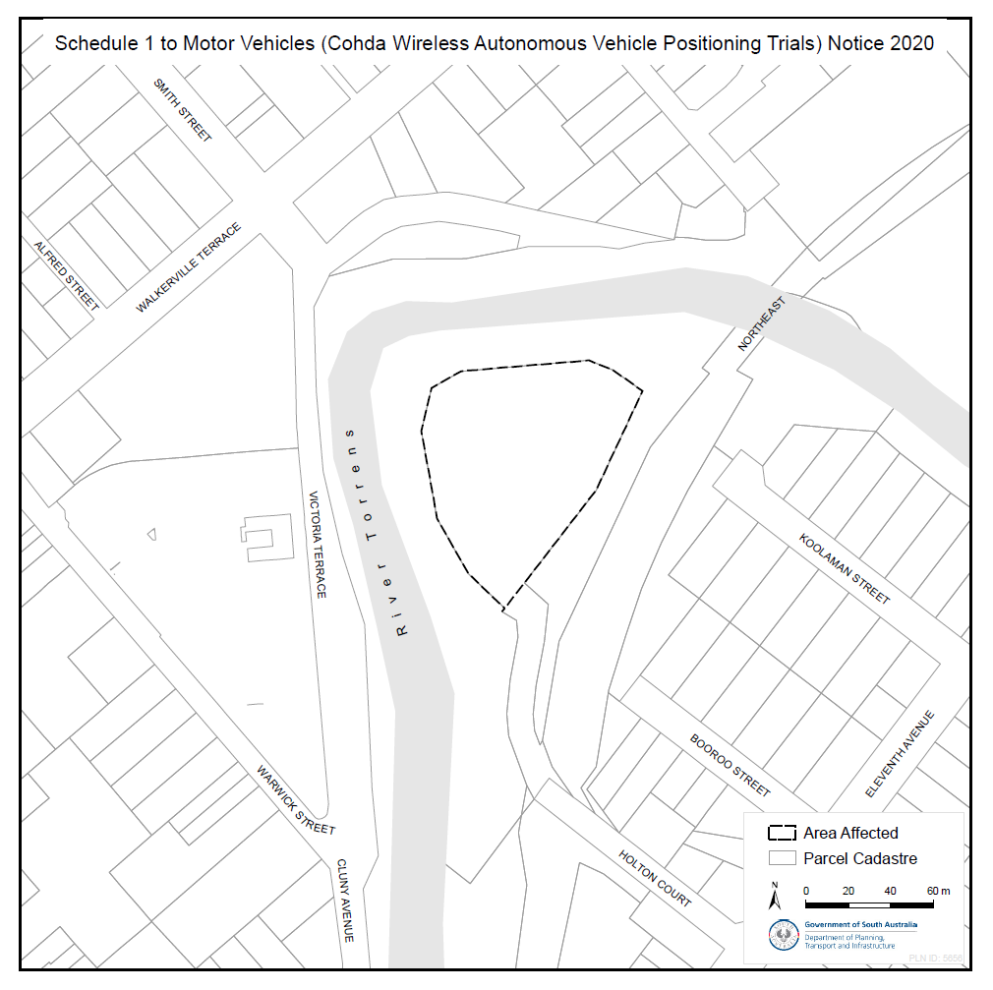
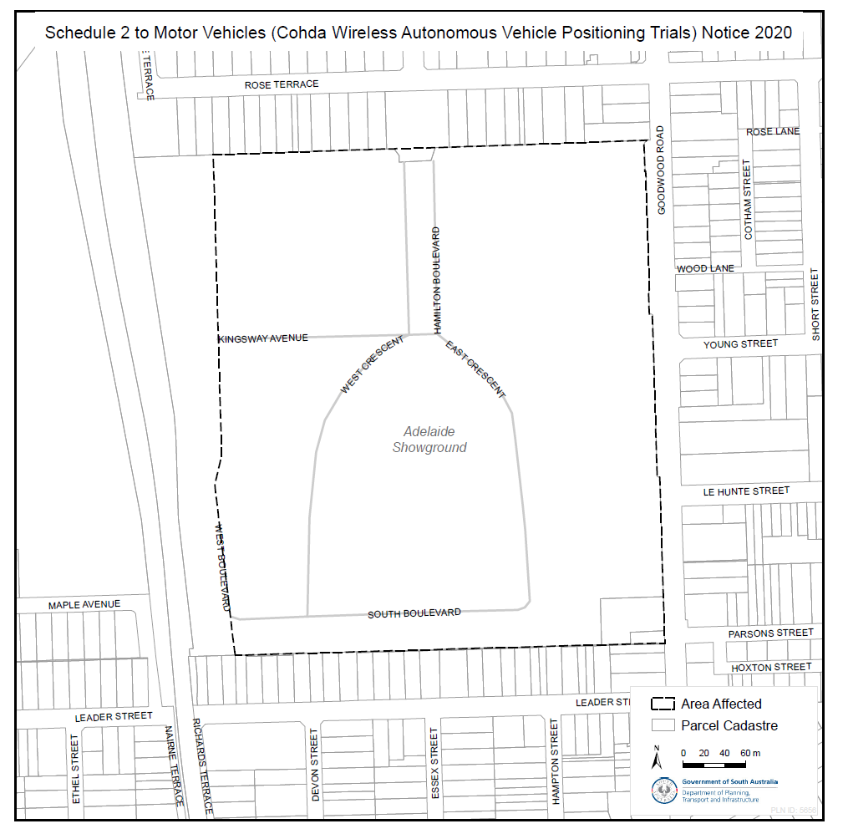

Natural Resources Management Act 2004
Notice of Authorisation to Take Water from the Central Adelaide Prescribed Wells Area—Ref. 291770
PURSUANT to Section 128 of the Natural Resources Management Act 2004 (the Act), I, David Speirs, Minister for Environment and Water (the Minister) in the State of South Australia and the Minister to whom the Act is committed, hereby authorise the taking of water from the Central Adelaide Prescribed Wells Area, from the prescribed wells specified in Schedule A, for the purpose set out in Schedule B and subject to the conditions specified in Schedule C.
Schedule A
Prescribed Wells
Well unit numbers 6628-27437, 6628-15439, 6628-26033, 6628-28698, 6628-30605, and 6628-30607.
Schedule B
Purpose
For operating the Waterproofing Eastern Adelaide Managed Aquifer Recharge and Recovery Scheme (‘the scheme’), whereby water recharged into the Central Adelaide Plains Prescribed Wells Area for the scheme, is later extracted for the irrigation of reserves, ovals, sporting and recreation facilities and schools located within the Town of Walkerville, the City of Norwood, Payneham & St Peters, the City of Unley, the City of Prospect, the City of Port Adelaide Enfield and the Campbelltown City Council.
Schedule C
Conditions
- Water may only be taken from the date of publication of this notice until 30 June 2023.

- The volume of water permitted to be extracted in a water use year must not exceed the volume of water recharged under the scheme over the previous five water use years, minus any volume that has subsequently been extracted over the five year period. The maximum volume taken in any given water use year, however, must not exceed the volumes referred to in Condition 3 of this authorisation.
- Subject to condition 2 of this authorisation, a total maximum volume of 500 megalitres of water per water use year (a maximum volume of 150 megalitres per water use year, per well) may be taken from the prescribed wells specified in Schedule A during the period referred to in Condition 1 of this authorisation.
- The water user must not take water except through a meter(s) supplied, installed and maintained in accordance with the South Australian Licensed Water Use Meter Specification approved by the Minister and as may be amended from time to time.
- Meter readings must be used to determine the quantity of water taken from each well.
- The water user must measure and record, for each well referred to in Schedule A, at least once during each calendar month, at the same time during each calendar month:
  - meter readings;
  - extraction volumes; and
  - water level.
- The current Water Proofing Eastern Adelaide MAR Risk Assessment & Monitoring Plan (the current plan) must be revised, to the satisfaction of the Minister’s representative, by no later than 30 June 2021.
- The scheme must be operated in accordance with the current plan, until such time as the revised plan has been adopted. Once the revised plan has been adopted, the scheme must be operated in accordance with the revised plan.
- The water user must comply with all measuring, monitoring and recording requirements as specified in the plan, including the requirement to provide a report annually, not more than 14 days after cessation of the water use year. The report will be provided in the form specified by the Minister’s representative, and include:
  - all data in accordance with condition 6 of this authorisation; and
  - monitoring data collected in accordance with the annual report monitoring deliverables contained in the adopted version of the plan at that time.
The report is to be emailed to dew.mar@sa.gov.au and dewwaterlicensing@sa.gov.au.
- If any device used to measure and collect data relevant to this authorisation, fails to accurately measure or record, or there is any reason to suspect that the device may be defective, then the water user must notify the Minister’s representative immediately, replace or repair the device as soon as practical and provide suitable alternative data to replace missing data.
- The water user must comply with the provisions applying to meters set out in Regulation 14 of the Natural Resources Management (Financial Provisions) Regulations 2005. It is an offence to contravene or fail to comply with those provisions.
For the purposes of this authorisation:
‘Water user’ means a person who is authorised to take water pursuant to this notice.
‘Water use year’ means a period of 12 months commencing on 1 July and ending 30 June the following calendar year.
For the purpose of determining a penalty for unauthorised water use, as declared under section 115 of the Act, the ‘volumetric limit’ of this authorisation is the lessor of a) the volume of water recharged under the scheme at any time over the previous five water use years, minus any volume that has subsequently been extracted or b) 500 megalitres (up to 150 megalitres per well) per water use year.
Words used in this authorisation that are defined in the Act shall have the meanings as set out in the Act.
This authorisation will commence on the date below and will remain in effect until 30 June 2023 unless earlier varied or revoked.
Dated: 19 June 2020
David Speirs MP
Minister for Environment and Water

Natural Resources Management Act 2004
Notice of Authorisation to Take Water from the Central Adelaide Prescribed Wells Area—Ref. 362821
PURSUANT to Section 128 of the Natural Resources Management Act 2004 (the Act), I, David Speirs, Minister for Environment and Water (the Minister) in the State of South Australia and the Minister to whom the Act is committed, hereby authorise the taking of water from the Central Adelaide Prescribed Wells Area, from the prescribed wells specified in Schedule A, for the purpose set out in Schedule B and subject to the conditions specified in Schedule C.
Schedule A
Prescribed Wells
Well unit numbers 6628-30605 and 6628-30607.
Schedule B
Purpose
For commissioning of wells 6628-30605 and 6628-30607 as part of the Waterproofing Eastern Adelaide Managed Aquifer Recharge and Recovery Scheme (‘the scheme’), authorised under section 128 of the Natural Resources Management Act 2004 (notice of authorisation number 291770).
Schedule C
Conditions
- Water may only be taken from the date of publication of this notice until 30 June 2021.
- The volume of water permitted to be extracted under this authorisation must not exceed a total of 10 megalitres (5 megalitres per well) from the prescribed wells specified in Schedule A during the period referred to in Condition 1 of this authorisation.
- Water can only be used for commissioning purposes of the wells specified in Schedule A with any unused portion forfeited.
- The water user must not take water except through a meter(s) supplied, installed and maintained in accordance with the South Australian Licensed Water Use Meter Specification approved by the Minister and as may be amended from time to time.
- Meter readings must be used to determine the quantity of water taken from each well.
- The water user must measure and record, for each well referred to in Schedule A, at least once during each calendar month, at the same time during each calendar month:
- meter readings;
- extraction volumes; and
- water level.
- The water user must provide a report annually, not more than 14 days after cessation of the water use year. The report will be provided in the form specified by the Minister’s representative, and include all data in accordance with condition 6 of this authorisation. This report must be separate to the report provided for Notice of Authorisation 291770.
The report is to be emailed to dew.mar@sa.gov.au and dewwaterlicensing@sa.gov.au.
- If any device used to measure and collect data relevant to this authorisation, fails to accurately measure or record, or there is any reason to suspect that the device may be defective, then the water user must: notify the Minister’s representative immediately; replace or repair the device as soon as practical; and provide suitable alternative data to supplement missing data.
- The water user must comply with the provisions applying to meters set out in Regulation 14 of the Natural Resources Management (Financial Provisions) Regulations 2005. It is an offence to contravene or fail to comply with those provisions.
For the purposes of this authorisation:
‘Water user’ means a person who is authorised to take water pursuant to this notice.
‘Water use year’ means a period of 12 months commencing on 1 July and ending 30 June the following calendar year.
Words used in this authorisation that are defined in the Act shall have the meanings as set out in the Act.
This authorisation will commence on the date below and will remain in effect until 30 June 2021 unless earlier varied or revoked.
Dated: 19 June 2020
David Speirs MP
Minister for Environment and Water

Natural Resources Management Act 2004
Revocation of Notice of Authorisation to Take Water from the Central Adelaide Prescribed Wells Area
Pursuant to section 128 (5) of the Natural Resources Management Act 2004, I, David Speirs, Minister for Environment and Water, and the Minister to whom the Act is committed, hereby revoke the Notice of Authorisation to Take Water from the Central Adelaide Prescribed Wells Area published pursuant to Section 128 (1) of the Act in the Government Gazette (Ref: 291770) on 21 June 2018 (Ref: 291770).
Dated: 19 June 2020
David Speirs MP
Minister for Environment and Water

Natural Resources Management Act 2004
Southern Basins and Musgrave Prescribed Wells Areas Water Allocation Plan
I, DAVID SPEIRS, Minister for Environment and Water, to whom administration of the Natural Resources Management Act 2004 is committed, hereby give notice for the purposes of the Water Allocation Plan for the Southern Basins and Musgrave Prescribed Wells Area adopted under Schedule 4 of the Natural Resources Management Act 2004, of the level of storage, the water to be made available for allocation and the value on individual unit shares available from respective consumptive pools for the 2020-21 water use year as set out below:
Table 1: Consumptive Pools Data For Southern Basins & Musgrave Prescribed Wells Areas
Pwa | Consumptive Pool | Level Of Storage (%) | Proportion Of Water Available (%) | Value Of Share | Volume Of Consumptive Pool (Kl)
Southern Basins | Coffin Bay | 98.6 | 100.0 | 1.000 | 138170
 | Uley Wanilla Public Water Supply | 80.7 | 93.0 | 0.930 | 221118
 | Uley North | 77.9 | 0.0 | 0.000 | 27860
 | Uley South Public Water Supply | 87.1 | 97.0 | 0.970 | 7056279
 | Lincoln South Public Water Supply | 94.7 | 100.0 | 1.000 | 1833679
 | Lincoln North |  |  |  | 173190
 | Port Lincoln Golf Club |  |  |  | 7000
 | Southern Basins Unsaturated |  |  |  | 6960
 | Tertiary |  |  |  | 29140
 | Basement |  |  |  | 483518

Pwa | Consumptive Pool | Level Of Storage (%) | Proportion Of Water Available (%) | Value Of Share | Volume Of Consumptive Pool (Kl)
Musgrave | Polda | 57.3 | 0 | 0.000 | 34730
 | Bramfield | 74.5 | 31.9 | 0.319 | 559110
 | Sheringa | 79.3 | 40.1 | 0.401 | 617755
 | Musgrave Unsaturated |  |  |  | 10600
 | Tertiary |  |  |  | 68390
 | Basement |  |  |  | 67270

Dated: 17 June 2020
David Speirs MP
Minister for Environment and Water

Petroleum and Geothermal Energy Act 2000
Application for Grant of Associated Activities Licence AAL 287
Pursuant to section 65(6) of the Petroleum and Geothermal Energy Act 2000 (the Act) and Delegation dated 29 June 2018, notice is hereby given that an application for the grant of an associated activities licence over the area described below has been received from:
Beach Energy Limited
Great Artesian Oil and Gas Pty Ltd
The application will be determined on or after 10 July 2020.
All that part of the State of South Australia, bounded as follows:
All coordinates MGA2020, Zone 54
338740mE 6930344mN
338727mE 6931267mN
339401mE 6931276mN
339401mE 6930331mN
339401mE 6929428mN
339025mE 6929424mN
339014mE 6930342mN
338740mE 6930344mN
AREA: 0.97 square kilometres approximately
Dated: 22 June 2020
Barry A. Goldstein
Executive Director
Energy Resources Division
Department for Energy and Mining
Delegate of the Minister for Energy and Mining

Planning, Development and Infrastructure (General) Regulations 2017
Notice of Decision—Regulation 57 (1)
Determination by the Minister of the Form for a Notice of a Decision under Regulation 57 (1)
Preamble
Regulation 57 (1) of the Planning, Development and Infrastructure (General) Regulations 2017 provides that notice of a decision on an application under Part 7 of the Planning, Development and Infrastructure Act 2016 (other than Subdivision 4 of Division of that Part) must be given in a form determined by the Minister for Planning (being a form published by the Minister in the Gazette).
NOTICE
PURSUANT to Regulation 57(1) of the Planning, Development and Infrastructure (General) Regulations 2017, I, Stephan Knoll, being the Minister administering the Planning, Development and Infrastructure Act 2016, have determined that the form contained in ‘Attachment A’ comprises the form for a notice of a decision on an application given under Part 7 of the Planning, Development and Infrastructure Act 2016 (other than Subdivision 4 of Division 2 of that Part).
The form may be adapted into a digital format for use on the SA planning portal.
This notice will come into force on the day the Phase Two (Rural Areas) Planning and Design Code Amendment comes into effect pursuant to section 73(12) of the Planning, Development and Infrastructure Act 2016.
Dated: 31 May 2020
Hon Stephan Knoll MP
Minister for Transport, Infrastructure and Local Government
Minister for Planning

Attachment A
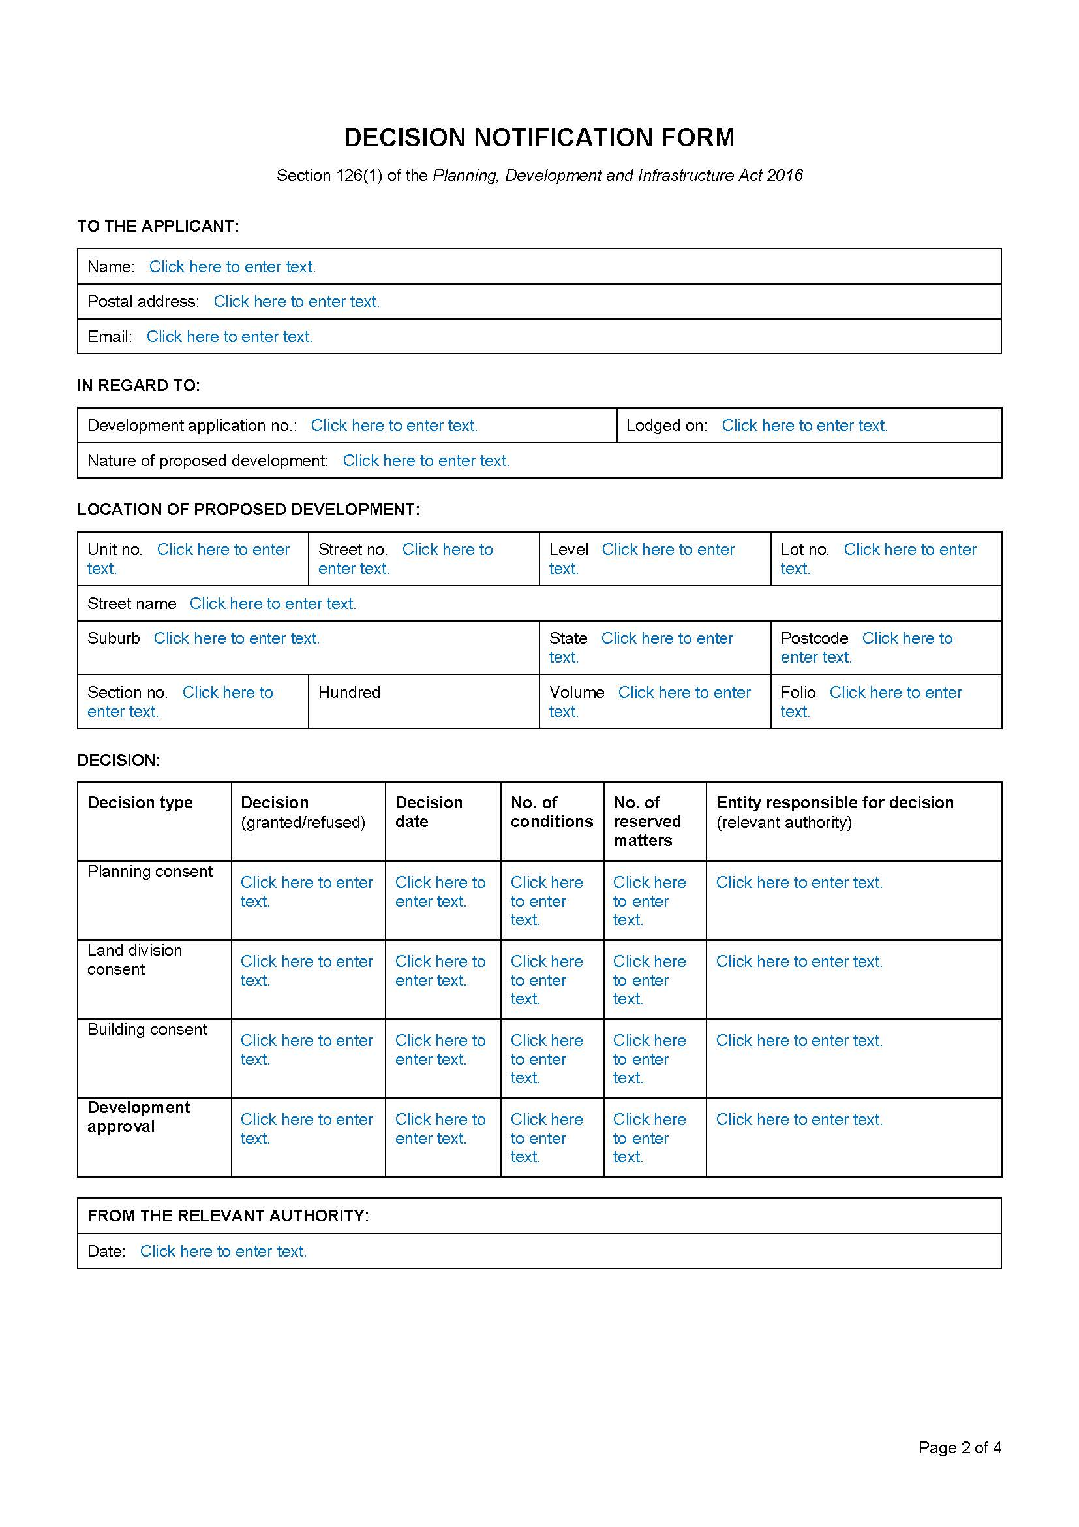

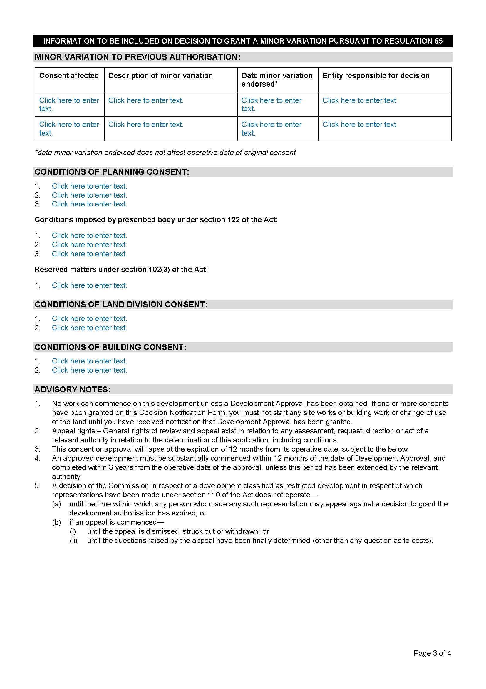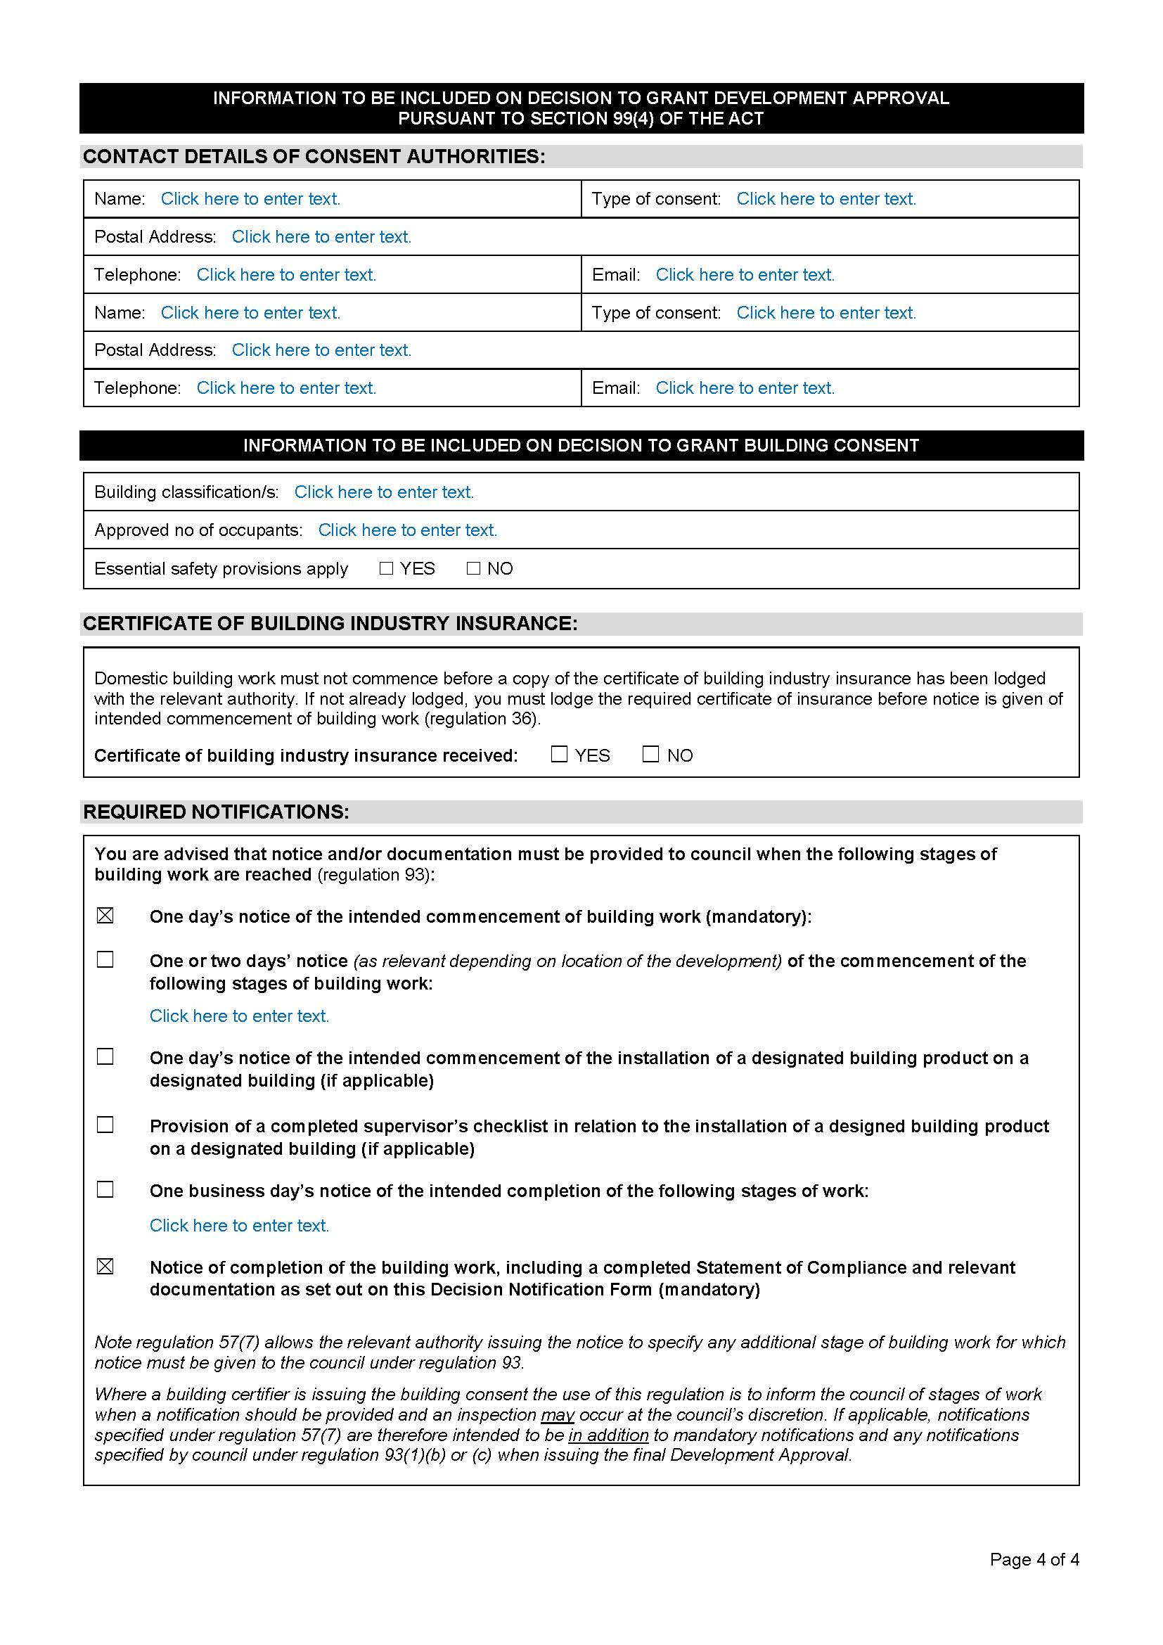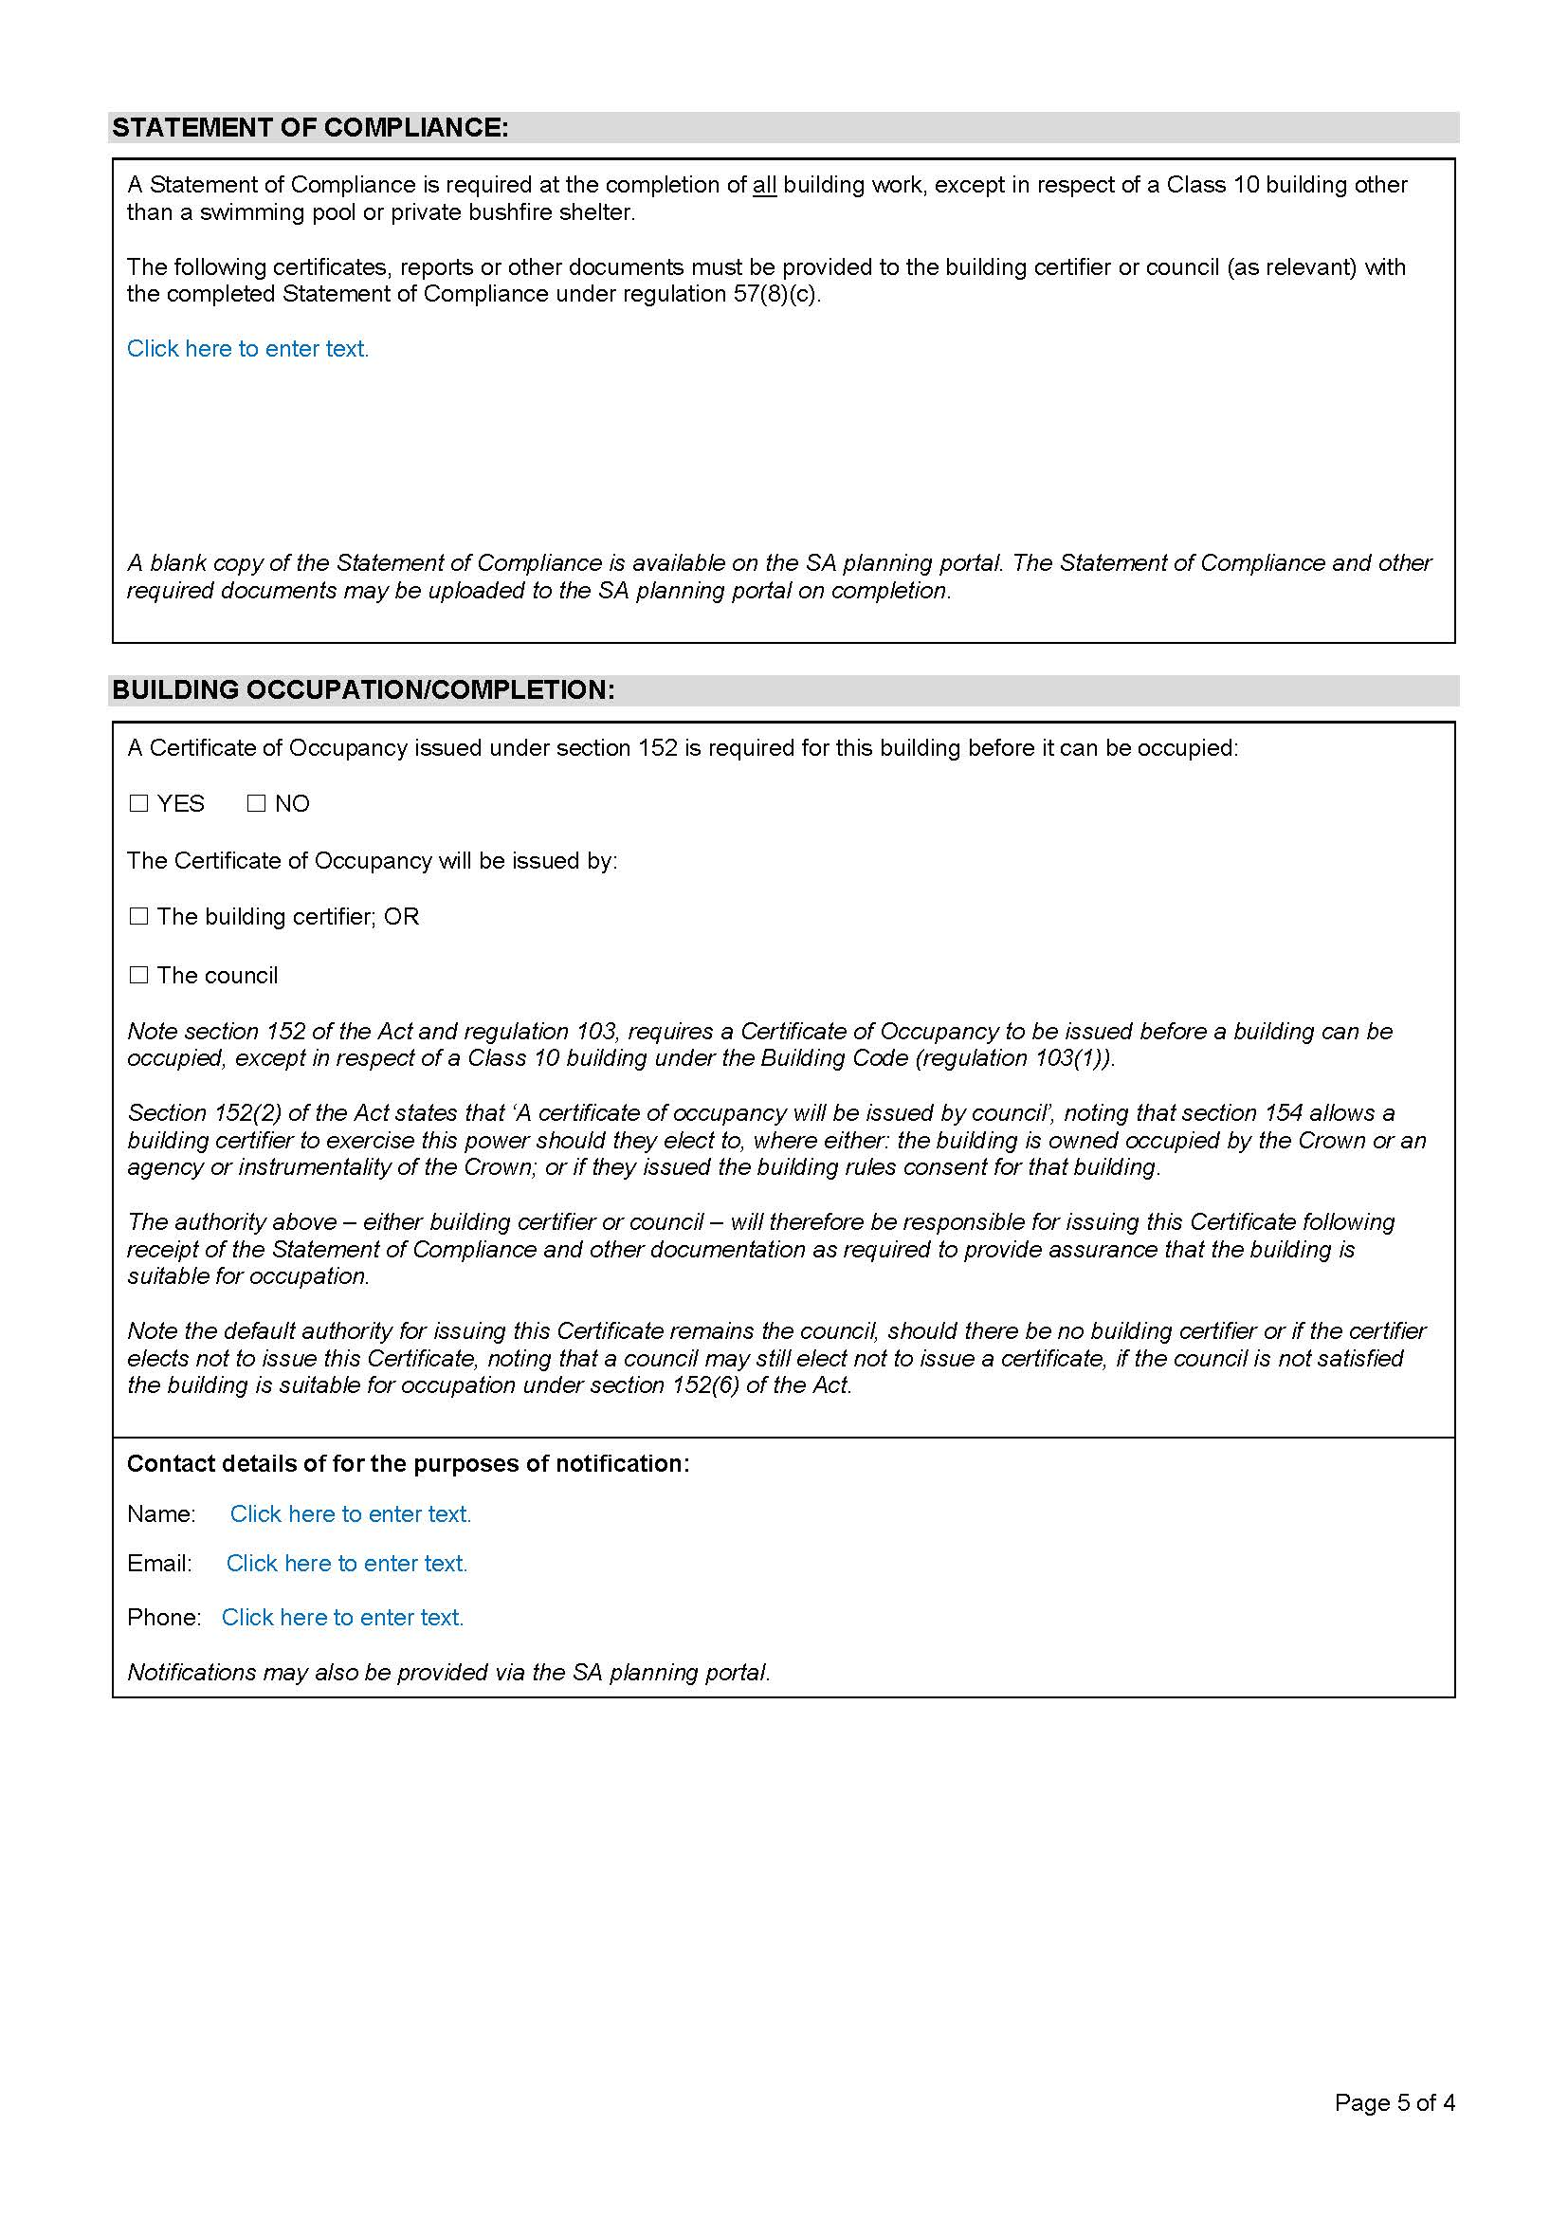

Planning, Development and Infrastructure Act 2016
Section 80(1)
Publication of Ministerial Building Standards
Preamble
- Section 80(1) of the Planning, Development and Infrastructure Act 2016 provides that the Minister for Planning may, after consultation with the State Planning Commission, publish Ministerial Building Standards that relate to building matters.
- Section 3(1) of the Planning, Development and Infrastructure Act 2016 provides that the Building Rules meaning includes the Ministerial Building Standards published by the Minister under the Act.
NOTICE
PURSUANT to section 80(1) of the Planning, Development and Infrastructure Act 2016, I, Stephan Knoll, being the Minister administering the Planning, Development and Infrastructure Act 2016, hereby give notice that the following Ministerial Building Standards have been published and now form part of the Building Rules under the Act:
- Ministerial Building Standard MBS 008 – Designated bushfire prone areas – additional requirements
- Ministerial Building Standard MBS 009 – On-site retention of stormwater
- Ministerial Building Standard MBS 010 – Construction requirements for the control of external sound
These Standards have been published on the SA Planning portal at www.saplanningportal.sa.gov.au
This notice will come into force on the day the Phase Two (Rural Areas) Planning and Design Code Amendment comes into effect pursuant to section 73(12) of the Planning, Development and Infrastructure Act 2016.
Dated: 31 May 2020
Hon Stephan Knoll MP
Minister for Transport, Infrastructure and Local Government
Minister for Planning

Public Sector Act 2009
South Australia
Public Sector (Reorganisation of Public Sector
Operations—Department for Environment and Water) Notice 2020
under section 9(1) of the Public Sector Act 2009
1—Short title
This notice may be cited as the Public Sector (Reorganisation of Public Sector Operations—Department for Environment and Water) Notice 2020.
2—Commencement
This notice will come into operation on 1 July 2020.
3—Transfer of employees
(1) The employees of the Department for Environment and Water listed in column 1 of the table below are transferred to the employing authority listed in column 2 opposite the reference to the employee on the same basis of engagement as applied before the transfer.
(2) Subclause (1) includes employees who are:
  - Currently working on a term basis in another public sector agency and who have a right of return to duties pursuant to regulation 6 of the Public Sector Regulations 2010
  - Absent from their substantive duties on any form of paid or unpaid leave and who have a right at the conclusion of such leave to return to their duties.
(3) Employees listed in column 1 of the table below who are engaged on a temporary or contract basis are transferred only insofar as their temporary or casual employment is to be transferred.

Employee | Employing authority
All employees assigned to perform functions in connection with the operations or activities of the Alinytjara Wilurara Natural Resources Management Board. | The general manager of the Alinytjara Wilurara Landscape Board
All employees assigned to perform functions other than business support in connection with the operations or activities of the Eyre Peninsula Natural Resources Management Board | The general manager of the Eyre Peninsula Landscape Board
All employees assigned to perform functions other than business support in connection with the operations or activities of the Kangaroo Island Natural Resources Management Board | The general manager of the Kangaroo Island Landscape Board
All employees assigned to perform functions other than business support in connection with the operations or activities of the South East Natural Resources Management Board | The general manager of the Limestone Coast Landscape Board
All employees assigned to perform functions other than business support in connection with the operations or activities of the Northern and Yorke Natural Resources Management Board | The general manager of the Northern and Yorke Landscape Board
All employees assigned to perform functions other than business support in connection with the operations or activities of the South Australian Arid Lands Natural Resources Management Board | The general manager of the South Australian Arid Lands Landscape Board
All employees assigned to perform functions other than business support in connection with the operations or activities of the South Australian Murray-Darling Basin Natural Resources Management Board, with the exception of  Denise Fowles  Alexander (Sandy) Cummings  Dwayne Godfrey  Thomas Mowbray  Mardi Van der Wielen | The general manager of the Murraylands and Riverland Landscape Board
The following employees:  Jessica Cavallo  Veronica Clayton  Anthony Fox  David Hughes  Brooke Kerin  Christopher Madigan  Taryn Mangelsdorf  Elizabeth Ninnes  Jamie Pook | The general manager of the Northern & Yorke Landscape Board
The following employees:  Joel Allan  Catherine Austin  Sophie Bass  Nicole Bennett  Jacqueline Best  Lisa Blake  Tom Brookman  Alexander (Sandy) Cummings  Benjamin Della Torre  Caroline Dorr  Jeffrey Edwards  Mark Fagan  Dwayne Godfrey  James Hall  William Hannaford  Megan Harper  Steven Hearn  Lucy Hyde  Susan Ivory  Shane Johansen  Randall Johnson  Wayne Lawrence  Marijana Levak  Dana Miles  Thomas Mowbray  Robert Murphy  Jodie Pain  Luke Price  Joanna Rex  Samson Schoofs  Jerry Smith  Martin Stokes  Wendy Telfer  James Thiessen  Abigail Thomas  Rebecca Tonkin  Mardi Van Der Wielen  Paul Wainwright  Katrina Warner  Jodie Woof | The general manager of the Hills & Fleurieu Landscape Board
Made by the Premier
on 25 June 2020

South Australian Civil and Administrative Tribunal
SACAT Reference Number: 2020/Sa001254 & 2020/Sa001256
Notice of Renewal and Granting of Exemption
Before Tribunal Member Edward Stratton-Smith
I HEREBY certify that on the 17th June 2020, the South Australian Civil and Administrative Tribunal, on application of ASC Pty Ltd, ASC AWD Shipbuilder Pty Ltd, and ASC OPV Shipbuilder Pty Ltd made the following orders for renewal of an exemption:
1. The exemption from compliance with the provisions of sections 52, 53, 54 and 103(1) of the Equal Opportunity Act 1984 (SA) (the Act) with respect to ‘nationality’ and ‘country of origin’ granted to the First and Second Applicants on 29 June 2017 is renewed for a period of three years.
2. The Third Applicant is granted an exemption from compliance with the provisions of sections 52, 53, 54 and 103(1) of the Act with respect to ‘nationality’ and ‘country of origin’ for a period of three years.
3. The First, Second and Third Applicant must, on the 12 month anniversary of these Orders, and every 12 months thereafter for the duration of this exemption, report to the Equal Opportunity Commissioner on their compliance with the Orders and changes (if any) in their procedures to reflect any amendments to the International Traffic in Arms Regulations (ITAR) 22 CFR § 120 (2003) (USA), and as to how their employees and contractors are affected. That report must include:
a. The training and education provided to new and existing employees on these Orders and their implementation;
b. The steps taken by the Applicants to implement these Orders;
c. How the Applicants monitor compliance with these Orders;
d. The number of persons affected by these Orders and the nature of those effects;
e. The steps taken by the Applicants to address any adverse effects on existing employees as a result of these Orders;
f. The steps taken by the Applicants to minimise the impact of these Orders on current and future employees.
4. The above exemption is to remain in force for a period of 3 years commencing on 17 June 2020.
Dated: 17 June 2020
Anne Lindsay
Principal Registrar
South Australian Civil and Administrative Tribunal

South Australian Water Corporation
Fees and Charges Schedule
Rates and Sales
Pursuant to section 36 of the Water Industry Act the following charges for water, sewerage and associated services apply. These charges are fixed for the period 1 July 2020 to 30 June 2021.
Pursuant to the Water Industry Regulations 2012 (regulations 38) and Government Gazette 6 June 2013, SA Water may levy an availability charge despite the fact that the land is not connected to SA Water’s infrastructure. All charges for sewerage services and the availability charge for water applying to some commercial properties are based on the property valuation of the land. Property values are set annually by the Valuer-General for the next financial year.
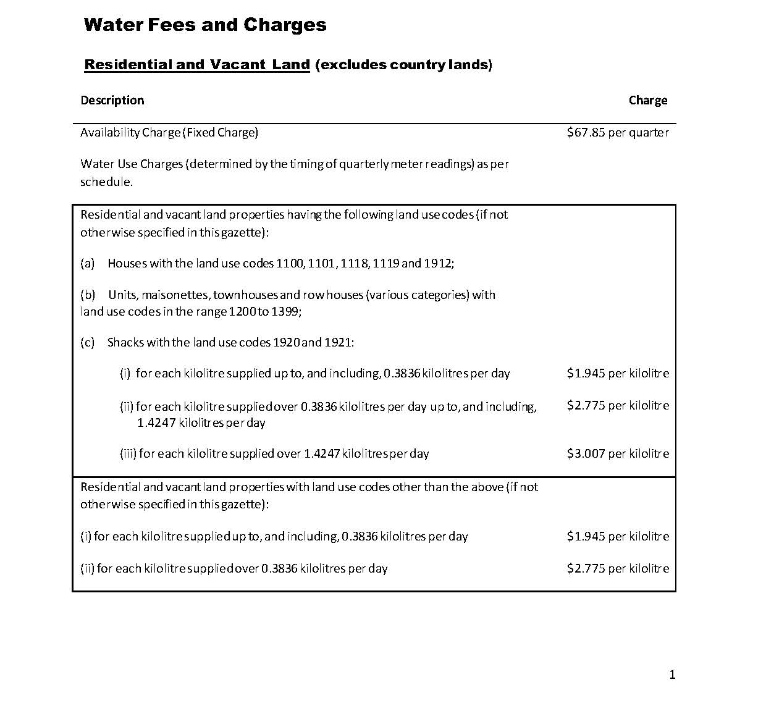

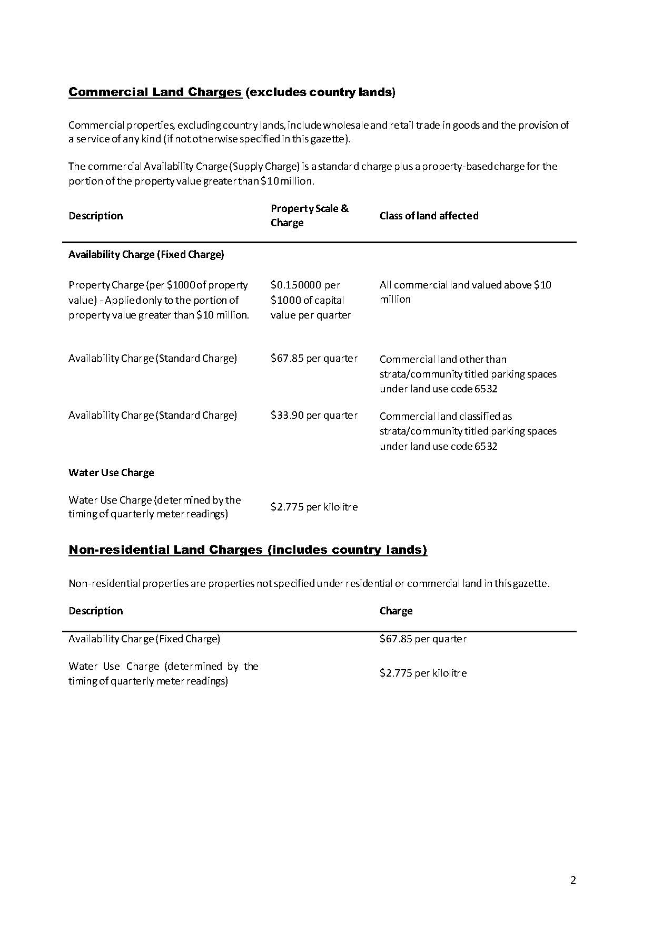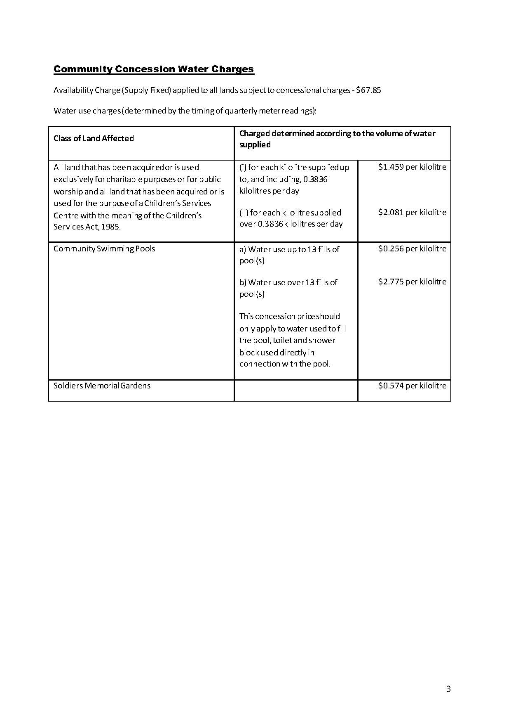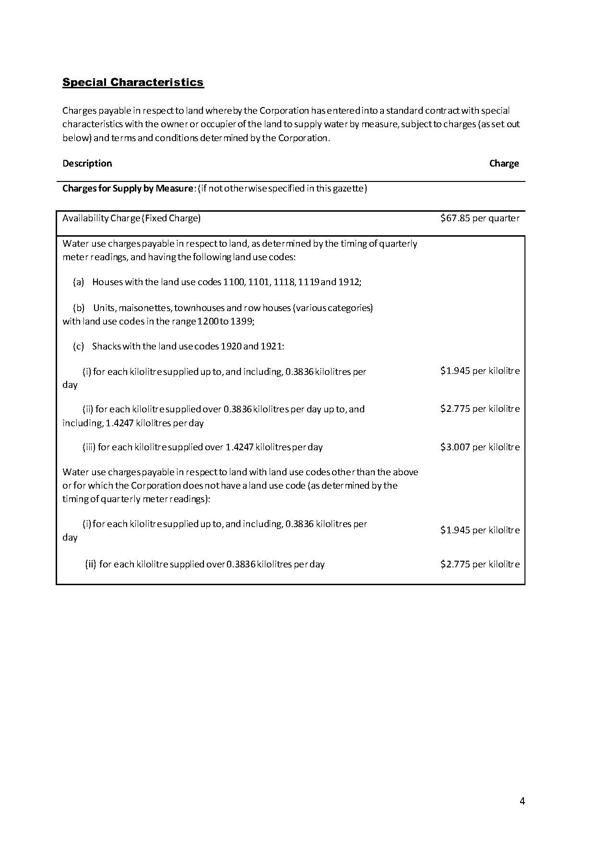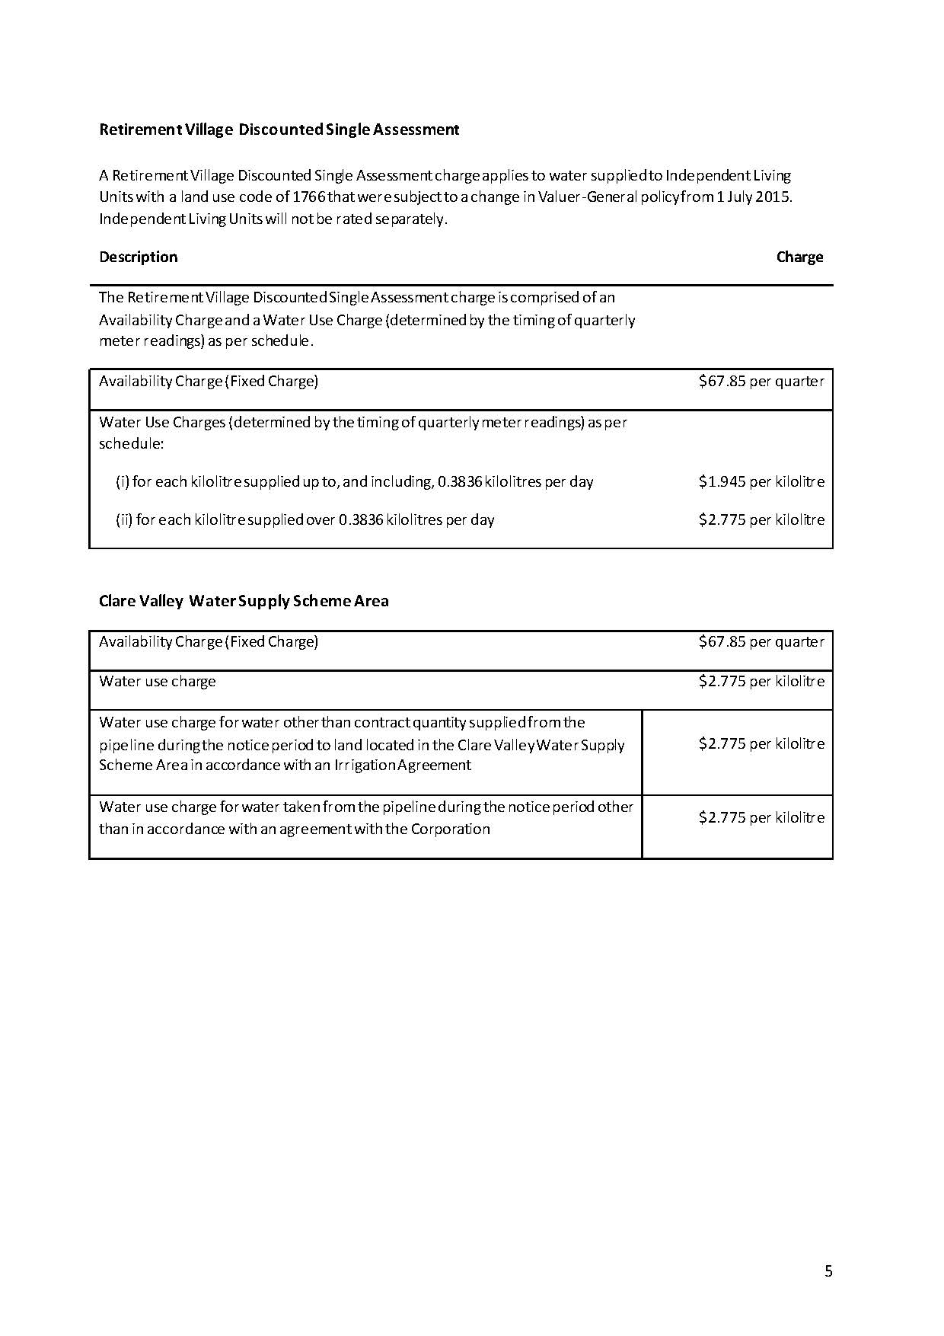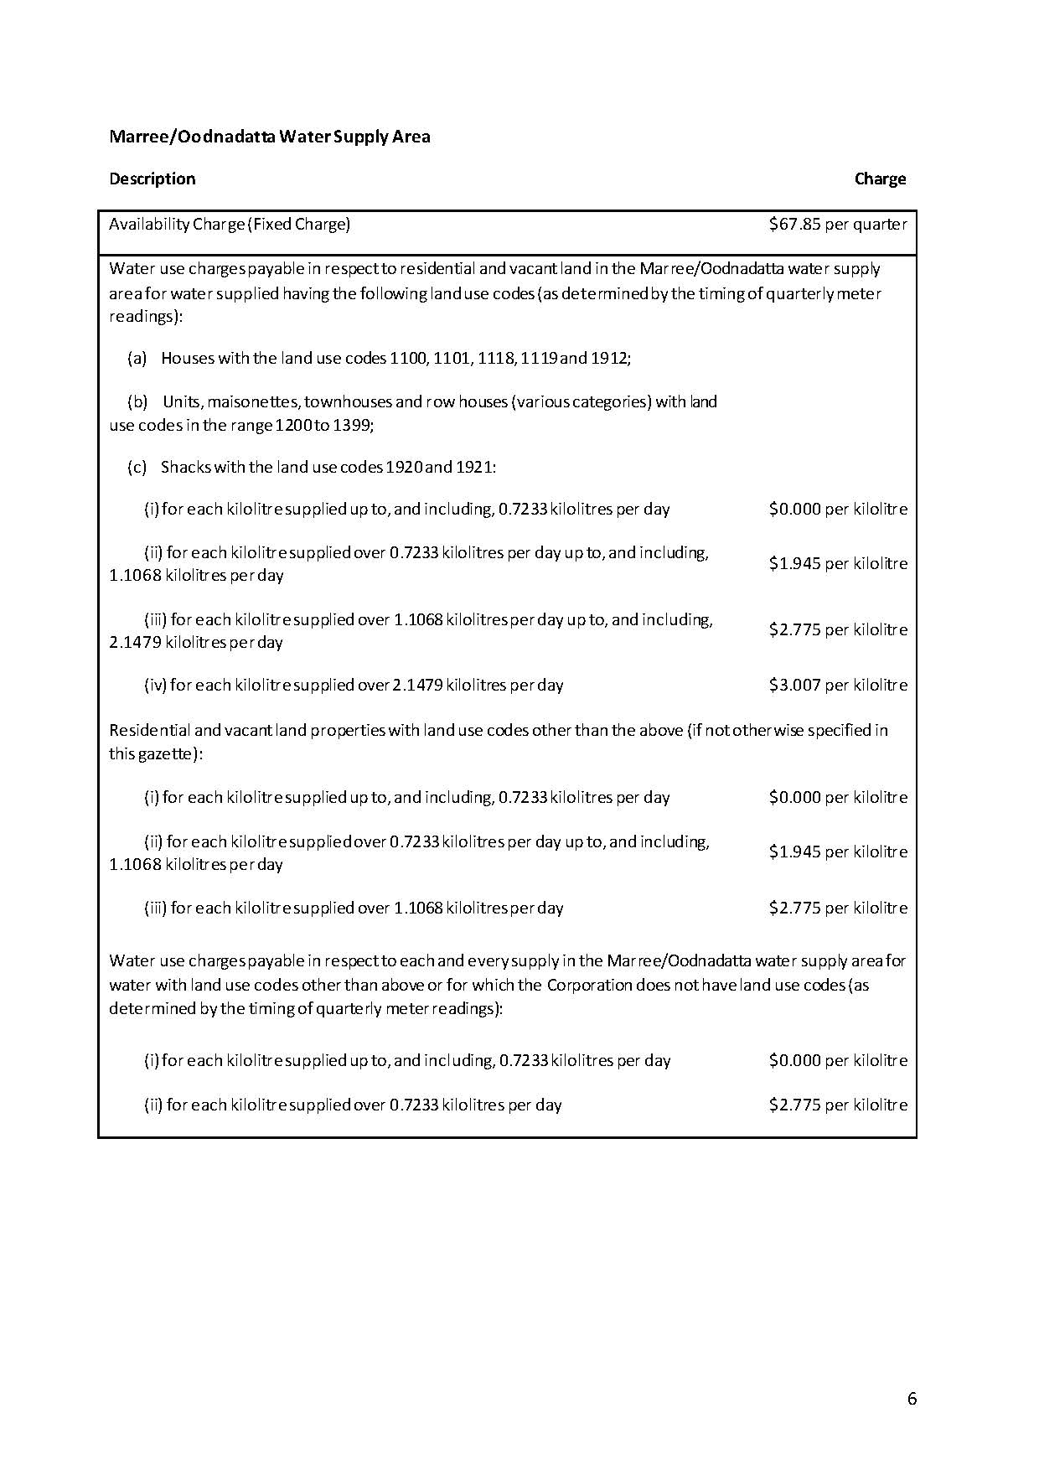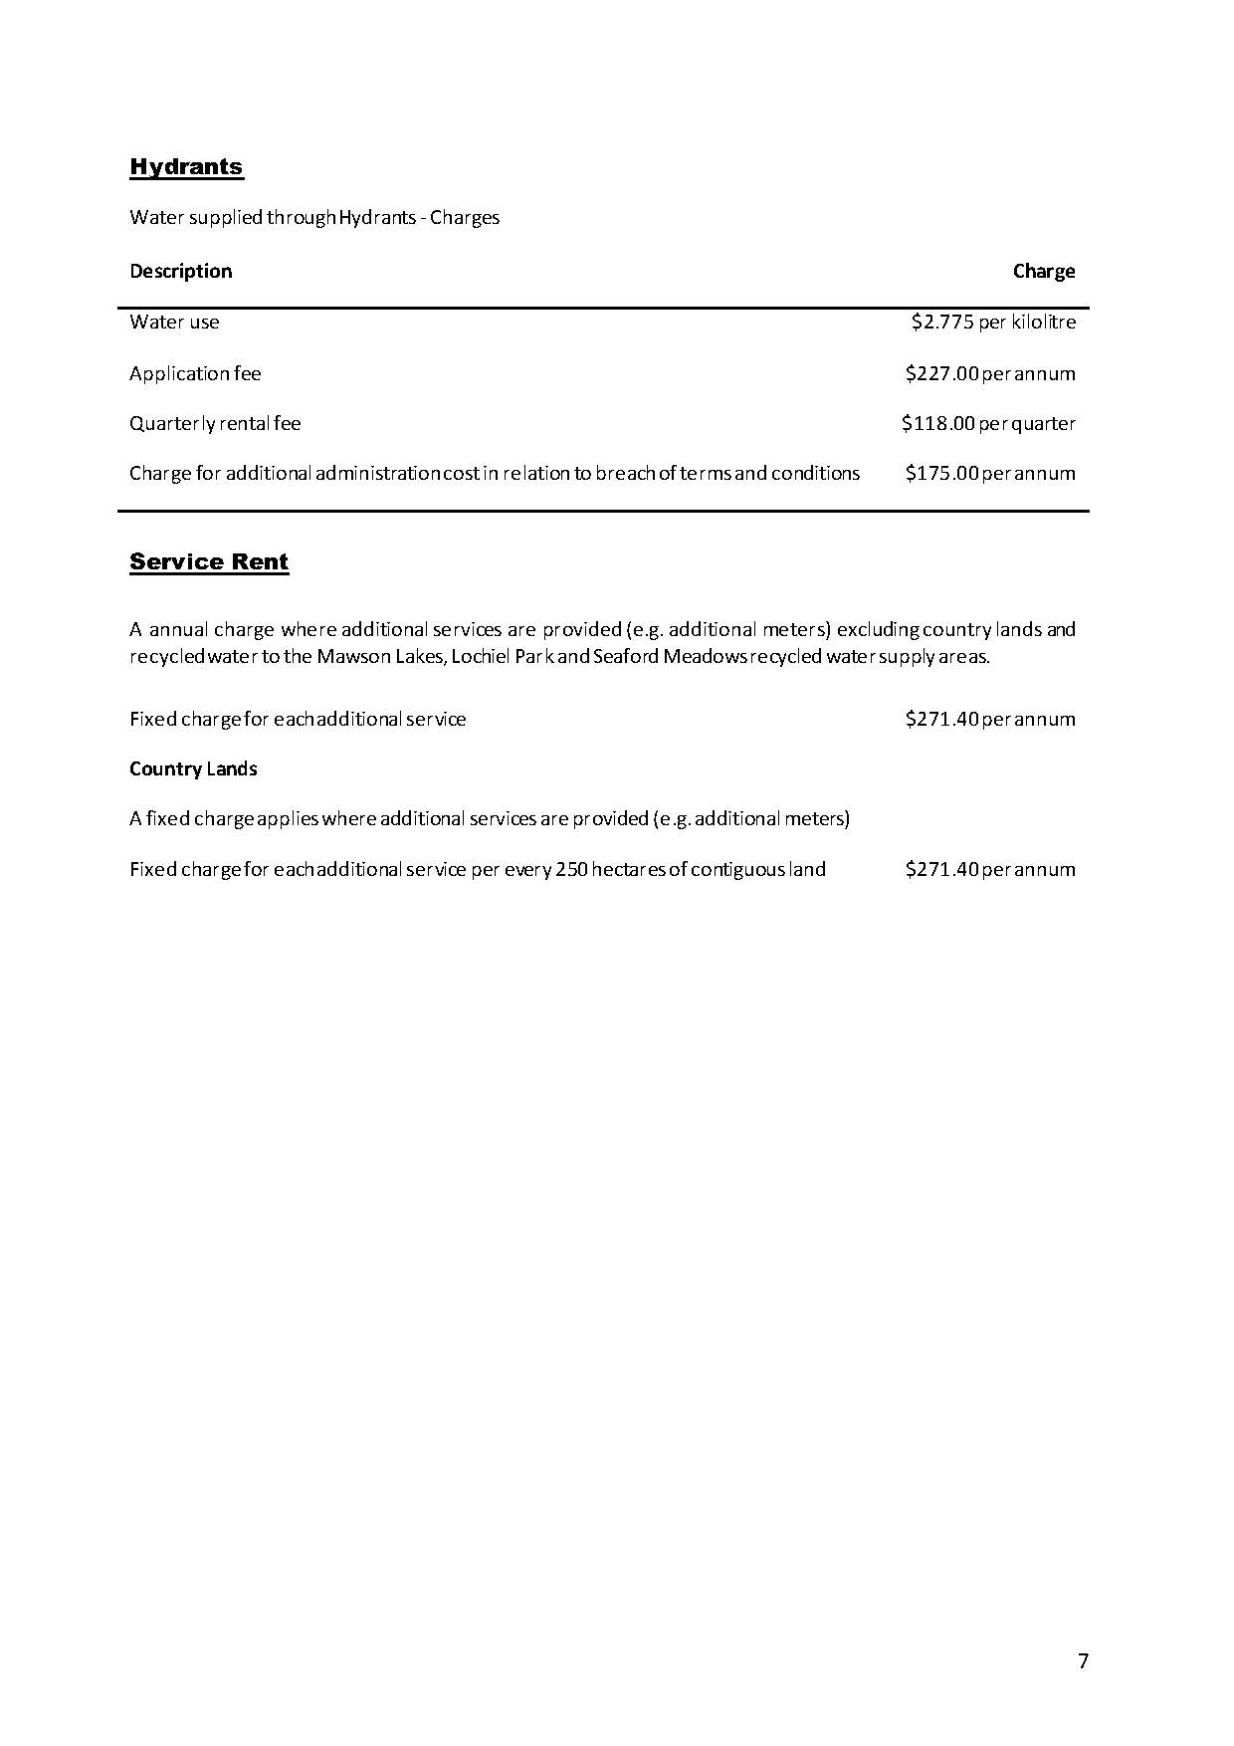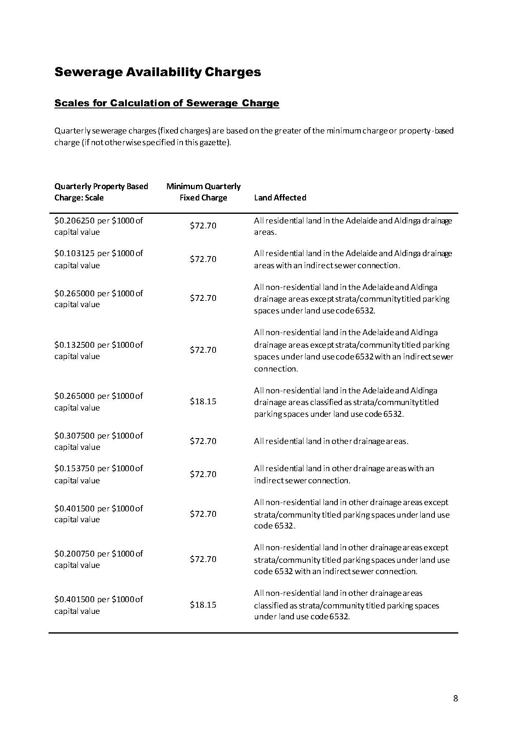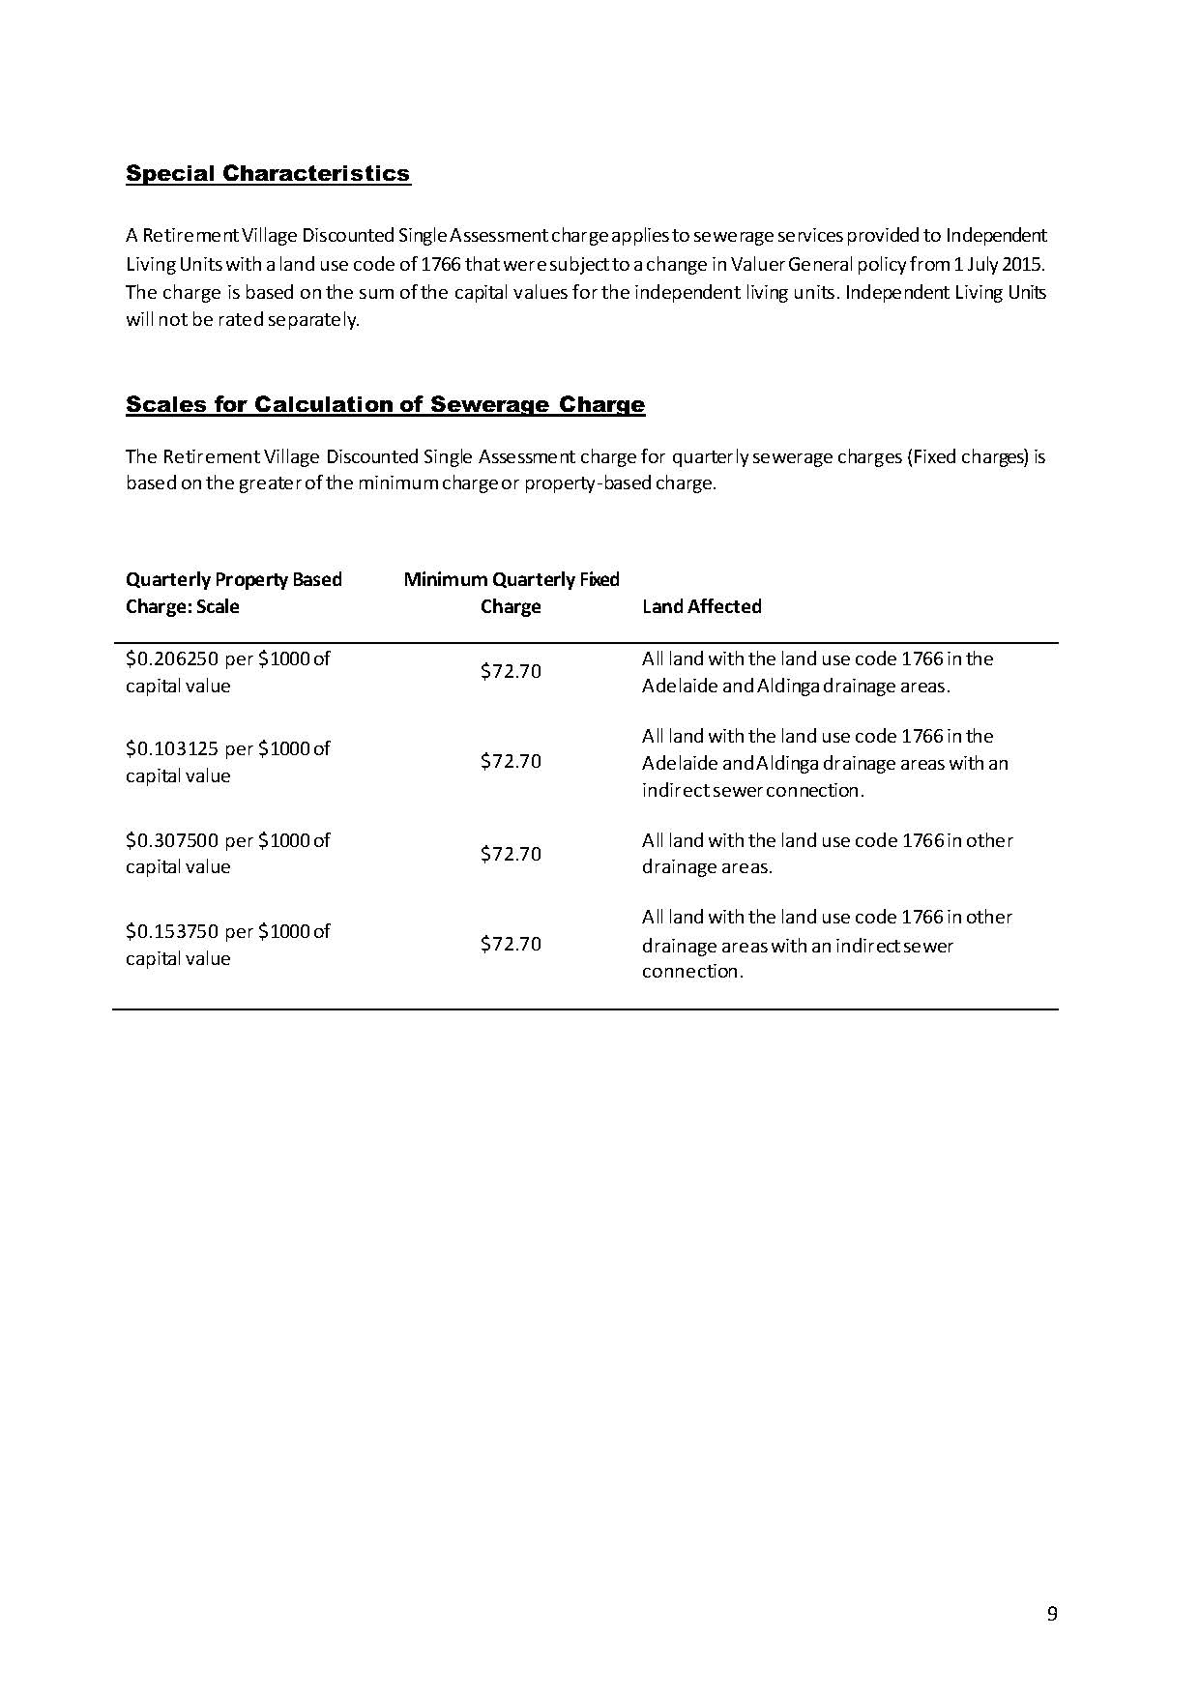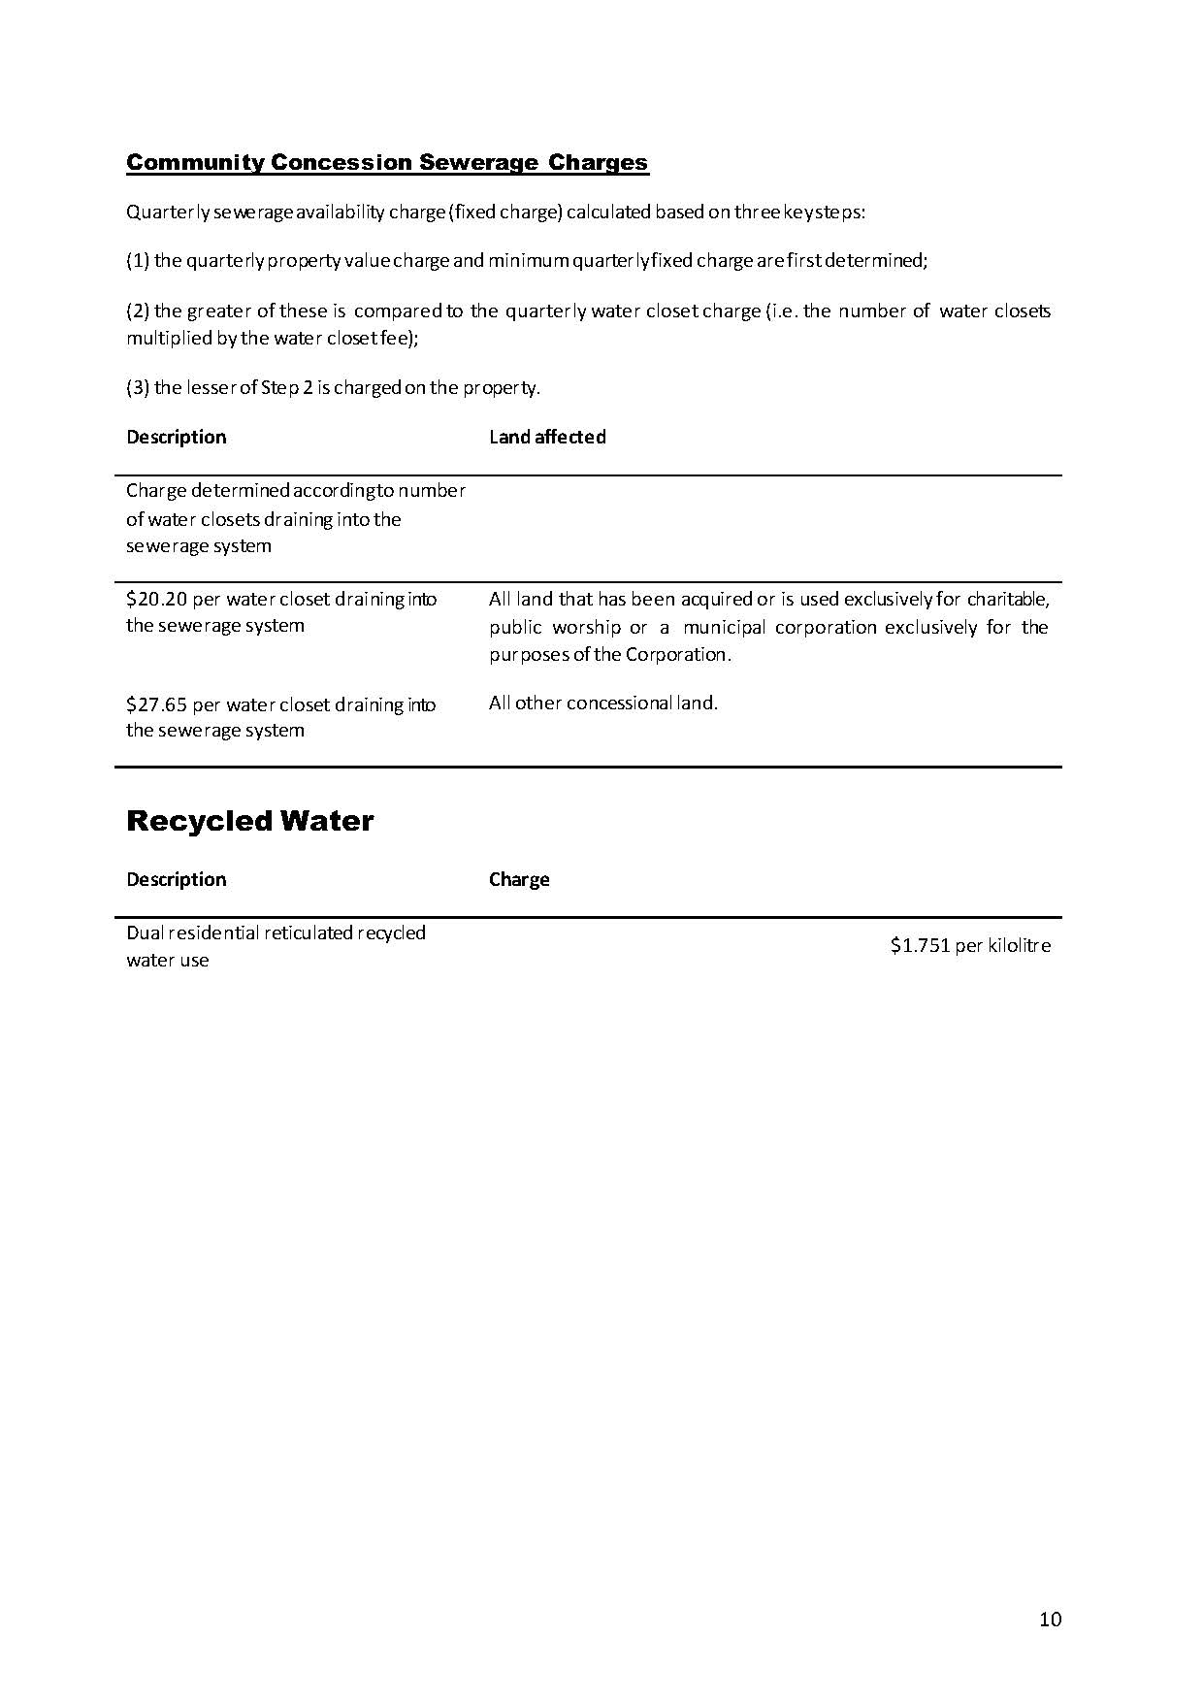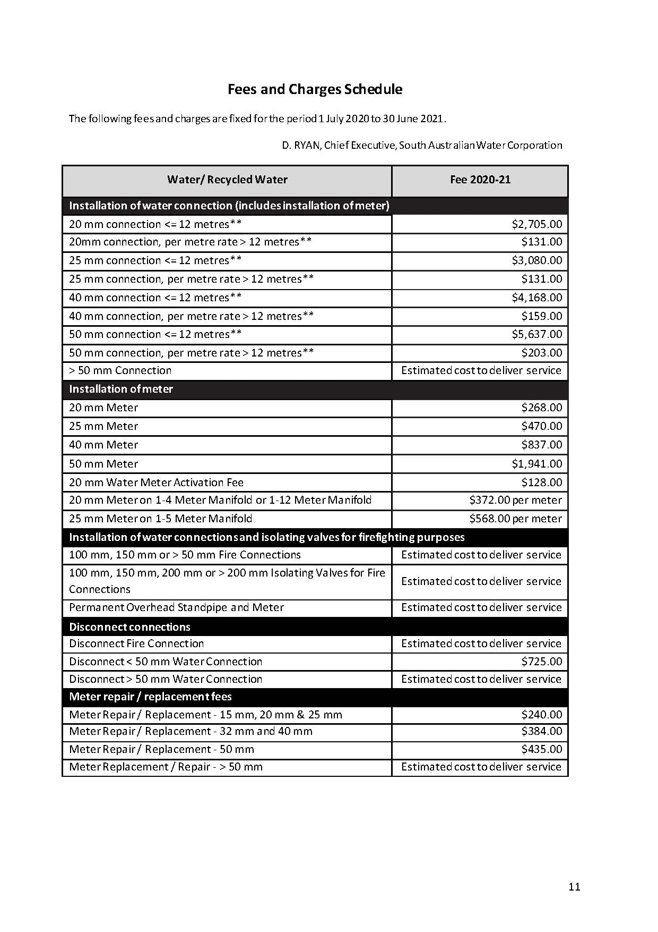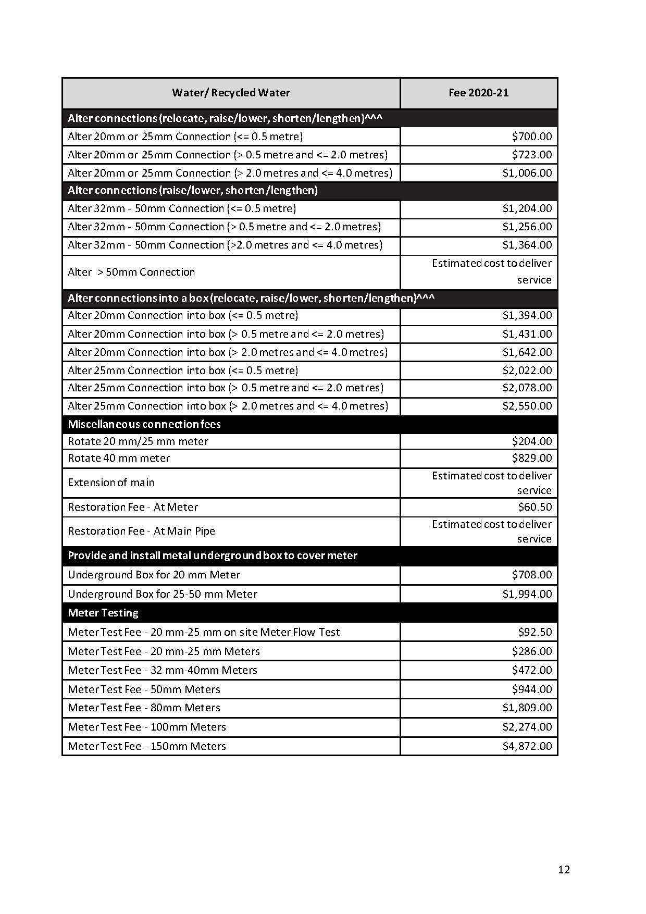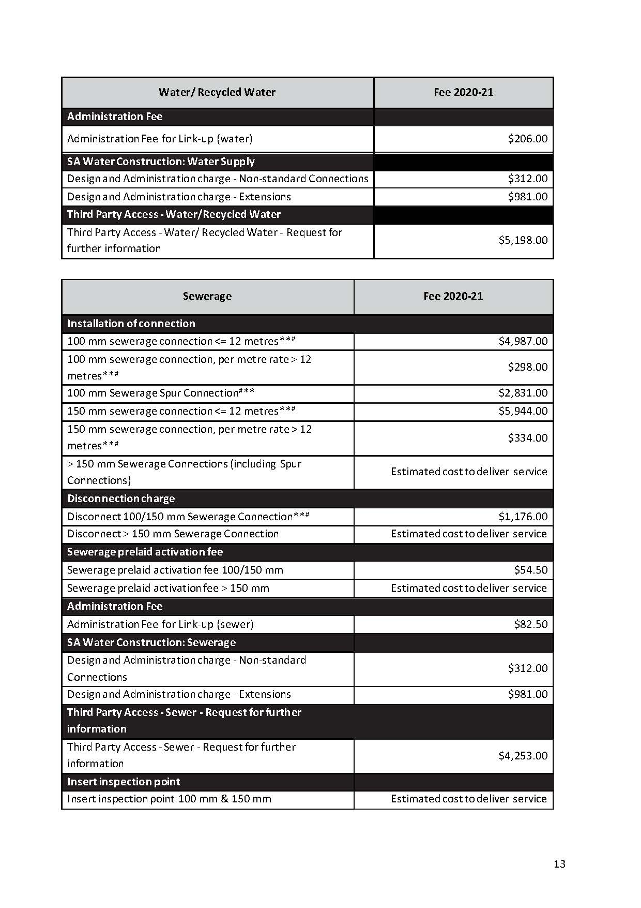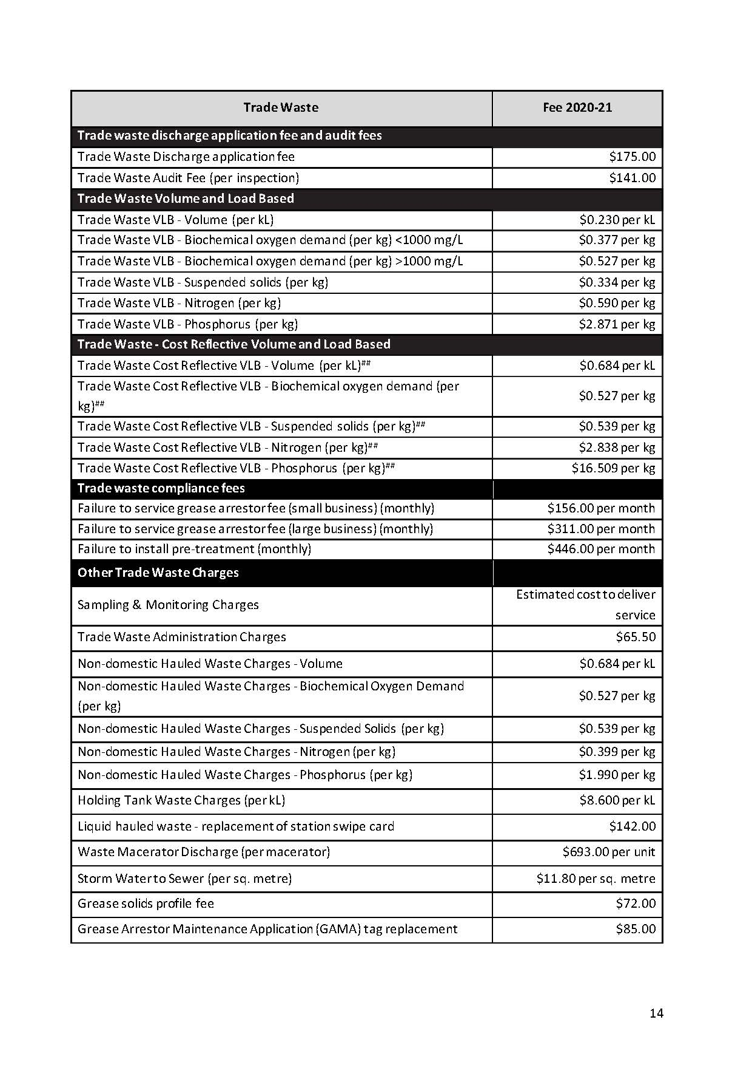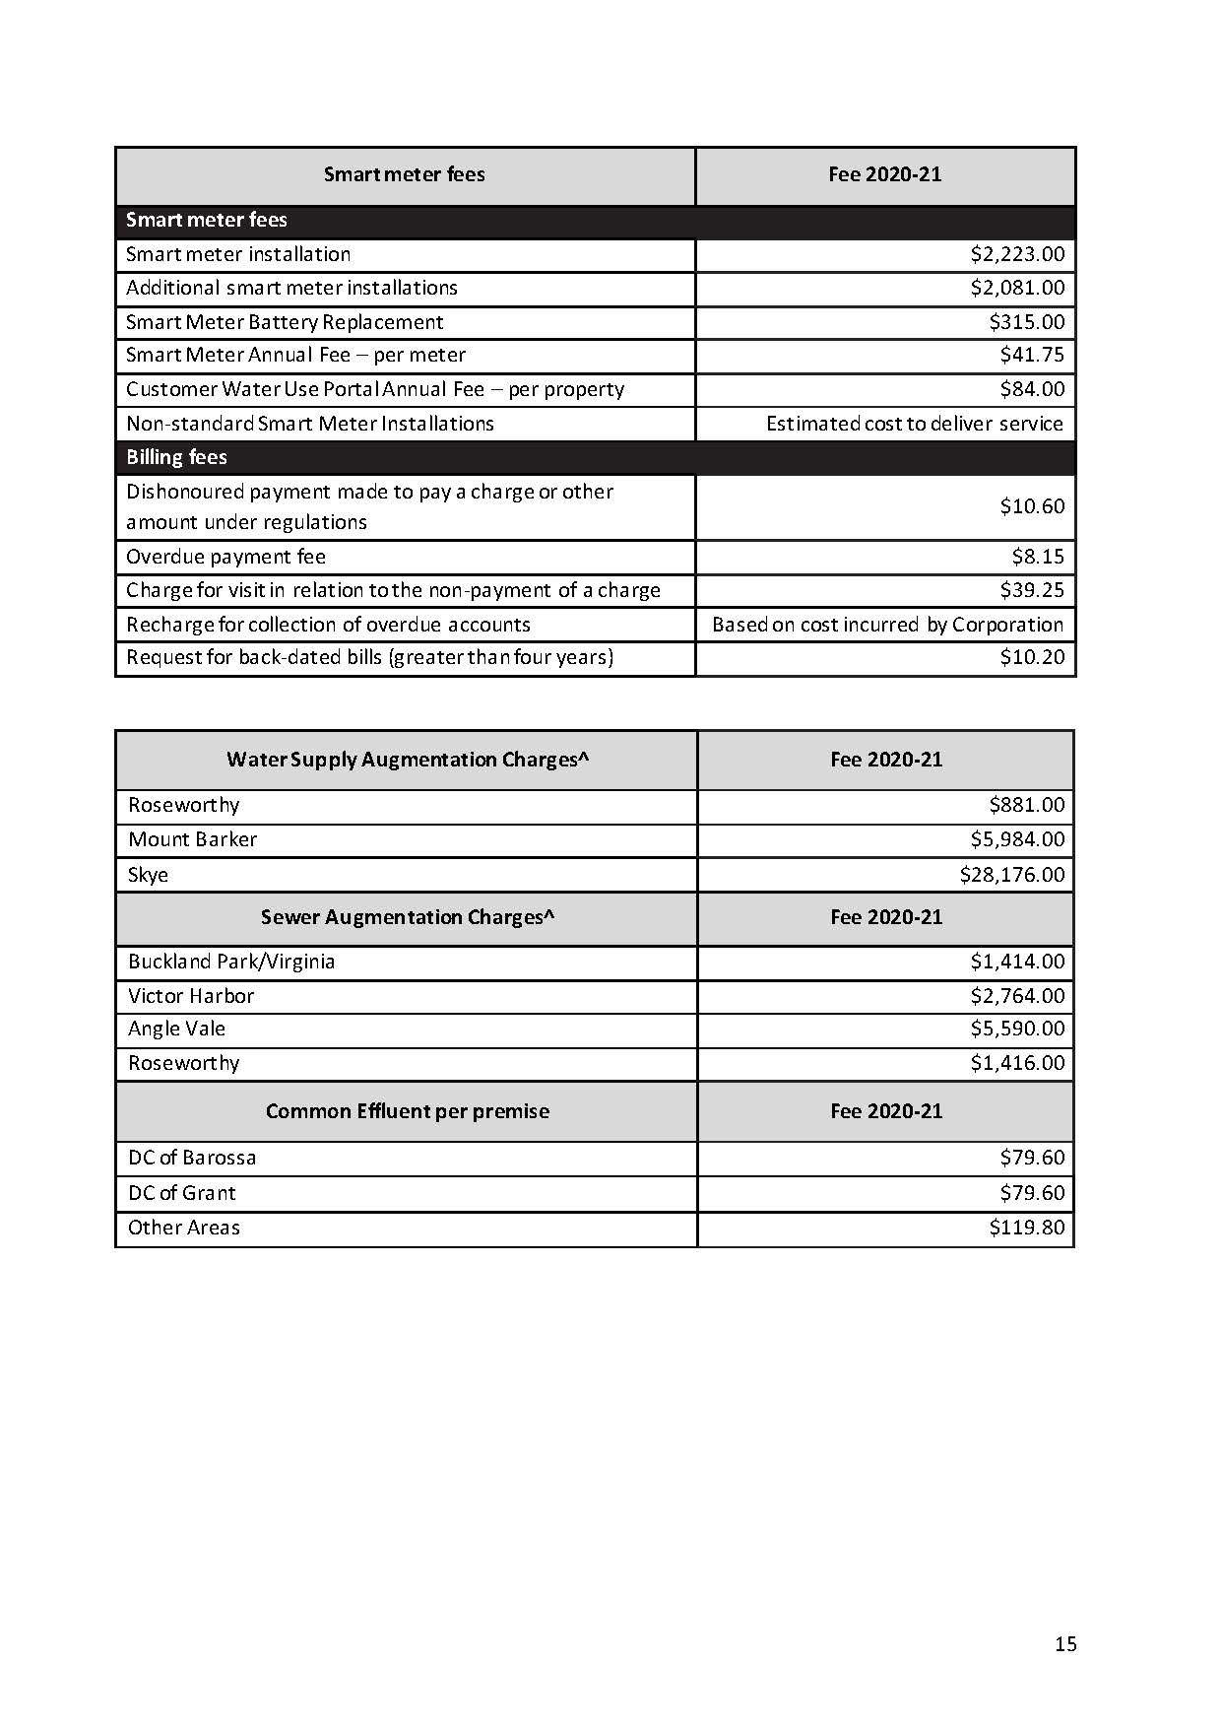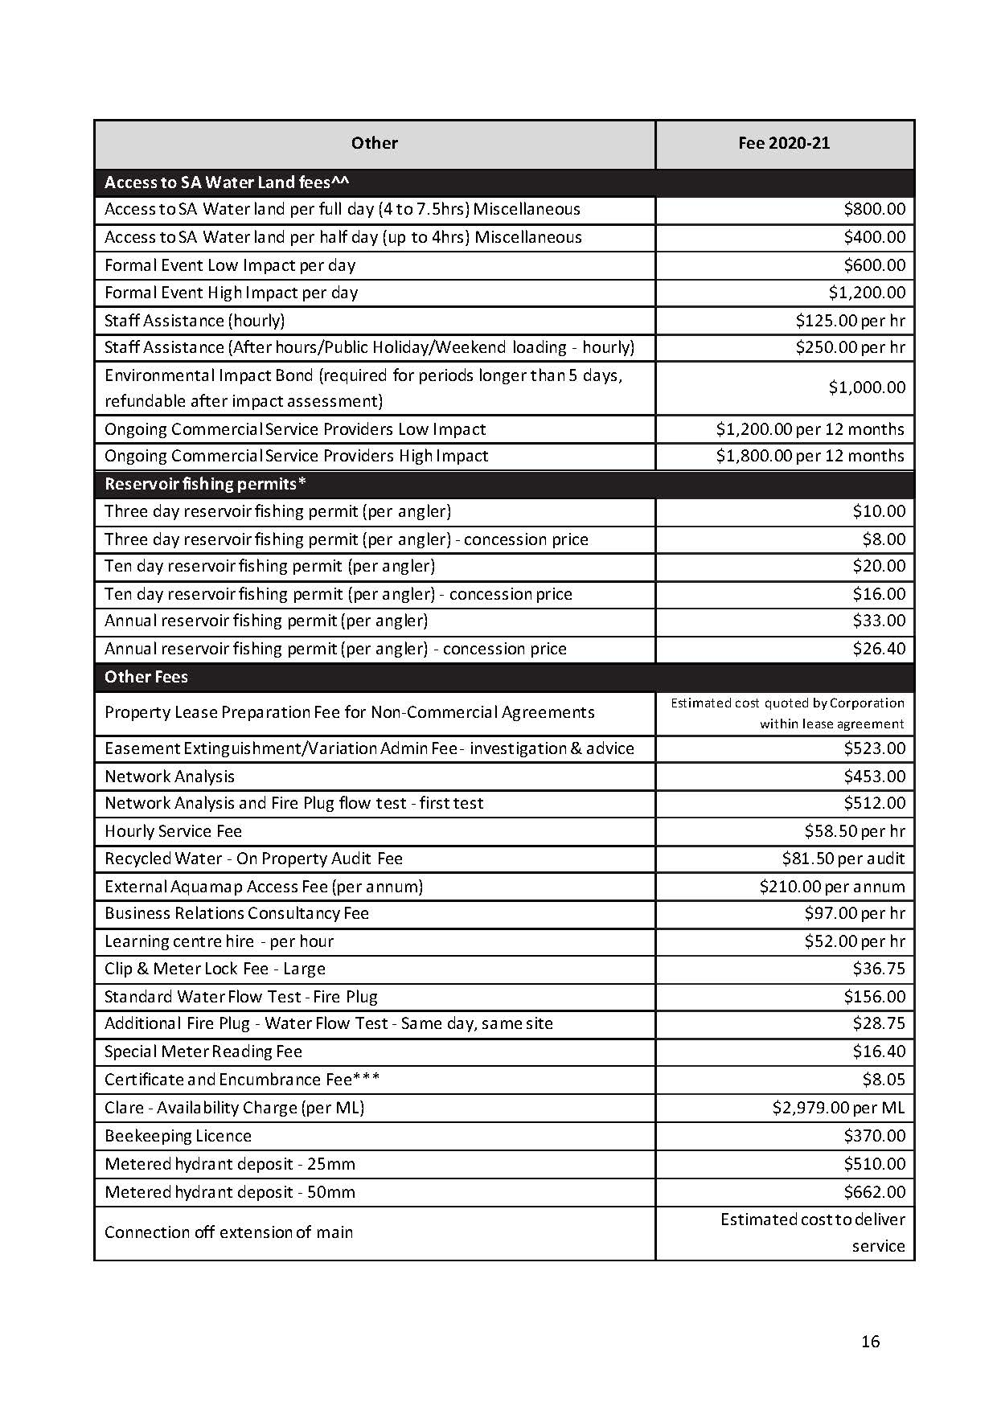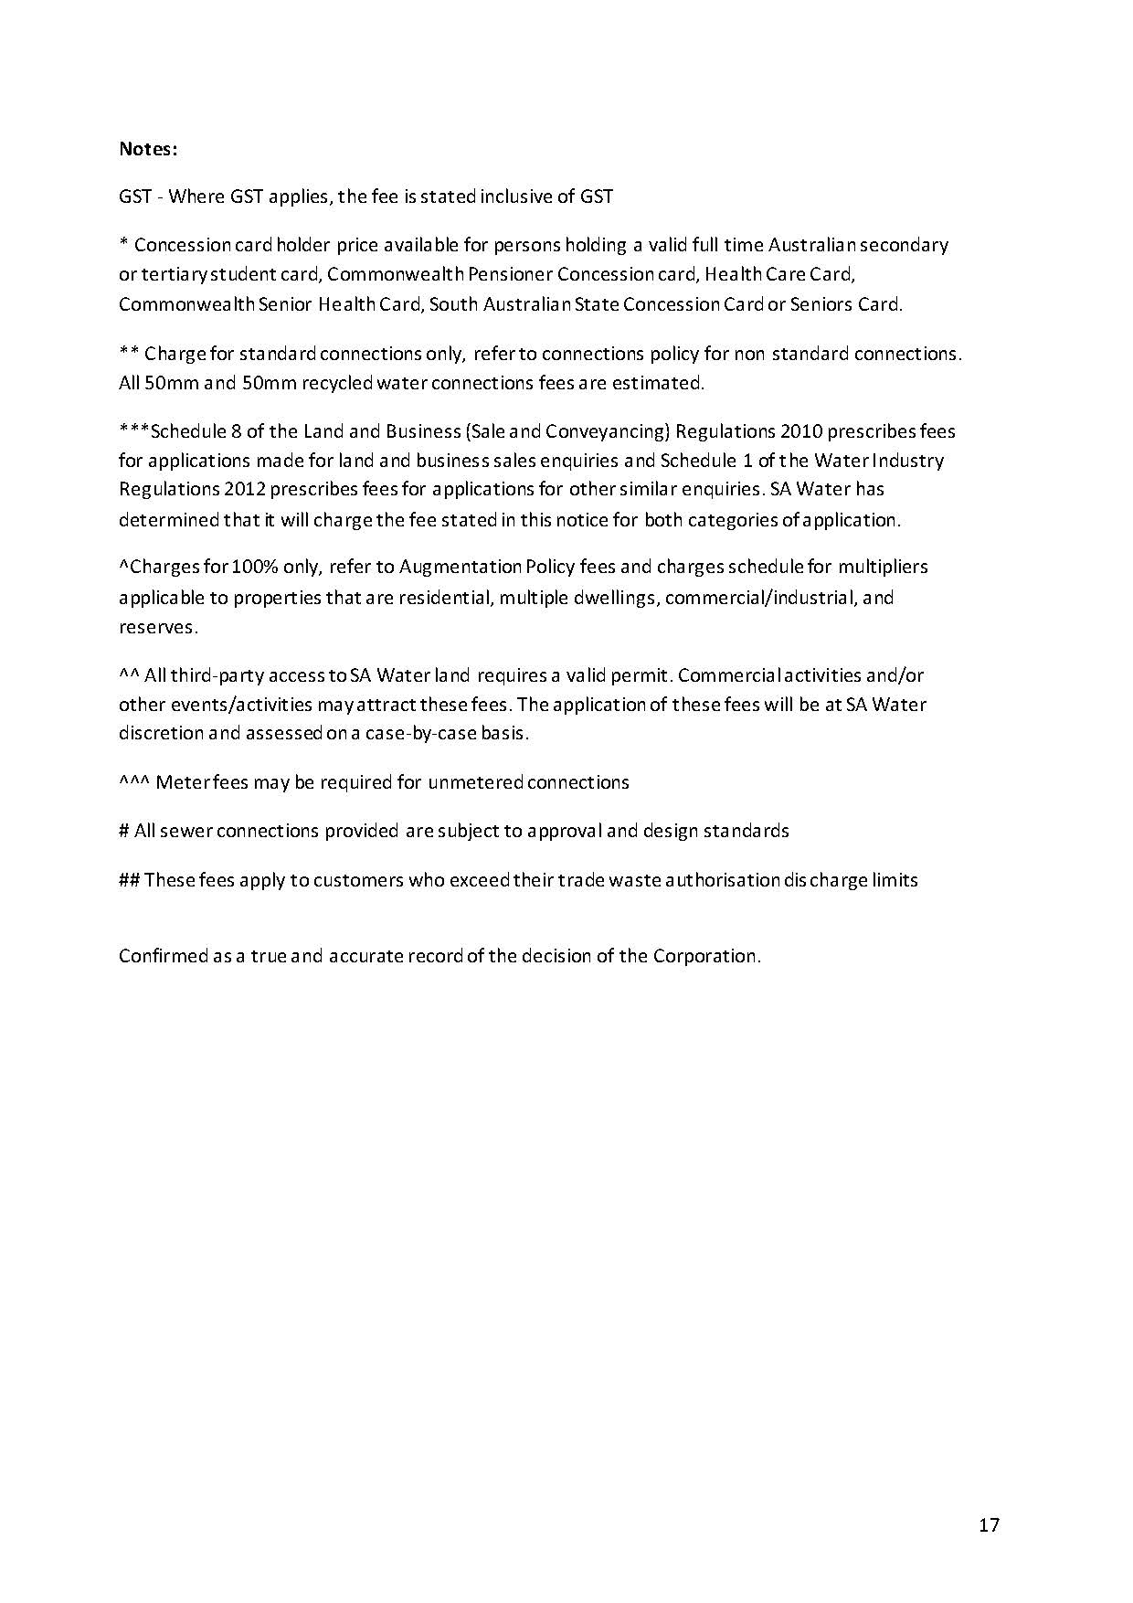

Dated: 24 June 2020
D. Ryan
Chief Executive
South Australian Water Corporation

Training and Skills Development Act 2008
Part 4—Apprenticeships/Traineeships
PURSUANT to the provision of the Training and Skills Development Act 2008, the Training and Skills Commission (TaSC) gives notice that determines the following Trades or Declared Vocations in addition to the gazette notices of:
- 25 September 2008 | - 23 October 2008 | - 13 November 2008 | - 4 December 2008
- 18 December 2008 | - 29 January 2009 | - 12 February 2009 | - 5 March 2009
- 12 March 2009 | - 26 March 2009 | - 30 April 2009 | - 18 June 2009
- 25 June 2009 | - 27 August 2009 | - 17 September 2009 | - 24 September 2009
- 9 October 2009 | - 22 October 2009 | - 3 December 2009 | - 17 December 2009
- 4 February 2010 | - 11 February 2010 | - 18 February 2010 | - 18 March 2010
- 8 April 2010 | - 6 May 2010 | - 20 May 2010 | - 3 June 2010
- 17 June 2010 | - 24 June 2010 | - 8 July 2010 | - 9 September 2010
- 23 September 2010 | - 4 November 2010 | - 25 November 2010 | - 16 December 2010
- 23 December 2010 | - 17 March 2011 | - 7 April 2011 | - 21 April 2011
- 19 May 2011 | - 30 June 2011 | - 21 July 2011 | - 8 September 2011
- 10 November 2011 | - 24 November 2011 | - 1 December 2011 | - 8 December 2011
- 16 December 2011 | - 22 December 2011 | - 5 January 2012 | - 19 January 2012
- 1 March 2012 | - 29 March 2012 | - 24 May 2012 | - 31 May 2012
- 7 June 2012 | - 14 June 2012 | - 21 June 2012 | - 28 June 2012
- 5 July 2012 | - 12 July 2012 | - 19 July 2012 | - 2 August 2012
- 9 August 2012 | - 30 August 2012 | - 13 September 2012 | - 4 October 2012
- 18 October 2012 | - 25 October 2012 | - 8 November 2012 | - 29 November 2012
- 13 December 2012 | - 25 January 2013 | - 14 February 2013 | - 21 February 2013
- 28 February 2013 | - 7 March 2013 | - 14 March 2013 | - 21 March 2013
- 28 March 2013 | - 26 April 2013 | - 23 May 2013 | - 30 May 2013
- 13 June 2013 | - 20 June 2013 | - 11 July 2013 | - 1 August 2013
- 8 August 2013 | - 15 August 2013 | - 29 August 2013 | - 6 February 2014
- 12 June 2014 | - 28 August 2014 | - 4 September 2014 | - 16 October 2014
- 23 October 2014 | - 5 February 2015 | - 26 March 2015 | - 16 April 2015
101. 27 May 2015 | 102. 18 June 2015 | 103. 3 December 2015 | 104. 7 April 2016
105. 30 June 2016 | 106. 28 July 2016 | 107. 8 September 2016 | 108. 22 September 2016
109. 27 October 2016 | 110. 1 December 2016 | 111. 15 December 2016 | 112. 7 March 2017
113. 21 March 2017 | 114. 23 May 2017 | 115. 13 June 2017 | 116. 18 July 2017
117. 19 September 2017 | 118. 26 September 2017 | 119. 17 October 2017 | 120. 3 January 2018
121. 23 January 2018 | 122. 14 March 2018 | 123. 14 June 2018 | 124. 5 July 2018
125. 2 August 2018 | 126. 9 August 2018 | 127. 16 August 2018 | 128. 30 August 2018
129. 27 September 2018 | 130. 4 October 2018 | 131. 18 October 2018 | 132. 1 November 2018
133. 15 November 2018 | 134. 22 November 2018 | 135. 29 November 2018 | 136. 6 December 2018
137. 20 December 2018 | 138. 24 January 2019 | 139. 14 February 2019 | 140. 30 May 2019
141. 6 June 2019 | 142. 13 June 2019 | 143. 20 June 2019 | 144. 27 June 2019
145. 11 July 2019 | 146. 8 August 2019 | 147. 22 August 2019 | 148. 12 September 2019
149. 19 September 2019 | 150. 14 November 2019 | 151. 28 November 2019 | 152. 12 December 2019
153. 19 December 2019 | 154. 23 January 2020 | 155. 27 February 2020 | 156. 21 April 2020
157. 25 June 2020

Trades or Declared Vocations and Required Qualifications and Training Contract Conditions for
Corrections for Property Services (CPP) and Resources and Infrastructure (RII) from Notice 156
*Trade/ #Declared Vocation/ Other Occupation | Qualification Code | Qualification Title | Nominal Term of Training Contract | Probationary Period
Civil Construction and Maintenance Worker # | RII30919 | Certificate III in Civil Construction | 36 | 90
Asset Security Operations # | CPP40719 | Certificate IV in Security Management | 18 | 60

Dated: 23 June 2020
John Evangelista
Director
Traineeship and Apprenticeship Services

Work Health And Safety Regulations 2012
Exemption
Pursuant to regulation 684 of the Work Health Safety Regulations 2012 (WHS Regulations) I, Martyn Antony Campbell, Executive Director of SafeWork SA, having taken into account all relevant matters, hereby exempt:
The following class of persons:
- manufacturers and importers of hazardous chemicals;
- suppliers of hazardous chemicals; and
- a person conducting a business or undertaking.
from the provisions of:
Clauses 329, 330(1), 330(2), 330(3), 335 of the WHS Regulations as they apply to manufacturers and importers of hazardous chemicals
Clause 338 of the WHS Regulations as it applies to suppliers of hazardous chemicals
Clauses 341, 342(1), 342(2) and 345 of the WHS Regulations as they apply to a person conducting a business or undertaking.
This exemption applies providing that the person manufactured, imported, supplied, labelled, transferred or decanted the hazardous chemical after 1 July 2020 and the person complies with the WHS Regulations as if the WHS Regulations were amended as follows:
- each reference to ‘GHS’ is a reference to ‘GHS 7’; and
- the text “:Product identifier and chemical identity’ is omitted from Clause 1(2)(a) of Schedule 7; and
- the text ‘, including how the chemical may be safely used’ is omitted from Clause 1(2)(g) of Schedule 7
NOTE: GHS 7 means the Globally Harmonised System of Classification and Labelling of Chemicals, Seventh revised edition, published by the United Nations as if it were modified by Schedule 6 to the WHS Regulations.
This exemption is subject to the following conditions:
- Commences on 1 July 2020 and expires on 31 December 2020.
All other provisions of both the Work Health and Safety Act 2012 and the WHS Regulations shall continue to apply.
Dated: 23 June 2020
Martyn Campbell
Executive Director
The exeSafeWork SA

Local Government Instruments

Rural City of Murray Bridge
Adoption of Valuations and Declaration of Rates 2020-2021
NOTICE is hereby given that the Rural City of Murray Bridge at a meeting held on 9 June 2020, resolved:
Adoption of Annual Business Plan and Budget 2020-2021
That pursuant to Section 123(6) and (7) of the Local Government Act 1999 and Regulation 6 of the Local Government (Financial Management) Regulations 2011, having considered submissions in accordance with Section 12(6) of the Local Government Act 1999 and having regard to all relevant information in the possession of the Council, the Council adopts the Annual Business Plan and Budget for 2020-2021.
Adoption of Valuations
That pursuant to Section 167(2) of the Local Government Act 1999 the most recent valuations of the Valuer-General available to Council of the capital value of land within Council’s area totalling $3,611,423,640 be adopted for rating purposes with the total capital value of rateable land within Council’s area for 2020-2021 being $3,478,423,049.
Declaration of Rates
That, having taken into consideration the general principles of rating contained in Section 150 of the Local Government Act 1999 and having observed the requirements of Section 153 of the Local Government Act 1999, and in accordance with Regulation 14 of the Local Government (General) Regulations 2013, the Council declares, for the year ending 30 June 2021, a rate increase of 1.2% representing the following differential rates in respect of all rateable land within its area –
- 0.68351 cents in the dollar of the Capital Value of rateable land of Categories (a) and (i) uses (residential and “other” categories)
- 1.09361 cents in the dollar of the Capital Value of rateable land of Categories (b), (c) and (d) uses (commercial categories)
- 0.95691 cents in the dollar of the Capital Value of rateable land of Categories (e) and (f) uses (industrial categories)
- 0.61515 cents in the dollar of the Capital Value of rateable land of Category (g) use (primary production category)
- 0.88856 cents in the dollar of the Capital Value of rateable land of Category (h)) use (vacant land category)
Declaration of Minimum Rates
That pursuant to Section 158(1) (a) of the Local Government Act 1999 the Council fixes in respect to the year ending 30 June 2021, a minimum amount payable by way of general rates of $976.
Regional Landscape Levy
That pursuant to Part 5 of the Landscape South Australia Act 2019 and Section 154 of the Local Government Act 1999, the Council declares, in respect of the year ending 30 June 2021, a separate rate of 0.0234691 cents in the dollar, based on the capital value of rateable land within the Council’s area and within the area of the Murraylands and Riverland Landscape Board in order to recover the amount payable to the Board.
Declaration of Annual Service Charges and Service Rates
Community Waste Water Management and Water Supply Schemes
(1) Riverglen
That pursuant to Section 155(2) of the Local Government Act 1999, a total of $148,785 is to be levied against the properties within the area defined as “Riverglen” to which Council provides the prescribed services of septic tank effluent disposal and water supply. A service charge of $826 per assessment is imposed on rateable and non rateable land and a service rate of 0.115590 cents in the dollar of the capital value of rateable land is declared on Allotments 1 to 30, 125 and 126 in Deposited Plan DP30450, Allotment 50 in Deposited Plan DP42391 and Units 1 to 73 in Strata Plan No SP11238, being land which the septic tank effluent disposal and the water supply schemes are provided.
(2) Woodlane
That pursuant to Section 155(2) of the Local Government Act 1999, a total of $68,602 is to be levied against the properties within the area defined as “Woodlane” to which Council provides the prescribed services of septic tank effluent disposal and water supply. A service charge of $799 per assessment is imposed on rateable and non rateable land and a service rate of 0.168183 cents in the dollar of the capital value of rateable land is declared on Allotments 1 to 18 in Deposited Plan DP48073, Allotments 191 and 192 in Deposited Plan DP75292, Allotments 1 to 4, 7 to 37 and 40 in Deposited Plan DP51229, Allotment 50 in Deposited Plan DP53034 and Allotment 200 in Deposited Plan DP62423, being land which the septic tank effluent disposal and the water supply schemes are provided.
The metered supply of water to sections of Woodlane commenced from 1 July 2010 with annual readings. The rates for supply of water are charged at $3.65 per kL for any usage above 130kL per annum.
Waste Collection
That pursuant to Section 155(2) of the Local Government Act 1999 the following variable annual service charges are imposed according to the nature of the service as follows, subject (where relevant) to the application of Regulation 13 of the Local Government (General) Regulations 2013:
- New Garbage Collection Service
For the supply of a mobile garbage bin to land to which the new service is provided, a service charge of $83 per bin in respect of the year ending 30 June 2021.
- Replacement Bins
For the replacement of lost, damaged or stolen bins, a service charge of $83 per bin in respect of the year ending 30 June 2021.
- Additional Garbage Collection Service
For the supply of additional mobile garbage bin/s to land to which the service is provided, an annual service charge of $138 per bin in respect of the year ending 30 June 2021.
- Kerbside Recycling and Green Waste Service
A service charge of $87 will be applied in 2020-21 for the provision of a kerbside recycling service. An additional $55 will be applied to Murray Bridge properties that receive the green waste service.

Payment of Rates
That pursuant to Section 181(11) of the Local Government Act 1999 rates for the year ended 30 June 2021 will fall due in four equal or approximately equal instalments on 7 September 2020, 1 December 2020, 1 March 2021 and 1 June 2021.
Dated: 25 June 2020
M.Sedgman
Chief Executive Officer

District Council of Elliston
Adoption of Valuations and Declarations of Rates 2020-21
NOTICE is hereby given that the District Council of Elliston at its meeting held on 16 June 2020:
Adopted capital valuations to apply in its area for rating purposes supplied by the Valuer-General, being the most recent valuations available to the Council totalling $482,181,360.
Declared differential general rates varying according to the locality of the land and its use as follows:
1.0080 cents in the dollar in respect of all rateable land within the Bulk Handling Zone;
0.4120 cents in the dollar in respect of all rateable land within the Residential Zone;
0.4120 cents in the dollar in respect of all rateable land within the Commercial-Shop Zone;
0.4120 cents in the dollar in respect of all rateable land within the Commercial-Office Zone;
0.4120 cents in the dollar in respect of all rateable land within the Commercial-Other Zone;
0.4120 cents in the dollar in respect of all rateable land within the Industry-Light Zone;
0.4120 cents in the dollar in respect of all rateable land within the Industry-Other Zone;
0.4120 cents in the dollar in respect of all rateable land within the Primary Production Zone;
0.4120 cents in the dollar in respect of all rateable land within the Vacant Land Zone;
0.4120 cents in the dollar in respect of all rateable land within the Other Zone;
Declared a fixed charge of $274.50 payable in respect of rateable land within its area.
Declared that the annual service charges on all land to which the Council provides or makes available its Community Wastewater Management Systems is $397 per property.
Declared that the annual service charges on all land to which the Council provides or makes available its provision of water serviced by the Port Kenny Water Supply is $135 per property.
Declared that the annual service charges based on the level of usage and on all land to which the Council provides or makes available its prescribed service of the collection, treatment or disposal of waste via its Waste Management Service is as follows:
0-0.3m³ of waste per week on average - $270 per annum
0.3-0.6m³ of waste per week on average - $540 per annum
0.6m³ to 0.9m³ of waste per week on average - $810 per annum
Provided on the basis that the sliding scale provided for in Regulation (13) of the Local Government (General) Regulations will be applied. Single farm enterprises and adjoining allotments are only charged the annual service charge in respect of the assessment constituting the principal property.
Declared a separate rate based on a fixed charge of $79.15 against all residential, vacant and other rateable properties, $118.72 on commercial and industrial properties, and $158.30 on primary production properties in respect of all rateable land in the area of the Eyre Peninsula Landscape Board.
Dated: 25 June 2020
Geoff Sheridan
Chief Executive Officer

Regional Council of Goyder
Adoption of Valuation and Declaration of Rates
NOTICE is hereby given that at a meeting of the Council held on Tuesday 16 June 2020, the Council resolved as follows:
1. Adopted for rating purposes, for the financial year ending 30 June 2021, the most recent valuations of the Valuer-General of the Capital Value of land within the area of the Council, and specifies that the total of the values that are to apply within the area is $1,398,148,020.
2. Declared differential rates for the year ending 30 June 2021 on rateable land within its area, based upon the capital value of the land and varying according to land use as follows:
a) 0.2590 cents in the dollar for all rateable land within the area with a land use of Primary Production; and
b) 0.5246 cents in the dollar for all other rateable land in the Council area that includes Residential, Commercial – Shop, Commercial – Office, Commercial – Other, Industry – Light, Industry – Other, Vacant Land and Other.
3. Declared a fixed charge of $150.00 against each separate piece of rateable land within the Council area for the year ending 30 June 2021.
4. Imposed an annual service charge based on the level of usage of the service and varying according to whether the land is vacant or occupied on all land to which Council provides or makes available the prescribed service of Community Wastewater Management Systems for the year ending 30 June 2021:
4.1 in respect of all land in the area serviced by the Burra CWMS, an annual service charge of:
a) $392.00 per property unit on occupied rateable and non-rateable land; and
b) $295.00 per property unit on assessments of vacant rateable and non-rateable land.
4.2 in respect of all land in the area serviced by the Eudunda CWMS, an annual service charge of:
a) $569.00 per property unit on occupied rateable and non-rateable land; and
b) $436.00 per property unit on assessments of vacant rateable and non-rateable land.
5. Imposed an annual service charge on all land in the townships of Terowie, Whyte Yarcowie, Hallett, Mt Bryan, Burra, Robertstown, Point Pass, Eudunda, Farrell Flat and Booborowie to which it provides or makes available the prescribed service of waste collection for the year ending 30 June 2021, of $225.00.
6. For the purpose of reimbursing Council amount contributed to the Northern and Yorke Landscape Region Board, based upon the contributions previously made to the South Australian Murray-Darling Basin Natural Resources Management Board and the Northern and Yorke Natural Resources Management Board, adopted the following separate rates for the year ending 30 June 2021, based on the capital value of the land:
a) all rateable land within the area of Council and of the South Australian Murray-Darling Basin Natural Resources Management Board as at the 30th June 2020, a rate in the dollar of $0.000218; and
b) all rateable land within the area of Council and of the Northern and Yorke Natural Resources Management Board as at the 30th June 2020, a rate in the dollar of $0.000188.
Dated: 25 June 2020
David J. Stevenson
Chief Executive Officer

District Council of Grant
Adoption of Valuation and Declaration of Rates
NOTICE is hereby given that at its meeting held on 15 June 2020 in relation to the financial year ending 30 June 2021, the District Council of Grant, made the following resolutions:
1. Adopted for rating purposes, the capital valuations of land within the Council area made by the Valuer-General, being the most recent valuations available to the Council, totalling $2,821,697,940 comprising $2,755,615,071 in respect of rateable land and $66,082,869 in respect of non-rateable land before alteration.
2. Declared a general rate on all rateable land within the Council’s area of 0.3044 cents in the dollar.
3. Fixed a minimum amount of $610.00 payable by way of general rates on rateable land within the Council’s area.
4. Declared a separate rate of $1,613 per assessment, in respect to assessments A1493, A1494, A1543, A1544 and A1545 in order to reimburse the Council for the costs of construction for the Cape Douglas Community Wastewater Management Scheme.
5. Imposed an annual service charge based on the nature of the service of $254.00 for the prescribed service of collection, treatment and disposal (including recycling) of waste (Mobile Garbage Bins) on all land to which it provides or makes available the service.
6. Imposed an annual service charge based on the nature of the service and varying according to whether the land is vacant or occupied on all land to which the Council provides or makes available the Community Wastewater Management Systems being prescribed services for the collection, treatment and disposal of waste in the townships of, Port MacDonnell, Tarpeena, Allendale East, Cape Douglas, Donovans and Pelican Point as follows:
Occupied Land $610.00
Vacant Land $520.00
7. Declared a separate rate (Regional Landscape Levy) on all rateable land within the region of the Board and within the Council area in order to reimburse the Council for amounts contributed to the South East Natural Resource Management Board, based on a fixed charge and differentiated according to land use on all rateable land as follows:
Residential, Vacant and Other $78.00 per rateable property
Commercial (Shop, Office and Other) $119.00 per rateable property
Industry (Light and Other) $188.00 per rateable property
Primary Production $345.00 per rateable property
Dated: 15 June 2020
Darryl Whicker
Chief Executive Officer

District Council of Grant
Road (Opening and Closing) Act, 1991
Kieselbach Road, MacDonnell
NOTICE is hereby given, pursuant to Section 10 of the Roads (Opening and Closing) Act, 1991, that the District Council Grant hereby gives notice of its intent to implement a Road Process Order to close portion of Public Road and merge with the adjoining Sections 336 and 377 in the H421000 more particularly delineated and lettered as “A & B” in Preliminary Plan 20/0025.
A copy of the plan and a statement of persons affected are available for viewing on Council’s website www.dcgrant.sa.gov.au and at the Adelaide office of the Surveyor-General during normal office hours.
The Preliminary Plan can also be viewed at www.sa.gov.au/roadsactproposals
Any application for easement or objection must set out the full name, address and details of the submission and must be fully supported by reasons. The application for easement or objection must be made in writing to the Council at PO Box 724, MOUNT GAMBIER SA 5290 WITHIN 28 DAYS OF THIS NOTICE and a copy must be forwarded to the Surveyor-General at GPO Box 1354, Adelaide 5001. Where a submission is made, the Council will give notification of a meeting at which the matter will be considered.
Dated: 25 June 2020
Darryl Whicker
Chief Executive Officer

Mount Barker District Council
Mount Barker Regional Town Centre Car Parking Fund
NOTICE is hereby given, pursuant to section 50A (3) of the Development Act 1993, that the Mount Barker District Council has redefined the area for which the Car Parking Fund applies. The Car Parking Fund now applies in the whole of Council’s Regional Town Centre Zone as referenced in Council’s Development Plan.
Funds will be applied in a manner consistent with section 50A of the Development Act 1993. Council confirms that under section 50A (6) (b) on 1 July 2020, the contribution amount per space for the contribution fund has increased from $25,666.00 to $26,624.00 (including GST). This applies to all of the Zone for which the fund is applicable. The redefinition of the area in which the Car Parking Fund applies is effective from the date of this notice.
Dated: 25 June 2020
A. Stuart
Chief Executive Officer

YORKE PENINSULA COUNCIL
Exclusion from Classification as Community Land
NOTICE is hereby given that Council at its meeting held on 13 August 2014, resolved to exclude a portion of CT 6090/312 from the Classification as Community Land (the land now being Allotment 22, Elizabeth Street Maitland CT 6159/51 in DP 110077) having complied with all requirements in relation to section 193 of the Local Government Act 1999.
Dated: 22 June 2020
Andrew Cameron
Chief Executive Officer

YORKE PENINSULA COUNCIL
Exclusion from Classification as Community Land
NOTICE is hereby given that Council at its meeting held on 23 July 2014, resolved to exclude CT 5803/660 and CT 5524/737 from the Classification as Community Land (the land now being Allotment 22, Elizabeth Street Maitland CT 6159/51 in DP 110077) having complied with all requirements in relation to section 193 of the Local Government Act 1999.
Dated: 22 June 2020
Andrew Cameron
Chief Executive Officer

Public Notices

National Electricity Law
Initiation of Rule Change Request
The Australian Energy Market Commission (AEMC) gives notice under the National Electricity Law as follows:
Under s 95, the Australian Energy Market Operator has requested the Technical standards for distributed energy resources (Ref. ERC0301) proposal. The proposal seeks to create an obligation on AEMO to create a subordinate instrument for a minimum technical standard for distributed energy resources. Submissions must be received by 23 July 2020.
Submissions can be made via the AEMC’s website. Before making a submission, please review the AEMC’s privacy statement on its website. Submissions should be made in accordance with the AEMC’s Guidelines for making written submissions on Rule change proposals. The AEMC publishes all submissions on its website, subject to confidentiality.
Written requests should be sent to submissions@aemc.gov.au and cite the reference in the title. Before sending a request, please review the AEMC’s privacy statement on its website.
Documents referred to above are available on the AEMC’s website and are available for inspection at the AEMC’s office.
Australian Energy Market Commission
Level 15, 60 Castlereagh St
Sydney NSW 2000
Telephone: (02) 8296 7800
www.aemc.gov.au
Dated: 25 June 2020

National Energy Retail Law
Initiation of Rule Change Request
The Australian Energy Market Commission (AEMC) gives notice under the National Energy Retail Law as follows:
Under s 251, the Australian Energy Market Operator has requested the Technical standards for distributed energy resources (Ref. RRC0037) proposal. The proposal seeks to create an obligation on AEMO to create a subordinate instrument for a minimum technical standard for distributed energy resources. Submissions must be received by 23 July 2020.
Submissions can be made via the AEMC’s website. Before making a submission, please review the AEMC’s privacy statement on its website. Submissions should be made in accordance with the AEMC’s Guidelines for making written submissions on Rule change proposals. The AEMC publishes all submissions on its website, subject to confidentiality.
Documents referred to above are available on the AEMC’s website and are available for inspection at the AEMC’s office.
Australian Energy Market Commission
Level 15, 60 Castlereagh St
Sydney NSW 2000
Telephone: (02) 8296 7800
www.aemc.gov.au
Dated: 25 June 2020

Notice Submission

The South Australian Government Gazette is compiled and published each Thursday.
Notices must be submitted before 4 p.m. Tuesday, the week of intended publication.
All submissions are formatted per the gazette style and proofs are supplied as soon as possible. Alterations must be returned before 4 p.m. Wednesday.
Requests to withdraw submitted notices must be received before 10 a.m. on the day of publication.

Gazette notices should be emailed as Word files in the following format:
- Title—name of the governing Act/Regulation
- Subtitle—brief description of the notice
- A structured body of text
- Date of authorisation
- Name, position, and government department/organisation of the person authorising the notice

Please provide the following information in your email:
- Date of intended publication
- Contact details of at least two people responsible for the notice content
- Name of the person and organisation to be charged for the publication (Local Council and Public notices)
- Request for a quote, if required
- Purchase order, if required

Email: governmentgazettesa@sa.gov.au
Phone: (08) 7109 7760
Website: www.governmentgazette.sa.gov.au

All instruments appearing in this gazette are to be considered official, and obeyed as such

Printed and published weekly by authority of S. Smith, Government Printer, South Australia
$7.70 per issue (plus postage), $387.60 per annual subscription—GST inclusive
Online publications: www.governmentgazette.sa.gov.au

