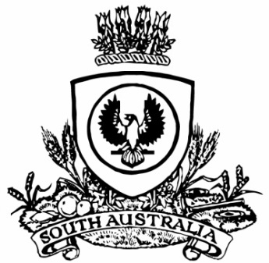
No. 23 p. 611
SUPPLEMENTARY GAZETTE
THE SOUTH AUSTRALIAN
GOVERNMENT GAZETTE
Published by Authority

Adelaide, Friday, 27 March 2020

Contents

State Government Instruments
Controlled Substances (Poisons) Regulations 2011 612

State Government Instruments

Controlled Substances (Poisons) Regulations 2011
South Australia
Controlled Substances (Poisons) (Emergency Supply – Human Coronavirus Disease (COVID-19)) Notice 2020
under regulation 21 of the Controlled Substances (Poisons) Regulations 2011
1—Short title
This notice may be cited as the Controlled Substances (Poisons) (Emergency Supply – Human Coronavirus Disease (COVID-19)) Notice 2020.
2—Commencement
This notice comes into operation on the day on which it is made.
3—Declaration of emergency and period
For the purposes of regulation 21(2)(f)(ii)(A) of the Controlled Substances (Poisons) Regulations 2011 I specify:
- the emergency consisting of the major emergency declared by the State Coordinator for the State of South Australia on 22 March 2020 at 13:00 hours pursuant to section 23(1) of the Emergency Management Act 2004 in relation to the outbreak of the Human Disease named COVID-19 within South Australia; and

- the period of time that the declaration of a major emergency referred to in (a) remains in force under the Emergency Management Act 2004.
Made by the Minister for Health and Wellbeing
On 27 March 2020

All instruments appearing in this gazette are to be considered official, and obeyed as such

Printed and published weekly by authority of S. Smith, Government Printer, South Australia
$7.70 per issue (plus postage), $387.60 per annual subscription—GST inclusive
Online publications: www.governmentgazette.sa.gov.au

