THE SOUTH AUSTRALIAN
GOVERNMENT GAZETTE
Published by Authority

Adelaide, Thursday, 15 October 2020

Contents

Governor’s Instruments
Appointments 4846
Emergency Management Act 2004 4847
Proclamation—
Railways (Operations and Access) (Application of Access Regime) (Tram Track) Variation Proclamation 2020 4848
Regulations—
Return to Work (Exclusions) Variation
Regulations 2020—No. 284 of 2020 4849
Road Traffic (Light Vehicle Standards) (Motor Bikes
and Other Matters) Variation Rules 2020—
No. 285 of 2020 4850
Railways (Operations and Access) Regulations 2020—
No. 286 of 2020 4853
State Government Instruments
Dangerous Substances Act 1979 4854
Development Act 1993 4854
Dog Fence Act 1946 4858
Fire and Emergency Services Act 2005 4858
Firearms Regulations 2017 4860
Fisheries Management Act 2007 4860
Fisheries Management (Prawn Fisheries)
Regulations 2017 4861
Housing Improvement Act 2016 4861
Land Acquisition Act 1969 4862
Major Events Act 2013 4865
Motor Vehicle Accidents (Lifetime Support Scheme)
Act 2013 4866
Public Finance and Audit Act 1987 4866
Railways (Operations and Access) Act 1997 4866
Roads (Opening and Closing) Act 1991 4866

Local Government Instruments
City of Charles Sturt 4868
City of Salisbury 4868

Public Notices
National Electricity Law 4869

Governor’s Instruments

Appointments
Department of the Premier and Cabinet
Adelaide, 15 October 2020
His Excellency the Governor in Executive Council has been pleased to appoint the undermentioned to the Police Superannuation Board, pursuant to the provisions of the Police Superannuation Act 1990:
Member: from 30 October 2020 until 29 October 2023
Graeme Arthur Barton
Anna Erica Hughes
Michael Anthony Kent
Mark John Carroll
Deputy Member: from 30 October 2020 until 29 October 2023
Alannah Mary Pearce (Deputy to Barton)
Julie Elizabeth Thomas (Deputy to Hughes)
Daryl Wayne Mundy (Deputy to Kent)
Trevor Lindsay Milne (Deputy to Carroll)
Presiding Member: from 30 October 2020 until 29 October 2023
Graeme Arthur Barton
By command,
Jacqueline Michelle Ann Lensink, MLC
For Premier
T&F20/080CS

Department of the Premier and Cabinet
Adelaide, 15 October 2020
His Excellency the Governor in Executive Council has been pleased to appoint the undermentioned to the South Australian Housing Trust Board of Management, pursuant to the provisions of the South Australian Housing Trust Act 1995:
Member: from 1 November 2020 until 31 October 2023
Andrew Phillip Beer
Member: from 1 November 2020 until 31 October 2021
Meredith Perry
By command,
Jacqueline Michelle Ann Lensink, MLC
For Premier
MHACS20009

Department of the Premier and Cabinet
Adelaide, 15 October 2020
His Excellency the Governor in Executive Council has been pleased to appoint Daniel Roy Cregan, MP, as the Premier’s Advocate for Suicide Prevention and Community Resilience for a term commencing on 15 October 2020 and expiring on 18 March 2022 - pursuant to section 68 of the Constitution Act 1934.
By command,
Jacqueline Michelle Ann Lensink, MLC
For Premier
DPC20/104CS

Department of the Premier and Cabinet
Adelaide, 15 October 2020
His Excellency the Governor in Executive Council has been pleased to appoint Matthew William Butlin as the Chair of the South Australian Productivity Commission for a term commencing on 22 October 2020 and expiring on 28 February 2021 - pursuant to section 68 of the Constitution Act 1934.
By command,
Jacqueline Michelle Ann Lensink, MLC
For Premier
DPC20/085CS

Emergency Management Act 2004
Section 23
Approval of the Governor—Extension of a Major Emergency Declaration
Recital
The State Co-ordinator declared a Major Emergency on 22 March 2020 under section 23(1) of the Emergency Management Act 2004 (the Act) in respect of the outbreak of the human disease named COVID-19 within South Australia (the Declaration).
With the advice and consent of the Executive Council and pursuant to section 23(2) of the Act, on the days and for the periods set out in the Schedule to this Approval, I approved an extension of the Declaration.
PURSUANT to section 23(2) of the Act and with the advice and consent of the Executive Council, I NOW approve a further extension of the Declaration for a period of 28 days commencing on 17 October 2020.
Given under my hand and the Public Seal of South Australia at Adelaide.
Dated: 15 October 2020.
Hieu Van Le
Governor

Schedule
• On 2 April 2020, for a period of 28 days to commence on 4 April 2020.
• On 30 April 2020 for a period of 28 days to commence on 2 May 2020.
• On 28 May 2020 for a period of 28 days to commence on 30 May 2020.
• On 27 June 2020 for a period of 28 days to commence on 27 June 2020.
• On 23 July 2020 for a period of 28 days to commence on 25 July 2020.
• On 20 August 2020 for a period of 28 days to commence on 22 August 2020.
• On 17 September for a period of 28 days to commence on 19 September 2020.

Proclamation
South Australia

Railways (Operations and Access) (Application of Access Regime) (Tram Track) Variation Proclamation 2020
under section 7 of the Railways (Operations and Access) Act 1997
Part 1—Preliminary
1—Short title
This proclamation may be cited as the Railways (Operations and Access) (Application of Access Regime) (Tram Track) Variation Proclamation 2020.
2—Commencement
This proclamation comes into operation on the day on which it is made.
3—Variation provisions
In this proclamation, a provision under a heading referring to the variation of a specified proclamation varies the proclamation so specified.
Part 2—Variation of Railways (Operations and Access) (Application of Access Regime) Proclamation 2016
4—Variation of clause 4—Application of access regime
Clause 4(2)(c)—delete paragraph (c) and substitute:
(c) services associated with the tram track that runs between the Adelaide Entertainment Centre and Glenelg including the 2 extensions of that tram track that run—
(i) along North Terrace between the intersection of North Terrace and King William Street and the Adelaide Botanic Garden; and
(ii) along King William Road between the intersection of North Terrace and King William Street and the Festival Plaza; or
Made by the Governor
with the advice and consent of the Executive Council
on 15 October 2020

Regulations
South Australia

Return to Work (Exclusions) Variation Regulations 2020
under the Return to Work Act 2014

Contents
Part 1—Preliminary
1 Short title
2 Commencement
3 Variation provisions
Part 2—Variation of Return to Work Regulations 2015
4 Variation of regulation 6—Exclusions (section 4 of Act)

Part 1—Preliminary
1—Short title
These regulations may be cited as the Return to Work (Exclusions) Variation Regulations 2020.
2—Commencement
These regulations come into operation on the day on which they are made.
3—Variation provisions
In these regulations, a provision under a heading referring to the variation of specified regulations varies the regulations so specified.
Part 2—Variation of Return to Work Regulations 2015
4—Variation of regulation 6—Exclusions (section 4 of Act)
Regulation 6(1)(e)—delete paragraph (e)
Note—
As required by section 10AA(2) of the Subordinate Legislation Act 1978, the Minister has certified that, in the Minister's opinion, it is necessary or appropriate that these regulations come into operation as set out in these regulations.
Made by the Governor
with the advice and consent of the Executive Council
on 15 October 2020
No 284 of 2020

South Australia

Road Traffic (Light Vehicle Standards) (Motor Bikes and Other Matters) Variation Rules 2020
under the Road Traffic Act 1961

Contents
Part 1—Preliminary
1 Short title
2 Commencement
3 Variation provisions
Part 2—Variation of Road Traffic (Light Vehicle Standards) Rules 2018
4 Variation of rule 3—Definitions
5 Variation of rule 13—Vehicles to which the Light Vehicle Standards do not apply
6 Variation of rule 26—Steering
7 Variation of rule 44—Window tinting
8 Variation of rule 46—Wheels and tyres—size and capacity
9 Variation of rule 53—Steering gear and handlebars

Part 1—Preliminary
1—Short title
These rules may be cited as the Road Traffic (Light Vehicle Standards) (Motor Bikes and Other Matters) Variation Rules 2020.
2—Commencement
These rules come into operation on the day on which they are made.
3—Variation provisions
In these rules, a provision under a heading referring to the variation of specified rules varies the rules so specified.
Part 2—Variation of Road Traffic (Light Vehicle Standards) Rules 2018
4—Variation of rule 3—Definitions
Rule 3(1)—after the definition of ADR insert:
ADR (Definitions and Vehicle Categories) means the third edition ADR titled "Vehicle Standard (Australian Design Rule – Definitions and Vehicle Categories) 2005" made under the Motor Vehicle Standards Act;
5—Variation of rule 13—Vehicles to which the Light Vehicle Standards do not apply
Rule 13(2), note—delete "the Australian Design Rule - Definitions and Vehicle Categories which are standards determined under section 7 of the Motor Vehicle Standards Act" and substitute:
ADR (Definitions and Vehicle Categories)
6—Variation of rule 26—Steering
Rule 26(3)—delete subrule (3) and substitute:
(3) In relation to a motor vehicle built before 1 January 2005, a component of the steering system of the vehicle that is essential for effective steering of the vehicle must be built to transmit energy by mechanical means only.
7—Variation of rule 44—Window tinting
After rule 44(6B) insert:
Note—
ADR (Definitions and Vehicle Categories) provides for the vehicle category of goods vehicles.
8—Variation of rule 46—Wheels and tyres—size and capacity
Rule 46(1), definition of ADR (Definitions and Vehicle Categories)—delete the definition
9—Variation of rule 53—Steering gear and handlebars
(1) Rule 53(1)—after "motor bike" insert:
, other than a motor bike in vehicle category LC or LD,
(2) Rule 53—after subrule (1) insert:
(1A) The handlebars on a motor bike in vehicle category LC or LD must extend at least 250 millimetres, but not over 550 millimetres, on each side of the centre line of the vehicle.
Note—
The LC and LD vehicle categories are defined in ADR (Definitions and Vehicle Categories).
(3) Rule 53(3)—delete subrule (3) and substitute:
(3) The lowest part of the hand grip on the handlebars must not be higher than 380 millimetres above—
(a) for a motor bike built on or after 1 July 2020—the lowest part of the upper surface of the driver’s seat; and
(b) for any other motor bike—the attachment point of the handlebars to the motor bike.

Note—
As required by section 10AA(2) of the Subordinate Legislation Act 1978, the Minister has certified that, in the Minister's opinion, it is necessary or appropriate that these rules come into operation as set out in these rules.
Made by the Governor
with the advice and consent of the Executive Council
on 15 October 2020
No 285 of 2020

South Australia

Railways (Operations and Access) Regulations 2020
under the Railways (Operations and Access) Act 1997

Contents
1 Short title
2 Commencement
3 Interpretation
4 Extension of operation of access regime

1—Short title
These regulations may be cited as the Railways (Operations and Access) Regulations 2020.
2—Commencement
These regulations come into operation on 31 October 2020.
3—Interpretation
In these regulations, unless the contrary intention appears—
Act means the Railways (Operations and Access) Act 1997.
4—Extension of operation of access regime
Pursuant to section 7A(6)(b) of the Act, the period of operation of the access regime is extended for a period of 5 years commencing on 31 October 2020.
Note—
As required by section 10AA(2) of the Subordinate Legislation Act 1978, the Minister has certified that, in the Minister's opinion, it is necessary or appropriate that these regulations come into operation as set out in these regulations.
Made by the Governor
with the advice and consent of the Executive Council
on 15 October 2020
No 286 of 2020

State Government Instruments

Dangerous Substances Act 1979
Authorised Officers
I, Martyn Antony Campbell, Executive Director, SafeWork SA, hereby appoint the following persons as Authorised Officers for the purposes of the Dangerous Substances Act 1979 pursuant to section 7(1) of that Act:
• Armando MAIELI
• Catherine Rhiannon JONES
• Muhammad NOMAN
• Emma-Jane Louise WATSON
• Frederick Paul WRIGHT
• Jason Paul LENNON
• Craig William DOUGLASS
• David Charles BARRETT
• Gail Ruth SPRIGGS
• Andrew Mark PLUMMER
Dated: 13 October 2020
Martyn Campbell
Executive Director
SafeWork SA

Development Act 1993
Section 25(17)
City of Port Adelaide Enfield—
Rezoning of 165-179 and 181-193 Days Road, Regency Park for Residential Development—
Development Plan Amendment
Preamble
1. The Rezoning of 165-179 and 181-193 Days Road, Regency Park for Residential Development—Development Plan Amendment (the Amendment) by the City of Port Adelaide Enfield has been finalised in accordance with the provisions of the Development Act 1993.
2. The Minister for Planning and Local Government has decided to approve the Amendment.
PURSUANT to section 25 of the Development Act 1993, I—
a. approve the Amendment; and
b. fix the day on which this notice is published in the Gazette as the day on which the Amendment will come into operation.
Dated: 6 October 2020
Vickie Chapman MP
Minister for Planning and Local Government

Development Act 1993
Section 25(17)
City of Unley—Norman Terrace Everard Park Regeneration—
Development Plan Amendment
Preamble
1. The Norman Terrace Everard Park Regeneration Development Plan Amendment (the Amendment) by the City of Unley has been finalised in accordance with the provisions of the Development Act 1993.
2. The Minister for Planning and Local Government has decided to approve the Amendment.
PURSUANT to section 25 of the Development Act 1993, I—
a. approve the Amendment; and
b. fix the day on which this notice is published in the Gazette as the day on which the Amendment will come into operation.
Dated: 6 October 2020
Vickie Chapman MP
Minister for Planning and Local Government

Development Act 1993
Section 29
Amendment to the Marion Council Development Plan
Preamble
It is necessary to amend the Marion Council Development Plan (the Plan) dated 9 July 2020.
PURSUANT to Section 29 (2) (b) (ii) of the Development Act 1993, I—
1. Replace Table Mar/2A - Off Street Vehicle Parking Requirements for Designated Areas in its entirety with the contents of ATTACHMENT ‘A’.
2. Fix the day on which this notice is published in the Gazette as the day on which the Section 29 amendment will come into operation.
Dated: 12 October 2020
Sally Smith
Executive Director
Planning and Land Use Services
As Delegate of Vickie Chapman, Minister for Planning and Local Government

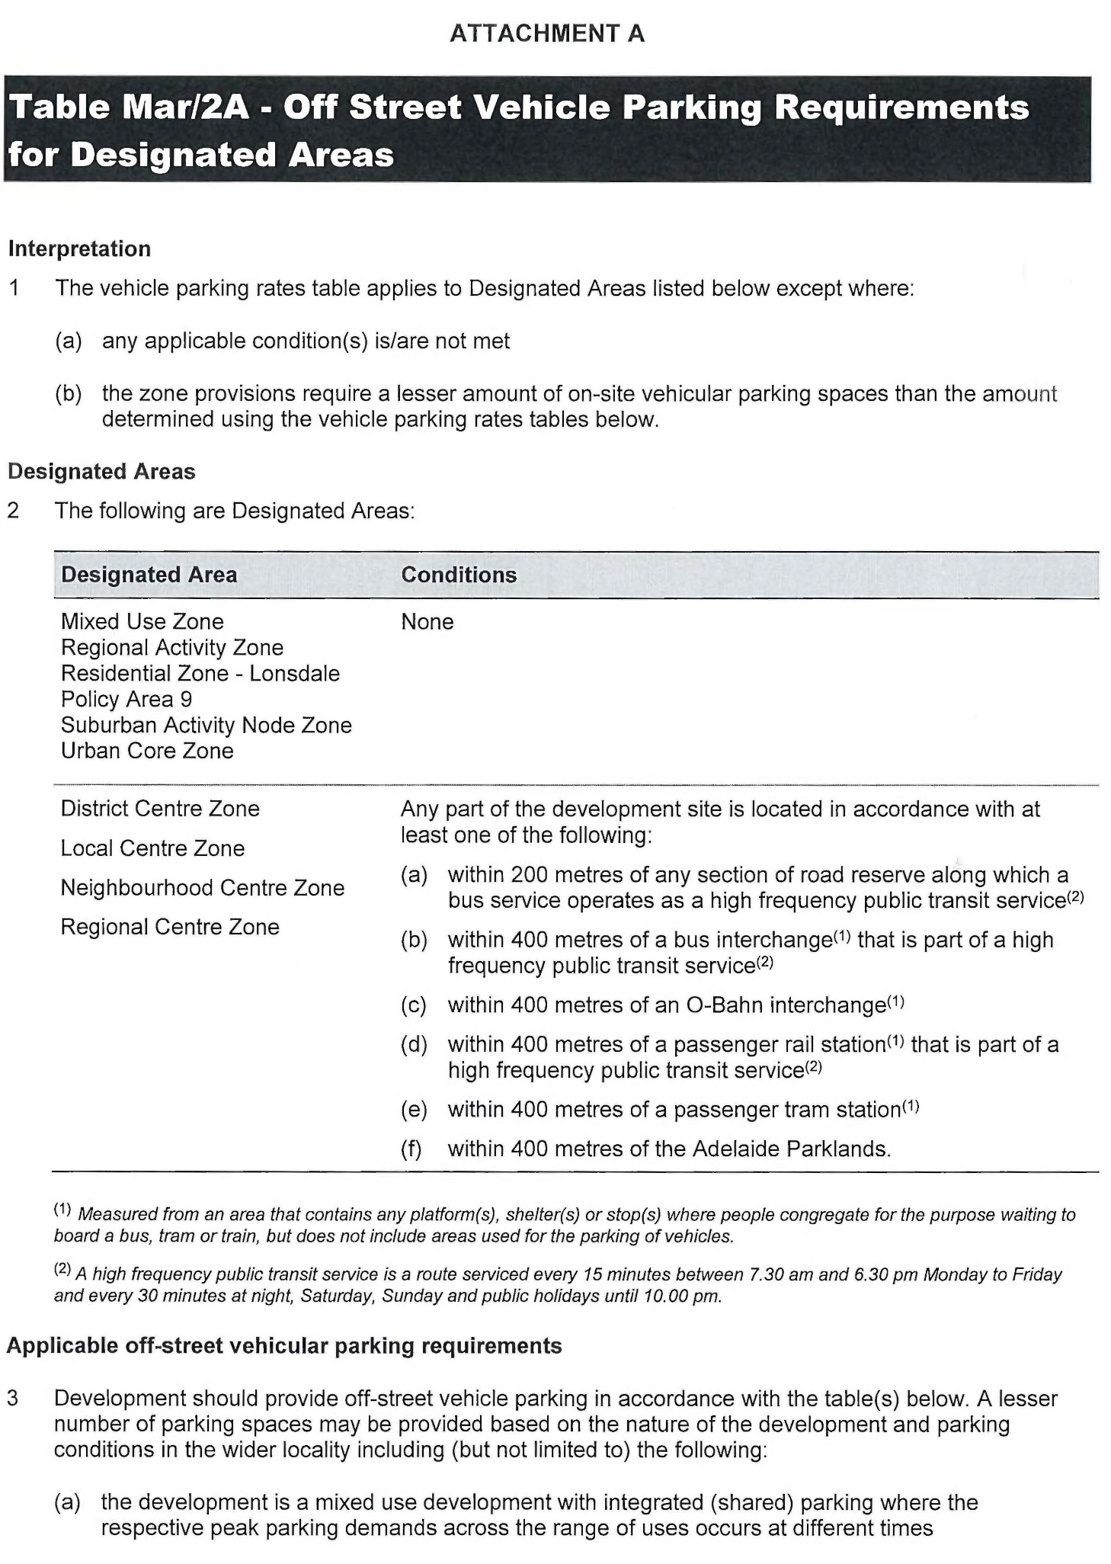
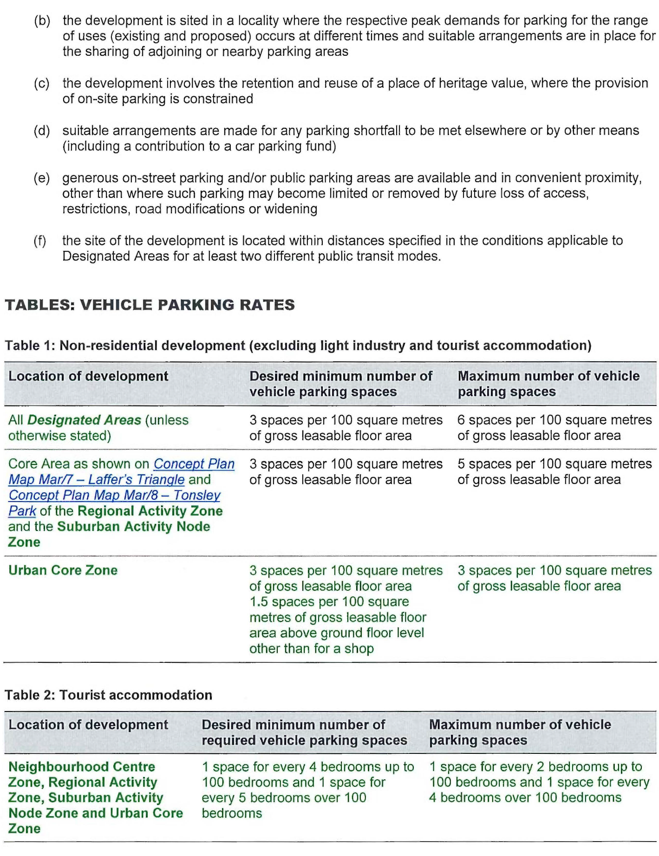
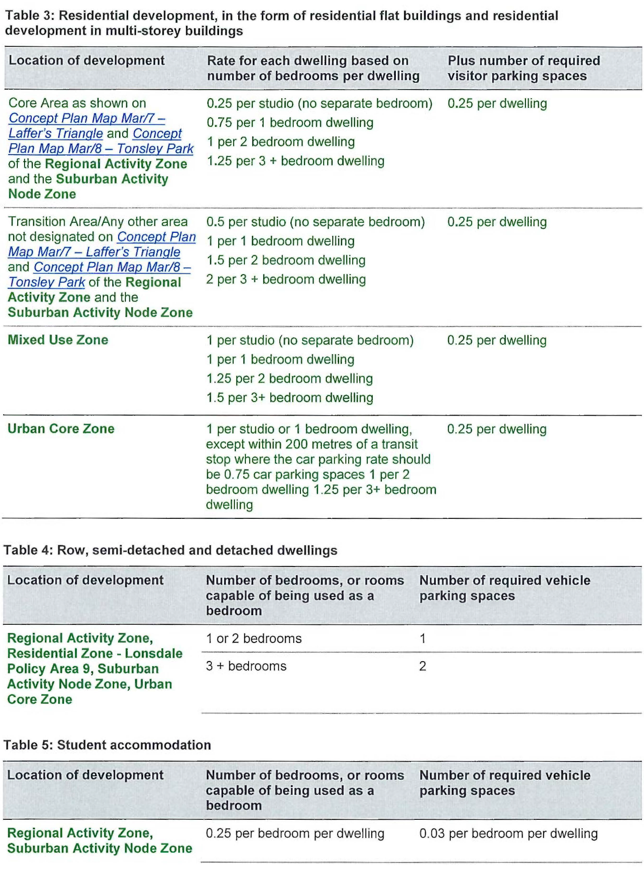

Dog Fence Act 1946
Statement of Receipts and Payments
PURSUANT to the provision of Section 34 (3) of the Dog Fence Act 1946, the Dog Fence Board hereby publishes a copy of the receipts and payments for the financial year 2019-2020.
 | 2020 (Outflows) Inflows $’000 | 2019 (Outflows) Inflows $’000
Cash outflows from operating activities
Grants & subsidies | (666) | (864)
Payments for staffing and board expenses | (232) | (228)
Fence maintenance | (152) | (206)
Motor vehicle expenses | (11) | (27)
Interest paid | (1) | -
Payments for supplies and services | (97) | (63)
Auditor’s remuneration | (18) | (18)
Cash used in operations | (1 177) | (1 406)
Cash inflows from operating activities
Interest received | 3 | 4
Rates and levies received | 1 233 | 582
SA Government subsidies | 864 | 563
Commonwealth receipts | 3 000 | 200
Cash generated from operations | 5 100 | 1 349
Net cash provided by / (used in) operating activities | 3 923 | (57)
Cash Flows from Financing Activities
Cash outflows
Repayment of Leases | (12) | -
Cash used in financing activities | (12) | -
Net cash provided by / (used in) financing activities | (12) | -
Net increase / (decrease) in cash and cash equivalents | 3 911 | (57)
Cash and cash equivalents at the beginning of the reporting period | 107 | 164
Cash and cash equivalents at the end of the reporting period | 4 018 | 107
Dated: 15 October 2020
Geoff Power
Chair Dog Fence Board

Fire and Emergency Services Act 2005
Section 131
Protection of Names and Logos
Pursuant to Section 131(1)(a) of the Fire and Emergency Services Act 2005, the South Australian Fire and Emergency Services Commission, with the consent of the Minister for Police, Emergency Services and Correctional Services, declares the following logos to be logos for the purposes of Section 131 of the Fire and Emergency Services Act 2005:
1. South Australian Country Fire Service, “SACFS” or “CFS”

2. South Australian Metropolitan Fire Service, “SAMFS” or “MFS”

3. South Australian State Emergency Service, “SASES” or “SES”

Dated: 13 October 2020
Dominic Lane
Chief Executive
SA Fire and Emergency Services Commission

MARK JONES
Chief Officer
SA Country Fire Service

MICHAEL MORGAN
Chief Officer
SA Metropolitan Fire Service

CHRIS BEATTIE
Chief Officer
SA State Emergency Service

Firearms Regulations 2017
Recognised Firearms Club
I DECLARE the Gunnery Shooting Club to be a recognised Firearms Club, pursuant to Regulation 69 (1) of the Firearms Regulations 2017.
Dated: 9 October 2020
Superintendent Stephen Howard
Delegate of the Registrar of Firearms

Fisheries Management Act 2007
Section 115
Ministerial Exemption ME9903120
TAKE NOTICE that pursuant to section 115 of the Fisheries Management Act 2007, Garry Warrick of 1979 Kingston Road, NEW RESIDENCE SA 5333 (the ‘exemption holder’), holder of River Fishery licence number R27, is exempt from sections 53(2) and 70 of the Fisheries Management Act 2007 and Regulation 5, Clause 6 of Schedule 6, and Schedule 7 of the Fisheries Management (General) Regulations 2017 but only insofar as he may use the devices described in Schedule 1 to take Carp, Bony Bream and Redfin in the areas specified in Schedule 2 for the purpose of trade or business (the ‘exempted activity’), subject to the conditions set out in Schedule 3, from 27 September 2020 until 26 September 2021, unless varied or revoked earlier.
Schedule 1
• 30 x ‘Carp net’—a gill net with a ply greater than 5, having a maximum length of 50 metres and a minimum mesh size of 10 centimetres and a maximum mesh size not exceeding 18 centimetres.
• 2 x Carp Separation Cages forming part of Lock 1 in Blanchetown on the River Murray.
Schedule 2
1. Subject to paragraph (2), the holder of licence R27 may conduct fishing activities pursuant to this licence in all backwaters of the River Murray excluding the following areas during the corresponding period set out in the following table:
Area Excluded | Period of Closure
Lake Littra and outflow channel | Permanent—all year
Clover Lake | Permanent—all year
Coombool Swamp | Permanent—all year
Lake Limbra and outflow channel | Permanent—all year
Lake Woolpolool | Permanent—all year
Ral Ral Creek below Chaffey Pumping Station and entrance waters to Lake Merreti | Permanent—all year
Katarapko Creek and Eckert Creek, including The Splash | Permanent—all year
Bulyong Creek | Permanent—all year
Pilby Creek | Permanent—all year
Hancock Creek | Permanent—all year
Mundic Creek | Permanent—all year
Pike River | Permanent—all year
Punkah Creek | Permanent—all year
Slaney Creek | Permanent—all year
Loch Luna | Permanent—all year
Cobdogla Swamp | 1 August to 30 April (inclusive)
Loveday Swamp/Mussel lagoons | 1 August to 30 April (inclusive)
Lake Merreti | 1 August to 31 January (inclusive)
2. The holder of licence R27 may conduct fishing operations within the closure areas and periods listed above if given written approval by the A/Executive Director, Fisheries and Aquaculture to undertake specified carp eradication work in a specified area for a specified period.
3. The holder of licence R27 may conduct fishing activities using the Carp Separation Cages which form part of Lock 1 on the River Murray.
Schedule 3
1. The exemption holder must not use more than thirty (30) Carp nets in permitted backwaters of the River Murray and two (2) Carp Separation Cages at Lock 1 on the River Murray at any one time.
2. The exemption holder must not have more than 30 Carp nets in his possession at any time when he is deploying Carp nets in the backwaters of the River Murray and use no more than two Carp Separation Cages at Lock 1 on the River Murray.
3. The exemption holder may only engage in the exempted activity when also fishing pursuant to River Fishery licence number R27, and may only use a boat to engage in the exempted activity if that boat is registered by endorsement on River Fishery licence number R27.
4. The exempted activity may only be conducted by the exemption holder or his nominated agent, Mr Jayden Warrick.
5. All native fish (excluding Bony Bream) taken in the course of the exempted activity must be immediately returned to the water.
6. Immediately prior to commencing the exempted activity, the exemption holder must contact the PIRSA Fishwatch on 1800 065 522 and provide the following details:
• The licence number and person(s) conducting the activity;
• The exact location(s) of the fishing activities;
• The number of Carp nets being used;
• Exemption number ME9903120

7. The exemption holder must ensure that the Carp nets are checked and all fish removed at least once during each 24 hour period.
8. Carp nets and Carp Separation Cages must be removed from the water when fishing pursuant to this exemption notice ceases.
9. When the exemption holder moves the Carp nets more than 3 kilometres from the reported location of the nets under condition 6, or removes the nets from the river completely, the exemption holder must provide an additional report to PIRSA Fishwatch on 1800 065 522 and either provide details as required under condition 6 of this exemption notice, or report that fishing with Carp nets and Carp Separation Cages has ceased.
10. While engaging in the exempted activity, the exemption holder must be in possession of a copy of this notice. Such notice must be produced to a Fisheries Officer as requested.
11. The exemption holder must not contravene or fail to comply with the Fisheries Management Act 2007 or any regulations made under that Act, except where specifically exempted by this notice.
Dated: 28 September 2020
Prof Gavin Begg
A/Executive Director
Fisheries and Aquaculture
Delegate of the Minister for Primary Industries and Regional Development

Fisheries Management (Prawn Fisheries) Regulations 2017
Revocation of Closure Notice in the Spencer Gulf Prawn Fishery
TAKE NOTICE that the notice made under regulation 10 (1) (b) of the Fisheries Management (Prawn Fisheries) Regulations 2017, the notice dated 12 March 2020 on page 567 of the South Australian Government Gazette of 19 March 2020 concerning the “Temporary Prohibition of Fishing Activities in the Spencer Gulf Prawn Fishery” is HEREBY revoked.
Dated: 8 October 2020
Steve Shanks
Prawn Fishery Manager
Delegate of the Minister for Primary Industries and Regional Development

Fisheries Management (Prawn Fisheries) Regulations 2017
Temporary Prohibition on Fishing Activities in the Spencer Gulf Prawn Fisheries
TAKE notice that pursuant to regulation 10 (a) of the Fisheries Management (Prawn Fisheries) Regulations 2017, the activities of the class specified in Schedule 1 are prohibited in the waters of the Spencer Gulf Prawn Fishery during the period specified in Schedule 2 unless this notice is varied or revoked.
Schedule 1
The act of taking or an act preparatory to or involved in the taking of King Prawns (Melicertus latisulcatus) pursuant to a Spencer Gulf Prawn Fishery Licence.
Schedule 2
From 1800 hours on 8 October 2020 to 1800 hours on 30 September 2021.
Dated: 8 October 2020
Steve Shanks
Prawn Fishery Manager
Delegate of the Minister for Primary Industries and Regional Development

Housing Improvement Act 2016
Rent Control
The Minister for Human Services Delegate in the exercise of the powers conferred by the Housing Improvement Act 2016, does hereby fix the maximum rental per week which shall be payable subject to Section 55 of the Residential Tenancies Act 1995, in respect of each house described in the following table. The amount shown in the said table shall come into force on the date of this publication in the Gazette.
Address of Premises | Allotment Section | Certificate of Title  Volume/Folio | Maximum Rental  per Week Payable
308 Dalziel Road, Glossop SA 5344 | Allotment Comprising pieces 1 & 2 Deposited Plan 24056  Hundred of Berri Irrigation Area | CL647/36, CT5987/587 | $187.00
55 Stanton Rd, Virginia SA 5120 | Allotment 1 Deposited Plan 19550 Munno Para | CT 5361/152 | $0.00  Unfit for Human Habitation
Dated: 15 October 2020
David Osborne
Acting Housing Regulator and Registrar
Housing Safety Authority, SAHA
Delegate of Minister for Human Services

Land Acquisition Act 1969
(Section 16)
Form 5—Notice of Acquisition
1. Notice of acquisition
The Commissioner of Highways (the Authority), of 50 Flinders Street, Adelaide SA 5000, acquires the following interests in the following land:
Comprising an estate in fee simple in that piece of land being portion of Allotment 4 in Filed Plan No. 139484 comprised in Certificate of Title Volume 5456 Folio 448, and being the whole of the land identified as Allotment 50 in D124568 lodged in the Lands Titles Office expressly excluding the party wall rights over the land marked B (T2062290) and the easement(s) over the land marked C (T2062290).
This notice is given under Section 16 of the Land Acquisition Act 1969.
2. Compensation
A person who has or had an interest consisting of native title or an alienable interest in the land that is divested or diminished by the acquisition or the enjoyment of which is adversely affected by the acquisition who does not receive an offer of compensation from the Authority may apply to the Authority for compensation.
2A. Payment of professional costs relating to acquisition (Section 26B)
If you are the owner in fee simple of the land to which this notice relates, you may be entitled to a payment of $10 000 from the Authority for use towards the payment of professional costs in relation to the acquisition of the land.
Professional costs include legal costs, valuation costs and any other costs prescribed by the Land Acquisition Regulations 2019.
3. Inquiries
Inquiries should be directed to:
Rob Gardner
GPO Box 1533
Adelaide, SA 5001
Phone: (08) 8343 2567
Dated: 12 October 2020
The Common Seal of the COMMISSIONER OF HIGHWAYS was hereto affixed by authority of the Commissioner in the presence of:
Rocco Caruso
Manager, Property Acquisition
Authorised Officer
Department for Infrastructure and Transport
DIT 2019/18693/01

Land Acquisition Act 1969
(Section 16)
Form 5—Notice of Acquisition
1. Notice of acquisition
The Commissioner of Highways (the Authority), of 50 Flinders Street, Adelaide SA 5000, acquires the following interests in the following land:
First: Comprising an unencumbered estate in fee simple in that piece of land being a portion of Allotment 1 in Filed Plan No. 110709 comprised in Certificate of Title Volume 6147 Folio 503, being more particularly defined as Allotment 100 on approved Deposited Plan 123883, expressly excluding the right of way over the land marked ‘A’ on FP57243 (T1517476).
Secondly: Comprising an unencumbered estate in fee simple in that piece of land being a portion of Allotment 2 in Filed Plan No. 110710 comprised in Certificate of Title Volume 5976 Folio 564, and that portion of the right of way marked ‘A’ (T1517476) held appurtenant to Certificate of Title Volume 6147 Folio 503, being more particularly defined as Allotment 101 on approved Deposited Plan 123883.
This notice is given under Section 16 of the Land Acquisition Act 1969.
2. Compensation
A person who has or had an interest consisting of native title or an alienable interest in the land that is divested or diminished by the acquisition or the enjoyment of which is adversely affected by the acquisition who does not receive an offer of compensation from the Authority may apply to the Authority for compensation.
2A. Payment of professional costs relating to acquisition (Section 26B)
If you are the owner in fee simple of the land to which this notice relates, you may be entitled to a payment of $10 000 from the Authority for use towards the payment of professional costs in relation to the acquisition of the land.
Professional costs include legal costs, valuation costs and any other costs prescribed by the Land Acquisition Regulations 2019.
3. Inquiries
Inquiries should be directed to:
Ric Lohmeyer
GPO Box 1533
Adelaide, SA 5001
Phone: (08) 8343 2554
Dated: 12 October 2020
The Common Seal of the COMMISSIONER OF HIGHWAYS was hereto affixed by authority of the Commissioner in the presence of:
Rocco Caruso
Manager, Property Acquisition
Authorised Officer
Department for Infrastructure and Transport
DIT 2019/18723/01

Land Acquisition Act 1969
(Section 16)
Form 5—Notice of Acquisition
1. Notice of acquisition
The Commissioner of Highways (the Authority), of 50 Flinders Street, Adelaide SA 5000, acquires the following interests in the following land:
Comprising an unencumbered estate in fee simple in that piece of land being portion of Allotment 192 in Deposited Plan No 7275 comprised in Certificate of Title Volume 5566 Folio 660, and being the whole of the land identified as Allotment 201 in D124138 lodged in the Lands Titles Office.
This notice is given under Section 16 of the Land Acquisition Act 1969.
2. Compensation
A person who has or had an interest consisting of native title or an alienable interest in the land that is divested or diminished by the acquisition or the enjoyment of which is adversely affected by the acquisition who does not receive an offer of compensation from the Authority may apply to the Authority for compensation.
2A. Payment of professional costs relating to acquisition (Section 26B)
If you are the owner in fee simple of the land to which this notice relates, you may be entitled to a payment of $10 000 from the Authority for use towards the payment of professional costs in relation to the acquisition of the land.
Professional costs include legal costs, valuation costs and any other costs prescribed by the Land Acquisition Regulations 2019.
3. Inquiries
Inquiries should be directed to:
Carlene Russell
GPO Box 1533
Adelaide, SA 5001
Phone: (08) 8343 2512
Dated: 12 October 2020
The Common Seal of the COMMISSIONER OF HIGHWAYS was hereto affixed by authority of the Commissioner in the presence of:
Rocco Caruso
Manager, Property Acquisition
Authorised Officer
Department for Infrastructure and Transport
DIT 2020/05181/01

Land Acquisition Act 1969
(Section 16)
Form 5—Notice of Acquisition
1. Notice of acquisition
The Commissioner of Highways (the Authority), of 50 Flinders Street, Adelaide SA 5000, acquires the following interests in the following land:
Comprising an unencumbered estate in fee simple in that piece of land being portion of Allotment 321 in Filed Plan No 162670 comprised in Certificate of Title Volume 5806 Folio 842, and being the whole of the land identified as Allotment 200 in D124070 lodged in the Lands Titles Office.
This notice is given under Section 16 of the Land Acquisition Act 1969.
2. Compensation
A person who has or had an interest consisting of native title or an alienable interest in the land that is divested or diminished by the acquisition or the enjoyment of which is adversely affected by the acquisition who does not receive an offer of compensation from the Authority may apply to the Authority for compensation.
2A. Payment of professional costs relating to acquisition (Section 26B)
If you are the owner in fee simple of the land to which this notice relates, you may be entitled to a payment of $10 000 from the Authority for use towards the payment of professional costs in relation to the acquisition of the land.
Professional costs include legal costs, valuation costs and any other costs prescribed by the Land Acquisition Regulations 2019.
3. Inquiries
Inquiries should be directed to:
Carlene Russell
GPO Box 1533
Adelaide, SA 5001
Phone: (08) 8343 2512
Dated: 12 October 2020
The Common Seal of the COMMISSIONER OF HIGHWAYS was hereto affixed by authority of the Commissioner in the presence of:
Rocco Caruso
Manager, Property Acquisition
Authorised Officer
Department for Infrastructure and Transport
DIT 2020/05180/01

Land Acquisition Act 1969
(Section 16)
Form 5—Notice of Acquisition
1. Notice of acquisition
The Commissioner of Highways (the Authority), of 50 Flinders Street, Adelaide SA 5000, acquires the following interests in the following land:
Comprising an unencumbered estate in fee simple in that piece of land being portion of Allotment 317 in Filed Plan No 162666 comprised in Certificate of Title Volume 6208 Folio 849, and being the whole of the land identified as Allotment 203 in D124140 lodged in the Lands Titles Office.
This notice is given under Section 16 of the Land Acquisition Act 1969.
2. Compensation
A person who has or had an interest consisting of native title or an alienable interest in the land that is divested or diminished by the acquisition or the enjoyment of which is adversely affected by the acquisition who does not receive an offer of compensation from the Authority may apply to the Authority for compensation.
2A. Payment of professional costs relating to acquisition (Section 26B)
If you are the owner in fee simple of the land to which this notice relates, you may be entitled to a payment of $10 000 from the Authority for use towards the payment of professional costs in relation to the acquisition of the land.
Professional costs include legal costs, valuation costs and any other costs prescribed by the Land Acquisition Regulations 2019.
3. Inquiries
Inquiries should be directed to:
Carlene Russell
GPO Box 1533
Adelaide, SA 5001
Phone: (08) 8343 2512
Dated: 12 October 2020
The Common Seal of the COMMISSIONER OF HIGHWAYS was hereto affixed by authority of the Commissioner in the presence of:
Rocco Caruso
Manager, Property Acquisition
Authorised Officer
Department for Infrastructure and Transport
DIT 2020/05183/01

Land Acquisition Act 1969
(Section 16)
Form 5—Notice of Acquisition
1. Notice of acquisition
The Commissioner of Highways (the Authority), of 50 Flinders Street, Adelaide SA 5000, acquires the following interests in the following land:
Comprising an estate in fee simple in that piece of land being portion of Allotment 1 in Deposited Plan No 82066 comprised in Certificate of Title Volume 6063 Folio 878, and being the whole of the land identified as Allotment 202 in D124137 lodged in the Lands Titles Office subject to the easement(s) over the land marked “C” created by TG 2999373 and over the land marked “A” created by Section 223LG RPA.
This notice is given under Section 16 of the Land Acquisition Act 1969.
2. Compensation
A person who has or had an interest consisting of native title or an alienable interest in the land that is divested or diminished by the acquisition or the enjoyment of which is adversely affected by the acquisition who does not receive an offer of compensation from the Authority may apply to the Authority for compensation.
2A. Payment of professional costs relating to acquisition (Section 26B)
If you are the owner in fee simple of the land to which this notice relates, you may be entitled to a payment of $10 000 from the Authority for use towards the payment of professional costs in relation to the acquisition of the land.
Professional costs include legal costs, valuation costs and any other costs prescribed by the Land Acquisition Regulations 2019.
3. Inquiries
Inquiries should be directed to:
Carlene Russell
GPO Box 1533
Adelaide, SA 5001
Phone: (08) 8343 2512
Dated: 12 October 2020
The Common Seal of the COMMISSIONER OF HIGHWAYS was hereto affixed by authority of the Commissioner in the presence of:
Rocco Caruso
Manager, Property Acquisition
Authorised Officer
Department for Infrastructure and Transport
DIT 2020/05182/01

Major Events Act 2013
Section 6B
Major Event Declaration
PURSUANT to section 6B of the Major Events Act 2013, I, Hon Steven Marshall MP, Premier of South Australia declare the 2020
National Pharmacies Christmas Pageant to be held on 14 November 2020 to be declared a major event.
By virtue of the provisions of the Major Events Act 2013, I do hereby:
1. Specify the period for the event, being 14 November 2020 from midday to midnight.
2. Declare the major event venue to be Adelaide Oval.
3. Specify an area bounded by Festival Drive, King William Road, Pennington Terrace, Montefiore Hill and Montefiore Road as a controlled area in relation to the event.
4. Designate the South Australian Tourism Commission to be the event organiser for the event.
5. Apply section 8 of the Major Events Act to the event.
6. Apply section 10 of the Major Events Act to the event.
7. Apply section 11 of the Major Events Act to the event.
8. Apply section 12 of the Major Events Act to the event.
9. Apply section 13 of the Major Events Act to the event.
10. Apply section 14 of the Major Events Act to the event by specifying the official title as 2020 National Pharmacies Christmas Pageant and the official logo as it appears below.
Dated: 15 October 2020
Hon Steven Marshall MP
Premier of South Australia

Major Events Act 2013
Section 6B
Major Event Declaration
PURSUANT to section 6B of the Major Events Act 2013, I, Hon Steven Marshall MP, Premier of South Australia declare the 2020 NRL State of Origin Game One to be held on 4 November 2020 to be declared a major event.
By virtue of the provisions of the Major Events Act 2013, I do hereby:
1. Specify the period for the event, being 4 November 2020.
2. Declare the major event venue to be Adelaide Oval.
3. Specify an area bounded by Festival Drive, King William Road, Pennington Terrace, Montefiore Hill and Montefiore Road as a controlled area in relation to the event.
4. Designate the NRL to be the event organiser for the event.
5. Apply section 8 of the Major Events Act to the event.
6. Apply section 10 of the Major Events Act to the event.
7. Apply section 11 of the Major Events Act to the event.
8. Apply section 12 of the Major Events Act to the event.
9. Apply section 13 of the Major Events Act to the event.
10. Apply section 14 of the Major Events Act to the event by specifying the official title as State of Origin 2020 and the official logo as it appears below.

Dated: 15 October 2020
Hon Steven Marshall MP
Premier of South Australia

Motor Vehicle Accidents (Lifetime Support Scheme) Act 2013
Notice by the Minister
Re-appointment of Medical Experts, Convenor and Deputy Convenor under Schedule 1
TAKE notice that I, Hon Stephen Wade MLC, Minister for Health and Wellbeing, pursuant to Schedule 1, do hereby:
(a) RE-APPOINT the following persons as medical experts for a period of three years from the date of this notice:
Ms Andrea Aitchison
Ms Frances Allan
Dr Peter Anastassiadis
Dr Janet Baker
Dr David Caudrey
Professor Brian Freeman
Associate Professor Stacey George
Professor Susan Hillier
Associate Professor Ruth Marshall
Ms Anne Morgan
Dr Charitha Perera
Dr Emma Fitzgerald
Ms Madeleine Trewartha
Dr Adrian Winsor
(b) RE-APPOINT Dr David Caudrey as Convenor and Associate Professor Stacey George as Deputy Convenor for a period of three years from the date of this notice.
Dated: 7 October 2020
Stephen Wade
Minister for Health and Wellbeing

Public Finance and Audit Act 1987
Section 17(1)
Exclusion from Definition of Financial Arrangement
Notice by the Treasurer
I, ROBERT LUCAS, Treasurer, pursuant to Section 17(1) of the Public Finance and Audit Act 1987 hereby exclude from the ambit of
the definition of “financial arrangement” a lease within the meaning of Accounting Standard AASB 16 Leases, as issued by the
Australian Accounting Standards Board.
Dated: 10 October 2020
Robert Lucas
Treasurer

Railways (Operations and Access) Act 1997
Section 7A
2020 South Australian Rail Access Regime Review, Final Report
I, COREY LUKE WINGARD MP, Minister for Infrastructure and Transport, pursuant to section 7A(5) of the Railways (Operations and Access) Act 1997 (the Act), note the following:
That the Regulator under the Act, being the Essential Services Commission of South Australia, has recommended in its report, 2020 South Australian Rail Access Regime Review, Final Report, August 2020, that the application of the access regime providing for third party access to South Australian railway infrastructure services should continue from 31 October 2020 for a further five year period.
Dated: 1 October 2020
Corey Luke Wingard
Minister for Infrastructure and Transport

Roads (Opening and Closing) Act 1991
Section 24
Notice of Confirmation of Road Process Order
Road Closure—Grant Road, Evanston South
BY Road Process Order made on 10 June 2020, the Town of Gawler ordered that:
1. The whole of Grant Road, Evanston South, situated adjoining Allotment 81 in Deposited Plan 6328, Allotment 1001 in Deposited Plan 54686 and Allotment 62 in Filed Plan 154963, Hundred of Munno Para, more particularly delineated and marked ‘A’ in Preliminary Plan 20/0011 be closed.
2. Transfer the whole of the land subject to closure to D & K Parks Pty Ltd in accordance with the Agreement for Transfer dated 10 June 2020 entered into between the Town of Gawler and D & K Parks Pty Ltd.
3. The following easement is to be granted over portion of the land subject to closure:
Grant to Distribution Lessor Corporation (subject to Lease 8890000) an easement for the transmission of electricity by underground cable over the land marked ‘B’ in Deposited Plan 124375.
On 13 October 2020 that order was confirmed by the Attorney-General conditionally upon the deposit by the Registrar-General of Deposited Plan 124375 being the authority for the new boundaries.
Pursuant to section 24 of the Roads (Opening and Closing) Act 1991, NOTICE of the order referred to above and its confirmation is hereby given.
Dated: 15 October 2020
M. P. Burdett
Surveyor-General
DPTI: 2020/06116/01

Roads (Opening and Closing) Act 1991
Section 24
Notice of Confirmation of Road Process Order
Road Closure—Llanelly Road, Salter Springs
BY Road Process Order made on 2 June 2020, the Wakefield Regional Council ordered that:
1. Portions of Llanelly Road, Salter Springs, situated adjoining Allotments 11, 12 and 13 in Deposited Plan 118947, Hundred of Alma, more particularly delineated and lettered ‘B’, ‘C’ and ‘D’ in Preliminary Plan 20/0006 be closed.
2. Transfer portion of the land subject to closure marked ‘B’ to Marion Claire Eckert in accordance with the Agreement for Transfer dated 2 June 2020 entered into between the Wakefield Regional Council and Marion Claire Eckert.
3. Transfer portions of the land subject to closure marked ‘C’ and ‘D’ to Kenneth Bruce Warnes and Michael Bruce Warnes in accordance with the Agreements for Transfer dated 2 June 2020 entered into between the Wakefield Regional Council and Kenneth Bruce Warnes and Michael Bruce Warnes.
4. The following easement is to be granted over portion of the land subject to that closure:
Grant to Transmission Lessor Corporation of 1 undivided 2nd part (subject to Lease 9061500) and ElectraNet Pty Ltd of 1 undivided 2nd part an easement for overhead electricity supply purposes over the land marked ‘B’ in Deposited Plan 124362.
On 13 October 2020 that order was confirmed by the Attorney-General conditionally upon the deposit by the Registrar-General of Deposited Plan 124362 being the authority for the new boundaries.
Pursuant to section 24 of the Roads (Opening and Closing) Act 1991, NOTICE of the order referred to above and its confirmation is hereby given.
Dated: 15 October 2020
M. P. Burdett
Surveyor-General
DPTI: 2020/03820/01

Local Government Instruments

City of Charles Sturt
Local Government Act 1999
Review of Elector Representation
Notice is hereby given that the City of Charles Sturt is undertaking a review to determine whether a change of arrangements is required in respect to the Council’s elector representation. The purpose of the review is to ensure that electors of the Council area are being adequately and fairly represented.
Pursuant to Section 12(7) of the Local Government Act 1999, notice is hereby given that the Council has prepared a Representation Options Paper that examines the advantages and disadvantages of the various options available regarding the composition and structure of the Council and the division of the Council into wards
Copies of the Representation Options Paper are available on the Council’s website at www.charlessturt.sa.gov.au and for inspection at the Council Office:
• Civic Centre - 72 Woodville Road, Woodville
Written submissions are invited from interested persons from Thursday, 15 October 2020 and must be received by close of business on Thursday, 26 November 2020. Written submissions should be addressed to:
Representation Review
City of Charles Sturt
Via mail to: PO Box 1, Woodville SA 5011
Via email to: council@charlessturt.sa.gov.au
Via Yoursay at: www.yoursaycharlessturt.com.au
In person: Civic Centre - 72 Woodville Road, Woodville
Information regarding the Representation Review can be obtained by contacting Mary Del Giglio on (08) 8408 1120 or email
mdelgiglio@charlessturt.sa.gov.au
Dated: 13 October 2020
Paul Sutton
Chief Executive Officer

City of Salisbury
Local Government Act 1999
Revocation of Community Land Classification
Pursuant to Section 194 of the Local Government Act 1999(2) (b), The City of Salisbury proposes to revoke the Community Land Classification from a portion of community land.
The City of Salisbury is the registered owner of the land described as Prettejohn Gully, Allotment 827 in Deposited Plan 6755, described in Certificate of Title Volume 5550, Folio 512. A portion measuring approximately 460 square meters is required to be to be revoked of its Community Land Classification for the purpose of constructing a roundabout and declaring as road adjacent Kesters Road and Nelson Road, Para Hills.
A copy of the plans detailing the proposals and location are available for public inspection at Council’s Community Hub at 34 Church Street, Salisbury.
Any objection to the proposal must set out the full name and address of the person making the objection and must be fully supported by reasons.
Any submissions must be made in writing prior to the Friday, 6 November 2020 to the Council at PO Box 8, Salisbury SA 5108.
Where submissions are made Council will give notification of a meeting to deal with the matter.
Enquiries may be directed to Liz Lynch on (08) 8406 8216 or by email to elynch@salisbury.sa.gov.au.
Dated: 6 October 2020
John Harry
Chief Executive Officer

Public Notices

National Electricity Law
Initiation of Fast Tracked Rule Change
The Australian Energy Market Commission (AEMC) gives notice under the National Electricity Law as follows:
Under s 95, the Australian Energy Regulator has requested the Semi scheduled generator dispatch obligations (Ref. ERC0313) proposal. The proposal seeks to prevent semi-scheduled generators from adjusting their anticipated level of output without informing the Australian Energy Market Operator (AEMO) of that intention and waiting to receive a revised dispatch target. Under s 96A, the AEMC has decided to fast track this proposal.
Documents referred to above are available on the AEMC’s website and are available for inspection at the AEMC’s office.
Australian Energy Market Commission
Level 15, 60 Castlereagh St
Sydney NSW 2000
Telephone: (02) 8296 7800
www.aemc.gov.au
Dated: 15 October 2020

Notice Submission

The South Australian Government Gazette is compiled and published each Thursday.
Notices must be submitted before 4 p.m. Tuesday, the week of intended publication.
All submissions are formatted per the gazette style and proofs are supplied as soon as possible. Alterations must be returned before 4 p.m. Wednesday.
Requests to withdraw submitted notices must be received before 10 a.m. on the day of publication.

Gazette notices should be emailed as Word files in the following format:
- Title—name of the governing Act/Regulation
- Subtitle—brief description of the notice
- A structured body of text
- Date of authorisation
- Name, position, and government department/organisation of the person authorising the notice

Please provide the following information in your email:
- Date of intended publication
- Contact details of at least two people responsible for the notice content
- Name of the person and organisation to be charged for the publication (Local Council and Public notices)
- Request for a quote, if required
- Purchase order, if required

Email: governmentgazettesa@sa.gov.au
Phone: (08) 7109 7760
Website: www.governmentgazette.sa.gov.au

All instruments appearing in this gazette are to be considered official, and obeyed as such

Printed and published weekly by authority of S. Smith, Government Printer, South Australia
$7.70 per issue (plus postage), $387.60 per annual subscription—GST inclusive
Online publications: www.governmentgazette.sa.gov.au

