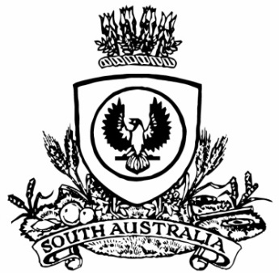
No. 70 p. 4507
SUPPLEMENTARY GAZETTE
THE SOUTH AUSTRALIAN
GOVERNMENT GAZETTE
Published by Authority

Adelaide, Wednesday, 2 September 2020

Contents

Governor’s Instruments
Appointment 4508
Public Finance and Audit Act 1987 4508
Proclamations—
National Parks and Wildlife (Dhilba Guuranda-Innes
National Park) Proclamation 2020 4509
National Parks and Wildlife (Innes National Park) Proclamation 2020 4510

Governor’s Instruments

APPOINTMENT
Department of the Premier and Cabinet
Adelaide, 2 September 2020
His Excellency the Governor in Executive Council has been pleased to appoint Rodney Oates as a Magistrate commencing on 2 September 2020, in place of his earlier appointment on 21 January 2016 to the office of Magistrate on a part-time basis (0.5 full-time equivalent) that commenced on 21 January 2016 - pursuant to the provisions of the Magistrates Act 1983.
By command,
Steven Spence Marshall
Premier
AGO0141-20CS

PUBLIC FINANCE AND AUDIT ACT 1987
Governor’s Appropriation Fund
Approval to Appropriate Funds from the Consolidated Account
PURSUANT to Section 12 of the Act, I approve the appropriation from the Consolidated Account to the public purposes of the State an amount of $460,069,800 for the financial year ending 30 June 2021.
Given under my hand this 2nd day of September 2020.
Hieu Van Le
Governor

PROCLAMATIONS
South Australia

National Parks and Wildlife (Dhilba Guuranda-Innes National Park) Proclamation 2020
under section 27(3) of the National Parks and Wildlife Act 1972
1—Short title
This proclamation may be cited as the National Parks and Wildlife (Dhilba Guuranda-Innes National Park) Proclamation 2020.
2—Commencement
This proclamation comes into operation on the day on which it is made immediately after the National Parks and Wildlife (Innes National Park) Proclamation 2020 comes into operation.
3—Alteration of boundaries of Dhilba Guuranda-Innes National Park
The boundaries of the Dhilba Guuranda-Innes National Park are altered by adding to the Park the following Crown land:
Sections 10, 129, 130, 177 and 268, Hundred of Warrenben, County of Fergusson;
Allotment 2 in Deposited Plan 46329, Hundred of Warrenben, County of Fergusson.
Made by the Governor
with the advice and consent of the Executive Council
on 2 September 2020

South Australia

National Parks and Wildlife (Innes National Park) Proclamation 2020
under section 27(3) of the National Parks and Wildlife Act 1972
1—Short title
This proclamation may be cited as the National Parks and Wildlife (Innes National Park) Proclamation 2020.
2—Commencement
This proclamation comes into operation on the day on which it is made.
3—Alteration of name of Innes National Park
The name assigned to the Innes National Park is altered to Dhilba Guuranda-Innes National Park.
Made by the Governor
with the advice and consent of the Executive Council
on 2 September 2020

All instruments appearing in this gazette are to be considered official, and obeyed as such

Printed and published weekly by authority of S. Smith, Government Printer, South Australia
$7.70 per issue (plus postage), $387.60 per annual subscription—GST inclusive
Online publications: www.governmentgazette.sa.gov.au

