THE SOUTH AUSTRALIAN
GOVERNMENT GAZETTE
Published by Authority

Adelaide, Thursday, 17 September 2020

Contents

Governor’s Instruments
Acts—No. 27-29 of 2020 4614
Appointments 4614
Emergency Management Act 2004 4615
Marine Parks Act 2007 4615
Proclamations—
Marine Parks Variation Proclamation 2020 4617
Regulations—
Superannuation (Prescribed Authorities) Variation Regulations 2020—No. 267 of 2020 4618
Cost of Living Concessions Regulations 2020—
No. 268 of 2020 4620
Fair Trading (Gift Cards) Revocation
Regulations 2020—No. 269 of 2020 4626
Rules of Court
Magistrate Court Rules 1992—Amendment No.85 4627
State Government Instruments
Associations Incorporation Act 1985 4643
Development Act 1993 4643
Housing Improvement Act 2016 4644
Landscape South Australia Act 2019 4644
Mining Act 1971 4645
Motor Vehicles Act 1959 4646
Petroleum and Geothermal Energy Act 2000 4647
Training and Skills Development Act 2008 4649
Local Government Instruments
City of Mitcham 4650
City of Onkaparinga 4651
City of Unley 4651
District Council of Elliston 4651
District Council of Grant 4652
Yorke Peninsula Council 4652
Public Notices
National Electricity Law 4653

Governor’s Instruments

ACTS
Department of the Premier and Cabinet
Adelaide, 17 September 2020
His Excellency the Governor directs it to be notified for general information that he has in the name and on behalf of Her Majesty The Queen, this day assented to the undermentioned Acts passed by the Legislative Council and House of Assembly in Parliament assembled, viz.:
No. 27 of 2020—Single-use and Other Plastic Products (Waste Avoidance) Act 2020
An Act to restrict and prohibit the manufacture, production, distribution, sale and supply of certain single-use and other plastic products and for other purposes
No. 28 of 2020—Controlled Substances (Confidentiality and Other Matters) Amendment Act 2020
An Act to amend the Controlled Substances Act 1984
No. 29 of 2020—Fair Trading (Repeal of Part 6A-Gift Cards) Amendment Act 2020
An Act to amend the Fair Trading Act 1987
By command,
Steven Spence Marshall
Premier

APPOINTMENTS
Department of the Premier and Cabinet
Adelaide, 17 September 2020
His Excellency the Governor in Executive Council has been pleased to appoint the undermentioned to the Teachers Registration Board of South Australia, pursuant to the provisions of the Teachers Registration and Standards Act 2004:
Member: from 28 September 2020 until 30 March 2021
Lisa Jane Dwiar
Deputy Member: from 28 September 2020 until 30 March 2021
Leona Gayle Graham (Deputy to Dwiar)
By command,
Steven Spence Marshall
Premier
ME20/045

Department of the Premier and Cabinet
Adelaide, 17 September 2020
His Excellency the Governor in Executive Council has been pleased to appoint the undermentioned to the Carrick Hill Trust, pursuant to the provisions of the Carrick Hill Trust Act 1985:
Member: from 17 September 2020 until 16 September 2023
Ian Christopher Sharpley
By command,
Steven Spence Marshall
Premier
DPC20//047CS

Department of the Premier and Cabinet
Adelaide, 17 September 2020
His Excellency the Governor in Executive Council has been pleased to appoint the undermentioned to the Art Gallery Board, pursuant to the provisions of the Art Gallery Act 1939:
Presiding Member: from 17 September 2020 until 1 April 2023
Jason Demetrios Karas
Member: from 17 September 2020 until 16 September 2023
Jane Elizabeth Yuile
Member: from 12 December 2020 until 11 December 2023
Jacqueline Elizabeth McGill
By command,
Steven Spence Marshall
Premier
DPC20/049CS

Department of the Premier and Cabinet
Adelaide, 17 September 2020
His Excellency the Governor in Executive Council has been pleased to appoint the undermentioned to the Veterinary Surgeons Board of South Australia, pursuant to the provisions of the Veterinary Practice Act 2003:
Member: from 1 October 2020 until 30 September 2023
Chalette Brown
By command,
Steven Spence Marshall
Premier
MPI20/0030

EMERGENCY MANAGEMENT ACT 2004
Section 23
Approval of Extension of a Major Emergency Declaration by the Governor
Recital
The State Co-ordinator declared a Major Emergency on 22 March 2020 under section 23(1) of the Emergency Management Act 2004 (the Act) in respect of the outbreak of the human disease named COVID-19 within South Australia (the Declaration).
With the advice and consent of the Executive Council and pursuant to section 23(2) of the Act, on the days and for the periods set out in the Schedule to this Approval, I approved an extension of the Declaration.
PURSUANT to section 23(2) of the Act and with the advice and consent of the Executive Council, I NOW approve a further extension of the Declaration for a period of 28 days commencing on 19 September 2020.
Given under my hand and the Public Seal of South Australia at Adelaide.
Dated: 17 September 2020
Hieu Van Le
Governor

Schedule
• On 2 April 2020, for a period of 28 days to commence on 4 April 2020.
• On 30 April 2020 for a period of 28 days to commence on 2 May 2020.
• On 28 May 2020 for a period of 28 days to commence on 30 May 2020.
• On 27 June 2020 for a period of 28 days to commence on 27 June 2020.
• On 23 July 2020 for a period of 28 days to commence on 25 July 2020.
• On 20 August 2020 for a period of 28 days to commence on 22 August 2020

Marine Parks Act 2007
South Australia
Marine Parks (Authorised Management Plan Amendments) Notice 2020
under section 14(8) of the Marine Parks Act 2007

Preamble
1 By notice in the Gazette (Gazette 29.11.2012 p5239), the following management plans are declared to be authorised management plans:
(a) Encounter Marine Park Management Plan;
(b) Neptune Islands Group (Ron and Valerie Taylor) Marine Park Management Plan;
(c) Nuyts Archipelago Marine Park Management Plan;
(d) Upper Gulf St Vincent Marine Park Management Plan;
(e) Upper South East Marine Park Management Plan;
(f) Western Kangaroo Island Marine Park Management Plan.
2 Following completion of a process under section 14 of the Marine Parks Act 2007, the draft management plan amendments referred to in Schedule 1, to amend the authorised management plans referred to in clause 1 of this preamble, have been adopted by the Minister for Environment and Water.
3 It is now intended that those draft management plan amendments be declared to be authorised management plan amendments.

1—Short title
This notice may be cited as the Marine Parks (Authorised Management Plan Amendments) Notice 2020.
2—Commencement
This notice comes into operation on 1 January 2021.
3—Authorised management plan amendments
(1) The draft management plan amendments referred to in Schedule 1 are declared to be authorised management plan amendments.
(2) The authorised management plan amendments come into operation on 1 January 2021.
Schedule 1—Authorised management plan amendments
Encounter Marine Park Management Plan Amendment 2020
Neptune Islands Group (Ron and Valerie Taylor) Marine Park Management Plan Amendment 2020
Nuyts Archipelago Marine Park Management Plan Amendment 2020
Upper Gulf St Vincent Marine Park Management Plan Amendment 2020
Upper South East Marine Park Management Plan Amendment 2020
Western Kangaroo Island Marine Park Management Plan Amendment 2020
Made by the Governor
with the advice and consent of the Executive Council
on 17 September 2020

Proclamations
South Australia

Marine Parks Variation Proclamation 2020
under section 10 of the Marine Parks Act 2007

Preamble
1 By proclamation made under the Marine Parks Act 2007 (Gazette 29.1.2009 p481) as varied, certain marine parks are established and assigned names.
2 It is now intended that by this proclamation the boundaries of the Encounter Marine Park and the Upper Gulf St Vincent Marine Park be altered by the addition of areas to these parks.

Part 1—Preliminary
1—Short title
This proclamation may be cited as the Marine Parks Variation Proclamation 2020.
2—Commencement
This proclamation comes into operation on 1 January 2021.
3—Variation provisions
In this proclamation, a provision under a heading referring to the variation of a specified proclamation varies the proclamation so specified.
Part 2—Variation of Marine Parks Proclamation 2009 (Gazette 29.1.2009 p481)
4—Variation of Schedule 1—Marine parks
(1) Schedule 1, table, item 14—delete "Rack Plan No 1066" and substitute:
Rack Plan No 1504
(2) Schedule 1, table, item 15—delete "Rack Plan No 1927" and substitute:
Rack Plan No 1505
Made by the Governor
on the recommendation of the Minister for Environment and Water and with the advice and consent of the Executive Council
on 17 September 2020

Regulations
South Australia

Superannuation (Prescribed Authorities) Variation Regulations 2020
under the Superannuation Act 1988

Contents
Part 1—Preliminary
1 Short title
2 Commencement
3 Variation provisions
Part 2—Variation of Superannuation Regulations 2016
4 Variation of regulation 45—Prescribed authorities etc

Part 1—Preliminary
1—Short title
These regulations may be cited as the Superannuation (Prescribed Authorities) Variation Regulations 2020.
2—Commencement
These regulations come into operation on the day on which they are made.
3—Variation provisions
In these regulations, a provision under a heading referring to the variation of specified regulations varies the regulations so specified.
Part 2—Variation of Superannuation Regulations 2016
4—Variation of regulation 45—Prescribed authorities etc
Regulation 45—after paragraph (o) insert:
(p) Downer EDI Works Pty Ltd;
(q) Fulton Hogan Industries Pty Ltd;
(r) Lendlease Services Pty Ltd.
Note—
As required by section 10AA(2) of the Subordinate Legislation Act 1978, the Minister has certified that, in the Minister's opinion, it is necessary or appropriate that these regulations come into operation as set out in these regulations.
Made by the Governor
with the advice and consent of the Executive Council
on 17 September 2020
No 267 of 2020

South Australia

Cost of Living Concessions Regulations 2020
under the Cost of Living Concessions Act 1986

Contents
1 Short title
2 Commencement
3 Interpretation
4 Prescribed classes of person (section 2(2) and (3))
5 Remission of water rates
6 Eligible person (section 3(1))
7 Concession eligibility requirements (section 3(2)(b))
8 Concession payment amounts (section 3(2))
Schedule 1—Revocation of Cost of Living Concessions Regulations 2009

1—Short title
These regulations may be cited as the Cost of Living Concessions Regulations 2020.
2—Commencement
These regulations come into operation on 30 September 2020.
3—Interpretation
(1) In these regulations—
Act means the Cost of Living Concessions Act 1986;
CPI means the Consumer Price Index (All groups index for Adelaide) published by the Australian Bureau of Statistics;
domestic partner means a person who is a domestic partner within the meaning of the Family Relationships Act 1975, whether declared as such under that Act or not;
low income earner, for a financial year, means a person of a class determined by the Minister, by notice published on a website determined by the Minister, to be low income earners for that financial year;
prescribed capacity—see subregulation (2);
prescribed card means—
(a) a Pensioner Concession Card issued by the Commonwealth Government; or
(b) a Low Income Health Care Card issued by the Commonwealth Government; or
(c) a TPI Gold Repatriation Health Card issued by the Commonwealth Government; or
(d) a War Widows Gold Repatriation Health Card issued by the Commonwealth Government; or
(e) a Gold Repatriation Health Card (EDA) issued by the Commonwealth Government; or
(f) a Gold Repatriation Health Card issued by the Commonwealth Government to a person with 80 or more overall impairment points under the Military Rehabilitation and Compensation Act 2004 of the Commonwealth; or
prescribed payments means—
(a) any of the following payments under the Social Security Act 1991 of the Commonwealth:
(i) an Austudy payment;
(ii) a JobSeeker payment;
(iii) a parenting payment;
(iv) a partner allowance;
(v) a sickness allowance;
(vi) a special benefit;
(vii) a widow allowance;
(viii) a youth allowance; or
(b) Abstudy payments from the Commonwealth Government; or
(c) payments under the Community Development Employment Project established by the Commonwealth Government; or
(d) payments under the New Enterprise Incentive Scheme established by the Commonwealth Government; or
(e) a pension as a war widow under legislation of the United Kingdom or New Zealand; or
(f) farm household allowance payments under the Farm Household Support Act 2014 of the Commonwealth;
residential park site agreement has the same meaning as in the Residential Parks Act 2007;
residential park tenancy agreement has the same meaning as in the Residential Parks Act 2007;
spouse—a person is the spouse of another if they are legally married;
water rates means—
(a) rates under the Irrigation Act 2009; or
(b) rates under the Renmark Irrigation Trust Act 2009.
(2) For the purposes of these regulations, a person will be taken to occupy land as the person's principal place of residence in a prescribed capacity only if the person occupies the land as the person's principal place of residence—
(a) as sole or joint proprietor of an estate in freehold in possession; or
(b) as sole or joint proprietor of a Crown lease or Crown under lease; or
(c) as the purchaser of an estate in fee simple under an agreement for sale and purchase where the purchase price is payable in more than 2 instalments; or
(d) as the occupier under an agreement to occupy provided that—
(i) no rent is payable; and
(ii) the tenure is for the life of the occupier and not subject to earlier determination except by the occupier; and
(iii) the occupier is liable for all rates and taxes; or
(e) as—
(i) joint proprietor with other persons who own; or
(ii) a shareholder in a body corporate that owns,
a block of home units or other group residential premises (the person to be regarded for the purposes of this paragraph as being the sole or joint proprietor of the home unit or residential premises the person occupies); or
(f) as a lessee or licensee of land other than Crown land under a lease or licence that extends for 5 or more years and under which the dwelling occupied by the person on that land remains the property of that person; or
(g) as the occupier of a house or residential unit in an approved aged persons housing scheme; or
(h) as the spouse or domestic partner of any of the persons referred to in paragraphs (a) to (g); or
(i) as a beneficiary under an estate entitling the person to occupy the property in 1 of the capacities referred to in paragraphs (a) to (g).
(3) In these regulations, if a monetary amount is followed by the word (indexed), the amount is, subject to subregulation (4), to be adjusted on 1 July of each year beginning on 1 July 2021, by multiplying the stated amount by a multiplier obtained by dividing the CPI for the December quarter of the immediately preceding year by the CPI for the December quarter of 2019 (with the amount so adjusted being rounded up to the nearest multiple of 10 cents).
(4) If an amount to be remitted or paid in a financial year is, when adjusted in accordance with subregulation (3), less than the amount remitted or paid in the immediately preceding financial year, the amount to be remitted or paid will not be the amount as adjusted in accordance with subregulation (3), but will instead be an amount equal to the amount remitted or paid in the immediately preceding financial year.
4—Prescribed classes of person (section 2(2) and (3))
(1) For the purposes of section 2(2)(b)(ix) of the Act, the following classes of person are prescribed:
(a) spouses and domestic partners of any of the persons referred to in subparagraphs (i) to (vii) of section 2(2)(b) of the Act;
(b) persons who are granted a right of occupancy under a residential park site agreement;
(c) spouses and domestic partners of persons who are granted a right of occupancy under a residential park site agreement.
(2) For the purposes of section 2(3)(b)(ii) of the Act, persons who are granted a right of occupancy under a residential park tenancy agreement are prescribed.
5—Remission of water rates
(1) Subject to subregulation (2), a ratepayer is entitled under the Act to a remission of water rates for land if—
(a) on the relevant date—
(i) the ratepayer holds a prescribed card or is in receipt of prescribed payments; and
(ii) the ratepayer occupies the land as the ratepayer's principal place of residence in a prescribed capacity; or
(b) on the relevant date—
(i) the spouse or domestic partner of the ratepayer holds a prescribed card or is in receipt of prescribed payments; and
(ii) the ratepayer and the ratepayer's spouse or domestic partner occupy the land as their principal place of residence in a prescribed capacity; or
(c) at the time of recovery of the rates—
(i) the ratepayer satisfies the Minister, by submitting to a means test determined by the Minister, that the ratepayer is suffering exceptional circumstances of hardship; and
(ii) the ratepayer occupies the land as the ratepayer's principal place of residence in a prescribed capacity.
(2) A ratepayer who satisfies the conditions set out in subregulation (1)(a) or (b) on the date on which the rates are payable by the ratepayer but not on the date on which the ratepayer is billed with the rates must, in addition, have been entitled to a remission of water rates for the preceding rating period in respect of the same or different land.
(3) If 2 or more persons own land jointly or as tenants in common, each of them who is entitled to a remission of water rates for the land is entitled to a proportion of the amount of the remission equal to the proportion of the person's interest in the land.
(4) The amount of the remission of water rates for land for a financial year is 30% of the amount of the rates, subject to the prescribed minimum remission and the prescribed maximum remission for that year.
(5) In this regulation—
prescribed maximum remission for a financial year means—$317.30 (indexed);
prescribed minimum remission for a financial year means—$199.00 (indexed);
relevant date means—
(a) the date on which the person is billed with the rates; or
(b) the date on which the rates are payable by the person.
6—Eligible person (section 3(1))
The following classes of person are prescribed for the purposes of section 3(1) of the Act:
(a) holders of a prescribed card;
(b) holders of a Commonwealth Seniors Health Card issued by the Commonwealth Government;
(c) persons in receipt of prescribed payments;
(d) low income earners.
7—Concession eligibility requirements (section 3(2)(b))
(1) Subject to subregulation (3), for the purposes of section 3(2)(b) of the Act, the following eligibility requirements are prescribed:
(a) subject to subregulation (2), it is a requirement that the eligible person must have, before 31 December in that financial year, applied to the Minister in a manner and form determined by the Minister (and the application must have been accompanied by any documents or information required by the Minister in connection with the application);
(b) it is a requirement that the Minister has been provided with ADI account details which will allow the payment under section 3(2) of the Act for that financial year to be made to the person by electronic funds transfer;
(c) it is a requirement that no other eligible person has been given a payment under section 3(2) of the Act for that financial year in respect of the same residential premises;
(d) in the case of a person who is an eligible person for a financial year because the person occupied residential premises as a tenant on 1 July of that financial year, it is (in addition to the requirements set out in the preceding paragraphs) a requirement that the person must not have, on that date, occupied the residential premises with another person whose annual income is more than the designated amount, unless—
(i) the other person was, on that date, the spouse, domestic partner or a dependent of the eligible person; or
(ii) the income of the other person consists only of prescribed payments.
(2) The eligibility requirement set out in subregulation (1)(a) does not apply to an eligible person if the person received a payment under section 3(2) of the Act for the previous financial year in respect of the same residential premises.
(3) A person is not eligible for a payment under section 3(2) of the Act in respect of the financial year commencing 1 July 2020 if—
(a) the person received a designated payment made by the Minister during the prescribed period; or
(b) another person received such a payment in respect of the same residential premises.
(4) In this regulation—
designated amount means the amount determined (from time to time) by the Minister, by notice published on a website determined by the Minister;
designated payment means an ex gratia COVID-19 JobSeeker Household Payment made by the Minister;
prescribed period means the period—
(a) commencing on the day on which this regulation is made; and
(b) ending on the day notified in the Gazette by the Minister.
8—Concession payment amounts (section 3(2))
The amount to be paid to an eligible person in respect of a financial year in accordance with section 3(2) of the Act is determined as follows:
(a) in the case of an eligible person who, on 1 July of that financial year, occupied residential premises as an owner—
(i) where the eligible person was, on that date, of a class described in paragraph (b) of regulation 6—$107.60 (indexed);
(ii) where the eligible person was, on that date, of a class described in paragraph (a), (c) or (d) of regulation 6—$215.10 (indexed);
(b) in the case of an eligible person who, on 1 July of that financial year, occupied residential premises as a tenant—$107.60 (indexed).
Schedule 1—Revocation of Cost of Living Concessions Regulations 2009
The Cost of Living Concessions Regulations 2009 regulations are revoked.
Note—
As required by section 10AA(2) of the Subordinate Legislation Act 1978, the Minister has certified that, in the Minister's opinion, it is necessary or appropriate that these regulations come into operation as set out in these regulations.
Made by the Governor
with the advice and consent of the Executive Council
on 17 September 2020
No 268 of 2020

South Australia

Fair Trading (Gift Cards) Revocation Regulations 2020
under the Fair Trading Act 1987

Contents
Part 1—Preliminary
1 Short title
2 Commencement
Part 2—Revocation of Fair Trading (Gift Cards) Regulations 2018
3 Revocation of regulations

Part 1—Preliminary
1—Short title
These regulations may be cited as the Fair Trading (Gift Cards) Revocation Regulations 2020.
2—Commencement
These regulations come into operation on the day on which they are made.
Part 2—Revocation of Fair Trading (Gift Cards) Regulations 2018
3—Revocation of regulations
The Fair Trading (Gift Cards) Regulations 2018 are revoked.
Note—
As required by section 10AA(2) of the Subordinate Legislation Act 1978, the Minister has certified that, in the Minister's opinion, it is necessary or appropriate that these regulations come into operation as set out in these regulations.
Made by the Governor
with the advice and consent of the Executive Council
on 17 September 2020
No 269 of 2020

Rules of Court

Magistrate Court of south Australia
Amendment 85 to the Magistrates Court Rules 1992
PURSUANT to section 49 of the Magistrates Court Act 1991 and all other enabling powers, we, the undersigned, do hereby make the following amendments to the Magistrates Court Rules 1992 as amended.
1. These Rules may be cited as the 'Magistrates Court Rules 1992 (Amendment 85)'.
2. The Magistrates Court Rules 1992 ('the Rules') as amended by these amendments apply to and govern all actions commenced in the criminal division of the Court on and after the date on which Part 4, Division 6 of the Ageing and Adult Safeguarding Act 1995 commences.
3. The following is inserted after rule 4.17:
4.18 The jurisdiction conferred on the Court by Part 4, Division 6 of the Ageing and Adult Safeguarding Act 1995 shall vest in the Criminal Division of the Court.
4. The following is inserted after rule 78.03:
79.00 AGEING AND ADULT SAFEGUARING ACT 1995
79.01 An application made pursuant to s 31(1) of the Ageing and Adult Safeguarding Act 1995 must comply with Form 143.
79.02 When filing an application, the applicant must also file with the Court an affidavit verifying the grounds for the application.
79.03 An Interim Order must comply with Form 144.
79.04 A Final Order must comply with Form 145.
79. 05 An application to vary or revoke an order pursuant to s 33(3) of the Ageing and Adult Safeguarding Act 1995 must comply with Form 146.
79.05 When filing an application to vary or revoke an order, the applicant must also file with the Court an affidavit verifying the grounds for the application.
79.06 If a Final Order is varied, the Final Order as varied must comply with Form 145A.
5. Form 143, Form 144, Form 145, Form 145A and Form 146 are inserted.
Dated: 11 September 2020
Mary-Louise Hribal
Chief Magistrate
Kathryn Hodder
Magistrate
Brett Jonathon Dixon
Magistrate
Kym Andrew Millard
Magistrate

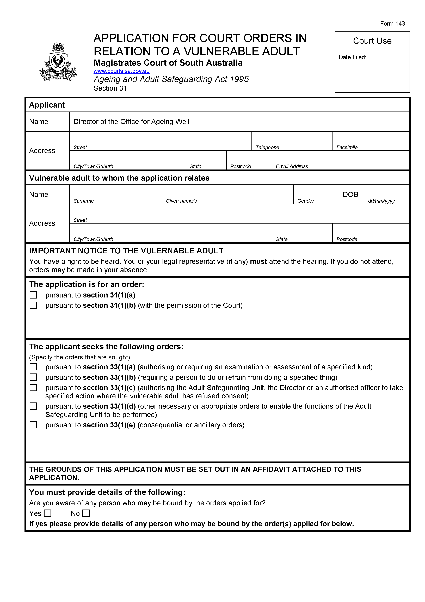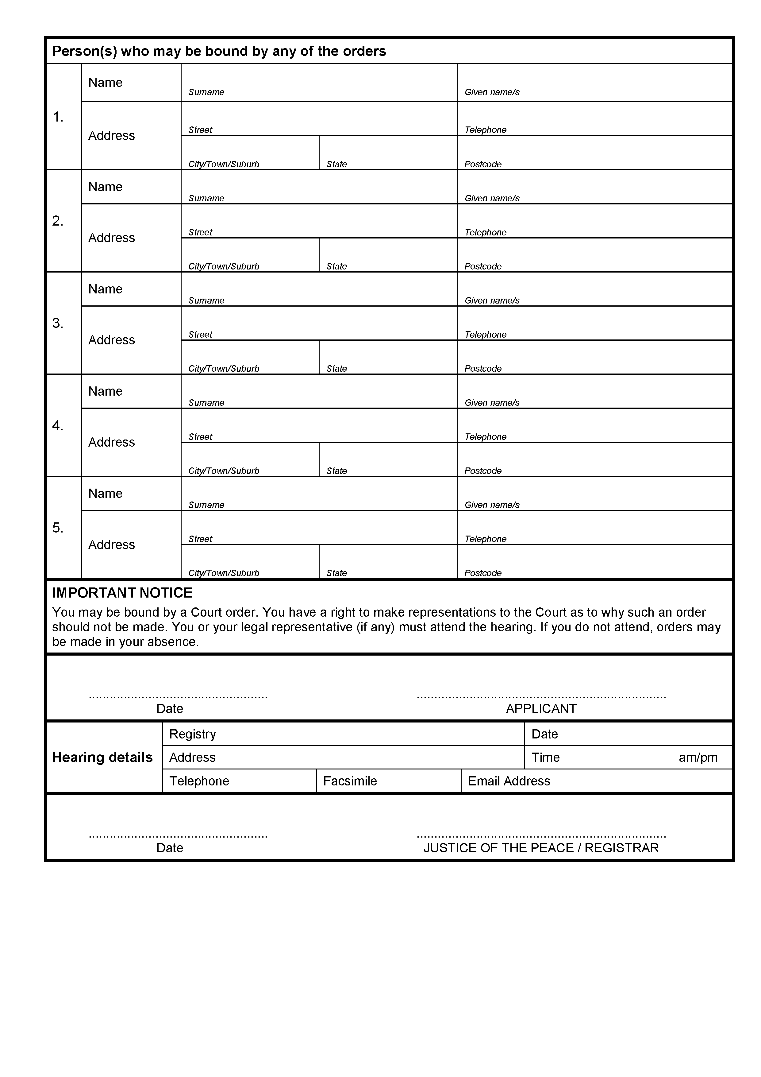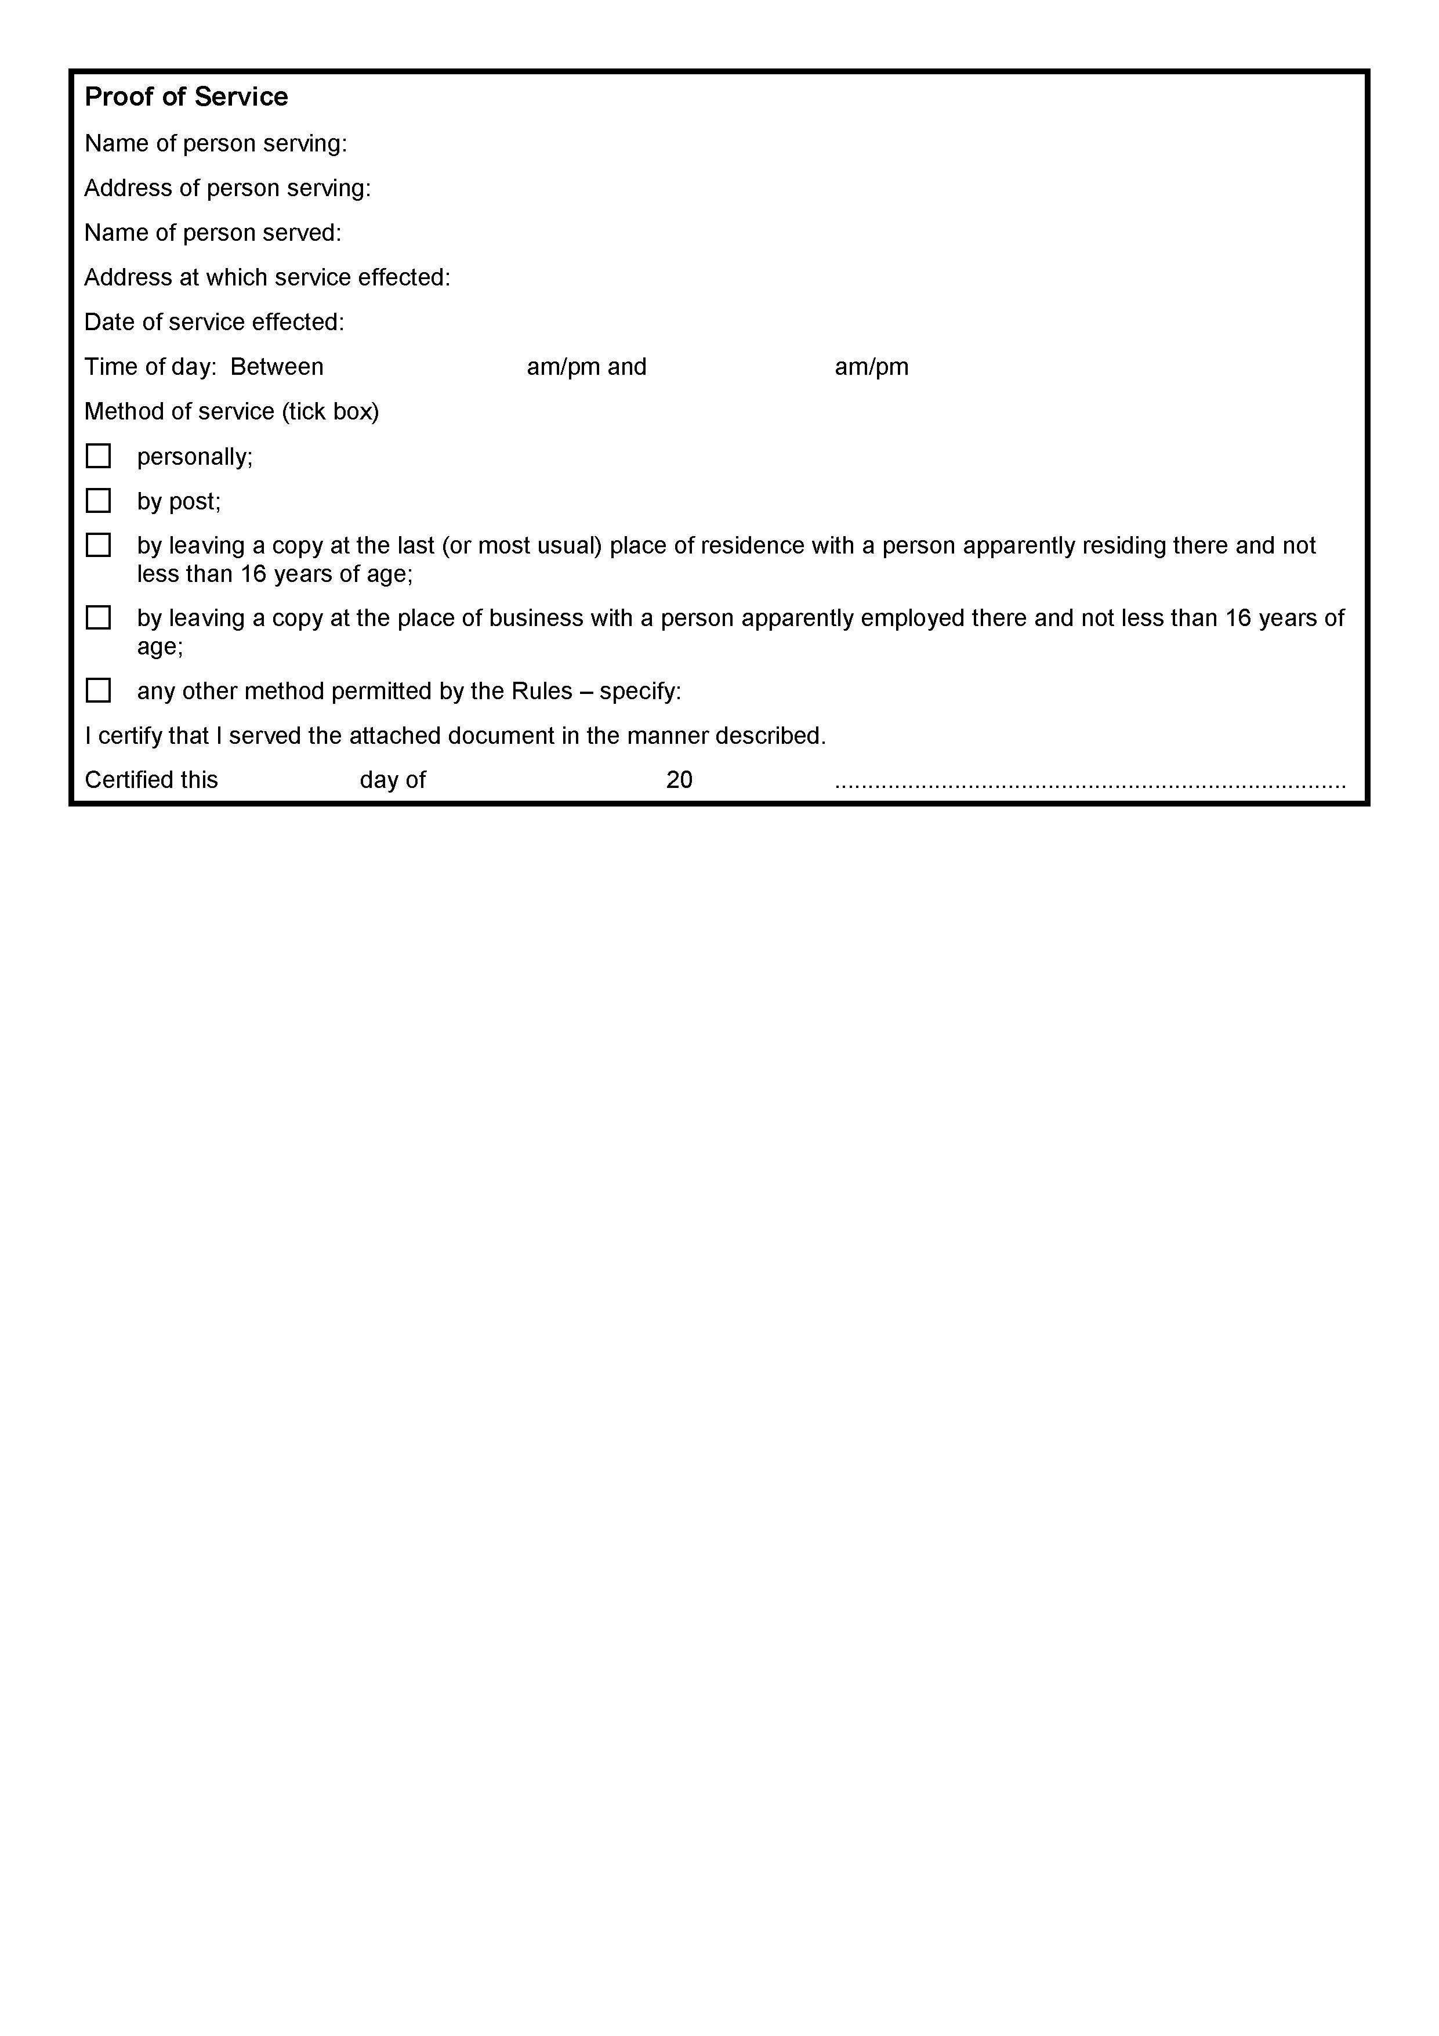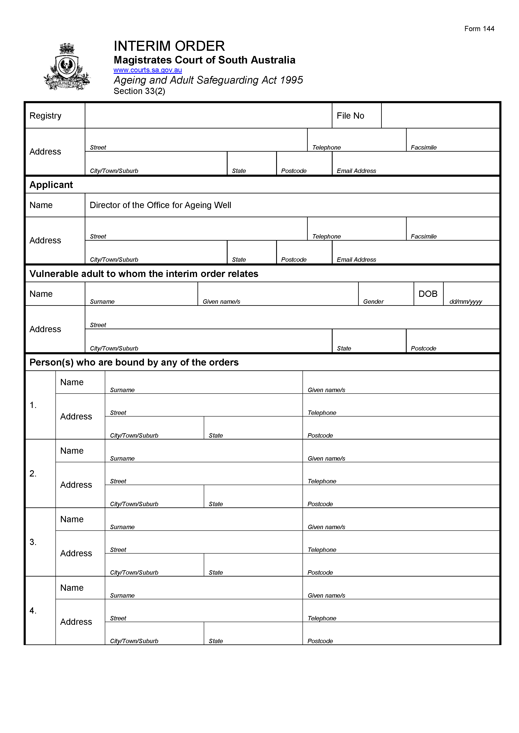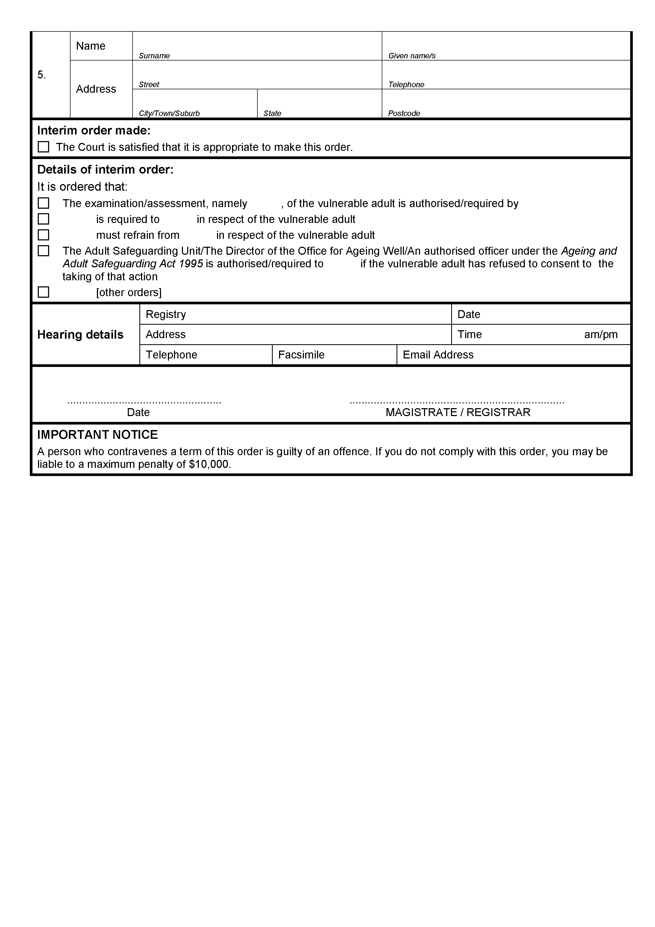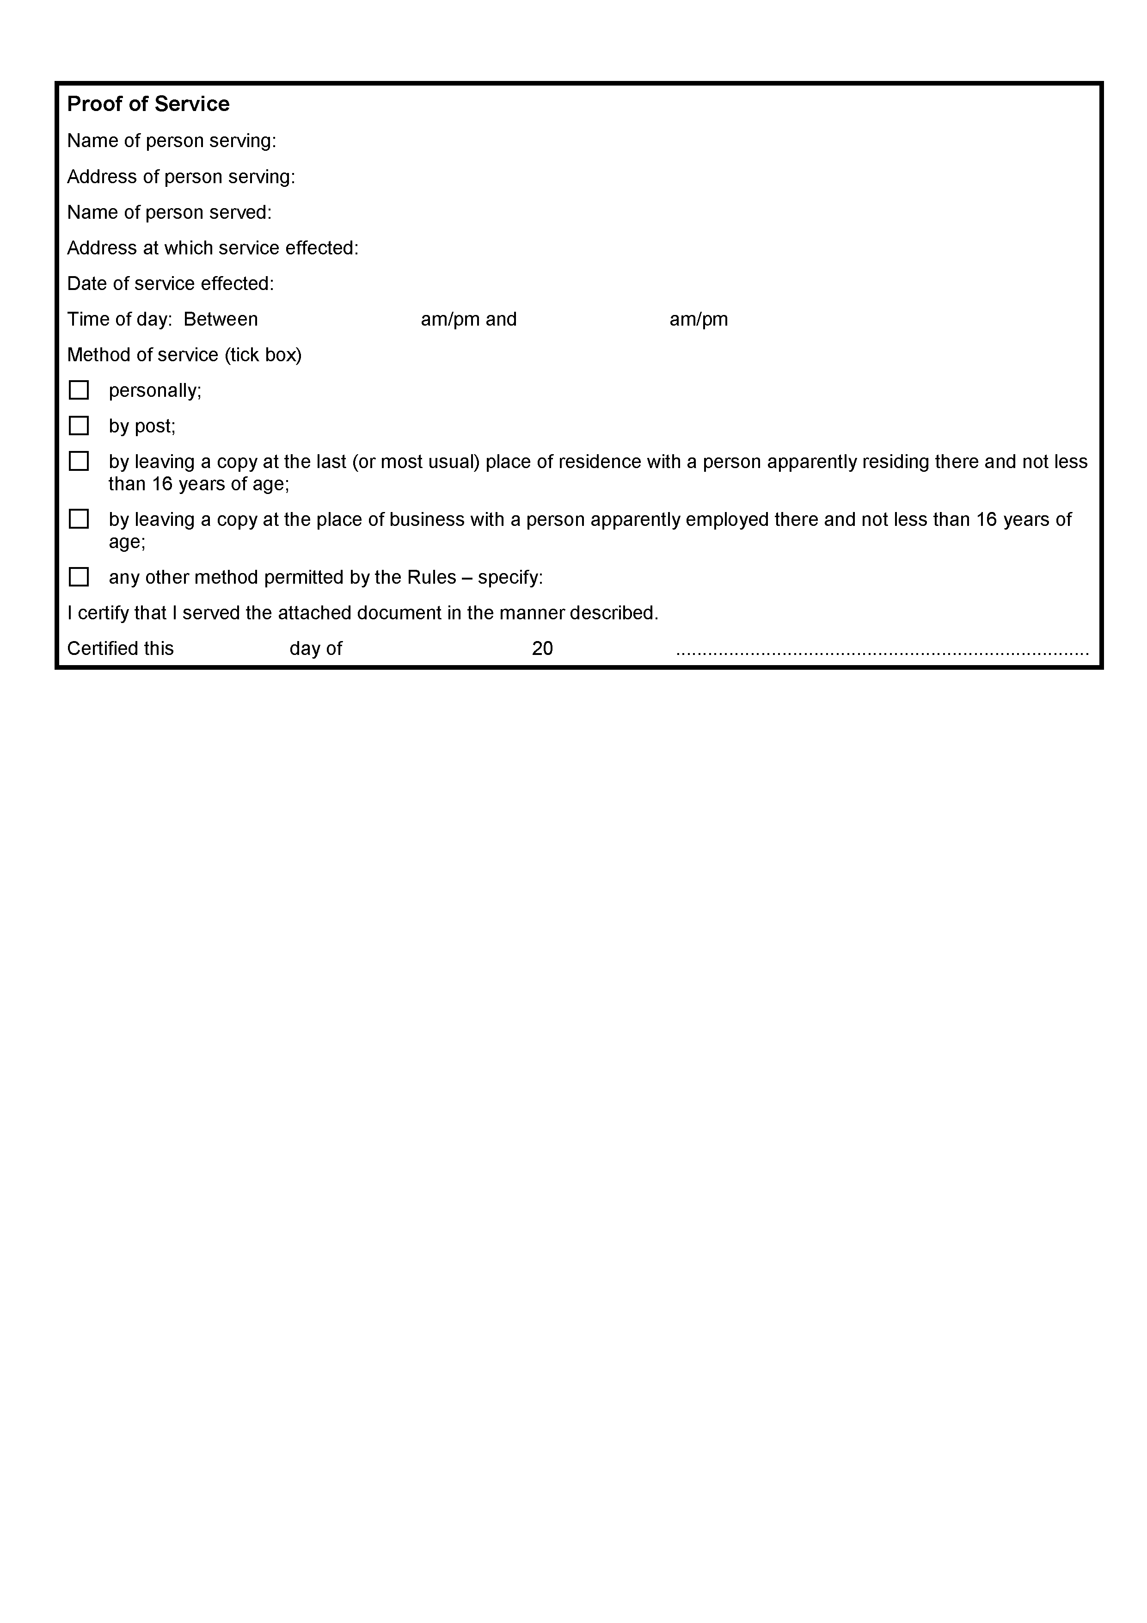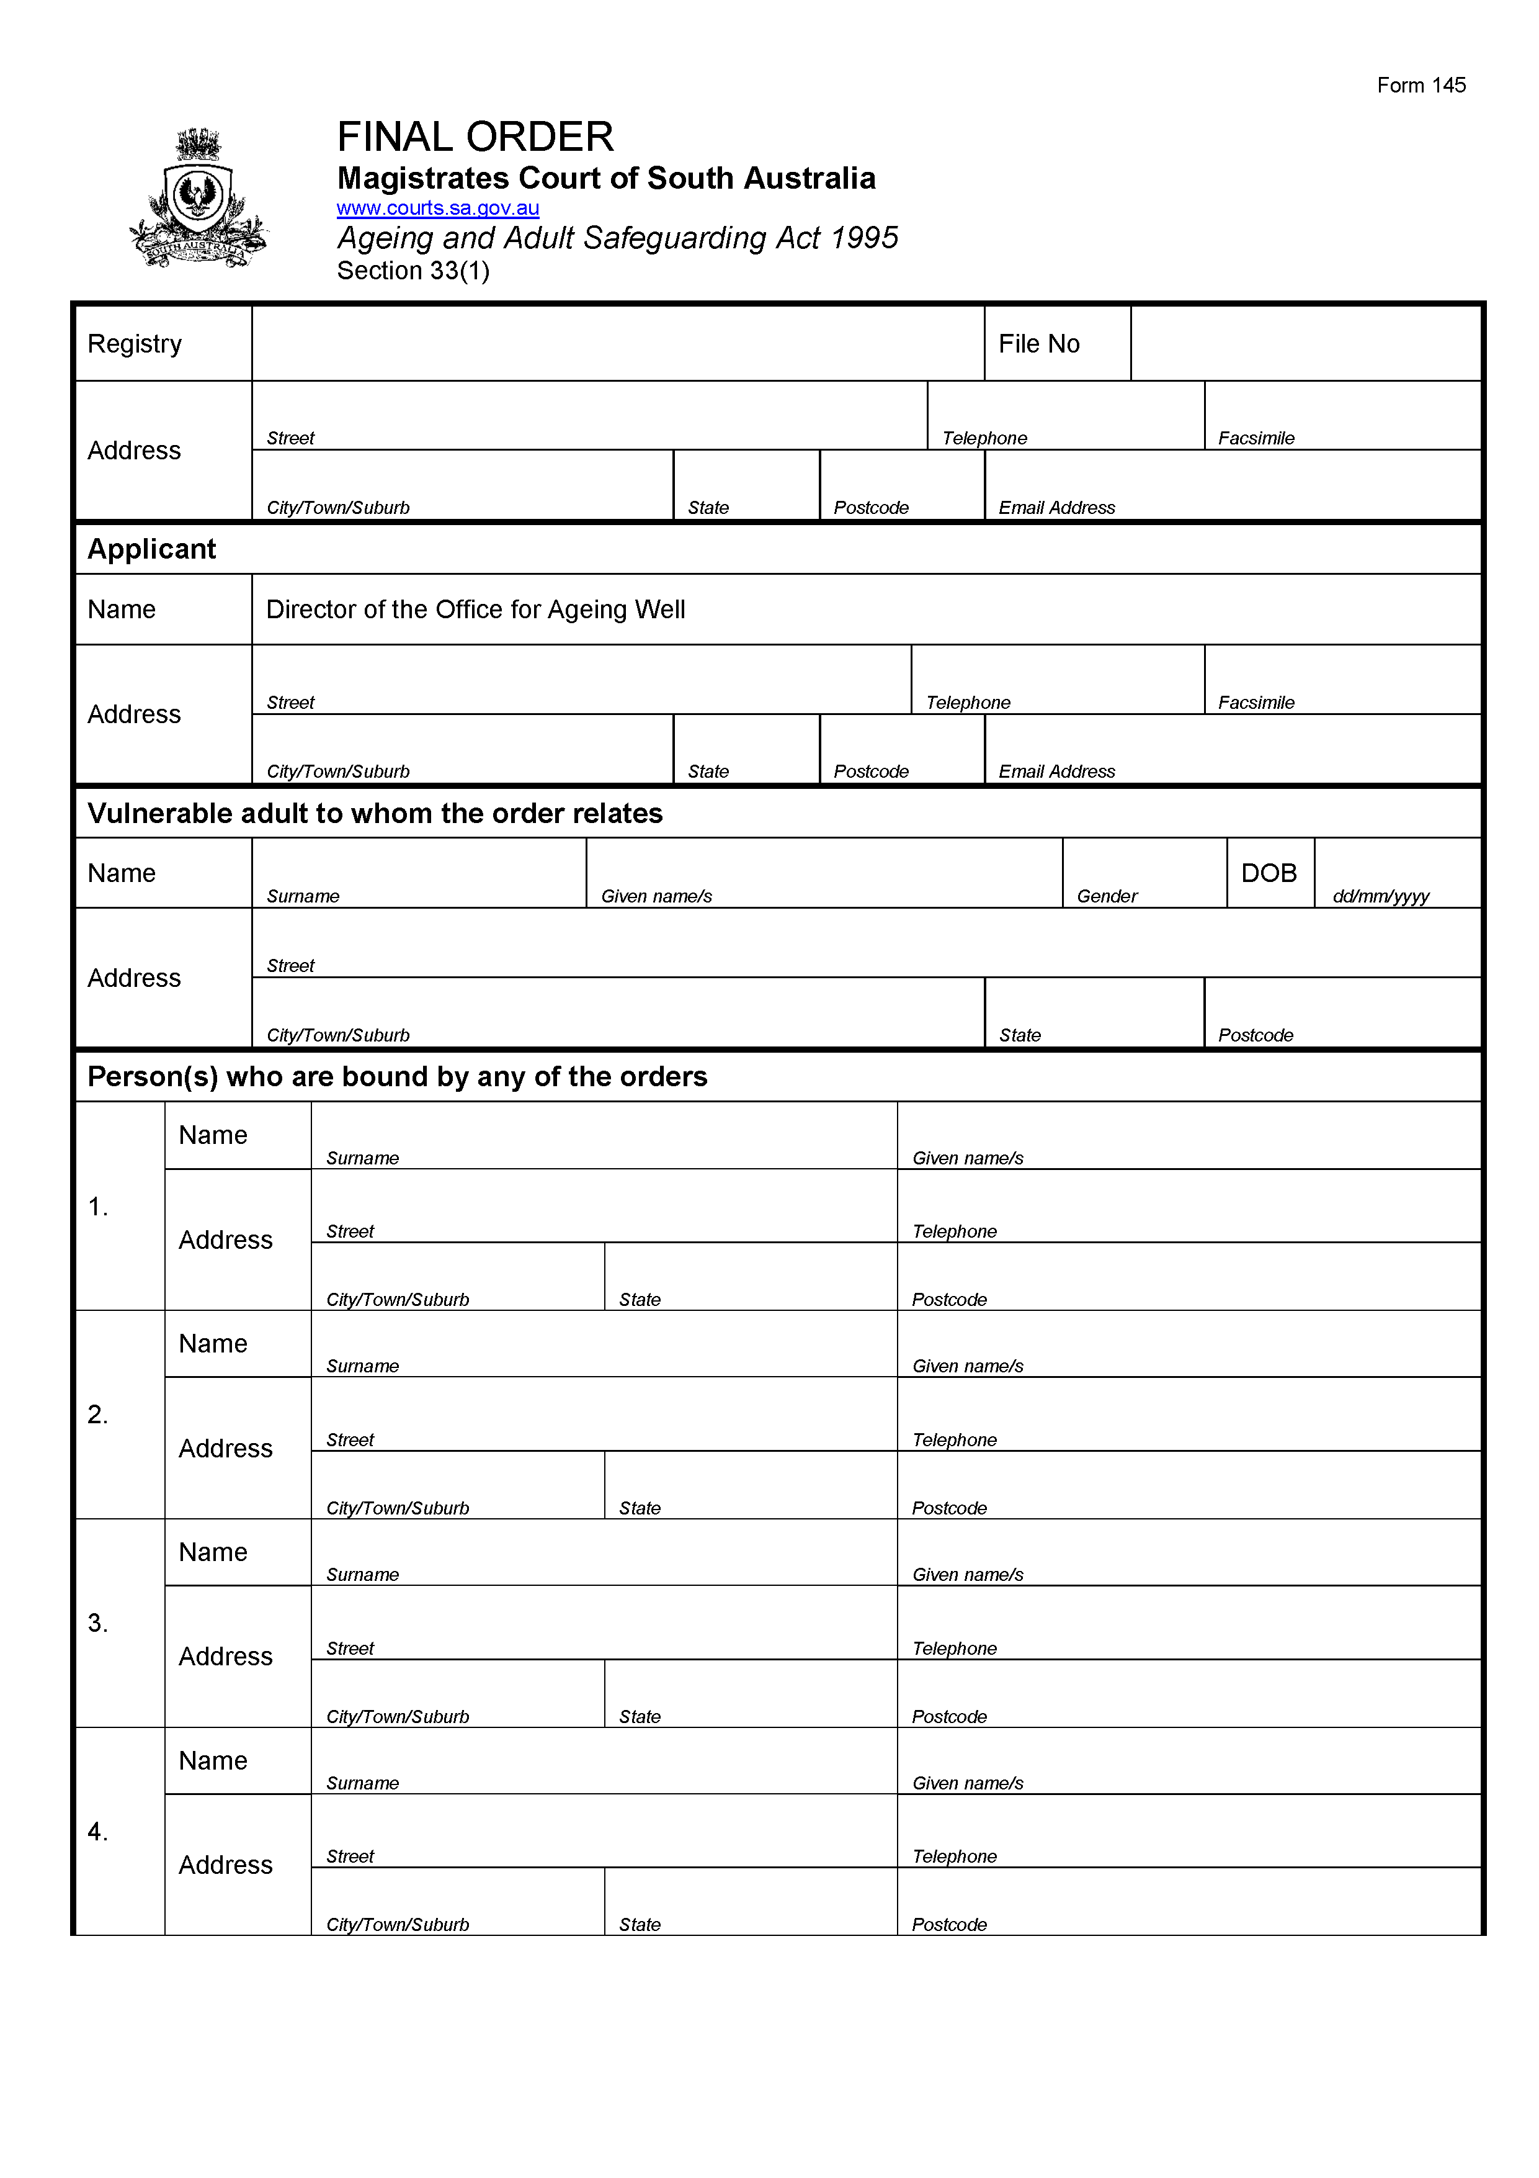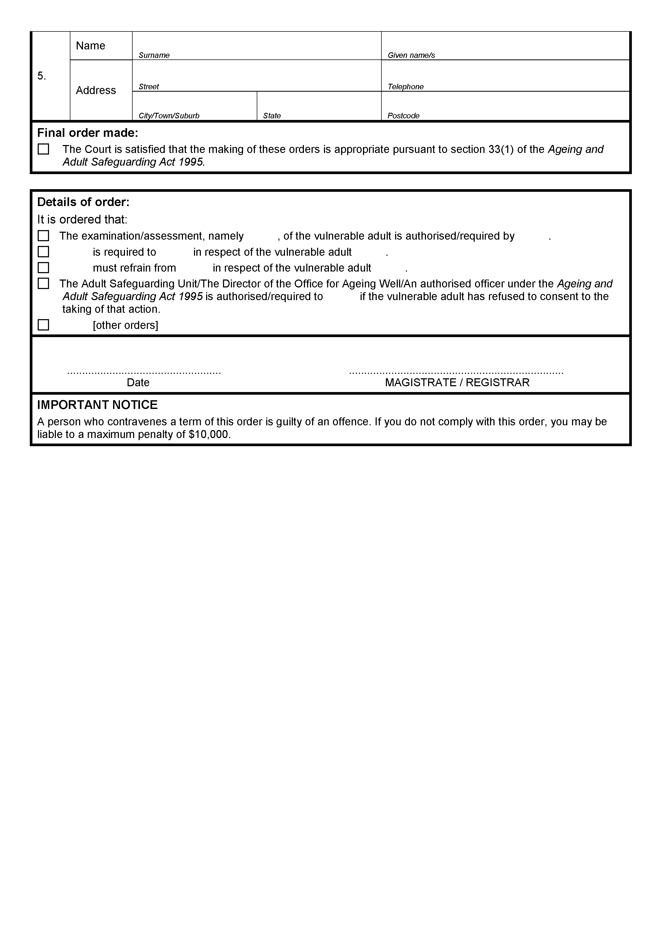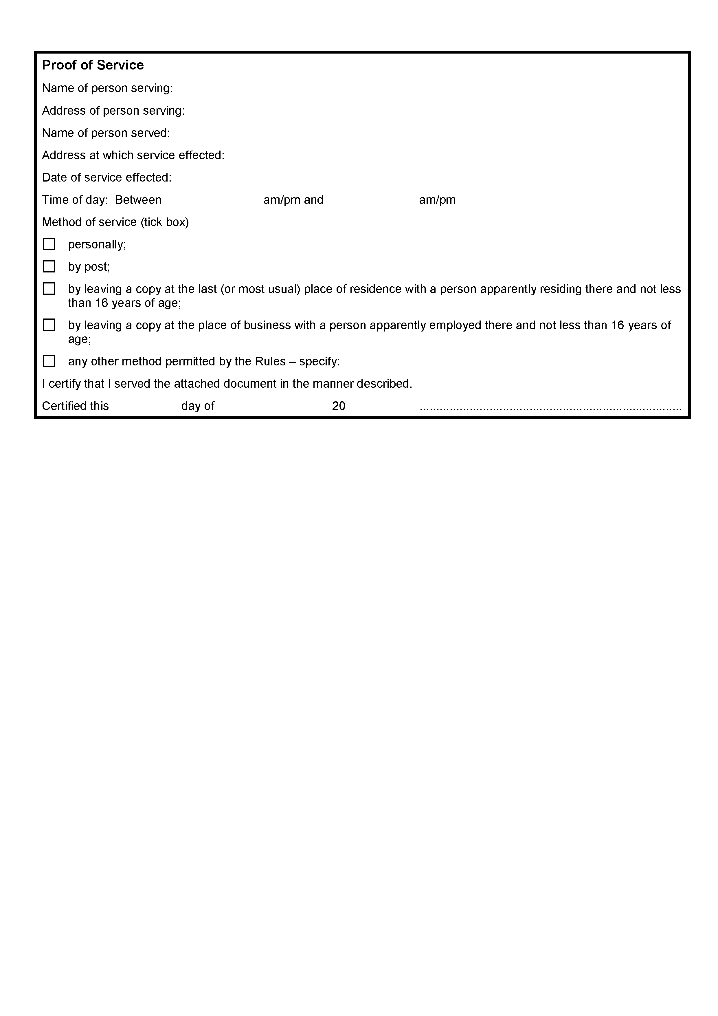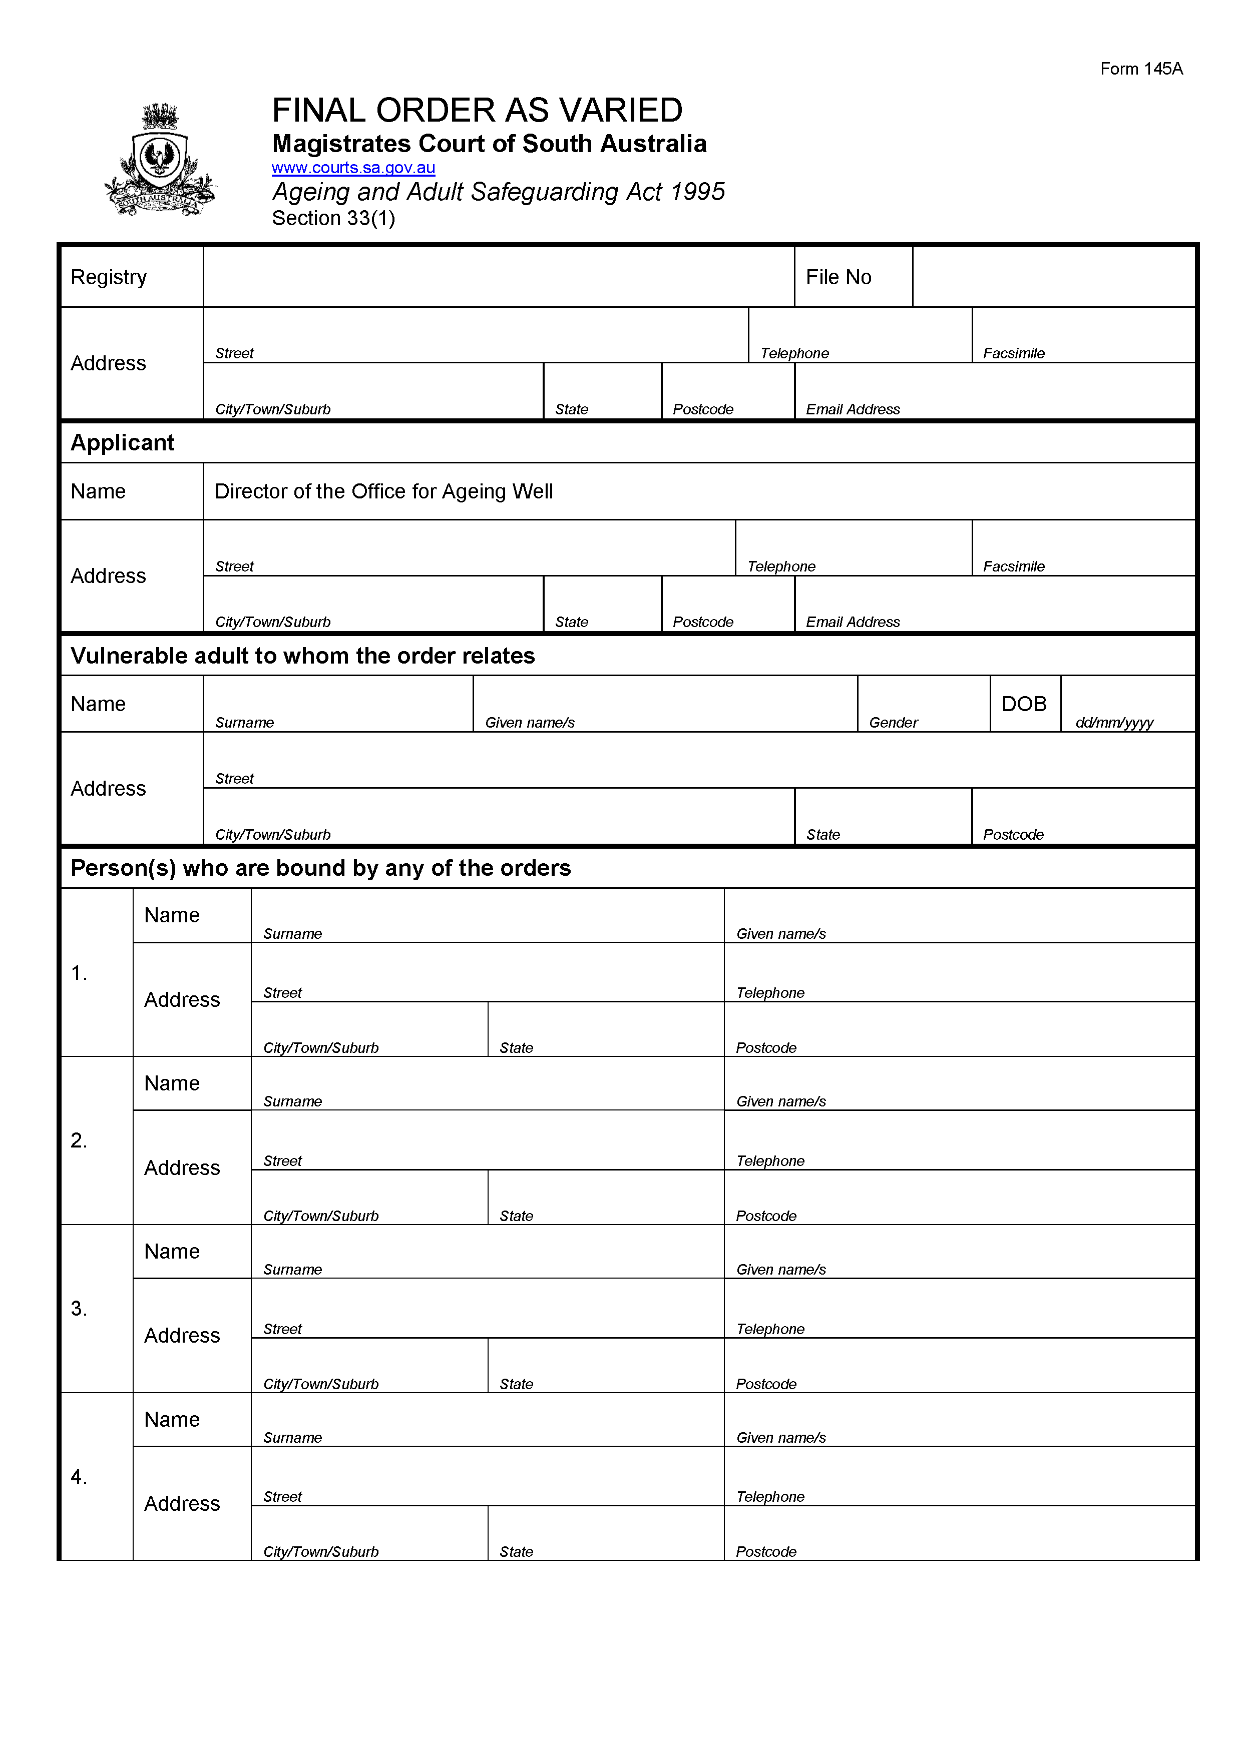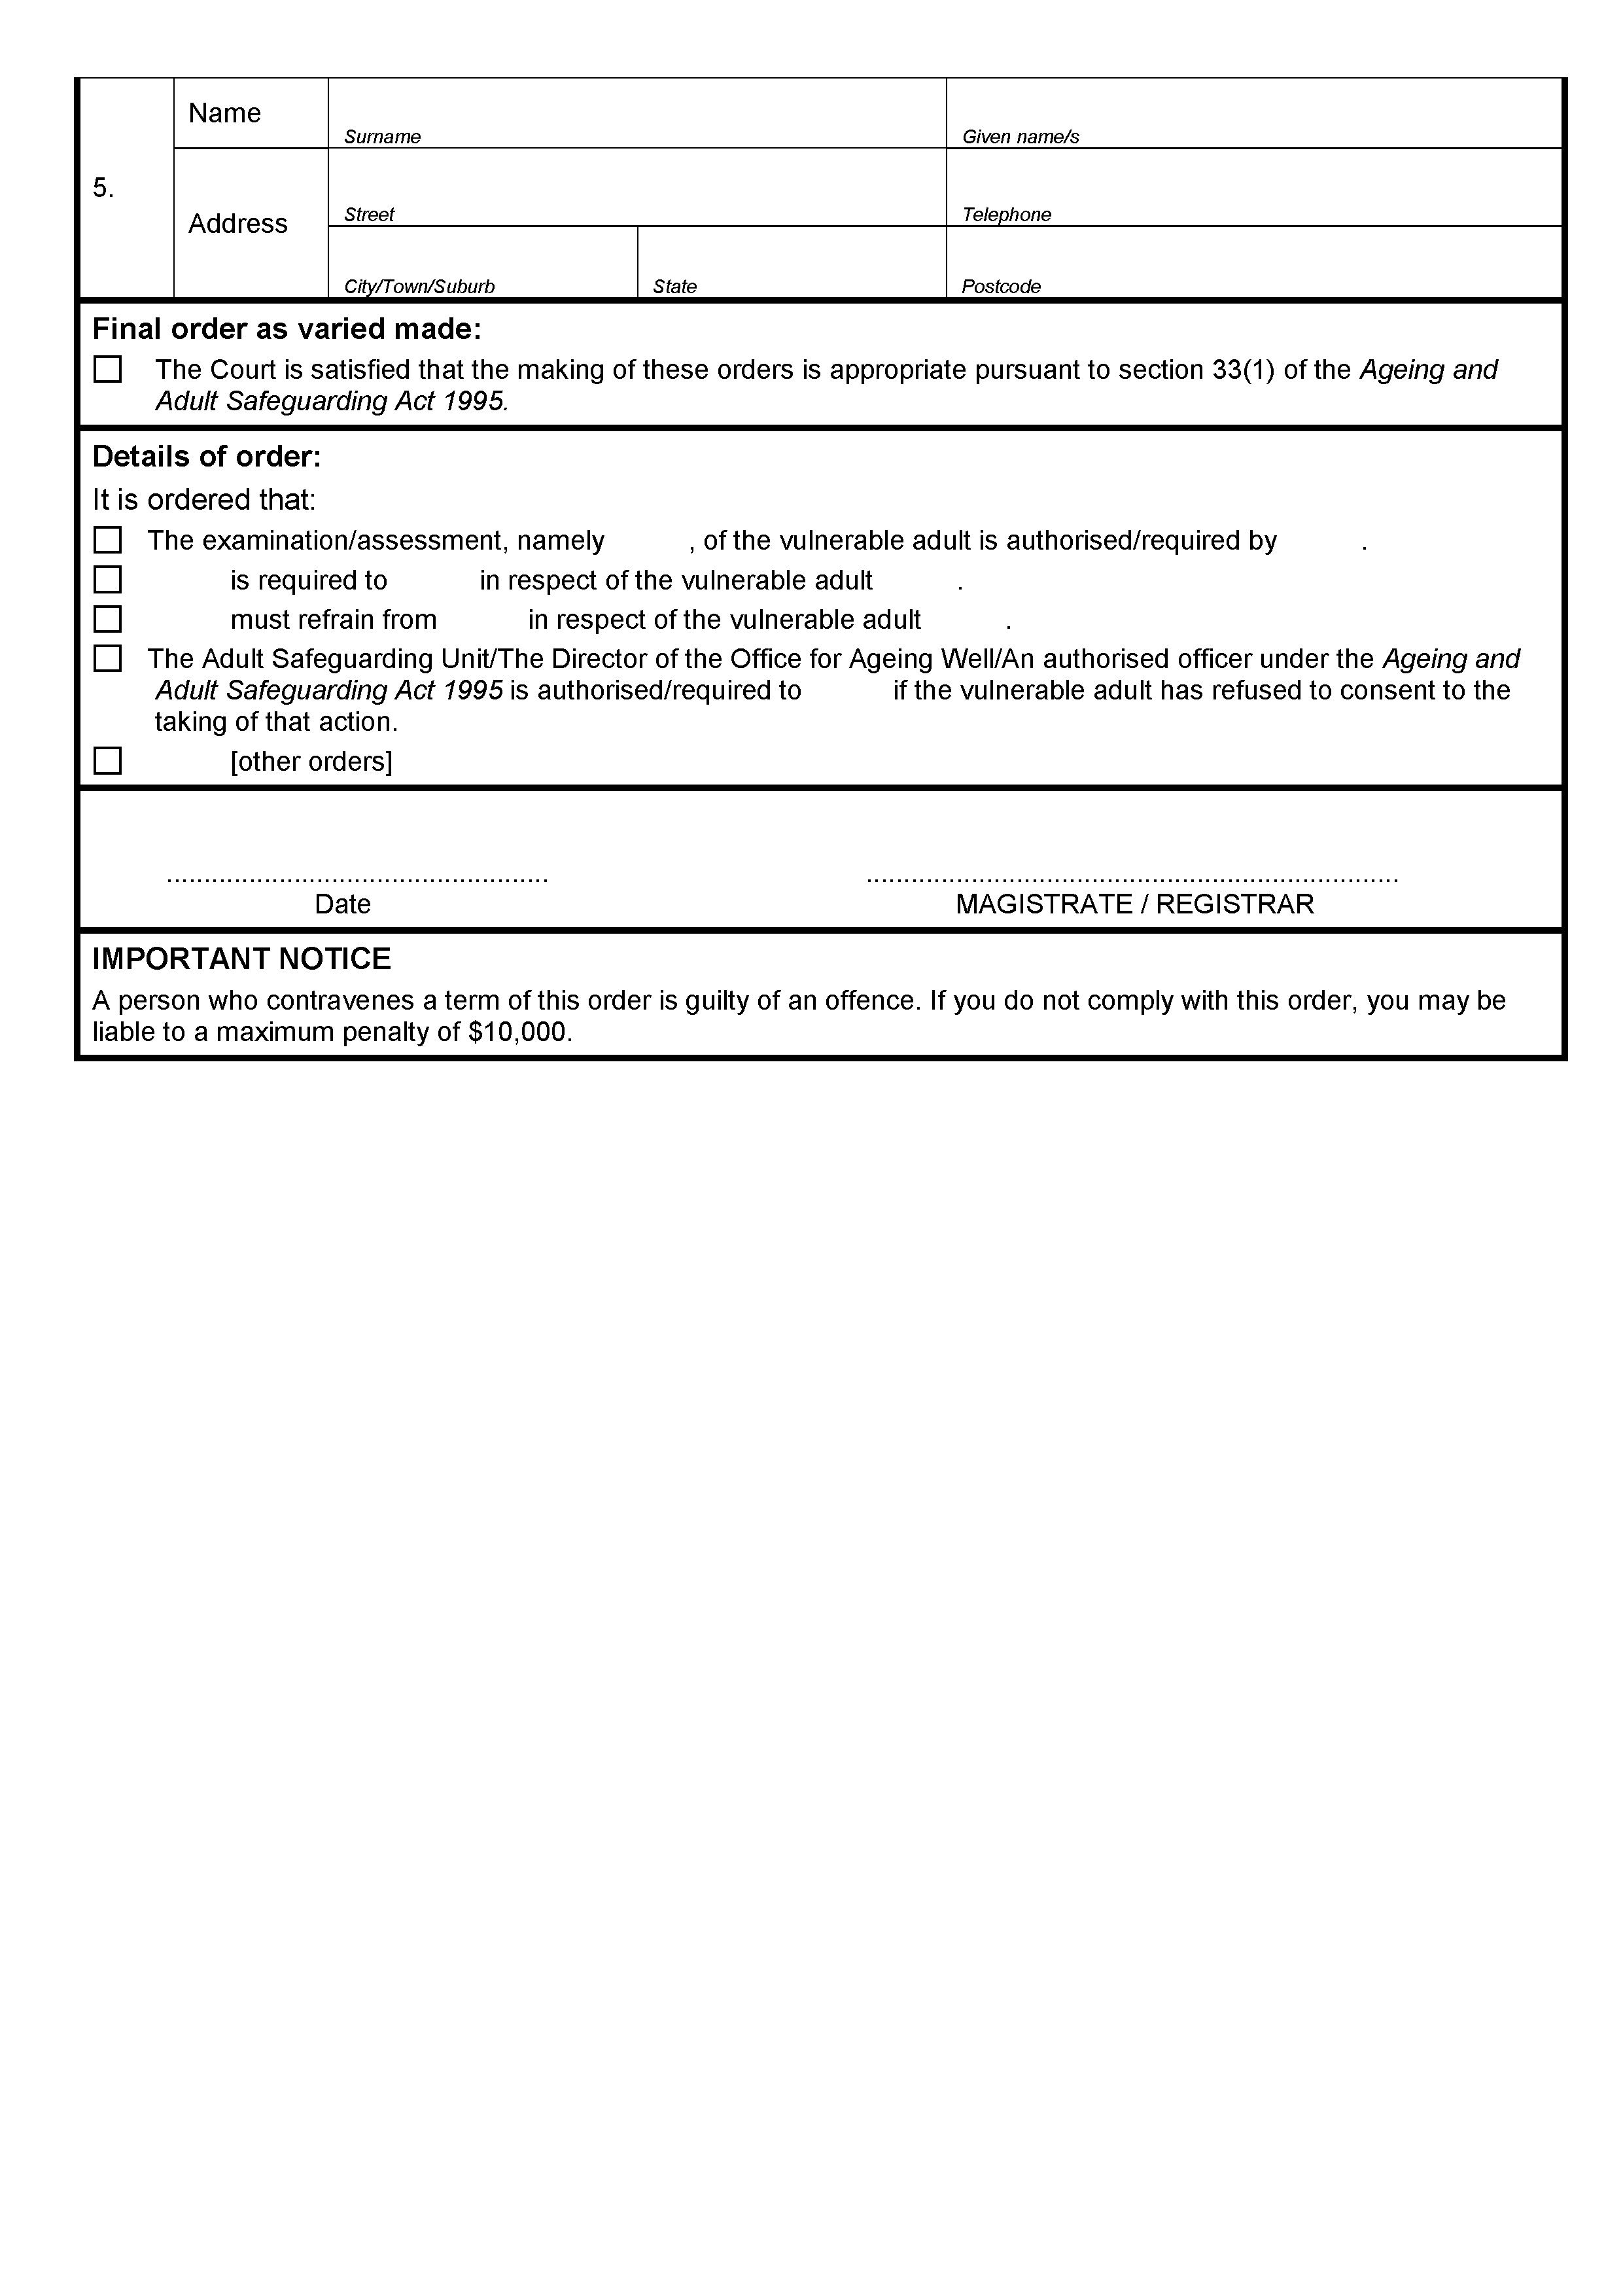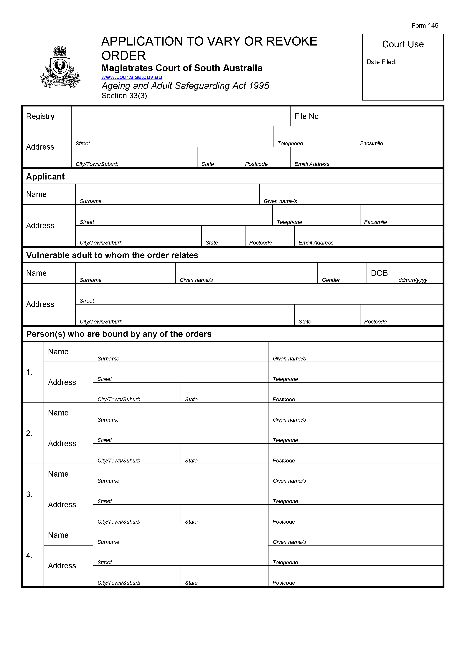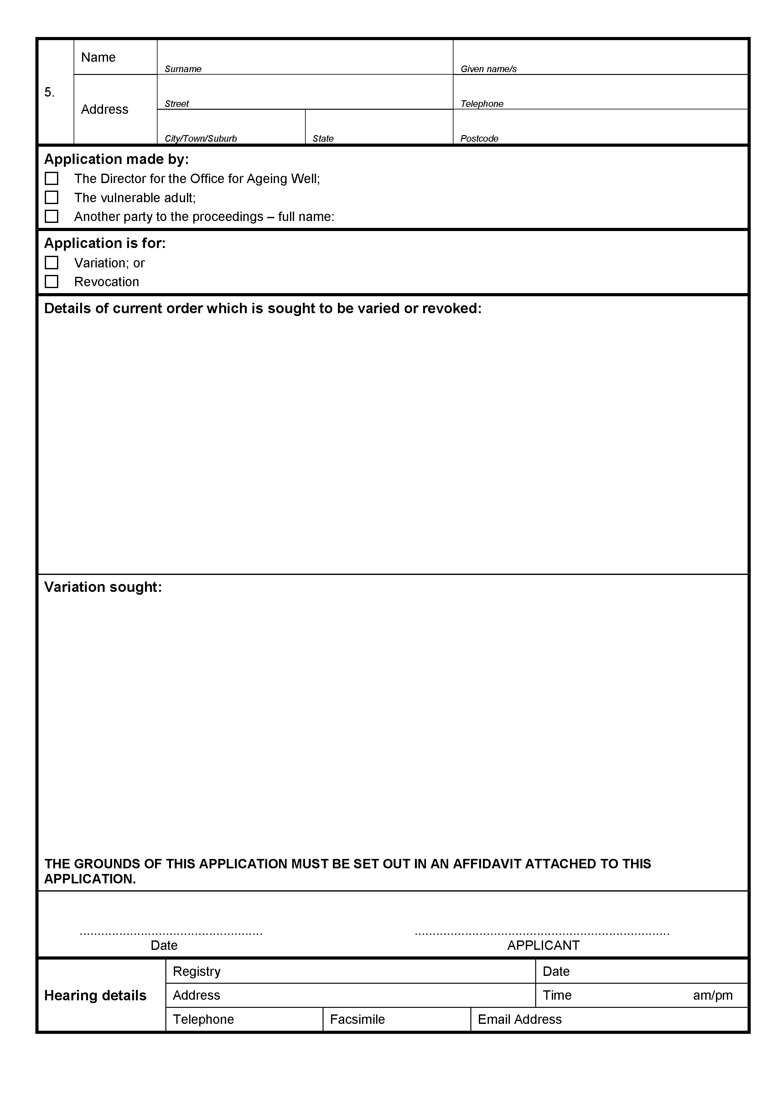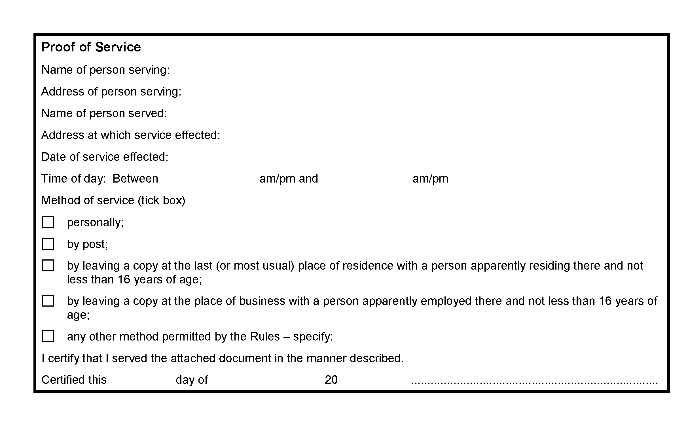

State Government Instruments

ASSOCIATIONS INCORPORATION ACT 1985
Section 43A
Deregistration of Associations
NOTICE is hereby given that the Corporate Affairs Commission approves the applications for deregistration received from the associations named below pursuant to section 43A of the Associations Incorporation Act, 1985. Deregistration takes effect on the date of publication of this notice.
CLARE VALLEY YOUNG PROFESSIONALS INCORPORATED
FIBROMUSCULAR DYSPLASIA ASSOCIATION OF AUSTRALASIA INCORPORATED
LAURA AND ALFRED WEST COTTAGE HOMES INCORPORATED
SHOULDER 2 SHOULDER INCORPORATED
THE BAROSSA WINE AND FOOD SOCIETY INCORPORATED
THE HECTORVILLE SOCIAL DANCE INCORPORATED
Dated: 17 September 2020
Bradley Simpson
A Delegate of the
Corporate Affairs Commission

DEVELOPMENT ACT 1993
Oaklands Park Renewal Development Plan Amendment
Prepared by the Minister for Planning and Local Government
For Public Consultation
Notice is hereby given that the Minister for Planning and Local Government, pursuant to sections 24 and 26 of the Development Act 1993, has prepared the Oaklands Park Renewal Development Plan Amendment (DPA) to amend the Marion Council Development Plan.
The DPA proposes to rezone 19.25 hectares of land immediately south of the Commonwealth Warradale Barracks to enable redevelopment of aged SA Housing Authority dwellings with new, fit for purpose, medium-density housing. Surplus land will be developed to provide for new housing to be put to market.
The DPA will be on public consultation from Thursday, 17 September 2020 to Thursday, 12 November 2020.
There will be two public (drop-in) information sessions available. If you wish to attend please book an attendance time so that crowds can be managed and safety obligations met in line with COVID-19 requirements:
- Session 1: 11.45am to 1.15pm, Saturday 17 October 2020 at Club Marion in Room 1 at 262 Sturt Road, Marion.
Book your attendance via: www.trybooking.com/BLOST
- Session 2: 4.45pm to 6.15pm, Tuesday 20 October 2020 at Club Marion in Room 1 at 262 Sturt Road, Marion.
Book your attendance via: www.trybooking.com/BLOST
For more information and to view the DPA online visit the amendment webpage on the State Government website:
- www.sa.gov.au/planning/ministerialdpas
Copies of the DPA also are available during normal office hours at the following locations:
- City of Marion
935 Marion Road, Mitchell Park
Monday to Friday, 8.30am to 5.00pm
(Phone: (08) 8375 6600)
- Attorney-General’s Department
Level 5, 50 Flinders Street, Adelaide
Monday to Friday, 9.00am to 5.00pm
(Phone: (08) 7109 7004)
Written submissions regarding the DPA should be submitted no later than 5.00 pm on Thursday, 12 November 2020.
- by email: SAplanningcommission@sa.gov.au
- by post: GPO Box 1815, Adelaide SA 5001.
Submissions should be marked Oaklands Park Renewal DPA and sent to Chair, State Planning Commission, c/- Attorney-General’s Department.
Your submission should clearly indicate whether you wish to be heard at or wish to observe the public hearing (details below).
Copies of all public submissions will be available for inspection by interested persons at the Attorney-General’s Department, Level 5, 50 Flinders Street, Adelaide, from Friday 13 November 2020 to the conclusion of the public hearing on Thursday 26 November 2020, and will also be available for viewing online in the Oaklands Park Renewal DPA amendment webpage at:
- www.sa.gov.au/planning/ministerialdpas
The State Planning Commission has scheduled a public hearing for 7.30pm Thursday 26 November 2020.
Due to the ongoing COVID-19 concerns, the format of the public hearing will not be determined until the consultation period is closed in case the hearing is required to be conducted on-line / by video rather than with a physical presence.
If you would like to add to your submission or would like to be heard directly by the State Planning Commission, please advise in your submission that you would like to be heard or alternatively email SAplanningcommission@sa.gov.au of your desire to be heard, before 5.00pm Thursday 12 November 2020. Alternatively, you will be welcome to attend the public hearing without speaking, however, you will still need to register your interest via email SAplanningcommission@sa.gov.au. You will be advised at the close of consultation of the public hearing arrangements.
The public hearing may not be held if no one requests to be heard. Please check the status of hearings on www.saplanningportal.sa.gov.au/en/consultation.
If you would like more information about the DPA, please contact the department on phone number (08) 7109 7004.
Dated: 17 September 2020
Executive Officer
State Planning Commission

DEVELOPMENT ACT 1993
Payneham and Stepney Strategic Sites Development Plan Amendment
Prepared by the Minister
For Public Consultation
In relation to the notice given by the State Planning Commission on 10 September 2020 that the Payneham and Stepney Strategic Sites Development Plan Amendment (DPA) was being undertaken by the Minister for Planning and Local Government to amend the Norwood Payneham and St Peters (City) Development Plan, the following corrections are made.
- The DPA will be on public consultation from Thursday, 10 September 2020 to Thursday, 12 November 2020.
- Submissions will be made publicly available from Friday 13 November 2020 to Wednesday 18 November 2020.
All other details remain unchanged.
The DPA and updated details regarding the consultation process can be viewed online via the amendment webpage on the State Government website:
- www.sa.gov.au/planning/ministerialdpas
If you would like more information about the DPA, please contact the department on phone number (08) 7109 7004.
Dated: 17 September 2020
Executive Officer
State Planning Commission

HOUSING IMPROVEMENT ACT 2016
Rent Control
The Minister for Human Services Delegate in the exercise of the powers conferred by the Housing Improvement Act 2016, does hereby fix the maximum rental per week which shall be payable subject to Section 55 of the Residential Tenancies Act 1995, in respect of each house described in the following table. The amount shown in the said table shall come into force on the date of this publication in the Gazette.
Address of Premises | Allotment Section | Certificate of Title  Volume/Folio | Maximum Rental  per Week Payable
6 Wootton Street, Davoren Park SA 5113 | Allotment 10 Deposited Plan 49400 Hundred of Munno Para | CT 5537/773 | $100.00
Dated: 17 September 2020
Craig Thompson
Acting Housing Regulator and Registrar
Housing Safety Authority, SAHA
Delegate of Minister for Human Services

HOUSING IMPROVEMENT ACT 2016
Rent Control Revocations
Whereas the Minister for Human Services Delegate is satisfied that each of the houses described hereunder has ceased to be unsafe or unsuitable for human habitation for the purposes of the Housing Improvement Act 2016, notice is hereby given that, in exercise of the powers conferred by the said Act, the Minister for Human Services Delegate does hereby revoke the said Rent Control in respect of each property.
Address of Premises | Allotment Section | Certificate of Title  Volume/Folio
29A Westralia Street, Greenacres SA 5086 | Allotment 75 Filed Plan 127209 Hundred of Yatala | CT5399/81
Dated: 17 September 2020
Craig Thompson
Acting Housing Regulator and Registrar
Housing Safety Authority, SAHA
Delegate of Minister for Human Services

Landscape South Australia Act 2019
Section 71
Notice of Levy Payable in 2020-21 by persons who occupy land outside Council Areas
in the South Australian Arid Lands Landscape Region
Notice is hereby given pursuant to section 71 of the Landscape South Australia Act 2019 (“the Act”) that, the annual business plan for the South Australian Arid Lands Landscape Board (“Board”) having specified an amount to be contributed by persons who occupy land outside council areas in the South Australian Arid Lands Landscape Region (“rateable land”) toward the costs of the Board performing its functions under the Act in the 2020-2021 financial year, the Board has determined and hereby declares the following levy payable by persons who occupy rateable land, based on the area occupied:
- $64.30 per rateable property <10 ha
- $214.30 per rateable property >10 ha - <100 ha
- $428.65 per rateable property >100 ha - <100,000 ha
- $750.29 per rateable property >100,000 ha
Dated: 9 September 2020
Ross Sawers
Presiding Member
South Australian Arid Lands Landscape Board

Landscape South Australia Act 2019
Section 192(3)(A)
Notice of Control Measures for Declared Animals in Declared Areas Goats in South Australia (excluding Kangaroo Island)
For the purposes of section 192(3)(a) of the Landscape South Australia Act 2019 [LSA Act] and in accordance with the Landscape South Australia (General) Regulations 2020, I John Schutz, Chief Executive, hereby notify that an owner of land within the declared area of mainland South Australia (excluding Kangaroo Island) must take the following measures to control and keep controlled any goats on their land:
- In the case of goats kept by, or with the consent of, an owner of the land:
- the goats must be kept on that land within enclosures with boundary fencing (including any gates) constructed and maintained at all times to a standard sufficient to prevent the escape of any goats, taking into account the particular terrain;
- boundary fencing (including gates) must be maintained in a state of good repair, free from any gaps, holes or damage, and be kept free from fallen trees or branches;
- immediately upon becoming aware of an escape of goats kept on their land, the owner of the land must inspect and repair any damage to, or means of escape from, the goat enclosure fences.
- Where an owner of land becomes aware that goats are on their land without their consent, the owner of land must take all reasonable steps to ensure that the goats are captured and, within 6 weeks of capture, either:
- removed from the land or destroyed; or
- if the goats have identification tags, notify the owner of the goats (or the regional Landscape Board if the owner of the goats is not known) and enable the goats to be collected and removed.
On pastoral lease land as defined under the Pastoral Land Management and Conservation Act 1989, any stated policy of the Pastoral Board in relation to the management of domestic goats will take precedence over this Notice to the extent of any inconsistency.
Dated: 11 September 2020
John Schutz
Chief Executive

Mining Act 1971
Section 28(5)
Exploration Licences
Notice is hereby given in accordance with Section 28(5) of the Mining Act 1971 that the delegate of the Minister for Energy and Mining intends to grant Exploration Licences over the areas described below.
Applicant: Panda Mining Pty Ltd
Location: Mount Rose - area approximately 50 km northeast of Leigh Creek
Pastoral Leases: Yankaninna, Mount Serle, Mount Lyndhurst
Term: Two years
Area in km2: 237
Reference number: 2020/00057
Applicant: Obsidian Mining Corporation Pty Ltd
Location: Dawson area - approximately 20 km northeast of Peterborough
Term: Two years
Area in km2: 999
Reference number: 2020/00099
Applicant: Copar Resources Pty Ltd
Location: Holowiliena south - area approximately 75 km northeast of Quorn
Pastoral Leases: Holowiliena South, Three Creeks, Wilcowie, Minburra, Witchitie, Baratta
Term: Two years
Area in km2: 497
Reference number: 2020/00101
Applicant: Tigers Dominion Group Pty Ltd
Location: Mulgathing area - approximately 35km west-southwest of Tarcoola
Pastoral Leases: Mulgathing
Term: Two years
Area in km2: 94
Reference number: 2020/00102
Applicant: Yandan Gold Mines Pty Ltd
Location: Oakden Hills area - approximately 40 km south of Woomera
Pastoral Leases: Oakden Hills, Yalymboo
Term: Two years
Area in km2: 336
Reference number: 2020/00103
Applicant: Halona Holdings Pty Ltd, Metal Ventures Pty Limited
Location: Nilpinna Station area - approximately 130 km northeast of Coober Pedy
Pastoral Leases: The Peake, Nilpinna, Anna Creek
Term: Two years
Area in km2: 624
Reference number: 2020/00105
Applicant: Indiana Resources Limited
Location: Wilgena area - approximately 195 km west-northwest of Woomera
Pastoral Leases: Wilgena, North Well
Term: Two years
Area in km2: 534
Reference number: 2020/00106
Applicant: Indiana Resources Limited
Location: Wilgena area - approximately 30 km northwest of Kingoonya
Pastoral Leases: North Well
Term: Two years
Area in km2: 50
Reference number: 2020/00109
Plans and co-ordinates can be found on the Department for Energy and Mining website:
http://energymining.sa.gov.au/minerals/exploration/public_notices/exploration_licence_applications or by contacting Mineral Tenements on 08 8463 3103.
Community information on mineral exploration licence processes and requirements under the Mining Act 1971 is available from:
http://energymining.sa.gov.au/minerals/exploration/public_notices/exploration_licence_applications or hard copy on request to Mineral Tenements.
Dated: 17 September 2020
J Martin
Mining Registrar as delegate for the Minister for Energy and Mining
Department for Energy and Mining

Motor Vehicles Act 1959
South Australia

Motor Vehicles (EasyMile Autonomous Vehicle Trial –
Phase 1 at Renmark) Notice 2020

under Part 4A of the Motor Vehicles Act 1959

1 Short Title

This Notice may be cited as the Motor Vehicles (EasyMile Renmark Trial Extension) Notice 2020.

2 Commencement and operation

The Motor Vehicles (EasyMile Renmark Trial) Notice 2019 published on 20 June 2019 is hereby revoked. This Notice will come into operation at 12:01 am on the day after it is published, and will expire at 11:59 pm on 30 June 2021.

3 Interpretation

In this Notice―

Act means the Motor Vehicles Act 1959 (SA);
authorised vehicle means the EasyMile EZ10 Gen 2, serial number VJRD1A10224000040, for participation in the EasyMile Renmark Trial;
EasyMile means EasyMile Pty Ltd ACN 628 408 346;
Council means Renmark Paringa Council ABN 91 578 073 215;
Link SA means Link SA Pty Ltd ACN 131 552 415.
4 Authorisation

I hereby AUTHORISE, under section 134D of the Act, EasyMile, Link SA, Council, the owner(s) of the authorised vehicle, and any individuals authorised by EasyMile, Link SA, Council or the vehicle owner(s), to undertake a trial of automotive technology in accordance with Part 4A of the Act and the exemptions herein, subject to the conditions herein. The scope and nature of the trial is to integrate on-demand driverless shuttle technology and remote operations capabilities into the regional passenger transport network, and to employ early co-operative intelligent transport systems.

5 Exemptions

5.1 I hereby EXEMPT, under section 134E of the Act, the authorised vehicle from the following legislative requirements:

Road Traffic Act 1961 section 110B – Motor vehicle must bear vehicle identification plate
Road Traffic (Light Vehicles Standards) Rules 2018

5.2 Subject to clause 5.3, I hereby exempt EasyMile, the owners of the authorised vehicle and any authorised individuals from the following legislative requirements:

Motor Vehicles Act 1959 section 9 – Duty to register a vehicle
Passenger Transport Act 1994
Road Traffic Act 1961 section 110C – Offences regarding vehicle identification plate
Road Traffic Act 1961 section 117 – Liability of driver for breach of light vehicle standards
Road Traffic Act 1961 section 118 – Liability of operator for breach of light vehicle standards
Australian Road Rules Part 12 – Restrictions on stopping and parking

5.3 The exemption from the requirements of sections 117 and 118 of the Road Traffic Act 1961 does not extend to the requirement to maintain the vehicle in a safe condition within the meaning of section 116 of that Act.

6 Conditions

6.1 The authorised vehicle may only operate within the area designated in the Schedule to this Notice.

6.2 The authorised vehicle must operate in accordance with the Guidelines for Trials of Automated Vehicles in Australia published by the National Transport Commission, and the Safe Work Method Statement and the Traffic Management Plan, both as agreed from time to time between EasyMile, Link SA, Council and the Department for Infrastructure and Transport.

7 Execution

Hon Corey Wingard MP
Minister for Infrastructure and Transport
Dated: 7 September 2020

Petroleum and Geothermal Energy Act 2000
Grant of Petroleum Production Licence—PPL 270
Pursuant to section 92(1) of the Petroleum and Geothermal Energy Act 2000, notice is hereby given that the undermentioned Petroleum Production Licence has been granted under the provisions of the Petroleum and Geothermal Energy Act 2000, pursuant to delegated powers dated 29 June 2018.
No of Licence | Licensees | Locality | Area in km² | Reference
PPL 270 | Stuart Petroleum Pty Ltd | Cooper Basin | 10.26 | MER-2020/0321
Description of Area
All that part of the State of South Australia, bounded as follows:
Commencing at a point being the intersection of latitude 28°25'40"S GDA2020 and longitude 140°07'10"E GDA2020, thence west to longitude 140°07'05"E GDA2020,
south to latitude 28°25'50"S GDA2020, east to longitude 140°07'10"E GDA2020,
south to latitude 28°26'00"S GDA2020, east to longitude 140°07'15"E GDA2020,
south to latitude 28°26'30"S GDA2020, east to longitude 140°07'20"E GDA2020,
south to latitude 28°26'55"S GDA2020, west to longitude 140°07'15"E GDA2020,
south to latitude 28°27'05"S GDA2020, west to longitude 140°07'10″E GDA2020,
south to latitude 28°27'10"S GDA2020, west to longitude 140°07'00"E GDA2020,
south to latitude 28°27'20"S GDA2020, west to longitude 140°06'50"E GDA2020,
south to latitude 28°27'25"S GDA2020, west to longitude 140°06'10"E GDA2020,
north to latitude 28°27'20"S GDA2020, west to longitude 140°06'05"E GDA2020,
north to latitude 28°27'15"S GDA2020, west to longitude 140°06'00"E GDA2020,
north to latitude 28°27'10"S GDA2020, west to longitude 140°05'50"E GDA2020,
north to latitude 28°27'00"S GDA2020, west to longitude 140°05'40"E GDA2020,
north to latitude 28°26'55"S GDA2020, west to longitude 140°05'30"E GDA2020,
north to latitude 28°26'35"S GDA2020, east to longitude 140°05'35"E GDA2020,
north to latitude 28°26'25"S GDA2020, east to longitude 140°05'40"E GDA2020,
north to latitude 28°26'05"S GDA2020, east to longitude 140°05'45"E GDA2020,
north to latitude 28°25'50"S GDA2020, east to longitude 140°05'50"E GDA2020,
north to latitude 28°25'40"S GDA2020, east to longitude 140°05'55"E GDA2020,
north to latitude 28°25'35"S GDA2020, east to longitude 140°06'00"E GDA2020,
north to latitude 28°25'30"S GDA2020, east to longitude 140°06'10"E GDA2020,
north to latitude 28°25'20"S GDA2020, east to longitude 140°06'15"E GDA2020,
north to latitude 28°25'10"S GDA2020, east to longitude 140°06'20"E GDA2020,
north to latitude 28°25'05"S GDA2020, east to longitude 140°06'30"E GDA2020,
north to latitude 28°25'00"S GDA2020, east to longitude 140°06'35"E GDA2020,
north to latitude 28°24'55"S GDA2020, east to longitude 140°07'25"E GDA2020,
south to latitude 28°25'20"S GDA2020, west to longitude 140°07'20"E GDA2020,
south to latitude 28°25'30"S GDA2020, west to longitude 140°07'15"E GDA2020,
south to latitude 28°25'35"S GDA2020, west to longitude 140°07'10"E GDA2020 and south to the point of commencement.
AREA: 10.26 square kilometres approximately
Dated: 10 September 2020
Barry A. Goldstein
Executive Director
Energy Resources Division
Department for Energy and Mining
Delegate of the Minister for Energy and Mining

Petroleum and Geothermal Energy Act 2000
Grant of Associated Activities Licence—AAL 286
Notice is hereby given that the undermentioned Associated Activities Licence has been granted with effect from 10 September 2020, under the provisions of the Petroleum and Geothermal Energy Act 2000, pursuant to delegated powers dated 29 June 2018.
No of Licence | Licensees | Locality | Area in km² | Reference
AAL 286 | Stuart Petroleum Pty Ltd | Cooper Basin | 2.16 | MER-2020/0322
Description of Area
All that part of the State of South Australia, bounded as follows:
All coordinates GDA2020 Geographicals
-28° 23' 09.97" | 140° 05' 40.03" | -28° 24' 39.95" | 140° 06' 20.03"
-28° 23' 14.95" | 140° 05' 40.03" | -28° 24' 34.95" | 140° 06' 20.03"
-28° 23' 14.95" | 140° 05' 45.03" | -28° 24' 34.95" | 140° 06' 15.03"
-28° 23' 34.95" | 140° 05' 45.03" | -28° 24' 24.95" | 140° 06' 15.03"
-28° 23' 34.95" | 140° 05' 50.03" | -28° 24' 24.95" | 140° 06' 10.03"
-28° 23' 39.97" | 140° 05' 50.03" | -28° 24' 19.95" | 140° 06' 10.03"
-28° 23' 39.97" | 140° 05' 55.00" | -28° 24' 19.95" | 140° 06' 05.03"
-28° 23' 49.95" | 140° 05' 55.00" | -28° 24' 14.95" | 140° 06' 05.03"
-28° 23' 49.95" | 140° 06' 00.03" | -28° 24' 14.95" | 140° 06' 00.03"
-28° 23' 54.95" | 140° 06' 00.03" | -28° 24' 34.95" | 140° 06' 00.03"
-28° 23' 54.95" | 140° 06' 05.03" | -28° 24' 34.95" | 140° 06' 05.03"
-28° 24' 04.95" | 140° 06' 05.03" | -28° 24' 59.95" | 140° 06' 05.03"
-28° 24' 04.95" | 140° 06' 10.03" | -28° 24' 59.95" | 140° 06' 10.00"
-28° 24' 09.95" | 140° 06' 10.03" | -28° 25' 30.00" | 140° 06' 10.00"
-28° 24' 09.95" | 140° 06' 15.03" | -28° 25' 30.00" | 140° 06' 00.03"
-28° 24' 14.95" | 140° 06' 15.03" | -28° 24' 59.95" | 140° 06' 00.03"
-28° 24' 14.95" | 140° 06' 20.03" | -28° 24' 59.95" | 140° 05' 55.03"
-28° 24' 19.95" | 140° 06' 20.03" | -28° 24' 39.95" | 140° 05' 55.03"
-28° 24' 19.95" | 140° 06' 25.03" | -28° 24' 39.95" | 140° 05' 50.03"
-28° 24' 29.95" | 140° 06' 25.03" | -28° 23' 59.95" | 140° 05' 50.03"
-28° 24' 29.95" | 140° 06' 30.03" | -28° 23' 59.95" | 140° 05' 45.03"
-28° 24' 39.95" | 140° 06' 30.03" | -28° 23' 49.95" | 140° 05' 45.03"
-28° 24' 39.95" | 140° 06' 35.03" | -28° 23' 49.95" | 140° 05' 35.03"
-28° 24' 55.00" | 140° 06' 35.03" | -28° 23' 39.95" | 140° 05' 35.03"
-28° 24' 55.00" | 140° 06' 35.00" | -28° 23' 39.95" | 140° 05' 25.03"
-28° 25' 00.00" | 140° 06' 35.00" | -28° 23' 14.97" | 140° 05' 25.03"
-28° 25' 00.00" | 140° 06' 30.00" | -28° 23' 14.97" | 140° 05' 30.00"
-28° 25' 05.00" | 140° 06' 30.00" | -28° 23' 09.97" | 140° 05' 30.00"
-28° 25' 05.00" | 140° 06' 25.03" | -28° 23' 09.97" | 140° 05' 40.03"
-28° 24' 39.95" | 140° 06' 25.03"
AREA: 2.16 square kilometres approximately
Dated: 10 September 2020
Barry A. Goldstein
Executive Director
Energy Resources Division
Department for Energy and Mining
Delegate of the Minister for Energy and Mining

TRAINING AND SKILLS DEVELOPMENT ACT 2008
Part 4—Apprenticeships/Traineeships
PURSUANT to the provision of the Training and Skills Development Act 2008, the Training and Skills Commission (TaSC) gives notice that determines the following Trades or Declared Vocations in addition to the gazette notices of:
- 25 September 2008 | - 23 October 2008 | - 13 November 2008 | - 4 December 2008
- 18 December 2008 | - 29 January 2009 | - 12 February 2009 | - 5 March 2009
- 12 March 2009 | - 26 March 2009 | - 30 April 2009 | - 18 June 2009
- 25 June 2009 | - 27 August 2009 | - 17 September 2009 | - 24 September 2009
- 9 October 2009 | - 22 October 2009 | - 3 December 2009 | - 17 December 2009
- 4 February 2010 | - 11 February 2010 | - 18 February 2010 | - 18 March 2010
- 8 April 2010 | - 6 May 2010 | - 20 May 2010 | - 3 June 2010
- 17 June 2010 | - 24 June 2010 | - 8 July 2010 | - 9 September 2010
- 23 September 2010 | - 4 November 2010 | - 25 November 2010 | - 16 December 2010
- 23 December 2010 | - 17 March 2011 | - 7 April 2011 | - 21 April 2011
- 19 May 2011 | - 30 June 2011 | - 21 July 2011 | - 8 September 2011
- 10 November 2011 | - 24 November 2011 | - 1 December 2011 | - 8 December 2011
- 16 December 2011 | - 22 December 2011 | - 5 January 2012 | - 19 January 2012
- 1 March 2012 | - 29 March 2012 | - 24 May 2012 | - 31 May 2012
- 7 June 2012 | - 14 June 2012 | - 21 June 2012 | - 28 June 2012
- 5 July 2012 | - 12 July 2012 | - 19 July 2012 | - 2 August 2012
- 9 August 2012 | - 30 August 2012 | - 13 September 2012 | - 4 October 2012
- 18 October 2012 | - 25 October 2012 | - 8 November 2012 | - 29 November 2012
- 13 December 2012 | - 25 January 2013 | - 14 February 2013 | - 21 February 2013
- 28 February 2013 | - 7 March 2013 | - 14 March 2013 | - 21 March 2013
- 28 March 2013 | - 26 April 2013 | - 23 May 2013 | - 30 May 2013
- 13 June 2013 | - 20 June 2013 | - 11 July 2013 | - 1 August 2013
- 8 August 2013 | - 15 August 2013 | - 29 August 2013 | - 6 February 2014
- 12 June 2014 | - 28 August 2014 | - 4 September 2014 | - 16 October 2014
- 23 October 2014 | - 5 February 2015 | - 26 March 2015 | - 16 April 2015
101. 27 May 2015 | 102. 18 June 2015 | 103. 3 December 2015 | 104. 7 April 2016
105. 30 June 2016 | 106. 28 July 2016 | 107. 8 September 2016 | 108. 22 September 2016
109. 27 October 2016 | 110. 1 December 2016 | 111. 15 December 2016 | 112. 7 March 2017
113. 21 March 2017 | 114. 23 May 2017 | 115. 13 June 2017 | 116. 18 July 2017
117. 19 September 2017 | 118. 26 September 2017 | 119. 17 October 2017 | 120. 3 January 2018
121. 23 January 2018 | 122. 14 March 2018 | 123. 14 June 2018 | 124. 5 July 2018
125. 2 August 2018 | 126. 9 August 2018 | 127. 16 August 2018 | 128. 30 August 2018
129. 27 September 2018 | 130. 4 October 2018 | 131. 18 October 2018 | 132. 1 November 2018
133. 15 November 2018 | 134. 22 November 2018 | 135. 29 November 2018 | 136. 6 December 2018
137. 20 December 2018 | 138. 24 January 2019 | 139. 14 February 2019 | 140. 30 May 2019
141. 6 June 2019 | 142. 13 June 2019 | 143. 20 June 2019 | 144. 27 June 2019
145. 11 July 2019 | 146. 8 August 2019 | 147. 22 August 2019 | 148. 12 September 2019
149. 19 September 2019 | 150. 14 November 2019 | 151. 28 November 2019 | 152. 12 December 2019
153. 19 December 2019 | 154. 23 January 2020 | 155. 27 February 2020 | 156. 21 April 2020
157. 25 June 2020 | 158. 10 September 2020 | 159. 17 September 2020
Trades or Declared Vocations and Required Qualifications and Training Contract Conditions for
the Information And Communications Technology (ICT) training package
*Trade/ #Declared Vocation/ Other Occupation | Qualification Code | Qualification Title | Nominal Term of Training Contract | Probationary Period
Civil Construction and Maintenance Worker | RII30919 | Certificate III in Civil Construction | 36 | 90

Local Government Instruments

City of Mitcham
Supplementary Election of Councillor for Gault Ward
Close of Nominations
Nominations Received
At the close of nominations at 12 noon on Thursday 10 September 2020 the following people were accepted as candidates and are listed in the order in which their names will appear on the ballot paper.
Councillor for Gault Ward - 1 Vacancy
SCOTT, Janet
TREWARTHA, Ali
GRIFFIN, Mark Anthony
WESTBROOK, Ashley
CHENEY, Coralie
WELLS, Joanna
KING, Jack
Postal Voting
The election will be conducted by post. Ballot papers and pre-paid envelopes for each voting entitlement will be posted between Tuesday 22 September 2020 and Monday 28 September 2020 to every person, or designated person of a body corporate or group listed on the voters roll at roll close on Friday 31 July 2020. Voting is voluntary.
A person who has not received voting material by Monday 28 September 2020 and believes they are entitled to vote should contact the Deputy Returning Officer on 1300 655 232.
Completed voting material must be returned to reach the Returning Officer no later than 12 noon on Monday 12 October 2020.
A ballot box will be provided at the Council Office, 131 Belair Road, Torrens Park for electors wishing to hand deliver their completed voting material during office hours.
Vote Counting Location
The scrutiny and counting of votes will take place at ECSA Offices, Level 6, 60 Light Square, Adelaide as soon as practicable after 1:30pm on Tuesday 13 October 2020. A provisional declaration will be made at the conclusion of the election count.
Campaign Donations Return
All candidates must forward a Campaign Donations Return to the Council Chief Executive Officer within 30 days after the conclusion of the election.
Dated: 17 September 2020
Mick Sherry
Returning Officer

CITY OF MITCHAM
Development Act 1993
Special Residential Character Areas Development Plan Amendment—Agency and Public Consultation
Notice is hereby given that, pursuant to Sections 24 and 25 of the Development Act 1993, the City of Mitcham has prepared a Special Residential Character Areas Development Plan Amendment Report (DPA) to amend its Development Plan.
The DPA affects parts or all of the following suburbs which have been identified by Council as Special Residential Character Areas:-
- Cumberland Park;
- Westbourne Park;
- Hawthorn;
- Springfield;
- Belair;
- Blackwood
- Eden Hills; and
- Coromandel Valley
The DPA report will be on agency and public consultation from Thursday, 17 September 2020 until 5pm Friday, 13 November 2020.
For more information and to view the DPA online visit www.mitchamcouncil.sa.gov.au/draftdpa.
The DPA is available for inspection (without charge) during normal business hours at:-
- Council’s Civic Centre at 131 Belair Road, Torrens Park;
- Mitcham Library, 154 Belair Road, Hawthorn;
- Blackwood Library, 215 Main Road, Blackwood.
Paper copies of the DPA will be available for purchase from Council’s Civic Centre at a cost of $20
Council invites any interested person to make written submissions regarding the DPA. These must be submitted no later than 5.00 pm on Friday, 13 November 2020:-
- by post to PO Box 21, Mitcham Shopping Centre, Torrens Park, SA, 5062
- by e-mail to mitcham@mitchamcouncil.sa.gov.au
- by completing an electronic feedback form at www.mitchamcouncil.sa.gov.au/draftdpa
All submissions should clearly indicate whether you wish to be heard at the public meeting.
Copies of all public submissions will be available for inspection by interested persons during normal business hours at Council’s Civic Centre, 131 Belair Road, Torrens Park, following the close of the public consultation period on Friday, 13 November 2020 until the conclusion of the public meeting on Tuesday, 17 November 2020 (or, if no such meeting is to be held, until the decision is made not to hold the meeting).
The public hearing is proposed to be held at 7.00pm on Tuesday, 17 November 2020 at Council’s Civic Centre at 131 Belair Road, Torrens Park at which time interested persons may speak in relation to the DPA and the submissions. This public hearing will not be held if no submissions are received or if no one requests to be heard.
If you would like more information about the DPA please contact Ben Hignett, Business Partner Strategic Planning and Projects on 0419 711 417 or 8372 8888.
Dated: 17 September 2020
Matthew Pears
Chief Executive Officer
City of Mitcham

City of Onkaparinga
Supplementary Election of Councillor for Mid Coast Ward
Election Results
Conducted on Tuesday 8 September 2020
Formal Ballot Papers – 3,790 Informal Ballot Papers – 25 Quota – 1,896
Candidates | First Preference Votes | Elected/Excluded | Votes at Election/ Exclusion | Count
RAYMOND, Krystal | 214 | Excluded | 306 | 75
BROWN, Michael | 112 | Excluded | 112 | 3
BHATIA, Shikasta | 274 | Excluded | 501 | 163
TONKIN, Sue | 347 | Elected | 825 | 284
DE JONGE, Rob | 418 | Excluded | 675 | 223
RHODES, Anne | 190 | Excluded | 223 | 34
PILOT, Alema | 137 | Excluded | 146 | 11
MUNRO, Luke | 265 | Excluded | 353 | 99
COXON, Rebecca Jayne | 131 | Excluded | 137 | 7
DEAKIN, Jon | 234 | Excluded | 294 | 56
PLATTEN, Dan | 421 |  | 817 | 284
FOSSEY, Matthew | 169 | Excluded | 198 | 25
MILEN, Rima Anne | 198 | Excluded | 250 | 44
REITER, Joshua | 27 | Excluded | 27 | 1
MERRITT, Heather | 146 | Excluded | 167 | 17
HAMMOND, Alan J | 98 | Excluded | 98 | 2
WAGNER, Kristy | 117 | Excluded | 119 | 4
DIBDIN, Mark | 292 | Excluded | 427 | 129
Dated: 17 September 2020
Mick Sherry
Returning Officer

City of Unley
Supplementary Election of Councillor for Parkside Ward
Election Results
Conducted on Wednesday 9 September 2020
Formal Ballot Papers – 943 Informal Ballot Papers – 5 Quota – 472
Candidates | First Preference Votes | Elected/Excluded | Votes at Election/ Exclusion | Count
DABROWSKI, Rob | 170 |  | 333 | 14
JACOBS, Brent | 94 | Excluded | 100 | 3
HARRISON, Ryan | 113 | Excluded | 140 | 5
DOYLE, Luke | 173 | Excluded | 229 | 9
SMOLUCHA, Luke | 68 | Excluded | 68 | 2
BONHAM, Jennifer | 325 | Elected | 440 | 14
Dated: 17 September 2020
Mick Sherry
Returning Officer

District Council of Elliston
Naming of Public Road
NOTICE is hereby given that , at its meeting held on 15 September 2020 the District Council of Elliston resolved to name a public road at Elliston as Sheoak Lane, pursuant to Section 219 (1) of the Local Government Act 1999.
Dated: 16 September 2020
Geoff Sheridan
Chief Executive Officer

District Council of Grant
Supplementary Election of Councillor for Central Ward
Close of Nominations
At the close of nominations at 12 noon on Thursday 10 September 2020, Gavin Clarke was elected unopposed as the only nominated candidate for the position. No election will be necessary.
Dated: 17 September 2020
Mick Sherry
Returning Officer

Yorke Peninsula Council
Supplementary Election of Councillor for Gum Flat Ward
Election Results
Conducted on Wednesday 9 September 2020
Formal Ballot Papers – 1184 Informal Ballot Papers – 2 Quota – 593
Candidates | First Preference Votes | Elected/Excluded | Votes at Election/ Exclusion | Count
GUNNING, Richard | 96 | Excluded | 107 | 5
CLERKE, Trevor Noel | 179 | Excluded | 210 | 12
BROWN, Stephen Keith | 63 | Excluded | 64 | 3
HIGGINS, Brian | 156 | Excluded | 169 | 8
LAMBERT, Vivienne | 174 |  | 247 | 12
HEADON, Alan John | 34 | Excluded | 34 | 2
MURDOCK, Michael John | 482 | Elected | 631 | 12
Dated: 17 September 2020
Mick Sherry
Returning Officer

Public Notices

National Electricity Law
Initiation and consolidation of requests
The Australian Energy Market Commission (AEMC) gives notice under the National Electricity Law as follows:
Under s 95, the Australian Energy Market Operator has requested the Clarification and use of NER definitions (Ref. ERC0312) proposal. The proposal seeks to amend and consolidate NER definitions where non-controversial changes can be made.
Under s 95, Dr Kerry Schott AO has requested the Amendments to NER definitions to align with the NEL (Ref. ERC0315) proposal. The proposal seeks to replace non-controversial definitions in the NER that are inconsistent with the NEL, with a reference to the defined term in the Law.
Under s 93(1)(a), the rule change requests for ERC0312 and ERC0315 have been consolidated. The consolidated request is named Simplification of NER definitions (Ref. ERC0312). Submissions for the consolidated request are currently open and must be received by 15 October 2020.
Submissions can be made via the AEMC’s website. Before making a submission, please review the AEMC’s privacy statement on its website. Submissions should be made in accordance with the AEMC’s Guidelines for making written submissions on Rule change proposals. The AEMC publishes all submissions on its website, subject to confidentiality.
Documents referred to above are available on the AEMC’s website and are available for inspection at the AEMC’s office.
Australian Energy Market Commission
Level 15, 60 Castlereagh St
Sydney NSW 2000
Telephone: (02) 8296 7800
www.aemc.gov.au
Dated: 17 September 2020

Notice Submission

The South Australian Government Gazette is compiled and published each Thursday.
Notices must be submitted before 4 p.m. Tuesday, the week of intended publication.
All submissions are formatted per the gazette style and proofs are supplied as soon as possible. Alterations must be returned before 4 p.m. Wednesday.
Requests to withdraw submitted notices must be received before 10 a.m. on the day of publication.

Gazette notices should be emailed as Word files in the following format:
- Title—name of the governing Act/Regulation
- Subtitle—brief description of the notice
- A structured body of text
- Date of authorisation
- Name, position, and government department/organisation of the person authorising the notice

Please provide the following information in your email:
- Date of intended publication
- Contact details of at least two people responsible for the notice content
- Name of the person and organisation to be charged for the publication (Local Council and Public notices)
- Request for a quote, if required
- Purchase order, if required

Email: governmentgazettesa@sa.gov.au
Phone: (08) 7109 7760
Website: www.governmentgazette.sa.gov.au

All instruments appearing in this gazette are to be considered official, and obeyed as such

Printed and published weekly by authority of S. Smith, Government Printer, South Australia
$7.70 per issue (plus postage), $387.60 per annual subscription—GST inclusive
Online publications: www.governmentgazette.sa.gov.au

