No. 52 p. 3007
SUPPLEMENTARY GAZETTE
THE SOUTH AUSTRALIAN
GOVERNMENT GAZETTE
Published by Authority

Adelaide, Thursday, 5 August 2021

Contents

State Government Instrument
Road Traffic Act 1961—
[Republished] 3008

State Government Instrument
[Republished]
The notice under the Road Traffic Act 1961 in the South Australian Government Gazette No. 51, dated 5 August 2021, on page 2996, being the second notice on that page, was published without the accompanying map and should be replaced with the following:

Road Traffic Act 1961
South Australia
Road Traffic (Electric Personal Transporters) Notice No 3 2021
under section 161A of the Road Traffic Act 1961
1 Short title
This Notice may be cited as the Road Traffic (SA Police E-scooter Trial) Notice 2021.
2 Operation
This Notice comes into operation on the day on which it is made, and will cease operation on 31 October 2022.
3 Interpretation
In this Notice—
Act means the Road Traffic Act 1961;
Council means the Corporation of the City of Adelaide;
electric personal transporter has the same meaning as in the Road Traffic (Miscellaneous) Regulations 2014;
Minister means the Minister to whom the administration of the Act is committed;
SA Police means the South Australia Police as composed under the Police Act 1998.
4 Approval
In accordance with the power under section 161A of the Act, I hereby approve an electric personal transporter to be driven on or over a road.
5 Conditions
An electric personal transporter may be driven:
1. within the Council area designated in the Schedule to this Notice;
2. by a sworn officer of the SA Police;
3. if the electric personal transporter meets the criteria in paragraphs (a) to (d) of the definition of scooter in rule 244A(1) of the Australian Road Rules.
6 Revocation
This Notice may be revoked by the Minister or his delegate at any time.
7 Execution
Dated: 28 July 2021
Hon Corey Wingard MP
Minister for Infrastructure and Transport

Schedule
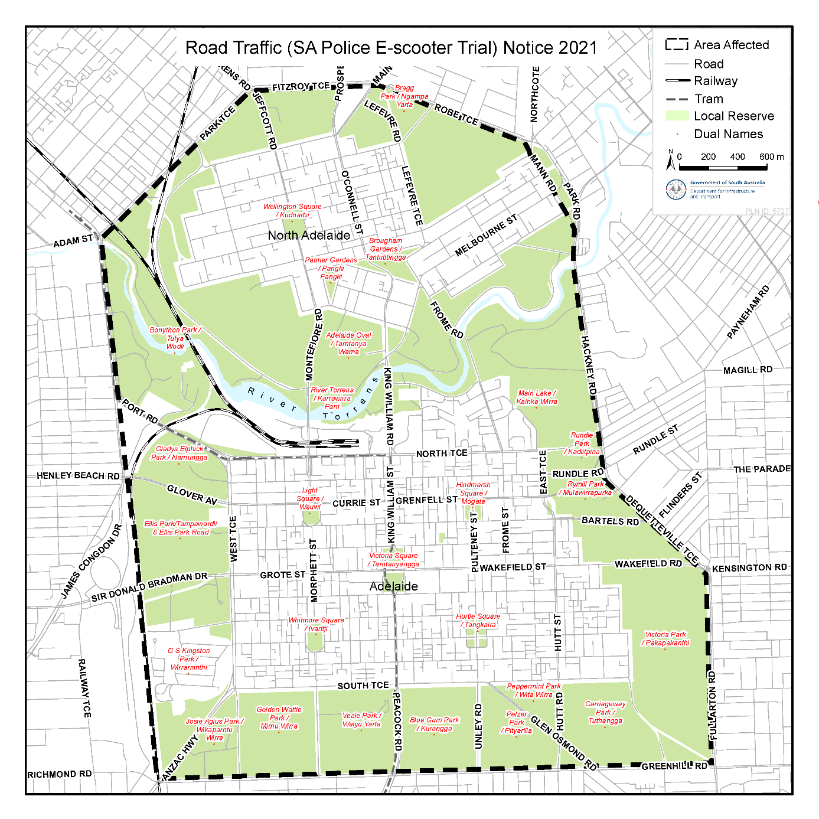

All instruments appearing in this gazette are to be considered official, and obeyed as such

Printed and published weekly by authority of S. Smith, Government Printer, South Australia
$8.00 per issue (plus postage), $402.00 per annual subscription—GST inclusive
Online publications: www.governmentgazette.sa.gov.au

