No. 53 p. 3011
THE SOUTH AUSTRALIAN
GOVERNMENT GAZETTE
Published by Authority

Adelaide, Thursday, 12 August 2021

Contents

Governor’s Instruments
Appointments 3012
Proclamation—
Constitution (Legislative Council Casual Vacancy) Proclamation 2021 3016
Regulations—
Electricity (Principles of Vegetation Clearance) Regulations 2021—No. 114 of 2021 3018
COVID-19 Emergency Response (Savings and
Transitional Matters) Regulations 2021—
No. 115 of 2021 3052
Criminal Law Consolidation (General)
Regulations 2021—No. 116 of 2021 3054
Professional Standards Regulations 2021—
No. 117 of 2021 3064
Subordinate Legislation (Postponement of Expiry) Regulations 2021—No. 118 of 2021 3068
State Government Instruments
Associations Incorporation Act 1985 3072
Building Work Contractors Act 1995 3072
Development Act 1993 3072
Education and Children’s Services Act 2019 3073
Electoral Act 1985 3073
Environment Protection Act 1993 3073
Fisheries Management Act 2007 3079
Housing Improvement Act 2016 3080
Land Acquisition Act 1969 3080
Landscape South Australia Act 2019 3082
Mental Health Act 2009 3083
Petroleum and Geothermal Energy Act 2000 3083
Planning, Development and Infrastructure Act 2016 3084
Survey Act 1992 3085
Local Government Instruments
City of Mitcham 3088
City of Salisbury 3088
City of Victor Harbor 3088
City of Whyalla 3089
District Council of Coober Pedy 3089
Coorong District Council 3089
Flinders Ranges Council, The 3090
District Council of Lower Eyre Peninsula 3091
Naracoorte Lucindale Council 3091
District Council of Tumby Bay 3093
Wattle Range Council 3094
Public Notices
Trustee Act 1936 3095
National Electricity Law 3095
National Energy Retail Law 3095

Governor’s Instruments

Appointments
Department of the Premier and Cabinet
Adelaide, 12 August 2021
His Excellency the Governor in Executive Council has been pleased to appoint Elspeth Kate Brown as a Clerk of Executive Council commencing on 12 August 2021 - pursuant to the Letters Patent and section 68 of the Constitution Act 1934.
By command,
Steven Spence Marshall
Premier
DPC21/058CS

Department of the Premier and Cabinet
Adelaide, 12 August 2021
His Excellency the Governor in Executive Council has been pleased to appoint Mr Naguib Kaldas APM, the Honourable James Sholto Douglas QC and Dr Peggy Brown AO to be Commissioners to enquire into and report upon the matters set out in the commission issued to the said Mr Naguib Kaldas APM, the Honourable James Sholto Douglas QC and Dr Peggy Brown AO on 12 August 2021 - pursuant to the Royal Commissions Act 1917.
By command,
Steven Spence Marshall
Premier
DPC21/063CS

Department of the Premier and Cabinet
Adelaide 12 August 2021
HIS EXCELLENCY THE HONOURABLE HIEU VAN LE, Companion in the Order of Australia, Governor in and over the State of South Australia:
TO
Mr Naguib Kaldas APM
The Honourable James Sholto Douglas QC
Dr Peggy Brown AO
Greeting:
RECOGNISING the unique nature of military service, and the ongoing impact such service may have on the physical and mental health of defence members and veterans.
AND that as a community Australians value the contribution and sacrifice made by defence members and veterans in their service, and the sacrifice of their families.
AND that every death by suicide is a tragic event, and that there is an overrepresentation of defence and veteran deaths by suicide in Australia, and that this overrepresentation should be acknowledged and understood to ensure that learnings are made and to prevent future deaths by suicide.
AND the critical role played by, and broad concept of, families, carers, friends and others as the support network for defence members and veterans.
AND that government and non-government organisations including the Australian Defence Force (the ADF), the Department of Veterans’ Affairs, ex-service organisations and the health care system provide important services (including mental health support services) and support for defence members, veterans and their families that are beneficial to wellbeing and whole-of-life care.
AND that Australia as a nation must take action to examine and expose all systemic issues and risk factors related to suicide, and implement actions to address the systemic issues and risk factors exposed.
AND that hearing from defence members, veterans, their families and others about their individual experiences will be a central contribution to your inquiry and these experiences can inform best-practice, strategies and reforms and can assist in prevention and healing.
AND all Australian Governments have expressed their support for, and undertaken to cooperate with, your inquiry.
AND that your independent inquiry, including its findings and recommendations, will provide a foundation for the future work of the National Commissioner for Defence and Veteran Suicide Prevention.
I, the Governor, with the advice and consent of the Executive Council and under the Royal Commissions Act 1917, DO HEREBY APPOINT YOU to be Commissioners, and require and authorise you to inquire into the following matters:
(a) systemic issues and any common themes among defence and veteran deaths by suicide, or defence members and veterans who have other lived experience of suicide behaviour or risk factors (including attempted or contemplated suicide, feelings of suicide or poor mental health outcomes);
(b) a systemic analysis of the contributing risk factors relevant to defence and veteran death by suicide, including the possible contribution of pre-service, service (including training and deployments), transition, separation and post-service issues, such as the following:
(i) the manner or time in which the defence member or veteran was recruited to the ADF;
(ii) the relevance, if any, of the particular branch, service or posting history, or the rank of the defence member or veteran;
(iii) the manner or time in which the defence member or veteran transitioned from the ADF or transitioned between service categories;

(iv) the availability, accessibility, timeliness and quality of health, wellbeing and support services (including mental health support services) to the defence member or veteran, and the effectiveness of such services;
(v) the manner and extent to which information about the defence member or veteran is held by and shared within and between different government entities;
(vi) the reporting and recording of information, relevant to the mental and physical health of defence members and veterans, at enlistment and during and after service;
(c) the impact of culture within the ADF, the Department of Defence and the Department of Veterans’ Affairs on defence members’ and veterans’ physical and mental wellbeing;
(d) the role of non-government organisations, including ex-service organisations, in providing relevant services and support for defence members, veterans, their families and others;
(e) protective and rehabilitative factors for defence members and veterans who have lived experience of suicide behaviour or risk factors;
(f) any systemic issues in the current availability and effectiveness of support services for, and in the engagement with, families and others:
(i) affected by a defence and veteran death by suicide; or
(ii) who have supported a defence member or veteran with lived experience of suicide behaviour or risk factors;
(g) any systemic issues in the nature of defence members’ and veterans’ engagement with the Department of Defence, the Department of Veterans’ Affairs or other Commonwealth, State or Territory government entities (including those acting on behalf of those entities) about support services, claims or entitlements relevant to defence and veteran deaths by suicide or relevant to defence members and veterans who have other lived experience of suicide behaviour or risk factors, including any systemic issues in engaging with multiple government entities;
(h) the legislative and policy frameworks, administered by the Department of Defence, the Department of Veterans’ Affairs and other Commonwealth, State or Territory government entities, relating to the support services, claims and entitlements referred to in paragraph (g);
(i) any systemic risk factors contributing to defence and veteran death by suicide, including the following:
(i) defence members’ and veterans’ social or family contexts;
(ii) housing or employment issues for defence members and veterans;
(iii) defence members’ and veterans’ economic and financial circumstances;
(j) any matter reasonably incidental to a matter referred to in paragraphs (a) to (i) or that you believe is reasonably relevant to your inquiry.
AND I direct you to make any recommendations arising out of your inquiry that you consider appropriate, including recommendations about any policy, legislative, administrative or structural reforms.
AND, without limiting the scope of your inquiry or the scope of any recommendations arising out of your inquiry that you may consider appropriate, I direct you, for the purposes of your inquiry and recommendations, to have regard to the following matters:
(k) the findings and recommendations of previous relevant reports and inquiries (including relevant coronial inquiries, the Productivity Commission A Better Way to Support Veterans inquiry (2019), and other relevant Royal Commissions and commissions of inquiry), including an assessment of the adequacy and extent of implementation of those recommendations;
(l) the work of, and any relevant information and data provided to you by, the interim National Commissioner for Defence and Veteran Suicide Prevention or the National Commissioner for Defence and Veteran Suicide Prevention;
(m) the support available to members of the defence forces of other countries and veterans of such defence forces, particularly in Canada, New Zealand, the United Kingdom, and the United States of America;
(n) ways in which government and non-government organisations and the community could:
(i) address systemic risk factors relevant to defence and veteran death by suicide; and
(ii) better protect and support vulnerable defence members and veterans;
(o) desirable support services for, and engagement with, families and others affected by defence and veteran death by suicide or who have supported a defence member or veteran with lived experience of suicide behaviour or risk factors;
(p) opportunities to promote understanding of suicide behaviour and risk factors, and protective factors, within the ADF and veteran communities, and the broader Australian community.
AND I further declare that you are not required by these Letters Patent to inquire, or to continue to inquire, into a particular matter to the extent that you are satisfied that the matter has been, is being, or will be, sufficiently and appropriately dealt with by another inquiry or investigation or a criminal or civil proceeding.
AND I further declare that you are not required by these Letters Patent to make findings on the manner or cause of death in relation to a particular defence and veteran death by suicide.
AND, without limiting the scope of your inquiry or the scope of any recommendations arising out of your inquiry that you may consider appropriate, I direct you, for the purposes of your inquiry and recommendations, to consider the following matters, and I authorise you, as you consider appropriate, having regard to the date by which you are required to submit your final report, to take (or refrain from taking) any action arising out of your consideration:
(q) the need to establish accessible and appropriate trauma-informed arrangements for the following people to engage with your inquiry and to provide evidence to you, and share information with you, about their experiences, recognising that some people may not wish to share their experiences:
(i) defence members and veterans with lived experience of suicide behaviour or risk factors;
(ii) families and others affected by defence and veteran death by suicide, or who have supported a defence member or veteran with lived experience of suicide behaviour or risk factors;
(r) the need to focus your inquiry and recommendations on systemic issues, recognising nevertheless that you will be informed by individual experiences and may need to make referrals to appropriate authorities;

(s) the need to establish mechanisms to facilitate the timely communication of information, or the furnishing of evidence, documents or things, in accordance with any relevant law, including, for example, for the purpose of enabling the timely investigation and prosecution of offences;
(t) the need to ensure that evidence that may be received by you that identifies particular individuals as having been subject to inappropriate treatment is dealt with in a way that does not prejudice current or future criminal or civil proceedings or coronial inquiries or other contemporaneous inquiries;
(u) the need to establish appropriate arrangements in relation to current and previous inquiries, in Australia and elsewhere, for evidence and information to be shared with you in ways consistent with relevant obligations so that the work of those inquiries, including, with any necessary consents, the testimony of witnesses, can be taken into account by you in a way that avoids unnecessary duplication, improves efficiency and avoids unnecessary trauma to witnesses;
(v) the need to recognise and appropriately protect any intelligence information or operationally sensitive information obtained by you;
(w) the need to establish appropriate arrangements with the heads of the relevant Australian intelligence entities for obtaining, storing, accessing, using, disclosing and returning intelligence information relating to an Australian intelligence entity.
AND I appoint you, Mr Naguib Kaldas APM, to be the Chair of the Commission.
AND I direct that the Chair be responsible for ensuring the effective, orderly and expeditious conduct of the inquiry in all its facets and, in discharging that responsibility, the Chair may give directions to other appointed Commissioners.
AND I, pursuant to section 4 of the Royal Commissions Act 1917—
(a) authorise individual Commissioners to sit independently to conduct parts or aspects of the inquiry that are, by direction of; and the Chair, to be dealt with independently by individual Commissioners; and
(b) direct that the Commission be exempt from the requirements of section 4(4)(a) of the Royal Commissions Act 1917 so that the Commission, when the Commissioners are to sit jointly for the purposes of the inquiry or any aspect of the inquiry, is not required to have a quorum equal to, or greater than, one-half the total number of Commissioners.
AND I declare that you are authorised to conduct your inquiry into any matter under these Letters Patent in combination with any inquiry into the same matter, or a matter related to that matter, that you are directed or authorised to conduct by any Commission, or under any order or appointment, made by the Governor-General or any of the Governors of the States or by the Government of any of the Territories.
AND I declare that in these Letters Patent:
Australian Defence Force or ADF has the same meaning as in the Defence Act 1903.
Australian intelligence entity means:
(a) the Australian Secret Intelligence Service; or
(b) the Australian Security Intelligence Organisation; or
(c) the Australian Geospatial-Intelligence Organisation; or
(d) the Defence Intelligence Organisation; or
(e) the Australian Signals Directorate; or
(f) the Office of National Intelligence.
defence and veteran death by suicide means the death of a defence member or veteran by suicide, or suspected suicide.
defence member means a member of the Defence Force (within the meaning of the Defence Act 1903).
Note: The Defence Force includes the Naval Reserve, the Army Reserve and the Air Force Reserve.
Department of Defence means the Department administered by the Minister administering the Defence Force Discipline Act 1982.
Department of Veterans’ Affairs means the Department administered by the Minister administering the Veterans’ Entitlements Act 1986.
head, of an Australian intelligence entity, means:
(a) in relation to the Australian Security Intelligence Organisation-the Director-General of Security; or
(b) in relation to the Australian Secret Intelligence Service­ the Director-General of the Australian Secret Intelligence Service; or
(c) in relation to the Australian Signals Directorate-the Director-General of the Australian Signals Directorate; or
(d) in relation to the part of the Department of Defence known as the Australian Geospatial-Intelligence Organisation-the Director of that part of the Department; or
(e) in relation to the part of the Department of Defence known as the Defence Intelligence Organisation-the Director of that part of the Department; or
(f) in relation to the Office of National Intelligence-the Director-General of National Intelligence.
intelligence information means information:
(a) that was acquired or prepared by or on behalf of an Australian intelligence entity in connection with its functions; or
(b) that relates to the performance by an Australian intelligence entity of its functions; or
(c) that identifies a person as being, or having been, a staff member (within the meaning of the Intelligence Services Act 2001) or agent of the Australian Secret Intelligence Service or the Australian Security Intelligence Organisation.

law enforcement or security agency means any of the following agencies:
(a) the Australian Defence Force;
(b) the Australian Federal Police;
(c) the Australian Criminal Intelligence Commission;
(d) the Department administered by the Minister administering the Australian Border Force Act 2015;
(e) the Office of the Special Investigator;
(f) the police force of a State or Territory.
operationally sensitive information means:
(a) information about information sources or operational activities or methods available to a law enforcement or security agency; or
(b) information about particular operations that have been, are being or are proposed to be undertaken by a law enforcement or security agency, or about proceedings relating to those operations; or
(c) information provided by a foreign government, or by an agency of a foreign government, where that government does not consent to the public disclosure of the information.
veteran means a person who has served, or is serving, as a member of the Permanent Forces (within the meaning of the Defence Act 1903) or as a member of the Reserves (within the meaning of the Defence Act 1903).
AND I:
(x) require you to begin your inquiry as soon as practicable; and
(y) require you to make your inquiry as expeditiously as possible; and
(z) require you to ensure the inquiry is conducted in a professional, impartial, respectful and courteous manner, including appropriately managing any actual or perceived conflicts of interest; and
(za) require you to submit to me an interim report that you consider appropriate not later than 11 August 2022, focusing on:
(i) issues requiring urgent or immediate action; and
(ii) any other matters you consider necessary or you consider should be referred to the interim National Commissioner for Defence and Veteran Suicide Prevention or the National Commissioner for Defence and Veteran Suicide Prevention; and
(zb) require you to submit to me a report of the results of your inquiry, and your recommendations, not later than 15 June 2023.
Given under my hand and the Public Seal of South Australia, at Adelaide this 12th day of August 2021.
By command,
Steven Spence Marshall
Premier
Recorded in Register of Commissions, Letters Patent, Etc., Vol. XXIX
James March
Clerk of Executive Council
GOD SAVE THE QUEEN!

Proclamation
South Australia

Constitution (Legislative Council Casual Vacancy) Proclamation 2021
under section 13 of the Constitution Act 1934

Preamble
1 A seat of a member of the Legislative Council has become vacant by virtue of the resignation of the Honourable John David Wickham Ridgway MLC.
2 A person must be chosen to occupy the vacant seat by an assembly of the members of both Houses of Parliament.
3 It is necessary to make provision in relation to the constitution and proceedings of that assembly.

1—Short title
This proclamation may be cited as the Constitution (Legislative Council Casual Vacancy) Proclamation 2021.
2—Commencement
This proclamation comes into operation on the day on which it is made.
3—Provisions relating to the assembly of members
The following provisions apply in relation to the constitution and proceedings of an assembly of the members of both Houses of Parliament to choose a person to occupy the vacant seat in the Legislative Council caused by the resignation of the Honourable John David Wickham Ridgway MLC:
(a) the assembly will meet at 10:00 am on Tuesday, 24 August 2021 at the Legislative Council Chamber;
(b) the Honourable John Samuel Letts Dawkins MLC is appointed to preside over the assembly;
(c) Christopher David Schwarz is appointed to be clerk of the assembly;
(d) the following rules are to be observed at the assembly and applied as the method by which the decision of the assembly will be evidenced:
(i) the presiding officer will take the chair;
(ii) the clerk of the assembly will read this proclamation;
(iii) the presiding officer will invite nominations for the vacant seat from the members of the assembly;
(iv) nominations will first be made without debate;

(v) a nomination will not be accepted by the presiding officer unless—
(A) the nomination is seconded; and
(B) the person nominated is a person who can lawfully be chosen by the assembly to occupy the vacancy;
(vi) when it appears that no further nominations are to be made, the members making the nominations, the members seconding the nominations and any other members of the assembly may speak if they desire;
(vii) when members have concluded their remarks, a ballot will be taken if necessary;
(viii) the presiding officer will announce to the assembly the name of the person chosen to occupy the vacant seat;
(ix) the President of the Legislative Council must be informed in writing of the decision of the assembly and notice of the decision must be published in the Gazette.
Made by the Governor
with the advice and consent of the Executive Council
on 12 August 2021

Regulations
South Australia

Electricity (Principles of Vegetation Clearance) Regulations 2021
under the Electricity Act 1996

Contents
1 Short title
2 Commencement
3 Interpretation
4 Duty of electricity entity or council
5 Duty of occupier
6 Planting and nurturing vegetation near powerlines
7 Technical Regulator may grant exemption from principles of vegetation clearance
8 Vegetation clearance scheme outside prescribed areas agreed between council and electricity entity
9 Agreement between occupier and electricity entity
10 Objections relating to vegetation clearance
11 Notification of clearance by electricity entity to council
12 Electricity entity vegetation clearance power—prescribed qualification
Schedule 1—Clearance and buffer zones around overhead powerlines
1 Legend for diagrams
2 Clearance zone around overhead powerlines on public land in a non-bushfire risk area
3 Clearance and buffer zones around overhead powerlines on private land in a non-bushfire risk area
4 Clearance and buffer zones around overhead powerlines in the bushfire risk area
5 Tables for determination of value of V, H, B, S and P
6 Technical Regulator may determine values for clearance zone around particular powerline in certain circumstances
Schedule 2—Planting or nurturing vegetation near public powerlines
1 Interpretation
2 General rules
3 Exemption
4 Table
Schedule 3—Revocation of Electricity (Principles of Vegetation Clearance) Regulations 2010

1—Short title
These regulations may be cited as the Electricity (Principles of Vegetation Clearance) Regulations 2021.

2—Commencement
These regulations come into operation on 1 September 2021.
3—Interpretation
(1) In these regulations, unless the contrary intention appears—
Act means the Electricity Act 1996;
buffer zone, in relation to an overhead powerline in the bushfire risk area or on private land in a non-bushfire risk area, means the space around the powerline that adjoins the clearance zone around that powerline, as shown in the diagrams in Schedule 1;
bushfire risk area means the part of the State shown in the maps published on a website determined by the Technical Regulator and identified as the bushfire risk area (and excluding the areas shown in those maps as non-bushfire risk areas);
centreline, in relation to a powerline, means—
(a) in the case of an underground powerline—
(i) that consists of a single conductor—an imaginary line on the ground directly above that conductor; or
(ii) that consists of more than 1 conductor—an imaginary line on the ground above the powerline that is equidistant from the outer conductors; or
(b) in the case of an overhead powerline—
(i) that consists of a single conductor—an imaginary line on the ground directly beneath the position maintained by that conductor in still air; or
(ii) that consists of more than 1 conductor—an imaginary line on the ground below the powerline that is equidistant from the positions maintained by the outer conductors in still air;
clearance zone means the space around an overhead powerline as shown in the diagrams in Schedule 1 (the values of V, H, B, S and P referred to in those diagrams being determined by reference to the tables in Schedule 1 clause 5 or, if a determination of the Technical Regulator under Schedule 1 clause 6 is in force in relation to a particular powerline, that determination);
low risk powerline means an overhead powerline or portion of an overhead powerline—
(a) that is in a prescribed area; and
(b) each span of which does not exceed 50 m and has low voltage conductors;
low voltage conductor means a conductor constructed to operate at a voltage not exceeding 480V;
non-bushfire risk area means a part of the State not within the bushfire risk area;
prescribed area—see subregulation (3);
private powerline—see subregulation (2);
public land means land other than private land;
span, in relation to an overhead powerline, means the part of the powerline that lies between 2 poles or other supports for that line.

(2) For the purposes of the definition of private powerline in section 4(1) of the Act, the prescribed voltage is 19kV.
(3) For the purposes of Part 5 of the Act and these regulations, each non-bushfire risk area (or portion of a non-bushfire risk area) that is shown in a map published on a website determined by the Technical Regulator is a prescribed area except where such an area (or portion of such an area) is indicated to be a non-bushfire risk area (not prescribed).
4—Duty of electricity entity or council
(1) The principles of vegetation clearance set out in this regulation are prescribed for the purposes of Part 5 of the Act and govern the duty of an electricity entity or a council to take reasonable steps to keep vegetation clear of powerlines.
(2) At intervals of no longer than 3 years, overhead powerlines must be inspected and vegetation cleared as follows:
(a) in the case of powerlines other than low risk powerlines—vegetation must be cleared so that—
(i) no vegetation remains in the clearance zone surrounding the powerline in still air at the time of the clearance; and
(ii) no growth or regrowth is likely to intrude into the clearance zone within 3 years (or, if an inspection and clearance is scheduled to take place in less than 3 years, within that lesser period), taking into account the reasonably ascertainable characteristics of the powerline and vegetation; and
(iii) no part of the vegetation or growth or regrowth is likely to bend in the wind into the clearance zone at the time of clearance or within 3 years (or, if an inspection and clearance is scheduled to take place in less than 3 years, within that lesser period), taking into account the reasonably ascertainable characteristics of the powerline and vegetation and winds that might reasonably be expected in the area;
(b) in the case of low risk powerlines—vegetation must be cleared—
(i) in accordance with the principles set out in paragraph (a); or
(ii) so that no part of the vegetation or growth or regrowth is likely to come into contact with the powerline (including by bending in the wind) so as to—
(A) form a leakage current to ground through the vegetation resulting in a risk of fire or electric shock; or
(B) form an electrical path for tracking voltage exceeding 480V into low voltage conductors; or
(C) bridge 2 or more low voltage conductors resulting in a phase to phase or phase to neutral breach; or
(D) cause damage to the powerline resulting in a risk of fire, electric shock or loss of electricity supply,
at the time of the clearance or within 3 years (or, if an inspection and clearance is scheduled to take place in less than 3 years, within that lesser period), taking into account the reasonably ascertainable characteristics of the powerline and the vegetation and winds that might reasonably be expected in the area.
(3) If the supporting structure of a low risk powerline also supports conductors that are not low voltage conductors, then—
(a) the principles set out in subregulation (2)(a) apply in relation to the conductors that are not low voltage conductors; and
(b) the principles set out in subregulation (2)(b) apply in relation to the low voltage conductors.
(4) The principles set out in subregulation (2)(b)(ii) only apply if the Technical Regulator has given approval to the electricity entity or council to keep vegetation clear of the powerlines in accordance with those principles.
(5) If an electricity entity has the duty to keep vegetation clear of the powerlines—
(a) the entity must not, in clearing vegetation in accordance with the principles set out in subregulation (2)(a), clear vegetation from around an overhead powerline—
(i) more than is reasonably necessary to satisfy those principles; or
(ii) if there is a buffer zone around the powerline, beyond the buffer zone,
except if—
(iii) it is reasonably necessary to do so for the purposes of—
(A) enhancing the stability or health of remaining vegetation; or
(B) enhancing the appearance of remaining vegetation (but in that case, if there is a buffer zone around the powerline, the vegetation must not be cleared beyond the buffer zone); or
(iv) the vegetation to be cleared consists of plants that have grown wholly in the immediately preceding 5 years and the vegetation is identified as being of a species that will grow into the clearance zone around the powerline; or
(v) the entity agrees, at the request of the occupier of the land on which the vegetation is situated, to undertake the clearance and the clearance would not be contrary to the provisions of any other law if carried out by the occupier; and
(b) the entity must not, in clearing vegetation in accordance with the principles set out in subregulation (2)(b)(ii), clear more vegetation than it could by clearing in accordance with the principles set out in subregulation (2)(a).
(6) The Technical Regulator may require an electricity entity to prepare guidelines in respect of the clearance of vegetation in accordance with subregulation (5)(a)(iv).
(7) If a council has the duty to keep vegetation clear of the powerlines, the council need not, in clearing vegetation in accordance with the principles set out in subregulation (2)(b)(ii), clear more vegetation than would be reasonably necessary to satisfy the principles set out in subregulation (2)(a).

5—Duty of occupier
(1) The principles of vegetation clearance set out in this regulation are prescribed for the purposes of Part 5 of the Act and govern the duty of an occupier of private land to take reasonable steps to keep vegetation clear of private powerlines on the land.
(2) An occupier of private land must keep vegetation (other than naturally occurring vegetation) clear of any private overhead powerline on that land so that—
(a) no part of the vegetation at any time intrudes into the clearance zone around that powerline in still air; and
(b) no part of the vegetation is at any time likely to bend into that zone in winds that might reasonably be expected in the area.
(3) An occupier of private land is not required to clear vegetation beyond the buffer zone around any powerline.
(4) An occupier of private land must not clear vegetation which the occupier may not lawfully clear apart from this regulation—
(a) more than is reasonably necessary to satisfy the requirements of subregulation (2) and for the purposes of enhancing the appearance, stability or health of any remaining vegetation; or
(b) if there is a buffer zone around the powerline, beyond the buffer zone.
6—Planting and nurturing vegetation near powerlines
For the purposes of Part 5 of the Act, Schedule 2 sets out requirements for planting or nurturing vegetation near powerlines.
7—Technical Regulator may grant exemption from principles of vegetation clearance
(1) The Technical Regulator may, on application—
(a) exempt an occupier of land on which vegetation is planted or nurtured for commercial purposes (not including the production of timber) from compliance with regulation 5; or
(b) exempt a person from compliance with a provision of Schedule 2 in relation to specified vegetation.
(2) An application under this regulation must—
(a) be made in a form approved by the Technical Regulator; and
(b) contain the information specified in the form; and
(c) be accompanied by an application fee fixed by the Minister.
(3) Before determining an application under this regulation, the Technical Regulator must give the electricity entity or council with the duty to keep the vegetation clear of powerlines a reasonable opportunity to make submissions and be heard on the matter.

(4) An exemption under this regulation—
(a) must be in writing; and
(b) may be subject to conditions, including a condition that the applicant is to pay any costs that the electricity entity or council incur in keeping the vegetation clear of powerlines in accordance with these regulations.
(5) A person who contravenes, or fails to comply with, a condition of an exemption under this regulation is guilty of an offence.
Maximum penalty: $5 000.
Expiation fee: $315.
8—Vegetation clearance scheme outside prescribed areas agreed between council and electricity entity
(1) This regulation applies to public land in a non-bushfire risk area but not within a prescribed area.
(2) An electricity entity may agree a vegetation clearance scheme with a council governing the way in which the entity will carry out its duty to clear vegetation in the area of the council or part of that area.
(3) The factors that should be taken into consideration in formulating a scheme include the following:
(a) the nature of the vegetation, including its expected rate of growth;
(b) the impact that the clearance work would be likely to have on the amenity of the area;
(c) the historical or biological significance (if any) of the vegetation;
(d) the long term effect that the clearance work would be likely to have on the health and appearance of the vegetation;
(e) the controls on the planting and nurturing of vegetation applicable in the area;
(f) the need to prevent damage to the powerlines and interruption to the supply of electricity and to safeguard the public against electric shock and damage to property;
(g) the extent and frequency of past vegetation clearance in the area;
(h) whether requirements with respect to vegetation clearance and the planting and nurturing of vegetation have been complied with in the area and, if not, the reasons for the non-compliance;
(i) the existence and terms of other vegetation clearance schemes;
(j) any proposal to alter, remove or underground powerlines in the area;
(k) the costs of the proposals (including insurance premiums) to the council and to the electricity entity and the financial resources of the council and entity;
(l) the limits on the financial and other resources of the electricity entity that may be devoted to the scheme and the schemes for the areas of other councils;
(m) any arrangement between the electricity entity and the council conferring on the council a specified role in relation to vegetation clearance.

(4) A scheme cannot derogate from the principles set out in regulation 4.
(5) A scheme—
(a) must be in writing and executed by the council and the electricity entity (however, separate execution is not required if the scheme is combined with an arrangement under Part 5 of the Act conferring on the council a specified role in relation to vegetation clearance); and
(b) may be varied or revoked by written agreement between the parties.
(6) A vegetation clearance scheme as agreed has effect, and may be enforced, as a contract between the electricity entity and the council concerned.
9—Agreement between occupier and electricity entity
(1) An electricity entity may enter into an agreement with an occupier of private land under which—
(a) vegetation around powerlines in a specified area of the land is to be inspected and cleared more frequently than required under regulation 4; or
(b) the occupier undertakes to carry out the required inspection and clearance of vegetation on that land on behalf of the entity.
(2) The agreement—
(a) must be in writing and executed by the occupier and the electricity entity; and
(b) must specify—
(i) the area concerned; and
(ii) the intervals at which inspection and clearance must be carried out; and
(iii) unless the occupier undertakes to carry out the inspections and clearance on behalf of the electricity entity—the payments agreed between the parties in respect of the costs of the additional work required under the agreement; and
(c) may be varied or revoked by further written agreement between the parties; and
(d) has effect, and may be enforced, as a contract between the electricity entity and the occupier.
10—Objections relating to vegetation clearance
(1) An occupier or owner of private land may lodge an objection with the Technical Regulator concerning a matter set out in a notice of intention to enter land to carry out work received from an electricity entity or council under Part 5 of the Act.
(2) An objection under this regulation must—
(a) be made to the Technical Regulator in writing; and
(b) be lodged with the Technical Regulator within 21 days after receipt of the notice to which the objection relates or such further time as the Technical Regulator allows.
(3) The Technical Regulator must, on receipt of an objection, notify the electricity entity or council, as the case may require, of the objection.
(4) On receiving notification of the objection, the electricity entity or council is prohibited from carrying out the clearance of vegetation to which the objection relates until the objection has been determined by the Technical Regulator.
(5) The Technical Regulator may—
(a) dismiss the objection; or
(b) direct the electricity entity or council to take or to refrain from taking any specified action in relation to the matter; or
(c) if the objector and the electricity entity or council have reached an agreement as to how the objection might be resolved, and the agreement does not involve a breach of these regulations—determine the objection so as to reflect the agreement.
(6) The Technical Regulator may dismiss the objection—
(a) on the ground that—
(i) the subject matter of the objection is substantially the same as the subject matter of an objection previously considered; or
(ii) the objection is frivolous or vexatious or without reasonable basis; or
(iii) the objector has not made a reasonable attempt to resolve the matter by agreement with the electricity entity or council; or
(b) if satisfied that the objector and the electricity entity or council have entered into an agreement under regulation 9 that relates to the subject matter of the objection; or
(c) if satisfied for any other reason that the objection should not be allowed.
(7) The Technical Regulator must, as soon as practicable, notify the objector and the electricity entity or council, as the case may require, of the Technical Regulator's determination of the objection.
(8) An electricity entity or council must, when giving notice of an intention to enter private land to carry out work under Part 5 of the Act, include in or with the notice a statement of the rights of the owner or occupier to lodge an objection under this regulation.
11—Notification of clearance by electricity entity to council
(1) An electricity entity must give a council not less than 30 days written notice before commencing a program of vegetation clearance in the area of the council, including details of when and where clearance is to take place under the program.
(2) Subregulation (1) does not apply if the clearance work to be carried out is subject to a vegetation clearance scheme.
12—Electricity entity vegetation clearance power—prescribed qualification
For the purposes of section 55AA(2) of the Act, the prescribed qualification is a diploma in arboriculture obtained from a training organisation registered under the South Australian Skills Act 2008 or a law of the Commonwealth, or another State or Territory, relating to training and skills development.

Schedule 1—Clearance and buffer zones around overhead powerlines
1—Legend for diagrams
2—Clearance zone around overhead powerlines on public land in a non-bushfire risk area
(1) Diagram A—public land in non-bushfire risk area—fully insulated or low voltage
This diagram applies to a powerline that has conductors which are fully insulated (for example, aerial bundled cables) or low voltage conductors.
The clearance zone as shown extends along the length of each span of the powerline.
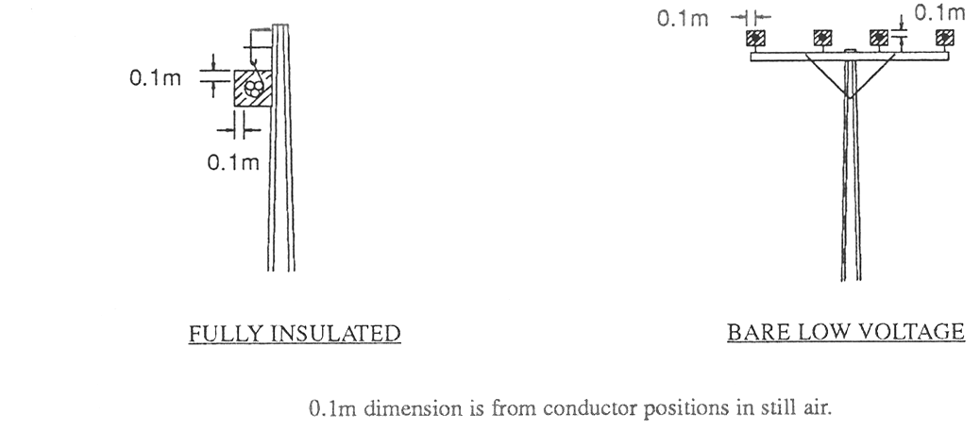
(2) Diagram B—public land in non-bushfire risk area—insulated unscreened
This diagram applies to a powerline the conductors of which are Insulated Unscreened Conductor ("IUC" or "CCT").
The clearance zone as shown extends along the length of each span of the powerline.
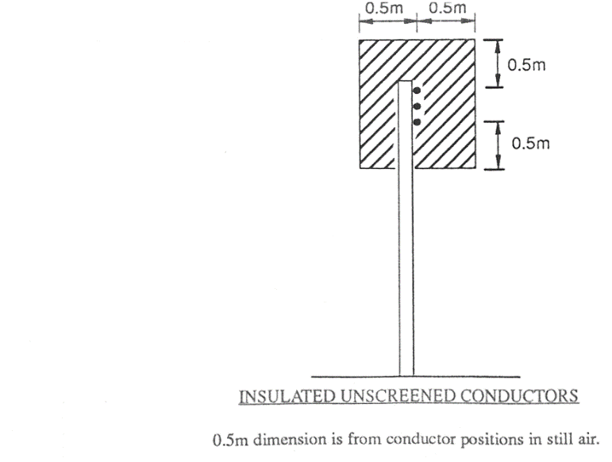
(3) Diagram C—public land in non-bushfire risk area—not insulated more than 480V
but less than 33kV
These diagrams apply to a powerline, the conductors of which are not insulated, constructed to operate at a voltage of more than 480V but less than 33kV.
Diagram C.1 shows the clearance zone at the pole or other support at the end of each span of the powerline.
Diagram C.2 shows the clearance zone at mid span (as shown in diagrams C.3 and C.4) for each span of the powerline.
Diagrams C.3 and C.4 show the manner in which the clearance zone extends along the length of each span of the powerline.
The values of V, H and P are set out in Tables 1 and 2 in clause 5.
C.1—public land in non-bushfire risk area—not insulated more than 480V
but less than 33kV—at each end of span
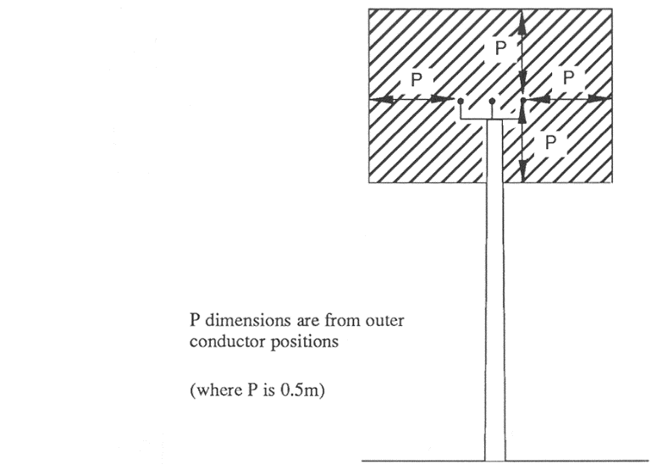
C.2—public land in non-bushfire risk area—not insulated more than 480V
but less than 33kV—mid span (as shown in diagrams C.3 and C.4)
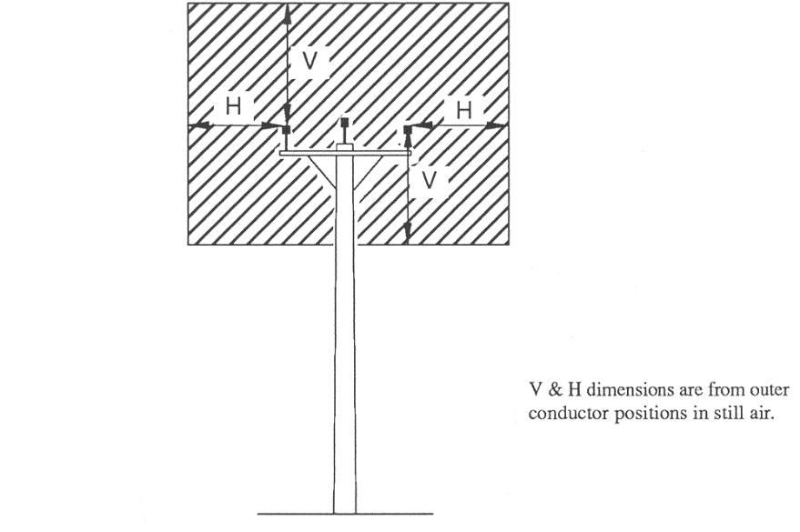
C.3—public land in non-bushfire risk area—not insulated more than 480V
but less than 33kV—view of clearance zone from above
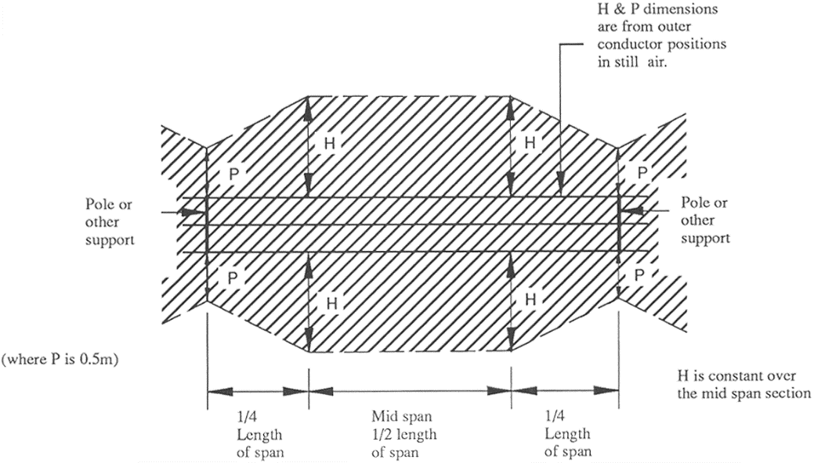
C.4—public land in non-bushfire risk area—not insulated more than 480V
but less than 33kV—view of clearance zone from side
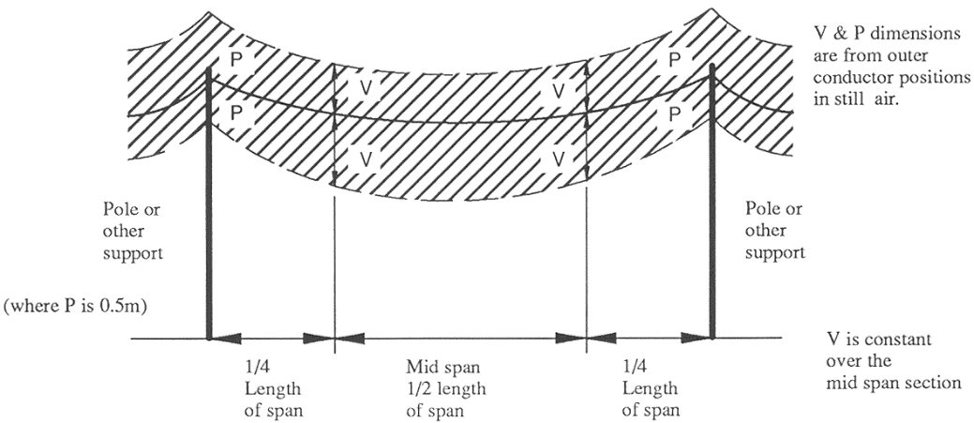

(4) Diagram D—public land in non-bushfire risk area—not insulated 33kV to 66kV
These diagrams apply to a powerline, the conductors of which are not insulated, constructed to operate at a voltage from 33kV to 66kV inclusive.
Diagram D.1 shows the clearance zone at the pole or other support at the end of each span of the powerline.
Diagram D.2 shows the clearance zone at mid span (as shown in diagrams D.3 and D.4) for each span of the powerline.
Diagrams D.3 and D.4 show the manner in which the clearance zone extends along the length of each span of the powerline.
The values of V, H and P are set out in Table 3 in clause 5.
D.1—public land in non-bushfire risk area—not insulated 33kV to 66kV—
at each end of a span
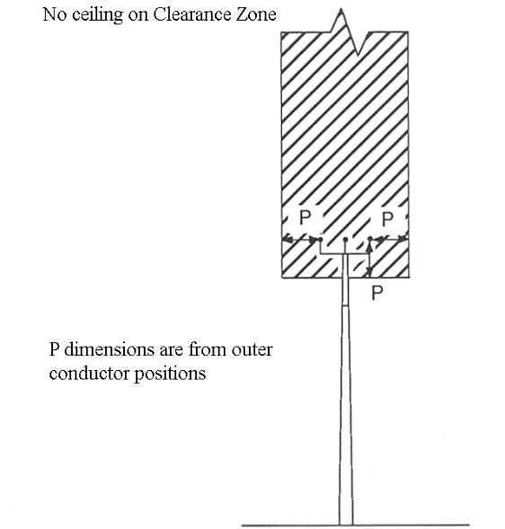
D.2—public land in non-bushfire risk area—not insulated 33kV to 66kV—
mid span (as shown in diagrams D.3 and D.4)
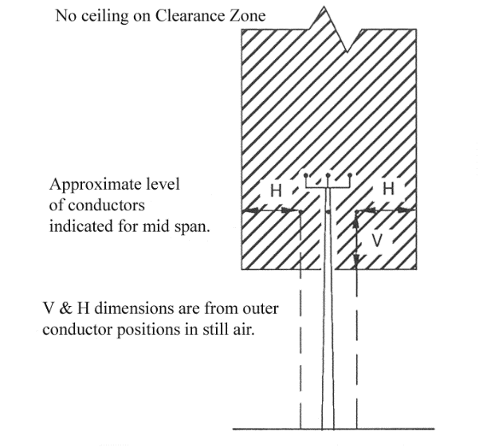

D.3—public land in non-bushfire risk area—not insulated 33kV to 66kV—
view of clearance zone from above
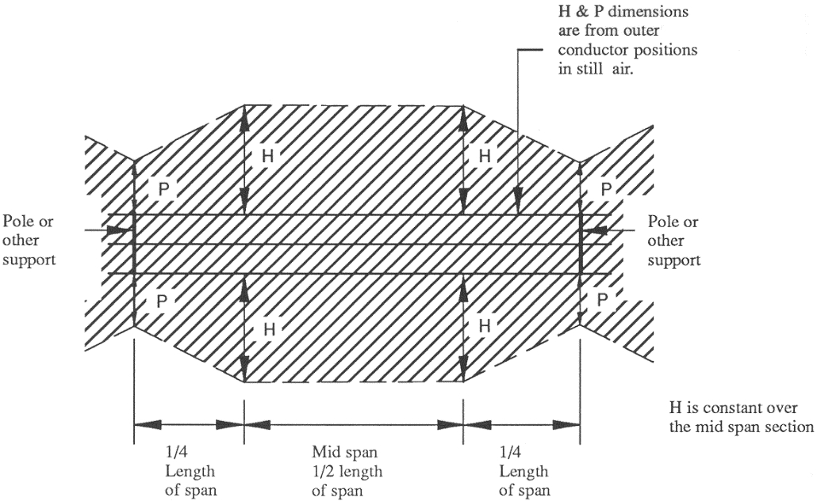
D.4—public land in non-bushfire risk area—not insulated 33kV to 66kV—
view of clearance zone from side
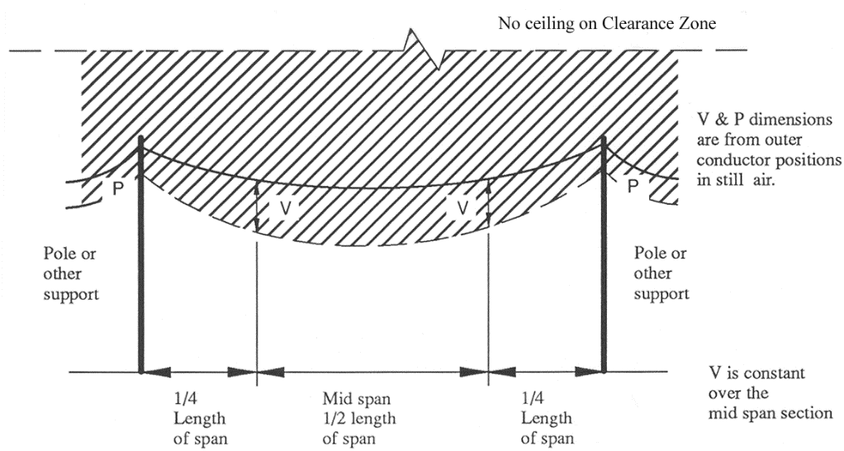

(5) Diagram E—public land in non-bushfire risk area—not insulated 132kV to 275kV
These diagrams apply to a powerline, the conductors of which are not insulated, constructed to operate at a voltage from 132kV to 275kV inclusive.
Diagram E.1 shows the clearance zone at the pole or other support at the end of each span of the powerline.
Diagram E.2 shows the clearance zone at mid span (as shown in diagrams E.3 and E.4) for each span of the powerline.
Diagrams E.3 and E.4 show the manner in which the clearance zone extends along the length of each span of the powerline.
The values of V, H, S and P are set out in Table 4 in clause 5.
The 45° component of the clearance zone is determined as being 3 m from the 45° cutoff line.
E.1—public land in non-bushfire risk area—not insulated 132kV to 275kV—
at each end of a span
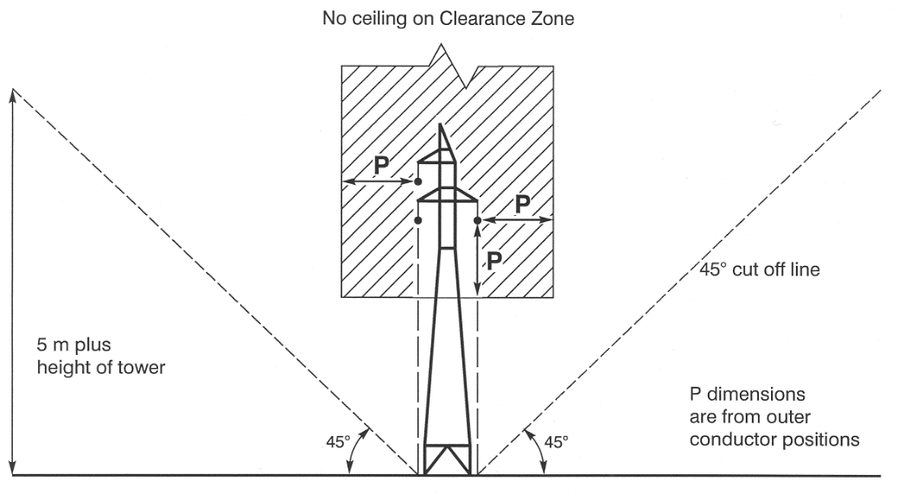
E.2—public land in non-bushfire risk area—not insulated 132kV to 275kV—
mid span (as shown in diagrams E.3 and E.4)
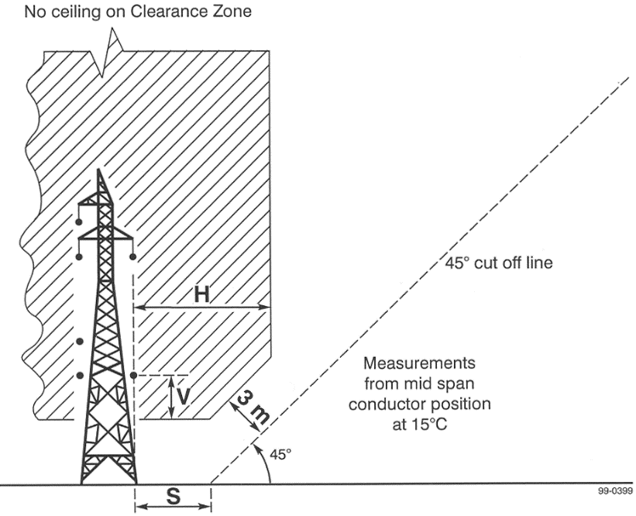
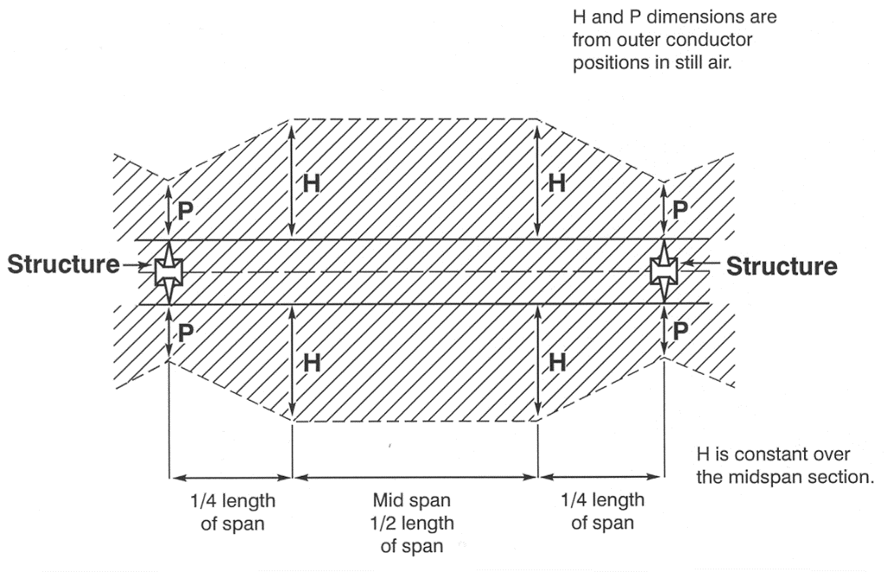
E.3—public land in non-bushfire risk area—not insulated 132kV to 275kV—
view of clearance zone from above
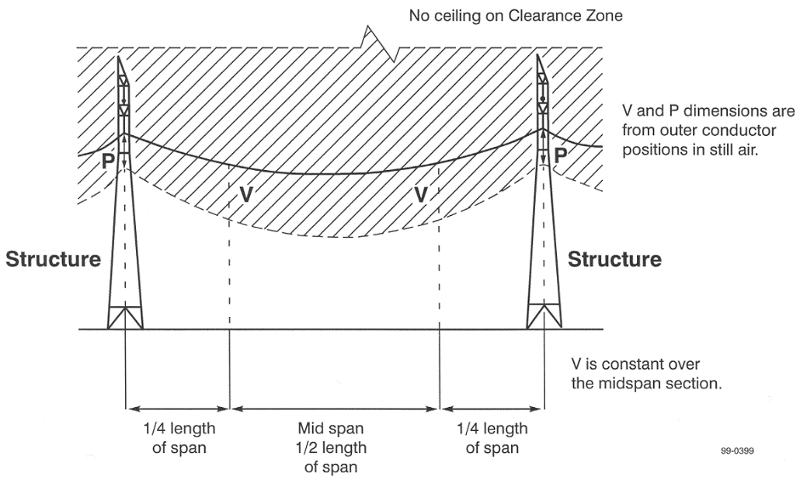
E.4—public land in non-bushfire risk area—not insulated 132kV to 275kV—
view of clearance zone from side

3—Clearance and buffer zones around overhead powerlines on private land in a non-bushfire risk area
(1) Diagram A—private land in non-bushfire risk area—fully insulated or low voltage
This diagram applies to a powerline that has conductors which are fully insulated (for example, aerial bundled cables) or low voltage conductors.
The zones as shown extend along the length of each span of the powerline.
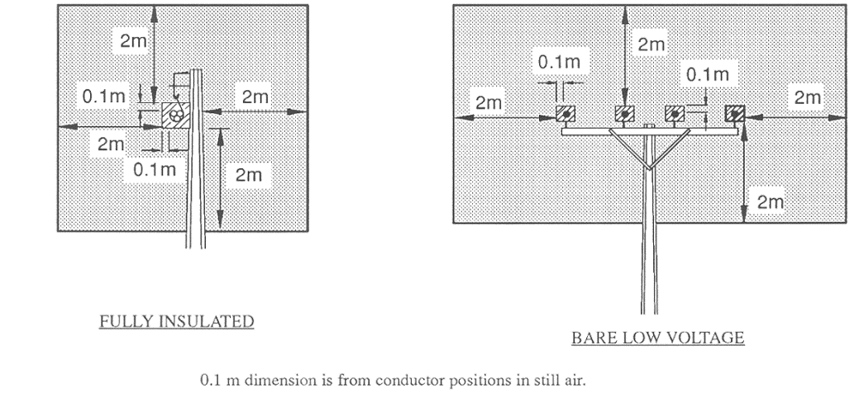
(2) Diagram B—private land in non-bushfire risk area—insulated unscreened
This diagram applies to a powerline the conductors of which are Insulated Unscreened Conductor ("IUC" or "CCT").
The zones as shown extend along the length of each span of the powerline.
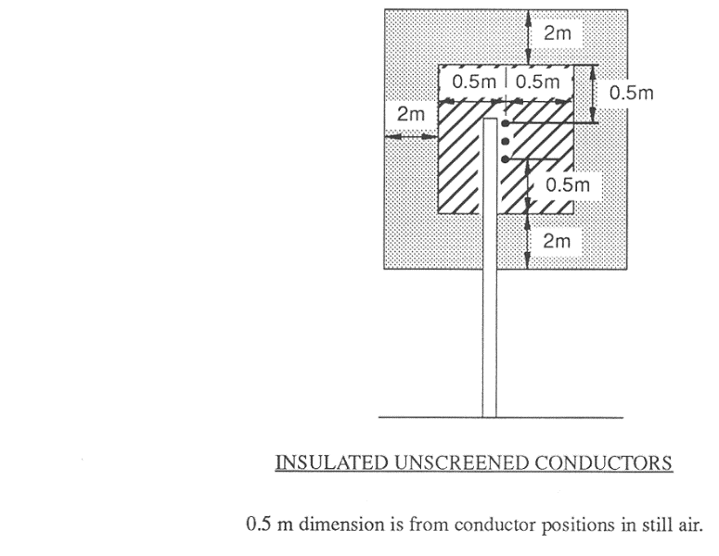

(3) Diagram C—private land in non-bushfire risk area—not insulated more than 480V
but less than 33kV
These diagrams apply to a powerline the conductors of which are not insulated, constructed to operate at a voltage of more than 480V but less than 33kV.
Diagram C.1 shows the zones at the pole or other support at the end of each span of the powerline.
Diagram C.2 shows the clearance zone at mid span (as shown in diagrams C.3 and C.4) for each span of the powerline.
Diagrams C.3 and C.4 show the manner in which the clearance zone extends along the length of each span of the powerline.
Although not shown in diagrams C.3 and C.4, the buffer zone as shown in diagrams C.1 and C.2 extends along the length of each span of the powerline.
The values of V, H and P are set out in Tables 1 and 2 in clause 5.
C.1—private land in non-bushfire risk area—not insulated more than 480V
but less than 33kV—at each end of a span
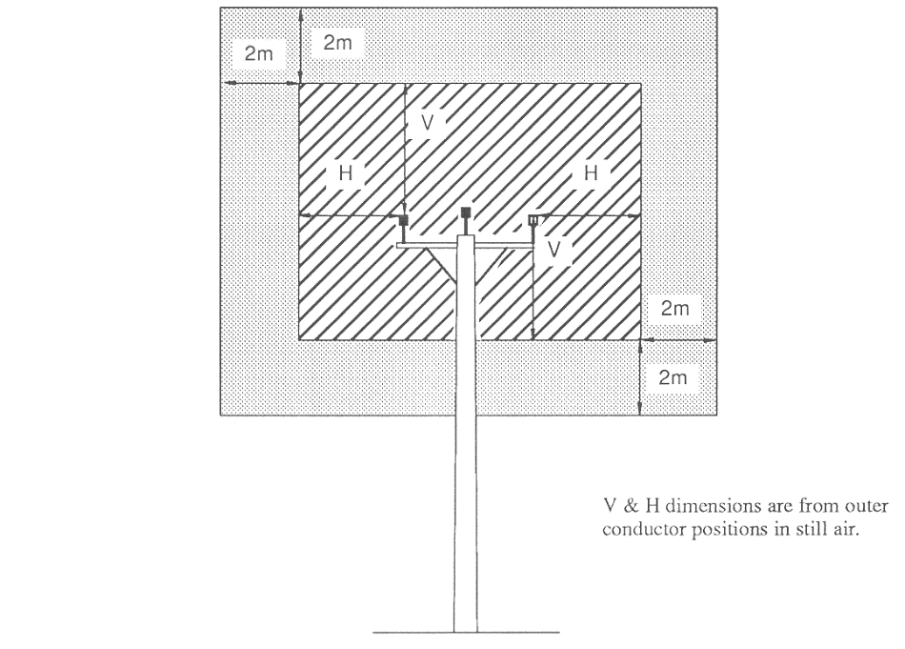
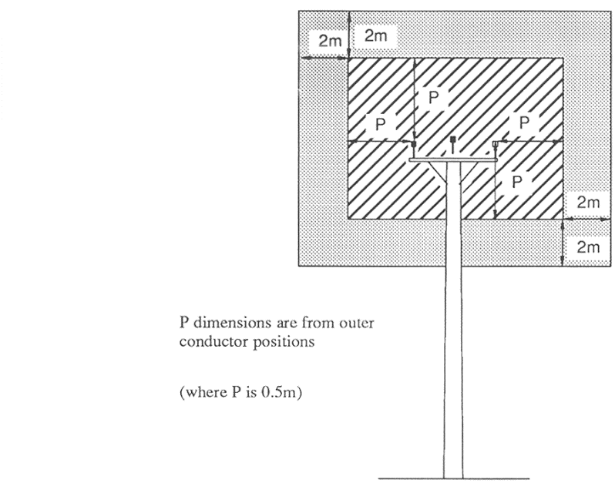
C.2—private land in non-bushfire risk area—not insulated more than 480V
but less than 33kV—mid span (as shown in diagrams C.3 and C.4)
C.3—private land in non-bushfire risk area—not insulated more than 480V
but less than 33kV—view of clearance zone from above
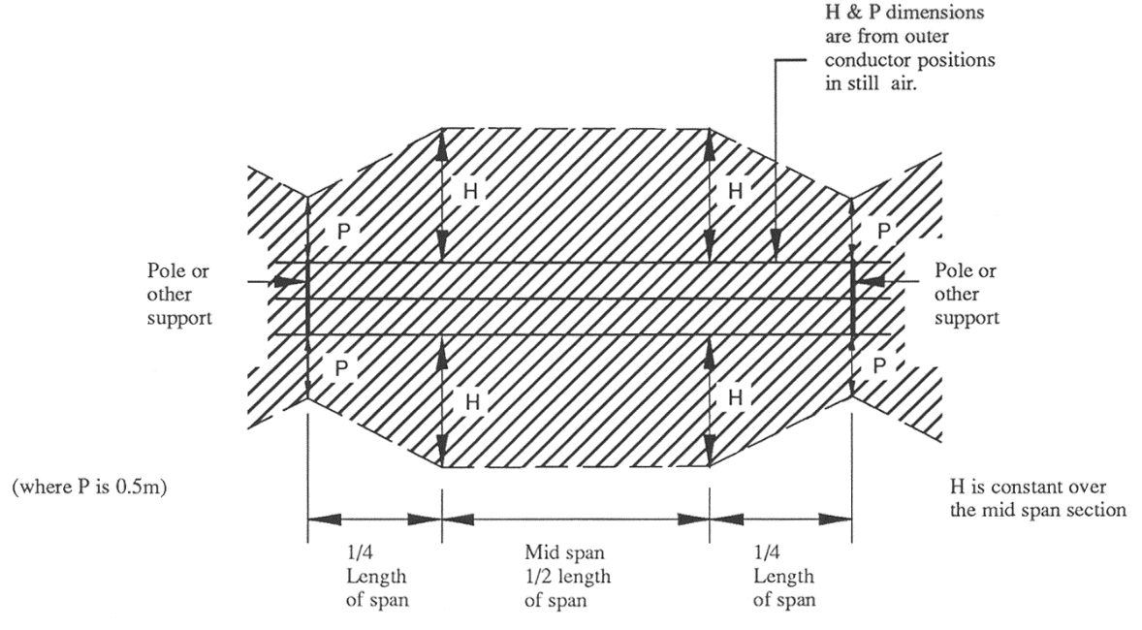
C.4—private land in non-bushfire risk area—not insulated more than 480V
but less than 33kV—view of clearance zone from side
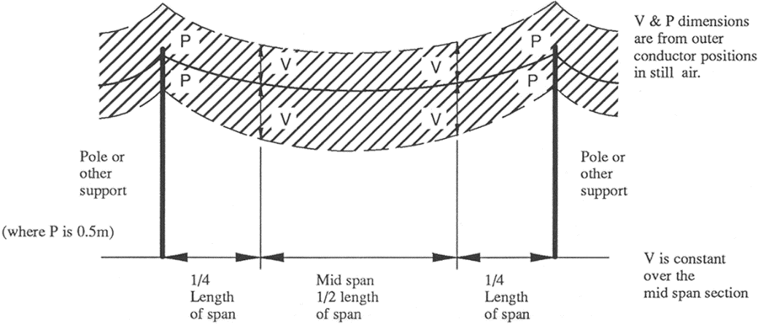
(4) Diagram D—private land in non-bushfire risk area—not insulated 33kV to 66kV
These diagrams apply to a powerline, the conductors of which are not insulated, constructed to operate at a voltage from 33kV to 66kV inclusive.
Diagram D.1 shows the zones at the pole or other support at the end of each span of the powerline.
Diagram D.2 shows the zones at mid span (as shown in diagrams D.3 and D.4) for each span of the powerline.
Diagrams D.3 and D.4 show the manner in which the clearance zone extends along the length of each span of the powerline.
Although not shown in diagrams D.3 and D.4, the buffer zone as shown in diagrams D.1 and D.2 extends along the length of each span of the powerline.
The values of V, H, B and P are set out in Table 3 in clause 5.
D.1—private land in non-bushfire risk area—not insulated 33kV to 66kV—
at each end of a span
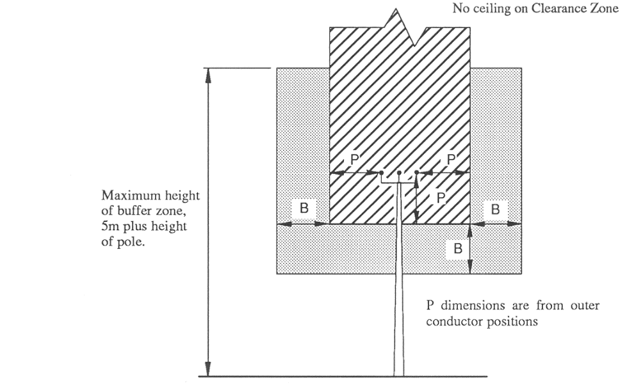
D.2—private land in non-bushfire risk area—not insulated 33kV to 66kV—
mid span (as shown in diagrams D.3 and D.4)
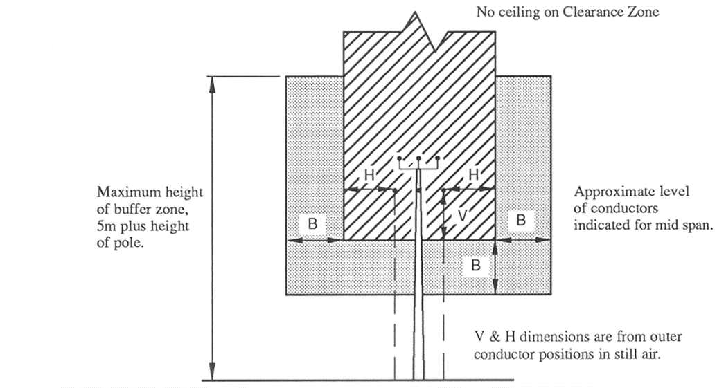

D.3—private land in non-bushfire risk area—not insulated 33kV to 66kV—
view of clearance zone from above
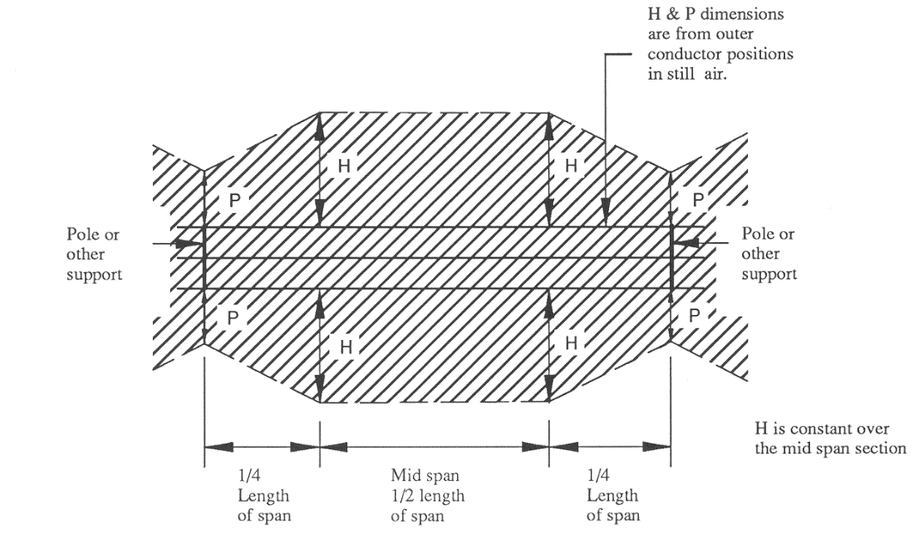
D.4—private land in non-bushfire risk area—not insulated 33kV to 66kV—
view of clearance zone from side
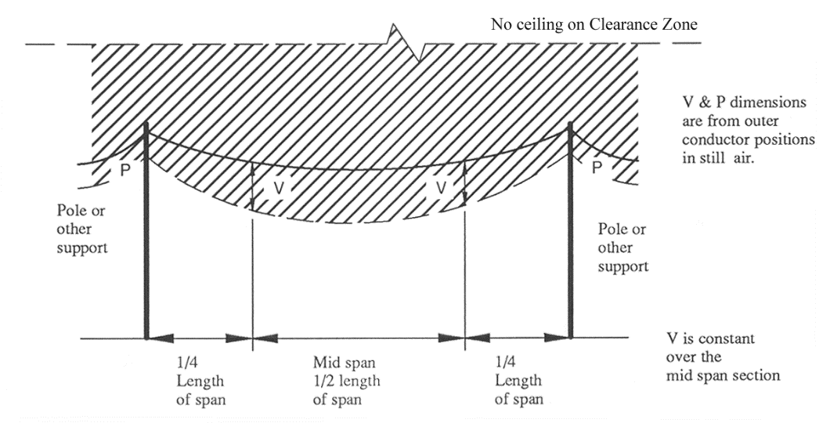
(5) Diagram E—private land in non-bushfire risk area—not insulated 132kV to 275kV
These diagrams apply to a powerline, the conductors of which are not insulated, constructed to operate at a voltage from 132kV to 275kV inclusive.
Diagram E.1 shows the zones at the pole or other support at the end of each span of the powerline.
Diagram E.2 shows the zones at mid span (as shown in diagrams E.3 and E.4) for each span of the powerline.
Diagrams E.3 and E.4 show the manner in which the clearance zone extends along the length of each span of the powerline.
Although not shown in diagrams E.3 and E.4, the buffer zone as shown in diagrams E.1 and E.2 extends along the length of each span of the powerline.
The values of V, H, S, B and P are set out in Table 4 in clause 5.
The 45° component of the clearance zone is determined as being 3 m inside the buffer zone.
E.1—private land in non-bushfire risk area—not insulated 132kV to 275kV—
at each end of a span
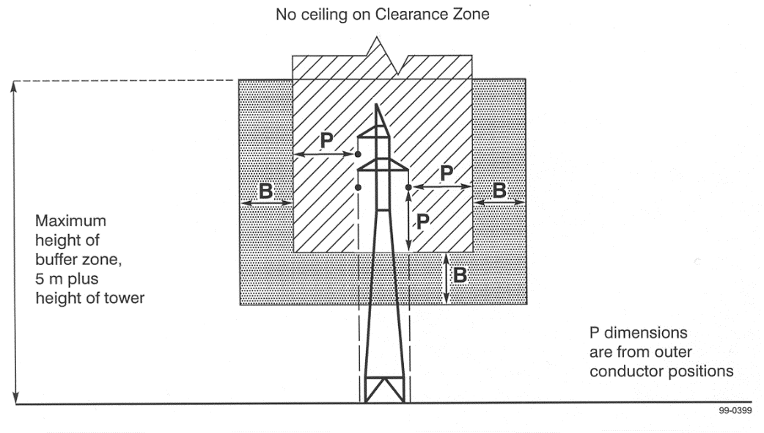
E.2—private land in non-bushfire risk area—not insulated 132kV to 275kV—
mid span (as shown in diagrams E.3 and E.4)
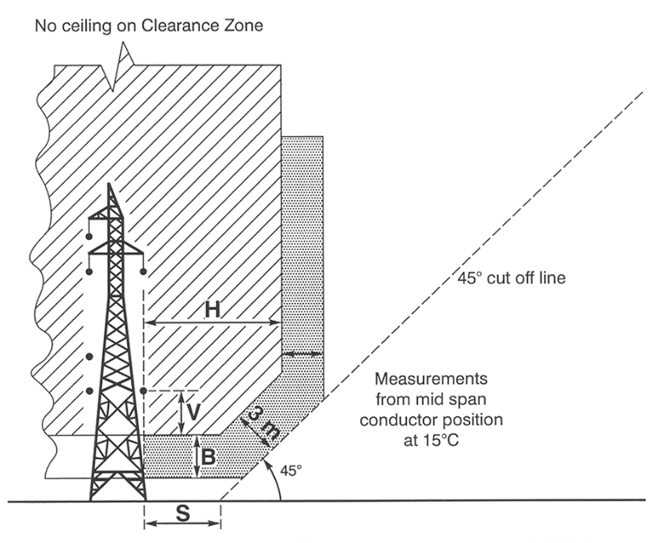
E.3—private land in non-bushfire risk area—not insulated 132kV to 275kV—view of clearance zone from above
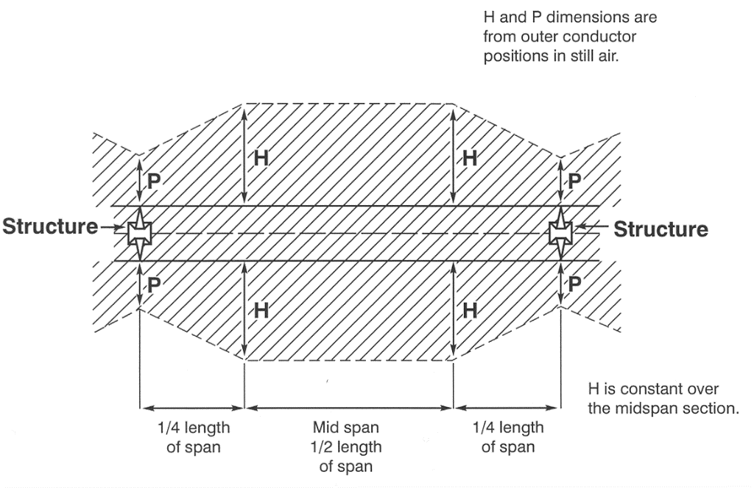
E.4—private land in non-bushfire risk area—not insulated 132kV to 275kV—view of clearance zone from side
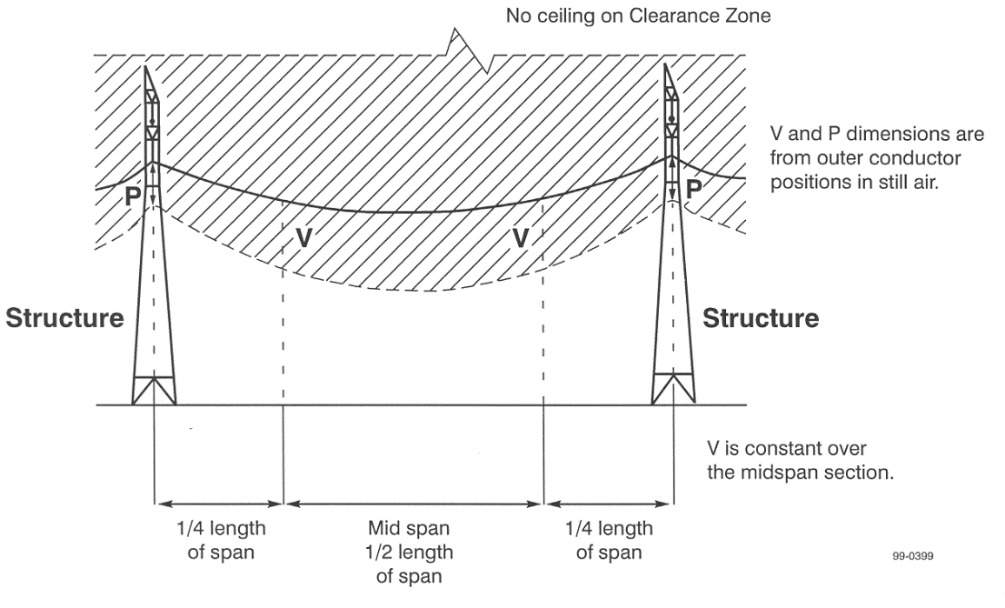

4—Clearance and buffer zones around overhead powerlines in the bushfire risk area
(1) Diagram A—bushfire risk area—fully insulated
This diagram applies to a powerline the conductors of which are fully insulated (for example, aerial bundled cables).
The zones as shown extend along the length of each span of the powerline.
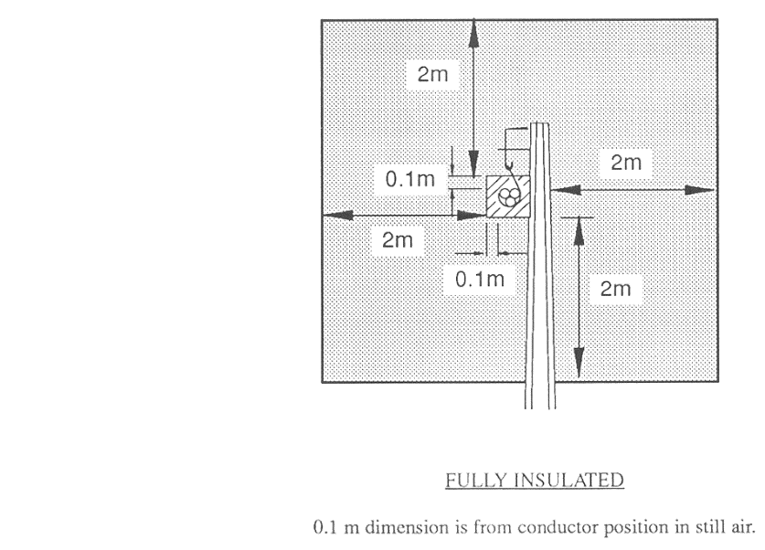
(2) Diagram B—bushfire risk area—insulated unscreened
This diagram applies to a powerline the conductors of which are Insulated Unscreened Conductor ("IUC" or "CCT").
The zones as shown extend along the length of each span of the powerline.
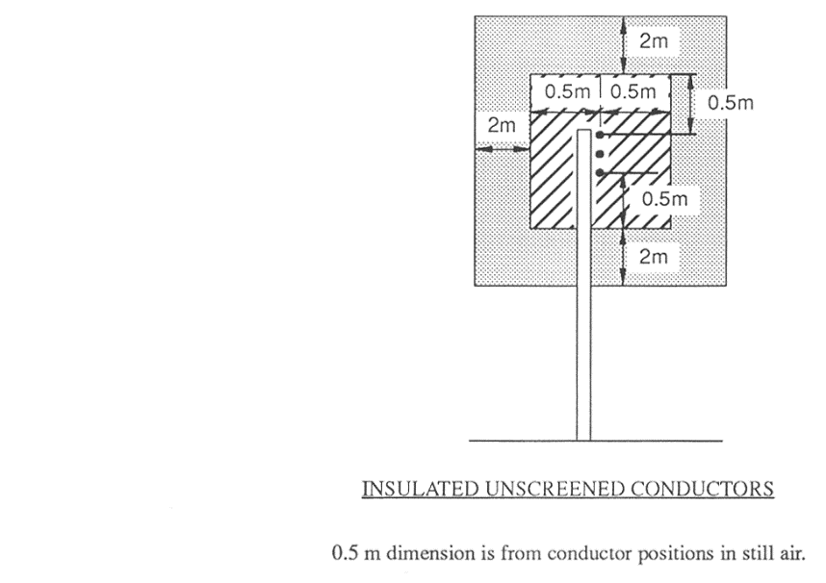

(3) Diagram C—bushfire risk area—not insulated less than 33kV
These diagrams apply to a powerline, the conductors of which are not insulated, constructed to operate at a voltage of less than 33kV.
Diagram C.1 shows the zones at the pole or other support at the end of each span of the powerline.
Diagram C.2 shows the zones at mid span (as shown in diagrams C.3 and C.4) for each span of the powerline.
Diagrams C.3 and C.4 show the manner in which the clearance zone extends along the length of each span of the powerline.
Although not shown in diagrams C.3 and C.4, the buffer zone as shown in diagrams C.1 and C.2 extends along the length of each span of the powerline.
The values of V, H and P are set out in Tables 1 and 2 in clause 5.
C.1—bushfire risk area—not insulated less than 33kV—at each end of a span
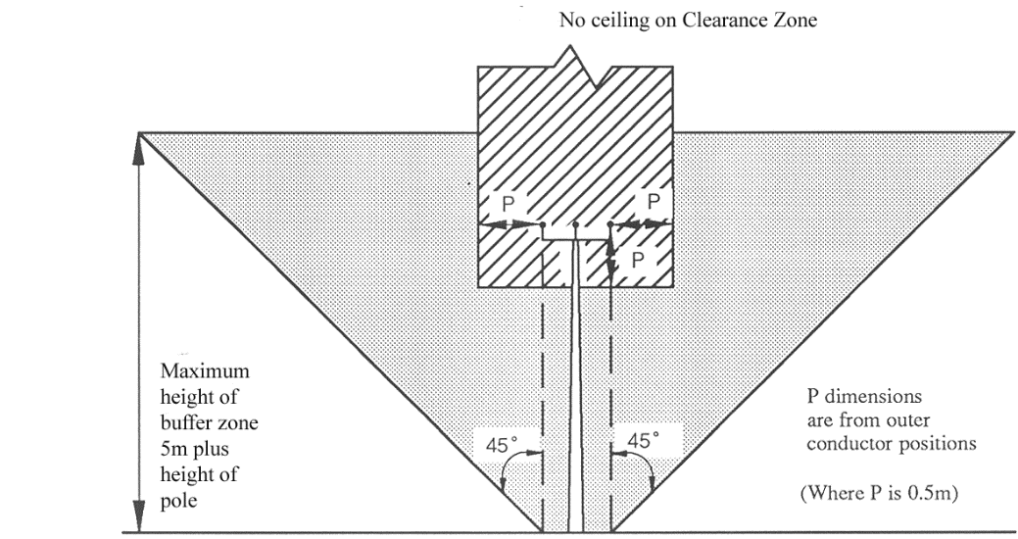
C.2—bushfire risk area—not insulated less than 33kV—mid span
(as shown in diagrams C.3 and C.4)
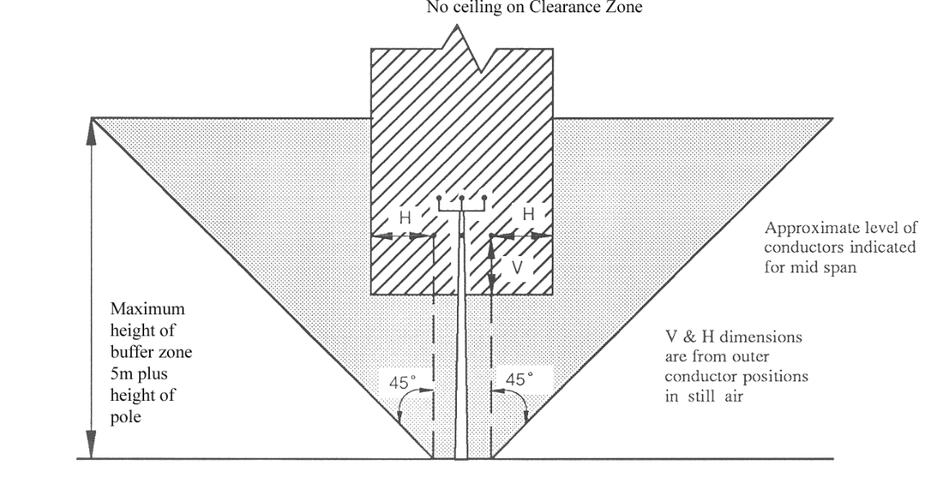

C.3—bushfire risk area—not insulated less than 33kV—view of clearance zone
from above
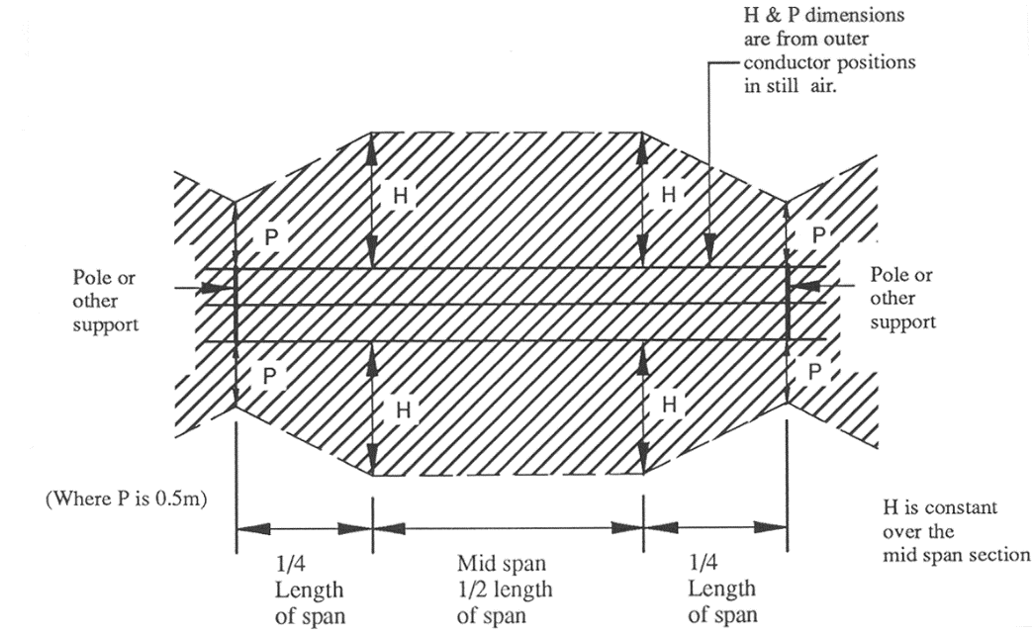
C.4—bushfire risk area—not insulated less than 33kV—view of clearance zone
from side
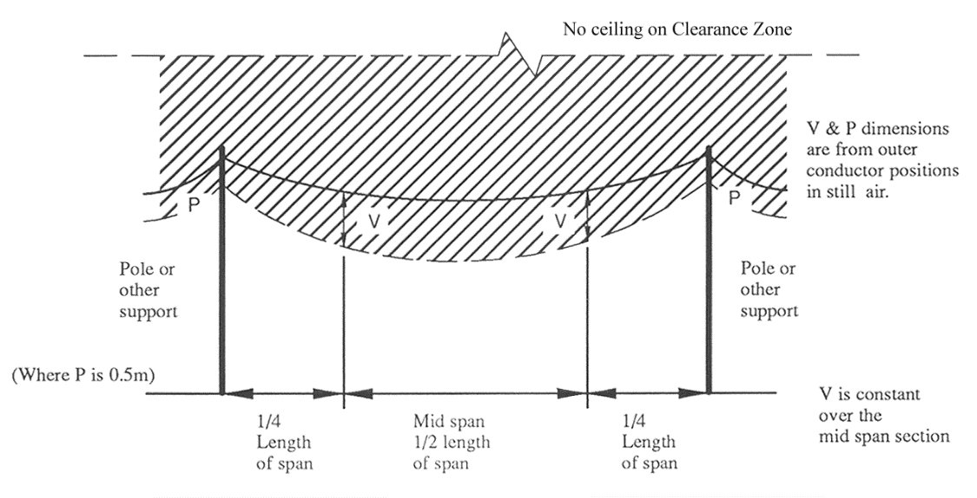
(4) Diagram D—bushfire risk area—not insulated 33kV to 66kV
These diagrams apply to a powerline, the conductors of which are not insulated, constructed to operate at a voltage from 33kV to 66kV inclusive.
Diagram D.1 shows the zones at the pole or other support at the end of each span of the powerline.
Diagram D.2 shows the zones at mid span (as shown in diagrams D.3 and D.4) for each span of the powerline.
Diagrams D.3 and D.4 show the manner in which the clearance zone extends along the length of each span of the powerline.
Although not shown in diagrams D.3 and D.4, the buffer zone as shown in diagrams D.1 and D.2 extends along the length of each span of the powerline.
The values of V, H and P are set out in Table 3 in clause 5.
D.1—bushfire risk area—not insulated 33kV to 66kV—at each end of a span
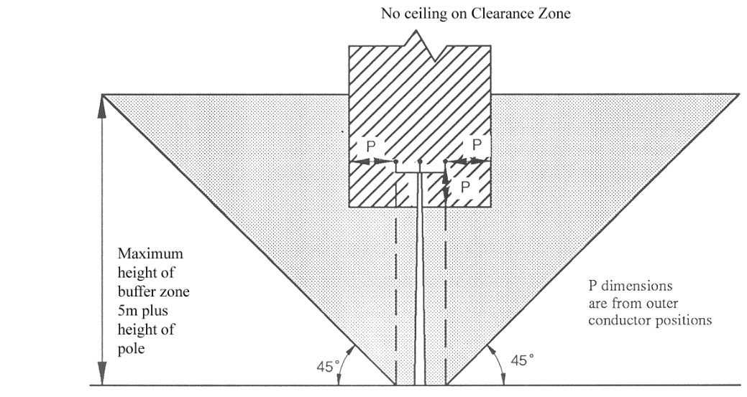
D.2—bushfire risk area—not insulated 33kV to 66kV—mid span
(as shown in diagrams D.3 and D.4)
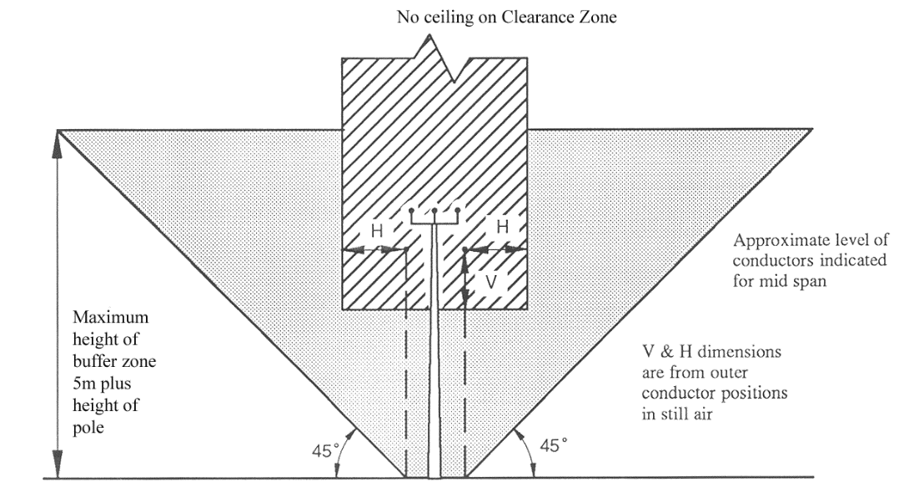

D.3—bushfire risk area—not insulated 33kV to 66kV—view of clearance zone
from above
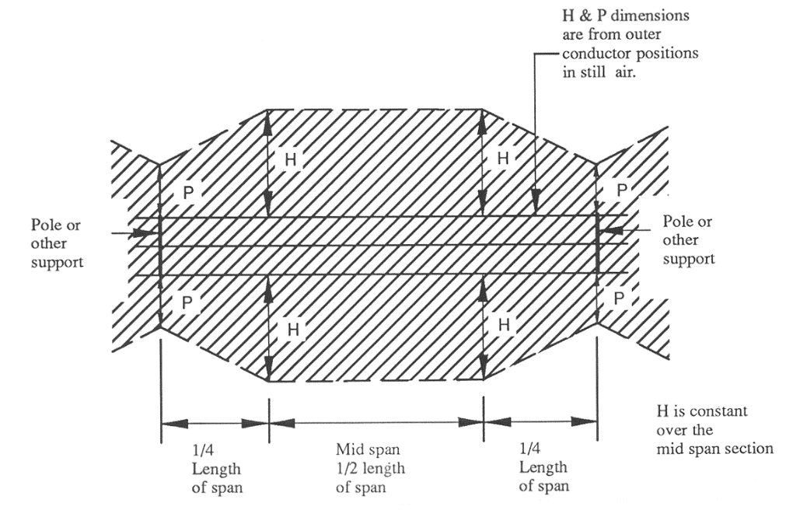
D.4—bushfire risk area—not insulated 33kV to 66kV—view of clearance zone
from side
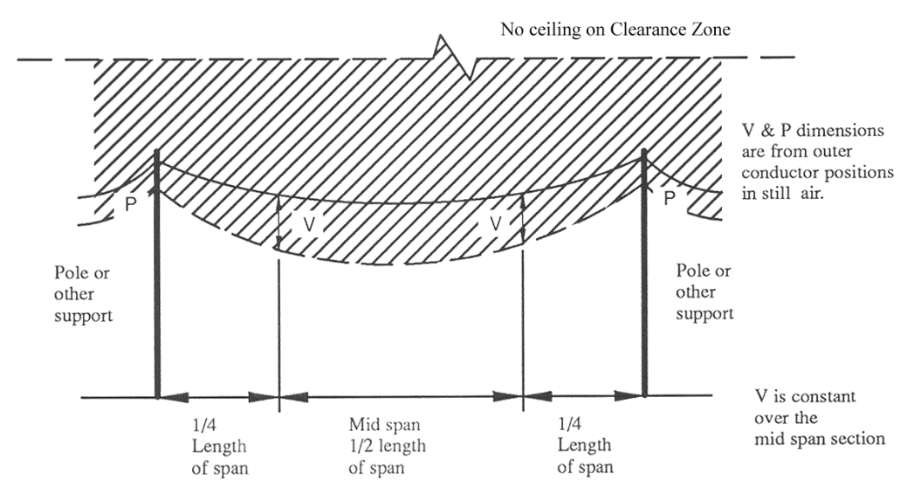

(5) Diagram E—bushfire risk area—not insulated 132kV to 275kV
These diagrams apply to a powerline, the conductors of which are not insulated, constructed to operate at a voltage from 132kV to 275kV inclusive.
Diagram E.1 shows the zones at the pole or other support at the end of each span of the powerline.
Diagram E.2 shows the zones at mid span (as shown in diagrams E.3 and E.4) for each span of the powerline.
Diagrams E.3 and E.4 show the manner in which the clearance zone extends along the length of each span of the powerline.
Although not shown in diagrams E.3 and E.4, the buffer zone as shown in diagrams E.1 and E.2 extends along the length of each span of the powerline.
The values of V, H, S, B and P are set out in Table 4 in clause 5.
The 45° component of the clearance zone is determined as being 3 m inside the buffer zone.
E.1—bushfire risk area—not insulated 132kV to 275kV—at each end of a span
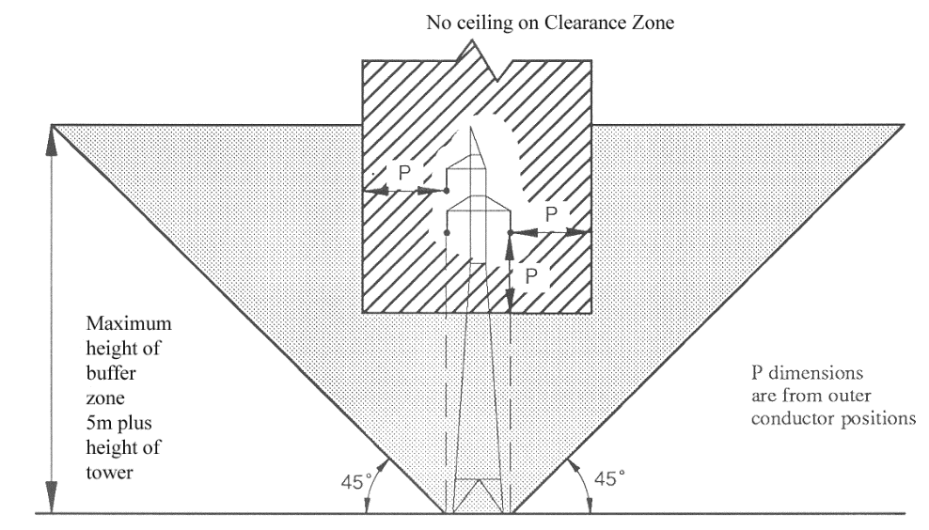
E.2—bushfire risk area—not insulated 132kV to 275kV—mid span
(as shown in diagrams E.3 and E.4)
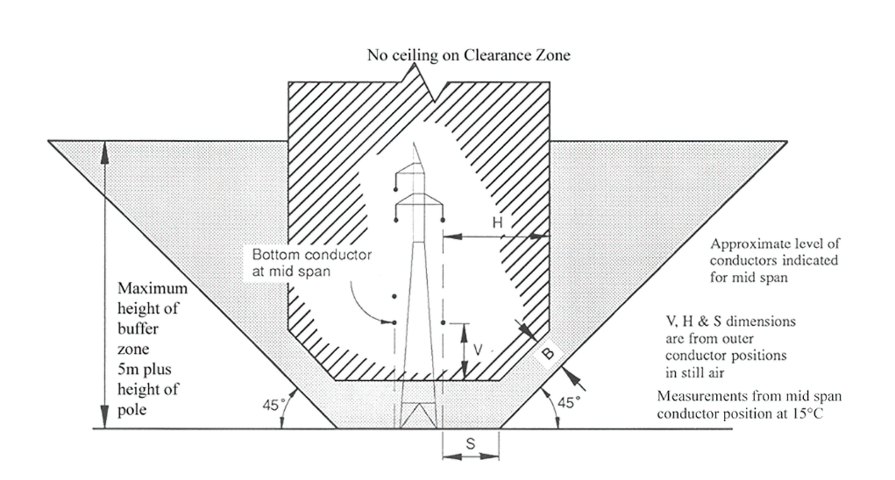

E.3—bushfire risk area—not insulated 132kV to 275kV—view of clearance zone
from above
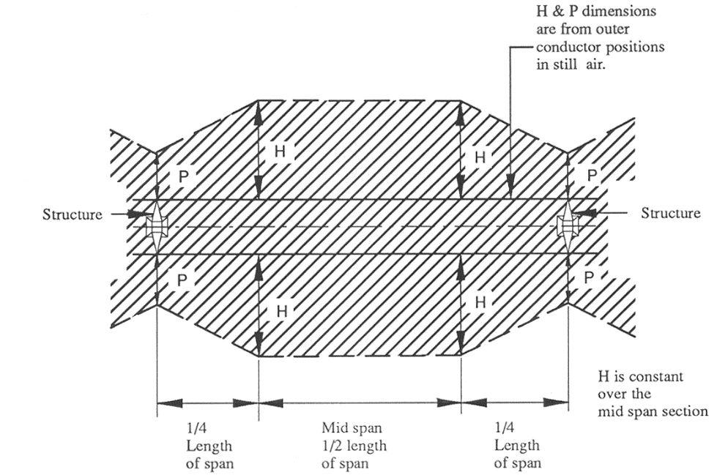
E.4—bushfire risk area—not insulated 132kV to 275kV—view of clearance zone
from side
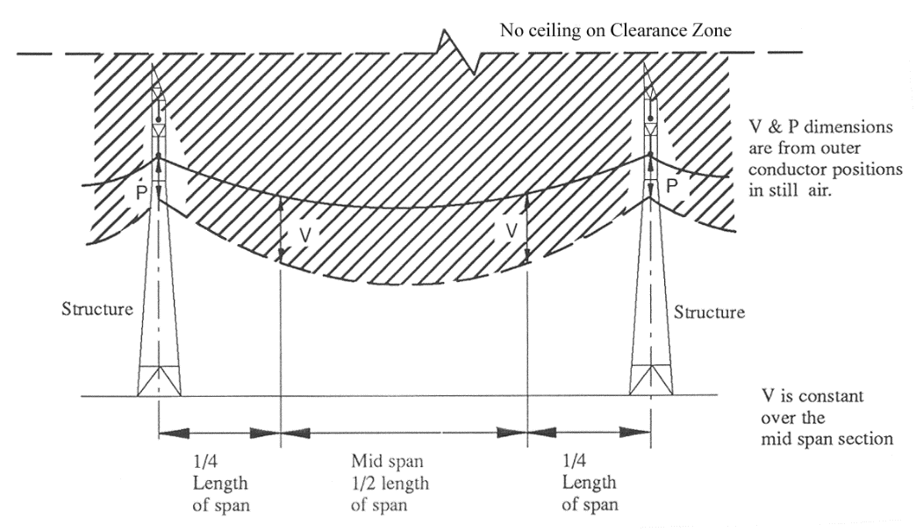
5—Tables for determination of value of V, H, B, S and P
(1) The values of V, H, B, S and P are determined by the voltage at which the powerline is constructed to operate and the length of the span concerned.
(2) For 132kV and 275kV lines, a "stepout" S is required for the buffer zone.
(3) For the purposes of compliance with the requirements of these regulations as to clearance of vegetation from around powerlines, as an alternative, the value of S may be taken to be that fixed for S* in Table 4 provided that the clearance zone will still extend at least—
(a) in the case of a 132kV line—1.5 m; or
(b) in the case of a 275kV line—2.5 m,
beyond any point to which the line may swing or sag at a wind pressure of 400Pa (taking into account the length of the span concerned and the characteristics of the line).
(4) The values given are in metres.
(5) The clearance to uninsulated LV conductors in non-bushfire risk areas is 0.1 m for the length of the line and beyond termination poles or structures, as is also the case for fully insulated conductors in any part of the State.
(6) The value of P determines the clearances required beyond a pole where a line terminates, in addition to clearances at poles or other supports along the length of the powerline.
(7) A buffer zone of 1 m and no clearance zone applies where a neutral conductor (CMEN) is not within the clearance zone or buffer zone of an adjoining conductor.
(8) The clearance to Insulated Unscreened Conductor ("IUC" or "CCT") is 0.5 m for the length of the line and beyond termination poles or structures, in any part of the State.

Table 1—Bare or covered conductor at operating voltages of 240V to 11kV
Voltage | All spans | Span (in metres)
 |  | 0–50 |  | Over 50–100 |  | Over 100–150 |  | Over 150–200 |  | Over 200
 | P | V | H | V | H | V | H | V | H | V | H
Voltage not exceeding 480V in the bushfire risk area only | 0.5 | 1.0 | 1.0 | 1.5 | 2.5 | 1.5 | 3.5 | — | — | — | —
7.6kV and 11kV in bushfire and non-bushfire risk areas | 0.5 | 1.5 | 1.5 | 2.0 | 2.5 | 2.5 | 3.5 | 2.5 | 4.5 | 2.5 | 6.0

Table 2—Bare or covered conductor at an operating voltage of 19kV
Voltage | All spans | Span (in metres)
 |  | 0–100 |  | Over 100–200 |  | Over 200–300 |  | Over 300–400 |  | Over 400
 | P | V | H | V | H | V | H | V | H | V | H
19kV single wire earth return (SWER) | 0.5 | 1.0 | 1.0 | 1.0 | 2.5 | 1.5 | 5.0 | 2.0 | 7.0 | 2.0 | 9.0

Table 3—Bare or covered conductor at operating voltages of 33kV and 66kV
Voltage |  |  |  | Span (in metres)
 | All spans |  |  | 0–100 | Over 100–200 | Over 200–300 | Over 300–400 | Over 400–500 | Over 500–600 | Over 600–700 | Over 700–800 | Over 800–900 | Over 900
 | V | P | B | H | H | H | H | H | H | H | H | H | H
33kV | 2.5 | 0.5 | 2.0 | 2.5 | 4.5 | 6.5 | 9.5 | 14.0 | 19.0 | 25.0 | 32.0 | 39.5 | 48.0
66kV | 3.0 | 1.0 | 2.0 | 2.5 | 4.5 | 6.5 | 9.5 | 14.0 | 19.0 | 25.0 | 32.0 | 39.5 | 48.0

6—Technical Regulator may determine values for clearance zone around particular powerline in certain circumstances
(1) The Technical Regulator may, on application by an electricity entity with a duty under section 55 of the Act in relation to an overhead powerline, determine that for the purposes of that duty in relation to a specified portion of the powerline—
(a) the value of V, H, B or S is to be a specified number of metres instead of the value given in clause 5; or
(b) a particular method may be used to calculate the value of V, H, B or S instead of V, H, B or S having the value given in clause 5.
(2) The Technical Regulator must not make a determination under subclause (1) unless satisfied by the electricity entity that the clearance zone will still extend at least—
(a) in the case of a 240V to 11kV, 19kV or 33kV line—0.5 m; or
(b) in the case of a 66kV line—1.0 m; or
(c) in the case of a 132kV line—1.5 m; or
(d) in the case of a 275kV line—2.5 m,
beyond any point to which the line may swing or sag at a wind pressure of 400Pa (taking into account the length of the span concerned and the characteristics of the line).
(3) An application under this clause must—
(a) be made in a form approved by the Technical Regulator; and
(b) contain the information specified in the form; and
(c) be accompanied by an application fee fixed by the Minister.
(4) A determination under this clause must be in writing.
(5) The Technical Regulator may, by notice in writing to an electricity entity with a duty under section 55 of the Act in relation to a powerline to which a determination under this clause relates, vary or revoke the determination.
Schedule 2—Planting or nurturing vegetation near public powerlines
1—Interpretation
In this Schedule—
approved vegetation means species in the list of vegetation with an expected mature height of 3 m or less published on a website determined by the Technical Regulator;
exempt vegetation means—
(a) vegetation (such as small plants that produce flowers or vegetables, ground covers, cereal crops or small bushes or shrubs) with an expected mature height of less than 2 m; or
(b) vegetation in relation to which an exemption is in force under these regulations;

permitted vegetation means species in the list of vegetation with an expected mature height of more than 3 m but not more than 6 m published on a website determined by the Technical Regulator;
prescribed distance means—
(a) in the case of a powerline constructed to operate at a voltage listed below—the distance set out below in relation to that voltage:

Voltage | Distance (in metres)
500kV | 19.0
275kV | 12.5
132kV, other than a single pole | 15.0
132kV, single pole | 10.0
66kV | 6.5
(b) in any other case—6 m.
2—General rules
(1) Subject to clause 3, only vegetation of a kind set out in the third column of Table 1 may be planted within the distance set out in the second column from a powerline of a kind set out in the first column.
(2) Subject to clause 3, only vegetation of a kind set out in the third or fourth column of Table 1 may be nurtured if it is growing within the distance set out in the second column from a powerline of a kind set out in the first column.
3—Exemption
Vegetation may be planted in proximity to a public powerline in a non-bushfire risk area and any such vegetation may be nurtured, if—
(a) the vegetation is planted in replacement of vegetation in a stand or avenue of vegetation situated along a road; and
(b) the vegetation is of the same species as that being replaced.
4—Table

Table 1—General rules
Powerline | Distance within which planting or nurturing is controlled | Vegetation which may be planted or nurtured | Additional vegetation which may be nurtured
Overhead public powerline, the conductors of which are not insulated, in the bushfire risk area. | Prescribed distance from centreline. | Approved vegetation.  Exempt vegetation. | Any vegetation planted or self-sown before 1 November 1988.
 | More than the prescribed distance but less than twice the prescribed distance from centreline. | Approved vegetation or permitted vegetation.  Exempt vegetation. | Any vegetation planted or self-sown before 1 November 1988.
Any other overhead public powerline. | Prescribed distance from centreline. | Approved vegetation or permitted vegetation.  Exempt vegetation. | Any vegetation planted or self-sown before 1 November 1988.
Underground public powerline constructed to operate at a voltage of 66kv or more. | 3 m from centreline. | Approved vegetation.  Exempt vegetation. | Any vegetation planted or self-sown before 1 November 1988.
Any other underground public powerline. | No control.
Schedule 3—Revocation of Electricity (Principles of Vegetation Clearance) Regulations 2010
The Electricity (Principles of Vegetation Clearance) Regulations 2010 are revoked.
Note—
As required by section 10AA(2) of the Subordinate Legislation Act 1978, the Minister has certified that, in the Minister's opinion, it is necessary or appropriate that these regulations come into operation as set out in these regulations.
Made by the Governor
after consulting with the Minister responsible for the administration of the Environment Protection Act 1993 and with the advice and consent of the Executive Council
on 12 August 2021
No 114 of 2021

South Australia

COVID-19 Emergency Response (Savings and Transitional Matters) Regulations 2021
under the COVID-19 Emergency Response Act 2020

Contents
1 Short title
2 Commencement
3 Interpretation
4 Orders to continue in force

1—Short title
These regulations may be cited as the COVID-19 Emergency Response (Savings and Transitional Matters) Regulations 2021.
2—Commencement
These regulations come into operation on the day on which they are made.
3—Interpretation
In these regulations, unless the contrary intention appears—
Act means the COVID-19 Emergency Response Act 2020;
licensing authority has the same meaning as in the Supported Residential Facilities Act 1992;
Tribunal means the South Australian Civil and Administrative Tribunal established under the South Australian Civil and Administrative Tribunal Act 2013.
4—Orders to continue in force
(1) Pursuant to section 20 of the Act, an order of the Tribunal under, or made for the purposes of, section 8 of the Act in force immediately before the designated day will, on and from the designated day, continue in force for the period specified in, or as contemplated by, the order or until revoked by the Tribunal by further order.
(2) Pursuant to section 20 of the Act, an order of the Tribunal under, or made for the purposes of, section 9 of the Act in force immediately before the designated day will, on and from the designated day, continue in force for the period specified in, or as contemplated by, the order or until revoked by the Tribunal by further order.
(3) Pursuant to section 20 of the Act, an order of the Tribunal or a licensing authority under, or made for the purposes of, section 10 of the Act in force immediately before the designated day will, on and from the designated day, continue in force for the period specified in, or as contemplated by, the order or until revoked by the Tribunal or licensing authority (as the case requires) by further order.

(4) The Tribunal or licensing authority (as the case requires) may, on application—
(a) vary or revoke an order referred to in a preceding subregulation; and
(b) make such other orders as the Tribunal or licensing authority thinks fit.
(5) In this regulation—
designated day means—
(a) for the purposes of subregulation (1)—the day on which section 8 of the Act expires; and
(b) for the purposes of subregulation (2)—the day on which section 9 of the Act expires; and
(c) for the purposes of subregulation (3)—the day on which section 10 of the Act expires.
Note—
As required by section 10AA(2) of the Subordinate Legislation Act 1978, the Minister has certified that, in the Minister’s opinion, it is necessary or appropriate that these regulations come into operation as set out in these regulations.
Made by the Governor
with the advice and consent of the Executive Council
on 12 August 2021
No 115 of 2021

South Australia

Criminal Law Consolidation (General) Regulations 2021
under the Criminal Law Consolidation Act 1935

Contents
1 Short title
2 Commencement
3 Interpretation
4 Prescribed occupations and employment—aggravated offences
5 Emergency workers and employing authorities
6 Certain conduct not to constitute street race
7 Prescribed objects
8 Certain activities or functions not to constitute administering website
9 Certain activities or functions not to constitute hosting website
10 Relevant industry regulatory authority
11 Prescribed explosive substances
12 Prescribed equipment
13 Dealing with surrendered items
14 False or misleading information entered into electronic court management system
15 Determination of appropriate form of custody—section 269X
Schedule 1—Revocation of Criminal Law Consolidation (General) Regulations 2006

1—Short title
These regulations may be cited as the Criminal Law Consolidation (General) Regulations 2021.
2—Commencement
These regulations come into operation on the day on which they are made.
3—Interpretation
In these regulations, unless the contrary intention appears—
Act means the Criminal Law Consolidation Act 1935.
4—Prescribed occupations and employment—aggravated offences
(1) For the purposes of section 5AA(1)(ka) of the Act, the following occupations and employment are prescribed:
(a) emergency work;
(b) employment as a person (whether a medical practitioner, nurse, midwife, security officer or otherwise) performing duties in a hospital (including, to avoid doubt, a person providing assistance or services to another person performing duties in a hospital);
(c) employment as a person (whether a medical practitioner, nurse, pilot or otherwise) performing duties in the course of retrieval medicine;
(d) employment as a medical practitioner or other health practitioner (both within the meaning of the Health Practitioner Regulation National Law (South Australia)) attending an out of hours or unscheduled callout, or assessing, stabilising or treating a person at the scene of an accident or other emergency, in a rural area;
(e) employment as a person designated as an officer of the Department under section 4A of the Correctional Services Act 1982;
(f) passenger transport work;
(g) police support work;
(h) employment as a court security officer;
(i) employment as a bailiff appointed under the South Australian Civil and Administrative Tribunal Act 2013;
(j) employment as a protective security officer within the meaning of the Protective Security Act 2007;
(k) employment as an inspector within the meaning of the Animal Welfare Act 1985.
(2) In this regulation—
accident or emergency department of a hospital means the part of a hospital dedicated to the hospital’s major accident and emergency functions, including those areas of the department used for administrative, waiting, reception, storage, diagnostic, treatment, consultation, triage and resuscitation functions and the access bays for ambulance and police;
court security officer means a sheriff, deputy sheriff, sheriff’s officer or security officer within the meaning of the Sheriff’s Act 1978;
emergency means an event that causes or threatens to cause—
(a) the death of, or injury or other damage to the health of, any person; or
(b) the destruction of, or damage to, property; or
(c) a disruption to essential services or to services usually enjoyed by the community; or
(d) harm to the environment, or to flora or fauna;
emergency services provider means—
(a) South Australian Country Fire Service; or
(b) South Australian Metropolitan Fire Service; or
(c) South Australian State Emergency Service; or
(d) SA Ambulance Service Inc; or
(e) St John Ambulance Australia South Australia Incorporated; or
(f) Surf Life Saving South Australia Incorporated; or
(g) Royal Flying Doctor Service; or
(h) Air Sea Rescue Squadron Cowell Incorporated; or
(i) Australian Volunteer Coast Guard Association Incorporated; or
(j) Royal Volunteer Coastal Patrol (SA) Incorporated; or
(k) South Australian Sea Rescue Squadron Incorporated; or
(l) Victor Harbor-Goolwa Sea Rescue Squadron Incorporated; or
(m) Whyalla Sea Rescue Squadron Incorporated; or
(n) the accident or emergency department of a hospital;
emergency work means work carried out (whether or not in response to an emergency) by or on behalf of an emergency services provider;
hospital has the same meaning as in the Health Care Act 2008;
medical practitioner has the same meaning as in the Health Practitioner Regulation National Law (South Australia);
passenger transport service has the same meaning as in the Passenger Transport Act 1994;
passenger transport work means—
(a) work consisting of driving a public passenger vehicle for the purposes of a passenger transport service; or
(b) work undertaken as an authorised officer appointed under section 53 of the Passenger Transport Act 1994; or
(c) work undertaken as an authorised person under Part 4 Division 2 Subdivision 2 of the Passenger Transport Regulations 2009;
police support work means work consisting of the provision of assistance or services to South Australia Police (and includes, to avoid doubt, the provision of assistance or services to a member of the public who is being assisted, or seeking to be assisted, by South Australia Police);
public passenger vehicle has the same meaning as in the Passenger Transport Act 1994;
retrieval medicine means the assessment, stabilisation and transportation to hospital of patients with severe injury or critical illness (other than by a member of SA Ambulance Service Inc);
rural area means an area outside of Metropolitan Adelaide as defined by GRO Plan 639/93.
5—Emergency workers and employing authorities
(1) For the purposes of the definition of emergency workers in section 19A(11) of the Act, the following persons are emergency workers for the purposes of that section:
(a) members of an emergency services organisation within the meaning of the Fire and Emergency Services Act 2005;
(b) persons engaged in the provision of emergency ambulance services in accordance with section 57(1) of the Health Care Act 2008 on behalf of SA Ambulance Service Inc.
(2) For the purposes of paragraph (b) of the definition of employing authority in section 19A(11) of the Act, the employing authority for a person who is an emergency worker for the purposes of that section is—
(a) in relation to an emergency worker referred to in subregulation (1)(a)—
(i) if the emergency worker is a member of the South Australian Metropolitan Fire Service—the Chief Officer of SAMFS; or
(ii) if the emergency worker is a member of the South Australian Country Fire Service—the Chief Officer of SACFS; or
(iii) if the emergency worker is a member of the South Australian State Emergency Service—the Chief Officer of SASES; or
(b) in relation to an emergency worker referred to in subregulation (1)(b)—the Chief Executive Officer of SA Ambulance Service Inc.
6—Certain conduct not to constitute street race
(1) For the purposes of the definition of street race in section 19AD(7) of the Act, the following conduct is declared not to be included within the ambit of that definition:
(a) conduct reasonably occurring in the course of—
(i) obtaining a genuine qualification (however described) to operate a motor vehicle of a particular kind or in a particular manner; or
(ii) participation in a genuine program designed to improve the defensive driving skills of a person;
(b) conduct that occurs in the course of an event the subject of an order made under section 33 of the Road Traffic Act 1961 (being conduct that complies with any requirement or condition imposed in relation to the order);
(c) conduct that occurs in the course of an event the subject of a permit granted by Motorsport Australia (being conduct that complies with any requirement or condition imposed in relation to the permit);
(d) conduct that occurs in the course of an event comprising a tour, regularity trial, treasure hunt or similar event in which the participants drive in a manner that indicates a general intention to comply with the provisions of the Road Traffic Act 1961;
(e) conduct comprising a road test of a motor vehicle that occurs—
(i) in the course of the purchase, or potential purchase, of the motor vehicle; or
(ii) in the course of, or is consequential upon, repairing or maintaining the motor vehicle,
and that is undertaken in a manner that indicates a general intention on the part of the driver to comply with the provisions of the Road Traffic Act 1961;
(f) conduct that occurs with the approval of the Commissioner of Police.
(2) An application for approval under subregulation (1)(f) must be made in a manner and form determined by the Commissioner of Police.
(3) An approval under subregulation (1)(f)—
(a) must be in writing; and
(b) may be conditional or unconditional; and
(c) may be varied or revoked by the Commissioner of Police by notice in writing.
(4) If a person contravenes or fails to comply with a condition specified in an approval under subregulation (1)(f), the approval does not, while the contravention or non-compliance continues, operate in that person’s favour.
7—Prescribed objects
(1) For the purposes of section 32A of the Act, a prescribed object is an object that would, on impact with a vehicle, cause severe damage to the vehicle or harm (whether directly or indirectly) to an occupant of the vehicle (but does not include soft fruits, vegetables or eggs).
Examples—
(a) rocks;
(b) bricks;
(c) lumps, blocks or pieces of clay or concrete;
(d) sizeable or heavy pieces of metal or metal objects;
(e) sizeable or heavy pieces of wood;
(f) glass bottles;
(g) filled cans or plastic containers.
(2) In this regulation—
harm has the same meaning as in section 21 of the Act.
8—Certain activities or functions not to constitute administering website
For the purposes of the definition of administering a website in section 62 of the Act, the following are activities or functions of a kind excluded from the ambit of that definition:
(a) the administration, or assisting in the administration, of a website by a police officer or other law enforcement officer acting in the course of the officer’s duties;
(b) the administration, or assisting in the administration, of a website by any other person acting in the course of the person’s duties in the administration of the criminal justice system.
9—Certain activities or functions not to constitute hosting website
For the purposes of the definition of hosting a website in section 62 of the Act, the following are activities or functions of a kind excluded from the ambit of that definition:
(a) the hosting, or assisting in the hosting, of a website by a police officer or other law enforcement officer acting in the course of the officer’s duties;
(b) the hosting, or assisting in the hosting, of a website by any other person acting in the course of the person’s duties in the administration of the criminal justice system.
10—Relevant industry regulatory authority
For the purposes of the definition of relevant industry regulatory authority in section 62 of the Act, the eSafety Commissioner appointed under the Enhancing Online Safety Act 2015 of the Commonwealth is prescribed as a relevant industry regulatory authority for the purposes of section 63AB(3)(d) of the Act.
11—Prescribed explosive substances
For the purposes of the definition of explosive substance in section 83M(1) of the Act, the following substances are prescribed:
(a) acetone;
(b) aluminium powder;
(c) ammonium nitrate;
(d) ammonium perchlorate;
(e) hydrogen peroxide;
(f) magnesium powder;
(g) methyl ethyl ketone;
(h) nitric acid;
(i) nitromethane;
(j) potassium chlorate;
(k) potassium nitrate;
(l) potassium perchlorate;
(m) sodium azide;
(n) sodium chlorate;
(o) sodium nitrate;
(p) sodium perchlorate.
12—Prescribed equipment
(1) For the purposes of section 83O(1)(b) of the Act, the following equipment is prescribed:
(a) equipment of a kind that is used to perform the function of an ice bath or a chemical reaction cooling system in the manufacture of an explosive substance or an explosive device;
(b) equipment of a kind that is used to perform the function of grinding or mixing in the manufacture of an explosive substance or an explosive device;
(c) equipment of a kind that is used to perform the function of a reaction vessel in the manufacture of an explosive substance or an explosive device;
(d) equipment that forms part of equipment of a kind referred to in a preceding paragraph;
(e) equipment that would, but for modifications apparently made to the equipment, be equipment of a kind referred to in a preceding paragraph.
(2) Equipment may be determined to be of a kind prescribed in subregulation (1) regardless of whether the equipment—
(a) is in working order; or
(b) has been commercially manufactured or appears to be home-made.
13—Dealing with surrendered items
(1) For the purposes of sections 269NC(3) and 269OA(3) of the Act, the Commissioner of Police must deal with a surrendered item in accordance with this regulation.
(2) A surrendered item that is a prohibited weapon (within the meaning of the Summary Offences Act 1953), or that is an item that cannot otherwise be lawfully possessed in this State, is, by force of this subregulation, forfeited to the Crown.
(3) The Commissioner of Police must retain a surrendered item (other than a surrendered item forfeited under subregulation (2)) in a location determined by the Commissioner of Police until—
(a) the surrendered item is forfeited to the Crown under this or any other Act; or
(b) the surrendered item is returned in accordance with this regulation to the person who surrendered it; or
(c) the surrendered item is seized or surrendered under the provisions of another Act,
whichever occurs first.
(4) If—
(a) the condition imposed under section 269NB(4)(a) of the Act on the release on licence of the person who surrendered the surrendered item is revoked, or a Division 3A order to which the person is subject is revoked or lapses; or
(b) the condition imposed under section 269O(1a)(a) of the Act on the release on licence of the person who surrendered the surrendered item is revoked, or a supervision order to which the person is subject is revoked or lapses,
(as the case may be) the person may notify the Commissioner of Police of that fact.
(5) Subject to this regulation, if the Commissioner of Police—
(a) is notified pursuant to subregulation (4); or
(b) otherwise becomes aware that—
(i) the release on licence of the person is no longer subject to the condition imposed under section 269NB(4)(a), or the Division 3A order to which the person is subject is revoked or lapses; or
(ii) the release on licence of the person is no longer subject to the condition imposed under section 269O(1a)(a), or the supervision order to which the person is subject is revoked or lapses,
(as the case may be) the Commissioner of Police must cause the surrendered item to be returned to the person who surrendered the item.
(6) If the Commissioner of Police is required to return a surrendered item under subsection (5), the Commissioner of Police must give notice in writing to the person who surrendered the item setting out—
(a) that the surrendered items specified in the notice are to be returned to the person; and
(b) the location at which the surrendered items may be collected; and
(c) that the surrendered items must be collected from the specified location within 3 months of the date specified in the notice (or such longer time as may be specified by the Commissioner of Police); and
(d) that the surrendered items will only be returned if the person holds any necessary authorisation under the Firearms Act 2015 or any other Act to possess the surrendered item; and
(e) the effect of subregulations (7) and (8).
(7) However, the Commissioner of Police may refuse to return a surrendered item to a person if—
(a) the person is on conditional release that is subject to a condition prohibiting the person from possessing a firearm, ammunition or part of a firearm; or
(b) the person does not hold any necessary authorisation under the Firearms Act 2015 or any other Act to possess the surrendered item, or is otherwise prohibited from possessing the surrendered item,
and, if the Commissioner of Police does so refuse, he or she must give notice in writing to the person who surrendered the surrendered item setting out—
(c) the reasons for the refusal; and
(d) in the case of a refusal contemplated by subregulation (7)(a)—the effect of subregulation (9).
(8) If—
(a) a surrendered item is not collected within the period specified in subregulation (6)(c); or
(b) the person does not, at the end of the period specified in subregulation (6)(c), hold the necessary authorisation under the Firearms Act 2015 or any other Act to possess the surrendered item, or is otherwise prohibited from possessing the surrendered item,
the surrendered item is, by force of this subregulation, forfeited to the Crown.
(9) If the Commissioner of Police refuses to return a surrendered item to a person pursuant to subregulation (7)(a)—
(a) the surrendered item will be taken to have been surrendered pursuant to a direction under the provision of the Act under which the conditional release was granted (corresponding to section 269NC(1) or 269OA(1) of the Act, as the case requires); and
(b) the surrendered item must be dealt with in accordance with that Act.
(10) The Commissioner of Police may recover from the person who surrendered the surrendered item the reasonable costs incurred in connection with the storage of the surrendered item.
(11) This regulation is in addition to, and does not derogate from, the operation of any other Act or law.
(12) No compensation is payable by the Crown in respect of the forfeiture of a surrendered item under this regulation.
(13) A notice required to be given to a person under this regulation may—
(a) be given to the person personally; or
(b) be posted in an envelope addressed to the person—
(i) at the person’s last known address; or
(ii) at the person’s address for service; or
(c) be left for the person at the person’s last known address or address for service with someone apparently over the age of 16 years.
(14) In this regulation—
conditional release means—
(a) a grant of bail under the Bail Act 1985; or
(b) a bond under the Sentencing Act 2017 or the Criminal Law (Sentencing) Act 1988; or
(c) release on home detention under the Sentencing Act 2017 or the Criminal Law (Sentencing) Act 1988; or
(d) release on an intensive correction order under the Sentencing Act 2017; or
(e) release on licence under the Act, the Sentencing Act 2017 or the Criminal Law (Sentencing) Act 1988; or
(f) release from prison on home detention or parole under the Correctional Services Act 1982; or
(g) release on licence, on home detention or conditional release from detention, under the Young Offenders Act 1993;
surrendered item means a firearm, ammunition or any part of a firearm surrendered pursuant to a direction under section 269NC(1) or 269OA(1) of the Act.
14—False or misleading information entered into electronic court management system
(1) For the purposes of the definition of ECMS in section 241A(3) of the Act, the electronic court management systems established under the Uniform Civil Rules 2020 and the Supreme Court Probate Rules 2015 are prescribed.
(2) For the purposes of paragraph (b) of the definition of enters information into an ECMS in section 241A(3) of the Act, the marking of a check box (however described) selecting a particular option is prescribed.
(3) For the purposes of the definition of information in section 241A(3) of the Act, the following information, or information of a kind, is prescribed:
(a) information setting out—
(i) in the case of a party who is a natural person—
(A) the name, business name or trading name of the person; or
(B) an Australian Business Number; or
(C) the date of birth of the person; or
(D) the residential address of the person; or
(E) an address at which documents can be served on the person; or
(F) a telephone number; or
(G) an email address; or
(ii) in the case of a party who is a body corporate—
(A) the name, business name or trading name of the body corporate; or
(B) an Australian Business Number or Australian Company Number; or
(C) the name, date of birth and residential address of a director of the body corporate; or
(D) the registered office (if any) of the body corporate (within the meaning of the Corporations Act 2001 of the Commonwealth); or
(E) an address at which the body corporate undertakes activities; or
(F) an address at which documents can be served on the body corporate; or
(G) a telephone number; or
(H) an email address;
(b) in the case where a party is acting, or purportedly acting, on behalf of another person or body—information identifying that person or body, the relationship of that person or body to the party and the basis on which the party is acting on behalf of that person or body;
(c) information setting out the nature of a party (for example, whether a party is an individual, partnership, organisation or regular party);
(d) information relating to whether a specified person is a legal practitioner;
(e) information relating to whether any relevant orders have been made by a court or tribunal and the terms of those orders;
(f) information relating to a probate, testamentary or administration matter (including, to avoid doubt, information relating to the assets and liabilities of a person or any other information which may affect a right or liability in relation to an estate).
15—Determination of appropriate form of custody—section 269X
(1) For the purposes of the definition of designated officer in section 269X(7) of the Act, the office of Clinical Director, Forensic Mental Health Services, Department for Health and Wellbeing, is prescribed.
(2) In determining an appropriate form of custody for the detention of a defendant pursuant to section 269X(5) of the Act, the designated officer must consult with the CE (within the meaning of section 269X) and take into account any representation made to the designated officer by the CE in respect of an appropriate form of custody for the defendant.
Schedule 1—Revocation of Criminal Law Consolidation (General) Regulations 2006
The Criminal Law Consolidation (General) Regulations 2006 are revoked.
Note—
As required by section 10AA(2) of the Subordinate Legislation Act 1978, the Minister has certified that, in the Minister’s opinion, it is necessary or appropriate that these regulations come into operation as set out in these regulations.
Made by the Governor
with the advice and consent of the Executive Council
on 12 August 2021
No 116 of 2021

South Australia

Professional Standards Regulations 2021
under the Professional Standards Act 2004

Contents
1 Short title
2 Commencement
3 Interpretation
4 Fees
5 Period within which scheme may be challenged
6 Notification of limitation of liability
Schedule 1—Fees
Schedule 2—Revocation and transitional provisions
Part 1—Preliminary
1 Interpretation
Part 2—Revocation
2 Revocation of Professional Standards Regulations 2006
Part 3—Transitional provisions
3 Fees and interest
4 Period for challenge
5 Form of statement of limitation of liability

1—Short title
These regulations may be cited as the Professional Standards Regulations 2021.
2—Commencement
These regulations come into operation on the day on which they are made.
3—Interpretation
In these regulations, unless the contrary intention appears—
Act means the Professional Standards Act 2004;
professional standards legislation means the Act or a law of another State that is similar in effect to the Act.

4—Fees
(1) The fees fixed by Schedule 1 are payable to the Council.
(2) An occupational association whose members are subject to a scheme in force under the Act must pay the annual fee in respect of each member of the association—
(a) if the relevant scheme commences during the period of 3 months ending on 31 March in any year—not later than 31 March in each year; or
(b) if the relevant scheme commences during the period of 3 months ending on 30 June in any year—not later than 30 June in each year; or
(c) if the relevant scheme commences during the period of 3 months ending on 30 September in any year—not later than 30 September in each year; or
(d) if the relevant scheme commences during the period of 3 months ending on 31 December in any year—not later than 31 January of each following year.
(3) However, if at any time a scheme in force under the Act becomes applicable to an additional member of an occupational association, the association must pay the annual fee in respect of the additional member—
(a) if the scheme becomes applicable to the member during the period of 3 months ending on 31 March in a year—not later than 31 March in the year; or
(b) if the scheme becomes applicable to the member during the period of 3 months ending on 30 June in a year—not later than 30 June in the year; or
(c) if the scheme becomes applicable to the member during the period of 3 months ending on 30 September in a year—not later than 30 September in the year; or
(d) if the scheme becomes applicable to the member during the period of 3 months ending on 31 December in a year—not later than 31 January of the following year.
(4) If any part of the annual fee (including a payment required under subregulation (3)) is not paid within 30 days after it is due, simple interest at the rate of 0.05% per day is payable to the Council on the outstanding balance until the balance is paid.
(5) The Council may, if it considers that there are special reasons for doing so in a particular case, remit (in whole or in part) either or both of the following:
(a) a fee fixed by Schedule 1;
(b) interest payable under subregulation (4).
(6) However, if the Council delegates its power under subregulation (5) to the Executive Officer of the Council, the maximum amount of a fee or interest that may be remitted is $250.
5—Period within which scheme may be challenged
For the purposes of subsection (1) of section 16 of the Act, the prescribed period within which a person may apply to the Supreme Court for an order that a scheme referred to in that subsection is void is 2 months after the date on which the scheme comes into operation.
6—Notification of limitation of liability
For the purposes of section 35(2) of the Act, the prescribed form of statement is the following statement printed or typewritten in a size not less than the face measurement of Times New Roman typeface in 8 point:
Liability limited by a scheme approved under professional standards legislation.
Schedule 1—Fees

1 | For an application by an occupational association—
 | (a) for approval of a scheme prepared under section 8 of the Act | $5 000
 | (b) for an amendment to, or revocation of, such a scheme | $5 000
2 | Annual fee payable in respect of each member of an occupational association subject to a scheme in force under the Act | $50
Schedule 2—Revocation and transitional provisions
Part 1—Preliminary
1—Interpretation
In this Schedule—
the revoked regulations means the Professional Standards Regulations 2006.
Part 2—Revocation
2—Revocation of Professional Standards Regulations 2006
The Professional Standards Regulations 2006 are revoked.
Part 3—Transitional provisions
3—Fees and interest
(1) A fee payable under a provision of the revoked regulations relating to a scheme in force under the Act prior to the commencement of these regulations—
(a) that fell due before the commencement of these regulations; or
(b) that would, but for the commencement of these regulations, have fallen due after that commencement,
that has not been paid prior to the commencement of these regulations will, on the commencement of these regulations, be taken be so due and payable under the equivalent provision of these regulations.
(2) Interest payable under a provision of the revoked regulations that fell due, but has not been paid, prior to the commencement of these regulations will after the commencement of these regulations be taken to be so due and payable (and, where applicable, continue to accrue) under the equivalent provision of these regulations.
(3) A remittance of a fee or interest made pursuant to a provision of the revoked regulations will, on the commencement of these regulations, be taken to have been made under the equivalent provision of these regulations.

4—Period for challenge
Where—
(a) a scheme is in force under the Act prior to the commencement of these regulations; and
(b) the period prescribed under regulation 5 of the revoked regulations for an application to be made to the Supreme Court for the purposes of section 16(1) of the Act in relation to that scheme has not expired prior to the commencement of these regulations,
then on the commencement of these regulations the remainder of that period will be taken to be the prescribed period for the purposes of regulation 5 of these regulations.
5—Form of statement of limitation of liability
A statement referred to in section 35 of the Act that—
(a) was printed on a document before the commencement of these regulations; and
(b) complies with the requirements of regulation 6 of the revoked regulations in relation to such a statement,
will on the commencement of these regulations be taken to comply with the requirements of regulation 6 of these regulations in relation to such a statement.
Note—
As required by section 10AA(2) of the Subordinate Legislation Act 1978, the Minister has certified that, in the Minister’s opinion, it is necessary or appropriate that these regulations come into operation as set out in these regulations.
Made by the Governor
with the advice and consent of the Executive Council
on 12 August 2021
No 117 of 2021

South Australia

Subordinate Legislation (Postponement of Expiry) Regulations 2021
under the Subordinate Legislation Act 1978

Contents
1 Short title
2 Commencement
3 Interpretation
4 Postponement of expiry for 1 year—Regulations made before 1 January 2011
5 Expiry of obsolete regulations
Schedule 1—Postponement of expiry
Schedule 2—Expiry of obsolete regulations
Schedule 3—Revocation of Subordinate Legislation (Postponement of Expiry) Regulations 2020

1—Short title
These regulations may be cited as the Subordinate Legislation (Postponement of Expiry) Regulations 2021.
2—Commencement
These regulations come into operation on the day on which they are made.
3—Interpretation
In these regulations—
Act means the Subordinate Legislation Act 1978.
4—Postponement of expiry for 1 year—Regulations made before 1 January 2011
The expiry under Part 3A of the Act of the regulations listed in Schedule 1 is postponed for a period of 1 year commencing on 1 September 2021.
5—Expiry of obsolete regulations
The regulations listed in Schedule 2 will expire under the Act on 1 September 2021.

Schedule 1—Postponement of expiry
Adelaide Festival Centre Trust Regulations 2007
Administration and Probate Regulations 2009
Anangu Pitjantjatjara Yankunytjatjara Land Rights Regulations 2010
Architectural Practice (Election) Regulations 2010
Architectural Practice (General) Regulations 2010
Assisted Reproductive Treatment Regulations 2010
Associations Incorporation Regulations 2008
Bills of Sale Regulations 2009
Botanic Gardens and State Herbarium Regulations 2007
Child Sex Offenders Registration Regulations 2007
City of Adelaide (Elections and Polls) Regulations 2010
City of Adelaide (Members Allowances and Benefits) Regulations 2010
Construction Industry Training Fund Regulations 2008
Conveyancers Regulations 2010
Courts Administration Regulations 2008
Criminal Investigation (Extraterritorial Offences) Regulations 2010
Criminal Law (Clamping, Impounding and Forfeiture of Vehicles) Regulations 2007
Criminal Law (Forensic Procedures) Regulations 2007
Cross-border Justice Regulations 2009
Crown Land Management Regulations 2010
Crown Proceedings Regulations 2008
Dangerous Substances (Dangerous Goods Transport) Regulations 2008
Daylight Saving Regulations 2009
Electoral Regulations 2009
Electricity (Principles of Vegetation Clearance) Regulations 2010
Emergency Management Regulations 2009
Employment Agents Registration Regulations 2010
Environment Protection Regulations 2009
Evidence Regulations 2007
Fair Trading (Health and Fitness Industry Code) Regulations 2007
Fair Trading Regulations 2010
Fair Work (Clothing Outworker Code of Practice) Regulations 2007
Fair Work (General) Regulations 2009
Fair Work (Representation) Regulations 2009
Family and Community Services Regulations 2009
Family Relationships Regulations 2010
Fisheries Management (Lakes and Coorong Fishery) Regulations 2009
Freedom of Information (Exempt Agency) Regulations 2008
Harbors and Navigation Regulations 2009
Harbors and Navigation (Alcohol and Drug Testing) Regulations 2009
Health Care Regulations 2008
Health Practitioner Regulation National Law (South Australia) Regulations 2010
History Trust of South Australia Regulations 2010
Hydroponics Industry Control Regulations 2010
Irrigation Regulations 2009
Land Agents Regulations 2010
Land and Business (Sale and Conveyancing) Regulations 2010
Land Tax Regulations 2010
Land Valuers Regulations 2010
Local Government (Elections) Regulations 2010
Local Government (Members Allowances and Benefits) Regulations 2010
Lottery and Gaming Regulations 2008
Marine Parks Regulations 2008
Members of Parliament (Register of Interests) Regulations 2008
Mental Health Regulations 2010
Motor Vehicles Regulations 2010
National Parks and Wildlife (Protected Animals—Marine Mammals) Regulations 2010
Outback Communities (Administration and Management) Regulations 2010
Passenger Transport Regulations 2009
Petroleum Products Regulations 2008
Plant Health Regulations 2009
Plastic Shopping Bags (Waste Avoidance) Regulations 2008
Plumbers, Gas Fitters and Electricians Regulations 2010
Primary Industry Funding Schemes (Barossa Wine Industry Fund) Regulations 2007
Primary Industry Funding Schemes (Clare Valley Wine Industry Fund) Regulations 2008
Primary Industry Funding Schemes (SA Grape Growers Industry Fund) Regulations 2007
Primary Produce (Food Safety Schemes) (Plant Products) Regulations 2010
Protective Security Regulations 2008
Public Corporations (Distribution Lessor Corporation) Regulations 2010
Public Corporations (General) Regulations 2008
Public Corporations (Generation Lessor Corporation) Regulations 2010
Public Corporations (Transmission Lessor Corporation) Regulations 2010
Public Sector (Honesty and Accountability) Regulations 2010
Public Sector Regulations 2010
Public Trustee Regulations 2010
Real Property Regulations 2009
Renmark Irrigation Trust Regulations 2009
Residential Parks Regulations 2007
Residential Tenancies Regulations 2010
Retail and Commercial Leases Regulations 2010
SACE Board of South Australia Regulations 2008
Second-hand Vehicle Dealers Regulations 2010
Serious and Organised Crime (Control) Regulations 2008
Serious and Organised Crime (Unexplained Wealth) Regulations 2010
South Australian Housing Trust Regulations 2010
Superannuation Funds Management Corporation of South Australia Regulations 2010
Supported Residential Facilities Regulations 2009
Young Offenders Regulations 2008
Schedule 2—Expiry of obsolete regulations
Natural Resources Management (Peake, Roby and Sherlock Prescribed Wells Area—Reduction of Water Access Entitlements) Regulations 2010
Schedule 3—Revocation of Subordinate Legislation (Postponement of Expiry) Regulations 2020
The Subordinate Legislation (Postponement of Expiry) Regulations 2020 are revoked.
Note—
As required by section 10AA(2) of the Subordinate Legislation Act 1978, the Minister has certified that, in the Minister’s opinion, it is necessary or appropriate that these regulations come into operation as set out in these regulations.
Made by the Governor
with the advice and consent of the Executive Council
on 12 August 2021
No 118 of 2021

State Government Instruments

Associations Incorporation Act 1985
Section 42(2)
Dissolution of Association
Whereas the Corporate Affairs Commission (the Commission) pursuant to section 42(1) of the Associations Incorporation Act 1985 (the Act) is of the opinion that the undertaking or operations of RISE CHURCH AUSTRALIA INCORPORATED (the Association) being an incorporated association under the Act are being carried on, or would more appropriately be carried on by companies limited by guarantee incorporated under the Corporations Act 2001 (Cth) and whereas the Commission was on 23 March 2021 requested by the Association to transfer its undertaking to RISE CHURCH AUSTRALIA LIMITED (Australian Company Number 642 188 798) and RISE ASSIST LTD (Australian Company Number 643 421 041), the Commission pursuant to section 42(2) of the Act does hereby order that on 12 August 2021, the Association will be dissolved, the property of the Association becomes the property of RISE CHURCH AUSTRALIA LTD and RISE ASSIST LTD and the rights and liabilities of the Association become the rights and liabilities of RISE CHURCH AUSTRALIA LTD and RISE ASSIST LTD.
Given under the seal of the Commission at Adelaide.
Dated: 10 August 2021
Lauren Hilliker
Delegate of the Corporate Affairs Commission

Building Work Contractors Act 1995
Exemption
Take notice that, pursuant to section 45 of the Building Work Contractors Act 1995, I, Zoe Thomas as a delegate for the Attorney-General, do hereby exempt the licensee named in Schedule 1 from the application of Division 3 of Part 5 of the above Act in relation to domestic building work described in Schedule 2 and subject to the conditions specified in Schedule 3.
Schedule 1
BELLEVUE BUILDING CONCEPTS PTY LTD (BLD 249228)
Schedule 2
Renovation of a kitchen in an existing residential dwelling at Allotment 58 in Deposited Plan 7580 being a portion of the land described in Certificate of Title Volume 5596 Folio 115, more commonly known as 4 Sheoak Avenue, Novar Gardens SA 5040.
Schedule 3
1. This exemption is limited to domestic building work personally performed by the licensee in relation to the building work described in Schedule 2.
2. This exemption does not apply to any domestic building work the licensee contracts to another building work contractor, for which that contractor is required by law to hold building indemnity insurance.
3. That the licensee does not transfer its interest in the land prior to five years from the date of completion of the building work the subject of this exemption, without the prior authorisation of Consumer and Business Services (CBS). Before giving such authorisation, CBS may require the licensee to take any reasonable steps to protect the future purchaser(s) of the property, including but not limited to:
• Providing evidence that an adequate policy of building indemnity insurance is in force to cover the balance of the five-year period from the date of completion of the building work the subject of this exemption;
• Providing evidence of an independent expert inspection of the building work the subject of this exemption;
• Making an independent expert report available to prospective purchasers of the property;
• Giving prospective purchasers of the property notice of the absence of a policy of building indemnity insurance.
Dated: 4 August 2021
Zoe Thomas
Assistant Director, Licensing
Delegate for the Attorney-General

Development Act 1993
Section 48
Decision by the Minister for Planning and Local Government
Preamble
1. By notice published in the Gazette on 23 February 2017 at p.604, and a further notice published in the Gazette on 3 October 2019 at pp.3379-3380, the Minister for Planning declared that section 46 of the Development Act 1993 (the Act) applied to development directly associated with the establishment and operation of a multi-user deep water port facility at Smith Bay, Kangaroo Island (the declaration).
2. On 13 March 2017 Kangaroo Island Plantation Timbers Pty Ltd (the proponent) lodged an application under section 46(6) of the Act for development authorisation in relation to development within the ambit of the declaration (the proposed development). That application was subsequently varied by the proponent, including by submission dated 24 October 2019 and by submission of an addendum to the Environmental Impact Statement (EIS) on 22 December 2020.
3. The proposed development has been the subject of an EIS and an Assessment Report under sections 46 and 46B of the Act.
4. Since 1 July 2019 the Act has applied in relation to the proposed development pursuant to and as modified by regulation 11(3) of the Planning, Development and Infrastructure (Transitional Provisions) Regulations 2017.

Decision
Pursuant to section 48(2)(b)(ii) of the Development Act 1993 (as it applies pursuant to and as modified by regulation 11(3) of the Planning, Development and Infrastructure (Transitional Provisions) Regulations 2017), I refuse approval to the proposed development.
Dated: 9 August 2021
Vickie Chapman MP
Minister For Planning and Local Government

Education and Children’s Services Act 2019
Establishment of a Governing Council for a Government School
I, Anne Millard, Executive Director, Partnerships, Schools and Preschools, in accordance with section 34(1) of the Education and Children’s Services Act 2019, establish the following school governing councils:
• Aldinga Payinthi College Governing Council
• Goolwa Secondary College Governing Council
• Riverbanks College B-12 Governing Council
• Whyalla Secondary College Governing Council
Dated: 6 August 2021
Anne Millard
Executive Director, Partnerships, Schools and Preschools
Delegate of the Minister for Education

Electoral Act 1985
Part 6—Registration of Political Parties
Notice is hereby given that the following application for registration as a registered political party under the provisions of Part 6 of the Electoral Act 1985, has been received:
Name of Party: Pauline Hanson’s One Nation
Name of Applicant: Pauline Lee Hanson
Any elector who believes that the party should not be registered because:
• the party does not have as a purpose, the promotion of the election to the State Parliament of its endorsed candidate(s); or
• the application does not fulfil the technical requirements specified in the Act; or
• the party’s name is likely to be confused with that of another registered party, parliamentary party or prominent public body,
can formally object in writing to the Electoral Commissioner, Level 6, 60 Light Square Adelaide SA 5000 by 5pm (ACST) on Monday, 13 September 2021. Objections must contain the postal address and signature of the objector and detail the grounds upon which the objection is made.
Dated: 12 August 2021
Mick Sherry
Electoral Commissioner

Environment Protection Act 1993
Section 68
Approval of Category B Containers
I, Andrea Kaye Woods, Team Leader, Container Deposit Legislation and Delegate of the Environment Protection Authority (‘the Authority’), pursuant to Section 68 of the Environment Protection Act 1993 (SA) (‘the Act’) hereby:
Approve as Category B Containers, subject to the conditions in sub-clauses 1, 2, 3 and 4 below, each of the classes of containers identified by reference to the following matters described in the first 4 columns of Schedule 1 of this Notice which are sold in South Australia:
(a) the product which each class of containers shall contain;
(b) the size of the containers;
(c) the type of containers;
(d) the name of the holders of these approvals.
1. That containers of the class to which the approval relates must bear the refund marking specified by the Authority for containers of that class.
2. The holder of the approval must have in place an effective and appropriate waste management arrangement in relation to containers of that class. For the purpose of this approval notice the company named in Column 5 of Schedule 1 of this Notice is the nominated super collector.
3. In the case of an approval in relation to Category B containers that the waste management arrangement must require the holder of the approval to provide specified super collectors with a declaration in the form determined by the Authority in relation to each sale of such containers by the holder of the approval as soon as practicable after the sale.
4. The holder of these approvals must ensure that if a sticker bearing the refund marking has been approved, and is applied to the container, then the sticker must not be placed on any portion of the opening mechanism or in any other place that would require complete or partial removal of the sticker before the contents may be consumed.
Dated: 12 August 2021
Andrea Kaye Woods
Delegate of the Environment Protection Authority

Schedule 1
Column 1 | Column 2 | Column 3 | Column 4 | Column 5
Product Name | Container  Size | Container  Type | Approval Holder | Collection  Arrangements
Hardys Brave New World Black Shiraz | 187ml | PET | Accolade Wines Australia Ltd | Statewide Recycling
Hardys The Chronicles Pinot Grigio | 187ml | PET | Accolade Wines Australia Ltd | Statewide Recycling
X Aqua Adelaide Hills Natural Spring Water | 750ml | PET | Aqua Distribution | Statewide Recycling
X Aqua Adelaide Hills Natural Spring Water | 350ml | PET | Aqua Distribution | Statewide Recycling
X Aqua Adelaide Hills Natural Spring Water | 600ml | PET | Aqua Distribution | Statewide Recycling
X Aqua Adelaide Hills Natural Spring Water | 1,500ml | PET | Aqua Distribution | Statewide Recycling
X Aqua Sparkling Water | 500ml | PET | Aqua Distribution | Statewide Recycling
Surgiva Natural Mineral Water Trentino Italia Sparkling | 250ml | Glass | Aqua Sano Pty Limited | Statewide Recycling
Surgiva Natural Mineral Water Trentino Italia Sparkling | 1,000ml | Glass | Aqua Sano Pty Limited | Statewide Recycling
Surgiva Natural Mineral Water Trentino Italia Sparkling | 750ml | Glass | Aqua Sano Pty Limited | Statewide Recycling
Surgiva Natural Mineral Water Trentino Italia Sparkling | 500ml | Glass | Aqua Sano Pty Limited | Statewide Recycling
Surgiva Natural Mineral Water Trentino Italia Still | 250ml | Glass | Aqua Sano Pty Limited | Statewide Recycling
Surgiva Natural Mineral Water Trentino Italia Still | 500ml | Glass | Aqua Sano Pty Limited | Statewide Recycling
Surgiva Natural Mineral Water Trentino Italia Still | 1,000ml | Glass | Aqua Sano Pty Limited | Statewide Recycling
Surgiva Natural Mineral Water Trentino Italia Still | 750ml | Glass | Aqua Sano Pty Limited | Statewide Recycling
Woodstock Bourbon And Cola Spice  Blended Bourbon | 375ml | Aluminium | Asahi Premium Beverages Pty Ltd | Marine Stores Ltd
Dairy Farmers Classic Banana Split  Flavoured Milk Limited Edition | 500ml | HDPE | BDD Australia Pty Ltd | Marine Stores Ltd
Dairy Farmers Classic Hokey Pokey  Flavoured Milk Limited Edition | 500ml | HDPE | BDD Australia Pty Ltd | Marine Stores Ltd
Dare Toffee Nut Latte Robusta & Arabica Coffee | 500ml | HDPE | BDD Australia Pty Ltd | Marine Stores Ltd
Dare Toffee Nut Latte Robusta & Arabica Coffee | 750ml | HDPE | BDD Australia Pty Ltd | Marine Stores Ltd
Bickford & Sons Dry Tonic | 250ml | Aluminium | Bickford’s Australia Pty Ltd | Statewide Recycling
Bickford & Sons Dry Tonic Sugar Free | 250ml | Aluminium | Bickford’s Australia Pty Ltd | Statewide Recycling
Bickford & Sons Dry Tonic Water Citrus Orange Sugar Free Limited Edition | 250ml | Aluminium | Bickford’s Australia Pty Ltd | Statewide Recycling
Bickford & Sons Ginger Ale | 250ml | Aluminium | Bickford’s Australia Pty Ltd | Statewide Recycling
Bickford & Sons Soda Water | 250ml | Aluminium | Bickford’s Australia Pty Ltd | Statewide Recycling
Big Shed Brewing 1st Tuesday Beer Club Tribute II Tribute To The Tribute Hoppy Red Ale | 375ml | Aluminium | Big Shed Brewing Concern Pty Ltd | Marine Stores Ltd
Big Shed Brewing Body Jar Session Haze | 375ml | Aluminium | Big Shed Brewing Concern Pty Ltd | Marine Stores Ltd
Big Shed Brewing Co Buckin Awesome Lonestar Rib House And Brews APA | 375ml | Aluminium | Big Shed Brewing Concern Pty Ltd | Marine Stores Ltd
Big Shed Brewing Co Double Boozy Fruit | 375ml | Aluminium | Big Shed Brewing Concern Pty Ltd | Marine Stores Ltd
Big Shed Brewing Co Menz Bruchocs  Dark Cherry Fruit Stout Beer | 375ml | Aluminium | Big Shed Brewing Concern Pty Ltd | Marine Stores Ltd
Big Shed Brewing Co Menz Bruchocs  White Raspberry Oat Cream IPA Beer | 375ml | Aluminium | Big Shed Brewing Concern Pty Ltd | Marine Stores Ltd
Big Shed Brewing Co Menz Fru Sour Beer | 375ml | Aluminium | Big Shed Brewing Concern Pty Ltd | Marine Stores Ltd
Big Shed Brewing Co Orange And Passionfruit Signature Hard Seltzers | 375ml | Aluminium | Big Shed Brewing Concern Pty Ltd | Marine Stores Ltd
Big Shed Brewing Co Watermelon &  Strawberry Sour | 375ml | Aluminium | Big Shed Brewing Concern Pty Ltd | Marine Stores Ltd
Wild Turkey Signature Bourbon Paired With Ginger Ale & Hint of Lime | 330ml | Glass | Campari Australia | Statewide Recycling
Wild Turkey Signature Bourbon Paired With Sparkling Lemon Soda | 330ml | Glass | Campari Australia | Statewide Recycling
V8 Hydrate Blend Enhanced Water + Juice Antioxidant Vitamin C + E With Acai Extract Blackcurrant Flavour | 1,250ml | PET | Campbell Australasia Pty Ltd t/as Campbell Soups Australia | Statewide Recycling
V8 Hydrate Blend Enhanced Water + Juice Calm Vitamin B9 With Chamomile Extract  Peach Flavour | 1,250ml | PET | Campbell Australasia Pty Ltd t/as Campbell Soups Australia | Statewide Recycling
V8 Hydrate Blend Enhanced Water + Juice Hydrate Natural Electrolytes With Hibiscus Extract Raspberry & Hibiscus Flavour | 1,250ml | PET | Campbell Australasia Pty Ltd t/as Campbell Soups Australia | Statewide Recycling
V8 Hydrate Blend Enhanced Water + Juice Revive Vitamin B9 With Green Tea Extract Pineapple & Passionfruit Flavour | 1,250ml | PET | Campbell Australasia Pty Ltd t/as Campbell Soups Australia | Statewide Recycling
Coca Cola Vanilla No Sugar | 250ml | PET | Coca Cola Amatil (Aust)  Pty Ltd | Statewide Recycling
Fanta Orange No Sugar | 250ml | PET | Coca Cola Amatil (Aust)  Pty Ltd | Statewide Recycling
Sprite No Sugar | 250ml | PET | Coca Cola Amatil (Aust)  Pty Ltd | Statewide Recycling
Sapporo Premium Beer | 500ml | Aluminium | Coopers Brewery Limited | Marine Stores Ltd
Dainton Beer Crumblicious Honeycomb & Toffee Stout | 355ml | Aluminium | Daicom Australia Pty Ltd  t/as Dainton Brewery | Statewide Recycling
Dainton Beer Free S’Peach Salted Peach Sour | 355ml | Aluminium | Daicom Australia Pty Ltd  t/as Dainton Brewery | Statewide Recycling
Dainton Beer Insane Uncle IPA Retro  Limited Edition Retro Re-Deux | 355ml | Aluminium | Daicom Australia Pty Ltd  t/as Dainton Brewery | Statewide Recycling
Dainton Beer Uncle Cam’s Plum Pie  Imperial Pastry Sour | 355ml | Aluminium | Daicom Australia Pty Ltd  t/as Dainton Brewery | Statewide Recycling
Dash Water Sparkling Water Infused With Wonky Cucumbers | 300ml | Aluminium | Dash Brands Pacific Pty Ltd | Marine Stores Ltd
Dash Water Sparkling Water Infused With Wonky Lemons | 300ml | Aluminium | Dash Brands Pacific Pty Ltd | Marine Stores Ltd
Dash Water Sparkling Water Infused With Wonky Peaches | 300ml | Aluminium | Dash Brands Pacific Pty Ltd | Marine Stores Ltd
Dash Water Sparkling Water Infused With Wonky Raspberries | 300ml | Aluminium | Dash Brands Pacific Pty Ltd | Marine Stores Ltd
DVST8 Energy Drink Fairy Floss Inspired  Zero Sugar | 500ml | Aluminium | Export Corporation Australia Pty Ltd t/as  Nutrition Systems | Statewide Recycling
DVST8 Energy Drink Lime Inspired  Zero Sugar | 500ml | Aluminium | Export Corporation Australia Pty Ltd t/as  Nutrition Systems | Statewide Recycling
DVST8 Energy Drink Peach Mango  Inspired Zero Sugar | 500ml | Aluminium | Export Corporation Australia Pty Ltd t/as  Nutrition Systems | Statewide Recycling
DVST8 Energy Drink Strawberry Champagne Inspired Zero Sugar | 500ml | Aluminium | Export Corporation Australia Pty Ltd t/as  Nutrition Systems | Statewide Recycling
Fellr Passionfruit Brewed Alcoholic Seltzer | 330ml | Aluminium | Fella Drinks Pty Ltd | Statewide Recycling
Four Pillars Rare Dry Gin & Tonic | 250ml | Aluminium | Healesville Distilling Pty Ltd t/as Four Pillars Gin | Marine Stores Ltd
OAK Gingerbread Flavoured Milk | 600ml | LPB—  Gable Top | Lactalis Australia Pty Ltd | Statewide Recycling
Ballistic Beer Co HBC 630 Hazy IPA | 375ml | Aluminium | Mighty Craft Operations  Pty Ltd | Statewide Recycling
Ballistic Beer Co HBC 630 West Coast IPA | 375ml | Aluminium | Mighty Craft Operations  Pty Ltd | Statewide Recycling
Ballistic Beer Co Twang Guava &  Raspberry Mojito | 375ml | Aluminium | Mighty Craft Operations  Pty Ltd | Statewide Recycling
Sauce Brewing Co Collab Mimosa Gose Orange & Champagne Sour | 375ml | Aluminium | Mighty Craft Operations  Pty Ltd | Statewide Recycling
Sauce Brewing Co Special Batch Bruclipse TDH Juicy IPA | 375ml | Aluminium | Mighty Craft Operations  Pty Ltd | Statewide Recycling
Sauce Brewing Co Special Batch Strawberry Dreamshake Milkshake IPA Beer | 375ml | Aluminium | Mighty Craft Operations  Pty Ltd | Statewide Recycling
Slipstream Brewing Co Fruit Cart Feijoa Sour | 375ml | Aluminium | Mighty Craft Operations  Pty Ltd | Statewide Recycling
Slipstream Brewing Co Maximum G-Force Imperial IPA | 500ml | Aluminium | Mighty Craft Operations  Pty Ltd | Statewide Recycling
Slipstream Brewing Co Mocha Stout | 375ml | Aluminium | Mighty Craft Operations  Pty Ltd | Statewide Recycling
Shine + Better Energy Nootropic Drink Blueberry Lemonade | 250ml | Aluminium | Mind Water Pty Ltd | Statewide Recycling
Shine + Better Energy Nootropic Drink  Orange Mango | 250ml | Aluminium | Mind Water Pty Ltd | Statewide Recycling
Shine + Better Energy Nootropic Drink  Peach Passionfruit | 250ml | Aluminium | Mind Water Pty Ltd | Statewide Recycling
Mischief Brew Adelaide Hills Soda Water Sparkling Spring Water | 250ml | Aluminium | Mischief Brew | Statewide Recycling
Mischief Brew Bengal Tonic Citrus  Pimento Cinchona | 250ml | Aluminium | Mischief Brew | Statewide Recycling
Mischief Brew Dry Ginger Ale  Ginger Pepperberry Citrus | 250ml | Aluminium | Mischief Brew | Statewide Recycling
Mischief Brew Myrtle Lemonade Citrus Tasmanian Lemon Myrtle | 250ml | Aluminium | Mischief Brew | Statewide Recycling
Mischief Brew Spiced Cola Cinnamon  Burnt Sugar Citrus | 250ml | Aluminium | Mischief Brew | Statewide Recycling
NORT All Day IPA Non Alcoholic  100% Crafted Low Cal | 375ml | Aluminium | MO Brewing Company  Pty Ltd | Statewide Recycling
NORT Pacific Ale Non Alcoholic  100% Crafted Low Cal | 330ml | Glass | MO Brewing Company  Pty Ltd | Statewide Recycling
NORT Refreshing Ale Non Alcoholic  100% Crafted Low Cal | 375ml | Aluminium | MO Brewing Company  Pty Ltd | Statewide Recycling
NORT Tropical XPA Non Alcoholic  100% Crafted Low Cal | 375ml | Aluminium | MO Brewing Company  Pty Ltd | Statewide Recycling
Moon Dog Craft Brewery Bless The Haze DDH Oat Cream IPA | 440ml | Aluminium | Moon Dog Brewing Pty Ltd t/as Moon Dog Craft Brewery | Marine Stores Ltd
Moon Dog Craft Brewery Game Of Thrones Breaker Of Chains Chilli And Vanilla  Imperial Stout | 440ml | Aluminium | Moon Dog Brewing Pty Ltd t/as Moon Dog Craft Brewery | Marine Stores Ltd
Moon Dog Craft Brewery Game Of Thrones Brewery Watchers Of The Wall White Chocolate Imperial White Ale | 440ml | Aluminium | Moon Dog Brewing Pty Ltd t/as Moon Dog Craft Brewery | Marine Stores Ltd
Moon Dog Craft Brewery Groundhog Haze  Hazy IPA | 330ml | Aluminium | Moon Dog Brewing Pty Ltd t/as Moon Dog Craft Brewery | Marine Stores Ltd
Moon Dog Craft Brewery Timothy Tamothy Slamothy Chocolate Biscuit Milk Stout | 330ml | Aluminium | Moon Dog Brewing Pty Ltd t/as Moon Dog Craft Brewery | Marine Stores Ltd
Moon Dog Craft Brewy Banh Mi Cucumber, Chilli & Coriander Gose | 440ml | Aluminium | Moon Dog Brewing Pty Ltd t/as Moon Dog Craft Brewery | Marine Stores Ltd
Moon Dog Fizzer Alcoholic Seltzer  Lemon Squeezy | 330ml | Aluminium | Moon Dog Brewing Pty Ltd t/as Moon Dog Craft Brewery | Marine Stores Ltd
Moon Dog Fizzer Alcoholic Seltzer  Peach Iced Tea | 330ml | Aluminium | Moon Dog Brewing Pty Ltd t/as Moon Dog Craft Brewery | Marine Stores Ltd
Moon Dog Fizzer Alcoholic Seltzer  Pink Flamingo | 330ml | Aluminium | Moon Dog Brewing Pty Ltd t/as Moon Dog Craft Brewery | Marine Stores Ltd
Moon Dog Fizzer Alcoholic Seltzer  Raspberry Sorbet | 330ml | Aluminium | Moon Dog Brewing Pty Ltd t/as Moon Dog Craft Brewery | Marine Stores Ltd
My Muscle Chef Protein Shake  Mocha Flavoured | 375ml | PET | My Muscle Chef Pty Ltd | Flagcan Distributors
Naturally Nexba Sugar Free Ginger Ale | 1,000ml | PET | Nexba Beverages Pty Ltd | Statewide Recycling
Naturally Nexba Sugar Free Iced Tea Peach | 1,000ml | PET | Nexba Beverages Pty Ltd | Statewide Recycling
Naturally Nexba Sugar Free Lemon Squash Sparkling Soda | 375ml | Aluminium | Nexba Beverages Pty Ltd | Statewide Recycling
Naturally Nexba Sugar Free Liquid Brekkie  No Sugar Nothing Artificial  Madagascan Vanilla | 500ml | PET | Nexba Beverages Pty Ltd | Statewide Recycling
Naturally Nexba Sugar Free Liquid Brekkie  No Sugar Nothing Artificial Rich Chocolate | 500ml | PET | Nexba Beverages Pty Ltd | Statewide Recycling
9CHA Milk Tea Jasmine Tea Flavoured Milk | 500ml | PET | NineCha (Aust) Pty Ltd | Statewide Recycling
9CHA Milk Tea Jasmine Tea Flavoured Milk  No Added Sugar | 500ml | PET | NineCha (Aust) Pty Ltd | Statewide Recycling
9CHA Milk Tea Original No Added Sugar | 500ml | PET | NineCha (Aust) Pty Ltd | Statewide Recycling
9CHA Milk Tea Original Tea Flavoured Milk | 500ml | PET | NineCha (Aust) Pty Ltd | Statewide Recycling
Nippy’s Pineapple Crush | 450ml | PET | Nippys Fruit Juices Pty Ltd | Statewide Recycling
Kang Shi Fu Green Tea Drink  Honey Jasmine Flavour | 500ml | PET | Oriental Merchant Pty Ltd | Statewide Recycling
Kang Shi Fu Ice Black Tea Drink  Lemon Flavour | 500ml | PET | Oriental Merchant Pty Ltd | Statewide Recycling
Kang Shi Fu Jasmine Tea Drink | 500ml | PET | Oriental Merchant Pty Ltd | Statewide Recycling
Kang Shi Fu Jasmine Tea Drink Honey Flavour | 500ml | PET | Oriental Merchant Pty Ltd | Statewide Recycling
Kang Shi Fu Pear Juice With Rock Sugar Drink | 500ml | PET | Oriental Merchant Pty Ltd | Statewide Recycling
Kang Shi Fu Sour Plum Juice Drink | 500ml | PET | Oriental Merchant Pty Ltd | Statewide Recycling
Pedla Co Nitrogen Infused Cold Press  Coffee Black | 250ml | Aluminium | Pedla Co Pty Ltd | Statewide Recycling
Absolut Soda Passionfruit | 250ml | Aluminium | Pernod Ricard Winemakers Pty Ltd | Marine Stores Ltd
Jameson Irish Whiskey Soda, Ginger & Lime | 375ml | Aluminium | Pernod Ricard Winemakers Pty Ltd | Marine Stores Ltd
Pirate Life Brewing Belgian Dark Ale  Grande Reserve | 500ml | Aluminium | Pirate Life Brewery Pty Ltd | Statewide Recycling
Pirate Life Brewing Black Forest Gateau  Dark Sour | 355ml | Aluminium | Pirate Life Brewery Pty Ltd | Statewide Recycling
Pirate Life Brewing Burton Maple Bacon  Coffee Porter | 355ml | Aluminium | Pirate Life Brewery Pty Ltd | Statewide Recycling
Pirate Life Brewing California Pale Ale | 500ml | Aluminium | Pirate Life Brewery Pty Ltd | Statewide Recycling
Pirate Life Brewing Imperial Stout Ice Beer | 355ml | Aluminium | Pirate Life Brewery Pty Ltd | Statewide Recycling
Pirate Life Brewing Miso Icky Sticky Stout | 500ml | Aluminium | Pirate Life Brewery Pty Ltd | Statewide Recycling
Pirate Life Brewing PA 1870 The Creed Lager | 355ml | Aluminium | Pirate Life Brewery Pty Ltd | Statewide Recycling
Prancing Pony Brewery Pony Lager German | 375ml | Aluminium | Prancing Pony Brewery  Pty Ltd | Statewide Recycling
Really Good Coffee Specialty Coffee With  Milk ST. ALi Double Shot | 300ml | Liquid Paper Board | Riverina Fresh Pty Ltd | Marine Stores Ltd
Really Good Coffee Specialty Coffee With  Milk ST. ALi No Added Sugar Lactose Free | 300ml | Liquid Paper Board | Riverina Fresh Pty Ltd | Marine Stores Ltd
Really Good Coffee Specialty Coffee With  Milk ST. ALi Original | 300ml | LiquidPaper Board | Riverina Fresh Pty Ltd | Marine Stores Ltd
Hung Fook Tong Brewing American  Ginseng Drink | 500ml | PET | Rockman (Australia) Pty Ltd | Statewide Recycling
Hung Fook Tong Qu Shi Tea Drink | 1,500ml | PET | Rockman (Australia) Pty Ltd | Statewide Recycling
Hung Fook Tong Tangerine Peel  Mandarin Drink | 500ml | PET | Rockman (Australia) Pty Ltd | Statewide Recycling
IF Local Sensation Longan Juice Drink +  Aloe Vera Pieces | 350ml | PET | Rockman (Australia) Pty Ltd | Statewide Recycling
IF Local Sensation Pineapple Juice Drink +  Aloe Vera Pieces | 350ml | PET | Rockman (Australia) Pty Ltd | Statewide Recycling
Monmilk Chewy Fruit Milk Beverage  Blueberry Flavor | 250ml | LPB—Aseptic | Rockman (Australia) Pty Ltd | Statewide Recycling
Monmilk Chewy Fruit Milk Beverage  Peach Flavor | 250ml | LPB—Aseptic | Rockman (Australia) Pty Ltd | Statewide Recycling
Monmilk Chewy Fruit Milk Beverage  Strawberry Flavor | 250ml | LPB—Aseptic | Rockman (Australia) Pty Ltd | Statewide Recycling
Mr Juicy Lemon Coix Seed Juice Drink  No Added Preservatives | 500ml | PET | Rockman (Australia) Pty Ltd | Statewide Recycling
Mr Juicy Rose Buckwheat Drink  No Added Preservatives | 500ml | PET | Rockman (Australia) Pty Ltd | Statewide Recycling
Sunkist Sparkling Cider Pineapple | 350ml | PET | Rockman (Australia) Pty Ltd | Statewide Recycling
Sunkist Strawberry & Kiwi Sparkling Cider | 350ml | PET | Rockman (Australia) Pty Ltd | Statewide Recycling
Misty Miyagi Hazy IPA Deep Creek | 440ml | Aluminium | Safe Hands t/as Experience It/ Birra Italiana | Statewide Recycling
OffShoot Beer Co Relax Hazy IPA | 440ml | Aluminium | Safe Hands t/as Experience It/ Birra Italiana | Statewide Recycling
OffShoot Beer Co Vistas Double Dry Hopped Hazy IPA | 440ml | Aluminium | Safe Hands t/as Experience It/ Birra Italiana | Statewide Recycling
Rogue Dead Guy Ale | 440ml | Aluminium | Safe Hands t/as Experience It/ Birra Italiana | Statewide Recycling
Rogue Nitro Chocolate Stout | 440ml | Aluminium | Safe Hands t/as Experience It/ Birra Italiana | Statewide Recycling
Siren Crystal Cove California IPA | 440ml | Aluminium | Safe Hands t/as Experience It/ Birra Italiana | Statewide Recycling
Stone Fear Movie Lions Double IPA | 440ml | Aluminium | Safe Hands t/as Experience It/ Birra Italiana | Statewide Recycling
The Bruery Goses Are Red | 440ml | Aluminium | Safe Hands t/as Experience It/ Birra Italiana | Statewide Recycling
Shapeshifter Brewing Co. A Million Miles of Fun DDH Oat Cream IPA | 375ml | Aluminium | Shapeshifter Brewing Company Pty Ltd | Statewide Recycling
Shapeshifter Brewing Co. X Starward Event Horizon 2021 Barrel Aged Imperial Stout | 375ml | Aluminium | Shapeshifter Brewing Company Pty Ltd | Statewide Recycling
Apple Grove Sparkling Apple Juice | 750ml | Glass | Tru Blu Beverages  Pty Limited | Flagcan Distributors
Diet Rite All About Balance Ginger Beer  No Sugar With Natural Flavour | 375ml | Aluminium | Tru Blu Beverages  Pty Limited | Flagcan Distributors
Diet Rite All About Balance Passionfruit  No Sugar With Natural Flavour | 375ml | Aluminium | Tru Blu Beverages  Pty Limited | Flagcan Distributors
Diet Rite All About Balance Pine Lime  No Sugar With Natural Flavour | 375ml | Aluminium | Tru Blu Beverages  Pty Limited | Flagcan Distributors
Diet Rite Pine Lime No Sugar | 1,250ml | PET | Tru Blu Beverages  Pty Limited | Flagcan Distributors
Jump Lemon Flavoured Soft Drink No Sugar | 1,250ml | PET | Tru Blu Beverages  Pty Limited | Flagcan Distributors
Northbrook Lemon Sparkling Mineral Water | 1,250ml | PET | Tru Blu Beverages  Pty Limited | Flagcan Distributors
Northbrook Lightly Sparkling Spring Water With A Hint Of Lemon Flavour | 1,250ml | PET | Tru Blu Beverages  Pty Limited | Flagcan Distributors
Northbrook Lightly Sparkling Spring Water With A Hint Of Lime Flavour | 1,250ml | PET | Tru Blu Beverages  Pty Limited | Flagcan Distributors
Northbrook No Added Sugar Lemon Lime & Bitters Sparkling Mineral Water | 1,250ml | PET | Tru Blu Beverages  Pty Limited | Flagcan Distributors
Northbrook No Added Sugar Orange & Passionfruit Sparkling Mineral Water | 1,250ml | PET | Tru Blu Beverages  Pty Limited | Flagcan Distributors
Northbrook Orange & Mango Sparkling  Mineral Water | 1,250ml | PET | Tru Blu Beverages  Pty Limited | Flagcan Distributors
Que Cola No Sugar | 375ml | Aluminium | Tru Blu Beverages  Pty Limited | Flagcan Distributors
Que Lemonade | 375ml | Aluminium | Tru Blu Beverages  Pty Limited | Flagcan Distributors
Que Pineapple | 375ml | Aluminium | Tru Blu Beverages  Pty Limited | Flagcan Distributors
Regal Dry Ginger Ale Mixers | 1,250ml | PET | Tru Blu Beverages  Pty Limited | Flagcan Distributors
Regal No Sugar Tonic Water Mixers | 1,250ml | PET | Tru Blu Beverages  Pty Limited | Flagcan Distributors
Regal Soda With Lime Mixers 5% Juice | 1,250ml | PET | Tru Blu Beverages  Pty Limited | Flagcan Distributors
Regal Tonic Water Mixers | 1,250ml | PET | Tru Blu Beverages  Pty Limited | Flagcan Distributors
Riviera Golden Pineapple Flavoured Sparkling Fruit Drink With Organic Juice | 330ml | Glass | Tru Blu Beverages  Pty Limited | Flagcan Distributors
Riviera Sweet Watermelon Flavoured Sparkling Fruit Drink With Organic Juice | 330ml | Glass | Tru Blu Beverages  Pty Limited | Flagcan Distributors
Tiger Ginger Beer | 750ml | Glass | Tru Blu Beverages  Pty Limited | Flagcan Distributors
Tiger Ginger Beer | 375ml | Glass | Tru Blu Beverages  Pty Limited | Flagcan Distributors
Sea Arch Non Alcoholic Distilled Spirit  Coastal Juniper Sea Kelp, Samphire,  Blood Orange | 700ml | Glass | Vinzero Pty Ltd | Statewide Recycling
Cocktails By Vok Cosmopolitan Vodka,  Triple Sec, Cranberry Juice & Lime | 3,000ml | Cask—cardboard box and PE/Metal/  Polyester bag | Vok Beverages Pty Ltd | Statewide Recycling
Cocktails By Vok Gin & Juice Gin, Elderflower & Lemon Juice | 3,000ml | Cask—cardboard box and PE/Metal/  Polyester bag | Vok Beverages Pty Ltd | Statewide Recycling
Cocktails By Vok Lime Mojito White Rum,  Lime Juice & Mint | 3,000ml | Cask—cardboard box and PE/Metal/  Polyester bag | Vok Beverages Pty Ltd | Statewide Recycling
Cocktails By Vok Passion Martini Vok Passionfruit Liqueur, Vodka & Vanilla | 2,000ml | Cask—cardboard box and PE/Metal/  Polyester bag | Vok Beverages Pty Ltd | Statewide Recycling
Brewboys Cider Space Pressed Apple Cider | 355ml | Aluminium | Whet Whistle Pty Ltd  t/as Brewboys | Marine Stores Ltd
Brewboys Gather Mana Magic Spiced Porter | 355ml | Aluminium | Whet Whistle Pty Ltd  t/as Brewboys | Marine Stores Ltd
Brewboys Hop Dragon Red IPA | 355ml | Aluminium | Whet Whistle Pty Ltd  t/as Brewboys | Marine Stores Ltd
Brewboys King Brown Brown Ale | 355ml | Aluminium | Whet Whistle Pty Ltd  t/as Brewboys | Marine Stores Ltd
Brewboys Pastafarian Spaghetti Session IPA | 355ml | Aluminium | Whet Whistle Pty Ltd  t/as Brewboys | Marine Stores Ltd
Brewboys Pining Passion Pine &  Passionfruit sour | 355ml | Aluminium | Whet Whistle Pty Ltd  t/as Brewboys | Marine Stores Ltd

Environment Protection Act 1993
Section 68
Vary the Approval of Category B Containers
I, Andrea Kaye Woods, Delegate of the Environment Protection Authority (‘the Authority’), pursuant to Section 68 of the Environment Protection Act 1993 (SA) (‘the Act’) hereby:
Approve as Category B Containers, subject to the conditions 1, 2, 3 and 4 below, each of the classes of containers identified by reference to the following matters described in the first 4 columns of Schedule 1 of this Notice which are sold in South Australia:
(a) the product which each class of containers shall contain;
(b) the size of the containers;
(c) the type of containers;
(d) the name of the holders of these approvals.
1. That containers of the class to which the approval relates must bear the refund marking specified by the Authority for containers of that class. The Authority specifies the following refund markings for Category B containers:
(1) “10c refund at collection depots when sold in SA”; or
(2) “10c refund at SA/NT collection depots in State/Territory of purchase”; or
(3) “10c refund at collection depots/points in participating state/territory of purchase”.
2. The holder of the approval must have in place an effective and appropriate waste management arrangement in relation to containers of that class. For the purpose of this approval notice the company named in Column 5 of Schedule 1 of this Notice is the nominated super collector.
3. In the case of an approval in relation to Category B containers that the waste management arrangement must require the holder of the approval to provide specified super collectors with a declaration in the form determined by the Authority in relation to each sale of such containers by the holder of the approval as soon as practicable after the sale.
4. The holder of these approvals must ensure that if a sticker bearing the refund marking has been approved, and is applied to the container, then the sticker must not be placed on any portion of the opening mechanism or in any other place that would require complete or partial removal of the sticker before the contents may be consumed.
Dated: 12 August 2021
Andrea Kaye Woods
Delegate of the Environment Protection Authority

Schedule 1
Column 1 | Column 2 | Column 3 | Column 4 | Column 5
Product Name | Container Size  (mL) | Container Type | Approval Holder | Collection  Arrangements
Two Birds Brewing Pale | 330 | Glass | Square Keg Pty Ltd | Marine Stores
Two Birds Brewing Spring Saison | 330 | Glass | Square Keg Pty Ltd | Marine Stores
Two Birds Brewing Winter Stout | 330 | Glass | Square Keg Pty Ltd | Marine Stores
Two Birds Brewing Summer Pilsner | 330 | Glass | Square Keg Pty Ltd | Marine Stores
Two Birds Brewing Autumn IPA | 330 | Glass | Square Keg Pty Ltd | Marine Stores
Two Birds Taco Beer | 330 | Glass | Square Keg Pty Ltd | Marine Stores
Two Birds Sunset Ale | 330 | Glass | Square Keg Pty Ltd | Marine Stores
Two Birds Golden Ale | 330 | Glass | Square Keg Pty Ltd | Marine Stores
Two Birds Brewing Passion Victim | 330 | Aluminium | Square Keg Pty Ltd | Marine Stores

Fisheries Management Act 2007
Section 115
Ministerial Exemption: ME9903157
Take notice that pursuant to section 115 of the Fisheries Management Act 2007 (the Act), I Professor Gavin Begg, Executive Director Fisheries and Aquaculture, delegate to the Minister of Primary Industries and Regional Development, hereby exempt Erica Durante, University of South Australia SA 5005 (the ‘exemption holder’), and her nominated agent, from Section 70 of the Fisheries Management Act 2007 and Regulation 5, Clause 116 of Schedule 6 of the Fisheries Management (General) Regulations 2017 but only insofar as the exemption holder may engage in the collection of Shore Crabs and Periwinkles (Turbo) by hand in the waters specified in Schedule 1, using the gear specified in Schedule 2 and subject to the conditions specified in Schedule 3, from 7 August July 2021 until 1 March 2022, unless varied or revoked earlier.
Schedule 1
The coastal and intertidal waters, excluding aquatic reserves (unless otherwise authorised under the Act), sanctuary, habitat protection and restricted access zones of marine parks (unless otherwise authorised under the Marine Parks Act 2007) and the Adelaide Dolphin Sanctuary, seaward of the line of Mean High Water Springs to a depth of 2m in the following Marine Fishing Areas:
36—the waters contained within and bounded by a line commencing at point 34°30′0.000″S, 138°0′0.000″E on the line of Mean High Water Spring, then easterly to point 34°30′0.000″S, 138°17′57.355″E, then southerly to point 35°0′0.000″S, 138°30′39.216″E, then westerly to point 35°0′0.000″S, 138°0′0.000″E, then northerly back up to point 34°30′0.000″S, 138°0′0.000″E and;
43—the waters contained within and bounded by a line commencing at point 35°0′0.000″S, 138°0′0.000″E on the line of Mean High Water Spring, then easterly to point 35°0′0.000″S, 138°30′39.216″E, then southerly to point 35°16′12.000″S, 138°26′43.875″E, then westerly to point 35°16′12.000″S, 138°0′0.000″E, then northerly back up to point 35°0′0.000″S, 138°0′0.000″E.
Schedule 2
• 2 x opera house net (Yabby Pot)
Schedule 3
1. The exemption holder or the nominated agent, must not collect more than 1,000 shore crabs and periwinkles in any one location or collection trip under this exemption and not more than a combined total of 5,000 shore crabs and periwinkles over the duration of this exemption.
2. The specimens collected under this exemption are for scientific research purposes only and must not be sold.
3. The nominated agent of the exemption holder is:
• Qiaz Hua Qian Hui, University of Adelaide, North Terrace Campus, Darling 1/115.
4. The exemption holder must not collect any specimens for aquaculture research purposes pursuant to this notice.
5. Any protected species and unwanted aquatic resources (other than noxious species) caught must be returned to the water as soon as practicable in the location where they may be taken.
6. Any noxious species collected must be retained and disposed of appropriately.
7. Any equipment used to collect and hold fish during the exempted activity must be decontaminated prior to and after undertaking the research activities.
8. Any organisms collected and retained pursuant to this notice must not be released into waters of the State if they have been kept separate to their natural environment for any length of time.
9. At least 1 hour before conducting activities under this exemption, the exemption holder, or nominated agent, must contact the Department of Primary Industries and Regions (PIRSA) Fishwatch on 1800 065 522 and answer a series of questions about the exempted activity. The exemption holder will need to have a copy of this notice in their possession at the time of making the call, and be able to provide information about the area and time of the exempted activity, the vehicles and/or boats involved, the number of persons assisting with undertaking the exempted activity and other related questions.
10. The exemption holder must provide a report in writing detailing the activities carried out pursuant to this notice to PIRSA, Fisheries and Aquaculture (GPO Box 1625, Adelaide SA 5001) within 14 days of the activity being completed with the following details:
• the date and location of sampling;
• the gear used;
• the number and description of all species caught and their fate;
• any interactions with protected species and marine mammals; and
• any other information regarding size, breeding or anything deemed relevant or of interest that is able to be volunteered.
Or if no research activities are undertaken, the exemption holder must provide a report to that effect to PIRSA within 14 days of expiry of this exemption.
11. While engaging in the exempted activity, the exemption holder and nominated agent must be in possession of a copy of this exemption. The exemption must be produced to a PIRSA Fisheries Officer, if requested.
12. The exemption holder or nominated agent must not contravene or fail to comply with the Fisheries Management Act 2007 or any regulations made under that Act, except where specifically exempted by this notice.
This notice does not purport to override the provisions or operation of any other Act including, but not limited to, the Marine Parks Act 2007, the National Parks and Wildlife Act 1972 and the Adelaide Dolphin Sanctuary Act 2005. The exemption holder and her nominated agent must comply with any relevant regulations, permits, requirements and directions from the Department for Environment and Water when undertaking activities within a marine park, national park or specially protected area.
For the purpose of this notice all lines are geodesics based on the Geocentric Datum of Australia 2020 (GDA2020). GDA2020 has the same meaning as in the National Measurement (Recognized-Value Standard of Measurement of Position) Determination 2017 made under section 8A of the National Measurement Act 1960 of the Commonwealth. All co-ordinates are expressed in terms of GDA2020.
Dated: 6 August 2021
Professor Gavin Begg
Executive Director
Fisheries and Aquaculture
Delegate of the Minister for Primary Industries and Regional Development

Housing Improvement Act 2016
Rent Control Revocations
Whereas the Minister for Human Services Delegate is satisfied that each of the houses described hereunder has ceased to be unsafe or unsuitable for human habitation for the purposes of the Housing Improvement Act 2016, notice is hereby given that, in exercise of the powers conferred by the said Act, the Minister for Human Services Delegate does hereby revoke the said Rent Control in respect of each property.
Address of Premises | Allotment Section | Certificate of Title  Volume/Folio
14 Gardiner Street, Wallaroo SA 5556 | Allotment 659 Filed Plan 189601 Hundred of Wallaroo | CT5453/778
Dated: 12 August 2021
Craig Thompson
Housing Regulator and Registrar
Housing Safety Authority, SAHA
Delegate of Minister for Human Services

Land Acquisition Act 1969
Section 16
Form 5—Notice of Acquisition
1. Notice of acquisition
The Commissioner of Highways (the Authority), of 50 Flinders Street, Adelaide SA 5000, acquires the following interests in the following land:
Comprising an unencumbered estate in fee simple in that piece of land being portion of Allotment 25 in Deposited Plan No. 113414 comprised in Certificate of Title Volume 6199 Folio 686, and being the whole of the land identified as Allotment 331 in D127267 lodged in the Lands Titles Office, expressly excluding the free and unrestricted right(s) of way over the land marked ‘A’ on D113414 and expressly excluding the free and unrestricted right(s) of way over the land marked ‘B’ on F252860 (TG12811867).
This notice is given under section 16 of the Land Acquisition Act 1969.
2. Compensation
A person who has or had an interest consisting of native title or an alienable interest in the land that is divested or diminished by the acquisition or the enjoyment of which is adversely affected by the acquisition who does not receive an offer of compensation from the Authority may apply to the Authority for compensation.
2A. Payment of professional costs relating to acquisition (section 26B)
If you are the owner in fee simple of the land to which this notice relates, you may be entitled to a payment of $10,000 from the Authority for use towards the payment of professional costs in relation to the acquisition of the land.
Professional costs include legal costs, valuation costs and any other costs prescribed by the Land Acquisition Regulations 2019.

3. Inquiries
Inquiries should be directed to:
Philip Cheffirs
GPO Box 1533
Adelaide SA 5001
Telephone: (08) 8343 2575
Dated: 11 August 2021
The Common Seal of the COMMISSIONER OF HIGHWAYS was hereto affixed by authority of the Commissioner in the presence of:
Rocco Caruso
Manager, Property Acquisition
(Authorised Officer)
Department for Infrastructure and Transport
DIT 2020/16865/01

Land Acquisition Act 1969
Section 16
Form 5—Notice of Acquisition
1. Notice of acquisition
The Commissioner of Highways (the Authority), of 50 Flinders Street, Adelaide SA 5000, acquires the following interests in the following land:
First: Comprising an estate in fee simple in that piece of land being portion of Allotment 20 in Filed Plan No 33441 comprised in Certificate of Title Volume 5206 Folio 804, and being the whole of the land identified as Allotment 44 in D127029 lodged in the Lands Titles Office subject to Easement(s) over the land marked W to the Minister for Infrastructure (VM 7533995).
Secondly: Comprising an estate in fee simple in that piece of land being portion of Allotment 21 in Filed Plan No 33441 comprised in Certificate of Title Volume 5206 Folio 805, and being the whole of the land identified as Allotment 46 in D127093 lodged in the Lands Titles Office subject to the Easement(s) over the within land to the Electricity Trust of South Australia (T3663115).
This notice is given under section 16 of the Land Acquisition Act 1969.
2. Compensation
A person who has or had an interest consisting of native title or an alienable interest in the land that is divested or diminished by the acquisition or the enjoyment of which is adversely affected by the acquisition who does not receive an offer of compensation from the Authority may apply to the Authority for compensation.
2A. Payment of professional costs relating to acquisition (section 26B)
If you are the owner in fee simple of the land to which this notice relates, you may be entitled to a payment of $10,000 from the Authority for use towards the payment of professional costs in relation to the acquisition of the land.
Professional costs include legal costs, valuation costs and any other costs prescribed by the Land Acquisition Regulations 2019.
3. Inquiries
Inquiries should be directed to:
Chris Southam
GPO Box 1533
Adelaide SA 5001
Telephone: (08) 8343 2574
Dated: 9 August 2021
The Common Seal of the COMMISSIONER OF HIGHWAYS was hereto affixed by authority of the Commissioner in the presence of:
Rocco Caruso
Manager, Property Acquisition
Authorised Officer
Department for Infrastructure and Transport
DIT 2020/18275/01 & 2020/18563/01

Land Acquisition Act 1969
Section 16
Form 5—Notice of Acquisition
1. Notice of acquisition
The Commissioner of Highways (the Authority), of 50 Flinders Street, Adelaide SA 5000, acquires the following interests in the following land:
Comprising an estate in fee simple in that piece of land being portion of Allotment 28 in Deposited Plan No. 47665 comprised in Certificate of Title Volume 5517 Folio 478, and being the whole of the land identified as Allotment 39 in plan D127095 lodged in the Lands Titles Office subject only to easement(s) over the land marked A to the ETSA Corporation (GRO No. 95 Book 515).
This notice is given under section 16 of the Land Acquisition Act 1969.

2. Compensation
A person who has or had an interest consisting of native title or an alienable interest in the land that is divested or diminished by the acquisition or the enjoyment of which is adversely affected by the acquisition who does not receive an offer of compensation from the Authority may apply to the Authority for compensation.
2A. Payment of professional costs relating to acquisition (section 26B)
If you are the owner in fee simple of the land to which this notice relates, you may be entitled to a payment of $10,000 from the Authority for use towards the payment of professional costs in relation to the acquisition of the land.
Professional costs include legal costs, valuation costs and any other costs prescribed by the Land Acquisition Regulations 2019.
3. Inquiries
Inquiries should be directed to:
Philip Cheffirs
GPO Box 1533
Adelaide SA 5001
Telephone: (08) 8343 2575
Dated: 9 August 2021
The Common Seal of the COMMISSIONER OF HIGHWAYS was hereto affixed by authority of the Commissioner in the presence of:
Rocco Caruso
Manager, Property Acquisition
Authorised Officer
Department for Infrastructure and Transport
DIT 2020/18412/01

Landscape South Australia Act 2019
Declaration of Penalty in Relation to the Unauthorised or Unlawful Taking of Water
from the River Murray Prescribed Watercourse
Pursuant to Section 88(1) of the Landscape South Australia Act 2019 (‘the Act’), I, Ben Bruce, delegate of the Minister for Environment and Water and Minister to whom the Act is committed, hereby declare that the following penalties are payable in relation to the unauthorised or unlawful taking or use of water during the consumption period that corresponds to the accounting period defined in Column 1 of Schedule 1:
1. Where a person who is the holder of a water allocation takes water from the River Murray Prescribed Watercourse in excess of the amount available under the allocation, the penalty declared pursuant to Section 88(1)(a) is:
(a) the corresponding rate in Column 2 of Schedule 1 of this notice for all water taken in excess of the amount available under the allocation endorsed on the relevant instrument under the terms of the water licence to which the allocation is attributable, up to and including 500,000 kilolitres; and
(b) the corresponding rate in Column 3 of Schedule 1 of this notice for all water taken in excess of 500,000 kilolitres.
2. Where a person who is authorised under section 105 of the Act takes water from the River Murray Prescribed Watercourse that exceeds the amount authorised under the terms of that authorisation the penalty declared pursuant to Section 88(1)(e) is:
(a) the corresponding rate in Column 2 of Schedule 1 of this notice for all water taken in excess of the amount authorised by a notice under Section 105 of the Act, up to and including 500,000 kilolitres; and
(b) the corresponding rate in Column 3 of Schedule 1 of this notice for all water taken in excess of 500,000 kilolitres.
3. Where water is taken from the River Murray Prescribed Watercourse by a person who is not the holder of a water management authorisation or who is not authorised under Section 105 of the Act to take the water, the penalty declared under Section 88(1)(e) is the corresponding rate in Column 4 of Schedule 1 to this notice per kilolitre of water determined or assessed to have been taken in accordance with Section 79 of the Act.
4. Where a person takes water from the River Murray Prescribed Watercourse in excess of the amount authorised for use under Section 109 of the Act the penalty declared pursuant to Section 88(1)(f) is:
(a) the corresponding rate in Column 2 of Schedule 1 of this notice for all water taken in excess of the amount authorised for use by a notice under Section 109 of the Act, up to and including 500,000 kilolitres; and
(b) the corresponding rate in Column 3 of Schedule 1 of this notice for all water taken in excess of 500,000 kilolitres.
5. Where water is taken from the River Murray Prescribed Watercourse subject to a notice under Section 109 of the Act by a person who is not authorised to use the water the penalty declared under Section 88(1)(f) is the corresponding rate in Column 4 of Schedule 1 of this notice per kilolitre of water determined or assessed to have been taken in accordance with Section 79 of the Act.
6. Where a person may be subject to more than one penalty under Section 88 of the Act, the penalty that is the greater shall be imposed.
Schedule 1
Penalties for overuse from the River Murray Prescribed Watercourse 1 July 2021 to 30 September 2021 inclusive:
Column 1 | Column 2 | Column 3 | Column 4
Accounting Period | Penalty for overuse of  up to 500,000 kL | Penalty for overuse greater than 500,000 kL | Penalty for unlawful taking or use of water
1 July 2021 to 30 September 2021 | $1.125/kL | $1.500/kL | $1.500/kL
Unit of measure kL is the abbreviation of kilolitre.

For the purposes of this notice:
‘the River Murray Prescribed Watercourse’ means the watercourses and lakes declared to be the River Murray Proclaimed Watercourse by proclamation under Section 25 of the Water Resources Act 1976 (see Gazette 10 August 1978, p. 467)
‘accounting period’ means the period determined by the Minister from time to time by notice in the Gazette (with the period not necessarily being the same period as the accounting period under Division 2)
‘consumption period’ means a period of approximately the same length as the accounting period that commences or terminates during the accounting period and in respect of which the quantity of water is measured by meter readings.
Words used in this notice that are defined in the Act shall have the meanings as set out in the Act.
Dated: 9 August 2021
Ben Bruce
Executive Director, Water and River Murray
Department for Environment and Water
Delegate of the Minister for Environment and Water

Mental Health Act 2009
Authorised Mental Health Professional
Notice is hereby given in accordance with Section 94(1) of the Mental Health Act 2009, that the Chief Psychiatrist has determined the following person as an Authorised Mental Health Professional:
Pamela Mavingire
A person’s determination as an Authorised Mental Health Professional expires three years after the commencement date.
Dated: 12 August 2021
Dr J. Brayley
Chief Psychiatrist

Petroleum and Geothermal Energy Act 2000
Suspension of Petroleum Exploration Licence—PEL 112
Pursuant to section 90 of the Petroleum and Geothermal Energy Act 2000, notice is hereby given that the abovementioned Licence has been suspended for the period from 1 August 2021 until 31 July 2022 inclusive, pursuant to delegated powers dated 29 June 2018.
The expiry date of PEL 112 is now determined to be 10 January 2024.
Dated: 9 August 2021
Barry A. Goldstein
Executive Director
Energy Resources Division
Department for Energy and Mining
Delegate of the Minister for Energy and Mining

Petroleum and Geothermal Energy Act 2000
Suspension of Petroleum Exploration Licence—PEL 444
Pursuant to section 90 of the Petroleum and Geothermal Energy Act 2000, notice is hereby given that the abovementioned Licence has been suspended for the period from 1 August 2021 until 31 July 2022 inclusive, pursuant to delegated powers dated 29 June 2018.
The expiry date of PEL 444 is now determined to be 11 January 2025.
Dated: 9 August 2021
Barry A. Goldstein
Executive Director
Energy Resources Division
Department for Energy and Mining
Delegate of the Minister for Energy and Mining

Petroleum and Geothermal Energy Act 2000
Suspension of Petroleum Retention Licences—PRLs 14, 17, 18, 180, 181 and 182
Pursuant to section 90 of the Petroleum and Geothermal Energy Act 2000, notice is hereby given that the abovementioned Licences have been suspended for the period from 28 July 2021 to 27 November 2021 inclusive, pursuant to delegated powers dated 29 June 2018.
PRL 14 is now due to expire on 4 March 2024.
PRLs 17 and 18 are now due to expire on 19 August 2022.
PRLs 180, 181 and 182 are now due to expire on 11 September 2022.
Dated: 5 August 2021
Barry A. Goldstein
Executive Director
Energy Resources Division
Department for Energy and Mining
Delegate of the Minister for Energy and Mining

Petroleum and Geothermal Energy Act 2000
Suspension of Petroleum Retention Licences—
PRLs 132, 133, 134, 191, 192, 193, 194, 195, 196, 197, 199, 200, 202, 203, 204, 205 and 206
Pursuant to section 90 of the Petroleum and Geothermal Energy Act 2000, notice is hereby given that the abovementioned Licences have been suspended for the period indicated below, pursuant to delegated powers dated 29 June 2018.
PRLs 132, 133, 134, 191, 192, 193, 194, 195, 196, 197, 199, 200, 202, 203, 204, 205 and 206 for the period from 30 July 2021 to 29 July 2022 inclusive.
PRLs 132, 133 and 134 are now due to expire on 7 October 2026.
PRLs 191, 192, 193, 194, 195, 196, 197, 199, 200, 202, 203, 204, 205 and 206 are now due to expire on 8 October 2022.
Dated: 3 August 2021
Barry A. Goldstein
Executive Director
Energy Resources Division
Department for Energy and Mining
Delegate of the Minister for Energy and Mining

Planning, Development and Infrastructure Act 2016
Section 76
Amendment to the Planning and Design Code
Preamble
It is necessary to amend the Planning and Design Code (the Code) in operation at 29 July 2021 (Version 2021.10) in order to make changes of form, address inconsistency and correct errors that relate to:
• Adjusting the Code’s spatial layers to maintain the correct relationship between parcels and Code spatial layers.
Pursuant to section 76 of the Planning, Development and Infrastructure Act 2016, I—
1. Amend the Code as follows:
(a) Undertake minor alterations to the geometry of the spatial layers and data in the Planning and Design Code to maintain the current relationship between the parcel boundaries and Planning and Design Code data as a result of the following:
• New plans of division deposited in the Land Titles Office between 23 July 2021 and 5 August 2021 affecting the following spatial and data layers in the Planning and Design Code:
A. Zones and subzones
B. Technical and Numeric Variations
• Building Heights (Levels)
• Building Heights (Metres)
• Gradient Minimum Site Area
• Gradient Minimum Frontage
• Minimum Dwelling Allotment Size
• Minimum Frontage
• Minimum Site Area
• Minimum Primary Street Setback
• Minimum Side Boundary Setback
• Future Local Road Widening Setback
C. Overlays
• Coastal Areas
• Defence Aviation Area
• Environment and Food Production Area
• Future Road Widening
• Hazard (Bushfire—High Risk)
• Hazard (Bushfire—Medium Risk)
• Hazard (Bushfire—General Risk)
• Hazard (Bushfire—Urban Interface)
• Hazard (Bushfire—Regional)
• Hazard (Bushfire—Outback)
• Heritage Adjacency
• Historic Area
• Key Outback and Rural Routes
• Limited Dwelling
• Limited Land Division
• Local Heritage Place
• Major Urban Transport Routes
• Non-stop Corridors
• State Heritage Place
• Stormwater Management
• Urban Transport Routes
• Urban Tree Canopy
• Improved spatial data for existing land parcels undertaken between 23 July 2021 and 5 August 2021 in the following locations (Column A) that affect data layers in the Planning and Design Code (Column B):
Location (Column A) | Layers (Column B)
D77741—Port Germein | Zones and Subzones  Technical and Numeric Variations  - Minimum Site Area  Overlays  - Coastal Areas  - Dwelling Excision  - Limited land Division
D84427—Andrews Farm | Technical and Numeric Variations  - Concept Plan
Hart | Overlays  - Heritage Adjacency  - Local Heritage
• Remedy minor miscellaneous gaps, overlaps and misalignments between parcel boundaries and Planning and Design Code data.
(b) Update the Table of Planning and Design Code Amendments (Part 13—Table of Amendments), pursuant to this Section 76 Amendment.
2. Declare that the Section 76 Amendment will take effect upon being published on the SA planning portal.
Dated: 9 August 2021
Sally Smith
Executive Director, Planning & Land Use Services,
Attorney-General’s Department
Delegate of Vickie Chapman MP, Minister for Planning and Local Government

Survey Act 1992
South Australia
Register of Surveyors
It is hereby notified for general information that the names of the undermentioned persons are duly registered or licensed under the above Act.
List of Licensed Surveyors
Licensed Surveyor’s Name | Licensed Surveyor’s Address | Date of Licence
Afnan, Ruhi | 19 Dunn Street, Bridgewater SA 5155 | 9/04/1992
Allen, Scott Lewis—Non-Practicing | GPO Box 2471, Adelaide SA 5001 | 8/05/1986
Anderson, Ralph Ian | 26 Evans Street, Renmark SA 5341 | 10/05/1990
Andrew, Robert Lindsay | 29 Fowler Street, Seaview Downs SA 5049 | 23/10/1974
Arnold, Timothy | PO Box 27, Hove SA 5048 | 9/12/2010
Aslanidis, Nicholas Peter | 9A The Parkway, Holden Hill SA 5088 | 20/09/2012
Bacchus, Scott John | PO Box 1345, Dawesley SA 5252 | 6/08/2003
Baker, Trevor John | PO Box 708, Stirling SA 5152 | 18/05/2017
Barnes, Lyall Bruce | 7 Boronia Court, Paradise SA 5075 | 14/04/1994
Barwick, Craig | PO Box 1000, Kent Town SA 5071 | 15/11/2001
Bennett, Mark Nicholas | 15 Military Road, Tennyson SA 5022 | 18/11/2004
Bested, Antony John | 362 Magill Road, Kensington Park SA 5068 | 1/01/1992
Bevan, Matthew John | 137 Days Road, Regency Park SA 5010 | 21/02/2013
Bleeze, Denis Robert | 130 Range Road, South Houghton SA 5131 | 30/08/1981
Blok, Timothy | 5 Seventh Avenue, Hove SA 5048 | 13/09/1990
Blundell, Marc John Pole | PO Box 1354, Adelaide SA 5001 | 17/07/2003
Brinkley, Peter James | PO Box 1354, Adelaide SA 5001 | 19/08/2010
Brogden, Damian John | 176 Prospect Road, Prospect SA 5082 | 13/07/1989
Burdett, Michael Paul | PO Box 1354, Adelaide SA 5001 | 12/08/1982
Burgess, Gregory Stephen | 18A Cameron Road, Mount Barker SA 5251 | 6/07/1995
Burgess, Kevin Trevor | 46 Second Avenue, St Peters SA 5069 | 8/07/1982
Cameron, Michael Leigh | 8 Robinson Street, Mount Gambier SA 5290 | 20/04/2006
Carn, Brenton Allen | 16 Chester Street, Henley Beach SA 5022 | 19/09/1996
Castelanelli, Carmelo | 25 Hardys Road, Underdale SA 5032 | 11/03/1993
Cavallo, Rocco | 9 George Street, Hindmarsh SA 5007 | 19/09/1990
Christie, Brenton Andrew | 4 Topaz Court, Hope Valley SA 5090 | 21/07/2005
Ciccarello, Mark Alexander | 1 Vines Court, Oakden SA 5086 | 16/11/2015
Clarke, Matthew James | 69 Heather Road, Heathfield SA 5153 | 19/11/2009
Cooper, Daniel Charles | 19 Belmont Crescent, Mount Barker SA 5251 | 20/06/2013
Crowe, Simon John | PO Box 1000, Kent Town SA 5071 | 17/03/2012
Curnow, James | PO Box 1000, Kent Town SA 5071 | 10/12/1976
D’Aloia, Giuseppe | 9 Cassia Crescent, Kidman Park SA 5025 | 20/06/2002
Deane, Harry James | PO Box 1000, Kent Town SA 5071 | 20/08/2020
Dellatorre, Wade Christopher—Non-Practicing | 19 Willard Street, Moonta Bay SA 5558 | 16/05/2002
Donaghey, Shaun Bernard | 1 Leak Avenue, Glenelg North SA 5045 | 17/10/2002
Driver, Malcolm John | PO Box 1000, Kent Town SA 5071 | 9/08/1984
Eiternick, Paul | 5 Gulfview Road, Blackwood SA 5051 | 17/10/2013
Evans, Jesse Troy | 7 Inglis Street New Town SA 5444 | 19/03/2020
Falkenberg, Andrew John | PO Box 1354, Adelaide SA 5001 | 6/12/1990
Filmer, Scott John | 1 Railway Place, Mount Barker SA 5251 | 16/08/2007
Forster, Geoffrey | 29 Greengable Court, Croyden Hills VIC 3136 | 5/09/2014
Fudge, Jeffrey Charles | 55 Lewistone Street, Seaton SA 5023 | 11/08/1978
Gathercole, Dylan Luke | 22 Chancery Lane, Adelaide SA 5000 | 16/02/2012
Gehren, Noel Ralfe | 51 Marine Parade, Seacliff SA 5049 | 13/12/2007
Gilbert, Peter Mark | PO Box 32, Fullarton SA 5063 | 8/09/1994
Georgiou, Kristan Michael | 2 Elm Grove, Lobethal SA 5241 | 19/06/2016
Gluis, Joel Mark | PO Box 182, Aldinga Beach SA 5173 | 17/03/2011
Grear, Michael Stuart | 24B Willunga Street, Eden Hills SA 5050 | 1/01/1992
Harmer, Michael William | 4 Tay Road, Woodforde SA 5072 | 18/11/2010
Heinrich, Chad Anthony | 17B Whiteleaf Crescent, Glengowrie SA 5044 | 16/08/2018
Henley, John Edward | PO Box 2099, Magill North SA 5072 | 12/10/1989
Hennig, Shayne Bryan | 275 Marion Road, North Plympton SA 5037 | 14/06/1990
Hillyard, Tyson Peter | 108 Turners Avenue, Hawthorndene SA 5051 | 15/11/2012
Holland, Damian John | 2 Porter Terrace, Rostrevor SA 5073 | 01/12/2016
Hopkins, Michael Jessop | 3 Glenrowan Avenue, Myrtle Bank SA 5064 | 17/04/1984
Hordacre, Glenn Ian | PO Box 1000, Kent Town SA 5071 | 12/11/1992
Hynes, Matthew David | 43 Edward Street, Norwood SA 5067 | 20/05/2004
Jeanes, Peter Ian | PO Box 387, Daw Park SA 5041 | 3/02/1982
Jeffrey, Thomas Samuel | 6 Todd Street, Port Adelaide SA 5015 | 18/06/2013
Jericho, David Allan | 48 Lawrence Street, Kadina SA 5554 | 11/03/1993
Kennedy, Ross Alexander | 20 Sizer Street, Lower Mitcham SA 5062 | 14/05/1992
Klau, Timothy David | 7 Bunker Court, Port Hughes SA 5558 | 18/05/2006
Klitscher, Simon Martin | PO Box 226, Brooklyn Park SA 5032 | 15/06/2000
Lambis, Haralambos Michael | PO Box 358, Prospect SA 5082 | 21/04/2005
Lane, Gregory Charles | 4 Light Road, Coromandel Valley SA 5051 | 15/06/2006
Lange, Robert Harry | PO Box 422, Port Adelaide SA 5015 | 13/09/1984
Langman, James Stephen | 72 Rapid Avenue, Northgate SA 5085 | 18/03/2010
Leaker, Martin John | 24 Richardson Avenue, Glenelg North SA 5045 | 11/10/1994
Leith, Grantley David | 30 College Road, Somerton Park SA 5044 | 10/05/1990
Liebelt, Michael John | 6 Graves Street, Kadina SA 5554 | 11/06/1992
Light, Brenton Andrew | 6 Graves Street, Kadina SA 5554 | 21/01/2021
Linsell, John Thomas | 23 Sydenham Road, Norwood SA 5067 | 20/08/2009
Lock, Craig James | 5 Sturt Street, Glenelg North SA 5043 | 8/03/1984
Lock, Michael Grant | 87 Springbank Road, Clapham SA 5062 | 13/02/1986
Mann, Grant Glenn | 11 Island View Crescent, Victor Harbor SA 5211 | 11/03/1993
Mattsson, Jeffrey Ian | 10 Braeside Ave, Seacombe Heights SA 5047 | 10/11/1985
McCarthy, Alan John | 196 Research Road, Tanunda SA 5352 | 17/04/1984
Millett, Christopher John | Level 1/124 South Terrace, Adelaide SA 5000 | 1/01/1992
Neale, Graeme Edward | 27 Dover Street, Malvern SA 5061 | 15/05/1980
Nietschke, Michael Dean | 13 Michael Street, Lockleys SA 5032 | 16/10/1997
North, Ashley Linton | 178 Main Road, McLaren Vale SA 5171 | 20/08/2009
O’Callaghan, Michael Patrick | L/5 Riverside Centre, North Terrace, Adelaide SA 5000 | 14/03/1985
Oldfield, Mark Howard | 2 Quandong Avenue, Athelstone SA 5076 | 11/09/1986
Paull, Gregory John | PO Box 1354, Adelaide SA 5001 | 21/03/2013
Pennino, Damiano | PO Box 917, Salisbury SA 5108 | 20/06/2013
Petrilli, Kevin John | 64 Gladstone Road, Nth Brighton SA 5048 | 19/07/1990
Phillips, David Graham | PO Box 1818, Renmark SA 5341 | 24/05/1972
Phillips, Perry Mark | 2/110 Victoria Street, Victor Harbor SA 5211 | 13/12/1984
Pittman, Mark Roger | 6 Moore Street, Somerton Park SA 5044 | 21/08/1997
Pohl, Henry Michael | 23 Sydenham Road, Norwood SA 5067 | 31/03/1983
Pyper, David Edward | 5 Wokurna Avenue, Mitcham SA 5062 | 1/01/1991
Rea, Franco | PO Box 1000, Kent Town SA 5071 | 15/06/2000
Retallack, Richard Alan | 25 Narinna Avenue, Cumberland Park SA 5041 | 9/04/1992
Richardson, Brett John | 67 Francis Forde Boulevard, Forde ACT 2914 | 17/03/2011
Rigon, Dario | 26 Woodcroft Drive, Morphett Vale SA 5162 | 10/03/1998
Ryan, Kane Benjamin | PO Box 1000, Kent Town SA 5071 | 18/03/2010
Sayer, Max Alfred Michael | 176 Prospect Road, Prospect SA 5082 | 12/10/1989
Seskis, Samuel Thomas | 22 Chancery Lane, Adelaide SA 5000 | 16/06/2015
Shepherd, Ben | 18 Leslie Crescent, Crafers SA 5152 | 21/04/2016
Slape, Bradley James | GPO Box 1354, Adelaide SA 5001 | 20/04/2006
Stockley, Nathan James | PO Box 1000, Kent Town SA 5071
Struthers, David Barrie | PO Box 510, North Adelaide SA 5006 | 16/04/2015
Summers, Clayton Myles | 9 St Georges Street, Willunga SA 5172 | 12/06/1986
Teakle, Mark Ronald Bray—Non-Practicing | PO Box 981, Mount Gambier SA 5290 | 8/11/1984
Tennant, Alistair Charles | 220 Henley Beach Road, Torrensville SA 5031 | 13/10/1983
Thorley, Beau | PO Box 1000, Kent Town SA 5071 | 17/11/2011
Townsend, Steven James | 8 Beaver Court, Port Lincoln SA 5606 | 18/08/2005
Tripodi, Alfredo | 10 Paula Street, Athelstone SA 5076 | 15/03/2007
Turnbull, Shaun William | 176 Prospect Road, Prospect SA 5082 | 15/02/2007
Tucker, Paul | 3 Bruce Road Barmera SA 5345 | 31/05/1973
Turner, George Joseph | C/o Jacobs 121 King William Street, Adelaide SA 5000 | 19/05/2011
van Senden, Geoffrey Clifton | 11 Chapel Street, Strathalbyn SA 5255 | 11/10/1990
Waye, Rowan Samuel | 33 Maughan Avenue, Redwood Park SA 5097 | 19/06/2016
Weston, David Arthur Giles | 78 Castle Street, Parkside SA 5063 | 12/03/1992
Whitford, Mark Kenneth | 4 Wycliff Street, Fullarton SA 5063 | 21/11/2013
Wiggins, Adam Michael | 33 The Boulevard, Parafield Gardens SA 5107 | 16/06/2015
Williams, Mark Antony Peter | PO Box 1000, Kent Town SA 5071 | 17/06/2004
Window, Ashley Greg | 9 Dorene Street, St Marys SA 5042 | 13/03/2008
Wood, Adam Browning | 24 Hakea Avenue, Athelstone SA 5076 | 17/08/2006
List of Registered Surveyors
Registered Surveyor’s Name | Registered Surveyor’s Address | Date of Registration
Chemny, Luke Vasyl | PO Box 1000, Kent Town SA 5171 | 19/02/2020
Grose, Michelle Elaine | 113 Mead Street, Peterhead SA 5016 | 19/07/2018
McFarlane, John Alexander | 7 Prince Street, Alberton SA 5014 | 19/07/2007
Pickett, Richard Bruce | 3A Fuller Street, Parkside SA 5063 | 01/01/2000
Walker, Graham | 2/1 North Esplanade, Glenelg SA 5045 | 05/12/2019
Dated: 12 August 2021
S. Medlow Smith
Registrar

Local Government Instruments

City of Mitcham
Adoption of Valuations and Declaration of Rates
Notice is hereby given that at a meeting of the Council held on 13 July 2021, the Council resolved for the financial year commencing 1 July 2021 as follows:
Adoption of Assessment
To adopt the capital valuations made by the Valuer-General for the Council area, being $19,887,291,620 in relation to the whole area of the Council (of which $18,716,628,836 represents rateable land).
Declaration of Differential General Rates
To declare differential general rates, as follows:
(a) 0.286724 cents in the dollar on the capital value of rateable land of Residential, Primary Production and Other land;
(b) 0.601583 cents in the dollar on the capital value of rateable land of Commercial-Shop, Commercial—Office, Commercial—Other, Industrial—Light, Industrial—Other and Vacant land uses; and
(c) To fix a minimum amount payable by way of the general rates of $1,122.00.
Declaration of Landscape Levy
To declare a separate rate of 0.009501 cents in the dollar on the capital value of rateable land in the Council area within the Green Adelaide Board area.
Dated: 13 July 2021
M. Pears
Chief Executive Officer

City of Salisbury
Local Government Act 1999
Revocation of Community Land Classification
Pursuant to Section 194 of the Local Government Act 1999(2)(b), The City of Salisbury proposes to revoke the Community Land classification from a portion of Community Land.
The City of Salisbury is the registered owner of the land described as Burton Drainage Reserve, Allotment 23 in Deposited Plan 68667, described in Certificate of Title Volume 6080 Folio 161. A portion measuring approximately 3,024 square meters is required to be to be revoked of its Community Land Classification for the purpose of selling to the adjoining land owner for use as a drainage swale.
A copy of the plans detailing the proposals and location are available for public inspection at Council’s Community Hub at 34 Church Street, Salisbury.
Any objection to the proposal must set out the full name and address of the person making the objection and must be fully supported by reasons.
Any submissions must be made in writing prior to the Friday, 3 September 2021 to the Council at PO Box 8, Salisbury SA 5108.
Where submissions are made Council will give notification of a meeting to deal with the matter.
Enquiries to be directed to Tim Starr on (08) 8406 8577 or by email to tstarr@salisbury.sa.gov.au
Dated: 12 August 2021
John Harry
Chief Executive Officer

City of Victor Harbor
Adoption of Valuations and Declaration of Rates
Notice is hereby given that at the Special Meeting on 2 August 2021 the City of Victor Harbor resolved for the financial year ending 30 June 2022:
1. To adopt the most recent capital valuations provided by the Valuer-General for land within the Council area, totalling $4,553,489,640 for rating purposes for the year ending 30 June 2022.
2. To declare differential general rates as follows:
• 0.4458 cents in the dollar on rateable land of Category (a) (Residential) and Category (i) (Other)
• 0.5795 cents in the dollar on rateable land of Category (b) (Commercial—Shop), Category (c) (Commercial—Office) and Category (d) (Commercial—Other)
• 0.5126 cents in the dollar of rateable land of Category (e) (Industry—Light) and Category (f) (Industry—Other)
• 0.4012 cents in the dollar of rateable land of Category (g) (Primary Production)
• 0.6687 cents in the dollar of rateable land of Category (h) (Vacant Land)
3. To impose a fixed charge of $400 on each separate piece of rateable land within the area of the Council.
4. To declare the separate rate of 0.009384 cents in the dollar on all rateable land in the area of the council and the Hills and Fleurieu Regional Landscape Board.
Dated: 12 August 2021
Victoria MacKirdy
Chief Executive Officer

City of Whyalla
Classification of Community Land
Notice is herby given that pursuant to Section 193 of the Local Government Act 1999, Council at its meeting held on 20 August 2018, resolved to exclude the following parcel of land from the classification of Community Land:
• Allotment 101 Deposited Plan 125756 in the area named Whyalla, Out of Hundreds (Whyalla) Hundred of Randell CT6248/310 which encompasses land surrounding the newly constructed Jetty which extends from the breakwater arm of the Whyalla Marina.
Please contact Jodie Perone on 8640 3444 for further details.
Dated: 12 August 2021
J. Ballantine
Director City Growth

District Council of Coober Pedy
Adoption of Valuations and Declaration of Rates
Notice is hereby given that at its meeting of 3 August 2021 the District Council of Coober Pedy adopted its valuations and declared its rates for the 2021/22 financial year.
Adoption of Valuations
Council adopted for rating purposes and effective from 1 July 2021 valuations of the Valuer-General of the Capital Value of land within the Council’s area totalling $164,544,800.
Declaration of Differential General Rates
Council declared differential general rates on all rateable land within its area as follows:
Land Use 1 Residential 0.9003 cents in the dollar
Land Use 2 Commercial—Shop 1.3401 cents in the dollar
Land Use 3 Commercial—Office 1.3401 cents in the dollar
Land Use 4 Commercial—Other 1.3401 cents in the dollar
Land Use 5 Industry Light 1.3401 cents in the dollar
Land Use 6 Industry—Other 1.3401 cents in the dollar
Land Use 8 Vacant Land 0.9003 cents in the dollar
Land Use 9 Other 1.3401 cents in the dollar
Council declared that a fixed charge of $200.00 will apply to all rateable land within the Council’s area for the financial year ending 30 June 2022.
Adoption of Regional Landscape Levy
Council declared a separate rate based on a fixed charge of $66.80 in respect of all rateable land within the area of the Council and of the South Australian Arid Lands Natural Resource Management Board for the year ending 30 June 2022 to recover the levy payable to the Board.
Adoption of Water Annual Service Charge
Council declared an annual service charge for the financial year ending 30 June 2022 on land within the Council’s area to which the Council provides or makes available the provision of water of $274.40.
Declaration of Sewerage Service Rate
Council declared a service rate in respect of all land within the Sewerage Scheme Area for the financial year ending 30 June 2022 of 0.423 cents in the dollar.
Payment of Rates
Council resolved that for the financial year ending 30 June 2022 rates are payable in four equal or approximately equal instalments to be received on or before the 17 September 2021, 15 December 2021, 15 March 2022 and 15 June 2022.
Dated: 12 August 2021
D. Miller
Chief Executive Officer

Coorong District Council
Adoption of Valuations and Declarations of Rates
Notice is hereby given that at the ordinary Council meeting held on Thursday, 29 July 2021, Coorong District Council passed the following resolutions for the financial year ended 30 June 2022:
Adoption of Valuations
To adopt for rating purposes the most recent capital valuations of the Valuer-General totalling $2,229,375,050.
Declaration of General Rates and Separate Rates
To declare general rates as follows:
1. A fixed charge of $250 in respect to each rateable assessment.
2. Differential general rates on the capital value and locality of all rateable land within the Bulk Handling Zone as described in Council’s Rating Strategy at 1.0561 cents in the dollar.
3. Differential general rates on the capital value and locality of all rateable land outside the Bulk Handling Zone according to its land use as follows:
(a) 0.3654 cents in the dollar in respect of land with the land use of Residential and Other;
(b) 0.4020 cents in the dollar in respect of land with the land use of Commercial—Shop, Commercial—Office, Commercial—Other,
(c) 0.4385 cents in the dollar in respect of land with the land use of Industry—Light, Industry—Other;

(d) 0.3106 cents in the dollar in respect of land with the land use of Primary Production; and
(e) 0.5298 cents in the dollar in respect of land with the land use of Vacant Land.
4. A separate rate per property of 0.02019 cents in the dollar on the capital value of all rateable land within that part of the Council area that is within the area of the Murraylands & Riverland Landscape Board.
5. A differential separate rate per property on all rateable land within that part of the Council area that is within the area of the Limestone Coast Board with the following land uses.
(a) $ 81.00 per rateable property with the land use of Residential, Vacant & Other;
(b) $121.00 per rateable property with the land use of Commercial—Shop, Office or Other;
(c) $193.00 per rateable property with the land use of Industrial—Light or Other; and
(d) $354.00 per rateable property with the land use of Primary Production.
To impose annual service charges as follows:
1. Community Wastewater Management Scheme (CWMS):
Tailem Bend, Meningie, Tintinara and Wellington East:
• $643 per occupied unit;
• $615 per vacant allotment.
2. On each assessment of rateable and non-rateable land to which the Council makes available a water supply service in the areas of Wellington East and Peake:
• A supply charge of $235 per property;
• A usage charge of $0.60 per kilolitre used.
3. $337 on each eligible assessment of rateable and non-rateable land within the kerbside collection boundary to which the Council makes available a Kerbside Waste Management Service.
Declaration of Payment of Rates
Rates are payable in four equal or approximately equal instalments on:
• 17 September 2021;
• 10 December 2021;
• 11 March 2022; and
• 10 June 2022.
Dated: 29 July 2021
Bridget Mather
Chief Executive Officer

The Flinders Ranges Council
Supplementary Election of 2 Area Councillors
Close of Nominations
Nominations Received
At the close of nominations at 12 noon on Thursday, 5 August 2021 the following people were accepted as candidates and are listed in the order in which their names will appear on the ballot paper:
Area Councillor—2 Vacancies
BURKE, Maurie
CARPENTER, Ian
PARKINSON, Ashley J
Postal Voting
The election will be conducted by post. Ballot papers and pre-paid envelopes for each voting entitlement will be posted between Tuesday, 24 August 2021 and Monday, 30 August 2021 to every person, or designated person of a body corporate or group listed on the voters roll at roll close on Wednesday, 30 June 2021. Voting is voluntary.
A person who has not received voting material by Monday, 30 August 2021 and believes they are entitled to vote should contact the Deputy Returning Officer on 1300 655 232.
Completed voting material must be returned to reach the Returning Officer no later than 12 noon on Monday, 13 September 2021.
A ballot box will be provided at the Council Office, 1 Seventh Street, Quorn for electors wishing to hand deliver their completed voting material during office hours.
Vote Counting Location
The scrutiny and counting of votes will take place at the Electoral Commission of South Australia, Level 6, 60 Light Square, Adelaide from 1pm on Wednesday, 15 September 2021. A provisional declaration will be made at the conclusion of the election count.
Campaign Donations Return
All candidates must forward a Campaign Donations Return to the Council Chief Executive Officer within 30 days after the conclusion of the election.
Dated: 12 August 2021
Mick Sherry
Returning Officer

District Council of Lower Eyre Peninsula
Adoption of Valuation and Declaration of Rates
Notice is hereby given that on 30 July 2021, the District Council of Lower Eyre Peninsula, pursuant to Chapter 10 of the Local Government Act 1999 and for the financial year ending 30 June 2022:
1. Adopted for rating purposes the most recent capital valuations made by the Valuer-General and available to Council that apply to rateable land within its area totalling $2,333,048,220.
2. Declared differential general rates varying according to the locality of land as follows:
• 0.2462 cents in the dollar in respect of rateable land within the gazetted townships of Cummins, Coffin Bay, North Shields, Louth Bay, Boston, Tulka and Tiatukia;
• 0.2319 cents in the dollar in respect of rateable land within the gazetted townships of Poonindie;
• 0.2052 cents in the dollar in respect of rateable land within the gazetted townships of Edillilie, Yeelanna, Coulta, Mount Hope, Wanilla, Farm Beach, Little Douglas, Mount Dutton Bay and Lake Wangary; and
• 0.2052 cents in the dollar in respect of all other rateable land outside of those gazetted townships and within the area of the Council.
3. Declared a fixed charge of $550.00 in respect of all rateable land within the area of the Council.
4. Declared the following separate rates in respect of all rateable land within the area of the Eyre Peninsula Regional Landscape Board and within the area of the Council:
$78.62 per Residential Property
$117.92 per Commercial—Shop Property
$117.92 per Commercial—Office Property
$117.92 per Commercial—Other Property
$117.92 per Industry—Light Property
$117.92 per Industry—Other Property
$157.23 per Primary Production Property
$78.62 per Vacant Land Property
$78.62 per Other Property
5. Imposed the following annual service charges based on the nature of the service in respect of all land to which it provides or makes available Community Wastewater Management Systems within the Council area:
Occupied Allotment Charge $510.00
Vacant Allotment Charge $345.00
Full Pump Reduction Charge $345.00
Power Only Pump Reduction Charge $485.00
Extra Pump Out Charge—Coffin Bay Township $70.00
6. Imposed an annual service charge of $115.42 on all properties within the townships of Cummins, Coffin Bay, North Shields, Louth Bay, Poonindie, Boston, Tulka and Tiatukia which Council will provide the prescribed service of fortnightly kerbside recycling collection from 1 November 2021.
Dated: 30 July 2021
Delfina Lanzilli
Chief Executive Officer

Naracoorte Lucindale Council
Adoption of Annual Business Plan 2021-2022
Notice is hereby given that at its meeting held on 22 June 2021, the Council, in accordance with section 123 of the Local Government Act 1999, adopted its Annual Business Plan 2021-2022.
Adoption of Valuation and Declaration of Rates
Notice is hereby given that at its meeting held on 22 June 2021 the Council, in exercise of the powers contained in Chapter 10 of the Local Government Act 1999, adopted the following resolutions:
Adoption of Assessment
That pursuant to Section 167(2)(a) of the Local Government Act 1999, Council adopts for the year ending 30 June 2022 the most recent valuations of the Valuer-General available to the Council of the capital value of land within the Council’s area being:
Rateable Properties $3,206,281,307
Non-Rateable Properties $57,497,793
and specifies 1 July 2021 as the day from which such valuations shall become the valuations of the Council.
Adoption of Budget
That pursuant to the provisions of Section 123 of the Local Government Act 1999, the 2021-2022 financial budget, as presented, including the:
• Budgeted Statement of Comprehensive Income;
• Budgeted Statement of Financial Position;
• Budgeted Statement of Changes in Equity;
• Budgeted Statement of Cash Flow;
• Budgeted Uniform Presentation of Finances;
• Budgeted Financial Indicators;

is adopted involving:
• a total operating surplus of $587,662;
• a total operating expenditure of $18,578,471;
• a total capital expenditure of $11,476,207;
• total loan principal payments of $449,305;
• a total estimated income and borrowings (other than general rates) of $11,178,909;
• a total amount required to be raised from general rates (before rate rebates) of $10,919,151.
Rate Capping
That pursuant to Section 153(3) of the Local Government Act 1999, the Council has determined that it will not fix a maximum increase in the general rate to be charged on any rateable land within its area that constitutes the principal place of residence.
Declaration of the Rates
That pursuant to Section 156(1)(c) of the Local Government Act 1999, the Council declares differential general rates according to the locality and the use of the land and based upon the capital value of the land on all rateable properties within the area of the Council, for the year ending 30 June 2022 as follows:
Rural Living 0.438
Deferred Urban 0.438
Residential (Naracoorte) Zone 0.601
Recreation (Naracoorte) Zone 0.601
Conservation (Naracoorte) Zone 0.601
Caravan & Tourist Park (Naracoorte) Zone 0.601
Mixed Use (Naracoorte) Zone 0.601
Commercial (Naracoorte) Zone 0.625
Light Industry (Naracoorte) Zone 0.625
Industry (Naracoorte) Zone 0.625
Town Centre (Naracoorte) Zone 0.625
Infrastructure (Naracoorte) Zone 0.625
Industry Zone 0.625
Primary Production Zone 0.256
Airfield Zone 0.256
Town Centre (Lucindale) Zone 0.601
Commercial (Lucindale) Zone 0.601
Townships Zone 0.601
Residential (Lucindale) Zone 0.601
Recreation (Lucindale) Zone 0.601
Minimum Rate
Pursuant to Section 158 of the Local Government Act 1999, the Council fixes a minimum amount of $395.00 payable by way of rates for the year ending 30 June 2022.
Declaration of CWMS Service Charge
Pursuant to Section 155 of the Local Government Act 1999, the Council fixes an annual service charge for the Lucindale Community Wastewater Management Scheme (CWMS) for the year ending 30 June 2022 as follows:
(a) in respect of all occupied properties serviced by that scheme in the township of Lucindale $589.00.
(b) in respect of all vacant properties serviced by that scheme in the township of Lucindale $213.00.
Declaration of Waste & Recycling Collection Service Charge
Pursuant to Section 155 of the Local Government Act 1999, the Council fixes an annual service charge for the Waste and Recycling Collection for the year ending 30 June 2022 as follows:
In respect of all occupied rateable properties in defined waste collection areas in Naracoorte, Lucindale, Frances, Hynam and Kybybolite, and properties zoned Rural Living $356.00.
Declaration of Regional Landscape Levy
Pursuant to the powers contained in the Landscape South Australia Act 2019, and Section 154(1) of the Local Government Act 1999, in order to reimburse Council, the amount contributed to the Limestone Coast Landscape Board, the Council fixed a separate levy based on land use codes as established by the Valuer-General in respect of each rateable property in the area of the Council in the catchment area of the Board:
• Residential, Vacant & Other $80.10
• Commercial $120.00
• Industrial $192.50
• Primary Production $353.00
Payment of Rates by Quarterly Instalments
That pursuant to Section 181 of the Act that the payment of rates may be made by four (4) approximately equal instalments, the first of which shall be due on 1 September 2021, the second on 1 December 2021, the third on 1 March 2022 and the fourth on 1 June 2022.
Dated: 12 August 2021
Trevor Smart
Chief Executive Officer

District Council of Tumby Bay
Adoption of Valuations and Declaration of Rates
Notice is hereby given that the District Council of Tumby Bay at its Special Council Meeting held on 3 August 2021, resolved for the financial year ending 30 June 2022 the following:
1. Adopted for rating purposes the most recent valuations of the Valuer-General of the site value of rateable land within the Council’s area, totalling $1.056,853,900.
2. Declared differential general rate as follows:
(a) 0.54121 cents in the dollar on all rateable land within all the Townships in the Council’s area excluding any such land with a land use of Commercial—Shop, Commercial—Other, Industry—Light and Industry—Other;
(b) 0.44515 cents in the dollar on all rateable land with a land use of Commercial-Shop, Commercial—Office, Commercial—Other, Industry—Light and Industry—Other;
(c) 7.979 cents in the dollar on all rateable land within the Employment (Bulk Handling) Zone under the Planning and Design Code (the code);
(d) 0.20949 cents in the dollar on all other rateable land within the Council’s area not included in subparagraphs (a), (b) or (c) above.
3. Declared a fixed charge of $712 on all rateable land.
4. Declared a differential separate rate for the purpose of making available and maintaining the Port Neill War Memorial Hall as follows:
• 0.018437 cents in the dollar on all rateable land within the Port Neill Township.
• 0.005036 cents in the dollar on all rateable land outside the Port Neill Township and within the Hundred of Dixson.
5. Declared a separate rate for the Regional Landscape Levy, based on a fixed charge of:
• $79.43 on all rateable land with a land use of Residential, Other and Vacant Land;
• $119.14 on all rateable land with a land use of Commercial—Shop, Commercial—Office, Commercial—Other, Industry—Light and Industry—Other;
• $158.86 on all rateable land with a land use of Primary Production.
6. Declared an annual service charge:
(a) within the townships of Tumby Bay, Port Neill, Lipson and Ungarra for the collection, treatment or disposal of waste in the amount of:
(i) $231 for each occupied allotment;
(ii) $231 for each additional 140 litre bin requested per property; and
(b) for the provision of the Community Wastewater Management Scheme of $541 per property unit.
Dated: 3 August 2021
R. E. Hayes
Chief Executive Officer

District Council of Tumby Bay
Supplementary Election of Area Councillor
Close of Nominations
Nominations Received
At the close of nominations at 12 noon on Thursday, 5 August 2021 the following people were accepted as candidates and are listed in the order in which their names will appear on the ballot paper:
Area Councillor—1 Vacancy
KING, Roxanne
EDWARDS, Kym Reginald
ELLIOTT, Julie
STEWART, Geoff
CHURCHETT, Geoff
Postal Voting
The election will be conducted by post. Ballot papers and pre-paid envelopes for each voting entitlement will be posted between Tuesday, 24 August 2021 and Monday, 30 August 2021 to every person, or designated person of a body corporate or group listed on the voters roll at roll close on Wednesday, 30 June 2021. Voting is voluntary.
A person who has not received voting material by Monday, 30 August 2021 and believes they are entitled to vote should contact the Deputy Returning Officer on 1300 655 232.
Completed voting material must be returned to reach the Returning Officer no later than 12 noon on Monday, 13 September 2021.
A ballot box will be provided at the Council Office, Corner Mortlock Street and West Terrace, Tumby Bay for electors wishing to hand deliver their completed voting material during office hours.
Vote Counting Location
The scrutiny and counting of votes will take place at Electoral Commission SA, Level 6, 60 Light Square, Adelaide as soon as practicable after 9:30am on Wednesday, 15 September 2021. A provisional declaration will be made at the conclusion of the election count.
Campaign Donations Return
All candidates must forward a Campaign Donations Return to the Council Chief Executive Officer within 30 days after the conclusion of the election.
Dated: 12 August 2021
Mick Sherry
Returning Officer

Wattle Range Council
Resignation of Councillor
Notice is hereby given in accordance with section 54(6) of the Local Government Act 1999, that a vacancy has occurred in the office of Councillor for Riddoch Ward, due to the resignation of Councillor Rick Paltridge, to take effect from Tuesday, 3 August, 2021.
Dated: 3 August 2021
B. J. Gower
Chief Executive Officer

Public Notices

Trustee Act 1936
Public Trustee
Estates of Deceased Persons
In the matter of the estates of the undermentioned deceased persons:
BAKER Roger David late of 34 Norman Terrace Everard Park of no occupation who died 1 February 2021
CHESTERFIELD David James late of 122 Esplanade Semaphore of no occupation who died 29 January 2021
HANSEN Harald Johannes late of 18 Cherry Street Freeling Retired Seaman who died 26 May 2014
MCLEAN-CARR Donald late of 1 Bond Street Northfield Contract Accountant who died 12 February 2021
MIHALJEVIC Vukasin late of Unit 1, 467 Victoria Road Taperoo of no occupation who died 8 January 2021
PARKER Kenneth Gordon late of 3-9 Salisbury Road Beaconsfield Upper Vic Retired Plumber who died 28 January 2021
ROBIN Peter De Quetteville late of Unit 17, 1A Frederick Street Maylands of no occupation who died 11 September 2020
RONITIS Helga Irena late of 19 Cornhill Road Victor Harbor of no occupation who died 29 April 2021
THOMPSON Sylvia June late of 244 Jenkins Avenue Whyalla Stuart Home Duties who died 26 April 2021
VANSTONE Roger Stanley late of 84 Valley View Drive McLaren Vale of no occupation who died 11 October 2020
Notice is hereby given pursuant to the Trustee Act 1936, the Inheritance (Family Provision) Act 1972 and the Family Relationships Act 1975 that all creditors, beneficiaries, and other persons having claims against the said estates are required to send, in writing, to the office of Public Trustee at GPO Box 1338, Adelaide, 5001, full particulars and proof of such claims, on or before the 10 September 2021 otherwise they will be excluded from the distribution of the said estate; and notice is also hereby given that all persons indebted to the said estates are required to pay the amount of their debts to the Public Trustee or proceedings will be taken for the recovery thereof; and all persons having any property belonging to the said estates are forthwith to deliver same to the Public Trustee.
Dated: 12 August 2021
N. S. Rantanen
Public Trustee

National Electricity Law
Extension of Final Determination
Making of Final Determination and Final Rule
The Australian Energy Market Commission (AEMC) gives notice under the National Electricity Law as follows:
Under s 107, the time for the making of the final determination on the Settlement under low operational demand (Ref. ERC0327) proposal has been extended to 7 October 2021.
Under ss 102 and 103, the making of the National Electricity Amendment (Access, pricing and incentive arrangements for distributed energy resources) Rule 2021 No. 9 (Ref. ERC0311) and related final determination. Schedules 1 and 3 of the rule commence operation on 19 August 2021. Schedule 2 of the rule commences operation on 1 July 2022.
Documents referred to above are available on the AEMC’s website and are available for inspection at the AEMC’s office.
Australian Energy Market Commission
Level 15, 60 Castlereagh St
Sydney NSW 2000
Telephone: (02) 8296 7800
www.aemc.gov.au
Dated: 12 August 2021

National Energy Retail Law
Making of Final Determination and Final Rule
The Australian Energy Market Commission (AEMC) gives notice under the National Energy Retail Law as follows:
Under ss 259 and 261, the making of the National Energy Retail Amendment (Access, pricing and incentive arrangements for distributed energy resources) Rule 2021 No. 4 (Ref. RRC0039) and related final determination. Schedules 1 and 4 of the rule commence operation on 19 August 2021. Schedule 2 of the rule commences operation on 21 October 2021. Schedule 3 of the rule commences operation on 31 March 2022.
Documents referred to above are available on the AEMC’s website and are available for inspection at the AEMC’s office.
Australian Energy Market Commission
Level 15, 60 Castlereagh St
Sydney NSW 2000
Telephone: (02) 8296 7800
www.aemc.gov.au
Dated: 12 August 2021

Notice Submission

The South Australian Government Gazette is compiled and published each Thursday.
Notices must be submitted before 4 p.m. Tuesday, the week of intended publication.
All submissions are formatted per the gazette style and proofs are supplied as soon as possible. Alterations must be returned before 4 p.m. Wednesday.
Requests to withdraw submitted notices must be received before 10 a.m. on the day of publication.

Gazette notices should be emailed as Word files in the following format:
• Title—name of the governing Act/Regulation
• Subtitle—brief description of the notice
• A structured body of text
• Date of authorisation
• Name, position, and government department/organisation of the person authorising the notice

Please provide the following information in your email:
• Date of intended publication
• Contact details of at least two people responsible for the notice content
• Name of the person and organisation to be charged for the publication (Local Council and Public notices)
• Request for a quote, if required
• Purchase order, if required

Email: governmentgazettesa@sa.gov.au
Phone: (08) 7109 7760
Website: www.governmentgazette.sa.gov.au

All instruments appearing in this gazette are to be considered official, and obeyed as such

Printed and published weekly by authority of S. Smith, Government Printer, South Australia
$8.00 per issue (plus postage), $402.00 per annual subscription—GST inclusive
Online publications: www.governmentgazette.sa.gov.au

