No. 78 p. 4211
THE SOUTH AUSTRALIAN
GOVERNMENT GAZETTE
Published by Authority

Adelaide, Thursday, 2 December 2021

Contents

Governor’s Instruments

Letters Patent Constituting the Office of Governor 4212

Appointments 4212

Proclamations—
South Australian Multicultural Act (Commencement) Proclamation 2021 4214
Administrative Arrangements (Administration of South Australian Multicultural Act) Proclamation 2021 4215
South Australian Civil and Administrative Tribunal
(Designation of Magistrate as Member of
Tribunal) Proclamation 2021 4216
Youth Court (Designation and Classification of
Magistrate) Proclamation 2021 4217

Regulations—
Native Vegetation (Prescribed Areas) Variation Regulations 2021—No. 177 of 2021 4218
Passenger Transport (Definition of Metropolitan
Adelaide and Other Matters) Variation
Regulations 2021—No. 178 of 2021 4290

State Government Instruments

Administrative Arrangements Act 1994 4295

Controlled Substances Act 1984 4295

Education and Children’s Services Act 2019 4295

Emergency Management Act 2004 4296

Fire and Emergency Services Act 2005 4296

Fisheries Management Act 2007 4297

Fisheries Management (Prawn Fisheries) Regulations 2017 4297

Housing Improvement Act 2016 4299

Justices of the Peace Act 2005 4299

Land Acquisition Act 1969 4300

Mental Health Act 2009 4301

Passenger Transport Act 1994 4301

Primary Industry Funding Schemes Act 1998 4306

Return to Work Act 2014 4306

South Australian Skills Act 2008 4306

South Australian Water Corporation Act 1994 4307

Local Government Instruments

Flinders Ranges Council 4308

District Council of Grant 4308

Kangaroo Island Council 4308

District Council of Kimba 4308

District Council of Lower Eyre Peninsula 4312

Yorke Peninsula Council 4318

Public Notices

National Electricity Law 4321

Trustee Act 1936 4321

Governor’s Instruments

LETTERS PATENT CONSTITUTING THE OFFICE OF GOVERNOR
Assumption of the Administration of the State by an Administrator
TAKE NOTICE THAT, having been notified of the temporary incapacity of Her Excellency the Governor, I have requested that Professor Brenda Wilson, Lieutenant-Governor, assume the administration of the State as Administrator from 10am on Thursday, 2 December 2021, until the Governor ceases to be incapacitated, pursuant to the Letters Patent Constituting the Office of Governor made on 14 February 1986 and the Order in Council by the Governor of the State of South Australia made on 25 October 2001.
Dated: 2 December 2021
Steven Marshall, MP
Premier

APPOINTMENTS
Department of the Premier and Cabinet
Adelaide, 2 December 2021
Her Excellency the Administrator in Executive Council has been pleased to appoint the undermentioned to the Carrick Hill Trust, pursuant to the provisions of the Carrick Hill Trust Act 1985:
Member: from 6 December 2021 until 5 December 2024
Vickianne Margaret West
By command,
Steven Spence Marshall
Premier
DPC21/085CS

Department of the Premier and Cabinet
Adelaide, 2 December 2021
Her Excellency the Administrator in Executive Council has been pleased to appoint the undermentioned to the South Australian Country Arts Trust, pursuant to the provisions of the South Australian Country Arts Trust Act 1992:
Member: from 6 December 2021 until 5 December 2024
Andrew James Birtwistle-Smith
Member: from 21 February 2022 until 20 August 2022
Michael Velibor Luchich
Member: from 1 April 2022 until 30 September 2022
Victoria Jane MacKirdy
Presiding Member: from 21 February 2022 until 20 August 2022
Michael Velibor Luchich
By command,
Steven Spence Marshall
Premier
DPC21/086CS

Department of the Premier and Cabinet
Adelaide, 2 December 2021
Her Excellency the Administrator in Executive Council has been pleased to appoint the undermentioned to the Police Disciplinary Tribunal, pursuant to the provisions of the Police Complaints and Discipline Act 2016:
Panel Member: from 6 December 2021 until 28 April 2023
Roderick Neil Jensen
By command,
Steven Spence Marshall
Premier
AGO0188-21 CS

Department of the Premier and Cabinet
Adelaide, 2 December 2021
Her Excellency the Administrator in Executive Council has been pleased to appoint the undermentioned to the Protective Security Officers Disciplinary Tribunal, pursuant to the provisions of the Protective Security Act 2007:
Panel Member: from 6 December 2021 until 28 April 2023
Roderick Neil Jensen
By command,
Steven Spence Marshall
Premier
AGO0188-21 CS

Department of the Premier and Cabinet
Adelaide, 2 December 2021
Her Excellency the Administrator in Executive Council has been pleased to appoint the undermentioned to the Training Centre Review Board, pursuant to the provisions of the Young Offenders Act 1993:
Member: from 6 December 2021 until 5 December 2024
Suraya Naidoo
Deputy Member: from 6 December 2021 until 5 December 2024
Sarah Macdonald (Deputy to Naidoo)
By command,
Steven Spence Marshall
Premier
AGO0194-21CS

Department of the Premier and Cabinet
Adelaide, 2 December 2021
Her Excellency the Administrator in Executive Council has been pleased to appoint Roderick Neil Jensen as a Magistrate commencing on 6 December 2021 – pursuant to the provisions of the Magistrates Act 1983.
By command,
Steven Spence Marshall
Premier
AGO0188-21 CS

Proclamations
South Australia

South Australian Multicultural Act (Commencement) Proclamation 2021
1—Short title
This proclamation may be cited as the South Australian Multicultural Act (Commencement) Proclamation 2021.
2—Commencement of Act
The South Australian Multicultural Act 2021 (No 39 of 2021) comes into operation on 2 December 2021.
Made by the Administrator
with the advice and consent of the Executive Council
on 2 December 2021

South Australia

Administrative Arrangements (Administration of South Australian Multicultural Act) Proclamation 2021
under section 5 of the Administrative Arrangements Act 1994
1—Short title
This proclamation may be cited as the Administrative Arrangements (Administration of South Australian Multicultural Act) Proclamation 2021.
2—Commencement
This proclamation comes into operation on the day on which it is made.
3—Administration of Act committed to Premier
The administration of the South Australian Multicultural Act 2021 is committed to the Premier.
Made by the Administrator
with the advice and consent of the Executive Council
on 2 December 2021

South Australia

South Australian Civil and Administrative Tribunal (Designation of Magistrate as Member of Tribunal) Proclamation 2021
under section 18 of the South Australian Civil and Administrative Tribunal Act 2013
1—Short title
This proclamation may be cited as the South Australian Civil and Administrative Tribunal (Designation of Magistrate as Member of Tribunal) Proclamation 2021.
2—Commencement
This proclamation comes into operation on 6 December 2021.
3—Designation of magistrate as member of Tribunal
The following magistrate holding office under the Magistrates Act 1983 is designated as a member of the South Australian Civil and Administrative Tribunal:
Roderick Neil Jensen
Made by the Administrator
on the recommendation of the Minister for Planning and Local Government (exercising the powers and functions of the Attorney-General, pursuant to the Administrative Arrangements (Conferral of Ministerial Functions and Powers) Proclamation 2021) after consultation by the Attorney-General with the President of the South Australian Civil and Administrative Tribunal and the Chief Magistrate and with the advice and consent of the Executive Council
on 2 December 2021

South Australia

Youth Court (Designation and Classification of Magistrate) Proclamation 2021
under section 9 of the Youth Court Act 1993
1—Short title
This proclamation may be cited as the Youth Court (Designation and Classification of Magistrate) Proclamation 2021.
2—Commencement
This proclamation comes into operation on 6 December 2021.
3—Designation and classification of magistrate
The magistrate named in Schedule 1 is—
(a) designated as a magistrate of the Youth Court of South Australia; and
(b) classified as a member of the Court's ancillary judiciary.
Schedule 1—Magistrate of the Court
Roderick Neil Jensen
Made by the Administrator
with the advice and consent of the Executive Council
on 2 December 2021

Regulations
South Australia

Native Vegetation (Prescribed Areas) Variation Regulations 2021
under the Native Vegetation Act 1991

Contents
Part 1—Preliminary
1 Short title
2 Commencement
3 Variation provisions
Part 2—Variation of Native Vegetation Regulations 2017
4 Insertion of regulation 4A
4A Application of Act
5 Insertion of Schedule A1
Schedule A1—Application of Act
Part 1—Hundreds of Adelaide, Munno Para, Noarlunga and Yatala
Part 2—Hundred of Port Adelaide

Part 1—Preliminary
1—Short title
These regulations may be cited as the Native Vegetation (Prescribed Areas) Variation Regulations 2021.
2—Commencement
These regulations come into operation on the day on which they are made.
3—Variation provisions
In these regulations, a provision under a heading referring to the variation of specified regulations varies the regulations so specified.

Part 2—Variation of Native Vegetation Regulations 2017
4—Insertion of regulation 4A
After regulation 4 insert:
4A—Application of Act
(1) Pursuant to section 4(2)(c) of the Act, the area designated in the maps set out in Schedule A1 Part 1 as an area in which the Act applies is, to the extent that the Act does not already apply in that area by virtue of section 4, prescribed for the purposes of section 4(2).
(2) Pursuant to section 4(2b)(c) of the Act, the part of the Hundred of Port Adelaide designated in the maps set out in Schedule A1 Part 2 as an area in which the Act applies is, to the extent that the Act does not already apply in that area by virtue of section 4, prescribed for the purposes of section 4(2b).
5—Insertion of Schedule A1
Before Schedule 1 insert:
Schedule A1—Application of Act
Part 1—Hundreds of Adelaide, Munno Para, Noarlunga and Yatala

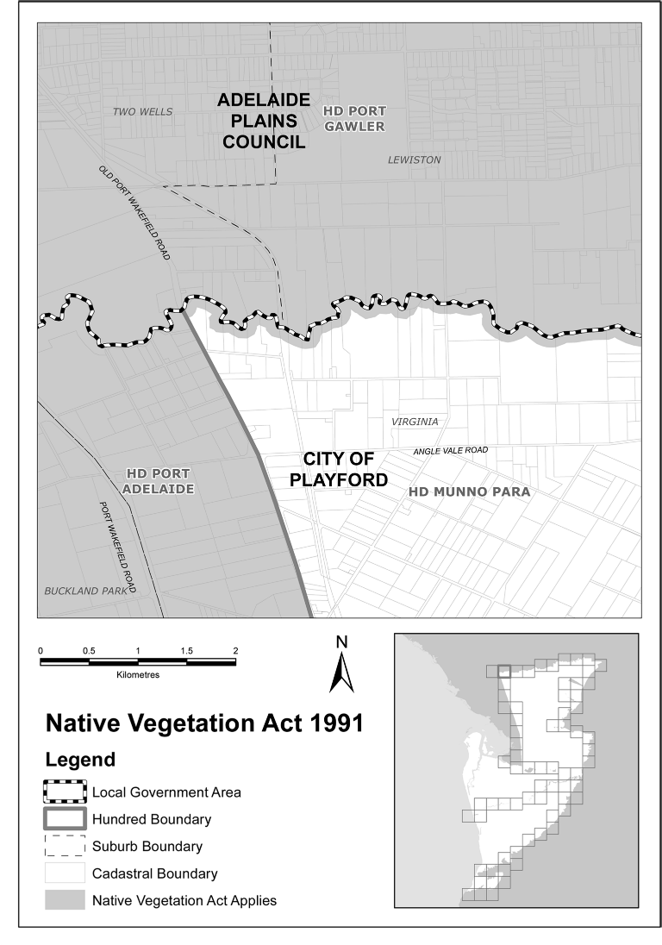
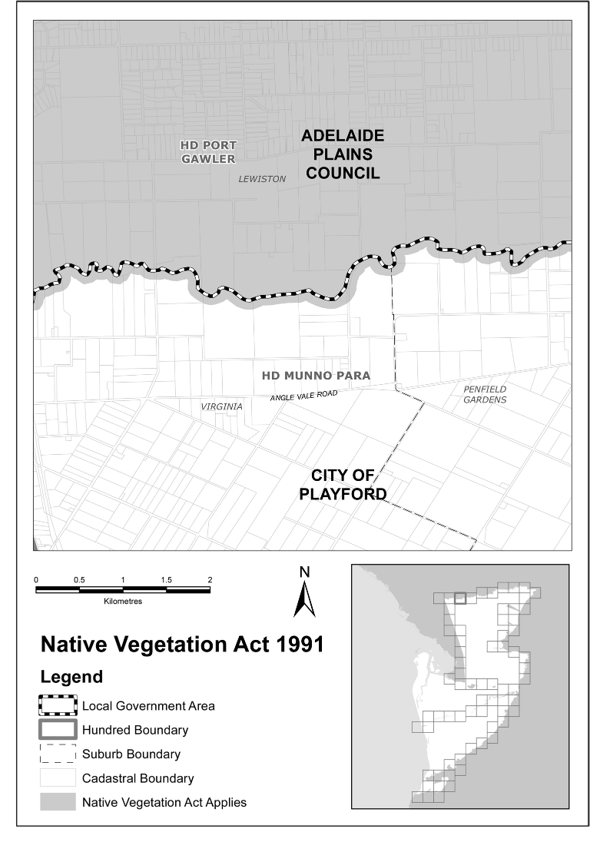
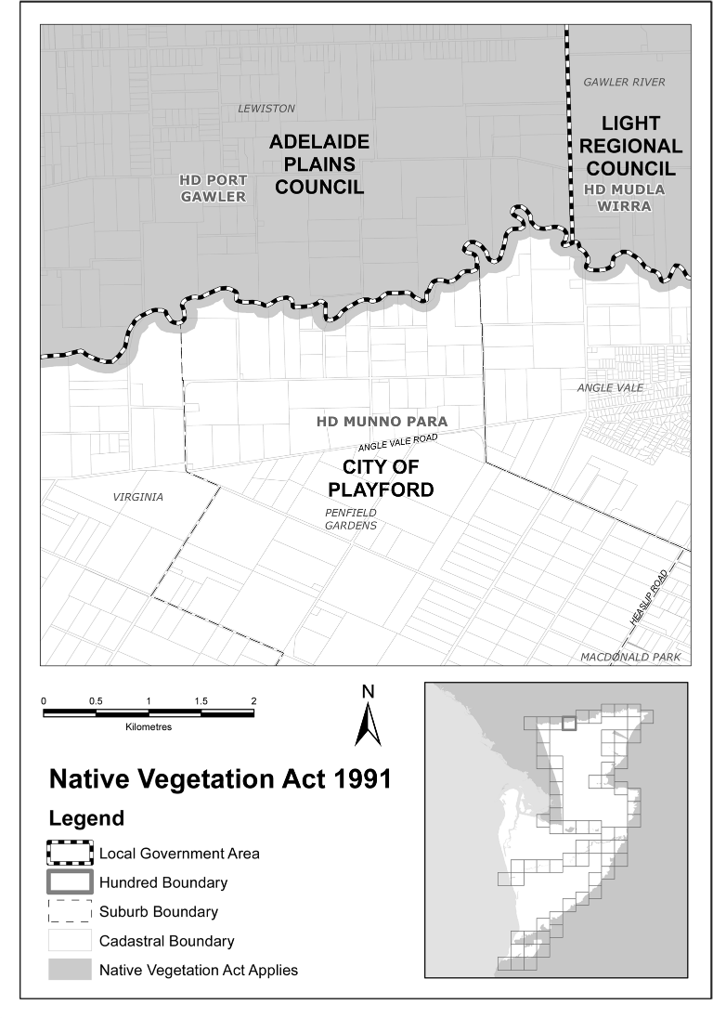
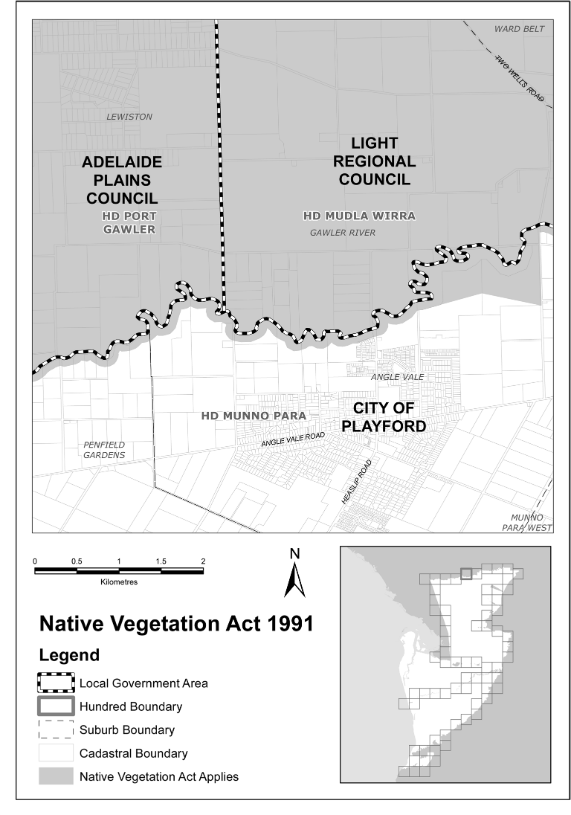
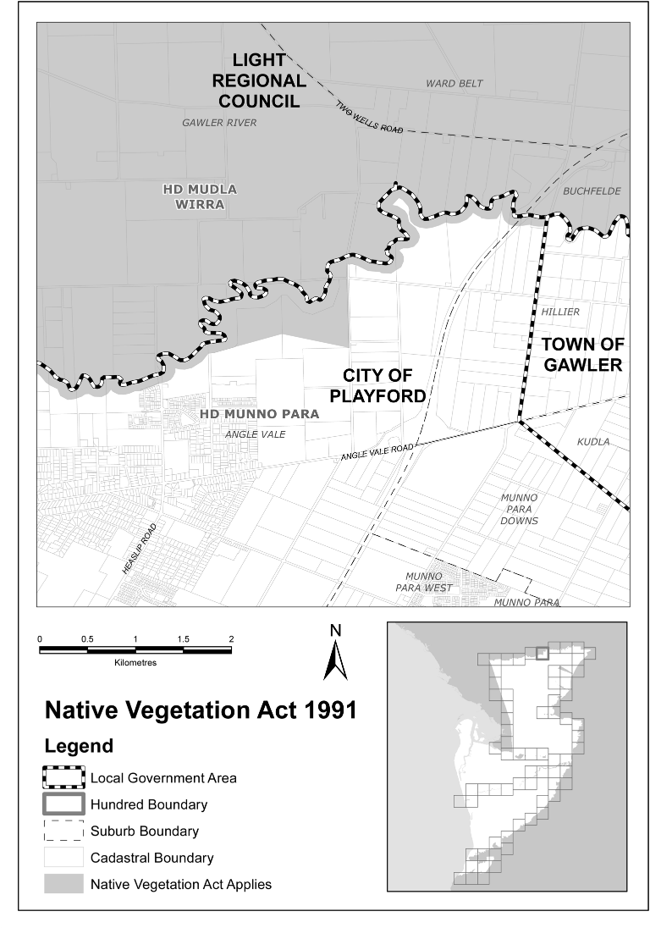
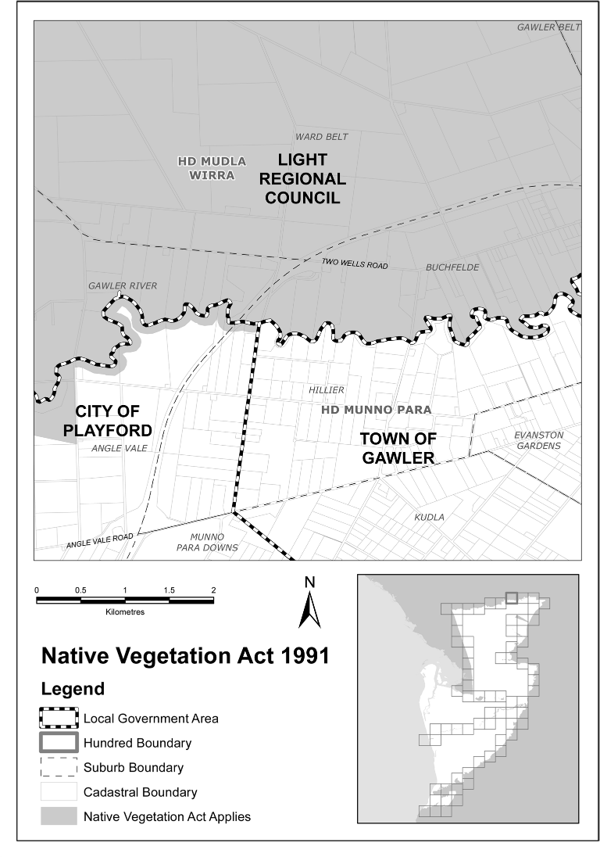
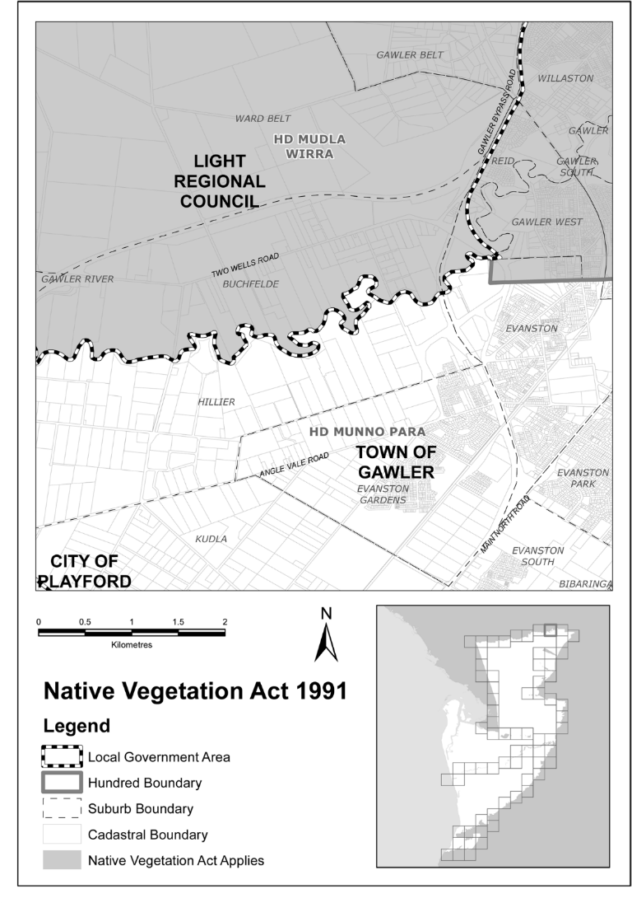
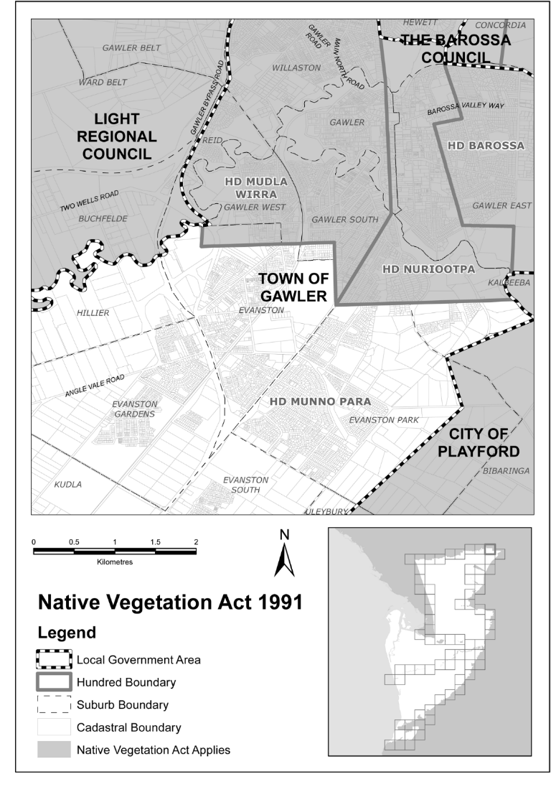
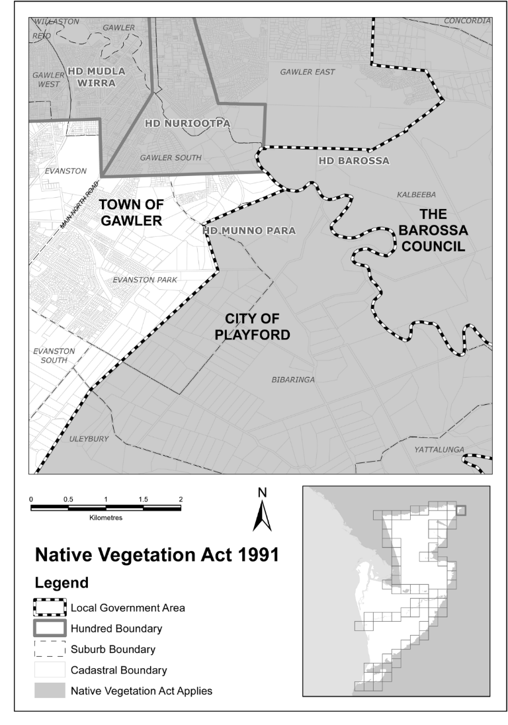
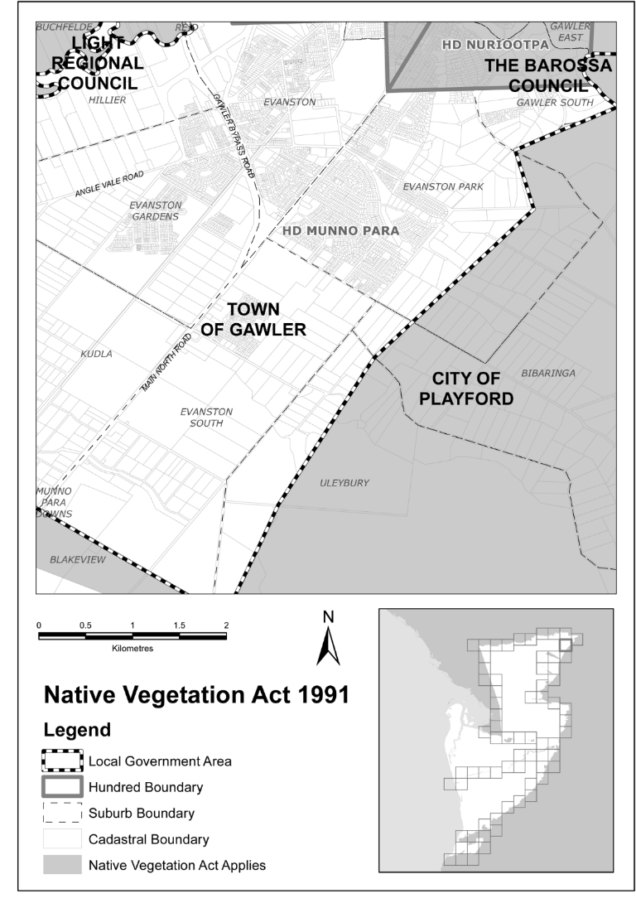
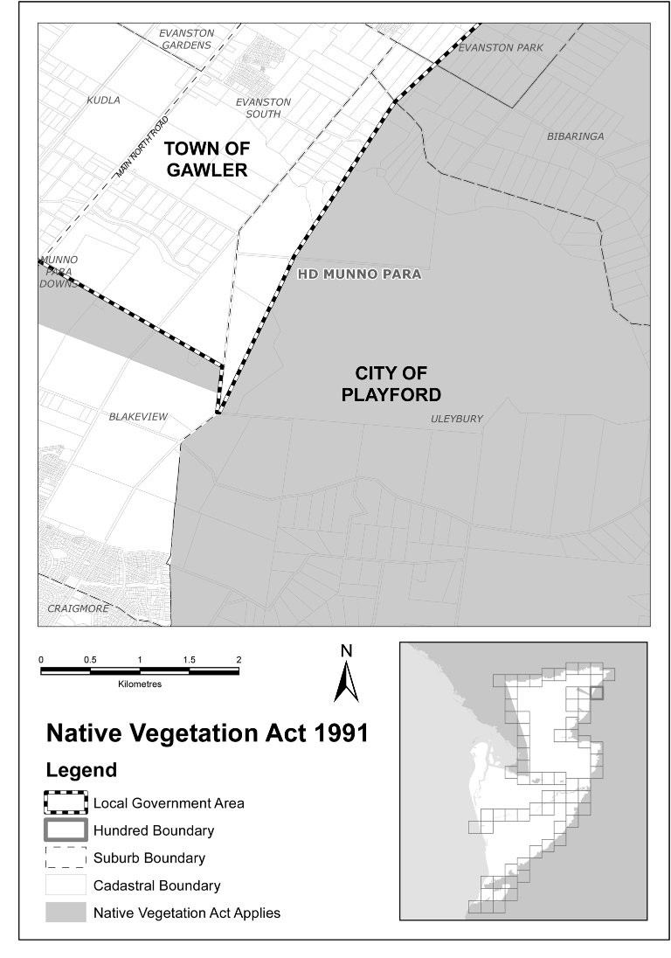
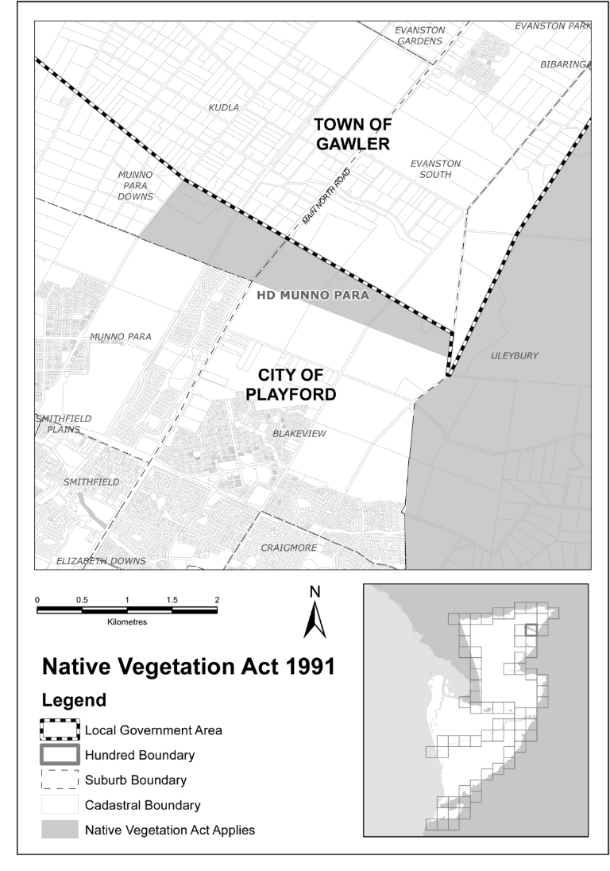
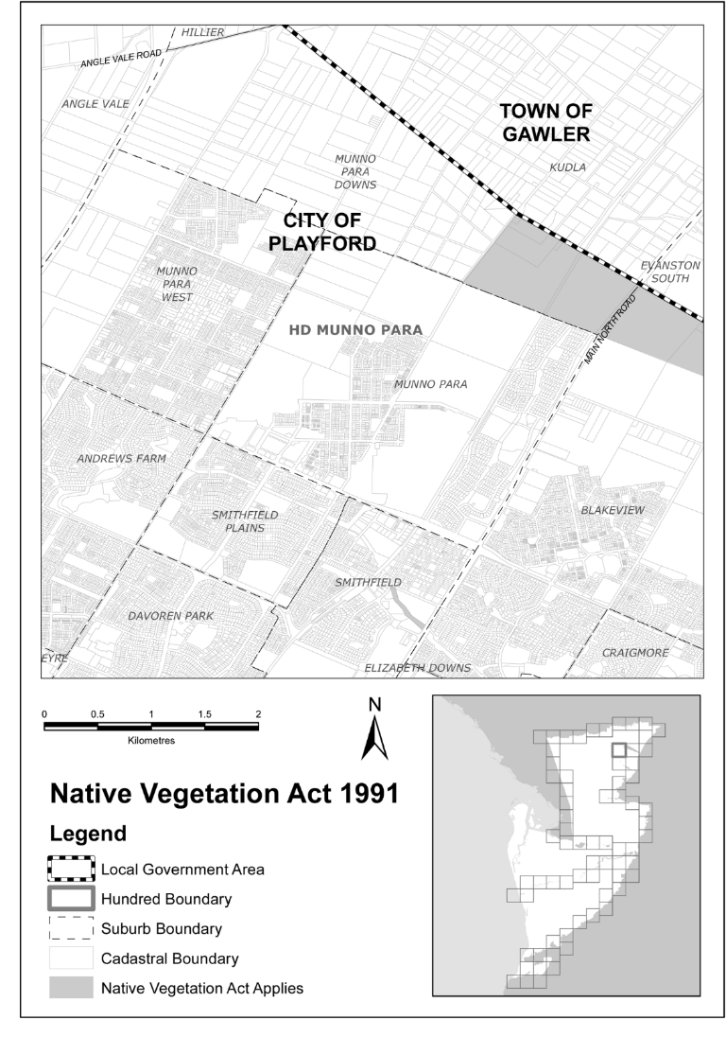
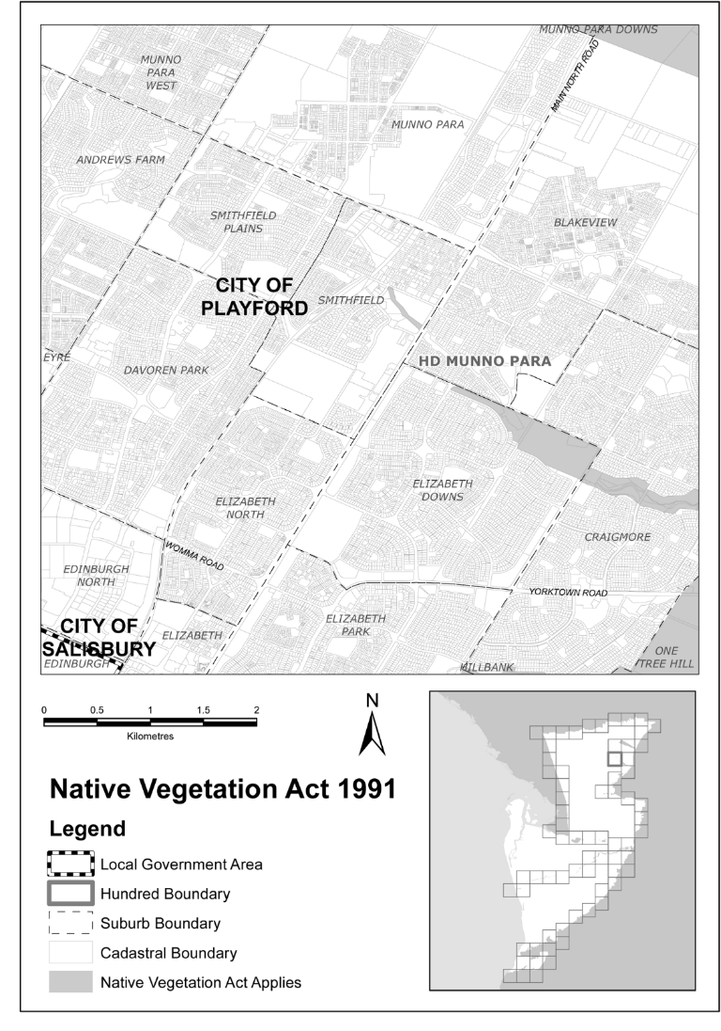
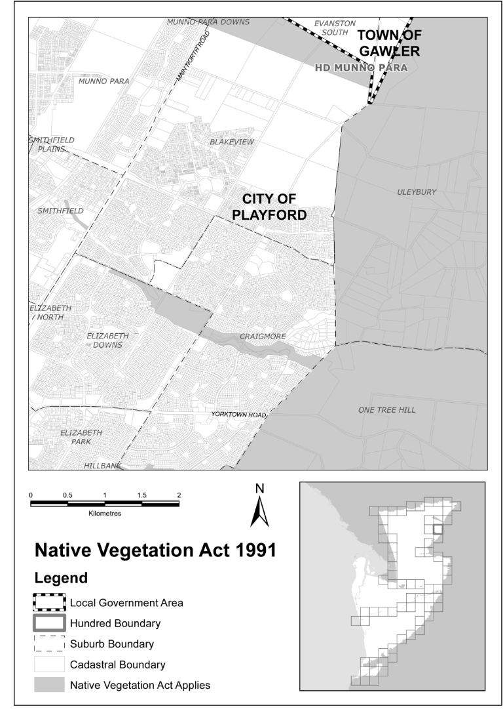
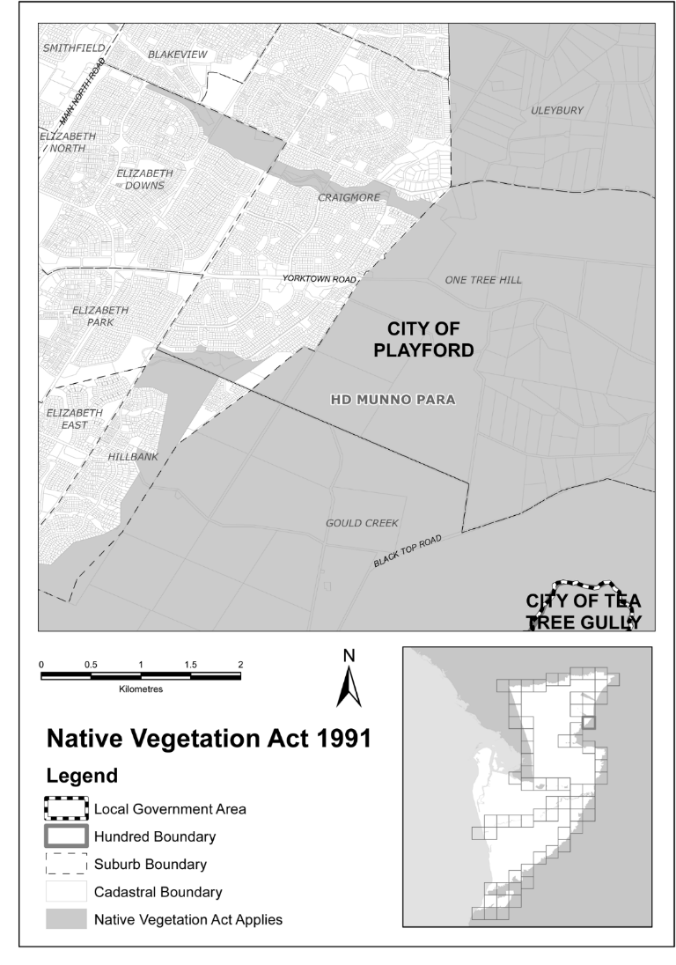
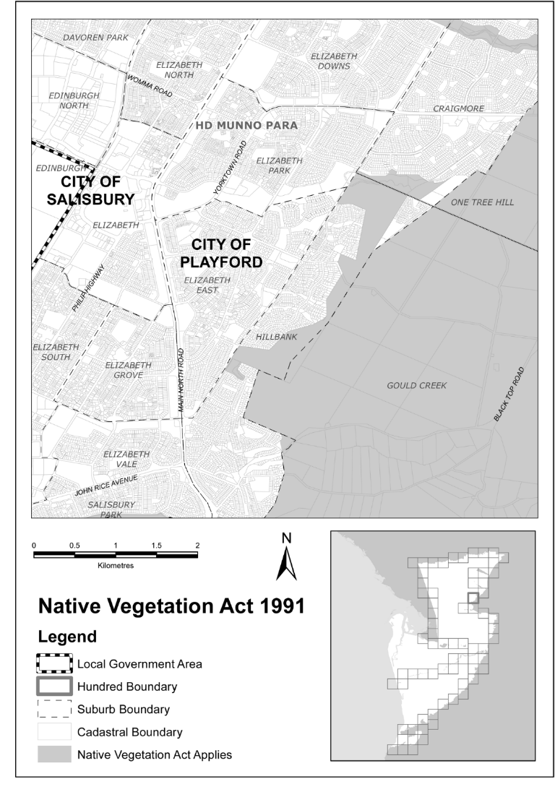
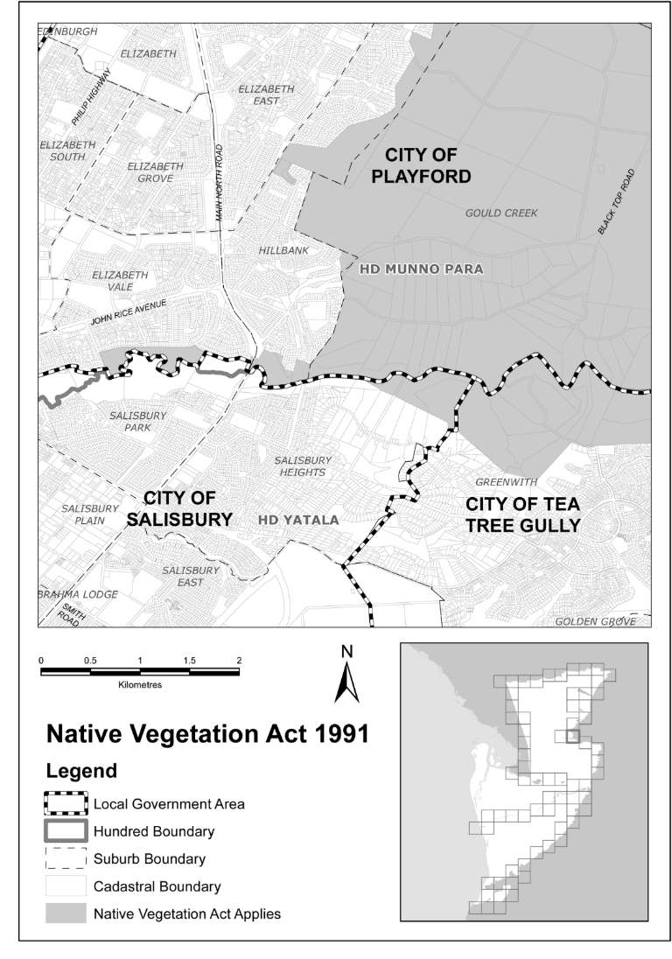
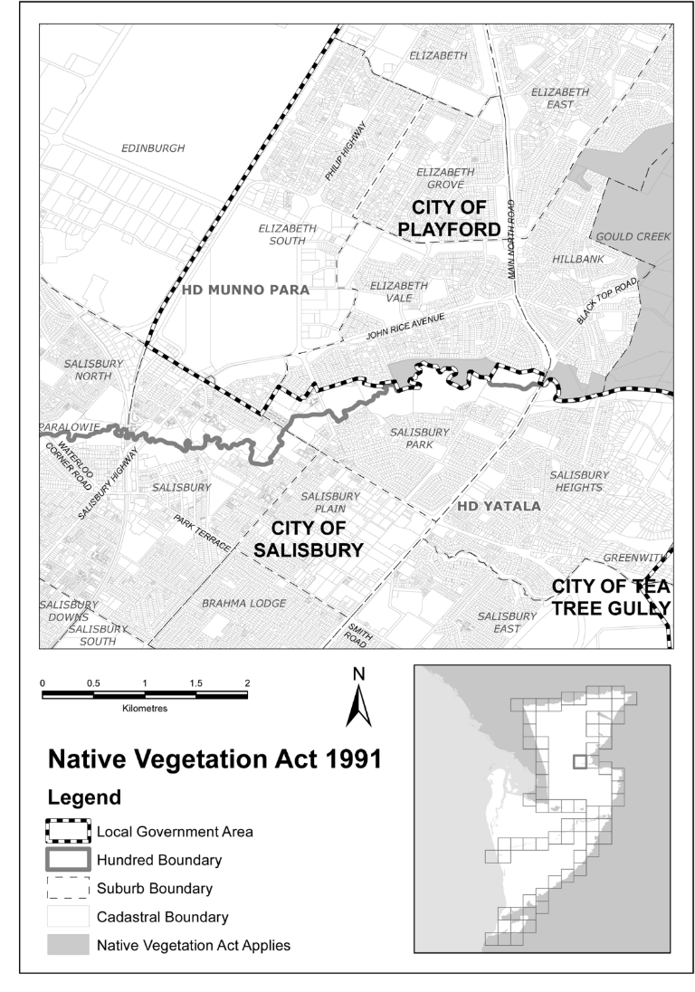
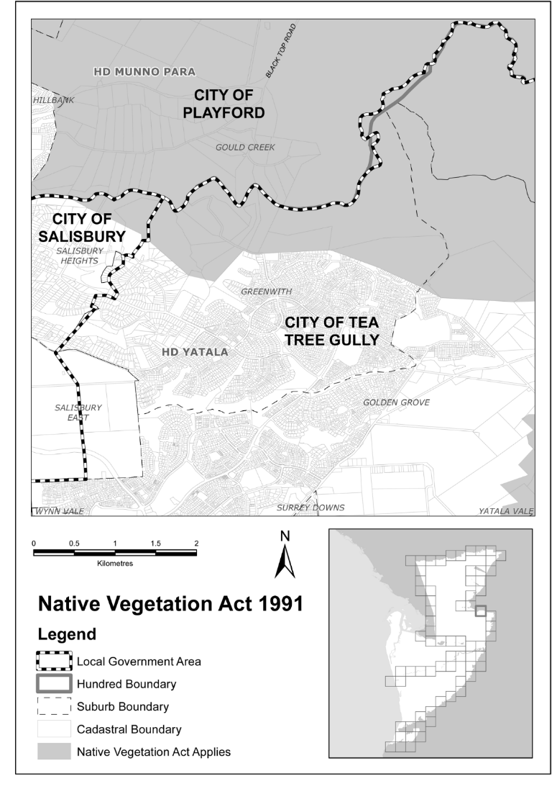
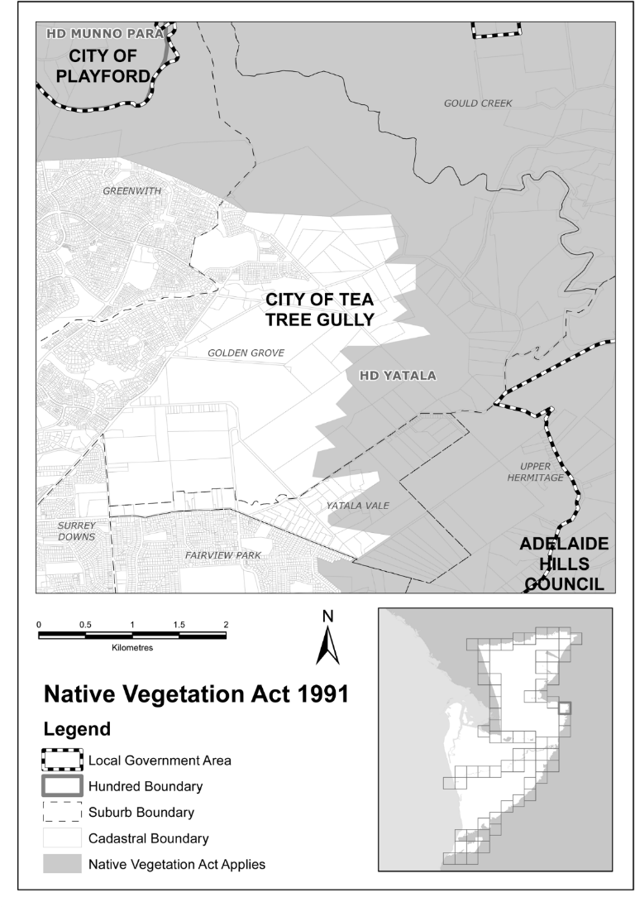
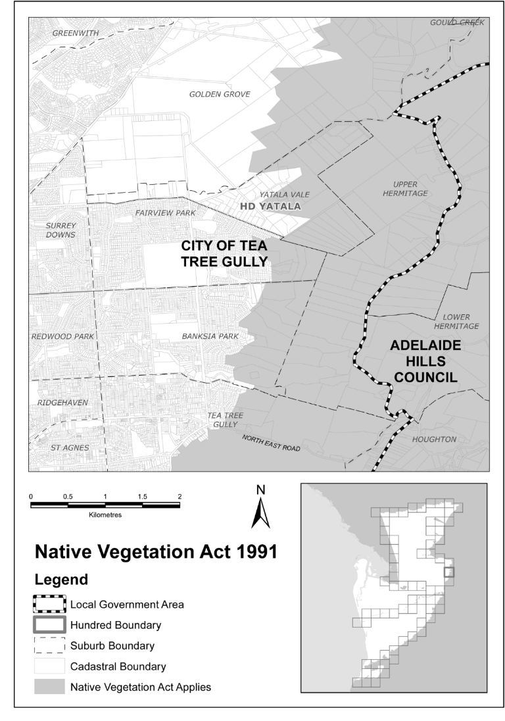
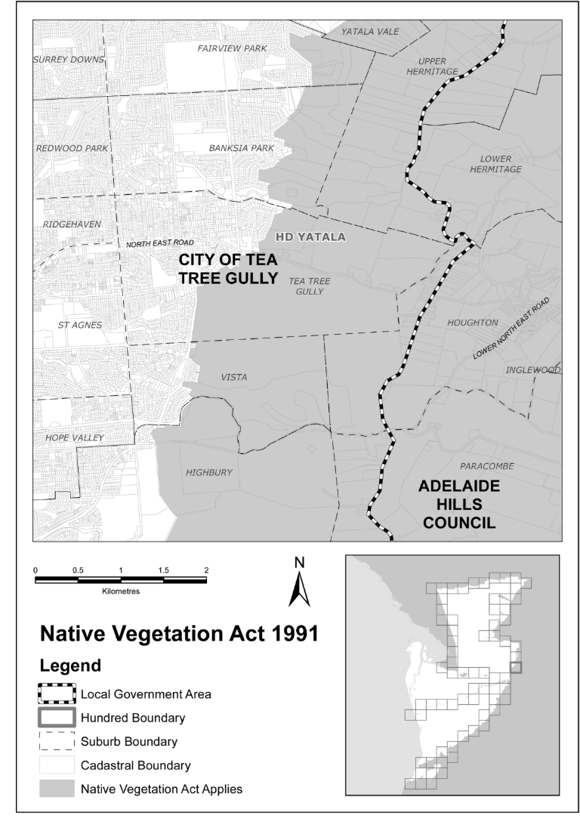
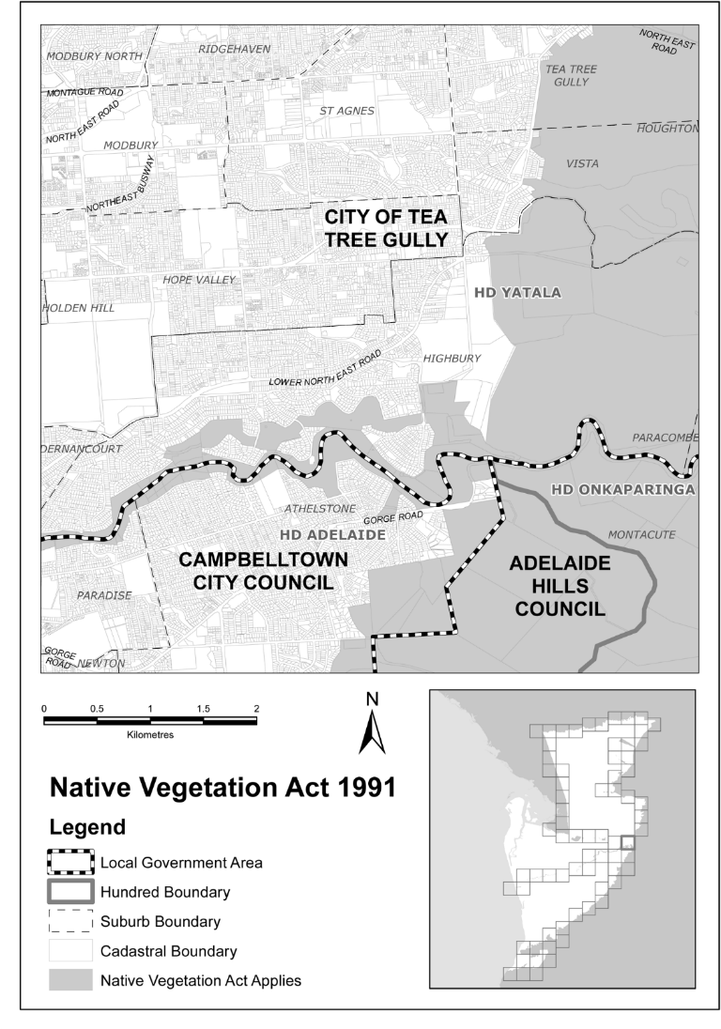
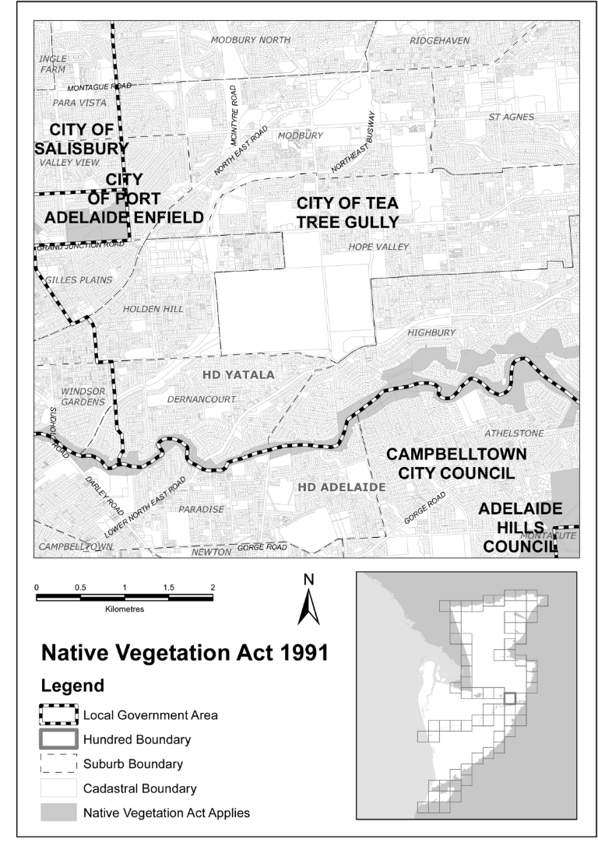
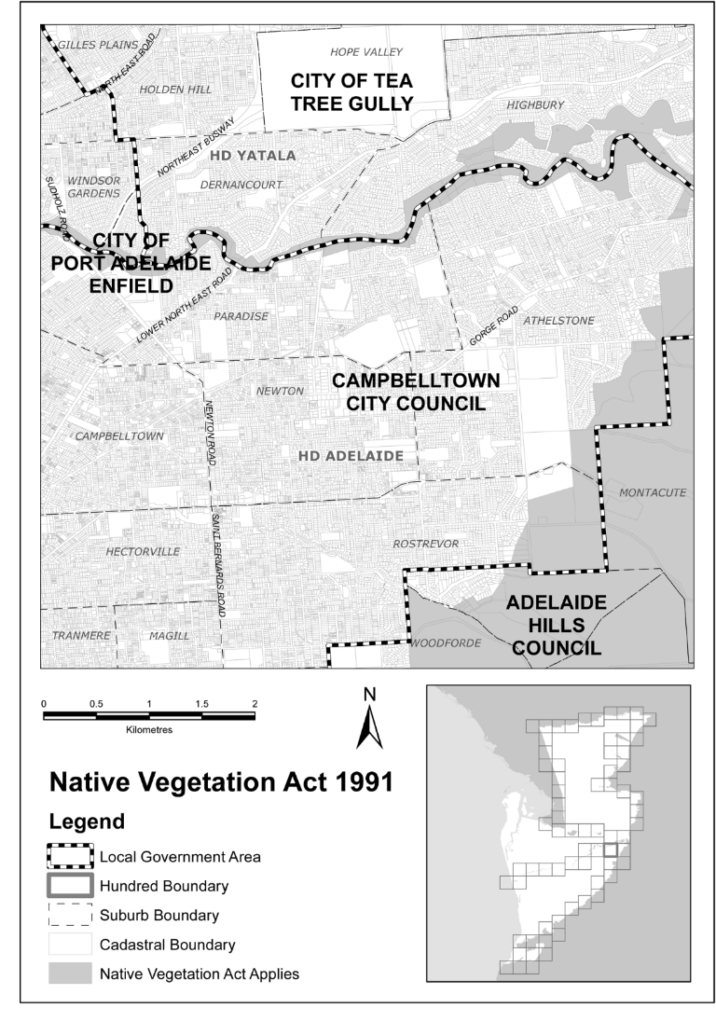
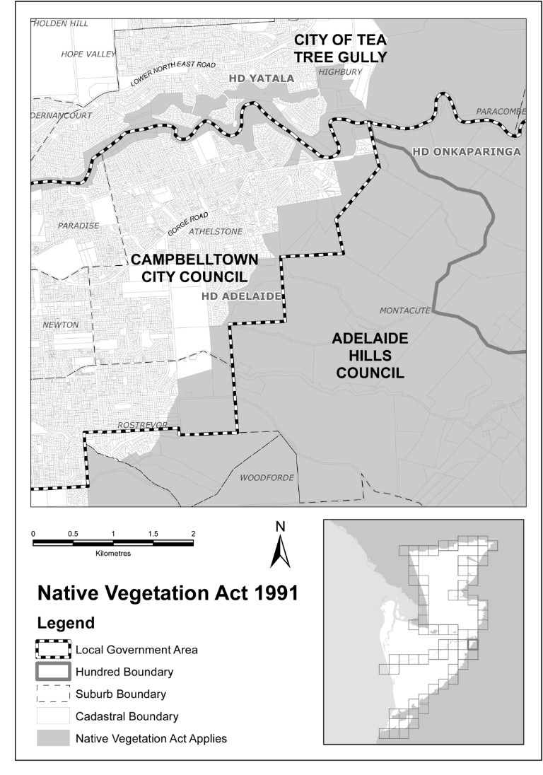
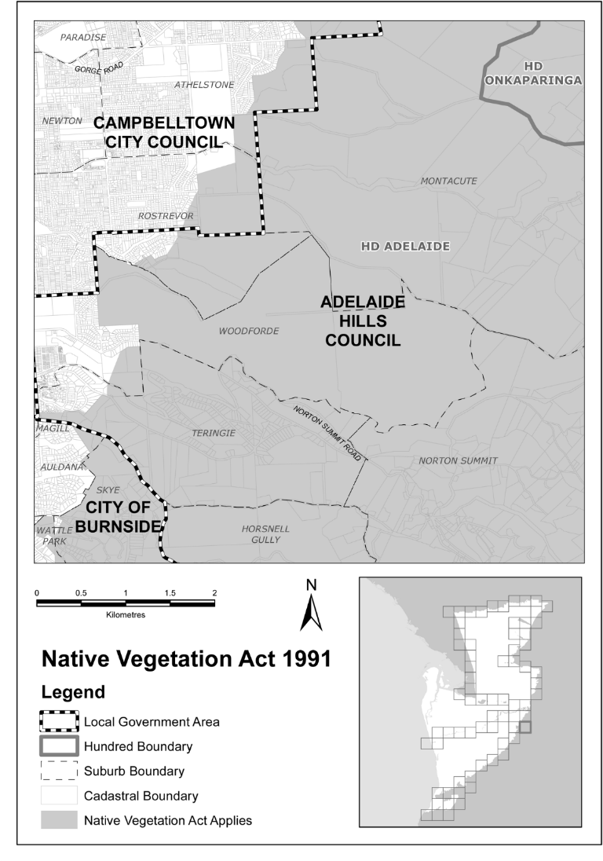
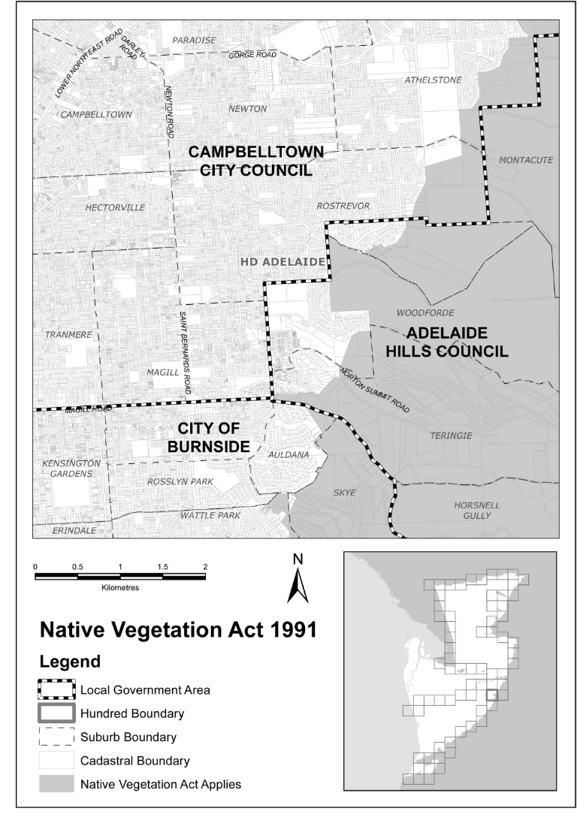
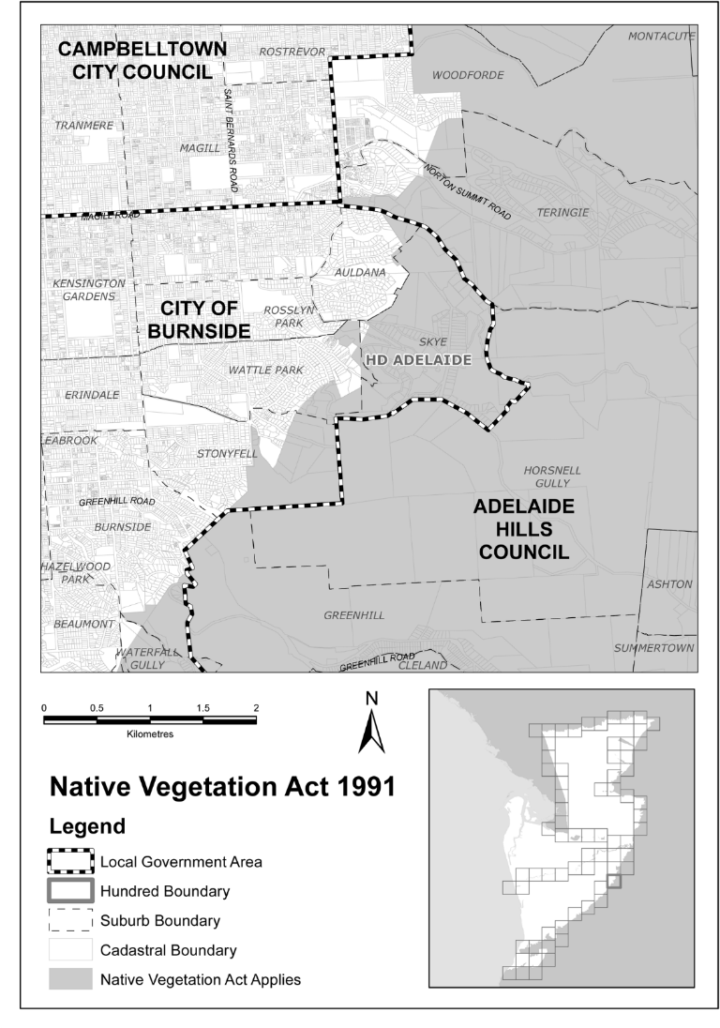
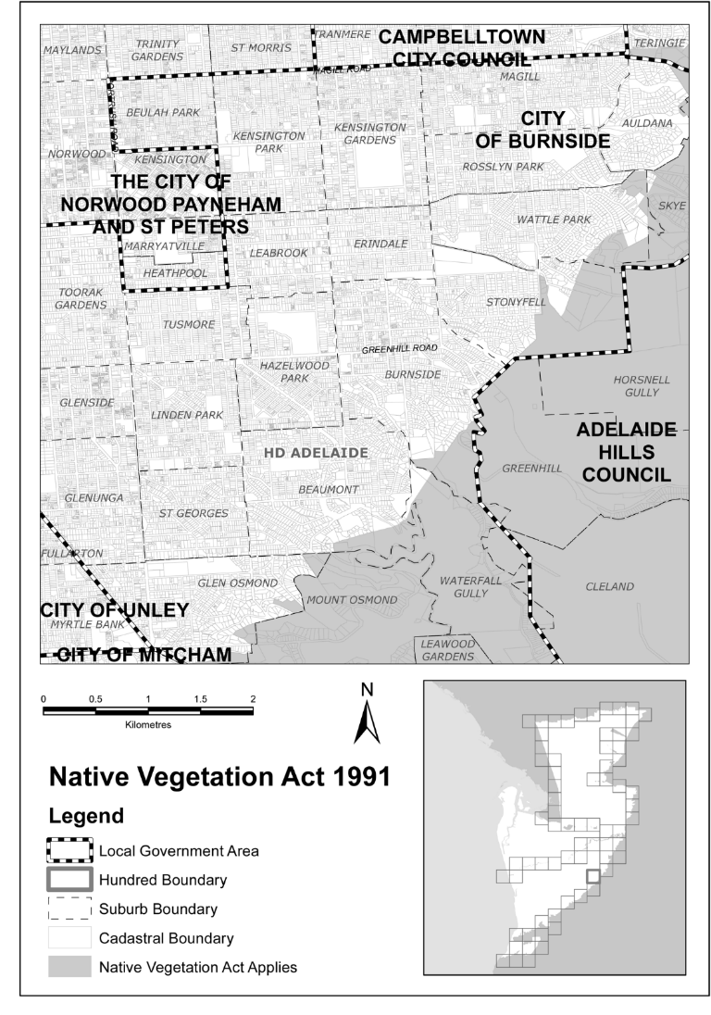
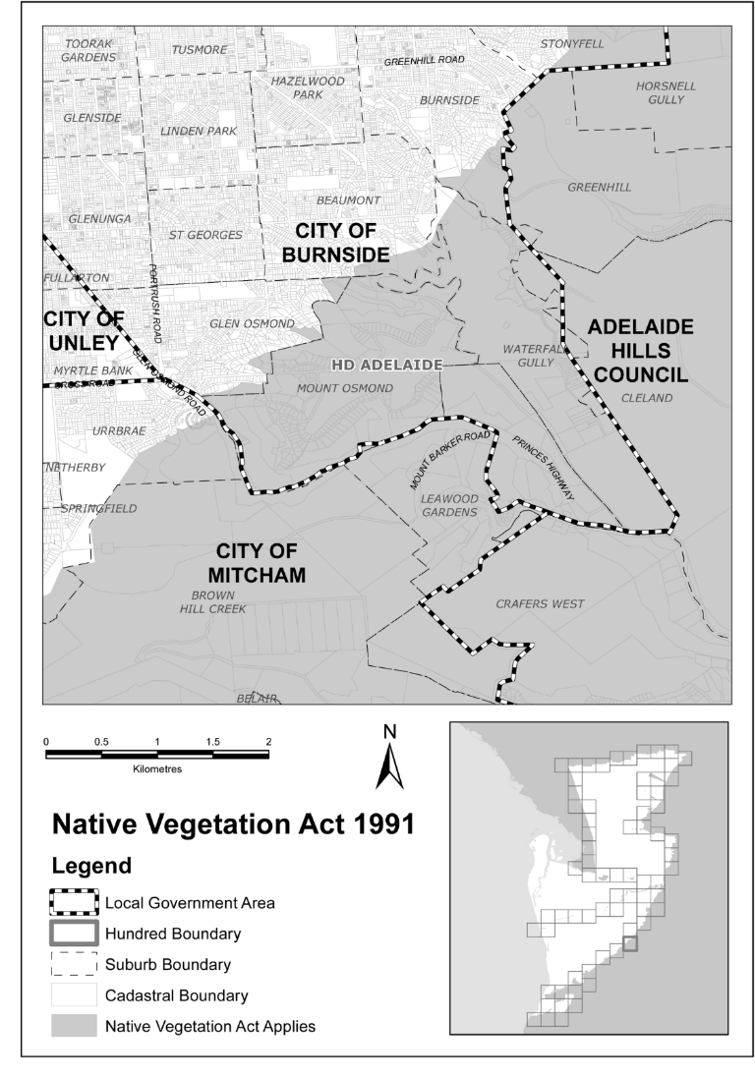
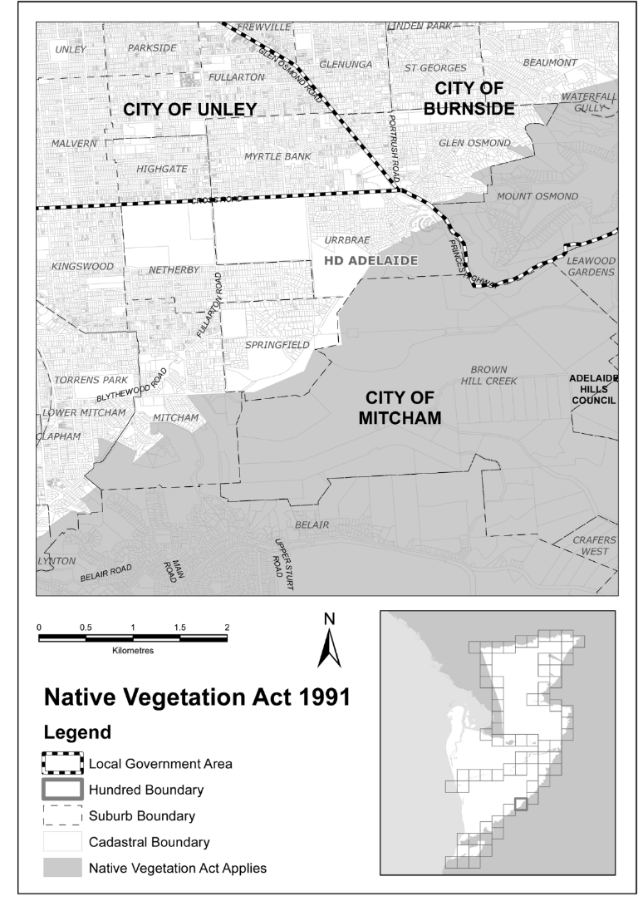
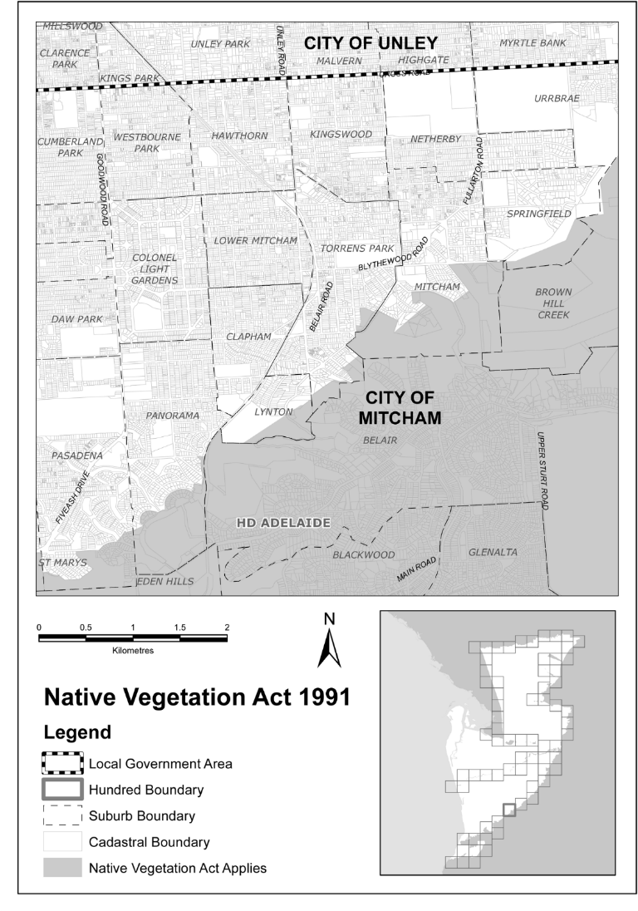
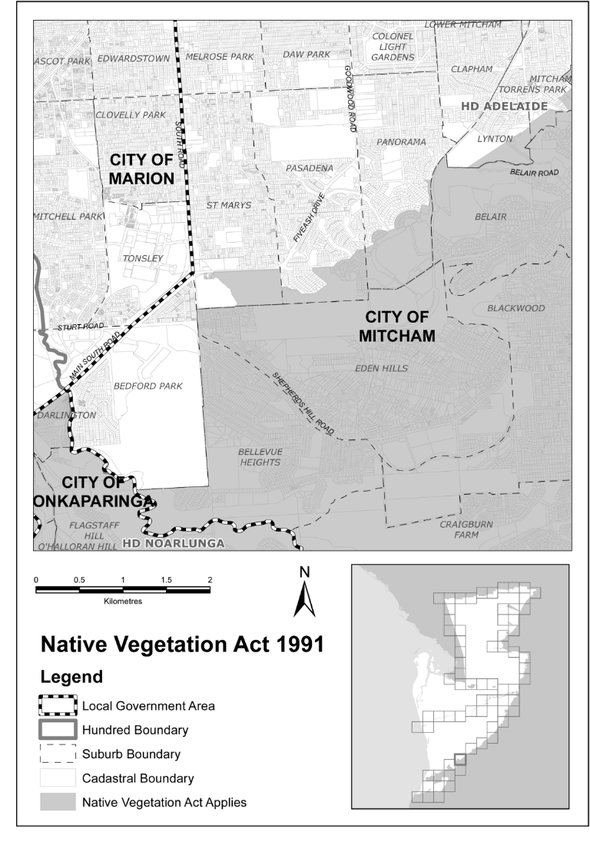
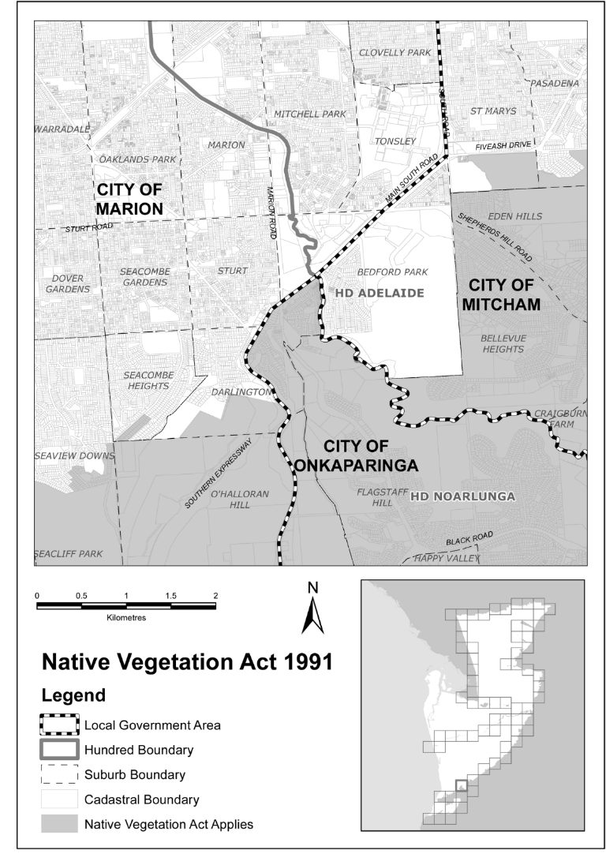
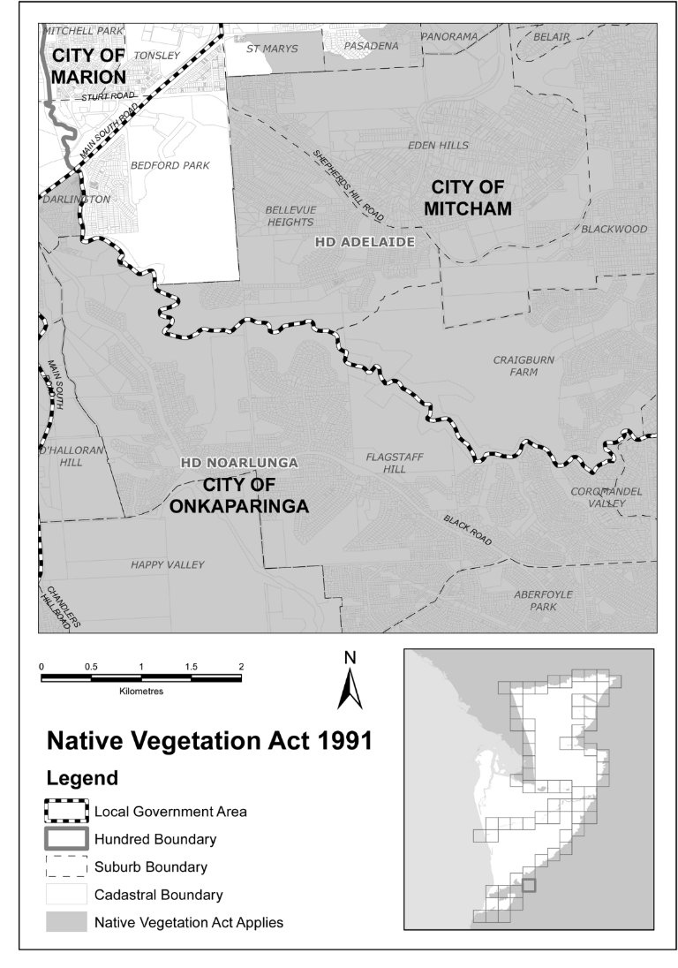
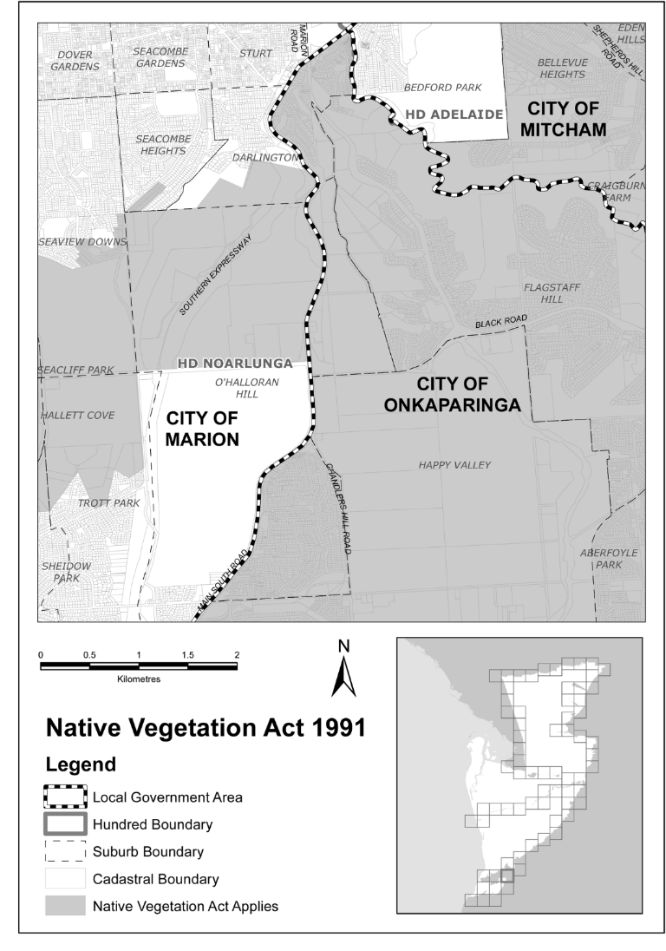
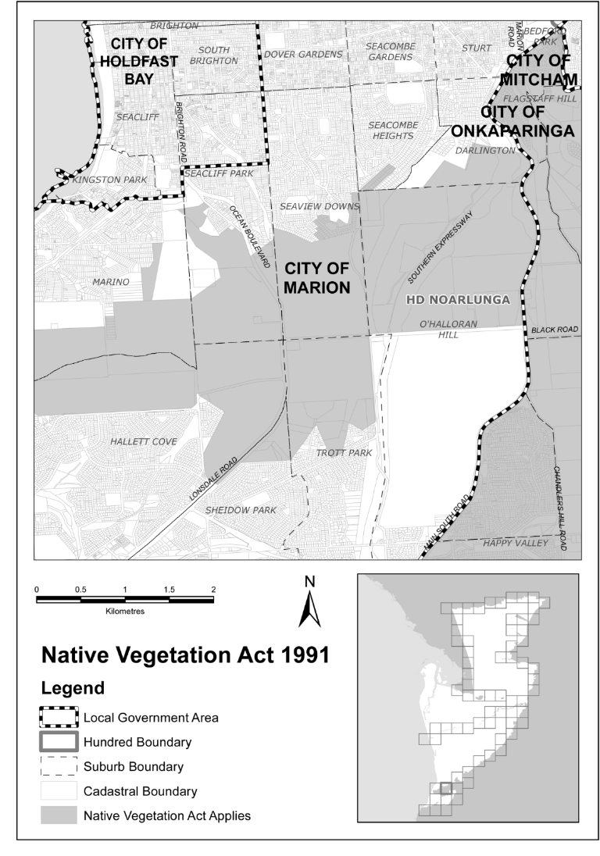
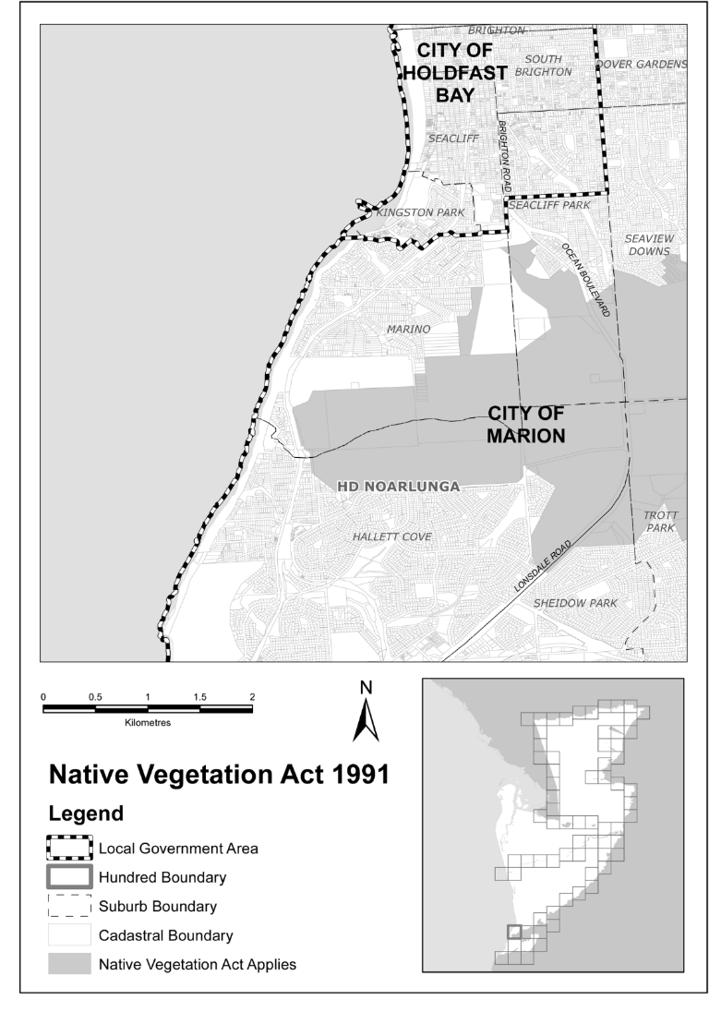
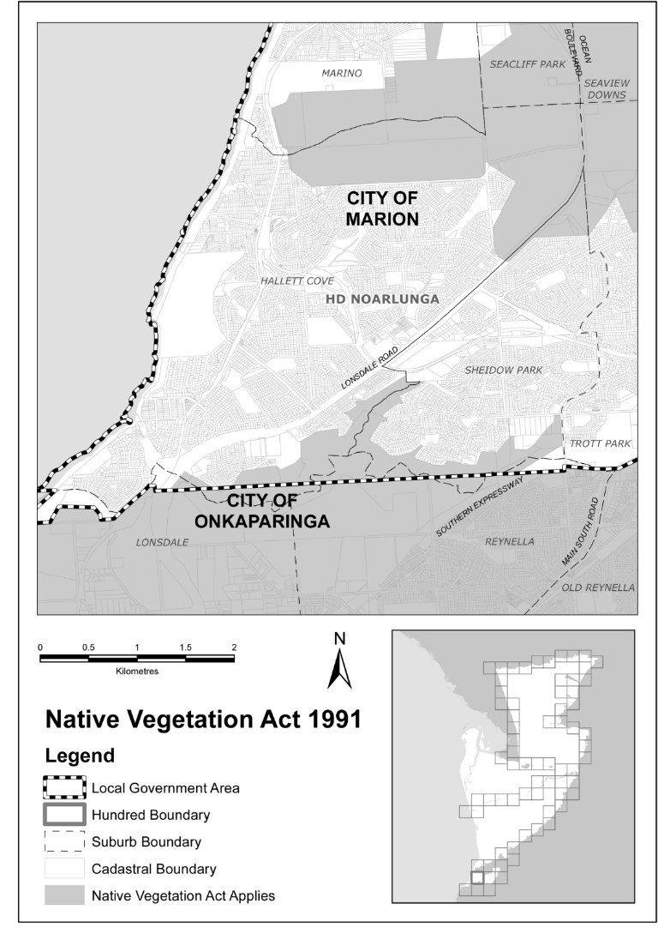
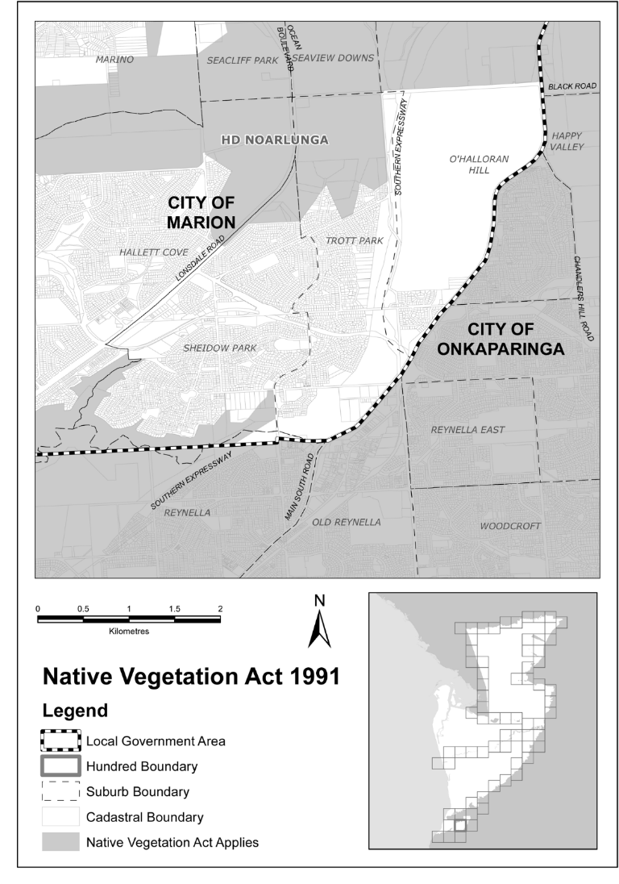
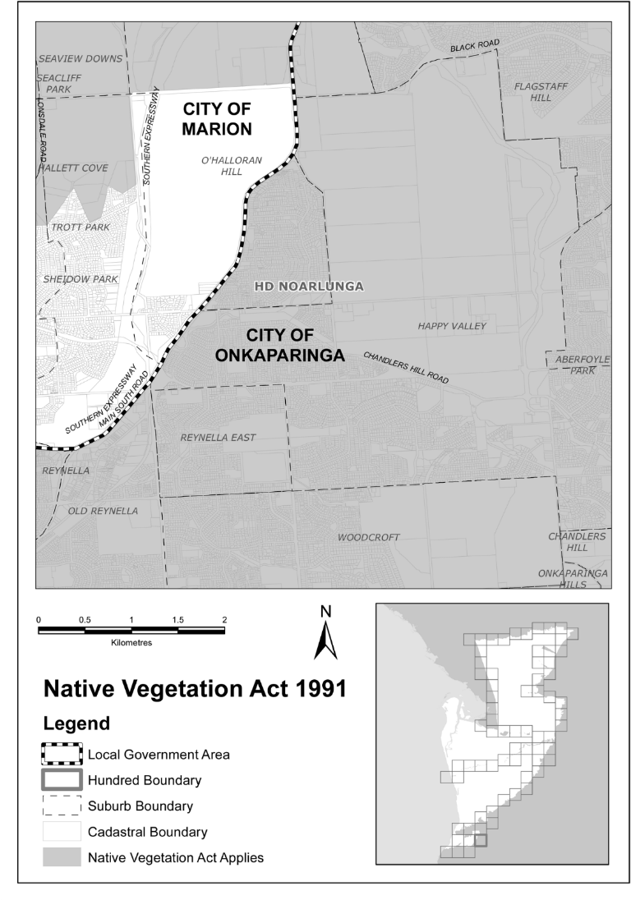
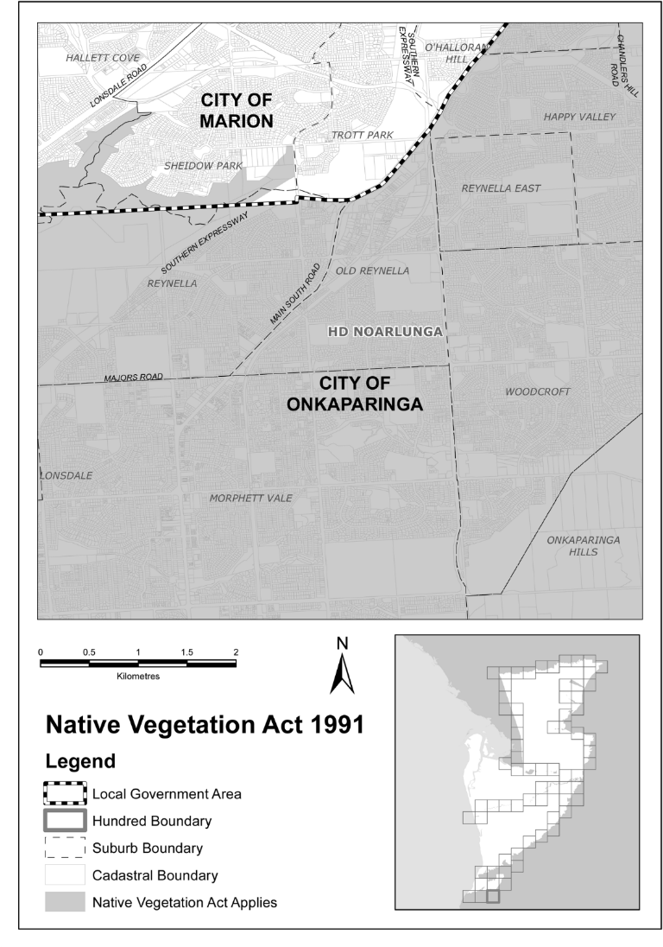
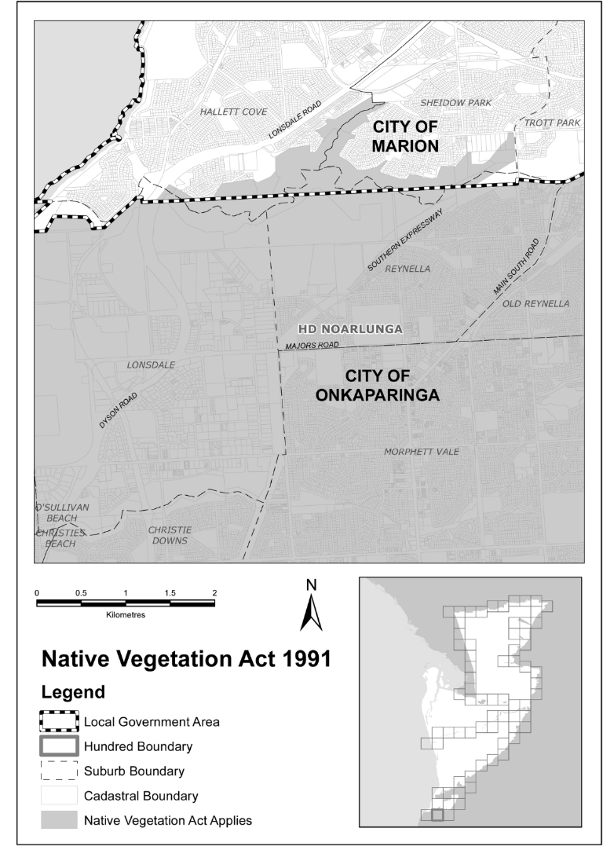
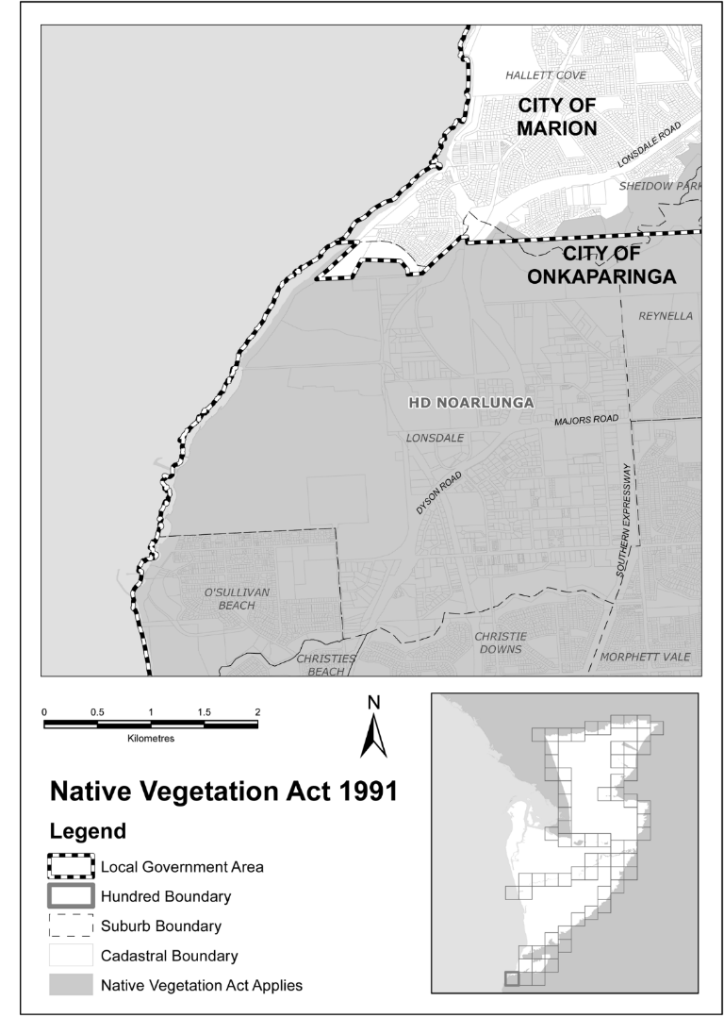
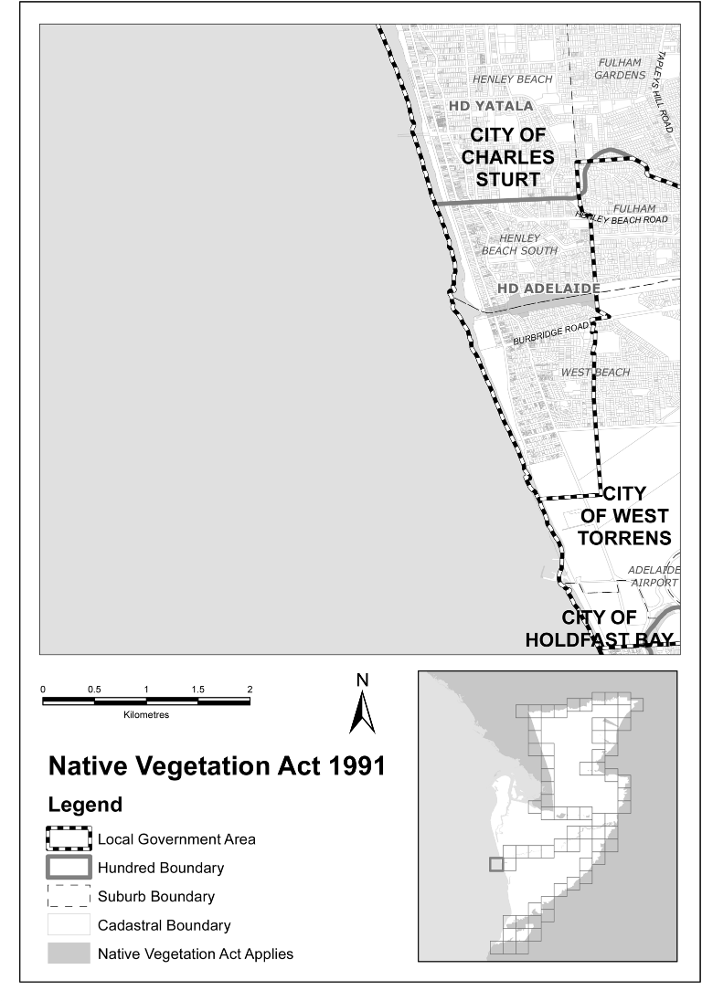
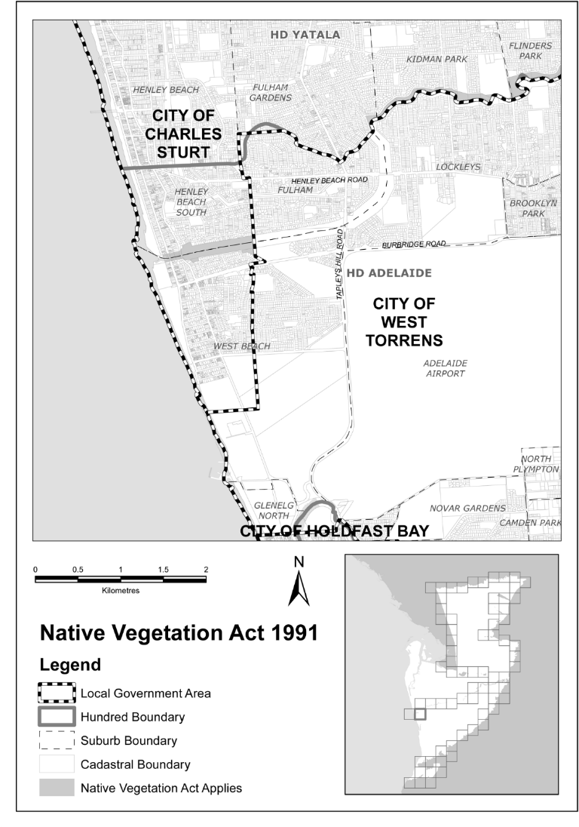
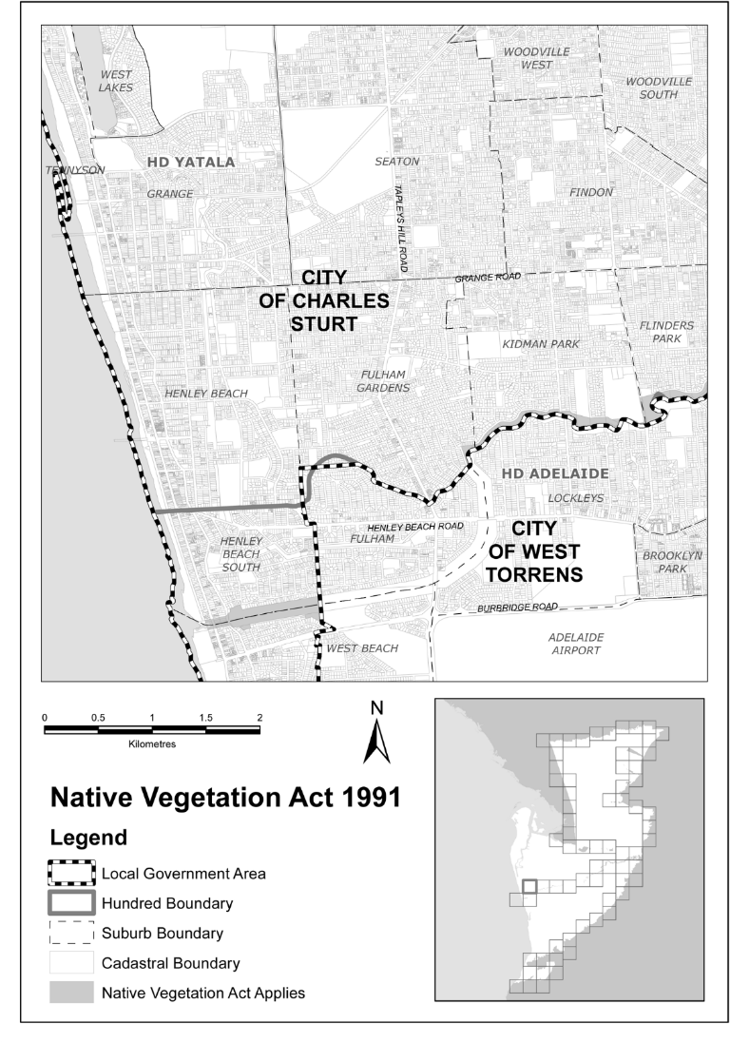
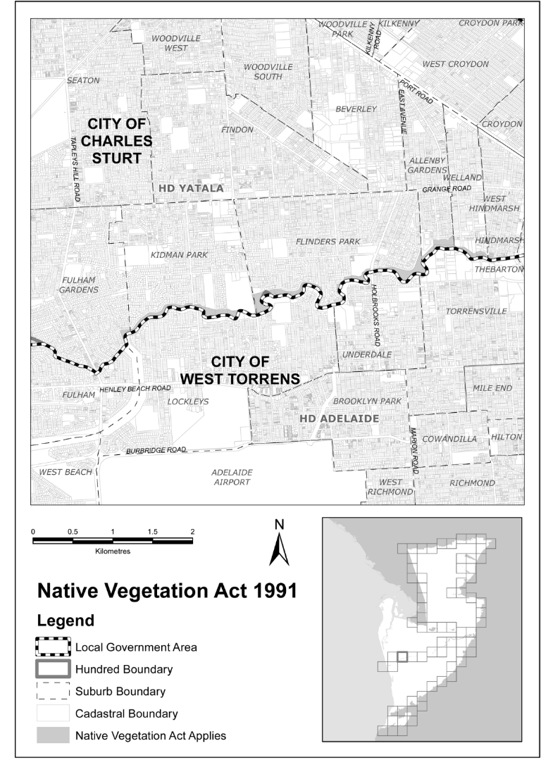
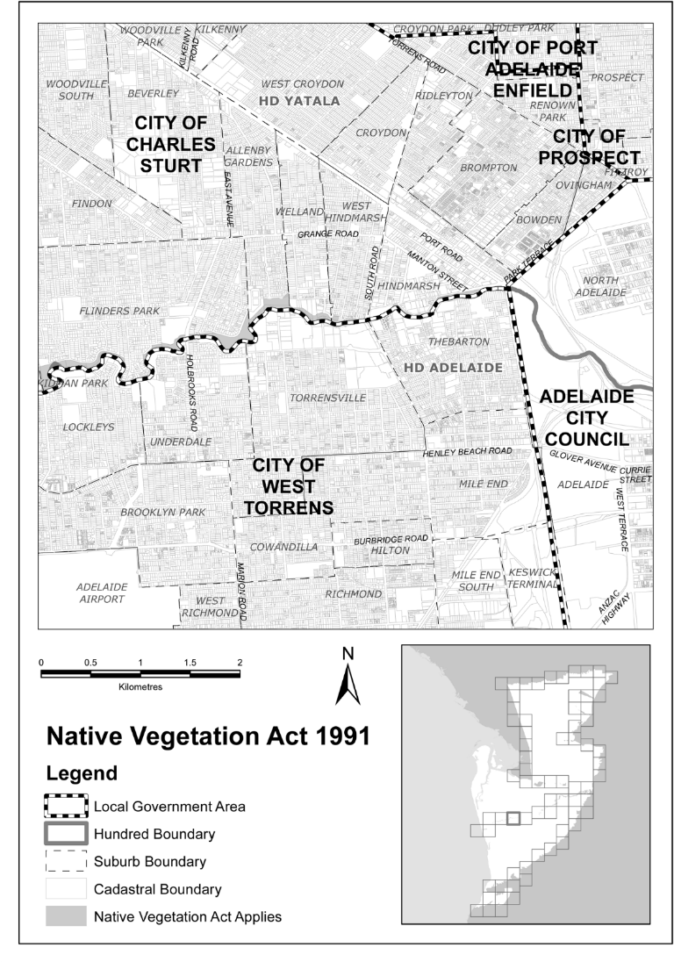
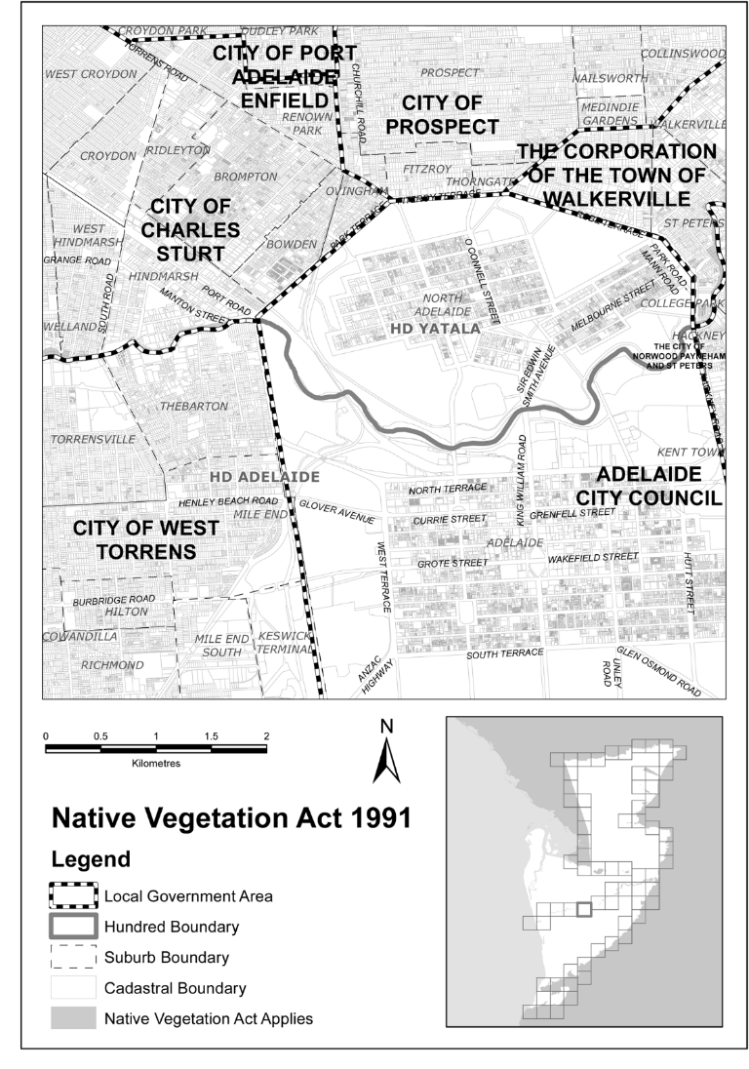
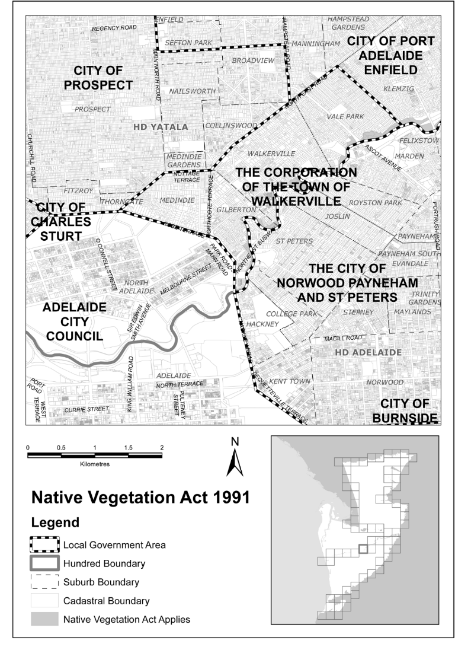
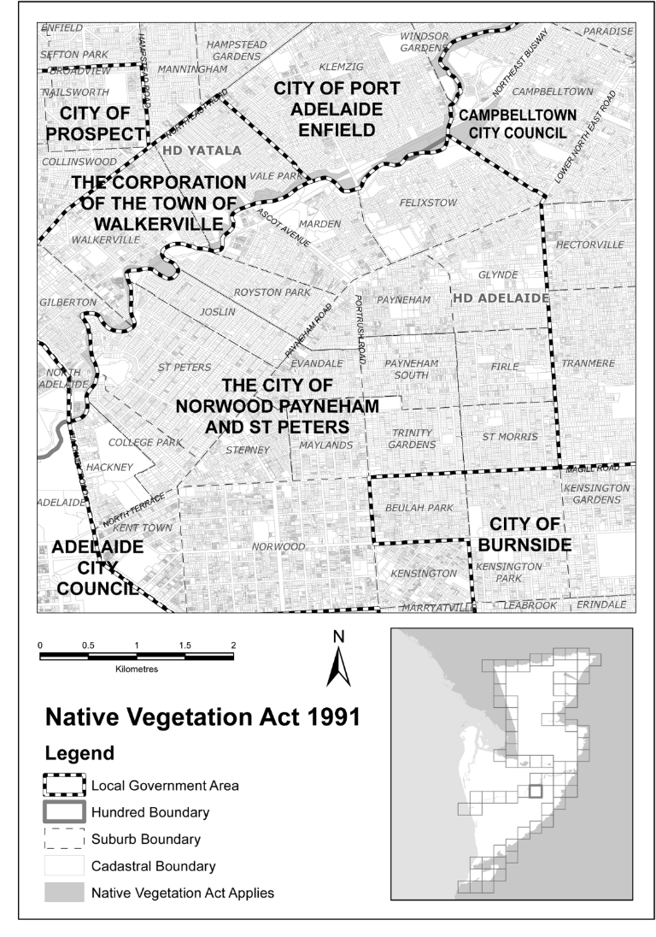
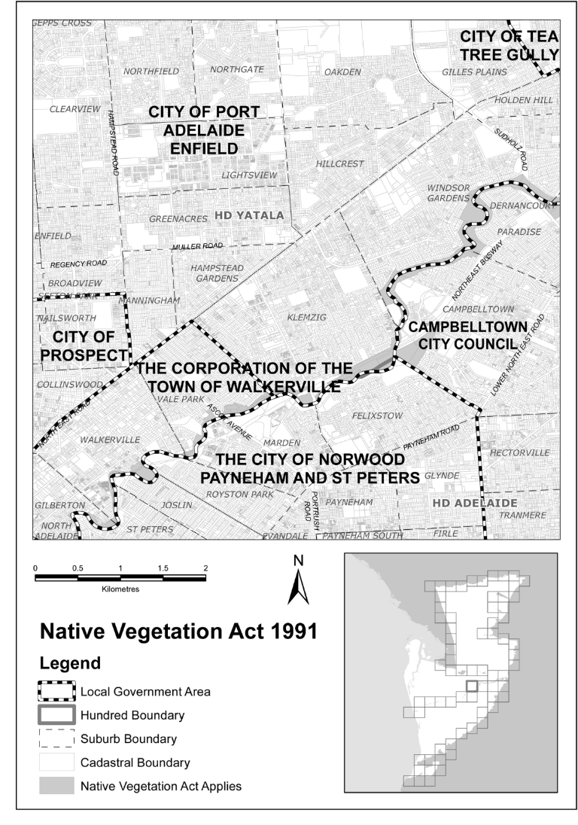
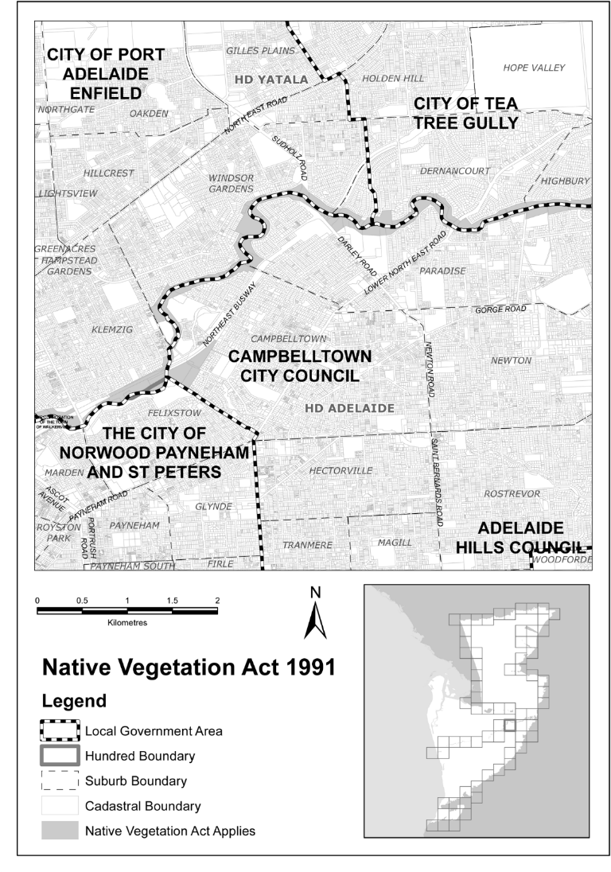
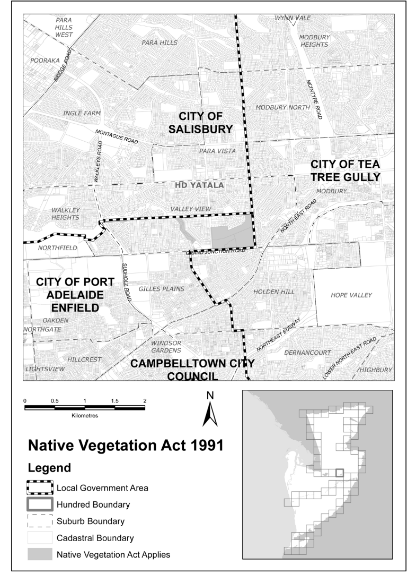
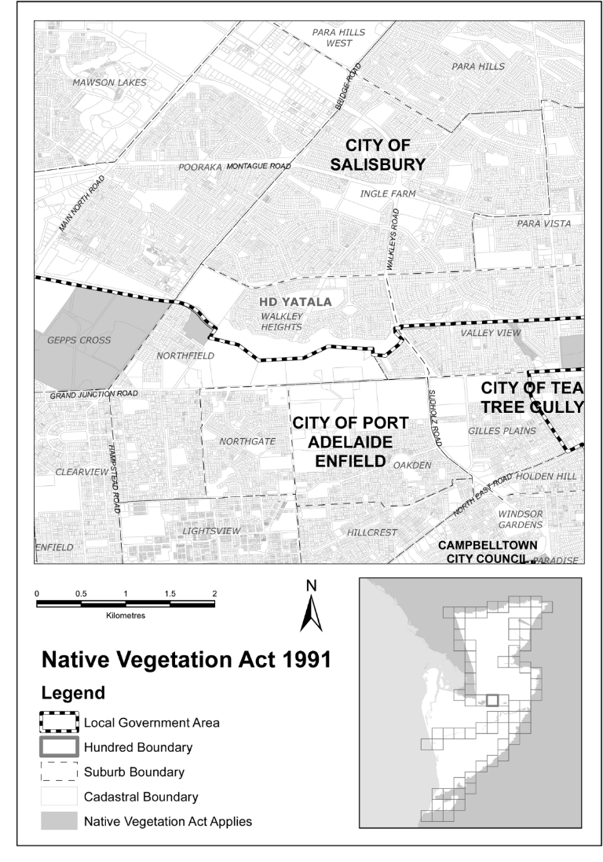
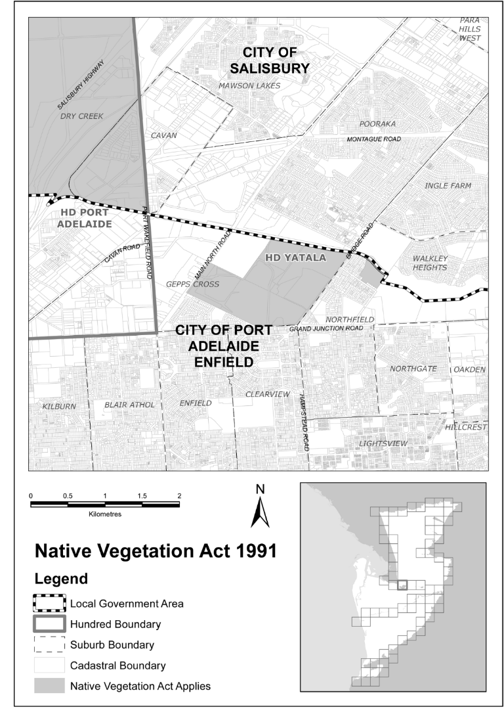
Part 2—Hundred of Port Adelaide
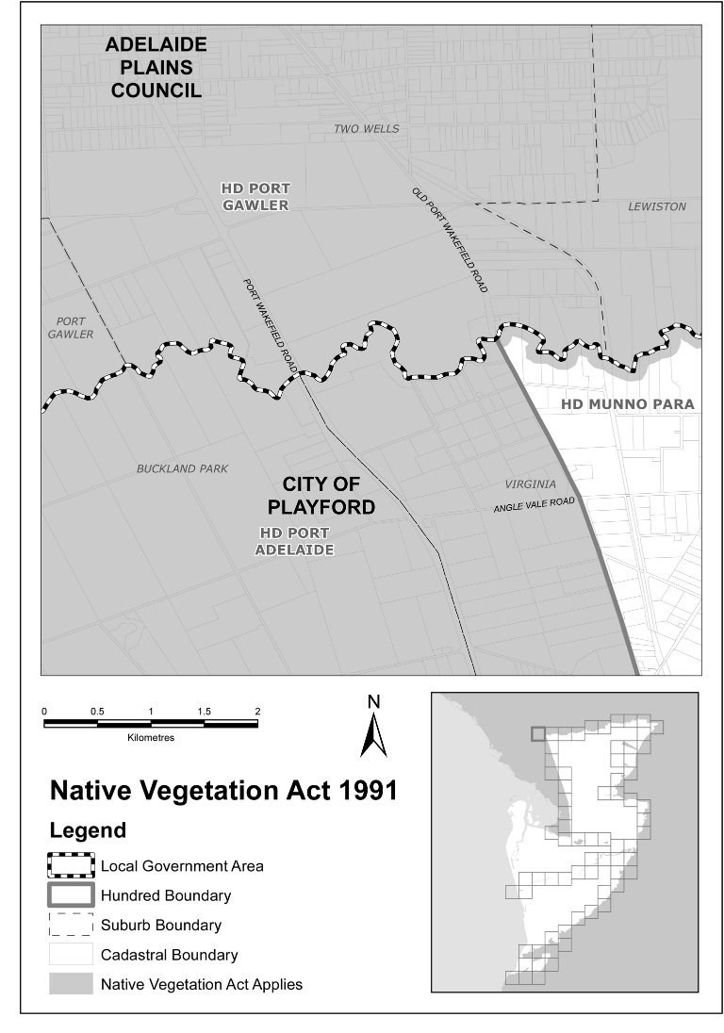
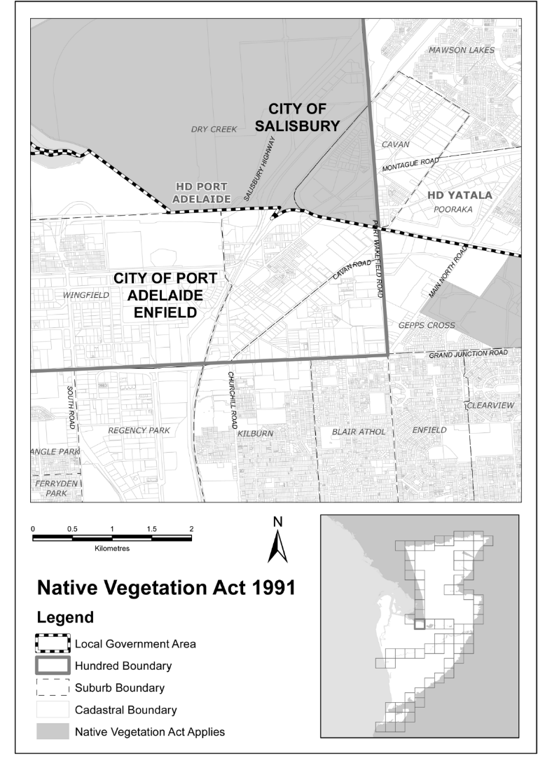
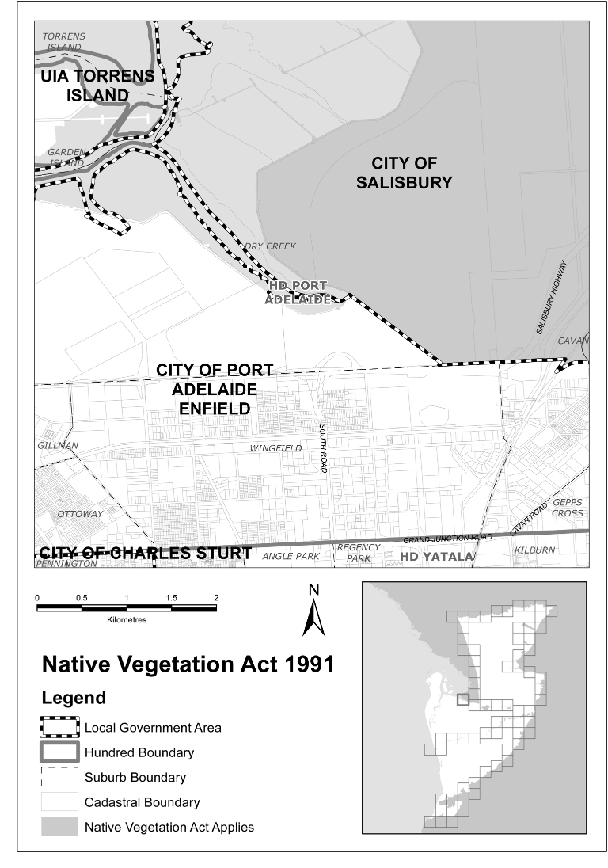
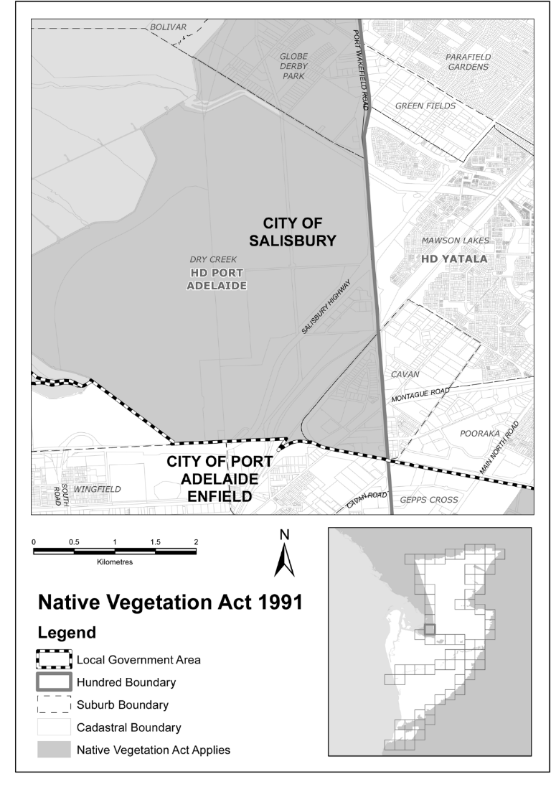
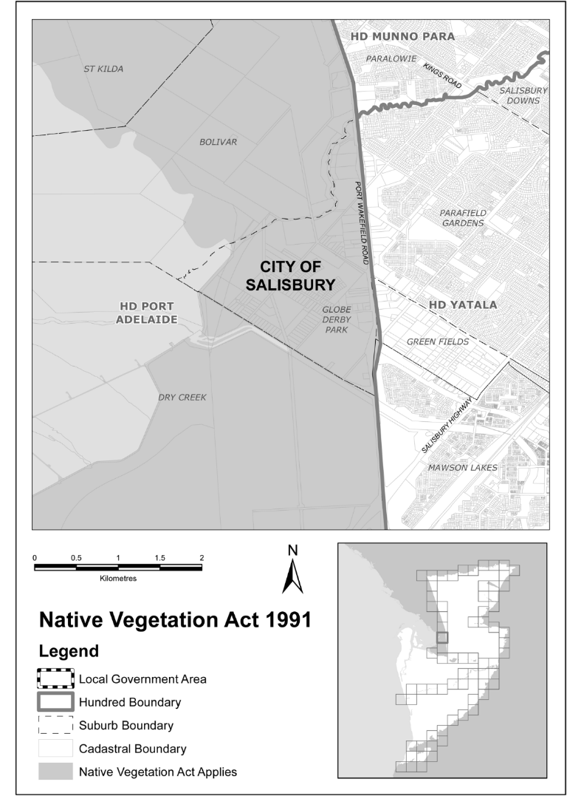
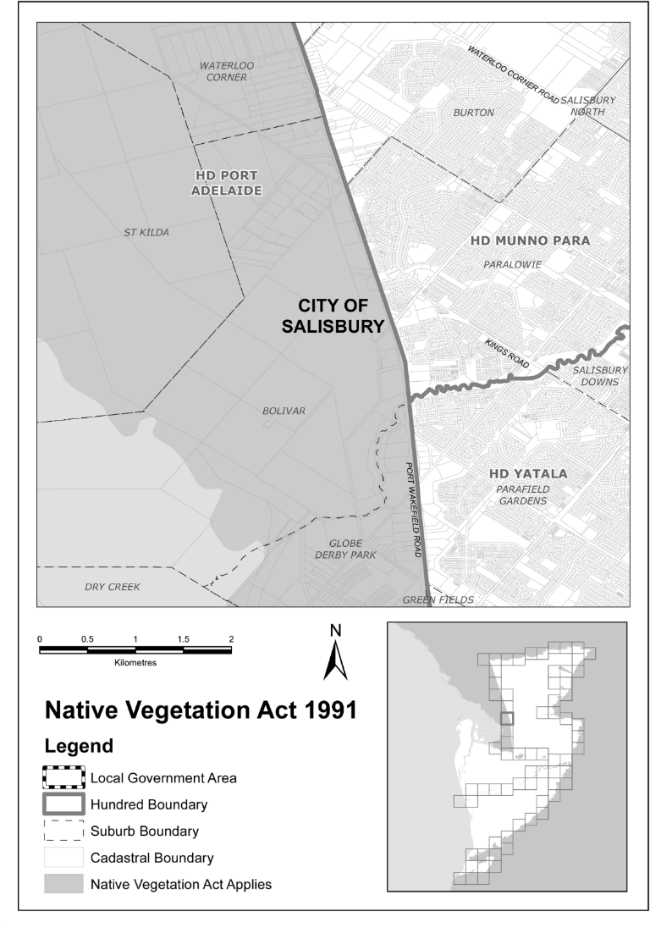
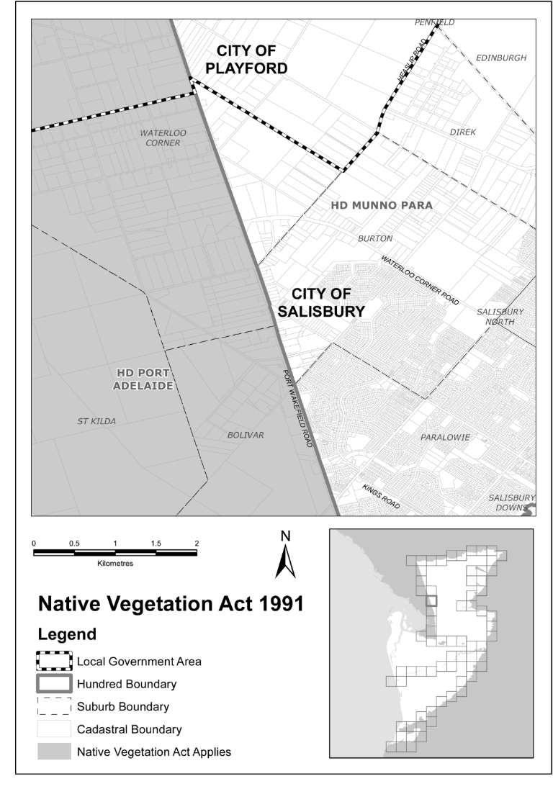
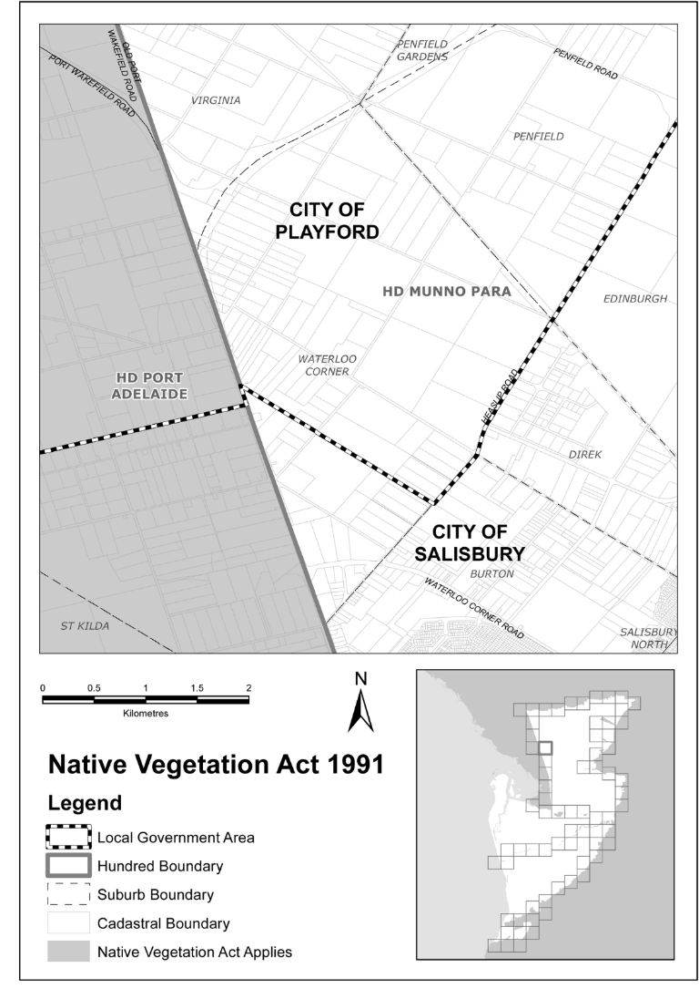
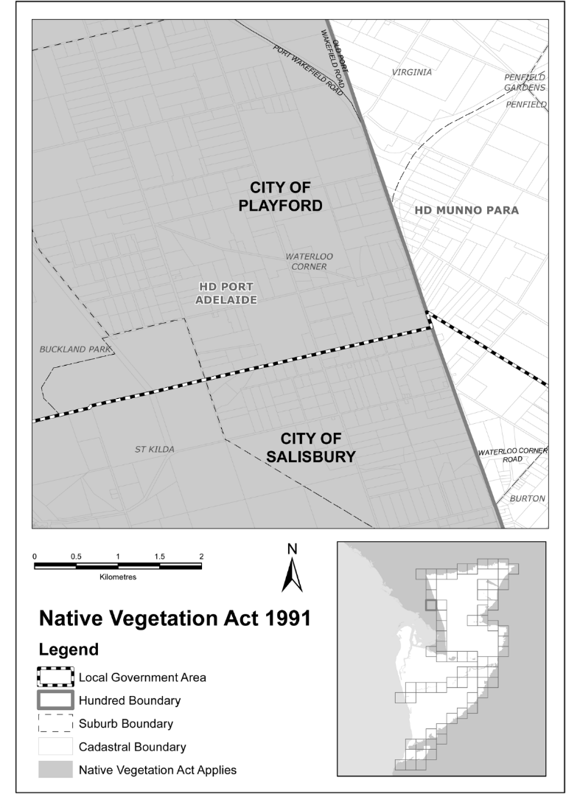
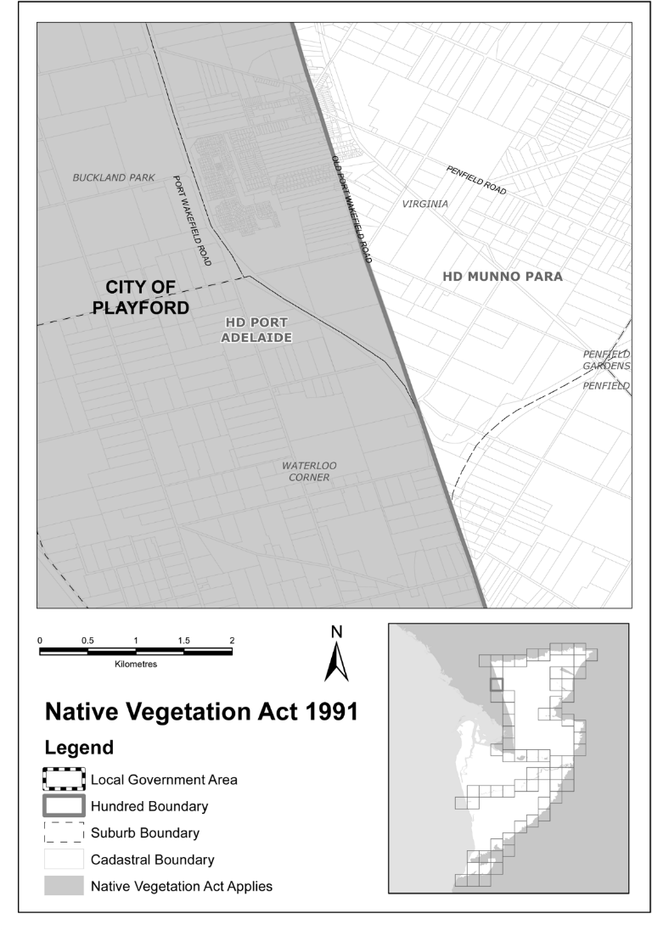
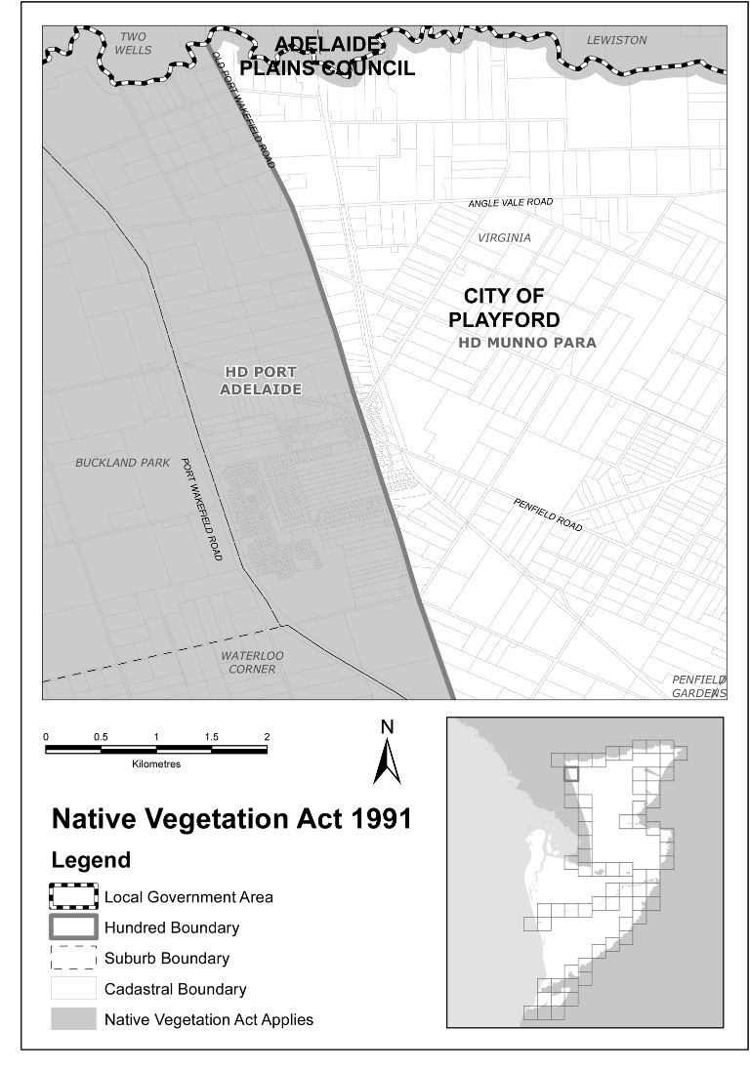
Note—
As required by section 10AA(2) of the Subordinate Legislation Act 1978, the Minister has certified that, in the Minister's opinion, it is necessary or appropriate that these regulations come into operation as set out in these regulations.
Made by the Administrator
being satisfied as to the matters set out in section 4(2c)(a) of the Native Vegetation Act 1991 and with the advice and consent of the Executive Council
on 2 December 2021
No 177 of 2021

South Australia

Passenger Transport (Definition of Metropolitan Adelaide and Other Matters) Variation Regulations 2021
under the Passenger Transport Act 1994

Contents
Part 1—Preliminary
1 Short title
2 Commencement
3 Variation provisions
Part 2—Variation of Passenger Transport Regulations 2009
4 Substitution of regulation 4
4 Definition of Metropolitan Adelaide
5 Insertion of regulation 7AA
7AA Sections 39(3)(a), 40(5) and 40(6) of Act not to apply in Metropolitan Adelaide (Area B)
6 Variation of regulation 68—Duty to accept or continue hiring
7 Variation of Schedule 3—Maximum fares (metropolitan taxis)
1 Journeys ending in Metropolitan Adelaide
2 Journeys ending outside Metropolitan Adelaide (Area A)

Part 1—Preliminary
1—Short title
These regulations may be cited as the Passenger Transport (Definition of Metropolitan Adelaide and Other Matters) Variation Regulations 2021.
2—Commencement
These regulations come into operation on 2 December 2021.
3—Variation provisions
In these regulations, a provision under a heading referring to the variation of specified regulations varies the regulations so specified.
Part 2—Variation of Passenger Transport Regulations 2009
4—Substitution of regulation 4
Regulation 4—delete the regulation and substitute:
4—Definition of Metropolitan Adelaide
(1) The following areas are included within the ambit of the definition of Metropolitan Adelaide in section 4(1) of the Act:
(a) the areas defined in a plan deposited in the General Registry Office by the Minister for the purposes of this regulation and identified by the Minister by notice in the Gazette;
(b) that portion of the area of the Adelaide Hills Council that is outside Metropolitan Adelaide as defined in the Development Act 1993 immediately before 1 July 2019;
(c) the area of the Mount Barker District Council.
(2) In these regulations, unless the contrary intention appears—
Metropolitan Adelaide (Area A) means the area comprised of—
(a) Metropolitan Adelaide as defined in the Development Act 1993 immediately before 1 July 2019; and
(b) the areas specified in subregulation (1)(a);
Metropolitan Adelaide (Area B) means the areas specified in subregulation (1)(b) and (c).
5—Insertion of regulation 7AA
After regulation 7A insert:
7AA—Sections 39(3)(a), 40(5) and 40(6) of Act not to apply in Metropolitan Adelaide (Area B)
(1) Section 39(3)(a) of the Act does not apply in relation to service contracts that relate (either wholly or partly) to regular passenger services operating in Metropolitan Adelaide (Area B).
(2) Section 40(5) of the Act does not apply in relation to fares payable by passengers on regular passenger services operating in Metropolitan Adelaide (Area B).
(3) Section 40(6) of the Act does not apply in relation to fares or fare systems under service contracts that relate (either wholly or partly) to regular passenger services operating in Metropolitan Adelaide (Area B).
6—Variation of regulation 68—Duty to accept or continue hiring
Regulation 68(1)(a)—after "Metropolitan Adelaide" insert:
(other than Metropolitan Adelaide (Area B))
7—Variation of Schedule 3—Maximum fares (metropolitan taxis)
Schedule 3, clauses 1 and 2—delete the clauses and substitute:
1—Journeys ending in Metropolitan Adelaide
(1) This clause applies to the following journeys by metropolitan taxi:
(a) a journey within Metropolitan Adelaide (Area A);
(b) a journey that begins and ends in Metropolitan Adelaide (Area A);
(c) a journey within Metropolitan Adelaide (Area B);
(d) a journey that begins in Metropolitan Adelaide (Area B) and ends in Metropolitan Adelaide (Area A).

(2) For a journey by metropolitan taxi to which this clause applies, the fare must not exceed the sum of the following:

(a) flagfall—
(i) on tariff 1 | $3.70
(ii) on tariff 2 | $4.90
(iii) on tariff 3 | $4.70
(iv) on tariff 4 | $6.40
(b) for the distance travelled—
(i) on tariff 1—for every 53.41 metres or part | $0.10
(ii) on tariff 2—for every 46.24 metres or part | $0.10
(iii) on tariff 3—for every 41.25 metres or part | $0.10
(iv) on tariff 4—for every 35.55 metres or part | $0.10
(c) for waiting time after the commencement of the hiring—
(i) on tariff 1—for each period of 9.16 seconds | $0.10
(ii) on tariff 2—for each period of 9.16 seconds | $0.10
(iii) on tariff 3—for each period of 7.05 seconds | $0.10
(iv) on tariff 4—for each period of 7.05 seconds | $0.10
(3) The following tariffs apply to the hiring of a metropolitan taxi for a journey to which this clause applies:
(a) in the case of a multi-seat hiring—
(i) commenced between the hours of 7 pm on Monday to Thursday inclusive and 6 am on the following day, or between the hours of 7 pm on Friday and 6 am on the following Monday, or during a public holiday—tariff 4 applies;
(ii) commenced at any other time—tariff 3 applies;
(b) in any other case—
(i) commenced between the hours of 7 pm on Monday to Thursday inclusive and 6 am on the following day, or between the hours of 7 pm on Friday and 6 am on the following Monday, or during a public holiday—tariff 2 applies;
(ii) commenced at any other time—tariff 1 applies.
(4) For a journey by metropolitan taxi to which this clause applies that is—
(a) between the hours of 12.01 am and 5.59 am on a Saturday or public holiday; or
(b) on a day during a declared period,
the fare calculated in accordance with this clause may include an additional amount of $2.
Note—
All Sundays are public holidays under the Holidays Act 1910.
(5) In circumstances determined by the Minister, a lifting fee of an amount determined by the Minister may be charged in respect of a period determined by the Minister during which the taxi is delayed by reason of the driver assisting the user of a wheelchair, scooter or other large (ride-on) mobility aide to enter or leave the taxi instead of an amount that would be chargeable for that period under subclause (2)(c).
(6) In this clause—
declared period means—
(a) a declared period within the meaning of the South Australian Motor Sport Act 1984; or
(b) any period declared by the Minister by notice in the Gazette to be a declared period for the purposes of this clause.
2—Journeys ending outside Metropolitan Adelaide (Area A)
(1) This clause applies to the following journeys by metropolitan taxi:
(a) a journey that begins in Metropolitan Adelaide (Area A) and ends in Metropolitan Adelaide (Area B);
(b) a journey that begins in Metropolitan Adelaide (Area A) and ends outside Metropolitan Adelaide;
(c) a journey that begins in Metropolitan Adelaide (Area B) and ends outside Metropolitan Adelaide.
(2) For a journey by metropolitan taxi to which this clause applies, the fare must be determined by contract between the hirer and the driver but—
(a) in the case of a multi-seat hiring—must not exceed $1.54 per kilometre calculated on the forward and return journey plus waiting time at the rate of $0.10 for each period of 9.16 seconds;
(b) in any other case—must not exceed $1.18 per kilometre calculated on the forward and return journey plus waiting time at the rate of $0.10 for each period of 9.16 seconds.
(3) The hirer must, if requested to do so by the driver, pay the estimated fare in advance.
(4) If at the conclusion of the forward journey the hirer requests the driver to wait and pays the fare for the forward journey plus the estimated waiting time at the rate of $0.10 for each period of 9.16 seconds up to a limit of 2 hours, the driver must comply with the request and complete the journey at the contract rate.
(5) The hirer must pay for all meals and accommodation expenses necessarily incurred by the driver in the journey but time spent during meals or rest periods must not be calculated as waiting time.
(6) Unless otherwise agreed, the flagfall specified in clause 1 applies to any such journey.

Note—
As required by section 10AA(2) of the Subordinate Legislation Act 1978, the Minister has certified that, in the Minister's opinion, it is necessary or appropriate that these regulations come into operation as set out in these regulations.
Made by the Administrator
with the advice and consent of the Executive Council
on 2 December 2021
No 178 of 2021

State Government Instruments

Administrative Arrangements Act 1994
Instrument of Delegation
I, STEPHEN GRAHAM WADE, Minister for Health and Wellbeing, HEREBY delegate to the Hon Vickie Chapman MP, Attorney-General; pursuant to section 9 of the Administrative Arrangements Act 1994 and section 14C of the Acts Interpretation Act 1915 the functions and powers to be conferred on me under section 56A of the Controlled Substances Act 1984 (the Act) in relation to accreditation of drug assessment and treatment services providers for the purposes of Part 7A of the Act only.
This instrument of delegation has effect from the day on which it is published in the Government Gazette.
Dated: 8 November 2021
Stephen Wade
Minister for Health and Wellbeing

Controlled Substances Act 1984
Approval and Publication of the Vaccine Administration Code
NOTICE is hereby given that on 29 November 2021, Dr Christopher McGowan, Chief Executive, Department for Health and Wellbeing, approved for publication the Vaccine Administration Code (December 2021) on the SA Health website.
The Code is available at: www.sahealth.sa.gov.au/immunisationprovider.
Dated: 29 November 2021
C. McGowan
Chief Executive
Department for Health and Wellbeing

Education and Children’s Services Act 2019
Notice Fixing Charges for Dependants of Subclass 500, 572, 573 and 574 Visa Holders
Pursuant to section 130(1)(c) of the Education and Children’s Services Act 2019, I, Chief Executive of the Department for Education, fix the following charges payable in respect of a dependant of a person who is the subject of a student visa for education in a Government school.
For the purposes of this notice, student visa means a student visa that is:
(1) a Subclass 500 (Student) visa that relates to study in the vocational education and training, higher education or postgraduate research sectors;
(2) a Subclass 572 (Vocational Education and Training Sector) visa;
(3) a Subclass 573 (Higher Education Sector) visa; or
(4) a Subclass 574 (Postgraduate Research Sector) visa,
issued under the Migration Act 1958 of the Commonwealth.
Fees commencing from 1 January 2023 per school year:
(1) The administration charge for application processing and school enrolment is—
(a) for the first school year of enrolment—$660;
(b) for each subsequent school year of enrolment—$340.
(2) The tuition charge for a full school year for a dependant of a person who is the subject of a student visa is—
(a) for tuition in primary courses—$6,400;
(b) for tuition in secondary courses or in an intensive English course at secondary level (years 7 to 12)—$7,600;
(3) The tuition charge for a part of a school year for a dependant of a person who is the subject of a student visa is such proportion of the tuition charge that would be payable if the dependant were enrolled for the full school year (being the proportion that the number of school terms for the whole or part of which the student is enrolled bears to 4), rounded up to the nearest dollar.
Dated: 29 November 2021
R. Persse
Chief Executive

Education and Children’s Services Act 2019
Notice Fixing Charges for Full Fee Paying Overseas Students
Pursuant to section 130(1)(a) of the Education and Children’s Services Act 2019, I, Chief Executive of the Department for Education, fix the following charges payable by a full fee paying overseas student (defined in section 130(6) of the Education and Children’s Services Act 2019) of a Government school.
Fees commencing from 1 January 2023 per school year:
(1) The administration charge for application processing and school enrolment in relation to a full fee paying overseas student is—
(a) in the case of a student holding a temporary visa under the Migration Act 1958 of the Commonwealth that is valid for a total period of 12 months or less and who is enrolled for the whole or part of school year—$1,180;
(b) in any other case—
(i) for the first school year of enrolment—$660;
(ii) for each subsequent school year of enrolment—$340.

(2) The tuition charge for a full school year for a full fee paying overseas student is—
(a) for tuition in primary courses or in an intensive English course at primary level—$11,400;
(b) for tuition in secondary courses or in an intensive English course at secondary level—
(i) for years 7 to 10—$13,600;
(ii) for years 11 to 12—$15,000.
(3) The tuition charge for a part of a school year for a full fee paying overseas student is to be determined as follows:
(a) in the case of a student who is enrolled for a period of less than 9 weeks—the tuition charge is as specified in the following table:
Weeks | Primary | Junior Secondary (Years 7 to 10) | Senior Secondary (Years 11 to 12)
1 to 5 | $1,675.00 | $1,950.00 | $2,125.00
6 | $2,010.00 | $2,340.00 | $2,550.00
7 | $2,345.00 | $2,730.00 | $2,975.00
8 | $2,680.00 | $3,120.00 | $3,400.00
(b) in any other case—the tuition charge is such proportion of the tuition charge that would be payable if the student were enrolled for the full school year (being the proportion that the number of school terms for the whole or part of which the student is enrolled bears to 4), rounded up to the nearest dollar.
Dated: 29 November 2021
R. Persse
Chief Executive

Emergency Management Act 2004
Section 26A
Modification of Controlled Substances Act 1984
I, Steven Spence Marshall, Premier for the State of Australia, pursuant to section 26A of the Emergency Management Act 2004 hereby modify the operation of section 18 of the Controlled Substances Act 1984 for the duration of the declaration of a Major Emergency declared by Grantley Stevens, the State Coordinator pursuant to section 23(1) of the Emergency Management Act 2004 on 22 March 2020 in respect of the outbreak of the Human Disease named COVID-19 within South Australia, which declaration has been extended by the Governor, as follows:
Section 18 of the Controlled Substances Act 1984 applies with the following modification:
After section 18(1d)(e) insert:
(f) a registered Aboriginal and Torres Strait Islander health practitioner, Aboriginal health practitioner or Torres Strait Islander health practitioner may administer a prescription drug which is a COVID-19 vaccine to another person if the practitioner is acting in the ordinary course of the practitioner’s profession and:
- the practitioner:
  - has completed the Certificate IV in Aboriginal and/or Torres Strait Islander Primary Health Care Practice which includes completion of the HLTAHW020 Administer medications module; and
  - complies with all requirements of the South Australian COVID-19 Immunisation Program Legislative and Clinical Competency Framework: Aboriginal and Torres Strait Islander Health Practitioners, as published by SA Health; and
- the administration of the COVID-19 vaccine by the practitioner:
  - is in accordance with a Standing Medication Order approved by the Drug and Therapeutics Committee or equivalent committee of the employing organisation; and
  - is under the supervision of a registered nurse, midwife or medical practitioner.
For the purposes of this Notice:
- COVID-19 Vaccine means a vaccine for COVID-19 included in the Australian Register of Therapeutic Goods
- Aboriginal and Torres Strait Islander health practitioner, Aboriginal health practitioner and Torres Strait Islander health practitioner means a person registered under the Health Practitioner Regulation National Law to practise in the health profession of Aboriginal and Torres Strait Islander health practice profession as an Aboriginal and Torres Strait Islander health practitioner, Aboriginal health practitioner and Torres Strait Islander health practitioner (other than as a student)
- SA COVID-19 Immunisation Program Legislative and Clinical Competency Framework: ATSIHP means the document of that name published by the Department (as amended from time to time)
Dated: 29 November 2021
Steven Spence Marshall
Premier for the State of South Australia

Fire and Emergency Services Act 2005
Section 4
Establishment of Areas for Fire and Emergency Services
I, JULIA WADDINGTON-POWELL, Chief Executive of the South Australian Fire and Emergency Services Commission, hereby establish the following Fire District (Adelaide Metropolitan) as set out in rack plan number 1507 lodged in the Surveyor-Generals Office at Adelaide. This notice will come into operation on 8 December 2021.
Dated: 25 November 2021
J. Waddington-Powell
Chief Executive
SAFECOM

Fisheries Management Act 2007
Section 115
Ministerial Exemption ME9903192
TAKE NOTICE that pursuant to section 115 of the Fisheries Management Act 2007 (the Act), I Professor Gavin Begg, Executive Director Fisheries and Aquaculture, delegate to the Minister for Primary Industries and Regional Development, hereby exempt unlicensed persons fishing in inland waters within the counties of MacDonnell, Robe and Grey, excluding the waters of Lake George, from Section 70 of the Fisheries Management Act 2007, Regulation 5 and clause 95 of schedule 6 of the Fisheries Management (General) Regulations 2017 but only insofar as they may use the devices listed in Schedule 1 (the ‘exempted activity’), subject to the fishing restrictions and limitations prescribed under the Act in particular clause 44 of schedule 6 of the Fisheries Management (General) Regulations 2017, from 25 November 2021 until 24 November 2022, unless varied or revoked earlier.
Schedule 1
- Dip tin
- Shrimp trap
- Drop net
- Hoop net
- Pyramid net
Dated: 24 November 2021
Prof Gavin Begg
Executive Director
Fisheries and Aquaculture
Delegate of the Minister for Primary Industries and Regional Development

Fisheries Management (Prawn Fisheries) Regulations 2017
Temporary Prohibition on Fishing Activities in the Gulf St Vincent Prawn Fishery
TAKE notice that pursuant to regulation 10 of the Fisheries Management (Prawn Fisheries) Regulations 2017, the activities of the class specified in Schedule 1 are prohibited in the waters of the Gulf St Vincent Prawn Fishery during the period specified in Schedule 2 except for the licences listed in Schedule 3 undertaking the activities described in Schedule 4 unless this notice is varied or revoked.
Schedule 1
The act of taking or an act preparatory to or involved in the taking of King Prawns (Melicertus latisulcatus).
Schedule 2
Commencing at sunset on 27 November 2021 to sunrise on 1 December 2021
Schedule 3
Licence Number | Licence Holder | Boat Name
V03 | Josephine K Fisheries Pty Ltd | Josephine K
V06 | Todreel Pty Ltd | Anna Pearl
Schedule 4
- For the purposes of this schedule the trawl survey areas cannot include any waters of a habitat protection zone or a sanctuary zone of a marine park established under the Marine Parks Act 2007 or depths less than 10 metres.
- The licence holders listed in Schedule 3 or their registered master must comply with all regulations and conditions that apply to fishing activities undertaken pursuant to their Gulf St Vincent Prawn Fishery licence, in addition to the conditions imposed by this notice.
- All fishing activity pursuant to this fishing notice must be conducted in the area of Fishery Independent Survey stations identified on page 16 of the “Gulf St Vincent Prawn Penaeus (Melicertus) latisulcatus Fishery 2019/20” (McLeay and Hooper 2020).
- Fishing activity pursuant to this fishing notice must not exceed more than one survey shot at each of the Fishery Independent Survey stations.
- While engaged in fishing activities or unloading the survey catch, the licence holders listed in Schedule 3 or their registered master must have a copy of this notice on board the boat or near his person. This notice must be produced to a Fisheries Officer if requested.
- No fishing activity may be undertaken between the prescribed times of sunrise and sunset for Adelaide (as published in the South Australian Government Gazette).
- The licence holders listed in Schedule 3 or their register master must not contravene or fail to comply with the Fisheries Management Act 2007, or any other regulations made under that Act except where specifically exempted by this notice.
- This notice does not purport to override the provisions or operation of any other Act including, but not limited to, the Marine Parks Act 2007. The notice holder and his agents must comply with any relevant regulations, permits, requirements and directions from the Department for Environment and Water when undertaking activities within a marine park.
- A report (including the raw survey data) are to be provided to SARDI by the Saint Vincent Gulf Prawn Boat Owner’s Association detailing the outcomes of the survey as soon as practicable on the survey completion.
Dated: 24 November 2021
Yolande Markey
A/Prawn Fisheries Manager
Delegate of the Minister for Primary Industries and Regional Development

Fisheries Management (Prawn Fisheries) Regulations 2017
Variation to Prohibited Fishing Activities in Spencer Gulf Prawn Fishery
TAKE NOTE that pursuant to regulation 10 of the Fisheries Management (Prawn Fisheries) Regulations 2017, the notice dated 28 September 2021 on page 3654 of the South Australian Government Gazette on 30 September 2021 prohibiting fishing activities in the Spencer Gulf Prawn Fishery, is hereby varied such that it will not be unlawful for a person fishing pursuant to a Spencer Gulf Prawn Fishery licence to use prawn trawl nets in the areas specified in Schedule 1, during the period specified in Schedule 2, and under the conditions specified in Schedule 3
Schedule 1
The waters of the Spencer Gulf Prawn Fishery:
- Except the Northern Closure area, which is defined as the area north of the following index points:
 | 33 | ° | 29.50 | S |  | 137 | ° | 18.00 | E
 | 33 | ° | 29.50 | S |  | 137 | ° | 30.00 | E
 | 33 | ° | 22.00 | S |  | 137 | ° | 30.00 | E
 | 33 | ° | 16.75 | S |  | 137 | ° | 32.30 | E
 | 33 | ° | 10.50 | S |  | 137 | ° | 39.50 | E
 | 33 | ° | 10.50 | S |  | 137 | ° | 53.00 | E
- Except the Wallaroo Closure area, which is defined as the waters contained within the following index points:
 | 33 | ° | 17.00 | S |  | 137 | ° | 53.00 | E
 | 33 | ° | 37.00 | S |  | 137 | ° | 33.00 | E
 | 33 | ° | 44.50 | S |  | 137 | ° | 30.00 | E
 | 33 | ° | 50.00 | S |  | 137 | ° | 39.00 | E
- Except the Southern area, which is defined as the waters contained within the following index points:
 | 33 | ° | 41.00 | S |  | 137 | ° | 06.00 | E
 | 33 | ° | 56.00 | S |  | 137 | ° | 18.00 | E
 | 34 | ° | 14.00 | S |  | 136 | ° | 57.00 | E
 | 34 | ° | 14.00 | S |  | 136 | ° | 55.00 | E
 | 34 | ° | 18.00 | S |  | 136 | ° | 54.00 | E
 | 34 | ° | 22.00 | S |  | 136 | ° | 51.50 | E
 | 34 | ° | 36.00 | S |  | 136 | ° | 38.00 | E
 | 34 | ° | 36.00 | S |  | 136 | ° | 35.00 | E
 | 34 | ° | 20.00 | S |  | 136 | ° | 39.50 | E
 | 34 | ° | 02.00 | S |  | 136 | ° | 52.00 | E
 | 33 | ° | 57.00 | S |  | 137 | ° | 00.00 | E
 | 33 | ° | 52.50 | S |  | 136 | ° | 55.00 | E
 | 33 | ° | 51.00 | S |  | 136 | ° | 57.50 | E
 | 33 | ° | 47.00 | S |  | 136 | ° | 53.00 | E
- Except the Wardang Closure area, which is defined as the waters contained within the following index points:
 | 34 | ° | 10.00 | S |  | 137 | ° | 28.00 | E
 | 34 | ° | 21.00 | S |  | 137 | ° | 12.00 | E
 | 34 | ° | 45.00 | S |  | 137 | ° | 15.00 | E
 | 34 | ° | 48.53 | S |  | 137 | ° | 09.45 | E
 | 34 | ° | 48.53 | S |  | 137 | ° | 06.00 | E
 | 34 | ° | 50.75 | S |  | 137 | ° | 06.00 | E
 | 34 | ° | 54.00 | S |  | 137 | ° | 01.00 | E
- Except the Corny closure area, which is defined as the waters within and bounded by the following closure index points:
 | 34 | ° | 27.00 | S |  |  | 136 | ° | 53.00 | E
 | 34 | ° | 27.00 | S |  |  | 137 | ° | 02.00 | E
 | 34 | ° | 35.00 | S |  |  | 136 | ° | 56.00 | E
 | 34 | ° | 48.60 | S |  |  | 136 | ° | 52.00 | E
 | 34 | ° | 54.00 | S |  |  | 136 | ° | 52.00 | E
 | 34 | ° | 54.00 | S |  |  | 136 | ° | 48.50 | E
 | 34 | ° | 49.50 | S |  |  | 136 | ° | 48.50 | E
 | 34 | ° | 49.50 | S |  |  | 136 | ° | 40.50 | E
 | 34 | ° | 39.50 | S |  |  | 136 | ° | 40.50 | E
 | Then back to point 1
- Except the Jurassic Park closure area, which is defined as the waters contained within the following closure index points:
 | 33 | ° | 54.90 |  | S |  | 137 | ° | 17.60 | E
 | 33 | ° | 54.40 |  | S |  | 137 | ° | 19.40 | E
 | 33 | ° | 54.70 |  | S |  | 137 | ° | 19.60 | E
 | 33 | ° | 55.20 |  | S |  | 137 | ° | 17.80 | E
 | Then back to point 1
- Except the Illusions closure area, which is defined as the waters contained within the following closure index points:
 | 33 | ° | 28.80 |  | S |  | 137 | ° | 32.20 | E
 | 33 | ° | 28.30 |  | S |  | 137 | ° | 33.20 | E
 | 33 | ° | 28.85 |  | S |  | 137 | ° | 33.50 | E
 | 33 | ° | 29.40 |  | S |  | 137 | ° | 32.50 | E
 | Then back to point 1
- Except the Estelle Star closure area, which is defined as the waters contained within the following closure index points:
 | 33 | ° | 58.80 |  | S |  | 136 | ° | 49.80 | E
 | 33 | ° | 58.20 |  | S |  | 136 | ° | 51.00 | E
 | 33 | ° | 59.10 |  | S |  | 136 | ° | 51.70 | E
 | 33 | ° | 59.80 |  | S |  | 136 | ° | 50.40 | E
 | Then back to point 1
Schedule 2
Commencing at sunset on 30 November 2021 and ending at sunrise on the 12 December 2021.

Schedule 3
- The coordinates in Schedule 1 are defined as degrees decimal minutes and are based on the World Geodetic System 1984 (WGS 84).
- No fishing activity may be undertaken between the prescribed times of sunrise and sunset for Adelaide (as published in the South Australian Government Gazette pursuant to the requirements of the Proof of Sunrise and Sunset Act 1923) during the period specified in Schedule 2.
- Based on the best information available from the fleet, fishing must cease in an area in the Mid/North Gulf if the average prawn bucket count exceeds 260 prawns per 7kg; or in an area in the Southern Gulf if the average prawn bucket count exceeds 260 prawns/7kg, or in the whole area when a total catch of 220 tonnes has been landed, or if the catches drop below 300kg/vessel/night.
- No fishing activity may occur without the authorisation of Coordinator at Sea, Ashley Lukin, or other nominated Coordinator at Sea appointed by the Spencer Gulf and West Coast Prawn Fishermen’s Association.
- The authorisation of the Coordinator at Sea must be in writing, signed and record the day, date and permitted fishing area within the waters of Schedule 1 in the form of a notice sent to the fishing fleet or vary an earlier authorisation issued by the Coordinator at Sea.
- The Coordinator at Sea must cause a copy of any authorisation for fishing activity or variation of same, made under this notice to be emailed to the Prawn Fisheries Manager immediately after it is made.
- The Spencer Gulf and West Coast Prawn Fishermen’s Association must keep records of all authorisations issued pursuant to this notice.
Dated: 24 November 2021
Ashley Lukin
Coordinator at Sea
Spencer Gulf & West Coast Prawn Fishermen’s Association Inc.
Delegate of the Minister for Primary Industries and Regional Development

Housing Improvement Act 2016
Rent Control Revocations
Whereas the Minister for Human Services Delegate is satisfied that each of the houses described hereunder has ceased to be unsafe or unsuitable for human habitation for the purposes of the Housing Improvement Act 2016, notice is hereby given that, in exercise of the powers conferred by the said Act, the Minister for Human Services Delegate does hereby revoke the said Rent Control in respect of each property.
Address of Premises | Allotment  Section | Certificate of Title  Volume Folio
8 Sheila Street, Rostrevor SA 5073 | Allotment 49 Deposited Plan 4719 Hundred of Adelaide | CT5645/924
393 Marion Road, Plympton SA 5038 | Allotment 88 Filed Plan 8103 Hundred of Adelaide | CT5279/54
2 Main Road, Robertstown SA 5381 | Allotment 183 Filed Plan 169122 Hundred of English | CT5783 / 654
3 Clark Street, Exeter SA 5019 | Allotment 277 Filed Plan 17705 Hundred of Port Adelaide | CT5453/392
10 King William Street, Rosewater SA 5013 | Allotment 134 Filed Plan 30138 Hundred of Port Adelaide | CT5086/402
17 Day Terrace, Croydon SA 5008 | Allotment 64 Filed Plan 115876 Hundred of Yatala | CT5348/550
1 / 31 Bakewell Road, Evandale SA 5069 | Allotment 11 Filed Plan 135162 Hundred of Adelaide | CT472/68, CT5827/925
2 / 31 Bakewell Road, Evandale SA 5069 | Allotment 11 Filed Plan 135162 Hundred of Adelaide | CT472/68, CT5827/925
39 Finniss Street, Gawler SA 5118 | Allotment 26 Filed Plan 154427 Hundred of Mudla Wirra | CT5289/211
14 Farnham Road, Keswick SA 5035 | Allotment 279 Filed Plan 19502 Hundred of Adelaide | CT 6184/103
Dated: 2 December 2021
Craig Thompson
Housing Regulator and Registrar
Housing Safety Authority, SAHA
Delegate of Minister for Human Services

Justices of the Peace Act 2005
Section 4
Appointment of Justices of the Peace for South Australia—Notice by the Commissioner for Consumer Affairs
I, Dini Soulio, Commissioner for Consumer Affairs, delegate of the Attorney-General, pursuant to section 4 of the Justices of the Peace Act 2005, do hereby appoint the people listed as Justices of the Peace for South Australia as set out below.
For a period of ten years for a term commencing on 15 December 2021 and expiring on 14 December 2031:
Russell Paul WORTLEY
Andrew Colin WOOLFORD
Colin Arthur WILLIAMS
Graham Keith WATTS
Paul Daryl SWANBURY
Neil John SURFIELD
Mark Andrew STOKES
Kerryn Geoffrey ST CLAIR
Gregory Nikolaus SIEROCINSKI
Robert John Peebles SHAW
Tania Jane SCHULTZ
Michael Franz Hermann SACHSSE
Peter John ROWLAND
Geoffrey Donald John RAWSON
Keith Ross RASHEED
Deane Walters PHILLIPS
Julie-Ann MOULD
Peter Jeffrey MICKLEM
Rudite MCWATERS
Kenneth Reginald MAYNARD
Trevor John KUBENK
Michael Allen KRIEGER
Roger Philip KIRCHNER
Rex John KEILY
Robert John HUGHES
Kristene Ann HENRY
David Grant HALL
David Brenton GEHLERT
Ian Joseph DENTON
William Edward COOMANS
William Michael COAD
Barry John CHENOWETH
Garth James CHALLANS
Marilyn Faye BURGEMEISTER
Dennis Graham BOCK
Darryl James BISHOP
Francesco BAVARESCO
Thompson BANH
Dated: 29 November 2021
Dini Soulio
Commissioner for Consumer Affairs
Delegate of the Attorney-General

Land Acquisition Act 1969
Section 16
Form 5 – Notice of Acquisition
1. Notice of acquisition
The Commissioner of Highways (the Authority), of 50 Flinders Street, Adelaide SA 5000, acquires the following interests in the following land:
First, comprising an unencumbered estate in fee simple in that piece of land being the whole of Allotment 92 in Filed Plan No 12864 comprised in Certificate of Title Volume 5095 Folio 841.
Second, comprising an unencumbered estate in fee simple in that piece of land being the whole of Allotment 91 in Filed Plan 12864 comprised in Certificate of Title Volume 5095 Folio 840.
This notice is given under section 16 of the Land Acquisition Act 1969.
2. Compensation
A person who has or had an interest consisting of native title or an alienable interest in the land that is divested or diminished by the acquisition or the enjoyment of which is adversely affected by the acquisition who does not receive an offer of compensation from the Authority may apply to the Authority for compensation.
2A. Payment of professional costs relating to acquisition (section 26B)
If you are the owner in fee simple of the land to which this notice relates, you may be entitled to a payment of $10 000 from the Authority for use towards the payment of professional costs in relation to the acquisition of the land.
Professional costs include legal costs, valuation costs and any other costs prescribed by the Land Acquisition Regulations 2019.
3. Inquiries
Inquiries should be directed to: Rob Gardner
GPO Box 1533
Adelaide SA 5001
Telephone: (08) 8343 2567
Dated: 30 November 2021
The Common Seal of the COMMISSIONER OF HIGHWAYS was hereto affixed by authority of the Commissioner in the presence of:
Rocco Caruso
Manager, Property Acquisition (Authorised Officer)
Department for Infrastructure and Transport
DIT 2021/08328/01

Land Acquisition Act 1969
Section 16
Form 5 – Notice of Acquisition
1. Notice of acquisition
The Commissioner of Highways (the Authority), of 50 Flinders Street, Adelaide SA 5000, acquires the following interests in the following land:
Comprising an unencumbered estate in fee simple in that piece of land being portion of Allotment 24 in Filed Plan No 153410 comprised in Certificate of Title Volume 5752 Folio 903, and being the whole of the land identified as Allotment 101 in plan D127395 lodged in the Lands Titles Office.
This notice is given under section 16 of the Land Acquisition Act 1969.
2. Compensation
A person who has or had an interest consisting of native title or an alienable interest in the land that is divested or diminished by the acquisition or the enjoyment of which is adversely affected by the acquisition who does not receive an offer of compensation from the Authority may apply to the Authority for compensation.
2A. Payment of professional costs relating to acquisition (section 26B)
If you are the owner in fee simple of the land to which this notice relates, you may be entitled to a payment of $10 000 from the Authority for use towards the payment of professional costs in relation to the acquisition of the land.
Professional costs include legal costs, valuation costs and any other costs prescribed by the Land Acquisition Regulations 2019.
3. Inquiries
Inquiries should be directed to: Philip Cheffirs
GPO Box 1533
Adelaide SA 5001
Telephone: (08) 8343 2575
Dated: 30 November 2021
The Common Seal of the COMMISSIONER OF HIGHWAYS was hereto affixed by authority of the Commissioner in the presence of:
Rocco Caruso
Manager, Property Acquisition (Authorised Officer)
Department for Infrastructure and Transport
DIT 2020/16831/01

MENTAL HEALTH ACT 2009
Authorised Mental Health Professionals
NOTICE is hereby given in accordance with Section 94(1) of the Mental Health Act 2009, that the Chief Psychiatrist has determined the following people as Authorised Mental Health Professionals:
Simon McKay
Petrina Roennfeldt
Jenni Moore
A person’s determination as an Authorised Mental Health Professional expires three years after the commencement date.
Dated: 2 December 2021
Dr J Brayley
Chief Psychiatrist

Passenger Transport Act 1994
Section 5
Exemption for Country Taxi Accredited Operators
Exemption:
I, the Hon Corey Wingard, Minister for Infrastructure and Transport, pursuant to section 5(2) of the Passenger Transport Act 1994 (the Act) hereby EXEMPT the following class of persons:
- All operators accredited under the class of Country Taxi Accreditation established under section 32(3) of the Act, for the purposes of section 27 of the Act who operate within Metropolitan Adelaide (Area B) under an approved country taxi service plan (‘Exempt Persons’)
from the requirements set out in 1 below when providing passenger transport services in Metropolitan Adelaide (Area B) (see map in the Schedule to this notice for information), subject to the conditions specified in 2 in this exemption notice.
- Requirements
The Exempt Persons are exempt from compliance with the following legislative provisions, being the requirements to:
  - hold Metropolitan Taxi Accreditation established under section 32(3) of the Act, for the purposes of section 27 of the Act, for the provision of a passenger transport service for any journey that is inside of Metropolitan Adelaide (Area B);
  - hold accreditation to operate a Centralised Booking Service within Metropolitan Adelaide (Area B) under section 29(1) of the Act;
  - hold a licence to provide a passenger transport service within Metropolitan Adelaide (Area B) under section 45(1) and (2) of the Act;
  - collect the point to point transport service transaction levy ($1 levy) for a journey that commences or ends within Metropolitan Adelaide (Area B) for the purposes of schedule 2 clause 3(b) of the Act;
  - keep records of point to point transport services as required under regulation 150D of the Regulations; and
  - prepare and lodge a return containing information for an accurate assessment of any liability to the $1 levy under regulation 150E of the Passenger Transport Regulations 2009 (the Regulations).
- Conditions of Exemption
Pursuant to section 5(3) of the Act, this exemption is granted subject to the following conditions, that the Exempt Persons:
  - can only provide rank and hail services within Metropolitan Adelaide (Area B) and areas wholly outside of Metropolitan Adelaide;
  - cannot operate wholly within Metropolitan Adelaide (Area A);
  - may start a trip inside of Metropolitan Adelaide (Area B) and end a trip outside of Metropolitan Adelaide (Area B);
  - may start a trip outside of Metropolitan Adelaide (Area B) and end a trip within Metropolitan Adelaide (Area B); and
  - may continue to charge the non-metropolitan regulated taxi fare within Metropolitan Adelaide (Area B).
Note: All other requirements of a country taxi service as applicable to each of the Exempt Persons continue to apply despite operating within Metropolitan Adelaide (Area B).
- Interpretation
Any terms italicised in this instrument have the same meaning as in the Act and the Regulations.
- Commencement
This exemption comes into operation on 2 December 2021 and will remain in force until varied or revoked by a subsequent notice issued pursuant to section 5(4) of the Act.
Dated: 26 November 2021
Hon Corey Wingard MP
Minister for Infrastructure and Transport

Schedule
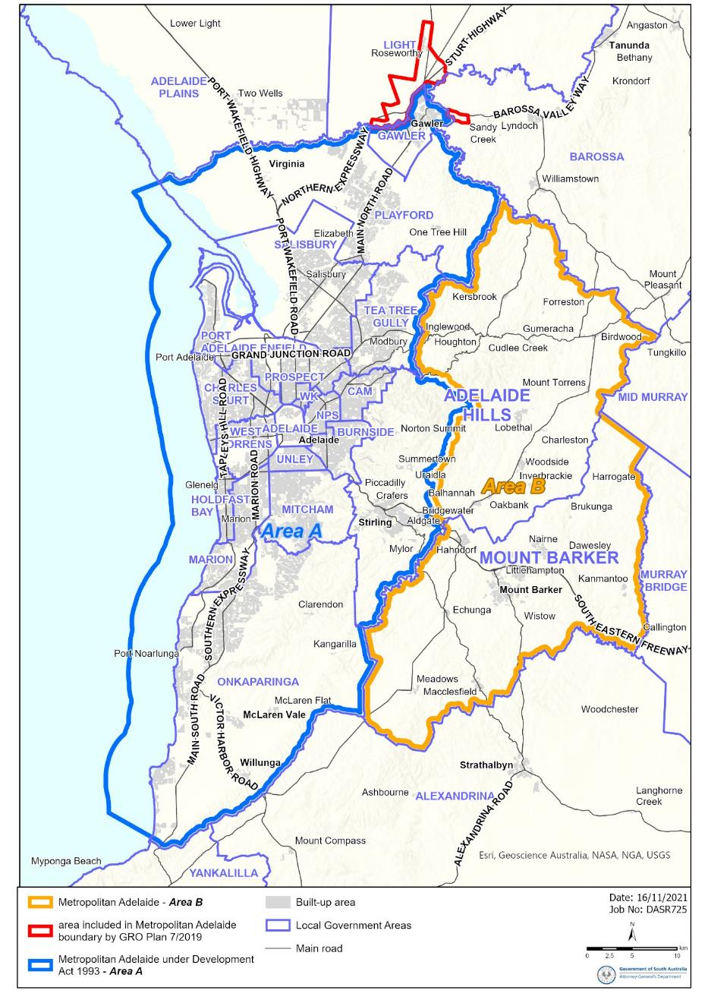
This map is for information purposes only, please see the Act and Regulations for details:

Passenger Transport Act 1994
Section 5
Exemption for Small Passenger Vehicle (Non-Metropolitan) Accredited Operators
Exemption:
I, the Hon Corey Wingard, Minister for Infrastructure and Transport, pursuant to section 5(2) of the Passenger Transport Act 1994 (the Act) hereby EXEMPT the following class of persons:
- All operators accredited for a chauffeured vehicle service provided under the class of Small Passenger Vehicle (Non-Metropolitan) Accreditation established under section 32(3) of the Act, for the purposes of section 27 of the Act who operate within Metropolitan Adelaide (Area B) under an approved plan of operation (‘Exempt Persons’)
from the requirements set out in 1 below when providing passenger transport services in Metropolitan Adelaide (Area B) (see map in the Schedule to this notice for information), subject to the conditions specified in 2 in this exemption notice.
- Requirements
The Exempt Persons are exempt from compliance with the following legislative provisions, being the requirements to:
  - hold Small Passenger Vehicle (Metropolitan) Accreditation established under section 32(3) of the Act, for the purposes of section 27 of the Act, for the provision of a passenger transport service for any journey that is inside of Metropolitan Adelaide (Area B);
  - hold accreditation to operate a Centralised Booking Service within Metropolitan Adelaide (Area B) under section 29(1) of the Act and regulation 7A of the Passenger Transport Regulations 2009 (the Regulations);
  - collect the point to point transport service transaction levy ($1 levy) for a journey that commences or ends within Metropolitan Adelaide (Area B) for the purposes of schedule 2 clause 3(b) of the Act;
  - keep records of point to point transport services as required under regulation 150D of the Regulations; and
  - prepare and lodge a return containing information for an accurate assessment of any liability to the $1 levy under regulation 150E of the Regulations.
- Conditions of Exemption
Pursuant to section 5(3) of the Act, this exemption is granted subject to the following conditions, that the Exempt Persons:
  - cannot operate wholly within Metropolitan Adelaide (Area A);
  - may start a trip inside of Metropolitan Adelaide (Area B) and end a trip outside of Metropolitan Adelaide (Area B); and
  - may start a trip outside of Metropolitan Adelaide (Area B) and end a trip within Metropolitan Adelaide (Area B).
Note: All other requirements of a Small Passenger Vehicle (Non-Metropolitan) Accreditation as applicable to each of the Exempt Persons, continue to apply despite an Exempt Person operating within Metropolitan Adelaide (Area B).
- Interpretation
Any terms italicised in this instrument have the same meaning as in the Act and the Regulations.
- Commencement
This exemption comes into operation on 2 December 2021 and will remain in force until varied or revoked by a subsequent notice issued pursuant to section 5(4) of the Act.
Dated: 26 November 2021
Hon Corey Wingard MP
Minister for Infrastructure and Transport

Schedule
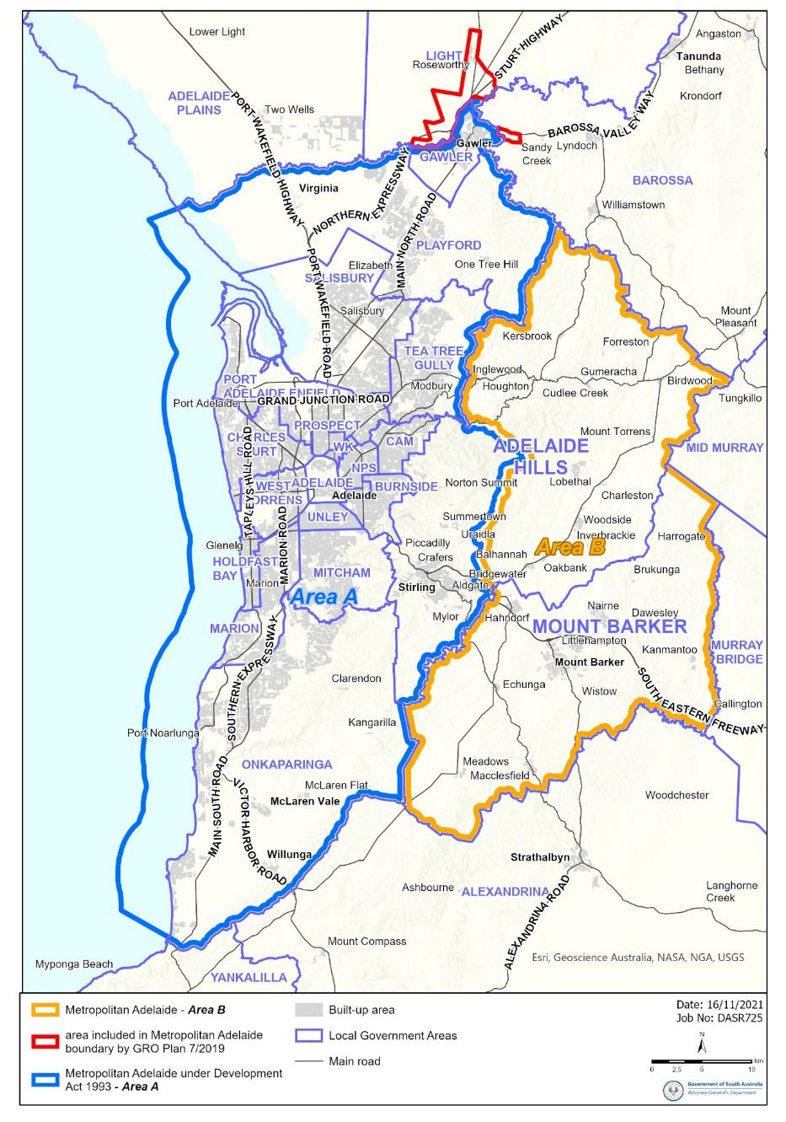
This map is for information purposes only, please see the Act and Regulations for details:

Primary Industry Funding Schemes Act 1998
SA Grape Growers Industry Fund
NOTICE is hereby given in accordance with Regulation 5(1) of the Primary Industry Funding Schemes (SA Grape Growers Industry Fund) 2021, that following a review of the contributions for the SA Grape Growers Industry Fund, the amount payable to the Minister be amended to a rate of 0.2% per tonne farm gate value of SA grapes grown and sold by a SA grape grower on or after 1 July 2021.
Dated: 8 October 2021
Hon David Basham MP
Minister for Primary Industries and Regional Development

Return to Work Act 2014
Section 33(8)
Notice of Travel Allowance
Preamble
Section 33(8) of the Return to Work Act 2014 (the Act) states that:
If a worker travels in a private vehicle to or from any place for the purpose of receiving medical services, hospitalisation or approved recovery/return to work services, and the travel is reasonably necessary in the circumstances of the case, the worker is entitled to a travel allowance at rates fixed by a scale published by the Minister under this section.
NOTICE
I DECLARE that the rate for travel allowance in 2022 is hereby fixed for the purposes of section 33(8) of the Act at 47.6 cents per kilometre, and this notice supersedes all previous notices of the travel allowance rate published under section 33(8) of the Act.
This Notice is effective for travel on or after 1 January 2022.
Dated: 24 November 2021
Hon Rob Lucas MLC
Treasurer

SOUTH AUSTRALIAN SKILLS ACT 2008
Part 4 – Apprenticeships, Traineeships and Training Contracts
PURSUANT to the provision of the South Australian Skills Act 2008, the South Australian Skills Commission (SASC) gives notice that determines the following Trades or Declared Vocations in addition to the gazette notices of:
1. 25 September 2008 | 2. 23 October 2008 | 3. 13 November 2008 | 4. 4 December 2008
5. 18 December 2008 | 6. 29 January 2009 | 7. 12 February 2009 | 8. 5 March 2009
9. 12 March 2009 | 10. 26 March 2009 | 11. 30 April 2009 | 12. 18 June 2009
13. 25 June 2009 | 14. 27 August 2009 | 15. 17 September 2009 | 16. 24 September 2009
17. 9 October 2009 | 18. 22 October 2009 | 19. 3 December 2009 | 20. 17 December 2009
21. 4 February 2010 | 22. 11 February 2010 | 23. 18 February 2010 | 24. 18 March 2010
25. 8 April 2010 | 26. 6 May 2010 | 27. 20 May 2010 | 28. 3 June 2010
29. 17 June 2010 | 30. 24 June 2010 | 31. 8 July 2010 | 32. 9 September 2010
33. 23 September 2010 | 34. 4 November 2010 | 35. 25 November 2010 | 36. 16 December 2010
37. 23 December 2010 | 38. 17 March 2011 | 39. 7 April 2011 | 40. 21 April 2011
41. 19 May 2011 | 42. 30 June 2011 | 43. 21 July 2011 | 44. 8 September 2011
45. 10 November 2011 | 46. 24 November 2011 | 47. 1 December 2011 | 48. 8 December 2011
49. 16 December 2011 | 50. 22 December 2011 | 51. 5 January 2012 | 52. 19 January 2012
53. 1 March 2012 | 54. 29 March 2012 | 55. 24 May 2012 | 56. 31 May 2012
57. 7 June 2012 | 58. 14 June 2012 | 59. 21 June 2012 | 60. 28 June 2012
61. 5 July 2012 | 62. 12 July 2012 | 63. 19 July 2012 | 64. 2 August 2012
65. 9 August 2012 | 66. 30 August 2012 | 67. 13 September 2012 | 68. 4 October 2012
69. 18 October 2012 | 70. 25 October 2012 | 71. 8 November 2012 | 72. 29 November 2012
73. 13 December 2012 | 74. 25 January 2013 | 75. 14 February 2013 | 76. 21 February 2013
77. 28 February 2013 | 78. 7 March 2013 | 79. 14 March 2013 | 80. 21 March 2013
81. 28 March 2013 | 82. 26 April 2013 | 83. 23 May 2013 | 84. 30 May 2013
85. 13 June 2013 | 86. 20 June 2013 | 87. 11 July 2013 | 88. 1 August 2013
89. 8 August 2013 | 90. 15 August 2013 | 91. 29 August 2013 | 92. 6 February 2014
93. 12 June 2014 | 94. 28 August 2014 | 95. 4 September 2014 | 96. 16 October 2014
97. 23 October 2014 | 98. 5 February 2015 | 99. 26 March 2015 | 100. 16 April 2015
101. 27 May 2015 | 102. 18 June 2015 | 103. 3 December 2015 | 104. 7 April 2016
105. 30 June 2016 | 106. 28 July 2016 | 107. 8 September 2016 | 108. 22 September 2016
109. 27 October 2016 | 110. 1 December 2016 | 111. 15 December 2016 | 112. 7 March 2017
113. 21 March 2017 | 114. 23 May 2017 | 115. 13 June 2017 | 116. 18 July 2017
117. 19 September 2017 | 118. 26 September 2017 | 119. 17 October 2017 | 120. 3 January 2018
121. 23 January 2018 | 122. 14 March 2018 | 123. 14 June 2018 | 124. 5 July 2018
125. 2 August 2018 | 126. 9 August 2018 | 127. 16 August 2018 | 128. 30 August 2018
129. 27 September 2018 | 130. 4 October 2018 | 131. 18 October 2018 | 132. 1 November 2018
133. 15 November 2018 | 134. 22 November 2018 | 135. 29 November 2018 | 136. 6 December 2018
137. 20 December 2018 | 138. 24 January 2019 | 139. 14 February 2019 | 140. 30 May 2019
141. 6 June 2019 | 142. 13 June 2019 | 143. 20 June 2019 | 144. 27 June 2019
145. 11 July 2019 | 146. 8 August 2019 | 147. 22 August 2019 | 148. 12 September 2019
149. 19 September 2019 | 150. 14 November 2019 | 151. 28 November 2019 | 152. 12 December 2019
153. 19 December 2019 | 154. 23 January 2020 | 155. 27 February 2020 | 156. 21 April 2020
157. 25 June 2020 | 158. 10 September 2020 | 159. 17 September 2020 | 160. 8 October 2020
161. 29 October 2020 | 162. 5 November 2020 | 163. 10 December 2020 | 164. 17 December 2020
165. 24 December 2020 | 166. 21 January 2021 | 167. 11 February 2021 | 168. 25 February 2021
169. 25 March 2021 | 170. 1 April 2021 | 171. 8 April 2021 | 172. 6 May 2021
173. 10 June 2021 | 174. 1 July 2021 | 175. 12 August 2021 | 176. 9 September 2021
177. 23 September 2021 | 178. 30 September 2021 | 179. 14 October 2021 | 180. 21 October 2021
181. 11 November 2021 | 182. 2 December 2021
Trades or Declared Vocations and Required Qualifications and Training Contract Conditions
for the Sport, Fitness and Recreation (SIS) Training Package/S
*Trade/ #Declared Vocation/ Other Occupation | Qualification Code | Qualification Title | Nominal Term of Training Contract | Probationary Period | Supervision Level Rating
Recreation Industry Worker # | SIS30521 | Certificate III in Sport Coaching | 12 | 60 | M
Recreation Industry Worker # | SIS20221 | Certificate II in Sport - Developing Athlete | 12 | 60 | L
Recreation Industry Worker # | SIS30421 | Certificate III in Sport - Athlete | 12 | 60 | M
Recreation Industry Worker # | SIS40321 | Certificate IV in Sport Coaching | 18 | 60 | M
Recreation Industry Worker # | SIS40421 | Certificate IV in Sport Development | 18 | 60 | M
Dated: 28 October 2021
John Evangelista
Director, Traineeship and Apprenticeship Services

South Australian Water Corporation Act 1994
Section 18A
Access to Reservoir Reserves owned by SA Water
Pursuant to Section 18A of the South Australian Water Corporation Act 1994 a person is prohibited from entering and remaining on SA Water’s land including reservoir reserves without authority.
Commencing 4 December 2021, Public Access is available at Mount Bold Reservoir Reserve to undertake recreational activities in accordance with SA Water’s Conditions of Access and on-site signs/information.
All visitors must comply with access conditions, including signs and all reasonable directions made by persons authorised by SA Water to administer the access arrangements. Site entry may be refused and/or varied by persons authorised by SA Water and at any time for non-compliance with access conditions or other reason including SA Water operational requirements.
This notice supersedes any previous gazettal notices relating to public access at Mount Bold Reservoir.
Dated: 25 November 2021
David Ryan
Chief Executive
SA Water

Local Government Instruments

Flinders Ranges Council
Local Government Act 1999
Review of Elector Representation
NOTICE is hereby given that the Flinders Ranges Council has reviewed its composition and elector representation arrangements in accordance with the requirements of Section 12 (4) of the Local Government Act 1999 (the Act).
Certification
Pursuant to Section 12 (13) (a) of the Act, the Electoral Commissioner has certified that the review undertaken by Council satisfies the requirements of Section 12 of the Act. As such, the following arrangements will take effect as from polling day of the periodic Local Government election to be held in November 2022.
- The principal member of Council will be a Mayor elected by the community.
- The Council will comprise the Mayor and eight (8) area councillors, all of whom shall represent the whole of the Council area and shall be elected by the community at council-wide elections.
- The Council area will not be divided into wards (i.e. the existing “no wards” structure will be retained).
Dated: 26 November 2021
Eric Brown
Chief Executive Officer

DISTRICT COUNCIL OF GRANT
Roads (Opening and Closing) Act 1991
Road Closing—Avondale Road, Wepar
NOTICE is hereby given, pursuant to section 10 of the Roads (Opening and Closing) Act 1991, that the council proposes to make a Road Process Order to close and sell to the adjoining owner the un-made Public Road (Avondale Road) adjoining allotment 2 in D16346 more particularly delineated and lettered ‘A’ on Preliminary Plan 21/0029.
The Preliminary Plan and Statement of Persons Affected is available for public inspection at the offices of the District Council of Grant located at 324 Commercial Street West, Mount Gambier and the Adelaide Office of the Surveyor-General at Level 2, 101 Grenfell Street Adelaide during normal office hours. The Preliminary Plan can also be viewed at www.sa.gov.au/roadsactproposals.
Any application for easement or objection must set out the full name, address and details of the submission and must be fully supported by reasons. The application for easement or objection must be made in writing to the District Council of Grant at PO Box 724 Mount Gambier SA 5290 or info@dcgrant.sa.gov.au, WITHIN 28 DAYS OF THIS NOTICE and a copy must be forwarded to the Surveyor-General at GPO Box 1354, Adelaide 5001. Where a submission is made, the Council will give notification of a meeting at which the matter will be considered.
Council contact for enquiries is Adrian Schutz, phone: 8721 0444.
Dated: 2 December 2021
Darryl Whicker
Chief Executive Officer

Kangaroo Island Council
Local Government Act 1999
Change of Name to Public Road
NOTICE is hereby given that at its meeting held 25 November 2021, Council resolved that, pursuant to the powers contained in Section 219 of the Local Government Act 1999, that the road name The Lane, Penneshaw located between Middle Terrace and Cheopis Street Penneshaw be changed to Mary Seymour Lane. This will take effect as of 25 November 2021.
Dated: 25 November 2021
Greg Georgopoulos
Chief Executive Officer

District Council of Kimba
Change of Meeting Date
Notice is hereby given that the District Council of Kimba resolved at its meeting held on 10th November 2021 to change the scheduled January 2022 Council Meeting from Wednesday, 12th January, 2022 commencing at 2 pm to Wednesday, 19th January, 2022 commencing at 2 pm.
Dated: 10 November 2021
Deb Larwood
Chief Executive Officer

District Council of Kimba
Liquor Licensing Act 1997
Kimba Area 1
South Australia
Liquor Licensing (Dry Areas) Notice 2021
Under section 131(1a) of the Liquor Licensing Act 1997
1—Short Title
This notice may be cited as the Liquor Licensing (Dry Areas) Notice 2021.
2—Commencement
This notice comes into operation on 31 December 2021.
3—Interpretation
- In this notice –
principal notice means the Liquor Licensing (Dry Areas) Notice 2015 published in the Gazette on 5.1.15, as in force from time to time.
- Clause 3 of the principal notice applies to this notice as if it were the principal notice.
4—Consumption etc of liquor prohibited in dry areas
- Pursuant to Section 131 of the Act, the consumption and possession of liquor in the area described in the Schedule is prohibited in accordance with the provisions of the Schedule.
- The prohibition has effect during the periods specified in the Schedule.
- The prohibition does not extend to private land in the area described in the Schedule.
- Unless the contrary intention appears, the prohibition of the possession of liquor in the area does not extend to—
(a) a person who is genuinely passing through the area if—
(i) the liquor is in the original container in which it was purchased from licensed premises; and
(ii) the container has not been opened; or
(b) a person who has possession of the liquor in the course of carrying on a business or in the course of his or her employment by another person in the course of carrying on a business; or
(c) a person who is permanently or temporarily residing at premises within the area or on the boundary of the area and who enters the area solely for the purpose of passing through it to enter those premises or who enters the area from those premises for the purpose of leaving the area.
Schedule – Kimba Area 1
1—Extent of prohibition
The consumption of liquor is prohibited and the possession of liquor is prohibited.
2—Period of Prohibition
From 9pm on 31 December 2021 until 8am 1 January 2022.
3—Description of area
Kimba Area 1
The area in and adjacent to Kimba bounded as follows: commencing at the point at which the prolongation in a straight line of the eastern boundary of Railway Terrace intersects the northern boundary of Tola Road, then westerly along the northern boundary of Tola Road to the point at which it is intersected by the prolongation in a straight line of the north-western boundary of Seal Road, then south-westerly along that prolongation and boundary of Seal Road to the northern boundary of Haskett Road, then westerly and south-westerly along that boundary of Haskett Road, and the prolongation in a straight line of that boundary, to the southern boundary of Buckleboo Road, then south-easterly along that boundary of Buckle boo Road to the north-western boundary of Cant Road, then south-westerly along that boundary of Cant Road to the point at which it is intersected by the prolongation in a straight line of the south-western boundary of Freeth Road, then south-easterly along that prolongation and boundary of Freeth Road, and the prolongation in a straight line of that boundary, to the south-eastern boundary of Eyre Highway, then generally north-easterly along that boundary of Eyre Highway to the southern side of the intersection at which Eyre Highway, South Terrace and Railway Terrace meet, then in a straight line by the shortest route (across the intersection) to the south-western end of the south-eastern boundary of Railway Terrace, then generally north-easterly along the south-eastern boundary of Railway Terrace to the south-western boundary of Kimba Terrace, then south-easterly along that boundary of Kimba Terrace to the north-western boundary of Eyre Highway, then generally north-easterly along that boundary of Eyre Highway to the south-western boundary of Grund Road, then north­westerly along that boundary of Grund Road to the south-eastern boundary of Railway Terrace, then generally north-easterly and northerly along that boundary of Railway Terrace, and the prolongation in a straight line of that boundary, to the point of commencement.

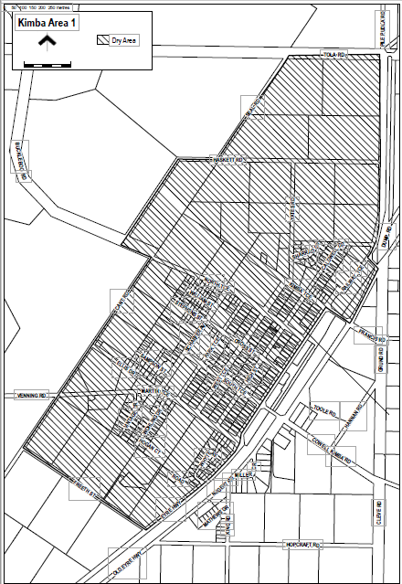
Dated: 10 November 2021
Debra Larwood
Chief Executive Officer

District Council of Kimba
Road Closure for Christmas Pageant 2021
Notice is hereby given that at a meeting of Council held on Wednesday 10th November 2021, District Council of Kimba exercised the power subject to Section 33 of the Road Traffic Act 1961 and clause F of the instrument of general approval of the Minister dated 22nd August 2013, to make an order that:
1. High Street from Martin Terrace to the southern side of North Terrace be closed between 5.00 pm and 8.30 pm and that High Street between Cross Street and the southern side of North Terrace remain closed between 8.30 pm and 12 midnight; and
2. Cross Street from High Street to the eastern side of the Emergency Services building be closed between 5.00pm and 12 midnight;
on Saturday 18th December 2021 for the purpose of holding Kimba’s Christmas pageant and festivities.
That pursuant to Section 33(1)(b) of the Road Traffic Act 1961, make an order directing that persons taking part in the event be exempted, in relation to roads, from the duty to observe the Australian Road Rules specified and attached to the exemption: Rule 230 – Crossing a Road – General Rule 298 – Driving with a person in a trailer provided the speed of the vehicle does not exceed 25 km/h.
Dated: 10 November 2021
DL Larwood
Chief Executive Officer

District Council of Lower Eyre Peninsula
Liquor Licensing Act 1997
Coffin Bay Area 1
South Australia
Liquor Licensing (Dry Areas) Notice 2021
under section 131(1a) of the Liquor Licensing Act 1997

1—Short title
This notice may be cited as the Liquor Licensing (Dry Areas) Notice 2021.

2—Commencement
This notice comes into operation on 31 December 2021.

3—Interpretation
- In this notice—
principal notice means the Liquor Licensing (Dry Areas) Notice 2015 published in the Gazette on 5.1.15, as in force from time to time.
- Clause 3 of the principal notice applies to this notice as if it were the principal notice.

4—Consumption etc of liquor prohibited in dry areas
- Pursuant to section 131 of the Act, the consumption and possession of liquor in the area described in the Schedule is prohibited in accordance with the provisions of the Schedule.
- The prohibition has effect during the periods specified in the Schedule.
- The prohibition does not extend to private land in the area described in the Schedule.
- Unless the contrary intention appears, the prohibition of the possession of liquor in the area does not extend to—
  - a person who is genuinely passing through the area if—
    - the liquor is in the original container in which it was purchased from licensed premises; and
    - the container has not been opened; or

  - a person who has possession of the liquor in the course of carrying on a business or in the course of his or her employment by another person in the course of carrying on a business; or
  - a person who is permanently or temporarily residing at premises within the area or on the boundary of the area and who enters the area solely for the purpose of passing through it to enter those premises or who enters the area from those premises for the purpose of leaving the area.

Schedule—Coffin Bay Area 1

1—Extent of prohibition
The consumption of liquor is prohibited and the possession of liquor is prohibited.
2—Period of prohibition
From 9pm on 31 December 2021 to 8am on 1 January 2022.
3—Description of area
The public area in and adjacent to the town of Coffin Bay bounded as follows: commencing at the point at which the prolongation in a straight line of the northern boundary of Section 665 Hd of Lake Wangary intersects the low water mark of Coffin Bay, then generally northerly, easterly, southerly, south-easterly and north-easterly along the low water mark to the point at which it is intersected by the prolongation in a straight line of the western boundary of Section 131 Hd of Lake Wangary, then southerly along that prolongation and boundary of Section 131 to the northern boundary of Lot 57 DP 54186, then generally south-westerly and south-easterly along the northern and south- western boundaries of Lot 57 to the point at which the south-western boundary is intersected by the prolongation in a straight line of the north-western boundary of Section 273 Hd of Lake Wangary, then south-westerly along that prolongation and boundary of Section 273 to the point at which it meets the eastern boundary of Section 295 Hd of Lake Wangary, then south-westerly, north-westerly, north-easterly and north- westerly along the north-eastern and northern boundaries of Section 295 to the western boundary of the Section, then southerly along the western boundaries of Section 295, Lots 212 and 211 of DP 71703, Lot 101 of DP 56785 and Lot 6 DP 25759 to the northern boundary of Section 665 Hd of Lake Wangary, then generally westerly, north- westerly, northerly and westerly along the northern boundary of that Section to the point at which it meets the eastern boundary of Section 667 Hd of Lake Wangary, then westerly along the northern boundary of Section 667, the northern boundary of Section 665 Hd of Lake Wangary and the prolongation in a straight line of the northern boundary of Section 665 to the point of commencement. The area includes the whole of any jetty, boat ramp or other structure that projects below the low water mark from within the area described above (as well as any area beneath such a structure).

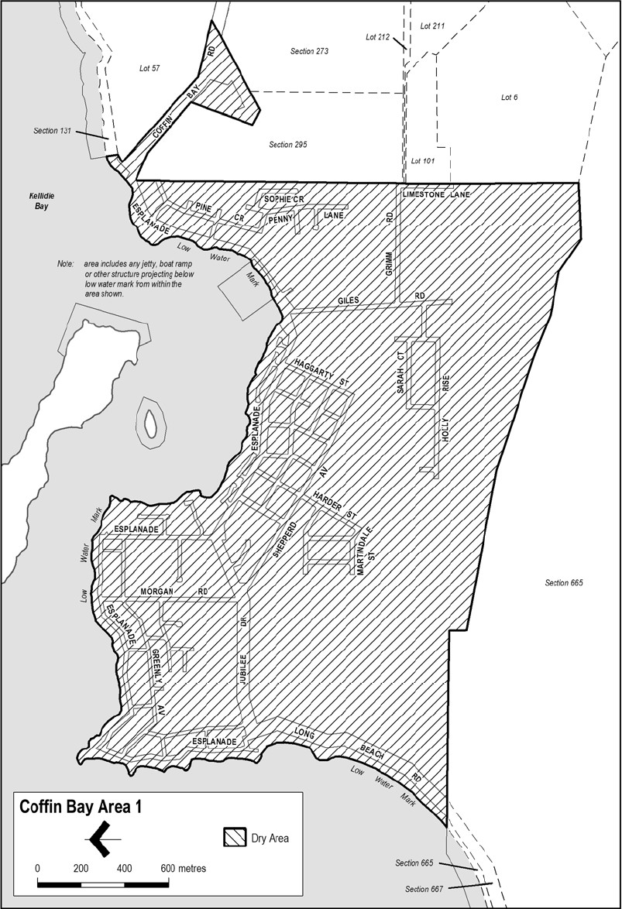

Dated: 17 September 2021
Delfina Lanzilli
Chief Executive Officer

District Council of Lower Eyre Peninsula
Liquor Licensing Act 1997
Cummins Area 1
South Australia
Liquor Licensing (Dry Areas) Notice 2021
under section 131(1a) of the Liquor Licensing Act 1997

1—Short title
This notice may be cited as the Liquor Licensing (Dry Areas) Notice 2021.

2—Commencement
This notice comes into operation on 31 December 2021.

3—Interpretation
- In this notice—
principal notice means the Liquor Licensing (Dry Areas) Notice 2015 published in the Gazette on 5.1.15, as in force from time to time.
- Clause 3 of the principal notice applies to this notice as if it were the principal notice.

4—Consumption etc of liquor prohibited in dry areas
- Pursuant to section 131 of the Act, the consumption and possession of liquor in the area described in the Schedule is prohibited in accordance with the provisions of the Schedule.
- The prohibition has effect during the periods specified in the Schedule.
- The prohibition does not extend to private land in the area described in the Schedule.
- Unless the contrary intention appears, the prohibition of the possession of liquor in the area does not extend to—
  - a person who is genuinely passing through the area if—
    - the liquor is in the original container in which it was purchased from licensed premises; and
    - the container has not been opened; or
  - a person who has possession of the liquor in the course of carrying on a business or in the course of his or her employment by another person in the course of carrying on a business; or
  - a person who is permanently or temporarily residing at premises within the area or on the boundary of the area and who enters the area solely for the purpose of passing through it to enter those premises or who enters the area from those premises for the purpose of leaving the area.

Schedule—Cummins Area 1

1—Extent of prohibition
The consumption of liquor is prohibited and the possession of liquor is prohibited.
2—Period of prohibition
From 9pm on 31 December 2021 to 8am on 1 January 2022.
3—Description of area
The public area in Cummins bounded as follows:
All in the Hundred of Cummins and within an area as defined as commencing at northwest corner of Allotment 99 in FP 180131 and extending northwards in line with the western boundary of this allotment to a point on the northern boundary of Warrow Road, then heading eastwards and following the boundary of Allotment 550 in DP 66791 until the north corner of Allotment 22 in DP 79231, then heading eastwards across Bratten Way to follow the southern boundary, then the eastern boundary of Allotment 71 in DP 94689 to a point in line with the northern boundary of Section 80, then heading eastwards across the Tod Highway to follow northern and then eastern boundary of Section 80, then heading roughly southeast to the nearest corner of Section 30, then heading eastwards along the northern boundary of Section 30 until reaching a point in line with the northeast corner of Allotment 601 in DP 87427, then heading southwest and following the boundary of Allotment 600 in DP 87427 until the southern corner of Allotment 24 in DP 50626, then heading to a point on the southern boundary of Tumby Bay Road in line with the southeast boundary of Allotment 24 in DP 50626, then heading northwest and following the southern boundary of Bratten Way up to the northwest corner of Allotment 149 in FP 180181 and then following, in a southerly direction the western boundary of Allotments 10, 11 and 12 in DP 95966 and Allotment 52 in DP 53199 until the southwest corner of Allotment 802 in FP 209177, then heading westwards along and in line with the southern boundary of Allotment 802 in FP 209177 until the western boundary of the Tod Highway, then heading north and following the boundary of Allotment 111 in DP 67442 until, and then following the eastern boundary of Allotment 11 in DP 85166 until the commencement point being the northwest corner of Allotment 99 in FP 180131.

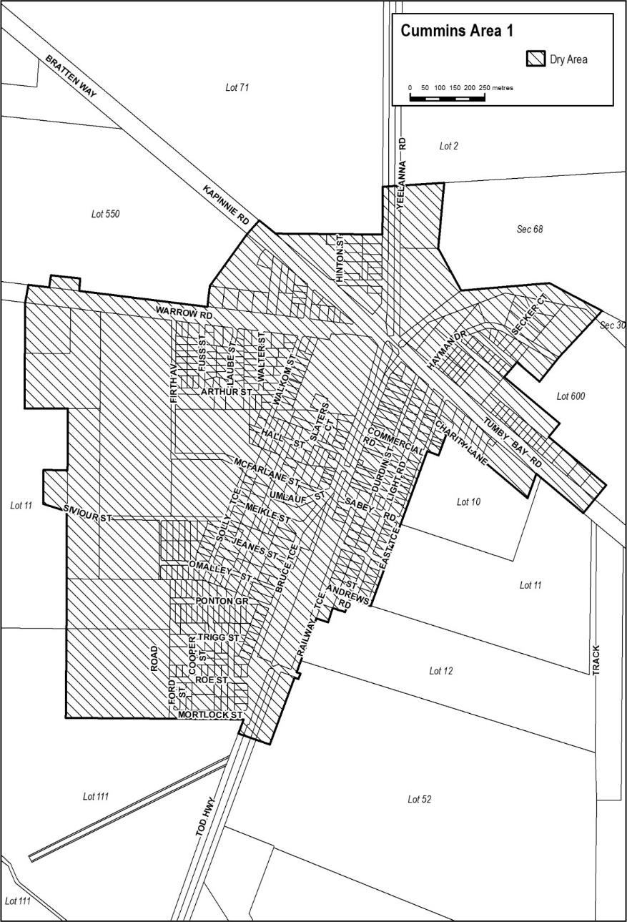
Dated: 17 September 2021
Delfina Lanzilli
Chief Executive Officer

Yorke Peninsula Council
Liquor Licensing Act 1997
Stansbury Area 1 and Area 2
South Australia
Liquor Licensing (Dry Areas) Notice 2021
Under section 131 (1ab) of the Liquor Licensing Act 1997
1—Short title
This notice may be cited as the Liquor Licensing Act 1997.
2—Commencement
This notice comes into operation on 31 December 2021.
3—Interpretation
(1) Pursuant to section 131 (1ab) of the Act, the Yorke Peninsula Council has declared that consumption and possession of liquor in the area described in the Schedule is prohibited in accordance with the provisions of the Schedule.
(2) The prohibition has effect during the periods specified in the Schedule.
(3) The prohibition does not extend to private land in the area described in the Schedule.
(4) Unless the contrary intention appears, the prohibition of the possession of liquor in the area does not extend to—
(a) A person who is genuinely passing through the area if—
(1) the liquor is in the original container in which it was purchased from licensed premises; and
(2) the container has not been opened; or
(b) a person who has possession of the liquor in the course of carrying on a business or in the course of his or her employment by another person in the course of carrying on a business; or
(c) a person who is permanently or temporarily residing in premises within the area or on the boundary of the area and who enters the area solely for the purpose of passing through it to enter those premises or who enters the area from those premises for the purpose of leaving the area.
Schedule—Stansbury Area 1 and Area 2
1—Extent of prohibition
The consumption of liquor and the possession of liquor is prohibited.
2—Period of prohibition
From 10pm on 31 December 2021 to 8am on 1 January 2022.
3—Description of area
The Area 1 in Stansbury is bounded as follows: commencing at the point at which the prolongation in a straight line of the south-eastern boundary of Stormbird Street intersects the low water mark on the western side of Gulf St. Vincent, then south-westerly along that prolongation to the south- western boundary of Anzac Parade, then north-westerly along that boundary of Anzac Parade to the northern boundary of Towler Street, then westerly along that that boundary of Towler Street to the western boundary of Weaver Street, the northerly along that boundary of Weaver Street and the prolongation in a straight line of that boundary to the south-western boundary of Anzac Parade, then generally north-westerly and westerly along that boundary of Anzac Parade and the southern boundary of North Terrace to the western boundary of Parrington Street, then along the prolongation in a straight line of then western boundary of Parrington Street to the southern boundary of Dalrymple Terrace, the easterly along that boundary of Dalrymple Terrace to the western boundary of Adelaide Road, then in a straight line by the shortest route to the point at which the southern boundary of Bayview Road meets the eastern boundary of Adelaide Road, then generally easterly and north easterly along that boundary of Bayview Road to the point at which it meets the southern corner of Lot 17 DP 5864, then north-easterly and northerly along the western boundary of Lot 1 DP 37028 to the northern boundary of the Lot, then easterly along the northern boundary of Lot 1 and the prolongation in a straight line of the boundary to the low water mark on the western side of Gulf St. Vincent, then generally south-easterly along the low water mark to the northern side of Stansbury Jetty, then north-easterly south-easterly and south- westerly around the outer boundary of the jetty back to the low water mark on the southern side of the jetty (so as to include in the area the whole of the jetty and any area beneath the jetty), then south-easterly along the low water mark to the northern side of the breakwater that forms the northern wall of the enclosed boat launching facility immediately to the south-east of the jetty, then generally north-easterly, south-easterly and south-westerly around the outer boundary of the boat launching facility back to the low water mark on the shore on the southern side of the facility (so as to include in the area the whole of the facility, including the breakwaters and the area between them), then generally south-westerly and south-easterly along the low water mark on the point of commencement.
Area 2 will include the area bounded on the north by South Terrace, on the east by Weaver Street, on the south by Park Terrace and on the west by the prolongation in a straight line of the western boundary of Lot 692 FP 196114.
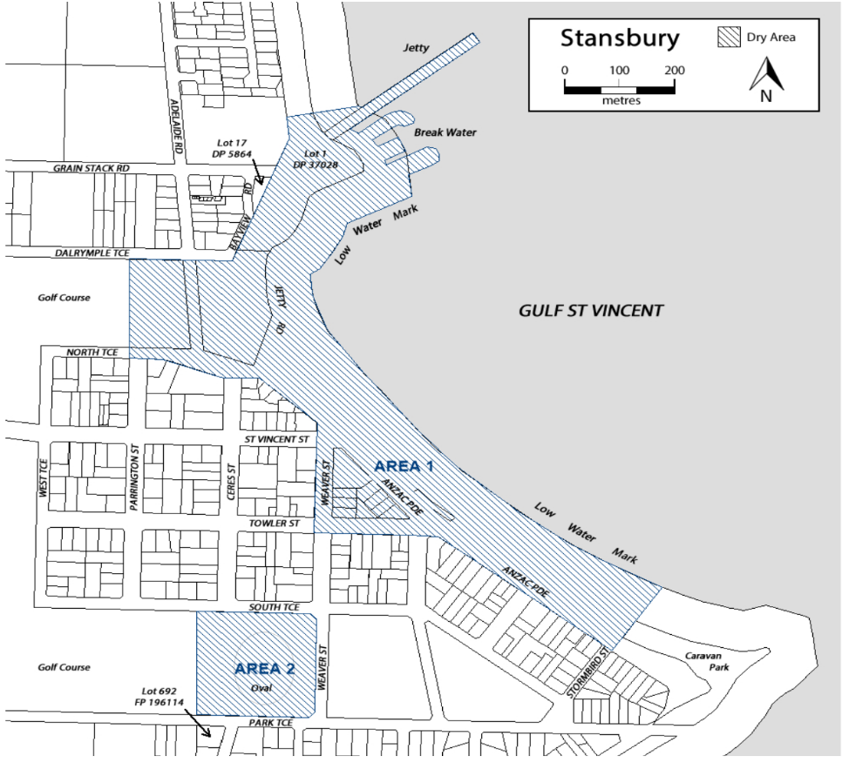
Dry Area Location—Area 1 and Area 2
Dated: 10 November 2021
Andrew Cameron
Chief Executive Officer

YORKE PENINSULA COUNCIL
Roads (Opening and Closing) Act 1991
Road Closing—Glen Street, Maitland
NOTICE is hereby given, pursuant to section 10 of the Roads (Opening and Closing) Act 1991, that the council proposes to make a Road Process Order to close and sell to the adjoining owner the whole of Glen Street between allotment 52 in D788, allotment 10 in D127359 and allotment 100 in D122709 more particularly delineated and lettered ‘A’ on Preliminary Plan 21/0028.
The Preliminary Plan and Statement of Persons Affected is available for public inspection at the offices of the Yorke Peninsula Council located at 8 Elizabeth Street Maitland, 18 Main Street Minlaton and 15 Edithburgh Road Yorketown and the Adelaide Office of the Surveyor-General at Level 2, 101 during normal office hours. The Preliminary Plan can also be viewed at www.sa.gov.au/roadsactproposals.
Any application for easement or objection must set out the full name, address and details of the submission and must be fully supported by reasons. The application for easement or objection must be made in writing to the Yorke Peninsula Council at PO Box 57 Maitland SA 5573 or admin@yorke.sa.gov.au, WITHIN 28 DAYS OF THIS NOTICE and a copy must be forwarded to the Surveyor-General at GPO Box 1354, Adelaide 5001. Where a submission is made, the Council will give notification of a meeting at which the matter will be considered.
Council contact for enquiries is Sue Beech, phone: 8832 0000.
Dated: 2 December 2021
Andrew Cameron
Chief Executive Officer

Public Notices

National Electricity Law
Extension of Final Determination
Making of Final Rule
Making of Draft Determination and Draft Rule
Extension of Draft Determination
Making of Final Rule and Determination
Notice of Change of Rule Making Process
The Australian Energy Market Commission (AEMC) gives notice under the National Electricity Law as follows:
Under s 107, the time for the making of the final determination on the Primary frequency response incentive arrangements (Ref. ERC0263) proposal has been extended to 7 July 2022.
Under ss 102 and 103, the making of the National Electricity Amendment (Compensation for market participants affected by intervention events) Rule 2021 No. 14 (Ref. ERC0284) and related final determination. Schedule 1 commences operation on 1 August 2022. Schedules 2 and 3 commence operation on 9 December 2021.
Under s 99, the making of a draft determination and related draft rule on the Updating Short Term PASA proposal (Ref. ERC0332). Submissions must be received by 10 February 2022.
Under s 107, the time for making the draft determination on the Synchronous services markets (Ref. ERC0290) proposal has been extended to 30 June 2022.
Under s 107, the time for making the draft determination on the Capacity commitment mechanism for system security and reliability services (Ref. ERC0306) proposal has been extended to 30 June 2022.
Under ss 102 and 103, the making of the National Electricity Amendment (Integrating energy storage systems into the NEM) Rule 2021 No. 13 (Ref. ERC0280) and related final determination. All provisions commence as follows Schedule 1-6 of the Amending Rule commence on 3 June 2024, Schedule 7 commences on 9 December 2021.
Under s 107, the time for making the draft determination on the Material change in network infrastructure project costs (Ref. ERC0325) proposal has been extended to 28 April 2022.
Under s 96(3), the proposed National Electricity Amendment (Extension of time and reduction in scope of the 2022 Reliability Standards and Settings Review) Rule will be made under the standard rule making process in accordance with Part 7 Division 3 (other than s 96) of the NEL, rather than through an expedited process (Project Ref ERC0336).
Documents referred to above are available on the AEMC’s website and are available for inspection at the AEMC’s office.
Submissions can be made via the AEMC’s website. Before making a submission, please review the AEMC’s privacy statement on its website. Submissions should be made in accordance with the AEMC’s Guidelines for making written submissions on Rule change proposals. The AEMC publishes all submissions on its website, subject to confidentiality.
Australian Energy Market Commission
Level 15, 60 Castlereagh St
Sydney NSW 2000
Telephone: (02) 8296 7800
www.aemc.gov.au
Dated: 2 December 2021

Trustee Act 1936
Public Trustee
Estates of Deceased Persons
In the matter of the estates of the undermentioned deceased persons:
ARTHUR Kym John late of 30 Alice Crescent Morphett Vale Retired Business Owner who died 06 July 2021
BERRY Siyanne late of 28 Cawthorne Street Thebarton of no occupation who died 21 November 2012
CAHILL Trevor John late of 6 Jury Street Royal Park of no occupation who died 19 June 2019
FALK Jack Henry late of 81 Tapleys Hill Road Hendon Retired Clerk who died 7 July 2021
FROST Steven Brian late of 61 Tollner Road Compton of no occupation who died 8 March 2020
NEIL John Charles late of 12-16 King George Avenue North Brighton of no occupation who died 6 June 2021
SMITH Valerie Isobel late of 41 Portland Road Queenstown of no occupation who died 16 September 2021
THORNE Beverley Helen late of 10 Education Road Happy Valley of no occupation who died 4 September 2021
WELLS Beryl late of 38 Nairne Road Woodside of no occupation who died 15 July 2021
Notice is hereby given pursuant to the Trustee Act 1936, the Inheritance (Family Provision) Act 1972 and the Family Relationships Act 1975 that all creditors, beneficiaries, and other persons having claims against the said estates are required to send, in writing, to the office of Public Trustee at GPO Box 1338, Adelaide, 5001, full particulars and proof of such claims, on or before the 31 December 2021 otherwise they will be excluded from the distribution of the said estate; and notice is also hereby given that all persons indebted to the said estates are required to pay the amount of their debts to the Public Trustee or proceedings will be taken for the recovery thereof; and all persons having any property belonging to the said estates are forthwith to deliver same to the Public Trustee.
Dated: 2 December 2021
N. S. Rantanen
Public Trustee

Notice Submission

The South Australian Government Gazette is compiled and published each Thursday.
Notices must be submitted before 4 p.m. Tuesday, the week of intended publication.
All submissions are formatted per the gazette style and proofs are supplied as soon as possible. Alterations must be returned before 4 p.m. Wednesday.
Requests to withdraw submitted notices must be received before 10 a.m. on the day of publication.

Gazette notices should be emailed as Word files in the following format:
• Title—name of the governing Act/Regulation
• Subtitle—brief description of the notice
• A structured body of text
• Date of authorisation
• Name, position, and government department/organisation of the person authorising the notice

Please provide the following information in your email:
• Date of intended publication
• Contact details of at least two people responsible for the notice content
• Name of the person and organisation to be charged for the publication (Local Council and Public notices)
• Request for a quote, if required
• Purchase order, if required

Email: governmentgazettesa@sa.gov.au
Phone: (08) 7109 7760
Website: www.governmentgazette.sa.gov.au

All instruments appearing in this gazette are to be considered official, and obeyed as such

Printed and published weekly by authority of S. Smith, Government Printer, South Australia
$8.00 per issue (plus postage), $402.00 per annual subscription—GST inclusive
Online publications: www.governmentgazette.sa.gov.au

