No. 80 p. 4325
THE SOUTH AUSTRALIAN
GOVERNMENT GAZETTE
Published by Authority

Adelaide, Thursday, 9 December 2021

Contents

Governor’s Instruments

Acts—No. 48–58 of 2021 4326

Appointment 4326

Emergency Management Act 2004 4326

Proclamation—
Statutes Amendment (Gambling Regulation) Act (Commencement) Proclamation 2021 4328

Regulations—
National Electricity (South Australia) (Local Provisions) Variation Regulations 2021—No. 179 of 2021 4329
Electricity (General) (Payment Condition) Variation Regulations 2021—No. 180 of 2021 4331
Gaming Machines (Miscellaneous) Variation
Regulations 2021—No. 181 of 2021 4333
Lotteries (Miscellaneous) Variation Regulations 2021—
No. 182 of 2021 4335
Public Corporations (Australian Children's Performing
Arts Company) (Dissolution and Revocation) Regulations 2021—No. 183 of 2021 4337
Victims of Crime (Fund and Levy) (Young Offenders)
Variation Regulations 2021—No. 184 of 2021 4339

Rules of Court
Youth Court (Care and Protection) Rules 2018 4341

State Government Instruments

Associations Incorporation Act 1985 4357

Constitution Act 1934 4357

Equal Opportunity Act 1994 4359

Fisheries Management Act 2007 4359

Fisheries Management (Prawn Fisheries) Regulations 2017 4362

Geographical Names Act 1991 4362

Health Care Act 2008 4363

Housing Improvement Act 2016 4363

Land Acquisition Act 1969 4363

Livestock Act 1997 4371

Mining Act 1971 4373

Motor Vehicles Regulations 2010 4374

Passenger Transport Act 1994 4375

Passenger Transport Regulations 2009 4375

Pastoral Land Management and Conservation Act 1989 4377

Petroleum and Geothermal Energy Act 2000 4377

Proof of Sunrise and Sunset Act 1923 4377

Remuneration Act 1990 4357

Road Traffic (Road Rules – Ancillary and Miscellaneous Provisions) Regulations 2014 4379

South Australian Public Health Act 2011 4380

South Australian Water Corporation Act 1994 4380

Local Government Instruments

City of Burnside 4381

City of Holdfast Bay 4381

Adelaide Plains Council 4384

Alexandrina Council 4384

District Council of Franklin Harbour 4391

District Council of Mount Remarkable 4391

Port Pirie Regional Council 4392

District Council of Streaky Bay 4393

District Council of Tumby Bay 4393

Wudinna District Council 4393

Yorke Peninsula Council 4393

Governor’s Instruments

ACTS
Department of the Premier and Cabinet
Adelaide, 9 December 2021
Her Excellency the Governor directs it to be notified for general information that she has in the name and on behalf of Her Majesty The Queen, this day assented to the undermentioned Acts passed by the Legislative Council and House of Assembly in Parliament assembled, viz.:
No. 48 of 2021—Aquaculture (Tourism Development) Amendment Act 2021
An Act to amend the Aquaculture Act 2001
No. 49 of 2021—Road Traffic (Drug Driving and Careless or Dangerous Driving) Amendment Act 2021
An Act to amend the Road Traffic Act 1961 and to make related amendments to the Motor Vehicles Act 1959
No. 50 of 2021—Fair Trading (Motor Vehicle Insurers and Repairers) Amendment Act 2021
An Act to amend the Fair Trading Act 1987 and to make related amendments to the Small Business Commissioner Act 2011
No. 51 of 2021—Suicide Prevention Act 2021
An Act to reduce the incidence of deaths by suicide in this State, to establish the Suicide Prevention Council, to provide for the preparation and implementation of suicide prevention plans, to encourage the training of persons and organisations in suicide prevention and postvention, and for other purposes
No. 52 of 2021—Civil Liability (Institutional Child Abuse Liability) Amendment Act 2021
An Act to amend the Civil Liability Act 1936
No. 53 of 2021—Statutes Amendment (Strata Schemes) Act 2021
An Act to amend the Community Titles Act 1996 and the Strata Titles Act 1988
No. 54 of 2021—Mutual Recognition (South Australia) (Further Adoption) Amendment Act 2021
An Act to Amend the Mutual Recognition (South Australia) Act 1993
No. 55 of 2021—Children and Young People (Safety) (Inquiry into Foster and Kinship Care) Amendment Act 2021
An Act to amend the Children and Young People (Safety) Act 2017
No. 56 of 2021—Social Workers Registration Act 2021
An Act to make provision for the registration of social workers, to establish the Social Workers Registration Board and for other purposes
No. 57 of 2021—Statutes Amendment (Child Sexual Abuse) Act 2021
An Act to amend the Criminal Law Consolidation Act 1935, the Criminal Procedure Act 1921, the Evidence Act 1929, the Sentencing Act 2017, the Summary Offences Act 1953 and the Young Offenders Act 1993
No. 58 of 2021—Coorong Environmental Trust Act 2021
An Act to establish the Coorong Environmental Trust, to provide for the administration of the Trust, and for other purposes
By command,
Steven Spence Marshall
Premier

Appointment
Department of the Premier and Cabinet
Adelaide, 9 December 2021
Her Excellency the Governor in Executive Council has been pleased to appoint the Honourable John Anthony William Gardner, MP, Minister for Education to be also Acting Minister for Human Services for the period from 13 December 2021 to 28 December 2021 inclusive, during the absence of the Honourable Jacqueline Michelle Ann Lensink, MLC.
By command,
Steven Spence Marshall
Premier
DHSCS21010

Emergency Management Act 2004
Section 23
Approval by the Governor of Extension of a Major Emergency Declaration
Recital
The State Co-ordinator declared a Major Emergency on 22 March 2020 under section 23(1) of the Emergency Management Act 2004 (the Act) in respect of the outbreak of the human disease named COVID-19 within South Australia (the Declaration).
With the advice and consent of the Executive Council and pursuant to section 23(2) of the Act, on the days and for the periods set out below, His Excellency the Governor approved an extension of the Declaration.
On 2 April 2020 for a period of 28 days to commence on 4 April 2020.
On 30 April 2020 for a period of 28 days to commence on 2 May 2020.
On 28 May 2020 for a period of 28 days to commence on 30 May 2020.
On 27 June 2020 for a period of 28 days to commence on 27 June 2020.
On 23 July 2020 for a period of 28 days to commence on 25 July 2020.
On 20 August 2020 for a period of 28 days to commence on 22 August 2020.
On 17 September 2020 for a period of 28 days to commence on 19 September 2020.
On 15 October 2020 for a period of 28 days to commence on 17 October 2020.
On 12 November 2020 for a period of 28 days to commence on 14 November 2020.
On 10 December 2020 for a period of 28 days to commence on 12 December 2020.
On 6 January 2021 for a period of 28 days to commence on 9 January 2021.
On 4 February 2021 for a period of 28 days to commence on 6 February 2021.
On 4 March 2021 for a period of 28 days to commence on 6 March 2021.
On 1 April 2021 for a period of 28 days to commence on 3 April 2021.
On 29 April 2021 for a period of 28 days to commence on 1 May 2021.
On 27 May 2021 for a period of 28 days to commence on 29 May 2021.
On 24 June 2021 for a period of 28 days to commence 26 June 2021.
On 22 July 2021 for a period of 28 days to commence 24 July 2021.
On 18 August 2021 for a period of 28 days to commence 21 August 2021.
With the advice and consent of the Executive Council and pursuant to section 23(2) of the Act, on the days and for the periods set out below, Her Excellency the Administrator approved an extension of the Declaration.
On 16 September 2021 for a period of 28 days to commence 18 September 2021.
With the advice and consent of the Executive Council and pursuant to section 23(2) of the Act, on the days and for the periods set out below, Her Excellency the Governor approved an extension of the Declaration.
On 14 October 2021 for a period of 28 days to commence 16 October 2021.
On 11 November 2021 for a period of 28 days to commence 13 November 2021.
PURSUANT to section 23(2) of the Act and with the advice and consent of the Executive Council, I NOW approve a further extension of the Declaration for a period of 28 days commencing on 11 December 2021.
Given under my hand and the Public Seal of South Australia at Adelaide.
Dated: 9 December 2021
Frances Adamson AC
Governor

Proclamations
South Australia

Statutes Amendment (Gambling Regulation) Act (Commencement) Proclamation 2021
1—Short title
This proclamation may be cited as the Statutes Amendment (Gambling Regulation) Act (Commencement) Proclamation 2021.
2—Commencement of suspended provision
Section 128 of the Statutes Amendment (Gambling Regulation) Act 2019 (No 44 of 2019) comes into operation on 9 December 2021.
Made by the Governor
with the advice and consent of the Executive Council
on 9 December 2021

Regulations
South Australia

National Electricity (South Australia) (Local Provisions) Variation Regulations 2021
under the National Electricity (South Australia) Act 1996

Contents
Part 1—Preliminary
1 Short title
2 Commencement
3 Variation provisions
Part 2—Variation of National Electricity (South Australia) (Local Provisions) Regulations 2019
4 Variation of regulation 3—Modification of National Electricity Rules—retailer reliability obligation
5 Insertion of regulation 4
4 Regulated stand-alone power systems

Part 1—Preliminary
1—Short title
These regulations may be cited as the National Electricity (South Australia) (Local Provisions) Variation Regulations 2021.
2—Commencement
These regulations come into operation 4 months after the day on which they are made (see Subordinate Legislation Act 1978 section 10AA).
3—Variation provisions
In these regulations, a provision under a heading referring to the variation of specified regulations varies the regulations so specified.
Part 2—Variation of National Electricity (South Australia) (Local Provisions) Regulations 2019
4—Variation of regulation 3—Modification of National Electricity Rules—retailer reliability obligation

Regulation 3(1)—after paragraph (b) insert:
(ba) as though, in Rule 4A.C.5(a), after "AER makes a T-3 reliability instrument" there were inserted:
or the South Australian Minister makes a T-3 reliability instrument under section 19B of the National Electricity (South Australia) Act 1996
5—Insertion of regulation 4
After regulation 3 insert:
4—Regulated stand-alone power systems
In accordance with section 6B of the National Electricity Law, the stand-alone power system comprised of the distribution network described in the maps annexed (in Schedule 3) to the licence authorising the distribution of electricity issued by the South Australian Independent Industry Regulator on 11 October 1999, as varied from time to time, (being the licence held by SA Power Networks (ACN 332 330 749)) forms part of the national electricity system.
Made by the Governor
with the advice and consent of the Executive Council
on 9 December 2021
No 179 of 2021

South Australia

Electricity (General) (Payment Condition) Variation Regulations 2021
under the Electricity Act 1996

Contents
Part 1—Preliminary
1 Short title
2 Commencement
3 Variation provisions
Part 2—Variation of Electricity (General) Regulations 2012
4 Insertion of regulation 17A
17A Prescribed condition—use of prepayment meter system
5 Insertion of regulation 21A
21A Variation of licences by Commission

Part 1—Preliminary
1—Short title
These regulations may be cited as the Electricity (General) (Payment Condition) Variation Regulations 2021.
2—Commencement
These regulations come into operation on 1 July 2022.
3—Variation provisions
In these regulations, a provision under a heading referring to the variation of specified regulations varies the regulations so specified.
Part 2—Variation of Electricity (General) Regulations 2012
4—Insertion of regulation 17A
After regulation 17 insert:
17A—Prescribed condition—use of prepayment meter system
(1) In accordance with section 21(2) of the Act, the Commission is required to impose on the relevant licence the condition that the holder of the licence only sell electricity to prescribed customers using a prepayment meter system.
(2) This regulation applies in relation to the relevant licence despite the fact that it was issued before the commencement of this regulation.
(3) Despite subregulation (1), the Minister may grant the holder of the relevant licence an exemption from complying with the condition applying under that subregulation in relation to the supply of electricity to a specified prescribed customer, or a prescribed customer of a specified class.
(4) An exemption under subregulation (3)—
(a) may be granted subject to specified conditions; and
(b) may be varied or revoked by the Minister.
(5) In this regulation—
excluded customer means a small customer who is required under a contract for the sale of electricity in a prescribed area in force immediately before the commencement of the Electricity (General) (Payment Condition) Variation Regulations 2021 to pay for electricity supplied under the contract;
prepayment meter system has the same meaning as in the National Energy Retail Law;
prescribed area means—
(a) Trust Land within the meaning of the Aboriginal Lands Trust Act 2013; or
(b) "the lands" within the meaning of the Anangu Pitjantjatjara Yankunytjatjara Land Rights Act 1981; or
(c) "the lands" within the meaning of the Maralinga Tjarutja Land Rights Act 1984;
prescribed customer means a small customer supplied (or seeking the supply of) electricity in a prescribed area, other than an excluded customer;
relevant licence means the licence authorising the retailing of electricity under the Act to prescribed customers.
5—Insertion of regulation 21A
After regulation 21 insert:
21A—Variation of licences by Commission
In accordance with section 98(2)(e) of the Act, the Commission is, in varying the conditions of a licence for the purpose of complying with regulation 17A(1), exempt from the application of section 27(2) of the Act.
Made by the Governor
with the advice and consent of the Executive Council
on 9 December 2021
No 180 of 2021

South Australia

Gaming Machines (Miscellaneous) Variation Regulations 2021
under the Gaming Machines Act 1992

Contents
Part 1—Preliminary
1 Short title
2 Commencement
3 Variation provisions
Part 2—Variation of Gaming Machines Regulations 2020
4 Variation of regulation 27—Operation of gaming machine by insertion of a ticket—prescribed requirements
5 Insertion of regulation 27A
27A Unclaimed winnings—prescribed amount

Part 1—Preliminary
1—Short title
These regulations may be cited as the Gaming Machines (Miscellaneous) Variation Regulations 2021.
2—Commencement
These regulations come into operation on the day on which section 128 of the Statutes Amendment (Gambling Regulation) Act 2019 comes into operation.
3—Variation provisions
In these regulations, a provision under a heading referring to the variation of specified regulations varies the regulations so specified.
Part 2—Variation of Gaming Machines Regulations 2020
4—Variation of regulation 27—Operation of gaming machine by insertion of a ticket—prescribed requirements
(1) Regulation 27(7)—delete "$50" and substitute:
$750
(2) Regulation 27(8), definition of unredeemed ticket—after "value" insert:
of or above $1
5—Insertion of regulation 27A
After regulation 27 insert:
27A—Unclaimed winnings—prescribed amount
For the purposes of section 76AA(3) of the Act, the prescribed amount is—
(a) in relation to an amount of winnings—$50.01; or
(b) in relation to a residual jackpot—$10 000.01 (less any start-up value).
Note—
As required by section 10AA(2) of the Subordinate Legislation Act 1978, the Minister has certified that, in the Minister's opinion, it is necessary or appropriate that these regulations come into operation as set out in these regulations.
Made by the Governor
with the advice and consent of the Executive Council
on 9 December 2021
No 181 of 2021

South Australia

Lotteries (Miscellaneous) Variation Regulations 2021
under the Lotteries Act 2019

Contents
Part 1—Preliminary
1 Short title
2 Commencement
3 Variation provisions
Part 2—Variation of Lotteries Regulations 2021
4 Variation of regulation 31—Prohibition on entry etc
5 Variation of Schedule 2—Minor bingo session rules

Part 1—Preliminary
1—Short title
These regulations may be cited as the Lotteries (Miscellaneous) Variation Regulations 2021.
2—Commencement
These regulations come into operation immediately after the Lotteries Regulations 2021 come into operation.
3—Variation provisions
In these regulations, a provision under a heading referring to the variation of specified regulations varies the regulations so specified.
Part 2—Variation of Lotteries Regulations 2021
4—Variation of regulation 31—Prohibition on entry etc
(1) Regulation 31(1)—delete "enter a lottery" and substitute:
enter or participate in a prescribed lottery
(2) Regulation 31(2)—delete "enter a lottery" and substitute:
enter or participate in a prescribed lottery
(3) Regulation 31—after subregulation (2) insert:
(3) In this regulation—
prescribed lottery means a major lottery, a major bingo session, a card jackpot lottery or a trade promotion lottery.
5—Variation of Schedule 2—Minor bingo session rules
Schedule 2, clause 6(1)(b)—delete paragraph (b) and substitute:
(b) the gross proceeds, prizes and winners of prizes exceeding $100 of each game of bingo played during a bingo session,
Note—
As required by section 10AA(2) of the Subordinate Legislation Act 1978, the Minister has certified that, in the Minister's opinion, it is necessary or appropriate that these regulations come into operation as set out in these regulations.
Made by the Governor
with the advice and consent of the Executive Council
on 9 December 2021
No 182 of 2021

South Australia

Public Corporations (Australian Children's Performing Arts Company) (Dissolution and Revocation) Regulations 2021
under the Public Corporations Act 1993

Contents
1 Short title
2 Commencement
3 Dissolution of Australian Children's Performing Arts Company
4 Transfer of assets and liabilities of Australian Children's Performing Arts Company
Schedule 1—Revocation of Public Corporations (Australian Children's Performing Arts Company) Regulations 2016

1—Short title
These regulations may be cited as the Public Corporations (Australian Children's Performing Arts Company) (Dissolution and Revocation) Regulations 2021.
2—Commencement
These regulations come into operation on 30 June 2022.
3—Dissolution of Australian Children's Performing Arts Company
The Australian Children's Performing Arts Company, established by the Public Corporations (Australian Children's Performing Arts Company) Regulations 2001 as a subsidiary of the Minister for the Arts, is dissolved.
4—Transfer of assets and liabilities of Australian Children's Performing Arts Company
(1) The assets, rights and liabilities of the Australian Children's Performing Arts Company immediately before its dissolution are vested in or attached to the Minister for Education.
(2) The Minister for Education may, by notice in the Gazette, declare that a reference in an Act, instrument, contract, agreement or other document to the Australian Children's Performing Arts Company will have effect as if it were a reference to the Minister, or to a body specified by the Minister in the notice.
(3) The following provisions apply in connection with the operation of subregulation (1):
(a) nothing in that subregulation—
(i) constitutes a breach of, or default under, an Act or other law; or
(ii) constitutes a breach of, or default under, a contract, agreement, understanding or undertaking; or
(iii) constitutes a breach of a duty of confidence (whether arising by contract, in equity or by custom or in any other way); or
(iv) constitutes a civil or criminal wrong; or
(v) terminates an agreement or obligation or fulfils any condition that allows a person to terminate an agreement or obligation, or gives rise to any other right or remedy; or
(vi) releases a surety or other obligee wholly or in part from an obligation;
(b) that subregulation will have effect despite the terms of any contract, agreement, understanding or undertaking and without the need for any other act or consent.
(4) In this regulation—
Minister for Education means the Minister responsible for the administration of the Education and Children's Services Act 2019.
Schedule 1—Revocation of Public Corporations (Australian Children's Performing Arts Company) Regulations 2016
The Public Corporations (Australian Children's Performing Arts Company) Regulations 2016 are revoked.
Made by the Governor
with the advice and consent of the Executive Council
on 9 December 2021
No 183 of 2021

South Australia

Victims of Crime (Fund and Levy) (Young Offenders) Variation Regulations 2021
under the Victims of Crime Act 2001

Contents
Part 1—Preliminary
1 Short title
2 Commencement
3 Variation provisions
Part 2—Variation of Victims of Crime (Fund and Levy) Regulations 2018
4 Variation of Schedule 1—Victims of crime levy

Part 1—Preliminary
1—Short title
These regulations may be cited as the Victims of Crime (Fund and Levy) (Young Offenders) Variation Regulations 2021.
2—Commencement
These regulations come into operation on 31 January 2023.
3—Variation provisions
In these regulations, a provision under a heading referring to the variation of specified regulations varies the regulations so specified.
Part 2—Variation of Victims of Crime (Fund and Levy) Regulations 2018
4—Variation of Schedule 1—Victims of crime levy
Schedule 1, clause 3—delete clause 3 and substitute:

3 | The amount of the levy for an offender who is a youth is—
 | (a) in respect of a summary offence (other than an offence listed in clause 2)—
 | (i) if the offence is expiated without the making of an enforcement determination under section 22 of the Fines Enforcement and Debt Recovery Act 2017 in relation to the expiation notice | $20
 | (ii) in any other case | $40
 | (b) in respect of an indictable offence (other than an offence listed in clause 2)— | $60
 | (c) in respect of an offence listed in clause 2— | $100
Made by the Governor
with the advice and consent of the Executive Council
on 9 December 2021
No 184 of 2021

Rules of Court

Youth Court Act 1993
Youth Court (Care and Protection) Rules 2018
South Australia

Youth Court (Care and Protection) Rules 2018
under the Youth Court Act 1993

Contents
Part 1—Preliminary
1 Short title
2 Commencement
3 Interpretation
4 Application of rules
5 Object of rules
6 Forms
Part 2—Notification of urgent removals
7 Notification of urgent removals
Part 3—Applications, supporting material and responses
8 Applications—general provision
9 Case plans
10 Material supporting applications—other requirements
11 Responses
12 Interlocutory applications
Part 4—Conferences and the facilitation of trials
13 Pre-trial conferences
14 Documents required for pre-trial conferences
15 Status conferences and facilitation of trials
16 Trial books
Part 5—Trials and orders
17 Listing of trials
18 Trials
19 Minutes of orders
Part 6—Miscellaneous
20 Temporary instruments of guardianship and restraining notices
21 Video and other links
22 Proof of service
23 Litigation guardians
24 Revocation
Schedule 1—Forms

Part 1—Preliminary
1—Short title
These rules may be cited as the Youth Court (Care and Protection) Rules 2018.
2—Commencement
These rules will come into operation on 22 October 2018.
3—Interpretation
(1) In these rules, unless the contrary intention appears—
care and protection jurisdiction of the Court means the jurisdiction of the Court under the Children and Young People (Safety) Act 2017;
care and protection order means an order made by the court under section 53 of the Children and Young People (Safety) Act 2017;
Court means the Youth Court;
direction of the Court means a practice direction or specific direction or order of the Court; and direct has a corresponding meaning;
interlocutory application means an application for a direction of the Court relating to—
(a) the course or conduct of proceedings for a final order of the Court; or
(b) matters preliminary or ancillary to such proceedings;
the term includes an application for an order that the Court is empowered to make on an adjournment of proceedings for a final order of the Court and any application that the Court directs to be treated as interlocutory for the purposes of these rules;
prescribed child or young person has the same meaning as in section 28 of the Children and Young People (Safety) Act 2017.
(2) A term used in these rules that is defined in the Children and Young People (Safety) Act 2017 has the same meaning in these rules as it has in that Act (unless the contrary intention appears).
4—Application of rules
These rules apply to the care and protection jurisdiction of the Court. The care and protection jurisdiction of the Court is also governed by the Youth Court (General) Rules 2016.
5—Object of rules
The object of these rules is the fair, effective, expeditious and efficient conduct of the proceedings of the Court.
6—Forms
(1) It is sufficient compliance with these rules, as to the form of any document, if the document is substantially in accordance with the form specified by these rules.
(2) Forms not provided by these rules may be prepared at the direction of the Court or by the Registrar on behalf of the Court.
(3) All forms for use specifically in the care and protection jurisdiction must use numbering with the prefix CP.
(4) The forms set out in Schedule 1 must be used for the purposes specified in that Schedule or these rules.
Part 2—Notification of urgent removals
7—Notification of urgent removals
(1) If a child protection officer removes a child or young person in the exercise of a power under section 41 of the Children and Young People (Safety) Act 2017, the Chief Executive must ensure that notice of the removal is given to the Court on the day on which the child or young person is removed or, if that is not reasonably practicable, by the end of the next business day.
(2) The notice must be given by email addressed to the Court and sent to an email address provided by the Registrar to the Chief Executive for the purposes of this rule, or in such other manner as the Registrar may allow.
(3) A notice does not need to be given under this rule if—
(a) the child or young person is, at the time of the removal, already under the guardianship, or in the custody, of the Chief Executive; and
(b) it is not anticipated by the Chief Executive that an application is to be made to the Court in connection with the removal.
Part 3—Applications, supporting material and responses
8—Applications—general provision
(1) This rule applies to any application to the Court other than an interlocutory application.
(2) An application must—
(a) be in writing in an appropriate form; and
(b) state the orders that are sought; and
(c) state the statutory provision under which each order might be made; and
(d) state the grounds of the application; and
(e) include particulars of the factual allegations or circumstances relied on to make out the grounds of the application; and
(f) be signed by the applicant, or on the applicant's behalf by the applicant's legal representative.
(3) All statements and particulars in an application must be in plain language, and be set out and expressed clearly, specifically and succinctly.
(4) If multiple or alternative orders are sought in an application, the application must indicate this clearly and, for each order, link the grounds and supporting statements and particulars relevant to that order clearly and specifically to that order.
8A—Application for Care and Protection Order or for Variation, Revocation or Discharge
(1) An application for a care and protection order is to be made in the prescribed form set out in Schedule 1.
Prescribed form—
Form CP1 Application for Care and Protection Order or to Vary, Extend or Revoke Instrument of Guardianship
(2) An application to vary, revoke or discharge a Care and Protection Order is to be made in the prescribed form set out in Schedule 1.
Prescribed form—
Form CP2 Application to Vary, Revoke or Discharge Care and Protection Orders
8B—Interested Persons
If an interested person wishes to appear at trial and make submissions in respect of a child or young person pursuant to section 66 of the Children and Young People (Safety) Act 2017, an application must be made in the prescribed form set out in Schedule 1.
Prescribed form—
Form CP5 Application for Interested Person(s) to be Heard
8C—Undertakings
An undertaking entered into by a party in relation to an Application under this Part must be made in the prescribed form set out in Schedule 1 and signed by the person entering into the undertaking.
Prescribed form—
Form CP8 Undertaking
9—Case plans
(1) If an application relates to a prescribed child or young person, the application to the Court with respect to that child or young person must be accompanied by (or include)—
(a) a case plan prepared under section 28 of the Children and Young People (Safety) Act 2017 or, if a case plan has been varied or substituted, the latest version of the case plan; or
(b) if a case plan has not been completed—information about what is proposed for the case plan in accordance with the requirements under subrule (2).
(2) The information required under this subrule will be the following (insofar as is reasonably known to the applicant):
(a) an outline of the proposed content of the case plan, taking into account the requirements of section 28(2) of the Children and Young People (Safety) Act 2017 and any relevant regulations under that Act;
(b) without limiting paragraph (a), specific information about the approach intended to be adopted in relation to the care and protection of the child or young person, the steps to be taken in connection with the preparation of the case plan, and how the various parts of the case plan are to be achieved;
(c) information about when the first version of case plan is expected to have been completed.
(3) A party must also provide to the Court such information about the case plan (including information about steps that are being taken to further review or develop the case plan, and to give effect to the case plan) as the Court may from time to time require as part of the proceedings.
(4) If a child or young person becomes a prescribed child or young person during the course of any proceedings, the applicant in the proceedings must provide—
(a) as soon as is reasonably practicable—information about what is proposed for the case plan in accordance with the requirements of subrule (2); and
(b) as soon as it has been prepared—a copy of the case plan.
10—Material supporting applications—other requirements
(1) An application to the Court as referred to in rule 9 must also be supported by material that sufficiently sets out the evidence on which the application is based.
(2) In the case of an application seeking a care and protection order in respect of a child or young person in respect of whom there has been a previous care and protection order, the material in support of the order must include—
(a) a document reporting on the outcomes of any review meetings conducted during the operation of the previous order; and
(b) in the case of a prescribed child or young person—an up-to-date copy of the case plan required under section 28 of the Children and Young People (Safety) Act 2017; and
(c) a document reporting the extent to which each party has complied with requirements or undertakings applicable to the party under the previous order.
(3) Material in support of an application provided under this rule must be filed in the Court and, unless the Court directs otherwise, served on the other parties, at least 10 business days before the pre-trial conference in relation to the application.
(4) After the expiration of the period that applies under subrule (3), material in support of an application may only be filed in the Court with leave and on such terms or conditions as the Court directs.
(5) Leave to file further material may be sought orally and at any stage of the proceedings and, unless the Court allows or directs otherwise, served on the other parties at least 2 business days before the next date for the hearing of the proceedings.
11—Responses
(1) This rule applies to any application to the Court other than—
(a) an interlocutory application; or
(b) an application of a kind excluded from the application of this rule by the Court by practice direction.
(2) A party to an application who opposes the application in whole or part must file a response in the Court, and serve the response on the other parties, at least 5 business days before the pre-trial conference in relation to the application.
(3) A response to an application must—
(a) be in the prescribed form set out in Schedule 1; and
(b) state clearly the order or orders sought in the application that are opposed and any order that is not opposed; and
(c) if an order is proposed as an alternative to an order sought in the application, indicate that clearly, and specify the proposed order and which order it would replace; and
(d) in relation to each ground of the application, state whether the ground is—
(i) admitted; or
(ii) disputed; or
(iii) not admitted, but not disputed for the purposes of the determination of the application; and
(e) in relation to each separate particular of a factual allegation in the application, state whether the particular is—
(i) admitted; or
(ii) disputed; or
(iii) not admitted, but not disputed for the purposes of the determination of the application; and
(f) if a ground or particular is disputed, state briefly the manner in which the ground or particular is disputed.
Prescribed form—
Form CP7 Response
(4) A response should be supported by material that provides evidence of the respondent's version of events or of any matter relevant to the determination of the application.
(5) Material in support of a response may be in the form of—
(a) affidavits (including annexures); or
(b) expert reports; or
(c) chronologies of significant events; or
(d) subject to a direction of the Court, other documentary evidence.
(6) Material in support of a response provided under this rule must be filed in the Court and, unless the Court directs otherwise, served on the other parties, at least 5 business days before the pre-trial conference in relation to the application.
(7) After the expiration of the period that applies under subrule (6), material in support of a response may only be filed in the Court with leave and on such terms or conditions as the Court directs.
(8) Leave to file further material may be sought orally and at any stage of the proceedings and, unless the Court allows or directs otherwise, served on the other parties at least 2 business days before the next date for the hearing of the proceedings.
(9) The Court will make such determinations based on the contents of a response, or the failure to file a response, as the Court considers appropriate, and proceed accordingly, subject to the provisions of the Children and Young People (Safety) Act 2017.
12—Interlocutory applications
(1) This rule does not apply to an application of a kind excluded from the application of the rule by the Court by practice direction.
(2) An interlocutory application is to be in the prescribed form set out in Schedule 1, accompanied by an affidavit in the prescribed form evidencing the grounds on which the application is being made.
Prescribed forms—
Form CP6 Interlocutory Application
Form CP4 Affidavit
(3) Nothing prevents an interlocutory application from being combined with an application for a final order of the Court.
(4) The applicant must serve a copy of the application (and accompanying documents) on the other parties as soon as practicable after it is filed in the Court, but not later than 2 business days before the next date for the hearing of the proceedings.
(5) However, service on another party is not required if the application does not affect the interests of the other party.
(6) The Court may, on conditions the Court considers appropriate, dispense with a requirement of this rule—
(a) if the urgency of the case requires; or
(b) by consent of the parties; or
(c) if for any other reason the Court considers it appropriate to do so.
(7) The Court may determine an interlocutory application without hearing oral submissions from the parties if—
(a) the application is not contentious; or
(b) the Court decides on the application of a party to determine the application on the basis of written submissions.
(8) On an interlocutory application, the Court may give directions relating to the proceedings irrespective of whether the applicant has asked for such directions in the application.
Part 4—Conferences and the facilitation of trials
13—Pre-trial conferences
(1) This rule applies to any application to the Court other than—
(a) an interlocutory application; or
(b) an application of a kind excluded from the application of this rule by the Court by practice direction.
(2) Defended applications will be listed for pre-trial conference with the goal that, so far as is practicable, each conference will be held within 8 weeks from the filing of the application.
(3) If matters remain in dispute at the end of a pre-trial conference, the application concerned will be allocated a trial date and, if a status conference is to be held, a date for that conference.
(4) The judicial officer presiding over a pre-trial conference may, subject to section 65 of the Children and Young People (Safety) Act 2017, determine what matters are in dispute for the purposes of the trial and direct that the trial be limited to such matters.
14—Documents required for pre-trial conferences
A party to an application listed for a pre-trial conference must, at least 2 business days before the date fixed for the pre-trial conference, file in the Court, and serve on the other parties—
(a) a list of all witnesses to be called by a party at the trial; and
(b) copies of reports of any proposed expert witness; and
(c) a synopsis of the evidence of any other proposed witnesses.
15—Status conferences and facilitation of trials
(1) A status conference may be held before the trial of a defended application.
(2) A status conference will, if practicable, be presided over by the judicial officer who is to hear the trial.
(3) At a status conference, the Court may give 1 or more of the following directions:
(a) limiting the issues to be determined at the trial;
(b) appointing a party dux litis in relation to issues to be determined at the trial;
(c) requiring or relating to the discovery, inspection and copying of evidentiary material;
(d) enabling non-parties to be present or participate at the trial;
(e) arranging for the interviewing of a child or young person by the trial judicial officer;
(f) requiring the concurrent calling of expert witnesses;
(g) arranging for the taking of views;
(h) requiring any party to prepare a chronology of events relating to any matter or circumstances to be considered at the trial;
(i) arranging for the taking of evidence by telephone link, video link or other medium;
(j) any other direction that may facilitate the conduct of the trial.
(4) Any such direction may, in any event, be given before or at the trial.
16—Trial books
(1) Unless the Court directs otherwise, the Minister or the Chief Executive must prepare a trial book for the purposes of a trial.
(2) A trial book—
(a) must contain the application and all material filed by the parties in the proceedings; and
(b) must be provided to the Court and other parties at least 2 business days before the trial.
Part 5—Trials and orders
17—Listing of trials
Defended applications (including on an amendment of an application) will be listed for trial with the goal that, so far as is practicable, the trial will be commenced within 12 weeks from the filing of the application.
18—Trials
A trial will be conducted, as far as practicable, on the basis that—
(a) each party's case is substantially contained in documentary material filed in accordance with these rules, and incorporated in the trial book; and
(b) examination-in-chief of witnesses avoids undue repetition of matters contained in the filed material and is limited to necessary and reasonable explanation, correction or supplementation of the filed material and to eliciting responses to, or comments on, another party's case.
19—Minutes of orders
(1) This rule applies to any interim or final order made by the Court on an application, but does not apply to a purely procedural direction.
(2) Unless the Court otherwise directs, the Minister or the Chief Executive must prepare minutes of the order.
(3) The minutes of an order—
(a) must be provided to the Court at the hearing at which the order is made; or
(b) must be filed in the Court within 2 business days of the making of the order.
Part 6—Miscellaneous
20—Temporary instruments of guardianship and restraining notices
(1) For the purposes of sections 45(4)(b) and 46(4)(b) of the Children and Young People (Safety) Act 2017, an instrument of guardianship or restraining notice (as the case may be) must be lodged with the Court in the prescribed form in Schedule 1.
Prescribed form—
Form CP3 Notice of Lodgement of Instrument
(2) An application to the Court to vary arrangements for the care of a child or young person under section 45(6) of the Children and Young People (Safety) Act 2017 must be made in the prescribed form in Schedule 1.
Prescribed form—
Form CP1 Application for Care and Protection Order or to Vary,
Extend or Revoke Instrument of Guardianship
(3) An application to the Court to extend the guardianship period or a restraining notice period under section 47 of the Children and Young People (Safety) Act 2017 must be made using the prescribed form in Schedule 1.
Prescribed form—
Form CP1 Application for Care and Protection Order or to Vary,
Extend or Revoke Instrument of Guardianship
21—Video and other links
(1) In appropriate cases, the Court will facilitate the appearance of parties or counsel via an audio visual link, or by a telephone link or other medium.
(2) A party wishing to appear via a link or other medium must provide adequate notice and adequate information to the Court to enable the Court, if it considers it appropriate to do so, to arrange the link or to agree to the use of a particular medium.
(3) In the ordinary course—
(a) an audio visual link will be from a courthouse, State Government office, or other appropriate facility; and
(b) a telephone link will be via a landline (not a mobile telephone).
22—Proof of service
(1) If an application or other document is required to be served on another party, the Court may decline to consider the application or document until proof of service of the application has been filed in, or produced to, the Court.
(2) Proof of service of an application or document may consist of an affidavit in the prescribed form made by the person who served the application or document setting out—
(a) the date, time and place of service; and
(b) how the person to be served was identified; and
(c) how service was effected.
Prescribed form—
Form CP9 Affidavit of Service
(3) The Court may, however, require or permit oral evidence of service.
23—Litigation guardians
(1) If the Court is satisfied that a party, other than a child the subject of proceedings, is incapable by reason of disability of adequately conducting any proceedings, the Court may—
(a) seek to have a legal guardian or appropriate advocate appointed to conduct the proceedings on behalf of the party; or
(b) if necessary, appoint a litigation guardian under this rule to conduct the proceedings on behalf of the party.
(2) A litigation guardian appointed under this rule is responsible for the conduct of the proceedings on behalf of the relevant party and may take any step in the proceedings that such party might have done if of full capacity.
(3) The Court may appoint a person as a litigation guardian if the person—
(a) is an adult; and
(b) has no interest in the proceedings adverse to the interest of the party needing the litigation guardian, or has some lawful authority to manage or administer the party's affairs; and
(c) can fairly and competently conduct the proceedings on behalf of the party; and
(d) has consented to act as the litigation guardian.
(4) The Court may require a litigation guardian seeking a consent order on behalf of the party needing the litigation guardian to satisfy the Court that the order is in the party's best interests.
(5) A party who becomes aware that another party is a person to whom this rule may apply, and is not adequately represented, must inform the Court of that fact.
(6) The Court may remove a litigation guardian on any reasonable ground, and may permit or appoint another person to be the litigation guardian.
24—Revocation
The Youth Court (Children's Protection) Rules 2012 are revoked.

GIVEN under our hands and the Seal of the Youth Court of South Australia.
Dated: 1 December 2021
P. Eldridge
Judge
A. Adair
Magistrate
O. Koehn
Magistrate
K. Hodder
Magistrate

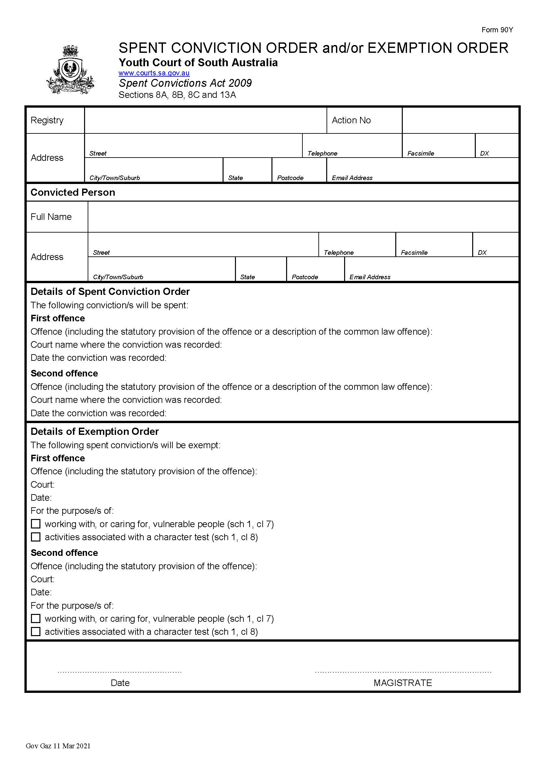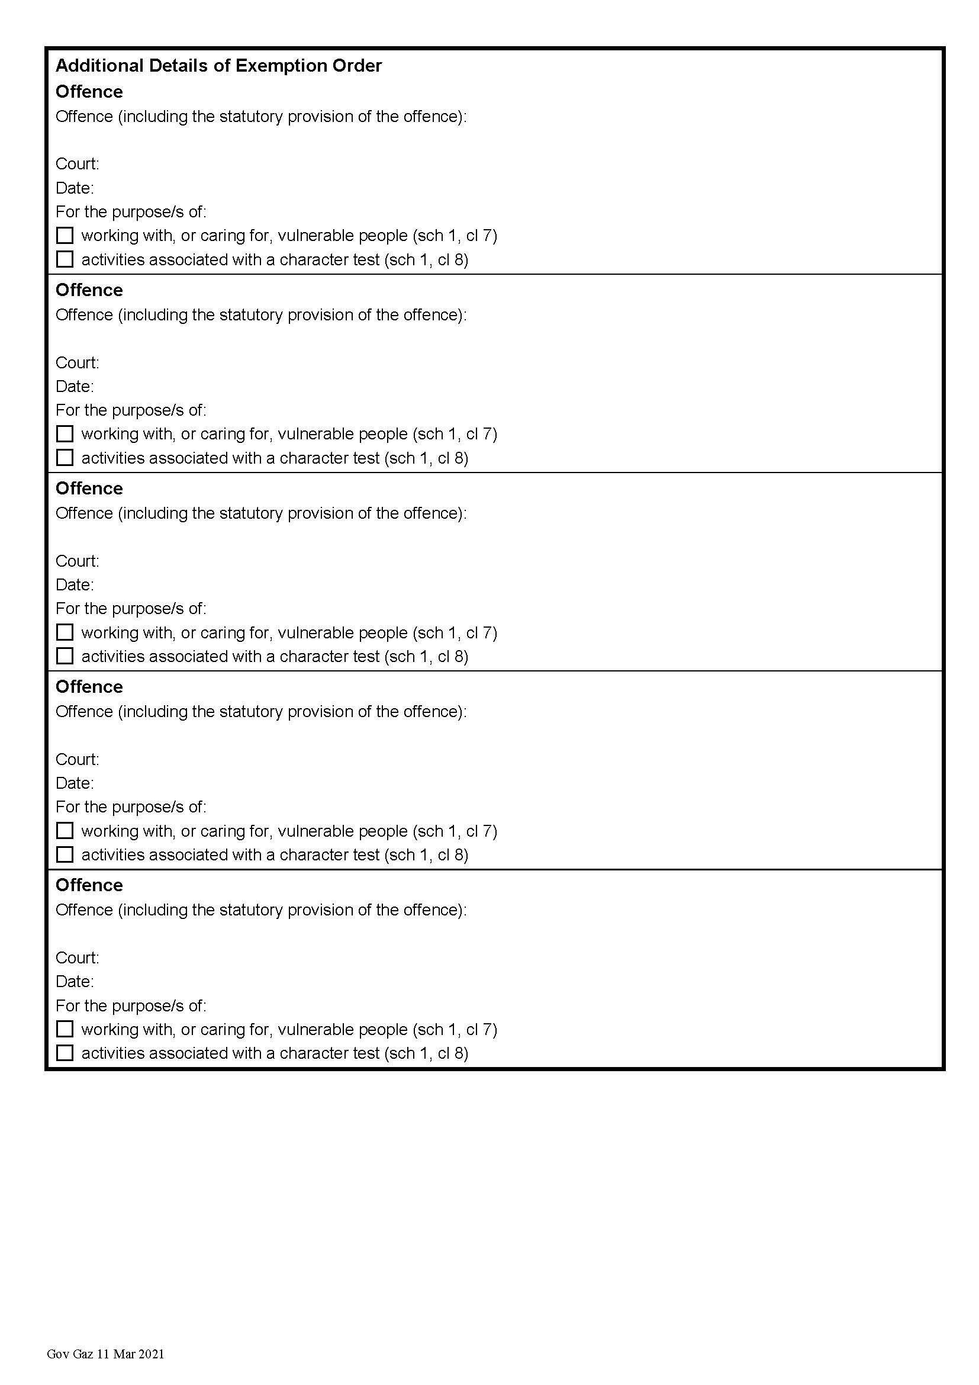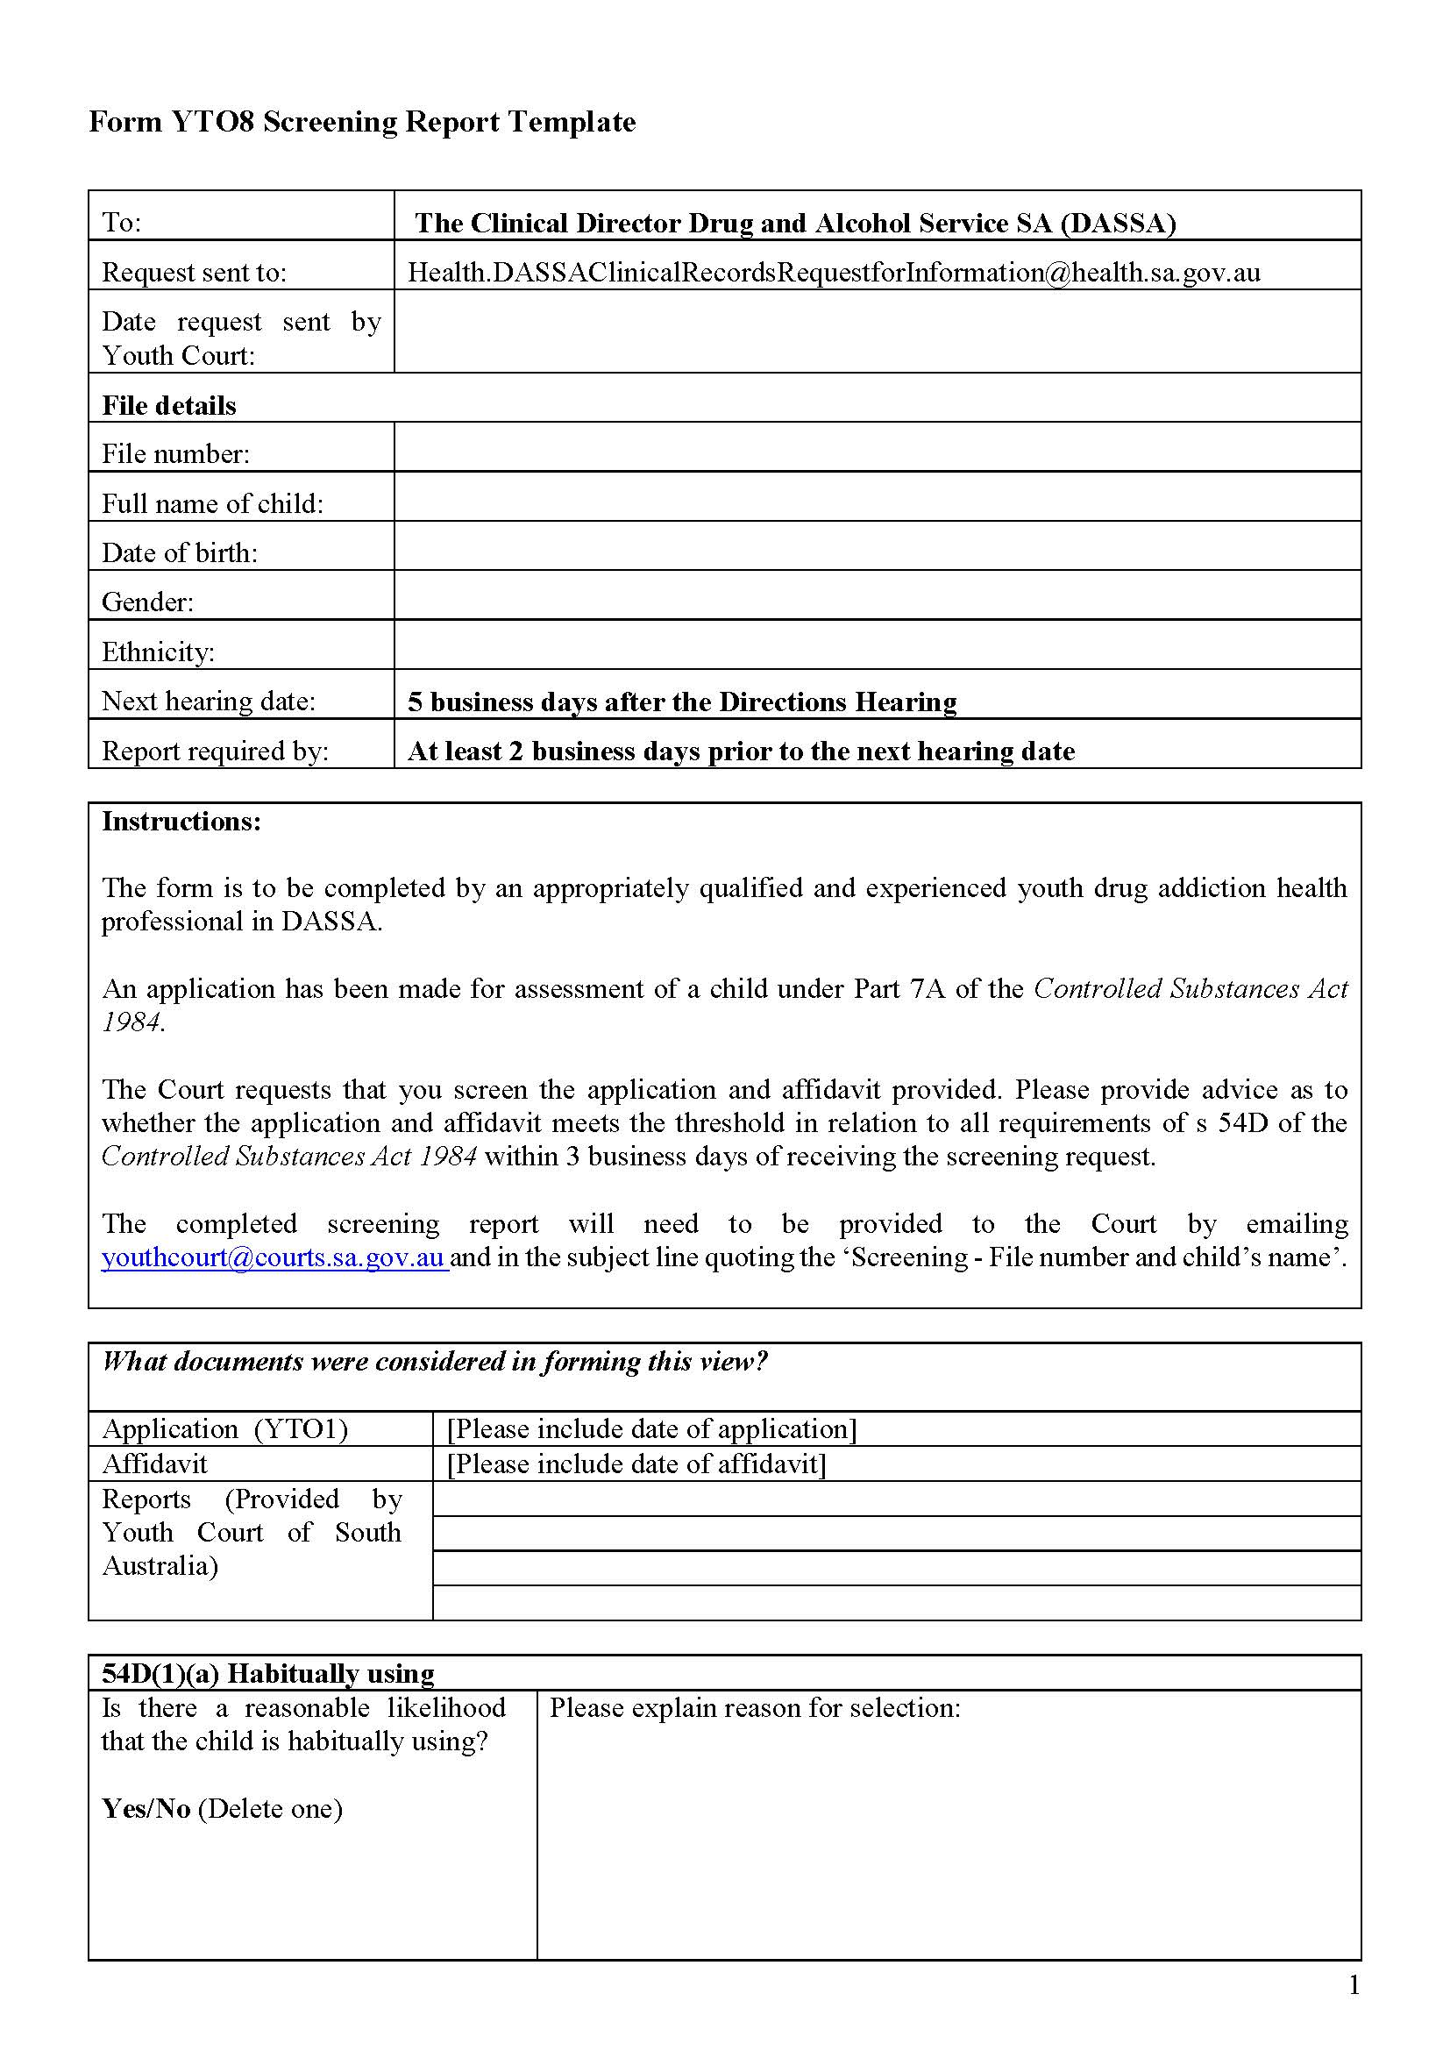

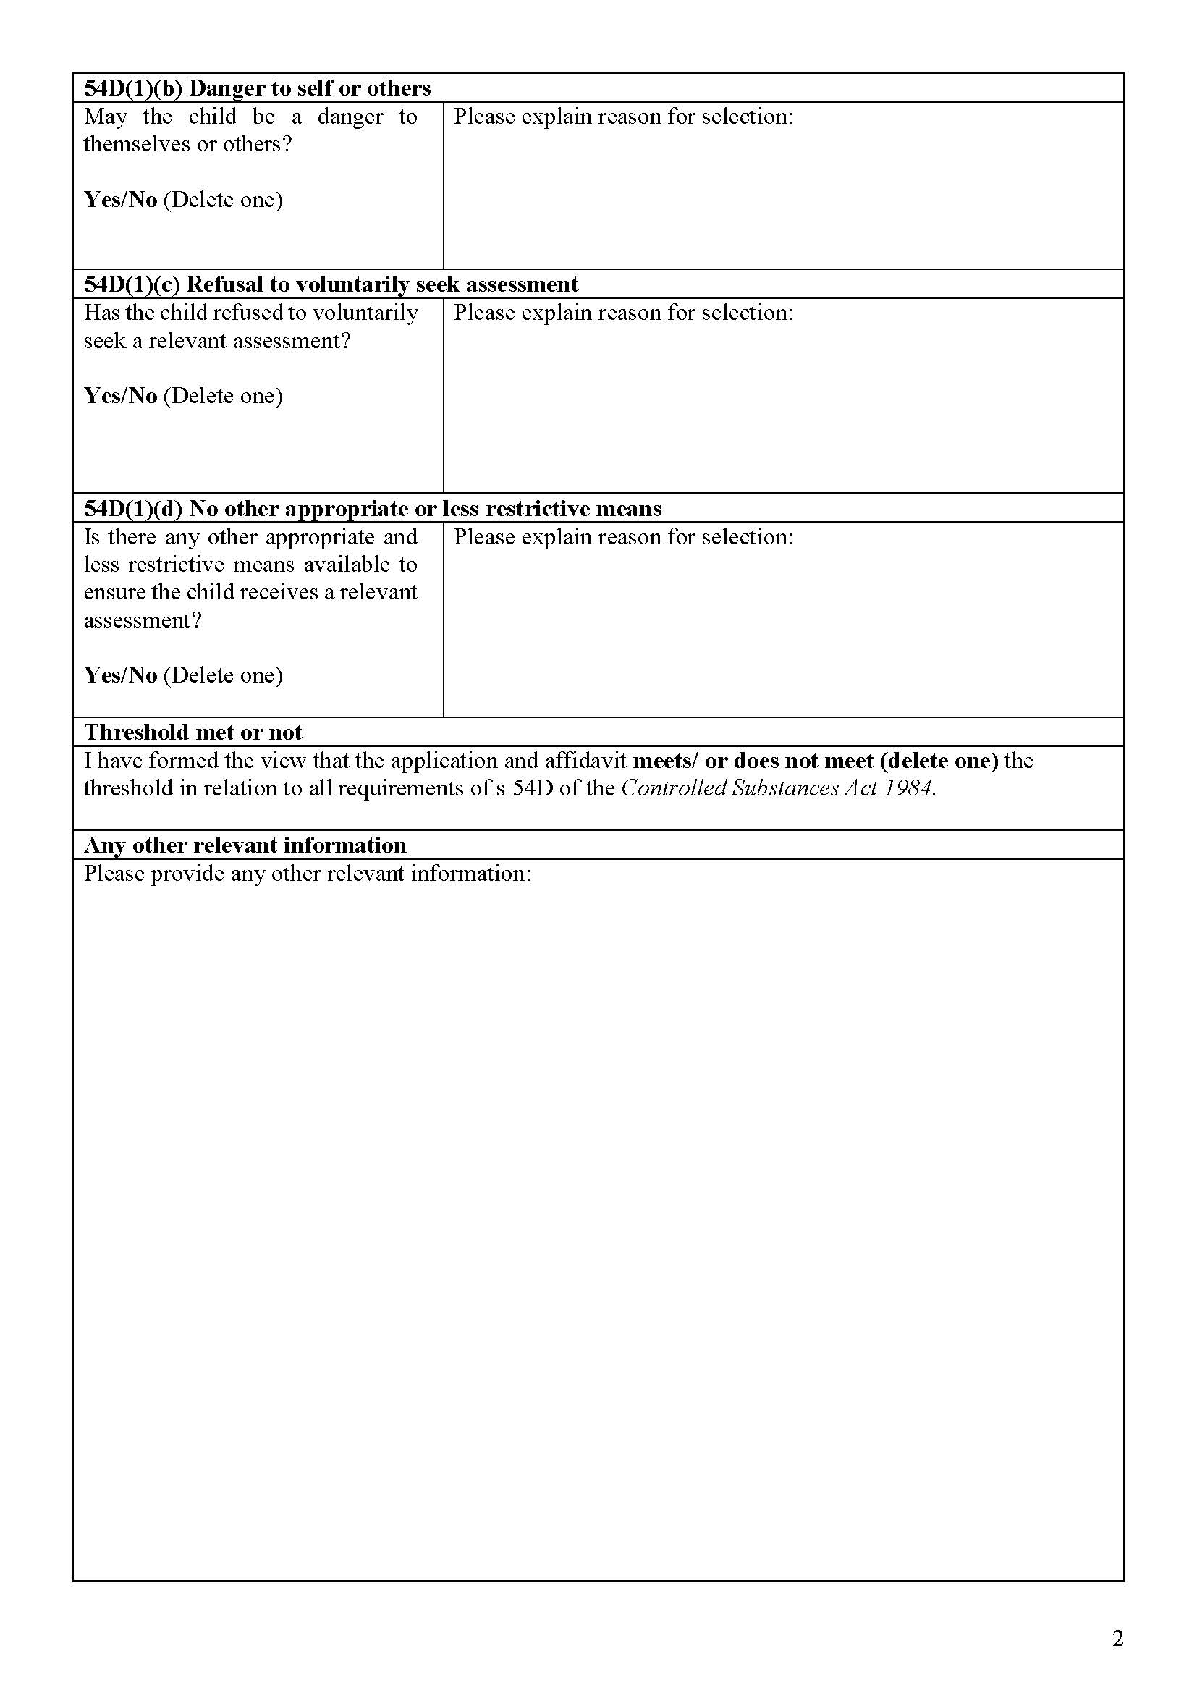

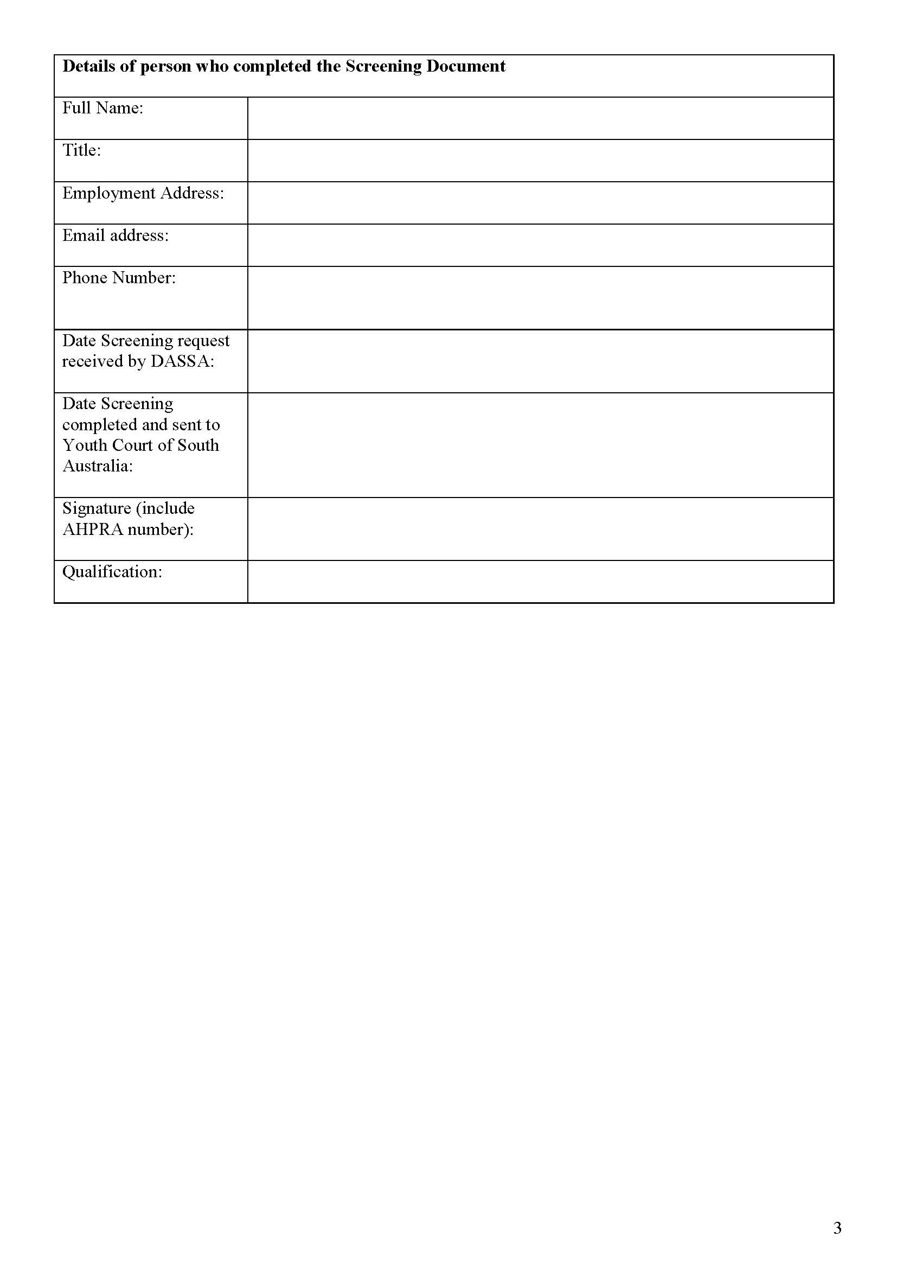

State Government Instruments

Associations Incorporation Act 1985
Section 42(2)
Dissolution of Association
WHEREAS the CORPORATE AFFAIRS COMMISSION (the Commission) pursuant to section 42(1) of the Associations Incorporation Act 1985 (the Act) is of the opinion that the undertaking or operations of AUSTRALIAN CALISTHENIC FEDERATION INCORPORATED (the Association) being an incorporated association under the Act are being carried on, or would more appropriately be carried on by a company limited by guarantee incorporated under the Corporations Act 2001 (Cth) AND WHEREAS the Commission was on 28 October 2021 requested by the Association to transfer its undertaking to AUSTRALIAN CALISTHENIC FEDERATION LIMITED (Australian Company Number 654 450 067), the Commission pursuant to section 42(2) of the Act DOES HEREBY ORDER that on 1 December 2021, the Association will be dissolved, the property of the Association becomes the property of AUSTRALIAN CALISTHENIC FEDERATION LIMITED and the rights and liabilities of the Association become the rights and liabilities of AUSTRALIAN CALISTHENIC FEDERATION LIMITED.
Given under the seal of the Commission at Adelaide.
Dated: 1 December 2021
Lauren Hilliker
A delegate of the Corporate Affairs Commission

Constitution ACT 1934

Remuneration ACT 1990
Report of the Remuneration Tribunal—No. 12 of 2021
2021 Review of Salary of the Governor of South Australia
INTRODUCTION
- The Remuneration Tribunal (“the Tribunal”) has jurisdiction under section 14 of the Remuneration Act 1990 (“the Act”) and section 73 of the Constitution Act 1934 (“the Constitution Act”), to determine the rate of salary payable to Her Excellency the Governor of South Australia (“the Governor”).
BACKGROUND
- In the earlier part of 2021, the Tribunal conducted its annual review of the salary of the Governor. The Tribunal decided that it was not appropriate to increase the salary of the Governor at the time of that review.
- The Tribunal made the following remarks in its 2021 Report¹:
“Notwithstanding the Tribunal’s decision to not increase the Governor’s salary at the time of this Review, the Tribunal is conscious of the level of the Governor’s salary when compared against the salaries of Governors in other jurisdictions. That information is detailed in the above table. The Tribunal considers that this is one of a range of factors which mitigate in favour of a more comprehensive review of the Governor’s salary. The Tribunal will invite submissions from affected persons to enable such a review to be carried out in mid-2021. The Tribunal will provide an appropriate notice period for the making of submissions.”
¹ Report 2 of 2021 – Review of Salary of the Governor of South Australia
- In keeping with the Tribunal’s remarks earlier this year, the Tribunal has further reviewed the salary applicable to the office of the Governor.
PROCEDURAL HISTORY
- Section 10(2) of the Act provides that prior to the making of a Determination, the Tribunal must allow an affected person, or persons of an affected class, a reasonable opportunity to make submissions orally or in writing to the Tribunal.
- Section 10(4) provides that the Minister responsible for the Act may intervene, personally or by counsel or other representative, in proceedings before the Tribunal for the purpose of introducing evidence, or making submissions, on any question relevant to the public interest.
- The Tribunal, by letter dated 19 October 2021, invited the Governor to make a submission in relation to the review of the salary applicable to the office of the Governor.
- The Tribunal, by letter dated 19 October 2021, invited the Honourable Premier of South Australia (“the Premier”), as the Minister responsible for the Act, to make submissions in the public interest.
- In addition, on 19 October 2021, a notification of the review was placed on the Tribunal’s public website.
SUBMISSIONS
- The Official Secretary to the Governor wrote to the Tribunal advising that the Governor did not intend to make a submission in relation to the Tribunal’s review of the Governor’s salary and will leave the matter for the Tribunal’s independent discretion.
- The Crown Solicitor’s Office, on behalf of the Premier, submitted that a review of the Governor’s salary is appropriate and that the review should take into consideration a comparative analysis of interstate Governor salaries. The Premier considers that the quantum of any increase to the governor’s salary, and the operative date, should be determined at the discretion of the Tribunal.
- No other submissions were received by the Tribunal in relation to this Review.

INTERJURISDICTIONAL COMPARISON
- The Tribunal has considered the following interjurisdictional comparison in the making of its decision:
The Salaries of Governors in Other Jurisdictions
Jurisdiction* | Governor Salary Per Annum | Operative Date | Relevant Authority
NSW | $513,860 | 2 Oct 21 | Independent Tribunal
CTH^ | $495,000 | 6 Apr 19 | Act of Parliament
VIC | $468,020 | 17 Sep 19 | Act of Parliament
TAS | $464,729 | 31 May 20 | Act of Parliament
WA | $454,028 | 21 Jan 18 | Independent Tribunal
QLD | $421,218 | 1 Jul 19 | Act of Parliament & Regulation
Median Salary ex SA | $466,375
Average Salary ex SA | $469,476
SA | $351,015 | 1 Jan 20 | Independent Tribunal
*NT and ACT have not been included as there is no office of Governor in those jurisdictions.
^The Australian Constitution prevents the salary of the Governor-General from being altered during an incumbent’s time in office
CONSIDERATION AND CONCLUSION
- Notwithstanding the completely understandable absence of submissions in this matter, the Tribunal considers it is appropriate to establish a sustainable basis for the remuneration of the Governor.
- In approaching the Tribunal’s statutory task of fixing an appropriate level of salary for the Governor, the Tribunal has considered the importance of the Governor’s role in South Australia’s constitutional democracy as the head of state. The Tribunal does not consider it appropriate or necessary in the circumstances to conduct a traditional work value assessment of the duties of the Governor. Those functions are enshrined in our constitution and democratic system and have been most ably undertaken by successive Governors.
- The Tribunal has also recognised the significance of this role within and outside South Australia and the extent to which the office of Governor of South Australia should be regarded as comparable to that of Governors in other states.
- The Tribunal has considered the above evidence in relation the salaries of Governors in other jurisdictions. The Tribunal has observed that the salary applicable to the office of Governor of South Australia prior to this review is materially lower than the median salary of Governor’s in other Australian jurisdictions. If this anomaly is not addressed, it has the potential to indicate a lessor role for a Governor in South Australia.
- Accordingly, the Tribunal has decided to increase the salary of the Governor. The Tribunal has noted that this Determination is being made at a time of substantial financial constraints associated with the COVID pandemic. Notwithstanding this, the Tribunal considers that this anomaly should be addressed.
- Accordingly, the Tribunal has decided that an increase in Governor’s salary shall occur in two tranches, as follows:
Salary | Operative Date
$408,695 per annum | on and from 1 January 2022
$463,375 per annum | on and from 1 January 2023
- The accompanying Determination will now issue.
Dated: 2 December 2021
Matthew O’Callaghan
President
Deborah Black
Member
Peter de Cure
Member

Constitution Act 1934
Determination of the Remuneration Tribunal—No. 12 of 2021
Salary of the Governor of South Australia
DETERMINATION
- Pursuant to section 73 of the Constitution Act 1934, the Remuneration Tribunal hereby determines that the following rates of salary be applicable to the office of Governor of South Australia:
Salary | Operative Date
$408,695 per annum | on and from 1 January 2022
$463,375 per annum | on and from 1 January 2023
Dated: 2 December 2021
Matthew O’Callaghan
President
Deborah Black
Member
Peter de Cure
Member

DANGEROUS SUBSTANCES ACT 1979
Authorised Officers
I, Martyn Antony Campbell, Executive Director, SafeWork SA, hereby revoke the following persons as Authorised Officers for the purposes of the Dangerous Substances Act 1979 pursuant to section 7(4) of that Act:
- Armando MAIELI
- David James CAREY
- Craig David TONKS
- Kristyn Jayne GAULT
- Richard SZMELTER
- Barry Anthony John SHEPPARD
- Shelley Kerkham ROWETT
- Miroslav PETKOVICH
- Martin Clifford FLETCHER
- John Martin GARVEY
- Kimberley Louise MICHEL
- Dean Colin ROBERTS
- Graeme Joseph SAUER
Dated: 2 December 2021
Martyn Campbell
Executive Director
SafeWork SA

Equal Opportunity Act 1994
South Australian Civil and Administrative Tribunal
Notice of Exemption before Tribunal Member Griffin – SACAT Reference Number: 2021/SA001982
I HEREBY certify that on the 20th of October 2021, the South Australian Civil and Administrative Tribunal, on application of Fernwood Women's Health Clubs (Australia) Pty Ltd, made the following orders for an exemption:
1. Pursuant to section 92 of the Equal Opportunity Act 1994 [SA] (‘the Act’) the Tribunal grants an exemption to the Applicant Fernwood Women’s Health Clubs (Australia) Pty Ltd, its franchises, operating divisions (Fernwood Centres) its authorised agents and employees, from the following provisions of the Act subject to the following conditions and limitations as they apply to sex, gender identity and intersex status (excluding sexual orientation);
1.1. Section 30 sub-sections (1) and (2) [inclusive];
1.2. Section 31 sub-sections (1), (2) and (3) [inclusive];
1.3. Section 39 sub-sections (1) and (2) [inclusive];
1.4. Section 103 sub-section (1).
2. The above exemption is to remain in force for a period of 3 years commencing on 20 October 2021.
Dated: 2 December 2021
Anne Lindsay
Principal Registrar
South Australian Civil and Administrative Tribunal

Fisheries Management Act 2007
Section 115
Ministerial Exemption ME9903168
TAKE NOTICE that pursuant to section 115 of the Fisheries Management Act 2007, I Professor Gavin Begg, Executive Director Fisheries and Aquaculture, delegate of the Minister for Primary Industries and Regional Development, hereby exempt Garry Warrick of 1979 Kingston Road, NEW RESIDENCE SA 5333 (the ‘exemption holder’), holder of River Fishery licence number R27 and his nominated agent, from sections 53(2) and 70 of the Fisheries Management Act 2007 and Regulation 5, Clause 6 of Schedule 6, and Schedule 7 of the Fisheries Management (General) Regulations 2017 but only insofar as he may use the devices described in Schedule 1 to take Carp, Bony Bream and Redfin Perch in the areas specified in Schedule 2 for the purpose of trade or business (the ‘exempted activity’), subject to the conditions set out in Schedule 3, from 2 December 2021 until 1 December 2022, unless varied or revoked earlier.
Schedule 1
- 30 x ‘Carp net’ – a gill net with a ply greater than 5, having a maximum length of 50 metres and a minimum mesh size of 10 centimetres and a maximum mesh size not exceeding 18 centimetres.
- 2 x Carp Separation Cages forming part of Lock 1 in Blanchetown on the River Murray.
- 1 x Backpack electrofisher (Smith-Root LR24)
- 1 x Boat electrofisher (Smith-Root 5.0 kW GPP)
Schedule 2
- Subject to paragraph (2), the exemption holder may conduct fishing activities pursuant to this licence in South Australian Reservoirs if given prior approval by SA Water to undertake specified eradication work, and the following areas of the backwaters of the River Murray:
- Lake Bonney and connected Chambers Creek
- Wachtels Lagoon
- Spectacle Lakes and unnamed connected creek
- Yatco Lagoon
- Gurra Gurra Lakes
- The exemption holder may conduct fishing operations in the waters listed in paragraph (1) if given written approval by the Executive Director, Fisheries and Aquaculture, to undertake specified carp eradication work in a specified area for a specified period.
- The exemption holder may conduct fishing activities using the Carp Separation Cages which form part of Lock 1 on the River Murray.
Schedule 3
- The exemption holder must not use more than the permitted number of devices under Schedule 1 at any one time.
- The exemption holder must not have more than 30 Carp nets in his possession at any time when he is deploying Carp nets in the backwaters of the River Murray and use no more than two Carp Separation Cages at Lock 1 on the River Murray.
- Except for use of electrofisher gear in Reservoirs by SA Water, the exemption holder may only engage in the exempted activity when also fishing pursuant to River Fishery licence number R27, and may only use a boat to engage in the exempted activity if that boat is registered by endorsement on River Fishery licence number R27.
- The exempted activity may only be conducted by the exemption holder or his nominated agent, Mr Jayden Warrick.
- The exemption holder and his nominated agent must be qualified to use the electrofisher gear and must only operate the gear in accordance with the Australian Code of Electrofishing Practice.
- All native fish (excluding Bony Bream) taken in the course of the exempted activity must be immediately returned to the water, and consistent with the Australian Code of Electrofishing Practice, when native species are encountered while electrofishing, electricity must be discontinued until the native species recovers and escapes.
- Immediately prior to commencing the exempted activity, the exemption holder must contact the Department of Primary Industries and Regions (PIRSA) Fishwatch on 1800 065 522 and provide the following details:
- The licence number and person(s) conducting the activity;
- The exact location(s) of the fishing activities;
- The gear type and quantity being used;
- Exemption number ME9903168
- The exemption holder must ensure that the Carp nets are checked and all fish removed at least once during any 24 hour period in the water.
- Carp nets and Carp Separation Cages must be removed from the water when fishing pursuant to this exemption notice ceases.
- When the exemption holder moves the Carp nets more than 3 kilometres from the reported location of the nets under condition 7, or removes any of the nets from the river completely, the exemption holder must provide an additional report to PIRSA Fishwatch on 1800 065 522 and either provide details as required under condition 7 of this exemption notice, or report that fishing with Carp nets and Carp Separation Cages has ceased.
- While engaging in the exempted activity, the exemption holder must be in possession of a copy of this notice. Such notice must be produced to a Fisheries Officer as requested.
- The exemption holder must not contravene or fail to comply with the Fisheries Management Act 2007 or any regulations made under that Act, except where specifically exempted by this notice.
Dated: 1 December 2021
Prof Gavin Begg
Executive Director
Fisheries and Aquaculture
Delegate of the Minister for Primary Industries and Regional Development

Fisheries Management Act 2007
Section 115
Exemption Number ME9903172
TAKE NOTICE that pursuant to section 115 of the Fisheries Management Act 2007, I Professor Gavin Begg, Executive Director Fisheries and Aquaculture, delegate of the Minister for Primary Industries and Regional Development, hereby exempt Dr Peter Gill of the Blue Whale Study Inc. of 25 Priestly Road, TYRENDARRA VIC 3285 (the ‘exemption holder’) from sections 71(1) and 71(2) of the Fisheries Management Act 2007 but only insofar as the exemption holder is permitted, in the areas specified in Schedule 1, to undertake the activities described in Schedule 2, subject to the conditions set out in Schedule 3, from 5 December 2021 until 4 December 2022, unless varied or revoked earlier.
Schedule 1
The exempted activity is permitted in all South Australian marine waters excluding aquatic reserves, the Adelaide Dolphin Sanctuary and sanctuary or restricted access zones of marine parks (unless otherwise authorised under the Marine Parks Act 2007).
Schedule 2
The taking of tissue biopsies and attachment of satellite and suction-cup dive-logger tags to:
- 25 Blue whales (Balaenoptera musculus)
- 5 Fin Whales (Balaenoptera physalus)
- 5 Sei Whales (Balaenoptera borealis)
- 25 Humpback Whales (Megaptera novaeangliae)
- 5 Sperm Whales (Physeter macrocephalus)
- 20 Common Dolphins (Delphinus)
- 20 Bottlenose Dolphins (Tursiops)
- 20 Dusky Dolphins (Lagenorhynchus obscurus)
Schedule 3
- The specimens collected by the exemption holder are for scientific and research purposes only and must not be sold.
- The exemption holder must take all reasonable steps to minimise the extent of injury, damage or harm to cetaceans when undertaking the research activity.
- Before undertaking the exempted activity pursuant to this notice, the exemption holder must contact the Department of Primary Industries and Regions (PIRSA) FISHWATCH on 1800 065 522 and answer a series of questions about the exempted activity. The exemption holder will need to have a copy of the exemption at the time of making the call and be able to provide information about the area and time of the exempted activity, the vehicles and/or boats involved and other related questions.
- The exemption holder must provide a report in writing detailing the outcomes of the research and collection of tissue biopsies pursuant to this notice to the Executive Director, Fisheries and Aquaculture (GPO Box 1625, ADELAIDE SA 5001) within 30 days of the final collection (the exempted activity) with the following details:
      - the date, time and location of sampling; and
      - any other information deemed relevant or of interest that is able to be volunteered.
- While engaging in the exempted activity, the exemption holder must be in possession of a copy of this notice and the notice must be produced to a Fisheries Officer, if requested.
- The exemption holder must not contravene or fail to comply with the Fisheries Management Act 2007 or any regulations made under that Act, except where specifically exempted by this notice.
This notice does not purport to override the provisions or operation of any other Act including but not limited to the Marine Parks Act 2007.
Dated: 4 December 2021
Prof Gavin Begg
Executive Director
Fisheries and Aquaculture
Delegate of the Minister for Primary Industries and Regional Development

Fisheries Management Act 2007
Section 115
Exemption No. ME9903176
TAKE NOTICE that pursuant to section 115 of the Fisheries Management Act 2007 (the Act), Professor. Sabine Dittmann (the ‘exemption holder’) of Flinders University, Sturt Road, Bedford Park, or her nominated agents, are exempt from Section 70 of the Fisheries Management Act 2007, Regulation 5(a) and clauses 42, 74, 113(1)(a) and 116 of Schedule 6 of the Fisheries Management (General) Regulations 2017 in the waters specified in Schedule 1 but only insofar as they are for the purposes of activities specified in Schedule 2, using the gear specified in Schedule 3, (the ‘exempted activity’), subject to the conditions specified in Schedule 4, from 3 December 2021 until 2 December 2022, unless varied or revoked earlier.
Schedule 1
All waters of South Australia, including the River Murray Protection Area, excluding aquatic reserves (unless otherwise authorised under the Act) and sanctuary and restricted access zones of marine parks (unless otherwise authorised under the Marine Parks Act 2007) and the Adelaide Dolphin Sanctuary (unless otherwise authorised under the Adelaide Dolphin Sanctuary Act 2005).
Schedule 2
The research activities entitled:
- Ecological assessments in the Coorong - Long-term monitoring of benthic macroinvertebrates as part of ‘The Living Murray Condition Monitoring’ and ‘Healthy Coorong – Healthy Basin’ Program.
- Mudflat biodiversity and condition monitoring in Gulf St Vincent, South Australia.
Schedule 3
- 10 x Plastic Corer, Hand Held, PVC: 10 cm diameter, 20 cm height
- 1 x Ekman Grab: 15 cm x 15 cm, 20 cm height
- 10 x Emergence traps: 20 cm by 20 cm
- 12 x Fyke Nets: 3 m wing, 5.6 m funnel, 0.6 m hoop diameter, 8 mm mesh size
- 12 x Box Trap: 47 cm length, 25 cm width, 2-3 mm mesh size
- 8 x UBRUV/BRUV (Remote underwater video): 35 cm x 35 cm
Schedule 4
- Any equipment used to collect and hold fish during the exempted activity must be decontaminated prior to and after undertaking the research activities.
- All relevant pending Department of Environment and Water permit approvals are to be provided to the Department of Primary Industries and Regions (PIRSA) no later than 10 December 2021.
- All species caught pursuant to this notice that are not being collected for scientific, education or research purposes must be returned to the water as soon as practicable, except for species declared as noxious under the Act. Noxious species must not be returned to the water and must be disposed of appropriately.
- All protected species incidentally taken while undertaking the exempted activity must be returned to the water as soon as practicable. Protected species must not be retained.
- If in undertaking the activities outlined in Schedule 2 using the exempt device types outlined in Schedule 3 cause entanglement, injury or death to a Dolphin within the Adelaide Dolphin Sanctuary, you must disentangle and report the interaction immediately to the National Parks and Wildlife Services Ranger Duty Officer on 0427 556 676.
- The specimens collected by the exemption holder are for scientific, education or research purposes only and must not be sold or consumed.
- The Ministerial exemption holder must not collect specimens for aquaculture research purposes pursuant to this notice.
- Specimens collected pursuant to this notice must not be released into waters of the State once they have been kept separate to their natural environment.
- The Ministerial exemption holder or agent must not conduct any other fishing activity, including recreational fishing whilst undertaking the exempted activity.
- The nominated agents for the purpose of this permit are: Ryan Baring – Flinders University, Laura Schroder – Flinders University, Orlando Lam Gordillo – Flinders University, Anthony Newbery – Flinders University.
- At least 1 hour before conducting an exempted activity, the exemption holder must contact PIRSA Fishwatch on 1800 065 522 and answer a series of questions about the exempted activity. The exemption holder will need to have a copy of this notice in their possession at the time of making the call, and be able to provide information about the area and time of the exempted activity, the specific gear to be used, vehicles and/or boats involved, the number of permit holders undertaking the exempted activity and other related questions.
- The exemption holder must provide a report in writing detailing the activities carried out pursuant to this notice to PIRSA, Fisheries and Aquaculture (GPO Box 1625, ADELAIDE SA 5001) within 14 days of the activity being completed with the following details:
      - the date and location of sampling;
      - the gear used;
      - the number and description of all species caught and their fate;
      - the number and description of any samples/biopsies collected;
      - any interactions with protected species and their fate; and
      - any other information regarding size, breeding or anything deemed relevant or of interest that is able to be volunteered.
- While engaging in the exempted activity, the exemption holder and agents must be in possession of a signed copy of this notice and carry their identification card issued by Flinders University. Such notice and identification must be produced to a PIRSA Fisheries Officer if requested.
- A person acting as an agent of the exemption holder must possess a copy of a signed letter from the exemption holder stating that they are acting as an agent during the exempted activity and carry their identification card issued by Flinders University.
- The exemption holder, or agent must not contravene or fail to comply with the Act or any regulations made under the Act, except where specifically exempted by this notice.
This notice does not purport to override the provisions or operation of any other Act including, but not limited to, the Marine Parks Act 2007, the River Murray Act 2003 or the Adelaide Dolphin Sanctuary Act 2005. The exemption holder and her agents must comply with any relevant regulations, permits, requirements and directions from the Department for Environment and Water when undertaking activities within a marine park.
Dated: 2 December 2021
Prof Gavin Begg
Executive Director
Fisheries and Aquaculture
Delegate of the Minister for Primary Industries and Regional Development

Fisheries Management (Prawn Fisheries) Regulations 2017
December 2021 Fishing in the West Coast Prawn Fishery
TAKE notice that pursuant to regulation 10 of the Fisheries Management (Prawn Fisheries) Regulations 2017, the notice dated 18 November 2021 on page 4170 of the South Australian Government Gazette of 25 November 2021, prohibiting fishing activities in the West Coast Prawn Fishery is HEREBY revoked.
Dated: 7 December 2021
Yolande Markey
A/Prawn Fishery Manager
Delegate of the Minister for Primary Industries and Regional Development

Geographical Names Act 1991
Notice to Alter Boundaries of a Place
NOTICE is hereby given pursuant to Section 11B of the Geographical Names Act 1991, that I, VICKIE CHAPMAN, Attorney-General, Minister of the Crown to whom the administration of the Geographical Names Act 1991 is committed, DO HEREBY;
Alter the locality boundary between Armagh and Clare to exclude from the bounded locality of ARMAGH that area marked (A) shown highlighted in green and include in the locality of CLARE.
A copy of the plan showing the extent of the altered boundary can be viewed on the Land Boundaries website at: www.sa.gov.au/placenameproposals
Dated: 19 November 2021
Vickie Chapman MP
Attorney-General
DIT: 2021/03842/01

Geographical Names Act 1991
Notice to Alter Boundaries of a Place
NOTICE is hereby given pursuant to Section 11B of the Geographical Names Act 1991, that I, VICKIE CHAPMAN, Attorney-General, Minister of the Crown to whom the administration of the Geographical Names Act 1991 is committed, DO HEREBY;
Alter the locality boundary between Salter Springs and Riverton to exclude from the bounded locality of SALTER SPRINGS that area marked (A) shown highlighted in green and include in the locality of RIVERTON.
A copy of the plan showing the extent of the altered boundary can be viewed on the Land Boundaries website at: www.sa.gov.au/placenameproposals
Dated: 19 November 2021
Vickie Chapman MP
Attorney-General
DIT: 2021/03842/01

Health Care Act 2008
Section 64
Declaration of Authorised Quality Improvement Activity and Authorised Person
TAKE notice that I, Stephen Wade, Minister for Health and Wellbeing, pursuant to sections 64 (1) (a) (i) and (b) (i) do hereby:
DECLARE the Activities described in the Schedule to this declaration (the Activities) to be authorised quality improvement activities to which Part 7 of the Act applies, and
DECLARE the Person or group of Persons (including a group formed as a committee) described in the Schedule to this declaration (the Persons) to be an authorised entity for the purposes of carrying out the authorised quality improvement activities to which Part 7 of the Act applies,
being satisfied that:
    - the performance of the activities within the ambit of the declaration and the functions or activities of the person or group of persons within the ambit of the declaration, would be facilitated by the making of the declaration; and
    - that the making of the declaration is in the public interest.
Dated: 5 December 2021
Stephen Wade
Minister for Health and Wellbeing

Schedule
Activity | Person or Group of Persons
Clinical Review Quality Improvement | The Burnside War Memorial Hospital Incorporated Clinical Review Committee

Housing Improvement Act 2016
Rent Control Revocations
Whereas the Minister for Human Services Delegate is satisfied that each of the houses described hereunder has ceased to be unsafe or unsuitable for human habitation for the purposes of the Housing Improvement Act 2016, notice is hereby given that, in exercise of the powers conferred by the said Act, the Minister for Human Services Delegate does hereby revoke the said Rent Control in respect of each property.
Address of Premises | Allotment  Section | Certificate of Title  Volume Folio
13 Clarke Street, Rosetown SA 5275 | Allotment 243 Town Plan 430702 Hundred of Lacepede | CT5176/518
434 Grand Junction Road, Mansfield Park SA 5012 | Allotment 81 Filed Plan 126249 Hundred of Yatala | CT5421/762
79 Addison Avenue, Athelstone SA 5076 | Allotment 37 Deposited Plan 6857 Hundred of Adelaide | CT5453/947
Dated: 9 December 2021
Craig Thompson
Housing Regulator and Registrar
Housing Safety Authority, SAHA
Delegate of Minister for Human Services

Land Acquisition Act 1969
Section 16
Form 5 – Notice of Acquisition
1. Notice of acquisition
The Commissioner of Highways (the Authority), of 50 Flinders Street, Adelaide SA 5000, acquires the following interests in the following land:
First: Comprising an unencumbered estate in fee simple in that piece of land being portion of Allotment 21 in Deposited Plan No 27953 comprised in Certificate of Title Volume 5913 Folio 817, and being the whole of the land identified as Allotment 71 in D128080 lodged in the Lands Titles Office
Secondly: Comprising an unencumbered estate in fee simple in that piece of land being portion of Allotment 23 in Filed Plan No 153409 comprised in Certificate of Title Volume 5743 Folio 551, and being the whole of the land identified as Allotment 73 in D128080 lodged in the Lands Titles Office
Thirdly: Comprising an unencumbered estate in fee simple in that piece of land being portion of Allotment 53 in Deposited Plan No 69077 comprised in Certificate of Title Volume 6167 Folio 132, and being the whole of the land identified as Allotment 75 in D128080 lodged in the Lands Titles Office
This notice is given under section 16 of the Land Acquisition Act 1969.
2. Compensation
A person who has or had an interest consisting of native title or an alienable interest in the land that is divested or diminished by the acquisition or the enjoyment of which is adversely affected by the acquisition who does not receive an offer of compensation from the Authority may apply to the Authority for compensation.

2A. Payment of professional costs relating to acquisition (section 26B)
If you are the owner in fee simple of the land to which this notice relates, you may be entitled to a payment of $10 000 from the Authority for use towards the payment of professional costs in relation to the acquisition of the land.
Professional costs include legal costs, valuation costs and any other costs prescribed by the Land Acquisition Regulations 2019.
3. Inquiries
Inquiries should be directed to: Chris Southam
GPO Box 1533
Adelaide SA 5001
Telephone: (08) 8343 2574
Dated: 7 December 2021
The Common Seal of the COMMISSIONER OF HIGHWAYS was hereto affixed by authority of the Commissioner in the presence of:
Rocco Caruso
Manager, Property Acquisition (Authorised Officer)
Department for Infrastructure and Transport
DIT 2020/16828/01, 2020/16830/01, 2020/16834/01

Land Acquisition Act 1969
Section 16
Form 5 – Notice of Acquisition
1. Notice of acquisition
The Commissioner of Highways (the Authority), of 50 Flinders Street, Adelaide SA 5000, acquires the following interests in the following land:
First: An unencumbered estate in fee simple in that piece of land being portion of Allotment 324 in Filed Plan 210300 comprised in Certificate of Title Volume 6193 Folio 309, expressly excluding the Right of Way created by TG 12743850 over the land marked “B” in Allotment 60 in plan D127032, and being the whole of the land identified as Allotment 75 in plan D127602 lodged in the Lands Titles Office.
Secondly: Portion of the land comprised in Certificate of Title Volume 6193 Folio 309, being that portion of the Right of Way created by TG 12743850 over the land marked “B” in Filed Plan 252500 that forms a portion of Allotment 61 in plan D127032, with the intent that that portion of the Right of Way will merge and be extinguished in the fee simple of the said Allotment 61.
This notice is given under section 16 of the Land Acquisition Act 1969.
2. Compensation
A person who has or had an interest consisting of native title or an alienable interest in the land that is divested or diminished by the acquisition or the enjoyment of which is adversely affected by the acquisition who does not receive an offer of compensation from the Authority may apply to the Authority for compensation.
2A. Payment of professional costs relating to acquisition (section 26B)
If you are the owner in fee simple of the land to which this notice relates, you may be entitled to a payment of $10 000 from the Authority for use towards the payment of professional costs in relation to the acquisition of the land.
Professional costs include legal costs, valuation costs and any other costs prescribed by the Land Acquisition Regulations 2019.
3. Inquiries
Inquiries should be directed to: Philip Cheffirs
GPO Box 1533
Adelaide SA 5001
Telephone: (08) 8343 2575
Dated: 8 December 2021
The Common Seal of the COMMISSIONER OF HIGHWAYS was hereto affixed by authority of the Commissioner in the presence of:
Rocco Caruso
Manager, Property Acquisition (Authorised Officer)
Department for Infrastructure and Transport
DIT 2020/19454/01

Land Acquisition Act 1969
Section 16
Form 5 – Notice of Acquisition
1. Notice of acquisition
The Commissioner of Highways (the Authority), of 50 Flinders Street, Adelaide SA 5000, acquires the following interests in the following land:
Comprising an unencumbered estate in fee simple in that piece of land being the whole of Allotment 1 in Deposited Plan No 2278 comprised in Certificate of Title Volume 5508 Folio 444.
This notice is given under section 16 of the Land Acquisition Act 1969.
2. Compensation
A person who has or had an interest consisting of native title or an alienable interest in the land that is divested or diminished by the acquisition or the enjoyment of which is adversely affected by the acquisition who does not receive an offer of compensation from the Authority may apply to the Authority for compensation.

2A. Payment of professional costs relating to acquisition (section 26B)
If you are the owner in fee simple of the land to which this notice relates, you may be entitled to a payment of $10 000 from the Authority for use towards the payment of professional costs in relation to the acquisition of the land.
Professional costs include legal costs, valuation costs and any other costs prescribed by the Land Acquisition Regulations 2019.
3. Inquiries
Inquiries should be directed to: William Ridgway
GPO Box 1533
Adelaide SA 5001
Telephone: (08) 7109 7672
Dated: 8 December 2021
The Common Seal of the COMMISSIONER OF HIGHWAYS was hereto affixed by authority of the Commissioner in the presence of:
Rocco Caruso
Manager, Property Acquisition (Authorised Officer)
Department for Infrastructure and Transport
DIT 2020/20869/01

Land Acquisition Act 1969
Section 16
Form 5 – Notice of Acquisition
1. Notice of acquisition
The Commissioner of Highways (the Authority), of 50 Flinders Street, Adelaide SA 5000, acquires the following interests in the following land:
First, comprising an unencumbered estate in fee simple in that piece of land being portion of Piece 6 in Deposited Plan No 48238 comprised in Certificate of Title Volume 5627 Folio 749, and being the whole of the land identified as Allotment 54 in D128009 lodged in the Lands Titles Office.
Secondly, comprising an estate in fee simple in that piece of land being portion of Piece 5 in Deposited Plan No 48238 comprised in Certificate of Title Volume 5627 Folio 749, and being the whole of the land identified as Allotment 53 in D128009 subject to the easement over the land marked C for transmission of electricity by underground cable to the South Australian Water Corporation (TG 8551879).
Thirdly, comprising an estate in fee simple in that piece of land being portion of Piece 5 in Deposited Plan No 48238 comprised in Certificate of Title Volume 5627 Folio 749, and being the whole of the land identified as Allotment 50 in D128009 subject to the right(s) of way and easement(s) over the land marked B (RTC 8338095).
This notice is given under section 16 of the Land Acquisition Act 1969.
2. Compensation
A person who has or had an interest consisting of native title or an alienable interest in the land that is divested or diminished by the acquisition or the enjoyment of which is adversely affected by the acquisition who does not receive an offer of compensation from the Authority may apply to the Authority for compensation.
2A. Payment of professional costs relating to acquisition (section 26B)
If you are the owner in fee simple of the land to which this notice relates, you may be entitled to a payment of $10 000 from the Authority for use towards the payment of professional costs in relation to the acquisition of the land.
Professional costs include legal costs, valuation costs and any other costs prescribed by the Land Acquisition Regulations 2019.
3. Inquiries
Inquiries should be directed to: Daniel Tuk
GPO Box 1533
Adelaide SA 5001
Telephone: (08) 7109 7133
Dated: 7 December 2021
The Common Seal of the COMMISSIONER OF HIGHWAYS was hereto affixed by authority of the Commissioner in the presence of:
Rocco Caruso
Manager, Property Acquisition (Authorised Officer)
Department for Infrastructure and Transport
DIT 2020/20884/01

Land Acquisition Act 1969
Section 16
Form 5 – Notice of Acquisition
1. Notice of acquisition
The Commissioner of Highways (the Authority), of 50 Flinders Street, Adelaide SA 5000, acquires the following interests in the following land:
Comprising an unencumbered estate in fee simple in that piece of land being portion of Allotment 4 in Filed Plan No 102880 comprised in Certificate of Title Volume 5126 Folio 504, and being the whole of the land identified as Allotments 58 and 60 in D128011 lodged in the Lands Titles Office
This notice is given under section 16 of the Land Acquisition Act 1969.

2. Compensation
A person who has or had an interest consisting of native title or an alienable interest in the land that is divested or diminished by the acquisition or the enjoyment of which is adversely affected by the acquisition who does not receive an offer of compensation from the Authority may apply to the Authority for compensation.
2A. Payment of professional costs relating to acquisition (section 26B)
If you are the owner in fee simple of the land to which this notice relates, you may be entitled to a payment of $10 000 from the Authority for use towards the payment of professional costs in relation to the acquisition of the land.
Professional costs include legal costs, valuation costs and any other costs prescribed by the Land Acquisition Regulations 2019.
3. Inquiries
Inquiries should be directed to: Rob Gardner
GPO Box 1533
Adelaide SA 5001
Telephone: (08) 8343 2567
Dated: 3 December 2021
The Common Seal of the COMMISSIONER OF HIGHWAYS was hereto affixed by authority of the Commissioner in the presence of:
Rocco Caruso
Manager, Property Acquisition (Authorised Officer)
Department for Infrastructure and Transport
DIT 2020/20907/01

Land Acquisition Act 1969
Section 16
Form 5 – Notice of Acquisition
1. Notice of acquisition
The Commissioner of Highways (the Authority), of 50 Flinders Street, Adelaide SA 5000, acquires the following interests in the following land:
Comprising an unencumbered estate in fee simple in that piece of land being portion of Section 118 in the Hundred of Comaum comprised in Certificate of Title Volume 6248 Folio 87, and being the whole of the land identified as Allotment 31 in D127828 lodged in the Lands Titles Office
This notice is given under section 16 of the Land Acquisition Act 1969.
2. Compensation
A person who has or had an interest consisting of native title or an alienable interest in the land that is divested or diminished by the acquisition or the enjoyment of which is adversely affected by the acquisition who does not receive an offer of compensation from the Authority may apply to the Authority for compensation.
2A. Payment of professional costs relating to acquisition (section 26B)
If you are the owner in fee simple of the land to which this notice relates, you may be entitled to a payment of $10 000 from the Authority for use towards the payment of professional costs in relation to the acquisition of the land.
Professional costs include legal costs, valuation costs and any other costs prescribed by the Land Acquisition Regulations 2019.
3. Inquiries
Inquiries should be directed to: Daniel Tuk
GPO Box 1533
Adelaide SA 5001
Telephone: (08) 7109 7133
Dated: 3 December 2021
The Common Seal of the COMMISSIONER OF HIGHWAYS was hereto affixed by authority of the Commissioner in the presence of:
Rocco Caruso
Manager, Property Acquisition (Authorised Officer)
Department for Infrastructure and Transport
DIT 2021/02628/01

Land Acquisition Act 1969
Section 16
Form 5 – Notice of Acquisition
1. Notice of acquisition
The Commissioner of Highways (the Authority), of 50 Flinders Street, Adelaide SA 5000, acquires the following interests in the following land:
Comprising an unencumbered estate in fee simple in that piece of land being portion of Allotment 93 in Filed Plan No 173131 comprised in Certificate of Title Volume 5354 Folio 892 and being the whole of the land identified as Allotments 81 and 82 in D127827 lodged in the Lands Titles Office
This notice is given under section 16 of the Land Acquisition Act 1969.
2. Compensation
A person who has or had an interest consisting of native title or an alienable interest in the land that is divested or diminished by the acquisition or the enjoyment of which is adversely affected by the acquisition who does not receive an offer of compensation from the Authority may apply to the Authority for compensation.

2A. Payment of professional costs relating to acquisition (section 26B)
If you are the owner in fee simple of the land to which this notice relates, you may be entitled to a payment of $10 000 from the Authority for use towards the payment of professional costs in relation to the acquisition of the land.
Professional costs include legal costs, valuation costs and any other costs prescribed by the Land Acquisition Regulations 2019.
3. Inquiries
Inquiries should be directed to: Daniel Tuk
GPO Box 1533
Adelaide SA 5001
Telephone: (08) 7109 7133
Dated: 8 December 2021
The Common Seal of the COMMISSIONER OF HIGHWAYS was hereto affixed by authority of the Commissioner in the presence of:
Rocco Caruso
Manager, Property Acquisition (Authorised Officer)
Department for Infrastructure and Transport
DIT 2021/02629/01

Land Acquisition Act 1969
Section 16
Form 5 – Notice of Acquisition
1. Notice of acquisition
The Commissioner of Highways (the Authority), of 50 Flinders Street, Adelaide SA 5000, acquires the following interests in the following land:
First: Comprising an unencumbered estate in fee simple in that piece of land being the whole of Allotment 2 in Deposited Plan No 34021 comprised in Certificate of Title Volume 5083 Folio 132
Secondly: Comprising an unencumbered estate in fee simple in that piece of land being the whole of Allotment 177 in Deposited Plan No 4728 comprised in Certificate of Title Volume 5083 Folio 133
This notice is given under section 16 of the Land Acquisition Act 1969.
2. Compensation
A person who has or had an interest consisting of native title or an alienable interest in the land that is divested or diminished by the acquisition or the enjoyment of which is adversely affected by the acquisition who does not receive an offer of compensation from the Authority may apply to the Authority for compensation.
2A. Payment of professional costs relating to acquisition (section 26B)
If you are the owner in fee simple of the land to which this notice relates, you may be entitled to a payment of $10 000 from the Authority for use towards the payment of professional costs in relation to the acquisition of the land.
Professional costs include legal costs, valuation costs and any other costs prescribed by the Land Acquisition Regulations 2019.
3. Inquiries
Inquiries should be directed to: Rob Gardner
GPO Box 1533
Adelaide SA 5001
Telephone: (08) 8343 2567
Dated: 7 December 2021
The Common Seal of the COMMISSIONER OF HIGHWAYS was hereto affixed by authority of the Commissioner in the presence of:
Rocco Caruso
Manager, Property Acquisition (Authorised Officer)
Department for Infrastructure and Transport
DIT 2021/04265/01

Land Acquisition Act 1969
Section 16
Form 5 – Notice of Acquisition
1. Notice of acquisition
The Commissioner of Highways (the Authority), of 50 Flinders Street, Adelaide SA 5000, acquires the following interests in the following land:
First: Comprising an unencumbered estate in fee simple in that piece of land being the whole of Allotment 7 in Deposited Plan 3775 comprised in Certificate of Title Volume 6128 Folio 29
Secondly: Comprising an unencumbered estate in fee simple in that piece of land being the whole of Allotment 8 in Deposited Plan No 3775 comprised in Certificate of Title Volume 6128 Folio 30
This notice is given under section 16 of the Land Acquisition Act 1969.
2. Compensation
A person who has or had an interest consisting of native title or an alienable interest in the land that is divested or diminished by the acquisition or the enjoyment of which is adversely affected by the acquisition who does not receive an offer of compensation from the Authority may apply to the Authority for compensation.

2A. Payment of professional costs relating to acquisition (section 26B)
If you are the owner in fee simple of the land to which this notice relates, you may be entitled to a payment of $10 000 from the Authority for use towards the payment of professional costs in relation to the acquisition of the land.
Professional costs include legal costs, valuation costs and any other costs prescribed by the Land Acquisition Regulations 2019.
3. Inquiries
Inquiries should be directed to: Rob Gardner
GPO Box 1533
Adelaide SA 5001
Telephone: (08) 8343 2567
Dated: 7 December 2021
The Common Seal of the COMMISSIONER OF HIGHWAYS was hereto affixed by authority of the Commissioner in the presence of:
Rocco Caruso
Manager, Property Acquisition (Authorised Officer)
Department for Infrastructure and Transport
DIT 2021/04268/01

Land Acquisition Act 1969
Section 16
Form 5 – Notice of Acquisition
1. Notice of acquisition
The Commissioner of Highways (the Authority), of 50 Flinders Street, Adelaide SA 5000, acquires the following interests in the following land:
Comprising an unencumbered estate in fee simple in that piece of land being the whole of Allotment 4 in Deposited Plan No 3775 comprised in Certificate of Title Volume 5123 Folio 413
This notice is given under section 16 of the Land Acquisition Act 1969.
2. Compensation
A person who has or had an interest consisting of native title or an alienable interest in the land that is divested or diminished by the acquisition or the enjoyment of which is adversely affected by the acquisition who does not receive an offer of compensation from the Authority may apply to the Authority for compensation.
2A. Payment of professional costs relating to acquisition (section 26B)
If you are the owner in fee simple of the land to which this notice relates, you may be entitled to a payment of $10 000 from the Authority for use towards the payment of professional costs in relation to the acquisition of the land.
Professional costs include legal costs, valuation costs and any other costs prescribed by the Land Acquisition Regulations 2019.
3. Inquiries
Inquiries should be directed to: Rob Gardner
GPO Box 1533
Adelaide SA 5001
Telephone: (08) 8343 2567
Dated: 7 December 2021
The Common Seal of the COMMISSIONER OF HIGHWAYS was hereto affixed by authority of the Commissioner in the presence of:
Rocco Caruso
Manager, Property Acquisition (Authorised Officer)
Department for Infrastructure and Transport
DIT 2021/04332/01

Land Acquisition Act 1969
Section 16
Form 5 – Notice of Acquisition
1. Notice of acquisition
The Commissioner of Highways (the Authority), of 50 Flinders Street, Adelaide SA 5000, acquires the following interests in the following land:
First: Comprising an unencumbered estate in fee simple in that piece of land being the whole of Allotment 3 in Deposited Plan No 3775 comprised in Certificate of Title Volume 5648 Folio 908
Secondly: Comprising an unencumbered estate in fee simple in that piece of land being the whole of Allotment 91 and 92 in Filed Plan No 216744 comprised in Certificate of Title Volume 5649 Folio 35
Thirdly: Comprising an unencumbered estate in fee simple in that piece of land being the whole of Allotment 22 in Deposited Plan No 3775 comprised in Certificate of Title Volume 5707 Folio 562.
Fourthly: Comprising an unencumbered estate in fee simple in that piece of land being the whole of Allotment 21 in Deposited Plan No 3775 comprised in Certificate of Title Volume 5733 Folio 938.
This notice is given under section 16 of the Land Acquisition Act 1969.
2. Compensation
A person who has or had an interest consisting of native title or an alienable interest in the land that is divested or diminished by the acquisition or the enjoyment of which is adversely affected by the acquisition who does not receive an offer of compensation from the Authority may apply to the Authority for compensation.

2A. Payment of professional costs relating to acquisition (section 26B)
If you are the owner in fee simple of the land to which this notice relates, you may be entitled to a payment of $10 000 from the Authority for use towards the payment of professional costs in relation to the acquisition of the land.
Professional costs include legal costs, valuation costs and any other costs prescribed by the Land Acquisition Regulations 2019.
3. Inquiries
Inquiries should be directed to: Rob Gardner
GPO Box 1533
Adelaide SA 5001
Telephone: (08) 8343 2567
Dated: 7 December 2021
The Common Seal of the COMMISSIONER OF HIGHWAYS was hereto affixed by authority of the Commissioner in the presence of:
Rocco Caruso
Manager, Property Acquisition (Authorised Officer)
Department for Infrastructure and Transport
DIT 2021/04333/01

Land Acquisition Act 1969
Section 16
Form 5 – Notice of Acquisition
1. Notice of acquisition
The Commissioner of Highways (the Authority), of 50 Flinders Street, Adelaide SA 5000, acquires the following interests in the following land:
Comprising an unencumbered estate in fee simple in that piece of land being portion of Section 45 Hundred of Light in the Area Named Stockport comprised in Certificate of Title Volume 5504 Folio 77, and being the whole of the land identified as Allotment 84 in Deposited Plan 128175 lodged in the Lands Titles Office
This notice is given under section 16 of the Land Acquisition Act 1969.
2. Compensation
A person who has or had an interest consisting of native title or an alienable interest in the land that is divested or diminished by the acquisition or the enjoyment of which is adversely affected by the acquisition who does not receive an offer of compensation from the Authority may apply to the Authority for compensation.
2A. Payment of professional costs relating to acquisition (section 26B)
If you are the owner in fee simple of the land to which this notice relates, you may be entitled to a payment of $10 000 from the Authority for use towards the payment of professional costs in relation to the acquisition of the land.
Professional costs include legal costs, valuation costs and any other costs prescribed by the Land Acquisition Regulations 2019.
3. Inquiries
Inquiries should be directed to: Sean Frost
GPO Box 1533
Adelaide SA 5001
Telephone: (08) 8456 4862
Dated: 3 December 2021
The Common Seal of the COMMISSIONER OF HIGHWAYS was hereto affixed by authority of the Commissioner in the presence of:
Rocco Caruso
Manager, Property Acquisition (Authorised Officer)
Department for Infrastructure and Transport
DIT 2021/09323/01

Land Acquisition Act 1969
Section 16
Form 5 – Notice of Acquisition
1. Notice of acquisition
The Commissioner of Highways (the Authority), of 50 Flinders Street, Adelaide SA 5000, acquires the following interests in the following land:
Comprising an unencumbered estate in fee simple in that piece of land being portion of Allotment 1 in Deposited Plan No 79467 comprised in Certificate of Title Volume 6032 Folio 929 and being the whole of the land identified as 23 in D 128172 lodged in the Lands Titles Office
This notice is given under section 16 of the Land Acquisition Act 1969.
2. Compensation
A person who has or had an interest consisting of native title or an alienable interest in the land that is divested or diminished by the acquisition or the enjoyment of which is adversely affected by the acquisition who does not receive an offer of compensation from the Authority may apply to the Authority for compensation.
2A. Payment of professional costs relating to acquisition (section 26B)
If you are the owner in fee simple of the land to which this notice relates, you may be entitled to a payment of $10 000 from the Authority for use towards the payment of professional costs in relation to the acquisition of the land.
Professional costs include legal costs, valuation costs and any other costs prescribed by the Land Acquisition Regulations 2019.
3. Inquiries
Inquiries should be directed to: Sean Frost
GPO Box 1533
Adelaide SA 5001
Telephone: (08) 8456 4862
Dated: 3 December 2021
The Common Seal of the COMMISSIONER OF HIGHWAYS was hereto affixed by authority of the Commissioner in the presence of:
Rocco Caruso
Manager, Property Acquisition (Authorised Officer)
Department for Infrastructure and Transport
DIT 2021/09325/01

Land Acquisition Act 1969
Section 16
Form 5 – Notice of Acquisition
1. Notice of acquisition
The Commissioner of Highways (the Authority), of 50 Flinders Street, Adelaide SA 5000, acquires the following interests in the following land:
Comprising an unencumbered estate in fee simple in that piece of land being portion of Allotment 102 in Deposited Plan No 62820 comprised in Certificate of Title Volume 5911 Folio 97, and being the whole of the land identified as Allotment 24 in D 128171 lodged in the Lands Titles Office
This notice is given under section 16 of the Land Acquisition Act 1969.
2. Compensation
A person who has or had an interest consisting of native title or an alienable interest in the land that is divested or diminished by the acquisition or the enjoyment of which is adversely affected by the acquisition who does not receive an offer of compensation from the Authority may apply to the Authority for compensation.
2A. Payment of professional costs relating to acquisition (section 26B)
If you are the owner in fee simple of the land to which this notice relates, you may be entitled to a payment of $10 000 from the Authority for use towards the payment of professional costs in relation to the acquisition of the land.
Professional costs include legal costs, valuation costs and any other costs prescribed by the Land Acquisition Regulations 2019.
3. Inquiries
Inquiries should be directed to: Sean Frost
GPO Box 1533
Adelaide SA 5001
Telephone: (08) 8456 4862
Dated: 3 December 2021
The Common Seal of the COMMISSIONER OF HIGHWAYS was hereto affixed by authority of the Commissioner in the presence of:
Rocco Caruso
Manager, Property Acquisition (Authorised Officer)
Department for Infrastructure and Transport
DIT 2021/09326/01

Land Acquisition Act 1969
Section 16
Form 5 – Notice of Acquisition
1. Notice of acquisition
The Commissioner of Highways (the Authority), of 50 Flinders Street, Adelaide SA 5000, acquires the following interests in the following land:
Comprising an unencumbered estate in fee simple in that piece of land being portion of Allotment Comprising Pieces 104, 105 and 106 in Deposited Plan No 92945 comprised in Certificate of Title Volume 6140 Folio 778, and being the whole of the land identified as Allotment 98 in D 128169 lodged in the Lands Titles Office
This notice is given under section 16 of the Land Acquisition Act 1969.
2. Compensation
A person who has or had an interest consisting of native title or an alienable interest in the land that is divested or diminished by the acquisition or the enjoyment of which is adversely affected by the acquisition who does not receive an offer of compensation from the Authority may apply to the Authority for compensation.
2A. Payment of professional costs relating to acquisition (section 26B)
If you are the owner in fee simple of the land to which this notice relates, you may be entitled to a payment of $10 000 from the Authority for use towards the payment of professional costs in relation to the acquisition of the land.
Professional costs include legal costs, valuation costs and any other costs prescribed by the Land Acquisition Regulations 2019.
3. Inquiries
Inquiries should be directed to: Sean Frost
GPO Box 1533
Adelaide SA 5001
Telephone: (08) 8456 4862

Dated: 3 December 2021
The Common Seal of the COMMISSIONER OF HIGHWAYS was hereto affixed by authority of the Commissioner in the presence of:
Rocco Caruso
Manager, Property Acquisition (Authorised Officer)
Department for Infrastructure and Transport
DIT 2021/09330/01

Livestock Act 1997
Notice by the Chief Inspector of Stock
Notifiable Diseases
PURSUANT to Section 87 of the Livestock Act 1997, I, Mary Ruth Carr, Chief Inspector of Stock, delegate of the Minister for Primary Industries and Regional Development, revoke the notice made by the Minister for Primary Industries and Regional Development pursuant to section 4 of the Livestock Act 1997 on 5 August 2020, published 13 August 2020.
PURSUANT to Section 4 of the Livestock Act 1997, I declare to be notifiable diseases those diseases listed as exotic diseases and report only diseases plus the following diseases:
Diseases, infections, and infestations of bees with:
Melissococcus pluten (European foulbrood)
Paenibacillus larvae (American foulbrood)
Diseases, infections, and infestations of aquatic species with:
Aeromonas salmonicida - atypical strains
Aphanomyces invadans (epizootic ulcerative syndrome)
Batrachochytrium dendrobatidis
Bonamia exitiosa
Epizootic haematopoietic necrosis virus
Ostreid herpesvirus-1
Perkinsus olseni
Viral encephalopathy and retinopathy
Diseases, infections, and infestations of other species with:
Aino virus
Akabane virus
Anaplasma marginale (bovine anaplasmosis)
Babesia bovis, B. bigemina or B. divergens (bovine babesiosis)
Bovine ephemeral fever
Bovine leukaemia virus (enzootic bovine leucosis)
Brucella suis
Burkholderia pseudomallei (melioidosis)
Chlamydophilia pecorum (sporadic bovine encephalomyelitis)
Cysticercus bovis caused by Taenia saginata (bovine cysticercosis)
Ehrlichia canis (ehrlichiosis)
Escherichia coli (verotoxigenic strains)
Equine herpes virus-1 (abortigenic and neurological strains)
Equine infectious anaemia virus
Equine arteritis virus
Footrot (in sheep and in goats only)
Infectious laryngotracheitis virus
Listeria monocytogenes (listeriosis)
Mycobacterium avian (avian tuberculosis)
Salmonella pullorum (pullorum disease)
Exotic Diseases
Bees diseases, infections, and infestations with:
Acarapis woodi (acariasis tracheal mite)
Acute bee paralysis virus
Braula coeca (bee louse)
Tropilaelaps clareae or T. mercedesae (tropilaelaps mite)
Varroa destructor or V. jacobsoni (varroosis)
Diseases, infections, and infestations of aquatic species with:
Abalone herpesvirus (Haliotid herpesvirus-1)
Acute hepatopancreatic necrosis disease
Aeromonas salmonicida subsp. salmonicida (furunculosis)
Aphanomyces astaci (crayfish plague)
Baculoviral midgut gland necrosis virus
Batrachochytrium salamandrivorans
Boccardia knoxi
Bonamia ostreae
Decapod iridescent virus 1
Edwardsiella ictaluri (enteric septicaemia of catfish)
Enterocytozoon hepatopenaei
European catfish virus / European sheatfish virus
Gill-associated virus
Gyrodactylus salaris
Haplosporidium costale or H. nelsoni (haplosporidiosis)
Hepatobacter penaei (necrotising hepatopancreatitis)
HPR salmon anaemia virus
Infectious haematopoietic necrosis virus
Infectious hypodermal and haematopoietic necrosis virus
Infectious myonecrosis virus
Infectious pancreatic necrosis virus
Infectious spleen and kidney necrosis virus
Koi herpesvirus (Cyprinid herpesvirus 3)
Macrobrachium rosenbergii nodavirus (white tail disease)
Marteilia refringens
Marteilia sydneyi
Marteilioides chungmuensis
Mikrocytos mackini
Mollusc iridoviroses
Monodon slow growth syndrome
Myxobolus cerebralis (whirling disease)
Oncorhynchus masou virus disease
Perkinsus marinus
Piscirickettsia salmonis (piscirickettsiosis)
Ranavirus species
Red sea bream iridovirus
Renibacterium salmoninarum (bacterial kidney disease)
Salmonid alphavirus
Scale drop disease virus
Singapore grouper iridovirus (ranavirus)
Spawner-isolated mortality virus
Spring viraemia of carp virus
Taura syndrome virus
Tilapia lake virus (TiLV) disease
Turbot reddish body iridovirus
Viral haemorrhagic septicaemia virus
White spot syndrome virus
White sturgeon iridoviral disease
Xenohaliotis californiensis
Yellow head virus genotype 1
Yersinia ruckeri – Hagerman strain (enteric redmouth disease)
Diseases, infections, and infestations of other livestock species with:
African horse sickness virus
African swine fever virus
Alcelaphine herpesvirus-1 (malignant catarrhal fever, wildebeest-associated)
Aujeszky’s disease virus (pseudorabies virus)
Australian bat lyssavirus
Avian bornavirus (proventricular dilatation syndrome)
Avian metapneumovirus (turkey rhinotracheitis)
Babesia caballi, B. equi or Theileria equi (equine piroplasmosis)
Bacillus anthracis (anthrax)
Bluetongue virus
Borrelia burgdorferi (Lyme disease)
Borna disease virus
Bovine virus diarrhoea virus (type 2)
Brucella abortus
Brucella canis
Brucella melitensis
Bungowannah virus (porcine myocarditis virus or atypical porcine pestivirus)
Burkholderia mallei (glanders)
Camelpox virus
Chlamydophila abortus (enzootic abortion of ewes / ovine chlamydiosis)
Classical swine fever virus
Chrysomya bezziana (Old World screwworm fly)
Cochliomyia hominivorax (New World screwworm fly)
Contagious agalactia
Cowpox virus
Crimean-Congo haemorrhagic fever virus
Devil facial tumour disease
Duck herpes virus 1 (duck viral enteritis / duck plague)
Duck virus hepatitis
Echinococcus multilocularis
Ehrlichia ruminantium (heartwater)
Elaphostrongylus cervi
Encephalitides (tick borne)
Epizootic haemorrhagic disease virus
Equine encephalomyelitis viruses (Eastern, Western or Venezuelan)
Equine encephalosis virus
Equine influenza virus
Fasciola gigantica
Foot and mouth disease virus
Francisella tularensis (tularaemia)
Getah virus
Haematobia irritans exigua (buffalo fly)
Hantaan river virus
Hendra viruses
Histoplasma farciminosum (epizootic lymphangitis)
Infectious bursal disease virus (very virulent and exotic antigenic variant forms)
Influenza A viruses in birds and swine
Japanese encephalitis virus
Jembrana disease virus
Leptospirosis interrogans serovar Canicola
Louping ill virus
Lumpy skin disease virus
Leishmania spp.
Maedi-visna
Menangle virus
Mycobacterium bovis
Mycobacterium caprae
Mycobacterium tuberculosis
Mycoplasma capricolum subsp. capripneumoniae (contagious caprine pleuropneumonia)
Mycoplasma iowae
Mycoplasma mycoides subsp. mycoides SC (contagious bovine pleuropneumonia)
Nairobi sheep disease virus
Neoricketsia risticii (Potomac fever)
Newcastle disease virus (virulent)
Nipah virus
Pasturella multocida serotypes 6:b and 6:e (haemorrhagic septicaemia)
Peste des petits ruminants virus
Pseudogymnoascus destructans in bats (white nose syndrome)
Porcine cysticercosis (Cysticercus cellulosae infestation caused by Taenia solium or T. asiatica)
Porcine epidemic diarrhoea virus
Porcine reproductive and respiratory syndrome virus
Post-weaning multi-centric wasting syndrome
Psoroptes ovis (sheep scab)
Pulmonary adenomatosis (Jaagsiekte)
Rabies virus
Rhipicephalus microplusm (cattle tick)
Rift Valley fever virus
Rinderpest virus
Salmonella abortus-equi
Salmonella abortus-ovis
Salmonella enteritidis
Salmonella gallinarum (fowl typhoid)
Senecavirus A (Seneca Valley virus)
Sheep pox virus or goat pox virus
Shope’s fibroma virus
Swine vesicular disease virus
Taylorella equigenitalis (contagious equine metritis)
Taenia multiceps, T. serialis, T. brauni, and T. glomeratus (causing infestation with Coenurus cerebralis)
Teschovirus A (porcine enterovirus encephalomyelitis)
Theileria annulata (Mediterranean theilerosis)
Theileria parva (East Coast fever)
Transmissible gastroenteritis coronavirus
Transmissible spongiform encephalopathies (bovine spongiform encephalopathy, chronic wasting disease of deer, feline spongiform encephalopathy, scrapie)
Trichinella spp.
Trypanosomosis cruzi (Chagas disease)
Trypanosoma equiperdum (dourine)
Trypanosomosis evansi (surra)
Trypanosomosis (tsetse fly associated)
Vesicular exanthema of swine virus
Vesicular stomatitis virus
Warble-fly (warble-fly myiasis)
Wesselsbron virus
West Nile Virus
Report Only Diseases
Diseases, infections, and infestations with:
Paratuberculosis (Johne’s disease)
Streptococcus equi equi (strangles)
Virulent avian paramyxovirus
Dated: 2 December 2021
Mary Ruth Carr
Chief Inspector of Stock
Delegate of the Minister for Primary Industries and Regional Development

Mining Act 1971
Section 56H
Application for a Mining Lease
Notice is hereby given in accordance with Section 56H of the Mining Act 1971, that an application for a Mining Lease over the undermentioned mineral claim has been received:
Applicant: Olsson Industries Pty Ltd
Claim Number: 4532
Location: CT 6191/583, Warooka area, approximately 6km southwest of Warooka
Area: 23.01 hectares approximately
Purpose: Industrial Minerals (Salt)
Reference: 2021/000275
To arrange an inspection of the proposal at the Department for Energy and Mining, please call the Department on 08 8463 3103.
An electronic copy of the proposal can be found on the Department for Energy and Mining website: http://energymining.sa.gov.au/minerals/mining/public_notices_mining.
Written submissions in relation to this application are invited to be received at the Department for Energy and Mining, Mining Regulation, Attn: Business Support Officer, GPO Box 320 ADELAIDE SA 5001 or dem.miningregrehab@sa.gov.au by no later than 23 December 2021.
The delegate of the Minister for Energy and Mining is required to have regard to these submissions in determining whether to grant or refuse the application and, if granted, the terms and conditions on which it should be granted.
When you make a written submission, that submission becomes a public record. Your submission will be provided to the applicant and may be made available for public inspection.
Dated: 3 December 2021
J Martin
Mining Registrar as delegate for the Minister for Energy and Mining
Department for Energy and Mining

Motor Vehicles Regulations 2010
Motor Vehicles (Specified Event) Notice 2022
South Australia
Motor Vehicles (Specified Event) Notice 2022
PURSUANT to regulation 25(4) of the Motor Vehicles Regulations 2010

1. Short title

This notice may be cited as the Motor Vehicles (Specified Event) Notice 2022.

2. Commencement

This notice will come into operation on the day it is published in the Government Gazette.

3. Specified event, period and conditions

In accordance with regulation 25(4) of the Motor Vehicles Regulations 2010, and with the concurrence of the Minister for Infrastructure and Transport (as the Minister responsible for the operation of the Motor Vehicles Act 1959), I, the Premier of South Australia:
(a) specify the Santos Festival of Cycling as an event; and
(b) specify the period commencing at 12.01 a.m. on 28th December 2021 and ending at 11.58 p.m. on 31st January 2022 as the period during which motor vehicles approved by me may be driven, or caused to stand, on a road in relation to the Santos Festival of Cycling; and
(c) specify that the following condition applies to driving such a motor vehicle, or causing such a motor vehicle to stand, on a road in relation to the Santos Festival of Cycling:
All such vehicles must display number plate covers of a design approved by the Registrar of Motor Vehicles over their vehicle number plates at all times during the period specified in paragraph (b).
Dated: 7 December 2021
Hon Steven Marshall MP
Premier

2022 Santos Festival of Cycling
Numberplate Design – Series 001 – 150

Passenger Transport Act 1994

Passenger Transport Regulations 2009
Determination
Metropolitan Taxi Vehicles – Notices to be Fitted
Pursuant to regulation 153 of the Passenger Transport Regulations 2009 (‘the Regulations’), I, Stuart Gilbert, Director, Regulation, as delegate of the Minister for Infrastructure and Transport, hereby DETERMINE the requirements for the fitting of notices to a Metropolitan Taxi vehicle.
Metropolitan Taxi vehicles must be fitted with a Notice displaying the allocated Taxi Identification Number. The Notice will be a minimum requirement for vehicles used for metropolitan taxi services from the date of approval of this determination.
The minimum size of the Notice and size and position of alpha numeric characters must be as indicated in Schedule 1 of this determination. Larger signs are permissible.
The Notice must be clearly displayed on both the driver and passenger side of the Metropolitan Taxi vehicle.
The application and size requirements are indicated in Schedule 1, and outlined as follows:
- The Notice must be blue or black letters (TAXI) on a white background, so as to be upright and clearly visible.
- Blue or black numbers to match the taxi licence must be applied on a white background, so as to be upright and clearly visible.
Schedule 1 sets out the minimum size requirements for a four-digit licence number. Note that a three-digit number will be smaller (see Schedule 1 for detail).
This determination:
- will take effect from the date published in the South Australian Government Gazette; and
- revokes all earlier determinations pursuant to regulation 153 of the Regulations in respect of the requirements for the fitting of notices to a Metropolitan Taxi.
Dated: 1 December 2021
Stuart Gilbert
Director, Regulation
Department for Infrastructure and Transport

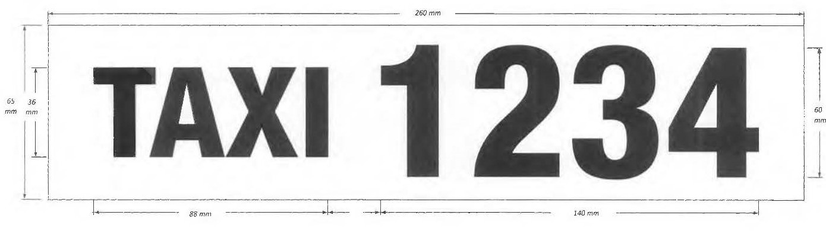
Schedule 1
Note: Schedule1 sets out the minimum size required for a four-digit licence number. The total decal size of a three-digit licence number will be smaller by 35mm, the width of a single number.

Passenger Transport Regulations 2009
Regulation 150A and Schedule 3
South Australian Transport Subsidy Scheme– Lifting Fee Determination
I, Corey Wingard, Minister for Infrastructure and Transport hereby:
- REVOKE Section 11 – SATSS Lifting Fee of the determination published in the South Australian Government Gazette on 10 December 2020 (p5701) - ‘South Australian Transport Subsidy Scheme’ (SATSS); AND
- DETERMINE pursuant to Clause 1 (3a) of Schedule 3 and Regulation 150A of the Passenger Transport Regulations 2009 (Regulations), that a lifting fee of $25 plus GST will be paid by the Department for Infrastructure and Transport in relation to a taxi service provided to a SATSS member where the taxi is delayed by reason of the driver assisting the user of the wheelchair, scooter or other large (ride-on) mobility aide to enter or leave the taxis and where all the following requirements are satisfied:
- Requirements
  - Eligible trip
The trip:
    - involves the carriage of a person with a disability using a wheelchair or large ride on mobility device;
    - is taken in a taxi operating under a special licence (i.e. an Access Taxi);
    - is paid in whole or part by use of a SATSS Member ID Card and/or SATSS voucher providing a 50%, 75% or 100% subsidy; and
    - is booked through the contracted Access Taxi Centralised Booking Service.
  - Taxi-meter
The taxi has a taxi-meter that:
    - is programmed and approved to apply the lifting fee;
    - is programmed such that the waiting time calculation does not commence prior to 7 minutes and 31 seconds elapsing or, upon the vehicle travelling 100 metres or more (whichever occurs first), following activation of the meter;
    - only applies the lifting fee if the lifting fee function/tariff selection is automated and activated by the contracted Access Taxi Centralised Booking Service, or as otherwise approved;
    - does not include the lifting fee as part of the fare component to be paid in full or part by the passenger or display the lifting fee in such a manner as to imply the passenger is liable for any payment of the lifting fee;
    - may record the lifting fees on the taxi-meter totals for a shift or other appropriate time period; and
    - may display the lifting fee on the face of the taxi-meter, but where it does so, it must indicate a lifting fee applies to the trip and is paid by the government of South Australia.
  - Tariffs – Schedule 3, clause 1 of the Regulations
    - Tariff 1 and Tariff 2 as set out in clause 1 of Schedule 3 of the Regulations must be used for calculating the legal fare.
    - For ease of meter programming and audit purposes, the lifting fee together with the legal fare payable on Tariff 1 and Tariff 2 in clause 1 of Schedule 3 to the Regulations, may be respectively displayed on the taxi-meter and in records as Tariff 5 and Tariff 6. In all other respects, Tariff 5 and Tariff 6 will be taken to be respectively Tariff 1 and Tariff 2 for the purposes of determining and charging the legal fare.
  - General
    - SATSS members and accredited drivers and operators of taxi services providing services to eligible persons under the SATSS scheme must comply with all other SATSS Conditions of Use and relevant provisions in the Passenger Transport Act 1994 (Act) and Regulations.
    - In accordance with regulations 21 and 22 of the Regulations, the holder of an accreditation under Part 4 of the Act must, if required by me, provide information relevant to, or associated with, the payment of the lifting fee.
- Interpretation
SATSS Member ID Card means a non-transferable identification card issued to a SATSS member which contains a photograph of the member and a unique barcode which has been approved by the Minister.
Any terms italicised in this notice have the same meaning as in the Passenger Transport Act 1994 and Passenger Transport Regulations 2009.
- Commencement and operation
This determination:
- takes effect from 13 December 2021 and will remain in force until varied or revoked by a subsequent notice; and
- supplements the ‘South Australian Transport Subsidy Scheme’ determination published in the South Australian Government Gazette on 10 December 2020 (p5701)
Dated: 6 December 2021
Hon Corey Wingard MP
Minister for Infrastructure and Transport

Pastoral Land Management and Conservation Act 1989
Public Access Route Closures 2021-2022 Summer
Notice of Intent to Temporarily Close Public Access Route Number 13, named Halligan Point
Notice is hereby given of the intent to temporarily close the Halligan Point Public Access Route from the Oodnadatta Track to Lake Eyre National Park, for the period 1 December 2021 to and including 16 March 2022, pursuant to section 45 (7) of the Pastoral Land Management and Conservation Act 1989.
Notice of Intent to Temporarily Close Public Access Route Number 15, named K1 Warburton Crossing
Notice is hereby given of the intent to temporarily close the K1 Warburton Crossing Public Access Route from the Birdsville Track to the Simpson Desert Regional Reserve, for the period 1 December 2021 to and including 16 March 2022, pursuant to section 45 (7) of the Pastoral Land Management and Conservation Act 1989.
Notice of Intent to Temporarily Close Public Access Route Number 16, named Walkers Crossing
Notice is hereby given of the intent to temporarily close the Walkers Crossing Public Access Route from the Birdsville Track to the Innamincka Regional Reserve, for the period 1 December 2021 to and including 16 March 2022, pursuant to section 45 (7) of the Pastoral Land Management and Conservation Act 1989.
Dated: 1 December 2021
Bianca Lewis
Manager Pastoral Unit
Rural Solutions SA
Department of Primary Industries and Regions SA
Pastoral Board delegate of section 45 (7) of the Pastoral Land Management and Conservation Act 1989

Petroleum and Geothermal Energy Act 2000
Temporary Cessation of Suspension
Petroleum Exploration Licence PEL 120
Pursuant to section 90 of the Petroleum and Geothermal Energy Act 2000, notice is hereby given that pursuant to delegated powers dated 29 June 2018, the suspension of petroleum exploration licence (PEL) 120 dated 28 April 2021 has been temporarily ceased for the period from 6 December 2021 to 31 December 2021 inclusive.
The expiry date of PEL 120 remains as 1 January 2023.
Dated: 1 December 2021
Nick Panagopoulos
A/Executive Director
Energy Resources Division
Department for Energy and Mining
Delegate of the Minister for Energy and Mining

Proof of Sunrise and Sunset Act 1923
Almanac for January, February and March 2022
Pursuant to the requirements of the Proof of Sunrise and Sunset Act 1923, I Anthony David Braxton-Smith, Chief Executive, Department for Infrastructure and Transport, at the direction of the Minister for Infrastructure and Transport, publish in the Schedule hereto an almanac setting out the times of sunrise and sunset on every day for the three calendar months January, February and March 2022.
Dated: 1 December 2021
Anthony David Braxton-Smith
Chief Executive
Department for Infrastructure and Transport

Schedule

Road Traffic (Road Rules – Ancillary and Miscellaneous Provisions) Regulations 2014
Road Traffic (Motorised Wheelchairs) Notice 2021
South Australia
Road Traffic (Motorised Wheelchairs) Notice 2021
Regulation 6 of the Road Traffic (Road Rules – Ancillary and Miscellaneous Provisions) Regulations 2014
1 Operation
This Notice comes into operation on the day on which it is made.
2 Interpretation
In this Notice—
Act means the Road Traffic Act 1961;
Minister means the Minister to whom the administration of the Act is committed;
path means a footpath, separated footpath or shared path;
wheelchair has the same meaning as in the Act.
3 Exemption
In accordance with the power under regulation 6 of the Road Traffic (Road Rules – Ancillary and Miscellaneous Provisions) Regulations 2014, I hereby EXEMPT a driver of a motorised wheelchair from the requirement in rule 288 of the Australian Road Rules that the driver must not drive on a path unless the unladen mass of the wheelchair is not over 110 kilograms.
4 Conditions
A motorised wheelchair may only be driven on a path if the unladen mass of the wheelchair is not over 170 kilograms.
5 Revocation
This Notice may be revoked by the Minister or his delegate at any time.
6 Execution
Dated: 1 December 2021
Hon Corey Wingard MP
Minister for Infrastructure and Transport

South Australian Public Health Act 2011
Section 51 (23) (b) –Appointments
Public Health Partner Authority
TAKE notice that I, Hon Stephen Wade MLC, Minister for Health and Wellbeing, pursuant to section 51 (23) (b) of the South Australian Public Health Act 2011, do hereby declare the undermentioned entity as Public Health Partner Authority:
- Local Government Association of South Australia
Dated: 5 December 2021
Hon Stephen Wade MLC
Minister for Health and Wellbeing

South Australian Water Corporation Act 1994
Section 18A
Access to Reservoir Reserves owned by SA Water
Pursuant to Section 18A of the South Australian Water Corporation Act 1994, a person is prohibited from entering and remaining on SA Water’s land including reservoir reserves without authority.
Commencing 11 December 2021, Public Access is available at Happy Valley Reservoir Reserve to undertake recreational activities in accordance with SA Water’s Conditions of Access and on-site signs/information.
All visitors must comply with access conditions, including signs and all reasonable directions made by persons authorised by SA Water to administer the access arrangements. Site entry may be refused and/or varied by persons authorised by SA Water and at any time for non-compliance with access conditions or other reason including SA Water operational requirements.
This notice supersedes any previous gazettal notices relating to public access at Happy Valley Reservoir.
Dated: 25 November 2021
David Ryan
Chief Executive
SA Water

Local Government Instruments

City of Burnside
Local Government Act 1999
Review of Elector Representation
NOTICE is hereby given that the City of Burnside has reviewed its composition and elector representation arrangements in accordance with the requirements of Section 12 (4) of the Local Government Act 1999 (the Act).
Certification
Pursuant to Section 12 (13) (a) of the Act, the Electoral Commissioner has certified that the review undertaken by Council satisfies the requirements of Section 12 of the Act. As such, the following arrangements will take effect as from polling day of the periodic Local Government election to be held in November 2022.
- The principal member of the Council shall be a Mayor elected by the community.
- The elected body of Council shall comprise the Mayor and twelve (12) ward councillors.
- The Council area shall be divided into six (6) wards, as per the current ward structure, with each ward being represented by two (2) ward councillors.
- The wards shall be identified as Beaumont; Burnside; Eastwood and Glenunga; Kensington Gardens and Magill; Kensington Park; and Rose Park and Toorak Gardens.
Dated: 7 December 2021
Chris Cowley
Chief Executive Officer

City of Holdfast Bay
Liquor Licensing Act 1997
Dry Area – Glenelg 2 – Council Resolution C261021/2458
South Australia
Liquor Licensing (Dry Areas) Notice 2021
under section 131 of the Liquor Licensing Act 1997

1—Short title
This notice may be cited as the Liquor Licensing (Dry Areas) Notice 2021

2—Commencement
This notice comes into operation on 31 December 2021.

3—Interpretation
- In this notice—

principal notice means the Liquor Licensing (Dry Areas) Notice 2021 published in the Gazette on 09.12.2021, as in force from time to time.

- Clause 3 of the principal notice applies to this notice as if it were the principal notice.

4—Consumption etc of liquor prohibited in dry areas
- Pursuant to section 131 of the Act, the consumption and possession of liquor in the area described in the Schedule is prohibited in accordance with the provisions of the Schedule.
- The prohibition has effect during the periods specified in the Schedule.
- The prohibition does not extend to private land in the area described in the Schedule.
- Unless the contrary intention appears, the prohibition of the possession of liquor in the area does not extend to—
- a person who is genuinely passing through the area if—
- the liquor is in the original container in which it was purchased from licensed premises; and
- the container has not been opened; or
- a person who has possession of the liquor in the course of carrying on a business or in the course of his or her employment by another person in the course of carrying on a business; or
- a person who is permanently or temporarily residing at premises within the area or on the boundary of the area and who enters the area solely for the purpose of passing through it to enter those premises or who enters the area from those premises for the purpose of leaving the area.

Schedule 1—Glenelg Area 2
1—Extent of prohibition
The consumption of liquor is prohibited. The possession of liquor is prohibited, and the prohibition extends to possession in each of the circumstances referred to in clause 4(4). This also includes the total prohibition of alcohol in sealed and/or unsealed containers on community land.

2—Period of prohibition
From 6pm on Friday, 31 December 2021 to 6am on Saturday, 1 January 2022.

3—Description of area
The area in Glenelg bounded as follows: commencing at the point at which the eastern boundary of Colley Terrace intersects the northern boundary of Augusta Street, then generally easterly along the northern boundary of Augusta Street (including around the western, northern and eastern boundaries of Torrens Square) to its intersection with the eastern boundary of Brighton Road, then southerly along that boundary of Brighton Road to the northern boundary of Dunbar Terrace, then easterly along that boundary of Dunbar Terrace to the point at which it meets the western boundary of First Avenue, then in a straight line by the shortest route (across Dunbar Terrace and Maxwell Terrace) to the point at which the southern boundary of Maxwell Terrace meets the eastern boundary of Fortrose Street, then westerly along that boundary of Maxwell Terrace to the eastern boundary of Brighton Road, then southerly along that boundary of Brighton Road to its intersection with the prolongation in a straight line of the southern boundary of High Street, then generally westerly along that prolongation and boundary of High Street to the point at which the prolongation in a straight line of that southern boundary of High Street intersects the western boundary of Moseley Street, then northerly along that boundary of Moseley Street to the southern boundary of College Street, then westerly along that boundary of College Street and the prolongation in a straight line of that boundary to the western boundary of St John's Row, then northerly along that boundary of St John's Row to the southern boundary of South Esplanade Lane (the northern boundary of Lot 101 FP 6859), then westerly along that boundary of South Esplanade Lane to the eastern boundary of the South Esplanade, then south-westerly along that boundary of the South Esplanade to the northern boundary of Kent Street, then westerly along that boundary of Kent Street and the prolongation in a straight line of that boundary to the low water mark of Gulf St Vincent, then generally northerly along the low water mark (including the low water mark around the outer boundary of any breakwater or groyne) to the entrance to the Patawalonga River, then generally south easterly, easterly, northerly, easterly and northerly along the southern and eastern bank of the River to the point at which the eastern bank of the River intersects the prolongation in a straight line of the southern boundary of St Anne's Terrace, then easterly along that prolongation to the western boundary of Adelphi Terrace, then southerly along that western boundary of Adelphi Terrace and the prolongation in a straight line of that boundary to the southern boundary of Anzac Highway, then westerly along that boundary of Anzac Highway to the eastern boundary of Colley Terrace, then southerly along that boundary of Colley Terrace to the point of commencement. The area includes the Glenelg Jetty and any other jetty, wharf, mooring, dock or other structure (apart from the Patawalonga Weir) projecting into the Gulf or River from the area described above, as well as any area beneath such a structure.

Extended Dry Area—New Year’s Eve 31 December 2021
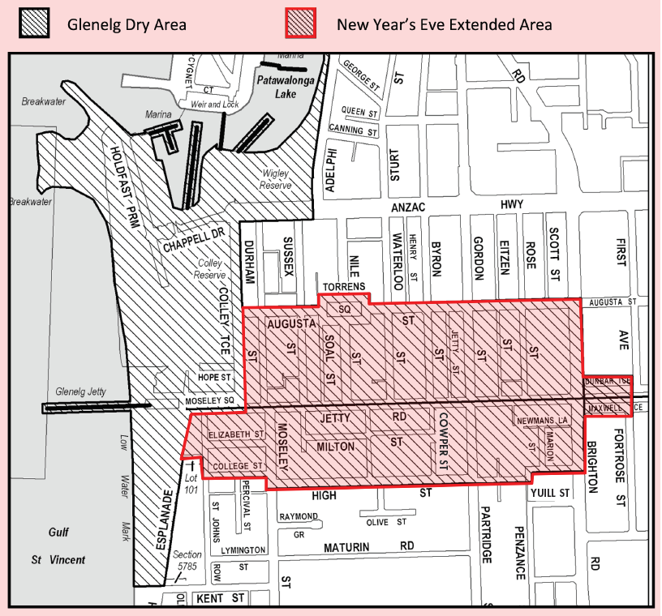

Dated: 26 October 2021
Roberto Bria
Chief Executive Officer
City of Holdfast Bay

City of Holdfast Bay
Local Government Act 1999
Review of Elector Representation
Notice is hereby given that the City of Holdfast Bay, in accordance with the requirements of section 12(4) of the Local Government Act 1999 (the Act), has reviewed its composition and elector representation arrangements.
Certification
Pursuant to section 12(13)(a) of the Act, the Electoral Commissioner has certified that the review undertaken by the Council satisfies the requirements of section 12 and may therefore now be put into effect as from the day of the first periodic election held after the publication of this notice.
The representation arrangements are as follows:
- the principal member of Council continues to be a Mayor elected by the community;
- area councillors are not introduced in addition to ward councillors;
- the future elected body of Council comprise the Mayor and twelve (12) ward councillors;
- the Council area continue to be divided into four (4) wards, as per the current ward structure, with each of the wards being represented by three (3) councillors; and
- the wards continue to be named Glenelg, Somerton, Brighton and Seacliff.
Dated: 9 December 2021
Roberto Bria
Chief Executive Officer

Adelaide Plains Council
Local Government Act 1999
Review of Elector Representation
NOTICE is hereby given that the Adelaide Plains Council has reviewed its composition and elector representation arrangements in accordance with the requirements of Section 12(4) of the Local Government Act 1999 (the Act).
Certification
Pursuant to Section 12(13)(a) of the Act, the Electoral Commissioner has certified that the review undertaken by Council satisfies the requirements of Section 12 of the Act. As such, the following arrangements will take effect as from polling day of the periodic Local Government election to be held in November 2022.
- The principal member of Council shall continue to be a Mayor elected by the community.
- The Council area will not be divided into wards (i.e. wards will be abolished).
- The future elected body of Council will comprise the Mayor and nine (9) area councillors, all of whom will represent the whole of the Council area and shall be elected by the community at council-wide elections.
Dated: 30 November 2021
James Miller
Chief Executive Officer

Alexandrina Council
Liquor Licensing Act 1997
Schedule 1 – Strathalbyn Showgrounds
South Australia
Liquor Licensing (Dry Areas) Notice 2021
under section 131(1a) of the Liquor Licensing Act 1997
1—Short title
This notice may be cited as the Liquor Licensing (Dry Areas) Notice 2021.
2—Commencement
This notice comes into operation on 9 December 2021.
3—Interpretation
(1) In this notice—
principal notice means the Liquor Licensing (Dry Areas) Notice 2015 published in the Gazette on 5.1.15, as in force from time to time.
(2) Clause 3 of the principal notice applies to this notice as if it were the principal notice.
4—Consumption etc of liquor prohibited in dry areas
(1) Pursuant to section 131 of the Act, the consumption and possession of liquor in the area described in the Schedule is prohibited in accordance with the provisions of the Schedule.
(2) The prohibition has effect during the periods specified in the Schedule.
(3) The prohibition does not extend to private land in the area described in the Schedule.
(4) Unless the contrary intention appears, the prohibition of the possession of liquor in the area does not extend to—
(a) a person who is genuinely passing through the area if—
(i) the liquor is in the original container in which it was purchased from licensed premises; and
(ii) the container has not been opened; or
(b) a person who has possession of the liquor in the course of carrying on a business or in the course of his or her employment by another person in the course of carrying on a business; or
(c) a person who is permanently or temporarily residing at premises within the area or on the boundary of the area and who enters the area solely for the purpose of passing through it to enter those premises or who enters the area from those premises for the purpose of leaving the area.
Schedule 1 – Strathalbyn Showgrounds
1 – Extent of prohibition
The consumption of liquor is prohibited and the possession of liquor is prohibited.
2 – Period of prohibition
From 4.00pm on 10 December 2021 – 10.00pm on 10 December 2021
3 – Description of area
Strathalbyn Showgrounds
The area within the Showgrounds Precinct bounded by Coronation Road to Stowe Court, Queen Street and Ashbourne Road with exception to the Strathalbyn Caravan Park.
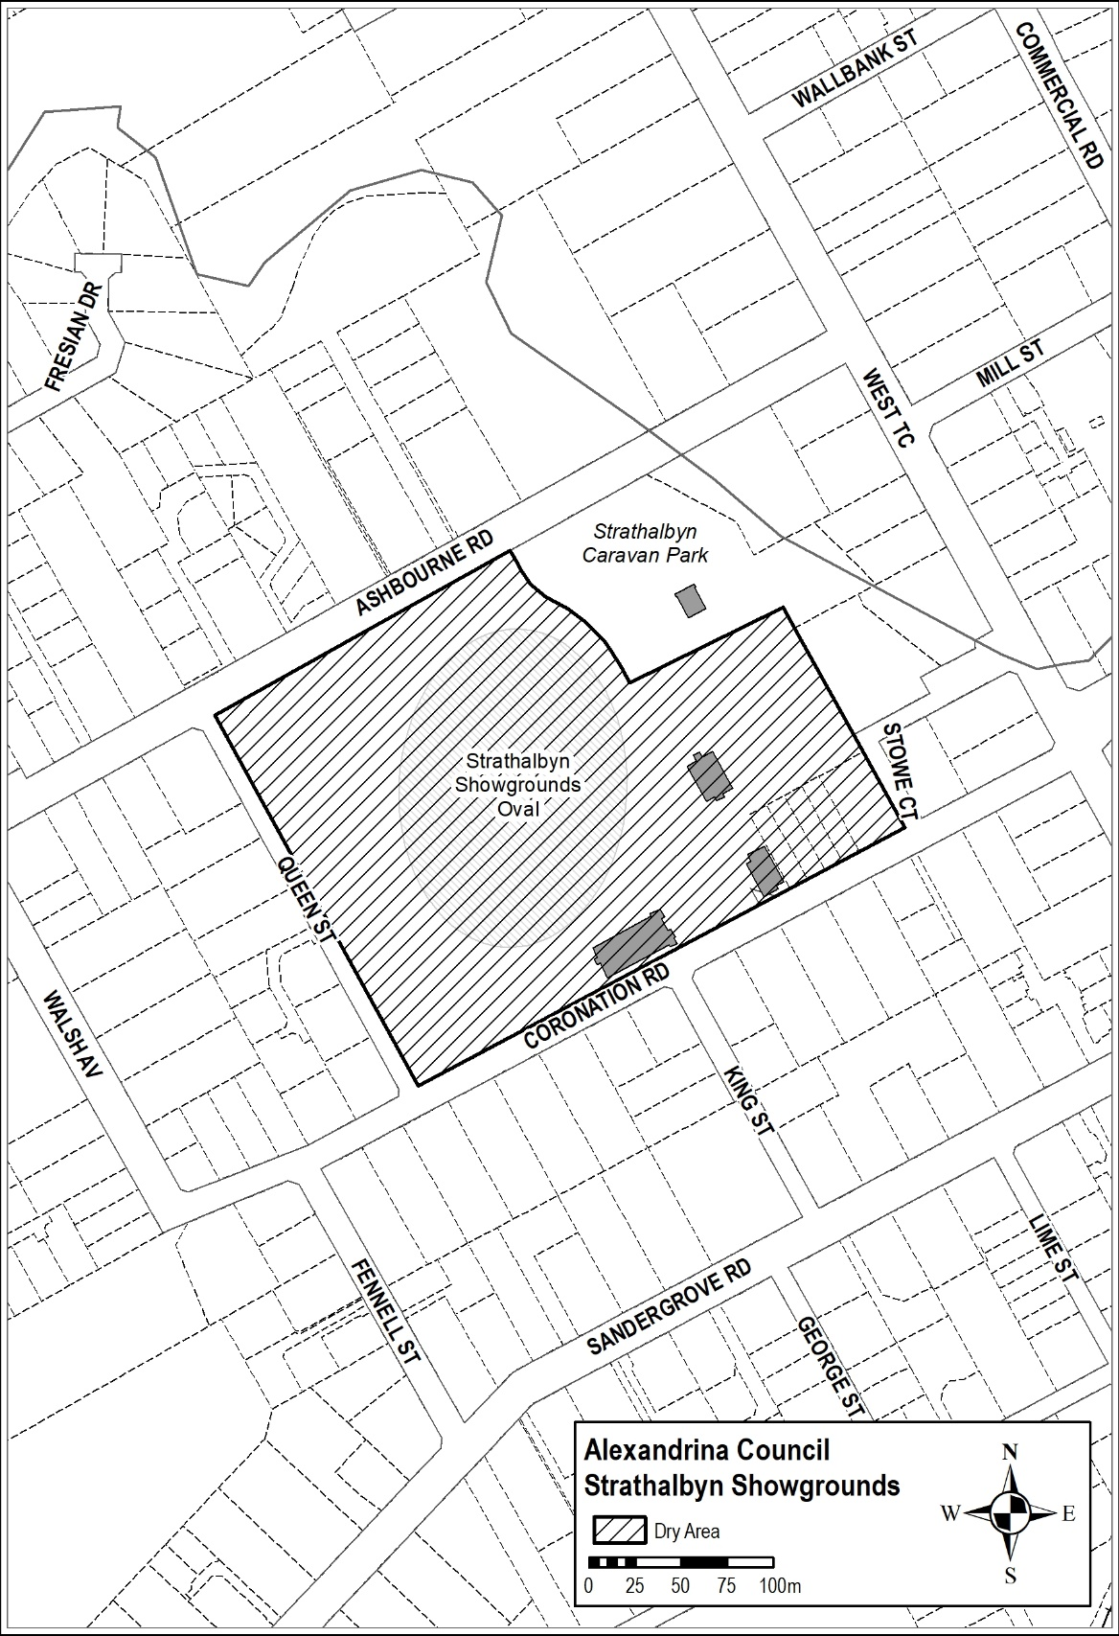
Schedule 2 – Goolwa Oval Recreation Precinct
1 – Extent of prohibition
The consumption of liquor is prohibited and the possession of liquor is prohibited.
2 – Period of prohibition
From 2.00pm on 12 December 2021 – 7.00pm on 12 December 2021
3 – Description of area
Goolwa Oval Recreation Precinct
The area within the Recreation Precinct bounded by Hutchinson Street from Wildman Street to Collingwood Street, Wildman Street from Hutchinson Street to Goyder Street, Goyder Street from Wildman Street to Dawson Street.
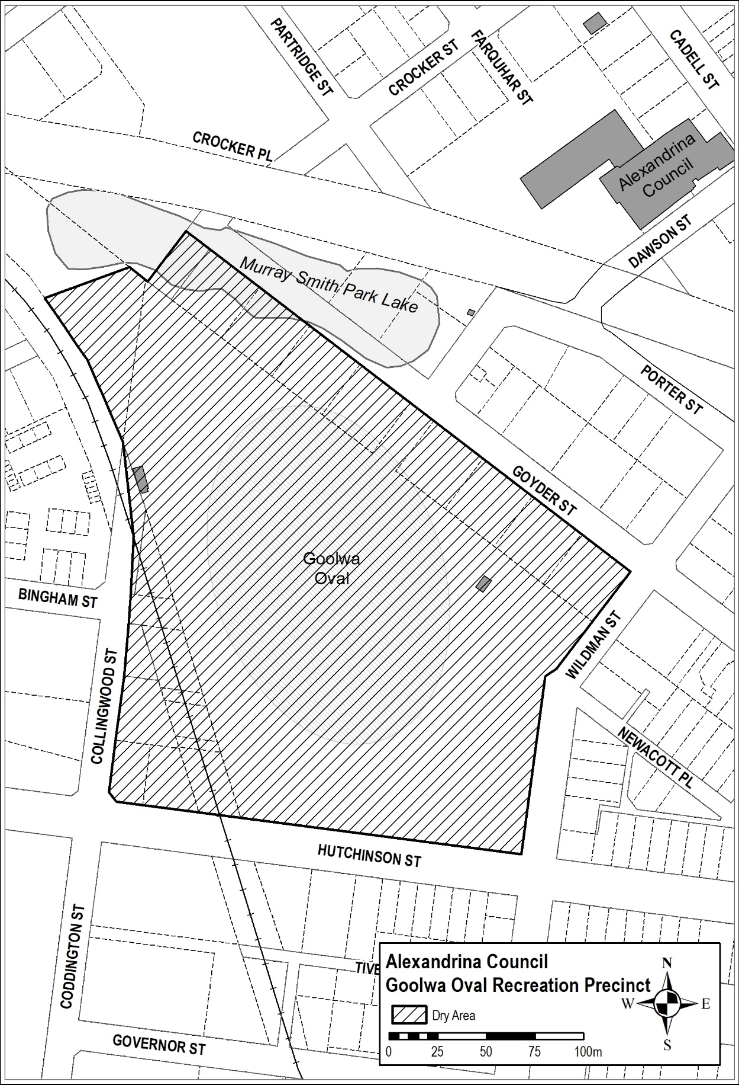
Dated: 15 November 2021
Glenn Rappensberg
Chief Executive Officer

Alexandrina Council
Review of Elector Representation
NOTICE is hereby given that the Alexandrina Council has reviewed its composition and elector representation arrangements in accordance with the requirements of Section 12 (4) of the Local Government Act 1999 (the Act).
Certification
Pursuant to Section 12 (13) (a) of the Act, the Electoral Commissioner has certified that the review undertaken by Council satisfies the requirements of Section 12 of the Act. As such, the following arrangements will take effect as from polling day of the periodic Local Government election to be held in November 2022.
- The principal member of the Council shall continue to be a Mayor elected by the community.
- The elected body of Council shall comprise the Mayor and nine (9) ward councillors.
- The Council area shall be divided into three (3) wards, as defined in Schedules One to Three inclusive.
- Each of the wards shall be represented by three (3) councillors.
- The wards shall be identified as Alexandrina West, Alexandrina North and Alexandrina South.
Glenn Rappensberg
Chief Executive Officer

Schedule 1
Alexandrina West
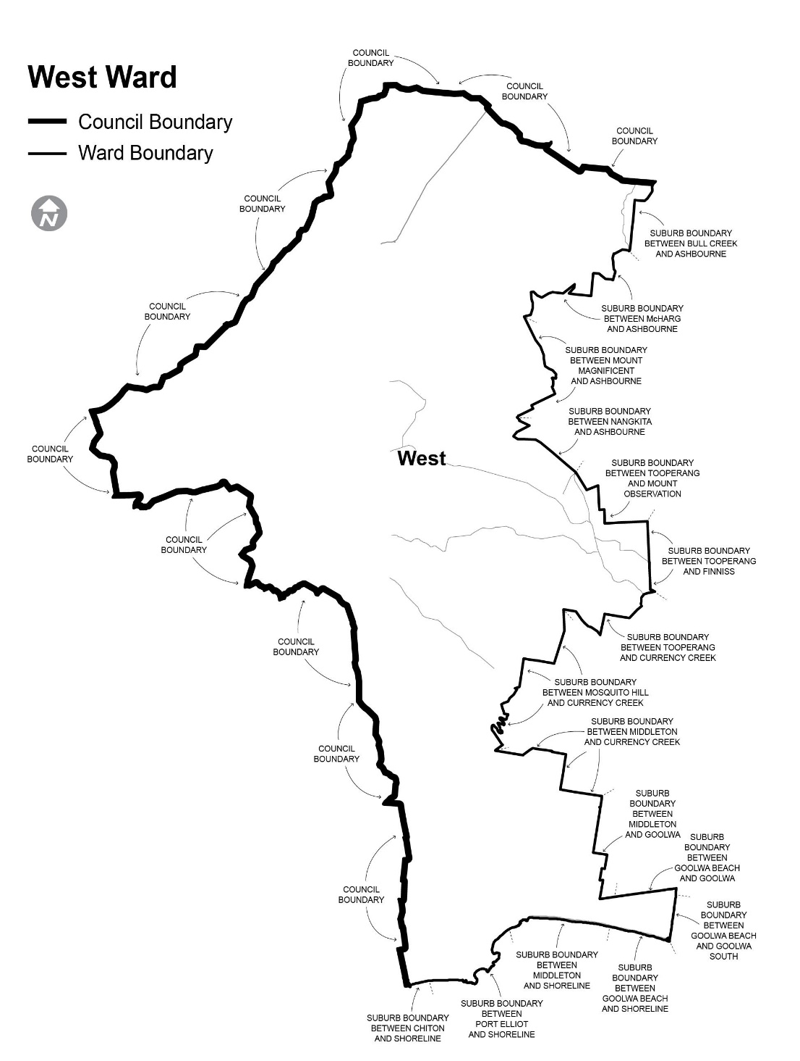
Comprising the districts/localities of Blackfellows Creek, Bull Creek, Chiton, Dingabledinga, Goolwa Beach, Hope Forest, Kuitpo, Kuitpo Colony, Kyeema, McHarg Creek, Middleton, Montarra, Mosquito Hill, Mount Compass, Mount Jagged, Mount Magnificent, Nangkita, Pages Flat, Port Elliot, Prospect Hill, The Range, Tooperang, Willunga Hill and Yundi.
Schedule 2

Alexandrina North
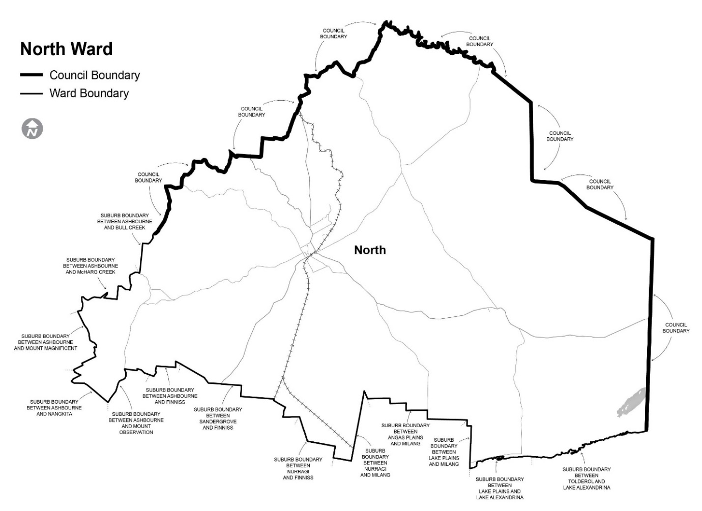
Comprising the districts/localities of Angas Plains, Ashbourne, Belvidere, Bletchley, Gemmells, Hartley, Highland Valley, Lake Plains, Langhorne Creek, Macclesfield, Nurragi, Paris Creek, Red Creek, Salem, Sandergrove, Strathalbyn, Tolderol, Willyaroo and Woodchester.
Schedule 3
Alexandrina South
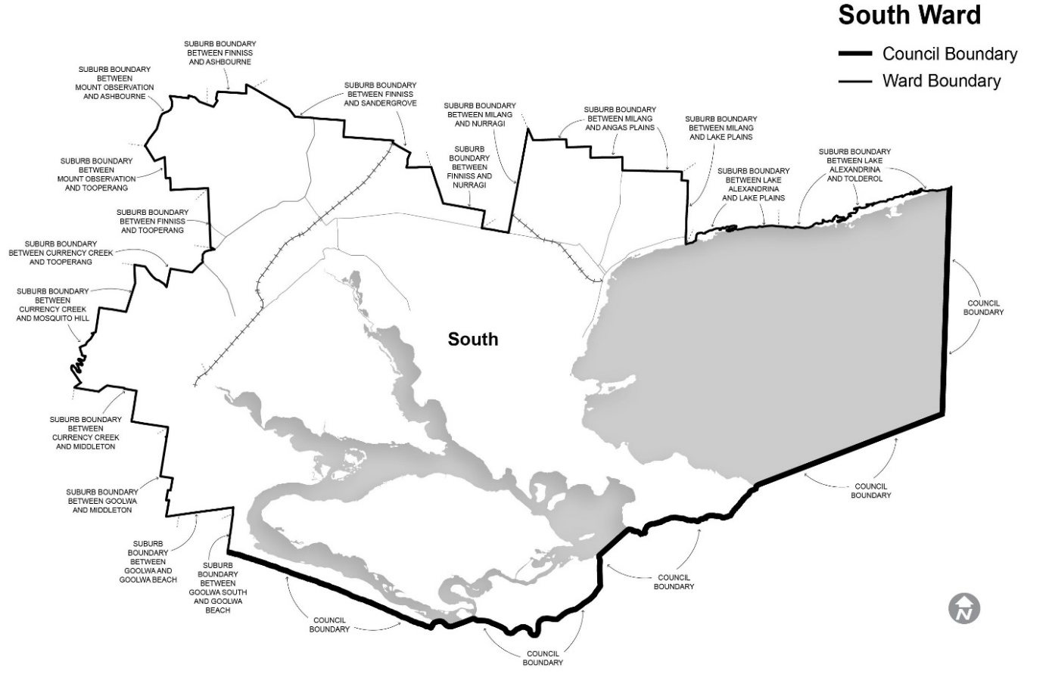
Comprising the districts/localities of Clayton Bay, Currency Creek, Finniss, Goolwa, Goolwa North, Goolwa South, Hindmarsh Island, Milang, Mount Observation, Mundoo Island and Point Sturt.

District Council of Franklin Harbour
Local Government Act 1999 – Section 219
Power to Assign and Name, or Change the Name, of a Road or Public Place
Notice is hereby given pursuant to section 219(1) of the Local Government Act 1999 that on the 10th November 2021 Council resolved that:
- The new section of road being an extension of Second Street (parcel D124864 lot 100, Lot 101, Lot 102, Lot 103 and Lot 104) be assigned the street name Jetty Road.
- The street name Thompson Drive be assigned to the section of the Esplanade (Plan D124864 Lot 104) from Main Street to Jetty Road.
Dated: 10 November 2021
S Gill
Chief Executive Officer

District Council of Franklin Harbour
Local Government Act 1999
Review of Elector Representation
NOTICE is hereby given that the District Council of Franklin Harbour has reviewed its composition and elector representation arrangements in accordance with the requirements of Section 12 (4) of the Local Government Act 1999 (the Act).
Certification
Pursuant to Section 12 (13) (a) of the Act, the Electoral Commissioner has certified that the review undertaken by Council satisfies the requirements of Section 12 of the Act. As such, the following arrangements will take effect as from polling day of the periodic Local Government election to be held in November 2022.
- The principal member of Council shall be a Chairperson who is selected by and from amongst the elected members.
- The Council shall comprise six (6) area councillors.
- The Council area shall not be divided into wards (i.e. the existing “no wards” structure shall be retained).
Dated: 30 November 2021
Shane Gill
Chief Executive Officer

DISTRICT COUNCIL OF MOUNT REMARKABLE
Liquor Licensing Act 1997
Short Term Dry Area-Wilmington
Notice is hereby given that the District Council of Mount Remarkable pursuant to 31(1a) of the Liquor Licensing Act 1997 that Council declares Short Term Dry Areas commencing from 12 noon on Saturday 29 January 2022 to 12 noon on Sunday 30 January 2022.
- Pursuant to section 131 of the Act, the consumption and possession of liquor in the area described in the Schedule is prohibited in accordance with the provisions of the Schedule.
- The prohibition has effect during the periods specified in the Schedule.
- The prohibition does not extend to private land in the area described in the Schedule.
- Unless the contrary intention appears, the prohibition of the possession of liquor in the area does not extend to-
- A person who is genuinely passing through the areas if-
- The liquor is in the original container in which it was purchased from licensed premises; and
- The container has not been opened; or
- A person who has possession of the liquor in the course of carrying on a business or in the course of his or her employment by another person in the course of carrying on a business; or
- A person who is permanently or temporarily residing at premises within the area or on the boundary of the area and who enters the area solely for the purpose of passing through it to enter those premises or who enters the area from those premises for the purpose of leaving the area.
Description of area:
The area in and adjacent to Wilmington bounded as follows: commencing at the intersection of the south-western boundary of Maria Terrace and the south-eastern boundary of Cudmore Terrace (at the south-eastern corner of Section 536 Hundred of Willochra), then travelling generally north-westerly along the western boundary of Maria Terrace until it intersects the southern boundary of Section 3 Hundred of Willochra, then north-easterly along that boundary until it intersects the south-western boundary of Oval Road, then generally north-westerly along that western boundary of Oval Road to the point at which the prolongation in a straight line of Oval Road intersects the northern boundary of Horrocks Pass Road, then easterly along that northern boundary of Horrocks Pass Road to the point at which the northern boundary of Horrocks Pass Road meets the south-western boundary of Gunyah Road, then north-westerly along the western boundary of Gunyah Road to the point at which it is intersected by the prolongation in a straight line of the north-western boundary of Beautiful Valley Road, then north-easterly along the northern boundary of Beautiful Valley Road to the south-western boundary of Section 716 Hundred of Willochra, then south-easterly along the prolongation in a straight line of that boundary of Section 716 to the south-eastern boundary of Horrocks Highway, then south-westerly along that boundary of Horrocks Highway to the point at which it intersects the north-eastern boundary of Alexis Road, then south-easterly along the eastern boundary of Alexis Road to the point at which it is intersected by the prolongation in a straight line of the south-eastern boundary of Gogler Road, then travelling south-westerly along the southern boundary and thence north-westerly along the western boundary of Gogler Road to a point where it intersects with the south-eastern boundary of Parkville Avenue, then in a south westerly direction along the southern boundary of Parkville Avenue to a point where the prolongation in a straight line of that boundary meets the intersection of the south-western boundary of Wilds Way and western boundary of Horrocks Highway, then north-westerly along the western boundary of Horrocks Highway until it intersects with the southern boundary of Cudmore Terrace, then south westerly along that boundary to the point of commencement.
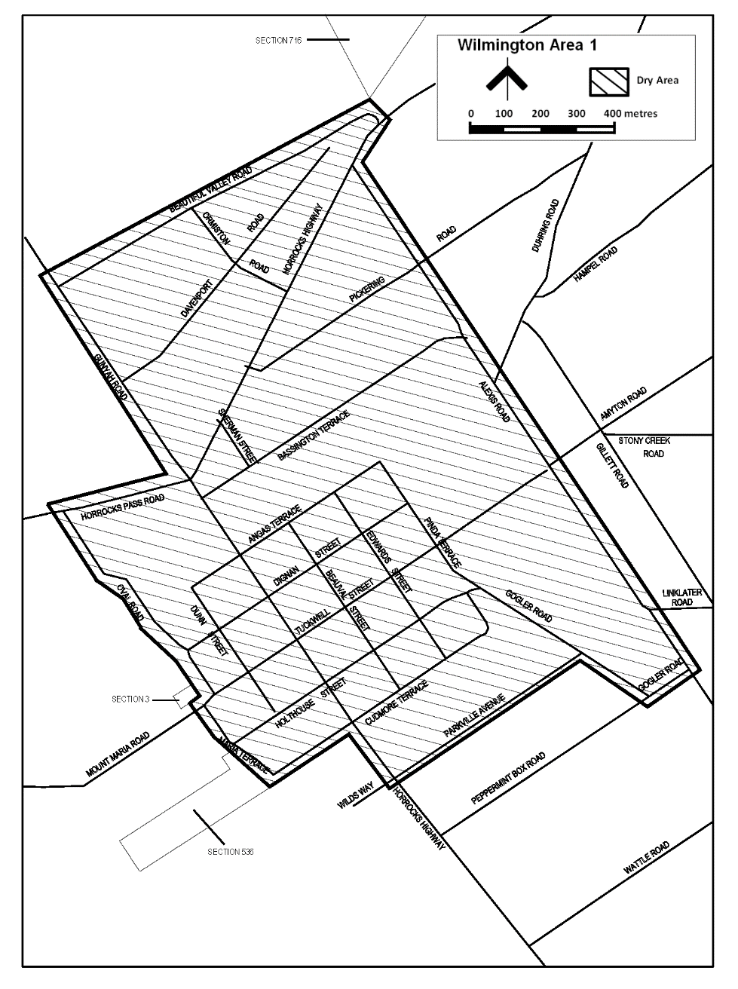
Dated: 7 December 2021
Sam Johnson
Chief Executive Officer

Port Pirie Regional Council
Local Government Act 1999
Declaration of Public Roads
Notice is hereby given, pursuant to Section 210(1)(a) of the Local Government Act, 1999 that the Port Pirie Regional Council resolved at the meeting held on the 28th of July 2021, that the private roads identified as allotments 28 and 29 in Deposited Plan 2423, known as Jellicoe Street and Elizabeth Street, Port Pirie South be hereby declared public roads.
Dated: 2 December 2021
Peter Ackland
Chief Executive Officer

District Council of Streaky Bay
Local Government Act 1999
Review of Elector Representation
NOTICE is hereby given that the District Council of Streaky Bay has reviewed its composition and elector representation arrangements in accordance with the requirements of Section 12 (4) of the Local Government Act 1999 (the Act).
Certification
Pursuant to Section 12 (13) (a) of the Act, the Electoral Commissioner has certified that the review undertaken by Council satisfies the requirements of Section 12 of the Act. As such, the following arrangements will take effect as from polling day of the periodic Local Government election to be held in November 2022.
- The principal member of Council shall continue to be a Chairperson chosen by and from amongst the elected members.
- The future elected body of Council shall continue to comprise eight (8) councillors.
- The Council area shall continue to be divided into wards, as per the current two ward structure, with each ward being represented by four (4) ward councillors.
- The wards shall continue to be named Flinders and Eyre.
Dated: 30 November 2021
Damian Carter
Chief Executive Officer

District Council of Tumby Bay
Local Government Act 1999
Review of Elector Representation
NOTICE is hereby given that the District Council of Tumby Bay has reviewed its composition and elector representation arrangements in accordance with the requirements of Section 12 (4) of the Local Government Act 1999 (the Act).
Certification
Pursuant to Section 12 (13) (a) of the Act, the Electoral Commissioner has certified that the review undertaken by Council satisfies the requirements of Section 12 of the Act. As such, the following arrangements will take effect as from polling day of the periodic Local Government election to be held in November 2022.
- The principal member of Council shall continue to be a Mayor who is elected by the community.
- The Council shall continue to comprise the Mayor and six (6) area councillors.
- The Council area shall not be divided into wards (i.e. the existing “no wards” structure shall be retained).
Dated: 2 December 2021
Rebecca Hayes
Chief Executive Officer

Wudinna District Council
Local Government Act 1999
Review of Elector Representation
NOTICE is hereby given that the Wudinna District Council has reviewed its composition and elector representation arrangements in accordance with the requirements of Section 12 (4) of the Local Government Act 1999 (the Act).
Certification
Pursuant to Section 12 (13) (a) of the Act, the Electoral Commissioner has certified that the review undertaken by Council satisfies the requirements of Section 12 of the Act. As such, the following arrangements will take effect as from polling day of the periodic Local Government election to be held in November 2022.
- The principal member of Council shall continue to be a Chairperson (with the title of Mayor) who is to be selected/appointed by and from amongst the elected members.
- Council shall continue to comprise seven (7) area councillors.
- The Council area shall not be divided into wards (i.e. the existing “no wards” structure shall be retained).
Dated: 7 December 2021
Alan McGuire
Chief Executive Officer

Yorke Peninsula Council
Local Government Act 1999
Review of Elector Representation
NOTICE is hereby given that the Yorke Peninsula Council has reviewed its composition and elector representation arrangements in accordance with the requirements of Section 12 (4) of the Local Government Act 1999 (the Act).
Certification
Pursuant to Section 12 (13) (a) of the Act, the Electoral Commissioner has certified that the review undertaken by Council satisfies the requirements of Section 12 of the Act. As such, the following arrangements will take effect as from polling day of the periodic Local Government election to be held in November 2022.
- The principal member of Council shall continue to be a Mayor elected by the community.
- The Council area shall be divided into three (3) wards, as per the current ward structure.

- The future elected body of Council shall continue to comprise the Mayor and eleven (11) ward councillors.
- The wards shall continue to be named Kalkabury, Gum Flat and Innes/Penton Vale.
- The Gum Flat Ward shall be represented by three (3) ward councillors; and the Kalkabury and Innes/Penton Vale Wards shall each be represented by four (4) ward councillors.
Dated: 7 December 2021
Andrew Cameron
Chief Executive Officer

Notice Submission

The South Australian Government Gazette is compiled and published each Thursday.
Notices must be submitted before 4 p.m. Tuesday, the week of intended publication.
All submissions are formatted per the gazette style and proofs are supplied as soon as possible. Alterations must be returned before 4 p.m. Wednesday.
Requests to withdraw submitted notices must be received before 10 a.m. on the day of publication.

Gazette notices should be emailed as Word files in the following format:
• Title—name of the governing Act/Regulation
• Subtitle—brief description of the notice
• A structured body of text
• Date of authorisation
• Name, position, and government department/organisation of the person authorising the notice

Please provide the following information in your email:
• Date of intended publication
• Contact details of at least two people responsible for the notice content
• Name of the person and organisation to be charged for the publication (Local Council and Public notices)
• Request for a quote, if required
• Purchase order, if required

Email: governmentgazettesa@sa.gov.au
Phone: (08) 7109 7760
Website: www.governmentgazette.sa.gov.au

All instruments appearing in this gazette are to be considered official, and obeyed as such

Printed and published weekly by authority of S. Smith, Government Printer, South Australia
$8.00 per issue (plus postage), $402.00 per annual subscription—GST inclusive
Online publications: www.governmentgazette.sa.gov.au

