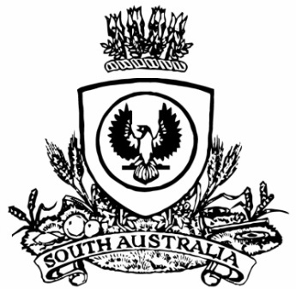
No. 7 p. 249
SUPPLEMENTARY GAZETTE
THE SOUTH AUSTRALIAN
GOVERNMENT GAZETTE
Published by Authority

Adelaide, Tuesday, 2 February 2021

State Government Instruments
Fisheries Management Act 2007
Section 79
Temporary Prohibition of Snapper Fishing in the Waters of the
West Coast, Spencer Gulf and Gulf St Vincent
Pursuant to Section 79 of the Fisheries Management Act 2007, I Professor Gavin Begg, Executive Director Fisheries and Aquaculture, delegate of the Minister for Primary Industries and Regional Development, hereby declare that it is unlawful for a person to:
1. engage in a fishing activity specified in Schedule 1;
2. have possession or control of aquatic resources of the species specified in Schedule 2;
3. during the period specified in Schedule 3.
Schedule 1
The taking by a person, in all waters of the West Coast, Spencer Gulf and Gulf St Vincent, of Snapper (Chrysophrys auratus).
Schedule 2
Being in possession of Snapper (Chrysophrys auratus) taken from the waters of the West Coast, Spencer Gulf and Gulf St Vincent.
Schedule 3
From 00:01 hours on 2 February 2021 until 23:59 hours on 31 January 2022.
For the purpose of this notice:
Waters of West Coast, Spencer Gulf, and Gulf St Vincent—Waters of the West Coast, Spencer Gulf and Gulf St Vincent comprises the waters of the State contained within and bounded by a line commencing at a location on mean high water springs closest to 31°41′12.94″ (31°41.216′) South, 129°00′04.90″ (129°00.082′) East, then beginning north-easterly following the line of mean high water springs to a location closest to 35°38′33.82″ (35°38.564′) South, 138°3120.77″ (138°31.346′) East (Newland Head), then south westerly to a location on mean high water springs closest to 35°50′29.19″ (35°50.486′) South, 138°08′05.64″ (138°08.094′) East (Cape Willoughby), then beginning north-westerly following the line of mean high water springs to the location closest to 35°53′11.307″ (35°53.188′) South, 136°32′3.880″ (136°32.065′) East (Vennachar Point), then continuing south along the meridian of longitude 136°32′36″ (136°32.600′) East to the southern limit of the waters of the State, then beginning south-westerly along the said boundary to the intersection with the western border of the State of South Australia 31°41′15.24″ (31°41.254′) South, 129°00′04.54″ (129°00.076′) East, then north-easterly along the said border to the point of commencement (GDA2020).
Dated: 1 February 2021
Prof Gavin Begg
Executive Director
Fisheries and Aquaculture
Delegate of the Minister for Primary Industries and Regions

