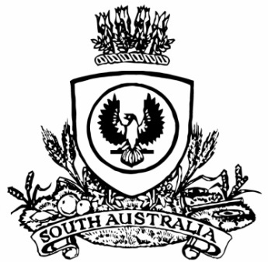
No. 47 p. 2821
SUPPLEMENTARY GAZETTE
THE SOUTH AUSTRALIAN
GOVERNMENT GAZETTE
Published by Authority

Adelaide, Thursday, 8 July 2021

Contents

State Government Instrument
Fisheries Management Act 2007 2822

State Government Instrument

Fisheries Management Act 2007
Section 79
Closure to Restrict Fishing Activities in Marine Parks
Take notice that, pursuant to section 79 of the Fisheries Management Act 2007, it will be unlawful for any person to engage in any recreational or commercial fishing activity including any act preparatory to the taking, or removal of any aquatic resources other than fishing activities specified in Schedule 1 in the areas specified in Schedule 2 during the period specified in Schedule 3.
Schedule 1
Other than a fishing activity and any act preparatory, included in the conduct of scientific research by a scientific observer authorised to conduct the research under the Fisheries Management Act 2007; or authorised by a statutory authorisation under the National Parks and Wildlife Act 1972 or Wilderness Protection Act 1992.
Schedule 2
The waters within the following sanctuary zones:
1. That part of the Upper Gulf St. Vincent Marine Park comprising the State waters contained within the Clinton Wetlands Sanctuary Zone (SZ-1) as bounded by the coordinates:
138°8.002′E, 34°10.270′S; 138°8.002′E, 34°12.304′S; 138°1.669′E, 34°12.304′S
2. Those parts of the Nuyts Archipelago Marine Park comprising the State waters contained within the Nutys Reef Sanctuary Zone (SZ-1) as bounded by the coordinates:
132°7.435′E, 31°58.062′S; 132°11.419′E, 32°1.246′S; 132°11.419′E, 32°9.084′S; 132°7.435′E, 32°9.084′S; and
Isles of St Francis Sanctuary Zone (SZ-8) bounded by the coordinates:
133°13.842′E, 32°28.876′S; 133°20.306′E, 32°28.876′S; 133°20.306′E, 32°36.037′S; 133°13.842′E, 32°36.037′S.
3. That part of the Neptune Islands Group (Ron and Valerie Taylor) Marine Park comprising the State waters contained within the North Neptune Island Sanctuary Zone (SZ-1) bounded by the coordinates:
136°2.162′E, 35°12.279′S; 136°6.147′E, 35°12.279′S; 136°6.147′E, 35°15.532′S; 136°2.162′E, 35°15.532′S.
4. That part of the Western Kangaroo Island Marine Park comprising the State waters contained within the Cape du Couedic Sanctuary Zone (SZ-3) bounded by the coordinates:
136°45.276′E, 36°2.910′S; 136°45.270′E, 36°2.919′S; 136°45.575′E, 36°2.930′S; 136°45.575′E, 36°5.415′S; 136°41.348′E, 36°5.415′S; 136°41.348′E, 36°3.244 ‘ S; 136°41.782′E, 36°3.244′S.
For the purpose of this notice the spatial descriptions are based on the Geocentric Datum of Australia (GDA94).
Schedule 3
From 00:01 hrs on 9 July 2021 until 23:59 hrs on 10 September 2021.
Dated: 8 July 2021
Professor Gavin Begg
Executive Director
Fisheries and Aquaculture
Delegate of the Minister for Primary Industries and Regional Development

All instruments appearing in this gazette are to be considered official, and obeyed as such

Printed and published weekly by authority of S. Smith, Government Printer, South Australia
$8.00 per issue (plus postage), $402.00 per annual subscription—GST inclusive
Online publications: www.governmentgazette.sa.gov.au

