THE SOUTH AUSTRALIAN
GOVERNMENT GAZETTE
Published by Authority

Adelaide, Thursday, 9 September 2021

Contents

Governor’s Instruments

Appointments 3506

State Government Instruments

Environment Protection Act 1993 3507

Fisheries Management Act 2007 3511

Housing Improvement Act 2016 3511

Justices of the Peace Act 2005 3512

Land Acquisition Act 1969 3512

Liquor Licensing Act 1997 3513

Mining Act 1971 3519

Petroleum and Geothermal Energy Act 2000 3519

Planning, Development and Infrastructure Act 2016 3521

Plant Health Act 2009 3532

Port Augusta Circuit Court 3535

Road Traffic Act 1961 3536

Roads (Opening and Closing) Act 1991 3536

Shop Trading Hours Act 1977 3536

Local Government Instruments

City of Mitcham 3537

City of Norwood Payneham & St Peters 3537

Copper Coast Council 3537

Tatiara District Council 3540

Public Notices

Trustee Act 1936 3541

National Electricity Law 3541

Governor’s Instruments

Appointments
Department of the Premier and Cabinet
Adelaide, 9 September 2021
Her Excellency the Administrator in Executive Council has been pleased to appoint the undermentioned to the Controlled Substances Advisory Council, pursuant to the provisions of the Controlled Substances Act 1984:
Member: from 13 September 2021 until 12 September 2024
Marina Jane Bowshall
Pamela Elizabeth Macintyre
Mark William Reeve
Robyn Jayne Johns
Judith Ellen Smith
Presiding Member: from 13 September 2021 until 12 September 2024
Marina Jane Bowshall
By command,
David Gregory Pisoni
for Premier
HEAC-2021-00026

Department of the Premier and Cabinet
Adelaide, 9 September 2021
Her Excellency the Administrator in Executive Council has been pleased to appoint the undermentioned to the Superannuation Funds Management Corporation of South Australia Board, pursuant to the provisions of the Superannuation Funds Management Corporation of South Australia Act 1995:
Director: from 4 October 2021 until 3 October 2024
Christopher Charles Hall
Director: from 10 December 2021 until 1 December 2023
Melinda Jane Jeffreys
By command,
David Gregory Pisoni
for Premier
T&F21/076CS

Department of the Premier and Cabinet
Adelaide, 9 September 2021
Her Excellency the Administrator in Executive Council has been pleased to appoint the undermentioned to the Parole Board of South Australia, pursuant to the provisions of the Correctional Services Act 1982:
Member: from 10 September 2021 until 9 September 2024
Maria Naso
Katherine Jane McLachlan
Denis George Edmonds
Deputy Member: from 10 September 2021 until 9 September 2024
Vanessa Swan
Trevor Maxwell Lovegrove
By command,
David Gregory Pisoni
for Premier
21COR0002CS

State Government Instruments

Environment Protection Act 1993
Section 68
Approval of Category B Containers
I, Andrea Kaye Woods, Team Leader, Container Deposit Legislation and Delegate of the Environment Protection Authority (‘the Authority’), pursuant to section 68 of the Environment Protection Act 1993 (SA) (‘the Act’) hereby:
Approve as Category B Containers, subject to the conditions in sub-clauses 1, 2, 3 and 4 below, each of the classes of containers identified by reference to the following matters described in the first 4 columns of Schedule 1 of this Notice which are sold in South Australia:
(a) the product which each class of containers shall contain;
(b) the size of the containers;
(c) the type of containers;
(d) the name of the holders of these approvals.
1. That containers of the class to which the approval relates must bear the refund marking specified by the Authority for containers of that class.
2. The holder of the approval must have in place an effective and appropriate waste management arrangement in relation to containers of that class. For the purpose of this approval notice the company named in Column 5 of Schedule 1 of this Notice is the nominated super collector.
3. In the case of an approval in relation to Category B containers that the waste management arrangement must require the holder of the approval to provide specified super collectors with a declaration in the form determined by the Authority in relation to each sale of such containers by the holder of the approval as soon as practicable after the sale;
4. The holder of these approvals must ensure that if a sticker bearing the refund marking has been approved, and is applied to the container, then the sticker must not be placed on any portion of the opening mechanism or in any other place that would require complete or partial removal of the sticker before the contents may be consumed.
Schedule
Column 1 | Column 2 | Column 3 | Column 4 | Column 5
Product Name | Container Size | Container Type | Approval Holder | Collection Arrangements
4 Hearts Brewing Coal Miners Stout | 375ml | Aluminium | 4 Hearts Brewing Pty Ltd | Flagcan Distributors
4 Hearts Brewing Gluten Free Single Hop Pale Ale | 375ml | Aluminium | 4 Hearts Brewing Pty Ltd | Flagcan Distributors
4 Hearts Brewing Queen Of Hearts  Imperial Red IPA | 375ml | Aluminium | 4 Hearts Brewing Pty Ltd | Flagcan Distributors
4 Hearts Brewing Sippy Num Nums  New England IPA | 375ml | Aluminium | 4 Hearts Brewing Pty Ltd | Flagcan Distributors
4 Hearts Brewing Supermodel Australian Pale Ale | 375ml | Aluminium | 4 Hearts Brewing Pty Ltd | Flagcan Distributors
Amazonia Acai Superfood Drink Original | 1,000ml | LPB—Aseptic | Amazonia Specialties Pty Ltd | Marine Stores Ltd
Knowledge Water Pure Spring Water From  The Heart Of East Arnhem Land | 500ml | LPB—  Gable Top | Arnhem Beverage Company  Pty Ltd | Statewide Recycling
Schweppes Infused Natural Mineral Water With  A Hint Of Blood Orange & Mango Zero Sugar | 375ml | Aluminium | Asahi Beverages Pty Ltd | Statewide Recycling
Schweppes Infused Natural Mineral Water With  A Hint Of Lime Zero Sugar | 375ml | Aluminium | Asahi Beverages Pty Ltd | Statewide Recycling
Schweppes Infused Natural Mineral Water With  A Hint Of Raspberry Zero Sugar | 375ml | Aluminium | Asahi Beverages Pty Ltd | Statewide Recycling
Good Tides Hard Seltzer Sparkling Water + Vodka Natural Guava Flavour | 300ml | Aluminium | Asahi Premium Beverages  Pty Ltd | Marine Stores Ltd
Zooper Dooper Bubblegum Limited Edition Flavoured Milk By M | 600ml | LPB—  Gable Top | BDD Australia Pty Ltd | Marine Stores Ltd
Zooper Dooper Pineapple Limited Edition Flavoured Milk By M | 600ml | LPB—  Gable Top | BDD Australia Pty Ltd | Marine Stores Ltd
Zooper Dooper Raspberry Limited Edition Flavoured Milk By M | 600ml | LPB—  Gable Top | BDD Australia Pty Ltd | Marine Stores Ltd
The Apple Thief Pink Lady Non-Alcoholic Cider | 330ml | Aluminium | Cider Productions Pty Ltd | Statewide Recycling
Canadian Club Soda & Lime | 375ml | Aluminium | Coca Cola Amatil (Aust) Pty Ltd | Statewide Recycling
Rekorderlig Premium Swedish Cider  Blueberry-Lemon | 330ml | Glass | Coca Cola Amatil (Aust) Pty Ltd | Statewide Recycling
Yebisu Premium | 350ml | Aluminium | Coopers Brewery Limited | Marine Stores Ltd
Asabiraki Nanburyu Densho Zukuri Daigingjo Japanese Sake | 1,800ml | Glass | Daiwa Food Corporation Pty Ltd | Statewide Recycling
Calpis Water | 335ml | Aluminium | Daiwa Food Corporation Pty Ltd | Statewide Recycling
Choya Authentic Mutenka Honkaku Umeshu | 1,800ml | LiquidPaper  Board | Daiwa Food Corporation Pty Ltd | Statewide Recycling
Choya Sarari Light Type Ume Fruit Liqueur | 500ml | Glass | Daiwa Food Corporation Pty Ltd | Statewide Recycling
Choya Ume Excellent | 750ml | Glass | Daiwa Food Corporation Pty Ltd | Statewide Recycling
Choya Ume Soda Non Alcohol | 350ml | Aluminium | Daiwa Food Corporation Pty Ltd | Statewide Recycling
Choya Umeshu Gold Edition | 500ml | Glass | Daiwa Food Corporation Pty Ltd | Statewide Recycling
Choya Yume Grape Wine With Ume Extract | 750ml | Glass | Daiwa Food Corporation Pty Ltd | Statewide Recycling
Choya Yuzu Soda | 250ml | Aluminium | Daiwa Food Corporation Pty Ltd | Statewide Recycling
Choya Yuzu Soda Non Alcohol | 350ml | Aluminium | Daiwa Food Corporation Pty Ltd | Statewide Recycling
Daku Cloudy Sake Nigori Junmai | 720ml | Glass | Daiwa Food Corporation Pty Ltd | Statewide Recycling
Hata Bin Ramune Soft Drink | 200ml | Glass | Daiwa Food Corporation Pty Ltd | Statewide Recycling
Hitachino Nest Red Rice Ale | 330ml | Glass | Daiwa Food Corporation Pty Ltd | Statewide Recycling
Hitachino Nest White Ale | 330ml | Glass | Daiwa Food Corporation Pty Ltd | Statewide Recycling
Kiuchi Brewery Yuzu Lager Hitachino Nest Beer | 350ml | Aluminium | Daiwa Food Corporation Pty Ltd | Statewide Recycling
Kizakura Junmai Dai Ginjo S | 500ml | Glass | Daiwa Food Corporation Pty Ltd | Statewide Recycling
Kizakura Kyoto Beer Matcha IPA | 330ml | Glass | Daiwa Food Corporation Pty Ltd | Statewide Recycling
Koshihikari Echigo Beer Smooth Dry & Crisp Premium Quality Rice Lager | 500ml | Glass | Daiwa Food Corporation Pty Ltd | Statewide Recycling
Miyozakura Junmai Cup Japanese Sake | 180ml | Glass | Daiwa Food Corporation Pty Ltd | Statewide Recycling
Morita Nenohi Junmai No Sake Japanese Sake | 1,800ml | Glass | Daiwa Food Corporation Pty Ltd | Statewide Recycling
Morita Nenohi Junmai No Sake Japanese Sake | 720ml | Glass | Daiwa Food Corporation Pty Ltd | Statewide Recycling
Namacho Asabiraki Fresh Junmai Sake  Pasteurized Once | 180ml | Glass | Daiwa Food Corporation Pty Ltd | Statewide Recycling
Ohmine Junmai 3 Grain Japanese Sake | 720ml | Glass | Daiwa Food Corporation Pty Ltd | Statewide Recycling
Rihaku Junmaishu Sake | 1,800ml | Glass | Daiwa Food Corporation Pty Ltd | Statewide Recycling
Saito Shuzo You’s Time Light | 375ml | Glass | Daiwa Food Corporation Pty Ltd | Statewide Recycling
T4U Aloe Vera | 490ml | PET | Daiwa Food Corporation Pty Ltd | Statewide Recycling
T4U Aloe Vera Lychee Flavoured | 490ml | PET | Daiwa Food Corporation Pty Ltd | Statewide Recycling
T4U Aloe Vera Mango Flavoured | 490ml | PET | Daiwa Food Corporation Pty Ltd | Statewide Recycling
T4U Aloe Vera Watermelon | 490ml | PET | Daiwa Food Corporation Pty Ltd | Statewide Recycling
Tatsuriki Honda Shoten Doragon Red Label Japanese Sake | 720ml | Glass | Daiwa Food Corporation Pty Ltd | Statewide Recycling
The Choya Black | 1,800ml | Glass | Daiwa Food Corporation Pty Ltd | Statewide Recycling
Yamamoto Honke Maccha No Osake | 300ml | Glass | Daiwa Food Corporation Pty Ltd | Statewide Recycling
Yuki No Bosha Junmai Ginjo Japanese Sake | 720ml | Glass | Daiwa Food Corporation Pty Ltd | Statewide Recycling
Yukino Bousha Junmai Ginjo Japanese Sake | 1,800ml | Glass | Daiwa Food Corporation Pty Ltd | Statewide Recycling
Dash Water Sparkling Water Infused With  Wonky Blackcurrants O Calories No Sugar  No Sweeteners Naturally | 330ml | Aluminium | Dash Brands Pacific Pty Ltd | Marine Stores Ltd
Dash Water Sparkling Water Infused With  Wonky Cucumbers O Calories No Sugar  No Sweeteners Naturally | 330ml | Aluminium | Dash Brands Pacific Pty Ltd | Marine Stores Ltd
Dash Water Sparkling Water Infused With  Wonky Lemons O Calories No Sugar  No Sweeteners Naturally | 330ml | Aluminium | Dash Brands Pacific Pty Ltd | Marine Stores Ltd
Dash Water Sparkling Water Infused With  Wonky Peaches O Calories No Sugar  No Sweeteners Naturally | 330ml | Aluminium | Dash Brands Pacific Pty Ltd | Marine Stores Ltd
Dash Water Sparkling Water Infused With  Wonky Raspberries O Calories No Sugar  No Sweeteners Naturally | 330ml | Aluminium | Dash Brands Pacific Pty Ltd | Marine Stores Ltd
Doss Blockos Presents D Draft | 375ml | Aluminium | East 9th Brewing | Statewide Recycling
Amply’s Spicy Alcoholic Ginger Beer | 375ml | Aluminium | Endeavour Group Limited | Marine Stores Ltd
Bluey Ultra Crisp Lager | 330ml | Glass | Endeavour Group Limited | Marine Stores Ltd
Calaverita Cerveza | 355ml | Glass | Endeavour Group Limited | Marine Stores Ltd
Cocolada | 1,000ml | Glass | Endeavour Group Limited | Marine Stores Ltd
Colossal Brewing Hopmospshere West Coast India Pale Ale | 375ml | Aluminium | Endeavour Group Limited | Marine Stores Ltd
Colossal Brewing Mind Harvest East Coast India Pale Ale | 375ml | Aluminium | Endeavour Group Limited | Marine Stores Ltd
Culture House Sour Cider Apple & Mango Alcoholic Cider | 375ml | Aluminium | Endeavour Group Limited | Marine Stores Ltd
Del Centro Cerveza Clara | 355ml | Aluminium | Endeavour Group Limited | Marine Stores Ltd
Gin O’Clock Pink Gin & Soda | 250ml | Aluminium | Endeavour Group Limited | Marine Stores Ltd
Gin O’Clock Sugar Free G&T | 250ml | Aluminium | Endeavour Group Limited | Marine Stores Ltd
Gin O’Clock Timeless G&T | 250ml | Aluminium | Endeavour Group Limited | Marine Stores Ltd
Ginger Resistance Hard Ginger Beer  Cinnamon & Lime | 330ml | Aluminium | Endeavour Group Limited | Marine Stores Ltd
Ginger Resistance Hard Ginger Beer Lower Sugar | 330ml | Aluminium | Endeavour Group Limited | Marine Stores Ltd
Ginger Resistance Hard Ginger Beer  Original Flavour | 330ml | Aluminium | Endeavour Group Limited | Marine Stores Ltd
Hurricane Head Brewing Co Lager | 330ml | Glass | Endeavour Group Limited | Marine Stores Ltd
Hurricane Head Brewing Co Lager | 375ml | Aluminium | Endeavour Group Limited | Marine Stores Ltd
Sky River Cider Co Cider & Soda Passionfruit | 330ml | Aluminium | Endeavour Group Limited | Marine Stores Ltd
Sky River Cider Co Cider & Soda Watermelon | 330ml | Aluminium | Endeavour Group Limited | Marine Stores Ltd
Sprig Mixed Ciders Blood Orange & Passionfruit | 250ml | Aluminium | Endeavour Group Limited | Marine Stores Ltd
Sprig Mixed Ciders Elderflower & Yuzu | 250ml | Aluminium | Endeavour Group Limited | Marine Stores Ltd
Tropa Palooza Alcoholic Seltzer Berry & Lime | 375ml | Aluminium | Endeavour Group Limited | Marine Stores Ltd
Tropa Palooza Alcoholic Seltzer Passionfruit | 375ml | Aluminium | Endeavour Group Limited | Marine Stores Ltd
Tropa Palooza Alcoholic Seltzer Watermelon  Lime Mint | 375ml | Aluminium | Endeavour Group Limited | Marine Stores Ltd
VOSO Vodka Soda 6.0% | 375ml | Aluminium | Endeavour Group Limited | Marine Stores Ltd
VOSO Vodka+Soda 4.2% | 375ml | Aluminium | Endeavour Group Limited | Marine Stores Ltd
Zytho Brewing Hemp IPA | 375ml | Aluminium | Endeavour Group Limited | Marine Stores Ltd
Grenade Carb Killa High Protein Shake Banana Armour Chocolate & Banana Flavoured | 330ml | HDPE | Epik Brands Pty Ltd | Statewide Recycling
Grenade Carb Killa High Protein Shake  Cookies & Cream Flavoured | 330ml | HDPE | Epik Brands Pty Ltd | Statewide Recycling
Grenade Carb Killa High Protein Shake Fudge Brownie Flavoured | 330ml | HDPE | Epik Brands Pty Ltd | Statewide Recycling
Grenade Carb Killa High Protein Shake Strawberries & Cream Flavoured | 330ml | HDPE | Epik Brands Pty Ltd | Statewide Recycling
Grenade Carb Killa High Protein Shake  White Chocolate Flavoured | 330ml | HDPE | Epik Brands Pty Ltd | Statewide Recycling
Way Better Ginger & Lemon Australian Sparkling Water Zero Calories Zero Sugar | 330ml | Glass | Feel Good Foods Pty Ltd | Statewide Recycling
Way Better Hibiscus & Vanilla Australian Sparkling Water Zero Calories Zero Sugar | 330ml | Glass | Feel Good Foods Pty Ltd | Statewide Recycling
Way Better Lemon Australian Sparkling Water Zero Calories Zero Sugar | 330ml | Glass | Feel Good Foods Pty Ltd | Statewide Recycling
Way Better Original Australian Sparkling Water | 330ml | Glass | Feel Good Foods Pty Ltd | Statewide Recycling
Way Better Strawberry Australian Sparkling Water Zero Calories Zero Sugar | 330ml | Glass | Feel Good Foods Pty Ltd | Statewide Recycling
Hard Fizz Fisher LTD Edition Pineapple & Agave Sparkling Hard Seltzer Naturally Brewed | 330ml | Aluminium | Fizzy Mates Pty Ltd | Marine Stores Ltd
Hard Fizz Natural Caffeine Sparkling Hard Seltzer Grape & Stawberry 99% Sugar Free  Naturally Brewed | 250ml | Aluminium | Fizzy Mates Pty Ltd | Marine Stores Ltd
Matso’s Broome Brewery Hard Berry & Lime Naturally Alcoholic Less Sugar Real Fruit | 330ml | Aluminium | Good Drinks Australia | Statewide Recycling
Matso’s Broome Brewery Hard Lemon Naturally Alcoholic Less Sugar Real Fruit | 330ml | Aluminium | Good Drinks Australia | Statewide Recycling
Matso’s Broome Brewery Hard Melon & Mint Naturally Alcoholic Less Sugar Real Fruit | 330ml | Aluminium | Good Drinks Australia | Statewide Recycling
Matso’s Broome Brewery Hard Orange & Yuzu Naturally Alcoholic Less Sugar Real Fruit | 330ml | Aluminium | Good Drinks Australia | Statewide Recycling
Monday Distillery Mezcalita Non-Alcoholic  Sugar Free | 300ml | Glass | Higher State Co | Marine Stores Ltd
Applelachia Organic Sparkling Raspberry + Lime Prebiotics + Probiotics Apple Cider Vinegar Drink | 330ml | Glass | Juicy Isle Pty Ltd | Statewide Recycling
Kombucha Bucha of Byron Acai Berry  Hard Seltzer | 330ml | Aluminium | Kombucha Brewing Co Pty Ltd  t/as The Bucha of Byron | Marine Stores Ltd
Kombucha Bucha of Byron Tropical Hard Seltzer | 330ml | Aluminium | Kombucha Brewing Co Pty Ltd  t/as The Bucha of Byron | Marine Stores Ltd
Sneaky Bucha of Byron Low Carb Crisp Lager With A Dash Of Kombucha | 330ml | Glass | Kombucha Brewing Co Pty Ltd  t/as The Bucha of Byron | Marine Stores Ltd
Ice Break With Oak Chocolate Mocha | 750ml | HDPE | Lactalis Australia Pty Ltd | Statewide Recycling
Ice Break With Oak Chocolate Mocha | 500ml | HDPE | Lactalis Australia Pty Ltd | Statewide Recycling
Oak Thickshake Hokey Pokey | 425ml | PET | Lactalis Australia Pty Ltd | Statewide Recycling
Murree Brewery Bigg Apple Fizzzzy Fun Carbonated Apple Flavoured Drink | 330ml | Aluminium | M&H Importers Pty Ltd | Statewide Recycling
Murree Brewery Cindy Non Alcoholic Malt Drink | 330ml | Aluminium | M&H Importers Pty Ltd | Statewide Recycling
Murree Brewery Lemon Malt Non Alcoholic Carbonated Lemon Flavoured Malt Drink | 330ml | Aluminium | M&H Importers Pty Ltd | Statewide Recycling
Murree Brewery Peach Malt Non Alcoholic Carbonated Peach Malt Drink Delicious Aaaaaroooo Drink | 330ml | Aluminium | M&H Importers Pty Ltd | Statewide Recycling
Murree Brewery’s Apple Malt Non Alcoholic Carbonated Apple Flavoured Malt Drink | 300ml | Glass | M&H Importers Pty Ltd | Statewide Recycling
Murree Brewery’s Lemon Malt Non Alcoholic Carbonated Lemon Flavoured Malt Drink | 300ml | Glass | M&H Importers Pty Ltd | Statewide Recycling
Murree Brewery’s Malt 79 Non Alcoholic Carbonated Malt Drink | 300ml | Glass | M&H Importers Pty Ltd | Statewide Recycling
Murree Brewery’s Pome Malt Non Alcoholic Carbonated Pome Malt Drink | 300ml | Glass | M&H Importers Pty Ltd | Statewide Recycling
Nudie Probiotic Smoothie Mango Passionfruit Pear Orange Banana | 400ml | PET | Monde Nissin Australia Pty Ltd t/as Nudie Foods | Statewide Recycling
Nudie Probiotic Smoothie Strawberry Raspberry Pear Orange Banana | 400ml | PET | Monde Nissin Australia Pty Ltd t/as Nudie Foods | Statewide Recycling
My Muscle Chef Protein Shake Mango & Coconut Flavoured 34g Protein Low Fat Low Sugar | 375ml | PET | My Muscle Chef Pty Ltd | Flagcan Distributors
My Muscle Chef Protein Shake Strawberry Flavoured 32g Protein Low Fat Low Sugar | 375ml | PET | My Muscle Chef Pty Ltd | Flagcan Distributors
Cleanse NudeHerbs With Natural Lemonade Flavour Freshly Brewed Dandelion Nettle Coriander Marjoram Ginger | 350ml | Glass | NudeHerbs Pty Ltd | Marine Stores Ltd
Focus NudeHerbs With Natural Tropical Pineapple Flavour Ginkgo Turmeric Siberian Ginseng Sage Rosemary Green Tea | 350ml | Glass | NudeHerbs Pty Ltd | Marine Stores Ltd
Relax NudeHerbs With Natural Mango Flavour Freshly Brewed Lemon Balm Passionflower Holy Basil Damiana Hop Hibiscus | 350ml | Glass | NudeHerbs Pty Ltd | Marine Stores Ltd
Malfy Italy Con Limone Sparkling Lemon Gin Aperitivo Lemon Gin & Tonica With  A Hint Of Mint | 300ml | Glass | Pernod Ricard Winemakers Pty Ltd | Marine Stores Ltd
Malfy Italy Rosa Sparkling Pink Grapefruit Gin Aperitivo Pink Grapefruit Gin & Tonica  With A Hint Of Rosemary | 300ml | Glass | Pernod Ricard Winemakers Pty Ltd | Marine Stores Ltd
West Coast Cooler Hard Seltzer Alcoholic Sparkling Water With A Dash Of Lime | 250ml | Aluminium | Pernod Ricard Winemakers Pty Ltd | Marine Stores Ltd
West Coast Cooler Hard Seltzer Alcoholic Sparkling Water With A Dash Of Mango | 250ml | Aluminium | Pernod Ricard Winemakers Pty Ltd | Marine Stores Ltd
Pirate Life Brewing < 100 Under Calories Pale Ale | 355ml | Aluminium | Pirate Life Brewery Pty Ltd | Statewide Recycling
Pirate Life Brewing Blackcurrant & Blackberry Imperial Stout | 500ml | Aluminium | Pirate Life Brewery Pty Ltd | Statewide Recycling
Pirate Life Brewing Choc Porter | 355ml | Aluminium | Pirate Life Brewery Pty Ltd | Statewide Recycling
Pirate Life Brewing Dilmah Earl Grey IPA | 355ml | Aluminium | Pirate Life Brewery Pty Ltd | Statewide Recycling
Pirate Life Brewing Trang White Ale  Lemongrass + Ginger | 355ml | Aluminium | Pirate Life Brewery Pty Ltd | Statewide Recycling
Pirate Life Brewing Trans-Tasman IIPA  Imperial India Pale Ale | 500ml | Aluminium | Pirate Life Brewery Pty Ltd | Statewide Recycling
Soul Origin Cloudy Apple Cold Pressed Juice Home Squeezed Apple Juice | 300ml | PET | Preshafood Pty. Ltd | Statewide Recycling
Soul Origin Honest Orange Cold Pressed Juice Straight Up Orange Juice | 300ml | PET | Preshafood Pty. Ltd | Statewide Recycling
Soul Origin Minty Melon Cold Pressed Juice Watermelon+Apple+Mint | 300ml | PET | Preshafood Pty. Ltd | Statewide Recycling
Soul Origin Tutti Kale Cold Pressed Juice Kale+Pear+Apple+Ginger | 300ml | PET | Preshafood Pty. Ltd | Statewide Recycling
Remedy Digestion With Prebiotics Ginger  No Sugar | 60ml | Glass | Remedy Kombucha Pty Ltd | Marine Stores Ltd
Remedy Energy With 60MG Of Caffeine  No Sugar Berry | 60ml | Glass | Remedy Kombucha Pty Ltd | Marine Stores Ltd
Remedy Immune+ With Vitamins A, C & B6  No Sugar Lemon & Lime | 60ml | Glass | Remedy Kombucha Pty Ltd | Marine Stores Ltd
Remedy Organic Kombucha No Sugar Passionfruit | 250ml | Aluminium | Remedy Kombucha Pty Ltd | Marine Stores Ltd
JUST Water 100% Spring Water | 1,000ml | LiquidPaper  Board | Slades Beverages Pty Ltd | Statewide Recycling
C.A.N Vodka + Soda Pineapple & Passionfruit Low Sugar | 330ml | Aluminium | Southtrade International Pty Ltd | Statewide Recycling
C.A.N Vodka + Soda Ruby Grapefruit Low Sugar | 330ml | Aluminium | Southtrade International Pty Ltd | Statewide Recycling
Fireball Cinnamon Whisky | 1,750ml | PET | Southtrade International Pty Ltd | Statewide Recycling
Mr Black Session Espresso Martini Eyes Open | 200ml | Aluminium | Southtrade International Pty Ltd | Statewide Recycling
Southern Comfort Black Whiskey Liqueur | 50ml | PET | Southtrade International Pty Ltd | Statewide Recycling
Southern Comfort Black Whiskey Liqueur | 200ml | PET | Southtrade International Pty Ltd | Statewide Recycling
Southern Comfort Original Whiskey Liqueur | 200ml | PET | Southtrade International Pty Ltd | Statewide Recycling
Juice Lab Wellness Calm Plant Based All Natural No Added Sugar Sparkling Blueberry  With Hemp & Chamomile | 250ml | Aluminium | Thirsty Brothers Pty Ltd | Statewide Recycling
Juice Lab Wellness Focus Plant Based All Natural No Added Sugar Sparkling Lemon  With Ginger & Ginseng | 250ml | Aluminium | Thirsty Brothers Pty Ltd | Statewide Recycling
Juice Lab Wellness Uplift Plant Based All Natural No Added Sugar Sparkling Orange  With Turmeric & Ginger | 250ml | Aluminium | Thirsty Brothers Pty Ltd | Statewide Recycling
Four Pillars Rare Dry Gin & Tonic | 250ml | Aluminium | Vanguard Luxury Brands Pty Ltd | Marine Stores Ltd
El Toro Tequila Blanco Grapefruit Paloma Tequila, Lime, Grapefruit & Soda Water | 330ml | Aluminium | Vok Beverages Pty Ltd | Statewide Recycling
El Toro Tequila Blanco Lime Ranch Water Tequila, Lime & Soda Water | 330ml | Aluminium | Vok Beverages Pty Ltd | Statewide Recycling
El Toro Tequila Blanco Mango Margarita Tequila, Lime, Mango & Soda Water | 330ml | Aluminium | Vok Beverages Pty Ltd | Statewide Recycling
Vale El Toro Margarita Sour | 375ml | Aluminium | Vok Beverages Pty Ltd | Statewide Recycling
Vok Passionfruit Collins Made With Vok Passionfruit Liqueur Vodka, Lemon Juice & Soda Water | 250ml | Aluminium | Vok Beverages Pty Ltd | Statewide Recycling
Vok Ready To Pour Cocktail Classic Cosmopolitan | 500ml | Glass | Vok Beverages Pty Ltd | Statewide Recycling
Vok Ready To Pour Cocktail Classic Margarita | 500ml | Glass | Vok Beverages Pty Ltd | Statewide Recycling
Vok Ready To Pour Cocktail Lychee Martini | 500ml | Glass | Vok Beverages Pty Ltd | Statewide Recycling
Vok Ready To Pour Cocktail Tropical Daquiri | 500ml | Glass | Vok Beverages Pty Ltd | Statewide Recycling
Vok Strawberry Mojito Made With Vok Strawberry Liqueur White Rum, Lime Juice & Soda Water | 250ml | Aluminium | Vok Beverages Pty Ltd | Statewide Recycling
Vok Watermelon Gin Fizz Made With Watermelon Liqueur Gin, Lime Juice & Soda Water | 250ml | Aluminium | Vok Beverages Pty Ltd | Statewide Recycling

Fisheries Management Act 2007
Section 79
Variation
Take note that at the request of the Minister to whom the administration of the Marine Parks Act 2007 is committed the notice made under Section 79 of the Fisheries Management Act 2007, dated 8 July 2021, and published in the South Australian Government Gazette dated 8 July 2021, on page 2822, being the first notice on that page, referring to Closure to Restrict Fishing Activities in Marine Parks, is hereby varied such that Schedule 3, the period to which the notice applies is deleted and the following is inserted:
Schedule 3
From 00:01 hrs on 9 July 2021 until 23:59 hrs on 9 June 2022.
Dated: 8 September 2021
Professor Gavin Begg
Executive Director, Fisheries and Aquaculture
Delegate of the Minister for Primary Industries and Regional Development

Housing Improvement Act 2016
Rent Control Issued
The Minister for Human Services Delegate in the exercise of the powers conferred by the Housing Improvement Act 2016, does hereby fix the maximum rental per week which shall be payable subject to Section 55 of the Residential Tenancies Act 1995, in respect of each house described in the following table. The amount shown in the said table shall come into force on the date of this publication in the Gazette.
Address of Premises | Allotment Section | Certificate of Title Volume/Folio | Maximum Rental  per week payable
5 Monte Court, North Haven SA 5018 | Allotment 886 Deposited Plan 10632 Hundred of Port Adelaide | CT5270/245 | $0.00  (unfit for human habitation)
Dated: 9 September 2021
Craig Thompson
Housing Regulator and Registrar
Housing Safety Authority, SAHA
Delegate of Minister for Human Services

Housing Improvement Act 2016
Rent Control Revocations
Whereas the Minister for Human Services Delegate is satisfied that each of the houses described hereunder has ceased to be unsafe or unsuitable for human habitation for the purposes of the Housing Improvement Act 2016, notice is hereby given that, in exercise of the powers conferred by the said Act, the Minister for Human Services Delegate does hereby revoke the said Rent Control in respect of each property.
Address of Premises | Allotment Section | Certificate of Title  Volume/Folio
24 Hayles Road, Elizabeth Park SA 5113 | Allotment 712 Deposited Plan 7006 Hundred of Munno Para | CT5608/496
247 Hogarth Road, Elizabeth Grove SA 5112 | Allotment 23 Filed Plan 18197 Hundred of Munno Para | CT5120/474
18 Medlow Road, Blakeview SA 5114  (AKA Lot 431) | Allotment 431 Filed Plan 163399 Hundred of Munno Para | CT5823/120
35 Bacon Street, Hindmarsh SA 5007 | Allotment 87 Filed Plan 120106 Hundred of Yatala | CT1752/87,  CT5725/218
Dated: 9 September 2021
Craig Thompson
Housing Regulator and Registrar
Housing Safety Authority, SAHA
Delegate of Minister for Human Services

Justices of the Peace Act 2005
Section 4
Notice of Appointment of Justices of the Peace For South Australia
by the Commissioner for Consumer Affairs
I, Dini Soulio, Commissioner for Consumer Affairs, delegate of the Attorney-General, pursuant to section 4 of the Justices of the Peace Act 2005, do hereby appoint the people listed as Justices of the Peace for South Australia as set out below. It being a condition of appointment that the Justices of the Peace must take the oaths required of a justice under the Oaths Act 1936 and return the oaths of office form to Justice of the Peace Services within three months after the date of appointment:
For a period of ten years for a term commencing on 27 September 2021 and expiring on 26 September 2031:
Gerard Max YATES
Carol YATES
Glenn Hayden WILKIN
Ian Thomas TOWNSEND
Angela Margaret SWAIN
Marko STRINIC
Leigh Anne SHATTOCK
Anastasia SAHLOS
Leanne Kaye POWELL
Shirley Ann MCCARRON
Raechelle Louise MARSHALL
Vanessa MACEACHERN
Richard John HATCHER
Adam Scott DIENELT
Heather Cathrine DESBOROUGH
Christine Erica DALLY
Ann Elisabeth DAHLEN FLIGHT
Thomas John BYRNE
Dated: 6 September 2021
Dini Soulio
Commissioner for Consumer Affairs
Delegate of the Attorney-General

Land Acquisition Act 1969
Section 16
Form 5—Notice of Acquisition
1. Notice of acquisition
The Commissioner of Highways (the Authority), of 50 Flinders Street, Adelaide SA 5000, acquires the following interests in the following land:
First: Comprising an unencumbered estate in fee simple in that piece of land being portion of Allotment 2 in Filed Plan No. 9851 comprised in Certificate of Title Volume 5951 Folio 687, and being the whole of the land identified as Allotment 161 in D126986 lodged in the Lands Titles Office.
Secondly: Comprising an unencumbered estate in fee simple in that piece of land being portion of Allotment 1 in Filed Plan No. 9851 comprised in Certificate of Title Volume 5951 Folio 687, and being the whole of the land identified as Allotment 163 in D126986 lodged in the Lands Titles Office.
This notice is given under section 16 of the Land Acquisition Act 1969.
2. Compensation
A person who has or had an interest consisting of native title or an alienable interest in the land that is divested or diminished by the acquisition or the enjoyment of which is adversely affected by the acquisition who does not receive an offer of compensation from the Authority may apply to the Authority for compensation.
2A. Payment of professional costs relating to acquisition (section 26B)
If you are the owner in fee simple of the land to which this notice relates, you may be entitled to a payment of $10,000 from the Authority for use towards the payment of professional costs in relation to the acquisition of the land.
Professional costs include legal costs, valuation costs and any other costs prescribed by the Land Acquisition Regulations 2019.
3. Inquiries
Inquiries should be directed to:
Chris Southam
GPO Box 1533
Adelaide SA 5001
Telephone: (08) 8343 2574
Dated: 3 September 2021
The Common Seal of the COMMISSIONER OF HIGHWAYS was hereto affixed by authority of the Commissioner in the presence of:
Rocco Caruso
Manager, Property Acquisition
(Authorised Officer)
Department for Infrastructure and Transport
DIT 2020/16840/01

Land Acquisition Act 1969
Section 16
Form 5—Notice of Acquisition
1. Notice of acquisition
The Commissioner of Highways (the Authority), of 50 Flinders Street, Adelaide SA 5000, acquires the following interests in the following land:
Comprising an unencumbered estate in fee simple in that piece of land being portion of Allotment 10 in Deposited Plan No. 56715 comprised in Certificate of Title Volume 5853 Folio 191, and being the whole of the land identified as Allotment 611 in D126773 lodged in the Lands Titles Office.
This notice is given under section 16 of the Land Acquisition Act 1969.
2. Compensation
A person who has or had an interest consisting of native title or an alienable interest in the land that is divested or diminished by the acquisition or the enjoyment of which is adversely affected by the acquisition who does not receive an offer of compensation from the Authority may apply to the Authority for compensation.
2A. Payment of professional costs relating to acquisition (section 26B)
If you are the owner in fee simple of the land to which this notice relates, you may be entitled to a payment of $10,000 from the Authority for use towards the payment of professional costs in relation to the acquisition of the land.
Professional costs include legal costs, valuation costs and any other costs prescribed by the Land Acquisition Regulations 2019.
3. Inquiries
Inquiries should be directed to:
Chris Southam
GPO Box 1533
Adelaide SA 5001
Telephone: (08) 8343 2574
Dated: 3 September 2021
The Common Seal of the COMMISSIONER OF HIGHWAYS was hereto affixed by authority of the Commissioner in the presence of:
Rocco Caruso
Manager, Property Acquisition
(Authorised Officer)
Department for Infrastructure and Transport
DIT 2020/16815/01

Liquor Licensing Act 1997
South Australia
Liquor Licensing (Dry Areas) Notice 2021
under section 131(1a) of the Liquor Licensing Act 1997
1—Short title
This notice may be cited as the Liquor Licensing (Dry Areas) Notice 2021.
2—Commencement
This notice comes into operation on 26 December 2021.
3—Interpretation
(1) In this notice—
principal notice means the Liquor Licensing (Dry Areas) Notice 2015 published in the Gazette on 5.1.15, as in force from time to time.
(2) Clause 3 of the principal notice applies to this notice as if it were the principal notice.
4—Consumption etc of liquor prohibited in dry areas
(1) Pursuant to section 131 of the Act, the consumption and possession of liquor in the area described in the Schedule is prohibited in accordance with the provisions of the Schedule.
(2) The prohibition has effect during the periods specified in the Schedule.
(3) The prohibition does not extend to private land in the area described in the Schedule.
(4) Unless the contrary intention appears, the prohibition of the possession of liquor in the area does not extend to—
(a) a person who is genuinely passing through the area if—
(i) the liquor is in the original container in which it was purchased from licensed premises; and
(ii) the container has not been opened; or
(b) a person who has possession of the liquor in the course of carrying on a business or in the course of his or her employment by another person in the course of carrying on a business; or
(c) a person who is permanently or temporarily residing at premises within the area or on the boundary of the area and who enters the area solely for the purpose of passing through it to enter those premises or who enters the area from those premises for the purpose of leaving the area.
Schedule—Beachport Area 1

1—Extent of prohibition
The consumption of liquor is prohibited and the possession of liquor is prohibited.

2—Periods of prohibition
Between the hours of 12:01am and 7:00am on each day from Sunday, 26 December 2021 to Friday, 31 December 2021 (inclusive); and
Between the hours of 7:00am on Friday, 31 December 2021 and 12:01pm on Sunday, 2 January 2022.

3—Description of area
The area in Beachport, generally known as Centennial Park, comprising Lot 2 DP 41193.
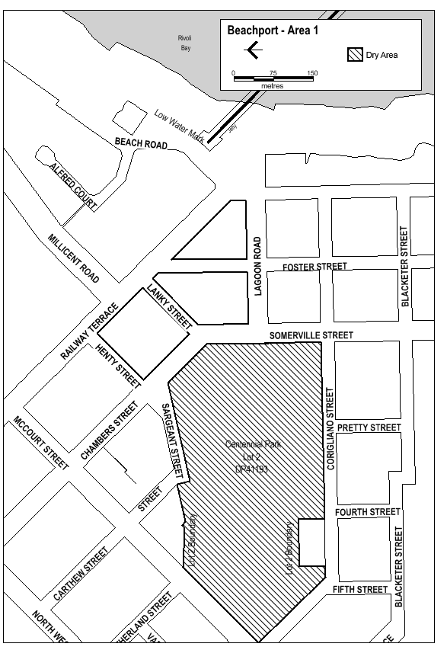
Made on behalf of the Liquor and Gambling Commissioner
On 1 September 2021

Liquor Licensing Act 1997
South Australia
Liquor Licensing (Dry Areas) Notice 2021
under section 131(1a) of the Liquor Licensing Act 1997
1—Short title
This notice may be cited as the Liquor Licensing (Dry Areas) Notice 2021.
2—Commencement
This notice comes into operation on 26 December 2021.
3—Interpretation
(1) In this notice—
principal notice means the Liquor Licensing (Dry Areas) Notice 2015 published in the Gazette on 5.1.15, as in force from time to time.
(2) Clause 3 of the principal notice applies to this notice as if it were the principal notice.

4—Consumption etc of liquor prohibited in dry areas
(1) Pursuant to section 131 of the Act, the consumption and possession of liquor in the area described in the Schedule is prohibited in accordance with the provisions of the Schedule.
(2) The prohibition has effect during the periods specified in the Schedule.
(3) The prohibition does not extend to private land in the area described in the Schedule.
(4) Unless the contrary intention appears, the prohibition of the possession of liquor in the area does not extend to—
(a) a person who is genuinely passing through the area if—
(i) the liquor is in the original container in which it was purchased from licensed premises; and
(ii) the container has not been opened; or
(b) a person who has possession of the liquor in the course of carrying on a business or in the course of his or her employment by another person in the course of carrying on a business; or
(c) a person who is permanently or temporarily residing at premises within the area or on the boundary of the area and who enters the area solely for the purpose of passing through it to enter those premises or who enters the area from those premises for the purpose of leaving the area.
Schedule—Beachport Area 2

1—Extent of prohibition
The consumption of liquor is prohibited and the possession of liquor is prohibited.

2—Period of prohibition
Between the hours of 12:01pm on Sunday, 26 December 2021 and 12:01pm on Sunday, 2 January 2022.

3—Description of area
The area in and adjacent to Beachport comprising the following roads and other areas:
(a) Railway Terrace between the south-eastern boundary of McCourt Street and the north-western boundary of Beach Road;
(b) Chambers Street and Somerville Street between the south-eastern boundary of McCourt Street and the southern boundary of Lagoon Road;
(c) Lagoon Road between the eastern boundary of Somerville Street and the western boundary of Beach Road;
(d) Henty Street;
(e) Lanky Street;
(f) Foster Street between Railway Terrace and the southern boundary of Lagoon Road;
(g) the area commencing at the point at which the prolongation in a straight line of the southern boundary of Lagoon Road intersects the low water mark on the western side of Rivoli Bay, then westerly along that prolongation to the western boundary of Beach Road, then generally northerly, north-easterly and northerly along that boundary of Beach Road to the southern boundary of Alfred Court, then along the prolongation in a straight line of that southern boundary of Alfred Court to the low water mark on the western side of Rivoli Bay, then generally south-westerly along the low water mark to the point of commencement.

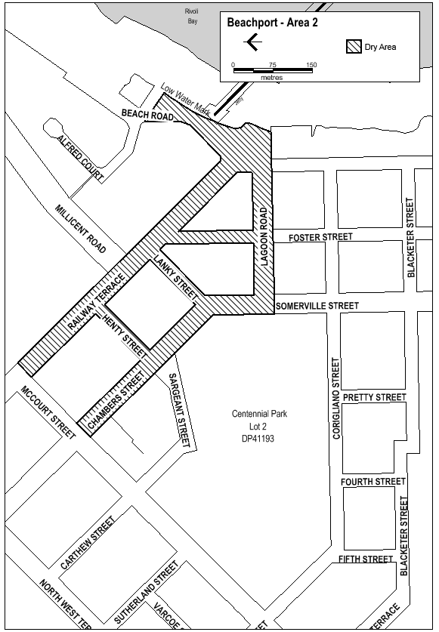
Made on behalf of the Liquor and Gambling Commissioner
On 1 September 2021

Mining Act 1971
Application for a Retention Lease
Notice is hereby given in accordance with Section 56H of the Mining Act 1971, that an application for a Retention Lease over the undermentioned mineral claim has been received:
Applicant: Buttrose Earthmovers Pty Ltd
Claim Number: 4496
Location: CT6217/178, Lyndoch area, approximately 7km east-northeast of Gawler.
Area: 12.39 hectares approximately
Purpose: Undertake environmental, social and operational investigations to inform the development of a mining proposal.
Reference: 2019/001769
To arrange an inspection of the proposal at the Department for Energy and Mining, please call the Department on (08) 8463 3103.
An electronic copy of the proposal can be found on the Department for Energy and Mining website:
http://energymining.sa.gov.au/minerals/mining/public_notices_mining
Written submissions in relation to this application are invited to be received at the Department for Energy and Mining, Mining Regulation, Attn: Business Support Officer, GPO Box 320, Adelaide SA 5001 or dem.miningregrehab@sa.gov.au by no later than 7 October 2021.
The delegate of the Minister for Energy and Mining is required to have regard to these submissions in determining whether to grant or refuse the application and, if granted, the terms and conditions on which it should be granted.
When you make a written submission, that submission becomes a public record. Your submission will be provided to the applicant and may be made available for public inspection.
J. Martin
Mining Registrar
Delegate for the Minister for Energy and Mining
Department for Energy and Mining

Petroleum and Geothermal Energy Act 2000
Grant of Petroleum Exploration Licence—PEL 676
Notice is hereby given that the undermentioned Petroleum Exploration Licence has been granted with effect from 2 September 2021, under the provisions of the Petroleum and Geothermal Energy Act 2000, pursuant to delegated powers dated 29 June 2018.
No. of Licence | Licensees | Area km² | Locality | Reference
PEL 676 | Leigh Creek Oil & Gas Pty Ltd | 2,008.96 | Cooper Basin | MER-2020/0119
Description of Area
All that part of the State of South Australia, bounded as follows:
Area 1
Commencing at a point being the intersection of latitude 26°35′00″S AGD66 and longitude 140°27′30″E GDA94, thence east to longitude 140°40′00″E GDA94, north to latitude 26°30′00″S GDA94, east to longitude 140°45′00″E GDA94, north to latitude 26°20′00″S GDA94, east to longitude 140°50′00″E GDA94, north to latitude 26°15′00″S GDA94, east to longitude 140°55′00″E GDA94, north to latitude 26°10′00″S GDA94, east to the eastern border of the State of South Australia, then north and west along the said border to longitude 140°50′00″E GDA94, south to latitude 26°07′30″S GDA94, west to longitude 140°32′30″E GDA94, south to latitude 26°30′00″S GDA94, west to longitude 140°27′30″E GDA94, and south to the point of commencement.
Area 2
Commencing at a point being the intersection of latitude 26°52′00″S GDA94 and longitude 140°03′00″E GDA94, thence east to longitude 140°10′00″E GDA94, south to latitude 26°55′00″S GDA94, east to longitude 140°22′00″E GDA94, south to latitude 26°56′35″S GDA94, west to longitude 140°13′00″E GDA94, north to latitude 26°56′05″S GDA94, west to longitude 140°09′25″E GDA94, north to latitude 26°55′45″S GDA94, west to longitude 140°08′30″E GDA94, north to latitude 26°54′30″S GDA94, west to longitude 140°08′10″E GDA94, north to latitude 26°53′15″S GDA94, west to longitude 140°07′25″E GDA94, north to latitude 26°52′45″S GDA94, west to longitude 140°04′45″E GDA94, south to latitude 26°54′00″S GDA94, east to longitude 140°05′10″E GDA94, south to latitude 26°55′00″S GDA94, east to longitude 140°05′55″E GDA94, south to latitude 26°57′05″S GDA94, west to longitude 140°05′20″E GDA94, south to latitude 26°58′05″S GDA94, west to longitude 140°04′35″E GDA94, south to latitude 26°59′10″S GDA94, west to longitude 140°03′50″E GDA94, south to latitude 26°59′50″S GDA94, west to longitude 140°03′10″E GDA94, south to latitude 27°01′05″S GDA94, west to longitude 140°00′50″E GDA94, north to latitude 27°00′35″S GDA94, west to longitude 139°58′05″E GDA94, south to latitude 27°01′35″S GDA94, east to longitude 139°58′25″E GDA94, south to latitude 27°02′20″S GDA94, east to longitude 139°58′45″E GDA94, south to latitude 27°03′50″S GDA94, west to longitude 139°53′40″E GDA94, south to latitude 27°04′35″S GDA94, west to longitude 139°52′35″E GDA94, north to latitude 27°03′00″S GDA94, east to longitude 139°57′00″E GDA94, north to latitude 27°00′00″S GDA94, east to longitude 140°02′00″E GDA94, north to latitude 26°59′00″S GDA94, east to longitude 140°03′00″E GDA94, and north to the point of commencement.

Area 3
Commencing at a point being the intersection of latitude 26°55′00″S GDA94 and longitude 140°26′00″E AGD66, thence east to longitude 140°28′00″E GDA94, south to latitude 27°01′15″S GDA94, east to longitude 140°34′50″E GDA94, south to latitude 27°02′40″S GDA94, east to longitude 140°35′25″E GDA94, south to latitude 27°03′25″S GDA94, east to longitude 140°35′50″E GDA94, south to latitude 27°04′10″S GDA94, east to longitude 140°36′20″E GDA94, south to latitude 27°06′05″S GDA94, west to longitude 140°34′55″E GDA94, south to latitude 27°07′10″S GDA94, west to longitude 140°33′40″E GDA94, south to latitude 27°07′30″S GDA94, west to longitude 140°28′55″E GDA94, north to latitude 27°05′45″S GDA94, west to longitude 140°27′20″E GDA94, north to latitude 27°05′35″S GDA94, west to longitude 140°27′15″E GDA94, north to latitude 27°05′25″S GDA94, west to longitude 140°27′10″E GDA94, north to latitude 27°05′15″S GDA94, west to longitude 140°27′00″E GDA94, north to latitude 27°05′05″S GDA94, west to longitude 140°26′50″E GDA94, north to latitude 27°04′50″S GDA94, west to longitude 140°26′35″E GDA94, north to latitude 27°04′25″S GDA94, west to longitude 140°26′00″E AGD66, and north to the point of commencement.
AREA: 2008.96 square kilometres approximately.
Dated: 2 September 2021
Barry A. Goldstein
Executive Director
Energy Resources Division
Department for Energy and Mining
Delegate of the Minister for Energy and Mining

Petroleum And Geothermal Energy Act 2000
Notification of Successful Applicant for a Petroleum Exploration Licence
2019 South Australian Petroleum Acreage Release—Area CO 2019-B
Pursuant to section 22(6)(a) of the Petroleum and Geothermal Energy Act 2000, (the Act) and delegation dated 29 June 2018, notice is hereby given that the following applicant was successful in an application for a Petroleum Exploration Licence over the designated CO 2019-B area.
Leigh Creek Oil & Gas Pty Ltd
Further, it is notified that the successful applicant for this area was selected on the basis of the selection criteria published in the Gazette dated 30 May 2019 for the grant of a Petroleum Exploration Licence.
The applicant’s proposed work program is as follows:
Licence Year | Proposed Work Program*
One | Geological and geophysical studies.
Two | Drill 2 wells.
Three | 150km² 3D seismic acquisition.
Four | Drill 1 well.
Five | Geological and geophysical studies.
*Years one to four work programs are guaranteed
Dated: 2 September 2021
Barry A. Goldstein
Executive Director
Energy Resources Division
Department for Energy and Mining
Delegate of the Minister for Energy and Mining

Petroleum and Geothermal Energy Act 2000
Statement of Environmental Objectives
Pursuant to Section 104(1) of the Petroleum and Geothermal Energy Act 2000 (the Act) I, Barry Goldstein, Executive Director Energy Resources Division, Department for Energy and Mining do hereby publish the following document as having been approved as a statement of environmental objectives under the Act.
Documents:
• Santos Ltd, South Australia—Cooper Basin—Statement of Environmental Objectives: Drilling, Completion and Well Operations, July 2021
This document is available for public inspection on the Environmental Register section of the following webpage:
https://www.petroleum.sa.gov.au/regulation/environmental-register
or at the Public Office determined pursuant to Section 107(1) of the Act to be at:
Energy Resources Division
Customer Services
Level 4
11 Waymouth Street
Adelaide SA 5000
Dated: 3 September 2021
Barry Goldstein
Executive Director
Energy Resources Division
Department for Energy and Mining
Delegate of the Minister for Energy and Mining

Planning, Development and Infrastructure Act 2016
Section 76
Amendment to the Planning and Design Code
Preamble
It is necessary to amend the Planning and Design Code (the Code) in operation at 26 August 2021 (Version 2021.12) in order to make changes of form, address inconsistency and correct errors that relate to:
• Misapplication of the Local Heritage Place Overlay to the identified property of Newenham Road off Flaxley Road, Mount Barker;
• Spatial application of the State Heritage Place Overlay to 10 identified listings; and
• Adjusting the Code’s spatial layers to maintain the correct relationship between parcels and Code spatial layers.
Pursuant to Section 76 of the Planning, Development and Infrastructure Act 2016, I—
1. Amend the Code as follows:
(a) Amend the spatial application of the Local Heritage Place Overlay to the area identified and only apply it to the ‘LHP’ area in map contained in Attachment A, and make corresponding spatial adjustments to the Heritage Adjacency Overlay to reflect this change.
(b) Amend Part 11—Local Heritage Places relevant to ‘Mount Barker’ replacing the following address in the column headed ‘Property Address’:
Newenham Road off Flaxley Rd MOUNT BARKER
With:
Lot 1081 Newenham Parade MOUNT BARKER
(c) Spatially apply the State Heritage Place Overlay to the areas identified ‘SHP’ in the maps contained in Attachment B, and make corresponding spatial adjustments to the Heritage Adjacency Overlay to reflect this change.
(d) Undertake minor alterations to the geometry of the spatial layers and data in the Planning and Design Code to maintain the current relationship between the parcel boundaries and Planning and Design Code data as a result of the following:
• New plans of division deposited in the Land Titles Office between 20 August 2021 and 2 September 2021 affecting the following spatial and data layers in the Planning and Design Code:
A. Zones and subzones
B. Technical and Numeric Variations
• Building Heights (Levels)
• Building Heights (Metres)
• Finished Ground and Floor Levels
• Interface Height
• Minimum Frontage
• Minimum Site Area
• Minimum Primary Street Setback
• Minimum Side Boundary Setback
• Future Local Road Widening Setback
• Site Coverage
C. Overlays
• Affordable Housing
• Character Preservation Districts
• Coastal Flooding
• Environment and Food Production Area
• Future Road Widening
• Future Local Road Widening
• Hazard (Bushfire—High Risk)
• Hazard (Bushfire—Medium Risk)
• Hazard (Bushfire—General Risk)
• Hazard (Bushfire—Urban Interface)
• Hazard (Bushfire—(Regional)
• Hazard (Bushfire—Outback)
• Heritage Adjacency
• Historic Area
• Key Outback and Rural Routes

• Limited Land Division
• Limited Dwelling
• Local Heritage Place
• Major Urban Transport Routes
• Noise and Air Emissions
• Non-stop Corridor
• Regulated and Significant Tree
• State Heritage Place
• Stormwater Management
• Urban Transport Routes
• Urban Tree Canopy
• Improved spatial data for existing land parcels undertaken between 20 August 2021 and 2 September 2021 in the following locations (Column A) that affect data layers in the Planning and Design Code (Column B):
Location (Column A) | Layers (Column B)
F192875—Suttontown | Overlays  - Hazard (Bushfire—High Risk)  - Hazard (Bushfire—General Risk)
F57104—Barinia | Overlays  - Heritage Adjacency  - Local Heritage Place
Mount Pleasant | Zones and Subzones  Technical and Numeric Variations  - Minimum Frontage  - Minimum Site Area  - Minimum Side Boundary Setback  Overlays  - Affordable Housing  - Character Preservation District  - Heritage Adjacency  - Limited Land Division  - Local Heritage Place  - Historic Area  - State Heritage Place
West Lakes | Zones and Subzones  Technical and Numeric Variations  - Concept Plan  - Interface Height  - Building Height (Metres)  - Building Height (Levels)  Overlays  - Affordable Housing  - Noise and Air Emissions
Clare | Zones and Subzones  Technical and Numeric Variations  - Minimum Site Area  Overlays  - Gateway  - Limited Land Division  - Significant landscape Protection
• Remedy minor miscellaneous gaps, overlaps and misalignments between parcel boundaries and Planning and Design Code data.
(e) Update the Table of Planning and Design Code Amendments (Part 13—Table of Amendments), pursuant to this Section 76 Amendment.
2. Declare that the Section 76 Amendment will take effect upon being published on the SA planning portal.
Dated: 6 September 2021
Sally Smith
Executive Director, Planning & Land Use Services,
Attorney-General’s Department
Delegate of Vickie Chapman MP, Minister for Planning and Local Government

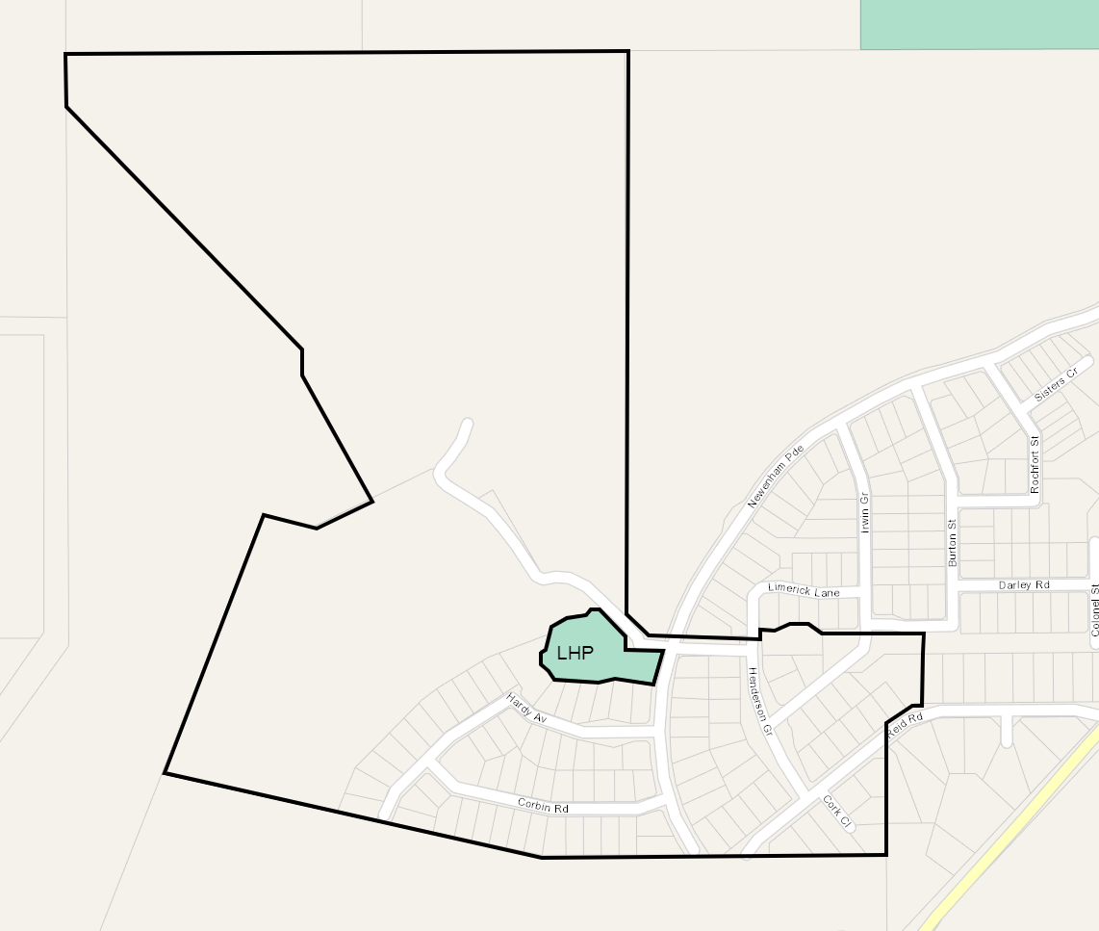
Attachment A

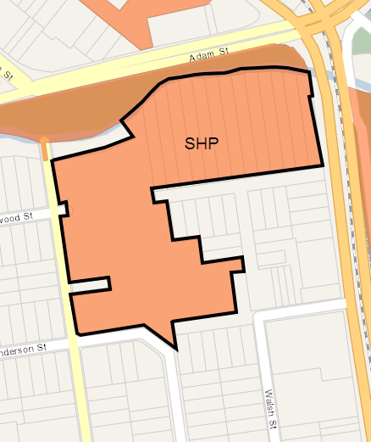
Attachment B

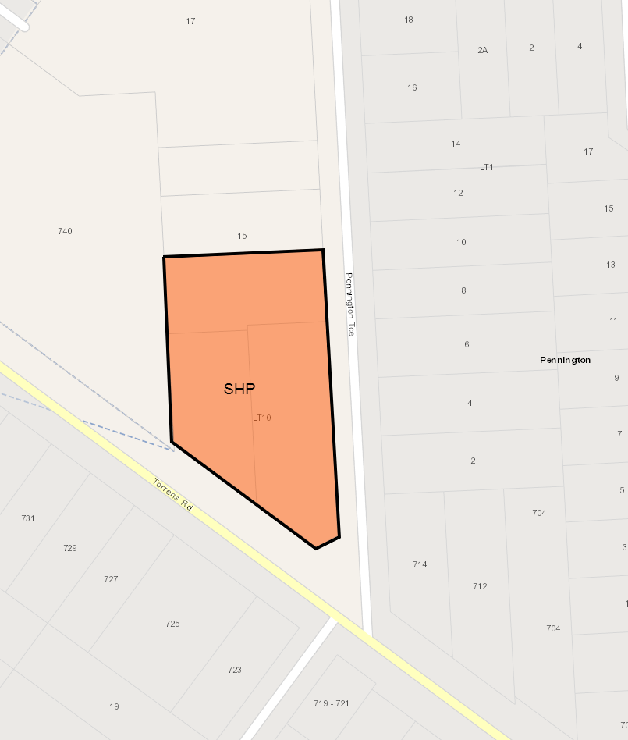
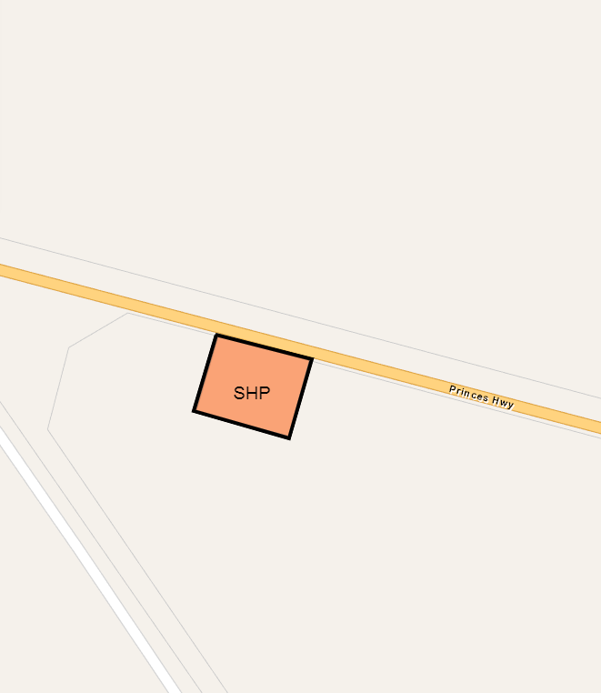
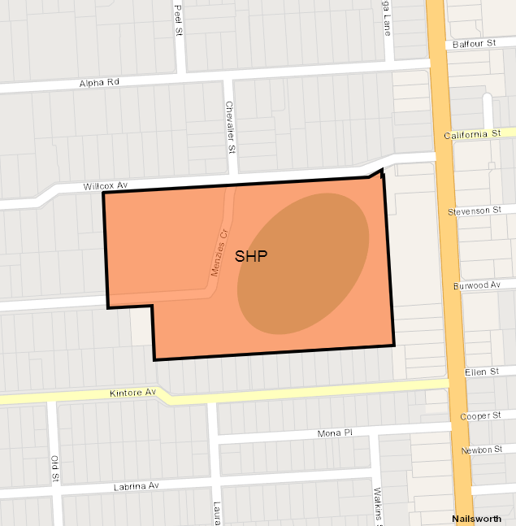
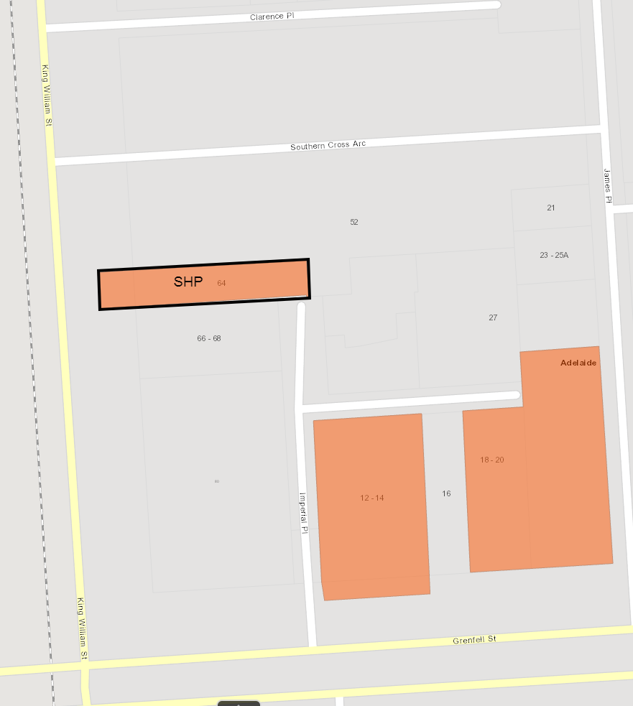
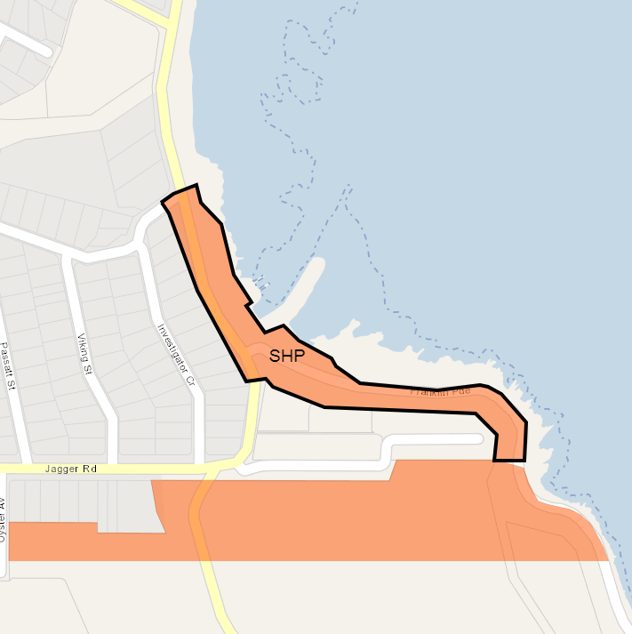
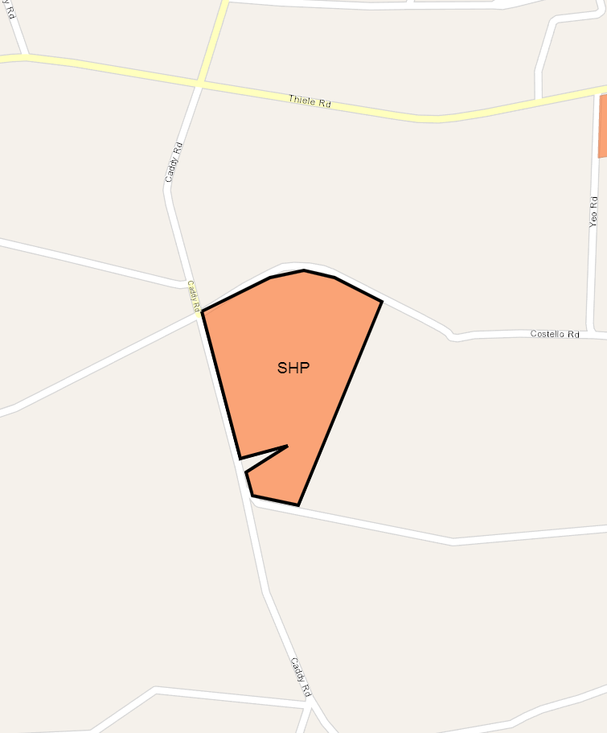
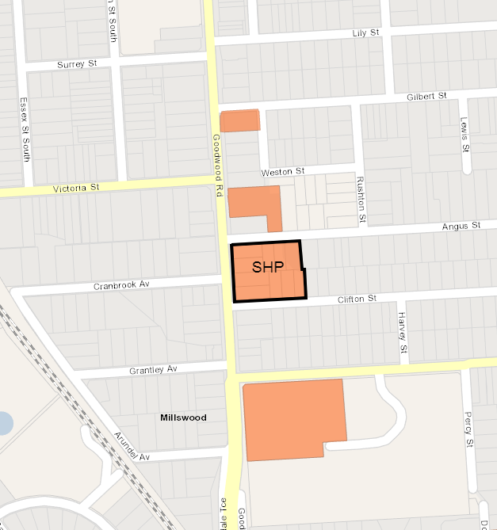

Plant Health Act 2009
Sections 4 and 8
Declaration of Pests
Pursuant to Sections 4 and 8 of the Plant Health Act 2009, I, Ross Meffin, Chief Inspector, delegate of the Minister for Primary Industries and Regional Development, make the following notice:
1. Application
All previous notices made pursuant to Sections 4 and 8 of the Plant Health Act 2009 are hereby revoked.
2. Declaration of Pests—Pursuant to Section 4 of the Act
2.1 The following are declared to be pests for the purposes of the Act:
(1) The pests specified by common name and scientific name immediately below:
Common Name(s) | Scientific Name(s)
African citrus psyllid | Trioza erytreae
American serpentine leaf miner | Liriomyza trifolii
Anthracnose of Brassica crops | Colletotrichum higginsianum
Asian citrus psyllid | Diaphorina citri
Asian longicorn beetle | Anaplophora glabripennis
Asian subterranean termite | Cryptotermes gestroi
Australian plague locust | Chortoicetes terminifera
Bacterial wilt of potato | Ralstonia solanacearum Race 3
Barley stem gall midge | Mayetiola hordei
Barley stripe rust | Puccinia striiformis f. sp. hordei
Blueberry rust  Boil smut of maize | Thekopsora minima  Ustilago maydis
Brown marmorated stink bug | Halyomorpha halys
Browsing ant | Lepisiota frauenfeldi
Burning moth | Hylesia nigricans
Caracollina lenticula | Caracollina lenticula
Ceratocystis wilt | Ceratocystis manginecans, Ceratocystis spp.  (exotic species)
Chestnut blight | Cryphonectria parasitica
Chickpea leaf miner | Liriomyza cicerina
Citrus blight | (unknown causal agent)
Citrus canker | Xanthomonas citri subsp. citri
Citrus longicorn beetle | Anaplophora chinensis
Citrus tristeza virus—sweet orange stem pitting strain | Citrus tristeza closterovirus—  sweet orange stem pitting strain
Citrus variegated chlorosis | Xylella fastidiosa
Citrus red mite | Panonychus citri
Columnea latent viroid (CLVd) | Columnea latent viroid
Cucumber fruit mottle mosaic virus (CFMMV) | Cucumber fruit mottle mosaic tobamovirus
Cucumber green mottle mosaic virus (CGMMV) | Cucumber green mottle mosaic tobamovirus
Drywood termite | Cryptotermes dudleyi
Electric ant | Wasmannia auropunctata
Exotic gypsy moth | Lymantria spp.  (L. dispar and sub-species, L. monacha)
Fire blight | Erwinia amylovora
European House Borer | Hylotrupes bajulus
Fruit flies | Pest species of Tephritidae family
Fusarium wilt of tomatoes | Fusarium oxysporum f.sp. lycopersicon Race 3
Giant African snail | Lissachatina fulica
Giant pine scale | Marchalina hellenica
Glassy-winged sharpshooter | Homalodisca vitripennis
Golden apple snail | Pomacea canaliculata
Grapevine leaf rust | Phakopsora euvitis
Grapevine red blotch-associated virus | Grapevine red blotch-associated geminivirus
Green snail | Cantareus apertus
Harlequin lady beetle | Harmonia axyridis
Hessian fly | Mayetiola destructor
Huanglongbing disease of citrus | ‘Candidatus liberibacter’ spp.
Karnal bunt | Tilletia indica
Khapra beetle | Trogoderma granarium
Kyuri green mottle mosaic virus (KGMMV) | Kyuri green mottle mosaic tobamovirus
Melon necrotic spot virus (MNSV) | Melon necrotic spot carmovirus
Melon thrips | Thrips palmi
Myrtle rust (exotic strains) | Austropuccinia psidii  (syn. Puccinia psidii, Uredo rangelii)—exotic strains
Myrtle rust | Puccinia psidii (syn. Uredo rangelii)
Onion Smut | Urocystis cepulae
Parlatoria date scale | Parlatoria blanchardi
Phylloxera | Daktulosphaira vitifolliae
Potato blackleg and soft rot | Dickeya spp. Including D. dianthicola, D. dadantii and D. solani
Potato cyst nematode | Globodera pallida
Potato cyst nematode | Globodera rostochiensis
Potato spindle tuber viroid (PSTVd) | Potato spindle tuber pospiviroid
Pepino mosaic virus (PepMV) | Pepino mosaic potexvirus
Pepper chat fruit viroid (PCFVd) | Pepper chat fruit viroid
Phoney peach disease | Xylella fastidiosa
Phytophthora blight | Phytophthora kernoviae
Pierce’s disease of grapevines | Xylella fastidiosa
Pine wilt nematode | Bursaphelenchus spp. including B. xylophilus
Pitch canker | Fusarium circinatum
Polyphagous shot hole borer-associated fusarium wilt | Fusarium euwallaceae
Potato late blight | Phytophthora infestans (A2 mating type)
Pyriform scale | Protopulvinaria pyriformis
Red imported fire ant | Solenopsis invicta
Sawyer beetles | Monochamus spp. including M. alternatus,  M. galloprovincialis, M. scutellatus, M. titillator
Serpentine leaf miner | Liriomyza huidobrensis
Sharka | Plum pox potyvirus
Small plague grasshopper | Austroicetes cruciata
Spotted-winged drosophila (fruit fly) | Drosophila suzukii
Strawberry latent ringspot virus (SLRSV) | Strawberry latent ringspot virus
Stubborn disease of citrus | Spiroplasma citri
Subterranean termite | Coptotermes formosanus
Sudden oak death | Phytophthora ramorum
Tarnished plant bug | Lygus lineolaris
Teratosphaeria canker | Teratosphaeria destructans and T. zuluensis
Tomato apical stunt viroid (TASVd) | Tomato apical stunt viroid
Tomato black ring virus (TBRV) | Tomato black ring nepovirus
Tomato brown rugose fruit virus (ToBRFV) | Tomato brown rugose fruit tobamovirus
Tomato chlorotic dwarf viroid (TCDVd) | Tomato chlorotic dwarf viroid
Tomato leaf miner | Liriomyza bryoniae
Tomato mottle mosaic virus (ToMMV) | Tomato mottle mosaic tobamovirus
Tomato planta macho viroid (TPMVd) | Tomato planta macho viroid
Tomato-potato psyllid | Bactericera cockerelli
Tropical fire ant | Solenopsis geminata
Vegetable leaf miner | Liriomyza sativae
Watermelon green mottle mosaic virus (WGMMV) | Watermelon green mottle mosaic tobamovirus
West Indian drywood termite | Cryptotermes brevis
Western plant bug | Lygus hesperus
Wheat stem rust (exotic strains) | Puccinia graminis f. sp. tritici (exotic strains)
Wheat stem sawfly | Cephus spp. (C. cinctus, C. pygmeaus)
Yellow crazy ant | Anoplolepis gracilipes
Zebra chip of potatoes, ‘yellows’ and other diseases of solanaceous and apiaceous plants | ‘Candidatus Liberibacter solanacearum’ (all Haplotypes)
Zucchini green mottle mosaic virus (ZGMMV) | Zucchini green mottle mosaic tobamovirus
3. Quarantine Areas—Pursuant to Section 8 of the Act
3.1 The following portions of the State are declared to be quarantine areas:
(1) with respect to pest fruit flies, a “fruit fly outbreak area” (as defined in Section 4 of this Notice),
(2) with respect to pest fruit flies, a “fruit fly suspension area” (as defined in Section 4 of this Notice),
(3) with respect to pest fruit flies, for the purpose of excluding fruit flies from the Riverland of South Australia (“Riverland Pest Free Area”),
(i) the County of Hamley, and
(ii) the Hundreds of Bookpurnong, Cadell, Gordon, Holder, Katarapko, Loveday, Markaranka, Moorook, Murtho, Parcoola, Paringa, Pooginook, Pyap, Stuart, Waikerie, Eba, Fisher, Forster, Hay, Murkbo, Nildottie, Paisley, Ridley and Skurray.
(4) the whole of Kangaroo Island with respect to the declared diseases of potato, namely bacterial wilt (Ralstonia solanacearum Race 3) and potato cyst nematodes (Globodera rostochinesis and Globodera pallida). This quarantine area is to be known as the ‘Kangaroo Island Protected Production Area’.
(5) with respect to Caracollina lenticula, the following are declared to be quarantine areas:
(i) 9 Creswell Road, Largs North, Certificate of Title Volume 5781 Folio 919,
(ii) 10 Creswell Road, Largs North, Certificate of Title Volume 5208 Folio 532, and
(iii) 1-4/2 Elder Road, Largs North, Certificates of Title Volume 6129 Folio 124 and Volume 6129 Folio 125.
3.2 Measures to be taken in Quarantine Areas
(1) The owner or occupier of any premises within a portion of the State declared to be a fruit fly outbreak area must take the measures prescribed in the Standard for the control and eradication of such flies.
(2) The owner or occupier of any premises within a portion of the state declared to be a fruit fly suspension area must take the measures prescribed in the Standard for the control and eradication of such flies.
(3) The owner or occupier of any premises within the ‘Kangaroo Island Protected Production Area’ established under Section 3.1(4) must take the measures prescribed in the Standard for eradication of the declared diseases of potato.
(4) Measures for the exclusion of fruit flies from the Riverland of South Australia (“Riverland Pest Free Area”):
(i) Introduction of host fruits of fruit flies (“host fruits”) as specified under Section 7 of the Act, into the Riverland Pest Free Area is prohibited unless:
(a) in transit through the Riverland Pest Free Area; or
(b) if the host fruit was produced in a State or Territory other than South Australia: the host fruit complies with the treatments described within 3.2(4)(ii) below.
(c) if the host fruit was produced in any part of South Australia outside the Riverland Pest Free Area, the host fruit has been certified by an inspector as having been either;
i. grown in an area free of fruit flies as defined by the Standard; or
ii. treated in compliance with the treatments described in 3.2(4)(iv) below.
(ii) if the host fruit was originally produced in the Riverland Pest Free Area, but has moved outside that area and is now proposed to be re-introduced into the area, the produce must either be;
(a) certified by an inspector that it has been maintained under secure conditions throughout the duration that it was outside the Riverland Pest Free Area; or
(b) moved under an accreditation arrangement as approved by the Minister under Part 4 Division 2 of the Act and Regulation 7 of the Plant Health Regulations 2009; or
(c) Treated in compliance with the treatments described in 3.2(4)(ii) below.
(iii) The following treatments are prescribed for the purpose of moving produce into the Riverland Pest Free Area:
(a) Treatment in accordance with Condition 9 (Area Freedom for fruit flies/secure transportation) as described in the Standard;
(b) Treatment in accordance with Condition 10.1 (Hard green or similar condition for Fruit Fly) as described in the Standard;
(c) Treatment in accordance with Condition 11 (Disinfestation by Cold Storage) as described in the Standard;
(d) Treatment in accordance with Condition 12 (Disinfestation using Dimethoate—Queensland fruit fly) as described in the Standard;
(e) Treatment in accordance with Condition 12E (Winegrapes Secure Transportation—Queensland Fruit Fly / Mediterranean Fruit Fly—Systems Approach—ICA 33) as described in the Standard;
(f) Treatment in accordance with Condition 13 (Disinfestation by Methyl Bromide fumigation) as described in the Standard;
(g) Treatment in accordance with Condition 14 (Disinfestation by Irradiation) as described in the Standard;
(h) Treated or consigned under conditions approved by the Chief Inspector.
(5) The owner or occupier of any premises within the quarantine area with respect to Caracollina lenticula, must take the following measures:
(i) all outdoor areas must be treated with the following molluscicide bait treatments in accordance with label specifications:
(a) a metaldehyde-based bait (e.g. Metarex Inov Slug and Snail Bait, Axcela Slug and Snail Bait) at least once during the months of March, April, May, September, October and November; and
(b) an iron-based bait (e.g. Protect Us Snail and Slug Killer, Eradicate Snail and Slug Bait) at least once during the months of June, July and August of each year.
(c) bait applications must occur at regular intervals over the twelve months (e.g. every 30 days plus (+) or minus (–) 3 days).
(ii) all annual vegetative ground cover must be destroyed but retained within the premises.
(iii) any item from the quarantine area that may harbour Caracollina lenticula is prohibited from leaving the quarantine area unless it meets the conditions laid out in 3.2(5)(iii)(a) to 3.2(5)(iii)(d) below:
(a) the item is inspected by an inspector and the inspector is satisfied that the item is free of Caracollina lenticula; or
(b) a staff member nominated by the affected business who is authorised by an inspector to do the inspections is satisfied that the item is free of len Caracollina lenticula, and,
(c) if Caracollina lenticula are found during inspection, or the item cannot be inspected to satisfy that the item is free of Caracollina lenticula, the item must be cleaned or treated in a method approved by the Department of Primary Industries and Regions, South Australia, and
(d) the item is removed from the quarantine area immediately upon being inspected in accordance with Section 3.2(5)(iii)(a) or (b) above; or immediately upon being cleaned or treated in accordance with Section 3.2(5)(iii)(c) above.
4. In this notice:
• “the Act” means the Plant Health Act 2009.
• “annual vegetation” means plants that grow for only a single year and not purposely grown for amenity reasons.
• “fruit fly outbreak area” means an area within 1.5km radius of a fruit fly outbreak centre.
• “fruit fly outbreak centre” means the single discovery point where eggs, larvae or adults of fruit flies have been detected that meet the triggers for outbreak declaration set in Australia’s national fruit fly management agreements, or the epicentre of several such discovery points which are no more than 1km apart.
• “fruit fly suspension area” means an area surrounding a fruit fly outbreak centre that has lost area freedom status, in accordance with Australia’s national fruit fly management agreements. The fruit fly suspension area consists of all of the land within a 15km radius for Queensland fruit fly, or within a 7.5km radius for Mediterranean fruit fly, of the “fruit fly outbreak centre”.
• “inspector” means an inspector appointed pursuant to Section 41 of the Act.
• an “item that may harbour Caracollina lenticula” includes any vehicle, machinery or equipment, whether or not it is a plant related product.
• “molluscicide” means a pesticide that will kill snails and slugs.
• “plant related product” has the same meaning as in the Act.

• “quarantine area” means the area described in Section 3 of this Notice.
• “the Standard” means the document published by Primary Industries and Regions South Australia entitled the “Plant Quarantine Standard South Australia”.
• “in transit” means the movement of securely contained plant product, either directly through South Australia or through another quarantine area for a plant pest, that is accompanied by documentation that can demonstrate both the origin and destination of product, and, whilst in South Australia or another quarantine area, is not subject to off-loading, reloading or storage.
• “securely contained” means, transported in a manner that prevents infestation of product with a quarantine pest and/or release of a quarantine pest and for fruit fly purposes meets the requirements of Condition 9 of the Standard.
This Notice will remain in force until revoked by subsequent Notice.
Dated: 7 September 2021
Ross Meffin
Chief Inspector
Delegate of the Minister for Primary Industries and Regional Development

THE DISTRICT COURT OF SOUTH AUSTRALIA

Port Augusta Circuit Court
Sheriff’s Office, Adelaide, 7 September 2021
In pursuance of a precept from the District Court to me directed, I do hereby give notice that the said Court will sit as a Court of Oyer and Terminer and General Gaol Delivery at the Courthouse at Port Augusta on the day and time undermentioned and all parties bound to prosecute and give evidence and all jurors summoned and all others having business at the said Court are required to attend the sittings thereof and the order of such business will be unless a Judge otherwise orders as follows:
Tuesday, 7 September 2021 at 10 am on the first day of the sittings the only business taken will be the arraignment of prisoners in gaol and the passing of sentences on prisoners in gaol committed for sentence; the surrender of prisoners on bail committed for sentence; the surrender of persons in response to ex officio informations or of persons on bail and committed for trial who have signified their intentions to plead guilty and the passing of sentences for all matters listed for disposition by the District Court.
Juries will be summoned for 7 September 2021 and persons will be tried on this and subsequent days of the sittings.
Prisoners in H.M. Gaol and on bail for sentence and for trial at the sittings
of the Port Augusta Courthouse, commencing 7 September 2021.
Bilney, Graham Patrick Adrian |  | Rape | On bail
B, B J |  | Maintaining an unlawful sexual relationship with a child | On bail
Borowski, Bradley John |  | Aggravated assault (4); aggravated threaten to kill or endanger life | On bail
Damon, Travis Blake |  | Trafficking in a large commercial quantity of a controlled drug | On bail
Doak, Jared Leigh |  | Aggravated serious criminal trespass in a place of residence; aggravated assault; aggravated threaten to cause harm | In gaol
Gatti, J A Sarunic, T |  | Trafficking in a controlled drug | On bail
Gould, Walter John |  | Indecent assault (11); gross indecency (3); unlawful sexual intercourse (2) | In gaol
Grosser, Brenton James |  | Trafficking in a large commercial quantity of controlled drug | On bail
Habermann, Zackery Alexander |  | Arson; damaging property | On bail
Haggerty, Rebecca Jane |  | Trafficking in a controlled drug | On bail
Hatches, Franklin Treacle |  | Aggravated assault; aggravated causing harm with intent to cause harm | In gaol
Hodgson, Kym |  | Indecent assault; unlawful sexual intercourse with a person 12 to 17 years | On bail
James, Ricky Gogo |  | Rape (2) | In gaol
Johannes, Joseph Andrew |  | Maintaining an unlawful sexual relationship with a child | On bail
Kilpatrick, Tallen Douglas Kilpatrick, Dillon Brian Sims, Mark Wayne |  | Aggravated causing harm with intent to cause harm (3); theft; assault | On bail  On bail  On bail
Kirkland, Damian Paul |  | Maintaining an unlawful sexual relationship with a child | On bail
Lambadgee, Christine Allison |  | Aggravated causing serious harm with intent to cause serious harm | In gaol
Lynch, Connor Scott |  | Rape | On bail
Matasia, James |  | Aggravated causing harm with intent to cause harm | In gaol
McLean, Jamahl |  | Aggravated causing harm with intent to cause harm | On bail
McNamee, Brian Anthony John |  | Rape | On bail
Medlam, Chantelle Lee Hanslow, Joshua Clinton |  | Aggravated assault; aggravated recklessly causing serious harm; aggravated threatening life; threatening a person involved in a criminal investigation; assisting an offender | On bail  On bail
Miller, James Ronald |  | Aggravated possessing child exploitation material; possessing child exploitation material | On bail
Mundy, Trevor Keenan |  | Aggravated robbery | On bail
Pedler, Dylan Pedler,  Nathan James |  | Aggravated serious criminal trespass in a place of residence; aggravated assault | In gaol  In gaol
P, J J |  | Maintaining an unlawful sexual relationship with a child | On bail
Reid, Tyson James Stuart |  | Aggravated causing harm with intent to cause harm | On bail
Roberts, Benjamin |  | Arson | On bail
R, M A |  | Maintaining an unlawful sexual relationship with a child | In gaol
Spencer, Joshua Paul |  | Assault (2); intentionally causing harm to a prescribed emergency worker | On bail
Tabone, Phillip Graham |  | Maintaining an unlawful sexual relationship with a child | On bail
Watts, Nicholas Ra |  | Unlawfully choking, suffocating or strangling another (2); aggravated assault (4); damaging property (2) | In gaol
Werth, Nathan |  | Aggravated assault (2); unlawfully choking, suffocating or strangling another | In goal
Prisoners on bail must surrender at 10 am of the day appointed for their respective trials. If they do not appear when called upon their recognizances and those of their bail will be estreated and a bench warrant will be issued forthwith.
By order of the Court,
A. Gransden
Sheriff

Road Traffic Act 1961
Authorisation to Operate Breath Analysing Instruments
I, Grant Stevens, Commissioner of Police, do hereby notify that on and from 27 August 2021, the following persons were authorised by the Commissioner of Police to operate breath analysing instruments as defined in and for the purposes of the:
• Road Traffic Act 1961;
• Harbors and Navigation Act 1993;
• Security and Investigation Industry Act 1995; and
• Rail Safety National Law (South Australia) Act 2012.
PD Number | Officer Name
10550 | DOLAN, Ryan Patrick
77030 | EYLES, Ashley Kay
10671 | GARNER, Jevan Trent
77257 | GAULD, Lisa Jane
10669 | HEYCOCK, Gregory John
77331 | HILL, Hannah Georgia
77205 | HOFF, Ehlana Jane
10158 | PALMER, Megan Lynn
10561 | POWRIE, Michelle Nicole
77110 | RAONTA, Samarth
10146 | WEST, Matilda Alexandra
Grant Stevens
Commissioner of Police
Reference: 2021-0143

Roads (Opening and Closing) Act 1991
Section 24
NOTICE OF CONFIRMATION OF
ROAD PROCESS ORDER
Road Closure—Jaffray Street, Kapunda
By Road Process Order made on 3 June 2021, the Light Regional Council ordered that:
1. Portion of Jaffray Street, Kapunda, situated adjoining Allotment 401 in Filed Plan 176473, Hundred of Kapunda, more particularly delineated and lettered ‘A’ in Preliminary Plan 21/0008 be closed.
2. Transfer the whole of the land subject to closure to Catherine Veronica Harrowfield in accordance with the Agreement for Transfer dated 21 April 2021 entered into between the Light Regional Council and Catherine Veronica Harrowfield.
On 2 September 2021 that order was confirmed by the Attorney-General conditionally upon the deposit by the Registrar-General of Deposited Plan 127315 being the authority for the new boundaries.
Pursuant to section 24 of the Roads (Opening and Closing) Act 1991, NOTICE of the Order referred to above and its confirmation is hereby given.
Dated: 9 September 2021
M. P. Burdett
Surveyor-General
DPTI: 2021/02974/01

Shop Trading Hours Act 1977
Trading Hours—Exemption
Notice is hereby given that pursuant to section 5(9)(b) of the Shop Trading Hours Act 1977 (the Act), I, Rob Lucas MLC, Treasurer, on my own initiative, do hereby declare:
• Non-exempt shops, excluding shops that are solely or predominantly the retail sale of motor vehicles or boats, situated within the Metropolitan Shopping District and Glenelg Tourist Precinct to be exempt from the provisions of the Act between the hours of:
◦ 11.00 am and 5.00 pm on Monday, 4 October 2021.
This exemption is subject to the following conditions:
• Normal trading hours prescribed by section 13 of the Act shall apply at all other times.
• All employees working during these extended hours will do so on a strictly voluntary basis.
• Any and all relevant industrial instruments are to be complied with.
• All work health and safety issues (in particular those relating to extended trading hours) must be appropriately addressed.
Dated: 31 August 2021
Hon Rob Lucas MLC
Treasurer

Local Government Instruments

City of Mitcham
Adoption of Amended Community Land Management Plans
for Hawthorndene Oval and Apex Park, Hawthorndene
Notice is hereby given that pursuant to Section 198 of the Local Government Act 1999, that the City of Mitcham has adopted the proposal for the amended Community Land Management Plans for Hawthorndene Oval and Apex Park, Hawthorndene.
Further information can be found on the City of Mitcham website at: www.mitchamcouncil.sa.gov.au.
Dated: 9 September 2021
Matthew Pears
Chief Executive Officer

City of Norwood Payneham & St Peters
Local Government Act 1999 (SA)
Proposed Declaration under Section 210(1)
The City of Norwood Payneham & St Peters (Council) hereby gives notice that it proposes to make a declaration under Section 210(1) of the Local Government Act 1999 (SA) converting the following private road within its Council area into a public road on 9 December 2021 or thereafter:
Firstly, portion of the land delineated in Block 25 in Plot 19 sheet 3 of Section 276 Hundred of Adelaide and subsequently redesignated Allotment 18 in DP798 being a private road commonly known as ‘Church Avenue’ in the area of Norwood.
Secondly, the land marked ‘1 foot wide reserve’ in Certificate of Title Volume 398 Folio 245 Comprising allotment 15 in D798 and which is a private road commonly known as ‘Church Avenue’ in the area of Norwood.
The executors, administrator, heirs and assigns of the last known registered proprietors of the estates of the late James Hardman of Adelaide and the late Horace Stanthorpe Cowan may contact the Council about the said declaration.
Dated: 9 September 2021
Mario Barone
Chief Executive Officer

Copper Coast Council
South Australia
Liquor Licensing (Dry Areas) Notice 2021
under section 131(1a) of the Liquor Licensing Act 1997
1—Short title
This notice may be cited as the Liquor Licensing (Dry Areas) Notice 2021.
2—Commencement
This notice comes into operation on 31 December 2021.
3—Interpretation
(1) In this notice—
principal notice means the Liquor Licensing (Dry Areas) Notice 2015 published in the Gazette on 5.1.15, as in force from time to time.
(2) Clause 3 of the principal notice applies to this notice as if it were the principal notice.
4—Consumption etc of liquor prohibited in dry areas
(1) Pursuant to section 131 of the Act, the consumption and possession of liquor in the area described in the Schedule is prohibited in accordance with the provisions of the Schedule.
(2) The prohibition has effect during the periods specified in the Schedule.
(3) The prohibition does not extend to private land in the area described in the Schedule.
(4) Unless the contrary intention appears, the prohibition of the possession of liquor in the area does not extend to—
(a) a person who is genuinely passing through the area if—
(i) the liquor is in the original container in which it was purchased from licensed premises; and
(ii) the container has not been opened; or

(b) a person who has possession of the liquor in the course of carrying on a business or in the course of his or her employment by another person in the course of carrying on a business; or
(c) a person who is permanently or temporarily residing at premises within the area or on the boundary of the area and who enters the area solely for the purpose of passing through it to enter those premises or who enters the area from those premises for the purpose of leaving the area.
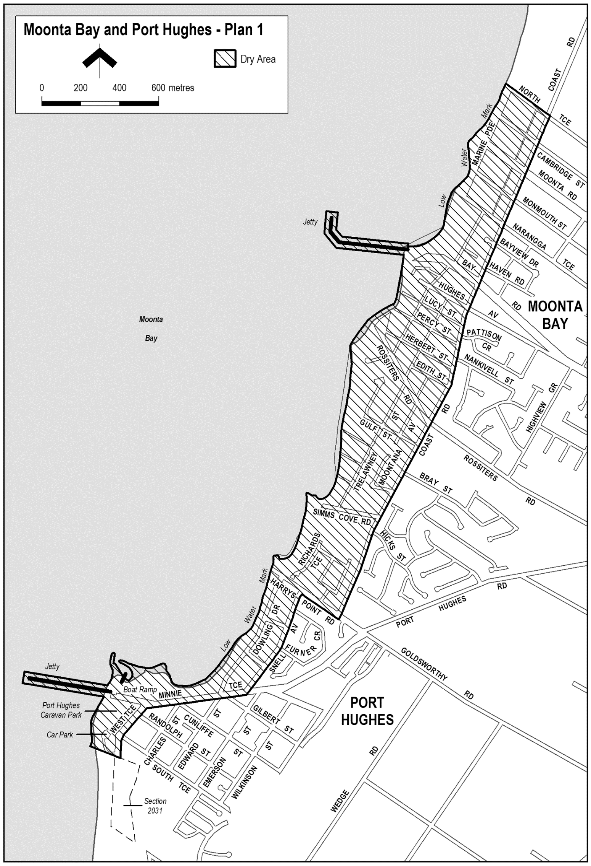
Schedule—Moonta Bay and Port Hughes Area 1
1—Extent of prohibition
The consumption of liquor is prohibited and the possession of liquor is prohibited.
2—Period of prohibition
From 12 noon on 31 December 2021 to 7.00 am on 1 January 2022.
3—Description of area
The area in and adjacent to Moonta Bay and Port Hughes bounded as follows: Commencing at the point at which the northern boundary of North Terrace, Moonta Bay intersects the eastern boundary of Coast Road, then generally south-westerly along that eastern boundary of Coast Road and the prolongation in a straight line of that boundary to the point at which the prolongation intersects the southern boundary of Harry’s Point Road, Port Hughes then north-westerly along the southern boundary of Harry’s Point Road to the point at which it meets the eastern boundary of Snell Avenue, Port Hughes then generally south-westerly along that boundary of Snell Avenue and the prolongation in a straight line of that boundary to the point at which it intersects the southern boundary of Minnie Terrace, Port Hughes then generally westerly along that boundary of Minnie Terrace to the eastern boundary of West Terrace, Port Hughes then generally south-westerly and southerly along that boundary of West Terrace and the continuation of West Terrace (past South Terrace) to the northern boundary of Section 2031 Hundred of Wallaroo, then north-westerly along that boundary of Section 2031 and the prolongation in a straight line of that boundary to the low water mark on the eastern side of Spencer Gulf, then generally northerly and north-easterly along the low water mark to the point at which it is intersected by the prolongation in a straight line of the northern boundary of North Terrace, Moonta Bay then south-easterly along that prolongation and boundary of North Terrace to the point of commencement. The area includes any jetty, boat ramp or other structure projecting below low water mark from within the area described above (as well as any area beneath such a structure).

Schedule—Wallaroo Area 4
1—Extent of prohibition
The consumption of liquor is prohibited and the possession of liquor is prohibited.
2—Period of prohibition
From 12 noon on 31 December 2021 to 7.00 am on 1 January 2022.
3—Description of area
The area in and adjacent to Wallaroo and North Beach bounded as follows: Commencing at the point at which the prolongation in a straight line of the northern boundary of Woodforde Drive, North Beach intersects the low water mark on the eastern side of Spencer Gulf, then north-easterly and south-easterly along that prolongation and boundary of Woodforde Drive to the point at which it meets the northern boundary of Islesworth Street, North Beach then generally easterly and northerly along that boundary of Islesworth Street and the prolongation in a straight line of that boundary to the northern boundary of Rupara Road, North Beach then easterly along that boundary of Rupara Road and the prolongation in a straight line of that boundary to the point at which the prolongation intersects the eastern boundary of Hopgood Road, North Beach then generally south-easterly and south-westerly along the eastern boundary of Hopgood Road and the eastern boundary of North Beach Road to the point at which the eastern boundary of North Beach Road meets the northern boundary of the Wallaroo to Alford Road, then north-easterly along that boundary of the Wallaroo to Alford Road to the point at which it is intersected by the prolongation in a straight line of the eastern boundary of Bowman Road, Wallaroo then southerly and south-westerly along that boundary of Bowman Road, the eastern boundary of Sharples Road, Wallaroo and the prolongation in a straight line of the eastern boundary of Sharples Road to the southern boundary of Magazine Road, Wallaroo then generally north-westerly and westerly along that boundary of Magazine Road to the south-western boundary of Cresco Road, Wallaroo then generally north-westerly along that boundary of Cresco Road and the prolongation in a straight line of that boundary to the point at which the prolongation intersects the low water mark on the eastern side of spencer Gulf, then generally north-easterly along the low water mark to the commencement of the southern breakwater at the entrance to the Copper Cove Marina, then north-westerly along the outer boundary of the breakwater to its north-western end, then in a straight line by the shortest route (across the entrance to the marina) to the northern boundary at the western end of the northern breakwater at the entrance to the marina, then easterly along the outer boundary of the breakwater back to the low water mark on the shore on the northern side of the marina, then generally northerly and north-westerly along the low water mark to the point of commencement. The area includes the whole of any wharf, jetty, breakwater, boat ramp or other structure projecting below low water mark from within the area described above (as well as any area beneath such structure).
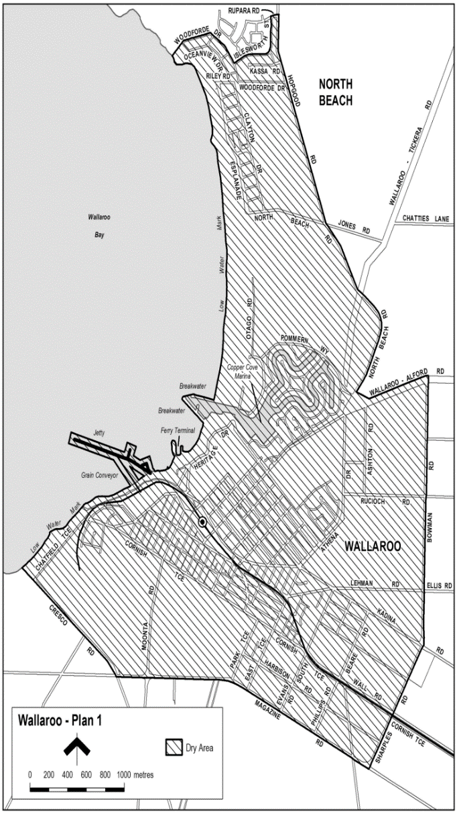
Dated: 1 September 2021
Russell Peate
Chief Executive Officer

Tatiara District Council
Representation Review
Final Recommendation
Notice is hereby given that Tatiara District Council in accordance with the requirements of section 12(4) of the Local Government Act 1999, has reviewed its composition and elector representation arrangements.
Certification
Pursuant to section 12(13)(a) of the said Act, the Electoral Commissioner has certified that the review undertaken by Council satisfies the requirements of section 12 and may therefore now be put into effect from the first day of the first periodic election held after the publication of this notice.
The representation review arrangements are as follows:
1. Retain the existing no ward structure
2. Retain the existing representation levels of:
2.1 an elected Mayor
2.2 nine elected members
Dated: 30 August 2021
Anne Champness
Chief Executive Officer

Public Notices

Trustee Act 1936
Public Trustee
Estates of Deceased Persons
In the matter of the estates of the undermentioned deceased persons:
DOLAN Ethan Dennis late of 140 Cartledge Avenue Whyalla Stuart of no occupation who died 13 February 2021
DOUBRAVA Jaromir late of Lot 247 Bean Street Coober Pedy Retired Opal Miner who died 29 December 2019
HAY Shirley Mona Aileen late of 15 Halliday Street Risdon Park of no occupation who died 24 May 2021
HAZELDINE Lindsay John late of 19 Bay Road Victor Harbor of no occupation who died 9 March 2021
KOTISH Anna late of 16-24 Penneys Hill Road Hackham of no occupation who died 9 April 2021
KYRIAKOPOULOS Vassilios late of 23 Paez Street Paralowie Labourer who died 16 December 2017
MARSH Janet Nora late of 333 Marion Road North Plympton Retired Registered Nurse who died 5 June 2021
MAY Reginald Maxwell late of 13 Ashbrook Avenue Payneham Retired Painter who died 18 July 2020
OATLEY Edward George late of 15 Rex Avenue Klemzig Retired Salesman who died 23 May 2021
O’BRIEN John Joseph late of 67 Porter Street Salisbury of no occupation who died 1 July 2021
O’GOERK Robert George late of 2 Leighton Avenue Klemzig of no occupation who died 23 May 2021
THEIS Rita late of 14 Glasford Street Wishart of no occupation who died 2 December 2020
Notice is hereby given pursuant to the Trustee Act 1936, the Inheritance (Family Provision) Act 1972 and the Family Relationships Act 1975 that all creditors, beneficiaries, and other persons having claims against the said estates are required to send, in writing, to the office of Public Trustee at GPO Box 1338, Adelaide, 5001, full particulars and proof of such claims, on or before the 8 October 2021 otherwise they will be excluded from the distribution of the said estate; and notice is also hereby given that all persons indebted to the said estates are required to pay the amount of their debts to the Public Trustee or proceedings will be taken for the recovery thereof; and all persons having any property belonging to the said estates are forthwith to deliver same to the Public Trustee.
Dated: 9 September 2021
N. S. Rantanen
Public Trustee

National Electricity Law
Final Determination, No Rule
The Australian Energy Market Commission (AEMC) gives notice under the National Electricity Law as follows:
Under s 102, the making of the final determination on the Contingency arrangements for five minute settlement implementation (Ref. ERC0331) proposal.
Documents referred to above are available on the AEMC’s website and are available for inspection at the AEMC’s office.
Australian Energy Market Commission
Level 15, 60 Castlereagh St
Sydney NSW 2000
Telephone: (02) 8296 7800
www.aemc.gov.au
Dated: 9 September 2021

Notice Submission

The South Australian Government Gazette is compiled and published each Thursday.
Notices must be submitted before 4 p.m. Tuesday, the week of intended publication.
All submissions are formatted per the gazette style and proofs are supplied as soon as possible. Alterations must be returned before 4 p.m. Wednesday.
Requests to withdraw submitted notices must be received before 10 a.m. on the day of publication.

Gazette notices should be emailed as Word files in the following format:
• Title—name of the governing Act/Regulation
• Subtitle—brief description of the notice
• A structured body of text
• Date of authorisation
• Name, position, and government department/organisation of the person authorising the notice

Please provide the following information in your email:
• Date of intended publication
• Contact details of at least two people responsible for the notice content
• Name of the person and organisation to be charged for the publication (Local Council and Public notices)
• Request for a quote, if required
• Purchase order, if required

Email: governmentgazettesa@sa.gov.au
Phone: (08) 7109 7760
Website: www.governmentgazette.sa.gov.au

All instruments appearing in this gazette are to be considered official, and obeyed as such

Printed and published weekly by authority of S. Smith, Government Printer, South Australia
$8.00 per issue (plus postage), $402.00 per annual subscription—GST inclusive
Online publications: www.governmentgazette.sa.gov.au

