No. 25 p. 995
THE SOUTH AUSTRALIAN
GOVERNMENT GAZETTE
Published by Authority

Adelaide, Thursday, 28 April 2022

Contents

Governor’s Instruments

Appointments 996

Emergency Management Act 2004 996

State Government Instruments

Boxing and Martial Arts Act 2000 997

Building Work Contractors Act 1995 997

Fisheries Management Act 2007 998

Fisheries Management (Prawn Fisheries) Regulations 2017 998

Housing Improvement Act 2016 999

Land Acquisition Act 1969 1000

Petroleum and Geothermal Energy Act 2000 1002

Planning, Development and Infrastructure Act 2016 1003

Public Notices

National Electricity Law 1009

National Energy Retail Law 1009

Partnership Act 1891 (SA) 1009

Trustee Act 1936 1009

Unclaimed Moneys Act 1891 1010

Governor’s Instruments

APPOINTMENTS
Department of the Premier and Cabinet
Adelaide, 28 April 2022
Her Excellency the Governor in Executive Council has been pleased to appoint the undermentioned to the Legal Services Commission, pursuant to the provisions of the Legal Services Commission Act 1977:
Member: from 28 April 2022 until 30 November 2022
Stephanie Jane Jude Halliday
By command,
Anastasios Koutsantonis
For Premier
AGO0018-22CS

Department of the Premier and Cabinet
Adelaide, 28 April 2022
Her Excellency the Governor in Executive Council has been pleased to appoint Naomi Mary Kereru as coroner for a term commencing on 28 April 2022 and expiring on 10 August 2022 — pursuant to Section 6(1) of the Coroners Act 2003.
By command,
Anastasios Koutsantonis
For Premier
AGO0017-22CS

Emergency Management Act 2004
Section 23
Approval by the Governor of Extension of a Major Emergency Declaration
Recital
The State Co-ordinator declared a Major Emergency on 22 March 2020 under section 23(1) of the Emergency Management Act 2004 (the Act) in respect of the outbreak of the human disease named COVID-19 within South Australia (the Declaration).
With the advice and consent of the Executive Council and pursuant to section 23(2) of the Act, on the days and for the periods set out below, His Excellency the Governor approved an extension of the Declaration.
On 2 April 2020 for a period of 28 days to commence on 4 April 2020.
On 30 April 2020 for a period of 28 days to commence on 2 May 2020.
On 28 May 2020 for a period of 28 days to commence on 30 May 2020.
On 27 June 2020 for a period of 28 days to commence on 27 June 2020.
On 23 July 2020 for a period of 28 days to commence on 25 July 2020.
On 20 August 2020 for a period of 28 days to commence on 22 August 2020.
On 17 September 2020 for a period of 28 days to commence on 19 September 2020.
On 15 October 2020 for a period of 28 days to commence on 17 October 2020.
On 12 November 2020 for a period of 28 days to commence on 14 November 2020.
On 10 December 2020 for a period of 28 days to commence on 12 December 2020.
On 6 January 2021 for a period of 28 days to commence on 9 January 2021.
On 4 February 2021 for a period of 28 days to commence on 6 February 2021.
On 4 March 2021 for a period of 28 days to commence on 6 March 2021.
On 1 April 2021 for a period of 28 days to commence on 3 April 2021.
On 29 April 2021 for a period of 28 days to commence on 1 May 2021.
On 27 May 2021 for a period of 28 days to commence on 29 May 2021.
On 24 June 2021 for a period of 28 days to commence 26 June 2021.
On 22 July 2021 for a period of 28 days to commence 24 July 2021.
On 18 August 2021 for a period of 28 days to commence 21 August 2021.
With the advice and consent of the Executive Council and pursuant to section 23(2) of the Act, on the days and for the periods set out below, Her Excellency the Administrator approved an extension of the Declaration.
On 16 September 2021 for a period of 28 days to commence 18 September 2021.
With the advice and consent of the Executive Council and pursuant to section 23(2) of the Act, on the days and for the periods set out below, Her Excellency the Governor approved an extension of the Declaration.
On 14 October 2021 for a period of 28 days to commence 16 October 2021.
On 11 November 2021 for a period of 28 days to commence 13 November 2021.
On 9 December 2021 for a period of 28 days to commence 11 December 2021.
On 7 January 2022 for a period of 28 days to commence 8 January 2022.
On 3 February 2022 for a period of 28 days to commence 5 February 2022.
On 2 March 2022 for a period of 28 days to commence 5 March 2022.
On 31 March 2022 for a period of 28 days to commence 2 April 2022.
PURSUANT to section 23(2) of the Act and with the advice and consent of the Executive Council, I NOW approve a further extension of the Declaration for a period of 28 days commencing on 30 April 2022.
Given under my hand and the Public Seal of South Australia at Adelaide on Thursday, 28 April 2022.
Frances Adamson AC
Governor

State Government Instruments

Boxing and Martial Arts Act 2000
Revocation of Rules
TAKE NOTICE that pursuant to section 10 of the Boxing and Martial Arts Act 2000, I Kylie Taylor, Chief Executive of the Office for Recreation, Sport and Racing, as delegate for the Minister for Recreation, Sport and Racing to whom the administration of the Boxing and Martial Arts Act 2000 is committed, have revoked the rules applicable to the conduct of boxing events to cease operation on this date of publication.
The revoked rules are set out below.
Dated: 21 April 2022
Kylie Taylor
Chief Executive, Office for Recreation, Sport and Racing
as delegate for the Minister for Recreation, Sport and Racing

Boxing Australia Technical and Competition Regulations amended 9 December 2021

Boxing and Martial Arts Act 2000
Notice of Rules
TAKE NOTICE that pursuant to section 10 of the Boxing and Martial Arts Act 2000, I Kylie Taylor, Chief Executive of the Office for Recreation, Sport and Racing, as delegate for the Minister for Recreation, Sport and Racing to whom the administration of the Boxing and Martial Arts Act 2000 is committed, have approved the rules applicable to the conduct of boxing events to commence operation on this date of publication.
The approved rules are set out below.
Dated: 21 April 2022
Kylie Taylor
Chief Executive, Office for Recreation, Sport and Racing
as delegate for the Minister for Recreation, Sport and Racing

Boxing Australia Technical and Competition Regulations amended 2 March 2022

Building Work Contractors Act 1995
Exemption
TAKE notice that, pursuant to section 45 of the Building Work Contractors Act 1995, I, Zoe Thomas as a delegate for the Attorney-General, do hereby exempt the licensee named in Schedule 1 from the application of Division 3 of Part 5 of the above Act in relation to domestic building work described in Schedule 2 and subject to the conditions specified in Schedule 3.
Schedule 1
PETER EDWARD LAWRENCE SWIFT (BLD 176070)
Schedule 2
Construction of a prefabricated garage with concrete floor at Allotment 92 Filed Plan 145020 being a portion of the land described in Certificate of Title Volume 5424 Folio 778, more commonly known as 6 Sheirlaw Street, Richmond SA 5033.
Schedule 3
1. This exemption is limited to domestic building work personally performed by the licensee in relation to the building work described in Schedule 2.
2. This exemption does not apply to any domestic building work the licensee contracts to another building work contractor, for which that contractor is required by law to hold building indemnity insurance.
3. That the licensee does not transfer his interest in the land prior to five years from the date of completion of the building work the subject of this exemption, without the prior authorisation of Consumer and Business Services (CBS). Before giving such authorisation, CBS may require the licensee to take any reasonable steps to protect the future purchaser(s) of the property, including but not limited to:
- Providing evidence that an adequate policy of building indemnity insurance is in force to cover the balance of the five-year period from the date of completion of the building work the subject of this exemption;
- Providing evidence of an independent expert inspection of the building work the subject of this exemption;
- Making an independent expert report available to prospective purchasers of the property;
- Giving prospective purchasers of the property notice of the absence of a policy of building indemnity insurance.
Dated: 21 April 2022
Zoe Thomas
Assistant Director, Licensing
Delegate for the Attorney-General

Fisheries Management Act 2007
Section 115
Ministerial Exemption Number: ME9903210
TAKE notice that pursuant to section 115 of the Fisheries Management Act 2007, I Professor Gavin Begg, Executive Director Fisheries and Aquaculture, delegate of the Minister for Primary Industries and Regional Development, hereby declare that the holder of a Commercial Fishery Licence in the Marine Scalefish Fishery, Restricted Marine Scalefish Fishery, Lakes and Coorong Fishery, Southern Zone Rock Lobster Fishery or Northern Zone Rock Lobster Fishery (the ‘exemption holders’) or their registered master and agents are exempt from Section 70 of the Fisheries Management Act 2007, Regulation 5, and clause 113(2) of Schedule 6 of the Fisheries Management (General) Regulations 2017 in that the exemption holder shall not be guilty of an offence when taking Wrasse species (other than Western Blue Groper) that are greater than 35 cm from coastal waters of the state as described in Schedule 1, subject to the conditions specified in Schedule 2 from 00:01 hrs on 21 April 2022 to 23:59 hrs on 20 April 2023, unless varied or revoked earlier.
Schedule 1
Coastal waters of the state excluding waters within a Sanctuary Zone or Restricted Access Zone of a Marine Park, or an aquatic reserve, or the Adelaide Dolphin Sanctuary, or the River Murray.
Schedule 2
- The exemption holder may take Wrasse species (other than Western Blue Groper) that are greater than 35 cm in length when measured from the foremost part of the head to the end of the tail.
- The exemption holder must record all Wrasse taken within the terms of this notice in the South Australian Commercial Marine Scalefish Fishery Daily Catch and Effort Logbook provided by the Department of Primary Industries and Regions and submit the returns within 15 days of the end of the month to which it relates.
- While engaging in the exempted activity, the exemption holder must be in possession of a copy of this notice. This notice must be produced to a Fisheries Officer if requested.
- The exemption holders shall not contravene or fail to comply with the Fisheries Management Act 2007, or any regulations made under that Act except where specifically exempted by this notice.
This notice does not purport to override the provisions or operation of any other Act including, but not limited to, the Marine Parks Act 2007. The exemption holders and their agents must comply with any relevant regulations, permits, requirements and directions from the Department for Environment and Water when undertaking activities within a marine park.
Dated: 20 April 2022
Prof Gavin Begg
Executive Director
Fisheries and Aquaculture
Delegate of the Minister for Primary Industries and Regional Development

Fisheries Management (Prawn Fisheries) Regulations 2017
April/May 2022 Fishing for the West Coast Prawn Fishery
TAKE notice that pursuant to regulation 10 of the Fisheries Management (Prawn Fisheries) Regulations 2017, the notice dated 5 October 2021 on page 3721 of the South Australian Government Gazette of 7 October 2021, prohibiting fishing activities in the West Coast Prawn Fishery is HEREBY varied such that it will not be unlawful for a person fishing pursuant to a West Coast Prawn Fishery licence to use prawn trawl nets in the areas specified in Schedule 1, during the period specified in Schedule 2, and under the conditions specified in Schedule 3.
Schedule 1
The waters of the West Coast Prawn Fishery excluding:
1: Ceduna as defined in the West Coast Prawn Fishery Harvest Strategy; and
2: An area of Corvisart Bay east of a line described by the following coordinates:
- 32°45.254’S 134°5.781’E
- 32°47.018’S 134°.2.088’E
- 32°54.344’S 134°3.613’E (WGS 84).
Schedule 2
Commencing at sunset on 23 April 2022 and ending at sunrise on 9 May 2022.
Schedule 3
- Each licence holder of a fishing licence undertaking fishing activities pursuant to this notice must ensure that a representative sample of catch (a 'bucket count') is taken at least 3 times per night during the fishing activity.
- Each 'bucket count' sample must be accurately weighed to 7 kg where possible and the total number of prawns contained in the bucket must be recorded on the daily catch and effort return.
- Fishing must cease if one of the following limits is reached:
  - A total of 14 nights of fishing are completed.
  - The average catch per vessel, per night (for all 3 vessels) drops below 300 kg for two consecutive nights.
  - The average 'bucket count' for all vessels exceeds 240 prawns per 7 kg bucket on any single fishing night in the Coffin Bay area.
  - The average 'bucket count' for all vessels exceeds 250 prawns per 7 kg bucket on any single fishing night in the Venus Bay area.
  - The average ‘bucket count’ for all vessels exceeds 250 prawns per 7 kg bucket on any single fishing night in the Corvisart Bay area.
  - A total of 6 tonnes is harvested by the fishing fleet in Corvisart Bay.
- Each licence holder, or registered master of a fishing license undertaking fishing activities must provide a daily report by telephone or SMS message, via a nominated representative, to the Department of Primary Industries and Regions, Prawn Fishery Manager, providing the following information for all vessels operating in the fishery from the previous nights fishing:
  - average prawn catch; and
  - the average prawn 'bucket count'.
- No fishing activity may be undertaken after the expiration of 30 minutes from the prescribed time of sunrise and no fishing activity may be undertaken before the prescribed time of sunset for Adelaide (as published in the South Australian Government Gazette pursuant to the requirements of the Proof of Sunrise and Sunset Act 1923) during the period specified in Schedule 2.
Dated: 22 April 2022
Prof Gavin Begg
Executive Director, Fisheries and Aquaculture
Delegate of the Minister for Primary Industries and Regional Development

Fisheries Management (Prawn Fisheries) Regulations 2017
Temporary Prohibition on Fishing Activities in the Gulf St Vincent Prawn Fishery
TAKE notice that pursuant to Regulation 10 of the Fisheries Management (Prawn Fisheries) Regulations 2017, the activities of the class specified in Schedule 1 are prohibited in the waters of the Gulf St Vincent Prawn Fishery during the period specified in Schedule 2 unless this notice is varied or revoked.
Schedule 1
The act of taking or an act preparatory to or involved in the taking of King Prawns (Melicertus latisulcatus) pursuant to a Gulf St Vincent Prawn Fishery Licence.
Schedule 2
From sunset on 27 April 2022 to sunrise on 1 May 2022.
Dated 26 April 2022
Annabel Jones
A/Prawn Fishery Manager
Delegate of the Minister for Primary Industries and Regional Development

Housing Improvement Act 2016
Rent Control
The Minister for Human Services Delegate in the exercise of the powers conferred by the Housing Improvement Act 2016, does hereby fix the maximum rental per week which shall be payable subject to Section 55 of the Residential Tenancies Act 1995, in respect of each house described in the following table. The amount shown in the said table shall come into force on the date of this publication in the Gazette.
Address of Premises | Allotment  Section | Certificate of Title  Volume Folio | Maximum Rental  per week payable
22 Gawler Street, Seaview Downs SA 5049 | Allotment 511 Deposited Plan 3065  Hundred of Noarlunga | 5659/723 | $255.00
Dated: 28 April 2022
Craig Thompson
Housing Regulator and Registrar
Housing Safety Authority, SAHA
Delegate of Minister for Human Services

Housing Improvement Act 2016
Rent Control Revocations
Whereas the Minister for Human Services Delegate is satisfied that each of the houses described hereunder has ceased to be unsafe or unsuitable for human habitation for the purposes of the Housing Improvement Act 2016, notice is hereby given that, in exercise of the powers conferred by the said Act, the Minister for Human Services Delegate does hereby revoke the said Rent Control in respect of each property.
Address of Premises | Allotment  Section | Certificate of Title  Volume Folio
141 Devonport Terrace, Prospect SA 5082 | Allotment 4 Filed Plan 110483 Hundred of Yatala | CT5217/420
1088 Dawkins Road, Gawler River SA 5118 | Allotment 23 Deposited Plan 88415 Hundred of Mudla Wirra | CR5755/136, CR6089/51, CT6173/369
Dated: 28 April 2022
Craig Thompson
Housing Regulator and Registrar
Housing Safety Authority, SAHA
Delegate of Minister for Human Services

Land Acquisition Act 1969
Section 16
Form 5 – Notice of Acquisition
1. Notice of acquisition
The Commissioner of Highways (the Authority), of 50 Flinders Street, Adelaide SA 5000, acquires the following interests in the following land:
Comprising an unencumbered estate in fee simple in that piece of land being whole of Allotment 26 in Filed Plan No 103939 comprised in Certificate of Title Volume 6134 Folio 453 subject only to registered Memoranda of Lease numbers 13254603 and 13341923.
This notice is given under section 16 of the Land Acquisition Act 1969.
2. Compensation
A person who has or had an interest consisting of native title or an alienable interest in the land that is divested or diminished by the acquisition or the enjoyment of which is adversely affected by the acquisition who does not receive an offer of compensation from the Authority may apply to the Authority for compensation.
2A. Payment of professional costs relating to acquisition (section 26B)
If you are the owner in fee simple of the land to which this notice relates, you may be entitled to a payment of up to $10 000 from the Authority for use towards the payment of professional costs in relation to the acquisition of the land.
Professional costs include legal costs, valuation costs and any other costs prescribed by the Land Acquisition Regulations 2019.
3. Inquiries
Inquiries should be directed to: Rob Gardner
GPO Box 1533
Adelaide SA 5001
Telephone: (08) 8343 2567
Dated: 26 April 2022
The Common Seal of the COMMISSIONER OF HIGHWAYS was hereto affixed by authority of the Commissioner in the presence of:
Steve McQuillan
Director, Property (Authorised Officer)
Department for Infrastructure and Transport
DIT 2021/04247/01

Land Acquisition Act 1969
Section 16
Form 5 – Notice of Acquisition
1. Notice of acquisition
The Commissioner of Highways (the Authority), of 50 Flinders Street, Adelaide SA 5000, acquires the following interests in the following land:
Comprising an unencumbered estate in fee simple in that piece of land being the whole of Allotment 56 in Filed Plan No 7587 comprised in Certificate of Title Volume 5075 Folio 940.
This notice is given under section 16 of the Land Acquisition Act 1969.
2. Compensation
A person who has or had an interest consisting of native title or an alienable interest in the land that is divested or diminished by the acquisition or the enjoyment of which is adversely affected by the acquisition who does not receive an offer of compensation from the Authority may apply to the Authority for compensation.
2A. Payment of professional costs relating to acquisition (section 26B)
If you are the owner in fee simple of the land to which this notice relates, you may be entitled to a payment of up to $10 000 from the Authority for use towards the payment of professional costs in relation to the acquisition of the land.
Professional costs include legal costs, valuation costs and any other costs prescribed by the Land Acquisition Regulations 2019.
3. Inquiries
Inquiries should be directed to: Petrula Pettas
GPO Box 1533
Adelaide SA 5001
Telephone: (08) 8343 2619
Dated: 26 April 2022
The Common Seal of the COMMISSIONER OF HIGHWAYS was hereto affixed by authority of the Commissioner in the presence of:
Steve McQuillan
Director, Property (Authorised Officer)
Department for Infrastructure and Transport
DIT 2021/15302/01

Land Acquisition Act 1969
Section 16
Form 5 – Notice of Acquisition
1. Notice of acquisition
The Commissioner of Highways (the Authority), of 50 Flinders Street, Adelaide SA 5000, acquires the following interests in the following land:
Comprising an unencumbered estate in fee simple in that piece of land being the whole of Unit 1 in Strata Plan 7618 comprised in Certificate of Title Volume 5009 Folio 343.
This notice is given under section 16 of the Land Acquisition Act 1969.
2. Compensation
A person who has or had an interest consisting of native title or an alienable interest in the land that is divested or diminished by the acquisition or the enjoyment of which is adversely affected by the acquisition who does not receive an offer of compensation from the Authority may apply to the Authority for compensation.
2A. Payment of professional costs relating to acquisition (section 26B)
If you are the owner in fee simple of the land to which this notice relates, you may be entitled to a payment of up to $10 000 from the Authority for use towards the payment of professional costs in relation to the acquisition of the land.
Professional costs include legal costs, valuation costs and any other costs prescribed by the Land Acquisition Regulations 2019.
3. Inquiries
Inquiries should be directed to: Petrula Pettas
GPO Box 1533
Adelaide SA 5001
Telephone: (08) 8343 2619
Dated: 26 April 2022
The Common Seal of the COMMISSIONER OF HIGHWAYS was hereto affixed by authority of the Commissioner in the presence of:
Steve McQuillan
Director, Property (Authorised Officer)
Department for Infrastructure and Transport
DIT 2021/15029/01

Land Acquisition Act 1969
Section 16
Form 5 – Notice of Acquisition
1. Notice of acquisition
The Commissioner of Highways (the Authority), of 50 Flinders Street, Adelaide SA 5000, acquires the following interests in the following land:
First: Comprising an unencumbered estate in fee simple in that piece of land being the whole of Unit 2 in Strata Plan No 7618 comprised in Certificate of Title Volume 5009 Folio 344.
This notice is given under section 16 of the Land Acquisition Act 1969.
2. Compensation
A person who has or had an interest consisting of native title or an alienable interest in the land that is divested or diminished by the acquisition or the enjoyment of which is adversely affected by the acquisition who does not receive an offer of compensation from the Authority may apply to the Authority for compensation.
2A. Payment of professional costs relating to acquisition (section 26B)
If you are the owner in fee simple of the land to which this notice relates, you may be entitled to a payment of up to $10 000 from the Authority for use towards the payment of professional costs in relation to the acquisition of the land.
Professional costs include legal costs, valuation costs and any other costs prescribed by the Land Acquisition Regulations 2019.
3. Inquiries
Inquiries should be directed to: Petrula Pettas
GPO Box 1533
Adelaide SA 5001
Telephone: (08) 8343 2619
Dated: 26 April 2022
The Common Seal of the COMMISSIONER OF HIGHWAYS was hereto affixed by authority of the Commissioner in the presence of:
Steve McQuillan
Director, Property (Authorised Officer)
Department for Infrastructure and Transport
DIT 2021/15030/01

PETROLEUM AND GEOTHERMAL ENERGY ACT 2000
Section 104(1)
Statement of Environmental Objectives – 5 Year Review
PURSUANT to section 104(1) of the Petroleum and Geothermal Energy Act 2000 (the Act) I, Nick Panagopoulos, Acting Executive Director Energy Resources Division, Department for Energy and Mining do hereby publish the following document as having been approved as a statement of environmental objectives under the Act.
Documents:
- APA Group, South East South Australia Pipeline (PL16) - Statement of Environmental Objectives, April 2022
This document is available for public inspection on the Environmental Register section of the following webpage - (https://www.petroleum.sa.gov.au/regulation/environmental-register) or at the Public Office determined pursuant to section 107 (1) of the Act to be at:
Energy Resources Division
Customer Services
Level 4, 11 Waymouth Street
Adelaide SA 5000
Dated: 19 April 2022
Nick PANAGOPOULOS
Acting Executive Director
Energy Resources Division
Department for Energy and Mining
Delegate of the Minister for Energy and Mining

Petroleum and Geothermal Energy Act 2000
Section 76A
Suspension of Condition and Extension of Licence Term—Petroleum Exploration Licence PEL 512
Extension of Licence Term—Associated Activities Licence AAL 293
Pursuant to section 76A of the Petroleum and Geothermal Energy Act 2000, notice is hereby given that Condition 1 of petroleum exploration licence 512 has been suspended for the period from 29 April 2022 to 28 October 2022 inclusive, pursuant to delegated powers dated 29 June 2018.
The term of PEL 512 has been extended by a period corresponding to the period of suspension, such that PEL 512 will now expire on 28 October 2024.
As a consequence of the suspension and extension of PEL 512, the term of the adjunct associated activities licence AAL 293 is extended, such that AAL 293 will now expire on 15 December 2022.
Dated: 21 April 2022
Nick Panagopoulos
A/Executive Director
Energy Resources Division
Department for Energy and Mining
Delegate of the Minister for Energy and Mining

Petroleum and Geothermal Energy Act 2000
Section 90
Suspension of Petroleum Exploration Licence PEL 515
Pursuant to section 90 of the Petroleum and Geothermal Energy Act 2000, notice is hereby given that the abovementioned Petroleum Exploration Licence has been suspended for the period from 26 March 2022 until 25 March 2023 inclusive, pursuant to delegated powers dated 29 June 2018.
The expiry date of PEL 515 is now determined to be 4 May 2026.
Dated: 21 April 2022
Nick Panagopoulos
A/Executive Director
Energy Resources Division
Department for Energy and Mining
Delegate of the Minister for Energy and Mining

Petroleum and Geothermal Energy Act 2000
Section 25(5)(b)
Variation of Petroleum Exploration Licence PEL 512
Notice is hereby given that under the provisions of the Petroleum and Geothermal Energy Act 2000, pursuant to delegated powers dated 29 June 2018, the conditions of the abovementioned Exploration Licence have been varied as follows:
Condition 1 of the licence is omitted and the following substituted:
“1. During the term of the licence, the Licensee shall carry out or cause to be carried out, exploratory operations on the area comprised in the licence in accordance with such work programs as are approved by the Minister from time to time. Years one to five exploratory operations are guaranteed. These exploratory operations shall include but not necessarily be limited to:-

Year of Term of Licence | Minimum Work Requirements
One | - Geological and Geophysical studies
Two | - 100 km² 3D seismic
Three | - 350 km² 3D seismic
Four | - Drill three wells
Five | - Drill four wells
”
The revised work requirements as a result of this variation would not have altered the outcome of the original competitive tender process.
Dated: 21 April 2022
Nick Panagopoulos
A/Executive Director
Energy Resources Division
Department for Energy and Mining
Delegate of the Minister for Energy and Mining

Planning, Development and Infrastructure Act 2016
Section 76
Amendment to the Planning and Design Code
Preamble
It is necessary to amend the Planning and Design Code (the Code) in operation at 31 March 2022 (Version 2022.6) in order to make changes:
- of form relating to:
  - the Code’s spatial layers and their relationship with land parcels. NOTE: There are no changes to the application of zone, subzone or overlay boundaries and their relationship with affected parcels or the intent of policy application as a result of this amendment
  - the inclusion of Concept Plan 100 under the heading ‘Barossa’ in Part 12 of the Code, being a concept plan that is applicable to that Council area
- to correct errors in relation to:
  - the nomination of ‘activity centres’ in the following Concept Plans:
    - Concept Plan 11 – Munno Para
    - Concept Plan 12 – Urban Growth Area
    - Concept Plan 18 – Playford North
    - Concept Plan 100 – Gawler East
  - the policy provisions and procedural matters applied to the Performance Assessed pathway for a Carport within the Housing Diversity Neighbourhood Zone, and the Master Planned Township Zone
- PURSUANT to section 76 of the Planning, Development and Infrastructure Act 2016 (the Act), I hereby amend the Code in order to make changes of form (without altering the effect of underlying policy), correct errors and make operational amendments as follows:
- Undertake minor alterations to the geometry of the spatial layers and data in the Code to maintain the current relationship between the parcel boundaries and Code data as a result of the following:
  - New plans of division deposited in the Land Titles Office between 23 March 2022 and 19 April 2022 affecting the following spatial and data layers in the Code:
    - Zones and subzones
    - Technical and Numeric Variations
      - Building Heights (Levels)
      - Building Heights (Metres)
      - Concept Plan
      - Interface Height
      - Minimum Dwelling Allotment Size
      - Finished Ground and Floor Levels
      - Minimum Frontage
      - Minimum Primary Street Setback
      - Minimum Side Boundary Setback
      - Minimum Local Road Widening Setback
      - Minimum Site Area
    - Overlays
      - Affordable Housing
      - Character Preservation District
      - Defence Aviation Area
      - Environment and Food Production Area
      - Future Local Road Widening
      - Future Road Widening
      - Hazard (Bushfire - High Risk)
      - Hazard (Bushfire - Medium Risk)
      - Hazard (Bushfire - General Risk)
      - Hazard (Bushfire - Urban Interface)
      - Hazard (Bushfire - Regional)
      - Hazard (Bushfire - Outback)
      - Heritage Adjacency
      - Historic Area
      - Limited Dwelling
      - Limited Land Division
      - Local Heritage Place
      - Regulated and Significant Trees
      - State Heritage Place
      - Stormwater Management
      - Urban Tree Canopy
  - Improved spatial data for existing land parcels in the following locations (as described in Column A) that affect data layers in the Code (as shown in Column B):
Location (Column A) | Layers (Column B)
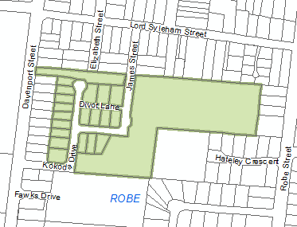  D118655 – Robe | Technical and Numeric Variations  - Building Heights (Levels)  - Building Heights (Metres)  - Minimum Frontage  - Minimum Site Area  Overlays  - Hazard (Bushfire - General Risk)  - Hazard (Bushfire - Urban Interface)  - Historic Area
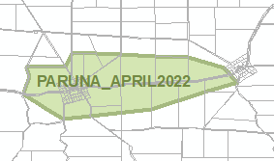  Paruna | Zones  Technical and Numeric Variations  - Minimum Dwelling Allotment Size  - Minimum Site Area  Overlays  - Dwelling Excision  - Key Outback and Rural Routes
- Amend the Housing Diversity Neighbourhood Zone so that Table 5 – Procedural Matters – Notification is returned from the online SA planning portal query function for the following Performance Assessed classes of development:
  - Carport
- In Table 3 – Applicable Policies for Performance Assessed Development of the Master Planned Township Zone, add relevant zone policy ‘PO 17.1’ and ‘PO 17.2’ of the Master Planned Township Zone in the row commencing ‘Carport’ in Column 1.
- In Part 12:
- under the heading ‘Playford’, replace existing Concept Plan 11 Munno Para, Concept Plan 12 Urban Growth Area, and Concept Plan 18 – Playford North with updated Concept Plan 11 Munno Para, Concept Plan 12 Urban Growth Area, and Concept Plan 18 – Playford North contained in Attachment A
- under the heading ‘Gawler’, replace existing Concept Plan 100 – Gawler East with updated Concept Plan 100 – Gawler East contained in Attachment A
- insert Concept Plan 100 – Gawler East contained in Attachment A under the heading relevant to ‘Barossa’.
- In Part 13 of the Code – Table of Amendments, update the publication date, Code version number, amendment type and summary of amendments within the ‘Table of Planning and Design Code Amendments’ to reflect the amendments to the Code as described in this Notice.
- PURSUANT to section 76(5)(a) of the Act, I further specify that the amendments to the Code as described in this Notice will take effect upon the date those amendments are published on the SA planning portal.
Dated: 26 April 2022
Sally Smith
Executive Director, Planning & Land Use Services,
Attorney-General’s Department
Delegate of the Minister for Planning

Attachment A
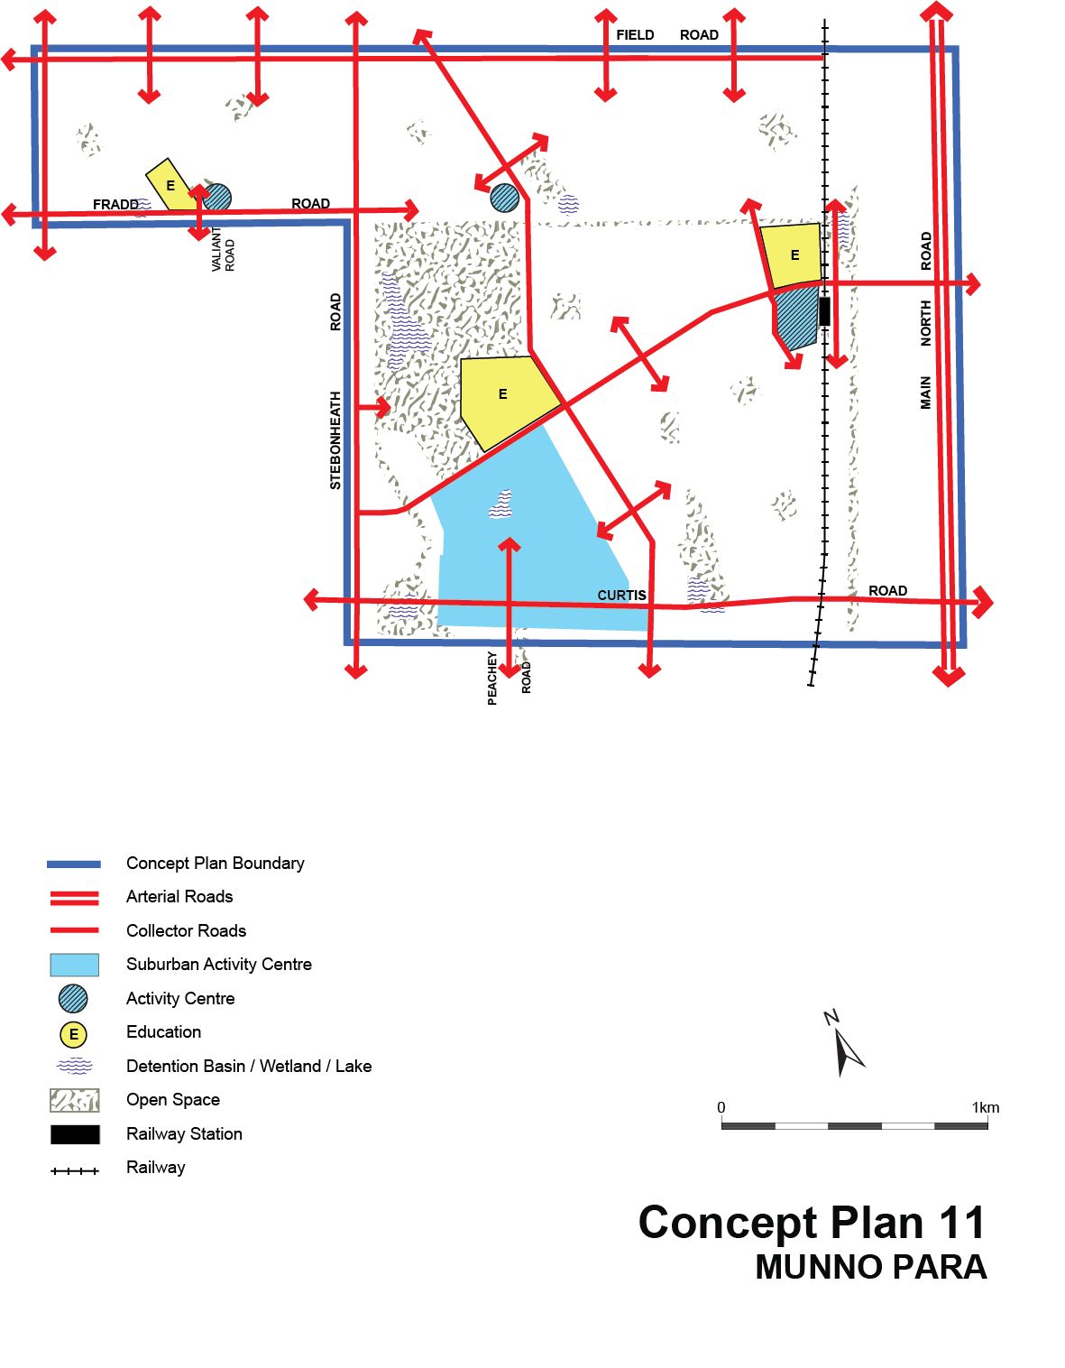

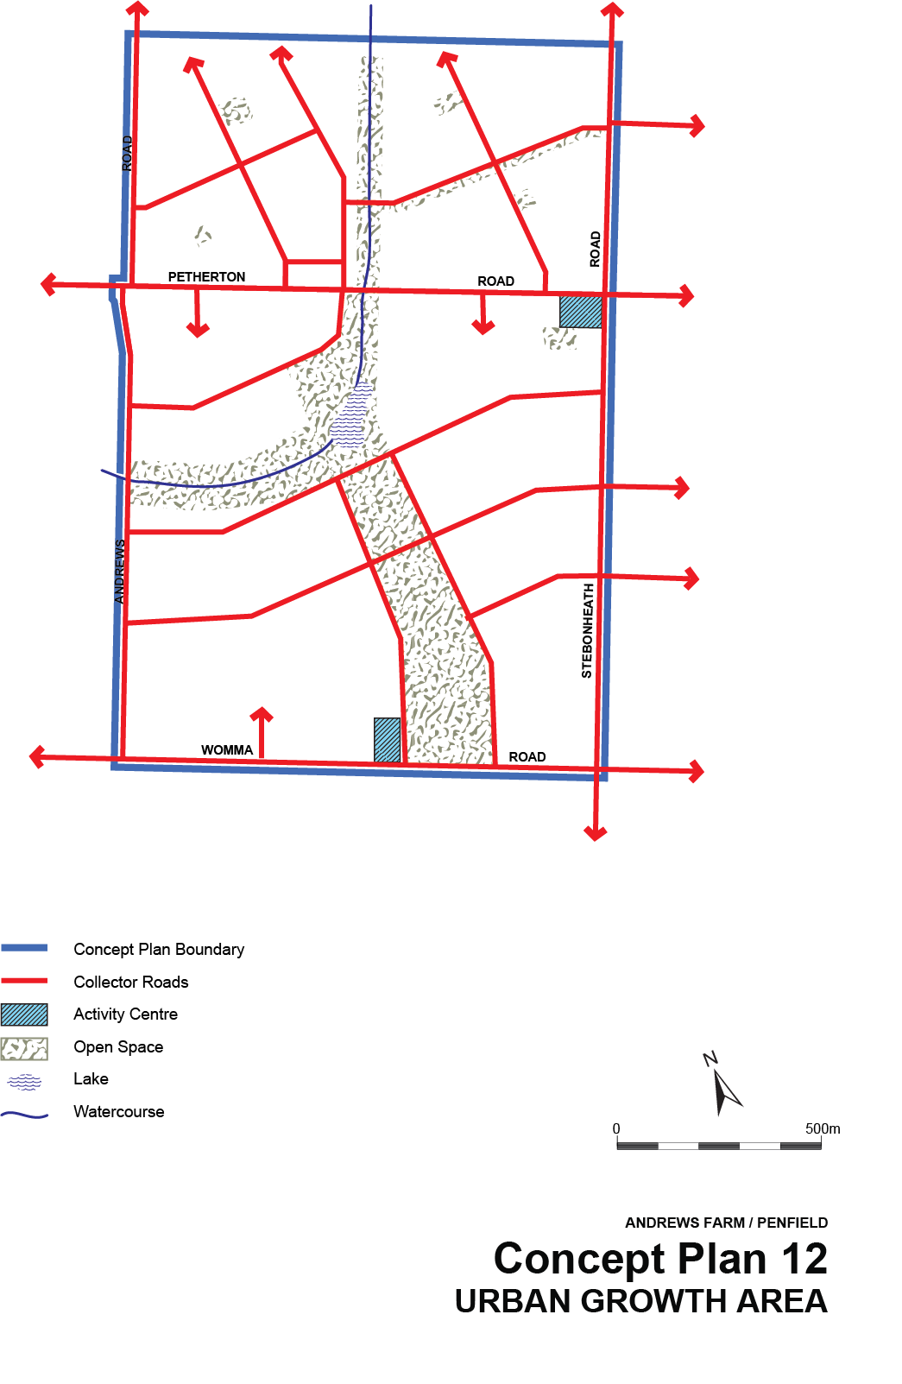
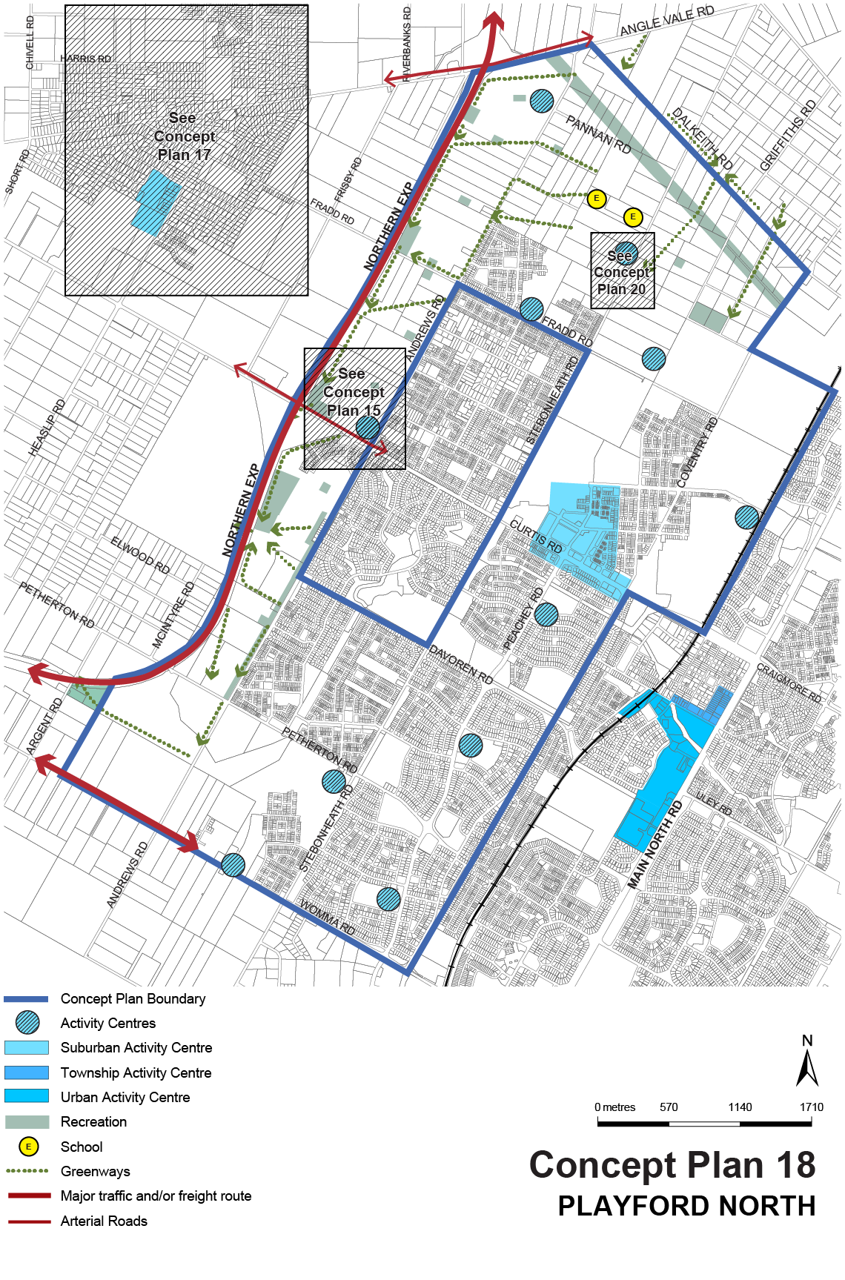
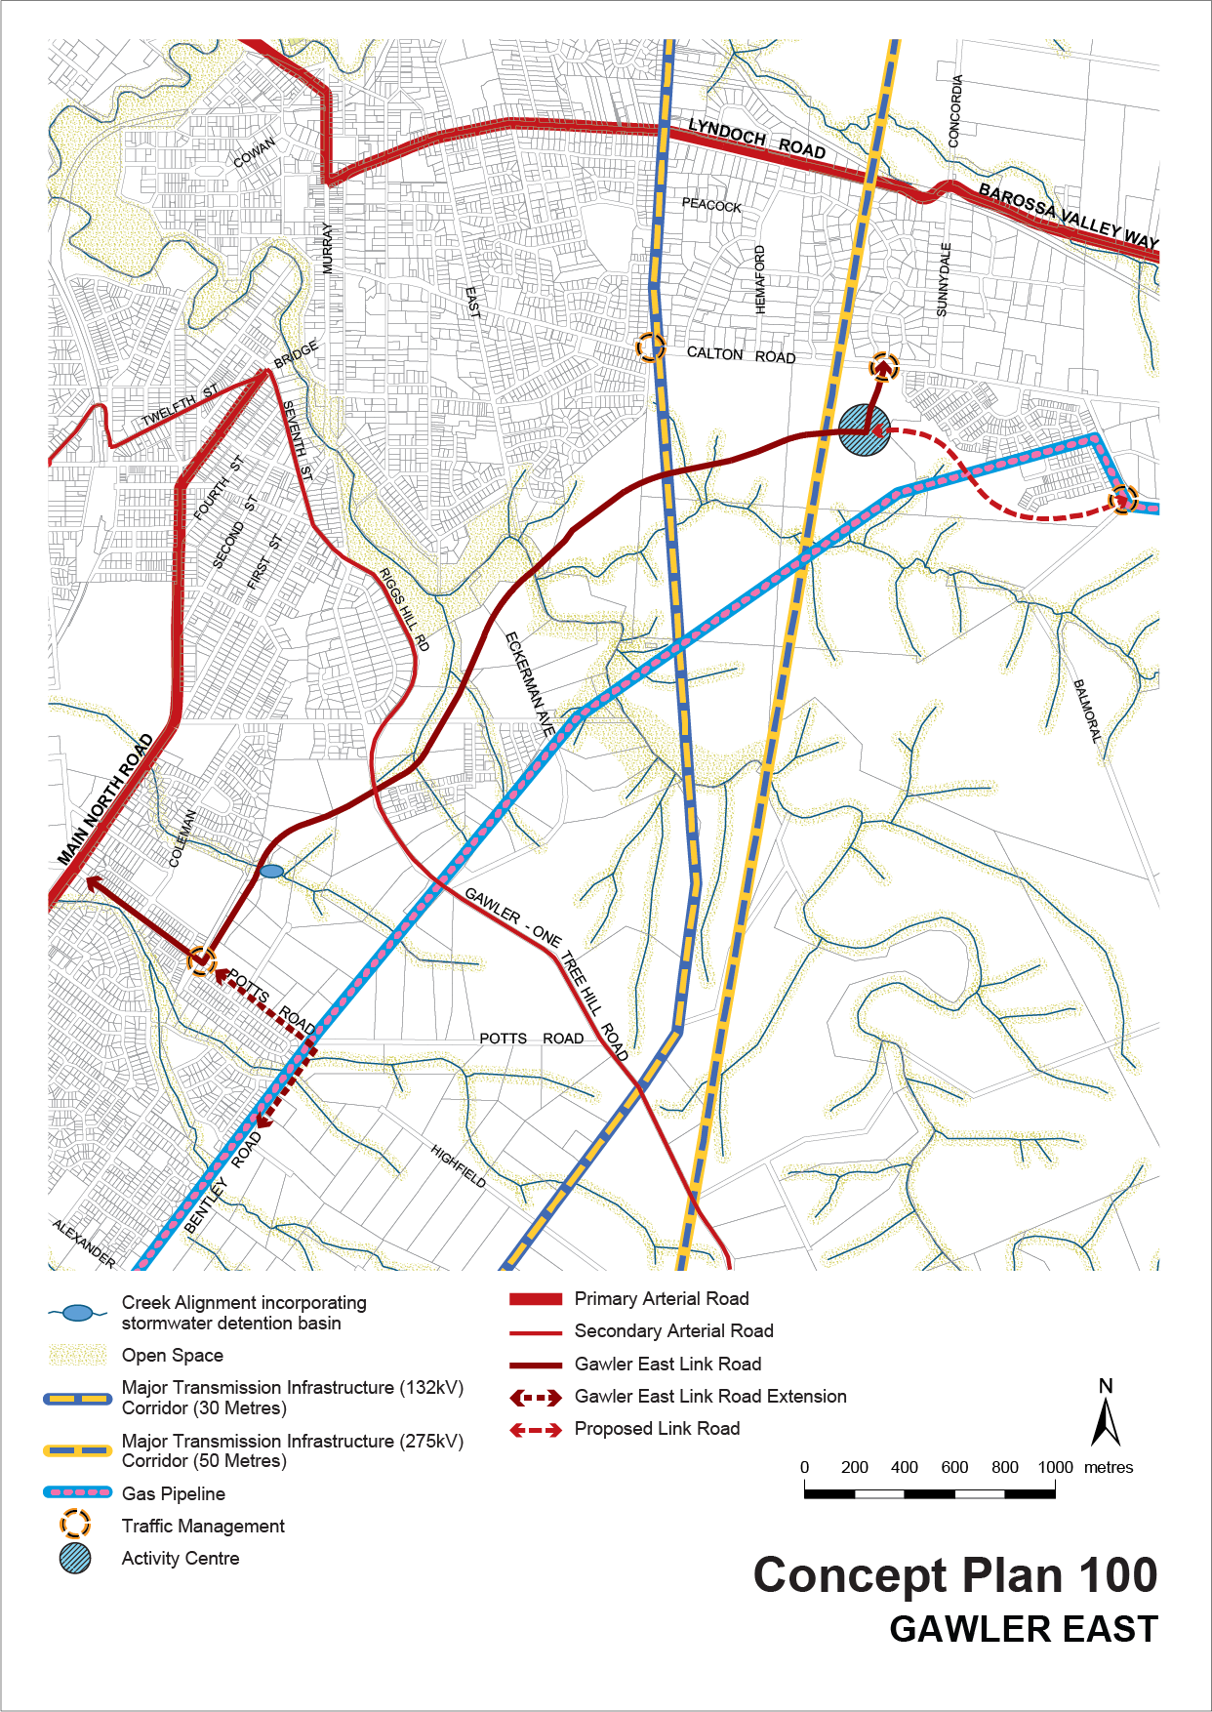

Public Notices

National Electricity Law
Notice of Initiation of Non-Controversial Rule Change
The Australian Energy Market Commission (AEMC) gives notice under the National Electricity Law as follows:
Under s 95, Energy Networks Australia (ENA) has requested the Recovering the cost of AEMO’s participant fees (Ref. ERC0335) proposal. The proposal seeks to allow TNSPs to recover the costs of AEMO’s new participant fees more directly. The AEMC intends to expedite the proposal under s 96 as it considers the proposed Rule is non-controversial, subject to requests not to do so. Written requests not to expedite the proposal must be received by 12 May 2022. Submissions for the request must be received by 26 May 2022.
Submissions can be made via the AEMC’s website. Before making a submission, please review the AEMC’s privacy statement on its website. Submissions should be made in accordance with the AEMC’s Guidelines for making written submissions on Rule change proposals. The AEMC publishes all submissions on its website, subject to confidentiality.
Written requests should be sent to submissions@aemc.gov.au and cite the reference in the title. Before sending a request, please review the AEMC’s privacy statement on its website.
Documents referred to above are available on the AEMC’s website and are available for inspection at the AEMC’s office.
Australian Energy Market Commission
Level 15, 60 Castlereagh St
Sydney NSW 2000
Telephone: (02) 8296 7800
www.aemc.gov.au
Dated: 28 April 2022

National Energy Retail Law
Notice of Extension for Draft Determination
The Australian Energy Market Commission (AEMC) gives notice under the National Energy Retail Law as follows:
Under s 266, the time for making the draft determination on the Protecting customers affected by family violence (Ref. RRC0042) proposal has been extended to 16 June 2022.
Documents referred to above are available on the AEMC’s website and are available for inspection at the AEMC’s office.
Australian Energy Market Commission
Level 15, 60 Castlereagh St
Sydney NSW 2000
Telephone: (02) 8296 7800
www.aemc.gov.au
Dated: 28 April 2022

Partnership Act 1891 (SA)
Notice of Dissolution of Partnership
Notice is hereby given that the partnership 'C.J. & N.L Schultz' ABN 93 102 320 792, the business of which traded in part under the name 'Nature's Chicken', was dissolved effective 21 April 2022.
Dated: 21 April 2022
Nadine Schultz
Partner
C.J. & N.L Schultz

Trustee Act 1936
Public Trustee
Estates of Deceased Persons
In the matter of the estates of the undermentioned deceased persons:
COOK Barbara June late of 8 Elmgrove Road Salisbury North of no occupation who died 05 February 2022
DODGSON Ruby Margaret late of 46 Burley Griffin Boulevard Brompton Retired Cleaner who died 30 December 2021
FRAZER Margaret Jeanette late of 421 The Parade Kensington Gardens Retired Company Director who died 10 July 2020
GREEN Edna May late of 15-29 Homestead Avenue Walkley Heights of no occupation who died 27 September 2021
HALL Lenard Louis late of 10 Mankina Grove Morphett Vale of no occupation who died 10 January 2022
LINDSAY Kenneth Samuel Rennie late of 147 Frost Road Salisbury South of no occupation who died 01 May 2020
PHILP Shirley Lorraine late of 38 Davenport Terrace Seacliff Park of no occupation who died 28 December 2021
POYNTER Kay late of 17 Rockville Avenue Daw Park of no occupation who died 08 November 2021

Notice is hereby given pursuant to the Trustee Act 1936, the Inheritance (Family Provision) Act 1972 and the Family Relationships Act 1975 that all creditors, beneficiaries, and other persons having claims against the said estates are required to send, in writing, to the office of Public Trustee at GPO Box 1338, Adelaide, 5001, full particulars and proof of such claims, on or before the 27 May 2022 otherwise they will be excluded from the distribution of the said estate; and notice is also hereby given that all persons indebted to the said estates are required to pay the amount of their debts to the Public Trustee or proceedings will be taken for the recovery thereof; and all persons having any property belonging to the said estates are forthwith to deliver same to the Public Trustee.
Dated: 28 April 2022
N. S. Rantanen
Public Trustee

Unclaimed Moneys Act 1891
Copper Coast Council
Register of Unclaimed Moneys held for the years 2014 - 2021
Name of Owner and Last Known Address | Amount Due | Description of Unclaimed Moneys | Date
Unknown | $703.50 | Unallocated BPAY | 3/11/2014
Unknown | $984.05 | Unallocated BPAY | 1/10/2015
Unknown | $200.00 | Unallocated BPAY | 29/09/2016
Unknown | $42.00 | Unallocated BPAY | 23/06/2018
Unknown | $1,185.20 | Unallocated BPAY | 3/07/2018
Unknown | $1,214.65 | Unallocated BPAY | 13/08/2018
Unknown | $240.00 | Unallocated BPAYS - 8 X $30 | 29/2, 14/3, 28/3, 11/4, 25/4, 9/5, 23/5, 6/6
Unknown | $30.00 | Unallocated BPAY | 22/06/2020
Unknown - found under porch outside | $50.00 | Funds handed over counter by customer | 17/08/2020
Unknown | $713.50 | Unallocated BPAY | 24/11/2020
Unknown | $330.00 | Unallocated BPAYS 11 x $30 | 4/7/2020  18/7/2020  1/8/2020  15/8/2020  29/8/2020  12/9/2020  26/9/2020  10/10/2020  24/10/2020  7/11/2020  21/11/2020
Unknown | $30.00 | Unallocated BPAY | 5/12/2020
Unknown | $60.00 | Unalllocated BPAYS 2 x $30 | 19/12/2020  4/1/2021
Unknown | $30.00 | Unallocated BPAY | 16/01/2021
Anthony Michael Thomson, Adelaide SA 5000 | $373.90 | Cancelled Cheque 28255 19/4/21 creditor C7102 less cancellation fee | 20/01/2021
Unknown | $40.00 | Unallocated BPAY | 23/01/2021
Unknown | $30.00 | Unallocated BPAY | 30/01/2021
Unknown | $753.00 | Unalloacted BPAY | 5/02/2021
Unknown | $30.00 | Unalloacted BPAY | 16/02/2021
Unknown | $30.00 | Unalloacted BPAY | 27/02/2021
Unknown | $30.00 | Unalloacted BPAY | 13/03/2021
Unknown | $30.00 | Unalloacted BPAY | 27/03/2021
Celsete Lloyd, Wallaroo Mines SA 5554 | $54.00 | Overpaid Infringement | 30/03/2021
Unknown | $30.00 | Unallocated BPAY | 10/04/2021
Unknown | $30.00 | Unallocated BPAY | 24/04/2021
Unknown | $30.00 | Unallocated BPAY | 8/05/2021
Unknown | $30.00 | Unallocated BPAY | 22/05/2021
Unknown | $351.10 | Unallocated BPAY | 26/05/2021
Unknown | $30.00 | Unallocated BPAY | 5/06/2021
Unknown | $30.00 | Unallocated BPAY | 19/06/2021
Unknown | $30.00 | Unallocated BPAY | 3/07/2021
Unknown | $30.00 | Unallocated BPAY | 17/07/2021
Unknown | $1,489.70 | Unallocated BPAY | 27/08/2021
Unknown | $30.00 | Unallocated BPAY | 31/07/2021
Unknown | $30.00 | Unallocated BPAY | 14/08/2021
Unknown | $30.00 | Unallocated BPAY | 30/08/2021
Unknown | $30.00 | Unallocated BPAY | 11/09/2021
Unknown | $30.00 | Unallocated BPAY | 25/09/2021
Unknown | $30.00 | Unallocated BPAY | 9/10/2021
Unknown | $30.00 | Unallocated BPAY | 23/10/2021
Unknown | $30.00 | Unallocated BPAY | 6/11/2021
Unknown | $30.00 | Unallocated BPAY | 22/11/2021
Unknown | $30.00 | Unallocated BPAY | 4/12/2021
Unknown | $30.00 | Unallocated BPAY | 18/12/2021

Unclaimed Moneys Act 1891
Thryv Australia Pty Ltd
Register of Unclaimed Moneys held for the year ended 2014
Name | Suburb | State | Postcode | Amount ($) | Description | Date
A1 Fishing Charters | MOONTA | SA | 5558 | $1,446.35 | Credit | 2014
Adam & Eve Express Waxing & Tanning | MOUNT GAMBIER | SA | 5290 | $183.31 | Credit | 2014
Advanced Fencing | ROSEWATER | SA | 5013 | $195.25 | Credit | 2014
Affordable Timber Flooring (SA) Pty Ltd | STRATHALBYN | SA | 5255 | $72.39 | Credit | 2014
Ali Seedman Catering | STIRLING | SA | 5152 | $155.20 | Credit | 2014
Donna G | BURNSIDE | SA | 5066 | $139.49 | Credit | 2014
Be Road Wise! | CHRISTIES BEACH | SA | 5165 | $407.35 | Credit | 2014
Bell's Glass | MODBURY | SA | 5092 | $145.97 | Credit | 2014
Beyond Bank | ADELAIDE | SA | 5000 | $123.20 | Credit | 2014
Boardline All Areas | FLAGSTAFF HILL | SA | 5159 | $126.50 | Credit | 2014
Body Mind & Soul | ADELAIDE | SA | 5000 | $61.11 | Credit | 2014
Bradley Painting | SOMERTON PARK | SA | 5044 | $316.98 | Credit | 2014
Brenda Rolls | GLENELG | SA | 5045 | $233.20 | Credit | 2014
Burnside Dental Practice | HAZELWOOD PARK | SA | 5066 | $141.70 | Credit | 2014
CDS Services | LONSDALE | SA | 5160 | $55.00 | Credit | 2014
Cheryl Dimonte | KENSINGTON | SA | 5068 | $128.70 | Credit | 2014
City Towing Service | ALBERTON | SA | 5014 | $154.00 | Credit | 2014
Class Gardens By Matthew Hill | VICTOR HARBOR | SA | 5211 | $62.13 | Credit | 2014
Comms Complete | SURREY DOWNS | SA | 5126 | $77.41 | Credit | 2014
Contours Face & Body Clinic | NORWOOD | SA | 5067 | $179.82 | Credit | 2014
Conveyancing Corner | PLYMPTON | SA | 5038 | $160.00 | Credit | 2014
Costin Hire & Sales | WILLASTON | SA | 5118 | $487.49 | Credit | 2014
D E Complete Welding Pty Ltd | EDINBURGH NORTH | SA | 5113 | $179.28 | Credit | 2014
DNCR - Normans Locksmiths | REYNELLA | SA | 5161 | $844.80 | Credit | 2014
Donato Steel Fabrications Pty Ltd | GLYNDE | SA | 5070 | $100.24 | Credit | 2014
Dunn Street Medical Centre | NORTH ADELAIDE | SA | 5006 | $328.23 | Credit | 2014
Euro Exploration Services | KENT TOWN | SA | 5067 | $70.79 | Credit | 2014
Freedom Retractable Screens | UNDERDALE | SA | 5032 | $54.18 | Credit | 2014
Glazing & Construction Supplies | RICHMOND | SA | 5033 | $278.03 | Credit | 2014
Hackney; Dental Laboratory | MT BARKER | SA | 5251 | $301.95 | Credit | 2014
Harvey Carpenters for Sheds | PORT LINCOLN | SA | 5606 | $111.18 | Credit | 2014
Housework Heroes | HACKNEY | SA | 5069 | $557.60 | Credit | 2014
JP Mechanical | KILKENNY | SA | 5009 | $174.02 | Credit | 2014
Lincoln Beauty Therapy | PORT LINCOLN | SA | 5606 | $80.30 | Credit | 2014
Luv 2 Scrap | HACKHAM WEST | SA | 5163 | $123.19 | Credit | 2014
Manna Caffe | ADELAIDE | SA | 5000 | $155.71 | Credit | 2014
Michele Demasi Carpentry | ATHELSTONE | SA | 5076 | $69.01 | Credit | 2014
Motivation One | SEATON | SA | 5023 | $64.39 | Credit | 2014
Mpower Solar Systems Pty Ltd | KILBURN | SA | 5084 | $1,009.61 | Credit | 2014
Murano Glass Replacement and Repair Services | GULFVIEW HEIGHTS | SA | 5096 | $466.54 | Credit | 2014
New Elements Pty Ltd | HAWTHORNDENE | SA | 5051 | $211.96 | Credit | 2014
O.S Platinum Tiling | ROSTREVOR | SA | 5073 | $294.50 | Credit | 2014
Panalpina World Transport | BROOKLYN PARK | SA | 5032 | $57.92 | Credit | 2014
Paul Townsend | POORAKA | SA | 5095 | $69.11 | Credit | 2014
Penrice Soda Products Pty Ltd | OSBORNE | SA | 5017 | $1,317.32 | Credit | 2014
Petstock Animal Supplies | MELROSE PARK | SA | 5039 | $128.70 | Credit | 2014
Pinnacle Bakery & Integrated Ingredients | ADELAIDE | SA | 5000 | $70.36 | Credit | 2014
Red Pearl Couture | STEPNEY | SA | 5069 | $287.42 | Credit | 2014
Rural Business Machines Pty Ltd | NARACOORTE | SA | 5271 | $103.95 | Credit | 2014
Sawasdee Thai Restaurant | FIRLE | SA | 5070 | $93.03 | Credit | 2014
Septek Wastewater Systems | STRATHALBYN | SA | 5255 | $176.49 | Credit | 2014
Sinclair Florists | VICTOR HARBOR | SA | 5211 | $54.34 | Credit | 2014
Solid Concrete Constructions | PARAFIELD GARDENS | SA | 5107 | $278.30 | Credit | 2014
Solo Marine & Automotive | INGLE FARM | SA | 5098 | $508.20 | Credit | 2014
South Australian Masters Squash Association Inc. | FULHAM GARDENS | SA | 5024 | $100.01 | Credit | 2014
Southern Fleurieu Home Improvements | GOOLWA | SA | 5214 | $916.52 | Credit | 2014
Spectora Property inspections | WAYVILLE | SA | 5034 | $116.60 | Credit | 2014
Splash Pressure Cleaning | REYNELLA EAST | SA | 5161 | $92.72 | Credit | 2014
Step Into Life S.A | SEATON | SA | 5023 | $137.54 | Credit | 2014
Sunlounge | NORWOOD | SA | 5067 | $146.71 | Credit | 2014
Supscaf Pty Ltd | MARDEN | SA | 5070 | $164.20 | Credit | 2014
The Label Factory (SA) Pty Ltd. | POORAKA | SA | 5095 | $130.00 | Credit | 2014
The Shutter House Pty Ltd | ST MARYS | SA | 5042 | $142.09 | Credit | 2014
Thom The Tiler & Sons Pty Ltd | HEWETT | SA | 5118 | $68.90 | Credit | 2014
Timber; Works Home Improvements | MODBURY HEIGHTS | SA | 5092 | $79.71 | Credit | 2014
Tony Walker Communications | MOONTA BAY | SA | 5558 | $243.42 | Credit | 2014
Valentine's Costumes Plus | EVANSTON PARK | SA | 5116 | $70.88 | Credit | 2014
Vizplus | RICHMOND | SA | 5033 | $221.41 | Credit | 2014
Williams Industrial Insulations | MOUNT GAMBIER | SA | 5290 | $386.91 | Credit | 2014
ZEN Home Energy Systems | NORWOOD | SA | 5067 | $230.58 | Credit | 2014

Unclaimed Moneys Act 1891
Thryv Australia Pty Ltd
Register of Unclaimed Moneys held for the year ended 2015
Name | Suburb | State | Postcode | Amount ($) | Description | Date
A Antique Market | ADELAIDE | SA | 5000 | $179.19 | Credit | 2015
A Better Massage Clinic | ATHELSTONE | SA | 5076 | $27.52 | Credit | 2015
A Fair Dinkum Towing | WINDSOR | SA | 5501 | $23.21 | Credit | 2015
A Hartrodt Wine Trade | REGENCY PARK | SA | 5942 | $179.95 | Credit | 2015
A.A. Plastics Company | NORTH PLYMPTON | SA | 5037 | $23.92 | Credit | 2015
AA Adelaide All Areas TV Services | POORAKA | SA | 5095 | $90.00 | Credit | 2015
AAA Custom Made Hi-Lo Beds & Tilst n Lift Chairs | POORAKA | SA | 5095 | $166.10 | Credit | 2015
AALL Authentic Jaguars | WOODVILLE | SA | 5011 | $346.50 | Credit | 2015
Abba Mechanical Repairs | SOMERTON PARK | SA | 5044 | $115.50 | Credit | 2015
Absolute Dance | HAZELWOOD PARK | SA | 5066 | $106.22 | Credit | 2015
Ace Skylights & Home Improvements | ATHOL PARK | SA | 5012 | $127.25 | Credit | 2015
Adelaide Acupuncture Clinic | ADELAIDE BC | SA | 5000 | $131.00 | Credit | 2015
Adelaide Bobcat & Bins | GOODWOOD | SA | 5034 | $242.00 | Credit | 2015
Adelaide Bobcat Hire | SOMERTON PARK | SA | 5044 | $22.24 | Credit | 2015
Adelaide Budget Computers | FLAGSTAFF HILL | SA | 5159 | $72.42 | Credit | 2015
Adelaide Cake Decorating Centre | RICHMOND | SA | 5033 | $121.20 | Credit | 2015
Adelaide City Fringe Service Apartments & Motel | FREWVILLE | SA | 5063 | $195.65 | Credit | 2015
Adelaide Concreting Specialists | MUNNO PARA WEST | SA | 5115 | $104.33 | Credit | 2015
Adelaide Foot and Ankle Semaphore | SEMAPHORE PARK | SA | 5019 | $22.99 | Credit | 2015
Adelaide Marquees | LARGS BAY | SA | 5016 | $94.16 | Credit | 2015
Adelaide Mind Relaxation | GLENELG | SA | 5045 | $29.26 | Credit | 2015
Adelaide Office Fitouts | PARADISE | SA | 5075 | $50.26 | Credit | 2015
Adelaide Star Removals | EDEN HILLS | SA | 5050 | $230.82 | Credit | 2015
Adelaide W/S Cleaning Supplies | O'HALLORAN HILL | SA | 5158 | $126.60 | Credit | 2015
Adelaide Z Cars | HACKHAM | SA | 5163 | $108.24 | Credit | 2015
ADS Carpet Clean | NOARLUNGA DOWNS | SA | 5168 | $42.76 | Overpayment | 2015
Advanced Concepts | LONSDALE | SA | 5160 | $127.33 | Credit | 2015
Advanced Tilt Tray Towing | ST AGNES | SA | 5097 | $38.68 | Overpayment | 2015
Affordable Ceilings | GOOLWA | SA | 5214 | $347.05 | Credit | 2015
Afiatta Staff Bureau | KENT TOWN DC | SA | 5071 | $22.88 | Credit | 2015
AGIX IT Technology & Services | TORRENS PARK | SA | 5062 | $121.00 | Credit | 2015
Agrichem | CLARE | SA | 5453 | $66.60 | Credit | 2015
AKG Restoration & Motor Repairs | SOMERTON PARK | SA | 5044 | $25.16 | Credit | 2015
Alan Wise Crash Repairs | MURRAY BRIDGE | SA | 5253 | $12.45 | Credit | 2015
Alberts Electrical Service | HALLETT COVE | SA | 5158 | $13.87 | Credit | 2015
All Panels & Parts | LONSDALE | SA | 5160 | $336.60 | Credit | 2015
All Type Catering Equipment | KENT TOWN | SA | 5067 | $57.77 | Credit | 2015
Alpha Security Systems | ALBERTON | SA | 5014 | $219.36 | Credit | 2015
Alphutte Restaurant Pty Ltd | ADELAIDE | SA | 5000 | $131.97 | Credit | 2015
AlS Pizza & Take Away | CHRISTIES BEACH | SA | 5165 | $50.00 | Credit | 2015
AM-PM Chauffeurs | WATERVALE | SA | 5452 | $50.58 | Credit | 2015
Anastasia Bridal Couture | UNLEY | SA | 5061 | $44.11 | Overpayment | 2015
Anastasios (Tus) Sianis | WEST CROYDON | SA | 5008 | $24.83 | Credit | 2015
Angela Ferdinandy | HALIFAX STREET | SA | 5000 | $25.25 | Overpayment | 2015
Anna Gray | SEACLIFF | SA | 5049 | $22.17 | Credit | 2015
Anything Air Conditioning Pty Ltd | ST MORRIS | SA | 5068 | $40.00 | Credit | 2015
Apparel Labels | GLENSIDE | SA | 5065 | $80.64 | Credit | 2015
Aquaduct Plumbing Service | KIDMAN PARK | SA | 5025 | $30.90 | Credit | 2015
Aquatec Pumps Pty Ltd | MEADOWS | SA | 5201 | $11.99 | Credit | 2015
Artistic Framing | ST AGNES | SA | 5097 | $102.20 | Credit | 2015
Ashmore Engineering Pty Ltd | FARRELL FLAT | SA | 5416 | $51.98 | Credit | 2015
Associated Compressor Engineers | ROSEWATER | SA | 5013 | $133.37 | Credit | 2015
Audiomotive Car Audio & Accessorries | WILLUNGA | SA | 5172 | $36.10 | Credit | 2015
Auspine Limited | KALANGADOO | SA | 5278 | $23.29 | Credit | 2015
Australian Classic Homes | NORWOOD | SA | 5067 | $308.17 | Overpayment | 2015
Australian Institute for Loss & Grief | ETHELTON | SA | 5015 | $17.05 | Credit | 2015
Auto Carburettor Services | MARION | SA | 5043 | $26.37 | Overpayment | 2015
B & T Smith Bros. | MT GAMBIER | SA | 5290 | $23.32 | Overpayment | 2015
Balloons Galore | COLLEGE PARK | SA | 5069 | $57.63 | Credit | 2015
Bark Busters | WOODCROFT | SA | 5162 | $56.55 | Credit | 2015
Barry Perkins Motors | LONSDALE | SA | 5160 | $100.32 | Credit | 2015
BeFit Hire & Sales. | MELROSE PARK | SA | 5039 | $316.71 | Credit | 2015
Better Relationships Counselling Services | WARRADALE | SA | 5046 | $21.80 | Credit | 2015
Beyond Bank Australia | ADELAIDE | SA | 5000 | $489.17 | Credit | 2015
Bobcat Tipper & Auger Hire | MURRAY BRIDGE | SA | 5253 | $220.00 | Credit | 2015
Body & Sole Beauty Care | MORPHETT VALE | SA | 5162 | $23.35 | Credit | 2015
Bondy Home & Garden | NOARLUNGA DOWNS | SA | 5168 | $14.58 | Credit | 2015
Bonnie Wigs | ADELAIDE | SA | 5000 | $63.25 | Credit | 2015
Boo & Child | STIRLING | SA | 5152 | $22.40 | Credit | 2015
Boral Concrete | HINDMARSH | SA | 5007 | $930.38 | Credit | 2015
Bozco Pty Ltd | PORT LINCOLN | SA | 5606 | $79.20 | Credit | 2015
BP Entertainment | NOARLUNGA DOWNS | SA | 5168 | $149.60 | Credit | 2015
Brunelli | FELIXSTOW | SA | 5070 | $33.00 | Overpayment | 2015
BSS Light Audio Visual | FLINDERS PARK | SA | 5025 | $88.44 | Credit | 2015
Buik Motor Works | ADELAIDE | SA | 5000 | $49.26 | Credit | 2015
C.B.D. Maintenance Services Pty Ltd | TORRENSVILLE | SA | 5031 | $172.52 | Overpayment | 2015
Cadbury Schweppes | PAYNEHAM | SA | 5070 | $1,076.00 | Credit | 2015
Caffe Acqua | ELIZABETH | SA | 5112 | $23.12 | Credit | 2015
Caff'e Belgiorno & Tapas Bar | MT GAMBIER | SA | 5290 | $46.20 | Overpayment | 2015
Call It Stumps | WARRADALE | SA | 5046 | $49.50 | Credit | 2015
Caron Milham & Associates Pty Ltd | BLACKWOOD | SA | 5051 | $136.87 | Credit | 2015
Cayley Carol Dr | BLACKWOOD | SA | 5051 | $108.32 | Credit | 2015
Celestine's Mobile Bookkeeping | PORT LINCOLN | SA | 5606 | $229.39 | Credit | 2015
Cellular One | WHYALLA JENKINS | SA | 5609 | $156.80 | Credit | 2015
Chaircovers Over All | NORWOOD | SA | 5067 | $55.00 | Credit | 2015
City - Bay Fun Run | ADELAIDE | SA | 5000 | $22.74 | Credit | 2015
City Pearl Chinese Restaurant | WHYALLA NORRIE | SA | 5608 | $35.32 | Credit | 2015
CJ's Scrap Metal & car Body Removalists | PARALOWIE | SA | 5108 | $305.36 | Credit | 2015
Cleanhall Services | ERINDALE | SA | 5066 | $612.70 | Overpayment | 2015
Collins Greg | SOLOMONTOWN | SA | 5540 | $29.48 | Credit | 2015
Compton Refrigeration | MOUNT GAMBIER WEST | SA | 5291 | $57.20 | Credit | 2015
Computer Furniture Industries Pty Ltd | NORTH PLYMPTON | SA | 5037 | $319.35 | Credit | 2015
Cool It Mobile Cool Room Hire | HAWTHORNDENE | SA | 5051 | $22.22 | Credit | 2015
Copia Business Machines Pty Ltd | ADELAIDE | SA | 5000 | $184.88 | Credit | 2015
Corston Coaches | TWO WELLS | SA | 5501 | $88.07 | Credit | 2015
CVIZ | NORTH ADELAIDE | SA | 5006 | $80.91 | Credit | 2015
Dale Wood Business Sales Consultancy | KENT TOWN | SA | 5067 | $18.70 | Credit | 2015
Dale Woods Business Brokers P/L | KENT TOWN | SA | 5067 | $126.50 | Credit | 2015
Daryle Forbes Maintenance | BLYTH | SA | 5462 | $27.17 | Credit | 2015
Diamondback Roofing | VALE PARK | SA | 5081 | $101.34 | Credit | 2015
Disability Advocacy & Complaint Service | PLYMPTON PARK | SA | 5038 | $983.40 | Credit | 2015
DKM Electrical and Civil | PLYMPTON | SA | 5038 | $30.80 | Credit | 2015
Dr Peter E Runge | GREENACRES | SA | 5086 | $45.81 | Credit | 2015
Dr Quynh Nguyen | MITCHELL PARK | SA | 5043 | $752.51 | Credit | 2015
Driver Assessment Rehabilitation Service | ADELAIDE | SA | 5000 | $140.85 | Credit | 2015
Dun-Yesti Professional Painting & Roof Restoration | MT GAMBIER | SA | 5290 | $171.61 | Credit | 2015
DVD Transfer | ADELAIDE | SA | 5000 | $52.49 | Credit | 2015
Easy AV | WELLAND | SA | 5007 | $265.93 | Credit | 2015
Eclipse Opening Roof | WEST LAKES | SA | 5021 | $357.50 | Credit | 2015
Eco Building Services | INGLE FARM | SA | 5098 | $634.00 | Overpayment | 2015
Erotic Desires | OTTOWAY | SA | 5013 | $90.02 | Credit | 2015
Executive Flowers & Gifts | ADELAIDE | SA | 5000 | $114.73 | Overpayment | 2015
Fantasia Costume Hire | SOMERTON PARK | SA | 5044 | $39.49 | Credit | 2015
Fentons Farm Machinery | GAWLER | SA | 5118 | $203.84 | Credit | 2015
First Choice Resoration & Cleaning | REGENCY PARK | SA | 5942 | $24.06 | Credit | 2015
Floors Adelaide | CHELTENHAM | SA | 5014 | $640.91 | Credit | 2015
For Weddings & A Formal | SALISBURY HEIGHTS | SA | 5109 | $73.70 | Credit | 2015
Foreign Elegance | HYDE PARK | SA | 5061 | $435.00 | Credit | 2015
Francesco's Function Centre | MURRAY BRIDGE | SA | 5253 | $326.70 | Credit | 2015
Fyfe Pty Ltd | ADELAIDE | SA | 5000 | $433.50 | Overpayment | 2015
Gardenchic | MT GAMBIER | SA | 5290 | $78.64 | Credit | 2015
Goyns Rowan John | CRAIGMORE | SA | 5114 | $178.50 | Credit | 2015
Grand Tasman Hotel | PORT LINCOLN | SA | 5606 | $268.42 | Credit | 2015
Haines Medical Australia | SOMERTON PARK | SA | 5044 | $92.40 | Credit | 2015
Hebbard J.H Pty Ltd | NORTH PLYMPTON | SA | 5037 | $227.71 | Credit | 2015
Heritage Marika | BRIGHTON | SA | 5048 | $43.33 | Credit | 2015
High Street Butchery | BURNSIDE | SA | 5066 | $14.93 | Credit | 2015
Hoad Water Cartage Pty Ltd | URAIDLA | SA | 5142 | $44.82 | Credit | 2015
Holstens Pty Ltd | HINDMARSH | SA | 5007 | $101.93 | Credit | 2015
How Sweet It Is | ADELAIDE | SA | 5000 | $20.00 | Credit | 2015
Ian Warren Funerals | REDWOOD PARK | SA | 5097 | $858.90 | Credit | 2015
Innovative Body & Skin Rejuvenating Solutions | EVANDALE | SA | 5069 | $175.65 | Credit | 2015
Insight Lighting Solutions Pty Ltd | KENT TOWN | SA | 5067 | $75.79 | Credit | 2015
Itchy Toe | GLANDORE | SA | 5037 | $330.50 | Credit | 2015
Jacqui Richards | PARK HOLME | SA | 5043 | $77.00 | Credit | 2015
Janome Westside Sewing Centre | WOODVILLE WEST | SA | 5011 | $77.71 | Credit | 2015
Jeff Fausch | HACKHAM WEST | SA | 5163 | $21.60 | Credit | 2015
Jigsaw Publications | TORRENSVILLE PLAZA | SA | 5031 | $20.13 | Credit | 2015
Joan Chataway | BRIDGEWATER | SA | 5155 | $21.07 | Credit | 2015
John Akker School Of Motoring | PORT PIRIE | SA | 5540 | $45.22 | Credit | 2015
Jubilee Car Detailing | MT GAMBIER | SA | 5290 | $40.29 | Credit | 2015
Kapunda Print | KAPUNDA | SA | 5373 | $48.40 | Credit | 2015
Kerr Family Chiropractic Centre | MODBURY | SA | 5092 | $156.73 | Credit | 2015
Kevin J Smith | MORPHETT VALE | SA | 5162 | $278.55 | Credit | 2015
Kevin Kenny Tyres | GREENACRES | SA | 5086 | $26.61 | Overpayment | 2015
Kilkenny meats | KILKENNY | SA | 5009 | $90.66 | Credit | 2015
Kitmart Australia Pty Ltd | PARAFIELD GARDENS | SA | 5107 | $29.41 | Credit | 2015
Lamond Landscaping & Horticultural Services | PASADENA | SA | 5042 | $34.77 | Credit | 2015
Lash Out | PARALOWIE | SA | 5108 | $343.20 | Credit | 2015
Lawrie Commercial Diving | ALBERTON | SA | 5014 | $274.98 | Credit | 2015
Limestone Coast Combined Therapies | MOUNT GAMBIER | SA | 5290 | $40.70 | Credit | 2015
Limestone Coast Periodontics | MOUNT GAMBIER | SA | 5290 | $34.53 | Credit | 2015
Lloyd Walker Contract Painter | GOOLWA BEACH | SA | 5214 | $327.30 | Credit | 2015
Logi Pro Group Pty Ltd- Rx Medtech Medwin (SA) | BRIGHTON | SA | 5048 | $118.25 | Credit | 2015
Lord Of The Dings | EDINBURGH NORTH | SA | 5113 | $35.20 | Credit | 2015
LPI Render | NAILSWORTH | SA | 5083 | $159.12 | Credit | 2015
Luay's Refridgeration | WINDSOR GARDENS | SA | 5087 | $59.80 | Credit | 2015
Lucivero Plumbing Pty Ltd | PORT PIRIE SOUTH | SA | 5540 | $23.02 | Credit | 2015
M. G. Earthmoving | PORT AUGUSTA WEST | SA | 5700 | $26.64 | Credit | 2015
M.G. (Emgee) Sales & Service | RIDLEYTON | SA | 5008 | $85.76 | Credit | 2015
Maesbury Plumbers Pty Ltd | RICHMOND | SA | 5033 | $256.75 | Credit | 2015
Main North Automatics & Driveline Pty Ltd | BLAIR ATHOL | SA | 5084 | $133.00 | Credit | 2015
Manacon Tanks | SALISBURY PLAIN | SA | 5109 | $96.20 | Credit | 2015
Master Class Carpet Cleaning | ST MARYS | SA | 5042 | $120.58 | Credit | 2015
Mattmans kitchen and bathroom resurfacing | CRAIGMORE | SA | 5114 | $41.96 | Credit | 2015
Mattsson & Martyn | MARDEN | SA | 5070 | $107.80 | Overpayment | 2015
Meningie Marine Supplies | MENINGIE | SA | 5264 | $65.18 | Credit | 2015
Miller Cycle Garage | PORT AUGUSTA | SA | 5700 | $16.94 | Credit | 2015
Monetarium | ADELAIDE | SA | 5000 | $238.58 | Credit | 2015
Mr Lawn Genie | VALLEY VIEW | SA | 5093 | $21.31 | Credit | 2015
Murray Bridge Glass | MURRAY BRIDGE | SA | 5253 | $75.50 | Credit | 2015
Mypolonga Traders Pty Ltd | MYPOLONGA | SA | 5254 | $53.42 | Credit | 2015
Naracoorte Caves National Park | NARACOORTE | SA | 5271 | $31.68 | Credit | 2015
New Log Homes | CHERRY GARDENS | SA | 5157 | $88.00 | Credit | 2015
New To You | HYDE PARK | SA | 5061 | $99.97 | Credit | 2015
Nichol Brothers Plastering | PORT NOARLUNGA SOUTH | SA | 5167 | $163.72 | Credit | 2015
No-Fuss Rentals | ONE TREE HILL | SA | 5114 | $100.00 | Credit | 2015
North East Car Security Services | REDWOOD PARK | SA | 5097 | $424.60 | Credit | 2015
North Terrace Optometrists | ADELAIDE | SA | 5000 | $26.54 | Credit | 2015
Northern Conveyors | SURREY DOWNS | SA | 5126 | $1,038.40 | Credit | 2015
Not-For-Profit Accounting Specialists | HIGHGATE | SA | 5063 | $99.00 | Credit | 2015
On2DVD | BRIGHTON | SA | 5048 | $168.00 | Credit | 2015
Party Time Party Supplies & Hire Pty Ltd | WOODVILLE SOUTH | SA | 5011 | $714.56 | Credit | 2015
Penola Hardware | PENOLA | SA | 5277 | $68.35 | Credit | 2015
Peterborough's Railway Hotel Motel | PETERBOROUGH | SA | 5422 | $107.09 | Credit | 2015
Peter's 50's & 60's DJ Service | ALLENBY GARDENS | SA | 5009 | $82.45 | Credit | 2015
Phoenix Society Incorporated | MARLESTON | SA | 5033 | $219.53 | Credit | 2015
Physiologic Physiotherapy Service | NOARLUNGA CENTRE | SA | 5168 | $154.00 | Credit | 2015
Portside Swim & Leisure Centre | LARGS BAY | SA | 5016 | $97.69 | Credit | 2015
Precision Homes (Australia) Pty Ltd | HACKNEY | SA | 5069 | $23.76 | Credit | 2015
Presley Limousines Rentals | PLYMPTON | SA | 5038 | $30.09 | Credit | 2015
Professionals Salisbury & Playford | SALISBURY | SA | 5108 | $119.86 | Overpayment | 2015
Property Investment Educator | SOUTH PLYMPTON | SA | 5038 | $65.31 | Credit | 2015
qemedicalimaging | WOODVILLE SOUTH | SA | 5011 | $40.59 | Credit | 2015
Raw Health Distributors Pty Ltd | GLEN OSMOND | SA | 5064 | $85.76 | Credit | 2015
Reynolds Electrical Service | KLEMZIG | SA | 5087 | $228.80 | Credit | 2015
Rite Price Heating & Cooling | POORAKA | SA | 5095 | $815.24 | Overpayment | 2015
Rocla Quarry Products | ROSEWATER EAST | SA | 5013 | $84.34 | Credit | 2015
SA Suburban Electrical PTY LTD | WEST CROYDON | SA | 5008 | $77.88 | Credit | 2015
Saasii Fashions | WELLAND | SA | 5007 | $136.00 | Credit | 2015
Sabatino Builders Pty Ltd | PARKSIDE | SA | 5063 | $131.60 | Overpayment | 2015
Saigon Food Product SA PTY LTD | POORAKA | SA | 5095 | $156.60 | Credit | 2015
Simon Alexander | ADELAIDE | SA | 5000 | $48.39 | Credit | 2015
SKIPPERS AVIATION PTY LTD | SUBIACO | SA | 6008 | $80.79 | Credit | 2015
Sorelle Restaurant | MAGILL | SA | 5072 | $106.62 | Credit | 2015
South East Tinting | MOUNT GAMBIER | SA | 5290 | $59.57 | Credit | 2015
Southern Automotive Specialist | HINDMARSH | SA | 5007 | $41.20 | Overpayment | 2015
Southern Cross Horticultural | SEAFORD | SA | 5169 | $73.70 | Credit | 2015
Specialised Sanitary Services Pty Ltd | THEBARTON | SA | 5031 | $236.50 | Credit | 2015
Speedie Parcel Delivery | NANGWARRY | SA | 5277 | $30.14 | Credit | 2015
Splodge | FLAGSTAFF HILL | SA | 5159 | $99.18 | Credit | 2015
Stacey Hales Window Cleaning Services | MOUNT GAMBIER | SA | 5290 | $213.67 | Credit | 2015
Static Engineering Pty Ltd | ELIZABETH VALE | SA | 5112 | $158.40 | Credit | 2015
Steve Rylands Painting & Decorating | SEACOMBE HEIGHTS | SA | 5047 | $53.44 | Credit | 2015
Stonehenge Garden Products | SEAFORD MEADOWS | SA | 5169 | $59.73 | Credit | 2015
Stoneideas | PARKSIDE | SA | 5063 | $48.19 | Credit | 2015
Stratco (S.A.) Pty Ltd | GEPPS CROSS | SA | 5094 | $2,017.70 | Credit | 2015
Streamline Cartons Pty Ltd | CAVAN | SA | 5094 | $34.84 | Credit | 2015
Studio 207 | BROOKLYN PARK | SA | 5032 | $289.42 | Credit | 2015
Summit Security | SALISBURY DOWNS | SA | 5108 | $103.44 | Credit | 2015
SunSafe Skin Cancer & Cosmetic Clinic | HUNTFIELD HEIGHTS | SA | 5163 | $244.67 | Credit | 2015
Switched On | VICTOR HARBOR | SA | 5211 | $119.13 | Credit | 2015
T.M. Electrical Pty Ltd | REYNELLA | SA | 5161 | $58.86 | Credit | 2015
Tasty Treat Bakery | MANSFIELD PARK | SA | 5012 | $187.45 | Credit | 2015
The Chair Doctor (S.A.) Pty Ltd | WINGFIELD | SA | 5013 | $190.60 | Credit | 2015
The Dancers Studio | PROSPECT EAST | SA | 5082 | $58.30 | Credit | 2015
The Flower Wagon | GAWLER | SA | 5118 | $75.00 | Credit | 2015
The Head Crew | ADELAIDE | SA | 5000 | $66.30 | Credit | 2015
The House & Christian Church | MITCHELL PARK | SA | 5043 | $83.10 | Credit | 2015
The Mortgage Mob | SALISBURY | SA | 5108 | $189.20 | Credit | 2015
The Portolesi Group of Companies | HINDMARSH | SA | 5007 | $27.86 | Credit | 2015
The Radiator Warehouse | MELROSE PARK | SA | 5039 | $55.76 | Credit | 2015
Tomeo and Laslett Pharmacy Group | ALBERTON | SA | 5014 | $506.00 | Overpayment | 2015
Traditional Brick Ovens | MAGILL | SA | 5072 | $1,011.93 | Credit | 2015
Transport Training Centre Inc | KILBURN | SA | 5084 | $260.70 | Credit | 2015
TYGER SKIPS PTY LTD | MORPHETT VALE | SA | 5162 | $39.99 | Credit | 2015
Ulonga Lodge | AMERICAN RIVER | SA | 5221 | $22.11 | Credit | 2015
Unique Skin & Body Clinic | CAMPBELLTOWN | SA | 5074 | $260.00 | Credit | 2015
Unitrans S.A. Student Accommodation | OAKDEN | SA | 5086 | $96.00 | Credit | 2015
Vic's Party Hire | RICHMOND | SA | 5033 | $326.70 | Credit | 2015
Visayan Traders | WILLASTON | SA | 5118 | $94.60 | Credit | 2015
Wallala Fabrics | STREAKY BAY | SA | 5680 | $122.11 | Credit | 2015
Waterfield Painting & Decorating | PROSPECT | SA | 5082 | $27.68 | Credit | 2015
Weather Shade Blinds | LONSDALE | SA | 5160 | $30.66 | Credit | 2015
Westside Painting & Decorating | PORT ADELAIDE DC | SA | 5015 | $21.38 | Credit | 2015
Wild Saffron | CLARE | SA | 5453 | $29.71 | Credit | 2015
Yellow Cabs SA | ADELAIDE | SA | 5000 | $1,936.05 | Credit | 2015

Notice Submission

The South Australian Government Gazette is published each Thursday afternoon.
Notices must be emailed by 4 p.m. Tuesday, the week of publication.
Submissions are formatted per the gazette style and a proof will be supplied prior to publication, along with a quote if applicable. Please allow one day for processing notices.
Alterations to the proof must be returned by 4 p.m. Wednesday.

Gazette notices must be submitted as Word files, in the following format:
• Title—the governing legislation
• Subtitle—a summary of the notice content
• Body—structured text, which can include numbered lists, tables, and images
• Date—day, month, and year of authorisation
• Signature block—name, role, and department/organisation authorising the notice

Please provide the following information in your email:
• Date of intended publication
• Contact details of the person responsible for the notice content
• Name and organisation to be charged for the publication—Local Council and Public notices only
• Purchase order, if required—Local Council and Public notices only

Email: governmentgazettesa@sa.gov.au
Phone: (08) 7109 7760
Website: www.governmentgazette.sa.gov.au

All instruments appearing in this gazette are to be considered official, and obeyed as such

Printed and published weekly by authority of S. Smith, Government Printer, South Australia
$8.00 per issue (plus postage), $402.00 per annual subscription—GST inclusive
Online publications: www.governmentgazette.sa.gov.au

