No. 55 p. 2487
THE SOUTH AUSTRALIAN
GOVERNMENT GAZETTE
Published by Authority

Adelaide, Thursday, 11 August 2022

Contents

Governor’s Instruments

Appointments 2488

Proclamations—
Return to Work (Scheme Sustainability) Amendment
Act (Commencement) Proclamation 2022 2489
Voluntary Assisted Dying Act (Commencement) Proclamation 2022 2489
Administrative Arrangements (Administration of
Voluntary Assisted Dying Act) Proclamation 2022 2490
Return to Work (Scheme Sustainability) (Designated
and Relevant Days and Periods) Proclamation 2022 2490

Regulations—
Legislative Instruments (Postponement of Expiry) Regulations 2022—No. 59 of 2022 2492
Child Sex Offenders Registration Regulations 2022—
No. 60 of 2022 2496
Fair Work (Clothing Outworker Code of Practice) Regulations 2022—No. 61 of 2022 2503
Return to Work (Prescribed Limits) Amendment Regulations 2022—No. 62 of 2022 2531

State Government Instruments

Building Work Contractors Act 1995 2533

Child Sex Offenders Registration Act 2006 2534

Fisheries Management Act 2007 2534

Housing Improvement Act 2016 2535

Justices of the Peace Act 2005 2536

Land Acquisition Act 1969 2536

Landscape South Australia Act 2019 2538

Liquor Licensing Act 1997 2539

Major Events Act 2013 2544

Mental Health Act 2009 2546

Petroleum and Geothermal Energy Act 2000 2546

Roads (Opening and Closing) Act 1991 2546

South Australian Local Government Grants
Commission Act 1992 2547

South Australian Skills Act 2008 2547

Local Government Instruments

City of Onkaparinga 2549

City of Unley 2549

Corporation of the Town of Walkerville 2549

Local Government Act 1999 2550

Public Notices

Trustee Act 1936 2558

Unclaimed Moneys Act 1981 2558

Governor’s Instruments

Appointments
Department of the Premier and Cabinet
Adelaide, 11 August 2022
Her Excellency the Governor in Executive Council has been pleased to appoint the undermentioned to the Radiation Protection Committee, pursuant to the provisions of the Radiation Protection and Control Act 1982:
Member: from 21 August 2022 until 9 February 2023
Tony Circelli
Sarah Christine Constantine
Costas Kapsis
Graeme Robert Palmer
Nigel Antony Spooner
Eva Bezak
Wilson Vallat
Peter James Hondros
Pamela Joy Sykes
Bettina Venner
Deputy Member: from 21 August 2022 until 9 February 2023
Keith Baldry (Deputy to Circelli)
Michelle Jayne Nottage (Deputy to Constantine)
Judith Mary Pollard (Deputy to Spooner)
Kathryn Heather Liedig-Levingstone (Deputy to Bezak)
Ian David Kirkwood (Deputy to Vallat)
Michael Trent Lardelli (Deputy to Sykes)
Michelle Waters (Deputy to Venner)
Presiding Member: from 21 August 2022 until 9 February 2023
Tony Circelli
By command,
Peter Bryden Malinauskas
Premier
CAB22/00030

Department of the Premier and Cabinet
Adelaide, 11 August 2022
Her Excellency the Governor in Executive Council has been pleased to appoint the undermentioned to the State Bushfire Coordination Committee, pursuant to the provisions of the Fire and Emergency Services Act 2005:
Member: from 11 August 2022 until 13 November 2023
Ivan-Tiwu Peter Copley
Stuart Vaughan McLean
Deputy Member: from 11 August 2022 until 13 November 2023
John De Candia (Deputy to McLean)
Colin James Lindsay (Deputy to Button)
Alison Jayne May (Deputy to Loughlin)
By command,
Peter Bryden Malinauskas
Premier
22MES0001CS

Department of the Premier and Cabinet
Adelaide, 11 August 2022
Her Excellency the Governor in Executive Council has been pleased to appoint the Honourable Chief Justice Christopher John Kourakis as Governor’s Deputy of South Australia for the period from 4.30pm on Friday, 12 August 2022 until 8.30pm on Sunday, 14 August 2022.
By command,
Peter Bryden Malinauskas
Premier

Department of the Premier and Cabinet
Adelaide, 11 August 2022
Her Excellency the Governor in Executive Council has been pleased to appoint the Honourable Susan Elizabeth Close, MP, Deputy Premier, Minister for Industry, Innovation and Science, Minister for Defence and Space Industries and Minister for Climate, Environment and Water to be Acting Minister for Tourism and Acting Minister for Multicultural Affairs from 14 August 2022 until 20 August 2022 inclusive, during the absence of the Honourable Zoe Lee Bettison, MP.
By command,
Peter Bryden Malinauskas
Premier
MTOU22-003CS

Proclamations
South Australia

Return to Work (Scheme Sustainability) Amendment Act (Commencement) Proclamation 2022
1—Short title
This proclamation may be cited as the Return to Work (Scheme Sustainability) Amendment Act (Commencement) Proclamation 2022.
2—Commencement of suspended provisions
The remaining provisions of the Return to Work (Scheme Sustainability) Amendment Act 2022 (No 4 of 2022) come into operation on 11 August 2022.
Made by the Governor
with the advice and consent of the Executive Council
on 11 August 2022

South Australia

Voluntary Assisted Dying Act (Commencement) Proclamation 2022
1—Short title
This proclamation may be cited as the Voluntary Assisted Dying Act (Commencement) Proclamation 2022.
2—Commencement of Act
(1) Subject to subclause (2), the Voluntary Assisted Dying Act 2021 (No 29 of 2021) comes into operation on 1 September 2022.
(2) The following provisions of the Act come into operation on 31 January 2023:
(a) sections 4 to 106 (inclusive);
(b) section 110(1) to (6) (inclusive);
(c) section 111;
(d) sections 113 to 130 (inclusive);
(e) Schedule 1.
Made by the Governor
with the advice and consent of the Executive Council
on 11 August 2022

South Australia

Administrative Arrangements (Administration of Voluntary Assisted Dying Act) Proclamation 2022
under section 5 of the Administrative Arrangements Act 1994
1—Short title
This proclamation may be cited as the Administrative Arrangements (Administration of Voluntary Assisted Dying Act) Proclamation 2022.
2—Commencement
This proclamation comes into operation on the day on which it is made.
3—Administration of Act committed to Minister for Health and Wellbeing
The administration of the Voluntary Assisted Dying Act 2021 is committed to the Minister for Health and Wellbeing.
Made by the Governor
with the advice and consent of the Executive Council
on 11 August 2022

South Australia

Return to Work (Scheme Sustainability) (Designated and Relevant Days and Periods) Proclamation 2022
under Schedule 1 clause 1 of the Return to Work (Scheme Sustainability) Amendment Act 2022
1—Short title
This proclamation may be cited as the Return to Work (Scheme Sustainability) (Designated and Relevant Days and Periods) Proclamation 2022.
2—Commencement
This proclamation comes into operation on the day on which Schedule 1 clause 3 of the Return to Work (Scheme Sustainability) Amendment Act 2022 comes into operation.
3—Interpretation
In this proclamation—
Act means the Return to Work (Scheme Sustainability) Amendment Act 2022 (No 4 of 2022).
4—Designated periods
(1) For the purposes of the definition of category 1 designated period in the definition of category 1 seriously injured worker in clause 1(1) of Schedule 1 of the Act, the period commencing on 11 August 2022 and ending on 31 December 2022 is appointed.
(2) For the purposes of the definition of category 2 seriously injured worker in clause 1(1) of Schedule 1 of the Act, the period commencing on 1 January 2023 and ending on 31 December 2023 is appointed.
5—Designated days
For the purposes of the definition of designated day in clause 1(1) of Schedule 1 of the Act—
(a) 1 January 2023 is appointed as the designated day for the purposes of Schedule 1 clause 2(2) and (3);
(b) 11 August 2022 is appointed as the designated day for the purposes of Schedule 1 clause 3(1)(a) and (b);
(c) 1 January 2024 is appointed as the designated day for the purposes of Schedule 1 clause 3(2)(a) and (b);
(d) 1 January 2023 is appointed as the designated day for the purposes of Schedule 1 clause 3(3);
(e) 1 January 2023 is appointed as the designated day for the purposes of Schedule 1 clause 4(2);
(f) 1 January 2024 is appointed as the designated day for the purposes of Schedule 1 clause 4(3)(c);
(g) 17 October 2022 is appointed as the designated day for the purposes of Schedule 1 clause 4(4)(c)(i);
(h) 1 January 2024 is appointed as the designated day for the purposes of Schedule 1 clause 4(5)(a);
(i) 17 October 2022 is appointed as the designated day for the purposes of Schedule 1 clause 4(6)(b)(i);
(j) 11 August 2022 is appointed as the designated day for the purposes of Schedule 1 clause 5(3)(a)(i);
(k) 1 January 2024 is appointed as the designated day for the purposes of Schedule 1 clause 5(3)(a)(ii) and (iii);
(l) 1 January 2023 is appointed as the designated day for the purposes of Schedule 1 clause 5(3)(b).
6—Relevant day
For the purposes of the definition of relevant day in clause 1(1) of Schedule 1 of the Act, 17 October 2022 is appointed as the relevant day for the purposes of Schedule 1 clause 4(2).
Made by the Governor
with the advice and consent of the Executive Council
on 11 August 2022

Regulations
South Australia

Legislative Instruments (Postponement of Expiry) Regulations 2022
under the Legislative Instruments Act 1978

Contents
1 Short title
2 Commencement
3 Interpretation
4 Postponement of expiry for 1 year—regulations made before 1 January 2012
5 Expiry of obsolete regulations
Schedule 1—Postponement of expiry
Schedule 2—Expiry of obsolete regulations
Schedule 3—Repeal of Subordinate Legislation (Postponement of Expiry) Regulations 2021

1—Short title
These regulations may be cited as the Legislative Instruments (Postponement of Expiry) Regulations 2022.
2—Commencement
These regulations come into operation on the day on which they are made.
3—Interpretation
In these regulations—
Act means the Legislative Instruments Act 1978.
4—Postponement of expiry for 1 year—regulations made before 1 January 2012
The expiry under Part 3A of the Act of the regulations listed in Schedule 1 is postponed for a period of 1 year commencing on 1 September 2022.
5—Expiry of obsolete regulations
The regulations listed in Schedule 2 will expire under the Act on 1 September 2022.
Schedule 1—Postponement of expiry
Administration and Probate Regulations 2009
Anangu Pitjantjatjara Yankunytjatjara Land Rights Regulations 2010
Architectural Practice (Election) Regulations 2010
Architectural Practice (General) Regulations 2010
Assisted Reproductive Treatment Regulations 2010
Associations Incorporation Regulations 2008
Births, Deaths and Marriages Registration Regulations 2011
Building and Construction Industry Security of Payment Regulations 2011
Building Work Contractors Regulations 2011
City of Adelaide (Elections and Polls) Regulations 2010
City of Adelaide (Members Allowances and Benefits) Regulations 2010
Classification (Publications, Films and Computer Games) Regulations 2011
Community Titles Regulations 2011
Controlled Substances (Poisons) Regulations 2011
Conveyancers Regulations 2010
Courts Administration Regulations 2008
Criminal Investigation (Extraterritorial Offences) Regulations 2010
Cross-border Justice Regulations 2009
Crown Land Management Regulations 2010
Crown Proceedings Regulations 2008
Dangerous Substances (Dangerous Goods Transport) Regulations 2008
Daylight Saving Regulations 2009
Education and Early Childhood Services (Registration and Standards) Regulations 2011
Electoral Regulations 2009
Emergency Management Regulations 2009
Employment Agents Registration Regulations 2010
Environment Protection Regulations 2009
Expiation of Offences Regulations 2011
Explosives Regulations 2011
Fair Trading (Pre-paid Funerals Industry Code) Regulations 2011
Fair Trading Regulations 2010
Fair Work (General) Regulations 2009
Fair Work (Representation) Regulations 2009
Family and Community Services Regulations 2009
Family Relationships Regulations 2010
Fisheries Management (Lakes and Coorong Fishery) Regulations 2009
Freedom of Information (Exempt Agency) Regulations 2008
Harbors and Navigation (Alcohol and Drug Testing) Regulations 2009
Harbors and Navigation Regulations 2009
Health Care Regulations 2008
Health Practitioner Regulation National Law (South Australia) Regulations 2010
Health Services Charitable Gifts Regulations 2011
Hydroponics Industry Control Regulations 2010
Intervention Orders (Prevention of Abuse) Regulations 2011
Irrigation Regulations 2009
Land Agents Regulations 2010
Land and Business (Sale and Conveyancing) Regulations 2010
Land Tax Regulations 2010
Land Valuers Regulations 2010
Local Government (Elections) Regulations 2010
Local Government (Financial Management) Regulations 2011
Local Government (Members Allowances and Benefits) Regulations 2010
Marine Parks Regulations 2008
Members of Parliament (Register of Interests) Regulations 2008
Mental Health Regulations 2010
Motor Vehicles Regulations 2010
National Parks and Wildlife (Hunting) Regulations 2011
National Parks and Wildlife (Protected Animals—Marine Mammals) Regulations 2010
Outback Communities (Administration and Management) Regulations 2010
Passenger Transport Regulations 2009
Petroleum Products Regulations 2008
Plastic Shopping Bags (Waste Avoidance) Regulations 2008
Plumbers, Gas Fitters and Electricians Regulations 2010
Protective Security Regulations 2008
Public Corporations (Distribution Lessor Corporation) Regulations 2010
Public Corporations (General) Regulations 2008
Public Corporations (Generation Lessor Corporation) Regulations 2010
Public Corporations (StudyAdelaide) Regulations 2011
Public Corporations (Transmission Lessor Corporation) Regulations 2010
Public Sector (Honesty and Accountability) Regulations 2010
Public Sector Regulations 2010
Public Trustee Regulations 2010
Real Property Regulations 2009
Recreation Grounds Regulations 2011
Renmark Irrigation Trust Regulations 2009
Residential Tenancies Regulations 2010
Retail and Commercial Leases Regulations 2010
SACE Board of South Australia Regulations 2008
Second-hand Vehicle Dealers Regulations 2010
Security and Investigation Industry Regulations 2011
Serious and Organised Crime (Control) Regulations 2008
Serious and Organised Crime (Unexplained Wealth) Regulations 2010
South Australian Housing Trust Regulations 2010
Spent Convictions Regulations 2011
Summary Procedure (Restraining Orders) Regulations 2011
Superannuation Funds Management Corporation of South Australia Regulations 2010
Supported Residential Facilities Regulations 2009
Trustee Regulations 2011
Young Offenders Regulations 2008
Schedule 2—Expiry of obsolete regulations
Bills of Sale Regulations 2009
Schedule 3—Repeal of Subordinate Legislation (Postponement of Expiry) Regulations 2021
The Subordinate Legislation (Postponement of Expiry) Regulations 2021 are repealed.
Editorial note—
As required by section 10AA(2) of the Legislative Instruments Act 1978, the Minister has certified that, in the Minister's opinion, it is necessary or appropriate that these regulations come into operation as set out in these regulations.
Made by the Governor
with the advice and consent of the Executive Council
on 11 August 2022
No 59 of 2022

South Australia

Child Sex Offenders Registration Regulations 2022
under the Child Sex Offenders Registration Act 2006

Contents
1 Short title
2 Commencement
3 Interpretation
4 Corresponding child sex offender registration order
5 Corresponding law
6 Supervising authority
7 Foreign witness protection laws
8 Specified corresponding laws
9 New South Wales registrable offenders
10 Persons required to report under corresponding law
11 Change of travel plans while out of South Australia to be given
12 Notice given to registrable offender of reporting period
13 Details of notice by supervising authority to Commissioner under section 51
14 Confidentiality of information
15 Acknowledgement of notices
16 Notification where registrable offender is a child or has a disability or special need
17 Disclosure of personal information without authorisation
18 Disclosure of personal information with authorisation
Schedule 1—Savings and transitional provisions (Schedule 1 clause 76 of Independent Commissioner Against Corruption (CPIPC Recommendations) Amendment Act 2021)
1 Application of Act to continuing complaints etc.
Schedule 2—Repeal of Child Sex Offenders Registration Regulations 2007

1—Short title
These regulations may be cited as the Child Sex Offenders Registration Regulations 2022.
2—Commencement
These regulations come into operation on the day on which they are made.
3—Interpretation
In these regulations—
Act means the Child Sex Offenders Registration Act 2006.
4—Corresponding child sex offender registration order
For the purposes of the definition of corresponding child sex offender registration order in section 4(1) of the Act, each of the following classes of order is a corresponding child sex offender registration order for the purposes of the Act:
(a) a child sex offender registration order made under the Crimes (Child Sex Offenders) Act 2005 of the Australian Capital Territory;
(b) a child protection registration order made under the Child Protection (Offenders Registration) Act 2000 of New South Wales;
(c) an offender reporting order made under the Child Protection (Offender Reporting and Registration) Act 2004 of the Northern Territory;
(d) an offender reporting order made under the Child Protection (Offender Reporting and Offender Prohibition Order) Act 2004 of Queensland;
(e) an offender reporting order made under the Community Protection (Offender Reporting) Act 2005 of Tasmania;
(f) a sex offender registration order made under the Sex Offenders Registration Act 2004 of Victoria;
(g) an offender reporting order made under the Community Protection (Offender Reporting) Act 2004 of Western Australia.
5—Corresponding law
For the purposes of the definition of corresponding law in section 4(1) of the Act, each of the following laws is declared to be a corresponding law for the purposes of the Act:
(a) the Crimes (Child Sex Offenders) Act 2005 of the Australian Capital Territory;
(b) the Child Protection (Offenders Registration) Act 2000 of New South Wales;
(c) the Child Protection (Offender Reporting and Registration) Act 2004 of the Northern Territory;
(d) the Child Protection (Offender Reporting and Offender Prohibition Order) Act 2004 of Queensland;
(e) the Community Protection (Offender Reporting) Act 2005 of Tasmania;
(f) the Sex Offenders Registration Act 2004 of Victoria;
(g) the Community Protection (Offender Reporting) Act 2004 of Western Australia.
6—Supervising authority
For the purposes of the definition of supervising authority in section 4(1) of the Act, the supervising authority referred to in Column 1 of the table below is the supervising authority in relation to an offender who belongs to the class of offender referred to in Column 2 of the table opposite the reference.

Supervising authority | Class of offender
Magistrates Court | A registrable offender who ceases to be in government custody or ceases to be subject to a supervised sentence as a result of an order of the Magistrates Court
District Court | A registrable offender who ceases to be in government custody or ceases to be subject to a supervised sentence as a result of an order of the District Court
Supreme Court | A registrable offender who ceases to be in government custody or ceases to be subject to a supervised sentence as a result of an order of the Supreme Court
The Minister to whom the administration of the Mental Health Act 2009 is committed | A registrable offender who is committed to detention under Part 8A of the Criminal Law Consolidation Act 1935, having been released from some other form of government custody
The Minister to whom the administration of the Mental Health Act 2009 is committed | A registrable offender who ceases to be committed to detention under Part 8A of the Criminal Law Consolidation Act 1935
The Parole Board of South Australia | A registrable offender who ceases to be subject to a licence under Part 8A of the Criminal Law Consolidation Act 1935
The Parole Board of South Australia | A registrable offender who ceases to be subject to a condition of parole requiring the person to be subject to supervision
The chief executive of the agency principally assisting the Minister to whom the administration of the Correctional Services Act 1982 is committed | An adult registrable offender who, except as provided in a preceding provision of this table, ceases to be in government custody, ceases to be subject to a supervised sentence or ceases to be an existing licensee
The chief executive of the agency principally assisting the Minister to whom the administration of the Children and Young People (Safety) Act 2017 is committed | A child registrable offender who, except as provided in a preceding provision of this table, ceases to be in government custody, ceases to be subject to a supervised sentence or ceases to be an existing licensee
7—Foreign witness protection laws
Each of the following laws is specified as a foreign witness protection law for the purposes of section 6(5) and section 54(2) of the Act:
(a) the Witness Protection Act 1994 of the Commonwealth;
(b) the Witness Protection Act 1996 of the Australian Capital Territory;
(c) the Witness Protection Act 1995 of New South Wales;
(d) the Witness Protection (Northern Territory) Act 2002 of the Northern Territory;
(e) the Witness Protection Act 2000 of Queensland;
(f) the Witness Protection Act 2000 of Tasmania;
(g) the Witness Protection Act 1991 of Victoria;
(h) the Witness Protection (Western Australia) Act 1996 of Western Australia.
8—Specified corresponding laws
Each of the laws declared to be a corresponding law in regulation 5 is specified for the purposes of section 6(5) and section 54(2) of the Act.
9—New South Wales registrable offenders
The date specified for the purposes of section 8 of the Act is 18 October 2007.
10—Persons required to report under corresponding law
For the purposes of section 14(2) of the Act, a person may contact the Commissioner, as required by that subsection, by presenting themselves in person at a police station.
11—Change of travel plans while out of South Australia to be given
For the purposes of section 18(3) of the Act, a registrable offender may make a report under section 18—
(a) by writing sent by post to the following address:
ANCOR Section, GPO Box 1539, ADELAIDE SA 5001; or
(b) by writing transmitted by email to the following email address:
sapol.ancor@police.sa.gov.au
12—Notice given to registrable offender of reporting period
(1) In accordance with section 48(3) of the Act, a notice required to be given to a registrable offender under section 48 is not required to specify the registrable offender's reporting period.
(2) A notice containing a registrable offender's reporting period must be given to the registrable offender at the time the offender reports their personal details to the Commissioner under section 11 of the Act.
13—Details of notice by supervising authority to Commissioner under section 51
A notice required to be given by a supervising authority to the Commissioner under section 51 of the Act must include the following details:
(a) the name of the registrable offender;
(b) the relevant event under section 51(1) that gave rise to the requirement for the notice and the date the event occurred or is to occur;
(c) the name and position of the person providing the notice and any other particulars necessary to identify the person providing the notice;
(d) the date on which the notice is issued;
(e) details of the residential address of the registrable offender following the registrable offender's release from custody or the supervision of the supervising authority (if known);
(f) information held by the supervising authority that classifies a registrable offender as legally incapacitated or describes the registrable offender as having a disability or other special need, or an impaired ability to understand their reporting obligations under the Act.
14—Confidentiality of information
For the purposes of section 67(1)(a) of the Act, the following information is prescribed:
(a) the name of the registrable offender;
(b) the fact that the registrable offender is a registrable offender;
(c) whether or not the registrable offender is required to comply with the reporting obligations imposed by Part 3 of the Act.
15—Acknowledgement of notices
If the Commissioner gives a notice to a registrable offender under—
(a) section 48 of the Act (notice of reporting obligations); or
(b) section 50 of the Act (notice of change to reporting period); or
(c) section 52 of the Act (notice given by the Commissioner),
the Commissioner may request the registrable offender to acknowledge receipt of that notice in writing.
16—Notification where registrable offender is a child or has a disability or special need
(1) This regulation applies to a registrable offender who—
(a) is a child, or is a person who has a disability or other special need; and
(b) is unable to understand—
(i) their reporting obligations under the Act; or
(ii) the consequences of failing to comply with those obligations.
(2) Subject to subregulation (3), a notice in respect of a registrable offender's reporting obligations that is required to be given by the Commissioner to a registrable offender to whom this regulation applies, may be given to a designated person for the purpose of enabling the designated person to assist the registrable offender to comply with the registrable offender's reporting obligations under the Act.
(3) A notice may only be given to a designated person under this regulation if the person agrees in writing to assist the registrable offender to comply with the offender's reporting obligations under the Act.
(4) If the Commissioner gives a notice to a designated person who has agreed to assist a registrable offender under subregulation (3), the Commissioner may request the designated person to acknowledge receipt of that notice in writing.
(5) If a designated person who has agreed to assist a registrable offender under subregulation (3) no longer wishes, or is no longer able to do so, the designated person must give written notice to the Commissioner as soon as reasonably practicable.
(6) In this regulation—
designated person, in relation to a registrable offender means—
(a) an adult person nominated by the registrable offender for the purposes of this regulation; or
(b) if no such person is nominated—an adult person who is a relative, guardian, carer or friend of the registrable offender.
17—Disclosure of personal information without authorisation
For the purposes of Schedule 2 clause 4(h) of the Act, the following types of disclosure of personal information about a registrable offender are permitted:
(a) disclosure to a corresponding registrar where the registrable offender has, under section 17 of the Act, reported an intention to travel to the State, Territory or country (as the case may be) of the corresponding registrar;
(b) disclosure to—
(i) the Registrar of Births, Deaths and Marriages (including any person acting as Registrar); or
(ii) the Deputy Registrar of Births, Deaths and Marriages (including any person acting as Deputy Registrar); or
(iii) any other person undertaking functions under the Births, Deaths and Marriages Registration Act 1996 authorised by a person referred to in subparagraph (i) or (ii),
for purposes related to monitoring compliance with section 66K of the Act;
(c) disclosure to—
(i) the central assessment unit operating under the Child Safety (Prohibited Persons) Act 2016; or
(ii) an interstate screening agency within the meaning of section 42B of the Child Safety (Prohibited Persons) Act 2016; or
(iii) the central assessment unit operating under the Disability Inclusion Act 2018; or
(iv) an interstate screening agency within the meaning of section 18Z of the Disability Inclusion Act 2018; or
(v) an authorised screening unit within the meaning of the Disability Services (Assessment of Relevant History) Regulations 2014,
where the personal information relates to a control order made under Part 5C of the Act.
18—Disclosure of personal information with authorisation
For the purposes of Schedule 2 clause 5(d) of the Act, the following types of disclosure of personal information about a registrable offender are permitted with authorisation:
(a) disclosure to a police officer of this State or a foreign jurisdiction where the information is reasonably required for the purpose of investigating a suspected offence against a child that is not a registrable offence;
(b) if the registrable offender is subject to a requirement of the Commissioner to wear or carry a tracking device under section 66N of the Act—disclosure to a person, or person of a class, specified in the authorisation, being a person, or class of person, performing a function or providing a service related to or affected by the wearing or carrying of the tracking device;
(c) disclosure to a police officer where the personal information—
(i) may be relevant to the investigation of, or prosecution of a person for, an offence against a law of the State; or
(ii) relates to any other purpose, function or power of South Australia Police under any Act or law.
Schedule 1—Savings and transitional provisions (Schedule 1 clause 76 of Independent Commissioner Against Corruption (CPIPC Recommendations) Amendment Act 2021)
1—Application of Act to continuing complaints etc.
The Act as in force before the commencement of Schedule 1 of the Independent Commissioner Against Corruption (CPIPC Recommendations) Amendment Act 2021 continues to apply in connection with any complaint, report or investigation referred to in clause 70 of that Schedule.
Schedule 2—Repeal of Child Sex Offenders Registration Regulations 2007
The Child Sex Offenders Registration Regulations 2007 are repealed.
Editorial Note—
As required by section 10AA(2) of the Legislative Instruments Act 1978, the Minister has certified that, in the Minister's opinion, it is necessary or appropriate that these regulations come into operation as set out in these regulations.
Made by the Governor
with the advice and consent of the Executive Council
on 11 August 2022
No 60 of 2022

South Australia

Fair Work (Clothing Outworker Code of Practice) Regulations 2022
under the Fair Work Act 1994

Contents
1 Short title
2 Commencement
3 Interpretation
4 Establishment of code
Schedule 1—South Australian Clothing Outworker Code of Practice
Part 1—Preliminary
1 Name of code
2 General purpose
3 Objectives
4 Regulatory framework
5 Definitions
6 Scope and interpretation of code
Part 2—Application and operation of code
7 Obligations under code
8 Compliance with code
9 Application of code to agreements
Part 3—Responsibilities of retailers
10 Retailer to take reasonable steps to ascertain compliance with code
11 Retailers must report less favourable conditions
12 Keeping of records by retailers
13 Retailer to provide documents to suppliers
Part 4—Responsibilities of supplier, continuing entity and contractor
14 Supplier to provide sufficient information
15 Obligations of suppliers to provide information
16 Details of agreement to be provided by supplier and contractor
17 Relevant person must inform retailer of any changes to details provided by retailer under code
18 Supplier's continuing entity to provide information to retailer
19 Obligations of suppliers who carry on business outside State
Part 5—General
20 Notice may be given to retailers to produce records
21 Suppliers and other relevant persons to be registered under relevant industrial instrument
22 Person making declarations under code taken to have authority
23 Misleading or deceptive information
24 Aiding in or facilitating evasion of code or outworker entitlements
25 Forms to be completed in accordance with directions
26 Keeping of records within State
27 General requirements for documents
28 Application of Award protection standards
Schedule 2—Repeal of Fair Work (Clothing Outworker Code of Practice) Regulations 2007

1—Short title
These regulations may be cited as the Fair Work (Clothing Outworker Code of Practice) Regulations 2022.
2—Commencement
These regulations come into operation on 1 September 2022.
3—Interpretation
In these regulations—
Act means the Fair Work Act 1994.
4—Establishment of code
The code of practice set out in Schedule 1 is established under section 99C of the Act.
Schedule 1—South Australian Clothing Outworker Code of Practice
Part 1—Preliminary
1—Name of code
This code may be referred to as the South Australian Clothing Outworker Code of Practice.
2—General purpose
This code is intended to ensure outworkers in the clothing trades receive their lawful entitlements under the Textile, Clothing, Footwear and Associated Industries Award 2020 and under any other enforceable industrial instrument.
3—Objectives
The code will—
(a) aid in monitoring the use of outworkers in the manufacture of clothing products within South Australia or for retail sale within South Australia; and
(b) prescribe practices and standards that will aid compliance with, and prevent avoidance of, the Textile, Clothing, Footwear and Associated Industries Award 2020 and other relevant industrial instruments with respect to the engagement and performance of work by outworkers in the supply of clothing products within South Australia or for retail sale within South Australia; and
(c) prescribe reporting practices and conduct to prevent the use of legal structures and other commercial arrangements as a means of avoiding the payment of remuneration and other lawful entitlements to outworkers in the clothing trades; and
(d) facilitate and complement initiatives by the Government of South Australia to prevent circumvention and contraventions of laws regarding the employment conditions of outworkers in the clothing trades; and
(e) complement and encourage compliance with Ethical Clothing Australia's Code of Practice, incorporating Homeworkers by parties to that code.
4—Regulatory framework
(1) This code is made under section 99C of the Fair Work Act 1994.
(2) This code is to be read in conjunction with the Act, the Award and any other relevant industrial instrument.
5—Definitions
In this code—
Act means the Fair Work Act 1994;
agreement includes an arrangement or understanding—
(a) whether formal or informal or partly formal and partly informal; and
(b) whether written or oral or partly written and partly oral; and
(c) whether or not having legal or equitable force within the State; and
(d) whether or not based on legal or equitable rights enforceable within the State,
between a retailer and a supplier for the supply of clothing products, the whole or part of which are to be offered for retail sale within the State whether by the retailer, or another person on consignment or commission of the retailer;
applicable industrial standard means any statute, regulation, order, determination, award, industrial instrument or workplace agreement (whether under the Act or under the Commonwealth Act) to which the employment of an employee is subject, or which confers or imposes any rights, entitlements, obligations or liabilities on a party engaging a worker (whether as an employer or otherwise) for the purpose of performing work, or on a worker (whether as an employee or otherwise) or on a party involved in the giving out of work (whether as an employer or otherwise), but does not include the Award;
associate of a person means—
(a) a relative of the person; or
(b) a partner of the person; or
(c) a trustee of a trust in which the person is a beneficiary; or
(d) a beneficiary of a trust in which the person is a trustee; or
(e) if the associate is a body corporate—
(i) an officer of the body; or
(ii) a related body corporate; or
(iii) an officer of a related body corporate;
assumption, in relation to rights or obligations under an agreement, includes any conduct resulting in a person assuming the rights or obligations under an agreement—
(a) with or without the consent of the retailer or supplier; and
(b) whether or not the conduct has legal force within the State; and
(c) whether or not the conduct is based on legal or equitable rights enforceable within the State;
authorised person means—
(a) an officer or employee of the Manufacturing Division of the CFMMEU who is authorised pursuant to section 140 of the Act; or
(b) an inspector;
Award means the Textile, Clothing, Footwear and Associated Industries Award 2020 as made or varied from time to time by the Fair Work Commission;
capacity to control includes a power or control—
(a) that is indirect; and
(b) that is, or can be, exercised as a result of, by means of, or by the revocation or breach of—
(i) a trust; or
(ii) a contract; or
(iii) a practice; or
(iv) any combination of (i), (ii) or (iii),
whether or not enforceable within or outside the State; and
(c) that is, or can be made, subject to restraint or restriction; and
(d) whether express, informal, exercised alone or jointly with someone else;
CFMMEU means the Construction, Forestry, Maritime, Mining and Energy Union;
charitable organisation means an organisation, society, institution or body carried on for a religious, educational, benevolent or charitable purpose, provided that it is not also carried on for the purpose of securing pecuniary benefit for its members;
clothing factory means any building or place in which—
(a) 4 or more persons are engaged directly or indirectly in any handicraft or process in or incidental to the making, altering, preparing, ornamenting or finishing of any clothing, fabrics, hats, buttons or related products for trade, sale or gain; or
(b) mechanical power is used in aid of any handicraft or process in or incidental to the making, altering, preparing, ornamenting or finishing of any clothing, fabrics, hats, buttons or related products for trade, sale or gain;
clothing products includes—
(a) any male or female garment or wearing apparel; and
(b) any part of a garment or wearing apparel; and
(c) handkerchiefs, serviettes, pillowslips, pillow-shams, sheets, tablecloths, towels, quilts, aprons, mosquito nets, bed valances or bed curtains; and
(d) clothing ornamentations; and
(e) a permanent label attached to an item referred to in paragraph (a), (b), (c) or (d) indicating any or all of the following:
(i) a trade mark;
(ii) a fashion house design;
(iii) the country of origin;
(iv) the style of garment or wearing apparel;
(v) the size of the garment or wearing apparel;
(vi) the washing instructions;
(vii) the ironing instructions,
manufactured in Australia from material of any description, but does not include second hand clothing products;
code means the South Australian Clothing Outworker Code of Practice;
Commonwealth Act means the Fair Work Act 2009 of the Commonwealth;
constitutional corporation means a corporation to which section 51(xx) of the Commonwealth Constitution applies;
contractor means—
(a) a contractor who is engaged by a supplier, continuing entity or transferee; and
(b) a subcontractor of a contractor referred to in paragraph (a),
for the supply of clothing products for delivery to a retailer;
Director-General means the Executive Director of SafeWork SA;
employer of an outworker has the same meaning as given under the Act;
entered into, in relation to an agreement (or a contract or an arrangement or understanding), includes any act (whether or not legally binding) that results in the renewal or extension of an existing agreement (or contract, arrangement or understanding);
giving out of work by a party includes any contract (or any other arrangement or understanding) entered into by a party in order to obtain the supply of clothing products to the party or in order that work will be performed in the course of the supply of clothing products to the party, if any work performed on the clothing products is to be performed at premises that are not business or commercial premises of the party, whether any such contract or arrangement or understanding is—
(a) formal or informal or partly formal and partly informal; and
(b) whether written or oral or partly written and partly oral; and
(c) whether or not having legal or equitable force within the State; and
(d) whether or not based on legal or equitable rights enforceable within the State,
and includes the giving out of work to an outworker but does not include any agreement between a retailer and another person other than an outworker solely for the purpose of the supply (to the retailer) of clothing products for retail sales by the retailer (whereby the agreement does not confer on the retailer any rights to supervise or otherwise control the performance of work prior to the clothing products being delivered to the retailer);
industrial relations legislation means any of the following Acts and the regulations made under any such Act:
(a) Fair Work Act 1994;
(b) Long Service Leave Act 1987;
(c) Holidays Act 1910;
inspector means a person appointed as an inspector under section 219A of the Act;
lawful entitlements of an outworker means the entitlements conferred on the outworker by law, including any entitlements conferred by or under industrial relations legislation, other legislation and the Award;
manufacture or manufactured, in relation to clothing products, means the process of—
(a) manufacturing clothing products in Australia; and
(b) altering or working on clothing products in Australia (whether the products are imported into Australia or produced in Australia),
which is covered by a relevant industrial instrument;
officer of a body corporate means—
(a) a director or secretary of the body; or
(b) a person—
(i) who makes, or participates in making, decisions that affect the whole, or a substantial part, of the business of the body; or
(ii) who has the capacity to affect significantly the body's financial standing; or
(iii) in accordance with whose instructions or wishes the directors of the body are accustomed to act (excluding advice given by the person in the proper performance of functions attaching to the person's professional capacity or their business relationship with the directors or the body); or
(c) a receiver, or receiver and manager, of the property of the corporation; or
(d) an administrator of the body within the meaning of section 9 of the Corporations Act 2001 of the Commonwealth; or
(e) an administrator of a deed of company arrangement executed by the corporation; or
(f) a liquidator of the body; or
(g) a trustee or other person administering a compromise or arrangement made between the body and someone else;
outworker means any person as so defined under the Act;
record includes—
(a) anything on which there is writing; or
(b) anything on which there are marks, figures, symbols or perforations having a meaning for persons qualified to interpret them; or
(c) anything from which sounds, images or writings can be reproduced with or without the aid of anything else; or
(d) a map, plan, drawing or photograph,
that is required to be given or kept under this code;
related body corporate has the same meaning as it has under section 50 of the Corporations Act 2001 of the Commonwealth;
relative means a spouse, parent or more remote lineal ancestor, son, daughter or more remote issue, or brother or sister of the supplier;
relevant award includes the Award and any other relevant industrial instrument that regulates the conditions of employment of outworkers and applies to the performance of work by an outworker;
relevant industrial instrument includes the provisions of this code, a relevant award and any federal or interstate award or industrial instrument or workplace agreement (including any workplace agreement under the Commonwealth Act) that regulates the conditions of employment of outworkers and applies to the performance of work by an outworker;
relevant person means—
(a) a supplier; or
(b) a contractor; or
(c) a supplier's continuing entity; or
(d) a transferee;
retailer means—
(a) any person, wherever domiciled, who sells clothing products by retail within the State; and
(b) any person, wherever domiciled, who is an associate of, and has a commercial relationship with, a person referred to in paragraph (a) as to the retail sale of clothing products within the State;
second hand clothing products means clothing products that—
(a) have been worn or used; and
(b) are represented by a retailer as being used products;
supplier means any person, wherever domiciled, who enters into an agreement with a retailer for the supply of clothing products within the State;
supplier's continuing entity or continuing entity means—
(a) a relative of a supplier; or
(b) a body corporate in which a supplier is an officer or has the capacity to control; or
(c) a related body corporate of a body corporate in which a supplier is an officer or has the capacity to control; or
(d) a trust in which a supplier—
(i) is a trustee; or
(ii) is a beneficiary; or
(iii) is able to appoint or remove the trustee; or
(iv) has the capacity to control the decision making of the trustee; or
(e) partnership in which a supplier—
(i) is a partner; or
(ii) has the capacity to control the decision making of the partnership; or
(f) any combination of (a), (b), (c), (d) or (e) in which a supplier has a capacity to control;
supply means—
(a) to supply manufactured clothing products; and
(b) to manufacture clothing products; and
(c) to arrange the manufacture of clothing products; and
(d) to arrange the supply of manufactured clothing products; and
(e) to do any combination of (a), (b), (c) or (d);
transfer includes arrangement, understanding, plan, proposal, course of action or course of conduct to confer an obligation or right under an agreement—
(a) whether or not having legal force within or outside the State; and
(b) whether or not based on legal or equitable rights enforceable within or outside the State;
transferee means any person to whom a supplier or continuing entity has transferred an obligation or right under an agreement by way of a bona fide commercial arrangement, but does not include a person who is a continuing entity of the supplier;
work means—
(a) hand or machine sewing or fusion of material in the construction of clothing products; and
(b) hand or machine sewing in the affixing of labels to clothing products.
6—Scope and interpretation of code
(1) In the interpretation of a provision of this code, a construction that would promote the objectives underlying the code is to be preferred to a construction that would not promote those objectives.
(2) In this code—
(a) a reference to a person engaging in conduct is to be read as a reference to doing or refusing to do any act, including the making of, or the giving effect to a provision of, an agreement; and
(b) a reference to a retailer or relevant person entering into an agreement within the State is to be read as a reference to an agreement which is made under, or subject to, the law of South Australia; and
(c) a reference to a retailer or relevant person includes a reference to an employee, agent or officer of a retailer or relevant person.
(3) To remove doubt regarding the application of this code to an external administrator of a body corporate, a reference to a person includes a reference to an administrator, liquidator, or receiver and manager of a body corporate.
(4) In the event of an inconsistency between the provisions of this code and the provisions of a relevant industrial instrument, the provisions of the relevant industrial instrument that are applicable to outworkers in the clothing trades will prevail to the extent of the inconsistency.
(5) An agreement between a retailer and a supplier will be deemed to be for the supply of clothing products within the State if—
(a) the retailer has outlets for the retail sale of clothing products within the State; or
(b) the agreement is made within the State or is subject to the law of South Australia; or
(c) the retailer has indicated in records kept under this code that the clothing products are for retail sale within the State; or
(d) the agreement stipulates that the whole, or part of, the clothing products are to be delivered to an address within the State; or
(e) the supplier, or contractor of the supplier, manufactures the clothing products within the State; or
(f) the supplier, or contractor of the supplier, engages outworkers who are domiciled within the State to perform work on the clothing products,
unless the retailer is able to establish a contrary intention.
Part 2—Application and operation of code
7—Obligations under code
(1) The provisions of this code are mandatory and apply to persons (other than charitable organisations) engaged in or in connection with the manufacture or provision of clothing products in Australia including, but not limited to—
(a) retailers and suppliers; and
(b) contractors and subcontractors; and
(c) continuing entities of suppliers; and
(d) transferees.
(2) A person specified in subclause (1) who fails, without reasonable excuse, to adopt any standard of conduct or practice set out in this code is guilty of an offence under this code.
Maximum penalty: $2 500.
(3) Subject to clause 8, a person who contravenes a provision of this code will be deemed to have failed to adopt the standard of conduct or practice specified in the contravened provision.
8—Compliance with code
(1) A person engaged in the clothing industry, or a sector of the clothing industry, specified or described in this code must comply fully with the code, but a failure to comply with a provision of the code will be deemed to be a reasonable excuse if the person establishes that the failure was due to—
(a) a reasonable mistake (not being a mistake based on a lack of knowledge of the provisions of this code) and without intent to evade the provisions of this code; or
(b) a reasonable reliance on information supplied by another person; or
(c) an act or failure to act of another person, or an accident or some other cause beyond the person's control, provided that the person took reasonable precautions and exercised due diligence to avoid the failure; or
(d) an act done under duress or undue influence; or
(e) the person being a party to, or accredited under, Ethical Clothing Australia's Code of Practice, incorporating Homeworkers and acting in compliance with that code.
(2) For the purposes of subclause (1)(e), Ethical Clothing Australia's Code of Practice, incorporating Homeworkers is the agreement of that name between the following parties:
(a) in the case of Part 1 (Manufacturers)—The Textile, Clothing, Footwear Sector of the Manufacturing Division of the CFMMEU, The Australian Industry Group, The New South Wales Business Chamber and various individual companies;
(b) in the case of Part 2 (Retailers)—The Textile, Clothing, Footwear Sector of the Manufacturing Division of the CFMMEU, The Australian Chamber of Manufacturers Industry Group, The New South Wales Business Chamber, The Australian Retailers Association and various individual companies.
(3) Subject to the operation of section 235 of the Act, proceedings for contraventions of this code may be instituted by—
(a) an inspector; or
(b) if specified in this code—an authorised officer or employee of the Manufacturing Division of the CFMMEU.
9—Application of code to agreements
The provisions of this code apply to agreements for clothing products that are entered into on or after the commencement date of the code.
Part 3—Responsibilities of retailers
10—Retailer to take reasonable steps to ascertain compliance with code
(1) A retailer must, before entering into an agreement with a supplier—
(a) ascertain from the supplier whether the services of an outworker will be engaged under a relevant award by the supplier or a contractor of the supplier to perform work in connection with the agreement; and
(b) request the supplier to provide information in respect of the matters specified under Form 2 Part B.
(2) If an outworker is to be engaged by the supplier, or a contractor of the supplier, or both, to perform work on clothing products, a retailer must, before entering into an agreement with the supplier—
(a) obtain an undertaking from the supplier (as set out in Form 2 Part B) that—
(i) the engagement of the outworker by the supplier, or contractor, or both, will be under conditions that are no less favourable than those prescribed under the relevant industrial instrument; and
(ii) the addresses where work on the clothing products is to be performed is to be disclosed; and
(b) inform the supplier that a breach of the undertaking by the supplier, or the contractor, or both, will be taken to be a breach of an essential term of the agreement and grounds for the agreement's termination.
(3) A retailer must not enter into an agreement with a supplier in contravention of this clause.
(4) A breach of subclause (3) does not affect the validity of an agreement.
11—Retailers must report less favourable conditions
(1) If a retailer becomes aware that a relevant person is intending to engage, or has engaged, an outworker on less favourable terms than the conditions prescribed under a relevant award or other relevant industrial instrument, the retailer must report the matter in writing to the Manufacturing Division of the CFMMEU or to the Director-General.
(2) A retailer will be taken to contravene subclause (1) if the retailer—
(a) has information provided under this code; or
(b) has knowledge based on previous dealings or commercial arrangements with or through a relevant person; or
(c) has information arising from an inspection of premises where work is or has been performed by outworkers,
that would lead a reasonable person in the position of the retailer to be so aware that the outworkers have been, or will be, employed on less favourable terms and conditions than that prescribed under the relevant award or other relevant industrial instrument.
12—Keeping of records by retailers
(1) A retailer must keep a record of the following details when entering into an agreement with a supplier:
(a) the name of the supplier of clothing products;
(b) if applicable—the supplier's ACN or ARBN and ABN;
(c) the registered office or principal place of business of the supplier;
(d) if applicable—the registered number of the supplier, and title of the relevant industrial instrument which authorises the supplier to give work out to be performed outside the supplier's premises;
(e) if the work is, or has been, undertaken by or through a contractor of the supplier—
(i) the name of the contractor; and
(ii) if applicable—the contractor's ACN or ARBN and ABN; and
(iii) the registered office or principal place of business of the contractor; and
(iv) if applicable—the registered number of the contractor, and title of the relevant industrial instrument which authorises the contractor to give work out to be performed outside the contractor's premises;
(f) the address or addresses of where the work has been, or is to be, performed—
(i) by the supplier; and
(ii) by the contractor,
and, if applicable, the registration number for each address in accordance with the provisions of any occupational health and safety regulation for the registration of clothing factories;
(g) the date of the agreement and (if applicable) the giving out of the work;
(h) the date for the delivery (completion of order) of the clothing products to be supplied under the agreement;
(i) a description, including specification, size, style, image or sketch drawing and any other relevant information in order to identify the clothing products to be supplied and the material used;
(j) the number of clothing products to be supplied under the agreement;
(k) the wholesale price or cost paid by the retailer for each item of clothing products supplied under the agreement;
(l) the wholesale price or cost paid by the retailer for the clothing products supplied under the agreement,
if the clothing products, or some of the products, are to be offered for retail sale within the State whether by the retailer, or another person on consignment or commission of the retailer.
(2) A retailer will be taken to comply with this clause if the retailer retains a completed copy of Parts A and B of the form provided under clauses 13 and 15, and retains copies of any other forms or written information required under this code to be submitted by a relevant person to the retailer, in relation to each agreement for the supply of clothing goods.
(3) A retailer must provide to the Director-General, and to the Manufacturing Division of the CFMMEU, from records required to be kept by the retailer under subclause (1), a full and accurate extract of particulars in or to the effect of Form 1 regarding agreements entered into with suppliers—
(a) during the 3 months preceding each of the following periods ending on:
(i) 4 February;
(ii) 28 April;
(iii) 21 July;
(iv) 11 November,
of each year; or
(b) if the retailer elects to do so and notifies the Director-General in writing of that election—during the 6 month period ending on—
(i) 28 February; and
(ii) 31 August,
of each year.
(4) An extract of particulars provided under subclause (3) must be submitted within 28 days of the dates specified in that subclause.
13—Retailer to provide documents to suppliers
(1) A retailer must, before entering into an agreement with a supplier, provide to the supplier a form in or to the effect of Form 2 (including a completed copy of Part A of the form).
(2) A retailer must—
(a) at the time of providing the form under subclause (1) insert a common identifying number on the top of each page of the form; and
(b) keep a copy of the form for a period of 7 years from the date of providing the form to the supplier.
Part 4—Responsibilities of supplier, continuing entity and contractor
14—Supplier to provide sufficient information
A supplier must provide to the retailer sufficient information to enable the retailer to comply with clauses 10, 12 and 13.
15—Obligations of suppliers to provide information
(1) A supplier must, when showing samples of clothing or offering for sale ready made items of clothing, indicate to the retailer whether any or all of the clothing items will be, or have been, manufactured in Australia.
(2) A supplier must indicate on each invoice for the supply of clothing products to a retailer which of the clothing products supplied have been manufactured in Australia.
(3) A supplier must include with the invoice for the supply of clothing products a completed copy of the Part B provided by the retailer under clause 13.
(4) A retailer must retain a copy of each invoice for clothing products and the Part B provided by a supplier under this clause for a period of 7 years.
16—Details of agreement to be provided by supplier and contractor
(1) A supplier must—
(a) at the time of engaging a contractor, provide to the contractor a copy of the form issued by the retailer to the supplier under clause 13(1) (containing particulars provided by the retailer and supplier under Parts A and B of the form); and
(b) keep a copy of the form for a period of 7 years from the date of providing a copy of the form to the contractor.
(2) A contractor must—
(a) at the time of engaging a subcontractor, provide to the subcontractor a copy of the form (including the completed Parts A and B) issued by the retailer under clause 13(1); and
(b) keep a copy of the form for a period of 7 years from the date of providing a copy of the document to the subcontractor.
17—Relevant person must inform retailer of any changes to details provided by retailer under code
(1) A relevant person has an obligation under this code to assist a retailer to maintain accurate records in respect of an agreement with the retailer for the supply of clothing products—
(a) to facilitate compliance with, and prevent avoidance of, a relevant award with respect to the engagement and performance of work by outworkers in the supply of clothing products or for retail sale within South Australia; and
(b) to prevent the use of legal structures and other commercial arrangements as a means of avoiding the payment of remuneration and other lawful entitlements to outworkers in the clothing trades.
(2) A relevant person must inform a retailer in writing of any false or misleading information, or changes to particulars, provided to the retailer under clause 13(1) within 14 days of the relevant person becoming aware of the information or change.
18—Supplier's continuing entity to provide information to retailer
(1) A supplier's continuing entity must give written notice to a retailer that the continuing entity has or intends—
(a) to assume—
(i) all or any of the supplier's obligations; or
(ii) any of the rights of the supplier (without assuming obligations) including, but not limited to, a claim for any remuneration or other benefit payable to the supplier; or
(iii) all of the supplier's rights and obligations; or
(b) to transfer—
(i) all or any of the supplier's obligations; or
(ii) any of the rights of the supplier (without assuming obligations) including, but not limited to, a claim for any remuneration or other benefit payable to the supplier; or
(iii) all of the supplier's rights and obligations,
under an agreement made within the State between the retailer and supplier.
(2) A supplier's continuing entity must—
(a) on the assumption of an obligation or right under an agreement made within the State; and
(b) if an outworker is, or has been, engaged under the Award to perform work in respect of the supply of clothing products under the agreement,
provide to the retailer details of arrangements for the payment of the outworker's lawful entitlements by the supplier or the continuing entity, or both, as the case may be.
(3) The provisions of—
(a) subclause (1) are satisfied if the supplier's continuing entity lodges with the retailer a declaration in or to the effect of—
(i) in the case of the assumption of an obligation or right under an agreement—Form 3; or
(ii) in the case of the transfer of an obligation or right—Form 4; and
(b) subclause (2) are satisfied if the continuing entity lodges with the retailer a declaration in or to the effect of Form 5,
within 14 days of the assumption, exercise or assignment of the obligation or right.
(4) Despite the application of subclauses (1) and (2) to agreements made within the State, a supplier's continuing entity must not cause or permit a retailer to keep records within the State that fail to disclose any of the matters prescribed in those subclauses in respect of the continuing entity's assumption or transfer of an obligation, or right, under an agreement made outside the State.
(5) A supplier's continuing entity may inspect any records kept by a retailer within the State relating to the continuing entity's assumption or transfer of a right or obligation, or right and obligation, under an agreement.
19—Obligations of suppliers who carry on business outside State
(1) A supplier must assist a retailer to maintain accurate records within the State in relation to agreements with the retailer for the supply of clothing products by—
(a) the supplier; and
(b) a contractor of the supplier; and
(c) the supplier's continuing entity.
(2) A supplier must not cause or permit a retailer to keep within the State—
(a) a copy of the form provided to the supplier under clause 13(1) that—
(i) does not include a copy of the Part B completed by the supplier; or
(ii) includes a copy of the Part B which is incomplete; or
(iii) includes a copy of the Part B which contains false or misleading information; and
(b) records that fail to disclose information required to be provided by the supplier under clause 15.
(3) A supplier may inspect any records kept by a retailer within the State relating to an agreement for the supply of clothing products by the supplier.
(4) For the purposes of this clause, a reference to a supplier means a supplier who carries on business outside the State.
Part 5—General
20—Notice may be given to retailers to produce records
(1) An authorised person may, by written notice, require a retailer to produce—
(a) for the examination by the officer or other authorised person indicated in the notice; and
(b) on such date and at such time and place (other than the retailer's registered office or principal place of business), as the authorised person may specify in the notice,
any record required to be kept under this code for the purpose of investigating possible contraventions of the relevant award (whether on complaint or by way of routine investigation).
(2) A record produced by a retailer under subclause (1) may be retained by the authorised person for such reasonable period as may be necessary to take copies of or extracts from it.
(3) A notice under this clause—
(a) must be in the form or to the effect of Form 6; and
(b) may be given personally or served by post at—
(i) the registered office; or
(ii) the principal place of business; or
(iii) the address of the nominated agent,
of a retailer within the State.
(4) An authorised person must provide a receipt to the retailer on the production of documents under this clause, which must indicate the time, date, place and nature of documents produced.
(5) An authorised person must keep confidential the contents of any record made available under subclause (1).
(6) Subclause (5) does not operate to prevent the disclosure of information if that disclosure is—
(a) made in connection with the administration or enforcement of the industrial relations legislation, or the provisions of this code or a relevant award; or
(b) made with the prior permission of the Minister; or
(c) ordered by a court, or by any other body or person authorised by law to examine witnesses, in the course of, and for the purpose of, the hearing and determination by that court, body or person of any matter or thing.
(7) A retailer must not produce to an authorised person a record containing inaccurate or false information with intent—
(a) to mislead or deceive the authorised person; or
(b) to evade any of the provisions of this code; or
(c) to avoid obligations under a relevant industrial instrument; or
(d) to facilitate, or aid in, a relevant person evading any of the provisions of this code or a relevant industrial instrument.
(8) If a notice is issued by an authorised officer or employee of the Manufacturing Division of the CFMMEU, a contravention of subclauses (1) and (7) may be enforced by the authorised officer or employee on behalf of the Manufacturing Division of the CFMMEU.
(9) A reference in this clause to a record includes a reference to any document (including an extract of a document or record) that is required to be kept under this code and to any particulars contained in the document.
Note—
Clause 20(8) is subject to compliance with the requirements of section 235 of the Fair Work Act 1994.
21—Suppliers and other relevant persons to be registered under relevant industrial instrument
A retailer must not knowingly—
(a) enter into an agreement with a supplier involving the engagement of an outworker unless the supplier, and each contractor used by the supplier, are registered under a relevant industrial instrument to give work out to be performed outside the supplier's or contractor's premises; or
(b) accept clothing products under an agreement from a relevant person if work has been performed on the goods by an outworker, unless the relevant person is registered under a relevant industrial instrument to give work out to be performed outside the relevant person's premises.
22—Person making declarations under code taken to have authority
(1) A person on whose behalf a declaration is made, or information has been provided, under this code, is taken to have authorised the making of the declaration or the provision of the information if the declaration or information is made or provided by—
(a) a person who has the capacity to control the first-mentioned person; or
(b) any person who is held out by the first-mentioned person to have that authority; or
(c) if the first-mentioned person is a body corporate—an officer of that body; or
(d) a person who has received a benefit directly or indirectly from the first-mentioned person for the making of the declaration or provision of the information.
(2) Despite the provisions of subclause (1)(b) and (c), a person will not be taken to be liable under those provisions if the person can show—
(a) that the declaration or provision of information was done without authority of the person; and
(b) that in the circumstances it would be unreasonable for the person to be held liable for the declaration or the provision of the information, as the case may be.
23—Misleading or deceptive information
A retailer or relevant person must not—
(a) knowingly engage in conduct that is misleading or deceptive, or likely to mislead or deceive an outworker regarding the outworker's—
(i) entitlements under a relevant award; or
(ii) civil liability to an employer or other relevant person; or
(b) make, order or allow to be made any entry or erasure in, or any omission from, records or other document that is produced, delivered or kept for the purposes of this code, with intent to falsify them or it or to evade any of the provisions of this code.
24—Aiding in or facilitating evasion of code or outworker entitlements
(1) A retailer or relevant person must not aid or facilitate another person to evade, or attempt to evade—
(a) the provisions of this code; or
(b) the payment of outworker entitlements under a relevant award.
(2) A retailer or relevant person will be taken to have contravened subclause (1) if the retailer or relevant person engages in any conduct—
(a) which would lead a reasonable person in the position of the retailer or relevant person to believe that the conduct would aid or facilitate a person to evade—
(i) any provision of this code; or
(ii) the payment of entitlements to an outworker under a relevant award; or
(b) that is performed outside the State, but which has the effect of negating or restricting—
(i) the implementation or operation of this code; or
(ii) enforcement of, and compliance with, this code; or
(iii) obligations under this code,
within the State in respect of a person, or class of persons, engaged in the manufacturing of clothing products.
(3) A person must not, by intimidation, duress or undue influence, bring about an act whereby a person in the clothing industry fails to comply with any provision of this code.
(4) Nothing in this clause is to be interpreted as affecting or removing lawful rights and entitlements which a retailer or relevant person has under a law of the State, Commonwealth or another State or Territory.
25—Forms to be completed in accordance with directions
A form contained in this code must be completed in accordance with the directions and instructions specified in the form.
26—Keeping of records within State
(1) All records required to be kept by a person under this code (including extracts of records provided under clause 12) must—
(a) be kept in the State—
(i) at the person's registered office or principal place of business; or
(ii) at the address of a nominated agent of the person,
for a period of 7 years from the date of the making of the document, unless otherwise stated in this code; and
(b) during normal business hours, be made available to an inspector on request.
(2) Records kept in accordance with subclause (1) may be stored or recorded electronically if a written reproduction of the stored or recorded document is available for inspection or production in accordance with this code.
27—General requirements for documents
A document or form required to be given under this code must—
(a) be on white or light pastel colour paper; and
(b) be of international A4 size; and
(c) be of medium weight and good quality; and
(d) contain information which is clearly printed or written in black or dark blue ink in a manner that is permanent and will make possible a reproduction, by photographic, computerised or other electronic means; and
(e) not be a carbon copy or a copy reproduced by any spirit duplication method.
28—Application of Award protection standards
(1) The provisions of the Award in respect of any matters relating to outworkers apply and have effect by force of this subclause in relation to constitutional corporations involved in the giving out of work and also in relation to outworkers, which are engaged by constitutional corporations.
(2) To avoid doubt, the provisions of the Award in respect of any matters relating to outworkers extend to all provisions of the Award (except insofar as the provisions confer rights or entitlements solely for the benefit of an employee other than an outworker or impose obligations or liabilities on an employer solely in relation to an employee other than an outworker) including (but not limited to)—
(a) provisions which confer rights or entitlements on outworkers; and
(b) provisions which impose obligations or liabilities on a party involved in the giving out of work, whether such provisions impose—
(i) obligations requiring a party involved in the giving out of work to make or keep records of such work given out; or
(ii) obligations requiring a party involved in the giving out of work to disclose any information about such work given out; or
(iii) obligations prescribing any other conditions with which a party involved in the giving out of work must comply; or
(iv) liabilities arising from obligations to provide entitlements to an outworker performing any work given out; and
(c) provisions which confer powers of entry and inspection on a representative of an employee association in relation to premises for a purpose connected with the giving out of work (including any purpose connected with outworkers); and
(d) provisions which confer powers to oversee or regulate the giving out of work on any body constituted pursuant to the Act or on any officer authorised pursuant to the Act.
(3) Subject to subclause (4), a constitutional corporation which is involved in the giving out of work is required to comply with a provision of the Award having effect by force of subclause (1) as if the constitutional corporation were an employer (or other party) bound by and subject to the Award.
(4) A constitutional corporation bound by and subject to an applicable industrial standard is required to comply with a provision of the Award having effect by force of subclause (3) if the constitutional corporation is involved in the giving out of work, except insofar as the applicable industrial standard—
(a) imposes on the constitutional corporation obligations and liabilities which are equivalent to the obligations and liabilities imposed by the provision of the Award; and
(b) confers on an outworker rights and entitlements which are equivalent to, or more generous than, the rights and entitlements conferred by the provision of the Award; and
(c) confers on a representative of an employee association powers of entry and inspection in relation to premises and documents (concerning the giving out of work), which powers are equivalent to the powers of entry and inspection (concerning the giving out of work) conferred on a representative of the employee association by the Award.
(5) Whether an entitlement which would have been owed by the constitutional corporation under the applicable industrial standard in relation to a matter is more generous than the entitlement owed in relation to the corresponding matter under the provision of the Award having effect by force of subclause (3) is to be ascertained in accordance with the ordinary meaning of the term "more generous".
(6) A constitutional corporation may, after the constitutional corporation has paid to the outworker concerned any part of the amount of an entitlement owed under an applicable industrial standard in respect of any matter relating to outworkers, deduct or set-off the amount the constitutional corporation has paid to the outworker from any amount that the constitutional corporation owes to the outworker under a provision of the Award (in respect of the corresponding matter) having effect by force of subclause (3).
(7) This clause does not (except as provided by subclauses (4), (5) and (6)) limit or exclude any other rights of recovery of an outworker, or any obligation or liability of any person with respect to the giving out of work or with respect to the remuneration of such an outworker or in respect of the provision of rights or entitlements to such an outworker, whether or not arising under the Act or this code or any other law or an applicable industrial standard.
(8) Nothing in this clause limits the powers of entry and inspection of an official of an employee association for the purpose of investigating time books or wage records or workplaces or for the purpose of investigating non-compliance with the Act or non-compliance with the provisions of the Award having effect by force of subclause (3).
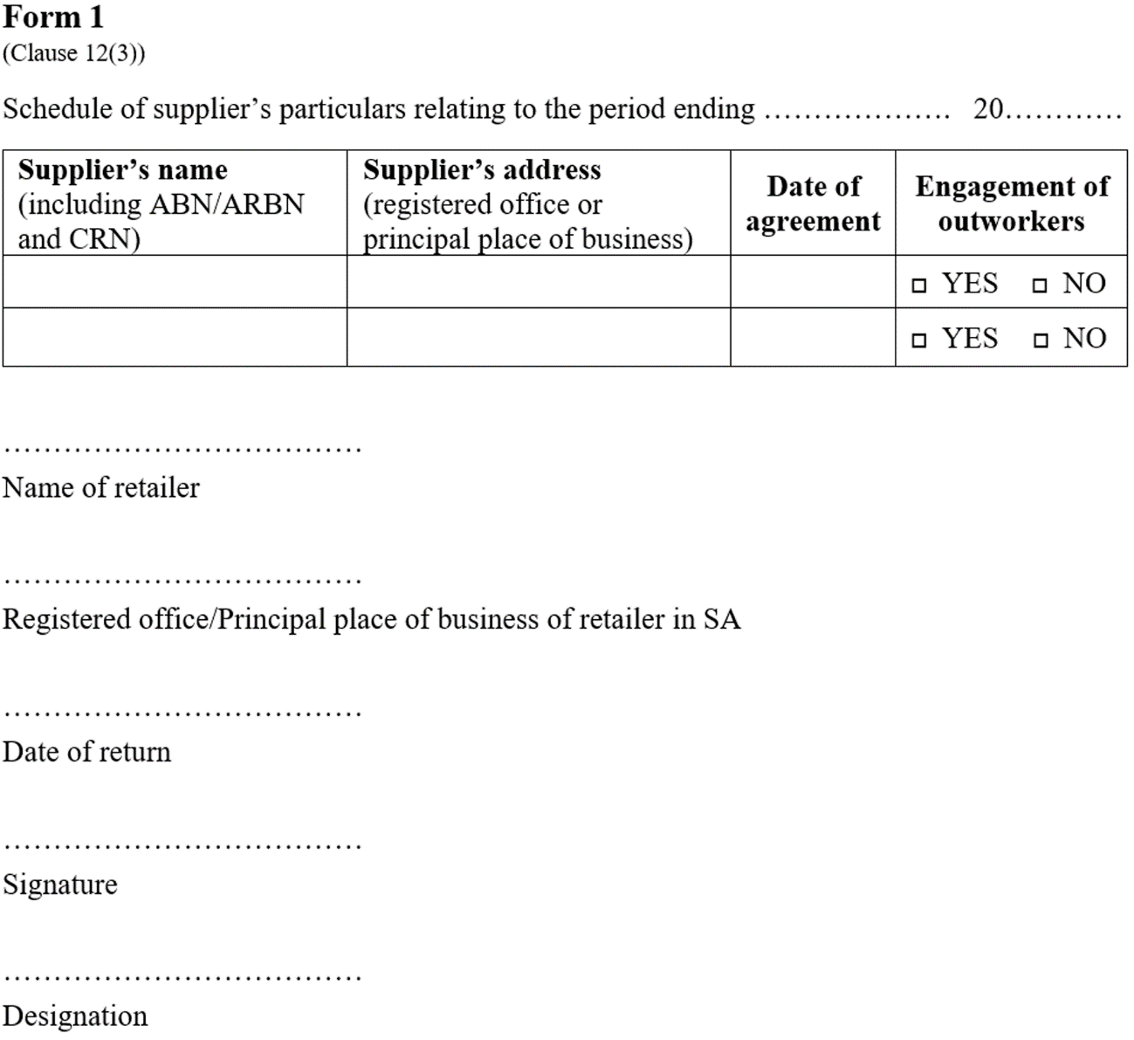
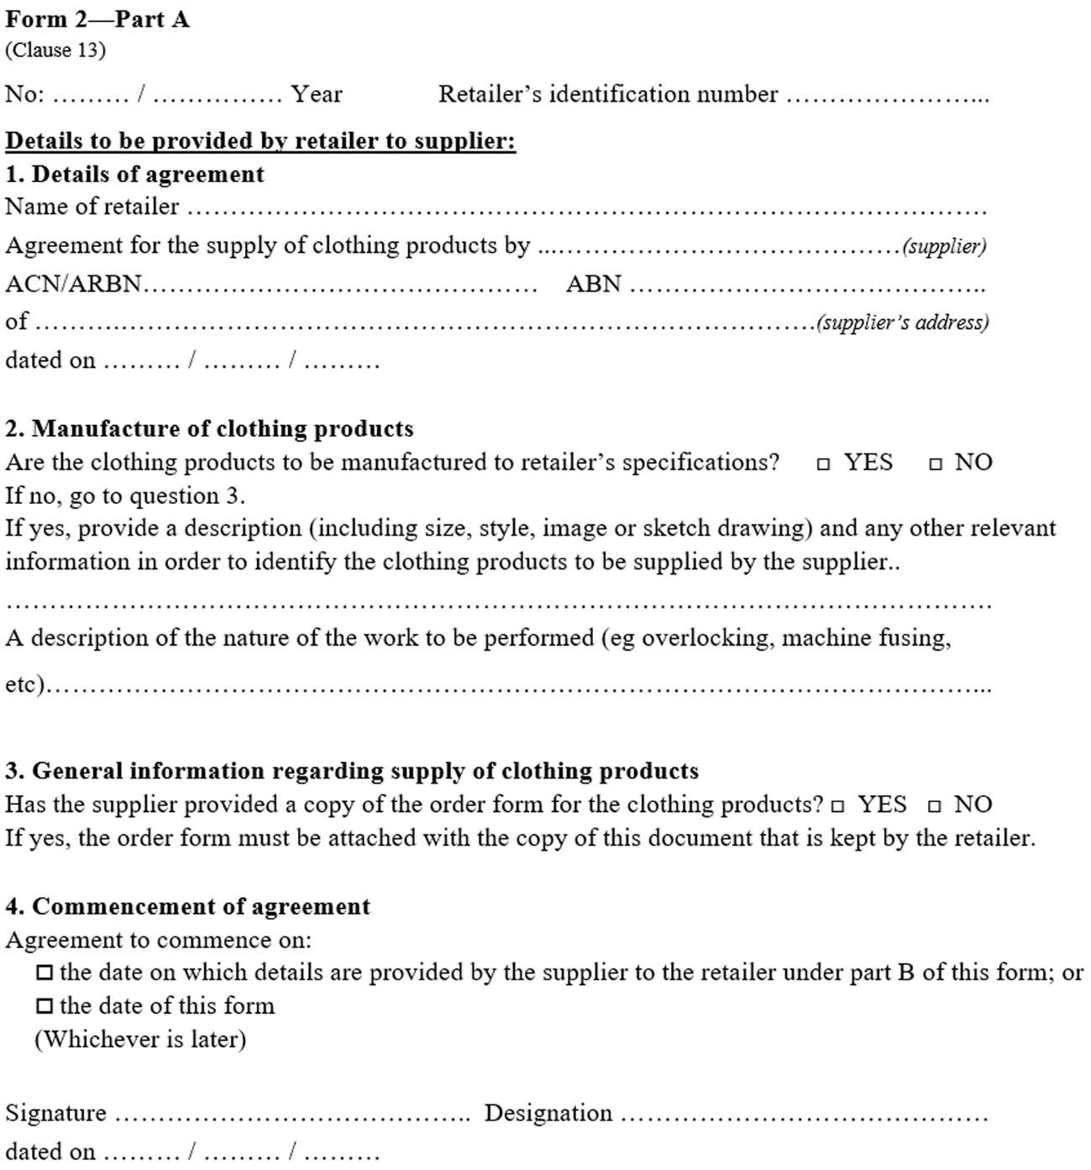
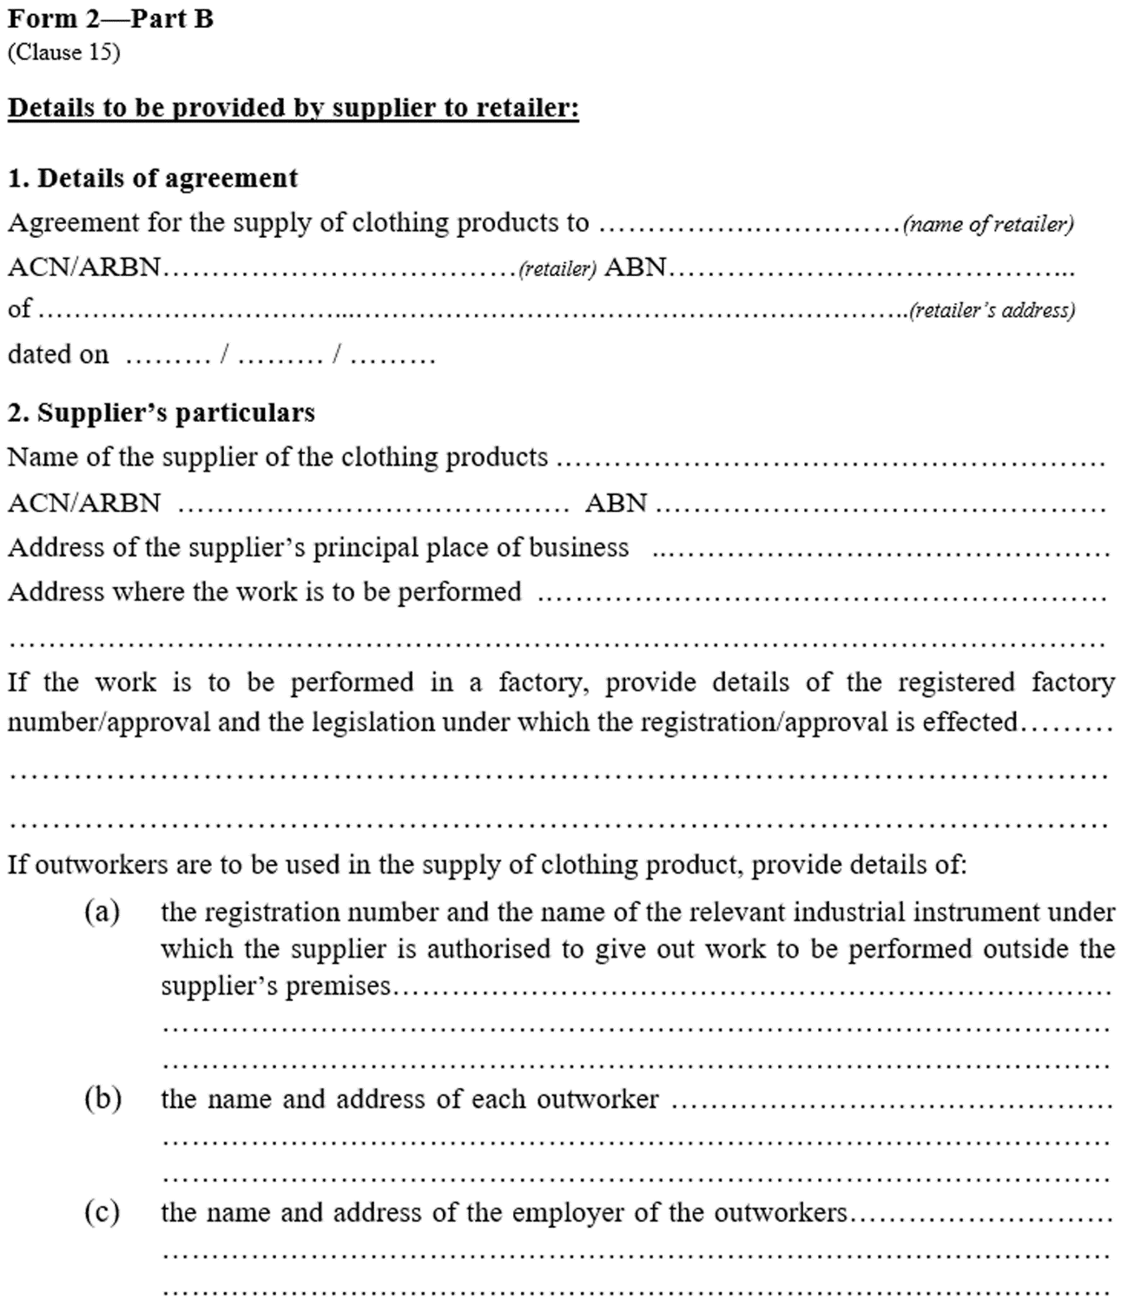
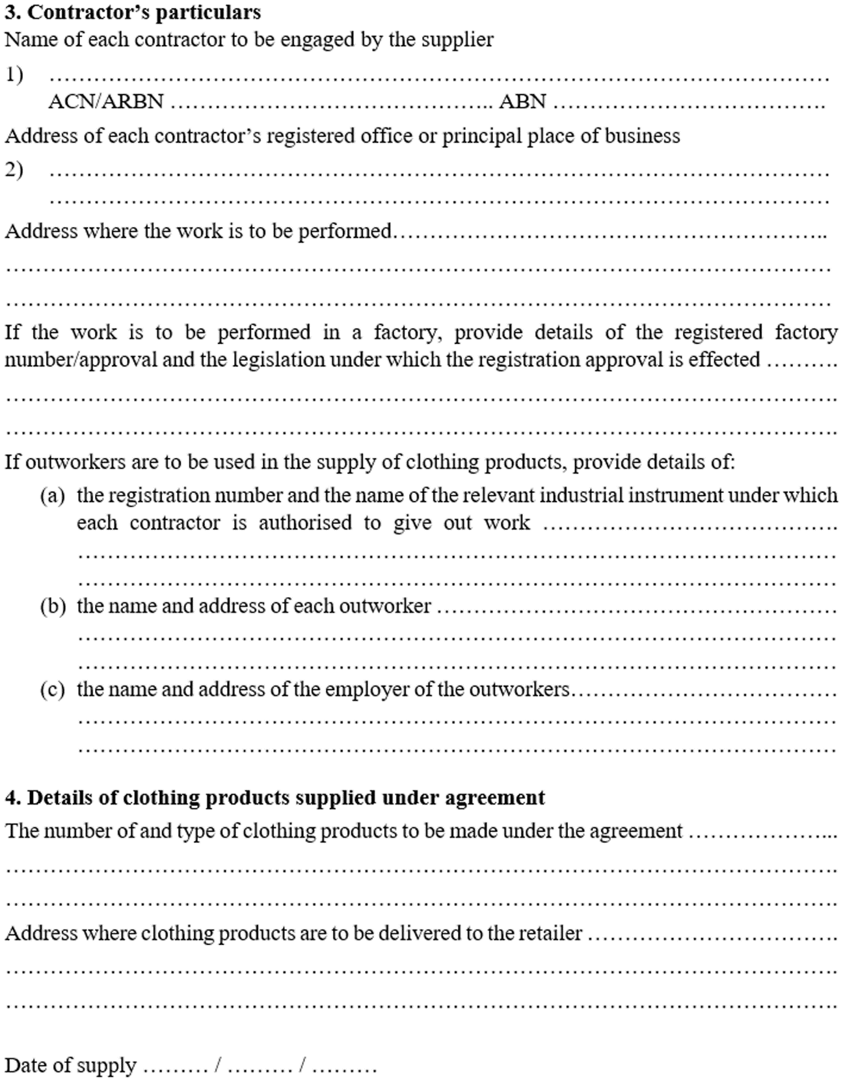
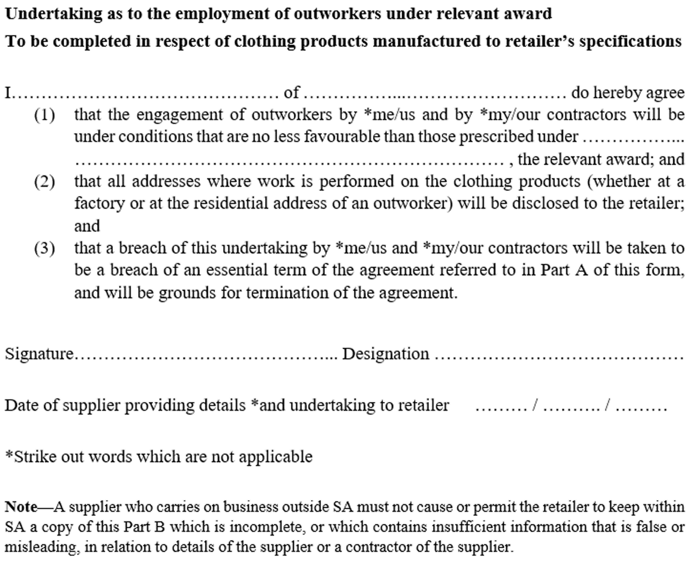
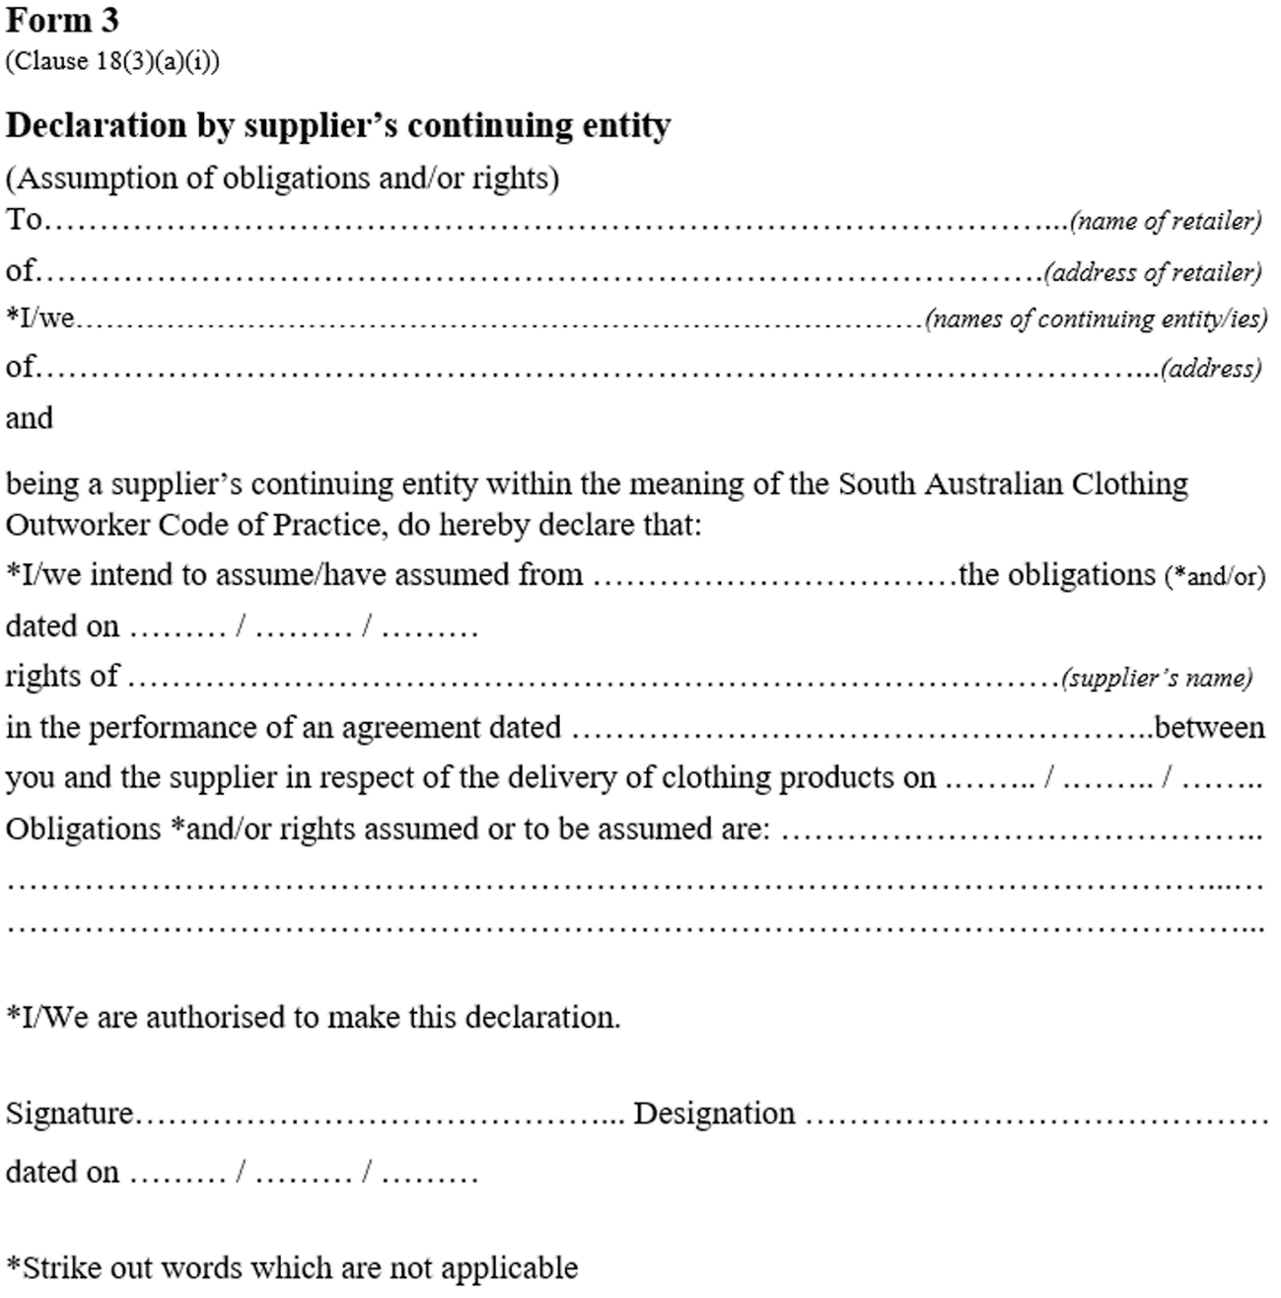
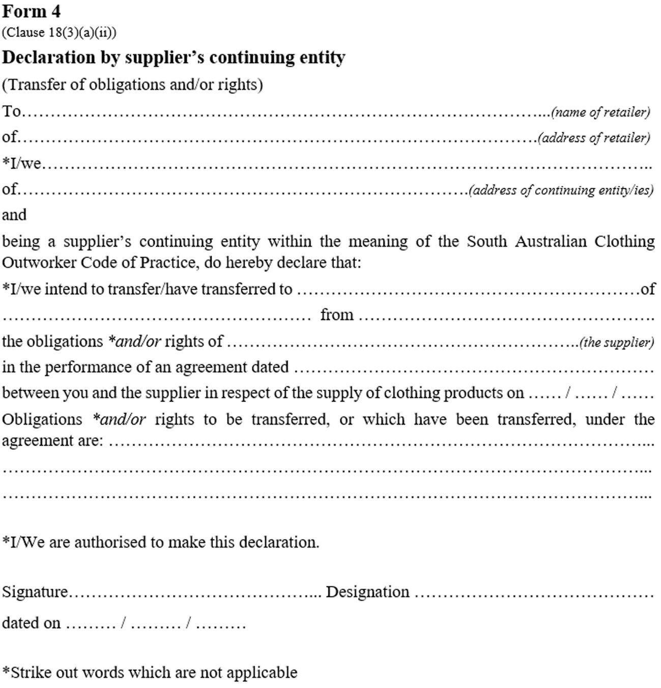
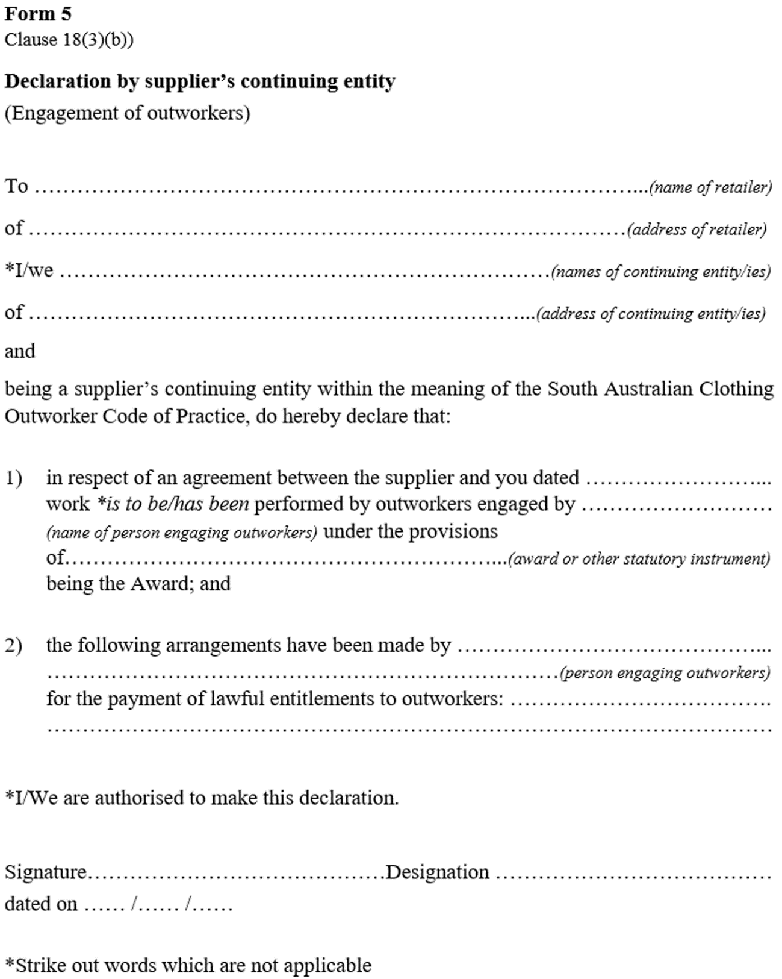
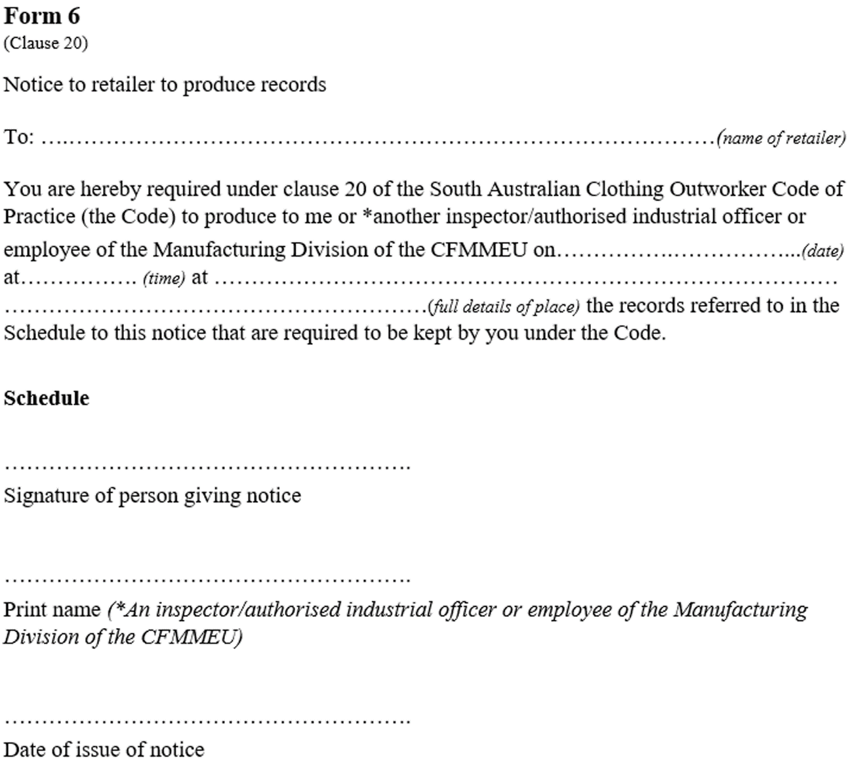
Schedule 2—Repeal of Fair Work (Clothing Outworker Code of Practice) Regulations 2007
The Fair Work (Clothing Outworker Code of Practice) Regulations 2007 are repealed.
Editorial note—
As required by section 10AA(2) of the Legislative Instruments Act 1978, the Minister has certified that, in the Minister's opinion, it is necessary or appropriate that these regulations come into operation as set out in these regulations.
Made by the Governor
with the advice and consent of the Executive Council
on 11 August 2022
No 61 of 2022

South Australia

Return to Work (Prescribed Limits) Amendment Regulations 2022
under the Return to Work Act 2014

Contents
Part 1—Preliminary
1 Short title
2 Commencement
Part 2—Amendment of Return to Work Regulations 2015
3 Insertion of regulation 32A
32A Prescribed limits on costs—provision of advice (section 56A of Act)

Part 1—Preliminary
1—Short title
These regulations may be cited as the Return to Work (Prescribed Limits) Amendment Regulations 2022.
2—Commencement
These regulations come into operation on the day on which section 12 of the Return to Work (Scheme Sustainability) Amendment Act 2022 (No 4 of 2022) comes into operation.
Part 2—Amendment of Return to Work Regulations 2015
3—Insertion of regulation 32A
After regulation 32 insert:
32A—Prescribed limits on costs—provision of advice (section 56A of Act)
For the purposes of section 56A(15) of the Act, the following limits are prescribed:

Item | Amount
Obtaining competent professional advice about the consequences of making an election | $900 (indexed)
Obtaining financial advice from a qualified financial adviser about the investment or use of money to be received on the election | $900 (indexed)
Obtaining advice from a recognised health practitioner about the future progression of their injury and its likely impact on their capacity to work | $900 (indexed)
Editorial note—
As required by section 10AA(2) of the Legislative Instruments Act 1978, the Minister has certified that, in the Minister's opinion, it is necessary or appropriate that these regulations come into operation as set out in these regulations.
Made by the Governor
with the advice and consent of the Executive Council
on 11 August 2022
No 62 of 2022

State Government Instruments

Building Work Contractors Act 1995
Exemption
TAKE notice that, pursuant to section 45 of the Building Work Contractors Act 1995, I, Zoe Thomas as a delegate for the Minister for Consumer and Business Affairs, do hereby exempt the licensee named in Schedule 1 from the application of Division 3 of Part 5 of the above Act in relation to domestic building work described in Schedule 2 and subject to the conditions specified in Schedule 3.
Schedule 1
CHRISTOPHER DALE HANSEN (BLD 39923)
Schedule 2
Construction of a three bedroom, two bathroom single story residential dwelling, with attached verandah and carport at Lot 1 Primary Community Plan 42173, being a portion of the land described in Certificate of Title Volume 6243 Folio 410, more commonly known as 12 Ocean Street, Aldinga Beach SA 5173.
Schedule 3
1. This exemption is limited to domestic building work personally performed by the licensee in relation to the building work described in Schedule 2.
2. This exemption does not apply to any domestic building work the licensee contracts to another building work contractor, for which that contractor is required by law to hold building indemnity insurance.
3. That the licensee does not transfer his interest in the land prior to five years from the date of completion of the building work the subject of this exemption, without the prior authorisation of Consumer and Business Services (CBS). Before giving such authorisation, CBS may require the licensee to take any reasonable steps to protect the future purchaser(s) of the property, including but not limited to:
- Providing evidence that an adequate policy of building indemnity insurance is in force to cover the balance of the five-year period from the date of completion of the building work the subject of this exemption;
- Providing evidence of an independent expert inspection of the building work the subject of this exemption;
- Making an independent expert report available to prospective purchasers of the property;
- Giving prospective purchasers of the property notice of the absence of a policy of building indemnity insurance.
Dated: 5 August 2022
Zoe Thomas
Assistant Director, Licensing
Delegate for the Minister for Consumer and Business Affairs

Building Work Contractors Act 1995
Exemption
TAKE notice that, pursuant to section 45 of the Building Work Contractors Act 1995, I, Zoe Thomas as a delegate for the Minister for Consumer and Business Affairs, do hereby exempt the licensee named in Schedule 1 from the application of Division 3 of Part 5 of the above Act in relation to domestic building work described in Schedule 2 and subject to the conditions specified in Schedule 3.
Schedule 1
GRAEME WAYNE RAMSAY (BLD 35721)
Schedule 2
Addition of a pergola to an existing residential dwelling at Allotment 27 Deposited Plan 41114, being a portion of the land described in Certificate of Title Volume 5250 Folio 737, more commonly known as 574 Senate Road, Risdon Park South, SA 5540.
Schedule 3
1. This exemption is limited to domestic building work personally performed by the licensee in relation to the building work described in Schedule 2.
2. This exemption does not apply to any domestic building work the licensee contracts to another building work contractor, for which that contractor is required by law to hold building indemnity insurance.
3. That the licensee does not transfer his interest in the land prior to five years from the date of completion of the building work the subject of this exemption, without the prior authorisation of Consumer and Business Services (CBS). Before giving such authorisation, CBS may require the licensee to take any reasonable steps to protect the future purchaser(s) of the property, including but not limited to:
- Providing evidence that an adequate policy of building indemnity insurance is in force to cover the balance of the five-year period from the date of completion of the building work the subject of this exemption;
- Providing evidence of an independent expert inspection of the building work the subject of this exemption;
- Making an independent expert report available to prospective purchasers of the property;
- Giving prospective purchasers of the property notice of the absence of a policy of building indemnity insurance.
Dated: 8 August 2022
Zoe Thomas
Assistant Director, Licensing
Delegate for the Minister for Consumer and Business Affairs

Child Sex Offenders Registration Act 2006
South Australia
Child Sex Offenders Registration (Fees) Notice 2022
under the Child Sex Offenders Registration Act 2006
1—Short title
This notice may be cited as the Child Sex Offenders Registration (Fees) Notice 2022.
Editorial Note—
This is a fee notice made in accordance with the Legislation (Fees) Act 2019.
2—Commencement
This notice has effect on the day on which the Child Sex Offenders Registration Regulations 2022 come into operation.
3—Interpretation
In this notice—
Act means the Child Sex Offenders Registration Act 2006.
4—Fees
The fees set out in Schedule 1 are prescribed for the purposes of the Act.
Schedule 1—Fees

1 | For an application for a declaration under Part 5A of the Act (section 66D(1)(b) of the Act) | $200
Signed by the Attorney General
on 27 July 2022

Fisheries Management Act 2007
Section 79
Restrictions on taking of Catfish (Hyrtl’s Tandan and Silver Tandan)
Pursuant to section 79 of the Fisheries Management Act 2007, I Professor Gavin Begg, Executive Director Fisheries and Aquaculture, delegate of the Minister for Primary Industries and Regional Development, hereby declare that it is unlawful for a person to engage in a fishing activity specified in Schedule 1 in the waters of the State 2 during the period specified in Schedule 2.
Schedule 1
In any one day, the taking of:
- more than 10 Silver Tandan (Porochilus argenteus) by any one person; or
- more than 10 Silver Tandan (Porochilus argenteus) in combination with Hyrtl’s Tandan (Neosilurus hyrtlii) by any one person; or
- more than 30 Silver Tandan (Porochilus argenteus) per boat (when three or more people are on board); or
- more than 30 Silver Tandan (Porochilus argenteus) in combination with Hyrtl’s Tandan (Neosilurus hyrtlii), per boat (when three or more people are on board).
Schedule 2
From: 00:01 hours on 6 August 2022 until 23:59 hours on 5 August 2023.
Dated: 5 August 2022
Prof. Gavin Begg
Executive Director
Fisheries and Aqauculture
Delegate of the Minister for Primary Industries and Regional Development

Fisheries Management Act 2007
Section 79
Temporary prohibition of Fishing Activity
Trailing a baited line or lure
Pursuant to section 79 of the Fisheries Management Act 2007, I Professor Gavin Begg, Executive Director Fisheries and Aquaculture, delegate of the Minister for Primary Industries and Regional Development, hereby declare that it shall be unlawful for any person to engage in the class of fishing activity specified in Schedule 1, in the area specified in Schedule 2 during the period specified in Schedule 3.
Schedule 1
The act of fishing by trailing a baited line or trailing a lure through the water from a moving vessel. For the purposes of this notice ‘lure’ means any artificial device used to attract fish.
Schedule 2
In all waters of the River Murray proper and Lakes Albert and Alexandrina, (excluding the waters of the Coorong) as described in the Fisheries Management (General) Regulations 2017.
Schedule 3
From midnight on 4 August 2022 until midnight on 31 December 2022.
Dated: 3 August 2022
Prof. Gavin Begg
Executive Director
Fisheries and Aqauculture
Delegate of the Minister for Primary Industries and Regional Development

Fisheries Management Act 2007
Section 79
Temporary prohibition on taking of Murray Cod from Chowilla floodplain
TAKE notice that pursuant to section 79 of the Fisheries Management Act 2007, I Professor Gavin Begg, Executive Director Fisheries and Aquaculture, delegate of the Minister for Primary Industries and Regional Development, hereby declare that it shall be unlawful for any person to engage in the class of fishing activity specified in Schedule 1, in the area specified in Schedule 2 during the period specified in Schedule 3.
Schedule 1
- The act of taking or an act preparatory to or involved in the taking of Murray Cod (Maccullochella peelii).
- The removal of any part of a Murray Cod (Maccullochella peelii) from the water other than for the purposes of removing a fishing hook to immediately release the fish, where:
- The weight of the fish is at all times supported by water;
- The gills or fins of the fish are not handled at any stage; and
- Only the head (not extending past the gills) is out of the water at any stage.
Schedule 2
Any part of the Chowilla floodplain north of the River Murray (excluding the River Murray) between 34°9'46.65" South, 140°45'30.41" East (Ral Ral Creek) upstream to the River Murray at 34°1'14.55" South, 141°0’9.72" East (South Australia and New South Wales border).
For the purpose of this notice all lines are geodesics coordinates are expressed in terms of the Geocentric Datum of Australia 2020 (GDA2020).
Schedule 3
From midnight 4 August 2022 to midnight on 3 August 2023.
Dated: 3 August 2022
Prof. Gavin Begg
Executive Director
Fisheries and Aqauculture
Delegate of the Minister for Primary Industries and Regional Development

Housing Improvement Act 2016
Rent Control Revocations
Whereas the Minister for Human Services Delegate is satisfied that each of the houses described hereunder has ceased to be unsafe or unsuitable for human habitation for the purposes of the Housing Improvement Act 2016, notice is hereby given that, in exercise of the powers conferred by the said Act, the Minister for Human Services Delegate does hereby revoke the said Rent Control in respect of each property.
Address of Premises | Allotment  Section | Certificate of Title  Volume Folio
21 Jagoe ST, Semaphore SA 5019 | Allotment 113 Filed Plan 2711 Hundred of Port Adelaide | CT5451/533
16 Twelfth Avenue, Woodville North SA 5012 | Allotment 65 Deposited Plan 4177 Hundred of Yatala | CT5575/307
Dated: 11 August 2022
Craig Thompson
Housing Regulator and Registrar
Housing Safety Authority, SAHA
Delegate of Minister for Human Services

Justices of the Peace Act 2005
Section 4
Notice of Appointment of Justices of the Peace for South Australia
by the Commissioner for Consumer Affairs
I, Dini Soulio, Commissioner for Consumer Affairs, delegate of the Attorney-General, pursuant to section 4 of the Justices of the Peace Act 2005, do hereby appoint the people listed as Justices of the Peace for South Australia as set out below.
For a period of ten years for a term commencing on 16 August 2022 and expiring on 15 August 2032:
Klaus ZIMMERMANN
Garth Wayne WRIGHT
Andrew Nicholas WINTER
Kaye Lorraine STEAD
Lynda May SMITH
Geoffrey Bernard SAEGENSCHNITTER
Robert John RANDALL
John David PICK
Dennis Raymond PAGE
Ernest Colin ORR
Peter James MUDGE
Noel Emmanuel Andrew Paul MIFSUD
Theo Steven MARAS
Thomas Dominic MALONEY
Julie-Ann LEARHINAN
Ioannis KASSELOURIS
William Neil JENSEN
Christine HARRIS
Michael GRECH
Christopher Neil FAWCETT
John Malcolm EVANS
Alan Reginald ECKERMANN
Christopher James Wallace BYRON-SCOTT
Garry Ernest BROWN
Peter James ALEXANDER
Dated: 4 August 2022
Dini Soulio
Commissioner for Consumer Affairs
Delegate of the Attorney-General

Land Acquisition Act 1969
Section 16
Form 5 – Notice of Acquisition
1. Notice of acquisition
The Commissioner of Highways (the Authority), of 50 Flinders Street, Adelaide SA 5000, acquires the following interests in the following land:
Comprising an unencumbered estate in fee simple in that piece of land being portion of Allotment 2 in Deposited Plan No 51952 comprised in Certificate of Title Volume 5665 Folio 381 and being the whole of the land identified as Allotment 701 in D129587 lodged in the Lands Titles Office expressly excluding the following: the easement(s) over the land marked ‘A’ for water supply purposes (RTC 8644670), the easement(s) over the land marked ‘A’ (RTC 8644670) and the free and unrestricted right(s) of way over the land marked ‘A’.
This notice is given under section 16 of the Land Acquisition Act 1969.
2. Compensation
A person who has or had an interest consisting of native title or an alienable interest in the land that is divested or diminished by the acquisition or the enjoyment of which is adversely affected by the acquisition who does not receive an offer of compensation from the Authority may apply to the Authority for compensation.
2A. Payment of professional costs relating to acquisition (section 26B)
If you are the owner in fee simple of the land to which this notice relates, you may be entitled to a payment of up to $10 000 from the Authority for use towards the payment of professional costs in relation to the acquisition of the land.
Professional costs include legal costs, valuation costs and any other costs prescribed by the Land Acquisition Regulations 2019.
3. Inquiries
Inquiries should be directed to: Philip Cheffirs
GPO Box 1533
Adelaide SA 5001
Telephone: (08) 8343 2575
Dated: 5 August 2022
The Common Seal of the COMMISSIONER OF HIGHWAYS was hereto affixed by authority of the Commissioner in the presence of:
Hanna Samuels
A/Manager, Property Acquisition (Authorised Officer)
Department for Infrastructure and Transport
DIT 2020/16839/01

Land Acquisition Act 1969
Section 16
Form 5 – Notice of Acquisition
1. Notice of acquisition
The Commissioner of Highways (the Authority), of 50 Flinders Street, Adelaide SA 5000, acquires the following interests in the following land:
Comprising an unencumbered estate in fee simple in that piece of land being the whole of Allotment 46 in Deposited Plan No 1324 comprised in Certificate of Title Volume 5834 Folio 377.
This notice is given under section 16 of the Land Acquisition Act 1969.
2. Compensation
A person who has or had an interest consisting of native title or an alienable interest in the land that is divested or diminished by the acquisition or the enjoyment of which is adversely affected by the acquisition who does not receive an offer of compensation from the Authority may apply to the Authority for compensation.
2A. Payment of professional costs relating to acquisition (section 26B)
If you are the owner in fee simple of the land to which this notice relates, you may be entitled to a payment of up to $10 000 from the Authority for use towards the payment of professional costs in relation to the acquisition of the land.
Professional costs include legal costs, valuation costs and any other costs prescribed by the Land Acquisition Regulations 2019.
3. Inquiries
Inquiries should be directed to: Petrula Pettas
GPO Box 1533
Adelaide SA 5001
Telephone: (08) 8343 2619
Dated: 9 August 2022
The Common Seal of the COMMISSIONER OF HIGHWAYS was hereto affixed by authority of the Commissioner in the presence of:
Rocco Caruso
Manager, Property Acquisition (Authorised Officer)
Department for Infrastructure and Transport
DIT 2021/13011/01

Land Acquisition Act 1969
Section 16
Form 5 – Notice of Acquisition
1. Notice of acquisition
The Commissioner of Highways (the Authority), of 50 Flinders Street, Adelaide SA 5000, acquires the following interests in the following land:
Comprising an unencumbered estate in fee simple in that piece of land being portion of Allotment 53 in Deposited Plan 87801 comprised in Certificate of Title Volume 6094 Folio 484, and being the whole of the land identified as Allotment 421 in plan D127969 lodged in the Lands Titles Office, expressly excluding the free and unrestricted right(s) of way over the land marked ‘E’ (RTC 11742419)
This notice is given under section 16 of the Land Acquisition Act 1969.
2. Compensation
A person who has or had an interest consisting of native title or an alienable interest in the land that is divested or diminished by the acquisition or the enjoyment of which is adversely affected by the acquisition who does not receive an offer of compensation from the Authority may apply to the Authority for compensation.
2A. Payment of professional costs relating to acquisition (section 26B)
If you are the owner in fee simple of the land to which this notice relates, you may be entitled to a payment of up to $10 000 from the Authority for use towards the payment of professional costs in relation to the acquisition of the land.
Professional costs include legal costs, valuation costs and any other costs prescribed by the Land Acquisition Regulations 2019.
3. Inquiries
Inquiries should be directed to: Philip Cheffirs
GPO Box 1533
Adelaide SA 5001
Telephone: (08) 8343 2575
Dated: 9 August 2022
The Common Seal of the COMMISSIONER OF HIGHWAYS was hereto affixed by authority of the Commissioner in the presence of:
Hanna Samuels
A/Manager, Property Acquisition (Authorised Officer)
Department for Infrastructure and Transport
DIT 2020/16884/02

Land Acquisition Act 1969
Section 16
Form 5 – Notice of Acquisition
1. Notice of acquisition
The Commissioner of Highways (the Authority), of 50 Flinders Street, Adelaide SA 5000, acquires the following interests in the following land:
Comprising an unencumbered estate in fee simple in that piece of land being portion of Allotment 272 in Deposited Plan 127096 comprised in Certificate of Title Volume 6259 Folio 131, and being the whole of the land identified as Allotment 101 in plan D129586 lodged in the Lands Titles Office.
This notice is given under section 16 of the Land Acquisition Act 1969.
2. Compensation
A person who has or had an interest consisting of native title or an alienable interest in the land that is divested or diminished by the acquisition or the enjoyment of which is adversely affected by the acquisition who does not receive an offer of compensation from the Authority may apply to the Authority for compensation.
2A. Payment of professional costs relating to acquisition (section 26B)
If you are the owner in fee simple of the land to which this notice relates, you may be entitled to a payment of up to $10 000 from the Authority for use towards the payment of professional costs in relation to the acquisition of the land.
Professional costs include legal costs, valuation costs and any other costs prescribed by the Land Acquisition Regulations 2019.
3. Inquiries
Inquiries should be directed to: Philip Cheffirs
GPO Box 1533
Adelaide SA 5001
Telephone: (08) 8343 2575
Dated: 9 August 2022
The Common Seal of the COMMISSIONER OF HIGHWAYS was hereto affixed by authority of the Commissioner in the presence of:
Hanna Samuels
A/Manager, Property Acquisition (Authorised Officer)
Department for Infrastructure and Transport
DIT 2020/16859/02

LANDSCAPE SOUTH AUSTRALIA ACT 2019
Declaration of Penalty in Relation to the Unauthorised or Unlawful Taking of Water from the
River Murray Prescribed Watercourse
PURSUANT to Section 88 (1) of the Landscape South Australia Act 2019 (‘the Act’), I, Ben Bruce, delegate of the Minister for Climate, Environment and Water and Minister to whom the Act is committed, hereby declare that the following penalties are payable in relation to the unauthorised or unlawful taking or use of water during the consumption period that corresponds to the accounting period defined in Column 1 of Schedule 1:
- Where a person who is the holder of a water allocation takes water from the River Murray Prescribed Watercourse in excess of the amount available under the allocation, the penalty declared pursuant to Section 88 (1) (a) is:
- the corresponding rate in Column 2 of Schedule 1 to this notice for all water taken in excess of the amount available under the allocation endorsed on the relevant instrument under the terms of the water licence to which the allocation is attributable, up to and including 500,000 kilolitres; and
- the corresponding rate in Column 3 of Schedule 1 to this notice for all water taken in excess of the quantity of water referred to in paragraph (a) above 500,000 kilolitres.
- Where a person who is authorised under section 105 of the Act takes water from the River Murray Prescribed Watercourse that exceeds the amount authorised under the terms of that authorisation the penalty declared pursuant to Section 88 (1) (e) is:
- the corresponding rate in Column 2 of Schedule 1 to this notice for all water taken in excess of the amount authorised by a notice under Section 105 of the Act, up to and including 500,000 kilolitres; and
- the corresponding rate in Column 3 of Schedule 1 to this notice for all water taken in excess of the quantity referred to in paragraph (a) above 500,000 kilolitres.
- Where water is taken from the River Murray Prescribed Watercourse by a person who is not the holder of a water management authorisation or who is not authorised under Section 105 of the Act to take the water, the penalty declared under Section 88 (1) (e) is the corresponding rate in Column 4 of Schedule 1 to this notice per kilolitre of water determined or assessed to have been taken in accordance with Section 79 of the Act.
- Where a person takes water from the River Murray Prescribed Watercourse in excess of the amount authorised for use under Section 109 of the Act the penalty declared pursuant to Section 88 (1) (f) is:
- the corresponding rate in Column 2 of Schedule 1 to this notice for all water taken in excess of the amount authorised for use by a notice under Section 109 of the Act, up to and including 500,000 kilolitres; and
- the corresponding rate in Column 3 of Schedule 1 to this notice for all water taken in excess of the quantity referred to in paragraph (a) above 500,000 kilolitres.
- Where water is taken from the River Murray Prescribed Watercourse subject to a notice under Section 109 of the Act by a person who is not authorised to use the water the penalty declared under Section 88 (1) (f) is the corresponding rate in Column 4 of Schedule 1 to this notice per kilolitre of water determined or assessed to have been taken in accordance with Section 79 of the Act.
- Where a person may be subject to more than one penalty under Section 88, the penalty that is the greater shall be imposed.

Schedule 1
Penalties for overuse from the River Murray Prescribed Watercourse between 1 July 2022 to 30 September 2022 inclusive:
Column 1 | Column 2 | Column 3 | Column 4
Accounting Period | Penalty for overuse up to and including 500,000 kL | Penalty for overuse above 500,000 kL | Penalty for unlawful taking or use of water
1 July 2022 to  30 September 2022 | $0.918 | $1.224 | $1.224
Unit of measure kL is the abbreviation of kilolitre.
For the purposes of this notice:
‘the River Murray Prescribed Watercourse’ means the watercourses and lakes declared to be the River Murray Proclaimed Watercourse by proclamation under Section 25 of the Water Resources Act 1976 (see Gazette 10 August 1978, p. 467).
‘accounting period’ means the period determined by the Minister from time to time by notice in the Gazette (with the period not necessarily being the same period as the accounting period under Division 2).
‘consumption period’ in relation to an accounting period means a period of approximately the same length as the accounting period that commences or terminates during the accounting period and during which water is taken or used.
Words used in this notice that are defined in the Act shall have the meanings as set out in the Act.
Dated: 4 August 2022
Ben Bruce
Executive Director, Water and River Murray
Department for Environment and Water
Delegate of the Minister for Climate, Environment and Water

Liquor Licensing Act 1997
South Australia
Liquor Licensing (Dry Areas) Notice 2022
under section 131(1a) of the Liquor Licensing Act 1997
1—Short title
This notice may be cited as the Liquor Licensing (Dry Areas) Notice 2022.
2—Commencement
This notice comes into operation on 21 November 2022.
3—Interpretation
(1) In this notice—
principal notice means the Liquor Licensing (Dry Areas) Notice 2015 published in the Gazette on 5.1.15, as in force from time to time.
(2) Clause 3 of the principal notice applies to this notice as if it were the principal notice.
4—Consumption etc of liquor prohibited in dry areas
(1) Pursuant to section 131 of the Act, the consumption and possession of liquor in the area described in the Schedule is prohibited in accordance with the provisions of the Schedule.
(2) The prohibition has effect during the periods specified in the Schedule.
(3) The prohibition does not extend to private land in the area described in the Schedule.
(4) Unless the contrary intention appears, the prohibition of the possession of liquor in the area does not extend to—
(a) a person who is genuinely passing through the area if—
(i) the liquor is in the original container in which it was purchased from licensed premises; and
(ii) the container has not been opened; or
(b) a person who has possession of the liquor in the course of carrying on a business or in the course of his or her employment by another person in the course of carrying on a business; or
(c) a person who is permanently or temporarily residing at premises within the area or on the boundary of the area and who enters the area solely for the purpose of passing through it to enter those premises or who enters the area from those premises for the purpose of leaving the area.
Schedule— Victor Harbor Area 2

1—Extent of prohibition
The consumption of liquor is prohibited and the possession of liquor is prohibited.
2—Period of prohibition
From 8 AM on Monday 21 November 2022 to 10 AM on Monday 28 November 2022.
3—Description of area
The whole of Granite Island to low water mark, together with the whole of the causeway linking the mainland and Granite Island (apart from the part of the causeway above the low water mark on the mainland as well as any area beneath the causeway). In addition to the causeway, the area also includes the whole of any wharf, jetty, boat ramp, breakwater or other structure extending below low water mark from Granite Island, as well as any area beneath such a structure.

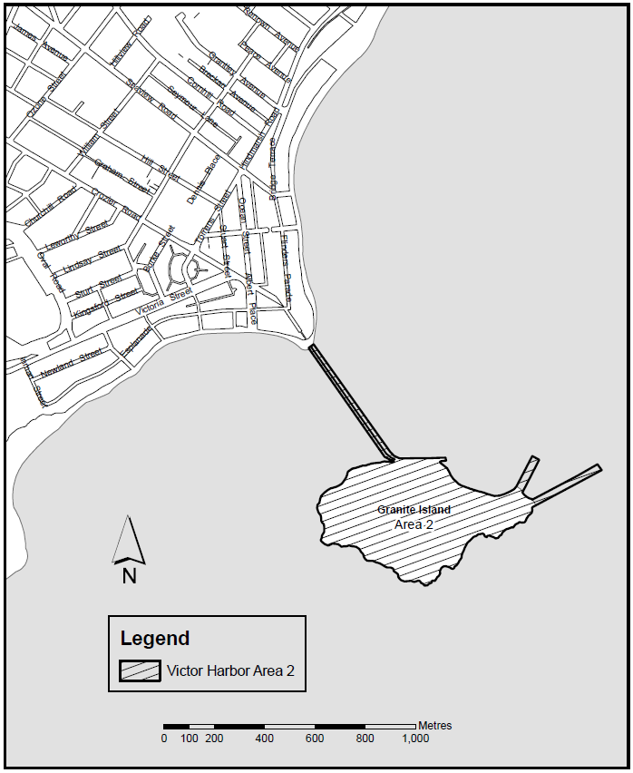
Made by the Liquor and Gambling Commissioner
On 8 August 2022
Zoe Thomas
Assistant Director Licensing
Delegate of the Liquor and Gambling Commissioner

Liquor Licensing Act 1997
Liquor Licensing (Dry Areas) Notice 2022
under section 131(1a) of the Liquor Licensing Act 1997
1—Short title
This notice may be cited as the Liquor Licensing (Dry Areas) Notice 2022.
2—Commencement
This notice comes into operation on 21 November 2022.
3—Interpretation
(1) In this notice—
principal notice means the Liquor Licensing (Dry Areas) Notice 2015 published in the Gazette on 5.1.15, as in force from time to time.
(2) Clause 3 of the principal notice applies to this notice as if it were the principal notice.
4—Consumption etc of liquor prohibited in dry areas
(1) Pursuant to section 131 of the Act, the consumption and possession of liquor in the area described in the Schedule is prohibited in accordance with the provisions of the Schedule.
(2) The prohibition has effect during the periods specified in the Schedule.
(3) The prohibition does not extend to private land in the area described in the Schedule.
(4) Unless the contrary intention appears, the prohibition of the possession of liquor in the area does not extend to—
(a) a person who is genuinely passing through the area if—
(i) the liquor is in the original container in which it was purchased from licensed premises; and
(ii) the container has not been opened; or
(b) a person who has possession of the liquor in the course of carrying on a business or in the course of his or her employment by another person in the course of carrying on a business; or
(c) a person who is permanently or temporarily residing at premises within the area or on the boundary of the area and who enters the area solely for the purpose of passing through it to enter those premises or who enters the area from those premises for the purpose of leaving the area.

Schedule— Victor Harbor Area 4

1—Extent of prohibition
The consumption of liquor is prohibited, and the possession of liquor is prohibited.
2—Period of prohibition
From 8 AM on Monday 21 November 2022 to 10 AM on Monday 28 November 2022.
3—Description of area
The area in and adjacent to Victor Harbor bounded as follows: commencing at the point at which the north-western boundary of Hindmarsh Road intersects the southern bank of the Hindmarsh River, then generally westerly, north-easterly and north-westerly along that bank of the Hindmarsh River to the point at which it is intersected by the prolongation in a straight line of the northern boundary of Dinan Road, then easterly along that prolongation and boundary of Dinan Road and the prolongation in a straight line of that boundary to the western boundary of Laxton Street, then generally south-westerly and south-easterly along that boundary of Laxton Street, the south-western boundary of Adare Avenue and the prolongation in a straight line of the south-western boundary of Adare Avenue to the south-eastern boundary of Hindmarsh Road, then generally south-westerly along that boundary of Hindmarsh Road to the point at which it intersects the northern bank of the Hindmarsh River, then along that bank of the Hindmarsh River to the low water mark of Encounter Bay, then generally south-westerly and southerly along the low water mark to the eastern side of the causeway linking Granite Island to the mainland, then in a straight line by the shortest route to the low water mark on the western side of the causeway, then generally westerly, south-westerly, southerly and south-westerly along the low water mark to the point at which it is intersected by the prolongation in a straight line of the south-western boundary of Harbour View Terrace, then north-westerly along that prolongation and boundary of Harbour View Terrace to the point at which it is intersected by the prolongation in a straight line of the north-western boundary of Kent Drive, then generally north-easterly, northerly and north-westerly along that prolongation and boundary of Kent Drive to the point at which it is intersected by the prolongation in a straight line of the south-eastern boundary of a foot bridge across the Inman River (being the foot bridge closest to the mouth of the river), then north-easterly along the line of that south-eastern boundary of the foot bridge across the river to the south-western boundary of the Victor Harbor Beachfront Holiday Park, then generally south-easterly and north-easterly along the boundary of the park to the south-western boundary of Inman Street, then north-westerly along that boundary of Inman Street and the prolongation in a straight line of that boundary to the north-western boundary of Victoria Street, then north-easterly along that boundary of Victoria Street to the south-western boundary of George Main Road, then north-westerly along that boundary of George Main Road to the northern bank of the Inman River, then westerly along that bank of the river to the point at which it is intersected by the prolongation in a straight line of the western boundary of Lot 57 of FP 20694, then north-westerly along that prolongation to the kerb line on the south-eastern side of Bay Road, then generally north-easterly along that kerb line to the kerb line on the south-western side of George Main Road, then in a straight line by the shortest route across George Main Road to the north-eastern boundary of that road, then north-westerly along that boundary of George Main Road to the point at which the north-eastern boundary of George Main Road meets the eastern boundary of Lot 11 DP 14245 (Victor Harbor High School), then north-easterly, north-westerly, north-easterly, north-westerly and south-westerly along that boundary of Lot 11 to the point at which it meets the south-eastern boundary of Kullaroo Road, then north-easterly along the south-eastern boundary of Kullaroo Road and the prolongation in a straight line of that boundary to the north-eastern corner of Lot 333 FP 165581, then in a straight line by the shortest route to the point at which the north-western boundary of Leworthy Street meets the north-eastern boundary of Oval Road, then generally north-easterly along that north-western boundary of Leworthy Street and the prolongation in a straight line of that boundary to the north-eastern boundary of Crozier Road, then south-easterly along that boundary of Crozier Road to the north-western boundary of Acraman Street, then north-easterly along the north-western boundaries of Acraman Street and Carlyle Street to the point at which the north-western boundary of Carlyle Street intersects the north-eastern boundary of Cornhill Road, then south-easterly along that north-eastern boundary of Cornhill Road to the north-western boundary of Hindmarsh Road, then north-easterly along that boundary of Hindmarsh Road to the north-eastern boundary of Peace Avenue, then north-westerly along that boundary of Peace Avenue to the south-eastern boundary of Broadway Terrace, then north-easterly along that boundary of Broadway Terrace to the south-western boundary of Renown Avenue, then south-easterly along that boundary of Renown Avenue to the north-western boundary of Hindmarsh Road, then generally north-easterly along that boundary of Hindmarsh Road to the point of commencement. The area includes the whole of any wharf, jetty, boat ramp, breakwater or other structure that extends below low water mark from within the area (as well as any area beneath such a structure), but does not include that part of the causeway to Granite Island that lies within the area to which the prohibition in Victor Harbor Area 2 applies.
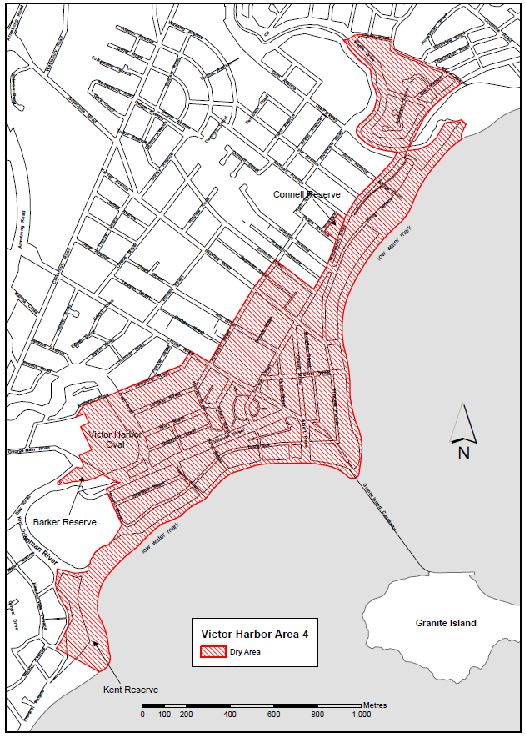
Made by the Liquor and Gambling Commissioner
On 8 August 2022
Zoe Thomas
Assistant Director Licensing
Delegate of the Liquor and Gambling Commissioner

Major Events Act 2013
Section 6b
Declaration of a Major Event
PURSUANT to section 6B of the Major Events Act 2013, I, Hon Zoe Bettison MP, Minister for Tourism declare Harvest Rock to be held at Rymill Park/Murlawirrapurka (Park 14), King Rodney Park/Ityamai-itpina (Park 15) and Bartels Road between East Terrace and Dequetteville Terrace from 18 to 21 November 2022 inclusive to be a major event.
By virtue of the provisions of the Major Events Act 2013 (the Act), I do hereby:
- Declare Harvest Rock to be a major event for the purposes of the Act.
- Specify the major event period for the event to be 18 to 21 November 2022 inclusive from 10.00am on 18 November to 11.59pm on 21 November 2022.
- Declare the major event venue to be Rymill Park/Murlawirrapurka (Park 14), King Rodney Park / Ityamai-itpina (Park 15), Bartels Road between East Terrace and Dequetteville Terrace, shown as “the event site” in the Map.
- Declare that an area bounded by the southern boundary of Rundle Road, the south-western boundary of the portion of Dequetteville Terrace between Rundle Road and Wakefield Road, the northern boundary of Wakefield Road and the northern and eastern boundaries of the portion of East Terrace between Wakefield Road and Rundle Road is a controlled area for the event, shown as “declared controlled area” in the Map.
- Declare that Bartels Road, between East Terrace and Dequetteville Terrace will be closed to traffic from 18 to 21 November 2022 inclusive from 10.00am on 18 November to 11.59pm on 21 November 2022 for the purposes of the event; and for the purposes of maintaining good order, or preventing interference with events or activities conducted, at the major event venue.
- Designate Secret Sounds Group Pty Ltd (ACN 160 017 461) to be the event organiser for the event.
- Declare that the following provisions of Part 3 of the Act apply to the event, the major event venue for the event and the controlled area for the event.
  - section 8;
  - section 10;
  - section 11;
  - section 12;
  - section 13;
  - section 14.
- Being satisfied that the title “Harvest Rock” is sufficiently connected with the identity and conduct of the major event, and that the event has commercial arrangements that are likely to be adversely affected by unauthorised use of titles, I hereby declare, pursuant to section 14(1) of the Act, that “Harvest Rock” is an official title in respect of the event.
Dated: 10 August 2022
Hon Zoe Bettison MP
Minister for Tourism

Map of the Declared Area
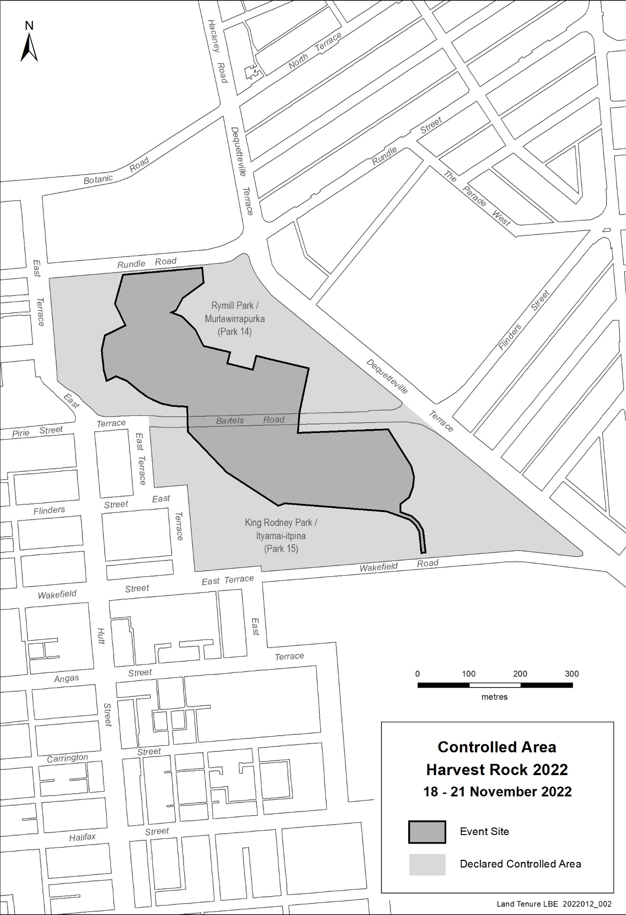

Mental Health Act 2009
Authorised Mental Health Professional
NOTICE is hereby given in accordance with Section 94(1) of the Mental Health Act 2009, that the Chief Psychiatrist has determined the following person as an Authorised Mental Health Professional:
Jenny Sadler
A person’s determination as an Authorised Mental Health Professional expires three years after the commencement date.
Dated: 5 August 2022
Dr J Brayley
Chief Psychiatrist

Petroleum and Geothermal Energy Act 2000
Temporary Cessation of Suspension
Petroleum Exploration Licence—PEL 94
Associated Activities Licence—AAL 200
Pursuant to Section 90 of the Petroleum and Geothermal Energy Act 2000, notice is hereby given that the suspension of PEL 94 and AAL 200 dated 8 October 2021 has been temporarily ceased, for the period 8 August 2022 to 18 August 2022 inclusive, pursuant to delegated powers dated 29 June 2018.
The expiry date of PEL 94 and AAL 200 remains as 4 November 2023.
Dated: 5 August 2022
Nick Panagopoulos
A/Executive Director
Energy Resources Division
Department for Energy and Mining
Delegate of the Minister for Energy and Mining

Petroleum and Geothermal Energy Act 2000
Temporary Cessation of Suspension
Petroleum Exploration Licence—PEL 95
Pursuant to Section 90 of the Petroleum and Geothermal Energy Act 2000, notice is hereby given that the suspension of PEL 95 dated 8 October 2021 has been temporarily ceased, for the period 9 August 2022 to 19 August 2022 inclusive, pursuant to delegated powers dated 29 June 2018.
The expiry date of PEL 95 remains as 29 October 2023.
Dated: 5 August 2022
Nick Panagopoulos
A/Executive Director
Energy Resources Division
Department for Energy and Mining
Delegate of the Minister for Energy and Mining

Roads (Opening and Closing) Act 1991
Section 24
Notice of Confirmation of Road Process Order
Road Closure—Public Road, Alford
BY Road Process Order made on 2 June 2022, the Barunga West Council ordered that:
- Portions of Public Road, Alford, situated adjoining Sections 212, 211N, 211S, 210, 209, 69, 134, 208, 207, 206 and 177, Hundred of Tickera, more particularly delineated and lettered ‘A’, ‘B’ & ‘C’ in Preliminary Plan 22/0003 be closed.
- Transfer the whole of the land subject to closure to Florafield Pty. Ltd. in accordance with the Agreement for Transfer dated 2 June 2022 entered into between the Barunga West Council and Florafield Pty. Ltd.
On 26 July 2022 that order was confirmed by the Minister for Planning conditionally upon the deposit by the Registrar-General of Deposited Plan 129894 being the authority for the new boundaries.
Pursuant to section 24 of the Roads (Opening and Closing) Act 1991, NOTICE of the Order referred to above and its confirmation is hereby given.
Dated: 11 August 2022
B. J. Slape
Surveyor-General
2022/02609/01

South Australian Local Government Grants Commission Act 1992
Notice by the Minister
I, Geoff Brock, Minister for Local Government, being the Minister responsible for the administration of the South Australian Local Government Grants Commission Act 1992 (the Act), hereby state pursuant to Section 6 of the Act that:
- the total amount available for payment of grants pursuant to this Act for 2022-23 is $182,717,457;
- the amount available for payment of general purpose grants within the total amount for 2022-23 is $135,138,065;
- the amount available for payment of identified local road grants within the total amount for 2022-23 is $47,579,392;
- an amount of $8,355,073 relating to the underpayment of grants for 2021-22 will be added from the funds to be paid to councils during 2022-23, using the grant relativities applied in 2021-22; and
- an amount of $136,657,653 relating to the payment of grants for 2022-23 brought forward and paid in April 2022 will be deducted from the funds to be paid to councils during 2022-23.
Dated: 4 August 2022
Hon. Geoff Brock MP
Minister for Local Government

South Australian Skills Act 2008
Part 4 – Apprenticeships, Traineeships and Training Contracts
PURSUANT to the provision of the South Australian Skills Act 2008, the South Australian Skills Commission (SASC) gives notice that determines the following Trades or Declared Vocations in addition to the gazette notices of:
1. 25 September 2008 | 2. 23 October 2008 | 3. 13 November 2008 | 4. 4 December 2008
5. 18 December 2008 | 6. 29 January 2009 | 7. 12 February 2009 | 8. 5 March 2009
9. 12 March 2009 | 10. 26 March 2009 | 11. 30 April 2009 | 12. 18 June 2009
13. 25 June 2009 | 14. 27 August 2009 | 15. 17 September 2009 | 16. 24 September 2009
17. 9 October 2009 | 18. 22 October 2009 | 19. 3 December 2009 | 20. 17 December 2009
21. 4 February 2010 | 22. 11 February 2010 | 23. 18 February 2010 | 24. 18 March 2010
25. 8 April 2010 | 26. 6 May 2010 | 27. 20 May 2010 | 28. 3 June 2010
29. 17 June 2010 | 30. 24 June 2010 | 31. 8 July 2010 | 32. 9 September 2010
33. 23 September 2010 | 34. 4 November 2010 | 35. 25 November 2010 | 36. 16 December 2010
37. 23 December 2010 | 38. 17 March 2011 | 39. 7 April 2011 | 40. 21 April 2011
41. 19 May 2011 | 42. 30 June 2011 | 43. 21 July 2011 | 44. 8 September 2011
45. 10 November 2011 | 46. 24 November 2011 | 47. 1 December 2011 | 48. 8 December 2011
49. 16 December 2011 | 50. 22 December 2011 | 51. 5 January 2012 | 52. 19 January 2012
53. 1 March 2012 | 54. 29 March 2012 | 55. 24 May 2012 | 56. 31 May 2012
57. 7 June 2012 | 58. 14 June 2012 | 59. 21 June 2012 | 60. 28 June 2012
61. 5 July 2012 | 62. 12 July 2012 | 63. 19 July 2012 | 64. 2 August 2012
65. 9 August 2012 | 66. 30 August 2012 | 67. 13 September 2012 | 68. 4 October 2012
69. 18 October 2012 | 70. 25 October 2012 | 71. 8 November 2012 | 72. 29 November 2012
73. 13 December 2012 | 74. 25 January 2013 | 75. 14 February 2013 | 76. 21 February 2013
77. 28 February 2013 | 78. 7 March 2013 | 79. 14 March 2013 | 80. 21 March 2013
81. 28 March 2013 | 82. 26 April 2013 | 83. 23 May 2013 | 84. 30 May 2013
85. 13 June 2013 | 86. 20 June 2013 | 87. 11 July 2013 | 88. 1 August 2013
89. 8 August 2013 | 90. 15 August 2013 | 91. 29 August 2013 | 92. 6 February 2014
93. 12 June 2014 | 94. 28 August 2014 | 95. 4 September 2014 | 96. 16 October 2014
97. 23 October 2014 | 98. 5 February 2015 | 99. 26 March 2015 | 100. 16 April 2015
101. 27 May 2015 | 102. 18 June 2015 | 103. 3 December 2015 | 104. 7 April 2016
105. 30 June 2016 | 106. 28 July 2016 | 107. 8 September 2016 | 108. 22 September 2016
109. 27 October 2016 | 110. 1 December 2016 | 111. 15 December 2016 | 112. 7 March 2017
113. 21 March 2017 | 114. 23 May 2017 | 115. 13 June 2017 | 116. 18 July 2017
117. 19 September 2017 | 118. 26 September 2017 | 119. 17 October 2017 | 120. 3 January 2018
121. 23 January 2018 | 122. 14 March 2018 | 123. 14 June 2018 | 124. 5 July 2018
125. 2 August 2018 | 126. 9 August 2018 | 127. 16 August 2018 | 128. 30 August 2018
129. 27 September 2018 | 130. 4 October 2018 | 131. 18 October 2018 | 132. 1 November 2018
133. 15 November 2018 | 134. 22 November 2018 | 135. 29 November 2018 | 136. 6 December 2018
137. 20 December 2018 | 138. 24 January 2019 | 139. 14 February 2019 | 140. 30 May 2019
141. 6 June 2019 | 142. 13 June 2019 | 143. 20 June 2019 | 144. 27 June 2019
145. 11 July 2019 | 146. 8 August 2019 | 147. 22 August 2019 | 148. 12 September 2019
149. 19 September 2019 | 150. 14 November 2019 | 151. 28 November 2019 | 152. 12 December 2019
153. 19 December 2019 | 154. 23 January 2020 | 155. 27 February 2020 | 156. 21 April 2020
157. 25 June 2020 | 158. 10 September 2020 | 159. 17 September 2020 | 160. 8 October 2020
161. 29 October 2020 | 162. 5 November 2020 | 163. 10 December 2020 | 164. 17 December 2020
165. 24 December 2020 | 166. 21 January 2021 | 167. 11 February 2021 | 168. 25 February 2021
169. 25 March 2021 | 170. 1 April 2021 | 171. 8 April 2021 | 172. 6 May 2021
173. 10 June 2021 | 174. 1 July 2021 | 175. 12 August 2021 | 176. 9 September 2021
177. 23 September 2021 | 178. 30 September 2021 | 179. 14 October 2021 | 180. 21 October 2021
181. 9 November 2021 | 182. 2 December 2021 | 183. 23 December 2021 | 184. 24 February 2022
185. 10 March 2022 | 186. 24 March 2022 | 187. 12 May 2022 | 188. 16 June 2022
189. 23 June 2022 | 190. 11 August 2022

Trades or Declared Vocations and Required Qualifications and Training Contract Conditions for the
Animal Care and Management (ACM), Transport and Logistics (TLI) Training Package/s
*Trade / #Declared Vocation / Other Occupation | Qualification Code | Qualification Title | Nominal Term of Training Contract | Probationary Period | Supervision Level Rating
Animal Attendant # | ACM30122 | Certificate III in Animal Care Services | 24 | 60 | L
Animal Attendant # | ACM40222 | Certificate IV in Animal Facility Management | 36 | 90 | M
Animal Management Officer # | ACM40122 | Certificate IV in Animal Regulation and Management | 36 | 90 | H
Rail Transport (Civil Infrastructure) # | TLI37122 | Certificate III in Rail Infrastructure | 18 | 60 | M
Rail Transport (Civil Infrastructure) # | TLI37122 | Certificate III in Rail Infrastructure | 24 | 60 | M
Rail Transport (Train Operations) # | TLI42622 | Certificate IV in Train Driving | 24 | 60 | H
Road Transport Operator # | TLI31222 | Certificate III in Driving Operations | 24 | 60 | M
Dated: 11 August 2022
John Evangelista
Director, Traineeship and Apprenticeship Services
Department for Innovation and Skills

Local Government Instruments

City of Onkaparinga
Place naming—Elna Hay Park
NOTICE is hereby given that at its meeting held on 2 August 2022, pursuant to Section 219 of the Local Government Act 1999, the City of Onkaparinga assigned the formal name ‘Elna Hay Park’ for the land located between Poplar Walk and Birch Avenue in Seaford, described as Allotment (Reserve) 182 in Deposited Plan 37901 comprised in Certificate of Title Volume 5145 Folio 695 and Deposited Plan 37901.
Dated: 2 August 2022
J. Grant
Acting Chief Executive Officer

CITY OF UNLEY
Roads (Opening and Closing) Act 1991
Road Closing—Beaconsfield Street, Hyde Park
NOTICE is hereby given, pursuant to Section 10 of the Roads (Opening and Closing) Act 1991 that the City of Unley proposes to make a Road Process Order to close and transfer to the adjoining owner allotment 193 in F11105 (Beaconsfield Street), more particularly delineated and lettered ‘A’ on Preliminary Plan 22/0037.
The Preliminary Plan and Statement of Persons Affected is available for public inspection at the offices of the City of Unley, 181 Unley Road Unley, and the Adelaide Office of the Surveyor-General, during normal office hours. The Preliminary Plan can also be viewed at www.sa.gov.au/roadsactproposals.
Any application for easement or objection must set out the full name, address and details of the submission and must be fully supported by reasons. The application for easement or objection must be made in writing to the City of Unley, PO Box 1 Unley SA 5061, WITHIN 28 DAYS OF THIS NOTICE, and a copy must be forwarded to the Surveyor-General at GPO Box 1354, Adelaide 5001. Where a submission is made, the Council will give notification of a meeting at which the matter will be considered.
Dated: 11 August 2022
Peter Tsokas
Chief Executive Officer

Corporation of the Town of Walkerville
Adoption of Valuation and Declaration of Rates 2022/23
NOTICE is hereby given that the Council of the Corporation of the Town of Walkerville at a Special Meeting held on Monday 1 August 2022, and in relation to the 2022/23 financial year, in exercise of the powers contained in the Local Government Act 1999:
- Adopted the most recent valuations of the Valuer-General available to the Council of the capital value of land in its area totalling $4,674,771,540.
- Declared differential general rates as follows:
2.1 Residential: a rate of 0.0018468 in the dollar on the capital value of such rateable land;
2.2 Commercial—Shop: a rate of 0.0030472 in the dollar on the capital value of such rateable land;
2.3 Commercial—Office: a rate of 0.0030472 in the dollar on the capital value of such rateable land;
2.4 Commercial—Other: a rate of 0.0030472 in the dollar on the capital value of such rateable land;
2.5 Industry—light: a rate of 0.0030472 in the dollar on the capital value of such rateable land;
2.6 Industry—other: a rate of 0.0030472 in the dollar on the capital value of such rateable land;
2.7 Primary production: a rate of 0.0030472 in the dollar on the capital value of such rateable land;
2.8 Vacant land: a rate of 0.0036013 in the dollar on the capital value of such rateable land;
2.9 Other: a rate of 0.0030472 in the dollar on the capital value of such rateable land.
- Declared a minimum amount payable by way of general rates of $1,293.
- Declared a separate rate of 0.000076 in the dollar on the capital valuation of all rateable land in the area of the Council and the Green Adelaide Board.
Payment of rates
Rates can be paid in one payment by 12 September 2022 or in four equal, or approximately equal, parts which, pursuant to Section 181 (2) of the Local Government Act 1999, will fall due on the following dates:
1st payment: 12 September 2022
2nd payment: 12 December 2022
3rd payment: 12 March 2023
4th payment: 12 June 2023
A copy of the 2022/23 Annual Business Plan can be viewed at the Civic and Community Centre, 66 Walkerville Terrace, Gilberton, SA 5081, during business hours, or from www.walkerville.sa.gov.au.
Dated: 2 August 2022
Scott Reardon
Acting Chief Executive Officer

Local Government Act 1999
Southern Region Waste Resource Authority Regional Subsidiary
Charter 2022
PART I: GENERAL
1. INTRODUCTION
1.1 Name
The name of the subsidiary is Southern Region Waste Resource Authority (referred to as ‘the Authority’ in this Charter).
1.2 Definitions
1.2.1 absolute majority means a majority of the whole number of the Board members or of the Constituent Councils as the case may be;
1.2.2 Act means the Local Government Act 1999;
1.2.3 Board means the board of management of the Authority;
1.2.4 Budget means a budget consistent with Clause 6.5 and last adopted by the Board
1.2.5 Constituent Councils means the Councils identified at Clause 2.1 of this Charter;
1.2.6 Gazette means the South Australian Government Gazette;
1.2.7 net assets means total assets (current and non-current) less total liabilities (current and non-current) as reported in the annual audited financial statements of the Authority together with the net present value of the projected future cash inflows net of cash outflows of the remaining useable airspace over the SRWRA Landfill Operation as licensed by the Environment Protection Authority;
1.2.8 simple majority means a majority of those present and entitled to vote;
1.2.9 SRWRA Landfill Operation means that land which is held by the Authority under certificates of title volume 5822, folio 967; volume 5822, folio 966; volume 5822, folio 965; volume 5299, folio 719; volume 5299, folio 720; volume 6199, folio 621 and volume 6217, folio 132;
1.2.10 waste means any or all waste as approved under the Environment Protection Act licence held by the Authority or its contractor.
PART II: GOVERNANCE
2. THE AUTHORITY
2.1 Establishment and Charter
2.1.1 The Authority is a regional subsidiary established pursuant to Section 43 of and Schedule 2 to the Act by the:
2.1.1.1 City of Holdfast Bay;
2.1.1.2 City of Marion; and
2.1.1.3 City of Onkaparinga.
2.1.2 This Charter may be amended at any time by unanimous decision (expressed by resolution) of the Constituent Councils.
2.1.3 Before the Constituent Councils vote on a proposal to alter this Charter, they must take into account any recommendations of the Board.
2.1.4 For the purposes of Clause 19(5)(b) of Schedule 2 to the Act, the Chief Executive Officers of the Constituent Councils have determined that a copy of the Charter, must be published on the website of the Authority.
2.1.5 This Charter must be read in conjunction with Parts 2 and 3 of Schedule 2 to the Act. The Authority shall conduct its affairs in accordance with Schedule 2 to the Act except as modified by this Charter in a manner permitted by Schedule 2.
2.2 Objects and Purposes
2.2.1 The Authority is established to:
2.2.1.1 provide and operate services at a place or places for the management of waste by or on behalf of the Constituent Councils and/or any other approved councils;
2.2.1.2 undertake anything relevant (including educational programmes and processes) to the management of waste;
2.2.1.3 provide a forum for discussion and/or research for the ongoing improvement of management of waste;
2.2.1.4 undertake management of waste on behalf of the Constituent Councils on a competitive basis;
2.2.1.5 fulfil, on behalf of the Constituent Councils, any ongoing obligation in relation to rehabilitation and monitoring of waste management facilities under its control;
2.2.1.6 secure best value and value for money in waste management activities and services;
2.2.1.7 develop or facilitate activities or enterprises that result in a beneficial use of waste;
2.2.1.8 be financially self-sufficient;
2.2.1.9 develop or facilitate activities or enterprises that result in a beneficial use of the landfill site or infrastructure;
2.2.1.10 keep the Constituent Councils informed about relevant emerging opportunities, trends or issues in waste management; and
2.2.1.11 have regard in the performance of its functions to sustainable, environmentally efficient practices with regard to waste management
2.2.2 The Authority must in the performance of its role and functions and in all of its plans, policies and activities:
2.2.2.1 operate in a sustainable manner by giving due weight to economic, social and environmental considerations; and
2.2.2.2 conduct its activities in compliance with all regulatory requirements and in a manner that minimises risk to the Constituent Councils.
2.3 Powers and Functions of the Authority
Subject to this Charter, the Authority may exercise the following powers in the performance or discharge of its objects and purposes:
2.3.1 the accumulation of surplus funds including for investment purposes;
2.3.2 investing any of the funds of the Authority in any investment authorised by the Trustee Act 1936, or with the Local Government Finance Authority provided that:
2.3.2.1 in exercising this power to invest the Authority must exercise the care, diligence and skill that a prudent person of business would exercise in managing the affairs of other persons; and
2.3.2.2 the Authority must avoid investments that are speculative or hazardous in nature;
2.3.3 setting aside a reserve fund or funds clearly identified for the upkeep and/or replacement of fixed assets of the Authority or meeting any deferred liability of the Authority;
2.3.4 borrowing money and/or to incurring expenditure in accordance with Clause 6.2 of this Charter;
2.3.5 opening and operating bank accounts;
2.3.6 entering into contracts, purchasing, selling, leasing, hiring, renting or otherwise acquiring or disposing of any personal property or interests therein;
2.3.7 purchasing, selling, leasing, hiring, renting or otherwise acquiring or disposing of any real property or interests therein, provided that it is a condition precedent, that in any such transaction where the Authority will incur a singular or a total liability of $1,000,000 or more that unless the liability is included in the Budget; the prior written approval of two-thirds of the Constituent Councils is obtained;
2.3.8 participating in a joint venture, trust, partnership or similar for the purpose of engaging in a commercial activity or enterprise;
2.3.9 appointing, managing, suspending and dismissing the Chief Executive Officer of the Authority;
2.3.10 engaging retaining, and dispensing with the services of professional advisers to the Authority;
2.3.11 charging whatever fees, the Authority considers appropriate for services rendered to any person, body or Council;
2.3.12 making any election for the purpose of any tax or statutory charge;
2.3.13 determining the types of waste which shall be received and the method of collection, treatment, recycling and disposal of that waste;
2.3.14 undertaking all manner of things relating and incidental to the collection, treatment, recycling and disposal of waste;
2.3.15 pursuing the concept of co-operative regionalism in the collection, treatment, recycling and disposal of waste for which the Constituent Councils are or may become responsible
2.3.16 causing all waste collected by the Authority to be treated, recycled and disposed of in a sanitary and environmentally acceptable way;
2.3.17 providing a forum for the discussion and consideration of topics related to the Constituent Councils’ obligations and responsibilities in respect of waste;
2.3.18 adopting and using a trading name provided that the Authority shall first register the trading name with the Australian Securities and Investment Commission;
2.3.19 commencing legal proceedings provided that any legal proceedings seeking urgent relief be the subject of an urgent report to the Constituent Councils by the Chief Executive Officer;
2.3.20 without limiting the Authority’s powers and functions, making submissions to and negotiating with the Federal Government, State Government and other sources of grant funding in relation to the provision and receipt of funding for the Authority; and
2.3.21 anything else necessary or convenient for or incidental to the exercise, performance or discharge of its powers and, functions or the attainment of its objects and purposes.
2.4 National Competition Policy
If the Authority engages in any commercial activity or enterprise which constitutes a significant business activity of the Authority, it will, where necessary and having regard to a cost/benefit analysis, apply relevant principles of competitive neutrality to that activity.
2.5 Acting Outside Areas of Constituent Councils
The Authority may undertake its activities outside the areas of the Constituent Councils in accordance with the Act but only where such activities have been approved by the Constituent Councils as being necessary or expedient to the performance by the Authority of its functions and the activity is included in the annual business plan of the Authority.
2.6 Delegation by the Authority
The Authority may delegate any of its powers except those to:
2.6.1 impose charges;
2.6.2 enter into transactions in excess of $250,000
2.6.3 subject to this Charter, borrow money or obtain any other form of financial accommodation;
2.6.4 approve expenditure of money on the works, services or operations of the Authority not set out in the Budget or where required by this Charter, approved by the Constituent Councils;
2.6.5 approve the payment of allowances to members of the Board;
2.6.6 adopt or revise an annual business plan or Budget or any financial estimates and reports; and
2.6.7 make any application or recommendation to the Minister.
2.7 Committees
2.7.1 The Board may establish a committee comprised of any persons to deal with any matter within the Authority’s functions and as detailed in the terms of reference adopted by the Board for the committee.
2.7.2 The Board may delegate powers and functions to a committee.
2.7.3 A member of a committee established under this clause holds office at the pleasure of the Board.
2.7.4 The Chair of the Board is an ex-officio a member of any committee established by the Board.
3. CONSTITUENT COUNCILS
3.1 Withdrawal
3.1.1 A Constituent Council may not withdraw from the Authority except with the approval of the Minister and subject to the Act and this Charter.
3.1.2 A Constituent Council which intends to withdraw from the Authority shall give to the Board and the other Constituent Councils written notice of such intention, specifying the date of intended withdrawal. The notice shall be a minimum of twenty-four months’ notice expiring on 30 June of the relevant financial year.
3.1.3 The withdrawal of any Constituent Council does not extinguish the liability of that Constituent Council for the payment of its contribution towards any actual or contingent deficiency in the net assets of the Authority at the end of the financial year in which such withdrawal occurs.
3.1.4 The withdrawal of any Constituent Council does not extinguish the liability of that Constituent Council to contribute to any loss or liability incurred by the Authority at any time before or after such withdrawal in respect of any act or omission by the Authority prior to such withdrawal. For the avoidance of doubt, any and all costs associated with closure processes (including but not limited to capping and post-closure monitoring and necessary actions) of a waste cell or the landfill site generally is a liability incurred before the withdrawal of a Constituent Council and is, therefore, a continuing liability for the purposes of this clause.
3.1.5 Payment by or to the withdrawing Constituent Council must be fully paid by 30 June of the financial year following 30 June of the year in which the withdrawal occurs unless there is agreement of alternative payment arrangements made by the Constituent Councils.
3.2 New Members
Subject to the provisions of the Act, the Constituent Councils may unanimously agree to admit a new Constituent Council or Councils, to membership of the Authority, with or without conditions.
3.3 Direction by Constituent Councils
To be effective, a direction of the Constituent Councils for the purposes of Clause 26 of Schedule 2 to the Act must be evidenced by a minute signed by the Chief Executive Officer of each of the Constituent Councils and provided to the Chief Executive Officer of the Authority, as a true and accurate record of the decision made by the delegate or at the relevant Council meeting.
4. BOARD OF MANAGEMENT
The Authority is a body corporate and is governed by the Board, which has the responsibility to manage the business and other affairs of the Authority in accordance with this Charter and any delegations made to it by the Constituent Councils.
4.1 Functions of the Board
4.1.1 The formulation of strategic plans and strategies aimed at improving the business of the Authority.
4.1.2 To provide professional input and policy direction to the Authority.
4.1.3 Monitoring, overseeing and measuring the performance of the Chief Executive Officer of the Authority.
4.1.4 Implementing effective risk management policies, practices, procedures and strategies, including by ensuring the protection of assets under the care and control of the Authority.
4.1.5 Ensuring that a code of ethical behaviour and integrity is established and implemented in all business dealing of the Authority.
4.1.6 Developing business plans.
4.1.7 Exercising the care, diligence and skill that a prudent person of business would exercise in managing the affairs of other persons.
4.1.8 Observing all plans, targets, structures, systems and practices required or applied to the Authority by the Constituent Councils.
4.1.9 Ensuring that all information furnished to a Constituent Council is accurate.
4.1.10 Ensuring that the Constituent Councils are advised, as soon as practicable, of any material development that affects the financial or operating capacity of the Authority or gives rise to the expectation that the Authority may not be able to meet its debts as and when they fall due.
4.2 Membership of the Board
4.2.1 The Board shall consist of seven members appointed as follows:
4.2.1.1 two persons appointed by each Constituent Council, one of whom must be an officer of the Constituent Council making the appointment;
4.2.1.2 one person appointed jointly by the Constituent Councils who is not a member or officer of a Constituent Council but who, in the opinion of the Constituent Councils, has expertise in waste management and/or business. This person will be chosen from a list of persons circulated to the Constituent Councils and appointed by a panel comprising the Chief Executive Officer (or nominee) and one other person from each Constituent Council nominated by the Chief Executive Officer.
4.2.2 With the exception of the person appointed pursuant to subclause 4.2.1.2, a Board Member shall, subject to this Charter, be appointed for a term not exceeding the term determined by the Constituent Council and specified in the instrument of appointment and at the expiration of the term of office will be eligible for re-appointment.
4.2.3 The Constituent Councils may appoint either a specific Deputy for each Board Member appointed pursuant to subclause 4.2.1.1 or one non-specific Deputy for both such Board Members and a second Deputy to that Deputy. In the absence of a Board Member, the specific Deputy or the non-specific Deputy will be deemed to be the Board Member for that time or, where a non-specific Deputy and second Deputy have been appointed and both Board Members are absent then both Deputies will be deemed to be the Board Members for that time, exercising all of the rights and privileges and being subject to all of the obligations and liabilities of the Board Member(s) during the absence of the Board Member(s).
4.2.4 In addition to the circumstances provided for under Clause 20(3) of Schedule 2 to the Act, the office of a Board Member will become vacant upon:
4.2.4.1 the Constituent Council (or Constituent Councils as the case may be) responsible for appointing the Board Member providing written notice to the Board Member and the Board of the Constituent Council’s (or Constituent Councils’) decision to remove the Board Member from office. The Board Member appointed under subclause 4.2.1.2, can only be removed from office by a unanimous decision of the Constituent Councils; or
4.2.4.2 if the Board Member is an elected member or officer of a Constituent Council, upon ceasing to be either an elected member of or an employee of the Constituent Council as the case may be; or
4.2.4.3 if the Board Member has been appointed pursuant to subclause 4.2.1.1, upon the Constituent Council withdrawing from the Authority.
4.2.5 The Board may by a two-thirds majority vote of the Board Members present (excluding the Board Member subject to this subclause 4.2.5) make a recommendation to the relevant Constituent Council requesting the Constituent Council to terminate the appointment of a Board Member that it has appointed under subclause 4.2.1.1 or, to all of the Constituent Councils to terminate the appointment of the Board Member appointed under subclause 4.2.1.2 for:
4.2.5.1 any behaviour of the Board Member which, in the opinion of the Board, amounts to impropriety and includes, but is not limited to, a breach of the Member’s obligations under the Act;
4.2.5.2 serious neglect of duty in attending to his/her responsibilities as a Board Member;
4.2.5.3 breach of fiduciary duty to the Authority;
4.2.5.4 breach of the duty of confidentiality to the Authority; or
4.2.5.5 any other behaviour which, in the opinion of the Board, may discredit the Authority.
4.2.6 If any casual vacancy occurs in the membership of the Board it will be filled in the same manner as the original appointment for the balance of the term of the original appointment.
4.2.7 The Board Member appointed pursuant to subclause 4.2.1.2 shall be eligible for an allowance from the funds of the Authority as the Board shall determine from time to time.
4.3 Propriety of Members of the Board
4.3.1 Whilst all Board Members must comply with their statutory obligations under the Act, only the Independent Chair is required to comply with Division 2, Part 4 (Register of Interests) of Chapter 5 of the Act.
4.4 Chair of the Board
4.4.1 The Chair of the Board shall be the person appointed pursuant to subclause 4.2.1.2 and shall hold office for a term of three years, unless he/she resigns, is removed from office pursuant to subclause 4.2.4 or, is otherwise no longer eligible to act as a Board Member.
4.4.2 The Chair is eligible for re-appointment at the expiration of the term of office. The decision regarding re-appointment is made by the panel formed pursuant to subclause 4.2.1.2.
4.4.3 The Board will choose a person appointed pursuant to subclause 4.2.1.1 to be the Deputy Chair of the Board for a term determined by the Board.
4.4.4 In the event of the Chair being absent from a meeting, the Deputy Chair shall preside and in the event of both the Chair and the Deputy Chair being absent from a meeting, the Board Members present shall appoint a person from amongst themselves to chair the meeting.
4.4.5 In the event that the Chair either resigns or is no longer eligible to act as a Board Member prior to the expiration of their term, the Deputy Chair shall hold office until a further appointment is made pursuant to subclause 4.2.1.2 whereupon the person so appointed will hold office for the duration of the original appointment. The Deputy Chair is not entitled to any allowance that is paid to the Chair whilst acting in the office of the Chair.
4.5 Meetings of the Board
4.5.1 Subject to the requirements of Schedule 2 to the Act, this Charter and any direction of the Constituent Councils, the Board must determine its own meeting procedures for the proceedings and conduct of all Board meetings and set them out in a Code of Practice for Meetings which shall be reviewed every two years.
4.5.2 Ordinary meetings of the Board must take place at such times and places as may be fixed by the Board or the Chief Executive Officer of the Authority from time to time. There shall be at least six ordinary meeting of the Board held in each financial year. Meetings shall not be held before 5 p.m. unless the Board resolves otherwise by resolution supported unanimously by all of the Board Members present at the meeting which determines the issue.
4.5.3 An ordinary meeting of the Board will constitute an ordinary meeting of the Authority.
4.5.4 Notice of ordinary meetings of the Board must be given by the Chief Executive Officer to each Board Member in the same manner as notice is given by a Chief Executive Officer of a council for an ordinary meeting of the council and for these purposes Section 83 of the Act extends to the Authority as if it were a council.
4.5.5 Any Constituent Council or Board Member may by delivering a written request to the Chief Executive Officer of the Authority require a special meeting of the Board to be held. The request will only be valid if it is accompanied by the agenda for the special meeting. On receipt of the request the Chief Executive Officer shall send a notice of the special meeting to all Board Members at least 24 hours prior to the commencement of the special meeting. Such notice shall comply with subclauses 4.5.7 and 4.5.9 of this Charter.
4.5.6 The quorum for a meeting of the Board is one-half of the members in office, ignoring any fraction plus one.
4.5.7 All matters will be decided by a simple majority of votes of the Board Members present except where this Charter provides otherwise.
4.5.8 Subject to complying with their statutory obligations, all Board Members present at a meeting shall vote.
4.5.9 Chapter 6, Part 3 of the Act does not apply to the Authority. Meetings of the Board will not be open to the public unless the Board otherwise resolves.
4.5.10 Each Board Member must be supplied with a copy of all minutes of the proceedings of a meeting within five days of the meeting.
4.5.11 Prior to the conclusion of each meeting of the Board, the Board must identify which agenda items considered by the Board at that meeting will be the subject of an information report to the Constituent Councils.
PART III: BUSINESS & FINANCIAL REQUIREMENTS
5. STAFF
5.1 The Board must appoint a Chief Executive Officer of the Authority to manage the business of the Authority on terms determined by the Board, acting reasonably. The Chief Executive Officer may be a natural person or a body corporate.
5.2 The Chief Executive Officer shall cause records to be kept of the business and financial affairs of the Authority in accordance with this Charter.
5.3 In the absence or likely absence of the Chief Executive Officer for any period exceeding two weeks, a suitable person to act in the position of Chief Executive Officer of the Authority must be appointed by the Chief Executive Officer after consultation with the Chair or, in default, by the Chair.
5.4 The Chief Executive Officer is responsible for the day to day management of the Authority and will ensure that sound business and human resource management practices are applied in the efficient and effective management of the operations of the Authority.
5.5 The functions of the Chief Executive Officer shall be specified in the terms and conditions of appointment and shall include but not be limited to:
5.5.1 attending at all meetings of the Board unless excluded by resolution of the Board;
5.5.2 ensuring that lawful decisions of the Board are implemented in a timely and efficient manner;
5.5.3 providing information to assist the Board to assess the Authority’s performance against its Strategic and business plans;
5.5.4 appointing, managing, suspending and dismissing other employees of the Authority;
5.5.5 determining the conditions of employment of employees of the Authority, within budgetary constraints set by the Board;
5.5.6 providing advice and reports to the Board on the exercise and performance of the powers and functions under this Charter or any Act;
5.5.7 ensuring that the Authority is at all times complying with all relevant statutory obligations;
5.5.8 co-ordinating and initiating proposals for consideration of the Board including but not limited to continuing improvement of the operations of the Authority;
5.5.9 ensuring that the assets and resources of the Authority are properly managed and maintained;
5.5.10 ensuring that records required under the Act or any other legislation are properly kept and maintained;
5.5.11 exercising, performing or discharging other powers, functions or duties conferred on the Chief Executive Officer by or under the Act or any other Act, and performing other functions lawfully directed by the Board;
5.5.12 achieving financial outcomes in accordance with adopted plans and the Budget of the Authority;
5.5.13 inviting any person to attend at a meeting of the Board to act in an advisory capacity; and
5.5.14 providing reports to the Constituent Councils in accordance with subclause 4.5.19.
5.6 The Chief Executive Officer may delegate or sub-delegate to an employee of the Authority any power or function vested in the Chief Executive Officer or, in the case of a sub-delegation, any power delegated to the office by the Board. A delegation or sub-delegation by Chief Executive Officer may be subject to any conditions or limitations as determined by the Chief Executive Officer.
5.7 A written record of all delegations and sub-delegations must be kept by the Chief Executive Officer.
5.8 The Chief Executive Officer and any other officer declared by the Board to be subject to this provision is required to comply with Division 2 of Part 4 of Chapter 7 (Register of Interests) of the Act. Section 118 (Inspection of Register) of the Act and Section 119 (Restrictions on disclosure) of the Act will apply in respect of the returns furnished by officers of the Authority.
6. MANAGEMENT
6.1 Financial Management
6.1.1 The Authority must ensure that appropriate policies, practices and procedures of internal control are implemented and maintained in order to assist it to carry out its activities in an efficient and orderly manner to achieve its objectives, to ensure adherence to management policies, to safeguard its assets and to secure (as far as possible) the accuracy and reliability of its records.
6.1.2 The Authority must establish and maintain a bank account with such banking facilities and at a bank to be determined by the Board.
6.1.3 Any cheques must be signed by two persons authorised by resolution of the Board. Any payments made by Electronic Funds Transfer must be made in accordance with procedures which have received the prior written approval of the Board.
6.1.4 The Chief Executive Officer must act prudently in the handling of all financial transactions for the Authority and must provide quarterly financial and corporate reports to the Board.
6.1.5 The Authority’s books of account are available for inspection by any Board Member or authorised representative of any Constituent Council at any reasonable time on request.
6.2 Borrowings and Expenditure
6.2.1 The Authority has the power to incur expenditure and/or to borrow money:
6.2.1.1 in accordance with the Budget of the Authority; or
6.2.1.2 pursuant to the provisions of subclauses 1.5.7 and 6.2.4 of this Charter; or
6.2.1.3 with the prior approval of two-thirds of the Constituent Councils for amounts which do not exceed 25% of the value of the net assets of the Authority and with the prior approval of all the Constituent Councils for other amounts, which approval must be evidenced by formal resolution of the Councils, or
6.2.1.4 otherwise for genuine emergency or hardship.
6.2.2 For the purpose of exercising the powers at Clause 6.2.1 of this Charter the Authority may borrow money from the Local Government Finance Authority or from a registered bank or financial institution within Australia.
6.2.3 For the purposes of Clause 6.2.2 but subject to this Charter borrowings of the Authority:
6.2.3.1 must not be used for the purpose of funding operational costs; and
6.2.3.2 where the borrowings are undertaken with the prior approval of the Constituent Councils, must be drawn down within a period of twenty-four months from the date of approval.
6.2.4 The Authority may operate an overdraft facility or facilities as required provided that the overdrawn balance must not exceed $100,000 or the amount set out in the annual business plan, whichever is the greater, without the prior approval of two-thirds of the Constituent Councils.
6.3 Audit
6.3.1 The Authority shall appoint an auditor in accordance with the Local Government (Financial Management) Regulations 2011, on terms and conditions set by the Board.
6.4 Strategic Plan
The Authority shall:
6.4.1 prepare a five-year Strategic Plan linking the core business activities of the Authority to strategic, operational and organisational requirements with supporting financial projections setting out the estimates of revenue and expenditure as necessary for the period; and
6.4.2 review the Strategic Plan annually; and
6.4.3 consult with the Constituent Councils prior to adopting or amending the Strategic Plan.
6.5 Annual Business Plan and Budget
6.5.1 The Authority shall, after 31 May but before the end of June in each financial year, prepare and adopt an annual business plan and Budget for the ensuing financial year in accordance with the Act.
6.5.2 The draft annual business plan and the draft Budget must be referred to the Constituent Councils with sufficient time to receive any comments from the Councils for consideration by the Board at the time it is considered by the Board for adoption.
6.5.3 For the purposes of subclause 6.5.2, a Constituent Council may comment in writing to the Chief Executive Officer on the draft annual business plan and draft Budget but may only do so at least five business days before the Board meeting at which it will be considered
6.5.4 The Authority must provide a copy of its annual business plan and Budget to the Constituent Councils within five business days after adoption by the Board.
6.5.5 Reports summarising the financial position and performance of the Authority against the annual business plan and the Budget shall be prepared and presented to the Board every three calendar months and copies provided to the Constituent Councils within five days of the Board meeting to which they have been presented.
6.6 Reporting
6.6.1 The Authority must submit to the Constituent Councils by 30 September in each year in respect of the immediately preceding financial year, a report on the work and operations of the Authority detailing achievement of the aims and objectives of its Business Plan and incorporating the audited Financial Statements of the Authority and any other information or reports required by the Constituent Councils.
6.6.2 The Board shall present a balance sheet and full financial report to the Constituent Councils at the end of each financial year.
7. MISCELLANEOUS
7.1 Equitable Interest
7.1.1 Subject to subclause 7.1.2 the equitable interest of the Constituent Councils in the Authority is agreed as follows:
7.1.1.1 City of Holdfast Bay: 15%.
7.1.1.2 City of Marion: 30%.
7.1.1.3 City of Onkaparinga: 55%.
7.1.2 The equitable interests of the Constituent Councils in the Authority as set out at subclause 7.1.1 may be varied by agreement of the Constituent Councils and will be varied where a new Constituent Council or Councils is admitted to or and existing Constituent Council withdraws from the Authority pursuant to Clause 3.1.
7.2 Insurance Requirements
7.2.1 The Authority shall register with the Local Government Mutual Liability Scheme and comply with the Rules of that Scheme.
7.2.2 The Authority shall advise Local Government Risk Management Services of its insurance requirements relating to Local Government Special Risks including buildings, structures, vehicles and equipment under the management, care and control of the Authority.
7.2.3 The Authority must register with the Local Government Workers Compensation Scheme and comply with the Rules of that Scheme.
7.3 Winding Up and Statutory Guarantee
7.3.1 On winding up of the Authority, the surplus assets or liabilities of the Authority, as the case may be, shall be distributed between or becomes the responsibility of the Constituent Councils in the same proportion as their equitable interest in the Authority in accordance with subclause 7.1.
7.3.2 If there are insufficient funds to pay all expenses due by the Authority on winding up (or at any other time there are unfunded liabilities which the Authority cannot meet), the Constituent Councils must financially contribute in proportion to their equity share for the purpose of satisfying their statutory guarantee of the liabilities of the Authority.
7.4 Common Seal
7.4.1 The Authority will have a common seal, which may be affixed to documents requiring execution under seal and where affixed must be witnessed by two Board Members or where authority has been conferred by instrument executed under the common seal of the Authority, by the Chair of the Board and the Chief Executive Officer.
7.4.2 The common seal must not be affixed to a document except to give effect to a resolution of the Board.
7.4.3 The Chief Executive Officer must maintain a register which records the resolutions of the Board giving authority to affix the common seal and details of the documents to which the common seal has been affixed with the particulars of persons who witnessed the fixing of the seal and the date that the seal was affixed.
8. DISPUTE RESOLUTION
8.1 About this clause:
8.1.1 The procedure in this clause must be applied to any dispute that arises between the Authority and a Constituent Council concerning the affairs of the Authority, or between Constituent Councils concerning the affairs of the Authority, including as to the meaning or effect of this Charter.
8.1.2 The Authority and a Constituent Council must continue to observe and perform this Charter despite the dispute.
8.1.3 This clause does not prejudice the right of a party:
8.1.3.1 to require the continuing observance and performance of this Charter by all parties; or
8.1.3.2 to institute proceedings to enforce payment due under this Charter or to seek injunctive relief to prevent immediate and irreparable harm.
8.1.4 Subject to this clause, a dispute must not be the subject of legal proceedings between any of the parties in dispute. If legal proceedings are initiated or continued in breach of this provision, a party to the dispute is entitled to apply for and be granted an order of the court adjourning those proceedings pending completion of the procedure set out in this clause.
8.2 Dispute Resolution Process
8.2.1 The Constituent Councils and the Authority agree to work together in good faith to resolve any matter requiring their direction or resolution.
8.2.2 A party to the dispute must promptly notify each other party to the dispute:
8.2.2.1 of the nature of the dispute, giving reasonable details; and
8.2.2.2 what action (if any) the party giving notice thinks will resolve the dispute; but a failure to give such notice does not entitle any other party to damages.
8.2.3 Upon receipt of a notice under subclause 8.2.2, the parties to a dispute may agree to refer the dispute for mediation by a mediator agreed by the parties or, if no agreement can be reached, a mediator nominated by the then President of the of the South Australian Bar Association (or equivalent officer of any successor organisation). The cost of any mediation are to be borne by the parties to the dispute in equal shares.
8.2.4 Where the parties are unable to resolve a matter (including by way of any mediation process) within ninety (90) days of the matter being presented to them, the matter will be referred for arbitration in accordance with this Clause 8.2.
8.2.5 There must be only one arbitrator who must be a natural person agreed by the parties or, if they cannot agree within fourteen business days, an arbitrator nominated by the then Chairperson of the Resolution Institute.
8.2.6 The role of the arbitrator is to resolve the dispute and make decisions binding on the parties; The arbitration must take place in a location in Adelaide determined by the arbitrator.
8.2.7 A party must cooperate in arranging and expediting arbitration.
8.2.8 A party must send to the arbitration a senior manager with authority to resolve the dispute.
8.2.9 The parties may provide evidence and given written and verbal submissions to the arbitrator within the time set by the arbitrator.
8.2.10 The arbitrator must:
8.2.10.1 consider the evidence and submissions, decide the dispute; and
8.2.10.2 give written reasons to each party.
8.2.11 Subject to this clause, the arbitration must take place in accordance with the provisions of the Commercial Arbitration Act 2011 or subject to this clause, the arbitrator must fix the rules of arbitration.
8.2.12 The costs and expenses of the arbitrator and of each party must be borne as the arbitrator decides.
9. CIRCUMSTANCES NOT PROVIDED FOR
If any circumstances arise about which this Charter is silent, incapable of taking effect or being implemented according to its strict provisions, the Board has the power to consider the circumstance and determine the action to be taken.
Dated: 11 August 2022
Chris Adams
Chief Executive Officer

Public Notices

Trustee Act 1936
Public Trustee
Estates of Deceased Persons
In the matter of the estates of the undermentioned deceased persons:
COONEY Mavis Amelia late of 33 Catalina Road Elizabeth East of no occupation who died 17 September 2021
DIMOU Panagiota late of 89 Hawker Street Brompton home duties who died 11 December 2021
DOOLAN Phillip Ian late of Unit 6, 7 Martin Court Ottoway retired aeronautical engineer who died 25 January 2022
EARLE Gregory Brian late of 56 Hornet Crescent Elizabeth East courier who died 24 March 2022
ELLIS William Albert late of 84 Reservoir Road Modbury Electrical Engineer who died 22 February 2021
HOGAN Margaret Mary late of 23 Portland Avenue Sturt home duties who died 17 December 2021
LANGFORD Beryl Irene late of 71 Stokes Terrace Port Augusta West of no occupation who died 3 February 2022
McDOUGALL Allen David late of 50 Gulfview Road Christies Beach of no occupation who died 15 February 2022
PERRY Betty Gladys late of 95-97 Awoonga Road Hope Valley of no occupation who died 6 March 2022
SOWTER Glenda Margaret late of 15 Murray Avenue Clearview of no occupation who died 13 March 2022
SWANN Julie Louise late of 2a O'Neil Street Panorama retired factory worker who died 17 February 2022
VAN SCHUILENBURG Cornelia Johanna Elisabeth late of 7-8 Oakmont Court Salisbury East retired geriatric nurse who died 21 August 2021
Notice is hereby given pursuant to the Trustee Act 1936, the Inheritance (Family Provision) Act 1972 and the Family Relationships Act 1975 that all creditors, beneficiaries, and other persons having claims against the said estates are required to send, in writing, to the office of Public Trustee at GPO Box 1338, Adelaide, 5001, full particulars and proof of such claims, on or before the 9 September 2022 otherwise they will be excluded from the distribution of the said estate; and notice is also hereby given that all persons indebted to the said estates are required to pay the amount of their debts to the Public Trustee or proceedings will be taken for the recovery thereof; and all persons having any property belonging to the said estates are forthwith to deliver same to the Public Trustee.
Dated: 11 August 2022
N. S. Rantanen
Public Trustee

Unclaimed Moneys Act 1981
Register of Unclaimed Moneys held by Harvey Norman Mount Gambier
Name and Address of Owner |  | Amount $ | Dividend Payment | Date
J Holloway Developments | PO Box 2441, Mount Gambier, SA 5290 | 929 | Refund | 23/07/2010
Andrea Knight | 13 Truman Street, Mount Gambier, SA 5290 | 400 | Refund | 2/06/2011
Millennium General Insurance | 8B Percy Street, Mount Gambier, SA 5290 | 252.3 | Refund | 6/06/2011
Gary Franklin | 1 Bowering Street, Millicent, SA 5280 | 100 | Refund | 14/10/2011
Shannon Cibrias | Mayura Road, Millicent, SA 5280 | 134 | Refund | 23/12/2011
Rosella Prosperi-Porta | 6 Max Young Drive, Mount Gambier, SA 5290 | 254 | Refund | 19/08/2013
Wainwright | 81/83 Clarke Street, Penola, SA 5277 | 100 | Refund | 28/10/2013
Melinda Munro | 1455 Carapook Road, Carapook, VIC 3312 | 1699 | Refund | 14/06/2014
Kerrie Mclean | 3 Mile Lane, Penola, SA 5277 | 1099 | Refund | 17/06/2014
Amanda Davis | 3 Cowell Street, Tarpeena, SA 5277 | 864 | Refund | 4/07/2014
Millennium General Insurance | PO Box 338, Mount Gambier, SA 5290 | 77 | Refund | 10/10/2014
Nancy Ross | RMB 1030, Penola, SA 5277 | 1400 | Refund | 26/05/2015
Mitchell Laube | 7 Buffalo Cres, Mount Gambier, SA 5290 | 255 | Refund | 8/08/2015
Dated: 9 August 2022
Rebecca Boneham
Administration Manager
Harvey Norman Mount Gambier

Notice Submission

The South Australian Government Gazette is published each Thursday afternoon.
Notices must be emailed by 4 p.m. Tuesday, the week of publication.
Submissions are formatted per the gazette style and a proof will be supplied prior to publication, along with a quote if applicable. Please allow one day for processing notices.
Alterations to the proof must be returned by 4 p.m. Wednesday.

Gazette notices must be submitted as Word files, in the following format:
• Title—the governing legislation
• Subtitle—a summary of the notice content
• Body—structured text, which can include numbered lists, tables, and images
• Date—day, month, and year of authorisation
• Signature block—name, role, and department/organisation authorising the notice

Please provide the following information in your email:
• Date of intended publication
• Contact details of the person responsible for the notice content
• Name and organisation to be charged for the publication—Local Council and Public notices only
• Purchase order, if required—Local Council and Public notices only

Email: governmentgazettesa@sa.gov.au
Phone: (08) 7109 7760
Website: www.governmentgazette.sa.gov.au

All instruments appearing in this gazette are to be considered official, and obeyed as such

Printed and published weekly by authority of C. McArdle, Government Printer, South Australia
$8.15 per issue (plus postage), $411.00 per annual subscription—GST inclusive
Online publications: www.governmentgazette.sa.gov.au

