No. 57 p. 2607
THE SOUTH AUSTRALIAN
GOVERNMENT GAZETTE
Published by Authority

Adelaide, Thursday, 25 August 2022

Contents

Governor’s Instruments

Appointments 2608

Proclamations—
Criminal Law Consolidation (Causing Death by
Use of Motor Vehicle) Amendment Act
(Commencement) Proclamation 2022 2609
Criminal Law Consolidation (Driving at Extreme
Speed) Amendment Act (Commencement)
Proclamation 2022 2609

Regulations—
Criminal Law Consolidation (General) (Prescribed
Occupations and Employment) Amendment
Regulations 2022—No. 67 of 2022 2610
Criminal Law Consolidation (General) (Serious
Vehicle Offences) Amendment
Regulations 2022—No. 68 of 2022 2612
Criminal Law (Forensic Procedures)
Regulations 2022—No. 69 of 2022 2618
Bail (Forms) Amendment Regulations 2022—
No. 70 of 2022 2622
Adelaide Festival Centre Trust Regulations 2022—
No. 71 of 2022 2628
Education and Early Childhood Services (Registration
and Standards) (Amendment of Education and Care
Services National Law Text) Regulations 2022—
No. 72 of 2022 2634

Rules of Court

Uniform Civil (No 7) Amending Rules 2022 2637

State Government Instruments

Crimes at Sea Act 1998 2696

Criminal Law (Forensic Procedures) Act 2007 2697

Education and Children’s Services Regulations 2020 2698

Electoral Act 1985 2705

Environment Protection Act 1993 2705

Fisheries Management Act 2007 2713

Housing Improvement Act 2016 2715

Justices of the Peace Act 2005 2715

Land Acquisition Act 1969 2716

Mental Health Act 2009 2721

Mining Act 1971 2722

Petroleum and Geothermal Energy Act 2000 2722

Port Augusta Circuit Court 2723

Local Government Instruments

Campbelltown City Council 2725

City of Mitcham 2728

The Flinders Ranges Council 2744

District Council of Kimba 2744

District Council of Streaky Bay 2744

Public Notices

National Electricity Law 2746

Trustee Act 1936 2746

Governor’s Instruments

Appointments
Department of the Premier and Cabinet
Adelaide, 25 August 2022
Her Excellency the Governor in Executive Council has been pleased to appoint the undermentioned to the South Australian Country Arts Trust, pursuant to the provisions of the South Australian Country Arts Trust Act 1992:
Member: from 25 August 2022 until 24 February 2023
Michael Velibor Luchich
Presiding Member: from 25 August 2022 until 24 February 2023
Michael Velibor Luchich
By command,
Zoe Lee Bettison, MP
For Premier
ART0137-22CS

Department of the Premier and Cabinet
Adelaide, 25 August 2022
Her Excellency the Governor in Executive Council has been pleased to appoint Helen Tracey Scott as the Commissioner of the Lotteries Commission of South Australia for a term commencing on 20 September 2022 and expiring on 21 March 2024, or whenever she ceases to hold an executive level position in the Department of Treasury and Finance, whichever is the earlier – pursuant to the provisions of the State Lotteries Act 1966.
By command,
Zoe Lee Bettison, MP
For Premier
T&F22-037CS

Department of the Premier and Cabinet
Adelaide, 25 August 2022
Her Excellency the Governor in Executive Council has been pleased to appoint Stephanie Anne Johnston as a member to the State Planning Commission for a term commencing on 1 September 2022 and expiring on 31 October 2024 – pursuant to the provisions of the Planning, Development and Infrastructure Act 2016.
By command,
Zoe Lee Bettison, MP
For Premier
22MPCS-00667

Department of the Premier and Cabinet
Adelaide, 25 August 2022
Her Excellency the Governor in Executive Council has been pleased to appoint Nicola Jane Spurrier as the Chief Public Health Officer for a term of three years commencing on 29 August 2022 and expiring on 28 August 2025 – pursuant to the provisions of the South Australian Public Health Act 2011.
By command,
Zoe Lee Bettison, MP
For Premier
HEAC-2022-00044

Proclamations
South Australia

Criminal Law Consolidation (Causing Death by Use of Motor Vehicle) Amendment Act (Commencement) Proclamation 2022
1—Short title
This proclamation may be cited as the Criminal Law Consolidation (Causing Death by Use of Motor Vehicle) Amendment Act (Commencement) Proclamation 2022.
2—Commencement of Act
The Criminal Law Consolidation (Causing Death by Use of Motor Vehicle) Amendment Act 2021 (No 11 of 2021) comes into operation on 29 August 2022.
Made by the Governor
with the advice and consent of the Executive Council
on 25 August 2022

South Australia

Criminal Law Consolidation (Driving at Extreme Speed) Amendment Act (Commencement) Proclamation 2022
1—Short title
This proclamation may be cited as the Criminal Law Consolidation (Driving at Extreme Speed) Amendment Act (Commencement) Proclamation 2022.
2—Commencement of suspended provisions
Sections 7 and 8 of the Criminal Law Consolidation (Driving at Extreme Speed) Amendment Act 2021 (No 28 of 2021) come into operation on 29 August 2022 immediately after the Criminal Law Consolidation (Causing Death by Use of Motor Vehicle) Amendment Act 2021 comes into operation.
Made by the Governor
with the advice and consent of the Executive Council
on 25 August 2022

Regulations
South Australia

Criminal Law Consolidation (General) (Prescribed Occupations and Employment) Amendment Regulations 2022
under the Criminal Law Consolidation Act 1935

Contents
Part 1—Preliminary
1 Short title
2 Commencement
Part 2—Amendment of Criminal Law Consolidation (General) Regulations 2021
3 Amendment of regulation 4—Prescribed occupations and employment—aggravated offences

Part 1—Preliminary
1—Short title
These regulations may be cited as the Criminal Law Consolidation (General) (Prescribed Occupations and Employment) Amendment Regulations 2022.
2—Commencement
These regulations come into operation on the day on which they are made.
Part 2—Amendment of Criminal Law Consolidation (General) Regulations 2021
3—Amendment of regulation 4—Prescribed occupations and employment—aggravated offences
(1) Regulation 4(1)—after paragraph (k) insert:
(l) employment as a person whose duties primarily involve working in an area of a shop accessible to the public.
(2) Regulation 4(2)—after the definition of rural area insert:
shop means the whole or any part of a building, yard, place, structure, stall, tent or vehicle in which goods are sold (or offered or exposed for sale) by retail, including by auction.
Editorial note—
As required by section 10AA(2) of the Legislative Instruments Act 1978, the Minister has certified that, in the Minister's opinion, it is necessary or appropriate that these regulations come into operation as set out in these regulations.
Made by the Governor
with the advice and consent of the Executive Council
on 25 August 2022
No 67 of 2022

South Australia

Criminal Law Consolidation (General) (Serious Vehicle Offences) Amendment Regulations 2022
under the Criminal Law Consolidation Act 1935

Contents
Part 1—Preliminary
1 Short title
2 Commencement
Part 2—Amendment of Criminal Law Consolidation (General) Regulations 2021
3 Amendment of regulation 3—Interpretation
4 Insertion of regulation 6A
6A ILOL notices etc (sections 19AE and 19AF of the Act)
5 Insertion of Schedule 1
Schedule 1—ILOL notices—prescribed particulars etc (sections 19AE and 19AF of Act)
1 Prescribed particulars (section 19AE(1a) of Act)
2 Prescribed particulars (section 19AE(3) of Act)
3 Prescribed particulars (section 19AE(4) of the Act)
4 Prescribed particulars (section 19AF(1a) of the Act)
5 Prescribed particulars (section 19AF(3) of the Act)
6 Prescribed particulars (section 19AF(4) of the Act)
7 Prescribed particulars (section 19AF(9) of Act)
8 Prescribed information (section 19AF(10) of Act)
9 Prescribed particulars (section 19AF(11) of Act)

Part 1—Preliminary
1—Short title
These regulations may be cited as the Criminal Law Consolidation (General) (Serious Vehicle Offences) Amendment Regulations 2022.
2—Commencement
These regulations come into operation immediately after section 7 of the Criminal Law Consolidation (Driving at Extreme Speed) Amendment Act 2021 comes into operation.
Part 2—Amendment of Criminal Law Consolidation (General) Regulations 2021
3—Amendment of regulation 3—Interpretation
Regulation 3—after the definition of Act insert:
ILOL notice means a notice of immediate licence disqualification or suspension given under Part 3 Division 6 of the Act.
4—Insertion of regulation 6A
After regulation 6 insert:
6A—ILOL notices etc (sections 19AE and 19AF of the Act)
(1) For the purposes of sections 19AE and 19AF of the Act, the particulars set out in Schedule 1 (other than clause 8) are prescribed.
(2) For the purposes of section 19AF(10) of the Act, the information set out in Schedule 1 clause 8 is prescribed.
(3) For the purposes of sections 19AE and 19AF of the Act, an ILOL notice must be given to a person—
(a) in writing served personally on the person; or
(b) if the person consents to receiving the ILOL notice by email—by email sent to an email address provided by the person for that purpose.
5—Insertion of Schedule 1
After regulation 15 insert:
Schedule 1—ILOL notices—prescribed particulars etc (sections 19AE and 19AF of Act)
1—Prescribed particulars (section 19AE(1a) of Act)
For the purposes of section 19AE(1a) of the Act, the particulars to be contained in a ILOL notice are as follows:
The name, residential address and date of birth of the person to whom the notice is given
The person's driver's licence number (if known)
The date and time of the alleged offence to which the notice relates
The notice number
The date and time of the giving of the notice
That the notice is given under section 19AE of the Act
That the notice is given as a result of the person being charged with an offence against section 19A(1) of the Act
That the person is disqualified from holding or obtaining a driver's licence, or the person's driver's licence is suspended, for the prescribed period as defined in section 19AE of the Act
That the disqualification or suspension comes into effect when the person is given the notice
That the person may apply to the court for an order removing the disqualification of the person from holding or obtaining a driver's licence or ending the suspension of the person's driver's licence.
2—Prescribed particulars (section 19AE(3) of Act)
For the purposes of section 19AE(3) of the Act, the particulars of an ILOL notice to be forwarded to the Registrar are as follows:
The name, residential address and date of birth of the person to whom the notice was given
The person's driver's licence number (if known)
The date and time of the alleged offence to which the notice relates
The notice number
The date and time of the giving of the notice
That the notice was given under section 19AE of the Act
That the notice was given as a result of the person being charged with an offence against section 19A(1) of the Act
Whether the notice replaced an ILOL notice issued under section 19AF(1)(a) of the Act in respect of the same alleged offence (and if so, the notice number of the previous notice).
3—Prescribed particulars (section 19AE(4) of the Act)
For the purposes of section 19AE(4) of the Act, the particulars of an ILOL notice to be given to a person by the Registrar are as follows:
The name, residential address and date of birth of the person to whom the notice was given
The person's driver's licence number
The date and time of the alleged offence to which the notice relates
The date and time of the notice was given
That the notice was given under section 19AE of the Act
That the notice was given as a result of the person being charged with an offence against section 19A(1) of the Act
The date and time of the issue of the notice
The date and time of the commencement of the disqualification or suspension
Whether the notice replaced an ILOL notice issued under section 19AF(1)(a) of the Act in respect of the same alleged offence.
4—Prescribed particulars (section 19AF(1a) of the Act)
For the purposes of section 19AF(1a) of the Act, the particulars to be contained in a ILOL notice are as follows:
The name, residential address and date of birth of the person to whom the notice was given
The person's driver's licence number (if known)
The date and time of the alleged offence to which the notice relates
The notice number
The date and time of the giving of the notice
That the notice is given as a result of the issuing police officer exercising powers under s19AF of the Act
That the giving of the notice is based on a reasonable belief that the person has committed an offence against section 19A(1) or 19ADA(1) of the Act
Whether the notice relates to an offence against section 19A(1) or 19ADA(1) of the Act
The rank, name and identification number of the police officer giving the notice
That the person is disqualified from holding or obtaining a driver's licence, or the person's driver's licence is suspended, for the prescribed period as defined by section 19AF of the Act
That the disqualification or suspension commences when the person is given the notice
In the case of a notice relating to an alleged offence against section 19ADA(1) of the Act—that the disqualification or suspension will end after 12 months
That the person may apply to the court for an order removing the disqualification of the person from holding or obtaining a driver's licence or ending the suspension of the person's driver's licence.
5—Prescribed particulars (section 19AF(3) of the Act)
For the purposes of section 19AF(3) of the Act, the particulars of an ILOL notice to be forwarded to the Registrar are as follows:
The name, residential address and date of birth of the person to whom the notice was given
The person's driver's licence number (if known)
The date and time of the alleged offence to which the notice relates
The notice number
The date and time of the notice was given
That the notice was given under section 19AF of the Act
Whether the notice relates to an alleged offence against section 19A(1) or 19ADA(1) of the Act
The date and time of the commencement of the disqualification or suspension.
6—Prescribed particulars (section 19AF(4) of the Act)
For the purposes of section 19AF(4) of the Act, the particulars of an ILOL notice to be given to a person by the Registrar are as follows:
The name, residential address and date of birth of the person to whom the notice was given
The person's driver's licence number
The date and time of the alleged offence to which the notice relates
The date and time of the giving of the notice
That the notice was given under section 19AF of the Act
Whether the notice relates to an alleged offence against section 19A(1) or 19ADA(1) of the Act
The date and time of the commencement of the disqualification or suspension
In the case of a notice relating to an alleged offence against section 19ADA(1) of the Act—that the period of disqualification or suspension will end after 12 months.
7—Prescribed particulars (section 19AF(9) of Act)
For the purposes of section 19AF(9) of the Act, the particulars of an order to be forwarded to the Registrar are as follows:
The name, residential address and date of birth of the person to whom the order relates
The notice number of the ILOL notice that the order relates to
The date on which the order was made
The terms of the order.
8—Prescribed information (section 19AF(10) of Act)
For the purposes of section 19AF(10) of the Act, the information to be contained in a notice of determination given to a person is as follows:
The person's name, residential address and date of birth
The date and time of the alleged offence to which the ILOL notice given to the person relates
Whether the ILOL notice related to an offence against section 19A(1) or 19ADA(1) of the Act
That a determination has been made that the person should not be charged with the alleged offence
The date and time of the making of the determination
A statement advising the person that the disqualification or suspension ended when the determination was made.
9—Prescribed particulars (section 19AF(11) of Act)
For the purposes of section 19AF(11) of the Act, the particulars of a determination to be forwarded to the Registrar are as follows:
The name, residential address and date of birth of the person to whom the determination relates
The date and time of the alleged offence to which the ILOL notice given to the person relates
Whether the ILOL notice related to an alleged offence against section 19A(1) or 19ADA(1) of the Act
The ILOL notice number
That a determination has been made that the person should not be charged with the alleged offence
The date and time of the making of the determination.
Editorial note—
As required by section 10AA(2) of the Legislative Instruments Act 1978, the Minister has certified that, in the Minister's opinion, it is necessary or appropriate that these regulations come into operation as set out in these regulations.
Made by the Governor
with the advice and consent of the Executive Council
on 25 August 2022
No 68 of 2022

South Australia

Criminal Law (Forensic Procedures) Regulations 2022
under the Criminal Law (Forensic Procedures) Act 2007

Contents
1 Short title
2 Commencement
3 Interpretation
4 Corresponding laws (section 3 of Act)
5 Blood testing for communicable diseases—Notice to accused (section 20B of Act)
6 Blood testing for communicable diseases—Notification of results to accused (section 20B of Act)
7 Blood testing for communicable diseases—Notification of results to affected person (section 20B of Act)
8 Persons qualified to carry out forensic procedures (sections 24 and 55 of Act)
9 Confidentiality (section 50 of Act)
10 Release and disclosure for scientific purposes—prescribed authority (section 50A of Act)
11 Registration of orders (section 56 of Act)
Schedule 1—Repeal of Criminal Law (Forensic Procedures) Regulations 2007
1 Repeal of Criminal Law (Forensic Procedures) Regulations 2007

1—Short title
These regulations may be cited as the Criminal Law (Forensic Procedures) Regulations 2022.
2—Commencement
These regulations come into operation on the day on which they are made.
3—Interpretation
In these regulations—
Act means the Criminal Law (Forensic Procedures) Act 2007.
4—Corresponding laws (section 3 of Act)
The following laws, as in force from time to time, are prescribed for the purposes of the definition of corresponding law in section 3(1) of the Act:
(a) the Crimes (Forensic Procedures) Act 2000 of the Australian Capital Territory;
(b) Part ID of the Crimes Act 1914 of the Commonwealth;
(c) the Crimes (Forensic Procedures) Act 2000 of New South Wales;
(d) Part VII Division 7 of the Police Administration Act 1978 of the Northern Territory;
(e) Part 2 Division 3 of the Youth Justice Act 2005 of the Northern Territory;
(f) Chapter 17 of the Police Powers and Responsibilities Act 2000 of Queensland;
(g) the Forensic Procedures Act 2000 of Tasmania;
(h) Part III Division 1 Subdivision 30A of the Crimes Act 1958 of Victoria;
(i) the Criminal Investigation (Identifying People) Act 2002 of Western Australia.
5—Blood testing for communicable diseases—Notice to accused (section 20B of Act)
(1) If a forensic procedure consisting of the taking of a sample of blood is to be carried out on a person pursuant to section 20B of the Act, the authorising officer must, before the procedure is carried out—
(a) give the person written notice that—
(i) a sample of the person's blood is to be taken pursuant to section 20B of the Act; and
(ii) the blood will be tested for communicable diseases; and
(b) if the person is under the age of 16 years—take reasonable steps to give to the person's parent or guardian written notice of the matters set out in paragraph (a); and
(c) invite the person (or, if the person is under the age of 16 years, the person's parent or guardian) to nominate a medical practitioner to receive a copy of the results of the testing.
(2) A failure to comply with a requirement of subregulation (1) in respect of a forensic procedure does not invalidate the forensic procedure or otherwise affect the authority to perform the forensic procedure and any testing on the material obtained from it.
6—Blood testing for communicable diseases—Notification of results to accused (section 20B of Act)
(1) If a forensic procedure is carried out on a person pursuant to section 20B of the Act, the Commissioner of Police must take reasonable steps to notify the following persons of the results of testing for communicable diseases undertaken on the material obtained from the forensic procedure:
(a) the person on whom the forensic procedure was carried out;
(b) if the person is under the age of 16 years at the time the forensic procedure is carried out—the person's parent or guardian.
(2) The Commissioner of Police is taken to have complied with the requirement of subregulation (1) to notify a person or the person's parent or guardian of the results of testing on provision of the results to a medical practitioner nominated by the person or the person's parent or guardian.
7—Blood testing for communicable diseases—Notification of results to affected person (section 20B of Act)
(1) The Commissioner of Police must take reasonable steps to notify the following persons of the results of testing for communicable diseases undertaken on material obtained from a forensic procedure carried out pursuant to section 20B of the Act:
(a) each affected person;
(b) if the affected person is under the age of 16 years—the affected person's parent or guardian.
(2) The Commissioner of Police is taken to have complied with the requirement of subregulation (1) to notify a person or the person's parent or guardian of the results of testing on provision of the results to a medical practitioner nominated by the person or the person's parent or guardian.
(3) In this regulation—
affected person in relation to a forensic procedure, means a person engaged in prescribed employment referred to in section 20B(1)(b) of the Act who likely came into contact with, or was otherwise exposed to, biological material of the person on whom the forensic procedure is carried out.
8—Persons qualified to carry out forensic procedures (sections 24 and 55 of Act)
(1) For the purposes of section 24(1)(b) and 55(5) of the Act—
(a) a person who is a registered nurse is qualified to carry out a forensic procedure of any type except the taking of a dental impression; and
(b) a police officer or a person authorised by the Commissioner of Police is qualified to carry out a forensic procedure (other than an intrusive forensic procedure) consisting of—
(i) the taking of prints of the hands, fingers, feet or toes; or
(ii) an examination of a part of a person's body; and
(c) a person who has satisfactorily completed a course of training approved for the purpose by the Minister is qualified to carry out a forensic procedure (other than an intrusive forensic procedure) consisting of 1 or more of the following:
(i) the taking of a sample of hair from a person's body;
(ii) the taking of a sample of fingernail or toenail, or material from under a fingernail or toenail;
(iii) the taking of a sample of biological or other material from an external part of the body;
(iv) the taking of a sample by buccal swab;
(v) the taking of a sample of blood by finger-prick for the purpose of obtaining a DNA profile;
(vi) the taking of an impression or cast of a wound.
(2) A forensic procedure consisting of the taking of a sample of blood by finger-prick for the purpose of obtaining a DNA profile should only be carried out by a person in accordance with subregulation (1)(c)(v) if it is not appropriate, in the circumstances, to take a sample by buccal swab for the purpose of obtaining the DNA profile.
9—Confidentiality (section 50 of Act)
For the purposes of section 50(1)(p) of the Act, a purpose connected to the administration of Part 2 Division 4 of the Act is prescribed.
10—Release and disclosure for scientific purposes—prescribed authority (section 50A of Act)
For the purposes of section 50A(1) of the Act, a person for the time being performing the duties, or holding or acting in the position, of Director of Forensic Science SA is a prescribed authority.
11—Registration of orders (section 56 of Act)
(1) The Minister will maintain a register of orders for the purposes of section 56(2) of the Act (the Register).
(2) The Register—
(a) may be kept in electronic form; and
(b) must contain the following particulars in relation to each order:
(i) the date on which and place at which the order was made;
(ii) the name of the court or authority that made the order;
(iii) the name of the person against whom the order was made;
(iv) the terms of the order.
(3) If the Minister has entered into an arrangement with the Minister responsible for the administration of a corresponding law in accordance with section 56(2) of the Act, the Minister will, at the request of the Minister responsible for the administration of the corresponding law, register an order made under the corresponding law in the Register.
(4) In any proceedings an apparently genuine document purporting to be a certified copy of, or extract from, the Register will be accepted, in the absence of proof to the contrary, as proof of the matters specified in the copy or extract.
Schedule 1—Repeal of Criminal Law (Forensic Procedures) Regulations 2007
1—Repeal of Criminal Law (Forensic Procedures) Regulations 2007
The Criminal Law (Forensic Procedures) Regulations 2007 are repealed.
Editorial note—
As required by section 10AA(2) of the Legislative Instruments Act 1978, the Minister has certified that, in the Minister's opinion, it is necessary or appropriate that these regulations come into operation as set out in these regulations.
Made by the Governor
with the advice and consent of the Executive Council
on 25 August 2022
No 69 of 2022

South Australia

Bail (Forms) Amendment Regulations 2022
under the Bail Act 1985

Contents
Part 1—Preliminary
1 Short title
2 Commencement
Part 2—Amendment of Bail Regulations 2015
3 Substitution of regulation 4
4 Forms
4 Amendment of Schedule 1—Forms

Part 1—Preliminary
1—Short title
These regulations may be cited as the Bail (Forms) Amendment Regulations 2022.
2—Commencement
These regulations come into operation on 29 August 2022.
Part 2—Amendment of Bail Regulations 2015
3—Substitution of regulation 4
Regulation 4—delete the regulation and substitute:
4—Forms
(1) If the bail authority is a court, the form prescribed for the purposes of a particular provision of the Act is the relevant form set out in the Joint Criminal Rules 2022.
(2) If the bail authority is not a court, the form prescribed for the purposes of a particular provision of the Act is the relevant form set out in Schedule 1.
(3) A form set out in Schedule 1 must contain the information required by, and be completed in accordance with, the instructions contained in the form.
4—Amendment of Schedule 1—Forms
(1) Schedule 1—delete:
Form 6 Application for review of bail by magistrate
(2) Schedule 1, Form 1—delete Form 1 and substitute:
Form 1—Application for release on bail
Bail Act 1985
(section 8(1))
Application for release on bail
I, [Insert full name] (the applicant) apply for bail.
Date of birth of applicant:
Signature of applicant:
Date of application:
Time of application:
Decision of bail authority
Tick appropriate box
☐ Bail refused (The bail authority must make a written record of the reasons for its decision)
☐ Bail granted (Form 4 Bail Agreement must be completed)
Bail Authority:
• If the bail authority is a police officer—the police officer's surname, rank and police identification number:
• If the bail authority is not a police officer—the full name of the bail authority:
Bail authority's signature:
Date:
Time:
(3) Schedule 1, Forms 3 to 5—delete Forms 3 to 5 (inclusive) and substitute:
Form 3—Grant of bail
Bail Act 1985
[Insert full name] (the person) has been granted bail subject to the conditions listed below and stipulated in the bail agreement (see Form 4).
Conditions of bail1-4
[Insert bail conditions]
Bail Authority:
• If the bail authority is a police officer—the police officer's surname, rank and police identification number:
• If the bail authority is not a police officer—the full name of the bail authority:
Signature of bail authority:
Date:
Time:
Notes—
1 Section 11(1a) of the Act provides that a bail authority may only vary or revoke the conditions of a grant of bail under section 11(1) of the Act if the bail authority is satisfied that—
(a) there are cogent reasons for doing so; and
(b) the possession of a firearm, ammunition or part of a firearm by the person to whom the bail agreement relates does not represent an undue risk to the safety of the public.
If a bail authority varies or revokes a condition imposed by section 11(1) of the Act, the bail authority must make a written record of the reasons for its decision.
2 Section 11(2ab) of the Act provides that if the person is a class 1 or class 2 offence suspect (within the meaning of the Child Sex Offenders Registration Act 2006), any grant of bail to the applicant must, subject to that section, be made subject to the following conditions:
(a) a condition that the applicant agrees not to engage in child-related work;
(b) a condition that the applicant agrees not to apply for child-related work.
A bail authority may only vary or revoke these conditions if satisfied that there are cogent reasons for doing so and the person engaging in child-related work will not pose a risk to the safety and well-being of children.
If a bail authority varies or revokes a condition imposed by section 11(2ab) of the Act, the bail authority must make a written record of the reasons for its decision.
Details of guarantor(s)
Name in full:
Address:
Form 4—Bail agreement
Bail Act 1985
(section 6(2))
Part A
I, [insert full name] of [insert address] being charged with/convicted of/* the following offences [insert offences]:
Agree to be present at [insert name of court] at [insert time] on [insert date], or at any other time when called on and, subject to any direction in this agreement to the contrary, to be present throughout all proceedings relating to this matter until the matter is disposed of.
Directions as to attendance at proceedings [insert]
I agree to comply with all of the conditions of bail listed in this agreement.
I understand that if I do not appear when required, or if I fail to comply with a condition of bail—
• I may be arrested with or without a warrant; and
• I may have to pay any money that I have agreed to pay to the Crown if I breach this agreement; and
• I may be convicted of an offence against the Bail Act 1985 and liable to a maximum penalty of a fine of $10 000 or 2 years imprisonment.
Conditions of bail1-7
[Insert bail conditions]
Signature of person entering agreement:
Date:
Time:
Witnessed by authorised person8:
Signed:
Title, rank or other authorisation:
Date:
Time:
*Strike out whichever does not apply.
Notes—
1 Section 11(6) of the Act provides that it is a condition of every bail agreement that the person released under the agreement will not leave the State for any reason—
• if the person is under the supervision of an officer of a government department—without the permission of the Chief Executive Officer of the department;
• in any other case—without the permission of a judge or magistrate, or police officer who is of or above the rank of sergeant or the responsible officer for a police station.
2 Section 11(1)(a) of the Act provides that it is a condition of every grant of bail that an applicant is prohibited from possessing a firearm, ammunition or any part of a firearm.
3 Section 11(1)(b) of the Act provides that it is a condition of every grant of bail that the applicant submit to such tests (including testing without notice) for gunshot residue as may be reasonably required by the bail authority, or a person or class of persons or body specified by the bail authority.
4 Section 11(1a) of the Act provides that a bail authority may only vary or revoke the conditions of a grant of bail under section 11(1) of the Act if the bail authority is satisfied that—
• there are cogent reasons for doing so; and
• the possession of a firearm, ammunition or part of a firearm by the person to whom the bail agreement relates does not represent an undue risk to the safety of the public.
If a bail authority varies or revokes a condition imposed by section 11(1) of the Act, the bail authority must make a written record of the reasons for its decision.
5 Section 11(2ab) of the Act provides that if the person is a class 1 or class 2 offence suspect (within the meaning of the Child Sex Offenders Registration Act 2006), any grant of bail to the applicant must, subject to that section, be made subject to the following conditions:
(a) a condition that the applicant agrees not to engage in child-related work;
(b) a condition that the applicant agrees not to apply for child-related work.
A bail authority may only vary or revoke these conditions if satisfied that there are cogent reasons for doing so and the person engaging in child-related work will not pose a risk to the safety and well-being of children.
If a bail authority varies or revokes a condition imposed by section 11(2ab) of the Act, the bail authority must make a written record of the reasons for its decision.
6 The authorised person may be the bail authority, a person or person of a class specified by the bail authority, a justice, a police officer who is of or above the rank of sergeant or the responsible officer for a police station or, if the person is in prison, the person in charge of the prison.
Part B: To be completed by bail authority if a condition of bail is altered
Date:
Bail Authority:
• If the bail authority is a police officer—the police officer's surname, rank and police identification number:
• If the bail authority is not a police officer—the full name of the bail authority:
Details of new condition:
Signature of bail authority:
Signature of person granted bail:
Signature of guarantor:
(4) Schedule 1, Form 6—delete the form
(5) Schedule 1, Forms 7 and 8—delete Forms 7 and 8 and substitute:
Form 7—Application to vary conditions of bail agreement or to revoke bail agreement
Bail Act 1985
(section 6(4))
[Insert full name of person released on bail] of [insert address] is charged with/has been convicted of* [insert offence(s)] and was granted bail on [insert date].
I, [insert name of applicant] of [insert address] apply to [insert name of bail authority] at [insert location] to—
* vary the condition s of the bail agreement
* revoke the bail agreement
I make this application on the following grounds: [insert grounds]
Applicant's signature:
Date:
*Strike out whichever does not apply.
Form 8—Application to vary terms of guarantee of bail or to revoke guarantee of bail
Bail Act 1985
(section 7(4))
[Insert full name of person released on bail] of [insert address] is charged with/has been convicted of* [insert offence(s)] and was granted bail on [insert date].
I, [insert name of guarantor] of [insert address] apply to [insert name of bail authority] at [insert location] to—
* vary the terms on my guarantee of bail
* revoke my guarantee of bail
I make this application on the following grounds:
Guarantor's signature:
Date:
*Strike out whichever does not apply.
Editorial note—
As required by section 10AA(2) of the Legislative Instruments Act 1978, the Minister has certified that, in the Minister's opinion, it is necessary or appropriate that these regulations come into operation as set out in these regulations.
Made by the Governor
with the advice and consent of the Executive Council
on 25 August 2022
No 70 of 2022

South Australia

Adelaide Festival Centre Trust Regulations 2022
under the Adelaide Festival Centre Trust Act 1971

Contents
Part 1—Preliminary
1 Short title
2 Commencement
3 Interpretation
Part 2—Administration
4 Acting with approval of Trust or authorised officer
Part 3—Regulation of conduct
5 Behaviour
6 Protection of property
7 Restricted areas
8 Photographs and recordings
9 Prohibition against riding wheeled recreational devices in Centre
10 Other prohibited activities
Part 4—Special provisions relating to vehicles
11 Public vehicular access to Centre
12 Driving or bringing vehicles into the Centre
13 Liability of vehicle owners and expiation of certain offences
Part 5—Miscellaneous
14 Confiscated or surrendered property
Schedule 1—Repeal of regulations
1 Repeal of Adelaide Festival Centre Trust Regulations 2007

Part 1—Preliminary
1—Short title
These regulations may be cited as the Adelaide Festival Centre Trust Regulations 2022.
2—Commencement
These regulations come into operation on 1 September 2022.
3—Interpretation
In these regulations—
Act means the Adelaide Festival Centre Trust Act 1971;
drive has the same meaning as in the Road Traffic Act 1961;
owner, in relation to a vehicle, has the same meaning as in the Road Traffic Act 1961;
theatre or associated theatre area means a theatre within the Centre, or a foyer, restaurant, convenience or other facility associated with that theatre;
vehicle has the same meaning as in the Road Traffic Act 1961;
wheeled recreational device has the same meaning as in the Road Traffic Act 1961.
Part 2—Administration
4—Acting with approval of Trust or authorised officer
(1) These regulations do not prevent a person from doing anything with the approval of the Trust or an authorised officer or otherwise with lawful authority.
(2) An approval given by the Trust or an authorised officer for the purposes of these regulations—
(a) must be in writing or, if given orally, must be confirmed in writing as soon as practicable; and
(b) may relate to a particular person or matter or persons or matters of a class specified by the Trust or authorised officer; and
(c) may be subject to conditions (including a condition requiring payment of a fee) specified by the Trust or authorised officer; and
(d) may be varied or revoked by the Trust or authorised officer at any time.
(3) If the Trust or an authorised officer gives approval subject to a condition, the person to whom the approval is given must not contravene or fail to comply with the condition.
Maximum penalty: $200.
Part 3—Regulation of conduct
5—Behaviour
A person must not—
(a) use abusive, threatening or insulting language; or
(b) behave in a threatening, intoxicated, indecent or otherwise disorderly or offensive manner or create any disturbance; or
(c) interfere with another person's reasonable enjoyment of the Centre or an activity in the Centre; or
(d) refuse to comply with a reasonable instruction from an authorised officer, or a person employed to work at the Centre (including a volunteer); or
(e) disturb or interfere with a performance or activity being carried on in the Centre with lawful authority; or
(f) intentionally obstruct, disturb, interrupt or annoy any other person making proper use of the Centre; or
(g) throw, roll or discharge a stone, substance or missile or engage in any other activity that may endanger the safety of a person or animal in the Centre.
Maximum penalty: $200.
6—Protection of property
A person must not—
(a) remove, damage, deface or interfere with property owned by or under the care or control of the Trust, including vegetation in the grounds of the Centre; or
(b) touch, or otherwise interfere with an artwork, exhibit or display in the Centre or a case containing an artwork, exhibit or display; or
(c) climb on a building, fixture, flora or property owned by or under the care or control of the Trust; or
(d) walk on or over a garden bed in the Centre.
Maximum penalty: $200.
7—Restricted areas
A person must not enter or remain in an area of the Centre that is, at the direction of the Trust, closed to public access.
Maximum penalty: $200.
8—Photographs and recordings
A person must not take a photograph or make a film, video or sound or other recording of any kind—
(a) in a theatre within the Centre; or
(b) of the whole or a part of a rehearsal, performance, exhibition or other activity taking place within a theatre or associated area.
Maximum penalty: $200.
9—Prohibition against riding wheeled recreational devices in Centre
A person must not travel in or on a wheeled recreational device in the Centre.
Maximum penalty: $200.
Expiation fee: $25.
10—Other prohibited activities
(1) A person must not—
(a) bring an animal other than an assistance animal into the Centre; or
(b) bring alcohol into the Centre or consume alcohol in the Centre except in licensed premises; or
(c) dispose of litter or waste except in a receptacle provided for that purpose; or
(d) bathe in or take (or attempt to take) fish from a fountain or pool in the Centre; or
(e) foul or pollute a fountain or pool in the Centre; or
(f) light or maintain a fire in the Centre, other than in a place set aside for that purpose by the Trust; or
(g) play a musical instrument or operate a radio receiver, amplifier or other sound producing electronic device in the Centre; or
(h) sell or offer for sale any goods in the Centre; or
(i) collect or seek money or other donations in the Centre; or
(j) engage in advertising or marketing activities for commercial purposes in the Centre; or
(k) distribute or leave for collection in the Centre any pamphlets or leaflets; or
(l) display or erect a flag, banner, sign, placard or similar object in the Centre.
Maximum penalty: $200.
(2) In this regulation—
assistance animal means an animal that is—
(a) accredited as an assistance dog under the Dog and Cat Management Act 1995; or
(b) an assistance animal within the meaning of the Disability Discrimination Act 1992 of the Commonwealth.
Part 4—Special provisions relating to vehicles
11—Public vehicular access to Centre
The Trust may, from time to time, determine areas of the Centre that are closed to public vehicular access.
12—Driving or bringing vehicles into the Centre
A person must not—
(a) fail to comply with any speed, parking or other traffic restriction or direction indicated on an official sign in the Centre; or
(b) bring a vehicle into, or drive a vehicle in, any part of the Centre closed to public vehicular access; or
(c) drive a vehicle in the Centre except on an area specifically set aside for the driving or parking of vehicles; or
(d) bring into the Centre a tracked motor vehicle or a motor vehicle the mass of which with or without its load exceeds 5 tonnes or drive such a vehicle in the Centre.
Maximum penalty: $200.
Expiation fee: $50.
13—Liability of vehicle owners and expiation of certain offences
(1) Without derogating from the liability of any other person, but subject to this regulation, if a vehicle is involved in an offence against regulation 12, the owner of the vehicle is guilty of an offence and liable to the same penalty as is prescribed for the principal offence and the expiation fee that is fixed for the principal offence applies in relation to an offence against this regulation.
(2) The owner and driver of a vehicle are not both liable through the operation of this regulation to be convicted of an offence arising out of the same circumstances, and consequently conviction of the owner exonerates the driver and conversely conviction of the driver exonerates the owner.
(3) An expiation notice or expiation reminder notice given under the Expiation of Offences Act 1996 to the owner of a vehicle for an alleged offence against this regulation involving the vehicle must be accompanied by a notice inviting the owner, if they were not the driver at the time of the alleged offence against regulation 12, to provide the Trust, within the period specified in the notice, with a statutory declaration—
(a) setting out the name and address of the driver; or
(b) if they had transferred ownership of the vehicle to another prior to the time of the alleged offence against regulation 12 and has complied with the Motor Vehicles Act 1959 in respect of the transfer—setting out details of the transfer (including the name and address of the transferee).
(4) Before proceedings are commenced against the owner of a vehicle for an offence against this regulation involving the vehicle, the complainant must send the owner a notice—
(a) setting out particulars of the alleged offence against regulation 12; and
(b) inviting the owner, if they were not the driver at the time of the alleged offence against regulation 12, to provide the complainant, within 21 days of the date of the notice, with a statutory declaration setting out the matters referred to in subregulation (3).
(5) Subregulation (4) does not apply to—
(a) proceedings commenced where an owner has elected under the Expiation of Offences Act 1996 to be prosecuted for the offence; or
(b) proceedings commenced against an owner of a vehicle who has been named in a statutory declaration under this regulation as the driver of the vehicle.
(6) Subject to subregulation (7), in proceedings against the owner of a vehicle for an offence against this regulation, it is a defence to prove—
(a) that, in consequence of some unlawful act, the vehicle was not in the possession or control of the owner at the time of the alleged offence against regulation 12; or
(b) that the owner provided the complainant with a statutory declaration in accordance with an invitation under this regulation.
(7) The defence in subregulation (6)(b) does not apply if it is proved that the owner made the declaration knowing it to be false in a material particular.
(8) If—
(a) an expiation notice is given to a person named as the alleged driver in a statutory declaration under this regulation; or
(b) proceedings are commenced against a person named as the alleged driver in such a statutory declaration,
the notice or summons, as the case may be, must be accompanied by a notice setting out particulars of the statutory declaration that named the person as the alleged driver.
(9) The particulars of the statutory declaration provided to the person named as the alleged driver must not include the address of the person who provided the statutory declaration.
(10) In proceedings against a person named in a statutory declaration under this regulation for the offence to which the declaration relates, it will be presumed, in the absence of proof to the contrary, that the person was the driver of the vehicle at the time at which the alleged offence was committed.
(11) In proceedings against the owner or driver of a vehicle for an offence against this Part, an allegation in the complaint that a notice was given under this regulation on a specified day will be accepted as proof, in the absence of proof to the contrary, of the facts alleged.
Part 5—Miscellaneous
14—Confiscated or surrendered property
(1) Subject to the Act, the Trust should endeavour to return to a person, when the person leaves the Centre, anything that was surrendered by or confiscated from the person under the Act or these regulations.
(2) However, the Trust may retain anything that the Trust reasonably believes may constitute evidence of the commission of an offence (but only for such period as is necessary for the purposes of legal proceedings).
Schedule 1—Repeal of regulations
1—Repeal of Adelaide Festival Centre Trust Regulations 2007
The Adelaide Festival Centre Trust Regulations 2007 are repealed.
Editorial note—
As required by section 10AA(2) of the Legislative Instruments Act 1978, the Minister has certified that, in the Minister's opinion, it is necessary or appropriate that these regulations come into operation as set out in these regulations.
Made by the Governor
with the advice and consent of the Executive Council
on 25 August 2022
No 71 of 2022

South Australia

Education and Early Childhood Services (Registration and Standards) (Amendment of Education and Care Services National Law Text) Regulations 2022
under the Education and Early Childhood Services (Registration and Standards) Act 2011

Contents
Part 1—Preliminary
1 Short title
2 Commencement
3 Interpretation
4 Amendment of Education and Care Services National Law text
Part 2—Amendment of Education and Care Services National Law text
5 Definitions
6 Matters to be taken into account in assessing whether fit and proper person
7 Grant or refusal of provider approval
8 Conditions on service approval
9 Transfer may be subject to intervention by Regulatory Authority
10 Powers of entry for assessing and monitoring approved education and care service
11 Application of Commonwealth FOI Act
12 Disclosure of information to approved providers

Part 1—Preliminary
1—Short title
These regulations may be cited as the Education and Early Childhood Services (Registration and Standards) (Amendment of Education and Care Services National Law Text) Regulations 2022.
2—Commencement
These regulations come into operation on the day on which Part 4 of the Regulatory Legislation Amendment (Reform) Act 2022 of Victoria comes into operation.
3—Interpretation
In these regulations—
Act means the Education and Early Childhood Services (Registration and Standards) Act 2011;
National Law means the Education and Care Services National Law text.
4—Amendment of Education and Care Services National Law text
Pursuant to section 11 of the Act, the Education and Care Services National Law text is amended as set out in Part 2 of these regulations.
Part 2—Amendment of Education and Care Services National Law text
5—Definitions
In section 5(1) of the National Law, for the definition of Ministerial Council substitute—
Ministerial Council means a body (however described) that consists of the Minister of the Commonwealth, and the Minister of each State and Territory, who is responsible, or principally responsible, for matters under this Law;
6—Matters to be taken into account in assessing whether fit and proper person
In section 13(2)(d) of the National Law—
(a) in subparagraph (i), for "section 200" substitute "section 195H";
(b) in subparagraph (ii), for "section 201A" substitute "section 197A";
(c) in subparagraph (iii), for "section 219TSI" substitute "section 219WA"
7—Grant or refusal of provider approval
In the note at the foot of section 15(3) of the National Law, for "section 14(2)" substitute "section 14"
8—Conditions on service approval
In section 51(3) of the National Law, for "service must" substitute "approved provider must"
9—Transfer may be subject to intervention by Regulatory Authority
In section 62(1)(b) of the National Law, for "operates" substitute "operates or has operated"
10—Powers of entry for assessing and monitoring approved education and care service
In section 197(3) of the National Law, for "to being used" substitute "to be used"
11—Application of Commonwealth FOI Act
In section 264(2) of the National Law—
(a) in paragraph (a), for "Freedom of" first occurring substitute "Australian";
(b) in paragraph (b), omit "Freedom of" first occurring
12—Disclosure of information to approved providers
In the heading to section 272 of the National Law, for "education and care services" substitute "approved providers"
Editorial note—
As required by section 10AA(2) of the Legislative Instruments Act 1978, the Minister has certified that, in the Minister's opinion, it is necessary or appropriate that these regulations come into operation as set out in these regulations.
Made by the Governor
being satisfied that the amendments made by these regulations correspond, or substantially correspond, to amendments made by the Parliament of Victoria to the Education and Care Services National Law set out in the Schedule to the Education and Care Services National Law Act 2010 of Victoria and that such amendments should be made to the Education and Care Services National Law (South Australia) and with the advice and consent of the Executive Council
on 25 August 2022
No 72 of 2022

Rules of Court
Supreme Court Act 1935
District Court Act 1991
Magistrates Court Act 1991
South Australia

Uniform Civil (No 7) Amending Rules 2022
By virtue and in pursuance of the Supreme Court Act 1935, the District Court Act 1991 and the Magistrates Court Act 1991, and all other enabling powers, we, the Chief Justice of the Supreme Court, the Chief Judge of the District Court and the Chief Magistrate of the Magistrates Court, make the following Uniform Civil (No 7) Amending Rules 2022.
- These Rules may be cited as the Uniform Civil (No 7) Amending Rules 2022.
- The Uniform Civil Rules 2020 are amended as set out below.
- The amendments made by these Rules come into effect on the commencement date.
- The commencement date is—
(a) subject to subrule (b), the date of the publication of these Rules in the Gazette;
(b) if these Rules are published in the Gazette on a day other than a Monday, the date that is the first Monday following that publication.
- Despite amending rules 57, 59, 61 and 66, if a proceeding governed by one of the following provisions of the Uniform Civil Rules 2020 was instituted before the commencement date, that proceeding continues to be governed by the Uniform Civil Rules 2020 in their unamended form—
(a) Chapter 19 Part 6 Division 8—Production, examination, monitoring and freezing orders;
(b) Chapter 20 Part 5—ICAC and ACC Investigations;
(c) Chapter 20 Part 17—Serious and organised crime control;
(d) Chapter 20 Part 18—Terrorism preventative detention reviews;
(e) Chapter 22 Part 9—Serious and organised crime public safety order.
- The notes below rule 1.5 are deleted and replaced as follows:
“Notes—
Section 3 of the Legislation Interpretation Act 2021 generally applies the provisions of the Act to “legislative instruments”.
These Rules are a “legislative instrument” within the meaning of the Legislation Interpretation Act 2021.
Section 14 of the Legislation Interpretation Act 2021 provides that, in interpreting a provision of an Act or a legislative instrument, the interpretation that best achieves the purpose or object of the Act or the instrument (whether or not that purpose or object is expressly stated in the Act or instrument) is to be preferred to any other interpretation.”
- Subrule 2.1(1) is amended to delete the definition of “document” and replace it with the following:
“document—see definition in section 4 of the Legislation Interpretation Act 2021;”
- Subrule 2.1(1) is amended to delete the definition of original service and replace it with the following:
“original service—see rule 42.11;”
- Subrule 2.1(1) is amended to substitute “Legislation Interpretation Act 2021” for “Acts Interpretation Act 1915” in (a) and (b) of the definition of “statute”.
- The first paragraph of the notes below subrule 2.1(2) is deleted and replaced with the following:
“Notes—
Section 7 of the Legislation Interpretation Act 2021 provides that, if a word or phrase has a defined meaning, other parts of speech and grammatical forms of the word or phrase have, unless the contrary intention appears, corresponding meanings.”
- The note below paragraph 2.3(1)(b) is deleted and replaced with the following:
“Note—
Section 19 of the Legislation Interpretation Act 2021 identifies material that, subject to any express provision to the contrary, does and does not form part of a legislative instrument.”
- The note below paragraph 2.3(2)(b) is deleted and replaced with the following:
“Note—
Sections 6 to 20 of the Legislation Interpretation Act 2021 contain rules of construction. Those rules of construction apply to these Rules subject to manifestation of a contrary intention.”
- Paragraph 13.1(2)(c) is amended to substitute “Chief Judicial Officer” for “delegate”.
- Paragraph 13.2(4)(c) is amended to substitute “delegating officer” for “delegate”.
- Paragraph 13.6(4)(c) is amended to insert the words “or CAA website” after “the Electronic System’s portal”.
- Paragraph 31.7(9)(d) is amended to substitute the number “2” for “5” and to delete the words “the body of the affidavit and before”.
- Paragraph 31.9(2)(a) is amended to delete the word “or” after the words “acting for the party;”.
- Existing paragraph 31.9(2)(b) is renumbered as paragraph 31.9(2)(c) and new paragraph (b) is inserted immediately after paragraph 31.9(2)(a) as follows:
“(b) the attesting witness is a police officer who is not the party; or”.
- A new rule 31.10 is inserted immediately after rule 31.9 as follows:
“31.10—Original of affidavit uploaded into Electronic System
(1) This rule applies to a law firm, other representative of a party or an unrepresented party who uploads a document that comprises or includes an affidavit electronically to the Electronic System or files with or produces to the Court such a document for the Court to upload to the Electronic System.
(2) A person or entity to whom this rule applies undertakes to the Court to retain possession of the original document until finalisation of the proceeding and any appeal and expiration of any appeal period.”
- Paragraph 32.1(2)(a) is amended to remove the words “by the Registry” after the words “to the document”.
- Paragraph 32.1(2)(b) is amended to remove the words “by the Registry” after the words “(as applicable)”.
- Subrule 32.3(3) is amended to substitute “2(c)” for “3(c)”.
- Subrule 33.2(3) is amended to add the words “, unless the document it amends was not to be served” after the words “as soon as practicable”.
- Paragraph 42.3(1)(a) is amended to insert the words “or post office box” between the words “physical” and “address”.
- A new rule 42.4 is inserted immediately after rule 42.3 as follows:
“42.4—Electronic service
(1) A document is served by electronic service on a person (the recipient) if—
(a) it is contained in a data storage device sent to the recipient in accordance with rule 42.1, rule 42.2, rule 42.3, rule 42.6 or rule 42.7; and
(b) one of the following applies—
(i) the recipient has consented to the document or a class of documents encompassing the document being served on the recipient by such service; or
(ii) the Court orders that service may be affected in this manner.
Example—
An example of an electronic data storage device is a USB drive.
(2) A document is also served by electronic service on a person (the recipient) if—
(a) it is contained at an internet address;
(b) it can be accessed at and downloaded from that internet address with a link;
(c) such a link is sent to the recipient in accordance with rule 42.1, rule 42.2, rule 42.3, rule 42.6 or rule 42.7; and
(d) one of the following applies—
(i) the recipient has consented to the document or a class of documents encompassing the document being served on the recipient by such service; or
(ii) the Court orders that service may be affected in this manner.”
- A new rule 42.5 is inserted immediately after new rule 42.4 as follows:
“42.5—Portal service
(1) A document is served by portal service on a party (the recipient) if each of the following applies—
(a) it is contained in the case maintained on the Electronic System;
(b) it is accessible to the party or a law firm acting for the party to be served upon their being granted access to the case;
(c) the party serving the document sends to the party to be served or a law firm acting for them an email identifying the case number maintained on the Electronic System (or otherwise identifying the case), the existence of the document in the case and the title, date and FDN of the document;
(d) the email address to which an email referred to in paragraph (c) is sent is an email address—
(i) that the party to be served has provided to the party serving for the purpose of communications in relation to the case; or
(ii) contained in the address for service of the party to be served.
(e) the party to be served or a law firm acting for them is or becomes a registered user of the Electronic System and has been granted or is granted access to the case maintained on the Electronic System.
(2) A document served by portal service under subrule (1) is to be regarded as having been served on the date and at the time when the last event referred to in subrule (1) occurs.
(3) A document is also served by portal service on a party (the recipient) if—
(a) it is contained in the case maintained on the Electronic System; and
(b) the party to be served or a law firm acting for them views or downloads the document in the case maintained on the Electronic System.
(4) A document served by portal service under subrule (3) is to be regarded as having been served on the date and at the time when the party or their law firm first views or downloads the document in the case maintained on the Electronic System.”
- Existing rule 42.4 is renumbered as rule 42.6.
- Existing rule 42.5 is renumbered as rule 42.7.
- Existing rule 42.6 is renumbered as rule 42.8.
- Existing rule 42.7 is renumbered as rule 42.9.
- Existing rule 42.8 is renumbered as rule 42.10.
- Existing rule 42.9 is renumbered as rule 42.11.
- The paragraph renumbered as 42.11(1)(b) is amended to add the words “, rule 42.4, rule 42.5” between the words “rule 42.3” and “or, if applicable” and to substitute “rule 42.6, rule 42.7, rule 42.8 or rule 42.9” for “rule 42.4, rule 42.5, rule 42.6 or rule 42.7”.
- The paragraph renumbered as 42.11(2) is amended to substitute “rule 42.10” for “rule 42.8”.
- Existing rule 42.10 is renumbered as rule 42.12.
- Paragraph 44.3(d) is amended by deleting the word “or” after the words “in accordance with rule 42.3;”
- Existing paragraph 44.3(e) is renumbered as paragraph 44.3(g) and new paragraphs (e) and (f) are inserted immediately after paragraph 44.3(d) as follows:
“(e) made available by electronic service in accordance with rule 42.4;
(f) made available by portal service in accordance with rule 42.5; or”
- Rule 45.6 is amended to substitute “rule 42.6” for “rules 42.4” and to substitute “rule 42.7” for “42.5”.
- Paragraph 45.6(b) is amended to substitute “rule 42.6(a)” for “rule 42.4(a)” wherever it appears in the paragraph.
- Paragraph 45.6(c) is amended to substitute “rule 42.6(b)” for “rule 42.4(b)” wherever it appears in the paragraph.
- Paragraph 45.6(d) is amended to substitute “rule 42.7” for “rule 42.5” wherever it appears in the paragraph.
- Rule 45.7 is amended to substitute “rule 42.8” for “rule 42.6”.
- Paragraph 45.7(b) is amended to substitute “rule 42.8” for “rule 42.6”.
- Rule 45.8 is amended to substitute “rule 42.9” for “rule 42.7”.
- Subrule 63.4(3) is amended to add the words “, rule 42.4, rule 42.5” between the words “rule 42.3” and “or, if applicable” and to substitute “rule 42.6, rule 42.7, rule 42.8 or rule 42.9” for “rule 42.4, rule 42.5, rule 42.6 or rule 42.7”.
- Subrule 63.4(4) is amended to substitute “rule 42.10” for “rule 42.8”.
- Subrule 82.4(3) is amended to add the words “, rule 42.4, rule 42.5” between the words “rule 42.3” and “or, if applicable” and to substitute “rule 42.6, rule 42.7, rule 42.8 or rule 42.9” for “rule 42.4, rule 42.5, rule 42.6 or rule 42.7”.
- Subrule 82.4(4) is amended to substitute “rule 42.10” for “rule 42.8”.
- New subrules 131.3(9) and (10) are inserted immediately after subrule 131.3(8) as follows:
“(9) The Registrar must publish the fees which are charged by external mediators for the purposes of Court ordered mediation on the CAA website.
(10) The parties must pay their proportion of the cost of mediation, if any, into Court at least 7 days before the date fixed for the mediation. Subject to any order of the Court, the costs of the mediation will be borne equally by the parties.”
- Rule 134.3 is amended by inserting the words “party represented by a” between the words “involving a” and “representative party”.
- Paragraph 142.11(1)(b) is amended to substitute “rule 42.9” for “rule 42.7”.
- A new subrule 156.2(5) is inserted immediately after subrule 156.2(4) as follows:
“(5) A subpoena that is returnable before trial may only be issued with the prior leave of the Court.”
- A new rule 195.7A is inserted immediately after rule 195.7 as follows:
“195.7A—Witness fees—Supreme Court and District Court
(1) The Chief Judicial Officer, on the recommendation of the Masters, may produce and amend from time to time an indicator to the exercise of the discretion in respect of witness fees (a Witness Fee Indicator).
(2) A Witness Fee Indicator is a guide only and does not fetter the exercise of the discretion of the Court in a particular case.
(3) The Registrar must publish the current version of any Witness Fee Indicator on the CAA website.”
- The note below subrule 201.2(2)(b) is amended to substitute “Notes” for “Note” and a second paragraph is inserted immediately after the existing paragraph as follows:
“If an applicant seeks to enforce an order for possession by a warrant of possession, rule 204.2(2) and rule 204.3(2A) require the judgment to have been served personally on the respondent despite this rule.”
- Subrule 204.2(2) is amended to substitute “rule 42.9” for “rule 42.7”.
- Subrule 204.3(2A) is amended to substitute “rule 42.9” for “rule 42.7”.
- Subrule 236.1(1) is amended to delete the definitions of “confiscation freezing order”, “monitoring order” and “production order”, and insert definitions of trust account and of trust money immediately after the definition of “transaction set aside order” as follows:
“trust account means a trust account within the meaning of the Legal Practitioners Act 1981, the Land Agents Act 1994, the Conveyancers Act 1994 or any other account in which trust money is deposited and held;
trust money means money held in an account by the account holder on trust for another person or persons;”
- Existing subrule 236.14(3) is renumbered as subrule 236.14(4) and a new subrule (3) is inserted immediately after subrule 236.14(2) as follows:
“(3) If the forfeiture order sought encompasses moneys held in a trust account, the supporting affidavit must—
(a) state that the moneys concerned are held in a trust account;
(b) identify and verify the name of the trust account holder;
(c) identify whether the applicant has informed the holder of the trust account of the proposed application and, if so, provide details; and
(d) identify whether the applicant has reason to believe that any other person (including the holder of the trust account) has a beneficial interest in the moneys in the trust account and, if so, provide details.”
- The following rules in Chapter 19 Part 6 Division 8 are deleted:
- Rule 236.27;
- Rule 236.28; and
- Rule 236.29.
- The second note below subrule 241.1(6) is amended to substitute “rule 42.9” for “rule 42.7”.
- The following Parts of Chapter 20 are deleted:
- Part 5;
- Part 17; and
- Part 18.
- Rule 263.3 is amended to insert the words “and lodgement” in the title of the rule immediately after the word “Timing”.
- Subrules 263.3(2) and (3) are deleted and new subrule (2) is inserted immediately after subrule 263.3(1) as follows:
“(2) Applications are to be emailed to: chambers.chiefjustice@courts.sa.gov.au.”
- Rule 263.5 is deleted.
- Rule 283.3 is amended to substitute “rule 42.11” for “rule 42.9”.
- Part 9 of Chapter 22 is deleted.
- Subrule 319.1(2) is amended to substitute “Possession List” for “Corporations List”.
- Paragraph 331.3(o) is amended to insert the words “Part 1 and” between “Chapter 12” and “Part 2” and the words “discontinuance and” between the words “(rules as to” and “judgment in default of defence)”.
- Schedule 6 Part 2 is amended as follows:
- subrule 3(1) is amended to substitute “(4)” for “(3)”.
- item 6 of the table in subrule 3(1) is amended to substitute “page” for “sheet” in the Amount column.
- subrule 3(2) is amended to substitute “(4)” for “(3)”.
- item 6 in the table in subrule 3(2) is amended to substitute “page” for “sheet” in the Amount column.
- existing subrule 3(3) is renumbered to 3(4) and the words “(1) and (2)” are deleted and replaced with “(1), (2) and (3)”.
- subrule 4(8) is amended to substitute “pages” for “sheets” and “page” for “sheet”.
- a new subrule 4(16) is inserted immediately after subrule 4(15) as follows:
“(16) For the purposes of items 6 and 13 in the tables in rule 3(1), rule 3(2) and rule 3(3) and subrule (8) of this rule, a page means an entire single side of one page, regardless of how much of that side is occupied and its size (be it A4 or otherwise). Accordingly, if any document is copied, printed, scanned or collated on both sides, that will count as two pages.”
- In Schedule 6 Part 2, a new subrule 3(3) is inserted as follows:
“(3) Subject to subrule (4), the Higher Courts costs scale in respect of work done from on or after 1 January 2022 is set out in the following table.
Higher Courts costs scale
Item | Description | Amount
Documents
1 | Drawing any document of importance, other than documents mentioned under item 2, 10 or 11 (including original and the lawyer’s file copy). | $59.00—for each ¼ page.
2 | Drawing proofs, indices, formal lists, extracts from other documents, lists of authorities, or other formal documents (including original and the lawyer’s file copy). | $19.38—for each ¼ page.
3 | Engrossing documents, when copying or scanning is not appropriate (including original and the lawyer’s file copy). | $5.61—for each ¼ page.
4 | Perusing documents (including electronic documents). | a range between $2.81 and $10.97—for each ¼ page.
5 | Examining documents (including electronic documents), when a perusal is not justified. | $0.71—for each ¼ page.
6 | Documents produced by copying or scanning, or receiving emails, faxes or any other electronic transmissions. | $0.41—for each page.
Attendances and Communications
7 | Attendances and oral communications, whether personal or by electronic communication, including attendances to swear or take affidavits. | Either:  - for each 6 minute unit by a lawyer involving skill—$40.80;  - for each 6 minute unit by a lawyer not involving skill—$24.48;  - for each 6 minute unit by a non-lawyer employed or engaged by a lawyer—$19.38; or  - for arranging appointments, including all work involved—$27.54 per person.
8 | Attending hearings, including preparation, and when not attending as instructing lawyer for counsel. | Either:  - for an ordinary hearing—$204.00; or  - if protracted (beyond 5 units), for each 6 minute unit of hearing time—$40.80.
9 | Filing or delivery of documents other than personal service, when no other attendance is properly allowable. | $27.54.
Correspondence
10 | Correspondence, including original to send and the lawyer’s file copy, and the ordinary postal or transmission expenses—whether sent by letter, email, SMS or fax. | $27.54—for each ¼ page.
11 | Circular correspondence, including original to send and the lawyer’s file copy, and the ordinary postal or transmission, expenses—after the first. | $13.77—for each letter, including copying for subsequent pages (regardless of the number of pages).
Miscellaneous
12 | Paying disbursements by whatever means and including all work and associated expenses. | $27.54.
13 | Preparation of Pleadings Books, Tender Books, Application Books, Appeal Books and Briefs, including indices, pagination and binding. | $2.04—for each page.
14 | Lump sum on a default judgment. | $2785.62.”
- Schedule 6 Part 3 is amended as follows:
- subrule 5(1) is amended to substitute “(3)” for “(2)”.
- item 20 in the table in subrule 5(1) is amended to delete the words “when required” in the Amount column.
- new subrule 5(3) is inserted immediately after new subrule 5(2) as follows:
“(3) The tables in subrules (1) and (2) are subject to the notes in rule 6.”
- In Schedule 6 Part 3, subrule 5(2) is deleted and new subrule 5(2) is inserted as follows:
“(2) Subject to subrule (3), the Magistrates Court costs scale in respect of work done from on or after 29 August 2022 is set out in the following table.
Magistrates Court costs scale
Item | Description | Amount
1 | Pre-litigation notice of action (solicitor and counsel). | Either:  - in an action other than for personal injury—1% of quantum; or  - in an action for personal injury—2% of quantum.
2 | Filing a claim, originating application, defence or response (solicitor and counsel), including:  - a supporting affidavit or opposing affidavit; and  - attending the first directions hearing or hearing (as applicable). | 5% of quantum.
3 | Any and all activity after the first directions hearing or hearing (solicitor and counsel) until:  - if the action is to proceed to trial—the last hearing before trial, whether a directions hearing, hearing or pre-trial conference; or  - the final determination of an originating application:  - when determined at a hearing; and  - when the action is not listed for trial. | 14% of quantum.
4 | All aspects not otherwise specified of, and incidental to, preparing for trial (solicitor and counsel), including:  - proofing witnesses;  - advice on evidence and law; and  - delivering brief to counsel. | 8% of quantum.
5 | Preparing and filing a trial plan (solicitor and counsel). | 2.5% of quantum.
6 | Advice on compromise or settlement when Court approval is required (solicitor and counsel). | Either:  - when only the amount is in dispute—the greater of the following:  - $1,270; or  - 2% of quantum; or  - when liability and amount are in dispute—the greater of the following:  - $1,900; or  - 3% of quantum.
7 | Attendance as counsel at trial, including fee on brief. | The following applies:  - the first day—the greater of the following:  (i) $1,410; or  (ii) 4% of quantum; or  - subsequent days—the greater of the following:  - $1,060; or  - 3% of quantum.
8 | Arranging attendance of a witness at trial, including issuing a subpoena, if applicable. | $110.
9 | Any other attendance when the costs are not within any other item (solicitor and counsel). | $160.
10 | Notice of demand and registration of a lien under the Worker’s Liens Act 1893. | Either:  - for claims of $1 up to and including $10,000—$270; or  - for claims above $10,000—$480.
11 | Notice of withdrawal, or satisfaction, of a lien, and registration under the Worker’s Liens Act 1893. | Either:  - for claims of $1 up to and including $10,000—$100; or  - for claims above $10,000—$150.
12 | Filing a request for judgment. | $110.
13 | Preparing a bill for taxation, including attendance. | $370.
Enforcement
14 | Attendance on an application to set aside a warrant. | $160.
15 | Request for an enforcement process. | Either:  - for a warrant of sale or warrant of possession—$55; or  - for any other process (including attending at the hearing)—$120.
16 | Preparing and registering a warrant of sale against real property and registering it. | Either:  - for claims of $1 up to and including $10,000—$150; or  - for claims above $10,000—$190.
17 | Discharging a warrant of sale. | Either:  - for claims of $1 up to and including $10,000—$100; or  - for claims above $10,000—$150.
18 | Applying for and obtaining a charging order over real property and registering it. | Either:  - for claims of $1 up to and including $10,000—$230; or  - for claims above $10,000—$480.
19 | Discharging a charging order at the Lands Titles Office. | Either:  - For claims of $1 up to and including $10,000—$100; or  - for claims above $10,000—$150.
Disbursements
20 | Service of originating process. | Either:  - personal service on an individual—$110; or  - other—$55.
21 | Professional or other expert witness fee per day (includes waiting). | $1,050 or such other amount ordered by the Court.
22 | Other adult witness per day (includes waiting). | $380 or such other amount ordered by the Court.
23 | Juvenile witness (includes waiting). | $160 or such other amount ordered by the Court.
24 | Travel expenses for witness when witness normally resident more than 50 km from the trial court. | 90 cents per km or the least expensive return air fare, whichever is the lesser, or the cheapest combination of both.
25 | Accommodation for witness when witness required to be absent from normal place of residence overnight. | $310 per night or such larger amount ordered by the Court prior to judgment for accommodation and sustenance.
26 | Expert reports. | $1,050 or such other amount ordered by the Court.
27 | Documents produced by photocopying. | $0.68—for each page.
28 | Other. | All Court fees, search fees, and other fees and payments to the extent to which they have been properly and reasonably incurred and paid; but excluding the usual and incidental expenses and overheads of a legal practice and in particular excluding postage, telephone charges (other than those charged by time) and courier expenses.”
- Schedule 6 Part 4 is amended as follows:
- subrule 7(1) is amended to substitute “(3)” for “(2)”.
- item 16 of the table in subrule 7(1) is amended to delete the words “where required” in the Amount column.
- item 17 of the table in subrule 7(1) is amended to insert the words “or such other amount ordered by the Court” after the words “per day” in the Amount column.
- item 18 of the table in subrule 7(1) is amended to insert the words “or such other amount ordered by the Court” after the words “per day” in the Amount column.
- new subrule 7(3) is inserted as follows:
“(3) The tables in subrules (1) and (2) are subject to the notes in rule 8.”
- subrule 8(3) is deleted and existing subrules 8(4), (5) and (6) are renumbered as 8(3), (4) and (5) respectively.
- In Schedule 6 Part 4, subrule 7(2) is deleted new subrule 7(2) is inserted as follows:
“(2) Subject to subrule (3), the Minor Civil costs scale in respect of work done from on or after 29 August 2022 is set out in the following table.
Minor Civil costs scale
Item | Description | Amount
1 | Filing an action if prepared and filed by a lawyer. | $20 plus 5% of quantum (up to a maximum of $500).
2 | Having a lawyer prepare and file personal injury particulars. | 2% of quantum.
3 | Where a matter is defended and a Magistrate orders that the complexity of the action justifies legal advice in the pre-trial processes. | 5% of quantum.
4 | Any attendance at Court by party or lawyer (when lawyer is entitled to attend). | 0.5% of quantum.
5 | Filing and serving a subpoena. | $55.
6 | Preparation of a trial plan when the Court permits it due to special circumstances (Magistrates Court Act 1991 section 38(5)). | 3% of quantum.
7 | To advise on compromise or settlement when court approval required. | Either:  - when only the amount is in dispute—$1,060; or  - when liability and amount are in dispute—$1,590.
8 | Notice of Demand and registration of Lien under the Worker’s Liens Act 1893. | Either:  - for claims of $1 up to and including $10,000—$270; or  - for claims above $10,000—$480.
9 | Notice of withdrawal or satisfaction of Lien and registration. | Either:  - for claims of $1 up to and including $10,000—$100; or  - for claims above $10,000—$150.
Enforcement
10 | Request for Investigation or Examination summons including attendance at the hearing. | $55.
11 | Any other request for enforcement of judgment. | $55.
12 | Preparing and registering a warrant of sale against real property. | Either:  - for claims of $1 up to and including $10,000—$150; or  - for claims above $10,000–$190.
13 | Discharging a warrant of sale. | Either:  - for claims of $1 up to and including $10,000—$100; or  - for claims above $10,000—$150.
14 | Applying for and obtaining a charging order over real property and registering it. | Either:  - for claims of $1 up to and including $10,000—$230; or  - for claims above $10,000—$480.
15 | Discharging a charging order at the Lands Titles Office. | Either:  - for claims of $1 up to and including $10,000—$100; or  - for claims above $10,000—$150.
Disbursements
16 | Service of originating process. | Either:  - personal service on an individual—$110; or  - other—$55.
17 | Witness fees generally. | $85—per day or such other amount ordered by the Court.
18 | Professional witness. | $530—per day or such other amount ordered by the Court.
19 | All other Court fees. | As allowed by the Court.
20 | Other disbursements. | As allowed by the Court.
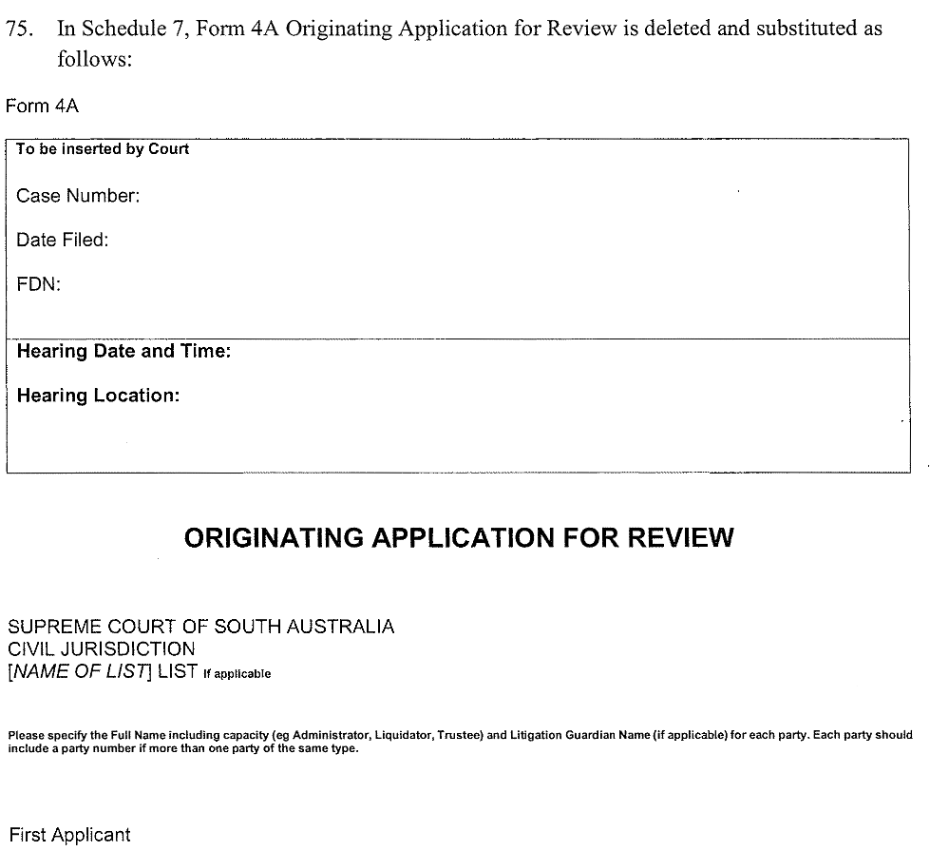

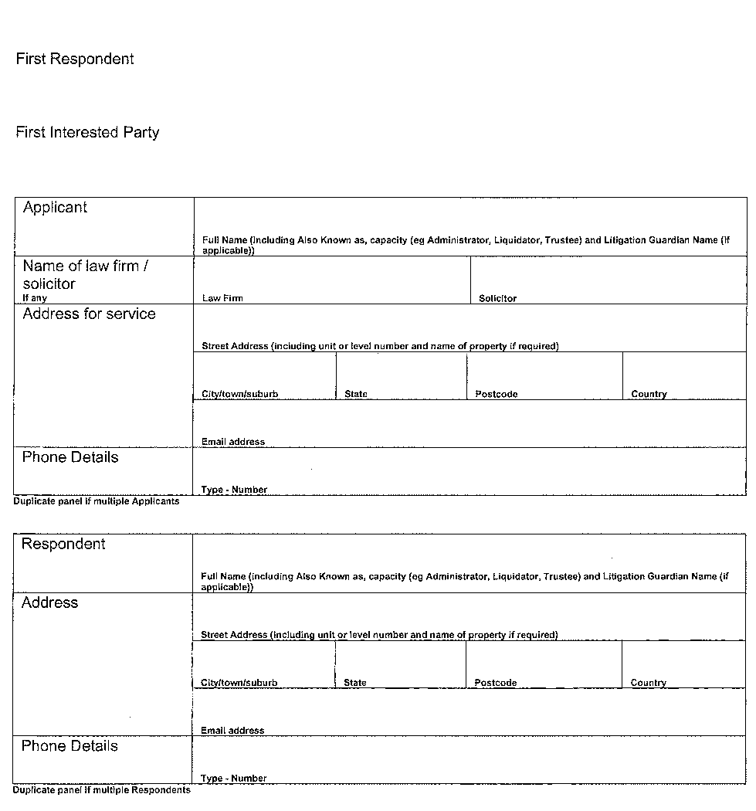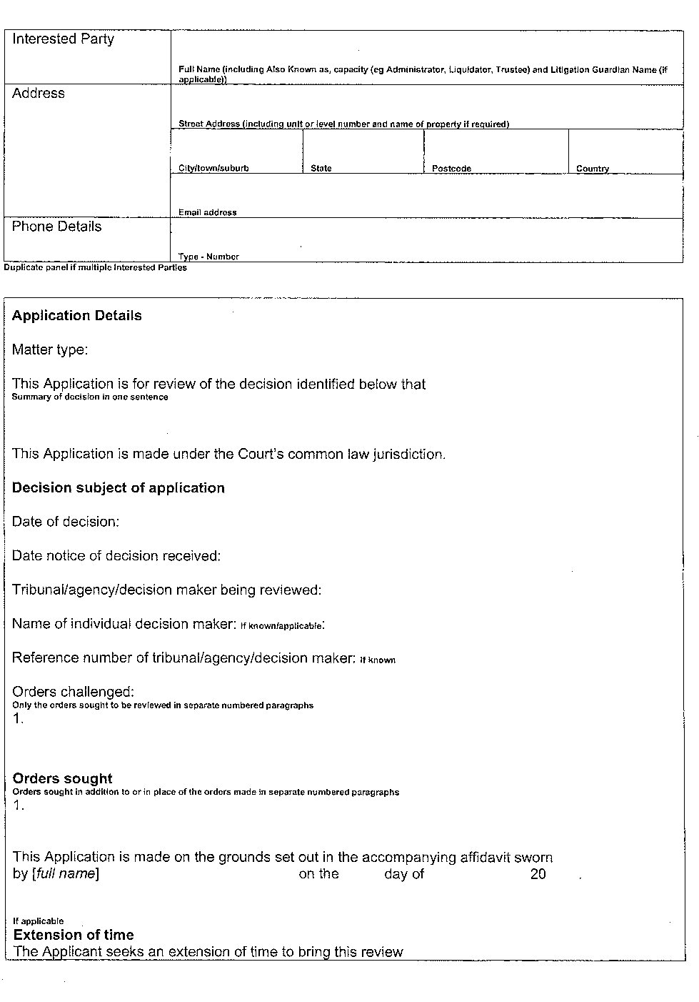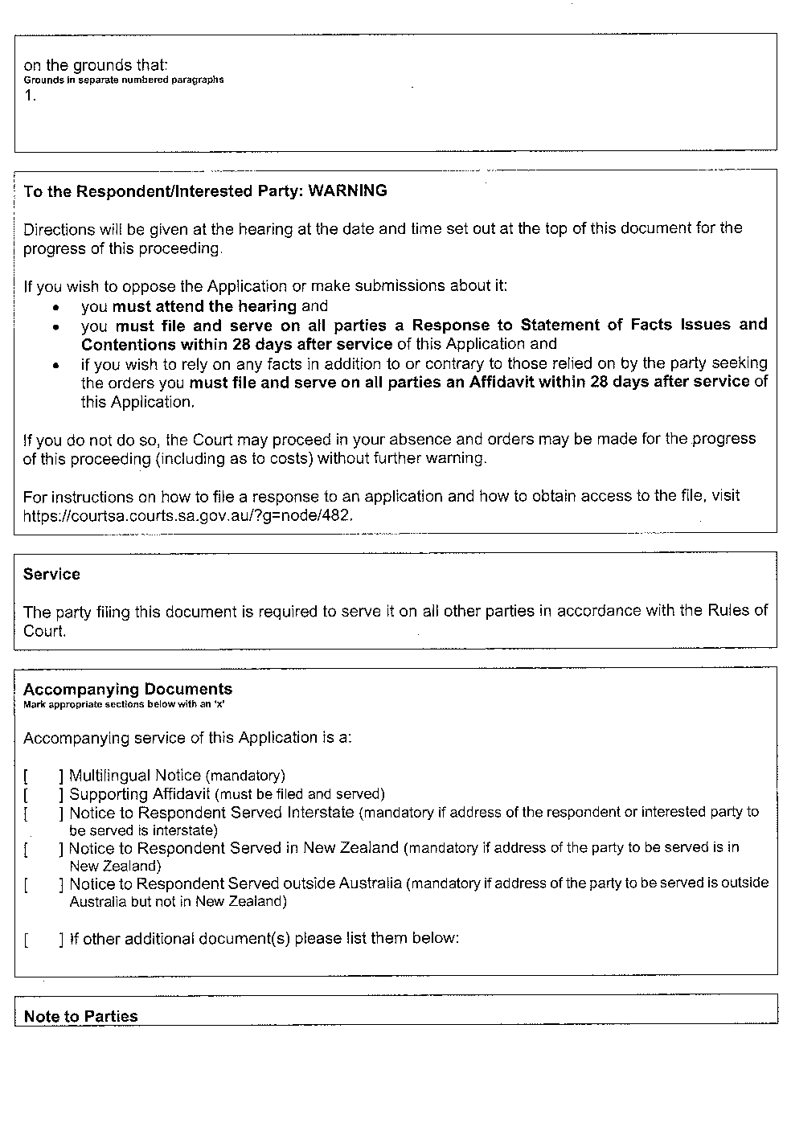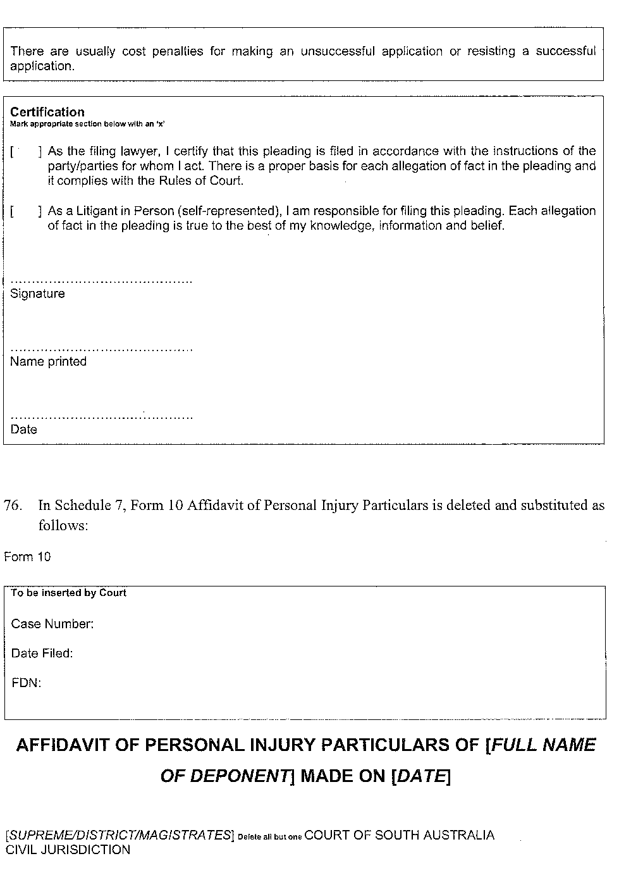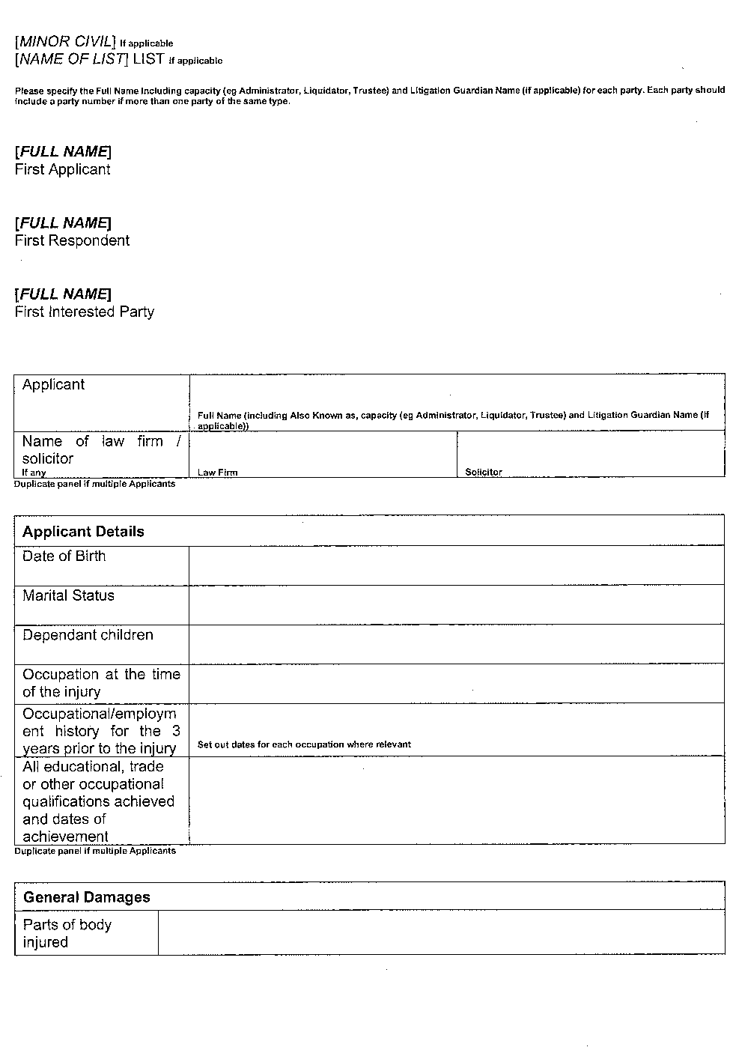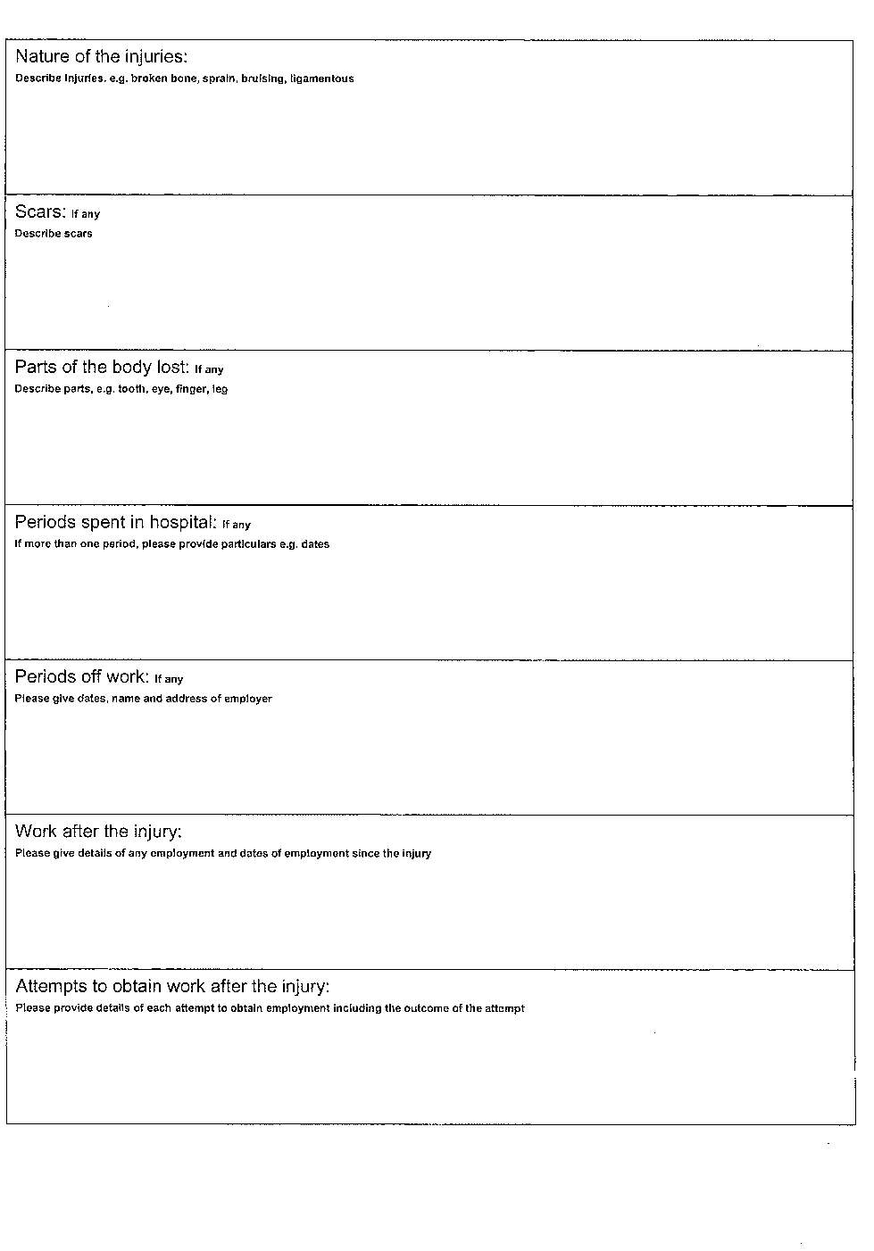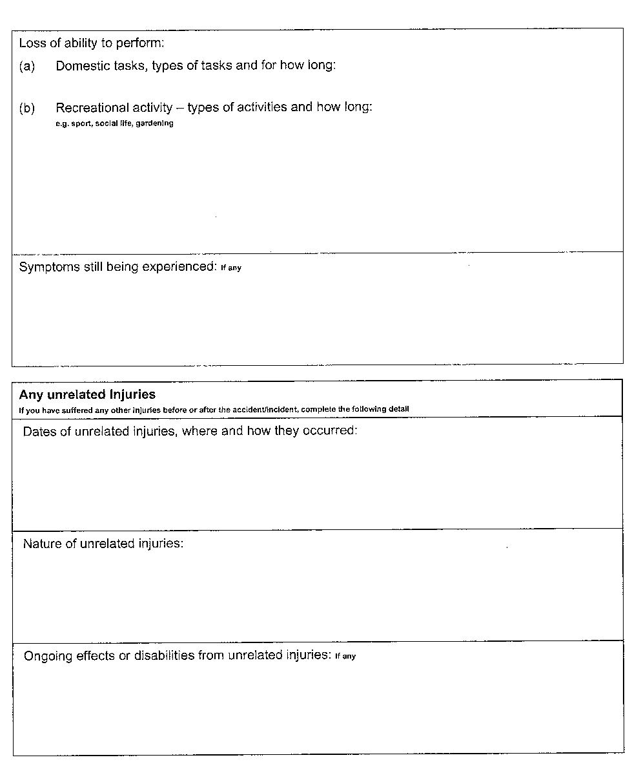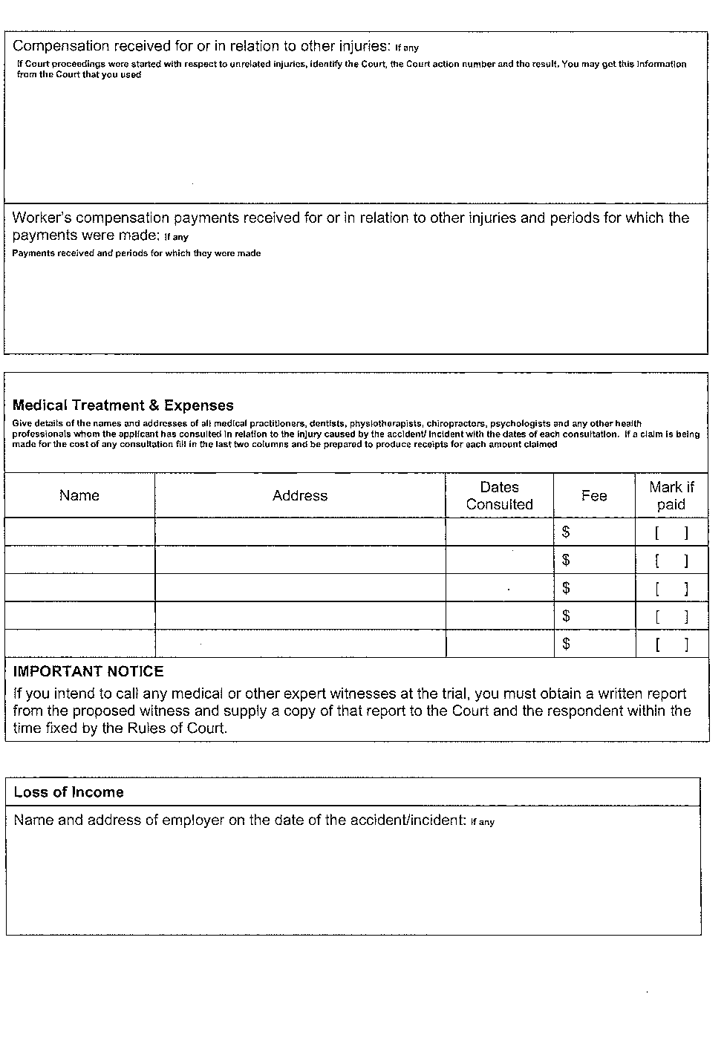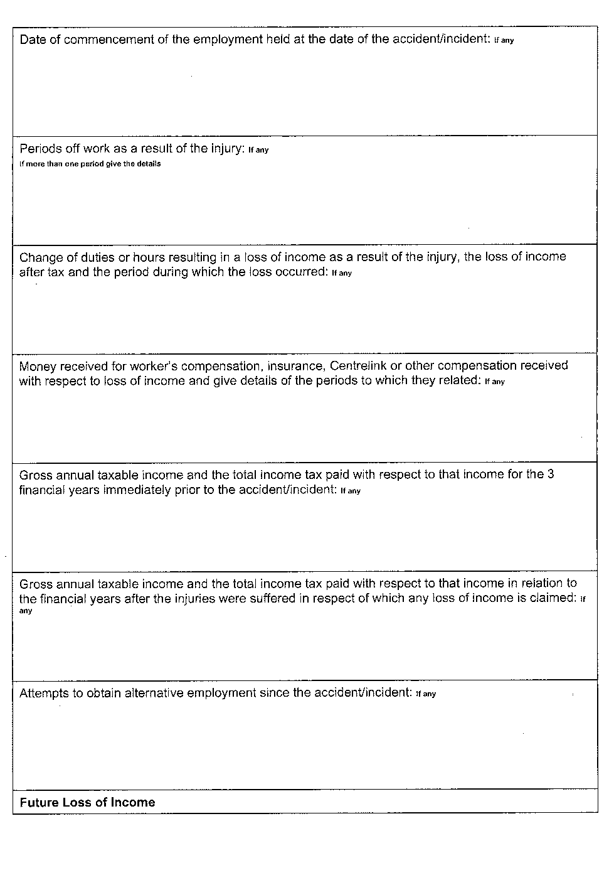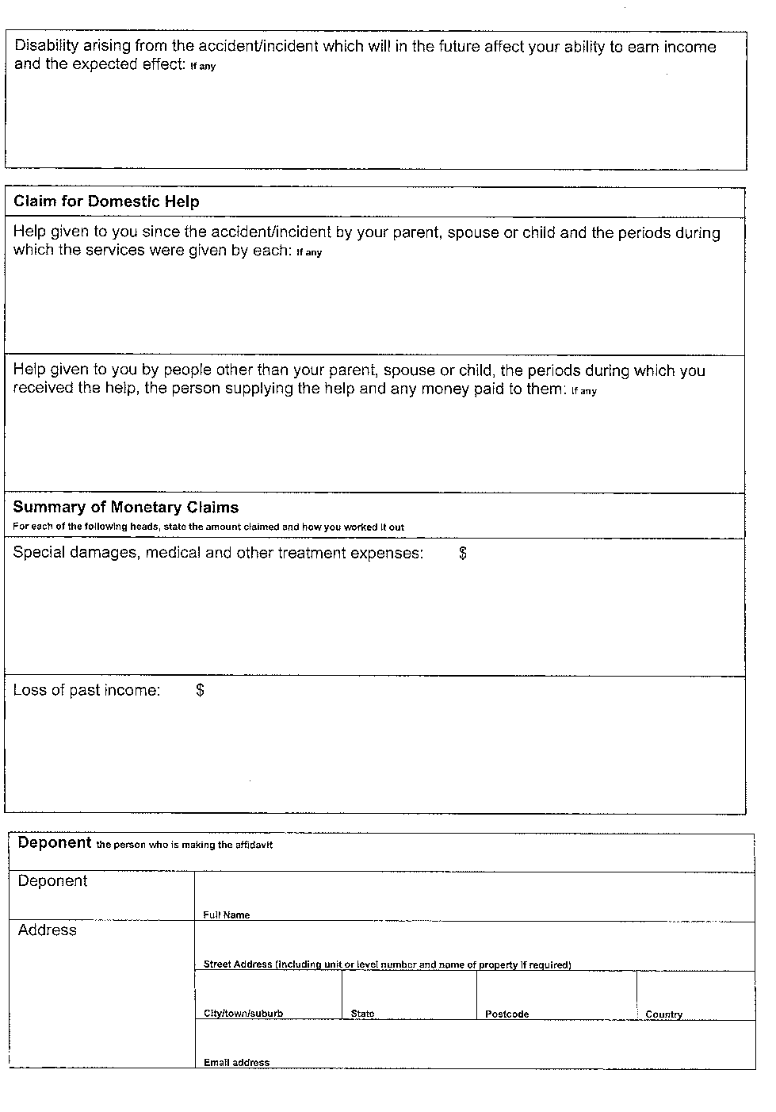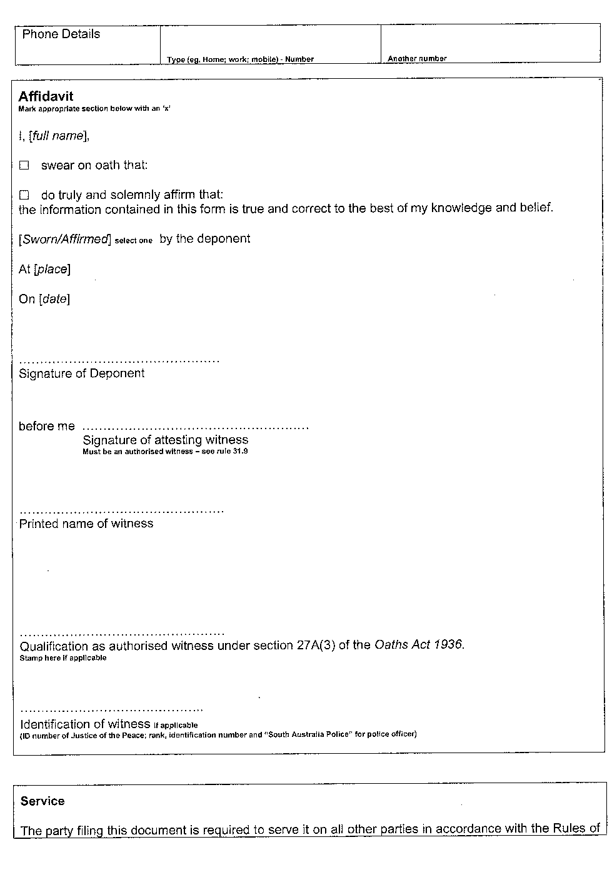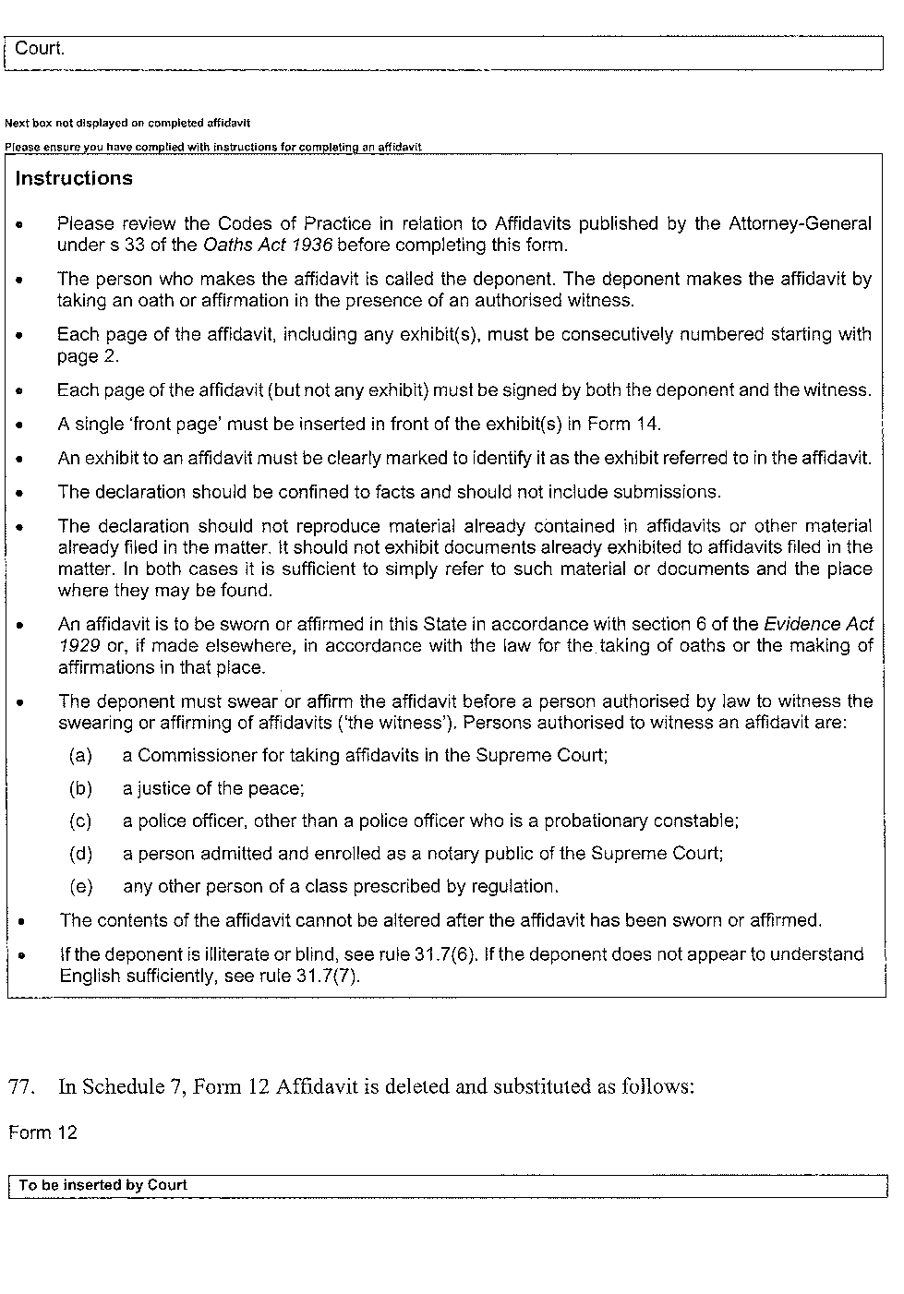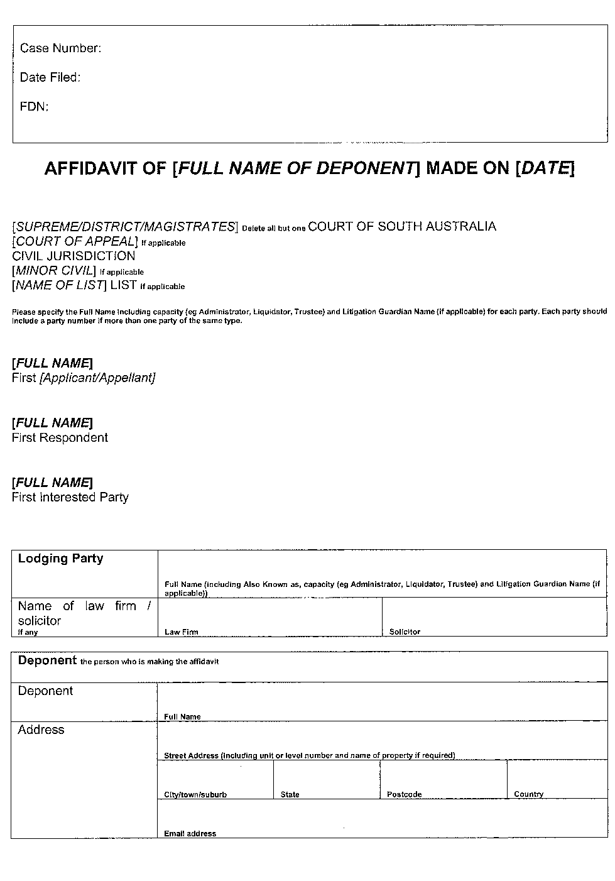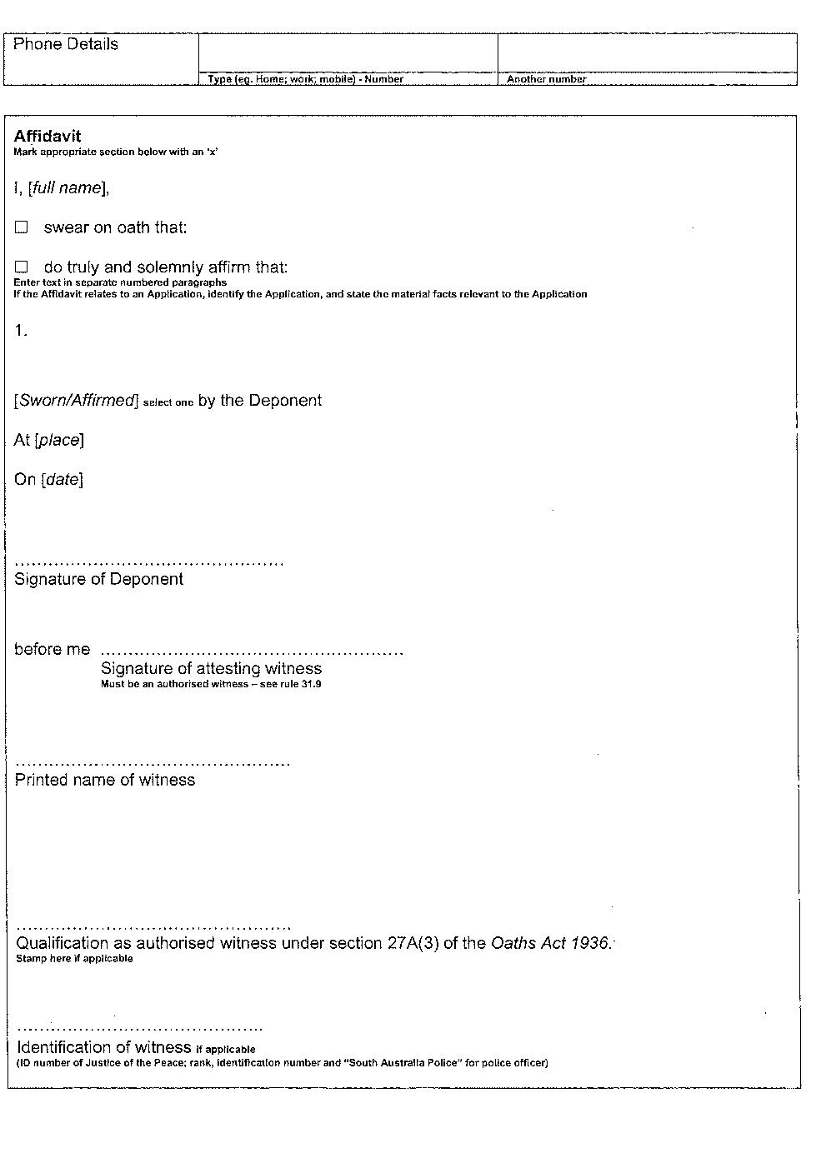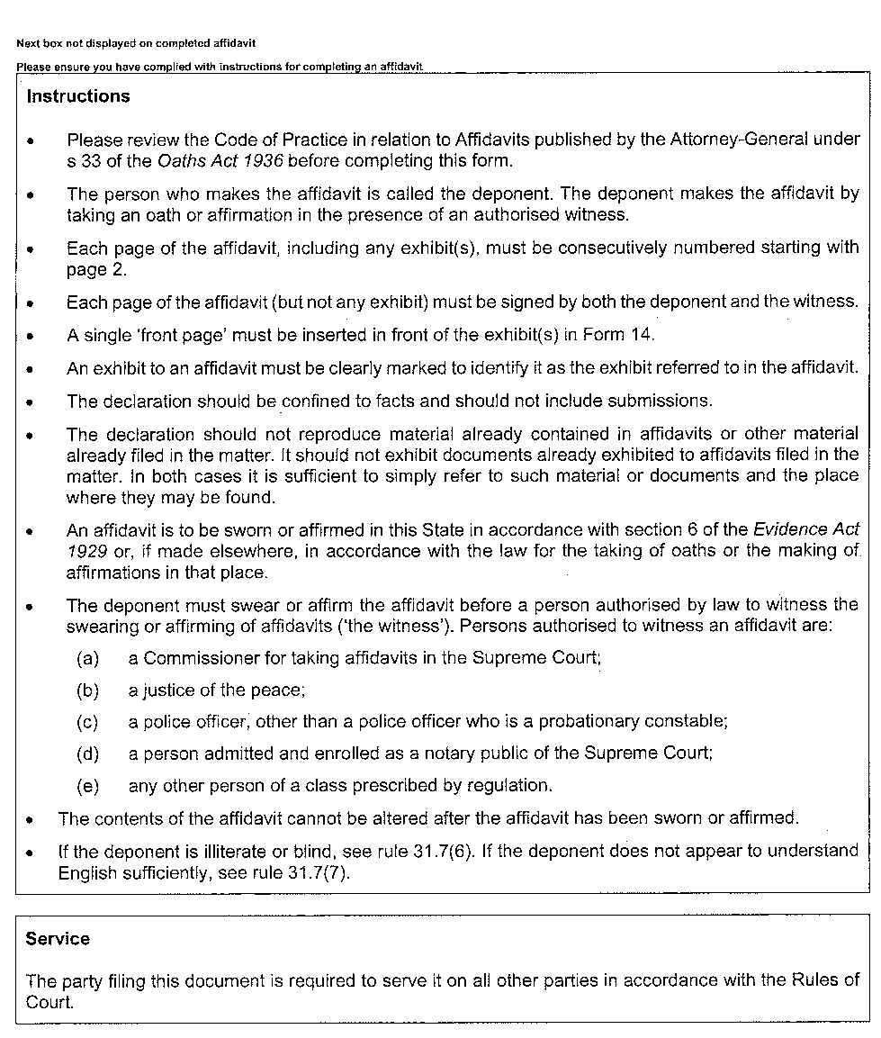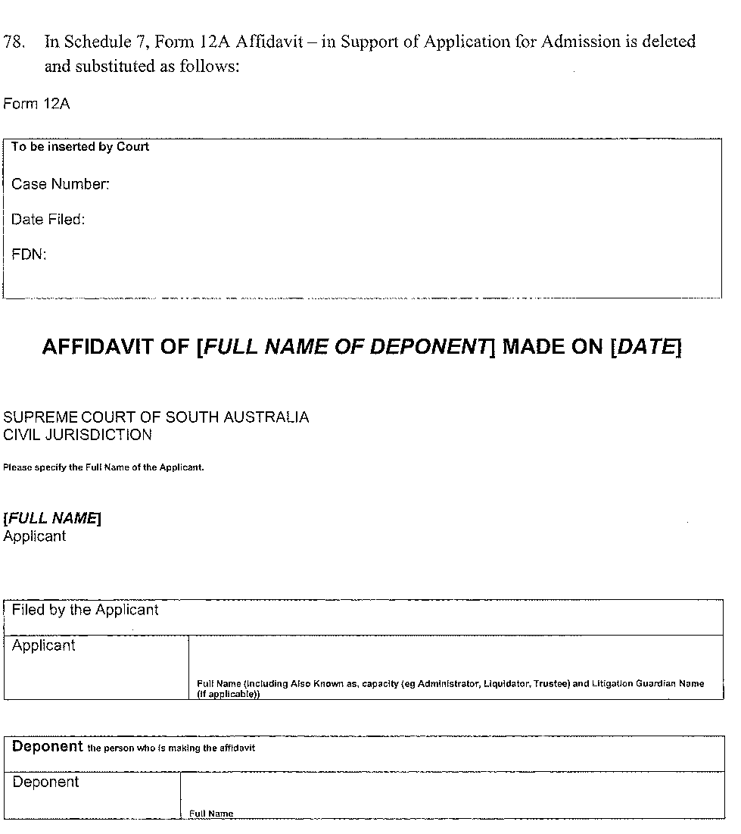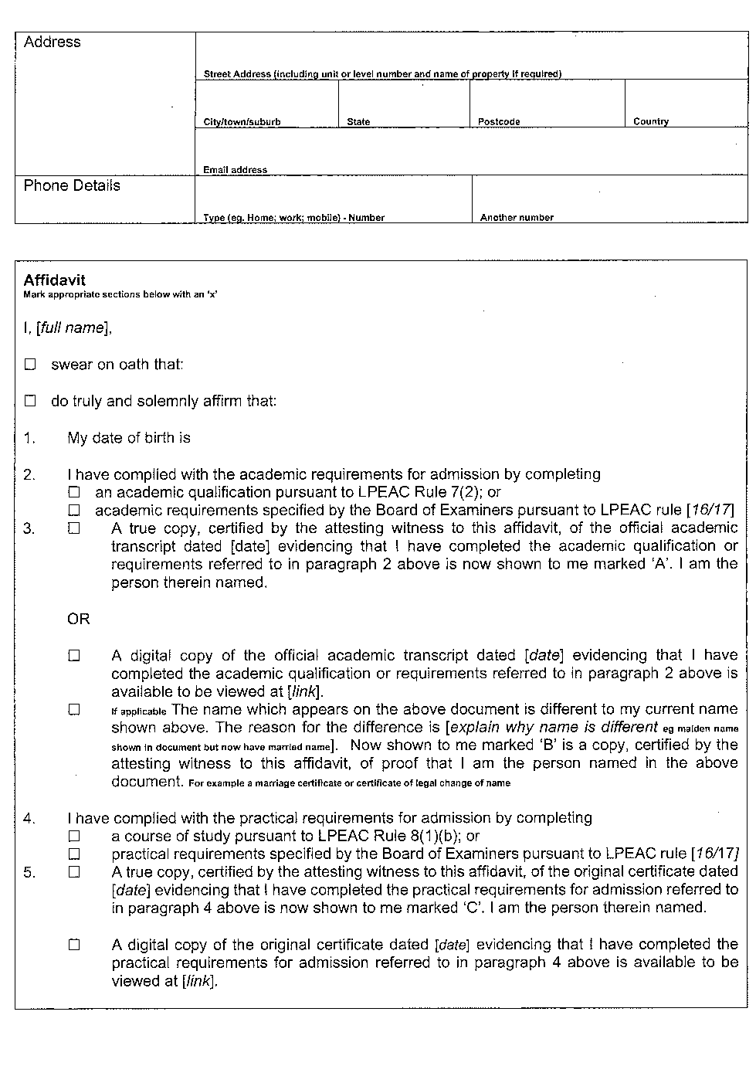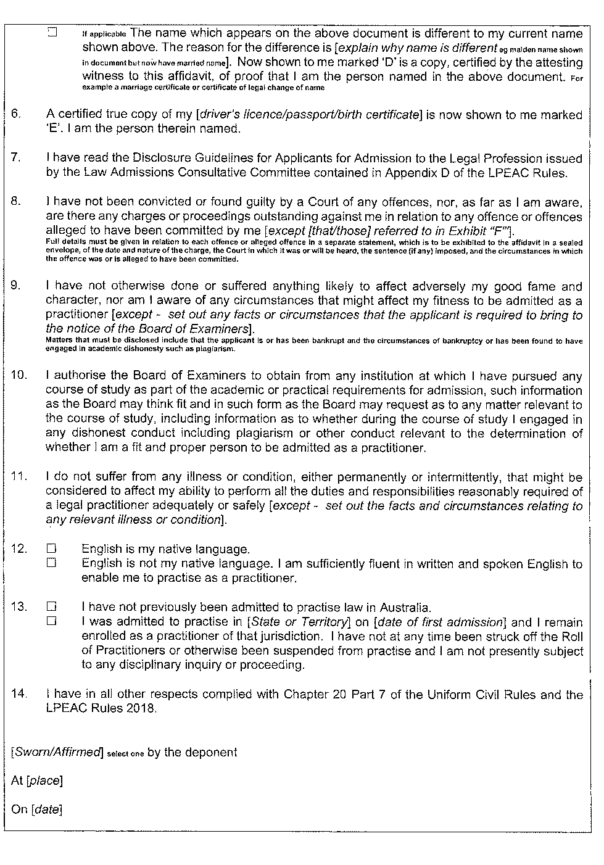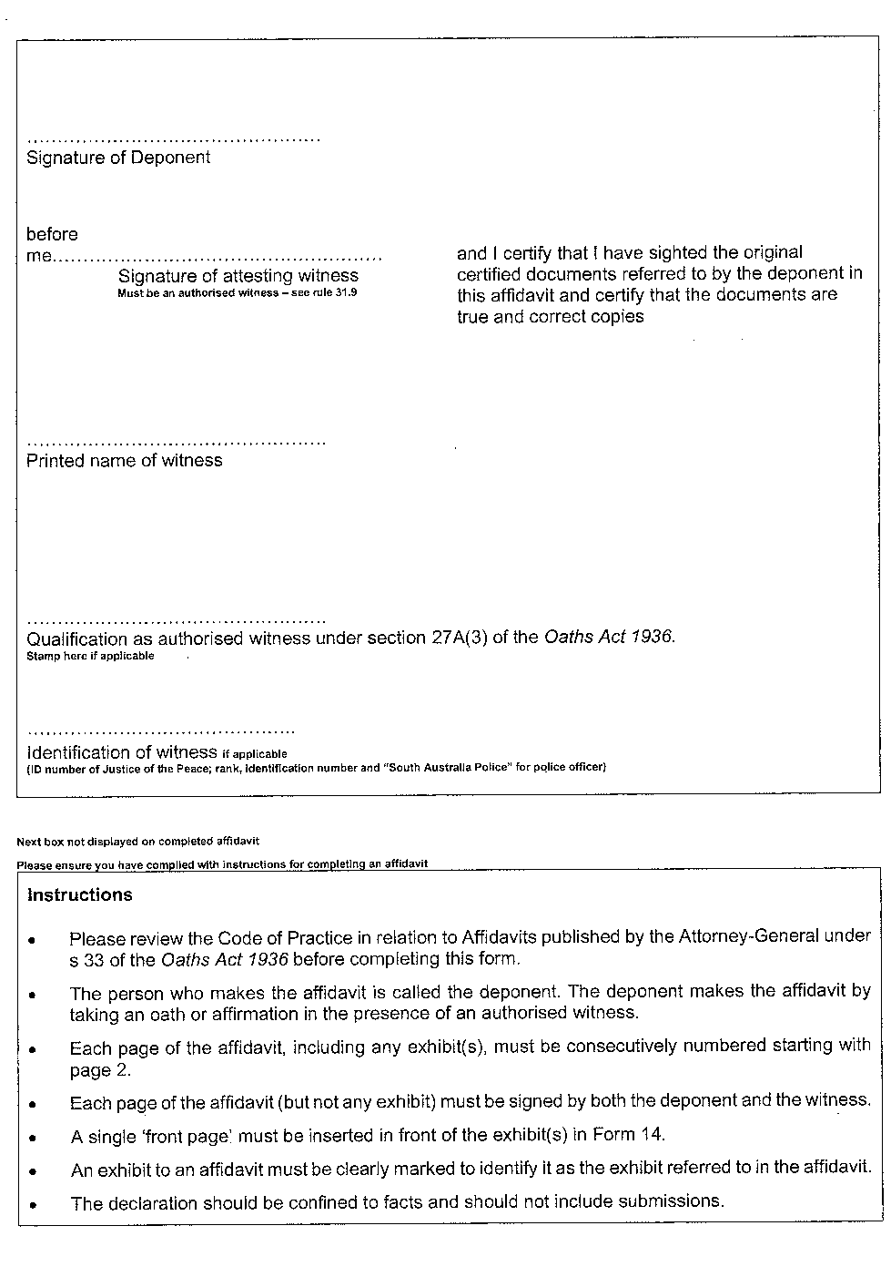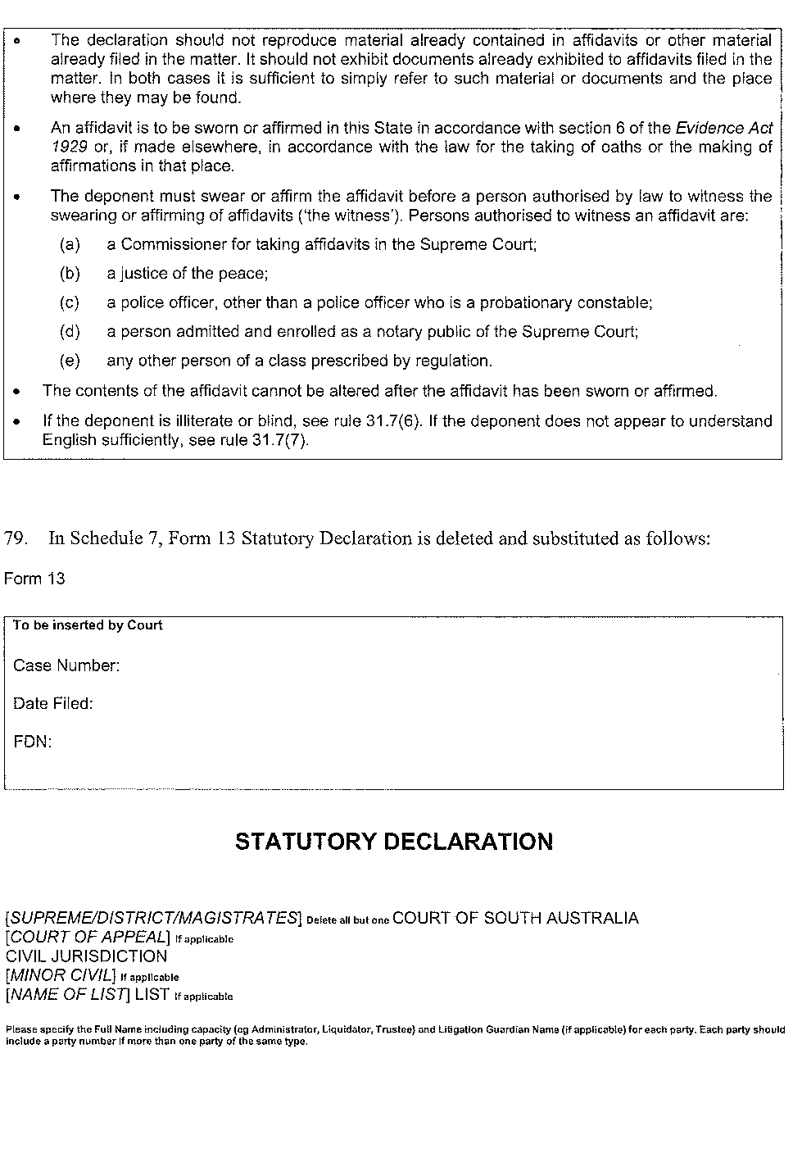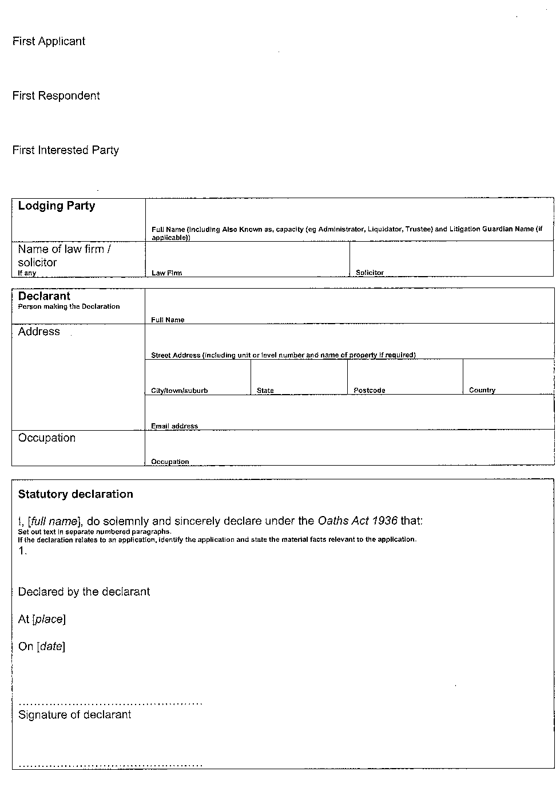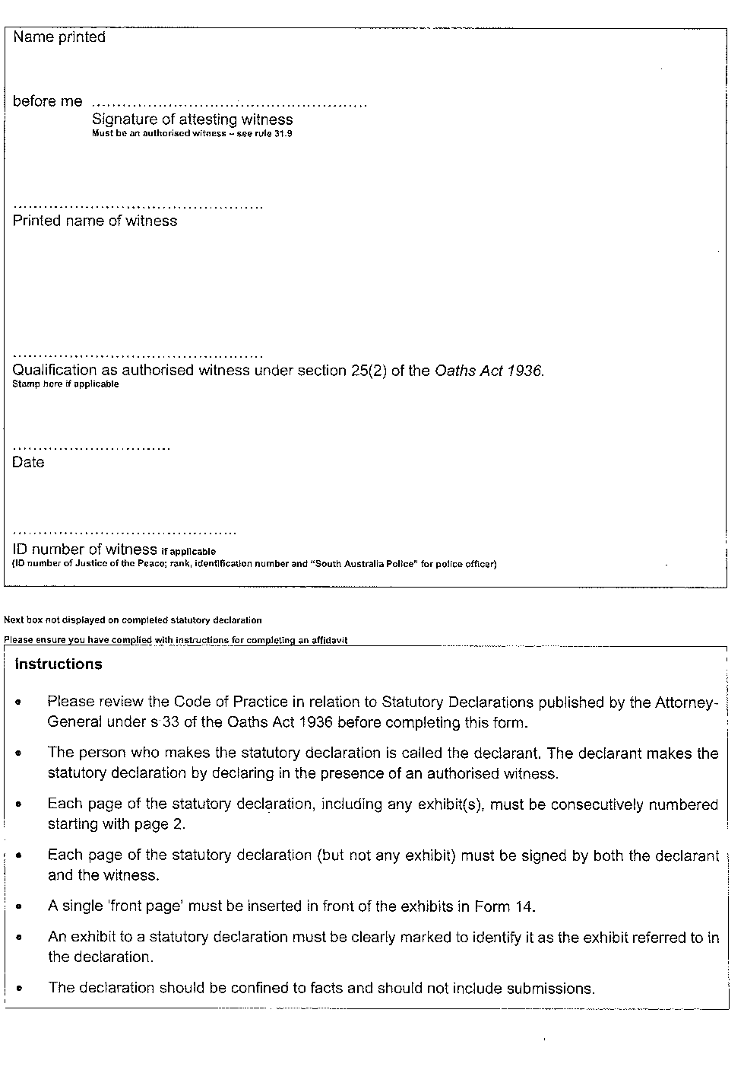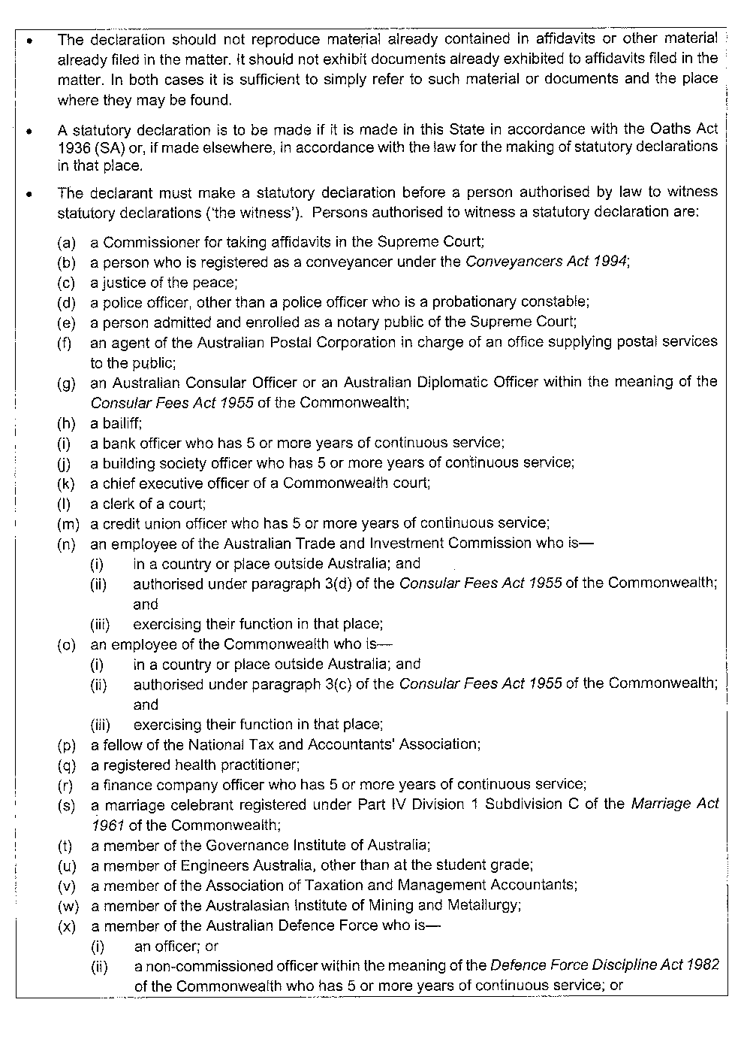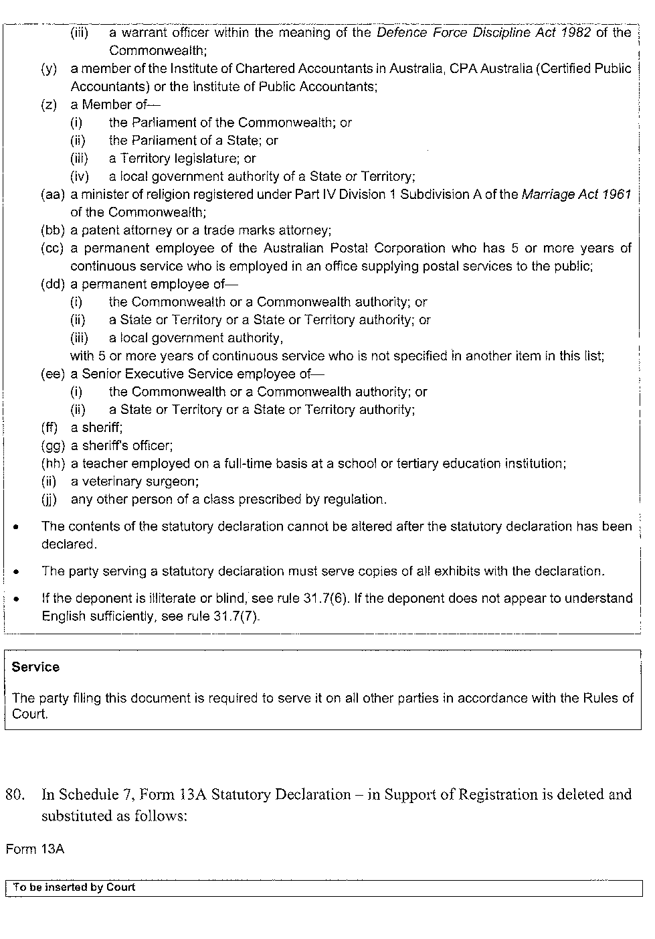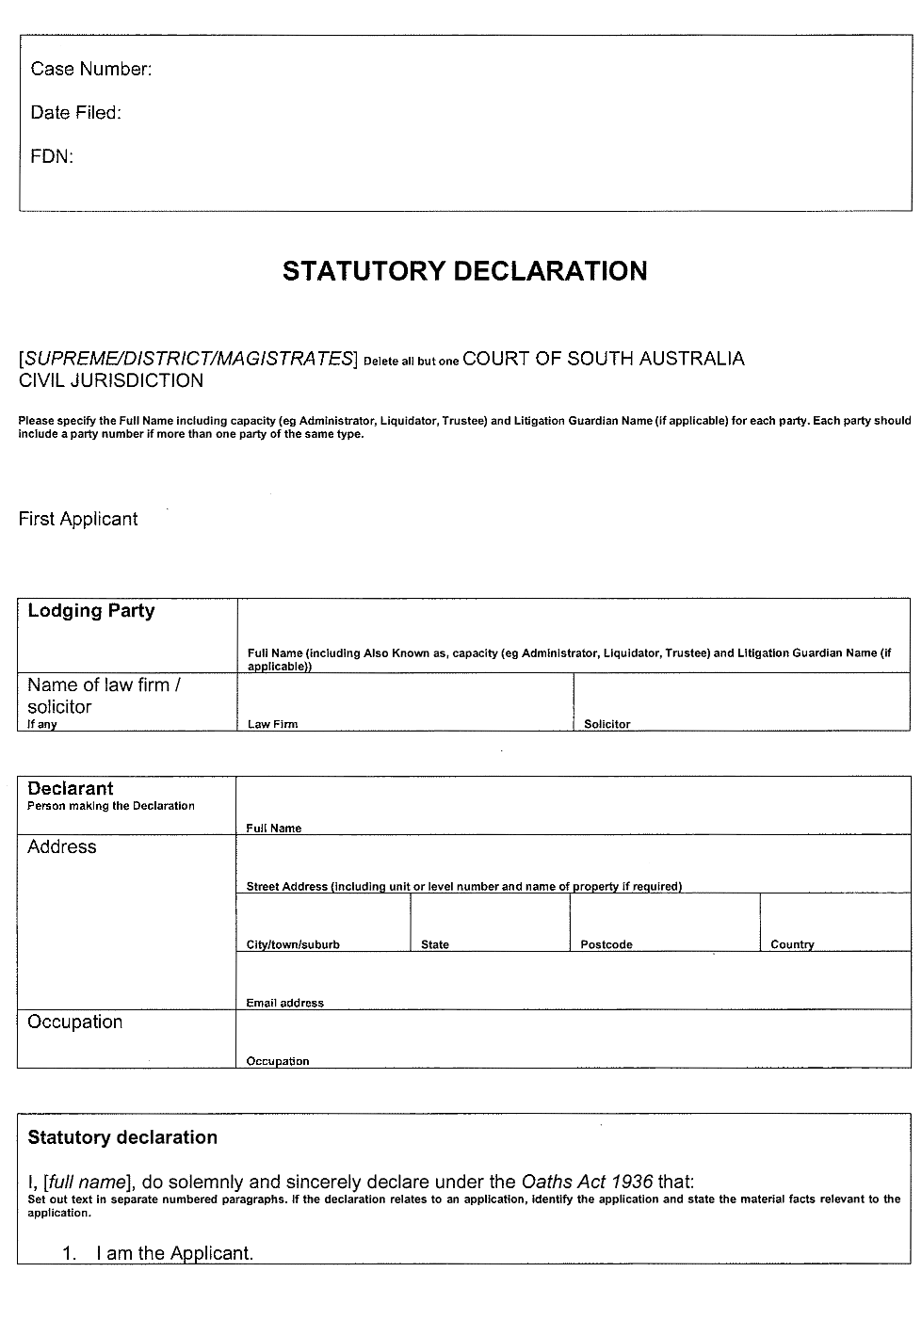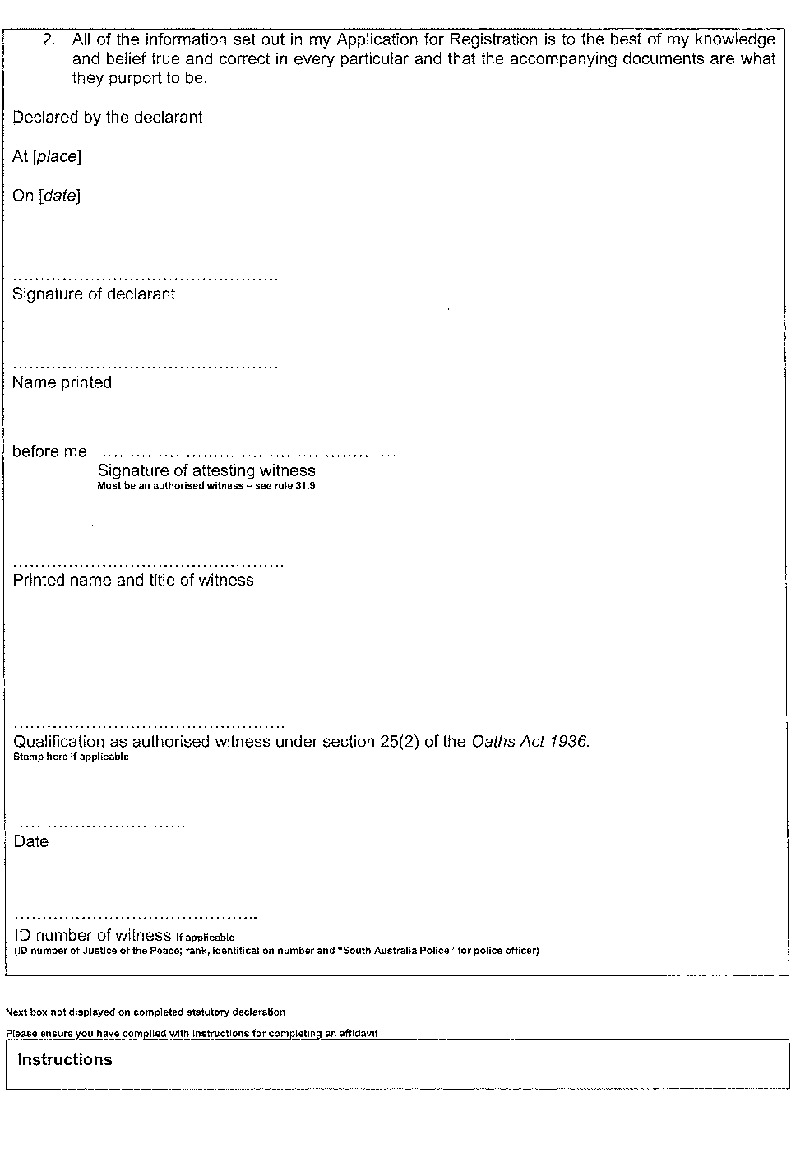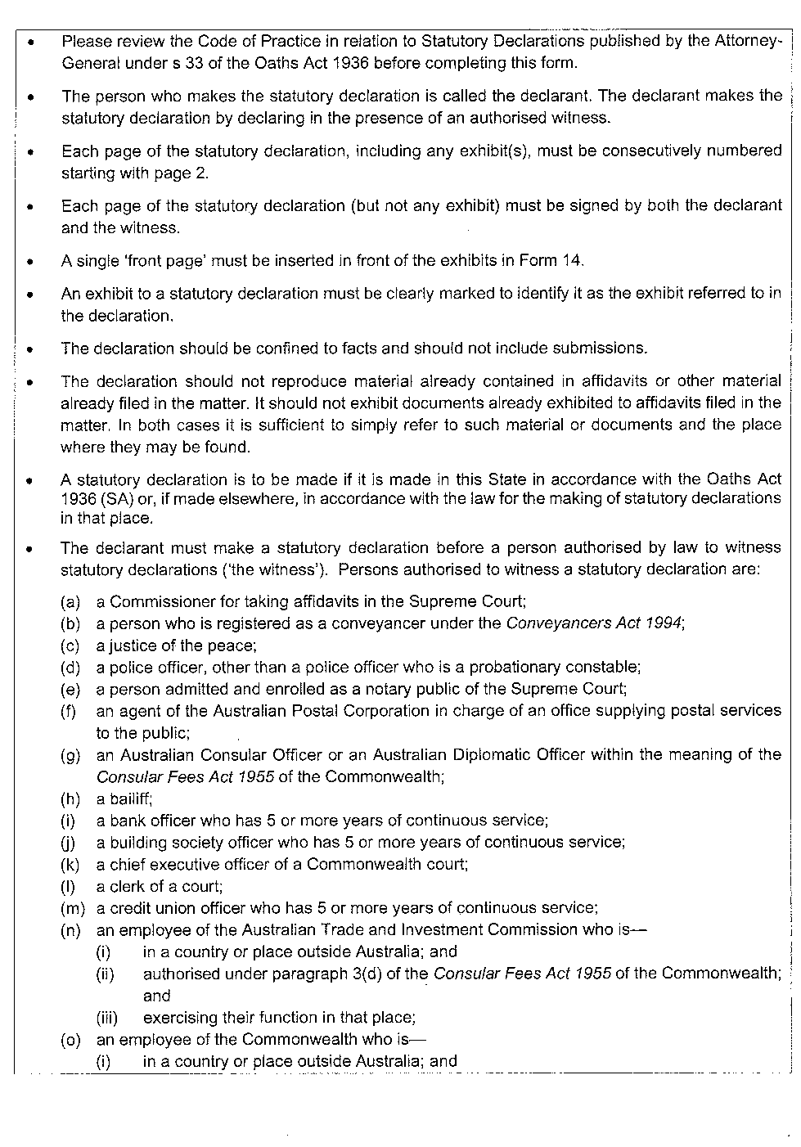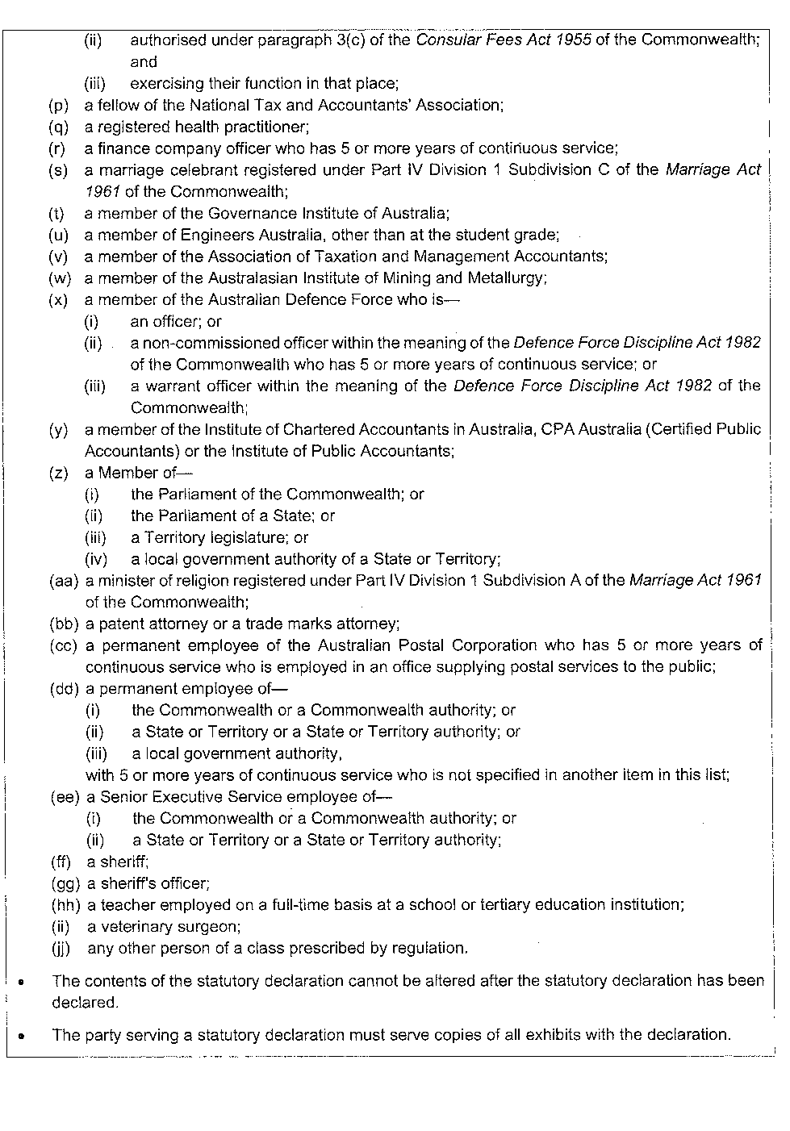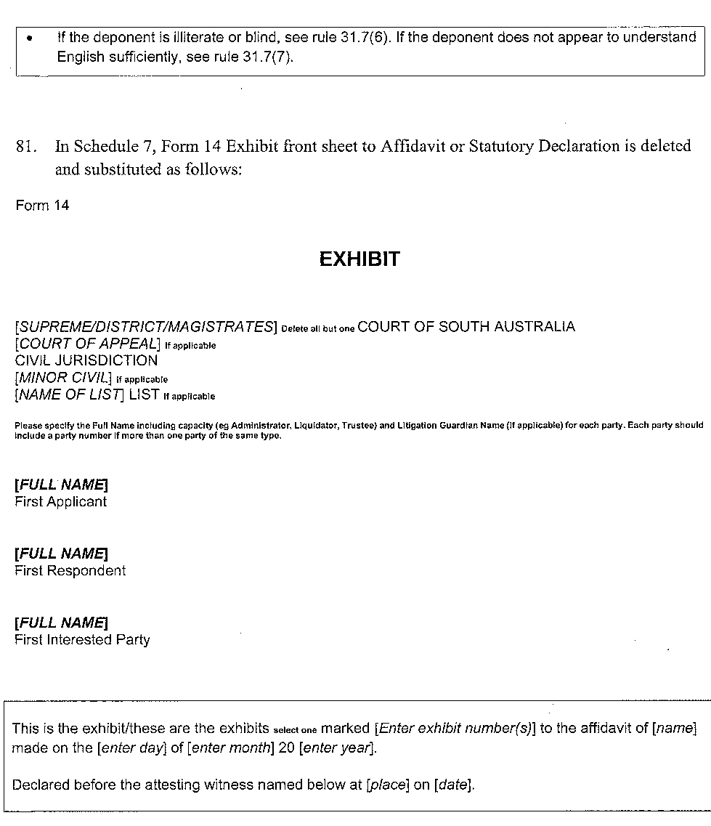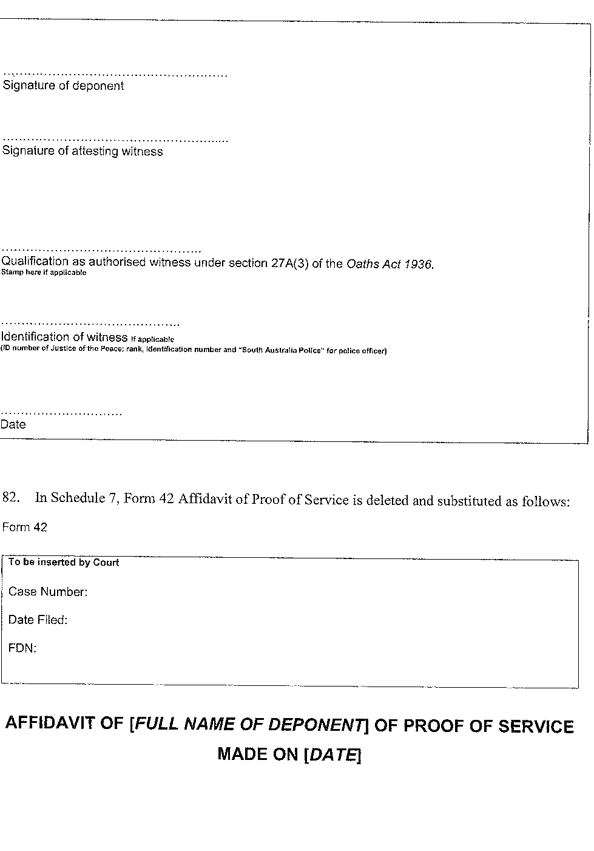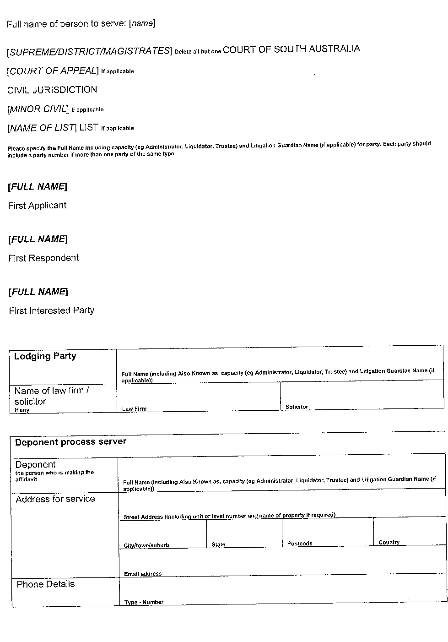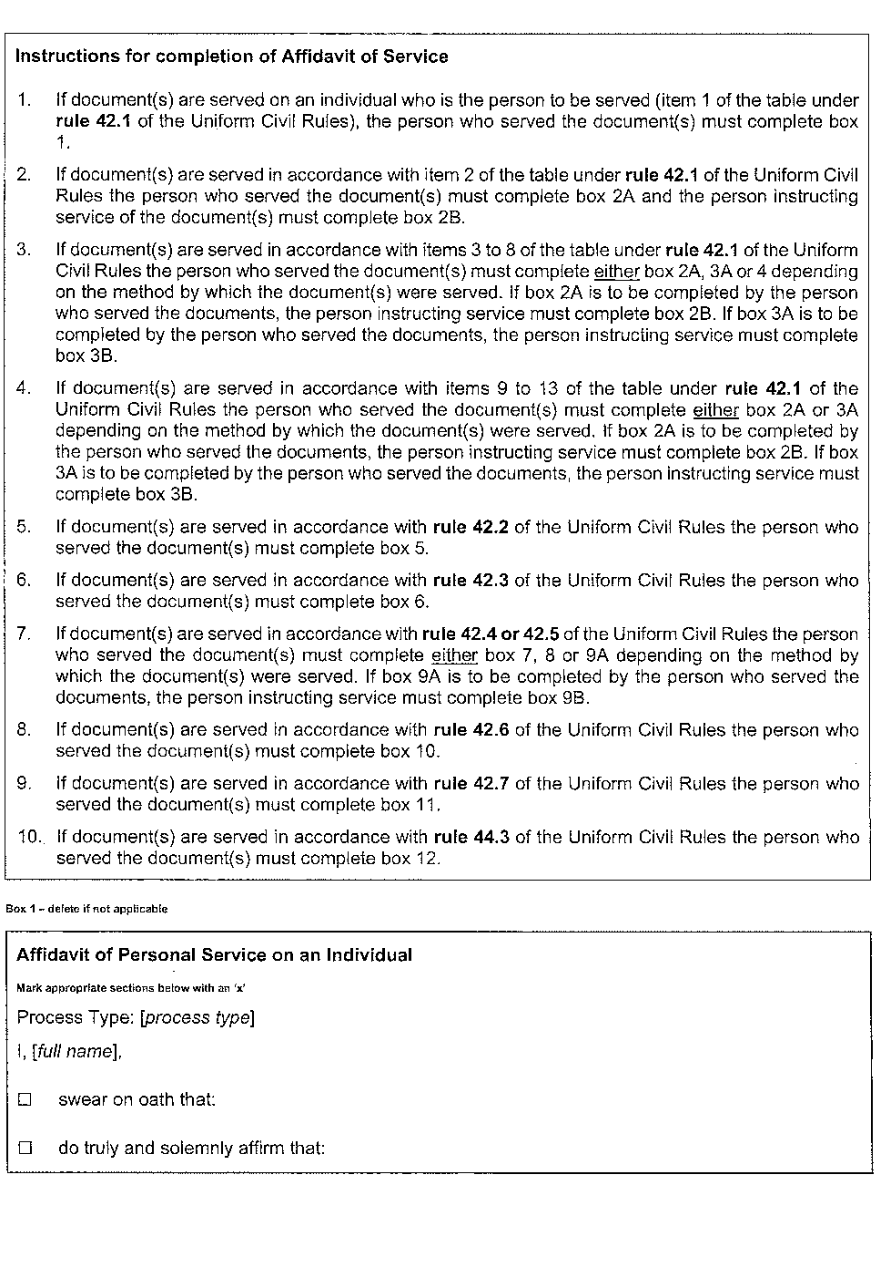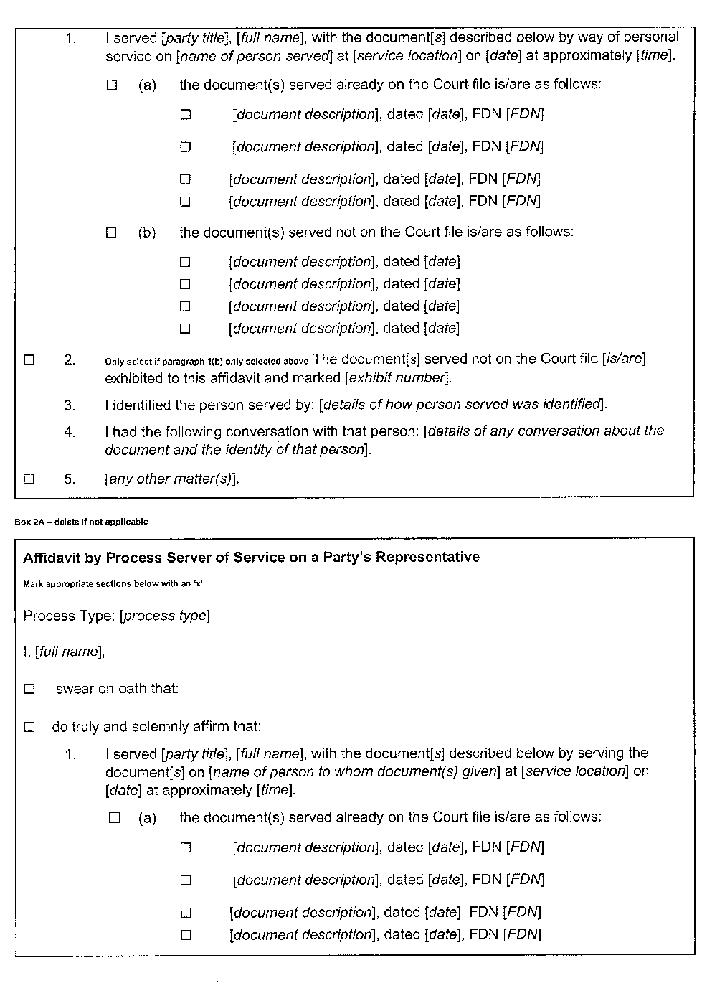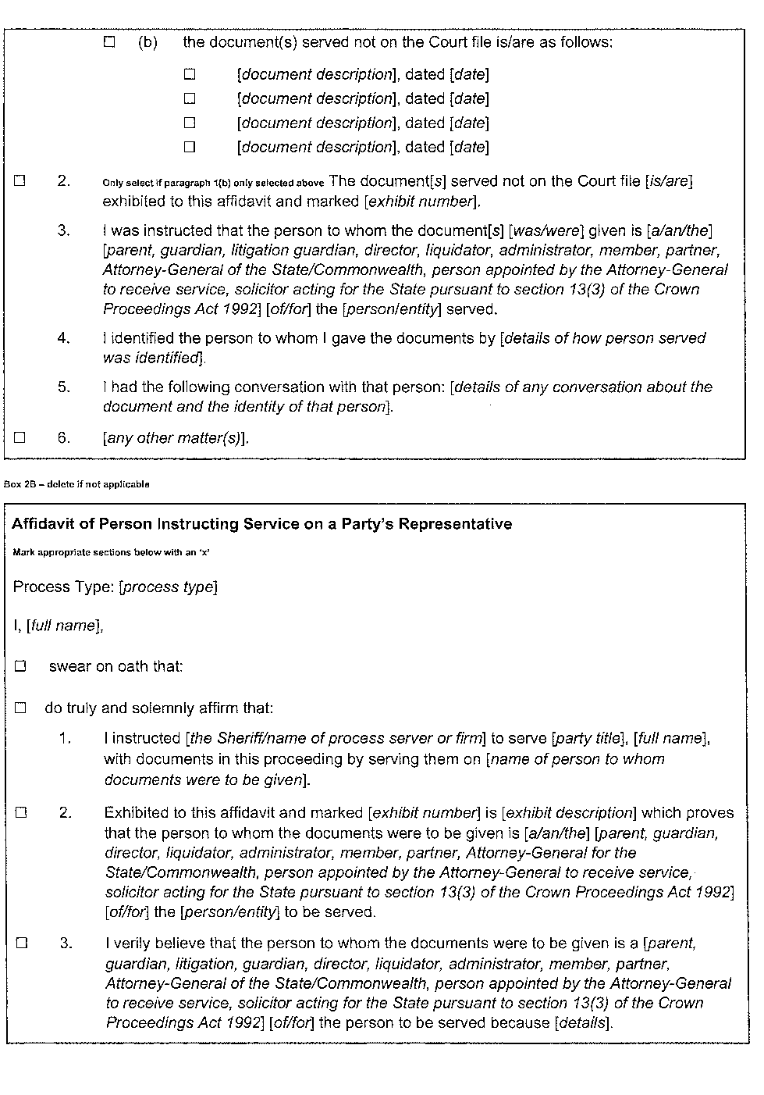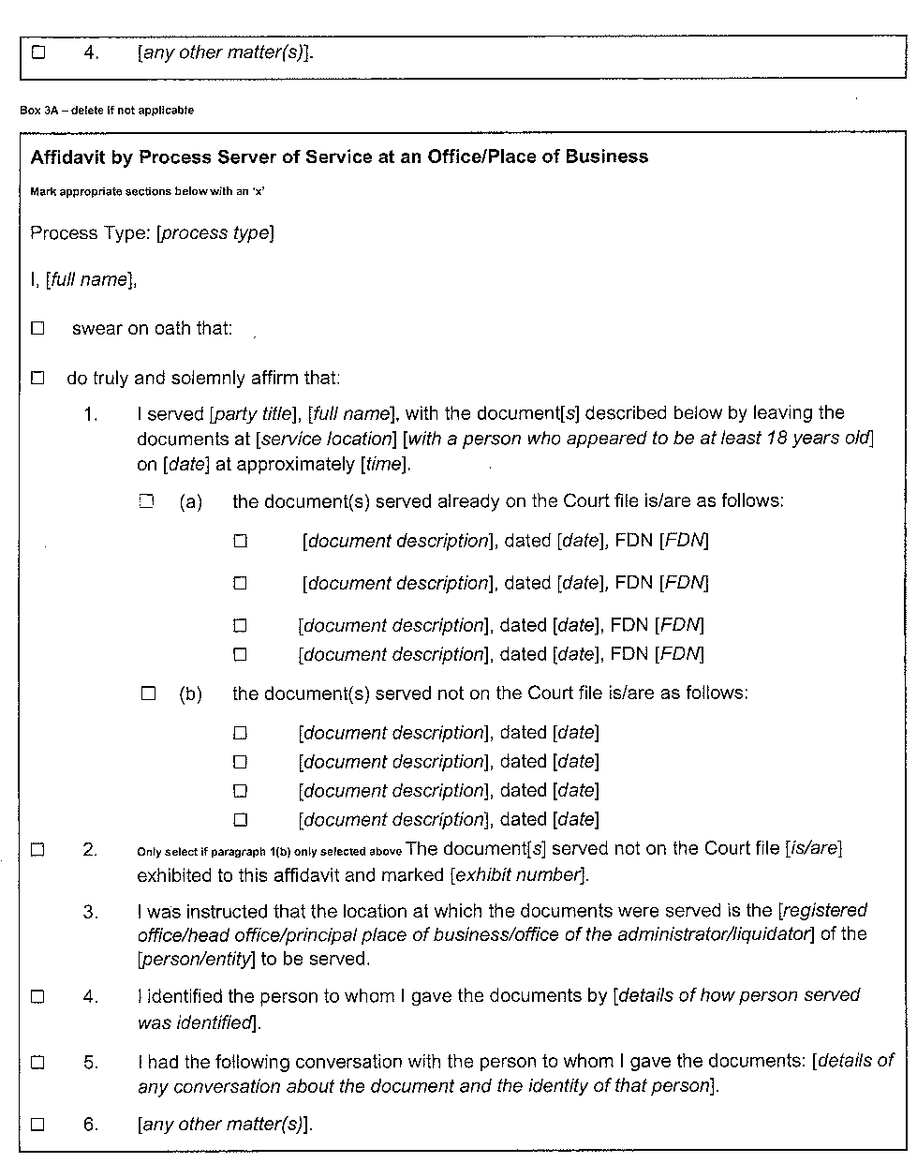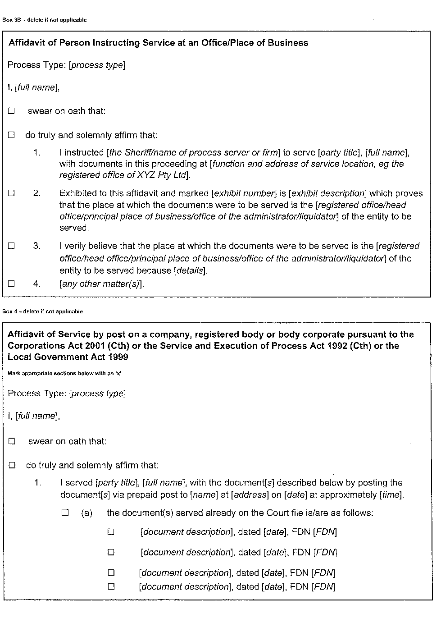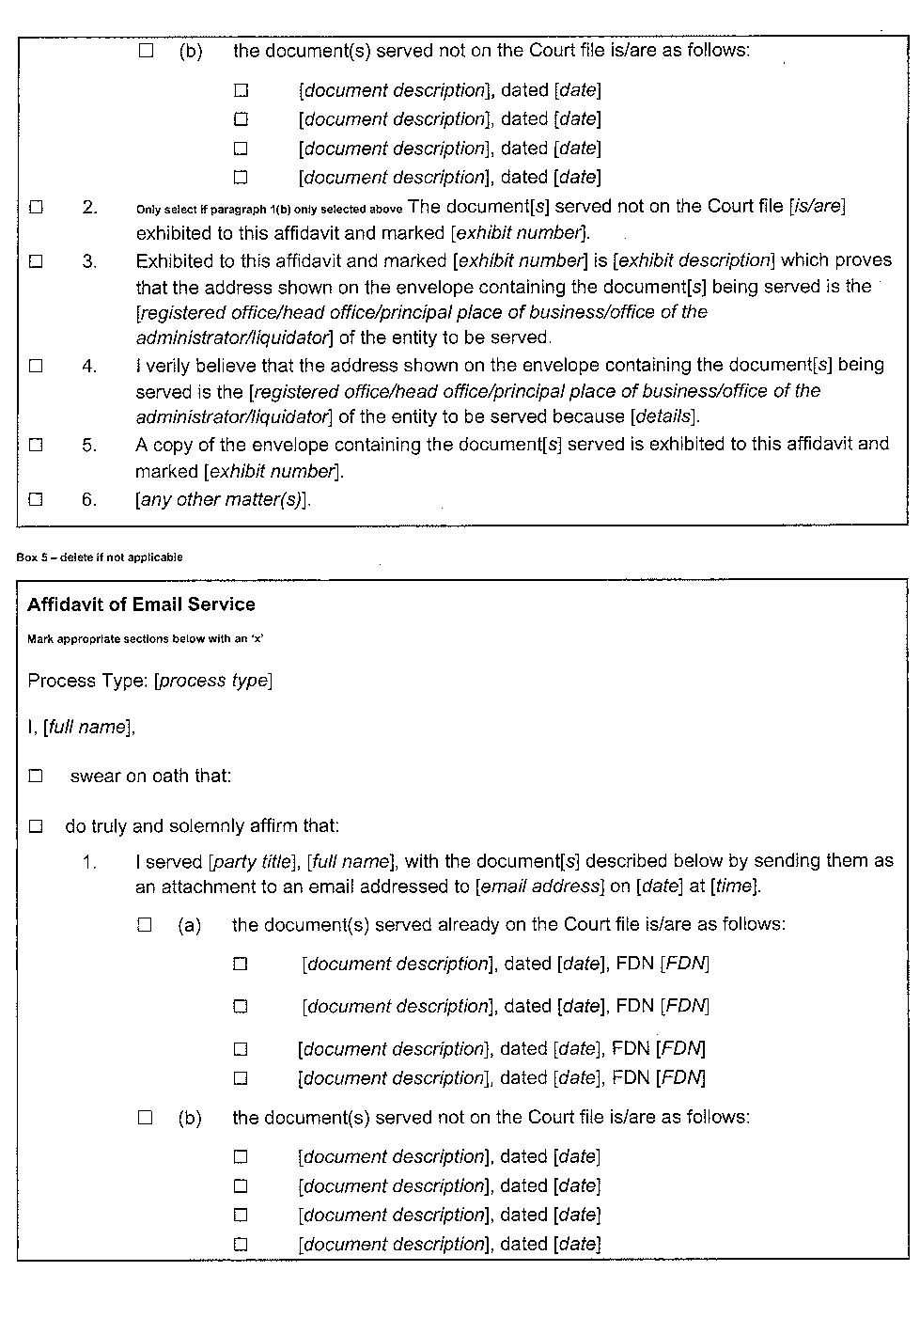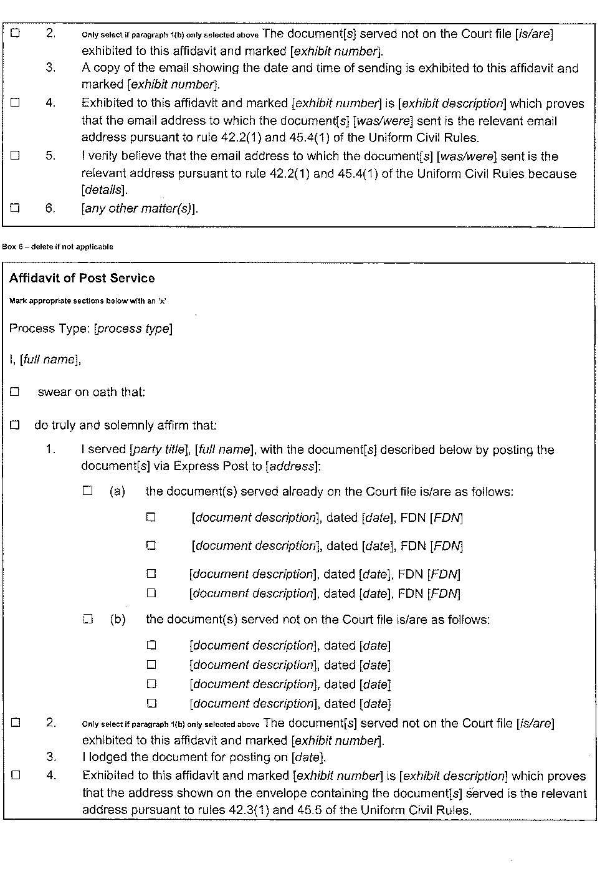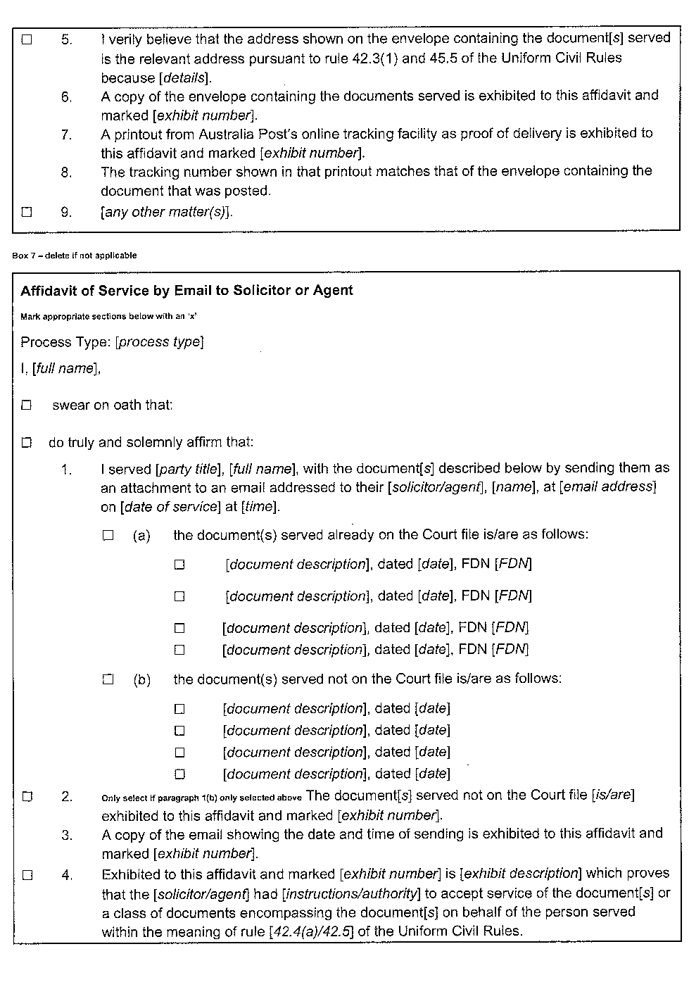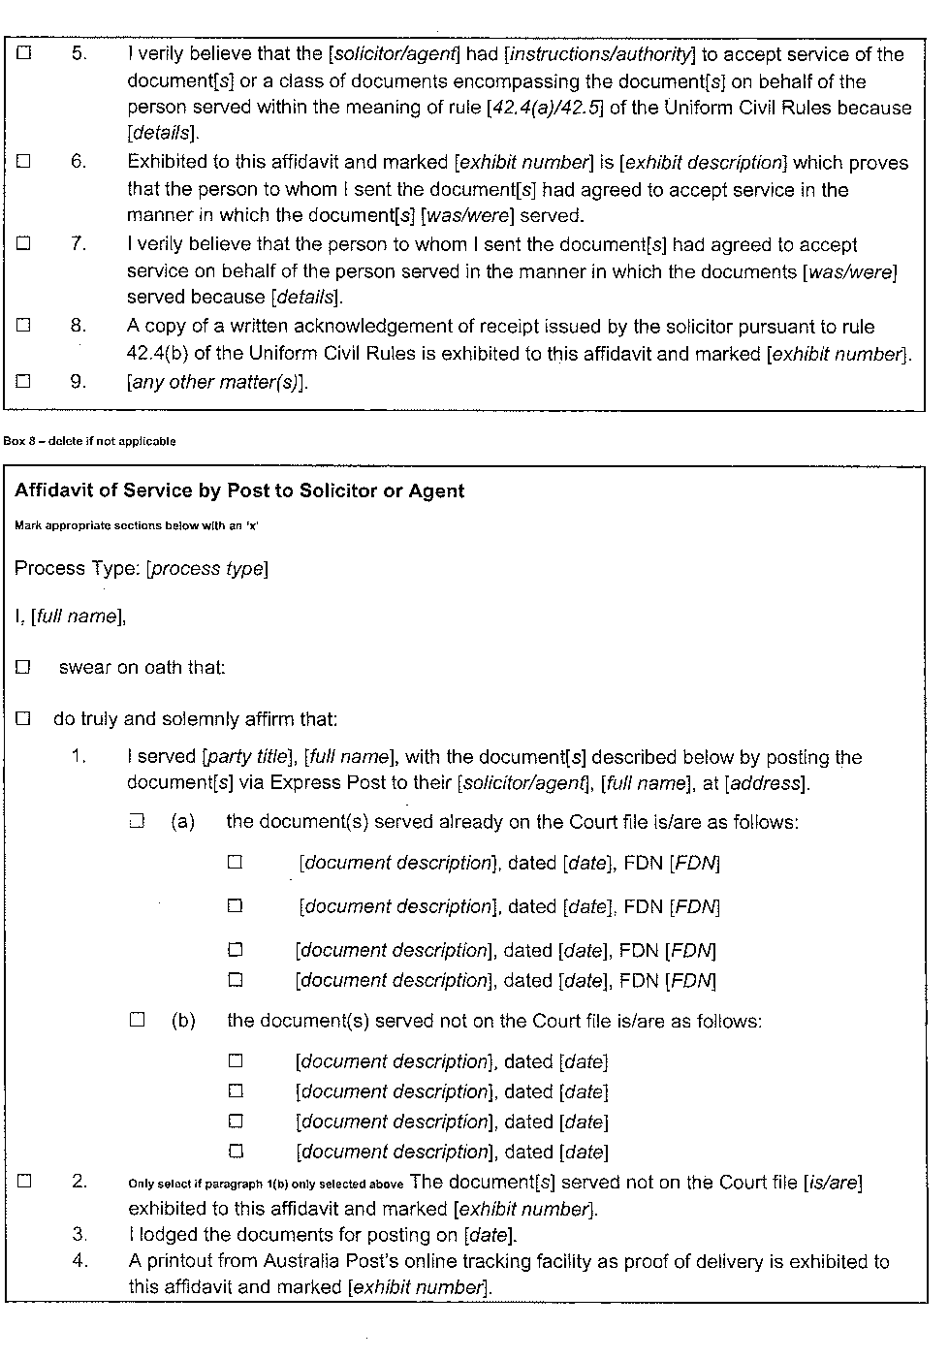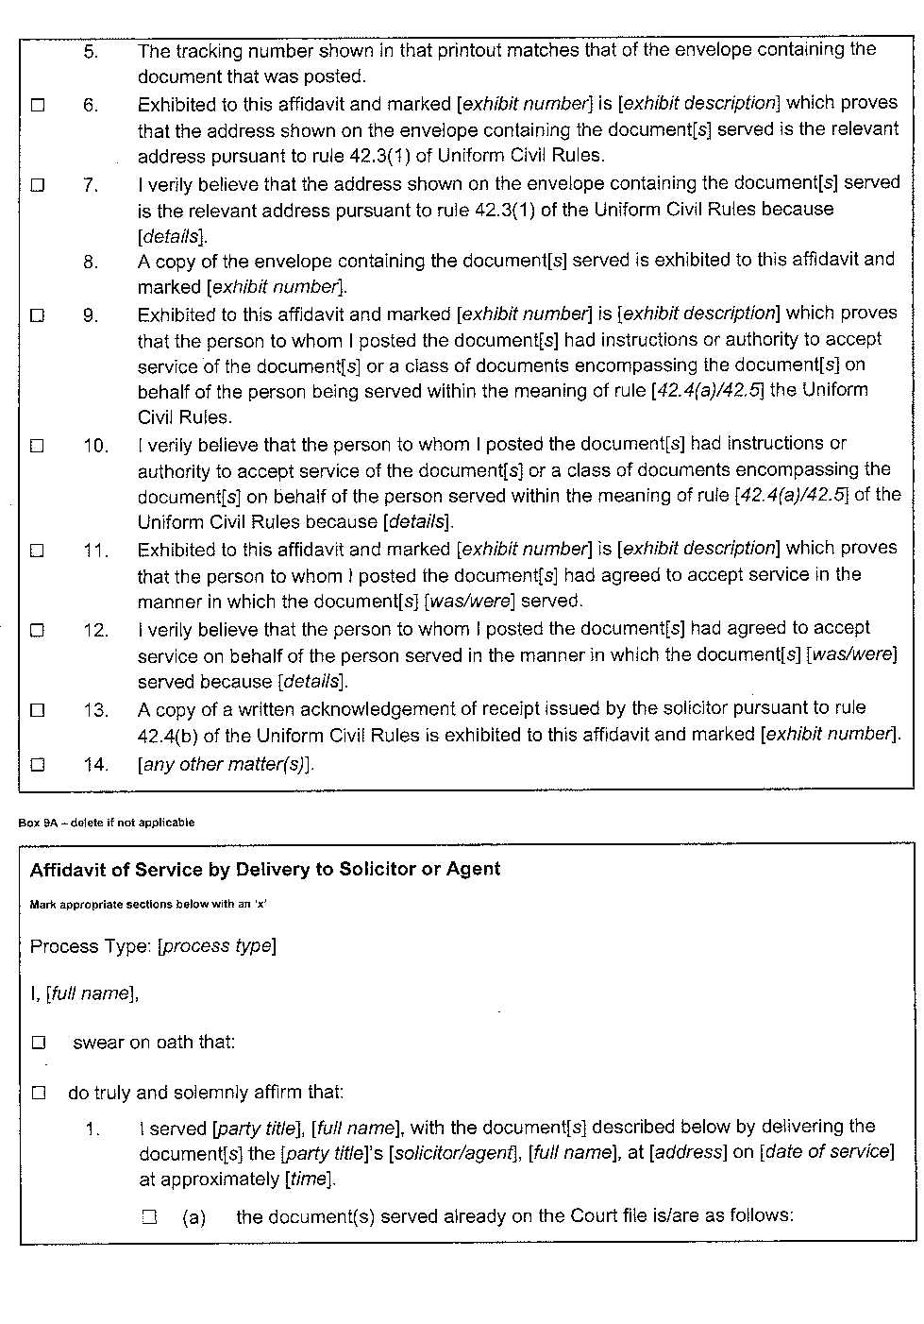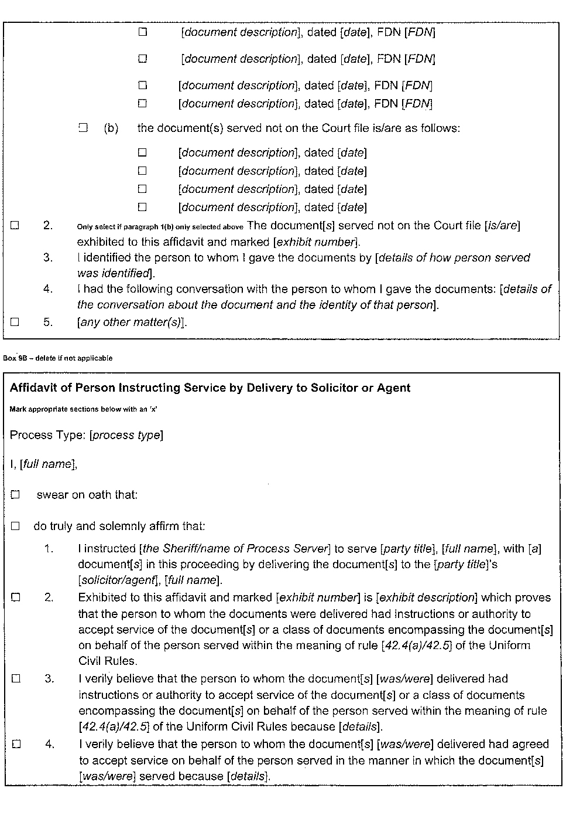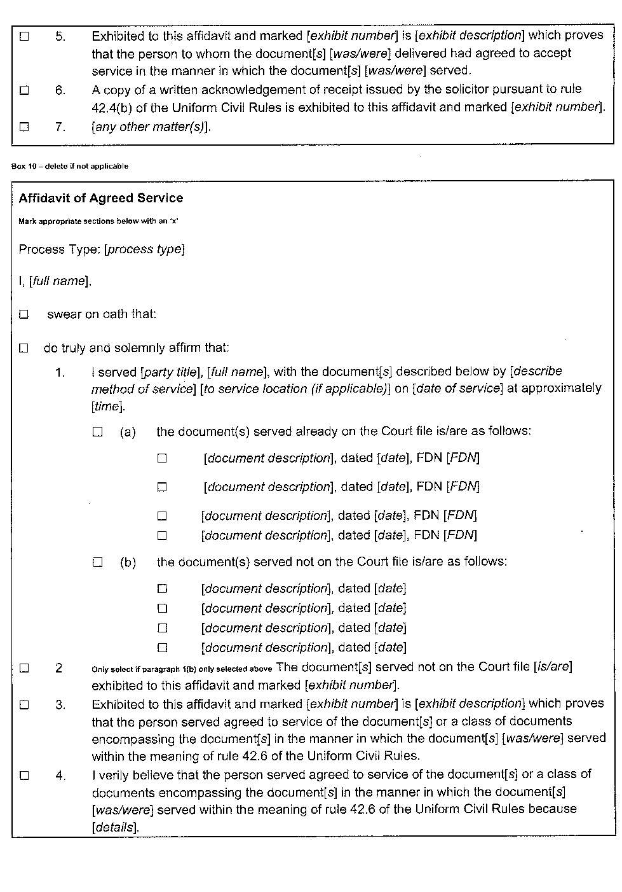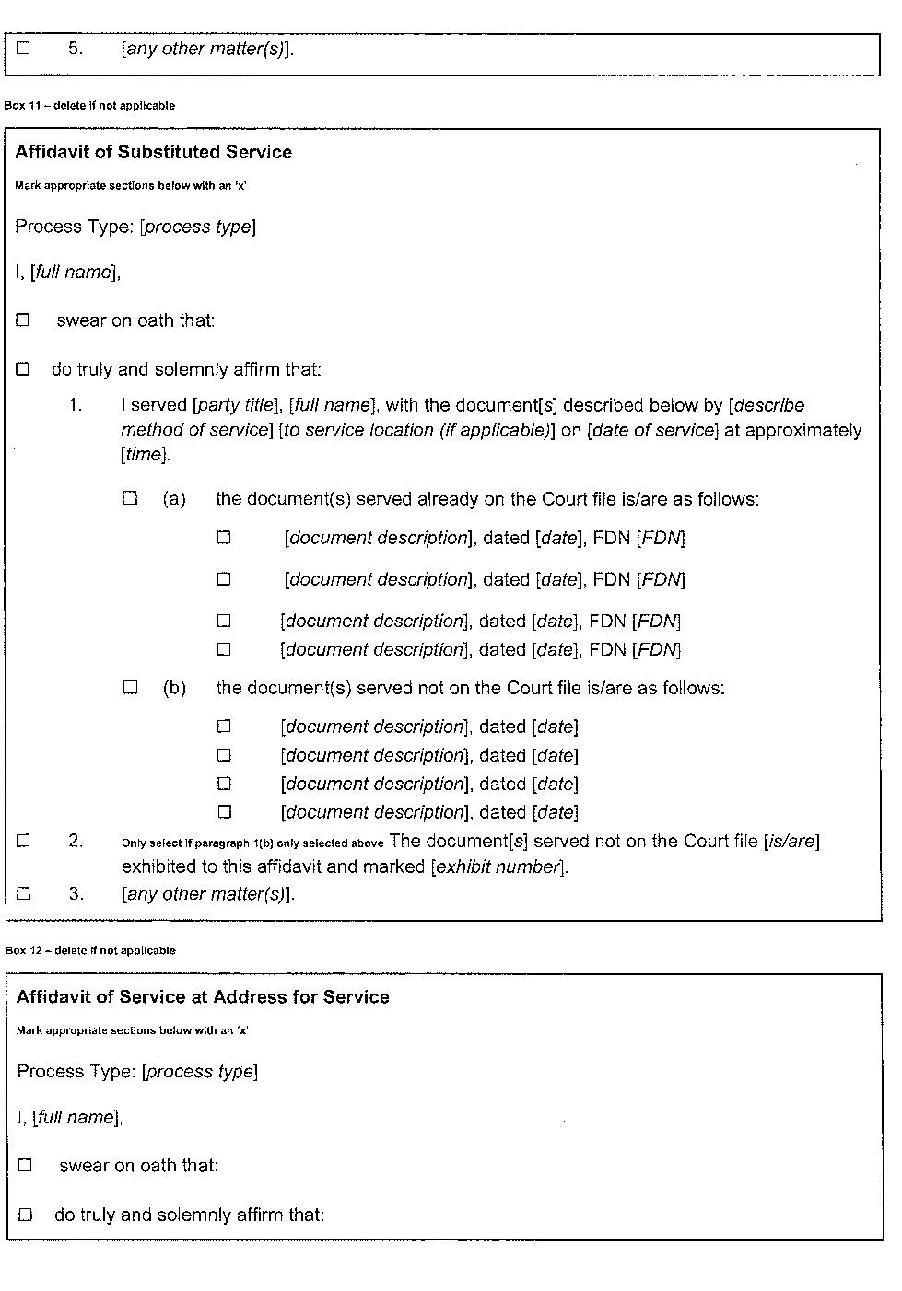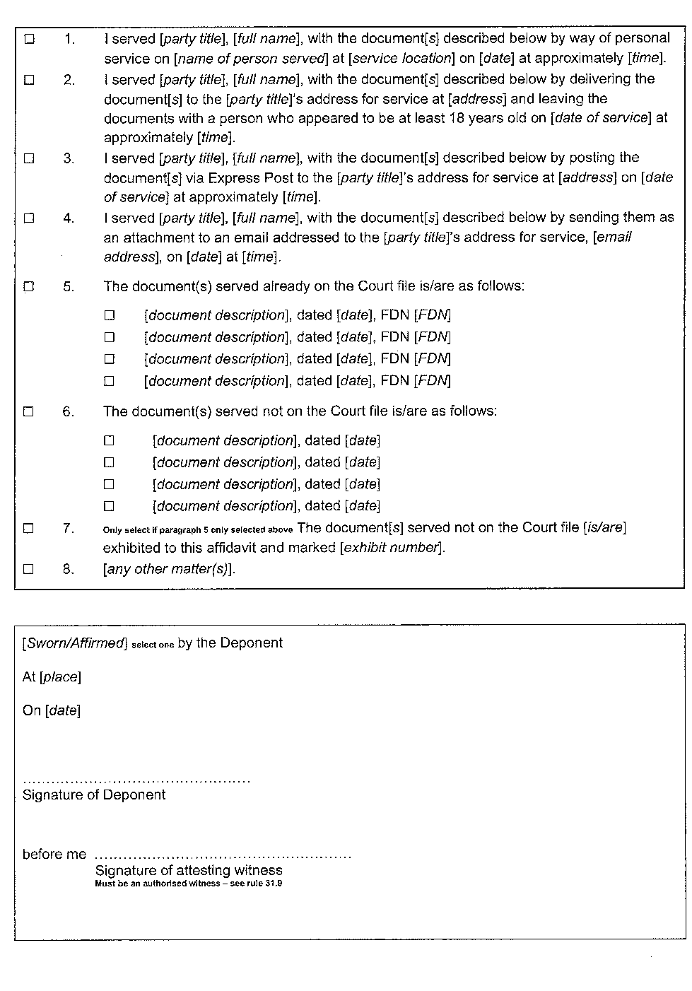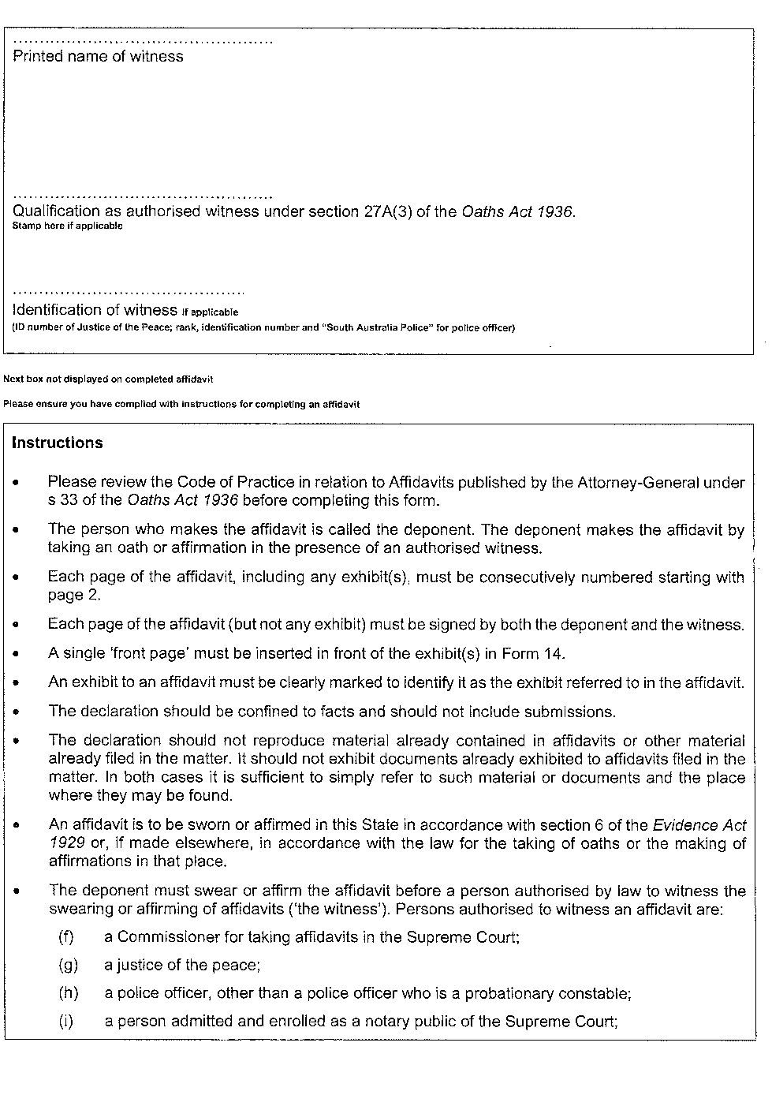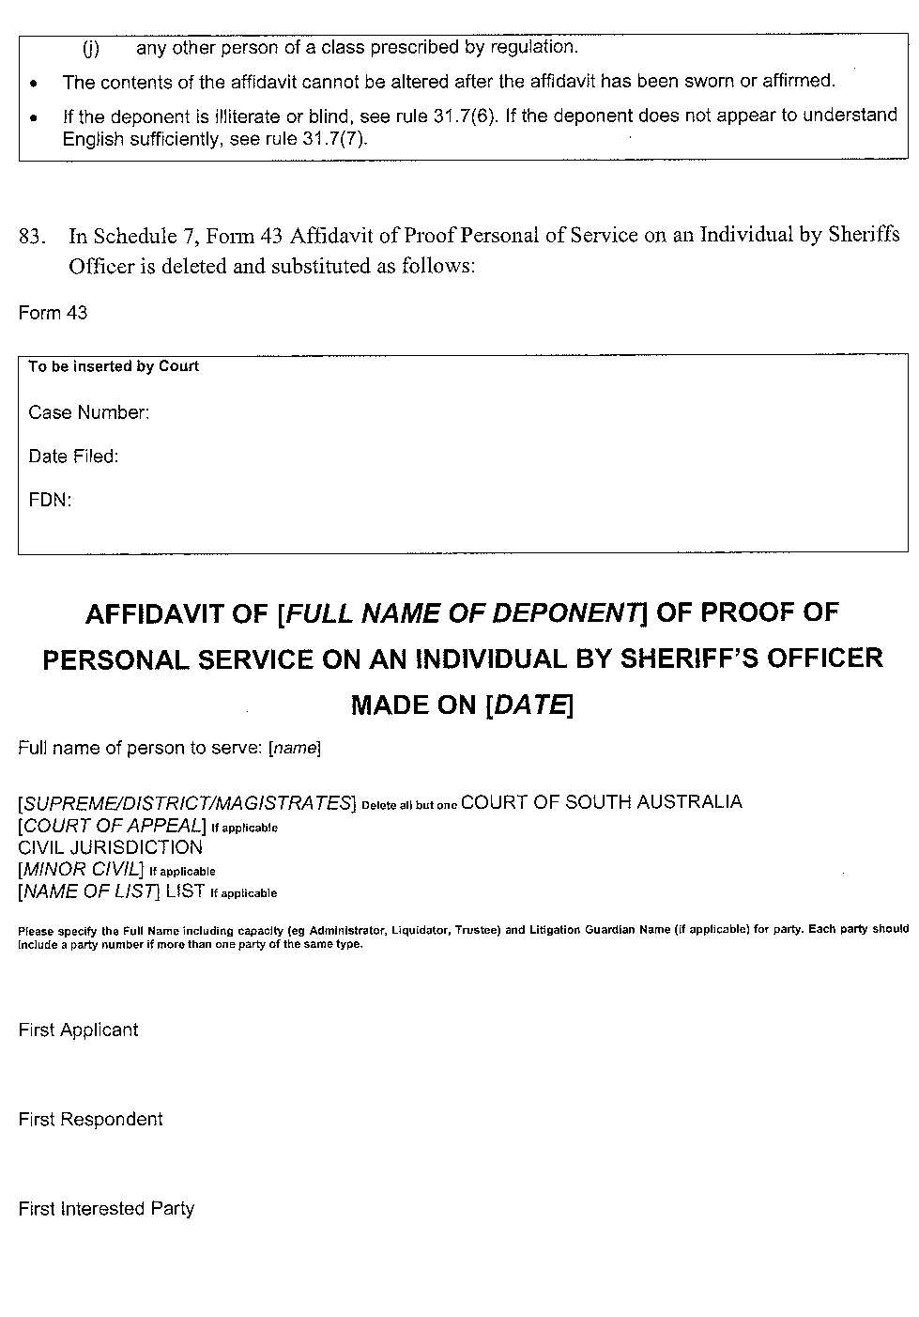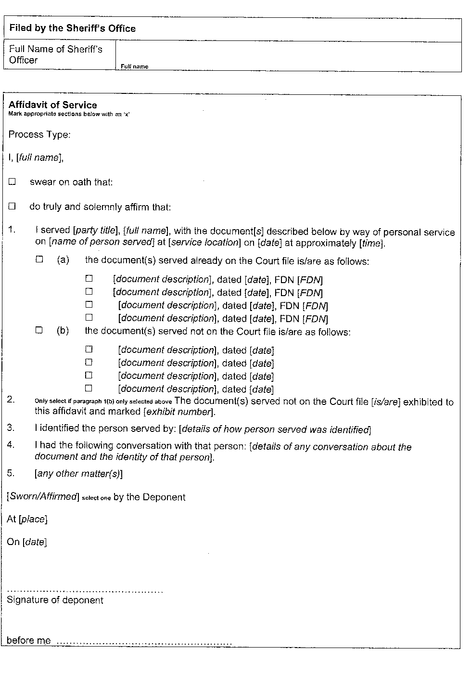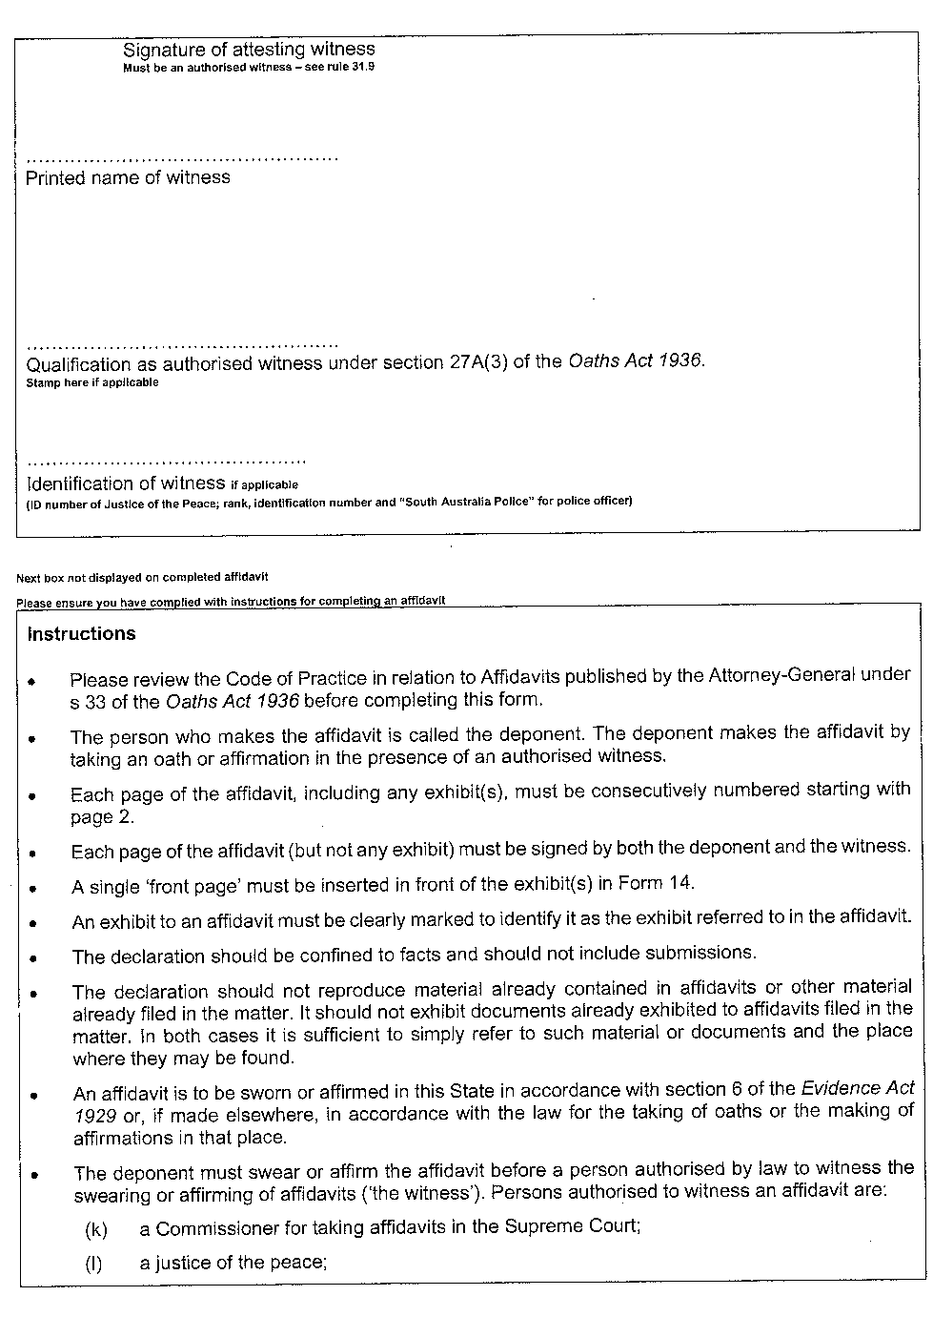In accordance with the Supreme Court Act 1935, the District Court Act 1991 and the Magistrates Court Act 1991, and all other enabling powers, the Uniform Civil (No 7) Amending Rules 2022 have been made –
- as rules of the Supreme Court by 3 or more Judges of the Supreme Court; and
- as rules of the District Court by the Chief Judge and 2 or more other Judges of the District Court; and
- as rules of the Magistrates Court by the Chief Magistrate and 2 or more other Magistrates,
and such rules will apply to and in relation to the Court in accordance with their terms.
Dated: 16 August 2022
Chief Justice Kourakis
Chief Judge Evans
Chief Magistrate Hribal

State Government Instruments

Crimes at Sea Act 1998
Intergovernmental Agreement Crimes at Sea
This Agreement is made on 29 November 2019
Between
The Commonwealth of Australia
The State of New South Wales
The State of Victoria
The State of Queensland
The State of Western Australia
The State of South Australia
The State of Tasmania
The Northern Territory
GIVEN THAT
(a) the Commonwealth and the States have agreed to a cooperative scheme to apply the criminal law of the States extraterritorially in the areas adjacent to the coast of Australia; and
(b) the cooperative scheme is given the force of law by the following laws:
(i) Crimes at Sea Act 2000 (Commonwealth);
(ii) Crimes at Sea Act 1998 (New South Wales);
(iii) Crimes at Sea Act 1999 (Victoria);
(iv) Crimes at Sea Act 2001 (Queensland);
(v) Crimes at Sea Act 2000 (Western Australia);
(vi) Crimes at Sea Act 1998 (South Australia);
(vii) Crimes at Sea Act 1999 (Tasmania);
(viii) Crimes at Sea Act 2000 (Northern Territory); and
(c) clause 5 of the cooperative scheme authorises the making of an intergovernmental agreement providing for the division of responsibility for administering and enforcing the law relating to crimes at sea.
THE COMMONWEALTH AND THE STATES AGREE AS FOLLOWS
1 Definitions
In this Agreement:
adjacent area means an area where the law of a State is applied by Commonwealth law.
adjacent state, in relation to an adjacent area, means the State whose laws are applied to that area by Commonwealth law.
applied laws, in relation to a State, means the substantive and procedural laws applied to the State by clauses 2 and 3 of the cooperative scheme.
arrival State means the participating State in which an Australian ship next arrives, with the alleged offender on board, after an offence has been committed on or from that ship within the adjacent area of another participating State.
Australian ship has the meaning given by clause 1 of the cooperative scheme.
authority has the meaning given in clause 3 of the cooperative scheme.
Commonwealth means the Commonwealth of Australia.
cooperative scheme means the legislative and administrative scheme for applying and enforcing criminal law in the areas adjacent to the coast of Australia, set out in Schedule 1 to the Crimes at Sea Act 2000 (Commonwealth).
participating State means a State that is party to the cooperative scheme and this Agreement.
State has the meaning given by clause 1 of the cooperative scheme.
2 Duty etc of an authority of an adjacent State
An authority (other than a court) of a State that has a power, duty or function (other than a power, duty or function involving the exercise of judicial power) under a provision of the criminal law of that State that is also an applied law, has a corresponding power, duty or function under the applied law.
3 International obligations to be observed
In exercising or performing powers, duties and functions under the cooperative scheme, the parties and their agencies must act so as to avoid any breach by Australia of its international obligations, in particular under the United Nations Convention on the Law of the Sea, having regard especially to the responsibilities of Australia with respect to ships of the Australian flag, and to the rights of other countries in the maritime areas to which the arrangements in this Agreement apply.
4 Application of primary responsibility
(1) In respect of an alleged offence in an adjacent area, the adjacent State has primary responsibility for taking investigation and prosecution action under its applied laws in any of the following circumstances:
(a) the conduct occurs on, from or in relation to, a fixed or floating platform or other installation in that area;
(b) the conduct occurs on or from an Australian ship and the next place of entry to Australia is, or is intended to be at the time the conduct occurs, within that State;
(c) the alleged offender is an Australian citizen whose next place of entry to Australia is, or is intended to be at the time the conduct occurs, within that State.

(2) However:
(a) the arrival State has primary responsibility for taking investigation and prosecution action if the conduct occurs on or from an Australian ship and the next place of entry to Australia is within that State; and
(b) the Commonwealth has primary responsibility for taking investigation and prosecution action in respect of any alleged offence on or from an Australian Defence Force ship when it is outside the limits of a State.
5 Investigatory etc decision to conform to standard
A decision of an authority of the State (or the Commonwealth) having primary responsibility under clause 4 whether to investigate, or further investigate, or prosecute or seek extradition, must be taken in the same manner and subject to the same considerations and policies as apply to decisions in relation to other similar alleged offences against the laws of that State or the Commonwealth.
6 Undertaking to consult
(1) Where more than one party may take investigation or prosecution action in relation to the same alleged offence, the parties concerned must consult at the request of any of them on how the matter should be dealt with.
(2) If, following consultation, it appears that one of those parties may more conveniently take action to investigate or prosecute the alleged offence, it should do so.
7 Undertaking to assist other parties
Bearing in mind the possible difficulties for any single party of taking action at sea in relation to an alleged offence:
- any other party must, on request, give whatever assistance it considers practicable to the party with primary responsibility in relation to the alleged offence; and
- the Commonwealth must, on a request for assistance being made to the Attorney-General of the Commonwealth by the Attorney-General of the State with primary responsibility in relation to the alleged offence, use its best endeavours to secure that assistance from any relevant Commonwealth department, body or agency (including the Australian Defence Force, the Australian Border Force and the Australian Federal Police), and any such assistance may include:
- the gathering of evidence; or
- the provision of investigating personnel; or
- the provision of transport, communication facilities or information.
8 Date of effect
(1) This Agreement commences at the start of the day after the instrument is registered.
9 Agreement supersedes previous Agreement
(1) This Agreement supersedes the Intergovernmental Agreement – Crimes at Sea (Commonwealth of Australia Gazette, GN 49, 12 December 2001 at 3596 to 3600).
Christian Porter
Honourable Attorney-General of the Commonwealth of Australia
Mark Speakman
Honourable Attorney-General of the State of New South Wales
Jill Hennessy
Honourable Attorney-General of the State of Victoria
Yvette D'Ath
Honourable Attorney-General of the State of Queensland
John Quigley
Honourable Attorney-General of the State of Western Australia
Vickie Chapman
Honourable Attorney-General of the State of South Australia
Elise Archer
Honourable Attorney-General of the State of Tasmania
Natasha Fyles
Honourable Attorney-General of the State of Northern Territory

Criminal Law (Forensic Procedures) Act 2007
South Australia
Criminal Law (Forensic Procedures) (Fees) Notice 2022
under the Criminal Law (Forensic Procedures) Act 2007
1—Short title
This notice may be cited as the Criminal Law (Forensic Procedures) (Fees)
Notice 2022.
Editorial note--
This is a fee notice made in accordance with the Legislation (Fees) Act 2019.

2—Commencement
This notice has effect on the day on which the Criminal Law (Forensic Procedures)
Regulations 2022 come into operation.
3—Interpretation
In this notice-
Act means the Criminal Law (Forensic Procedures) Act 2007.
4—Fees
The fees set out in Schedule 1 are prescribed for the purposes of the Act.
Schedule 1—Fees
1 For a copy of an audiovisual recording made under—
(a) section 26 of the Act $10.00
(b) section 43 of the Act $10.00
Signed by the Attorney-General
On 22 August 2022

Education and Children’s Services Regulations 2020
Notice of Policy by the Minister for Education, Training and Skills
PURSUANT to regulation 12(1) of the Education and Children’s Services Regulations 2020, I, the Minister for Education, Training and Skills publish the following Capacity Management Plan in relation to the enrolment of a child of compulsory school age at Aldinga Payinthi College:
CAPACITY MANAGEMENT PLAN
Aldinga Payinthi College
This Capacity Management Plan sets out the conditions for enrolment at Aldinga Payinthi College (“the school”).
Aldinga Payinthi College zones
A school zone is a defined area from which the school accepts its core intake of students. Aldinga Payinthi College operates a primary campus zone and secondary campus zone.
Primary Campus School zone
Aldinga Payinthi College operates a shared primary school zone with Aldinga Beach B-6 School, within the area bounded by the entire suburbs of Maslin Beach, Port Willunga, Aldinga, Aldinga Beach, Sellicks Beach and the part suburb of Sellicks Hill (west of Culley Road and south to the southern boundary of the City of Onkaparinga).
Families living in the shared primary school zone wishing to enrol their children at Aldinga Payinthi College may be referred to Aldinga Beach B-6 School if capacity is reached in specific year levels. If no vacancies exist at either school applicants will be encouraged to remain at their current school (Year 1 to 6), or referred to other neighbouring schools.
Secondary Campus School zone
The area bounded by the entire suburbs of Maslin Beach, Port Willunga, Aldinga, Aldinga Beach, Sellicks Beach and the part suburb of Sellicks Hill (west of Culley Road and south to the southern boundary of the City of Onkaparinga).
An online map and a search tool to indicate if an applicant’s home address is within the primary or secondary campus school zones by enrolment year is available at www.education.sa.gov.au/findaschool.
Student Enrolment Numbers
As a new school, opened in 2022, Aldinga Payinthi College has a progressive enrolment process. This process will introduce a new Year 7 cohort at the start of each school year, until the school has all year levels in 2026.
Reception
The number of students entering Reception is limited to 52. If there are more than 52 applications for enrolment that have met the criteria for enrolment below, applicants living in the primary campus school zone may be shared with Aldinga Beach B-6 School.
Year 1 to 6
The number of students enrolled in Year 1 to 2 is limited to 52 students per year level, while Year 3 is limited to 60 places and Year 4 to 6 is limited to 30 students per year level.
Year 7
The student enrolment ceiling for Year 7 is limited to 192 students, unless there are more applications that have met the enrolment criteria below.
Supported Learning Centre
The school’s Supported Learning Centre is a regional facility catering for a maximum of 62 students with disability.
Placement in the Supported Learning Centre is determined through the department’s state-wide panel process for placement in an inclusive education option.
International Education Program
No International Education Program places will be offered at the school.
Enrolment Criteria – By Year Level
YEAR LEVEL: RECEPTION
Applications for enrolment from parents of prospective Reception students must meet one of the following requirements to be eligible for enrolment through the registration of interest process for the coming school year:
- the child is living in the shared school zone of Aldinga Beach B-6 School and Aldinga Payinthi College primary campus zone
- the child identifies as Aboriginal and/or Torres Strait Islander through the Enter for Success program
- the child has been granted enrolment due to special or extenuating circumstances, including but not limited to a child in care where there is a custody or guardianship order made under the Children and Young People (Safety) Act 2017.
Applications for Reception from students living in the primary campus school zone
Parents of prospective Reception students living in the primary campus school zone can lodge their application for enrolment by the end of week 10, term 2 in the year prior to starting school.
If more than 52 applications for enrolment are received from parents living in the primary campus school zone, places will be offered based on whether any, all or a combination of the following applies:
- the child is currently attending the school’s preschool program
- the child has a sibling currently enrolled in the school’s primary campus and will be attending school in the same calendar year
- the length of time the child has lived in the school zone
- the distance of the child’s residence from the school
- other personal needs, such as curriculum, transportation/location convenience, social/family links at the school.
The school will notify parents of the outcome of this process by week 8, term 3.
Applicants not allocated to Aldinga Payinthi College will be placed on the enrolment register and the school will support the family to enrol at the shared zone primary school (Aldinga Beach B-6 School).
Late applications for Reception from students living in the primary campus school zone
Families who move into the primary campus school zone or who are already living in the primary campus school zone but lodge their application for enrolment after the end of week 10, term 2 will only have their applications considered if or when vacancies exist, with priority consideration afforded to those applicants already on the school’s enrolment register.
In these cases, applications will be considered based on the distance of the child’s residence from the school and any other personal needs, such as curriculum, transportation/location convenience, and social/family links.
The school will notify parents by the beginning of week 1, term 4 if a vacancy is available for their child to attend the following school year.
If no vacancies exist, the applicants will be placed on the enrolment register and the school will support the family to enrol at the shared zone school (Aldinga Beach B-6 School).
Applications for Reception from students living outside the zone with siblings currently at the primary campus
There is no automatic entry to the school for Reception students who live outside the school’s primary campus zone and have siblings who currently attend the school.
Enter for Success Reception students
Through Enter for Success, a child that identifies as Aboriginal and/ or Torres Strait Islander will be offered a Reception place at the school for the following year. Families enrolling through Enter for Success can do so until the end of term 4 in the year prior to starting reception.
Intensive English Language Centre (IELC) Reception students
Any Reception student offered enrolment at the primary school campus and who is eligible to attend an Intensive English Language Centre (IELC), will be able to attend an IELC during Reception and begin Year 1 at Aldinga Payinthi College primary campus the following year.
YEAR LEVEL: 1 TO 6
Application for Year 1 to Year 6 from students living in the primary campus school zone
Applications for enrolment from parents of prospective students living inside the primary campus school zone will be considered if or when vacancies exist, with priority consideration afforded to those applicants already on the school’s enrolment register.
In these cases, places will be offered based on siblings at the primary campus, the length of time the child has lived in the primary campus school zone, the distance of the child’s residence from the primary campus and other personal needs such as curriculum, transportation/location convenience and social/family links to the primary campus.
The school will notify parents of the outcome of this process by the end of week 8, term 3.
If no vacancies exist, the applicants will be encouraged to remain at their current primary school, or the school will support the family to enrol at Aldinga Beach B-6 School or another neighbouring schools and upon the applicant’s request will be placed on the enrolment register.
Transfer of students between schools in the shared PRIMARY school CAMPUS zone
Applications for students living in the shared primary school campus zone seeking to transfer from Aldinga Beach B-6 School to Aldinga Payinthi College primary campus will only be considered in special circumstances and by agreement between the principals of the schools. These applications will be assessed on a case-by-case basis.

YEAR LEVEL: 7
Applications for enrolment from parents of prospective Year 7 students require that the student must be enrolled in a government or non-government school in South Australia at the time the parents apply for enrolment through the state-wide registration of interest process (coordinated by the Department for Education).
The applicant must meet one of the following requirements to be eligible for a Year 7 allocation through the registration of interest process for the coming school year:
- the child is living in the Aldinga Payinthi College high school zone
- the child is attending the school’s primary school campus
- the child identifies as Aboriginal and/or Torres Strait Islander through the Enter for Success program
- the child has been granted enrolment due to special or extenuating circumstances, including but not limited to a child in care where there is a custody or guardianship order made under the Children and Young People (Safety) Act 2017.
Late applications for Year 7 from students living in the secondary campus school zone
Families who move into the secondary campus school zone, or who are already living in the secondary campus school zone but lodge their application for enrolment after the department’s registration of interest process is completed (end of term 2), will have their applications considered if or when vacancies exist, with priority consideration afforded to those applicants already on the school’s enrolment register.
In these cases, applications will be considered based on the distance of the child’s residence from the secondary campus and any other personal needs, such as curriculum (excluding special interest programs), transportation/location convenience, and social/family links.
The school will notify parents by the beginning of week 3, term 4 if a vacancy is available for their child to attend the following school year.
If no vacancies exist, the applicant will be placed on the enrolment register and the school will support the family to enrol at a neighbouring school.
Applications for Year 7 from students living outside the secondary campus zone with siblings currently at the secondary campus
There is no automatic entry to the school for Year 7 students who live outside the school’s secondary campus zone and have siblings who currently attend the secondary campus.
Enter for Success Year 7 students
Through Enter for Success, a child that identifies as Aboriginal and/ or Torres Strait Islander will be offered a Year 7 place at the school for the following year. Families enrolling through Enter for Success can do so until the end of term 4 in the year prior to starting Year 7.
YEAR 8 and 9 (in 2023)
Application for Year 8 and 9 from students living inside the secondary campus school zone
Applications for enrolment from parents of prospective students living in the secondary campus school zone will be considered if or when vacancies exist, with priority consideration afforded to those applicants already on the enrolment register.
In these cases, applications will be considered based on siblings at the secondary campus, the distance of the child’s residence from the secondary campus and any other personal needs, such as curriculum, transportation/location convenience, and social/family links.
The school will notify parents by the beginning of week 3, term 4 if a vacancy is available for their child to attend the following school year.
If no vacancies exist the applicants will be encouraged to remain at their current high school, or the school will support the family to enrol at a neighbouring school, and upon an applicant’s request will be placed on the school’s enrolment register.
YEAR LEVEL: 10 - 12
Applications for enrolment in year levels 10 to 12 will not be accepted for 2023.
The applicant will be encouraged to remain at their current school or the school will support the family to enrol at a neighbouring school.
OUT OF ZONE APPLICATIONS
There is no automatic entry to the school for any year level for students who live outside of the primary or secondary campus zones and have siblings who attend the school.
Applications from parents of prospective students, who live outside the primary or secondary campus zones will only be given consideration for enrolment if the school is under its year level student enrolment numbers.
Enrolment Criteria – General
Special Circumstances
Enrolment applications for special consideration based on compelling or unusual reasons, including but not limited to a child in care where there are custody or guardianship orders made under the Children and Young People (Safety) Act 2017, may be granted by the Principal in consultation with the Education Director. These applications will be assessed on a case-by-case basis.
Enrolment Process
Enrolment Register
Parents whose child’s name has been placed on the enrolment register will be contacted by the end of week 3, term 4 if vacancies become available for the following year.
The enrolment register will be reviewed and updated annually by the school.
The position that a child’s name appears on the register is confidential and will only be disclosed as required by law.
Monitoring and enforcement
It is the responsibility of the parents applying for enrolment to be able to verify to the satisfaction of the school that the information provided is true and factual.
If a child was enrolled at the school on the basis of false or misleading information (including residential address) the Chief Executive may direct that the child be instead enrolled at another Government school pursuant to section 63(1) of the Education and Children’s Services Act 2019.
The Principal is responsible for the implementation of this Capacity Management Plan and all decisions on enrolments, including year level progression/placement.
This Capacity Management Plan will be reviewed annually.
Aldinga Payinthi College Preschool Enrolment Policy
Aldinga Payinthi College preschool local catchment area
A preschool local catchment area is a defined area from which the preschool accepts its core intake of students.
Aldinga Payinthi College operates a preschool local catchment area within the area bounded by Main South Road, How Road, Bowering Hill Road, north along the coast to the northern boundary of 152 Old Coach Road, Old Coach Road and Sherriff Road.
An online map and a search tool to indicate if an applicant’s home address is within the preschool local catchment area by enrolment year is available at www.education.sa.gov.au/findaschool.
Student Enrolment Numbers
The number of students entering at Preschool is limited to 40 students.
Application for Preschool from students living in the preschool local catchment area
Priority consideration will be given to applications for enrolment from parents of prospective preschool children to enrol the following year, if they have been living inside the preschool local catchment area and lodge their application for enrolment by the end of week 10, term 2 in the year prior to starting preschool.
If more than 40 registrations for enrolment are received from parents living in the preschool local catchment area by the end of week 10, term 2 in the year prior to enrolment, places will be offered based on whether any, all or a combination of the following applies:
- the child is identified as requiring special consideration
- the child identifies as Aboriginal and/or Torres Strait Islander
- the distance of the child’s residence from the preschool
- the child has a sibling currently enrolled at the primary campus and will be attending the preschool in the same calendar year
- other personal needs such as curriculum, transportation/location convenience, social/family links at the school.
Unsuccessful applicants will be placed on the enrolment register upon request, and the preschool will support the family to enrol at a neighbouring preschool
If vacancies exist at the beginning of the school year, the Principal may approve places being offered to a child living outside the preschool local catchment area, based on the child living within the primary campus school zone.
Inclusive Preschool Program
The Inclusive Preschool Program supports up to 6 children in 2023 with disability and/or complex needs to improve their learning outcomes within a preschool setting.
Placement in the Inclusive Preschool Program is determined through the department’s state-wide panel process for placement in an inclusive education option.
Out of Catchment Applications
There is no automatic entry to the preschool for children who live outside of the preschool local catchment area and have siblings who attend the school.
Applications from parents of prospective preschool students, who live outside the preschool local catchment area will only be given consideration for enrolment if the preschool is under its enrolment number.
Dated: 15 August 2022
Blair Boyer
Minister for Education, Training and Skills

Education and Children’s Services Regulations 2020
Notice of Policy by the Minister for Education, Training and Skills
PURSUANT to Regulation 12(1) of the Education and Children’s Services Regulations 2020, I, the Minister for Education, Training and Skills publish the following Capacity Management Plan in relation to the enrolment of a child of compulsory school age at Riverbanks College B-12:
CAPACITY MANAGEMENT PLAN
Riverbanks College B-12
This Capacity Management Plan sets out the conditions for enrolment at Riverbanks College B-12 (“the school”).
Riverbanks College B-12 zones
A school zone is a defined area from which the school accepts its core intake of students. Riverbanks College B-12 operates a primary campus zone and secondary campus zone.
Primary Campus School zone
Riverbanks College B-12 operates a shared primary school zone with Angle Vale Primary School, within the area bounded by Pederick Road, following the Gawler River east to Hayman Road, Angle Vale Road, Taylors Road, Ransomes Road, Short Road, Hodgson Road, Broadacres Drive, Buckby Road, Heaslip Road, Robert Road, Petherton Road, Andrews Road, Fradd East Road, Stebonheath Road, Pearson Road, following the Gawler River west, Northern Expressway, Two Wells Road and Gawler Road.
Families living in the shared primary school zone wishing to enrol their children at Riverbanks College B-12 may be referred to Angle Vale Primary School if capacity is reached in specific year levels. If no vacancies exist at either school applicants will be encouraged to remain at their current school (Year 1 to 6) or referred to other neighbouring schools.

Secondary Campus School zone
The area bounded by Thompsons Beach Road to the coast, south along the coast to Thompson Road, Brooks Road, Ryan Road, Port Wakefield Highway, Northern Expressway, Petherton Road, Andrews Road, Fradd East Road, Stebonheath Road, Pearson Road, west along the Gawler River to the Northern Expressway, Whitelaw Road, Leak Road, Fairlie Road, Oates Road, Lucas Road, Semmler Road, Redbanks Road, Day Road, Verner Road, Conrad Road, Barabba Road, Gallipoli Road, Jarmyn Road and Limerock Road.
An online map and a search tool to indicate if an applicant’s home address is within the primary or secondary campus school zones by enrolment year is available at www.education.sa.gov.au/findaschool.
Student Enrolment Numbers
As a new school, opened in 2022, Riverbanks College B-12 has a progressive enrolment process. This process will introduce a new Year 7 cohort at the start of each school year, until the school has all year levels in 2026.
Reception
The number of students entering Reception is limited to 52. If there are more than 52 applications for enrolment that have met the criteria for enrolment below, applicants living in the primary campus school zone may be shared with Angle Vale Primary School.
Year 1 to 6
The number of students enrolled in Year 1 to 2 is limited to 52 students per year level, while Year 3 to 6 is limited to a maximum of 60 students per year level.
Year 7
The student enrolment ceiling for Year 7 is limited to 192 students per year level, unless there are more applications that have met the enrolment criteria below.
Supported Learning Centre
The school’s Supported Learning Centre is a regional facility catering for a maximum of 62 students with disability in 2023.
Placement in the Supported Learning Centre is determined through the department’s state-wide panel process for placement in an inclusive education option.
International Education Program
No International Education Program places will be offered at the school.
Enrolment Criteria – By Year Level
YEAR LEVEL: RECEPTION
Applications for enrolment from parents of prospective Reception students must meet one of the following requirements to be eligible for enrolment through the registration of interest process for the coming school year:
- the child is living in the shared school zone of Angle Vale Primary School and Riverbanks College B-12 primary campus zone
- the child identifies as Aboriginal and/or Torres Strait Islander through the Enter for Success program
- the child has been granted enrolment due to special or extenuating circumstances, including but not limited to a child in care where there is a custody or guardianship order made under the Children and Young People (Safety) Act 2017.
Applications for Reception from students living in the primary campus school zone
Parents of prospective Reception students living in the primary campus school zone can lodge their application for enrolment by the end of week 10, term 2 in the year prior to starting school.
If more than 52 applications for enrolment are received from parents living in the primary campus school zone, a priority order may be applied to applications and places will be offered based on whether any, all or a combination of the following applies:
- the child is currently attending the school’s preschool program
- the child has a sibling currently enrolled in the school’s primary campus and will be attending school in the same calendar year
- the length of time the child has lived in the school zone
- the distance of the child’s residence from the school
- other personal needs, such as curriculum, transportation/location convenience, social/family links at the school.
The school will notify parents of the outcome of this process by the end of week 8, term 3.
Applicants not allocated to Riverbanks College B-12 will be placed on the enrolment register and the school will support the family to enrol at the shared zone primary school (Angle Vale Primary School).
Late applications for Reception from students living in the primary campus school zone
Families who move into the primary campus school zone or who are already living in the primary campus school zone but lodge their application for enrolment after the end of week 10, term 2 will only have their applications considered if or when vacancies exist, with priority consideration afforded to those applicants already on the school’s enrolment register.
In these cases, applications will be considered based on the distance of the child’s residence from the school and any other personal needs, such as curriculum, transportation/location convenience, and social/family links.
The school will notify parents by the beginning of week 1, term 4 if a vacancy is available for their child to attend the following school year.
If no vacancies exist, the applicants will be placed on the enrolment register and the school will support the family enrol at the shared zone school (Angle Vale Primary School).
Applications for Reception from students living outside the zone with siblings currently at the primary campus
There is no automatic entry to the school for Reception students who live outside the school’s primary campus zone and have siblings who currently attend the school.

Enter for Success Strategy Reception students
Through Enter for Success, a child that identifies as Aboriginal and/ or Torres Strait Islander will be offered a Reception place at the school for the following year. Families enrolling through Enter for Success can do so until the end of term 4 in the year prior to starting reception.
Intensive English Language Centre (IELC) Reception students
Any Reception student offered enrolment at the primary school campus and who is eligible to attend an Intensive English Language Centre (IELC), will be able to attend an IELC during Reception and begin Year 1 at Riverbanks College B-12 primary campus the following year.
YEAR LEVEL: 1 TO 6
Application for Year 1 to Year 6 from students living in the primary campus school zone
Applications for enrolment from parents of prospective students living inside the primary campus school zone will be considered if or when vacancies exist, with priority consideration afforded to those applicants already on the school’s enrolment register.
In these cases, places will be offered based on siblings at the primary campus, the length of time the child has lived in the primary campus school zone, the distance of the child’s residence from the primary campus and other personal needs such as curriculum, transportation/location convenience and social/family links to the primary campus.
The school will notify parents of the outcome of this process by the end of week 8, term 3. If no vacancies exist, the applicants will be encouraged to remain at their current primary school, or the school will support the family to enrol at Angle Vale Primary School or a neighbouring school, and upon an applicant’s request will be placed on the enrolment register.
Transfer of students between schools in the shared PRIMARY school CAMPUS zone
Applications from students who live in the shared primary school campus zone and are currently enrolled at Angle Vale Primary School seeking to transfer Riverbanks College B-12 primary campus, will only be considered in special circumstances and by agreement between the principals of the schools. These applications will be assessed on a case-by-case basis.
YEAR LEVEL: 7
Applications for enrolment from parents of prospective Year 7 students require that the student must be enrolled in a government or non-government school in South Australia at the time the parents apply for enrolment through the state-wide registration of interest process (coordinated by the Department for Education).
The applicant must meet one of the following requirements to be eligible for a Year 7 allocation through the registration of interest process for the coming school year:
- the child is living in the Riverbanks College B-12 high school zone
- the child is attending the school’s primary school campus
- the child identifies as Aboriginal and/or Torres Strait Islander through the Enter for Success program
- the child has been granted enrolment due to special or extenuating circumstances, including but not limited to a child in care where there is a custody or guardianship order made under the Children and Young People (Safety) Act 2017.
Late applications for Year 7 from students living in the secondary campus school zone
Families who move into the secondary campus school zone, or who are already living in the secondary campus school zone but lodge their application for enrolment after the department’s registration of interest process is completed (end of term 2), will have their applications considered if or when vacancies exist, with priority consideration afforded to those applicants already on the school’s enrolment register.
In these cases, applications will be considered based on the distance of the child’s residence from the secondary campus and any other personal needs, such as curriculum (excluding special interest programs), transportation/location convenience, and social/family links.
The school will notify parents by the beginning of week 3, term 4 if a vacancy is available for their child to attend the following school year.
If no vacancies exist, the applicant will be placed on the enrolment register and the school will support the family to enrol at a neighbouring school.
Applications for Year 7 from students living outside the secondary campus zone with siblings currently at the secondary campus
There is no automatic entry to the school for Year 7 students who live outside the school’s secondary campus zone and have siblings who currently attend the secondary campus.
Enter for Success Strategy Year 7 students
Through Enter for Success, a child that identifies as Aboriginal and/ or Torres Strait Islander will be offered a Year 7 place at the school for the following year. Families enrolling through Enter for Success can do so until the end of term 4 in the year prior to starting Year 7.
YEAR 8 and 9 (in 2023)
Application for Year 8 and 9 from students living inside the secondary campus school zone
Applications for enrolment from parents of prospective students living in the secondary campus school zone will be considered if or when vacancies exist, with priority consideration afforded to those applicants already on the enrolment register.
In these cases, applications will be considered based on siblings at the secondary campus, the distance of the child’s residence from the secondary campus and any other personal needs, such as curriculum, transportation/location convenience, and social/family links.
The school will notify parents by the beginning of week 3, term 4 if a vacancy is available for their child to attend the following school year.
If no vacancies exist the applicants will be encouraged to remain at their current high school, or the school will support the family to enrol at a neighbouring school, and upon an applicant’s request will be placed on the school’s enrolment register.
YEAR LEVEL: 10 - 12
Applications for enrolment for year level 10 to 12 will not be accepted for 2023.
The applicant will be encouraged to remain at their current school or the school will support the family to enrol at a neighbouring school.
OUT OF ZONE APPLICATIONS
There is no automatic entry to the school for any year level for students who live outside of the primary or secondary campus zones and have siblings who attend the school.
Applications from parents of prospective students, who live outside the primary or secondary campus zones will only be given consideration for enrolment if the school is under its year level student enrolment numbers.
Enrolment Criteria – General
Special Circumstances
Enrolment applications for special consideration based on compelling or unusual reasons, including but not limited to a child in care where there is custody or guardianship orders made under the Children and Young People (Safety) Act 2017, may be granted by the Principal in consultation with the Education Director. These applications will be assessed on a case-by-case basis.
Enrolment Process
Enrolment Register
Parents whose child’s name has been placed on the enrolment register will be contacted by the end of week 3, term 4 if vacancies become available for the following year.
The enrolment register will be reviewed and updated annually by the school.
The position that a child’s name appears on the register is confidential and will only be disclosed as required by law.
Monitoring and enforcement
It is the responsibility of the parents applying for enrolment to be able to verify to the satisfaction of the school that the information provided is true and factual.
If a child was enrolled at the school on the basis of false or misleading information (including residential address) the Chief Executive may direct that the child be instead enrolled at another Government school pursuant to section 63(1) of the Education and Children’s Services Act 2019.
The Principal is responsible for the implementation of this Capacity Management Plan and all decisions on enrolments, including year level progression/placement.
This Capacity Management Plan will be reviewed annually.
Riverbanks College B-12 Preschool Enrolment Policy
Riverbanks College B-12 preschool local catchment area
A preschool local catchment area is a defined area from which the preschool accepts its core intake of students.
Riverbanks College B-12 operates a preschool local catchment area within the area bounded by Angle Vale Road, Heaslip Road, Gawler River and Northern Expressway.
An online map and a search tool to indicate if an applicant’s home address is within the preschool local catchment area by enrolment year is available at www.education.sa.gov.au/findaschool.
Student Enrolment Numbers
The number of students entering at Preschool is limited to 33 students.
Application for Preschool from students living in the preschool local catchment area
Priority consideration will be given to applications for enrolment from parents of prospective preschool children to enrol the following year, if they have been living inside the preschool local catchment area and lodge their application for enrolment by the end of week 10, term 2 in the year prior to starting preschool.
If more than 33 registrations for enrolment are received from parents living in the preschool campus zone by the end of week 10, term 2 in the year prior to enrolment, places will be offered based on whether any, all or a combination of the following applies:
- the child is identified as requiring special consideration
- the child identifies as Aboriginal and/or Torres Strait Islander
- the distance of the child’s residence from the preschool
- the child has a sibling currently enrolled at the primary campus and will be attending the preschool in the same calendar year
- other personal needs such as curriculum, transportation/location convenience, social/family links at the school.
Unsuccessful applicants will be placed on the enrolment register upon request and referred for enrolment to neighbouring preschools.
If vacancies exist at the beginning of the school year, the Principal may approve places being offered to a child living outside the preschool local catchment area, based on the child living within the primary campus school zone.
Inclusive Preschool Program
The Inclusive Preschool Program supports up to 6 children in 2023 with disability and/or complex needs to improve their learning outcomes within a preschool setting.
Placement in the Inclusive Preschool Program is determined through the department’s state-wide panel process for placement in an inclusive education option.
Out of Catchment Applications
There is no automatic entry to the preschool for children who live outside of the preschool local catchment area and have siblings who attend the school.
Applications from parents of prospective preschool students, who live outside the preschool local catchment area will only be given.
Dated: 15 August 2022
Blair Boyer
Minister for Education, Training and Skills

Education and Children’s Services Regulations 2020
Notice of Revocation of Policy by the Minister for Education, Training and Skills
PURSUANT to Regulation 12(3) of the Education and Children’s Services Regulations 2020, I, the Minister for Education, Training and Skills revoke the Aldinga Payinthi College Capacity Management Plan, published in the Gazette on 21 January 2021. I also revoke the Aldinga Payinthi College preschool enrolment policy, published in the Gazette on 21 January 2021. The revocation is effective from 25 August 2022.
Dated: 15 August 2022
Blair Boyer
Minister for Education, Training and Skills

Education and Children’s Services Regulations 2020
Notice of Revocation of Policy by the Minister for Education, Training and Skills
PURSUANT to Regulation 12(3) of the Education and Children’s Services Regulations 2020, I, the Minister for Education, Training and Skills revoke the Riverbanks College B-12 Capacity Management Plan, published in the Gazette on 21 January 2021. I also revoke the Riverbanks College B-12 preschool enrolment policy, published in the Gazette on 21 January 2021. The revocation is effective from 25 August 2022.
Dated: 15 August 2022
Blair Boyer
Minister for Education, Training and Skills

ELECTORAL ACT 1985
Part 6—Registration of Political Parties
NOTICE is hereby given that I have on this day de-registered the political party named below following application for de-registration made under the provision of section 44 of the Act:
Name of Party: Advance SA
Dated: 25 August 2022
Mick Sherry
Electoral Commissioner

Environment Protection Act 1993
Section 68
Approval of Category B Containers
I, Nicholas Stewart, Team Leader, Container Deposit Legislation and Delegate of the Environment Protection Authority (‘the Authority’), pursuant to Section 68 of the Environment Protection Act 1993 (SA) (‘the Act’) hereby:
Approve as Category B Containers, subject to the conditions in subclauses 1, 2, 3 and 4 below, each of the classes of containers identified by reference to the following matters described in the first 4 columns of Schedule 1 of this Notice which are sold in South Australia:
(a) the product which each class of containers shall contain;
(b) the size of the containers;
(c) the type of containers; and
(d) the name of the holders of these approvals.
1. That containers of the class to which the approval relates must bear the refund marking specified by the Authority for containers of that class. The Authority specifies the following refund markings for Category B containers:
(1) “10c refund at collection depots when sold in SA”; or
(2) “10c refund at SA/NT collection depots in State/Territory of purchase”; or
(3) “10c refund at collection depots/points in participating state/territory of purchase”.
2. The holder of the approval must have in place an effective and appropriate waste management arrangement in relation to containers of that class. For the purpose of this approval notice the company named in Column 5 of Schedule 1 of this Notice is the nominated super collector.
3. In the case of an approval in relation to Category B containers that the waste management arrangement must require the holder of the approval to provide specified super collectors with a declaration in the form determined by the Authority in relation to each sale of such containers by the holder of the approval as soon as practicable after the sale.
4. The holder of these approvals must ensure that if a sticker bearing the refund marking has been approved, and is applied to the container, then the sticker must not be placed on any portion of the opening mechanism or in any other place that would require complete or partial removal of the sticker before the contents may be consumed.
Dated: 25 August 2022
Nicholas Stewart
Team Leader, Deposit Scheme and Product Stewardship
Delegate of the Environment Protection Authority

Schedule 1
Column 1 | Column 2 | Column 3 | Column 4 | Column 5
Product Name | Container  Size | Container Type | Approval Holder | Collection Arrangements
4 Pines Brewing Company Aussie Wheat Ale | 375 ml | Aluminium | 4 Pines Brewing Company Wholesale Pty Ltd | Marine Stores Ltd
4 Pines Brewing Company Galactic XPA Cryo Pop Limited Release | 375 ml | Aluminium | 4 Pines Brewing Company Wholesale Pty Ltd | Marine Stores Ltd
4 Pines Brewing Company Japanese Style Lager | 375 ml | Aluminium | 4 Pines Brewing Company Wholesale Pty Ltd | Marine Stores Ltd
Brookvale Union Vodka Lemon Squash Low Sugar | 330 ml | Aluminium | 4 Pines Brewing Company Wholesale Pty Ltd | Marine Stores Ltd
Banrock Station Pinot Grigio | 750 ml | PET | Accolade Wines Australia Ltd | Statewide Recycling
Banrock Station Pinot Noir | 750 ml | PET | Accolade Wines Australia Ltd | Statewide Recycling
Blind Tiger Gin Organic Premium Gin & Tonic | 250 ml | Aluminium | Angoves Family Winemakers | Statewide Recycling
Mountain Dew Energised No Sugar Major Melon | 600 ml | PET | Asahi Beverages Pty Ltd | Statewide Recycling
Pure Blonde Cider & Soda Refreshing Cider 80% Less Sugar | 330 ml | Aluminium | Asahi Premium Beverages Pty Ltd | Marine Stores Ltd
Poets Country Lager | 330 ml | Glass | Australian Beer Company Pty Ltd | Marine Stores Ltd
Pressman's All Australian Apple Cider | 330 ml | Glass | Australian Beer Company Pty Ltd | Marine Stores Ltd
Yenda Brewing Co Pale Ale | 330 ml | Glass | Australian Beer Company Pty Ltd | Marine Stores Ltd
Yenda Brewing Co Pale Ale | 375 ml | Aluminium | Australian Beer Company Pty Ltd | Marine Stores Ltd
Yenda Brewing Co Session Lager | 375 ml | Aluminium | Australian Beer Company Pty Ltd | Marine Stores Ltd
Yenda Brewing Co Session Lager | 330 ml | Glass | Australian Beer Company Pty Ltd | Marine Stores Ltd
Yenda Brewing Co XPA | 375 ml | Aluminium | Australian Beer Company Pty Ltd | Marine Stores Ltd
Dairy Farmers Classic Caramel Flavoured Milk | 500 ml | PET | BDD Australia Pty Ltd | Marine Stores Ltd
Dairy Farmers Classic Caramel Flavoured Milk | 600 ml | LPB - Gable Top | BDD Australia Pty Ltd | Marine Stores Ltd
Dairy Farmers Classic Vanilla Slice Flavoured Milk | 500 ml | HDPE | BDD Australia Pty Ltd | Marine Stores Ltd
Dare Butterscotch Latte | 500 ml | HDPE | BDD Australia Pty Ltd | Marine Stores Ltd
Dare Butterscotch Latte | 500 ml | HDPE | BDD Australia Pty Ltd | Marine Stores Ltd
Dare Butterscotch Latte | 750 ml | HDPE | BDD Australia Pty Ltd | Marine Stores Ltd
Dare Butterscotch Latte | 750 ml | HDPE | BDD Australia Pty Ltd | Marine Stores Ltd
Dare Intense Espresso | 500 ml | HDPE | BDD Australia Pty Ltd | Marine Stores Ltd
Yoplait Yop2Go Mango & Passionfruit Yoghurt Drink | 250 g | PET | BDD Australia Pty Ltd | Marine Stores Ltd
Yoplait Yop2Go Mixed Berry Yoghurt Drink | 250 g | PET | BDD Australia Pty Ltd | Marine Stores Ltd
Yoplait Yop2Go Strawberry Yoghurt Drink | 250 g | PET | BDD Australia Pty Ltd | Marine Stores Ltd
Yoplait Yop2Go Vanilla Yoghurt Drink | 250 g | PET | BDD Australia Pty Ltd | Marine Stores Ltd
Zooper Dooper Limited Edition Cola Spider Flavoured Milk | 600 ml | LPB - Gable Top | BDD Australia Pty Ltd | Marine Stores Ltd
Zooper Dooper Limited Edition Fairy Floss Flavoured Milk | 600 ml | LPB - Gable Top | BDD Australia Pty Ltd | Marine Stores Ltd
Bacardi Pina Colada Rum, Pineapple & Coconut Cocktail | 250 ml | Aluminium | Bacardi Martini Australia Pty Ltd | Marine Stores Ltd
Bacardi Raspberry Mojito Rum, Lime, Mint & Raspberry Cocktail | 250 ml | Aluminium | Bacardi Martini Australia Pty Ltd | Marine Stores Ltd
Bombay Citron Presse Citrus Collins Created With Our Distilled Gin And A Mediterranean Lemon Infusion Mixed With Soda Water | 250 ml | Aluminium | Bacardi Martini Australia Pty Ltd | Marine Stores Ltd
BeachPort Brewing Co BeachPorter Warm Your Cockles | 375 ml | Aluminium | Beachport Brewing Co | Statewide Recycling
BeachPort Brewing Co Beachport Cream Brown Ale Thick And Creamy | 375 ml | Aluminium | Beachport Brewing Co | Statewide Recycling
BeachPort Brewing Co De Mole Dark Lager Smooth And Full Bodied | 375 ml | Aluminium | Beachport Brewing Co | Statewide Recycling
BeachPort Brewing Co Golden Hour Quince Sour A Fruity Twist | 375 ml | Aluminium | Beachport Brewing Co | Statewide Recycling
BeachPort Brewing Co Lipson Lager Crisp And Refreshing | 375 ml | Aluminium | Beachport Brewing Co | Statewide Recycling
Aqua Pura Sparkling Purified Australian Water | 750 ml | Glass | Bickford's Australia Pty Ltd | Statewide Recycling
Aqua Pura Still Purified Australian Water | 750 ml | Glass | Bickford's Australia Pty Ltd | Statewide Recycling
Vale Red Lager American Red Lager | 375 ml | Aluminium | Bickford's Australia Pty Ltd | Statewide Recycling
Big Shed Brewing Chase Finance Lager | 375 ml | Aluminium | Big Shed Brewing Concern Pty Ltd | Marine Stores Ltd
Big Shed Brewing Cherry & Rhubarb Porter | 375 ml | Aluminium | Big Shed Brewing Concern Pty Ltd | Marine Stores Ltd
Big Shed Brewing Cool Off A Little Easy Drinkin' Lager | 375 ml | Aluminium | Big Shed Brewing Concern Pty Ltd | Marine Stores Ltd
Big Shed Brewing Donut Lad Cinnamon Donut Beer | 375 ml | Aluminium | Big Shed Brewing Concern Pty Ltd | Marine Stores Ltd
Big Shed Brewing Galactic Meltdown Galaxy Hopped IPA | 375 ml | Aluminium | Big Shed Brewing Concern Pty Ltd | Marine Stores Ltd
Big Shed Brewing Hard Lemonade | 375 ml | Aluminium | Big Shed Brewing Concern Pty Ltd | Marine Stores Ltd
Big Shed Brewing Hopsy IPA | 375 ml | Aluminium | Big Shed Brewing Concern Pty Ltd | Marine Stores Ltd
Billson's Vodka Peaches & Cream Lightly Sparkling Mixed Spirit Drink | 355 ml | Aluminium | Billson's Beverages Pty Ltd | Statewide Recycling
Billson's Vodka Pine Lime Lightly Sparkling Mixed Spirit Drink | 355 ml | Aluminium | Billson's Beverages Pty Ltd | Statewide Recycling
Billson's Vodka Tropical Punch Lightly Sparkling Mixed Spirit Drink | 355 ml | Aluminium | Billson's Beverages Pty Ltd | Statewide Recycling
Billson's Vodka Watermelon Lightly Sparkling Mixed Spirit Drink | 355 ml | Aluminium | Billson's Beverages Pty Ltd | Statewide Recycling
Billson's Vodka Zesty Lemon Lightly Sparkling Mixed Spirit Drink | 355 ml | Aluminium | Billson's Beverages Pty Ltd | Statewide Recycling
Billson's Vodka Ginger & Lime Lightly Sparkling Mixed Spirit Drink | 355 ml | Aluminium | Billson's Beverages Pty Ltd | Statewide Recycling
Billson's Vodka Green Apple Lightly Sparkling Mixed Spirit Drink | 355 ml | Aluminium | Billson's Beverages Pty Ltd | Statewide Recycling
Left Barrel Brewing Bob's Ya Dunkel Munich Dunkel Chocolate Lager | 375 ml | Aluminium | Bown Consulting Pty Ltd T/AS Left Barrel Brewing | Marine Stores Ltd
Left Barrel Brewing Duck Hunter Pale Ale | 375 ml | Aluminium | Bown Consulting Pty Ltd T/AS Left Barrel Brewing | Marine Stores Ltd
Left Barrel Brewing Forty Six & Two Black IPA | 375 ml | Aluminium | Bown Consulting Pty Ltd T/AS Left Barrel Brewing | Marine Stores Ltd
Left Barrel Brewing Forty Six & Two Norwegian IPA Kviek Yeast | 375 ml | Aluminium | Bown Consulting Pty Ltd T/AS Left Barrel Brewing | Marine Stores Ltd
Left Barrel Brewing Hop Tendrils Hazy Pale Ale | 375 ml | Aluminium | Bown Consulting Pty Ltd T/AS Left Barrel Brewing | Marine Stores Ltd
Left Barrel Brewing Limited Release Dark Ale | 375 ml | Aluminium | Bown Consulting Pty Ltd T/AS Left Barrel Brewing | Marine Stores Ltd
Left Barrel Brewing Limited Release Pale Ale | 375 ml | Aluminium | Bown Consulting Pty Ltd T/AS Left Barrel Brewing | Marine Stores Ltd
Left Barrel Brewing Pellicosis Red Flanders Red Ale Barrel Fermented Barrel Aged | 375 ml | Aluminium | Bown Consulting Pty Ltd T/AS Left Barrel Brewing | Marine Stores Ltd
Left Barrel Brewing Renegade of Funk Belgian Dark Strong Ale | 375 ml | Aluminium | Bown Consulting Pty Ltd T/AS Left Barrel Brewing | Marine Stores Ltd
Left Barrel Brewing Sauer Puss Berliner Weisse | 375 ml | Aluminium | Bown Consulting Pty Ltd T/AS Left Barrel Brewing | Marine Stores Ltd
Kilburn Brewing Co Funnel Wed | 330 ml | Glass | Brewstorm Pty Ltd T/A Kilburn Brewing Co | Statewide Recycling
Kilburn Brewing Co IPA | 330 ml | Glass | Brewstorm Pty Ltd T/A Kilburn Brewing Co | Statewide Recycling
Kilburn Brewing Co Maple Lager | 330 ml | Glass | Brewstorm Pty Ltd T/A Kilburn Brewing Co | Statewide Recycling
Kilburn Brewing Co Mexican Crown | 330 ml | Glass | Brewstorm Pty Ltd T/A Kilburn Brewing Co | Statewide Recycling
Kilburn Brewing Co Steam Ale | 330 ml | Glass | Brewstorm Pty Ltd T/A Kilburn Brewing Co | Statewide Recycling
Gekkeikan Sake Daiginjo | 720 ml | Glass | Brown Forman Australia Pty Ltd | Statewide Recycling
Gekkeikan Sake Junmai Nigori | 720 ml | Glass | Brown Forman Australia Pty Ltd | Statewide Recycling
Gekkeikan Sake Taru Sake | 720 ml | Glass | Brown Forman Australia Pty Ltd | Statewide Recycling
Gekkeikan Sake Tokubetsu Junmai | 720 ml | Glass | Brown Forman Australia Pty Ltd | Statewide Recycling
Jack Daniel's Crisp & Delicious Tennessee Apple Liqueur Perfectly Mixed With Soda | 330 ml | Aluminium | Brown Forman Australia Pty Ltd | Statewide Recycling
Jack Daniel's Crisp & Delicious Tennessee Apple Liqueur Perfectly Mixed With Soda | 330 ml | Aluminium | Brown Forman Australia Pty Ltd | Statewide Recycling
Part Time Rangers Peach Penguin Vodka Peach & Sparkling Water | 330 ml | Aluminium | Brown Forman Australia Pty Ltd | Statewide Recycling
Burleigh Brewing Burleigh Twisted Palm Tropical Pale Ale | 375 ml | Aluminium | Burleigh Brewing Company Pty Ltd | Statewide Recycling
Truly Watermelon Lemonade Hard Seltzer Alcoholic Sparkling Water | 330 ml | Aluminium | Campari Australia | Statewide Recycling
Capital Brewing Co ALC-Less Your Zero Hero Pacific Ale | 375 ml | Aluminium | Capital Brewing Co Pty Ltd | Statewide Recycling
Capital Brewing Co Coast Ale | 375 ml | Aluminium | Capital Brewing Co Pty Ltd | Statewide Recycling
Capital Brewing Co Hang Loose Juice NEIPA Beer | 375 ml | Aluminium | Capital Brewing Co Pty Ltd | Statewide Recycling
Capital Brewing Co Rock Hopper IPA | 375 ml | Aluminium | Capital Brewing Co Pty Ltd | Statewide Recycling
Capital Brewing Co Seasonal All Night Long Dark Lager | 375 ml | Aluminium | Capital Brewing Co Pty Ltd | Statewide Recycling
Capital Brewing Co Seasonal Mango Tango XPA | 375 ml | Aluminium | Capital Brewing Co Pty Ltd | Statewide Recycling
Capital Brewing Co Summit Session Ale | 375 ml | Aluminium | Capital Brewing Co Pty Ltd | Statewide Recycling
Capital Brewing Co Trail Pale Ale | 375 ml | Aluminium | Capital Brewing Co Pty Ltd | Statewide Recycling
Capital Brewing Co XPA | 375 ml | Aluminium | Capital Brewing Co Pty Ltd | Statewide Recycling
Asahi Super Dry Non-Alcoholic | 330 ml | Glass | Carlton & United Breweries Pty Ltd | Marine Stores Ltd
Asahi Super Dry Non-Alcoholic | 330 ml | Aluminium | Carlton & United Breweries Pty Ltd | Marine Stores Ltd
Matilda Bay Aussie Wheat Ale | 375 ml | Aluminium | Carlton & United Breweries Pty Ltd | Marine Stores Ltd
Matilda Bay Dogbolter Winter Ale | 375 ml | Aluminium | Carlton & United Breweries Pty Ltd | Marine Stores Ltd
Matilda Bay Yarra Valley Pils | 375 ml | Aluminium | Carlton & United Breweries Pty Ltd | Marine Stores Ltd
Peroni Nastro Azzurro 0.0% | 330 ml | Glass | Carlton & United Breweries Pty Ltd | Marine Stores Ltd
Peroni Nastro Azzurro Italiana | 500 ml | Aluminium | Carlton & United Breweries Pty Ltd | Marine Stores Ltd
Peroni Nastro Azzurro Italiana | 330 ml | Glass | Carlton & United Breweries Pty Ltd | Marine Stores Ltd
Cola Cola Vanilla No Sugar | 250 ml | Aluminium | Coca Cola Amatil (Aust) Pty Ltd | Statewide Recycling
Fanta Raspberry No Sugar | 250 ml | Aluminium | Coca Cola Amatil (Aust) Pty Ltd | Statewide Recycling
Jim Beam Double Serve Zero Sugar Cola | 375 ml | Aluminium | Coca Cola Amatil (Aust) Pty Ltd | Statewide Recycling
Mother Energy Drink Lava Guava Flavour High Caffeine Content | 500 ml | Aluminium | Coca Cola Amatil (Aust) Pty Ltd | Statewide Recycling
Rekorderlig Premium Swedish Cider Watermelon Citrus | 330 ml | Glass | Coca Cola Amatil (Aust) Pty Ltd | Statewide Recycling
Sprite Lemon + Caffeine + Zesty Lemon Flavour | 375 ml | Aluminium | Coca Cola Amatil (Aust) Pty Ltd | Statewide Recycling
Sprite Lemon + Caffeine + Zesty Lemon Flavour | 390 ml | PET | Coca Cola Amatil (Aust) Pty Ltd | Statewide Recycling
Sprite Lemon + Caffeine + Zesty Lemon Flavour | 1250 ml | PET | Coca Cola Amatil (Aust) Pty Ltd | Statewide Recycling
Sprite Lemon + Caffeine + Zesty Lemon Flavour | 600 ml | PET | Coca Cola Amatil (Aust) Pty Ltd | Statewide Recycling
Sprite Lemon + Caffeine + Zesty Lemon Flavour Zero Sugar | 600 ml | PET | Coca Cola Amatil (Aust) Pty Ltd | Statewide Recycling
Sprite Lemon + Caffeine + Zesty Lemon Flavour Zero Sugar | 1250 ml | PET | Coca Cola Amatil (Aust) Pty Ltd | Statewide Recycling
Bundaberg Alcoholic Lemon Lime & Bitters | 375 ml | Aluminium | Diageo Australia Ltd | Statewide Recycling
Smirnoff Ice Double Black Zesty Citrus | 330 ml | Aluminium | Diageo Australia Ltd | Statewide Recycling
Smirnoff Ice Double Black Zesty Citrus Zero Sugar | 330 ml | Aluminium | Diageo Australia Ltd | Statewide Recycling
Divas VCR Cola And Raspberry | 375 ml | Aluminium | Divas Beverages Australia Ltd | Statewide Recycling
Balter Hazy Pale Ale Limited Release | 375 ml | Aluminium | Emencee Pty Ltd t/as Balter Brewing | Statewide Recycling
Mountain Culture Beer Co Balter Hazy IIPA Bucket Full of Nothin' | 375 ml | Aluminium | Emencee Pty Ltd t/as Balter Brewing | Statewide Recycling
Belhaven McCallums Sweet Scottish Stout | 440 ml | Aluminium | Empire Liquor Pty Ltd | Statewide Recycling
Robinsons Brewery Iron Maiden Limited Edition Trooper 666 Premium British Beer | 330 ml | Glass | Empire Liquor Pty Ltd | Statewide Recycling
Robinsons Brewery Iron Maiden Limited Edition Trooper Hallowed Belgian Style | 330 ml | Glass | Empire Liquor Pty Ltd | Statewide Recycling
Robinsons Brewery Iron Maiden Limited Edition Trooper Red N Black Porter | 330 ml | Glass | Empire Liquor Pty Ltd | Statewide Recycling
Robinsons Brewery Iron Maiden Special Edition Trooper Day of the Dead Ale | 500 ml | Glass | Empire Liquor Pty Ltd | Statewide Recycling
Robinsons Brewery Iron Maiden Trooper Fear Of The Dark English Stout | 330 ml | Glass | Empire Liquor Pty Ltd | Statewide Recycling
Robinsons Brewery Iron Maiden Trooper Fear of the Dark English Stout | 500 ml | Glass | Empire Liquor Pty Ltd | Statewide Recycling
Robinsons Brewery Iron Maiden Trooper IPA | 500 ml | Glass | Empire Liquor Pty Ltd | Statewide Recycling
Robinsons Brewery Iron Maiden Trooper IPA | 330 ml | Glass | Empire Liquor Pty Ltd | Statewide Recycling
Robinsons Brewery Iron Maiden Trooper Premium British Beer | 500 ml | Can - Aluminium | Empire Liquor Pty Ltd | Statewide Recycling
Robinsons Ginger Old Tom Strong Ale | 330 ml | Glass | Empire Liquor Pty Ltd | Statewide Recycling
Robinsons Old Tom Strong Ale | 330 ml | Glass | Empire Liquor Pty Ltd | Statewide Recycling
Robinsons Trooper Sun and Steel Sake Lager by Iron Maiden | 330 ml | Glass | Empire Liquor Pty Ltd | Statewide Recycling
Hey Days XPA Beer Zero Alcohol | 375 ml | Aluminium | Endeavour Group Limited | Marine Stores Ltd
High Pour Sally Cosmopolitan Cocktail Made with Vodka | 250 ml | Aluminium | Endeavour Group Limited | Marine Stores Ltd
High Pour Sally Moscow Mule Cocktail Made with Vodka | 250 ml | Aluminium | Endeavour Group Limited | Marine Stores Ltd
High Pour Sally Passionfruit Martini Cocktail Made with Vodka | 250 ml | Aluminium | Endeavour Group Limited | Marine Stores Ltd
High Pour Sally Pineapple & Mint Mojito Cocktail Made with White Rum | 250 ml | Aluminium | Endeavour Group Limited | Marine Stores Ltd
High Pour Sally Watermelon Margarita Cocktail Made with Tequila | 250 ml | Aluminium | Endeavour Group Limited | Marine Stores Ltd
Hughie Goulburn NSW Aussie Wheat Beer | 375 ml | Aluminium | Endeavour Group Limited | Marine Stores Ltd
Hughie Goulburn NSW Real Aussie Lager | 375 ml | Aluminium | Endeavour Group Limited | Marine Stores Ltd
Lumen Australian Lager Superior Refreshment | 330 ml | Glass | Endeavour Group Limited | Marine Stores Ltd
Monsuta Okinawa Dry Premium Draft | 350 ml | Aluminium | Endeavour Group Limited | Marine Stores Ltd
Monsuta Okinawa Dry Premium Draft | 500 ml | Aluminium | Endeavour Group Limited | Marine Stores Ltd
Old Fat Unicorn Prosecco | 250 ml | Aluminium | Endeavour Group Limited | Marine Stores Ltd
Sudo Capital Lager | 350 ml | Aluminium | Endeavour Group Limited | Marine Stores Ltd
Bang Energy Frose Rose | 500 ml | Aluminium | Export Corporation Australia Pty Ltd T/As Nutrition Systems | Statewide Recycling
Bang Energy Rainbow Unicorn | 500 ml | Aluminium | Export Corporation Australia Pty Ltd T/As Nutrition Systems | Statewide Recycling
Bang Energy Sour Heads | 500 ml | Aluminium | Export Corporation Australia Pty Ltd T/As Nutrition Systems | Statewide Recycling
Bang Energy Star Blast | 500 ml | Aluminium | Export Corporation Australia Pty Ltd T/As Nutrition Systems | Statewide Recycling
Fleurieu Milk Company Banana Lactose Free | 500 ml | HDPE | Fleurieu Milk Company Pty Ltd | Statewide Recycling
Fleurieu Milk Company Chocolate Lactose Free | 500 ml | HDPE | Fleurieu Milk Company Pty Ltd | Statewide Recycling
Fleurieu Milk Company Chocolate Lactose Free | 300 ml | HDPE | Fleurieu Milk Company Pty Ltd | Statewide Recycling
Fleurieu Milk Company Strawberry Lactose Free | 300 ml | HDPE | Fleurieu Milk Company Pty Ltd | Statewide Recycling
Fleurieu Milk Company Strawberry Lactose Free | 500 ml | HDPE | Fleurieu Milk Company Pty Ltd | Statewide Recycling
Suntory Boss Coffee Iced Caramel Latte Flash Brew | 237 ml | Can - Steel | Frucor Suntory Australia Pty Ltd | Statewide Recycling
Atomic Lemon Whip | 330 ml | Aluminium | Gage Roads Brewing Co | Statewide Recycling
Atomic Mando Sour | 330 ml | Aluminium | Gage Roads Brewing Co | Statewide Recycling
Gage Roads Hazy As Hazy Pale Ale | 330 ml | Aluminium | Gage Roads Brewing Co | Statewide Recycling
Magners Irish Cider Original Apple Cider | 568 ml | Glass | Gage Roads Brewing Co | Statewide Recycling
Magners Irish Cider Original Apple Cider | 330 ml | Glass | Gage Roads Brewing Co | Statewide Recycling
Matso's Broome Brewery Nightlife Strong Ginger Beer 6% Tropical Strength | 330 ml | Aluminium | Gage Roads Brewing Co | Statewide Recycling
Matso's Broome Brewery Nightlife Strong Ginger Beer With Mint & Lime 6% Tropical Strength | 330 ml | Aluminium | Gage Roads Brewing Co | Statewide Recycling
Matso's Broome Brewery Nightlife Strong Ginger Beer With Rum & Lime 6% Tropical Strength | 330 ml | Aluminium | Gage Roads Brewing Co | Statewide Recycling
Coors Beer | 330 ml | Glass | Good Drinks Australia Ltd | Statewide Recycling
Matso's Broome Brewery Chilli & Lime Alcoholic Ginger Beer | 330 ml | Glass | Good Drinks Australia Ltd | Statewide Recycling
Matso's Broome Brewery Cucumber & Mint Alcoholic Ginger Beer | 330 ml | Glass | Good Drinks Australia Ltd | Statewide Recycling
Miller Chill Slow Brewed Lower Carb Lager With Real Blood Orange | 330 ml | Glass | Good Drinks Australia Ltd | Statewide Recycling
Miller Chill Slow Brewed Lower Carb Lager With Real Lime | 330 ml | Glass | Good Drinks Australia Ltd | Statewide Recycling
Miller Genuine Draft | 330 ml | Glass | Good Drinks Australia Ltd | Statewide Recycling
Pip Squeeze Lychee Lime-Onade | 1000 ml | PET | Grove Fruit Juice Pty Ltd | Statewide Recycling
H2Melon Water Pure Watermelon No Added Sugar | 500 ml | Aluminium | H2coco Pty Ltd | Statewide Recycling
Monday Distillery Cello Bella Non Alcoholic Sugar Free | 300 ml | Glass | Higher State Co | Marine Stores Ltd
Monday Distillery Rouge Fizz Non Alcoholic Sugar Free | 300 ml | Glass | Higher State Co | Marine Stores Ltd
Monday Distillery Stormy Royale Non Alcoholic Sugar Free | 300 ml | Glass | Higher State Co | Marine Stores Ltd
Ink Gin And Tonic Low Sugar | 250 ml | Aluminium | Husk Industries Pty Ltd | Marine Stores Ltd
JIVA Kombucha Passionfruit & Mango Organic Probiotic Beverage | 250 ml | Glass | Jiva Products Pty Ltd | Marine Stores Ltd
JIVA Kombucha Pomegranate Organic Probiotic Beverage | 1000 ml | Glass | Jiva Products Pty Ltd | Marine Stores Ltd
Xtreme Tonic Detox Spicy Ginger Vitamin C Ginger Turmeric Lemon Apple Cider Vinegar | 100 ml | Glass | Jiva Products Pty Ltd | Marine Stores Ltd
Xtreme Tonic Energy Sour Passionfruit Lemon Guarana B Group Vitamins Golden Oak Mushroom | 100 ml | Glass | Jiva Products Pty Ltd | Marine Stores Ltd
Xtreme Tonic Immunity Sour Apple Lemon Ginger Wheatgrass Chlorophyll Prebiotics | 100 ml | Glass | Jiva Products Pty Ltd | Marine Stores Ltd
Kimbolton Rose Spritz Langhorne Creek | 250 ml | Aluminium | Kimbolton Vineyards Pty Ltd | Marine Stores Ltd
Ice Break Real Coffee Lactose Free 2 Shots | 500 ml | HDPE | Lactalis Australia Pty Ltd | Statewide Recycling
OAK Choc Mint | 600 ml | LPB - Gable Top | Lactalis Australia Pty Ltd | Statewide Recycling
OAK Golden Gaytime | 600 ml | LPB - Gable Top | Lactalis Australia Pty Ltd | Statewide Recycling
OAK Thickshake Neapolitan | 425 ml | PET | Lactalis Australia Pty Ltd | Statewide Recycling
Brooklyn Brand Bel Air Sour Ginger Sour Ale | 375 ml | Aluminium | Lion Beer Spirits & Wine Pty Ltd t/as Lion Beer Australia | Marine Stores Ltd
Brooklyn Brand Pulp Art Hazy India Pale Ale | 375 ml | Aluminium | Lion Beer Spirits & Wine Pty Ltd t/as Lion Beer Australia | Marine Stores Ltd
James Squire Zero Premium 0.0% Alcohol | 330 ml | Glass | Lion Beer Spirits & Wine Pty Ltd t/as Lion Beer Australia | Marine Stores Ltd
Little Creatures Elsie WA Ale | 375 ml | Aluminium | Lion Beer Spirits & Wine Pty Ltd t/as Lion Beer Australia | Marine Stores Ltd
Little Creatures Ezy Az Hazy Ale | 375 ml | Aluminium | Lion Beer Spirits & Wine Pty Ltd t/as Lion Beer Australia | Marine Stores Ltd
White Rabbit Paloma Sour Ale | 375 ml | Aluminium | Lion Beer Spirits & Wine Pty Ltd t/as Lion Beer Australia | Marine Stores Ltd
Little Bang Brewing Co Critical Hit Daily Dry Hopped Double IPA | 375 ml | Aluminium | Little Bang Brewing Company Pty Ltd | Marine Stores Ltd
Little Bang Brewing Co Echo Chamber Black Forest Ganache Pastry Stout | 375 ml | Aluminium | Little Bang Brewing Company Pty Ltd | Marine Stores Ltd
Little Bang Brewing Co Face Berserker Double Citrus Super Sour | 375 ml | Aluminium | Little Bang Brewing Company Pty Ltd | Marine Stores Ltd
Little Bang Brewing Co Fudgebeast Imperial Dessert Stout | 375 ml | Aluminium | Little Bang Brewing Company Pty Ltd | Marine Stores Ltd
Little Bang Brewing Co Kentucky Sludge Imperial Bourbon Stout | 375 ml | Aluminium | Little Bang Brewing Company Pty Ltd | Marine Stores Ltd
Little Bang Brewing Co Love Bomb Oat Cream Double IPA | 375 ml | Aluminium | Little Bang Brewing Company Pty Ltd | Marine Stores Ltd
Little Bang Brewing Co Luxe Deluxe Choc Honeycomb Luxury Stout | 375 ml | Aluminium | Little Bang Brewing Company Pty Ltd | Marine Stores Ltd
Little Bang Brewing Co Retro Feels New World West Coast IIPA | 375 ml | Aluminium | Little Bang Brewing Company Pty Ltd | Marine Stores Ltd
Local Spiked Seltzer Lemon Iced Tea 109 Cals | 330 ml | Aluminium | Local Beverages Pty LTD | Statewide Recycling
Local Spiked Seltzer Passsionfruit Iced Tea 99 Cals | 330 ml | Aluminium | Local Beverages Pty LTD | Statewide Recycling
Local Spiked Seltzer Peach Iced Tea 99 Cals | 330 ml | Aluminium | Local Beverages Pty LTD | Statewide Recycling
Ballistic Beer Co Sleep When You're Dead Triple IPA | 375 ml | Aluminium | Mighty Craft Operations Pty Ltd | Statewide Recycling
Mismatch Brewing Co Barrel Aged Barley Wine Vintage 2022 | 500 ml | Aluminium | Mighty Craft Operations Pty Ltd | Statewide Recycling
Mismatch Brewing Co Bourbon Barrel Aged Imperial Stout | 500 ml | Aluminium | Mighty Craft Operations Pty Ltd | Statewide Recycling
Mismatch Brewing Co Jetty Road Brewery New Age IPA | 375 ml | Aluminium | Mighty Craft Operations Pty Ltd | Statewide Recycling
Mismatch Brewing Co Wai-iti Hazy | 375 ml | Aluminium | Mighty Craft Operations Pty Ltd | Statewide Recycling
Ministry Of Beer Barossa Valley Aged Barrel Sour Tart Saison | 750 ml | Glass | Ministry of Beer | Marine Stores Ltd
Ministry Of Beer Barossa Valley Limited Release Red Sour with Boysenberries | 750 ml | Glass | Ministry of Beer | Marine Stores Ltd
Ministry Of Beer Barossa Valley Limited Release Tart Saison with Honey, Lime & Ginger | 750 ml | Glass | Ministry of Beer | Marine Stores Ltd
Ministry Of Beer Barossa Valley Limited Release Tart Saison with Rhubarb | 750 ml | Glass | Ministry of Beer | Marine Stores Ltd
Ministry Of Beer Limited Release Oatmeal Stout with Cacao Nibs | 500 ml | Aluminium | Ministry of Beer | Marine Stores Ltd
Mischief Brew COLA Spices, Burnt Sugar and Citrus | 250 ml | Aluminium | Mischief Brew Pty Ltd | Statewide Recycling
Mischief Brew GINGER ALE Ginger, Pepperberry and Lemon | 250 ml | Aluminium | Mischief Brew Pty Ltd | Statewide Recycling
Mischief Brew LEMONADE Citrus and Lemon Myrtle | 250 ml | Aluminium | Mischief Brew Pty Ltd | Statewide Recycling
Mischief Brew SODA Carbonated Water Bubbles | 250 ml | Aluminium | Mischief Brew Pty Ltd | Statewide Recycling
Mischief Brew TONIC NO.1 Cinchona, Grapefruit and Pimento | 250 ml | Aluminium | Mischief Brew Pty Ltd | Statewide Recycling
Mischief Brew TONIC NO.2 Lemon Myrtle, Rosemary and Bitter Orange | 250 ml | Aluminium | Mischief Brew Pty Ltd | Statewide Recycling
Moon Dog Craft Brewery Dip-Hop-Opotamus Dip Hopped Cold IPA | 440 ml | Aluminium | Moon Dog Brewing Pty Ltd T/AS Moon Dog Craft Brewery | Marine Stores Ltd
Moon Dog Craft Brewery Rescue All-Stars Asha & Poppy Juicy Pale Ale | 440 ml | Aluminium | Moon Dog Brewing Pty Ltd T/AS Moon Dog Craft Brewery | Marine Stores Ltd
Moon Dog Craft Brewery XII Rye Whiskey Barrel Aged Smokey Stout | 330 ml | Glass | Moon Dog Brewing Pty Ltd T/AS Moon Dog Craft Brewery | Marine Stores Ltd
Muffy Malone Brewing Hazy Pale Ale | 375 ml | Aluminium | Muffy Malone Brewing | Marine Stores Ltd
Nudeherbs Beauty Naturally Brewed Silica Calendula Nettle Hibiscus Jasmine Lemongrass Cornflower | 350 ml | Glass | NudeHerbs Pty Ltd | Marine Stores Ltd
Jameson Irish Whiskey Soda Ginger & Lime | 375 ml | Aluminium | Orlando Wyndham Group Pty Ltd | Marine Stores Ltd
Absolut Cocktails Mango Mule Sparkling Alcoholic Drink | 250 ml | Aluminium | Pernod Ricard Winemakers Pty Ltd | Marine Stores Ltd
Jameson Irish Whiskey Zero Sugar Natural Raw Cola | 375 ml | Aluminium | Pernod Ricard Winemakers Pty Ltd | Marine Stores Ltd
Jameson Irish Whiskey Zero Sugar Smooth Dry & Lime | 375 ml | Aluminium | Pernod Ricard Winemakers Pty Ltd | Marine Stores Ltd
Pirate Life Brewing Fluff IPA | 355 ml | Aluminium | Pirate Life Brewery Pty Ltd | Statewide Recycling
Pirate Life Brewing Red IPA | 355 ml | Aluminium | Pirate Life Brewery Pty Ltd | Statewide Recycling
Pirate Life Brewing Short Stack Brown Ale | 355 ml | Aluminium | Pirate Life Brewery Pty Ltd | Statewide Recycling
Pirate Life Brewing Australian Wheat Ale | 355 ml | Aluminium | Pirate Life Brewing Pty Ltd | Statewide Recycling
Pirate Life Brewing Balter X PL Hazy IPA | 355 ml | Aluminium | Pirate Life Brewing Pty Ltd | Statewide Recycling
Pirate Life Brewing Balter X West Coast IPA | 355 ml | Aluminium | Pirate Life Brewing Pty Ltd | Statewide Recycling
Pirate Life Brewing Fremantle Dockers Wharfie Draught | 355 ml | Aluminium | Pirate Life Brewing Pty Ltd | Statewide Recycling
Pirate Life Brewing Ice Beer Imperial Stout | 355 ml | Aluminium | Pirate Life Brewing Pty Ltd | Statewide Recycling
Pirate Life Brewing Knobby Mango Hazy Pale | 355 ml | Aluminium | Pirate Life Brewing Pty Ltd | Statewide Recycling
Jose Cuervo Pink Grapefruit Sparkling Margarita | 330 ml | Aluminium | Proximo Australia Pty Ltd | Statewide Recycling
Jose Cuervo Watermelon Sparkling Margarita | 330 ml | Aluminium | Proximo Australia Pty Ltd | Statewide Recycling
The Kraken Black Spiced Rum Black Mojito | 330 ml | Aluminium | Proximo Australia Pty Ltd | Statewide Recycling
O'Brien Brown Ale Gluten Free Beer | 375 ml | Aluminium | Rebellion Brewery Pty Ltd T/As O'Brien Beer | Statewide Recycling
O'Brien Lager 3.0 Gluten Free Beer | 375 ml | Aluminium | Rebellion Brewery Pty Ltd T/As O'Brien Beer | Statewide Recycling
O'Brien Lager Gluten Free Beer | 375 ml | Aluminium | Rebellion Brewery Pty Ltd T/As O'Brien Beer | Statewide Recycling
O'Brien Lager Gluten Free Beer | 375 ml | Aluminium | Rebellion Brewery Pty Ltd T/As O'Brien Beer | Statewide Recycling
O'Brien Pale Ale Gluten Free Beer | 375 ml | Aluminium | Rebellion Brewery Pty Ltd T/As O'Brien Beer | Statewide Recycling
O'Brien XPA Gluten Free Beer | 375 ml | Aluminium | Rebellion Brewery Pty Ltd T/As O'Brien Beer | Statewide Recycling
Red Bull Energy Drink The Purple Edition Acai Flavour Sugar Free | 250 ml | Aluminium | Red Bull Australia Pty Ltd | Statewide Recycling
Remedy Brain Power With Nootropics Blueberry No Sugar Naturally | 60 ml | Glass | Remedy Kombucha Pty Ltd | Marine Stores Ltd
Remedy KICK Natural Energy Blackberry No Sugar | 250 ml | Aluminium | Remedy Kombucha Pty Ltd | Marine Stores Ltd
Remedy KICK Natural Energy Lemon Lime No Sugar | 250 ml | Aluminium | Remedy Kombucha Pty Ltd | Marine Stores Ltd
Remedy KICK Natural Energy Mango Pineapple No Sugar | 250 ml | Aluminium | Remedy Kombucha Pty Ltd | Marine Stores Ltd
Remedy Sleep With Melatonin Passionfruit No Sugar Naturally | 60 ml | Glass | Remedy Kombucha Pty Ltd | Marine Stores Ltd
Riot Wine Co Identity Thief Shiraz 2021 | 250 ml | Aluminium | Riot Wine Co Pty Ltd | Marine Stores Ltd
Riot Wine Co Loxton Contra Bianco d'Alessano 2021 | 250 ml | Aluminium | Riot Wine Co Pty Ltd | Marine Stores Ltd
Riot Wine Co Out of the Wood Chardonnay 2021 | 250 ml | Aluminium | Riot Wine Co Pty Ltd | Marine Stores Ltd
Riot Wine Co The OG Grenache 2021 | 250 ml | Aluminium | Riot Wine Co Pty Ltd | Marine Stores Ltd
Sunraysia Immunity Cranberry Juice Blend + Vitamins C, D, B12, Potassium, Prebiotic Fibre No Added Cane Sugar | 1000 ml | Glass | Sabrands Australia Management Pty Ltd | Statewide Recycling
Sunraysia Immunity Orange Juice Blend + Vitamins C, D, B12, Potassium, Prebiotic Fibre No Added Cane Sugar | 1000 ml | Glass | Sabrands Australia Management Pty Ltd | Statewide Recycling
Toatl Oat Milk Smooth & Creamy Caramel Flavour | 500 ml | PET | Sanitarium Health & Wellbeing | Statewide Recycling
Toatl Oat Milk Smooth & Creamy Chocolate Flavour | 500 ml | PET | Sanitarium Health & Wellbeing | Statewide Recycling
Toatl Oat Milk Smooth & Creamy Strawberry Flavour | 500 ml | PET | Sanitarium Health & Wellbeing | Statewide Recycling
Paradox Coffee Roasters Cold Brew Coffee Single Origin Kenya | 250 ml | Aluminium | Seven Weeks Holdings Pty Ltd T/A Paradox Coffee Roasters | Statewide Recycling
Fever Tree Mediterranean Tonic Water | 200 ml | Glass | Southtrade International Pty Ltd | Statewide Recycling
Fever Tree Clementine Orange Tonic Water | 200 ml | Glass | Southtrade International Pty Ltd | Statewide Recycling
Fever Tree Distillers Cola | 200 ml | Glass | Southtrade International Pty Ltd | Statewide Recycling
Fireball Cinnamon Flavoured Whisky Dragon Serve with Cola | 250 ml | Aluminium | Southtrade International Pty Ltd | Statewide Recycling
Fireball Cinnamon Flavoured Whisky with Apple | 355 ml | Aluminium | Southtrade International Pty Ltd | Statewide Recycling
Fireball Cinnamon Flavoured Whisky with Cola | 355 ml | Aluminium | Southtrade International Pty Ltd | Statewide Recycling
StrangeLove Coastal Tonic | 540 ml | Glass | StrangeLove Beverage Co Pty Ltd | Flagcan Distributors
StrangeLove Dirty Tonic | 540 ml | Glass | StrangeLove Beverage Co Pty Ltd | Flagcan Distributors
StrangeLove Distiller's Tonic | 180 ml | Glass | StrangeLove Beverage Co Pty Ltd | Flagcan Distributors
StrangeLove Salted Grapefruit | 540 ml | Glass | StrangeLove Beverage Co Pty Ltd | Flagcan Distributors
StrangeLove Sparkling Mineral Water | 350 ml | Glass | StrangeLove Beverage Co Pty Ltd | Flagcan Distributors
StrangeLove Sparkling Mineral Water | 750 ml | Glass | StrangeLove Beverage Co Pty Ltd | Flagcan Distributors
StrangeLove Still Mineral Water | 350 ml | Glass | StrangeLove Beverage Co Pty Ltd | Flagcan Distributors
StrangeLove Still Mineral Water | 750 ml | Glass | StrangeLove Beverage Co Pty Ltd | Flagcan Distributors
Tattoo Me Cooler Hard Seltzer Mandarin & Yuzu | 250 ml | Aluminium | Tattoo Me Cooler Drinks Pty Ltd | Marine Stores Ltd
Tattoo Me Cooler Hard Seltzer Pear & Lychee | 250 ml | Aluminium | Tattoo Me Cooler Drinks Pty Ltd | Marine Stores Ltd
SixTwelve Brewing The Barun Coffee Porter | 375 ml | Aluminium | The Trustee for SixTwelve Brewing T/as Sixtwelve Brewing Pty Ltd | Marine Stores Ltd
Grainshaker Australian Vodka Passionfruit & Soda Low Sugar | 330 ml | Aluminium | Top Shelf International Pty Ltd | Marine Stores Ltd
NED Australian Whisky Blended With Soda & Apple No Sugar | 375 ml | Aluminium | Top Shelf International Pty Ltd | Marine Stores Ltd
Ned Australian Whisky Blended With Cola | 200 ml | Aluminium | Top Shelf International Pty Ltd | Marine Stores Ltd
Aloha 65 Vodka Cocktail With Passionfruit Ginger And A Squeeze Of Lemon | 250 ml | Aluminium | Tribe Brands Pty Ltd | Statewide Recycling
Pabst Blue Ribbon One Pint | 473 ml | Aluminium | Tribe Brands Pty Ltd | Statewide Recycling
Calypso Tropical Mango Lemonade | 473 ml | Glass | Trident Sales & Distribution Australia | Statewide Recycling
Juicee Crush 99% Fruit Juice 10 Fruits No Added Sugar | 250 ml | LPB - Aseptic | Tru Blu Beverages Pty Limited | Flagcan Distributors
Waterfords Sparkling Watermelon Flavoured Natural Mineral Water | 475 ml | PET | Tru Blu Beverages Pty Limited | Flagcan Distributors
Vessel Sparkling Spring Water | 750 ml | Aluminium | Vessel Beverages Pty Ltd | Marine Stores Ltd
Vessel Still Spring Water | 750 ml | Aluminium | Vessel Beverages Pty Ltd | Marine Stores Ltd
Vive Grapefruit Sparkling Nootropic Think Drink <1G Sugar | 250 ml | Aluminium | Vive Drinks | Statewide Recycling
Vive Lime Sparkling Nootropic Think Drink <1G Sugar | 250 ml | Aluminium | Vive Drinks | Statewide Recycling
Vive Raspberry Sparkling Nootropic Think Drink <1G Sugar | 250 ml | Aluminium | Vive Drinks | Statewide Recycling
Vale Aus IPA East Coast IPA | 375 ml | Aluminium | Vok Beverages Pty Ltd | Statewide Recycling
Vale Hazy Tropic Ale Hazed | 375 ml | Aluminium | Vok Beverages Pty Ltd | Statewide Recycling
Little Pete Brewing Hazy Langhorne Creek | 375 ml | Aluminium | WBB Wines Pty Ltd t/a Little Pete Brewing | Marine Stores Ltd
Maitland Est 1872 | 375 ml | Aluminium | Watsacowie Brewing Company Pty Ltd | Marine Stores Ltd
Watsacowie Brewing Company Holyharvest Holiday Ale | 375 ml | Aluminium | Watsacowie Brewing Company Pty Ltd | Marine Stores Ltd
Watsacowie Brewing Company Yorke Pils Pilsner | 375 ml | Aluminium | Watsacowie Brewing Company Pty Ltd | Marine Stores Ltd
Western Ridge Brewing Ukraine Support Style | 375 ml | Aluminium | Western Ridge Brewing & Distilling Co Pty Ltd | Marine Stores Ltd
Western Ridge Brewing ARD Bitta Dark British Bitter | 375 ml | Aluminium | Western Ridge Brewing & Distilling Co Pty Ltd | Marine Stores Ltd
Western Ridge Brewing Collab Re-Lease Style | 375 ml | Aluminium | Western Ridge Brewing & Distilling Co Pty Ltd | Marine Stores Ltd
Western Ridge Brewing Dark Matter Schwartz Bier | 375 ml | Aluminium | Western Ridge Brewing & Distilling Co Pty Ltd | Marine Stores Ltd
Western Ridge Brewing Just A Cosmic Girl Hazy Pale Ale | 375 ml | Aluminium | Western Ridge Brewing & Distilling Co Pty Ltd | Marine Stores Ltd
Western Ridge Brewing King Jong Boom Hazy IPA | 375 ml | Aluminium | Western Ridge Brewing & Distilling Co Pty Ltd | Marine Stores Ltd
Western Ridge Brewing Limited Seasonal Release Style | 375 ml | Aluminium | Western Ridge Brewing & Distilling Co Pty Ltd | Marine Stores Ltd
Western Ridge Brewing Memestout Stout | 375 ml | Aluminium | Western Ridge Brewing & Distilling Co Pty Ltd | Marine Stores Ltd
Western Ridge Brewing No Bitter Feelings Amber Ale | 375 ml | Aluminium | Western Ridge Brewing & Distilling Co Pty Ltd | Marine Stores Ltd
Western Ridge Brewing Olexij's Next Beer Style | 375 ml | Aluminium | Western Ridge Brewing & Distilling Co Pty Ltd | Marine Stores Ltd
Western Ridge Brewing RieslingRidge WesternFreak Wine Spritzer | 750 ml | Glass | Western Ridge Brewing & Distilling Co Pty Ltd | Marine Stores Ltd
Western Ridge Brewing Rose Cucumber & Watermelon Wine Spritzer | 750 ml | Glass | Western Ridge Brewing & Distilling Co Pty Ltd | Marine Stores Ltd
Western Ridge Brewing Rose Cucumber And Watermelon Wine Spritzer | 375 ml | Aluminium | Western Ridge Brewing & Distilling Co Pty Ltd | Marine Stores Ltd
Western Ridge Brewing Seasonal Soda Artisan Soft Drink | 750 ml | Glass | Western Ridge Brewing & Distilling Co Pty Ltd | Marine Stores Ltd
Western Ridge Brewing Seasonal Soda Artisan Soft Drink | 375 ml | Aluminium | Western Ridge Brewing & Distilling Co Pty Ltd | Marine Stores Ltd
Western Ridge Brewing Session Strawberry Gum Infused Ale | 375 ml | Aluminium | Western Ridge Brewing & Distilling Co Pty Ltd | Marine Stores Ltd
Western Ridge Brewing Solidarity Ale Fruited Pale Ale | 375 ml | Aluminium | Western Ridge Brewing & Distilling Co Pty Ltd | Marine Stores Ltd
Western Ridge Brewing Stockwell Ale Aussie Red Ale | 375 ml | Aluminium | Western Ridge Brewing & Distilling Co Pty Ltd | Marine Stores Ltd
Western Ridge Brewing Vox Populi Rye IPA | 375 ml | Aluminium | Western Ridge Brewing & Distilling Co Pty Ltd | Marine Stores Ltd
Western Ridge Brewing Yet Another F*****G Pale Ale West Coast IPA | 375 ml | Aluminium | Western Ridge Brewing & Distilling Co Pty Ltd | Marine Stores Ltd
Woolshed Brewery Saltbush Bae Salted Caramel Porter | 375 ml | Aluminium | Wilkadene Pty Ltd T/AS Woolshed Brewery | Marine Stores Ltd

Fisheries Management Act 2007
Section 115
Ministerial Exemption ME9902960
Take note that pursuant to section 115 of the Fisheries Management Act 2007, Mr Reece Gynell (the ‘exemption holder’) or his agent are exempt from the provisions of regulation 3(1), Part 2, clause 7(1)(b) of Schedule 2 and regulation 5, clause 113 of Schedule 6 of the Fisheries Management (General) Regulations 2017, but only in so far as the exemption holder shall not be guilty of an offence when taking Anapella cycladea, from State waters specified in Schedule 1, subject to the conditions specified in Schedule 2 and Schedule 3 from 24 June 2022 until 23 June 2023, unless varied or revoked earlier.
Schedule 1
State coastal waters, within Marine Fishing Area 9 excluding aquatic reserves and sanctuary or restricted access zones of any marine park (unless otherwise authorised under the Marine Parks Act 2007),
Schedule 2
- The exemption holder will be deemed responsible for the conduct of all persons conducting the exempted activities under this notice. Any person conducting activities under this exemption must be provided with a copy of this notice, which they must have signed as an indication that they have read and understand the conditions under it.
- The exemption holder or agent must notify the Department of Primary Industries and Regions (PIRSA) FISHWATCH on 1800 065 522 at least 2 hours prior to conducting the exempted activity and answer a series of questions about the exempted activity.
- The exempted activity may only be conducted by the exemption holder or on behalf of the exemption holder by his nominated agent, Mr Joseph Gynell.
- A maximum TACC of 1,000 kilograms of Anapella cycladea is permitted to be harvested pursuant in each 12 month period commencing on the day this notice comes into effect.
- The exemption holder may not take Anapella cycladea less than 2 centimetres in length.
- The exemption holder is permitted to use not more than two Restricted Cockle Rakes to harvest Anapella cycladea.
- All Anapella cycladea taken pursuant to this exemption must be identified with a PIRSA issued tag, stored in a sealed container and remain separate from other species harvested.
- The exemption holder, upon completion of each day undertaking the exempted activity, must complete a daily entry in the Anapella Research Permit Logbook provided by the Department.
- The exemption holder must submit the monthly return (South Australian Commercial Marine Scalefish and Miscellaneous Fisheries daily catch and effort logbook) together with the Anapella Research Permit Logbook to SARDI Aquatic Sciences within 15 days of the end of the month to which it relates.
- The exemption holder must collect samples of Anapella cycladea subject to the following provisions:
- The exemption holder must work under the direction of the Molluscan Fisheries sub-program of SARDI Aquatic Sciences to collect 50 Anapella cycladea at two sites on four occasions each year (June, September, December and March) within South Australian Marine Fishing Area 9 (total annual sample = 400). Samples collected are required to be accompanied by a SARDI endorsed data sheet recording the following information: date, location (GPS), time-start, time-end, and estimate of the area size raked (in metres squared).
- The exemption holder must provide the samples and accompanying data sheet to an employee of SARDI Aquatic Sciences, Lincoln Marine Science Centre, 1 Hindmarsh St, Port Lincoln as practicable after landing the fish.
- The exemption holder shall not contravene or fail to comply with the Fisheries Management Act 2007, or any other regulations made under that Act except where specifically exempted by this notice.
- Whilst engaged in the exempted activity the exemption holder must have in his possession a copy of this notice and produce a copy of the notice if required by a PIRSA Fisheries Officer.
Schedule 3
- All Anapella cycladea meat and corresponding shells taken pursuant to this notice must be delivered to one of the following registered fish processors for weighing, within 48 hours of landing, within the State of South Australia:
FP0796  Reece Gynell  Farside Fisheries  923 Proper Bay Road  Port Lincoln SA 5606 | FP0110  Southern Ocean Express Pty Ltd  56 Buberis Road  Port Lincoln SA 5606 | FP0482  The Fresh Fish Place  20 Proper Bay Road  Port Lincoln SA 5606
This notice does not purport to override the provisions or operation of any other Act including, but not limited to, the Marine Parks Act 2007. The exemption holder and his agents must comply with any relevant regulations, permits, requirements and directions from the Department for Environment and Water when undertaking activities within a marine park.
Dated: 23 June 2022
Prof. Gavin Begg
Executive Director
Fisheries and Aquaculture
Delegate of the Minister for Primary Industries and Regional Development

Fisheries Management Act 2007
Section 115
Ministerial Exemption ME9903144
Take note that pursuant to section 115 of the Fisheries Management Act 2007 (the Act), the holders of a Fish Processor registration issued under part 6, division 3 of the Act specified in Schedule 1 (the ‘exemption holders’) are exempt from the provisions of regulation 3(1) and clause 7(1)(b) of Schedule 2 of the Fisheries Management (General) Regulations 2017, and regulation 7 of the Fisheries Management (Fish Processors) Regulations 2017 but only in so far that the exemption holder shall not be guilty of an offence when possessing and processing Anapella cycladea consigned by Mr Reece Gynell the holder of Miscellaneous Research Fishing Permit MRP014 (the exempted activity) subject to the conditions specified in Schedule 2 from 24 June 2022 until 23 June 2023, unless varied or revoked earlier.
Schedule 1
FP0110  Southern Ocean Express Pty Ltd  PO Box 1009  Port Lincoln SA 5606 | FP0482  The Fresh Fish Place  PO Box 2011  Port Lincoln SA 5606
FP0796
Farside Fisheries (Reece Gynell)
PO Box 2340
Port Lincoln SA 5606
Schedule 2
- The exemption holder may not possess or process Anapella cycladea that is less than 2 cm in shell length.
- The exemption holder must ensure that each bag or bin of Anapella cycladea is processed separately to other species of cockle consigned.
- The exemption holder must not dispose of any Anapella cycladea shells or waste product in any waters of the State.
Dated: 23 June 2022
Prof. Gavin Begg
Executive Director
Fisheries and Aquaculture
Delegate of the Minister for Primary Industries and Regional Development

Fisheries Management Act 2007
Section 115
Ministerial Exemption ME9903215
TAKE NOTICE that pursuant to section 115 of the Fisheries Management Act 2007 (the Act), Dr Scotte Wedderburn of the School of Biological Sciences, University of Adelaide SA 5005 (the ‘exemption holder’) or his nominated agents, are exempt from Sections 70 and 71(2) of the Fisheries Management Act 2007, and regulation 5, clauses 72(b), 74 and 75 of Schedule 6 of the Fisheries Management (General) Regulations 2017 but only insofar as he may use the fishing gear specified in Schedule 1, in the waters specified in Schedule 2, subject to the conditions specified in Schedule 3, from 17 October 2022 to 28 July 2023, unless varied or revoked earlier.
Schedule 1
- Up to 12 fyke nets that are consistent with the following dimensions:
- Having a single 6 m wing, 5 mm half mesh, 60 cm front hoop.
Schedule 2
- In wetland habitats associated with Lake Albert and Lake Alexandrina, South Australia.
Schedule 3
- The exemption holder will be deemed responsible for the conduct of all persons conducting the exempted activities under this notice. Any person conducting activities under this exemption must be provided with a copy of this notice, which they must have signed as an indication that they have read and understand the conditions under it.
- Subject to requirements for noxious fish under this notice, the exemption holder may only catch fish for the purpose of identification and recording and thereafter they must be immediately returned to the water in the location where they were caught.
- Noxious fish captured during the exempted activity must not be returned to the water and must be humanely destroyed.
- A maximum of three (3) fyke nets may be set at any one site but must be retrieved the following morning.
- Fyke nets must be deployed with a minimum of two floats >10 cm diameter in the cod end (final chamber) to permit surface access for air-breathing by-catch.
- The exempted activity may only occur where it is consistent authorised activities under Scientific Research permit Q26018-14 issued under the National Parks and Wildlife Act 1972.
- Any equipment used to collect and hold fish during the exempted activity must be decontaminated prior to and after undertaking the research activities.
- At least 1 hour before conducting activities under this exemption, the exemption holder or nominated agent must contact the Department of Primary Industries and Regions (PIRSA) Fishwatch on 1800 065 522 and answer a series of questions about the exempted activity. The exemption holder will need to have a copy of this notice in their possession at the time of making the call and be able to provide information about the area and time of the exempted activity, the vehicles and/or boats involved, the number of persons assisting with undertaking the exempted activity and other related questions.
- The exemption holder must provide a report in writing detailing the activities carried out pursuant to this notice to the Executive Director, Fisheries and Aquaculture (GPO Box 1625, ADELAIDE SA 5001) within 30 days of the expiry of this exemption that includes the following details:
- the date and location of sampling;
- the gear used;
- the number and description of all species collected;
- any interactions with protected species and marine mammals; and
- other information regarding size, breeding or anything deemed relevant or of interest that is able to be volunteered.
- While engaging in the exempted activity, the exemption holder must be in possession of a copy of this exemption. Such exemption must be produced to a PIRSA Fisheries Officer if requested.
- The exemption holder must not contravene or fail to comply with the Fisheries Management Act 2007 or any regulations made under that Act, except where specifically exempted by this notice
- This notice does not purport to override the provisions or operation of any other Act including, but not limited to, the River Murray Act 2003. The exemption holder must comply with any relevant regulations, permits, requirements and directions from the Department for Environment and Water when undertaking activities within a specially protected area.
Dated: 23 August 2022
Prof. Gavin Begg
Executive Director
Fisheries and Aquaculture
Delegate of the Minister for Primary Industries and Regional Development

Housing Improvement Act 2016
Rent Control Revocations
Whereas the Minister for Human Services Delegate is satisfied that each of the houses described hereunder has ceased to be unsafe or unsuitable for human habitation for the purposes of the Housing Improvement Act 2016, notice is hereby given that, in exercise of the powers conferred by the said Act, the Minister for Human Services Delegate does hereby revoke the said Rent Control in respect of each property.
Address of Premises | Allotment  Section | Certificate of Title  Volume Folio
59 Whitmore Square, ADELAIDE SA 5000 | Allotment 293 Filed Plan 182755 Hundred of Adelaide | CT4063/935, CT5640/225, CT5640/226, CT6046/4
44 May Tce, OTTOWAY SA 5013 | Allotment 6 Filed Plan 105441 Hundred of Port Adelaide | CT5479/461
Dated: 25 August 2022
Craig Thompson
Housing Regulator and Registrar
Housing Safety Authority, SAHA
Delegate of Minister for Human Services

Justices of the Peace Act 2005
Section 4
Appointment of Justices of the Peace for South Australia
Notice by the Commissioner for Consumer Affairs
I, Dini Soulio, Commissioner for Consumer Affairs, delegate of the Attorney-General, pursuant to section 4 of the Justices of the Peace Act 2005, do hereby appoint the people listed as Justices of the Peace for South Australia as set out below:
For a period of ten years for a term commencing on 6 September 2022 and expiring on 5 September 2032:
Barbara Adella WILLIAMS
Marilyn Jean WATERMAN
Jacqualene TAYLOR
Yvonne Michelle Geraldine SONGER
Janice Rose SHEPHERD
Craig Douglas SAMPSON
James Edward RUTTER
Ashley Myles RUTH
Bernard Lewis MORELLINI
Jan MCKINLAY MOSS
Janine Marcia MARTIN
Teresa Anne MANN
Christine June LAWRENCE
Jillian Mary KETTERIDGE
Robert Gerald HILLIER
Bruce William HEWETT
Jodie Leah HAWKES
Samantha Jane HAMMER
Carlos Andres GONZALEZ
Janita Noreen GILES
Silvija FOOTNER
Gregory Ray EDEN
Janice Dora CASS
Barbara Jean CAMPOREALE
Allison Mary BRYANT
Garry Neil BOLTON
Heather June BITTER
Melannie Sheron BENDON
Patricia Mary BARRETT
Christopher William ARTIS
Christopher Carl AIKEN
Dated: 22 August 2022
Dini Soulio
Commissioner for Consumer Affairs
Delegate of the Attorney-General

Justices of the Peace Act 2005
Section 4
Appointment of Justices of the Peace for South Australia
Notice by the Commissioner for Consumer Affairs
I, Dini Soulio, Commissioner for Consumer Affairs, delegate of the Attorney-General, pursuant to section 4 of the Justices of the Peace Act 2005, do hereby appoint the people listed as Justices of the Peace for South Australia as set out below. It being a condition of appointment that the Justices of the Peace must take the oaths required of a justice under the Oaths Act 1936 and return the oaths of office form to Justice of the Peace Services within three months after the date of appointment:
For a period of ten years for a term commencing on 5 September 2022 and expiring on 4 September 2032:
Tony Dai Luong PHAM
Antonia LARIZZA
Daniel James CLUTTERBUCK
Dated: 22 August 2022
Dini Soulio
Commissioner for Consumer Affairs
Delegate of the Attorney-General

Land Acquisition Act 1969
Section 16
Form 5 – Notice of Acquisition
1. Notice of acquisition
The Commissioner of Highways (the Authority), of 50 Flinders Street, Adelaide SA 5000, acquires the following interests in the following land:
First, comprising an unencumbered estate in fee simple in the whole of the land comprised in Certificate of Title Volume 6177 Folio 942;
Secondly, portion of the land comprised in Certificate of Title Volume 6187 Folio 941 (being the free and unrestricted Right(s) of Way over the land marked “46” in Filed Plan 7397 (T822000) appurtenant to Allotment 12 in Deposited Plan 114171), to the intent that the free and unrestricted Right(s) of Way will merge and be extinguished in the fee simple in the land comprised in Allotment 46 in Filed Plan 7397;
Thirdly, portion of the land comprised in Certificate of Title Volume 6177 Folio 954 (being the free and unrestricted Right(s) of Way over the land marked “46” in Filed Plan 7397 (T776170) appurtenant to Allotment 13 in Filed Plan 7397), to the intent that the free and unrestricted Right(s) of Way will merge and be extinguished in the fee simple in the land comprised in Allotment 46 in Filed Plan 7397;
Fourthly, portion of the land comprised in Certificate of Title Volume 6177 Folio 952 (being the free and unrestricted Right(s) of Way over the land marked “46” in Filed Plan 7397 (RT 12532985) appurtenant to Allotment 11 in Filed Plan 7397), to the intent that the free and unrestricted Right(s) of Way will merge and be extinguished in the fee simple in the land comprised in Allotment 46 in Filed Plan 7397;
Fifthly, portion of the land comprised in Certificate of Title Volume 6177 Folio 963 (being the free and unrestricted Right(s) of Way over the land marked “46” in Filed Plan 7397, appurtenant to Allotments 21 and 22 in Filed Plan 7397) (T678026), to the intent that the free and unrestricted Right(s) of Way will merge and be extinguished in the fee simple in the land comprised in Allotment 46 in Filed Plan 7397;
Sixthly, portion of the land comprised in Certificate of Title Volume 6177 Folio 967 (being the free and unrestricted Right(s) of Way over the land marked “46” in Filed Plan 7397 (T822000), appurtenant to Allotment 34 in Filed Plan 7397), to the intent that the free and unrestricted Right(s) of Way will merge and be extinguished in the fee simple in the land comprised in Allotment 46 in Filed Plan 7397; and
Seventhly, portion of the land comprised in Certificate of Title Volume 6177 Folio 962 (being the free and unrestricted Right(s) of Way over that portion of the land marked “46” in Filed Plan 7397 (T568529) that is marked “A” on Certificate of Title Volume 6177 Folio 962 and which is appurtenant to Allotment 19 in Filed Plan 7397), to the intent that the free and unrestricted Right(s) of Way will merge and be extinguished in the fee simple in that portion of the land comprised in Allotment 46 in Filed Plan 7397 that is marked “A” on Certificate of Title Volume 6177 Folio 962.
This notice is given under section 16 of the Land Acquisition Act 1969.
2. Compensation
A person who has or had an interest consisting of native title or an alienable interest in the land that is divested or diminished by the acquisition or the enjoyment of which is adversely affected by the acquisition who does not receive an offer of compensation from the Authority may apply to the Authority for compensation.
2A. Payment of professional costs relating to acquisition (section 26B)
If you are the owner in fee simple of the land to which this notice relates, you may be entitled to a payment of up to $10 000 from the Authority for use towards the payment of professional costs in relation to the acquisition of the land.
Professional costs include legal costs, valuation costs and any other costs prescribed by the Land Acquisition Regulations 2019.
3. Inquiries
Inquiries should be directed to: Petrula Pettas
GPO Box 1533
Adelaide SA 5001
Telephone: (08) 8343 2619
Dated: 22 August 2022
The Common Seal of the COMMISSIONER OF HIGHWAYS was hereto affixed by authority of the Commissioner in the presence of:
Rocco Caruso
Manager, Property Acquisition (Authorised Officer)
Department for Infrastructure and Transport
DIT 2021/19186/01

Land Acquisition Act 1969
Section 16
Form 5 – Notice of Acquisition
1. Notice of acquisition
The Commissioner of Highways (the Authority), of 50 Flinders Street, Adelaide SA 5000, acquires the following interests in the following land:
Comprising an unencumbered estate in fee simple in that piece of land being the whole of Allotment 20 in Filed Plan No 7397 comprised in Certificate of Title Volume 5085 Folio 518.
This notice is given under section 16 of the Land Acquisition Act 1969.
2. Compensation
A person who has or had an interest consisting of native title or an alienable interest in the land that is divested or diminished by the acquisition or the enjoyment of which is adversely affected by the acquisition who does not receive an offer of compensation from the Authority may apply to the Authority for compensation.
2A. Payment of professional costs relating to acquisition (section 26B)
If you are the owner in fee simple of the land to which this notice relates, you may be entitled to a payment of up to $10 000 from the Authority for use towards the payment of professional costs in relation to the acquisition of the land.
Professional costs include legal costs, valuation costs and any other costs prescribed by the Land Acquisition Regulations 2019.
3. Inquiries
Inquiries should be directed to: Petrula Pettas
GPO Box 1533
Adelaide SA 5001
Telephone: (08) 8343 2619
Dated: 22 August 2022
The Common Seal of the COMMISSIONER OF HIGHWAYS was hereto affixed by authority of the Commissioner in the presence of:
Rocco Caruso
Manager, Property Acquisition (Authorised Officer)
Department for Infrastructure and Transport
DIT 2021/15304/01

Land Acquisition Act 1969
Section 16
Form 5 – Notice of Acquisition
1. Notice of acquisition
The Commissioner of Highways (the Authority), of 50 Flinders Street, Adelaide SA 5000, acquires the following interests in the following land:
Comprising an unencumbered estate in fee simple in that piece of land being the whole of Unit 1 in Strata Plan No 10372 comprised in Certificate of Title Volume 5003 Folio 708.
This notice is given under section 16 of the Land Acquisition Act 1969.
2. Compensation
A person who has or had an interest consisting of native title or an alienable interest in the land that is divested or diminished by the acquisition or the enjoyment of which is adversely affected by the acquisition who does not receive an offer of compensation from the Authority may apply to the Authority for compensation.
2A. Payment of professional costs relating to acquisition (section 26B)
If you are the owner in fee simple of the land to which this notice relates, you may be entitled to a payment of up to $10 000 from the Authority for use towards the payment of professional costs in relation to the acquisition of the land.
Professional costs include legal costs, valuation costs and any other costs prescribed by the Land Acquisition Regulations 2019.
3. Inquiries
Inquiries should be directed to: Petrula Pettas
GPO Box 1533
Adelaide SA 5001
Telephone: (08) 8343 2619
Dated: 22 August 2022
The Common Seal of the COMMISSIONER OF HIGHWAYS was hereto affixed by authority of the Commissioner in the presence of:
Rocco Caruso
Manager, Property Acquisition (Authorised Officer)
Department for Infrastructure and Transport
DIT 2021/13417/01

Land Acquisition Act 1969
Section 16
Form 5 – Notice of Acquisition
1. Notice of acquisition
The Commissioner of Highways (the Authority), of 50 Flinders Street, Adelaide SA 5000, acquires the following interests in the following land:
Comprising an unencumbered estate in fee simple in that piece of land being the whole of Unit 2 in Strata Plan No 10372 comprised in Certificate of Title Volume 5003 Folio 709.
This notice is given under section 16 of the Land Acquisition Act 1969.
2. Compensation
A person who has or had an interest consisting of native title or an alienable interest in the land that is divested or diminished by the acquisition or the enjoyment of which is adversely affected by the acquisition who does not receive an offer of compensation from the Authority may apply to the Authority for compensation.
2A. Payment of professional costs relating to acquisition (section 26B)
If you are the owner in fee simple of the land to which this notice relates, you may be entitled to a payment of up to $10 000 from the Authority for use towards the payment of professional costs in relation to the acquisition of the land.
Professional costs include legal costs, valuation costs and any other costs prescribed by the Land Acquisition Regulations 2019.
3. Inquiries
Inquiries should be directed to: Petrula Pettas
GPO Box 1533
Adelaide SA 5001
Telephone: (08) 8343 2619
Dated: 22 August 2022
The Common Seal of the COMMISSIONER OF HIGHWAYS was hereto affixed by authority of the Commissioner in the presence of:
Rocco Caruso
Manager, Property Acquisition (Authorised Officer)
Department for Infrastructure and Transport
DIT 2021/13418/01

Land Acquisition Act 1969
Section 16
Form 5 – Notice of Acquisition
1. Notice of acquisition
The Commissioner of Highways (the Authority), of 50 Flinders Street, Adelaide SA 5000, acquires the following interests in the following land:
Comprising an unencumbered estate in fee simple in that piece of land being the whole of Allotment 124 in Filed Plan No 14262 comprised in Certificate of Title Volume 5567 Folio 311.
This notice is given under section 16 of the Land Acquisition Act 1969.
2. Compensation
A person who has or had an interest consisting of native title or an alienable interest in the land that is divested or diminished by the acquisition or the enjoyment of which is adversely affected by the acquisition who does not receive an offer of compensation from the Authority may apply to the Authority for compensation.
2A. Payment of professional costs relating to acquisition (section 26B)
If you are the owner in fee simple of the land to which this notice relates, you may be entitled to a payment of up to $10 000 from the Authority for use towards the payment of professional costs in relation to the acquisition of the land.
Professional costs include legal costs, valuation costs and any other costs prescribed by the Land Acquisition Regulations 2019.
3. Inquiries
Inquiries should be directed to: Petrula Pettas
GPO Box 1533
Adelaide SA 5001
Telephone: (08) 8343 2619
Dated: 22 August 2022
The Common Seal of the COMMISSIONER OF HIGHWAYS was hereto affixed by authority of the Commissioner in the presence of:
Rocco Caruso
Manager, Property Acquisition (Authorised Officer)
Department for Infrastructure and Transport
DIT 2021/15300/01

Land Acquisition Act 1969
Section 16
Form 5 – Notice of Acquisition
1. Notice of acquisition
The Commissioner of Highways (the Authority), of 50 Flinders Street, Adelaide SA 5000, acquires the following interests in the following land:
Comprising an unencumbered estate in fee simple in that piece of land being portion of Allotment 502 in Deposited Plan 127335 comprised in Certificate of Title Volume 6258 Folio 913, and being the whole of the land identified as Allotment 101 in D130020 lodged in the Lands Titles Office.
This notice is given under section 16 of the Land Acquisition Act 1969.
2. Compensation
A person who has or had an interest consisting of native title or an alienable interest in the land that is divested or diminished by the acquisition or the enjoyment of which is adversely affected by the acquisition who does not receive an offer of compensation from the Authority may apply to the Authority for compensation.
2A. Payment of professional costs relating to acquisition (section 26B)
If you are the owner in fee simple of the land to which this notice relates, you may be entitled to a payment of up to $10 000 from the Authority for use towards the payment of professional costs in relation to the acquisition of the land.
Professional costs include legal costs, valuation costs and any other costs prescribed by the Land Acquisition Regulations 2019.
3. Inquiries
Inquiries should be directed to: Chris Southam
GPO Box 1533
Adelaide SA 5001
Telephone: (08) 8343 2574
Dated: 24 August 2022
The Common Seal of the COMMISSIONER OF HIGHWAYS was hereto affixed by authority of the Commissioner in the presence of:
Rocco Caruso
Manager, Property Acquisition (Authorised Officer)
Department for Infrastructure and Transport
DIT 2020/16889/01

Land Acquisition Act 1969
Section 16
Form 5 – Notice of Acquisition
1. Notice of acquisition
The Commissioner of Highways (the Authority), of 50 Flinders Street, Adelaide SA 5000, acquires the following interests in the following land:
Comprising an unencumbered estate in fee simple in the whole of the land identified as Allotment 641 in D127971 lodged in the Lands Titles Office, being:
First: Portion of Allotment 51 in Deposited Plan 87801 comprised in Certificate of Title Volume 6094 Folio 482 and expressly excluding the free and unrestricted Right(s) of Way over the land marked ‘C’ (RTC 11742419);
Secondly: Portion of the land comprised in Certificate of Title Volume 6094 Folio 484 (being the free and unrestricted Right(s) of Way over the land marked "E" in Deposited Plan 87801 that, is appurtenant to Allotment 53 in the said Deposited Plan (RTC 11742419) and is contained within Allotment 641 in D127971), to the intent that the Right(s) of Way will merge and be extinguished in the fee simple in Allotment 641 in D127971; and
Thirdly: Portion of the land comprised in Certificate of Title Volume 6183 Folio 860 (being portion of the free and unrestricted Right(s) of Way over the land marked “B” in Deposited Plan 113612, that is appurtenant to Allotment 13 in the said Deposited Plan (RTC 11742419) and is contained within Allotment 641 in D127971, to the intent that that portion of the Right(s) of Way will merge and be extinguished in the fee simple in Allotment 641 in D127971.
This notice is given under section 16 of the Land Acquisition Act 1969.
2. Compensation
A person who has or had an interest consisting of native title or an alienable interest in the land that is divested or diminished by the acquisition or the enjoyment of which is adversely affected by the acquisition who does not receive an offer of compensation from the Authority may apply to the Authority for compensation.
2A. Payment of professional costs relating to acquisition (section 26B)
If you are the owner in fee simple of the land to which this notice relates, you may be entitled to a payment of up to $10 000 from the Authority for use towards the payment of professional costs in relation to the acquisition of the land.
Professional costs include legal costs, valuation costs and any other costs prescribed by the Land Acquisition Regulations 2019.
3. Inquiries
Inquiries should be directed to: Chris Southam
GPO Box 1533
Adelaide SA 5001
Telephone: (08) 8343 2574
Dated: 24 August 2022
The Common Seal of the COMMISSIONER OF HIGHWAYS was hereto affixed by authority of the Commissioner in the presence of:
Rocco Caruso
Manager, Property Acquisition (Authorised Officer)
Department for Infrastructure and Transport
DIT 2020/16903/01

Land Acquisition Act 1969
Section 16
Form 5 – Notice of Acquisition
1. Notice of acquisition
The Commissioner of Highways (the Authority), of 50 Flinders Street, Adelaide SA 5000, acquires the following interests in the following land:
Comprising an unencumbered estate in fee simple in the whole of the land identified as Allotment 591 in D127970 lodged in the Lands Titles Office, being:
First: Portion of Allotment 13 in Deposited Plan 113612 comprised in Certificate of Title Volume 6183 Folio 860, and expressly excluding the Free and Unrestricted Right(s) of Way over the land marked “B” in D113612; and
Secondly: Portion of the land comprised in Certificate of Title Volume 6094 Folio 484 (being the free and unrestricted Right(s) of Way over the land marked “E” in Deposited Plan 87801, that is appurtenant to Allotment 53 in the said Deposited Plan (RTC 11742419) and is contained within the said land identified as Allotment 591 in D127970, to the intent that the Right(s) of Way will merge and be extinguished in the fee simple in the land identified as Allotment 591 in D127970.
This notice is given under section 16 of the Land Acquisition Act 1969.
2. Compensation
A person who has or had an interest consisting of native title or an alienable interest in the land that is divested or diminished by the acquisition or the enjoyment of which is adversely affected by the acquisition who does not receive an offer of compensation from the Authority may apply to the Authority for compensation.
2A. Payment of professional costs relating to acquisition (section 26B)
If you are the owner in fee simple of the land to which this notice relates, you may be entitled to a payment of up to $10 000 from the Authority for use towards the payment of professional costs in relation to the acquisition of the land.
Professional costs include legal costs, valuation costs and any other costs prescribed by the Land Acquisition Regulations 2019.

3. Inquiries
Inquiries should be directed to: Chris Southam
GPO Box 1533
Adelaide SA 5001
Telephone: (08) 8343 2574
Dated: 24 August 2022
The Common Seal of the COMMISSIONER OF HIGHWAYS was hereto affixed by authority of the Commissioner in the presence of:
Rocco Caruso
Manager, Property Acquisition (Authorised Officer)
Department for Infrastructure and Transport
DIT 2020/16900/01

Mental Health Act 2009
Authorised Medical Practitioner
NOTICE is hereby given in accordance with Section 93(1) of the Mental Health Act 2009, that the Chief Psychiatrist has determined the following person as an Authorised Medical Practitioner:
Joseph John Roland Nicholls
A determination will be automatically revoked upon the person being registered as a specialist psychiatrist with the Australian Health Practitioner Regulation Agency and as a fellow of the Royal Australian and New Zealand College of Psychiatrists.
Dated: 16 August 2022
Dr J. Brayley
Chief Psychiatrist

Mental Health Act 2009
Authorised Mental Health Professional
NOTICE is hereby given in accordance with Section 94(1) of the Mental Health Act 2009, that the Chief Psychiatrist has determined the following person as an Authorised Mental Health Professional:
Nicholas Jones
Jayne Clark
A person’s determination as an Authorised Mental Health Professional expires three years after the commencement date.
Dated: 16 August 2022
Dr J. Brayley
Chief Psychiatrist

Mental Health Act 2009
Authorised Mental Health Professional
NOTICE is hereby given in accordance with Section 94(1) of the Mental Health Act 2009, that the Chief Psychiatrist has determined the following person as an Authorised Mental Health Professional:
Jorja Terrell
A person’s determination as an Authorised Mental Health Professional expires three years after the commencement date.
Dated: 19 August 2022
Dr J. Brayley
Chief Psychiatrist

Mental Health Act 2009
Authorised Mental Health Professional
NOTICE is hereby given in accordance with Section 94(1) of the Mental Health Act 2009, that the Chief Psychiatrist has determined the following person as an Authorised Mental Health Professional:
Christopher Vanstone
Lesley Langford
Vijay Conhye
A person’s determination as an Authorised Mental Health Professional expires three years after the commencement date.
Dated: 22 August 2022
Dr J. Brayley
Chief Psychiatrist

Mining Act 1971
Application for a Mining Lease
Notice is hereby given in accordance with Section 56H of the Mining Act 1971, that an application for a Mining Lease over the undermentioned mineral claim has been received:
Applicant: Clay & Mineral Sales Pty Ltd
Claim Number: 4528
Location: CT 6251/350, Waikerie area, approximately 10km southwest of Waikerie.
Area: 21.4 hectares approximately
Purpose: Extractive Minerals (Sand)
Reference: 2021/000279
To arrange an inspection of the proposal at the Department for Energy and Mining, please call the Department on 08 8463 3103.
An electronic copy of the proposal can be found on the Department for Energy and Mining website:
https://www.energymining.sa.gov.au/industry/minerals-and-mining/mining/community-engagement-opportunities
Written submissions in relation to this application are invited to be received at the Department for Energy and Mining, Mining Regulation, Attn: Business Support Officer, GPO Box 320 ADELAIDE SA 5001 or dem.miningregrehab@sa.gov.au by no later than 7 September 2022.
The delegate of the Minister for Energy and Mining is required to have regard to these submissions in determining whether to grant or refuse the application and, if granted, the terms and conditions on which it should be granted.
When you make a written submission, that submission becomes a public record. Your submission will be provided to the applicant and may be made available for public inspection.
Dated: 25 August 2022
J. Martin
Mining Registrar as delegate for the Minister for Energy and Mining
Department for Energy and Mining

Mining Act 1971
Application for a Mining Lease
Notice is hereby given in accordance with Section 56H of the Mining Act 1971, that an application for a Mining Lease over the undermentioned mineral claim has been received:
Applicant: GDP Civil and Quarry Pty Ltd
Claim Number: 4543
Location: CT 5844/893, Burrungule area - Approximately 17 km west-northwest of Mount Gambier.
Area: 12.54 hectares approximately
Purpose: Extractive Minerals (Limestone)
Reference: 2022/000034
To arrange an inspection of the proposal at the Department for Energy and Mining, please call the Department on 08 8463 3103.
An electronic copy of the proposal can be found on the Department for Energy and Mining website:
https://www.energymining.sa.gov.au/industry/minerals-and-mining/mining/community-engagement-opportunities
Written submissions in relation to this application are invited to be received at the Department for Energy and Mining, Mining Regulation, Attn: Business Support Officer, GPO Box 320 ADELAIDE SA 5001 or dem.miningregrehab@sa.gov.au by no later than 20 September 2022.
The delegate of the Minister for Energy and Mining is required to have regard to these submissions in determining whether to grant or refuse the application and, if granted, the terms and conditions on which it should be granted.
When you make a written submission, that submission becomes a public record. Your submission will be provided to the applicant and may be made available for public inspection.
Dated: 25 August 2022
J. Martin
Mining Registrar as delegate for the Minister for Energy and Mining
Department for Energy and Mining

Petroleum and Geothermal Energy Act 2000
Temporary Cessation of Suspension
Petroleum Exploration Licence—PEL 94
Associated Activities Licence—AAL 200
Pursuant to Section 90 of the Petroleum and Geothermal Energy Act 2000, notice is hereby given that the suspension of PEL 94 and AAL 200 dated 8 October 2021 has been temporarily ceased, for the period 20 August 2022 to 31 August 2022 inclusive, pursuant to delegated powers dated 29 June 2018.
The expiry date of PEL 94 and AAL 200 remains as 4 November 2023.
Dated: 19 August 2022
Nick Panagopoulos
A/Executive Director
Energy Resources Division
Department for Energy and Mining
Delegate of the Minister for Energy and Mining

Petroleum and Geothermal Energy Act 2000
Temporary Cessation of Suspension
Petroleum Exploration Licence—PEL 95
Pursuant to Section 90 of the Petroleum and Geothermal Energy Act 2000, notice is hereby given that the suspension of PEL 95 dated 8 October 2021 has been temporarily ceased, for the period 20 August 2022 to 22 August 2022 inclusive, pursuant to delegated powers dated 29 June 2018.
The expiry date of PEL 95 remains as 29 October 2023.
Dated: 19 August 2022
Nick Panagopoulos
A/Executive Director
Energy Resources Division
Department for Energy and Mining
Delegate of the Minister for Energy and Mining

The District Court of South Australia

Port Augusta Circuit Court
Sheriff’s Office, Adelaide, 6 September 2022
IN pursuance of a precept from the District Court to me directed, I do hereby give notice that the said Court will sit as a Court of Oyer and Terminer and General Gaol Delivery at the Courthouse at Port Augusta on the day and time undermentioned and all parties bound to prosecute and give evidence and all jurors summoned and all others having business at the said Court are required to attend the sittings thereof and the order of such business will be unless a Judge otherwise orders as follows:
Tuesday 6 September at 10 a.m. on the first day of the sittings the only business taken will be the arraignment of prisoners in gaol and the passing of sentences on prisoners in gaol committed for sentence; the surrender of prisoners on bail committed for sentence; the surrender of persons in response to ex officio informations or of persons on bail and committed for trial who have signified their intentions to plead guilty and the passing of sentences for all matters listed for disposition by the District Court.
Juries will be summoned for 6 September 2022 and persons will be tried on this and subsequent days of the sittings.
Prisoners in H.M. Gaol and on bail for sentence and for trial at the sittings
of the Port Augusta Courthouse, commencing 6 September 2022.
Ashton, Michelle Renee Smith, John Charles |  | Unlawful sexual intercourse (2) | On bail On bail
Baptiste, Daniel William |  | Maintaining an unlawful sexual relationship with a child | On bail
Beaumont, Kevin Thomas Cyril |  | Indecent assault (5); aggravated indecent assault (3) | On bail
Bishop, Stephen Graham |  | Maintaining an unlawful sexual relationship with a child | On bail
Byrne, Francis James |  | Unlawfully choking, suffocating or strangling another; aggravated assault | On bail
Coombe, Simon Geoffrey |  | Unlawfully choking, suffocating or strangling another; aggravated assault (2); aggravated assault causing harm | On bail
Coulthard, Troy Wapala |  | Aggravated robbery; aggravated causing harm with intent to cause harm | In gaol
Crabbe, Peter Matthew |  | Aggravated assault (4); aggravated threatening life | In gaol
Degenaro, David Reginald |  | Deception; attempted deception | On bail
Doolan, Anthony Coadie |  | Aggravated causing harm with intent to cause harm | On bail
Evans, Daniel Peter |  | Causing harm with intent to cause harm; aggravated causing harm with intent to cause harm; aggravated threatening life | On bail
George, Reece |  | Indecent filming (4); aggravated possess child exploitation material (2) | In gaol
Griffiths, Steven |  | Aggravated assault (2); rape (3); unlawfully choking, suffocating or strangling another (2) | In gaol
Gunn, Georgina Kate Wardle, Nicholas James Allsopp, Dean David |  | Trafficking in a controlled drug; deliver; introduce; have possession of controlled drug in a correctional institution | On bail In gaol In gaol
Habermann, Zackery Alexander |  | Arson; damaging property | On bail
Haynes, Adrian Ronald |  | Trafficking in a controlled drug | On bail
Hill, Jacsyn Douglas |  | Maintaining an unlawful sexual relationship with a child; aggravated assault | In gaol
Hodge, Brandon Anthony |  | Endanger life (2); drive in reckless or dangerous manner (2) | On bail
H, T R |  | Maintaining an unlawful sexual relationship with a child | On bail
Humphries, Caihleb James |  | Assault (2); unlawfully choking, suffocating or strangling another (4); aggravated assault (2); assault causing harm | On bail
Kilpatrick, Tallen Douglas Kilpatrick, Dillon Brian Sims, Mark Wayne |  | Aggravated causing harm with intent to cause harm (3); theft; assault | On bail On bail On bail
Kirkland, Damian Pail |  | Maintaining an unlawful sexual relationship with a child | On bail
Klingberg, Roxann Elizabeth |  | Trafficking in a large commercial quantity of a controlled drug | On bail
Kumer, Steven Anthony |  | Aggravated indecent assault (2); gross indecency | On bail
Longman, Daniel Robert Wayne |  | Attempted rape; aggravated indecent assault (2); maintaining an unlawful sexual relationship with a child | On bail
Longman, Daniel Robert Wayne |  | Unlawful sexual intercourse with a person under 17 years; rape (2) | On bail
McClelland, Jake William |  | Rape | On bail
McCourt, Darren Wayne |  | Possess child abuse material using carriage service; use carriage service to access child abuse material | On bail
McGrath, James Clarence |  | Rape | On bail
McInnis, Angus David |  | Indecent assault (4); gross indecency; rape (2); unlawful sexual intercourse with a person under 17 years (2) | In gaol
McInnis, Angus David |  | Unlawful sexual intercourse (2) | In gaol
McInnis, Angus David |  | Maintaining an unlawful sexual relationship with a child | In gaol
McLean, Jamahl |  | Aggravated causing harm with intent to cause harm | In gaol
McNamee, Brian Anthony John |  | Rape | On bail
Milera, Clifford Arthur |  | Aggravated robbery; robbery | In gaol
Mohi, Sonny Ngawhakatoki |  | Attempting to dissuade a witness (3) | On bail
Molling, Luke Anthony |  | Aggravated recklessly causing serious harm | On bail
M, C R |  | Produce child exploitation material | On bail
Olds, Mark David |  | Aggravated assault causing harm; unlawfully choking, suffocating or strangling another (2) | On bail
O’Toole, Duncan Jowel |  | Manslaughter | In gaol
Pedler, Dylan Pace, Joel Lloyd |  | Unlawful sexual intercourse with a person under 17 years; rape (3) | On bail In gaol
Robinson, David Michael |  | Trafficking in a controlled drug (13); money laundering (2) | In gaol
Salmoni, Robert Heath |  | Unlawfully choking, suffocating or strangling another; aggravated assault | On bail
Saunders, Quentin Malcolm |  | Aggravated cause harm by dangerous driving | In gaol
Schmerl, James Terrance |  | Aggravated causing harm with intent; aggravated assault causing harm | On bail
Simic, Andre |  | Maintaining an unlawful sexual relationship with a child | On bail
Smith, Shane Andrew |  | Aggravated indecent assault (2) | On bail
Spirat, Nicholas Richard |  | Communicate to make child amenable to sexual activity; aggravated communicate to make child amenable to sexual activity; possess child exploitation material (3); aggravated possess child exploitation material | On bail
Steen, Kelly Jane |  | Trafficking in a controlled drug | On bail
Tayler, Lucas |  | Trafficking in a large commercial quantity of controlled drug | On bail
Turnbull, Charles Dennis |  | Trafficking in a large commercial quantity of controlled drug; money laundering | On bail
Warrior, Adrian Williams |  | Maintaining an unlawful sexual relationship with a child | In gaol
W, D A |  | Maintaining an unlawful sexual relationship with a child | In gaol
Whelan, Bayden |  | Maintaining an unlawful sexual relationship with a child; unlawful sexual intercourse; producing child exploitation material | On bail
W, J T |  | Aggravated recklessly causing serious harm | In gaol
W, J T |  | Strangulation; aggravated assault causing harm | In gaol
W, J T |  | Maintaining an unlawful sexual relationship with a child (2) | In goal
Young, Mark Gregory |  | Maintaining an unlawful sexual relationship with a child | On bail
Prisoners on bail must surrender at 10 a.m. of the day appointed for their respective trials. If they do not appear when called upon their recognizances and those of their bail will be estreated and a bench warrant will be issued forthwith.
By order of the Court;
A. Gransden
Sheriff

Local Government Instruments

Campbelltown City Council
Local Government Act 1999
Dog and Cat Management Act 1995
By-law No. 6 of 2022—Cats By-law 2022
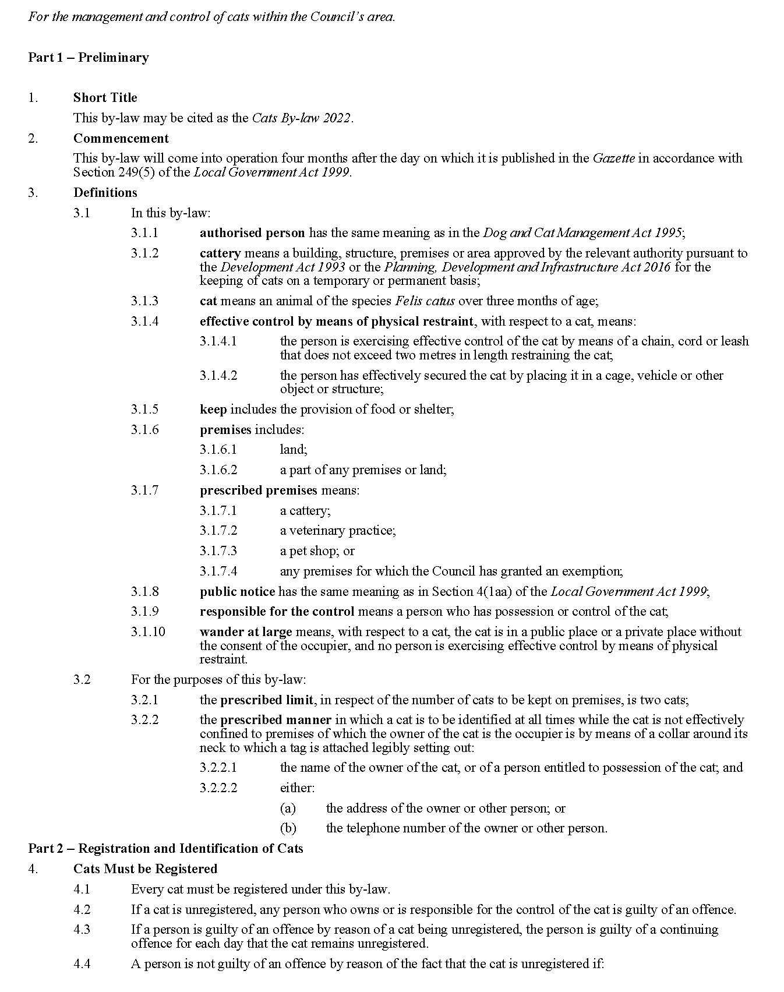

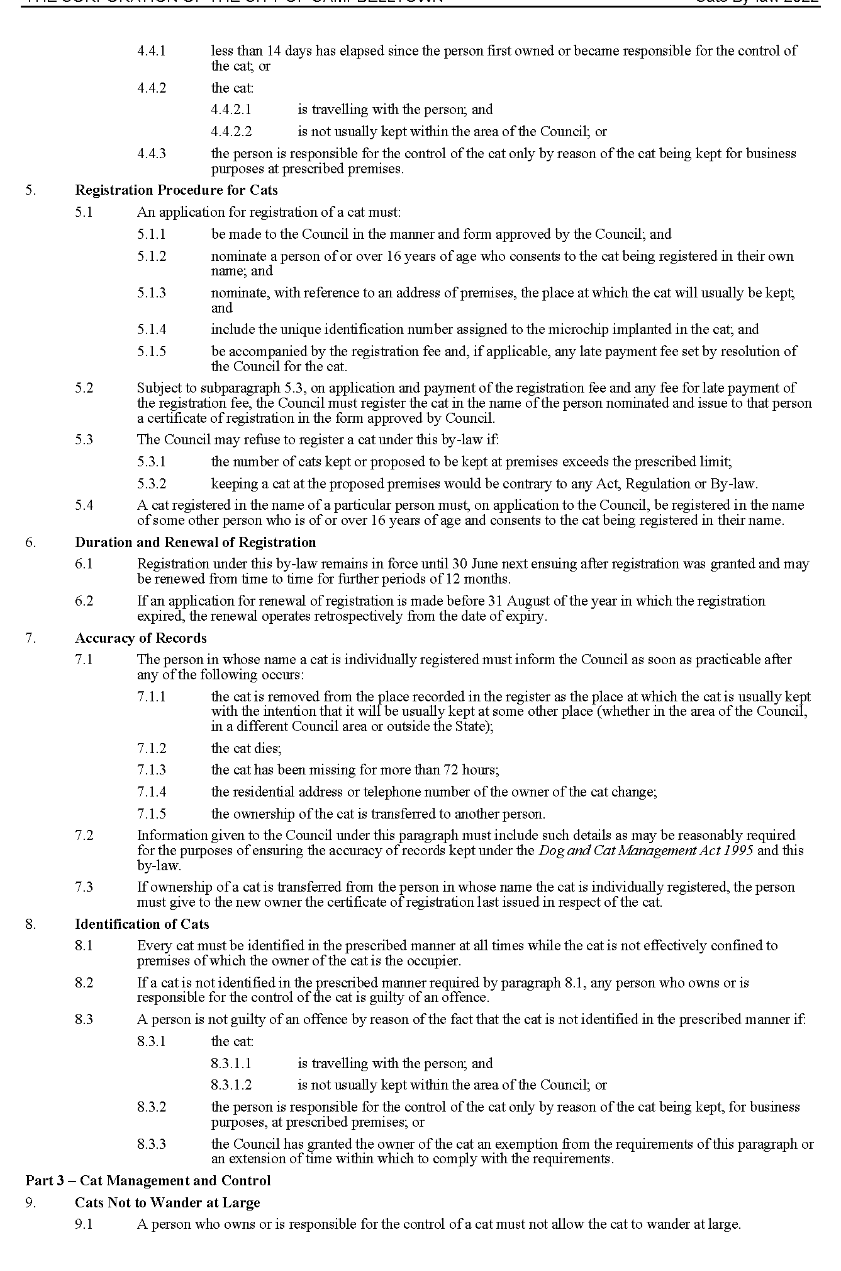
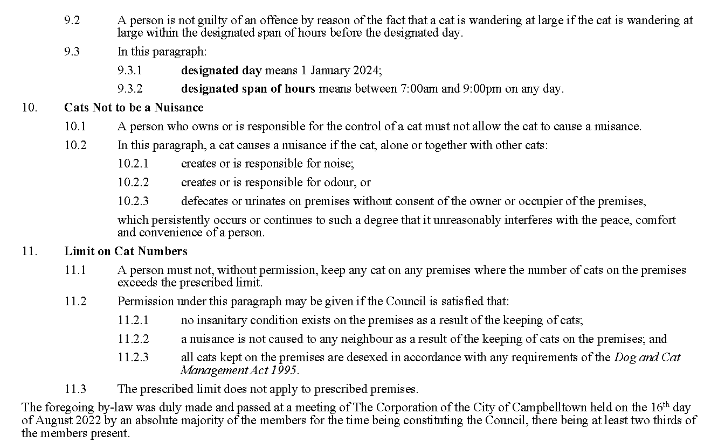
Paul Di Iulio
Chief Executive Officer

City of Mitcham
Local Government Act 1999
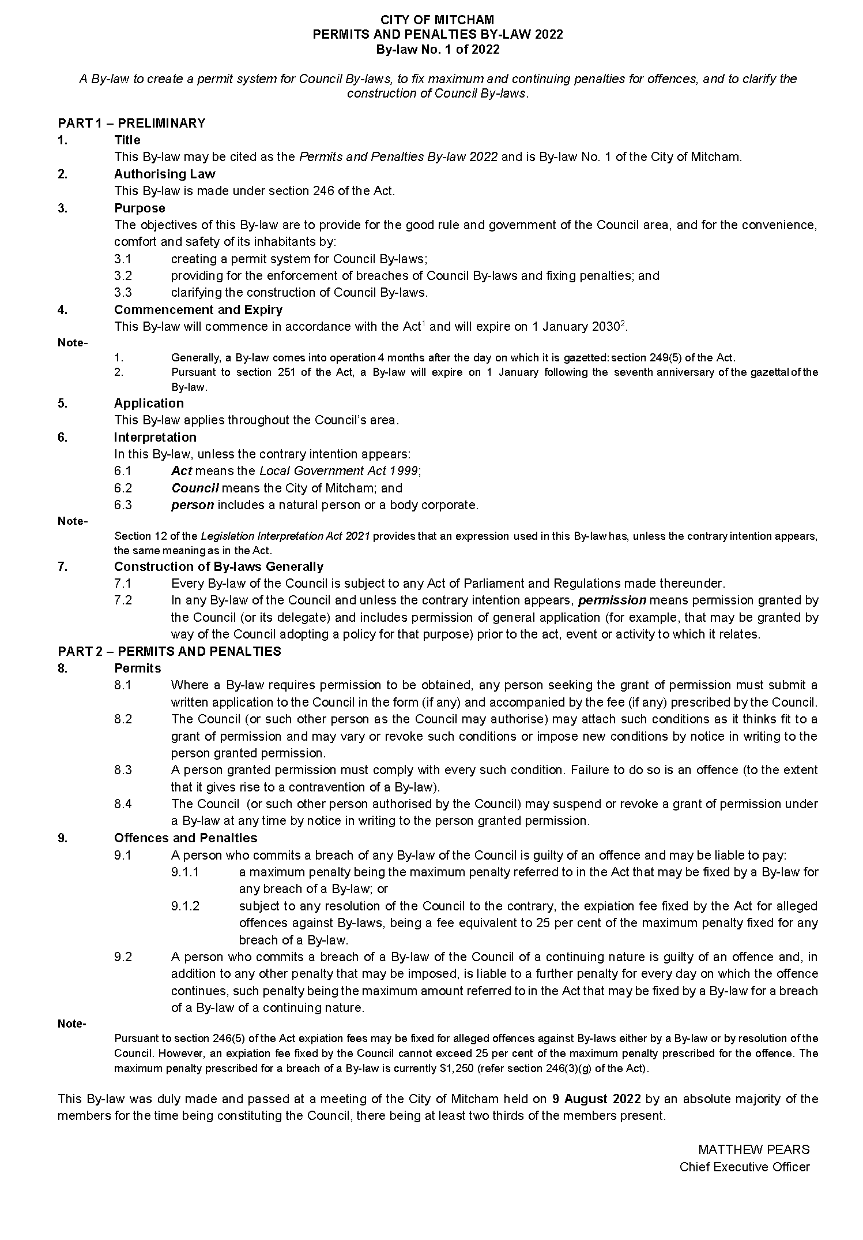
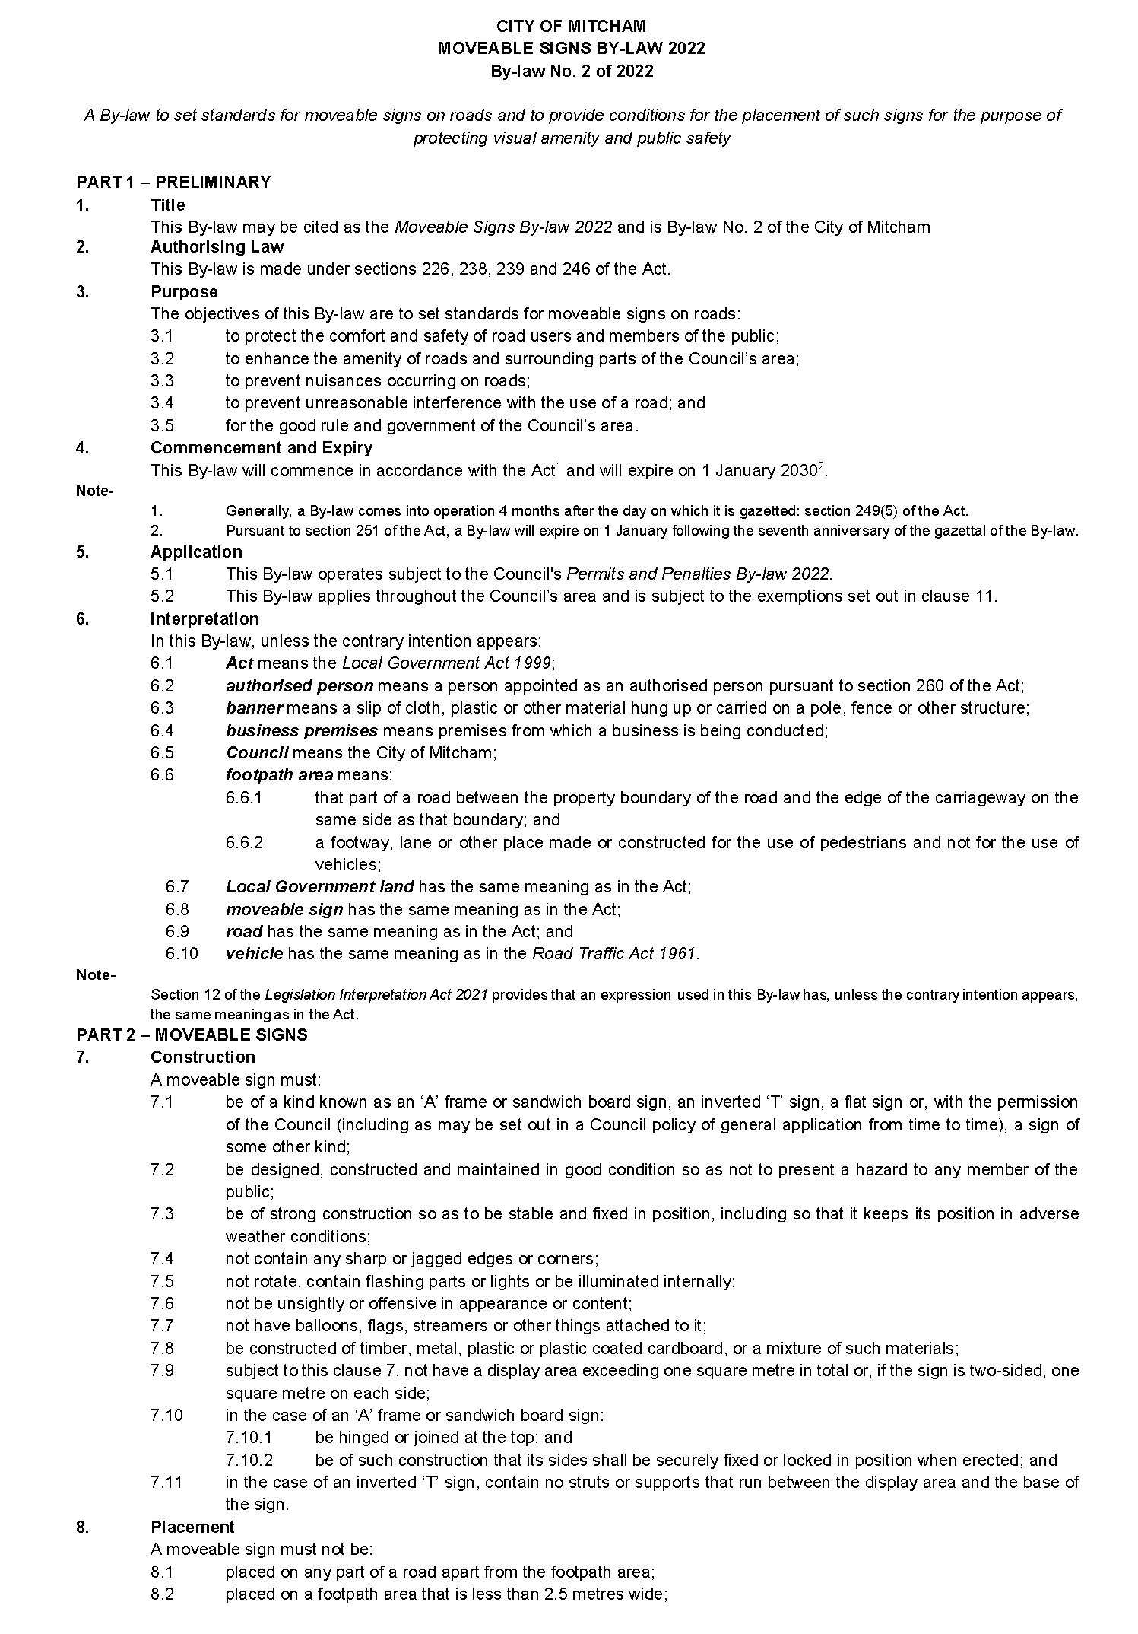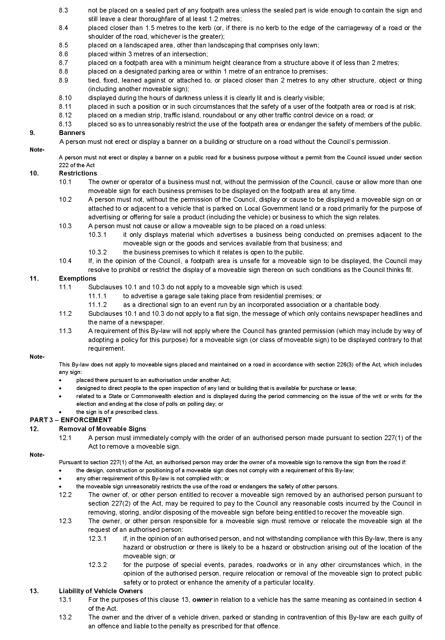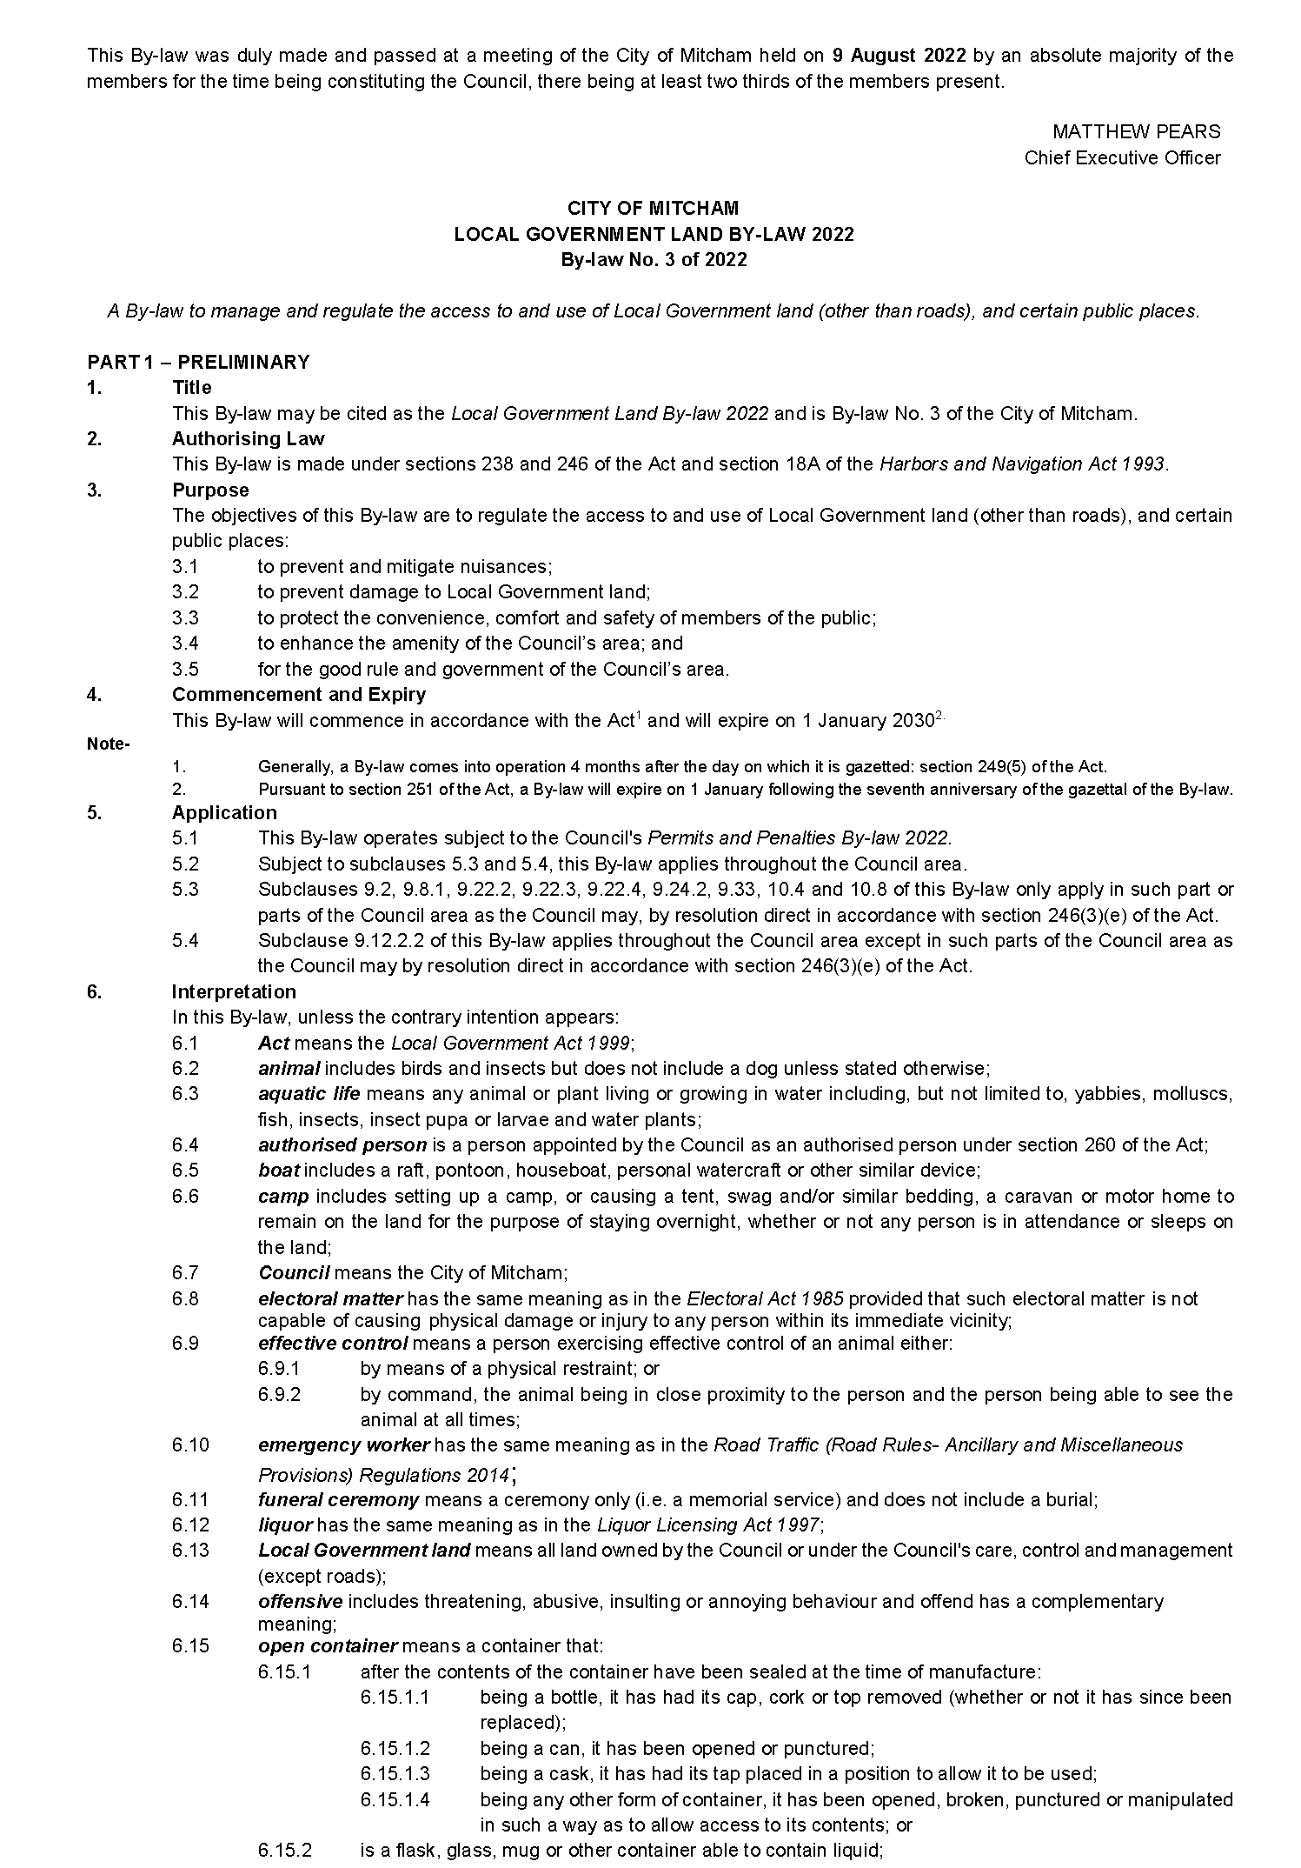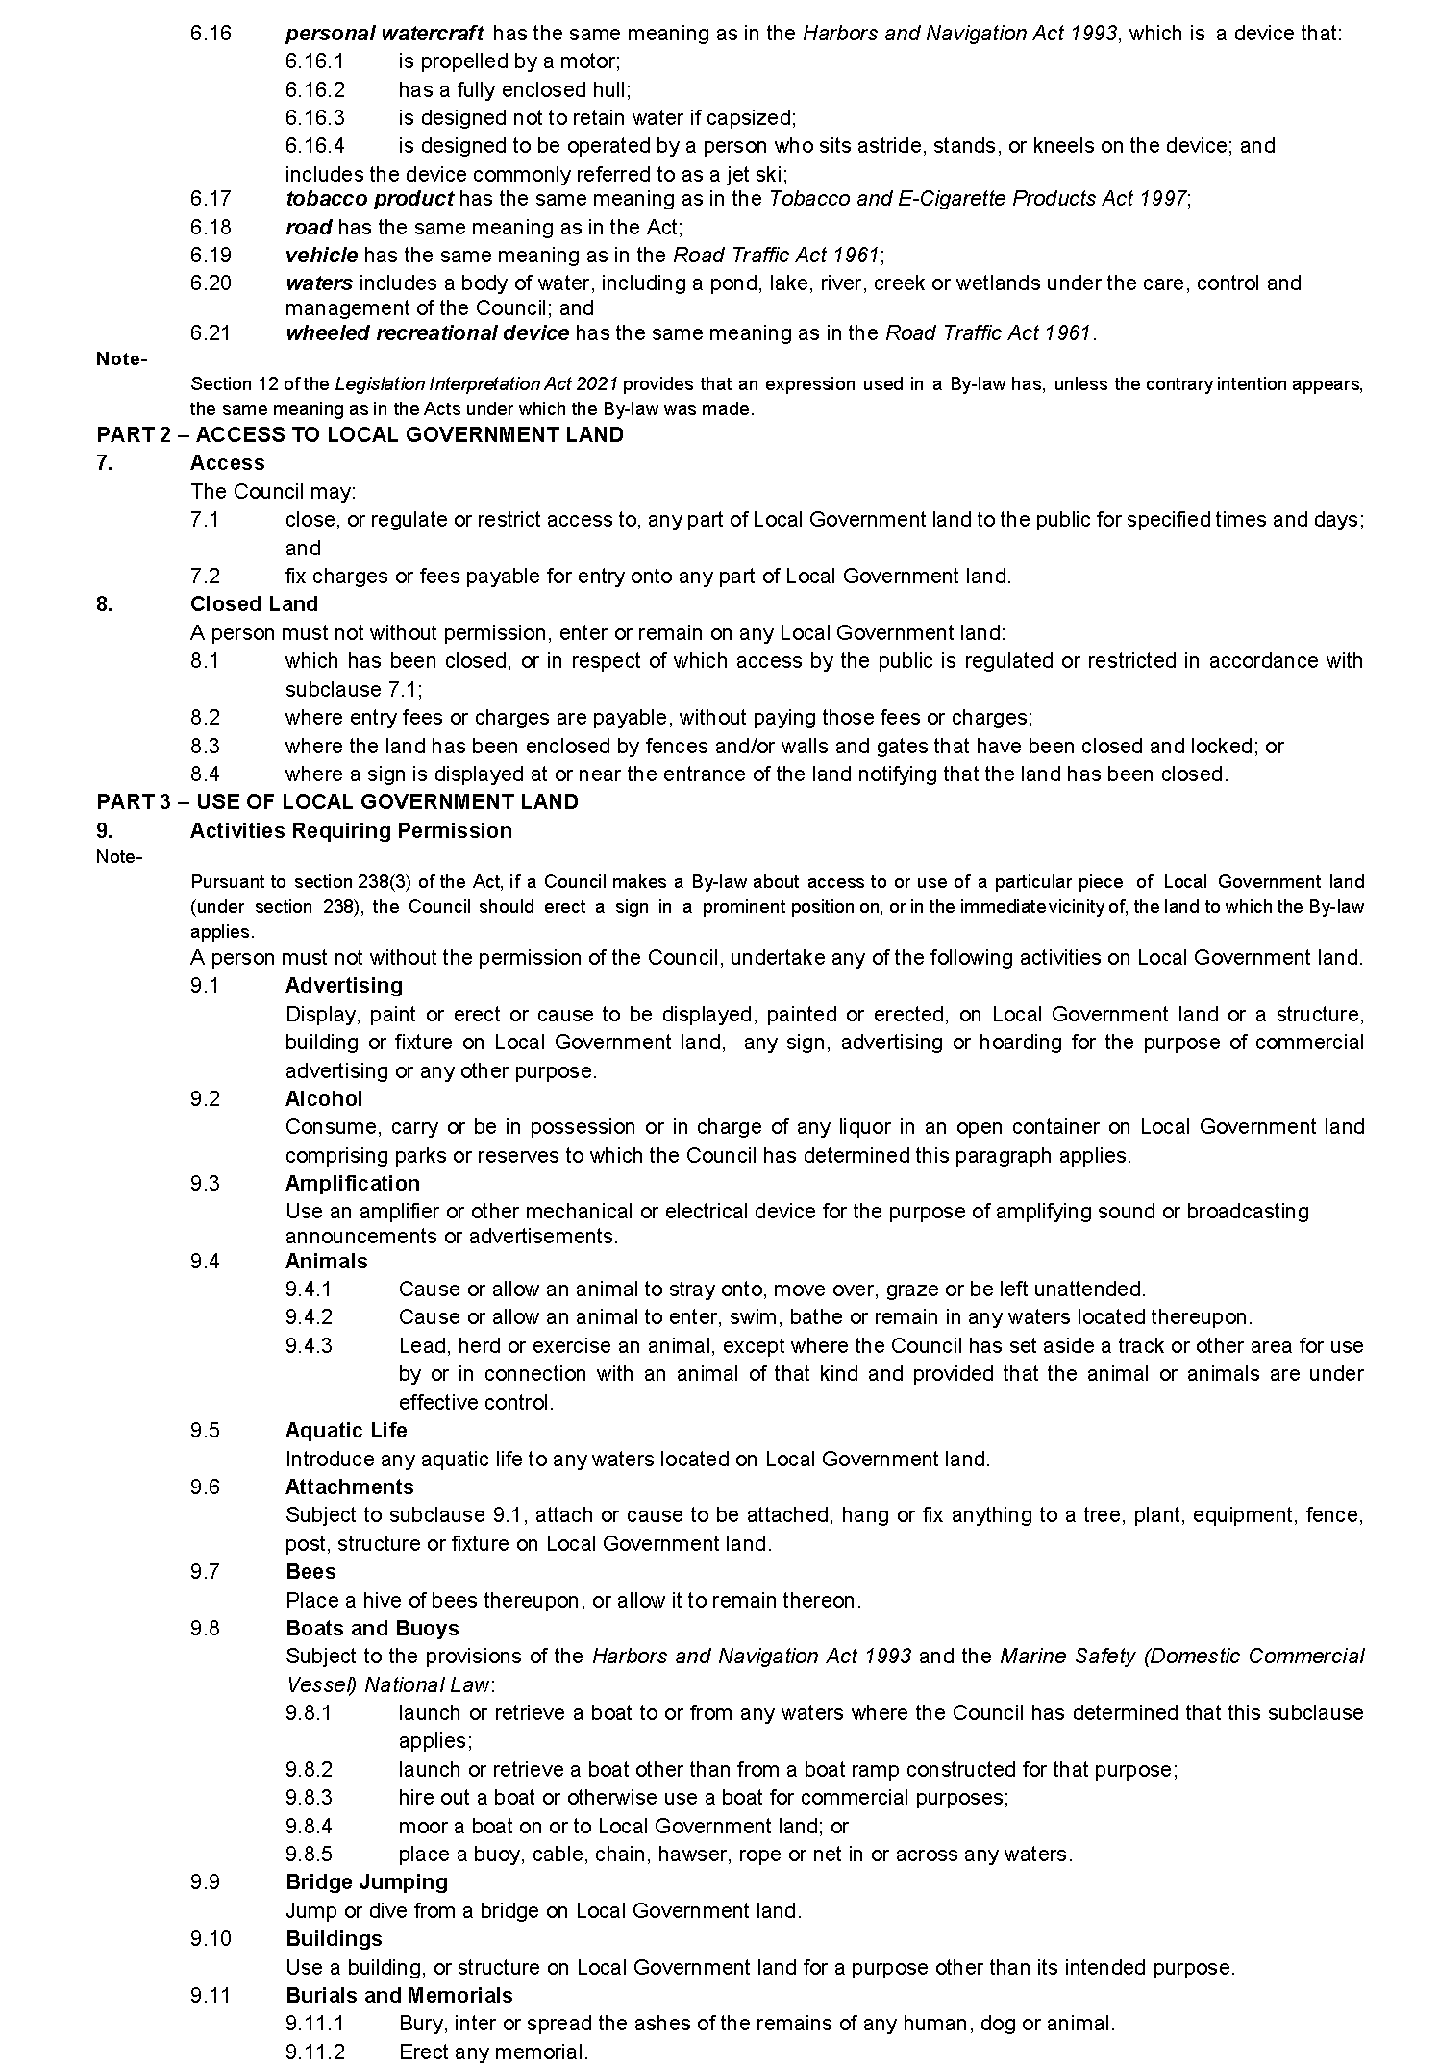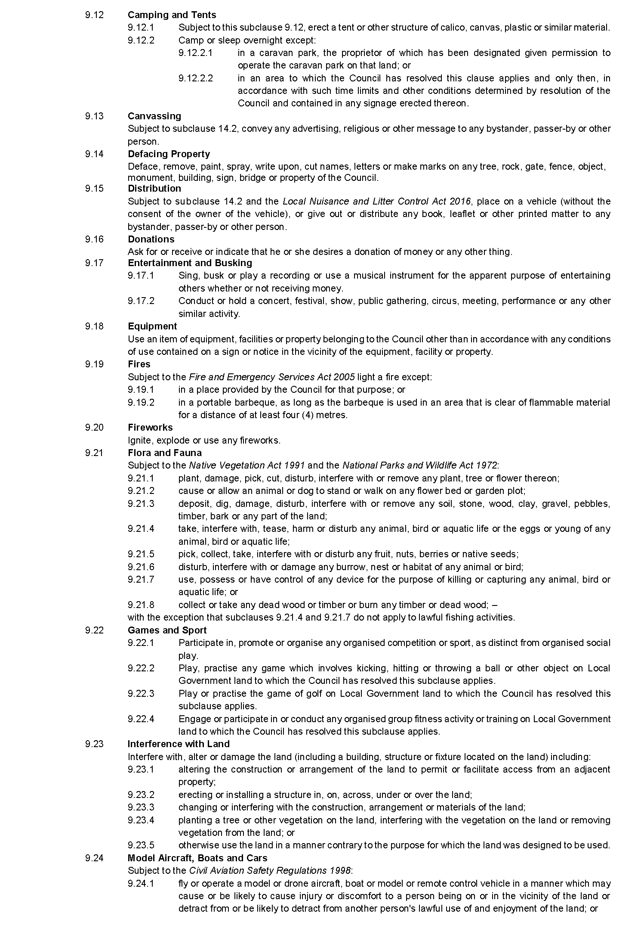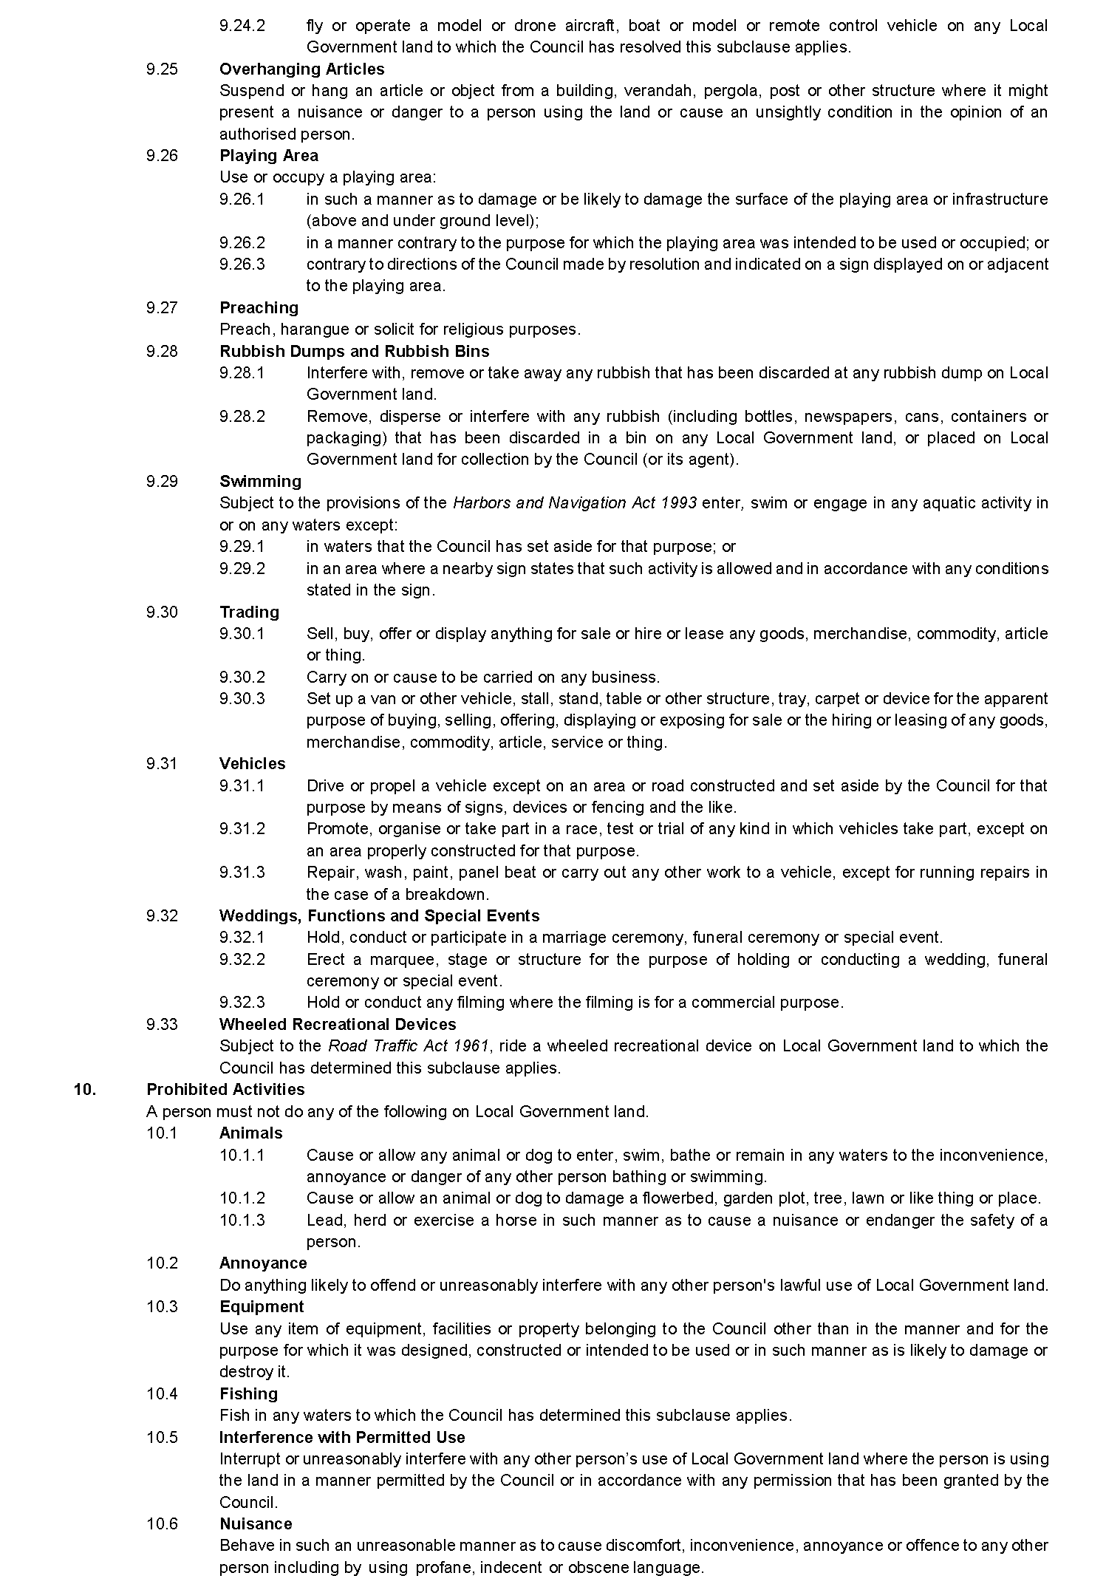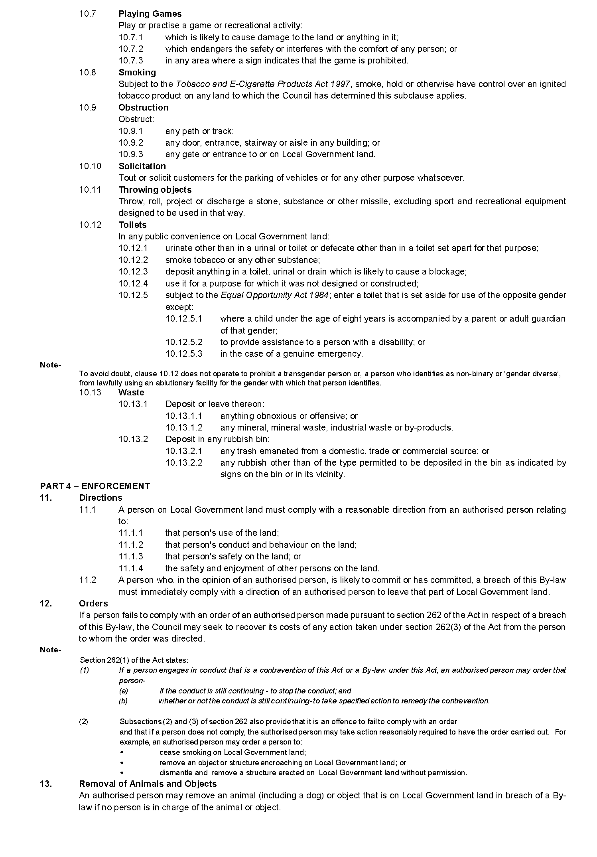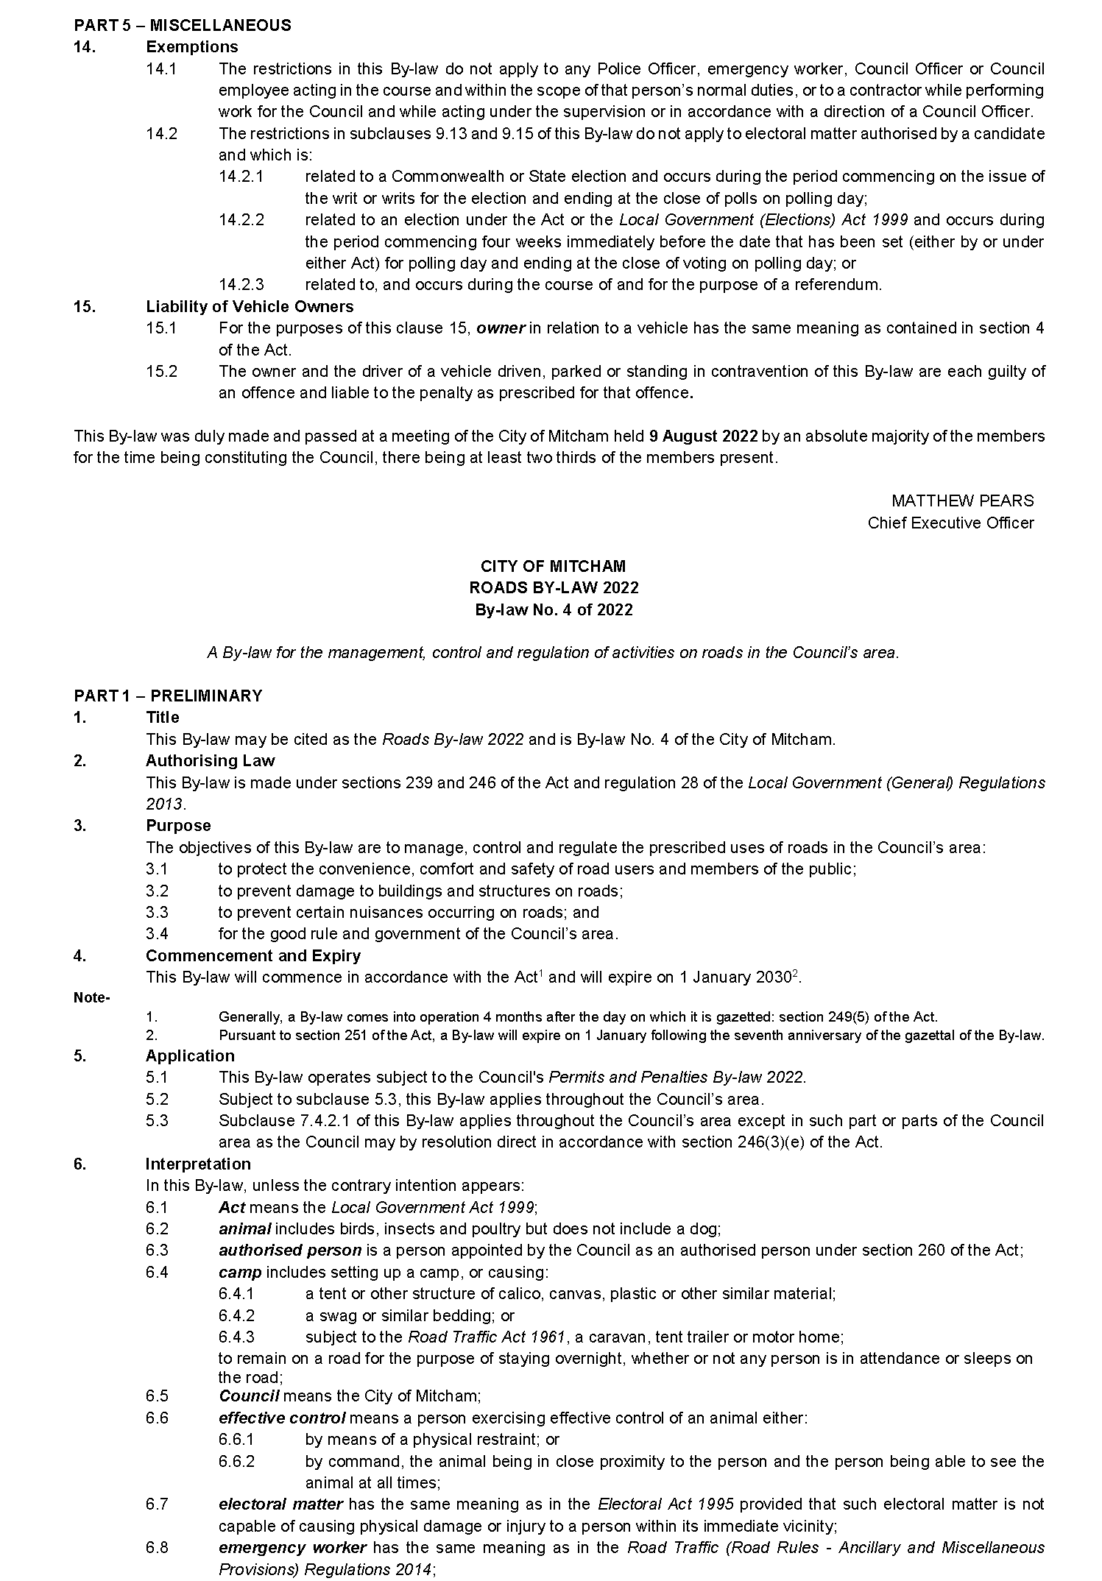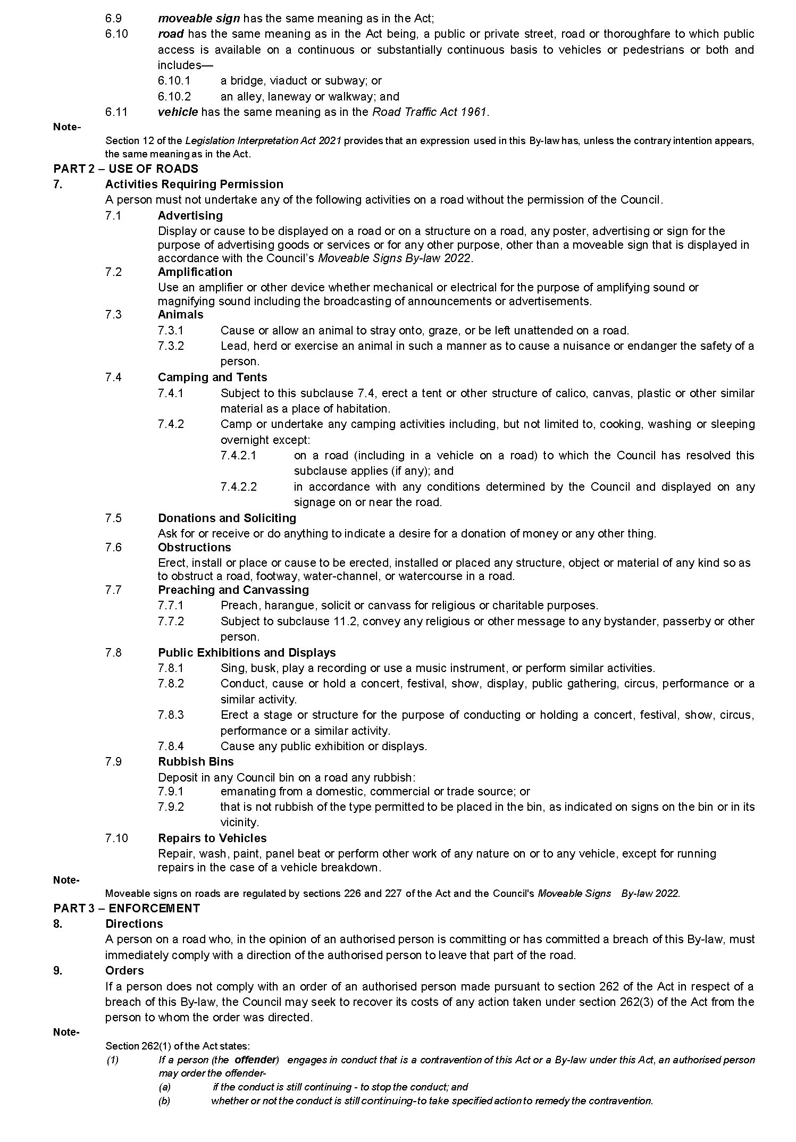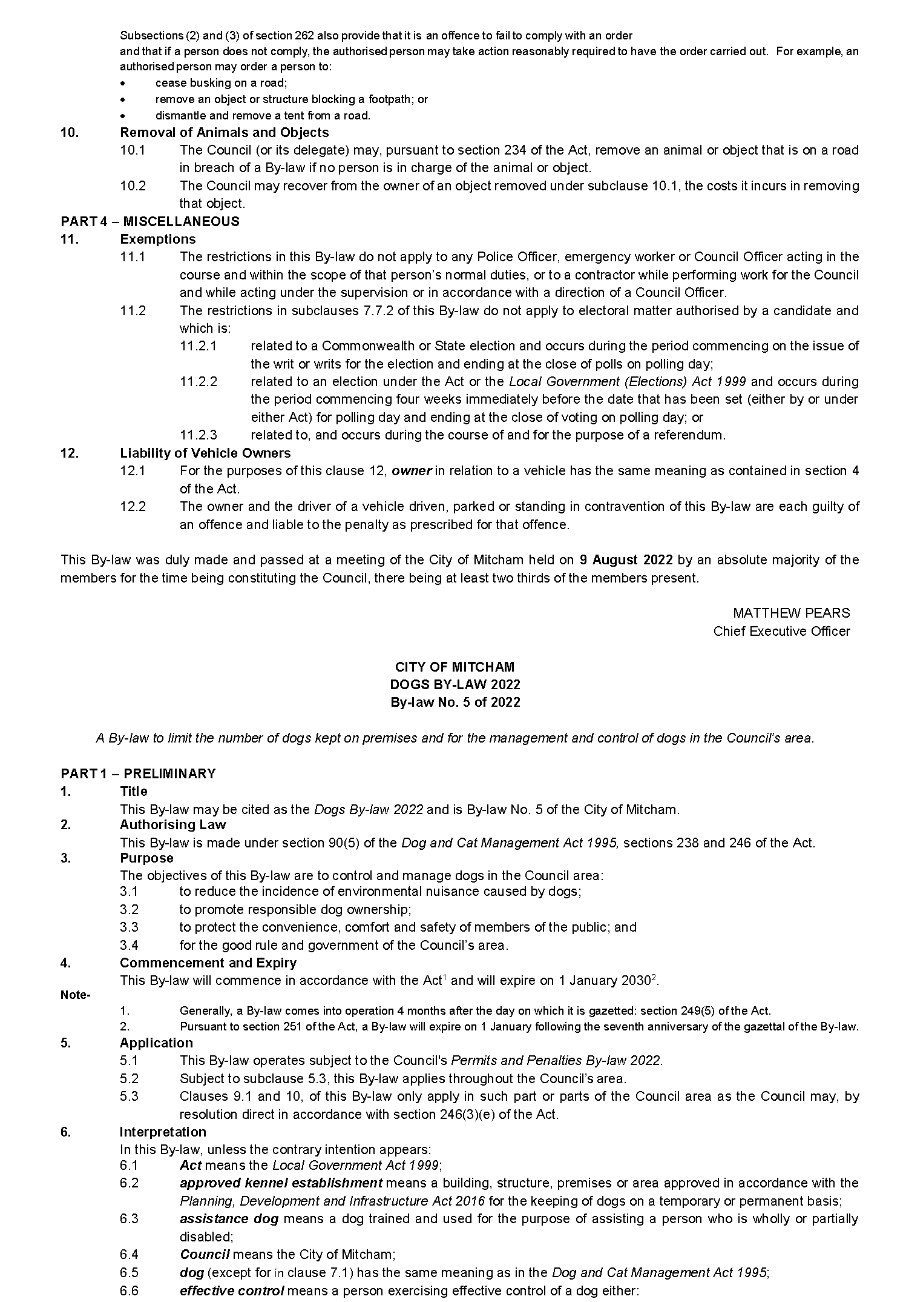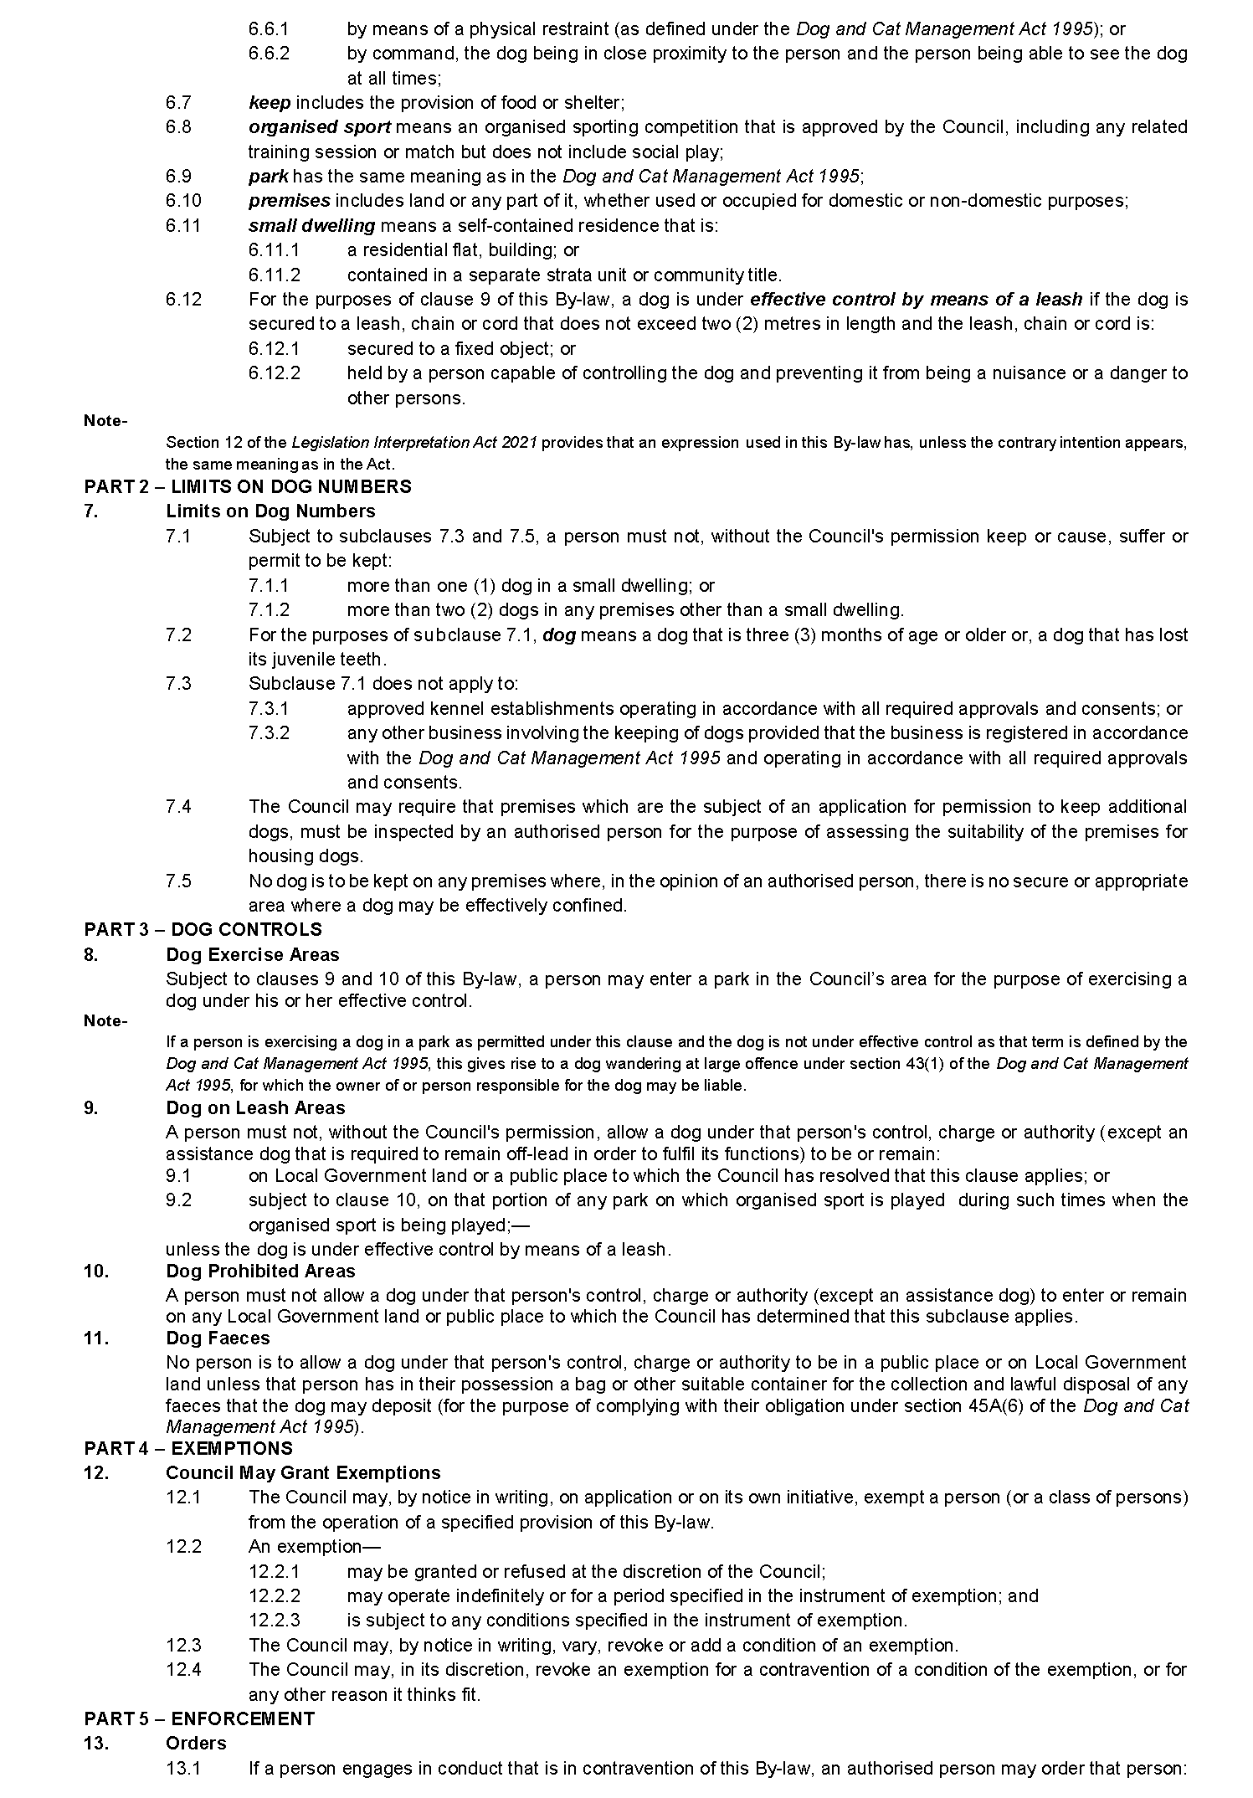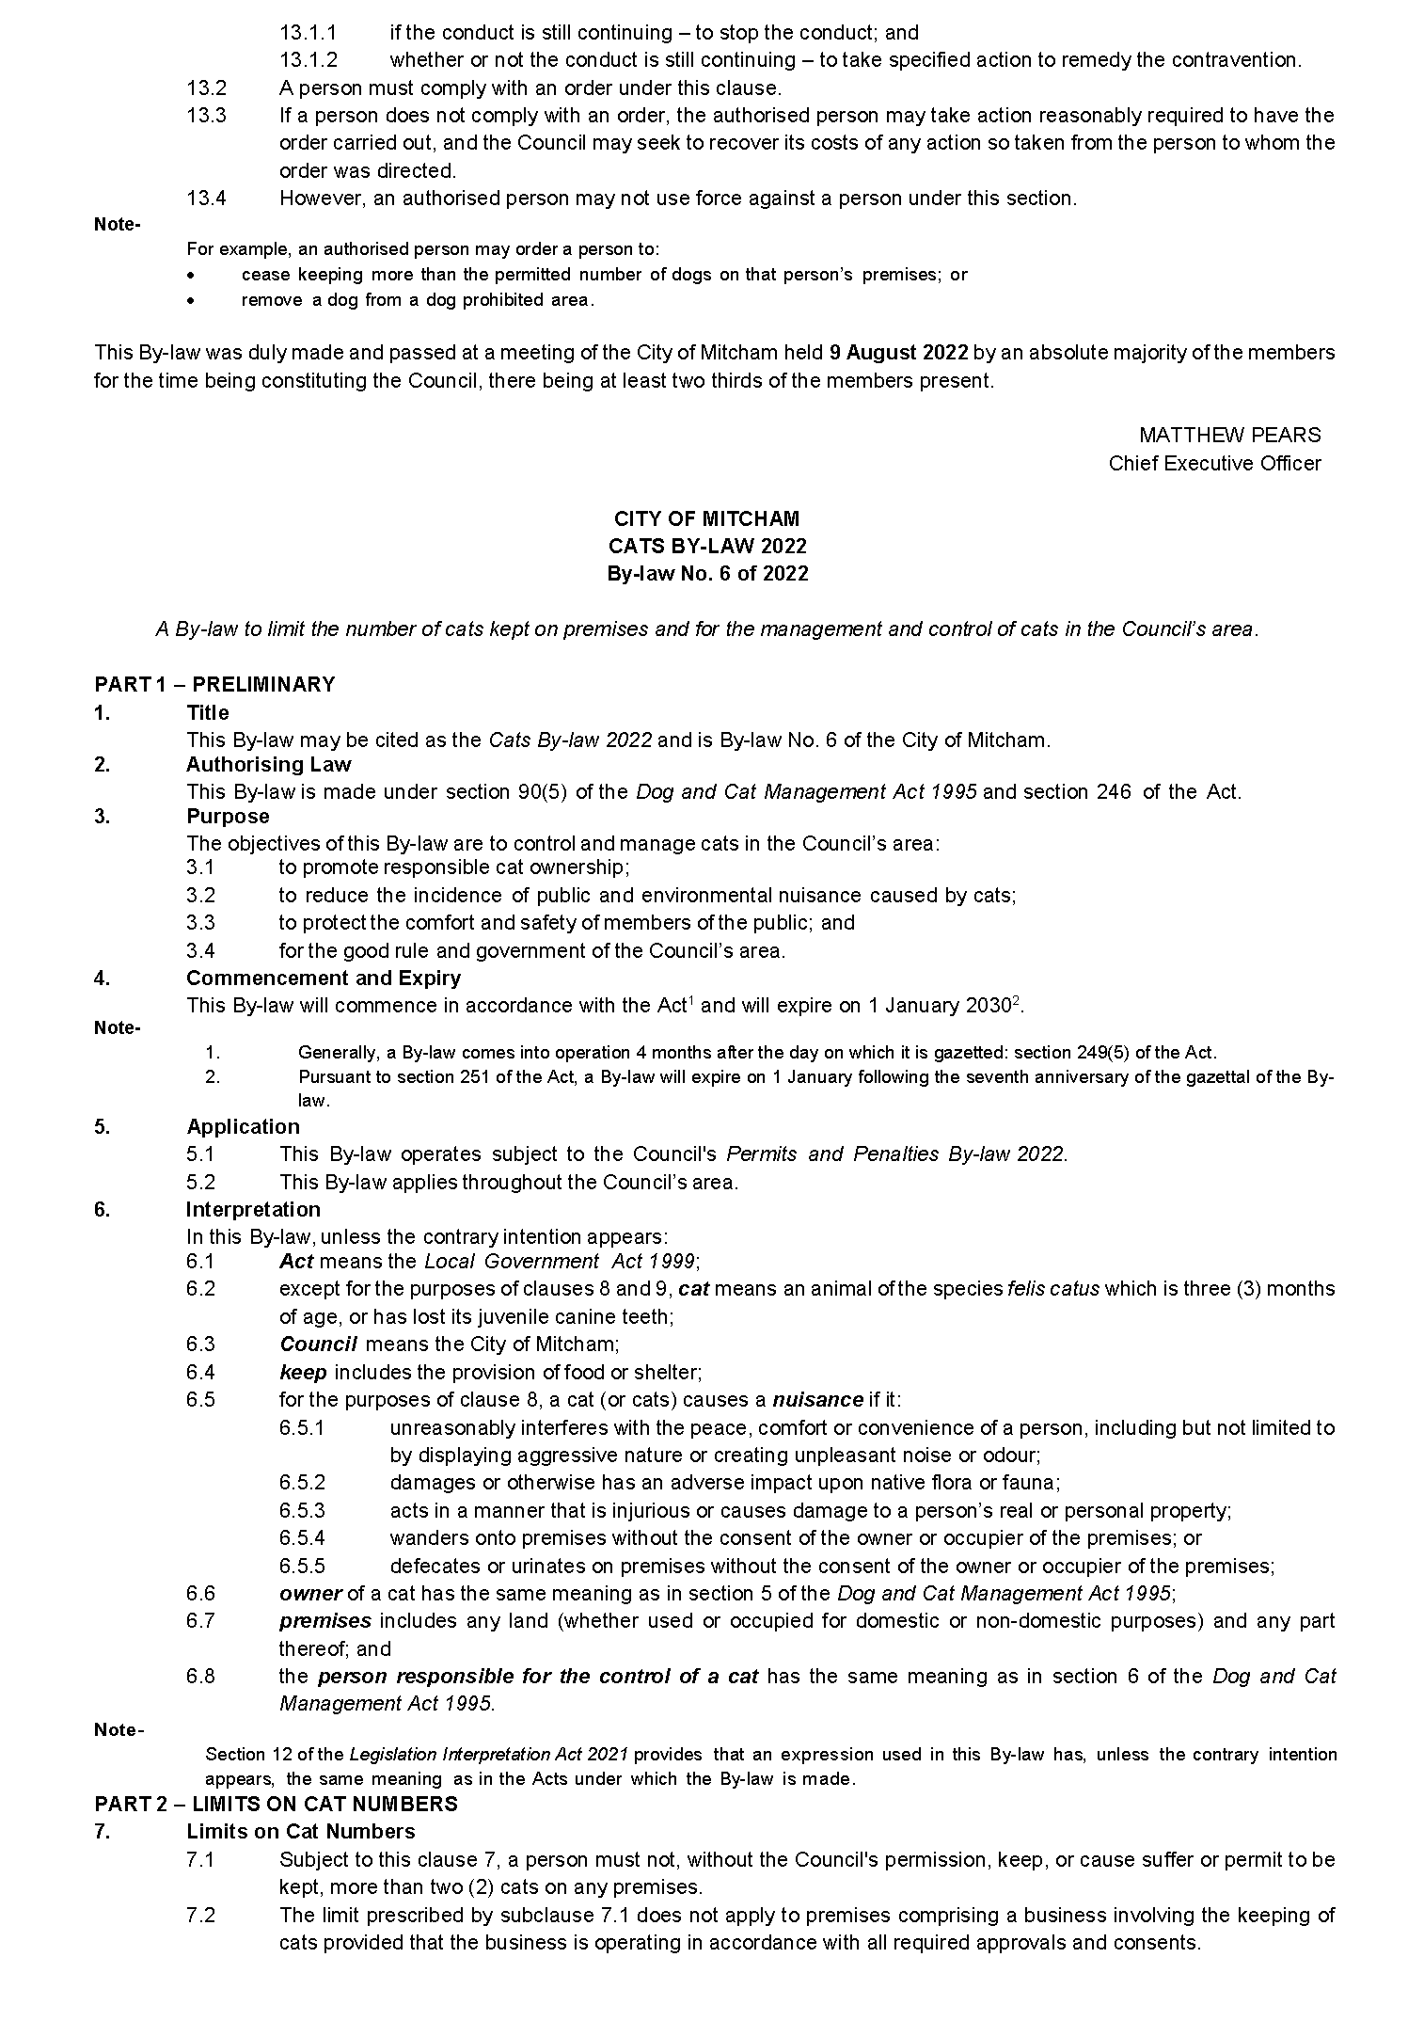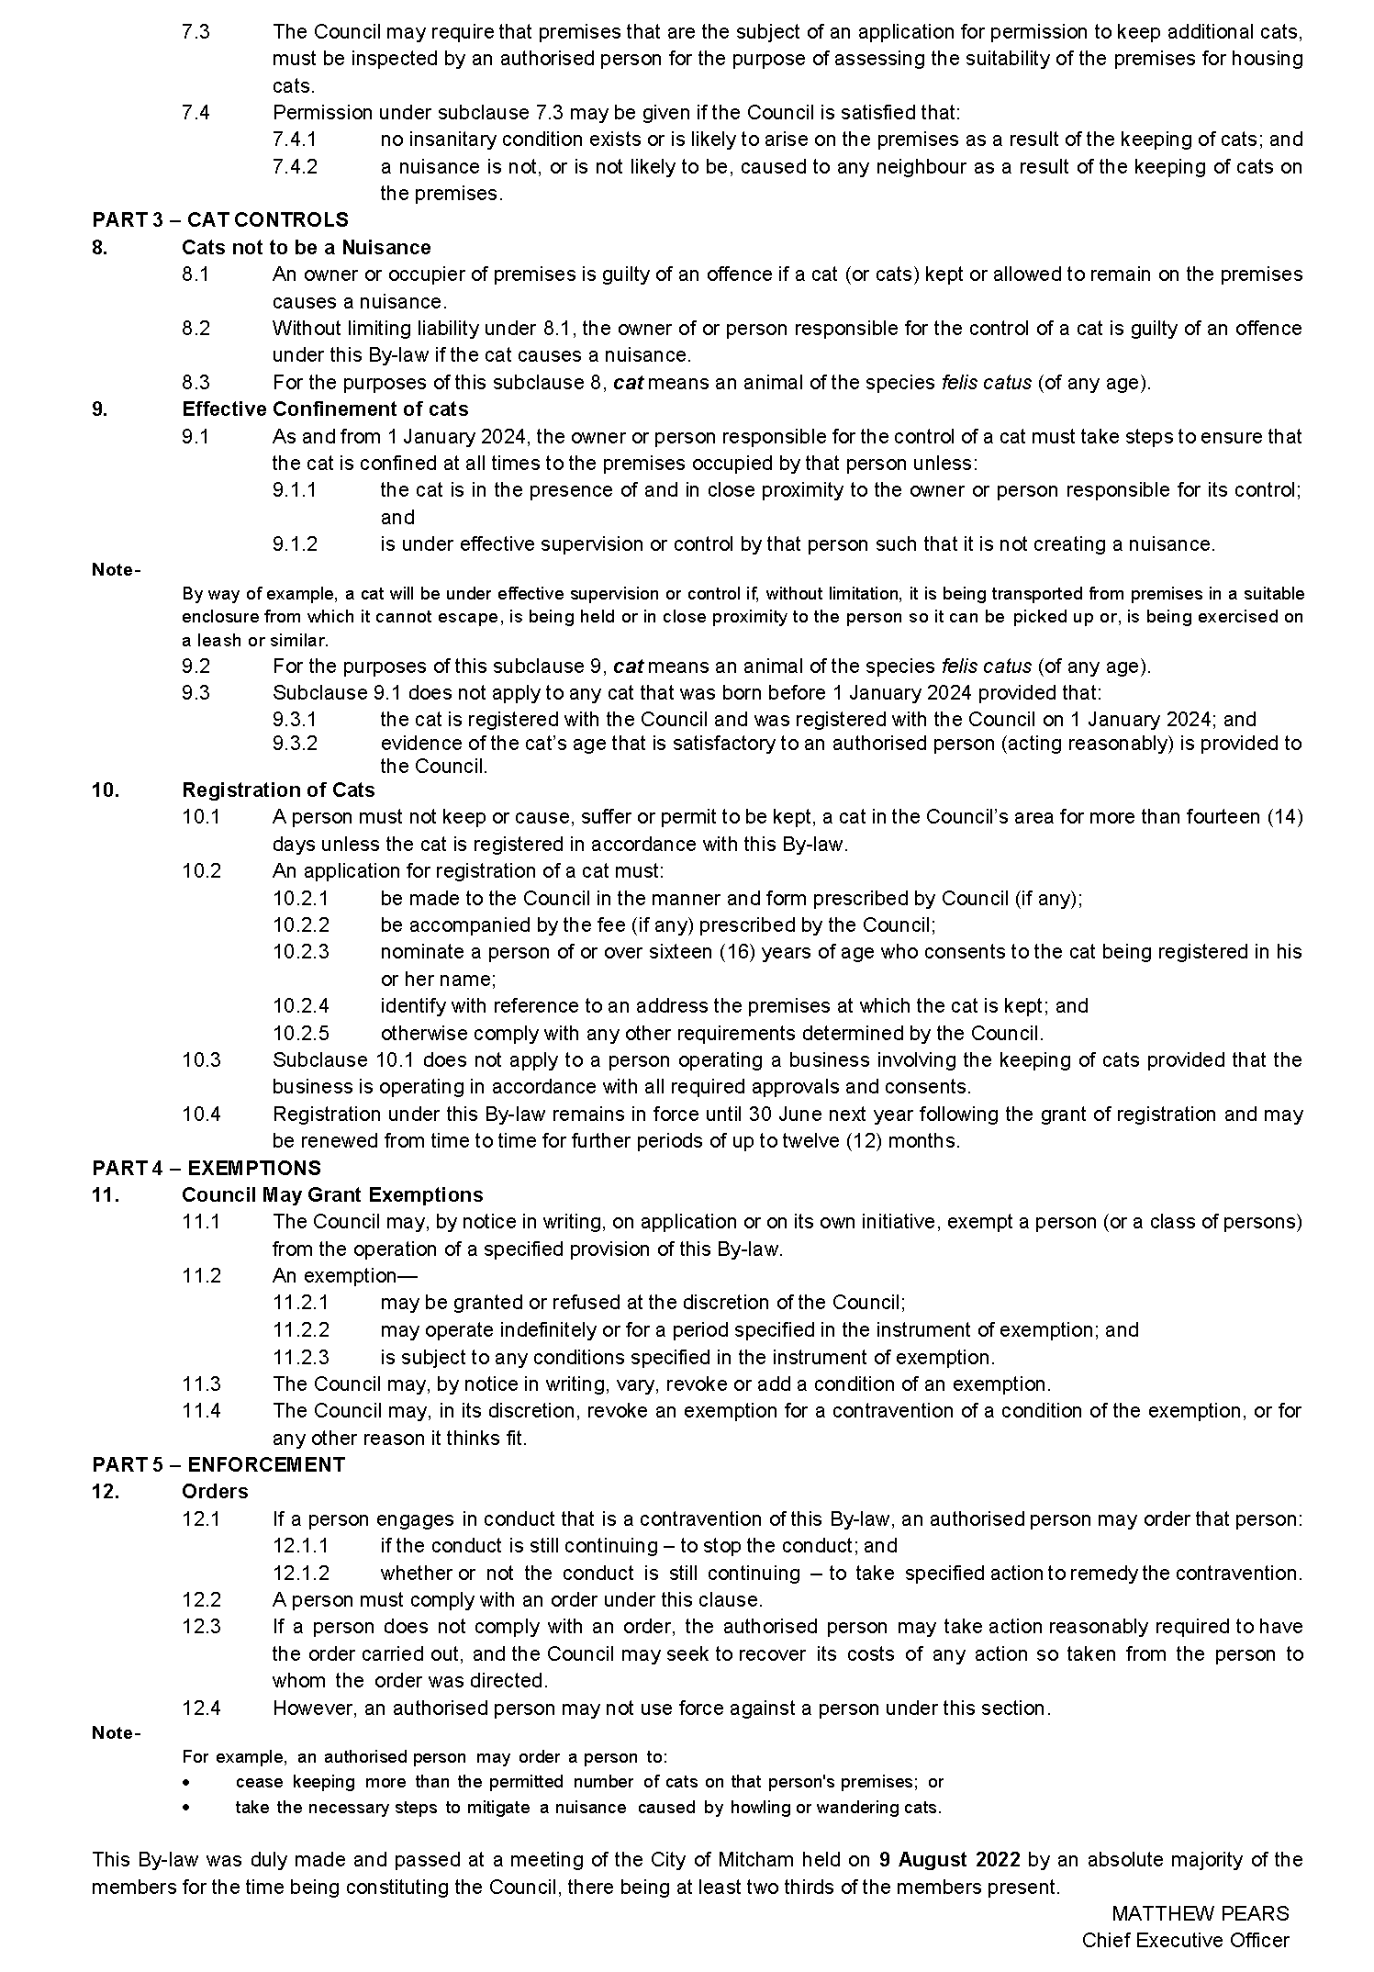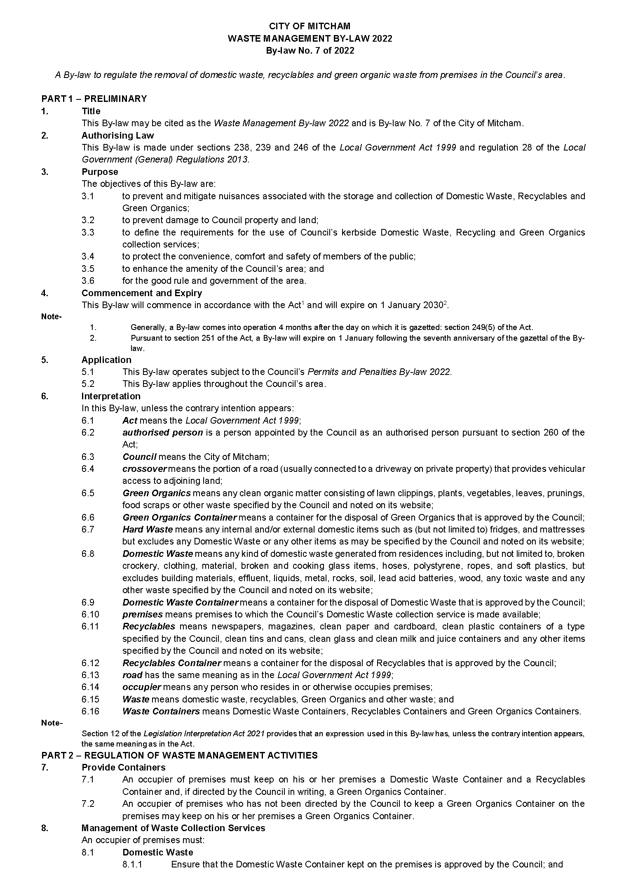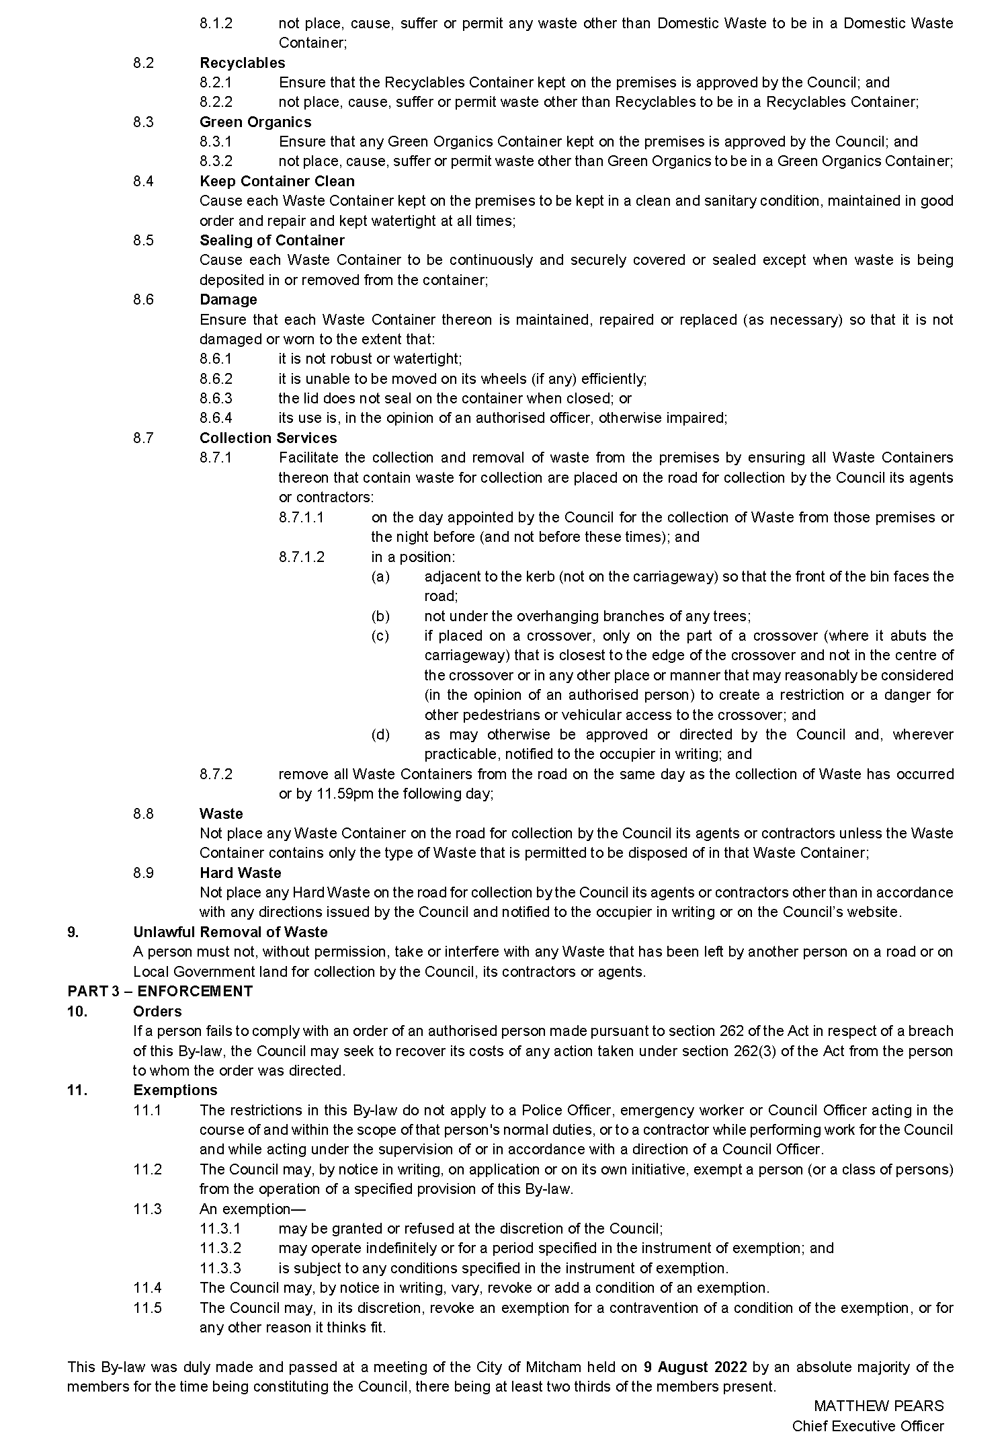

The Flinders Ranges Council
Notice of Casual Vacancy
Notice is hereby given in accordance with section 54(6) of the Local Government Act 1999, that a vacancy has occurred in the office of Councillor for The Flinders Ranges Council, due to the resignation of Councillor Woolford, effective 18 August 2022. In accordance with Section 6(2)(a)(ii) of the Local Government (Elections) Act 1999, a supplementary election is not required to be held as a result of this vacancy.
Dated: 18 August 2022
Eric Brown
Chief Executive Officer

District Council of Kimba
Change of Meeting Time
Notice is hereby given that the District Council of Kimba resolved at its meeting held on 10 August 2022 to change the scheduled September Council Meeting from Wednesday, 14 September, 2022 commencing at 2 pm to Wednesday, 14 September, 2022 commencing at 9 am.
Dated: 25 August 2022
Deb Larwood
Chief Executive Officer

District Council of Streaky Bay
Adoption of the Annual Business Plan Budget
Adoption of Declaration of Rates 2022-2023
Notice is hereby given that at its Ordinary Council Meeting held on 9 August 2022 the District Council of Streaky Bay resolved the following:
Adoption of the Annual Business Plan 2022-2023
That Council, pursuant to the provisions of s123 (6) of the Local Government Act 1999 and Regulation 5A of the Local Government (Financial Management) Regulations 2011 adopt the Annual Business Plan 2022-2023, for the financial year ending 30 June 2023.
Adoption of the Annual Budget 2022-2023
That Council, pursuant to Section 123 (7) of the Local Government Act 1999 and Regulation 7 of the Local Government (Financial Management) Regulations 2011, adopt the Annual Budget for the financial year ending 30 June 2023, as presented in the Annual Business Plan 2022-2023 which includes:
(a) a budgeted income statement, balance sheet and statement of cash flows, presented in a manner consistent with the Model Financial Statements; and
(b) a statement whether projected operating income is sufficient to meet projected operating expenses for the relevant financial year; and
(c) a summary of operating and capital investment activities presented in a manner consistent with the note in the Model Financial Statements entitled Uniform Presentation of Finances; and
estimates with respect to the Council's operating surplus ratio, asset sustainability ratio and net financial liabilities ratio presented in a manner consistent with the note in the Model Financial Statements.
Adoption of Valuations
That Council, pursuant to s167 (2)(a) of the Local Government Act 1999, for the financial year ending 30 June 2023, and its role under Section 6, 7 and 8 of the Local Government Act 1999, adopt for rating purposes, the most recent valuations of the Valuer-General available to the Council of the Site Value of land within the Council’s area, totalling $458,312,240 of rateable land, and hereby specifies 9 August 2022 as the day from which such valuations shall become and be the valuations of Council, subject to such alterations as may appear necessary.
Attribution of Land Uses
(a) the numbers indicated against the various categories of land use prescribed by the Local Government (General) Regulations 2013 Reg. 14 (1), be used to designate land uses in the Assessment Book;
(b) the use indicated by those numbers in respect of each separate assessment of land described in the Assessment Book on this date be attributed to each such assessment respectively; and
(c) reference in this resolution to land being of a certain category use means the use indicated by that category number in the Regulations.
Residential Rate Cap
That Council, pursuant to s153 (3) of the Local Government Act 1999, for the financial year ending 30 June 2023, has determined not to fix a maximum increase in the general rate charged on rateable land that constitutes the principal place of residence of a principal ratepayer.
Declaration of Rates
That Council, having taken into consideration the general principles of rating contained in Section 150 of the Local Government Act 1999 and having observed the requirements of Section 153 of the Local Government Act 1999, pursuant to Sections 151 (1) (c), 152 (1) (c), 153 (1) (b) and 156 (1) (c) of the Local Government Act 1999, the Council, for the financial year ending 30 June 2023:
Declares differential rates on the basis of locality and land use as follows:
In the Neighbourhood zone
- (0.6850) cents in the dollar of the Site Value of rateable land of categories 1, 8 and 9 use;
- (0.9230) cents in the dollar of the Site Value of rateable land of categories 2, 3, 4, 5 and 6 use;
- (0.4140) cents in the dollar of the Site Value of rateable land of category 7 use;
In the Town Activity Centre zone
- (0.6850) cents in the dollar of the Site Value of rateable land of category 1 use;
- (1.2890) cents in the dollar of the Site Value of rateable land of categories 2, 3, 4, 5, 6, 8 and 9 use;
In the Strategic Employment zones
- (0.6850) cents in the dollar of the Site Value of rateable land of category 1 use;
- (0.9230) cents in the dollar of the Site Value of rateable land of categories 2, 3, 4, 5, 6, 8 and 9 use;
- (0.4616) cents in the dollar of the Site Value of rateable land of category 7 use;
In the Rural Aquaculture zone
- (0.4140) cents in the dollar of the Site Value of rateable land of category 7 and 8 use;
In the Rural zone
- (0.6080) cents in the dollar of the Site Value of rateable land of categories 1, 2, 3, 6 and 9 use;
- (25.8900) cents in the dollar of the Site Value of rateable land of category 4 use;
- (0.4140) cents in the dollar of the Site Value of rateable land of categories 5, 7 and 8 use;
In the Employment (Bulk Handling) zone
- (25.8900) cents in the dollar of the Site Value of rateable land of all category uses;
In the Deferred Urban zone
- (0.4140) cents in the dollar of the Site Value of rateable land of categories 1, 2, 3, 4, 5, 6, and 7 use;
- (0.6080) cents in the dollar of the Site Value of rateable land of categories 8 & 9 use;
In the Caravan and Tourist Park zone
- (1.2890) cents in the dollar of the Site Value of rateable land of category 4 use;
In the Township, Rural Settlement and Rural Shack Settlement zones
- (0.6080) cents in the dollar of the Site Value of rateable land of all categories
In the Conservation Visitor Experience zone
- (0.6080) cents in the dollar of the Site Value of rateable land of categories 1, 2, 3, 5, 6, 8 and 9 use;
- (0.4140) cents in the dollar of the Site Value of rateable land of category 7 use;
In the Rural Living, Rural Neighbourhood, & Recreation zones
- (0.6080) cents in the dollar of the Site Value of rateable land of categories 1, 2, 3, 4, 5, 6, 8 and 9 use;
- (0.4140) cents in the dollar of the Site Value of rateable land of category 7 use;
Where each of the above zones is a defined zone within the Development Plan under the Planning, Development and Infrastructure Act 2016.
Fixed Charge
The Council has imposed a fixed charge of $640.00. The fixed charge is levied against the whole of an allotment (including land under a separate lease or licence) and only one fixed charge is levied against two or more pieces of adjoining land (whether intercepted by a road or not) if they are owned by the same owner and occupied by the same occupier. The reasons for imposing a fixed charge are:
• the Council considers it appropriate that all rateable properties make a contribution to the cost of administering the Council’s activities;
the Council considers it appropriate that all rateable properties make a contribution to the cost of creating and maintaining the physical infrastructure that supports each.
Annual Service Charge
Pursuant to Section 155 of the Local Government Act 1999 and in accordance with Regulation 12(4)(b) of the Local Government (General) Regulations 2013, the Council imposes an annual service charge as set out below:
$511.00 on all applicable land;
to which it provides or makes available the Community Wastewater Management Systems, being services for the collection and disposal of waste.
$260.00 on all applicable land
to all properties within the Waste Management Collection service area that have an occupiable dwelling, outbuilding or other class of structure and those en-route that are outside of collection areas that receive a Waste Management Collection service.
Regional Landscape Levy (RL Levy)
Pursuant to Section 95 of the Landscape South Australia Act 2019 the Council declares variable separate rates, in respect of all rateable land in the area of the Eyre Peninsula Landscape Board and within the area of the Council in order to recoup the amount of $171,763 being Council’s contribution to the Board for the period ending 30 June 2023. The rates are as below:-
Residential $ 81.25
Commercial $121.85
Industrial $121.85
Primary Producers $162.50
Other & Vacant Land $ 81.25
Schedule of Fees and Charges
That Council, pursuant to Section 188 of the Local Government Act 1999 adopt the fees and charges for the financial year ending 30 June 2023.
Dated: 9 August 2022
Damian Carter
Chief Executive Officer

Public Notices

National Electricity Law
Notice of Extension of Draft Determination
The Australian Energy Market Commission (AEMC) gives notice under the National Electricity Law as follows:
Under s 107, the time for making the draft determination on the Operational security mechanism rule change request (Ref. ERC0290) proposal has been extended to 22 September 2022.
Documents referred to above are available on the AEMC’s website and are available for inspection at the AEMC’s office.
Australian Energy Market Commission
Level 15, 60 Castlereagh St
Sydney NSW 2000
Telephone: (02) 8296 7800
www.aemc.gov.au
Dated: 25 August 2022

Trustee Act 1936
Public Trustee
Estates of Deceased Persons
In the matter of the estates of the undermentioned deceased persons:
CARSON Charles William late of Corner Fort Street and Sylvan Way Grange of no occupation who died 9 March 2022
CRAM Robert Arthur late of 30 Sussex Terrace Westbourne Park retired cartographer who died 01 April 2022
HUGHES Selma late of 19 Windsor Avenue Pennington of no occupation who died 10 February 2022
MARKS Colin Dale late of 1A Lyn Street Aberfoyle Park Retired commercial photographer who died 03 May 2022
MOORE Barry Charles Douglas late of 150 Reynell Road Woodcroft Retired Administration Officer who died 8 May 2022
PAYNE Barrie Ian late of 2A Hargrave Street Northfield of no occupation who died 15 May 2022
SANCHEZ Judith Annette late of 33 Gunther Parade Pasadena of no occupation who died 27 April 2022
SAUNDERS Carolyn Joy late of 37 Smith Street Thebarton of no occupation who died 26 December 2021
Notice is hereby given pursuant to the Trustee Act 1936, the Inheritance (Family Provision) Act 1972 and the Family Relationships Act 1975 that all creditors, beneficiaries, and other persons having claims against the said estates are required to send, in writing, to the office of Public Trustee at GPO Box 1338, Adelaide, 5001, full particulars and proof of such claims, on or before the 23 September 2022 otherwise they will be excluded from the distribution of the said estate; and notice is also hereby given that all persons indebted to the said estates are required to pay the amount of their debts to the Public Trustee or proceedings will be taken for the recovery thereof; and all persons having any property belonging to the said estates are forthwith to deliver same to the Public Trustee.
Dated: 25 August 2022
N. S. Rantanen
Public Trustee

Notice Submission

The South Australian Government Gazette is published each Thursday afternoon.
Notices must be emailed by 4 p.m. Tuesday, the week of publication.
Submissions are formatted per the gazette style and a proof will be supplied prior to publication, along with a quote if applicable. Please allow one day for processing notices.
Alterations to the proof must be returned by 4 p.m. Wednesday.

Gazette notices must be submitted as Word files, in the following format:
• Title—the governing legislation
• Subtitle—a summary of the notice content
• Body—structured text, which can include numbered lists, tables, and images
• Date—day, month, and year of authorisation
• Signature block—name, role, and department/organisation authorising the notice

Please provide the following information in your email:
• Date of intended publication
• Contact details of the person responsible for the notice content
• Name and organisation to be charged for the publication—Local Council and Public notices only
• Purchase order, if required—Local Council and Public notices only

Email: governmentgazettesa@sa.gov.au
Phone: (08) 7109 7760
Website: www.governmentgazette.sa.gov.au

All instruments appearing in this gazette are to be considered official, and obeyed as such

Printed and published weekly by authority of C. McArdle, Government Printer, South Australia
$8.15 per issue (plus postage), $411.00 per annual subscription—GST inclusive
Online publications: www.governmentgazette.sa.gov.au

