No. 83 p. 6753
THE SOUTH AUSTRALIAN
GOVERNMENT GAZETTE
Published by Authority

Adelaide, Thursday, 1 December 2022

Contents

Governor’s Instruments
Appointments 6754
Emergency Management Act 2004 6754
Proclamations—
Cross Border Commissioner Act (Commencement) Proclamation 2022 6755
Independent Commissioner Against Corruption
(CPIPC Recommendations) Amendment Act (Commencement) Proclamation 2022 6755
Administrative Arrangements (Administration of Cross
Border Commissioner Act) Proclamation 2022 6756
National Parks and Wildlife (Dissolution of Trust) Proclamation 2022 6756
Regulations—
National Electricity (South Australia) (Disclosure)
Amendment Regulations 2022—No. 107 of 2022 6757
Health Practitioner Regulation National Law
(South Australia) (Amendment of Law)
Regulations 2022—No. 108 of 2022 6758
Motor Vehicles (Ultra High Powered Vehicle Driver
Licensing) Amendment Regulations 2022—
No. 109 of 2022 6768
State Government Instruments
Administrative Arrangements Act 1994 6771
Controlled Substances Act 1984 6771
Firearms Regulations 2017 6771
Fisheries Management (Prawn Fisheries) Regulations 2017 6771
Geographical Names Act 1991 6773
Housing Improvement Act 2016 6773
Justices of the Peace Act 2005 6774
Land Acquisition Act 1969 6774
Liquor Licensing Act 1997 6776
Livestock Act 1997 6781
Major Events Act 2013 6784
Real Property Act 1886 6802
Roads (Opening and Closing) Act 1991 6806
Summary Offences Act 1953 6807

Local Government Instruments
Adelaide Plains Council 6809
District Council of Kimba 6810

Public Notices
Trustee Act 1936 6815

Governor’s Instruments

Appointments
Department of the Premier and Cabinet
Adelaide, 1 December 2022
His Excellency the Governor's Deputy in Executive Council has been pleased to appoint the undermentioned to the Adelaide Festival Corporation Board, pursuant to the provisions of the Adelaide Festival Corporation Act 1998:
Member: from 1 December 2022 until 30 November 2025
Brenton Philip Vincent Cox
Member: from 5 December 2022 until 4 December 2025
Alison Claire Beare
By command,
Kyam Joseph Maher, mlc
For Premier
ART0019-22CS

Department of the Premier and Cabinet
Adelaide, 1 December 2022
His Excellency the Governor's Deputy in Executive Council has been pleased to appoint the undermentioned to the Libraries Board of South Australia, pursuant to the provisions of the Libraries Act 1982:
Member: from 1 December 2022 until 18 November 2024
Janet May Hunter Finlay
Member: from 1 December 2022 until 30 November 2025
Joanne Cys
Amanda Elizabeth Nettelbeck
By command,
Kyam Joseph Maher, mlc
For Premier
ART0018-22CS

Department of the Premier and Cabinet
Adelaide, 1 December 2022
His Excellency the Governor's Deputy in Executive Council has been pleased to appoint Philip Mark Strickland as Inspector, for a term commencing on 5 December 2022 and expiring on 4 June 2023 - pursuant to the Independent Commission Against Corruption Act 2012.
By command,
Kyam Joseph Maher, mlc
For Premier
AGO138-22CS

Emergency Management Act 2004
Approval of Extension of a Major Emergency Declaration under Section 23
Approval of the Governor’s Deputy
RECITAL
The State Co-ordinator declared a Major Emergency on 21 November 2022 under section 23(1) of the Emergency Management Act 2004 (the Act) in respect of the River Murray High Flow Flood Event (the Declaration).
PURSUANT to section 23(2) of the Act and with the advice and consent of the Executive Council, I NOW approve the extension of the Declaration for a period of 45 days commencing on 5 December 2022.
Given under my hand and the Public Seal of South Australia at Adelaide on Thursday, 1 December 2022.
Governor’s Deputy

Proclamations
South Australia

Cross Border Commissioner Act (Commencement) Proclamation 2022
1—Short title
This proclamation may be cited as the Cross Border Commissioner Act (Commencement) Proclamation 2022.
2—Commencement of Act
The Cross Border Commissioner Act 2022 (No 8 of 2022) comes into operation on 1 December 2022.
Made by the Governor's Deputy
with the advice and consent of the Executive Council
on 1 December 2022

South Australia

Independent Commissioner Against Corruption (CPIPC Recommendations) Amendment Act (Commencement) Proclamation 2022
1—Short title
This proclamation may be cited as the Independent Commissioner Against Corruption (CPIPC Recommendations) Amendment Act (Commencement) Proclamation 2022.
2—Commencement of provision
Section 59 of the Independent Commissioner Against Corruption (CPIPC Recommendations) Amendment Act 2021 (No 38 of 2021) comes into operation on 5 December 2022.
Made by the Governor's Deputy
with the advice and consent of the Executive Council
on 1 December 2022

South Australia

Administrative Arrangements (Administration of Cross Border Commissioner Act) Proclamation 2022
under section 5 of the Administrative Arrangements Act 1994
1—Short title
This proclamation may be cited as the Administrative Arrangements (Administration of Cross Border Commissioner Act) Proclamation 2022.
2—Commencement
This proclamation comes into operation on the day on which it is made.
3—Administration of Act committed to Minister for Primary Industries and Regional Development
The administration of the Cross Border Commissioner Act 2022 is committed to the Minister for Primary Industries and Regional Development.
Made by the Governor's Deputy
with the advice and consent of the Executive Council
on 1 December 2022

South Australia

National Parks and Wildlife (Dissolution of Trust) Proclamation 2022
under section 45L of the National Parks and Wildlife Act 1972
1—Short title
This proclamation may be cited as the National Parks and Wildlife (Dissolution of Trust) Proclamation 2022.
2—Commencement
This proclamation comes into operation on the day on which it is made.
3—Dissolution of Glenthorne Development Trust
Pursuant to section 45L(1) of the National Parks and Wildlife Act 1972, the Glenthorne Development Trust is dissolved.
Note—
The Glenthorne Development Trust was established in accordance with section 45B of the National Parks and Wildlife Act 1972 on 10 February 2022—see Gazette 10.2.2022 p335.
Made by the Governor's Deputy
with the advice and consent of the Executive Council
on 1 December 2022

Regulations
South Australia

National Electricity (South Australia) (Disclosure) Amendment Regulations 2022
under the National Electricity (South Australia) Act 1996

Contents
Part 1—Preliminary
1 Short title
2 Commencement
Part 2—Amendment of National Electricity (South Australia) Regulations
3 Insertion of regulation 6B
6B Disclosure of protected information

Part 1—Preliminary
1—Short title
These regulations may be cited as the National Electricity (South Australia) (Disclosure) Amendment Regulations 2022.
2—Commencement
These regulations come into operation on the day on which they are made.
Part 2—Amendment of National Electricity (South Australia) Regulations
3—Insertion of regulation 6B
After regulation 6A insert:
6B—Disclosure of protected information
For the purposes of section 54C(2)(g) of the new National Electricity Law, the Commonwealth Scientific and Industrial Research Organisation is prescribed.
Made by the Governor's Deputy
on the unanimous recommendation of the Ministers of the participating jurisdictions and with the advice and consent of the Executive Council
on 1 December 2022
No 107 of 2022

South Australia

Health Practitioner Regulation National Law (South Australia) (Amendment of Law) Regulations 2022
under the Health Practitioner Regulation National Law (South Australia) Act 2010

Contents
Preamble
Part 1—Preliminary
1 Short title
2 Commencement
3 Amendment provisions
Part 2—Amendment of Health Practitioner Regulation National Law (South Australia)
4 Amendment of section 3—Objectives and guiding principles
5 Insertion of section 3A
3A Guiding principles
6 Amendment of section 4—How functions to be exercised
7 Amendment of section 5—Definitions
8 Amendment of section 17—Notification and publication of directions and approvals
9 Repeal of Part 3
10 Amendment of section 25—Functions of National Agency
11 Substitution of heading to Part 4 Division 2
Division 2—Agency Board
12 Amendment of section 29—Agency Management Committee
13 Amendment of section 30—Functions of Agency Management Committee
14 Amendment of section 33—Membership of National Boards
15 Amendment of section 35—Functions of National Boards
16 Repeal of Part 7 Division 8 Subdivision 3
17 Amendment of section 102—Decision about application
18 Amendment of section 127A—When matters under this Subdivision may be decided by review body of a co-regulatory jurisdiction
19 Amendment of section 133—Advertising
20 Amendment of section 136—Directing or inciting unprofessional conduct or professional misconduct
21 Amendment of section 142—Mandatory notifications by employers
22 Amendment of section 156—Power to take immediate action
23 Amendment of section 161—Registered health practitioner or student to be given notice of investigation
24 Amendment of section 196—Decision by responsible tribunal about registered health practitioner
25 Amendment of section 219—Disclosure of information to other Commonwealth, State and Territory entities
26 Amendment of section 236—Protection from personal liability for persons exercising functions
27 Repeal of Part 12 Division 16
28 Insertion of Part 14
Part 14—Transitional provisions for Health Practitioner Regulation National Law and Other Legislation Amendment Act 2022
324 Renaming of Agency Management Committee
325 Saving of endorsement of midwife practitioner
29 Repeal of Schedule 1
30 Substitution of heading to Schedule 2
31 Amendment of Schedule 2—Agency Board
32 Amendment of Schedule 3—National Agency
33 Amendment of Schedule 7—Miscellaneous provisions relating to interpretation

Preamble
1 Section 4 of the Health Practitioner Regulation National Law (South Australia) Act 2010 provides that if the Parliament of Queensland enacts an amendment to the Health Practitioner National Law set out in the Schedule to the Health Practitioner Regulation National Law Act 2009 of Queensland (the Queensland Act), the Governor may, by regulation, modify the Health Practitioner Regulation National Law (South Australia) text to give effect to that amendment as a law of South Australia.
2 The Parliament of Queensland has enacted the Health Practitioner Regulation National Law and Other Legislation Amendment Act 2022 to amend the Queensland Act and the amendments set out in Part 2 of these regulations to the Health Practitioner Regulation National Law (South Australia) text give effect to those Queensland amendments.
3 Section 4(6) of the Health Practitioner Regulation National Law (South Australia) Act 2010 provides that a regulation may take effect from the day of the commencement of an amendment made by the Parliament of Queensland in that State (including a day that is earlier than the day of this regulation's publication in the Gazette—see regulation 2).

Part 1—Preliminary
1—Short title
These regulations may be cited as the Health Practitioner Regulation National Law (South Australia) (Amendment of Law) Regulations 2022.
2—Commencement
These regulations will be taken to have come into operation on the day on which the Health Practitioner Regulation National Law and Other Legislation Amendment Act 2022 of Queensland was assented to by the Governor of Queensland.
Editorial note—
The Health Practitioner Regulation National Law and Other Legislation Amendment Act 2022 of Queensland was assented to on 21 October 2022.
3—Amendment provisions
Pursuant to section 4(4) of the Act, the Health Practitioner Regulation National Law (South Australia) text is amended as specified in Part 2 of these regulations.
Part 2—Amendment of Health Practitioner Regulation National Law (South Australia)
4—Amendment of section 3—Objectives and guiding principles
(1) Section 3, heading—delete "and guiding principles"
(2) Section 3(2)—after paragraph (c) insert:
(ca) to build the capacity of the Australian health workforce to provide culturally safe health services to Aboriginal and Torres Strait Islander persons; and
(3) Section 3(3)—delete subsection (3)
5—Insertion of section 3A
After section 3 insert:
3A—Guiding principles
(1) The main guiding principle of the national registration and accreditation scheme is that the following are paramount:
(a) protection of the public;
(b) public confidence in the safety of services provided by registered health practitioners and students.
(2) The other guiding principles of the national registration and accreditation scheme are as follows:
(a) the scheme is to operate in a transparent, accountable, efficient, effective and fair way;
(b) the scheme is to ensure the development of a culturally safe and respectful health workforce that—
(i) is responsive to Aboriginal and Torres Strait Islander persons and their health; and
(ii) contributes to the elimination of racism in the provision of health services;
Example—
Codes and guidelines developed and approved by National Boards under section 39 may provide guidance to health practitioners about the provision of culturally safe and respectful health care.
(c) fees required to be paid under the scheme are to be reasonable having regard to the efficient and effective operation of the scheme;
(d) restrictions on the practice of a health profession are to be imposed under the scheme only if it is necessary to ensure health services are provided safely and are of an appropriate quality.
6—Amendment of section 4—How functions to be exercised
Section 4—delete "section 3" and substitute:
sections 3 and 3A
7—Amendment of section 5—Definitions
(1) Section 5, definition of Advisory Council—delete the definition
(2) Section 5—before the definition of Agency Fund insert:
Agency Board means the Australian Health Practitioner Regulation Agency Board established by section 29;
(3) Section 5, definition of Agency Management Committee—delete the definition
(4) Section 5, definition of COAG Agreement, note—delete "Council of Australian Governments' website" and substitute:
National Agency's website
8—Amendment of section 17—Notification and publication of directions and approvals
Section 17(1)(a)—delete "Management Committee" and substitute:
Board
9—Repeal of Part 3
Part 3—delete the Part
10—Amendment of section 25—Functions of National Agency
(1) Section 25(j)—delete paragraph (j) and substitute:
(j) to give advice to the Ministerial Council on issues relating to the national registration and accreditation scheme;
(2) Section 25—after paragraph (k) insert:
(ka) to do anything else necessary or convenient for the effective and efficient operation of the national registration and accreditation scheme;
11—Substitution of heading to Part 4 Division 2
Heading to Part 4 Division 2—delete the heading to Division 2 and substitute:
Division 2—Agency Board
12—Amendment of section 29—Agency Management Committee
(1) Section 29, heading—delete "Management Committee" and substitute:
Board
(2) Section 29(1)—delete "Management Committee" and substitute:
Board
(3) Section 29(2)—delete "Management Committee" and substitute:
Board
(4) Section 29(4)—delete "Management Committee" and substitute:
Board
13—Amendment of section 30—Functions of Agency Management Committee
(1) Section 30, heading—delete "Management Committee" and substitute:
Board
(2) Section 30(1)—delete "Management Committee" and substitute:
Board
(3) Section 30(1)(c)—delete "Committee" and substitute:
Board
(4) Section 30(2)—delete "Management Committee" wherever occurring and substitute in each case:
Board
14—Amendment of section 33—Membership of National Boards
Section 33(8)—delete "Management Committee" and substitute:
Board
15—Amendment of section 35—Functions of National Boards
Section 35(1)(j)—delete "undertaking" and insert:
undertakings
16—Repeal of Part 7 Division 8 Subdivision 3
Part 7 Division 8 Subdivision 3—delete Subdivision 3
17—Amendment of section 102—Decision about application
Section 102(3), definition of relevant section—delete ", 96"
18—Amendment of section 127A—When matters under this Subdivision may be decided by review body of a co-regulatory jurisdiction
Section 127A(3)—delete "is" and substitute:
agrees
19—Amendment of section 133—Advertising
Section 133(1), penalty provision—delete the penalty provision and substitute:
Maximum penalty:
(a) in the case of an individual—$60 000; or
(b) in the case of a body corporate—$120 000.
20—Amendment of section 136—Directing or inciting unprofessional conduct or professional misconduct
Section 136(1), penalty provision—delete the penalty provision and substitute:
Maximum penalty:
(a) in the case of an individual—$60 000; or
(b) in the case of a body corporate—$120 000.
21—Amendment of section 142—Mandatory notifications by employers
Section 142(1)—before the note insert:
Example—
An employer takes action against a registered health practitioner by withdrawing or restricting the practitioner's clinical privileges at a hospital because the employer reasonably believes the public is at risk of harm by the practitioner practising the profession in a way that constitutes a significant departure from accepted professional standards—see paragraph (d) of the definition of notifiable conduct in section 140. The employer must notify the National Agency of the notifiable conduct.
22—Amendment of section 156—Power to take immediate action
Section 156(1)(a)(i)—delete "conduct, performance or health" and substitute:
health, conduct or performance
23—Amendment of section 161—Registered health practitioner or student to be given notice of investigation
Section 161(1)—delete "within"
24—Amendment of section 196—Decision by responsible tribunal about registered health practitioner
(1) Section 196(4)(b)—delete "from—" and substitute:
from doing either or both of the following:
(2) Section 196(4)(b)(i)—delete "or"
25—Amendment of section 219—Disclosure of information to other Commonwealth, State and Territory entities
Section 219(1)(a)—delete paragraph (a) and substitute:
(a) the Chief Executive Medicare under the Human Services (Medicare) Act 1973 of the Commonwealth;
26—Amendment of section 236—Protection from personal liability for persons exercising functions
(1) Section 236(3), definition of protected person, (a)—delete paragraph (a)
(2) Section 236(3), definition of protected person, (b)—delete "Management Committee" and substitute:
Board
27—Repeal of Part 12 Division 16
Part 12 Division 16—delete Division 16
28—Insertion of Part 14
After section 323 insert:
Part 14—Transitional provisions for Health Practitioner Regulation National Law and Other Legislation Amendment Act 2022
324—Renaming of Agency Management Committee
(1) The renaming of the Agency Management Committee by the Health Practitioner Regulation National Law and Other Legislation Amendment Act 2022 does not affect the validity of an appointment of a person to the Committee before the renaming.
(2) In this section—
Agency Management Committee means the Australian Health Practitioner Regulation Agency Management Committee established by section 29, as in force immediately before the commencement of this section.
325—Saving of endorsement of midwife practitioner
(1) If, immediately before the commencement of section 75 of the Health Practitioner Regulation National Law and Other Legislation Amendment Act 2022, a registered health practitioner's registration was endorsed as being qualified to practise as a midwife practitioner, the practitioner may do any of the following as if section 96 had not been repealed:
(a) if the practitioner continues to comply with any approved registration standard relevant to the endorsement—continue to hold and renew the endorsement, subject to any conditions stated in the endorsement;
(b) while holding the endorsement, use the title "midwife practitioner" or otherwise hold themself out as holding the endorsement.
(2) Section 119 continues to apply in relation to a claim by any other registered health practitioner to hold, or to be qualified to hold, an endorsement as a midwife practitioner as if section 96 had not been repealed.
29—Repeal of Schedule 1
Schedule 1—delete the Schedule
30—Substitution of heading to Schedule 2
Heading to Schedule 2—delete the heading and substitute:
Schedule 2—Agency Board
31—Amendment of Schedule 2—Agency Board
(1) Schedule 2, clause 1, definition of Chairperson—delete "Committee" and substitute:
Agency Board
(2) Schedule 2, clause 1, definition of Committee—delete the definition
(3) Schedule 2, clause 1, definition of member—delete "Committee" and substitute:
Agency Board
(4) Schedule 2, clause 4(1)(d)—delete "Committee" wherever occurring and substitute in each case:
Agency Board
(5) Schedule 2, clause 4(2)(d)—delete "Committee" and substitute:
Agency Board
(6) Schedule 2, clause 4(3)—delete "Committee" wherever occurring and substitute in each case:
Agency Board
(7) Schedule 2, clause 5(1)—delete "Committee" and substitute:
Agency Board
(8) Schedule 2, clause 5(2)—delete "Committee" and substitute:
Agency Board
(9) Schedule 2, clause 5, note—delete "Management Committee" and substitute:
Board
(10) Schedule 2, clause 7(1)—delete "Committee" and substitute:
Agency Board
(11) Schedule 2, clause 7(2)—delete "Committee" and substitute:
Agency Board
(12) Schedule 2, clause 8(1)—delete "Committee" wherever occurring and substitute in each case:
Agency Board
(13) Schedule 2, clause 8(2)—delete "Committee" and substitute:
Agency Board
(14) Schedule 2, clause 8(3)—delete "Committee" wherever occurring and substitute in each case:
Agency Board
(15) Schedule 2, clause 8(4)—delete "Committee" wherever occurring and substitute in each case:
Agency Board
(16) Schedule 2, clause 8(5)—delete "Committee" and substitute:
Agency Board
(17) Schedule 2, clause 9—delete "Committee" wherever occurring and substitute in each case:
Agency Board
(18) Schedule 2, clause 10—delete "Committee" and substitute:
Agency Board
(19) Schedule 2, clause 11—delete "Committee" wherever occurring and substitute in each case:
Agency Board
(20) Schedule 2, clause 12(1)—delete "Committee" wherever occurring and substitute in each case:
Agency Board
(21) Schedule 2, clause 13—delete "Committee" wherever occurring and substitute in each case:
Agency Board
(22) Schedule 2, clause 14(1)—delete "Committee" wherever occurring and substitute in each case:
Agency Board
(23) Schedule 2, clause 14(2)—delete "Committee" and substitute:
Agency Board
(24) Schedule 2, clause 14(3)—delete "Committee" and substitute:
Agency Board
(25) Schedule 2, clause 15—delete "Committee" and substitute:
Agency Board
(26) Schedule 2, clause 16—delete "Committee" wherever occurring and substitute in each case:
Agency Board
32—Amendment of Schedule 3—National Agency
(1) Schedule 3, clause 1(1)—delete "Management Committee" and substitute:
Board
(2) Schedule 3, clause 2(1)—delete "Management Committee" and substitute:
Board
(3) Schedule 3, clause 2(2)—delete "Management Committee" wherever occurring and substitute in each case:
Board
(4) Schedule 3, clause 3(2)—delete "Management Committee" and substitute:
Board
(5) Schedule 3, clause 4(1)—delete "Management Committee" wherever occurring and substitute in each case:
Board
(6) Schedule 3, clause 4(2)—delete "Management Committee" and substitute:
Board
33—Amendment of Schedule 7—Miscellaneous provisions relating to interpretation
Schedule 7, clause 38—after "and" insert:
in
Editorial note—
As required by section 10AA(2) of the Legislative Instruments Act 1978, the Minister has certified that, in the Minister's opinion, it is necessary or appropriate that these regulations come into operation as set out in these regulations.
Made by the Governor's Deputy
with the advice and consent of the Executive Council
on 1 December 2022
No 108 of 2022

South Australia

Motor Vehicles (Ultra High Powered Vehicle Driver Licensing) Amendment Regulations 2022
under the Motor Vehicles Act 1959

Contents
Part 1—Preliminary
1 Short title
2 Commencement
Part 2—Amendment of Motor Vehicles Regulations 2010
3 Amendment of regulation 3—Interpretation
4 Amendment of regulation 45—Exemptions from duty to hold licence, learner's permit or particular class of licence
5 Amendment of regulation 98—Guidelines for disclosure of information
6 Amendment of Schedule 2—Classification of driver's licences
Schedule 1—Transitional provision
1 Temporary exemption in relation to ultra high powered vehicles

Part 1—Preliminary
1—Short title
These regulations may be cited as the Motor Vehicles (Ultra High Powered Vehicle Driver Licensing) Amendment Regulations 2022.
2—Commencement
These regulations come into operation on the day on which they are made.
Part 2—Amendment of Motor Vehicles Regulations 2010
3—Amendment of regulation 3—Interpretation
Regulation 3(1)—after the definition of Transport Department insert:
ultra high powered vehicle means a motor vehicle—
(a) with a GVM not greater than 4.5 tonnes, but not including a bus or a motor bike or motor trike; and
(b) with a power to weight ratio equal to or greater than 276 kilowatts per tonne.
4—Amendment of regulation 45—Exemptions from duty to hold licence, learner's permit or particular class of licence
(1) Regulation 45—after subregulation (1) insert:
(1a) If a person who holds a driver's licence other than a licence that is assigned the R-DATE, R or U classification—
(a) is employed at a motor vehicle related workplace; and
(b) is required by their employer to drive an ultra high powered vehicle on a road in the course of their employment,
the person may drive an ultra high powered vehicle as so required by their employer.
(2) Regulation 45(11)—delete subregulation (11) and substitute:
(11) In this regulation—
international driving permit, interstate licence and permanent resident have the same respective meanings as in section 97A of the Act;
motor home means a motor vehicle with a GVM not exceeding 4.5 tonnes that is designed and constructed for the primary purpose of providing a temporary dwelling for persons using the vehicle for recreational travel;
motor vehicle related workplace means a place at which the primary business relates to the repair, sale, trade, inspection or transport of motor vehicles, or the renting or leasing out of motor vehicles.
5—Amendment of regulation 98—Guidelines for disclosure of information
Regulation 98(6)—after paragraph (k) insert:
(ka) whether a particular motor vehicle is an ultra high powered vehicle for the purposes of the Act;
6—Amendment of Schedule 2—Classification of driver's licences
(1) Schedule 2, clause 1(3)(b)—delete paragraph (b) and substitute:
(b) has—
(i) passed a practical driving test approved by the Registrar; or
(ii) completed a driver training course approved by the Registrar,
(2) Schedule 2, table, item relating to licence class C, second column, clause 1—after paragraph (b) insert:
(c) an ultra high powered vehicle.
(3) Schedule 2, table, item relating to licence class MC, second column, clause 1—delete "or motor trike" and substitute:
, a motor trike or an ultra high powered vehicle
(4) Schedule 2, table—after item relating to licence class MC insert:

U | 1 An ultra high powered vehicle. | The applicant must have held a driver's licence endorsed with the classification C, LR, MR, HR, HC or MC for at least 3 years.
Schedule 1—Transitional provision
1—Temporary exemption in relation to ultra high powered vehicles
(1) If, on the commencement day, the holder of a licence is authorised to drive an ultra high powered vehicle on a road under section 74(3)(b)(ii) of the Act, section 74(4) of the Act does not apply when the holder of the licence drives an ultra high powered vehicle during the relevant period.
(2) In this clause—
commencement day means the day on which these regulations come into operation;
relevant period means the period beginning on the commencement day and ending on the day that is 2 years after the commencement day;
ultra high powered vehicle means an ultra high powered vehicle within the meaning of the Motor Vehicles Regulations 2010 as amended by these regulations.
Editorial note—
As required by section 10AA(2) of the Legislative Instruments Act 1978, the Minister has certified that, in the Minister's opinion, it is necessary or appropriate that these regulations come into operation as set out in these regulations.
Made by the Governor's Deputy
with the advice and consent of the Executive Council
on 1 December 2022
No 109 of 2022

State Government Instruments

Administrative Arrangements Act 1994
Delegation under section 9
I, Blair Ingram BOYER, Minister for Education, Training and Skills, hereby delegate to the Minister for Child Protection under section 9 of the Administrative Arrangements Act 1994 my powers under sections 30(2) and 31(1) of the Children and Young People (Oversight and Advocacy Bodies) Act 2016 to appoint a member to the Child Death and Serious Injury Review Committee and to determine the term and conditions of the member’s appointment.
This instrument of delegation has effect from the day on which it is published in the Government Gazette.
Dated: 25 November 2022
Blair Ingram Boyer MP
Minister for Education, Training and Skills

Controlled Substances Act 1984
Subsection 57 (2)
REVOCATION OF PROHIBITION ORDER
TAKE notice that on 24 November 2022, I, Dr Christopher Lease, Executive Director, Health Protection and Licensing Services, Department for Health and Wellbeing, SA Health exercised the power delegated to me under section 62A of the Controlled Substances Act 1984 (SA) (“the Act”), and made the following Order under subsection 57 (2) of the Act:
The Prohibition Order made on 4 February 2010 under subsection 57 (1) (c) of the Act in relation to
Natasha Veronika DeRosi – date of birth 04/05/1981
is hereby REVOKED.
Dated: 24 November 2022
Dr Christopher Lease
Executive Director
Health Protection and Licensing Services
Department for Health and Wellbeing
SA Health

Firearms Regulations 2017
Recognised Firearms Club
I DECLARE The Wilkawatt Gun Club Incorporated to now be known as Wilkawatt Clay Target Club Incorporated and to be a recognised Firearms Club, pursuant to Regulation 69 (1) of the Firearms Regulations 2017.
First Schedule
Gazette Reference:
The Wilkawatt Gun Club Incorporated, dated 5 November 1981, Page 1435
Second Schedule
Wilkawatt Clay Target Club Incorporated
Dated: 24 November 2022
Inspector Stephen Windle
Delegate of the Registrar of Firearms

Fisheries Management (Prawn Fisheries) Regulations 2017
Variation to fishing activities in the Spencer Gulf Prawn Fishery
TAKE NOTE that pursuant to regulation 10 of the Fisheries Management (Prawn Fisheries) Regulations 2017, the notice dated 20 September 2022 on page 6144 of the South Australian Government Gazette on 23 September 2022 prohibiting fishing activities in the Spencer Gulf Prawn Fishery, is hereby varied such that it will not be unlawful for a person fishing pursuant to a Spencer Gulf Prawn Fishery licence to use prawn trawl nets in the areas specified in Schedule 1, during the period specified in Schedule 2, and under the conditions specified in Schedule 3.
Schedule 1
The waters of the Spencer Gulf Prawn Fishery:

- Except the Northern Closure area, which is defined as the area north of the following index points:
 | 33 | ° | 42.50 | S |  | 137 | ° | 08.00 | E
 | 33 | ° | 42.50 | S |  | 137 | ° | 26.00 | E
 | 33 | ° | 29.20 | S |  | 137 | ° | 26.00 | E
 | 33 | ° | 29.20 | S |  | 137 | ° | 28.50 | E
 | 33 | ° | 31.50 | S |  | 137 | ° | 28.50 | E
 | 33 | ° | 31.50 | S |  | 137 | ° | 30.24 | E
 | 33 | ° | 25.50 | S |  | 137 | ° | 30.24 | E
 | 33 | ° | 25.50 | S |  | 137 | ° | 32.50 | E
 | 33 | ° | 29.90 | S |  | 137 | ° | 34.26 | E
 | 33 | ° | 37.00 | S |  | 137 | ° | 33.00 | E
 | 33 | ° | 44.50 | S |  | 137 | ° | 30.00 | E
 | 33 | ° | 50.00 | S |  | 137 | ° | 39.00 | E
 | 33 | ° | 42.50 | S |  | 137 | ° | 08.00 | E
- Excluding the Stones/Musgrave area which will remain open, as defined by the area within the following index points:
 | 33 | ° | 16.00 | S |  | 137 | ° | 50.00 | E
 | 33 | ° | 16.00 | S |  | 137 | ° | 42.00 | E
 | 33 | ° | 12.50 | S |  | 137 | ° | 41.00 | E
 | 33 | ° | 12.50 | S |  | 137 | ° | 40.00 | E
 | 33 | ° | 17.50 | S |  | 137 | ° | 35.00 | E
 | 33 | ° | 17.50 | S |  | 137 | ° | 36.50 | E
 | 33 | ° | 28.50 | S |  | 137 | ° | 36.50 | E
 | 33 | ° | 28.50 | S |  | 137 | ° | 56.00 | E
- Except the Southern area, which is defined as the waters contained within the following index points:
 | 33 | ° | 41.10 | S |  | 137 | ° | 01.80 | E
 | 33 | ° | 50.20 | S |  | 137 | ° | 01.80 | E
 | 33 | ° | 51.40 | S |  | 136 | ° | 59.00 | E
 | 33 | ° | 55.10 | S |  | 137 | ° | 04.00 | E
 | 33 | ° | 52.20 | S |  | 137 | ° | 14.90 | E
 | 33 | ° | 56.00 | S |  | 137 | ° | 18.00 | E
 | 34 | ° | 14.00 | S |  | 136 | ° | 57.00 | E
 | 34 | ° | 22.20 | S |  | 136 | ° | 53.00 | E
 | 34 | ° | 22.20 | S |  | 136 | ° | 57.80 | E
 | 34 | ° | 36.00 | S |  | 136 | ° | 43.90 | E
 | 34 | ° | 36.00 | S |  | 136 | ° | 35.00 | E
 | 34 | ° | 20.10 | S |  | 136 | ° | 39.50 | E
 | 34 | ° | 08.90 | S |  | 136 | ° | 47.30 | E
 | 33 | ° | 57.00 | S |  | 136 | ° | 33.00 | E
 | 33 | ° | 41.10 | S |  | 137 | ° | 01.80 | E
- Except the Wardang Closure area, which is defined as the waters contained within the following index points:
 |  | 34 | ° | 10.00 | S |  | 137 | ° | 28.00 | E
 |  | 34 | ° | 21.00 | S |  | 137 | ° | 12.00 | E
 |  | 34 | ° | 45.00 | S |  | 137 | ° | 15.00 | E
 |  | 34 | ° | 48.53 | S |  | 137 | ° | 09.45 | E
 |  | 34 | ° | 48.53 | S |  | 137 | ° | 06.00 | E
 |  | 34 | ° | 50.75 | S |  | 137 | ° | 06.00 | E
 |  | 34 | ° | 54.00 | S |  | 137 | ° | 01.00 | E
- Except the Corny closure area, which is defined as the waters within and bounded by the following closure index points:
 |  |  | 34 | ° | 27.00 | S |  | 136 | ° | 53.00 |  | E
 |  |  | 34 | ° | 27.00 | S |  | 137 | ° | 02.00 |  | E
 |  |  | 34 | ° | 35.00 | S |  | 136 | ° | 56.00 |  | E
 |  |  | 34 | ° | 48.60 | S |  | 136 | ° | 52.00 |  | E
 |  |  | 34 | ° | 54.00 | S |  | 136 | ° | 52.00 |  | E
 |  |  | 34 | ° | 54.00 | S |  | 136 | ° | 48.50 |  | E
 |  |  | 34 | ° | 49.50 | S |  | 136 | ° | 48.50 |  | E
 |  |  | 34 | ° | 49.50 | S |  | 136 | ° | 40.50 |  | E
 |  |  | 34 | ° | 39.50 | S |  | 136 | ° | 40.50 |  | E
 |  | Then back to point 1
- Except the Jurassic Park closure area, which is defined as the waters contained within the following closure index points:
 | 33 | ° | 54.90 | S |  | 137 | ° | 17.60 | E
 | 33 | ° | 54.40 | S |  | 137 | ° | 19.40 | E
 | 33 | ° | 54.70 | S |  | 137 | ° | 19.60 | E
 | 33 | ° | 55.20 | S |  | 137 | ° | 17.80 | E
 | Then back to point 1
- Except the Illusions closure area, which is defined as the waters contained within the following closure index points:
1. | 33 | ° | 28.80 | S |  | 137 | ° | 32.20 | E
2. | 33 | ° | 28.30 | S |  | 137 | ° | 33.20 | E
3. | 33 | ° | 28.85 | S |  | 137 | ° | 33.50 | E
4. | 33 | ° | 29.40 | S |  | 137 | ° | 32.50 | E
(then back to 1)
- Except the Estelle Star closure area, which is defined as the waters contained within the following closure index points:
 |  | 33 | ° | 58.80 | S |  | 136 | ° | 49.8 | E
 |  | 33 | ° | 58.20 | S |  | 136 | ° | 51.00 | E
 |  | 33 | ° | 59.10 | S |  | 136 | ° | 51.70 | E
 |  | 33 | ° | 59.80 | S |  | 136 | ° | 50.40 | E
 | (Then back to point 1)

Schedule 2
Commencing at sunset on 24 November 2022 and ending at sunrise on the 3 December 2022.
Schedule 3
- The coordinates in Schedule 1 are defined as degrees decimal minutes and are based on the World Geodetic System 1984 (WGS 84).
- No fishing activity may be undertaken between the prescribed times of sunrise and sunset for Adelaide (as published in the South Australian Government Gazette pursuant to the requirements of the Proof of Sunrise and Sunset Act 1923) during the period specified in Schedule 2.
- Based on the best information available from the fleet, fishing must cease in an area in the Mid/North Gulf if the average prawn bucket count exceeds 260 prawns per 7kg; or in an area in the Southern Gulf if the average prawn bucket count exceeds 260 prawns/7kg, or when a total catch of 280 tonnes has been landed, or the fleet average/vessel/night drops below 400kg, north of latitude 33° 29.00 (or 3 nights, whichever comes first) or the fleet catch average/vessel/night drops below 250kg/vessel/night, south of latitude 33° 29.00.
- No fishing activity may occur without the authorisation of Coordinator at Sea, Ashley Lukin, or other nominated Coordinator at Sea appointed by the Spencer Gulf and West Coast Prawn Fishermen’s Association.
- The authorisation of the Coordinator at Sea must be in writing, signed and record the day, date and permitted fishing area within the waters of Schedule 1 in the form of a notice sent to the fishing fleet or vary an earlier authorisation issued by the Coordinator at Sea.
- The Coordinator at Sea must cause a copy of any authorisation for fishing activity or variation of same, made under this notice to be emailed to the Prawn Fisheries Manager immediately after it is made.
- The Spencer Gulf and West Coast Prawn Fishermen’s Association must keep records of all authorisations issued pursuant to this notice.
Dated: 24 November 2022
Ashley Lukin
Coordinator at Sea, Spencer Gulf & West Coast Prawn Fishermen’s Association Inc.
Delegate of the Minister for Primary Industries and Regional Development

Geographical Names Act 1991
Notice to Assign a Name to a Place
NOTICE is hereby given that, pursuant to section 11B(1)(a) of the Geographical Names Act 1991, I, the Honourable Nick Champion MP, Minister for Planning, Minister of the Crown to whom the administration of the Geographical Names Act 1991 is committed, DO HEREBY;
- Assign the name DINGABLEDINGA CREEK to the geographical feature (creek) located in the areas known as Willunga Hill, Hope Forest and Dingabledinga.
This notice is to take effect immediately upon its publication in the Government Gazette.
A copy of the location map for this naming proposal can be viewed at;
- the Office of the Surveyor-General, 101 Grenfell Street, Adelaide
- www.sa.gov.au/placenameproposals
Dated: 28 November 2022
Hon Nick Champion MP
Minister for Planning
2020/19382/01

Housing Improvement Act 2016
Rent Control
The Minister for Human Services Delegate in the exercise of the powers conferred by the Housing Improvement Act 2016, does hereby fix the maximum rental per week which shall be payable subject to Section 55 of the Residential Tenancies Act 1995, in respect of each house described in the following table. The amount shown in the said table shall come into force on the date of this publication in the Gazette.
Address of Premises | Allotment  Section | Certificate of Title  Volume Folio | Maximum Rental  per week payable
10 Haddy Street, Port Augusta SA 5700 | Allotment 11 Deposited Plan 722 Hundred of Davenport | CT6038/893 | $230.00
Dated: 1 December 2022
Craig Thompson
Housing Regulator and Registrar
Housing Safety Authority, SAHA
Delegate of Minister for Human Services

Housing Improvement Act 2016
Rent Control Revocations
Whereas the Minister for Human Services Delegate is satisfied that each of the houses described hereunder has ceased to be unsafe or unsuitable for human habitation for the purposes of the Housing Improvement Act 2016, notice is hereby given that, in exercise of the powers conferred by the said Act, the Minister for Human Services Delegate does hereby revoke the said Rent Control in respect of each property.
Address of Premises | Allotment  Section | Certificate of Title  Volume Folio
53 Old Sarum Road, Elizabeth North SA 5113 | Allotment 4 Deposited Plan 31630 Hundred of Munno Para | CT 5421/209
Dated: 1 December 2022
Craig Thompson
Housing Regulator and Registrar
Housing Safety Authority, SAHA
Delegate of Minister for Human Services

Justices of the Peace Act 2005
Section 4
Notice of Appointment of Justices of the Peace for South Australia
by the Commissioner for Consumer Affairs
I, Dini Soulio, Commissioner for Consumer Affairs, delegate of the Attorney-General, pursuant to Section 4 of the Justices of the Peace Act 2005, do hereby appoint the people listed as Justices of the Peace for South Australia as set out below:
For a period of ten years for a term commencing on 13 December 2022 and expiring on 12 December 2032:
Jennifer Joan ZIETZ
Trevor Wayne WILLIS
Philip John WALLACE
Tracy Ann VENNING
Philip David SMYTH
Denis John NEED
Peter David MELINE
Anna MCGRATH
Rodney Lloyd LANGE
Paul Anthony KIRCHNER
Kevin John HILL
Kerry Victoria HAGE
Carmel George GRISCTI
Steven Donald GOSS
Todd Gerard GEISLER
Victor GARCIA
Kym Robert GALE
Colin David FIELD
Kevin James FAWCETT
Craig Ronald FARLEY
Malcolm John DIXON
Emilio Giovanni COSTANZO
Margaret Lesley COLLINS
Michael John CATFORD
Peter Donald CARPENTER
Margaret Mary BUCKLEY
Mignon Marjorie BRUCE
Michael Alan BOYD
Susan Mary BARANSKI
Rosalba ALOI
Dated: 24 November 2022
Dini Soulio
Commissioner for Consumer Affairs
Delegate of the Attorney-General

Land Acquisition Act 1969
Section 16
Form 5—Notice of Acquisition
1. Notice of acquisition
The Commissioner of Highways (the Authority), of 83 Pirie Street, Adelaide SA 5000, acquires the following interests in the following land:
First: Comprising an estate in fee simple in that piece of land being the whole of Allotment 23 in Filed Plan No 7397 comprised in Certificate of Title Volume 6177 Folio 964, subject to party wall right(s) over the land marked B (T 2464099) and together with party wall right(s) over the land marked A (T 2464100).
Secondly: Comprising an unencumbered estate in fee simple in that piece of land being the whole of Allotment 24 in Filed Plan 7397 comprised in Certificate of Title Volume 6177 Folio 965.
This notice is given under section 16 of the Land Acquisition Act 1969.
2. Compensation
A person who has or had an interest consisting of native title or an alienable interest in the land that is divested or diminished by the acquisition or the enjoyment of which is adversely affected by the acquisition who does not receive an offer of compensation from the Authority may apply to the Authority for compensation.

2A. Payment of professional costs relating to acquisition (section 26B)
If you are the owner in fee simple of the land to which this notice relates, you may be entitled to a payment of up to $10 000 from the Authority for use towards the payment of professional costs in relation to the acquisition of the land.
Professional costs include legal costs, valuation costs and any other costs prescribed by the Land Acquisition Regulations 2019.
3. Inquiries
Inquiries should be directed to: Petrula Pettas
GPO Box 1533
Adelaide SA 5001
Telephone: (08) 7133 2457
Dated: 29 November 2022
The Common Seal of the COMMISSIONER OF HIGHWAYS was hereto affixed by authority of the Commissioner in the presence of:
Rocco Caruso
Manager, Property Acquisition (Authorised Officer)
Department for Infrastructure and Transport
DIT 2021/15306/01

Land Acquisition Act 1969
Section 16
Form 5—Notice of Acquisition
1. Notice of acquisition
The Commissioner of Highways (the Authority), of 83 Pirie Street, Adelaide SA 5000, acquires the following interests in the following land:
Comprising the entirety of the right, estate or interest of Zamri Mohd and Sitiurika Ahmad whether as lessee, as sub-lessee or as licensee or otherwise in that piece of land, being the whole of Lot 6 in Primary Community Plan No 23281 comprised in Certificate of Title Volume 5958 Folio 191.
This notice is given under section 16 of the Land Acquisition Act 1969.
2. Compensation
A person who has or had an interest consisting of native title or an alienable interest in the land that is divested or diminished by the acquisition or the enjoyment of which is adversely affected by the acquisition who does not receive an offer of compensation from the Authority may apply to the Authority for compensation.
2A. Payment of professional costs relating to acquisition (section 26B)
If you are the owner in fee simple of the land to which this notice relates, you may be entitled to a payment of up to $10 000 from the Authority for use towards the payment of professional costs in relation to the acquisition of the land.
Professional costs include legal costs, valuation costs and any other costs prescribed by the Land Acquisition Regulations 2019.
3. Inquiries
Inquiries should be directed to: Petrula Pettas
GPO Box 1533
Adelaide SA 5001
Telephone: (08) 7133 2457
Dated: 29 November 2022
The Common Seal of the COMMISSIONER OF HIGHWAYS was hereto affixed by authority of the Commissioner in the presence of:
Rocco Caruso
Manager, Property Acquisition (Authorised Officer)
Department for Infrastructure and Transport
DIT 2021/13020/01

Land Acquisition Act 1969
Section 16
Form 5—Notice of Acquisition
1. Notice of acquisition
The Commissioner of Highways (the Authority), of 83 Pirie Street, Adelaide SA 5000, acquires the following interests in the following land:
Comprising an unencumbered estate in fee simple in that piece of land being portion of Allotment 47 in Filed Plan No 159724 comprised in Certificate of Title Volume 6158 Folio 502, and being the whole of the land identified as Allotment 363 in D129778 lodged in the Lands Titles Office.
This notice is given under section 16 of the Land Acquisition Act 1969.
2. Compensation
A person who has or had an interest consisting of native title or an alienable interest in the land that is divested or diminished by the acquisition or the enjoyment of which is adversely affected by the acquisition who does not receive an offer of compensation from the Authority may apply to the Authority for compensation.
2A. Payment of professional costs relating to acquisition (section 26B)
If you are the owner in fee simple of the land to which this notice relates, you may be entitled to a payment of up to $10 000 from the Authority for use towards the payment of professional costs in relation to the acquisition of the land.
Professional costs include legal costs, valuation costs and any other costs prescribed by the Land Acquisition Regulations 2019.
3. Inquiries
Inquiries should be directed to: Daniel Tuk
GPO Box 1533
Adelaide SA 5001
Telephone: (08) 7133 2479
Dated: 29 November 2022
The Common Seal of the COMMISSIONER OF HIGHWAYS was hereto affixed by authority of the Commissioner in the presence of:
Rocco Caruso
Manager, Property Acquisition (Authorised Officer)
Department for Infrastructure and Transport
DIT 2022/03367/01

Liquor Licensing Act 1997
South Australia
Liquor Licensing (Dry Areas) Notice 2022
under section 131(1a) of the Liquor Licensing Act 1997
1—Short title
This notice may be cited as the Liquor Licensing (Dry Areas) Notice 2022.
2—Commencement
This notice comes into operation on 23 December 2022.
3—Interpretation
(1) In this notice—
principal notice means the Liquor Licensing (Dry Areas) Notice 2015 published in the Gazette on 5 January 2015, as in force from time to time.
(2) Clause 3 of the principal notice applies to this notice as if it were the principal notice.
4—Consumption etc of liquor prohibited in dry areas
(1) Pursuant to section 131 of the Act, the consumption and possession of liquor in the area described in the Schedule is prohibited in accordance with the provisions of the Schedule.
(2) The prohibition has effect during the periods specified in the Schedule.
(3) The prohibition does not extend to private land in the area described in the Schedule.
(4) Unless the contrary intention appears, the prohibition of the possession of liquor in the area does not extend to—
(a) a person who is genuinely passing through the place if—
(i) the liquor is in the original container in which it was purchased from licensed premises; and
(ii) the container has not been opened; or
(b) a person who has possession of the liquor in the course of carrying on a business or in the course of their employment by another person in the course of carrying on a business; or
(c) a person who is permanently or temporarily residing at premises near the public place and who enters the public place solely for the purpose of passing through it to enter those premises or who enters the public place from those premises for the purpose of leaving the place; or
(d) a person who possesses or consumes the liquor for sacramental or other similar religious purposes.
Schedule—Robe Area 1

1—Extent of prohibition
The consumption of liquor is prohibited and the possession of liquor is prohibited.
2—Period of prohibition
From 12 noon on 23 December 2022 to 12 midnight on 2 January 2023.
3—Description of area
The area in and adjacent to Robe bounded as follows: commencing at the western end of the northern boundary of Dawson Drive, then in a straight line by the shortest route to the low water mark of Guichen Bay on the eastern side of the entrance to Fox's Lake, then in a straight line by the shortest route (across the entrance) to the low water mark on the western side of the entrance, then generally westerly along the low water mark to the eastern side of the entrance to Lake Butler, then in a straight line by the shortest route (across the entrance) toD the eastern boundary of the breakwater on the western side of the entrance to the lake, then northerly, north-easterly, westerly and south-westerly around the outer boundary of the breakwater back to the low water mark on the shore on the western side of the breakwater, then generally north-westerly and southerly along the low water mark to the point at which it is intersected by the prolongation in a straight line of the southern boundary of Evans Cave Road (the northern boundary of Section 363 Hundred of Waterhouse), then generally easterly along that prolongation and boundary of Evans Cave Road, and the prolongation in a straight line of that boundary, to the eastern boundary of Robe Street, then northerly along that boundary of Robe Street to the southern boundary of Beacon Hill Road, then generally easterly along that boundary of Beacon Hill Road to the point at which it meets the north-eastern boundary of Lot 5 of DP 78111, then generally south-easterly and easterly along that boundary of Lot 5 and easterly and north-easterly along the northern boundary of Section 289 Hundred of Waterhouse to the eastern boundary of Section 289, then in a straight line by the shortest route to the south-western corner of Lot 11 of DP 64831, then easterly along the southern boundary of Lot 11 and the prolongation in a straight line of that boundary to the point at which the prolongation intersects the eastern boundary of Nora Creina Road, then northerly along that boundary of Nora Creina Road to the point at which it meets the southern boundary of Wildfield Road, then generally easterly along that boundary of Wildfield Road and the prolongation in a straight line of that boundary to the point at which the prolongation intersects the northern boundary of Southern Ports Highway, then generally north-westerly and south-westerly along that boundary of Southern Ports Highway and the northern boundary of Main Road to the eastern boundary of Dawson Drive, then generally north-westerly and westerly along that boundary of Dawson Drive to the point of commencement. The area includes any wharf, jetty, boat ramp, breakwater or other structure projecting below low water mark from within the area described above (as well as any area beneath such a structure).

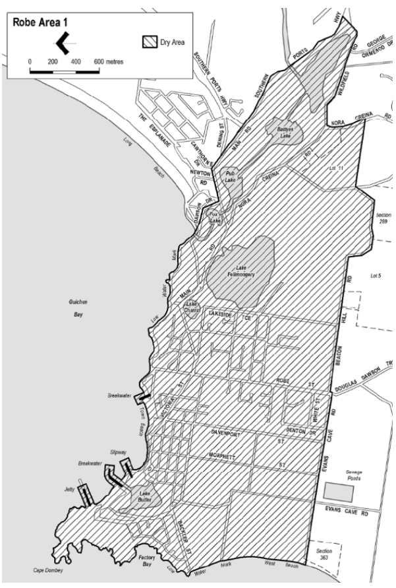
Made by the Liquor and Gambling Commissioner
on 28 November 2022

Liquor Licensing Act 1997
South Australia
Liquor Licensing (Dry Areas) Notice 2022
under section 131(1a) of the Liquor Licensing Act 1997
1—Short title
This notice may be cited as the Liquor Licensing (Dry Areas) Notice 2022.
2—Commencement
This notice comes into operation on 23 December 2022.
3—Interpretation
(1) In this notice—
principal notice means the Liquor Licensing (Dry Areas) Notice 2015 published in the Gazette on 5 January 2015, as in force from time to time.
(2) Clause 3 of the principal notice applies to this notice as if it were the principal notice.
4—Consumption etc of liquor prohibited in dry areas
(1) Pursuant to section 131 of the Act, the consumption and possession of liquor in the area described in the Schedule is prohibited in accordance with the provisions of the Schedule.
(2) The prohibition has effect during the periods specified in the Schedule.
(3) The prohibition does not extend to private land in the area described in the Schedule.
(4) Unless the contrary intention appears, the prohibition of the possession of liquor in the area does not extend to—
(a) a person who is genuinely passing through the place if—
(i) the liquor is in the original container in which it was purchased from licensed premises; and
(ii) the container has not been opened; or
(b) a person who has possession of the liquor in the course of carrying on a business or in the course of their employment by another person in the course of carrying on a business; or
(c) a person who is permanently or temporarily residing at premises near the public place and who enters the public place solely for the purpose of passing through it to enter those premises or who enters the public place from those premises for the purpose of leaving the place; or
(d) a person who possesses or consumes the liquor for sacramental or other similar religious purposes.

Schedule—Robe Area 1

1—Extent of prohibition
The consumption of liquor is prohibited and the possession of liquor is prohibited.
2—Period of prohibition
From 12 noon on 23 December 2022 to 12 midnight on 2 January 2023.
3—Description of area
The area in and adjacent to Robe bounded as follows: commencing at the western end of the northern boundary of Dawson Drive, then in a straight line by the shortest route to the low water mark of Guichen Bay on the eastern side of the entrance to Fox's Lake, then generally north-easterly along the low water mark to the point at which it is intersected by the prolongation in a straight line of the northern boundary of Section 573 Hundred of Waterhouse, then easterly along that prolongation and boundary of Section 573 to the eastern boundary of the Section, then generally southerly and south-westerly along that boundary of Section 573 to the north-eastern boundary of Section 390 Hundred of Waterhouse, then south-easterly along that boundary of Section 390 to the point at which it is intersected by the prolongation in a straight line of the northern boundary of Dennis Avenue, then easterly along that prolongation and boundary of Dennis Avenue, and the prolongation in a straight line of that boundary, to the point at which the prolongation intersects the western boundary of Lot 223 of FP 205569, then generally south-westerly and southerly along that boundary of Lot 223 and the prolongation in a straight line of that boundary to the point at which the prolongation intersects the south-eastern boundary of Southern Ports Highway, then south-westerly along that boundary to the western boundary of Lot 2 of FP 9707, then southerly along that boundary of Lot 2 to the southern boundary of the Lot, then generally north-westerly and south-westerly along the northern boundary of Southern Ports Highway and the northern boundary of Main Road to the eastern boundary of Dawson Drive, then generally north-westerly and westerly along that boundary of Dawson Drive to the point of commencement.
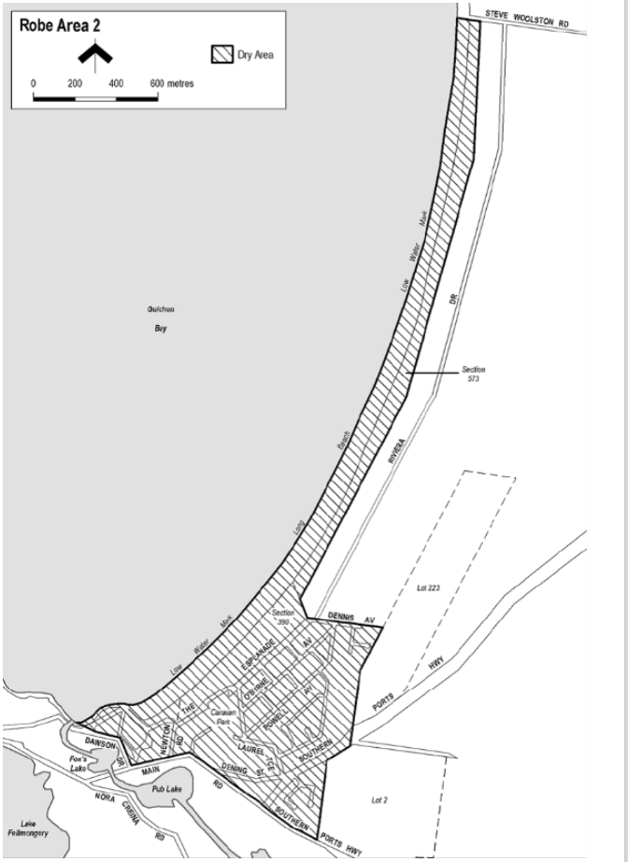
Made by the Liquor and Gambling Commissioner
on 28 November 2022

Livestock Act 1997
Notice by the Chief Inspector of Stock
Notifiable Diseases
PURSUANT to Section 87 of the Livestock Act 1997, I, Mary Ruth Carr, Chief Inspector of Stock, delegate of the Minister for Primary Industries and Regional Development, revoke the notice made by the Minister for Primary Industries and Regional Development pursuant to section 4 of the Livestock Act 1997 on 2 December 2021, published 9 December 2021.
PURSUANT to Section 4 of the Livestock Act 1997, I declare to be notifiable diseases those diseases listed as exotic diseases and report only diseases plus the following diseases:
Diseases, infections, and infestations of bees with:
Melissococcus pluten (European foulbrood)
Paenibacillus larvae (American foulbrood)
Diseases, infections, and infestations of aquatic species with:
Aeromonas salmonicida - atypical strains
Aphanomyces invadans (epizootic ulcerative syndrome)
Batrachochytrium dendrobatidis
Bonamia exitiosa
Epizootic haematopoietic necrosis virus
Ostreid herpesvirus-1
Perkinsus olseni
Viral encephalopathy and retinopathy
Diseases, infections, and infestations of other species with:
Aino virus
Akabane virus
Anaplasma marginale (bovine anaplasmosis)
Babesia bovis, B. bigemina or B. divergens (bovine babesiosis)
Bovine ephemeral fever
Bovine leukaemia virus (enzootic bovine leucosis)
Brucella suis
Burkholderia pseudomallei (melioidosis)
Chlamydophilia pecorum (sporadic bovine encephalomyelitis)
Cysticercus bovis caused by Taenia saginata (bovine cysticercosis)
Ehrlichia canis (ehrlichiosis)
Escherichia coli (verotoxigenic strains)
Equine herpes virus-1 (abortigenic and neurological strains)
Equine infectious anaemia virus
Equine arteritis virus
Footrot (in sheep and in goats only)
Infectious laryngotracheitis virus
Listeria monocytogenes (listeriosis)
Mycobacterium avian (avian tuberculosis)
Salmonella pullorum (pullorum disease)
Exotic Diseases
Bees diseases, infections, and infestations with:
Acarapis woodi (acariasis tracheal mite)
Acute bee paralysis virus
Braula coeca (bee louse)
Tropilaelaps clareae or T. mercedesae (tropilaelaps mite)
Varroa destructor or V. jacobsoni (varroosis)
Diseases, infections, and infestations of aquatic species with:
Abalone herpesvirus (Haliotid herpesvirus-1)
Acute hepatopancreatic necrosis disease
Aeromonas salmonicida subsp. salmonicida (furunculosis)
Aphanomyces astaci (crayfish plague)
Baculoviral midgut gland necrosis virus
Batrachochytrium salamandrivorans
Boccardia knoxi
Bonamia ostreae
Decapod iridescent virus 1
Edwardsiella ictaluri (enteric septicaemia of catfish)
Enterocytozoon hepatopenaei
European catfish virus / European sheatfish virus
Gill-associated virus
Gyrodactylus salaris
Haplosporidium costale or H. nelsoni (haplosporidiosis)
Hepatobacter penaei (necrotising hepatopancreatitis)
HPR salmon anaemia virus
Infectious haematopoietic necrosis virus
Infectious hypodermal and haematopoietic necrosis virus
Infectious myonecrosis virus
Infectious pancreatic necrosis virus
Infectious spleen and kidney necrosis virus
Koi herpesvirus (Cyprinid herpesvirus 3)
Macrobrachium rosenbergii nodavirus (white tail disease)
Marteilia refringens
Marteilia sydneyi
Marteilioides chungmuensis
Mikrocytos mackini
Mollusc iridoviroses
Monodon slow growth syndrome
Myxobolus cerebralis (whirling disease)
Oncorhynchus masou virus disease
Perkinsus marinus
Piscirickettsia salmonis (piscirickettsiosis)
Ranavirus species
Red sea bream iridovirus
Renibacterium salmoninarum (bacterial kidney disease)
Salmonid alphavirus
Scale drop disease virus
Singapore grouper iridovirus (ranavirus)
Spawner-isolated mortality virus
Spring viraemia of carp virus
Taura syndrome virus
Tilapia lake virus (TiLV) disease
Turbot reddish body iridovirus
Viral haemorrhagic septicaemia virus
White spot syndrome virus
White sturgeon iridoviral disease
Xenohaliotis californiensis
Yellow head virus genotype 1
Yersinia ruckeri – Hagerman strain (enteric redmouth disease)
Diseases, infections, and infestations of other livestock species with:
African horse sickness virus
African swine fever virus
Alcelaphine herpesvirus-1 (malignant catarrhal fever, wildebeest-associated)
Aujeszky’s disease virus (pseudorabies virus)
Australian bat lyssavirus
Avian bornavirus (proventricular dilatation syndrome)
Avian metapneumovirus (turkey rhinotracheitis)
Babesia caballi, B. equi or Theileria equi (equine piroplasmosis)
Bacillus anthracis (anthrax)
Bluetongue virus
Borrelia burgdorferi (Lyme disease)
Borna disease virus
Bovine virus diarrhoea virus (type 2)
Brucella abortus
Brucella canis
Brucella melitensis
Bungowannah virus (porcine myocarditis virus or atypical porcine pestivirus)
Burkholderia mallei (glanders)
Camelpox virus
Chlamydophila abortus (enzootic abortion of ewes / ovine chlamydiosis)
Classical swine fever virus
Chrysomya bezziana (Old World screwworm fly)
Cochliomyia hominivorax (New World screwworm fly)
Contagious agalactia
Cowpox virus
Crimean-Congo haemorrhagic fever virus
Devil facial tumour disease
Duck herpes virus 1 (duck viral enteritis / duck plague)
Duck virus hepatitis
Echinococcus multilocularis
Ehrlichia ruminantium (heartwater)
Elaphostrongylus cervi
Encephalitides (tick borne)
Epizootic haemorrhagic disease virus
Equine encephalomyelitis viruses (Eastern, Western or Venezuelan)
Equine encephalosis virus
Equine influenza virus
Fasciola gigantica
Foot and mouth disease virus
Francisella tularensis (tularaemia)
Getah virus
Haematobia irritans exigua (buffalo fly)
Hantaan river virus
Hendra viruses
Histoplasma farciminosum (epizootic lymphangitis)
Infectious bursal disease virus (very virulent and exotic antigenic variant forms)
Influenza A viruses in birds and swine
Jembrana disease virus
Leptospirosis interrogans serovar Canicola
Louping ill virus
Lumpy skin disease virus
Leishmania spp.
Maedi-visna
Menangle virus
Mycobacterium bovis
Mycobacterium caprae
Mycobacterium tuberculosis
Mycoplasma capricolum subsp. capripneumoniae (contagious caprine pleuropneumonia)
Mycoplasma iowae
Mycoplasma mycoides subsp. mycoides SC (contagious bovine pleuropneumonia)
Nairobi sheep disease virus
Neoricketsia risticii (Potomac fever)
Newcastle disease virus (virulent)
Nipah virus
Pasturella multocida serotypes 6:b and 6:e (haemorrhagic septicaemia)
Peste des petits ruminants virus
Pseudogymnoascus destructans in bats (white nose syndrome)
Porcine cysticercosis (Cysticercus cellulosae infestation caused by Taenia solium or T. asiatica)
Porcine epidemic diarrhoea virus
Porcine reproductive and respiratory syndrome virus
Post-weaning multi-centric wasting syndrome
Psoroptes ovis (sheep scab)
Pulmonary adenomatosis (Jaagsiekte)
Rabies virus
Rhipicephalus microplusm (cattle tick)
Rift Valley fever virus
Rinderpest virus
Salmonella abortus-equi
Salmonella abortus-ovis
Salmonella enteritidis
Salmonella gallinarum (fowl typhoid)
Senecavirus A (Seneca Valley virus)
Sheep pox virus or goat pox virus
Shope’s fibroma virus
Swine vesicular disease virus
Taylorella equigenitalis (contagious equine metritis)
Taenia multiceps, T. serialis, T. brauni, and T. glomeratus (causing infestation with Coenurus cerebralis)
Teschovirus A (porcine enterovirus encephalomyelitis)
Theileria annulata (Mediterranean theilerosis)
Theileria parva (East Coast fever)
Transmissible gastroenteritis coronavirus
Transmissible spongiform encephalopathies (bovine spongiform encephalopathy, chronic wasting disease of deer, feline spongiform encephalopathy, scrapie)
Trichinella spp.
Trypanosomosis cruzi (Chagas disease)
Trypanosoma equiperdum (dourine)
Trypanosomosis evansi (surra)
Trypanosomosis (tsetse fly associated)
Vesicular exanthema of swine virus
Vesicular stomatitis virus
Warble-fly (warble-fly myiasis)
Wesselsbron virus
West Nile Virus
Report Only Diseases
Diseases, infections, and infestations with:
Japanese encephalitis virus
Paratuberculosis (Johne’s disease)
Streptococcus equi equi (strangles)
Virulent avian paramyxovirus
Dated: 23 November 2022
Mary Ruth Carr
Chief Inspector of Stock
Delegate of the Minister for Primary Industries and Regional Development

Major Events Act 2013
Section 6B
Declaration of a Major Event
PURSUANT to section 6B of the Major Events Act 2013, I, Hon Zoe Bettison MP, Minister for Tourism South Australia declare the 2023 Santos Tour Down Under to be held from 13 to 22 January 2023 inclusive to be a major event.
By virtue of the provisions of the Major Events Act 2013 (the Act), I do hereby:
- Declare the 2023 Santos Tour Down Under to be a major event for the purposes of the Act.
- Specify the major event period for the event to be 13 to 22 January 2023 inclusive.
- Declare the 2023 Santos Tour Down Under and its associated events officially organised by the event organiser to be a major event;
- The Santos Tour Down Under comprises:
- Schwalbe Classic
- Three days of women’s competition racing, namely:
- Ziptrak Stage One
- Stage Two
- Stage Three
- Six days of men’s competition racing, namely:
- Efex Prologue
- Ziptrak Men’s Stage 1
- Men’s Stage 2
- Men’s Stage 3
- Think! Road Safety Men’s Stage 4
- Men’s Stage 5

- The associated events officially organised by the event organiser, namely:
- Tour Village
- Kids Classic
- Team Presentation and Free Concert
- Challenge Tour
- Detours
- Golden Grass
- Declare the major event venues to be the women’s race routes, men’s race routes, Schwalbe Classic race route, Tour Village, and any public place or part of a public place that is within 250 metres of the boundary of the race route or Tour Village.
- Designate the South Australian Tourism Commission to be the event organiser for the event.
- Declare that the following provisions of Part 3 of the Act apply to the event, the major event venue for the event and the controlled area for the event.
- section 8;
- section 10;
- section 11;
- section 12;
- section 13;
- section 14 be applied to the event by specifying the official title as Santos by Tour Down Under and the official logo as it appears below.
Dated: 15 November 2022
Hon Zoe Bettison MP
Minister for Tourism

Map of Controlled Areas for the Santos Tour Down Under
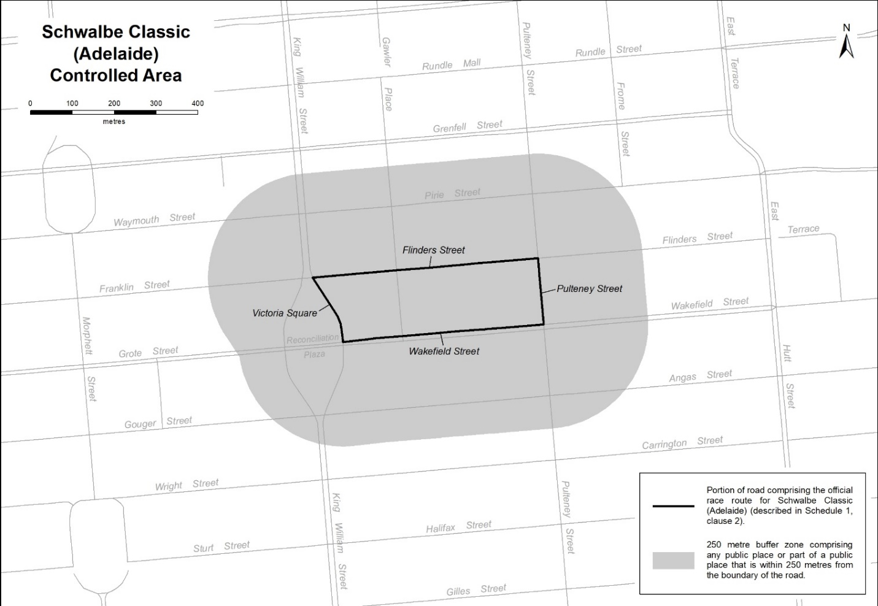
Description of official race route for Schwalbe Classic (Adelaide)
The official race route for the Schwalbe Classic (Adelaide) comprises the portion of road commencing in Adelaide at the intersection of Flinders Street and the portion of road (running generally north-west to south-east) known as Victoria Square, then generally south-easterly and southerly along the portion of road known as Victoria Square to its intersection with Wakefield Street, then easterly along Wakefield Street to its intersection with Pulteney Street, then northerly along Pulteney Street to its intersection with Flinders Street, then westerly along Flinders Street to the point of commencement.

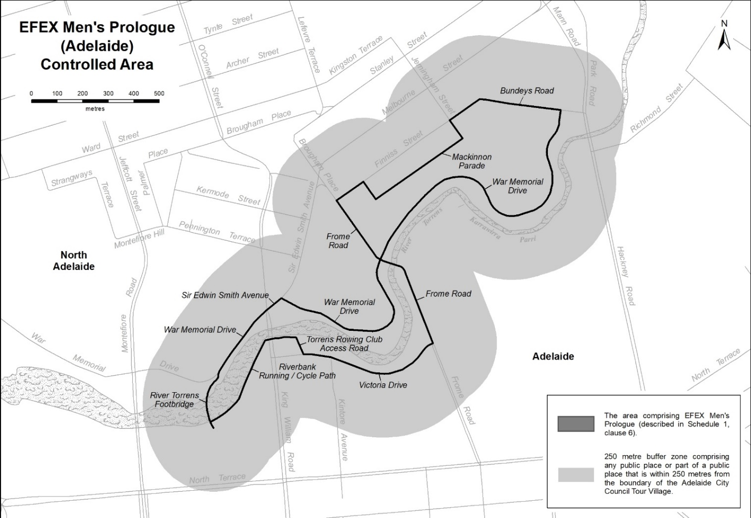
Description of official race route for Men’s Prologue (Adelaide)
The official race route for Men’s Prologue (Adelaide) comprises the portion of road commencing at the southern end of the River Torrens Footbridge in Adelaide, then generally northerly along River Torrens Footbridge to its intersection with War Memorial Drive, then generally north-easterly along War Memorial Drive to its intersection with Sir Edwin Smith Avenue, then generally north-easterly along Sir Edwin Smith Avenue to its intersection with War Memorial Drive, then generally south-easterly, generally northerly and generally north-easterly along War Memorial Drive to its intersection with Bundeys Road, then westerly along Bundeys Road to its intersection with Mackinnon Parade, then south-westerly, south-easterly, south-westerly, north-easterly and south-westerly along Mackinnon Parade to its intersection with Frome Road, then generally south-easterly along Frome Road to its intersection with Victoria Drive, then generally south-westerly, westerly and north-westerly along Victoria Drive to its intersection with the Torrens Rowing Club access road, then north-westerly along the Torrens Rowing Club access road to its intersection with the riverbank running / cycle path, then generally westerly and generally south-westerly along the riverbank running / cycle path to its intersection with the River Torrens Footbridge in Adelaide.

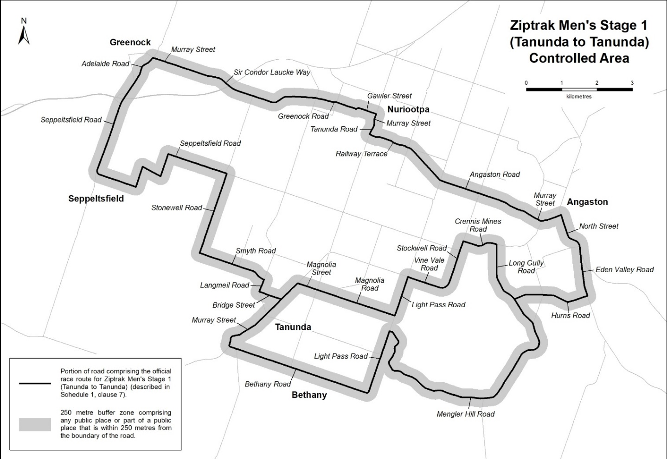
Description of official race route for Men’s Stage 1 (Tanunda to Tanunda)
The official race route for Men’s Stage 1 (Tanunda to Tanunda) comprises the portion of road commencing at the intersection of Murray Street and Bridge Street in Tanunda, then north-westerly along Bridge Street to its intersection with Langmeil Road, then north-easterly along Langmeil Road to its intersection with Smyth Road, then generally north-westerly along Smyth Road to its intersection with Stonewell Road, then north-easterly along Stonewell Road to its intersection with Seppeltsfield Road, then north-westerly, south-westerly, north-westerly, south-westerly, north-westerly and generally north-easterly along Seppeltsfield Road until it becomes Adelaide Road in Greenock, then north-easterly along Adelaide Road to its intersection with Murray Street in Greenock, then south-easterly along Murray Street until it becomes Sir Condor Laucke Way, then generally south-easterly, generally north-easterly and generally easterly along Sir Condor Laucke Way until it becomes Greenock Road in Nuriootpa, then generally easterly and generally south-easterly along Greenock Road until it becomes Gawler Street in Nuriootpa, then south-easterly along Gawler Street to its intersection with Murray Street in Nuriootpa, then generally south-westerly along Murray Street until it becomes Tanunda Road, then generally south-westerly along Tanunda Road to its intersection with Railway Terrace, then generally south-easterly along Railway Terrace until it becomes Angaston Road, then generally south-easterly along Angaston Road until it becomes Murray Street in Angaston, then generally south-easterly and generally north-easterly along Murray Street to its intersection with North Street, then generally south-easterly along North Street until it becomes Eden Valley Road, then generally south-easterly along Eden Valley Road to its intersection with Hurns Road, then generally south-westerly, generally north-westerly and generally south-westerly along Hurns Road to its intersection with Long Gully Road, then generally south-easterly along Long Gully Road until it becomes Mengler Hill Road, then generally south-easterly, generally south-westerly, generally north-westerly and generally northerly along Mengler Hill Road to its intersection with Light Pass Road, then south-westerly along Light Pass Road to its intersection with Bethany Road, then north-westerly along Bethany Road to its intersection with Murray Street in Tanunda, then north-westerly, northerly and generally north-easterly along Murray Street to its intersection with Magnolia Street, then south-easterly along Magnolia Street until it becomes Magnolia Road, then south-easterly along Magnolia Road to its intersection with Light Pass Road, then north-easterly along Light Pass Road to its intersection with Vine Vale Road, then south-easterly along Vine Vale Road to its intersection with Stockwell Road, then north-easterly along Stockwell Road to its intersection with Crennis Mines Road, then generally easterly along Crennis Mines Road to its intersection with Long Gully Road, then southerly and generally south-easterly along Long Gully Road to its intersection with Hurns Road.
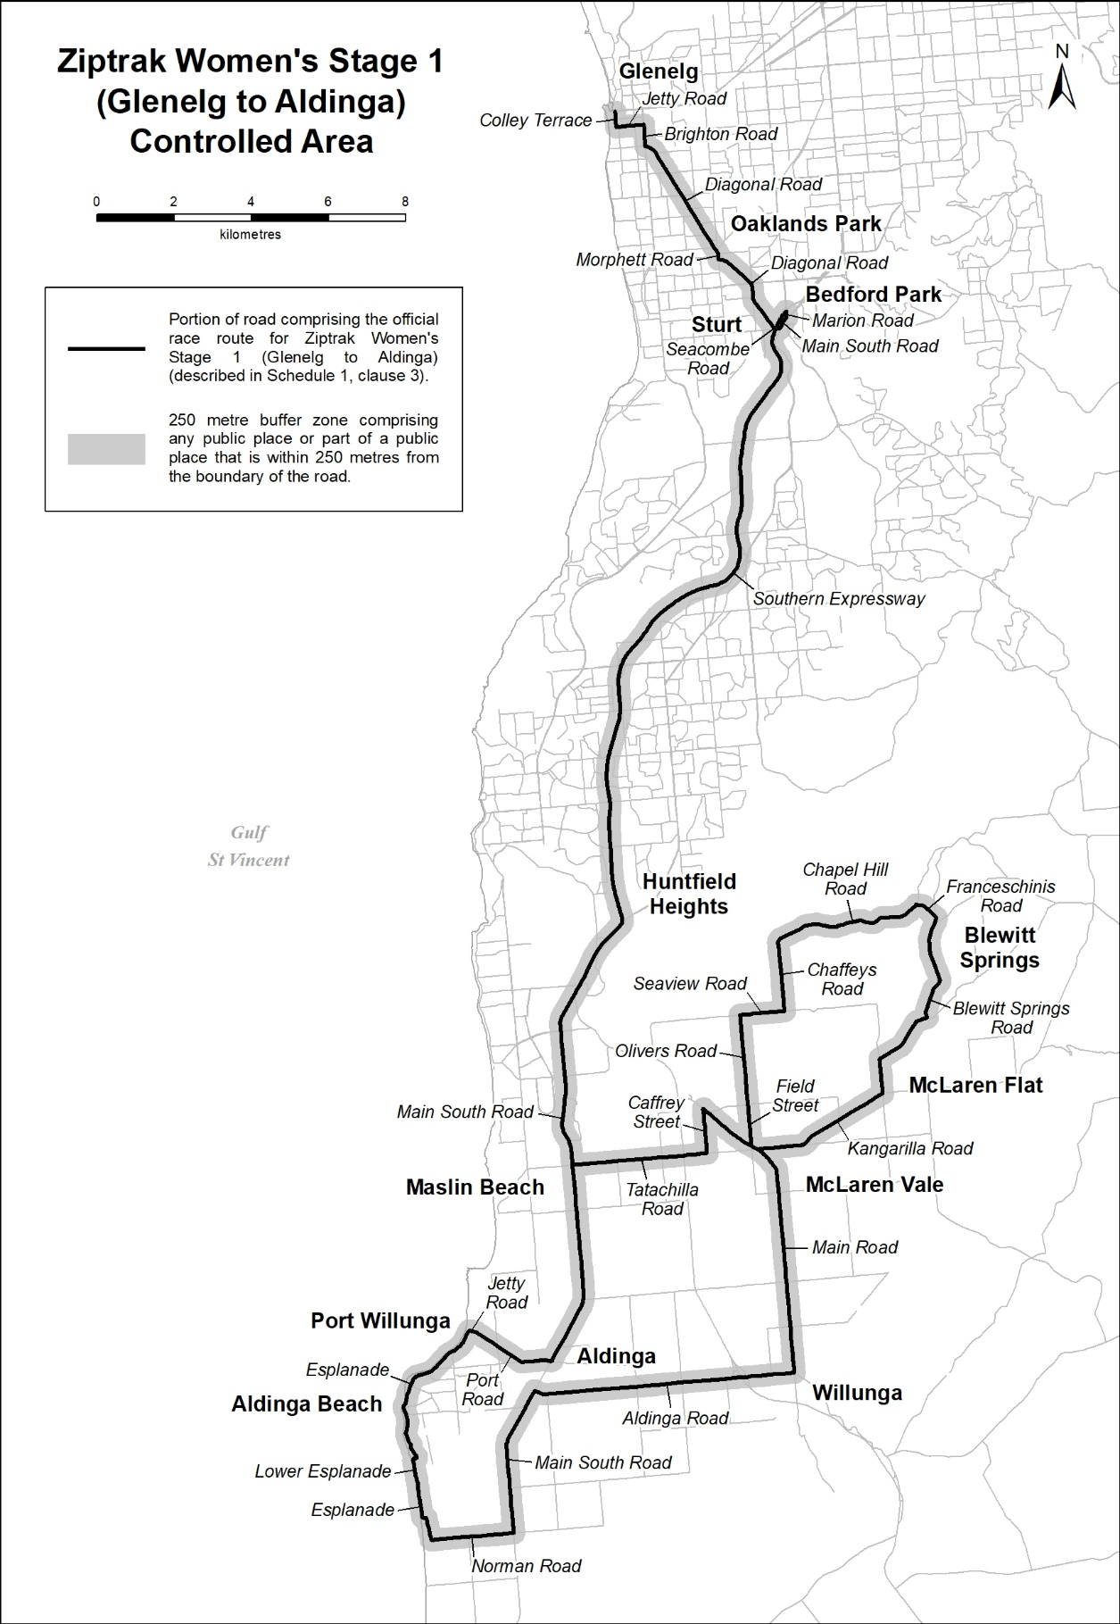
Description of official race route for Ziptrak Women’s Stage 1 (Glenelg to Aldinga)
The official race route for Ziptrak Women’s Stage 1 (Glenelg to Aldinga) comprises –
- the portion of road commencing at the intersection of Anzac Highway and Colley Terrace in Glenelg, then southerly along Colley Terrace to its intersection with Jetty Road, then easterly along Jetty Road to its intersection with Brighton Road, then southerly along Brighton Road to its intersection with Diagonal Road, then south-easterly along Diagonal Road to its intersection with Morphett Road, then south-easterly and southerly along Morphett Road to its intersection with Diagonal Road, then south-easterly and southerly along Diagonal Road to its intersection with Seacombe Road, then easterly along Seacombe Road to its intersection with Main South Road, then generally north-easterly along Main South Road to its intersection with Marion Road, then northerly along Marion Road to its intersection with the Marion Road Ramp from Adelaide, then south-westerly along the Marion Road Ramp from Adelaide to its intersection with the Southern Expressway, then generally southerly and generally south-westerly along the Southern Expressway to its intersection with Main South Road, then generally south-westerly and generally southerly along Main South Road to its intersection with Tatachilla Road, then easterly along Tatachilla Road to its intersection with Chaffey Street then northerly along Chaffey Street to its intersection with Main Road, then generally south-easterly and southerly along Main Road to its intersection with Aldinga Road, then westerly and north-westerly along Aldinga Road to its intersection with Main South Road, then south-westerly and southerly along Main South Road to its intersection with Norman Road, then westerly along Norman Road to its intersection with Esplanade, then generally northerly, easterly and generally northerly along Esplanade to its intersection with Lower Esplanade, then generally northerly and easterly along Lower Esplanade to its intersection with Esplanade, then generally north-westerly and generally north-easterly along Esplanade to its intersection with Jetty Road, then generally easterly along Jetty Road to its intersection with Port Road, then south-easterly and generally easterly along Port Road to its intersection with Main South Road, then north-easterly and northerly along Main South Road to its intersection with Tatachilla Road in Maslin Beach; and
- the portion of road commencing at the intersection of Main Road and Field Street in McLaren Vale, then northerly along Field Street until it becomes Olivers Road, then northerly along Olivers Road to its intersection with Seaview Road, then easterly along Seaview Road to its intersection with Chaffeys Road, then northerly along Chaffeys Road to its intersection with Chapel Hill Road, then generally north-easterly along Chapel Hill Road to its intersection with Franceschinis Road, then easterly and south-easterly along Franceschinis Road to its intersection with Blewitt Springs Road, then generally southerly and generally south-westerly along Blewitt Springs Road to its intersection with Kangarilla Road, then generally south-westerly and westerly along Kangarilla Road to its intersection with Main Road in McLaren Vale.
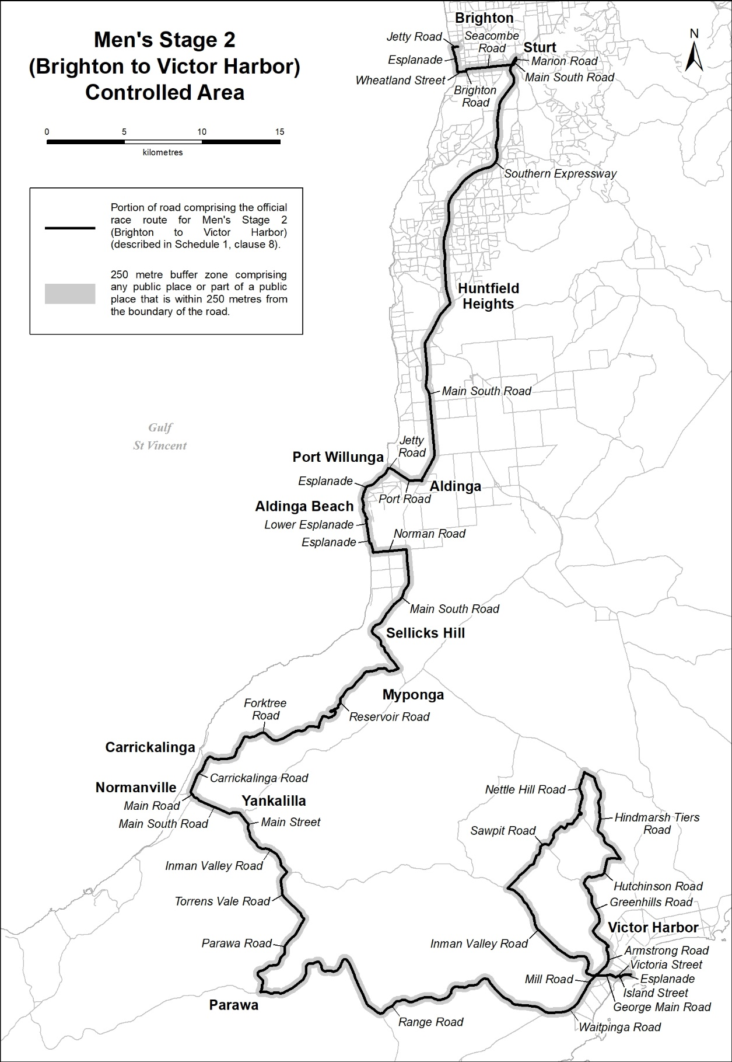
Description of official race route for Men’s Stage 2 (Brighton to Victor Harbor)
The official race route for Men’s Stage 2 (Brighton to Victor Harbor) comprises the portion of road commencing at the intersection of Cedar Avenue and Jetty Road in Brighton, then westerly along Jetty Road to its intersection with Esplanade, then generally southerly along Esplanade to its intersection with Wheatland Street, then easterly along Wheatland Street to its intersection with Brighton Road, then northerly along Brighton Road to its intersection with Seacombe Road, then easterly along Seacombe Road to its intersection with Main South Road, then generally north-easterly along Main South Road to its intersection with Marion Road, then northerly along Marion Road to its intersection with the Marion Road Ramp from Adelaide, then south-westerly along the Marion Road Ramp from Adelaide to its intersection with the Southern Expressway, then generally southerly and generally south-westerly along the Southern Expressway to its intersection with Main South Road, then generally south-westerly and generally southerly along Main South Road to its intersection with Port Road in Aldinga, then generally westerly and north-westerly along Port Road to its intersection with Jetty Road, then generally westerly along Jetty Road to its intersection with Esplanade, then generally south-westerly and generally south-easterly to its intersection with Lower Esplanade, then westerly and generally southerly along Lower Esplanade to its intersection with Esplanade, then generally southerly, easterly and generally southerly along Esplanade to its intersection with Norman Road, then easterly along Norman Road to its intersection with Main South Road, then southerly, generally south-westerly and generally south-easterly to its intersection with Reservoir Road, then generally westerly and generally south-westerly along Reservoir Road to its intersection with Forktree Road, then generally westerly and generally south-westerly along Forktree Road until it becomes Carrickalinga Road, then generally south-westerly along Carrickalinga Road until it becomes Main Road in Normanville, then generally south-easterly along Main Road until it becomes Main South Road, then generally south-easterly along Main South Road to its intersection with Main Street in Yankalilla, then south-easterly and generally southerly along Main Street until it becomes Inman Valley Road, then generally south-easterly along Inman Valley Road to its intersection with Torrens Vale Road, then south-westerly, generally southerly and generally south-easterly along Torrens Vale Road to its intersection with Parawa Road, then generally south-westerly and generally southerly along Parawa Road to its intersection with Range Road, then generally easterly, generally south easterly, generally north-easterly and generally south-easterly along Range Road to its intersection with Waitpinga Road, then easterly and north-easterly along Waitpinga Road until it becomes Mill Road in Encounter Bay, then generally north-easterly along Mill Road to its intersection with Inman Valley Road, then generally westerly, generally northerly and generally north-westerly along Inman Valley Road to its intersection with Sawpit Road, then generally north-easterly along Sawpit Road to its intersection with Nettle Hill Road, then north-westerly and generally northerly along Nettle Hill Road to its intersection with Hindmarsh Tiers Road, then generally south-easterly, generally southerly and generally south-easterly along Hindmarsh Tiers Road to its intersection with Hutchinson Road, then generally westerly and generally south-westerly along Hutchinson Road to its intersection with Greenhills Road, then generally south-easterly, generally south-westerly and generally south-easterly along Greenhills Road to its intersection with Greenhills Road slip lane to Armstrong Road, then north-westerly along Greenhills Road slip lane to Armstrong Road to its intersection with Armstrong Road, then generally southerly and generally south-westerly along Armstrong Road to its intersection with Armstrong Road slip lane to George Main Road, then south-easterly along Armstrong Road slip lane to George Main Road to its intersection with George Main Road, then generally easterly and generally south-easterly along George Main Road to its intersection with Victoria Street, then north-easterly along Victoria Street to its intersection with Island Street, then south-easterly along Island Street to its intersection with Esplanade, then north-easterly and generally easterly along Esplanade to its intersection with Flinders Parade in Victor Harbor.
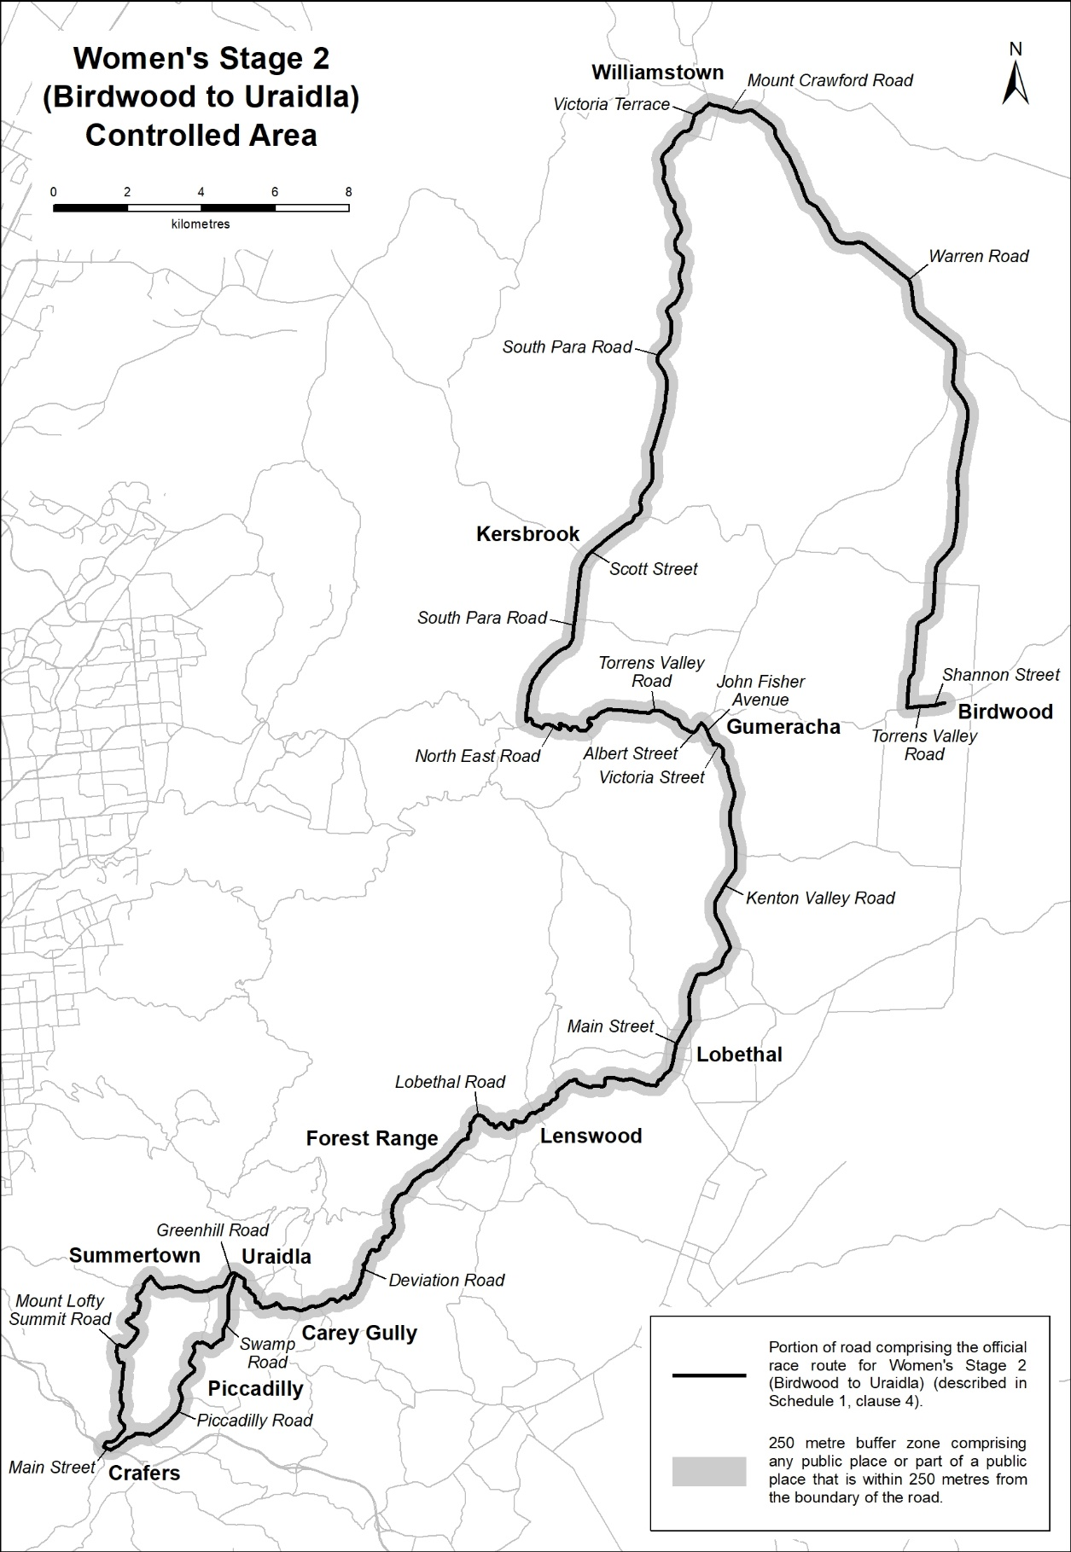
Description of official race route for Women’s Stage 2 (Birdwood to Uraidla)
The official race route for Women’s Stage 2 (Birdwood to Uraidla) comprises the portion of road commencing at the point on Shannon Street in Birdwood 175 metres easterly of the entrance to the National Motor Museum carpark, then westerly along Shannon Street until it becomes Torrens Valley Road, then westerly along Torrens Valley Road to its intersection with Warren Road, then generally north-easterly and generally north-westerly along Warren Road until it becomes Mount Crawford Road in Williamstown, then generally north-westerly along Mount Crawford Road to its intersection with Victoria Terrace, then generally south-westerly along Victoria Terrace until it becomes South Para Road in Williamstown, then generally south-westerly and generally southerly along South Para Road until it becomes Scott Street in Kersbrook, then generally south-westerly along Scott Street until it becomes South Para Road in Kersbrook, then southerly and generally south-westerly along South Para Road to its intersection with North East Road, then generally easterly along North East Road until it becomes Torrens Valley Road in Chain of Ponds, then generally north-easterly, generally easterly and generally south-easterly along Torrens Valley Road until it becomes Albert Street in Gumeracha, then generally south-easterly and generally north-easterly along Albert Street to its intersection with John Fisher Avenue, then generally south-easterly along John Fisher Avenue to its intersection with Victoria Street, then generally easterly and generally south-easterly along Victoria Street until it becomes Kenton Valley Road in Gumeracha, then generally southerly, generally south-easterly and generally south-westerly along Kenton Valley Road until it becomes Main Street in Lobethal, then generally south-westerly along Main Street until it becomes Lobethal Road in Lobethal, then generally south-westerly along Lobethal Road to its intersection with Deviation Road, then generally south-westerly along Deviation Road to its intersection with Greenhill Road, then generally westerly, generally north-westerly and generally south-westerly along Greenhill Road to its intersection with Mount Lofty Summit Road, then generally south-westerly, generally south-easterly, generally southerly and generally south-westerly along Mount Lofty Summit Road to its intersection with Main Street in Crafers, then south-easterly along Main Street to its intersection with Piccadilly Road, then generally north-easterly, generally northerly and generally easterly along Piccadilly Road to its intersection with Swamp Road, then generally south-easterly, generally north-easterly and generally northerly along Swamp Road to its intersection with Greenhill Road in Uraidla.

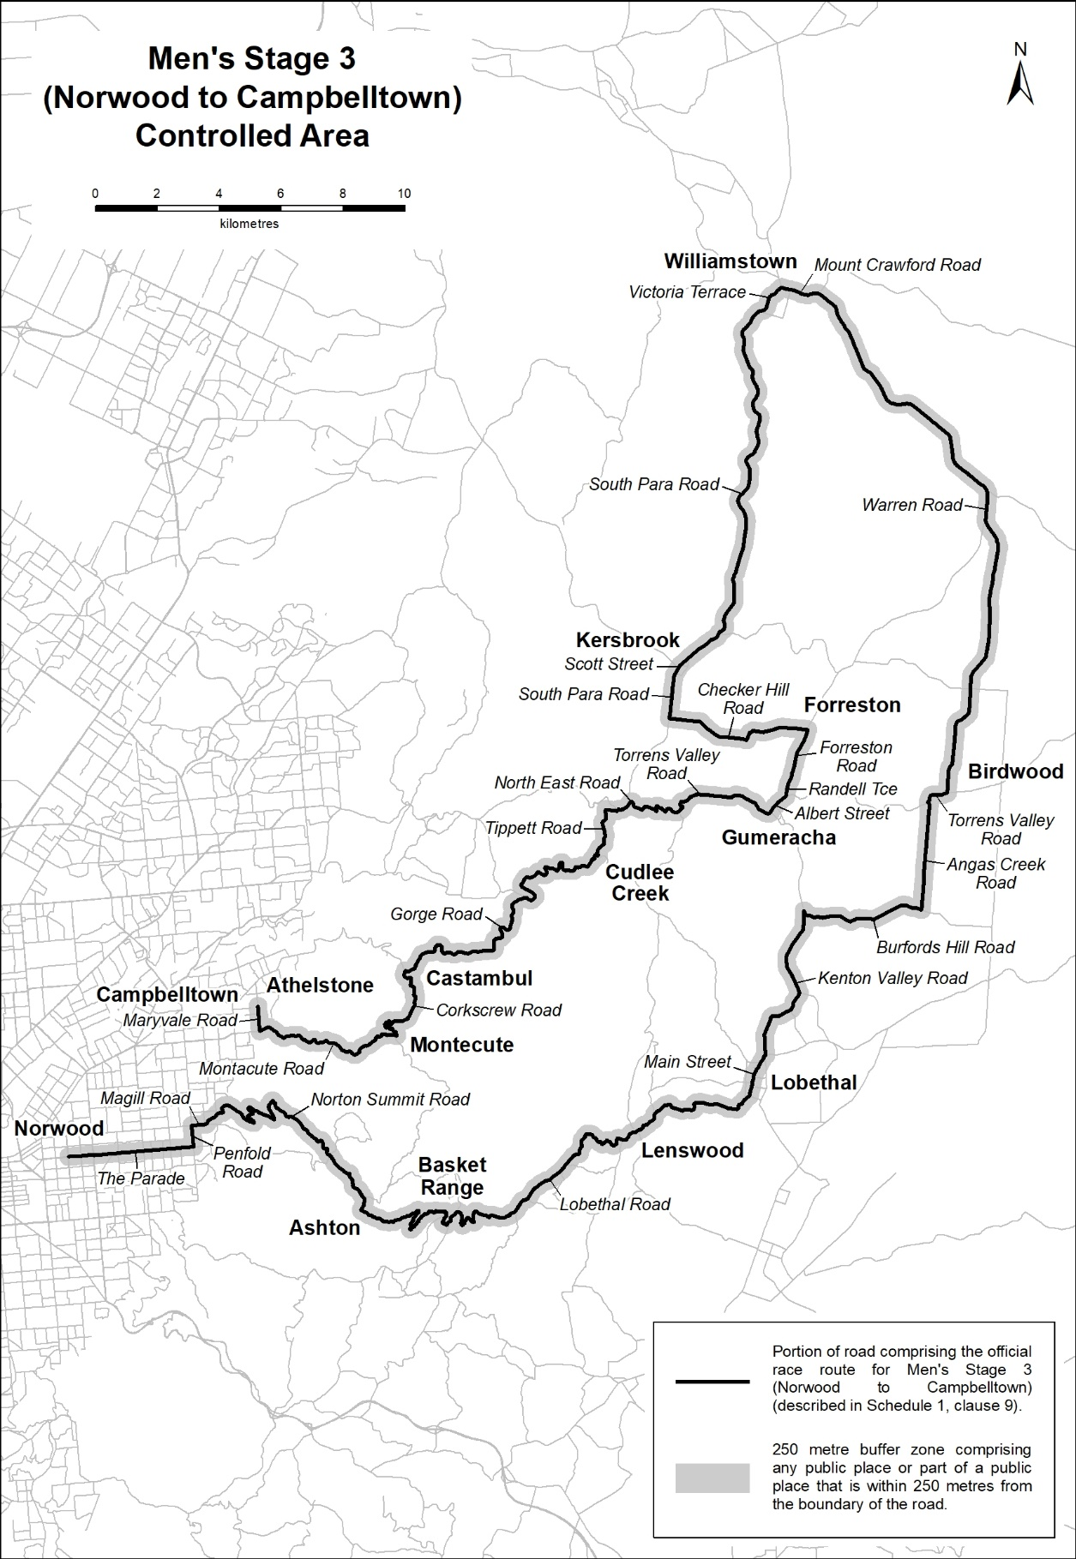
Description of official race route for Men’s Stage 3 (Norwood to Campbelltown)
The official race route for Men’s Stage 3 (Norwood to Campbelltown) comprises the portion of road commencing at the intersection of Osmond Terrace and The Parade in Norwood, then easterly along The Parade to its intersection with Penfold Road, then northerly along Penfold Road to its intersection with Magill Road, then easterly along Magill Road to its intersection with Norton Summit Road, then generally north easterly, generally easterly and generally south-easterly along Norton Summit Road to its intersection with Lobethal Road, then generally south easterly, generally easterly and generally north-easterly along Lobethal Road until it becomes Main Street in Lobethal, then generally north-easterly along Main Street to its intersection with Kenton Valley Road, then generally north-easterly, generally north-westerly and generally northerly along Kenton Valley Road to its intersection with Burfords Hill Road, then generally easterly along Burfords Hill Road to its intersection with Angas Creek Road, then northerly along Angas Creek Road to its intersection with Torrens Valley Road, then generally northerly and generally easterly along Torrens Valley Road to its intersection with Warren Road, then generally north-easterly and generally north-westerly along Warren Road until it becomes Mount Crawford Road in Williamstown, then generally north-westerly along Mount Crawford Road to its intersection with Victoria Terrace, then generally south-westerly along Victoria Terrace until it becomes South Para Road in Williamstown, then generally south-westerly and generally southerly along South Para Road until it becomes Scott Street in Kersbrook, then generally south-westerly along Scott Street until it becomes South Para Road in Kersbrook, then southerly and generally south-westerly along South Para Road to its intersection with Checker Hill Road, then generally easterly along Checker Hill Road to its intersection with Forreston Road, then generally south-westerly along Forreston Road until it becomes Randell Terrace in Gumeracha, then south-westerly along Randell Terrace to its intersection with Albert Street, then generally south-easterly and generally north-easterly along Albert Street until it becomes Torrens Valley Road, then generally north-westerly, generally westerly and generally south-westerly along Torrens Valley Road until it becomes North East Road in Chain of Ponds, then generally westerly along North East Road to its intersection with Tippett Road, then generally westerly, generally southerly and generally south-westerly along Tippett Road to its intersection with Gorge Road, then generally south-westerly and generally westerly along Gorge Road to its intersection with Corkscrew Road, then generally southerly and generally south-westerly along Corkscrew Road to its intersection with Montecute Road, then generally south-westerly and generally north-westerly along Montecute Road to its intersection with Maryvale Road, then northerly along Maryvale Road to a point 250 metres northerly of the intersection of Maryvale Road with Sunset Strip in Athelstone (Campbelltown City Council).

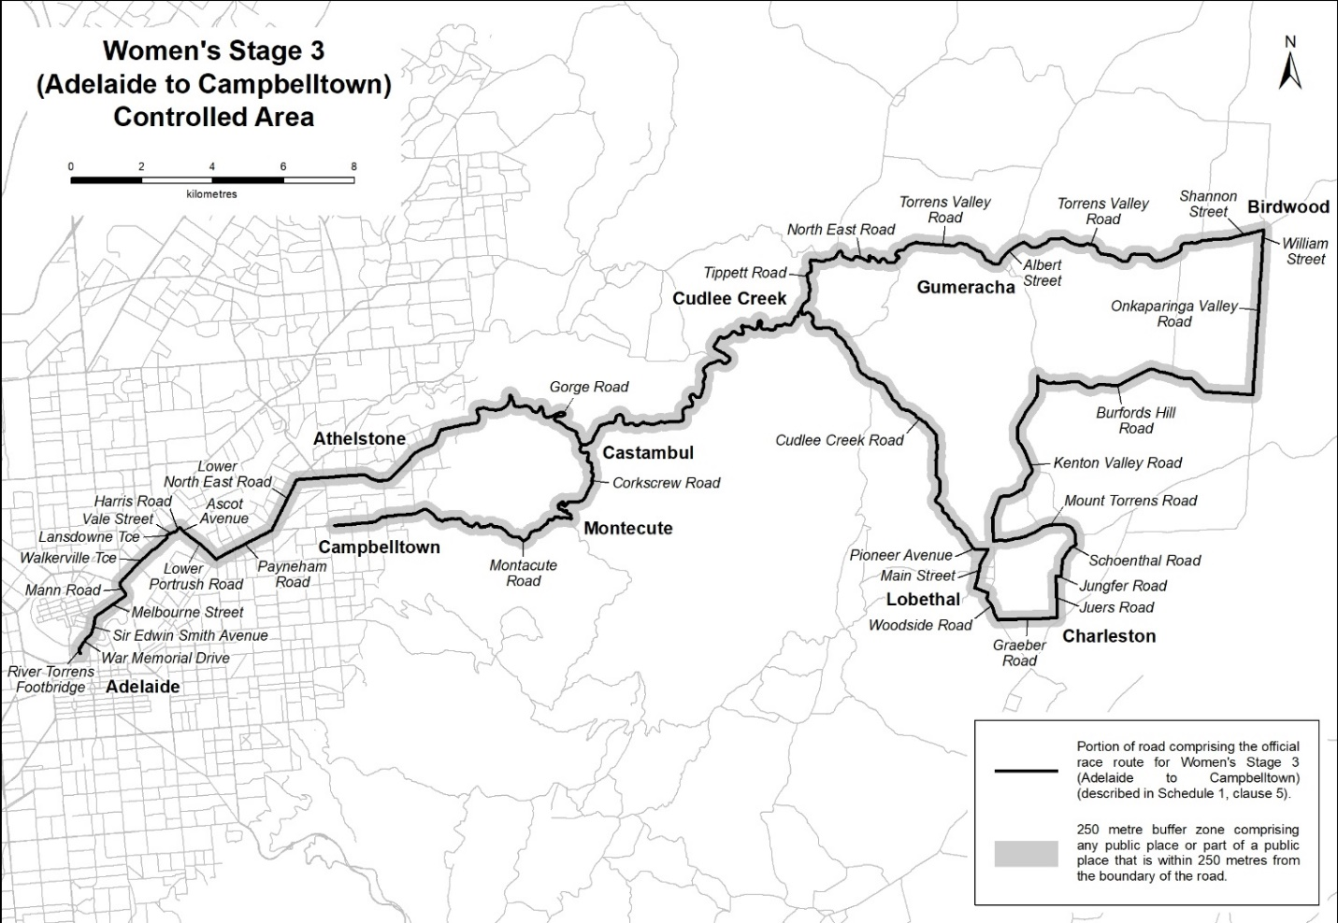
Description of official race route for Women’s Stage 3 (Adelaide to Campbelltown)
The official race route for Women’s Stage 3 (Adelaide to Campbelltown) comprises –
- the portion of road commencing at the southern end of the River Torrens Footbridge in Adelaide, then generally northerly along the River Torrens Footbridge to its intersection with War Memorial Drive, then generally north-easterly along War Memorial Drive to its intersection with Sir Edwin Smith Avenue, then generally north-easterly along Sir Edwin Smith Avenue to its intersection with Melbourne Street, then generally north-easterly along Melbourne Street to its intersection with Mann Road, then north-westerly along Mann Road to its intersection with Northcote Terrace, then generally northerly along Northcote Terrace to its intersection with Walkerville Terrace, then generally north-easterly along Walkerville Terrace to its intersection with Lansdowne Terrace, then generally north-westerly along Lansdowne Terrace to its intersection with Vale Street, then generally north-easterly along Vale Street until it becomes Harris Road in Vale Park, then easterly and north-easterly along Harris Road to its intersection with Ascot Avenue, then generally south-easterly along Ascot Avenue until it becomes Lower Portrush Road in Marden, then generally south-easterly along Lower Portrush Road to its intersection with Payneham Road, then north-easterly along Payneham Road to its intersection with Lower North East Road, then north-easterly along Lower North East Road to its intersection with Gorge Road, then generally easterly and generally north-easterly along Gorge Road to its intersection with Cudlee Creek Road, then generally south-easterly and generally southerly along Cudlee Creek Road until it becomes Pioneer Avenue in Lobethal, then south-easterly and easterly along Pioneer Avenue to its intersection with Main Street, then generally south-westerly along Main Street to its intersection with Woodside Road, then generally south-easterly along Woodside Road to its intersection with Graeber Road, then easterly along Graeber Road to its intersection with Juers Road, then northerly along Juers Road to its intersection with Jungfer Road, then easterly along Jungfer Road to its intersection with Schoenthal Road, then generally north-easterly along Schoenthal Road to its intersection with Mount Torrens Road, then generally westerly along Mount Torrens Road to its intersection with Kenton Valley Road, then generally north-easterly, generally north-westerly and generally northerly along Kenton Valley Road to its intersection with Burfords Hill Road, then generally easterly along Burfords Hill Road to its intersection with Onkaparinga Valley Road, then northerly along Onkaparinga Valley Road until it becomes William Street in Birdwood, then northerly along William Street to its intersection with Shannon Street, then westerly along Shannon Street until it becomes Torrens Valley Road, then generally westerly along Torrens Valley Road until it becomes Albert Street in Gumeracha, then generally south-westerly and generally north-westerly along Albert Street until it becomes Torrens Valley Road, then generally north-westerly, generally westerly and generally south-westerly along Torrens Valley Road until it becomes North East Road in Chain of Ponds, then generally westerly along North East Road to its intersection with Tippett Road, then generally westerly, generally southerly and generally south-westerly along Tippett Road to its intersection with Gorge Road; and
- the portion of road commencing at the intersection of Gorge Road and Corkscrew Road, then generally southerly and generally south-westerly along Corkscrew Road to its intersection with Montecute Road, then generally south-westerly, generally north-westerly and generally westerly along Montecute Road to its intersection with Julia Drive in Rostrevor (Campbelltown City Council).
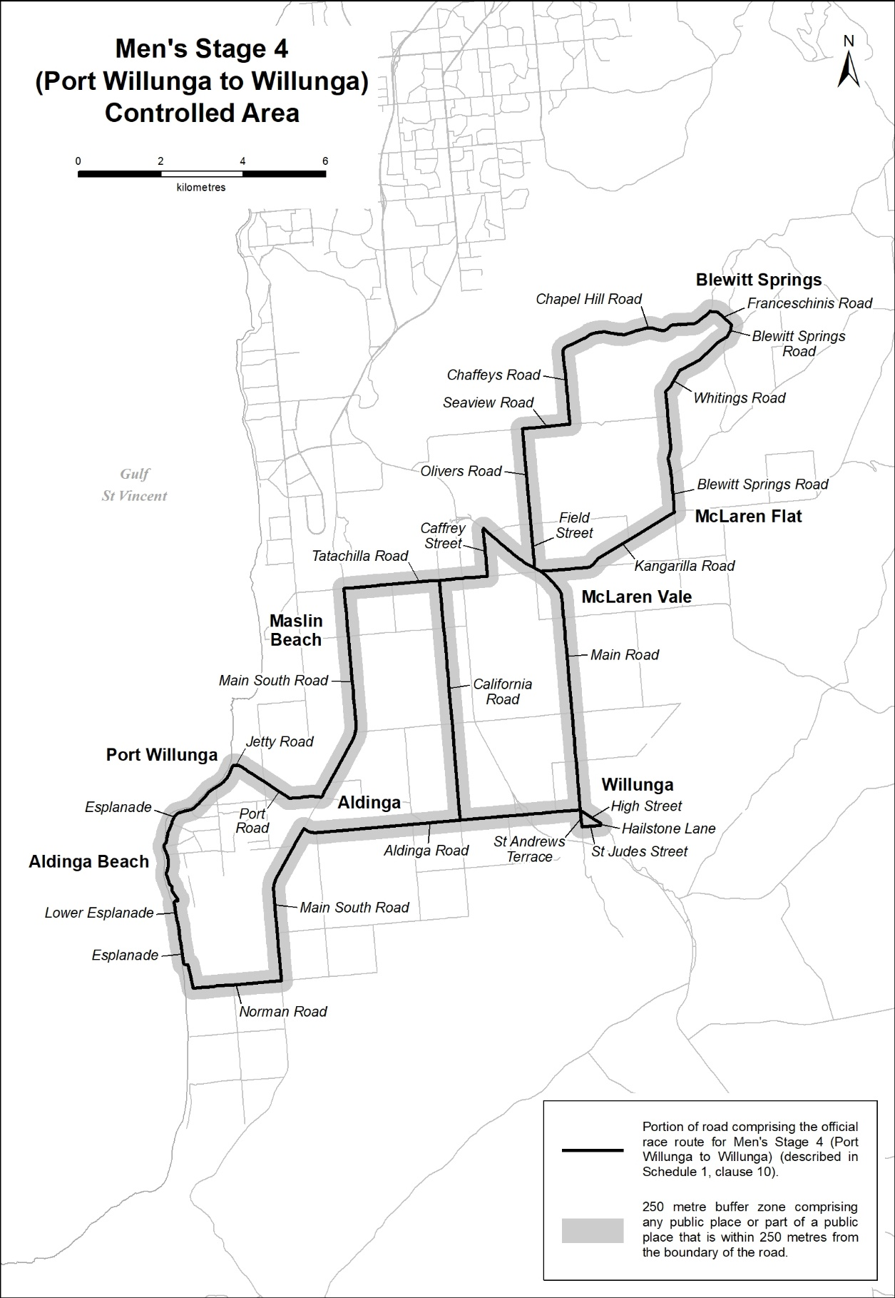
Description of official race route for Men’s Stage 4 (Port Willunga to Willunga)
The official race route for Men’s Stage 4 (Port Willunga to Willunga) comprises –
- the portion of road commencing at the intersection of Esplanade and Jetty Road in Port Willunga, then generally easterly along Jetty Road to its intersection with Port Road, then south-easterly and generally easterly along Port Road to its intersection with Main South Road, then north-easterly and northerly along Main South Road to its intersection with Tatachilla Road, then easterly along Tatachilla Road to its intersection with Chaffey Street then northerly along Chaffey Street to its intersection with Main Road, then generally south-easterly and southerly along Main Road to its intersection with Aldinga Road, then westerly and north-westerly along Aldinga Road to its intersection with Main South Road, then south-westerly and southerly along Main South Road to its intersection with Norman Road, then westerly along Norman Road to its intersection with Esplanade, then generally northerly, westerly and generally northerly along Esplanade to its intersection with Lower Esplanade, then generally northerly and easterly along Lower Esplanade to its intersection with Esplanade, then generally north-westerly and generally north-easterly along Esplanade to its intersection with Jetty Road in Port Willunga; and
- the portion of road commencing at the intersection of Main Road and Field Street in McLaren Vale, then northerly along Field Street until it becomes Olivers Road, then northerly along Olivers Road to its intersection with Seaview Road, then easterly along Seaview Road to its intersection with Chaffeys Road, then northerly along Chaffeys Road to its intersection with Chapel Hill Road, then generally north-easterly along Chapel Hill Road to its intersection with Franceschinis Road, then easterly and south-easterly along Franceschinis Road to its intersection with Blewitt Springs Road, then generally south-westerly along Blewitt Springs Road to its intersection with Whitings Road, then generally south-westerly and generally southerly along Whitings Road to its intersection with Blewitt Springs Road, then southerly along Blewitt Springs Road to its intersection with Kangarilla Road, then generally south-westerly and westerly along Kangarilla Road to its intersection with Main Road in McLaren Vale; and
- the portion of road commencing at the intersection of Main Road and High Street in Willunga, then south-easterly along High Street to its intersection with Hailstone Lane, then generally southerly along Hailstone Lane to its intersection with St Judes Street, then westerly along St Judes Street to its intersection with St Andrews Terrace, then generally northerly along St Andrews Terrace to its intersection with High Street in Willunga; and
- the portion of road commencing at the intersection of Aldinga Road and California Road in Whites Valley, then northerly along California Road to its intersection with Tatachilla Road in Tatachilla.

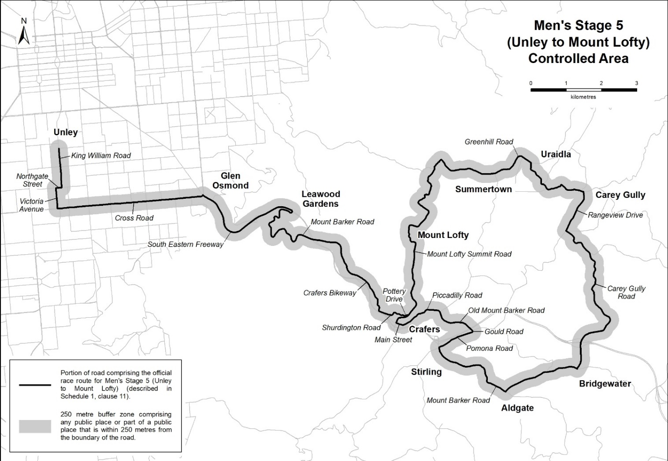
Description of official race route for Men’s Stage 5 (Unley to Mount Lofty)
The official race route for Men’s Stage 5 (Unley to Mount Lofty) comprises the portion of road commencing at the intersection of Arthur Street and King William Road in Unley, then southerly along King William Road to its intersection with Northgate Street, then westerly along Northgate Street to its intersection with Victoria Avenue, then southerly along Victoria Avenue to its intersection with Cross Road, then easterly along Cross Road to its intersection with South Eastern Freeway, then generally south-easterly and generally north-easterly along South Eastern Freeway to its intersection with Mount Barker Road, then generally easterly, generally westerly, generally southerly, generally north-easterly and generally south-easterly along Mount Barker Road to its intersection with Crafers Bikeway, then generally south-easterly along Crafers Bikeway until it becomes Shurdington Road, then south-easterly, generally north-easterly and generally south-easterly along Shurdington Road to its intersection with Pottery Drive, then generally easterly along Pottery Drive to its intersection with Mount Lofty Summit Road, then generally north-easterly, generally northerly, generally north-westerly and generally north-easterly along Mount Lofty Summit Road to its intersection with Greenhill Road, then generally north-easterly, generally south-easterly and generally easterly along Greenhill Road to its intersection with Rangeview Drive, then generally southerly and generally south-westerly along Rangeview Drive to its intersection with Carey Gully Road, then generally south-easterly, generally south-westerly and generally southerly along Carey Gully Road to its intersection with Mount Barker Road, then generally south-westerly and generally north-westerly along Mount Barker Road to its intersection with Pomona Road, then generally north-easterly along Pomona Road to its intersection with Gould Road, then north-easterly along Gould Road to its intersection with Old Mount Barker Road, then generally north-westerly along Old Mount Barker Road to its intersection with Piccadilly Road, then generally westerly and generally south-westerly along Piccadilly Road to its intersection with Main Street in Crafers, then north-westerly along Main Street to its intersection with Mount Lofty Summit Road, then generally northerly and generally north-easterly along Mount Lofty Summit Road to its intersection with Pottery Road in Crafers.
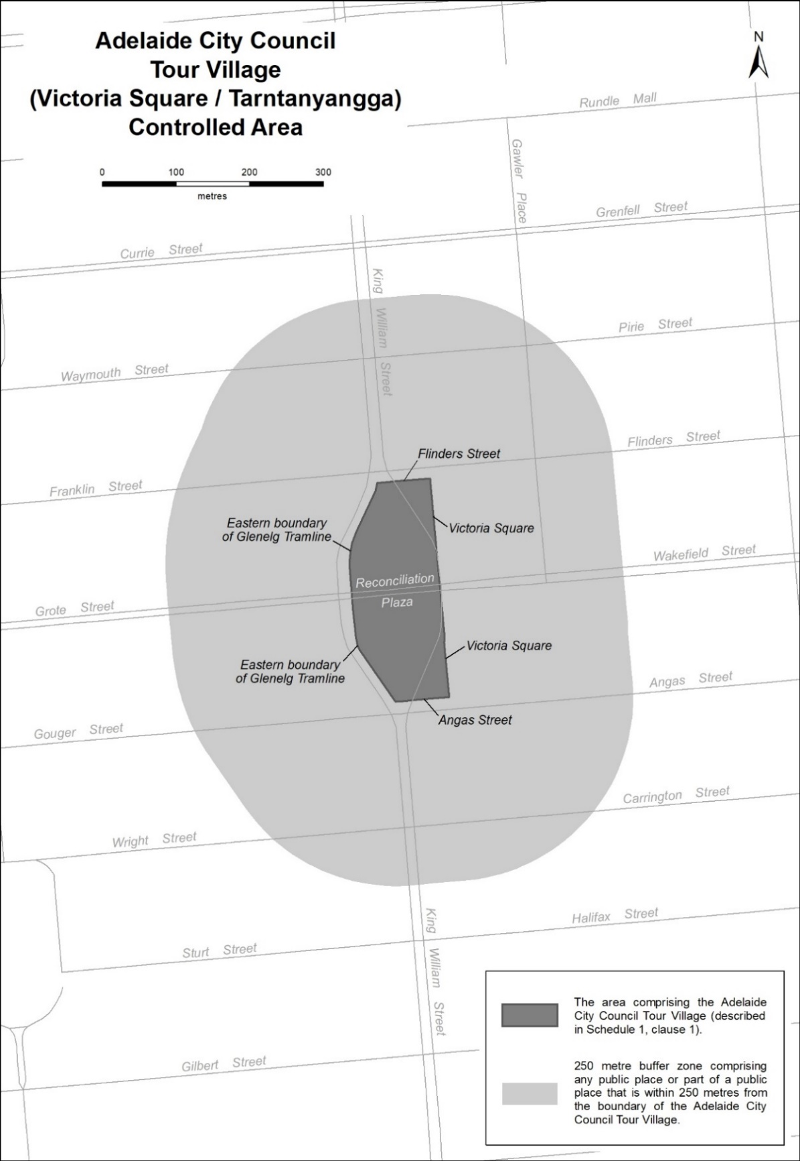
Description of Adelaide City Council Tour Village
The Adelaide City Council Tour Village comprises the area in Victoria Square / Tarntanyangga in Adelaide bounded as follows: commencing at the point at which the eastern boundary of the Glenelg Tramline intersects the southern boundary of Franklin Street, then easterly along the southern boundary of Franklin Street to its intersection with the western boundary of the portion of road (running generally north to south) known as Victoria Square, then southerly along that boundary to its south-eastern-most point, then southerly in a straight line across Wakefield Street to the north-eastern-most point on the western boundary of the portion of road (running generally north to south) known as Victoria Square, then southerly along that boundary to its intersection with the northern boundary of Angas Street, then westerly along the northern boundary of Angas Street to its intersection with the eastern boundary of the Glenelg Tramline, then generally north-westerly and northerly along the eastern boundary of the Glenelg Tramline to its intersection with the southern boundary of Reconciliation Plaza, then northerly in a straight line across Reconciliation Plaza to the intersection of the northern boundary of Reconciliation Plaza with the eastern boundary of the Glenelg Tramline, then northerly and generally north-easterly along the eastern boundary of the Glenelg Tramline to the point of commencement.

Real Property Act 1886
South Australia
Real Property (Fees No 2) Notice 2022
under the Real Property Act 1886
1—Short title
This notice may be cited as the Real Property (Fees No 2) Notice 2022.
Note—
This is a fee notice made in accordance with the Legislation (Fees) Act 2019.
2—Commencement
This notice has effect from the day on which it is published in the Gazette.
3—Revocation
All previous fee notices made under the Act are revoked.
4—Interpretation
In this notice, unless the contrary intention appears—
Act means the Real Property Act 1886.
4—Fees
The fees set out in Schedule 1 are prescribed for the purposes of the Act and are payable to the Registrar-General.
Schedule 1—Fees

1 | For the registration or entry of each instrument (irrespective of the number of folios to be endorsed)—other than any registration or entry specifically provided for | $179.00
2 | For the registration of an instrument registering a mortgage and changing name of mortgagor(s) | $344.00
3 | For registering a transfer—
 | (a) where the consideration, or the capital value of the land, (whichever is the greater)—
 | (i) does not exceed $5 000 | $179.00
 | (ii) does not exceed $20 000 | $200.00
 | (iii) does not exceed $40 000 | $220.00
 | (iv) exceeds $40 000 | $309.00
 | plus $91.50 for every $10 000 (or part of $10 000) above $50 000
 | (b) where the Commissioner of State Taxation has adjudged the transfer to be exempt from stamp duty or where no ad valorem stamp duty is payable (other than in respect of land that is qualifying land under section 105A of the Stamp Duties Act 1923) | $179.00
 | (c) that has been assessed pursuant to section 71CA, 71CB, 71CBA or 71CC of the Stamp Duties Act 1923 | $179.00
4 | On lodgment of a caveat under sections 39, 80F or 223D of the Act | $179.00
5 | On lodgment of a priority notice under section 154A of the Act | $23.70
6 | On lodgment of an application to extend the duration of a priority notice under section 154G of the Act | $11.70
7 | On lodgment of notice of withdrawal of a priority notice under section 154E of the Act | no fee
8 | For a search of the details of a priority notice | no fee
9 | For the deposit, or noting the revocation, of a duplicate or attested copy of a power of attorney | $179.00
10 | For the registration of an application to note a change of address | no fee
11 | For entry of a foreclosure order (exclusive of the cost of advertising in the Gazette) | $300.00
12 | For a certified copy of—
 | (a) a certificate of title under section 51A of the Act | $36.00
 | (b) a statement under section 51D of the Act | $36.00
13 | Unless otherwise specified—
 | (a) (except where paragraph (b) applies) for the issue of a new certificate of title | $97.50
 | (b) for the issue of a new certificate of title on the amalgamation of allotments wholly within the Mount Lofty Catchment Area | no fee
14 | For the issue of a certificate of title—
 | (a) (limited or ordinary) on the land first being brought under the Act | no fee
 | (b) to a corporation or district council for a road, street or reserve | no fee
 | (c) to effect correction or amendment of title or for the convenience of the Lands Titles Registration Office in effecting registration or redesignation | no fee
15 | For an application for the division of land—
 | (a) where deposit of the plan of division will not vest an estate or interest in land (except a street, road, thoroughfare, reserve or other similar open space that vests in a council or other authority or reverts to the Crown or an easement that will vest in an authority or entity in accordance with section 223LG of the Act) in any person | $179.00
 | (b) in all other cases | $447.00
Note—
Fees for the examination of the plan of division, deposit or acceptance for filing of the plan and for the issue of new certificates of title are payable under this Schedule in addition to this amount.
16 | For an application for the amalgamation of allotments—
 | (a) for the amalgamation of allotments that are wholly within the Mount Lofty Catchment Area | no fee
 | (b) for any other amalgamation of allotments | $179.00
Note—
Fees for the examination of the plan of amalgamation, deposit or acceptance for filing of the plan and for the issue of new certificates of title are payable under this Schedule in addition to this amount.
17 | For the deposit or acceptance for filing by the Registrar-General—
 | (a) of a plan of amalgamation of allotments wholly within the Mount Lofty Catchment Area | no fee
 | (b) of any other plan | $164.00
18 | Unless otherwise specified, for the examination—
 | (a) of a plan of survey certified correct by a licensed surveyor and lodged with or submitted to the Registrar-General (for freehold or Crown land)—  plus a further $537, payable by the surveyor, if the plan is relodged or resubmitted following rejection by the Registrar-General (however, the Registrar-General may waive or reduce the further fee if the Registrar-General considers that appropriate in a particular case having regard to the work involved in examining the relodged or resubmitted plan) | $1071.00
 | (b) of an uncertified data plan (except a plan of a kind referred to in paragraph (c)) lodged with or submitted to the Registrar-General (for freehold or Crown land) | $537.00
 | (c) of an uncertified data plan lodged with or submitted to the Registrar-General for the amalgamation of allotments wholly within the Mount Lofty Catchment Area | no fee
 | (d) of a plan lodged with or submitted to the Registrar-General for the purposes of a lease of part of an allotment | $216.00
19 | For the examination—
 | (a) of a plan of survey certified correct by a licensed surveyor and lodged with the Registrar-General for information purposes only | no fee
 | (b) of an uncertified data plan lodged with the Registrar-General for information purposes only | no fee
 | (c) of a plan of survey certified by a licensed surveyor and lodged with the Registrar-General by the Surveyor-General | no fee
 | (d) of plans submitted under the Roads (Opening and Closing) Act 1991 | no fee
20 | Unless otherwise specified, for the deposit or acceptance for filing of any plan (for freehold or Crown land) | $164.00
21 | For the deposit or acceptance for filing of a plan prepared by the Registrar-General or under the Registrar-General's authorisation | no fee
22 | For the withdrawal of any instrument, application or plan submitted for registration, deposit or acceptance for filing | $71.00
23 | For the withdrawal of any plan of survey certified correct by a licensed surveyor and lodged with or submitted to the Registrar-General for examination | $146.00
24 | For an application under section 146 of the Act (exclusive of the cost of registration of the instrument of discharge) | $237.00
25 | For searching the Register Book—
 | (a) comprising a search statement from the Registrar-General's unregistered document system, a copy of the certificate of title a check search and a historical search of the certificate of title | $32.00
 | (b) comprising a search of the electronic records of the certificate of title, the Registrar-General's unregistered document system a check search and a historical search of the certificate of title, including access to the relevant plan image and all registered instruments and dealings recorded on that certificate of title | $39.00
26 | For a copy—
 | (a) of a registered instrument | $11.70
 | (b) of a plan deposited or accepted for filing by the Registrar-General | $12.70
 | (c) of a cancelled certificate of title | no fee
 | (d) of any instrument, entry, document or record not otherwise specifically provided for | $11.70
27 | For requesting any of the following under the South Australian Integrated Land Information System (SAILIS):
 | (a) a check search of a specified certificate of title | no fee
 | (b) the details of a specified document | no fee
 | (c) the location of a specified document or plan | no fee
 | (d) the details of a specified plan | no fee
 | (e) a list of the numbers assigned to plans lodged in respect of a specified Section of land in a Hundred | no fee
 | (f) the details of the delivery of a specified item | no fee
 | (g) the details of the delivery of documents relating to—
 | (i) a specified agent code | no fee
 | (ii) a specified delivery slip | no fee
 | (h) the details of a specified agent code | no fee
 | (i) in respect of a specified document—a search of—
 | (i) the series in which the document was lodged; and | no fee
 | (ii) any other series into which the document may, subsequently, have been moved, prior to registration of the document | no fee
 | (j) a search of the location of, and the numbers assigned to, documents lodged in a specified series | no fee
 | (k) a record of all documents lodged or registered under a specified name | no fee
 | (l) a historical search of a specified certificate of title | $2.60
28 | For advertising in the Gazette—
 | (a) an application for a foreclosure | no fee
 | (b) an application under Part 4 of the Act | no fee
 | (c) an application under Part 7A of the Act | no fee
29 | For reporting to a local government authority—
 | (a) a change of ownership of land (for each change of ownership reported) | $2.50
 | (b) a converted certificate of title (for each converted certificate of title reported) | $2.50
 | (c) on the subdivision of land—details of— | $2.50
 | (i) cancelled certificates of title; and
 | (ii) newly created parcels of land and new certificates of title issued in respect of those parcels; and
 | (iii) the valuation assessment for each new certificate of title issued,
 | (for each valuation assessment reported)
30 | For reporting to the South Australian Water Corporation—
 | (a) a change of ownership of land (for each change of ownership reported) | $2.50
 | (b) on the subdivision of land—details of— | $2.50
 | (i) cancelled certificates of title; and
 | (ii) newly created parcels and new certificates of title issued in respect of those parcels,
 | (for each new certificate of title reported)
31 | For providing miscellaneous reports of changes of ownership of land to government agencies (other than the South Australian Water Corporation) | no fee
32 | For providing reports of Heritage Agreements to the administrative unit of the Public Service that is, under a Minister, responsible for the administration of the Heritage Places Act 1993 | no fee
33 | For reporting to SA Power Networks a change of ownership of land  (plus an additional fee of $5.35 for each change of ownership reported) | $38.25
34 | For a copy of any of the following documents under the Bills of Sale Act 1886:
 | (a) a document filed under section 11A of the Bills of Sale Act 1886 | $11.70
 | (b) a registered bill of sale or a discharge, extension or renewal of a bill of sale | $11.70
 | (c) any other document | $11.70
35 | For a copy of a plan under the Strata Titles Act 1988 (including provision of the unit entitlement sheet) | $12.70
36 | For a copy of a plan under the Community Titles Act 1996 (including provision of the lot entitlement sheet) | $12.70
37 | For providing a lodgement support service suite in respect of electronic lodgement (known as LSS 1) consisting of— | $16.20
 | (a) supply of title data for completion of electronic document forms
 | (b) unlimited title activity checks
 | (c) unlimited lodgement verifications for lodgements which reference title
38 | For providing a lodgement support service suite in respect of electronic lodgement (known as LSS 2) consisting of— | $12.70
 | (a) supply of title data for completion of electronic document forms
 | (b) unlimited lodgement verifications, for lodgements which reference title
39 | For providing a lodgement support service suite in respect of electronic lodgement (known as LSS3) consisting of the resupply of title data for electronic documents forms if original data for the title has already been supplied | no fee
Signed by the Minister for Planning
on 24 November 2022

Roads (Opening and Closing) Act 1991
Section 34C
NOTICE OF CONFIRMATION OF
ROAD PROCESS ORDER
Road Closure—Portion of Buckland Road, Riverlea Park
BY Road Process Order made on 29 November 2022, the Surveyor-General, authorised delegate for the Minister for Planning, ordered that:
- Portion of Buckland Road, Riverlea Park, situated adjoining the eastern boundary of Block 69 in Deposited Plan 1671, Hundred of Port Adelaide, more particularly delineated and lettered ‘A’ in Preliminary Plan 22/0011 be closed.
- Transfer the whole of the land subject to closure to Walker Pastoral Pty Ltd (ACN: 132 702 508) in accordance with the Agreement for Transfer dated 17 March 2022 entered into between the City of Playford and Walker Pastoral Pty Ltd (ACN: 132 702 508).
- The following easement is to be granted over portion of the land subject to closure:
Grant a free and unrestricted right of way over the land marked ‘A’ in Deposited Plan 129442 in favour of Allotments 102 and 103 in Deposited Plan 129442.
On 29 November 2022 that order was confirmed by the Surveyor-General, authorised delegate for the Minister for Planning, conditionally upon the deposit by the Registrar-General of Deposited Plan 129442 being the authority for the new boundaries.
Pursuant to section 34C of the Roads (Opening and Closing) Act 1991, NOTICE of the Order referred to above and its confirmation is hereby given.
Dated: 1 December 2022
B. J. Slape
Surveyor-General
Authorised delegate for the Minister for Planning
2022/03590/01

Summary Offences Act 1953
Declared Public Precincts
Notice of Ministerial Determination
I, KYAM MAHER, Attorney-General in the State of South Australia, being the Minister responsible for the administration of Part 14B – Declared Public Precincts of the Summary Offences Act 1953, DO HEREBY DECLARE pursuant to the provisions of section 66 of the said Act that the area, comprised of more than one public place, within the following boundaries:
- Southern boundary of Pier Street taking a straight line west to the low tide of the Gulf St. Vincent;
- Low tide of the Gulf St. Vincent (western edge) to the most northern point at low tide of the breakwater;
- The most northern point at low tide of the breakwater, to the south west corner of the Holdfast Shores Marina (inclusive of Holdfast Promenade Plaza); the boundary of the southern end of the marina extending east to Anzac Highway (northern boundary); then extending east on Anzac Highway (northern boundary) to eastern boundary of Brighton Road;
- Eastern boundary of Brighton Road to southern boundary of Pier Street; and
- Tram Stop 15; including the northern boundary of Dunbar Terrace to Service Road, south across the tram tracks 40 metres east of Brighton Road, to the southern side of Maxwell Terrace up to the intersection with Fortrose Street
will be a declared public precinct for a period of 12 hours from 6:00pm on Saturday 31 December 2022 until 6:00am on Sunday 1 January 2023, local time.
I am satisfied that there is, during the period specified in this declaration, a reasonable likelihood of conduct posing a risk to public order and safety in the area specified.
I am satisfied that the inclusion of each public place in the area is reasonable having regard to that identified risk.
Dated: 20 November 2022
Kyam Maher
Attorney-General

Appendix A
Glenelg Declared Public Precinct
Declared Public Precinct GLENELG, as per the below defined map is bordered by:
- Southern boundary of Pier Street taking a straight line west to the low tide of the Gulf St. Vincent.
- Low tide of the Gulf St. Vincent (western edge) to the most northern point at low tide of the breakwater.
- The most northern point at low tide of the breakwater, to the south west corner of the Holdfast Shores Marina (inclusive of Holdfast Promenade Plaza); the boundary of the southern end of the marina extending east to Anzac Highway (northern boundary); then extending east on Anzac Highway (northern boundary) to eastern boundary of Brighton Road.
- Eastern boundary of Brighton Road to southern boundary of Pier Street.
- Tram Stop 15; including the northern boundary of Dunbar Terrace to Service Road, south across the tram tracks 40 metres east of Brighton Road, to the southern side of Maxwell Terrace up to the intersection with Fortrose Street.
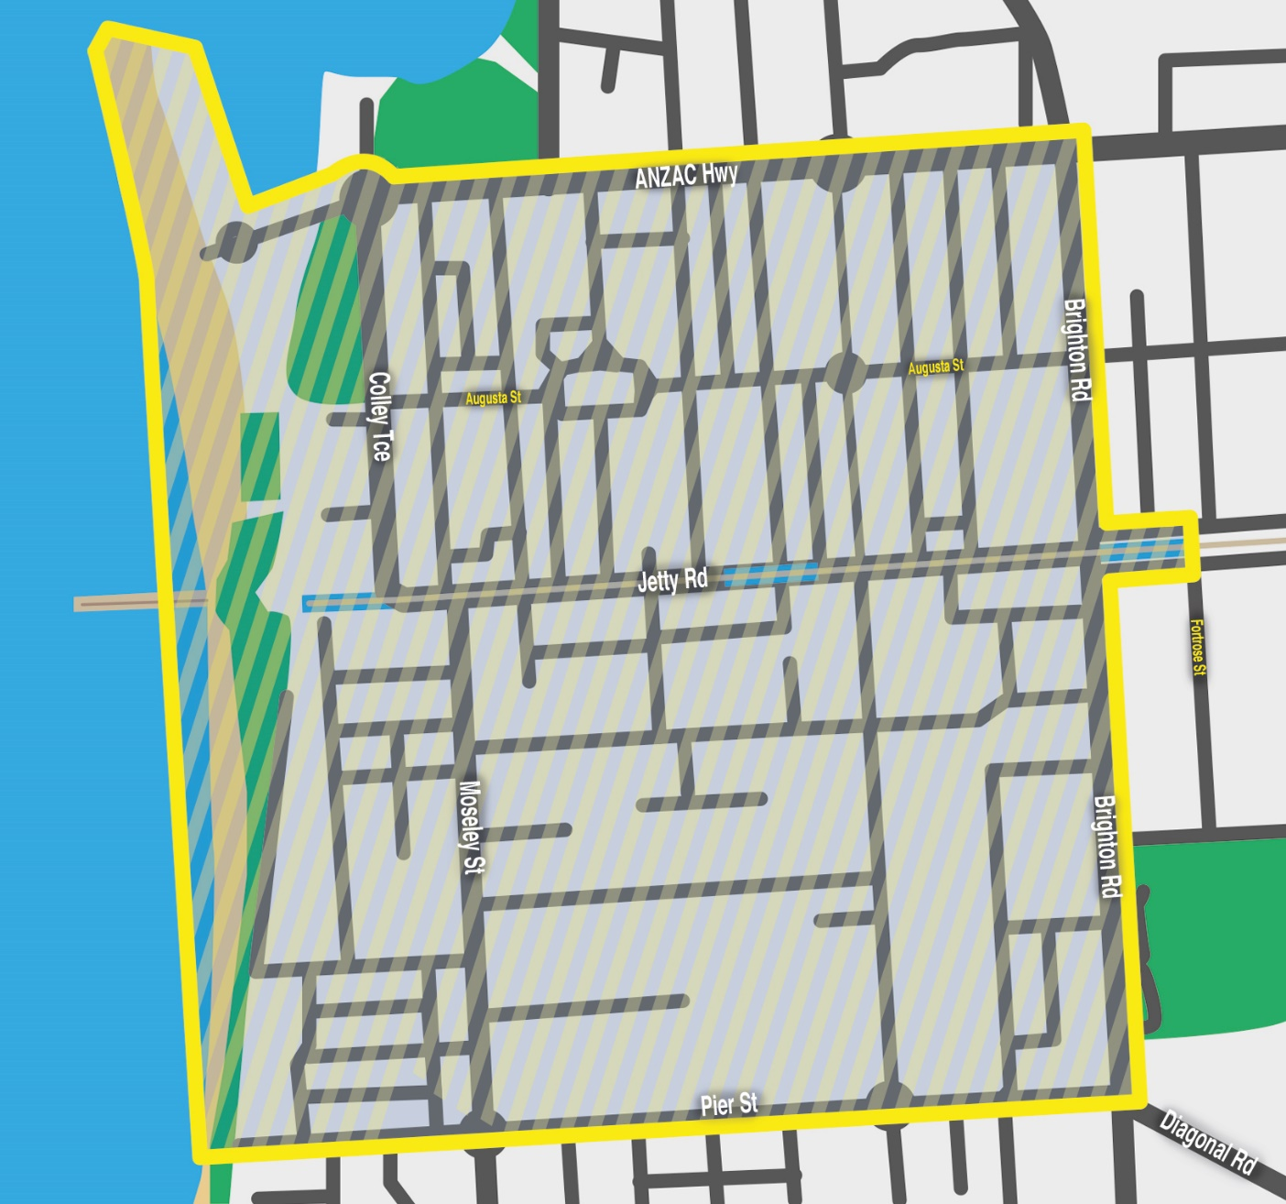

Local Government Instruments

ADELAIDE PLAINS COUNCIL
South Australia
Liquor Licensing (Dry Areas) Notice 2022
under section 131(1ab) of the Liquor Licensing Act 1997
1—Short title
This notice may be cited as the Liquor Licensing (Dry Areas) Notice 2022.
2—Commencement
This notice comes into operation on 16 December 2022.
3—Interpretation
(1) In this notice—
principal notice means the Liquor Licensing (Dry Areas) Notice 2015 published in the Gazette on 5 January 2015, as in force from time to time.
(2) Clause 3 of the principal notice applies to this notice as if it were the principal notice.
4—Consumption etc of liquor prohibited in dry areas
(1) Pursuant to section 131 of the Act, the consumption and possession of liquor in the area described in the Schedule is prohibited in accordance with the provisions of the Schedule.
(2) The prohibition has effect during the periods specified in the Schedule.
(3) The prohibition does not extend to private land in the area described in the Schedule.
(4) Unless the contrary intention appears, the prohibition of the possession of liquor in the area does not extend to—
(a) a person who is genuinely passing through the place if—
(i) the liquor is in the original container in which it was purchased from licensed premises; and
(ii) the container has not been opened; or
(b) a person who has possession of the liquor in the course of carrying on a business or in the course of their employment by another person in the course of carrying on a business; or
(c) a person who is permanently or temporarily residing at premises near the public place and who enters the public place solely for the purpose of passing through it to enter those premises or who enters the public place from those premises for the purpose of leaving the place; or
(d) a person who possesses or consumes the liquor for sacramental or other similar religious purposes.
Schedule—Two Wells Area 1
1—Extent of prohibition
The consumption of liquor is prohibited and the possession of liquor is prohibited.
2—Period of prohibition
From 4pm on 16 December 2022 to 5am on 17 December 2022.
3—Description of area
Old Port Wakefield Road between Gawler Road and Chapman Street in Two Wells.
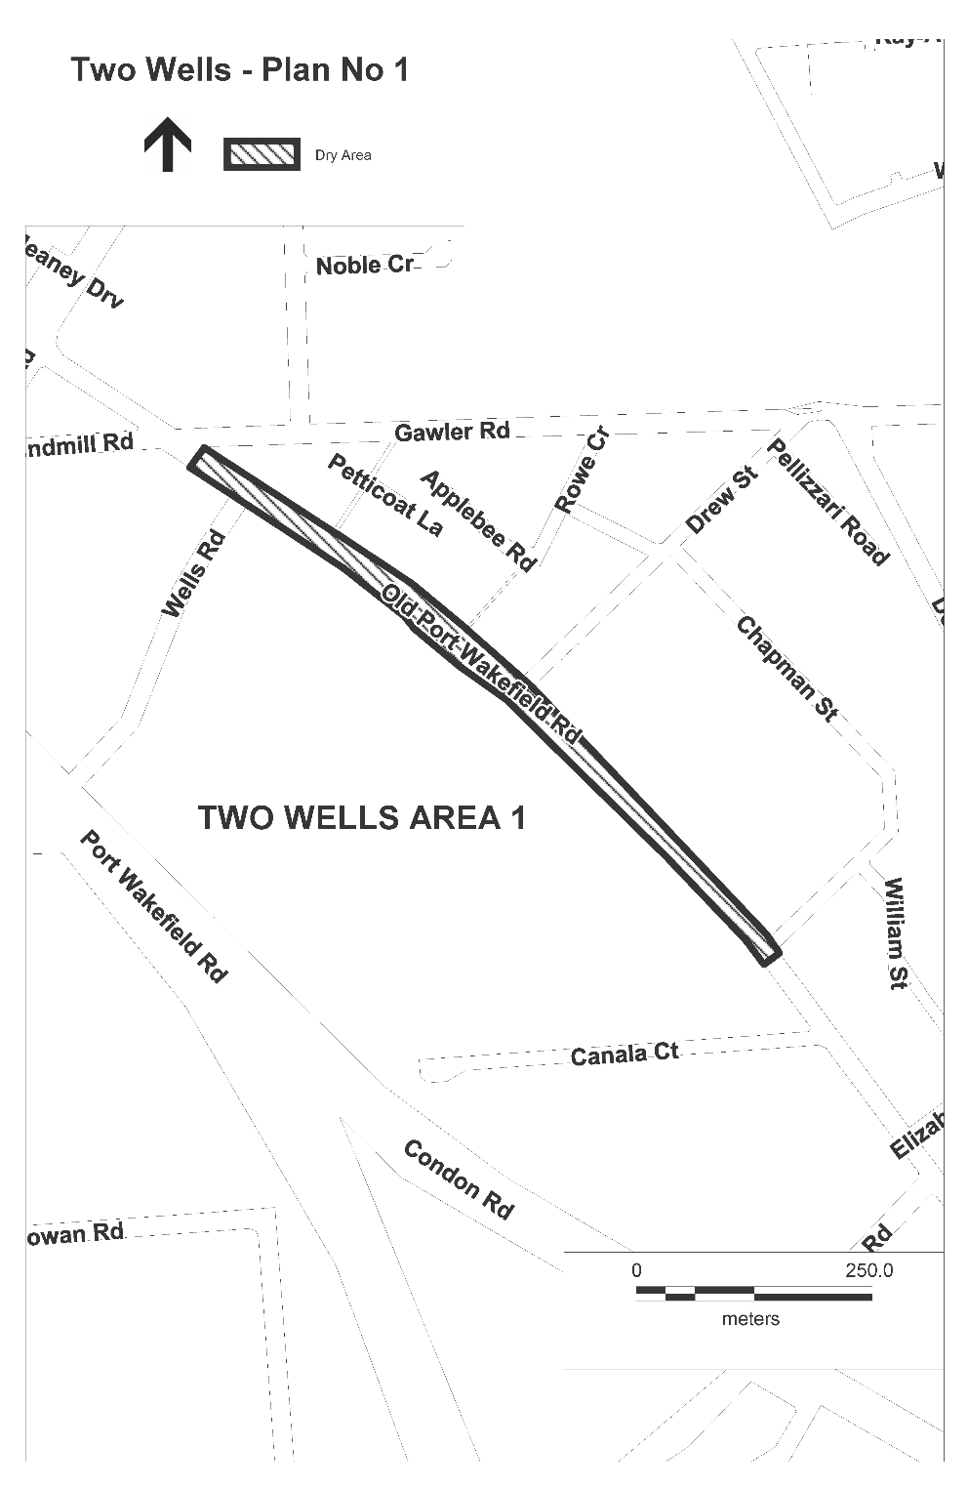
Dated: 28 November 2022
James Miller
Chief Executive Officer

District Council of Kimba
Change of Meeting Date
Notice is hereby given that the District Council of Kimba resolved at its meeting held on 18 November 2022 to change the scheduled January 2023 Council Meeting from Wednesday, 11 January 2023 commencing at 2 pm to Wednesday, 18 January 2023 commencing at 2 pm.
Dated: 1 December 2022
Deb Larwood
Chief Executive Officer

District Council of Kimba
South Australia
Liquor Licensing (Dry Areas) Notice 2022
Under section 131(1a) of the Liquor Licensing Act 1997
1—Short Title
This notice may be cited as the Liquor Licensing (Dry Areas) Notice 2022.
2—Commencement
This notice comes into operation on 31 December 2022.
3—Interpretation
- In this notice –
principal notice means the Liquor Licensing (Dry Areas) Notice 2015 published in the Gazette on 5.1.15, as in force from time to time.
- Clause 3 of the principal notice applies to this notice as if it were the principal notice.
4—Consumption etc of liquor prohibited in dry areas
- Pursuant to Section 131 of the Act, the consumption and possession of liquor in the area described in the Schedule is prohibited in accordance with the provisions of the Schedule.
- The prohibition has effect during the periods specified in the Schedule.
- The prohibition does not extend to private land in the area described in the Schedule.
- Unless the contrary intention appears, the prohibition of the possession of liquor in the area does not extend to—
(a) a person who is genuinely passing through the area if—
(i) the liquor is in the original container in which it was purchased from licensed
premises; and
(ii) the container has not been opened; or
(b) a person who has possession of the liquor in the course of carrying on a business or in the course of his or her employment by another person in the course of carrying on a business; or
(c) a person who is permanently or temporarily residing at premises within the area or on the boundary of the area and who enters the area solely for the purpose of passing through it to enter those premises or who enters the area from those premises for the purpose of leaving the area.

Schedule – Kimba Area 1
1—Extent of prohibition
The consumption of liquor is prohibited and the possession of liquor is prohibited.
2—Period of Prohibition
From 9pm on 31 December 2022 until 8am 1 January 2023.
3—Description of area
Kimba Area 1
The area in and adjacent to Kimba bounded as follows: commencing at the point at which the prolongation in a straight line of the eastern boundary of Railway Terrace intersects the northern boundary of Tola Road, then westerly along the northern boundary of Tola Road to the point at which it is intersected by the prolongation in a straight line of the north-western boundary of Seal Road, then south-westerly along that prolongation and boundary of Seal Road to the northern boundary of Haskett Road, then westerly and south-westerly along that boundary of Haskett Road, and the prolongation in a straight line of that boundary, to the southern boundary of Buckleboo Road, then south-easterly along that boundary of Buckle boo Road to the north-western boundary of Cant Road, then south-westerly along that boundary of Cant Road to the point at which it is intersected by the prolongation in a straight line of the south-western boundary of Freeth Road, then south-easterly along that prolongation and boundary of Freeth Road, and the prolongation in a straight line of that boundary, to the south-eastern boundary of Eyre Highway, then generally north-easterly along that boundary of Eyre Highway to the southern side of the intersection at which Eyre Highway, South Terrace and Railway Terrace meet, then in a straight line by the shortest route (across the intersection) to the south-western end of the south-eastern boundary of Railway Terrace, then generally north-easterly along the south-eastern boundary of Railway Terrace to the south-western boundary of Kimba Terrace, then south-easterly along that boundary of Kimba Terrace to the north-western boundary of Eyre Highway, then generally north-easterly along that boundary of Eyre Highway to the south-western boundary of Grund Road, then northwesterly along that boundary of Grund Road to the south-eastern boundary of Railway Terrace, then generally north-easterly and northerly along that boundary of Railway Terrace, and the prolongation in a straight line of that boundary, to the point of commencement.

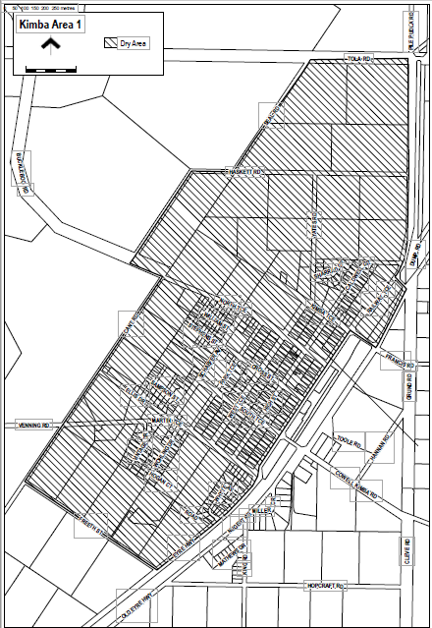
Debra Larwood
Chief Executive Officer

District Council of Kimba
Road Closure Pageant 2022
Notice is hereby given that at a meeting of Council held on Friday, 18 November 2022 District Council of Kimba exercise the power subject to Section 33 of the Road Traffic Act 1961 and clause F of the instrument of general approval of the Minister dated 22 August 2013 to make an order that:
- High Street from Martin Terrace to the southern side of North Terrace be closed between 5.00 pm and 8.30 pm and that High Street between Cross Street and the southern side of North Terrace remain closed between 8.30 pm and 12 midnight;
and
- Cross Street from High Street to the eastern side of the Emergency Services building be closed between 5.00pm and 12 midnight;
on Saturday, 17 December 2022 for the purpose of holding Kimba’s Christmas pageant and festivities.
That pursuant to Section 33(1)(b) of the Road Traffic Act 1961, make an order directing that persons taking part in the event be exempted, in relation to roads, from the duty to observe the Australian Road Rules specified and attached to the exemption: Rule 230 – Crossing a Road – General Rule 298 – Driving with a person in a trailer provided the speed of the vehicle does not exceed 25 km/h.
Dated: 1 December 2022
Deb Larwood
Chief Executive Officer

District Council of Kimba
Setting of Council Meeting Time
NOTICE is hereby given that the District Council of Kimba, at its meeting held on 18 November 2022, resolved that Council Meetings will be held on the second Wednesday of every month, and that these meetings be held in the Kimba Council Chambers, Cross Street, Kimba, commending at 2 p.m
Dated: 1 December 2022
Deb Larwood
Chief Executive Officer

Public Notices

Trustee Act 1936
Public Trustee
Estates of Deceased Persons
In the matter of the estates of the undermentioned deceased persons:
BERRY Derek Leslie late of 11 Waterford Street Salisbury Downs Retired Electronics Technical Specialist who died 21 January 2022
EVANS Mark late of 92 Robert Street West Croydon Retired Painter and Decorator who died 26 March 2022
HARRIS Benise Cowan late of 43 Fisher Street Magill of no occupation who died 16 July 2022
HARVEY Trevor Anthony late of 2-4 Anesbury Street Whyalla Norrie of no occupation who died 8 April 2022
OPPERMAN Marlene Janice late of 43 Derrington Street Mount Gambier Retail Worker who died 13 June 2022
ORTLIEB Eileen late of 36C Halsey Road Elizabeth East Retired School Assistant who died 2 July 2022
RICHARDS-MOUSLEY Claudia May late of 2 Malken Way Findon of no occupation who died 26 January 2022
ROSE Ronald Edwin late of 110 Strathfield Terrace Largs North Retired Laboratory Technician who died 12 June 2022
ROWE Betty June late of 14 Wootten Street Greenacres of no occupation who died 25 August 2022
WARD Jean late of 7 Braun Drive Hahndorf Retired Executive Secretary who died 1 July 2022
Notice is hereby given pursuant to the Trustee Act 1936, the Inheritance (Family Provision) Act 1972 and the Family Relationships Act 1975 that all creditors, beneficiaries, and other persons having claims against the said estates are required to send, in writing, to the office of Public Trustee at GPO Box 1338, Adelaide 5001, full particulars and proof of such claims, on or before the 30 December 2022 otherwise they will be excluded from the distribution of the said estate; and notice is also hereby given that all persons indebted to the said estates are required to pay the amount of their debts to the Public Trustee or proceedings will be taken for the recovery thereof; and all persons having any property belonging to the said estates are forthwith to deliver same to the Public Trustee.
Dated: 1 December 2022
N. S. Rantanen
Public Trustee

Notice Submission

The South Australian Government Gazette is published each Thursday afternoon.
Notices must be emailed by 4 p.m. Tuesday, the week of publication.
Submissions are formatted per the gazette style and a proof will be supplied prior to publication, along with a quote if applicable. Please allow one day for processing notices.
Alterations to the proof must be returned by 4 p.m. Wednesday.

Gazette notices must be submitted as Word files, in the following format:
• Title—the governing legislation
• Subtitle—a summary of the notice content
• Body—structured text, which can include numbered lists, tables, and images
• Date—day, month, and year of authorisation
• Signature block—name, role, and department/organisation authorising the notice

Please provide the following information in your email:
• Date of intended publication
• Contact details of the person responsible for the notice content
• Name and organisation to be charged for the publication—Local Council and Public notices only
• Purchase order, if required—Local Council and Public notices only

Email: governmentgazettesa@sa.gov.au
Phone: (08) 7109 7760
Website: www.governmentgazette.sa.gov.au

All instruments appearing in this gazette are to be considered official, and obeyed as such

Printed and published weekly by authority of C. McArdle, Government Printer, South Australia
$8.15 per issue (plus postage), $411.00 per annual subscription—GST inclusive
Online publications: www.governmentgazette.sa.gov.au

