No. 84 p. 6817
THE SOUTH AUSTRALIAN
GOVERNMENT GAZETTE
Published by Authority

Adelaide, Thursday, 8 December 2022

Contents

Governor’s Instruments
Acts—No. 23-31 of 2022 6818
Appointments 6818
Proclamations—
Statutes Amendment (National Energy Laws)
(Regulatory Sandboxing) Act (Commencement) Proclamation 2022 6823
Law of Property (Declaration of Bodies)
Proclamation 2022 6824
Regulations—
National Electricity (South Australia) (Regulatory
Sandboxing) Amendment Regulations 2022—
No. 110 of 2022 6825
National Energy Retail (Regulatory Sandboxing)
Amendment Regulations 2022—No. 111 of 2022 6827
National Gas (South Australia) (Regulatory Sandboxing) Amendment Regulations 2022—No. 112 of 2022 6829
State Government Instruments
Building Work Contractors Act 1995 6831
Electoral Act 1985 6831
Environment Protection Act 1993 6831
Equal Opportunity Act 1994 6832
Fisheries Management Act 2007 6833
Harbors and Navigation Act 1993 6833
Housing Improvement Act 2016 6834
Justices of the Peace Act 2005 6835
Land Acquisition Act 1969 6835
Local Government (Elections) Act 1999 6836
Mining Act 1971 6875
Petroleum and Geothermal Energy Act 2000 6876
Planning, Development and Infrastructure Act 2016 6876
Proof of Sunrise and Sunset Act 1923 6881
Local Government Instruments
Campbelltown City Council 6883
City of Marion 6883
Mid Murray Council 6883
Northern Areas Council 6892
Public Notices
National Electricity Law 6893
National Energy Retail Law 6893
Partnership Act 1891 6893
Trustee Act 1936 6893
University of Adelaide Act 1971 6894

Governor’s Instruments

Acts
Department of the Premier and Cabinet
Adelaide, 8 December 2022
Her Excellency the Governor directs it to be notified for general information that she has in the name and on behalf of His Majesty The King, this day assented to the undermentioned Bills passed by the Legislative Council and House of Assembly in Parliament assembled, viz.:
No. 23 of 2022—Health Care (Acquisition of Property) Amendment Bill 2022
An Act to amend the Health Care Act 2008
No. 24 of 2022—Statutes Amendment (Use of Devices in Vehicles) Bill 2022
An Act to amend the Motor Vehicles Act 1959 and the Road Traffic Act 1961
No. 25 of 2022—Statutes Amendment (Stealthing and Consent) Bill 2022
An Act to amend the Criminal Law Consolidation Act 1935, the Criminal Procedure Act 1921 and the Evidence Act 1929
No. 26 of 2022—Magistrates Court (Nunga Court) Amendment Bill 2022
An Act to amend the Magistrates Court Act 1991
No. 27 of 2022—Automated External Defibrillators (Public Access) Bill 2022
An Act to require the installation and registration of Automated External Defibrillators in certain buildings, facilities and vehicles and for other purposes
No. 28 of 2022—Criminal Procedure (Monitoring Orders) Amendment Bill 2022
An Act to amend the Criminal Procedure Act 1921
No. 29 of 2022—Statutes Amendment (Attorney-General's Portfolio) (No 3) Bill 2022
An Act to amend the Coroner's Act 2003 and the Criminal Law Consolidation Act 1935
No. 30 of 2022—Summary Offences (Dog Theft) Amendment Bill 2022
An Act to amend the Summary Offences Act 1953
No. 31 of 2022—Livestock (Emergency Animal Disease) Amendment Bill 2022
An Act to amend the Livestock Act 1997
By command,
Christopher James Picton, MP
For Premier

Appointments
Department of the Premier and Cabinet
Adelaide, 8 December 2022
Her Excellency the Governor in Executive Council has been pleased to appoint the undermentioned to the Prescribed Psychiatric Treatment Panel, pursuant to the provisions of the Mental Health Act 2009:
Member: from 13 February 2023 until 12 February 2028
Terence James Coyne
Belinda Jane Edwards
Shane Patrick Gill
Tara Simpson
Judith Ellen Smith
Member: from 13 February 2023 until 12 August 2026
Cecil Stephen Camilleri
Thomas Craig Paterson
By command,
Christopher James Picton, MP
For Premier
HEAC-2022-00068

Department of the Premier and Cabinet
Adelaide, 8 December 2022
Her Excellency the Governor in Executive Council has been pleased to appoint the undermentioned to the South Australian Film Corporation, pursuant to the provisions of the South Australian Film Corporation Act 1972:
Member: from 8 December 2022 until 7 December 2025
Lauren Ann Hillman
Shouwn Tjalling Oosting
Angela Mary Heesom
By command,
Christopher James Picton, MP
For Premier
ART0022-22CS

Department of the Premier and Cabinet
Adelaide, 8 December 2022
Her Excellency the Governor in Executive Council has been pleased to appoint the undermentioned to the State Opera of South Australia Board, pursuant to the provisions of the State Opera of South Australia Act 1976:
Member: from 8 December 2022 until 7 December 2025
Beatrice Maria Byok
Member: from 8 December 2022 until 7 December 2024
Philippa Christine Williams
Peter David Goldsworthy
Presiding Member: from 8 December 2022 until 22 October 2023
Elizabeth Christina Olsson
By command,
Christopher James Picton, MP
For Premier
ART0020-22CS

Department of the Premier and Cabinet
Adelaide, 8 December 2022
Her Excellency the Governor in Executive Council has been pleased to appoint the Honourable Kyam Joseph Maher MLC, to be Acting Deputy Premier, Acting Minister for Industry, Innovation and Science, and Acting Minister for Defence and Space Industries, from Friday, 9 December 2022 to Sunday, 8 January 2023 inclusive, during the absence of the Honourable Dr Susan Elizabeth Close MP.
By command,
Christopher James Picton, MP
For Premier
DPC22/087CS

Department of the Premier and Cabinet
Adelaide, 8 December 2022
Her Excellency the Governor in Executive Council has been pleased to appoint the Honourable Joseph Karl Szakacs MP, to be Acting Minister for Climate, Environment and Water, from Friday, 9 December 2022 to Sunday, 8 January 2023 inclusive, during the absence of the Honourable Dr Susan Elizabeth Close MP.
By command,
Christopher James Picton, MP
For Premier
DPC22/087CS

Department of the Premier and Cabinet
Adelaide, 8 December 2022
Her Excellency the Governor in Executive Council has been pleased to appoint the Honourable Peter Bryden Malinauskas MP, to be Acting Treasurer, from Thursday, 22 December 2022 to Wednesday, 4 January 2023 inclusive, during the absence of the Honourable Stephen Campbell Mullighan MP.
By command,
Christopher James Picton, MP
For Premier
DPC22/087CS

Department of the Premier and Cabinet
Adelaide, 8 December 2022
Her Excellency the Governor in Executive Council has been pleased to appoint the Honourable Andrea Michaels MP, to be Acting Minister for Tourism, and Acting Minister for Multicultural Affairs, from Thursday, 15 December 2022 to Thursday, 5 January 2023 inclusive, during the absence of the Honourable Zoe Lee Bettison MP.
By command,
Christopher James Picton, MP
For Premier
DPC22/087CS

Department of the Premier and Cabinet
Adelaide, 8 December 2022
Her Excellency the Governor in Executive Council has been pleased to appoint the Honourable Stephen Campbell Mullighan MP, to be Acting Minister for Health and Wellbeing, from Saturday, 7 January 2023 to Sunday, 22 January 2023 inclusive, during the absence of the Honourable Christopher James Picton MP.
By command,
Christopher James Picton, MP
For Premier
DPC22/087CS

Department of the Premier and Cabinet
Adelaide, 8 December 2022
Her Excellency the Governor in Executive Council has been pleased to appoint the Honourable Christopher James Picton MP, to be Acting Minister for Primary Industries and Regional Development, and Acting Minister for Forest Industries, from Friday, 23 December 2022 to Friday, 30 December 2022 inclusive, during the absence of the Honourable Clare Michele Scriven MLC.
By command,
Christopher James Picton, MP
For Premier
DPC22/087CS

Department of the Premier and Cabinet
Adelaide, 8 December 2022
Her Excellency the Governor in Executive Council has been pleased to appoint the Honourable Katrine Anne Hildyard MP, to be Acting Minister for Education, Training and Skills, for the period from Friday, 23 December 2022 to Sunday, 8 January 2023 inclusive, during the absence of the Honourable Blair Ingram Boyer MP.
By command,
Christopher James Picton, MP
For Premier
DPC22/087CS

Department of the Premier and Cabinet
Adelaide, 8 December 2022
Her Excellency the Governor in Executive Council has been pleased to appoint the Honourable Anastasios Koutsantonis MP, to be Acting Minister for Local Government, Acting Minister for Regional Roads and Acting Minister for Veterans Affairs, from Saturday, 24 December 2022 to Sunday, 8 January 2023 inclusive, during the absence of the Honourable Geoffrey Graeme Brock MP.
By command,
Christopher James Picton, MP
For Premier
DPC22/087CS

Department of the Premier and Cabinet
Adelaide, 8 December 2022
Her Excellency the Governor in Executive Council has been pleased to appoint the Honourable Andrea Michaels MP, to be Acting Minister for Trade and Investment, Acting Minister for Housing and Urban Development, and Acting Minister for Planning, from Friday, 23 December 2022 to Sunday, 8 January 2023 inclusive, during the absence of the Honourable Nicholas David Champion MP.
By command,
Christopher James Picton, MP
For Premier
DPC22/087CS

Department of the Premier and Cabinet
Adelaide, 8 December 2022
Her Excellency the Governor in Executive Council has been pleased to appoint Grant Thomas Davies as Health and Community Services Complaints Commissioner for a term of three years commencing on 26 February 2023 until 25 February 2026 - pursuant to the Health and Community Services Complaints Act 2004.
By command,
Christopher James Picton, MP
For Premier
HEAC-2022-00052

Department of the Premier and Cabinet
Adelaide, 8 December 2022
Her Excellency the Governor in Executive Council has been pleased to appoint Elizabeth Hannah McKinnon as a Cross Border Commissioner for a term of three years commencing on 3 April 2023 until 2 April 2026 - pursuant to the Cross Border Commissioner Act 2022.
By command,
Christopher James Picton, MP
For Premier
MPIRDF2022/000070CS

Department of the Premier and Cabinet
Adelaide, 8 December 2022
Her Excellency the Governor in Executive Council has been pleased to appoint the independent land valuers listed to the valuation review panels established in relation to the regions set out below for a term commencing on 30 January 2023 and expiring on 29 January 2026—pursuant to Section 25A of the Valuation of Land Act 1971.
By command,
Christopher James Picton, MP
For Premier
22MPCS01159

Name | Region
Bart Thomas Quinn | Metropolitan Adelaide
Chris David Wakeham | Metropolitan Adelaide  Adelaide Hills  Barossa, Light and Lower North
Christopher James Carter | Metropolitan Adelaide
Daniel Anton D’Elia | Adelaide Hills  Barossa, Light and Lower North  Fleurieu/Kangaroo Island  Eyre and Western
Daniel Ian Sander | Metropolitan Adelaide  Eyre and Western  Murray and Mallee
Iain Douglas Henshaw | Metropolitan Adelaide
Jack Hansen | Metropolitan Adelaide  Adelaide Hills  Barossa, Light and Lower North
James Liam Khabbaz | Metropolitan Adelaide  Adelaide Hills  Fleurieu/Kangaroo Island
Janet Rosemary Hawkes | Metropolitan Adelaide  Adelaide Hills  Barossa, Light and Lower North  Fleurieu/Kangaroo Island  Eyre and Western
Jarrod Bruce Harper | Metropolitan Adelaide  Adelaide Hills  Fleurieu/Kangaroo Island
John Tomazos | Metropolitan Adelaide
Jordan David Bilibio | Metropolitan Adelaide  Adelaide Hills  Barossa, Light and Lower North
Kee Van Tan | Metropolitan Adelaide
Kelly Anne Matthews | Metropolitan Adelaide  Adelaide Hills  Barossa, Light and Lower North  Murray and Mallee  Yorke and Mid North
Luke Philip Walker | Metropolitan Adelaide
Matthew Phillip Noack | Metropolitan Adelaide
Matthew Scott Richardson | Metropolitan Adelaide  Yorke and Mid North
Matthew Leonard Singleton | Metropolitan Adelaide  Adelaide Hills  Fleurieu/Kangaroo Island  Murray and Mallee
Maximilian Stephanides | Metropolitan Adelaide  Yorke and Mid North
Nicola Lombardi | Metropolitan Adelaide  Eyre and Western
Paul Charles Sanders | Metropolitan Adelaide
Paul Anthony Szumski | Metropolitan Adelaide  Adelaide Hills  Barossa, Light and Lower North  Fleurieu/Kangaroo Island  Eyre and Western  Far North  Limestone Coast  Murray and Mallee  Yorke and Mid North
Peter Robert Lornie | Metropolitan Adelaide  Adelaide Hills  Barossa, Light and Lower North  Fleurieu/Kangaroo Island  Eyre and Western  Far North  Limestone Coast  Murray and Mallee  Yorke and Mid North
Simon James Pascoe | Metropolitan Adelaide  Adelaide Hills  Barossa, Light and Lower North  Yorke and Mid North
Stephanos Roushas | Metropolitan Adelaide

Department of the Premier and Cabinet
Adelaide, 8 December 2022
Her Excellency the Governor in Executive Council has been pleased to appoint Miriam Amena Silva as Presiding Member, South Australian Film Corporation for a term commencing on 8 December 2022 and expiring on 7 June 2023, or until a new Presiding Member is appointed, whichever occurs sooner—pursuant to the South Australian Film Corporation Act 1972.
By command,
Christopher James Picton, MP
For Premier
ART0022-22CS

Department of the Premier and Cabinet
Adelaide, 8 December 2022
Her Excellency the Governor in Executive Council has been pleased to appoint the people listed to the position of Community Visitor for a term of three years commencing on 8 December 2022 and expiring on 7 December 2025—pursuant to the provisions of the Mental Health Act 2009.
John Raymond Callaghan
Jade McInerney
Louisa Mary McLennan
Pamela Lorraine Simmons
By command,
Christopher James Picton, MP
For Premier
HEAC-2022-00071

Proclamations
South Australia

Statutes Amendment (National Energy Laws) (Regulatory Sandboxing) Act (Commencement) Proclamation 2022
1—Short title
This proclamation may be cited as the Statutes Amendment (National Energy Laws) (Regulatory Sandboxing) Act (Commencement) Proclamation 2022.
2—Commencement of Act
The Statutes Amendment (National Energy Laws) (Regulatory Sandboxing) Act 2022 (No 22 of 2022) comes into operation on 8 December 2022.
Made by the Governor
with the advice and consent of the Executive Council
on 8 December 2022

South Australia

Law of Property (Declaration of Bodies) Proclamation 2022
under section 41A(2) of the Law of Property Act 1936
1—Short title
This proclamation may be cited as the Law of Property (Declaration of Bodies) Proclamation 2022.
2—Commencement
This proclamation comes into operation on the day on which it is made.
3—Declaration of bodies
The bodies set out in Schedule 1 are declared to be bodies for the purposes of section 41A(1)(a)(iii) of the Law of Property Act 1936.
Schedule 1—Declared bodies
Australian Rail Track Corporation Limited (ACN 081 455 754)
Goyder Wind Farm Common Asset Pty Ltd (ACN 649 966 138)
Monarto Water Network Limited (ACN 617 867 562)
Made by the Governor
with the advice and consent of the Executive Council
on 8 December 2022

Regulations
South Australia

National Electricity (South Australia) (Regulatory Sandboxing) Amendment Regulations 2022
under the National Electricity (South Australia) Act 1996

Contents
Part 1—Preliminary
1 Short title
2 Commencement
Part 2—Amendment of National Electricity (South Australia) Regulations
3 Insertion of regulations 5B to 5D
5B Additional innovative trial principles
5C Prescribed period for extension of trial waiver
5D Prescribed period for extension of trial Rule

Part 1—Preliminary
1—Short title
These regulations may be cited as the National Electricity (South Australia) (Regulatory Sandboxing) Amendment Regulations 2022.
2—Commencement
These regulations come into operation on the day on which section 5 of the Statutes Amendment (National Energy Laws) (Regulatory Sandboxing) Act 2022 comes into operation.
Part 2—Amendment of National Electricity (South Australia) Regulations
3—Insertion of regulations 5B to 5D
After regulation 5A insert:
5B—Additional innovative trial principles
For the purposes of section 7B(i) of the new National Electricity Law, the following principles are prescribed:
(a) whether the trial project is able to be trialled and evaluated;
(b) whether there is potential for the trial project to be successfully expanded;
(c) whether the trial project will provide for public sharing of knowledge, information and data resulting from the trial project.
5C—Prescribed period for extension of trial waiver
For the purposes of section 18ZQ(1) of the new National Electricity Law, the period of 1 year is prescribed.
5D—Prescribed period for extension of trial Rule
For the purposes of section 104A(1) of the new National Electricity Law, the period of 1 year is prescribed.
Made by the Governor
on the unanimous recommendation of the Ministers of the participating jurisdictions and with the advice and consent of the Executive Council
on 8 December 2022
No 110 of 2022

South Australia

National Energy Retail (Regulatory Sandboxing) Amendment Regulations 2022
under the National Energy Retail Law (South Australia) Act 2011

Contents
Part 1—Preliminary
1 Short title
2 Commencement
Part 2—Amendment of National Energy Retail Regulations
3 Insertion of regulations 9A to 9C
9A Additional innovative trial principles
9B Prescribed period for extension of trial waiver
9C Prescribed period for extension of trial Rule

Part 1—Preliminary
1—Short title
These regulations may be cited as the National Energy Retail (Regulatory Sandboxing) Amendment Regulations 2022.
2—Commencement
These regulations come into operation on the day on which section 19 of the Statutes Amendment (National Energy Laws) (Regulatory Sandboxing) Act 2022 comes into operation.
Part 2—Amendment of National Energy Retail Regulations
3—Insertion of regulations 9A to 9C
After regulation 9 insert:
9A—Additional innovative trial principles
For the purposes of section 13A(i) of the Law, the following principles are prescribed:
(a) whether the trial project is able to be trialled and evaluated;
(b) whether there is potential for the trial project to be successfully expanded;
(c) whether the trial project will provide for public sharing of knowledge, information and data resulting from the trial project.
9B—Prescribed period for extension of trial waiver
For the purposes of section 121H(1) of the Law, the period of 1 year is prescribed.
9C—Prescribed period for extension of trial Rule
For the purposes of section 262A(1) of the Law, the period of 1 year is prescribed.
Made by the Governor
on the unanimous recommendation of the Ministers of the participating jurisdictions and with the advice and consent of the Executive Council
on 8 December 2022
No 111 of 2022

South Australia

National Gas (South Australia) (Regulatory Sandboxing) Amendment Regulations 2022
under the National Gas (South Australia) Act 2008

Contents
Part 1—Preliminary
1 Short title
2 Commencement
Part 2—Amendment of National Gas (South Australia) Regulations
3 Insertion of regulations 5B to 5D
5B Additional innovative trial principles
5C Prescribed period for extension of trial waiver
5D Prescribed period for extension of trial Rule

Part 1—Preliminary
1—Short title
These regulations may be cited as the National Gas (South Australia) (Regulatory Sandboxing) Amendment Regulations 2022.
2—Commencement
These regulations come into operation on the day on which section 33 of the Statutes Amendment (National Energy Laws) (Regulatory Sandboxing) Act 2022 comes into operation.
Part 2—Amendment of National Gas (South Australia) Regulations
3—Insertion of regulations 5B to 5D
After regulation 5A insert:
5B—Additional innovative trial principles
For the purposes of section 24A(i) of the NGL, the following principles are prescribed:
(a) whether the trial project is able to be trialled and evaluated;
(b) whether there is potential for the trial project to be successfully expanded;
(c) whether the trial project will provide for public sharing of knowledge, information and data resulting from the trial project.
5C—Prescribed period for extension of trial waiver
For the purposes of section 30ZB(1) of the NGL, the period of 1 year is prescribed.
5D—Prescribed period for extension of trial Rule
For the purposes of section 314A(1) of the NGL, the period of 1 year is prescribed.
Made by the Governor
on the unanimous recommendation of the Ministers of the participating jurisdictions and with the advice and consent of the Executive Council
on 8 December
No 112 of 2022

State Government Instruments

Building Work Contractors Act 1995
Exemption
TAKE notice that, pursuant to Section 45 of the Building Work Contractors Act 1995, I, Zoe Thomas as a delegate for the Minister for Consumer and Business Affairs, do hereby exempt the licensee named in Schedule 1 from the application of Division 3 of Part 5 of the above Act in relation to domestic building work described in Schedule 2 and subject to the conditions specified in Schedule 3.
Schedule 1
JASON GEOFFREY MOORE BLD 146726
Schedule 2
Interior fit out of an existing split level detached dwelling at Allotment 1 in Deposited Plan 77657 being a portion of the land described in Certificate of Title Volume 6015 Folio 778, more commonly known as 38 Latimer Crescent, Trott Park SA 5158.
Schedule 3
1. This exemption is limited to domestic building work personally performed by the licensee in relation to the building work described in Schedule 2.
2. This exemption does not apply to any domestic building work the licensee contracts to another building work contractor, for which that contractor is required by law to hold building indemnity insurance.
3. That the licensee does not transfer his interest in the land prior to five years from the date of completion of the building work the subject of this exemption, without the prior authorisation of Consumer and Business Services (CBS). Before giving such authorisation, CBS may require the licensee to take any reasonable steps to protect the future purchaser(s) of the property, including but not limited to:
• Providing evidence that an adequate policy of building indemnity insurance is in force to cover the balance of the five-year period from the date of completion of the building work the subject of this exemption;
• Providing evidence of an independent expert inspection of the building work the subject of this exemption;
• Making an independent expert report available to prospective purchasers of the property;
• Giving prospective purchasers of the property notice of the absence of a policy of building indemnity insurance.
Dated: 5 December 2022
Zoe Thomas
Assistant Director, Licensing
Delegate for the Minister for Consumer and Business Affairs

Electoral Act 1985
Part 6—Registration of Political Parties
NOTICE is hereby given that I have on this day de-registered the political party named below, under the provision of Section 45 of the Act, for failing to comply with the requirements under the provisions of Section 43A of the Act; namely failing to lodge an annual return and failing to demonstrate the minimum number of 200 members:
Name of Party: SA Party—Stop Overdevelopment & Corruption
Dated: 8 December 2022
Mick Sherry
Electoral Commissioner

Environment Protection Act 1993
Prohibition on Taking Water affected by Site Contamination
I, Rebecca Anne Hughes, Manager Site Contamination and Delegate of the Environment Protection Authority (‘the Authority’), being satisfied that site contamination exists that affects or threatens groundwater and that action is necessary pursuant to Section 103S of the Environment Protection Act 1993 to prevent actual or potential harm to human health or safety hereby prohibit the taking of groundwater from the 1st, 2nd and 3rd Quaternary aquifers (as defined below) within the area specified in the map to this notice, other than for environmental assessment or environmental monitoring purposes or as approved in writing by the Authority.
This Notice relates to groundwater in:
(i) The Pooraka Formation aquifer and the underlying first and second Hindmarsh Clay aquifer, being the body of groundwater 0 to approximately 45 metres below ground surface within the specified area (see map)
The site contamination affecting the groundwater is in the form of chlorinated hydrocarbons, metals and per – and polyfluoroalkyl substances (PFAS) which represent actual or potential harm to human health or safety. This prohibition becomes official upon the gazettal of this notice.
Dated: 8 December 2022
R. Hughes
Manager Site Contamination
Environment Protection Authority

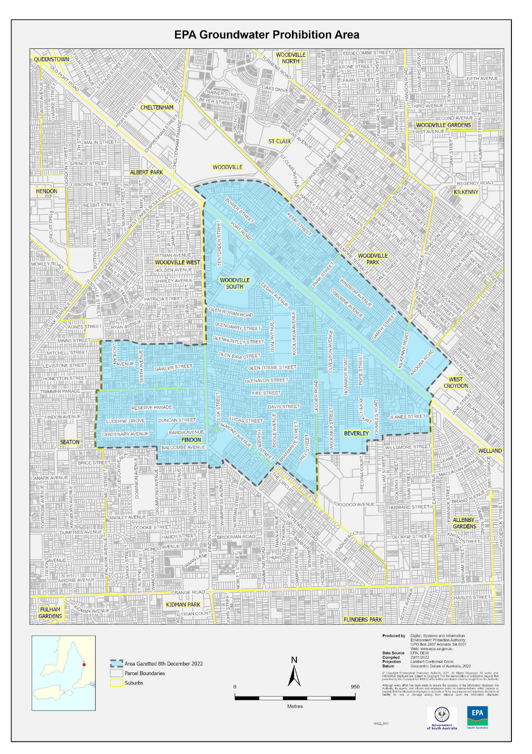

EQUAL OPPORTUNITY ACT 1994
South Australian Civil and Administrative Tribunal
Notice of Exemption Before Tribunal Alex Lazarevich—SACAT Reference Number: 2022/SA003315
I HEREBY certify that on the 29 November 2022, the South Australian Civil and Administrative Tribunal, on application of COBHAM AVIATION SERVICES AUSTRALIA PTY LTD, COBHAM SAR SERVICES PTY LTD, COBHAM NAS PTY LTD, and SURVEILLANCE AUSTRALIA PTY LTD, made the following orders for an exemption:
1. Pursuant to s 92 of the Act, the applicants are exempted for a period of three years expiring 29 November 2025 from compliance with the provisions of ss 52, 53, 54 and 103(1) of the Act to the extent that they may:
a. request information relating to the nationality, country of birth and current and past citizenship from existing and potential employees and contractors;
b. take a person’s nationality, country of birth and current and past citizenship into account in determining who should be offered employment or contract work in areas requiring access to Controlled Defence Articles and when making decisions as to the participation of employees or contractors in such work;
c. maintain records of the nationality, country of birth and current and past citizenship of all employees and contractors who have or may have access to Controlled Defence Articles in the performance of their work;
d. ensure that Controlled Defence Articles are disclosed only to persons who are not prohibited from receiving a disclosure in accordance with applicable United States laws;
e. impose limitations or prohibitions on persons of particular nationalities, countries of origin and current and past citizenship having access to Controlled Defence Articles in the performance of their work;
f. to the extent necessary to comply with their legal obligations to the Commonwealth, disclose to the Commonwealth the nationality, country of birth and current and past citizenship of all employees and contractors who require access to Controlled Defence Articles in the performance of their work;
g. disclose to US Contractors with whom any of the Applicants are party to a US Export Authorisation and to the US Department of State, the nationality, country of birth and current and past citizenship of all employees and contractors who will have access to Controlled Defence Articles in the performance of their work; and h. establish security systems which will prevent the unauthorised re-export or retransfer of Controlled Defence Articles.
2. That the exemption apply subject to the following conditions:
a. It will only apply to conduct by the applicants where:
i. that conduct is necessary to enable the applicants to enter into and/or perform contractual undertakings requiring access to Controlled Defence Articles; and
ii. the applicants have taken all steps that are reasonably available (including steps that might be taken in negotiating and performing the terms of their agreements with US Contractors) to avoid the necessity of engaging in conduct that would otherwise be in breach of sections 52, 53, 54 and 103 of the Act.
b. Where, in the exercise of this exemption, an employee or contract worker is moved from a project involving the use of Controlled Defence Articles to any other work controlled by the applicants or any of their related entities, the applicants must explain to the person through a duly authorised officer why he or she is being transferred and must otherwise take all reasonable steps to avoid or limit harm or loss to that person.
c. Where the applicants use a system of security passes to reflect the fact of access to Controlled Defence Articles or levels of access to any security sensitive material by employees and contract workers, the passes may be coded but not in such a way as to identify the nationality, country of birth and current and past citizenship of the person or the reasons for that person’s level of access.
d. All information relating to nationality, country of birth and current and past citizenship and access to Controlled Defence Articles shall be restricted to technology control officers, export control officers, security officers, legal officers and human resources officers of the applicants or their properly appointed nominees on a ‘need to know’ basis.
e. The applicants’ employment policies shall be amended as soon as reasonably possible so as to refer to the terms of this exemption, including all conditions attaching to it, and to make it clear that the purpose of the request for information regarding nationality, country of birth and current and past citizenship is made solely for the purposes of compliance with United States laws.
f. The First Applicant must prepare and retain records annually on 26 November for the duration of the exemption on the Applicants’ compliance with the exemption requirements and changes in its procedures to reflect amendments to the International Traffic in Arms Regulations 22 CFR 120 (2003) (USA), and as to how its employees and contractors are affected.
g. The First Applicant must provide the Commissioner’s Office with an annual report of compliance for the duration of the exemption on its compliance with the exemption requirements, any changes in its procedures reflecting any amendments to the ITAR and how employees and contractors are affected in the context of the protections afforded by the Act.
Dated: 29 November 2022
Anne Lindsay
Principal Registrar
South Australian Civil and Administrative Tribunal

Fisheries Management Act 2007
Section 47
Extension of the Term of the Management Plan for the Commercial Blue Crab Fishery
TAKE notice that pursuant to Section 47(3) of the Fisheries Management Act 2007, the term of the Management Plan for the South Australian Commercial Blue Crab Fishery, that came into effect on 1 January 2018 by notice made pursuant to Section 44 of the Fisheries Management Act 2007 in the South Australian Government Gazette dated 5 December 2017, on page 4807, is hereby extended to 30 June 2024.
Dated: 3 December 2022
Professor Gavin Begg
Executive Director
Fisheries and Aquaculture
Delegate of the Minister for Primary Industries and Regional Development

Harbors and Navigation Act 1993
Section 67
Notice of Direction—No. 2 of 2022
River Murray
I, Emma Megan Kokar, Executive Director, Road and Marine Services Division of the Department for Infrastructure and Transport, delegate of the Minister for Infrastructure and Transport in the State of South Australia in accordance with section 11 of the Harbors and Navigation Act 1993 (the Act), and pursuant to Section 67 of the Act, do hereby direct the following in the waters of the River Murray:
1. All vessels and any other water traffic be restricted to a speed of 4 knots when operating:
• within 250 metres from the location of any dwellings or buildings, where any part of the dwelling or building is partially or wholly submerged; or
• within 250 metres of a levee bank, where any part of the levee bank is partially or wholly submerged; or
• during the hours of darkness or conditions of restricted visibility.

2. All Personal Watercraft (commonly referred to as Jet-Skis) must operate at a maximum speed not exceeding 4 knots on any part of River Murray.
3. No persons shall swim, bathe or dive within 250 metres of a lock or weir.
4. No canoes, kayaks, surf skis, rowboats or other human-powered vessels or aquatic toys to be used or operated within 250 meters of a lock or weir.
5. Each occupant in the open area of a vessel up to 12 metres in length, must at all times, while the vessel is underway or at anchor, wear a lifejacket equivalent to a level 50 standard or above.
Definitions:
For the purposes of this Notice of Direction the following terms are defined as follows:
Aquatic Toy means: a surfboard, sailboard, kite board or any other aid to swimming or fishing that is not primarily designed for navigation.
Darkness means: between the hours of sunset and sunrise.
Human powered vessel means: any vessel or craft that is not fitted with an engine or motor and is propelled by human force.
Levee bank means: bank is human made structure built to contain, control or divert the flow of water in order to provide protection to towns, and/or agricultural land from flooding.
River Murray means: All creeks, tributaries, lakes, lagoons and other bodies of water connected to the River Murray between the border of South Australia and a line joining the upstream sides of the landings used by the ferry at Wellington, except a body of water that has been exempted.
Weir means: a barrier and/or dam across the width of the River Murray that alters or restricts the flow and/or characteristics of water and usually results in a change of height in river levels.
This Notice of Direction is in operation during times of declared High Flow or Flood in the waters of the River Murray by the South Australian State Emergency Services or until varied or revoked by a subsequent Notice of Direction.
All other provisions of the Harbors and Navigation Act 1993 and Regulations will continue to apply.
Dated: 22 November 2022
Emma Megan Kokar
Delegate of the Minister for Infrastructure and Transport

Harbors and Navigation Act 1993
Section 67
Notice of Direction—No. 3 of 2022
Power Lines—River Murray
I, Emma Megan Kokar, Executive Director, Road and Marine Services Division of the Department for Infrastructure and Transport, delegate of the Minister for Infrastructure and Transport in the State of South Australia in accordance with Section 11 of the Harbors and Navigation Act 1993 (the Act), and pursuant to Section 67 of the Act, do hereby direct the following in the waters of the River Murray:
1. That no vessels or any other water traffic (including canoes, kayaks, surf skis, rowboats or other human-powered vessels or aquatic toys) be operated or moored within 50 metres of an overhead power line in a floodplain.
2. That no persons shall swim, bathe or dive within 50 metres of an overhead power line in a floodplain.
Definitions:
For the purposes of this Notice of Direction the following terms are defined as follows:
Aquatic Toy means: a surfboard, sailboard, kite board or any other aid to swimming or fishing that is not primarily designed for navigation.
Floodplain means: an area of flat or nearly flat land adjacent to the River Murray which stretches outwards from the banks of it’s channel, and which experiences flooding during periods of declared High Flow or Flood by the South Australian State Emergency Services.
Human powered vessel means: any vessel or craft that is not fitted with an engine or motor and is propelled by human force.
Overhead Power Line means: any electrical infrastructure used in electric power transmission and distribution to transmit electrical energy across large distances that consists of one or more uninsulated electrical cables suspended by towers or poles and may include any overhead electrical appliance or transformer.
River Murray means: All creeks, tributaries, lakes, lagoons and other bodies of water connected to the River Murray between the border of South Australia and extending to the Murray Mouth, except a body of water that has been exempted.
This Notice of Direction is in operation during times of declared High Flow or Flood in the waters of the River Murray by the South Australian State Emergency Services or until varied or revoked by a subsequent Notice of Direction.
All other provisions of the Harbors and Navigation Act 1993 and Regulations will continue to apply.
Dated: 1 December 2022
Emma Megan Kokar
Delegate of the Minister for Infrastructure and Transport

Housing Improvement Act 2016
Rent Control Revocations
Whereas the Minister for Human Services Delegate is satisfied that each of the houses described hereunder has ceased to be unsafe or unsuitable for human habitation for the purposes of the Housing Improvement Act 2016, notice is hereby given that, in exercise of the powers conferred by the said Act, the Minister for Human Services Delegate does hereby revoke the said Rent Control in respect of each property.
Address of Premises | Allotment Section | Certificate of Title  Volume/Folio
Unit 1-11 Norman Street, Woodville SA 5011 | Allotment 64 Filed Plan 123858 Hundred of Yatala | CT5549/225
Unit 2-11 Norman Street, Woodville SA 5011 | Allotment 64 Filed Plan 123858 Hundred of Yatala | CT5549/225
Dated: 8 December 2022
Craig Thompson
Housing Regulator and Registrar
Housing Safety Authority, SAHA
(Delegate of Minister for Human Services)

Justices of the Peace Act 2005
Section 4
Notice of Appointment of Justices of the Peace for South Australia
by the Commissioner for Consumer Affairs
I, Dini Soulio, Commissioner for Consumer Affairs, delegate of the Attorney-General, pursuant to Section 4 of the Justices of the Peace Act 2005, do hereby appoint the people listed as Justices of the Peace for South Australia as set out below:
For a period of ten years for a term commencing on 20 December 2022 and expiring on 19 December 2032:
Vicki Ann WHITE
Peter Desmond WAKE
Theodore Stephen VITAGLIANO
Anthony John STOLL
Margret Christina SCHEIL
Giuseppe SCALZI
Andrew Michael SBROIAVACCA
Alan Franklin MORRIS
Peter Michael HEWITT
Rodger Bruce GRIFFITHS
Kenneth Donald GAMBLE
Samantha Yvette FLETCHER
Jerzy Julian DUDZINSKI
Robert James Bryce DRIDAN
Bernadette Anne DOUGLAS
Lynette Alison CZERWONKA
Sherelle Jayne COUTTS
Janine Andre CARGER
Susan Mary CALOGHIRIS
John Anthony CALLISTO
Robert James BUTLER
Heather Annie BROWN
Diane Helen BROOKS
Paul Nathan BROADBRIDGE
Max Ashurst BRATTON
Lucyna BIGGS
Elaine Mhairi BENSTED
Karen Lyn BEARD
Philip James BADCOCK
Katherine Clare ANDERSEN
Dated: 5 December 2022
Dini Soulio
Commissioner for Consumer Affairs
Delegate of the Attorney-General

Land Acquisition Act 1969
Section 16
Form 5 – Notice of Acquisition
1. Notice of acquisition
The Commissioner of Highways (the Authority), of 83 Pirie Street, Adelaide SA 5000, acquires the following interests in the following land:
Comprising the entirety of the right, estate or interest of Melania Mailoa, whether as lessee, as sub-lessee or as licensee or otherwise in that piece of land, being the whole of Unit 1 in Strata Plan No 5343 comprised in Certificate of Title Volume 5016 Folio 994.
This notice is given under section 16 of the Land Acquisition Act 1969.
2. Compensation
A person who has or had an interest consisting of native title or an alienable interest in the land that is divested or diminished by the acquisition or the enjoyment of which is adversely affected by the acquisition who does not receive an offer of compensation from the Authority may apply to the Authority for compensation.

2A. Payment of professional costs relating to acquisition (section 26B)
If you are the owner in fee simple of the land to which this notice relates, you may be entitled to a payment of up to $10 000 from the Authority for use towards the payment of professional costs in relation to the acquisition of the land.
Professional costs include legal costs, valuation costs and any other costs prescribed by the Land Acquisition Regulations 2019.
3. Inquiries
Inquiries should be directed to: Petrula Pettas
GPO Box 1533
Adelaide SA 5001
Telephone: (08) 7133 2457
Dated: 8 December 2022
The Common Seal of the COMMISSIONER OF HIGHWAYS was hereto affixed by authority of the Commissioner in the presence of:
Rocco Caruso
Manager, Property Acquisition (Authorised Officer)
Department for Infrastructure and Transport
DIT 2021/17658/01

Local Government (Elections) Act 1999
Local Government Elections—Results
Corporation of the City of Adelaide
Lord Mayor, 1 vacancy
Formal Ballot Papers: 8,577
Informal Ballot Papers: 53
Quota: 4,289
Candidates | First Preference Votes | Elected
PATRICK, Rex | 2,734
GUPTA, Vivek | 391
KELLY, Steven | 297
LOMAX-SMITH, Jane | 2,666 | Elected 1
VERSCHOOR, Sandy | 2,489
Area Councillor, 2 vacancies
Formal Ballot Papers: 8,398
Informal Ballot Papers: 190
Quota: 2,800
Candidates | First Preference Votes | Elected
DU, Zhigang | 383
BARBARO, Frank | 612
BAIN, Glenn | 639
GILES, Janet | 1,686 | Elected 2
PATTERSON, Josephine | 217
ABRAHIMZADEH, Arman | 1,851 | Elected 1
GELONESE, Domenico | 649
LOCKWOOD, Juliette | 571
MORAN, Anne | 1,790
North Ward councillor, 2 vacancies
Formal Ballot Papers: 2,436
Informal Ballot Papers: 50
Quota: 813
Candidates | First Preference Votes | Elected
MARTIN, Phil | 878 | Elected 1
FARNAN, Robert | 200
WILKINSON, Sandy | 410
DUNIS, Valdis | 289
COUROS, Mary | 659 | Elected 2
Central Ward councillor, 4 vacancies
Formal Ballot Papers: 3,292
Informal Ballot Papers: 90
Quota: 659
Candidates | First Preference Votes | Elected
HAMILTON, Mark | 315
NOON, Carmel | 466 | Elected 1
LI, Jing | 508 | Elected 4
SIU, Hugo | 68
ELLIOTT, David | 337 | Elected 3
RADDA, Alex | 97
HOU, Zhuopeng (Simon) | 355 | Elected 2
HYDE, Alexander | 338
HUI, Fiona | 119
KNOLL, Franz Peter | 176
PAPALIA, Cassandra | 75
AYRIS, Ben | 135
SHARMA, Gagan | 238
VO, Tammy | 65
South Ward councillor, 3 vacancies
Formal Ballot Papers: 2,767
Informal Ballot Papers: 76
Quota: 692
Candidates | First Preference Votes | Elected
SIEBENTRITT, Mark | 275 | Elected 3
CRUZ, Helika | 139
VLASSIS, Theo | 241
SCOTT, Tim | 138
SLIGHT, Colette | 277
CULLEN-MACASKILL, Sean | 199
SNAPE, Keiran | 758 | Elected 1
RAMANAN, Param | 51
BROWN, Kimberlee | 146
DAVIS, Henry | 263 | Elected 2
McKAY, Sue | 115
LLEWELLYN-SMITH, Ida Jonassen | 165
Adelaide Hills Council
Mayor, 1 vacancy
Candidates | First Preference Votes | Elected
WISDOM, Jan-Claire | n/a | Elected Unopposed
Ranges Ward councillor, 7 vacancies
Formal Ballot Papers: 5,167
Informal Ballot Papers: 135
Quota: 646
Candidates | First Preference Votes | Elected
OSTERSTOCK, Mark | 798 | Elected 2
MUDGE, Leith | 644 | Elected 3
FREER, David | 218
PARKIN, Kirsty | 551 | Elected 4
DANIELL, Nathan David | 841 | Elected 1
KEMP, John | 252
CRAWFORD, Philip | 177
SADLER, James | 283
SLADE, Ashley | 186
BOYD, Kirrilee | 558 | Elected 5
PASCALE, Louise | 375 | Elected 6
CHEATER, Adrian | 284 | Elected 7
Valleys Ward councillor, 5 vacancies
Formal Ballot Papers: 3,912
Informal Ballot Papers: 72
Quota: 653
Candidates | First Preference Votes | Elected
GRANT, Chris | 697 | Elected 3
HUXTER, Lucy | 1,024 | Elected 2
HERRMANN, Malcolm Arthur | 1,415 | Elected 1
GILL, Pauline Elizabeth | 107 | Elected 5
SELWOOD, Melanie | 555 | Elected 4
CHAPLIN, Padma | 114
Adelaide Plains Council
Mayor, 1 vacancy
Formal Ballot Papers: 2,051
Informal Ballot Papers: 29
Quota: 1,026
Candidates | First Preference Votes | Elected
BURGESS, Steve | 866
WASLEY, Mark | 1,185 | Elected 1
Area Councillor, 9 vacancies
Formal Ballot Papers: 1,980
Informal Ballot Papers: 109
Quota: 199
Candidates | First Preference Votes | Elected
STRUDWICKE, Marcus | 254 | Elected 3
PATON, David | 116 | Elected 6
PARKER, Brian | 117
JONES, Stephen Edward | 74
PANELLA, Margherita | 92 | Elected 5
DI TROIA, Carmine | 91
LAWRENCE, Mel | 85
MAZZEO, Dante Isaiah | 102 | Elected 7
SLATER, Matt | 35
LUSH, John Wilton | 280 | Elected 2
WALTON, Thomas Glen | 26
KEEN, Terry-anne | 70 | Elected 8
BOMBARDIERI, Alana Rose | 330 | Elected 1
BOON, Kay | 183 | Elected 4
STUBING, Eddie | 125 | Elected 9
Alexandrina Council
Mayor, 1 vacancy
Formal Ballot Papers: 9,870
Informal Ballot Papers: 88
Quota: 4,936
Candidates | First Preference Votes | Elected
HURST, Mark | 314
PARKES, Keith | 3,608 | Elected 1
LEWIS, Bron | 3,360
SMITH, Shaun | 2,588
Alexandrina West Ward councillor, 3 vacancies
Formal Ballot Papers: 3,099
Informal Ballot Papers: 78
Quota: 775
Candidates | First Preference Votes | Elected
SCOTT, Michael | 729 | Elected 3
NICHOLSON, Lou | 935 | Elected 1
COOMANS, Bill | 734 | Elected 2
NEWPORT, Judy | 124
DYBALA, Victoria | 201
ROSENBERG, Lorraine Florence | 376
Alexandrina North Ward councillor, 3 vacancies
Formal Ballot Papers: 3,016
Informal Ballot Papers: 60
Quota: 755
Candidates | First Preference Votes | Elected
KEILY, Rex John | 350
MAIDMENT, Craig | 720 | Elected 2
THORNTON, Christie | 615 | Elected 3
MILLER, Sue | 753 | Elected 1
BAGSTER, Lance | 178
ARNEY, Lynton | 400
Alexandrina South Ward councillor, 3 vacancies
Formal Ballot Papers: 3,645
Informal Ballot Papers: 62
Quota: 912
Candidates | First Preference Votes | Elected
WATSON, Steven | 80
JONES, Mark | 87
DAVIS, Jim | 376
WILLIAMS, Jane | 196
THOMPSON, Gerry | 118
GARDNER, Margaret Anne | 435 | Elected 3
JORDAN, Julie | 332
BICKLEY, Eli | 252
GLADWIN, Dave | 76
OSTIGH, Craig | 158
OLIVER, Peter | 708 | Elected 2
RIVERS-THOMPSON, Michael | 93
LIVINGSTON, Milli | 734 | Elected 1
The Barossa Council
Mayor, 1 vacancy
Formal Ballot Papers: 7,359
Informal Ballot Papers: 35
Quota: 3,680
Candidates | First Preference Votes | Elected
LANGE, Michael (Bim) | 4,084 | Elected 1
SZUTY, Helen | 3,275
Area Councillor, 11 vacancies
Formal Ballot Papers: 7,077
Informal Ballot Papers: 369
Quota: 590
Candidates | First Preference Votes | Elected
WOODBURY, Bob | 291
KRUGER, Angie | 291
TROUP, Cathy | 384 | Elected 8
THOMPSON, Heidi Marie | 398 | Elected 6
GREATWICH, Jess | 284 | Elected 9
HARMS, Christopher | 246
ANGAS, John | 923 | Elected 1
HURN, Tony | 363 | Elected 4
LANE, Rick | 665 | Elected 2
SCHILLING, Kathryn Louise | 362 | Elected 5
LOHNER, Katrin | 137
BARRETT, Don | 392 | Elected 7
DAVIES, Colin | 53
VAN DER WIJNGAART, Katie (Kat) | 124
JAMES, Shelley | 60
HAEBICH, David | 251
JOHNSTONE, Russell | 223
PREECE, Bruce | 317 | Elected 11
HORE, Scott | 208
DE VRIES, Dave | 259 | Elected 10
EVANS, Jane | 594 | Elected 3
WIESE-SMITH, Carla | 252

Barunga West Council
Area Councillor, 9 vacancies
Formal Ballot Papers: 1,053
Informal Ballot Papers: 34
Quota: 106
Candidates | First Preference Votes | Elected
GREGORY, Kim | 122 | Elected 4
AXFORD, Cynthia Lorraine | 247 | Elected 2
BUTTON, Peter | 265 | Elected 1
LOCKYER, Brian John | 53 | Elected 6
EASON, Dave | 35 | Elected 8
KERLEY, Leonie | 161 | Elected 3
BEINKE, Kevin John | 67 | Elected 5
McDONALD, Margaret | 21 | Elected 7
LOCKE, Rob | 9
ROWLANDS, Grant | 56 | Elected 9
SIMMONS, Georgie | 17
Berri Barmera Council
Mayor, 1 vacancy
Formal Ballot Papers: 3,234
Informal Ballot Papers: 22
Quota: 1,618
Candidates | First Preference Votes | Elected
HUNT, Peter R | 1,421
WINNALL, Ella | 1,455 | Elected 1
NOBILE, Raffaele (Ralf) | 358
Area Councillor, 8 vacancies
Formal Ballot Papers: 3,142
Informal Ballot Papers: 102
Quota: 350
Candidates | First Preference Votes | Elected
RICHARDSON, Bruce Graeme | 496 | Elected 2
WATERMAN, David | 220 | Elected 5
SCOTT, Trevor Malcolm | 354 | Elected 3
SINDOS, Meta | 178
LITTLE, Adrian James | 215 | Elected 6
MARRETT, Collis | 243 | Elected 7
KASSEBAUM, Andrew | 224 | Elected 4
CENTOFANTI, Rhonda Louise | 1,006 | Elected 1
SCHLEIN, Ian | 206 | Elected 8
City of Burnside
Mayor, 1 vacancy
Formal Ballot Papers: 10,377
Informal Ballot Papers: 184
Quota: 5,189
Candidates | First Preference Votes | Elected
MONCEAUX, Anne | 5,785 | Elected 1
LEMON, Helga | 4,592
Beaumont Ward councillor, 2 vacancies
Formal Ballot Papers: 1,842
Informal Ballot Papers: 44
Quota: 615
Candidates | First Preference Votes | Elected
CAVALERI, Cathy | 102
HUEBL, Paul | 701 | Elected 1
GREEN, Jaimee | 387
CASBARRA, Pat | 38
HORTON, Robert John | 151
JONES, Harvey | 463 | Elected 2

Burnside Ward councillor, 2 vacancies
Formal Ballot Papers: 1,604
Informal Ballot Papers: 62
Quota: 535
Candidates | First Preference Votes | Elected
DAWS, Mike | 601 | Elected 1
TURNBULL, Jennifer Jillian | 515 | Elected 2
DINAN, Kevin | 488
Eastwood and Glenunga Ward councillor, 2 vacancies
Formal Ballot Papers: 1,972
Informal Ballot Papers: 79
Quota: 658
Candidates | First Preference Votes | Elected
WEST, Jason | 368
MELICK, Jenni | 172
JENNINGS, Ted | 360 | Elected 2
WINDERLICH, David Nicholas | 172
LEUNG, Janet | 228
WILKINS, Di | 672 | Elected 1
Kensington Gardens and Magill Ward councillor, 2 vacancies
Formal Ballot Papers: 1,497
Informal Ballot Papers: 21
Quota: 500
Candidates | First Preference Votes | Elected
THAKUR, Dilip | 206
JACKSON, Kym | 271
WALMSLEY, Jayson | 183
BATTERSBY, Alexandra | 123
HARVEY, Jo | 357 | Elected 1
HALLETT, Kerry Margaret | 357 | Elected 2
Kensington Park Ward councillor, 2 vacancies
Formal Ballot Papers: 1,908
Informal Ballot Papers: 54
Quota: 637
Candidates | First Preference Votes | Elected
ACCATINO, Damian Frank | 391
DAVEY, Jane | 672 | Elected 1
SHAKES, Christopher | 143
STEPHENSON-JONES, Tabitha | 153
XING, Andy | 549 | Elected 2
Rose Park and Toorak Gardens Ward councillor, 2 vacancies
Candidates | First Preference Votes | Elected
CORNISH, Peter | n/a | Elected Unopposed
HENSCHKE, Lilian | n/a | Elected Unopposed
Campbelltown City Council
Mayor, 1 vacancy
Candidates | First Preference Votes | Elected
WHITTAKER, Jill | n/a | Elected Unopposed
Hectorville Ward councillor, 2 vacancies
Formal Ballot Papers: 2,450
Informal Ballot Papers: 50
Quota: 817
Candidates | First Preference Votes | Elected
THOMAS, Colin | 213
KENNEDY, John | 399
WONG, Ching | 370
AJRISH, Yassir (Aj) | 415 | Elected 2
BLACKBOROUGH, Luci | 473 | Elected 1
BLACK, Judy | 324
McDONNELL, Joshua | 256
Gorge Ward councillor, 2 vacancies
Formal Ballot Papers: 2,175
Informal Ballot Papers: 50
Quota: 726
Candidates | First Preference Votes | Elected
MCLUSKEY, Johanna | 896 | Elected 1
SOHAL, Gurtej | 256
BUSATO, Gianni | 164
BARBARO, Dom | 859 | Elected 2
Newton Ward councillor, 2 vacancies
Formal Ballot Papers: 2,049
Informal Ballot Papers: 92
Quota: 684
Candidates | First Preference Votes | Elected
SCALZI, Claude | 457 | Elected 2
AGOSTINELLI, Paul | 330
FERGUSON, Mark | 227
LEOMBRUNO, Anna | 1,035 | Elected 1
River Ward councillor, 2 vacancies
Formal Ballot Papers: 2,200
Informal Ballot Papers: 45
Quota: 734
Candidates | First Preference Votes | Elected
PARKEN, Kevin Kingsley | 297
NOBLE, Matthew | 1,238 | Elected 1
CARBONE, Aniello | 119
LAKHANI, Jagdish Harish | 406 | Elected 2
OZGO, Eric Charles | 140
Woodforde Ward councillor, 2 vacancies
Candidates | First Preference Votes | Elected
BRITTON-LA SALLE, Therese | n/a | Elected Unopposed
FLYNN, John | n/a | Elected Unopposed
District Council of Ceduna
Mayor, 1 vacancy
Formal Ballot Papers: 1,129
Informal Ballot Papers: 9
Quota: 565
Candidates | First Preference Votes | Elected
MAYNARD, Ken | 651 | Elected
WILL, Perry Alan | 478
Area Councillor, 8 vacancies
Formal Ballot Papers: 1,103
Informal Ballot Papers: 40
Quota: 123
Candidates | First Preference Votes | Elected
BREWSTER, Joyce | 89 | Elected 7
NICHOLLS, Hayley | 69 | Elected 8
BROWN, Paul Gibson | 160 | Elected 2
SLEEP, Robert George | 238 | Elected 1
NICHOLLS, Anthony William | 117 | Elected 3
RYAN, Geoff | 104 | Elected 5
JACOBSEN, Michele | 114 | Elected 4
EVANS, Terena | 32
McGUINNESS, Jane Elizabeth | 24
EVANS , Janet Shirley | 104 | Elected 6
SAMSONENKO, Melanie Kate | 52

City of Charles Sturt
Mayor, 1 vacancy
Formal Ballot Papers: 26,434
Informal Ballot Papers: 283
Quota: 13,218
Candidates | First Preference Votes | Elected
PAPARELLA, Paul | 4,119
RUSSO, Maria | 2,374
EVANS, Angela | 11,557 | Elected 1
MITCHELL, Matt | 8,384
Semaphore Park Ward councillor, 2 vacancies
Formal Ballot Papers: 3,210
Informal Ballot Papers: 134
Quota: 1,071
Candidates | First Preference Votes | Elected
LE LACHEUR, Nicholas | 920 | Elected 2
WAKEFIELD, Dulin | 267
GHENT, Stuart | 1,167 | Elected 1
FERRAO, Gerard | 856
Grange Ward councillor, 2 vacancies
Formal Ballot Papers: 3,118
Informal Ballot Papers: 179
Quota: 1,040
Candidates | First Preference Votes | Elected
SCHEFFLER, Tom | 1,012 | Elected 2
McGRATH, Sarah | 626
BLAZIC, Mara | 446
TULLIO, Rachele | 1,034 | Elected 1
Henley Ward councillor, 2 vacancies
Formal Ballot Papers: 2,855
Informal Ballot Papers: 201
Quota: 952
Candidates | First Preference Votes | Elected
FARDONE, Merlindie | 839 | Elected 2
van den NIEUWELAAR, Kenzie | 1,298 | Elected 1
ADLEY, John Patrick | 718
Woodville Ward councillor, 2 vacancies
Formal Ballot Papers: 3,892
Informal Ballot Papers: 249
Quota: 1,298
Candidates | First Preference Votes | Elected
CHIDAMBARANATHAN, Senthil | 973 | Elected 2
TRAN, Khuyen (Quin) | 1,582 | Elected 1
RAWSON, Terry | 570
RIX, Shane | 767
West Woodville Ward councillor, 2 vacancies
Formal Ballot Papers: 3,117
Informal Ballot Papers: 231
Quota: 1,040
Candidates | First Preference Votes | Elected
MESCHINO, Carlo | 916
THOMAS, Kelly | 1,131 | Elected 1
MAZEIKA, Nicole | 1,070 | Elected 2
Findon Ward councillor, 2 vacancies
Formal Ballot Papers: 3,566
Informal Ballot Papers: 211
Quota: 1,189
Candidates | First Preference Votes | Elected
ROOPRAI, Rajveer | 349
TURELLI, George | 1,145 | Elected 2
TEDESCO, Frank | 943
PPIROS, Peter | 1,129 | Elected 1
Hindmarsh Ward councillor, 2 vacancies
Formal Ballot Papers: 2,936
Informal Ballot Papers: 107
Quota: 979
Candidates | First Preference Votes | Elected
SUTTON, Steve | 566
CAMPBELL, Alice | 675 | Elected 2
KINSELLA, Katriona | 714 | Elected 1
COOKE, Graham Marshall Hall | 293
ALEXANDRIDES, Paul | 688
Beverley Ward councillor, 2 vacancies
Candidates | First Preference Votes | Elected
AGIUS, Edgar | n/a | Elected Unopposed
MCEWEN, Michael | n/a | Elected Unopposed
Clare & Gilbert Valleys Council
Mayor, 1 vacancy
Formal Ballot Papers: 3,336
Informal Ballot Papers: 23
Quota: 1,669
Candidates | First Preference Votes | Elected
PERRY, Helen | 1,023
THOMAS, Wayne | 1,037
AUGHEY, Allan | 1,276 | Elected 1
Area Councillor, 9 vacancies
Formal Ballot Papers: 3,232
Informal Ballot Papers: 123
Quota: 324
Candidates | First Preference Votes | Elected
ALDER, Ann | 449 | Elected 2
BURFITT, Ian | 369 | Elected 3
KOCH, Brian | 236 | Elected 7
WILLSON, David | 548 | Elected 1
BARTHOLOMAEUS, Malcolm Kingsley | 356 | Elected 4
NAUGHTON, Jeannine | 197 | Elected 9
FURLER, Tania | 319 | Elected 6
BRUHN, Leon James | 336 | Elected 5
PERRY, Owen | 162
CALVERT, Elizabeth | 260 | Elected 8
District Council of Cleve
Area Councillor, 7 vacancies
Formal Ballot Papers: 871
Informal Ballot Papers: 11
Quota: 109
Candidates | First Preference Votes | Elected
RICHARDSON, Kelly | 206 | Elected 2
WETHERALL, Julie | 24
TARRAN, Chris | 10
CLAUGHTON, Greg | 108 | Elected 4
SIVIOUR, Grantley | 15
QUINN, Robert | 45 | Elected 5
EMANS, Jake | 116 | Elected 3
RAYSON, Colin | 23
TRIGG, Bryan | 56 | Elected 7
CAMERON, Phil | 216 | Elected 1
FENNELL, Grant Andrew | 52 | Elected 6

Coorong District Council
Mayor, 1 vacancy
Formal Ballot Papers: 2,135
Informal Ballot Papers: 11
Quota: 1,068
Candidates | First Preference Votes | Elected
JAENSCH, Neville | 421
SIMMONS, Paul | 1,505 | Elected 1
HILLAM, Rosa | 209
Area Councillor, 7 vacancies
Formal Ballot Papers: 2,091
Informal Ballot Papers: 64
Quota: 262
Candidates | First Preference Votes | Elected
PIETZSCH, Jonathan | 229 | Elected 5
ROWNTREE, Lisa | 283 | Elected 2
SEIDEL, David | 26
BLAND, Sharon | 310 | Elected 1
BARRIE, Julie | 78
MIDDLETON, Donna-marie | 42
ARTHUR, Jeffrey (Tank) | 259 | Elected 3
O’HARA, Mick | 219 | Elected 4
BELL, Geoff | 82
DENMEADE, Wendy | 13
MAIDMENT, Ruth | 116 | Elected 7
QUALMANN, Brenton David | 175 | Elected 6
TAYLOR, Glynis Ann | 129
LENG, Vern | 10
CONNOLLY, Terry | 120
Copper Coast Council
Mayor, 1 vacancy
Candidates | First Preference Votes | Elected
TALBOT, Roslyn |  | Elected Unopposed
Area Councillor, 9 vacancies
Candidates | First Preference Votes | Elected
MALE, Andrew | n/a | Elected Unopposed
OSWALD, Peter | n/a | Elected Unopposed
PADDICK, Sandra | n/a | Elected Unopposed
SAWLEY, Neil | n/a | Elected Unopposed
SCHMIDT, Bruce | n/a | Elected Unopposed
SIMS, Peter | n/a | Elected Unopposed
VLUGGEN, Catherine Elizabeth | n/a | Elected Unopposed
WALKER, Brent | n/a | Elected Unopposed
District Council of Elliston
Area Councillor, 8 vacancies
Formal Ballot Papers: 503
Informal Ballot Papers: 6
Quota: 56
Candidates | First Preference Votes | Elected
CUSTANCE, Tony | 71 | Elected 3
MATTHEWS, Fiona | 64 | Elected 4
MCLEOD, Andrew Roderick | 86 | Elected 1
HITCHCOCK, Peter | 19
ZERK, Michael Andrew | 60 | Elected 5
DOLPHIN, Anthony | 4
MAY, Debbie Sue | 29
TRAEGER, Ashley | 28 | Elected 6
POLKINGHORNE, Andrew | 25 | Elected 8
HANCOCK, Malcolm | 77 | Elected 2
PICKFORD, Alison | 40 | Elected 7
The Flinders Ranges Council
Mayor, 1 vacancy
Formal Ballot Papers: 733
Informal Ballot Papers: 3
Quota: 367
Candidates | First Preference Votes | Elected
ANDERSON, Ken | 426 | Elected 1
FLINT, Greg | 307
Area Councillor, 8 vacancies
Candidates | First Preference Votes | Elected
CARPENTER, Ian | n/a | Elected Unopposed
HIPWELL, Julian | n/a | Elected Unopposed
HUNTER, David John | n/a | Elected Unopposed
PARKINSON, Ashley J. | n/a | Elected Unopposed
REYNOLDS, Patsy | n/a | Elected Unopposed
RYKS-JONES , Clinton Andrew | n/a | Elected Unopposed
SEARCY, Angus | n/a | Elected Unopposed
TAYLOR, Steven | n/a | Elected Unopposed
District Council of Franklin Harbour
Area Councillor, 6 vacancies
Formal Ballot Papers: 638
Informal Ballot Papers: 7
Quota: 92
Candidates | First Preference Votes | Elected
GILES, Geoff | 10
NORRIS, Robert John | 55 | Elected 5
REHN, Terry Philip | 42 | Elected 6
HUNT, Muriel Turnbull | 12
CHASE, Susan Mary | 160 | Elected 2
WALSH, Robert John | 100 | Elected 3
WAGNER, Daven Michael | 10
BAUM, Kim | 50 | Elected 4
DEER, Rachel | 199 | Elected 1
Town of Gawler
Mayor, 1 vacancy
Formal Ballot Papers: 6,362
Informal Ballot Papers: 61
Quota: 3,182
Candidates | First Preference Votes | Elected
LITTLE, Paul | 1695
TOOLEY, Ian | 1700
REDMAN, Karen | 2469 | Elected 1
BOLTON, John | 498
Area Councillor, 10 vacancies
Formal Ballot Papers: 6,052
Informal Ballot Papers: 356
Quota: 551
Candidates | First Preference Votes | Elected
SOLOMON, Isaac | 507 | Elected 4
DAVIES, Cody | 350 | Elected 6
HENNESSY, Helen Elizabeth | 559 | Elected 3
DRUMMOND, Louise | 187
LAUNER, Mick | 272 | Elected 9
HUGHES, David | 320 | Elected 8
DORNFORD, Brent | 39
MILLIKAN, Angus Alexander | 94
MODRA, Tom | 206
KOCH, Paul | 371 | Elected 7
CARMODY, Helene | 80
BAILEY, Shane | 298
SAMBELL, Brian | 621 | Elected 1
SMITH, Lori | 138
WHITE, Ethan | 396 | Elected 5
GOLDSTONE, Kelvin | 163
BRUNT, Karen | 168
WARDROP, Colin | 33
WRIGHT, Kellie | 111
VALLELONGA, Jim | 243 | Elected 10
FISCHER, Wayne | 128
SHETLER, Sam | 153
SHANKS, Nathan | 615 | Elected 2
Regional Council of Goyder
Hallett Ward councillor, 1 vacancy
Formal Ballot Papers: 277
Informal Ballot Papers: 1
Quota: 139
Candidates | First Preference Votes | Elected
PERREN, David | 35
MARTIN, Felicity Judith | 70
BROOKS, Anthony (Tony) | 172 | Elected 1
Burra Ward councillor, 3 vacancies
Formal Ballot Papers: 734
Informal Ballot Papers: 5
Quota: 184
Candidates | First Preference Votes | Elected
HIRSCHAUSEN, Jeffrey Michael | 23
HILL, Jane | 156 | Elected 2
SELWAY, Deb | 109
GEBHARDT, Bill | 245 | Elected 1
SKINNER, Russell John | 31
OATES, John | 124 | Elected 3
LOFTES, Jenny | 46
Eudunda Ward councillor, 2 vacancies
Formal Ballot Papers: 531
Informal Ballot Papers: 6
Quota: 178
Candidates | First Preference Votes | Elected
SCHILLER, Peter Milton | 131
BUDDLE, Emily | 60
HIBBERT, Debbie | 131 | Elected 2
DABROWSKI, Bob | 37
ROBERTS, Marilyn | 17
PARTINGTON, Judy | 155 | Elected 1
Robertstown Ward councillor, 1 vacancy
Candidates | First Preference Votes | Elected
NEAL, John Harvey | n/a | Elected Unopposed
District Council of Grant
Mayor, 1 vacancy
Formal Ballot Papers: 3,452
Informal Ballot Papers: 39
Quota: 1,727
Candidates | First Preference Votes | Elected
SAGE, Richard | 1,284
BOSTON, Kylie | 2,168 | Elected 1
Central Ward councillor, 7 vacancies
Formal Ballot Papers: 2,587
Informal Ballot Papers: 75
Quota: 324

Candidates | First Preference Votes | Elected
BAXENDALE, Greg | 108
DUKALSKIS, Megan Jane | 546 | Elected 1
KUHL, Barry Ross | 392 | Elected 3
MANN, Brad | 278 | Elected 4
GREENE, Katherine | 267 | Elected 5
BAIN, Bruce James | 418 | Elected 2
CLARKE, Gavin | 249 | Elected 6
DUNCAN, Peter | 167 | Elected 7
SWIGGS, David | 88
SMITH, Terry | 74
Tarpeena Ward councillor, 1 vacancy
Formal Ballot Papers: 371
Informal Ballot Papers: 0
Quota: 186
Candidates | First Preference Votes | Elected
PHILLIPS, Valma | 174
TURNBULL, Karen | 197 | Elected 1
Port MacDonnell Ward councillor, 1 vacancy
Formal Ballot Papers: 429
Informal Ballot Papers: 2
Quota: 215
Candidates | First Preference Votes | Elected
CLAYFIELD, Gill | 179
VIRGO, Rodney James | 222 | Elected 1
ROGERS, Kaydee | 28
City of Holdfast Bay
Mayor, 1 vacancy
Formal Ballot Papers: 8,792
Informal Ballot Papers: 198
Quota: 4,397
Candidates | First Preference Votes | Elected
WILSON, Amanda Lucy | 8,033 | Elected 1
FERDINANDS, Kingsley | 759
Glenelg Ward councillor, 3 vacancies
Formal Ballot Papers: 2,095
Informal Ballot Papers: 44
Quota: 524
Candidates | First Preference Votes | Elected
REIMER , Andrew Michael | 208
ABLEY, Rebecca | 556 | Elected 1
PUTRIC, Justin | 246
KANE, Allison | 246 | Elected 3
NEWMAN, Tracey | 121
HOL, James | 102
CAMPBELL, Tom | 207
PATTON, Bob | 409 | Elected 2
Somerton Ward councillor, 3 vacancies
Formal Ballot Papers: 2,279
Informal Ballot Papers: 39
Quota: 570
Candidates | First Preference Votes | Elected
HARROP, Rob | 90
LOOKER, Tim | 344
MILLER, William | 760 | Elected 1
FLETCHER, Janet | 199
O’DONOHUE, Monique | 407 | Elected 3
SMEDLEY, John Michael | 479 | Elected 2

Brighton Ward councillor, 3 vacancies
Candidates | First Preference Votes | Elected
FLEMING, Jane Mary | n/a | Elected Unopposed
SNEWIN, Bob | n/a | Elected Unopposed
VENNING, Anthony John | n/a | Elected Unopposed
Seacliff Ward councillor, 3 vacancies
Formal Ballot Papers: 2,263
Informal Ballot Papers: 45
Quota: 566
Candidates | First Preference Votes | Elected
BRADSHAW, Annette | 667 | Elected 2
YATES, Lynda | 323
LINDOP, Clare | 726 | Elected 1
LONIE, Susan | 383 | Elected 3
HOLTMAN, Aretta | 164
Kangaroo Island Council
Mayor, 1 vacancy
Formal Ballot Papers: 2,176
Informal Ballot Papers: 23
Quota: 1,089
Candidates | First Preference Votes | Elected
NEWCOMER, James | 830
PENGILLY, Michael | 1346 | Elected 1
Area Councillor, 9 vacancies
Formal Ballot Papers: 2,123
Informal Ballot Papers: 83
Quota: 213
Candidates | First Preference Votes | Elected
GELLARD, Jeanette | 439 | Elected 2
BATES, Veronica | 159 | Elected 4
CHIRGWIN, Rosalie | 62
AUSTIN, Pat | 163 | Elected 6
MUMFORD, Sam | 454 | Elected 1
LIU, Ken | 162 | Elected 5
COTTERILL, Richard Thomas | 105 | Elected 9
MILLER, Gregory Paul | 126 | Elected 8
PLEDGE, Shirley | 168 | Elected 3
TEASDALE, Bob | 143 | Elected 7
HOLMES, John | 142
District Council of Karoonda East Murray
Mayor, 1 vacancy
Candidates | First Preference Votes | Elected
PHILLIPS, Caroline Anne | n/a | Elected Unopposed
Area Councillor, 6 vacancies
Formal Ballot Papers: 462
Informal Ballot Papers: 3
Quota: 67
Candidates | First Preference Votes | Elected
NORMAN, Russell | 51 | Elected 4
LOLLER, Hannah | 102 | Elected 2
SIECKER, Johanna Wilhelmina | 11
PAAY, Gerry | 27 | Elected 6
GROSSER, Malcolm Paul | 16
SMITH, Yvonne | 11
TURNER, Greg | 36 | Elected 5
CARTER, Chris | 8
ZADOW, Darren (Fred) | 144 | Elected 1
KOCH, Natalie | 21
MARTIN, Simon | 35 | Elected 3
District Council of Kimba
Area Councillor, 7 vacancies
Candidates | First Preference Votes | Elected
CANT, Brian Stuart | n/a | Elected Unopposed
HASKETT, Jim | n/a | Elected Unopposed
JOHNSON, Dean | n/a | Elected Unopposed
LIENERT, (Alison) Megan | n/a | Elected Unopposed
RAYSON, Peter | n/a | Elected Unopposed
SCOTT, Anthony Francis | n/a | Elected Unopposed
Kingston District Council
Mayor, 1 vacancy
No nominations received.
Area Councillor, 7 vacancies
Formal Ballot Papers: 1,142
Informal Ballot Papers: 18
Quota: 143
Candidates | First Preference Votes | Elected
POPE, Jeff | 172 | Elected 2
PARKINS, James | 72
STARLING, James | 159 | Elected 4
KOCH, Carol L | 121 | Elected 6
CHARLTON, Christopher Donald | 33
RASHEED, Fiona | 240 | Elected 1
ARMFIELD, William | 169 | Elected 3
ENGLAND, Chris | 111 | Elected 5
HARDING, Tim | 65 | Elected 7
Light Regional Council
Mayor, 1 vacancy
Formal Ballot Papers: 4,026
Informal Ballot Papers: 62
Quota: 2,014
Candidates | First Preference Votes | Elected
CHAMPION, Linda | 1,384
O’BRIEN, Bill | 2,642 | Elected 1
Dutton Ward councillor, 3 vacancies
Formal Ballot Papers: 1,876
Informal Ballot Papers: 32
Quota: 470
Candidates | First Preference Votes | Elected
GOLDFINCH, Linda | 142
SHANNON, David Reginald | 85
ANTONIOLI, Fabio | 277 | Elected 3
HUNTER, Cate | 178
MOSLEY, David Paul | 184
GRAIN, Jason | 140
ROSS, Colin | 466 | Elected 1
ROHRLACH, Deane | 404 | Elected 2
Light Ward councillor, 3 vacancies
Formal Ballot Papers: 1,095
Informal Ballot Papers: 22
Quota: 274
Candidates | First Preference Votes | Elected
REICHSTEIN, Lynette | 445 | Elected 1
KENNELLY, Peter | 173 | Elected 3
RYAN, Trevor | 227
ZELLER, Simon | 250 | Elected 2
Mudla Wirra Ward councillor, 3 vacancies
Formal Ballot Papers: 1,042
Informal Ballot Papers: 38
Quota: 261
Candidates | First Preference Votes | Elected
EMERY, Alyson Nicola | 290 | Elected 3
PHILLIPS-RYDER, Michael Arthur | 318 | Elected 2
SMITH, Grant | 105
CLOSE, Bill | 329 | Elected 1
District Council of Lower Eyre Peninsula
Area Councillor, 7 vacancies
Formal Ballot Papers: 1,647
Informal Ballot Papers: 46
Quota: 206
Candidates | First Preference Votes | Elected
TAYLOR, Isaac | 265 | Elected 2
MITCHELL, Peter Laurence | 150 | Elected 4
FAHY, Margie | 165 | Elected 6
HOWELL, Brett | 188 | Elected 3
TREZISE, Neville | 51 | Elected 7
QUIGLEY, Jo-Anne Therese | 697 | Elected 1
WOOLLEY, Steve | 89 | Elected 5
WEGENER, Susanne | 42
District Council of Loxton Waikerie
Mayor, 1 vacancy
Formal Ballot Papers: 4,477
Informal Ballot Papers: 12
Quota: 2,239
Candidates | First Preference Votes | Elected
NORTON, Trevor (Nobby) | 2,686 | Elected 1
NICHOLLS, Bob | 1,791
Area Councillor 10 vacancies
Formal Ballot Papers: 4,310
Informal Ballot Papers: 211
Quota: 392
Candidates | First Preference Votes | Elected
FERBER, Craig Francis | 341 | Elected 7
ALTSCHWAGER, Sonya | 565 | Elected 1
LIGHT, Ian James | 346 | Elected 6
FOWLER, Sonia Jane | 558 | Elected 2
PFEILER, Gary William | 436 | Elected 4
ANDREW, Kent | 193 | Elected 10
MATTHEWS, Clive Andrew | 235 | Elected 9
FLAVEL, Jody | 288 | Elected 8
SIMES, Frances | 134
HILL, Michelle | 424 | Elected 5
WHEELDON, Terry Michael | 196
VOWLES, Michael John | 474 | Elected 3
WEBBER, Kym | 120
City of Marion
Mayor, 1 vacancy
Formal Ballot Papers: 19,219
Informal Ballot Papers: 214
Quota: 9,610
Candidates | First Preference Votes | Elected
HULL, Bruce William | 4,536
MIDZI, Jaison | 2,695
HANNA, Kris | 11,988 | Elected 1
Mullawirra Ward councillor, 2 vacancies
Formal Ballot Papers: 3,116
Informal Ballot Papers: 205
Quota: 1,039

Candidates | First Preference Votes | Elected
SINGH, Amar | 932 | Elected 2
VELISKOU, Jason | 1,625 | Elected 1
GOLDING, Les | 559
Woodlands Ward councillor, 2 vacancies
Formal Ballot Papers: 3,292
Informal Ballot Papers: 87
Quota: 1,098
Candidates | First Preference Votes | Elected
KUMAR, Johar | 809
THOMPSON, Julian | 266
HOFFMANN, Jayne | 669 | Elected 2
MORRISON, Emma | 157
MASIKA, Joseph | 850 | Elected 1
LITHGOW, Kirsty Lyn | 260
STASINOWSKY, Andrew James | 131
PERRY, Nick | 97
PHILLIPS, Warren John | 53
Warracowie Ward councillor, 2 vacancies
Formal Ballot Papers: 3,161
Informal Ballot Papers: 118
Quota: 1,054
Candidates | First Preference Votes | Elected
BROAD, Bradley | 520
PRIOR, Nathan John | 1,061 | Elected 1
TAYLOR, Matt | 518 | Elected 2
SETHI, Jagjit | 221
METEVELIS, Chris | 183
APPLEBY, Jerome David | 355
RAJE, Sanjay Madhukar | 122
THIPTHORP, Chris | 181
Warriparinga Ward councillor, 2 vacancies
Formal Ballot Papers: 3,210
Informal Ballot Papers: 133
Quota: 1,071
Candidates | First Preference Votes | Elected
PORTWAY, Peter | 489
LAMA, Renuka | 955 | Elected 1
RASMUSSEN, Erik | 553
TELFER, Raelene | 942 | Elected 2
BARBARA, Anne | 271
Coastal Ward councillor, 2 vacancies
Formal Ballot Papers: 3,278
Informal Ballot Papers: 98
Quota: 1,093
Candidates | First Preference Votes | Elected
LUSCOMBE, Sarah | 934 | Elected 1
LERWILL, Fleur | 609
CROSSLAND, Ian | 841 | Elected 2
DERER, Blake | 353
DUNN, Peter | 173
PARKIN, Jonathan | 368
Southern Hills Ward councillor, 2 vacancies
Formal Ballot Papers: 2,638
Informal Ballot Papers: 109
Quota: 880
Candidates | First Preference Votes | Elected
SHILLING, Matthew | 688
NAISMITH, Luke | 750 | Elected 1
MATES, Jana Ruth | 742 | Elected 2
DUNCAN, Maggie May | 458
Mid Murray Council
Mayor, 1 vacancy
Formal Ballot Papers: 3,060
Informal Ballot Papers: 32
Quota: 1,531
Candidates | First Preference Votes | Elected
BAILEY, Simone | 1,655 | Elected 1
MYERS, Kevin Paul | 471
BURGESS, Dave | 934
Eyre Ward councillor, 2 vacancies
Formal Ballot Papers: 705
Informal Ballot Papers: 22
Quota: 236
Candidates | First Preference Votes | Elected
DAVIS, Jen | 206 | Elected 2
GAMERTSFELDER, Jakob | 134
TREDREA, Wayne | 168
FORRESTER, Leonard Thomas John | 197 | Elected 1
Shearer Ward councillor, 4 vacancies
Candidates | First Preference Votes | Elected
GLADIGAU, Kelly | n/a | Elected Unopposed
HAMMOND, Victoria | n/a | Elected Unopposed
MACGREGOR, Kirsty | n/a | Elected Unopposed
TOCZEK MCPEAKE, Mandy | n/a | Elected Unopposed
Murray Ward councillor, 2 vacancies
Formal Ballot Papers: 718
Informal Ballot Papers: 15
Quota: 240
Candidates | First Preference Votes | Elected
SIMS, Kristine | 64
BARBER, Geoff | 193 | Elected 1
BARNES, Jayne | 113
SCHULTZ, Roslyn | 139 | Elected 2
MOSS, Jim | 122
SCHIANSKY, Kitty | 87
City of Mitcham
Mayor, 1 vacancy
Formal Ballot Papers: 17,098
Informal Ballot Papers: 81
Quota: 8,550
Candidates | First Preference Votes | Elected
McGHEE, Ray | 1,912
SPEAR, Glenn | 6,882
HOLMES-ROSS, Heather | 8,304 | Elected 1
Boorman Ward councillor, 2 vacancies
Formal Ballot Papers: 2,802
Informal Ballot Papers: 60
Quota: 935
Candidates | First Preference Votes | Elected
KOSMIDER, Robyn | 318
WELLS, Joanna | 1,096 | Elected 1
CHRISTOPOULOS, Adriana | 611
TILLEY, Andrew Playford | 777 | Elected 2
Gault Ward councillor, 2 vacancies
Formal Ballot Papers: 2,784
Informal Ballot Papers: 33
Quota: 929

Candidates | First Preference Votes | Elected
WESTBROOK, Ashley | 448
GEORGE, Pia | 561 | Elected 2
MOSS, Rod | 681 | Elected 1
DHALIWAL, Sim | 444
HUTCHINSON, Luke | 314
HALLAHAN, James | 336
Overton Ward councillor, 2 vacancies
Formal Ballot Papers: 2,219
Informal Ballot Papers: 67
Quota: 740
Candidates | First Preference Votes | Elected
DENLAY, John | 280
STOJANI, Danielle | 431
MUNRO, Dave | 121
BUOB, Jonathan | 134
BHAGAT, Kamal | 692 | Elected 1
BANGE, Jane | 561 | Elected 2
Babbage Ward councillor, 2 vacancies
Formal Ballot Papers: 2,647
Informal Ballot Papers: 82
Quota: 883
Candidates | First Preference Votes | Elected
AVERY, Ellen | 480
VIDYAM, Sesh | 591
TODD, Yvonne | 871 | Elected 1
GREENSHIELDS, Aidan | 705 | Elected 2
Craigburn Ward councillor, 2 vacancies
Formal Ballot Papers: 3,042
Informal Ballot Papers: 107
Quota: 1,015
Candidates | First Preference Votes | Elected
HOCKLEY, Karen | 1,991 | Elected 1
KRUSE, Darren | 423 | Elected 2
DIENES, David Jesse | 484
ROUSE, Scott | 144
The Park Ward councillor, 2 vacancies
Formal Ballot Papers: 3,129
Informal Ballot Papers: 126
Quota: 1,044
Candidates | First Preference Votes | Elected
McCARTHY, Corin | 685 | Elected 2
STOCKER, Kellie | 593
MORRISON, Tom | 1,851 | Elected 1
Mount Barker District Council
Mayor, 1 vacancy
Formal Ballot Papers: 10,424
Informal Ballot Papers: 132
Quota: 5,213
Candidates | First Preference Votes | Elected
LEACH, David | 5,787 | Elected 1
FERGUSON, Ann Shirley | 4,637
North Ward councillor, 3 vacancies
Formal Ballot Papers: 2,870
Informal Ballot Papers: 59
Quota: 718
Candidates | First Preference Votes | Elected
SEAGER, Harry | 587 | Elected 3
WESTWOOD, Simon | 1,024 | Elected 2
HAMILTON, Susan Willa | 142
SZILASSY, Jessica | 1,117 | Elected 1
Central Ward councillor, 4 vacancies
Formal Ballot Papers: 4,283
Informal Ballot Papers: 104
Quota: 857
Candidates | First Preference Votes | Elected
ORR, Bradley | 1,016 | Elected 2
JONES, Samantha Jean | 744 | Elected 3
SIZE, Janette | 507
GROSSER, Ian David | 704 | Elected 4
HARDING, Sally | 1,312 | Elected 1
South Ward councillor, 3 vacancies
Formal Ballot Papers: 3,161
Informal Ballot Papers: 76
Quota: 791
Candidates | First Preference Votes | Elected
VOOGT, Rowan Roy | 629
COOMBE, Richard | 729 | Elected 2
HARDINGHAM, Narelle | 809 | Elected 1
HEWETT, Rebecca | 697 | Elected 3
HANKIN, Bill | 297
City of Mount Gambier
Mayor, 1 vacancy
Candidates | First Preference Votes | Elected
MARTIN, Lynette | n/a | Elected Unopposed
Area Councillor, 8 vacancies
Formal Ballot Papers: 7,866
Informal Ballot Papers: 296
Quota: 875
Candidates | First Preference Votes | Elected
BRUINS, Max | 1,186 | Elected 2
LOVETT, Mark | 314 | Elected 8
HOOD, Ben | 1,572 | Elected 1
MEZINEC, Sonya | 1,012 | Elected 3
PALEOKASTRITIS, Steve | 154
TURNER, Scott James | 25
AMOROSO, Kate | 389 | Elected 7
HERRMANN, Alysha | 119
VIRGO, Jason | 326
JENNER, Paul | 566 | Elected 5
EDWARDS, Justin | 213
MORELLO, Frank | 379 | Elected 6
LYNAGH, Josh | 764 | Elected 4
MORALE, Bruce Sebastian | 268
DRINKELL, Owen | 60
VON STANKE, Ian David | 307
JONES, Llew | 164
RAEDEL, Kevin | 48
District Council of Mount Remarkable
Telowie Ward councillor, 3 vacancies
Candidates | First Preference Votes | Elected
HEASLIP, Phillip Michael | n/a | Elected Unopposed
McCARTHY, Stephen | n/a | Elected Unopposed
TATE, Sheriden | n/a | Elected Unopposed

Willochra Ward councillor, 4 vacancies
Candidates | First Preference Votes | Elected
KELLER, Ian (Danny) | n/a | Elected Unopposed
NOTTLE, Colin Edward | n/a | Elected Unopposed
TILL, Lesley | n/a | Elected Unopposed
The Rural City of Murray Bridge
Mayor, 1 vacancy
Formal Ballot Papers: 5,563
Informal Ballot Papers: 42
Quota: 2,782
Candidates | First Preference Votes | Elected
MATTHEWS, Dawn Patricia | 1,470
THORLEY, Wayne Brian | 4,093 | Elected 1
Area councillor, 9 vacancies
Formal Ballot Papers: 5,337
Informal Ballot Papers: 282
Quota: 534
Candidates | First Preference Votes | Elected
HAIG, Tom | 735 | Elected 2
COURTNEY, Lisa Ann | 392 | Elected 7
UWIHOREYE, Jean-marie | 99
RICHARDSON, Liam | 108
TOOGOOD, Fred | 521 | Elected 5
O’TOOLE, Josephine | 98
ECKERMANN, Karen Jane | 296 | Elected 8
McINERNEY, Mellissa Anne | 93
BALTENSPERGER, Andrew | 630 | Elected 3
PERRETT, Monica | 68
SCHUBERT, Clem | 442 | Elected 6
DE MICHELE, John | 608 | Elected 4
O’BRIEN, Mat | 248 | Elected 9
KEEN, Airlie | 860 | Elected 1
SINGH, Jagtar | 139
Naracoorte Lucindale Council
Mayor, 1 vacancy
Formal Ballot Papers: 3,520
Informal Ballot Papers: 7
Quota: 1,761
Candidates | First Preference Votes | Elected
ROSS, Patrick | 2,111 | Elected 1
VICKERY, Erika | 1,409
Area Councillor, 10 vacancies
Formal Ballot Papers: 3,395
Informal Ballot Papers: 138
Quota: 309
Candidates | First Preference Votes | Elected
DENNIS, Tom | 329 | Elected 3
BANNING, Ken | 98
DOWNWARD, Andrew | 174 | Elected 9
ROSS, Damien | 204 | Elected 7
EARL, Julie | 156
JAMES, Derek Wilf | 75
IRELAND, Peter Bruce | 156 | Elected 8
ROBINSON, Toby | 103
CROSSLING, Monique | 325 | Elected 4
GOODMAN, Abigail | 240 | Elected 5
SHEPHERD, Peter (Huck) | 153
MOORE, Danielle | 137
RAYNER, Trevor | 210 | Elected 6
TURNER, Darren | 135 | Elected 10
MCGUIRE, Craig William | 391 | Elected 2
GRUNDY, Cameron | 509 | Elected 1
Northern Areas Council
Belalie Ward councillor, 4 vacancies
Formal Ballot Papers: 800
Informal Ballot Papers: 9
Quota: 161
Candidates | First Preference Votes | Elected
LANGES, Hank | 145 | Elected 2
MALONE, Thomas | 144 | Elected 3
HOCKEY, Fiona May | 123 | Elected 4
REYNOLDS, Justine | 50
MOORE, Glan | 338 | Elected 1
Broughton Ward councillor, 1 vacancy
Candidates | First Preference Votes | Elected
BROWNE, Ben | n/a | Elected Unopposed
Rocky River Ward councillor, 3 vacancies
Formal Ballot Papers: 532
Informal Ballot Papers: 4
Quota: 134
Candidates | First Preference Votes | Elected
BARBERIEN, John | 162 | Elected 2
HIGGINS, Denise | 210 | Elected 1
SCARMAN, Sue | 70 | Elected 3
WEBB, Kathy | 67
NUSSEY, Jordan | 23
Yackamoorundie Ward councillor, 1 vacancy
Candidates | First Preference Votes | Elected
POMERENKE, Ian Robert | n/a | Elected Unopposed
City of Norwood Payneham & St Peters
Mayor, 1 vacancy
Formal Ballot Papers: 8,646
Informal Ballot Papers: 67
Quota: 4,324
Candidates | First Preference Votes | Elected
MARSH, Tracy | 1,556
LITCHFIELD, Susan | 2,855
BRIA, Robert | 4,235 | Elected 1
St Peters Ward councillor, 2 vacancies
Formal Ballot Papers: 1,438
Informal Ballot Papers: 21
Quota: 480
Candidates | First Preference Votes | Elected
PHILLIS, Carrie | 131
TARCA, Andrew | 146
LEE, Diane | 33
CLUTTERHAM, Claire Louise | 253 | Elected 2
MOORHOUSE, Kester | 739 | Elected 1
DIPROSE, Sam | 136
Torrens Ward councillor, 2 vacancies
Formal Ballot Papers: 1,286
Informal Ballot Papers: 71
Quota: 429
Candidates | First Preference Votes | Elected
MINNEY, John | 320
HOLFELD, Hugh Daniel | 649 | Elected 1
KNOBLAUCH, Garry John | 317 | Elected 2
Payneham Ward councillor, 2 vacancies
Formal Ballot Papers: 1,202
Informal Ballot Papers: 39
Quota: 401
Candidates | First Preference Votes | Elected
AMES, Trent William | 200
ROBERTSON, Raymond George | 70
SAYYAR DASHTI, Shahin | 91
DUKE, Kevin John | 483 | Elected 1
ROBINSON, Josh | 358 | Elected 2
Maylands/Trinity Ward councillor, 3 vacancies
Formal Ballot Papers: 1,855
Informal Ballot Papers: 59
Quota: 464
Candidates | First Preference Votes | Elected
FRANCHITTO, Max | 201
SIMS, Scott | 451 | Elected 3
GRANOZIO, Connie | 584 | Elected 2
McFARLANE, Victoria Minvielle | 619 | Elected 1
West Norwood/Kent Town Ward councillor, 2 vacancies
Candidates | First Preference Votes | Elected
PIGGOTT, Grant | n/a | Elected Unopposed
WHITINGTON, Sue | n/a | Elected Unopposed
Kensington/East Norwood Ward councillor, 2 vacancies
Formal Ballot Papers: 1,275
Informal Ballot Papers: 41
Quota: 426
Candidates | First Preference Votes | Elected
SEALS, Robert Spinelli | 282
MEX, Christel Lorraine | 761 | Elected 1
CALLISTO, John | 232 | Elected 2
City of Onkaparinga
Mayor, 1 vacancy
Formal Ballot Papers: 32,286
Informal Ballot Papers: 382
Quota: 16,144
Candidates | First Preference Votes | Elected
HOWELL, Jeanette | 2,374
DE JONGE, Rob | 4,694
HANN, Steven | 3,251
NIELSEN, Mark | 5,969
FRANCIS, Janette Gail | 709
WERE, Moira | 6,810 | Elected 1
GOLDING, Dan | 2,223
McMAHON, Simon | 6,256
South Coast Ward, 2 vacancies
Formal Ballot Papers: 5,827
Informal Ballot Papers: 273
Quota: 1,943
Candidates | First Preference Votes | Elected
REITER, Josh | 522
KASHYAP, Victor | 226
HENNIGAN, Daniel James | 224
WEATHERLY, Sean | 785
COOK, Steven | 504
YEOMANS, Paul | 1,341 | Elected 1
SPENCE, Stephen | 539
REX, Beth | 507
JEW, Lauren | 1,100 | Elected 2
LEWIS, Robin | 79

Mid Coast Ward, 2 vacancies
Formal Ballot Papers: 5,726
Informal Ballot Papers: 294
Quota: 1,909
Candidates | First Preference Votes | Elected
DIBDIN, Mark | 449
PERRYMEANT, Mandy | 537
JACKSON, Russell | 440
WILKES, Gretel | 889 | Elected 2
BARROTT-WALSH, Callum | 446
PLATTEN, Dan | 1,024 | Elected 1
BRAVINGTON, Elijah James | 232
WALPOLE, Fergus | 557
TONKIN, Suzanne | 456
MUNRO, Luke | 696
Knox Ward, 2 vacancies
Formal Ballot Papers: 4,257
Informal Ballot Papers: 390
Quota: 1,420
Candidates | First Preference Votes | Elected
GREAVES, Heidi | 870 | Elected 1
CHALMERS, Jacqueline | 350
DE GRAAF, Alayna | 766
STAFFORD, Colt | 730 | Elected 2
JAMES, Joyal | 114
WHAN, David | 713
SCHIRMER, Katrina | 450
CARTER, Shane | 264
Pimpala Ward, 2 vacancies
Formal Ballot Papers: 4,844
Informal Ballot Papers: 227
Quota: 1,615
Candidates | First Preference Votes | Elected
FISHER, Michael John | 1,362 | Elected 1
POWYER-TAYLOR, Daniel John Lae | 474
HOWDEN, Belinda | 368
BROWN, Sandra K | 695
O’BRIEN, Michael | 471
RILETT, Kevin | 983 | Elected 2
HOCKING, Debra | 491
Thalassa Ward, 2 vacancies
Formal Ballot Papers: 5,120
Informal Ballot Papers: 218
Quota: 1,707
Candidates | First Preference Votes | Elected
EATON, Geoff | 1,717 | Elected 1
PHOTAKIS, John | 952
ROCHFORD, Helen | 496
HARLEY, Ilona | 424
CHABREL, Philip | 536
THEMELIOTIS, Marion | 995 | Elected 2
Southern Vales Ward, 2 vacancies
Formal Ballot Papers: 5,184
Informal Ballot Papers: 289
Quota: 1,729
Candidates | First Preference Votes | Elected
HUMPHRIES, John | 570
PRITCHARD, Jordan | 766 | Elected 2
BELL, Marisa | 1,391 | Elected 1
TASSELL, Wayne | 355
FOSSEY, Matthew | 532
BAKER, Colin | 401
OLSEN, Wayne | 831
KILBY, Gail | 338
District Council of Orroroo Carrieton
Area Councillor, 6 vacancies
Candidates | First Preference Votes | Elected
BOWMAN, Kathie | n/a | Elected Unopposed
CHAPMAN, Grant Allan | n/a | Elected Unopposed
FORD, Joylene Joan | n/a | Elected Unopposed
GOEHRING, Ralph | n/a | Elected Unopposed
PARKYN, Col (Shorty) | n/a | Elected Unopposed
WATSON, Jessica | n/a | Elected Unopposed
District Council of Peterborough
Mayor, 1 vacancy
Formal Ballot Papers: 764
Informal Ballot Papers: 2
Quota: 383
Candidates | First Preference Votes | Elected
DEAN, Christopher | 198
WHITTLE, Ruth | 566 | Elected 1
Area Councillor, 8 vacancies
Formal Ballot Papers: 754
Informal Ballot Papers: 16
Quota: 84
Candidates | First Preference Votes | Elected
MARTIN, Teena | 58 | Elected 7
SLEEP, Russell | 46 | Elected 5
BURFORD, Michael | 93 | Elected 3
CHAMBERS, Cassandra | 194 | Elected 1
TAVERNER, Donna Chantelle | 20
MERCER, Graham John | 173 | Elected 2
HOTCHIN, Raymond George | 51 | Elected 4
HUCKS, Neil Oliver | 50 | Elected 6
KEMPEN, Judith | 17
MILLER, Kim William | 52 | Elected 8
City of Playford
Mayor, 1 vacancy
Formal Ballot Papers: 17,634
Informal Ballot Papers: 311
Quota: 8,818
Candidates | First Preference Votes | Elected
DOCHERTY, Glenn | 8,366 | Elected 1
SMITH, Jerome | 2,459
REARDON, Shaun | 6,809
Ward 1 councillor, 3 vacancies
Formal Ballot Papers: 3,984
Informal Ballot Papers: 138
Quota: 997
Candidates | First Preference Votes | Elected
MUSOLINO, Dino | 557
RENTOULIS, Peter | 915 | Elected 1
VANDEPEEAR, Rebecca | 737 | Elected 2
BALFORT, Gary | 177
MCDONALD, Rita Anne | 92
DOUGLAS, Victoria Jayne | 97
NICOL, Phillip | 158
DIESSA, Possible | 320
TAME, Cathy Jo | 150
MARSH, Clint | 717 | Elected 3
KUHLMANN, Rita | 64
Ward 2 councillor, 3 vacancies
Formal Ballot Papers: 4,075
Informal Ballot Papers: 137
Quota: 1,019
Candidates | First Preference Votes | Elected
ONUZANS, Jane | 738 | Elected 2
JAMES, Corina | 282
COPPINS, Stephen | 308
CURREY, Donna-marie | 300
SMALLWOOD-SMITH, Gay | 580 | Elected 3
DAVIES, Russell Francis | 258
SHARMA POUDYAL, Puskar | 152
HATUNGIMANA, Modeste | 175
HANTON, Kym | 457
KARLSEN, Chantelle | 825 | Elected 1
Ward 3 councillor, 3 vacancies
Formal Ballot Papers: 3,079
Informal Ballot Papers: 73
Quota: 770
Candidates | First Preference Votes | Elected
SOUTHERN, Lainie | 150
FEDERICO, Joe | 339
RAE, Clare Louise | 267
SMILJANIC, Tanya | 384 | Elected 2
GOSSINK, Veronica | 214
HENDRICK, Sanja | 125
O’DONNELL, Tom | 201
KERRISON, David | 849 | Elected 1
AMANI, Ahmad | 167
CRAIG, Andrew | 383 | Elected 3
Ward 4 councillor, 3 vacancies
Formal Ballot Papers: 2,929
Informal Ballot Papers: 157
Quota: 733
Candidates | First Preference Votes | Elected
BAYANI, Zahra | 604 | Elected 2
STROET, Katrina | 266 | Elected 3
STUART, Terry | 149
PARKIN, Benjamin Jeffrey | 50
KRANZ, Lisa D | 237
DAVEY, Denis | 248
HORSELL, Chris | 73
ACHARYA, Ram | 170
HOLFTER, Rae | 255
BAKER, Marilyn | 637 | Elected 1
ALI, Mohammad | 52
WALKER, Sara | 188
Ward 5 councillor, 3 vacancies
Formal Ballot Papers: 3,300
Informal Ballot Papers: 146
Quota: 826
Candidates | First Preference Votes | Elected
SHAW, Mark Daniel | 385
HALLS, Shirley Patricia | 448 | Elected 3
NORRIS, Misty | 747 | Elected 2
RETALLICK, Matthew | 272
ARIFI, Akram | 1,260 | Elected 1
CALLAGHAN, Tammy | 188

City of Port Adelaide Enfield
Mayor, 1 vacancy
Candidates | First Preference Votes | Elected
BOAN, Claire | n/a | Elected Unopposed
Outer Harbor Ward councillor, 2 vacancies
Formal Ballot Papers: 3,027
Informal Ballot Papers: 56
Quota: 1,010
Candidates | First Preference Votes | Elected
TULLOCH, Vanessa | 1,451 | Elected 1
WOTTON, Adrian | 744 | Elected 2
SMITH, Mark | 154
PLUTA, Wally | 101
LE RAYE, John | 323
LIPSON, Emma | 254
Semaphore Ward councillor, 2 vacancies
Formal Ballot Papers: 3,188
Informal Ballot Papers: 54
Quota: 1,063
Candidates | First Preference Votes | Elected
WRIGHT, Helen | 804
WILKINS, David | 893 | Elected 2
WITT, Jamie | 188
LINEAGE, Ignatius | 198
McGREGOR, Peter | 884 | Elected 1
McLAREN, Chad Christian | 221
Port Adelaide Ward councillor, 2 vacancies
Formal Ballot Papers: 3,071
Informal Ballot Papers: 58
Quota: 1,024
Candidates | First Preference Votes | Elected
VINES, Steve | 1,015 | Elected 1
ANDERSON, Scott | 261
SARDINHA, Denzyl Savio | 143
DEN HARTOG, Joost | 1,001 | Elected 2
LAILEY, Jason | 206
THOMPSON, Martina | 445
Parks Ward councillor, 3 vacancies
Formal Ballot Papers: 4,878
Informal Ballot Papers: 189
Quota: 1,220
Candidates | First Preference Votes | Elected
SAEED, Wasim | 775 | Elected 3
MITCHELL, Kat | 986 | Elected 2
DINH, Kim | 1,989 | Elected 1
MORE, Sadanand | 224
CROCI, John | 407
PLEH, Anna | 497
Enfield Ward councillor, 3 vacancies
Formal Ballot Papers: 5,213
Informal Ballot Papers: 202
Quota: 1,304
Candidates | First Preference Votes | Elected
COLOMBO, Olivia | 2,188 | Elected 1
SHINDE, Mihir | 547
MARTIN, Carol | 1,473 | Elected 2
CLAYTON, Barbara | 1,005 | Elected 3
Klemzig Ward councillor, 2 vacancies
Formal Ballot Papers: 2,949
Informal Ballot Papers: 85
Quota: 984
Candidates | First Preference Votes | Elected
YARA, Haritha Reddy | 360
RUSSELL, Paul | 770 | Elected 2
GADHIA, Rahul | 105
EVANS, Hannah | 990 | Elected 1
McSHANE, Janice | 349
BARBARO, Paul | 375
Northfield Ward councillor, 3 vacancies
Formal Ballot Papers: 6,046
Informal Ballot Papers: 131
Quota: 1,512
Candidates | First Preference Votes | Elected
PANAYIOTOU, Lazaras | 718 | Elected 3
DOSTIZADA, Hafiz | 230
YOON, Jin Wook | 540
OSBORN, Matt | 2,089 | Elected 1
BASHAM, Mark | 1,794 | Elected 2
DARJI, Nayan | 675
Port Augusta City Council
Mayor, 1 vacancy
Formal Ballot Papers: 4,205
Informal Ballot Papers: 21
Quota: 2,103
Candidates | First Preference Votes | Elected
SHINE, Linley | 2,858 | Elected 1
BENBOW, Brett Andrew | 1,347
Area Councillor, 9 vacancies
Formal Ballot Papers: 4,061
Informal Ballot Papers: 188
Quota: 407
Candidates | First Preference Votes | Elected
McKINLEY, Michael | 294 | Elected 8
FOOTE, Louise | 707 | Elected 1
BENNETT, Nora | 106 | Elected 9
NAISBITT , John Eugene | 551 | Elected 3
SAUNDERSON, Anne-marie | 34
WILLIAMS, Rob | 54
MARSH, Maralyn Anne | 351 | Elected 6
MYERS, Mark | 264 | Elected 7
WATSON, Julie | 79
BROWN, Phillip | 405 | Elected 5
SINGH, Garry | 123
BATES, Sam | 610 | Elected 2
SINGH, Sunny | 483 | Elected 4
City of Port Lincoln
Mayor, 1 vacancy
Formal Ballot Papers: 4,317
Informal Ballot Papers: 33
Quota: 2,159
Candidates | First Preference Votes | Elected
FLAHERTY, Brad | 1,561
MISLOV, Diana | 2,756 | Elected 1
Area Councillor, 9 vacancies
Formal Ballot Papers: 4,152
Informal Ballot Papers: 157
Quota: 416
Candidates | First Preference Votes | Elected
ROWSELL, Robyn | 1,023 | Elected 1
BROADFOOT, Andrea Jane | 578 | Elected 3
LINN, Peter | 558 | Elected 4
STAUNTON, Valerie Ann | 614 | Elected 2
RICHARDS, Shania | 216 | Elected 6
HOLLAMBY, Karen | 130 | Elected 9
RITCHIE, Jack | 395 | Elected 5
COWLEY, Dylan | 345 | Elected 7
POYNTER, Lillian K | 219 | Elected 8
BROUGHAM, Benjamin | 74
Port Pirie Regional Council
Mayor, 1 vacancy
Candidates | First Preference Votes | Elected
STEPHENS, Leon William | n/a | Elected Unopposed
Area Councillor, 9 vacancies
Formal Ballot Papers: 4,986
Informal Ballot Papers: 220
Quota: 499
Candidates | First Preference Votes | Elected
PETERS, Leeanne | 596 | Elected 2
HOPGOOD, Mick | 404 | Elected 4
ZUBRINICH, Alan | 1,444 | Elected 1
PETAGNA, Grant | 271 | Elected 6
JACKSON, Kendall Jayne | 319 | Elected 5
TURTON, Brandon | 69
KEAIN, Jack | 498 | Elected 3
GULIN, Ali | 265 | Elected 9
MARKS, Claire | 67
GOREY, Carl | 98
BRADLEY, Joshua | 254
CONNOR, Joby Todd | 262 | Elected 7
JOYCE, Jade | 236 | Elected 8
TREGILGAS, Deb | 203
City of Prospect
Mayor, 1 vacancy
Formal Ballot Papers: 5,888
Informal Ballot Papers: 54
Quota: 2,945
Candidates | First Preference Votes | Elected
LEE, Wah Hin | 400
PISHAS, Emmanouel | 293
MENNER, David | 1,277
SANDERSON, Rachel | 1,631
LARWOOD, Matt | 2,287 | Elected 1
North Ward councillor, 2 vacancies
Formal Ballot Papers: 1,291
Informal Ballot Papers: 51
Quota: 431
Candidates | First Preference Votes | Elected
NGUYEN, Thuy | 367 | Elected 1
PEARCE, Robin | 188
FROSSINAKIS, Sally | 215
NELSON, Jason | 255 | Elected 2
LAWRIE, Lia | 126
REIMANN, Sarah Louise | 140
West Ward councillor, 2 vacancies
Formal Ballot Papers: 1,586
Informal Ballot Papers: 40
Quota: 529
Candidates | First Preference Votes | Elected
COLACO, Romeo (Roy) | 131
HART, Wayne Aaron | 100
TAYLOR, Andrew | 189
WORTLEY, Che | 223
BARNETT, Kristina | 318 | Elected 2
JACKSON, Simon | 75
NGUYEN, Trinh | 394 | Elected 1
SMALL, Carmel | 156
Central Ward councillor, 2 vacancies
Formal Ballot Papers: 1,544
Informal Ballot Papers: 53
Quota: 515
Candidates | First Preference Votes | Elected
IAMMARRONE, Tony | 200
NEWALL, Timothy Frederick | 114
GROOTE, Mark | 688 | Elected 1
PURVIS, Catherine | 225
DE BACKER, Alison | 317 | Elected 2
East Ward councillor, 2 vacancies
Formal Ballot Papers: 1,311
Informal Ballot Papers: 39
Quota: 438
Candidates | First Preference Votes | Elected
STANDEN, Mark | 523 | Elected 1
TAYLOR, Bronwyn | 45
ELSEY, Kelly | 113
HOLLITT, Lillian | 199 | Elected 2
MOUNTFORD, Russell | 202
BATTYE, Caitlin | 229
Renmark Paringa Council
Mayor, 1 vacancy
Formal Ballot Papers: 3,181
Informal Ballot Papers: 31
Quota: 1,591
Candidates | First Preference Votes | Elected
DU RIEU, Henry | 1,488
HUNTER, Peter | 1,693 | Elected 1
Area Councillor, 8 vacancies
Formal Ballot Papers: 3,146
Informal Ballot Papers: 70
Quota: 350
Candidates | First Preference Votes | Elected
JOHN, James | 739 | Elected 1
TURTON, Frank James | 210 | Elected 8
SPANO, Maria | 451 | Elected 3
GIBB, (Jack) Bronte John | 403 | Elected 4
SIMS, David | 151 | Elected 7
GREWAL, Jung | 68
MADDOCKS, Allan Peter | 157
BRAUER, Stephanie | 242 | Elected 6
HOWIE, Margaret | 252 | Elected 5
TOWNSEND, Ben | 473 | Elected 2
District Council of Robe
Mayor, 1 vacancy
No nominations received.
Area Councillor, 6 vacancies
Formal Ballot Papers: 943
Informal Ballot Papers: 9
Quota: 135

Candidates | First Preference Votes | Elected
PEEL, Kylie | 146 | Elected 3
WASSON, Fred | 40
DENING, Marcia | 54 | Elected 6
RUFFELL, Lisa | 159 | Elected 2
BROWN, Nick | 200 | Elected 1
WRIGHT, Ned | 79 | Elected 4
MURPHY, Mark Francis | 37
ALEXANDER, Kristina | 32
FRIED, Peter Anthony | 33
BAKER, Mark Andrew | 41
YOUNG, Duncan Thomas | 60 | Elected 5
LAURIE, David Park | 62
City of Salisbury
Mayor, 1 vacancy
Formal Ballot Papers: 30,426
Informal Ballot Papers: 480
Quota: 15,214
Candidates | First Preference Votes | Elected
REYNOLDS, Graham | 9,211
CARUSO, Linda | 7,063
ALDRIDGE, Gillian | 12,665 | Elected 1
KESSANIS, Josh | 1,487
Central Ward councillor, 2 vacancies
Formal Ballot Papers: 4,367
Informal Ballot Papers: 248
Quota: 1,456
Candidates | First Preference Votes | Elected
SINGH, Mahinga | 302
BURNER, Severina | 747 | Elected 2
BUCHANAN, Chad | 2,702 | Elected 1
SHARMA, Sarika | 291
PROLETA, Donna Margaret | 325
East Ward councillor, 2 vacancies
Formal Ballot Papers: 3,582
Informal Ballot Papers: 286
Quota: 1,195
Candidates | First Preference Votes | Elected
DAHAL, Kamal | 859
MAZZEO, Moni | 1,910 | Elected 1
CHEWPARSAD, Johnny | 813 | Elected 2
South Ward councillor, 2 vacancies
Formal Ballot Papers: 3,660
Informal Ballot Papers: 311
Quota: 1,221
Candidates | First Preference Votes | Elected
SINGH, Satwinder | 431
BRUG, Lauren | 1,202 | Elected 2
EYLES, Tony | 357
GRAHAM, Alan | 1,434 | Elected 1
VOIGT, Jason | 236
Hills Ward councillor, 2 vacancies
Formal Ballot Papers: 3,547
Informal Ballot Papers: 208
Quota: 1,183
Candidates | First Preference Votes | Elected
SCHNEIDER, Paul | 202
JENSEN, Peter | 1,406 | Elected 1
BRYANT, David John | 610
WEETRA, Kyron | 262
REARDON, Shiralee | 1,067 | Elected 2
Para Ward councillor, 2 vacancies
Formal Ballot Papers: 5,105
Informal Ballot Papers: 210
Quota: 1,702
Candidates | First Preference Votes | Elected
BAWDEN, Matilda | 628
GOHIL, Raj | 361
KAPASI, Milankumar Jagdishbhai | 312
GRENFELL, Kylie | 1,176 | Elected 2
WATSON, Edward Joseph | 217
OUK, Sarah | 1,852 | Elected 1
ZAHRA, Riccardo | 415
KALIA, Vikas | 144
North Ward councillor, 2 vacancies
Formal Ballot Papers: 4,193
Informal Ballot Papers: 335
Quota: 1,398
Candidates | First Preference Votes | Elected
BAWDEN, Grace Katherine | 1,267 | Elected 2
HOOD, David | 2,007 | Elected 1
SUNKANPALLY, Ananda | 451
KHAN, Munhemul | 468
West Ward councillor, 2 vacancies
Formal Ballot Papers: 4,695
Informal Ballot Papers: 179
Quota: 1,566
Candidates | First Preference Votes | Elected
BAWDEN, Luke | 298
McKELL, Sharon | 853 | Elected 2
BRUG, Beau | 2,247 | Elected 1
NYAMANDE, Kudzai | 233
LIM, Ly (Lee) | 684
WILLIAMS, Emily | 380
Southern Mallee District Council
Area Councillor, 7 vacancies
Candidates | First Preference Votes | Elected
PFEIFFER, Neville | n/a | Elected Unopposed
VALENTINE, Ron | n/a | Elected Unopposed
District Council of Streaky Bay
Flinders Ward Councillor, 4 vacancies
Candidates | First Preference Votes | Elected
BARBER, Travis | n/a | Elected Unopposed
PUDNEY, Clifford John | n/a | Elected Unopposed
TREZONA, Sally | n/a | Elected Unopposed
WHEATON, Philip Lawrence | n/a | Elected Unopposed
Eyre Ward Councillor, 4 vacancies
Candidates | First Preference Votes | Elected
GUNN, Graham | n/a | Elected Unopposed
LIMBERT, Greg | n/a | Elected Unopposed
TREZONA, Neville | n/a | Elected Unopposed
Tatiara District Council
Mayor, 1 vacancy
Formal Ballot Papers: 2,723
Informal Ballot Papers: 19
Quota: 1,362
Candidates | First Preference Votes | Elected
ROSS, John Stuart | 796
GOOSSENS, Liz | 1,927 | Elected 1
Area Councillor, 9 vacancies
Formal Ballot Papers: 2,641
Informal Ballot Papers: 109
Quota: 265
Candidates | First Preference Votes | Elected
MOORE, Natalie | 152 | Elected 9
BUTLER, Trevor | 171 | Elected 7
McINERNEY, Kenneth John | 85
DOWNING, Deb | 199 | Elected 6
MACKERETH, Chris | 49
LANGLEY, Cathy | 217 | Elected 5
MACKENZIE, Lynton Arnold | 546 | Elected 1
MARTIN, Clarry | 293 | Elected 3
HALLIDAY, Richard | 214 | Elected 4
GOLDING, Tiffany | 83
BROWN, Debbie | 156
ANDERSEN, Linda | 162 | Elected 8
HANNEMANN, Miles Weston | 314 | Elected 2
City of Tea Tree Gully
Mayor, 1 vacancy
Formal Ballot Papers: 19,277
Informal Ballot Papers: 317
Quota: 9,639
Candidates | First Preference Votes | Elected
HAWKVELT, Cory | 4,315
MORTON-HALL, Rose | 3,951
ANGELI, Steven | 803
RYAN, Marijka | 6,036 | Elected 1
KNIGHT, Kevin | 4,172
Pedare Ward councillor, 2 vacancies
Formal Ballot Papers: 2,913
Informal Ballot Papers: 133
Quota: 972
Candidates | First Preference Votes | Elected
SINCLAIR, Tammie Lee | 746 | Elected 2
VIVIAN, Joshua | 327
CHANANA, Sugandhi | 272
JENTSCH, Cameron | 324
KEANE, Bernie | 1,244 | Elected 1
Drumminor Ward councillor, 2 vacancies
Formal Ballot Papers: 2,820
Informal Ballot Papers: 131
Quota: 941
Candidates | First Preference Votes | Elected
PETRIE, Lyn | 581
WYLD, Damian | 1,083 | Elected 1
DROZDOFF, Kimberley | 464 | Elected 2
ROBERTS, Kylie | 438
LEUNG, Cyril | 254
Hillcott Ward councillor, 2 vacancies
Formal Ballot Papers: 2,883
Informal Ballot Papers: 139
Quota: 962
Candidates | First Preference Votes | Elected
KEANE, Sandy | 1,195 | Elected 1
BATTEN, Stanley | 351
FOREMAN, Kristianne | 1,167 | Elected 2
DINGLEY, John | 170
Balmoral Ward councillor, 2 vacancies
Formal Ballot Papers: 3,355
Informal Ballot Papers: 91
Quota: 1,119
Candidates | First Preference Votes | Elected
ZAGLADOV, Irena | 497 | Elected 2
UNGER, Rob | 991 | Elected 1
MATTISKE, Adla | 421
BAKSHI, Daljeet | 369
NICHOLLS, Kathy | 304
SALEHI, Bahar | 286
CHARLES, Nicholas | 386
KHIZAM, Mona | 101
Steventon Ward councillor, 2 vacancies
Formal Ballot Papers: 3,622
Informal Ballot Papers: 153
Quota: 1,208
Candidates | First Preference Votes | Elected
JONES, Lucas | 1,969 | Elected 1
KEARNEY, Anthony | 304
LINTVELT, Jessica | 1,349 | Elected 2
Water Gully Ward councillor, 2 vacancies
Formal Ballot Papers: 3,242
Informal Ballot Papers: 157
Quota: 1,081
Candidates | First Preference Votes | Elected
HARRIS, Luke | 605
BEDI, Gags | 416
CHAMPION, Marina | 974 | Elected 2
LAWRENSON, Blake | 1,247 | Elected 1
District Council of Tumby Bay
Mayor, 1 vacancy
Candidates | First Preference Votes | Elected
CHURCHETT, Geoffrey | n/a | Elected Unopposed
Area Councillor, 6 vacancies
Candidates | First Preference Votes | Elected
TRENBERTH, Ricky | n/a | Elected Unopposed
WILL, Rick | n/a | Elected Unopposed
City of Unley
Mayor, 1 vacancy
Formal Ballot Papers: 9,133
Informal Ballot Papers: 77
Quota: 4,567
Candidates | First Preference Votes | Elected
SCHNELL, Bob | 2,391
HEWITSON, Michael Gordon | 4,807 | Elected 1
CENTRELLA, Dario | 436
MACFARLANE, Marijana | 1,499
Unley Park Ward councillor, 2 vacancies
Formal Ballot Papers: 1,455
Informal Ballot Papers: 47
Quota: 486
Candidates | First Preference Votes | Elected
BRONIECKI, Monica | 557 | Elected 1
RABBITT, Michael James | 484 | Elected 2
CHATAWAY, Roslyn Marie | 235
PRIOR, Paul Thomas | 179
Parkside Ward councillor, 2 vacancies
Formal Ballot Papers: 1,372
Informal Ballot Papers: 49
Quota: 458

Candidates | First Preference Votes | Elected
BLYTH, Leah | 193
ANASTASSIADIS, Kay | 236
BONHAM, Jennifer | 414 | Elected 2
DOYLE, Luke | 529 | Elected 1
Fullarton Ward councillor, 2 vacancies
Formal Ballot Papers: 1,566
Informal Ballot Papers: 67
Quota: 523
Candidates | First Preference Votes | Elected
HAVORD, Peter | 121
GAFFEY, Jack | 556 | Elected 2
CAULFIELD, Finn | 128
BRAENDLER, Josh | 91
HUGHES, Peter | 670 | Elected 1
Goodwood Ward councillor, 2 vacancies
Formal Ballot Papers: 1,485
Informal Ballot Papers: 41
Quota: 496
Candidates | First Preference Votes | Elected
TIPPER, Denise | 209
HART, Georgie | 345 | Elected 1
CRABBE, Chris | 305 | Elected 2
TIPPER, Jake | 40
McPHEE, Scott | 223
MACFARLANE, Chris | 197
SMOLUCHA, Luke | 166

Clarence Park Ward councillor, 2 vacancies
Formal Ballot Papers: 1,422
Informal Ballot Papers: 35
Quota: 475
Candidates | First Preference Votes | Elected
PALMER, Don | 694 | Elected 1
ROGERS, Rebekah | 472 | Elected 2
SQUIRE, Jayden | 256
Unley Ward councillor, 2 vacancies
Formal Ballot Papers: 1,628
Informal Ballot Papers: 59
Quota: 543
Candidates | First Preference Votes | Elected
FINOS, Stephen | 565 | Elected 2
RUSSO, Jane | 597 | Elected 1
DEWING, Sue | 466
City of Victor Harbor
Mayor, 1 vacancy
Formal Ballot Papers: 6,314
Informal Ballot Papers: 48
Quota: 3,158
Candidates | First Preference Votes | Elected
JENKINS, Moira | 3,056 | Elected 1
CHARLES, Peter Alexander (Oopsy) | 1,437
HAYLES, Nick | 1,821
Area Councillor, 9 vacancies
Formal Ballot Papers: 6,026
Informal Ballot Papers: 312
Quota: 603
Candidates | First Preference Votes | Elected
BURNS, Stewart | 650 | Elected 2
MANN, Brayden Robert | 1,544 | Elected 1
REYNOLDS, Rob | 186
QUAREMBA, Carlos | 317 | Elected 7
MCKENZIE, Nick | 176 | Elected 9
WATSON, Malcolm David | 147
HENDERSON, Marilyn | 463 | Elected 4
STORER, Megan | 83
MILNER, John | 115
SCHOFIELD, Carol | 295 | Elected 8
BRUCE, James | 224
SCHILLER, Angela | 385 | Elected 6
QUINTON, Michael | 435 | Elected 3
ALSFORD, Marty | 153
MITCHELL, Timothy Richard | 28
ROBERTSON, Andrew | 186
HAMES, Bailey | 103
DELLANEY, Angelique | 118
KEMP, David | 418 | Elected 5
Wakefield Regional Council
Mayor, 1 vacancy
Candidates | First Preference Votes | Elected
REID, Rodney John | n/a | Elected Unopposed
North Ward councillor, 3 vacancies
Formal Ballot Papers: 744
Informal Ballot Papers: 6
Quota: 187
Candidates | First Preference Votes | Elected
MICHAEL, Tom | 97 | Elected 3
AGNEW , Denni | 265 | Elected 1
WOOD, John | 94
STRINGER, Derryn | 236 | Elected 2
PERRY, Ian | 23
HILL, Peter David | 29
Central Ward councillor, 4 vacancies
Formal Ballot Papers: 1,124
Informal Ballot Papers: 17
Quota: 225
Candidates | First Preference Votes | Elected
TAYLOR, Dianne | 458 | Elected 1
RANKINE, Michael Rex | 179 | Elected 3
GREENSHIELDS, Michael | 81 | Elected 4
BAIS, Laury | 43
MAY , Malcolm | 318 | Elected 2
GREENSHIELDS, Mark | 45
South Ward Councillor, 2 vacancies
Candidates | First Preference Votes | Elected
BOWYER, Peter | n/a | Elected Unopposed
CHAPPELL, Barbara Mary | n/a | Elected Unopposed
Corporation of the Town of Walkerville
Mayor, 1 vacancy
Formal Ballot Papers: 2,336
Informal Ballot Papers: 16
Quota: 1,169
Candidates | First Preference Votes | Elected
JONES, Melissa | 1,718 | Elected 1
FRICKER, Elizabeth | 618
Area Councillor, 8 vacancies
Formal Ballot Papers: 2,268
Informal Ballot Papers: 91
Quota: 253
Candidates | First Preference Votes | Elected
FORTH, Mark Steven | 76
WILLIAMS, James | 374 | Elected 1
KAUR , Aman | 264 | Elected 4
MONTAGUE, John | 83
RYPP, Steven | 275 | Elected 3
WILKINS, Conrad | 36
ALLANSON, Jay | 232 | Elected 6
TROTTER, Liz | 287 | Elected 2
NENKE, James | 78 | Elected 8
ZEPPEL, John | 139 | Elected 7
VANSTONE, Anthony James | 254 | Elected 5
FURLAN, Stephen | 90
NEWTON, Tess | 80
Wattle Range Council
Mayor, 1 vacancy
Candidates | First Preference Votes | Elected
NOLL, Des | n/a | Elected Unopposed
Kintore Ward councillor, 2 vacancies
Formal Ballot Papers: 838
Informal Ballot Papers: 16
Quota: 280
Candidates | First Preference Votes | Elected
ADAMO, Carrie | 197
COX, Sharon | 283 | Elected 2
CASSIDY, Richard | 358 | Elected 1
Riddoch Ward councillor, 2 vacancies
Formal Ballot Papers: 750
Informal Ballot Papers: 18
Quota: 251
Candidates | First Preference Votes | Elected
CASTINE, Emma | 283 | Elected 2
BURROW, Dean Francis | 178
BRODIE, Christopher Mark | 289 | Elected 1
Corcoran Ward councillor, 5 vacancies
Formal Ballot Papers: 1,893
Informal Ballot Papers: 38
Quota: 316
Candidates | First Preference Votes | Elected
MUHOVICS, Dennis | 832 | Elected 1
WALSHAW, David Pearson | 235 | Elected 2
NEAGLE, Moira | 294 | Elected 3
DUNNICLIFF, Peter | 132 | Elected 5
MORGAN, Lee Philip | 168
DREW, John Franklin | 232 | Elected 4
Sorby Adams Ward councillor, 2 vacancies
Formal Ballot Papers: 686
Informal Ballot Papers: 10
Quota: 229
Candidates | First Preference Votes | Elected
STEWART, Robert | 72
PRICE, Dale | 263 | Elected 1
MOORE, Gregory | 160
AGNEW, Deb | 191 | Elected 2
City of West Torrens
Mayor, 1 vacancy
Candidates | First Preference Votes | Elected
COXON, Michael Stuart | n/a | Elected Unopposed

Keswick Ward councillor, 2 vacancies
Formal Ballot Papers: 2,309
Informal Ballot Papers: 35
Quota: 770
Candidates | First Preference Votes | Elected
SINGH, Iqbal | 443
FARNDEN, Michael | 407
ADAMS, Roxane | 194
PAPANIKOLAOU, Elisabeth | 488 | Elected 2
WOODWARD, John | 590 | Elected 1
MINHAS, Gurpreet Singh | 187
Hilton Ward councillor, 2 vacancies
Formal Ballot Papers: 1,967
Informal Ballot Papers: 56
Quota: 656
Candidates | First Preference Votes | Elected
MALHOTRA, Rajeev | 264
WHITING, Sam | 605 | Elected 1
O’RIELLEY, Cindy | 543 | Elected 2
VLAHOS, George | 555
Plympton Ward councillor, 2 vacancies
Formal Ballot Papers: 1,943
Informal Ballot Papers: 38
Quota: 648
Candidates | First Preference Votes | Elected
PAL, Surender | 441 | Elected 2
FARNDEN, Haylee | 385
GELONESE, Lana | 648 | Elected 1
ALI , Abdurhman | 154
AHLUWALIA, Parneet Kaur | 315
Lockleys Ward councillor, 2 vacancies
Formal Ballot Papers: 1,913
Informal Ballot Papers: 48
Quota: 638
Candidates | First Preference Votes | Elected
HUGGETT, Daniel | 593 | Elected 2
MCKAY, Kym | 675 | Elected 1
O’SULLIVAN, Patrick | 166
MARRONE, Melissa | 479
Airport Ward councillor, 2 vacancies
Formal Ballot Papers: 1,713
Informal Ballot Papers: 27
Quota: 572
Candidates | First Preference Votes | Elected
NOBLE, Greg | 124
WOOD, Jassmine | 1,002 | Elected 1
MARCINIAK, Chris | 67
COMRIE, Sara | 316 | Elected 2
VERMA, Kirti | 98
PANDE, Sam | 106
Morphett Ward councillor, 2 vacancies
Candidates | First Preference Votes | Elected
DEMETRIOU, George |  | Elected Unopposed
MCKAY, Anne |  | Elected Unopposed
Thebarton Ward councillor, 2 vacancies
Formal Ballot Papers: 2,041
Informal Ballot Papers: 33
Quota: 681

Candidates | First Preference Votes | Elected
LOUTH, Peta-anne | 412
NITSCHKE, Graham | 479 | Elected 2
MUNDY, Linda | 283
PAPAFILOPOULOS, Zoi | 687 | Elected 1
KAUR, Payalpreet | 74
MCKAY, Matthew | 106
City of Whyalla
Mayor, 1 vacancy
Formal Ballot Papers: 6,567
Informal Ballot Papers: 36
Quota: 3,284
Candidates | First Preference Votes | Elected
ANTONIO, Thomas Anthony | 3,168
STONE, Phill | 3,399 | Elected 1
Area Councillor, 9 vacancies
Formal Ballot Papers: 6,288
Informal Ballot Papers: 268
Quota: 629
Candidates | First Preference Votes | Elected
ARCOBELLI, Ugo | 320
CAMPBELL , Kathryn Michelle | 393 | Elected 7
SIMPSON, Bill | 986 | Elected 1
WESTERMAN , Zia | 406 | Elected 3
HEAD, Mathew | 126
BORDA, Peter Laurence | 413 | Elected 4
KNOX, David | 412 | Elected 5
BABIDGE, Phillip Donald | 118
INGLIS, Mark Francis | 508 | Elected 2
KELLY, Amanda | 264
MOELLNER, Fiona | 225
OWENS, Jane Elizabeth | 205
KLOBUCAR, Peter | 411 | Elected 6
TODD, Sharon | 315 | Elected 9
WALSH, Sandra | 197
POND, Tamy | 386 | Elected 8
THOMPSON, Adrian | 49
BREUER, Timothy Raymond | 322
HANDLEY, Paul | 232
Wudinna District Council
Area Councillor, 7 vacancies
Candidates | First Preference Votes | Elected
COOK, Matthew William | n/a | Elected Unopposed
DUBOIS, Rick | n/a | Elected Unopposed
HABERMANN, Liz | n/a | Elected Unopposed
LUSCOMBE, Ned | n/a | Elected Unopposed
SCHOLZ, Eleanor | n/a | Elected Unopposed
SCHOLZ, Naomi | n/a | Elected Unopposed
District Council of Yankalilla
Field Ward councillor, 4 vacancies
Formal Ballot Papers: 960
Informal Ballot Papers: 23
Quota: 193
Candidates | First Preference Votes | Elected
ZARINS, Leon | 62
OLSSON, David | 178 | Elected 3
HOUSTON, Darryl John | 325 | Elected 1
ROTHWELL, Simon | 130 | Elected 4
POLOMKA, Lawrence Thomas | 204 | Elected 2
ONEIL, Peter Edwin | 61

Light Ward councillor, 5 vacancies
Formal Ballot Papers: 1,491
Informal Ballot Papers: 34
Quota: 249
Candidates | First Preference Votes | Elected
ROWLANDS, Glen | 234 | Elected 3
QUIRKE, Davina | 317 | Elected 1
GIBBS, Wayne | 158 | Elected 4
MOFFAT, Tim | 134 | Elected 5
VERCOE, Ed | 59
VERWEY, Bill | 305 | Elected 2
SHAUGHNESSY, Michele | 44
REED , Simon John | 46
GROCKE, Shane | 97
DENTON, Gavin | 97
Yorke Peninsula Council
Mayor, 1 vacancy
Candidates | First Preference Votes | Elected
BRAUND, Darren Terry | n/a | Elected Unopposed
Kalkabury Ward councillor, 4 vacancies
Candidates | First Preference Votes | Elected
CARRUTHERS, Richard William | n/a | Elected Unopposed
HEADON, Alan John | n/a | Elected Unopposed
JOHNS, Roger Thomas | n/a | Elected Unopposed
STOCK, Tania | n/a | Elected Unopposed
Gum Flat Ward councillor, 3 vacancies
Formal Ballot Papers: 1,326
Informal Ballot Papers: 8
Quota: 332
Candidates | First Preference Votes | Elected
CLERKE, Trevor Noel | 317 | Elected 2
BITTNER, Naomi | 498 | Elected 1
HOYLE, Scott W | 297 | Elected 3
O’BRIEN, Leanne Gail | 214
Innes/Penton Vale Ward councillor, 4 vacancies
Candidates | First Preference Votes | Elected
GRAY, Kylie Leanne | n/a | Elected Unopposed
MEYER, Adam | n/a | Elected Unopposed
MURDOCK, Kristin Louise | n/a | Elected Unopposed
O’CONNELL, Michael Dean | n/a | Elected Unopposed
Dated: 2 December 2022
Mick Sherry
Returning Officer

Mining Act 1971
Application for a Mining Lease
Notice is hereby given in accordance with Section 56H of the Mining Act 1971, that an application for a Mining Lease over the undermentioned mineral claims has been received:
Applicant: Central Iron Pty Ltd (ACN: 143 503 397)
Claim Number: 4544
Location: CL 1284/10, Glendambo area, approximately 3km west of Glendambo.
Area: 6 hectares approximately
Primary Authorised Mineral: Extractive Minerals—Calcrete, Gravel and Ironstone
Reference: 2021/000208
Applicant: Central Iron Pty Ltd (ACN: 143 503 397)
Claim Number: 4545
Location: CL 1284/10, Glendambo area, approximately 3km west of Glendambo.
Area: 8.01 hectares approximately
Primary Authorised Mineral: Extractive Minerals—Calcrete, Gravel and Ironstone
Reference: 2021/000553
Applicant: Central Iron Pty Ltd (ACN: 143 503 397)
Claim Number: 4546
Location: CL 1284/10, Glendambo area, approximately 6km west of Glendambo.
Area: 50.03 hectares approximately
Primary Authorised Mineral: Extractive Minerals—Calcrete, Gravel and Ironstone
Reference: 2021/000554
Applicant: Central Iron Pty Ltd (ACN: 143 503 397)
Claim Number: 4547
Location: CL 1284/10, Glendambo area. approximately 11km southwest of Glendambo.
Area: 16.26 hectares approximately
Primary Authorised Mineral: Extractive Minerals—Calcrete, Gravel and Ironstone
Reference: 2021/000555
To arrange an inspection of the proposal at the Department for Energy and Mining, please call the Department on 08 8463 3103.
An electronic copy of the proposal can be found on the Department for Energy and Mining website:
https://www.energymining.sa.gov.au/industry/minerals-and-mining/mining/community-engagement-opportunities
Written submissions in relation to this application are invited to be received at the Department for Energy and Mining, Mining Regulation, Attn: Business Support Officer, GPO Box 320 ADELAIDE SA 5001 or dem.miningregrehab@sa.gov.au by no later than 22 December 2022.
The delegate of the Minister for Energy and Mining is required to have regard to these submissions in determining whether to grant or refuse the application and, if granted, the terms and conditions on which it should be granted.
When you make a written submission, that submission becomes a public record. Your submission will be provided to the applicant and may be made available for public inspection.
Dated: 8 December 2022
C. Andrews
Acting Mining Registrar as delegate for the Minister for Energy and Mining
Department for Energy and Mining

Petroleum and Geothermal Energy Act 2000
Application for Grant of Petroleum Production Licence—PPL 276
Pursuant to Section 65(6) of the Petroleum and Geothermal Energy Act 2000 (the Act) and delegation dated 29 June 2018, notice is hereby given that an application for the grant of a petroleum production licence over the area described below, which falls within the area of petroleum retention licence PRL 86 has been received from:
Beach Energy Limited
Cooper Energy Limited
The application will be determined on or after 22 December 2022.
Description of Application Area
All that part of the State of South Australia, bounded as follows:
Area 1
Commencing at a point being the intersection of latitude 27°54′09″S GDA2020 and longitude 139°20′25″E GDA2020, thence east to longitude 139°20′59″E GDA2020, south to latitude 27°54′30″S GDA94, west to longitude 139°20′50″E GDA94, north to latitude 27°54′20″S GDA94, west to longitude 139°20′40″E GDA94, south to latitude 27°54′30″S GDA94, west to longitude 139°20′30″E GDA94, south to latitude 27°54′50″S GDA94, west to longitude 139°20′20″E GDA94, south to latitude 27°55′40″S GDA94, east to longitude 139°20′40″E GDA94, south to latitude 27°55′50″S GDA94, east to longitude 139°20′50″E GDA94, south to latitude 27°56′00″S GDA94, east to longitude 139°21′20″E GDA2020, south to latitude 27°56′06″S GDA2020, west to longitude 139°20′31″E GDA2020, north to latitude 27°55′52″S GDA2020, west to longitude 139°20′00″E GDA94, north to latitude 27°55′41″S GDA2020, east to longitude 139°20′02″E GDA2020, north to latitude 27°54′44″S GDA2020, east to longitude 139°20′15″E GDA2020, north to latitude 27°54′18″S GDA2020, east to longitude 139°20′25″E GDA2020 and north to the point of commencement.
Area 2
Commencing at a point being the intersection of latitude 27°54′30″S GDA2020 and longitude 139°21′10″E GDA94, thence east to longitude 139°21′20″E GDA2020, south to latitude 27°54′40″S GDA94, west to longitude 139°21′10″E GDA94 and north to the point of commencement.
AREA: 2.57 square kilometres approximately
Dated: 5 December 2022
Nick Panagopoulos
A/Executive Director
Energy Resources Division
Department for Energy and Mining
Delegate of the Minister for Energy and Mining

Planning, Development and Infrastructure Act 2016
Section 108(1)
Battery Anode Material Manufacturing Facility
Preamble
Section 108(1)(c) of the Planning, Development and Infrastructure Act 2016 allows the Minister for Planning to apply Section 108 (impact assessed development) to a specified kind of development (either in the State generally, or in a specified part of the State) by making a declaration to that effect having taken into account principles prescribed by the regulations.

Notice
PURSUANT to Section 108(1)(c) of the Planning, Development and Infrastructure Act 2016, having taken into account those principles prescribed under Regulation 27(2) of the Planning, Development and Infrastructure (General) Regulations 2017 (the Regulations) and having given consideration to the matters under Regulation 27(3) of the Regulations, I declare that Section 108 of the Act applies to all development of a kind specified in Schedule 1, in the part of the State specified in Schedule 2.
Schedule 1
Specified Kinds of Development
Development for the purposes of establishing and operating a Battery Anode Material Manufacturing Facility at Bolivar (being on the land specified in Schedule 2), including:
(a) development associated with the construction and operation of an industrial plant
(i) industrial buildings, including silos and ancillary facilities,
(ii) truck loading and unloading facilities, access and egress,
(iii) product bagging plant equipment, including pneumatic conveyance and feed hoppers,
(iv) mechanical, hydraulic and pneumatic conveyance and feed structures for the purpose of moving graphite concentrate, partially and wholly processed purified spherical graphite (PSG), chemical reagents and process by-products within the Plant,
(v) chemical storage equipment suitable for the storage of solid and liquid, caustic and acidic reagents including appropriate bunding/hardstand,
(vi) mineral crushing and grinding machinery comprising mechanical micronisation and spheronisation circuits, associated feed hoppers, dust mitigation, collection and conveyance structures, subject to final engineering design,
(vii) ancillary infrastructure, including permanent site offices, amenities, parking and access,
(viii) temporary construction compound and laydown areas.
(b) equipment associated with chemical processing including:
(i) caustic roast kiln (electric or gas-fired) including dry reagent mixing, cooling equipment, lump-breaking and pulping equipment,
(ii) leach tanks (caustic and acid), filtration structures and repulp tanks,
(iii) reverse osmosis (RO) water treatment equipment, including demineralisation brine capture and discharge,
(iv) caustic process water treatment and neutralisation,
(v) acid process water treatment and neutralisation,
(vi) solid process by-product isolation, drying and containment,
(vii) process monitoring equipment.
(c) facilities to provide steam generation, produce nitrogen and compressed air, water demineralisation, negative pressure and dust mitigation systems and services;
(d) development associated with any change in the use of land associated with any development within the ambit of the preceding paragraphs;
(e) development (including development undertaken on land in the State other than the land specified in Schedule 2) associated with the construction, installation or provision of any or all of the following infrastructure, facilities and services:
(i) roads;
(ii) stormwater;
(iii) water supply;
(iv) power supply;
(v) telecommunications; and
(vi) waste water treatment or disposal,
in each case, associated with any development within the ambit of the preceding paragraphs;
(f) development (including development undertaken on land in the State, inclusive of the land specified in Schedule 2) associated with any excavation or filling of land associated with any development within the ambit of the preceding paragraphs;
(g) development (including development undertaken on land in the State, inclusive of the land specified in Schedule 2) associated with the division of land associated with any development within the ambit of the preceding paragraphs; and
(h) any related or ancillary development (including development undertaken on land in the State, inclusive of the land specified in Schedule 2) associated with any development within the ambit of the preceding paragraphs.
In relation to (a) and (b) above, the Battery Anode Material Manufacturing Facility will include either—
(a) electric kiln, steam production and drying machinery, subject to availability of natural gas connection; or
(b) fuel burning equipment including kiln and boiler structures, natural gas connection, stack emission scrubbers (electrostatic precipitators), and associated emissions monitoring and combustion management equipment; or
(c) a combination of electric and gas-fired equipment associated with kiln processes, steam production and drying machinery, subject to the outcomes of the DFS.

Schedule 2
Specified Part of the State
The following part of the State is specified for the purposes of Schedule 1 as shown on the attached map for Schedule 2:
(a) The whole of the land comprised in Certificate of Title Volume 5723 Folio 299 (allotment 3 in Filed Plan 115108) located at 9 Bolivar Interchange Connector Road.
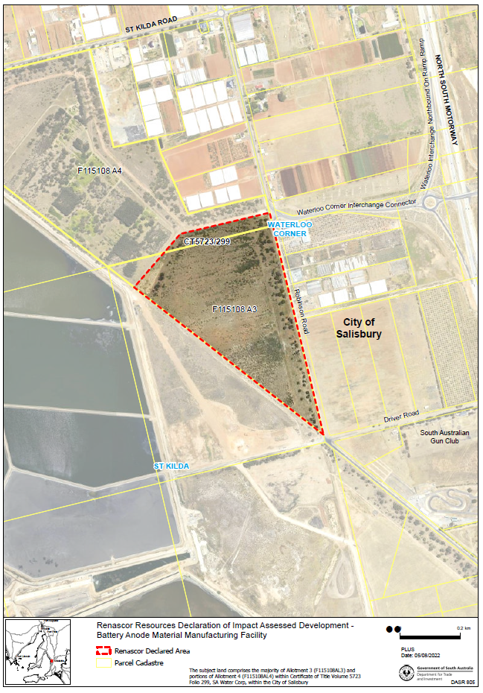
(b) Portion of the land comprised in Certificate of Title Volume 5723 Folio 299 (allotment 4 in Filed Plan 115108) located at 9 Bolivar Interchange Connector Road.
Dated: 17 November 2022
Hon Andrea Michaels MP
Delegate of the Minister for Planning

Planning, Development and Infrastructure Act 2016
Section 76
Amendment to the Planning and Design Code
Preamble
It is necessary to amend the Planning and Design Code (the Code) in operation at 24 November 2022 (Version 2022.22) in order to make changes of form relating to the Code’s spatial layers and their relationship with land parcels. NOTE: There are no changes to the application of zone, subzone or overlay boundaries and their relationship with affected parcels or the intent of policy application as a result of this amendment.
- PURSUANT to section 76 of the Planning, Development and Infrastructure Act 2016 (the Act), I hereby amend the Code in order to make changes of form (without altering the effect of underlying policy), correct errors and make operational amendments as follows:
- Undertake minor alterations to the geometry of the spatial layers and data in the Code to maintain the current relationship between the parcel boundaries and Code data as a result of the following:
  - New plans of division deposited in the Land Titles Office between 16 November 2022 and 29 November 2022 affecting the following spatial and data layers in the Code:
    - Zones and subzones
    - Technical and Numeric Variations
      - Building Heights (Levels)
      - Building Heights (Metres)
      - Concept Plan
      - Gradient Minimum Frontage
      - Gradient Minimum Site Area
      - Interface Height
      - Minimum Primary Street Setback
      - Minimum Side Boundary Setback
      - Future Local Road Widening Setback
      - Minimum Frontage
      - Minimum Site Area
    - Overlays
      - Affordable Housing
      - Dwelling Excision
      - Environment and Food Production Area
      - Future Local Road Widening
      - Future Road Widening
      - Hazards (Bushfire - High Risk)
      - Hazards (Bushfire - Medium Risk)
      - Hazards (Bushfire - General Risk)
      - Hazards (Bushfire - Urban Interface)
      - Hazards (Bushfire - Regional)
      - Hazards (Bushfire - Outback)
      - Heritage Adjacency
      - Interface Management
      - Limited Land Division
      - Local Heritage Place
      - Noise and Air Emissions
      - Significant Landscape Protection
      - State Heritage Place
      - Stormwater Management
      - Urban Tree Canopy
  - Improved spatial data for existing land parcels in the following locations (as described in Column A) that affect data layers in the Code (as shown in Column B):
Location (Column A) | Layers (Column B)
Meribah  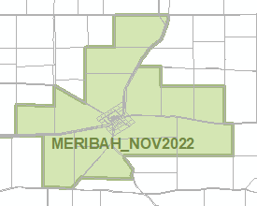 | Zones  Technical and Numeric Variations  - Minimum Dwelling Allotment Size  - Minimum Site Area  Overlays  - Dwelling Excision
Moculta  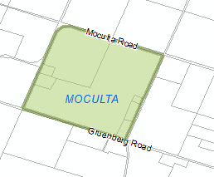 | Overlays  - Heritage Adjacency  - Local Heritage Place  - State Heritage Place
Mount Burr  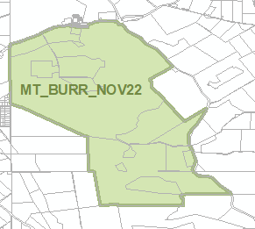 | Overlays  - Key Outback and Rural Routes
- In Part 13 of the Code – Table of Amendments, update the publication date, Code version number, amendment type and summary of amendments within the ‘Table of Planning and Design Code Amendments’ to reflect the amendments to the Code as described in this Notice.
- PURSUANT to section 76(5)(a) of the Act, I further specify that the amendments to the Code as described in this Notice will take effect upon the date those amendments are published on the SA planning portal.
Dated: 5 December 2022
Greg Van Gaans
Director, Land and Built Environment
Department for Trade and Investment
Delegate of the Minister for Planning

Planning, Development and Infrastructure Act 2016
Section 76
Amendment to the Planning and Design Code
Preamble
It is necessary to amend the Planning and Design Code (the Code) in operation at 24 November 2022 (Version 2022.22) in order to make changes:
• to correct errors in relation to the misapplication of the Local Heritage Place Overlay at Middleton, Old Noarlunga, North Adelaide and Walkerville.
1. PURSUANT to Section 76 of the Planning, Development and Infrastructure Act 2016 (the Act), I hereby amend the Code in order to make the following minor or operational amendments as follows:
(a) Amend the spatial layer of the Local Heritage Place Overlay so that it does not apply to the following properties:
(i) 5 Mill Terrace, Middleton (Lot 139, CT5467/369)
(ii) 8 Water Street, Old Noarlunga (Lot 1, CT5243/840)
(iii) Unit 2, 40 Warwick Street, Walkerville (S1405 Unit 2, CT5053/954)
and make corresponding spatial adjustment to the Heritage Adjacency Overlay to reflect this change.
(b) In Part 11 of the Code, in the section applicable to ‘Alexandrina’ delete the following row in the Table of Local Heritage Places:
5 Mill Street, MIDDLETON | Residence: The external form, materials and detailing of the front and side facades of the original dwelling. | a d | 14795
(c) Amend the spatial layer of the Local Heritage Place Overlay at North Adelaide so that it does not apply to the land bounded by the red line in Attachment A and make corresponding spatial adjustment to the Heritage Adjacency Overlay to reflect this change.
(d) In Part 13 of the Code—Table of Amendments, update the publication date, Code version number, amendment type and summary of amendments within the ‘Table of Planning and Design Code Amendments’ to reflect the amendments to the Code as described in this Notice.
2. PURSUANT to Section 76(5)(a) of the Act, I further specify that the amendments to the Code as described in this Notice will take effect upon the date those amendments are published on the SA planning portal.
Dated: 6 December 2022
Sally Smith
Executive Director, Planning and Land Use Services
Department for Trade and Investment
Delegate of the Minister for Planning

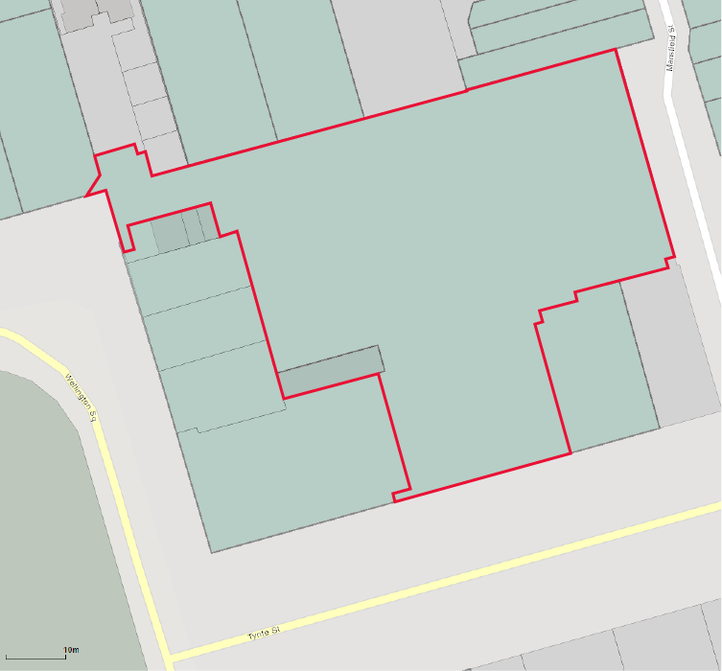
Attachment A

Proof of Sunrise and Sunset Act 1923
Almanac for January, February, March 2023
Pursuant to the requirements of the Proof of Sunrise and Sunset Act 1923, I Jon William Whelan, Chief Executive, Department for Infrastructure and Transport, at the direction of the Minister for Infrastructure and Transport, publish in the Schedule hereto an almanac setting out the times of sunrise and sunset on every day for the three calendar months January, February and March 2023.
Dated: 1 December 2022
Jon William Whelan
Chief Executive, Department for Infrastructure and Transport

Schedule
Sunrise and Sunset Times for Adelaide 2023
Latitude: South 34° 56′ Longitude: East 138° 36′
GMT+9.50 hours (Daylight saving GMT+l0.5 hours)
 | January |  |  |  |  |  | February |  |  |  |  |  | March
 | Rise |  |  | Set |  |  | Rise |  |  | Set |  |  | Rise |  |  | Set
Date | hr | min |  | hr | min |  | hr | min |  | hr | min |  | hr | min |  | hr | min
1 | 06 | 05 |  | 20 | 33 |  | 06 | 34 |  | 20 | 23 |  | 07 | 02 |  | 19 | 54
2 | 06 | 06 |  | 20 | 33 |  | 06 | 35 |  | 20 | 22 |  | 07 | 03 |  | 19 | 52
3 | 06 | 06 |  | 20 | 33 |  | 06 | 36 |  | 20 | 22 |  | 07 | 04 |  | 19 | 51
4 | 06 | 07 |  | 20 | 33 |  | 06 | 38 |  | 20 | 21 |  | 07 | 05 |  | 19 | 50
5 | 06 | 08 |  | 20 | 33 |  | 06 | 39 |  | 20 | 20 |  | 07 | 05 |  | 19 | 48
6 | 06 | 09 |  | 20 | 33 |  | 06 | 40 |  | 20 | 19 |  | 07 | 06 |  | 19 | 47
7 | 06 | 10 |  | 20 | 33 |  | 06 | 41 |  | 20 | 18 |  | 07 | 07 |  | 19 | 46
8 | 06 | 11 |  | 20 | 33 |  | 06 | 42 |  | 20 | 17 |  | 07 | 08 |  | 19 | 44
9 | 06 | 11 |  | 20 | 33 |  | 06 | 43 |  | 20 | 16 |  | 07 | 09 |  | 19 | 43
10 | 06 | 12 |  | 20 | 33 |  | 06 | 44 |  | 20 | 15 |  | 07 | 10 |  | 19 | 42
11 | 06 | 13 |  | 20 | 33 |  | 06 | 45 |  | 20 | 14 |  | 07 | 11 |  | 19 | 40
12 | 06 | 14 |  | 20 | 33 |  | 06 | 46 |  | 20 | 13 |  | 07 | 11 |  | 19 | 39
13 | 06 | 15 |  | 20 | 33 |  | 06 | 47 |  | 20 | 12 |  | 07 | 12 |  | 19 | 38
14 | 06 | 16 |  | 20 | 32 |  | 06 | 48 |  | 20 | 11 |  | 07 | 13 |  | 19 | 36
15 | 06 | 17 |  | 20 | 32 |  | 06 | 49 |  | 20 | 10 |  | 07 | 14 |  | 19 | 35
16 | 06 | 18 |  | 20 | 32 |  | 06 | 50 |  | 20 | 09 |  | 07 | 15 |  | 19 | 33
17 | 06 | 19 |  | 20 | 31 |  | 06 | 51 |  | 20 | 08 |  | 07 | 16 |  | 19 | 32
18 | 06 | 20 |  | 20 | 31 |  | 06 | 52 |  | 20 | 07 |  | 07 | 16 |  | 19 | 31
19 | 06 | 21 |  | 20 | 31 |  | 06 | 53 |  | 20 | 06 |  | 07 | 17 |  | 19 | 29
20 | 06 | 22 |  | 20 | 30 |  | 06 | 54 |  | 20 | 05 |  | 07 | 18 |  | 19 | 28
21 | 06 | 23 |  | 20 | 30 |  | 06 | 54 |  | 20 | 03 |  | 07 | 19 |  | 19 | 26
22 | 06 | 24 |  | 20 | 29 |  | 06 | 55 |  | 20 | 02 |  | 07 | 20 |  | 19 | 25
23 | 06 | 25 |  | 20 | 29 |  | 06 | 56 |  | 20 | 01 |  | 07 | 21 |  | 19 | 24
24 | 06 | 26 |  | 20 | 28 |  | 06 | 57 |  | 20 | 00 |  | 07 | 21 |  | 19 | 22
25 | 06 | 27 |  | 20 | 28 |  | 06 | 58 |  | 19 | 59 |  | 07 | 22 |  | 19 | 21
26 | 06 | 28 |  | 20 | 27 |  | 06 | 59 |  | 19 | 57 |  | 07 | 23 |  | 19 | 19
27 | 06 | 29 |  | 20 | 27 |  | 07 | 00 |  | 19 | 56 |  | 07 | 24 |  | 19 | 18
28 | 06 | 30 |  | 20 | 26 |  | 07 | 01 |  | 19 | 55 |  | 07 | 25 |  | 19 | 17
29 | 06 | 31 |  | 20 | 25 |  |  |  |  |  |  |  | 07 | 25 |  | 19 | 15
30 | 06 | 32 |  | 20 | 25 |  |  |  |  |  |  |  | 07 | 26 |  | 19 | 14
31 | 06 | 33 |  | 20 | 24 |  |  |  |  |  |  |  | 07 | 27 |  | 19 | 12
*NOTE: Daylight Saving Time is subject to change.
Sunrise and Sunset times calculated on 11/11/22. Certified correct: G. Papanikolas, 29 November 2022

Local Government Instruments

CAMPBELLTOWN CITY COUNCIL
Place Naming—Tuku Wirra
Notice is hereby given that at its meeting held 19 April 2022, pursuant to Section 219 of the Local Government Act 1999, the Campbelltown City Council adopted the name Tuku Wirra for combined Church Street Reserve and King George Reserve, comprising of Allotment 44, Section 341, Deposited Plan 32447, Volume 5518, Folio 987 and Allotment 17, Deposited Plan 28348, Volume 5373, Folio 225. The aforementioned Reserve is located off Koongara Court and Church Street, Magill.
Dated: 30 November 2022
P. Di Iulio
Chief Executive Officer

CITY OF MARION
Local Government Act 1999
Classification of Community Land
Notice is hereby given that the Corporation of the City of Marion, at its meeting held on 14 September 2021, resolved that following the land division of Kenton Avenue Reserve and the new title being issued being Allotment 301 in Deposited Plan 130441 contained in Certificate of Title Volume 6279 Folio 67, its Community Land Classification was to be reinstated pursuant to Section 193(5) of the Local Government Act 1999. This notice reinstates the community land status of Kenton Avenue Reserve.
Dated: 8 December 2022
T. Harrison
Chief Executive Officer

Mid Murray Council
Liquor Licensing (Dry Areas) Notice 2022
Under Section 131(1ab) of the Liquor Licensing Act 1997
1—Short title
This notice may be cited as the Liquor Licensing (Dry Areas) Notice 2022.
2—Commencement
This notice comes into operation on 31 December 2022.
3—Interpretation
(1) In this notice—
principal notice means the Liquor Licensing (Dry Areas) Notice 2017 published in the Gazette on 17.10.17, as in force from time to time.
(2) Clause 3 of the principal notice applies to this notice as if it were the principal notice.
4—Consumption etc of liquor prohibited in dry areas
(1) Pursuant to Section 131 of the Act, the consumption and possession of liquor in the area described in the Schedule is prohibited in accordance with the provisions of the Schedule.
(2) The prohibition has effect during the periods specified in the Schedule.
(3) The prohibition does not extend to private land in the area described in the Schedule.
(4) Unless the contrary intention appears, the prohibition of the possession of liquor in the area does not extend to—
(a) a person who is genuinely passing through the area if—
(i) the liquor is in the original container in which it was purchased from licensed premises; and
(ii) the contained has not been opened; or
(b) a person who has possession of the liquor in the course of carrying on a business or in the course of his or her employment by another person in the course of carrying on a business; or
(c) a person who is permanently or temporarily residing at premises within the area or on the boundary of the area and who enters the area solely for the purpose of passing through it to enter those premises or who enters the area from those premises for the purpose of leaving the area
(5) The Schedule is in addition to Schedule—Mannum Area 2, Mannum Area 3, Mannum Area 4 and Mannum Area 5 in the principal notice.

Schedule—Cadell Area 1
1—Extent of prohibition
The consumption of liquor is prohibited and the possession of liquor is prohibited.
2—Period of prohibition
From 4:00pm on 31 December 2022 to 9:00am on 1 January 2023.
3—Description of area
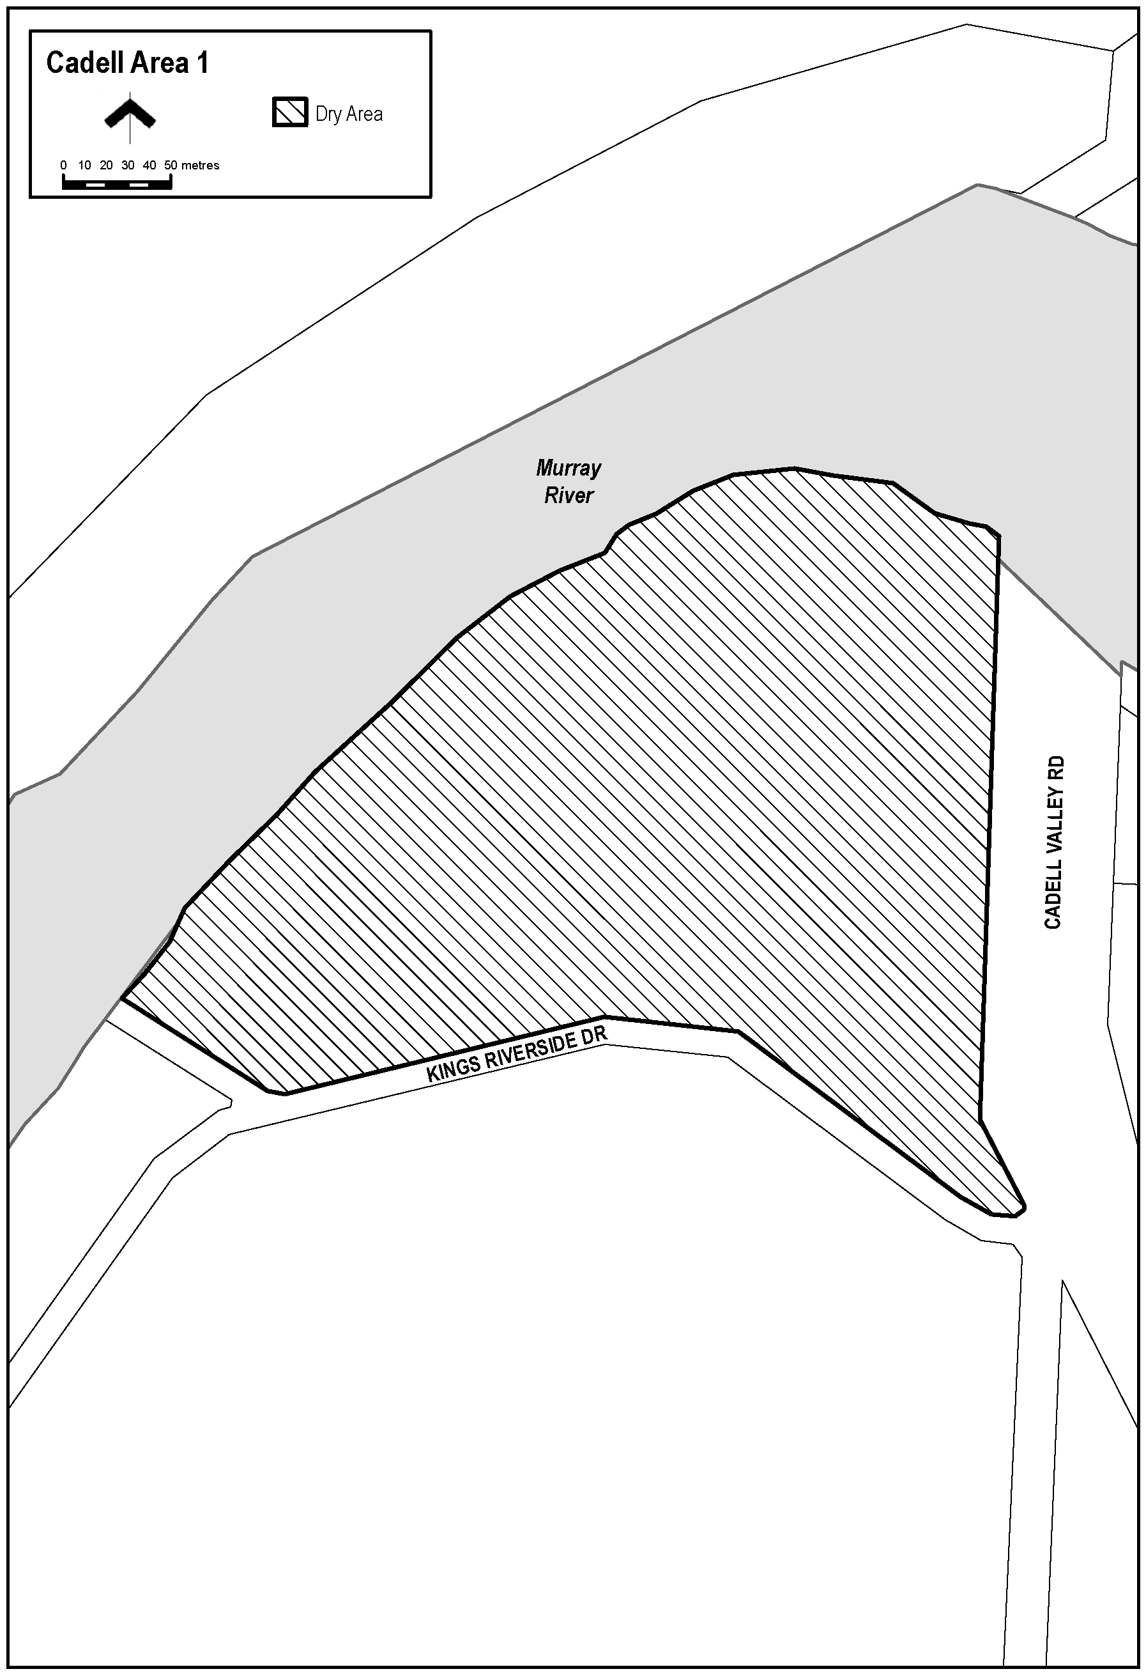
The area adjacent to and to the north of the town of Cadell, being the whole of the land comprised in Piece 14 DP75804 (approximately the area bounded on the north-west and north-east by the River Murray, on the east by the Cadell Valley Road and on the south by the portion of Kings Riverside Drive that runs generally east-west and the access road from that portion of Kings Riverside Drive to a boat ramp on the eastern bank of the River Murray).

Schedule—Morgan Area 1
1—Extent of prohibition
The consumption of liquor is prohibited and the possession of liquor is prohibited.
2—Period of prohibition
From 4:00pm on 31 December 2022 to 9:00am on 1 January 2023.
3—Description of area
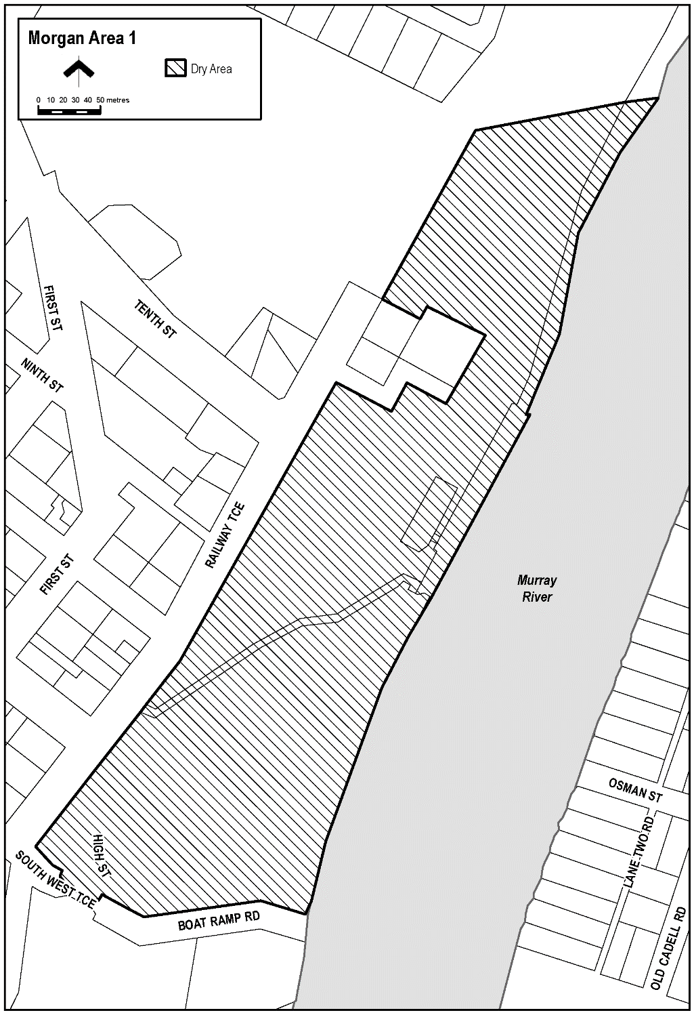
The area in Morgan bounded as follows: commencing at the point at which the prolongation in a straight line of the southern boundary of Section 432, Hundred of Eba intersects the waterline on the north-western side of the River Murray, then generally north-westerly, westerly and north-westerly along that prolongation and boundary of Section 432 so the south-eastern boundary of Railway Terrace, then generally north-easterly along that south-eastern boundary of Railway Terrace to the point at which it meets the northern corner of Section 484, Hundred of Eba, then generally north-easterly along the north-western boundary of Section 433, Hundred of Eba to the northernmost boundary of Section 429, Hundred of Eba, then north-easterly along that boundary of Section 429 and the prolongation in a straight line of that boundary to the waterline on the north-western side of the River Murray, then generally south-westerly along the waterline of the River to the point of commencement, but excluding Section 483, 484 and 485, Hundred of Eba.

Schedule—Mannum Area 2
1—Extent of prohibition
The consumption of liquor is prohibited and the possession of liquor is prohibited.
2—Period of prohibition
From 6:00pm to 11:00pm on 31 December 2022.
3—Description of area
Anna Street between Randell Street and William Street.
The stairway (generally known as “the Golden Stairs”) between Anna Street and Randell Street, adjacent to Shearer’s Carpark.
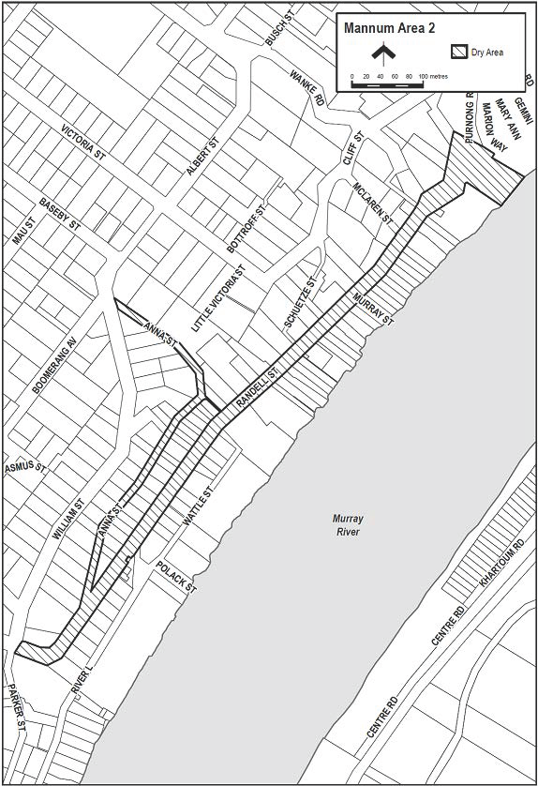
Randell Street (and Purnong Road) between William Street and River Road.

Schedule—Mannum Area 3
1—Extent of prohibition
The consumption of liquor is prohibited and the possession of liquor is prohibited.
2—Period of prohibition
From 6:00pm to 11:00pm on 31 December 2022.
3—Description of area
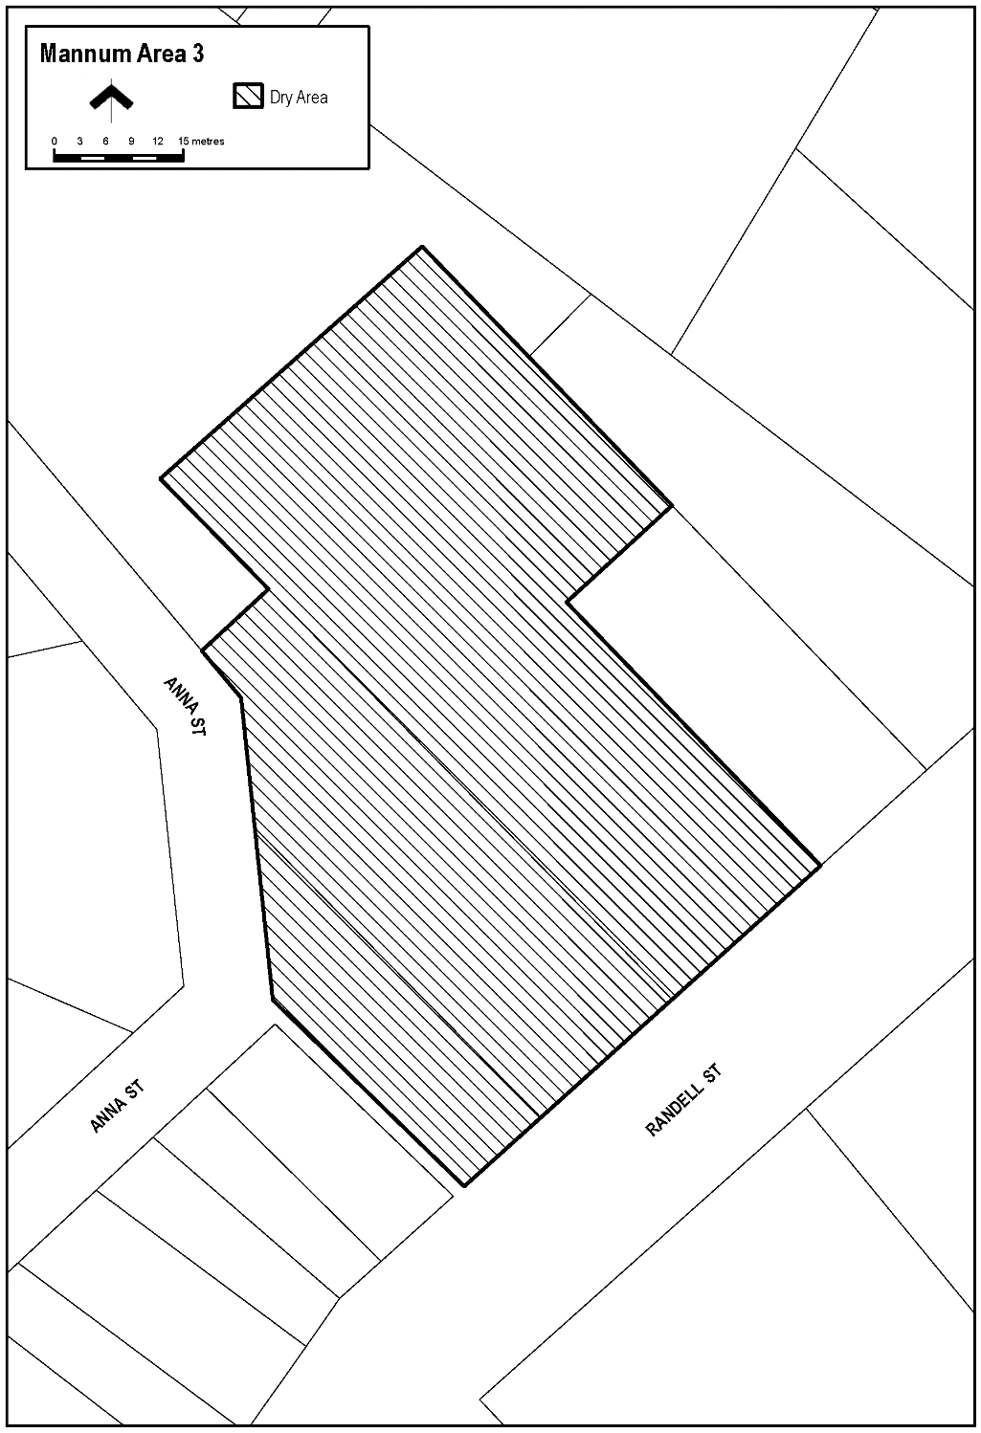
The car park in Mannum (generally known as Shearer’s Carpark) situated between Randell Street and Anna Street, being Lots 33 and 34 DP1091, Hundred of Finniss and Lot 435 FP208811, Hundred of Finniss.

Schedule—Mannum Area 4
1—Extent of prohibition
The consumption of liquor is prohibited and the possession of liquor is prohibited.
2—Period of prohibition
From 6:00pm to 11:00pm on 31 December 2022.
3—Description of area
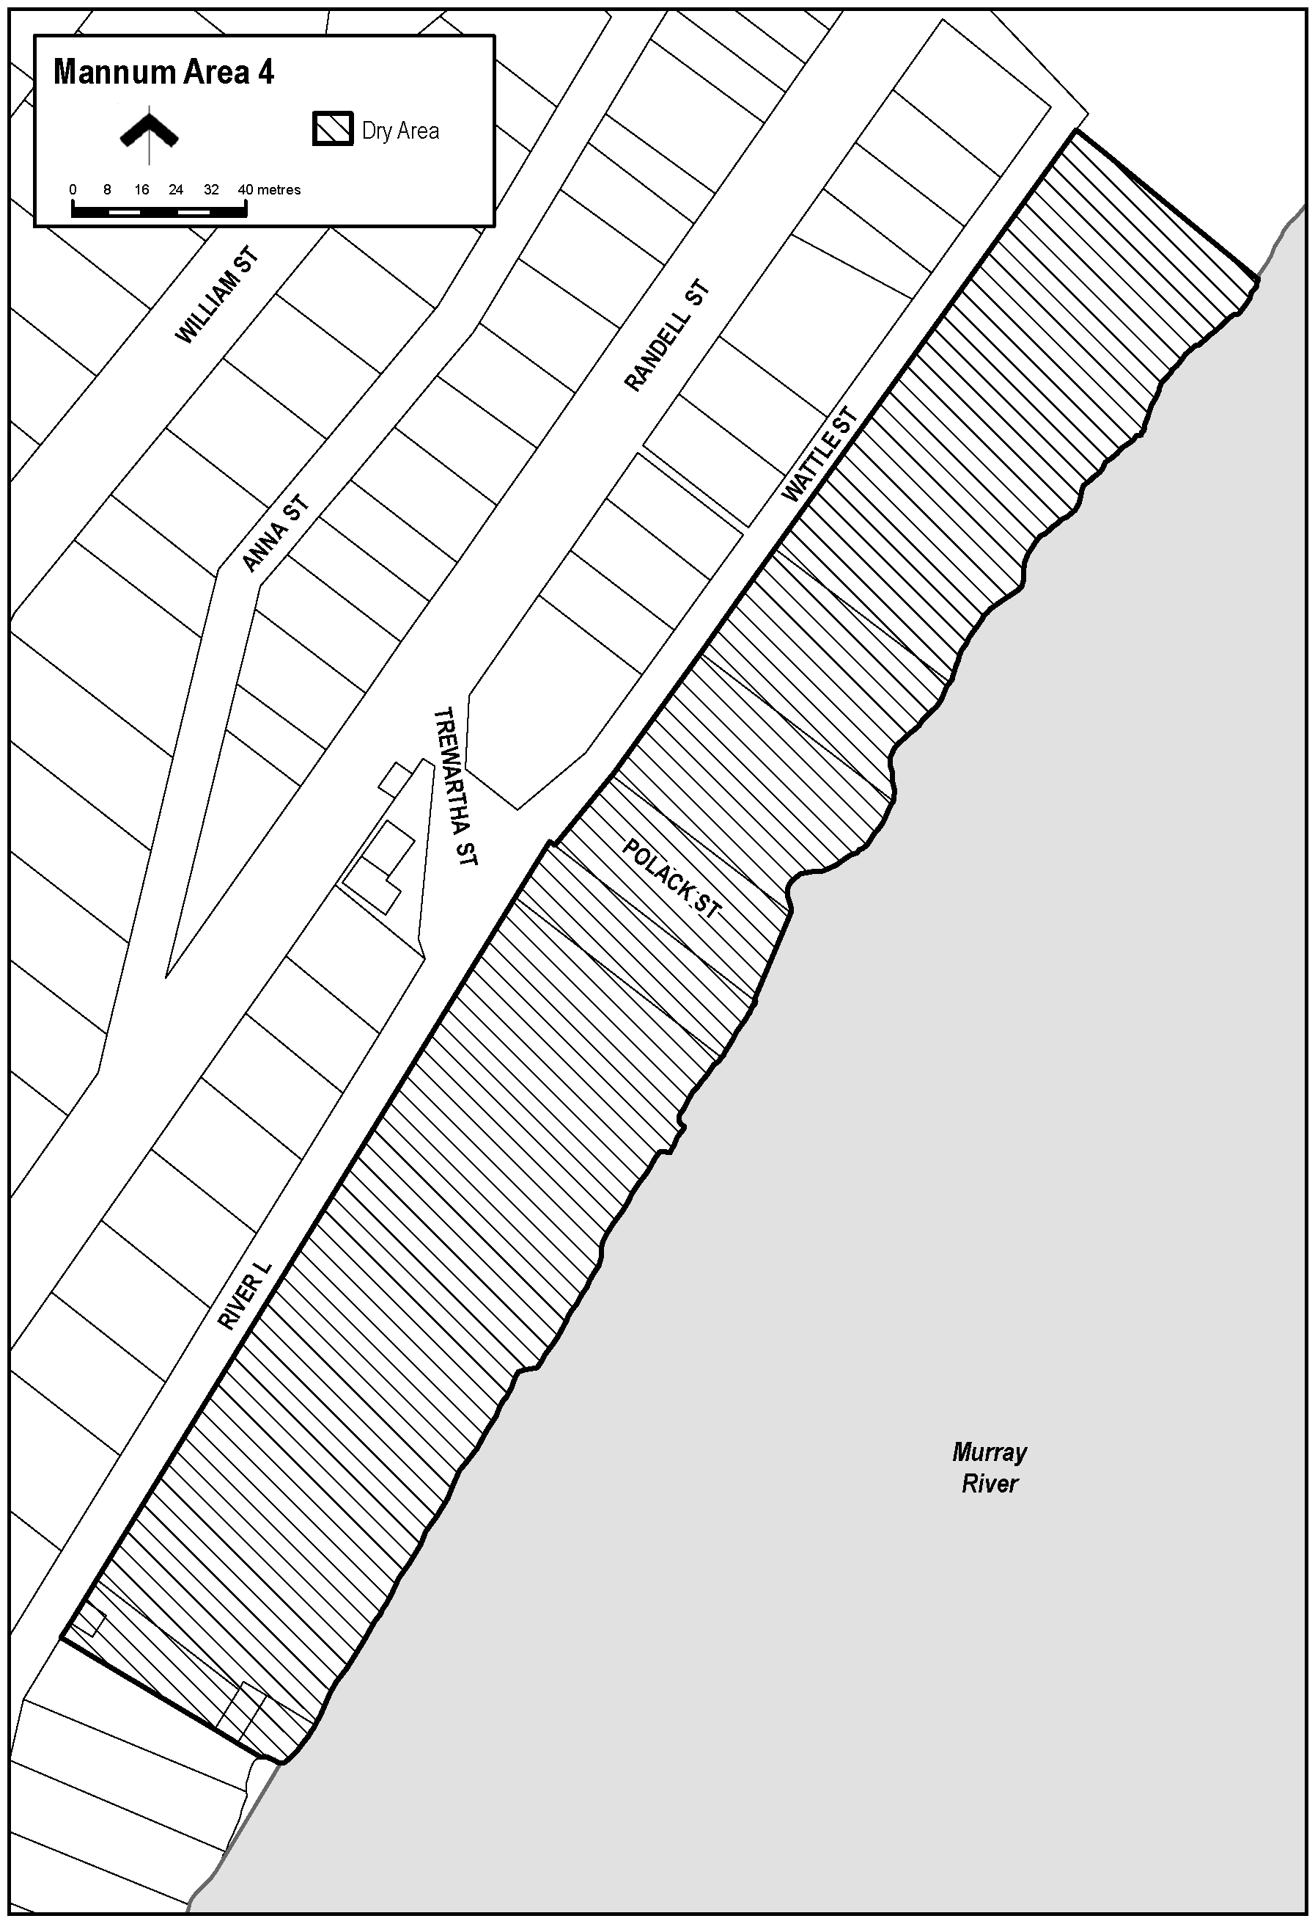
The area in Mannum known as Mary Ann Reserve (together with abutting land and structures), being the area bounded on the north-east by the south-west boundary of Lot 10 FP21817 (Bowling Green), on the north-west by River Lane, on the south-west by the north-eastern boundary of Certificate of Title Volume 5799 Folio 318 (24 River Lane) and on the south-east by the River Murray, together with the whole of any wharf, jetty, boat ramp or other structure projecting from that area into the River.

Schedule—Mannum Area 5
1—Extent of prohibition
The consumption of liquor is prohibited and the possession of liquor is prohibited.
2—Period of prohibition
From 6:00pm to 11:00pm on 31 December 2022.
3—Description of area
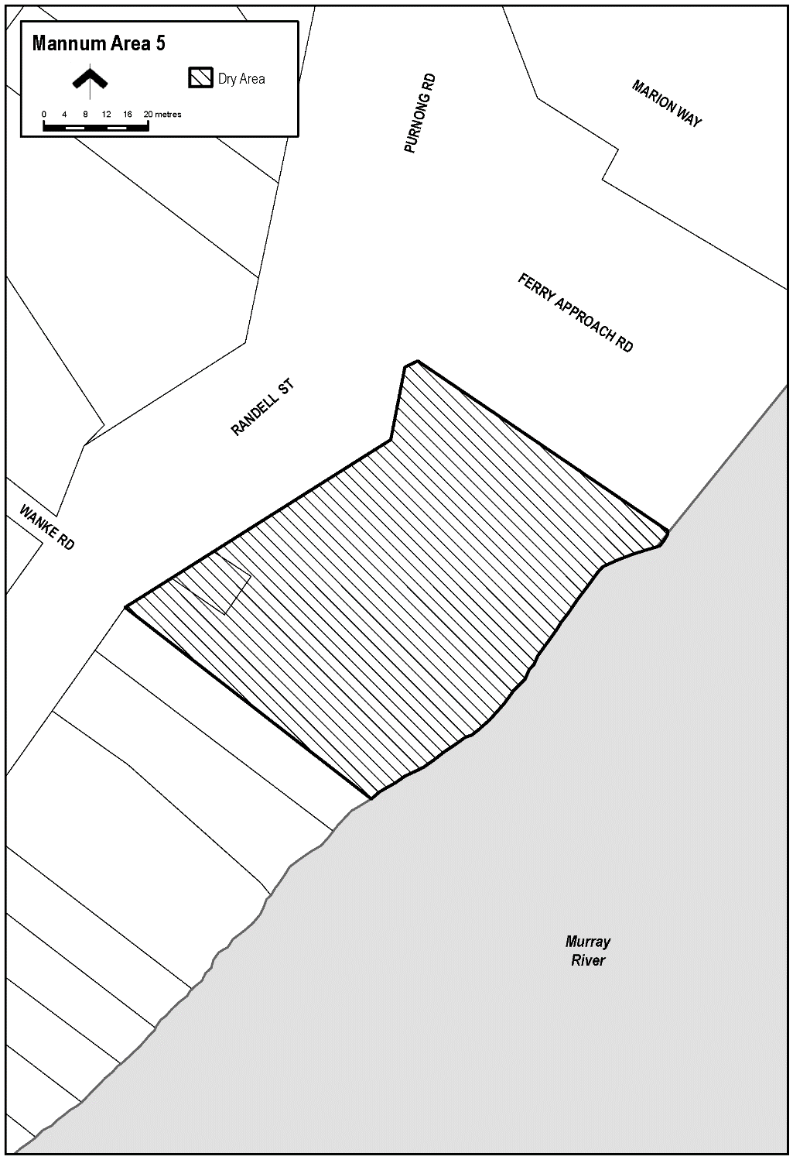
The area in Mannum known as Arnold Park, situated between Randell Street and the River Murray adjacent to the south-western boundary of River Road, being Lot 93 FP213066, Hundred of Finniss.

Schedule—Mannum Area 6
1—Extent of prohibition
The consumption of liquor is prohibited and the possession of liquor is prohibited.
2—Period of prohibition
From 6:00pm on 31 December 2022 to 8:00am on 1 January 2023.
3—Description of area
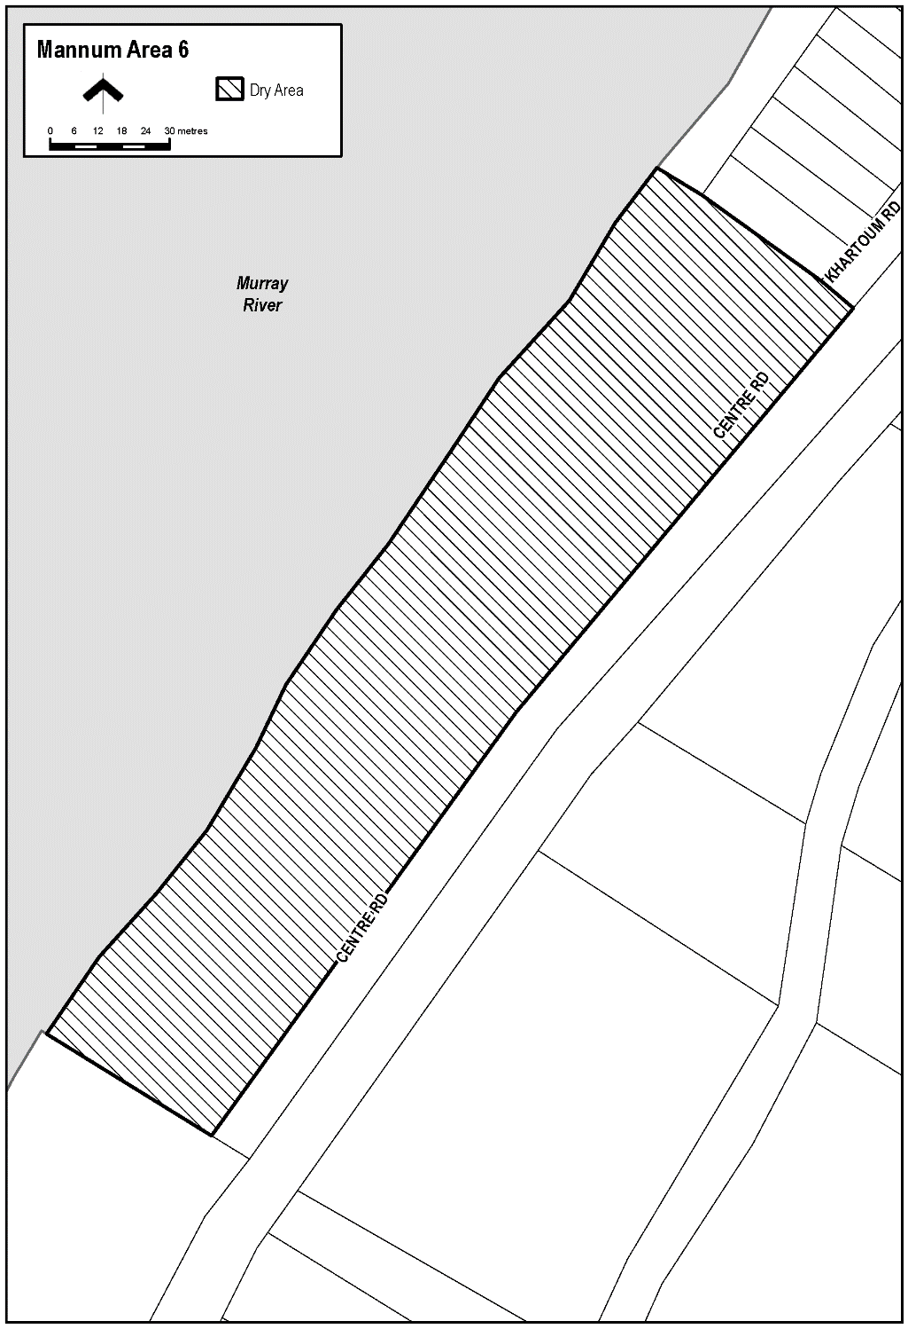
The area adjacent Mannum, generally known as Bolto Reserve, bounded on the south-east by the north-western boundary of Section 909, Hundred of Younghusband, on the south-west by the north-eastern boundary of Section 914, Hundred of Younghusband, on the north-west by the River Murray and on the north-east by the south-western boundary of Lot 94 DP49431 and the prolongation in a straight line north-westerly and south-easterly of that boundary.

Schedule—Mannum Area 7
1—Extent of prohibition
The consumption of liquor is prohibited and the possession of liquor is prohibited.
2—Period of prohibition
From 6:00pm on 31 December 2022 to 8:00am on 1 January 2023.
3—Description of area
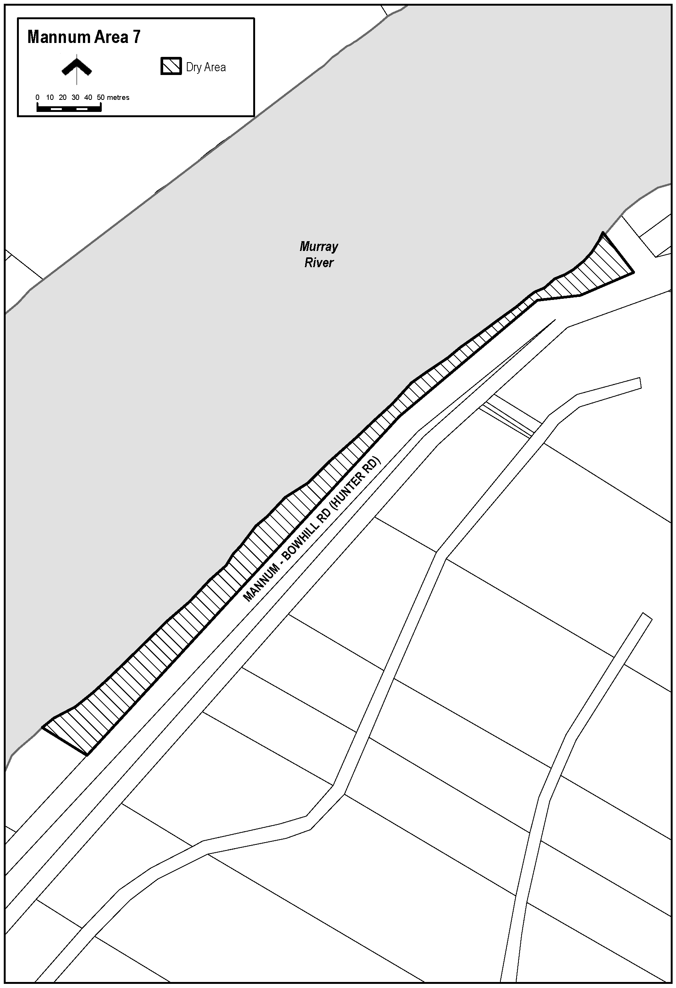
The area adjacent Mannum, generally known as Haythorpe Reserve, bounded on the south-east by the north-western boundary of the carriageway of Hunter Road, on the south-west by the south-western boundary of Section 727, Hundred of Younghusband and the prolongation in a straight line south-easterly and north-westerly of that boundary, on the north-west by the River Murray and on the north-east by the south-western boundary of Section 397, Hundred of Younghusband and the prolongation in a straight line north-westerly and south-easterly of that boundary.

Dated: 8 December 2022
Ben Scales
Chief Executive Officer

Northern Areas Council
Resignation of Councillor
Notice is hereby given in accordance with Section 54(6) of the Local Government Act 1999 that a vacancy has occurred in the office of Councillor for Broughton Ward of the Northern Areas Council, due to the resignation of Councillor Ben Browne, effective November 25 2022.
Dated: 8 December 2022
Pete Ward
Acting Chief Executive Officer

Public Notices

National Electricity Law
Initiation of Rule Change Request
The Australian Energy Market Commission (AEMC) gives notice under s 95 of the National Electricity Law as follows:
The Australian Energy Market Operator has requested the AEMC to make a rule on Unlocking CER benefits through flexible trading (Ref. ERC0346). We invite written submissions on the proposed rule by 16 February 2023.
Submissions can be made via the AEMC’s website. Before making a submission, please review the AEMC’s privacy statement on its website, and consider the AEMC’s Tips for making a submission. The AEMC publishes all submissions on its website, subject to confidentiality.
Documents referred to above are available on the AEMC’s website and are available for inspection at the AEMC’s office.
Australian Energy Market Commission
Level 15, 60 Castlereagh St
Sydney NSW 2000
Telephone: (02) 8296 7800
www.aemc.gov.au
Dated: 8 December 2022

National Energy Retail Law
Initiation of Rule Change Request
The Australian Energy Market Commission (AEMC) gives notice under s 251 of the National Energy Retail Law as follows:
The Australian Energy Market Operator has requested the AEMC to make a rule on Unlocking CER benefits through flexible trading (Ref. RRC0045). We invite written submissions on the proposed rule by 16 February 2023.
Submissions can be made via the AEMC’s website. Before making a submission, please review the AEMC’s privacy statement on its website, and consider the AEMC’s Tips for making a submission. The AEMC publishes all submissions on its website, subject to confidentiality.
Documents referred to above are available on the AEMC’s website and are available for inspection at the AEMC’s office.
Australian Energy Market Commission
Level 15, 60 Castlereagh St
Sydney NSW 2000
Telephone: (02) 8296 7800
www.aemc.gov.au
Dated: 8 December 2022

Partnership Act 1891
Dissolution of Partnership
Notice is hereby given that the partnership between KYLIE JANNE MARTENS & KYM JAMES MARTENS as trustees for the MARTENS INVESTMENT TRUST and ADRIAN BLAIR CROSS as trustee for the SIANN INVESTMENT TRUST ABN 32 269 872 400, the business of which traded in part under the name ‘The Siann Investment Trust & The Martens Investment Trust’ was dissolved effective 1 December 2022.
Dated: 1 December 2022
Kylie Janne Martens
as trustee for the Martens Investment Trust
Kym James Martens
as trustee for the Martens Investment Trust
Adrian Blair Cross
as trustee for the Siann Investments Trust

Trustee Act 1936
Public Trustee
Estates of Deceased Persons
In the matter of the estates of the undermentioned deceased persons:
BRANDENBURG John William late of 6A Dianne Street Klemzig Retired Engineer who died 27 September 2021
COOK Raymond John late of 31 Shirley Avenue Felixstow Retired Process Worker who died 21 May 2022
COOKSON Gathorne George late of 118 Yarrabee Road Greenhill Of no occupation who died 10 March 2022
COURT John Raymond late of 24 Wilcher Street Port Pirie West Retired Plant Operator who died 25 June 2022
FIRMINGER Mary Angeles late of 70 Gladstone Avenue Kilburn Retired Registered Nurse who died 21 February 2022
FISCHER Christina late of 80 Moseley Street Glenelg South Of no occupation who died 1 July 2022
KLIMACEK Paulina late of 95-97 Awoonga Road Hope Valley Retired Secretary who died 13 May 2022
KOELMAN Hillechien Wilhelmina late of 25 Roopena Street Ingle Farm Retired Machinist who died 8 May 2022
LOCKWOOD William Peter late of 2-10 First Street Brompton Retired Fisherman who died 16 April 2022
LOVEGROVE Edward Keith late of 43 North Street Henley Beach Retired Painter and Decorator who died 22 June 2022
MCNAMARA Iris Mary late of 52 Dunrobin Road Hove Of no occupation who died 22 August 2022
OBST Malcolm Edmund late of 58 Chief Street Brompton Retired Baker who died 26 August 2022
PERKS Steven James late of 4 Calthorpe Terrace Ottoway Computer Engineer who died 10 July 2022
REDEMSKI Keith Stanley late of 6 Webb Street Clare Of no occupation who died 2 April 2022
SIMPSON Colleen Eva late of 29 Austral Terrace Morphettville Of no occupation who died 26 April 2022
WATSON Ronald Patrick late of 117 Dalmeny Street Algester Queensland Retired Real Estate Office Proprietor who died 25 August 2022
Notice is hereby given pursuant to the Trustee Act 1936, the Inheritance (Family Provision) Act 1972 and the Family Relationships Act 1975 that all creditors, beneficiaries, and other persons having claims against the said estates are required to send, in writing, to the office of Public Trustee at GPO Box 1338, Adelaide 5001, full particulars and proof of such claims, on or before the 6 January 2023 otherwise they will be excluded from the distribution of the said estate; and notice is also hereby given that all persons indebted to the said estates are required to pay the amount of their debts to the Public Trustee or proceedings will be taken for the recovery thereof; and all persons having any property belonging to the said estates are forthwith to deliver same to the Public Trustee.
Dated: 8 December 2022
N. S. Rantanen
Public Trustee

University of Adelaide Act 1971
Award Program Fee Rules
Council resolved to revoke the Academic Year Rules and approve the new Award Program Fee Rules set out below:
1. The matters in respect of which a fee is to be charged by the University, the categories of persons who are to pay them, the determination of the amounts to be charged, the time and manner of payment, extensions for payment and exemptions from payment may be determined in accordance with one or more University policies approved and published by the Vice-Chancellor from time to time.
2. For the purposes of these Rules and Statute 89, the Council approves and adopts any policies established in accordance with Rule 1.
3. A student shall be liable for any increase, or entitled to refund of any decrease, in the total fee that may arise through variation of enrolment during the year.
4. Council delegates to the Vice-Chancellor the authority to:
(a) grant an extension of time for the payment of fees or exempt any person from liability to pay any fee in whole or part on the grounds set out in the Statutes; and
(b) determine and approve such arrangements as the Vice-Chancellor may deem appropriate for the discharge of a student’s outstanding fees and all other financial obligations due to the University for the purposes of permitting a student’s re-enrolment in the University or admission to a degree, diploma or certificate of the University.
5. The Vice-Chancellor may further sub-delegate the authority referred to in Rule 4 above to another officer of the University and may approve administrative policies and procedures regulating the exercise of such delegation.
Approved by Council.
Dated: 5 December 2022
Andrew Lee
Director, Governance Services
Office of the Chancellor and Council Secretariat
The University of Adelaide

Notice Submission

The South Australian Government Gazette is published each Thursday afternoon.
Notices must be emailed by 4 p.m. Tuesday, the week of publication.
Submissions are formatted per the gazette style and a proof will be supplied prior to publication, along with a quote if applicable. Please allow one day for processing notices.
Alterations to the proof must be returned by 4 p.m. Wednesday.

Gazette notices must be submitted as Word files, in the following format:
• Title—the governing legislation
• Subtitle—a summary of the notice content
• Body—structured text, which can include numbered lists, tables, and images
• Date—day, month, and year of authorisation
• Signature block—name, role, and department/organisation authorising the notice

Please provide the following information in your email:
• Date of intended publication
• Contact details of the person responsible for the notice content
• Name and organisation to be charged for the publication—Local Council and Public notices only
• Purchase order, if required—Local Council and Public notices only

Email: governmentgazettesa@sa.gov.au
Phone: (08) 7109 7760
Website: www.governmentgazette.sa.gov.au

All instruments appearing in this gazette are to be considered official, and obeyed as such

Printed and published weekly by authority of C. McArdle, Government Printer, South Australia
$8.15 per issue (plus postage), $411.00 per annual subscription—GST inclusive
Online publications: www.governmentgazette.sa.gov.au

