SUPPLEMENTARY GAZETTE
THE SOUTH AUSTRALIAN
GOVERNMENT GAZETTE
Published by Authority

Adelaide, Wednesday, 28 December 2022

Contents

State Government Instruments

Road Traffic Act 1961 7032

State Government Instruments

Road Traffic Act 1961
South Australia
Road Traffic (Electric Personal Transporters) Notice No 6 2022
under section 161A of the Road Traffic Act 1961
1 Short title
This Notice may be cited as the Road Traffic (City of Adelaide Scooter Trial) Notice No 2 of 2022.
2 Operation and revocation
This Notice comes into operation on the day on which it is made and will cease operation on 30 June 2023. This Notice revokes the Road Traffic (City of Adelaide Scooter Trial) Notice 2022 of 31 October 2022.
3 Interpretation
In this Notice—
Act means the Road Traffic Act 1961;
Council means the Corporation of the City of Adelaide;
electric personal transporter has the same meaning as in the Road Traffic (Miscellaneous) Regulations 2014;
Minister means the Minister to whom the administration of the Act is committed;
path means a bicycle path, footpath, separated footpath or shared path.
4 Approval
In accordance with the power under section 161A of the Act, I hereby approve an electric personal transporter to be driven on or over a road.
5 Conditions
An electric personal transporter may only be driven:
- within the Council area designated in the Schedule to this Notice;
- on roads and paths not prohibited for use by Council;
- if supplied by an operator permitted by Council, or otherwise authorised or accredited;
- by a driver aged 18 years old or older;
- if the electric personal transporter meets the criteria in paragraphs (a) to (d) of the definition of scooter in rule 244A(1) of the Australian Road Rules;
- if the maximum speed of the electric personal transporter cannot exceed 15km/h;
- if the unladen mass of the electric personal transporter does not exceed 25kg.

6 Revocation
This Notice may be revoked by the Minister or his delegate at any time.
7 Execution
Dated: 23 December 2022
Hon Tom Koutsantonis MP
Minister for Infrastructure and Transport

Schedule
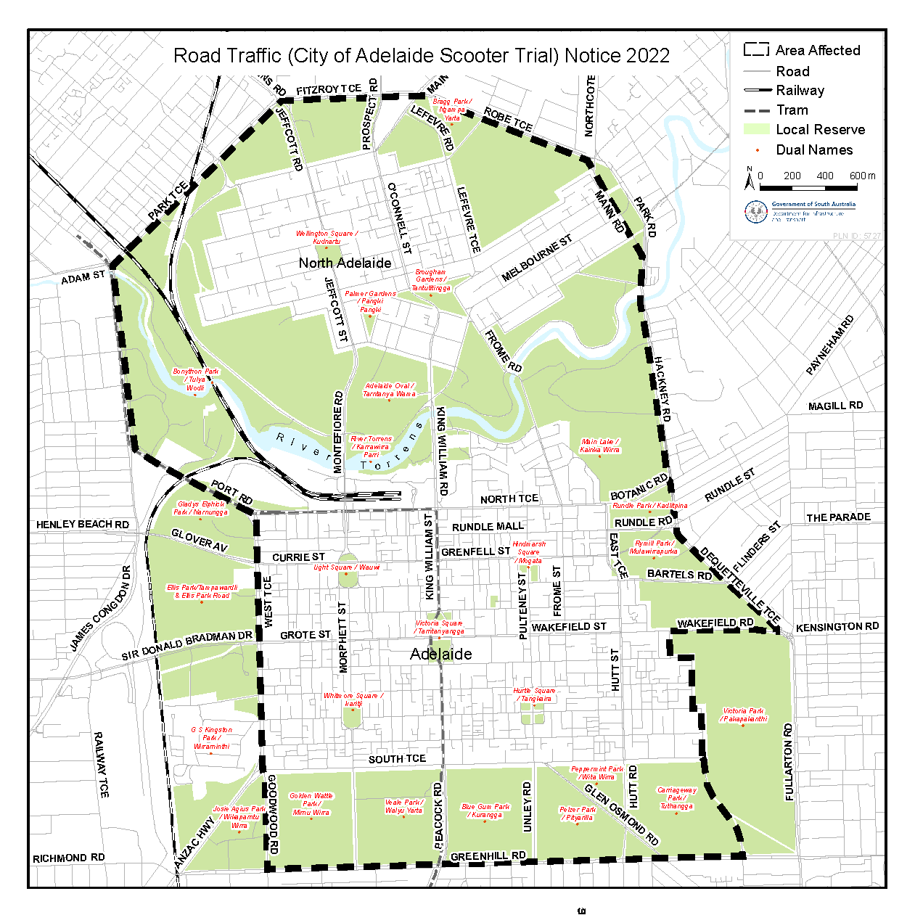

All instruments appearing in this gazette are to be considered official, and obeyed as such

Printed and published weekly by authority of C. McArdle, Government Printer, South Australia
$8.15 per issue (plus postage), $411.00 per annual subscription—GST inclusive
Online publications: www.governmentgazette.sa.gov.au

