No. 7 p. 189
THE SOUTH AUSTRALIAN
GOVERNMENT GAZETTE
Published by Authority

Adelaide, Thursday, 3 February 2022

Contents

Governor’s Instruments

Appointments 190

Emergency Management Act 2004 191

Proclamations—
Civil Liability (Designation of Minister)
Proclamation 2022 192
Statutes Amendment (Fund Selection and Other
Superannuation Matters) Act (Commencement) Proclamation 2022 193

Regulations—
Southern State Superannuation (Fund Selection and
Other Matters) Amendment Regulations 2022—
No. 7 of 2022 194
Child Safety (Prohibited Persons) Amendment
Regulations 2022—No. 8 of 2022 216
Youth Justice Administration Amendment
Regulations 2022—No. 9 of 2022 218

State Government Instruments

Adelaide Park Lands Act 2005 220

Environment Protection Act 1993 220
Housing Improvement Act 2016 224

Justices of the Peace Act 2005 224

Land Acquisition Act 1969 224

Landscape South Australia Act 2019 226

Mental Health Act 2009 226

Mining Act 1971 226

Pastoral Land Management and Conservation Act 1989 228

Planning, Development and Infrastructure Act 2016 229

Roads (Opening and Closing) Act 1991 230

South Australian Employment Tribunal Act 2014 230

Survey Act 1992 269

Local Government Instruments

City of Charles Sturt 272

City of West Torrens 272

Public Notices

Electoral Act 1985 273

National Electricity Law 324

Trustee Act 1936 324

Unclaimed Moneys Act 1891 324

Governor’s Instruments

APPOINTMENTS
Department of the Premier and Cabinet
Adelaide, 3 February 2022
Her Excellency the Governor in Executive Council has been pleased to appoint the undermentioned to the Carrick Hill Trust, pursuant to the provisions of the Carrick Hill Trust Act 1985:
Member: from 3 February 2022 until 2 August 2022
Adriana Christopoulos
By command,
Steven Spence Marshall
Premier
DPC22/001CS

Department of the Premier and Cabinet
Adelaide, 3 February 2022
Her Excellency the Governor in Executive Council has been pleased to appoint the undermentioned to the South Australian Museum Board, pursuant to the provisions of the South Australian Museum Act 1976:
Member: from 7 February 2022 until 6 February 2025
Ermioni Ranieri
By command,
Steven Spence Marshall
Premier
DPC22/004CS

Department of the Premier and Cabinet
Adelaide, 3 February 2022
Her Excellency the Governor in Executive Council has been pleased to appoint Dr James Muecke AM as Governor's Deputy of South Australia for the period from 6:00am on Saturday, 5 February 2022 until 5:30pm on Saturday, 5 February 2022.
By command,
Steven Spence Marshall
Premier

Department of the Premier and Cabinet
Adelaide, 3 February 2022
Her Excellency the Governor in Executive Council has been pleased to appoint the people listed as Commissioners of the South Australian Employment Tribunal for the terms specified - pursuant to the provisions of the South Australian Employment Tribunal Act 2014.
Appointed on a full-time basis commencing on 17 June 2022 and expiring on 16 June 2025
Andrew Neale
Appointed on a part-time basis commencing on 17 June 2022 and expiring on 16 June 2025
Lucy Delia Marie Byrt
Jodie Marieka Carrel
Melinda Jean Doggett
Appointed on a part-time basis commencing on 11 July 2022 and expiring on 16 June 2025
Luisa Jane Georgeff
By command,
Steven Spence Marshall
Premier
T&F22-007CS

Emergency Management Act 2004
Section 23
Approval by the Governor of Extension of a Major Emergency Declaration
RECITAL
The State Co-ordinator declared a Major Emergency on 22 March 2020 under section 23(1) of the Emergency Management Act 2004 (the Act) in respect of the outbreak of the human disease named COVID-19 within South Australia (the Declaration).
With the advice and consent of the Executive Council and pursuant to section 23(2) of the Act, on the days and for the periods set out below, His Excellency the Governor approved an extension of the Declaration.
On 2 April 2020 for a period of 28 days to commence on 4 April 2020.
On 30 April 2020 for a period of 28 days to commence on 2 May 2020.
On 28 May 2020 for a period of 28 days to commence on 30 May 2020.
On 27 June 2020 for a period of 28 days to commence on 27 June 2020.
On 23 July 2020 for a period of 28 days to commence on 25 July 2020.
On 20 August 2020 for a period of 28 days to commence on 22 August 2020.
On 17 September 2020 for a period of 28 days to commence on 19 September 2020.
On 15 October 2020 for a period of 28 days to commence on 17 October 2020.
On 12 November 2020 for a period of 28 days to commence on 14 November 2020.
On 10 December 2020 for a period of 28 days to commence on 12 December 2020.
On 6 January 2021 for a period of 28 days to commence on 9 January 2021.
On 4 February 2021 for a period of 28 days to commence on 6 February 2021.
On 4 March 2021 for a period of 28 days to commence on 6 March 2021.
On 1 April 2021 for a period of 28 days to commence on 3 April 2021.
On 29 April 2021 for a period of 28 days to commence on 1 May 2021.
On 27 May 2021 for a period of 28 days to commence on 29 May 2021.
On 24 June 2021 for a period of 28 days to commence 26 June 2021.
On 22 July 2021 for a period of 28 days to commence 24 July 2021.
On 18 August 2021 for a period of 28 days to commence 21 August 2021.
With the advice and consent of the Executive Council and pursuant to section 23(2) of the Act, on the days and for the periods set out below, Her Excellency the Administrator approved an extension of the Declaration.
On 16 September 2021 for a period of 28 days to commence 18 September 2021.
With the advice and consent of the Executive Council and pursuant to section 23(2) of the Act, on the days and for the periods set out below, Her Excellency the Governor approved an extension of the Declaration.
On 14 October 2021 for a period of 28 days to commence 16 October 2021.
On 11 November 2021 for a period of 28 days to commence 13 November 2021.
On 9 December 2021 for a period of 28 days to commence 11 December 2021.
On 7 January 2022 for a period of 28 days to commence 8 January 2022.
PURSUANT to section 23(2) of the Act and with the advice and consent of the Executive Council, I NOW approve a further extension of the Declaration for a period of 28 days commencing on 5 February 2022.
Given under my hand and the Public Seal of South Australia at Adelaide on Thursday, 3 February 2022.
Frances Adamson AC
Governor

Proclamations
South Australia

Civil Liability (Designation of Minister) Proclamation 2022
under section 76 of the Civil Liability Act 1936
1—Short title
This proclamation may be cited as the Civil Liability (Designation of Minister) Proclamation 2022.
2—Commencement
This proclamation comes into operation on the day on which it is made.
3—Designation of Minister
In accordance with the definition of designated Minister in section 76(16) of the Civil Liability Act 1936, the Treasurer is designated as the designated Minister for the purposes of that section.
Made by the Governor
with the advice and consent of the Executive Council
on 3 February 2022

South Australia

Statutes Amendment (Fund Selection and Other Superannuation Matters) Act (Commencement) Proclamation 2022
1—Short title
This proclamation may be cited as the Statutes Amendment (Fund Selection and Other Superannuation Matters) Act (Commencement) Proclamation 2022.
2—Commencement of Part
Part 2 of the Statutes Amendment (Fund Selection and Other Superannuation Matters) Act 2021 (No 16 of 2021) comes into operation on 30 November 2022.
Made by the Governor
with the advice and consent of the Executive Council
on 3 February 2022

Regulations
South Australia

Southern State Superannuation (Fund Selection and Other Matters) Amendment Regulations 2022
under the Southern State Superannuation Act 2009

Contents
Part 1—Preliminary
1 Short title
2 Commencement
3 Amendment provisions
Part 2—Amendment of Southern State Superannuation Regulations 2009 commencing on 1 April 2022
4 Amendment of regulation 6—Employment matters
5 Amendment of regulation 9—Membership
6 Amendment of regulation 14—Duration of membership
7 Amendment of regulation 16—Contribution, co-contribution and rollover accounts
8 Amendment of regulation 24—Spouse members and spouse accounts (section 19 of Act)
9 Amendment of regulation 28—Default invalidity/death insurance
10 Amendment of regulation 38—Persons not entitled to disability pension
11 Amendment of regulation 30—Application for additional invalidity/death insurance
12 Amendment of regulation 36B—Maximum level of income protection
13 Amendment of regulation 44—Interpretation
14 Amendment of regulation 47—Terms and conditions
15 Amendment of regulation 58—Invalidity or terminal illness
16 Amendment of regulation 73A—Medical information for invalidity and terminal illness benefits
17 Amendment of regulation 76—Liabilities may be set off against benefits
Part 3—Amendment of Southern State Superannuation Regulations 2009 commencing on later day
18 Amendment of regulation 3—Interpretation
19 Amendment of regulation 6—Employment matters
20 Amendment of regulation 7—Employer contribution percentage
21 Amendment of regulation 9—Membership
22 Amendment of regulation 13B—Members of Super SA Select
23 Amendment of regulation 14—Duration of membership
24 Amendment of regulation 15—Members to whom section 21 does not apply
25 Amendment of regulation 16—Contribution, co-contribution and rollover accounts
26 Amendment of regulation 17—Contributions (section 20 of Act)
27 Amendment of regulation 18—Prescribed rate of contributions (section 20 of Act)
28 Insertion of Part 2A
Part 2A—Portability and fund selection
Division 1—General
25A Definitions (section 21A of Act)
25B Transfer of funds (section 21B of Act)
25C Exclusion from operation of section 21C of Act
25D Employer obligations (section 21E of Act)
25E Matters affecting eligibility of funds (section 21F of Act)
25F Commencement of membership if direction given under section 21G of Act
25G Fund selection takes effect when first contribution made
Division 2—Insurance and income protection
25H Operation of insurance and income protection provisions
25I Effect of fund selection on entitlement to insurance and income protection
29 Amendment of regulation 36—Disability pension
30 Amendment of regulation 39—Payment of premiums by members
31 Amendment of regulation 43—Payment of premiums by spouse members
32 Amendment of regulation 47—Terms and conditions
33 Repeal of regulation 53
34 Amendment of regulation 58—Invalidity or terminal illness
35 Amendment of regulation 59—Death of member
36 Insertion of regulation 59A
59A Special benefit for members aged 65 or over
37 Amendment of regulation 63—Benefits for spouse members
38 Amendment of regulation 68—Effect on member's entitlement
39 Amendment of regulation 76—Liabilities may be set off against benefits
40 Amendment of regulation 78—Information to be given to certain members
Schedule 1—Transitional provisions
1 Interpretation
2 Time limits (regulations 4 and 15)
3 Continuing operation of regulation 53 of principal regulations

Part 1—Preliminary
1—Short title
These regulations may be cited as the Southern State Superannuation (Fund Selection and Other Matters) Amendment Regulations 2022.
2—Commencement
(1) Subject to subregulation (2), these regulations come into operation on 1 April 2022.
(2) Part 3 and Schedule 1 clause 3 come into operation on the day on which section 10 of the Statutes Amendment (Fund Selection and Other Superannuation Matters) Act 2021 comes into operation.
3—Amendment provisions
In these regulations, a provision under a heading referring to the amendment of specified regulations amends the regulations so specified.
Part 2—Amendment of Southern State Superannuation Regulations 2009 commencing on 1 April 2022
4—Amendment of regulation 6—Employment matters
Regulation 6(6)—delete subregulation (6)
5—Amendment of regulation 9—Membership
Regulation 9(2)—delete "satisfy" and substitute:
ensure that the Crown or an agency or instrumentality of the Crown satisfies
6—Amendment of regulation 14—Duration of membership
(1) Regulation 14(1)—delete "A person" and substitute:
Despite any other provision of these regulations, a person
(2) Regulation 14(1)—delete "under this Division" second occurring
7—Amendment of regulation 16—Contribution, co-contribution and rollover accounts
(1) Regulation 16(7)—delete subregulation (7) and substitute:
(7) The Board may fix an administrative charge and apply it to any account or accounts maintained by the Board on behalf of a member by deduction of a fixed fee from, or adjustment to the investment returns allocated to, the account or accounts.
(2) Regulation 16—after subregulation (9) insert:
(9a) An administrative charge fixed and applied under this regulation may comprise a fee for the provision to a member of financial advice by financial planners authorised by the Board
(3) Regulation 16(11)—delete subregulation (11) and substitute:
(11) The Board must keep a record of the aggregate of the amounts of premiums debited against accounts under this regulation.
8—Amendment of regulation 24—Spouse members and spouse accounts (section 19 of Act)
(1) Regulation 24(6)—delete subregulation (6) and substitute:
(6) The Board may fix an administrative charge and apply it to any account or accounts maintained by the Board on behalf of a spouse member by deduction of a fixed fee from, or adjustment to the investment returns allocated to, the account or accounts.
(2) Regulation 24(7)—delete "debited against" and substitute:
applied to
(3) Regulation 24(7)—after "co-contribution account" insert:
by deduction of a fixed fee from the account
(4) Regulation 24—after subregulation (7) insert:
(7a) An administrative charge fixed and applied under this regulation may comprise a fee for the provision to a spouse member of financial advice by financial planners authorised by the Board
9—Amendment of regulation 28—Default invalidity/death insurance
Regulation 28(2)(a)—after "or (8)" insert:
or 14(1)
10—Amendment of regulation 38—Persons not entitled to disability pension
Regulation 38(b)—after "or (8)" insert:
or 14(1)
11—Amendment of regulation 30—Application for additional invalidity/death insurance
Regulation 30—after subregulation (4) insert:
(4a) A person who is a member of the scheme by virtue only of regulation 14(1) is not entitled to additional invalidity/death insurance and any additional invalidity/death insurance cover held by a person if and when they become a member of the scheme by virtue only of regulation 14(1) is cancelled.
12—Amendment of regulation 36B—Maximum level of income protection
Regulation 36B(3)—after "maximum salary" second occurring insert:
income protection
13—Amendment of regulation 44—Interpretation
Regulation 44, definition of public sector superannuation scheme—delete the definition and substitute:
public sector superannuation scheme means—
(a) a scheme of superannuation established under the Act or under another Act; or
(b) Super SA Select; or
(c) another scheme of superannuation established for the benefit of employees of an agency or instrumentality of the Crown.
14—Amendment of regulation 47—Terms and conditions
Regulation 47(11)(b)—delete paragraph (b) and substitute:
(b) unless the insured has engaged in employment for an average of 9 or more hours per week in any 6 month period in the 2 year period prior to making a claim in respect of the invalidity.
15—Amendment of regulation 58—Invalidity or terminal illness
Regulation 58(14)—delete subregulation (14)
16—Amendment of regulation 73A—Medical information for invalidity and terminal illness benefits
Regulation 73A(3)—after "invalidity" insert:
, or a disability pension,
17—Amendment of regulation 76—Liabilities may be set off against benefits
Regulation 76—after its present contents (now to be designated as subregulation (1)) insert:
(2) An amount overpaid to a person under the Act or these regulations is a debt due to the Treasurer and constitutes a liability of the person for the purposes of subregulation (1).
Part 3—Amendment of Southern State Superannuation Regulations 2009 commencing on later day
18—Amendment of regulation 3—Interpretation
(1) Regulation 3(1), definition of retirement age—delete the definition and substitute:
retirement age of a person means—
(a) in the case of a police officer—the age of 50 years; and
(b) in any other case—the age of 55 years;
(2) Regulation 3(1)—after the definition of terminal illness insert:
transitional member—see regulation 9(1a);
19—Amendment of regulation 6—Employment matters
(1) Regulation 6(1)—delete subregulation (1) and substitute:
(1) If a person resigns from a particular position, or a person's employment in a particular position is terminated, so that they can take up some other position in employment to which the Act applies, or so that they can take up employment in the same position but on a different basis, the resignation or termination will, for the purposes of the Act and these regulations, be ignored unless there is an interval of more than 1 month between the time the resignation or termination takes effect and the commencement of the new employment.
(2) Regulation 6(2)—delete "member" and substitute:
person
(3) Regulation 6(2)—delete "member's" wherever occurring and substitute in each case:
person's
(4) Regulation 6(3)—delete "member" wherever occurring and substitute in each case:
person
(5) Regulation 6(4)—after "purposes of" insert:
the Act and
(6) Regulation 6(4)—after "to a member" insert:
(other than a transitional member)
(7) Regulation 6(4)(a)(ib)—after "member may" insert:
, subject to Part 2A Division 2,
(8) Regulation 6(7)—delete subregulation (7) and substitute:
(7) If, during the period of 12 months referred to in subregulation (4)(a)—
(a) all benefits payable under the Act or these regulations to, on behalf of or in respect of the member are paid; or
(b) all amounts standing to the credit of the member's accounts are rolled over to another superannuation fund (other than Super SA Select); or
(c) where the member is a member of the Triple S scheme by virtue of regulation 13B—all amounts standing to the credit of accounts established in Super SA Select on behalf of the member are rolled over to another superannuation fund (other than the Triple S scheme) or all benefits payable from Super SA Select to, on behalf of or in respect of the member are paid,
subregulation (4) will cease to operate in relation to the member.
(8) For the purposes of the Act and these regulations, a transitional member who is employed as a casual employee, and a person employed as a casual employee who makes a fund selection, will, despite any cessation of their membership of the Triple S scheme (if applicable), be taken to remain in employment for a period of 12 months after the last time that they performed work for their employer, and the fund selection made by the person in connection with that employment will therefore continue to apply (subject to any action occurring under Part 3A Division 3 of the Act in relation to the fund selection) in respect of that employment for the duration of that 12 month period.
(9) Subregulation (8) does not affect the application of subregulation (4) to a member.
20—Amendment of regulation 7—Employer contribution percentage
(1) Regulation 7(1)—delete "member" first and second occurring and substitute in each case:
person
(2) Regulation 7(1)(a)—delete "member" wherever occurring and substitute in each case:
person
(3) Regulation 7(2)—delete "his or her employer" and substitute:
an employer that is required to make contributions to the Treasurer on behalf of the member under section 21 of the Act
21—Amendment of regulation 9—Membership
Regulation 9—after subregulation (1) insert:
(1a) If—
(a) a member of the Triple S scheme makes a fund selection to a fund other than Super SA Select before their employer makes a contribution on behalf of the member under section 21 of the Act; and
(b) the first contribution made by the employer on behalf of the member is to the member's selected fund; and
(c) there are no amounts standing to the credit of any accounts maintained by the Board on behalf of the member under section 12 of the Act,
the member ceases to be a member of the scheme on the day on which the contribution referred to in paragraph (b) is made and is, until that time, a transitional member of the scheme for the purposes of these regulations.
22—Amendment of regulation 13B—Members of Super SA Select
(1) Regulation 13B(1) and (2)—delete subregulations (1) and (2) and substitute:
(1) Pursuant to section 19(3)(a) of the Act, if a person in respect of whom an employer is required to pay an amount under section 21 of the Act makes a fund selection to Super SA Select, the person is (despite section 19(2)(a) and (b) of the Act) a member of the Triple S scheme.
(2) A person's membership of the Triple S scheme under subregulation (1) is not affected by the person making a subsequent fund selection to another fund.
(2a) However—
(a) if the person's employment with the employer in connection with which the fund selection to Super SA Select was made terminates, membership of the Triple S scheme under subregulation (1) in respect of that employment will cease and the fund selection to Super SA Select will no longer apply; and
(b) if the person's employment with the employer in connection with which the fund selection to Super SA Select was made has not terminated but their membership of Super SA Select ceases, the person's membership of the Triple S scheme under subregulation (1) in connection with the same employment ceases unless and until they again become a member of Super SA Select by virtue of a fund selection made in connection with that employment.
(2) Regulation 13B—delete subregulation (3) and substitute:
(3) If a Super SA Select member is a member of the Triple S scheme by virtue of subregulation (1)—
(a) the Board must continue to maintain an employer contribution account in the member's name from which insurance premiums payable by the member, and the disability pension premium, will be debited in accordance with regulation 39; and
(b) the member is entitled to—
(i) payment, in accordance with Part 4, of the balance of each account maintained for the member by the Board as required under section 12 of the Act; and
(ii) default invalidity/death insurance and additional invalidity/death insurance taken out under Part 3 Division 2 Subdivision 2 or 3 (if any); and
(iii) subject to Part 3 Division 2 Subdivisions 4 and 4A, a disability pension or police disability pension,
but is not entitled to any other benefits under the Act.
(4) Despite section 19(2)(a) of the Act, if a member of Super SA Select engages in employment to which the Act applies, the Act applies to the person in respect of that employment as if they were not a member of Super SA Select unless and until they fall within the ambit of subregulation (1) by virtue of having made a fund selection to Super SA Select in respect of that employment.
23—Amendment of regulation 14—Duration of membership
Regulation 14—after subregulation (7) insert:
(8) If a person who has made a fund selection ceases to be a member of the scheme under section 19(2)(b) of the Act because they have opted to have all amounts standing to the credit of their accounts rolled over to a complying superannuation fund, their membership ceases on the day on which the amounts are paid by the Board to the complying superannuation fund.
24—Amendment of regulation 15—Members to whom section 21 does not apply
Regulation 15(2)—delete subregulation (2)
25—Amendment of regulation 16—Contribution, co-contribution and rollover accounts
(1) Regulation 16(3)—delete "A member's" and substitute:
Subject to subregulation (3a), a member's
(2) Regulation 16—after subregulation (3) insert:
(3a) If there are insufficient funds in a member's employer contribution account to enable debiting of a charge, premium or other payment under subregulation (3), the member's employee contribution account, rollover account or co-contribution account may be debited with the charge, premium or payment.
(3b) However, an administrative charge may not be debited against a member's co-contribution account under subregulation (3a) if the credit balance of the member's employer contribution account, employee contribution account or rollover account (if any) is sufficient to pay the administrative charge.
(3) Regulation 16(8)—delete subregulation (8)
26—Amendment of regulation 17—Contributions (section 20 of Act)
Regulation 17(2a)—delete subregulation (2a)
27—Amendment of regulation 18—Prescribed rate of contributions (section 20 of Act)
(1) Regulation 18—delete "required to contribute" and substitute:
required, subject to subregulation (2), to make contributions to the Treasurer
(2) Regulation 18—after its present contents as amended by this regulation (now to be designated as subregulation (1)) insert:
(2) If a member to whom subregulation (1) applies has made a fund selection, and the member's selected fund is Super SA Select, the member must make the contributions required under subregulation (1) to Super SA Select rather than the Treasurer.
28—Insertion of Part 2A
After Part 2 insert:
Part 2A—Portability and fund selection
Division 1—General
25A—Definitions (section 21A of Act)
(1) For the purposes of the definition of designated member in section 21A of the Act, the following members are prescribed:
(a) a police member;
(b) a member employed by SA Ambulance Service to whom regulation 18 applies.
(2) For the purposes of paragraph (c) of the definition of eligible fund in section 21A of the Act, Super SA Select is prescribed.
25B—Transfer of funds (section 21B of Act)
(1) Subject to subregulation (2), only 1 application to transfer funds may be made by a member under section 21B(1) of the Act in a financial year.
(2) The Board may permit a member to make more than 1 application to transfer funds under section 21B(1) of the Act in a financial year if the Board considers that the member's circumstances are exceptional.
(3) An application to transfer funds under section 21B(1) of the Act may not be made in relation to an amount that is less than the minimum transfer amount fixed by the Board for the purposes of this regulation.
(4) If a member applies to the Board under section 21B of the Act to transfer an amount standing to the credit of an account maintained by the Board on behalf of the member to Super SA Select, the Board may not accept the application unless the member is a member of Super SA Select at the time the application is made.
(5) For the purposes of section 21B(3)(a) of the Act, $25 000 is prescribed as the minimum amount.
(6) The Board may determine the eligible contribution account or accounts from which amounts are to be deducted on behalf of a member for the purposes of section 21B of the Act.
25C—Exclusion from operation of section 21C of Act
Pursuant to section 21C(1)(c) of the Act, persons who are members of the Triple S scheme solely by virtue of regulation 9(2), (5) or (8) are excluded from the operation of that section.
25D—Employer obligations (section 21E of Act)
A notification required to be given by a person's employer to the Board under section 21E(3) of the Act must be given within 14 days of the day on which the employer first makes a contribution to the person's selected fund.
25E—Matters affecting eligibility of funds (section 21F of Act)
(1) For the purposes of section 21F(c) of the Act, the prescribed period is 14 days from the day on which the person receives a fund selection notice from their employer (as required under section 21E(1)(c) of the Act).
(2) If, under section 21F of the Act, section 21 of the Act applies to a person as if a fund selection had not been made by the person, the person will, if they are not already a member of the Triple S scheme, become a member of the scheme on the day on which a contribution is first made on behalf of the member to the Treasurer by the member's employer pursuant to section 21 of the Act.
25F—Commencement of membership if direction given under section 21G of Act
If a person who gives a direction under section 21G(1) of the Act becomes a member of the Triple S scheme by virtue of subsection (3)(a) of that section, the person's membership of the scheme commences on the day on which the member's employer first makes a contribution on behalf of the member in accordance with subsection (3)(b) of that section.
25G—Fund selection takes effect when first contribution made
For the purposes of these regulations, if a person makes or varies a fund selection, the selection or variation takes effect on the day on which a contribution is first made by the employer of the person who made the selection or variation to the person's selected fund in accordance with the requirements of the Act.
Division 2—Insurance and income protection
25H—Operation of insurance and income protection provisions
(1) This regulation applies to—
(a) a person who has made or varied a fund selection or given a direction under section 21G of the Act; and
(b) a person to whom section 21 of the Act applies, as if the person had not made a fund selection, by virtue of the operation of section 21F of the Act.
(2) Part 3 and any other regulation relevant to insurance and income protection cover operate in relation to a person to whom this regulation applies, subject to regulation 25I.
(3) A premium for insurance or income protection cover paid or payable by a person to whom this regulation applies may be refunded or waived (as the case requires) in circumstances determined by the Board.
25I—Effect of fund selection on entitlement to insurance and income protection
(1) If—
(a) a person makes a fund selection under section 21C(5) of the Act to an eligible fund other than Super SA Select; or
(b) under section 21C(7) of the Act, a person varies a fund selection to Super SA Select by selecting another eligible fund (other than the Triple S scheme),
the following provisions apply:
(c) the person's entitlement to a disability pension under Part 3 Division 2 Subdivision 4 in connection with the employer to which the fund selection or variation relates will cease when the fund selection or variation takes effect;
(d) the fund selection or variation does not affect the person's entitlement to a disability pension insofar as that entitlement arises in connection with other employment to which the Act applies (but the person's salary from the employer to which the fund selection or variation relates is not to be taken into account when calculating the member's notional salary for the purposes of determining the amount of any such disability pension).
(2) If a person's membership of the Triple S scheme in connection with a particular employer under subregulation (1) ceases by virtue of regulation 13B(2a), but the person remains a member of the scheme, the person does not, despite any other provision of these regulations, have an entitlement to invalidity/death insurance unless the person has an entitlement to invalidity/death insurance that arises in connection with other employment to which the Act applies.
(3) If—
(a) a person—
(i) makes a fund selection under section 21C(5) of the Act from the Triple S scheme to Super SA Select; or
(ii) varies a fund selection to the Triple S scheme by selecting Super SA Select; or
(b) a person who has made a fund selection to Super SA Select—
(i) gives their employer a direction under section 21G of the Act for payments to be made on behalf of the person to the Triple S scheme; or
(ii) has their employer contributions redirected to the Triple S scheme by virtue of the operation of section 21F of the Act,
the following provisions apply:
(c) if the person—
(i) holds no invalidity/death insurance cover as a member of the Triple S scheme immediately before the effective day; but
(ii) is eligible for default invalidity/death insurance under regulation 28,
then, on and from the effective day, the person is entitled to default invalidity/death insurance under regulation 28;
(d) however, insurance benefits will not be payable to, or in connection with, a person who becomes entitled to default invalidity/death insurance under paragraph (c) in respect of a medical condition existing before the effective day unless the person has, after that day, been engaged in work in respect of employment to which the Act applies for a period that exceeds 12 months;
(e) if, immediately before the effective day, the person holds no income protection cover, the person will, subject to regulation 36(4), be entitled to income protection cover under Part 3 Division 2 Subdivision 4 on and from that day;
(f) however, a disability pension will not be payable to a person who becomes entitled to income protection cover under paragraph (e) in respect of incapacity for work arising from a medical condition existing before the effective day unless—
(i) the person has, after that day, been engaged in work in respect of employment to which the Act applies for a period that exceeds 12 months; and
(ii) the incapacity for work occurs after the end of that 12 month period.
(4) If—
(a) a person's employer contributions are redirected to the Triple S scheme by virtue of the operation of section 21F of the Act; or
(b) a person, having made a fund selection to a fund other than Super SA Select, gives a direction to their employer under section 21G of the Act for payments to be made on behalf of the person to the Triple S scheme; or
(c) a person varies a fund selection under section 21C(7) of the Act by selecting Super SA Select,
the following provisions apply:
(d) if the person—
(i) holds no insurance cover as a member of the Triple S scheme immediately before the effective day; but
(ii) is eligible for default invalidity/death insurance under regulation 28,
then, on and from the effective day, the person is entitled to default invalidity/death insurance under regulation 28;
(e) however, insurance benefits will not be payable to, or in connection with, a member who becomes entitled to default invalidity/death insurance under paragraph (d) in respect of a medical condition existing before the effective day unless the person has, after that day, been engaged in work in respect of employment to which the Act applies for a period that exceeds 12 months;
(f) if the person holds income protection cover immediately before the effective day, the person's salary from the employer to which the relevant action under paragraph (a), (b) or (c) relates is to be taken into account on and from that day when calculating the person's notional salary for the purposes of determining the amount of any disability pension to which the person is entitled;
(g) however, the person's salary from the employer to which the relevant action under paragraph (a), (b) or (c) relates is not to be taken into account for the purposes of determining the amount of any disability pension payable in respect of a medical condition existing before the effective day unless—
(i) the person has, after that day, been engaged in work in respect of employment to which the Act applies for a period that exceeds 12 months; and
(ii) the incapacity for work occurs after the end of that 12 month period;
(h) if, immediately before the effective day, the person holds no income protection cover, the person will, subject to regulation 36(4), be entitled to income protection cover under Part 3 Division 2 Subdivision 4 on and from that day;
(i) however, a disability pension will not be payable to a member who becomes entitled to income protection under paragraph (h) in respect of incapacity for work arising from a medical condition existing before the effective day unless—
(i) the person has, after that day, been engaged in work in respect of employment to which the Act applies for a period that exceeds 12 months; and
(ii) the incapacity for work occurs after the end of that 12 month period.
(5) Despite any other provision of this regulation—
(a) a person who is a transitional member of the Triple S scheme is not required to pay premiums in respect of default invalidity/death insurance or income protection cover held by the person; and
(b) any entitlement of a person who is a transitional member of the Triple S scheme to default invalidity/death insurance or income protection cover comes to an end when the person's membership of the scheme ceases under regulation 9(1a); and
(c) if—
(i) a member of the scheme makes a fund selection to Super SA Select before their employer makes a contribution on behalf of the member under section 21 of the Act; and
(ii) the first contribution made by the employer on behalf of the member is to Super SA Select; and
(iii) there are no amounts standing to the credit of any accounts maintained by the Board on behalf of the member under section 12 of the Act,
the member is not required to pay premiums in respect of default invalidity/death insurance held by the person before the fund selection takes effect.
(6) A reference in this regulation to the effective day in connection with a fund selection, or action occurring under Part 3A Division 3 of the Act in relation to a fund selection, means—
(a) in the case of—
(i) redirection of a person's employer contributions to the Triple S scheme by virtue of the operation of section 21F of the Act; or
(ii) a direction given by a person to their employer under section 21G of the Act for payments to be made on behalf of the person to the Triple S scheme,
the day on which the first contribution is made to the Triple S scheme; and
(b) in the case of a fund selection under section 21C(5) of the Act or variation of a fund selection under section 21C(7) of the Act—the day on which the fund selection or variation takes effect.
29—Amendment of regulation 36—Disability pension
Regulation 36—after subregulation (4) insert:
(4a) If regulation 9(1)(a) ceases to apply to a person, the following provisions apply:
(a) if the person holds income protection cover immediately before the day on which regulation 9(1)(a) ceases to apply, the person's salary from the relevant employer is to be taken into account on and from that day when calculating the person's notional salary for the purpose of determining the amount of any disability pension to which the person is entitled;
(b) however, the person's salary from the relevant employer is not to be taken into account for the purposes of determining the amount of any disability pension payable in respect of a medical condition existing before the day on which regulation 9(1)(a) ceases to apply unless—
(i) the person has, after that day, been engaged in work in respect of employment to which the Act applies for a period that exceeds 12 months; and
(ii) the incapacity for work occurs after the end of that 12 month period;
(c) if, immediately before the day on which regulation 9(1)(a) ceases to apply, the person holds no income protection cover, the person will, subject to subregulation (4), be entitled to income protection cover under Part 3 Division 2 Subdivision 4 on and from that day;
(d) however, a disability pension will not be payable to a member who becomes entitled to income protection under paragraph (c) in respect of incapacity for work arising from a medical condition existing before the day on which regulation 9(1)(a) ceases to apply unless—
(i) the person has, after that day, been engaged in work in respect of employment to which the Act applies for a period that exceeds 12 months; and
(ii) the incapacity for work occurs after the end of that 12 month period.
30—Amendment of regulation 39—Payment of premiums by members
(1) Regulation 39(1)—delete "employer contribution account" and substitute:
accounts
(2) Regulation 39(2) and (3)—delete subregulations (2) and (3) and substitute:
(2) If the debiting of a premium for invalidity/death insurance under subregulation (1) would result in a debit balance in 1 or more of the member's accounts—
(a) premiums will be debited against the member's accounts to the extent of any credit balance in those accounts until the insurance is cancelled under paragraph (b); and
(b) the member's invalidity/death insurance is cancelled on the expiration of the designated period unless, before the end of that period, 1 or more of the member's accounts is sufficiently in credit for the purposes of this regulation.
(3) If the debiting of a disability pension premium under subregulation (1) would result in a debit balance in 1 or more of the member's accounts—
(a) premiums will be debited against the member's accounts to the extent of any credit balance in those accounts until the entitlement to a pension is cancelled under paragraph (b); and
(b) the member's entitlement to a disability pension in the event of incapacity for work is cancelled on the expiration of the designated period unless, before the end of that period, 1 or more of the member's accounts is sufficiently in credit for the purposes of this regulation.
(4) For the purposes of this regulation—
(a) the designated period is a period commencing on the day on which debiting of a premium would, if it were to occur, first result in a debit balance in an account of a member and ending on a day determined by the Board; and
(b) an account of a member is sufficiently in credit if there are sufficient funds in the account to satisfy any arrears in premiums between the day that the debiting of a premium would have first resulted in a debit balance in the account and the end of the designated period.
31—Amendment of regulation 43—Payment of premiums by spouse members
Regulation 43(2) and (3)—delete subregulations (2) and (3) and substitute:
(2) If the debiting of a premium for death insurance under subregulation (1) would result in a debit balance in 1 or more of the spouse member's accounts—
(a) premiums will be debited against the spouse member's accounts to the extent of any credit balance in those accounts until the insurance is cancelled under paragraph (b); and
(b) the spouse member's death insurance is cancelled on the expiration of the designated period unless, before the end of that period, 1 or more of the member's accounts is sufficiently in credit for the purposes of this regulation.
(3) For the purposes of this regulation—
(a) the designated period is a period commencing on the day on which debiting of a premium would, if it were to occur, first result in a debit balance in an account of a spouse member and ending on a day determined by the Board; and
(b) an account of a spouse member is sufficiently in credit if there are sufficient funds in the account to satisfy any arrears in premiums between the day that the debiting of a premium would have first resulted in a debit balance in the account and the end of the designated period.
32—Amendment of regulation 47—Terms and conditions
(1) Regulation 47(4)(b)—delete paragraph (b) and substitute:
(b) the insurance is cancelled on the expiration of the designated period unless, before the end of that period, the insured's investment account is sufficiently in credit for the purposes of this subregulation.
(2) Regulation 47(5)—delete subregulation (5) and substitute:
(5) For the purposes of subregulation (4)—
(a) the designated period is a period commencing on the day on which debiting of a premium would, if it were to occur, first result in a debit balance in an insured's investment account and ending on a day determined by the Board; and
(b) an investment account is sufficiently in credit if there are sufficient funds in the account to satisfy any arrears in premiums between the day that the debiting of a premium would have first resulted in a debit balance in the account and the end of the designated period.
33—Repeal of regulation 53
Regulation 53—delete the regulation
34—Amendment of regulation 58—Invalidity or terminal illness
(1) Regulation 58(7)(c)—delete "paragraphs (d)" and substitute:
paragraphs (ca), (d)
(2) Regulation 58(7)—after paragraph (c) insert:
(ca) to a member in relation to whom regulation 9(1)(a) has ceased to apply if—
(i) the member became entitled to default invalidity insurance on regulation 9(1)(a) ceasing to apply; and
(ii) the invalidity or terminal illness is attributable to a medical condition existing before the day on which that cessation occurred,
unless the member has, after regulation 9(1)(a) has ceased to apply, been engaged in work in respect of employment to which the Act applies for a period that exceeds 12 months; or
(3) Regulation 58(9)—after paragraph (b) insert:
and
(c) if an amount standing to the credit of the member's employer contribution account or employee contribution account has been transferred to another complying fund under section 21B of the Act or taken as a cash withdrawal under regulation 59A, that amount will nevertheless be taken, for the purposes of determining benefits payable under subregulation (1), to have accumulated in the account as if the transfer or withdrawal had not been made; and
(d) in the case of a Super SA Select member—if an amount of the component of the account maintained by Super SA Select on behalf of the member attributable to employee contributions and employer contributions has been transferred to another complying fund, or an amount has been paid to the member in cash prior to the termination of their employment, that amount will nevertheless be taken, for the purposes of paragraph (b)(iv), to have accumulated in the account as if the transfer or payment had not been made.
(4) Regulations 58—after subregulation (9) insert:
(9aa) If a member is entitled to a payment under subregulation (8), and—
(a) an amount standing to the credit of the member's employer contribution account or employee contribution account has been transferred to another complying fund under section 21B of the Act; or
(b) the member has taken an amount as a cash withdrawal under regulation 59A; or
(c) if the member is a Super SA Select member—an amount of the component of the account maintained by Super SA Select on behalf of the member attributable to employee contributions and employer contributions has been transferred to another complying fund,
the payment is to be reduced by the amount that would have accumulated in the relevant account if the transfer or withdrawal had not been made.
35—Amendment of regulation 59—Death of member
(1) Regulation 59(4)—delete subregulation (4) and substitute:
(4) The default and additional death insurance benefits are not payable in respect of—
(a) the death of a member that occurs within 6 months of the commencement of their membership of the scheme if the death is attributable to a medical condition existing before that commencement; or
(b) the death of a member in relation to whom regulation 9(1)(a) has ceased to apply if—
(i) the member became entitled to death insurance on regulation 9(1)(a) ceasing to apply; and
(ii) the death is attributable to a medical condition existing before the day on which regulation 9(1)(a) ceased to apply,
unless the member has, after regulation 9(1)(a) has ceased to apply, been engaged in work in respect of employment to which the Act applies for a period that exceeds 12 months.
(2) Regulation 59—after subregulation (5) insert:
(5a) If a member becomes entitled to default invalidity/death insurance after—
(a) regulation 9(1)(a) ceases to apply to the member; or
(b) giving a direction under section 21G of the Act; or
(c) making a fund selection to Super SA Select under section 21C(5) of the Act; or
(d) varying a fund selection under section 21C(7) of the Act so as to select Super SA Select; or
(e) the member's employer contributions are redirected to the Triple S scheme by virtue of the operation of section 21F of the Act,
subregulation (5) applies to the member as if their membership of the scheme commences when the entitlement first arises.
(3) Regulation 59(8)—after paragraph (b) insert:
and
(c) if an amount standing to the credit of the member's employer contribution account or employee contribution account has been transferred to another complying fund under section 21B of the Act, or taken as a cash withdrawal under regulation 59A, that amount will nevertheless be taken, for the purposes of determining benefits payable under subregulation (2), to have accumulated in the employee account or employer account as if the transfer or withdrawal had not been made; and
(d) in the case of a Super SA Select member—if an amount of the component of the account maintained by Super SA Select on behalf of the member attributable to employee contributions and employer contributions has been transferred to another complying fund, or an amount has been paid to the member in cash prior to the termination of their employment, that amount will nevertheless be taken, for the purposes of paragraph (b)(iv), to have accumulated in the account as if the transfer or payment had not been made.
(4) Regulations 59—after subregulation (8) insert:
(8aa) If the member's legal personal representative, spouse or estate (as the case may be) is entitled to a payment under subregulation (7), and—
(a) an amount standing to the credit of the member's employer contribution account or employee contribution account has been transferred to another complying fund under section 21B of the Act; or
(b) the member has taken an amount as a cash withdrawal under regulation 59A; or
(c) if the member is a Super SA Select member—an amount of the component of the account maintained by Super SA Select on behalf of the member attributable to employee contributions and employer contributions has been transferred to another complying fund,
the payment is to be reduced by the amount that would have accumulated in the relevant account if the transfer or withdrawal had not occurred.
(5) Regulation 59(8a)—delete "subregulation (8)" and substitute:
subregulation (7)
36—Insertion of regulation 59A
After regulation 59 insert:
59A—Special benefit for members aged 65 or over
(1) A member who has reached the age of 65 years may apply to the Board for the payment of a specified proportion of the balance of the member's eligible contribution accounts.
(2) The Board may—
(a) require that an application under this regulation be made in such manner, and comply with such requirements, as the Board thinks fit; and
(b) fix a maximum number of payments that may be made to a member under this regulation in a financial year; and
(c) determine the eligible contribution account or accounts of a member from which a payment is to be made to the member under this regulation.
(3) The amount of a payment made to a member under this regulation may not be less than the applicable minimum withdrawal amount for the member.
(4) The combined balance of accounts maintained by the Board on behalf of a member to whom a payment has been made under this regulation must be equal to, or greater than, the applicable minimum balance amount for the member.
(5) For the purposes of subregulations (3) and (4), the applicable minimum withdrawal amount and the applicable minimum balance amount for a member are minimum amounts determined by the Board.
(6) The Board may, for the purposes of subregulation (5), determine that different minimum amounts apply to different members or classes of member.
(7) The making of a payment under this regulation must take into account the operation of any provision under Part 5.
(8) Amounts standing to the credit of a member's eligible contribution accounts cannot be withdrawn under this regulation if—
(a) the member is prevented from dealing with their superannuation interests by an instrument in force under the Family Law Act 1975 of the Commonwealth; or
(b) the member has a liability that arose under the Act.
(9) However, the Board may determine to permit a member to withdraw amounts standing to the credit of the member's eligible contribution accounts despite the member having a liability that arose under the Act if the Board is satisfied that the liability will be discharged in full.
(10) For the purposes of Schedule 1 clause 12(2) of the Act, if amounts standing to the credit of 1 or more of a member's eligible contribution accounts have been withdrawn under this regulation, the benefits to which the member would be entitled on retirement under these regulations are to be determined as if no such withdrawal had occurred.
(11) In this regulation—
eligible contribution accounts of a member means the member's—
(a) employee contribution account; and
(b) employer contribution account; and
(c) rollover account; and
(d) co-contribution account.
37—Amendment of regulation 63—Benefits for spouse members
(1) Regulation 63(1)(a)—delete paragraph (a) and substitute:
(a) the whole of the amount may, at the option of the spouse member, be transferred to another complying fund;
(aab) subject to conditions determined by the Board, part of the amount may, at the option of the spouse member, be transferred to another complying fund;
(2) Regulation 63(1), note—delete "suspended" and substitute:
cancelled
(3) Regulation 63(2)—after "subregulation (1)" insert:
or under section 21D(4) of the Act
(4) Regulation 63(7)—before the definition of relevant member insert:
complying fund has the same meaning as in Part 3A of the Act;
38—Amendment of regulation 68—Effect on member's entitlement
Regulation 68(5)—delete subregulation (5) and substitute:
(5) If a member has received a draw down benefit under regulation 53 (as in force immediately before it was revoked by the Southern State Superannuation (Fund Selection and Other Matters) Amendment Regulations 2022), the superannuation interest of the member will be taken to include the balance of any investment made by the Board on behalf of the member under subregulation (6) of that regulation.
39—Amendment of regulation 76—Liabilities may be set off against benefits
Regulation 76—after "these regulations" insert:
(including a liability of a kind referred to in section 21B(5)(c) or 21D(2)(b) of the Act)
40—Amendment of regulation 78—Information to be given to certain members
Regulation 78(1)—after "members of the scheme" insert:
(other than members who have made a fund selection)
Schedule 1—Transitional provisions
1—Interpretation
In this Schedule—
principal regulations means the Southern State Superannuation Regulations 2009.
2—Time limits (regulations 4 and 15)
(1) Regulation 6(6) of the principal regulations as in force immediately before the commencement of regulation 4 of these regulations continues to apply in relation to a member who became incapacitated to the extent envisaged by regulation 6(4)(a)(i) of the principal regulations during the 12 month period in which the member was taken to have remained in employment under that regulation if the incapacity commenced before 1 April 2020.
(2) Regulation 58(14) of the principal regulations as in force immediately before the commencement of regulation 15 of these regulations continues to apply in relation to a member who claims to be entitled to benefits under regulation 58 of the principal regulations, or a person acting on the member's behalf, if the member's employment (as referred to in regulation 58(12) of the principal regulations) terminated before 1 April 2020.
3—Continuing operation of regulation 53 of principal regulations
Regulation 53 of the principal regulations as in force immediately before its repeal by these regulations continues to apply in relation to an investment held under subregulation (6) of that regulation at the time of that revocation.
Editorial note—
As required by section 10AA(2) of the Legislative Instruments Act 1978, the Minister has certified that, in the Minister's opinion, it is necessary or appropriate that these regulations come into operation as set out in these regulations.
Made by the Governor
with the approval of the Treasurer and following consultation with the South Australian Superannuation Board and with the advice and consent of the Executive Council
on 3 February 2022
No 7 of 2022

South Australia

Child Safety (Prohibited Persons) Amendment Regulations 2022
under the Child Safety (Prohibited Persons) Act 2016

Contents
Part 1—Preliminary
1 Short title
2 Commencement
Part 2—Amendment of Child Safety (Prohibited Persons) Regulations 2019
3 Amendment of regulation 18—Prohibition notices
4 Insertion of regulation 27
27 Exemption—application for working with children check pending

Part 1—Preliminary
1—Short title
These regulations may be cited as the Child Safety (Prohibited Persons) Amendment Regulations 2022.
2—Commencement
These regulations come into operation on the day on which they are made.
Part 2—Amendment of Child Safety (Prohibited Persons) Regulations 2019
3—Amendment of regulation 18—Prohibition notices
Regulation 18(1)(b)—delete "personally on the person" and substitute:
in accordance with section 51 of the Act
4—Insertion of regulation 27
After regulation 26 insert:
27—Exemption—application for working with children check pending
(1) Pursuant to section 53(2)(a) of the Act, a person—
(a) in relation to whom an application for a working with children check has been made in accordance with the Act but that working with children check has not yet been conducted; and
(b) who is not a prohibited person; and
(c) who is not presumed to pose an unacceptable risk to children under section 26A of the Act,
is exempt from the operation of section 16 of the Act.
(2) It is a condition of an exemption under subregulation (1) that the person is, while working with children pursuant to the exemption, supervised by a prescribed supervisor.
(3) Pursuant to section 53(2)(a) of the Act, the employer of a person referred to in subregulation (1) is exempt from the operation of sections 17 and 18 of the Act in respect of the person.
(4) An exemption under this regulation expires on the day that the application referred to in subregulation (1)(a) is completed and a determination made under section 26(5) of the Act as to whether the person to whom the application relates is, or is not, to be prohibited from working with children.
(5) This regulation expires 12 months after the day on which it comes into operation.
(6) In this regulation—
prescribed supervisor means a person in relation to whom a working with children check (within the meaning of the Child Safety (Prohibited Persons) Act 2016) has been conducted within the preceding 5 years.
Editorial note—
As required by section 10AA(2) of the Legislative Instruments Act 1978, the Minister has certified that, in the Minister's opinion, it is necessary or appropriate that these regulations come into operation as set out in these regulations.
Made by the Governor
with the advice and consent of the Executive Council
on 3 February 2022
No 8 of 2022

South Australia

Youth Justice Administration Amendment Regulations 2022
under the Youth Justice Administration Act 2016

Contents
Part 1—Preliminary
1 Short title
2 Commencement
Part 2—Amendment of Youth Justice Administration Regulations 2016
3 Amendment of regulation 18—Application of section 21A of Act

Part 1—Preliminary
1—Short title
These regulations may be cited as the Youth Justice Administration Amendment Regulations 2022.
2—Commencement
These regulations come into operation on the day on which they are made.
Part 2—Amendment of Youth Justice Administration Regulations 2016
3—Amendment of regulation 18—Application of section 21A of Act
Regulation 18—after subregulation (1) insert:
(1a) For the purposes of section 21A(2) of the Act, the employment of the following persons and classes of persons is prescribed:
(a) a public sector employee within the meaning of the Public Sector Act 2009 (not being a person who is a prohibited person under the Child Safety (Prohibited Persons) Act 2016);
(b) any other person, or class of persons, determined by the Chief Executive by written instrument to be included in the ambit of this paragraph.
(1b) Subregulation (1a) expires 12 months after the day on which it comes into operation.
Editorial note—
As required by section 10AA(2) of the Legislative Instruments Act 1978, the Minister has certified that, in the Minister's opinion, it is necessary or appropriate that these regulations come into operation as set out in these regulations.
Made by the Governor
with the advice and consent of the Executive Council
on 3 February 2022
No 9 of 2022

State Government Instruments

Adelaide Park Lands Act 2005
Appointments
PURSUANT to Division 2 of the Adelaide Park Lands Act 2005 (the Act), I, Josh Teague, Minister for Planning and Local Government, Minister of the Crown to whom the administration of the Act is committed, am pleased to appoint the following persons as members of the Board of Management of the Adelaide Park Lands Authority:
For the purposes of Section 6 (1) (b) of the Act:
Ms Kirsteen Mackay
Mr Ben Willsmore
Mr Ashley Halliday
Mr Craig Wilkins
For the purposes of Sections 6 (1) (b) and 6 (4) of the Act:
Ms Stephanie Anne Johnston
For the purposes of Sections 6 (1) (b), 6 (4) and 6 (6) of the Act:
Professor Emeritus Damien Mugavin (as Deputy for Ms Stephanie Anne Johnston)
Pursuant to Section 7 (2) of the Act, I appoint the above members for the period commencing 1 April 2022 and concluding 1 April 2025.
Pursuant to Section 10 (2) of the Act, I appoint Ms Kirsteen Mackay as Deputy Presiding Member of the Board of Management of the Adelaide Park Lands Authority for the period commencing 1 April 2022 and concluding 1 April 2025.
Dated: 1 February 2022
Josh Teague MP
Minister for Planning and Local Government

Environment Protection Act 1993
Prohibition on Taking Water affected by Site Contamination
I, REBECCA ANNE HUGHES, Acting Manager Site Contamination and Delegate of the Environment Protection Authority (‘the Authority’), being satisfied that site contamination exists that affects or threatens groundwater and that action is necessary pursuant to section 103S of the Environment Protection Act 1993 to prevent actual or potential harm to human health or safety hereby prohibit the taking of groundwater from the 1st, 2nd and 3rd Quaternary aquifers and the Carisbrooke Sand aquifer (as defined below) within the area specified in the maps to this notice, other than for environmental assessment or environmental monitoring purposes or as approved in writing by the Authority.
This Notice relates to groundwater in:
  - The Pooraka Formation (Quaternary) aquifer and the underlying first Hindmarsh Clay (Quaternary) aquifer, being the body of groundwater 0 to approximately 30 metres below ground surface within the specified area (see map 1)
  - The Pooraka Formation (Quaternary) aquifer and the underlying two Hindmarsh Clay (Quaternary) aquifers, being the body of groundwater 0 to approximately 45 metres below the ground surface within the specified area (see map 2).
  - The Pooraka Formation (Quaternary) aquifer and the underlying two Hindmarsh Clay (Quaternary) aquifers and the underlying Carisbrooke Sand aquifer, being the body of groundwater 0 to approximately 60 metres below the ground surface within the specified (see map 3)
The site contamination affecting the groundwater is in the form per- and polyfluoroalkyl substances (PFAS) which represent actual or potential harm to human health or safety. This prohibition becomes official upon the gazettal of this notice.
Dated: 3 February 2022
R. Hughes
Acting Manager Site Contamination
Environment Protection Authority

Map 1
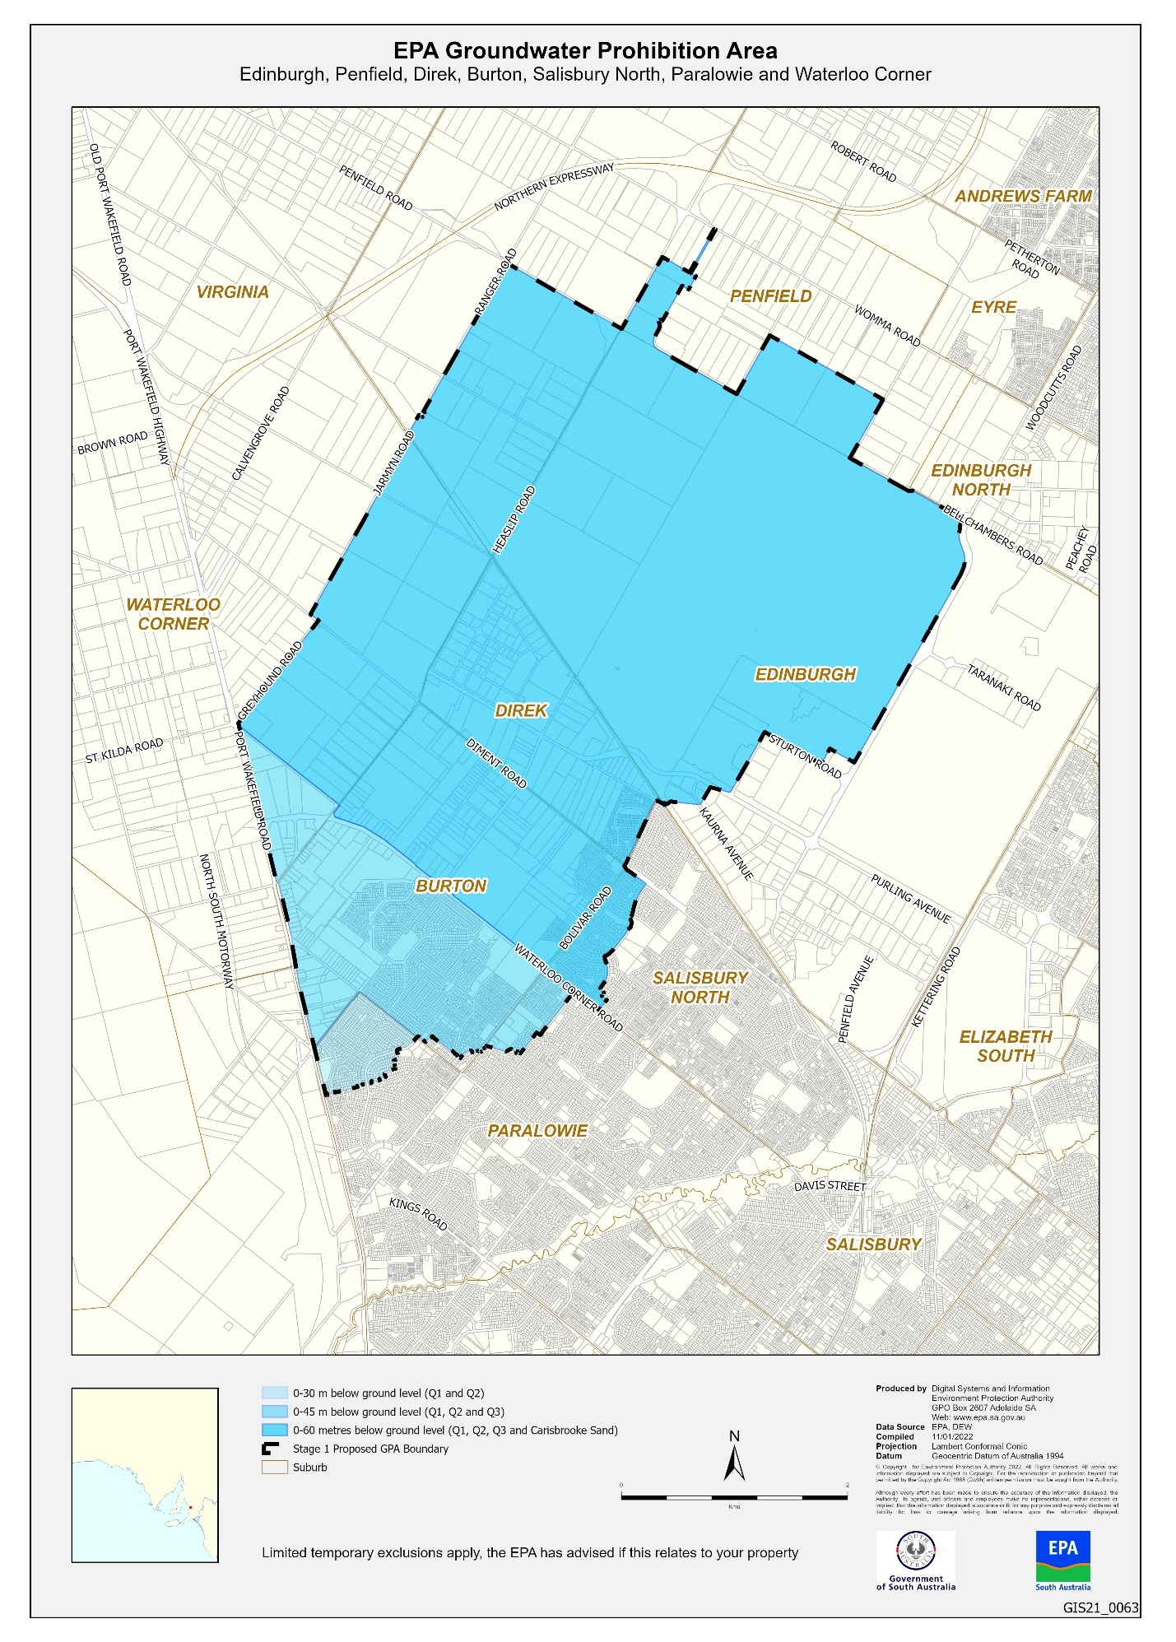

Map 2
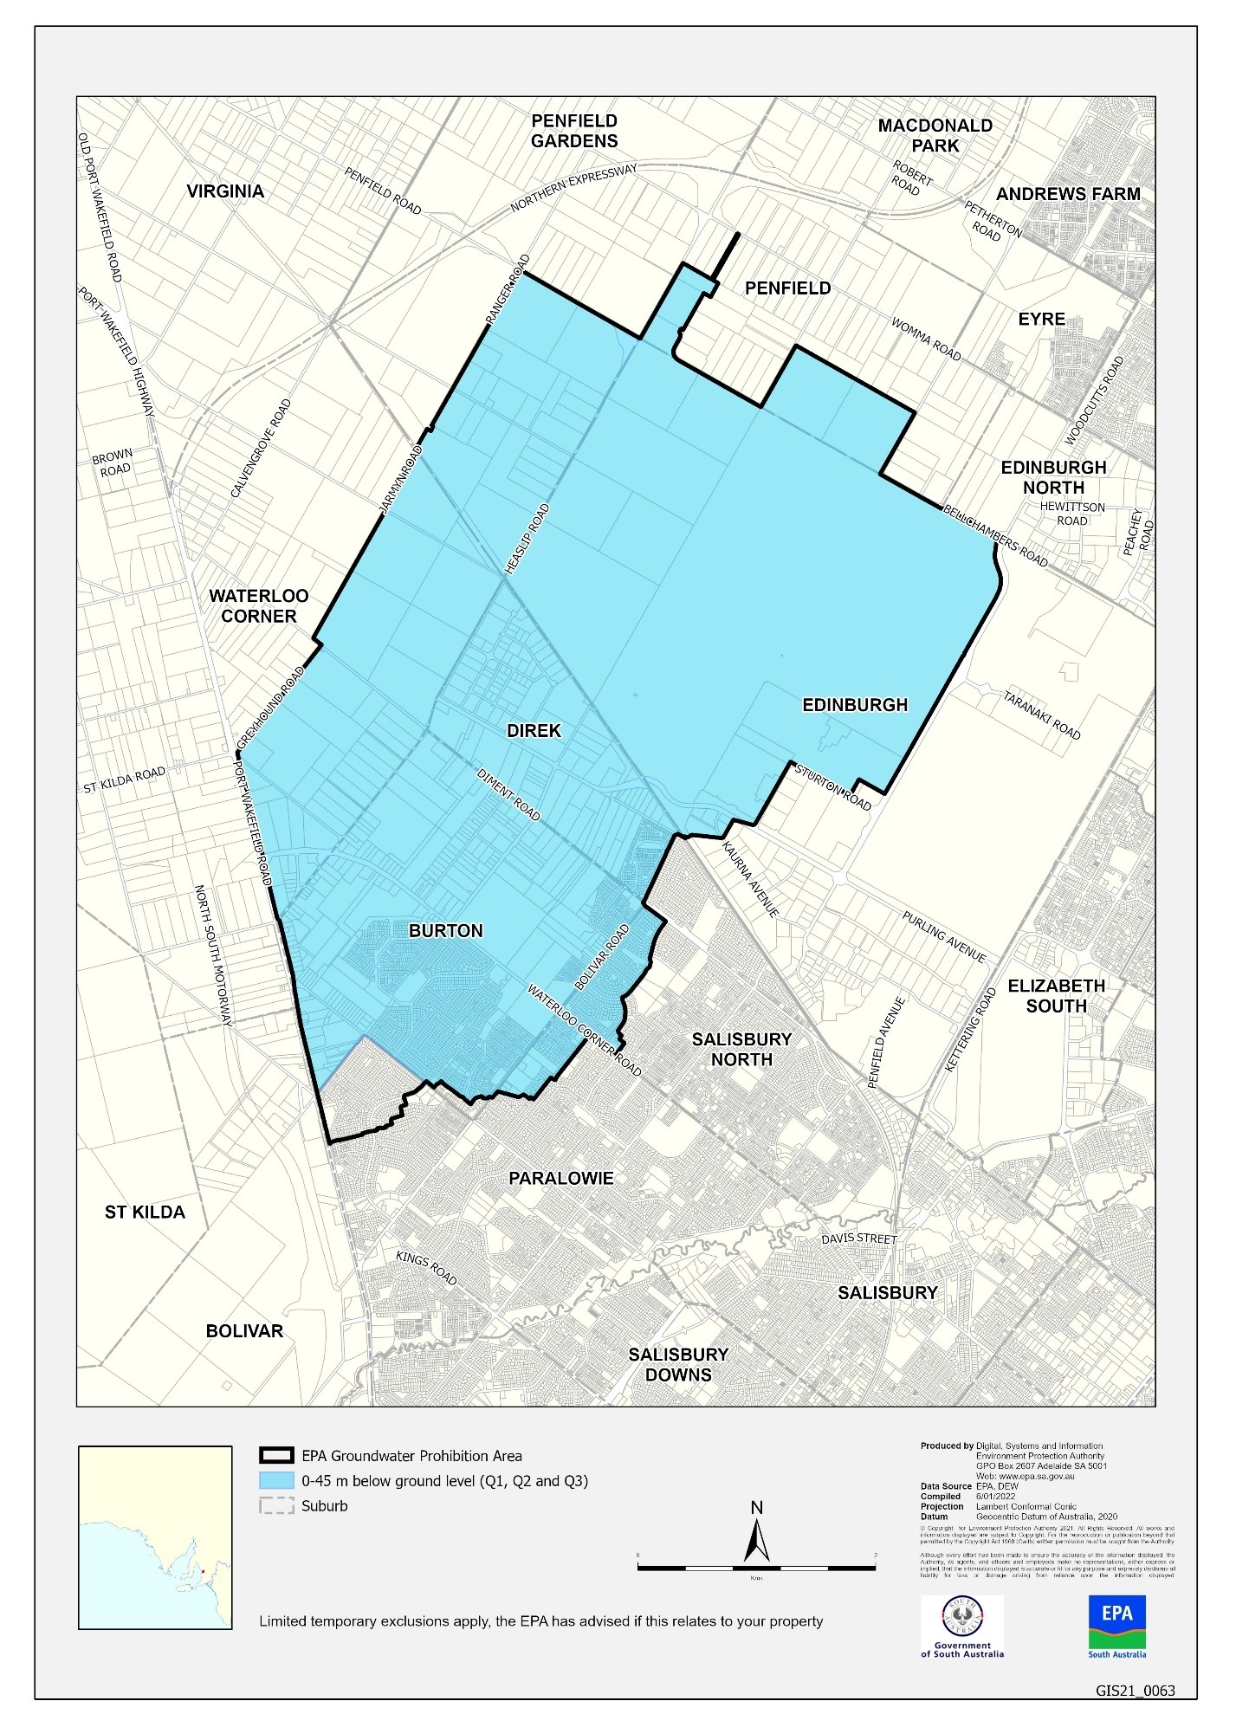
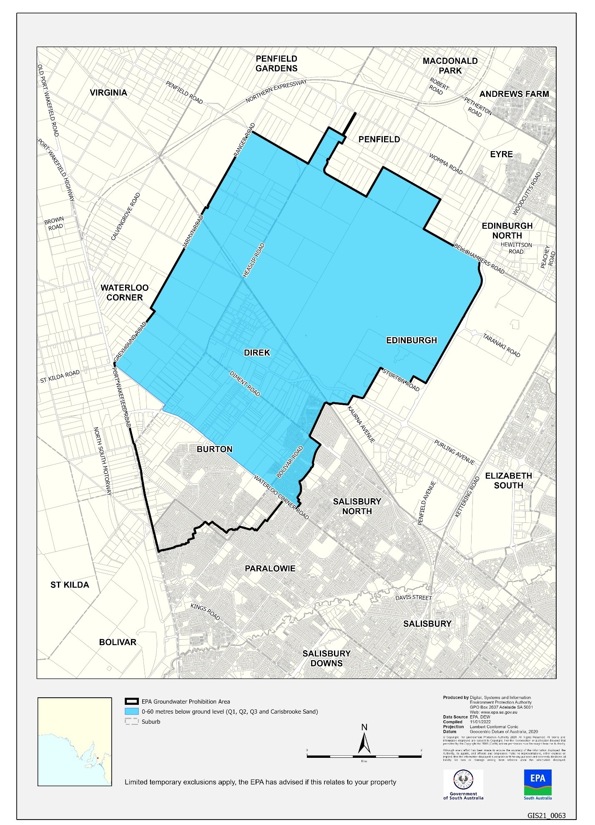
Map 3

Housing Improvement Act 2016
Rent Control Revocations
Whereas the Minister for Human Services Delegate is satisfied that each of the houses described hereunder has ceased to be unsafe or unsuitable for human habitation for the purposes of the Housing Improvement Act 2016, notice is hereby given that, in exercise of the powers conferred by the said Act, the Minister for Human Services Delegate does hereby revoke the said Rent Control in respect of each property.
Address of Premises | Allotment  Section | Certificate of Title  Volume Folio
203 Esplanade, Aldinga Beach SA 5173 | Allotment 260 Deposited Plan 4625 Hundred of Willunga | CT5677/891
17 West Terrace, Kapunda SA 5373 | Allotment 1 Filed Plan 107437 Hundred of Kapunda | CT5184/488
Dated: 3 February 2022
Craig Thompson
Housing Regulator and Registrar
Housing Safety Authority, SAHA
Delegate of Minister for Human Services

Justices of the Peace Act 2005
Section 4
Appointment of Justices of the Peace for South Australia
Notice by the Commissioner for Consumer Affairs
I, Dini Soulio, Commissioner for Consumer Affairs, delegate of the Attorney-General, pursuant to section 4 of the Justices of the Peace Act 2005, do hereby appoint the people listed as Justices of the Peace for South Australia as set out below.
For a period of ten years for a term commencing on 16 February 2022 and expiring on 15 February 2032:
John Douglas WOODBERRY
David Warren WARD
David Peter WARD
Velika TRAYANS
Anastasios William THEOLOGOU
Robert Harry STODDARD
Anna SPACCATORE
Loretta Mary SIST
Ronald Phillip SIMPSON
Sandrine Marie Madeleine POISSONNIER
Brian Leslie PILLER
Trevor Anthony PATTI
George PANAGOPOULOS
Ann Elizabeth NITSCHKE
Anna Maria MECHIS
Michael James MCKENZIE
Fulvio MATTIASSI
Trevor Dean GRAHAM
Dean Douglas FLEMING
Mark Barrington EVANS
Jeffrey Peter DROGEMULLER
Warren Frederick DIBBEN
David Wight COWANS
Colin Douglas BUTLER
Glenn Rodney BRUS
Gregory Stannard BRADSHAW
Neill Thomas BAKER
Susan Mary AVERAY
Michael George ANGELAKIS
Patricia Jean MILES
Dated: 28 January 2022
Dini Soulio
Commissioner for Consumer Affairs
Delegate of the Attorney-General

Land Acquisition Act 1969
Section 16
Form 5 – Notice of Acquisition
1. Notice of acquisition
The Commissioner of Highways (the Authority), of 50 Flinders Street, Adelaide SA 5000, acquires the following interests in the following land:
Comprising an unencumbered estate in fee simple in that piece of land being the whole of Allotment 66 in Filed plan No 148102 comprised in Certificate of Title Volume 6128 Folio 125
This notice is given under section 16 of the Land Acquisition Act 1969.

2. Compensation
A person who has or had an interest consisting of native title or an alienable interest in the land that is divested or diminished by the acquisition or the enjoyment of which is adversely affected by the acquisition who does not receive an offer of compensation from the Authority may apply to the Authority for compensation.
2A. Payment of professional costs relating to acquisition (section 26B)
If you are the owner in fee simple of the land to which this notice relates, you may be entitled to a payment of $10 000 from the Authority for use towards the payment of professional costs in relation to the acquisition of the land.
Professional costs include legal costs, valuation costs and any other costs prescribed by the Land Acquisition Regulations 2019.
3. Inquiries
Inquiries should be directed to: Rob Gardner
GPO Box 1533
Adelaide SA 5001
Telephone: (08) 8343 2567
Dated: 1 February 2022
The Common Seal of the COMMISSIONER OF HIGHWAYS was hereto affixed by authority of the Commissioner in the presence of:
Rocco Caruso
Manager, Property Acquisition (Authorised Officer)
Department for Infrastructure and Transport
DIT 2021/04266/01

Land Acquisition Act 1969
Section 16
Form 5 – Notice of Acquisition
1. Notice of acquisition
The Commissioner of Highways (the Authority), of 50 Flinders Street, Adelaide SA 5000, acquires the following interests in the following land:
Comprising an unencumbered estate in fee simple in that piece of land being portion of Allotment 40 in Deposited Plan No 116421 comprised in Certificate of Title Volume 6210 Folio 458, and being the whole of the land identified as Allotment 56 in plan D128223 lodged in the Lands Titles Office.
This notice is given under section 16 of the Land Acquisition Act 1969.
2. Compensation
A person who has or had an interest consisting of native title or an alienable interest in the land that is divested or diminished by the acquisition or the enjoyment of which is adversely affected by the acquisition who does not receive an offer of compensation from the Authority may apply to the Authority for compensation.
2A. Payment of professional costs relating to acquisition (section 26B)
If you are the owner in fee simple of the land to which this notice relates, you may be entitled to a payment of $10 000 from the Authority for use towards the payment of professional costs in relation to the acquisition of the land.
Professional costs include legal costs, valuation costs and any other costs prescribed by the Land Acquisition Regulations 2019.
3. Inquiries
Inquiries should be directed to: Philip Cheffirs
GPO Box 1533
Adelaide SA 5001
Telephone: (08) 8343 2575
Dated: 1 February 2022
The Common Seal of the COMMISSIONER OF HIGHWAYS was hereto affixed by authority of the Commissioner in the presence of:
Rocco Caruso
Manager, Property Acquisition (Authorised Officer)
Department for Infrastructure and Transport
DIT 2021/09649/01

Land Acquisition Act 1969
Section 16
Form 5 – Notice of Acquisition
1. Notice of acquisition
The Commissioner of Highways (the Authority), of 50 Flinders Street, Adelaide SA 5000, acquires the following interests in the following land:
Comprising an unencumbered estate in fee simple in that piece of land being portion of Section 236 in the Hundred of Solomon comprised in Certificate of Title Volume 5833 Folio 145, and being the whole of the land identified as Allotment 52 in plan D128221 lodged in the Lands Titles Office
This notice is given under section 16 of the Land Acquisition Act 1969.
2. Compensation
A person who has or had an interest consisting of native title or an alienable interest in the land that is divested or diminished by the acquisition or the enjoyment of which is adversely affected by the acquisition who does not receive an offer of compensation from the Authority may apply to the Authority for compensation.
2A. Payment of professional costs relating to acquisition (section 26B)
If you are the owner in fee simple of the land to which this notice relates, you may be entitled to a payment of $10 000 from the Authority for use towards the payment of professional costs in relation to the acquisition of the land.
Professional costs include legal costs, valuation costs and any other costs prescribed by the Land Acquisition Regulations 2019.
3. Inquiries
Inquiries should be directed to: Philip Cheffirs
GPO Box 1533
Adelaide SA 5001
Telephone: (08) 8343 2575
Dated: 31 January 2022
The Common Seal of the COMMISSIONER OF HIGHWAYS was hereto affixed by authority of the Commissioner in the presence of:
Rocco Caruso
Manager, Property Acquisition (Authorised Officer)
Department for Infrastructure and Transport
DIT 2021/09653/01

Landscape South Australia Act 2019
List of Declared Animals
PURSUANT to section 185(1) of the Landscape South Australia Act 2019 (the Act), I, David Speirs MP, Minister for Environment and Water, vary the List of Declared Animals by declaring the provisions of the Act apply to specified animals in specified declared areas as follows:
The List of Declared Animals is amended by the addition of CLASS 25, Pig (Domestic Form), Kangaroo Island and the amendment of CLASS 24 to exclude Kangaroo Island in the Declared Area.
Taxonomic Name | Common Name | Provision of Act which are to apply | Category | Declared Area
CLASS 24
MAMMALIA  ARTIODACTYLA |  | 189, 191(1), 192(3) | 3 | Whole of State (excluding Kangaroo Island)
Suidae  Sus scrofa | Pig  (Domestic form)
CLASS 25
MAMMALIA  ARTIODACTYLA |  | 186(1)(3), 187(2), 189, 191(1), 192(3) | 3 | Kangaroo Island
Suidae  Sus scrofa | Pig  (Domestic form)
The List of Declared Animals is amended by the change of Class 24 to exclude Kangaroo Island in the Declared area and by the addition of Class 25 for domestic pigs on Kangaroo Island
Dated: 31 January 2022
David Speirs MP
Minister for Environment and Water

MENTAL HEALTH ACT 2009
Authorised Mental Health Professional
NOTICE is hereby given in accordance with Section 94(1) of the Mental Health Act 2009, that the Chief Psychiatrist has determined the following person as an Authorised Mental Health Professional:
James Reynolds
A person’s determination as an Authorised Mental Health Professional expires three years after the commencement date.
Dated: 27 January 2022
Dr J Brayley
Chief Psychiatrist

Mining Act 1971
Section 56H
Application for a Mining Lease
Notice is hereby given in accordance with Section 56H of the Mining Act 1971, that an application for a Mining Lease over the undermentioned mineral claim has been received:
Applicant: Henschke Industries Pty Ltd
Claim Number: 4531
Location: CT 5811/916 and CT 5818/469, Naracoorte area, 2km southeast of Naracoorte.
Area: 4.6 hectares approximately
Purpose: Extractive Minerals (Limestone)
Reference: 2021/000246
To arrange an inspection of the proposal at the Department for Energy and Mining, please call the Department on 08 8463 3103.
An electronic copy of the proposal can be found on the Department for Energy and Mining website: http://energymining.sa.gov.au/minerals/mining/public_notices_mining.
Written submissions in relation to this application are invited to be received at the Department for Energy and Mining, Mining Regulation, Attn: Business Support Officer, GPO Box 320 ADELAIDE SA 5001 or dem.miningregrehab@sa.gov.au by no later than 16 February 2022.
The delegate of the Minister for Energy and Mining is required to have regard to these submissions in determining whether to grant or refuse the application and, if granted, the terms and conditions on which it should be granted.
When you make a written submission, that submission becomes a public record. Your submission will be provided to the applicant and may be made available for public inspection.
Dated: 3 February 2022
C Johanson
Acting Mining Registrar as delegate for the Minister for Energy and Mining
Department for Energy and Mining

Mining Act 1971
Section 56H
Application for Mining Leases
Notice is hereby given in accordance with Section 56H of the Mining Act 1971, that an application for a Mining Lease over the undermentioned mineral claim has been received:
Applicant: PP Paterson Holdings Pty Ltd
Claim Number: 4497
Location: CT 6110/231 and CT 6110/232, Cooke Plains area, approximately 19km southeast of Tailem Bend.
Area: 11.42 hectares approximately
Purpose: Industrial Mineral (Gypsum)
Reference: 2021/000075
Applicant: PP Paterson Holdings Pty Ltd
Claim Number: 4517
Location: CT 6248/811, Cooke Plains Area, approximately 21km south-east of Tailem Bend
Area: 11.67 hectares approximately
Purpose: Industrial Mineral (Gypsum)
Reference: 2021/000200
To arrange an inspection of the proposal at the Department for Energy and Mining, please call the Department on 08 8463 3103.
An electronic copy of the proposal can be found on the Department for Energy and Mining website: http://energymining.sa.gov.au/minerals/mining/public_notices_mining.
Written submissions in relation to this application are invited to be received at the Department for Energy and Mining, Mining Regulation, Attn: Business Support Officer, GPO Box 320 ADELAIDE SA 5001 or dem.miningregrehab@sa.gov.au by no later than 17 February 2022.
The delegate of the Minister for Energy and Mining is required to have regard to these submissions in determining whether to grant or refuse the application and, if granted, the terms and conditions on which it should be granted.
When you make a written submission, that submission becomes a public record. Your submission will be provided to the applicant and may be made available for public inspection.
Dated: 3 February 2022
C Johanson
Acting Mining Registrar as delegate for the Minister for Energy and Mining
Department for Energy and Mining

Mining Act 1971
Section 56H
Application for a Mining Lease
Notice is hereby given in accordance with Section 56H of the Mining Act 1971, that an application for a Mining Lease over the undermentioned mineral claim has been received:
Applicant: OneSteel Manufacturing Pty Ltd
Claim Number: 4539
Location: CR 6059/795, CR 6241/28, CR 6059/793, CT 5936/543, CT 6128/515, CL 6237/768 and CT 6150/28, Middleback range area, approximately 42km southwest of Whyalla.
Area: 340.4 hectares approximately
Purpose: Industrial Mineral (Iron Ore)
Reference: 2021/000478
To arrange an inspection of the proposal at the Department for Energy and Mining, please call the Department on 08 8463 3103.
An electronic copy of the proposal can be found on the Department for Energy and Mining website: http://energymining.sa.gov.au/minerals/mining/public_notices_mining.
Written submissions in relation to this application are invited to be received at the Department for Energy and Mining, Mining Regulation, Attn: Business Support Officer, GPO Box 320 ADELAIDE SA 5001 or dem.miningregrehab@sa.gov.au by no later than 3 March 2022.
The delegate of the Minister for Energy and Mining is required to have regard to these submissions in determining whether to grant or refuse the application and, if granted, the terms and conditions on which it should be granted.
When you make a written submission, that submission becomes a public record. Your submission will be provided to the applicant and may be made available for public inspection.
Dated: 3 February 2022
C Johanson
Acting Mining Registrar as delegate for the Minister for Energy and Mining
Department for Energy and Mining

Pastoral Land Management and Conservation Act 1989
Public Access Route Closures January 2022
Notice of Intent to Temporarily Close Public Access Route Number 1 Copper King Mine
Notice is hereby given of the intent to temporarily close the Copper King Mine Public Access Route from Zinc Mine Road turn off to the Copper King Mine, from 28 January 2022 until further notice, pursuant to section 45 (7) of the Pastoral Land Management and Conservation Act 1989. Notification of the re-opening of the Public Access Route will be provided on the Department of Planning, Transport and Infrastructure’s Outback Road Warnings website at www.dpti.sa.gov.au/OutbackRoads/outback_road_warnings/special_notices
Notice of Intent to Temporarily Close Public Access Route Number 6 Tallaringa
Notice is hereby given of the intent to temporarily close the Tallaringa Public Access Route from Mabel Creek Homestead to the gate into Tallaringa Conservation Park, from 28 January 2022 until further notice, pursuant to section 45 (7) of the Pastoral Land Management and Conservation Act 1989. Notification of the re-opening of the Public Access Route will be provided on the Department of Planning, Transport and Infrastructure’s Outback Road Warnings website at www.dpti.sa.gov.au/OutbackRoads/outback_road_warnings/special_notices
Notice of Intent to Temporarily Close Public Access Route Number 8 Pedirka
Notice is hereby given of the intent to temporarily close the Pedirka Public Access Route from Hamilton Homestead to the Witjira National Park boundary, from 28 January 2022 until further notice, pursuant to section 45 (7) of the Pastoral Land Management and Conservation Act 1989. Notification of the re-opening of the Public Access Route will be provided on the Department of Planning, Transport and Infrastructure’s Outback Road Warnings website at www.dpti.sa.gov.au/OutbackRoads/outback_road_warnings/special_notices
Notice of Intent to Temporarily Close Public Access Route Number 10 Lake Gairdner National Park
Notice is hereby given of the intent to temporarily close the Lake Gairdner National Park Public Access Route from Skull Camp Tanks Road turn off to Lake Gairdner camping area, from 28 January 2022 until further notice, pursuant to section 45 (7) of the Pastoral Land Management and Conservation Act 1989. Notification of the re-opening of the Public Access Route will be provided on the Department of Planning, Transport and Infrastructure’s Outback Road Warnings website at www.dpti.sa.gov.au/OutbackRoads/outback_road_warnings/special_notices
Notice of Intent to Temporarily Close Public Access Route Number 12 Old Peake Telegraph Station
Notice is hereby given of the intent to temporarily close the Old Peak Telegraph Station Public Access Route from Oodnadatta track turn off to the end sign at the springs/ruin complex, from 28 January 2022 until further notice, pursuant to section 45 (7) of the Pastoral Land Management and Conservation Act 1989. Notification of the re-opening of the Public Access Route will be provided on the Department of Planning, Transport and Infrastructure’s Outback Road Warnings website at www.dpti.sa.gov.au/OutbackRoads/outback_road_warnings/special_notices
Notice of Intent to Temporarily Close Public Access Route Number 14 Strangway Springs
Notice is hereby given of the intent to temporarily close the Strangway Springs Public Access Route from T-junction on Oodnadatta track to the Stile at carpark, from 28 January 2022 until further notice, pursuant to section 45 (7) of the Pastoral Land Management and Conservation Act 1989. Notification of the re-opening of the Public Access Route will be provided on the Department of Planning, Transport and Infrastructure’s Outback Road Warnings website at www.dpti.sa.gov.au/OutbackRoads/outback_road_warnings/special_notices
Notice of Intent to Temporarily Close Public Access Route Number 17 Arckaringa Hills
Notice is hereby given of the intent to temporarily close the Arckaringa Hills Public Access Route from Painted Desert Road turn off to the carpark and lookout, from 28 January 2022 until further notice, pursuant to section 45 (7) of the Pastoral Land Management and Conservation Act 1989. Notification of the re-opening of the Public Access Route will be provided on the Department of Planning, Transport and Infrastructure’s Outback Road Warnings website at www.dpti.sa.gov.au/OutbackRoads/outback_road_warnings/special_notices
Notice of Intent to Temporarily Close Public Access Route Number 18 Lake Cadibarrawirracanna
Notice is hereby given of the intent to temporarily close the Lake Cadibarrawirracanna Public Access Route from William Creek road turn off to the lookout, from 28 January 2022 until further notice, pursuant to section 45 (7) of the Pastoral Land Management and Conservation Act 1989. Notification of the re-opening of the Public Access Route will be provided on the Department of Planning, Transport and Infrastructure’s Outback Road Warnings website at www.dpti.sa.gov.au/OutbackRoads/outback_road_warnings/special_notices
Notice of Intent to Temporarily Close Public Access Route Number 19 Algebuckina Bridge and Waterhole
Notice is hereby given of the intent to temporarily close the Algebuckina Bridge and Waterhole Public Access Route from the Oodnadatta track turn off to the campground, from 28 January 2022 until further notice, pursuant to section 45 (7) of the Pastoral Land Management and Conservation Act 1989. Notification of the re-opening of the Public Access Route will be provided on the Department of Planning, Transport and Infrastructure’s Outback Road Warnings website at www.dpti.sa.gov.au/OutbackRoads/outback_road_warnings/special_notices
Notice of Intent to Temporarily Close Public Access Route Number 20 Beresford Bore
Notice is hereby given of the intent to temporarily close the Beresford Bore Public Access Route from the Oodnadatta track turn off to Beresford Bore Ruins, from 28 January 2022 until further notice, pursuant to section 45 (7) of the Pastoral Land Management and Conservation Act 1989. Notification of the re-opening of the Public Access Route will be provided on the Department of Planning, Transport and Infrastructure’s Outback Road Warnings website at www.dpti.sa.gov.au/OutbackRoads/outback_road_warnings/special_notices
Notice of Intent to Temporarily Close Public Access Route Number 23 Nonning
Notice is hereby given of the intent to temporarily close the Nonning Public Access Route from southern end of track to the northern end of track near the Nonning Gymkhana grounds, from 28 January 2022 until further notice, pursuant to section 45 (7) of the Pastoral Land Management and Conservation Act 1989. Notification of the re-opening of the Public Access Route will be provided on the Department of Planning, Transport and Infrastructure’s Outback Road Warnings website at www.dpti.sa.gov.au/OutbackRoads/outback_road_warnings/special_notices
Dated: 28 January 2022
Bianca Lewis
Pastoral Board delegate of section 45 (7) of the Pastoral Land Management and Conservation Act 1989
Manager Pastoral Unit, Rural Solutions SA
Department of Primary Industries and Regions SA

Planning, Development and Infrastructure Act 2016
Section 76
Amendment to the Planning and Design Code
Preamble
It is necessary to amend the Planning and Design Code (the Code) in operation at 20 January 2022 (Version 2022.1) in order to make changes of form relating to the Code’s spatial layers and their relationship with land parcels. NOTE: There are no changes to the application of zone, subzone or overlay boundaries and their relationship with affected parcels or the intent of policy application as a result of this amendment.
- Pursuant to section 76(1)(a) of the Planning, Development and Infrastructure Act 2016 (the Act), I hereby amend the Code in order to make changes of form (without altering the effect of underlying policy) as follows:
- Undertake minor alterations to the geometry of the spatial layers and data in the Code to maintain the current relationship between the parcel boundaries and Code data as a result of the following:
  - New plans of division deposited in the Land Titles Office between 14 January 2021 and 27 January 2022 affecting the following spatial and data layers in the Code:
    - Zones and subzones
    - Technical and Numeric Variations
      - Building Heights (Levels)
      - Building Heights (Metres)
      - Minimum Frontage
      - Minimum Site Area
      - Minimum Primary Street Setback
      - Minimum Side Boundary Setback
      - Future Local Road Widening Setback
    - Overlays
      - Affordable Housing
      - Defence Aviation Area
      - Environment and Food Production Area
      - Future Local Road Widening
      - Hazard (Bushfire - High Risk)
      - Hazard (Bushfire - Medium Risk)
      - Hazard (Bushfire - General Risk)
      - Hazard (Bushfire - Urban Interface)
      - Hazard (Bushfire - Regional)
      - Hazard (Bushfire - Outback)
      - Heritage Adjacency
      - Historic Area
      - Key Outback and Rural Routes
      - Limited Land Division
      - Local Heritage Place
      - Noise and Air Emissions
      - Regulated and Significant Tree
      - State Heritage Place
      - Stormwater Management
      - Urban Transport Routes
      - Urban Tree Canopy
  - Improved spatial data for existing land parcels in the following locations (as described in Column A) that affect data layers in the Code (as shown in Column B):
Location (Column A) | Layers (Column B)
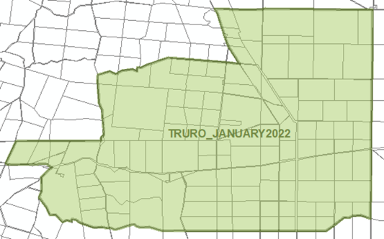  Truro | Zones  Technical and Numeric Variations  - Minimum Dwelling Allotment Size  - Minimum Site Area  Overlays  - Heritage Adjacency  - Key Outback and Rural Routes  - Resource Extraction Protection Area  - State Heritage Place
Henley Beach  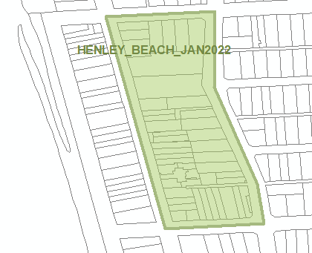 | Zones  Technical and Numeric Variations  - Maximum Building Height (Levels)  - Maximum Building Heights (Metres)  - Minimum Frontage  - Minimum Site Area  Overlays  - Heritage Adjacency  - Historic Area  - Local Heritage Place  - Urban Transport Routes
- Amending references to the following Concept Plan spatial layers and data in the Code for the City of Adelaide to align with Part 12 of the Code as follows:
- References to Concept Plan 85 - City Riverbank, Adelaide be amended to Concept Plan 85 – City Riverbank – Innovation
- References to Concept Plan 125– Riverbank Precinct be amended to Concept Plan 125 – City Riverbank – West
- In Part 13 of the Code – Table of Amendments, update the publication date, Code version number, amendment type and summary of amendments within the ‘Table of Planning and Design Code Amendments’ to reflect the amendments to the Code as described in this Notice.
- Pursuant to section 76(5)(a) of the Act, I further specify that the amendments to the Code as described in this Notice will take effect upon the date those amendments are published on the SA planning portal.
Dated: 1 February 2022
Sally Smith
Executive Director, Planning & Land Use Services
Attorney-General’s Department
Delegate of Josh Teague MP, Minister for Planning and Local Government

Roads (Opening and Closing) Act 1991
Section 24
Notice of Confirmation of Road Process Order
Road Opening and Closing—Montacute Road, Montacute
By Road Process Order made on 7 January 2022, the Adelaide Hills Council ordered that:
- Portion of Allotment 90 in Filed Plan 130444, Montacute, Hundred of Adelaide, more particularly delineated and numbered ‘1’ in Preliminary Plan 05/0056 be opened as road.
- Portion of Montacute Road, Montacute, situated adjoining the western boundary of Allotment 90 in Filed Plan 130444, Hundred of Adelaide, more particularly delineated and lettered ‘B’ in Preliminary Plan 05/0056 be closed.
- Transfer the whole of the land subject to closure to Bronte John Earl and Josephine Helen Dowsett in accordance with the Agreement for Exchange dated 27 March 2006 entered into between the Adelaide Hills Council and Bronte John Earl and Josephine Helen Dowsett.
On 27 January 2022 that order was confirmed by the Minister for Planning and Local Government (exercising the powers and functions of the Attorney-General), conditionally upon the deposit by the Registrar-General of Deposited Plan 127017 being the authority for the new boundaries.
Pursuant to section 24 of the Roads (Opening and Closing) Act 1991, NOTICE of the order referred to above and its confirmation is hereby given.
Dated: 3 February 2022
B. J. Slape
Surveyor-General
DAIS 05/0056

South Australian Employment Tribunal Act 2014
South Australian Employment Tribunal Rules 2022
The President and a Deputy President of the South Australian Employment Tribunal after consultation with the Minister make the following Rules under the South Australian Employment Tribunal Act 2014.
PART 1 - Preliminary
- Name of Rules
These rules are referred to as the South Australian Employment Tribunal Rules 2022 (the Rules).
- Commencement
The Rules will commence operation on the date of their publication in the Gazette.
- Revocation and transitional provisions
- Subject to this rule, the South Australian Employment Tribunal Rules 2017 and the Fast Track Stream Rules 2020 are revoked.
- A proceeding commenced in the Tribunal under the South Australian Employment Tribunal Rules 2017 prior to the commencement date of the Rules will, subject to any direction to the contrary made by the Tribunal, operate under the Rules from the date of commencement.
- In respect of any other proceeding commenced prior to the commencement date and transferred to the Tribunal, the Tribunal may give directions to resolve any uncertainty about which rule applies to the proceeding, or to a particular step in the proceeding, and may do anything else necessary to ensure the smoothest possible transition from one jurisdiction to another.
- Overriding purpose, application of the Rules and identification of any interest
- The overriding purpose of the Rules, in their application to proceedings in the Tribunal, is to facilitate the objects of the SAET Act and, in particular, the just, quick and cost effective resolution of the real issues in proceedings.
- The Tribunal must seek to give effect to the overriding purpose of the Rules when it exercises any power given to it by the SAET Act or by the Rules and when it interprets any provision in the Rules.
- A party to a proceeding is under a duty to assist the Tribunal to achieve the overriding purpose of the Rules, to participate in the processes of the Tribunal in a constructive manner and to comply with directions and orders of the Tribunal.
- A party, representative, witness or interpreter to or in a proceeding is under a duty to disclose any interest which is reasonably known or apprehended, personal or pecuniary, in or in relation to any matter or witness before the Tribunal.
- Each of the following persons must not, by their conduct, cause a party to a proceeding to be put in breach of a duty identified in sub-rule (3) or (4):
- a solicitor or barrister representing the party in a proceeding;
- any person with a relevant interest in a proceeding commenced by the party.
- The Tribunal may take into account a failure to comply with sub-rule (3), (4) or (5) in making or declining to make an order for costs.
- For the purposes of this rule, a person has a relevant interest in a proceeding if the person:
- provides financial assistance or other assistance to a party to the proceeding; and
- exercises direct or indirect control over, or influences, the conduct of the proceeding or the conduct of a party to the proceeding.
- Cost effectiveness
- Tribunal proceedings must be conducted efficiently and in a manner proportionate to the matter in dispute. Proportionality means ensuring that legal costs and other costs incurred in connection with a proceeding are reasonable and proportionate to the importance and complexity of the issues in dispute.
- Legal practitioners and other persons authorised to represent a party in a proceeding must use their best endeavours to facilitate the just, quick and cost effective resolution of the real issues in the proceeding before the Tribunal.
- Interpretation
- In the Rules, unless a contrary intention appears:
words used have the same meaning as words used in the SAET Act or Regulations or a relevant Act or regulations made under a relevant Act;
administrator means a person appointed as an administrator under an administration order as defined in the Guardianship and Administration Act 1993;
applicant has the meaning it has in the SAET Act;
approved form has the following meanings:
- a document is in an approved form if it is in the form of, or substantially similar to, a document approved by the President and published on the Tribunal website, or otherwise made available for use by the Tribunal, or otherwise approved by the Tribunal;
- a document is in the approved form if it is in the form of the document approved by the President and published on the Tribunal website, or otherwise made available for use by the Tribunal, or otherwise approved by the Tribunal;
Commissioner means a person holding office as a Commissioner of the Tribunal;
company means a company as defined by s 9 of the Corporations Act 2001 (Cth);
contact details of a person means the person’s address, telephone number, mobile number, pager number and email address (as far as each are known or relevant) that can be used by the Tribunal and other parties or persons to contact the person in relation to a proceeding (and in relation to an Australian company, includes the address of the registered office of the company);
contempt includes:
- a contempt in the face of the Tribunal;
- disruption of a proceeding in the Tribunal or of the Tribunal’s processes;
- obstruction or perversion of the course of justice:
- by intimidation of or interference with a witness; or
- by making statements or publishing material that could prejudice the fair and impartial determination of a proceeding before the Tribunal; or
- in any other way;
- obstruction or interference with the proper performance of official duties by an officer of the Tribunal;
- deliberate non-compliance with a judgment or order of the Tribunal;
- an attempt to do anything that would, assuming the attempt had been carried successfully to conclusion, have constituted a contempt under any of the above paragraphs;
counter-application means any document filed in response to an initiating application;
Court means the South Australian Employment Court however constituted and includes the Full Bench of the Court;
decision has the same meaning it has in the SAET Act;
Deputy President means a Deputy President of the Tribunal;
District Court means the District Court of South Australia;
Full Bench means a Full Bench of the Tribunal (including a Full Bench of the Court) consisting of 3 Presidential members;
guardian certificate means a certificate signed by a proposed litigation guardian certifying that:
- the person for whom the proposed litigation guardian consents to act is a person under a legal incapacity, identifying that person’s date of birth and, when applicable, details of their mental disability or illness rendering them incapable of managing their participation in a proceeding;
- the proposed litigation guardian is eligible to be a litigation guardian for the person under a legal incapacity in the proceeding;
- the proposed litigation guardian does not and would not have an interest in the proceeding adverse to the person under a legal incapacity;
- the proposed litigation guardian understands the rights and obligations of a litigation guardian; and
- the proposed litigation guardian consents to acting as litigation guardian for the person under a legal incapacity in the proceeding.
health practitioner means a health practitioner as defined by s 4 of the Return to Work Act 2014;
initiating application means any document by which a proceeding in the Tribunal is started by a person, or by which the Tribunal’s jurisdiction is otherwise invoked, and includes an internal review, an appeal and a referral made to or claim brought before the Tribunal under a relevant Act;
Magistrates Court means the Magistrates Court of South Australia;
person under a legal incapacity means a person:
- under the age of 18 years; or
- who, because of a mental disability or illness, is not capable of managing their participation in a proceeding;
Practice Direction means a direction made by the President about practices and procedures adopted by the Tribunal;
President means the President of the Tribunal;
Presidential member means the President or a Deputy President of the Tribunal;
proceeding means any matter, action, dispute, application, hearing, review, trial, reference, case stated, appeal or other step whatsoever before the Tribunal however constituted pursuant to the SAET Act or in consequence of any jurisdiction vested in it or a Tribunal member by a relevant Act, whether at the interlocutory or hearing stage or otherwise;
registered agent means a person who is named on the list of registered agents maintained under s 152 of the Fair Work Act 1994;
registrar means the Registrar or a Deputy Registrar of the Tribunal;
Regulations means the South Australian Employment Tribunal Regulations 2015;
relevant Act means an Act which confers jurisdiction on the Tribunal;
respondent means a person or entity in relation to whom a decision of the Tribunal or some other form of relief is sought by an applicant;
response means a respondent’s answer to an initiating application or any other application made to the Tribunal;
SAET Act means the South Australian Employment Tribunal Act 2014;
settlement conference has the meaning it has in rule 54(1);
Supreme Court means the Supreme Court of South Australia;
the Registrar means the principal registrar of the Tribunal;
Tribunal means the South Australian Employment Tribunal however constituted and, where the context permits, includes the Tribunal in Court Session;
Tribunal in Court Session means the South Australian Employment Court;
Tribunal member means a Presidential member or a Commissioner;
Tribunal website means www.saet.sa.gov.au;
Uniform Civil Rules means the Uniform Civil Rules 2020 as amended, varied, substituted, replaced and adopted by the District Court from time to time;
- A reference in the Rules to any Act or statutory instrument means that Act or statutory instrument as amended or substituted from time to time and includes any instrument made under it or the substituted Act or statutory instrument.
- The Rules are to be read as subject to the SAET Act and Regulations and to any applicable provision of a relevant Act or regulations made under a relevant Act.
- The Rules comprise general rules and rules that apply to specific types of proceedings. To the extent that there is an inconsistency between a general rule and a rule dealing with a specific type of proceeding, the specific rule is to apply, subject to contrary order of a Presidential member.
- Application of the Uniform Civil Rules
Subject to any order to the contrary made by the Tribunal, where any issue or procedure is not provided for under the Rules, the SAET Act or a relevant Act, the Uniform Civil Rules apply, and any relevant forms used by the District Court may be adopted and used with such modifications as the circumstances of any particular case may make necessary.
- Directions, relief from time limits and dispensation from the Rules
- The Tribunal may upon application or on its own initiative:
- give directions about the procedure to be followed in a particular matter;
- extend or abridge a time limit for doing anything in connection with any proceedings, or in relation to commencing any proceedings; or
- vary any requirement of the Rules; or
- dispense with compliance by any person, or by the Tribunal, with any requirement of the Rules, either before or after the time for compliance arises, and in doing so, may impose any conditions or give any consequential or other directions as are appropriate.
- An extension of time will automatically be granted, without application, to enable the Tribunal to conciliate a matter, subject to any order to the contrary made by a Presidential member at any time in a proceeding.
- Sub-rule (2) does not apply to a proceeding to which the Dust Diseases Act 2005 applies.
- Sub-rule (2) applies to a monetary claim or a claim for relief against unfair dismissal under the Fair Work Act 1994 but does not apply to any other proceeding under the Fair Work Act 1994.
- Sub-rule (2) does not apply to a review under the Public Sector Act 2009.
- A registrar of the Tribunal is expressly authorised to constitute the Tribunal for the purposes of this rule.
- Seals of the Tribunal
- The seals of the Tribunal will be applied to such documents as the President may direct.
- The seals of the Tribunal will be in the form that the President approves and kept in the custody of the Registrar.
- Practice Directions and Guidelines
- The President may make any Practice Direction contemplated by the Rules or considered necessary to regulate proceedings in the Tribunal.
- The President may issue Guidelines with respect to particular classes of proceedings in order to assist the preparation and conduct of proceedings.
PART 2 - Additional non-criminal jurisdiction of the Court
- Assignment of additional jurisdictions to the Court
In addition to the jurisdiction conferred on the Court by the SAET Act or a relevant Act, non-criminal proceedings under any of the following Acts or parts of Acts and proceedings in the Tribunal’s jurisdiction at common law or in equity, are assigned to the Court should the relevant proceedings be referred for hearing and determination at the conclusion of conciliation in that part of the Tribunal that does not sit as the Court:
- Sections 8, 11 and 12, and Chapter 3, Part 6 of the Fair Work Act 1994;
- Section 13 of the Long Service Leave Act 1987;
- Return to Work Act 2014, except for proceedings under Part 7 of that Act;
- SAET Act; and
- Work Health and Safety Act 2012, except for matters under s 65, Part 7 and Part 12 of that Act.
PART 3 - Documents
- Form of documents
All documents filed with the Tribunal must:
- be in English or, if not in English, be accompanied by a translation of the document into English either prepared by an accredited translator or as directed by a registrar; and
- clearly identify the name of the party filing the document or on whose behalf the document is filed; and
- include the case number of the proceeding.
- Filing documents with the Tribunal
- Any document, including any approved form, affidavit or other document a party intends to rely on in any proceeding, must be filed at the registry of the Tribunal.
- Subject to the Rules, a document must be filed with the Tribunal:
- by lodging it at the registry electronically; or
- by lodging it in paper form at the registry; or
- by sending it in paper form by post to the registry; or
- subject to compliance with any applicable Practice Direction, by providing it by any other means that the Tribunal makes available for that purpose.
- Except in the case of specified classes of documents the Tribunal has a preference for electronic filing and a registrar may refuse to receive a document that is presented to the Tribunal for filing in non-electronic form and may direct that the document be filed with the Tribunal electronically.
- The Registrar may determine that all documents, or specified classes of documents, sought to be filed by some or all persons, or specified classes of persons, must be filed electronically.
- The Registrar may determine that specified classes of documents must be filed in paper form.
- Failure to comply with sub-rule (4) or (5) may result in a document not being accepted for filing.
- Registrar may receive documents
Subject to the Rules and if considered appropriate, a registrar may receive an application or other document even though it does not comply with the Rules, and may do so subject to any terms and conditions.
- Registrar may refuse to receive documents
- Subject to the Rules, a registrar may refuse to receive any application or document if it does not comply with the Rules.
- A registrar must refuse to receive an application or other document for filing at the Tribunal if:
- it is not reasonably legible; or
- it is an application that is beyond the jurisdiction of the Tribunal and a Presidential member of the Tribunal has directed a registrar to refuse or reject the application for filing; or
- the application or document is an abuse of the Tribunal’s process or is scandalous, frivolous or vexatious and a Presidential member of the Tribunal has directed a registrar to refuse or reject the application or document for filing.
- The Tribunal may dismiss an application commenced by a document that ought to have been rejected under this rule.
- Rejection or dismissal of an application pursuant to this rule does not prevent a further application that complies with the Rules, the SAET Act and any relevant Act from being made.
- Provision by the Tribunal of copies of documents to parties and other persons
- Subject to the Rules, where any initiating application is filed with the Tribunal, a registrar must as soon as reasonably possible, and in any event within 3 business days, serve a copy of the application and any supporting documents:
- upon each other party to the proceeding; and
- upon any other person not a party to the proceeding as required by the Rules or any Act.
- If an initiating application is filed with the Tribunal within 3 business days of the hearing scheduled for the relevant proceeding, a registrar may:
- prior to the commencement of the hearing, give a copy of the application and any supporting documents to any person who should receive a copy of the application and supporting documents under the Rules; or
- require the person filing the initiating application to serve within a specified time, a copy of the application and any supporting documents on any person who should receive a copy of the application and documents under the Rules.
- Subject to the Rules and to the extent that it is reasonably necessary to achieve a just outcome in a proceeding before the Tribunal, or otherwise achieve the objectives of the SAET Act, a Presidential member may direct a registrar to serve a copy of any document or part of any document (including an application, response or other document filed with the Tribunal, a summons issued by the Tribunal, any notice arising during the course of a proceeding or any directions or orders made by the Tribunal) on any person reasonably considered to have a proper interest in the matter.
- A registrar may serve a notice or any other document on a party or other person by any means considered appropriate to bring the document to the attention of the party or other person.
- If a person refuses to accept a document, it may be served on them by putting the document down in his or her presence and telling them the nature of it.
- A registrar is not obliged to serve a copy of any document on a person if the person’s whereabouts or contact details cannot be ascertained after reasonable enquiries have been made.
- Power to order presumptive service
- The Tribunal may, on an application for directions brought by a party, make an order for presumptive service of a document.
- An order for presumptive service will, if the conditions of the order are complied with, have the effect of presuming that a copy of the document has been served upon the relevant party or person.
- Without limiting the nature of an order for presumptive service, an order may provide that service upon one person will stand as service upon another person who is not able to be served or an order may provide that the giving of a notice by some means determined by the Tribunal will stand as service upon a person.
Examples –
1. An order for presumptive service might provide for serving a copy of the document to a person who might reasonably be expected to bring the document to the attention of the party.
2. An order for presumptive service might provide for the publication of notice of the document in a particular newspaper or newspapers or by other means (including electronically).
- Parties to serve copies of documents on each other
- Subject to the Rules, in the case of any document that is not an initiating application, the party filing it must within 7 days serve a copy of the document and any supporting documents on all other parties to the proceeding, and on any other person not a party as required by the Rules or any Act (unless there is a hearing scheduled in relation to the matter, in which case service must take place not less than 3 business days before the date of the hearing).
- The Rules or a Practice Direction may require that a party serve a copy of a particular document on another party or person, in which case the copy must be served on the other party or person:
- on the same day, or as soon after filing as possible; or
- as directed by a registrar (which may include that the party file with the Tribunal an affidavit as to service of the document on the other party or person).
- If the relevant document is a summons issued by the Tribunal under s 33 of the SAET Act, the applicant for the summons must ensure that the summons is served on the person named in the summons at least 5 business days before the date specified in the summons for attendance or as otherwise directed by a Tribunal member.
- In any proceeding where an applicant is required to serve a document that initiates a proceeding upon another party, the applicant is responsible for proving that service of the document was effected.
- Service of a document may be proved by an affidavit made by the person who served the document setting out:
- the date, time and place of service;
- how the person to be served was identified; and
- how service was effected.
- The Tribunal may provide such directions as to service as are required in an individual case having regard to the circumstances of that case and may determine that a document has been served even if sub-rule (5) has not been complied with.
- Where an Act does not prescribe a particular method of service of a document that must be used, service may be effected by sending a copy of the document by email to the email address of the party to be served.
- An email address of a party served with a document under sub-rule (7) must be ascertained from the contact details provided by the party or by some other reasonable and reliable means.
- Serving copies on a partnership, trustees or unincorporated association
- For the purposes of the Rules but subject to sub-rule (3), if a proceeding is commenced against the members of an existing partnership in the partnership name, a document is taken to have been served on all members of the partnership if it is served on:
- any member of the partnership; or
- a person who apparently has the management or control of a business operated under the partnership.
- For the purposes of the Rules but subject to sub-rule (3), if a proceeding is commenced against trustees of an existing trust in the trust name, a document is taken to have been served on all trustees if it is served on:
- any trustee; or
- a person who apparently has the management or control of a business operated under the trust.
- If the partnership or trust has been dissolved, all former members or trustees against whom the party initiating the proceeding desires to pursue the relevant claim must be individually served with a copy of the relevant document.
- For the purposes of the Rules, if a proceeding is commenced against an unincorporated association in the name of the association, a document is taken to have been served on the association if it is served on:
- any member of the committee of management of the association; or
- any person who holds property on trust for the purposes of the association; or
- a person who apparently has the management or control of the business of the association.
PART 4 - Applications and responses
- Applications
- All initiating applications must be in the approved form setting out the grounds for the application and the remedy sought, and must be accompanied by any prescribed fee, or by an application in the approved form to waive or reduce any prescribed fee.
- All other applications in relation to proceedings, including applications for general directions about the conduct of the proceedings, must be in an approved form and:
- include the nature of the application being made and, if relevant, the legislation under which it is made; and
- include the reasons for the application; and
- include the directions or remedy sought, including the amount sought if it is a monetary claim.
- If an extension of time is sought to make any application or to do any other thing, the application must expressly seek the extension of time and include the reasons why an extension of time should be given.
- A person filing an application must provide details of any known requirements for an interpreter, for assistance with a disability for any special cultural requirement, for security or for any other need of a party or witness proposing to attend a conference or a hearing.
- When an application is commenced
An application is commenced on whichever is the later of:
- the date and time when the application is filed in the Tribunal; or
- if a fee is required to be paid under the Regulations in respect of the application, the date and time that the fee is paid; or
- if a fee required to be paid under the Regulations is waived, the date and time when the fee is waived.
- Counter-applications and third-party applications
- If the Tribunal’s jurisdiction permits, a respondent to an initiating application in the Tribunal’s jurisdictions under Division 1 or 2 of Part 3 of the SAET Act may, in the response to the application, or separately, make an application to the Tribunal for a remedy against the applicant (a counter-application), or may make an application against a person who is not a party to the proceeding (a third-party application).
- A respondent to an application for internal review or appeal who seeks to have the Tribunal’s original orders set aside or varied for reasons that differ from those of the applicant may, in the response to the application or separately, make a counter-application for internal review or appeal of the Tribunal’s decision.
- If a respondent contends that an appeal should be dismissed for reasons different to those contained in the decision under appeal, the respondent must file a notice stating in detail the grounds on which the respondent asserts that the decision should be upheld (a notice of alternate contentions) and provide a copy to the applicant within 14 days of being served with a copy of the appeal.
- Any counter-application or third-party application must comply with any relevant rule for applications of the relevant type, and any response to a counter-application or third-party application must comply with any relevant rule concerning responses.
- Subject to any time limit in a relevant Act, a counter-application or third-party application is to be filed within 14 days of service of the application it responds too.
- Unless a prescribed fee is waived, a party is not relieved of any requirement to pay any prescribed fee applicable to a counter-application or third-party application.
- Responses to applications
- Subject to the Rules, a response to an application must be in an approved form and must include the respondent’s answer to the application and must comply with any relevant rule for the response.
- A response must be filed with the Tribunal, and a copy served on all other parties, within 14 days of the respondent receiving a copy of the relevant application.
- If the Tribunal considers it appropriate to help effectively dispose of an application, the Tribunal may direct a party to file and serve a copy of a response to an application within a different time to that specified in sub-rule (2).
- A response must:
- admit or deny, either with or without qualification, each statement of fact made in an application; and
- state whether the relief claimed is agreed to or opposed.
- Unless otherwise ordered by the Tribunal, each claim set out in the application, and any liability of the respondent to pay any money claimed or give any other form of relief, will be taken to be admitted unless specifically denied in a response filed in the Tribunal.
- A person filing a response must provide details of any known requirements for an interpreter, for assistance with a disability for any special cultural requirement, for security or for any other need of a party or witness proposing to attend a conference or a hearing.
- Amendments
- Subject to this rule, an application, response, counter-application, third-party application or notice of alternate contentions may be amended without permission of the Tribunal by filing an amended document of the relevant kind and serving a copy of it on all other parties within 5 business days of the original filing date.
- A party who has filed a document to which this rule applies may only amend the document once without permission of the Tribunal.
- After the relevant application, response, counter-application, third-part application or notice of alternate contentions has been listed for a conference or a hearing, it may only be amended with the permission of the Tribunal.
- A registrar is expressly authorised to constitute the Tribunal for the purposes of this rule.
- Application to review a decision due to absence
- An application to review a decision because a person failed to attend or was not represented at a relevant hearing within the meaning of s 82 of the SAET Act must be made within 14 days of the relevant hearing.
- An application under this rule is to be made by an application for directions supported by an affidavit which explains the circumstances of the failure to attend or be represented.
- Withdrawal of proceedings
- Unless a relevant Act or the Rules provide otherwise, a proceeding or a part of a proceeding may be withdrawn by an applicant without the permission of the Tribunal upon the applicant filing a notice of withdrawal with the Tribunal in an approved form.
- If the permission of the Tribunal under s 40 of the SAET Act is required to withdraw a proceeding, an application for permission to withdraw the proceeding must be made in an approved form.
- If a notice of withdrawal is filed under this rule, a registrar must serve a copy of the notice on each other party and any other person a Tribunal member directs is to receive a copy.
- Subject to sub-rule (5), if a proceeding has been set down for hearing, a party may only withdraw that proceeding with the consent of all other parties or with the permission of the Tribunal.
- An applicant claiming relief under s 106 of the Fair Work Act 1994 may file a notice of withdrawal at any time but will be subject to any costs orders that the Tribunal may make under s 110(2) of that Act.
- The withdrawal of an internal review or an appeal does not affect the status of a counter-application in the same proceeding.
- Subject to the following exceptions, a party who withdraws a proceeding is not prevented from bringing a further proceeding based on the same or substantially the same claim.
Exceptions -
1. If a party to the later proceeding is entitled to costs in relation to the earlier proceeding, the Tribunal may, on the application of that party, stay any proceeding based on the same or substantially the same claim until the costs have been paid.
2. The Tribunal may order that the withdrawal of a proceeding is to have the same effect as a final judgment against the party withdrawing if the withdrawal is for the purpose of giving effect to a final settlement agreed between the parties.
3. A further proceeding may not be brought if a relevant time limit has expired and the Tribunal has not granted an extension of time.
- Subject to any relevant Act, the withdrawal of a proceeding does not preclude the Tribunal from making orders in relation to the costs of the proceeding.
- Changes to contact details and representation arrangements
- A party whose contact details change during the course of a proceeding must, within 7 days of the change, file with the Tribunal a written notice in the approved form setting out the new contact details.
- A representative who no longer acts for a party to a proceeding must, within 7 days of ceasing to act, file with the Tribunal a written notice in the approved form advising that they no longer act and must serve a copy of the notice on the party and all other parties.
- When a party provides an email address to the Tribunal or another party to a proceeding, or responds to an email sent by the Tribunal or another party by email, the email address provided or used to send email will be taken to be the party’s email address unless and until the party advises the Tribunal, in the approved form, of a change of email address and serves a copy on the other parties.
- Oral applications
Notwithstanding anything in the Rules, but subject to any express provision of the SAET Act or a relevant Act, an application made for any direction or interlocutory or final order of the Tribunal, and any response, may be made orally or in such other manner as the Tribunal may, in the particular circumstances, determine to be fair and convenient. The Tribunal may make a determination under this rule subject to conditions, including requiring notice to be given to any other party.
PART 5 - Criminal Jurisdiction
- Criminal Procedure
- The Magistrates Court Rules 1992 (Criminal Jurisdiction) generally apply, to the exclusion of the Rules, to the practice and procedure of the Tribunal in the exercise of its jurisdiction over offences, with such modifications as the circumstances in any particular case may make necessary.
- The Tribunal may modify the application of the Magistrates Court Rules 1992, including by a Practice Direction, either generally or by having regard to the requirements of particular cases in light of the nature of the Tribunal’s jurisdiction over offences and the number of prosecutions that may from time to time be commenced in the Tribunal.
PART 6 - Review jurisdiction
- Application of Part
This Part applies to an application made under Division 1 of Part 3 of the SAET Act.
- Applications for review
- An initiating application for review of a decision must be filed in the Tribunal in the approved form.
- The application must include:
- a list of all relevant documents;
- sufficient details of the complaints made about the decision so as to enable the relevant decision-maker to understand why and on what bases the decision is disputed;
- if the reviewable decision to which the application relates was communicated to the applicant in writing, a copy of the decision; and
- if the reviewable decision was not communicated to the applicant in writing after being made, sufficient other information so that the Tribunal can identify the decision, the decision-maker and the legislation under which the decision was made.
- If in the opinion of a registrar the detail provided in an application for review is insufficient, or supporting documents which must be attached to the application for review are not attached, a registrar or other Tribunal member may refuse to accept the application.
- Subject to sub-rule (5), where a registrar or other Tribunal member has refused to accept an application under this rule, the party whose application was refused is permitted to file a further application for review which complies with the Rules and any relevant Act within 14 days of the refusal, in which case the date of filing will be taken to be the date the original application for review was filed.
- The reconsideration process under PART 21 C commences from the date of compliance with the Rules and not the deemed date when the original application for review was filed.
- Section 28 statements, documents and things
- For the purposes of s 28 of the SAET Act in proceedings for the review of a decision, the written statement of the reasons for a decision and any document or thing in the decision-maker’s possession or control that may be relevant to the Tribunal’s review of the decision must be filed in the Tribunal in a Book of Documents within 21 days from when the decision-maker receives notice that an application for review has been made.
- Subject to this rule and to any order of the Tribunal to the contrary, at the same time that a Book of Documents is filed in the Tribunal, the decision-maker must provide a copy to all other parties.
- The requirement to provide a copy of a Book of Documents to other parties does not apply to any part of a Book of Documents that is the subject of a claim under sub-rule (4) and provision of a copy of that part of the Book of Documents is subject to a direction of the Tribunal.
- Where the decision-maker is aware that one or more documents that are required to be provided under s 28 of the SAET Act are the subject of a claim of privilege, public interest immunity or other immunity or a claim of non-disclosure for other proper reason, then a copy of the Book of Documents does not need be provided to the other parties under sub-rule (2).
- Where sub-rule (4) applies, the decision-maker must place the documents into separate parts or volumes of the Book of Documents, of which:
- one part is to contain all documents about which such a claim is made and include a clear statement as to the basis upon which the claim for privilege or non-disclosure is made for each document, and be clearly marked with a prominent statement that the part contains confidential materials which are only to be accessed on the direction of a Presidential member; and
- the balance of the Book of Documents is to contain all other required material subject to s 28 of the SAET Act, including where relevant a redacted copy of any document subject only in part to a claim under this sub-rule.
- A decision made under the Return to Work Act 2014 that complies with regulation 20 of the Return to Work Regulations 2015 will be taken to comply with s 28(2)(a) of the SAET Act.
PART 7 - Original Jurisdiction
- Application of Part
This Part applies to:
- an application made under an Act which confers an original jurisdiction on the Tribunal for the purposes of s 31A of the SAET Act; and
- an application made to the Tribunal in the exercise of its jurisdiction at common law or in equity.
- Applications in original jurisdiction
An initiating application in the Tribunal’s original jurisdiction must be filed in the Tribunal in the approved form.
- Actions for damages under the Return to Work Act 2014
- Unless the Rules or a Practice Direction provide otherwise, in an action for damages under Part 5 of the Return to Work Act 2014, or an action seeking contribution from any other tortfeasor liable in respect of those damages, the Uniform Civil Rules and the practice of the District Court of South Australia in its civil jurisdiction as in force from time to time will be applied.
- All documents filed in an action under this rule must indicate that the document is filed in the Court and must have immediately underneath the case number the words “Damages Claim, Return to Work Act 2014”.
- If a claim for damages under Part 5 of the Return to Work Act 2014 gives rise to a claim for some other matter and that claim is made along with the claim for damages, the precise nature of the other matter is to be specifically pleaded and properly explained in any relevant pleading.
- Actions for recovery of compensation under the Return to Work Act 2014
- Unless the Rules or a Practice Direction provide otherwise, in an action seeking recovery of compensation from a wrongdoer under Division 10 of Part 4 of the Return to Work Act 2014, the Uniform Civil Rules and the practice of the District Court of South Australia in its civil jurisdiction as in force from time to time will apply.
- All documents filed in an action to which this rule applies must indicate that the document is filed in the South Australian Employment Court and must have immediately underneath the case number the words “Recovery Claim, Return to Work Act 2014".
- Actions under the Dust Diseases Act 2005
- Unless the Rules or a Practice Direction provide otherwise, in a proceeding to which the Dust Diseases Act 2005 applies (a Dust Disease matter), the Uniform Civil Rules and the general practice of the District Court of South Australia in its civil jurisdiction as in force from time to time will apply.
- Any document filed in a Dust Disease matter must indicate that the document is filed in the South Australian Employment Court and must have immediately underneath the case number the words “Dust Diseases Act 2005”.
- Dust Disease matters will be placed into the Dust Diseases list and managed in accordance with this rule.
- At the first pre-hearing conference, the proceeding will be assigned to one of the following categories based on the state of health of the applicant or such other matter as the Court considers relevant:
ordinary matter: A proceeding that is not urgent because the applicant has a non-life-threatening dust disease or the proceeding is brought by a relative or dependant of a person who has a dust disease or some other appropriate reason.
urgent matter: A proceeding brought by an applicant who is seriously ill and needs an expedited hearing or some other circumstance that gives rise to urgency.
- If a party seeks to have a proceeding classified as an urgent matter, whether upon commencement or at a later time, an interlocutory application seeking an urgent pre-hearing conference is to be filed together with an affidavit, dealing with, as fully as circumstances permit, the following matters:
- The nature of the disease alleged
- the condition of the applicant's health and the degree of urgency;
- details of any notification given to other parties to the proceeding and details of practitioners by whom other parties are represented;
- readiness for hearing;
- whether experts’ reports have been obtained and served on other parties;
- whether further medical examinations are required;
- a proposed expedited interlocutory timetable; and
- if an urgent hearing date is sought, details and availability of witnesses and where it is suggested that evidence be taken.
- Any available medical report relevant to the applicant’s state of health and longevity is to be exhibited to an affidavit filed under sub-rule (5).
- An urgent matter will be listed for hearing as soon as possible.
PART 8 - Interlocutory applications
- Applications for specific or general directions
- Before making an interlocutory application, a party is required to endeavour to resolve the subject matter of the proposed application with all relevant parties by agreement.
- A party seeking general directions under s 37 of the SAET Act about the conduct of a proceeding, or seeking any specific interlocutory or non-final order, must make an application for directions in an approved form, supported by an affidavit.
- Each application filed under this rule must specify all orders sought and make specific reference to the provision/s of the SAET Act and / or a relevant Act authorising the application and must provide any information required by any applicable Practice Direction.
- An interlocutory application must be filed electronically if possible or otherwise in accordance with any Practice Direction or Guideline or the Rules.
- Unless a registrar determines otherwise, an interlocutory application must not be listed to be heard at the next scheduled hearing unless the application is made, and a copy served on all other parties, not less than 3 business days prior to the scheduled hearing.
- The Tribunal will usually deal with an interlocutory application on the papers and any submission, legal argument or fact asserted or relied upon should be described in the application or supporting affidavit.
- No order may be made on an interlocutory application unless the supporting affidavit states that the parties have conferred to try to resolve the issue giving rise to the application, and that the subject matter of the application remains in dispute.
- The Tribunal may waive the operation of sub-rule (7) in a case of urgency or for other good reason.
- The Tribunal may revoke or vary any order made or direction given in response to an interlocutory application upon request by a party or at its own initiative.
- Section 65 of the SAET Act - enlarging the scope of a proceeding
- An application to enlarge the scope of a proceeding under s 65 of the SAET Act must be made in the approved form and a copy of the application together with a notice of objection in the approved form must be served on all other parties to the proceeding at least 14 days before the application is heard by the Tribunal.
- If a notice of objection is not filed by any party within 14 days of the party being served a copy of an application under this rule, all parties to the proceeding will be taken to have consented to the application.
- Where the parties to a proceeding submit or seek consent orders that involve the resolution of a question not presently in issue in the proceeding, an order pursuant to s 65 of the SAET Act enlarging the scope of the proceeding to resolve will be deemed to have been made to answer the question, and the consent of all relevant parties to the making of the order will be deemed to have been given.
- Review under s 82 of the SAET Act
- An application under s 82 of the SAET Act made by a person in respect of whom the Tribunal has made a decision when the person was absent and not represented at the hearing must be filed at the Tribunal by an application for directions within 28 days of the Tribunal’s decision and must include:
- details of the relevant proceeding and decision; and
- details of when and how the applicant became aware of the Tribunal’s decision; and
- an explanation of why the applicant did not appear or was not represented at the relevant hearing.
- A person may only make one application under s 82 of the SAET Act in respect of the same proceeding without permission of the Tribunal.
- Directions made by consent
If a party on whom an application for directions is served advises the Tribunal in writing prior to the day on which the application is heard that the party does not wish to be heard upon the application or consents to the orders sought being made, the Tribunal may excuse the party from attending the hearing.
PART 9 - Compulsory Conciliation and other Conferences
- Compulsory conciliation and other conferences
- Subject to the SAET Act or a relevant Act, where a compulsory conciliation conference under s 43 of the SAET Act or other conference under a relevant Act is to be held, the procedure for the conduct of the conference will be as set out in this Part and any applicable Practice Direction.
- Subject to any contrary direction by a Presidential member, a compulsory conciliation conference will be conducted by a Commissioner.
- Initial directions hearing
- Subject to any contrary direction by a Presidential member, an initial directions hearing under s 43(1) of the SAET Act will be conducted by a Commissioner.
- The initial directions hearing may be conducted in person or by telephone or other means.
- At the initial directions hearing the Commissioner will consider the following:
- the issues in dispute;
- whether any reconsideration of a decision under review has been completed;
- the grounds of the application;
- the evidence on which the parties intend to rely;
- whether further evidence is needed to have an effective compulsory conciliation conference;
- the persons who may be required to attend a compulsory conciliation conference;
- any other issue that the Commissioner considers relevant.
- The parties or their representatives must be prepared to address the matters outlined in sub-rule (3) at the initial directions hearing.
- Commencement of a compulsory conciliation conference
- An initial directions hearing is to be conducted within 21 days of the lodgement of an application.
- A compulsory conciliation conference requiring the attendance of the parties must be scheduled as soon as the Commissioner or other Tribunal member conducting the conference is satisfied it is appropriate to do so.
- The Tribunal member conducting an initial directions hearing may direct that a compulsory conciliation conference proceed immediately after the initial directions hearing concludes if there are good reasons for making the direction.
- Actions and powers of Commissioners generally
- A Commissioner may exercise such powers and give such directions as may reasonably be required for the effective conduct of a compulsory conciliation conference.
- A Commissioner may contact a party and may ask questions in relation to the issue in dispute, and may provide his or her view of the merits of that issue with a view to making suggestions about the form and content of the conference.
- A Commissioner may at any time require a party or any other person, within a specified time, to:
- identify, clarify and narrow the issues in dispute;
- review the evidence relied upon;
- identify any issues affecting the parties’ ability to negotiate;
- consider strategies and develop a plan for gathering information;
- deal with actual or anticipated developments that may affect the dispute;
- attempt to resolve the dispute or some of the issues in dispute;
- give particulars outlining the factual and legal basis underpinning their position;
- require a claimant to formulate the amount or type of compensation sought;
- submit to, or help facilitate, the referral of a medical question to an independent medical adviser under s 121 of the Return to Work Act 2014;
- provide further material reasonably required to conciliate the dispute;
- make disclosure of documents as set out in the Rules;
- comply with his or her obligations under s 104(3) of the Return to Work Act 2014 for disclosure and access to evidentiary material;
- file a Book of Documents (or an index to a Book of Documents) and serve a copy on all other parties.
- Requirements for parties and representatives at a compulsory conciliation conference
- At a compulsory conciliation conference, the parties must attend in person and if represented by a solicitor or an officer of an industrial association, the person with conduct of the proceeding must also attend.
- Any party attending a compulsory conciliation conference is expected to participate in an active way, and may be required to:
- detail the preparatory work undertaken for the compulsory conciliation conference, and answer whether or not actions or steps the Commissioner requested or ordered be undertaken have been undertaken;
- meet with the Commissioner and produce evidentiary material, either at the compulsory conciliation conference or at some other time or place;
- answer questions put by the Commissioner;
- attend a compulsory conciliation conference when the other party may not be present;
- disclose any offers of settlement that have been made to the other party.
- Adjournments of compulsory conciliation conferences
An application to adjourn a compulsory conciliation conference must be accompanied by any documents (such as medical certificates) that support the reason for seeking the adjournment.
- Actions taken if a dispute is not resolved
- If a dispute is not resolved at a compulsory conciliation conference and a pre-hearing conference is listed, a Commissioner will:
- have regard to what actions the parties must take so that they are properly prepared for a pre-hearing conference, and may:
- order that a statement of facts and/or issues in dispute be prepared by the parties;
- ascertain what expert evidence (if any) each party intends to rely upon, and whether reports have been sought from those experts, and if appropriate issue directions accordingly having regard to the time limit for seeking reports set out in the Rules;
- make any other order or direction necessary to facilitate the expeditious resolution of the matter, and
- within the time allowed by any relevant Act, prepare and forward to the parties a memorandum which complies with s 43(13) of the SAET Act and also contains a summary of the nature of each dispute, the matters remaining in issue, and the positions of the parties.
- A s 43(13) memorandum must be kept confidential from the Tribunal member who hears and determines the dispute and is not admissible in proceedings before the Tribunal except, at the conclusion of proceedings, for the purposes of considering making an adverse costs order under s 106(3) of the Return to Work Act 2014 or for making any other order permitted by the SAET Act, a relevant Act or the Rules.
- A Tribunal member who presides over a compulsory conciliation conference or a settlement conference in relation to a proceeding must not hear and determine the proceeding unless all parties to the proceeding consent to that course.
- A Tribunal member who conducts a review under the Public Sector Act 2009 may commence the review by seeing whether some form of conciliated outcome can be achieved but must conduct any discussions concerning a conciliated outcome in the presence of all parties and/or the representatives of all parties.
- A Tribunal member who proceeds under sub-rule (4) is not precluded from conducting the review if a conciliated outcome is not achieved.
- A Presidential member who presides over a pre-hearing conference or settlement conference in relation to a proceeding may have regard to a s 43(13) memorandum but must not then hear and determine the proceeding unless all parties to the proceeding consent to that course.
- Sub-rule (6) does not preclude a Presidential member from making orders, giving directions and deciding interlocutory disputes prior to the hearing and determination of a proceeding.
- A document which contains a summary of the nature of each dispute, the subjects remaining in issue and the positions of the parties, but which does not contain any assessment of the merits made by a Commissioner under s 43(13)(a) of the SAET Act, may be provided to and considered by a Presidential member and does not preclude the Presidential member from hearing the proceeding.
- Consequences of failing to properly participate in conciliation
- Where a party is not ready to proceed at an initial directions hearing or a compulsory conciliation conference without good reason (the party), the Commissioner with conduct of the hearing or conference may refer the proceeding to a Presidential member for directions, and before doing so, may order:
- that some or all of the costs between the party’s professional representative and his or her client be disallowed or that the professional representative repay to his or her client the whole or part of any money paid on account of costs;
- that the party’s representative pay to his or her client some or all of the costs which his or her client has been ordered to pay to any other party;
- that the party’s professional representative pay some or all of the costs of any other party other than his or her client.
- Recording offers made at or after conciliation
If a party wishes to record an offer made to resolve a dispute at or after a compulsory conciliation conference, it must provide a written copy of the offer to the relevant Commissioner and must comply with any relevant Practice Direction in that regard.
PART 10 - Directions
- General Directions
At any time during a proceeding a Presidential member may make such directions or orders necessary to achieve the fair and expeditious resolution of the proceeding, including but not limited to the following subjects:
- identifying and narrowing the issues in dispute by document or otherwise;
- giving and responding to particulars;
- detailing the manner and sufficiency of service;
- disclosure, inspection and production of documents;
- joinder of parties;
- enlarging the scope of the proceeding;
- requiring the provision of a Statement of Facts, Issues and Contentions or ordering the provision of pleadings if considered appropriate;
- consolidating or splitting proceedings;
- inspecting property, real or otherwise;
- ordering that evidence be given by affidavit;
- ordering that an affidavit or other document which is filed and contains scandalous material is to be removed from the file;
- expert evidence and Tribunal experts;
- disclosure and exchange of expert reports;
- ordering an expert to produce an expert report either to a party to the proceedings or to the Tribunal;
- the number and order of expert witnesses;
- requiring that the parties engage in settlement negotiations independently of the Tribunal;
- the attendance of the parties, or any other person, at any conference;
- referring a proceeding, or any aspect of or in a proceeding, to mediation;
- providing for and limiting the extent of written submissions;
- taking evidence and receiving submissions by such means as the Tribunal considers appropriate;
- staying a proceeding;
- dismissing or striking out a proceeding, or part of a proceeding;
- adjourning a proceeding;
- granting summary relief;
- subject to the Rules and to any provision in a relevant Act, referring a proceeding to a Commissioner to be heard and determined, as a summary proceeding or otherwise;
- placing a proceeding in the fast track stream;
- determining the place, date, time and mode of any hearing;
- determining costs, both as to liability and quantum;
- any other matter that the Tribunal considers appropriate.
- Directions at Hearings
- A Tribunal member may at any time by direction –
- provide directions and make orders as to the way in which evidence is to be put before the Tribunal;
- limit the time to be taken in examining, cross-examining or re-examining a witness;
- limit the number of witnesses (including expert witnesses) that a party may call on a particular issue;
- limit the time to be taken in making any oral submission;
- limit the time to be taken by a party in presenting its case;
- limit the time to be taken by the hearing;
- amend any such limitation.
- In deciding whether to make a direction under this rule, a Tribunal member shall have regard to the following matters in addition to any other matters that may be relevant –
- the time allowed for a hearing or any part of a hearing must be appropriate; and
- any such direction must not detract from the principle that each party is entitled to a fair hearing; and
- the complexity or simplicity of the case; and
- the number of witnesses to be called by the parties;
- the volume and character of the evidence to be led;
- the state of the Tribunal lists; and
- the time expected to be taken for the trial; and
- the importance of the issues in the case as a whole.
- Attendance in Person
- A Tribunal member with conduct of a proceeding may determine, in relation to any hearing or conference, whether the parties and/or witnesses are to attend in person or whether they may participate by audio visual or telephonic means.
- In the absence of a specific direction to the contrary, the parties to a proceeding are to attend any compulsory conciliation conference, settlement conference or mediation in person.
PART 11 - Alternative dispute resolution
- Settlement conferences
- In this part:
Settlement conference means a meeting or series of meetings between the parties to attempt to:
- resolve by consent a proceeding;
- agree facts in dispute in a proceeding; or
- narrow the issues in dispute in a proceeding.
- A Presidential member may, under s 47 of the SAET Act, order that the parties attend a settlement conference presided over by a Tribunal member at any time during a proceeding.
- In presiding over a settlement conference a Tribunal member may make any determination, order or direction considered necessary to facilitate the fair and expeditious conduct of the settlement conference.
- If a proceeding is not resolved at a settlement conference, the Tribunal member who conducted the settlement conference may not hear and determine the proceeding unless all parties to the proceeding consent to the Tribunal member doing so.
- Unless the Tribunal orders otherwise, a party ordered to attend a settlement conference must attend:
- in person; or
- in the case of a corporation, by a representative with authority to resolve the dispute at the settlement conference;
and in the company of each party’s respective legal representatives.
- Subject to sub-rule (7) evidence of:
- anything said or done;
- any communication, whether oral or in writing;
- any admission made; or
- any document prepared;
in the course of or for the purposes of a settlement conference must be kept confidential from the Tribunal member who hears and determines the proceeding and is not admissible in the proceeding before the Tribunal.
- Sub-rule (6) does not affect the admissibility of any evidence or document in a proceeding if:
- the parties to the settlement conference consent to the admission of the evidence or document in the proceeding;
- there is a dispute in the proceeding as to whether or not the parties at or as a result of the settlement conference agreed to resolve the proceeding, or some part of or issue in the proceeding, and the evidence is relevant to the agreement or alleged agreement;
- there is a dispute in the proceeding as to whether or not the parties at or as a result of a settlement conference agreed any facts relevant to the proceeding and the evidence is relevant to the agreement or alleged agreement;
- the substantive proceeding has concluded and the issue remaining concerns an adverse costs order under s 106(3) of the Return to Work Act 2014 or any other order permitted by the SAET Act, a relevant Act or the Rules.
- Mediation conducted outside the Tribunal
- Where mediation is to be conducted under s 46 of the SAET Act by a person who is not a registrar or a Tribunal member, no later than 7 days prior to the commencement of the mediation, a registrar must give a notice to the person specified as the mediator by the Tribunal and the parties to the mediation stating:
- when, where and by whom the mediation is to be conducted; and
- the responsibilities of the mediator and the parties prior to, during and after the mediation.
- The person specified to conduct the mediation must conduct it in accordance with recognised ethical and professional standards for mediators.
- If the mediator is not a registrar or a Tribunal member, a party to the mediation may be directed by the Tribunal to pay or contribute to the costs of the mediation.
- Mediation conducted by the Tribunal
Where mediation is to be conducted under s 46 of the SAET Act by the Tribunal, the Tribunal will consult with the parties to make arrangements and establish protocols for the conduct of the mediation.
PART 12 – Disclosure of documents
- Disclosure and production of documents
- Unless a relevant Act provides otherwise, each party must disclose the documents that are, or have been, in the party’s possession, custody or power to produce and are directly relevant to any material issue in a proceeding.
- Unless a relevant Act provides otherwise, the Tribunal may at any time, including during the course of hearing a proceeding, order a party or any other person to disclose in the approved form and produce to the Tribunal and to other parties to the proceeding, any documents which are, or have been, in the possession of that person that are directly relevant to a material issue in the proceeding.
- Where a person is required to disclose or produce documents that are directly relevant to any material issue in a proceeding, but discloses or produces documents which are not directly relevant, an adverse order for costs, may be made against them to reflect the additional time and expense to which the other parties have been put by reason of the unnecessary disclosure or production, or an order may be made for such other penalty as the Tribunal sees fit to impose having regard to all the circumstances.
- A party to a proceeding may object to producing a document on the basis that the document is privileged from production, or if there is some other good reason why the document should not be produced.
- The Tribunal may excuse a party who has disclosed the existence of a document to which sub-rule (4) applies from producing the document or part of the document to the Tribunal or any other party.
- In proceedings under the Return to Work Act 2014, and in relation to evidence which comprises still or moving images of a worker taken without their knowledge or consent, the Tribunal may order that such evidence be disclosed and produced to the other parties to the dispute only if:
- the disclosure and production is by consent; or
- the evidence has previously been produced to a medical expert who is treating the worker; or
- the decision under review relies on a medical opinion that is wholly or predominantly based upon the evidence; or
- the Tribunal is satisfied that, in the interests of justice, there are good reasons that justify the disclosure and production of the evidence.
- In proceedings under the Return to Work Act 2014 where a party is in possession of evidentiary material the disclosure of which could prejudice the investigation of a suspected offence, and the party seeks to not disclose the material on that basis, the party can make an ex-parte application to be exempted from complying with s 104(3) of the Return to Work Act 2014 and the application will be heard by a Presidential member.
- A Presidential member who makes an order under sub-rule (7) may make such further or incidental orders thought fair and appropriate in the circumstances, including but not limited to, delaying or adjourning the hearing of any compulsory conciliation conference or imposing a time limit on any order made under sub-rule (7).
- Non-party disclosure and production of documents
- On an application made by a party to a proceeding, it the Tribunal is satisfied that a person or body who is not a party to the proceeding (a non-party) may be in possession of documents that appear to be relevant to any material issue in a proceeding, the Tribunal may order that the non-party.
- disclose in the approved form whether it has or has had possession, custody or power over documents apparently relevant to a material issue in a proceeding and if so, provide full particulars of such documents;
- produce documents apparently relevant to any material issue in a proceeding to the Tribunal or for inspection or copying by the parties;
- comply with rule 57 as though the non-party were a party to the proceedings, with any necessary changes; or
- verify the non-party’s disclosure, production or list of documents either by affidavit or in person, and if in person, be available for questioning.
- A non-party subject to an order made under this rule is entitled, subject to contrary order of the Tribunal, to reasonable compensation from the party seeking the disclosure, for the time and expense involved in complying with the order.
- The amount of compensation payable under sub-rule (2) is to be agreed between the relevant parties or adjudicated by the Tribunal.
- Possession of documents
For the purposes of this Part, a person is taken to be in possession of a document if:
- the document is in the person's custody or control; or
- it lies within the person's power to obtain immediate possession of the document or to control its disposition (whether or not the power is one that would be recognised at law or in equity).
PART 13 - Summonses
- Form of Summonses
- A summons issued to a person to give evidence or produce evidentiary material under s 33 of the SAET Act must be in the approved form.
- Permission of the Tribunal is required to issue a summons to a person or body who is not a party to a proceeding, to produce evidentiary material without giving oral evidence.
- If there is any conflict between a rule in this Part and a rule concerning a summons for medical records in a proceeding under the Return to Work Act 2014 in Part 22 E of the Rules, the rule in Part 22 E prevails to the extent of any inconsistency.
- A summons issued by the Tribunal is an order within the meaning of s 91(2) of the SAET Act.
- Complying with Summonses
- Subject to this Part, unless a person has a lawful excuse for not complying with a summons, they must comply with the summons and:
- in the case of a summons to attend and give evidence, must come to the Tribunal to give evidence on the date and at the time specified in the summons and remain in attendance until excused by the Tribunal; and
- in the case of a summons to produce documents or other things, must, in accordance with the terms of the specific order made, either:
- attend and produce the documents or other things to the Tribunal at the place and by the date and time specified in the summons; or
- send the summons or a copy of the summons and the documents or other things to a registrar at the place specified in the summons so the documents or things arrive by the date specified in the summons, or no later than 14 days from receipt of the summons if no date for delivery is specified.
- With the permission of a registrar, the date to attend the Tribunal or to produce documents or things may be varied to a later date by the person who applied for the summons by giving notice of the later date to the summonsed party. Such notice will be taken to vary the time to attend or produce things to the later date.
- Unless a summons specifically requires the production of the original or a certified copy of a document, a copy of the document required by the summons, including an electronic copy, will satisfy the summons.
- Objections to Summonses
- If a person to whom a summons is directed objects to complying with the summons, or if another person affected by the summons objects to the summons being complied with (the objector), the objector must try to resolve the objection with the party who applied for the summons to be issued before the date for compliance.
- If the objector is unable to resolve an objection to a summons informally, the objector must, before the time for compliance with the summons:
- inform a registrar and the party who applied for the summons of the basis of the objection in writing; and
- unless directed otherwise by the Tribunal, attend the Tribunal on the date for compliance to explain the basis of the objection.
- Objecting to a summons does not relieve the objector from complying with a summons.
- Unless an objection to a summons is dealt with under sub-rule (2) before the date for compliance, any document which is subject to an objection to produce, is to be provided to a registrar with the objection clearly stated in writing, or explained by the objector in person if the documents are delivered in person.
- If an objection to producing a document cannot be resolved by agreement, the issue is to be referred to a Tribunal member for decision.
- A registrar is expressly authorised to constitute the Tribunal for the purposes of this rule.
- Access to and use of documents and other things
- In the case of a summons to produce documents or other things, if by the date for compliance with the summons no person has objected to any party having access to the summonsed materials, a registrar will make directions in relation to access.
- Where sub-rule (1) applies, the Tribunal may order that parties have electronic access to the summonsed materials.
- If any person or party believes there are grounds for objecting to the parties to a proceeding having access to summonsed materials, they may object to access being given, or may seek to have access to the summonsed materials before any party is given access (first access).
- Without limiting the ambit of sub-rule (3), an objection to a party having access to summonsed materials may be based on privilege, confidentiality or other good reason.
- If first access is granted to a person or party, they are to inspect the summonsed materials and give notice to the Tribunal in writing within 7 days whether there is an objection to any party having access to the summonsed materials.
- A notice under sub-rule (5) must describe in sufficient detail the documents in respect of which access is opposed, the party or parties to whom access should not be given and the basis for opposing access.
- Allowances and Expenses of Complying with Summonses
- A party who applies for a summons to be issued is liable to pay:
- the reasonable expenses incurred in complying with a summons by the person or body which responds to the summons; and
- if some other loss or expense is reasonably incurred in complying with a summons, a reasonable amount to cover that loss or expense.
- If a summons to attend and give evidence is issued, the person named in the summons need not comply with the summons unless they are provided with a reasonable amount to cover the cost of travel to and from the Tribunal.
- The amount payable for an allowance, expense or loss under this rule is to be agreed between the party issuing the summons and the person or body summonsed or, failing agreement, by the Tribunal.
PART 14 - Expert evidence
- Application of Part
- Subject to those rules that concern the evidence of independent medical advisers appointed under s 118 of the Return to Work Act 2014, the provisions of this Part apply whenever a party proposes to provide the Tribunal with evidence from an expert witness in any proceedings, including a report obtained from a health practitioner as defined by the Return to Work Act 2014.
- An expert report that complies with this Part will be taken to be the evidence of the expert without the expert needing to be called.
- The author of an expert report may only be called to give oral evidence at a hearing by the party relying on the expert’s evidence with the permission of the Tribunal.
- Oral examination in chief of the author of an expert report who is required for cross examination may be permitted where good reason to do so exists and does not give rise to procedural unfairness to another party.
- Content of expert reports
- If a party proposes to rely on expert evidence in a proceeding, the party must seek a written report from the expert, which must:
- set out the expert's qualifications to make the report;
- set out the facts and factual assumptions on which the report is based;
- identify any documentary materials on which the report is based;
- distinguish between objectively verifiable facts and matters of opinion that cannot be (or have not been) objectively verified;
- set out the reasoning of the expert leading from the facts and assumptions to the expert’s opinion on the questions asked;
- set out the expert’s opinion on the questions asked;
- be provided on the understanding and acknowledgement that the expert’s primary duty is to be truthful and accurate to the Tribunal rather than to serve the interests of a party or parties;
- make reference to this rule; and
- comply with any requirements imposed by any Practice Direction.
- Filing and serving copies of expert reports
- Subject to this rule, any expert report on which a party intends to rely in a proceeding must be filed with the Tribunal, and a copy served on each other party along with a copy of the commissioning letter, within 7 days of the report being provided by the expert and no less than 14 days prior to the hearing and determination of the proceeding.
- Each party to the proceeding is to seek to ensure that any expert report upon which a party intends to rely in a proceeding is filed with the Tribunal, and a copy served on each other party, no less than 3 business days prior to any pre-hearing conference held under s 45 of the SAET Act.
- Where a party proposes to obtain an updated report from an expert prior to the hearing and determination of the proceeding, the report must be provided to any other party prior to the pre-hearing compliance or readiness conference.
- Special power in relation to expert evidence
The Tribunal may:
- direct that the evidence of an expert witness be deferred until all (non-expert) factual evidence has been taken; or
- ask an expert witness to review the (non-expert) factual evidence and to state, by affidavit or in oral evidence, whether the witness wishes to modify an opinion earlier expressed in the light of the evidence or a particular part of the evidence.
- arrange for an expert witness to give oral evidence, and permit each party to cross examine the expert, if a good reason exists why no party would call the expert and their evidence is likely to be relevant.
- Conferences, etc, of experts
- If two or more expert witnesses provide reports about the same or a similar question, the Tribunal may, on its own initiative or at the request of a party, give one or more of the following directions:
- that expert witnesses confer with each other;
- that expert witnesses produce for use by the Tribunal a document identifying:
- the matters and issues on which:
- they are in agreement; and
- they differ.
- that an expert witness be asked to review the opinion of another expert and to state in a report whether the witness wishes to modify an earlier opinion they have provided in light of the opinion of the other expert;
- that the evidence of two or more expert witnesses be taken in a particular sequence, or with the experts together, each being asked in turn to answer, questions relevant to the matter put by the Tribunal or by the parties or by both.
- Limit on number of experts
- Except with the permission of the Tribunal, a party may not rely on more than 3 experts of any kind in a proceeding or proceedings which are heard at the same time.
- Except with the permission of the Tribunal, a party may not rely on more than 1 expert witness, including a health practitioner as defined by the Return to Work Act 2014, in the same field of expertise. In the case of a health practitioner who is medically qualified, this means a person qualified to practice in a particular area or specialty of medicine or surgery.
- Shadow experts
- A shadow is an expert who –
- is engaged to assist with the preparation or presentation of a party's case but not on the basis that the expert will, or may, give evidence at the trial; and
- has not previously been engaged in some other capacity to give advice or an opinion in relation to the party's case or any aspect of it.
- An expert will not be regarded as a shadow expert unless, at or before the time the expert is engaged, the expert gives a certificate certifying that:
- the expert understands that it is not his or her role to provide evidence at the trial; and
- the expert has not been previously engaged in any other capacity to give advice or an opinion in relation to the party's case or any aspect of it.
- Evidence of a shadow expert is not admissible at the trial unless the Tribunal determines that there are special reasons to admit the evidence.
- If a party engages a shadow expert, the party must:
- notify the other parties of:
- the engagement; and
- the date of the engagement; and
- the name, address and qualifications of the relevant expert; and
- serve copies of the expert's certificate under sub-rule (2) on the other parties.
- The notification must be given:
- if the engagement takes effect before the time for disclosing expert reports expires, before the time expires;
- in any other case, as soon as practicable after the engagement takes effect.
PART 15 - Supplementary panels and referrals to experts or special referees
- Supplementary panels and members
In proceedings under legislation permitting the Tribunal to sit with supplementary panel members, the President will generally determine that the Tribunal will sit with such members if requested to do so by one or more of the parties, unless the President is satisfied that it would be of no advantage for the Tribunal to sit with supplementary panel members.
- Experts and special referees
The remaining rules in this Part apply to the referral of a question by the Tribunal to an expert under s 35 of the SAET Act or to a special referee under s 60 of the SAET Act.
- Referral on Tribunal’s initiative
If the Tribunal proposes to appoint an expert or special referee on its own initiative, the Tribunal will first obtain the views of the parties in writing or at a directions hearing.
- Referral at request of the parties
- If the parties jointly seek the referral of a question to an expert or to a special referee, the parties must apply in an approved form for appropriate directions to be made by consent.
- An application for directions under this rule must contain:
- the name of the proposed expert or special referee, details of their expertise, and confirmation that they have agreed to accept the referral; and
- the questions to be considered or determined, or the task to be performed, by the expert or special referee; and
- the date by which any documents (which must be clearly identified in the application) are to be provided to the expert or special referee and by whom they are to be provided; and
- the date by which the expert or special referee is to complete any report or determination.
- Following receipt of the application for directions, the Tribunal may make an order referring a question to the expert or special referee, or may refer the application to a directions hearing for decision.
- The Tribunal may decline to refer a question to an expert or special referee if the terms of the referral appear to be outside the proposed expert or special referee’s expertise or for such other reason as the Tribunal thinks fit.
PART 16 - Costs
- Costs Generally
- Awarding and assessing costs
- In any proceeding where a determination of the amount of the costs of a party is required, the following principles must be adopted:
- parties are expected to take all steps necessary to deal with or consolidate all issues in dispute between them, and deal with or consolidate all proceedings before the Tribunal, so as to avoid multiple hearings;
- the type and amount of work performed will be measured by what is considered to be reasonable by a prudent and properly advised, but not overly cautious litigant;
- any costs payable to an officer or employee of an industrial association will be assessed as the Tribunal considers appropriate.
- A registrar of the Tribunal is authorised to constitute the Tribunal for the purposes of this Part.
- Record required to be kept and file produced
- A party to a proceeding must maintain an adequate record of the party’s costs in respect of the proceeding in accordance with the Higher Courts Scale of the Uniform Civil Rules being the relevant Supreme Court Scale.
- A record of costs must enable the party to formulate a claim for costs in accordance with rules 79, 81 and 86(2).
- A lawyer acting for a party must maintain an adequate record of the party’s costs on the party’s behalf and is not entitled to charge a fee for doing so.
- If the Tribunal requires a lawyer’s file and supporting documents in connection with an adjudication of costs, the lawyer must produce all such documents to the Registry on request.
- A lawyer must be able to produce the lawyer’s file and supporting documents to the adjudicator, if required, at an adjudication of costs.
- If the lawyer ordinarily retains only an electronic file, and the Tribunal requires a copy of the file, the lawyer must produce a copy of the file electronically and in a format convenient for the Tribunal to be able to download and access the data.
- Consequences of non-compliance with the requirement to keep record and produce file
If a party fails to maintain an adequate record of the party’s costs the Tribunal may:
- decline to award costs in favour of the party or reduce the costs awarded in favour of the party by such amount as it thinks fit; or
- decline to adjudicate the quantum of costs awarded in favour of the party or reduce an award of costs by such amount as it thinks fit.
- The relevant costs scale
The relevant scale of costs for the purpose of an adjudication of costs in the Tribunal is the Higher Courts costs scale of the Supreme Court of South Australia together with such adjustments as may be made to such scale from time to time.
- Costs may be ordered at any stage
- The Tribunal may make an order for costs in favour of a party or a non-party or against a party or non-party at any stage of a proceeding up to and after the final determination of the proceeding.
- If the Tribunal determines that it does not have jurisdiction to hear and determine the substantive proceeding, the Tribunal may nevertheless order that a party pay costs in relation to the proceeding.
- Costs orders
Where not precluded from doing so from a relevant Act:
(a) The Tribunal may order that costs are awarded on a party/party basis, a solicitor/client basis or on some other basis specified by the Tribunal.
(b) The Tribunal may order that interest is payable on an award of costs in respect of a time before a decision is entered for the costs.
(c) The Tribunal may order that costs, including any interest, are awarded on a lump sum or a partial lump sum basis.
(d) The Tribunal may order that the costs awarded to a party be set-off against any liability the party may have, including a liability for costs.
- Presumptive costs
- Costs that are reserved but not subsequently the subject of a specific order are to be treated as part of the costs in accordance with any final order as to costs.
- The quantum of costs ordered is to be adjudicated if not agreed.
- Costs are not able to be adjudicated, and do not become payable, until after a proceeding is finally determined and all final costs orders are made
- General costs principles
- Any rule relating to costs is subject to the overriding discretion of the Tribunal in relation to costs.
- Any presumption in rule 82 applies to the extent that the Tribunal does not order otherwise.
- Discretionary factors
- In exercising its discretion as to costs, the Tribunal may have regard to any factors it considers relevant.
- Some of the factors referred to in sub-rule (1) may be:
- any misconduct or unreasonable conduct of a party or a representative of a party in connection with a proceeding;
- any breach by a party of overriding obligations, the Rules or an order of the Tribunal;
- the making or not making of an offer by a party to resolve a proceeding;
- the non-acceptance by a party of an offer made by another party to resolve a proceeding;
- the value and importance of the relief sought or obtained.
- Pre-adjudication steps
- Before seeking an adjudication of costs, a party must make a genuine offer to the party liable to pay costs (the liable party) in an attempt to agree the amount of costs payable.
- A genuine offer must:
- be in writing;
- state the amounts claimed for any solicitor costs;
- state the amounts claimed for any counsel fees;
- state the amounts claimed for any external disbursements; and
- make an offer of a fixed sum for the total amount of the costs, counsel fees and external disbursements which remains open for acceptance within 21 days.
- A recipient of an offer made under sub-rule (2) must respond within 21 14 days by:
- accepting the offer;
- making a counter offer of a fixed sum for the total amount of the costs, counsel fees and external disbursements; or
- offering to meet within 14 days to negotiate the amount of costs payable.
- Seeking an adjudication of costs
- A party may seek an adjudication of costs following the making of an order for costs, or by operation of the Rules, by filing and serving a claim for costs in an approved form upon the liable party.
- A claim for costs must:
- unless the Registrar or a Tribunal member permits it to be in some other form, be in a schedule in either Microsoft Word format or Microsoft Excel spreadsheet format;
- attach invoices for counsel fees and all external disbursements.
- A party seeking costs must, if a claim for costs proceeds to an adjudication:
- at the request of the liable party, produce for inspection any documents on which the party seeking costs proposes to rely; and
- if ordered by the Tribunal, identify any documents relevant to the claim that are not produced because of a claim of privilege which is not waived.
- In the alternative to filing and serving a claim for costs under sub-rule (1), a party may seek an adjudication of costs by filing and serving upon the liable party, an application for directions.
- An application for directions and affidavit filed and served under sub-rule (4) must contain sufficient detail to enable the Tribunal to make an award of costs.
- Response to a claim for costs
- The liable party must, within 28 days after service upon it of a claim for costs, file and serve a response to a claim for costs (response) in an approved form which reproduces the claim for costs in a schedule in Microsoft Word format; and
- Complete the response liability column in the schedule for each item by either:
- admitting liability;
- admitting liability to a specific extent; or
- denying liability and succinctly identifying the reason for the denial; and
- complete the response quantum column in the schedule for each item (on the assumption that liability exists for the item) by either:
          - admitting the quantum claimed; or
          - identifying what the liable party contends is the recoverable quantum and succinctly identifying the reason for the contention;
- If the liable party in its response does not respond to a particular item of costs in the schedule, in the manner required by sub-rule (1)(a), the item will be taken to be admitted in full.
- If the liable party fails to file and serve a response in accordance with sub-rule (1), the party seeking costs may request the entry of a costs judgment for the total amount shown in the claim for costs, counsel fees and external disbursement by filing an application to the Registrar in an approved form and an affidavit of proof of service proving service of the claim for costs on the liable party.
- A party may request entry of an interim costs judgment for the total amount admitted or taken to be admitted by the liable party in a response by filing an application with the registry in an approved form.
- Upon the Registrar or Tribunal member being satisfied that the party seeking an order for costs has provided sufficient information and documentation to establish the reasonableness of the amount claimed, the Registrar or Tribunal member presiding over an adjudication of costs may enter an administrative costs judgment for the appropriate amount upon the filing of a request by a party under sub-rule (3) or (4).
- Reference for adjudication
- If a claim for costs is not able to be resolved, the costs issue may be referred for adjudication by filing an application to the Registrar in an approved form.
- The Tribunal member assigned to adjudicate costs may convene a hearing in order to do so or to make orders or give directions about the adjudication.
- The parties in a disputed costs adjudication are to confer before the adjudication to attempt to resolve, limit or clarify the items of costs in dispute and to report to the Tribunal on the result at the commencement of the adjudication.
- General costs adjudication principles
- If the same law firm represents multiple parties, unless special circumstances exist, costs will not be allowed separately for each party but will be allowed on the basis of the work necessary and reasonable to represent the parties collectively.
- A representative of a party shall not charge excessive costs. Costs charged at greater than the Supreme Court scale of costs, as adjusted from time to time, shall, unless there are exceptional circumstances, be regarded as excessive.
- If a representative of a party proposes to charge for work performed in a proceeding before the Tribunal at a rate in excess of the Supreme Court scale of costs, an ex-parte application for directions supported by an affidavit seeking dispensation from sub-rule (2) and explaining what the exceptional circumstances are, must be filed in the registry.
- If an adjudication of costs is adjourned:
- as a result of the default of a party, the party should bear the costs; or
- as a result of the default of a lawyer, the lawyer should bear the costs.
- Delay
If a party unduly delays bringing a claim for costs and the liable party suffers prejudice as a result, the Tribunal may:
- not allow interest on the claim for costs (whether in whole or in part);
- disallow the claim for costs in whole or in part;
- assess compensation for the delay in favour of the liable party and reduce the costs awarded by that amount; or
- reduce the amount allowed to which the party would have been entitled if there had been no delay.
Note: ordinarily a period of time of more than three months from the date of order relating to costs will be treated as undue delay. However, particular circumstances including appeal proceedings or other proceedings, which are interrelated as to costs, may constitute a good reason as to why, nevertheless, there is not undue delay.
- Counsel fees
- The counsel fee indicator of the Supreme Court and District Court of South Australia may be used as a guide to the exercise of the discretion in respect of counsel fees.
- The counsel fee indicator is a guide only and does not fetter the exercise of the discretion of the Tribunal in a particular case.
- Powers at an adjudication of costs
- When adjudicating costs an adjudicator has the same powers the Tribunal has in relation to a proceeding in the Tribunal.
- An adjudicator may order or take evidence (on affidavit or orally), require the production of documents, require the attendance of witnesses or make orders about the participation of persons interested in the adjudication.
- An adjudicator is not bound by the rules of evidence and may decide questions by estimation or by any other expedient means.
- Without affecting the generality of sub-rule (1), an adjudicator may:
- require a party to produce its record of costs and disbursements and any other material relevant to the adjudication (subject to any claim for privilege);
- require a party to provide details of any item the subject of a claim for costs;
- make interim orders;
- order repayment of any overpayment of costs; or
- make any orders that might be made on a directions hearing in a proceeding.
- Methods of adjudication
- An adjudicator may use any one or more of the following methods to undertake an adjudication:
- a lump sum assessment, or otherwise determination of the amount of costs to be awarded in a wholesale manner, rather than undertaking an item by item assessment;
- an item by item assessment;
- assessments in successive stages;
- separate assessments of different components of the costs claimed; or
- any other method.
- An adjudicator may:
- accept an undisputed item of costs without enquiry;
- determine an issue in dispute;
- refer an issue in dispute to mediation or arbitration;
- refer an issue in dispute to an expert for enquiry and report;
- order that an item by item adjudication be undertaken on a future occasion and that the parties take steps in preparation for the adjudication; or
- make any order or further order that the adjudicator thinks fit.
- If an item by item adjudication is ordered, the liable party must file and serve an updated response to a claim for costs in an approved form which:
- substitutes the heading “amount disallowed” for the heading “offer” in the relevant column of the schedule; and
- adds any additional columns or particulars ordered by the adjudicator.
- Orders
- During or after an adjudication, an adjudicator may make a provisional order:
- determining a specific issue in dispute;
- allowing or disallowing a specific item;
- fixing the amount of costs, or a specified component of costs, to which the party is entitled; or
- that interest be payable on an award of costs in respect of a period before a costs decision is entered for the costs.
- During or after an adjudication an adjudicator may make a non-provisional order:
- determining a specific issue in dispute;
- allowing or disallowing a specific item;
- fixing the amount of costs or a specified component of costs, to which the claimant is entitled; or
- that interest be payable on an award of costs in respect of a period before a costs decision is entered for the costs.
- Costs of adjudication
- Subject to sub-rule (2), in a proceeding where a party is entitled to an award of costs, that party will ordinarily be entitled to the reasonable costs of an adjudication of costs.
- The Tribunal may make any order it thinks fit concerning payment of the costs of an adjudication, and in making such an order, may take the following matters into consideration:
- the overall result of the adjudication;
- a comparison between the result of the adjudication and the parties’ respective positions prior to the adjudication;
- a comparison between the result of the adjudication and any offer made by a party in relation to costs prior to finalising the adjudication process;
- the relative success or failure of the parties in relation to disputed items; or
- the relative number of items, and their respective quantum, in respect of which the amount claimed was disallowed.
- Review of provisional order
- If an adjudicator makes a provisional order, a party to the adjudication may, within 14 days after the date of the provisional order, request a review of the provisional order by filing and serving an application to the Registrar.
- If no party seeks review of a provisional order within 14 days of it being made, the provisional order becomes a non-provisional order.
- If a party requests a review of a provisional order within 14 days of it being made, the adjudicator will convene a hearing and give notice of the hearing to all parties to the proceeding in a prescribed form.
- An adjudicator shall conduct a review under this rule and will consider any provisional order which is the subject of the review.
- An adjudicator conducting a review under this rule may confirm or vary a provisional order, which then becomes a non-provisional order.
- Entry of decision
A non-provisional order and a provisional order that becomes a non-provisional order are decisions of the Tribunal.
B Costs in proceedings under the Return to Work Act 2014 (SA)
- Limit on costs able to be charged by a representative
- In a proceeding under the Return to Work Act 2014 a representative of a party shall not charge excessive costs. Costs charged at greater than the Higher Courts costs scale of the Supreme Court of South Australia as varied from time to time shall, unless there are exceptional circumstances, be regarded as excessive.
- If a representative of a party proposes to charge for work performed in a proceeding before the Tribunal at a rate in excess of the Higher Courts costs scale of the Supreme Court of South Australia, an ex-parte application for directions supported by an affidavit seeking dispensation from sub-rule (1) and explaining what the exceptional circumstances are must be filed in the registry.
- A representative of a worker or registered employer must provide their client copies of this rule and of s 107 of the Return to Work Act 2014 within 7 days of commencing to act in respect of any proceeding under that Act.
- If a party believes that their representative has caused costs:
- to be incurred improperly or without reasonable cause; or
- to be wasted by undue delay, negligence or by other misconduct or default;
- under s 107(2) of the Return to Work Act 2014, the party is to advise a registrar of the complaint in writing and the registrar shall then refer the matter to a Presidential member to deal with the complaint in accordance with s 107 of the Return to Work Act 2014.
- A registrar is authorised to inform workers generally of this rule and of the actions a worker may take if the worker believes that the amount of costs being charged is excessive or that an order under s 107 of the Return to Work Act 2014 should be made.
- A proceeding under s 107 of the Return to Work Act 2014 may be initiated by a party or by the Tribunal.
- The requirements of sub-rules (3), (4), (5) and (6) do not apply to a proceeding commenced before 1 July 2015.
- If a party believes that their representative has caused costs payable under s 107(2) of the Return to Work Act 2014:
- to be incurred improperly or without reasonable cause; or
- to be wasted by undue delay, negligence or by other misconduct or default;
the party is to advise the Registrar of that in writing and the Registrar shall then refer the matter to a Presidential member to deal with the matter in accordance with s 107 of the Return to Work Act 2014.
- The Tribunal may, of its own motion, address circumstances that appear to come within the ambit of s 107 of the Return to Work Act 2014.
PART 17 - Parties, representation of parties and assistance to other persons
- Trusts
- A trustee may bring or defend a proceeding in the name of the trust.
- A proceeding to which this rule applies will be taken to have been commenced by or against all the trustees of the trust.
- A trustee that brings an action in the name of the trust must have the authorisation of all of the trustees to bring the action and must file in the Tribunal with the initiating application a list of the trustees of the trust at the time the cause of action is alleged to have arisen.
- A trustee that defends a proceeding in the name of the trust must, on taking the first step in the action, file in the Tribunal a list setting out the names and addresses of the persons who were trustees of the trust at the time the cause of action is alleged to have arisen.
- Procedure for joinder or disjoinder of a party
- The Tribunal may order that a person be removed as a party to a proceeding before the Tribunal if the Tribunal is satisfied that it is in the interests of the efficient administration of justice to do so after all parties have had an opportunity to be heard on the question.
- The Tribunal may make an order to join or remove a person as a party to a proceeding:
- on its own initiative or on the application in an approved form of any person; and
- without notice to the person to whom the order relates.
- Intervention in a proceeding
- Where a person other than the Attorney-General seeks to intervene in a proceeding under s 50 of the SAET Act or any relevant Act, they must file an application in the approved form and serve a copy of the application on all other parties within 3 business days of the filing.
- The Tribunal may grant the application to intervene on such terms as it considers just, and may vary or discharge any permission to intervene at any time.
- An oral application for permission to intervene may be made at any time during a proceeding, subject to the right of any party asserting disadvantage as a consequence of the application having an opportunity to be heard in that regard.
- The Tribunal may continue to hear a proceeding while considering an application to intervene.
- Representation of a company or the Crown
- The Tribunal may, on application made on behalf of a company, give permission for representation of that company by a director or an officer of the company providing the Tribunal is satisfied that the person who is to represent the company has power to bind it in relation to the conduct of a proceeding.
- The Tribunal may, on application made on behalf of the Crown or an agency or instrumentality of the Crown, give permission for the entity to appear at a compulsory conciliation conference, settlement conference or mediation by a duly authorised employee or officer who is familiar with the issues and who has the authority to bind the entity to any agreement.
- Ceasing to act without instructions from a party
- Where a representative of a party does not have instructions to cease acting for a party but seeks to do so, the representative must file:
- an application for directions to cease acting; and
- a supporting affidavit which sets out the reasons why the representative seeks to cease to act.
- The application and supporting affidavit must be served on the party the representative seeks to cease acting for within 3 business days.
- Application for permission to represent a party
- In dealing with an application under s 51(1)(c) of the SAET Act for permission to be granted to a person to represent a party to proceedings, the Tribunal is to have regard to:
- whether the proposed representative has sufficient knowledge of the issues in dispute to enable him or her to represent the applicant effectively before the Tribunal; and
- whether the proposed representative will deal fairly and honestly with the Tribunal and other persons involved in the proceeding; and
- depending on the nature of the representative or his or her relationship to the party, whether the proposed representative has the consent of and sufficient authority to bind the party; and
- whether the proposed representative is likely to be a witness in the proceeding; and
- any other circumstances considered relevant.
- In giving permission under s 51(1)(c), the Tribunal may impose such conditions in relation to the representation as the Tribunal thinks fit.
- Only a Presidential member can give permission under s 51(1)(c) of the SAET Act for representation by someone:
- who has been found guilty of professional misconduct (however described) or of another breach of professional or occupational standards, in a disciplinary proceeding under a law of a State or Territory or the Commonwealth of Australia, or under the rules of a professional or occupational association or other body relevant to the person); or
- who has been declared for the purposes of s 39 the Supreme Court Act 1935 to have persistently instituted vexatious proceedings, or
- who has committed contempt of the Tribunal or some other court and has not purged that contempt.
- The Tribunal may revoke permission granted to a person to represent a party to a proceeding if:
- the party no longer consents to the person representing the party; or
- the person does not have the qualities referred to in this rule to act as the party’s representative; or
- the party is, or has become, incapable of instructing the representative; or
- on any other basis which the Tribunal considers justifies the revocation.
- Application for assistance by a friend
- An application under s 51(2) of the SAET Act for a person appearing before the Tribunal (the person) to be assisted by another person as a friend (the assistant) must be made by an application for directions.
- In dealing with the application, the Tribunal is to have regard to:
- whether the assistance may promote the interests of the person; and
- whether the assistance may facilitate the just, quick and efficient resolution of the real issues in the proceeding; and
- whether the assistant will deal fairly and honestly with the Tribunal and other persons involved in the proceeding; and
- any disability or other factor that impedes the person’s capacity to fully participate in the hearing; and
- the nature and seriousness of the interests of the person that are affected by the proceeding; and
- any other circumstances the Tribunal considers relevant.
- In giving permission for a person to provide assistance, the Tribunal may impose such conditions in relation to the assistance as the Tribunal thinks fit.
- Only a Presidential member can give permission for assistance by someone:
- who has been found guilty of professional misconduct (however described) or of another breach of professional or occupational standards, in a disciplinary proceeding under a law of a State or Territory or the Commonwealth of Australia, or under the rules of a professional or occupational association or other body relevant to the person); or
- who has been declared for the purposes of s 39 the Supreme Court Act 1935 to have persistently instituted vexatious proceedings, or
- who has committed contempt of the Tribunal or some other court and has not purged that contempt.
- The Tribunal may revoke permission granted to a person to assist a party to proceedings at any time if the Tribunal is satisfied that there are grounds to do so.
- Representation
Where a party to a proceeding under the Return to Work Act 2014 seeks to be represented by an officer or employee of an industrial association acting in the course of employment with that industrial association, the Tribunal may request proof of the representative’s standing including:
- a copy of the constitution of the industrial association;
- a copy of the contract of employment or other document which describes the legal relationship between the representative and the industrial association;
- any other document or thing reasonably required to assist the Tribunal to determine whether the representative comes within s 105 of the Return to Work Act 2014.
- Eligibility to be litigation guardian
- Subject to sub-rule (2), the following persons are eligible to be a litigation guardian for a person under a legal incapacity:
- a parent or guardian of the person under a legal incapacity;
- a person who holds an enduring power of attorney authorising them to act on behalf of the person under a legal incapacity;
- the Public Trustee of South Australia or an equivalent Public or State Trustee of another State or Territory or a licensed trustee company within the meaning of Part 5D of the Corporations Act 2001 having authority to manage the affairs of the person under a legal incapacity that extends to acting as litigation guarding in the proceeding; or
- a person approved by the Tribunal.
- A person is not eligible to be a litigation guardian for a person under a legal incapacity if:
- the person is a person under a legal incapacity;
- unless the Tribunal otherwise orders, the person has or would have an interest in the proceeding adverse to that of the person under a legal incapacity; or
- the Tribunal so orders.
- Failure to appoint a litigation guardian
- A failure to appoint a litigation guardian does not invalidate a proceeding by or against a person under a legal incapacity.
- On becoming aware that a party is a person under a legal incapacity, the Tribunal may make such orders concerning steps already taken in the proceeding, as it thinks fit, on such conditions as it thinks fit, including, without limitation, orders to:
- set aside or vary any step taken in the proceeding; or
- set aside or vary any order made or judgment granted in the proceeding.
- Proceedings involving litigation guardians
- Unless the Tribunal otherwise orders, an action or appeal by a person under a legal incapacity must be brought by an eligible person as litigation guardian for the person under a legal incapacity.
- An eligible person may bring an action or appeal as litigation guardian for a person under a legal incapacity if a guardian certificate is filed by the person immediately after filing of the originating process.
- Subject to sub-rule (4), an action or appeal may only be instituted against a person under a legal incapacity by naming both the person and a litigation guardian for the person as a respondent or interested party and filing a guardian certificate at the same time.
- A proceeding may be instituted against a person under a legal incapacity without naming a litigation guardian, but no further steps may be taken against or in respect of the person unless and until a litigation guardian is appointed.
- The Tribunal may at any stage appoint a person who signs a guardian certificate as a litigation guardian for a party to a proceeding, including in addition to or instead of any existing litigation guardian, or remove any litigation guardian on such conditions and make such consequential or transitional orders as the Tribunal thinks fit.
- The person under a legal incapacity is treated as the substantive party to the proceeding and the litigation guardian is treated as a quasi-attorney for the person under a legal incapacity.
- Unless the Tribunal otherwise orders, a litigation guardian may take any step in a proceeding that could be taken by the person under a legal incapacity if the person had capacity to act in their own right.
- Unless the Tribunal otherwise orders, any right or liability to receive or pay costs in a proceeding vests in the person under a legal incapacity and not in the litigation guardian.
- This rule does not affect the question whether a litigation guardian is entitled to be indemnified out of the assets of a person under a legal incapacity.
- In these and all other respects the roles and responsibilities of litigation guardians are guided in accordance with the practice and procedure of the District Court under the Uniform Civil Rules as governed by general legal principles.
- Proceedings involving persons under a legal incapacity
- A resolution of a proceeding to which a litigation guardian or person under a legal incapacity is a party is not binding unless the Tribunal approves the terms of the resolution.
- Where orders are sought by consent in a proceeding to which a litigation guardian or a person under a legal incapacity is a party, the orders proposed must include:
  - specific details of who is to receive any settlement funds;
  - an explanation why that person is an appropriate recipient; and
  - whether an administrator has been appointed on behalf of the person under a legal incapacity.
- In considering whether to grant the orders sought the Tribunal may make such inquiries and seek such further information as it sees fit.
- Any money to which a person under a legal incapacity is entitled under an agreement for the resolution of a proceeding approved by the Tribunal must be dealt with in accordance with orders of the Tribunal from time to time.
- Where counsel has acted on the instructions of a litigation guardian in settlement discussions, alternative counsel should be engaged to provide advice about the terms of the resolution reached unless otherwise ordered.
PART 18 - Fair Work Act
- Monetary Claims
- Service of proceedings
- In any proceeding under s 9 of the Fair Work Act 1994, the Tribunal is to serve the proceeding on a respondent.
- In any proceeding under s 10 of the Fair Work Act 1994, an applicant is to serve the proceeding on a respondent.
- Attendance at a compulsory conciliation conference
- All parties to a monetary claim under s 9 or s 10 of the Fair Work Act 1994 must attend a compulsory conference.
- Sub-rule (1) does not apply if a monetary claim is made on behalf of multiple applicants in which case one representative of the applicants and at least 1 applicant must attend the conference.
- If an applicant fails to attend a compulsory conference or a subsequent hearing in person or by a representative, the Tribunal may, if satisfied that the applicant had reasonable notice and a reasonable opportunity to be heard, dismiss the application.
- Industrial Proceedings and Disputes
- Enterprise Agreements
- Parties seeking approval by the Tribunal of an enterprise agreement are to file an electronic copy of the agreement in Microsoft word format, an electronic copy executed by or on behalf of all parties to the agreement, and an application for approval in the approved form.
- Where the Tribunal considers that the enterprise agreement is capable of being approved without a hearing, a notice will be issued to the parties and any representatives to that effect and will be published on the Tribunal website.
- Where a notice is issued under sub-rule (2) and a person who is eligible to intervene in any proceeding that may be conducted in relation to the approval wishes to be heard, that person must advise the Tribunal and the other parties in writing of their desire to be heard within the period specified in the notice.
- Where written notice of a desire to be heard is provided under sub-rule (3), the application will proceed to a formal hearing in accordance with directions given by the Tribunal.
- Except in the case of a provisional enterprise agreement, employer parties to an enterprise agreement must upon receipt copy of any notice issued by the Tribunal, display the notice in accordance with this rule on a noticeboard at the relevant workplace and circulate the notice by email to all affected employees.
- Applications for interpretation of an award or agreement
- An application for the interpretation of an award or an agreement is to be made in the approved form by any party bound by, or who claims to derive an interest in or claims a benefit from, the award or agreement.
- The application must set out:
- the relevant facts relating to each clause of the award or agreement in relation to which an interpretation is sought and state the reasons for seeking the interpretation; and
- the particulars of all other parties who have or who may have an interest in the application.
- Award proceedings
- The Tribunal may make orders regarding service and/or publication of any application for variation or rescission of an award or an application for a new award.
- The Registrar must settle all minutes of awards (including variations, rescissions and any orders affecting awards) made by any Tribunal member.
- Subject to any order to the contrary made by the Tribunal, the Registrar must give all interested parties reasonable notice of the date of the proposed settlement of the minutes of an award, and hear submissions from any parties relating to the award.
- Before final settlement of the award, a registrar must if requested by a party, or may otherwise on his or her own initiative, refer the matter to the Tribunal member who heard and determined the matter for advice as to the proper form of the award.
- A registrar must publish a notice on the Tribunal website to advise of the Tribunal making a determination in an award proceeding within 7 days of the date of the determination.
- Outworker remuneration claims
A claim by an outworker for an amount payable by an apparent responsible contractor under s 99G of the Fair Work Act 1994, and a claim by an apparent responsible contractor against a related employer for recovery of an amount paid to an outworker under s 99H of that Act, will be made and dealt with for the purposes of the Rules as if it were a monetary claim under s 9 of that Act.
- Unfair dismissal proceedings
- The parties to an unfair dismissal proceeding under the Fair Work Act 1994 must attend a compulsory conciliation conference under s 43 of the SAET Act.
- If an applicant fails to attend a compulsory conciliation conference or a subsequent hearing in person or by a representative, the Tribunal may, if satisfied that the applicant had reasonable notice and a reasonable opportunity to be heard, dismiss the application.
- If an applicant files an application under s 106 of the Fair Work Act 1994 and in response to any clarification sought by the Tribunal regarding their intention to proceed, does not confirm such an intention with 10 days, the application may be deemed to be discontinued without further notice.
- Where an adjudicating authority under s 106 of the Fair Work Act 1994 or other relevant Act purports to refer an application to the Tribunal pursuant to s 106 of the Fair Work Act 1994, the proceeding will be commenced by the adjudicating authority filing a statement which sets out the nature of the application made and the parties said to be involved.
- Industrial disputes
- Where a party seeks the assistance of the Tribunal to resolve an alleged industrial dispute the party must notify the Tribunal in the approved form.
- A party may make an oral request for the assistance of the Tribunal under this rule if the matter is urgent and if so, the party must provide a registrar with the detail required by the approved form and submit the approved form within 2 business days of making the oral application.
- Immediately after giving notice under sub-rule (1) or (2), the party making the application shall serve the approved form on all other parties to the dispute.
- Registered Agents
- Application for Registration
An application for registration as a registered agent under s 26 of the Fair Work Act 1994 must be made in the approved form.
- Registration of Associations - Locally Based Associations
- Application for Registration
- An association wishing to obtain registration under Chapter 4, Part 2 of the Fair Work Act 1994 must file in the registry an application in the approved form together with a certified copy of the rules of the association and a statutory declaration by the president or secretary of the association in the approved form.
- The members of the applicant association must have subscribed to, or otherwise agreed to be bound by, written rules constituting the association and regulating its affairs.
- A majority of the members present and voting at a meeting of the association specially called under this rule must have resolved by simple majority that an application be made for its registration under the Fair Work Act 1994. Notwithstanding any rule of the association to the contrary, 14 days’ notice in writing must be given by the committee of management of the association by prepaid post to all members at their last known address or by advertisement in a manner approved by the Tribunal. Not less than 5% of the total number of the members entitled to attend and vote at a general meeting of the association under its rules will constitute a quorum.
- In order to comply with the requirements of s 124 of the Fair Work Act 1994, the rules of an association must:
- specify:
- the name of the association;
- the nature of its membership;
- the purpose for which it is formed; and
- provide for the following matters in relation to the administration of the association:
- the mode by which and terms upon which members may be admitted or their membership will cease or be terminated;
- the automatic termination of the membership of any member who ceases to be a person eligible for membership of the association;
- the maintenance of a register of current members;
- the constitution of a committee of management and the election, appointment and removal of its members;
- the powers and duties of the Committee of Management and the control of it by the members either in general meeting, or in district meetings or by a general governing body or otherwise;
- the election and removal of officers and their respective powers and duties;
- the maintenance of a register of officers;
- the maintenance of a registered office and the hours during which it will be open to the public;
- the control of the property and investment of the funds of the association, and the mode by which funds may be disbursed whether for ordinary and extraordinary purposes;
- the mode by which rules of the association may be rescinded, varied or added to;
- the mode by which the association may be dissolved;
- the calling of and procedure at general meetings;
- the appointment of a registered company auditor who is not an officer or employee of the association.
- The conditions set out in sub-rules (2), (3) and (4) are the prescribed conditions for the purposes of s 122(1) of the Fair Work Act 1994 and are to be met unless waived in accordance with sub-rule (6).
- The following provisions apply to an application for waiver of a condition:
- an association seeking waiver of a condition must apply in writing to the Tribunal specifying any prescribed condition in relation to which waiver is sought.
- the Tribunal will exercise its power to waive any prescribed condition on such terms and conditions it considers proper.
- the Tribunal will sign and issue a written determination if waiver is granted under this sub-rule.
- Compliance by an association with a written determination made under sub-rule 6(c) will constitute compliance with the prescribed conditions.
- The rules of an association may also provide for any other matter not contrary to law.
- Alteration to rules of an association
- An application to register an addition or alteration to or a rescission of the rules of an association must be in the approved form.
- On receipt of an application for alteration of the rules of an association, the Tribunal may cause a notice of the application to be published on the Tribunal website.
- If the Tribunal is satisfied that it is impracticable for an association to alter its rules in accordance with its rules of association, the Tribunal may approve an alteration on such terms it considers appropriate upon an application made to it by the association.
- Objections to Alteration to Rules
- An objection to a proposed alteration will be made, heard and determined as if it were an objection to registration under the Rules, with such modifications as may be necessary.
- An objection under this rule must be made within 21 days of the publication of the notice required by s 125 of the Fair Work Act 1994.
- Change of Name
- An application for a change of name of an association under s 125(2) of the Fair Work Act 1994 must be made in the approved form.
- The application must have the existing Certificate of Registration of the association attached to it unless the Tribunal waives such requirement on an application made in writing for waiver.
- Compliance with rules
An application under s 127(1) of the Fair Work Act 1994 by a member of a registered association, or by a person who has been expelled from membership of a registered association, must be made in the approved form.
- Accounting Records
For the purposes of s 128 of the Fair Work Act 1994, an association must keep such accounting records as are required to correctly record and explain the transactions of the association and the financial position of the association.
- Amalgamation of Associations
- An application to register a body comprised of amalgamating associations as a registered association under s 129 of the Fair Work Act 1994 must:
- be in the approved form;
- be accompanied by a copy of the applicant body’s rules certified by its President; and
- include a statutory declaration of the applicant body’s President verifying due compliance with the procedure prescribed by s 129.
- A request for the Registrar to conduct a ballot under s 129(4) of the Fair Work Act 1994 must be made in writing, addressed to the Registrar and signed by the requisite number of members.
- A registered association must, at the request of the Registrar, furnish the Registrar with an up to date list of the members of the association with their most recent or last known address.
- The Registrar will conduct a ballot using such forms and procedures as the Registrar sees fit.
- Deregistration of Associations
An application for deregistration of an association is to be made in the approved form.
- Registration of Associations - Federally Based Associations
- Application for Registration
An association seeking registration under Part 3 of Chapter 4 of the Fair Work Act 1994 must file in the registry:
- an application in the approved form;
- a copy of the rules of the association registered under the Fair Work (Registered Organisations) Act 2009 (FW(RO) Act) certified by its president or secretary to be the current rules, and, in the case of an association with a South Australian branch or where a branch of an association registered under the FW(RO) Act seeks registration, proof that its rules comply with s 131(2) or (3) of the Fair Work Act 1994;
- a statutory declaration, in the approved form, by the president or secretary of the association stating:
- that a resolution was duly passed by the committee of management of the applicant association authorising the making of an application for registration under Part 3 of Chapter 4 of the Fair Work Act 1994, and the date on which the resolution was passed;
- the full names, addresses and occupations of the officers of the association and the offices held by each of them.
- Change of Name
- Where an association registered under s 134 of the Fair Work Act 1994 changes its name, the secretary of the association must notify the Registrar of the change in writing, providing evidence of the change, within 21 days.
- On receipt of the notification, a registrar will cause all relevant records to be altered accordingly.
- Deregistration of Associations
An application for deregistration of an organisation or a branch of an organisation is to be made in the approved form.
- Registration of Associations - General
- Objections to Registration
- An objection under s 121 or s 133 of the Fair Work Act 1994 must be in the approved form and be filed in the registry within 21 days of the publication of the notice required by s 120(2)(a) or s 132(2)(a) of the Fair Work Act 1994.
- An objection filed under sub-rule (1) must be accompanied by a written statement setting out briefly the facts upon which the objector relies in respect of each ground of objection.
- An objector will be restricted to the grounds specified in the notice of objection unless the Tribunal permits otherwise in a further application made by the objector that sets out the objector’s further reasons.
- Within 7 days after a notice of objection is filed in the registry, the objector must serve a copy of the notice and of the written statement accompanying it on the association applying for registration.
- The Tribunal will proceed to hear and determine the application and all objections to it, without limit to its power to adjourn the proceeding from time to time.
- Certificate of Registration
When an association is registered by the Tribunal under Chapter 4, Part 2 or Part 3 of the Fair Work Act 1994, and when the rules of a locally based association are altered by the Tribunal under Chapter 4, Part 2, Division 3 of that Act, a registrar must make an entry in a register book, or electronically, or both.
- Change of Address
- Where an association changes the address of its registered office, the secretary of the association must, within 14 days of such change, notify a registrar in writing of the change of address.
- On receipt of the notification, a registrar will cause all relevant records to be altered accordingly.
- Associations - Conscientious Objection
- Conscientious Objection
Any certificate granted pursuant to s 118 of the Fair Work Act 1994 must be in a form approved by the Registrar.
PART 19 - Fire and Emergency Services Act
- Notice to Chief Officer
A registrar must serve a copy of any initiating application made under the Fire and Emergency Services Act 2005 on the Chief Officer of the South Australian Metropolitan Fire Service if the Chief Officer is not named on the application as a party.
PART 20 - Public Sector Act
- Procedure
- A review under the Public Sector Act 2009 must be conducted as quickly, and with as little formality as proper consideration of the matter allows.
- Other than in an unfair dismissal proceeding brought under the Fair Work Act 1994, no compulsory conciliation conference and no pre-hearing conference as provided for by the SAET Act will take place in a review under the Public Sector Act 2009.
PART 21 - Return to Work Act
- Special jurisdiction to expedite decisions
- Procedure to be followed
- An applicant who believes there has been undue delay in deciding a claim or other matter must complete and file in the registry an application to expedite a decision under s 113 of the Return to Work Act 2014 in the approved form.
- An application to expedite a decision must be accompanied by a copy of any relevant documents, including any prior correspondence from the applicant requesting that the claim be determined.
- An application to expedite a decision must be referred to a Commissioner within 2 business days of being filed, and will be listed for hearing within 21 days of being filed, unless a Tribunal member orders otherwise.
- On receipt of an application to expedite a decision, a Tribunal member may contact the parties to the application prior to any hearing to seek such details or materials considered necessary to understand or resolve the application.
- Where sub-rule (4) applies, a party who provides details or materials to the Tribunal must provide a copy to all other parties.
- Certain applications for Review
- Average weekly earnings and reviews of weekly payments
- Where an application for review complains about a decision which set average weekly earnings by reference to s 5 of the Return to Work Act 2014, and a review or reviews of weekly payments has or have been undertaken under s 46, s 47 or s 60 of the Return to Work Act 2014 prior to the application for review being filed, any and all such s 46, s 47 or s 60 reviews will also be taken to be the subject of the application for review.
- In a proceeding to which this rule applies, if a party files an application for review in relation to both a decision which set average weekly earnings and any s 46, s 47 or s 60 review of that decision, the party will only be entitled to an award of costs for the application for review of the decision which set average weekly earnings.
- Reconsideration - s 102 Return to Work Act
- Confirmation of a decision under review
- If a compensating authority confirms, under s 102 of the Return to Work Act 2014, the decision under review, it must file in the registry a confirmation of decision in the approved form.
- The confirmation of a decision under review is a response for the purposes of the Rules.
- Variation of a decision under review
- If a decision under review is varied, either by way of alteration or being set aside, the compensating authority must file in the registry a variation of disputed decision in an approved form which complies with s 102(3) of the Return to Work Act 2014.
- A variation of a disputed decision is a response for the purposes of the Rules.
- If a compensating authority varies a decision, it is to serve the variation of disputed decision on all parties regardless of whether a Notice of Acting has been filed by them.
- Any party that receives a variation of disputed decision must respond to it within 14 days in an approved form.
- If no party responds to a variation of disputed decision within 14 days, an order will be made by the Tribunal confirming the variation of disputed decision.
- If more than 14 days have elapsed from the date a disputed decision is varied and the Tribunal has made an order confirming the variation of the disputed decision, any party that wishes to set aside that order must make an application to do so supported by an affidavit which explains the delay and must serve the application on any other party within 3 business days.
- Procedure when a varied decision is accepted
If the party that has sought review of a decision accepts the variation of that decision made at reconsideration, the party must advise the Tribunal accordingly in an approved form and request that the Tribunal make an order confirming the varied decision.
- Procedure when a varied decision is not accepted
- If the party that has sought review of a decision does not accept the variation of that decision made at reconsideration, the party must advise the Tribunal within 14 days and at the initial directions hearing in any event.
- If another interested party does not accept the variation of that decision made at reconsideration, the party must advise the Tribunal within 14 days and at the initial directions hearing in any event.
- Extension of time for reconsideration
- Where a compensating authority seeks an extension of time in which to reconsider a decision under review pursuant to s 102 of the Return to Work Act 2014, it must apply to the Tribunal in an approved form.
- The application for extension of time may, at the discretion of the Registrar, be determined either with or without consultation with the parties.
- If an extension of time for reconsideration is granted by the Registrar, the amended date on which the reconsideration is due will be the date on which a response is due under the Rules.
- Effect of a failure to reconsider a decision under review
If a compensating authority fails to complete reconsideration of a decision under review within the time prescribed by the Act or in such further time as ordered by the Registrar, the decision under review will be taken to have been confirmed.
- Independent Medical Advisers
- IMA Guidelines
The procedures for referring a medical question for assessment by an independent medical advisor (IMA), the conduct of any medical examination, the provision of a medical report, the payment for any such report and the giving of oral evidence by an IMA must be in accordance with the IMA Guidelines published by the Tribunal.
- Summonses for medical records
- Procedure to be followed where medical records are summonsed
- In a proceeding under the Return to Work Act 2014, a party must not issue a summons for production of medical notes, imaging, reports or other documents (“medical records”) concerning the medical history of a person without the permission of the Tribunal.
- If the Tribunal grants permission to issue a summons for medical records under this rule the summons must be accompanied by payment of $100 or such other amount as may be prescribed from time to time by a registrar for the purposes of this rule by electronic funds transfer directed to the medical practice from whom the medical records are sought.
- After a summons for medical records is issued, a registrar must give the person to whom the medical records relate 7 days, or such lesser time as is ordered by a Tribunal member, to consider the content of the medical records before they are released to the party issuing the summons.
- The party to whom the medical records relate may apply to the Tribunal to limit the extent of the disclosure or redact parts of the medical records if the person believes good grounds for making the application exist and those parts of the medical records over which non-disclosure or redaction is sought are not relevant to the proceeding.
- A person making an application under sub-rule (4) must tell the other parties to the proceeding the application is being made but the application can be made on an ex-parte basis to a Tribunal member and need not be served on the other parties.
- When hearing an application under sub-rule (4) a Tribunal member may have regard to all the medical records which have been produced in answer to the summons when considering the application and may order non-disclosure or redaction if the medical records are not relevant and if it is considered that confidentiality ought to be maintained.
- Approval of certain settlements
- Procedure where approval of a settlement is required
- Subject to s 47(3) of the SAET Act and s 191 of the Return to Work Act 2014, where the parties to a proceeding seek an order of the Tribunal which requires the consent of the Return to Work Corporation of South Australia under s 191 of the Return to Work Act 2014, the parties must advise the Tribunal member with conduct of the proceedings that such consent is required or has been given.
- In a case to which sub-rule (1) applies, a Tribunal member must not make the order sought unless a Presidential member has approved the order.
- A Presidential member acting under sub-rule (2) may order that an application for directions and supporting affidavit be filed and may issue such directions and adopt such procedures considered appropriate.
- Infants and persons under a legal disability
- Where a matter concerns the rights or obligations of an infant or a person under a legal disability, any settlement of the matter must be approved by a Presidential member.
- In a matter to which sub-rule (1) applies, a Presidential member may issue such directions and adopt such procedures considered appropriate, including giving a direction that an opinion about the suitability of the settlement be obtained from independent legal counsel.
- Special applications and notices
- Applications under s 18 of the Return to Work Act 2014
An application made under s 18(3) of the Return to Work Act 2014 will proceed to an initial directions hearing under s 43(1) of the SAET Act at which a date for a compulsory conciliation conference will be given unless a Tribunal member orders otherwise.
- Applications under s 48(18) of the Return to Work Act 2014
An application by an employer under s 48(18) of the Return to Work Act 2014 for the Tribunal to direct the Corporation to carry out or expedite a review relating to weekly payments to a worker must be made by an application for directions.
- Schedule 1 Workers Rehabilitation and Compensation Act disputes
Any proceeding which involves the application of clauses 2, 4 or 5 of Schedule 1 of the repealed Workers Rehabilitation and Compensation Act 1986 will immediately be referred to a Presidential member for such orders and directions thought necessary having regard to the nature of the proceeding.
- Notice to be heard
- The employer from whose employment a work injury arose or is alleged to have arisen is a party to a proceeding under the Return to Work Act 2014 by virtue of s 96(d) of the Return to Work Act 2014 and s 48(1)(f) of the SAET Act.
- If the employer from whose employment a work injury arose or is alleged to have arisen, or another party entitled to participate in a proceeding under the Return to Work Act 2014, wishes to participate in the proceeding but has not lodged and does not wish to lodge an application for review, the party must file a notice to be heard in the approved form which the Tribunal will serve upon all other parties to the proceeding.
- If a party who has filed a notice to be heard fails to attend a conference or hearing without good cause and without providing an explanation for not attending prior to the commencement of the conference or hearing, a Tribunal member may proceed with the conference or hearing as if the notice to be heard had not been filed.
- If a party who has filed a notice to be heard fails to attend 2 or more conferences or hearings after filing the notice, a Tribunal member may order that the notice be dismissed and may proceed with the conference or hearing as if the notice to be heard had not been filed.
- The Tribunal may permit a party who has filed a notice to be heard to withdraw from a proceeding and dismiss the notice and make any consequential order considered appropriate in the circumstances.
- Fast Track Stream
- Eligibility of proceedings to enter the Fast Track Stream
Proceedings which are non-complex and are able to proceed to a hearing in a relatively short time may be placed in and proceed in the Fast Track Stream (FTS) of the Tribunal.
- Objects of the Fast Track Stream
The objects of the FTS are to:
- resolve proceedings under the Return to Work Act 2014 that are not complex in an expeditious way;
- have proceedings in the FTS available to replace proceedings that are listed for hearing but which resolve or adjourn prior to the hearing date;
- simplify and expedite the hearing of non-complex proceedings.
- Referral
- At any time after a proceeding is referred to Hearing and Determination, an application may be made by a party to the proceeding to place the proceeding in the FTS, or the Tribunal may place the proceeding in the FTS of its own motion.
- At any time after a proceeding has been placed in the FTS a party to the proceeding may apply to have the proceeding removed from the FTS, or the Tribunal may remove the proceeding from the FTS of its own motion.
- Criteria
In determining whether a proceeding should be placed in the FTS, the Tribunal will have regard to the following matters:
- Whether all parties to the proceeding consent to the placement;
- Whether it would be unfair to a party to place a proceeding in the FTS;
- Whether the credibility of any witness is in issue;
- The advantages and disadvantages of placing the proceeding in the FTS;
- Whether the proceeding is likely to be concluded in one or two days;
- Whether there is a need for oral evidence to be given in court;
- The number of witnesses required to give oral evidence;
- The anticipated time taken for each witness to give oral evidence;
- The nature and extent of the issues in dispute;
- Any other matter the Tribunal considers relevant.
- Entry into and records of the Fast Track Stream
- The Registrar will maintain a record of all proceedings placed in or removed from the FTS.
- In a proceeding that has been placed in the FTS, all documents subsequently filed will show in the case heading, immediately above the case number, that the proceeding has been placed in the FTS.
- Consultation with other parties
A party who seeks to place a proceeding in the FTS must have regard to the objects and criteria of the FTS and must ascertain the attitude of any other party to a proposal to place the proceeding in the FTS before applying to do so.
- Form of application to enter the Fast Track Stream
- A party to a proceeding may, by an application for directions, apply to place a proceeding in, or remove a proceeding from, the FTS.
- The application for directions referred to in sub-rule (1) is to be filed and served upon each party to the proceeding.
- The application for directions referred to in sub-rule (1) must set out the material particulars relied upon to place a proceeding in, or remove it from the FTS.
- The application for directions referred to in sub-rule (1) is not required to be supported by an affidavit, however the Tribunal may, upon application of another party, or of its own motion, require the applicant to file a supporting affidavit.
- A party served with an application to have a proceeding placed in or removed from the FTS shall, within 5 business days, file in the registry and serve upon all other parties, a document that sets out its attitude to the application.
- Preliminary hearing
- Upon acceptance of a matter into the FTS, a pre-hearing conference is to be held on a date and time to be fixed by the Registrar and notified to the parties.
- The matters to be considered at an FTS pre-hearing conference include:
- The prospects of settlement;
- Identification of the issues in dispute;
- Whether any hearing is a final hearing or an interim hearing;
- Giving pre-hearing directions;
- Fixing a date of hearing;
- If it is proposed that oral evidence be adduced, ascertaining and making a ruling in relation to the number of expert and non-expert witnesses allowed to give oral evidence, the time permitted to ask questions of such witnesses, and whether a witness is required to attend in person to give evidence or provide evidence in some other way.
- Interlocutory applications
- Before making any interlocutory application in an FTS proceeding, a party is required to endeavour to resolve the issue by agreement.
- An interlocutory application in an FTS proceeding is to identify concisely, but with sufficient detail, the orders sought and the grounds relied upon.
- A supporting affidavit is not to be filed with an interlocutory application but the Tribunal may require the applicant to file and serve a supporting affidavit.
- Interlocutory hearings
Interlocutory applications and arguments in the FTS will be conducted informally and may be conducted by teleconference or videoconference.
- Conduct of hearings
- The parties to an FTS proceeding, and their lawyers, have a duty to the Tribunal to take all reasonable steps to ensure that hearings proceed as expeditiously and efficiently as possible.
- The Presidential member hearing an FTS proceeding may control the conduct of the hearing to identify; the issues in dispute, the parties’ respective contentions and the evidence relevant to the issues in dispute.
- A Presidential member hearing an FTS proceeding may give directions about:
- The issues on which the Tribunal requires evidence;
- The nature of the evidence required to decide those issues;
- The way in which evidence is to be placed before the Tribunal;
- The number of witnesses or the amount of evidence that a party may call or introduce on a particular issue.
- By way of illustration, under sub-rule (3) a Presidential member may:-
- Direct where multiple expert opinions have been received by a party on a particular issue that only one expert give oral evidence and that the opinion of the other experts be received by way of written report as untested evidence;
- Give directions as to the order in which the witnesses give evidence, regardless of the party by whom they are called;
- Enquire into and determine what issues are in dispute;
- Direct that witnesses give evidence on different topics and different times during the hearing
- Direct that submissions be heard on different topics at different times during the hearing or otherwise depart from the usual order in which submissions are made;
- Limit the time spent on the whole or any part of evidence or submissions;
- Direct that oral evidence be received in such manner as the Tribunal thinks fit including the evidence of a witness by teleconference or videoconference;
- Determine whether submissions are made orally or in writing.
- Non-expert evidence
- The Tribunal will determine the way in which the evidence of non-expert witnesses is given.
- In general, non-expert evidence will be given by affidavit and either filed and served in a form which has been sworn or affirmed or the oath or affirmation will be taken at trial upon the filing of a solicitor’s affidavit, with the unsworn affidavit, where the solicitor attests to:
- The reasons why it was not possible for the witness affidavit to be sworn or affirmed by the deponent;
- The witness affidavit having been prepared by the solicitor on the instructions of the deponent;
- The deponent having advised the solicitor that they have read the unsworn and unaffirmed affidavit and agrees with its content; and,
- The deponent having provided an assurance to the solicitor that he/she will affirm its contents at trial.
- Reasons for decision
The content of reasons for a decision in a FTS proceeding will depend upon the case under consideration and the matters in issue.
PART 22 - South Australian Skills Act
- Suspension under s 64
- Where an employer suspends an apprentice or trainee from employment under s 64 of the South Australian Skills Act 2008, the employer must notify the Tribunal as soon as reasonably practicable that the matter has been referred to the South Australian Skills Commission (the Commission) for mediation, by filing the approved form at the registry.
- If a matter is unable to be resolved by mediation at the Commission, the employer must refer the matter to the Tribunal under this rule within 3 business days of the conclusion of mediation by filing the approved form at the registry stating:
- the name, date of birth and the training contract identity number of the apprentice/trainee suspended and his/her contact details including mobile telephone number and email address where available;
- the employer’s legal name as stated on the training contract, trading name and the name and details of a contact person including telephone numbers and email addresses;
- a summary of the nature of the wilful and serious misconduct alleged; and
- the date and time of the suspension.
- Unless otherwise directed by the President, a registrar will provide the apprentice or trainee and the Commission with a copy of the form filed under this rule.
- Where an employer fails to attend the conference or any subsequent hearing in person or by a representative, the Tribunal may, if satisfied that the employer had reasonable notice and a reasonable opportunity to be heard, revoke the suspension and order that the employer pay any remuneration or compensation to which the apprentice/trainee would, but for the suspension, have been entitled.
- Disputes and Grievances
- An application under s 65 of the South Australian Skills Act 2008 is to be made in an approved form.
- The parties to a proceeding under this rule must attend a compulsory conciliation conference under s 43 of the SAET Act.
- If an applicant who files an application under this rule fails to attend a conference or subsequent hearing in person or by a representative, the Tribunal may, if satisfied that the applicant had reasonable notice and a reasonable opportunity to be heard, dismiss the application.
- Where an applicant files an application under this rule, and in response to any clarification sought by the Registrar or Tribunal member regarding their intention to proceed, does not confirm such an intention within 10 days, the Registrar may deem the matter to be discontinued without further notice.
PART 23 - Work Health and Safety Act
- Form of WHS Entry Permit
A registrar will determine the form to be used for a WHS Act entry permit as defined by s 4 of the Work Health and Safety Act 2012.
- Register of WHS Act Entry Permit Holders
- For the purposes of s 151 of the Work Health and Safety Act 2012, a registrar will publish a register of WHS Act entry permit holders on the Tribunal website.
- The register will contain the name of the permit holder and the union that a WHS entry permit holder represents, commencement and expiry dates (including suspension dates, if any), any conditions on the permit, and the date the register was last updated.
- Application to Revoke a WHS Act Entry Permit and Disputes about Right of Entry
- Applications under s 138 of the WHS Act to revoke a WHS Act entry permit and proceedings under s 142 to deal with a dispute about a right of entry (including disputes under s 128 about whether a request about entry is reasonable), shall be commenced in the approved form.
- As soon as practicable after filing the application in the Tribunal, the applicant shall provide a copy of the application to the other parties nominated on the application form (or their representatives).
- The President will assign matters under sub-rule (1) to a Tribunal member.
- A Practice Direction may be issued to outline the steps to be taken and procedures to be adopted in a dispute about a right of entry under the Work Health and Safety Act 2012.
- Surrender of WHS Act Entry Permits
- The person to whom a WHS Act entry permit is issued must return the permit to a registrar within 14 days of any of the following events taking place:
- the permit is revoked or suspended; or
- the permit expires; or
- a condition is imposed on the permit.
- A registrar may issue a replacement permit, including a permit which has had a condition imposed on it.
PART 24 - Industrial Referral Agreements
- Application of Part
- This Part applies to referral agreements entered into after its commencement.
- Referral agreements entered into prior to the commencement of this Part will be dealt with by the Tribunal as if the Industrial Proceeding Rules 2010 were still in operation with such modifications as may be necessary.
- Form and filing of a Referral Agreement
Parties may file a copy of a referral agreement with the Tribunal by forwarding a copy of that agreement to the Registrar with a written request that the document be received as a referral agreement between the parties for the period of its duration.
- Seeking the assistance of the Tribunal
- A request for the assistance of the Tribunal must be in an approved form and be accompanied by a copy of the referral agreement unless one has already been filed under this Part.
- In the event that a request for assistance is not signed by each party to the relevant referral agreement, the party making the request must serve a copy of it on each party to the referral agreement with an interest in the subject matter of the request for assistance.
- Conduct of the dispute resolution
- Subject to any terms to the contrary in the referral agreement:
- conciliation and mediation will be conducted in private;
- arbitration may be conducted in public or in private;
- the dispute resolution proceedings will not be published in the Tribunal case list;
- any determination will not be published on the Tribunal website or distributed to subscribers;
- the parties are entitled to be represented in conciliation, mediation or arbitration;
- the information or documents given during the course of the dispute resolution must not be used or disclosed other than for the purpose of conducting dispute resolution;
- evidence of anything said or done during the dispute resolution is not admissible in related proceedings unless the parties agree; and
- the Tribunal will exercise such powers as may be expedient to resolve the dispute, including (with such modifications as may be necessary or determined by the Tribunal) the powers of the Tribunal during the conduct of conciliation conferences, mediation and arbitration and to make directions.
- If the Tribunal resolves some or all of the issues between the parties, a memorandum of the terms of settlement will be drafted by the parties which may be filed in the registry or may be confidential between the parties.
- Notices to parties
- If the Tribunal member with conduct of a request for assistance has formed a preliminary view that no action should be taken on the request or that action should be suspended or discontinued, the Tribunal member will before making any determination to that effect:
- advise the parties in writing of their preliminary view;
- provide the parties with a reasonable opportunity to be heard by oral or written submissions on the issue;
- The Tribunal will provide the parties with a written determination setting out the reasons for a determination made on the request for assistance.
PART 25 - Applications for internal review - s 66 SAET Act
- Section 66 SAET Act - Internal review of a decision of the Tribunal
An initiating application for internal review under s 66 of the SAET Act must be filed in the approved form and must include details of the Tribunal’s decision, or the relevant part of the Tribunal’s decision, of which review is sought.
PART 26 - Appeals
- Application of Part
This Part applies to an appeal to the Full Bench of the Court under s 67 of the SAET Act against a decision of the Tribunal.
- Procedure for appeals
- A person seeking to appeal must file and serve a Notice of Appeal in the approved form within 28 days of the making of the orders appealed against unless a relevant Act or a rule in the Rules concerning a relevant Act provides otherwise.
- Where an appellant is legally represented a Notice of Appeal must be certified as having been settled by counsel; otherwise
- A Notice of Appeal must be certified by the appellant.
- Any cross appeal or notice of alternate contentions must be filed and served by a respondent to an appeal within 28 days of service of the appeal.
- Not less than 35 days before the hearing the appellant shall file with the Tribunal copies of one Appeal Book for each Presidential member, and serve a copy of the Appeal Book on each respondent.
- Not less than 28 days before the hearing of the appeal an appellant shall file with the Tribunal and serve on all other parties a summary of the appellant’s argument.
- Not less than 21 days before the hearing any other party who supports the position of the appellant shall file with the Tribunal and serve on all other parties a summary of that party’s argument.
- Not less than 14 days before the hearing each respondent to the appeal shall file with the Tribunal and serve on all other parties a summary of its argument.
- Not less than seven days before the hearing any other party who supports the position of the respondent shall file with the Tribunal and serve on all other parties a summary of the party’s argument.
- Not less than 21 days before an Appeal Book is filed the appellant is to file with the Tribunal and serve on all other parties a proposed index to the Appeal Book.
- Not less than 3 working days before the hearing, each respondent shall file copies of any additional transcript or exhibits (if any) upon which it relies, and shall serve a copy on the appellant and any other respondent(s).
- Any Notice of Appeal, cross appeal, notice of alternate contentions, Appeal Book, Statement of Issues and Contentions, written submission or summary of argument is to be served on any other party to the appeal within 2 business days of being filed unless a relevant Act or a rule in the Rules provides otherwise.
- Service and content of Appeal Books
- An Appeal Book shall contain:
- the Notice of Appeal;
- the decision appealed from; and
- a copy of the relevant portions of the transcript of evidence and relevant exhibits.
- Appeal Books must comply with the following:
- the books must have a title page;
- the books must be indexed and paginated;
- documents in Appeal Books are to be copied using both sides of good quality A4 sized bond paper and their contents must be clear and legible; and
- Appeal Books are to be bound so that when opened they lie flat, e.g., with spiral binding. Staples are not to be used in or as binding.
- A Practice Direction may be issued from time to time in relation to requirements for the lodgement of an Appeal Book.
- The index to an Appeal Book is to:
- be located immediately after the title page;
- contain the following columns; an item number; a short description of each document; the document’s date; and a page number;
- state the exhibit number (and the letters “MFI” where appropriate) of the document, including exhibits to affidavits; and
- number documents consecutively in the “Item Number” column.
- With a view to reducing the size of an Appeal Book, parties should as far as is practicable:
- exclude all documents and parts of documents that are not relevant to the issues on appeal;
- avoid duplication of documents; and
- include, when necessary, a concise summary of excluded parts of the evidence at first instance for the purpose of clarity.
- In all other respects, a party preparing an Appeal Book should endeavour to prepare and collate them in accordance with the approach required for the preparation of a Case Book under the Uniform Civil Rules.
- Form and content of summary of argument
- A summary of argument is to be as brief as possible and, without the prior permission of the Tribunal, is not to exceed ten A4 pages.
- A summary of argument is to:
- contain a summary of facts of the decision under appeal;
- identify and summarise the errors complained of by reference to the grounds of appeal;
- provide the Tribunal with an outline of the steps in the argument to be presented on each issue;
- contain a succinct statement of each contention to be advanced by the party followed by references to authorities, (giving paragraph or page numbers), legislation (giving section numbers), relevant passages of the evidence and exhibits and/or the reasons for the judgment under appeal;
- identify any ground of appeal that is not pursued.
- Except when necessary to identify an error made at first instance, a summary of argument should not set out passages from the reasons for decision of a judgment under appeal, or the evidence, or the authorities relied upon, but instead should be a guide to these materials.
- The summary of argument should include any case citations or other authority to be relied upon. Any case citation must include the particular pages or paragraphs to which reference is intended to be made.
- Statements of Issues and Contentions
- A Presidential member may, at an appeal, pre-hearing conference or at any other time, order a party to provide a Statement of Issues and Contentions in relation to an appeal.
- A Statement of Issues and Contentions is not to exceed five A4 pages without the prior permission of the Tribunal.
- A Statement of Issues and Contentions is to set out in successively numbered paragraphs:
- a brief and clear articulation of the essential issues raised on the appeal; and
- a succinct statement of the party’s contention advanced in relation to each of the issues identified.
- Issues set out in the Statement of Issues and Contentions are to be described in neutral terms without presenting a party’s position on those issues, and must, as far as practicable, particularise what issues are understood to be contested and what, if any, issues are agreed.
- Written Submissions
- A Presidential member may, at an appeal pre-hearing conference or any other time, order a party to provide written submissions in lieu of oral submissions in relation to an appeal.
- Written submissions are not to exceed 20 A4 pages without the prior permission of the Tribunal.
- Written submissions must:
- in respect of each ground of appeal or issue: set out succinctly each proposition advanced by the party together with supporting references to the reasons for judgment, evidence, legislation or authorities;
- in respect of each statement of law challenged: identify the statement of law challenged, why it is erroneous, provide a correct statement of law and cite any authorities relied on in support; and
- to the extent that a party challenges the reasoning of a Presidential member: identify the reasoning, why it is erroneous and state what the correct reasoning is.
- Written submissions should not, other than in exceptional circumstances, set out passages from the reasons for judgment, evidence, legislation or authorities but should merely identify them.
- Compliance with Practice Directions
- The Tribunal may decline to hear an appeal at the time listed if there is non-compliance with a relevant Practice Direction.
- The Tribunal may award the costs of any adjournment due to a failure of a party to comply with a Practice Direction against the defaulting party.
PART 27 - Rules relating to the use of interpreters in the South Australian Employment Tribunal
- Interpreters generally
- Main purposes of this part
The main purposes of this Part are:
- To ensure that the Tribunal has control over the use of interpreters for the interpretation or translation of other languages into English during conferences, pre-hearing conferences and hearings;
- To recognise the role of an interpreter in the administration of justice by declaring the duties of an interpreter in relation to the Tribunal and the parties to any proceeding which requires interpretation or translation.
- Interpretation
In this Part:
accurately, in relation to interpreting or translating, means optimally and completely transferring the meaning of another language into English and of English into the other language, preserving the content and intent of the other language or English (as the case may be) without omission or distortion and including details that may be considered inappropriate or offensive;
certified interpreter, in relation to a language other than English, means an interpreter who is accredited, registered or recognised by a recognised agency or the Tribunal as an interpreter for a language other than English;
code of conduct for interpreters means the code of conduct for interpreters set out in this Part and is referred to as the Code in this Part;
interpret means the process by which spoken or signed language is conveyed from one language (the source language) into another (the target language) orally.
interpreter means a person who interprets, translates, or sight translates;
other language means a spoken or signed language other than English.
recognised agency means:
- the National Accreditation Authority for Translators and Interpreters (NAATI); or
- any other organisation approved by the President of the Tribunal to be a recognised agency for the purposes of this Part;
sight translate means the process by which an interpreter or translator presents a spoken interpretation of a written text;
translate means the process by which written language is conveyed from one language (the source language) to another (the target language) in written form.
- Overarching role of Tribunal members
The rules that follow are subject to any direction made by a Tribunal member in relation to the conduct of hearings.
- Proceedings to be conducted in English
Subject to this Part, proceedings in the Tribunal are to be conducted in English.
- When an interpreter may be engaged
- If the Tribunal is satisfied that a witness cannot understand and speak the English language sufficiently to enable the witness to understand and make an adequate reply to questions that may be put to the witness, then the witness may give:
- oral evidence in another language that is interpreted into English by an interpreter who meets the standards and requirements set out in this Part; or
- evidence by affidavit or statement approved by the Tribunal in English that has been sight translated to the witness by an interpreter who meets the standards and requirements set out in this Part.
- The party calling a witness who requires an interpreter is responsible for informing the Tribunal, sufficiently in advance of any conference or hearing concerned:
- that the use of an interpreter is required;
- of the language and dialect to be interpreted; and
- of any other relevant matter that would enable the Tribunal to arrange for an appropriately qualified interpreter to be present.
- If the Tribunal is satisfied that a party cannot understand and speak the English language sufficiently to enable that party to understand and participate in the proceeding, the Tribunal may permit the party to use an interpreter who meets the standards and requirements set out in this Part so as to communicate with the Tribunal (but for no other purpose).
- Who may act as an interpreter
- A person must not act as an interpreter in a proceeding or a proposed proceeding unless the person:
- is currently a certified interpreter of the language concerned or otherwise satisfies the Tribunal that the person is qualified to act as an interpreter; and
- has read and agreed to comply with the Code; and
- where required by the Tribunal, takes an oath or makes an affirmation to interpret accurately to the best of the person’s ability.
- A person must not act as an interpreter if the person:
- is or may become a party to, or a witness in, the proceedings or proposed proceedings (other than as the interpreter); or
- is related to, or has a close personal relationship with, a party or a member of the party’s family, or with a witness or potential witness; or
- has or may have a financial or other interest of any other kind in the outcome of the proceedings or proposed proceedings (other than an entitlement to a reasonable fee for the services provided by the interpreter in the course of the person’s engagement or appointment); or
- is or may be unable to fulfil the person’s duty of accuracy or impartiality under the Code for any reason including, without limitation, personal or religious beliefs, cultural or other circumstances.
- A person acting as an interpreter must, if they become aware of a matter referred to in sub-rule (2) during a hearing:
- immediately disclose the issue to the Tribunal; and
- cease acting as an interpreter in the proceeding unless the Tribunal advises otherwise.
- Where it is in the interests of justice to do so, the Tribunal may allow a person to act or continue to act as an interpreter despite not complying with all of the requirements of sub-rules (1) to (3) if:
- the Tribunal is satisfied that, because of the person’s specialised knowledge based on their training, study or experience, the person is able to interpret and, if necessary sight translate, accurately to a level the Tribunal considers satisfactory both to and from another language and English; and
- the person takes an oath or makes an affirmation to interpret accurately to the best of their ability; and
- the Tribunal is satisfied that the person understands and accepts that, in acting as an interpreter, they:
- are not the agent, assistant or advocate of the witness or the party for which the person is to act as an interpreter; and
- owe a paramount duty to the Tribunal to be impartial and accurate to the best of their ability; and
- for the purposes of any trial, the Tribunal directs that the evidence and interpretation be sound recorded for spoken languages and video recorded for sign languages; and
- the person is over the age of eighteen years.
- Function of interpreters
Unless the Tribunal otherwise orders an interpreter may not assist a party or a party’s legal representatives in their conduct of a proceeding or proposed proceeding (including a hearing) except by:
- translating the questions and other spoken or signed communications in connection with the proceedings or proposed proceedings from English into the other language and from the other language into English; or
- sight translating the documents in connection with the proceedings or proposed proceedings from English into the other language and from the other language into English.
- Interpreted evidence
- Unless the Tribunal orders otherwise, a sight translated affidavit or statement of a witness must be accompanied by an affidavit from an interpreter that deposes to the following:
- before sight translating the affidavit or statement to the witness, the interpreter:
- read the Code and agreed to be bound by it; and
- had been given an adequate opportunity to prepare to sight translate the affidavit or statement.
- The interpreter sight translated the entire affidavit or statement to the witness.
- The witness, through the interpreter, informed the person who prepared the affidavit or statement that:
- The witness understood the interpreter; and
- The witness agreed with the contents of the affidavit or statement.
- The witness swore or affirmed the affidavit or signed the statement in the presence of the interpreter.
- Unless the Tribunal otherwise orders, the interpreter referred to in sub-rule (1) may, but is not required to, be the interpreter who interprets the evidence of that witness in any hearing of the proceeding in question.
- The Tribunal may at any time, either of its own motion or upon the application of a party, request that an interpreter correct, clarify, qualify or explain their interpretation of the evidence or sight translation of a document.
- Tribunal may give directions concerning interpreters
Without limiting the Tribunal’s powers to control its own procedures, the Tribunal may at any time give directions concerning any or all of the following matters having regard to the nature of the proceedings (including the type of allegations made and the characteristics of the parties and witnesses):
- any particular attributes required or not required for an interpreter including, without limitation, gender, age or ethnic, cultural or social background so as to accommodate any cultural or other reasonable concerns of a party or the witness;
- the number of interpreters required in any proceedings and whether relay interpreting should be used;
- establishing the expertise of an interpreter;
- the steps to be taken before an order is made concerning an interpreter;
- what information concerning the proceedings (including, without limitation, pleadings, affidavits, lists of witnesses and other documents) may be provided to a person in advance of any hearing to assist that person to prepare to act as an interpreter at that hearing;
- when, in what circumstances and under what (if any) conditions the information referred to in (e) may be provided;
- whether an interpreter is to interpret the witness’s evidence consecutively, simultaneously or in some other way;
- other resources such as dictionaries or other reference works that an interpreter may require to consult in the course of acting as an interpreter;
- the length of time for which an interpreter should interpret during a hearing without a break;
- security for an interpreter including, where necessary, arrangements to preserve the anonymity of the interpreter;
- practical matters concerning an interpreter such as seating for and the location of the interpreter;
- the disqualification, removal or withdrawal of an interpreter, including on the application of the interpreter or any party to the proceedings or by the Tribunal of its own motion.
- Payment of interpreters
From time to time a Practice Direction may be issued by the Tribunal in relation to the amounts payable to interpreters for providing interpretation services.
- Code of conduct for interpreters
- Application of the code of conduct for interpreters
The Code applies to any person who, whether or not for fee or any other reward, is engaged, appointed, volunteers or otherwise becomes involved in proceedings or proposed proceedings to act as an interpreter by interpreting or sight translating from any spoken or signed language (the other language) into English and from English into the other language for any reason.
- Compliance with the code of conduct for interpreters
- An interpreter must comply with the Code.
- Unless the otherwise ordered, as soon as practicable, after an interpreter is engaged or appointed in relation to a proceeding or proposed proceeding, a copy of the Code is to be provided to the interpreter by the Tribunal.
- Unless the Court otherwise orders, a witness may not give evidence using an interpreter unless the Tribunal is satisfied that the interpreter has read the Code and has agreed to be bound by it.
- Sub-rules (1)-(3) have effect subject to rule 188.
- General duty to the Tribunal
- An interpreter owes a paramount duty to the Tribunal to be impartial and accurate to the best of their ability.
- The duty to the Tribunal overrides any duty the person may have to a party.
- An interpreter must interpret, translate or sight translate impartially.
- An interpreter is not to act in any way as an advocate, agent or assistant for a party or witness.
- Unless the Tribunal orders otherwise, an interpreter must:
- interpret questions and all other spoken communications in the conference or hearing of the proceedings from English into the other language and from the other language into English; and
- subject to sub-rule (4), sight translate, whether before or during the course of the witness’ statement in the course of a conference or evidence at a hearing, documents shown to the witness.
- An interpreter may refuse to sight translate if:
- the interpreter considers that they are not competent to do so; or
- the task is too onerous or difficult by reason of the length or complexity of the task.
- Duty to comply with directions
An interpreter must comply with any directions made by the Tribunal.
- Duty of accuracy
- An interpreter must at all times during a proceeding use their judgement to interpret, translate or sight translate as accurately as possible.
- An interpreter must optimally and completely transfer the meaning of the language being interpreted, so as to preserve the content and intent of the other language or English (as the case may be) without omission or distortion, including by accurately interpreting matters that may be considered inappropriate or offensive.
- If an interpreter considers that their interpretation or sight translation is or could be in any way inaccurate or incomplete, or may require qualification or explanation (including, without limitation, where the other language is ambiguous or otherwise unclear for any reason), then the interpreter must:
- immediately inform the party who engaged them in relation to any pre-trial matter and advise the Tribunal and provide the necessary correction, qualification or explanation to that party or the Tribunal (as the case may be); and
- if the evidence is being given in a Court session, immediately inform the Tribunal and provide the necessary correction, qualification or explanation to the Tribunal or if in a conference or directions hearing immediately inform the presiding Tribunal member and provide the necessary correction, qualification or explanation.
- Duty of impartiality
- An Interpreter must at all times act impartially so as to be without bias in favour of or against any person, including but not limited to:
- the witness whose evidence the Interpreter is engaged to interpret, translate or sight translate;
- in circumstances of pre-action or pre-trial engagement by a party, the party who has engaged or is remunerating the Interpreter; or
- any other party or person involved in the proceedings or proposed proceedings.
- An interpreter must not provide any other assistance, service or advice (including by way of elaboration) to:
- the party, legal representative or other person who has engaged them; or
- any witness or potential witness, in relation to the proceeding or proposed proceeding.
- In any proceeding when the Tribunal sits as the Court an interpreter must not provide any service or assistance to a party or witness outside of the hearing without the approval of the Presidential member conducting the hearing.
- Duty of competence
An interpreter must only undertake interpreting work that they are competent to perform in the languages for which the interpreter is qualified by reason of the Interpreter’s training, qualifications or experience.
- Confidentiality
Subject to compulsion of law, an interpreter must keep confidential any information that they acquire in the course of an engagement or appointment as an interpreter unless:
- the information is in, or comes into, the public domain other than an interpreter breaching their duty of confidentiality; or
- the beneficiary of any legal professional privilege has waived that privilege.
PART 28 - Contempt of the Tribunal
- Contempt committed in the face of the Tribunal
- If a contempt is committed in the face of the Tribunal and it is necessary to deal urgently with it, the Tribunal sitting as the Court may:
- if the person alleged to have committed the contempt (the accused) is within the precincts of the Tribunal, order that the accused be taken into custody; or
- issue a warrant to have the accused arrested and brought before the Tribunal to be dealt with on a charge of contempt.
- The Tribunal must formulate a written charge containing reasonable details of the alleged contempt and have the charge served on the accused when, or as soon as practicable after, the accused is taken into custody.
- Tribunal initiated proceedings for contempt – other cases
- If the Tribunal decides on its own initiative to deal with a contempt of the Tribunal, a registrar may be required to formulate a written charge containing reasonable details of the alleged contempt.
- A registrar will then issue a summons requiring the person alleged to have committed the contempt (the accused) to appear before the Tribunal at a nominated time and place to answer the charge.
- The Tribunal may issue a warrant to have the accused arrested and brought before it to answer the charge if:
- there is reason to believe that the accused will not comply with a summons; or
- a summons has been issued and served but the accused has failed to appear in compliance with it.
- Contempt proceedings by a party to proceedings
- A party to a proceeding who claims to have been prejudiced by a contempt of the Tribunal committed by another party or a witness or another person in relation to the proceeding (the accused) may apply to the Tribunal to have the accused charged with contempt.
- An application under sub-rule (1):
- must be made as an interlocutory application supported by affidavit; and
- must include details of the alleged contempt.
- An application under sub-rule (1) may be made without notice to the accused or other parties but the Tribunal may direct the applicant to give notice of the application to the accused or the parties (or both).
- If a Presidential member of the Tribunal is satisfied on an application under sub-rule (1) that there are reasonable grounds to suspect the accused of the alleged contempt, the Tribunal may require a registrar to formulate a written charge containing reasonable details of the alleged contempt.
- The Registrar will then issue a summons requiring the accused to appear before the Tribunal at a nominated time and place to answer the charge.
- The Tribunal may issue a warrant to have the accused arrested and brought before it to answer the charge if:
- there is reason to believe that the accused will not comply with a summons; or
- a summons has been issued and served but the accused has failed to appear in compliance with it.
- Hearing a charge of contempt
- A charge of contempt is to be dealt with by the Tribunal sitting as the Court constituted by a single Presidential member except if the contempt is a contempt of the Full Tribunal in which case the Full Tribunal may itself deal with the charge.
- The Registrar will have the carriage of the prosecution of a charge of contempt, and may retain solicitors and counsel for that purpose.
- In relation to proceedings for contempt which were initiated by an application under rule 206(1), the Tribunal may direct the applicant to indemnify the Registrar in respect of the costs incurred by the Registrar or ordered to be paid by the Registrar and this right of cost recovery is additional to that contained in rule 208(3).
- The Tribunal will deal with a charge of contempt as follows:
- the Tribunal will hear relevant evidence for and against the charge from the prosecutor and the accused;
- the Tribunal may, on its own initiative, call witnesses who may be able to give relevant evidence;
- at the conclusion of the evidence, the Tribunal will allow the prosecutor and the accused a reasonable opportunity to address it on the question whether the charge has been established;
- if, after hearing the evidence and representations from the prosecutor and the accused, the Tribunal is satisfied beyond reasonable doubt that the charge has been established, the Tribunal will find the accused guilty of the contempt;
- the Tribunal will, if it finds the accused guilty of the contempt, allow the prosecutor and the accused a reasonable opportunity to make submissions on penalty;
- the Tribunal will then determine and impose a penalty.
- A witness called by the Tribunal may be cross-examined by the prosecutor and the accused.
- Punishment of contempt
- The Tribunal may punish a contempt by a fine or imprisonment (or both).
- If the Tribunal imposes a fine, it may:
- fix the time for payment of the fine; and
- fix a term of imprisonment in default of payment of the fine.
- The Tribunal may order a person who has been found guilty of a contempt to pay the costs of the proceedings for contempt.
- The Tribunal may release a person who has been found guilty of a contempt on the person entering into an undertaking to the Tribunal to observe conditions determined by the Tribunal.
- The Tribunal may, on its own initiative or on application by an interested person, cancel or reduce a penalty imposed for a contempt.
- An order for the imposition of a penalty for a contempt, or for the cancellation of a penalty imposed for a contempt:
- may be made on conditions the Tribunal considers appropriate; and
- may be suspended on conditions the Tribunal considers appropriate.
- The Tribunal may, on its own initiative or on application by the Registrar:
- cancel the release of a person who has been released under sub-rule (4) for breach of a condition of the undertaking; and
- issue a warrant to have the person arrested and brought before the Tribunal to be dealt with for the original contempt.
- The Registrar, if so directed by the Tribunal, must make an application under sub-rule (7).
PART 29 - Miscellaneous
- Notice of hearing
Before the Tribunal hears any application, a registrar must give a notice of the time and place of the hearing to the applicant and to any other person who has been served with a copy of the application.
- Location of hearing
- If a party wishes the hearing of a proceeding, or any part or step in a proceeding, to take place other than at the Tribunal’s principal location in Adelaide, the party must apply to the Tribunal member who is to hear the matter to have a hearing in some other place, nominate where the other place is, and give reasons why the matter should be heard there.
- The Tribunal member who is to hear a matter will decide where the matter is heard.
- Provision of consent orders
- A matter which resolves by consent will be taken to have resolved on the date when in-principle settlement of the matter takes place.
- Parties are required to advise the Tribunal in writing within 7 days of in-principle settlement occurring.
- The Tribunal may cancel any conference, attendance or hearing scheduled for a matter after in-principle settlement of a proceeding has taken place.
- Parties are required to provide draft orders in the approved form to the Tribunal within 28 days of in-principle settlement taking place and the Tribunal may require parties to advise of the date on which in principle settlement occurred.
- Procedure for identifying and dealing with summary proceedings
- Subject to the SAET Act, any relevant Act, the Rules and any Practice Direction, a Presidential member may direct that a particular proceeding, or a class of proceedings identified by a Practice Direction, be heard and determined as a summary proceeding.
- A summary proceeding may be heard by such Tribunal member as directed by a Presidential member.
- Parties must be prepared for a summary proceeding to be heard without delay.
- When making orders in relation to hearing a summary proceeding, and without limiting the ambit of the directions which may be made, the Tribunal may direct:
- that the proceeding be heard by reference to available documentary evidence only;
- that the evidence of any witness be reduced to writing;
- some or all witnesses not be required for cross-examination;
- that the parties agree the facts, or some of them;
- that the parties reduce their contentions, and the factual and legal findings they say should be made, to writing.
- that the time available to each party to present its case be limited to a specified time.
- Disrupting Tribunal proceedings
- If a Tribunal member considers that a person has behaved in a manner contrary to s 91(1) of the SAET Act, that member must refer the matter to the President or to a Presidential member to whom the President has delegated the power to deal with the matter.
- The Presidential member to whom a matter is referred under this rule will consider the appropriate action to take in the circumstances, including whether or not to recommend that a charge be laid against the person.
- Without limiting the generality of what order or orders may be made under this rule, a Presidential member may, after giving an opportunity to all affected parties to be heard, stay or strike out proceedings, if considered appropriate, or may order the proceedings continue subject to any terms and conditions thought necessary.
- Application to attend an examination by a health practitioner
- Subject to this rule, in any proceedings before the Tribunal in which the physical or mental condition of a person is a relevant issue and the person seeks a benefit or payment to which medical evidence may be relevant, another party may make application to the Tribunal under this rule seeking an order that the person submit to examination by a specified health practitioner at a specified time and place.
- A party making an application under this rule must organise the examination, provide the person sought to be examined with reasonable notice of the examination and be responsible for any fee or charge associated with the examination.
- A party making an application under this rule must, if requested by the person or their representative, pay to or on behalf of the person a reasonable sum to meet the travel or parking costs of a person attending the medical examination.
- Where a person opposes an application made under this rule, or attends the examination but does not do or answer all things reasonably requested by the health practitioner to facilitate the examination, the Tribunal may, upon application by another party, stay the proceedings or make such other order or direction as is appropriate.
- Fees may be published
- The Registrar may from time to time by notice published in the SA Government Gazette, specify the amount of any fee payable for:
- filing any proceeding or document;
- being provided with transcript of any proceedings, whether electronically or in paper form;
- the use in any proceedings of an interpreter;
- undertaking a search of any record held by the Tribunal;
- copying any documents;
- summonsing any document, person or thing.
- In any particular case, a registrar may direct that the whole or any part of fees otherwise payable under this rule, will not be charged, or if charged and paid, be returned.
- Paying money into the Tribunal
- All money paid into the Tribunal is to be paid into the SAET Fund established by the Registrar.
- Money is to be paid out of the Fund either:
- by order of a Presidential member; or
- upon the direction of the Registrar.
- The Fund and any income it produces are to be invested by the Registrar as a common fund pursuant to s 21 of the Public Finance and Audit Act 1987.
- As soon as practicable after the last days of June and December in each year, the Registrar is to fix the rate of interest payable in respect of funds in the Tribunal for the preceding half-year and to credit interest to the common fund or any special fund at those times.
- When money is paid out during any half-yearly period the rate of interest applicable to the previous half-year will apply unless the Registrar directs otherwise.
- Interest accrues from day to day up to the date when payment out is made.
- Delegation by registrars
- With the permission of the President, the Registrar may delegate to another member of the staff of the Tribunal a function of a registrar under the Rules.
- The delegation:
- must be in writing; and
- may be conditional; and
- does not derogate from the ability of the Registrar to act in any matter; and
- is revocable at will by the Registrar.
Dated: 31 January 2022
The Honourable Justice Steven Dolphin
President of the Tribunal
His Honour Judge Mark Calligeros
Deputy President of the Tribunal

Rules History
Title | Commenced | Revoked
South Australian Employment Tribunal Rules 2015 | 1 July 2015  SA Government Gazette: 18 June 2015 (No. 37, page 2918) | 1 July 2017
South Australian Employment Tribunal Rules 2017 | 1 July 2017  SA Government Gazette: 27 July 2017 (No. 42, page 2652)
South Australian Employment Tribunal Rules 2017 | Amendment no1  SA Government Gazette: 6 February 2018 (No. 8, page 669) | Rule 11 revoked and substituted  Rule 22(3) revoked and substituted  Rule 55(7) amended
South Australian Employment Tribunal Rules 2022

Survey Act 1992
Licensed and Registered Surveyors in South Australia at 31 January 2022
It is hereby notified for general information that the names of the undermentioned persons are duly registered or licensed under the above Act.
List of Licensed Surveyors
Licensed Surveyor’s Name | Licensed Surveyor’s Address | Date of Licence
Afnan, Ruhi | 19 Dunn Street, Bridgewater SA 5155 | 9/04/1992
Allen, Scott Lewis – Non-Practising | GPO Box 2471, Adelaide SA 5001 | 8/05/1986
Anderson, Ralph Ian | 26 Evans Street, Renmark SA 5341 | 10/05/1990
Andrew, Robert Lindsay | 29 Fowler Street, Seaview Downs SA 5049 | 23/10/1974
Arnold, Timothy | PO Box 27, Hove SA 5048 | 9/12/2010
Aslanidis, Nicholas Peter | 9A The Parkway, Holden Hill SA 5088 | 20/09/2012
Bacchus, Scott John | PO Box 1345, Dawesley SA 5252 | 6/08/2003
Baker, Trevor John | PO Box 708, Stirling SA 5152 | 18/05/2017
Barnes, Lyall Bruce | 7 Boronia Court, Paradise SA 5075 | 14/04/1994
Barwick, Craig | PO Box 1000, Kent Town SA 5071 | 15/11/2001
Bennett, Mark Nicholas | 15 Military Road, Tennyson SA 5022 | 18/11/2004
Bested, Antony John | 362 Magill Road, Kensington Park SA 5068 | 1/01/1992
Bevan, Matthew John | 137 Days Road, Regency Park SA 5010 | 21/02/2013
Bleeze, Denis Robert | 130 Range Road, South Houghton SA 5131 | 30/08/1981
Blok, Timothy | 5 Seventh Avenue, Hove SA 5048 | 13/09/1990
Blundell, Marc John Pole | PO Box 1354, Adelaide SA 5001 | 17/07/2003
Brinkley, Peter James | PO Box 1354, Adelaide SA 5001 | 19/08/2010
Brogden, Damian John | 176 Prospect Road, Prospect SA 5082 | 13/07/1989
Burdett, Michael Paul | PO Box 1354, Adelaide SA 5001 | 12/08/1982
Burgess, Gregory Stephen | 18A Cameron Road, Mount Barker SA 5251 | 6/07/1995
Burgess, Kevin Trevor | 46 Second Avenue, St Peters SA 5069 | 8/07/1982
Cameron, Michael Leigh | 8 Robinson Street, Mount Gambier SA 5290 | 20/04/2006
Carn, Brenton Allen | 16 Chester Street, Henley Beach SA 5022 | 19/09/1996
Castelanelli, Carmelo | 25 Hardys Road, Underdale SA 5032 | 11/03/1993
Cavallo, Rocco | 9 George Street, Hindmarsh SA 5007 | 19/09/1990
Christie, Brenton Andrew | 4 Topaz Court, Hope Valley SA 5090 | 21/07/2005
Ciccarello, Mark Alexander | 1 Vines Court, Oakden SA 5086 | 16/11/2015
Clarke, Matthew James | 69 Heather Road, Heathfield SA 5153 | 19/11/2009
Cooper, Daniel Charles | 19 Belmont Crescent, Mount Barker SA 5251 | 20/06/2013
Crowe, Simon John | PO Box 1000, Kent Town SA 5071 | 17/03/2012
Curnow, James | PO Box 1000, Kent Town SA 5071 | 10/12/1976
D’Aloia, Giuseppe | 9 Cassia Crescent, Kidman Park SA 5025 | 20/06/2002
Deane, Harry James | PO Box 1000, Kent Town SA 5071 | 20/08/2020
Dellatorre, Wade Christopher Non-Practising | 76 Fisher Street, Magill SA 5072 | 16/05/2002
Donaghey, Shaun Bernard | 1 Leak Avenue, Glenelg North SA 5045 | 17/10/2002
Driver, Malcolm John | PO Box 1000, Kent Town SA 5071 | 9/08/1984
Eiternick, Paul | 5 Gulfview Road, Blackwood SA 5051 | 17/10/2013
Evans, Jesse Troy | 7 Inglis Street New Town SA 5444 | 19/03/2020
Falkenberg, Andrew John | PO Box 1354, Adelaide SA 5001 | 6/12/1990
Filmer, Scott John | 1 Railway Place, Mount Barker SA 5251 | 16/08/2007
Forster, Geoffrey | 29 Greengable Court, Croyden Hills VIC 3136 | 5/09/2014
Fudge, Jeffrey Charles | 55 Lewistone Street, Seaton SA 5023 | 11/08/1978
Gathercole, Dylan Luke | 22 Chancery Lane, Adelaide SA 5000 | 16/02/2012
Gehren, Noel Ralfe | 51 Marine Parade, Seacliff SA 5049 | 13/12/2007
Gilbert, Peter Mark | PO Box 32, Fullarton SA 5063 | 8/09/1994
Georgiou, Kristan Michael | 2 Elm Grove, Lobethal SA 5241 | 19/06/2016
Gluis, Joel Mark | PO Box 182, Aldinga Beach SA 5173 | 17/03/2011
Grear, Michael Stuart | 24B Willunga Street, Eden Hills SA 5050 | 1/01/1992
Harmer, Michael William | 4 Tay Road, Woodforde SA 5072 | 18/11/2010
Heinrich, Chad Anthony | 17B Whiteleaf Crescent, Glengowrie SA 5044 | 16/08/2018
Henley, John Edward | PO Box 2099, Magill North SA 5072 | 12/10/1989
Hennig, Shayne Bryan | 275 Marion Road, North Plympton SA 5037 | 14/06/1990
Hillyard, Tyson Peter | 108 Turners Avenue, Hawthorndene SA 5051 | 15/11/2012
Holland, Damian John | 2 Porter Terrace, Rostrevor SA 5073 | 01/12/2016
Hopkins, Michael Jessop | 3 Glenrowan Avenue, Myrtle Bank SA 5064 | 17/04/1984
Hordacre, Glenn Ian | PO Box 1000, Kent Town SA 5071 | 12/11/1992
Hynes, Matthew David | 43 Edward Street, Norwood SA 5067 | 20/05/2004
Jeanes, Peter Ian | PO Box 387, Daw Park SA 5041 | 3/02/1982
Jeffrey, Thomas Samuel | 6 Todd Street, Port Adelaide SA 5015 | 18/06/2013
Jericho, David Allan | 48 Lawrence Street, Kadina SA 5554 | 11/03/1993
Kennedy, Ross Alexander | 20 Sizer Street, Lower Mitcham SA 5062 | 14/05/1992
Klau, Timothy David | 7 Bunker Court, Port Hughes SA 5558 | 18/05/2006
Klitscher, Simon Martin | PO Box 226, Brooklyn Park SA 5032 | 15/06/2000
Lambis, Haralambos Michael | PO Box 358, Prospect SA 5082 | 21/04/2005
Lane, Gregory Charles | 4 Light Road, Coromandel Valley SA 5051 | 15/06/2006
Lange, Robert Harry | PO Box 422, Port Adelaide SA 5015 | 13/09/1984
Langman, James Stephen | 72 Rapid Avenue, Northgate SA 5085 | 18/03/2010
Leaker, Martin John | 24 Richardson Avenue, Glenelg North SA 5045 | 11/10/1994
Leith, Grantley David | 30 College Road, Somerton Park SA 5044 | 10/05/1990
Liebelt, Michael John | 6 Graves Street, Kadina SA 5554 | 11/06/1992
Light, Brenton Andrew | 51 Bettess Road, Ward Hill SA 5522 | 21/01/2021
Linsell, John Thomas | 23 Sydenham Road, Norwood SA 5067 | 20/08/2009
Lock, Craig James | 5 Sturt Street, Glenelg North SA 5043 | 8/03/1984
Lock, Michael Grant | 87 Springbank Road, Clapham SA 5062 | 13/02/1986
Mann, Grant Glenn | 11 Island View Crescent, Victor Harbor SA 5211 | 11/03/1993
Mattsson, Jeffrey Ian | 10 Braeside Ave, Seacombe Heights SA 5047 | 10/11/1985
McCarthy, Alan John | 196 Research Road, Tanunda SA 5352 | 17/04/1984
Millett, Christopher John | Level 1/124 South Terrace, Adelaide SA 5000 | 1/01/1992
Neale, Graeme Edward | 27 Dover Street, Malvern SA 5061 | 15/05/1980
Nietschke, Michael Dean | 13 Michael Street, Lockleys SA 5032 | 16/10/1997
North, Ashley Linton | 178 Main Road, McLaren Vale SA 5171 | 20/08/2009
O’Callaghan, Michael Patrick | L/ 5 Riverside Cntr Nth Terrace, Adelaide SA 5000 | 14/03/1985
Oldfield, Mark Howard | 2 Quandong Avenue, Athelstone SA 5076 | 11/09/1986
Paull, Gregory John | PO Box 1354, Adelaide SA 5001 | 21/03/2013
Pennino, Damiano | PO Box 917, Salisbury SA 5108 | 20/06/2013
Petrilli, Kevin John | 64 Gladstone Road, Nth Brighton SA 5048 | 19/07/1990
Phillips, David Graham | PO Box 1818, Renmark SA 5341 | 24/05/1972
Phillips, Perry Mark | 2/110 Victoria Street, Victor Harbor SA 5211 | 13/12/1984
Pittman, Mark Roger | 6 Moore Street, Somerton Park SA 5044 | 21/08/1997
Pohl, Henry Michael | 23 Sydenham Road, Norwood SA 5067 | 31/03/1983
Pyper, David Edward | 5 Wokurna Avenue, Mitcham SA 5062 | 1/01/1991
Rea, Franco | PO Box 1000, Kent Town SA 5071 | 15/06/2000
Retallack, Richard Alan | 25 Narinna Avenue, Cumberland Park SA 5041 | 9/04/1992
Richardson, Brett John | 67 Francis Forde Boulevard, Forde ACT 2914 | 17/03/2011
Rigon, Dario | 26 Woodcroft Drive, Morphett Vale SA 5162 | 10/03/1998
Ryan, Kane Benjamin | 78 Goodwood Road Wayville SA 5034 | 18/03/2010
Sayer, Max Alfred Michael | 176 Prospect Road, Prospect SA 5082 | 12/10/1989
Seskis, Samuel Thomas | 22 Chancery Lane, Adelaide SA 5000 | 16/06/2015
Shepherd, Ben | 18 Leslie Crescent, Crafers SA 5152 | 21/04/2016
Slape, Bradley James | GPO Box 1354, Adelaide SA 5001 | 20/04/2006
Stockley, Nathan James | PO Box 1000, Kent Town SA 5071 | 17/02/2021
Struthers, David Barrie | PO Box 510, North Adelaide SA 5006 | 16/04/2015
Summers, Clayton Myles | 9 St Georges Street, Willunga SA 5172 | 12/06/1986
Teakle, Mark Ronald Bray - Non-Practising | PO Box 981, Mount Gambier SA 5290 | 8/11/1984
Tennant, Alistair Charles | 220 Henley Beach Road, Torrensville SA 5031 | 13/10/1983
Thorley, Beau | PO Box 1000, Kent Town SA 5071 | 17/11/2011
Townsend, Steven James | 8 Beaver Court, Port Lincoln SA 5606 | 18/08/2005
Tripodi, Alfredo | 10 Paula Street, Athelstone SA 5076 | 15/03/2007
Turnbull, Shaun William | 176 Prospect Rod, Prospect SA 5082 | 15/02/2007
Tucker, Paul | 3 Bruce Road Barmera SA 5345 | 31/05/1973
Turner, George Joseph | C/- Jacobs 121 King William Street, Adelaide SA 5000 | 19/05/2011
van Senden, Geoffrey Clifton | 11 Chapel Street, Strathalbyn SA 5255 | 11/10/1990
Waye, Rowan Samuel | 33 Maughan Avenue, Redwood Park SA 5097 | 19/06/2016
Weston, David Arthur Giles | 78 Castle Street, Parkside SA 5063 | 12/03/1992
Whitford, Mark Kenneth | 4 Wycliff Street, Fullarton SA 5063 | 21/11/2013
Wiggins, Adam Michael | 33 The Boulevard, Parafield Gardens SA 5107 | 16/06/2015
Williams, Mark Antony Peter | PO Box 1000, Kent Town SA 5071 | 17/06/2004
Window, Ashley Greg | 9 Dorene Street, St Marys SA 5042 | 13/03/2008
Wood, Adam Browning | 24 Hakea Avenue, Athelstone SA 5076 | 17/08/2006

List of Registered Surveyors
Registered Surveyor’s Name | Registered Surveyor’s Address | Date of Registration
Chemny, Luke Vasyl | PO Box 1000 Kent Town SA 5171 | 19/02/2020
Grose, Michelle Elaine | 113 Mead Street, Peterhead SA 5016 | 19/07/2018
McFarlane, John Alexander | PO Box 1000 Kent Town SA 5171 | 19/07/2007
Pickett, Richard Bruce | 3A Fuller Street, Parkside SA 5063 | 01/01/2000
Walker, Graham | 2/1 North Esplanade Glenelg SA 5045 | 05/12/2019
Dated: 31 January 2022
S. Medlow Smith
Registrar

Local Government Instruments

City of Charles Sturt
Reserve Name Change
Notice is hereby given that the Council of the City of Charles Sturt at its meeting held on 22 November 2021 resolved that pursuant to Section 219(1) of the Local Government Act 1999, that the reserve in Bowden (Reserve – Third Street – Volume 6219 Folio 429) to be named Wardli-ana Tapa Reserve.
A copy of the Council’s resolution is available for inspection at the Council’s Civic Centre, 72 Woodville Road, Woodville SA 5011, during the hours of 9.00am and 5.00pm on weekdays.
Dated: 31 January 2022
Paul Sutton
Chief Executive Officer

City of West Torrens
Roads (Opening & Closing) Act 1991
Road Closure – Land Adjacent 1 Witty Court, Underdale 5032
NOTICE is hereby given, pursuant to section 10 of the Road (Opening and Closing) Act 1991, that the City of West Torrens proposes to make a Road Process Order to close and sell to the adjoining owner portion of the Road Reserve adjacent to 1 Witty Court, Underdale being portion of Arthur Lemon Avenue adjoining Allotment 50 Deposited Plan D68576 more particularly delineated and lettered “A” on Preliminary Plan 22/0002.
A copy of the plan and a statement of persons affected are available for public inspection at the offices of the City of West Torrens, 165 Sir Donald Bradman Drive, Hilton 5033, the Hamra Centre Library, 1 Brooker Terrace, Hilton, Council’s website and the office of the Surveyor General at 101 Grenfell Street, Adelaide 5000, during normal office hours. The Preliminary Plan can also be viewed online at www.sa.gov.au/roadsactproposals.
Submissions objecting or requesting easement rights must be made in writing, setting out the full name, address and details of the reasons for the objection or request for easements right, to the City of West Torrens at 165 Sir Donald Bradman Drive, Hilton 5033, or via email csu@wtcc.sa.gov.au WITHIN 28 DAYS OF THIS NOTICE and a copy must be forwarded to the Surveyor General at GPO Box 1354, Adelaide SA, 5011. All written submissions will be duly presented to the Council in the form of a report. The report, including submissions, may be made publicly available on the Council’s website detailing the person’s name, suburb and feedback.
Dated: 24 January 2022
Terry Buss PSM
Chief Executive Officer

Public Notices

Electoral Act 1985
Part 3, Division 2
Division of the House of Assembly Electoral Districts
TAKE notice that pursuant to Section 15 of the Electoral Act 1985, I, Mick Sherry, Electoral Commissioner, divide the House of Assembly electoral districts, named in the Schedule, that were defined in the Electoral Districts Boundaries Commission Order of 18 November 2020 and that become effective at the next general elections.
The division of the district boundaries into 81 subdivisions are named, delineated and described in the separate sketch plans contained in the Schedule.

Schedule
Adelaide | Enfield | Kavel | Port Adelaide
Badcoe | Finniss | King | Ramsay
Black | Flinders | Lee | Reynell
Bragg | Florey | Light | Schubert
Chaffey | Frome | MacKillop | Stuart
Cheltenham | Gibson | Mawson | Taylor
Colton | Giles | Morialta | Torrens
Croydon | Hammond | Morphett | Unley
Davenport | Hartley | Mount Gambier | Waite
Dunstan | Heysen | Narungga | West Torrens
Elder | Hurtle Vale | Newland | Wright
Elizabeth | Kaurna | Playford
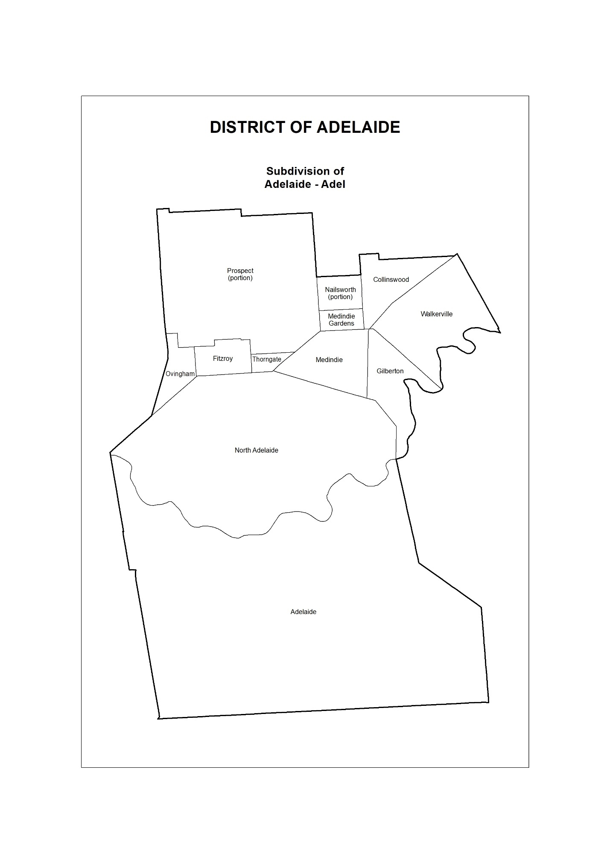
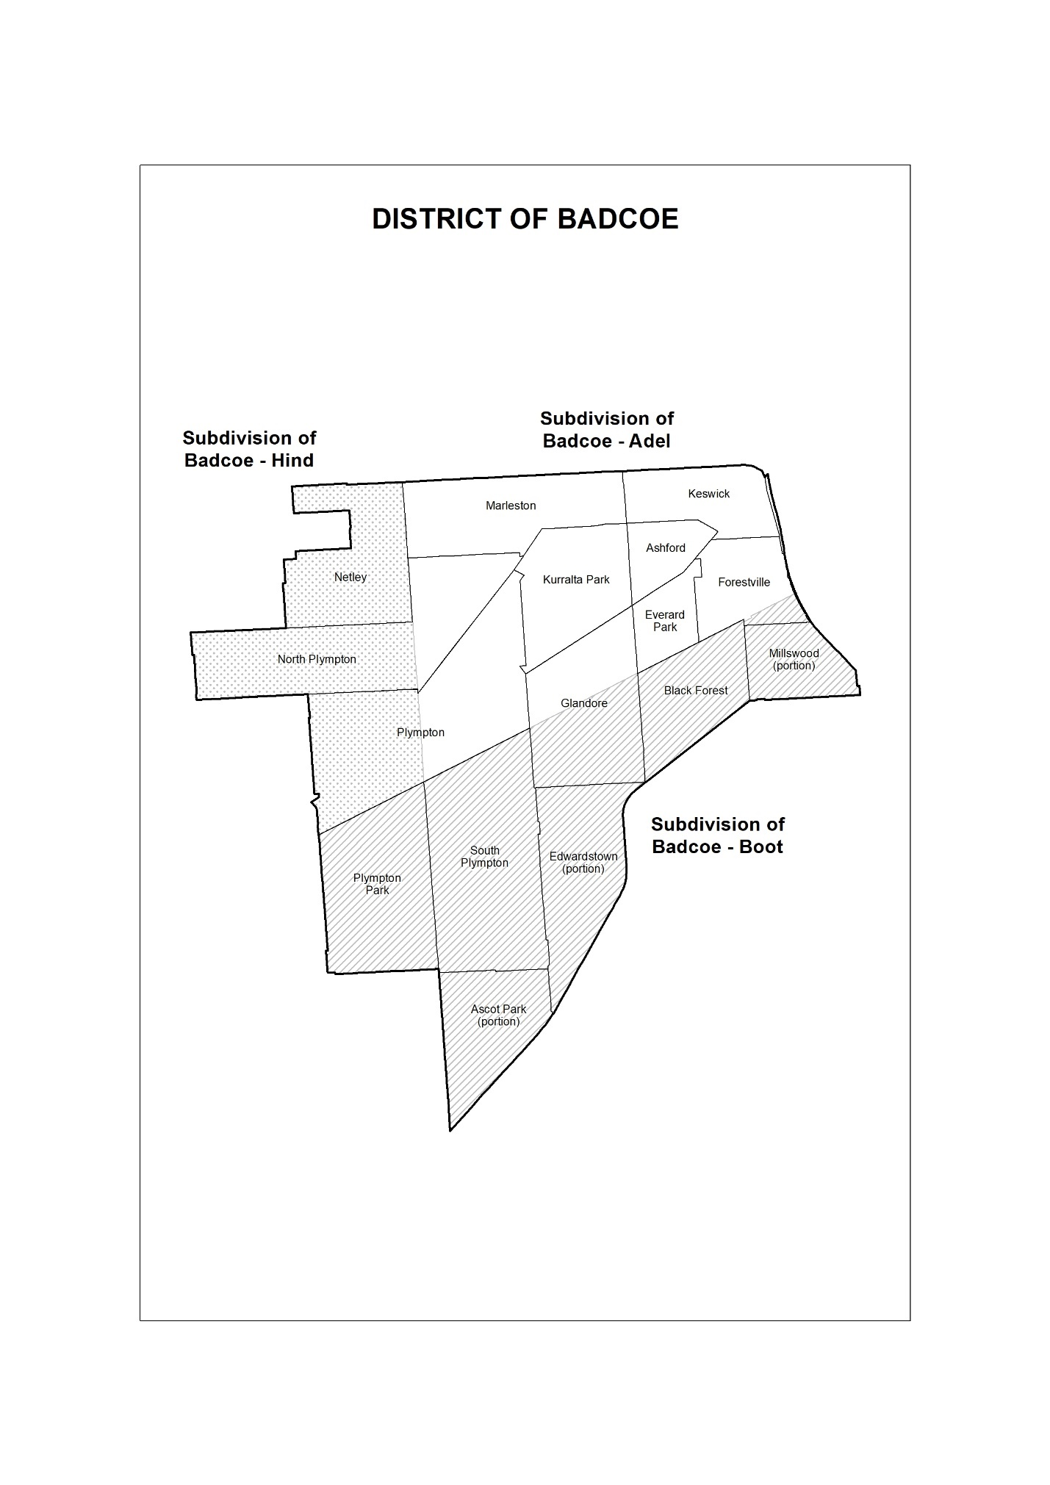

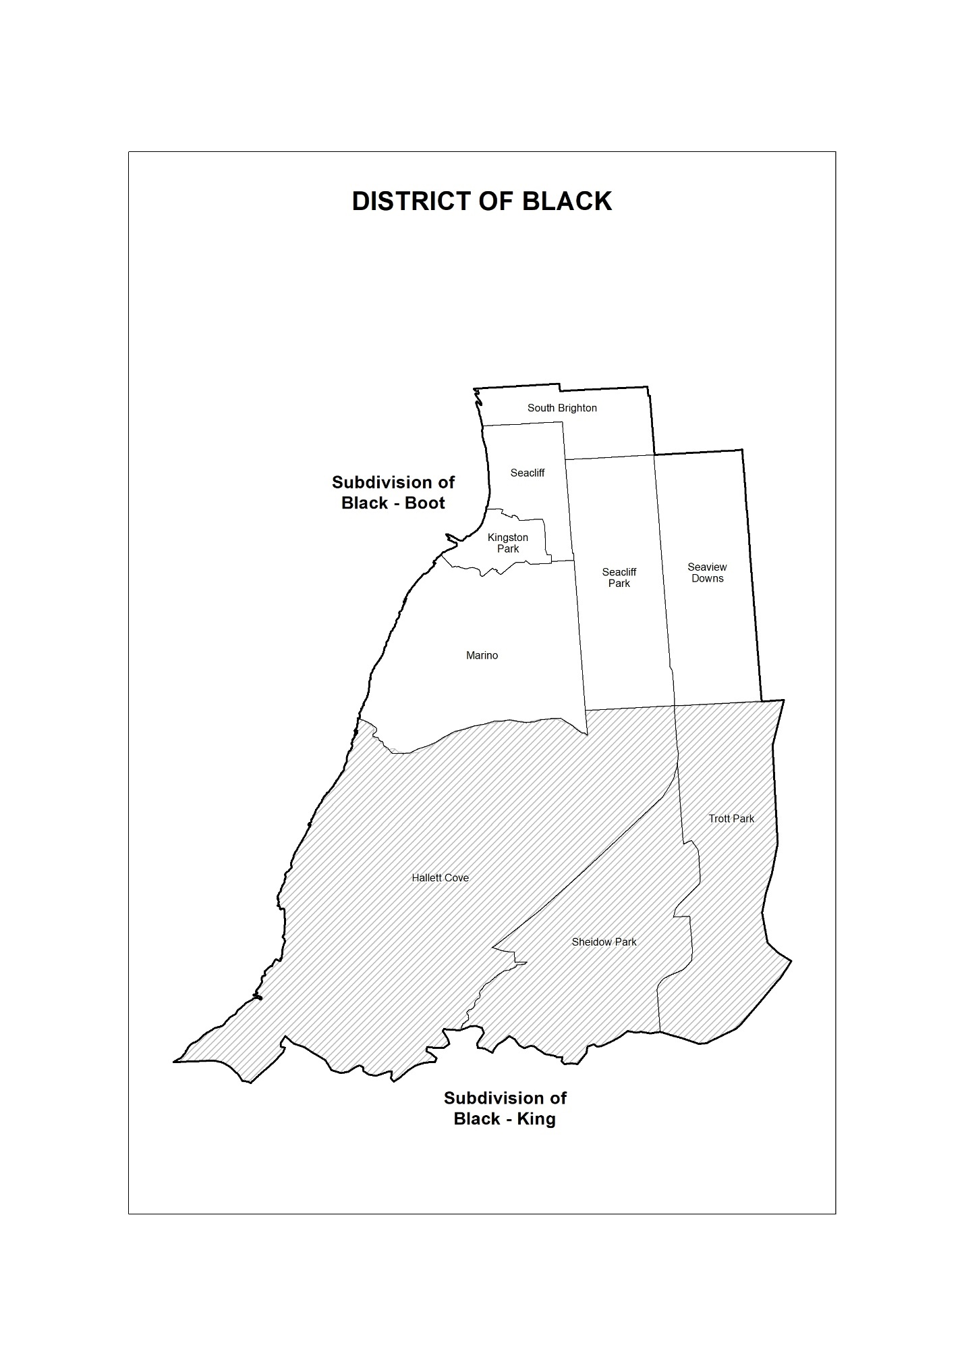

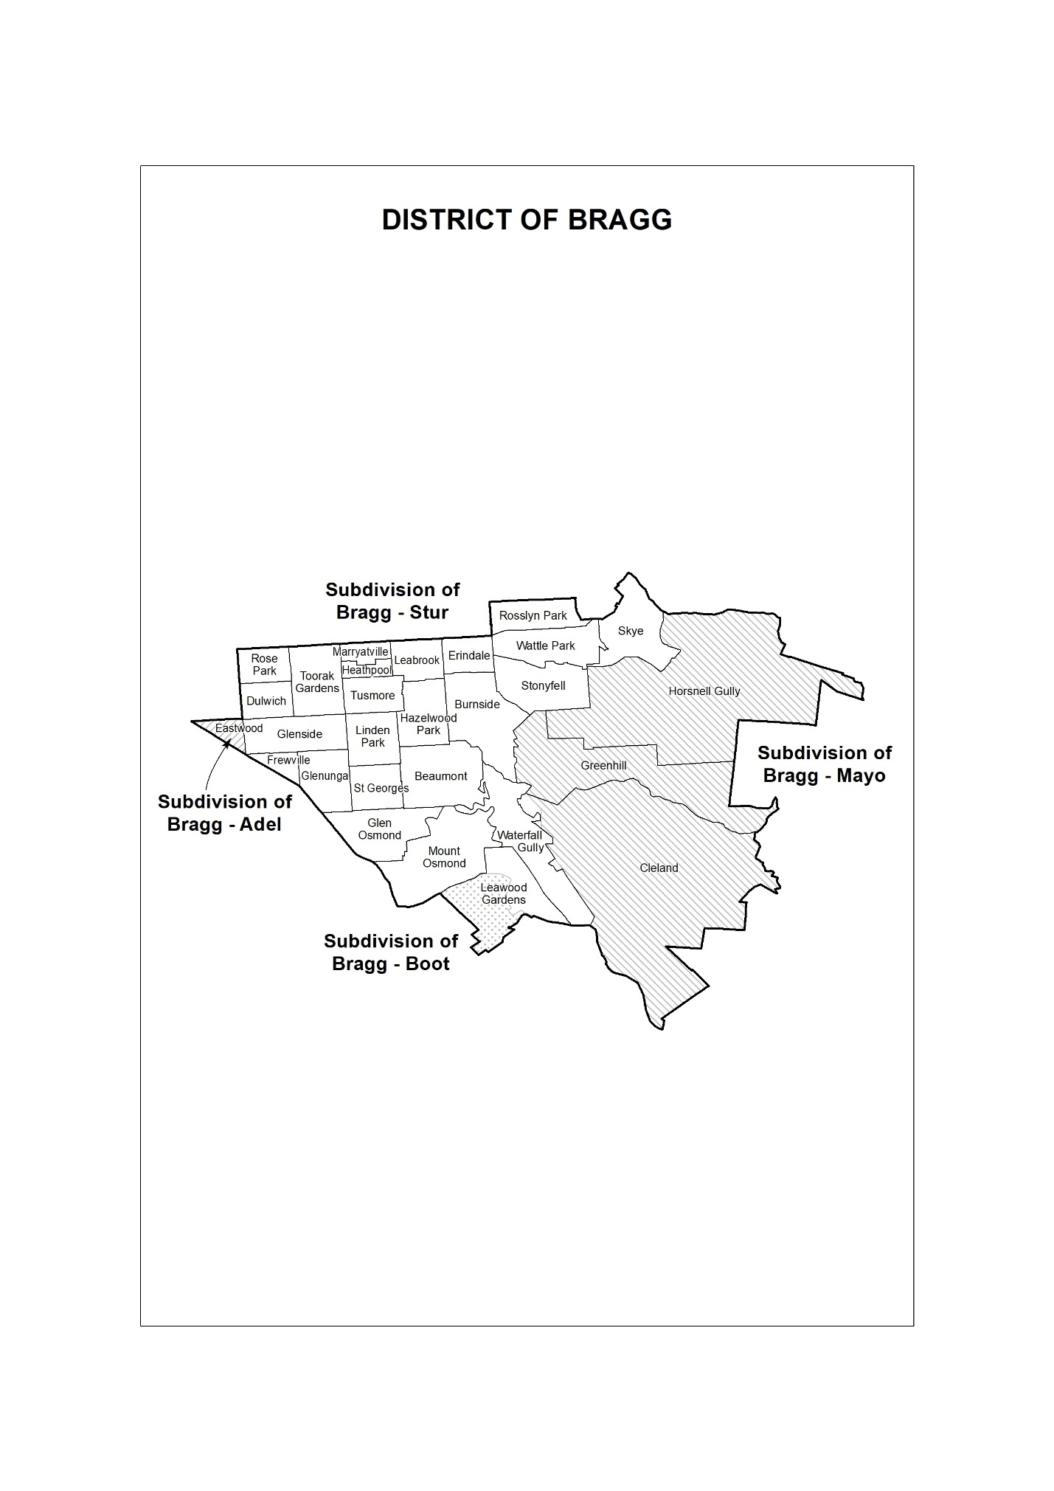

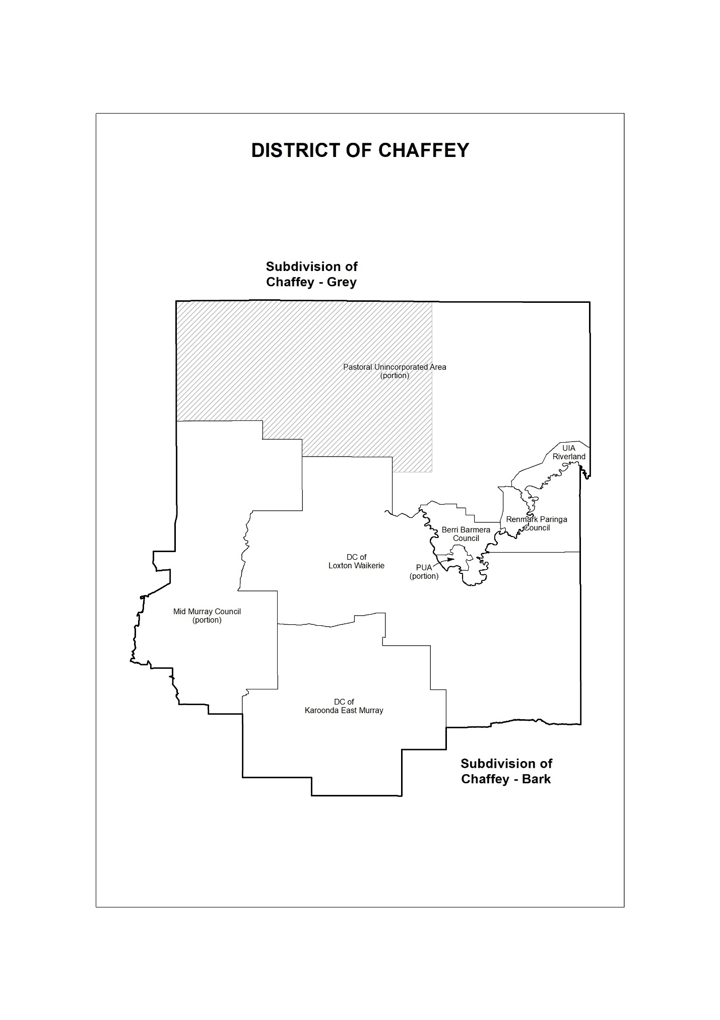

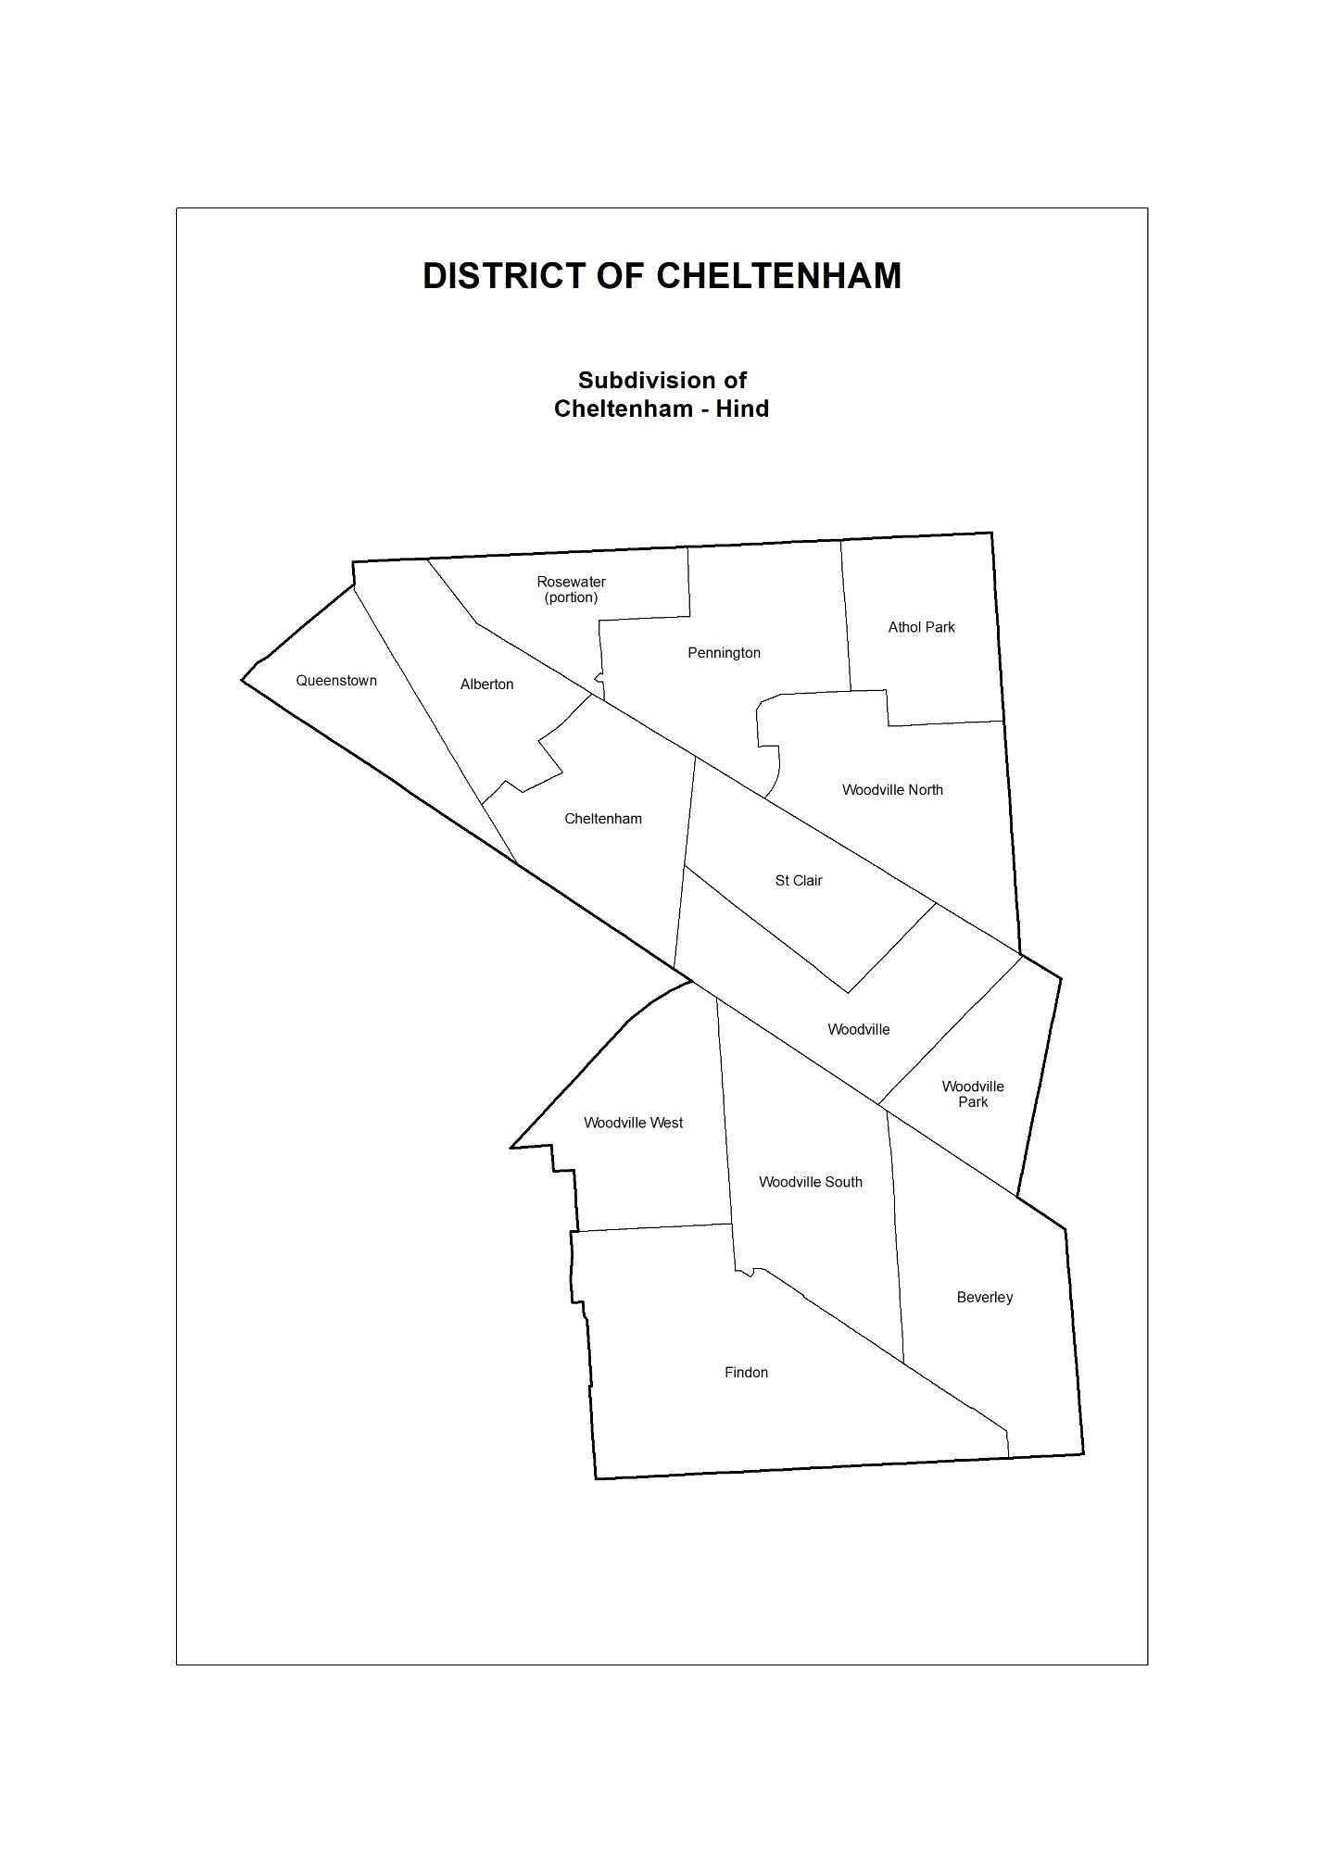

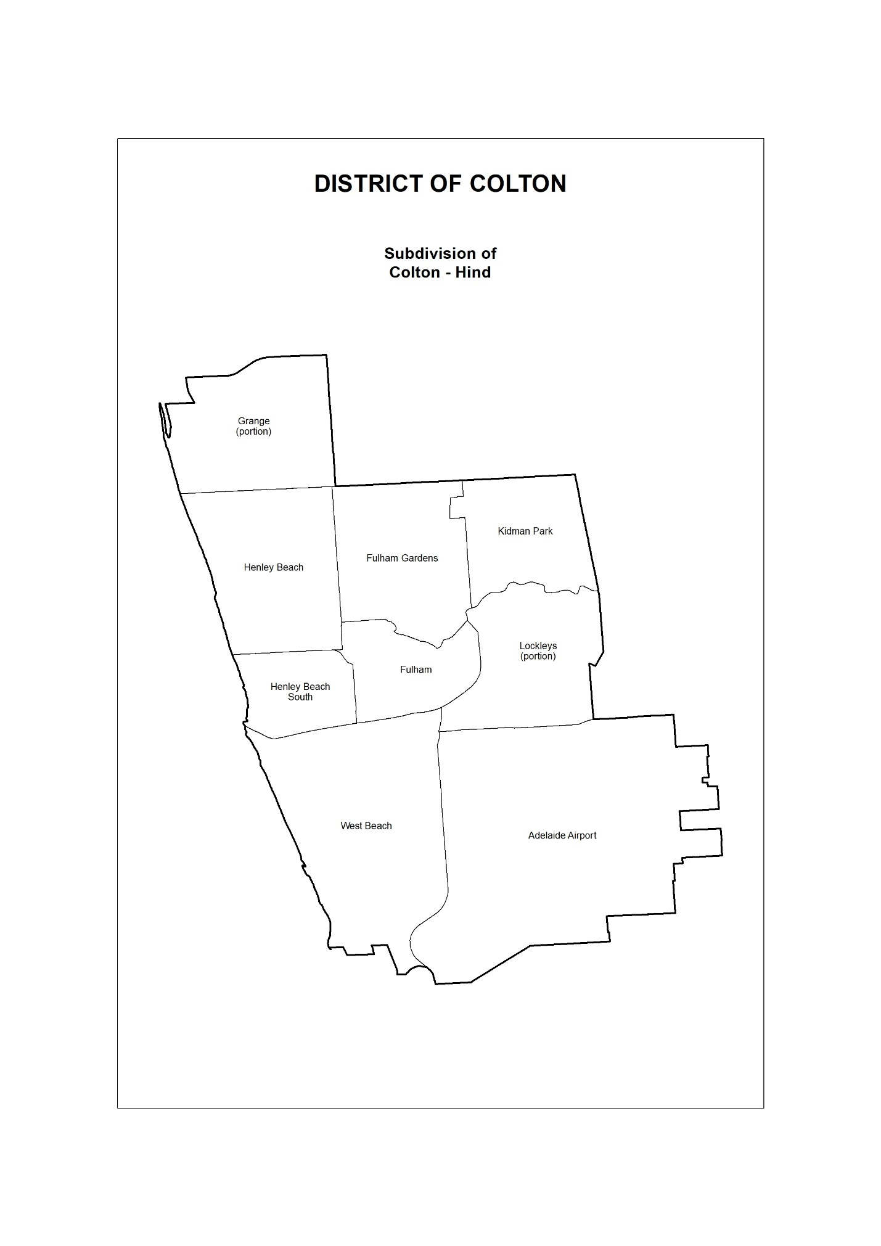

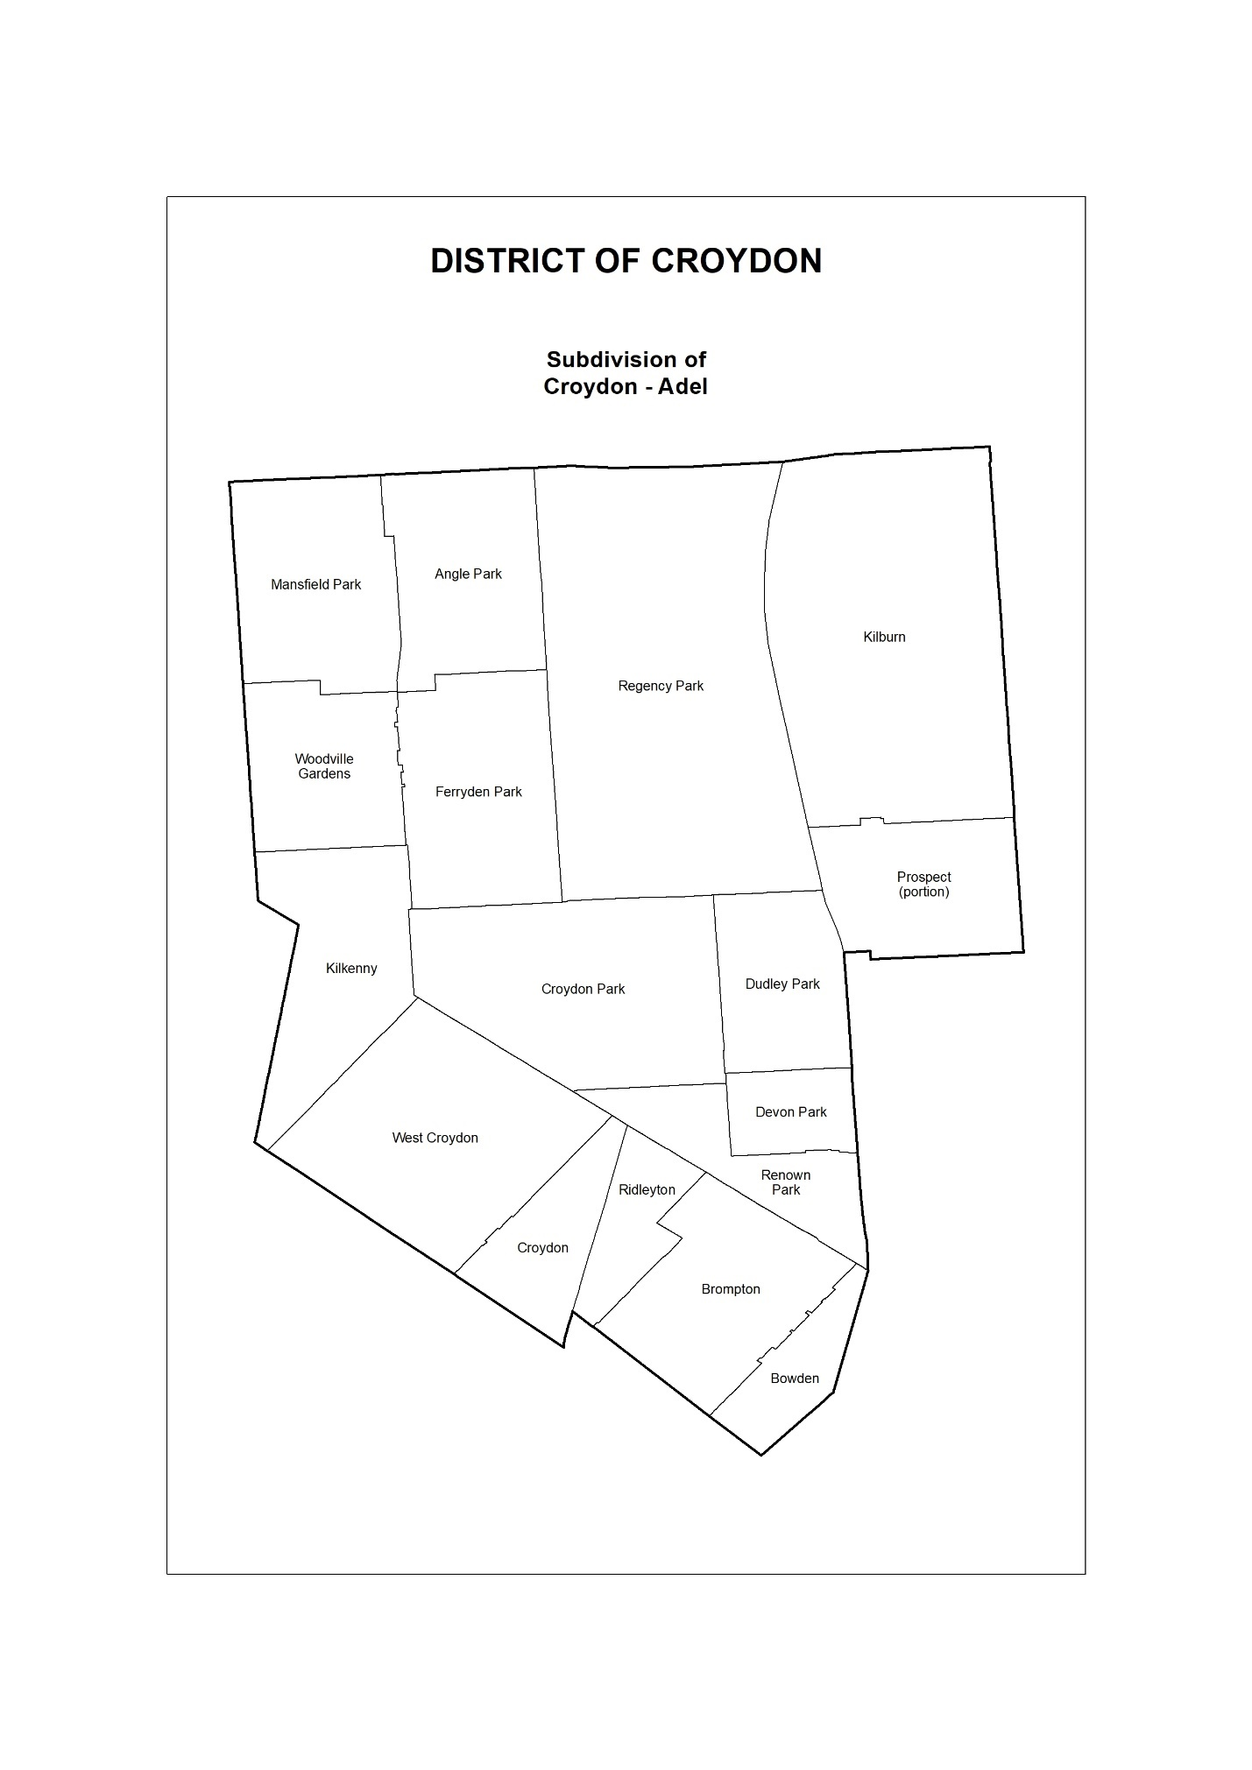

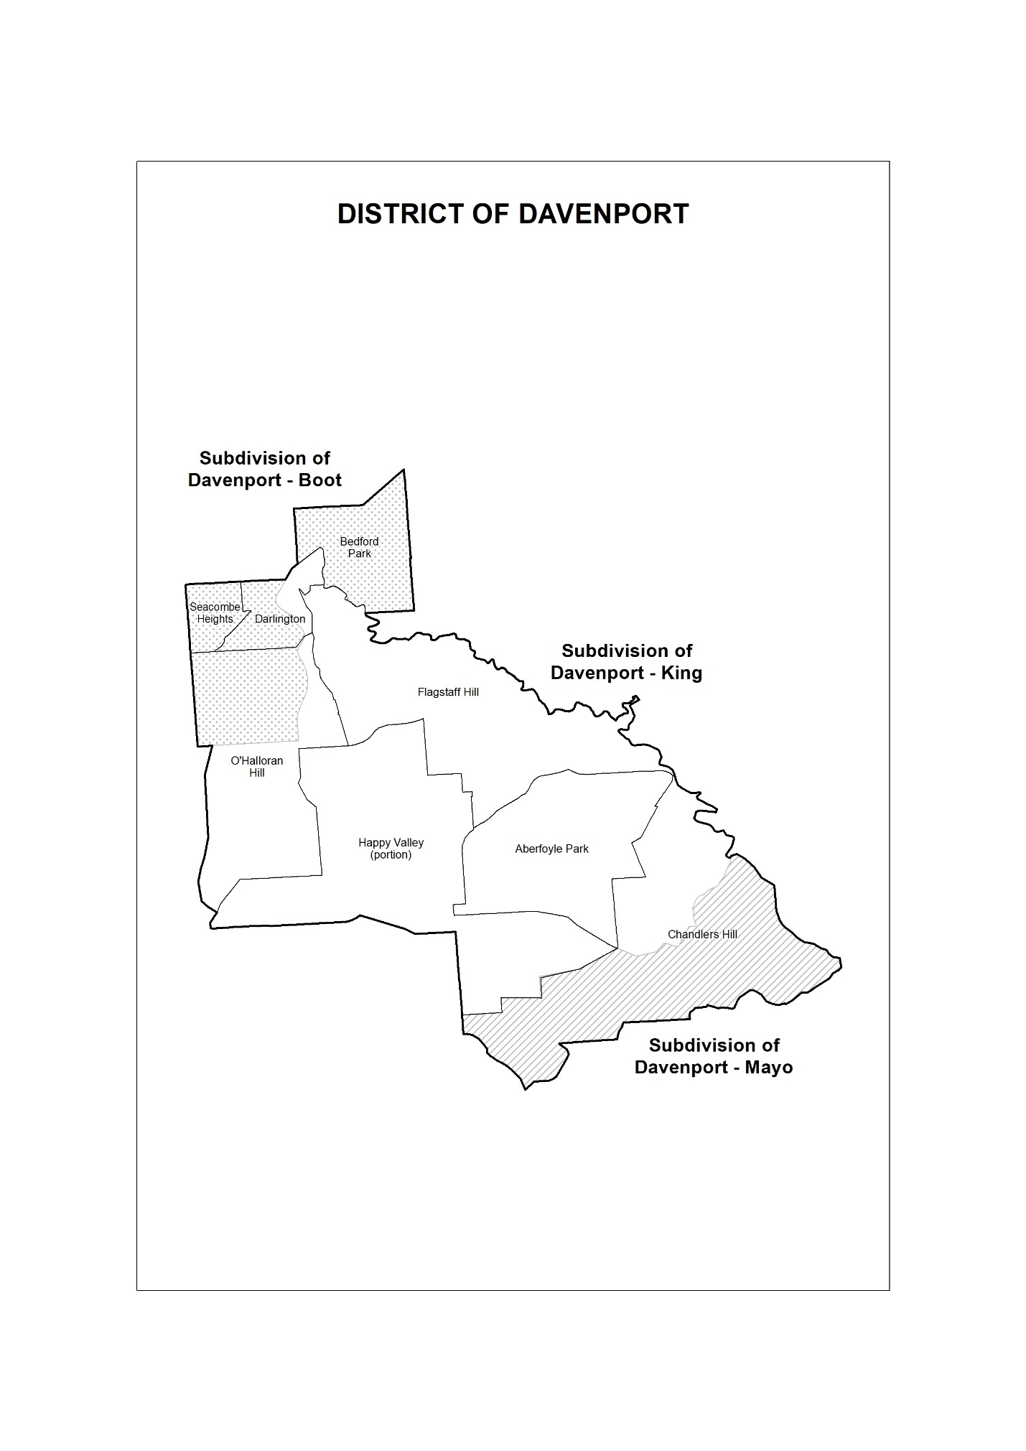

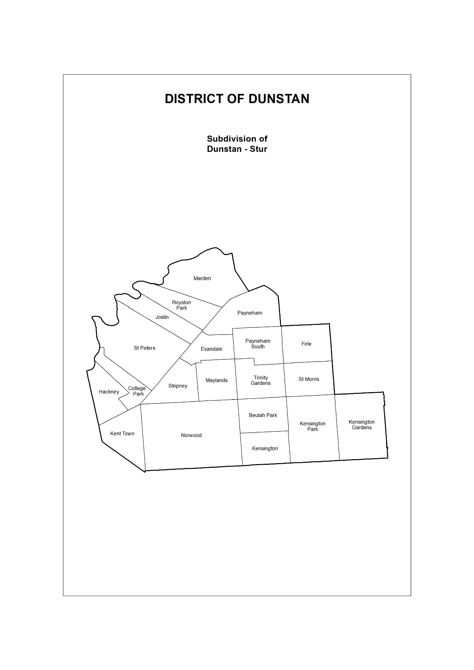

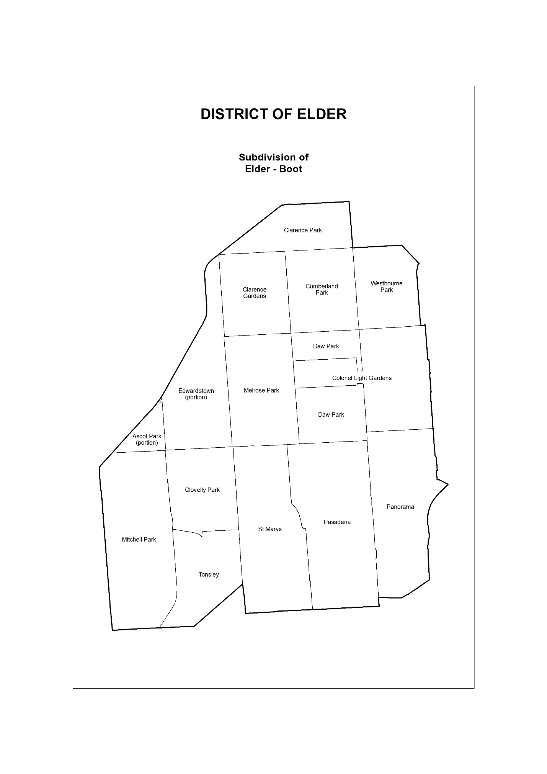

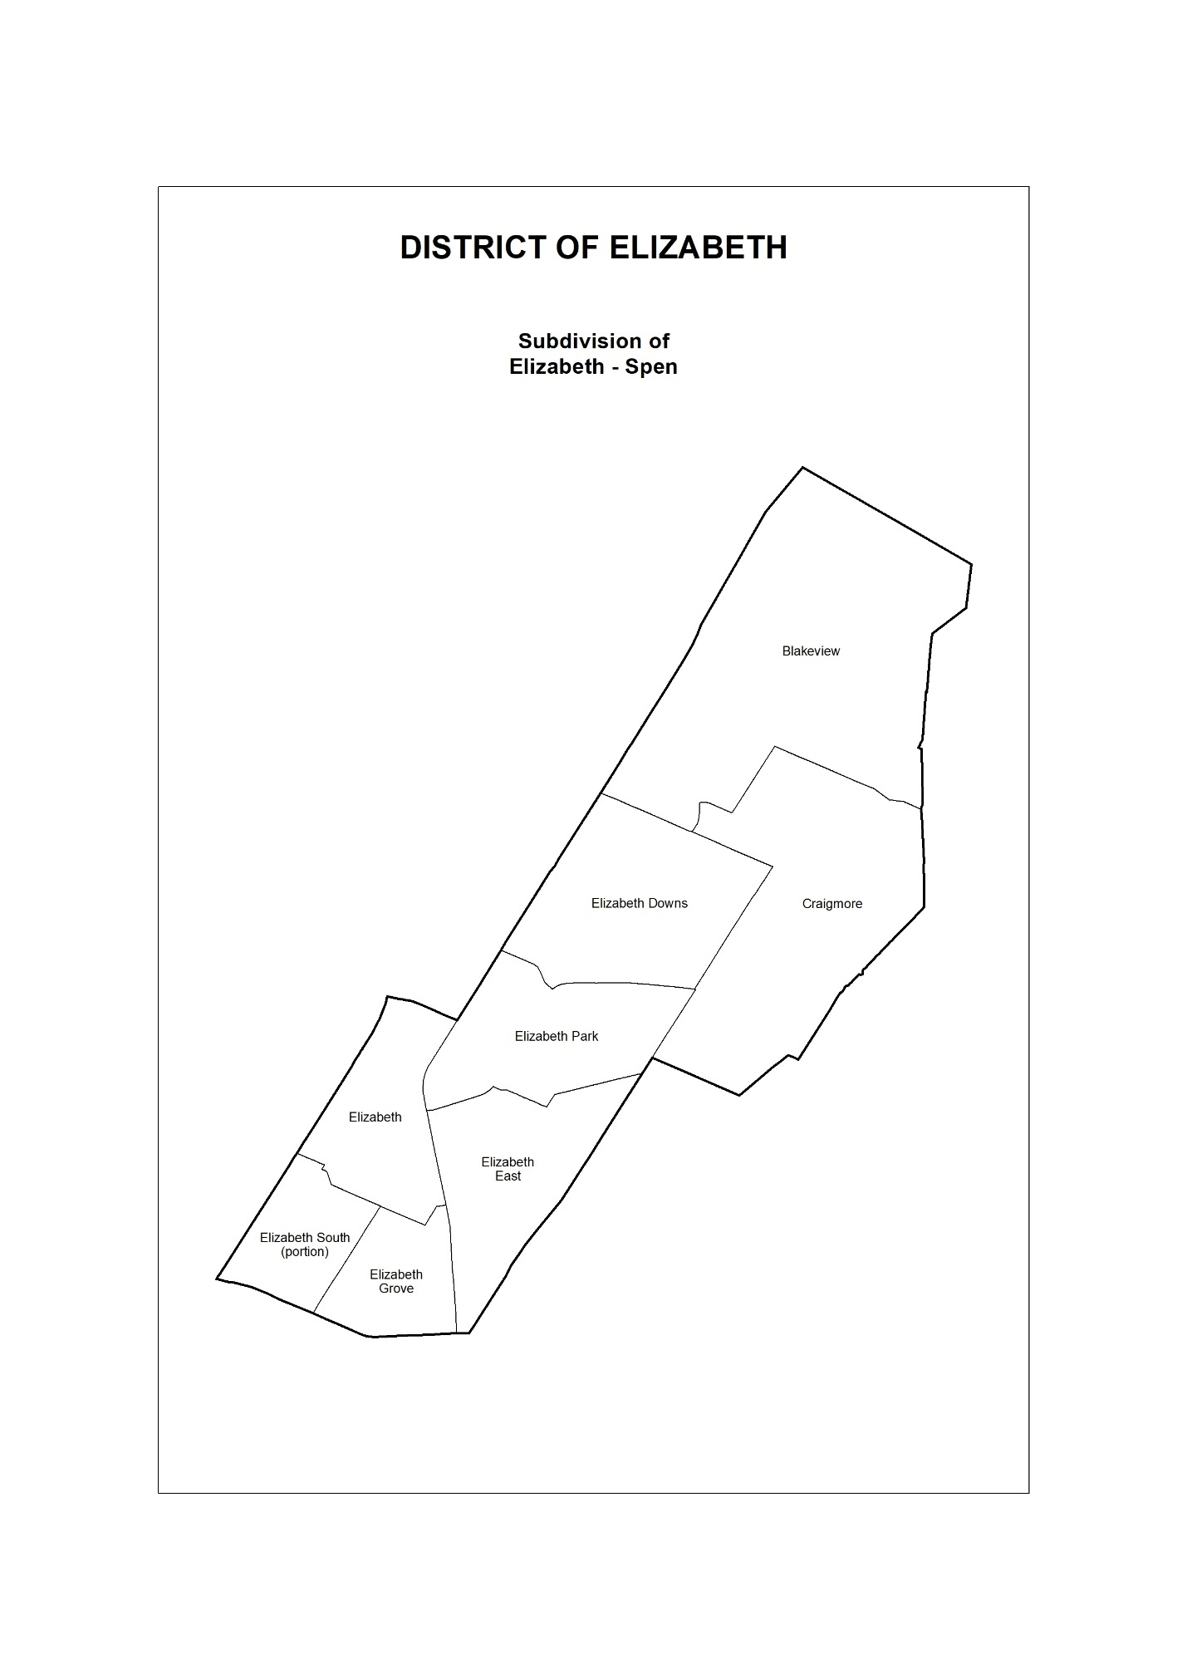

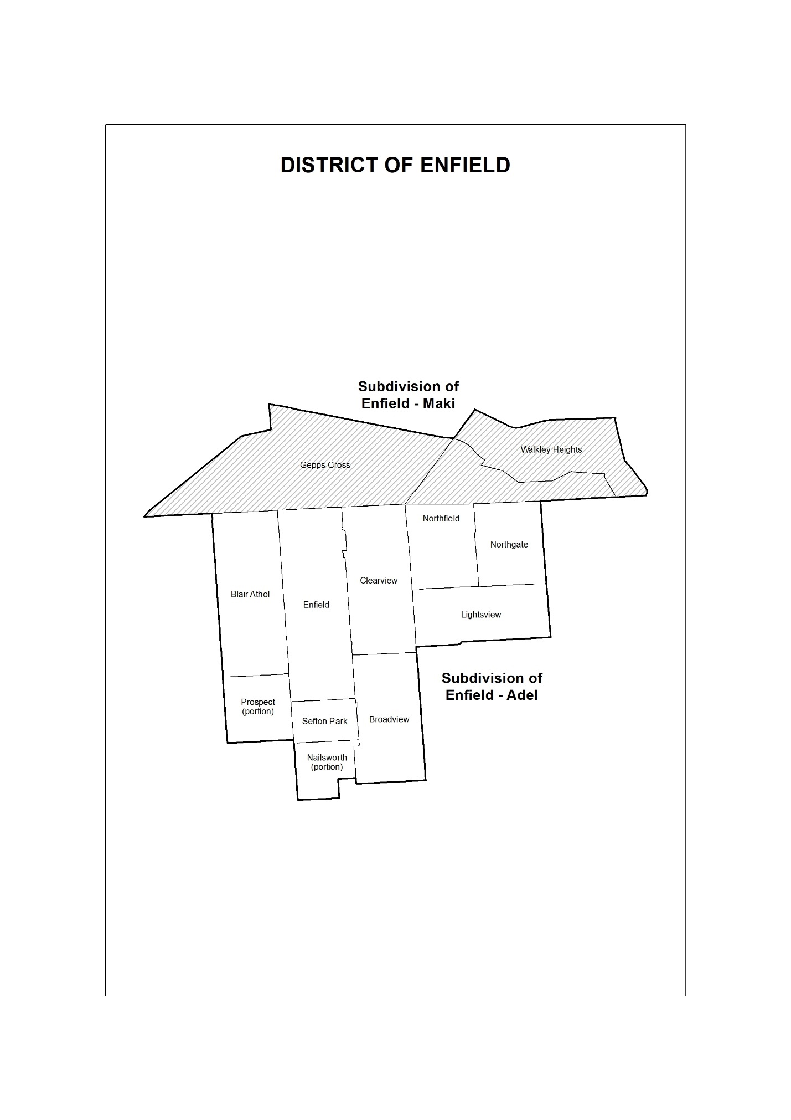

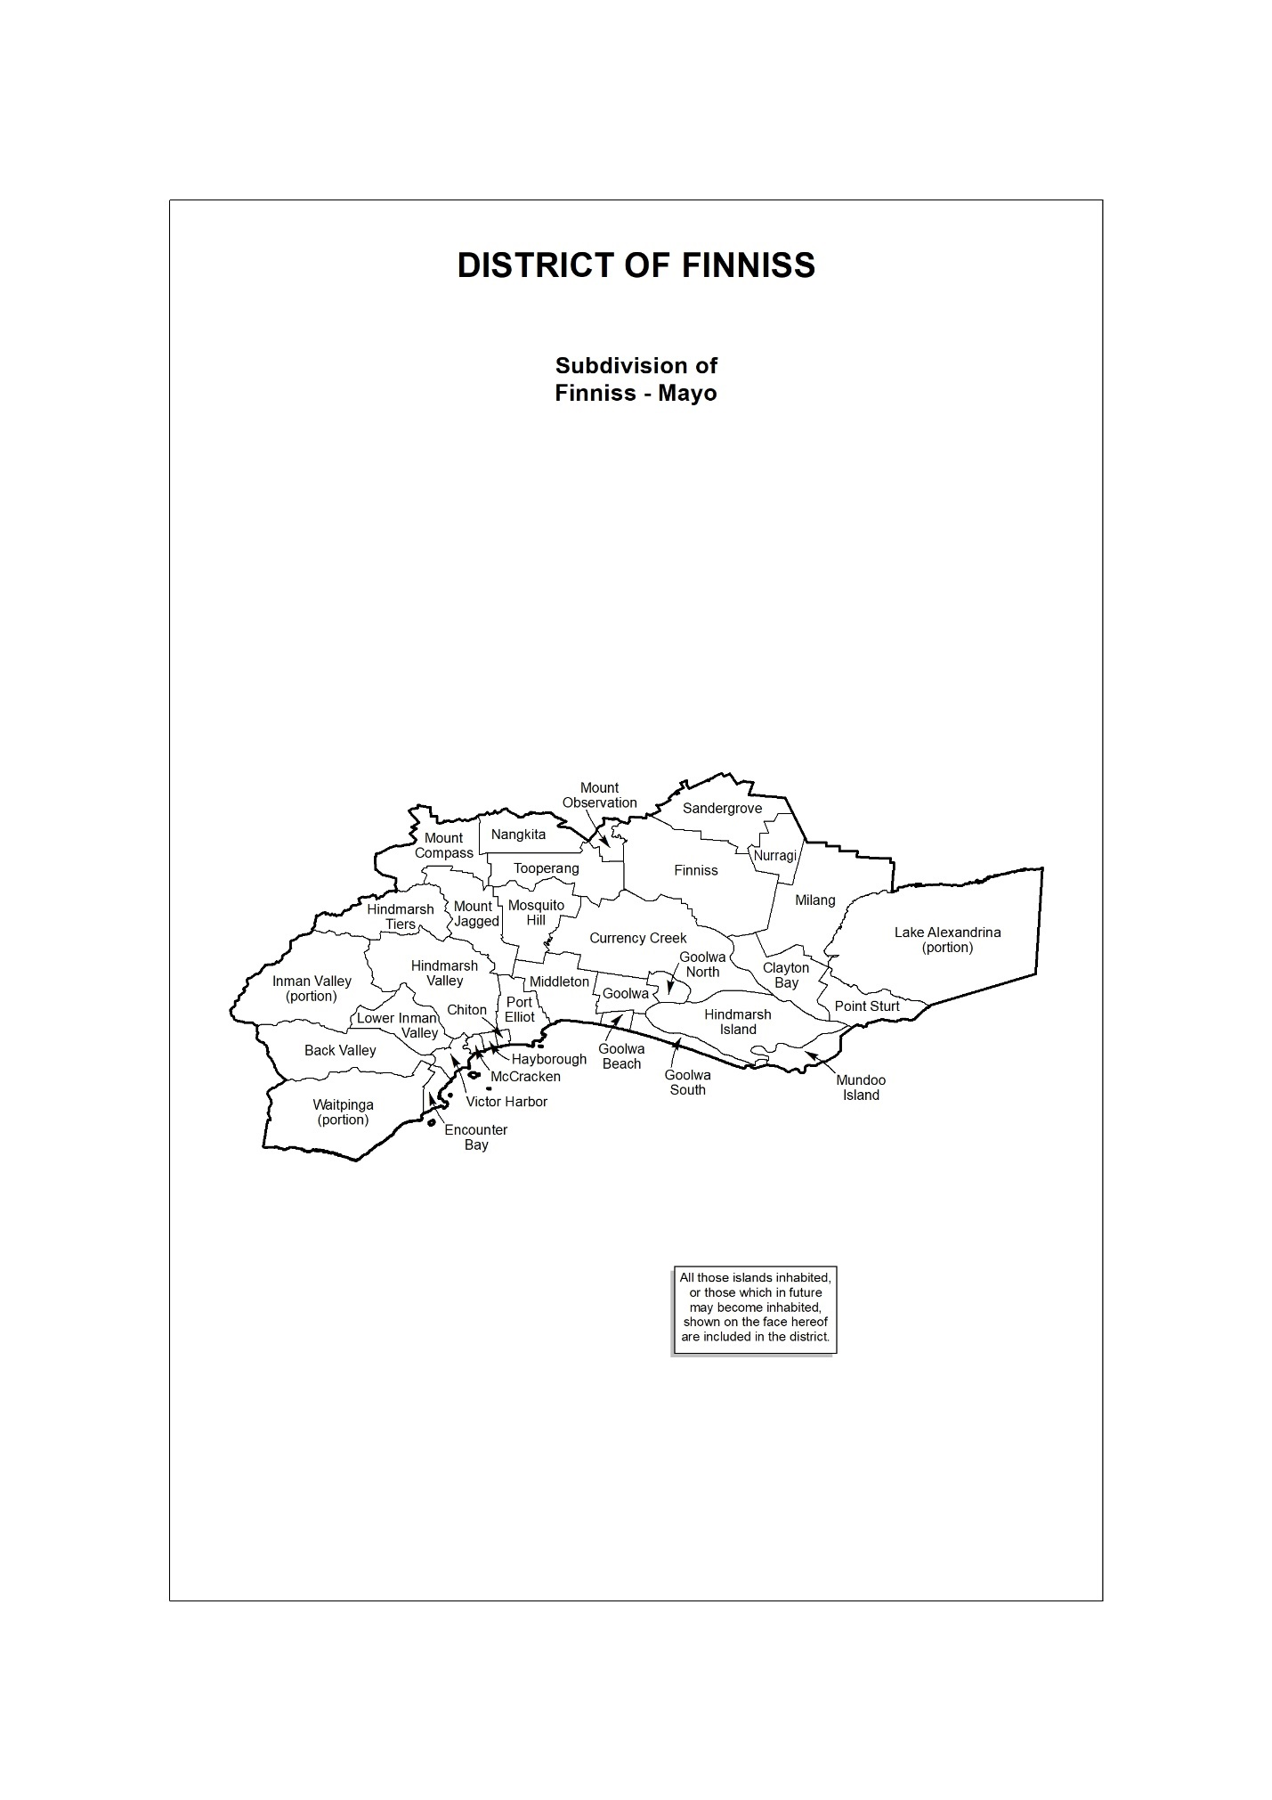

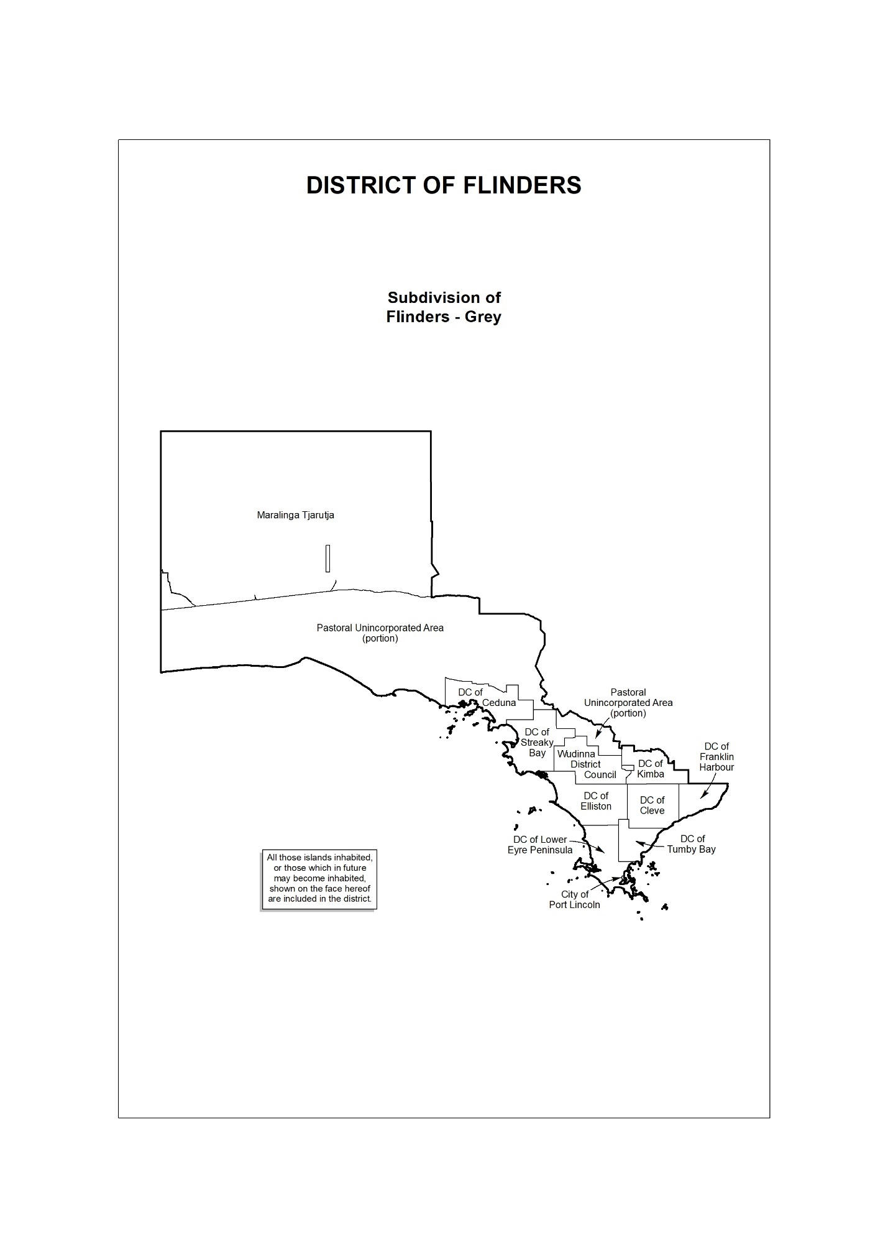

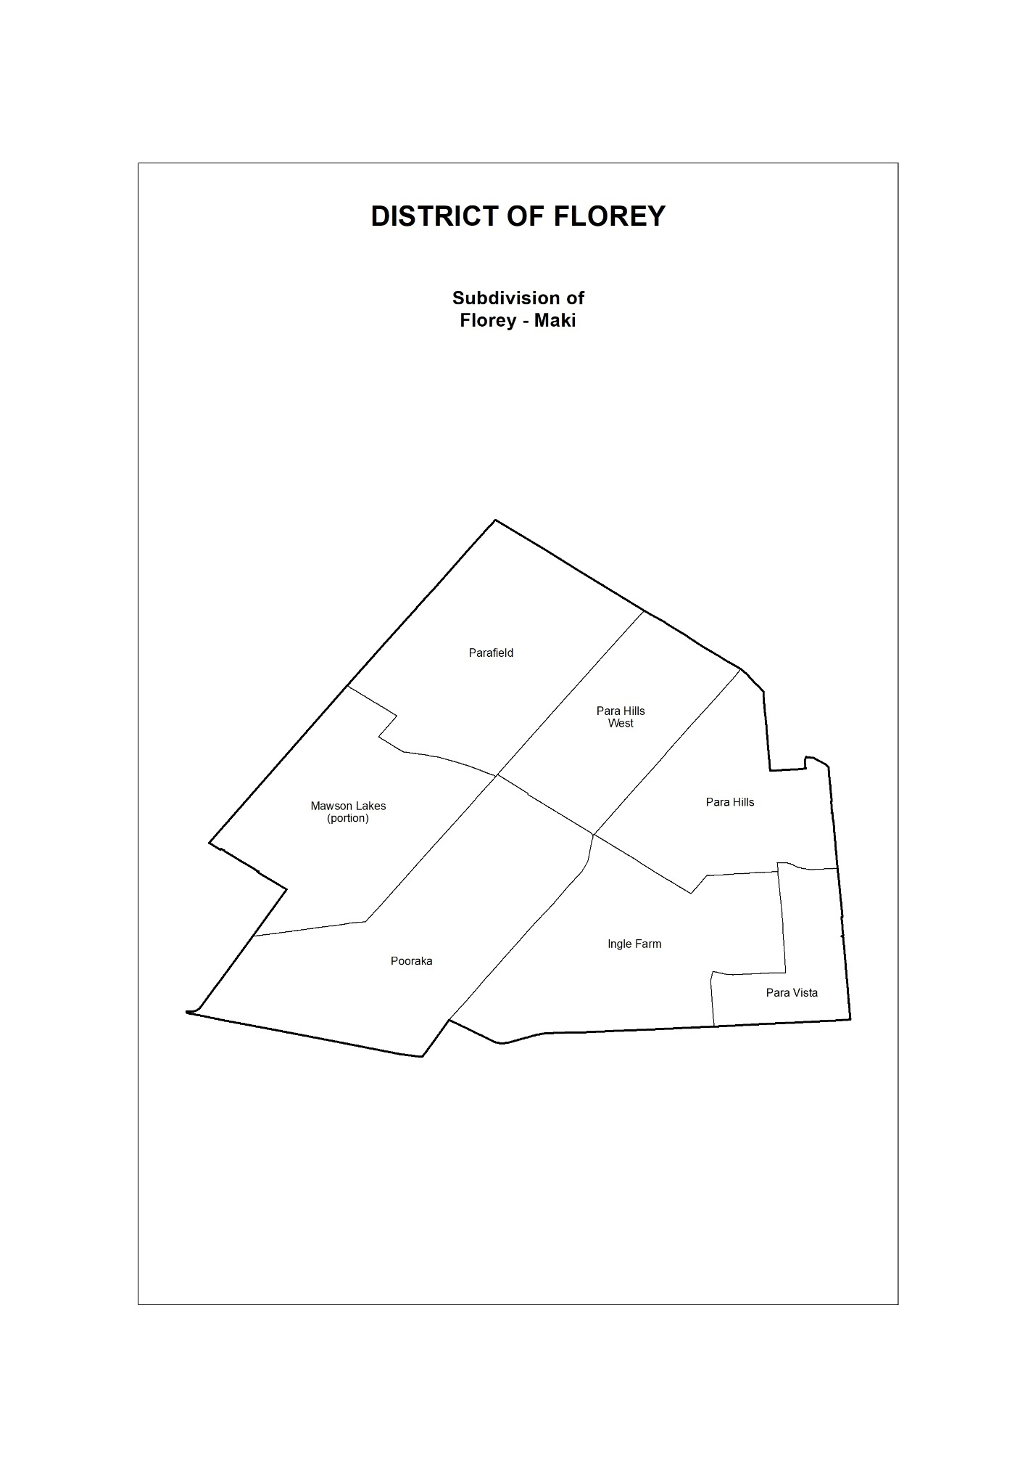

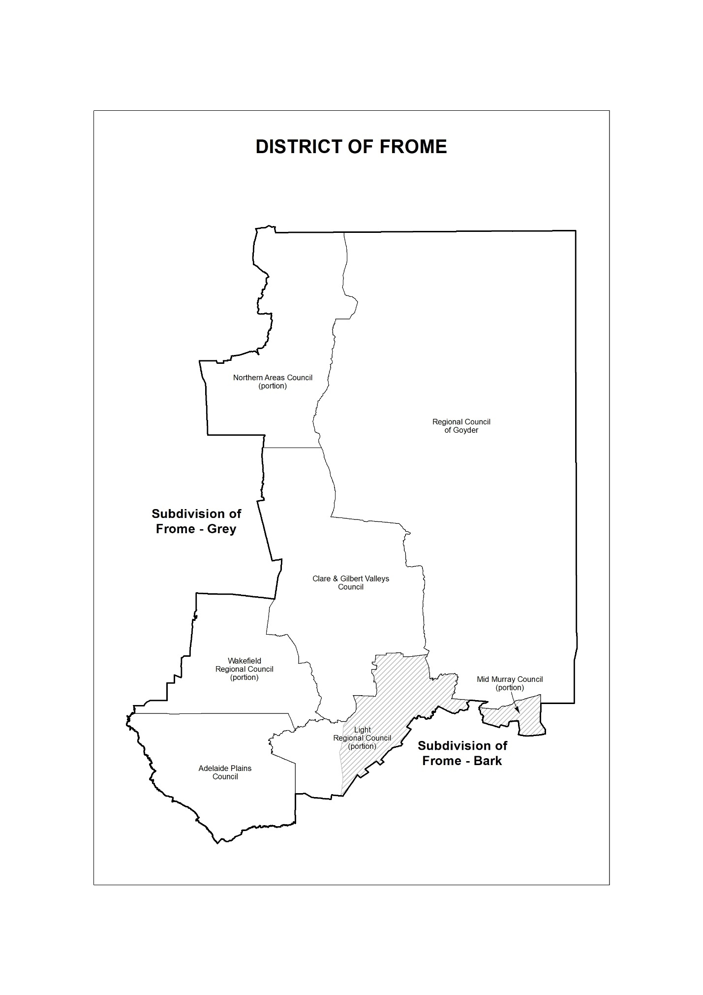

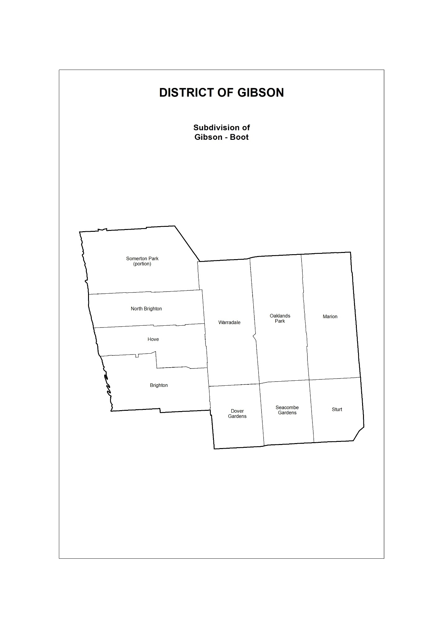

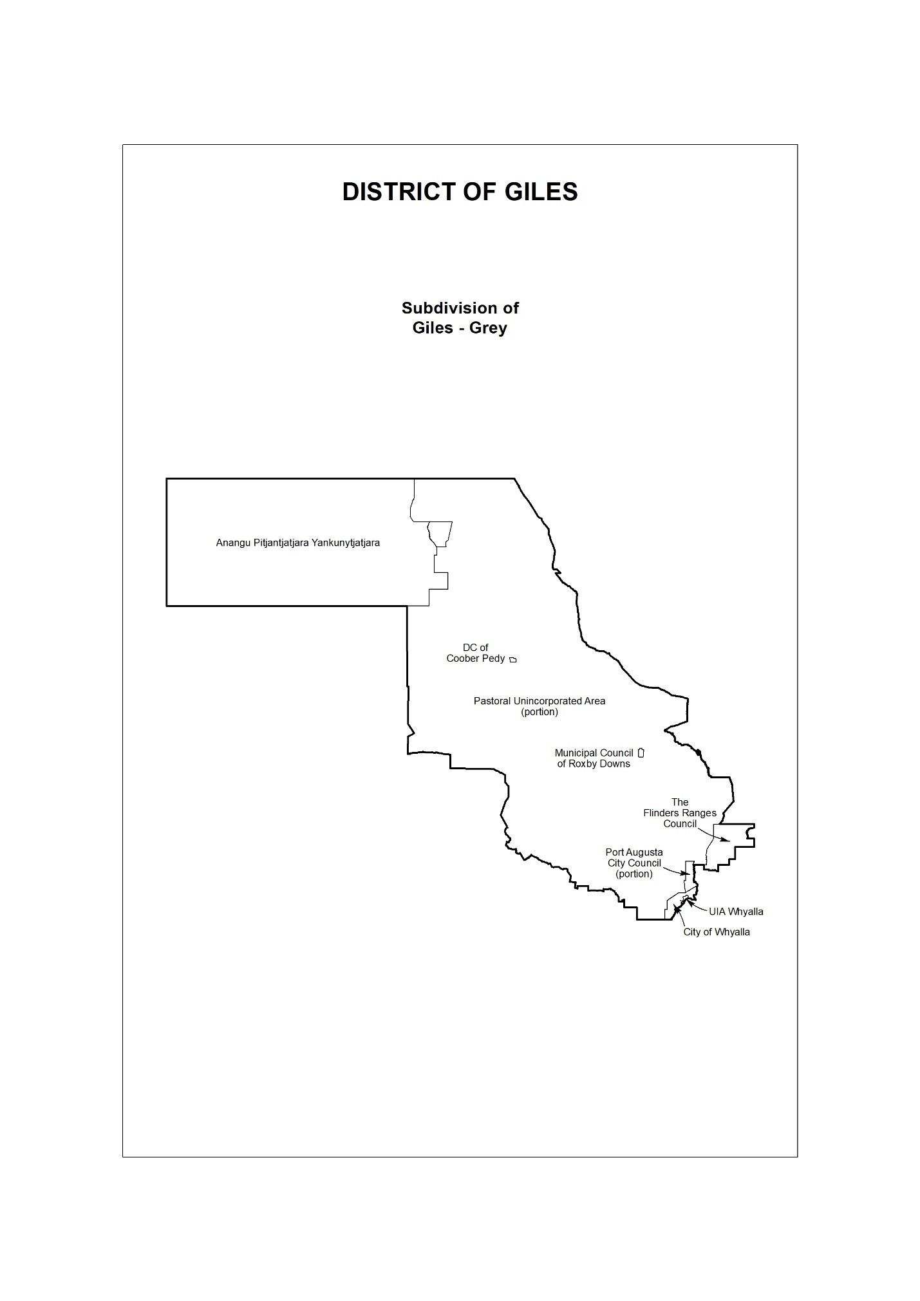

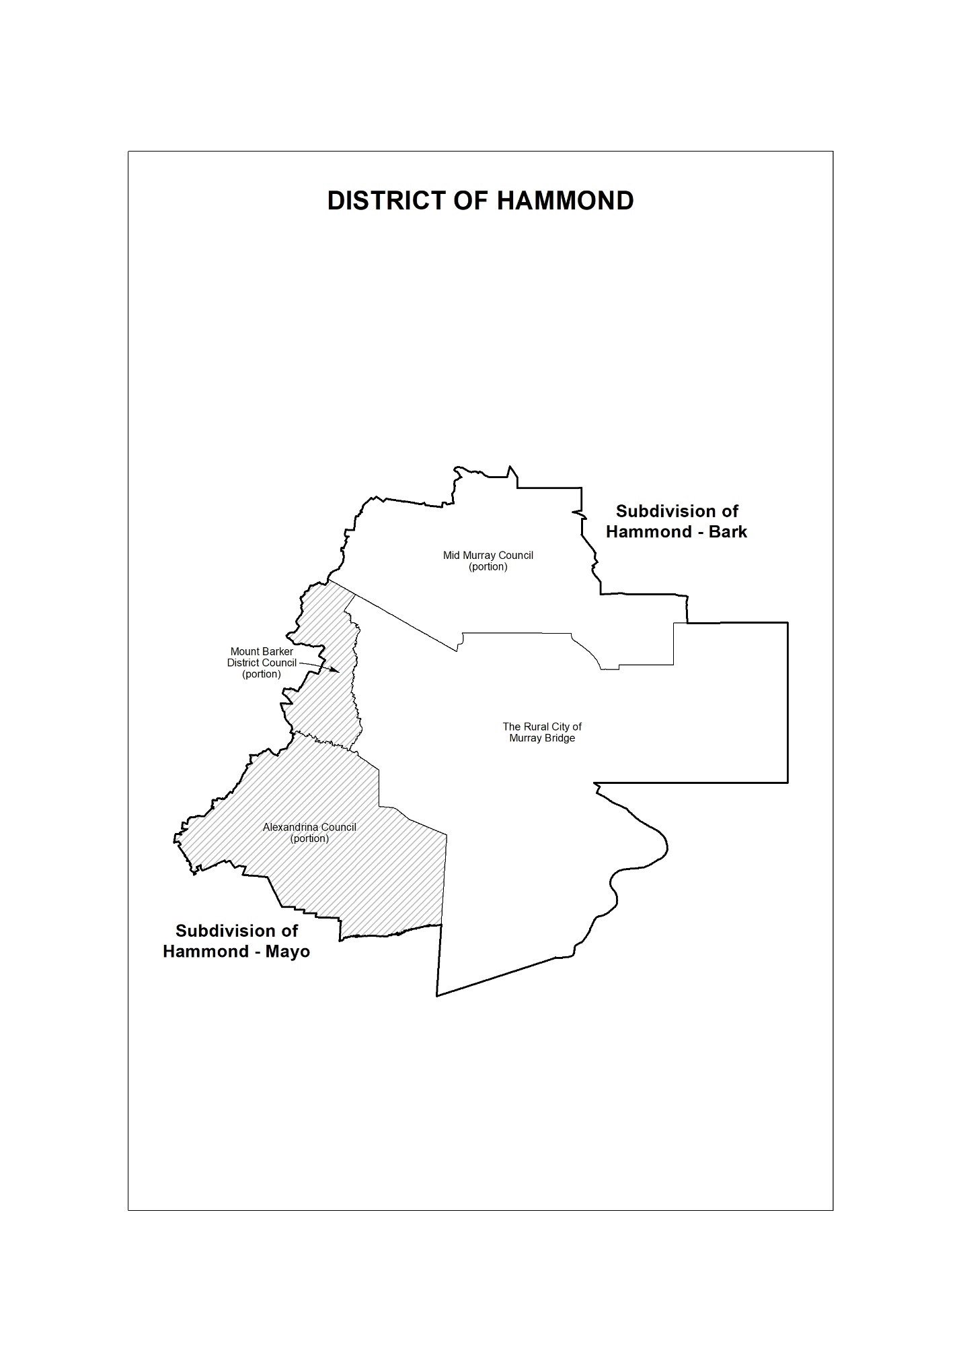

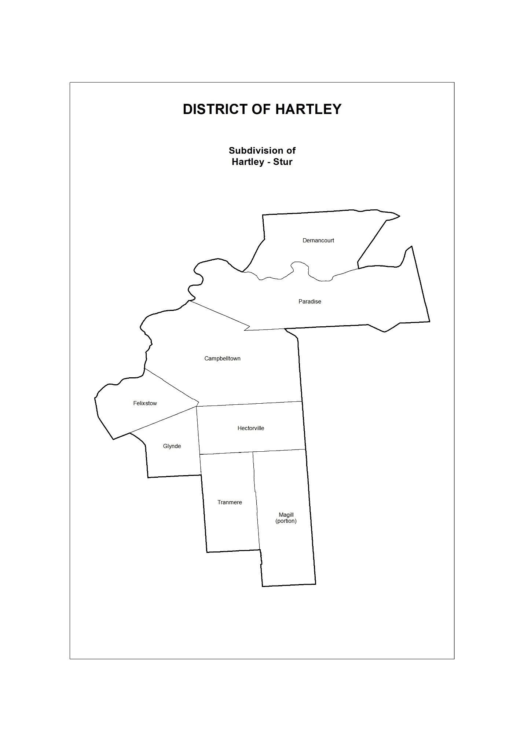

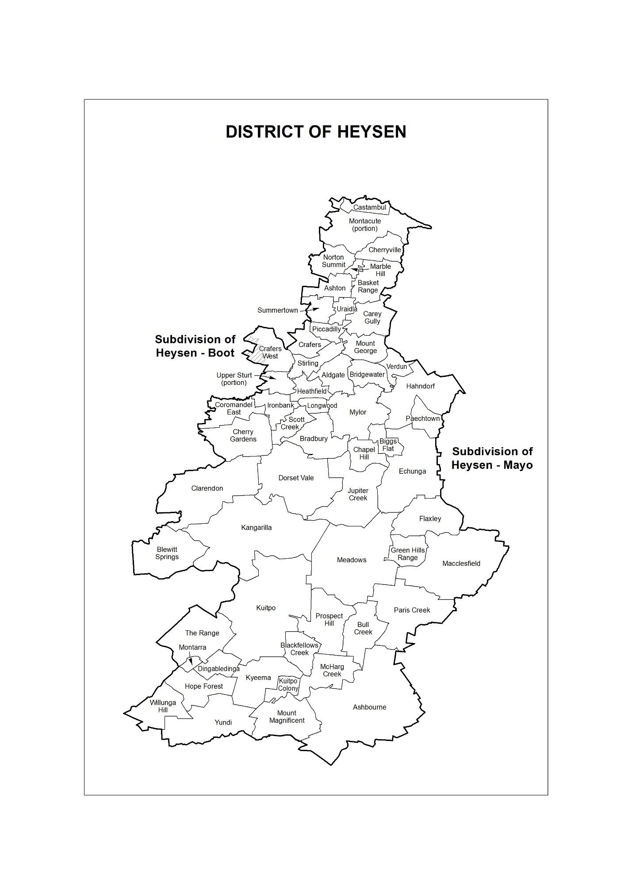

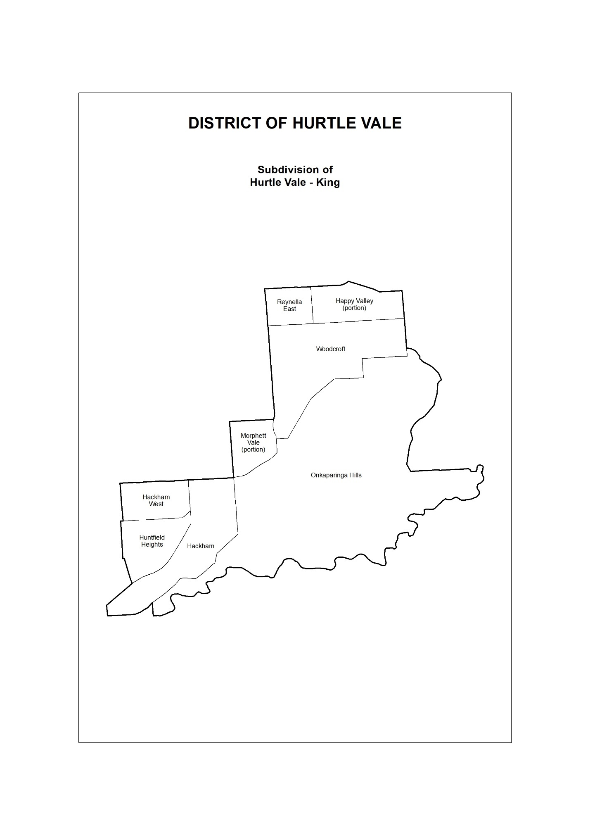

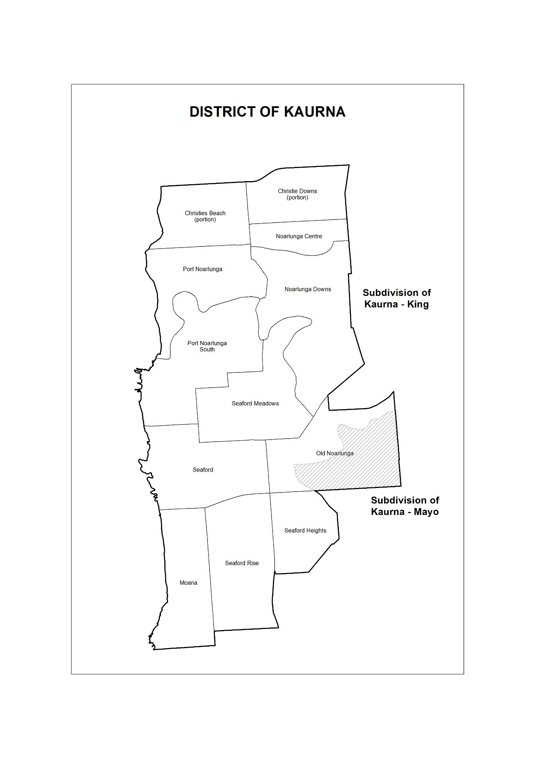

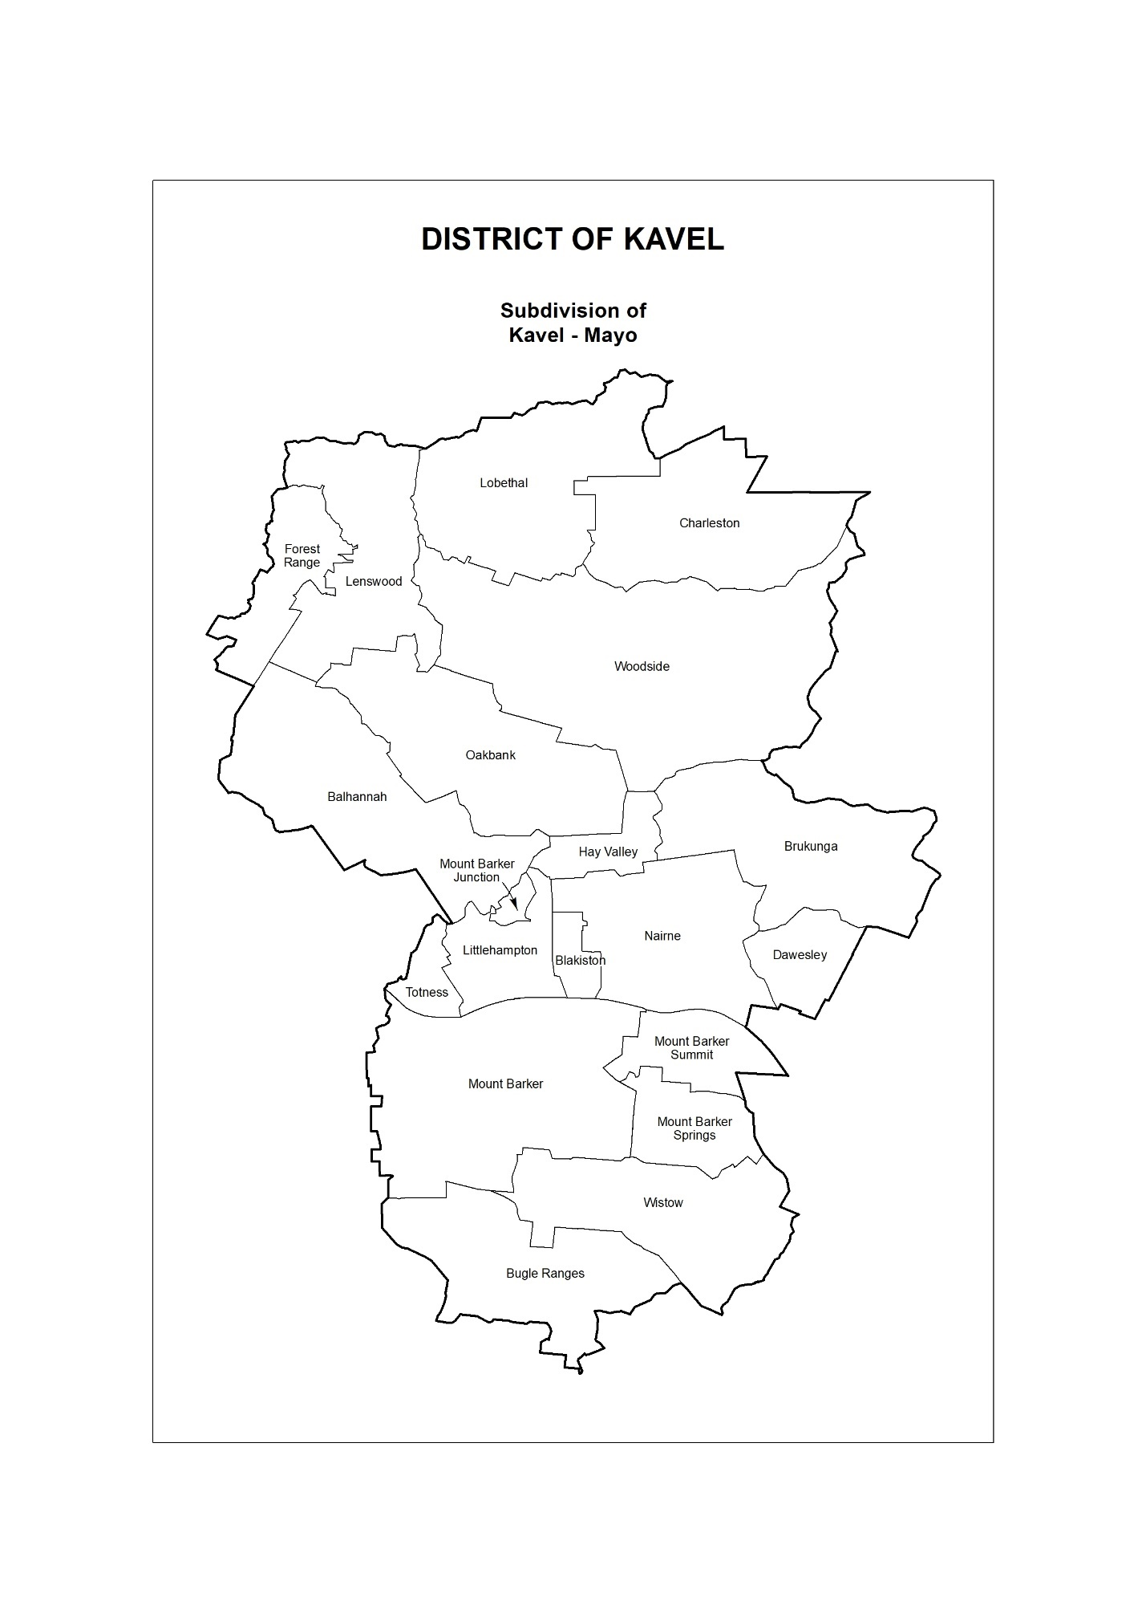

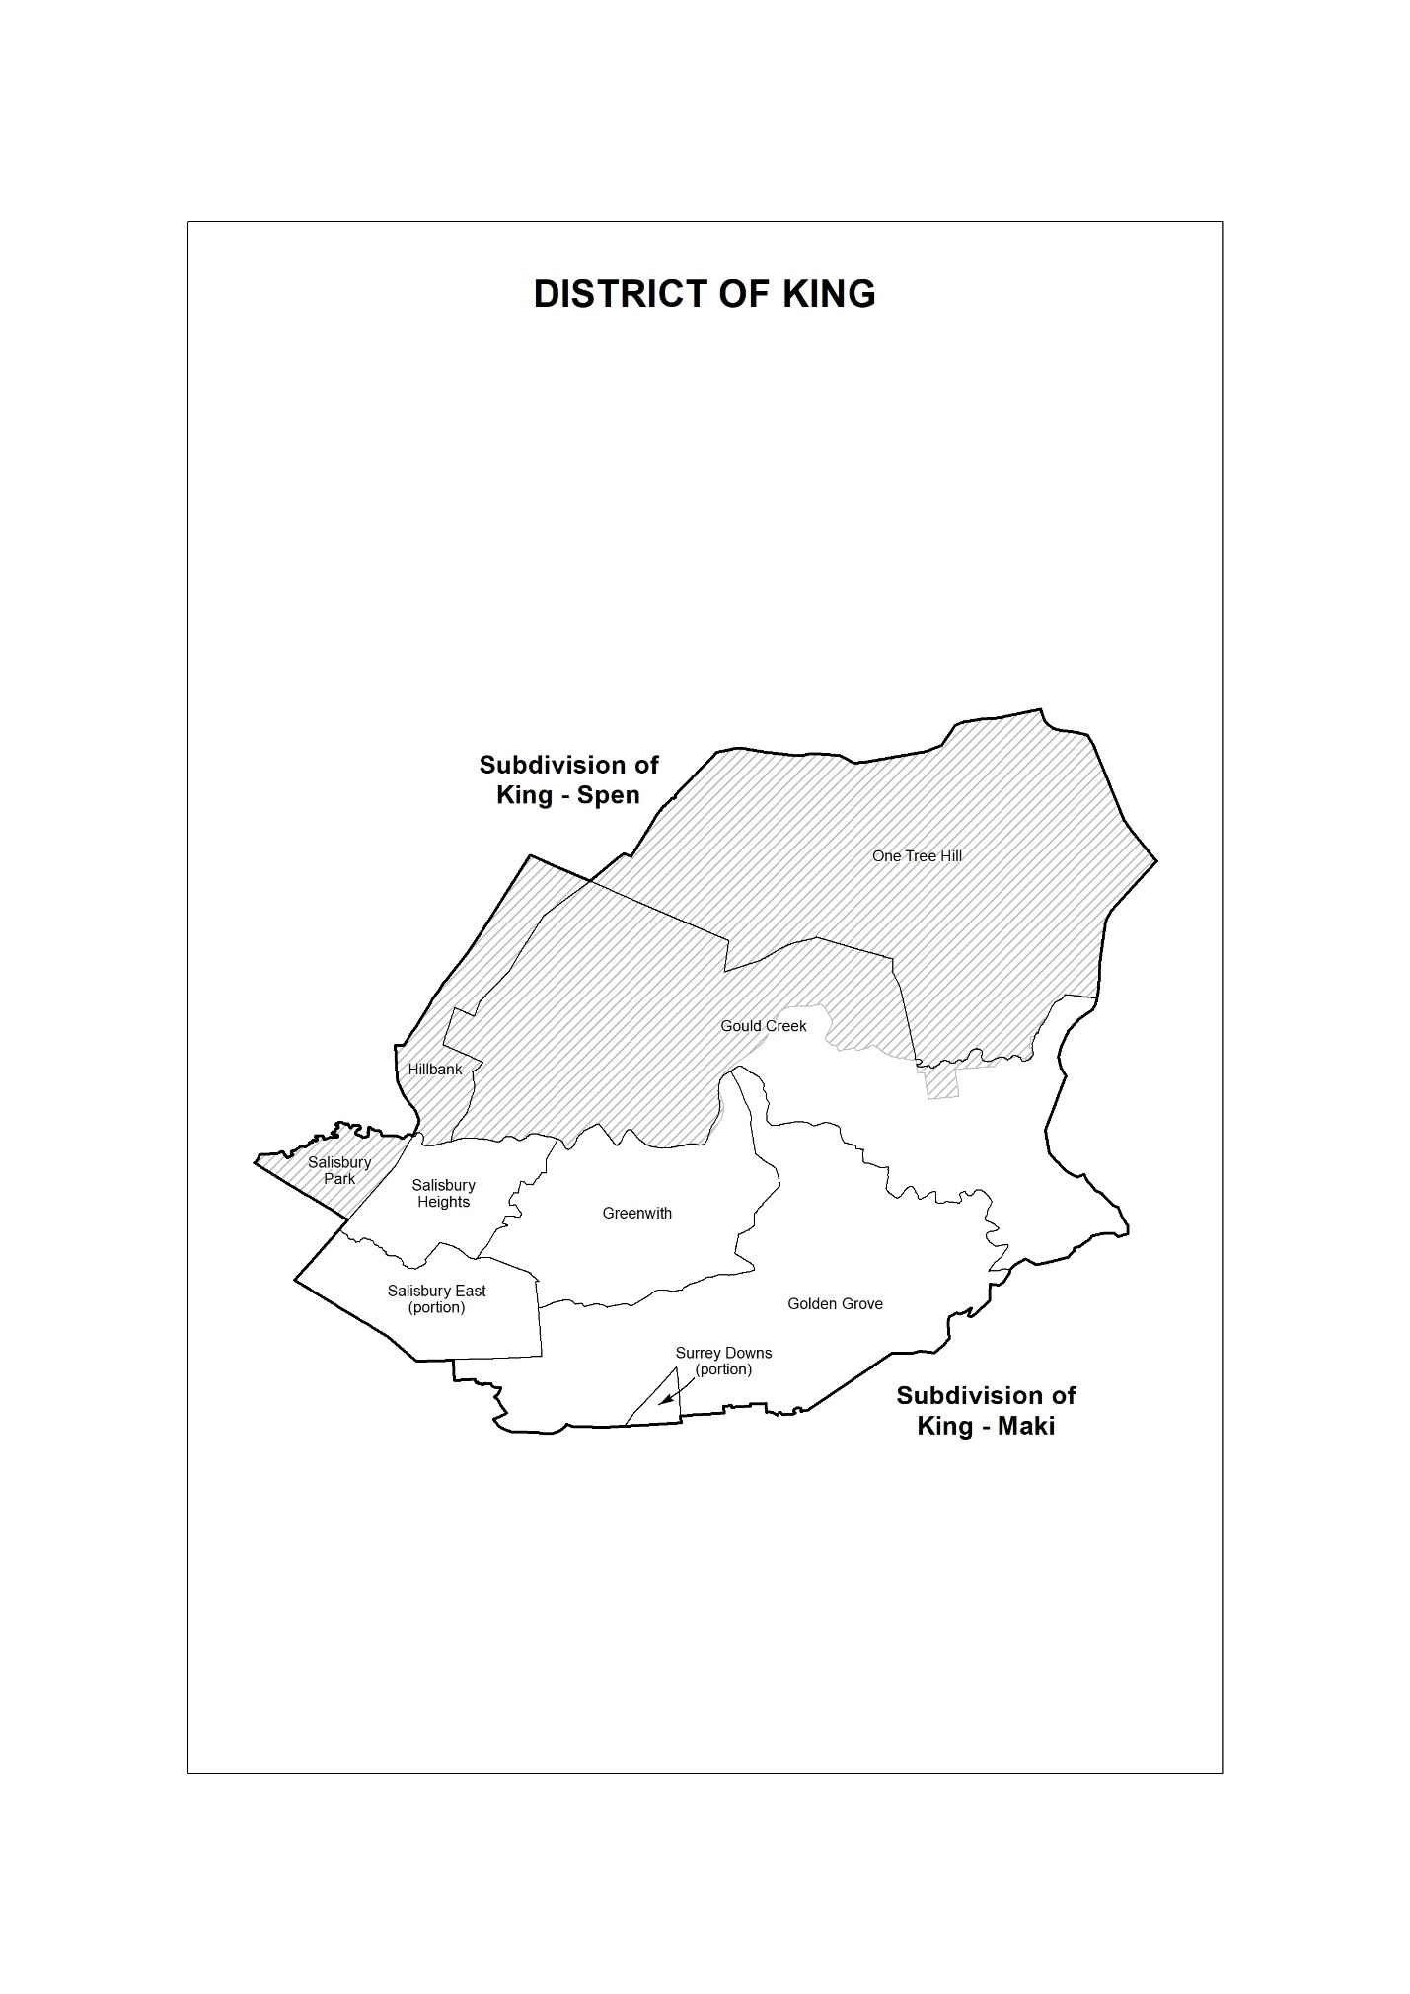

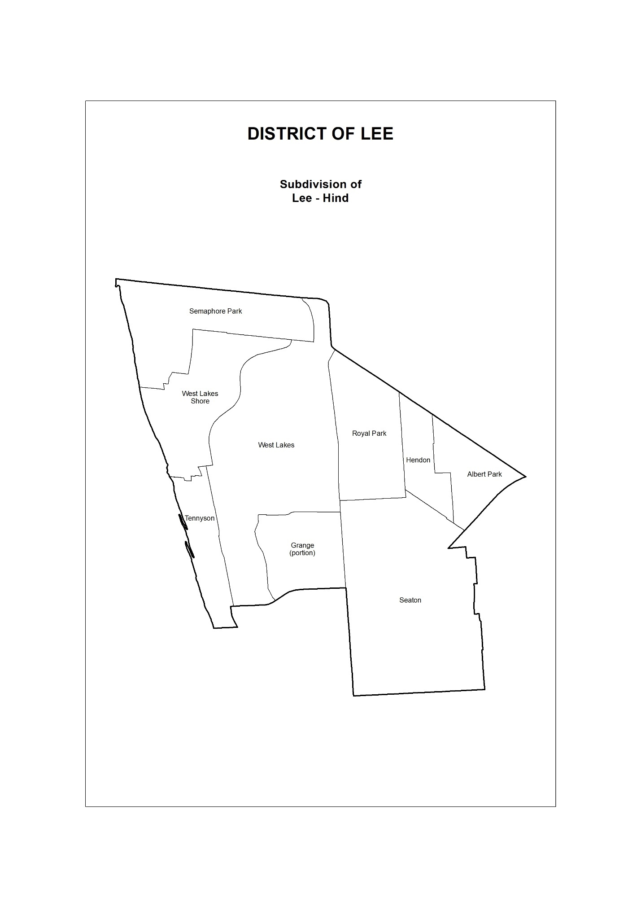

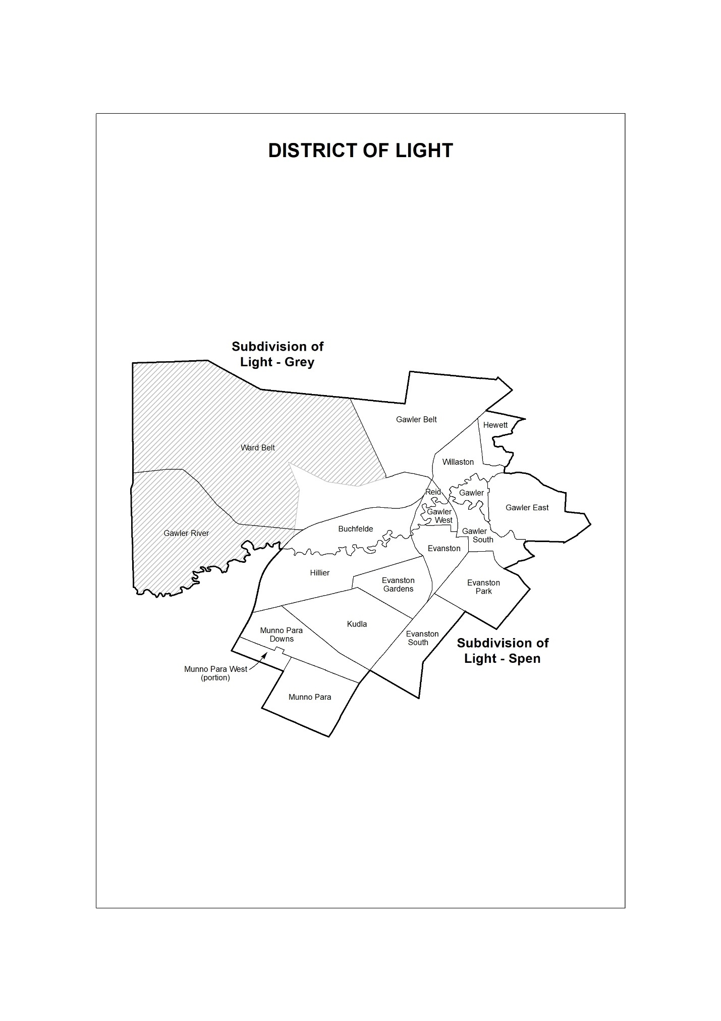

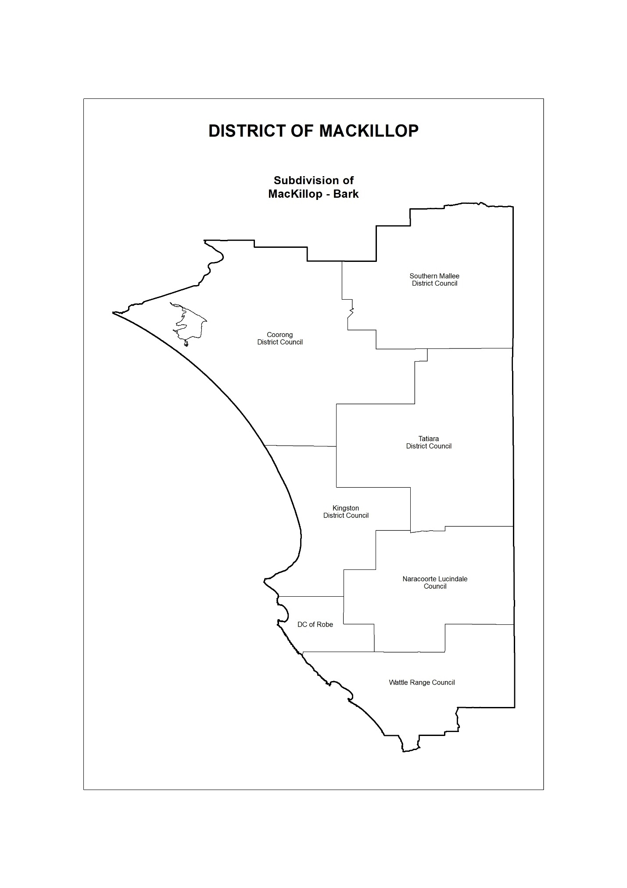

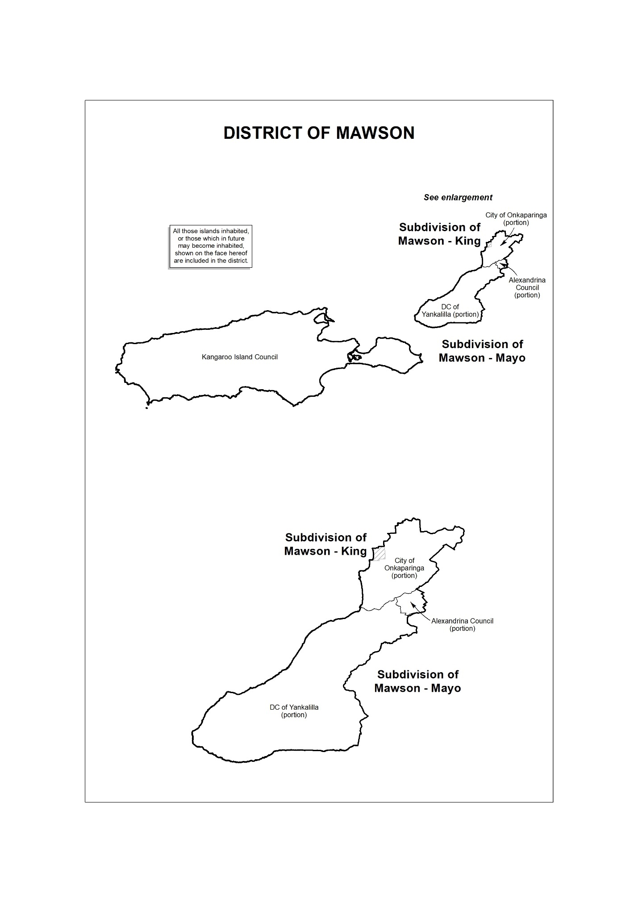

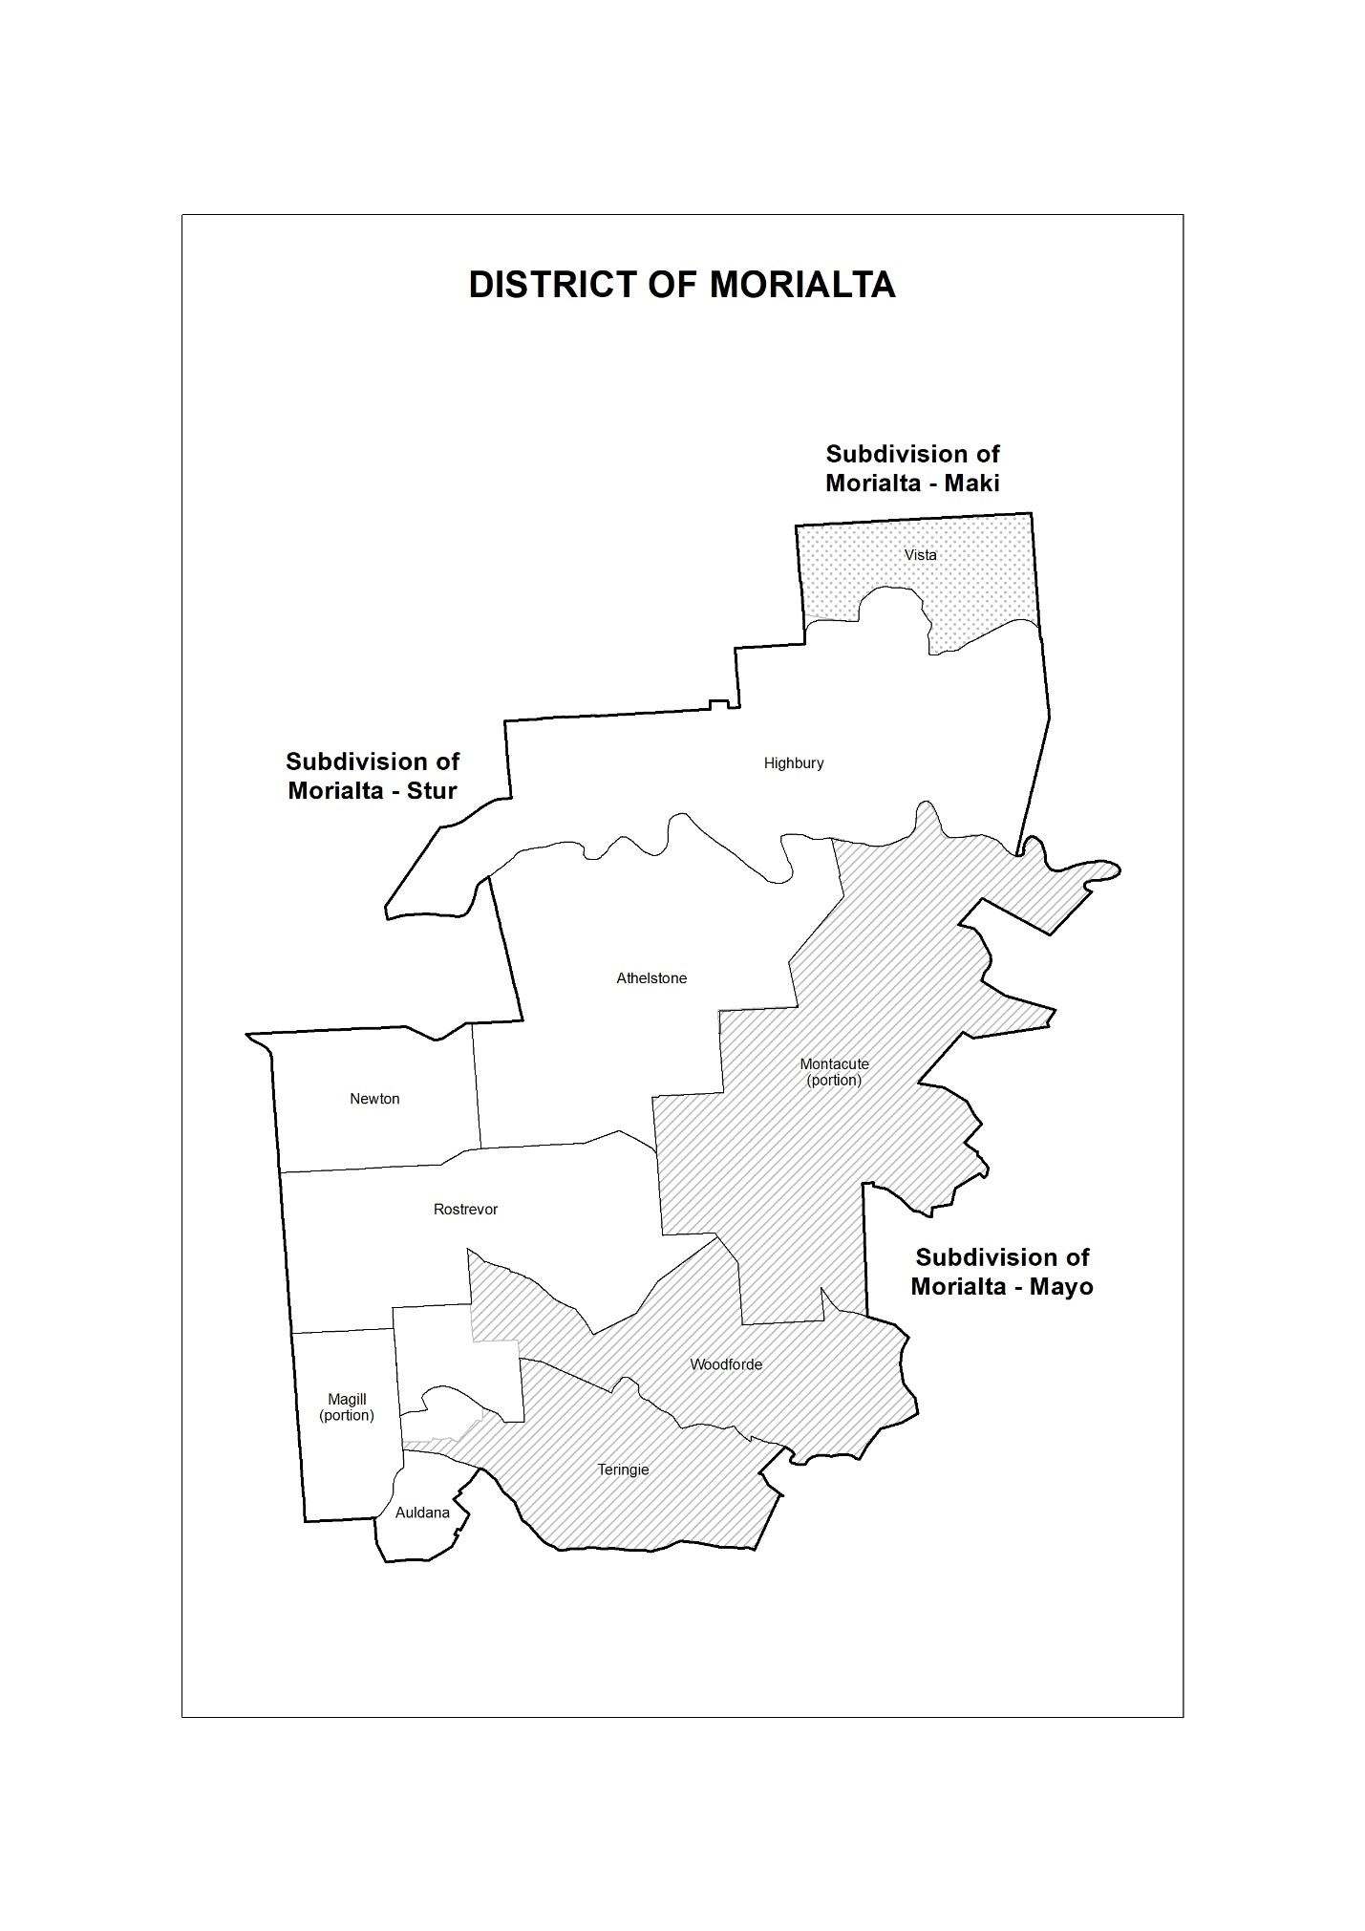

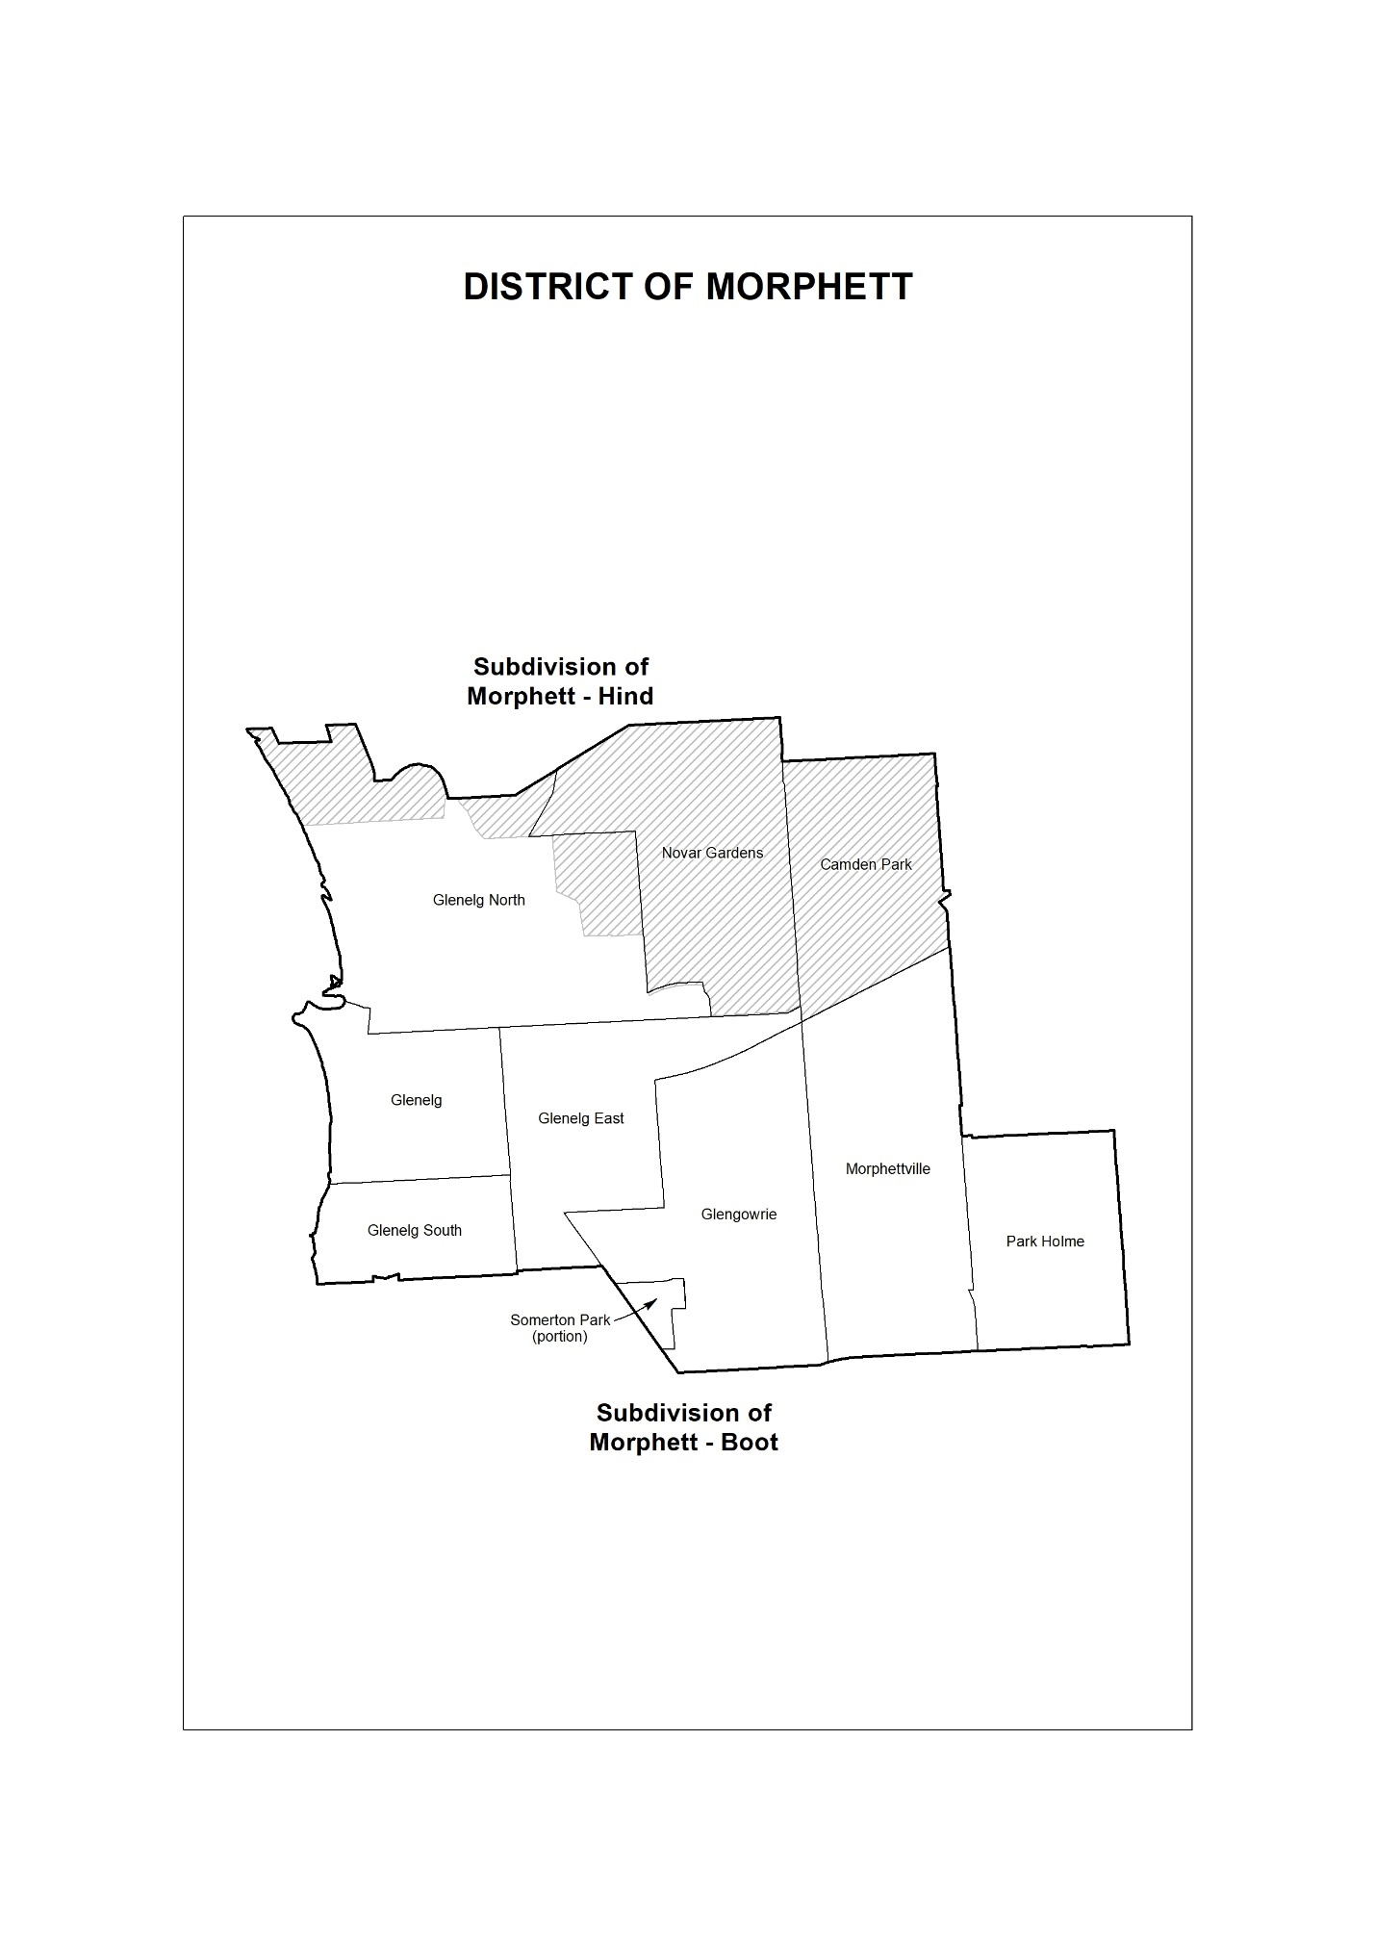

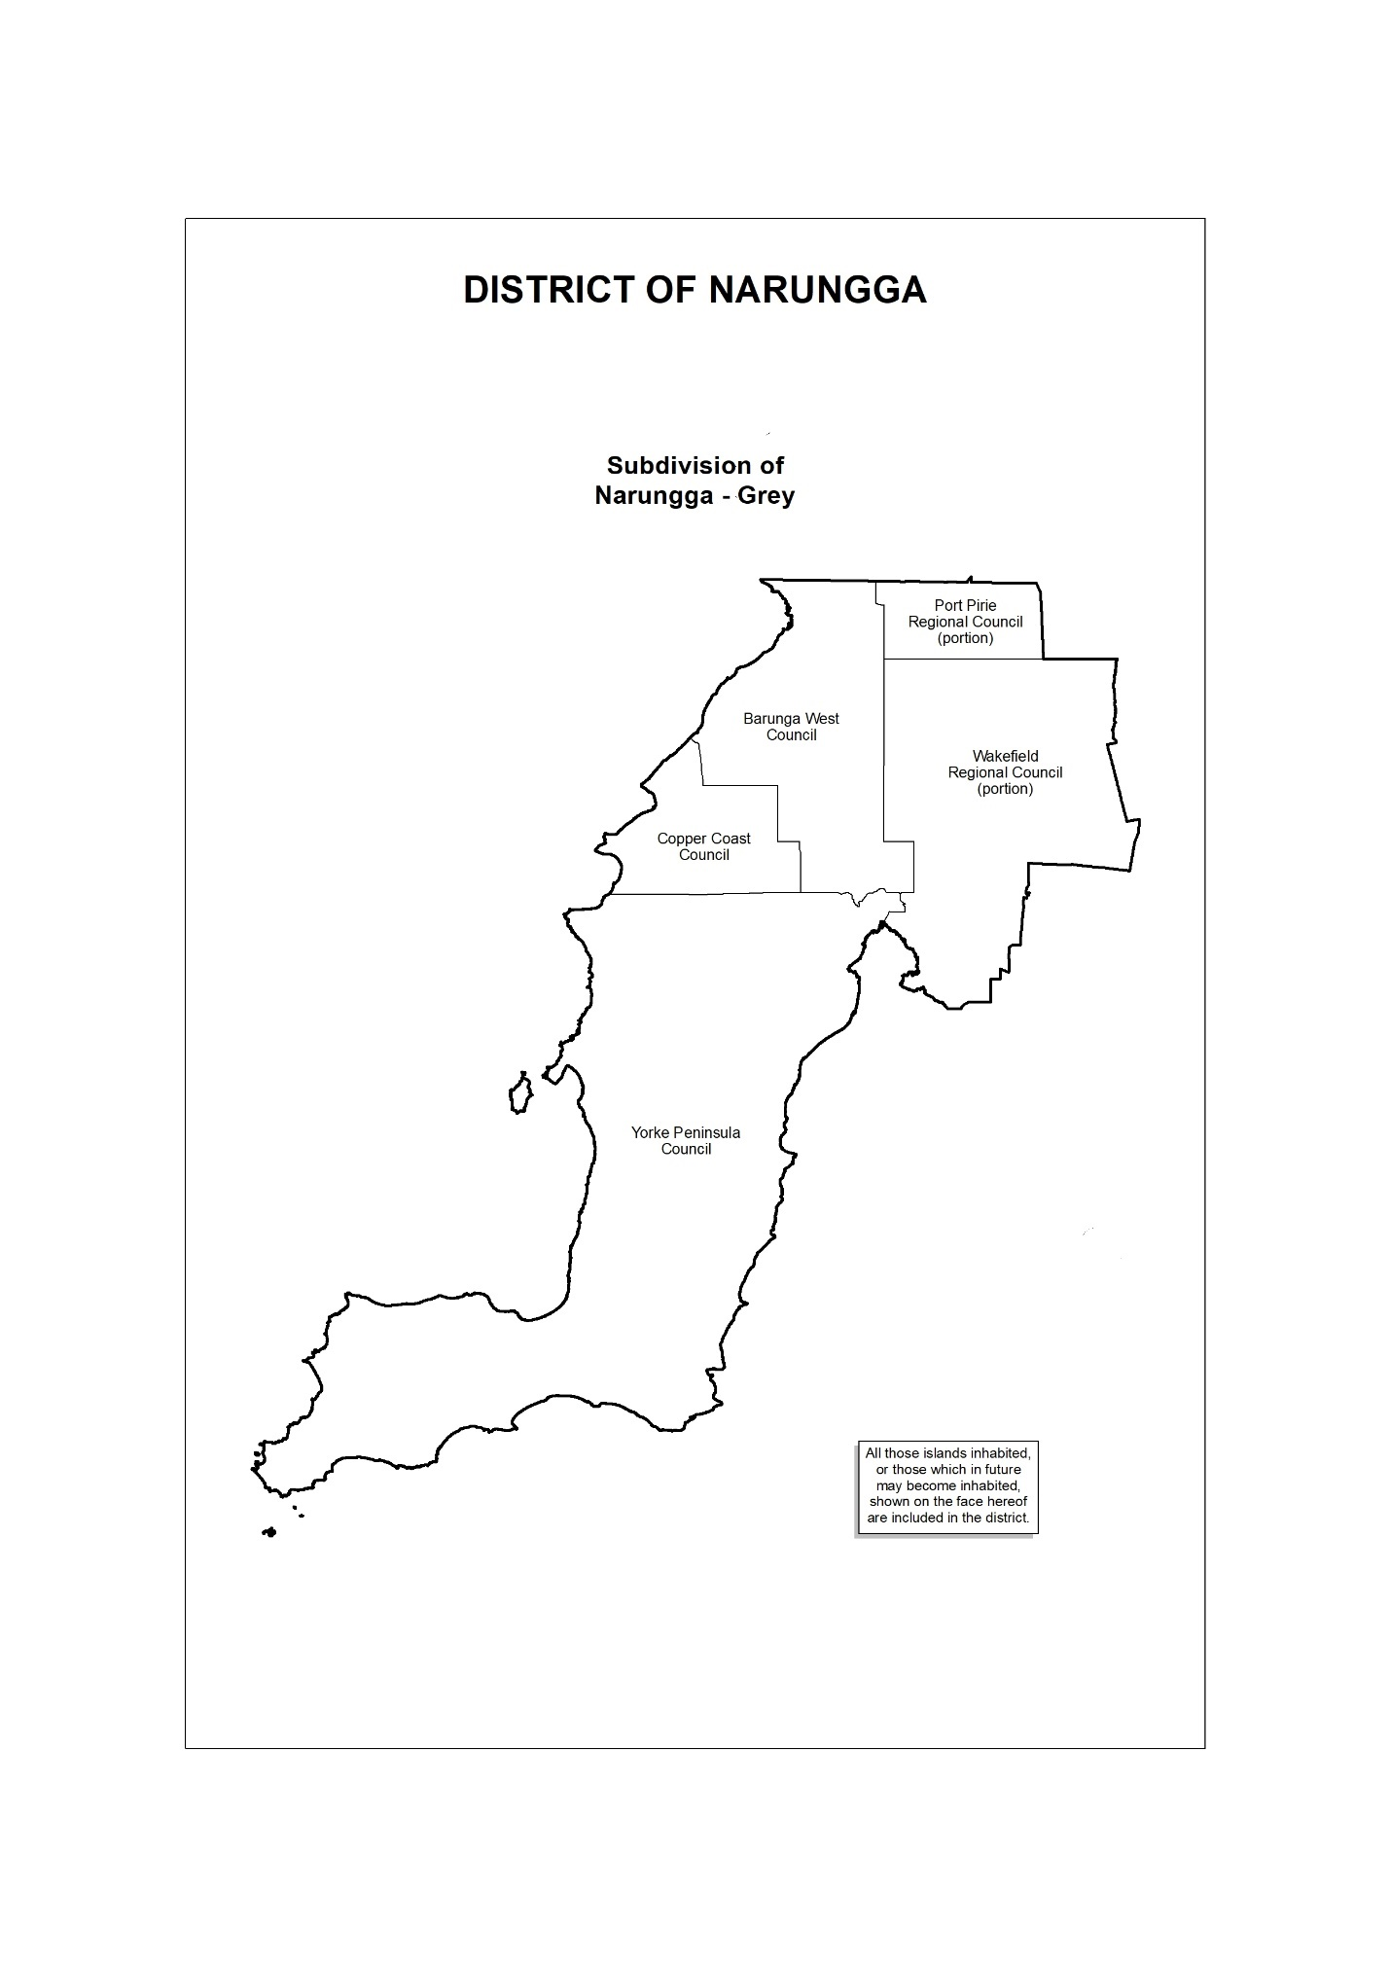

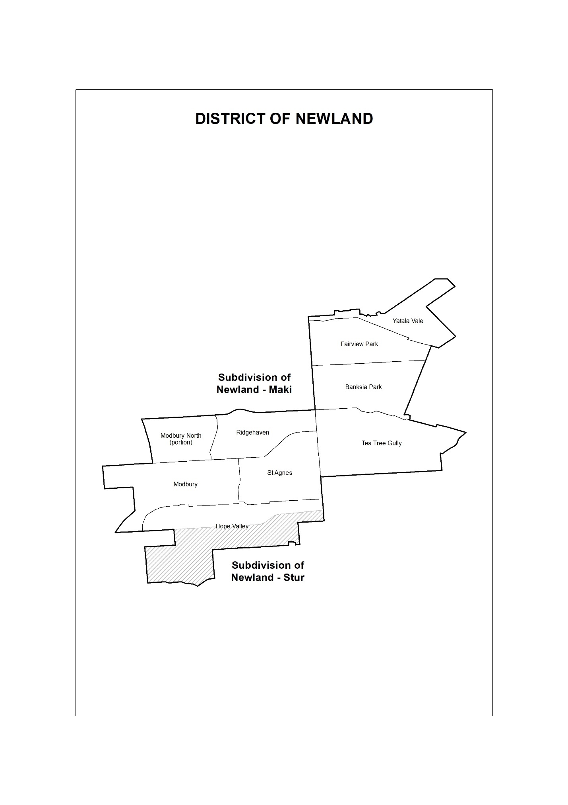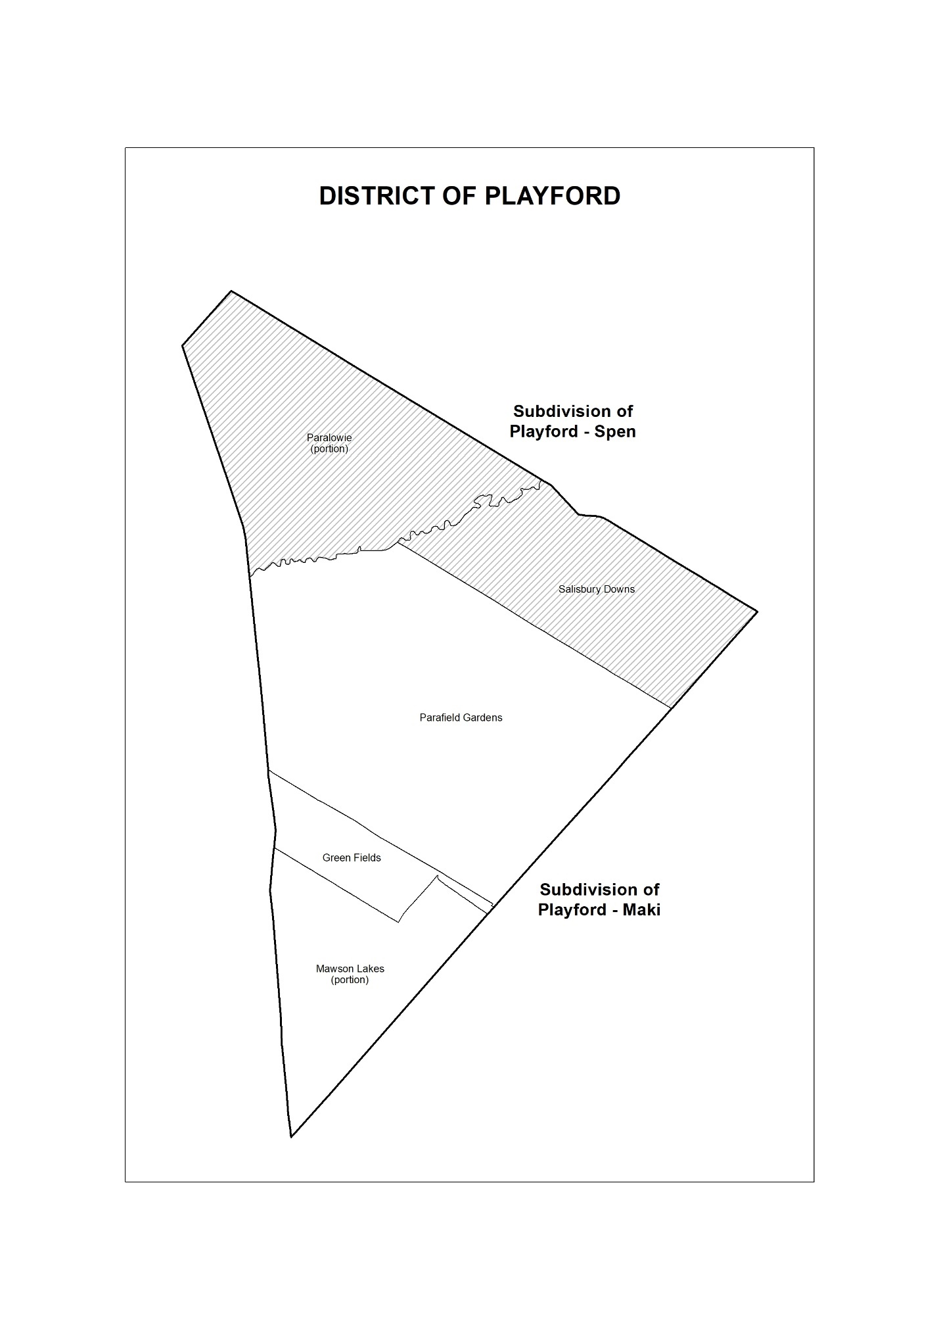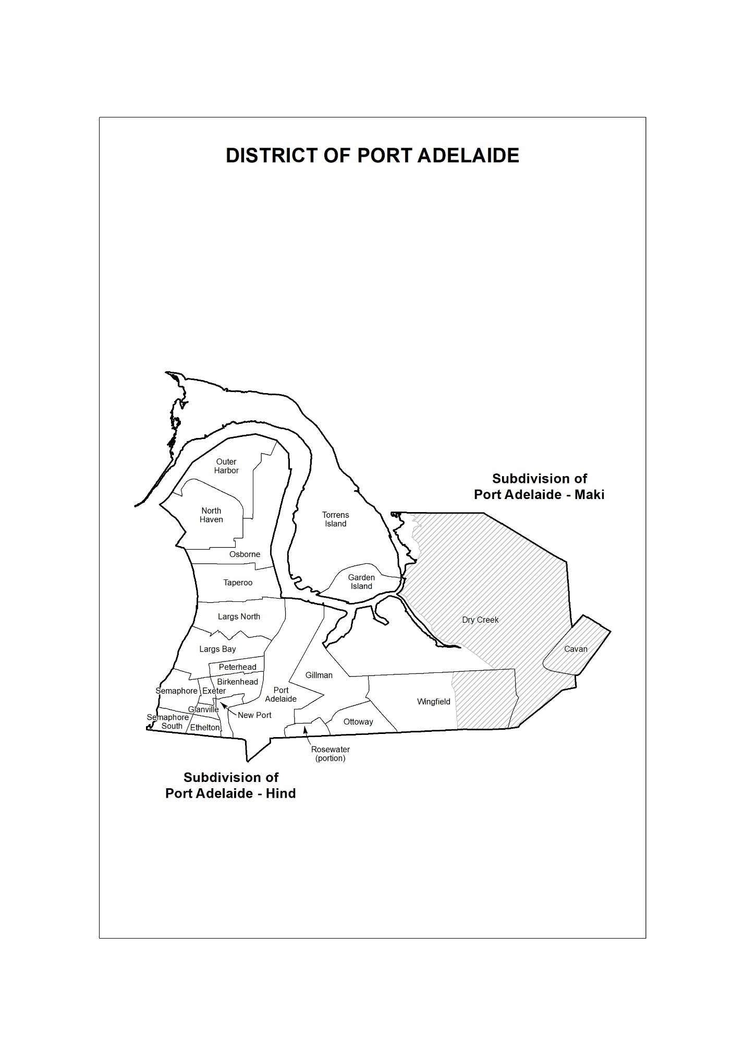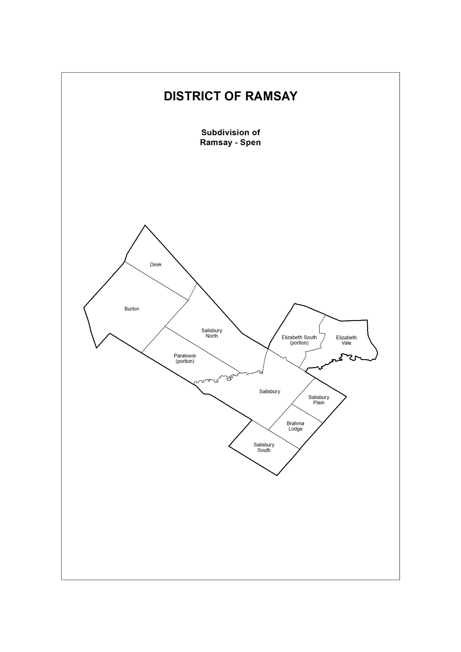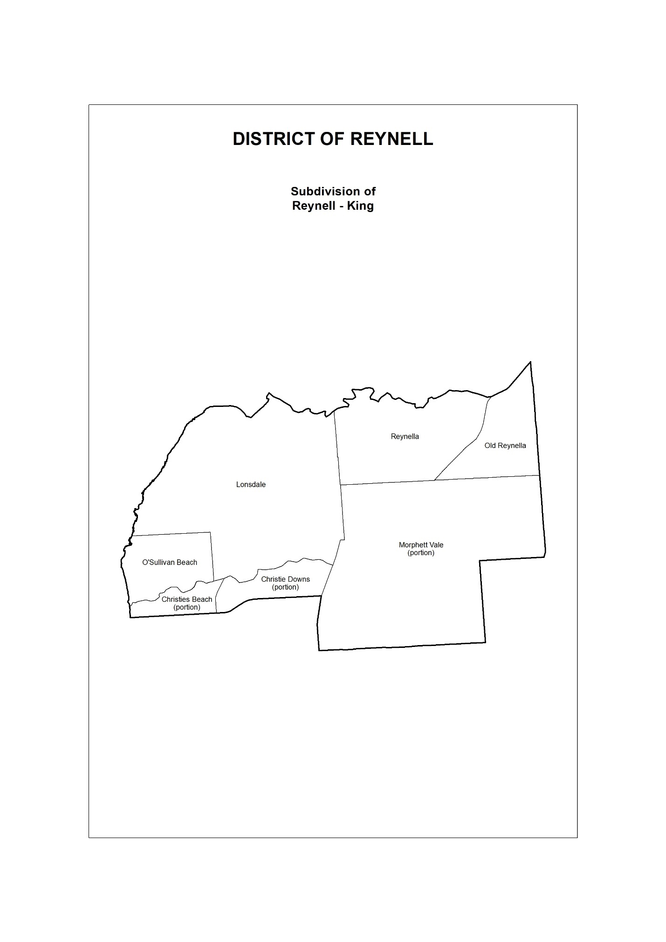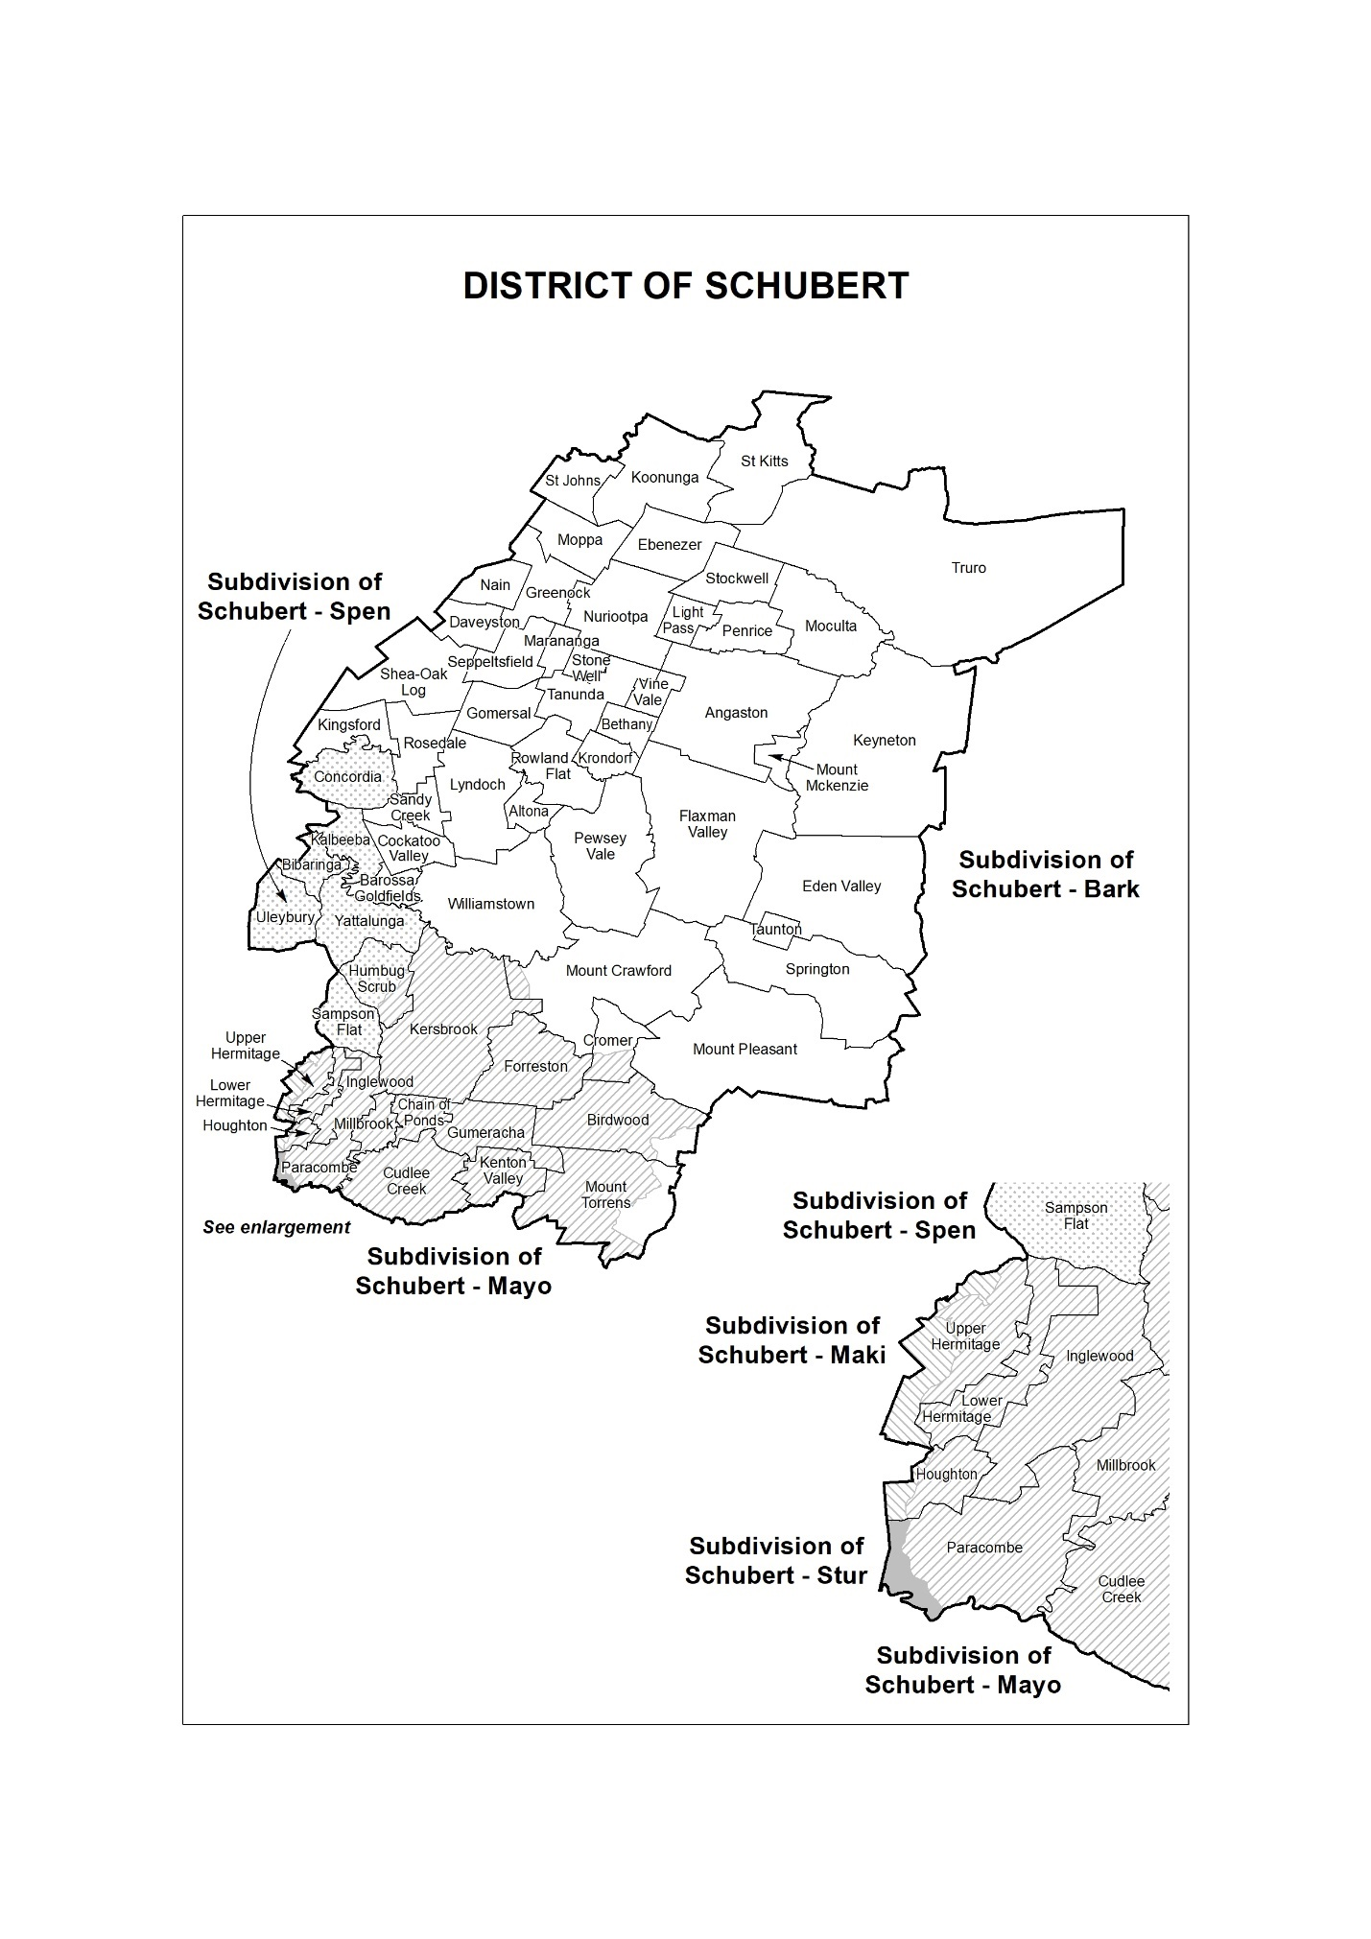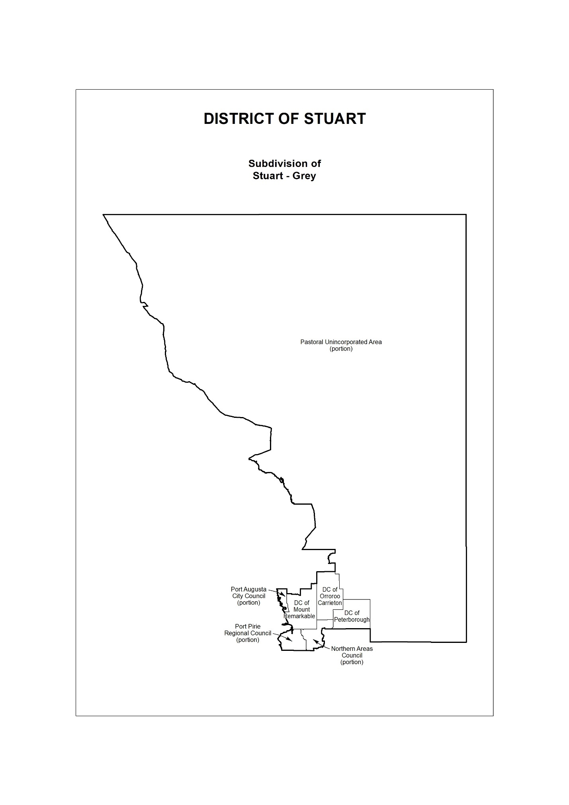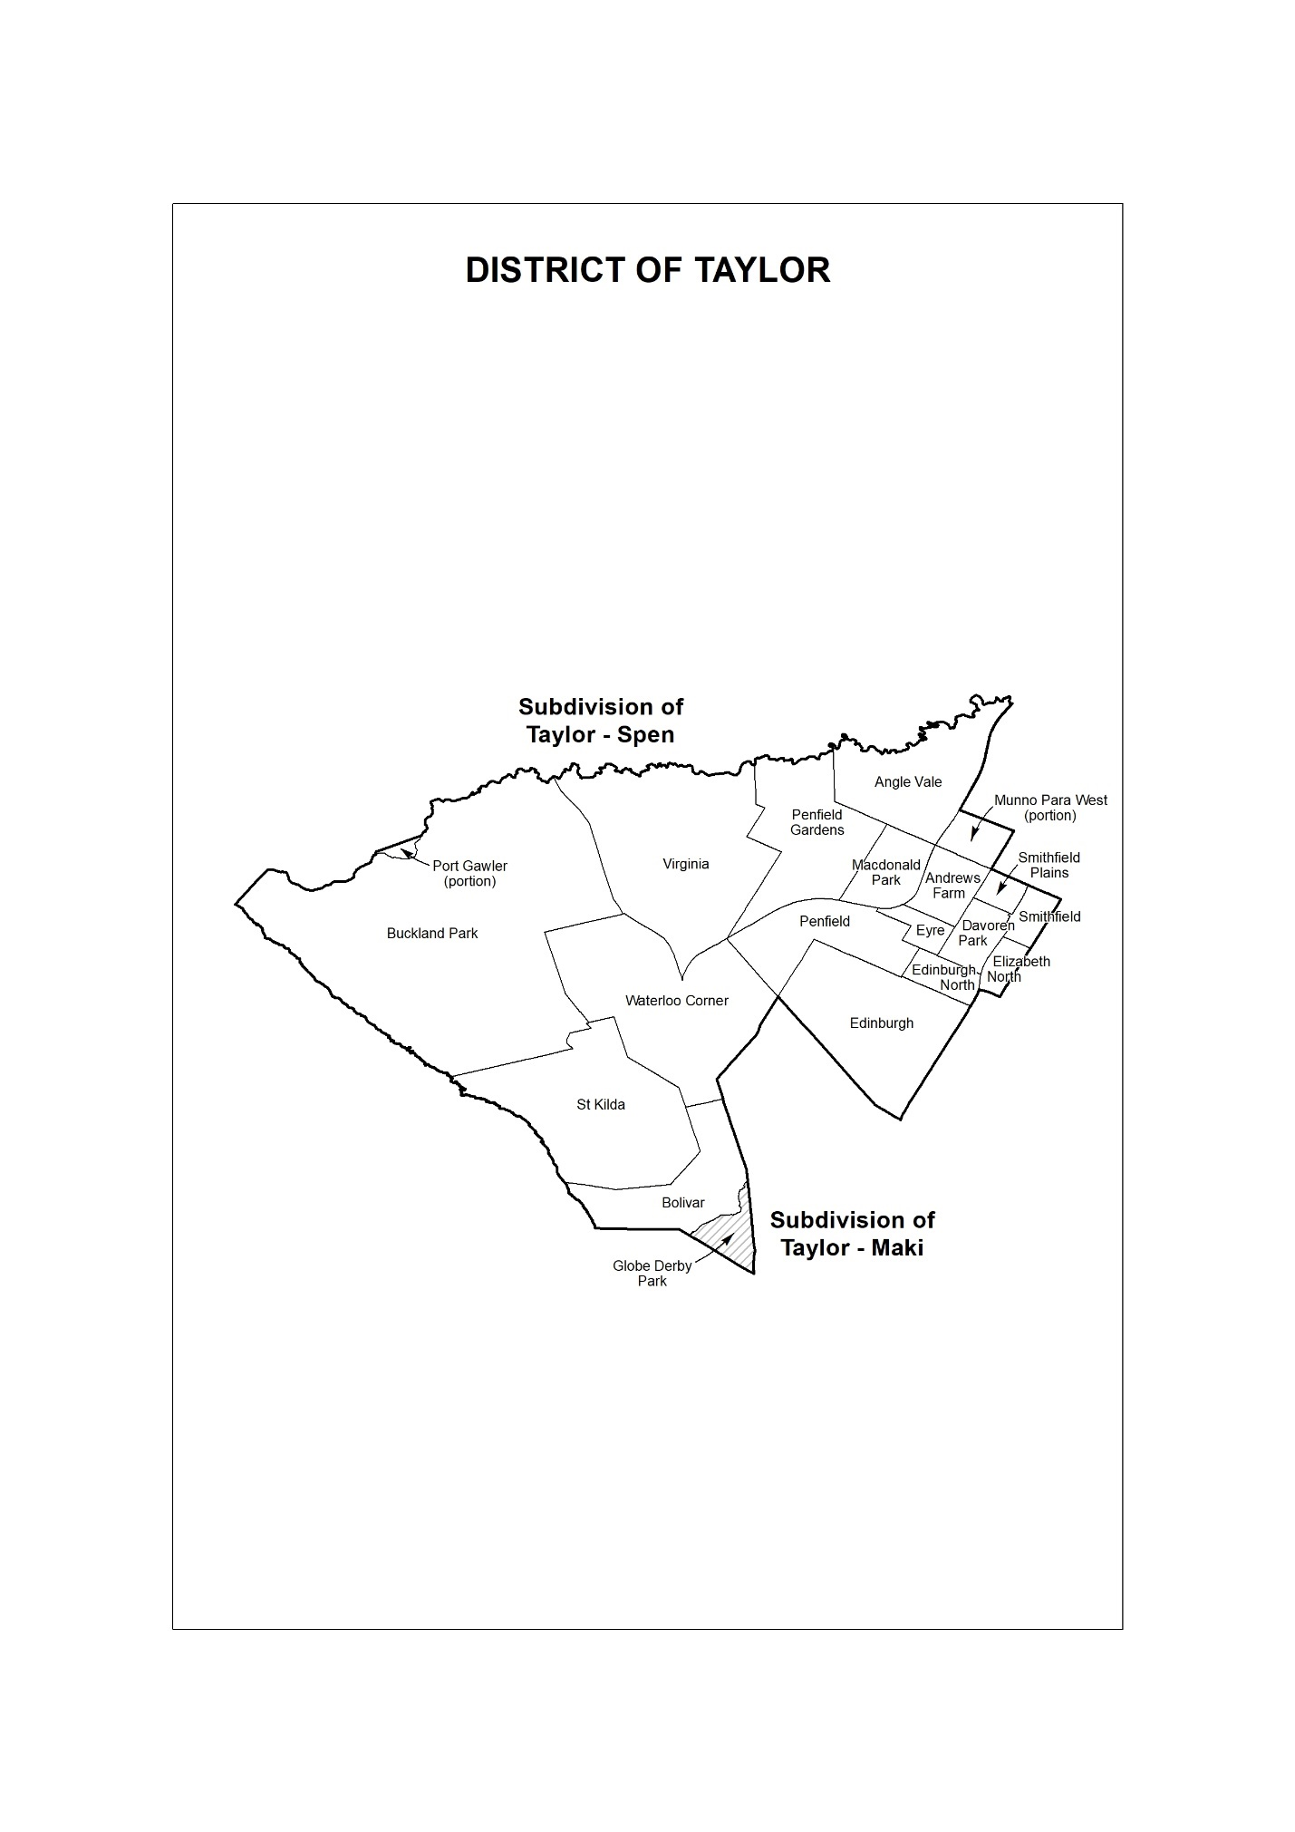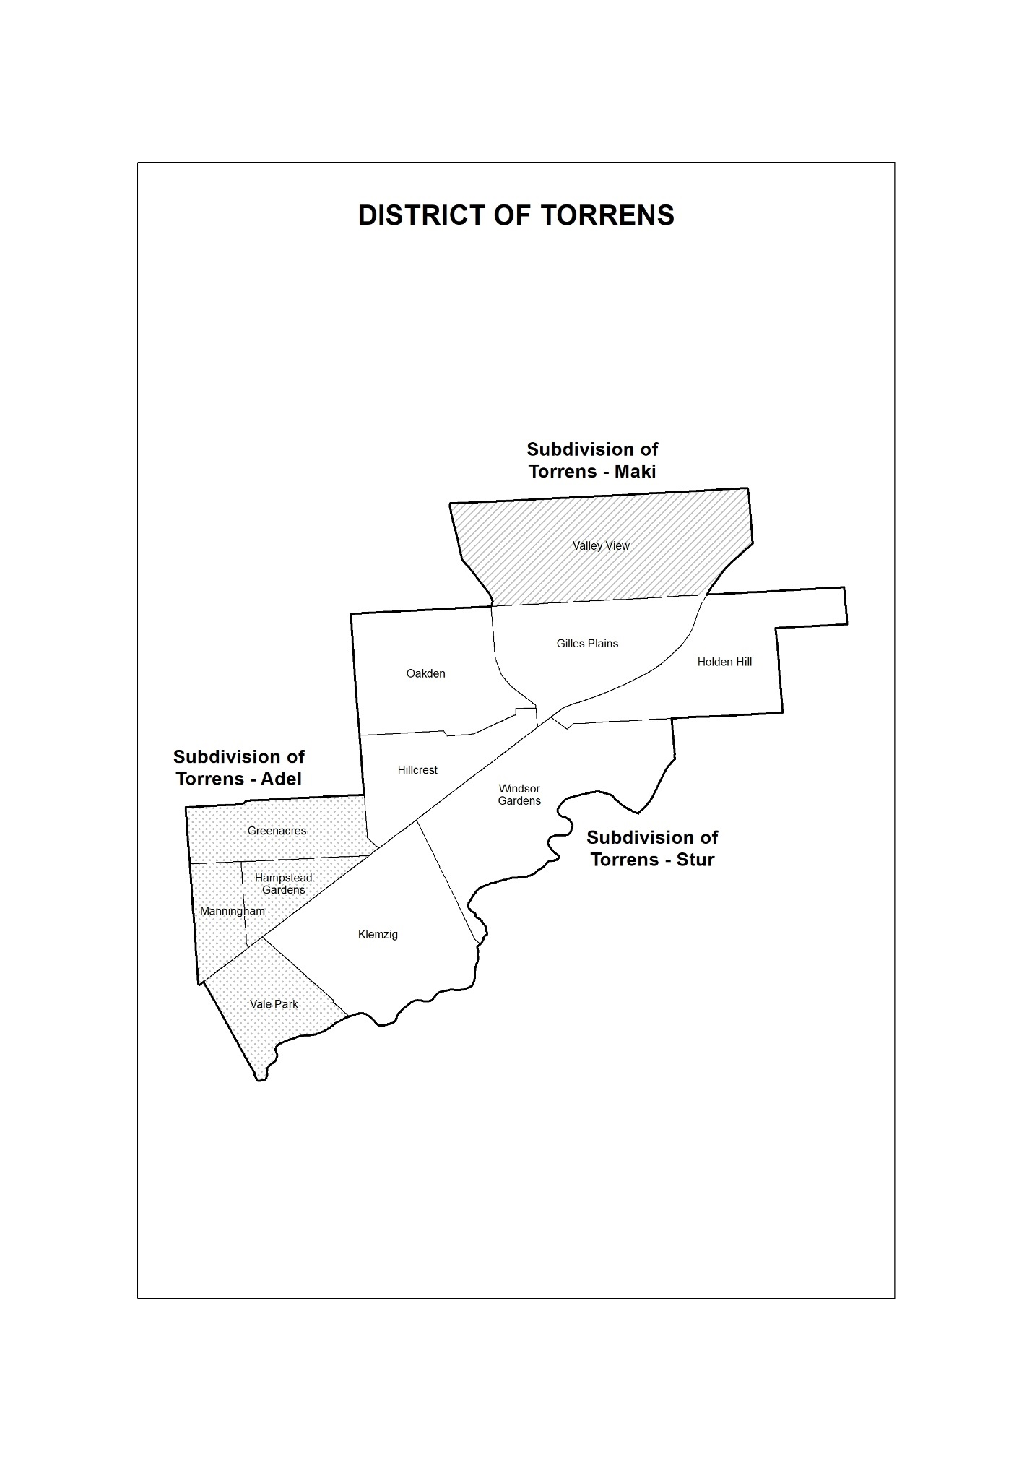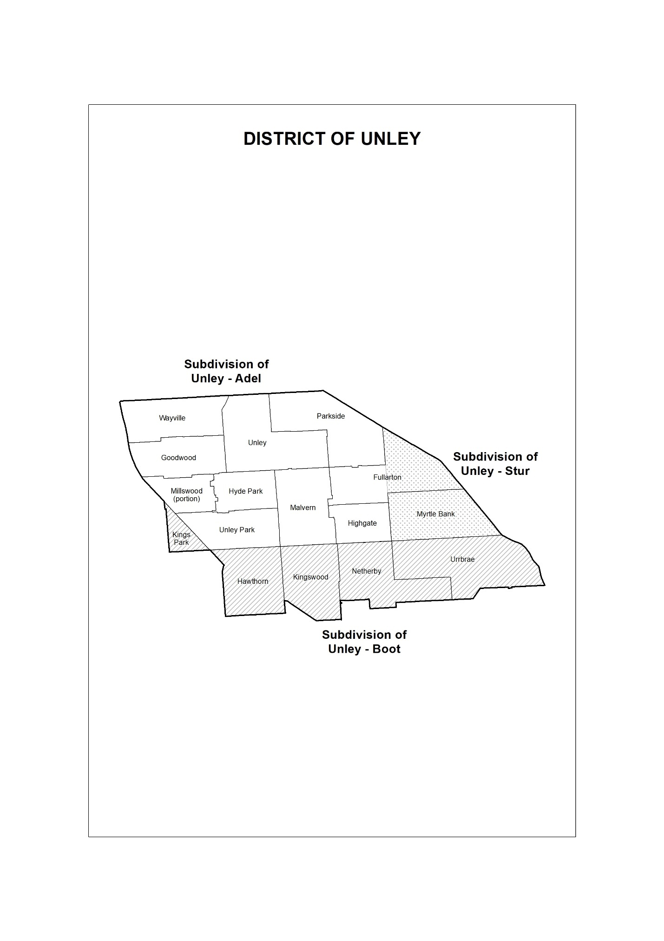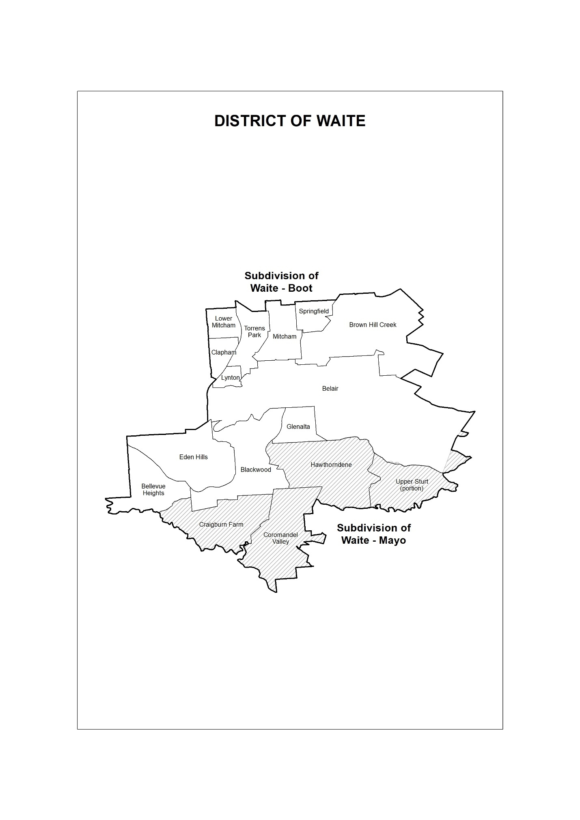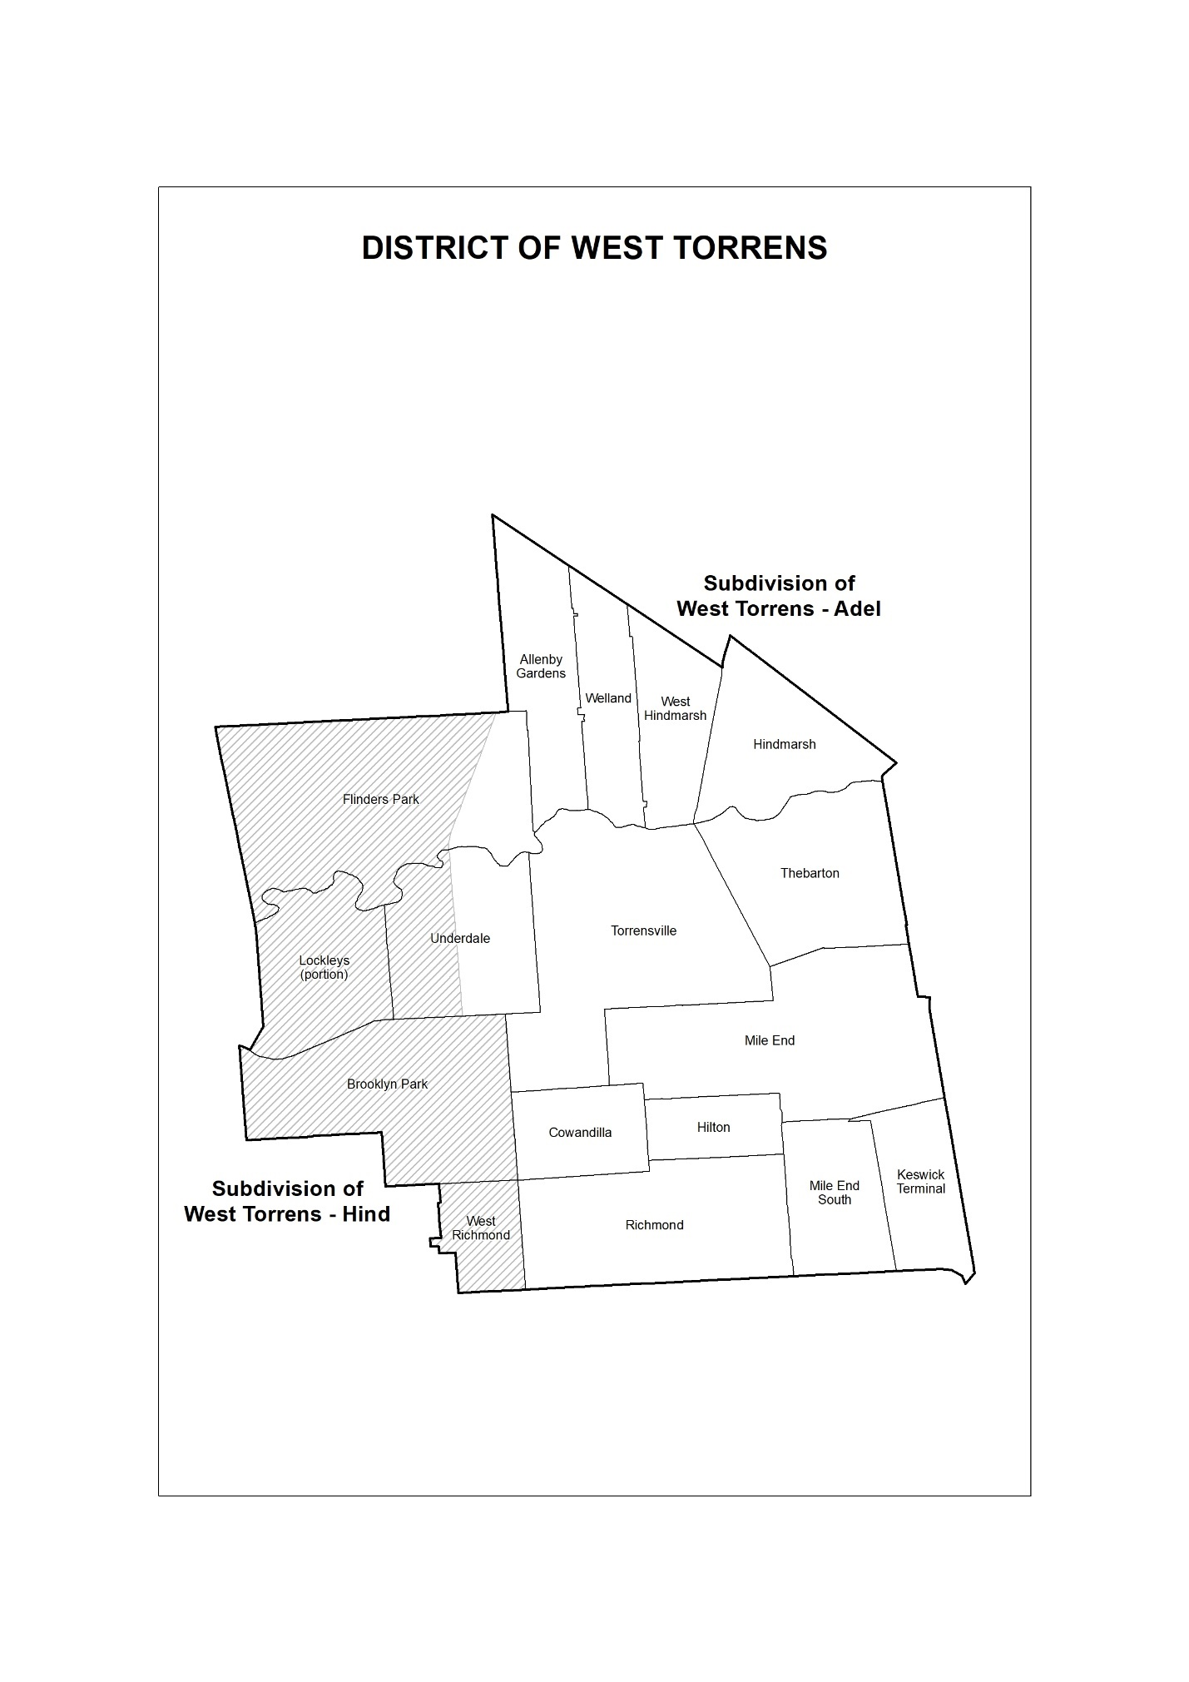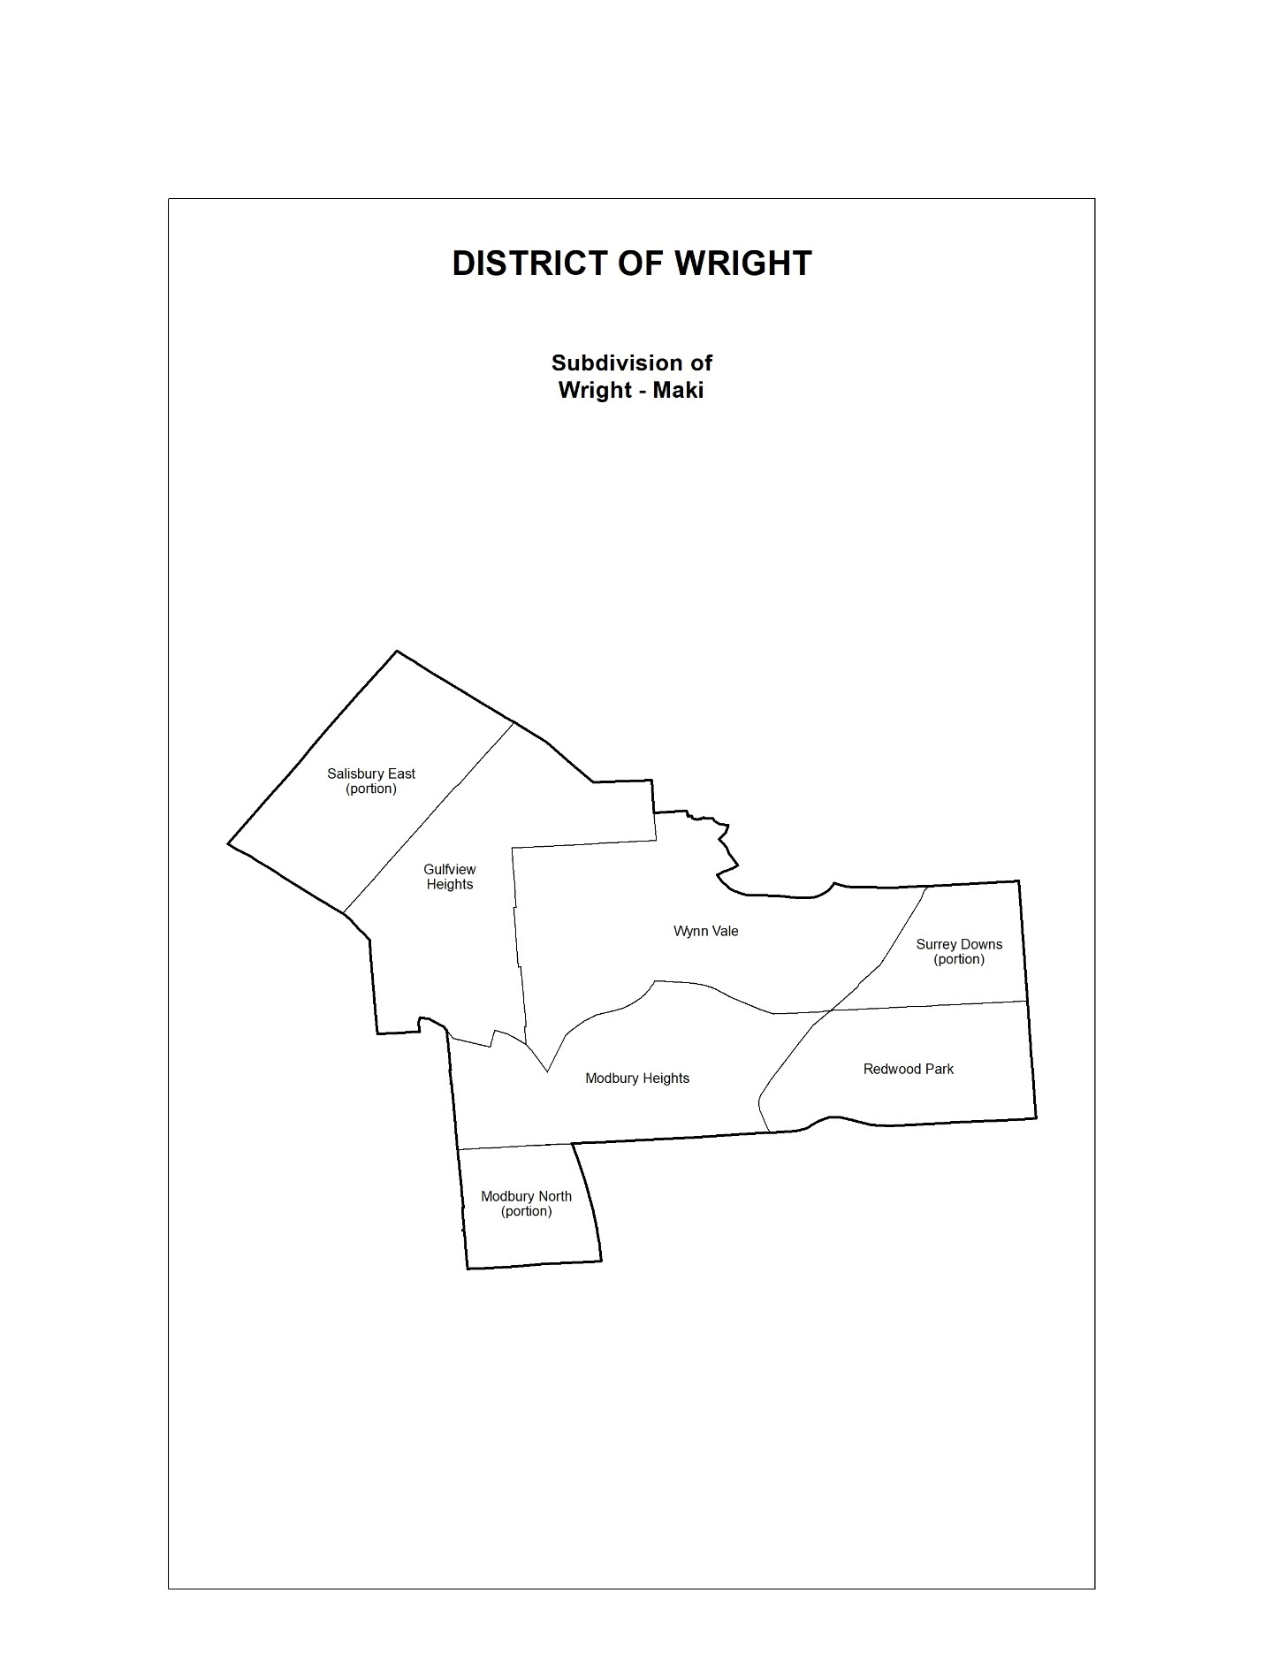
Dated: 3 February 2022
Mick Sherry
Electoral Commissioner

Electoral Act 1985
Part 3, Division 2
Remote Subdivisions
PURSUANT to Section 15 of the Electoral Act 1985, I, Mick Sherry, Electoral Commissioner, hereby revoke the declaration contained on page 255 of the South Australian Government Gazette dated 23 January 2018 and declare the following subdivisions to be remote subdivisions:
Chaffey-Bark
Flinders-Grey
Giles-Grey
MacKillop-Bark
Narungga-Grey
Stuart-Grey
Dated: 3 February 2022
Mick Sherry
Electoral Commissioner

Electoral Act 1985
Part 3, Division 4
District Polling Places
PURSUANT to Section 18 of the Electoral Act 1985, I, Mick Sherry, Electoral Commissioner, hereby abolish the polling places described in the notice contained on pages 255 to 257 of the South Australian Government Gazette, dated 23 January 2018, and appoint the following places to be polling places for both the Legislative Council district of South Australia and for the House of Assembly districts as specified:
District of Adelaide
Adelaide, Adelaide South, Adelaide West, Nailsworth S2, North Adelaide, North Adelaide East, Prospect S1, Prospect North S3, Prospect South, Walkerville, Walkerville North.
District of Badcoe
Ascot Park S2, Black Forest, Black Forest East S1, Edwardstown S1, Goodwood S2, Keswick, Kurralta Park, Netley, Park Holme South S2, Plympton, Plympton Park, Plympton West S1, Richmond S2, South Plympton, South Plympton North.
District of Black
Hallett Cove, Hallett Cove East, Hallett Cove South, Marino, Seacliff, Seacombe Heights S3, Seaview Downs, Sheidow Park, Sheidow Park South, South Brighton S1.
District of Bragg
Beaumont, Burnside, Glen Osmond, Glenunga S1, Kensington S2, Linden Park, Magill South S2, Parkside S2, Rose Park S1, Tusmore, Wattle Park.
District of Chaffey
Barmera, Berri, Blanchetown, Cadell, Cambrai, Cobdogla, Glossop, Karoonda, Loxton, Loxton North, Lyrup, Monash, Moorook, Morgan, Nildottie, Paringa, Purnong, Ramco, Renmark, Renmark North, Renmark West, Sedan, Swan Reach, Waikerie, Walker Flat, Winkie.
District of Cheltenham
Beverley, Cheltenham, Findon, Findon West, Kilkenny S2, Mansfield Park S2, Ottoway S2, Pennington, Queenstown, Rosewater S1, Seaton Park S2, St Clair, Woodville Gardens S2, Woodville South, Woodville West.
District of Colton
Fulham, Grange S1, Henley Beach, Henley Beach North, Henley Beach South, Kidman Park, Lockleys, Lockleys North S2, Seaton West S2, West Beach.
District of Croydon
Brompton, Croydon, Croydon Park, Kilburn, Kilkenny S1, Kilkenny North, Mansfield Park S1, Prospect S2, Prospect North S2, Regency Park, Renown Park, West Croydon, Woodville Gardens S1.
District of Davenport
Aberfoyle Park, Aberfoyle Park Central, Aberfoyle Park North, Aberfoyle Park South, Flagstaff Hill, Flagstaff Hill East S1, Happy Valley S2, Happy Valley West S1, Seacombe Heights S1.
District of Dunstan
Glynde S2, Joslin, Kensington S1, Kensington Park, Kent Town, Marden, Maylands, Norwood, Norwood West, Rose Park S2, St Morris, St Peters, St Peters East, Tranmere South S2, Trinity Gardens.
District of Elder
Ascot Park S1, Black Forest East S2, Clapham S2, Clarence Gardens, Clarence Park S1, Colonel Light Gardens South S1, Daw Park, Edwardstown S2, Hawthorn S3, Marion S2, Melrose Park, Mitchell Park, Mitchell Park South, Pasadena, St Marys, Westbourne Park.
District of Elizabeth
Craigmore, Craigmore North, Craigmore South, Elizabeth, Elizabeth Downs, Elizabeth East S1, Elizabeth Grove, Elizabeth Park, Elizabeth South, Hillbank S2, Munno Para East S2.
District of Enfield
Blair Athol, Blair Athol North, Broadview, Clearview, Enfield, Enfield South, Hampstead Gardens S2, Lightsview, Nailsworth S1, Northfield, Oakden S2, Pooraka S2, Prospect North S1, Walkley Heights S1.

District of Finniss
Currency Creek, Goolwa, Goolwa Central, Middleton, Milang, Mount Compass, Port Elliot, Victor Harbor, Victor Harbor East, Victor Harbor South.
District of Flinders
Arno Bay, Ceduna, Cleve, Coffin Bay, Cowell, Cummins, Darke Peak, Elliston, Kimba, Kirton Point, Lock, Minnipa, North Shields, Poochera, Port Kenny, Port Lincoln, Port Lincoln Central, Port Lincoln South, Port Neill, Smoky Bay, Streaky Bay, Tumby Bay, Ungarra, Wangary, Wirrulla, Wudinna.
District of Florey
Ingle Farm, Ingle Farm North, Mawson Lakes S1, Mawson Lakes North S1, Para Hills East S1, Para Hills West, Para Vista S1, Pooraka S1, Pooraka North, Walkley Heights S2.
District of Frome
Angle Vale S2, Auburn, Balaklava S1, Booborowie, Burra, Clare, Dublin, Eudunda, Farrell Flat, Freeling, Hallett, Hamley Bridge, Jamestown, Kapunda, Mallala, Manoora, Marrabel, Owen, Point Pass, Riverton, Robertstown, Roseworthy, Saddleworth, Spalding, Tarlee, Terowie, Two Wells, Wasleys, Watervale.
District of Gibson
Brighton, Glenelg South S2, Marion S1, Marion South, North Brighton, North Brighton West, Oaklands Park, Seacombe Heights S2, Somerton Park S1, South Brighton S2, Sturt, Warradale.
District of Giles
Andamooka, Coober Pedy, Hawker, Iron Knob, Port Augusta West, Quorn, Roxby Downs, Whyalla Central East, Whyalla Central West, Whyalla Norrie East, Whyalla Norrie North, Whyalla Norrie North-West, Whyalla Norrie South, Whyalla Stuart West, Woomera.
District of Hammond
Callington, Harrogate, Jervois, Langhorne Creek, Mannum, Murray Bridge, Murray Bridge East, Murray Bridge South, Murray Bridge West, Mypolonga, Palmer, Ponde, Strathalbyn, Wellington, Woodchester, Woods Point.
District of Hartley
Campbelltown, Dernancourt, Felixstow, Glynde S1, Hectorville, Holden Hill S2, Magill S2, Magill South S1, Newton S2, Paradise, Paradise East, Rostrevor South S2, Tranmere South S1.
District of Heysen
Aldgate, Ashbourne, Bradbury, Bridgewater, Cherry Gardens, Clarendon, Crafers, Echunga, Hahndorf, Kangarilla, Macclesfield, Meadows, Montacute, Mylor, Norton Summit, Oakbank S2, Piccadilly, Prospect Hill, Stirling, Stirling East, Summertown, Upper Sturt, Uraidla, Yundi.
District of Hurtle Vale
Hackham S1, Hackham West, Happy Valley S1, Happy Valley West S2, Huntfield Heights, Morphett Vale East S2, Morphett Vale South, Reynella East, Woodcroft.
District of Kaurna
Christie Downs S1, Christie Downs East S1, Christies Beach, Maslin Beach S2, McLaren Vale S2, Noarlunga Downs, Old Noarlunga, Port Noarlunga, Port Noarlunga South, Seaford, Seaford East, Seaford Rise.
District of Kavel
Brukunga, Charleston, Lenswood, Littlehampton, Lobethal, Mount Barker, Mount Barker Central, Mount Barker South, Nairne, Oakbank S1, Woodside.
District of King
Elizabeth East S2, Elizabeth Vale S2, Golden Grove, Golden Grove Central S1, Golden Grove East, Greenwith, Greenwith West, Hillbank S1, One Tree Hill S1, Salisbury East North, Salisbury Heights, Salisbury Park S1.
District of Lee
Albert Park, Grange S2, Royal Park, Royal Park South, Seaton, Seaton Park S1, Seaton West S1, Semaphore Park, Semaphore Park South, West Lakes Shore.
District of Light
Angle Vale S3, Evanston, Evanston Gardens, Evanston South, Gawler, Gawler East, Gawler South, Gawler West, Hewett, Munno Para S1, Munno Para East S1, Willaston.
District of MacKillop
Beachport, Bordertown, Coomandook, Coonalpyn, Coonawarra, Frances, Furner, Glencoe, Kalangadoo, Keith, Kingston, Lameroo, Lucindale, Meningie, Millicent, Millicent South, Mount Burr, Mundulla, Nangwarry, Naracoorte, Naracoorte South, Padthaway, Penola, Pinnaroo, Rendelsham, Robe, Southend, Tailem Bend, Tantanoola, Tintinara, Western Flat, Willalooka, Wolseley.
District of Mawson
Aldinga Beach, Aldinga Beach West, American River, Cape Jervis, Kingscote, Maslin Beach S1, McLaren Flat, McLaren Vale S1, Myponga, Parawa, Parndana, Penneshaw, Second Valley, Sellicks Beach, Willunga, Yankalilla.
District of Morialta
Athelstone, Athelstone South, Highbury S1, Highbury West, Hope Valley East S2, Magill S1, Newton S1, Rostrevor, Rostrevor South S1, St Agnes S2.
District of Morphett
Glenelg, Glenelg East, Glenelg East Central, Glenelg North, Glenelg South S1, Glengowrie, Morphettville, Novar Gardens, Park Holme, Park Holme South S1, Plympton West S2, Somerton Park S2.

District of Mount Gambier
Carpenter Rocks, Compton, Glenburnie, Kongorong, Moorak, Mount Gambier, Mount Gambier East, Mount Gambier North, Mount Gambier Park, Mount Gambier West, Port MacDonnell, Suttontown, Tarpeena, Yahl.
District of Narungga
Alford, Ardrossan, Arthurton, Balaklava S2, Blyth, Brinkworth, Bute, Coobowie, Corny Point, Curramulka, Edithburgh, Hardwicke Bay, Kadina, Lochiel, Maitland, Marion Bay, Minlaton, Moonta, Paskeville, Port Broughton, Port Clinton, Port Victoria, Port Vincent, Port Wakefield, Redhill, Snowtown, Stansbury, Wallaroo, Wallaroo Mines, Warooka, Yorketown.
District of Newland
Banksia Park, Fairview Park, Highbury S2, Hope Valley, Hope Valley East S1, Hope Valley West, Modbury S1, Modbury Heights S2, Modbury North S2, Modbury North East, Redwood Park S2, Ridgehaven S1, St Agnes S1, St Agnes West, Tea Tree Gully.
District of Playford
Mawson Lakes S2, Mawson Lakes North S2, Parafield Gardens, Parafield Gardens Central, Parafield Gardens North-West, Paralowie S2, Paralowie South S1, Paralowie West S1, Salisbury Downs S1.
District of Port Adelaide
Birkenhead, Ethelton, Largs Bay, Largs Bay Central, Mawson Lakes S3, Mawson Lakes North S3, North Haven, Ottoway S1, Port Adelaide, Rosewater S2, Semaphore, Semaphore South, Taperoo, Taperoo East.
District of Ramsay
Brahma Lodge, Burton, Elizabeth Vale S1, Lake Windemere, Paralowie S1, Paralowie South S2, Paralowie West S2, Salisbury, Salisbury Central, Salisbury Downs S2, Salisbury North, Salisbury Park S2.
District of Reynell
Christie Downs S2, Christie Downs East S2, Christie Downs North, Christies Beach North, Hackham S2, Morphett Vale, Morphett Vale Central, Morphett Vale East S1, Morphett Vale North, Old Reynella, O'Sullivan Beach, Pimpala, Reynella.
District of Schubert
Angaston, Birdwood, Cudlee Creek, Eden Valley, Forreston, Greenock, Gumeracha, Houghton, Kersbrook, Keyneton, Lyndoch, Moculta, Mount Pleasant, Mount Torrens, Nuriootpa, One Tree Hill S2, Paracombe, Sandy Creek, Springton, Stockwell, Tanunda, Truro, Williamstown.
District of Stuart
Booleroo Centre, Crystal Brook, Georgetown, Gladstone, Laura, Leigh Creek, Melrose, Napperby, Orroroo, Peterborough, Port Augusta, Port Augusta Central, Port Germein, Port Pirie, Port Pirie South, Risdon Park, Risdon Park South, Solomontown, Stirling North, Willsden, Wilmington, Wirrabara.
District of Taylor
Andrews Farm, Angle Vale S1, Davoren Park, Elizabeth North, Munno Para S2, Smithfield, Smithfield Plains, Virginia.
District of Torrens
Gilles Plains, Hampstead Gardens S1, Hillcrest, Holden Hill S1, Klemzig, Modbury S2, Oakden S1, Para Vista S2, Vale Park, Windsor Gardens East, Windsor Gardens West.
District of Unley
Clarence Park S2, Fullarton, Glenunga S2, Goodwood S1, Hawthorn S1, Kingswood S1, Millswood, Mitcham S2, Myrtle Bank, Netherby, Parkside S1, Unley, Unley Park, Unley South, Wayville.
District of Waite
Belair, Bellevue Heights, Blackwood, Blackwood Central, Clapham S1, Colonel Light Gardens South S2, Coromandel Valley, Eden Hills, Flagstaff Hill East S2, Hawthorn S2, Hawthorndene, Kingswood S2, Mitcham S1.
District of West Torrens
Allenby Gardens, Brooklyn Park, Brooklyn Park North, Brooklyn Park West, Cowandilla, Flinders Park, Lockleys North S1, Mile End, Richmond S1, Torrensville, West Hindmarsh.
District of Wright
Golden Grove Central S2, Gulfview Heights, Modbury Heights S1, Modbury North S1, Para Hills East S2, Redwood Park S1, Ridgehaven S2, Salisbury East, Salisbury East South, Surrey Downs, Wynn Vale, Wynn Vale West.
Polling places with ‘S1’, ‘S2’ or ‘S3’ denotes a shared polling location where more than one district’s polling booth will be established.
Dated: 3 February 2022
Mick Sherry
Electoral Commissioner

Electoral Act 1985
Part 9, Division 5
Declared Institutions
PURSUANT to section 83 of the Electoral Act 1985, I, Mick Sherry, Electoral Commissioner, hereby revoke the Schedule of Declared Institutions on page 257 of the South Australian Government Gazette dated 23 January 2018.
There will be no declaration in respect of the whole or specified parts of any institution for the March 2022 State Election. This decision reflects current health guidelines regarding access to aged care and similar institutions due to the risks of transmission of the Coronavirus disease (Covid-19). Alternative voting arrangements for residents of institutions are being implemented.
Dated: 3 February 2022
Mick Sherry
Electoral Commissioner

Electoral Act 1985
Part 9, Division 5a
Electronically Assisted Voting for Sight-Impaired Electors
PURSUANT to Section 84C of the Electoral Act 1985, I, Mick Sherry, Electoral Commissioner, hereby determine that the prescribed electronically assisted voting method is not to be used generally in respect of the 2022 South Australian State Election.
Dated: 3 February 2022
Mick Sherry
Electoral Commissioner

National Electricity Law
Initiation of Rule Change Request
The Australian Energy Market Commission (AEMC) gives notice under the National Electricity Law as follows:
Under s 95, Australian Energy Market Operator has requested the Enhancing information on generator availability in MT PASA (Ref. ERC0338) proposal. The proposal seeks to collect and publish generating unit status through reason codes and recall times in the Medium term projected assessment of system adequacy. Submissions must be received by 3 March 2022.
Submissions can be made via the AEMC’s website. Before making a submission, please review the AEMC’s privacy statement on its website. Submissions should be made in accordance with the AEMC’s Guidelines for making written submissions on Rule change proposals. The AEMC publishes all submissions on its website, subject to confidentiality.
Documents referred to above are available on the AEMC’s website and are available for inspection at the AEMC’s office.
Australian Energy Market Commission
Level 15, 60 Castlereagh St
Sydney NSW 2000
Telephone: (02) 8296 7800
www.aemc.gov.au
Dated: 3 February 2022

Trustee Act 1936
Public Trustee
Estates of Deceased Persons
In the matter of the estates of the undermentioned deceased persons:
ADAM Marie Vera late of 44 Cumberland Avenue Cumberland Park Retired Clerk who died 02 June 2021
CONTE Concetta late of 477-479 Military Road Largs Bay of no occupation who died 08 May 2021
MITCHELL Elliott Kent late of 333 Marion Road North Plympton Retired Storeman who died 16 October 2021
OAKLEY Thomas Norman late of 79 Main Road McLaren Flat Retired Vineyard Labourer who died 05 February 2021
SEXTON Valma Joan late of 1 Longford Crescent Ferryden Park Home Duties who died 09 August 2021
TURRELL Barbara Dawn late of 9 Luhrs Road Payneham South Retired Bookkeeper who died 02 August 2021
WRIGHT Dorothy May late of 6 Pridham Boulevard Aldinga Beach of no occupation who died 12 August 2021
Notice is hereby given pursuant to the Trustee Act 1936, the Inheritance (Family Provision) Act 1972 and the Family Relationships Act 1975 that all creditors, beneficiaries, and other persons having claims against the said estates are required to send, in writing, to the office of Public Trustee at GPO Box 1338, Adelaide, 5001, full particulars and proof of such claims, on or before the 4 March 2022 otherwise they will be excluded from the distribution of the said estate; and notice is also hereby given that all persons indebted to the said estates are required to pay the amount of their debts to the Public Trustee or proceedings will be taken for the recovery thereof; and all persons having any property belonging to the said estates are forthwith to deliver same to the Public Trustee.
Dated: 3 February 2022
N. S. Rantanen
Public Trustee

Unclaimed Moneys Act 1891
Amaysim
Register of Unclaimed Moneys for the years 2011-14
Full Name | Suburb, State, Postcode | Description | Amount $ | Date
Andrew Butcher | GOOLWA SOUTH SA 5214 | Unclaimed Money | 54.18 | 22/12/2014
Wendy Cable | PARA VISTA SA 5093 | Unclaimed Money | 24.05 | 11/03/2015
Quan Chan | KILKENNY SA 5009 | Unclaimed Money | 40.10 | 14/04/2014
Kwok Wai Cheng | PARAFIELD AIRPORT SA 5106 | Unclaimed Money | 43.12 | 22/06/2015
Don Colleon | FINDON SA 5023 | Unclaimed Money | 12.75 | 27/03/2015
Irvin Felkl | BELAIR SA 5052 | Unclaimed Money | 25.83 | 8/11/2014
Mark George | NURIOOTPA SA 5355 | Unclaimed Money | 15.10 | 15/12/2015
Sarwar Haidari | SMITHFIELD SA 5114 | Unclaimed Money | 25.08 | 21/11/2013
Kevin Harrison | SPALDING SA 5454 | Unclaimed Money | 30.10 | 26/03/2014
Julie Heuer | PARALOWIE SA 5108 | Unclaimed Money | 69.70 | 21/05/2014
Rebecca Hyde | CHERRY GARDENS SA 5157 | Unclaimed Money | 34.65 | 9/09/2014
Abbas Jafari Pourmoghaddam | CROYDON PARK SA 5008 | Unclaimed Money | 10.60 | 22/08/2014
Bruce E Johns | MODBURY NORTH SA 5092 | Unclaimed Money | 10.95 | 11/05/2015
John Kersten | LARGS NORTH SA 5016 | Unclaimed Money | 15.10 | 13/08/2014
Darren Klenk | ST GEORGES SA 5064 | Unclaimed Money | 30.35 | 1/07/2013
Cara Kolopelnyk | BROOKLYN PARK SA 5032 | Unclaimed Money | 30.20 | 21/01/2014
Angela Leung | SOMERTON PARK SA 5044 | Unclaimed Money | 78.67 | 3/02/2013
Brett Manuel | MORPHETT VALE SA 5162 | Unclaimed Money | 34.68 | 2/12/2015
Beth Mayfield | GLENELG SOUTH SA 5045 | Unclaimed Money | 119.60 | 3/09/2012
Alexa Mondello | DEVON PARK SA 5008 | Unclaimed Money | 65.00 | 9/07/2014
Pangszee Ong | ADELAIDE SA 5000 | Unclaimed Money | 15.10 | 26/11/2015
Rebecca Patzel | WILLASTON SA 5118 | Unclaimed Money | 25.10 | 4/09/2012
Kane Reynolds | MAWSON LAKES SA 5095 | Unclaimed Money | 29.78 | 25/09/2014
Richie Robinson | PARA HILLS WEST SA 5096 | Unclaimed Money | 159.20 | 13/12/2013
Alison Rodgers | CAMDEN PARK SA 5038 | Unclaimed Money | 15.00 | 12/09/2014
Judith Saebel | EVERARD PARK SA 5035 | Unclaimed Money | 29.31 | 16/11/2011
Akhilkumar Shah | PROSPECT SA 5082 | Unclaimed Money | 30.10 | 30/10/2014
Kristen Smith | ST MARY'S SA 5042 | Unclaimed Money | 16.10 | 31/12/2013
Gail Tomkins | MAGILL SA 5072 | Unclaimed Money | 19.47 | 5/08/2011
Dean Watson | HILLBANK SA 5112 | Unclaimed Money | 25.10 | 20/12/2012
Dorothy White | HOPE VALLEY SA 5090 | Unclaimed Money | 30.10 | 11/05/2015
Lucinda Wood | KENSINGTON SA 5068 | Unclaimed Money | 30.10 | 27/04/2015
Peng YE | FULLARTON SA 5063 | Unclaimed Money | 44.90 | 9/12/2012
Shao Yu Chen | MURRAY BRIDGE SA 5253 | Unclaimed Money | 34.43 | 22/07/2014
Nahid Zarei | SHEIDOW PARK SA 5158 | Unclaimed Money | 30.10 | 30/03/2015

Unclaimed Moneys Act 1891
ANZ
Register of Unclaimed Moneys for the years ended 2014 and 2015
Full Name | Suburb | State | Postcode | Description | Amount $ | Date
Hall, Jamie Geoffrey | SAILSBURY HEIGHTS | SA | 5109 | RECOVERY SECTION B | $325.00 | 09/12/2014
Coulthard, Samuel Richard | PORT AUGUSTA | SA | 5700 | RECOVERY SECTION B | $261.23 | 15/10/2014
Hall, Jamie Geoffrey | SAILSBURY HEIGHTS | SA | 5109 | RECOVERY SECTION B | $300.00 | 03/09/2014
Hall, Jamie Geoffrey | SAILSBURY HEIGHTS | SA | 5109 | RECOVERY SECTION B | $350.00 | 16/06/2014
Sims,Graham Colin | MOUNT GAMBIER | SA | 5290 | RECOVERY SECTION B | $423.11 | 29/04/2014
Dunn, Robert | STURT | SA | 5047 | RECOVERY SECTION B | $41.12 | 10/04/2014
Seekamp, Ashley Cameron | CLEARVIEW | SA | 5085 | RECOVERY SECTION B | $211.52 | 03/04/2014
Hall, Jamie Geoffrey | SAILSBURY HEIGHTS | SA | 5109 | RECOVERY SECTION B | $200.00 | 12/03/2014
Baltagie, Saleh | ST MARYS | SA | 5042 | RECOVERY SECTION B | $268.68 | 12/03/2014
Jacob, Abraham Thon | LAKE LAND | WA | 6210 | RECOVERY SECTION B | $70.00 | 28/02/2014
Timm, Christopher Kevin | HOWARD SPRINGS | NT | 0835 | RECOVERY SECTION B | $75.64 | 28/02/2014
Mills, Travis Ian | MOULDEN | NT | 0830 | RECOVERY SECTION B | $97.29 | 28/02/2014
Hall, Jamie Geoffrey | SAILSBURY HEIGHTS | SA | 5109 | RECOVERY SECTION B | $200.00 | 28/02/2014
Obbu, Elder | WOODVILLE GARDENS | SA | 5012 | RECOVERY SECTION B | $601.93 | 28/02/2014
Hall, Jamie Geoffrey | SAILSBURY HEIGHTS | SA | 5109 | RECOVERY SECTION B | $350.00 | 15/01/2014
Zanker, Tanya Valma | CAMPDERDOWN | SA | 5074 | RECOVERY SECTION B | $57.78 | 10/01/2014
Tjami, Rex | ALICE SPRINGS | NT | 0872 | RECOVERY SECTION B | $110.25 | 16/12/2015
Atkinson, Ben Freddy | GLENELG | SA | 5045 | RECOVERY SECTION B | $700.00 | 13/11/2015
Coulthard, Samuel Richard | PORT AUGUSTA | SA | 5700 | RECOVERY SECTION B | $672.46 | 12/11/2015
White, Robin | SMOKY BAY | SA | 5680 | RECOVERY SECTION B | $80.00 | 04/11/2015
Tjami, Rex | ALICE SPRINGS | NT | 0872 | RECOVERY SECTION B | $63.00 | 26/10/2015
Atkinson, Ben Freddy | GLENELG | SA | 5045 | RECOVERY SECTION B | $175.00 | 20/10/2015
Atkinson, Ben Freddy | GLENELG | SA | 5045 | RECOVERY SECTION B | $350.00 | 13/10/2015
Tjami, Rex | ALICE SPRINGS | NT | 0872 | RECOVERY SECTION B | $250.87 | 23/09/2015
White, Robin | SMOKY BAY | SA | 5680 | RECOVERY SECTION B | $80.00 | 23/09/2015
Coulthard, Damian Robert | LEIGH CREEK | SA | 5731 | RECOVERY SECTION B | $59.99 | 23/09/2015
Atkinson, Ben Freddy | GLENELG | SA | 5045 | RECOVERY SECTION B | $700.00 | 23/09/2015
Smith, Darren Lawence | BEACHPORT | SA | 5280 | RECOVERY SECTION B | $425.63 | 23/09/2015
Atkinson, Ben Freddy | GLENELG | SA | 5045 | RECOVERY SECTION B | $175.00 | 27/08/2015
Atkinson, Ben Freddy | GLENELG | SA | 5045 | RECOVERY SECTION B | $175.00 | 25/08/2015
Atkinson, Ben Freddy | GLENELG | SA | 5045 | RECOVERY SECTION B | $175.00 | 18/08/2015
Atkinson, Ben Freddy | GLENELG | SA | 5045 | RECOVERY SECTION B | $1,079.63 | 11/08/2015
Hall, Jamie Geoffrey | SAILSBURY HEIGHTS | SA | 5109 | RECOVERY SECTION B | $775.00 | 13/07/2015
Coulthard, Samuel Richard | PORT AUGUSTA | SA | 5700 | RECOVERY SECTION B | $600.00 | 06/07/2015
Loosz, Troy Michael | MT GAMBIER | SA | 5290 | RECOVERY SECTION B | $312.24 | 06/07/2015
Vastnet Enterprises Pty Ltd | HAMSTEAD GARDENS | SA | 5085 | RECOVERY SECTION B | $318.65 | 06/07/2015
White, Robin | SMOKY BAY | SA | 5680 | RECOVERY SECTION B | $160.00 | 02/07/2015
Coulthard, Samuel Richard | PORT AUGUSTA | SA | 5700 | RECOVERY SECTION B | $280.00 | 19/01/2015

Unclaimed Moneys Act 1891
Elders Rural Services Australia Ltd
Register of Unclaimed Moneys for the year ended 2014
Full Name | Suburb, State, Postcode | Description | Amount $ | Date
COMMERCIAL PROPERTY FINANCE PTY LTD | GIN GIN QLD 4671 | O/Pd A/C July 2013 | $10.78 | 14/01/2014
AP & TJ SCHULZ | MANDALAY QLD 4802 | Insurance Refund | $11.75 | 4/03/2014
Dun & Bradstreet - Leigh Dacey |  | Dun & Bradstreet | $23.40 | 6/01/2014
Dun & Bradstreet - Leigh Dacey |  | Dun & Bradstreet | $23.40 | 21/01/2014
Dun & Bradstreet - Leigh Dacey |  | Dun & Bradstreet | $23.40 | 28/01/2014
Dun & Bradstreet - Leigh Dacey |  | Dun & Bradstreet | $23.40 | 4/02/2014
Dun & Bradstreet - Leigh Dacey |  | Dun & Bradstreet | $23.40 | 10/02/2014
Dun & Bradstreet - Leigh Dacey |  | Dun & Bradstreet | $23.40 | 17/02/2014
Dun & Bradstreet - Leigh Dacey |  | Dun & Bradstreet | $23.40 | 24/02/2014
Dun & Bradstreet - Leigh Dacey |  | Dun & Bradstreet | $23.40 | 3/03/2014
Dun & Bradstreet - Leigh Dacey |  | Dun & Bradstreet | $23.40 | 10/03/2014
Dun & Bradstreet - Leigh Dacey |  | Dun & Bradstreet | $23.40 | 17/03/2014
Dun & Bradstreet - Leigh Dacey |  | Dun & Bradstreet | $23.40 | 10/04/2014
Dun & Bradstreet - Leigh Dacey |  | Dun & Bradstreet | $23.40 | 22/04/2014
Dun & Bradstreet - Leigh Dacey |  | Dun & Bradstreet | $23.40 | 22/05/2014
PETER BLAND | NEW GISBORNE VIC 3438 | Refund Opmt | $26.40 | 15/07/2014
Dun & Bradstreet - Edwina Margaret Glenie |  | Dun & Bradstreet | $27.30 | 5/05/2014
Dun & Bradstreet - Edwina Margaret Glenie |  | Dun & Bradstreet | $27.30 | 12/05/2014
Dun & Bradstreet - Edwina Margaret Glenie |  | Dun & Bradstreet | $27.30 | 19/05/2014
Dun & Bradstreet - Edwina Margaret Glenie |  | Dun & Bradstreet | $27.30 | 26/05/2014
Dun & Bradstreet - Edwina Margaret Glenie |  | Dun & Bradstreet | $39.00 | 3/02/2014
Dun & Bradstreet - Edwina Margaret Glenie |  | Dun & Bradstreet | $39.00 | 10/02/2014
Dun & Bradstreet - Edwina Margaret Glenie |  | Dun & Bradstreet | $39.00 | 17/02/2014
Dun & Bradstreet - Edwina Margaret Glenie |  | Dun & Bradstreet | $39.00 | 21/02/2014
Dun & Bradstreet - Edwina Margaret Glenie |  | Dun & Bradstreet | $39.00 | 3/03/2014
Dun & Bradstreet - Edwina Margaret Glenie |  | Dun & Bradstreet | $39.00 | 10/03/2014
Dun & Bradstreet - Edwina Margaret Glenie |  | Dun & Bradstreet | $39.00 | 14/03/2014
Dun & Bradstreet - Edwina Margaret Glenie |  | Dun & Bradstreet | $39.00 | 30/03/2014
Dun & Bradstreet - Edwina Margaret Glenie |  | Dun & Bradstreet | $39.00 | 2/04/2014
Dun & Bradstreet - Edwina Margaret Glenie |  | Dun & Bradstreet | $39.00 | 10/04/2014
Dun & Bradstreet - Edwina Margaret Glenie |  | Dun & Bradstreet | $39.00 | 14/04/2014
Dun & Bradstreet - Edwina Margaret Glenie |  | Dun & Bradstreet | $39.00 | 29/04/2014
IAN MILLER'S TAXI TRUCK SERVIC | TEMORA NSW 2666 | Accounts Payable | $44.00 | 9/11/2014
Adrian Heawood & Susan Moore | Ballarat Vic 3350 | SA Rent Trust Rent Proc | $56.57 | 23/01/2014
R B LANG | MILLICENT SA 5280 | Payout Acc Credit | $58.90 | 22/04/2015
DANDENONG STOCK FEED PTY LTD | DANDENONG VIC 3175 | Overpayment | $67.09 | 15/05/2014
BARGWANNA & GERRAR | YOUNG NSW 2594 | Overpayment 28/11/13 | $74.20 | 14/02/2014
IAN MILLER'S TAXI TRUCK SERVIC | TEMORA NSW 2666 | Accounts Payable | $88.00 | 10/11/2014
A E & D FORD | DENILIQUIN NSW 2710 | 3538/Ford | $89.28 | 20/05/2015
HARBRIDGE FINE WINES PTY LTD | BAULKHAM HILLS NSW 2153 | Refund | $113.72 | 19/02/2015
LYNDAVALE STATION | ALICE SPRINGS NT 0870 | Refund O/P Akubra | $115.00 | 7/01/2014
SPRINGBETT'S DELIVERIES PTY LTD | CLARE SA 5453 | Accounts Payable | $116.86 | 6/08/2014
Dun & Bradstreet - Edwina Margaret Glenie |  | Dun & Bradstreet | $125.06 | 3/10/2014
MOOKI MEATS PTY LTD | MURGON QLD 4605 | Pmt Recd 19/6 Bil Fe | $129.40 | 3/02/2014
WATERMILL PASTORAL CO | RED HILL VIC 3937 | Livestock Proceeds | $136.17 | 23/03/2014
JORDAN GRAZING | EMERALD QLD 4720 | Refund | $155.17 | 21/02/2014
SUNGROW AUSTRALIA PTY LTD | WAUCHOPE NSW 2446 | Cheque | $184.34 | 3/11/2014
DANNY BELBIN | MOONAH TAS 7009 | Livestock Proceeds | $204.70 | 13/06/2014
Unidentified Deposit |  | Sa Rent Trust | $210.00 | 15/01/2014
Interbank Credit Interbank Credit |  | Elders Rental Trust (Darwin) | $250.00 | 5/02/2014
TONY HARVEY & AMANDA MCMILLAN | BENA VIC 3946 | Livestock Proceeds | $262.75 | 25/04/2014
Corrine Rankin & Adam Ryan | NARRABRI | NSW Rent Trust Bond Refund | $280.50 | 19/06/2014
BJ IVERS | BATHURST NSW 2795 | Accounts Payable | $360.52 | 15/06/2014
COOPERS FREIGHT | COOTAMUNDRA NSW 2590 | Accounts Payable | $396.00 | 13/08/2014
A KEENAN | TUMUT NSW 2720 | Accounts Payable | $574.75 | 31/08/2015
DEAN CUNNEEN | COLERAINE VIC 3315 | Accounts Payable | $741.95 | 29/06/2014
LATROBE UNIVERSITY CENTRAL ANIMAL H | BUNDOORA VIC 3083 | Livestock Proceeds | $813.20 | 2/01/2014
AUSTRALIAN YOYOU DAIRY PTY LTD | KERNOT VIC 3979 | Livestock Proceeds | $839.49 | 1/08/2014
IP & TI STEWART | NUMERALLA NSW 2630 | Livestock Proceeds | $1,251.93 | 14/02/2014
M W MARNANE | ATHERTON QLD 4883 | Refund Over Payment | $1,446.36 | 6/08/2014
WG 7 SC STOTT | TUERONG VIC 3933 | Livestock Proceeds | $1,620.73 | 8/06/2014
AUSTRALIAN YOYOU DAIRY PTY LTD | KERNOT VIC 3979 | Livestock Proceeds | $1,851.60 | 3/08/2014
ANTHONY A BROWN | PLEYSTOWE QLD 4741 | Livestock Proceeds | $2,067.66 | 28/11/2014

Unclaimed Moneys Act 1891
Elders Rural Services Australia Ltd
Register of Unclaimed Moneys for the year ended 2015
Full Name | Suburb, State, Postcode | Description | Amount $ | Date
N J & J L Chenhall | FRANKFORD TAS 7275 | Livestock Proceeds | $36.23 | 26/06/2015
Denmark Express | ALBANY WA 6331 | Accounts Payable Vendor Payment | $60.50 | 18/08/2015
A Francis, C/- Craig Young | TAMWORTH NSW 2340 | Livestock Proceeds | $298.80 | 28/08/2015
Interbank Credit Rent TIO Elders Rental |  | Darwin Residential Rentals Trust | $440.00 | 11/06/2015
Deposit Cash |  | Darwin Residential Rentals Trust 085-933 813413953 | $470.00 | 4/02/2015
Stephen Clayton | CAPE SCHANCK VIC 3939 | Livestock Proceeds | $532.04 | 24/07/2015
Orsus Solutions | PAKENHAM VIC 3810 | Livestock Proceeds | $587.05 | 9/07/2015
Jim Litsus | BANGHOLME VIC 3175 | Livestock Proceeds | $623.71 | 14/07/2015
Unknown Cash Deposit 10 |  | NSW Rent Trust | $650.00 | 22/01/2015
Inter-Bank CR JB1042137 MACQM |  | Miscellaneous Credit | $726.00 | 28/08/2015
Interbank Credit Elders rental TIO Elders |  | Elders Darwin Residential Rentals Trust | $800.00 | 7/01/2015
Buurabalayji Thalanji Association | ONSLOW WA 6710 | Refund Credit Balance | $4,304.39 | 30/06/2015

Unclaimed Moneys Act 1891
The University of Adelaide
Register of Unclaimed Moneys for the years 2012-2015
Full Name | Suburb/City | Postcode | State/Country | Description | $ Amount | Date of last claim
Abd Aziz,Daeng Hazirah | Taman Munsyi Ibrahim | 81200 | Malaysia | Excess tuition fee payment | 69.00 | 2014
Agius,Alfred Parry | Aldgate | 5154 | South Australia | Excess tuition fee payment | 214.00 | 2015
Ahmad,Mushtaq | Riyadh |  | Saudi Arabia | Excess tuition fee payment | 9503.00 | 2015
Al Quwaitii,Reham Said Khalifa Khalifa | Muscat | 130 | Oman | Excess tuition fee payment | 50.00 | 2015
Almada,Luis Olazabal De | Lisbon | 1200-812 | Portugal | Excess tuition fee payment | 132.00 | 2014
Al-Qassabi,Haitham Saif | Oman |  | Oman | Excess accommodation fee payment | 56.25 | 2015
Aoukar,Georgia Rose | Highgate | 5063 | South Australia | Excess student services fee payment | 72.00 | 2015
Chen,Chao | Beihai | 536000 | Guangxi, China | Excess tuition fee payment | 4938.00 | 2014
Coetzer,Leon | Hanhdorf | 5245 | South Australia | Excess student services fee payment | 71.00 | 2014
Connolly,Tobias | Marryatville | 5068 | South Australia | Excess student services fee payment | 72.00 | 2015
Cui,Shaokai | Shenyang | 110043 | China | Excess tuition fee payment | 210.00 | 2014
D'Arbe,Alessandra | Kewdale | 6105 | Western Australia | Excess student services fee payment | 197.00 | 2013
Day,Lucas James | Woodcroft | 5162 | South Australia | Excess tuition fee payment | 72.00 | 2015
Do,Cao Tung | Bien Hoa |  | Vietnam | Excess tuition fee payment | 4800.00 | 2014
Duah,Kwame | Seaton | 5023 | South Australia | Excess tuition fee payment | 1096.60 | 2015
Eccleston,Thomas Michael | Littlehampton | 5250 | South Australia | Excess student services fee payment | 71.00 | 2014
Ford,Megan Annie | Henley Beach | 5022 | South Australia | Excess student services fee payment | 71.00 | 2014
Gao,Zheng | Jinzhou | 121000 | Liaoning, China | Excess tuition fee payment | 6150.00 | 2014
George,Christopher Edward | Hewett | 5118 | South Australia | Excess student services fee payment | 63.00 | 2014
Gerschwitz,Kaleb James | Camden Park | 5038 | South Australia | Excess student services fee payment | 72.00 | 2015
Ghanadi,Farzin | Maylands | 5069 | South Australia | Excess tuition fee payment | 4099.34 | 2014
Gilbertson,Stephen Michael | Adelaide | 5005 | South Australia | Excess overseas student health cover fee payment | 190.00 | 2014
Glew,Samuel Louis | Tusmore | 5065 | South Australia | Excess student services fee payment | 72.00 | 2015
Hayes,Annabelle Georgina Lewis | Adelaide | 5000 | South Australia | Excess tuition fee payment | 4615.20 | 2015
Hogg,Douglas James Arthur | Nuriootpa | 5355 | South Australia | Excess student services fee payment | 210.00 | 2014
Hor,Kok Chung | Darul Ehsan | 43600 | Selangor | Excess student services fee payment | 204.00 | 2013
Kare,Vidya Christina | St Agnes | 5097 | South Australia | Excess student services fee payment | 71.00 | 2014
Lau,Kan Kuen | Hong Kong |  | China | Excess tuition fee payment | 11100.00 | 2015
Li,Chun | Shenzhen | 518000 | Guangdong, China | Excess tuition fee payment | 10818.00 | 2014
Li,Yiqiu | Jiaozhou | 266300 | Shandong, China | Excess tuition fee payment | 2100.00 | 2015
Liu,Jialue | Qinhuangdao |  | China | Excess tuition fee payment | 72.00 | 2015
Liu,Zhengyang | Beijing | 100083 | China | Excess tuition fee payment | 5750.00 | 2015
McBride,Emma Margaret | The Entrance | 2261 | New South Wales | Excess tuition fee payment | 109.60 | 2015
McNeill,James Michael | Eastwood | 5063 | South Australia | Excess student services fee payment | 142.00 | 2015
Miao,Hongyi | Shenyang | 110000 | China | Excess tuition fee payment | 5600.00 | 2015
Mohd Rais,Farah Zawanah | Kuala Lumpur | 68100 | Wilayah Persekutuan, Malaysia | Excess overseas student health cover fee payment | 173.00 | 2014
Ng,Wing Sing Jonathan | Hong Kong |  | China | Excess tuition fee payment | 78.00 | 2014
Nghiem,Quy Van | Pooraka | 5095 | South Australia | Excess student services fee payment | 71.00 | 2014
Owczarek,Ellen Huber | Grange | 5022 | South Australia | Excess tuition fee payment | 78.00 | 2014
Owens,Michael Gary | Golden Grove | 5125 | South Australia | Excess student services fee payment | 214.00 | 2015
Panatsos,Debra | Norwood | 5067 | South Australia | Excess tuition fee payment | 50.00 | 2014
Pass,Jade | Bangor | 5481 | South Australia | Excess tuition fee payment | 76.00 | 2015
Qiu,Fupeng | Xing Tai |  | Hebei, China | Excess tuition fee payment | 2100.00 | 2015
Reed,Siobhan Laura | Hawthorn | 3122 | Victoria | Excess student services fee payment | 210.00 | 2015
Rusinova,Anastasia | Adelaide | 5005 | South Australia | Excess accommodation fee payment | 279.39 | 2014
Sabetzadeh,Nina | Evandale | 5069 | South Australia | Excess tuition fee payment | 210.00 | 2014
Scutter,Matthew Abraham | Willaston | 5118 | South Australia | Excess tuition fee payment | 51.00 | 2014
Sitepu,Rasita Dewi | Jakarta | 14022 | Indonesia | Excess tuition fee payment | 9106.00 | 2015
Still,Michael Daniel James | Eltham | 3095 | Victoria | Excess tuition fee payment | 4107.50 | 2014
Stoetzer,Tiarna Rose | Port Lincoln | 5606 | South Australia | Excess student services fee payment | 210.00 | 2014
Stone,Kieran Edward William | North Adelaide | 5006 | South Australia | Excess accommodation fee payment | 257.14 | 2013
Sun,Shouchen | Changchun | 130033 | China | Excess tuition fee payment | 5600.00 | 2014
Suspense | Unknown | Unknown | Unknown | Unidentifiable deposit | 71.18 | 2012
Suspense | Unknown | Unknown | Unknown | Unidentifiable deposit | 180.00 | 2012
Takahashi,Tomoe | Matsudo | 270-2254 | Japan | Excess tuition fee payment | 214.00 | 2015
Takos,James Mitchell | North Plympton | 5037 | South Australia | Excess student services fee payment | 72.00 | 2015
Treloar,Thomas William | Edillilie | 5630 | South Australia | Excess student services fee payment | 71.00 | 2014
Wang,Jingjing | Shanghai | 200051 | China | Excess accommodation fee payment | 166.25 | 2014
Wijaya,Caroline Rosa | Jakarta | 14240 | Indonesia | Excess tuition fee payment | 72.00 | 2015
Xu,Xiao | Nanchang | 330000 | China | Excess tuition fee payment | 69.00 | 2014
Yang,Bing Yao | Seaview Downs | 5049 | South Australia | Excess tuition fee payment | 96.00 | 2014
Yao,Ziyi | Dandong City | 118000 | China | Excess tuition fee payment | 7434.00 | 2015
Yi,Wei | Plympton | 5038 | South Australia | Excess tuition fee payment | 5688.00 | 2015
Zhao,Jia | Zhang Jia Kou | 075000 | Hebei, China | Excess tuition fee payment | 99.00 | 2014

Unclaimed Moneys Act 1891
Vaya
Register of Unclaimed Moneys for the years 2014-15
Full Name | Suburb, State, Postcode | Description | Amount $ | Date
Samuel Barnes | WALKERVILLE SA 5081 | Unclaimed Money | 200.00 | 17/01/2015
Keith Brenner | STIRLING SA 5152 | Unclaimed Money | 200.00 | 10/11/2015
Mark Buchanan | NOVAR GARDENS SA 5040 | Unclaimed Money | 60.00 | 13/06/2015
Brett Carman | PETWOOD SA 5254 | Unclaimed Money | 40.00 | 16/04/2015
Andrew Clark | BLAIR ATHOL SA 5084 | Unclaimed Money | 40.00 | 15/05/2015
Paul Greenwood | GULFVIEW HEIGHTS SA 5096 | Unclaimed Money | 80.00 | 13/04/2015
Martin Jane | WARRADALE SA 5046 | Unclaimed Money | 200.00 | 3/06/2015
Vincent Kabbaz | NORTH ADELAIDE SA 5006 | Unclaimed Money | 36.36 | 24/03/2015
Soo Sian Koh | BLACKWOOD SA 5051 | Unclaimed Money | 200.00 | 17/09/2014
Damian Lasocki | MALVERN SA 5061 | Unclaimed Money | 200.00 | 3/07/2015
Rebecca Marrone | EVANSTON SA 5116 | Unclaimed Money | 36.36 | 18/12/2015
Helge Menk | SOMERTON PARK SA 5044 | Unclaimed Money | 200.00 | 15/09/2014
Dinh Nguyen | ADELAIDE SA 5013 | Unclaimed Money | 200.00 | 3/07/2015
Satpal Padde | WEST HINDMARSH SA 5007 | Unclaimed Money | 200.00 | 17/12/2014
Saumil Patel | NORTHFIELD SA 5085 | Unclaimed Money | 200.00 | 3/09/2015
Cathy Pisani | LARGS BAY SA 5016 | Unclaimed Money | 36.36 | 17/05/2015
Horst Poehlmann | ADELAIDE SA 5000 | Unclaimed Money | 40.00 | 15/05/2015
Sebastian Prince | GLENGOWRIE SA 5044 | Unclaimed Money | 54.54 | 28/05/2015
Adam Richardson | HALLETT COVE SA 5158 | Unclaimed Money | 36.36 | 17/08/2015
Jane Alison Sladic | REYNELLA SA 5161 | Unclaimed Money | 110.00 | 7/11/2015
Peter Swallow | WOODCROFT SA 5162 | Unclaimed Money | 54.54 | 17/03/2015
Melanie Taylor | WAIKERIE SA 5330 | Unclaimed Money | 40.00 | 29/07/2015
Stian Sandvik Thomassen | HOPE VALLEY SA 5090 | Unclaimed Money | 118.18 | 17/02/2015
Helen Tsoulos | ADELAIDE SA 5000 | Unclaimed Money | 120.00 | 20/10/2015
John Turner | WEST LAKES SA 5021 | Unclaimed Money | 200.00 | 7/09/2015
David Tuzewski | ADELAIDE SA 5000 | Unclaimed Money | 318.18 | 17/03/2015
Jonathan Wade | KENSINGTON SA 5068 | Unclaimed Money | 200.00 | 1/09/2015
Scott John Walters | GLENELG EAST SA 5045 | Unclaimed Money | 54.54 | 9/04/2015
Michele Whitburn | MIDDLETON SA 5213 | Unclaimed Money | 36.36 | 2/06/2015
Anthony Ian Wilson | KINGS PARK SA 5034 | Unclaimed Money | 100.00 | 28/05/2015
Ben Wittwer | WHYALLA SA 5600 | Unclaimed Money | 40.00 | 10/12/2015

Unclaimed Moneys Act 1891
William Buck (SA) Pty Ltd – Trust Account
Register of Unclaimed Moneys held at 24 January 2022
Name of Owner | Address | Description | Amount ($) | Date
Unknown | Unknown | Deposit made in person at ANZ Bank Norwood SA - 057/0092 015310 04 | $81.93 | 06/02/2015
Dated: 24 January 2022
Ian Snook
Director
William Buck (SA) Pty Ltd

Notice Submission

The South Australian Government Gazette is published each Thursday afternoon.
Notices must be emailed by 4 p.m. Tuesday, the week of publication.
Submissions are formatted per the gazette style and a proof will be supplied prior to publication, along with a quote if applicable. Please allow one day for processing notices.
Alterations to the proof must be returned by 4 p.m. Wednesday.

Gazette notices must be submitted as Word files, in the following format:
• Title—the governing legislation
• Subtitle—a summary of the notice content
• Body—structured text, which can include numbered lists, tables, and images
• Date—day, month, and year of authorisation
• Signature block—name, role, and department/organisation authorising the notice

Please provide the following information in your email:
• Date of intended publication
• Contact details of the person responsible for the notice content
• Name and organisation to be charged for the publication—Local Council and Public notices only
• Purchase order, if required—Local Council and Public notices only

Email: governmentgazettesa@sa.gov.au
Phone: (08) 7109 7760
Website: www.governmentgazette.sa.gov.au

All instruments appearing in this gazette are to be considered official, and obeyed as such

Printed and published weekly by authority of S. Smith, Government Printer, South Australia
$8.00 per issue (plus postage), $402.00 per annual subscription—GST inclusive
Online publications: www.governmentgazette.sa.gov.au

