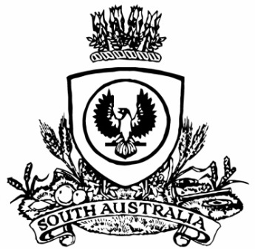
SUPPLEMENTARY GAZETTE
THE SOUTH AUSTRALIAN
GOVERNMENT GAZETTE
Published by Authority

Adelaide, Saturday, 19 February 2022

Governor’s Instruments
Constitution Act 1934
South Australia
Constitution (Dissolution of House of Assembly) Proclamation 2022
under section 28 of the Constitution Act 1934
1—Short title
This proclamation may be cited as the Constitution (Dissolution of House of Assembly) Proclamation 2022.
2—Commencement
This proclamation comes into operation on the day on which it is made.
3—Dissolution of House of Assembly
The House of Assembly is dissolved.
Made by the Governor
with the advice and consent of the Executive Council
on 19 February 2022

