No. 1 p. 1
THE SOUTH AUSTRALIAN
GOVERNMENT GAZETTE
Published by Authority

Adelaide, Thursday, 6 January 2022

Contents

State Government Instruments

Dangerous Substances Act 1979 2

Development Act 1993 2

Disability Inclusion (Restrictive Practices - NDIS)
Amendment Act 2021 6

Education and Children’s Services Regulations 2020 16

Fisheries Management (Rock Lobster Fisheries)
Regulations 2017 19

Housing Improvement Act 2016 19

Hydroponics Industry Control Act 2009 20

Justices of the Peace Act 2005 21

Land Acquisition Act 1969 21

Major Events Act 2013 23

Mental Health Act 2009 23

Motor Vehicles Act 1959 24

National Electricity (South Australia) Act 1996 26

Phylloxera and Grape Industry Act 1995 26

Planning, Development and Infrastructure (General)
Regulations 2017 26

Professional Standards Act 2004 (SA) 31

Shop Trading Hours Act 1977 31

Surveyor General 31

Local Government Instruments

District Council of Lower Eyre Peninsula 33

State Government Instruments

Dangerous Substances Act 1979
Authorised Officer
I, Martyn Antony Campbell, Executive Director, SafeWork SA, hereby revoke the following person as an Authorised Officer for the purposes of the Dangerous Substances Act 1979 pursuant to section 7(4) of that Act:
- Wayne Andrew Dodd
Dated: 30 December 2021
Martyn Campbell
Executive Director
SafeWork SA

Development Act 1993
Section 48
Decision by the Minister for Planning and Local Government
Preamble
- By notice published in the Gazette on 27 June 2019 at p.2272, and a further notice of variation published in the Gazette on 19 March 2020 at p.562, the then Minister for Planning declared that section 46 of the Development Act 1993 (the Development Act) applied in respect of any development of a kind specified in the Schedule of that notice (the declaration).
- On 18 July 2019 ElectraNet Pty Ltd (the proponent) lodged an application under section 46(6) of the Development Act for development authorisation for the South Australian portion of its proposal to construct a new high-voltage interconnector between Robertson in South Australia (SA) and Wagga Wagga in New South Wales (NSW). The application includes the construction of approximately 190 km of 275kV and 330kV transmission line between the existing Robertstown substation (117 km north, north east of Adelaide) and the SA-NSW border (40 km north east of Renmark), a new substation near Robertstown, temporary facilities including construction compounds, laydown areas, site offices, helicopter landing sites, and a temporary workers accommodation camp near Morgan, and ancillary works, including telecommunications infrastructure and access tracks, all development within the ambit of the declaration (the major development, or the development).
- The major development has been the subject of an Environmental Impact Statement and an Assessment Report under sections 46 and 46B of the Development Act.
- Since 1 July 2019 the Development Act has applied in relation to the proposed major development pursuant to and as modified by regulation 11(3) of the Planning, Development and Infrastructure (Transitional Provisions) Regulations 2017 (the Transitional Regulations).
- I am satisfied that an appropriate Environmental Impact Statement and Assessment Report have been prepared in relation to the major development, in accordance with the requirements of Part 4 Division 2 of the Development Act (as modified by regulation 11(3) of the Transitional Regulations), and I have had regard to all relevant matters under section 48(5) of the Development Act.
- I have decided to grant a provisional development authorisation for the major development, reserving a decision on specified matters until further assessment of the major development.
- I am delegating all of my powers and functions under section 48 of the Development Act in relation to the major development, including those matters in respect of which I have reserved my decision, to the State Planning Commission.
Decision
- Pursuant to section 48 of the Development Act 1993 (the Development Act) (as it applies pursuant to and as modified by regulation 11(3) of the Planning, Development and Infrastructure (Transitional Provisions) Regulations 2017 (the Transitional Regulations)), and having due regard to the matters set out in section 48(5) of the Act and all other relevant matters, I
- grant a provisional development authorisation in relation to the major development, subject to the conditions set out in Part A below;
- pursuant to section 48(6) of the Development Act, reserve the decision on the matters specified in Part B of this authorisation until further assessment of the major development;
- specify, for the purposes of section 48(7)(b)(i) of the Development Act, all matters which are the subject of conditions or reserved matters herein as matters in respect of which the conditions of this authorisation may be varied or revoked, or new conditions attached; and
- specify, for the purposes of section 48(11)(b) of the Development Act, the period of 2 years from the date of this authorisation as the time within which substantial work must be commenced on site, failing which I may cancel this authorisation.
- Pursuant to section 20 (and, to the extent necessary, 48(8)) of the Development Act, I hereby delegate my powers and functions under section 48 of the Development Act, and the powers and functions under section 115 of the Planning, Development and Infrastructure Act 2016, in relation to the major development, to the State Planning Commission (the Commission), including those matters in respect of which I have reserved my decision. This delegation allows for subdelegation of relevant powers and functions by the Commission.
PART A: CONDITIONS OF PROVISIONAL DEVELOPMENT AUTHORISATION
- Except where minor amendments may be required by other legislation or by conditions imposed herein, the construction, operation, use and maintenance of the major development must be undertaken in accordance with the approved plans and details, drawings, designs and specifications:
- set out in the application:
  - Project Energy Connect – Environmental Impact Statement – Main Report and Appendices – May 2021;
  - Project Energy Connect – Environmental Impact Statement – Response Document – November 2021; and

- set out in the final and approved:
  - Works Programme;
  - Stage Details Plan for each stage identified in the Works Programme as is approved;
  - Construction Environment Management Plan (CEMP);
  - Operational Environmental Management Plan (OEMP);
  - Cultural Heritage Management Plan;
  - Fire Hazard Management Plan;
  - Waste Minimisation and Management Plan;
  - Native Vegetation Management, Restoration and Monitoring Plan; and
  - Threatened Species Management Plan.
To the extent of any inconsistency, and subject to any contrary intention, a later document will prevail over an earlier one.
- The major development, including all stages, must be substantially completed within five (5) years of the date of this authorisation, failing which an extension of time may be sought from the Minister for Planning and Local Government (the Minister) prior to the expiry of that period or the authorisation may be cancelled.
- Should the major development not be substantially completed within five (5) years of the date of this authorisation, and no extension of time sought before such expiry and subsequently approved, the state and condition of the land and buildings must be reinstated, so far as is reasonably practicable, to the state and condition that the land and buildings were in immediately before the commencement of the major development.
- Further information and application(s) in relation to the following must be submitted for approval of the Minister:
- Works Programme;
- Stage Details Plan;
- CEMP;
- OEMP;
- Cultural Heritage Management Plan;
- Fire Hazard Management Plan;
- Waste Minimisation and Management Plan;
- Native Vegetation Management, Restoration and Monitoring Plan; and
- Threatened Species Management Plan.
- No building works on any part of the site of the major development (the site) may commence until a favourable decision has been notified to the proponent by the Minister in respect of the reserved matters (PART B) and until a development authorisation under section 48(2) of the Development Act 1993 and/or section 115(2) of the Planning, Development and Infrastructure Act 2016 is granted for the relevant stage as is approved in the Works Programme.
- The implementation of the CEMP must be continuously monitored and reviewed every six (6) months to ensure compliance with the measures to manage and monitor relevant impacts and effectiveness of those measures and updated (with approval of the Minister) as necessary. Each review must be made publicly available and a copy provided to the Minister until all construction stages are complete.
- The implementation of the OEMP must be continuously monitored and reviewed at regular intervals (being at least every 6 months for the first 2 years of operation) to ensure compliance with the measures to manage and monitor relevant impacts and effectiveness of those measures and updated (with approval of the Minister) as necessary. Each review must be made publicly available and a copy provided to the Minister.
- Council, utility or state agency maintained infrastructure that is demolished, altered, removed or damaged without lawful authority in the implementation of the major development must be reinstated to Council, utility or state agency specifications as applicable. All costs associated with these works must be met by the proponent.
- All road infrastructure upgrades must be completed to the standard required to enable use of the identified vehicle type (as specified in the Traffic Management Plan), to the satisfaction of the relevant road authority.
- All road infrastructure upgrades, unless otherwise identified, are to be funded by the proponent.
- The proponent must ensure that the design, construction and operation of the development complies with the applicable electric and magnetic fields (EMF) limits in the International Commission on Non-Ionizing Radiation Protection (ICNIRP) Guidelines for limiting exposure to time-varying electric and magnetic fields (1Hz – 100kHz) (ICNIRP, 2010).
- Should the proponent or any subsequent owner or operator of the relevant network intend that the operation of the relevant network or portion of it will cease, the Minister must be advised as soon is reasonably practicable, and a Decommissioning and Rehabilitation Plan (DRP) must be prepared in consultation with the relevant Government agencies and local councils, and must be submitted to the reasonable satisfaction of the Minister.
The DRP must be prepared nine (9) months prior to the time that the operation (or relevant portion of it) is scheduled to cease, and include information related to:
- identifying assets to be rehabilitated, remediated, decommissioned and/or removed, along with those that are proposed to be retained and the proposed tenure and management arrangements;
- confirming responsibility for costs associated with rehabilitation, remediating, decommissioning and/or removing and retaining assets;
- handover arrangements for useable assets;
- responsibility for future management and maintenance of useable assets; and
- measures, if required, to remove fuel and chemical storage and wastewater treatment facilities in accordance with relevant legislation and standards.
- Decommissioning of the development and rehabilitation of the site must be undertaken in accordance with the approved DRP.
- All external lighting, including for car parking areas and buildings at the Bundey Substation Site (being the land located at the corner of Powerline and Sutherlands Road, Bundey as comprised in Certificate of Title Volume 6257 Folio 867) (“the Bundey Substation Site”) must be designed and constructed to conform with Australian/New Zealand Standard AS/NZS 4282:2019 – Control of Obtrusive Effects of Outdoor Lighting and must be located, directed and shielded, and of such limited intensity, as far as reasonably practicable, that no unreasonable nuisance is caused to any person beyond the boundary of the site.
- All vehicle car parks, driveways and vehicle entry and manoeuvring areas at or providing access to and from the Bundey Substation Site must be designed and constructed in accordance with the relevant Australian Standards and appropriately line marked, and must be constructed, drained and paved with bitumen, concrete or paving bricks (or other such material as agreed to by the Minister for Planning and Local Government), in accordance with sound engineering practice.
- All loading and unloading, parking and manoeuvring areas at or providing access to and from the Bundey Substation Site must be designed and constructed to ensure that all vehicles can safely traffic the site and enter and exit the subject land in a forward direction.
- All stormwater design and construction at the Bundey Substation Site must be in accordance with Australian Standards and recognised engineering best practice to ensure that stormwater does not adversely affect any adjoining property or public road.
- All liquids or chemical substances that are to be stored at the Bundey Substation Site and that have the ability to cause environmental harm must be located within a bunded compound that has a capacity of at least 120% of the volume of the largest container, in accordance with the EPA ‘Bunding and Spill Management Guidelines’ (2016).
- Unless otherwise specifically provided for in these conditions or otherwise agreed to in writing with the Minister, all costs necessary for compliance with these conditions must be met solely by the proponent.
PART B: MATTERS RESERVED FOR FURTHER ASSESSMENT
I reserve my decision on the following matters:
- A Works Programme must identify the proposed stages of construction of the development.
- A Stage Details Plan for each stage that is identified in the Works Programme as is approved must include:
- final detailed designs for all transmission infrastructure, including detailed route plans, towers (and their location), details of any cut and fill, finishes and colours and access roads, including advice as to the design safety solution applicable to the existing airstrip located on Sugarwood Station consistent with applicable Civil Aviation Safety Authority (CASA) standards;
- final detailed plans and designs for all substation infrastructure, including site plans, building floor plans, elevations, cross-sections, details of cut and fill; and
- final detailed plans for all temporary construction component (i.e. laydown areas, works compounds, storage areas, helicopter landing areas etc.).
- A CEMP must be prepared in consultation with the Environment Protection Authority; the Department for Environment and Water; the Department of Primary Industries and Regions South Australia; the Country Fire Service; the Murraylands and Riverland Landscape Board and relevant local councils. The CEMP must (at a minimum) identify the predicted impacts of the major development on the following matters, the measures that will be implemented to manage and monitor the predicted impacts on those matters, and the predicted effectiveness of the measures:
- soil erosion and drainage;
- groundwater;
- flora and fauna;
- weeds and pests;
- air quality and greenhouse gas emissions;
- noise and vibration;
- traffic; and
- local community impacts.
The CEMP must include the following plans:
- Traffic Management Plan including a Pavement Monitoring & Management Plan.
- Emergency Response Plan.
- Soil Erosion and Drainage Management Plan.
- Air Quality Management Plan.
The CEMP must be prepared taking into consideration, and with explicit reference to, relevant Environment Protection Act 1993 policies and guidance documents, including but not limited to:
- the Environment Protection (Air Quality) Policy 2016.
- the Environment Protection (Noise) Policy 2007.
- the Environment Protection (Water Quality) Policy 2015.
- the Environment Protection (Waste to Resources) Policy 2010.
- the Environment Protection Authority Bunding and Spill Management Guideline 2016.
- Environment Protection Authority Handbooks for Pollution Avoidance.
- the Environment Protection Authority Stormwater Pollution Prevention Code of Practice for the Building and Construction Industry 1999.
- the Environment Protection Authority guideline ‘Construction environmental management plan (CEMP) 2019’.
- any other relevant legislative requirements, Guidelines and Australian Standards.
- An OEMP must be prepared in consultation with the Department of Environment and Water; the Department of Primary Industries and Regions South Australia; the Country Fire Service; the Murraylands and Riverland Landscape Board and local Councils. The OEMP must (at a minimum) identify the predicted impacts of the major development on the following matters, the measures that will be implemented to manage and monitor the predicted impacts on those matters, and the predicted effectiveness of the measures:

- soil erosion and drainage
- flora and fauna
- weeds and pests
- air quality
- noise and vibration
- local community impacts
- A Cultural Heritage Management Plan must be prepared in consultation with the Traditional Owner groups and the relevant Aboriginal heritage representatives, and must establish protocols to apply to the discovery of any Aboriginal sites, objects and/or remains during construction.
- A Fire Hazard Management Plan must be prepared in consultation with the South Australian Country Fire Service.
- A Waste Minimisation and Management Plan must be prepared in consultation with the Environment Protection Authority and relevant local council (to the extent relevant to their respective legislative authority).
- A Native Vegetation Management, Restoration and Monitoring Plan must be prepared in consultation with the Department for Environment and Water and the Murraylands and Riverland Landscape Board. It must include details on the management of both retained native vegetation within the transmission line corridor and any areas that are to be restored after the completion of construction. The Plan must address:
- Vegetation clearance requirements of the Native Vegetation Council.
- Vegetation clearance practices.
- Restoration measures, such as site preparation, natural regeneration or direct seeding.
- Protection and maintenance of remnant vegetation, including and the control of current / future degrading factors (especially erosion).
- Vegetation maintenance during operation, especially to maintain access, safety clearance zones under conductors and asset protection zones.
- Pest plant and animal control.
- Fire management.
- Monitoring requirements.
- A Threatened Species Management Plan must be prepared in consultation with the Department for Environment and Water and the Murraylands and Riverland Landscape Board and the Australian Government Department of Agriculture, Water and the Environment. The Plan shall address the measures to be implemented to avoid, minimise and off-set impacts on each nationally threatened species that could be affected by the proposal (including consideration of any Recovery Plans that relate to each species). Species of State and Regional conservation significance (especially those listed under the National Parks and Wildlife Act 1972) must also be addressed in the Plan.
- Building Rules compliance must be assessed and certified for each stage of the development by an accredited professional (or by a person determined by the Minister) and a copy of all relevant certification documentation must be provided to the Minister.
ADVISORY NOTES
  - The proponent is advised that all conditions must be met including monitoring, mitigation and reporting requirements as detailed in relevant management plans. Failure to comply with a condition is a breach of the Development Act 1993 or the Planning, Development and Infrastructure Act 2016 (as applicable), under which this authorisation is given.
  - An accredited professional undertaking Building Rules assessments for each stage must ensure that the assessment and certification for any stage is consistent with this provisional development authorisation and the approved Works Programme (including any conditions or advisory notes that apply in relation to this provisional development authorisation).
  - Construction of each stage of the development may commence only after a Building Rules assessment and certification has been undertaken in relation to that stage and has been issued by an accredited professional undertaking Building Rules assessments, and the Minister for has received a copy of the relevant certification documentation.
  - In accordance with the National Heavy Vehicle Law (South Australia) Act 2013, the proponent must apply to the National Heavy Vehicle regulator to obtain permits for use of Restricted Access Vehicles and/or High Productivity Vehicles on public roads, where access for such vehicle is currently not available. This might include such things as construction equipment and vehicles carrying large indivisible construction materials. This might also include access for vehicles such as Road Trains or Performance Based Standards (PBS) vehicles to transport commodities.
  - Prior to the use of any High Productivity Vehicles, the Department for Infrastructure and Transport requires that any additional road infrastructure upgrades required to facilitate this use must be completed to the satisfaction of the relevant road authority.
  - An important initial step, as outlined in the Heavy Vehicle Access Framework, is to have an assessment of the route undertaken by an Authorised Route Assessor, at the proponent’s cost. This process will identify any upgrades required to make the route safe and suitable for the type of vehicle access requested. As part of the approval/s, the proponent will be required to prepare a list of final transport infrastructure improvement needs upon completion of a full route assessment. If this is necessary, the list should identify the scope, timing and estimated cost of the required improvements.
  - The proponent is reminded of its obligations under the Aboriginal Heritage Act 1988 that excavation, damage, disturbance of, or interference with, any Aboriginal site, object or ancestral remains is unlawful without ministerial authorisation under sections 21 and 23 of the Act.
  - The proponent, and all agents, employees and contractors, such as construction crew, are reminded of requirements under the Aboriginal Heritage Act 1988, particularly the requirement to immediately contact the Department of Aboriginal Affairs and Reconciliation in the event that archaeological items (especially skeletal material) are uncovered during earthmoving.
  - The proponent is reminded of requirements under the Native Title Act 1993 particularly those requiring consultation with appropriate representatives of any relevant Aboriginal Groups in relation to any known sites of significance in the area and any Native Title Claims over the sea bed and subjacent lands.
  - The proponent is reminded of requirements under the Native Vegetation Act 1991 and the Native Vegetation Regulations 2017 particularly where native vegetation clearance must be undertaken in accordance with a management plan that has been approved by the Native Vegetation Council that results in a significant environmental benefit on the property where the development is being undertaken, or a payment is made into the Native Vegetation Fund of an amount considered by the Native Vegetation Council to be sufficient to achieve a significant environmental benefit in the manner contemplated by section 21(6) of the Native Vegetation Act 1991, prior to any clearance occurring.
  - The proponent is reminded of requirements under the National Parks and Wildlife Act 1972, particularly as permits are required for the ‘taking of protected animals’, such for the capture and relocation of animals during construction and the destruction or relocation of animals during operation.
  - The proponent is reminded of requirements under the Commonwealth Environment Protection and Biodiversity Conservation Act 1999 not to undertake any activity that could have a significant effect on any matter of National Environmental Significance without the approval of the Commonwealth Minister for Environment.
  - Should the proponent wish to vary the major development or any portion of it, an application to the Minister must be submitted, provided that the development application variation remains within the ambit of the Environmental Impact Statement and Assessment Report referred to in this development authorisation. If an application variation involves substantial changes to the proposal, pursuant to section 47 of the Development Act 1993 or section 114 of the Planning, Development and Infrastructure Act 2016 (as applicable), the proponent may be required to prepare an amended Environmental Impact Statement for public inspection and purchase. An amended Assessment Report may also be required to assess any new issues not covered by the original Assessment Report and the decision made pursuant to section 48 of the Development Act 1993 or section 115 of the Planning, Development and Infrastructure Act 2016 (as applicable).
  - The Minister has a specific power to require testing, monitoring and auditing under section 48C of the Development Act 1993 or section 117 of the Planning, Development and Infrastructure Act 2016 (as applicable).
Dated: 23 December 2021
Josh Teague MP
Minister For Planning and Local Government

Disability Inclusion (Restrictive Practices - NDIS) Amendment Act 2021
Part 6A, Section 23H
Restrictive Practices Guidelines
I, MICHELLE LENSINK, Minister for Human Services, hereby give notice of the following guidelines under Part 6A of the Disability Inclusion (Restrictive Practices - NDIS) Amendment Act 2021, “Restrictive Practices Guidelines”.
Introduction
All South Australians have the right to a life that is meaningful, self-determined and connected with the people and communities around them. When communities are inclusive and fair, people with disability can participate and contribute on the same basis as all others. Restrictive practices are any interventions that restrict the rights and freedoms of a person, with the goal to protect that person or others from harm. People with disability are more likely to experience restrictive practices than other members of the community.
Restrictive practices can be a serious breach of human rights. The South Australian government is committed to upholding the rights of people with disability, as enshrined in the United Nations Convention on the Rights of Persons with Disabilities 2006 and the Disability Inclusion Act 2018.
Along with state, territory and national counterparts, the South Australian government has endorsed the National Framework for Reducing and Eliminating Restrictive Practices in the Disability Sector 2013 (‘the National Framework’) and the National Principles for the Authorisation of Restrictive Practices (‘the National Principles’). This national approach ensures that people with disability have access to the same protections regardless of where they live.
The authorisation scheme established by Part 6A of the Disability Inclusion Act 2018 sets out the roles, processes, and criteria for the authorisation of restrictive practices by registered NDIS providers for NDIS participants in South Australia. Accountability, transparency, and visibility of restrictive practices are an important step in reducing their use. But it is only one step.
The Restrictive Practices Guidelines provide further details about the operation of the authorisation scheme. It situates the process of authorisation within a broader context of person-centred practice, education and awareness, and systems improvement that is most likely to prevent and reduce the use of restrictive practices over time.
Legislative Context
International human rights conventions
The United Nations Convention on the Rights of Persons with Disabilities (‘the CRPD’) was adopted in 2006, and Australia was one of the first countries to ratify this convention. The CRPD promotes, protects, and ensures ‘the full and equal enjoyment of all human rights and freedoms by all persons with disabilities, and to promote respect for their inherent dignity’.
Relevant to the issue of restrictive practices, the CRPD articulates people with disability’s rights to:
- Respect for their inherent dignity, individual autonomy including the freedom to make their own choices, and independence of person (Article 3).
- Equal recognition before the law (Article 12)
- Liberty and security of their person (Article 14)
- Freedom from cruel, inhuman, or degrading treatment or punishment (Article 15)
- Freedom from exploitation, violence, and abuse (Article 16)
- Right to physical and mental integrity (Article 17)
- Personal mobility (Article 20).
The CRPD provides a human rights framework that guides the operation, interpretation and oversight of the authorisation scheme.
National legislation
The South Australian NDIS restrictive practices authorisation scheme is situated within the context of Commonwealth legislation, specifically:

- The National Disability Insurance Scheme Act 2013, which establishes the National Disability Insurance Scheme (NDIS), the National Disability Insurance Agency (NDIA) and the NDIS Quality and Safeguards Commission (NDIS Commission). The NDIS Quality and Safeguards Commissioner’s behaviour support function is to provide leadership in relation to behaviour support, and in the reduction and elimination of the use of restrictive practices by NDIS providers.
- The National Disability Insurance Scheme (Provider Registration and Practice Standards) Rules 2018, which set out some of the conditions that providers must comply with to become and remain registered NDIS providers. It also sets out the NDIS Practice Standards that apply to all registered NDIS providers, and those that apply to providers delivering more complex services such as behaviour support.
- The National Disability Insurance Scheme (Restrictive Practices and Behaviour Support) Rules 2018 which establish the conditions of registration for registered NDIS providers who use regulated restrictive practices in the course of delivering NDIS supports. The Rules also establish the requirement to develop a behaviour support plan and report on the use of regulated restrictive practices.
- The National Disability Insurance Scheme (Incident Management and Reportable Incidents) Rules 2018 which establish the requirements to notify the NDIS Commission of reportable incidents, including the use of unauthorised restrictive practices.
- The National Disability Insurance Scheme (Code of Conduct) Rules 2018 sets out the NDIS Code of Conduct, which supports the rights of people with disability in the NDIS to have access to safe and ethical supports.
The national legislation, practice guidance and directions issued by the NDIS Commission establishes responsibilities and obligations on registered NDIS providers delivering supports for people with disability in the NDIS. Nothing in the South Australian authorisation scheme derogates from these responsibilities and obligations. Registered NDIS providers must ensure compliance with both national and state requirements.
State legislation
The Disability Inclusion Act 2018 (as amended by the Disability Inclusion (Restrictive Practices - NDIS) Amendment Act 2021) establishes the legislative framework for the authorisation of restrictive practices by registered NDIS providers for NDIS participants in South Australia. The authorisation scheme supports the objects of the Act (section 8) in ‘providing safeguards in relation to the delivery of all supports and services for people with disability’.
The Act, the Disability Inclusion (Restrictive Practices - NDIS) Regulations 2021 and the Restrictive Practices Guidelines 2021 must be considered in their entirety. These foundational requirements will also be supplemented by fact sheets, templates, and procedures for registered NDIS providers, people with disability, and others.
Practice Context
The restrictive practices authorisation scheme operates within the context of skilled and effective practice that is characterised by the following elements:
Positive Behaviour Support
Positive behaviour support is an evidence-based framework for assessment, planning and intervention that focuses on addressing a person’s needs to increase their quality of life and reduce behaviours of concern. Positive behaviour support involves working with the person, their family, carers and professionals to develop a shared understanding of behaviour, the needs that the behaviour is communicating, and the supports that are required to meet those needs in a positive way.
Positive behaviour support has a number of key components:
- A person-centred approach that is focused on the person with disability’s needs, goals, wishes and perspectives. Person-centred approaches respect the person’s dignity, autonomy and right to make decisions for themselves so that they can live meaningful and satisfying lives.
- Partnership with the person with disability, their family, carers and support professionals. Positive behaviour support recognises that behaviour occurs in the context of the person, their environment, and the relationships around them. Positive change can only occur when there is a shared understanding of behaviour and unmet needs, and a strengths-based approach to building the capacity that is needed to support the person. A partnership approach ensures that people with disability, their family, carers, support workers and other professionals are consulted and are able to contribute to the behaviour supports provided.
- Evidence-based intervention based on functional behaviour assessments. Examining when, where, why and what behaviour occurs, its antecedents and consequences, and the role of physical and social environments are central to reducing behaviours of concern. Behaviour support plans consolidate the assessment and interventions in a way that help the person with disability, their families, carers and professionals to support them in an agreed and consistent way.
- Skills development, where people with disability are supported to learn, practice and embed new skills and functionally equivalent replacement behaviours that allow them to meet their needs in a safe and positive way.
- Ongoing monitoring and review. Positive behaviour support is not a static process, but is continually being reviewed for progress towards behaviour goals and adjusted in light of emerging needs and increasing capacity. The documentation of this review process allows people with disability, their families, carers and professionals to form a shared understanding of their progress towards eliminating restrictive practices.
Restrictive practices can only be authorised when they are consistent with, and are supported by, a behaviour support plan established within this framework. Restrictive practices that are not authorised may constitute an assault or a tortious act against a person with disability.
Continuum of responses
Restrictive practices are a reactive, time-limited intervention intended to provide safety as a last resort when no other strategy is effective or appropriate. Restrictive practices must be situated within a continuum of supports for a person with disability that includes:
Preventive strategies that promote quality of life and reduce the unmet needs that give rise to behaviours of concern. These include adjustments to the person’s:
- environment that increase predictability, accessibility, and comfort
- routines that provide opportunities for recreation, stimulation, and social interactions
- ways of engagement that support participation and decision-making at the level that the person with disability feels most comfortable
Early intervention when there are indicators that needs are not being met. Early intervention relies on understanding a person’s individual signs of unmet needs which may be more subtle than behaviours of concern, and providing opportunities for targeted support, connection, and care.
Reactive strategies to redirect, intervene and minimise behaviours before the use of restrictive practices.

Relationship-based practice
Behaviour support (including restrictive practices) must be undertaken within a safe, trusting, and respectful relationship between the person with disability and their support workers. The use of restrictive practices (particularly physical restraint and seclusion) may cause ruptures in this relationship, for people who are the subject of the restrictive practice, those who apply the practice, and others who may witness or are indirectly affect by it. Debriefing and restorative actions are essential to ensuring that these ruptures are acknowledged and repaired, so that they do not compromise the ongoing relationship between people with disability and their support workers.
Relationship-based practice is especially important in the context of people with disability often having large numbers of family members, carers, and professionals who form their support network. Positive, trusting, and respectful relationships between these people are essential to providing consistent and seamless care that places the person with disability at the centre.
Trauma-informed practice
Trauma occurs when a person experiences stress that overwhelms their body’s capacity to cope. Restrictive practices (particularly physical restraint and seclusion) may constitute a trauma when they occur in the context of ongoing relationships, involve multiple incidents over time or a significant once-off event, and are associated with feelings of stigma and shame by the person who is restricted.
Restrictive practices may also compound the effects of past trauma including experiences of abuse and neglect, family violence, intergenerational trauma, and restrictive practices in different settings (child protection, justice and corrections, aged care, mental health). There is a high prevalence of trauma experiences among people with disability, and this prevalence is higher for people with disability who are Aboriginal, from culturally and linguistically diverse backgrounds, women, or who have a mental health condition.
A trauma-informed approach recognises this prevalence of trauma, how it affects a person’s experiences of restrictive practices, and the importance of not re-traumatising the person.
Trauma-informed approaches also recognise that a person’s cognitive capacity can fluctuate depending on their emotional, psychological, and physical state. This means that a person with disability may be able to use language and reasoning to make informed decisions for themselves when they feel calm, regulated, safe and supported but may not be able to do so in a heightened state of distress. They may not be able to remember what happened during a behaviour emergency and may need support to remember and understand why service providers may have responded in a particular way. Trauma-informed approaches are premised on unconditional positive regard for the person at all times.
While the traumatic impact of physical restraint and seclusion may be readily understood, the cumulative impact of other restrictive practices such as environmental restraints should not be underestimated. People with disability have highlighted the emotional complexity of restrictive practices, and its impact on their sense of agency and quality of life.
Trauma-informed responses to restrictive practices emphasise the importance of debriefing shortly after critical incidents, and providing supports to address the impact of restrictive practices, including:
- physical impacts (such as weight gain, headache, constipation, sexual dysfunction, dry mouth, low blood pressure, and insomnia)
- mental impacts (such as anxiety, distress, learned helplessness, hypervigilance, and depression)
- social and relational impacts (such as avoidance, clinginess, mistrust, and withdrawal).
Cultural safety and competence
The effective use of restrictive practices must be situated in a broader understanding of the impact of systemic racism, colonisation and the exercise of the state authority for Aboriginal and Torres Strait Islander people and some people from culturally and linguistically diverse backgrounds. Aboriginal and culturally diverse people who have had these experiences directly or indirectly are less likely to experience restrictive practices as a protective measure that supports their safety.
Aboriginal people and people from culturally and linguistically diverse backgrounds may also have different conceptualisations of behaviours of concern and what is required to support positive behaviours. What may be seen as behaviours of concern may reflect broader needs for an Aboriginal person with disability to be connected with culture, country and land which can be challenging in residential disability settings.
Culturally safe and competent practice requires working with the person with disability, their family, carers and people with cultural authority. It is important to understand how behaviours and unmet needs should be considered, by whom, and the supports that are required to support the person with disability to be well within themselves.
Service improvement
The use of restrictive practices must occur within a context of ongoing service improvement in organisations to ensure high quality supports and services. This involves:
- Ensuring that organisations have policies, procedures and practices that comply with national and state laws, policies, and guidelines.
- Reflective practice, supervision, and ongoing professional development for staff to create an organisational culture against the use of restrictive practices
- The evaluation of data about behaviours of concern and the authorisation and use of restrictive practices to inform systems improvement.
Practice Principles
Human rights, dignity and respect
People with disability have a right to the full and equal enjoyment of all human rights and fundamental freedoms. Restrictive practices limit the freedom of movement, choice, and bodily integrity of people with disability. The limited use of restrictive practices must only occur when they are necessary to address a risk of harm that jeopardises the rights of the person with disability and others to be safe and fully participate and be included.
People with disability have a right to be treated with dignity and respect, and to have their identity, culture and diversity valued. This means being able to exercise choice and independence to the greatest extent possible about:
- their own care and the services they receive
- their relationship with family, friends, carers and others
- their participation in the community, including recreation and social activities.
People with disability must be encouraged and supported to participate at all stages in the service delivery. This includes contributing to the development of their behaviour support plan, providing informed consent (or informed refusal) to the use of restrictive practices, and contributing to decisions about restrictive practices.

Safety
Restrictive practices should only be used to address safety issues arising from behaviours of concern. However, some restrictive practices may have safety implications for the person subject to the practice and for the person implementing the practice. The use of restrictive practices may also introduce new behaviours of concern.
Risk assessments should be undertaken as part of the behaviour support planning process to:
- identify risks
- assess the severity and likelihood of these risks
- balance the risks arising from behaviours of concern and the risks that are introduced through the use of restrictive practices
- develop proportionate strategies to mitigate these risks.
As behaviour interventions take effect, the nature and degree of risk should change. Risk assessments should be reviewed regularly as part of the behaviour support planning process to ensure that they remain relevant and accurate.
Restrictive practices should not be used to address all risks, but only the risk of harm from behaviours of concerns that cannot be managed in a less restrictive way. Where possible, people with disability should be supported to understand and manage the daily risky choices that are made by all members of the community.
Informed consent
While section 23M of the Disability Inclusion Act 2018 permits the use of restrictive practices without the consent of the person with disability, informed consent remains a core practice principle. People with disability are entitled to participate in decisions that affect them, to make informed choices about the behaviour supports that will be helpful in their circumstances, and to have their preferences taken into account and given practical effect wherever possible.
Many people with impaired decision-making capacity are able to make decisions about the use of restrictive practices for themselves and are able to recognise when they need support from workers, carers and family members to protect themselves and others from harm. Their informed consent (or refusal) for restrictive practices must be sought, considered and be influential in the authorisation decision. Supported decision making provides a best-practice framework to enable people with disability to exercise and enjoy these decision-making rights.
Where orders exist for substitute or alternative decision-makers, the views of these individuals about the use of restrictive practices for the person with disability should also be sought and documented for consideration in the authorisation decision.
Children and young people must be provided with support to make informed decisions about the use of restrictive practices in their care wherever possible. Their informed consent (or refusal) must be sought, considered and be influential in the authorisation decision if they have sufficient maturity to understand the nature and implications of using restrictive practices. To consider a child’s competency to make informed decisions, registered NDIS providers must consider the child’s:
- understanding of the relevant information
- ability to weigh up that information, including the benefits and risks for themselves and others
- ability to communicate their decision.
The informed consent (or refusal) of a person with disability about the use of restrictive practices in their care must be sought and documented as part of the behaviour support planning process and included in applications for authorisation of restrictive practices.
People with disability are able to make informed decisions to withdraw their consent about the use of restrictive practices, and this may occur for many reasons (e.g. where their circumstances have changed, based on their experiences, changes in their perspective). Like informed consent, withdrawal of consent is informed when the person understands the nature of the decision they are making and the implications of the decision. Consent and withdrawal of consent may not be considered to be informed decisions if they are made when the person is distressed, emotionally escalated and experiencing a crisis. In these situations, registered providers must give priority to the decisions the person with disability has made when they were feeling safe, settled and supported.
Least restrictive and last resort
Restrictive practices are considered to be an intervention of last resort in a limited number of circumstances where there is no reasonable alternative to protect a person with disability and others from behaviours of concern. Where restrictive practices are required, they must be proportionate to the negative consequences and risk of harm and apply the least amount of force for the least period of time.
The principle of “last resort” must be applied at two levels:
- The use of the behaviour support planning process to evaluate the use of preventative, early intervention and reactive strategies to address behaviours of concern to ensure that the use of restrictive practices is avoided where possible. The behaviour planning process should demonstrate that there have been reasonable and concerted efforts over time to support behaviour change, and why these have not been sufficient to secure safety.
- The stages of a behaviour incident for a person with disability must be understood, so that opportunities to prevent incidents, identify and respond to early signs of concerning behaviours, and redirect or minimise behaviours of concern before incidents escalate to the unsafe level where restrictive practices are required.
Authorised restrictive practices must be regularly reviewed to explore opportunities to practice new skills and trial incremental reductions in restriction.
Where restrictive practices are applied in shared residential settings, efforts must be made to reduce the impact on others living in the same house. This may include providing keys or access codes to other residents who do not require the same restrictive practices.
Transparency and accountability
People with disability are entitled to equal treatment and equal protection under the law and are entitled to transparency and accountability in the decisions that are made about restrictive practices.
The authorisation scheme provides transparency and accountability in setting out:
- Who has the authority to make decisions about restrictive practices
- The criteria that must be used to make these decisions
- How decisions are communicated to people with disability, their family members, legal guardians, and registered NDIS providers
- How these decisions are implemented by registered NDIS providers
- The means of review and appeal
- Reporting requirements at an individual, organisational and government level.

Restrictive Practices
Section 9 of the NDIS Act 2013 defines restrictive practices as ‘any practice or intervention that has the effect of restricting the rights or freedom of movement of a person with disability’. Section 6 of the NDIS (Restrictive Practices and Behaviour Support) Rules 2018 defines regulated restrictive practices, and these definitions are mirrored in section 23B (1) of the Disability Inclusion Act 2018. The use of regulated restrictive practices must be undertaken in accordance with state authorisation processes and a behaviour support plan.
The NDIS (Restrictive Practices and Behaviour Support) Rules 2018 set out the minimum requirements for behaviour support plans developed by NDIS behaviour support practitioners. Specifically, Rule 21 states that the plan must include strategies that are evidence-based, person-centred and proactive and that address the person with disability’s needs and the functions of the behaviour. The regulated restrictive practice must:
- ‘be clearly identified in the behaviour support plan; and
- if the State or Territory in which the regulated restrictive practice is to be used has an authorisation process (however described) in relation to that practice—be authorised in accordance with that process; and
- be used only as a last resort in response to risk of harm to the person with disability or others, and after the provider has explored and applied evidence-based, person-centred and proactive strategies; and
- be the least restrictive response possible in the circumstances to ensure the safety of the person or others; and
- reduce the risk of harm to the person with disability or others; and
- be in proportion to the potential negative consequence or risk of harm; and
- be used for the shortest possible time to ensure the safety of the person with disability or others.’
The person with disability must be given opportunities to participate in community activities and develop new skills that have the potential to reduce or eliminate the need for regulated restrictive practices in the future.
In the authorisation scheme in South Australia, ‘restrictive practices’ relate to practices that are for the primary purpose of influencing a person’s behaviour where it poses a risk of harm to the person or others.
Chemical restraint
Section 6 (b) of the NDIS (Restrictive Practices and Behaviour Support) Rules 2018 defines chemical restraint as:
‘the use of medication or chemical substance for the primary purpose of influencing a person’s behaviour. It does not include the use of medication prescribed by a medical practitioner for the treatment of, or to enable treatment of, a diagnosed mental disorder, a physical illness or a physical condition’.
Chemical restraints are Level 1 restrictive practices that can be approved by the Authorised Program Officer unless there are characteristics that increase the intrusiveness, risks and impact for people with disability.
The following Level 2 chemical restraints must be approved by the Senior Authorising Officer:
- Chemical restraints that are administered through an invasive procedure such as via injections and implants.
- The use of 2 or more psychotropic¹ drugs or more than 5 drugs to manage behaviours. These numbers only reflect medications that are used to manage behaviour and do not include medications that are used to treat a diagnosed mental health condition, a physical illness or a physical condition.
- Hormonal manipulation to manage harmful sexual behaviours and behaviours of concern associated with menstruation (e.g. smearing, behaviours demonstrating distress). It does not include hormonal manipulation to treat a medical condition such as endometriosis, a physical condition such as menstrual pain, or where the person with disability has made an informed decision to use contraceptives as a reproductive choice. The Senior Authorising Officer cannot authorise hormonal manipulation for the primary purpose of contraception.
¹ Psychotropic drugs are “any drug capable of affecting the mind, emotions and behaviour”. The three main categories are antidepressants, anti-anxiety medications (including benzodiazepines) and anti-psychotics.
When medications are prescribed for people with disability to manage their behaviour, the prescribing medical practitioner is the clinical decision-maker who determines the purpose of the medication. To support prescribing medical practitioners in their role, registered NDIS providers who implement chemical restraints must ensure that:
- there are appropriate positive behaviour support strategies in place
- the person with disability’s medications are reviewed regularly by a qualified professional
- the purpose of medication is clarified and documented
- the use of the medication is consistent with a behaviour support plan
- the person with disability and their decision makers are encouraged to seek a second medical opinion if there are concerns about the use of a medication
- opportunities to safely trial a reduction of chemical restraints are explored with prescribing medical practitioners.
Environmental restraint
Section 6 (e) of the NDIS (Restrictive Practices and Behaviour Support) Rules 2018 defines environmental restraint as follows:
‘environmental restraint, which restricts a person’s free access to all parts of their environment, including items or activities’
The Disability Inclusion (Restrictive Practices - NDIS) Regulations 4 (3) and 5 (3) identify that preventing access by a person with disability to an area that individuals are ordinarily not permitted to enter will be taken not to be an environmental restraint.
This is to reflect ordinary community standards of privacy and access that may occur in shared housing, workplaces and community spaces such as:
- staff rooms in disability accommodation premises where staff may undertake office work, sleep, store their personal belongings or confidential client files
- the private rooms of other clients in shared accommodation
- the locking of bathroom doors and toilet doors while they are in use
- locked utility and maintenance areas in disability accommodation premises where general access is restricted, including for staff members.
The locking of external gates and external doors for security purposes against external parties (including placing limitations on external parties coming into shared disability accommodation premises) is not an environmental restraint, as long as people with disability inside the premises are able to freely exit as required.
The use of CCTV in shared areas in disability accommodation premises is not considered an environment restraint where its primary purpose is for security against external persons, or for employee oversight. Where CCTV is installed for the purpose of monitoring client behaviour, including behaviour while in seclusion, it is an environmental restraint and can be approved by an Authorised Program Officer.
The use of electronic monitoring devices (e.g. motion sensors, alarm mats) and non-electronic means of supervision (e.g. observation windows, peep holes) are not environmental restraints in their own right. The use of these observation methods may alert registered NDIS providers to behaviours of concern that require support.
Communication devices that are the primary means by which a person communicates (such as augmentative and alternative communication devices (AAC)) can not be restricted unless they are being used in a way that poses a risk of harm to the person or others, and there is a reasonable alternative the person can use to communicate. In these situations, authorisation must be sought from the Senior Authorising Officer. If there is no reasonable alternative that the person can use to communicate, the restrictive practice is unauthorised.
The grouping of similar items that are locked in a space is considered to be one restrictive practice, while different types of items stored in a range of locations are considered to be multiple restrictive practices. For example:
- a number of food items locked in a fridge is one restrictive practice
- a number of sharp items locked in one cupboard or drawer is one restrictive practice
- locked chemicals in one cupboard, and locked knives in a drawer are considered to be two restrictive practices.
As a guide, registered NDIS providers should consider the extent of items and extent of locations that a person with disability would not be able to access. Restrictions on entire rooms (such as kitchens or bathrooms) should be avoided as most kitchens and bathrooms can be safely managed through limited environmental restrictions.
Environment restraint that is not detention
Section 23C of the Disability Inclusion Act 2018 defines detention as:
- any direct or indirect curtailment of a person’s ability to leave particular premises or a particular part of particular premises
- a requirement that a person be and remain in particular premises
- the refusal or limitation of access to means to leaving particular premises.
However, Regulation 7 prescribes that the locking of external gates and doors of residential premises is not detention where NDIS supports, and services are provided on a 24-hour basis on those premises to a person with disability who does not have supports to safely leave at their discretion. These situations constitute a Level 2 environmental restraint that can be authorised by the Senior Authorising Officer.
Where a person with disability does have sufficient supports to safely leave the premises at their discretion but are prevented from doing so, this constitutes detention and must be authorised by the South Australian Civil and Administrative Tribunal (SACAT).
The external gates and doors of an NDIS residential premises may be locked for the safety of residents for several reasons, such as behaviours of concern that place themselves and others at risk, or physical or cognitive impairments that affect their ability to safely navigate roads, traffic and environmental hazards. The Act and Regulations do not differentiate between the genesis of the safety concerns for purposes of this restrictive practice.
Where a person with disability requires continuous accompaniment by another person due their behaviours and the accompaniment is designed to provide an external control on the person’s behaviour (where they can go, modifying their interactions with others, modifying their behaviour), this is a Level 2 restrictive practice that must be authorised by the Senior Authorising Officer. Continuous accompaniment of a person because they are at risk of falls, seizures or similar reasons are not a regulated restrictive practice.
In emergency situations, where staff withdraw to a contained space (such as a locked staff room) while the person with disability is not able to leave due to locked external gates and doors, this is an environmental restraint that must be authorised by the Senior Authorising Officer. It is not seclusion as defined by Regulation 7 (2) (b) as the practice is not for the purpose of de-escalation or self-regulation. It should be noted that this categorisation is different to that provided by the NDIS Commission. This difference in categorisation does not impact on the requirements to ensure that the practice is authorised, and its use reported to the NDIS Commission.
Mechanical restraint
Section 6 (c) of the NDIS (Restrictive Practices and Behaviour Support) Rules 2018 defines mechanical restraint as:
‘the use of a device to prevent, restrict, or subdue a person’s movement for the primary purpose of influencing a person’s behaviour but does not include the use of devices for therapeutic or non-behavioural purpose’.
Authorised Program Officers are able to authorise Level 1 mechanical restraints such as restrictive clothing (eg onesies, overalls, bodysuits, gloves), helmets, and splints unless there are more than five Level 1 practices, or the restraints require the use of force to implement. More than five Level 1 practices or the use of force needs to be authorised by the Senior Authorising Officer.
Mechanical restraints do not include therapeutic devices that support body position, balance, posture, or alignment. They do not include devices that are used to manage involuntary body movements such as tics, tremors, or dystonia.
Care must be taken to evaluate if therapeutic devices are used in ways that are inconsistent with their primary therapeutic purpose.
Physical restraint
Section 6 (d) of the NDIS (Restrictive Practices and Behaviour Support) Rules 2018 defines physical restraint as:
‘the use or action of physical force to prevent, restrict or subdue movement of a person’s body, or part of their body, for the primary purpose of influencing their behaviour. Physical restraint does not include the use of a hands-on technique in a reflexive way to guide or redirect a person away from potential harm/injury, consistent with what could reasonably be considered the exercise of care towards a person’.
The use of physical force to implement a restrictive practice (such as holding a person still to apply restrictive clothing) is a physical restraint which must be authorised.
Physical restraint is a high-risk activity, both for the person applying the restraint and the person who is restrained. Consideration should be given to seeking medical advice as to whether the person with disability has an underlying medical condition that may be exacerbated by some or all forms of physical restraint. Where this is the case, medical reviews should occur regularly to ensure the use of the physical restraint is safe and appropriate in the circumstances.
Physical restraint is a Level 2 restrictive practice that must be authorised by the Senior Authorising Officer. Given the risks involved, registered NDIS providers who use physical restraints must ensure that staff are appropriately trained in safe physical restraint techniques that reduce the risk of injury. Certain physical restraints are prohibited because they are associated with high risk of injury and death (see Prohibited Restrictive Practices).
Seclusion
Section 6 (a) of the NDIS (Restrictive Practices and Behaviour Support) Rules 2018 defines seclusion as the
‘sole confinement of a person with disability in a room or a physical space at any hour of the day or night where voluntary exit is prevented, or not facilitated, or it is implied that voluntary exit is not permitted’.
In South Australia, the Regulations prescribe additional conditions on this definition, identifying that:
- the period of seclusion can not exceed two hours
- may only occur in an emergency situation where it is necessary to prevent serious harm to the person or others,
- is for the purpose of de-escalation or self-regulation.
Seclusion is a Level 2 restrictive practice that must be authorised by the Senior Authorising Officer.
There must be no routine or scheduled use of seclusion.
Seclusion is not a withdrawal of support, but an active intervention involving support, co-regulation and de-escalation. Registered NDIS providers must ensure that the environment in which a person with disability is secluded is safe and comfortable.
Consideration should be given to whether the environment provides the appropriate level of sensory input or reduction that is required to help the person regulate. People with disability must not be unsupervised during seclusion.
The Regulations specify that the period of seclusion must not exceed two hours. In practice, the effective use of seclusion as a supported process to co-regulate and de-escalate a person experiencing a behaviour emergency should take much less time than 2 hours.
Like all restrictive practices, patterns in the use of seclusion must be closely monitored. Where seclusion is consistently used for the maximum period of time, or where multiple periods of seclusion are used in close succession, this may have the effect of detention for the person with disability.
In these situations, registered NDIS providers must:
- seek an urgent review of the behaviour support plan with a behaviour support practitioner, the person with disability, their family and other professionals. Continued use of seclusion for the maximum period or in close succession is likely to indicate that the person with disability’s needs are not being met and additional support is required for their safety and wellbeing.
- Ask the person with disability’s legal guardian (or substitute decision-maker appointed under an advanced care directive) to apply to SACAT for a detention order. Orders for detention are reviewed after the first 6 months, and then at intervals of not more than one year. SACAT is not able to make detention orders for children under the Guardianship and Administration Act 1993.
Unauthorised restrictive practices
The authorisation scheme seeks to ensure that the use of restrictive practices complies with national and state legislative requirements, and in accordance with the person’s behaviour support plan. Behaviour emergencies may arise that are not contemplated by the behaviour support plan. A person with disability’s needs may also change to require support that is beyond the restrictive practices that have been authorised.
In these situations, staff may be required to use an unauthorised restrictive practice to ensure the safety of the person with disability or another person. Unauthorised restrictive practices must be reported to the NDIS Commission within the legal timeframes required. Persistent use of unauthorised restrictive practices may indicate that the person with disability’s needs are not being met, additional support is required for their safety and wellbeing, and a review of the behaviour plan is warranted. Registered NDIS providers should seek authorisation for unauthorised restrictive practices as soon as practicable.
Use of force
Physical force
Section 23M (4) of the Disability Inclusion Act 2018 states that ‘a person may use reasonable force in the course of using restrictive practices under this Part (however, the use of force is to be a last resort and must be reasonably necessary to enable the use of restrictive practices’. To be reasonable, the use of physical force must be consistent with the principles outlined in s 23G of the Disability Inclusion Act:
- It is used as a last resort, after other means such as verbal guidance or visual prompts have been unsuccessful
- Applying the least amount of force in the least restrictive way for the shortest period of time.
The use of physical force to implement a restrictive practice is a separate restrictive practice in its own right (physical restraint). All restrictive practices that require the use of physical force must be authorised by the Senior Authorising Officer due to the heightened risks for the person being restrained and the person implementing the restraint.
The use of force must be proportionate to the potential negative consequence of harm for the person applying the restraint, and the person being restrained. This means that the degree of force required to physically restrain a person who is hurting themselves or others is likely to be higher than the degree of force required to apply a helmet or restrictive clothing.
Where physical force is used to implement a restrictive practice, registered NDIS providers must monitor the person with disability for signs of injury, distress, and harm. Injuries arising from the use of force must be reported to the NDIS Commission.
Psycho-social pressure
While the use of force is generally considered in terms of physical force, staff should also consider the power that they have as staff members, as professionals and (for some) as a part of the government. For persons who have directly or indirectly experienced institutionalisation or authoritarian regimes, staff members and professionals may have actual and perceived power that increase psycho-social pressure.
Psycho-social pressure may be exerted through coercion, manipulation, the use of threatening tones or expressions, or implying negative consequences. These practices are prohibited and must not be used.
Psycho-social pressure may be a more subtle and hidden form of force and may reflect value-laden judgements about a person with disability’s lifestyle choices. People with disability are entitled to dignity of risk and to make decisions for themselves even where this holds inherent risks. Where the withholding of food, activities, or items are not related to safety reasons but are designed to influence lifestyle, this is an unreasonable use of psycho-social pressure.
Psycho-social pressure may be exerted despite not being intended. A request from a registered NDIS provider may be experienced by the person with disability as a direction and they may believe that they are not able to make an informed choice.
Registered NDIS providers must ensure that people with disability know the circumstances where they can make a choice, and that the exercise of that choice will not have adverse consequences for them.
Concealment
The concealment of a restrictive practice is considered to be a higher level of intrusion and requires a higher level of authorisation. For example, where chemical restraints are concealed in food and drinks and the person with disability is not aware of their use, this must be approved by the Senior Authorising Officer. The crushing or mixing of medications in food or drinks solely to prevent choking is not concealment as long as the person with disability is aware of the practice.

Children and the use of restrictive practices
The rights of children with disabilities are stated in Article 7 of the UN Convention on the Rights of Persons with Disabilities (2006) and overlap with the United Nations Convention on the Rights of the Child (1990) in articulating:
- In all actions concerning children with disabilities, the best interests of the child shall be a primary consideration
- Children have the right to express their views freely on all matters affecting them, their views being given due weight in accordance with their age and maturity.
The Disability Inclusion Act (2018) sets out a number of principles that must be applied in the administration of the Act for children and young people, including:
- The recognition that children with disability are more vulnerable to the risk of abuse or exploitation
- The developmental needs of children with disability must be taken into account, with particular focus on critical periods in their childhood and adolescence.
These principles recognise that the needs of children and young people are distinct from those of adults and must be considered within their developmental context. The use of restrictive practices for children and young people must be situated within community standards about the reasonable measures that adults should take to keep children and young people safe. Reasonable steps to lock doors to prevent young children from wandering onto the road may become unreasonable as children develop road safety skills and learn to navigate their environments. Learning to take appropriate risks safely is an important developmental step for young people, and the overuse of restrictive practices may impede this important learning process.
Children (especially those who are in out-of-home care due to abuse, neglect, significant medical needs or disability) are at heightened risk of adverse effects from restrictive practices, particularly physical restraint and seclusion. The use of these restrictive practices may jeopardise children’s ability to form safe and trusting relationships with adults and compromise their ability to self-regulate and self-manage. The use of restrictive practices may also contribute to children and young people’s feelings of anxiety, fear, helplessness, and hypervigilance.
To recognise the complex circumstances of children and young people in care, and the higher standard of care that should be afforded to this cohort, registered NDIS providers should refer restrictive practices (regardless of level) for children in care to the Senior Authorising Officer where:
- the legal guardian does not consent to the use of restrictive practices
- the young person has sufficient maturity to understand the restrictive practices and why they have been sought, and does not consent to their use.
In some jurisdictions, the use of seclusion is prohibited for children. In the South Australian authorisation scheme, the practice of seclusion is time-limited and involves the active task of de-escalation and regulation. Children and young people who are secluded due to a behaviour emergency must be supported by a caring adult who is supporting the child to de-escalate and regulate.
Children and young people with disability who have experienced physical restraint, seclusion and other restrictive practices must be supported to have discussions and debriefing outside of the incident, wherever possible. These discussions and debriefs must be aimed at helping the children and young person to understand why, when and how a restrictive practice will be used, and support the restoration of relationships with safe and caring adults.
Authority to enter, search, retain items
Sections 23N (5) and 23O (6) of the Disability Inclusion Act 2018 permit registered NDIS providers to:
- enter and remain in premises where a person with disability may be found
- search their clothing and possessions for items that the person with disability may use to harm themselves or others, or to damage property
- take possession and retain items for as long as is necessary for safety reasons.
These provisions are intended to prevent the physical harm that may arise from a person with disability ingesting food that may be a choking hazard, cause anaphylaxis or other serious medical complications. While the dangers are immediate in many situations, some dangers may arise over time if unsafe foods are not limited.
The provisions are also intended to prevent the harm that may arise from a person with disability retaining objects (including knives, scissors, needles) that may be used to hurt themselves or others, or damage property. As this authority is a significant power, its use must be considered in the context of the likelihood and the severity of the harm arising from the person’s possession of the object. These provisions cannot be used to:
- undertake routine searches to identify concerning behaviours
- remove an item that a person is not permitted to have (e.g. rationed money, cigarettes or junk food) but that does not cause harm to themselves or others
- search for suspected contraband such as illicit drugs or stolen items
Registered NDIS providers must have a suspicion on reasonable grounds that the person may use an object to cause harm to themselves or others or to damage property, and that the search and retention of the item is required for safety.
The Act requires that such a search be carried out expeditiously and in a manner that avoids causing any humiliation or offence. Registered NDIS providers undertaking searches under these provisions can not conduct a search that involves contact with or exposure of intimate parts of the body.
Registered NDIS providers should:
- ask the person with disability whether they have a preferred person to conduct the search where this is possible (e.g. staff who have a positive relationship with the person, staff member of a preferred gender)
- ask the person with disability to turn out their pockets and remove any exterior clothing
- use the least amount of force that is required to remove external clothing if the person refuses
- ensure that any use of force is consistent with the behaviour support plan and approved as a physical restraint, or reported as an unauthorised restrictive practice
- arrange for another staff member to be present to ensure that protective practices are maintained where possible.
Where an item can be safely returned to the person (e.g. when the situation has been de-escalated and the person is feeling calm and settled), it must be returned. Police advice should be sought about dealing with illegal items that may be found in a search such as illicit drugs or weapons.
Registered NDIS providers must develop internal procedures to inform decisions to undertake a search under these provisions, and the processes that must be adhered to within their organisation. To support consistent approaches by registered NDIS providers, the Senior Authorising Officer will provide an annotated template setting out the requirements.
Detention
Section 23C of the Disability Inclusion Act 2018 defines detention as:
- Any direct or indirect curtailment of a person’s ability to leave particular premises or a particular part of particular premises
- A requirement that a person be and remain in particular premises
- The refusal or limitation of access to means to leaving particular premises.
The curtailment of the person’s liberty can be via a direct means such as locking a door or gate, refusal to provide an access code, or creating a physical barrier (including by blocking exits). It may involve indirect means such as placing conditions on the person’s exit (e.g. it must be approved by a particular person or is time-limited). Indirect curtailment may also occur when a person is led to believe that they cannot leave or is coerced or pressured not to leave.
Regulation 7 prescribes two limited exceptions to this definition of detention:
- The locking of external gates and doors of residential premises where NDIS supports and services are provided on a 24-hour basis to a person with disability who does not have supports to safely leave at their discretion (see Environment Restraints)
- The temporary confinement (not exceeding 2 hours) of a person with disability in an emergency that is reasonably necessary to prevent serious harm and is for the purpose of de-escalation or self-regulation (see Seclusion).
Detention must be authorised through another legal authority, such as by SACAT under their special powers to place and detain protected persons under the Guardianship and Administration Act 1993. Registered NDIS providers are not able to directly apply to SACAT for detention orders; this must be sought by the person with disability’s guardian.
Interface between authorisation scheme and guardianship orders
Nothing in the Disability Inclusion Act 2018 derogates from or limits the operation of the Guardianship and Administration Act 1993 or any other law that authorises the use of restrictive practices.
It is possible that a person with disability may require orders for special powers to place and detain under the Guardianship and Administration Act as well as authorisation for restrictive practices under the Disability Inclusion Act. The interface between these two systems should be guided by the following principles:
- The importance of holistic assessment and intervention based on a comprehensive understanding of the person’s circumstances and needs
- The reduction of administrative burden for the person, their carers, families and service providers.
Where special power orders are required to place, detain, and apply restrictive practices for a person with disability, a single application should be made by the guardian to SACAT for authorisation of the restrictive practices and detention. The application to SACAT must first seek the appointment of a guardian (if one does not exist) and then the guardian may apply for special powers.
Where a person has existing orders from SACAT to place and/or detain, and new restrictive practices are required, an application can be made to the Authorised Program Officer or Senior Authorising Officer for additional restrictive practices authorisation (including those requiring the use of force).
Where a person has an existing authorisation from SACAT for restrictive practices (but no orders to place or detain), future applications for authorisation of restrictive practices (including those requiring the use of force) can be made to the Authorised Program Officer or Senior Authorising Officer.
Prohibited Restrictive Practices
The Regulations prescribe the kinds of restraints that are prohibited due to the high risk of injury and death that may arise from their use. These forms of physical restraints must not be used under any circumstances.
The use of punishments to manage behaviour is ineffective, has no place in positive behaviour support and are not restrictive practices. Punishments include:
- the use of aversive practices that cause pain, distress, and noxious or unpleasant experiences
- the removal of pleasant and desirable experiences or activities (including social, recreational, community, physical and sexual activities)
- the withholding of basic needs, including access to food, water, shelter, social and family relationships, culture, and language
- exclusionary behaviour such as ignoring, excluding or rejecting a person with disability in personal and social interactions.
Some practices that are used for a protective purpose may be experienced as a punishment by people with disability, such as the cancellation of a preferred activity. The behaviour support planning process provides an important means to clarify the safety concerns, and the practices that are required to protect the person and others from harm. The use of risk assessments also provides an important means of accountability and transparency:
- to identify that there is a genuine safety issue that requires a protective response
- to explore other strategies that could be used to manage that risk.
Authorised Program Officers
Nomination of individuals as Authorised Program Officers
Authorised Program Officers play a key role in the authorisation scheme, authorising the use of Level 1 restrictive practices for people with disability and endorsing the use of Level 2 restrictive practices for the Senior Authorising Officer’s authorisation. Their adherence to national and state requirements ensures that Level 1 restrictive practices are only authorised where appropriate behaviour assessment, support and interventions have been demonstrated, and the restrictive practice is included in a behaviour support plan.
To ensure that they have the requisite skill, knowledge and experience, Authorised Program Officers must have:
- tertiary qualifications relevant to the functions of an Authorised Program Officer under the Act (such as allied health, nursing, education, or a disability-specific or behaviour-specific discipline); and
- extensive experience and knowledge in the planning, development, implementation, evaluation, and monitoring of behaviour interventions and supports.
Authorised Program Officers should also be familiar with trauma-informed practices, client-centred approaches and the impact of colonisation and systemic racism for Aboriginal people. Authorised Program Officers who authorise restrictive practices for children and young people must have a sound understanding of child development and developmental trauma. Authorised Program Officers should have strong professional networks and be able to seek cultural, religious, gender and issue-based expertise to guide their authorisation decisions.
Authorised Program Officers must recuse themselves from authorising restrictive practices where they have been directly involved in the behaviour support planning process for the person. In these situations, the matter may be referred to a different Authorised Program Officer for the registered NDIS provider, or to the Senior Authorising Officer.
Registered NDIS providers may nominate a sufficient number of persons to be Authorised Program Officers to ensure that they are able to meet their authorisation requirements based on participant numbers, staff leave and movements, and recusals.
In limited circumstances, very small or newly established registered NDIS providers may negotiate to refer their matters directly to the Senior Authorising Officer if they are unable to sustain an Authorised Program Officer role within their organisation. Approval of this arrangement is at the discretion of the Senior Authorising Officer.
Quality Assurance and Service Improvement
Authorised Program Officers will have access to data reports about their organisation’s authorisations and use of restrictive practices. This organisation-specific data will complement the annual reporting that will be provided to Parliament about the number and types of restrictive practices authorised by the Senior Authorising Officer each year. The data is designed to support registered NDIS providers to analyse the trends and patterns of restrictive practices in their organisation and target:
- preventative and alternative supports for people with disability
- staff professional development and training
- policy and program review and development.
Registered NDIS providers should ensure that Authorised Program Officers can contribute to organisational planning and development, either directly or indirectly through the provision of reports and information.
Registered NDIS providers should also ensure that Authorised Program Officers are able to maintain their professional knowledge, skills and understanding about national and state restrictive practices requirements through participation in staff training, networking, and communities of practice.
Input into authorisation decisions
People with disability are entitled to contribute to decisions about their care to the greatest extent possible at every stage of decision making. This includes being able to provide input into decisions about the authorisation of restrictive practices, and having their views considered by the Authorised Program Officer and/or the Senior Authorising Officer.
People with disability and their family members should be asked if there is any information they would like the Authorised Program Officer or the Senior Authorising Officer to know in making the authorisation decision, and have their views conveyed to the authoriser in the most direct form possible. A person with disability may wish to speak to the Senior Authorising Officer and the DHS Restrictive Practices Authorisation Team about Level 2 restrictive practices in their circumstances. This information should be conveyed in the application for authorisation.
Appeal and Complaints
The ability to appeal a reviewable decision or make a complaint about a service are important quality assurance mechanisms that protect the rights of people with disability and contribute to service improvement.
The provision of information about appeals and complaints should be a standard part of communication about restrictive practices decisions and should be provided in accessible ways. The effective use of appeals is an important means of demonstrating the integrity and rigour of the authorisation scheme.
People with disability (particularly children and young people), their families, carers and guardians should be encouraged to seek a review or make a complaint if they are concerned about a decision, interaction, or service they have received. They may be concerned about a procedural error (the correct process was not followed), a factual error (the correct information was not provided), or that the outcome was unfair or unreasonable in their circumstances.
People with disability may need additional support to:
- clarify their concern
- identify the outcome they are seeking
- be reassured that they will not get into trouble or have their supports jeopardised by making a complaint or making an appeal
- seek assistance from an advocacy service.
The following are reviewable decisions under the Disability Inclusion Act 2018 for the restrictive practices authorisation scheme:
- S 23L - A decision by the Senior Authorising Officer about the authorisation of a nominated person to be an Authorised Program Officer, including any conditions or limitations on that authorisation
- S 23N - a decision of an Authorised Program Officer about the authorisation of Level 1 restrictive practices
- S 23O - a decision of the Senior Authorising Officer about the authorisation of Level 1 and 2 restrictive practices
- S 23 P - a decision of the Senior Authorising Officer about the revocation of authorisation to use restrictive practices
- S 23Y - a decision of the Senior Authorising Officer in the review of a decision by the Authorised Program Officer or NDIS service provider
A person who is aggrieved by a decision of an Authorised Program Officer or a registered NDIS provider is entitled to a review by the Senior Authorising Officer, in accordance with s 23Y of the Disability Inclusion Act. An application for review must be made within 30 days after the day on which the decision was made. The Senior Authorising Officer may extend this period for an appropriate reason. The Senior Authorising Officer may confirm, vary, or reverse the decision under review.
The South Australian Civil and Administrative Tribunal (SACAT) may review the decisions of the Senior Authorising Officer. An application for review must be made within 30 days of the decision (unless SACAT allows an extension of time due to special circumstances) by:
- the person to whom the decision relates
- the person’s family members, guardian or nominated advocate
- a prescribed NDIS provider who delivers NDIS supports to the person.
An authorised restrictive practice may be implemented while an appeal is pending if the practice is required to maintain the safety of the person with disability and others around them, or where there is a serious risk of harm.
The right to appeal a reviewable decision is different from the right to make a complaint.
A complaint is an expression of dissatisfaction about services or staff where a response is explicitly or implicitly required. Complaints may relate to interpersonal interactions with staff, unreasonable delays, or concerns about communications.
- Complaints about Authorised Program Officers and NDIS service providers must be made to the registered NDIS provider through their internal complaint management process. Complaints about registered NDIS providers can also be made to the NDIS Commission.
- Complaints about the Restrictive Practices Authorisation Team must be provided to the Senior Authorising Officer. Complaints about the Senior Authorising Officer must be provided to the Executive Director responsible for the restrictive practices authorisation scheme in the Department of Human Services.
The review of complaints and appeals can provide an important source of information about opportunities to improve service delivery and supports for people with disability.
References and Key Documents
Legislation
- National Disability Insurance Scheme Act 2013 (Cth)
- National Disability Insurance Scheme (Restrictive Practices and Behaviour Support) Rules 2018 (Cth)
- National Disability Insurance Scheme (Incident Management and Reportable Incidents) Rules 2018 (Cth)
- Disability Inclusion Act 2018 (SA)
- Disability Inclusion (Restrictive Practices-NDIS) Regulations 2021 (SA)
- Guardianship and Administration Act 1993 (SA)
Documents
- NDIS Quality and Safeguarding Framework (2016). Australian Government.
- NDIS Quality and Safeguards Commission (2021). Regulated restrictive practices with children and young people with disability: Practice guide. Penrith, Australia: NDIS Quality and Safeguards Commission.
- NDIS Quality and Safeguards Commission (2020). Regulated Restrictive Practices Guide. Penrith, Australia: NDIS Quality and Safeguards Commission.
- NDIS Quality and Safeguards Commission (2019). Positive behaviour support capability framework: For NDIS providers and behaviour support practitioners. Penrith, Australia: NDIS Quality and Safeguards Commission.
- People with Disability and Supported Decision-Making and the NDIS. National Disability Services
- National Framework for Reducing and Eliminating the Use of Restrictive Practices in the Disability Service Sector (2013). Australian Government.
- National Principles for the Authorisation of Restrictive Practices. Australian Government.
- National Zero Tolerance Framework
Dated: 23 December 2021
Michelle Lensink MLC
Minister for Human Services

Education and Children’s Services Regulations 2020
Charles Campbell College Secondary School Zone
Notice of Policy by the Minister for Education
PURSUANT to Regulation 12(1) of the Education and Children’s Services Regulations 2020, I, the Minister for Education publish a policy for the purposes of the enrolment of a child to attend at the secondary school at Charles Campbell College from 2023:
SCHOOL ZONE
Charles Campbell College secondary school zone
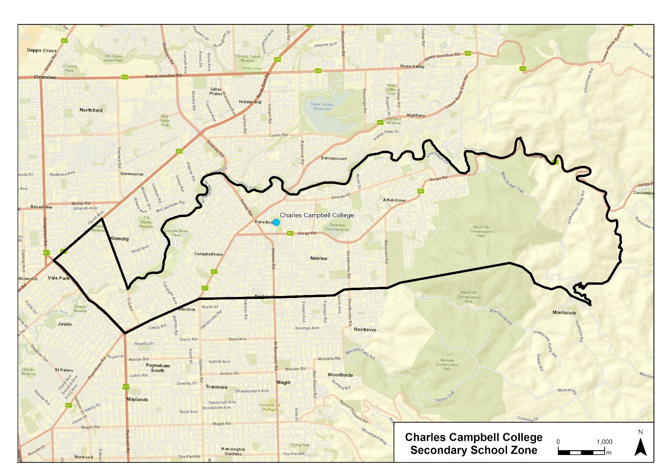
A school zone is a defined area from which the school accepts its core intake of students. The secondary school zone for Charles Campbell College is within the area bordered by the black line on the map below. Students residing within this zone are eligible to be enrolled in the secondary school at Charles Campbell College and will be given priority enrolment.
An online map of the Charles Campbell College secondary school zone and a search tool to indicate if a home address is within the school zone is available at www.education.sa.gov.au/findaschool.
Information on enrolment and placement in school is available from www.education.sa.gov.au/enrolment.
Dated: 28 October 2021
John Gardner
Minister for Education

Education and Children’s Services Regulations 2020
Marryatville High School Zone
Notice of Policy by the Minister for Education
PURSUANT to Regulation 12(1) of the Education and Children’s Services Regulations 2020, I, the Minister for Education publish a policy for the purposes of the enrolment of a child to attend at Marryatville High School from 2023:
SCHOOL ZONE
Marryatville High School
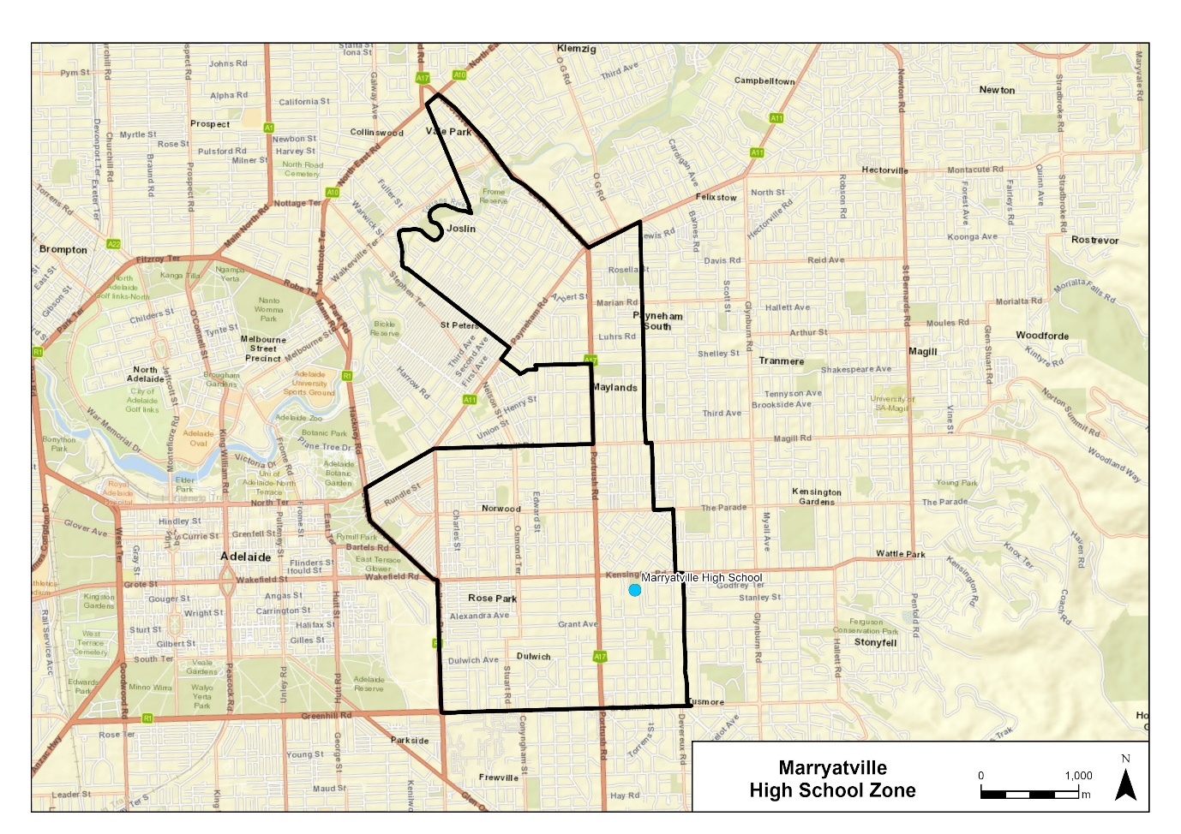
A school zone is a defined area from which the school accepts its core intake of students. The school zone for Marryatville High School is within the area bordered by the black line on the map below. Students residing within this zone are eligible to be enrolled at Marryatville High School and will be given priority enrolment.
An online map of the Marryatville High School zone and a search tool to indicate if a home address is within the school zone is available at www.education.sa.gov.au/findaschool.
Information on enrolment and placement in school is available from www.education.sa.gov.au/enrolment.
Dated: 28 October 2021
John Gardner
Minister for Education

Education and Children’s Services Regulations 2020
Morialta Secondary College Zone
Notice of Policy by the Minister for Education
PURSUANT to Regulation 12(1) of the Education and Children’s Services Regulations 2020, I, the Minister for Education publish a policy for the purposes of the enrolment of a child to attend at Morialta Secondary College from 2023:
SCHOOL ZONE
Morialta Secondary College
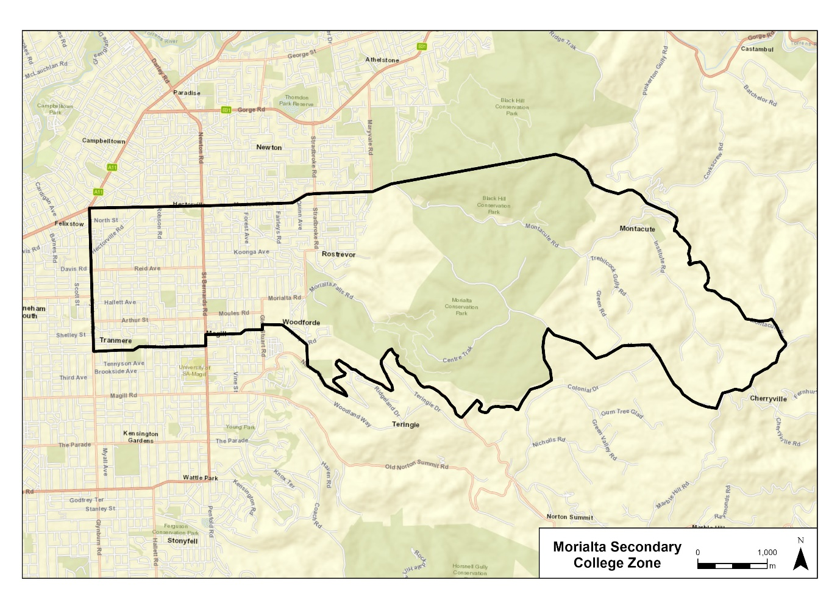
A school zone is a defined area from which the school accepts its core intake of students. The school zone for Morialta Secondary College is within the area bordered by the black line on the map below. Students residing within this zone are eligible to be enrolled at Morialta Secondary College and will be given priority enrolment.
An online map of the Morialta Secondary College zone and a search tool to indicate if a home address is within the school zone is available at www.education.sa.gov.au/findaschool.
Information on enrolment and placement in school is available from www.education.sa.gov.au/enrolment.
Dated: 28 October 2021
John Gardner
Minister for Education

Education and Children’s Services Regulations 2020
Norwood International High School Zone
Notice of Policy by the Minister for Education
PURSUANT to Regulation 12(1) of the Education and Children’s Services Regulations 2020, I, the Minister for Education publish a policy for the purposes of the enrolment of a child to attend at Norwood International High School from 2023:
SCHOOL ZONE
Norwood International High School
A school zone is a defined area from which the school accepts its core intake of students. The school zone for Norwood International High School is within the area bordered by the black line on the map below. Students residing within this zone are eligible to be enrolled at Norwood International High School and will be given priority enrolment.
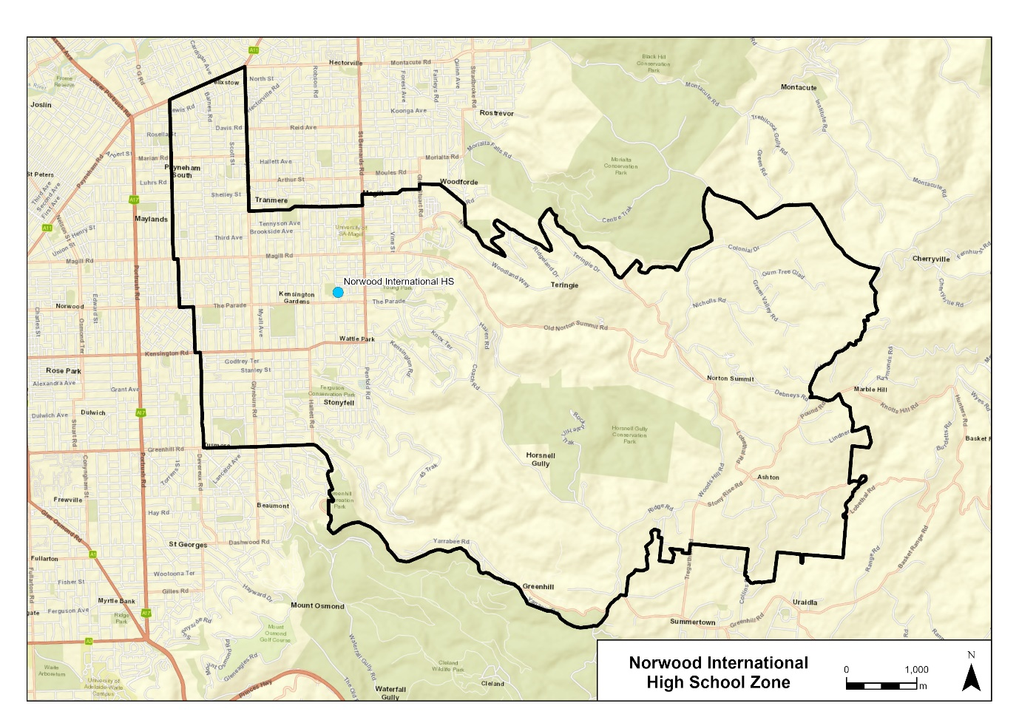
An online map of the Norwood International High School zone and a search tool to indicate if a home address is within the school zone is available at www.education.sa.gov.au/findaschool.
Information on enrolment and placement in school is available from www.education.sa.gov.au/enrolment.
Dated: 28 October 2021
John Gardner
Minister for Education

Fisheries Management (Rock Lobster Fisheries) Regulations 2017
Regulation 12
Removal of Restrictions on Fishing Activities during the Closed Season in the Northern Zone
For the purposes of regulation 12(1) and (2) relating to restrictions on fishing activities during the closed season in the Northern Zone – I make the following determinations –
- The holder of a licence in respect of the Northern Zone Rock Lobster Fishery may take rock lobster in the Northern Zone Inner Region during the period commencing at 1800 hours on 31 May 2022 and ending at 1200 hours on 1 November 2022.
- The holder of a licence in respect of the Northern Zone Rock Lobster Fishery may set a rock lobster pot in the Northern Zone Inner Region during the period commencing at 1800 hours on 31 May 2022 and ending at 1200 hours on 1 November 2022.
Dated: 5 January 2022
Keith Rowling
A/Executive Director, Fisheries and Aquaculture
As delegate of the Minister for Primary Industries and Regional Development

Housing Improvement Act 2016
Rent Control Revocations
Whereas the Minister for Human Services Delegate is satisfied that each of the houses described hereunder has ceased to be unsafe or unsuitable for human habitation for the purposes of the Housing Improvement Act 2016, notice is hereby given that, in exercise of the powers conferred by the said Act, the Minister for Human Services Delegate does hereby revoke the said Rent Control in respect of each property.
Address of Premises | Allotment  Section | Certificate of Title  Volume Folio
287 Semaphore Road, Birkenhead SA 5015 | Allotment 15 Filed Plan 4202 Hundred of Port Adelaide | CT5501/58
2 Homington Road, Elizabeth North SA 5113 | Allotment 250 Deposited Plan 6357 Hundred of Munno Para | CT5239/831
28 Whitford Road, Elizabeth South SA 5112 | Allotment 799 Deposited Plan 6033 Hundred of Munno Para | CT5958/35
Dated: 6 January 2022
Craig Thompson
Housing Regulator and Registrar
Housing Safety Authority, SAHA
Delegate of Minister for Human Services

Hydroponics Industry Control Act 2009
Notice of Exemption
TAKE notice that, pursuant to Section 9 of the Hydroponics Industry Control Act, 2009 (the Act), I, Vincent Tarzia, Minister for Police, Emergency Services and Correctional Service, hereby exempt Airofresh Intl Pty. Ltd. of 334 Glen Osmond Road, Myrtle Bank 5064 to the legislative provisions of the Act.
This exemption, granted under Section 9, subsection (1) is subject to the following conditions:
CONDITION 1
That advertising of any prescribed items of equipment for sale by retail in connection with hydroponics or related activities is prohibited.
CONDITION 2
That the prescribed items to be sold, as indicated (described in condition three) in the application for Ministerial Exemption, do not change.
CONDITION 3
The exemption from the Act, applies to selling by retail carbon filters designed to filter air within a room, or from 1 area of a building to another or to outside.
CONDITION 4
Subject to this exemption the business stated above must not sell prescribed equipment by retail to another person (the purchaser) unless the purchaser first produces identification. Identification to be produced consists of:
(a) One (1) of the following kinds of identification:
i. a current photographic driver’s licence issued under the Motor Vehicles Act, 1959 or under a corresponding law of another State or a Territory;
ii. a passport issued by the Commonwealth or under the law of another country, bearing a photograph of the person (being a current passport or a passport that has been expired for not more than 2 years);
iii. a current photographic Proof of Age card issued by the Registrar of Motor Vehicles or by a corresponding public authority of the Commonwealth or another State or a Territory;
iv. a current photographic firearms licence;
v. a current photographic licence or photographic permit issued under a law of the Commonwealth or a State or Territory;
vi. a photographic student identification card issued by an Australian educational institution; and
(b) Two (2) of the following kinds of identification:
i. a certified copy of, or extract from, a register of births kept under an Australian law, or under the law of the country in which the purchaser was born;
ii. a document issued or addressed to the purchaser by the Commonwealth or a State or Territory;
iii. a document showing the name and residential address of the purchaser issued by a public utility, a bank or credit union or a similar body;
iv. an identification card in the purchaser’s name issued by the person’s employer;
v. an identification card in the purchaser’s name issued by a professional or trade association;
vi. any other document determined by the Commissioner to be a document included in the ambit of this paragraph.
CONDITION 5
Subject to this Exemption, the business stated above must keep the information in relation to each transaction occurring in the course of, or for the purposes of the business. The information required to be kept must include:
- the name, address and business name (if any) of the exempt business;
- the place at which the transaction occurred;
- the date and time of the transaction;
- a description of the prescribed equipment involved in the transaction including the quantity of prescribed equipment;
- the full name, residential address and date of birth of the purchaser of the prescribed equipment and details of the identification produced by the purchaser;
- the name of the person to whom the purchaser produced the identification and;
- the intended purpose of use; For use of prescribed equipment in air purification
CONDITION 6
The particulars of a transaction must be available for inspection to the Commissioner of Police, or his delegate, within 72 hours of the transaction occurring and must be transferred in a manner and form determined from time to time by the Commissioner, or his delegate upon request.
CONDITION 7
The exempt business must keep this information at the address where the transaction occurred and for a period of not less than 7 years after the date on which the record is made. The information required to be kept may be kept in written or electronic form and be available for inspection by an authorised officer upon request.
CONDITION 8
If any change to Corporate Structure, the Commissioner of Police must be advised within 14 days.
Dated: 16 December 2021
Hon. Vincent Tarzia MP
Minister for Police, Emergency Services and Correctional Service

Justices of the Peace Act 2005
Section 4
Notice of Appointment of Justices of the Peace for South Australia
I, Dini Soulio, Commissioner for Consumer Affairs, delegate of the Attorney-General, pursuant to section 4 of the Justices of the Peace Act 2005, do hereby appoint the people listed as Justices of the Peace for South Australia as set out below. It being a condition of appointment that the Justices of the Peace must take the oaths required of a justice under the Oaths Act 1936 and return the oaths of office form to Justice of the Peace Services within three months after the date of appointment:
For a period of ten years for a term commencing on 10 January 2022 and expiring on 9 January 2032:
Haniel Yascha WILSON
Belinda Renee WALLIN
Mark Christopher TAYLOR
Carmela SPITERI
Sandra May MULLEN
Kristiana Louise MCMILLAN
Natalie Louise MCDONALD
Trent Edward MANSFIELD
Stephanie Catherine INGRAM
Michael George HOLMES
Anthony Francis HALMAN
Teresa Kaye GURNEY
Colleen Joy GROVE-JONES
Louise Bridget DAY
Milan DAHAL
Cameron Charles Patrick CROWELL
Linda CIAMPA
Reuben CHAND
Timothy Charles CAMILLERI
Naomi Ruth BOUSFIELD
Katrina Anne BATES
Sally ALLEN
Kerstine Jan Mejares ALBA
Dated: 22 December 2021
Dini Soulio
Commissioner for Consumer Affairs
Delegate of the Attorney-General

Land Acquisition Act 1969
Section 16
Form 5 – Notice of Acquisition
1. Notice of acquisition
The Commissioner of Highways (the Authority), of 50 Flinders Street, Adelaide SA 5000, acquires the following interests in the following land:
An estate in fee simple in that piece of land being the whole of the land identified as Allotment 82 in plan no. D128271, subject only to the encumbrance 8894067, lodged in the Lands Titles Office, being:
First, portion of Allotment 6 in Deposited Plan No 53696 comprised in Certificate of Title Volume 5747 Folio 538, and
Secondly, portion of the land comprised in Certificate of Title Volume 6261 Folio 910 being that portion of the easement created by RTC 8795217 over the land marked ‘D’ in Deposited Plan No 127071 that forms a portion of Allotment 82 in plan no. D128271 lodged in the Lands Titles Office, with the intent that that portion of the easement will merge and be extinguished in the fee simple in the said Allotment 82, and
Thirdly, portion of land comprised in Certificate of Title Volume 6261 Folio 912 being that portion of the easement created by RTC 8795217 over the land marked ‘D’ in Deposited Plan No 127232 that forms a portion of Allotment 82 in plan no. D128271 lodged in the Lands Titles Office, with the intent that that portion of the easement will merge and be extinguished in the fee simple in the said Allotment 82.
This notice is given under section 16 of the Land Acquisition Act 1969.
2. Compensation
A person who has or had an interest consisting of native title or an alienable interest in the land that is divested or diminished by the acquisition or the enjoyment of which is adversely affected by the acquisition who does not receive an offer of compensation from the Authority may apply to the Authority for compensation.
2A. Payment of professional costs relating to acquisition (section 26B)
If you are the owner in fee simple of the land to which this notice relates, you may be entitled to a payment of $10 000 from the Authority for use towards the payment of professional costs in relation to the acquisition of the land.
Professional costs include legal costs, valuation costs and any other costs prescribed by the Land Acquisition Regulations 2019.
3. Inquiries
Inquiries should be directed to: Wendy Murphy
GPO Box 1533
Adelaide SA 5001
Telephone: (08) 7109 7196
Dated: 23 December 2021
The Common Seal of the COMMISSIONER OF HIGHWAYS was hereto affixed by authority of the Commissioner in the presence of:
Rocco Caruso
Manager, Property Acquisition (Authorised Officer)
Department for Infrastructure and Transport
DIT 2020/18229/01, 2020/18234/02 and 2020/18421/01

Land Acquisition Act 1969
Section 16
Form 5 – Notice of Acquisition
1. Notice of acquisition
The Commissioner of Highways (the Authority), of 50 Flinders Street, Adelaide SA 5000, acquires the following interests in the following land:
First comprising an unencumbered estate in fee simple in that piece of land being portion of Section 314 Hundred of Light, comprised in Certificate of Title Volume 5573 Folio 81, and being the whole of the land identified as Allotment 87 in D128176 lodged in the Lands Titles Office
Secondly comprising an unencumbered estate in fee simple in that piece of land being portion of Sections 313 Hundred of Light, comprised in Certificate of Title Volume 5479 Folio 294, and being the whole of the land identified as Allotment 86 in D128174 lodged in the Lands Titles Office
Thirdly comprising an unencumbered estate in fee simple in that piece of land being portion of Section 312 Hundred of Light, comprised in Certificate of Title Volume 5525 Folio 111, and being the whole of the land identified as Allotment 85 in D128173 lodged in the Lands Titles Office
This notice is given under section 16 of the Land Acquisition Act 1969.
2. Compensation
A person who has or had an interest consisting of native title or an alienable interest in the land that is divested or diminished by the acquisition or the enjoyment of which is adversely affected by the acquisition who does not receive an offer of compensation from the Authority may apply to the Authority for compensation.
2A. Payment of professional costs relating to acquisition (section 26B)
If you are the owner in fee simple of the land to which this notice relates, you may be entitled to a payment of $10 000 from the Authority for use towards the payment of professional costs in relation to the acquisition of the land.
Professional costs include legal costs, valuation costs and any other costs prescribed by the Land Acquisition Regulations 2019.
3. Inquiries
Inquiries should be directed to: Sean Frost
GPO Box 1533
Adelaide SA 5001
Telephone: (08) 8456 4862
Dated: 22 December 2021
The Common Seal of the COMMISSIONER OF HIGHWAYS was hereto affixed by authority of the Commissioner in the presence of:
Rocco Caruso
Manager, Property Acquisition (Authorised Officer)
Department for Infrastructure and Transport
DIT 2021/09321/01

Land Acquisition Act 1969
Section 16
Form 5 – Notice of Acquisition
1. Notice of acquisition
The Commissioner of Highways (the Authority), of 50 Flinders Street, Adelaide SA 5000, acquires the following interests in the following land:
Comprising an unencumbered estate in fee simple in that piece of land being portion of Allotment 200 in Deposited Plan No 79236 comprised in Certificate of Title Volume 6046 Folio 574, and being the whole of the land identified as Allotment 25 in D128170 lodged in the Lands Titles Office.
This notice is given under section 16 of the Land Acquisition Act 1969.
2. Compensation
A person who has or had an interest consisting of native title or an alienable interest in the land that is divested or diminished by the acquisition or the enjoyment of which is adversely affected by the acquisition who does not receive an offer of compensation from the Authority may apply to the Authority for compensation.
2A. Payment of professional costs relating to acquisition (section 26B)
If you are the owner in fee simple of the land to which this notice relates, you may be entitled to a payment of $10 000 from the Authority for use towards the payment of professional costs in relation to the acquisition of the land.
Professional costs include legal costs, valuation costs and any other costs prescribed by the Land Acquisition Regulations 2019.
3. Inquiries
Inquiries should be directed to: Sean Frost
GPO Box 1533
Adelaide SA 5001
Telephone: (08) 8456 4862
Dated: 22 December 2021
The Common Seal of the COMMISSIONER OF HIGHWAYS was hereto affixed by authority of the Commissioner in the presence of:
Rocco Caruso
Manager, Property Acquisition (Authorised Officer)
Department for Infrastructure and Transport
DIT 2021/09327/01

Major Events Act 2013
Section 6B
2022 Santos Festival of Cycling
PURSUANT to section 6B of the Major Events Act 2013, I, Hon Steven Marshall MP, Premier of South Australia declare the 2022 Santos Festival of Cycling to be held from 23 to 29 January 2022 to be declared a major event.
By virtue of the provisions of the Major Events Act 2013, I do hereby:
- Declare the 2022 Santos Festival of Cycling to be a major event.
- Specify the period for the event, for which the declaration of the major event is in force, namely 23 to 29 January 2022 inclusive.
- Declare the major event venues to be the areas as shown in the attached descriptions and maps, covering the below start and finish locations; for the National Road Series men’s and women’s race routes and Victoria Park; and any public place or part of a public place that is within 250 metres from the boundary of the start and finish venues and Victoria Park:
  - Ziptrak Women’s Stage 1 - starting at Chateau Tanunda, Tanunda and finishing at Yettie Road, Williamstown.
  - Westpac Women’s Stage 2 - starting at Penny’s Hill Wines, McLaren Vale and finishing at Adelaide Road, Echunga.
  - Be Safe Be Seen Women’s Stage 3 - starting and finishing at Main Street, Lobethal.
  - Ziptrak Men’s Stage 1 - starting at Stirling Oval, Stirling and finishing at Lobethal Main Street, Lobethal.
  - BikeExchange Men’s Stage 2 - starting at Mount Lofty Summit carpark, Mount Lofty and finishing at Onkaparinga Valley Road, Woodside.
  - Be Safe Be Seen Men’s Stage 3 - starting at Main Street, McLaren Vale and finishing at Willunga Hill, Willunga.
  - The City of Adelaide Festival Village - Victoria Park, Adelaide.
- Designate the South Australian Tourism Commission to be the event organiser for the event.
- Apply section 8 of the Major Events Act to the event.
- Apply section 10 of the Major Events Act to the event.
- Apply section 11 of the Major Events Act to the event.
- Apply section 12 of the Major Events Act to the event.
- Apply section 13 of the Major Events Act to the event.
- Apply section 14 of the Major Events Act to the event by specifying the official title as Santos Festival of Cycling and the official logo as it appears below.

Dated: 29 December 2021
Hon Steven Marshall MP
Premier of South Australia

Mental Health Act 2009
Authorised Mental Health Professionals
NOTICE is hereby given in accordance with Section 94(1) of the Mental Health Act 2009, that the Chief Psychiatrist has determined the following persons as Authorised Mental Health Professionals:
Lorraine Smitham
Anna Trotta
Rob Wastell
Steve McEwen
A person’s determination as an Authorised Mental Health Professional expires three years after the commencement date.
Dated: 6 January 2022
Dr J Brayley
Chief Psychiatrist

Motor Vehicles Act 1959
South Australia
Motor Vehicles (Conditional Registration—Recognition of Motor Vehicle Clubs) Notice 2021 – Tin Men Cruzers’ Club Incorporated
under the Motor Vehicles Act 1959
1—Short title
This notice may be cited as the Motor Vehicles (Conditional Registration—Recognition of Motor Vehicle Clubs) Notice 2021 – Tin Men Cruzers’ Club Incorporated.
2—Commencement
This notice takes effect from the date it is published in the Gazette.
3—Interpretation
In this notice—

Act means the Motor Vehicles Act 1959;

Code of Practice means the ‘Code of Practice for Club Registration - a 90 day conditional registration scheme for historic, left hand drive and street rod vehicles’ published by the Department for Infrastructure and Transport;

Conditional Registration Scheme or Scheme means the scheme for conditional registration of historic, prescribed left hand drive and street rod motor vehicles under section 25 of the Act and regulations 15 and 16 of the Motor Vehicles Regulations 2010;

Department means the Department for Infrastructure and Transport;

Federation means the Federation of Historic Motoring Clubs SA Inc;

MR334 form means an ‘Approval for Registration of Vehicle on the Club Registration Scheme (MR334)’;

Prescribed log book means a log book in a form approved by the Registrar;

Registrar means the Registrar of Motor Vehicles;

Regulations means the Motor Vehicles Regulations 2010.
4—Recognition of motor vehicles clubs
The motor vehicle clubs specified in Schedule 1 are, subject to the conditions set out in clause 5, recognised for the purposes of regulation 16 of the Regulations.
5—Conditions of recognition
A motor vehicle club specified in Schedule 1 must comply with the following conditions:
  - the club must maintain a constitution approved by the Registrar;
(b) the club must nominate and have members authorised by the Registrar (authorised persons). The club’s authorised person(s) are responsible for approving applicants and motor vehicles for registration under the Scheme. This includes confirming that Scheme applicants are financial members of a club; any other details as required by the Registrar on the MR334 form; and to inspect members’ vehicles when requested to do so by the Registrar;
(c) the club must issue a prescribed log book to club members for each of their vehicles to record vehicle use;
(d) the club must cancel a member’s prescribed log book when a member resigns, must ensure that a statutory declaration is provided when a member’s log book is lost or destroyed, must keep details of members’ prescribed log book return sheets and forward copies of the same to the Registrar or Federation annually as required;
(e) the club must create and maintain records detailing all its financial members, its authorised persons, all vehicles for which an MR334 form has been issued, all statutory declarations received and prescribed log books issued and returned to the club;
(f) the club must keep records for a period of 5 years from the date of the document and these records must include all duplicate MR334 forms, all records of motor vehicle inspections undertaken in accordance with paragraph (b), all statutory declarations provided by members for the purposes of paragraphs (d), all prescribed log books issued by reference to their serial number, the member’s name and the vehicle for which it was issued, and to make all such records available for inspection or provide copies of the records at the request of the Registrar for audit purposes;
(g) the club must ensure, as far as practicable, that all members comply with the Code of Practice;
(h) the club, as far as practicable, must report to the Registrar or the Federation details of members and motor vehicles not complying with the conditions and criteria set out in the Code of Practice for the Scheme;
(i) the club must provide to the Registrar, within 2 months after the end of the club’s financial year, an annual report detailing members from that financial year with vehicles registered under the Scheme who are no longer financial members of the club;
(j) the club must notify the Registrar, in writing, within 14 days of resolution to cease operation as a club and must provide the club records specified in paragraph (f) to the Registrar within 14 days of its dissolution.
Note—
Under regulation 16(3)(c) of the Motor Vehicles Regulations 2010, the Registrar may, by notice in the Gazette, withdraw the recognition of a motor vehicle club if satisfied that the club has contravened or failed to comply with a condition applying to its recognition by the Registrar, or if there is other good cause to withdraw the recognition.

Schedule 1—Recognised motor vehicle clubs
Historic, left-hand drive and street rod motor vehicle clubs
Tin Men Cruzers’ Club Incorporated

Made by the Deputy Registrar of Motor Vehicles

On 4 January 2022

National Electricity (South Australia) Act 1996
Section 19B
Making of a T-3 Reliability Instrument for South Australia
I, Daniel Cornelis van Holst Pellekaan, Minister for Energy and Mining for the Crown in right of the State of South Australia, as the Minister administering the National Electricity (South Australia) Act 1996 of South Australia, hereby make a T-3 Reliability Instrument under section 19B of the National Electricity (South Australia) Act 1996.
This T-3 Reliability Instrument applies to the South Australian region of the National Electricity Market for the trading intervals between 3pm and 9pm Eastern Standard Time each working weekday during the period 13 January 2025 to 14 March 2025 inclusive.
Working weekday refers to any day other than a Saturday, Sunday or public holiday in South Australia.
The Australian Energy Market Operator’s one-in-two year peak demand forecast for this period is 2,905 Megawatts.
This T-3 Reliability Instrument takes effect from the date of publication in the Gazette.
Dated: 14 December 2021
Hon Daniel Cornelis van Holst Pellekaan MP
Deputy Premier
Minister for Energy and Mining

Phylloxera and Grape Industry Act 1995
Contributions Towards Primary Functions Under the Act for Year 2021-2022
PURSUANT to section 23 of the above Act, the Phylloxera and Grape Industry Board of SA, trading as Vinehealth Australia, gives notice that registered persons (being persons who are recorded in the Register established by the Board as owners of 0.5 hectares or more of planted vines) must contribute to the costs of the Board’s primary functions for the year ending 30 April 2022.
The rules of calculation of such contributions are as follows:
- Calculations will be based on the area of vines recorded in the Register as being owned by each registered person as at 30 April 2022.
- The rate per hectare of vines will be $9.50, with a minimum contribution per registered person of $50.
- The levy will be collected or recovered by the Commissioner of Land Tax on behalf of the Board as if the contribution were land tax and will be subject to the same penalties for delay or default in payment (section 23 (3) of the Act).
Winemakers and distillers are not required to pay a contribution in 2021-22.
Notices of contributions will be forwarded by email or post to registered persons.
Dated: 29 December 2021
Hon David Basham MP
Minister for Primary Industries and Regional Development

Planning, Development and Infrastructure (General) Regulations 2017
Notice of Decision – Regulation 57(1)
Determination of the Form for a Notice of a Decision under Regulation 57(1)
Preamble
Regulation 57(1) of the Planning, Development and Infrastructure (General) Regulations 2017 provides that notice of a decision on an application under Part 7 of the Planning, Development and Infrastructure Act 2016 (other than Subdivision 4 of Division of that Part) must be given in a form determined by the Minister for Planning and Local Government (being a form published by the Minister in the Gazette).
Notice
PURSUANT to Regulation 57(1) of the Planning, Development and Infrastructure (General) Regulations 2017, I, Troy Fountain, as the delegate of the Minister administering this regulation under the Planning, Development and Infrastructure Act 2016, have determined that the form contained in ‘Attachment A’ comprises the form for a notice of a decision on an application given under Part 7 of the Planning, Development and Infrastructure Act 2016 (other than Subdivision 4 of Division 2 of that Part).
The form may be adapted into a digital format for use on the SA planning portal.

This notice will come into force on 6 January 2022.
Dated: 23 December 2021
Troy Fountain
Manager, Commission Assessment
delegate of the Minister for Planning and Local Government

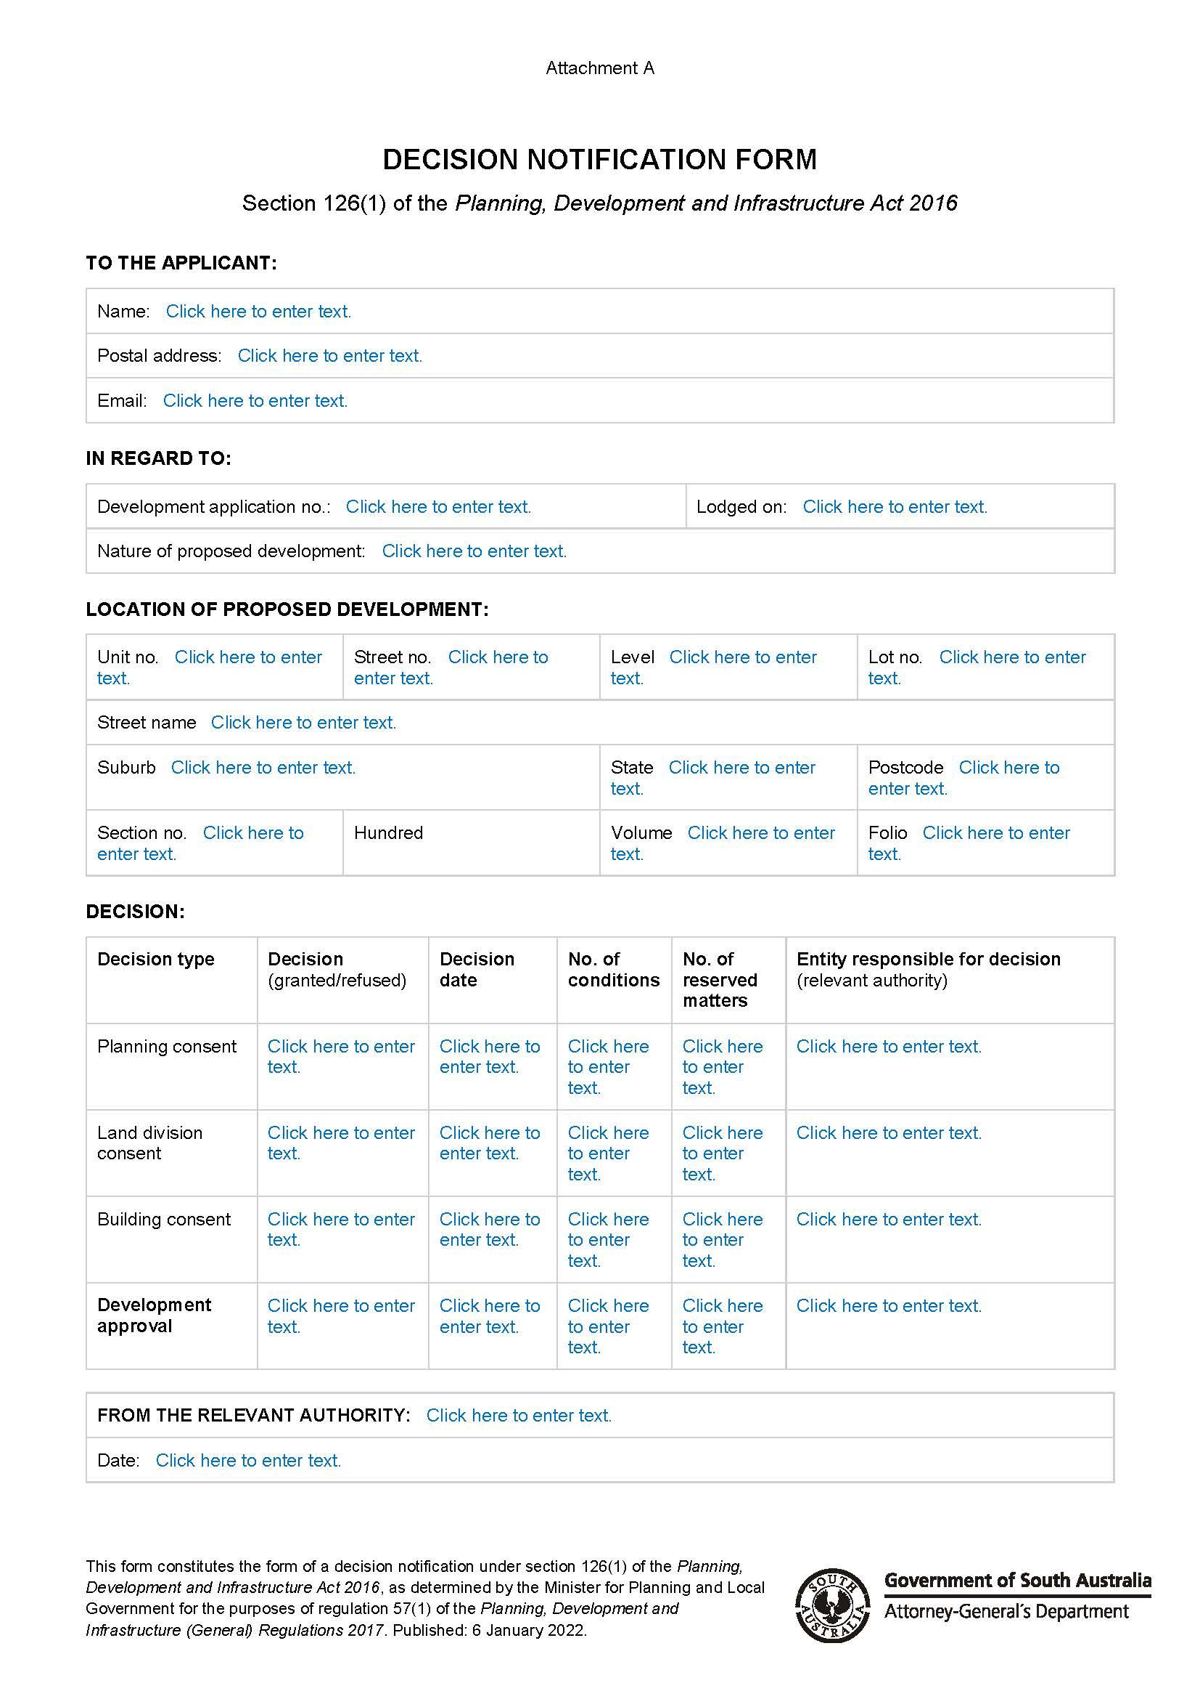

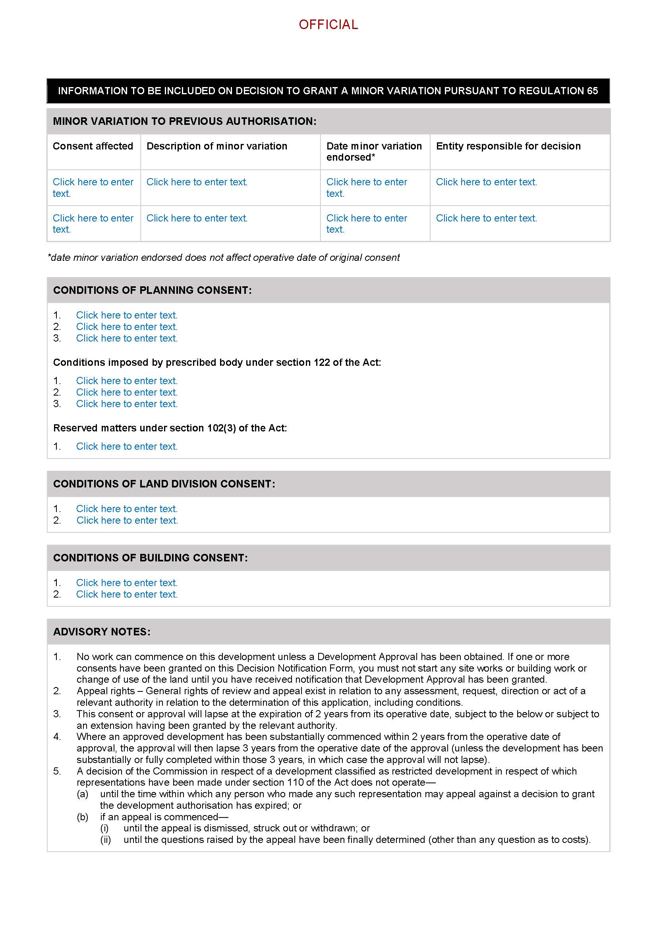

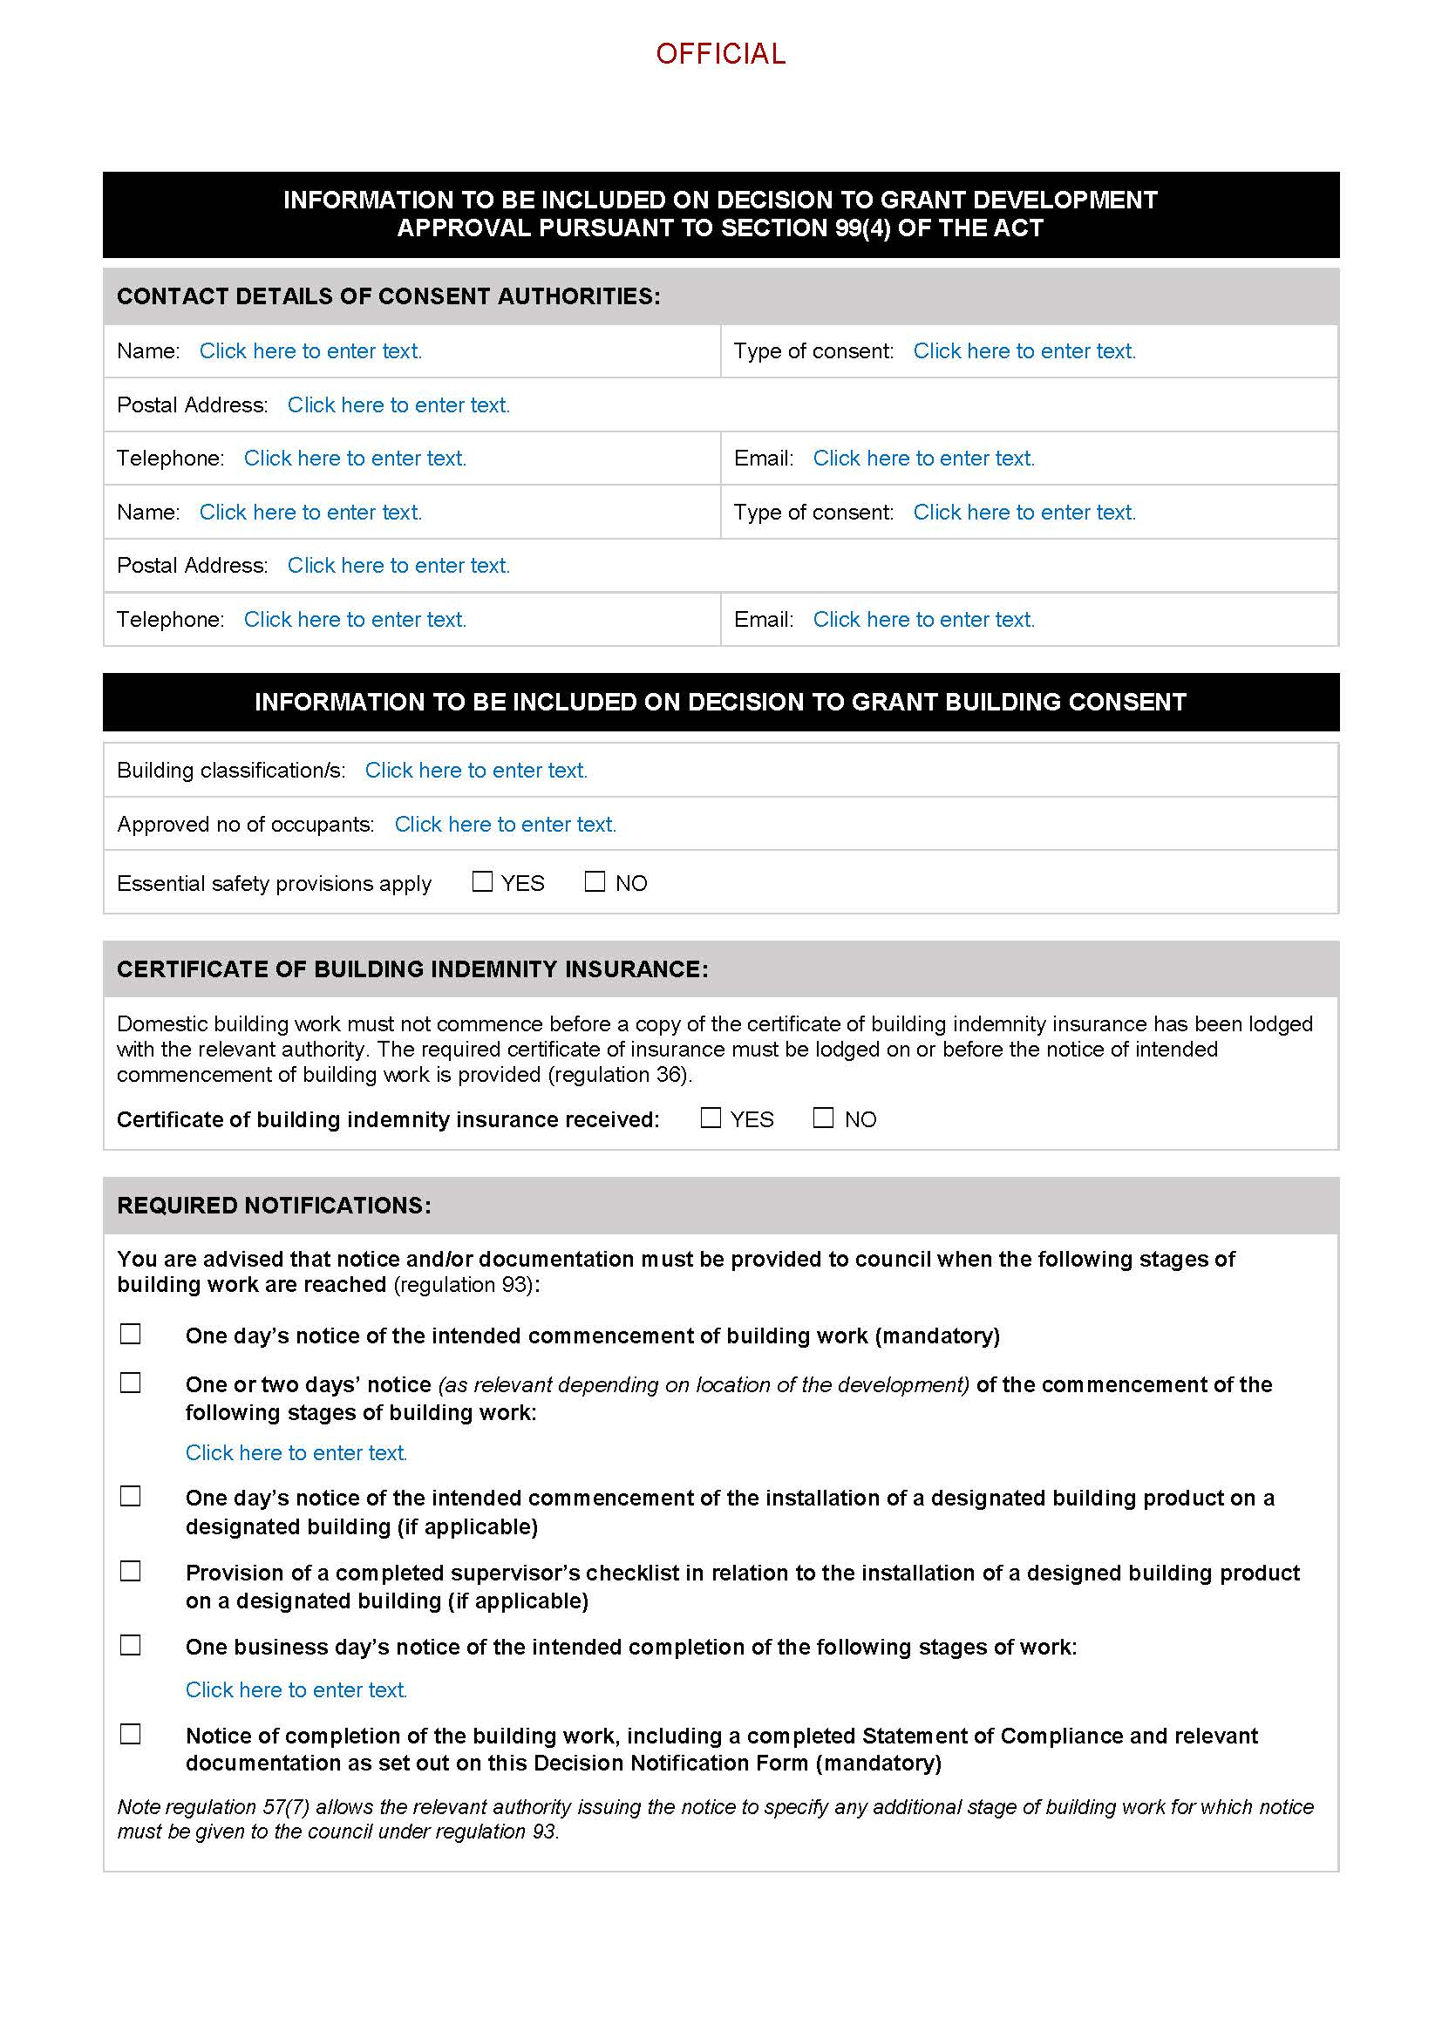

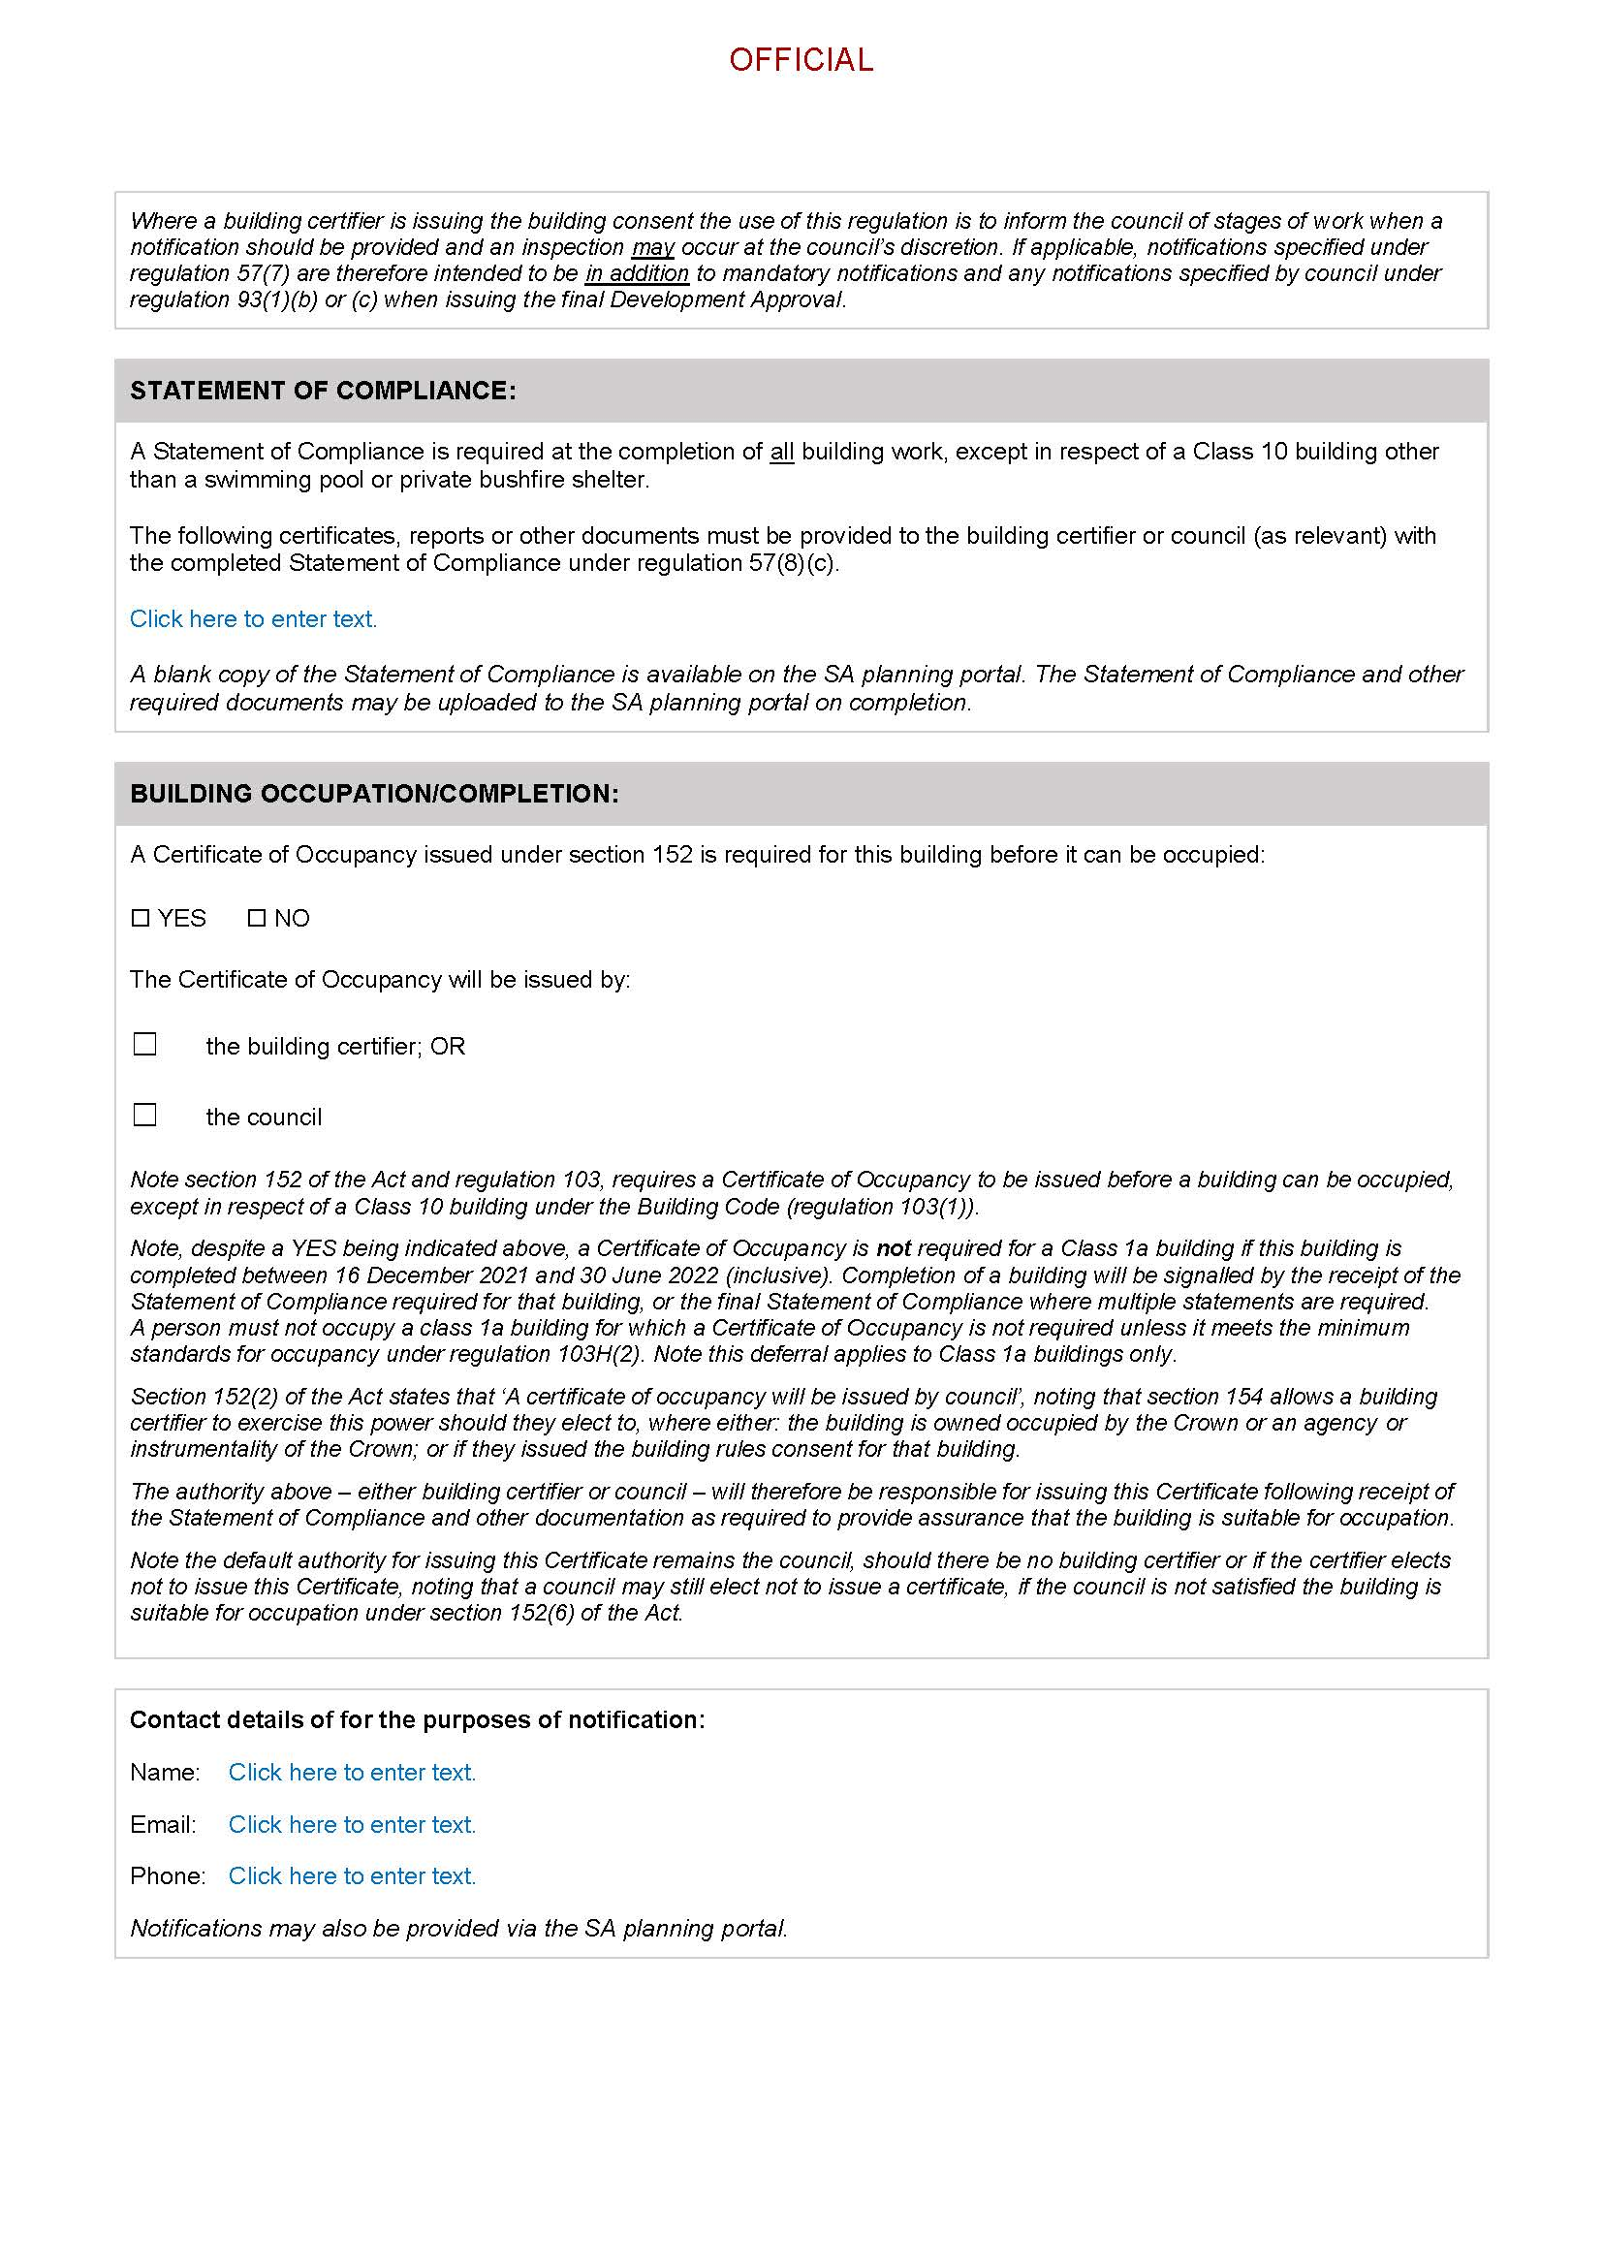

Professional Standards Act 2004 (SA)
Instrument of Appointment
Background
1. The Professional Standards Council ("the Council") is established pursuant to section 42 of the Professional Standards Act 2004 (SA) ("the Act").
2. Pursuant to section 43 of the Act, the Council is to consist of up to 11 people appointed by the Minister ("members") who have such experience, skills and qualifications as the Minister considers appropriate. ·
3. Pursuant to section 44 of the Act, the provisions relating to the conditions of appointment for members of the Council are provided for in Schedule 2 of the Act.
Appointment
Pursuant to the provision in section 43 of the Act, I, Joshua Teague, Minister for Planning and Local Government (exercising the powers and functions of the Attorney-General) for the State of South Australia, DO HEREBY APPOINT ANDREW LUMSDEN to the position of Deputy Chairperson of the South Australian Professional Standards Council from the date of this Instrument of Appointment until 31 December 2024 and to hold such appointment subject to the provisions of the Act and on the conditions set forth in this Instrument of Appointment.
Dated: 21 December 2021
Joshua Teague MP
Minister For Planning and Local Government
(exercising the powers and functions of the Attorney-General)

Professional Standards Act 2004 (SA)
Instrument of Appointment
Background
1. The Professional Standards Council ("the Council") is established pursuant to section 42 of the Professional Standards Act 2004 (SA) ("the Act").
2. Pursuant to section 43 of the Act, the Council is to consist of up to 11 people appointed by the Minister ("members") who have such experience, skills and qualifications as the Minister considers appropriate. ·
3. Pursuant to section 44 of the Act, the provisions relating to the conditions of appointment for members of the Council are provided for in Schedule 2 of the Act.
Appointment
Pursuant to the provision in section 43 of the Act, I, Joshua Teague, Minister for Planning and Local Government (exercising the powers and functions of the Attorney-General) for the State of South Australia, DO HEREBY APPOINT JOHN VINES OAM to the position of
Chairperson of the South Australian Professional Standards Council from the date of this Instrument of Appointment until 31 December 2024 and to hold such appointment subject to the provisions of the Act and on the conditions set forth in this Instrument of Appointment.
Dated: 21 December 2021
Joshua Teague MP
Minister For Planning and Local Government
(exercising the powers and functions of the Attorney-General)

SHOP TRADING HOURS ACT 1977
Trading Hours—Exemption
NOTICE is hereby given that pursuant to section 5(9)(b) of the Shop Trading Hours Act 1977 (the Act), I, Rob Lucas MLC, Treasurer, on my own initiative, do hereby declare:
- Non-exempt shops, excluding shops that are solely or predominantly the retail sale of motor vehicles or boats, situated within the Metropolitan Shopping District and Glenelg Tourist Precinct to be exempt from the provisions of the Act between the hours of:
- 11.00 am and 5.00 pm on Wednesday, 26 January 2022.
This exemption is subject to the following conditions:
- Normal trading hours prescribed by section 13 of the Act shall apply at all other times.
- All employees working during these extended hours will do so on a strictly voluntary basis.
- Any and all relevant industrial instruments are to be complied with.
- All work, health and safety issues (in particular those relating to extended trading hours) must be appropriately addressed.
Dated: 26 December 2021
Hon Rob Lucas MLC
Treasurer

Surveyor General
Spatial Data Provision to Local Government Authorities
Effective from 1 July 2021
The fees for the provision of spatial datasets provided to Local Government Authorities by the Surveyor-General are based on the consumption of the data provided. Annual fees for the 2021/22 financial year are set out below.

Extracts | Price GST Exclusive | Price GST Inclusive
6 | $4,334.00 | $4,767.40
5 | $3,730.00 | $4,103.00
4 | $3,126.00 | $3,438.60
3 | $2,522.00 | $2,774.20
2 | $1,917.00 | $2,108.70
1 | $1,313.00 | $1,444.30
Dated: 22 December 2021
Josh Teague MP
Minister for Planning and Local Government
(exercising the powers and functions of the Attorney-General)
#18110420

Local Government Instruments

District Council of Lower Eyre Peninsula
Local Government Act 1999—Section 194
Revocation of Community Land
Notice is hereby given that, pursuant to section 194 of the Local Government Act 1999, the District Council of Lower Eyre Peninsula by resolution passed on 15 October 2021 and with the consent of the Minister for Local Government, revoked the classification of the land identified as Allotment 10 in Deposited Plan 95966, Certificate of Title Volume 6168 Folio 184 in the Hundred of Cummins (located along East Terrace, Cummins).
Dated: 5 January 2022
Delfina Lanzilli
Chief Executive Officer

Notice Submission

The South Australian Government Gazette is published each Thursday afternoon.
Notices must be emailed by 4 p.m. Tuesday, the week of publication.
Submissions are formatted per the gazette style and a proof will be supplied prior to publication, along with a quote if applicable. Please allow one day for processing notices.
Alterations to the proof must be returned by 4 p.m. Wednesday.

Gazette notices must be submitted as Word files, in the following format:
• Title—the governing legislation
• Subtitle—a summary of the notice content
• Body—structured text, which can include numbered lists, tables, and images
• Date—day, month, and year of authorisation
• Signature block—name, role, and department/organisation authorising the notice

Please provide the following information in your email:
• Date of intended publication
• Contact details of the person responsible for the notice content
• Name and organisation to be charged for the publication—Local Council and Public notices only
• Purchase order, if required—Local Council and Public notices only

Email: governmentgazettesa@sa.gov.au
Phone: (08) 7109 7760
Website: www.governmentgazette.sa.gov.au

All instruments appearing in this gazette are to be considered official, and obeyed as such

Printed and published weekly by authority of S. Smith, Government Printer, South Australia
$8.00 per issue (plus postage), $402.00 per annual subscription—GST inclusive
Online publications: www.governmentgazette.sa.gov.au

