No. 3 p. 37
THE SOUTH AUSTRALIAN
GOVERNMENT GAZETTE
Published by Authority

Adelaide, Thursday, 13 January 2022

Contents

State Government Instruments

Adelaide Cemeteries Authority Act 2001 38

Electoral Act 1985 38

Fisheries Management Act 2007 38

Housing Improvement Act 2016 39

Justices of the Peace Act 2005 39

Magistrates Court Act 1991 40

Major Events Act 2013 44

Retirement Villages Act 2016 57

Youth Court Act 1993 57

Local Government Instruments

City of Charles Sturt 59

City of Port Adelaide Enfield 59

City of Tea Tree Gully 59

Public Notices

Local Government Act 1999 60

Trustee Act 1936 75

Unclaimed Money Act 2021 75

State Government Instruments

Adelaide Cemeteries Authority Act 2001
Re-opening of the Australian Imperial Forces Cemetery
PURSUANT to Section 8(4) of the Adelaide Cemeteries Authority Act 2001, I authorise the reopening of the portion of the West Terrace Cemetery known as the Australian Imperial Forces Cemetery, to be used as a place for the interment of members or former members of an arm of the Defence Forces of Australia or of the naval, military or air force of some other country, and for the interment of relatives of military veterans in existing grave sites.
Dated: 11 January 2022
Josh Teague
Minister for Planning and Local Government
(exercising the powers and functions of the Attorney-General)

Electoral Act 1985
Section 42
Part 6 - Registration of Political Parties
Notice is hereby given, pursuant to Section 42 of the Electoral Act 1985, that I have this day registered the following political party:
Name of Party Family First Party Inc
Abbreviation of Party Name Family First
Dated: 13 January 2022
Mick Sherry
Electoral Commissioner

Fisheries Management Act 2007
Section 115
Exemption No. ME9903183
TAKE NOTICE that pursuant to section 115 of the Fisheries Management Act 2007 (the Act), A/Prof Charlie Huveneers (the ‘exemption holder’) of Flinders University, Sturt Road, Bedford Park, or his nominated agents, are exempt from section 70 of the Fisheries Management Act 2007, and regulation 5(a) and clauses 39(a), 74 and 104 of Schedule 6 of the Fisheries Management (General) Regulations 2017 in the waters specified in Schedule 1 but only insofar as they are for the purposes of activities specified in Schedule 2, using the gear specified in Schedule 3, (the ‘exempted activity’), subject to the conditions specified in Schedule 4, from 11 January 2022 until 31 December 2022, unless varied or revoked earlier.
Schedule 1
All waters of Gulf St Vincent, South Australia, excluding aquatic reserves (unless otherwise authorised under the Act) and sanctuary and restricted access zones of marine parks (unless otherwise authorised under the Marine Parks Act 2007) and the Adelaide Dolphin Sanctuary.
Schedule 2
The research activities entitled “Assessing the effects of anthropogenic activity on the trophic and spatial niches of benthic shark and ray species”.
Schedule 3
- One long line with a maximum length of 2 km, maximum diameter 1.7mm leaders with not more than 200 hooks (14/0 gauge).
Schedule 4
- The exemption holder will be deemed responsible for the conduct of all persons conducting the exempted activities under this notice. Any person conducting activities under this exemption must be provided with a copy of this notice, which they must have signed as an indication that they have read and understand the conditions under it.
- The nominated agents pursuant to this Ministerial exemption are:
  - Lauren Meyer – Flinders University
  - Chloe Roberts – Flinders University
  - Joshua Dennis – Flinders University
  - Joshua Davey – Flinders University
  - Thomas Clarke – Flinders University
- The exemption holder or nominated agent/s may only take and retain muscle samples from the following species under this notice:
  - Port Jackson sharks (Heterodontus portusjacksoni)
  - Southern eagle rays (Myliobatis tenuicaudatus)
  - School sharks (Galeorhinus galeus)
  - Gummy sharks (Mustelus antarcticus)
- The Ministerial exemption holder or nominated agent/s must be in attendance of a long line, at all times when a long line is in use pursuant to this notice.
- All fish, sharks and rays caught pursuant to this notice must be returned to the water as soon as practicable.
- All protected species incidentally taken while undertaking the exempted activity must be returned to the water as soon as practicable. Protected species must not be retained.
- The samples collected by the exemption holder are for scientific, education or research purposes only and must not be sold or consumed.
- The exemption holder must not collect samples for aquaculture research purposes pursuant to this notice.
- Samples collected pursuant to this notice must not be released into waters of the State once they have been kept separate to their natural environment.
- Any equipment used to collect and hold fish during the exempted activity must be decontaminated prior to and after undertaking the research activities.
- The Ministerial exemption holder or agent must not conduct any other fishing activity, including recreational fishing whilst undertaking the exempted activity.
- At least 1 hour before conducting an exempted activity, the exemption holder must contact PIRSA Fishwatch on telephone 1800 065 522 and answer a series of questions about the exempted activity. The exemption holder will need to have a copy of this notice in their possession at the time of making the call, and be able to provide information about the area and time of the exempted activity, the specific gear to be used, vehicles and/or boats involved, the number of exemption holders undertaking the exempted activity and other related questions.
- The exemption holder must provide a report in writing detailing the activities carried out pursuant to this notice to PIRSA, Fisheries and Aquaculture (GPO Box 1625, ADELAIDE SA 5001) within 14 days of the activity being completed with the following details:
  - the date and location of sampling;
  - the gear used;
  - the number and description of all species sampled;
  - any interactions with protected species and their fate; and
  - any other information regarding size, breeding or anything deemed relevant or of interest that is able to be volunteered.
- While engaging in the exempted activity, the exemption holder and nominated agents must be in possession of a signed copy of this notice and carry their identification card issued by Flinders University. Such notice and identification must be produced to a PIRSA Fisheries Officer if requested.
- The exemption holder, or agent must not contravene or fail to comply with the Act or any regulations made under the Act, except where specifically exempted by this notice.
This notice does not purport to override the provisions or operation of any other Act including, but not limited to, the Marine Parks Act 2007, the River Murray Act 2003 or the Adelaide Dolphin Sanctuary Act 2005. The exemption holder and her agents must comply with any relevant regulations, permits, requirements and directions from the Department for Environment and Water when undertaking activities within a marine park.
Dated: 11 January 2022
Keith Rowling
A/Executive Director
Fisheries and Aquaculture
Delegate of the Minister for Primary Industries and Regional Development

Housing Improvement Act 2016
Rent Control Revocations
Whereas the Minister for Human Services Delegate is satisfied that each of the houses described hereunder has ceased to be unsafe or unsuitable for human habitation for the purposes of the Housing Improvement Act 2016, notice is hereby given that, in exercise of the powers conferred by the said Act, the Minister for Human Services Delegate does hereby revoke the said Rent Control in respect of each property.
Address of Premises | Allotment  Section | Certificate of Title  Volume Folio
58 Venn Avenue, Bordertown SA 5268 | Allotment 366 Filed Plan 204702 Hundred of Tatiara | CT5705/426
5352 Copper Coast Highway, Wallaroo SA 5556 | Allotment 4 Deposited Plan 12447 Hundred of Wallaroo | CT5347/61, CT6047/721
60 Highbury Street, Prospect SA 5082 | Allotment 91 Filed Plan 212867 Hundred of Yatala | CT3580/4, CT5556/574, CT5869/474
22 Hillier Road, Evanston SA 5116 | Allotment 2 Filed Plan 3123 Hundred of Munno Para | CT5475/729
86 The Terrace, Port Pirie West SA 5540 | Allotment 3 Deposited Plan 2374 Hundred of Pirie | CT4253/911, CT5457/537
Unit 2 3-9 George Street, Moonta SA 5558 | Allotment 373 Filed Plan 198554 Hundred of Wallaroo | CT5746/688, CT6038/963
Unit 4 3-9 George Street, Moonta SA 5558 | Allotment 373 Filed Plan 198554 Hundred of Wallaroo | CT5746/688, CT6038/963
Dated: 13 January 2022
Craig Thompson
Housing Regulator and Registrar
Housing Safety Authority, SAHA
Delegate of Minister for Human Services

Justices of the Peace Act 2005
Section 4
Appointment of Justices of the Peace for South Australia
Notice by the Commissioner for Consumer Affairs
I, Dini Soulio, Commissioner for Consumer Affairs, delegate of the Attorney-General, pursuant to section 4 of the Justices of the Peace Act 2005, do hereby appoint the people listed as Justices of the Peace for South Australia as set out below.
For a period of ten years for a term commencing on 27 January 2022 and expiring on 26 January 2032:
Marion Escourt ZAFRY
Susan Louise WILSON
Lynne Alma WEEN
Terence WARDLE
Mario VITAGLIANO
Andrew John UNDERWOOD
David Colin SPENCER
Andrew Wallace SCANLAN
Trevor Clarence ROOCKE
Eric David RANDALL
Sophia PROVATIDIS
Doreen NEWBERRY
Paul Leonard NEALE
Roger George MEEKS
Sandra Anne MALTHOUSE
Patricia May LEE
Peter Rodney KING
Bryan Kenneth HEARN
Brian Roger GITSHAM
John Francis GENOVESE
Peter Jan ELBERG
Eric Bruce CIRACOVITCH
Peter Derek CHAMPION
Francesco CANDELORO
Colin Leon BRUGGY
Alan Robert BELL
Dated: 11 January 2022
Dini Soulio
Commissioner for Consumer Affairs
Delegate of the Attorney-General

Magistrates Court Act 1991
South Australia
Magistrates Court (Fees) Notice 2021
under the Magistrates Court Act 1991
1—Short title
This notice may be cited as the Magistrates Court (Fees) Notice 2021
Note—
This is a fee notice made in accordance with the Legislation (Fees) Act 2019.
2—Commencement
This notice has effect on 13 January 2022.
3—Interpretation
In this notice, unless the contrary intention appears—
Act means the Magistrates Court Act 1991;
corporation has the same meaning as in the Corporations Act 2001 of the Commonwealth;
not-for-profit organisation means a corporation that is not for the purpose of trading or securing a pecuniary profit for its members from its transactions;
prescribed corporation means a corporation other than—
(a) a small business; or
(b) a not-for-profit organisation;
small business means a corporation that—
(a) has less than 20 full-time equivalent employees; and
(b) is not a subsidiary of a corporation that has 20 or more full-time employees;
subsidiary has the same meaning as in the Corporations Act 2001 of the Commonwealth.
4—Fees
The fees set out in Schedule 1 are prescribed for the purposes of the Act and are payable to the Court in relation to—
(a) in the case of Part 1 of that Schedule—
(i) proceedings in the Civil (General Claims) Division; or
(ii) proceedings in the Civil (Minor Claims) Division; or
(iii) proceedings in the Civil (Consumer and Business) Division; and
(b) in the case of Part 2 of that Schedule—proceedings in the Criminal Division; and
(c) in the case of Part 3 of that Schedule—proceedings in the Petty Sessions Division; and
(d) in the case of Part 4 of that Schedule—proceedings under the Fair Work Act 2009 of the Commonwealth.
Schedule 1—Fees
Part 1—Fees in Civil (General Claims) Division and Civil (Minor Claims) Division

1 | On filing a final notice of claim—
 | (a) in the case of a notice of claim filed using the Electronic System | $23.50
 | (b) in any other case | $56.50
2 | On filing a minor civil action | $159.00
3 | On filing a cross action in the nature of a counter claim or a third party claim in a minor civil action | $159.00
4 | On filing a document to commence any other proceeding under the Magistrates Court Act 1991—
 | (a) where the claim is not for money—
 | (i) in the case of a prescribed corporation | $587.00
 | (ii) in any other case | $346.00
 | (b) where the amount claimed, or the value of the property the subject of the proceeding, exceeds $12 000.00 but does not exceed $25 000.00—
 | (i) in the case of a prescribed corporation | $587.00
 | (ii) in any other case | $346.00
 | (c) where the amount claimed, or the value of the property the subject of the proceeding, exceeds $25 000.00 but does not exceed $50 000.00—
 | (i) in the case of a prescribed corporation | $836.00
 | (ii) in any other case | $445.00
 | (d) where the amount claimed, or the value of the property the subject of the proceeding, exceeds $50 000.00—
 | (i) in the case of a prescribed corporation | $1 225.00
 | (ii) in any other case | $836.00
5 | On filing a cross action in the nature of a counter claim or third party claim in any other proceeding under the Magistrates Court Act 1991—
 | (a) where the claim is not for money—
 | (i) in the case of a prescribed corporation | $587.00
 | (ii) in any other case | $346.00
 | (b) where the amount claimed, or the value of the property the subject of the proceeding, exceeds $12 000.00 but does not exceed $25 000.00—
 | (i) in the case of a prescribed corporation | $587.00
 | (ii) in any other case | $346.00
 | (c) where the amount claimed, or the value of the property the subject of the proceeding, exceeds $25 000.00 but does not exceed $50 000.00—
 | (i) in the case of a prescribed corporation | $836.00
 | (ii) in any other case | $445.00
 | (d) where the amount claimed, or the value of the property the subject of the proceeding, exceeds $50 000.00—
 | (i) in the case of a prescribed corporation | $1 225.00
 | (ii) in any other case | $836.00
6 | For issuing and administering an investigation or examination summons under the Magistrates Court Act 1991 | $60.50
7 | On commencement of a proceeding under any other Act | $159.00
8 | On filing a cross action in the nature of a counter claim or a third party claim in any proceeding under any other Act | $159.00
9 | On setting a date for trial—
 | (a) for a minor civil action—
 | (i) where the amount claimed does not exceed $4 000.00 | $222.00
 | (ii) in any other case | $668.00
 | (b) for any other proceeding under the Magistrates Court Act 1991—
 | (i) in the case of a prescribed corporation | $1 114.00
 | (ii) in any other case | $836.00
10 | For publishing an advertisement | actual costs reasonably incurred
11 | For each request to search and/or inspect a record of the Court | $26.25
12 | For an unsealed copy of the record of the Court | $26.25
13 | For a sealed copy of the record of the Court | $82.50
14 | For copy of evidence—
 | (a) per page in electronic form | $8.85
 | (b) per page in hard-copy form | $11.30
15 | For copy of reasons for judgment—per page  Note—  1 copy will be supplied to a party to the proceeding free of charge. | $8.85

16 | For copy of any other document—per page | $5.30
17 | For production of transcript at request of a party where the Court does not require the transcript—per page | $17.80
18 | Suitors' Fund—on interest collected on funds in Court or credited to an account, payable on transfer of interest out of the fund or account or at such earlier time or times as required by the Court—
 | (a) if the interest is $10.00 or less | no fee
 | (b) in any other case | 3% of amount of interest
19 | Taxation of costs: on lodging a claim for costs in an existing proceeding (other than in a minor civil action) | $82.50
20 | For opening Registry (or Registry remaining open) after hours for urgent execution of process—for each hour or part of an hour | $423.00
21 | For opening Court (or Court remaining open) after hours for urgent hearing—for each hour or part of an hour | $1 274.00

Part 2—Fees in Criminal Division

1 | On commencement of proceedings for summary applications, summary offences, minor indictable offences or indictable offences  Note—  No fee is payable under this clause for a private application for an intervention order, pursuant to clause 2. | $297.00 plus if the information alleges more than 1 offence—$54.00
2 | For a private application for an intervention order under section 20 of the Intervention Orders (Prevention of Abuse) Act 2009, where domestic abuse is alleged | No fee
3 | For each request to search and/or inspect a record of the Court | $26.25
4 | For an unsealed copy of the record of the Court | $26.25
5 | For a sealed copy of the record of the Court | $82.50
Note—
No fee is payable under clauses 3, 4 or 5 for a request made in respect of a record relating to criminal proceedings by or on behalf of the defendant or the victim of the offence that is the subject of those proceedings.
6 | For copy of evidence—
 | (a) per page in electronic form | $8.85
 | (b) per page in hard-copy form | $11.30
7 | For copy of reasons for judgment—per page  Note—  1 copy will be supplied to a party to the proceeding free of charge. | $8.85
8 | For copy of any other document—per page | $5.30
9 | For production of transcript at request of a party where the Court does not require the transcript—per page | $17.80
Part 3—Fee in Petty Sessions Division

1 | On an application under section 23 of the Fines Enforcement and Debt Recovery Act 2017 for a review of a decision to refuse to revoke an enforcement determination | $60.50
Part 4—Fee in Commonwealth Fair Work Act 2009 jurisdiction

1 | On an application in relation to the jurisdiction of the Court under the Fair Work Act 2009 of the Commonwealth | no fee
Dated: 12 January 2022
Hon Josh Teague MP
Minister for Planning and Local Government
(exercising the powers and functions of the Attorney-General)

Major Events Act 2013
Corrigendum
2022 Santos Festival of Cycling
In Government Gazette No. 1, published on 6 January 2022, the notice under the Major Events Act 2013 on page 23 was incorrect. It should be replaced as follows:
PURSUANT to section 6B of the Major Events Act 2013, I, Hon Steven Marshall MP, Premier of South Australia, declare the 2022 Santos Festival of Cycling to be held from 23 to 29 January 2022, to be a major event.
By virtue of the provisions of the Major Events Act 2013, I do hereby:
- Declare the 2022 Santos Festival of Cycling to be a major event.
- Specify the period for the event, for which the declaration of the major event is in force, namely 23 to 29 January 2022 inclusive.
- Declare the major event venues to be the areas as shown in the attached descriptions and maps, covering the below start and finish locations; for the National Road Series men’s and women’s race routes and Victoria Squre; and any public place or part of a public place that is within 250 metres from the boundary of the start and finish venues and Victoria Square:
  - Ziptrak Women’s Stage 1 - starting at Chateau Tanunda, Tanunda and finishing at Yettie Road, Williamstown.
  - Westpac Women’s Stage 2 - starting at Penny’s Hill Wines, McLaren Vale and finishing at Adelaide Road, Echunga.
  - Be Safe Be Seen Women’s Stage 3 - starting and finishing at Main Street, Lobethal.
  - Ziptrak Men’s Stage 1 - starting at Stirling Oval, Stirling and finishing at Lobethal Main Street, Lobethal.
  - BikeExchange Men’s Stage 2 - starting at Mount Lofty Summit carpark, Mount Lofty and finishing at Onkaparinga Valley Road, Woodside.
  - Be Safe Be Seen Men’s Stage 3 - starting at Main Street, McLaren Vale and finishing at Willunga Hill, Willunga.
  - The City of Adelaide Festival Village - Victoria Square, Adelaide.
  - Trek Night Rider Criterium race route
- Designate the South Australian Tourism Commission to be the event organiser for the event.
- Apply section 8 of the Major Events Act to the event.
- Apply section 10 of the Major Events Act to the event.
- Apply section 11 of the Major Events Act to the event.
- Apply section 12 of the Major Events Act to the event.
- Apply section 13 of the Major Events Act to the event.
- Apply section 14 of the Major Events Act to the event by specifying the official title as Santos Festival of Cycling and the official logo as it appears below.

Dated: 29 December 2021
Hon Steven Marshall MP
Premier of South Australia

Maps of Controlled Areas for the 2022 Santos Festival of Cycling

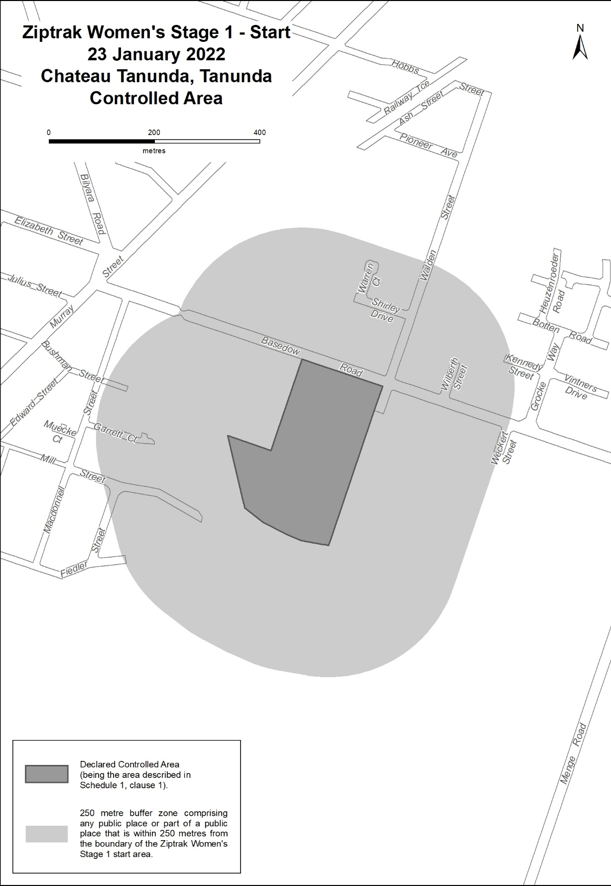

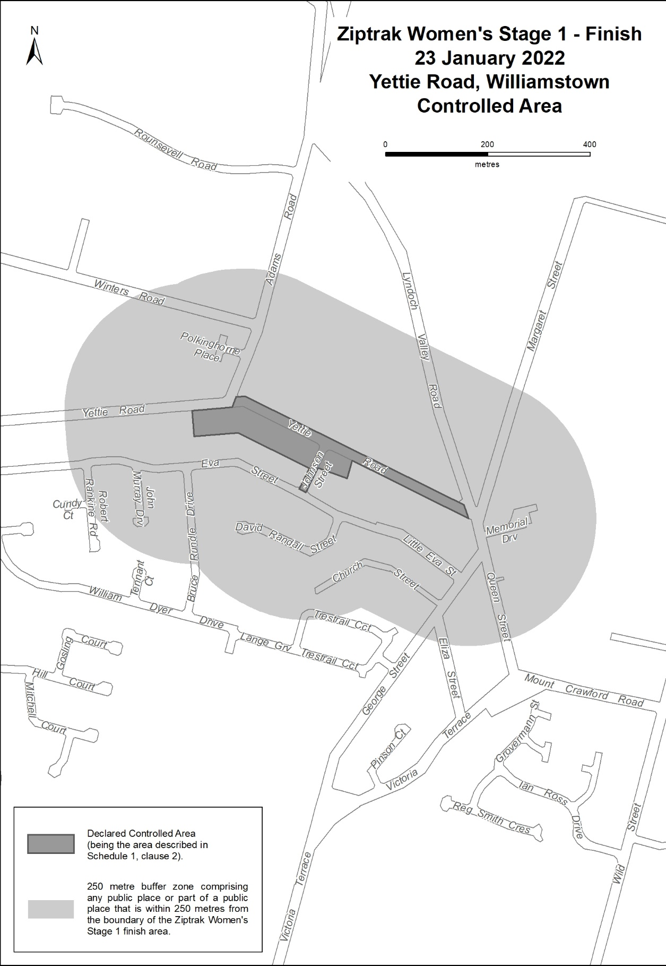

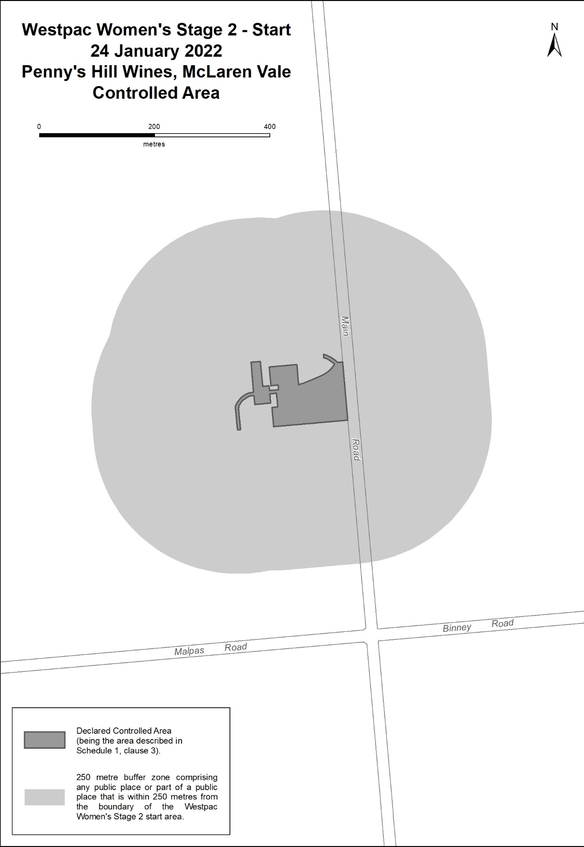

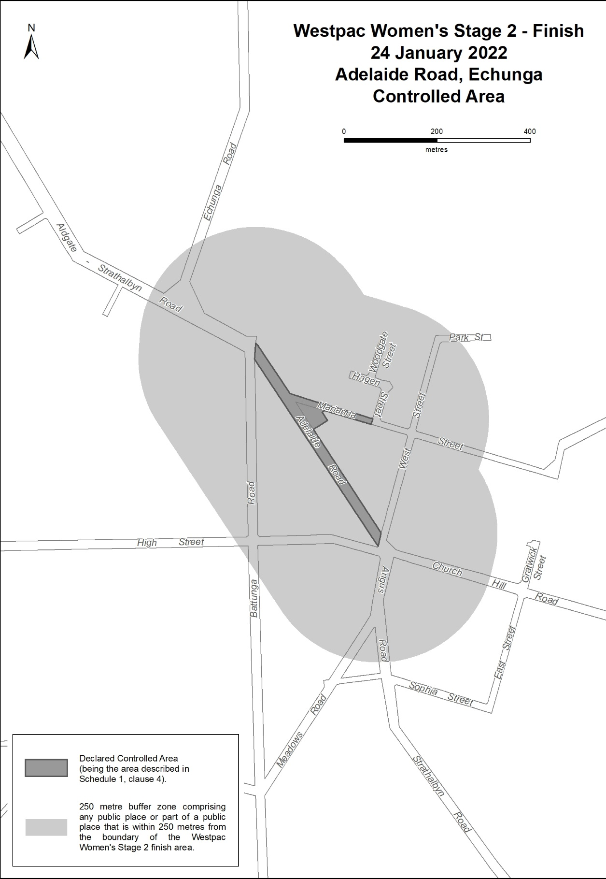

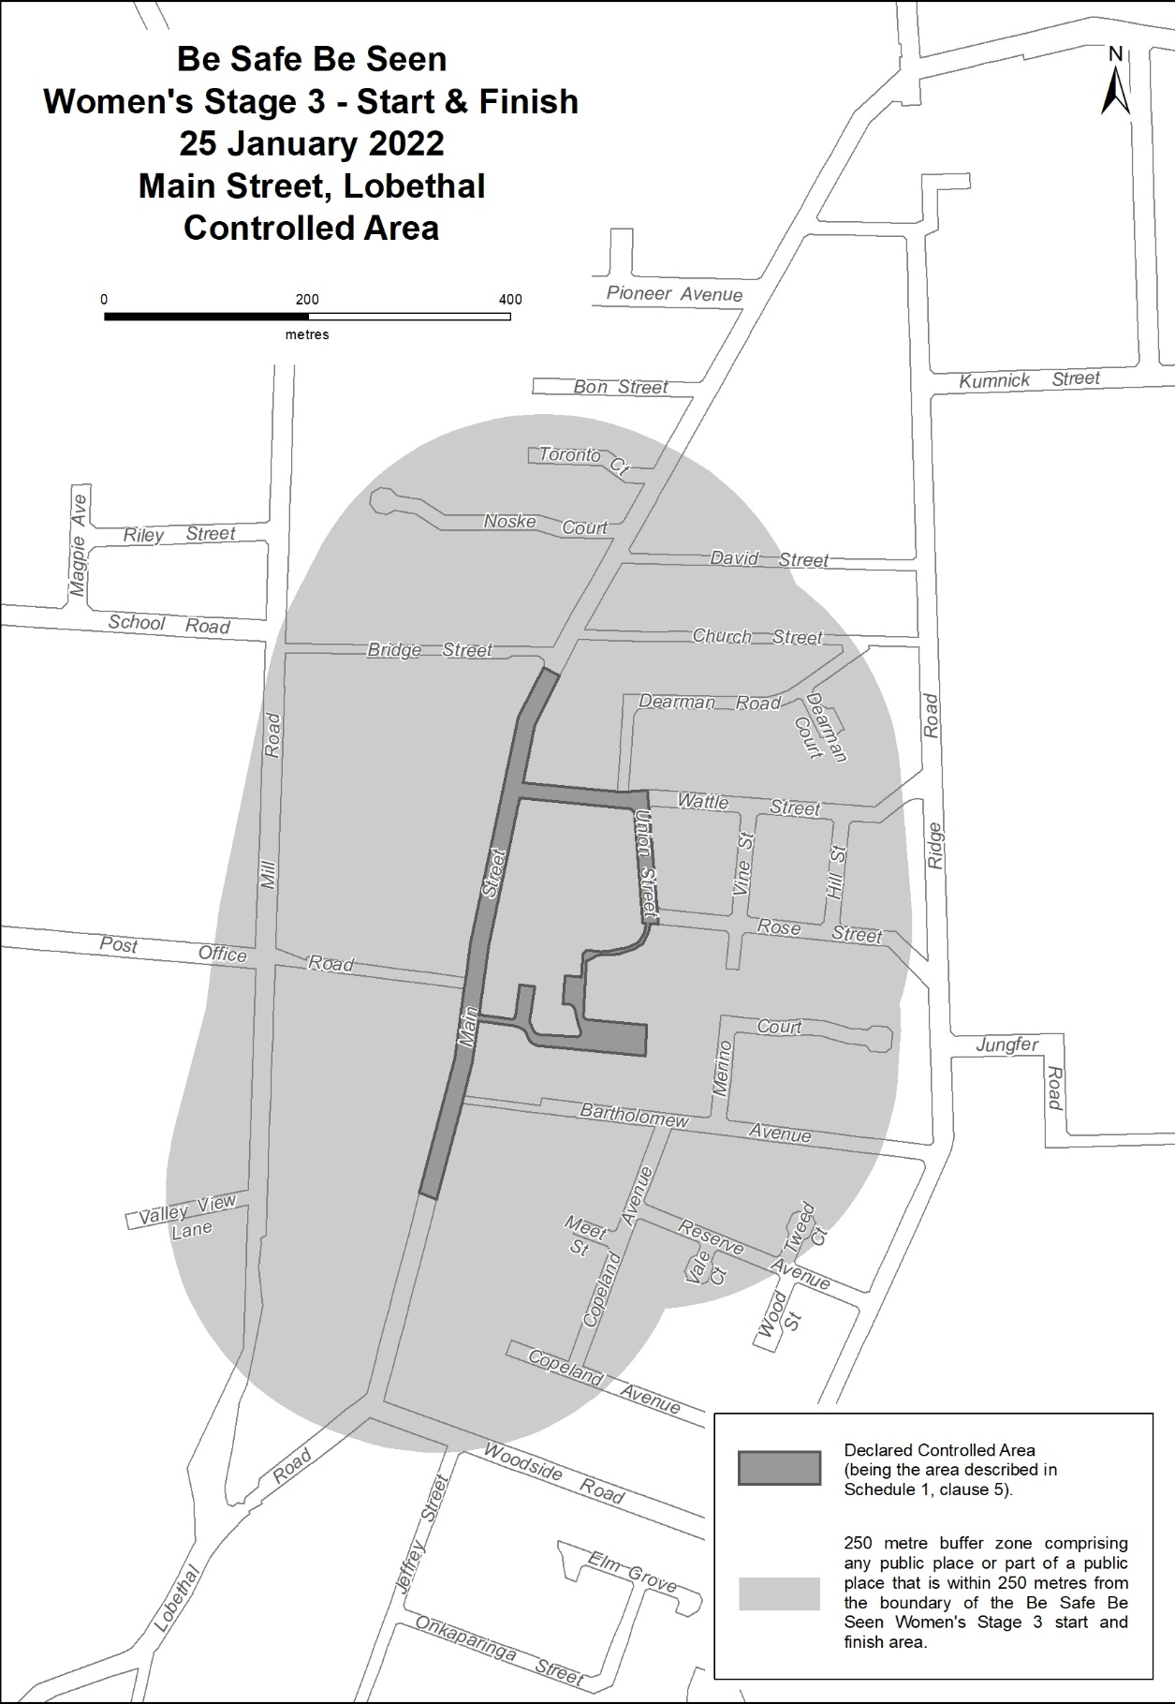

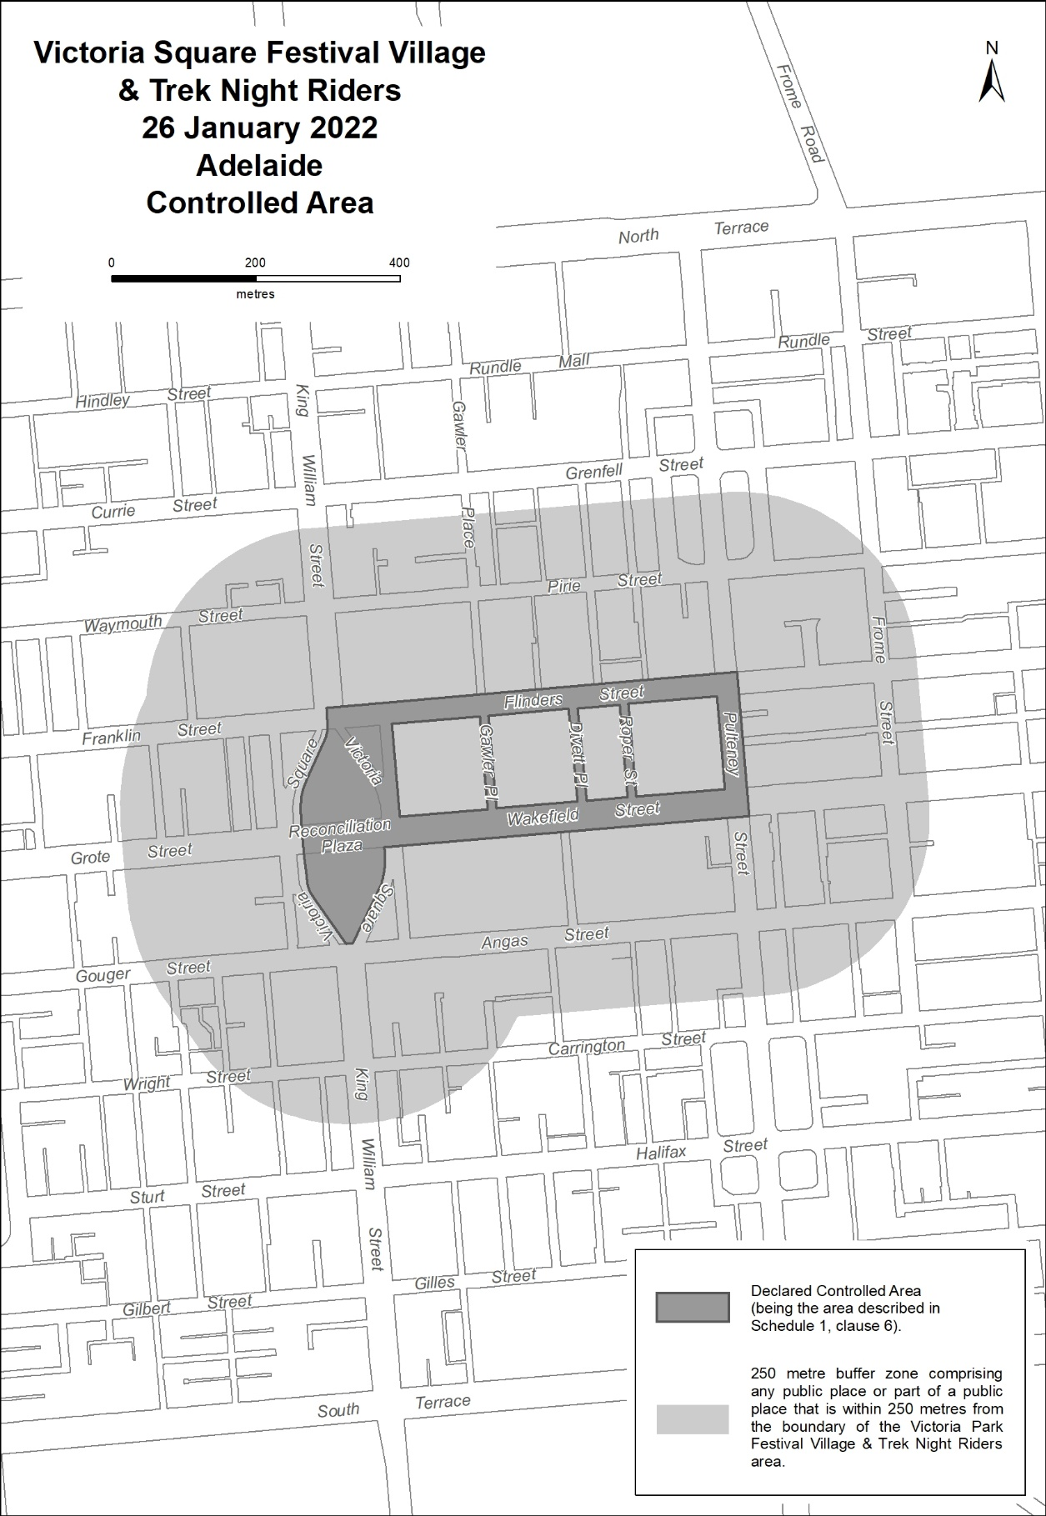

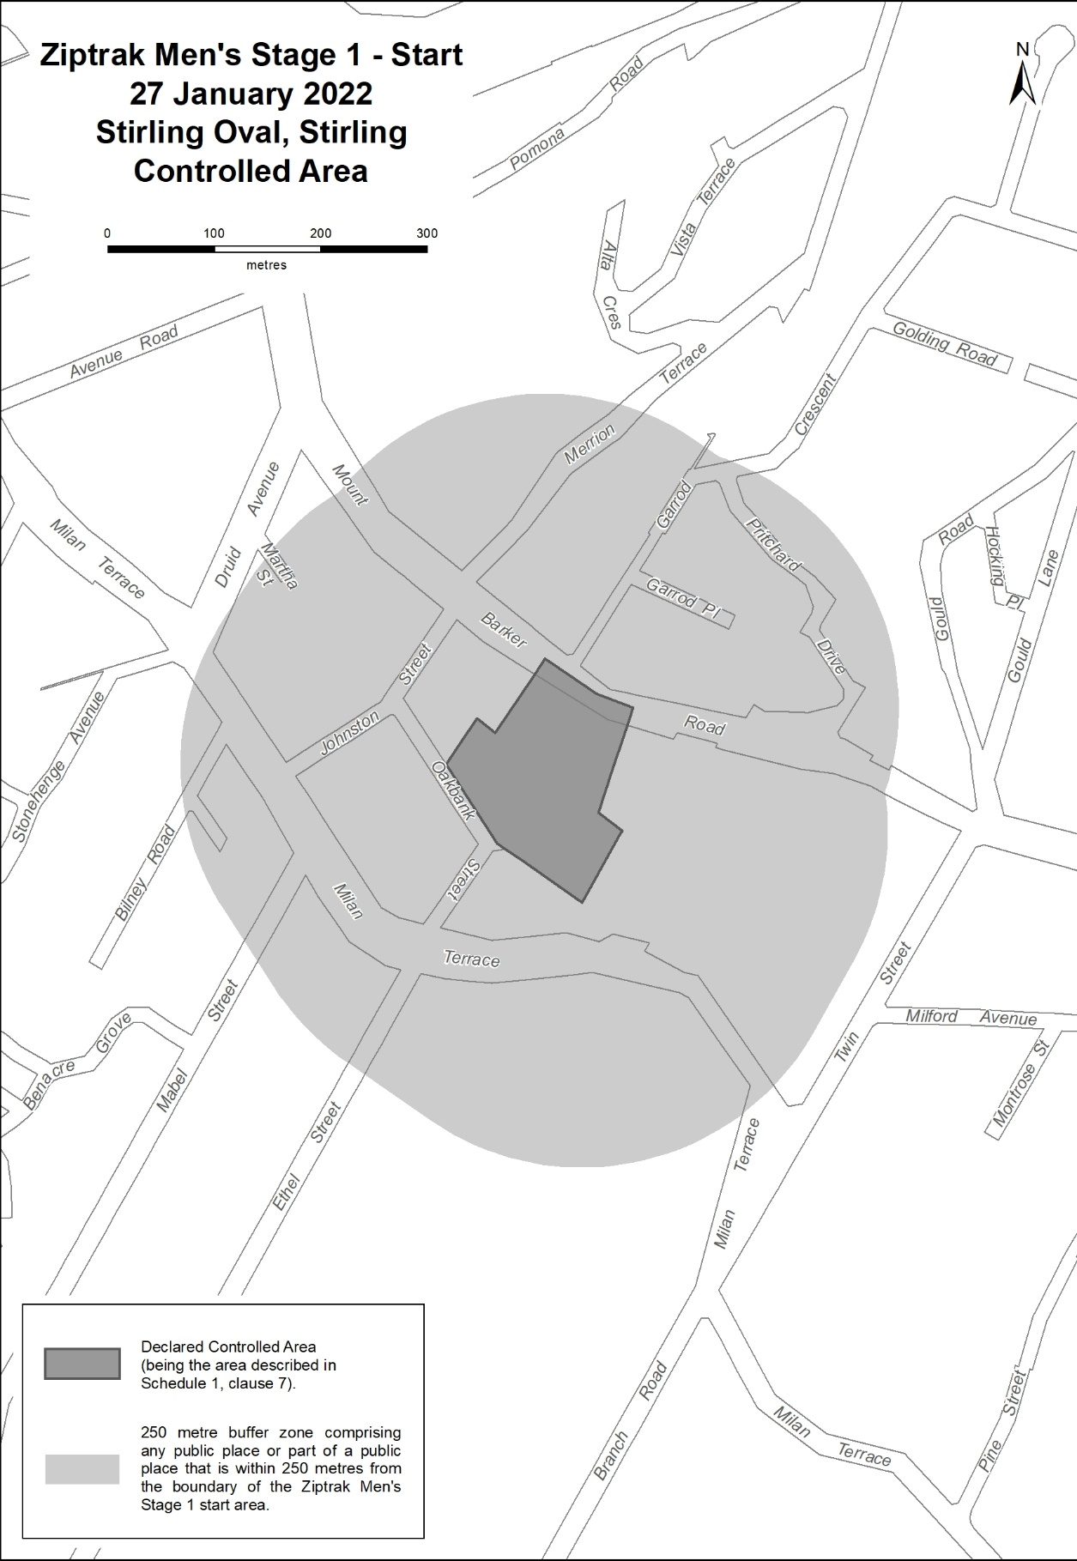

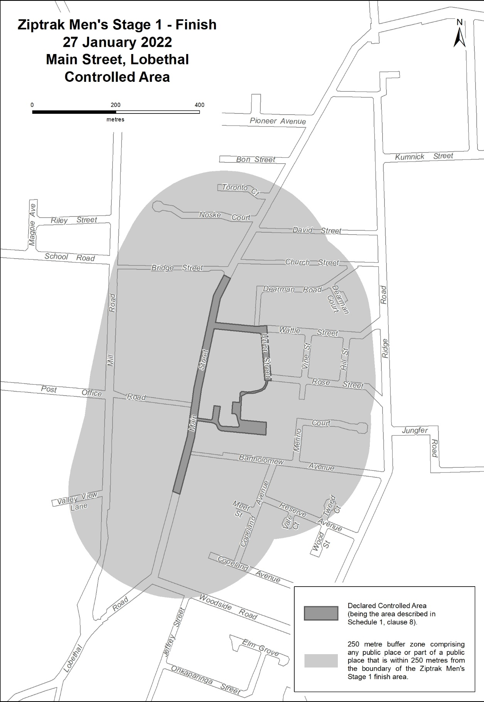

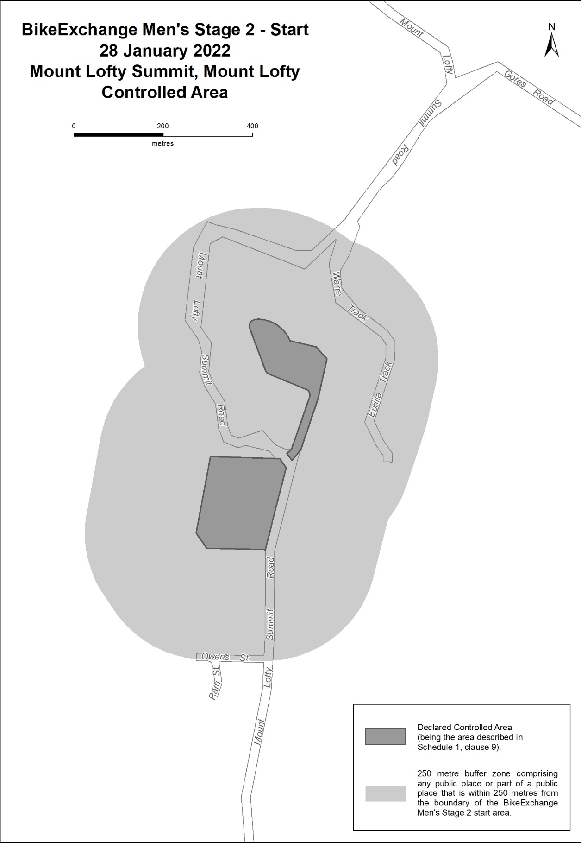

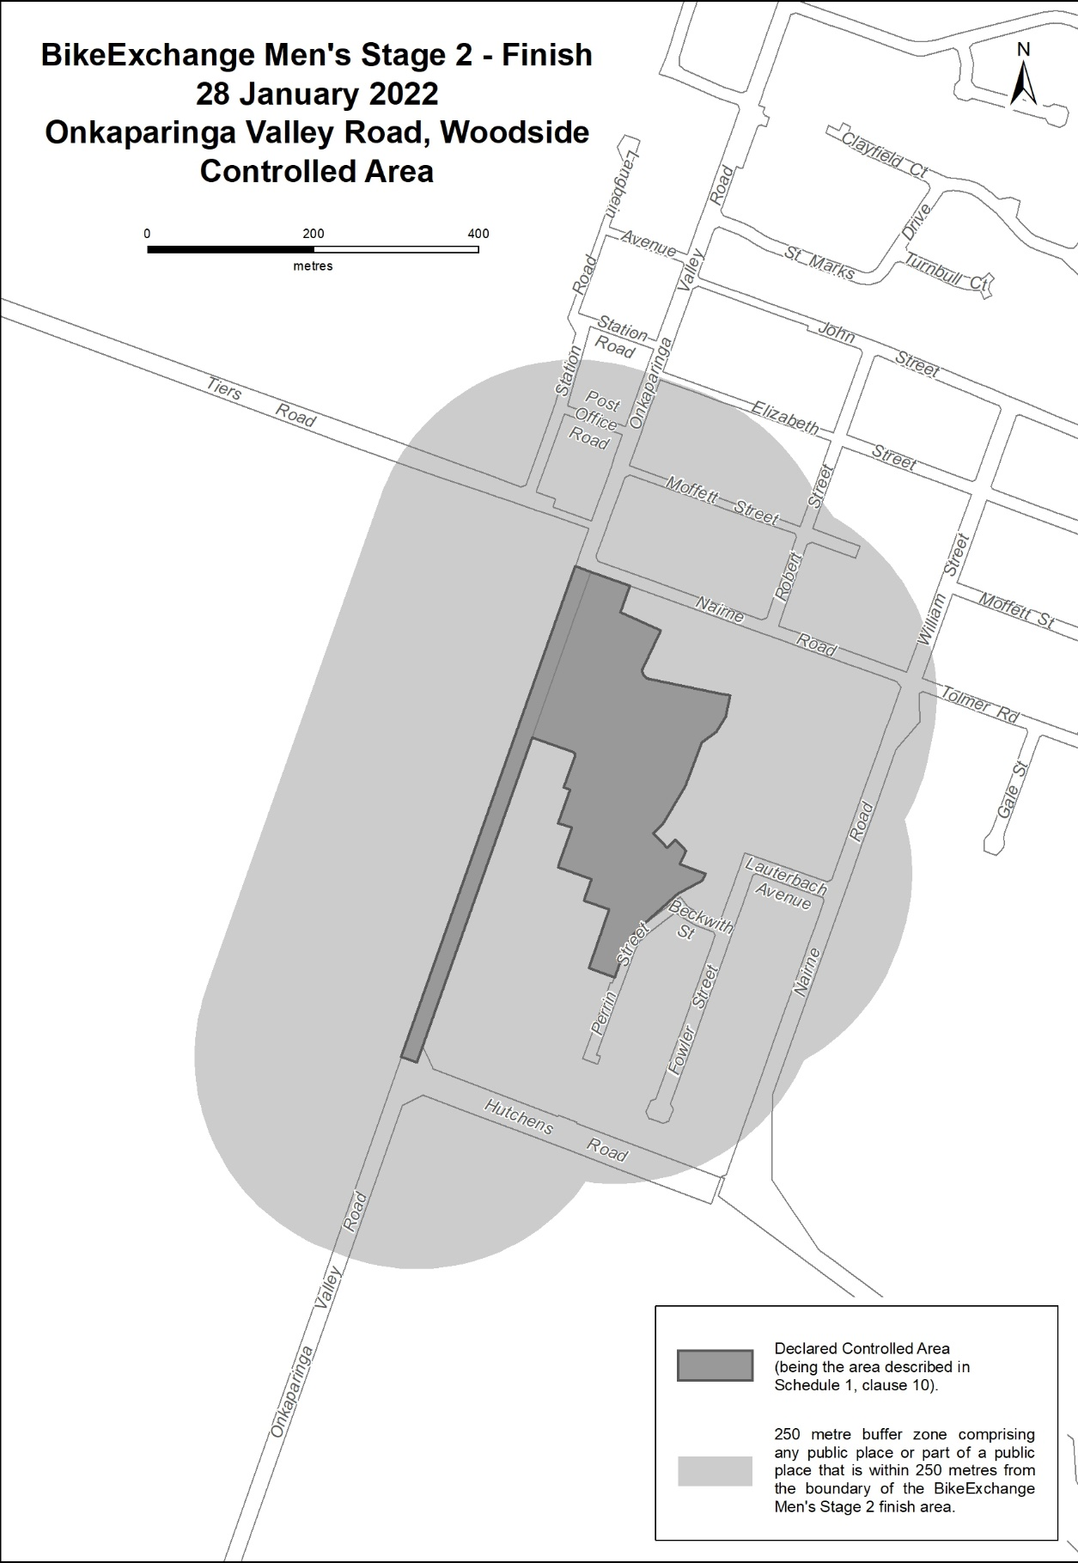

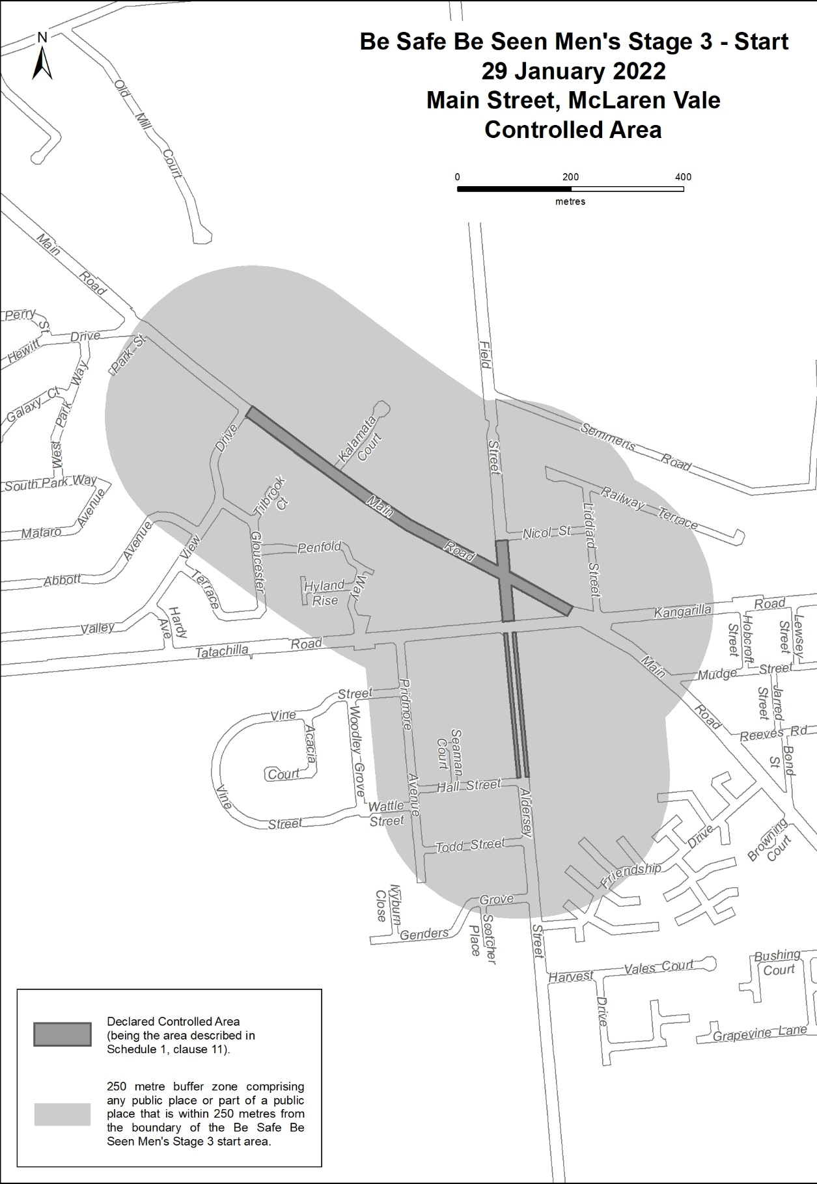

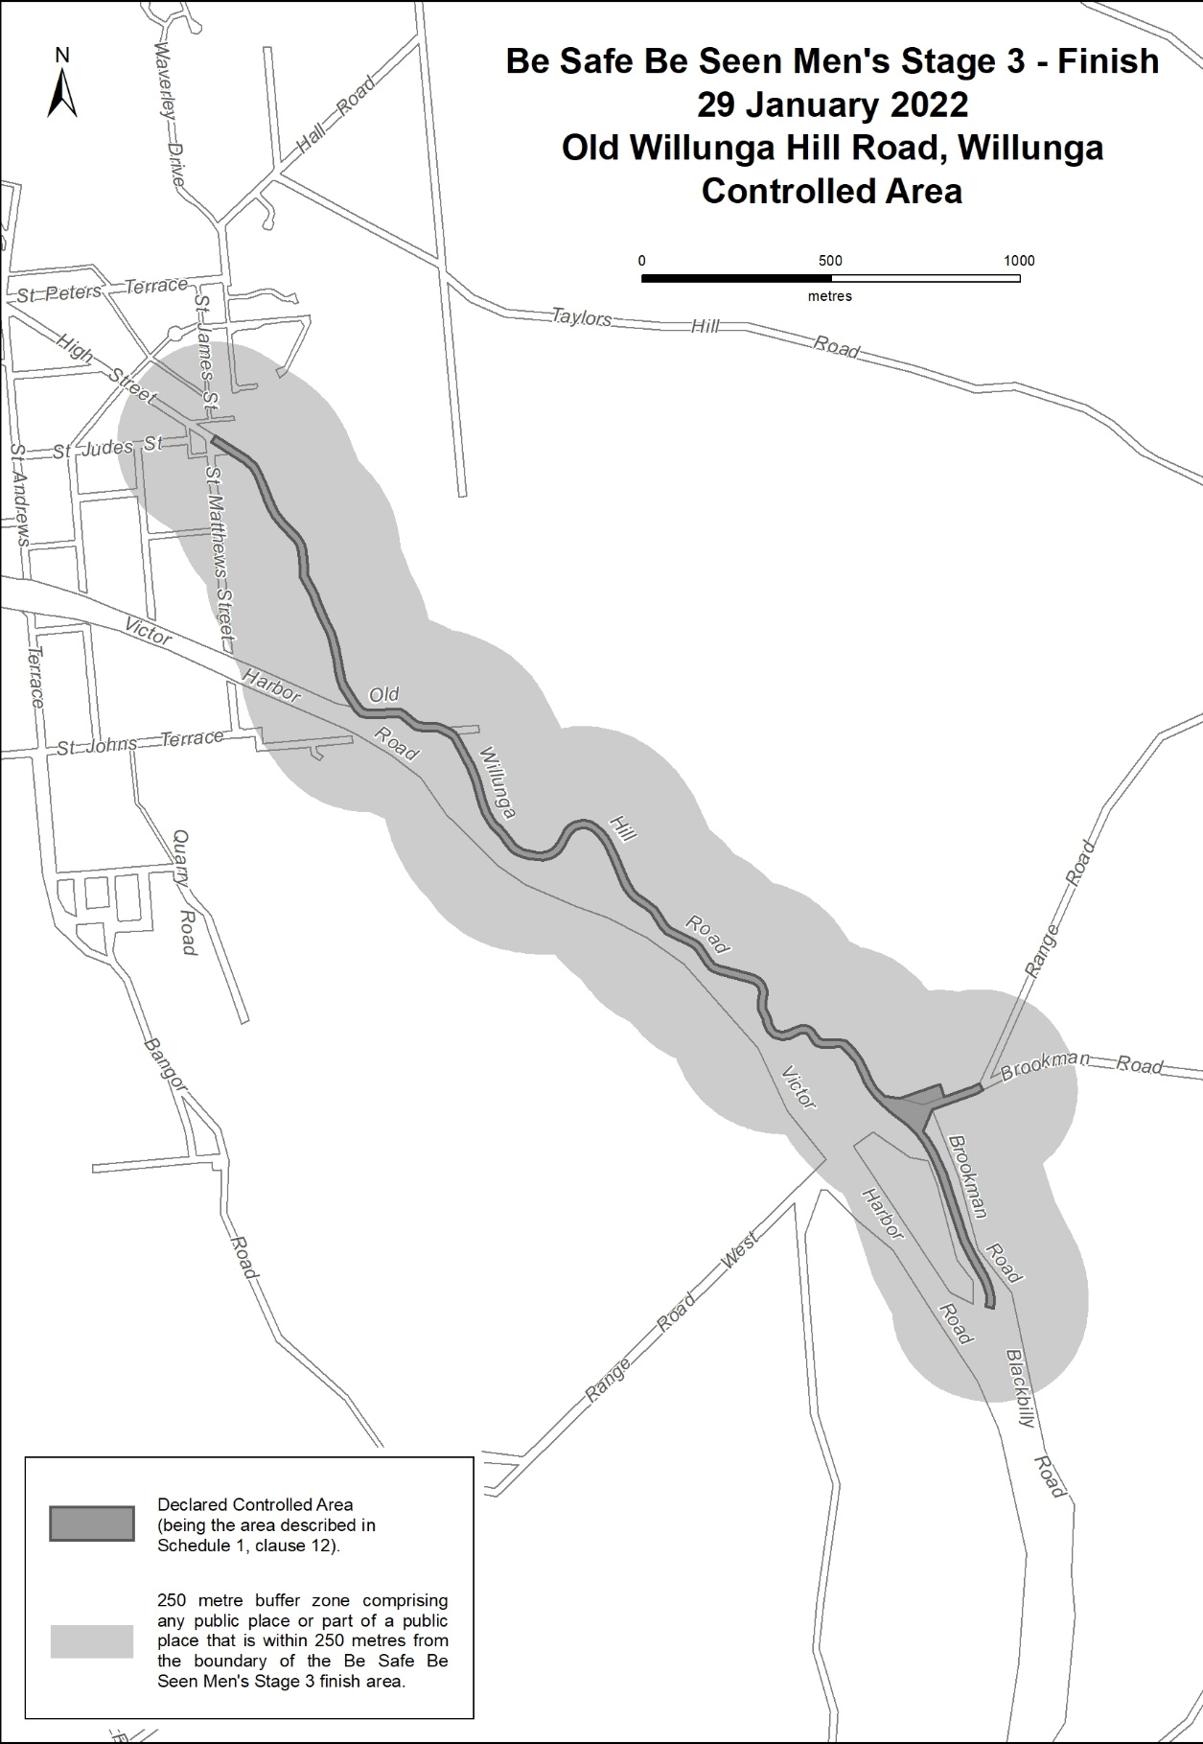

Retirement Villages Act 2016
Section 59 (1)
Voluntary Termination of Retirement Village Scheme
TAKE NOTICE that I, STEPHEN WADE, Minister for Health and Wellbeing, pursuant to section 59(1) of the Retirement Villages Act 2016, HEREBY TERMINATE the Sturt Palms Retirement Community retirement village scheme situated at 48 Sturt Road, BRIGHTON, SA, 5046 and comprising all of the land and improvements in Certificate of Title Register Book Volume 5472 Folio 993 and Volume 5145 Folio 780. I do so being satisfied for the purposes of section 59(2) of the Act that there are no retirement village residents in occupation. The termination will take effect on the day upon which the retirement village endorsement is cancelled.
Dated: 6 January 2022
Stephen Wade
Minister for Health and Wellbeing

Youth Court Act 1993
South Australia
Youth Court (Fees) Notice 2021
under the Youth Court Act 1993
1—Short title
This notice may be cited as the Youth Court (Fees) Notice 2021.
Note—
This is a fee notice made in accordance with the Legislation (Fees) Act 2019.
2—Commencement
This notice has effect on 13 January 2022.
3—Interpretation
In this notice, unless the contrary intention appears—
Act means the Youth Court Act 1993.
4—Fees
The fees set out in Schedule 1 are prescribed for the purposes of the Act and are payable to the Court.
Schedule 1—Fees

1 | On commencement of proceedings for summary applications, summary offences, minor indictable offences or indictable offences  Note—  No fee is payable under this clause for a private application for an intervention order, pursuant to clause 2. | $297.00 plus if the information alleges more than 1 offence—$54.00
2 | For a private application for an intervention order under section 20 of the Intervention Orders (Prevention of Abuse) Act 2009, where domestic abuse is alleged | No fee
3 | On application for an adoption order under the Adoption Act 1988 | $191.00
4 | For copy of evidence—
 | (a) per page in electronic form | $8.85
 | (b) per page in hard-copy form | $11.30
5 | For copy of reasons for judgment—per page  Note—  A party to proceedings is entitled to 1 copy of the reasons without charge. | $8.85
6 | For copy of any other document—per page | $5.30
7 | For production of transcript at request of a party where the Court does not require the transcript—per page | $17.80
Dated: 12 January 2022
Hon Josh Teague MP
Minister for Planning and Local Government
(exercising the powers and functions of the Attorney-General)

Local Government Instruments

City of Charles Sturt
Local Government Act 1999
Amended Community Land Management Plan – Grange Recreation Reserve
Notice is hereby given pursuant to section 197 (3) of the Local Government Act 1999 that the Council of the City of Charles Sturt did, at its meetings of 13 December 2021, resolve to adopt an amended Community Land Management Plan for Grange Recreation Reserve.
A copy of the Community Land Management Plan may be viewed by visiting Council’s website - www.charlessturt.sa.gov.au
Dated: 13 December 2021
P. Sutton
Chief Executive Officer

City of Port Adelaide Enfield
Roads (Opening and Closing) Act 1991
Rann Place, Port Adelaide
NOTICE is hereby given, pursuant to section 10 of the Roads (Opening and Closing) Act 1991, that Council proposes to make a Road Process Order to close Rann Place, Port Adelaide marked as “A” on the outlined plan.
A copy of the plan and statement of persons affected are available for public inspection at Community Civic Centre, located at 163 St Vincent Street, Port Adelaide and the office of the Surveyor General at 101 Grenfell Street, Adelaide during usual business hours.
The Preliminary Plan can also be viewed at www.sa.gov.au/roadsactproposals.
Any application for easement or objections to the Road Process must set out the full name, address and details of the submission with fully supported reasons.
Any submissions must be made in writing within 21 days of the date of this notice to the Council PO Box 110 Port Adelaide SA 5015, and a copy must be forwarded to the Surveyor General at GPO Box 1354 Adelaide SA 5001. Where submissions are made, Council will give notification of a meeting to consider any representations.
Enquiries may be directed to Liz Lynch on (08) 8405 6591.
Dated: 13 January 2022
Mark Withers
Chief Executive Officer

City of Tea Tree Gully
Election Results
Supplementary Election of Councillor for Hillcott Ward
Count conducted on Tuesday 14 December 2021
Formal Ballot Papers – 2200
Informal Ballot Papers – 8
Quota – 1101
Candidates | First Preference Votes | Elected/Excluded | Votes at Election/Exclusion | Count
DINGLEY, John Ronald | 109 | Excluded | 115 | 4
LORRAINE, Olivia | 405 |  | 693
warner, Bradley | 62 | Excluded | 63 | 3
foreman, Kristianne | 777 | Elected | 989 | 7
panagaris, Peter | 162 | Excluded | 176 | 5
barbaro, Paul | 418 | Excluded | 486 | 7
sweaney, Josh | 229 | Excluded | 251 | 6
Harris, Luke | 38 | Excluded | 38 | 2
Dated: 14 December 2021
Mick Sherry
Returning Officer
Electoral Commission SA

Public Notices

Local Government Act 1999
Local Government Association Mutual Liability Scheme
Scheme Rules
The Local Government Association of South Australia has resolved that the existing scheme rules for the LGA Mutual Liability Scheme be repealed and replaced with the amended scheme rules for these schemes as provided below.
- Operation of Rules

These Rules operate from 12:00am on 13 January 2022.
- Definitions

In these Rules, the following words have the following meanings given to them:
  - “Civil Liability” means any liability not being criminal resulting from an obligation, function, power or duty of a Member arising under law.
  - “Claim” means any claim for Civil Liability made upon a Member during the term of this Mutual Scheme.
  - “Delegate” has the meaning given to that term in Rule 3.1.
  - “Eligible Body” means:
    - LGA;
    - LGASA Mutual Pty Ltd (ACN 625 310 045);
    - LGCS Pty. Ltd. (ABN 21 094 805 964);
    - The Local Government Finance Authority of South Australia;
    - All Councils (including their subsidiaries) constituted pursuant to the provisions of the LG Act;
    - Any other body so prescribed by the provisions of the LG Act that is admitted to the membership of the Mutual Scheme; or
    - Any other entity admitted to the membership of the Mutual Scheme by LGA in accordance with Rule 5.2.
  - “Indemnity Cover” means insurance or reinsurance cover purchased or procured by LGA for and on behalf of Members to satisfy and manage the Claims admitted to indemnity in the amount determined from time to time by LGA.
  - “LG Act” means the Local Government Act 1999 (SA), and any Act of Parliament in addition to or in substitution for that Act.
  - “LGA” means Local Government Association of South Australia (ABN 83 058 386 353).
  - “LGA Board” means the board of directors of the LGA.
  - “LGA Member” means any Council (including its subsidiaries) constituted pursuant to the LG Act that is admitted as a member of the LGA in accordance with clause 8 of the Constitution of the LGA from time to time.
  - “Member” means an Eligible Body admitted to membership of the Mutual Scheme in accordance with Rule 5.
  - “ML Fund” means the fund established in accordance with Rule 6 and maintained in accordance with these Rules.
  - “ML Indemnity” means protection or security against loss or damage resulting from Civil Liability.
  - “ML Objectives” means the objectives of the Mutual Scheme contained in Rule 4.3.
  - “Mutual Scheme” means The Local Government Association Mutual Liability Scheme conducted pursuant to Schedule 1 of the LG Act and in accordance with these Rules.
  - “Notifier” has the meaning given to that term in Rule 19.1.
  - “Ordinary Resolution” means a resolution passed by at least the majority of the votes cast by all persons present and entitled to vote at the meeting at which the resolution is put.
  - “Pooled Cover” means the discretionary indemnity cover provided from the ML Fund to satisfy and manage the Claims admitted to indemnity in the amount determined from time to time by LGA.
  - “Recipient” has the meaning given to that term in Rule 19.1.
  - “Special Resolution” means a resolution passed by at least 75% of the votes cast by all persons present and entitled to vote at the meeting at which the resolution is put.
- Delegation
  - Subject to Rule 3.2, LGA may (but is not obliged to) delegate any power, function or duty under these Rules (including the power to sub-delegate) to an entity controlled by LGA which is responsible for the management of the Mutual Scheme (“Delegate”) subject to such limitations and conditions as may be determined by LGA.
  - LGA is not permitted to delegate any power, function or duty under Rules 5.2, 8.3, 9.8.1, 14.4, 15.1, 18.3, 18.7, 18.8.1, 19 and 20.1.
  - LGA may revoke or amend a delegated power, function or duty at any time. LGA may at any time exercise, in its own right, any of the powers or functions delegated by it and any such exercise will not, without more, amount to the revocation of any delegation in favour of a Delegate.
  - Subject only to any limitations or conditions in the delegation, the Delegate, in exercising delegated power, will be empowered under these Rules as if it were LGA.
- Objectives of the Mutual Scheme
  - The Mutual Scheme comprises the ML Fund which provides coverage to Members in relation to Claims.
  - LGA may establish funds under the Mutual Scheme in addition to the ML Fund to provide coverage to Members in relation to potential and actual claims relating to liability, loss or damage of Members, other than the Claims.
  - In relation to the ML Fund, the ML Objectives are to provide to Members of the Mutual Scheme assistance in respect of their potential and actual Claims more particularly set out in these Rules and including but not limited to:
    - advice in respect of minimising the occurrence and severity of all Claims;
    - assistance in the administration, investigation, management and resolution of all Claims;
    - legal representation in respect of all Claims; and
    - financial assistance by way of discretionary grants in respect of the Claims.
- Admission to Membership
  - The Eligible Bodies listed in Rules 2.4.1 to 2.4.6 inclusive are automatically entitled to membership of the Mutual Scheme.
  - The LGA Board may from time to time by Ordinary Resolution, and subject to the terms of these Rules, admit to membership of the Mutual Scheme for a financial year any other entity which makes an application to LGA and upon their admission, such entity will be an Eligible Body for the purposes of Rule 2.4.7.
  - In exercising discretion to admit an entity to membership of the Mutual Scheme pursuant to Rule 5.2, the LGA Board may take into account any matter which it considers relevant.
  - Notwithstanding the admission of a Member to membership of the Mutual Scheme pursuant to Rule 5.1 or Rule 5.2, a Member shall only be entitled to the benefits of the Mutual Scheme if, at the relevant time, that Member has paid in full any contribution payable by it under Rule 11 or otherwise as required in accordance with these Rules.
  - At the discretion of LGA, the benefits of membership of the Mutual Scheme may be limited to defined Claims, limited to Pooled Cover, limited to Indemnity Cover or any combination of those matters.
  - Payment of a contribution by a Member shall be evidence of the Member’s agreement to be bound by these Rules.
- ML Fund
  - LGA shall establish and maintain the ML Fund to meet the ML Objectives and for that purpose, subject to Rule 5.4, may apply the ML Fund to meet:
    - such Claims as may be made against any one or more of the Members during that year to the extent of the Pooled Cover;
    - such Claims as may have been made against any one or more of the Members during any previous year and which at the commencement of these Rules and any new financial year have not been settled;
    - the premium payable to an appropriate indemnity insurer to provide Indemnity Cover for the Members during that year;
    - the operating expenses of the Mutual Scheme for that year, including:
      - the remuneration of LGA referred to in Rule 12.1; and
      - any expenses of LGA or a Delegate referred to in Rule 12.2, in each case insofar as they relate to the ML Fund; and
    - any grants or allocations to Members, or any other person or body for or on behalf of any Member, which LGA in its discretion may make.
  - Each Claim shall be met:
    - to the extent that the Claim does not exceed the amount of the Pooled Cover, from the ML Fund;
    - to the extent that the Claim exceeds the amount of the Pooled Cover:
      - to the amount of the Pooled Cover, from the ML Fund;
      - thereafter from Indemnity Cover to the extent of that cover;
    - to the extent that the Claim exceeds the amount of the Pooled Cover and the Indemnity Cover:
      - to the amount of the Pooled Cover, from the ML Fund;
      - to the amount of the Indemnity Cover, to the extent of that cover; and
      - the balance by the Member against which the Claim was made.
  - The Members must contribute to the ML Fund in the proportions determined annually by LGA.
  - LGA shall administer the ML Fund with the intent that upon the settlement of all Claims made in any financial year:
    - any surplus remaining in the ML Fund attributable to that year shall be allocated at the absolute direction of LGA toward liabilities of the ML Fund for any other year whether future or past; and
    - any deficiency in the ML Fund in that year may be met by additional contributions levied by LGA against each Member for that year in the proportion in which contributions were made to the ML Fund for that year.
- Admission of Claim to Indemnity

LGA shall consider any Claim for which a Member seeks indemnity from the ML Fund and may in its sole and absolute discretion and either in whole or in part and upon such terms and conditions as LGA may consider appropriate determine whether it will grant indemnity for the Member from the ML Fund in respect of any such Claim.
- Powers, Duties and Functions of LGA
  - LGA will administer and manage the Mutual Scheme in the pursuit of the ML Objectives.
  - LGA shall be empowered for and on behalf of the Members to do all the following things namely:
    - levy Members for contributions in accordance with Rule 11, including differential contributions in respect of each Member to the ML Fund having regard to any matter which it considers relevant;
    - invest all contributions received from Members and other monies received comprising the ML Fund which are not immediately required to meet the liabilities of the Mutual Scheme;
    - expend the contributions of, and income earned by, the ML Fund in respect of each financial year in and towards:
      - the general administration of the Mutual Scheme;
      - assistance to Members by way of any advice in respect of their potential and actual Claims;
      - assistance to Members in the administration, investigation and resolution of Claims;
      - legal representation for Members in respect of any Claims;
      - financial assistance by way of discretionary grants in respect of any Claims;
      - any remuneration of LGA referred to in Rule 12.1; and
      - any expenses of LGA or a Delegate referred to in Rule 12.2.
  - LGA may make such additional rules to be observed by a Member or the Members as it may deem fit with respect to the terms and conditions upon which a Member or Members will be eligible for assistance from the Mutual Scheme, provided that no such rule shall be made in terms inconsistent with these Rules and further provided that no such rule shall operate and take effect in respect of any Member until a copy thereof shall have been served upon such Member or Members.
  - LGA will enter into all such agreements for and on behalf of Members as are necessary for or incidental to the proper administration of the Mutual Scheme in the pursuit of the ML Objectives.
  - LGA will carry out investigations of such relevant matters and make submissions to such relevant bodies as LGA may deem to be necessary for or incidental to, the proper administration of the Mutual Scheme in the pursuit of the ML Objectives.
  - The duties of LGA shall include:
    - to achieve and implement the ML Objectives;
    - to ensure from a financial perspective that the Mutual Scheme is viable;
    - to keep records of all activities for and on behalf of the Mutual Scheme;
    - to review the performance and function of the Mutual Scheme;
    - to be responsible for the financial management of the Mutual Scheme to the extent that it shall:
      - annually determine the total amount of contributions to be levied against all Members in respect of the ML Fund;
      - from time to time undertake an assessment of the Members or any of them and their activities to assist in the determination, in conjunction with actuarial advice, of the proportion in which the Members are to contribute to the ML Fund in any year and may upon the conclusion of any such investigation direct the Members or any of them as to the procedures to be adopted by them to prevent losses or to minimise Claims;
      - annually prepare the operating budget and the financial statements of the Mutual Scheme and report to the Members on any items arising from those statements;
      - annually determine the extent of Claims to be indemnified from the ML Fund;
      - annually determine the amount of Pooled Cover to be provided for the Members from the ML Fund;
      - annually determine the amount and nature of Indemnity Cover to be purchased for the Members from the ML Fund for any term and to determine the indemnity insurer for this purpose; and
      - be responsible for the assessment of the Members to determine, in conjunction with actuarial advice, the proportion in which they are to contribute to the ML Fund in each year from the total contributions determined in accordance with Rule 8.6.5.1;
    - to manage Claims made against each Member including:
      - the investigation and assessment of those Claims;
      - the provisions of loss prevention and risk minimisation guidelines; and
      - the keeping of the accounts of the ML Fund for each year.
  - The annual operating budget and financial statements referred to in Rule 8.6.5.3 shall deal separately with the following items:
    - the projected income of the ML Fund by way of contributions, interest or other sources;
    - the liabilities of the ML Fund for estimated Claims and Claims adjustment costs;
    - the amounts to be allowed to provide for the cost of arranging Indemnity Cover;
    - general and administrative costs to be charged against the ML Fund; and
    - any grants in accordance with Rules 6.1.5 and 10.7.
  - LGA may at its discretion alter the amounts to be expended in respect of the items listed in the budget for each year where necessary to meet the purposes of the Mutual Scheme.
  - Where it becomes apparent to LGA that for any year the ML Fund will be insufficient to meet Claims payable from the ML Fund, LGA may at any time require the payment by the Members of an additional contribution in the same proportions as the contribution paid by each of the Members to the ML Fund for that year in order to ensure that all Claims upon the ML Fund for that year are able to be met.
  - LGA shall report annually to the Members on all aspects of the operation of the Mutual Scheme for the preceding year, including details in relation to:
    - outstanding Claims (including an assessment as to the liability of outstanding Claims and the ability of the ML Fund to meet the assessment of liability);
    - further contributions required, if any;
    - the investment of the moneys of the ML Fund not immediately required;
    - the allocation of surplus moneys in the ML Fund, if any;
    - any remuneration received by LGA pursuant to Rule 12.1; and
    - any expenses of LGA (or its Delegate) referred to in Rule 12.2.
  - LGA shall be available at all times to any of the Members to answer any questions on the conduct of the activities of the Mutual Scheme.
  - LGA may establish such committees as it considers necessary to be constituted by such persons as LGA may determine to investigate and report to LGA on any matter relevant to the Mutual Scheme.
- Claims and Indemnity
  - Pooled Cover

In accordance with Rule 7, LGA shall consider granting indemnity with respect to any Claim from the ML Fund up to a level of Pooled Cover to be determined annually by LGA.
  - Indemnity Cover

LGA shall purchase Indemnity Cover in excess of Pooled Cover to an amount determined by LGA from year to year.
  - Excess

Each Member will be liable for the first amount of any Claim to be known as the “Excess” which shall be determined by LGA. The Excess may be a differential amount for each Member and for each Claim or a combination of both.
  - Limit of Exposure

Subject to admitting a Claim to indemnity under Rule 7, a Member’s entitlement to indemnity from the ML Fund shall never exceed the Pooled Cover for each Claim. Entitlement to claim from Indemnity Cover shall be as contracted by LGA on behalf of all Members. The quantum of any Claim in excess of Indemnity Cover shall be the responsibility of the Member.
  - Defaulting Member

LGA may by written notice to a Member in default of these Rules exclude that Member from any or a defined entitlement to Pooled Cover or Indemnity Cover.
  - Special Risks

LGA may by written notice to a Member exclude the Member from any or a defined entitlement to Pooled Cover or Indemnity Cover with respect to a “special risk” of Claims as determined by LGA.
  - Other Insurance

A Member is not entitled to indemnity from the Pooled Cover for any loss, damage or liability which at the time of the happening of such loss, damage or liability or the Claim for such was otherwise indemnified or insured by or would, but for the existence of this Mutual Scheme be indemnified or insured by any other Policy or Policies of Insurance or otherwise except in respect of any liability beyond the amount which would have been payable under such other Policy or Policies had this Mutual Scheme not been effected. This Rule is to be construed to exclude Claims made with respect to professional indemnity claims and occurrences for all other claims, made or occurring prior to 30 June 1989.
  - Failure to Notify and False Notification
    - Where a Member fails to notify LGA as required by Rules 10.1 and 10.3, breaches Rule 10.2, submits a false Claim or provides false information contrary to Rule 10.4 or fails to comply with any requirement or notice issued pursuant to Rule 0, LGA may (in lieu of terminating the membership of the defaulting Member pursuant to Rule 18 and in addition to any other power under these Rules) levy an additional contribution to be paid by a defaulting Member or remove any benefit which may otherwise have accrued to the benefit of the Member under these Rules as a condition precedent for the Claim against the Member to be considered for indemnity from the ML Fund.
    - A decision by LGA to levy an additional contribution against a Member in default, or to remove any benefit in lieu of termination of membership or any other sanction, does not preclude LGA from exercising the power to terminate the membership of the defaulting Member if there is any repeat of the default or failure by the Member to adequately address the issue of concern identified by LGA (including the payment of the additional contribution) or any other relevant performance or risk management issue.
- Claims Procedure
  - Notice

A Member shall, as a condition precedent to a Claim to be indemnified under these Rules and, subject to the default provisions, as a condition of continued entitlement to the benefits of membership of the Mutual Scheme, forthwith give to LGA written notice of each of the following:
    - any circumstance or occurrence of which the Member shall become aware which is likely to give rise to a Claim against the Member;
    - any receipt of notice, written or oral, from any person of any intention to make a Claim against the Member; and
    - any Claim made against the Member whether the quantum of the Claim exceeds the Excess or not.
  - Not admit liability

A Member shall not admit liability for, compromise, settle or make or promise any payment in respect of, any Claim which may be the subject of indemnity hereunder or incur any costs or expenses in connection therewith without the written consent of LGA which if it so wishes shall be entitled to take over and conduct in the name of the Member the defence and/or settlement of any such claim for which purpose the Member shall give all such information and assistance as LGA may reasonably require.
  - Increase in Risk

A Member shall forthwith give to LGA full particulars in writing of any material increase in the risk of any Claim and shall pay such additional contribution and shall comply with such other terms and conditions, if any, as may be reasonably required by LGA in respect of such Claim.
  - Fraudulent Claims and False Information

If a Member shall make any Claim knowing the Claim to be false or fraudulent as regards amount or otherwise or shall provide any false information with respect to a Claim the entitlement shall become void and all benefits hereunder relating to that Claim shall be forfeited.
  - Continued Support

During the continuance of any Claim against a Member which is to be indemnified from the ML Fund the Member shall provide LGA with whatever information and support (including technical and professional support if requested) as is requested to enable the adequate investigation, defence and resolution of any such Claim.
  - Subrogation

Every Member seeking indemnity from the ML Fund shall by membership of the Mutual Scheme have agreed to subrogate to LGA its rights to investigate, defend and resolve any Claim against the Member.
  - Special Assistance

Any Member requiring special assistance by way of a grant or otherwise to manage any risk which may result in a Claim may make written application for such to LGA whereupon LGA shall deal with the matter and in doing so may request any information from the Member and may resolve to refuse the grant, or make the grant on such terms and conditions as it deems appropriate.
  - Confidentiality

All communications between a member and the Mutual Scheme, and any investigator, lawyer or other persons engaged by or assisting the ML Fund, in relation to the claim, shall be confidential, and shall not be disclosed to any person without the prior written consent of the Mutual Scheme.
- Contributions
  - Contributions for each year shall be as determined by LGA having regard to any matter which it determines relevant. Contributions so determined must be paid by each Member as requested by LGA.
  - Contributions once paid by a Member to the ML Fund shall not be recoverable in whole or in part by the Member for any reason, including in the event of the resignation or early termination of membership of the Mutual Scheme under Rule 18, or a decision by LGA not to indemnify a Claim or to impose a condition on the grant of an indemnity.
  - Contributions by each Member shall be applied by LGA at its discretion toward the accumulation of the ML Fund, the purchase for and on behalf of each Member (as one of a group of Members of the Mutual Scheme) of Indemnity Cover in respect of Claims of each Member in excess of the level of Pooled Cover and otherwise in furtherance of the ML Objectives.
  - Contributions for each Member shall be determined by LGA from year to year and may be differential in respect of each Member to the ML Fund. For the purpose of determining the appropriate contribution for each Member, the Member shall provide LGA such information as is required to determine:
    - the history of Claims against the Member;
    - operating and risk management procedures of the Member in all of its activities; and
    - any other matter requested by LGA.
  - Additional contributions for any year may be levied by LGA against any Member or Members or all of the Members at any time for any of the following reasons:
    - increasing Pooled Cover in any year;
    - purchasing additional Indemnity Cover in any year;
    - to cover special risks as determined by LGA;
    - to cover an increase in risk of Claims of a Member;
    - to compensate the ML Fund for the actions of a defaulting Member;
    - to compensate the ML Fund for conditional risk, non-compliance with a request resulting in a loss to the ML Fund, or the failure by a Member to abide by a reasonable direction of LGA;
    - for any of the reasons contemplated by Rule 9.8.1; and
    - any other reason determined by LGA to be a relevant reason.
  - LGA may, having regard to the advice of an actuary, operate a “bonus/penalty” scheme and the Members shall be bound to accept such a decision by LGA.
- LGA’s Remuneration, Costs and Expenses
  - The LGA is entitled to reserve for itself from the contributions an amount in consideration of the conduct and management of the Mutual Scheme (LGA’s Remuneration). LGA’s Remuneration will be determined on an annual basis by LGA and reported to Members annually as contemplated by Rule 8.10.5.
  - LGA or its Delegate (as the case requires) shall be entitled to be reimbursed from the ML Fund for any operating expenses incurred by it in respect of the conduct and management of the Mutual Scheme.

- Member’s Obligations
  - The primary obligation of a Member is to comply strictly with the technical requirements, and the spirit and intent of these Rules so as to ensure the integrity and viability of the Mutual Scheme which has been established as a discretionary mutual indemnity scheme for the benefit of all Members.
  - In the spirit of mutual obligation every Member must not only comply with the technical requirements of these Rules and the direction of LGA but must also respect the spirit and intent of the Mutual Scheme by ensuring that timely and comprehensive notification is given to LGA of any incident, circumstance or matter which may give rise to a Claim, and by ensuring that adequate risk management and prevention strategies are put in place so as to absolutely minimise the risk of such a Claim.
  - It is also the obligation of every Member to notify LGA in advance of any activity to be undertaken by a Member or by any other person on a Member’s premises or under a Member’s control or influence which has by its nature a risk profile which is different to the risk profile of the usual and known activities of the Member, that is, usual activities of the Member actually known about by LGA.
  - LGA may at any time undertake a risk management audit of a Member’s activities, including those activities over which a Member has control or influence, and every Member is obliged to fully and honestly assist LGA to conduct such an audit by providing LGA with all information as requested by LGA and by giving LGA access to all property, premises, records and any other material requested by LGA for the purposes of the audit.
  - A Member must modify or cease activities which LGA determines to be an unacceptable risk and about which LGA has issued a notice to the Member.
  - A Member must comply with any notice given by LGA under these Rules.
- Financial Provisions
  - LGA shall in the name of the Mutual Scheme open an account for the ML Fund and any other fund established by LGA with a Bank of its choice.
  - LGA may authorise a person to operate the bank accounts.
  - All moneys received in respect of the ML Fund shall be immediately deposited to the credit of the bank account for the ML Fund and can be invested as follows:
    - with the Local Government Finance Authority of South Australia;
    - with the Superannuation Funds Management Corporation of South Australia trading as Funds SA;
    - subject (to the extent practicable in the circumstances) to consulting with the Treasurer, in any security or investment authorised by the Trustee Act; or
    - in any security or investment authorised by the LG Act or prescribed for the purposes of that Act.
  - LGA may borrow moneys for the purposes of meeting the ML Objectives and for that purpose may secure the repayment of such loans by granting security over the assets of the Mutual Scheme or the ML Fund.
  - LGA shall keep or cause to be kept all such accounting records for the Mutual Scheme as fully and correctly explain the transactions and financial position of the Mutual Scheme.
  - The accounting records shall be prepared and maintained in such a manner as will enable:
    - true and fair accounts of the Mutual Scheme to be prepared from time to time; and
    - the accounts of the Mutual Scheme to be conveniently and properly audited annually.
- Auditor
  - LGA shall appoint an auditor to audit the books of account kept in respect of the Mutual Scheme.
  - The Members (and the authorised representatives of each of the Members) and the Auditor shall be entitled at all times to have access to the accounting and all other records of the Mutual Scheme.
  - The Auditor:
    - shall audit the Mutual Scheme’s accounting records;
    - shall examine and report on the adequacy of the Mutual Scheme’s internal controls, including whether the internal controls provide a reasonable assurance that the relevant financial transactions have been recorded accurately and reliably; and
    - may, at the request of LGA, examine and report on the efficiency and economy with which the resources of the Mutual Scheme are managed or used,

annually during the currency of the Mutual Scheme or more frequently as LGA may direct.
    - The Auditor shall cause a written report to be sent to LGA on the completion of each annual audit in respect of the accounting records of the Mutual Scheme and other records relating to the accounts prepared therefrom.
    - The Auditor’s report shall state whether in the Auditor’s opinion the accounting records aforesaid have been kept in accordance with generally accepted accounting principles and if the Auditor considers that the records have not been so kept the Auditor shall specify the reason for not being satisfied with them.
- Actuary
  - LGA shall appoint an actuary to advise LGA on all aspects of the Mutual Scheme.
  - LGA will procure actuarial advice as and when required and at least annually for the purpose of preparing the annual budget.
  - The annual actuarial report will be provided to LGA.

- Accumulation

LGA is permitted to accumulate and to retain for purposes consistent with these Rules any money or contributions from Members in any one or more financial year for any purpose consistent with the ML Objectives.
- Cessation of Membership
  - Subject to Rule 18.2, each Member’s membership of the Mutual Scheme will automatically renew at the commencement of each financial year.
  - A Member may resign as a Member at any time by notice in writing to LGA. Any resignation under this Rule 18.2 will take effect from the date that is ninety (90) days from the date on which the notice of resignation is received by the LGA or such later date as is specified in the notice.
  - The LGA Board may by Ordinary Resolution terminate a Member’s membership of the Mutual Scheme in the event that the Member:
    - fails to comply with any notice issued under these Rules or the reasonable direction of LGA as to the conduct of its operations so as to minimise Claims;
    - fails to allow and/or accommodate a risk management audit to be undertaken by LGA or its nominee;
    - fails to pay any contributions, additional contributions, costs or expenses within the time prescribed by LGA;
    - commences or continues to undertake an activity which in the opinion of LGA is an activity which should not be undertaken or continued by the Member because it creates an unreasonable risk for the Member and the Mutual Scheme;
    - fails to notify LGA of any incident which may give rise to a Claim;
    - commits any other breach of these Rules; or
    - has, in the reasonable opinion of the LGA Board, brought the Mutual Scheme into disrepute.
  - Any termination pursuant to Rule 18.3 is effective forthwith upon the decision being made by the LGA Board or on such other later date as is determined by the LGA Board whereupon the Member is thereafter from the effective date of the decision of the LGA Board not entitled to any benefits of membership under the Mutual Scheme.
  - The resignation or termination of a Member’s membership of the Mutual Scheme in accordance with Rule 18.2 or Rule 18.3 shall not vary or waive the obligations of the continuing Members. For the avoidance of doubt, any Member who resigns as a Member in accordance with Rule 18.2 or has its membership terminated in accordance with Rule 18.3:
    - remains liable to pay any unpaid contribution in accordance with these Rules for the financial year in which the resignation or termination takes effect; and
    - is not entitled to a refund of any contribution previously paid in respect of the Mutual Scheme.
  - The resignation or termination of a Member’s membership of the Mutual Scheme in accordance with Rule 18.2 or Rule 18.3 (as the case may be) shall not otherwise affect any entitlement to indemnity for any Claim already admitted to indemnity by virtue of Rule 7 nor vary or waive the obligations of the Member to comply with the provisions of the Rules in respect of any year during which the Member was a Member of the Mutual Scheme.
  - If a Member is in default in payment of any contribution, additional contribution, costs or expenses, or in any other way so that the ML Fund suffers or is likely to suffer any financial loss or incur additional expense, LGA may, as an alternative to termination under Rule 18.3, require the defaulting Member to pay to the ML Fund an amount to be determined by LGA to reimburse the ML Fund for the loss or additional expense. A certificate issued by LGA specifying the amount so payable by the defaulting Member shall be final and binding upon the Member. The amount in the Certificate may be recovered against the member by LGA as a debt payable by the defaulting Member.
  - If a Member fails to comply with a notice or direction as contemplated by Rule 18.3.1 LGA may (in its absolute discretion), as an alternative to termination:
    - require the Member pay an additional contribution to the ML Fund cover the additional risk of Claims or as compensation for the default;
    - exclude the additional risk of Claims from the Pooled Cover and the Indemnity Cover; or
    - otherwise limit the exposure of the ML Fund and the reinsurer to such Claims.
  - Subject to compliance with the termination procedures a defaulting Member may have its entitlements to Pooled Cover and Indemnity Cover limited by LGA under this Rule.
  - A decision by the LGA Board to terminate membership of any Member is final and binding on all Members, including the terminated Member.
  - In any situation where membership is terminated or limited LGA shall forthwith provide formal notification of the fact to the Minister responsible for Local Government and to the Treasurer.
- Determination of Disputes
  - If any dispute or difference (other than a decision of the LGA Board under Rule 18.3 to terminate a membership) shall arise between any Member and LGA out of or in connection with the operations of the Mutual Scheme then either the Member or LGA (“Notifier”) may give written notice of dispute which adequately identifies and provides details of the dispute to the other person (“Recipient”). Notwithstanding the existence of a dispute the Notifier and the Recipient shall continue to perform their respective obligations under the Rules.
  - Within fourteen (14) days after receiving a notice of dispute, the Notifier and Recipient shall confer at least once and in good faith to resolve the dispute or to agree on methods of doing so. All aspects of every such conference, except the fact of the occurrence of the conference, shall be privileged. If either of the Notifier or the Recipient has not made a reasonable or meaningful attempt at a resolution within 28 days of service of the notice of dispute, that dispute shall be referred to arbitration.

  - If, within a further fourteen (14) days of the dispute being referred to arbitration under Rule 19.2, the Notifier and the Recipient have not agreed upon an arbitrator, the dispute shall be referred to a Solicitor or Barrister of the Supreme Court of South Australia appointed for this purpose by the President for the time being of the Law Society of South Australia and all proceedings shall be subject to the provisions of the Commercial Arbitration Act 1986.
  - Except where the Notifier and the Recipient otherwise agree in advance in writing, the Notifier and the Recipient shall each bear its own costs and pay one half of the fees and expenses of the arbitration.
  - The decision of the Arbitrator shall be final and binding upon the Notifier and the Recipient.
- Amendment to Rules
  - These Rules may be amended at any time by Special Resolution of the LGA Board.
  - Amendments to these Rules shall operate prospectively and not retrospectively and will be binding on all Members from the date on which the amended Rules are published in the South Australian Government Gazette.
  - Notice of any amendment shall be given forthwith to all Members and to the Minister responsible for Local Government and to the Treasurer as long as the reinsurance from the State Government exists.
- Term of Mutual Scheme and Termination
  - The Mutual Scheme will continue until it is terminated by an Act of the Parliament of the State of South Australia.
  - Upon termination of the Mutual Scheme, unless the Parliament of the State of South Australia determines otherwise, the ML Fund remaining after satisfying all liabilities will be paid by LGA for the benefit of the Members at that time in such manner as is determined by LGA in its absolute discretion for the purpose of minimising the risk of Claims arising in the future.
Dated: 5 January 2022
Clinton Jury
Chief Executive Officer
Local Government Association

Local Government Act 1999
Local Government Association Workers Compensation Scheme
Scheme Rules
The Local Government Association of South Australia has resolved that the existing scheme rules for the LGA Workers Compensation Scheme be repealed and replaced with the amended scheme rules for these schemes as provided below.
- Operation of Rules
These Rules operate from 12:00am on 13 January 2022.
- Definitions
In these Rules, the following words have the following meanings given to them:
  - “Claim” means any claim made upon a Member by an employee in respect of a compensable disability under the RTW Act, or a claim by another entity seeking recovery from a Member in respect of a compensable disability by any person.
  - “Delegate” has the meaning given to that term in Rule 3.1.
  - “Eligible Body” means:
    - LGA;
    - LGASA Mutual Pty Ltd (ACN 625 310 045);
    - LGCS Pty. Ltd. (ABN 21 094 805 964);
    - The Local Government Finance Authority of South Australia;
    - All Councils (including their subsidiaries) constituted pursuant to the provisions of the LG Act;
    - Any other body so prescribed by the provisions of the LG Act that is admitted to the membership of the Workers’ Scheme; or
    - Any other entity admitted to the membership of the Workers’ Scheme by LGA in accordance with Rule 5.2.
  - “Fund” means the fund established in accordance with Rule 6 and maintained in accordance with these Rules.
  - “Indemnity Cover” means insurance or reinsurance cover purchased or procured by LGA for and on behalf of Members to satisfy and manage the Claims admitted to indemnity in the amount determined from time to time by LGA.
  - “LG Act” means the Local Government Act 1999 (SA), and any Act of Parliament in addition to or in substitution for that Act.
  - “LGA” means Local Government Association of South Australia (ABN 83 058 386 353) which for the purposes of the Workers’ Scheme is treated as the employer of all workers employed by the Members pursuant to Section 129(12) of the RTW Act.
  - “LGA Board” means the board of directors of LGA.
  - “LGA Member” means any Council (including its subsidiaries) constituted pursuant to the LG Act that is admitted as a member of the LGA in accordance with clause 8 of the Constitution of the LGA from time to time.
  - “Member” means an Eligible Body admitted to membership of the Workers’ Scheme in accordance with Rule 5:
  - “Notifier” has the meaning given to that term in Rule 19.1.
  - “Objectives” means the objectives of the Workers’ Scheme contained in Rule 4.
  - “Ordinary Resolution” means a resolution passed by at least the majority of the votes cast by all persons present and entitled to vote at the meeting at which the resolution is put.
  - “Recipient” has the meaning given to that term in Rule 19.1.
  - “RTW Act” means the Return to Work Act 2014 (SA), and any Act of Parliament in addition to or in substitution for that Act.
  - “Special Resolution” means a resolution passed by at least 75% of the votes cast by all persons present and entitled to vote at the meeting at which the resolution is put.
  - “Workers’ Scheme” means The Local Government Association Workers’ Compensation Scheme first established in 1994 and conducted pursuant to the LG Act and in accordance with these Rules.
- Delegation
  - Subject to Rule 3.2, LGA may (but is not obliged to) delegate any power, function or duty under these Rules (including the power to sub-delegate) to an entity controlled by LGA which is responsible for the management of the Workers’ Scheme (“Delegate”) subject to such limitations and conditions as may be determined by LGA.
  - LGA is not permitted to delegate any power, function or duty under Rules 5.2, 8.3, 9.6.1, 14.4, 15.1, 18.3, 18.7, 18.8, 19 and 20.1.
  - LGA may revoke or amend a delegated power, function or duty at any time. LGA may at any time exercise, in its own right, any of the powers or functions delegated by it and any such exercise will not, without more, amount to the revocation of any delegation in favour of a Delegate.
  - Subject only to any limitations or conditions in the delegation, the Delegate, in exercising delegated power, will be empowered under these Rules as if it were LGA.
- Objectives of the Workers’ Scheme
  - The Objectives are to provide to Members assistance in respect of their potential and actual liabilities for any Claim for the rehabilitation of and/or payment of compensation to an employee or any other person so entitled for compensable disabilities under the RTW Act and including, but without limiting the generality of the foregoing, to provide:
    - advice in respect of minimising the risk of occurrence and severity of all compensable disabilities;
    - assistance in the administration, investigation and resolution of any Claim;
    - assistance in the rehabilitation of employees suffering from compensable disabilities; and
    - legal representation in respect of any Claim.
  - financial assistance by way of discretionary grants in respect of Member liabilities for the rehabilitation and compensation of all employees suffering from compensable disabilities.
- Admission to Membership
  - The Eligible Bodies listed in Rules 2.3.1 to 2.3.6 inclusive are automatically entitled to membership of the Workers’ Scheme.
  - The LGA Board may from time to time by Ordinary Resolution, and subject to the terms of these Rules, admit to membership of the Workers’ Scheme for a financial year any other entity which makes an application to LGA and upon their admission, such entity will be an Eligible Body for the purposes of Rule 2.3.7.
  - In exercising discretion to admit an entity to membership of the Workers’ Scheme pursuant to Rule 5.2, the LGA Board may take into account any matter which it considers relevant.
  - Notwithstanding the admission of a Member to membership of the Workers’ Scheme pursuant to Rule 5.1 or Rule 5.2, a Member shall only be entitled to the benefits of the Workers’ Scheme if, at the relevant time, that Member has paid in full any contribution payable by it under Rule 11 or otherwise as required in accordance with these Rules.
  - Payment of a contribution by a Member shall be evidence of the Member’s agreement to be bound by these Rules.
- Fund
  - LGA shall establish and maintain the Fund to meet the Objectives and for that purpose, subject to Rule 5.4, may apply the Fund to meet:
    - such Claims as may be made against any one or more of the Members during that year;
    - such Claims as may have been made against any one or more of the Members during any previous year and which at the commencement of these Rules and any new financial year have not been settled;
    - the premium payable to an appropriate indemnity insurer to provide Indemnity Cover for the Members during that year;
    - the operating expenses of the Workers’ Scheme for that year, including:
      - the remuneration of LGA referred to in Rule 12.1; and
      - any expenses of LGA or a Delegate referred to in Rule 12.2; and
    - any grants or allocations to Members, or any other person or body for or on behalf of any Member, which LGA in its discretion may make.
  - The Members must contribute to the Fund in the proportions and the amounts determined annually by LGA.
  - LGA shall administer the Fund with the intent that upon the settlement of all Claims made in any financial year:
    - any surplus remaining in the Fund attributable to that year shall be allocated at the absolute direction of LGA toward liabilities of the Fund for any other year whether future or past; and
    - any deficiency in the Fund in that year may be met by additional contributions levied by LGA against each Member for that year in the proportion in which contributions were made to the Fund by each Member for that year.

- Admission of Claim to Indemnity
LGA shall consider any Claim for which a Member seeks indemnity from the Fund and may in its sole and absolute discretion and either in whole or in part and upon such terms and conditions as LGA may consider appropriate determine whether it will grant indemnity and assistance for the Member from the Fund in respect of any such Claim.
- Powers, Duties and Functions of LGA
  - LGA will administer and manage the Workers’ Scheme in the pursuit of the Objectives.
  - LGA shall be empowered for and on behalf of the Members to do all the following things namely:
    - levy Members for contributions in accordance with Rule 11, including differential contributions in respect of each Member to the Fund having regard to any matter which it considers relevant;

    - invest all contributions received from Members and other monies received comprising the Fund which are not immediately required to meet the liabilities of the Workers’ Scheme;
    - expend the contributions of, and income earned by, the Fund in respect of each financial year in and towards:
      - the general administration of the Workers’ Scheme;
      - assistance to Members by way of any advice in respect of their potential and actual liabilities in respect of compensable disabilities;
      - assistance to Members in respect of the rehabilitation of employees suffering from compensable disabilities;
      - assistance to Members in the administration, investigation and resolution of Claims;
      - legal representation for Members in respect of any Claims;
      - financial assistance by way of discretionary grants to Members in respect of their liabilities to rehabilitate and compensate employees suffering from compensable disabilities;
      - any remuneration of LGA referred to in Rule 12.1; and
      - any expenses of LGA or a Delegate referred to in Rule 12.2.
  - LGA may make such additional rules to be observed by a Member or the Members as it may deem fit with respect to the terms and conditions upon which a Member or Members will be eligible for assistance from the Workers’ Scheme provided that no such rule shall be made in terms inconsistent with these Rules and further provided that no such rule shall operate and take effect in respect of any Member until a copy thereof shall have been served upon such Member or Members.
  - LGA will enter into all such agreements for and on behalf of Members as are necessary for or incidental to the proper administration of the Workers’ Scheme in the pursuit of the Objectives.
  - LGA will carry out investigations of such relevant matters and make submissions to such relevant bodies as LGA may deem to be necessary for or incidental to, the proper administration of the Workers’ Scheme in the pursuit of the Objectives.
  - The duties of LGA shall include:
    - to achieve and implement the Objectives;
    - to ensure from a financial perspective that the Workers’ Scheme is viable;
    - to keep records of all activities for and on behalf of the Workers’ Scheme;
    - to review the performance and function of the Workers’ Scheme;
    - to be responsible for the financial management of the Workers’ Scheme to the extent that it shall:
      - annually determine the total amount of contributions to be levied against all Members in respect of the Fund;
      - from time to time undertake an assessment of Members or any of them and their activities to assist in the determination, in conjunction with actuarial advice, of the proportion in which the Members are to contribute to the Fund in any year and may upon the conclusion of any such investigation direct the Members as to the procedures to be adopted by them to prevent losses or to minimise Claims;
      - annually prepare the operating budget and the financial statements of the Workers’ Scheme and report to the Members on any items arising from those statements;
      - annually determine the extent of Claims to be indemnified from the Fund;
      - annually determine the amount and nature of Indemnity Cover to be purchased for the Members from the Fund for any term and to determine the indemnity insurer for this purpose; and
      - be responsible for the assessment of the Members to determine, in conjunction with actuarial advice, the proportion in which they are to contribute to the Fund in each year from the total contributions determined in accordance with Rule 8.6.5.1;
    - to manage Claims made against each Member including:
      - the investigation and assessment of those Claims;
      - the provisions of loss prevention and risk minimisation guidelines;
      - the keeping of the accounts of the Fund for each year; and

    - the conduct of any investigation or audit of the activities of a Member so as to identify and assess risk, to give notice to a Member to take action to minimise risk and to report to the Board the outcome of such investigation or audit including detail of any notice given to a Member and the Member’s response to such notice.
  - The annual operating budget and financial statements referred to in Rule 8.6.5.3 shall deal separately with the following items:
    - the projected income of the Fund by way of contributions interest or other sources;
    - the liabilities of the Fund for estimated Claims and Claims adjustment costs;
    - the amounts to be allowed to provide for the cost of arranging Indemnity Cover;
    - general and administrative costs to be charged against the Fund; and
    - any grants in accordance with Rules 6.1.5 and 10.7.
  - LGA may at its discretion alter the amounts to be expended in respect of the items listed in the budget for each year where necessary to meet the purposes of the Workers’ Scheme.
  - Where it becomes apparent to LGA that for any year the Fund will be insufficient to meet Claims payable from the Fund, LGA may at any time require the payment by the Members for that year of an additional contribution in the same proportions as the contribution paid by each of the Members to the Fund for that year in order to ensure that all Claims upon the Fund for that year are able to be met.
  - LGA shall report annually to the Members on all aspects of the operation of the Workers’ Scheme for the preceding year, including details in relation to:
    - outstanding Claims (including an assessment as to the liability of outstanding Claims and the ability of the Fund to meet the assessment of liability);
    - further contributions required, if any;
    - the investment of the moneys of the Fund not immediately required;
    - the allocation of surplus moneys in the Fund, if any;
    - any remuneration received by LGA pursuant to Rule 12.1; and
    - any expenses of LGA (or its Delegate) referred to in Rule 12.2.
  - LGA shall be available at all times to the Members to answer any questions on the conduct of the activities of the Workers’ Scheme.
  - LGA may establish such committees as it considers necessary to be constituted by such persons as LGA may determine to investigate and report to LGA on any matter relevant to the Workers’ Scheme.
- Claims and Indemnity
  - Indemnity Cover
LGA shall purchase Indemnity Cover to an amount determined by LGA from year to year.
  - Excess
Each Member will be liable for the first amount of any Claim to be known as the “Excess” which shall be determined by LGA. The Excess may be a differential amount for each Member and for each Claim or a combination of both.
  - Defaulting Member
LGA may by written notice to a Member in default of these Rules exclude that Member from any or a defined entitlement to indemnity from the Fund for a particular year or years.
  - Special Risks
LGA may by written notice to a Member exclude a Member from any or a defined entitlement to indemnity from the Fund for a Claim in respect of a “special risk” as determined by LGA.
  - Other Insurance
A Member is not entitled to indemnity from the Fund for any Claim for which, at the time of the happening of the event giving rise to the Claim, the Member was otherwise indemnified or insured by or would, but for the existence of this Workers’ Scheme be indemnified or insured by any other Policy or Policies of Insurance or otherwise, except in respect of any liability beyond the amount which would have been payable under such other Policy or Policies had this Workers’ Scheme not been in existence.
  - Failure to Notify and False Notification
    - Where a Member fails to notify LGA as required by Rules 10.1 and 10.3, breaches Rule 10.2, submits a false Claim or provides false information contrary to Rule 10.4 or fails to comply with any requirement or notice issued pursuant to Rule 13, LGA may (in lieu of terminating the membership of the defaulting Member pursuant to Rule 18 and in addition to any other power under these Rules) levy an additional contribution to be paid by a defaulting Member or remove any benefit which may otherwise have accrued to the benefit of the Member under these Rules as a condition precedent for the Claim against the Member to be considered for indemnity from the Fund.
    - A decision by LGA to levy an additional contribution against a Member in default, or to remove any benefit in lieu of termination of membership or any other sanction, does not preclude LGA from exercising the power to terminate the membership of the defaulting Member if there is any repeat of the default or failure by the Member to adequately address the issue of concern identified by LGA (including the payment of the additional contribution) or any other relevant performance or risk management issue.

- Claims Procedure
  - Notice
A Member shall, as a condition precedent to a Claim to be indemnified under these Rules and, subject to the default provisions, as a condition of continued entitlement to the benefits of membership of the Workers’ Scheme, forthwith give to LGA written notice of each of the following:
    - any circumstance or occurrence of which the Member shall become aware or should reasonably be aware which is likely to give rise to a Claim;
    - receipt of any notice, written or oral, from any person of any intention to make a Claim; and
    - every Claim whether the quantum of the Claim exceeds the Excess or not.
  - Not admit liability
A Member shall not admit liability for, compromise, settle or make or promise any payment in respect of, any Claim which may be the subject of indemnity hereunder or incur any costs or expenses in connection therewith without the written consent of LGA which if it so wishes shall be entitled to take over and conduct in the name of the Member the defence and/or settlement of any such Claim for which purpose the Member shall give all such information and assistance as LGA may reasonably require.
  - Increase in Risk
A Member shall forthwith give to LGA full particulars in writing of any material increase in the risk of any Claim and shall pay such additional contribution and shall comply with such other terms and conditions, if any, as may be required by LGA in respect of such Claim.
  - Fraudulent Claim and False Information
If a Member shall submit a Claim for indemnity from the Fund knowing the Claim to be false or fraudulent as regards amount or otherwise or shall provide any false information with respect to a Claim the entitlement to indemnity from the Fund shall become void and all benefits hereunder relating to that Claim shall be forfeited.
  - Continued support
During the continuance of any Claim which is to be indemnified from the Fund the Member shall provide LGA with whatever information and support (including technical and professional support if requested) as is requested to enable the adequate investigation defence and resolution of any such Claim.
  - Subrogation
Every Member seeking indemnity from the Fund shall by membership of the Workers’ Scheme have agreed to subrogate to LGA its rights to investigate, defend and resolve any Claim.
  - Special Assistance
Any Member requiring special assistance by way of a grant or otherwise to manage any risk which may result in a Claim may make written application for such to LGA whereupon LGA shall deal with the matter and in doing so may request any information from the Member and may resolve to refuse the grant or make the grant on such terms and conditions as it deems appropriate.
- Contributions
  - Contributions for each year shall be as determined by LGA having regard to any matter which it determines relevant. Contributions so determined must be paid by each Member as requested by LGA.
  - Contributions once paid by a Member to the Fund shall not be recoverable in whole or in part by the Member for any reason, including in the event of the resignation or early termination of membership of the Workers’ Scheme under Rule 18, or a decision by LGA not to indemnify a Claim or to impose a condition for indemnity.
  - Contributions by each Member shall be applied by LGA at its discretion toward the accumulation of the Fund, the purchase for and on behalf of each Member (as one of a group of Members of the Workers’ Scheme) of Indemnity Cover in respect of Claims of each Member and otherwise in furtherance of the Objectives.
  - Contributions for each Member shall be determined by LGA from year to year and may be differential in respect of each Member to the Fund. For the purpose of determining the appropriate contribution for each Member, the Member shall provide LGA such information as is required to determine:
    - the history of Claims against the Member;
    - operating and risk management procedures of the Member in all of its activities; and
    - any other matter requested by LGA.
  - Additional contributions for any year may be levied by LGA against any Member or Members or all of the Members at any time for any of the following reasons:
    - purchasing additional Indemnity Cover in any year;
    - to cover special risks as determined by LGA;
    - to cover an increase in risk of Claims of a Member;
    - to compensate the Fund for the actions of a defaulting Member or Members;
    - to compensate the Fund for conditional risk, non-compliance with a request resulting in a loss to the Fund, or the failure by a Member to abide by a reasonable direction of LGA;
    - for any of the reasons contemplated by Rule 9.6.1; and
    - any other reason determined by LGA to be a relevant reason.
  - LGA may, having regard to the advice of an actuary, operate a “bonus/penalty” scheme and the Members shall be bound to accept such a decision by LGA.

- LGA’s Remuneration, Costs and Expenses
  - The LGA is entitled to reserve for itself from the contributions an amount in consideration of the conduct and management of the Workers’ Scheme (LGA’s Remuneration). LGA’s Remuneration will be determined on an annual basis by LGA and reported to Members annually as contemplated by Rule 8.10.5.
  - LGA or its Delegate (as the case requires) shall be entitled to be reimbursed from the Fund for any operating expenses incurred by it in respect of the conduct and management of the Workers’ Scheme.
- Member’s Obligations
  - The primary obligation of a Member is to comply strictly with the technical requirements, and the spirit and intent of these Rules so as to ensure the integrity and viability of the Workers’ Scheme which has been established as a discretionary mutual indemnity scheme for the benefit of all Members.
  - In the spirit of mutual obligation every Member must not only comply with the technical requirements of these Rules and the direction of LGA but must also respect the spirit and intent of the Workers’ Scheme by ensuring that timely and comprehensive notification is given to LGA of any incident, circumstance or matter which may give rise to a Claim or be a circumstance or matter which may be a risk capable of causing a compensable disability to any person, and by ensuring that adequate risk management and prevention strategies are put in place so as to absolutely minimise the risk of such a claim or compensable disability to any person.
  - It is also the obligation of every Member to notify LGA in advance of any activity to be undertaken by a Member or by any other person on a Member’s premises or under a Member’s control or influence which has by its nature a risk profile which is different to the risk profile of the usual and known activities of the Member, that is, usual activities of the Member actually known about by LGA.
  - LGA may at any time undertake a risk management audit of a Member’s activities, including those activities over which a Member has control or influence, and every Member is obliged to fully and honestly assist LGA to conduct such an audit by providing LGA with all information as requested by LGA and by giving LGA access to all property, premises, records and any other material requested by LGA for the purposes of the audit.
  - A Member must modify or cease activities which LGA determines to be an unacceptable risk and about which LGA has issued a notice to the Member.
  - A Member must comply with any notice given by LGA under these Rules.
- Financial Provisions
  - LGA shall in the name of the Workers’ Scheme open an account with a Bank of its choice.
  - LGA may authorise a person to operate the bank account.
  - All moneys received in respect of the Workers’ Scheme shall be immediately deposited to the credit of the bank account and can be invested as follows:
    - with the Local Government Finance Authority of South Australia;
    - with the Superannuation Funds Management Corporation of South Australia trading as Funds SA;
    - subject (to the extent practicable in the circumstances) to consulting with the Treasurer, in any security or investment authorised by the Trustee Act; or
    - in any security or investment authorised by the LG Act or prescribed for the purposes of that Act.
  - LGA may borrow moneys for the purposes of meeting the Objectives and for that purpose may secure the repayment of such loans by granting security over the assets of the Workers’ Scheme or the Fund.
  - LGA shall keep or cause to be kept all such accounting records for the Workers’ Scheme as fully and correctly explain the transactions and financial position of the Workers’ Scheme.
  - The accounting records shall be prepared and maintained in such a manner as will enable:
    - true and fair accounts of the Workers’ Scheme to be prepared from time to time; and
    - the accounts of the Workers’ Scheme to be conveniently and properly audited annually.
- Auditor
  - LGA shall appoint an auditor to audit the book of account kept in respect of the Workers’ Scheme and the Fund.
  - The Members (and the authorised representatives of each of the Members) and the Auditor shall be entitled at all times to have access to the accounting and all other records of the Workers’ Scheme.
  - The Auditor:
    - shall audit the Workers’ Scheme’s accounting records;
    - shall examine and report on the adequacy of the Workers’ Scheme’s internal controls, including whether the internal controls provide a reasonable assurance that the relevant financial transactions have been recorded accurately and reliably; and
    - may, at the request of LGA, examine and report on the efficiency and economy with which the resources of the Workers’ Scheme are managed or used,
annually during the currency of the Workers’ Scheme or more frequently as LGA may direct.
    - The Auditor shall cause a written report to be sent to LGA on the completion of each annual audit in respect of the accounting, records of the Workers’ Scheme and other records relating to the accounts prepared therefrom.
    - The Auditor’s report shall state whether in the. Auditor’s opinion the accounting records aforesaid have been kept in accordance with generally accepted accounting principles and if the Auditor considers that the records have not been so kept the Auditor shall specify the reason for not being satisfied with them.
- Actuary
  - LGA shall appoint an actuary to advise LGA on all aspects of the Workers’ Scheme.
  - LGA will procure actuarial advice as and when required and at least annually for the purpose of preparing the annual budget.
  - The annual actuarial report will be provided to LGA.
- Accumulation
LGA is permitted to accumulate and to retain for purposes consistent with these Rules any money or contributions from Members in any one or more financial year for any purpose consistent with the Objectives.
- Cessation of Membership
  - Subject to Rule 18.2, each Member’s membership of the Workers’ Scheme will automatically renew at the commencement of each financial year.
  - A Member may resign as a Member at any time by notice in writing to LGA. Any resignation under this Rule 18.2 will take effect from the date that is ninety (90) days from the date on which the notice of resignation is received by the LGA or such later date as is specified in the notice.
  - The LGA Board may by Ordinary Resolution terminate a Member’s membership of the Workers’ Scheme in the event that a Member:
    - fails to comply with any notice issued under these Rules or the reasonable direction of LGA as to the conduct of its operations so as to minimise Claims and the risk of exposure to Claims or compensable disability of any person;
    - fails to allow and/or accommodate a risk management audit to be undertaken by LGA or its nominee;
    - fails to pay any contributions, additional contributions, costs or expenses within the time prescribed by LGA;
    - commences or continues to undertake an activity which in the opinion of LGA is an activity which should not be undertaken or continued by the Member because it creates an unreasonable risk for the Member and the Workers’ Scheme;
    - conducts its activities in such a way as to put at risk the self-insurance status of LGA and the Members under the RTW Act;
    - fails to notify LGA of any incident which may give rise to a Claim;
    - commits any other breach of these Rules; or
    - has, in the reasonable opinion of the LGA Board, brought the Workers’ Scheme into disrepute.
  - Any termination pursuant to Rule 18.3 is effective forthwith upon the decision being made by the LGA Board or on such other later date as is determined by the LGA Board whereupon the Member is thereafter from the effective date of the decision of the LGA Board not entitled to any benefits of membership under the Workers’ Scheme.
  - The resignation or termination of a Member’s membership of the Workers’ Scheme in accordance with Rule 18.2 or Rule 18.3 shall not vary or waive the obligations of the continuing Members. For the avoidance of doubt, any Member who resigns as a Member in accordance with Rule 18.2 or has its membership terminated in accordance with Rule 18.3:
    - remains liable to pay any unpaid contribution in accordance with these Rules for the financial year in which the resignation or termination takes effect; and
    - is not entitled to a refund of any contribution previously paid in respect of the Workers’ Scheme.
  - The resignation or termination of a Member’s membership of the Workers’ Scheme in accordance with Rule 18.2 or Rule 18.3 (as the case may be) shall not otherwise affect any entitlement to indemnity for any Claim already admitted to indemnity by virtue of Rule 0 nor vary or waive the obligations of the Member to comply with the provisions of the Rules in respect of any year during which the Member was a member of the Workers’ Scheme.
  - If a Member is in default in payment of any contribution, additional contribution, costs or expenses, or in any other way so that the Fund suffers or is likely to suffer any financial loss or incur additional expense, LGA may, as an alternative to termination under Rule 18.3, require the defaulting Member to pay to the Fund an amount to be determined by LGA to reimburse the Fund for the loss or additional expense. A certificate issued by LGA specifying the amount so payable by the defaulting Member shall be final and binding upon the Member. The amount in the Certificate may be recovered against the member by LGA as a debt payable by the defaulting Member.
  - If Member fails to comply with a notice or direction as contemplated by Rule 18.3.1, LGA may (in its absolute discretion), as an alternative to termination, require the Member pay an additional contribution to the Fund to cover the additional risk of Claims or as compensation for the default.
  - A decision by the LGA Board under Rule 18.3 to terminate membership of any Member is final and binding on all Members, including the terminated Member.
  - In any situation where membership is terminated or limited LGA shall forthwith provide formal notification of the fact to the Minister responsible for Local Government and the Minister responsible for Industrial Relations.
- Determination of Disputes
  - If any dispute or difference (other than a decision of the LGA Board under Rule 18.3 to terminate a membership) shall arise between any Member and LGA out of or in connection with the operations of the Workers’ Scheme then either the Member or LGA (“Notifier”) may give written notice of dispute which adequately identifies and provides details of the dispute to the other person (“Recipient”). Notwithstanding the existence of a dispute the Notifier and the Recipient shall continue to perform their respective obligations under the Rules.
  - Within fourteen (14) days after receiving a notice of dispute, the Notifier and Recipient shall confer at least once and in good faith to resolve the dispute or to agree on methods of doing so. All aspects of every such conference, except the fact of the occurrence of the conference, shall be privileged. If either of the Notifier or the Recipient has not made a reasonable or meaningful attempt at a resolution within 28 days of service of the notice of dispute, that dispute shall be referred to arbitration.
  - If, within a further fourteen (14) days of the dispute being referred to arbitration under Rule 19.2, the Notifier and the Recipient have not agreed upon an arbitrator, the dispute shall be referred to a Solicitor or Barrister of the Supreme Court of South Australia appointed for this purpose by the President for the time being of the Law Society of South Australia and all proceedings shall be subject to the provisions of the Commercial Arbitration Act 1986.
  - Except where the Notifier and the Recipient otherwise agree in advance in writing, the Notifier and the Recipient shall each bear its own costs and pay one half of the fees and expenses of the arbitration.
  - The decision of the Arbitrator shall be final and binding upon the Notifier and the Recipient.
- Amendment to Rules
  - These Rules may be amended at any time by Special Resolution of the LGA Board.
  - Amendments to these Rules shall operate prospectively and not retrospectively and will be binding on all Members from the date on which the amended Rules are published in the South Australian Government Gazette.
  - Notice of any amendment shall be given forthwith to all Members and to the Minister responsible for Local Government and the Minister responsible for Industrial Relations.
- Term of Workers’ Scheme and Termination
  - The Workers’ Scheme will continue until it is terminated by an Act of the Parliament of the State of South Australia.
  - Upon termination of the Workers’ Scheme, unless the Parliament of the State of South Australia determines otherwise, the Fund remaining after satisfying all liabilities will be paid by LGA for the benefit of the Members at that time in such manner as is determined by LGA in its absolute discretion for the purpose of minimising the risk of Claims arising in the future.
Dated: 5 January 2022
Clinton Jury
Chief Executive Officer
Local Government Association

Trustee Act 1936
Public Trustee
Estates of Deceased Persons
In the matter of the estates of the undermentioned deceased persons:
CAMERON Kathleen Alice late of 60 Angus Avenue Edwardstown of no occupation who died 06 October 2021
CHASE Frank Alfred late of 110 Strathfield Terrace Largs North of no occupation who died 28 August 2021
CLARK Constantina late of 2 Jelley Street Woodville of no occupation who died 03 July 2021
DARLINGTON Kerrie Anne late of 47 Burton Road Salisbury of no occupation who died 02 October 2021
DREW Raymond Herbert late of 3 Duffield Street Gawler of no occupation who died 30 June 2021
DUNN Margaret Anne late of 25-37 Jarvis Road Elizabeth Vale of no occupation who died 06 August 2021
FAULKNER John Scott late of 5 Gawler Court Evanston Gardens of no occupation who died 09 July 2021
GODFREY Avis Joan late of 6 Ellis Street Enfield of no occupation who died 07 September 2021
GRAY Beverley Mary late of 13 Poole Street Osborne Home Duties who died 20 July 2021
HENKEL James Wayne late of 26 River Road Port Noarlunga of no occupation who died 14 October 2021
HILL Brenton Shane late of 48 King Street Pennington of no occupation who died 07 May 2021
HUGHES Elizabeth Ann late of 92 Finniss Street Oaklands Park of no occupation who died 04 August 2021
KARLSEN Peter late of 14-24 King William Road Wayville of no occupation who died 11 July 2021
LEACH Michael John late of 26 Old Sturt Highway Berri Retired General Manager who died 04 November 2021
LECNER John Steven late of 19 Woodland Road Mitchell Park of no occupation who died 14 June 2021
LOVICK Gladys Marie late of 78-96 Dumfries Avenue Northgate of no occupation who died 20 July 2021
LUSCOMBE Kingsley Howard late of 740 Torrens Road Rosewater Retired Locomotive Foreman who died 14 August 2021
MELLEN Phillip John late of 154-160 Carrington Street Adelaide Labourer who died 16 October 2021
MOODY Allen late of 26 Gorse Avenue Hawthorndene of no occupation who died 25 July 2021
MOORE Stephen Deane late of 18 Cudmore Terrace Marleston of no occupation who died 13 August 2021
PAYNE Jean Patricia late of 17 Rockville Avenue Daw Park of no occupation who died 21 June 2021
PILLIDGE Valerie Shirley late of 324 Military Road Semaphore Park of no occupation who died 22 February 2020
PISANIELLO Vittorio late of 160-168 OG Road Felixstow Retired Transport Driver who died 20 August 2021
PROCHAZKA Toni Kay late of 179 Gloucester Avenue Belair of no occupation who died 19 June 2021
PYRROS Nicholas Emmanuel late of 46 Blight Street Ridleyton of no occupation who died 16 October 2020
ROBINSON Bruce William late of 25 Kingfisher Road Noarlunga Downs Retired Painter who died 30 August 2021
ROBLEY Vernon John late of 20 Raymond Road Para Hills Retired Sales Representative who died 26 August 2021
SACCA Guiseppe late of 24 Hazel Road Salisbury East of no occupation who died 26 September 2021
SINGHAM Joyce Henrietta late of 77 Sydenham Road Norwood Retired Nursing Sister who died 02 September 2021
THOMAS Margaret Jean late of 2 Edith Street Gawler East of no occupation who died 03 March 2021
THOMPSON Joan Eileen late of 31-33 Rugby Street Kingswood Retired Social Worker who died 22 July 2021
TURRELL Lily Ada late of Halsey Road Elizabeth East Home Duties who died 15 September 2021
Notice is hereby given pursuant to the Trustee Act 1936, the Inheritance (Family Provision) Act 1972 and the Family Relationships Act 1975 that all creditors, beneficiaries, and other persons having claims against the said estates are required to send, in writing, to the office of Public Trustee at GPO Box 1338, Adelaide, 5001, full particulars and proof of such claims, on or before the 18 February 2022 otherwise they will be excluded from the distribution of the said estate; and notice is also hereby given that all persons indebted to the said estates are required to pay the amount of their debts to the Public Trustee or proceedings will be taken for the recovery thereof; and all persons having any property belonging to the said estates are forthwith to deliver same to the Public Trustee.
Dated: 20 January 2022
N. S. Rantanen
Public Trustee

Unclaimed Money Act 2021
Mercantile Collection Services
Register of Unclaimed Moneys held from 1 November 2019 to 31 August 2020
Name of Owner | Address of Owner | Amount ($) | Date | Description of Unclaimed Money
Unknown | Unknown | $ 95.37 | 1/11/2019 | MISS BIANCA MARIE CONA
Unknown | Unknown | $ 101.51 | 4/11/2019 | Louis medical BELSHAM
Unknown | Unknown | $ 130.00 | 5/11/2019 | Medication REBECCA SWAIN
Unknown | Unknown | $ 140.73 | 7/11/2019 | pharm CBA
Unknown | Unknown | $ 80.00 | 15/11/2019 | Payment agreement BENDIGO BANK
Unknown | Unknown | $ 86.47 | 27/11/2019 | FABCON PROJECT G
Unknown | Unknown | $ 236.50 | 5/02/2020 | KATHERINE JENNIFER TNA
Unknown | Unknown | $ 92.52 | 6/02/2020 | MR MITCHELL COLIN BANA
Unknown | Unknown | $ 108.21 | 10/02/2020 | ALLIANCE BANK
Unknown | Unknown | $ 156.70 | 10/02/2020 | KATHERINE THOMPSON NA
Unknown | Unknown | $ 196.20 | 17/02/2020 | TRENT PETER ROGERS NA
Unknown | Unknown | $ 155.90 | 6/03/2020 | Overdue Pay Overdue Pay
Unknown | Unknown | $ 110.34 | 14/04/2020 | 05711 BACASH SANDRA LE
Unknown | Unknown | $ 150.00 | 1/05/2020 | LERYLENE L BRYANT
Unknown | Unknown | $ 255.00 | 14/05/2020 | Mr Timothy Michael MProgesterone
Unknown | Unknown | $ 96.25 | 21/05/2020 | 9220454 GIO NSW WCover
Unknown | Unknown | $ 126.25 | 15/06/2020 | Johns Pills MARIAN LLOYD
Unknown | Unknown | $ 100.00 | 22/06/2020 | PHILIP YETTON philip orton st
Unknown | Unknown | $ 282.90 | 11/08/2020 | 581904 MICHAEL SMITH
Unknown | Unknown | $ 310.07 | 24/08/2020 | TAMARA HD EDEY

Unclaimed Money Act 2021
The Community Co-operative Store (Nuriootpa) Ltd
Register of Unclaimed Money for the years ended 2017, 2018 and 2019
Full Name | Suburb, State, Postcode |  |  | Amount $ | Date | Description of Unclaimed Money
ANGAS PARK FRUIT CO PTY LTD | Angaston | SA | 5353 | $ 421.06 | 31/01/2018 | Shares/Accum. Funds
MR C. E. & MRS J. M. ALLEN | Nuriootpa | SA | 5355 | $ 157.21 | 31/01/2019 | Shares/Accum. Funds
MISS W. K. ARNOLD | Redwood Park | SA | 5097 | $ 100.19 | 31/01/2018 | Shares/Accum. Funds
A-Z HOME IMPROVEMENTS | Gawler | SA | 5118 | $ 146.43 | 31/01/2018 | Shares/Accum. Funds
MR P. B. ALLCHURCH | Saddleworth | SA | 5413 | $ 129.05 | 31/01/2019 | Shares/Accum. Funds
MRS L. AHRENS | Tanunda | SA | 5352 | $ 214.99 | 31/01/2018 | Shares/Accum. Funds
AGOSTINO MITSUBISHI & HYUNDAI |  | SA | 5355 | $ 290.09 | 31/01/2019 | Shares/Accum. Funds
MRS D. K. ANDRISKE | Encounter Bay | SA | 5211 | $ 148.00 | 31/01/2017 | Shares/Accum. Funds
MRS C. B. BAKER | Gawler | SA | 5118 | $ 263.46 | 31/01/2017 | Shares/Accum. Funds
MS D. E. BASTIAN | Goolwa Beach | SA | 5214 | $ 293.77 | 31/01/2017 | Shares/Accum. Funds
MR I. G. BICKFORD | Freeling | SA | 5372 | $ 371.51 | 31/01/2019 | Shares/Accum. Funds
MS J. R. BARLOW | Yorketown | SA | 5576 | $ 455.32 | 31/01/2019 | Shares/Accum. Funds
MRS A. BROWN | Semaphore South | SA | 5019 | $ 596.08 | 31/01/2017 | Shares/Accum. Funds
MR S. M. & MRS K. A. BROWN | Williamstown | SA | 5351 | $ 969.14 | 31/01/2017 | Shares/Accum. Funds
MR M. J. BELL | Goodwood | SA | 5034 | $ 963.55 | 31/01/2017 | Shares/Accum. Funds
MR W. D. BRINKWORTH | Stockport | SA | 5410 | $ 210.06 | 31/01/2017 | Shares/Accum. Funds
JUNCTION & WOMENS HOUSING | Parkside | SA | 5063 | $ 571.59 | 31/01/2019 | Shares/Accum. Funds
MISS S. K. BRYAN | Nuriootpa | SA | 5355 | $ 156.70 | 31/01/2018 | Shares/Accum. Funds
MR C. & MRS M BIRCH | Ridgehaven | SA | 5097 | $ 149.18 | 31/01/2017 | Shares/Accum. Funds
MR M. D. BURNS | Tarlee | SA | 5411 | $ 146.57 | 31/01/2017 | Shares/Accum. Funds
MR R. M. BUBNER | Hamley Bridge | SA | 5401 | $ 113.89 | 31/01/2017 | Shares/Accum. Funds
MR C.T. & MRS B. G. BOGNER | Angaston | SA | 5353 | $ 239.38 | 31/01/2018 | Shares/Accum. Funds
MRS C. R. BRIEN | Gumeracha | SA | 5233 | $ 104.92 | 31/01/2018 | Shares/Accum. Funds
MS E. A. BULLEN | Springton | SA | 5235 | $ 107.72 | 31/01/2017 | Shares/Accum. Funds
MR A. BROAD & MR J. VINEY | Tanunda | SA | 5352 | $ 112.78 | 31/01/2017 | Shares/Accum. Funds
MRS R. P. BLACK | Lewiston | SA | 5501 | $ 138.11 | 31/01/2018 | Shares/Accum. Funds
MR J. CRUICKSHANK | Gawler East | SA | 5118 | $ 125.95 | 31/01/2017 | Shares/Accum. Funds
MR R. M. CAMPAIN | Kapunda | SA | 5373 | $ 122.69 | 31/01/2019 | Shares/Accum. Funds
MR V. CHAN | Nuriootpa | SA | 5355 | $ 326.55 | 31/01/2019 | Shares/Accum. Funds
MISS E. S. CHIBNALL | Mount Pleasant | SA | 5235 | $ 320.67 | 31/01/2019 | Shares/Accum. Funds
MR P.J. CAVANEY & MS S.A. WEBB | Lyndoch | SA | 5351 | $ 116.64 | 31/01/2017 | Shares/Accum. Funds
MRS L. M. COX | Lyndoch | SA | 5351 | $ 151.22 | 31/01/2017 | Shares/Accum. Funds
MRS K. COE | Minlaton | SA | 5575 | $ 965.19 | 31/01/2017 | Shares/Accum. Funds
MRS L. COLLIER | Mt Pleaseant | SA | 5235 | $ 403.90 | 31/01/2017 | Shares/Accum. Funds
MR P. R. & MRS R. I. CRUZ | Wasleys | SA | 5400 | $ 117.96 | 31/01/2018 | Shares/Accum. Funds
MR M. R. CONLON | Sedan | SA | 5353 | $ 110.98 | 31/01/2017 | Shares/Accum. Funds
MR B. CAUST | Nuriootpa | SA | 5355 | $ 133.09 | 31/01/2017 | Shares/Accum. Funds
COATES HIRE OPERATIONS PTY LTD | Nuriootpa | SA | 5355 | $ 140.43 | 31/01/2018 | Shares/Accum. Funds
DR A. CASELEYR | Mount Pleasant | SA | 5235 | $ 111.34 | 31/01/2017 | Shares/Accum. Funds
MR J. T. CASTANELLI | Nuriootpa | SA | 5355 | $ 338.54 | 31/01/2017 | Shares/Accum. Funds
MRS C. L. CROSS | Nuriootpa | SA | 5355 | $ 212.60 | 31/01/2017 | Shares/Accum. Funds
MISS J. A. COOKE | Kapunda | SA | 5373 | $ 135.56 | 31/01/2018 | Shares/Accum. Funds
MISS B. D. CRAMPTON | Angaston | SA | 5353 | $ 104.81 | 31/01/2017 | Shares/Accum. Funds
MRS V. R. CRAIG | Tanunda | SA | 5352 | $ 140.54 | 31/01/2018 | Shares/Accum. Funds
MS. K.L. CIFALA | Seaford Rise | SA | 5169 | $ 309.34 | 31/01/2017 | Shares/Accum. Funds
MR M. CATFORD | Nuriootpa | SA | 5355 | $ 100.83 | 31/01/2017 | Shares/Accum. Funds
MR C. & MRS P. CONOR | Tanunda | SA | 5352 | $ 118.80 | 31/01/2017 | Shares/Accum. Funds
MRS P. M. CAMPBELL | Park Holme | SA | 5043 | $ 155.53 | 31/01/2018 | Shares/Accum. Funds
MR C. & MRS K. CRANSTON | Gawler | SA | 5118 | $ 105.03 | 31/01/2019 | Shares/Accum. Funds
MR D. P. & MRS A. K. CONNOR | Nuriootpa | SA | 5355 | $ 199.85 | 31/01/2018 | Shares/Accum. Funds
MRS K. CLOW | Nuriootpa | SA | 5355 | $ 107.95 | 31/01/2018 | Shares/Accum. Funds
MR J. G. DORE | Tanunda | SA | 5352 | $ 3,262.95 | 31/01/2017 | Shares/Accum. Funds
MRS M. L. DAHLITZ | Nuriootpa | SA | 5355 | $ 239.39 | 31/01/2017 | Shares/Accum. Funds
MR R.DAVIES & MS A. SANDER | Pt Vincent | SA | 5581 | $ 203.90 | 31/01/2018 | Shares/Accum. Funds
MS N. DANSIE | Saddleworth | SA | 5413 | $ 107.19 | 31/01/2017 | Shares/Accum. Funds
MS G. DU PLESSIS | Woodside | SA | 5244 | $ 725.45 | 31/01/2017 | Shares/Accum. Funds
MRS L. DRUWITT | Tanunda | SA | 5352 | $ 590.40 | 31/01/2019 | Shares/Accum. Funds
MRS C. A. DENNIS | Cambrai | SA | 5353 | $ 131.66 | 31/01/2017 | Shares/Accum. Funds
MR F. DIMASI | Greenock | SA | 5360 | $ 133.07 | 31/01/2019 | Shares/Accum. Funds
MISS J. M. DOOLAN | Kapunda | SA | 5373 | $ 104.57 | 31/01/2017 | Shares/Accum. Funds
MRS L. M. DIEKMAN | Coolum Beach | QLD | 4573 | $ 103.10 | 31/01/2019 | Shares/Accum. Funds
MISS E. DOYLE | Owen | SA | 5460 | $ 156.45 | 31/01/2017 | Shares/Accum. Funds
MR A DICKINSON | Roseworthy | SA | 5371 | $ 132.82 | 31/01/2017 | Shares/Accum. Funds
MRS J. DIXON | Tanunda | SA | 5352 | $ 154.63 | 31/01/2017 | Shares/Accum. Funds
DE-VINE CAFE | Nuriootpa | SA | 5355 | $ 346.54 | 31/01/2017 | Shares/Accum. Funds
MR J. & MRS F. DOUGALL | Cleveland | QLD | 4163 | $ 123.15 | 31/01/2018 | Shares/Accum. Funds
MISS R. L. DRZAL | Eden Valley | SA | 5235 | $ 111.14 | 31/01/2017 | Shares/Accum. Funds
MR P. C. ECCLESTON | Greenock | SA | 5360 | $ 1,260.49 | 31/01/2018 | Shares/Accum. Funds
MR R. T. ELLIKER | Cambrai | SA | 5353 | $ 271.91 | 31/01/2018 | Shares/Accum. Funds
MR P. J. ELSWORTH | Lyndoch | SA | 5351 | $ 104.97 | 31/01/2017 | Shares/Accum. Funds
MR E. & MRS J. ELLISON | Swan Reach | SA | 5354 | $ 100.25 | 31/01/2017 | Shares/Accum. Funds
MR J. M. EDWARDS | Hillbank | SA | 5112 | $ 124.81 | 31/01/2019 | Shares/Accum. Funds
MS P. ELIES | Williamstown | SA | 5351 | $ 120.14 | 31/01/2018 | Shares/Accum. Funds
MRS M. EADON | Kapunda | SA | 5373 | $ 135.27 | 31/01/2018 | Shares/Accum. Funds
MRS K. A. EDWARDS | Angaston | SA | 5353 | $ 395.30 | 31/01/2019 | Shares/Accum. Funds
MR G. & MRS J. EGLINTON | Nuriootpa | SA | 5355 | $ 345.43 | 31/01/2018 | Shares/Accum. Funds
MR M. EVERINGHAM | Renmark | SA | 5341 | $ 134.07 | 31/01/2019 | Shares/Accum. Funds
MRS G. E. FISCHER | Tanunda | SA | 5352 | $ 308.14 | 31/01/2019 | Shares/Accum. Funds
MRS J. A. FOUNTAIN | Nuriootpa | SA | 5355 | $ 205.63 | 31/01/2019 | Shares/Accum. Funds
MS J. FRASER | Springton | SA | 5235 | $ 518.50 | 31/01/2019 | Shares/Accum. Funds
MRS C. J. FIELKE | Tanunda | SA | 5352 | $ 104.65 | 31/01/2017 | Shares/Accum. Funds
MISS S. K. FALKENBERG | Tanunda | SA | 5352 | $ 321.33 | 31/01/2017 | Shares/Accum. Funds
MR A. S. FISCHER | Kapunda | SA | 5373 | $ 184.03 | 31/01/2017 | Shares/Accum. Funds
MR B. FILSELL | Kapunda | SA | 5373 | $ 153.30 | 31/01/2017 | Shares/Accum. Funds
MR R. G. FULLER | Williamstown | SA | 5351 | $ 106.02 | 31/01/2019 | Shares/Accum. Funds
MR R. A. & MRS N. B. FREER | Nuriootpa | SA | 5355 | $ 161.42 | 31/01/2018 | Shares/Accum. Funds
MRS L. M. FLEMING | Mclaren Vale | SA | 5171 | $ 127.36 | 31/01/2018 | Shares/Accum. Funds
MR N. L. FLEMING | Blanchetown | SA | 5357 | $ 153.47 | 31/01/2017 | Shares/Accum. Funds
MR R. J. FOSTER | Tanunda | SA | 5352 | $ 104.18 | 31/01/2019 | Shares/Accum. Funds
MR T. & MRS L. FULLER | Lyndoch | SA | 5351 | $ 381.78 | 31/01/2017 | Shares/Accum. Funds
MS C. FORD | Nuriootpa | SA | 5355 | $ 320.84 | 31/01/2019 | Shares/Accum. Funds
FARM THIRTEEN | Angaston | SA | 5353 | $ 284.16 | 31/01/2019 | Shares/Accum. Funds
MISS R. FARNHAM | Nuriootpa | SA | 5355 | $ 152.32 | 31/01/2019 | Shares/Accum. Funds
MRS E. GRIGGS | Dutton | SA | 5356 | $ 445.30 | 31/01/2017 | Shares/Accum. Funds
MR P. D. GROCKE | Tanunda | SA | 5352 | $ 241.40 | 31/01/2017 | Shares/Accum. Funds
MRS M. G. GARDHAM | Angaston | SA | 5353 | $ 215.87 | 31/01/2019 | Shares/Accum. Funds
MR B. C. & MRS M. J. GEPP | Birdwood | SA | 5234 | $ 182.73 | 31/01/2019 | Shares/Accum. Funds
MRS M. D. GEYER | Eudunda | SA | 5374 | $ 162.19 | 31/01/2017 | Shares/Accum. Funds
MR A. R. GEPP | Hamlyn Heights | VIC | 3215 | $ 113.75 | 31/01/2019 | Shares/Accum. Funds
MR J. W. & MRS L. M. GILLIES | Cambrai | SA | 5353 | $ 341.67 | 31/01/2017 | Shares/Accum. Funds
MS B. GUM | Riverton | SA | 5412 | $ 123.26 | 31/01/2018 | Shares/Accum. Funds
MRS J. D. GLAETZER | Tanunda | SA | 5352 | $ 699.41 | 31/01/2018 | Shares/Accum. Funds
GC & J CONSTRUCTIONS | Gawler | SA | 5118 | $ 265.88 | 31/01/2017 | Shares/Accum. Funds
MR B. & MRS B. GRANZIEN | Tanunda | SA | 5352 | $ 136.78 | 31/01/2018 | Shares/Accum. Funds
MR G. D. GABE | Sedan | SA | 5353 | $ 167.25 | 31/01/2017 | Shares/Accum. Funds
MRS J. K. GOODALL | Swan Reach | SA | 5354 | $ 222.77 | 31/01/2017 | Shares/Accum. Funds
MRS A. GREEN | Tarlee | SA | 5411 | $ 228.72 | 31/01/2018 | Shares/Accum. Funds
MISS M. E. GUGLIELMI | Nuriootpa | SA | 5355 | $ 118.64 | 31/01/2018 | Shares/Accum. Funds
MS C. GRACE | Belair | SA | 5052 | $ 204.90 | 31/01/2018 | Shares/Accum. Funds
MS S. GEPP & MR B. LAWSON | Nuriootpa | SA | 5355 | $ 126.60 | 31/01/2019 | Shares/Accum. Funds
MRS R. A. HAGE | Tanunda | SA | 5352 | $ 126.60 | 31/01/2018 | Shares/Accum. Funds
MRS K. J. HAUSLER | Nuriootpa | SA | 5355 | $ 550.49 | 31/01/2017 | Shares/Accum. Funds
MRS D. M. HARE | Clare | SA | 5453 | $ 1,131.32 | 31/01/2017 | Shares/Accum. Funds
MR P. J. HERRMANN | Maitland | SA | 5573 | $ 218.20 | 31/01/2019 | Shares/Accum. Funds
MRS L. G. HERRIMAN | Eudunda | SA | 5374 | $ 164.21 | 31/01/2017 | Shares/Accum. Funds
MRS D. HUMPHRIES | Willaston | SA | 5118 | $ 340.59 | 31/01/2017 | Shares/Accum. Funds
MRS L. K. HELBIG | Tanunda | SA | 5352 | $ 347.77 | 31/01/2017 | Shares/Accum. Funds
MR B. & MRS E. HABERMANN | Wudinna | SA | 5652 | $ 850.49 | 31/01/2017 | Shares/Accum. Funds
MR C.B. & MRS S.R. HAHN | College Park | SA | 5069 | $ 164.64 | 31/01/2018 | Shares/Accum. Funds
MS C. A. HAMPEL | Nuriootpa | SA | 5355 | $ 349.26 | 31/01/2019 | Shares/Accum. Funds
MRS B. A. HOILLE | Springton | SA | 5235 | $ 153.97 | 31/01/2017 | Shares/Accum. Funds
MA A. L. HAMPEL | Eudunda | SA | 5374 | $ 300.66 | 31/01/2017 | Shares/Accum. Funds
MR J. & MRS R. HARRIS | Tanunda | SA | 5352 | $ 208.10 | 31/01/2017 | Shares/Accum. Funds
MISS D. J. HARPER | Nuriootpa | SA | 5355 | $ 609.50 | 31/01/2017 | Shares/Accum. Funds
MR G. & MRS P. HAJEK | Banksia Park | SA | 5091 | $ 130.00 | 31/01/2019 | Shares/Accum. Funds
MRS R. J. HILL | Nuriootpa | SA | 5355 | $ 166.63 | 31/01/2017 | Shares/Accum. Funds
MS M. HEAGNEY | Port Macquarie | NSW | 2444 | $ 303.43 | 31/01/2017 | Shares/Accum. Funds
MR B. K. HIGGINS | Prospect | SA | 5082 | $ 193.24 | 31/01/2017 | Shares/Accum. Funds
MR J. N. HAMBOUR | Tanunda | SA | 5352 | $ 517.51 | 31/01/2019 | Shares/Accum. Funds
MISS K. E. HAMANN | Morgan | SA | 5320 | $ 120.76 | 31/01/2019 | Shares/Accum. Funds
MRS S. L. HOCKING | Wasleys | SA | 5400 | $ 162.07 | 31/01/2017 | Shares/Accum. Funds
MR S. HAY | Nuriootpa | SA | 5355 | $ 497.46 | 31/01/2018 | Shares/Accum. Funds
MRS B. L. HARRISON | Moonta Bay | SA | 5558 | $ 231.85 | 31/01/2018 | Shares/Accum. Funds
MR J. & MRS A. HAVIS | Williamstown | SA | 5351 | $ 312.30 | 31/01/2018 | Shares/Accum. Funds
MR J. N. HILL | Nuriootpa | SA | 5355 | $ 172.50 | 31/01/2018 | Shares/Accum. Funds
MISS L. HARVEY | Nuriootpa | SA | 5355 | $ 120.41 | 31/01/2018 | Shares/Accum. Funds
MISS J. A. HATCHER | Nuriootpa | SA | 5355 | $ 148.94 | 31/01/2019 | Shares/Accum. Funds
MS J. J. HILL | Sedan | SA | 5353 | $ 131.56 | 31/01/2018 | Shares/Accum. Funds
MR P. W. HOUSTON | Albany | WA | 6330 | $ 104.65 | 31/01/2017 | Shares/Accum. Funds
MR B. HARKER | Nuriootpa | SA | 5355 | $ 101.60 | 31/01/2017 | Shares/Accum. Funds
MR R. HILL-SMITH | Angaston | SA | 5353 | $ 135.63 | 31/01/2017 | Shares/Accum. Funds
MRS S. R. HAINES | Nuriootpa | SA | 5355 | $ 107.24 | 31/01/2019 | Shares/Accum. Funds
MR P. S. & MRS E. U. HILL | Balhannah | SA | 5242 | $ 133.97 | 31/01/2019 | Shares/Accum. Funds
MR M. & MRS J. JOSLYN | Mildura | VIC | 3500 | $ 112.55 | 31/01/2017 | Shares/Accum. Funds
MR S. JOHN | Watervale | SA | 5452 | $ 549.38 | 31/01/2019 | Shares/Accum. Funds
MR J. C. JOHNSON | Waikerie | SA | 5330 | $ 312.86 | 31/01/2019 | Shares/Accum. Funds
MRS J. L. MATTNER | Canowie Belt | SA | 5420 | $ 461.79 | 31/01/2019 | Shares/Accum. Funds
MR P. & MRS K. JEFFREY | Greenock | SA | 5360 | $ 160.25 | 31/01/2017 | Shares/Accum. Funds
MR A. JABLONSKI | Nuriootpa | SA | 5355 | $ 102.16 | 31/01/2017 | Shares/Accum. Funds
MR P. & MRS K. JACKSON | Nuriootpa | SA | 5355 | $ 172.93 | 31/01/2017 | Shares/Accum. Funds
JBG ARCHITECTS PTY LTD | Tanunda | SA | 5352 | $ 110.41 | 31/01/2017 | Shares/Accum. Funds
MRS T.JONES-PHILPS | Stockwell | SA | 5355 | $ 187.14 | 31/01/2017 | Shares/Accum. Funds
MRS G. J. JOLLY | Stansbury | SA | 5582 | $ 167.57 | 31/01/2017 | Shares/Accum. Funds
MR M. D. KING & MISS J. MCMANUS | Reid | SA | 5118 | $ 250.49 | 31/01/2017 | Shares/Accum. Funds
MRS J. KETT | Nuriootpa | SA | 5355 | $ 275.18 | 31/01/2018 | Shares/Accum. Funds
MR C. R. KNOWLES | Nuriootpa | SA | 5355 | $ 183.69 | 31/01/2018 | Shares/Accum. Funds
MR S. KAYE | Bowen | QLD | 4805 | $ 130.21 | 31/01/2018 | Shares/Accum. Funds
MS E. KING | Nuriootpa | SA | 5355 | $ 280.79 | 31/01/2017 | Shares/Accum. Funds
MRS S. KOCHERGEN | Evanston Garden | SA | 5116 | $ 123.28 | 31/01/2018 | Shares/Accum. Funds
MRS G. KEARSLEY | Munno Para | SA | 5115 | $ 135.30 | 31/01/2017 | Shares/Accum. Funds
MS I. J. KLUSKE | Nuriootpa | SA | 5355 | $ 139.47 | 31/01/2017 | Shares/Accum. Funds
MR R. P. & MRS A. M. KITCHIN | Gumeracha | SA | 5233 | $ 167.03 | 31/01/2017 | Shares/Accum. Funds
MISS K. KRAWIEC | Eudunda | SA | 5374 | $ 108.59 | 31/01/2017 | Shares/Accum. Funds
MS C. A. KING | Stockwell | SA | 5355 | $ 101.48 | 31/01/2018 | Shares/Accum. Funds
MRS K. KIEFEL | East Melbourne | VIC | 3002 | $ 540.07 | 31/01/2018 | Shares/Accum. Funds
MR L. N. J. & MRS P. LLOYD | Rivertons | SA | 5412 | $ 353.19 | 31/01/2017 | Shares/Accum. Funds
MR P. J. LUCANTONI | Freeling | SA | 5372 | $ 173.99 | 31/01/2018 | Shares/Accum. Funds
MRS J. H. LEIBHARDT | Williamstown | SA | 5351 | $ 221.28 | 31/01/2018 | Shares/Accum. Funds
MR R. & MRS. L. LINDHOLM | Para Hills | SA | 5096 | $ 144.74 | 31/01/2017 | Shares/Accum. Funds
MRS P. D. LINKE | Nuriootpa | SA | 5355 | $ 249.54 | 31/01/2017 | Shares/Accum. Funds
MRS J. E. LEGG | Nuriootpa | SA | 5355 | $ 363.91 | 31/01/2019 | Shares/Accum. Funds
MR M. J. LOLEIT | Gawler | SA | 5118 | $ 110.13 | 31/01/2019 | Shares/Accum. Funds
MISS E. LAWSON | Nuriootpa | SA | 5355 | $ 109.37 | 31/01/2018 | Shares/Accum. Funds
MS K. A. LATTEY | Tanunda | SA | 5352 | $ 180.42 | 31/01/2017 | Shares/Accum. Funds
MISS J. LANE | Smithfield | SA | 5114 | $ 132.62 | 31/01/2017 | Shares/Accum. Funds
MR K. LIDDLE | Nuriootpa | SA | 5355 | $ 277.07 | 31/01/2018 | Shares/Accum. Funds
MR R. & MRS C. LUNGWITZ | Light Pass | SA | 5355 | $ 113.29 | 31/01/2018 | Shares/Accum. Funds
MR P. LAWTON | Tanunda | SA | 5352 | $ 135.98 | 31/01/2017 | Shares/Accum. Funds
MR J LEGGATT | Nuriootpa | SA | 5355 | $ 128.09 | 31/01/2019 | Shares/Accum. Funds
MS L. C. LOVE | Eudunda | SA | 5374 | $ 487.10 | 31/01/2019 | Shares/Accum. Funds
MRS A. LONG | Tanunda | SA | 5352 | $ 153.69 | 31/01/2019 | Shares/Accum. Funds
MR P. P. MITCHELL | Minlaton | SA | 5575 | $ 400.18 | 31/01/2019 | Shares/Accum. Funds
MR K. & MRS A. C. MATTHEWS | Kapunda | SA | 5373 | $ 221.36 | 31/01/2017 | Shares/Accum. Funds
MRS N. MCDONALD | Nuriootpa | SA | 5355 | $ 319.39 | 31/01/2018 | Shares/Accum. Funds
MR K. J. & MRS P. J. MEDHURST | Nuriootpa | SA | 5355 | $ 117.67 | 31/01/2017 | Shares/Accum. Funds
MISS M. J. MILLER | Nuriootpa | SA | 5355 | $ 209.32 | 31/01/2017 | Shares/Accum. Funds
MRS J. MILLER | Kapunda | SA | 5373 | $ 260.83 | 31/01/2017 | Shares/Accum. Funds
MR D. P. MATTNER | Nuriootpa | SA | 5355 | $ 139.43 | 31/01/2019 | Shares/Accum. Funds
MRS J. K. MACLACHLAN | Lyndoch | SA | 5351 | $ 307.14 | 31/01/2017 | Shares/Accum. Funds
MRS V. J. MENZEL | Robertstown | SA | 5381 | $ 288.39 | 31/01/2017 | Shares/Accum. Funds
MRS G. MILLAR | Lyndoch | SA | 5351 | $ 330.86 | 31/01/2019 | Shares/Accum. Funds
MRS H. E. MICKAN | Tarlee | SA | 5411 | $ 196.42 | 31/01/2018 | Shares/Accum. Funds
MR R. S. & MRS J. A. MANUEL | Tanunda | SA | 5352 | $ 455.59 | 31/01/2017 | Shares/Accum. Funds
MR D. & MRS L. MOULLAE | Mt Pleasant | SA | 5235 | $ 186.70 | 31/01/2017 | Shares/Accum. Funds
MR R. MARTIN | Nuriootpa | SA | 5355 | $ 243.90 | 31/01/2018 | Shares/Accum. Funds
MRS C. MOREY | Williamstown | SA | 5351 | $ 115.01 | 31/01/2017 | Shares/Accum. Funds
MS K. MATTOCK | Edwardstown | SA | 5039 | $ 218.54 | 31/01/2017 | Shares/Accum. Funds
MR D. F. & MRS R. B. MARTIN | Kapunda | SA | 5373 | $ 149.05 | 31/01/2017 | Shares/Accum. Funds
MR S. D. & MRS K. N. MORRISON | Tanunda | SA | 5352 | $ 432.30 | 31/01/2017 | Shares/Accum. Funds
MS K. MCKAY | Stockwell | SA | 5355 | $ 132.29 | 31/01/2018 | Shares/Accum. Funds
MRS A. T. MARTIN | Lyndoch | SA | 5351 | $ 178.72 | 31/01/2018 | Shares/Accum. Funds
MRS J. E. MACLAY | Adelaide | SA | 5000 | $ 142.97 | 31/01/2017 | Shares/Accum. Funds
MR M. W. MICKAN | Kapunda | SA | 5373 | $ 212.56 | 31/01/2017 | Shares/Accum. Funds
MISS K. A.MCMUTRIE | Eudunda | SA | 5374 | $ 191.96 | 31/01/2019 | Shares/Accum. Funds
MRS C. MCKAY | Williamstown | SA | 5351 | $ 118.88 | 31/01/2017 | Shares/Accum. Funds
MR R. & MRS B. MERRITT | Birdwood | SA | 5234 | $ 170.44 | 31/01/2017 | Shares/Accum. Funds
MRS S. METCALF | Tanunda | SA | 5352 | $ 111.81 | 31/01/2017 | Shares/Accum. Funds
MR P. A. MCPHARIN | Kapunda | SA | 5373 | $ 154.50 | 31/01/2017 | Shares/Accum. Funds
MS T MCDONALD | Nuriootpa | SA | 5355 | $ 112.80 | 31/01/2018 | Shares/Accum. Funds
MISS M. MAINHAGUIET | Tanunda | SA | 5352 | $ 131.06 | 31/01/2019 | Shares/Accum. Funds
MRS C. A. MCLEAN | Beelbangera | NSW | 2680 | $ 555.29 | 31/01/2017 | Shares/Accum. Funds
MR S. MALONE | Tanunda | SA | 5352 | $ 202.21 | 31/01/2018 | Shares/Accum. Funds
MR R. J. NAUGHTON | Nuriootpa | SA | 5355 | $ 125.56 | 31/01/2017 | Shares/Accum. Funds
MR A. P. NUSKE | Swan Reach | SA | 5354 | $ 206.06 | 31/01/2017 | Shares/Accum. Funds
MISS J. E. NEEDLE | Williamstown | SA | 5351 | $ 115.08 | 31/01/2017 | Shares/Accum. Funds
MRS S. J. NEILSON | Saddleworth | SA | 5413 | $ 129.97 | 31/01/2017 | Shares/Accum. Funds
MISS E. R. NEWBOUND | Cockatoo Valley | SA | 5351 | $ 119.91 | 31/01/2019 | Shares/Accum. Funds
MR C. G. NOLAN | Tanunda | SA | 5352 | $ 378.77 | 31/01/2019 | Shares/Accum. Funds
MISS C. D. NITSCHKE | Nuriootpa | SA | 5355 | $ 155.53 | 31/01/2019 | Shares/Accum. Funds
MR W. R. NOBLE | Tanunda | SA | 5352 | $ 146.01 | 31/01/2017 | Shares/Accum. Funds
MRS O. A. NAUGHTON | Eudunda | SA | 5374 | $ 111.84 | 31/01/2018 | Shares/Accum. Funds
MRS J. ORDWAY | Lyndoch | SA | 5351 | $ 420.87 | 31/01/2019 | Shares/Accum. Funds
MRS L. A. OTTO | Swan Reach | SA | 5354 | $ 839.98 | 31/01/2019 | Shares/Accum. Funds
MR W. J. O'RILEY | Kapunda | SA | 5373 | $ 142.07 | 31/01/2018 | Shares/Accum. Funds
MR J. W. OLDS | Angaston | SA | 5353 | $ 164.20 | 31/01/2019 | Shares/Accum. Funds
MR K. OWEN | Loveday | SA | 5345 | $ 153.83 | 31/01/2017 | Shares/Accum. Funds
MRS W. M. PASCOE | Kapunda | SA | 5373 | $ 176.82 | 31/01/2018 | Shares/Accum. Funds
MRS M. E. PINDER | Salisbury | SA | 5108 | $ 194.83 | 31/01/2018 | Shares/Accum. Funds
MRS L. A. PITT | Nuriootpa | SA | 5355 | $ 163.74 | 31/01/2019 | Shares/Accum. Funds
MRS C. A. PHELAN | Kapunda | SA | 5373 | $ 152.87 | 31/01/2017 | Shares/Accum. Funds
MRS P. E. PRIEST | Tanunda | SA | 5352 | $ 650.17 | 31/01/2018 | Shares/Accum. Funds
MRS R. A. PATON | Williamstown | SA | 5351 | $ 155.87 | 31/01/2019 | Shares/Accum. Funds
MR G. PITT | Kersbrook | SA | 5321 | $ 454.61 | 31/01/2017 | Shares/Accum. Funds
MS H. A. PHILLIPS | Elizabeth North | SA | 5113 | $ 159.72 | 31/01/2017 | Shares/Accum. Funds
MRS B. PRIOR | Kapunda | SA | 5373 | $ 158.07 | 31/01/2019 | Shares/Accum. Funds
MRS H. PALMER | Eudunda | SA | 5374 | $ 147.47 | 31/01/2017 | Shares/Accum. Funds
MR C. & MRS B. A. PARRY | Tarlee | SA | 5411 | $ 355.41 | 31/01/2019 | Shares/Accum. Funds
MR B. G. PYM | Rockleigh | SA | 5254 | $ 137.81 | 31/01/2017 | Shares/Accum. Funds
MRS H. PRYZIBILLA | Penrice | SA | 5353 | $ 181.76 | 31/01/2018 | Shares/Accum. Funds
MR V. & MRS S. PAIRMAN | Tanunda | SA | 5352 | $ 125.68 | 31/01/2017 | Shares/Accum. Funds
MR J. & MRS L. PODOLSKI | Windsor Gardens | SA | 5087 | $ 248.62 | 31/01/2017 | Shares/Accum. Funds
MS A. PESSANO | Gawler | SA | 5118 | $ 190.97 | 31/01/2019 | Shares/Accum. Funds
MR N. PHILLIPS & MS C. RANDALL | Wasleys | SA | 5400 | $ 130.35 | 31/01/2018 | Shares/Accum. Funds
MRS K. PRICE | Evanston Park | SA | 5116 | $ 122.56 | 31/01/2019 | Shares/Accum. Funds
MR J. & MRS N. PHELAN | Modbury Heights | SA | 5092 | $ 197.79 | 31/01/2018 | Shares/Accum. Funds
MS M. L. PLANT | Nuriootpa | SA | 5355 | $ 251.72 | 31/01/2017 | Shares/Accum. Funds
MR H. E. & MRS K. M. PRICE | Mount Pleasant | SA | 5235 | $ 133.94 | 31/01/2018 | Shares/Accum. Funds
MR D. PATTERSON & MS R. KAESLER | Hewitt | SA | 5118 | $ 222.61 | 31/01/2017 | Shares/Accum. Funds
MS R. K. PALMER | Peterhead | SA | 5016 | $ 153.97 | 31/01/2019 | Shares/Accum. Funds
PANDA2U_BUSINESS_SOLUTIONS | Lyndoch | SA | 5351 | $ 155.33 | 31/01/2018 | Shares/Accum. Funds
MRS L. PERRY | Hewett | SA | 5118 | $ 124.82 | 31/01/2018 | Shares/Accum. Funds
MR M. D. & MRS H. M. RAVEN | Tanunda | SA | 5352 | $ 132.95 | 31/01/2019 | Shares/Accum. Funds
MRS M. J. ROGERS | Gawler South | SA | 5118 | $ 177.73 | 31/01/2018 | Shares/Accum. Funds
MRS C. A. RATTRAY | Nuriootpa | SA | 5355 | $ 508.90 | 31/01/2017 | Shares/Accum. Funds
MRS R. M. RICHTER | Tanunda | SA | 5352 | $ 256.74 | 31/01/2019 | Shares/Accum. Funds
MR M. M. ROBINSON | Keyneton | SA | 5353 | $ 137.77 | 31/01/2017 | Shares/Accum. Funds
MR S. J. RYAN | Angaston | SA | 5353 | $ 412.50 | 31/01/2018 | Shares/Accum. Funds
MRS L. RYAN | Morgan | SA | 5320 | $ 105.28 | 31/01/2019 | Shares/Accum. Funds
MISS. C. RANDALL | Eudunda | SA | 5374 | $ 187.05 | 31/01/2017 | Shares/Accum. Funds
MS D. RUSSELL | Tanunda | SA | 5352 | $ 376.20 | 31/01/2017 | Shares/Accum. Funds
MRS D. ROACH | Kapunda | SA | 5373 | $ 242.84 | 31/01/2018 | Shares/Accum. Funds
MISS L. RICE | Tanunda | SA | 5352 | $ 105.58 | 31/01/2019 | Shares/Accum. Funds
MR J. W. RIDLEY | Salisbury | SA | 5108 | $ 150.44 | 31/01/2017 | Shares/Accum. Funds
MR A RAWNSLEY & MS K O'CONNOR | Hove | SA | 5048 | $ 173.73 | 31/01/2018 | Shares/Accum. Funds
MRS N. M. RICHARDSON | Williamstown | SA | 5351 | $ 127.70 | 31/01/2019 | Shares/Accum. Funds
MRS V. J. REZONJA | Angaston | SA | 5353 | $ 155.00 | 31/01/2017 | Shares/Accum. Funds
MRS K. A. ROBERTS | Nuriootpa | SA | 5355 | $ 221.14 | 31/01/2017 | Shares/Accum. Funds
MR J. K. SCHMITKE | Hewitt | SA | 5118 | $ 233.21 | 31/01/2017 | Shares/Accum. Funds
MR B. H. SCHEER | Tanunda | SA | 5352 | $ 247.52 | 31/01/2018 | Shares/Accum. Funds
MRS B. R. SCHMITKE | Hewitt | SA | 5118 | $ 135.11 | 31/01/2017 | Shares/Accum. Funds
MR L. R. & MRS D. K. SCHMIDT | Nuriootpa | SA | 5355 | $ 394.22 | 31/01/2017 | Shares/Accum. Funds
MRS D. H. SIMOUNDS | Roseworthy | SA | 5371 | $ 275.99 | 31/01/2017 | Shares/Accum. Funds
MRS S. SACHSE | Nuriootpa | SA | 5355 | $ 150.61 | 31/01/2019 | Shares/Accum. Funds
MRS B. SMID | Murray Bridge | SA | 5253 | $ 137.83 | 31/01/2017 | Shares/Accum. Funds
MRS M. SMITH | Prospect East | SA | 5082 | $ 375.15 | 31/01/2018 | Shares/Accum. Funds
MR G. SHEEHY | Nuriootpa | SA | 5355 | $ 289.91 | 31/01/2019 | Shares/Accum. Funds
MRS C. A. SCHODDE | Andrews Farm | SA | 5114 | $ 113.91 | 31/01/2018 | Shares/Accum. Funds
MR M. W. & MRS C. E. SCHMIDT | Evanston Garden | SA | 5516 | $ 206.22 | 31/01/2018 | Shares/Accum. Funds
MRS H. SCHRAPEL | Lyndoch | SA | 5351 | $ 154.91 | 31/01/2019 | Shares/Accum. Funds
MS L. K. SANDER | Mount Pleasant | SA | 5235 | $ 274.98 | 31/01/2019 | Shares/Accum. Funds
MR J. J. SCHULZ | Nuriootpa | SA | 5355 | $ 159.34 | 31/01/2017 | Shares/Accum. Funds
MR I. R. STAFFORD | Nuriootpa | SA | 5355 | $ 324.03 | 31/01/2017 | Shares/Accum. Funds
MR A. G. & MRS J. A. SOUTHERN | Greenock | SA | 5360 | $ 1,058.24 | 31/01/2018 | Shares/Accum. Funds
MR B. SHILLABER | Via Eudunda | SA | 5374 | $ 163.48 | 31/01/2018 | Shares/Accum. Funds
MR A. M. STEINERT | Doonan | QLD | 4562 | $ 723.20 | 31/01/2018 | Shares/Accum. Funds
MRS I. SCOTTSMITH | Angaston | SA | 5353 | $ 232.36 | 31/01/2017 | Shares/Accum. Funds
MISS J. STEVENS | Tanunda | SA | 5352 | $ 685.92 | 31/01/2019 | Shares/Accum. Funds
MR S. & MRS S. SKEVINGTON | Hyde Park | SA | 5061 | $ 170.45 | 31/01/2019 | Shares/Accum. Funds
STRAY LEAVES COTTAGES | Angaston | SA | 5353 | $ 463.92 | 31/01/2017 | Shares/Accum. Funds
MISS D. K. SAUNDERS | Hewett | SA | 5118 | $ 221.22 | 31/01/2019 | Shares/Accum. Funds
MR K. P. SLOTEGRAAF | Nuriootpa | SA | 5355 | $ 121.06 | 31/01/2017 | Shares/Accum. Funds
MR G. SINCLAIR | Kapunda | SA | 5373 | $ 146.68 | 31/01/2017 | Shares/Accum. Funds
MR E. & MRS T. SCHAFFARZ | Williamstown | SA | 5351 | $ 393.51 | 31/01/2019 | Shares/Accum. Funds
MR G. K. SECOMB | Gawler | SA | 5118 | $ 112.31 | 31/01/2019 | Shares/Accum. Funds
MISS Z. SKIPWORTH | Nuriootpa | SA | 5355 | $ 128.93 | 31/01/2017 | Shares/Accum. Funds
MS S. SHEPHARD | Angaston | SA | 5353 | $ 128.06 | 31/01/2019 | Shares/Accum. Funds
MRS P. D. SCHULZ | Tanunda | SA | 5352 | $ 165.72 | 31/01/2017 | Shares/Accum. Funds
MR C. SPENCER | Nuriootpa | SA | 5355 | $ 311.70 | 31/01/2017 | Shares/Accum. Funds
MR M. STAITE | Tanunda | SA | 5352 | $ 375.64 | 31/01/2018 | Shares/Accum. Funds
SHACK CARE | Blanchetown | SA | 5357 | $ 229.96 | 31/01/2019 | Shares/Accum. Funds
MR B. J. SCHMIDT | Nuriootpa | SA | 5355 | $ 216.02 | 31/01/2017 | Shares/Accum. Funds
MS R. SWINCER | Tanunda | SA | 5352 | $ 243.96 | 31/01/2017 | Shares/Accum. Funds
MR I. G. & MRS L. M. SIMPSON | Nildottie | SA | 5238 | $ 317.28 | 31/01/2019 | Shares/Accum. Funds
MRS A SPAULDING | Angaston | SA | 5353 | $ 146.38 | 31/01/2017 | Shares/Accum. Funds
MS E. D. SWEETLOVE | Davoren Park | SA | 5113 | $ 185.87 | 31/01/2017 | Shares/Accum. Funds
MRS A SHOPOV | Nuriootpa | SA | 5355 | $ 109.04 | 31/01/2019 | Shares/Accum. Funds
MR D. & MRS T. STRETTON | Eudunda | SA | 5374 | $ 109.56 | 31/01/2019 | Shares/Accum. Funds
MRS J. SCOTT | Wayervale | SA | 5452 | $ 114.01 | 31/01/2019 | Shares/Accum. Funds
MS J. L. SHAW | Tanunda | SA | 5352 | $ 440.67 | 31/01/2018 | Shares/Accum. Funds
MS J. SHERWIN | Brighton | SA | 5048 | $ 673.54 | 31/01/2017 | Shares/Accum. Funds
MRS K. P. SCOTT | Quorn | SA | 5433 | $ 162.50 | 31/01/2017 | Shares/Accum. Funds
TARAC_SOCIAL_&_SPORTS_CLUB | Nuriootpa | SA | 5355 | $ 128.38 | 31/01/2017 | Shares/Accum. Funds
MRS J. A. TRINNE | Williamstown | SA | 5351 | $ 290.67 | 31/01/2017 | Shares/Accum. Funds
MR P. THOMSON | Isle Of Wight |  | 304 | $ 216.83 | 31/01/2017 | Shares/Accum. Funds
MR C. & MRS S. TATHAM | Truro | SA | 5356 | $ 288.10 | 31/01/2017 | Shares/Accum. Funds
MRS S. A. TREWREN | Evanston | SA | 5116 | $ 205.67 | 31/01/2017 | Shares/Accum. Funds
MR D. G. TURNBULL | Truro | SA | 5356 | $ 144.92 | 31/01/2018 | Shares/Accum. Funds
MR G. R. & MRS S. L. TOONE | Paradise | SA | 5075 | $ 373.62 | 31/01/2018 | Shares/Accum. Funds
MRS W. L. TURNER | Tanunda | SA | 5352 | $ 561.24 | 31/01/2017 | Shares/Accum. Funds
MS S. L. TOWNSLEY | Mt Barker | SA | 5251 | $ 137.50 | 31/01/2019 | Shares/Accum. Funds
MR B. TOMLEY | Williamstown | SA | 5351 | $ 169.47 | 31/01/2017 | Shares/Accum. Funds
MRS S. THOMAS | Lyndoch | SA | 5351 | $ 203.44 | 31/01/2017 | Shares/Accum. Funds
MISS A. L. P. TRETHEWEY | Nuriootpa | SA | 5355 | $ 105.55 | 31/01/2018 | Shares/Accum. Funds
MS B. TRANTER | Nuriootpa | SA | 5355 | $ 166.59 | 31/01/2017 | Shares/Accum. Funds
MR J. & MRS K. TEE | Tanunda | SA | 5352 | $ 289.15 | 31/01/2017 | Shares/Accum. Funds
MR D. D. TREZISE | Gumeracha | SA | 5233 | $ 122.19 | 31/01/2019 | Shares/Accum. Funds
MR J. & MRS L. THOMPSON | East Albury | NSW | 2640 | $ 113.14 | 31/01/2019 | Shares/Accum. Funds
MR C. H. & MRS A. L. TSCHARKE | Nuriootpa | SA | 5355 | $ 152.20 | 31/01/2019 | Shares/Accum. Funds
T & S REFRIGERATION & ELECTRICAL PTY LTD | Gawler | SA | 5118 | $ 119.65 | 31/01/2019 | Shares/Accum. Funds
MRS P. C. UPPILL | Stonyfell | SA | 5066 | $ 186.07 | 31/01/2017 | Shares/Accum. Funds
MRS A. C. VANSTONE | Tanunda | SA | 5352 | $ 104.53 | 31/01/2017 | Shares/Accum. Funds
MRS S. A. VYDEN | Eden Valley | SA | 5235 | $ 434.79 | 31/01/2019 | Shares/Accum. Funds
MRS S. D. VICKERY | Nuriootpa | SA | 5355 | $ 460.97 | 31/01/2017 | Shares/Accum. Funds
MR K. J. & MRS J. M. VINE | Springton | SA | 5235 | $ 266.60 | 31/01/2018 | Shares/Accum. Funds
MRS P. VALLERANT | Sedan | SA | 5353 | $ 357.99 | 31/01/2017 | Shares/Accum. Funds
MR M. D. & MRS Y. M. VANNUCCI | Evanston Park | SA | 5116 | $ 351.81 | 31/01/2018 | Shares/Accum. Funds
MR L. VAN OIJEN | One Tree Hill | SA | 5114 | $ 137.64 | 31/01/2019 | Shares/Accum. Funds
MR I. VANDERFEEN | Greenock | SA | 5360 | $ 169.83 | 31/01/2019 | Shares/Accum. Funds
MR B. C. WILLIAMS | Modbury | SA | 5092 | $ 114.66 | 31/01/2017 | Shares/Accum. Funds
MR G. G. WILSON | Kapunda | SA | 5373 | $ 157.67 | 31/01/2017 | Shares/Accum. Funds
MS M. L. WIESE | Inglewood | SA | 5133 | $ 582.66 | 31/01/2019 | Shares/Accum. Funds
MS C. M. WHITFORD | Kapunda | SA | 5373 | $ 429.67 | 31/01/2018 | Shares/Accum. Funds
MRS L. WHITE | Kapunda | SA | 5355 | $ 188.87 | 31/01/2018 | Shares/Accum. Funds
MRS J. WIBLIN | Mannum | SA | 5238 | $ 209.33 | 31/01/2017 | Shares/Accum. Funds
MR E. WRIGHT | Wayville | SA | 5034 | $ 133.51 | 31/01/2018 | Shares/Accum. Funds
MR B. WALL | Burra | SA | 5417 | $ 204.07 | 31/01/2018 | Shares/Accum. Funds
MRS S. L. WHITE | Findon | SA | 5023 | $ 476.69 | 31/01/2019 | Shares/Accum. Funds
MR F. & MRS V. WYLD | Nuriootpa | SA | 5355 | $ 217.09 | 31/01/2017 | Shares/Accum. Funds
MRS N. WERNER | Lyndoch | SA | 5351 | $ 183.28 | 31/01/2017 | Shares/Accum. Funds
MR H. WESTON | Tanunda | SA | 5352 | $ 107.05 | 31/01/2019 | Shares/Accum. Funds
MR P. A. WASTELL | Tanunda | SA | 5352 | $ 121.64 | 31/01/2018 | Shares/Accum. Funds
WINERIES BY DESIGN | Willaston | SA | 5118 | $ 179.65 | 31/01/2017 | Shares/Accum. Funds
MISS J. L. WANDEL | Tarlee | SA | 5411 | $ 152.30 | 31/01/2018 | Shares/Accum. Funds
MRS J. WOODS | Springton | SA | 5235 | $ 127.68 | 31/01/2019 | Shares/Accum. Funds
MISS P. A. WALKER | Nuriootpa | SA | 5355 | $ 264.16 | 31/01/2019 | Shares/Accum. Funds
MS C. WILSON | Williamstown | SA | 5351 | $ 190.66 | 31/01/2019 | Shares/Accum. Funds
MRS L. WRIGHT | Tarlee | SA | 5411 | $ 121.39 | 31/01/2018 | Shares/Accum. Funds
MRS K. WILKINSON | Nuriootpa | SA | 5355 | $ 127.72 | 31/01/2017 | Shares/Accum. Funds
MR J. WEBB | Angaston | SA | 5353 | $ 166.60 | 31/01/2019 | Shares/Accum. Funds
MRS J. L. YOUNG | Gawler East | SA | 5118 | $ 203.42 | 31/01/2019 | Shares/Accum. Funds
MR R. YOUNG | Mt Magnet | WA | 6638 | $ 356.79 | 31/01/2018 | Shares/Accum. Funds
MR C. YOUNG | Kapunda | SA | 5373 | $ 106.81 | 31/01/2018 | Shares/Accum. Funds
MISS T. D. YOUNG | Nuriootpa | SA | 5355 | $ 140.24 | 31/01/2019 | Shares/Accum. Funds
MR S. C. YARROW | Palmer | SA | 5237 | $ 150.22 | 31/01/2017 | Shares/Accum. Funds
MRS J. M. ZERNER | Eudunda | SA | 5374 | $ 323.21 | 31/01/2018 | Shares/Accum. Funds
MR D. L. & MRS K. ZEUNERT | Mill Park | VIC | 3082 | $ 154.84 | 31/01/2017 | Shares/Accum. Funds
MR R. & MRS C. ZAGLER | Cockatoo Valley | SA | 5351 | $ 206.52 | 31/01/2017 | Shares/Accum. Funds

Notice Submission

The South Australian Government Gazette is published each Thursday afternoon.
Notices must be emailed by 4 p.m. Tuesday, the week of publication.
Submissions are formatted per the gazette style and a proof will be supplied prior to publication, along with a quote if applicable. Please allow one day for processing notices.
Alterations to the proof must be returned by 4 p.m. Wednesday.

Gazette notices must be submitted as Word files, in the following format:
• Title—the governing legislation
• Subtitle—a summary of the notice content
• Body—structured text, which can include numbered lists, tables, and images
• Date—day, month, and year of authorisation
• Signature block—name, role, and department/organisation authorising the notice

Please provide the following information in your email:
• Date of intended publication
• Contact details of the person responsible for the notice content
• Name and organisation to be charged for the publication—Local Council and Public notices only
• Purchase order, if required—Local Council and Public notices only

Email: governmentgazettesa@sa.gov.au
Phone: (08) 7109 7760
Website: www.governmentgazette.sa.gov.au

All instruments appearing in this gazette are to be considered official, and obeyed as such

Printed and published weekly by authority of S. Smith, Government Printer, South Australia
$8.00 per issue (plus postage), $402.00 per annual subscription—GST inclusive
Online publications: www.governmentgazette.sa.gov.au

