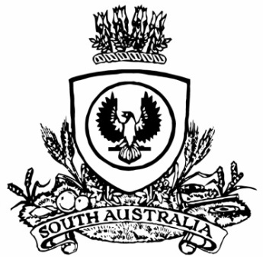
SUPPLEMENTARY GAZETTE
THE SOUTH AUSTRALIAN
GOVERNMENT GAZETTE
Published by Authority

Adelaide, Friday, 14 January 2022

Contents

Governor’s Instruments

Appointments 84

Proclamation—
Liquor Licensing (Conferral of Authority)
Proclamation 2022 85

Governor’s Instruments

APPOINTMENTS
Department of the Premier and Cabinet
Adelaide, 14 January 2022
Her Excellency the Governor in Executive Council has been pleased to appoint the undermentioned to the Adelaide Cemeteries Authority Board, pursuant to the provisions of the Adelaide Cemeteries Authority Act 2001:
Director: from 14 January 2022 until 13 January 2024
Patricia Christie
By command,
Steven Spence Marshall
Premier
MLG0026-21CS

Department of the Premier and Cabinet
Adelaide, 14 January 2022
Her Excellency the Governor in Executive Council has been pleased to appoint the undermentioned to the Veterinary Surgeons Board of South Australia, pursuant to the provisions of the Veterinary Practice Act 2003:
Member: from 14 January 2022 until 13 January 2025
Andrew Scott Hoare
Alejandra Isabel Arbe-Montoya
By command,
Steven Spence Marshall
Premier
MPI21/0037CS

Department of the Premier and Cabinet
Adelaide, 14 January 2022
Her Excellency the Governor in Executive Council has been pleased to appoint Anthony Brenton Allen QC as a Judge of the District Court of South Australia effective from 17 January 2022 – pursuant to section 12 of the District Court Act 1991.
By command,
Steven Spence Marshall
Premier
AGO0207-21CS

Department of the Premier and Cabinet
Adelaide, 14 January 2022
Her Excellency the Governor in Executive Council has been pleased to designate Anthony Brenton Allen QC as a Judge of the Environment, Resources and Development Court of South Australia effective from 17 January 2022 – pursuant to section 8(6) of the Environment, Resources and Development Court Act 1993.
By command,
Steven Spence Marshall
Premier
AGO0207-21CS

Proclamation
South Australia
Liquor Licensing (Conferral of Authority) Proclamation 2022
under section 15 of the Liquor Licensing Act 1997
1—Short title
This proclamation may be cited as the Liquor Licensing (Conferral of Authority) Proclamation 2022.
2—Commencement
This proclamation comes into operation on 17 January 2022.
3—Conferral of authority on District Court Judge
Authority is conferred on the District Court Judge named in Schedule 1 to exercise the jurisdiction of the Licensing Court of South Australia.
Schedule 1—District Court Judge on whom authority is conferred
His Honour Judge Anthony Brenton Allen
Made by the Governor
with the advice and consent of the Executive Council
on 14 January 2022

All instruments appearing in this gazette are to be considered official, and obeyed as such

Printed and published weekly by authority of S. Smith, Government Printer, South Australia
$8.00 per issue (plus postage), $402.00 per annual subscription—GST inclusive
Online publications: www.governmentgazette.sa.gov.au

