No. 46 p. 2117
THE SOUTH AUSTRALIAN
GOVERNMENT GAZETTE
Published by Authority

Adelaide, Thursday, 7 July 2022

Contents

Governor’s Instruments

Appointments 2118

South Australian Public Health Act 2011 2121

Proclamations—
Statutes Amendment (Local Government Review)
Act (Commencement) Proclamation 2022 2130
Correctional Services (Appointment of Visiting
Tribunals) Proclamation 2022 2131

Regulations—
Primary Produce (Food Safety Schemes) (Plant
Products) Regulations 2022—No.52 of 2022 2132
Plant Health Regulations 2022— No.53 of 2022 2135
Local Government (Elections) (Miscellaneous)
Amendment Regulations 2022— No.54 of 2022 2140
Local Government (General) (Electoral Advertising
Posters) Amendment Regulations 2022—
No.55 of 2022 2144

State Government Instruments

Administrative Arrangements Act 1994 2146

Associations Incorporation Act 1985 2146

Development Act 1993 2146

Environment Protection Act 1993 2148

Fisheries Management Act 2007 2153

Housing Improvement Act 2016 2153

Justices of the Peace Act 2005 2153

Land Acquisition Act 1969 2154

Petroleum and Geothermal Energy Act 2000 2155

Planning, Development and Infrastructure (General)
Regulations 2017 2155

Planning, Development and Infrastructure Act 2016 2159

The Remuneration Tribunal 2162

Waite Trust (Vesting of Land) Act 2020 2178

Local Government Instruments

City of Burnside 2179

City of Holdfast Bay 2179

City of Mitcham 2179

Rural City of Murray Bridge 2180

City of Port Lincoln 2181

City of Whyalla 2182

Barossa Council 2183

Berri Barmera Council 2183

District Council of Ceduna 2184

Clare & Gilbert Valleys Council 2184

District Council of Cleve 2185

Coorong District Council 2186

District Council of Elliston 2186

Kingston District Council 2187

Naracoorte Lucindale Council 2187

Southern Mallee District Council 2189

Public Notices

National Electricity Law 2190

National Energy Retail Law 2190

National Gas Law 2190

Sale of Property—
Warrant of Sale 2190

Trustee Act 1936 2191

Governor’s Instruments

Appointments
Department of the Premier and Cabinet
Adelaide, 7 July 2022
Her Excellency the Governor in Executive Council has been pleased to appoint Dr James Muecke AM as Governor's Deputy of South Australia for the periods from 7.00am on Sunday, 10 July 2022 until 9.00pm on Sunday, 10 July 2022 and 9.00am on Monday, 11 July 2022 until 10.00am on Wednesday, 13 July 2022.
By command,
Katrine Anne Hildyard, MP
For Premier

Department of the Premier and Cabinet
Adelaide, 7 July 2022
Her Excellency the Governor in Executive Council has been pleased to appoint the undermentioned to the Outback Communities Authority, pursuant to the provisions of the Outback Communities (Administration and Management) Act 2009:
Member: from 7 July 2022 until 30 June 2025
Janice Dawn Ferguson
Presiding Member: from 7 July 2022 until 30 September 2022
Janice Dawn Ferguson
By command,
Katrine Anne Hildyard, MP
For Premier
CAB2022/0004

Department of the Premier and Cabinet
Adelaide, 7 July 2022
Her Excellency the Governor in Executive Council has been pleased to appoint the Honourable Susan Elizabeth Close, MP, Deputy Premier, Minister for Industry, Innovation and Science as Acting Premier from 8 July 2022 until 22 July 2022 inclusive, during the absence of the Honourable Peter Bryden Malinauskas, MP.
By command,
Katrine Anne Hildyard, MP
For Premier
DPC22/059CS

Department of the Premier and Cabinet
Adelaide, 7 July 2022
Her Excellency the Governor in Executive Council has been pleased to appoint the Honourable Susan Elizabeth Close, MP, Deputy Premier, Minister for Industry, Innovation and Science as Acting Minister for Education, Training and Skills from 8 July 2022 until 17 July 2022 inclusive, during the absence of the Honourable Blair Ingram Boyer, MP.
By command,
Katrine Anne Hildyard, MP
For Premier
ME22-016

Department of the Premier and Cabinet
Adelaide, 7 July 2022
Her Excellency the Governor in Executive Council has been pleased to appoint the Honourable Susan Elizabeth Close, MP, Deputy Premier, Minister for Industry, Innovation and Science as Acting Minister for Infrastructure and Transport from 9 July 2022 until 31 July 2022 inclusive, during the absence of the Honourable Anastasios Koutsantonis, MP.
By command,
Katrine Anne Hildyard, MP
For Premier
22MIT0017CS

Department of the Premier and Cabinet
Adelaide, 7 July 2022
Her Excellency the Governor in Executive Council has been pleased to appoint the Honourable Christopher James Picton, MP, Minister for Health and Wellbeing as Acting Minister for Energy and Mining from 9 July 2022 until 31 July 2022 inclusive, during the absence of the Honourable Anastasios Koutsantonis, MP.
By command,
Katrine Anne Hildyard, MP
For Premier
22MIT0017CS

Department of the Premier and Cabinet
Adelaide, 7 July 2022
Her Excellency the Governor in Executive Council has been pleased to appoint the Honourable Katrine Anne Hildyard, MP, Minister for Child Protection, Minister for Women and the Prevention of Domestic and Family Violence, and Minister for Recreation, Sport and Racing as Acting Minister for Human Services from 9 July 2022 until 24 July 2022 inclusive, during the absence of the Honourable Natalie Fleur Cook, MP.
By command,
Katrine Anne Hildyard, MP
For Premier
MHS22002CS

Department of the Premier and Cabinet
Adelaide, 7 July 2022
Her Excellency the Governor in Executive Council has been pleased to appoint the Honourable Nicholas David Campion, MP, Minister for Trade and Investment, Minister for Housing and Urban Development and Minister for Planning as Acting Minister for Small and Family Business, Acting Minister for Consumer and Business Affairs and Acting Minister for Arts, from 9 July 2022 until 29 July 2022 inclusive, during the absence of the Honourable Andrea Michaels, MP.
By command,
Katrine Anne Hildyard, MP
For Premier
SFB0002-22CS

Department of the Premier and Cabinet
Adelaide, 7 July 2022
Her Excellency the Governor in Executive Council has been pleased to appoint the Honourable Kyam Joseph Maher, MLC, Minister for Aboriginal Affairs, Attorney-General and Minister for Industrial Relations and Public Sector as Acting Minister for Police, Emergency Services and Correctional Services from 10 July 2022 until 24 July 2022 inclusive, during the absence of the Honourable Joseph Karl Szakacs, MP.
By command,
Katrine Anne Hildyard, MP
For Premier
22MPO0003CS

Department of the Premier and Cabinet
Adelaide, 7 July 2022
Her Excellency the Governor in Executive Council has been pleased to appoint Ms Helen Connolly as Commissioner for Children and Young People for a period commencing on 16 July 2022 and expiring on 18 April 2025 - pursuant to the Children and Young People (Oversight and Advocacy Bodies) Act 2016.
By command,
Katrine Anne Hildyard, MP
For Premier
ME22/018

Department of the Premier and Cabinet
Adelaide, 7 July 2022
Her Excellency the Governor in Executive Council has been pleased to appoint Penelope Lesley Wright as the Guardian for Children and Young People for a term commencing on 10 July 2022 and expiring on 31 July 2022 - pursuant to section 22 of the Children and Young People (Oversight and Advocacy Bodies) Act 2016.
By command,
Katrine Anne Hildyard, MP
For Premier
MCP-F2022003483

Department of the Premier and Cabinet
Adelaide, 7 July 2022
Her Excellency the Governor in Executive Council has been pleased to appoint Shona Eliza Reid as the Guardian for Children and Young People for a term commencing on 1 August 2022 and expiring on 31 July 2027 - pursuant to section 22 of the Children and Young People (Oversight and Advocacy Bodies) Act 2016.
By command,
Katrine Anne Hildyard, MP
For Premier
MCP-F2022003483

Department of the Premier and Cabinet
Adelaide, 7 July 2022
Her Excellency the Governor in Executive Council has been pleased to appoint Shona Eliza Reid as the Training Centre Visitor for a term commencing on 1 August 2022 and expiring on 31 July 2027 - pursuant section 11 of the Youth Justice Administration Act 2016.
By command,
Katrine Anne Hildyard, MP
For Premier
MCP-F2022003483

Department of the Premier and Cabinet
Adelaide, 7 July 2022
Her Excellency the Governor in Executive Council has been pleased to appoint Shona Eliza Reid as the Child and Young Person's Visitor for a term commencing on 1 August 2022 and expiring on 31 July 2027 - pursuant section 117 of the Children and Young People (Safety) Act 2017.
By command,
Katrine Anne Hildyard, MP
For Premier
MCP-F2022003483

Department of the Premier and Cabinet
Adelaide, 7 July 2022
Her Excellency the Governor in Executive Council has been pleased to appoint Joyleen Thomas to the office of Official Visitor for a term commencing on 7 July 2022 and expiring on 1 July 2025 - pursuant to section 20 of the Correctional Services Act 1982.
By command,
Katrine Anne Hildyard, MP
For Premier
22MCS0004CS

South Australian Public Health Act 2011
South Australia
South Australian Public Health (COVID-19 Directions) Notice 2022
under section 90C of the South Australian Public Health Act 2011
Part 1—Preliminary
1—Short title
This notice may be cited as the South Australian Public Health (COVID-19 Directions) Notice 2022.
2—Commencement
This notice comes into operation on the expiry of clause 13 of the Emergency Management (COVID-19 Requirements) (Consolidated Measures) Direction 2022.
3—Interpretation
(1) In this notice—
allied health service means a service provided by any of the following:
(a) an art or creative therapist;
(b) an audiologist;
(c) a bowen therapist;
(d) a chiropractor;
(e) a counsellor;
(f) a dietitian;
(g) an exercise physiologist;
(h) a genetic counsellor;
(i) a music therapist;
(j) an occupational therapist;
(k) an optometrist;
(l) an orthoptist;
(m) an osteopath;
(n) a physiotherapist;
(o) a podiatrist;
(p) a prosthetist/orthotist;
(q) a psychologist;
(r) a radiation therapist;
(s) a radiographer;
(t) a rehabilitation counsellor;
(u) a social worker;
(v) a sonographer;
(w) a speech pathologist;
close contact means—
(a) a person who is a household member of a COVID-19 case during the relevant period of the COVID-19 case; or
(b) a person who is an intimate partner of a COVID-19 case during the relevant period of the COVID-19 case; or
(c) a person who has had close personal interaction with a COVID-19 case for a cumulative period of 4 hours or more during the relevant period of the COVID-19 case; or
(d) a person who has been at an exposure site during the exposure period for that site;
close personal interaction between a person and a COVID-19 case means interaction in close physical proximity occurring in an indoor setting where masks are not worn by the person and the COVID-19 case;
COVID-19 case means a person who has tested positive for COVID-19 (whether by COVID-19 PCR test or by COVID-19 Rapid Antigen Test);
COVID-19 PCR test means analysis of a combined oropharyngeal/nasal specimen taken by an appropriately trained and qualified health care worker to test for COVID19 (also referred to as SARS-CoV-2) using Polymerase Chain Reaction;
COVID-19 Rapid Antigen test means a self-collected antigen based test (upper respiratory tract or oropharyngeal specimen test) to test for COVID-19;
defined close contact period, in relation to a close contact, means the period comprised of—
(a) the day that is the close contact's exposure date; and
(b) the period of 7 days immediately following the close contact's exposure date;
disability care facility means a facility at which accommodation, and personal care or nursing care or both, are provided to persons with disability;
exposure date, in relation to a close contact, means—
(a) in relation to a close contact who is a household member of a COVID-19 case, the date the COVID-19 case first tested positive to COVID-19; or
(b) in relation to a close contact who is an intimate partner of, or has had close personal interaction with, a COVID-19 case, the date on which the close contact last had contact with the COVID-19 case; or
(c) in relation to a person who was present at an exposure site during an exposure period, the date on which they were last present at the site during the exposure period;
exposure site means a site listed on the SA Health website as an exposure site;
flexible care subsidy has the same meaning as the Aged Care Act 1997 of the Commonwealth;
health care services includes the following:
(a) a hospital;
(b) a general practice;
(c) a medical specialist service or practice;
(d) a mental health service or practice (including a drug and alcohol service);
(e) an allied health service;
(f) a service provided by a social worker in a health care centre;
(g) a complementary or alternative therapy service or practice (including Chinese medicine);
(h) a community health service (including an Aboriginal Community Controlled Health Service);
(i) a dental service;
(j) a reproductive health service (including a termination of pregnancy service);
(k) a sexual health service;
(l) a radiology service (including a screening service);
(m) a disability service;
(n) a rehabilitation service;
household member, of a COVID-19 case, means a member of a household of the COVID-19 case (being a person regularly living in such a household);
nominated residential premises means a residential premises nominated by a close contact or a COVID-19 case to undertake a period of quarantine or isolation;
notified—see subclause (2);
private pathology laboratory means a non-government pathology laboratory conducting Polymerase Chain Reaction COVID-19 tests (including Clinpath and Australian Clinical Labs);
relevant period, in relation to a COVID-19 case, means the period commencing 2 days prior to the onset of symptoms or a positive COVID-19 test result (whichever is earlier) and ending 7 days after their first positive COVID-19 test result;
residential aged care facility means—
(a) a facility at which accommodation, and personal care or nursing care or both, are provided to a person in respect of whom a residential care subsidy or a flexible care subsidy is payable under the Aged Care Act 1997 of the Commonwealth; or
(b) the aged care portion of a Multi-purpose Service (MPS) in which accommodation, and personal care or nursing care (or both), are provided to aged care residents, in aged care beds that are funded through the Commonwealth Government Multi-purpose Service Program; or
(c) that part of a regional hospital providing State funded residential aged care beds where accommodation, and personal care or nursing care (or both), are provided to a person in the same way as they would be if a residential care subsidy or a flexible care subsidy was payable under the Aged Care Act 1997 of the Commonwealth;
residential care subsidy has the same meaning as in the Aged Care Act 1997 of the Commonwealth;
SA Health website means https://www.sahealth.sa.gov.au/;
SoNG means the Series of National Guidelines—Coronavirus Disease 2019 (COVID19) CDNA National Guidelines for Public Health Units published by the Australian Commonwealth Government Department of Health;
symptoms of COVID-19 means any of the following symptoms:
(a) cough;
(b) sore throat;
(c) shortness of breath;
(d) runny nose;
(e) fever or history of fever or chills;
(f) acute loss of smell or taste;
(g) headache;
(h) muscle aches;
(i) unexplained fatigue;
(j) nausea;
(k) vomiting;
(l) diarrhoea;
Tier 1 sensitive setting means—
(a) a residential aged care facility; or
(b) a disability care facility; or
(c) a residential prison or correctional facility, training centre or other place of residential custody (other than short-term holding facilities); or
(d) a public or private hospital;
Tier 2 sensitive setting means—
(a) a health care service (other than a health care service that is a Tier 1 sensitive setting);
(b) a pharmacy;
(c) a pathology collection centre.
(2) For the purposes of this notice and without limiting the manner in which a person may be notified that they have tested positive for COVID-19 or are a close contact, a person is taken to have been notified that—
(a) they are a COVID-19 case upon—
(i) returning a positive COVID-19 Rapid Antigen test result; or
(ii) receiving a notice in writing (including SMS) by SA Pathology of a positive COVID-19 PCR test result; or
(iii) receiving notice in writing (including SMS) by a private pathology laboratory of a positive COVID-19 PCR test result; or
(iv) receiving telephone contact by SA Health informing them of a positive COVID-19 PCR test result; or
(b) they are a close contact upon—
(i) receiving notice in writing (including by SMS) by SA Health that they are a close contact; or
(ii) the relevant exposure site being published on the SA Health website; or
(iii) receiving telephone contact by SA Health informing them that they are a close contact; or
(iv) otherwise becoming aware that they are a close contact of a COVID-19 case.
Part 2—Directions
4—Directions—COVID-19 cases and close contacts
(1) A person who tests positive for COVID-19 must, on being first notified that they have tested positive to COVID-19, comply with the isolation, testing, reporting and other requirements specified in Schedule 1 clause 1.
(2) A person who is a close contact of a COVID-19 case must, on being first notified that they are a close contact of a COVID-19 case, comply with the quarantine, testing, reporting and other requirements specified in Schedule 1 clauses 2, 3 and 4.
(3) Subclauses (1) and (2) do not apply in relation to a person if—
(a) a protocol prescribing separate isolation, quarantine, testing, reporting and any other requirements for a specified workplace or industry has been made by the Chief Public Health Officer; and
(b) the relevant Chief Executive or person conducting a business or undertaking at the workplace or in the industry (as the case requires) implements the protocol and approves its application to the person.
(4) The relevant Chief Executive or person conducting a business or undertaking must ensure that the protocol in subclause (3)(a) is only implemented when necessary for the purposes of this direction, and that the person to whom the protocol applies complies with it.
(5) A person to whom a protocol referred to in subclause (3)(a) applies must, when not attending the specified workplace or industry or performing work or functions in relation to the specified workplace or industry, continue to comply with subclauses (1) and (2) as they may apply to the person.
(6) For the avoidance of doubt, this clause applies in relation to each instance of—
(a) a person's infection and reinfection with COVID-19; and
(b) a person being a close contact of a COVID-19 case.
Schedule 1—Direction requirements—COVID-19 cases and close contacts
1—COVID-19 cases
(1) A person who has tested positive for COVID-19 must isolate for a period of 7 days calculated to begin from the taking of the test.
Note—
For a person who returns a positive COVID-19 test result, having been tested on 10 July 2022, the 7 day period of isolation ends at 11:59pm on 17 July 2022 (see section 44(1) of the Legislation Interpretation Act 2021).
(2) A person required to isolate must isolate at—
(a) the person's nominated premises; or
(b) if an emergency officer has determined that the person should isolate at a hospital—a hospital specified by an emergency officer.
(3) A person who is to isolate at their nominated address must—
(a) travel by the most direct practical route and means to the nominated residential premises, if not already at those premises; and
(b) reside at the premises for the period required under this clause; and
(c) remain at those premises for the period required under this clause, except—
(i) for the purposes of obtaining urgent medical care; or
(ii) in any other emergency situation; or
(iii) for any reason approved in advance by the Chief Public Health Officer or an emergency officer,
during which times a mask must be worn at all times; and
(d) take reasonably practicable steps to remain isolated and segregated from other persons; and
(e) take reasonable steps to ensure that no other person enters the premises unless that other person—
(i) usually lives at the premises; or
(ii) is also complying with a direction to isolate or quarantine; or
(iii) is required to provide care and support to, or receive care and support from, the person to whom this direction applies at the place; or
(iv) is required for medical or emergency purposes; and
(f) follow all reasonable directions from a treating medical practitioner.
(4) A person who is required to isolate in a hospital must—
(a) remain in the hospital and follow all reasonable directions from a treating medical practitioner until a medical practitioner certifies that the person meets the criteria for discharge from a hospital in accordance with the SoNG; and
(b) on discharge, if the period for which the person was required to isolate has not elapsed, comply with the requirements of this clause as it applies to a person who is to reside at their nominated premises for the remainder of the period.
(5) A COVID-19 case who is suffering symptoms of COVID-19 on the 6th day of the period for which they are required to isolate must—
(a) report their symptoms to Chief Public Health Officer in a manner approved by the Chief Public Health Officer; and
(b) continue to isolate until the Chief Public Health Officer determines that they are no longer required to isolate.
(6) A COVID-19 case must notify any person who may reasonably be considered to be a close contact of the COVID19 case of their positive test result as soon as reasonably practicable after receiving that result.
(7) A person who has returned a positive result on a COVID-19 Rapid Antigen test must report their COVID-19 Rapid Antigen test result to Chief Public Health Officer in a manner approved by the Chief Public Health Officer.
2—Close contacts—general
(1) A person who is a close contact of a COVID-19 case must, during the defined close contact period for the person, wear a single use surgical mask whenever the person is not at their usual place of residence.
Example—
For a close contact whose exposure date is on 10 July, the period for which the person must wear a mask when not at their place of residence starts when the person is notified that they are a close contact and ends at 11:59 pm on 17 July 2022.
(2) A person who is a close contact must undertake 5 COVID-19 Rapid Antigen tests during the person's defined close contact period where—
(a) each test must be carried out at least 24 hours apart; and
(b) 1 test must be carried out on the 7th day after the close contact’s exposure date.
(3) A person who is a close contact must not attend a Tier 1 sensitive setting during the person's defined close contact period and the immediately following period of 7 days except—
(a) for the purpose of obtaining medical care or medical supplies; or
(b) if the close contact is an emergency services worker attending the Tier 1 setting to respond to an emergency.
(4) A person who is a close contact must not attend a Tier 2 sensitive setting during the person's defined close contact period except—
(a) for the purpose of obtaining medical care or medical supplies; or
(b) if the close contact is an emergency services worker attending the Tier 2 setting to respond to an emergency.
(5) A close contact must notify their employer, school or early childcare setting that they are a close contact as soon as reasonably practicable after being notified that they are a close contact.
(6) If a close contact develops any symptoms of COVID-19 during their defined close contact period, the close contact must—
(a) immediately seek to obtain a COVID-19 PCR test; and
(b) quarantine until they receive the result of the test.
(7) If the result of the COVID-19 PCR test referred in subclause (6) is negative, the close contact must continue to follow the requirements in this clause.
(8) Despite subclause (1), a close contact is not required to wear a mask—
(a) if they have a relevant serious medical condition; or
(b) in circumstances where the ability to see the mouth is essential for communication, such as to enable communication by or with any patron who is deaf or hard of hearing; or
(c) in circumstances where removal of the mask is lawfully required for identification purposes; or
(d) when the person is eating or drinking; or
(e) if the person is a child under 12 years of age.
(9) For the purpose of subclause (8)(a), a person must produce evidence of a relevant medical condition on request by an authorised officer.
3—Close contacts—quarantine requirements for symptomatic close contacts
(1) Subject to this clause, a close contact who develops symptoms of COVID-19 during their defined close contact period must—
(a) travel by the most direct practical route and means to a nominated residential premises, if not already at those premises; and
(b) reside and remain at the premises until receiving a negative COVID-19 PCR test result; and
(c) remain at those premises, except—
(i) for the purposes of obtaining medical care or medical supplies; or
(ii) in any other emergency situation; or
(iii) for any reason approved in advance by the Chief Public Health Officer or an emergency officer; or
(iv) for the purpose of undergoing a COVID-19 PCR test,
during which times a mask must be worn at all times and, in the case of a person leaving the premises to obtain a COVID-19 PCR test, the person must travel directly to the relevant site and inform the person performing the test of the reason for obtaining the test; and
(d) take reasonable steps to ensure that no other person enters the premises unless that other person—
(i) usually lives at the premises; or
(ii) is also complying with a direction to isolate; or
(iii) is required to provide care and support to, or receive care and support from, the person to whom this direction applies at the place; or
(iv) is required for medical or emergency purposes.
(2) An emergency officer may, by notice in writing issued to a close contact who develops symptoms of COVID-19 during their defined close contact period, determine that the close contact must quarantine in a hospital specified in the notice.
(3) A person who is given a notice under subclause (2) must comply with the requirement specified in the notice.
4—Close contacts—residents of residential aged care facilities, disability care facility, hospital setting or correctional facility
In addition to the requirements in clauses 2 and 3, a close contact who is a resident of a residential aged care facility, disability care facility, hospital setting or correctional facility must—
(a) while remaining at those facilities, remain quarantined, isolated and segregated from other residents (to the extent possible), for the close contact's defined close contact period; and
(b) not participate in group activities with other residents (to the extent possible) for the defined close contact period; and
(c) undertake testing in accordance with the requirements of the facility outbreak plan.
Schedule 2—Transitional provisions
1—Transitional provisions
(1) If a person has been notified before the commencement of this notice that they are a COVID-19 case or a close contact, on commencement of this notice an obligation applying to the person in relation to isolation, quarantine, testing, reporting or other requirements under a relevant provision of the Emergency Management (COVID-19 Requirements) (Consolidated Measures) Direction 2022 will cease to apply and Schedule 1 of this notice will apply to the person instead (subject to clause 4(3)).
(2) In this clause—
relevant provision, of the Emergency Management (COVID-19 Requirements) (Consolidated Measures) Direction 2022, means clause 13, 14 or 15, or a provision of Schedule 1 of that direction.
Made by the Governor
with the advice and consent of the Executive Council
on 7 July 2022

Proclamations
South Australia

Statutes Amendment (Local Government Review) Act (Commencement) Proclamation 2022
1—Short title
This proclamation may be cited as the Statutes Amendment (Local Government Review) Act (Commencement) Proclamation 2022.
2—Commencement of suspended provisions
The following provisions of the Statutes Amendment (Local Government Review) Act 2021 (No 26 of 2021) come into operation on 7 July 2022:
(a) section 150(5) and (8);
(b) section 150(9), but only insofar as it inserts subsection (8) into section 6 of the Local Government (Elections) Act 1999;
(c) section 151;
(d) section 160;
(e) section 174.
Made by the Governor
with the advice and consent of the Executive Council
on 7 July 2022

South Australia

Correctional Services (Appointment of Visiting Tribunals) Proclamation 2022
under section 17 of the Correctional Services Act 1982
1—Short title
This proclamation may be cited as the Correctional Services (Appointment of Visiting Tribunals) Proclamation 2022.
2—Commencement
This proclamation comes into operation on the day on which it is made.
3—Repeal of proclamations
All proclamations previously made pursuant to section 17 of the Correctional Services Act 1982 are repealed.
4—Appointment of Visiting Tribunals
Pursuant to section 17 of the Correctional Services Act 1982 the following persons are appointed as Visiting Tribunals for each of the correctional institutions listed in Schedule 1:
Robert Neale Dempsey
Marlene Natasha Haese
Schedule 1—Correctional Institutions
Adelaide Remand Centre
Cadell Training Centre
Mobilong Prison
Mount Gambier Prison
Northfield Prison Complex (now known as the Adelaide Women's Prison and the Adelaide Pre-Release Centre)
Port Augusta Gaol (now known as the Port Augusta Prison)
Port Lincoln Prison
Yatala Labour Prison
Made by the Governor
with the advice and consent of the Executive Council
on 7 July 2022

Regulations
South Australia

Primary Produce (Food Safety Schemes) (Plant Products) Regulations 2022
under the Primary Produce (Food Safety Schemes) Act 2004

Contents
Part 1—Preliminary
1 Short title
2 Commencement
3 Interpretation
Part 2—Seed sprouts
4 Seed sprouts food safety scheme
5 Obligation to be accredited
6 Requirements for accreditation
7 Compliance with Standard 4.2.6 of Food Standards Code
8 Approved food safety arrangements
9 Auditing approved food safety arrangements
10 Fees, charges and returns
11 Fee payable before grant of accreditation
Schedule 1—Repeal of Primary Produce (Food Safety Schemes) (Plant Products) Regulations 2010

Part 1—Preliminary
1—Short title
These regulations may be cited as the Primary Produce (Food Safety Schemes) (Plant Products) Regulations 2022.
2—Commencement
These regulations come into operation on 1 August 2022.
3—Interpretation
In these regulations, unless the contrary intention appears—
accredited producer means a person accredited under these regulations to carry on a seed sprouts production business;
Act means the Primary Produce (Food Safety Schemes) Act 2004;
Food Standards Code has the same meaning as in the Food Act 2001;
seed sprouts production means the production of seed sprouts intended for consumption by humans;
seed sprouts means young seedlings grown from—
(a) alfalfa, broccoli, clover, onion, radish or sunflower seeds or other seeds;
(b) mung beans or other beans;
(c) snow peas or other peas.
Part 2—Seed sprouts
4—Seed sprouts food safety scheme
(1) This Part establishes a food safety scheme for carrying on the business of seed sprouts production.
(2) The Minister is the accreditation body for the seed sprouts food safety scheme.
5—Obligation to be accredited
For the purposes of section 12 of the Act, a person must not carry on the business of seed sprouts production without an accreditation.
6—Requirements for accreditation
For the purposes of section 15(1)(c) of the Act, an applicant for accreditation must satisfy the Minister that the applicant has the capacity, or has made or proposes to make appropriate arrangements, to satisfy the requirements of the Act and these regulations applicable to the activities to be accredited.
7—Compliance with Standard 4.2.6 of Food Standards Code
An accredited producer must ensure that the activities under the accreditation are carried on in compliance with Standard 4.2.6 of the Food Standards Code (despite the fact that the Standard excludes food businesses that fall under the definition of primary food production from compliance with that Standard).
Maximum penalty: $5 000.
Expiation fee: $315.
8—Approved food safety arrangements
An accredited producer must have a food safety arrangement approved by the Minister.
9—Auditing approved food safety arrangements
(1) An accredited producer must allow an approved auditor to perform, without notice to the producer—
(a) the number of periodic audits of the producer's compliance with the producer's approved food safety arrangement required by the terms of that arrangement; and
(b) if an audit shows a failure to comply with the food safety arrangement—such additional audits as the Minister considers appropriate.
(2) An accredited producer must pay all of the costs associated with the audits.
10—Fees, charges and returns
(1) For the purposes of section 17 of the Act, for each year, an accredited producer must, not later than the day and month specified by the Minister by notice in writing to the accredited producer—
(a) pay to the Minister the annual fee prescribed by fee notice; and
(b) lodge with the Minister a return that conforms to the requirements of the Minister about its form, contents and the manner in which it is made.
(2) The penalty for default in payment of an annual fee or lodging an annual return is as prescribed by fee notice.
(3) The Minister may waive, defer or reduce payment of a fee if the Minister considers it appropriate to do so in the circumstances.
(4) The Minister may recover an amount payable to the Minister by way of a fee or part of a fee as a debt from the person liable to pay.
(5) In this regulation—
fee means a fee prescribed by fee notice;
fee notice has the same meaning as in the Legislation (Fees) Act 2019.
11—Fee payable before grant of accreditation
Before a person is granted accreditation, the person must pay a fee of an amount calculated by multiplying—
(a) the annual fee that would have been payable by or on behalf of the person had the person been an accredited producer at the last date for payment of the annual fee; and
(b) the proportion that the number of whole months between the grant of accreditation and the next date for payment of the annual fee bears to 12 months.
Schedule 1—Repeal of Primary Produce (Food Safety Schemes) (Plant Products) Regulations 2010
The Primary Produce (Food Safety Schemes) (Plant Products) Regulations 2010 are repealed.
Editorial note—
As required by section 10AA(2) of the Legislative Instruments Act 1978, the Minister has certified that, in the Minister's opinion, it is necessary or appropriate that these regulations come into operation as set out in these regulations.
Made by the Governor
with the advice and consent of the Executive Council
on 7 July 2022
No 52 of 2022

South Australia

Plant Health Regulations 2022
under the Plant Health Act 2009

Contents
1 Short title
2 Commencement
3 Interpretation
4 Declaration of corresponding laws
5 Packaging and labelling of fruit, vegetables and nuts for sale
6 Identification and labelling of plants sold for propagation
7 Accreditation of persons
8 Registration of importers
9 Exemptions
10 Fees
Schedule 1—Prescribed plants for propagation
Schedule 2—Repeal of Plant Health Regulations 2009

1—Short title
These regulations may be cited as the Plant Health Regulations 2022.
2—Commencement
These regulations come into operation on 1 August 2022.
3—Interpretation
(1) In these regulations, unless the contrary intention appears—
Act means the Plant Health Act 2009;
ICA means the scheme for Interstate Certification Assurance relating to plant quarantine requirements developed by the States in accordance with the Memorandum of Understanding agreed on 6 August 1999 at the sixteenth meeting of the Agriculture and Resource Management Council of Australia and New Zealand;
IP number means the unique identifier (comprising a combination of letters and numbers) assigned to an accredited person;
operational procedure means an operational procedure agreed under the ICA included in the list of operational procedures as published from time to time on the website maintained by the Domestic Quarantine Market Access Working Group, a subcommittee of the national Plant Health Committee.
(2) In these regulations, a reference to the Plant Quarantine Standard is—
(a) a reference to the Plant Quarantine Standard South Australia adopted by the notice under the Fruit and Plant Protection Act 1992 signed by the Minister on 6 February 2006 (see Gazette 16.2.2006 p552) as in force immediately before the commencement of clause 6(2) of Schedule 1 of the Act; or
(b) if the Minister, by notice under the Act, adopts some other plant quarantine standard—a reference to that other standard.
4—Declaration of corresponding laws
For the purposes of the definition of corresponding law in section 3(1) of the Act, the following Acts are declared to be corresponding laws:
(a) the Pest Plants and Animals Act 2005 of the Australian Capital Territory;
(b) the Biosecurity and Agriculture Management Act 2007 of Western Australia;
(c) the Biosecurity Act 2015 of New South Wales;
(d) the Plant Health Act 2008 of the Northern Territory;
(e) the Plant Biosecurity Act 2010 of Victoria;
(f) the Biosecurity Act 2014 of Queensland;
(g) the Plant Quarantine Act 1997 of Tasmania.
5—Packaging and labelling of fruit, vegetables and nuts for sale
(1) For the purposes of section 12(1)(d) of the Act, a person who packs for sale any fruit, vegetables or nuts must label the packaging as follows:
(a) the label must—
(i) be legibly written in English in permanent ink in letters at least 5 mm in height; and
(ii) be clearly visible on the outside of the packaging;
(b) if the person doing the packing is an accredited person—the label must include—
(i) the date (or date code) on which the produce was packed; and
(ii) a brief description of the contents of the package; and
(iii) the IP number of the accredited person; and
(iv) either—
(A) a code approved by the Chief Inspector for the purposes of this subparagraph indicating where the produce was grown; or
(B) the postcode of the town nearest to the place of production; and
(v) the words "meets ICA" followed by the number that identifies the particular ICA operational procedures that have been followed and met in respect of the produce;
(c) in any other case—
(i) the date (or date code) on which the produce was packed; and
(ii) a brief description of the contents of the package; and
(iii) the district of production; and
(iv) either—
(A) the name, address and postcode of both the grower and packer of the produce; or
(B) the codes approved for the purpose by the Chief Inspector for the purposes of this subparagraph identifying both the packer and grower.
Maximum penalty: $5 000.
Expiation fee: $315.
(2) A person must not pack for sale or sell any fruit, vegetables or nuts in used packaging unless the packaging—
(a) is in good repair; and
(b) is clean and free of extraneous visible matter; and
(c) is free of any objectionable odour; and
(d) is labelled in accordance with subregulation (1).
Maximum penalty: $5 000.
Expiation fee: $315.
(3) This regulation does not apply to a person who has been approved by the Chief Inspector to receive bulk loads of produce for processing.
(4) In this regulation—
date code means a code approved by the Chief Inspector for the purposes of this regulation indicating the date on which produce is packed.
6—Identification and labelling of plants sold for propagation
(1) For the purposes of section 13 of the Act, the plants listed in Schedule 1 are prescribed (a prescribed plant).
(2) A person must not sell for propagation a prescribed plant that has been brought or introduced into the State unless it is accompanied by—
(a) an assurance certificate or a plant health certificate issued in respect of the prescribed plant; and
(b) any other document issued in respect of the prescribed plant as required by the Minister and set out in the Plant Quarantine Standard.
Maximum penalty: $5 000.
Expiation fee: $315.
7—Accreditation of persons
(1) For the purposes of sections 17(1)(c) and 20(2)(f) of the Act, the prescribed protocols and operational procedures are the protocols and operational procedures specified by the Minister in respect of the particular authority conferred by the accreditation granted to a particular applicant.
(2) For the purposes of section 20(3) of the Act, the following conditions are prescribed:
(a) a condition imposed under section 20(2)(e);
(b) a condition imposed under section 20(2)(i).
8—Registration of importers
For the purposes of sections 27(1)(c) and 28(2)(c) of the Act, the prescribed protocols and operational procedures are the protocols and operational procedures specified by the Minister in respect of the particular authority conferred by the registration granted to a particular applicant.
9—Exemptions
The Minister may, in the Minister's discretion, by notice in the Gazette, exempt conditionally or unconditionally a class of persons, plants, plant related products or activities specified in the notice from the application of the Act or a specified provision of the Act, as determined by the Minister.
10—Fees
(1) The Minister may, on application or on the Minister's own initiative, in the Minister's discretion, waive payment of the whole or a part of a prescribed fee.
(2) In addition, the following are exempt from the relevant fees prescribed for the purposes of the Act:
(a) an application for registration as an importer where the applicant is—
(i) an accredited person; or
(ii) an agency or instrumentality of the Crown;
(b) an application for variation of registration as an importer where the applicant is—
(i) an accredited person; or
(ii) an agency or instrumentality of the Crown;
(c) an annual fee payable by a registered importer where the importer is—
(i) an accredited person; or
(ii) an agency or instrumentality of the Crown.
Schedule 1—Prescribed plants for propagation

Common name | Scientific name
Citrus | Citrus spp
Date palm offshoots | Phoenix dactylifera
Grapevines | Vitis spp
Pinus plants | Pinus spp
Tomato plants | Solanum lycopersicum (syn. Lycopersicon esculentum)

Schedule 2—Repeal of Plant Health Regulations 2009
The Plant Health Regulations 2009 are repealed.
Editorial note—
As required by section 10AA(2) of the Legislative Instruments Act 1978, the Minister has certified that, in the Minister's opinion, it is necessary or appropriate that these regulations come into operation as set out in these regulations.
Made by the Governor
with the advice and consent of the Executive Council
on 7 July 2022
No 53 of 2022

South Australia

Local Government (Elections) (Miscellaneous) Amendment Regulations 2022
under the Local Government (Elections) Act 1999

Contents
Part 1—Preliminary
1 Short title
2 Commencement
Part 2—Amendment of Local Government (Elections) Regulations 2010
3 Insertion of regulation 3A
3A Filling vacancy in certain circumstances
4 Amendment of regulation 5—Manner in which nominations are made
5 Insertion of regulation 10A
10A Filling vacancy if successful candidate dies

Part 1—Preliminary
1—Short title
These regulations may be cited as the Local Government (Elections) (Miscellaneous) Amendment Regulations 2022.
2—Commencement
These regulations come into operation on the day on which section 151 of the Statutes Amendment (Local Government Review) Act 2021 comes into operation.
Part 2—Amendment of Local Government (Elections) Regulations 2010
3—Insertion of regulation 3A
Before regulation 4 insert:
3A—Filling vacancy in certain circumstances
(1) For the purposes of section 6A(2)(a) of the Act—
(a) the returning officer must contact each candidate who was not elected in the most recent election for the relevant office or the designated supplementary election referred to in section 6(2)(c)(ii)(B) of the Act (as the case requires) to request that the candidate make a declaration under paragraph (b); and
(b) a candidate may, within the relevant period and in a form determined by the returning officer, make a declaration that they are still willing and eligible to be elected to the relevant office (an eligible candidate); and
(c) if, after the relevant period—
(i) there is 1 eligible candidate—that candidate will be determined to fill the vacancy; or
(ii) there is more than 1 eligible candidate—the returning officer must determine which of the eligible candidates will fill the vacancy or vacancies by recounting the votes in accordance with—
(A) if there is 1 vacancy—section 48(1a) of the Act as modified by subregulation (2); or
(B) if there is more than 1 vacancy—section 48(1) of the Act as modified by subregulation (2).
(2) For the purposes of a recount under subregulation (1), section 48 of the Act is modified as follows:
(a) a vote indicated on a ballot paper opposite the name of the candidate in whose office the vacancy occurred will be counted to the eligible candidate next in order of the voter's preference;
(b) in addition, a vote indicated on a ballot paper opposite the name of a candidate who is not an eligible candidate will be counted to the eligible candidate next in order of the voter's preference;
(c) after the returning officer gives effect to paragraphs (a) and (b), the numbers indicating subsequent preferences on the relevant ballot papers will be taken to have been altered accordingly;
(d) a reference in section 48 to a candidate will be taken to be a reference to an eligible candidate.
(3) To avoid doubt, a recount under subregulation (1) does not affect the election of any other member according to the votes actually cast at the election.
(4) A declaration under section 6A(2)(c)(i) of the Act will be taken to be a provisional declaration and a candidate (not being a successful candidate) may request a recount on the basis of this declaration in the manner contemplated by section 49 of the Act and the returning officer may then take such action that may be appropriate in the manner contemplated by section 50 of the Act.
(5) For the purposes of section 6A(2)(c)(ii) of the Act, the returning officer must determine the next successful candidate in such manner as the returning officer sees fit.
(6) To avoid doubt, for the purposes of this regulation, a reference to an eligible candidate in relation to a recount does not include a reference to a candidate who is, immediately before the commencement of the recount, an elected member of the council.
(7) In this regulation—
relevant period means the period determined by the returning officer.
4—Amendment of regulation 5—Manner in which nominations are made
(1) Regulation 5(2)(b)—delete paragraph (b) and substitute:
(b) the profile must not, subject to subregulation (2a), exceed 1 000 characters;
(2) Regulation 5—after subregulation (2) insert:
(2a) The contact details, statement and information provided under subregulation (2)(d), (e) and (f) (respectively) are excluded from the 1 000 character limit imposed by subregulation (2)(b) and the operation of subregulation (3).
(3) Regulation 5(3)—delete subregulation (3) and substitute:
(3) Subject to subregulation (2a), if—
(a) a profile submitted with a nomination form exceeds 1 000 characters; and
(b) the candidate has not reduced the size of the profile to 1 000 characters or less by the close of nominations,
the returning officer will exclude from the profile all characters appearing after the 1 000th character.
(4) Regulation 5(8)(d)—delete "bear on its back an endorsement" and substitute:
, in a manner determined by the Electoral Commissioner, be endorsed
5—Insertion of regulation 10A
After regulation 10 insert:
10A—Filling vacancy if successful candidate dies
(1) For the purposes of section 55A(2)(a) of the Act—
(a) the returning officer must contact each candidate who was not elected in the most recent election for the relevant office to request that the candidate make a declaration under paragraph (b); and
(b) a candidate may, within the relevant period and in a form determined by the returning officer, make a declaration that they are still willing and eligible to be elected to the relevant office (an eligible candidate); and
(c) if, after the relevant period—
(i) there is 1 eligible candidate—that candidate will be determined to fill the vacancy; or
(ii) there is more than 1 eligible candidate—the returning officer must determine which of the eligible candidates will fill the vacancy by recounting the votes in accordance with section 48(1a) of the Act as modified by subregulation (2).
(2) For the purposes of a recount under subregulation (1), section 48 of the Act is modified as follows:
(a) a vote indicated on a ballot paper opposite the name of the candidate in whose office the vacancy occurred will be counted to the eligible candidate next in order of the voter's preference;
(b) in addition, a vote indicated on a ballot paper opposite the name of a candidate who is not an eligible candidate will be counted to the eligible candidate next in order of the voter's preference;
(c) after the returning officer gives effect to paragraphs (a) and (b), the numbers indicating subsequent preferences on the relevant ballot papers will be taken to have been altered accordingly;
(d) a reference in section 48 to a candidate will be taken to be a reference to an eligible candidate.
(3) To avoid doubt, a recount under subregulation (1) does not affect the election of any other member according to the votes actually cast at the election.
(4) A declaration under section 55A(2)(c)(i) of the Act will be taken to be a provisional declaration and a candidate (not being a successful candidate) may request a recount on the basis of this declaration in the manner contemplated by section 49 of the Act and the returning officer may then take such action that may be appropriate in the manner contemplated by section 50 of the Act.
(5) For the purposes of section 55A(2)(c)(ii) of the Act, the returning officer must determine the next successful candidate in such manner as the returning officer sees fit.
(6) To avoid doubt, for the purposes of this regulation, a reference to an eligible candidate in relation to a recount does not include a reference to a candidate who is, immediately before the commencement of the recount, an elected member of the council.
(7) In this regulation—
relevant period means the period determined by the returning officer.
Editorial note—
As required by section 10AA(2) of the Legislative Instruments Act 1978, the Minister has certified that, in the Minister's opinion, it is necessary or appropriate that these regulations come into operation as set out in these regulations.
Made by the Governor
after consultation with the Local Government Association and with the advice and consent of the Executive Council
on 7 July 2022
No 54 of 2022

South Australia

Local Government (General) (Electoral Advertising Posters) Amendment Regulations 2022
under the Local Government Act 1999

Contents
Part 1—Preliminary
1 Short title
2 Commencement
Part 2—Amendment of Local Government (General) Regulations 2013
3 Insertion of regulation 25A
25A Electoral advertising posters

Part 1—Preliminary
1—Short title
These regulations may be cited as the Local Government (General) (Electoral Advertising Posters) Amendment Regulations 2022.
2—Commencement
These regulations come into operation on the day on which they are made.
Part 2—Amendment of Local Government (General) Regulations 2013
3—Insertion of regulation 25A
After regulation 25 insert:
25A—Electoral advertising posters
For the purposes of section 226(2a) of the Act, circumstances in which an electoral advertising poster—
(a) is published by or on behalf of the Electoral Commissioner, the LGA or a council; and
(b) contains advertising relating to any matter referred to in section 13A(1) of the Local Government (Elections) Act 1999; and
(c) is not calculated to affect the result of an election,
are prescribed.

Editorial note—
As required by section 10AA(2) of the Legislative Instruments Act 1978, the Minister has certified that, in the Minister's opinion, it is necessary or appropriate that these regulations come into operation as set out in these regulations.
Made by the Governor
after consultation with the Local Government Association and with the advice and consent of the Executive Council
on 7 July 2022
No 55 of 2022

State Government Instruments

Administrative Arrangements Act 1994
Delegation under section 9
I, Nicholas David Champion, as Minister for Housing and Urban Development, hereby delegate to the Treasurer under section 9 of the Administrative Arrangements Act 1994 all of my powers and functions under the Urban Renewal Act 1995, in so far as they relate to HomeStart Finance, and all of my powers and functions under the Urban Renewal (HomeStart Finance) Regulations 2020.
This instrument of delegation has effect from the day on which it is published in the Government Gazette.
Dated: 6 July 2022
Hon Nicholas Champion MP
Minister for Housing and Urban Development

Associations Incorporation Act 1985
Section 42(2)
Dissolution of Association
WHEREAS the CORPORATE AFFAIRS COMMISSION (the Commission) pursuant to section 42(1) of the Associations Incorporation Act 1985 (the Act) is of the opinion that the undertaking or operations of LANSONES VILLAGE HOUSING COOPERATIVE INCORPORATED (the Association) being an incorporated association under the Act are being carried on, or would more appropriately be carried on by a company limited by guarantee incorporated under the Corporations Act 2001 (Cth) AND WHEREAS the Commission was on 26 April 2022 requested by the Association to transfer its undertaking to COMMON EQUITY HOUSING SOUTH AUSTRALIA LTD (Australian Company Number 146 523 453), the Commission pursuant to section 42(2) of the Act DOES HEREBY ORDER that on 7 July 2022, the Association will be dissolved, the property of the Association becomes the property of COMMON EQUITY HOUSING SOUTH AUSTRALIA LTD and the rights and liabilities of the Association become the rights and liabilities of COMMON EQUITY HOUSING SOUTH AUSTRALIA LTD.
Given under the seal of the Commission at Adelaide.
Dated: 4 July 2022
Melissa Matthews
A delegate of the Corporate Affairs Commission

Associations Incorporation Act 1985
Section 42(2)
Dissolution of Association
WHEREAS the CORPORATE AFFAIRS COMMISSION (the Commission) pursuant to section 42(1) of the Associations Incorporation Act 1985 (the Act) is of the opinion that the undertaking or operations of SYP COMMUNITY HOUSING ASSOCIATION INCORPORATED (the Association) being an incorporated association under the Act are being carried on, or would more appropriately be carried on by a company limited by guarantee incorporated under the Corporations Act 2001 (Cth) AND WHEREAS the Commission was on 12 June 2022 requested by the Association to transfer its undertaking to UNITING COUNTRY HOUSING LTD (Australian Company Number 639 284 790), the Commission pursuant to section 42(2) of the Act DOES HEREBY ORDER that on 7 July 2022, the Association will be dissolved, the property of the Association becomes the property of UNITING COUNTRY HOUSING LTD and the rights and liabilities of the Association become the rights and liabilities of UNITING COUNTRY HOUSING LTD.
Given under the seal of the Commission at Adelaide.
Dated: 5 July 2022
Melissa Matthews
A delegate of the Corporate Affairs Commission

Development Act 1993
Section 46(4)
Notice of Revocation of Major Development Declaration
Preamble
- Clause 28(2) of the Olympic Dam and Stuart Shelf Indenture (the Indenture), in the Schedule to the Roxby Downs (Indenture Ratification) Act 1982, provides that, in relation to the land referred to in clause 28(1), references to the ‘Minister’ in Division 2 of Part 4 of the Development Act 1993 are to be taken to be references to the Minister responsible for the administration of the Roxby Downs (Indenture Ratification) Act 1982 for the time being (the Indenture Minister).
- By notice pursuant to section 46(1) of the Development Act 1993, published in the Gazette on 14 February 2019 on pages 461-462, the Indenture Minister declared that section 46 of the Development Act 1993 applied to certain development on the relevant land, to be undertaken as part of the proposed Olympic Dam Resource Development Strategy (the declaration).
- By notice pursuant to section 46(4) of the Development Act 1993, published in the Gazette on 19 September 2019 on pages 3309-3310 (the second notice), the Indenture Minister varied the declaration.
- On 2 October 2019 BHP Billiton Olympic Dam Corporation Pty Ltd (the applicant), invoking clause 7 of the Indenture, lodged with the Indenture Minister an application, under section 46(6) of the Development Act 1993, for development authorisation in relation to development that included development within the ambit of the declaration, as varied by the second notice (the application).
- By notice pursuant to section 46(4) of the Development Act 1993, published in the Gazette on 27 August 2020 on pages 4474-4475 (the third notice), the Indenture Minister further varied the declaration.
- By letter to the Indenture Minister dated 18 November 2021, the applicant withdrew the application.
Revocation
Pursuant to section 46(4) of the Development Act 1993, as it applies pursuant to regulation 11(3) of the Planning, Development and Infrastructure (Transitional Provisions) Regulations 2017, (or if the Planning, Development and Infrastructure Act 2016 now applies to the declaration, pursuant to section 108(6) of that Act), I revoke the declaration, as varied by the second notice and the third notice.
Dated: 30 June 2022
Hon Tom Koutsantonis MP
Minister for Energy and Mining

Development Act 1993
Section 46(4)
Notice of Revocation of Major Development Declaration
Preamble
- By notice pursuant to section 46(1) of the Development Act 1993, published in the Gazette on 14 February 2019 on page 461, the Minister for Planning declared that section 46 of the Development Act 1993 applied to certain development to be undertaken as part of the proposed Olympic Dam Resource Development Strategy (the declaration).
- By notice pursuant to section 46(4) of the Development Act 1993, published in the Gazette on 19 September 2019 on pages 3307-3308 (the second notice), the Minister for Planning varied the declaration.
- On 2 October 2019 BHP Billiton Olympic Dam Corporation Pty Ltd (the applicant), invoking clause 7 of the Olympic Dam and Stuart Shelf Indenture, lodged, with the Minister responsible for the administration of the Roxby Downs (Indenture Ratification) Act 1982 (the Indenture Minister), an application, under section 46(6) of the Development Act 1993, for development authorisation in relation to development that included development within the ambit of the declaration, as varied by the second notice (the application).
- By notice pursuant to section 46(4) of the Development Act 1993, published in the Gazette on 27 August 2020 on pages 4471-4473 (the third notice), the Minister for Planning and Local Government further varied the declaration.
- By letter to the Indenture Minister dated 18 November 2021, the applicant withdrew the application.
Revocation
Pursuant to section 46(4) of the Development Act 1993, as it applies pursuant to regulation 11(3) of the Planning, Development and Infrastructure (Transitional Provisions) Regulations 2017, (or if the Planning, Development and Infrastructure Act 2016 now applies to the declaration, pursuant to section 108(6) of that Act), I revoke the declaration, as varied by the second notice and the third notice.
Dated: 30 June 2022
Hon Nicholas David Champion MP
Minister for Planning

Development Act 1993
Section 46(3)(b)
Termination of Undertaking
To: BHP Olympic Dam Corporation Pty Ltd (formerly BHP Billiton Olympic Dam Corporation Pty Ltd) (BHP)
- Clause 28(2) of the Olympic Dam and Stuart Shelf Indenture (the Indenture), in the Schedule to the Roxby Downs (Indenture Ratification) Act 1982, provides that, in relation to the land referred to in clause 28(1), references to the ‘Minister’ in Division 2 of Part 4 of the Development Act 1993 are to be taken to be references to the Minister responsible for the administration of the Roxby Downs (Indenture Ratification) Act 1982 for the time being (the Indenture Minister).
- By notice pursuant to section 46(1) of the Development Act 1993, published in the Gazette on 14 February 2019 on pages 461-462, the Indenture Minister declared that section 46 of the Development Act 1993 applied to certain development on the relevant land, proposed as part of the Olympic Dam Resource Development Strategy (the declaration). The declaration was subsequently varied twice, pursuant to section 46(4) of the Development Act 1993, by notices published in the Gazette on 19 September 2019 (on pages 3309-3310) and 27 August 2020 (on pages 4474-4475).
- By notice pursuant to section 46(2)(b) of the Development Act 1993, published in the Gazette on 19 September 2019 on p.3308, the Indenture Minister gave BHP an undertaking that Division 2 of Part 4 of the Development Act 1993 would not apply to certain development that would otherwise be within the ambit of the declaration (the undertaking). The undertaking was subsequently varied, pursuant to section 46(2)(b) of the Development Act 1993, by notice published in the Gazette on 27 August 2020 on pages 4473-4474.
- On 2 October 2019 BHP, invoking clause 7 of the Indenture, lodged with the Indenture Minister an application, under section 46(6) of the Development Act 1993, for development authorisation in relation to development that included development within the ambit of the declaration, as varied (the application).
- By letter to the Indenture Minister dated 18 November 2021, BHP withdrew the application.
- By notice pursuant to section 46(4) of the Development Act 1993, published in the Gazette contemporaneously with the publication of this notice, I revoked the declaration, as varied.
- I consider that the undertaking should no longer apply because there has been a significant change in circumstances since it was varied in August 2020.
- Pursuant to section 46(3)(b) of the Development Act 1993, as it applies pursuant to regulation 11(3) of the Planning, Development and Infrastructure (Transitional Provisions) Regulations 2017, I bring the operation of the undertaking, as varied, to an end.
- A reference in this notice to the Development Act 1993 is a reference to that Act as affected by the Roxby Downs (Indenture Ratification) Act 1982 and the Indenture.
Dated: 30 June 2022
Hon Tom Koutsantonis MP
Minister for Energy and Mining

Development Act 1993
Section 46(3)(b)
Termination of Undertaking
To: BHP Olympic Dam Corporation Pty Ltd (formerly BHP Billiton Olympic Dam Corporation Pty Ltd) (BHP)
- By notice pursuant to section 46(1) of the Development Act 1993, published in the Gazette on 14 February 2019 on page 461, the Minister for Planning declared that section 46 of the Development Act 1993 applied to certain development to be undertaken as part of the proposed Olympic Dam Resource Development Strategy (the declaration). The declaration was subsequently varied twice, pursuant to section 46(4) of the Development Act 1993, by notices published in the Gazette on 19 September 2019 (on pages 3307-3308) and 27 August 2020 (on pages 4471-4473).
- By notice pursuant to section 46(2)(b) of the Development Act 1993, published in the Gazette on 19 September 2019 on p.3306, the Minister for Planning gave BHP an undertaking that Division 2 of Part 4 of the Development Act 1993 would not apply to certain development that would otherwise be within the ambit of the declaration (the undertaking). The undertaking was subsequently varied, pursuant to section 46(2)(b) of the Development Act 1993, by notice published in the Gazette on 27 August 2020 on pages 4470-4471.
- On 2 October 2019 BHP, invoking clause 7 of the Olympic Dam and Stuart Shelf Indenture (the Indenture), lodged, with the Minister responsible for the administration of the Roxby Downs (Indenture Ratification) Act 1982 (the Indenture Minister), an application, under section 46(6) of the Development Act 1993, for development authorisation in relation to development that included development within the ambit of the declaration, as varied (the application).
- By letter to the Indenture Minister dated 18 November 2021, BHP withdrew the application.
- By notice pursuant to section 46(4) of the Development Act 1993, published in the Gazette contemporaneously with the publication of this notice, I revoked the declaration, as varied.
- I consider that the undertaking should no longer apply because there has been a significant change in circumstances since it was varied in August 2020.
- Pursuant to section 46(3)(b) of the Development Act 1993, as it applies pursuant to regulation 11(3) of the Planning, Development and Infrastructure (Transitional Provisions) Regulations 2017, I bring the operation of the undertaking, as varied, to an end.
- A reference in this notice to the Development Act 1993 is a reference to that Act as affected by the Roxby Downs (Indenture Ratification) Act 1982 and the Indenture.
Dated: 30 June 2022
Hon Nicholas David Champion MP
Minister for Planning

Environment Protection Act 1993
Section 68
Revocation of Approval of Category B Containers
I, NICHOLAS STEWART, Delegate of the Environment Protection Authority (‘the Authority’), pursuant to Section 68 of the Environment Protection Act 1993 (SA) (‘the Act’) hereby revoke the approvals of the classes of Category B containers sold in South Australia as identified by reference to the following matters, which are described in the first 4 columns of Schedule 1 of this Notice:
(a) the product which each class of containers shall contain;
(b) the size of the containers;
(c) the type of containers;
(d) the name of the holders of these approvals.
These approvals are revoked as the Authority is satisfied that the waste management arrangement between the approval holder and the party named in Column 5 of Schedule 1 of this Notice has been cancelled.
Dated: 7 July 2022
Nicholas Stewart
Delegate of the Environment Protection Authority

Schedule 1
Column 1 | Column 2 |  |  |  |  | Column 3 |  |  | Column 4 | Column 5
Product Name | Container  Size |  |  |  |  | Container  Type |  |  | Approval Holder | Collection  Arrangements
ALMO Naturals Caramel & Sea Salt Almond Milk | 300 ml |  |  |  |  | PET |  |  | Almo Milk Pty Ltd | Statewide Recycling
ALMO Naturals Chamomile Almond Milk | 300 ml |  |  |  |  | PET |  |  | Almo Milk Pty Ltd | Statewide Recycling
ALMO Naturals Mango Almond Milk | 300 ml |  |  |  |  | PET |  |  | Almo Milk Pty Ltd | Statewide Recycling
Almo Naturals Cacao Almond Milk | 300 ml |  |  |  |  | PET |  |  | Almo Milk Pty Ltd | Statewide Recycling
Almaza | 330 ml |  |  |  |  | Glass |  |  | Australian Trade Partners | Marine Stores Ltd
Bad Elf | 500 ml |  |  |  |  | Glass |  |  | Australian Trade Partners | Marine Stores Ltd
Bad Elf Black | 500 ml |  |  |  |  | Glass |  |  | Australian Trade Partners | Marine Stores Ltd
Bad Elf Criminally | 500 ml |  |  |  |  | Glass |  |  | Australian Trade Partners | Marine Stores Ltd
Bad Elf Seriously | 500 ml |  |  |  |  | Glass |  |  | Australian Trade Partners | Marine Stores Ltd
Bad Elf Very | 500 ml |  |  |  |  | Glass |  |  | Australian Trade Partners | Marine Stores Ltd
Bedes Chalice | 500 ml |  |  |  |  | Glass |  |  | Australian Trade Partners | Marine Stores Ltd
Bitter & Twisted | 500 ml |  |  |  |  | Glass |  |  | Australian Trade Partners | Marine Stores Ltd
Bohemia | 355 ml |  |  |  |  | Glass |  |  | Australian Trade Partners | Marine Stores Ltd
Cairngorm Black Gold | 500 ml |  |  |  |  | Glass |  |  | Australian Trade Partners | Marine Stores Ltd
Cairngorm Blessed Thistle | 500 ml |  |  |  |  | Glass |  |  | Australian Trade Partners | Marine Stores Ltd
Cairngorm Trade Winds | 500 ml |  |  |  |  | Glass |  |  | Australian Trade Partners | Marine Stores Ltd
Cairngorm Wild Cat | 500 ml |  |  |  |  | Glass |  |  | Australian Trade Partners | Marine Stores Ltd
Cloister | 500 ml |  |  |  |  | Glass |  |  | Australian Trade Partners | Marine Stores Ltd
Coniston Blue Bird | 500 ml |  |  |  |  | Glass |  |  | Australian Trade Partners | Marine Stores Ltd
Coniston Old Man | 500 ml |  |  |  |  | Glass |  |  | Australian Trade Partners | Marine Stores Ltd
Crackshot | 500 ml |  |  |  |  | Glass |  |  | Australian Trade Partners | Marine Stores Ltd
Dark Island | 500 ml |  |  |  |  | Glass |  |  | Australian Trade Partners | Marine Stores Ltd
Dark Island Reserve | 750 ml |  |  |  |  | Glass |  |  | Australian Trade Partners | Marine Stores Ltd
Dark Island Reserve | 330 ml |  |  |  |  | Glass |  |  | Australian Trade Partners | Marine Stores Ltd
Desperados | 330 ml |  |  |  |  | Glass |  |  | Australian Trade Partners | Marine Stores Ltd
Desperados | 330 ml |  |  |  |  | Glass |  |  | Australian Trade Partners | Marine Stores Ltd
Dogfish Head 60 Minute | 355 ml |  |  |  |  | Glass |  |  | Australian Trade Partners | Marine Stores Ltd
Dogfish Head 90 Minute | 355 ml |  |  |  |  | Glass |  |  | Australian Trade Partners | Marine Stores Ltd
Dogfish Head India Brown | 355 ml |  |  |  |  | Glass |  |  | Australian Trade Partners | Marine Stores Ltd
Dogfish Head Nameste | 355 ml |  |  |  |  | Glass |  |  | Australian Trade Partners | Marine Stores Ltd
Dogfish Head Palo Santo | 355 ml |  |  |  |  | Glass |  |  | Australian Trade Partners | Marine Stores Ltd
Dragonhead Stout | 500 ml |  |  |  |  | Glass |  |  | Australian Trade Partners | Marine Stores Ltd
Durham White Stout | 500 ml |  |  |  |  | Glass |  |  | Australian Trade Partners | Marine Stores Ltd
Evensong | 500 ml |  |  |  |  | Glass |  |  | Australian Trade Partners | Marine Stores Ltd
Goldstar | 330 ml |  |  |  |  | Glass |  |  | Australian Trade Partners | Marine Stores Ltd
Grand Imperial Porter | 500 ml |  |  |  |  | Glass |  |  | Australian Trade Partners | Marine Stores Ltd
Harviestoun Engineers Reserve | 330 ml |  |  |  |  | Glass |  |  | Australian Trade Partners | Marine Stores Ltd
Harviestoun IPA | 330 ml |  |  |  |  | Glass |  |  | Australian Trade Partners | Marine Stores Ltd
House Ale | 330 ml |  |  |  |  | Glass |  |  | Australian Trade Partners | Marine Stores Ltd
Iron Maiden Red & Black | 330 ml |  |  |  |  | Glass |  |  | Australian Trade Partners | Marine Stores Ltd
Iron Maiden Trooper | 500 ml |  |  |  |  | Glass |  |  | Australian Trade Partners | Marine Stores Ltd
Jacobite Ale | 330 ml |  |  |  |  | Glass |  |  | Australian Trade Partners | Marine Stores Ltd
Jelen | 500 ml |  |  |  |  | Can - Aluminium |  |  | Australian Trade Partners | Marine Stores Ltd
Jelen 330 | 330 ml |  |  |  |  | Glass |  |  | Australian Trade Partners | Marine Stores Ltd
Jelen 500 | 500 ml |  |  |  |  | Glass |  |  | Australian Trade Partners | Marine Stores Ltd
Johannes | 500 ml |  |  |  |  | Glass |  |  | Australian Trade Partners | Marine Stores Ltd
Karlovacko | 330 ml |  |  |  |  | Glass |  |  | Australian Trade Partners | Marine Stores Ltd
Keo | 330 ml |  |  |  |  | Glass |  |  | Australian Trade Partners | Marine Stores Ltd
Kozlak | 500 ml |  |  |  |  | Glass |  |  | Australian Trade Partners | Marine Stores Ltd
Lasko Club | 330 ml |  |  |  |  | Glass |  |  | Australian Trade Partners | Marine Stores Ltd
Lasko Dark | 330 ml |  |  |  |  | Glass |  |  | Australian Trade Partners | Marine Stores Ltd
Lasko Zlatorog | 500 ml |  |  |  |  | Can - Aluminium |  |  | Australian Trade Partners | Marine Stores Ltd
Lav | 400 ml |  |  |  |  | Glass |  |  | Australian Trade Partners | Marine Stores Ltd
Lomza | 500 ml |  |  |  |  | Glass |  |  | Australian Trade Partners | Marine Stores Ltd
Lump of Coal | 500 ml |  |  |  |  | Glass |  |  | Australian Trade Partners | Marine Stores Ltd
Modelo Especial | 330 ml |  |  |  |  | Glass |  |  | Australian Trade Partners | Marine Stores Ltd
Monkey Wrench | 500 ml |  |  |  |  | Glass |  |  | Australian Trade Partners | Marine Stores Ltd
Monty Python | 500 ml |  |  |  |  | Glass |  |  | Australian Trade Partners | Marine Stores Ltd
Morocco Ale | 500 ml |  |  |  |  | Glass |  |  | Australian Trade Partners | Marine Stores Ltd
Newcastle Brown | 500 ml |  |  |  |  | Can - Aluminium |  |  | Australian Trade Partners | Marine Stores Ltd
Niksicko | 500 ml |  |  |  |  | Glass |  |  | Australian Trade Partners | Marine Stores Ltd
Niksicko | 500 ml |  |  |  |  | Can - Aluminium |  |  | Australian Trade Partners | Marine Stores Ltd
Niksicko Pivo | 330 ml |  |  |  |  | Glass |  |  | Australian Trade Partners | Marine Stores Ltd
Okocim | 330 ml |  |  |  |  | Glass |  |  | Australian Trade Partners | Marine Stores Ltd
Ola Dubh 12 | 330 ml |  |  |  |  | Glass |  |  | Australian Trade Partners | Marine Stores Ltd
Ola Dubh 16 | 330 ml |  |  |  |  | Glass |  |  | Australian Trade Partners | Marine Stores Ltd
Ola Dubh 18 | 330 ml |  |  |  |  | Glass |  |  | Australian Trade Partners | Marine Stores Ltd
Ola Dubh 21 Reserve | 330 ml |  |  |  |  | Glass |  |  | Australian Trade Partners | Marine Stores Ltd
Ola Dubh 30th Anniversary | 330 ml |  |  |  |  | Glass |  |  | Australian Trade Partners | Marine Stores Ltd
Old Engine Oil | 330 ml |  |  |  |  | Glass |  |  | Australian Trade Partners | Marine Stores Ltd
Old Fart English Ale | 500 ml |  |  |  |  | Glass |  |  | Australian Trade Partners | Marine Stores Ltd
Old Leg Over | 500 ml |  |  |  |  | Glass |  |  | Australian Trade Partners | Marine Stores Ltd
Otway Farmhouse Ale | 750 ml |  |  |  |  | Glass |  |  | Australian Trade Partners | Marine Stores Ltd
Otway Reserve | 750 ml |  |  |  |  | Glass |  |  | Australian Trade Partners | Marine Stores Ltd
Otway Saison | 750 ml |  |  |  |  | Glass |  |  | Australian Trade Partners | Marine Stores Ltd
Oxfordshire Blue | 500 ml |  |  |  |  | Glass |  |  | Australian Trade Partners | Marine Stores Ltd
Ozujsko | 330 ml |  |  |  |  | Glass |  |  | Australian Trade Partners | Marine Stores Ltd
Perla | 500 ml |  |  |  |  | Glass |  |  | Australian Trade Partners | Marine Stores Ltd
Perla Honey | 500 ml |  |  |  |  | Glass |  |  | Australian Trade Partners | Marine Stores Ltd
Prickly Moses Black Panther | 330 ml |  |  |  |  | Glass |  |  | Australian Trade Partners | Marine Stores Ltd
Prickly Moses Blueberry Hefe | 330 ml |  |  |  |  | Glass |  |  | Australian Trade Partners | Marine Stores Ltd
Prickly Moses Light | 330 ml |  |  |  |  | Glass |  |  | Australian Trade Partners | Marine Stores Ltd
Prickly Moses Organic Pilsener | 330 ml |  |  |  |  | Glass |  |  | Australian Trade Partners | Marine Stores Ltd
Prickly Moses Racontour | 330 ml |  |  |  |  | Glass |  |  | Australian Trade Partners | Marine Stores Ltd
Prickly Moses Red Ale | 330 ml |  |  |  |  | Glass |  |  | Australian Trade Partners | Marine Stores Ltd
Prickly Moses Spotted Ale | 330 ml |  |  |  |  | Glass |  |  | Australian Trade Partners | Marine Stores Ltd
Prickly Moses Stout | 330 ml |  |  |  |  | Glass |  |  | Australian Trade Partners | Marine Stores Ltd
Prickly Moses Summer Ale | 330 ml |  |  |  |  | Glass |  |  | Australian Trade Partners | Marine Stores Ltd
Prickly Moses Tailpipe | 330 ml |  |  |  |  | Glass |  |  | Australian Trade Partners | Marine Stores Ltd
Prickly Moses Wheat Chainsaw | 330 ml |  |  |  |  | Glass |  |  | Australian Trade Partners | Marine Stores Ltd
Red McGregor | 500 ml |  |  |  |  | Glass |  |  | Australian Trade Partners | Marine Stores Ltd
Ridgeway Foreign Export | 500 ml |  |  |  |  | Glass |  |  | Australian Trade Partners | Marine Stores Ltd
Ridgeway IPA | 500 ml |  |  |  |  | Glass |  |  | Australian Trade Partners | Marine Stores Ltd
Ridgeway Imperial Barley | 330 ml |  |  |  |  | Glass |  |  | Australian Trade Partners | Marine Stores Ltd
Ridgeway Imperial Red | 330 ml |  |  |  |  | Glass |  |  | Australian Trade Partners | Marine Stores Ltd
Ridgeway Imperial Russian | 330 ml |  |  |  |  | Glass |  |  | Australian Trade Partners | Marine Stores Ltd
Ripon Jewel | 500 ml |  |  |  |  | Glass |  |  | Australian Trade Partners | Marine Stores Ltd
Santas Butt | 500 ml |  |  |  |  | Glass |  |  | Australian Trade Partners | Marine Stores Ltd
Sarajevsko | 330 ml |  |  |  |  | Glass |  |  | Australian Trade Partners | Marine Stores Ltd
Sarajevsko | 500 ml |  |  |  |  | Glass |  |  | Australian Trade Partners | Marine Stores Ltd
Schiehallion | 500 ml |  |  |  |  | Glass |  |  | Australian Trade Partners | Marine Stores Ltd
Sheepshagger | 500 ml |  |  |  |  | Glass |  |  | Australian Trade Partners | Marine Stores Ltd
Skull Splitter | 330 ml |  |  |  |  | Glass |  |  | Australian Trade Partners | Marine Stores Ltd
St Cuthbert | 500 ml |  |  |  |  | Glass |  |  | Australian Trade Partners | Marine Stores Ltd
Temptation Stout | 500 ml |  |  |  |  | Glass |  |  | Australian Trade Partners | Marine Stores Ltd
Tusker | 500 ml |  |  |  |  | Glass |  |  | Australian Trade Partners | Marine Stores Ltd
Vergina | 330 ml |  |  |  |  | Glass |  |  | Australian Trade Partners | Marine Stores Ltd
Warka Red | 500 ml |  |  |  |  | Glass |  |  | Australian Trade Partners | Marine Stores Ltd
Youngs Chocolate Stout | 500 ml |  |  |  |  | Glass |  |  | Australian Trade Partners | Marine Stores Ltd
Zlote Lwy | 500 ml |  |  |  |  | Glass |  |  | Australian Trade Partners | Marine Stores Ltd
White Sangria | 330 ml |  |  |  |  | Can - Aluminium |  |  | Beach Road Wines Pty Ltd | Marine Stores Ltd
Appy Kids Co Summer Berries Fruit Drink | 200 ml |  |  |  |  | LPB - Aseptic |  |  | CTC Australia | Statewide Recycling
Appy Kids Co Tropical Fruit Drink | 200 ml |  |  |  |  | LPB - Aseptic |  |  | CTC Australia | Statewide Recycling
Coco Boost Guava Coconut Water Immunity Boost | 330 ml |  |  |  |  | LiquidPaperBoard |  |  | Cocoboost Pty Ltd | Statewide Recycling
Coco Boost Original Coco Water Metabolism Boost | 330 ml |  |  |  |  | LiquidPaperBoard |  |  | Cocoboost Pty Ltd | Statewide Recycling
Coco Boost Pineapple Coconut Water Rejuvenation Boost | 330 ml |  |  |  |  | LiquidPaperBoard |  |  | Cocoboost Pty Ltd | Statewide Recycling
Coors Beer | 355 ml |  |  |  |  | Aluminium |  |  | Coopers Brewery Limited | Marine Stores Ltd
Bintang Radler Beer & Lemon | 330 ml |  |  |  |  | Glass |  |  | DBG Australia Pty Ltd t/as Drinkworks | Marine Stores Ltd
Bonamys Apple Cider Tasmanian Cider Co | 330 ml |  |  |  |  | Glass |  |  | DBG Australia Pty Ltd t/as Drinkworks | Marine Stores Ltd
Little Green Apple Cider | 375 ml |  |  |  |  | Aluminium |  |  | DBG Australia Pty Ltd t/as Drinkworks | Marine Stores Ltd
Old Mount Cider Scrumpy & Berry | 1250 ml |  |  |  |  | PET |  |  | DBG Australia Pty Ltd t/as Drinkworks | Marine Stores Ltd
Old Mount Cider Scrumpy & Blackcurrant | 1250 ml |  |  |  |  | PET |  |  | DBG Australia Pty Ltd t/as Drinkworks | Marine Stores Ltd
Old Mount Cider Scrumpy & Tropical | 1250 ml |  |  |  |  | PET |  |  | DBG Australia Pty Ltd t/as Drinkworks | Marine Stores Ltd
Tuatara Coastin Session Ale | 330 ml |  |  |  |  | Can - Aluminium |  |  | DBG Australia Pty Ltd t/as Drinkworks | Marine Stores Ltd
Tuatara IPA | 330 ml |  |  |  |  | Glass |  |  | DBG Australia Pty Ltd t/as Drinkworks | Marine Stores Ltd
Tuatara Session IPA | 330 ml |  |  |  |  | Glass |  |  | DBG Australia Pty Ltd t/as Drinkworks | Marine Stores Ltd
Tuatara Tomahawk American Pale Ale | 330 ml |  |  |  |  | Glass |  |  | DBG Australia Pty Ltd t/as Drinkworks | Marine Stores Ltd
Be A Friend Uber Drinkwise Pure Spring Water | 600 ml |  |  |  |  | PET |  |  | Drinkwise Australia | Marine Stores Ltd
UberVINO Drinkwise Pure Spring Water | 600 ml |  |  |  |  | PET |  |  | Drinkwise Australia | Marine Stores Ltd
F6E Berry Energy Shot | 60 ml |  |  |  |  | PET |  |  | Focus Beverages Pty Ltd | Marine Stores Ltd
From Humble Grounds Cold Brew Coffee Black | 330 ml |  |  |  |  | Glass |  |  | From Humble Grounds | Marine Stores Ltd
Acqua Panna Natural Mineral Water | 500 ml |  |  |  |  | PET |  |  | Joval Wine Group Pty Ltd | Marine Stores Ltd
Acqua Panna Natural Mineral Water | 750 ml |  |  |  |  | Glass |  |  | Joval Wine Group Pty Ltd | Marine Stores Ltd
ARWA Spring Water | 500 ml |  |  |  |  | PET |  |  | Jubba Super Mart | Statewide Recycling
Hani Mango | 250 ml |  |  |  |  | PET |  |  | Jubba Super Mart | Statewide Recycling
Hani Orange | 250 ml |  |  |  |  | PET |  |  | Jubba Super Mart | Statewide Recycling
Juicy Mango | 250 ml |  |  |  |  | PET |  |  | Jubba Super Mart | Statewide Recycling
Melco Cocktail | 250 ml |  |  |  |  | LPB - Aseptic |  |  | Jubba Super Mart | Statewide Recycling
Melco Mango | 250 ml |  |  |  |  | LPB - Aseptic |  |  | Jubba Super Mart | Statewide Recycling
Original Apple Natural Drink | 1000 ml |  |  |  |  | PET |  |  | Jubba Super Mart | Statewide Recycling
Original Guava Natural Drink | 1000 ml |  |  |  |  | PET |  |  | Jubba Super Mart | Statewide Recycling
Original Mixed Fruit Drink | 1000 ml |  |  |  |  | PET |  |  | Jubba Super Mart | Statewide Recycling
Original Orange & Carrot Drink | 1000 ml |  |  |  |  | PET |  |  | Jubba Super Mart | Statewide Recycling
Original Orange & Carrot Drink | 1500 ml |  |  |  |  | PET |  |  | Jubba Super Mart | Statewide Recycling
AGV Adlay Oatmeal Deluxe | 340 g |  |  |  |  | Can - Aluminium |  |  | Kaisi Australia Pty Ltd | Marine Stores Ltd
AGV Coconut Drink | 335 ml |  |  |  |  | Can - Aluminium |  |  | Kaisi Australia Pty Ltd | Marine Stores Ltd
AGV Mulitgrain Active Tea |  | 600 ml |  |  |  | PET |  |  | Kaisi Australia Pty Ltd | Marine Stores Ltd
AGV Multigrain Activate Tea |  | 590 ml |  |  |  | PET |  |  | Kaisi Australia Pty Ltd | Marine Stores Ltd
AGV Red Beans Water |  | 540 ml |  |  |  | PET |  |  | Kaisi Australia Pty Ltd | Marine Stores Ltd
AVG Barley Water |  | 540 ml |  |  |  | PET |  |  | Kaisi Australia Pty Ltd | Marine Stores Ltd
Bifidus |  | 250 ml |  |  |  | PET |  |  | Kaisi Australia Pty Ltd | Marine Stores Ltd
Calpis Water |  | 500 ml |  |  |  | PET |  |  | Kaisi Australia Pty Ltd | Marine Stores Ltd
Calpis Water Original |  | 500 ml |  |  |  | PET |  |  | Kaisi Australia Pty Ltd | Marine Stores Ltd
Chenjoumei Plum Green Tea |  |  |  | 1500 ml |  |  | PET |  | Kaisi Australia Pty Ltd | Marine Stores Ltd
Chenjoumei Plum Green Tea |  |  |  | 600 ml |  |  | PET |  | Kaisi Australia Pty Ltd | Marine Stores Ltd
Chiao Kuo Grass Jelly Drink Lychee |  |  |  | 320 g |  |  | Can - Aluminium |  | Kaisi Australia Pty Ltd | Marine Stores Ltd
Classmate Tea Drink Black Lime Tea |  |  |  | 480 ml |  |  | PET |  | Kaisi Australia Pty Ltd | Marine Stores Ltd
Classmate Tea Drink Green Flavour |  |  |  | 480 ml |  |  | PET |  | Kaisi Australia Pty Ltd | Marine Stores Ltd
Coca Cola Milk Drink Peach Flavour |  |  |  | 450 g |  |  | PET |  | Kaisi Australia Pty Ltd | Marine Stores Ltd
Da Plum Green Tea |  |  |  | 500 ml |  |  | PET |  | Kaisi Australia Pty Ltd | Marine Stores Ltd
Every Morning Double Fiber Green Tea |  |  |  | 650 ml |  |  | PET |  | Kaisi Australia Pty Ltd | Marine Stores Ltd
Every Morning Health Green Tea |  |  |  | 900 ml |  |  | PET |  | Kaisi Australia Pty Ltd | Marine Stores Ltd
Every Morning Health Super Cooler Drink |  |  |  | 590 ml |  |  | PET |  | Kaisi Australia Pty Ltd | Marine Stores Ltd
Fanta Amggur Grape |  |  |  | 330 ml |  |  | Can - Aluminium |  | Kaisi Australia Pty Ltd | Marine Stores Ltd
Heng Song Herbal Tea |  |  |  | 535 ml |  |  | PET |  | Kaisi Australia Pty Ltd | Marine Stores Ltd
Hey Song Bubble Drink Grape Flavour |  |  |  | 300 ml |  |  | PET |  | Kaisi Australia Pty Ltd | Marine Stores Ltd
Hey Song CC Grape |  |  |  | 500 ml |  |  | PET |  | Kaisi Australia Pty Ltd | Marine Stores Ltd
Hey Song CC Lemon |  |  |  | 500 ml |  |  | PET |  | Kaisi Australia Pty Ltd | Marine Stores Ltd
Hey Song CC Lemon |  |  |  | 330 ml |  |  | Can - Aluminium |  | Kaisi Australia Pty Ltd | Marine Stores Ltd
Hey Song Guava Juice |  |  |  | 320 ml |  |  | Can - Aluminium |  | Kaisi Australia Pty Ltd | Marine Stores Ltd
Hey Song Sarsaparilla |  |  |  | 330 ml |  |  | Can - Aluminium |  | Kaisi Australia Pty Ltd | Marine Stores Ltd
Hey Song Sarsaparilla Salting |  |  |  | 330 ml |  |  | Can - Aluminium |  | Kaisi Australia Pty Ltd | Marine Stores Ltd
Jasmine Honey Tea Kuang Chuang |  |  |  | 300 ml |  |  | Can - Aluminium |  | Kaisi Australia Pty Ltd | Marine Stores Ltd
Kaisi Selection Premium Assam |  |  |  | 500 ml |  |  | LPB - Aseptic |  | Kaisi Australia Pty Ltd | Marine Stores Ltd
Kavalan Malz Natural Malt Beverage |  |  |  | 220 ml |  |  | Glass |  | Kaisi Australia Pty Ltd | Marine Stores Ltd
King Bee Black Bean Soymilk |  |  |  | 650 ml |  |  | PET |  | Kaisi Australia Pty Ltd | Marine Stores Ltd
Kuang Chuang Jasmine Green Tea |  |  |  | 300 ml |  |  | Can - Aluminium |  | Kaisi Australia Pty Ltd | Marine Stores Ltd
Kuromame Essence Water |  |  |  | 530 ml |  |  | PET |  | Kaisi Australia Pty Ltd | Marine Stores Ltd
Lu Lu Coconut Juice Milk |  | 245 ml |  |  |  | Can - Aluminium |  |  | Kaisi Australia Pty Ltd | Marine Stores Ltd
MZ Milk Banana Drink |  | 450 ml |  |  |  | PET |  |  | Kaisi Australia Pty Ltd | Marine Stores Ltd
MZ Milk Mango Drink |  | 450 ml |  |  |  | PET |  |  | Kaisi Australia Pty Ltd | Marine Stores Ltd
MZ Milk Peach Drink |  | 450 ml |  |  |  | PET |  |  | Kaisi Australia Pty Ltd | Marine Stores Ltd
MZ Minute Maid Grape Aloe Juice |  | 1250 ml |  |  |  | PET |  |  | Kaisi Australia Pty Ltd | Marine Stores Ltd
MZ Pineapple Milk Drink |  | 450 ml |  |  |  | PET |  |  | Kaisi Australia Pty Ltd | Marine Stores Ltd
MZ Strawberry Milk |  | 450 ml |  |  |  | PET |  |  | Kaisi Australia Pty Ltd | Marine Stores Ltd
Maiken Root Beer |  | 330 ml |  |  |  | Can - Aluminium |  |  | Kaisi Australia Pty Ltd | Marine Stores Ltd
Miracle Body |  | 500 ml |  |  |  | Bottle - Aluminium |  |  | Kaisi Australia Pty Ltd | Marine Stores Ltd
Mizone Kaffic Lime Flavour |  | 600 ml |  |  |  | PET |  |  | Kaisi Australia Pty Ltd | Marine Stores Ltd
Mizone Orange Flavour |  | 600 ml |  |  |  | PET |  |  | Kaisi Australia Pty Ltd | Marine Stores Ltd
Mizone Water Drink Lemon |  | 600 ml |  |  |  | PET |  |  | Kaisi Australia Pty Ltd | Marine Stores Ltd
Mizone Water Drink Lemon |  | 600 ml |  |  |  | PET |  |  | Kaisi Australia Pty Ltd | Marine Stores Ltd
Mizone Water Drink Lychee |  | 600 ml |  |  |  | PET |  |  | Kaisi Australia Pty Ltd | Marine Stores Ltd
Mizone Water Drink Mango |  | 600 ml |  |  |  | PET |  |  | Kaisi Australia Pty Ltd | Marine Stores Ltd
Mizone Water Drink Mango |  | 600 ml |  |  |  | PET |  |  | Kaisi Australia Pty Ltd | Marine Stores Ltd
Mizone Water Drink Orange |  |  | 600 ml |  |  |  | PET |  | Kaisi Australia Pty Ltd | Marine Stores Ltd
Mizone Water Drink Orange |  |  | 600 ml |  |  |  | PET |  | Kaisi Australia Pty Ltd | Marine Stores Ltd
Mizone Water Drink Peach |  |  | 600 ml |  |  |  | PET |  | Kaisi Australia Pty Ltd | Marine Stores Ltd
Mizone Water Drink Peach |  |  | 600 ml |  |  |  | PET |  | Kaisi Australia Pty Ltd | Marine Stores Ltd
Mizone Water Drink Peach |  |  | 1000 ml |  |  |  | PET |  | Kaisi Australia Pty Ltd | Marine Stores Ltd
Mizone Water Drink Pineapple |  |  | 600 ml |  |  |  | PET |  | Kaisi Australia Pty Ltd | Marine Stores Ltd
Mr Kon Lychee Drink |  |  | 450 ml |  |  |  | PET |  | Kaisi Australia Pty Ltd | Marine Stores Ltd
Mr Kon Pear Juice |  |  | 2000 ml |  |  |  | PET |  | Kaisi Australia Pty Ltd | Marine Stores Ltd
Mr Kon Wild Jujube Drink |  |  | 2000 ml |  |  |  | PET |  | Kaisi Australia Pty Ltd | Marine Stores Ltd
Nongfu Spring Lemon Water Drink |  |  | 445 ml |  |  |  | PET |  | Kaisi Australia Pty Ltd | Marine Stores Ltd
Nongfu Spring Lychee |  |  | 530 ml |  |  |  | PET |  | Kaisi Australia Pty Ltd | Marine Stores Ltd
Ocha Lemon Tea |  |  | 550 ml |  |  |  | PET |  | Kaisi Australia Pty Ltd | Marine Stores Ltd
Ocha Yen Every Morning Green Tea |  |  | 650 ml |  |  |  | PET |  | Kaisi Australia Pty Ltd | Marine Stores Ltd
Ocha Yen Everymorning Double Fiber Green Tea |  |  | 600 ml |  |  |  | PET |  | Kaisi Australia Pty Ltd | Marine Stores Ltd
Ocha Yen Everymorning Health Green Tea |  |  | 650 ml |  |  |  | PET |  | Kaisi Australia Pty Ltd | Marine Stores Ltd
Ocha Yen Iced Brewed Green Tea |  |  | 550 ml |  |  |  | PET |  | Kaisi Australia Pty Ltd | Marine Stores Ltd
Ocha Yen Japanese Green Tea |  |  | 550 ml |  |  |  | PET |  | Kaisi Australia Pty Ltd | Marine Stores Ltd
Ocha Yen Supreme Lemon Tea Drink |  |  | 550 ml |  |  |  | PET |  | Kaisi Australia Pty Ltd | Marine Stores Ltd
Ocha Yen Supreme Milk Tea Drink |  |  | 550 ml |  |  |  | PET |  | Kaisi Australia Pty Ltd | Marine Stores Ltd
Pocari Sweat Sport Drink |  |  | 580 ml |  |  |  | PET |  | Kaisi Australia Pty Ltd | Marine Stores Ltd
Pocari Sweat Sport Drink |  |  | 1500 ml |  |  |  | PET |  | Kaisi Australia Pty Ltd | Marine Stores Ltd
Prune Juice |  |  | 1500 ml |  |  |  | PET |  | Kaisi Australia Pty Ltd | Marine Stores Ltd
Qoo Orange Juice |  |  |  |  | 500 ml |  | PET | Kaisi Australia Pty Ltd |  | Marine Stores Ltd
Qoo Peach Juice |  |  |  |  | 500 ml |  | PET | Kaisi Australia Pty Ltd |  | Marine Stores Ltd
T Grand Strawberry Milk Tea |  |  |  |  | 530 ml |  | PET | Kaisi Australia Pty Ltd |  | Marine Stores Ltd
TGrand Assam Oolong & Milk Tea |  |  |  |  | 400 ml |  | LPB - Aseptic | Kaisi Australia Pty Ltd |  | Marine Stores Ltd
Tai San Herb Jelly |  |  |  |  | 255 ml |  | Can - Aluminium | Kaisi Australia Pty Ltd |  | Marine Stores Ltd
Tai San Mesona Tea |  |  |  |  | 330 ml |  | Can - Aluminium | Kaisi Australia Pty Ltd |  | Marine Stores Ltd
Tai San Mung Bean Coconut Soup |  | 330 g |  |  |  | Can - Aluminium |  |  | Kaisi Australia Pty Ltd | Marine Stores Ltd
Taisun Mesona Tea |  | 500 ml |  |  |  | PET |  |  | Kaisi Australia Pty Ltd | Marine Stores Ltd
Tea Green Tea |  | 500 ml |  |  |  | PET |  |  | Kaisi Australia Pty Ltd | Marine Stores Ltd
Tea Jasmine Tea |  | 500 ml |  |  |  | PET |  |  | Kaisi Australia Pty Ltd | Marine Stores Ltd
Tea Time Assam Milk Tea |  | 300 ml |  |  |  | LPB - Aseptic |  |  | Kaisi Australia Pty Ltd | Marine Stores Ltd
Tea Time Assam Oolong Milk Tea |  | 300 ml |  |  |  | LPB - Aseptic |  |  | Kaisi Australia Pty Ltd | Marine Stores Ltd
Tea Time Barley Milk Tea |  | 500 ml |  |  |  | LPB - Aseptic |  |  | Kaisi Australia Pty Ltd | Marine Stores Ltd
Tea Time Darjelling Milk Tea |  |  | 500 ml |  |  |  | LPB - Aseptic |  | Kaisi Australia Pty Ltd | Marine Stores Ltd
Tea Time Earl Grey Milk Tea |  |  | 500 ml |  |  |  | LPB - Aseptic |  | Kaisi Australia Pty Ltd | Marine Stores Ltd
Tea Time Tiramisu Milk Tea |  |  | 500 ml |  |  |  | LPB - Aseptic |  | Kaisi Australia Pty Ltd | Marine Stores Ltd
Uni Maishang Red Tea |  |  | 300 ml |  |  |  | LPB - Aseptic |  | Kaisi Australia Pty Ltd | Marine Stores Ltd
Uni Milk Tea |  |  | 300 ml |  |  |  | LPB - Aseptic |  | Kaisi Australia Pty Ltd | Marine Stores Ltd
Uni Premium Shueishalian Milk Tea |  |  | 600 ml |  |  |  | PET |  | Kaisi Australia Pty Ltd | Marine Stores Ltd
Uni President Green Tea Japanese Style |  |  | 1250 ml |  |  |  | PET |  | Kaisi Australia Pty Ltd | Marine Stores Ltd
Uni President Green Tea Taiwanese Style |  |  | 1250 ml |  |  |  | PET |  | Kaisi Australia Pty Ltd | Marine Stores Ltd
Uni Taiwanese Style Green Tea |  |  | 600 ml |  |  |  | PET |  | Kaisi Australia Pty Ltd | Marine Stores Ltd
Unif Barley Milk Green Tea |  |  | 300 ml |  |  |  | LPB - Aseptic |  | Kaisi Australia Pty Ltd | Marine Stores Ltd
VJG Prune Drink |  |  | 300 ml |  |  |  | Glass |  | Kaisi Australia Pty Ltd | Marine Stores Ltd
Vitalon Green Tea Style Jasmine Green Tea |  |  | 550 ml |  |  |  | PET |  | Kaisi Australia Pty Ltd | Marine Stores Ltd
Vitalon Kyoto Green Tea |  |  | 550 ml |  |  |  | PET |  | Kaisi Australia Pty Ltd | Marine Stores Ltd
Vitalon Red Tea |  |  | 550 ml |  |  |  | PET |  | Kaisi Australia Pty Ltd | Marine Stores Ltd
WHH Honey Milk Tea |  |  | 500 ml |  |  |  | PET |  | Kaisi Australia Pty Ltd | Marine Stores Ltd
WHH Milk Drink |  |  | 200 ml |  |  |  | PET |  | Kaisi Australia Pty Ltd | Marine Stores Ltd
WINCAFE American Coffee |  |  | 320 ml |  |  |  | Can - Aluminium |  | Kaisi Australia Pty Ltd | Marine Stores Ltd
WINCAFE Black Coffee |  |  | 320 ml |  |  |  | Can - Aluminium |  | Kaisi Australia Pty Ltd | Marine Stores Ltd
Wan Wan Grape Juice |  |  | 350 ml |  |  |  | Can - Aluminium |  | Kaisi Australia Pty Ltd | Marine Stores Ltd
Wan Wan Lactobacillus Drink |  |  | 450 ml |  |  |  | PET |  | Kaisi Australia Pty Ltd | Marine Stores Ltd
Want Want Peach Drink |  |  | 300 ml |  |  |  | Can - Aluminium |  | Kaisi Australia Pty Ltd | Marine Stores Ltd
Wu San Orange Milk Drink |  |  | 100 ml |  |  |  | PET |  | Kaisi Australia Pty Ltd | Marine Stores Ltd
Wu San Strawberry Milk Drink |  |  |  |  | 100 ml |  | PET | Kaisi Australia Pty Ltd |  | Marine Stores Ltd
Wu San Strawberry Milk Drink |  |  |  |  | 200 ml |  | PET | Kaisi Australia Pty Ltd |  | Marine Stores Ltd
Yeshu Coconut Drink |  |  |  |  | 250 ml |  | LPB - Aseptic | Kaisi Australia Pty Ltd |  | Marine Stores Ltd
Yeshu Coconut Juice |  |  |  |  | 1000 ml |  | LPB - Aseptic | Kaisi Australia Pty Ltd |  | Marine Stores Ltd
Fresh Up Apple & Orange |  |  |  |  | 355 ml |  | Can - Aluminium | Marchetti Smallgoods |  | Marine Stores Ltd
Fresh Up Big Fizz Feijoa Burst |  |  |  |  | 500 ml |  | Can - Aluminium | Marchetti Smallgoods |  | Marine Stores Ltd
L & P Lemon & Paeroa |  |  |  |  | 375 ml |  | Can - Aluminium | Marchetti Smallgoods |  | Marine Stores Ltd
L & P Lemon & Paeroa |  |  |  |  | 330 ml |  | Can - Aluminium | Marchetti Smallgoods |  | Marine Stores Ltd
L&P Lemon & Paeroa |  |  |  |  | 440 ml |  | Can - Aluminium | Marchetti Smallgoods |  | Marine Stores Ltd
L&P Lemon Paeroa |  |  |  |  | 355 ml |  | Can - Aluminium | Marchetti Smallgoods |  | Marine Stores Ltd
L&P Lemon Paeroa |  |  |  |  | 1500 ml |  | PET | Marchetti Smallgoods |  | Marine Stores Ltd
Tahitian Noni Family Grape |  |  |  |  | 750 ml |  | Can - Aluminium | Morinda International (Aust) Pty Ltd |  | Statewide Recycling
Tahitian Noni Family Mango Passionfruit |  |  |  |  | 750 ml |  | Can - Aluminium | Morinda International (Aust) Pty Ltd |  | Statewide Recycling
Tahitian Noni Original |  |  |  |  | 750 ml |  | Can - Aluminium | Morinda International (Aust) Pty Ltd |  | Statewide Recycling
Tahitian Noni Pure |  |  |  |  | 750 ml |  | Can - Aluminium | Morinda International (Aust) Pty Ltd |  | Statewide Recycling
Really Good Coffee Specialty Coffee With Milk ST. ALi Double Shot |  |  |  |  | 300 ml |  | LiquidPaperBoard | Riverina Fresh Pty Ltd |  | Marine Stores Ltd
Really Good Coffee Specialty Coffee With Milk ST. ALi No Added Sugar Lactose Free |  |  |  |  | 300 ml |  | LiquidPaperBoard | Riverina Fresh Pty Ltd |  | Marine Stores Ltd
Really Good Coffee Specialty Coffee With Milk ST. ALi Original |  |  |  |  | 300 ml |  | LiquidPaperBoard | Riverina Fresh Pty Ltd |  | Marine Stores Ltd
Leftfield New Zealand Wine Seltzer Pear & Ginger Pinot Gris & Sparkling Water |  |  |  |  | 250 ml |  | Aluminium | Villa Maria Wine Estate Pty Ltd |  | Flagcan Distributors
Leftfield New Zealand Wine Seltzer Strawberry & Hibiscus Rose & Sparkling Water |  |  |  |  | 250 ml |  | Aluminium | Villa Maria Wine Estate Pty Ltd |  | Flagcan Distributors
Leftfield New Zealand Wine Seltzer Yuzu, Mint & Cucumber Sauvignon Blanc & Sparkling Water |  |  |  |  | 250 ml |  | Aluminium | Villa Maria Wine Estate Pty Ltd |  | Flagcan Distributors

Environment Protection Act 1993
Section 69
Revocation of Collection Depot Approval
I, NICHOLAS STEWART, Delegate of the Environment Protection Authority (‘the Authority’), pursuant to Section 69 of the Environment Protection Act 1993 (SA) (‘the Act’) hereby:
1. Revocation of collection depot approval:
Revoke the approval of the collection depot identified by reference to the following matters, which previously received all containers belonging to a class of containers that were approved as Category B Containers:
(a) the name of the collection depot described in Column 1 of Schedule 1 of this Notice;
(b) the name of the proprietor of the depot identified in Column 3 of Schedule 1 of this Notice;
(c) the location of the depot described in Columns 4-6 of Schedule 1 of this Notice.
Dated: 7 July 2022
Nicholas Stewart
Delegate of the Environment Protection Authority

Schedule 1
Column 1 | Column 2 | Column 3 | Column 4 | Column 5 | Column 6
Depot Name | Company Name | Proprietors | Depot Location | Certificate of Title/Volume | Collection Area
Robe Beachport Recycle | Robe Beachport Recycle | Jonathan Anderson; Julie Ann Palmer | 10-12 Flint Street, Robe | 5993/16 | Regional
Cleve Receival Centre | Eastern Eyre Recycling | Frank Gillings; Gail Gillings | Lot 431,Depot Street, Cleve | n/a | Regional

FISHERIES MANAGEMENT ACT 2007
Section 79
Temporary Prohibition on Fishing Activities in the Gulf St Vincent Prawn Fishery
Pursuant to section 79 of the Fisheries Management Act 2007, I Professor Gavin Begg, Executive Director Fisheries and Aquaculture, delegate of the Minister for Primary Industries and Regional Development, hereby declare that it shall be unlawful for any person to engage in the act of taking or an act preparatory to or involved in the taking of King Prawn (Melicertus latisulcatus) in waters of the Gulf St Vincent Prawn Fishery specified in Schedule 1, during the period specified in Schedule 2 unless revoked or varied earlier.
Schedule 1
The waters of Gulf St Vincent north of a line commencing at 35.08476° S, 137.75060° E (Edithburgh Jetty) then east to 35.08476° S, 138.21777° E (in line with Second Valley) then north to 34.30516° S, 138.21777° E (near Proof Range in Upper Gulf St Vincent) then to the point of commencement.
Schedule 2
From 12:00pm on 5 July 2022 until 11:59pm on 31 July 2022.
For the purposes of this notice all lines are geodesics and coordinates are expressed in terms of the WGS84.
Dated: 4 July 2022
Prof Gavin Begg
Executive Director
Fisheries and Aquaculture
Delegate of the Minister for Primary Industries and Regional Development

Housing Improvement Act 2016
Rent Control Revocations
Whereas the Minister for Human Services Delegate is satisfied that each of the houses described hereunder has ceased to be unsafe or unsuitable for human habitation for the purposes of the Housing Improvement Act 2016, notice is hereby given that, in exercise of the powers conferred by the said Act, the Minister for Human Services Delegate does hereby revoke the said Rent Control in respect of each property.
Address of Premises | Allotment Section | Certificate of Title  Volume/Folio
5 Arthurton Road, Ardrossan SA 5571 | Allotment 297 Filed Plan 197668 Hundred of Cunningham | CT5701/701
1 Wharf Street, Port Augusta SA 5700 | Allotment 6 Deposited Plan 2137 Hundred of Davenport | CT5356/680
Dated: 7 July 2022
Craig Thompson
Housing Regulator and Registrar
Housing Safety Authority, SAHA
Delegate of Minister for Human Services

Justices of the Peace Act 2005
Section 4
Notice of Appointment of Justices of the Peace for South Australia
by the Commissioner for Consumer Affairs
I, Dini Soulio, Commissioner for Consumer Affairs, delegate of the Attorney-General, pursuant to Section 4 of the Justices of the Peace Act 2005, do hereby appoint the people listed as Justices of the Peace for South Australia as set out below. It being a condition of appointment that the Justices of the Peace must take the oaths required of a justice under the Oaths Act 1936 and return the oaths of office form to Justice of the Peace Services within three months after the date of appointment.
For a period of ten years for a term commencing on 11 July 2022 and expiring on 10 July 2032:
Joanne Michelle RICE
Douglas MELVIN
Lorraine KRISTALY
Joanne FARMASSONIS
Dated: 4 July 2022
Dini Soulio
Commissioner for Consumer Affairs
Delegate of the Attorney-General

Justices of the Peace Act 2005
Section 4
Notice of Appointment of Justices of the Peace for South Australia
by the Commissioner for Consumer Affairs
I, Dini Soulio, Commissioner for Consumer Affairs, delegate of the Attorney-General, pursuant to section 4 of the Justices of the Peace Act 2005, do hereby appoint the people listed as Justices of the Peace for South Australia as set out below.

For a period of ten years for a term commencing on 19 July 2022 and expiring on 18 July 2032:
Trevor James WILSON
Julia Margaret WHITTLE
Rodger William Scott THOMAS
Julian Ferdinand STEFANI
Glenn Raymond SANFORD
Maurice George SAINT
Nigel George MURTON
Diane Christine MORRIS
Zaharoula KARZIS-WYATT
Maria Teresa KANAS
Peter John HOOD
Brenton Douglas HILLARD
Terence Henry HEMMINGS
Ronald Daniell HAYNES
Martin Bradley HAWKE
Robert Morgan HAVELBERG
Anthony Burgoyne HARRAL
Sally Jane GUBBIN
Heather Lorraine ELLIS
Graham Sydney ELLIS
Christine Fay ELLIS
Leslie Allan DENNIS
Barry David CARRAILL
Philip John BRICE
Stephen BAINES
Graham John AMBLER
James Kingsley ADAMS
Dated: 4 July 2022
Dini Soulio
Commissioner for Consumer Affairs
Delegate of the Attorney-General

Land Acquisition Act 1969
Section 16
Form 5 – Notice of Acquisition
1. Notice of acquisition
The Commissioner of Highways (the Authority), of 50 Flinders Street, Adelaide SA 5000, acquires the following interests in the following land:
Comprising an unencumbered estate in fee simple in that piece of land being the whole of Allotment 48 in Deposited Plan No 1324 comprised in Certificate of Title Volume 5797 Folio 667.
This notice is given under section 16 of the Land Acquisition Act 1969.
2. Compensation
A person who has or had an interest consisting of native title or an alienable interest in the land that is divested or diminished by the acquisition or the enjoyment of which is adversely affected by the acquisition who does not receive an offer of compensation from the Authority may apply to the Authority for compensation.
2A. Payment of professional costs relating to acquisition (section 26B)
If you are the owner in fee simple of the land to which this notice relates, you may be entitled to a payment of up to $10 000 from the Authority for use towards the payment of professional costs in relation to the acquisition of the land.
Professional costs include legal costs, valuation costs and any other costs prescribed by the Land Acquisition Regulations 2019.
3. Inquiries
Inquiries should be directed to: Petrula Pettas
GPO Box 1533
Adelaide SA 5001
Telephone: (08) 8343 2619
Dated: 5 July 2022
The Common Seal of the COMMISSIONER OF HIGHWAYS was hereto affixed by authority of the Commissioner in the presence of:
Rocco Caruso
Manager, Property Acquisition (Authorised Officer)
Department for Infrastructure and Transport
DIT 2021/13355/01

PETROLEUM AND GEOTHERMAL ENERGY ACT 2000
Statement of Environmental Objectives—5 Year Review
PURSUANT to section 104(1) of the Petroleum and Geothermal Energy Act 2000 (the Act) I, Nick Panagopoulos, A/Executive Director Energy Resources Division, Department for Energy and Mining do hereby publish the following document as having been approved as a statement of environmental objectives under the Act.
Documents:
- Epic Energy, Adelaide (PL 1) and Beverley Lateral (PL 12) Pipelines - Statement of Environmental Objectives, February 2022
This document is available for public inspection on the Environmental Register section of the following webpage - (https://www.petroleum.sa.gov.au/regulation/environmental-register) or at the Public Office determined pursuant to section 107 (1) of the Act to be at:
Energy Resources Division
Customer Services
Level 4
11 Waymouth Street
Adelaide SA 5000
Dated: 7 July 2022
NICK PANAGOPOULOS
A/Executive Director
Energy Resources Division
Department for Energy and Mining
Delegate of the Minister for Energy and Mining

Planning, Development and Infrastructure (General) Regulations 2017
Notice of Decision – Regulation 57(1)
Determination of the form for a notice of a decision under Regulation 57(1)
Preamble
Regulation 57(1) of the Planning, Development and Infrastructure (General) Regulations 2017 provides that notice of a decision on an application under Part 7 of the Planning, Development and Infrastructure Act 2016 (other than Subdivision 4 of Division of that Part) must be given in a form determined by the Minister for Planning (being a form published by the Minister in the Gazette).
Notice
PURSUANT to Regulation 57(1) of the Planning, Development and Infrastructure (General) Regulations 2017, I, Troy Fountain, as the delegate of the Minister administering this regulation under the Planning, Development and Infrastructure Act 2016, have determined that the form contained in ‘Attachment A’ comprises the form for a notice of a decision on an application given under Part 7 of the Planning, Development and Infrastructure Act 2016 (other than Subdivision 4 of Division 2 of that Part).
The form may be adapted into a digital format for use on the SA planning portal.
This notice will come into force on 22 July 2022.
Dated: 5 July 2022.
Troy Fountain
Manager, Commission Assessment
delegate of the Minister for Planning

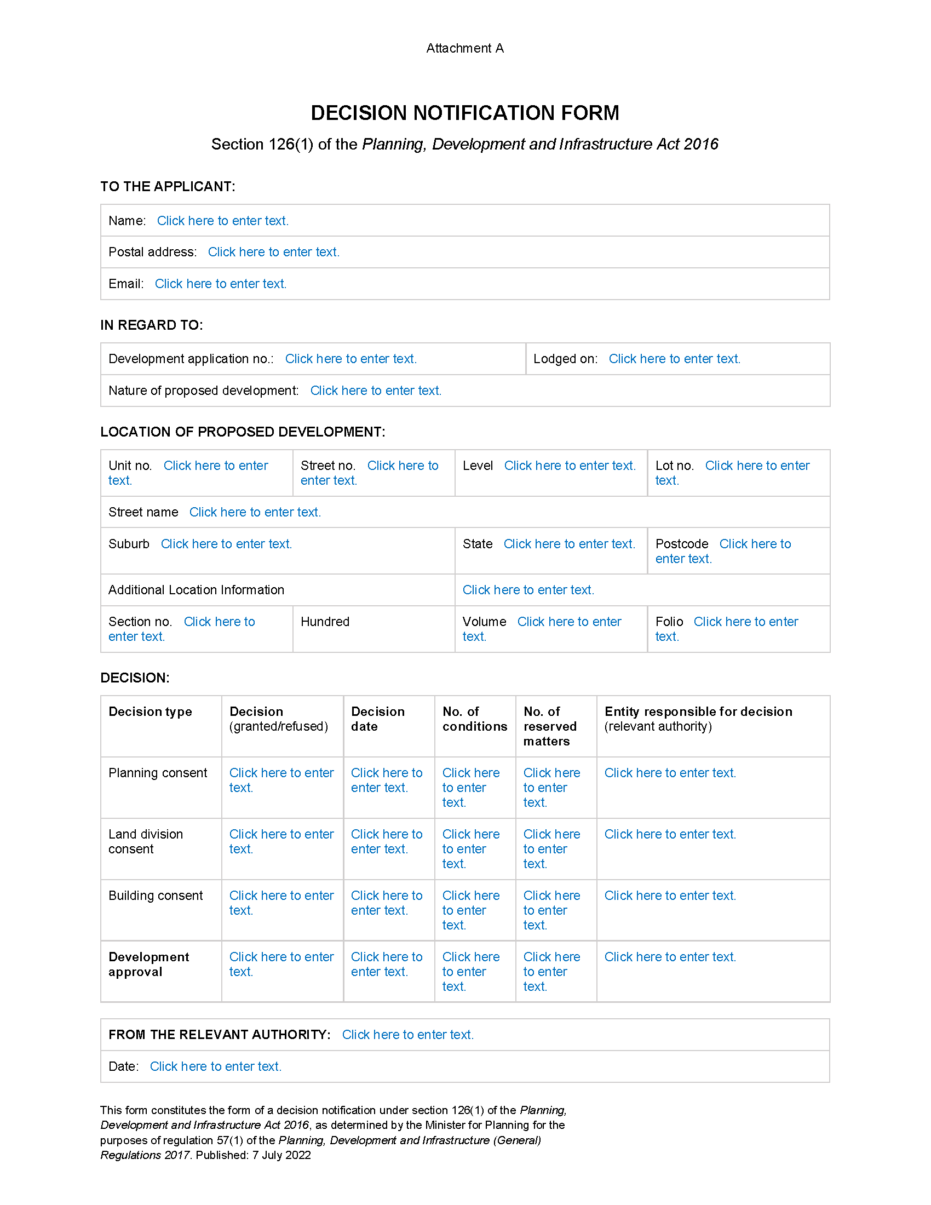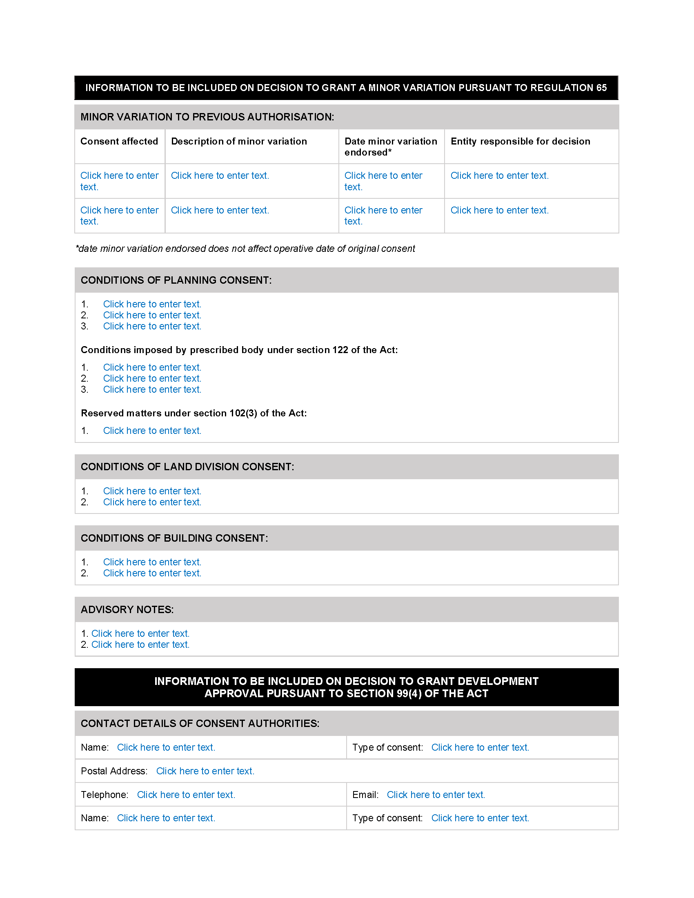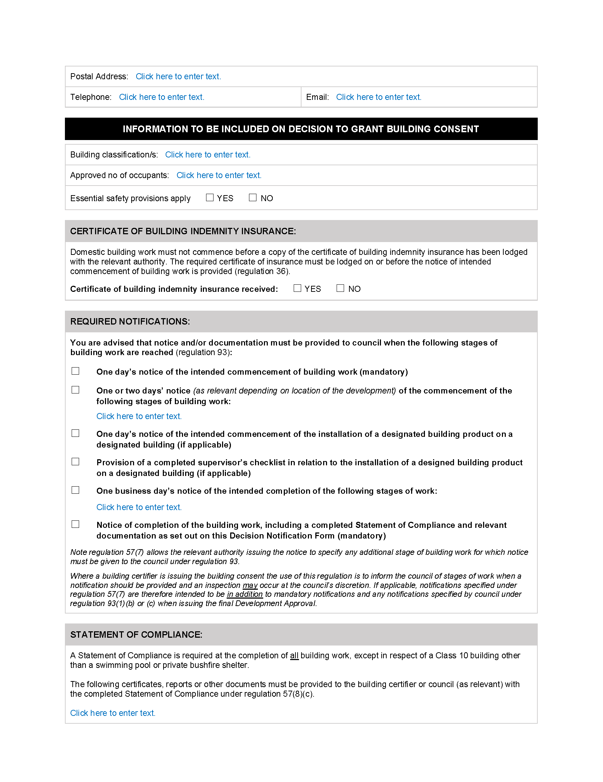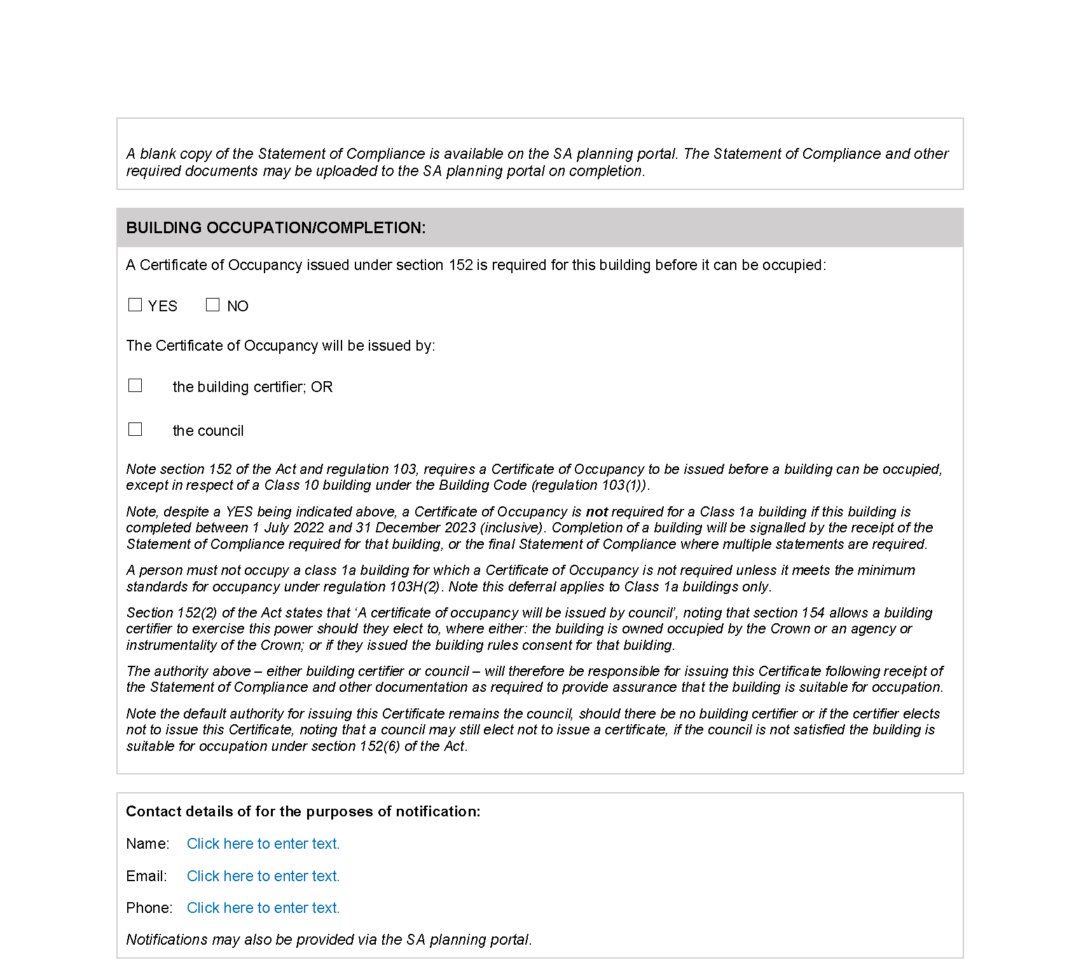

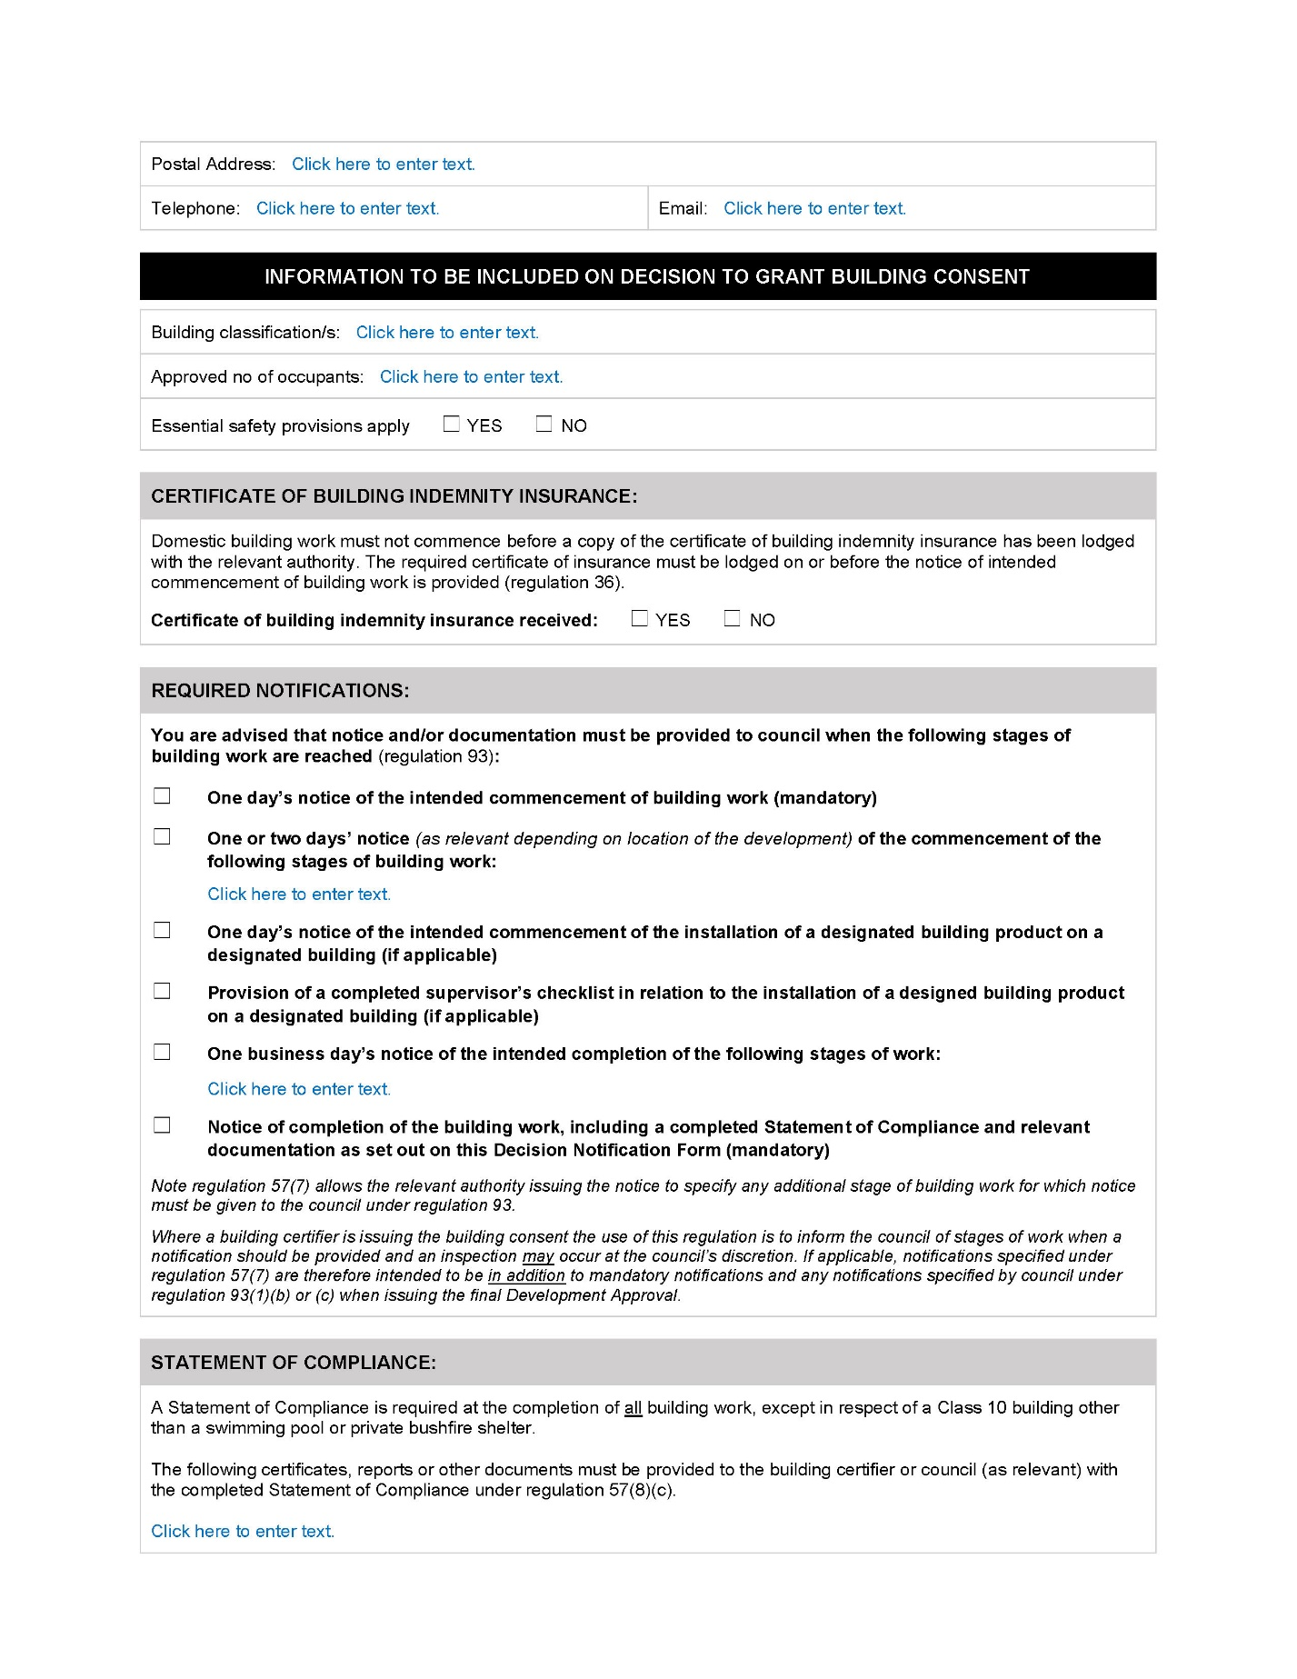

Planning, Development and Infrastructure Act 2016
Section 76
Amendment to the Planning and Design Code
Preamble
It is necessary to amend the Planning and Design Code (the Code) in operation at 23 June 2022 (Version 2022.11) in order to make changes of form relating to the Code’s spatial layers and their relationship with land parcels. NOTE: There are no changes to the application of zone, subzone or overlay boundaries and their relationship with affected parcels or the intent of policy application as a result of this amendment.
- PURSUANT to section 76 of the Planning, Development and Infrastructure Act 2016 (the Act), I hereby amend the Code in order to make changes of form (without altering the effect of underlying policy), correct errors and make operational amendments as follows:
- Undertake minor alterations to the geometry of the spatial layers and data in the Code to maintain the current relationship between the parcel boundaries and Code data as a result of the following:
  - New plans of division deposited in the Land Titles Office between 15 June 2022 and 28 June 2022 affecting the following spatial and data layers in the Code:
    - Zones and subzones
    - Technical and Numeric Variations
      - Building Heights (Levels)
      - Building Heights (Metres)
      - Interface Height
      - Minimum Frontage
      - Minimum Primary Street Setback
      - Minimum Side Boundary Setback
      - Future Local Road Widening Setback
      - Minimum Site Area
      - Site Coverage
    - Overlays
      - Affordable Housing
      - Defence Aviation Area
      - Design
      - Future Road Widening
      - Hazard (Bushfire - High Risk)
      - Hazard (Bushfire - Medium Risk)
      - Hazard (Bushfire - General Risk)
      - Hazard (Bushfire - Urban Interface)
      - Hazard (Bushfire - Regional)
      - Hazard (Bushfire - Outback)
      - Heritage Adjacency
      - Historic Area
      - Local Heritage Place
      - Noise and Air Emissions
      - State Heritage Place
      - Stormwater Management
      - Urban Tree Canopy
  - Improved spatial data for existing land parcels in the following locations (as described in Column A) that affect data layers in the Code (as shown in Column B):

Location (Column A) | Layers (Column B)
Blyth  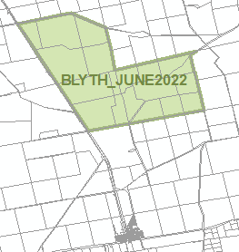 | Overlays  - Key Outback and Rural Routes
Ward Street / Marian Street - North Adelaide  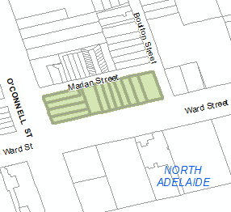 | Zones and Subzones  Technical and Numeric Variations  - Building Heights (Levels)  - Building Heights (Metres)  - Minimum Frontage  - Minimum Site Area  Overlays  - Affordable Housing  - Heritage Adjacency  - Historic Area  - Local Heritage Place  - Noise and Air Emissions  - Stormwater Management  - Urban Tree Canopy
F198178A807 - New Town  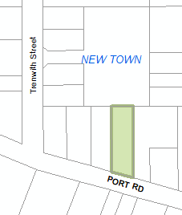 | Technical and Numeric Variations  - Building Heights (Levels)  - Building Heights (Metres)  - Minimum Frontage  - Minimum Site Area  Overlays  - Affordable Housing
Whites Flat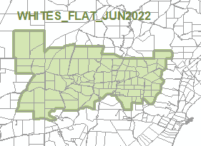 | Zones  Technical and Numeric Variations  - Minimum Site Area  Overlays  - Airport Building Heights (Regulated)  - Dwelling Excision  - Hazards (Bushfire - Medium Risk)  - Hazards (Bushfire - General Risk)  - Heritage Adjacency  - Limited Land Division  - State Heritage Place

- In Part 13 of the Code – Table of Amendments, update the publication date, Code version number, amendment type and summary of amendments within the ‘Table of Planning and Design Code Amendments’ to reflect the amendments to the Code as described in this Notice.
- PURSUANT to section 76(5)(a) of the Act, I further specify that the amendments to the Code as described in this Notice will take effect upon the date those amendments are published on the SA planning portal.
Dated: 1 July 2022
Greg Van Gaans
Director, Land and Built Environment,
Department for Trade and Investment
Delegate of the Minister for Planning

The Remuneration Tribunal
Report No. 2 of 2022
2022 Allowances for Members of Local Government Councils 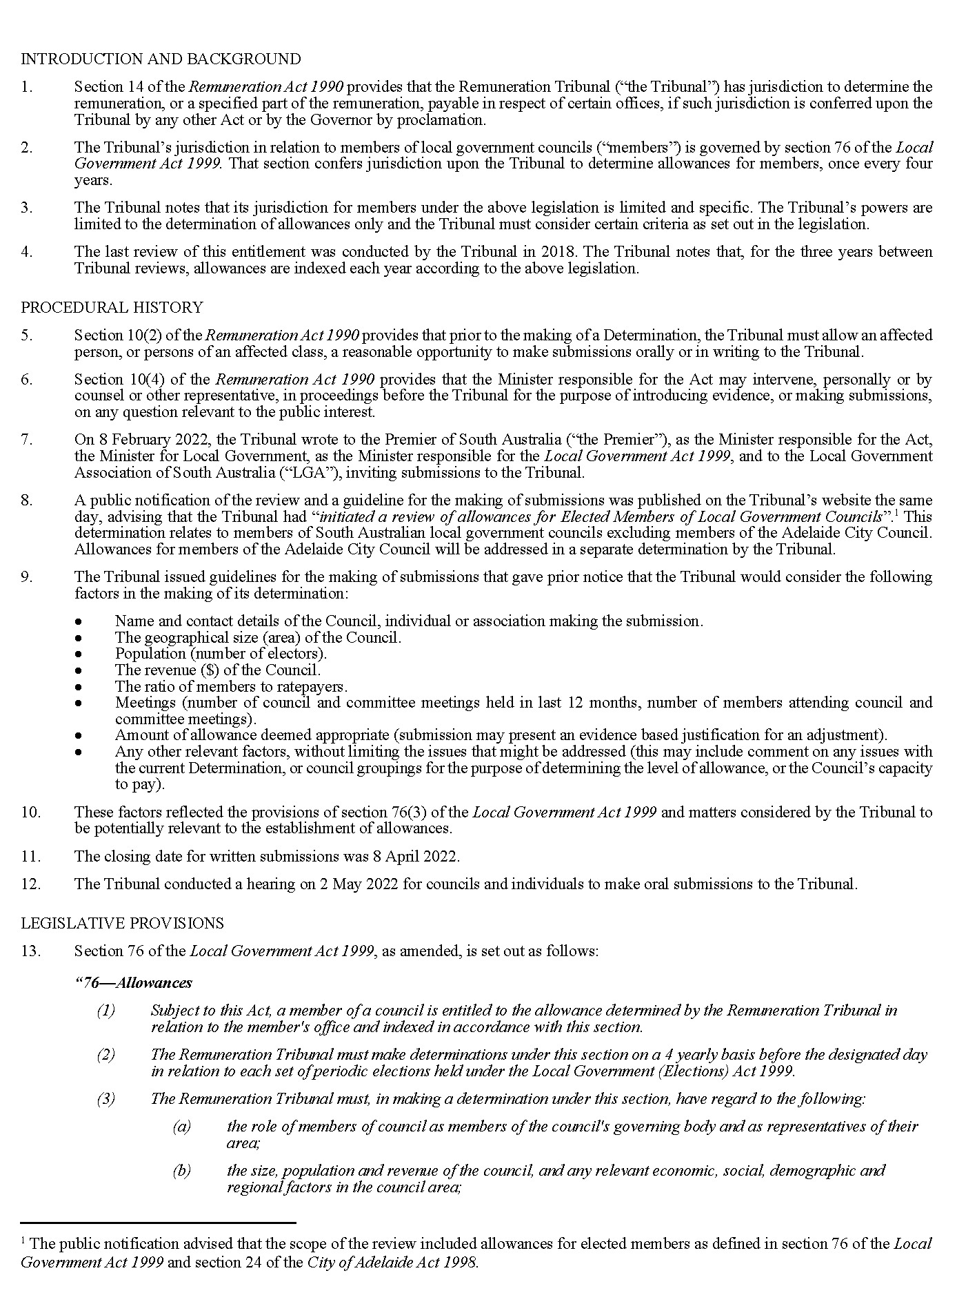
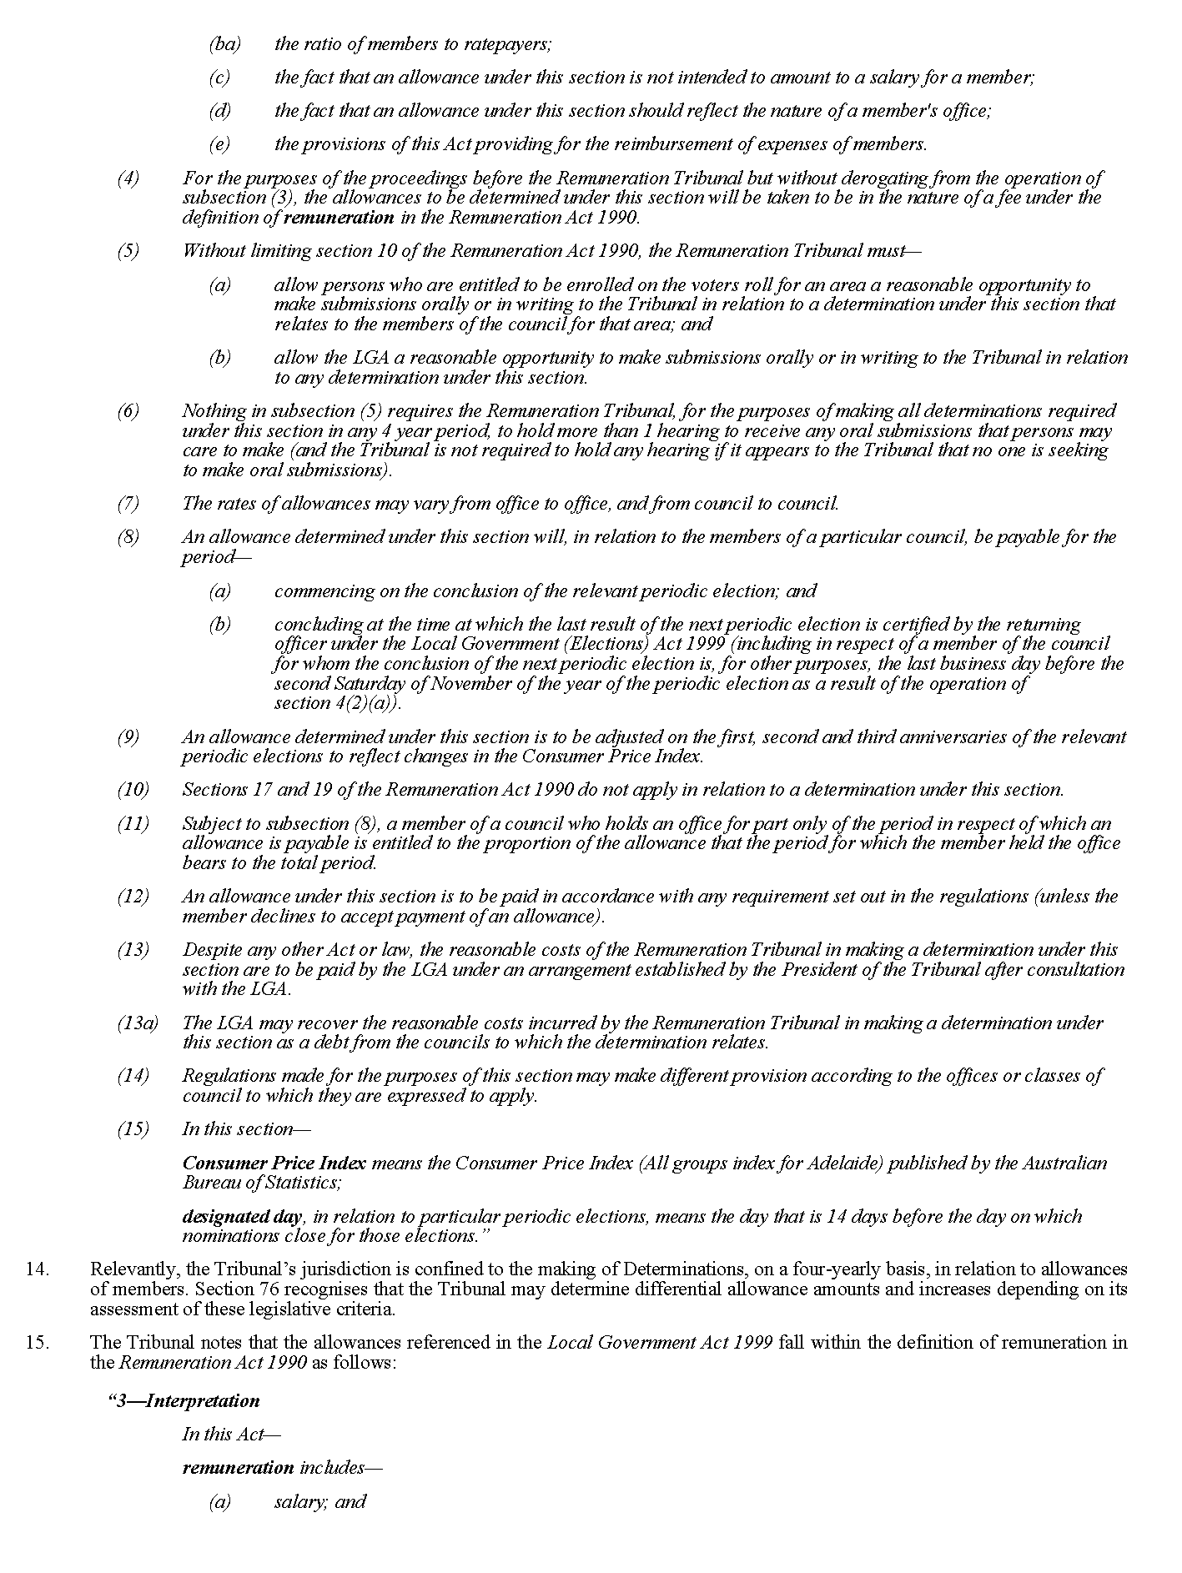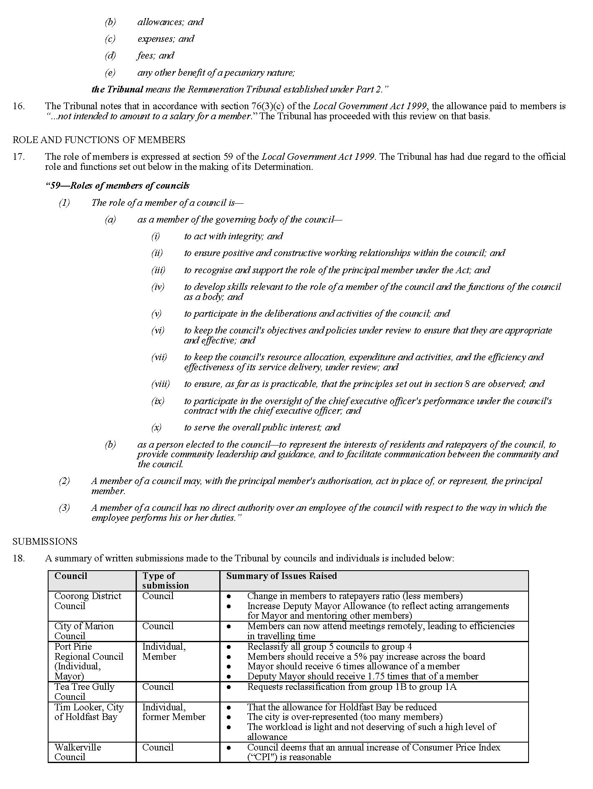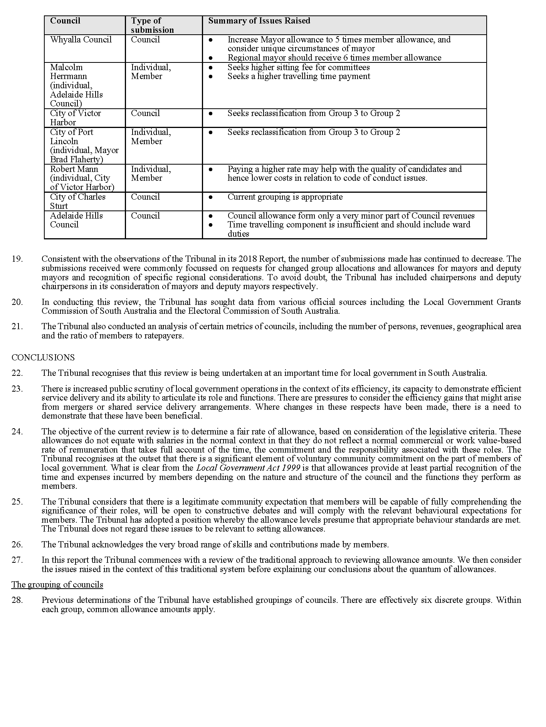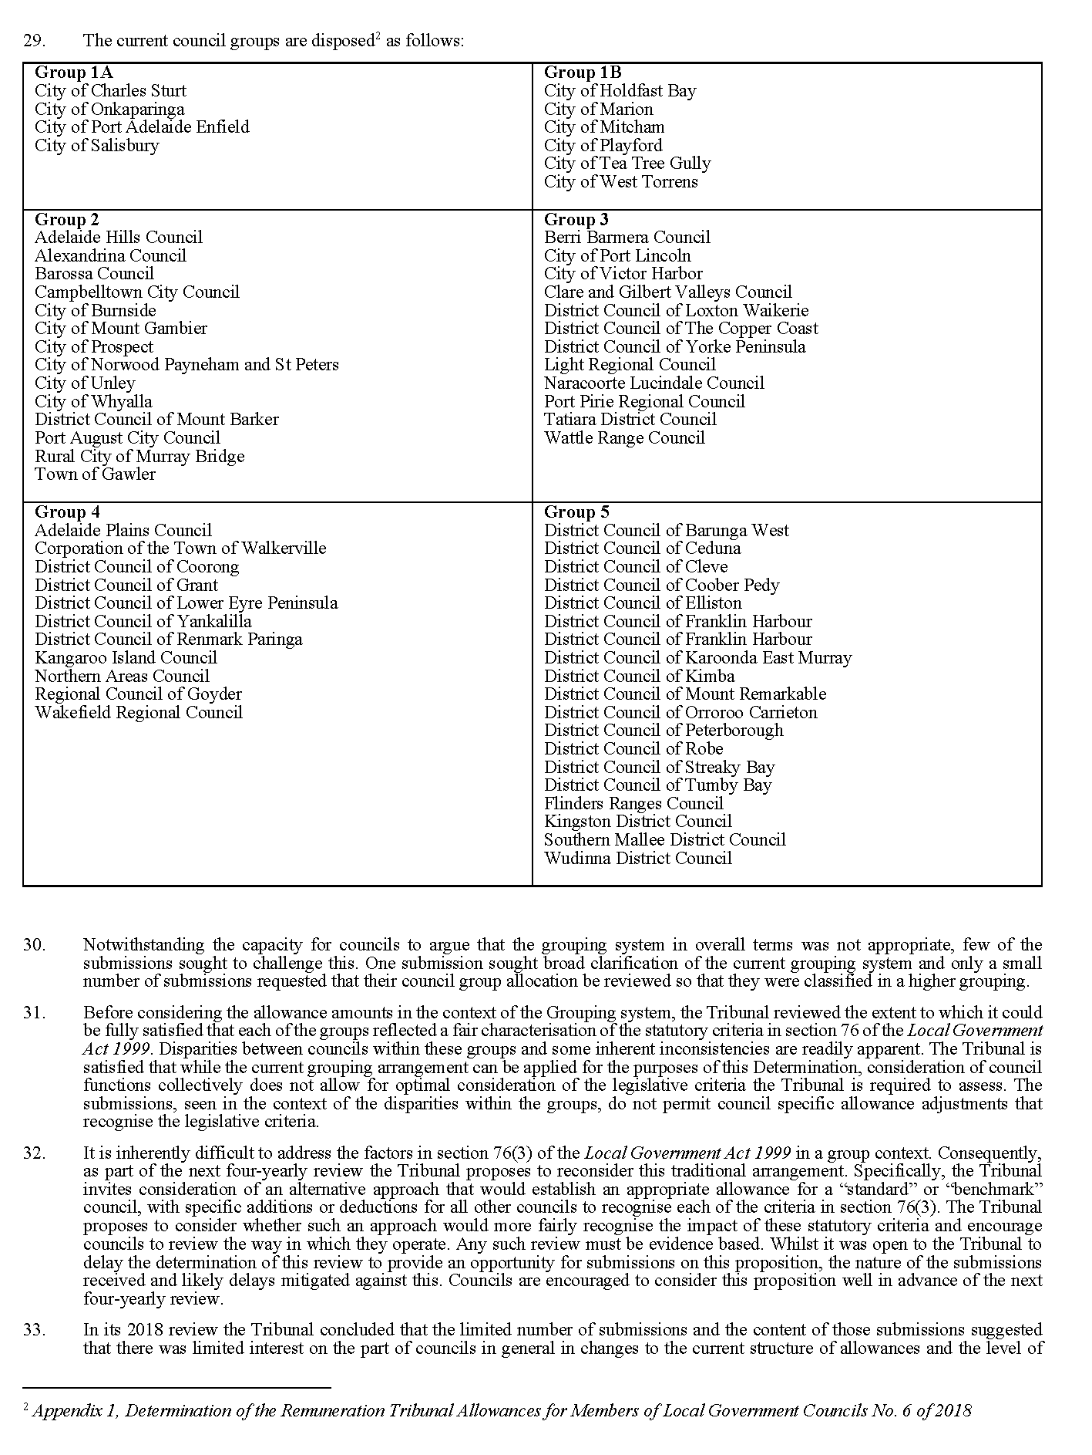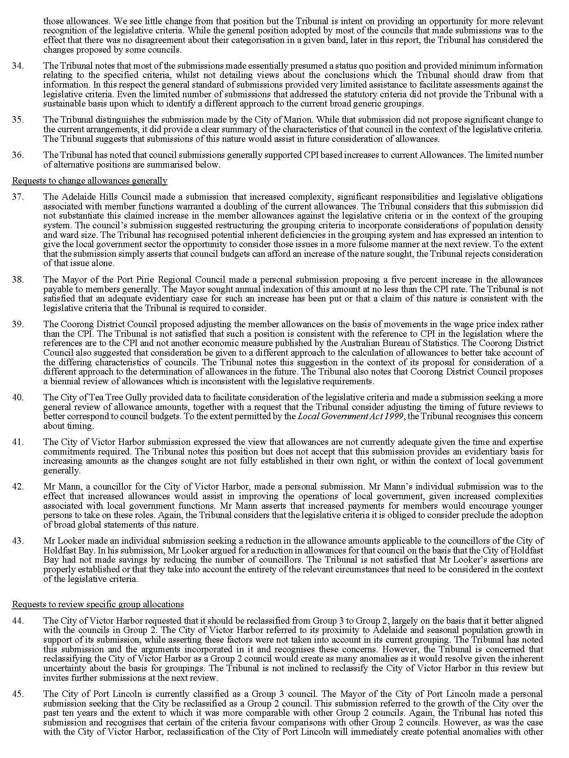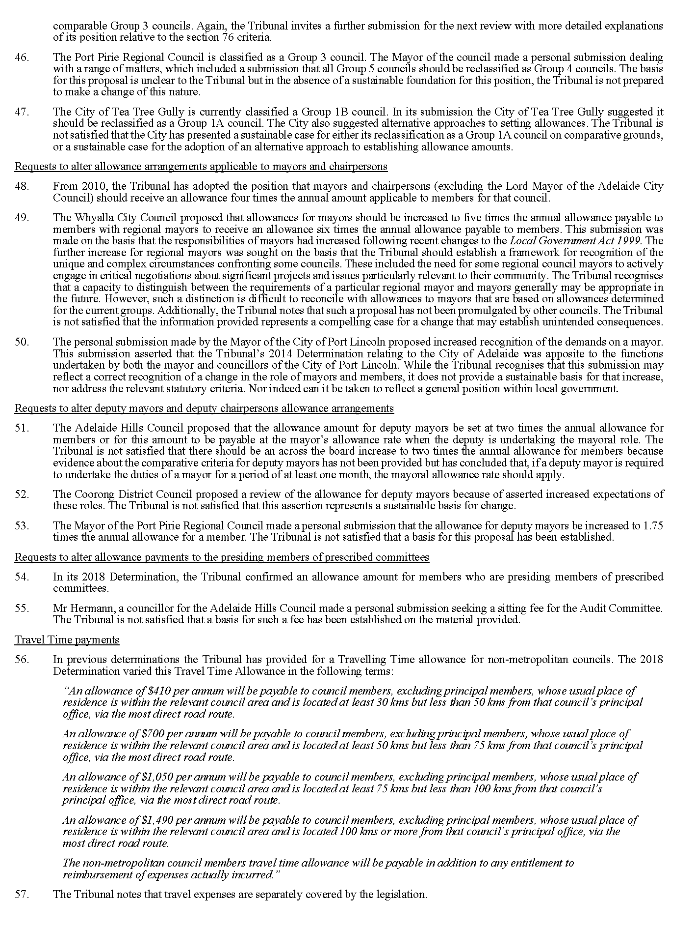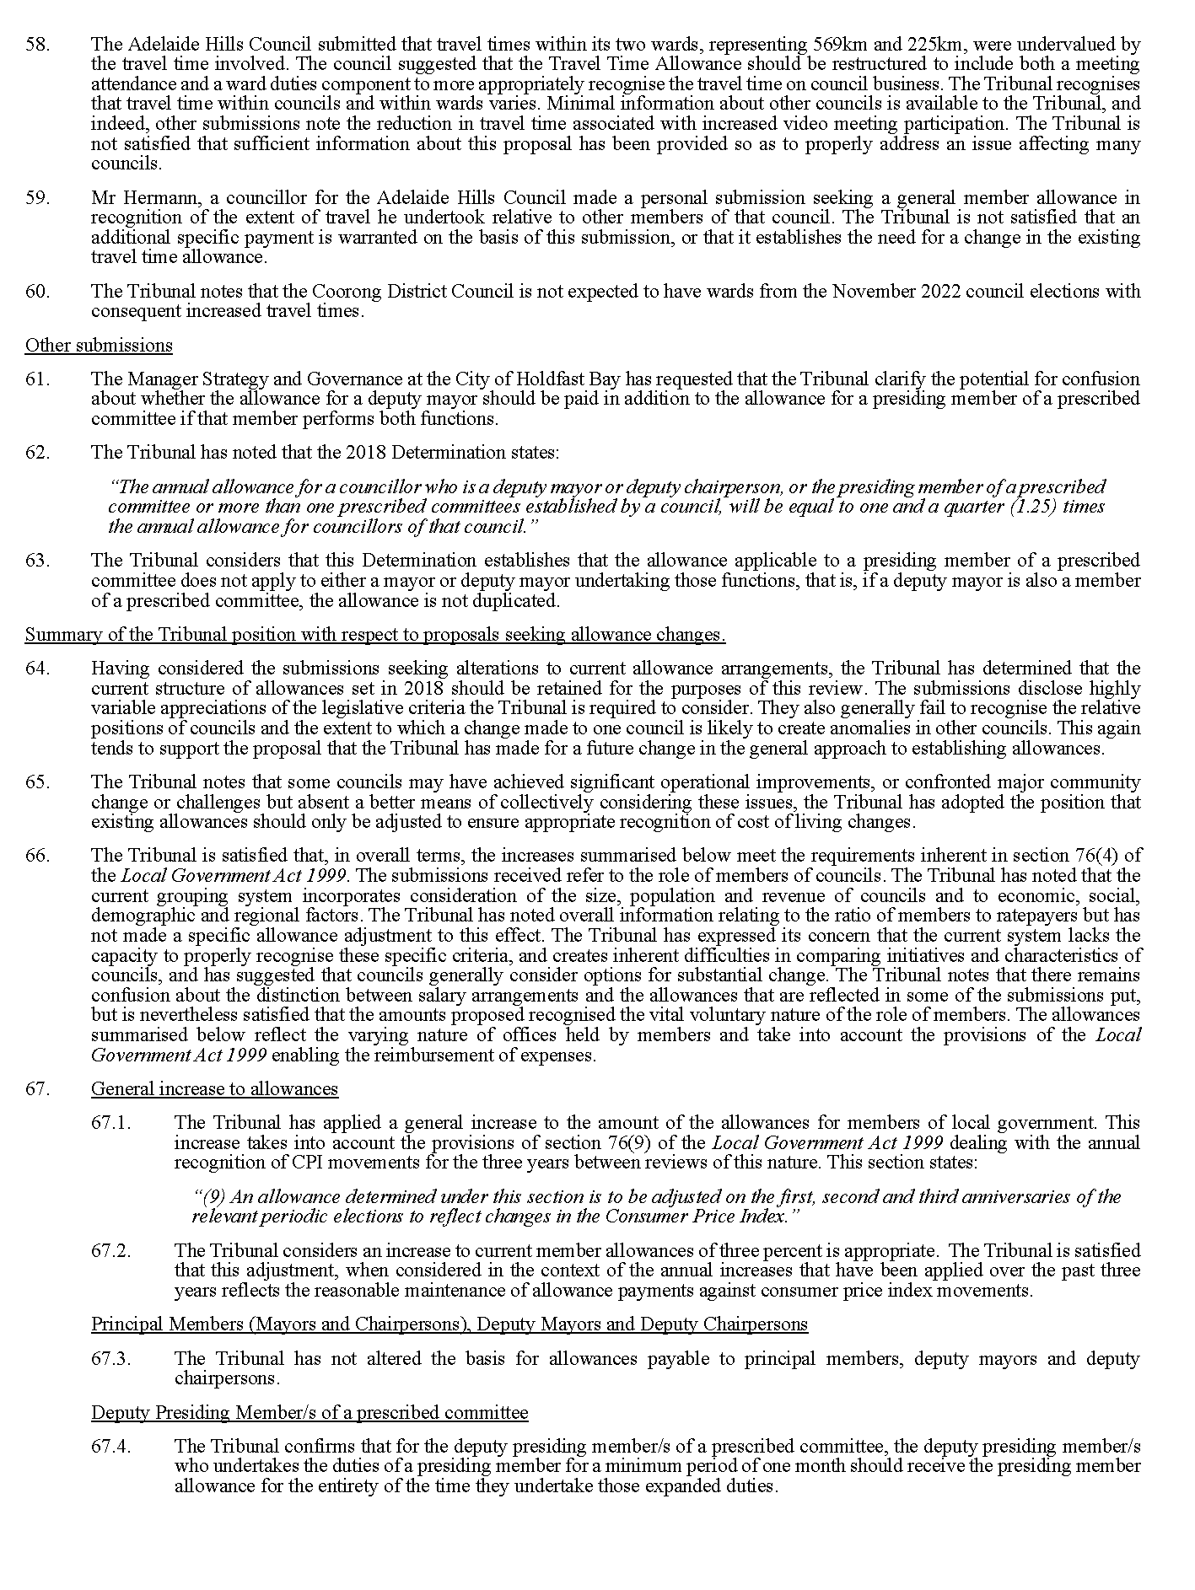
Dated: 5 July 2022
Matthew O’Callaghan
President
Deborah Black
Member
Peter de Cure
Member

The Remuneration Tribunal
Determination No. 2 of 2022
Allowances for Members of Local Government Councils
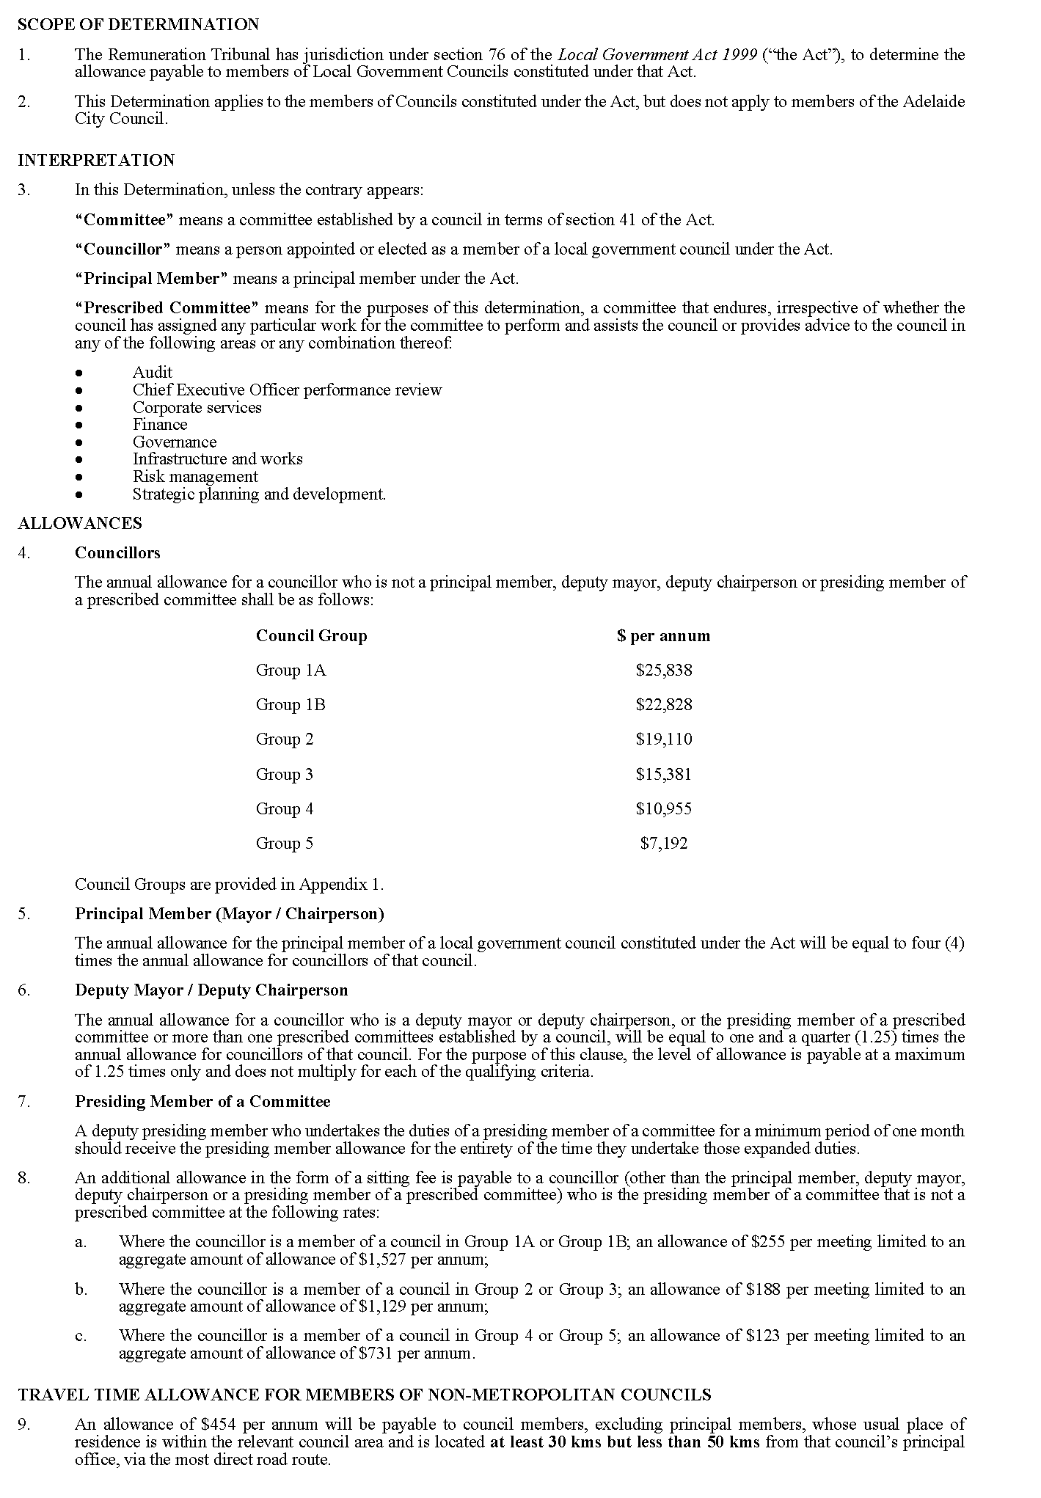
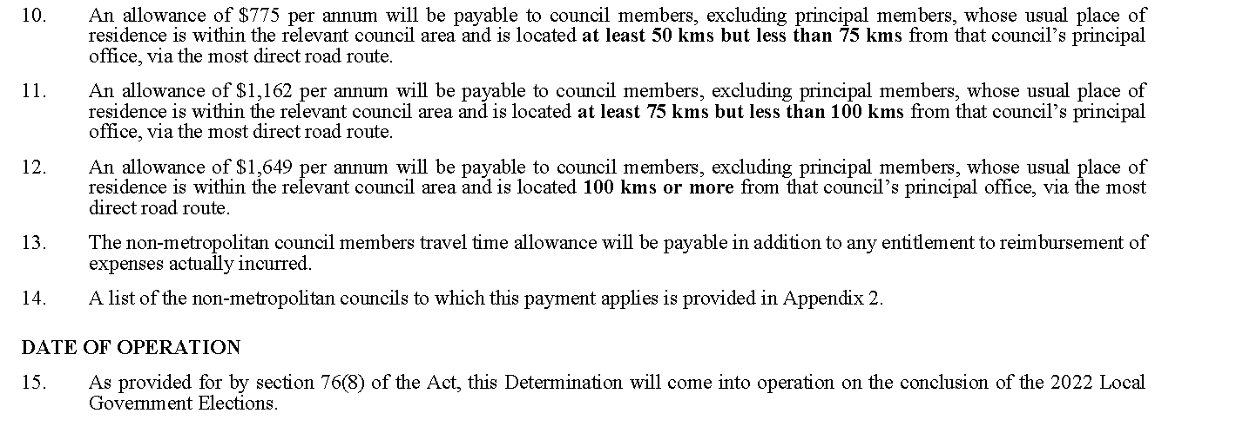
Dated: 5 July 2022
Matthew O’Callaghan
President
Deborah Black
Member
Peter de Cure
Member
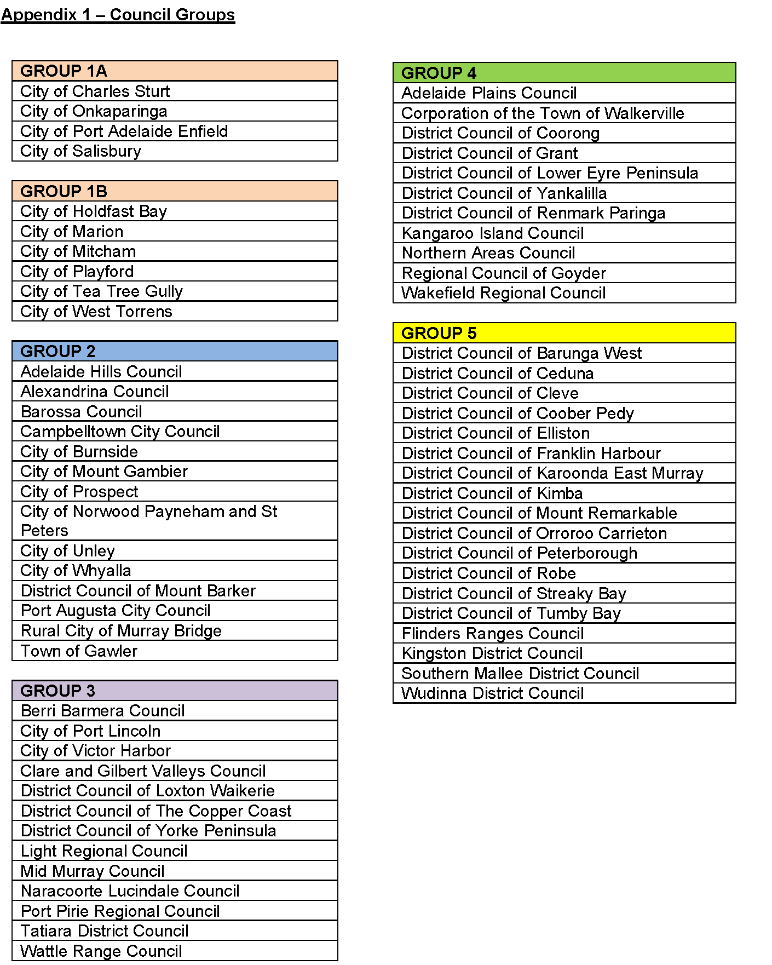
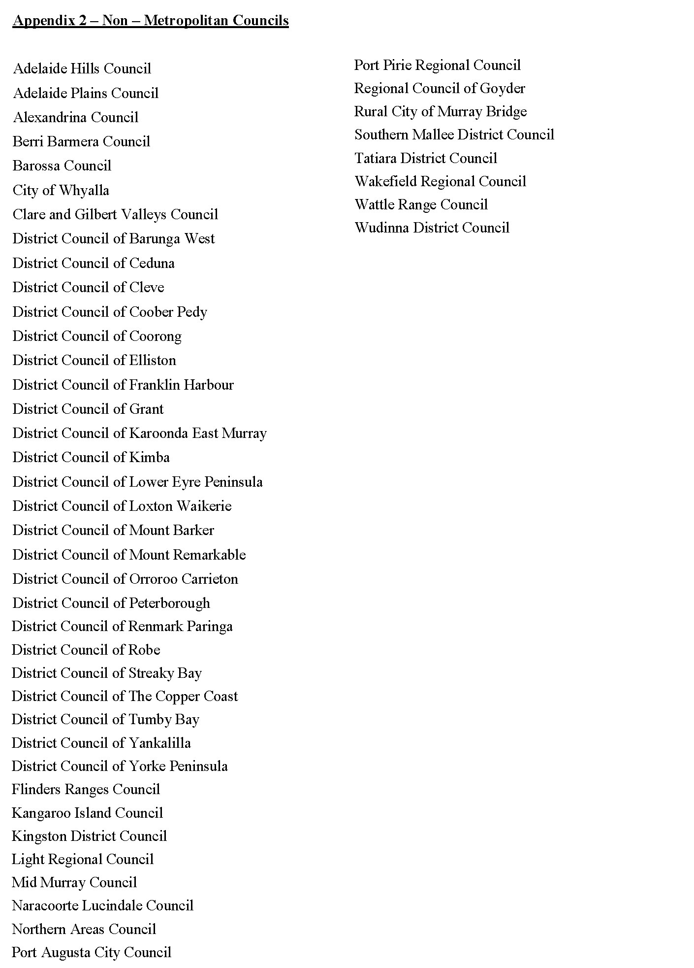

The Remuneration Tribunal
Report No. 3 of 2022
2022 Allowances for Members of Adelaide City Council
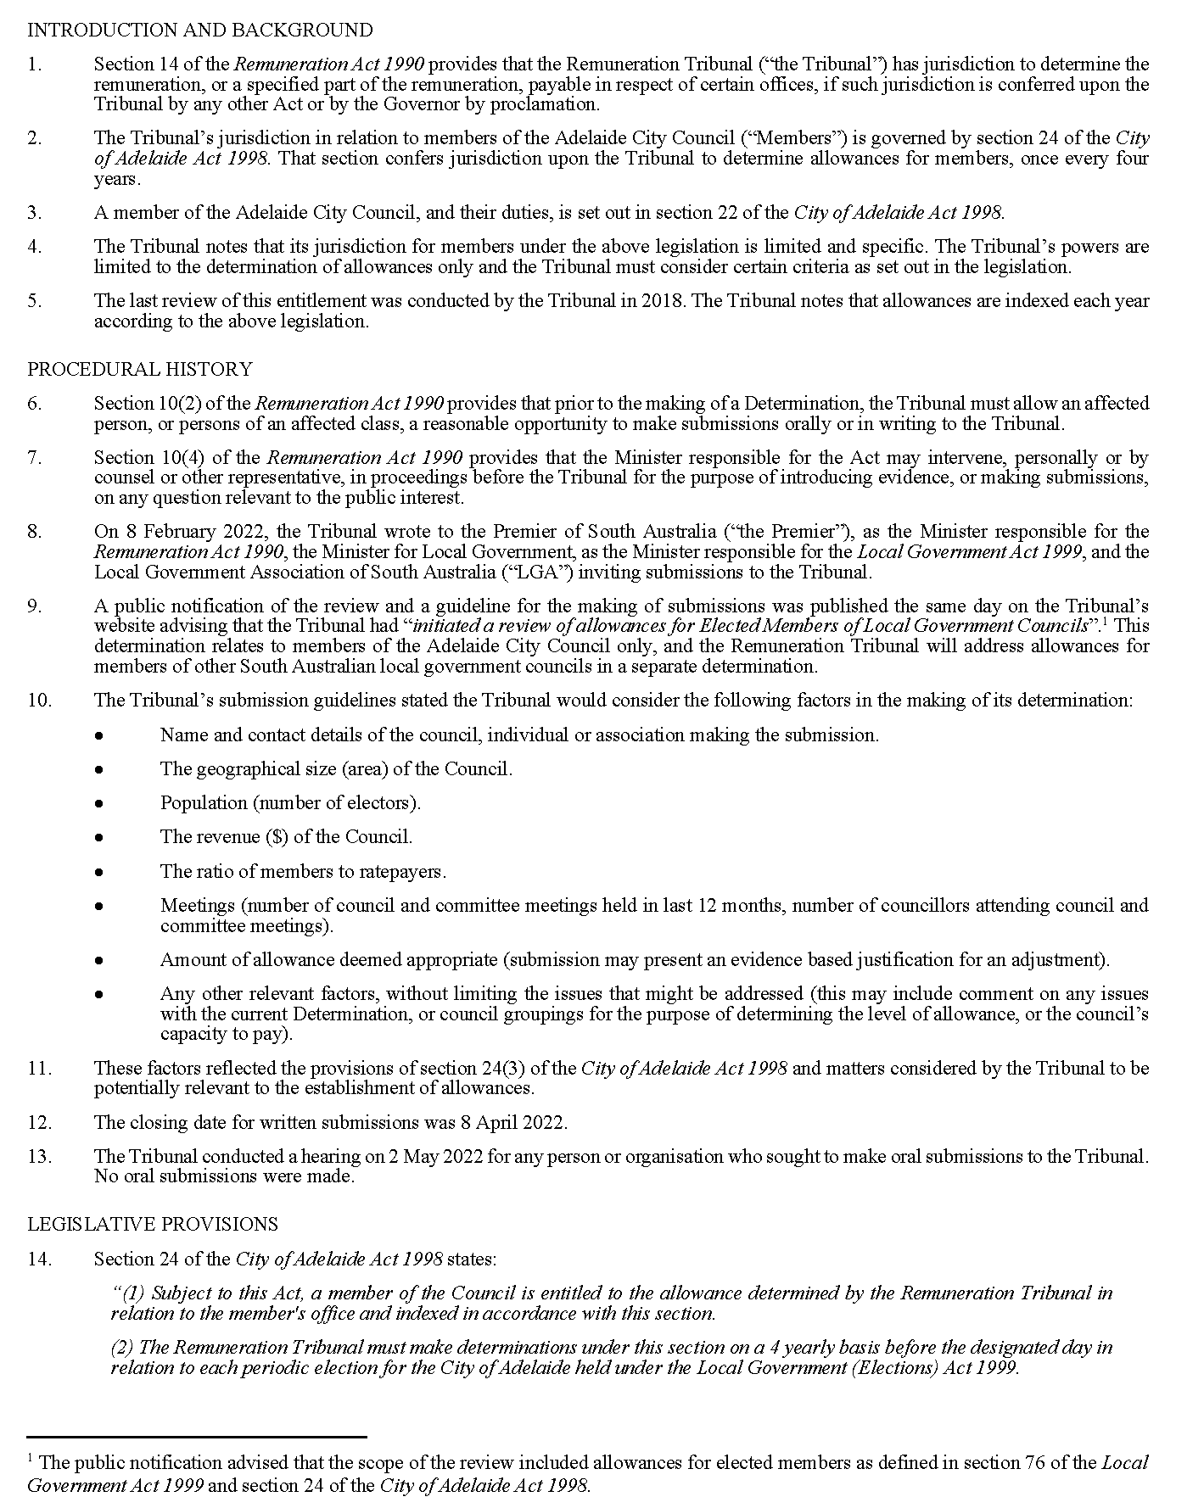
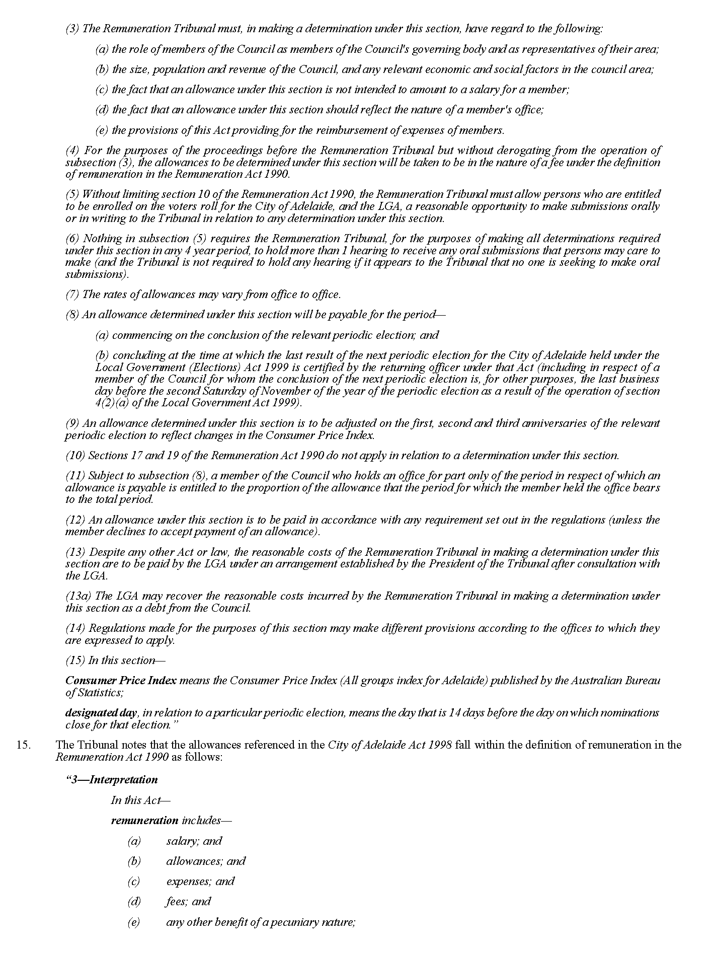
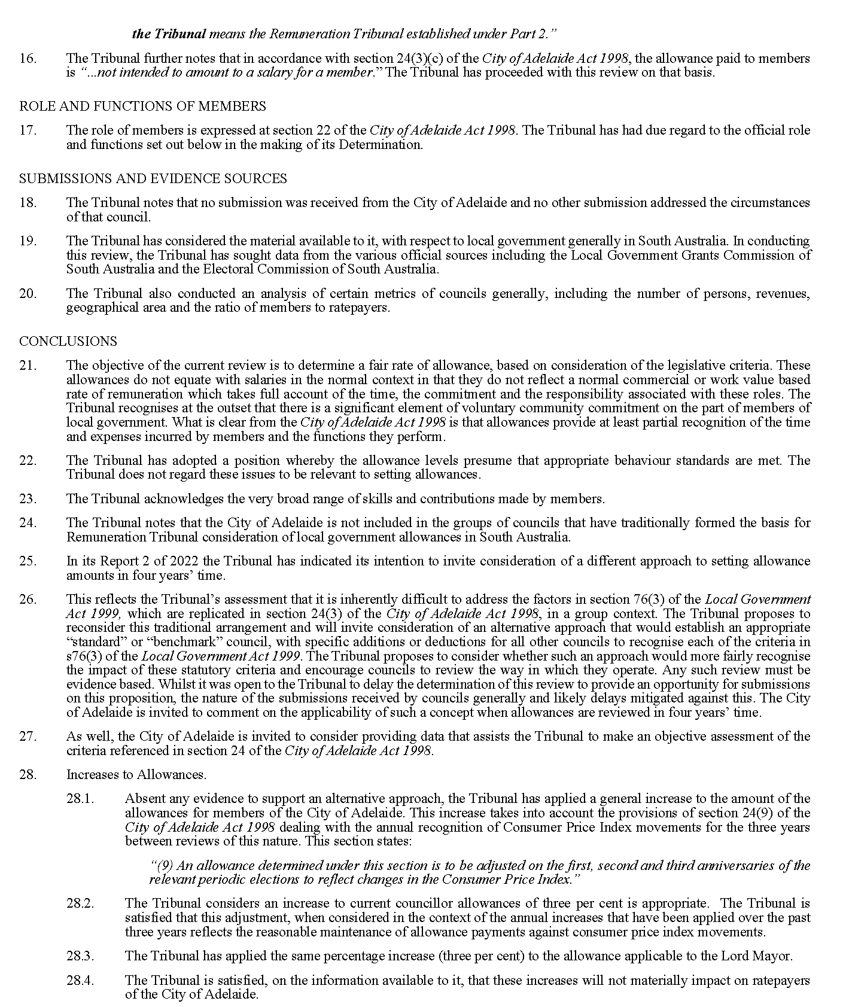

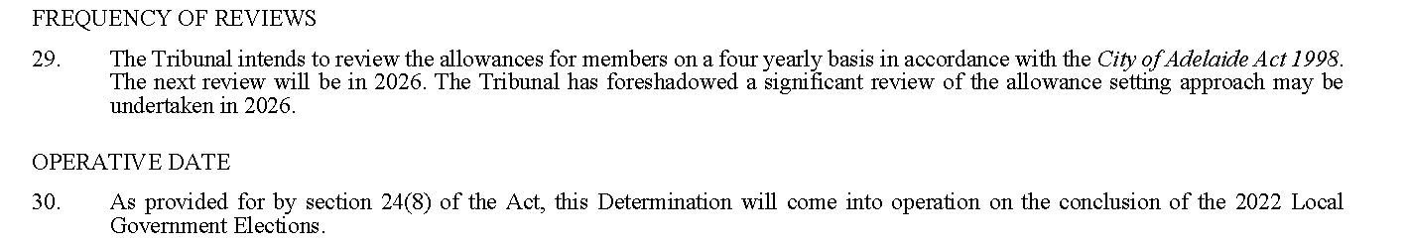
Dated: 5 July 2022
Matthew O’Callaghan
President
Deborah Black
Member
Peter de Cure
Member

The Remuneration Tribunal
Determination No. 3 of 2022
Allowances for Members of Adelaide City Council
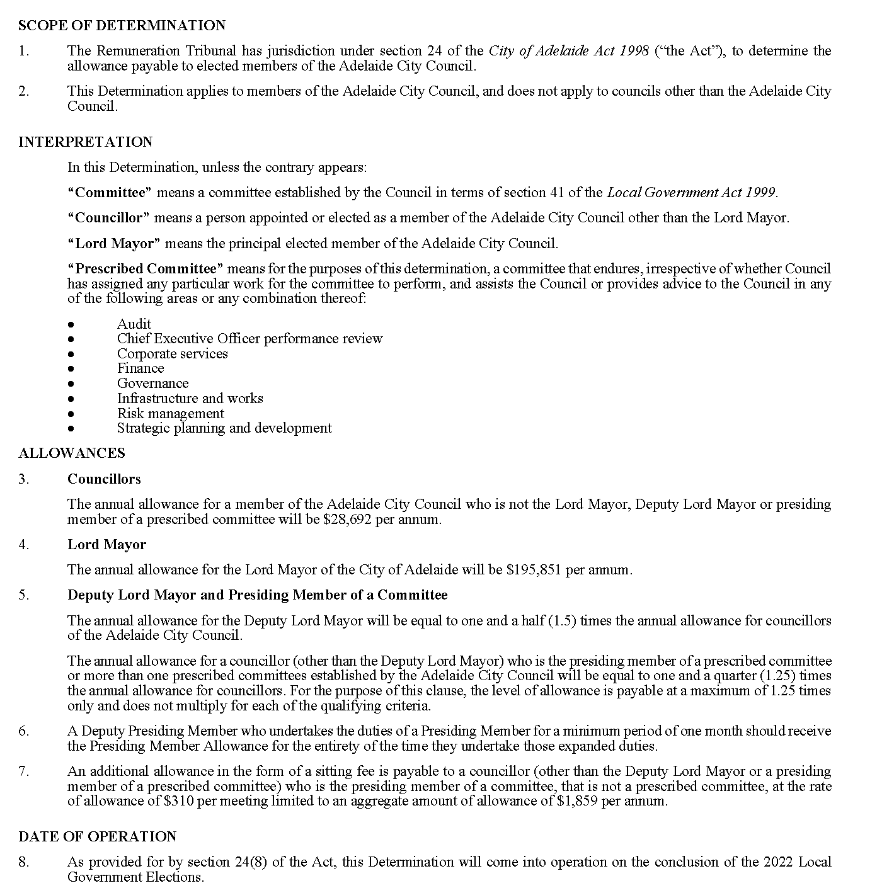
Dated: 5 July 2022
Matthew O’Callaghan
President
Deborah Black
Member
Peter de Cure
Member

Waite Trust (Vesting of Land) Act 2020
Notice pursuant to s4(1)
NOTICE is hereby given that pursuant to section 4(1) of the Waite Trust (Vesting of Land) Act 2020, I BLAIR BOYER, Minister for Education, Training and Skills, do hereby give notice that the following land is to vest in fee simple in the Commissioner of Highways, freed and discharged from the terms of the Waite Trust and any other relevant interests, conditions, covenants, easements or reservations:
Comprising an unencumbered estate in fee simple in that piece of land being a portion of Allotment 10 in Deposited Plan 39536 and Allotment 332 in Filed Plan 12138 comprised in Certificate of Title Volume 5540 Folio 952, and being the whole of the land identified as Allotments 62 and 63 in Plan numbered D129045 lodged in the Lands Titles Office.
Dated: 30 June 2022
Hon Blair Boyer MP
Minister for Education, Training and Skills

Local Government Instruments

City of Burnside
Adoption of Valuations and Declaration of Rates
NOTICE is hereby given that on the 28 June 2022 the Council of the City of Burnside, pursuant to the provisions of the Local Government Act 1999, for the year ending 30 June 2023.
Adoption of Valuations
Adopted, the capital valuations to apply in its area for rating purposes for the 2022-2023 financial year as supplied by the Valuer General totalling $24,526,060,100.
Declaration of Rates
Declared differential general rates in the dollar based on capital value as follows:
- 0.17251 cents in the dollar on rateable land of Category 1 – Residential, Category 2 – Commercial Shop, Category 3 – Commercial Office, Category 4 – Commercial Other, Category 5 – Industrial Light, Category 6 – Industrial Other, Category 7 – Primary Production and Category 9 – Other.
- 0.4313 cents in the dollar on rateable land of Category 8 – Vacant Land.
Resolved that the minimum amount payable by way of general rates in respect of rateable land within the area for the year ending 30 June 2023 be $906; and
Declared a Separate Rate (Regional Landscape Levy) of 0.007378 cents in the dollar on all rateable land in the Council’s area and within the area of the Green Adelaide Landscape Board Area;
The Council resolved that rates will be payable in four equal or approximately equal instalments, and that the due dates for those instalments will be 1 September 2022, 1 December 2022, 1 March 2023 and 1 June 2023.
Dated: 28 June 2022
C. Cowley
Chief Executive Officer

City of Holdfast Bay
Adoption of Valuations and Declaration of Rates
NOTICE is given that at its meeting on 28 June 2022, and in relation to the 2022/2023 financial year, the Council, in exercise of the powers contained in Chapter 10 of the Local Government Act 1999:
- Adopted the most recent valuations of the State Valuation Office of the capital value of all rateable land in its area totalling $17,750,855,300.
- Declared a differential general rate of 0.203271 cents in the dollar of the capital value of rateable land, used for Residential and Other Land uses.
- Declared a differential general rate of 0.32796 cents in the dollar of the capital value of rateable land, used for Commercial (Shop), Commercial (Office), Commercial (Other), Industrial (Light), Industrial (Other) and Vacant Land uses.
- Imposed a minimum amount payable by way of general rate of $1,079.
- Fixed a maximum increase of 6% (over the 2021/2022 general rate but subject to conditions) in the general rate charged on rateable land used for residential purposes that is the principal place of residence of a ratepayer.
- Declared a differential separate rate of 0.124231 cents in the dollar of the capital value of rateable land:
- with a frontage to Jetty Road, Glenelg or Moseley Square: and
- within the side streets that intersect with Jetty Road, Glenelg between High Street, Glenelg and Augusta Street, Glenelg; and
- the entire site referred to as the Holdfast Shores 2B Entertainment Centre; and
- that has a land use of Category 2 (Commercial – Shop), Category 3 (Commercial – Office) and Category 4 (Commercial – Other).
- Declared a separate rate of 0.9505 cents in the dollar of the capital value of rateable land within the Patawalonga basin bounded by the high water mark and fixed the maximum amount payable by way of this separate rate at $851.
- Declared a separate rate by way of a levy of 0.0077627 cents in the dollar of the capital value of rateable land in the Council's area for the Regional Landscape Levy in the catchment area of the Green Adelaide Board.
Due dates for rates being 1 September 2022, 1 December 2022, 1 March 2023 and 1 June 2023
Dated: 28 June 2022
R. Bria
Chief Executive Officer

City of Mitcham
Adoption of Valuations and Declaration of Rates
Notice is hereby given that at a meeting of the Council held on 28 June 2022, the Council resolved for the financial year commencing 1 July 2022 as follows:
Adoption of Assessment
To adopt the capital valuations made by the Valuer-General for the Council area, being $25,865,701,140 in relation to the whole area of the Council (of which $24,564,538,003 represents rateable land).

Declaration of Differential General Rates
To declare differential general rates, as follows:
(a) 0.22279 cents in the dollar on the capital value of rateable land of Residential, Primary Production and Other land;
(b) 0.56367 cents in the dollar on the capital value of rateable land of Commercial-Shop, Commercial—Office, Commercial—Other, Industrial—Light, Industrial—Other and Vacant land uses; and
(c) To fix a minimum amount payable by way of the general rates of $1,171.00.
Declaration of Landscape Levy
To declare a separate rate of 0.0074 cents in the dollar on the capital value of rateable land in the Council area within the Green Adelaide Board area.
Dated: 28 June 2022
M. Pears
Chief Executive Officer

Rural City of Murray Bridge
Adoption of Valuations and Declaration of Rates 2022-2023
NOTICE is hereby given that the Rural City of Murray Bridge at a meeting held on 14 June 2022, resolved:
Adoption of Annual Business Plan and Budget 2022-2023
That pursuant to Sections 123(6) and (7) of the Local Government Act 1999 and Regulations 6 and 7 of the Local Government (Financial Management) Regulations 2011, having considered submissions in accordance with Section 123(6) of the Local Government Act 1999 and having regard to all relevant information in the possession of the Council, the Council adopts the Annual Business Plan and Budget for 2022-2023.
Adoption of Valuations
That pursuant to Section 167(2) of the Local Government Act 1999 the most recent valuations of the Valuer-General available to Council of the capital value of land within Council’s area totalling $4,310,403,300 be adopted for rating purposes with the total capital value of rateable land within Council’s area for 2022-2023 being $4,158,236,051.
Declaration of General Rates
That, having taken into consideration the general principles of rating contained in Section 150 of the Local Government Act 1999 and having observed the requirements of Section 153 of the Local Government Act 1999, and in accordance with Regulation 14 of the Local Government (General) Regulations 2013, the Council declares, pursuant to Sections 152 and 153 of the Local Government Act 1999 for the year ending 30 June 2023, differential general rates in respect of all rateable land within its area as follows –
- 0.63566 cents in the dollar of the Capital Value of rateable land of Categories (a) and (i) uses (residential and “other” categories)
- 1.01706 cents in the dollar of the Capital Value of rateable land of Categories (b), (c) and (d) uses (commercial categories)
- 0.88993 cents in the dollar of the Capital Value of rateable land of Categories (e) and (f) uses (industrial categories)
- 0.57209 cents in the dollar of the Capital Value of rateable land of Category (g) use (primary production category)
- 0.82636 cents in the dollar of the Capital Value of rateable land of Category (h)) use (vacant land category)
Declaration of Minimum Rates
That pursuant to Section 158(1) (a) of the Local Government Act 1999 the Council fixes in respect to the year ending 30 June 2023, a minimum amount payable by way of general rates of $1,023.
Regional Landscape Levy
That pursuant to Part 5 of the Landscape South Australia Act 2019 and Section 154 of the Local Government Act 1999, the Council declares, in respect of the year ending 30 June 2023, a separate rate of 0.01877464 cents in the dollar, based on the capital value of rateable land within the Council’s area and within the area of the Murraylands and Riverland Landscape Board in order to recover the amount payable to the Board.
Declaration of Annual Service Charges and Service Rates
Community Waste Water Management and Water Supply Schemes
Riverglen
Pursuant to Section 155(2) of the Local Government Act 1999, a total of $116,500 is to be levied against the properties within the area known as “Riverglen” to which Council provides and make available the prescribed services of septic tank effluent disposal and water supply.
Accordingly, an annual service charge and service rate are imposed on Allotments 1 to 30 and Allotment 126 in Deposited Plan DP30450, Allotment 53 in Deposited Plan DP115992, Allotment 50 in Deposited Plan DP42391 and Units 1 to 73 in Strata Plan No SP11238, being land which the septic tank effluent disposal and the water supply schemes are provided and made available as follows:
- An annual service charge of $675 per assessment plus the relevant per kilolitre charge is imposed on the relevant rateable and non-rateable land based on the nature of the services and the level of usage of the water supply service.
- The relevant per kilolitre charge for the supply of water is as follows:
Usage Charge (<140 kL @ $1.966)
Usage Charge (140><520 kL @ $2.806)
Usage Charge (>520 kL @ $3.040)
- A service rate (which is varied in accordance with Section 155(3)(b) of the Local Government Act 1999 and Regulations 12(4)(a) and 14(1) of the Local Government (General) Regulations 2013) is imposed on rateable land as follows:
- 0.0703 cents in the dollar of the Capital Value of rateable land of Category (a), (e), (f), (g), (h) and (i) uses (residential, industry - light, industry - other, primary production, vacant land and other);
- 0.3433 cents in the dollar of the Capital Value of rateable land of Categories (b), (c), (d), uses (commercial - shop, commercial - office, commercial - other).
(2) Woodlane
That pursuant to Section 155(2) of the Local Government Act 1999, a total of $77,803 is to be levied against the properties within the area known as “Woodlane” to which Council provides the prescribed services of septic tank effluent disposal and water supply. A service charge of $827 per assessment plus the relevant per kilolitre charge is imposed on rateable and non rateable land and a service rate of 0.17407 cents in the dollar of the capital value of rateable land is declared on Allotments 1 to 18 in Deposited Plan DP48073, Allotments 191 and 192 in Deposited Plan DP75292, Allotments 1 to 4, 7 to 37 and 40 in Deposited Plan DP51229, Allotment 50 in Deposited Plan DP53034 and Allotment 200 in Deposited Plan DP62423, being land which the septic tank effluent disposal and the water supply schemes are provided.
The relevant per kilolitre charge for the supply of water is $3.040 per kL for any usage above 130kL per annum.
Waste Collection
That pursuant to Section 155(2) of the Local Government Act 1999 the following variable annual service charges are imposed according to the nature of the service as follows, subject (where relevant) to the application of Regulation 13 of the Local Government (General) Regulations 2013:
Kerbside Recycling and Green Waste Service
An annual service charge of $92 will be applied in 2022-23 to those properties to which the Council provides or makes available a kerbside recycling collection service.
An annual service charge of $58 will be applied in 2022-23 to those properties in Murray Bridge, Callington, Jervois, Mypolonga, Wellington and Woodlane to which the Council provides or makes available a kerbside green waste collection service.
That pursuant to Section 188 of the Local Government Act 1999 the following fees and charges are imposed:
(1) New Garbage Collection Service
For the supply of a mobile garbage bin to land to which the new service is provided, a charge of $87 per bin in respect of the year ending 30 June 2023.
(2) Replacement Bins
For the replacement of lost, damaged or stolen bins, a charge of $87 per bin in respect of the year ending 30 June 2023.
(3) Additional Garbage Collection Service
For the supply of additional mobile garbage bin/s to land to which the relevant collection service is provided, a charge of $145 per in in respect of the year ending 30 June 2023.
Payment of Rates
That pursuant to Section 181(11) of the Local Government Act 1999 rates for the year ending 30 June 2023 will fall due in four equal or approximately equal instalments on 5 September 2022, 1 December 2022, 1 March 2023 and 1 June 2023.
Dated: 14 June 2022
M. Sedgman
Chief Executive Officer

City of Port Lincoln
Adoption of Valuations and Declaration of Rates 2022/2023
Notice is hereby given that at its meeting on 27 June 2022, the City of Port Lincoln Council resolved for the year ending 30 June 2023 as follows:
• to adopt (effective from 1 July 2022) the valuations made by the Valuer-General of Site Values of all land within the area of the Council valued at $1,151,191,500 that are to apply for rating purposes;
• to declare differential general rates in respect of all rateable land within its area varying according to its land use as follows:
(i) Residential 0.8392 cents in the dollar
(ii) Commercial—Shop, Office, Other 0.8392 cents in the dollar
(iii) Industry—Light, Other 0.8392 cents in the dollar
(iv) Vacant Land 0.8392 cents in the dollar
(v) Marina Berths 0.8392 cents in the dollar
(vi) Other 0.8392 cents in the dollar
(vii) Primary Production 0.8392 cents in the dollar
• to impose a Fixed Charge of $475.00 in respect of all rateable land;
• to declare a Waste Annual Service Charge of $277.76 based on the nature of the service;
• to declare a Recycling Annual Service Charge of $56.22 based on the nature of the service (excludes vacant land and marina berths);
• to declare a separate rate based on a fixed charge, which will be determined by land use as follows:
(i) $80.84 fixed charge for Residential, Other and Vacant Land
(ii) $121.26 fixed charge for Commercial and Industrial Land
(iii) $161.68 fixed charge for Primary Producers
on all rateable land within the Council area and the area of the Eyre Peninsula Landscape Board in order to reimburse the Council the amount contributed to the Eyre Peninsula Landscape Board.
Dated: 7 July 2022
M. Morgan
Chief Executive Officer

City of Whyalla
Adoption of Valuations and Declaration of Rates 2022-2023
Notice is given that the City of Whyalla at a meeting of Council held on 27 June 2022, resolved for the financial year ending 30 June 2023 as follows:
Adoption of Valuations
Adopted the valuations as at 24 June 2022 of site value made by the Valuer-General for rating purposes for the year ending 30 June 2023. The total valuations for the area aggregate $809,046,520 of which $739,515,800 is the valuation of rateable land.
Declaration of Rates
Declared differential General Rates according to the locality of the land in various zones defined in the Development Plan, established pursuant to the Development Act 1993, and according to the use of the land, pursuant to Regulation 14(1) of the Local Government (General) Regulations 2013, the rate applies as follows:
(a) Locality and use of differentiating factors:
(i) In respect of all rateable land situated in the Commercial, District Centre, Local Centre, Town Centre, Open Space, Recreation and Caravan and Tourist Park Zones ,a differential general rate of 3.4249 cents in the dollar, excluding any land categorised as Residential and for which the general differential rate is declared in paragraph (b) hereunder;
(ii) In respect of all rateable land situated in the Industry, Light Industry and Deferred Industry Zones, a differential general rate of 3.4249 cents in the dollar, excluding any land categorised as Residential and for which the general differential rate is declared in paragraph (b) hereunder;
(iii) In respect of all rateable land situated in the Residential, Residential Character and Community Zones, a differential general rate of 1.4513 cents in the dollar, excluding any land categorised as Commercial-shop, Commercial-office, Commercial-other, Industry-light, Industry-other and Primary Production, and for which the general differential rate is declared in paragraph (b) hereunder;
(iv) In respect of all rateable land situated in the Rural Living Zone, a differential general rate of 0.4968 cents in the dollar, excluding any land categorised as Commercial-shop, Commercial-office, Commercial-other, Industry-light and Industry-other and for which the general differential rate is declared in paragraph (b) hereunder;
(v) In respect of all rateable land situated in the Special Industry (Hydrocarbons), a differential general rate of 24.8373 cents in the dollar, excluding any land categorised as Residential and Commercial-other and for which the general differential rate is declared in paragraph (b) hereunder;
(vi) In respect of all rateable land situated in the Coastal Settlement and Settlement Zones, a differential general rate of 0.3049 cents in the dollar, excluding any land categorised as Commercial—Shop, Commercial—Office, Commercial—Other, Industry—Light and Industry—Other and for which the general differential rate is declared in paragraph (b) hereunder;
(vii) In respect of all rateable land situated in the Regional Centre Zone, a differential general rate of 4.3114 cents in the dollar, excluding any land categorised as Residential and for which the general differential rate is declared in paragraph (b) hereunder;
(viii) In respect of all rateable land situated in the Remote Area Zone, a differential general rate of 0.0193 cents in the dollar, excluding any land categorised as Residential, Commercial-shop, Commercial-office, Commercial-other, Industry-light and Industry-other and for which the general differential rate is declared in paragraph (b) hereunder;
(b) Land use as a differentiating factor in respect of all land not otherwise falling within paragraph (a) above, as follows:
(i) Residential—a differential general rate of 1.4513 cents in the dollar;
(ii) Commercial—Shop—a differential general rate of 3.4249 cents in the dollar;
(iii) Commercial—Office—a differential general rate of 3.4249 cents in the dollar;
(iv) Commercial—Other—a differential general rate of 3.4249 cents in the dollar;
(v) Industry—Light—a differential general rate of 3.4249 cents in the dollar;
(vi) Industry—Other—a differential general rate of 3.4249 cents in the dollar;
(vii) Primary Production—a differential general rate of 0.0193 cents in the dollar;
(viii) Vacant Land—a differential general rate of 3.4249 cents in the dollar;
(ix) Other (any other land use not referred to in a previous category)—a differential general rate of 3.4249 cents in the dollar.
Fixed Charge
The Council imposes a fixed charge of $586.00 payable by way of General Rates on rateable land within the area of the Council for the year ending 30 June 2023.
Declaration of Separate Rates—Regional Landscape Levy
A separate rate based on a fixed charge and differentiated according to land use is declared on all rateable land within its area and within the area of the Eyre Peninsula Landscape Board for the purpose of the Regional Landscape Levy.
Residential $81.25
Commercial $121.87
Industrial $121.87
Primary Producer $162.50
Other/Vacant $81.25
Note: The Regional Landscape Levy is collected on behalf of, and funds the operations of, the Eyre Peninsula Landscape Board.
Declaration of Service Charges
The Council imposes for the year ending 30 June 2023 an annual service charge of $370.00 on rateable land within its area for the provision of the service of collection, treatment and disposal of hard waste where such a service is provided.
Dated: 28 June 2022
J. Commons
Chief Executive Officer

Barossa Council
Section 210 of the Local Government Act 1999
Notice of proposal to declare a private road a public road
The Barossa Council hereby gives NOTICE pursuant to section 210(2)(b) of the Local Government Act 1999, and in accordance with the Council’s resolution CO2018-22/34 of 15 May 2022, that at an upcoming meeting, the Council proposes to declare the following private road to be a public road:
- Allotment 52 in Deposited Plan 55 in the area named Angaston hundred of Moorooroo, being a portion of the land comprised in Certificate of Title Volume 5892 Folio 393.
A copy of this notice and further information, including a map showing the private road, can be obtained from the Council’s offices at 43 – 51 Tanunda Road, Nuriootpa SA 5355, during ordinary business hours, or on the Council’s website at www.barossa.sa.gov.au/.
Dated: 15 May 2022
Martin McCarthy
Chief Executive Officer

Berri Barmera Council
Adoption of Valuations and Declaration of Rates 2022/2023
Notice is hereby given that at a meeting of the Council held on Tuesday 28 June 2022 for the year ending 30 June 2023 it was resolved:
- To adopt the capital values provided by the Valuer-General totalling $1,689,532,040 of which $1,605,611,786 is in respect to rateable land.
- To declare differential general rates in respect of all rateable land within its area varying according to its land use as follows:
(a) Residential .5926 cents in the dollar
(b) Commercial – Shop, Office, Other .6601 cents in the dollar
(c) Industry – Light, Other .6601 cents in the dollar
(d) Primary Production .5504 cents in the dollar
(e) Vacant Land .5271 cents in the dollar
(f) Other .7554 cents in the dollar
- To fix a minimum amount payable by way of general rates of $655.00
- To impose an annual service charge for all properties serviced by the Berri Barmera Community Wastewater Management System (effluent disposal) as follows:
$779.00 per unit on each occupied allotment;
$743.00 per unit on each vacant allotment.
- To impose an annual service charge for all properties within the Berri Barmera District area as follows:
$240.00 3 bin collection
$203.00 2 bin collection
$220.00 1 Additional Red Bin Collection
- To declare a separate rate of .0208 cents in the dollar, to recover the amount payable to the Murraylands and Riverland Landscape Board, and to fix a minimum amount payable by way of this separate rate of $5.00.
Dated: 28 June 2022
Dylan Strong
Chief Executive Officer

Berri Barmera Council
Roads (Opening and Closing) Act 1991
Road Closure—Portion of Draper Road, Glossop
Notice is hereby given pursuant to section 10 of the Roads (Opening and Closing) Act 1991, that the Berri Barmera Council proposes to make a Road Process Order to close and merge with Section 1600 and Section 1964 the portion of the public road adjoining Section 1600, Section 1964, Section 1165, Section 130, Section 1781 and Allotment 24 in D120426, more particularly delineated and lettered “A” on Preliminary Plan 22/0033.
The Preliminary Plan and Statement of Persons Affected are available for public inspection at the offices of the Berri Barmera Council at Wilson Street, Berri, and the Adelaide office of the Surveyor-General during normal office hours. The Preliminary Plan can also be viewed at www.sa.gov.au/roadsactproposals.
Any application for easement or objection must set out the full name, address and details of the submission and must be fully supported by reasons. The application for easement or objection must be made in writing to the Berri Barmera Council, PO Box 229, Berri, SA 5343 WITHIN 28 DAYS OF THIS NOTICE and a copy must be forwarded to the Surveyor-General at GPO Box 1354, Adelaide SA 5001. Where a submission is made, the Council will give notification of a meeting at which the matter will be considered.
Dated: 29 June 2022
Dylan Strong
Chief Executive Officer

District Council of Ceduna
Notice is hereby given that the District Council of Ceduna at its Special Council Meeting
held on 29 June 2022 resolved the following charges for the year ending 30 June 2023:
- Adopted Site Valuation to apply in its area for rating purposes supplied by the Valuer-General, being the most recent valuations available to council totalling $ 284,575,440, effective 1 July 2022.
- Declared differential general rates varying according to the locality of the land as follows;
- 30.57185 cents in the $ For land within the: Industry Zone; and Decres Bay Policy Area 11 as defined in Council’s Development Plan; and
- 1.54474 cents in the dollar in respect of rateable land within the township of Ceduna; and
- 1.54474 cents in the dollar in respect of rateable land within the township of Thevenard: and;
- 1.54474 cents in the dollar in respect of rateable land within the township of Smoky Bay; and
- 1.54474 cents in the dollar in respect of rateable land within the township of Denial Bay: and
- 1.08132 cents in the dollar in respect of all other rateable land not hereinbefore referred to in the Council area: -
- Declared that the fixed charge payable by way of general rates in respect of all rateable land within Council’s area is $700
- Imposed an Annual Service Charge on all land to which the Council provides or makes available within the townships of Ceduna, Thevenard and Smoky Bay for its Community Wastewater Management System of $529.90.
- Imposed an Annual Service charge of $188.78 on all land to which the Council provides or makes available its Waste Management service for the collection, treatment and disposal of waste.
- Imposed an Annual Service Charge on all land to which the Council provides or makes available the service of the supply of potable water on the Ceduna Water West Scheme as follows;
- All rateable land with a land use of Residential, Vacant Land or Commercial – Other: $440.52 per water meter per assessment
- All rateable land with any other land use: $752.92 per water meter per assessment.
- Declared Separate Rates varying accordance to Land Use, for the recovery on Council’s contribution to the Eyre Peninsula Regional Landscapes Board as follows:
- A fixed charge of $81.25 per assessment for residential, other and vacant land uses,
- A fixed charge of $121.87 per assessment for commercial and industrial land uses, and
- A fixed charge of $162.50 per assessment for primary production properties.

AERODROME FEES ACT 1998
NOTICE is hereby given that, pursuant to the Aerodrome Fees Act 1998, the District Council of Ceduna hereby advises that Arrival and Departure Fees at the Ceduna Airport are fixed as follows and are effective from 1 July 2022
Landing Fees
General Aviation Landing Fee - $18.26/tonne for all aircraft (including helicopters) except Regular Passenger Transport.
Passenger Fees
Regular Passenger Transport operations:
Arrival Fees - $18.26 per person
Departure Fees - $18.26 per person
Charter Fees:
Arrival Fees - $18.26 per person
Departure Fees - $18.26 per person
Note - all above fees are GST inclusive
Dated: 29 June 2022
Ben Taylor
Acting Chief Executive Officer

Clare & Gilbert Valleys Council
Adoption of Valuation and Declaration of Rates
Notice is hereby given that the Clare & Gilbert Valleys Council at a Special Council Meeting held on 4 July 2022, resolved as follows for the year ending 30 June 2023:
1. Adopted for rating purposes the capital valuations made by the Valuer-General within Council’s area being $3,478,388,940 of which $3,432,338,930 represents rateable land.
2. Declared differential general rates based upon the use of the land as follows:
2.1 in respect of Category 1(a) (Residential), Category 1(h) (Vacant Land) and Category 1(i) (Other), a rate in the dollar of 0.0048530
2.2 in respect of Category 1(b) (Commercial—Shop), Category 1(c) (Commercial—Office) and Category 1(d) (Commercial—Other), a rate in the dollar of 0.0066000
2.3 in respect of Category 1(e) (Industry—Light) and Category 1(f) (Industry—Other) a rate in the dollar of 0.0066000
2.4 in respect of Category 1(g) (Primary Production) a rate in the dollar of $0.0027541
3. Fix a minimum amount of $730.00 payable by way of general rates.
4. Imposed for the financial year ending 30 June 2023, for each of the schemes, an annual service charge of $465.00 based on the level of usage of the service in respect of land to which it provides or makes available a Community Wastewater Management System service within the Townships of Clare, Riverton and Saddleworth.
5. Imposed for the financial year ending 30 June 2023, the following annual service charge based on the nature of the service in respect of all land within the towns and/or designated collection areas of Clare, Riverton, Saddleworth, Mintaro, Sevenhill, Auburn, Watervale, Manoora, Rhynie, Marrabel, Stockport, Tarlee, Waterloo, Armagh and Golfview Heights to which it provides or makes available the waste collection service, an annual service charge of $225.00.
6. Declared a separate rate in the dollar of 0.00015151 based on the capital value of the rateable land be declared in respect of all rateable land in the Council area, in order to reimburse the Council the amount contributed to the Northern & Yorke Landscape Board being $514,101.
Dated: 4 July 2022
Dr Helen Macdonald
Chief Executive Officer

District Council of Cleve
Adoption of Valuations and Declaration of Rates
NOTICE is hereby given that at its meeting held on 14 June 2022, the District Council of Cleve for the financial year ending 30 June 2023:
- adopted for rating purposes, the capital valuations of land within the Council area as made by the Valuer General, being the most recent valuations available to the Council, totalling $943,682,000;
- declared a fixed charge of $519.00 payable in respect of rateable land within the Council area;
- declared differential rates as follows:
All land within the Commercial  (Bulk Handling) zones as defined in  Council’s Development Plan | 1.018101 | cents in the $
All other land within the Council area
according to its land use as follows:
Residential (Category A) | 0.247999 | cents in the $
Commercial (Category B, C & D) | 0.247999 | cents in the $
Industrial (Category E & F) | 0.247999 | cents in the $
Primary Production (Category G) | 0.268375 | cents in the $
Vacant Land (Category H) | 0.247999 | cents in the $
Other (Category I) | 0.247999 | cents in the $
- imposed the following annual service charges, payable in respect to rateable land where a septic tank effluent disposal connection point is provided or made available:
- within the Township of Cleve - $538.00 per unit in respect of each piece of rateable land (if a connected allotment) serviced by the Cleve Scheme;
- within the Township of Cleve - $359.00 per unit in respect of each piece of rateable land (if an unconnected allotment) serviced by the Cleve Scheme;
imposed the following annual service charges, payable in respect to rateable land where a sewerage system connection point is provided or made available:
- within the Township of Arno Bay (Arno Bay Foreshore Properties) - $538.00 per unit in respect of each piece of rateable land (if a connected allotment) serviced by the Arno Bay Scheme;
- imposed an annual service charge of $256.00 per bin per assessment for the collection and disposal of waste and recyclables in respect of all land within the townships of Cleve, Arno Bay, Rudall and Darke Peak to which it provides or makes available the service;
- imposed an annual service charge, upon properties serviced by a common antenna television retransmission service for the properties serviced by the Whyte St/Cottages CATV system $122.00 (GST inc); and
- declared a separate rate to be applied over a 10 year period from 30 June 2021 to 30 June 2031 being a fixed charge of $508.09 to recover capital contribution towards the construction of the Arno Bay Foreshore Community Wastewater Management Scheme, allocated to the following Assessment Numbers: A1492, A223, A639, A828, A1037, A1164, A848, A156, A1132, A851, A1278, A459, A412, A210, A366, A285, A1131, A1280, A501, A979, A1264, A538, A410, A453, A1022, A788, A466, A577, A387, A1159, A369, A1265, A1137, A967, A914, A789, A13, A118, A394, A649, A682, A1034 and A2091.
- declared a differential separate rate according to land use in order to reimburse the Council the amount contributed to the Eyre Peninsula Landscape Board as follows:
Land Use | Levy rate per Land Use ($)
Residential | 81.25
Other & Vacant Land | 81.25
Commercial | 121.87
Industrial | 121.87
Primary Production | 162.50
Dated: 14 June 2022
David Penfold
Chief Executive Officer

Coorong District Council
Adoption of Valuations and Declarations of Rates
NOTICE is hereby given that at the ordinary Council meeting held on Tuesday 21 June 2022 and special Council meeting held on 5 July 2022, Coorong District Council resolved for the financial year ended 30 June 2023:
Adoption of Valuations
To adopt for rating purposes the most recent capital valuations of the Valuer General totalling $2,801,884,226.
Declaration of General Rates and Separate Rates
To declare general rates as follows:
- A fixed charge of $150 in respect to each rateable assessment.
- Differential general rates on the capital value and locality of all rateable land within the Bulk Handling Zone as described in Council’s Rating Strategy at 0.0089775.
- Differential general rates on the capital value and locality of all rateable land outside the Bulk Handling Zone according to its land use as follows:
- 0.0031500 in respect of land with the land use of Residential;
- 0.0031500 in respect of land with the land use of Other;
- The following amounts apply in respect to land with the following land use:
- 0.0037850 for Commercial – Shop;
- 0.0037850 for Commercial – Office;
- 0.0038200 for Commercial – Other,
- The following amounts apply in respect to land with the following land use:
- 0.0038000 for Industry – Light;
- 0.0038000 for Industry - Other
- 0.0026775 in respect of land with the land use of Primary Production; and
- 0.0045675 in respect of land with the land use of Vacant Land.
- A separate rate per property of 0.00017620 on the capital value of all rateable land within that part of the Council area that is within the area of the Murraylands & Riverland Landscape Board.
- A differential separate rate per property on all rateable land within that part of the Council area that is within the area of the Limestone Coast Landscape Board with the following land uses.
- $ 81.50 per rateable property with the land use of Residential, Vacant & Other;
- $122.50 per rateable property with the land use of Commercial – Shop, Office or Other;
- $196.00 per rateable property with the land use of Industrial – Light or Other; and
- $358.50 per rateable property with the land use of Primary Production.
To impose annual service charges as follows:
- Community Wastewater Management Scheme (CWMS):
Tailem Bend, Meningie, Tintinara and Wellington East:
- $643 per occupied unit;
- $615 per vacant allotment.
- On each assessment of rateable and non-rateable land to which the Council makes available a water supply service in the areas of Wellington East and Peake:
- A supply charge of $235 per property;
- A usage charge of $0.60 per kilolitre used.
- $337 on each eligible assessment of rateable and non-rateable land within the kerbside collection boundary to which the Council makes available a Kerbside Waste Management Service.
Dated: 5 July 2022
Bridget Mather
Chief Executive Officer

District Council of Elliston
Adoption of Valuations and Declarations of Rates 2022-23
NOTICE is hereby given that the District Council of Elliston at its meeting held on 21 June 2022:
Adopted capital valuations to apply in its area for rating purposes supplied by the Valuer-General, being the most recent valuations available to the Council of the Capital Value of land within the Council’s area totalling $637,954,620.
Declared differential general rates varying according to the locality of the land and its use as follows:
1.0720 cents in the dollar in respect of all rateable land within the Employment (Bulk Handling) Zone;
0.3305 cents in the dollar in respect of all rateable land within the Residential Zone;
0.3305 cents in the dollar in respect of all rateable land within the Commercial-Shop Zone;
0.3305 cents in the dollar in respect of all rateable land within the Commercial-Office Zone;
0.3305 cents in the dollar in respect of all rateable land within the Commercial-Other Zone;
0.3305 cents in the dollar in respect of all rateable land within the Industry-Light Zone;
0.3305 cents in the dollar in respect of all rateable land within the Industry-Other Zone;
0.3305 cents in the dollar in respect of all rateable land within the Primary Production Zone;
0.3305 cents in the dollar in respect of all rateable land within the Vacant Land Zone;
0.3305 cents in the dollar in respect of all rateable land within the Other Zone;
Declared a fixed charge of $310.00 payable in respect of rateable land within its area.
Declared that the annual service charges on all land to which the Council provides or makes available its Community Wastewater Management Systems is $431 per property.
Declared that the annual service charges on all land to which the Council provides or makes available its provision of water serviced by the Port Kenny Water Supply is $143 per property.
Declared that the annual service charges based on the level of usage and on all land to which the Council provides or makes available its prescribed service of the collection, treatment or disposal of waste via its Waste Management Service is as follows:
0-0.3m³ of waste per week on average - $317 per annum
0.3-0.6m³ of waste per week on average - $636 per annum
0.6m³ to 0.9m³ of waste per week on average - $953 per annum
Provided on the basis that the sliding scale provided for in Regulation (13) of the Local Government (General) Regulations 2013 will be applied. Single farm enterprises and adjoining allotments are only charged the annual service charge in respect of the assessment constituting the principal property.
Declared a separate rate based on a fixed charge of $81.25 against all residential, vacant and other categories of land use for rateable properties, $121.87 on commercial and industrial categories of land use for rateable properties, and $162.50 on the primary production category of land use for rateable properties in order to reimburse Council the amount of $110,053 contributed to the Eyre Peninsula Landscape Board for the 2022-23 financial year.
Dated: 21 June 2022
Geoff Sheridan
Chief Executive Officer

Kingston District Council
Adoption of Valuation and Declaration of Rates 2022/2023
NOTICE is given that at the meeting held on 28 June 2022, the Council for the financial year ending 30 June 2023 resolved as follows:
1. Adopted the capital values made by the Valuer General totaling $2,062,754,860.
2. Declared the following differential general rates for all rateable land within the Council area:
• A differential general rate of 0.304920 cents in the dollar on rateable land of Category (a) (Residential) Land Use;
• A differential general rate of 0.289674 cents in the dollar on rateable land of Category (b) (Commercial – Shop), Category (c) (Commercial – Office) and Category (d) (Commercial – Other) Land Use;
• A differential general rate of 0.289674 cents in the dollar on rateable land of Category (e) (Industrial – Light) and Category (f) (Industrial – Other) Land Use;
• A differential general rate of 0.213444 cents in the dollar on rateable land of Category (g) (Primary Production) Land Use;
• A differential general rate of 0.381150 cents in the dollar on rateable land of Category (h) (Vacant Land) Land Use;
• A differential general rate of 0.304920 cents in the dollar on rateable land of Category (i) (Other) Land Use;
• A differential general rate of 0.289674 cents in the dollar on rateable land of Category (j) (Marina Berth) Land Use.
3. Fixed a minimum amount payable by way of general rates of $635.10.
4. Declared a differential separate rate based upon a fixed charge dependent upon the use of the land to reimburse itself the contribution to the Limestone Coast Landscape Board as follows:
• $80.20 fixed charge on rateable land of Category (a) (Residential), Category (h) (Vacant), Category (i) (Other) and Category (j) (Marina Berth) Land Use.
• $120.70 fixed charge on rateable land of Category (b) (Commercial – Shop), Category (c) (Commercial – Office) and Category (d) (Commercial – Other) Land Use.
• $192.70 fixed charge on rateable land of Category (e) (Industrial – Light) and Category (f) (Industrial – Other) Land Use.
• $353.70 fixed charge on rateable land of Category (g) (Primary Production) Land Use.
5. Imposed an annual service charge on all land to which Council provides or makes available the prescribed service known as the Kingston Community Wastewater Management System (CWMS) as follows:
• $473.00 per unit on each occupied allotment
• $316.00 per unit on each vacant allotment
based upon the CWMS Property Units Code and varying according to whether land is vacant or occupied.
6. Imposed an annual service charge on all land to which the Council provides or makes available the prescribed service of Mobile Garbage Bin Collection and Disposal:
• $262.50 per mobile garbage bin service collected from each allotment
based upon the level of usage of the service and being charged in accordance with Council’s Mobile Garbage Bin Collection and Disposal Policy.
Dated: 28 June 2022
Nat Traeger
Chief Executive Officer

Naracoorte Lucindale Council
Adoption of Annual Business Plan 2022-2023
NOTICE is hereby given that at its meeting held on 28 June 2022, the Council, in accordance with section 123 of the Local Government Act 1999, adopted its Annual Business Plan 2022-2023.
Adoption of Valuation and Declaration of Rates
NOTICE is hereby given that at its meeting held on 28 June 2022 the Council, in exercise of the powers contained in Chapter 10 of the Local Government Act 1999, adopted the following resolutions:

Adoption of Assessment
That pursuant to Section 167(2)(a) of the Local Government Act 1999, Council adopts for the year ending 30 June 2023 the most recent valuations of the Valuer General available to the Council of the capital value of land within the Council’s area being
Rateable Properties $3,835,996,582
Non-Rateable Properties $ 63,691,918
and specifies 1 July 2022 as the day from which such valuations shall become the valuations of the Council.
Adoption of Budget
That pursuant to the provisions of Section 123 of the Local Government Act 1999, the 2022-2023 financial budget, as presented, including the:
- Budgeted Statement of Comprehensive Income;
- Budgeted Statement of Financial Position;
- Budgeted Statement of Changes in Equity;
- Budgeted Statement of Cash Flow;
- Budgeted Uniform Presentation of Finances;
- Budgeted Financial Indicators
is adopted involving:
- a total operating surplus of $889,423;
- a total operating expenditure of $18,804,828;
- a total capital expenditure of $13,888,146;
- total loan principal payments of $148,149;
- a total estimated income & borrowings (other than general rates) of $13,318,913;
- a total amount required to be raised from general rates (before rate rebates) of $11,109,510
Rate Capping
That pursuant to Section 153(3) of the Local Government Act 1999, the Council has determined that it will not fix a maximum increase in the general rate to be charged on any rateable land within its area that constitutes the principal place of residence.
Declaration of the Rates
That pursuant to Section 156(1)(c) of the Local Government Act 1999, the Council declares differential general rates according to the locality and the use of the land and based upon the capital value of the land on all rateable properties within the area of the Council, for the year ending 30 June 2023 as follows: -
Rural Living 0.360
Deferred Urban 0.360
Residential (Naracoorte) Zone 0.550
Recreation (Naracoorte) Zone 0.550
Conservation (Naracoorte) Zone 0.550
Caravan & Tourist Park (Naracoorte) Zone 0.550
Mixed Use (Naracoorte) Zone 0.550
Commercial (Naracoorte) Zone 0.570
Light Industry (Naracoorte) Zone 0.570
Industry (Naracoorte) Zone 0.570
Town Centre (Naracoorte) Zone 0.570
Infrastructure (Naracoorte) Zone 0.570
Industry Zone 0.570
Primary Production Zone 0.220
Airfield Zone 0.220
Town Centre (Lucindale) Zone 0.550
Commercial (Lucindale) Zone 0.550
Townships Zone 0.550
Residential (Lucindale) Zone 0.550
Recreation (Lucindale) Zone 0.550
Minimum Rate
Pursuant to Section 158 of the Local Government Act 1999, the Council fixes a minimum amount of $395.00 payable by way of rates for the year ending 30 June 2023.
Declaration of CWMS Service Charge
Pursuant to Section 155 of the Local Government Act 1999, the Council fixes an annual service charge for the Lucindale Community Wastewater Management Scheme (CWMS) for the year ending 30 June 2023 as follows: -
- in respect of all occupied properties serviced by that scheme in the township of Lucindale $589.00.
- in respect of all vacant properties serviced by that scheme in the township of Lucindale $213.00.
Declaration of Waste & Recycling Collection Service Charge
Pursuant to Section 155 of the Local Government Act 1999, the Council fixes an annual service charge for the Waste and Recycling Collection for the year ending 30 June 2023 as follows: -
in respect of all occupied rateable properties in defined waste collection areas in Naracoorte, Lucindale, Frances, Hynam and Kybybolite, and properties zoned Rural Living $373.00.

Declaration of Regional Landscape Levy
Pursuant to the powers contained in the Landscape South Australia Act 2019, and Section 154(1) of the Local Government Act 1999, in order to reimburse Council, the amount contributed to the Limestone Coast Landscape Board, the Council fixed a separate levy based on land use codes as established by the Valuer-General in respect of each rateable property in the area of the Council in the catchment area of the Board: -
- Residential, Vacant & Other $ 81.47
- Commercial $122.21
- Industrial $195.53
- Primary Production $358.47
Payment of Rates by Quarterly Instalments
That pursuant to Section 181 of the Act that the payment of rates may be made by four (4) approximately equal instalments, the first of which shall be due on 1 September 2022, the second on 1 December 2022, the third on 1 March 2023 and the fourth on 1 June 2023.
Dated: 28 June 2022
Trevor Smart
Chief Executive Officer

Southern Mallee District Council
Adoption of Valuation and Declaration of Rates
NOTICE is hereby given that the Southern Mallee District Council at its special meeting held on Wednesday, 29 June 2022, resolved for the year ending 30 June 2023 as follows;
Adoption of Valuation
To adopt the most recent valuations of the Valuer-General available to the Council of the capital value of land within the Council’s area totalling $900,106,100 and of which $883,800,300 is the total valuation of rateable land
Declaration of Differential General Rate
Differential rates be declared for the financial year ending 30 June 2023 on the assessed capital value of all rateable land and according to its locality within the area of the Council as follows:
0.004902 cents in the dollar on the capital value of rateable land within the townships of Geranium, Lameroo, Parilla, Parrakie and Pinnaroo, and
0.004167 cents in the dollar of the capital value of all other rateable land in the Council area.
Minimum Rate
Pursuant to Section 158 of the Local Government Act 1999, the Council declares a minimum amount payable by way of general rates of $656.00 in respect of all rateable properties within its area.
Regional Landscape Levy
That pursuant to Part 5 of the Landscape South Australia Act 2019 and Section 154 of the Local Government Act 1999, the Council declares, in respect of the year ending 30 June 2023, a separate rate of 0.00017448 cents in the dollar, based on the capital value of rateable land within the Council’s area and within the area of the Murraylands and Riverland Landscape Board in order to recover the amount payable to the Board.
Community Wastewater Management Scheme Service Charge
Community Wastewater Management Scheme as set out in Section 155 of the Local Government Act 1999, the Council imposes an annual service charge on each piece of occupied land of $635.00 and on each piece of vacant land of $315.00 to which the prescribed service (Community Wastewater Management Scheme) is available.
Mobile Garbage Bin Collection Service Charge
As set out in Section 155 of the Local Government Act 1999, the Council imposes an annual service charge against each rateable and non-rateable piece of land of $295.00 per annum and $212.00 per annum for each additional Mobile Garbage Bin Collection.
Dated: 29 June 2022
Matthew Sherman
Acting Chief Executive Officer

Public Notices

National ELECTRICITY Law
Notice of Draft Determination
Notice of Extension for Final Determination
Notice of Extension for Final Determination
The Australian Energy Market Commission (AEMC) gives notice under the National Electricity Law as follows:
Under s 99, the making of a draft determination and related draft rule on the Material change in network infrastructure projects costs proposal (Ref. ERC0325). Written requests for a pre-determination hearing must be received by 14 July 2022. Submissions must be received by 01 September 2022.
Under s 107, the time for the making of the final determination on the Primary frequency response incentive arrangements (Ref. ERC0263) proposal has been extended to 8 September 2022.
Under s 107, the time for the making of the final determination on the Improving consultation procedures in the rules (Ref. ERC0323) proposal has been extended to 4 August 2022.
Submissions can be made via the AEMC’s website. Before making a submission, please review the AEMC’s privacy statement on its website. Submissions should be made in accordance with the AEMC’s Guidelines for making written submissions on Rule change proposals. The AEMC publishes all submissions on its website, subject to confidentiality.
Documents referred to above are available on the AEMC’s website and are available for inspection at the AEMC’s office.
Australian Energy Market Commission
Level 15, 60 Castlereagh St
Sydney NSW 2000
Telephone: (02) 8296 7800
www.aemc.gov.au
Dated: 7 July 2022

National ENERGY RETAIL Law
Notice of Extension for Final Determination
The Australian Energy Market Commission (AEMC) gives notice under the National Energy Retail Law as follows:
Under s 266, the time for the making of the final determination on the Improving consultation procedures in the rules (Ref. RRC0043) proposal has been extended to 4 August 2022.
Documents referred to above are available on the AEMC’s website and are available for inspection at the AEMC’s office.
Australian Energy Market Commission
Level 15, 60 Castlereagh St
Sydney NSW 2000
Telephone: (02) 8296 7800
www.aemc.gov.au
Dated: 7 July 2022

National Gas Law
Notice of Extension for Final Determination
The Australian Energy Market Commission (AEMC) gives notice under the National Gas Law as follows:
Under s 317, the time for the making of the final determination on the Improving consultation procedures in the rules (Ref. GRC0060) proposal has been extended to 4 August 2022.
Documents referred to above are available on the AEMC’s website and are available for inspection at the AEMC’s office.
Australian Energy Market Commission
Level 15, 60 Castlereagh St
Sydney NSW 2000
Telephone: (02) 8296 7800
www.aemc.gov.au
Dated: 7 July 2022

Sale of Property
Warrant of Sale
Auction Date: Friday, 29 July 2022 at 11.30am
Location: Unit 29, 45 York Street, Adelaide, South Australia
Notice is hereby given that on the above date at the time and place stated, by virtue of the Warrant of Sale issued out of the Magistrates Court of South Australia, Action No. 6249 of 2019 directed to the Sheriff of South Australia in an action wherein Community Corporation 22550 Inc. are the Applicants and Seng Kuok Ling is the Respondent, I Angela Gransden, Sheriff of the State of South Australia, will by my auctioneers, Griffin Real Estate, make sale of the estate, right, title or interest whatsoever it may be of the defendant, Seng Kuok Ling the registered proprietor of an estate in fee simple in the following:
That piece of land situated in the area named Adelaide, being Unit 29, 45 York Street, Adelaide, Hundred of Adelaide, being the property comprised in Certificate of Title Register Book Volume 5928 Folio 762.

Further particulars from the auctioneers:
Mark Griffin
Griffin Real Estate
22 Greenhill Road,
Wayville SA 5034
Telephone 08 8372 7872
Dated: 7 July 2022
Angela Gransden
Sheriff of the State of South Australia

Trustee Act 1936
Public Trustee
Estates of Deceased Persons
In the matter of the estates of the undermentioned deceased persons:
CLARKE Elizabeth Anne late of 2-16 Cardigan Street Angle Park Spinster who died 22 January 2022
CLIFT Rodney Wayne late of Unit 1, 254 O'Sullivan Beach Road Morphett Vale of no occupation who died 4 February 2022
LAWSON Raymond John late of 276 Portrush Road Beulah Park of no occupation who died 25 August 2014
LINDSAY Rachel Catherine late of 32 Barons Street Tranmere of no occupation who died 20 January 2022
MAILES Robert Laurie late of 1 Wilton Street Davoren Park Retail Manager who died 22 March 2022
O'RILEY Ronald William late of 5 Flint Street Enfield Retired Labourer who died 31 March 2022
PAPAS Mick late of 550 Portrush Road Glen Osmond of no occupation who died 14 September 2020
SANTO Alan Gordon otherwise Gordon SANTO late of Unit 2, 60 Leah Street Forestville of no occupation who died 13 August 2021
VABOLIS Zyta late of 1 East Parkway Lightsview of no occupation who died 09 February 2022
Notice is hereby given pursuant to the Trustee Act 1936, the Inheritance (Family Provision) Act 1972 and the Family Relationships Act 1975 that all creditors, beneficiaries, and other persons having claims against the said estates are required to send, in writing, to the office of Public Trustee at GPO Box 1338, Adelaide, 5001, full particulars and proof of such claims, on or before the 5 August 2022 otherwise they will be excluded from the distribution of the said estate; and notice is also hereby given that all persons indebted to the said estates are required to pay the amount of their debts to the Public Trustee or proceedings will be taken for the recovery thereof; and all persons having any property belonging to the said estates are forthwith to deliver same to the Public Trustee.
Dated: 7 July 2022
N. S. Rantanen
Public Trustee

Trustee Act 1936
Deceased Estate
Notice to Creditors and Claimants
Jean Grundy formerly of Mundoo Island, via Goolwa, South Australia, Australia but late of 3 Frederik Street, Port Elliot, South Australia, deceased.
Creditors and other persons having claims (to which Section 29 of the Trustees Act 1936, relates) in respect of the estate of the deceased, who died on 29 June 2021 are required by the executors, Colin Jack Grundy and Robyn Kay Akmens to send particulars of their claims to Wendy Birse, c/- ANZ Wealth Legal Services, Level 21, 11 Waymouth Street, Adelaide SA 5000 within one (1) month of the date of publication hereof, after which date the executor may convey or distribute the assets having regard only to the claims of which the executor then has notice.
Dated: 7 July 2022
Wendy Birse
ANZ Wealth Legal Services, on behalf of
Colin Jack Grundy and Robyn Kay Akmens
as executors

Notice Submission

The South Australian Government Gazette is published each Thursday afternoon.
Notices must be emailed by 4 p.m. Tuesday, the week of publication.
Submissions are formatted per the gazette style and a proof will be supplied prior to publication, along with a quote if applicable. Please allow one day for processing notices.
Alterations to the proof must be returned by 4 p.m. Wednesday.

Gazette notices must be submitted as Word files, in the following format:
• Title—the governing legislation
• Subtitle—a summary of the notice content
• Body—structured text, which can include numbered lists, tables, and images
• Date—day, month, and year of authorisation
• Signature block—name, role, and department/organisation authorising the notice

Please provide the following information in your email:
• Date of intended publication
• Contact details of the person responsible for the notice content
• Name and organisation to be charged for the publication—Local Council and Public notices only
• Purchase order, if required—Local Council and Public notices only

Email: governmentgazettesa@sa.gov.au
Phone: (08) 7109 7760
Website: www.governmentgazette.sa.gov.au

All instruments appearing in this gazette are to be considered official, and obeyed as such

Printed and published weekly by authority of S. Smith, Government Printer, South Australia
$8.15 per issue (plus postage), $411.00 per annual subscription—GST inclusive
Online publications: www.governmentgazette.sa.gov.au

