No. 49 p. 2219
THE SOUTH AUSTRALIAN
GOVERNMENT GAZETTE
Published by Authority

Adelaide, Thursday, 14 July 2022

Contents

Governor’s Instruments

Acts—Nos 4-9 2220

Appointments 2220

State Government Instruments

Environment Protection Act 1993 2222

Fisheries Management Act 2007 2222

Land Acquisition Act 1969 2224

Mental Health Act 2009 2224

Motor Vehicles Act 1959 2225

Passenger Transport Regulations 2009 2241

Petroleum and Geothermal Energy Act 2000 2243

Public Finance and Audit Act 1987 2244

Retail and Commercial Leases Act 1995 2247

Roads (Opening and Closing) Act 1991 2248

Local Government Instruments

City of Adelaide 2249

Campbelltown City Council 2249

City of Marion 2249

City of Mount Gambier 2250

City of Onkaparinga 2250

City of Playford 2251

City of Port Adelaide Enfield 2251

City of Salisbury 2252

City of Tea Tree Gully 2272

City of Unley 2273

Town of Gawler 2273

Adelaide Hills Council 2277

Copper Coast Council 2277

Light Regional Council 2278

Northern Areas Council 2279

Renmark Paringa Council 2280

District Council of Robe 2280

Tatiara District Council 2281

Public Notices

Trustee Act 1936 2282

University of Adelaide Act 1971 2282

Governor’s Instruments

Acts
Department of the Premier and Cabinet
Adelaide, 14 July 2022
Her Excellency the Governor directs it to be notified for general information that she has in the name and on behalf of Her Majesty The Queen, this day assented to the undermentioned Acts passed by the Legislative Council and House of Assembly in Parliament assembled, viz.:
No. 4 of 2022—Return to Work (Scheme Sustainability) Amendment Act 2022
An Act to amend the Return to Work Act 2014
No. 5 of 2022—South Australian Motor Sport (Miscellaneous) Amendment Act 2022
An Act to amend the South Australian Motor Sport Act 1984
No. 6 of 2022—Civil Liability (BYO Containers) Amendment Act 2022
An Act to amend the Civil Liability Act 1936
No. 7 of 2022—Animal Welfare (Jumps Racing) Amendment Act 2022
An Act to amend the Animal Welfare Act 1985
No. 8 of 2022—Cross Border Commissioner Act 2022
An Act to establish a Cross Border Commissioner charged with facilitating improved outcomes for people and businesses in cross border communities, and for other purposes
No. 9 of 2022—Statutes Amendment (Child Sex Offences) Act 2022
An Act to amend the Child Sex Offenders Registration Act 2006, the Criminal Law Consolidation Act 1935 and the Sentencing Act 2017
By command,
Zoe Lee Bettison, MP
For Premier

Appointments
Department of the Premier and Cabinet
Adelaide, 14 July 2022
Her Excellency the Governor in Executive Council has been pleased to appoint the undermentioned to the Adelaide Festival Corporation Board, pursuant to the provisions of the Adelaide Festival Corporation Act 1998:
Member: from 14 July 2022 until 12 March 2025
Sandra Maaike Jayne Verschoor
By command,
Zoe Lee Bettison, MP
For Premier
ART0004-22CS

Department of the Premier and Cabinet
Adelaide, 14 July 2022
Her Excellency the Governor in Executive Council has been pleased to appoint the undermentioned to the Urban Renewal Authority Board of Management, pursuant to the provisions of the Urban Renewal Act 1995:
Member: from 31 July 2022 until 30 July 2023
Kimberley Willits
Anne Kathryn Skipper
Member: from 31 July 2022 until 30 July 2024
Stephen Charles Hains
Damien Guy Walker
Austin Robert Meerten Taylor
Member: from 31 July 2022 until 30 July 2025
Anne Veronica Moroney
David Andrew O'Loughlin
Presiding Member: from 31 July 2022 until 30 July 2024
Stephen Charles Hains
By command,
Zoe Lee Bettison, MP
For Premier
22MUDCS00232

Department of the Premier and Cabinet
Adelaide, 14 July 2022
Her Excellency the Governor in Executive Council has been pleased to appoint the Honourable Katrine Anne Hildyard, MP, Minister for Child Protection, Minister for Women and the Prevention of Domestic and Family Violence, and Minister for Recreation, Sport and Racing as Acting Minister for Primary Industries and Regional Development and Acting Minister for Forest Industries for the period from 18 July 2022 to 24 July 2022 inclusive, during the absence of the Honourable Clare Michele Scriven, MLC.
By command,
Zoe Lee Bettison, MP
For Premier
F22/000113CS

Department of the Premier and Cabinet
Adelaide, 14 July 2022
Her Excellency the Governor in Executive Council has been pleased to appoint the Honourable Kyam Joseph Maher, MLC, Minister for Aboriginal Affairs, Attorney-General, Ministerial for Industrial Relations and Public Sector as Acting Treasurer for the period from 16 July 2022 to 20 July 2022 inclusive and 23 July 2022 to 31 July 2022 inclusive, during the absence of the Honourable Stephen Campbell Mullighan, MP.
By command,
Zoe Lee Bettison, MP
For Premier
T&F22/022CS

Department of the Premier and Cabinet
Adelaide, 14 July 2022
Her Excellency the Governor in Executive Council has been pleased to appoint the Honourable Blair Ingram Boyer, MP, Minister for Education, Training and Skills as Acting Minister for Tourism and Acting Minister for Multicultural Affairs for the period from 18 July 2022 to 21 July 2022 inclusive, during the absence of the Honourable Zoe Lee Bettison MP.
By command,
Zoe Lee Bettison, MP
For Premier
22TMA0193

Department of the Premier and Cabinet
Adelaide, 14 July 2022
Her Excellency the Governor directs it to be notified that she has approved the retention of the title 'Honourable' by:
Mr John Darley
Mr John Dawkins
Dated: 13 July 2022
Peter Malinauskas
Premier

State Government Instruments

Environment Protection Act 1993
Section 69
Variation to Existing Approval of Collection Depot
I, Nicholas Stewart, Delegate of the Environment Protection Authority (‘the Authority’), pursuant to section 69 of the Environment Protection Act 1993 (SA) (‘the Act’) hereby:
1. Vary an Existing Approval of Collection Depot
Vary the approval of the collection depot listed at Schedule 1 of this notice, that was granted under the Act prior to the date of this Notice and impose the conditions of this approval to be as follows:
1.1 Approval of Collection Depot:
The collection depot identified by reference to the following matters is approved:
(a) the name of the collection depot described in column 1 of Schedule 1 of this Notice;
(b) the name of the company identified in column 2 of Schedule 1 of this notice;
(c) the name of the proprietor of the depot identified in column 3 of Schedule 1 of this Notice;
(d) the location of the depot described in columns 4-7 of Schedule 1 of this Notice.
The collection depot listed at Schedule 1 of this Notice is approved in relation to all classes of containers, which were approved under the Act, at or subsequent to the date of this Notice, as Category B Containers.
1.2 Conditions of approval:
Impose the following conditions on the approval:
1. If the Approval Holder’s name or postal address (or both) changes, then the Approval Holder must inform the Authority in writing, within 28 days of the change occurring.
2. If the collection depot is sold to another party, the Approval Holder must inform the Authority in writing, within 28 days of settlement.
3. The Approval Holder who wishes to cease operation of the depot shall notify the Authority in writing no less than 14 days from the date of closing.
4. The Approval Holder, or a person acting on his or her behalf, must not pay a refund on, or seek reimbursement for, containers that the Approval Holder, or the person acting on his or her behalf, knows were not purchased in South Australia.
5. The Approval Holder must ensure that prominent signage is displayed, detailing the offence and the penalties under Section 69 the Act, for presenting interstate containers for refund.
Dated: 14 July 2022
Nicholas Stewart
Team Leader, Container Deposit Scheme and Product Stewardship
Delegate of the Environment Protection Authority

Schedule
Depot Name | Company Name | Proprietors | Depot Location Street | Depot Location Suburb | Cert of Title Volume | Collection Area
Snowtown Recycling | Regional Recycling Systems Pty Ltd | Andrea Snodgrass | 2 High Street East | SNOWTOWN | CT-5681-743 | Regional
Quorn Recyclers | Hancock Trading Trust | Haydn Hancock; Hollie Hancock | Lot 40, Arden Vale Road | QUORN | 5267/33,145 | Regional

Fisheries Management Act 2007
Section 44
Management Plan for the South Australian Charter Boat Fishery (2022)
TAKE notice that pursuant to Section 44(7) and (10) of the Fisheries Management Act 2007 I hereby declare that I have adopted the Management Plan for the South Australian Charter Boat Fishery (2022) and fix 1 August 2022 as the date on which the plan will take effect:
Dated: 6 July 2022
Hon Clare Scriven MLC
Minister for Primary Industries and Regional Development
Minister for Forest Industries

Fisheries Management Act 2007
Section 115
Ministerial Exemption number: ME9903207
TAKE NOTICE that pursuant to section 115 of the Fisheries Management Act 2007, I Professor Gavin Begg, Executive Director Fisheries and Aquaculture, delegate of the Minister for Primary Industries and Regional Development, hereby exempt Dr Nick Whiterod of Aquasave - Nature Glenelg Trust (ABN 23 917 949 584), 16 Anglesea Road, Victor Harbor, South Australia, 5211 (the “exemption holder”), or a person acting as his nominated agent, from sections 70 and 71(2) of the Fisheries Management Act 2007; and regulation 5 and clauses 22, 38, 39(a), 40, 41, 42, 43, 44, 72, 73A, 73B, 74 and 96 of Schedule 6 of the Fisheries Management (General) Regulations 2017, but only insofar as the exemption holder may engage in catch and release research activities to survey fish, freshwater and Glenelg crayfish and surf clams from waters specified in Schedule 1, using the gear specified in Schedule 2 (the 'exempted activity'), subject to the conditions specified in Schedule 3 from 26 October 2022 until 25 October 2023 unless otherwise varied or revoked earlier.
Schedule 1
Inland, estuarine and coastal waters of the State excluding Aquatic Reserves, Marine Park sanctuary zones and restricted access zones (unless authorised under the Marine Parks Act 2007).
Schedule 2
- 5 x Seine nets (maximum length of 25m, minimum mesh size of 2mm)
- 24 x Fyke nets (maximum wing span of 7m, minimum mesh size of 2mm)
- 40 x Munyana nets (minimum 10cm entrance, minimum mesh size of 12mm)
- 20 x Hoop nets (minimum 10cm entrance, minimum mesh size of 12mm)
- 20 x Pyramid traps (minimum mesh size of 50mm)
- 1 x Backpack electrofisher (Smith-Root LR24)
- 1 x Boat electrofisher (Smith-Root 5.0 kW GPP)
- 5 x Cockle Rake (800x300mm, minimum mesh size of 12mm)
Schedule 3
1. The exemption holder will be deemed responsible for the conduct of all persons conducting the activities under this notice. Any person conducting activities as an agent under this exemption must be provided with a copy of this notice, which they must sign as an indication that they have read and understand the conditions of the exemption.
2. Fish sampled pursuant to this notice must be returned to the water in the location from which they were taken as soon as reasonably practicable on completion of scientific evaluation.
3. All noxious fish collected must be destroyed and disposed of appropriately.
4. Specimens retained from surveys for scientific and research purposes must not be sold.
5. The following persons are nominated agents of the exemption holder:
- Dr Sylvia Zukowski | - Dr Lauren Brown | - Jonathan Tuck
- Dr Ruan Gannon | - Dr Lachlan Farrington | - Scotte Wedderburn
- Cory Young | - Scott Huntley | - Maiko Lutz
- Peter Unmack | - Bryan Haywood | - Taylar Pay
- Dr Mike Hammer | - Simeon Pocha
6. The exemption holder must operate in accordance with the Australian Code of Electrofishing Practice 1997, to the extent that it relates to the exempted activity.
7. Before conducting the exempted activity, the exemption holder or nominated agent must contact the Department of Primary Industries and Regions (PIRSA) FISHWATCH on 1800 065 522 and answer a series of questions about the exempted activity and be able to provide information about the area and time of the exempted activity, the vehicles and/or boats involved, the number of agents undertaking the exempted activity and other related issues.
8. The exemption holder must provide a report in writing detailing the outcomes of the research and the collection of organisms pursuant to this notice to the Executive Director PIRSA Fisheries and Aquaculture, (GPO Box 1625, ADELAIDE SA 5001) within 2 weeks of completion of the last activity to occur under this notice or within 2 weeks of the expiry of this notice, whichever occurs first, giving the following details:
- the date and location of sampling;
- the number of and types of nets used;
- the description of all species collected (fish, invertebrates, turtles) for purposes of identification;
- the number of any species collected.
9. While engaging in the exempted activity, the exemption holder or a person acting as their agent must be in possession of a copy of this notice. Such notice must be produced to a Fisheries Officer if requested.
10. The exemption holder must not contravene or fail to comply with the Fisheries Management Act 2007 or any regulations made under that Act, except where specifically exempted by this notice or any other notice issued under that Act.
This notice does not purport to override the provisions or operation of any other Act including, but not limited to, the Marine Parks Act 2007 and River Murray Act 2003. The exemption holder and his agents must comply with any relevant regulations, permits, requirements and directions.
Dated: 5 July 2022
Prof. Gavin Begg
Executive Director
Fisheries and Aquaculture
Delegate of the Minister for Primary Industries and Regional Development

Fisheries Management Act 2007
Section 115
Variation to Ministerial Exemption number: ME9903197
South Australian Museum – collecting organisms for research
TAKE NOTE that the Ministerial exemption notice number ME9903197 in the name of Professor Stephen Donnellan of the South Australia Museum, made under section 115 of the Fisheries Management Act 2007, dated 11 March 2022, and published in the South Australian Gazette dated 17 March 2022, on page 873, being the first notice on that page, relating to the taking of voucher specimens for research is hereby varied such that the following persons are added to the list of nominated agents in Schedule 3 paragraph 7:
• Mr David Muirhead
• Mr Dan Monceaux
• Mr Steve Doyle
Dated: 5 July 2022
Prof. Gavin Begg
Executive Director
Fisheries and Aquaculture
Delegate of the Minister for Primary Industries and Regional Development

Land Acquisition Act 1969
Section 16
Form 5 – Notice of Acquisition
1. Notice of acquisition
The Minister for Infrastructure and Transport (the Authority), of 10 Franklin Street, Adelaide SA 5000, acquires the following interests in the following land:
First: Comprising an unencumbered estate in fee simple in that piece of land being portion of Allotment 79 in Filed Plan No 154080 comprised in Certificate of Title Volume 5548 Folio 365, and being a portion of the land identified as Allotment 150 in D129847 lodged in the Lands Titles Office
Secondly: Comprising an unencumbered estate in fee simple in that piece of land being portion of Allotment 81 in Filed Plan No 154082 comprised in Certificate of Title Volume 5548 Folio 366, and being a portion of the land identified as Allotment 150 in D129847 lodged in the Lands Titles Office
This notice is given under section 16 of the Land Acquisition Act 1969.
2. Compensation
A person who has or had an interest consisting of native title or an alienable interest in the land that is divested or diminished by the acquisition or the enjoyment of which is adversely affected by the acquisition who does not receive an offer of compensation from the Authority may apply to the Authority for compensation.
2A. Payment of professional costs relating to acquisition (section 26B)
If you are the owner in fee simple of the land to which this notice relates, you may be entitled to a payment of up to $10 000 from the Authority for use towards the payment of professional costs in relation to the acquisition of the land.
Professional costs include legal costs, valuation costs and any other costs prescribed by the Land Acquisition Regulations 2019.
3. Inquiries
Inquiries should be directed to: Daniel Tuk
GPO Box 1533
Adelaide SA 5001
Telephone: (08) 7109 7133
Dated: 8 July 2022
SIGNED for and on behalf of the MINISTER FOR INFRASTRUCTURE AND TRANSPORT by his duly constituted Attorney Pursuant to Power of Attorney No. 13405184, who has not received a notice of the revocation of that Power of Attorney in the presence of:
Rocco Caruso
Manager, Property Acquisition (Authorised Officer)
Department for Infrastructure and Transport
DIT 2021/10941/01

MENTAL HEALTH ACT 2009
Authorised Mental Health Professional
NOTICE is hereby given in accordance with Section 94(1) of the Mental Health Act 2009, that the Chief Psychiatrist has determined the following person as an Authorised Mental Health Professional
Victoria Johns
Anthony Shepherd
Natalie Ellul
Ann Anderson
Damon Fenech
Eva Gill-Minero
Leslie Miller
Vadim Kuznetsov
Ella Symonds
Jenny Fraser
Abigail English
A person’s determination as an Authorised Mental Health Professional expires three years after the commencement date.
Dated: 8 July 2022
Dr J. Brayley
Chief Psychiatrist

Motor Vehicles Act 1959
South Australia
Motor Vehicles (Approval of Motor Bikes and Motor Trikes) Notice 2022 No 2
under the Motor Vehicles Act 1959
1—Short title
This notice may be cited as the Motor Vehicles (Approval of Motor Bikes and Motor Trikes) Notice 2022.
2—Commencement
This notice will come into operation on the date of publication in this Gazette.
3—Approved motor bikes and motor trikes
For the purposes of Schedules 2 and 3 of the Motor Vehicles Regulations 2010 and the transitional provisions of the Motor Vehicles Variation Regulations 2005 (No 233 of 2005), the motor bikes and motor trikes specified in Schedule 1 are approved.
Schedule 1—Approved motor bikes and motor trikes
The following are approved:
- All motor bikes and motor trikes built before December 1960 with an engine capacity not exceeding 660ml
- All motor bikes and motor trikes with an engine capacity not exceeding 260 milliliters and a power to weight ratio not exceeding 150 kilowatts per tonne, except the following:
Suzuki RGV250
Kawasaki KR250 (KR-1 and KR1s models)
Honda NSR250
Yamaha TZR250
Aprilia RS250
- All motor bikes and motor trikes with electric powered engines, with a power output not in excess of 25 kw

Motor bikes and Motor trikes with electric powered engines listed in the table below are approved:

MAKE | MODEL | VARIANT NAME | YEAR(S) | CAPACITY
EVOKE | URBAN S |  | 2020-current | Electric
 | URBAN CLASSIC |  | 2020-current | Electric
FONZARELLI | 125 | 125 | 2014-2015 | Electric
ZERO | DS | Zero DS | Unit 2015 | Electric
 | S | Zero S | Until 2015 | Electric
Motor bikes and motor trikes with an engine capacity not less than 261ml and not exceeding 660ml listed in the table below are approved:

NAME | MODEL | VARIANT NAME | YEAR(S) | CAPACITY
AJP | PR7 | PR7 | 2017 | 600
AJS | MODEL 18 | MODEL 18 | pre 1963 | 497
 | MODEL 20 | MODEL 20 | 1955-61 | 498
APRILIA | Moto 6.5 | Moto 6.5 | 1998-99 | 649
 | M35 | SR MAX 300 | 2012 | 278
 | PEGASO 650 | DUAL SPORTS | 1994-01 | 652
 | PEGASO 650 | OUTBACK | 2000-01 | 652
 | PEGASO 650 | Factory 650 | 2007-08 | 660
 | PEGASO 650 I.E. | OUTBACK | 2001-02 | 652
 | PEGASO 650 I.E. | DUAL SPORTS | 2001-06 | 652
 | SCARABEO 300 | VRG | 2009 | 278
 | SCARABEO 400 | SCARABEO 400 | 2007 | 399
 | SCARABEO 500 | SCARABEO 500 | 2007-08 | 460
 | SPORTCITY300 | SPORTCITY300 | 2010-12 | 300
 | STRADA 650 | ROAD | 2006-08 | 659
 | STRADA 650 | TRAIL | 2006-08 | 659
 | VS (SXV 550) | SXV 550 (VSS-VSL) 14.5kW | 2006-08 | 553
 | VS (SXV 450) | SXV 450 (VSR-VSH) 14kW | 2006-08 | 449
 | VP (RXV 450) | VPV-VPT-VPH 18.3kW | 2006-10 | 449
 | VP (RXV 550) | VPZ- VPX- VPL 20kW | 2006-10 | 553
ASIAWING | LD450 | ODES MCF450 | 2011-13 | 449
ATK | 605 | 605 | 1995 | 598
BENELLI | VELVET DUSK | VELVET DUSK | 2003-05 | 383
 | LEON | Leoncino 500 | 2018-20 | 500
 | P10 | BN 302 | 2015 on | 300
 | P18 | LEONCINO 500 | 2017 on | 500
 | P18 | LEONCINO 500 TRAIL | 2018 on | 500
 | P18  P16 | BENELLI  TRK502 | 2017  2017 | 500  500
 | P16 | TRK 502X | 2018 on | 500
 | P25 | GT600 RESTRICTED | 2014-15 | 600
 | P25 | BN 600 RESTRICTED | 2013-on | 600
 | P36 | 502C | 2019 | 500
BETA | RR E3 | RR350 | 2011 | 349
 | RR E3 | RR400 | 2010-11 | 398
 | RR E3 | RR450 | 2010-11 | 449
 | RR450 | RR450 | 2008 | 448
 | RR450 | RR450 | 2000-07 | 448
 | RR E3 | RR520 | 2010-11 | 498
 | RR300 2T | RR300 2T | 2019 | 293
 | RR350 4T | RR350 4T | 2019 | 349
 | RR390 4T | RR390 4T | 2019 | 386
 | RR430 4T | RR430 4T | 2019 | 431
 | RR480 4T | RR480 4T | 2019 | 478
 | RR525 | RR525 | 2008 | 510
 | RR525 | RR525 | 2000-07 | 510
 | FUPA RR E3 | RR 2T 300 | 2012-17 | 293
 | FUPA RR E3 | RR350 20 & RR350 15 | 2016-17 | 349
 | FUPA RR E3 | RR390 31 & RR390 16 | 2016-17 | 386
 | FUPA RR E3 | RR430 32 & RR430 17 | 2016-17 | 431
 | FUPA RR E3 | RR480 33 & RR480 18 | 2016-17 | 478
 | FUPA E5 | E5 00 | 2015 | 293
 | FUPA E5 | E8/03 | 2016/17 | 293
 | BETA | FUPA RR E3 | 2018 | 293
 | BMA RR | RR350 15 | 2018 | 349
 | BMA RR | RR390 16 | 2018 | 386
 | BMA RR | RR430 17 | 2018 | 431
 | BMA RR | RR480 18 | 2018 | 478
 | XTRAINER 300 2T | XTRAINER 300 2T | 2019 | 293
BMW | C400X | 0C09/C400X | 2018-20 | 350
 | C650 | C600 SPORT | ALL | 647
 | C650 | C650 GT/Sport | All | 647
 | F650 | FUNDURO | 1995-00 | 652
 | F650CS | SCARVER | 2002-05 | 652
 | F650CS | SE ROAD | 2004-06 | 652
 | F650GS | DAKAR | 2000-08 | 652
 | F650GS | F650GS | 2000-08 | 652
 | F650ST | F650ST | 1998 | 652
 | F650 | G650 GS | 2009-2016 | 652
 | F650 | G650 GS Sertao | 2012-2016 | 652
 | G 450 X | G 450 X | 2008-10 | 450
 | G650GS | Sertao | All | 650
 | G310 | G310R-0G01 | 2016-17 | 313
 | G310GS | G310GS-0G02 | 2016 | 313
 | R45 | R45 | All | 453
 | R50 | R50 | 1969 | 499
 | R60 | R60 | 1967 | 590
 | R65 | R65 | 1981-88 | 650
 | R65LS | R65LS | 1982-86 | 650
 | R69 | R69 | 1961 | 600
BOLWELL | LM25W | FIRENZE | 2009 | 263
BRAAAP | ST | 450 | 2016-17 | 450
BRP | Can am Ryker | Rotax 600 ACE | 2018 | 599
BSA | A50 | A50 | 1964-70 | 500
 | A65 | A65 | 1966-69 | 650
 | A7 | A7 | 1961 | 500
 | B40 | B40 | 1969 | 350
 | B44 | B44 | 1967-71 | 440
 | B50 | B50 | 1971 | 495
 | B50SS GOLDSTAR | B50SS GOLDSTAR | 1971 | 498
 | GOLD STAR | GOLD STAR | 1962 | 500
 | LIGHTNING | LIGHTNING | 1964 | 654
 | SPITFIRE MKIII | SPITFIRE MKIII | 1967 | 650
 | THUNDERBOLT | THUNDERBOLT | 1968 | 499
BUELL | Blast | STREET FIGHTER | 2002-07 | 491
BUG | SEE KYMCO
BULTACO | ALPINA | ALPINA | 1974 | 350
 | FRONTERA | FRONTERA | 1974 | 360
 | SHERPA | SHERPA | 1974 | 350
CAGIVA | 360WR | 360WR | 1998-02 | 348
 | 410TE | 410TE | 1996 | 399
 | 610TEE | 610TEE | 1998 | 576
 | 650 ALAZZURA | 650 ALAZZURA | 1984-88 | 650
 | 650 ELFANT | 650 ELFANT | 1985-88 | 650
 | CANYON 500 | DUAL SPORTS | 1999-06 | 498
 | CANYON 600 | DUAL SPORTS | 1996-98 | 601
 | RIVER 600 | RIVER 600 | 1995-98 | 601
 | W16 600 | W16 600 | 1995-97 | 601
CCM | GP Series | GP450-1(A1 30kW) | 2015-16 | 450
 | GP Series | GP450-2(A1 30kW) | 2015-16 | 450
CFMOTO | CF 650 | CF650NK-LAM | 2012-16 | 649
 | CF 650 | CF650TK-LAM | 2013-17 | 649
 | CF 650 (400NK) | 400NK | 2016-17 | 400
 | CF 650 | 650NK-LAM | 2016-17 | 649
 | CF650 | 650MT | 2016-17 | 649
 | CF650 | 650GT | 2019-on | 649
COSSCK | 650 | Ural | 1974 | 649
DERBI | MULHACEN | MULHACEN | 2008 | 659
 | RAMBLA | RA 300 | 2010 | 278
DNEPR | K650 | K650 | 1972 | 650
 | K650 | K650 DNEPR | 1967-74 | 650
 | MT9 | MT9 | 1974 | 650
DUCATI | 400 MONSTER | 400 MONSTER | 2002 | 398
 | 400 SIE | 400 S I E monster |  | 398
 | 400 SS JUNIOR | 400 SS | 1989-96 | 398
 | 400SS | 400SS | 1992-95 | 398
 | 500SL | PANTAH | 1984 | 499
 | 500GTL | 500GTL | 1975-77 | 497
 | 500 DESMO | 500 Sport Desmo | 1978 | 497
 | 600 MONSTER | 600 MONSTER | 1994-01 | 583
 | 600 MONSTER | DARK | 1998-01 | 583
 | 600 S | 600 SUPERSPORT | 1994-97 | 583
 | 600M | 600M | 1994-01 | 583
 | 600SL | PANTAH | 1980-84 | 583
 | 600SS | 600SS | 1994-98 | 583
 | 620 MONSTER LITE | M620 LITE | 2003-07 | 618
 | 620 MULTISTRADA LITE | MTS620 24.5Kw | 2005-07 | 618
 | 659 Monster | Monster 659 | All | 659
 | DM 350 | 350 | pre 85 | 350
 | DM 450 | 450 | pre 85 | 448
 | DM450 | DM450 | 1972 | 450
 | DM500 | DM500 | 1981-84 | 498
 | F3 | 350 F3 | 1986-1989 | 349
 | F4 | 400 F4 | 1986 | 400
 | M4 | M620ie LITE | 2003-04 | 620
 | M5 | Monster 659 | 2011 | 659
 | KA (Scrambler) | 00AA Sixty2 | 2015-16 | 399
 | MD | 02AU | 2017 | 659
ELSTAR SHINERAY | XY400 | WB400 & WB400c | 2015-16 | 397
 | XY400 | CLASSIC C | 2018 | 397
 | XY400 | SCRAMBLER C | 2018 | 397
 | XY400 | CAFÉ RACER | 2018 | 397
 | XY400 | CAFÉ RACER F | 2018 | 397
ENFIELD | BULLET | CLASSIC | 1993-08 | 499
 | BULLET | DELUXE | 1993-08 | 499
 | BULLET | ELECTRA ROAD | 2006-08 | 499
 | BULLET 350 | DELUXE | 1988-01 | 346
 | BULLET 350 | SUPERSTAR | 1988-95 | 346
 | BULLET 350 | CLASSIC | 1993-01 | 346
 | BULLETT 500 | 500 | 1995 | 499
 | BULLET 65 | ROAD | 2003-04 | 499
 | LIGHTNING | ROAD | 2000-08 | 499
 | MILITARY | ROAD | 2002-08 | 499
 | TAURAS | DIESEL | 2001 | 325
FANTIC | TZ | EC300 | 2011-12 | 300
 | TZ | Gas Gas EC30 | 2012 | 300
 | CA50 | Flat Track | 2020-current | 449
 | CA50 | Scrambler | 2020-current | 449
 | CA50 | Rally | 2020-current | 449
GAS-GAS | 4E (IPA 48807) | EC 30 | 2018 | 299
 | 4E | EC 30 | 2017 | 299
 | 4E | EC25 | 2017 | 299
 | EC Series | EC300 | 2001-current | 293
 | EC Series | EC350F | 2021-current | 350
 | EC400 | FSE ENDURO | 2002-03 | 399
 | EC450 | FSE ENDURO | 2003-05 | 449
 | EC450 | FSE SUPERMOTARD | 2003-08 | 449
 | EC450 | FSR ENDURO | 2006-08 | 449
 | FS 400 | FS40A | 2006 | 398
 | FS 450 | FS45 | 2006 | 443
 | FS 500 | FS50 (503) | 2006-2009 | 503
 | FSE 400 | 400 | 2002 | 398
 | FSE 450 | 450 | 2003-08 | 398
 | PAMPERA | 320 TRAIL | 1998-02 | 333
 | PAMPERA | 400 TRAIL | 2006-08 | 399
 | PAMPERA | 450 | 2007-08 | 443
 | SM400 | SUPERMOTARD | 2003-08 | 399
 | SM450 | SUPERMOTARD | 2003-08 | 443
 | TT300 | EC300 | 1998-08 | 295
 | EC ENDURO | EC30 | 2016-17 | 299
 | CONTACT ES | 280 ES | 2018 | 272
GILERA | FUOCO 500 | FUOCO 500 | 2007-13 | 493
 | NEXUS 500 | NEXUS 500 | 2003-08 | 460
HARLEY DAVIDSON | SS350 | Sprint | 69-1974 | 350
 | XGS SERIES | Street 500 -XG500 16MY | 2014-15 | 494
 | XGS SERIES | Street 500 | 2016-on | 494
 | XGS SERIES | XG500 17MY | 2016-17 | 494
HONDA | 600V TRANSALP | 600V | 1988 | 583
 | BROS | BROS | 1992 | 399
 | C70 | DREAM | pre 1970 | 305
 | CB300R | CBF300NA | 2018-20 | 286
 | CB300 (FA) | CB300FA | 2014-17 | 286
 | CB350 | CB350 | 1969 | 348
 | CB350F | CB350F | 1973 | 325
 | CB360 | CB360 | 1973-75 | 360
 | CB400 | CB400 | 1981 -2013 | 395
 | CB400F | CB400F | 1975-77 | 408
 | CB400N | CB400N | 1981 | 395
 | CB400T | CB400T | 1977 | 408
 | CB400 ABS | CB400 ABS | 2008 - 2013 | 399
 | CB450 | CB450 | 1967-75 | 450
 | CB500 FOUR | CB500-FOUR K,K1,K2 | 1971-73 | 498
 | CB500 TWIN | CB500T | 1974-78 | 498
 | CB500F | CB500FA/F | 2012-19 | 471
 | CB500X | CB500XA | 2013-17 | 471
 | CB550 | CB550 | 1974-78 | 544
 | CB650F | CB650FA-LTD-16ym | 2015-2017 | 649
 | CBR650F | CBR650FA-LTD-16ym | 2015-2016 | 649
 | CB650 | CB650 | All | 650
 | CBR500R | CBR500RA | 2012-19 | 471
 | CBR650R | CBR650R | 2019 | 649
 | CBX550 | CBX550F | 1982-85 | 572
 | CX500 | CX500 | 1979 | 500
 | CMX500A | CMX500A | 2016-20 | 471
 | CJ360 | CJ360 | 1976 | 356
 | CL450 | CL450 | 1965-77 | 444
 | CRF150 | 150R/RB | All | 149
 | CRF300 | CRF300 Rally | 2020 | 286
 | CRF300 | CRF300L | 2020 | 286
 | CRF400R | CRF400R | 2013 | 399
 | CRF450L | CRF450L | 2018 | 449
 | CRF450X | CRF450X | 2005-09 | 449
 | CX500 | CX500 | 1977-82 | 495
 | DEAUVILLE | NT650V | 2002-06 | 647
 | CBR300R | CBR300R | 2014-15 | 286
 | CBR300R | CBR300RA | 2014-15 | 286
 | Fortza 300 | NSS300 Forza | All | 279
 | FJS400A | SW-T400 | 2009 | 399
 | FT500 | FT500 | 1984 | 498
 | FTS600D | SILVERWING | 2006-08 | 582
 | GB400 | GB400 | All | 399
 | GB500 | GB507 | 1987-91 | 498
 | GL400 | GL400 | 1985 | 396
 | NF02 | SH300 | 2009 | 279
 | NSS300 | NSS300 | 2013 | 279
 | NSS350 | NSS350 Forza | 2020 | 330
 | NT400 | NT400 | 1989-92 | 400
 | NT650V | DEAUVILLE | 2003-06 | 647
 | NTV650 | REVERE | 1989-92 | 647
 | NX650 | DOMINATOR | 1988-00 | 644
 | PCX150 | PCX150 | 153
 | REVERE | REVERE | 1990 | 647
 | SL350 | SL350 | 1972 | 348
 | OBI RVF400 VFR400 | OBI RVF400 Otobai import model only | All | 400
 | Steed | steed | 2002 | 398
 | VT400 | VT 400 | All | 398
 | VT400C | SHADOW | 2009 | 399
 | VT500 | VT500 | 1983-87 | 491
 | VT600C | VT600C | 1993-00 | 583
 | VT600C | SHADOW VLX | 1988-2008 | 583
 | XBR500 | XBR500 | 1986-89 | 499
 | XBR500SH | XBR500 | 1986-89 | 499
 | XL350 | XL350 | 1984-87 | 339
 | XL500 | XL500 | 1979-84 | 498
 | XL600R | XL600R | 1984-87 | 589
 | XL600RMG | XL600RMG | 1986-88 | 591
 | XL600VH | TRANSALP | 1987-89 | 583
 | XL650V | TRANSALP | 2002-08 | 647
 | XL650 | TRANSALP | 2005 | 647
 | XR250 | XR250R | All
 | XR350 | XR350 | 1983 | 339
 | XR350R | XR350R | 1983-84 | 339
 | XR350R | XR350R | 1985-86 | 353
 | XR400 | XR400 | 1996-08 | 397
 | XR400 MOTARD | XR400M | 1996-08 | 397
 | XR400R | XR400R | 1996-08 | 397
 | XR500R | XR500R | 1983-84 | 498
 | XR600R | XR600R | 1985-00 | 591
 | XR650L | XR650L/ XR650R | 2001-06 | 644
 | XR650R | XR650R Kss and Mss (only) | 2004-05 | 649
 | XR650R | XR650R (Australian version only) | 1999-2001 | 649
 | CRF450L | CRF450L2019YM | 2018 | 449
HUNTER | DD350E-6C | DAYTONA | 2010-13 | 320
 | DD350E-6C | SPYDER | 2010-13 | 320
 | DD350E-2 | BOBBER | 2011-13 | 320
HUSABERG | FE350 | ENDURO | All | 350
 | FE400 | ENDURO | All | 399
 | FE450 | ENDURO | 2008-14 | 449
 | FE501E | ENDURO | 1997-12 | 501
 | FE501 | ENDURO | 2012-14 | 510
 | FE570 | ENDURO | 2008-10 | 565
 | FE600E | ENDURO | 1997-00 | 595
 | FE650E | ENDURO | 2004-08 | 628
 | FE650E | ENDURO | 2000-04 | 644
 | FS450E | ENDURO | 2004 | 449
 | FS450 | SUPERMOTARD | 2008-10 | 449
 | FS570 | SUPERMOTARD | 2009-10 | 565
 | FS650C/E | SUPERMOTARD | 2004-08 | 628
 | FS650E | SUPERMOTARD | 2002-04 | 644
 | TE300 | TE Series | 2010-14 | 293
 | FE01 | FE450 MY05 (Ab) | 2004 | 449
 | FE01 | FS650 MY05 (Db) | 2004 | 628
HUSQVARNA | 300WR | WR300 | 2008-12 | 298
 | 310TE | TE310 A3 | 2009-13 | 303
 | 310TE | TE310 A2 | 2008-10 | 298
 | 350TE | TE350 | 1995 | 349
 | 400SM | SUPERMOTARD | 2002-04 | 400
 | 400TE | ENDURO | 2000-01 | 400
 | 410TE | ENDURO | 1998-00 | 400
 | 410TE | ENDURO | 1994-97 | 415
 | 450SM/R/RR | SUPERMOTARD | 2003-08 | 449
 | 450TC | MOTOCROSS | 2001-08 | 449
 | 450TE | ENDURO | 2001-07 | 449
 | 450TE-IE | ENDURO | 2007-08 | 449
 | 450TXC | TRAIL | 2007-08 | 449
 | A6 SMR 449 | A600AB | 2010-12 | 450
 | A6 TE 449 | A600AATE449 | 2010-13 | 450
 | A6 SMR 511 | A601AB | 2010-12 | 478
 | A6 TE 511 | A601AATE511 | 2010-13 | 478
 | A6 SMR 511 | A602AB | 2012 | 478
 | A8 | 0H11B 35kW | 2013 | 652
 | 510SM | SUPERMOTARD | 2006-10 | 501
 | 510TC | MOTOCROSS | 2004-07 | 501
 | 510TE | ENDURO | 1986-2008 | 510
 | 510TE-IE | TE510IE | 2008 | 510
 | 570TE | 570TE(RP) | 2000 | 577
 | 610SM | SUPERMOTARD | 2000-08 | 577
 | TE610 | TE610(RP), dual sports | 2000 on | 577
 | AE430 | ENDURO | 1986-88 | 430
 | SMS630 | A401AB SMS630 | 2010-on | 600
 | SMR449 | SMR449 | 2011 | 449.6
 | SMR511 | SMR511 | 2012 | 447.5
 | TE | TE300 | 2014 on | 298
 | TE | TE300 | 2016-17 | 293
 | FE | FE350 | 2014-on | 350
 | FE | FE450 | 2014 on | 449
 | FE | FE450 | 2016-17 | 450
 | FE | FE501 | 2014 on | 501
 | FE | FE501 | 2016-17 | 510
 | TE449 | Enduro 2014 | 2013 | 449.6
 | TE510 (A2) | Enduro 2013 | 2006-2013 | 477.5
 | TE630 | A401AA TE630 | 2010-on | 600
 | TR650 | TR650 Terra | 2013 | 652
 | WR260 | ENDURO | 1990-91 | 260
 | WR300 | ENDURO | 2010-13 | 293
 | WR360 | ENDURO | 1991-03 | 349
 | WR400 | ENDURO | 1984-88 | 396
 | WR430 | ENDURO | 1988 | 430
 | Pilen Series | VP 401 | 2018-on | 373
 | Pilen Series | SP 401 | 2018-on | 373
HYOSUNG | GT650 EFI | GT650EFI Lams | All | 647
 | GT650R EFI | GT650R EFI Learner | All | 647
 | GV650C/S | Lams model | All | 647
INDIAN | VELO | VELO | 1969 | 500
JAWA | 350 | 350 | 1974 | 350
 | 634 ROAD | 634 ROAD | 1984-85 | 343
 | 638 ROAD | 638 ROAD | 1985-86 | 343
JONWAY | MALIBU | MALIBU 320 | 2012 | 320
KAWASAKI | EN400 | Vulcan | 1986 | 400
 | EN450 | 450LTD | 1985-87 | 454
 | EN500 | Vulcan | 1990-02 | 500
 | ER-5 | ER500 | 1999-06 | 498
 | ER-6NL ABS | ER-6nl ABS learner model | 2012-2016 | 649
 | ER-650C | ER-6nL | 2009 | 649
 | ER-650C | ER-6nL ABS | 2009-11 | 649
 | ER650H | ER650H LAMS (Z650L) | 2016-17 | 649
 | ER650H | ER659K LAM (Z650L) | 2019 | 649
 | ER650H | ER650M LAMS (Z650RS) | 2021-on | 649
 | EX300A (Ninja 300) | EX300B Ninja/ special (A&B) | 2012-16 | 296
 | ER300B | ER300B (Z300 ABS) | 2015-on | 296
 | EX300B | EX300B | 2015-2018 | 296
 | EX400 | GPX 400R | 1987-94 | 399
 | EX400G | Ninja 400 & EX400G | 2018 - on | 399
 | EX650F | Ninja 650L (2012) | 2011 | 649
 | Ninja 650 L model | Ninja 650RL | 2009 | 649
 | Ninja 650 | Ninja 650RL ABS | 2009-11 | 649
 | Ninja 650 | Ninja 650L ABS | 2011-16 | 649
 | EX650K (LAMS) | Ninja 650 L | 2016-current | 649
 | GPZ550 | GPZ550 | 1981-90 | 553
 | GT550 | Z550 | 1984-88 | 553
 | KL600 | KLR600 | 1984-87 | 564
 | KL650 | KLR650 | 1987-99 | 651
 | KLE500 | DUAL SPORTS | 1992-08 | 498
 | KLE300C | KLE300C VERSYS-X 300 | 2017 | 295
 | KLR600 | KL600 | 1984-87 | 564
 | KLR650E | KL650E | 1987-2012 | 651
 | KL650E | KLR650 | 2013-2016 | 651
 | KLX150 | KLX150E/KLX150 L | All
 | KLX300R | KLX300R | 1996-04 | 292
 | KLX400 | KLX400 | 2003 | 400
 | KLX450R | KLX450R | 2007-16 | 449
 | KLX650 | KLX650 | 1989-95 | 651
 | KLX650R | ENDURO | 1993-04 | 651
 | KZ400 | KZ400 | 1974-84 | 398
 | KZ440 | KZ440 | 1985 | 443
 | KZ500 | KZ500 | 1979 | 497
 | KZ550 | KZ550 | 1986 | 547
 | LE650D | Versys 650L ABS | 2010 | 649
 | LE650D | Versys 650L ABS | 2011-14 | 649
 | LTD440 | LTD440 | 1982 | 443
 | LX400 | LX400 Eliminator | 1989 | 398
 | S2 | S2 | 1972 | 346
 | S3 | S3 | 1974 | 400
 | KLE500 | KLE500 | 1992-2008 | 498
 | KLE650F | Versys 650L ABS | 2014-17 | 649
 | KLE650F | KLE650F ABS L & ABS L MY17 | 2016-17 | 649
 | EN650B | Vulcan S ABS/ABS L | 2014-current | 649
 | EN650B | EN650E ABS L 1&2 | 2016-17 | 649
 | W400 | EJ400AE | 2006-09 | 399
 | Z400B2 | KZ400B2 | 1979 | 398
 | Z400D | KZ400D | 1975 | 398
 | Z500 | Z500 | 1980 | 498
 | EX400G | KAWASAKI | 2018 | 399
 | ZR550 | ZEPHYR | 1991-99 | 553
 | ZZR400 | ZZR400 | 1991 | 399
 | ZZR400 | ZZR400 | 1992 | 399
KTM | 2T-EXC | 300 EXC | 2012-2017 | 293
 | Adventure | 390 Adventure | 2020-on | 373
 | 300 exc | 300exc | All | 300
 | 390 Duke | 390 Duke | All | 390
 | 125 EXC | 125 EXC | All | 125
 | 300EXC | ENDURO | 84-2011 | 293
 | 300EXC-E | ENDURO | 2007-08 | 293
 | 300GS | ENDURO | 1990-95 | 280
 | 350EXC-F | ENDURO | 2011-on | 347
 | 350EXC Special-R | ENDURO | 2005-06 | 350
 | 360EXC | ENDURO | 1996-98 | 360
 | 380EXC | ENDURO | 2000 | 368
 | RC390 | RC390 | all | 390
 | 4T-EXC RACING | 350 EXC-F | 2012-2016 | 350
 | 4T-EXC RACING | 450 EXC | 2012-2016 | 449
 | 4T-EXC RACING | 500 EXC | 2012-2016 | 510
 | 400EXC | ENDURO | 2008-11 | 393
 | 400GS | ENDURO | 1993-99 | 400
 | 400SC | 400SC | 1996-98 | 400
 | 400TE | 400TE | 2001 | 400
 | 450EXC | ENDURO | 2002-07 | 448
 | 450EXC | ENDURO | 2005-11 | 449
 | 450EXC | ENDURO | 2011-on | 449
 | 500EXC | ENDURO | 2011-on | 510
 | 500GS | ENDURO | 1984-91 | 553
 | 510EXC | ENDURO | 1999-02 | 510
 | 520EXC | ENDURO | 2000-02 | 510
 | 525EXC | ENDURO | 2002-05 | 510
 | 525EXC-R | ENDURO | 2005-07 | 510
 | 530EXC | ENDURO | 2008-11 | 510
 | 600 ENDURO | ENDURO | 1987-93 | 553
 | 600 ENDURO INCAS | ENDURO | 1989-90 | 553
 | 625SMC | 625SMC | 2004 | 609
 | 640 4T -EGS | 640 LC4-EMY04 | 2004-05 | 625
 | 640 4T -EGS | 640 LC4-MY05 | 2004-05 | 625
 | 660 SMC | 4T-EGS | 2004 | 654
 | Freeride | Freeride (MY12 on) | 2012 | 350
 | IS DUKE | 390 DUKE (C3) | 2013 | 373
 | Rally | 450 RALLY | 2017-current | 449
 | Rally | 690 RALLY | 2017 | 654
 | IS RC | RC 390 | 2016-17 | 373
KYBURZ | DXP | KYBURZ | 2017
KYMCO | All model | All models |  | under 300
 | DT Series | DT X360/E70000 | 2021-on | 321
 | V2 | Downtown 350i (V200010, V20020, V20030, V23010-V23000, C71100)) | 2015-20 | 321
 | X-Town | KS60A (300i) | 2016-17 | 276
 | XCITING S 400 | D62001 & D62000 | 2019-20 | 400
 | AGILITY 300 | T4 (300) | 2020 | 276
LAMBRETTA | All model | Lambretta | pre 2008 | under 660
LARO | DD350E-6C | Pro Street 350 | 2011 | 320
 | SPT series | SPT350 | 2011 | 320
LAVERDA | 500 | 500 | 1979 | 497
LIFAN | All model | All models | 2009-10 | under 300
LIFENG | Regal Raptor | CRUISER 350 | 2011 | 320
MAICO | Enduro | 500E | 1984-88 | 488
MATCHLESS | G12 | G12 | pre 1966 | 646
 | G80 | HARRIS | 1988-90 | 494
 | G80 | G80 | pre 1963 | 497
MCI | All models | All models under 250 | all | 250
MBK | FALCONE | YAMAHA XT660R/X | 2005-08 | 660
MONTESA | COTA 330 | TRIAL | 1985-86 | 328
 | COTA 335 | TRIAL | 1986-88 | 327
 | COTA 348T | TRIAL | 1984-87 | 305
 | COTA 350 | TRIAL | 1984-85 | 349
MOTO GUZZI | 350 GT | 350 GT | 1992 | 350
 | Falcone | Falcone | 1972 | 498
 | V35 | V35 | 1977-90 | 346
 | V50 | V50 | 1977-79 | 490
 | V50 | Monza | 1980-85 | 490
 | V65 | V65 | 1982-94 | 643
 | V65 | Lario | 1984-89 | 643
MOTO MORINI | 3.5 ROAD | 3.5 ROAD | 1984-85 | 344
 | 350 SPORT | 350 SPORT | 1974-85 | 344
 | 500 CAMEL | TRAIL | 1984-86 | 479
 | 500 SEI | 500 SEI | 1984-85 | 479
 | 500 STRADA | 500 STRADA | 1977-85 | 479
MUZ | BAGHIRA | ENDURO | 1999-02 | 660
 | MASTIFF | SUPERMOTARD | 1999-02 | 660
 | SKORPION | REPLICA | 1998-02 | 660
 | SKORPION | SPORT | 1998-02 | 660
 | SKORPION | TRAVELLER | 1998-02 | 660
 | SKORPION | TOUR | 1998-02 | 660
MV AGUSTA | 350 | 350 | 1972-76 | 349
NORTON | 650SS | 650SS | 1961-68 | 650
 | ES2 | ES2 | pre 1963 | 490
 | MANXMAN | b | 1961 | 650
 | MODEL 50 | MODEL 50 | 1933-63 | 348
 | MODEL 88 | DOMINATOR | pre 1966 | 497
 | NAVIGATOR | NAVIGATOR | 1964 | 350
OZ TRIKE | FUN 500 | FUN 500 | pre 2008 | 500
PANTHER | MODEL 100 | 600 | pre 1963 | 598
 | MODEL 120 | 650 | pre 1966 | 645
PEUGEOT | GEOPOLIS | AEAA | 2007-08 | 399
 | SATELIS | AEAA | 2007-08 | 399
 | SATELIS | AFAA | 2007-08 | 493
 | METROPOLIS | AA | 2018 | 399
PGO | All models | All models under 220 | All | 220
PIAGGIO | All Models | All models | 2010-17 | under 350
 | PSI M59 (MP3 400) | M59101 (400ie RL) | 2006-08 | 399
 | PSI M52 | M52101 XEVO 400ie | 2006-08 | 399
QJ MOTORCYCLES | BJ60 | BJ60 | All | 600
 | P25 | BJ600 | All | 600
RICKMAN | 650 | Triumph | 1964 | 649
RIEJU | MR5E | MR300 ENDURO | 2020 | 293
RIEJU | MR5E | MR300 ENDURO PRO | 2020 | 293
RIYA | RY300T (RY) | RY300T | 2012-15 | 288
ROYAL ALLOY | GP300 | GP300 |  | 278
ROYAL ENFIELD | All models under660 | All models under 660 | till 2014
 | CNEX | CNEG | 2018 | 648
 | CNEX | CNEH | 2018 | 648
 | CNEX | CNEG (CONTINENTAL GT 650) | 2018-19 | 648
 | CNEX | CNEH (INTERCEPTOR GT 650) | 2018-19 | 648
 | UMI CONTINENTAL | CONTINENTAL GT | 2015 | 535
 | UMI BULLET | U3S | 2015-19 | 346
 | UMI BULLET | BULLET 500 CKE | 2015-19 | 499
 | D4A5C | Himalayan | 2016-2019 | 411
 | D4A5C EFI | Himalayan | 2019-20 | 411
 | Meteor | Meteor 350 | 2020-current | 349
RS HONDA | XR400M | MOTARD | 2005-08 | 397
RUDGE WHITWORTH | 650 | Rudge | pre 1961 | 650
SHERCO | S4 | ENDURO 450 | 2007-2010 | 448
 | S4 | ENDURO 510 | 2007-2010 | 510
 | S4 | ENDURO 300 | 2010 | 290
 | S6 | 300 2ST | 2016-17 | 293
 | S6 | 300 4ST | 2015-on | 303
 | S6 | 450 4ST | 2015-on | 449
 | S6 | 480ST | 2021-on | 479
SUZUKI | AN400 | BURGMAN | 2008-14 | 400
 | AN 400 | AN 400 | 2016-17 | 400
 | AN650 | BURGMAN | 2002-15 | 638
 | Burgman 650 | Burgman 650 | All | 638
 | Burgman 400ABS | Burgman 400ABS | All | 400
 | DR350 | All | 1991-98 | 349
 | DR400 | DR400 | 1999 | 400
 | DR500 | All | 1981-84 | 498
 | DR600R | DR600R | 1985-90 | 598
 | DR650 | All | 1990-08 | 644
 | DR650SE | DR650SE | 1997-19 | 644
 | DR-Z250 | DR-Z250 | All | 249
 | DR-Z400E | DR-Z400E | All | 398
 | DR-Z400S | DR-Z400S | 2005-14 | 398
 | DR-Z400SM | DR-Z400SM | 2005-17 | 398
 | DL650XAUE | V-Strom 650 XT learner approved | 2014-15 | 645
 | DL650AUE | V Strom | 2013-2015 | 649
 | DL650 | DL650 AUE & DL650X AUE | 2016-20 | 645
 | SVF650 (Market name-Gladius) | SVF650 U/UA | 2009-2014 | 645
 | SV650-3 | SV650 UA | 2015-2017 | 645
 | GN400 | GN400 | 1980-81 | 400
 | GR650 | All | 1983-88 | 651
 | GS400 | GS400 | 1976-82 | 400
 | RMX450 (market name RMX450Z) | RMX450 | 2014-15 | 449
 | GS450 | All | 1981-89 | 450
 | GS500 | GS500 | 2000-13 | 487
 | GS500E | GS500E | 1976-99 | 492
 | GS500F | GS500F | 2003-13 | 487
 | GS550 | All | 1977-82 | 549
 | GSR400 | GSR400 | 2006-08 | 398
 | GSX400 | F | 1981-04 | 398
 | GSX400 | E | 1981-84 | 398
 | GSX650F | GSX650 /FU | 2008-12 | 656
 | GT380 | GT380 | 1973-78 | 380
 | GT500 | GT500 | 1976-78 | 500
 | GT550 | GT550 | 1973-78 | 550
 | KATANA 550 | KATANA 550 | 1981-83 | 550
 | LS650 | Boulevard S40 | 2015-17 | 652
 | LS650 | SAVAGE | 1986-89 | 652
 | PE400 | PE400 | 1980-81 | 400
 | RE5 | ROTARY | 1974 | 500
 | SFV650U | SFV650U | 2009-17 | 645
 | SP370 | ENDURO | 1978 | 370
 | SV650S LAMS | SV650SU LAMs Gladdius | 2008/2013 | 645
 | MY18 | SV650 | 2018
 | MY18 | SV650AUL8 | 2018
 | T500 | T500 | 1970-74 | 500
 | TS400 | TS400 | 1976 | 400
 | XF650 | FREEWIND | 1997-01 | 644
 | LS650 | LS650 | 2018 | 652
 | DR650SE | DR650SE | 2018 | 644
 | DR-Z400E | DR-Z400E | 2018 | 398
 | DR-Z400E | DR-Z400 (2006 MY~) | 2018 | 398
 | DR-Z400E | DR-Z400 | 2018
 | AN400 | AN400 | 2018 | 400
 | LS650 | LS650 | 2018 | 652
SWM | AI | 01/AA and 01/AB | 2015-2017 | 600
 | A2 | 01/AA | 2016 | 300
 | A2 | 03/AA and 03/AB | 2016 | 500
 | A3 | 00-01-02 | 2016 | 445
 | B3 | Silver Vase, Gran Milano | 2019-20 | 445
SYM | All Models | All models under 400 | 2008-12 | 400
 | LN | GTS 300i Sport | 2015-16 | 278
TGB | All Models | All models under 300 | 2012 | 300
TM | 300E | ENDURO | 2000-08 | 294
 | 3002T | ENDURO | 2010 | 297
 | 400E | ENDURO | 2002-03 | 400
 | 450E | ENDURO | 2003-08 | 449
 | 450MX | 450MX | 2008 | 449
 | 4504T | ENDURO | 2010 | 450
 | 530E | ENDURO | 2003-08 | 528
 | 530MX | 530MX | 2008 | 528
 | 5304T | ENDURO | 2010 | 528
TRIUMPH | 21 | 21 | 1963 | 350
 | DAYTONA 500 | DAYTONA 500 | 1970 | 490
 | Street triple | LAMs Street Triple 659 L67Ls7 | 2014 | 659
 | HD Series | HD418MY | 2017 | 660
 | L Series | Trident | 2020 | 660
 | T100 | TIGER | pre-1970 | 498
 | T120 | BONNEVILLE | 1959-1974 | 649
 | TR5 | TROPHY | 1969 | 449
 | TR6 | TROPHY | 1961 - 73 | 649
 | TR7 | TIGER | 1971 | 649
 | TRIBSA | TRIBSA | 1960-70 | 650
UBCO | 2018 2X2 | UBCO | 2018
URAL | DNIEPNER | DNIEPNER | 1974 | 650
 | K650 | K650 | 1967-74 | 650
 | MT9 | MT9 | 1974 | 650
 | THRUXTON | THRUXTON | 1965-67 | 499
VESPA | All Models | All models | until 1/09/2013 | 50-300
 | PSI M45 | M45200 300 S/SS | 2016-20 | 278
 | PSI M45 | M45202 300 ABS | 2018-20 | 278
 | PSI M45 | M45710 300 S/SS | 2018-20 | 278
 | PSI M45 | M45715 300 S/TECH | 2019-20 | 278
 | PSI M45 | M45710 300 | 2018 | 278
 | PSI M45 | M45719 GTS 300 SS HPE | 2020 | 278
 | PSI M45 | M45724 GTS 300 SG | 2020 | 278
 | PSI M45 | M45200 300 S/SS M45202 300 ABS | 2016-2018 | 278
 | PSI M45 | M45202 300 ABS | 2018 | 278
 | PSI M45 | M452710 300 S/SS | Jul-05 | 278
 | PSI MA3 | MA330 300 E4 (GTS/SUPER/SS) | 2016-17 | 278
VOR | 400 ENDURO | 400 ENDURO | 2000 | 399
 | 450 ENDURO | 450 ENDURO | 2002 | 450
 | 500 ENDURO | 500 ENDURO | 2001 | 503
 | 530 ENDURO | 530 ENDURO | 2001 | 530
 | VOR ENDURO | 400SM | 2000-01 | 399
 | VOR ENDURO | 500SM | 2000-01 | 503
XINGYUE | XY400Y | XY400Y | 2008-09 | 400
YAMAHA | DT400 | DT400 | 1976-77 | 400
 | FZ6R | FZ6R | All | 600
 | FZ600 | FZ600 | All | 600
 | IT426 | IT426 | 1987 | 426
 | IT465 | IT465 | 1987 | 465
 | IT490 | IT490 | 1983 | 490
 | MT-03 | MT03 | 2011 on | 660
 | MT 07 | MT07 LAMS, MTN660-A | 2015-on | 655
 | MT 07 | MT07, MTN660 | 2015-on | 655
 | MTM660 | XSR700 | 2016-on | 655
 | MTT660-A | RM 161 | 2016-17 | 655
 | MTN320 | MTN320-A | All | 321
 | MX400 | MX400 | 1976 | 400
 | RD350 | RD350 | to 1975 | 350
 | RD400 | RD400 | 1976 | 398
 | RT2 | RT2 | 1970 | 360
 | RT350 | RT350 | 1972 | 347
 | SR400 | SR400 | All | 400
 | SR500 | SR500 | 1978-1981 | 499
 | SRX400 | SRX400 | 1985-90 | 400
 | SRX600 | SRX600 | 1986-96 | 608
 | SZR660 | SZR660 | 1997 | 659
 | Tenere | Tener | All | 660
 | Tricity 300 (MWD300) | Tricity 300 (MWD300) | 2020-current | 292
 | T MAX | Tmax 530 | All | 530
 | TT350 | TT350 | 1986-01 | 346
 | TT500 | TT500 | 1975 | 500
 | TT600 | TT600 | All | 595
 | TT600E | TT600E | All | 595
 | MT-07 | MT-07 LAMs | 2015-19 | 655
 | MTM660 | XSR700 | 2017-20 | 655
 | TT600R | TT600R | All | 595
 | TX650 | TX650 | 1976 | 653
 | WR400F | WR400F | 1998 - 2000 | 399
 | WR426F | Belgarda import ONLY | 2001 | 426
 | WR450F | WR450F | All | 450
 | WR450F | WR450F (2GC) | All | 449
 | XJ550 | XJ550 | 1981-82 | 528
 | XJ6 | XJ6FL/NL (25kW & 35kW) | All | 600
 | XJ6 | XJ6SL (25kW) | All | 600
 | XJR400 | ZJR400 | 1999 | 400
 | XJR400 | 4HM | 2003 | 399
 | XS360 | XS360 | All | 359
 | XS400 | XS400 | All | 391
 | XSR700 | RM131 | 2015-17 | 655
 | XP500 | XP500 | All | 499
 | XP500 | XP500 | All | 530
 | XS650 | XS650 | 1972-1984 | 653
 | XT250 | XT250 | All | 249
 | XT350 | XT350 | All | 346
 | XT500 | XT500 | All | 499
 | XT550 | XT550 | All | 552
 | XT600 | XT600 | All | 590
 | XT660R | XT660R | All | 659
 | XT660X | XT660X | All | 659
 | XT660Z T N R | XT660Z | All | 660
 | XTZ660 | XT660Z Tenere | All | 659
 | XV400 | XV400 Virago | 1983 | 399
 | XV535 | XV535 Virago | All years | 535
 | XVS400 | XVS400 Dragstar | 2001-03 | 400
 | XVS650A/custom | XVS650 custom and classic | All years | 649
 | XZ400 | XZ400 | 1982 | 399
 | XZ550 | XZ550 | 1982-83 | 550
 | YP400 | MAJESTY | All | 395
 | YZF R3 | YZF R3A | All | 321
 | CZD300 (X-Max300) | CZD300-A | 2016-20 | 292
ZHEJIANG | HT300T | Base | 2015 | 275
An approved motor bike and motor trike must:
- Be the standard model and variant as specified on the above list; and
- Not be modified in any way that increases its power-to-weight ratio.
Schedule 2—Revocation
The Motor Vehicles (Approval of Motor Bikes and Motor Trikes) Notice 2022 No 1 made on 5 May 2022.
(Gazette no.29, p.1159) is revoked.

Dated: 8 July 2022

Stuart Gilbert
DEPUTY REGISTRAR OF MOTOR VEHICLES

Passenger Transport Regulations 2009
Amendment to Fares and Charges for Regular Passenger Services Within Metropolitan Adelaide
Pursuant to regulation 149(1)(a) and (1)(b) of the Passenger Transport Regulations 2009, I have determined that the fares and charges to be paid by passengers on a regular passenger service are the fares and charges set out in the Determination below.
This Determination replaces the fares and charges determination made under the Passenger Transport Regulations 2009 and published in the South Australian Government Gazette on 9 June 2022 (p 1387).
The fares and charges in this determination will be effective from the date that this determination is published in the Government Gazette.
Dated: 7 July 2022
Hon Tom Koutsantonis MP
Minister for Infrastructure and Transport

Determination
FARES BY PERIOD
(and where tickets available from)
Journey | Ticket Type | No. of Journeys | Interpeak |  |  | Peak
 |  |  | Ticket outlets & Fare vending machines | Selected fare vending machines | On trams and O-Bahn buses | Ticket outlets & Fare vending machines | Selected fare vending machines | On trams and O-Bahn buses
1. Regular fares
- For a journey(s) by a passenger who is not eligible for a concession fare | Singletrip+^  Daytrip *+  Metrocard^  Tap and Pay ticket# | 1  Unlimited  1  1 | -  -  $2.25  - | $4.00  -  -  - | -  -  -  $2.25 | -  -  $4.05  - | $5.90  $11.20  -  - | -  -  -  $4.05
2. Concession fares
- For a journey(s) by a holder of a valid travel concession card or tertiary student identification card | Singletrip+^  Daytrip *+  Metrocard^ | 1  Unlimited  1 | -  -  $1.10 | $1.40  -  - | -  -  - | -  -  $2.00 | $3.00  $5.60  - | -  -  -
- For a journey(s) by a holder of a valid secondary student identification card and by a child from the age of 5 years and under 15 years | Singletrip+^  Daytrip *+  Metrocard^ | 1  Unlimited  1 | -  -  $1.10 | $1.40  -  - | -  -  - | -  -  $1.40 | $3.00  $5.60  - | -  -  -
- For a journey(s) on trains only for bicycles and surfboards, accompanied by a passenger (each item)** | Singletrip+^  Daytrip *+  Metrocard^ | 1  Unlimited  1 | -  -  $1.10 | $1.40  -  - | -  -  - | -  -  $2.00 | $3.00  $5.60  - | -  -  -
* Daytrip tickets
A parent/guardian holding a valid Daytrip ticket on weekends, public holidays or South Australian school holidays may be accompanied free of charge by up two children under 15 years of age.
** Bicycle travel on trains
Bicycles may be carried free on train services at the following times:
- Monday to Friday – 9.01 am to 3.00 pm and 6.01 pm until last service, when space is available
- Saturday, Sunday and public holidays – all day, when space is available
Holders of a valid South Australian Seniors card may carry a bicycle for free at all times, when space is available.
+ Singletrip and Daytrip tickets
These tickets are not available for sale from ticket outlets, however they can be purchased onboard trams and trains via fare vending machines. These tickets can also be purchased from other selected fare vending machines – see the Adelaide Metro website (adelaidemetro.com.au) for further details.
^ Singletrip tickets and Metrocards
A Singletrip ticket and a Metrocard can be used to transfer to any bus, tram or train service within 2 hours of first validation at no additional charge.
# Tap and Pay tickets
- A Tap and Pay ticket is available by tapping an acceptable Mastercard or Visa credit/debit card, or linked digital device, on a smart validator on a tram or O-Bahn bus.
- Tap and Pay ticket fares are aggregated daily and charged to the Mastercard or Visa credit/debit card used to travel, or to the Mastercard or Visa credit/debit card linked to the digital device used to travel.
- A Mastercard or Visa credit/debit card, or linked digital device, used to purchase a Tap and Pay ticket can be used to transfer to any tram or O-Bahn bus service within 2 hours of first purchasing the fare, at no additional charge. To transfer, tap this Mastercard or Visa credit/debit card, or linked digital device, on a smart validator on the next service(s).

 | Fare | Ticket Type
3. Special Vehicles  - Class 3 Special Vehicle  - Class 6 Special Vehicle | As determined.  Regular fare only (no concessions available) | Zone  Zone
4. Peak and Interpeak Periods | Peak  All times (other than Interpeak)  Interpeak  Monday to Friday 9:01 am to 3:00 pm  All day Sundays  All day public holidays  Seniors card holders  Holders of a valid South Australian Seniors card travel for free at all times on any journey.  Holders of a valid Seniors card from other Australian States and Territories may travel for free using a temporary Seniors Ticket:  - on weekdays (except from 7:01 am to 9:00 am and except from 3:01 pm to 7:00 pm); and  - all day on Saturday, Sunday and public holidays.  From 7:01 am to 9:00 am and from 3:01 pm to 7:00 pm on weekdays, holders of a Seniors card from other Australian States and Territories must purchase a concession fare.
5. Seniors Metrocard | No charge – provided through the Office for Ageing Well
6. Concession and Student Metrocards  - For purchase of a Metrocard by a holder of a valid Concession or Student card | $3.50 per card, a minimum of $5.00 recharge required
7. Regular Metrocard  - For purchase of a Regular Metrocard | $5.00 per card, a minimum of $5.00 recharge required
8. 28 Day Pass  - Unlimited travel on all Adelaide Metro services for 28 consecutive days | Regular $107.00  Concession $53.50  Student $26.50 | 28 Day Pass
9. 14 Day Pass  - Unlimited travel on all Adelaide Metro services for 14 consecutive days | Regular $64.50  Concession $32.20  Student $16.10 | 14 Day Pass
10. 3 Day Visitor Pass  - Unlimited travel on all Adelaide Metro services for 3 consecutive days | $26.00 | 3 Day Pass
11. Primary School Groups  - Unlimited travel on all Adelaide Metro services for an organised school group on a planned school excursion, including for up to  4 adults (Monday to Friday only) | No charge for travel commencing between 9.30am and 3pm
12. Cruise Ship Daytrip Metrocard  - Unlimited travel all day until 4:30am on any bus, train or tram service  - Two children under 15 years of age travel free at all times when accompanied by an adult using a Cruise Ship Daytrip Metrocard | Regular Cruise Ship  Daytrip Metrocard $10.00  Concession Cruise Ship  Daytrip Metrocard $5.00 | The Daytrip Metrocard is only available to cruise ship passengers with a valid cruise ship identification  The Daytrip Metrocard is only sold at the Adelaide Metro Outlet at Outer Harbor Railway Station and the InfoCentre within the Adelaide Railway Station
13. Special Community Ticket | $20.00 | 10 trips

Petroleum and Geothermal Energy Act 2000
Surrender of Geothermal Exploration Licence—GEL 223
Notice is hereby given that I have accepted the surrender of the abovementioned exploration licence under the provisions of the Petroleum and Geothermal Energy Act 2000, pursuant to delegated powers dated 29 June 2018 -
No. of Licence | Licensee | Locality | Effective Date of Surrender | Reference
GEL 223 | Osiris Energy Ltd | Otway Basin | 1 July 2022 | F2012/000750
Date: 1 July 2022
Nick Panagopoulos
A/Executive Director
Energy Resources Division
Department for Energy and Mining
Delegate of the Minister for Energy and Mining

Petroleum and Geothermal Energy Act 2000
Suspension of Petroleum Exploration Licences—PELs 120, 121, 122, 123, 160, 288, 289, 290 and 331
Pursuant to section 90 of the Petroleum and Geothermal Energy Act 2000, notice is hereby given that the abovementioned Licences have been suspended for the periods indicated below, pursuant to delegated powers dated 29 June 2018.
PELs 121, 122, 160, 288, 289, 290 and 331 for the period from 5 June 2022 to 4 June 2023 inclusive;
PEL 120 for the period from 8 July 2022 to 7 July 2023 inclusive; and
PEL 123 for the period from 21 July 2022 to 20 July 2023 inclusive
- PELs 121 and 122 will now expire on 31 December 2024.
- PEL 120 will now expire on 1 January 2024.
- PEL 123 will now expire on 5 July 2028.
- PEL 160 will now expire on 31 August 2027.
- PELs 288, 289, 290 and 331 are now due to expire on 31 May 2026.
Date: 8 July 2022
Nick Panagopoulos
A/Executive Director
Energy Resources Division
Department for Energy and Mining
Delegate of the Minister for Energy and Mining

PUBLIC FINANCE and AUDIT ACT 1987
Treasurer’s Quarterly Statement
Summary of the Statement on the Consolidated Account
Quarters and 9 Months Ended 31 March 2022 and 31 March 2021

Statement of the Receipts and Borrowings on the Consolidated Account
Quarters and 9 Months Ended 31 March 2022 and 31 March 2021

Summary of Payments on the Consolidated Account
Quarters and 9 Months Ended 31 March 2022 and 31 March 2021
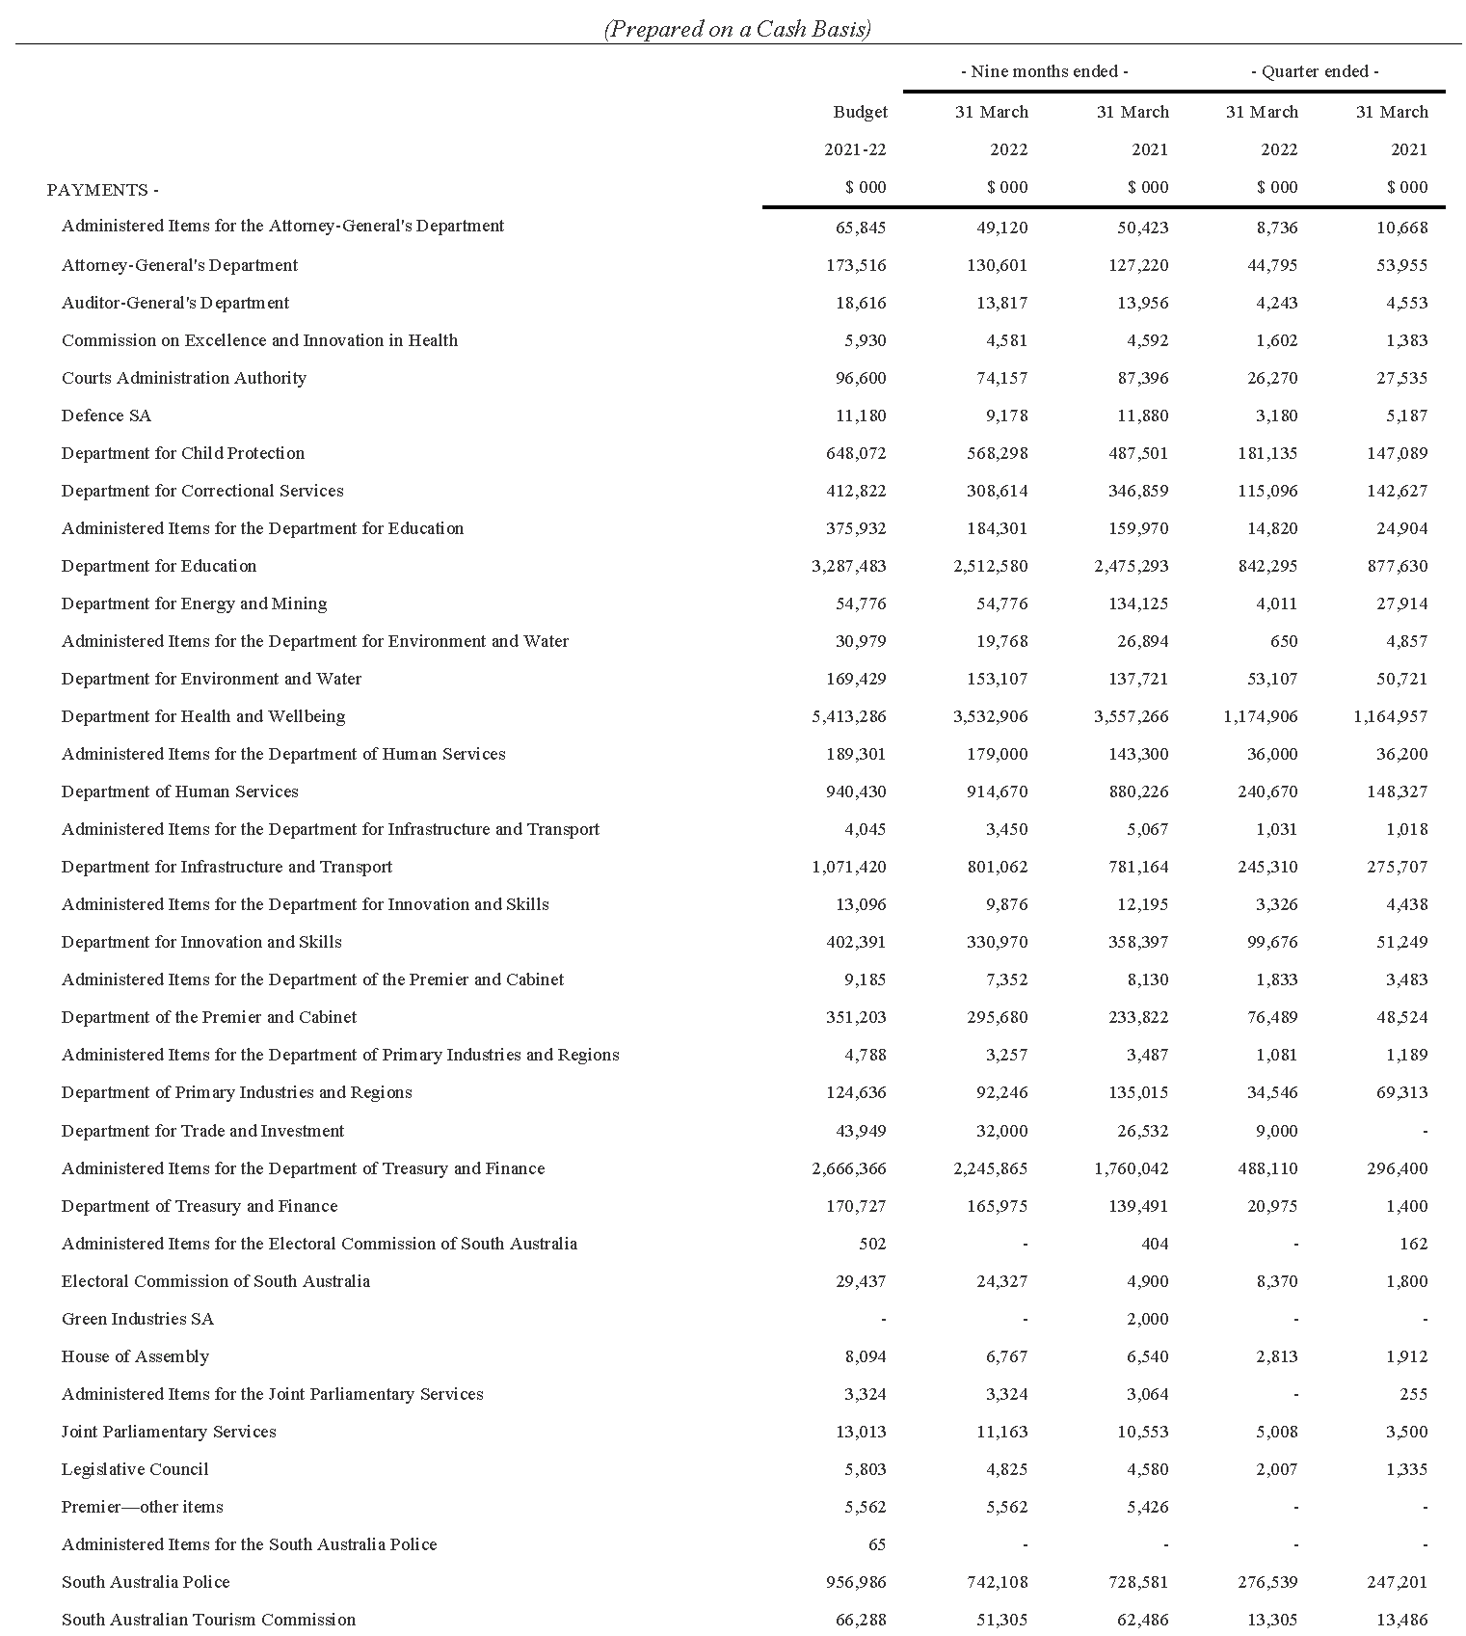
Commentary to the Statement of the Amounts Credited to and Issued from the Consolidated Account
for the Quarters Ended 31 March 2022 and 31 March 2021
Receipts
Taxation
Gambling tax receipts in the March quarter 2022 were lower compared to the corresponding prior year period as receipts in the March quarter 2021 also included payments relating to previous quarters. Gambling tax receipts in the nine months ended March 2022 were higher compared to the corresponding prior year period largely reflecting growth in gaming machine taxation receipts and the impact of
COVID-19 related gambling tax relief, which allowed licence holders to defer gaming machine taxation and casino duty payments.
Land tax receipts in the March quarter 2022 were higher compared to the corresponding prior year period, while land tax receipts in the nine months ended March 2022 were lower compared to the corresponding prior year period. These variances largely reflect differences in the timing of collections between years.
Payroll tax receipts in the March quarter 2022 and nine months ended March 2022 were higher compared to the corresponding prior year periods. This largely reflects the impacts of COVID-19 payroll tax relief measures in 2020-21, which lowered collections in that year, combined with growth in taxable payrolls.
Stamp duty receipts in the March quarter 2022 and nine months ended March 2022 were higher compared to the corresponding prior year periods. This was mainly due to higher conveyance duty on the transfer of properties, reflecting both an increase in the number of residential property transactions and the average value of properties transferred. In addition, insurance duty receipts and stamp duty receipts on the transfer of motor vehicles were higher over both periods.
Fees and charges
Fees and charges receipts in the March quarter 2022 and nine months ended March 2022 were higher than the corresponding prior year periods. This was mainly due to the timing of receipts for Land Services Regulatory Fees post the responsibility for these fees being transferred to the Attorney-General’s Department from 1 October 2020. The payment to the Consolidated Account of all fees collected by the Attorney-General’s Department in 2020-21 was conducted in June 2021. In 2021-22 the fees are being remitted to the Consolidated Account on a monthly basis.
Royalties
Royalty receipts in the March quarter 2022 were lower compared to the corresponding prior year period primarily due to the timing of collections. Royalty receipts in the nine months ended March 2022 were higher compared to the corresponding prior year period mainly due to improvements in commodity prices and increases in production.
Commonwealth – General Purpose Payments
Growth in general purpose grant receipts in 2021-22 compared to 2020-21 is not indicative of underlying movements in Goods and Services Tax (GST) revenue. This is because monthly grants are paid according to a payment schedule prepared by the Commonwealth Government rather than actual emerging monthly GST collections.
Based on the growth in the national GST pool and population estimates, and South Australia’s relativity in 2021-22, the Commonwealth Government estimated in its 2022-23 Budget that South Australia’s GST revenue grants will decline by 0.6 per cent in 2021-22.
Commonwealth – National Partnership Payments
National Partnership Payments received in the March quarter 2022 and nine months ended March 2022 were higher than the corresponding prior year periods. This was mainly due to reimbursements for Commonwealth HomeBuilder grants that are being administered by the state on behalf of the Commonwealth Government.
Other receipts
Other receipts in the March quarter 2022 and nine months ended March 2022 were higher compared to the corresponding prior year periods. This is largely due to the receipts from the Department for Environment and Water of the net proceeds from 2020-21 Crown Land sales to the Consolidated Account in 2021-22. This included the proceeds of the sale of land at Oakden to Renewal SA.
Payments
Payments were made pursuant to the Appropriation Act 2021 and also in accordance with other Acts for which specific appropriation has been authorised. The timing of the payments is based on agreed agency drawdown schedules and may change from period to period based on specific agency requirements.
All appropriations were paid within approved limits established under the various Acts.
Note
The following points should be considered when reviewing the quarterly statement of Consolidated Account transactions:
- Unlike, the State Budget, which comprises transactions on an accrual basis, the information reflected in the quarterly statement is limited to cash transactions.
- The Consolidated Account does not capture all the transactions undertaken by the general government sector. In particular, it does not record receipts to, and payments from Agency deposit and special deposit accounts.
- The timing of receipts and payments can be volatile within a financial year. As a result, apparently large movements between quarters or years may only be due to changes in the timing of receipts and payments and therefore may not have consequences for the underlying budget position.
Dated: 4 July 2022
Hon. Stephen Mullighan MP
Treasurer of South Australia

Retail and Commercial Leases Act 1995
Exemption from the Application of Section 13
PURSUANT to section 77(2) of the Retail and Commercial Leases Act 1995 (SA) I, Nerissa Kilvert, Small Business Commissioner for the State of South Australia,
EXEMPT the Conditional Lease to be entered into between Yorke Peninsula Council and Voysey Holdings Pty Ltd in about August 2022 in relation to the use of that portion of the land comprised in Crown Record Volume 5757 Folio 276 delineated as the area outlined in purple on the plan in Annexure A to the Lease from section 13 of the said Act.
Dated: 8 July 2022
Nerissa Kilvert
Small Business Commissioner

Roads (Opening and Closing) Act 1991
Section 24
NOTICE OF CONFIRMATION OF
ROAD PROCESS ORDER
Road Closure—Unnamed Public Road, Willamulka, Thomas Plain
BY Road Process Order made on 16 May 2022, the Barunga West Council ordered that:
- Portion of Public Road, Willamulka and Thomas Plain, situated adjoining Sections 74 and 75, Hundred of Ninnes, more particularly lettered ‘A’ and ‘B’ in Preliminary Plan 21/0026 be closed.
- Transfer the whole of land subject to closure to Jeffrey Clive Ayles in accordance with the Agreement for Transfer dated 16 May 2022 entered into between the Barunga West Council and Jeffrey Clive Ayles.
- The following easements are to be granted over the land subject to closure:
Grant a free and unrestricted Right of Way over the land marked ‘A’ in favour of Allotment 102 in Deposited Plan 129904.
On 12 July 2022 that order was confirmed by the Minister for Planning conditionally upon the deposit by the Registrar-General of Deposited Plan 129904 being the authority for the new boundaries.
Pursuant to section 24 of the Roads (Opening and Closing) Act 1991, NOTICE of the order referred to above and its confirmation is hereby given.
Dated: 14 July 2022
B. J. Slape
Surveyor-General
DPTI: 2022/18211/01

Local Government Instruments

City of Adelaide
Local Government Act 1999
Section 167—Valuation of Land for the Purpose of Rating
Section 170—Notice of Declaration of Rates
Adoption of Valuations and Declaration of Rates
NOTICE is hereby given that the Council of the Corporation of the City of Adelaide at its meeting held on 28 June 2022 and for the year ending 30 June 2023:
1. Adopted for rating purposes the valuations prepared by Valuers employed by the City of Adelaide of annual values applicable to land within the Council area totalling $1,187,258,452 of which $940,447,250 is for rateable land.
2. Declared differential general rates based upon the use of land as follows:
2.1 0.1149 rate in the dollar for all rateable land with a residential land use; and
2.2 0.2298 rate in the dollar for all rateable land with a vacant land use; and
2.3 0.1408 rate in the dollar for all other rateable land in the Council area.
3. Declared a separate rate of 0.00223 rate in the dollar (the Regional Landscape Levy (formerly the NRM Levy)) on all rateable land in the Council area to recover the amount of $2,096,521 payable to the Green Adelaide Board (formerly the Adelaide and Mount Lofty Ranges Natural Resource Management Board).
4. Declared a separate rate of 0.03582 rate in the dollar (the Rundle Mall Differential Separate Rate) on all rateable land except that with a residential land use within the ‘Rundle Mall Precinct’ (as defined) to fund marketing and management of the precinct, including actions and initiatives to promote Rundle Mall as a destination for shopping and to enhance the vibrancy of the precinct.
Dated: 28 June 2022
C. Mockler
Chief Executive Officer

Campbelltown City Council
Adoption of Valuations and Declaration of Rates
NOTICE is hereby given that at its meeting held on 5 July 2022, the Corporation of the City of Campbelltown for the financial year ending 30 June 2023 resolved:
Adoption of Valuation
To adopt for rating purposes the most recent valuations supplied by the Valuer-General of the capital value of land within the Council’s area totalling $16,644,971,912.
Declaration of General Rate for the Year 2022/2023
To declare a general rate of 0.253979 cents for each dollar of the assessed capital value of rateable land within the Council’s area.
Minimum Rate
To fix a minimum amount payable by way of general rates of $1,037 in respect of rateable land within the Council’s area.
Regional Landscape Levy
To declare a separate rate of 0.007559 cents in the dollar on the capital value of all rateable land within the Council’s area to reimburse the Council for amounts contributed to the Greening Adelaide Board.
Dated: 5 July 2022
P. Di Iulio
Chief Executive Officer

City of Marion
Adoption of Valuations and Declaration of Rates
NOTICE is hereby given that on 28 June 2022 the Council of the City of Marion, pursuant to the provisions of the Local Government Act 1999, for the year ending 30 June 2023,
Adoption of Valuations
- Adopted the capital valuations to apply in its area for rating purposes for the 2022-23 financial year as supplied by the Valuer-General totalling $28,260,874,460.
Declaration of Rates
- Declared differential general rates in the dollar based on capital value as follows:
- 0.272447 cents in the dollar on rateable land of Category 1 – Residential, Category 7 – Primary Production and Category 9 – Other.
- 0.585761 cents in the dollar on rateable land of Category 2 – Commercial Shop, Category 3 – Commercial Office, Category 4 – Commercial Other.
- 0.558516 cents in the dollar on rateable land of Category 5 – Industrial Light, Category 6 – Industrial Other.
- 0.599383 cents in the dollar on rateable land of Category 8 – Vacant Land.
- Resolved that the minimum amount payable by way of general rates in respect of rateable land within the area for the year ending 30 June 2023 be $1,091.00; and
- Declared a Separate Rate of 0.007972 cents in the dollar on all rateable land within the Green Adelaide Board Area within the area.
The Council resolved that rates will be payable in four equal or approximately equal instalments, and that the due dates for those instalments will be 1 September 2022, 1 December 2022, 1 March 2023 and 1 June 2023.
Dated: 14 July 2022
Tony Harrison
Chief Executive

City of Mount Gambier
Adoption of Valuations and Declaration of Rates
Notice is hereby given that the Council, in exercise of the powers contained in Chapters 8, 9 and 10 of the Local Government Act 1999 and the Landscape South Australia Act 2019 at a meeting held on 28 June 2022 and for the financial year ending 30 June 2023:
1. Adoption of Valuations
Adopted for rating purposes, the capital valuations of the Valuer-General’s most recent valuations applicable to land within the area of the Council totalling $4,826,351,100.
2. Declaration of Rates
(i) Declared differential general rates in the dollar based on capital values as follows:
(a) 0.222490 cents in the dollar on rateable land of categories (a) Residential, (g) Primary Production and (i) Other land uses; and
(b) 0.600723 cents in the dollar on rateable land of categories (b) Commercial—Shop, (c) Commercial—Office, (d) Commercial—Other, (e) Industry—Light, (f) Industry—Other and (h) Vacant Land land uses.
(ii) Declared a fixed charge as a component of the general rates of $532.60.
(iii) Declared separate rates with a fixed charge amount that depends upon the use of the land to recover the contribution to the Regional Landscape Levy for the Limestone Coast Landscape Region as follows:
(a) $81.20 per assessment on rateable land categories (a) Residential, (h) Vacant Land and (i) Other,
(b) $122.00 per assessment on rateable land categories (b) Commercial—Shop, (c) Commercial—Office and (d) Commercial—Other,
(c) $195.00 per assessment on rateable land categories (e) Industry—Light and (f) Industry—Other, and
(d) $355.00 per assessment on rateable land category (g) Primary Production.
3. Service Charge
Imposed a Waste Service Charge of $206.85 on all land to which it provides or makes available the prescribed service.
Dated: 14 July 2022
Sarah Philpott
Chief Executive Officer

City of Onkaparinga
Adoption of Valuations and Declaration of Rates for 2022-23
Notice is given that at its meeting held on 05 July 2022 the Council, for the financial year ending 30 June 2023:
Adoption of Valuation
Adopted for rating purposes the Valuer-General's most recent valuation of capital values of land within the Council’s area being $41,499,279,460.
Declaration of General Rates
Declared differential general rates based on two components:
- one being based on the value of the land and varying according to land use, as follows:
- 0.196535 cents in the dollar on rateable land of category (a) (Residential) use
- 0.376488 cents in the dollar on rateable land of categories (b),(c),(d), (Commercial - Shop , Office and Other respectively) and (e) and (f) (Industrial - Light and Other respectively) uses
- 0.252730 cents in the dollar on rateable land of category (g) (Primary Production) use
- 0.291257 cents in the dollar on rateable land of category (h) (Vacant Land) use and
- 0.241220 cents in the dollar on rateable land of category (i) (Other) use; and
- the other being a fixed charge of $730.00
Declaration of Separate Rates – Landscape Levies
Declared separate rates as follows:
- 0.008675 cents in the dollar on all rateable land in the Council area of the Hills and Fleurieu landscape management region
- 0.007671 cents in the dollar on all rateable land in the Council area of the Green Adelaide landscape management region
Service Charges
Imposed a community wastewater management annual service charge on all land (rateable and non-rateable) to which it provides or makes available the CWMS prescribed service of collection, disposal and treatment of waste based on the CWMS Property Units Code of:
- $1,130.96 per unit on each occupied allotment; and
- $1,130.96 per unit on each vacant allotment
Dated: 7 July 2022
Julia Grant
Acting Chief Executive Officer

City of Playford
Adoption of Valuations and Declaration of Rates
NOTICE is hereby given that the City of Playford at its meeting held on 28 June 2022, resolved as follows:
Adoption of Valuations
Pursuant to Section 167(2)(a) of the Act, the Council adopts for rating purposes for the year ending 30 June 2023 the Valuer-General’s Capital Valuation of land within the Council’s area, being $16,482,690,500, of which $15,919,914,412 represents rateable land.
Declaration of General Rate
That having considered and taken into account the general principles of rating contained in Section 150 of the Act, and in accordance with Section 153(2) of the Act issues of consistency and comparability across council areas in the imposition of rates on various sectors of the business and wider community, the Council pursuant to Sections 152(1)(c),153(1)(b) and 156(1)(a) of the Act and Regulation 14 of the Local Government (General) Regulations 2013, declares the following differential general rates for the year ending 30 June 2023, to apply to all rateable land within the Council area based on the following two components:
1. one being a fixed charge of $1,042.95
2. the other being a differential general rate based on the capital value of the land varying accordingly to land use as follows:
(a) $0.00202589 in the dollar of the capital value on rateable land of land uses category 1 (residential), category 7 (primary production), category 8 (vacant land) and category 9 (other) land use.
(b) $0.01270411 in the dollar of the capital value on rateable land of land uses category 2 (commercial shop), category 3 (commercial office), category 4 (commercial other), category 5 (industry light) and category 6 (industry other) land use.
Maximum Increase for Principal Place of Residence
Pursuant to Section 153(3) of the Act, the Council has determined that it will not apply a maximum increase (rates cap) on general rates to be imposed on rateable land constituting the principal place of residence of a principal ratepayer.
Separate Rate (Regional Landscape Levy)
Pursuant to Section 69 of the Landscape South Australia Act 2019 and Section 154 of the Act, the Council imposes a separate rate of $0.00006947 in the dollar for the year ending 30 June 2023 on the capital value of all rateable land in the Council area and the Green Adelaide Region, so as to reimburse the Council for the amount contributed or to be contributed by the Council to the Green Adelaide Board of $1,106,010.
Dated: 14 July 2022
Sam Green
Chief Executive Officer

City of Port Adelaide Enfield
Adoption of Valuations and Declaration of Rates for 2022/2023
NOTICE is hereby given that on 28 June 2022, the Council resolved for the financial year ending 30 June 2023:
1. To adopt the capital valuations that are to apply in its area for rating purposes totalling $41,426,901,850.
2. To declare differential general rates on rateable land within its area as follows:
• Residential
A differential general rate of $0.001950 in the dollar on the capital value of the land subject to the rate.
• Commercial—Shop
A differential general rate of $0.005794 in the dollar on the capital value of the land subject to the rate.
• Commercial—Office
A differential general rate of $0.005794 in the dollar on the capital value of the land subject to the rate.
• Commercial—Other
A differential general rate of $0.005794 in the dollar on the capital value of the land subject to the rate.
• Industry—Light
A differential general rate of $0.005794 in the dollar on the capital value of the land subject to the rate.
• Industry—Other
A differential general rate of $0.005794 in the dollar on the capital value of the land subject to the rate.
• Primary Production
A differential general rate of $0.005794 in the dollar on the capital value of the land subject to the rate.
• Vacant Land
A differential general rate of $0.005794 in the dollar on the capital value of the land subject to the rate.
• Other
A differential general rate of $0.005794 in the dollar on the capital value of the land subject to the rate.
• Marina Berths
A differential general rate of $0.005794 in the dollar on the capital value of the land subject to the rate.
3. Fixed a minimum amount payable by way of rates, pursuant to Section 158 of the Local Government Act 1999, in respect of the 2022-2023 financial year, in respect of rateable land within all parts of its area of $930.
4. Declared a separate rate in respect of the Regional Landscape Levy for the 2022-2023 financial year of $0.0000752 in the dollar on the capital value of rateable land in the area of Green Adelaide on 28 June 2022.
5. Declared a separate rate in respect to the 2022-2023 financial year of $0.0017 in the dollar on the capital value of rateable land for each allotment contained within Deposited Plan No 42580 comprising the New Haven Village at North Haven.
6. Declared that all rates declared or payable in respect of or during the 2022-2023 financial year will fall due (unless otherwise agreed with the Principal Ratepayer) in four equal or approximately equal instalments payable on 1 September 2022, 1 December 2022, 1 March 2023 and 1 June 2023.
With reference to categories of uses being the categories of uses as differentiating factors referred to in the Local Government (General) Regulations 2013 and Local Government Act 1999 and in the case of marina berths, as permitted by Section 156(4a) of the Local Government Act 1999.
Dated: 14 July 2022
M. Withers
Chief Executive Officer

City of Salisbury
Adoption of Valuations and Declaration Of Rates
NOTICE is given that the City of Salisbury at a meeting held on Monday 27 June 2022,
1. Adopted the Valuer-General's valuation of capital values, being rateable of $27,566,373,574, and non-rateable of $1,400,906,186, totalling $28,967,279,760 for the year ending 30 June 2023. The valuation shall, from 27 June 2022, become and be the valuation of the Council for rating purposes.
2. Declared differential general rates on property within its area for the financial year ending on the 30 June 2023, which rates shall vary by reference to the use of the rateable property in accordance with Regulation 14 of the Local Government (General) Regulations 2013 as follows:-
(a) In respect of rateable land with a "Commercial – Shop”, “Commercial – Office”, “Commercial – Other”, "Industrial - Light", “Industrial – Other”, or “Marina Berth” land use, a Differential General Rate of 0.6034 cents in the dollar for the assessed capital value of such land.
(b) In respect of rateable land which has a "Vacant Land" land use, a Differential General Rate of 0.4658 cents in the dollar for the assessed capital value of such land.
(c) In respect of all other rateable land in the area used for purposes other than as stated in paragraph (a) and (b) hereof, a Differential General Rate of 0.3583 cents in the dollar on the assessed capital value of such land.
3. Fixed a Minimum amount of $1,081 which shall be payable by way of rates on any one assessment within the municipality in respect of the year ending 30 June 2023.
4. Declared the following differential separate rates in accordance with Section 154 of the Local Government Act 1999, for the year ending 30 June 2023.
Salisbury Business Association Separate Rate
A separate rate of 0.060029 cents in the dollar on the capital value of rateable land in that area with a local government code classified as Commercial Shop, Commercial Office, Commercial Other, Industrial Light and Industrial Other.
The purpose of this separate rate is to provide a fund to promote and enhance business viability, profitability trade and commerce in that part of the Council's area, which is the subject of the separate rate.
Globe Derby Separate Rate
A separate rate of $150.00 for each share of common land being 1 share for each allotment numbered Lots 1-23 & Lots 26-32 of DP9830, 1 share for each allotment numbered Lots 50-51 DP18972, 1 share for each allotment numbered Lots 33-34 & Lots 38-64 of DP9831, 1 share for allotment numbered lot 2 of FP14624, and 1 share in total for Lots 1 on FP14624 and 37 on DP9831 combined of portion of Section 3070 of Hundred Port Adelaide (laid out as Bolivar).
The purpose of this separate rate is to provide a fund to the Globe Derby Community Club for the purpose of maintaining the common land, being Lot 65 in Deposited Plan No. 9832.
Green Adelaide Board Regional Landscape Levy Separate Rate
A separate rate of 0.008178 cents in the dollar on the capital valuation of all rateable properties within the area of the City of Salisbury.
The purpose of this separate rate is to reimburse to Council the amount contributed to the Green Adelaide Board as required under Section 69 of the Landscape South Australia Act 2019 and Section 154 of the Local Government Act 1999.
Dated: 27 June 2022
J. Harry
Chief Executive Officer

City of Salisbury
Local Government Act 1999
By-law No. 1 of 2022—Permits and Penalties
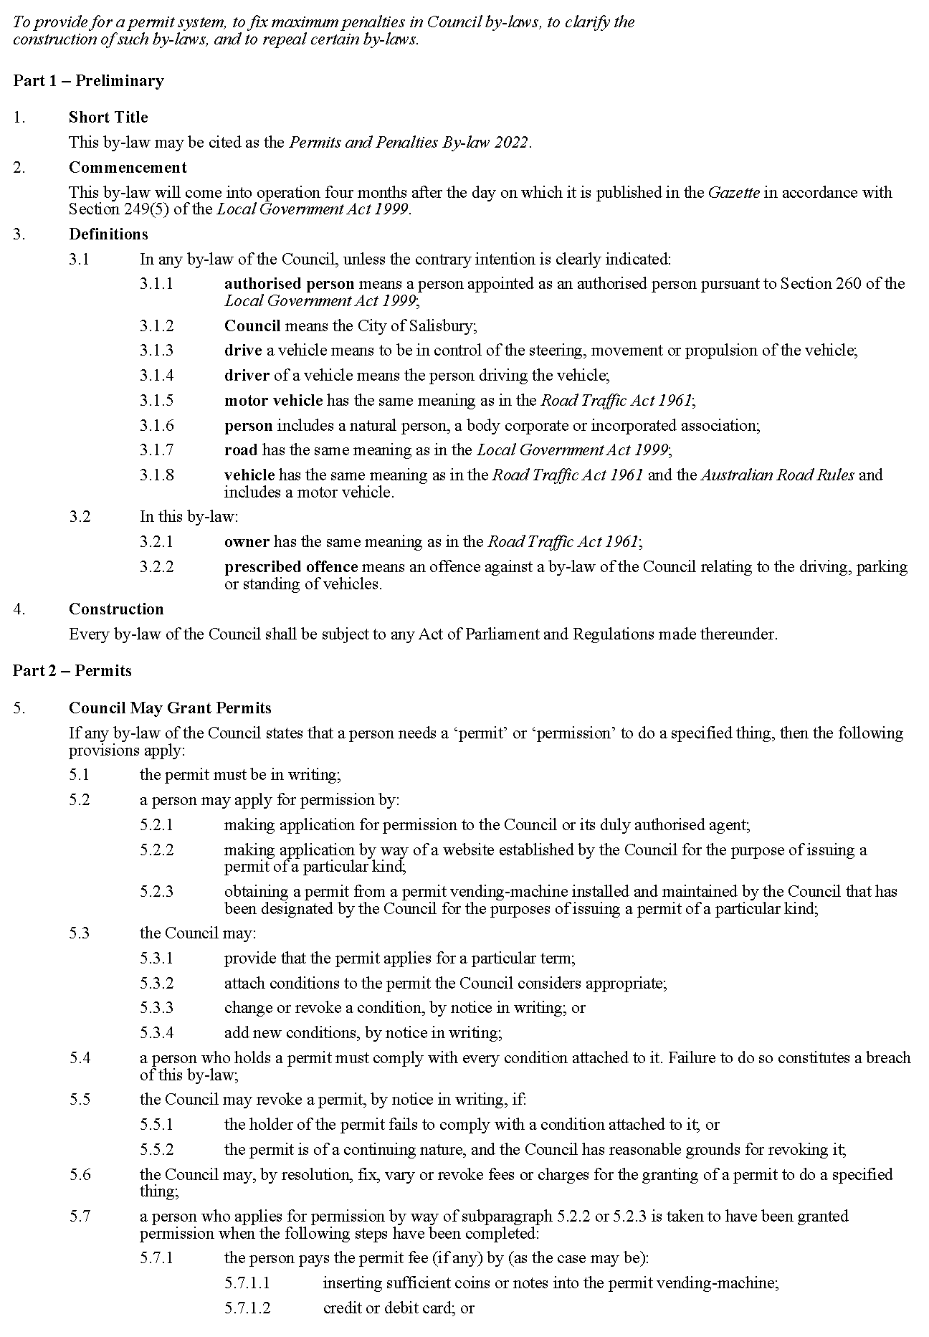
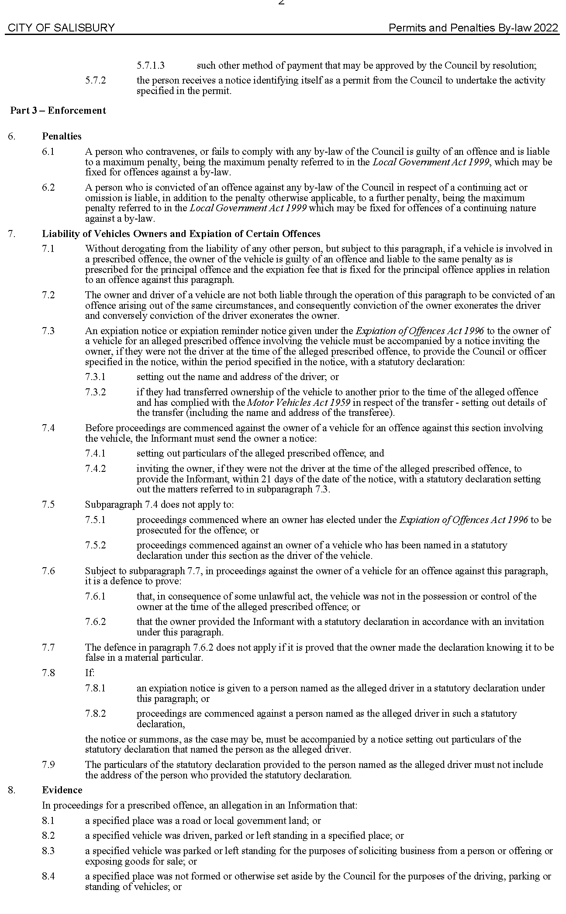

City of Salisbury
Local Government Act 1999
By-law No. 2 of 2022—Moveable Signs
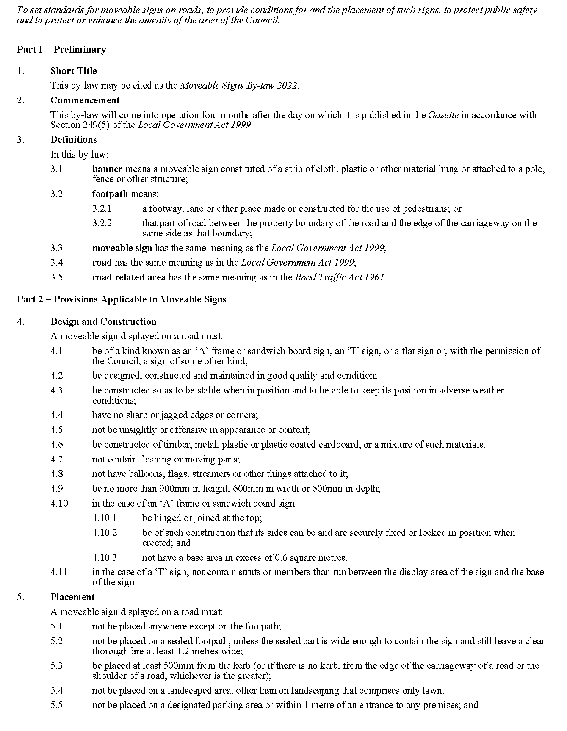
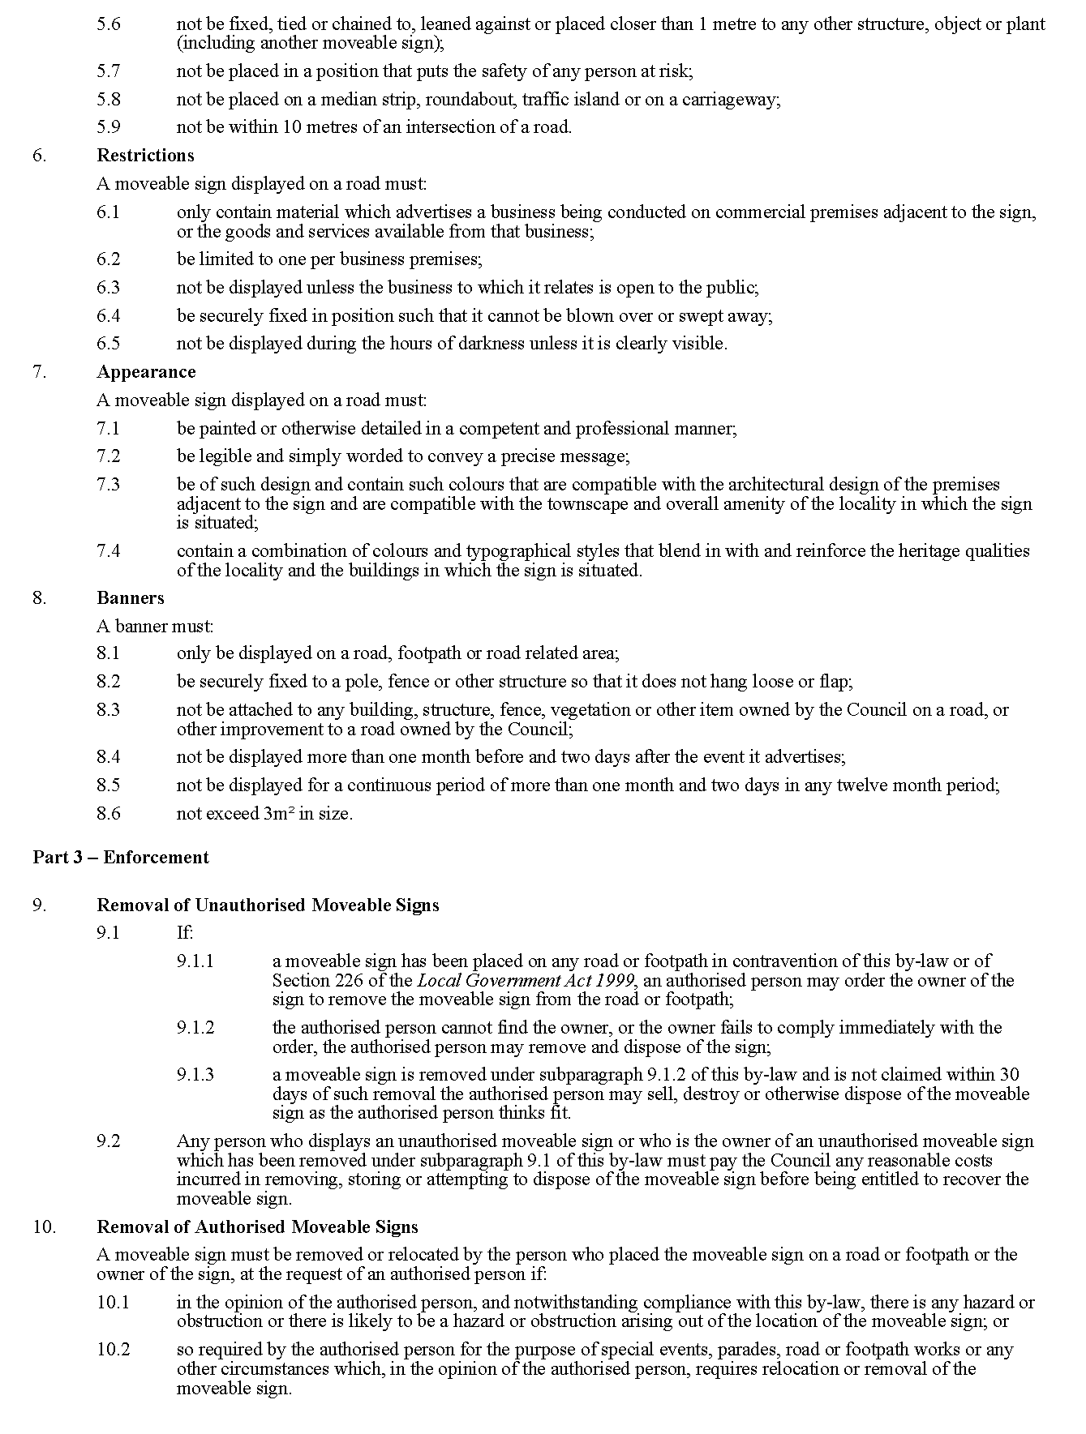
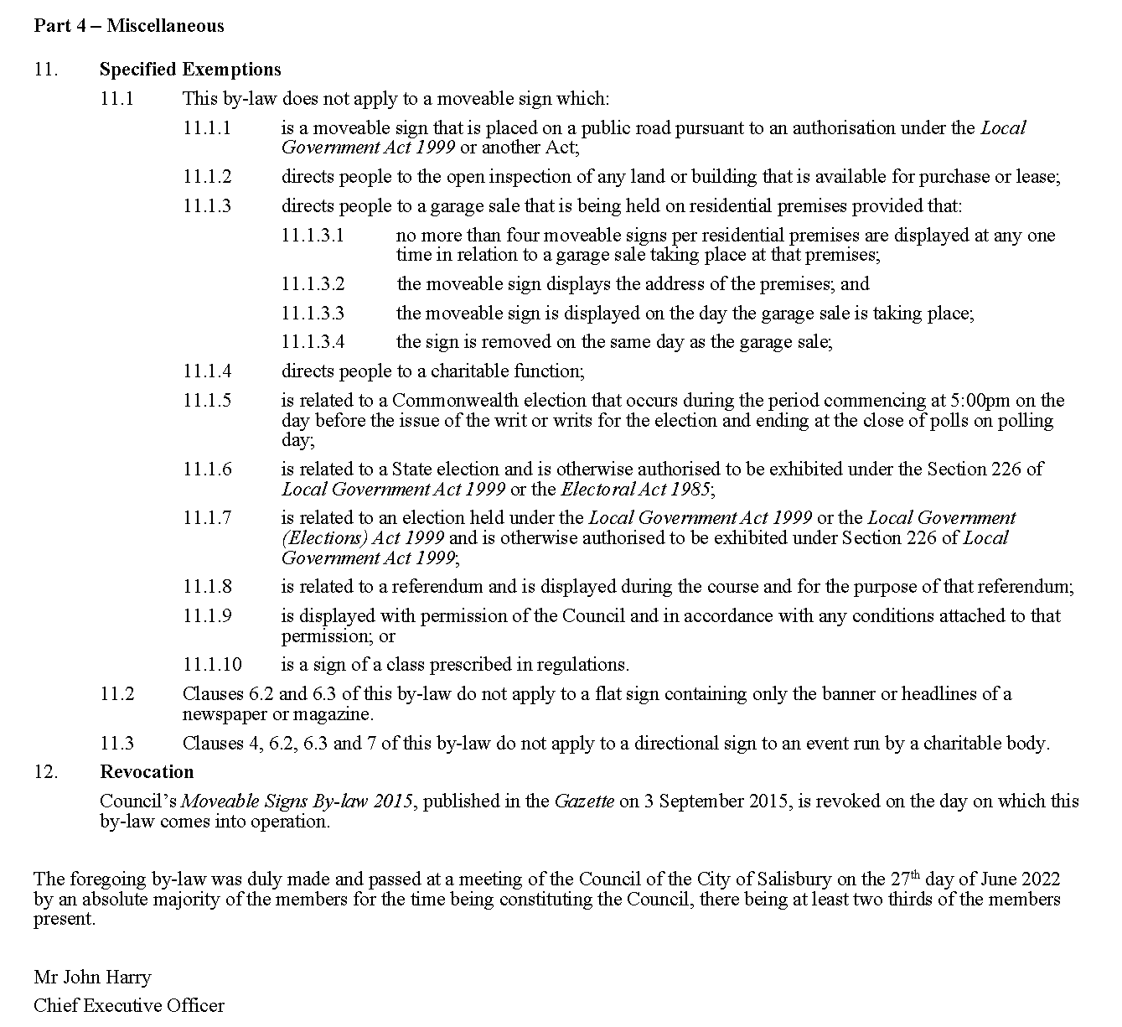

City of Salisbury
Local Government Act 1999
By-law No. 3 of 2022—Roads
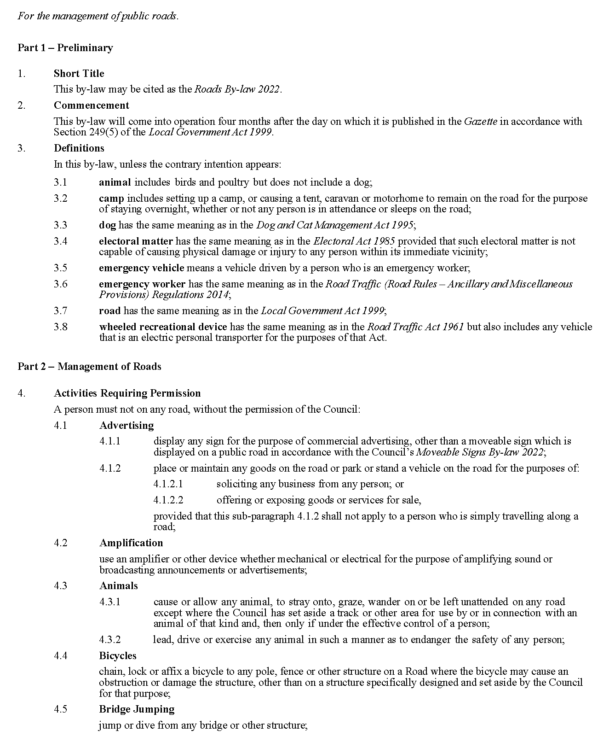
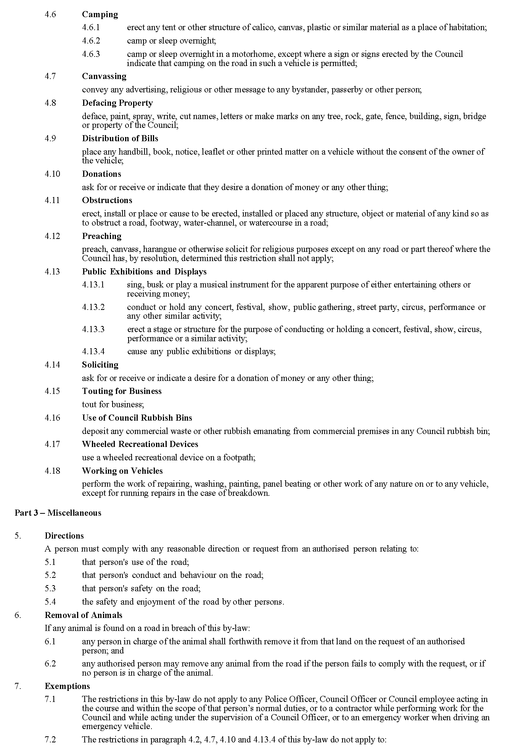

City of Salisbury
Local Government Act 1999
By-law No. 4 of 2022—Local Government Land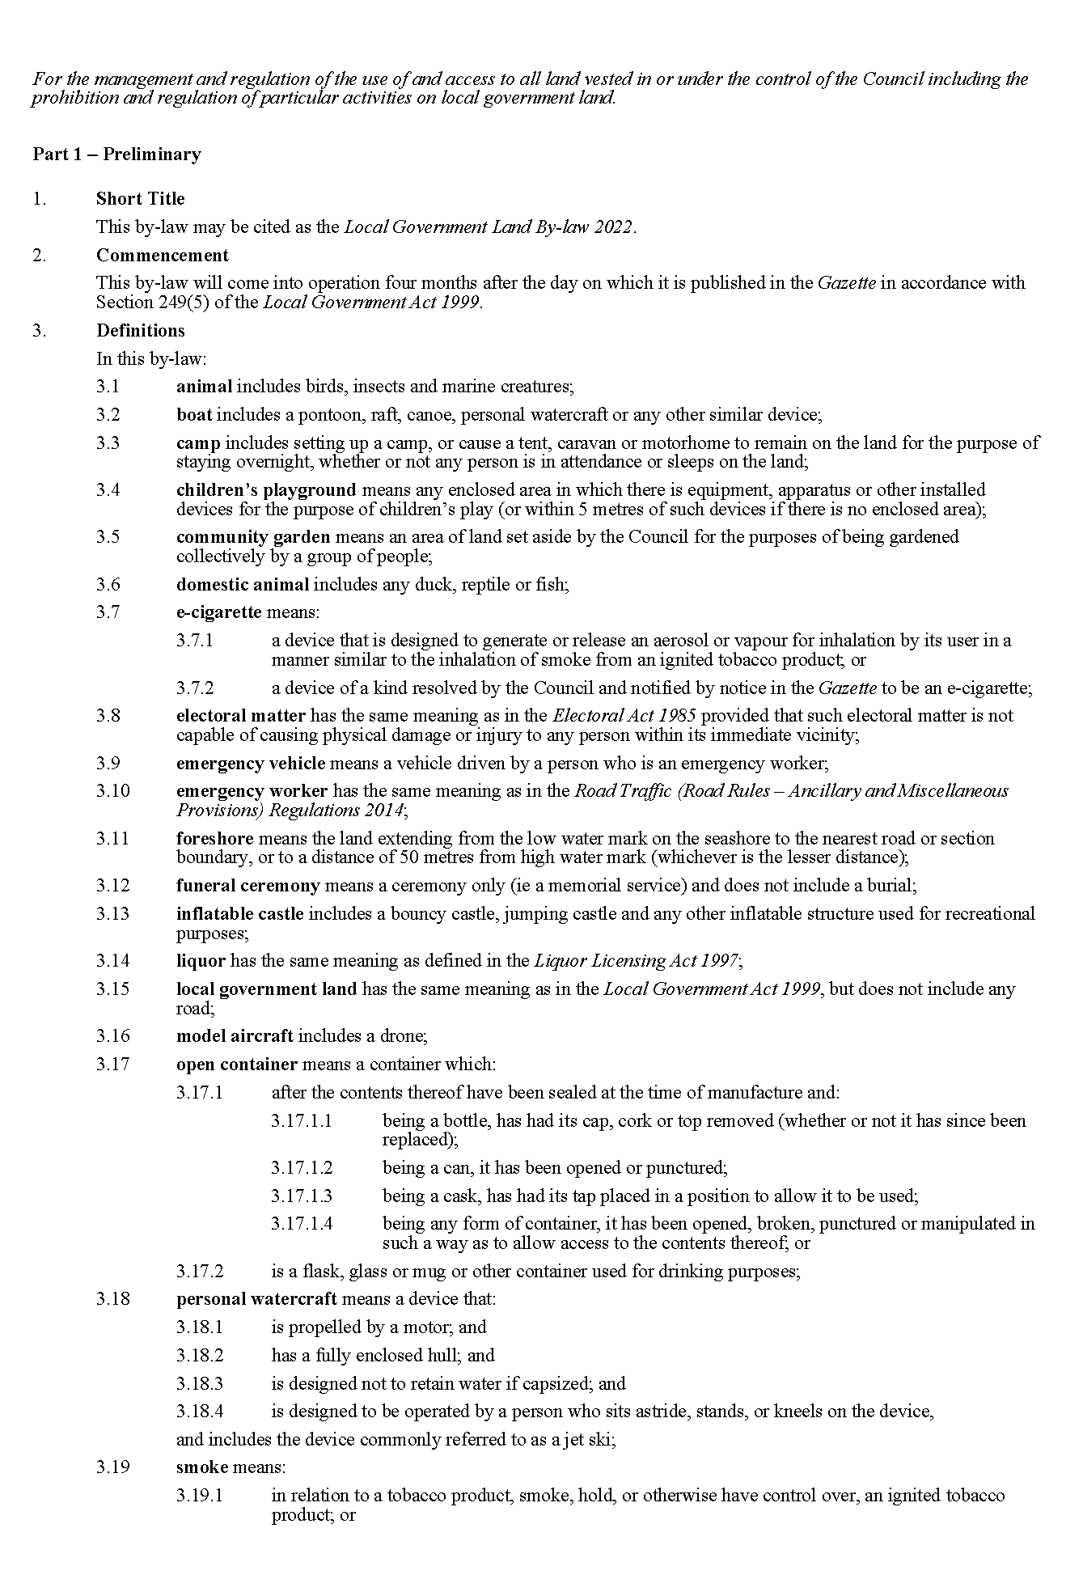
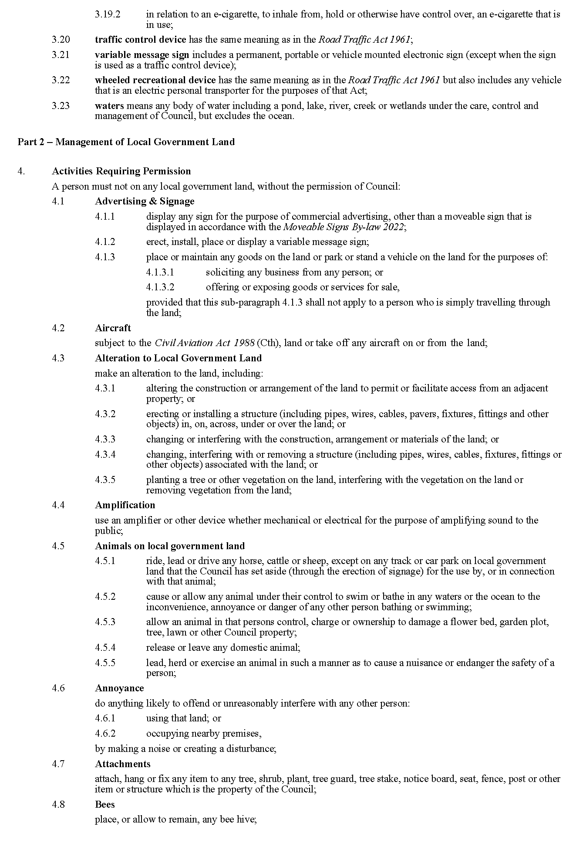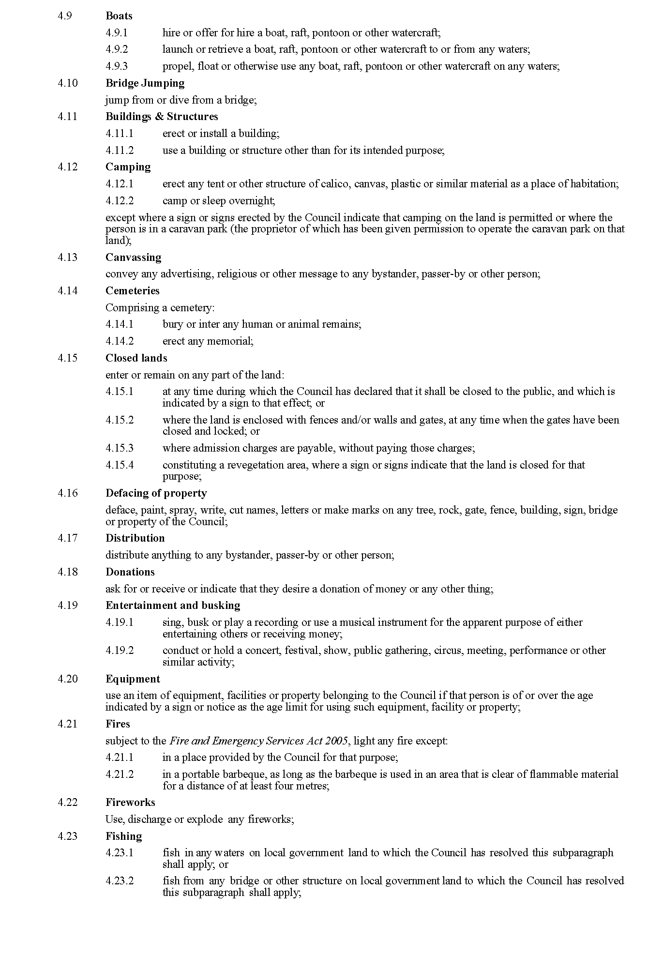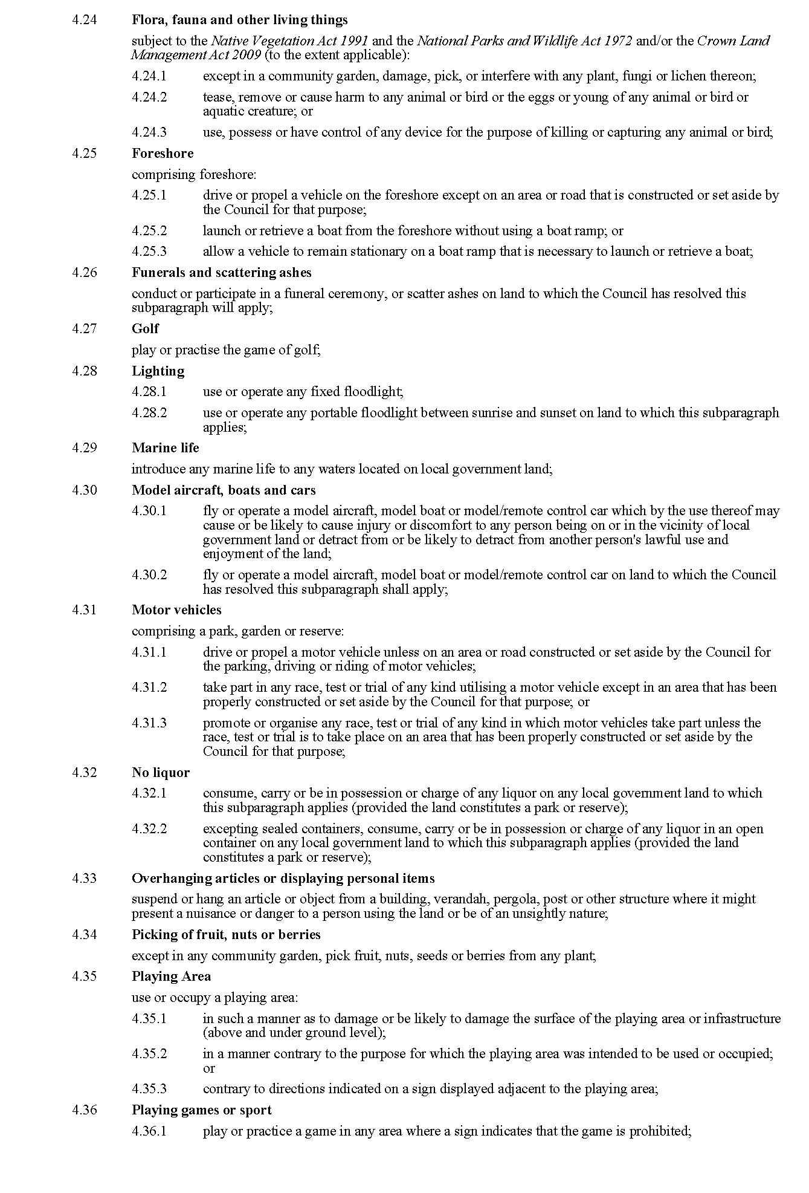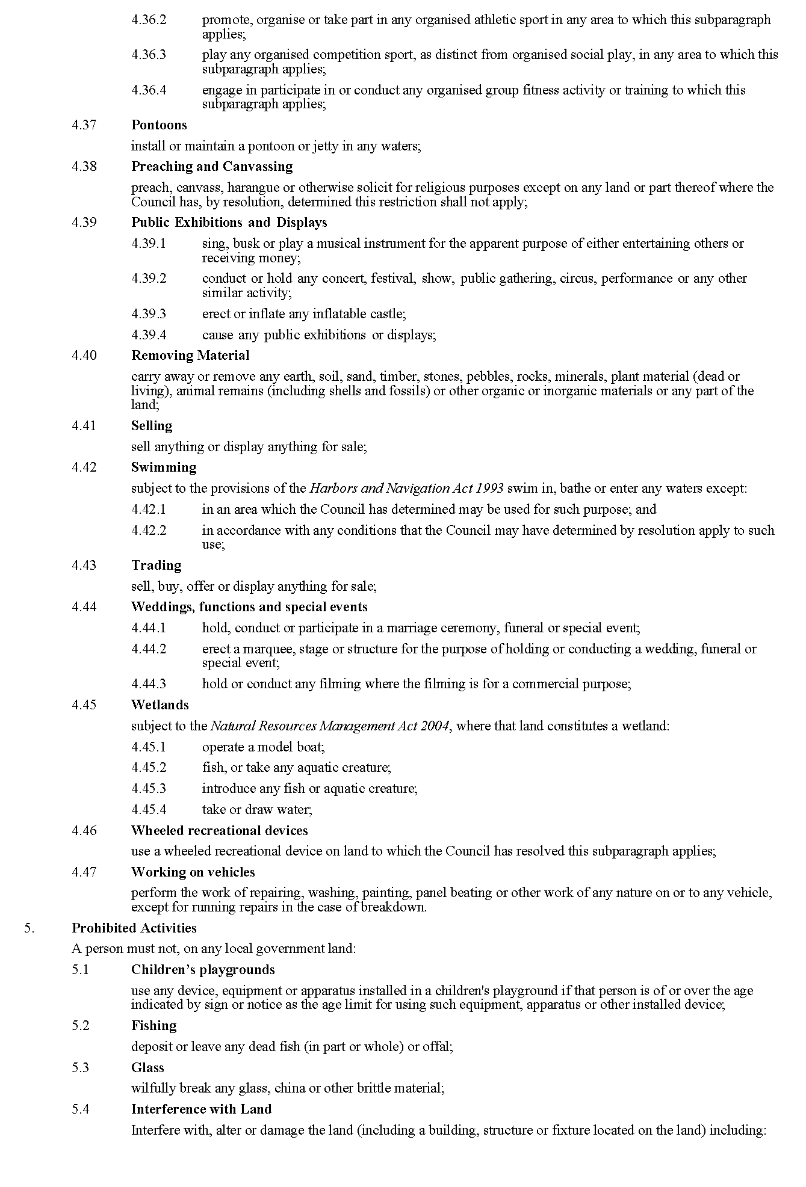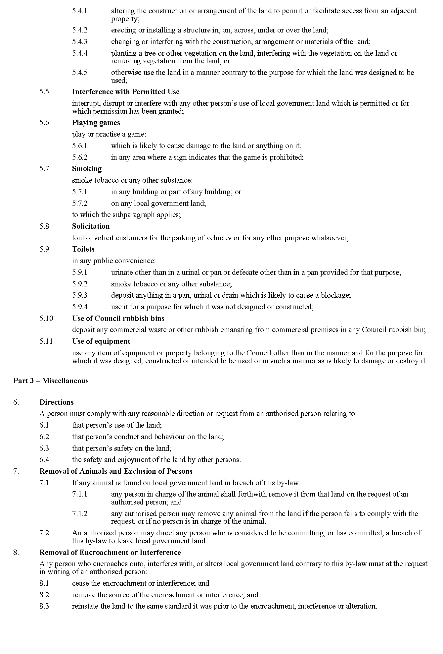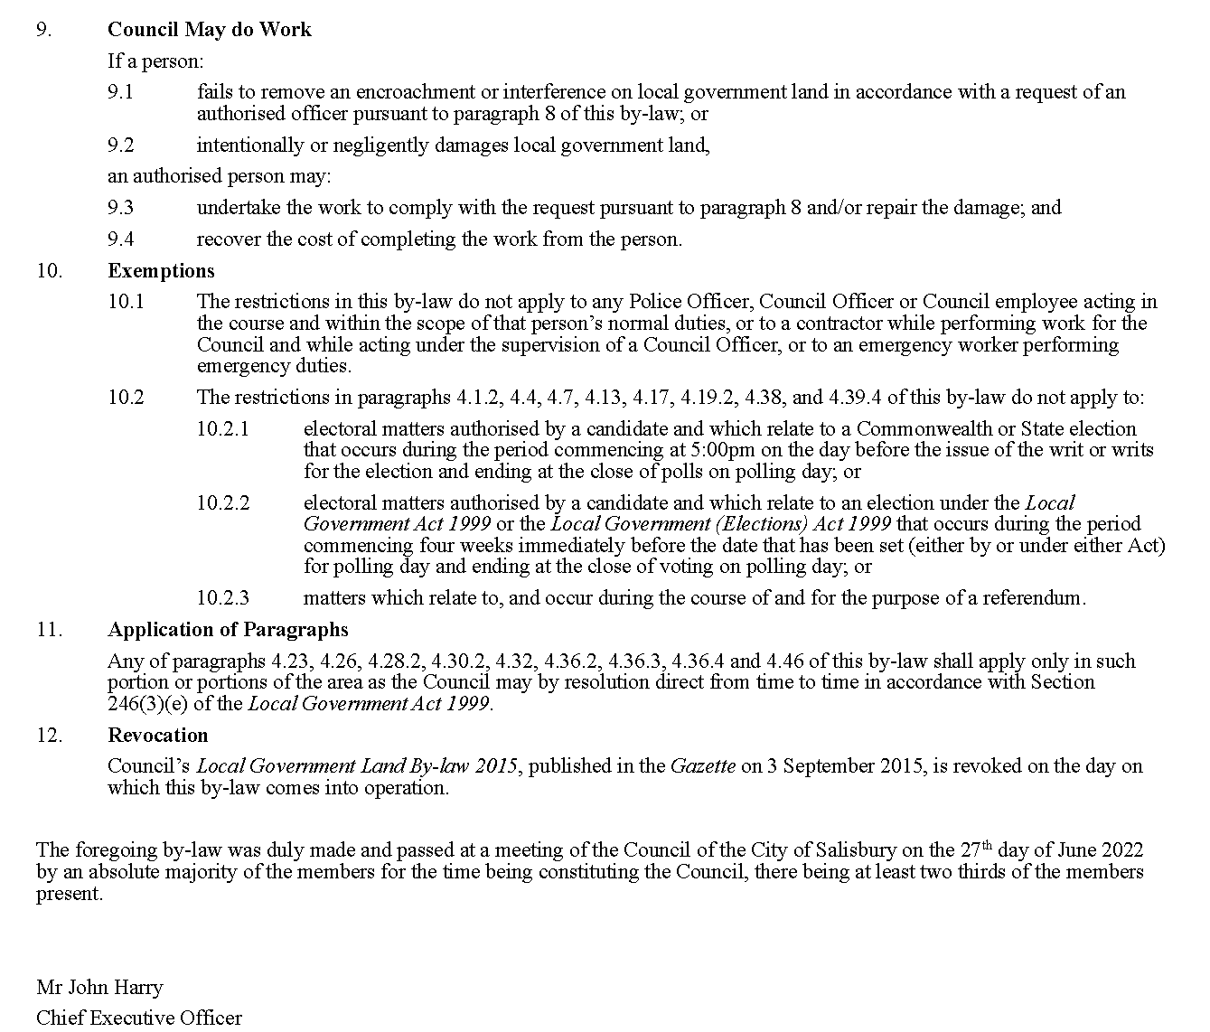

City of Salisbury
Local Government Act 1999
Dog and Cat Management Act 1995
By-law No. 5 of 2022—Dogs
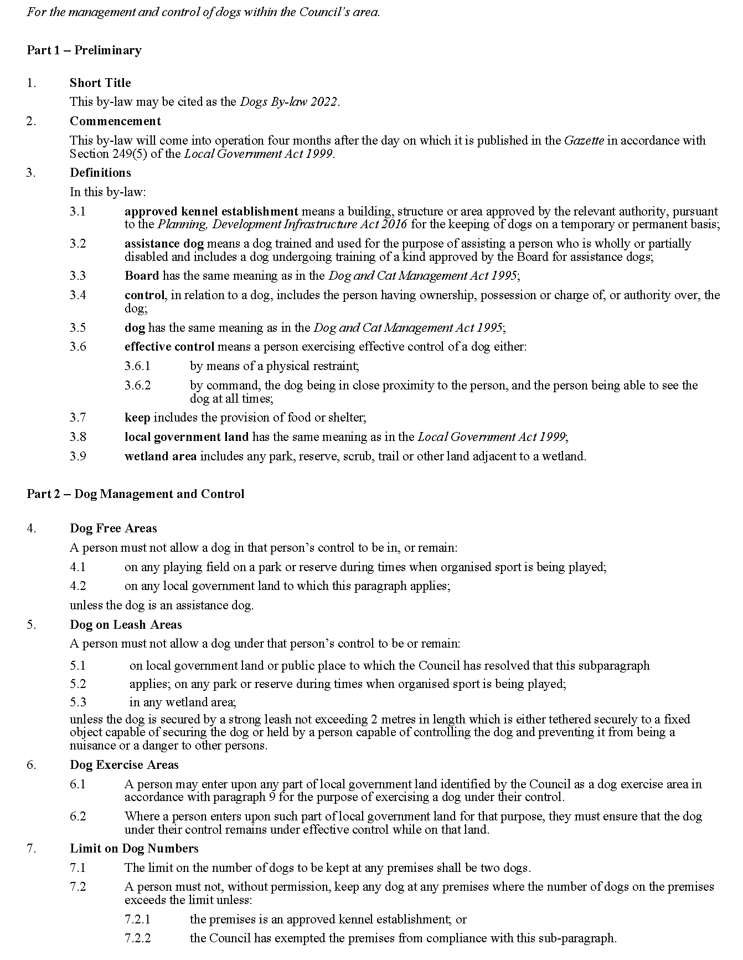

City of Salisbury
Local Government Act 1999
By-law No. 6 of 2022—Waste Management
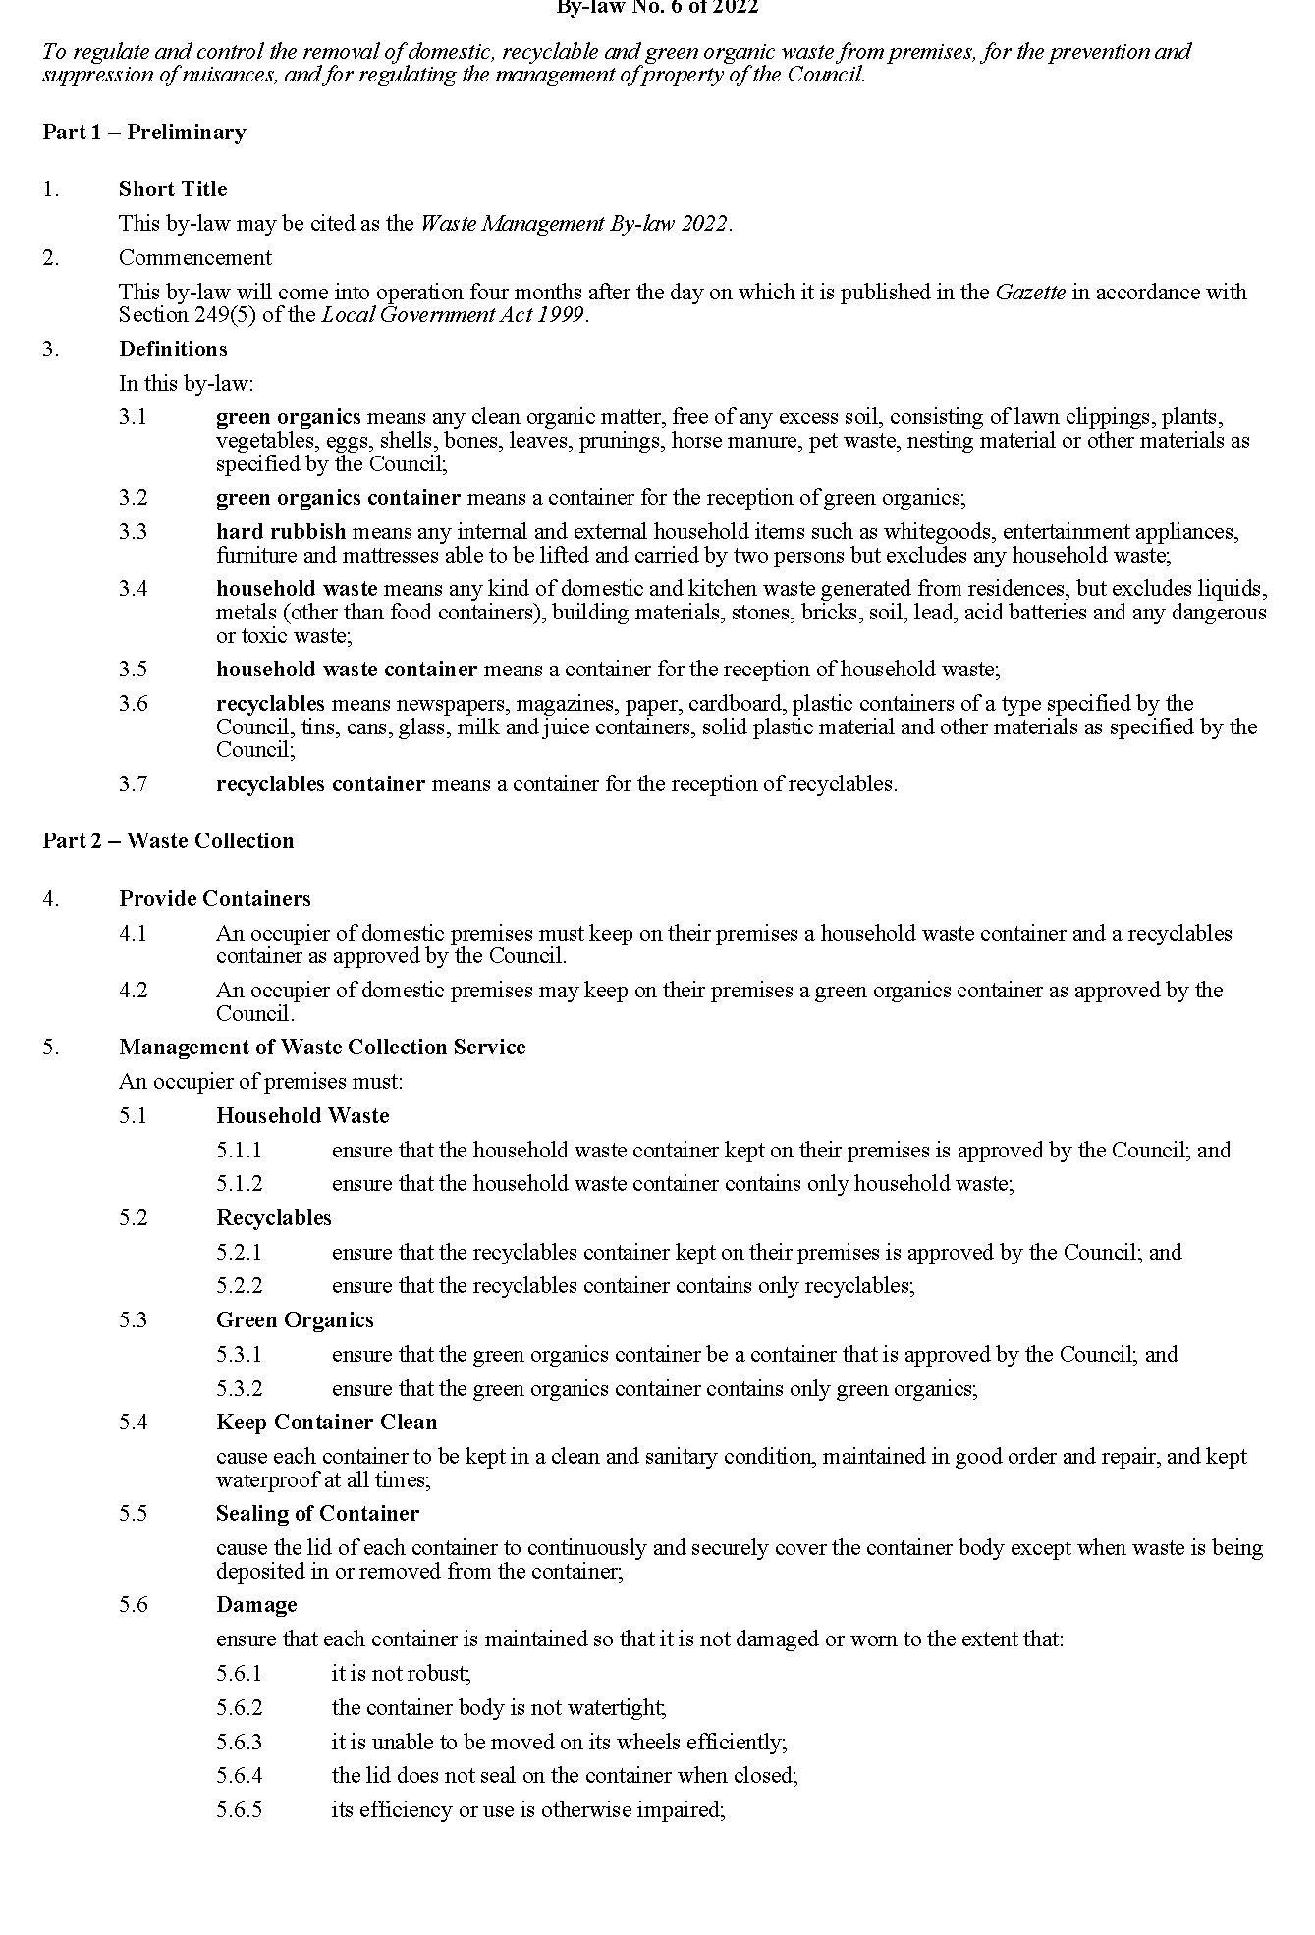
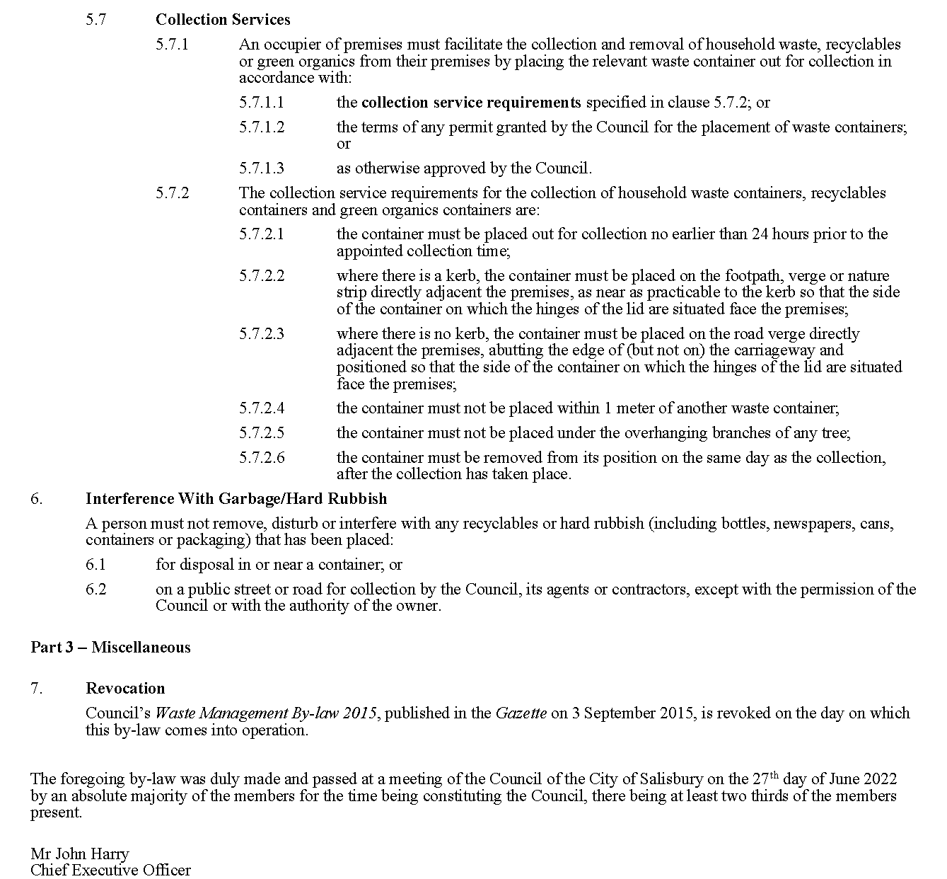

City of Tea Tree Gully
Adoption of Valuations and Declaration of Rates 2022-2023
Notice is hereby given that on 5 July 2022 the City of Tea Tree Gully, adopted and declared as follows for the year ending 30 June 2023:
1. Capital valuations for rating purposes as supplied by the Valuer-General totalling $24,647,439,700 (rateable properties $23,838,875,034).
2. A minimum amount of $1,280 payable by way of general rates on rateable properties within the area of the City of Tea Tree Gully.
3. Differential general rates based upon the use of the land as follows:
3.1 “Commercial—Shop”, “Commercial—Office”, “Commercial—Other”, “Industrial—Light” and “Industrial—Other”: 0.599611 cents in the dollar;
3.2 “Vacant Land”: 0.666234 cents in the dollar;
3.3 “Residential”, “Primary Production” and “Other”: 0.333117 cents in the dollar;
4. A separate rate of 0.007818 cents in the dollar on the capital value of all rateable land within the area of City of Tea Tree Gully to reimburse the amount contributed to the Green Adelaide Board.
Dated: 14 July 2022
J. Moyle
Chief Executive Officer

City of Unley
Adoption of Valuations and Declaration of Rates
NOTICE is hereby given that the Corporation of the City of Unley at a meeting on 27 June 2022 for the financial year ending 30 June 2023 resolved as follows:
Adoption of Valuations
Adopt for rating purposes the Government assessment of capital value being $20,577,659,880 as detailed in the valuation roll prepared by the Valuer-General in relation to the Council area and specified 1 July 2022 as the day as and from which the valuations shall become and be the valuations of the Council.
Declaration of Rates
Declared differential general rates, based upon the capital value of the land as follows:
(a) in respect to rateable land which is categorised as Residential, a differential general rate of 0.001869 rate in the dollar;
(b) in respect to rateable land which is categorised as Commercial—Shop, Industry—Light, Industry—Other, Primary Production, Vacant Land and Other, a differential general rate of 0.004715 rate in the dollar; and
(c) in respect to rateable land which is categorised as Commercial—Office and Commercial—Other, a differential general rate of 0.005425 rate in the dollar.
Fix a minimum amount payable by way of general rates at $907.
A separate rate of 0.00007365 rate in the dollar as the Regional Landscape Levy in accordance with the requirements of the Landscape South Australia Act 2019.
Differential Separate rates as follows:
• in that part of the Council’s area comprising rateable land with an Unley Road address, a differential separate rate of 0.0003303 rate in the dollar, capped at $2,000 in respect of land uses: Commercial—Shop, Commercial—Office and Commercial—Other.
• in that part of the Council’s area comprising rateable land with a Goodwood Road address and situated between Mitchell Street/Arundel Avenue to the south and Leader Street/Parsons Street to the North, a differential separate rate of 0.001198 rate in the dollar, capped at $2,000 in respect of land uses: Commercial-Shop, Commercial—Office and Commercial—Other.
• in that part of the Council’s area comprising rateable land with a King William Road address and situated between Greenhill Road and Commercial Road, a differential separate rate of 0.002005 rate in the dollar capped at $2,000 in respect of land use: Commercial—Shop.
• in that part of the Council’s area comprising rateable land along Fullarton Road between Cross Road and Fisher Street, a fixed charge of $250 in respect of land uses: Commercial-Shop, Commercial-Office and Commercial-Other.
Dated 12 July 2022
P. Tsokas
Chief Executive Officer

Town of Gawler
Adoption of Valuation and Declaration of Rates 2022-2023
NOTICE is hereby given that the Town of Gawler, at its meeting held on Tuesday, 28 June 2022 and for the fiscal year ending 30 June 2023 adopted the following Valuation and Declaration of Rates:
Adoption of Valuation
Adopts, pursuant to Section 167(2)(a) of the Local Government Act 1999 the most recent valuations supplied by the Valuer General of the capital value of land within the Council’s area totalling $4,852,274,860 and that this figure be adopted for rating purposes for the financial year ending 30 June 2023.
Differential General Rates
Adopts, having taken into account the general principles of rating outlined in Section 150 of the Local Government Act 1999 and the requirements of Section 153(2) of the Local Government Act 1999, pursuant to Sections 153(1)(b) and 156(1)(a) of the Local Government Act 1999 and Regulation 14(1) of the Local Government (General) Regulations 2013 the following Differential General Rates be declared in respect of all rateable land in the Council’s area for the financial year ending 30 June 2023 varying on the basis of the use of the land:
(a) Residential - 0.4653 cents in the dollar
(b) Commercial – Shop - 1.146 cents in the dollar
(c) Commercial – Office - 1.146 cents in the dollar
(d) Commercial – Other - 1.146 cents in the dollar
(e) Industry – Light - 1.146 cents in the dollar
(f) Industry – Other - 1.146 cents in the dollar
(g) Primary Production - 0.4653 cents in the dollar
(h) Vacant Land - 0.74448 cents in the dollar
(i) Other - 0.4653 cents in the dollar
Minimum Rate
Adopts, pursuant to Section 158(1)(a) of the Local Government Act 1999 for the financial year ending 30 June 2023 a minimum amount payable by way of rates of $1,085.00 being a 3.5% increase from the 2021/2022 financial year, in respect of all rateable land in the Council’s area.
Waste Management Annual Service Charge
Adopts, pursuant to Section 155 of the Local Government Act 1999, for the financial year ending 30 June 2023 an annual service charge of $233.00 based on the nature of the service imposed on all occupied land in the Council’s area (excluding Primary production properties with no, or minimal, built form) to which the Council provides or makes available the prescribed service of waste collection, treatment and disposal.

Separate Rate for Town Centre Business Development and Marketing
Adopts, pursuant to Section 154 of the Local Government Act 1999, for the financial year ending 30 June 2023, a separate differential rate for the purpose of business development and marketing in respect of all rateable land within the hatched area A defined within Attachment 1 of the 28 June 2022 report, and to which the following land uses have been attributed:
(a) Category 2 (Commercial - Shop),
(b) Category 3 (Commercial - Office),
(c) Category 4 (Commercial - Other),
(d) Category 5 (Industry - Light),
(e) Category 6 (Industry - Other)
of 0.065357 cents in the dollar based on the capital value of the land.
Separate Rate for Non Town Centre Business Development
Adopts, pursuant to Section 154 of the Local Government Act 1999, for the financial year ending 30 June 2023, a separate differential rate for the purpose of business development in respect of all rateable land within the Council area excluding the hatched area A as defined in Attachment 1 of the 28 June 2022 report, and to which the following land uses have been attributed:
(a) Category 2 (Commercial - Shop),
(b) Category 3 (Commercial - Office),
(c) Category 4 (Commercial - Other),
(d) Category 5 (Industry – Light),
(e) Category 6 (Industry - Other)
of 0.031843 cents in the dollar based on the capital value of the land.
Separate Rate for State Government Regional Landscape Levy
Adopts, in accordance with Section 69 of the Landscape South Australia Act 2019 and Section 154 of the Local Government Act 1999 for the financial year ending 30 June 2023, and in order to reimburse to the Council the amount of $378,016 contributed to the Northern & Yorke Landscape Board, a separate rate of 0.007957 cents in the dollar based upon the capital value of rateable land, on all rateable land in the Council area and within the Northern & Yorke Landscape Board area.
Separate Rate – Gawler East Transport Infrastructure
Adopts, pursuant to Section 154(2)(b) of the Local Government Act 1999, for the financial year ending 30 June 2023, a proportional separate rate on the following land parcels for the purpose of securing developer contributions towards construction of the Gawler East Link Road and associated deferred infrastructure (including trees), which will be of direct benefit to the land and occupiers of the land:
Assessment No. | Certificate of Title | Approx. Total Hectares | Per Ha Rate Payable ($) | Total Contribution  Payable ($)
Development Area – Springwood Communities
154322 | CT 6244/939 & CT 6256/75 | 54.6114 | $34,651.77 | $1,892,381.60
40868 | CT 6118/249 | 32.34 | $28,920.36 | $935,284.52
155626 | CT 6263/756 | 47.54 | $23,210.66 | $1,103,434.67
156735 | CT 6267/170 | 8.6935 | $39,399.98 | $342,523.71
Development Area – Other Future Developers
144572 | CT 6208/637 | 1.60 | $83,354.93 | $133,367.89
144564 | CT 6208/636 | 1.41 | $83,839.76 | $118,214.07
144556 | CT 6208/635 | 3.10 | $55,703.78 | $172,681.73
68584 | CT 5462/883 | 1.00 | $83,308.08 | $83,308.08
68576 | CT 5462/882 | 1.00 | $83,308.08 | $83,308.08
68802 | CT 5592/947 | 4.22 | $32,815.76 | $138,482.52
68827 | CT 5636/60 | 3.26 | $83,308.08 | $271,584.35
68819 | CT 5636/59 | 5.59 | $81,777.25 | $457,134.84
68568 | CT 5463/945 | 1.32 | $82,659.80 | $109,110.93
88222 | CT 5809/64 | 1.58 | $83,308.08 | $131,626.77
79776 | CT 5809/65 | 1.38 | $83,308.08 | $114,965.15
149866 | CT 5456/200 | 5.52 | $62,379.82 | $344,336.61
149899 | CT 5098/618 | 3.62 | $35,793.61 | $129,572.87
67345 | CT 5786/841 | 1.00 | $83,308.08 | $83,308.08
149874 | CT 5162/73 | 2.02 | $50,688.55 | $102,390.87
149882 | CT 5162/74 | 2.02 | $64,668.35 | $130,630.06
150421 | CT 6206/115 | 2.91 | $59,565.99 | $173,337.04
67078 | CT 6149/844 | 2.20 | $73,972.81 | $162,740.18
70808 | CT 5903/197 | 2.28 | $65,667.97 | $149,722.96
67086 | CT 5899/721 | 4.31 | $74,572.06 | $321,405.56
68535 | CT 6112/595 | 0.53 | $83,308.09 | $44,153.29
67191 | CT 5481/177 | 5.15 | $38,444.40 | $197,988.64
67183 | CT 5125/726 | 4.05 | $42,106.11 | $170,529.75
67175 | CT 5894/916 | 4.10 | $19,649.87 | $80,564.48
133348 | CT 6181/286 | 3.04 | $16,031.68 | $48,736.32
144491 | CT 6207/896 | 3.94 | $67,235.93 | $264,909.58
67159 | CT 6193/982 | 4.62 | $26,444.42 | $122,173.22
67142 | CT 5485/704 | 4.08 | $10,109.33 | $41,246.06
5262 | CT 6211/743 | 4.81 | $17,838.26 | $85,802.03

Separate Rate – Gawler East Community Infrastructure
Adopts, pursuant to Section 154(2)(b) of the Local Government Act 1999, for the financial year ending 30 June 2023, a proportional separate rate on the following land parcels for the purpose of securing developer contributions towards community infrastructure, which will be of direct benefit to the land and occupiers of the land:
Assessment No. | Certificate of Title | Approx. Total Hectares | Per Ha Rate Payable ($) | Total Contribution  Payable ($)
Development Area – Springwood Communities
154322 | CT 6244/939 & CT 6256/75 | 54.6114 | $22,326.80 | $1,219,297.84
40868 | CT 6118/249 | 32.34 | $18,632.76 | $602,583.48
155626 | CT 6263/756 | 47.54 | $14,954.12 | $710,918.95
156735 | CT 6267/170 | 8.6935 | $25,419.13 | $220,981.19
Development Area – Other Future Developers
144572 | CT 6208/637 | 1.60 | $38,531.16 | $61,649.85
144564 | CT 6208/636 | 1.41 | $38,780.19 | $54,680.07
144556 | CT 6208/635 | 3.10 | $26,085.45 | $80,864.90
68584 | CT 5462/883 | 1.00 | $38,507.10 | $38,507.10
68576 | CT 5462/882 | 1.00 | $38,507.10 | $38,507.10
68802 | CT 5592/947 | 4.22 | $15,786.08 | $66,617.27
68827 | CT 5636/60 | 3.26 | $38,507.09 | $125,533.13
68819 | CT 5636/59 | 5.59 | $37,818.24 | $211,403.95
68568 | CT 5463/945 | 1.32 | $38,215.37 | $50,444.29
88222 | CT 5809/64 | 1.58 | $38,507.10 | $60,841.21
79776 | CT 5809/65 | 1.38 | $38,507.10 | $53,139.79
149866 | CT 5456/200 | 5.52 | $29,089.60 | $160,574.59
149899 | CT 5098/618 | 3.62 | $17,126.08 | $61,996.42
67345 | CT 5786/841 | 1.00 | $38,507.10 | $38,507.10
149874 | CT 5162/73 | 2.02 | $23,828.65 | $48,133.87
149882 | CT 5162/74 | 2.02 | $30,119.41 | $60,841.21
150421 | CT 6206/115 | 2.91 | $27,828.32 | $80,980.41
67078 | CT 6149/844 | 2.20 | $34,306.32 | $75,473.91
70808 | CT 5903/197 | 2.28 | $30,569.23 | $69,697.84
67086 | CT 5899/721 | 4.31 | $34,575.98 | $149,022.45
68535 | CT 6112/595 | 0.53 | $38,507.08 | $20,408.75
67191 | CT 5481/177 | 5.15 | $18,318.91 | $94,342.38
67183 | CT 5125/726 | 4.05 | $19,966.64 | $80,864.90
67175 | CT 5894/916 | 4.10 | $9,861.57 | $40,432.45
133348 | CT 6181/286 | 3.04 | $8,233.43 | $25,029.62
144491 | CT 6207/896 | 3.94 | $31,274.80 | $123,222.70
67159 | CT 6193/982 | 4.62 | $12,919.05 | $59,686.00
67142 | CT 5485/704 | 4.08 | $5,568.43 | $22,719.19
5262 | CT 6211/743 | 4.81 | $9,046.36 | $43,513.01

Separate Rate – Gawler East Traffic Interventions
Adopts, pursuant to Section 154(2)(b) of the Local Government Act 1999, for the financial year ending 30 June 2023, a proportional separate rate on the following land parcels for the purpose of securing developer contributions towards Gawler East Traffic Interventions infrastructure, which will be of direct benefit to the land and occupiers of the land:
Assessment No. | Certificate of Title | Approx. Total Hectares | Per Ha Rate Payable ($) | Total Contribution  Payable ($)
Development Area – Springwood Communities
154322 | CT 6244/939 & CT 6256/75 | 54.6114 | $48,350.02 | $2,640,462.40
40868 | CT 6118/249 | 32.34 | $40,352.92 | $1,305,013.55
155626 | CT 6263/756 | 47.54 | $32,386.10 | $1,539,635.42
156735 | CT 6267/170 | 8.6935 | $54,975.26 | $477,927.39

Development Area – Other Future Developers
144572 | CT 6208/637 | 1.60 | $16,654.16 | $26,646.65
144564 | CT 6208/636 | 1.41 | $16,761.80 | $23,634.13
144556 | CT 6208/635 | 3.10 | $11,274.80 | $34,951.89
68584 | CT 5462/883 | 1.00 | $16,643.76 | $16,643.76
68576 | CT 5462/882 | 1.00 | $16,643.76 | $16,643.76
68802 | CT 5592/947 | 4.22 | $6,823.15 | $28,793.70
68827 | CT 5636/60 | 3.26 | $16,643.76 | $54,258.66
68819 | CT 5636/59 | 5.59 | $16,346.02 | $91,374.23
68568 | CT 5463/945 | 1.32 | $16,517.67 | $21,803.32
88222 | CT 5809/64 | 1.58 | $16,643.76 | $26,297.14
79776 | CT 5809/65 | 1.38 | $16,643.76 | $22,968.39
149866 | CT 5456/200 | 5.52 | $12,573.27 | $69,404.47
149899 | CT 5098/618 | 3.62 | $7,402.33 | $26,796.45
67345 | CT 5786/841 | 1.00 | $16,643.76 | $16,643.76
149874 | CT 5162/73 | 2.02 | $10,299.36 | $20,804.70
149882 | CT 5162/74 | 2.02 | $13,018.39 | $26,297.14
150421 | CT 6206/115 | 2.91 | $12,028.12 | $35,001.82
67078 | CT 6149/844 | 2.20 | $14,828.08 | $32,621.77
70808 | CT 5903/197 | 2.28 | $13,212.80 | $30,125.19
67086 | CT 5899/721 | 4.31 | $14,944.63 | $64,411.34
68535 | CT 6112/595 | 0.53 | $16,643.74 | $8,821.18
67191 | CT 5481/177 | 5.15 | $7,917.90 | $40,777.20
67183 | CT 5125/726 | 4.05 | $8,630.10 | $34,951.89
67175 | CT 5894/916 | 4.10 | $4,262.42 | $17,475.94
133348 | CT 6181/286 | 3.04 | $3,558.70 | $10,818.44
144491 | CT 6207/896 | 3.94 | $13,517.77 | $53,260.03
67159 | CT 6193/982 | 4.62 | $5,583.94 | $25,797.82
67142 | CT 5485/704 | 4.08 | $2,406.82 | $9,819.81
5262 | CT 6211/743 | 4.81 | $3,910.07 | $18,807.45

Residential Rates Cap
Adopts, pursuant to Section 153(3) of the Local Government Act 1999, and upon application from the principal ratepayer, a maximum increase in General rates to be charged on any rateable land that constitutes the principal place of residence of the principal ratepayer as follows:
• 10% - for self-funded retirees or those ratepayers whose primary income source is fixed government benefits
• 20% - for all other ratepayers
where the increase is as a result of significant valuation movements except where:
(a) significant capital improvements have been made to the property; or
(b) the basis for rating or rebates has changed from the previous year; or
(c) new building work and/or development activity has occurred on the land; or
(d) changes in land use, wholly or partially have occurred; or
(e) changes in zoning have occurred; or
(f) the ownership of the rateable property has changed from the previous year; or
(g) the property is no longer the principal place of residence of the principal ratepayer; or
(h) a correction has been made to a previously undervalued property by the Valuer General; or
(i) the property is owned by a company or incorporated body.
Alteration of General Rates for Commercial and Industrial properties
Alters, pursuant to Section 158(1)(b) of the Local Government Act 1999, the amount of General rates otherwise payable in respect of any rateable land with a land use of Category 2 (Commercial – Shop), Category 3 (Commercial – Office), Category 4 (Commercial – Other), Category 5 (Industry – Light) and Category 6 (Industry – Other) as follows:
Property Valuation $ | General Rate | Adjustment % | Effective Net General Rate
0 – 499,999 | 0.011460 | 45.53% | 0.00624246
500,000 – 749,999 | 0.011460 | 40.99% | 0.00676267
750,000 – 999,999 | 0.011460 | 36.45% | 0.00728287
1,000,000 – 1,499,999 | 0.011460 | 31.91% | 0.00780308
1,500,000 – 1,999,999 | 0.011460 | 22.83% | 0.00884349
2,000,000 – 4,999,999 | 0.011460 | 16.02% | 0.00962379
5,000,000 + | 0.011460 | - | 0.011460

Withholding of Discretionary General Rate Adjustments for Commercial properties in the
Town Centre in a state of neglect
Taking into consideration the determining factors outlined in Section 3.10 of the Strategic Rating Policy, not withhold any Discretionary Rate Adjustments provided to commercial properties (pursuant to Section 158(1)(b) of the Local Government Act 1999), on the basis that Council has deemed that no commercial properties are currently in a state of neglect which detracts significantly from the amenity of their locality.
Payment of General Rates and Service Charges
Adopts, pursuant to Section 181(2) of the Local Government Act 1999, rates and charges will be payable in four equal or approximately equal instalments falling due on:
(a) 1 September 2022;
(b) 1 December 2022;
(c) 1 March 2023; and
(d) 1 June 2023
Dated: 5 July 2022
H. Inat
Chief Executive Officer

Adelaide Hills Council
Adoption of Valuation and Declaration of Rates 2022-23
NOTICE is given that at the meeting held on 28 June 2022, the Council, for the financial year ending 30 June 2023, resolved as follows:
Determination of Valuation—2022-23
To adopt for rating purposes the most recent valuations of the State Valuation Office of the capital value of land within the Council area, amounting to $13,641,908,780.
Declaration of General Rates
1. To declare general rates based upon the capital value of rateable land:
(a) with a category (a), (g), (h) and (i) (Residential, Primary Production, Vacant Land and Other) land use, a rate of 0.2135 cents in the dollar; and
(b) with a category (b), (c), (d), (e) and (f) (Commercial—Shop, Commercial—Office, Commercial—Other, Industry—Light and Industry—Other) land use, a rate of 0.2455 cents in the dollar.
2. To declare a fixed charge of $733 in respect of all rateable land.
Declaration of a Separate Rate—Regional Landscape Levy
3. To declare a separate rate based upon the capital value of rateable land of 0.008482 cents in the dollar in the area of the Hills and Fleurieu Region.
Declaration of a Separate Rate—Stirling Business
4. To declare a separate rate of 0.07930 cents in the dollar on the capital value of rateable land within the precinct known as the District Centre (Stirling) Zone and businesses fronting both sides of Mt Barker Road east of the District Centre (Stirling) Zone to Pine Street, but excluding land with the land use category 1 (Residential) and otherwise government owned land; and:
(a) To fix a minimum amount payable of $297; and
(b) To fix a maximum amount payable of $2,657.
Service Charges
5. To impose annual service charges of $826 for occupied land and $415 for vacant land based on the nature of the service and the level of usage of the service where the Council provides or makes available the following prescribed services:
(a) the Woodside Community Wastewater Management System;
(b) the Woodside Extension Community Wastewater Management System;
(c) the Birdwood and Mt Torrens Community Wastewater Management System;
(d) the Kersbrook Community Wastewater Management System;
(e) the Charleston Community Wastewater Management System;
(f) the Verdun Community Wastewater Management System; and
(g) the Mt Lofty Ward Community Wastewater Management System.
Dated: 14 July 2022
A. Aitken
Chief Executive Officer

Copper Coast Council
Adoption of Valuations and Declaration of Rates
NOTICE is hereby given that the Copper Coast Council, at its Meeting held on Wednesday, 6 July 2022, resolved for the year ending 30 June 2023 as follows:
Adoption of Valuations
To adopt the most recent valuations of the Valuer-General available to the Council, of the capital value of land within the Council’s area totalling $4,499,213,160 and of which $4,365,008,546 is the total valuation of rateable land.

Adoption of Rates
1. To declare the following differential general rates varying according to the use of the land:
i. with a land use designated as Category (a) - Residential, a rate of 0.2923 cents in the dollar;
ii. with a land use designated as Category (b) - Commercial—Shop, Category (c) - Commercial—Office or Category (d) – Commercial-Other, a rate of 0.6422 cents in the dollar;
iii. with a land use designated as Category (e) – Industry-Light, Category (f) – Industry-Other, a rate of 0.6663 cents in the dollar;
iv. with a land use designated as Category (g) - Primary Production, a rate of 0.2526 cents in the dollar;
v. with a land use designated as Category (h) - Vacant Land, a rate of 0.4946 cents in the dollar;
vi. with a land use designated as Category (i) - Other (any other land use not referred to in a previous category), a rate of 0.3294 cents in the dollar; and
vii. with a land use designated as Marina Berths, a rate of 0.6422 cents in the dollar.
2. To impose an amount of $631 as a fixed charge as part of the general rates in respect of each separate piece of rateable land in the area of the Council.
3. To declare a separate rate of a fixed amount of $721 in respect of each separate piece of rateable land in that part of the Council area known as “The Dunes” to partly fund the activity of the maintenance of the Port Hughes Golf Course.
4. To declare a differential separate rate of 0.0370 cents in the dollar with a minimum amount of $50.00 being payable in respect of each separate piece of rateable land (excluding land with a residential land use) in that part of the Council area known as Kadina Central Business District for the activity which is the ‘revitalisation project’.
5. To declare a separate rate of a fixed amount of $265 in respect to each allotment per certificate of title for properties in that part of the Council area adjoining the Riley Cove Community Corporations 20692 internal roads to fund the activity of the replacement of the road seal, pavement and kerbing (internal road maintenance).
6. To declare a separate rate of a fixed amount of $164 in respect of each property allotment per certificate of title for properties adjoining Olive Parade, New Town for a 50% contribution towards the activity of installing kerbing for Olive Parade.
7. To declare a separate rate of a fixed amount of $297.67 per lineal metre in respect of each property allotment per certificate of title for properties along the western boundary of Otago Road, North Beach and the property on Lot 11 located to the immediate south of the North Beach Tourist Park for a 34% contribution towards the activity of the implementation of the Sand drift Study.
8. To declare a separate rate of a fixed amount of $1,231.20 in respect of each property allotment per certificate of title for properties adjoining David Street between George Street and Brittain Road for a 50% contribution to install kerbing and sealing on David Street.
Adoption of Community Wastewater Management Scheme Annual Service Charges
To impose an annual service charge based on the nature of the service and the level of usage of the service of $544 per property unit in respect of all land to which the Council provides or makes available the Community Wastewater Management scheme.
Adoption of Regional Landscape Levy
To declare a separate rate of 0.0152 cents in the dollar based on the capital value of all rateable land within the Council area and the area of the Northern and Yorke Landscape Board in order to reimburse the Council the amount of $658,019 payable to the Northern and Yorke Landscape Board.
Dated: 6 July 2022
Russell Peate
Chief Executive Officer

Light Regional Council
Adoption of Valuation and Declaration of Rates and Charges
Notice is hereby given that at its Meeting held on 28 June 2022, in relation to the financial year ending 30 June 2023, the Light Regional Council, in exercise of the powers contained within Chapter 10 of the Local Government Act 1999, made the following resolutions:
Adoption of Valuation
Council, pursuant to Section 167(2)(a) of the Local Government Act 1999, adopted for rating purposes (subject to alteration), the most recent valuations of the Valuer-General of South Australia available to the Council of the capital value of land within the area of the Council, with such valuations totalling $4,345,886,520 of which $4,281,600,938 is rateable.
Declaration of General Rate
Council, pursuant to Sections 153(1)(b) and 156(1)(a) of the Local Government Act 1999, declared the following differential general rates based on the capital value of rateable land varying according to the land use category:
(i) on all rateable land attributed Land Use Category 1—Residential, and Land Use Category 9—Other, a rate of 0.4342 cents in the dollar of the capital value of the land;
(ii) on all rateable land attributed Land Use Category 2—Commercial Shop, or Land Use Category 3—Commercial Office, or Land Use Category 8—Vacant Land, a rate of 0.7599 cents in the dollar of the capital value of the land;
(iii) on all rateable land attributed Land Use Category 4—Commercial Other, a rate of 0.8684 cents in the dollar of the capital value of the land;
(iv) on all rateable land attributed Land Use Category 5—Industrial Light, or Land Use Category 6—Industrial Other, a rate of 1.1941 cents in the dollar of the capital value of the land;
(v) on all rateable land attributed Land Use Category 7—Primary Production, a rate of 0.3343 cents in the dollar of the capital value of the land.
Application of Rate Capping
That Council determined to grant a discretionary rebate of rates as it is considered appropriate to provide relief against what would otherwise amount to a substantial change in rates caused by rapid changes in property valuations. In accordance with Section 166(1)(l)(ii) of the Local Government Act 1999 a rebate will be available on application by the ratepayer within its rating policy for the financial year ending 30 June 2023 for all rateable land, and Council delegates to the person occupying the office of Chief Executive Officer of the Council, or a staff member authorised by the person occupying office of the Chief Executive Officer, the power to accept and approve ratepayer applications in accordance with the following conditions:
• the rebate is available only for property valuation increases greater than 11% since the last general valuation.
• the rebate application process is to be received within 60 days of the first rates notice.
• the rebate is unavailable for 1) any property that has had improvements (valued at greater than $40,000) since the last general valuation, 2) any property purchased since the last valuation, 3) any property where the land use has changed, and 4) any property where the minimum rate applies.
• no minimum rebate amount is set.
Declaration of Minimum Rate
Council, pursuant to Section 158(1)(a) of the Local Government Act 1999, fixed a minimum amount payable by way of the general rate of $900.00 in respect of all rateable land within the council area.
Declaration of Community Wastewater Management System Annual Service Charge
Council, pursuant to Section 155 of the Local Government Act 1999, declared the following annual service charges based on the nature of the service on each assessment, whether vacant or occupied, to which the Council provides or makes available a Community Wastewater Management System service:
System | Annual Service Charge
Kapunda | $580
Freeling | $580
Freeling (Hanson Street Estates Sewer System) | $580
Greenock | $580
Nuriootpa | $580
Roseworthy | $580
Declaration of Domestic Refuse and Recycling Annual Service Charge
Council, pursuant to Section 155 of the Local Government Act 1999 declared an annual service charge based on the nature of the services for refuse collection and recycling of $323.00 per assessment in respect of all land to which Council makes available the 3-bin service, and of $218.00 per assessment in respect of all land to which Council provides or makes available the 2-bin service on the basis that the sliding scale provided for in Regulation 13 of the Local Government (General) Regulations 2013 will be applied to reduce the service charge payable, as prescribed.
Declaration of Separate Rate—Gawler Water Reuse Scheme
Council, pursuant to Section 154 of the Local Government Act 1999, declared a separate rate (based on a fixed charge against the land subject to the rate) of $1,800,000 to be levied against the rateable assessment number 6512, Valuer-General of South Australian assessment number 3120415503, described as Allotment 100 of Filed Plan 35604, Certificate of Title Volume 5253 Folio 627.
Declaration of Separate Rate for Regional Landscape Levy
Council, pursuant to the powers contained in the Landscape South Australian Act 2019, and Section 154 of the Local Government Act 1999, and in order to reimburse the Council for the amount contributed to the Northern & Yorke Landscape Board, being $349,177 declared a separate rate of 0.008361 cents in the dollar of the Capital Value of land, in respect of all rateable land in the Council’s area and in the area of that Board, the Capital Value of such land totalling $4,281,600,938.
Dated: 8 July 2022
B. Carr
Chief Executive Officer

Northern Areas Council
Adoption of Annual Business Plan, Budget & Valuations and Declarations of Rates
NOTICE is hereby given that the Northern Areas Council at its meeting held on 29 June 2022:
Adoption of Annual Business Plan and Budget 2022-2023
Pursuant to Section 123 of the Local Government Act 1999 and Regulations 6 and 7 of the Local Government (Financial Management) Regulations 2011, adopted the Annual Business Plan and Budget for 2022-2023.
Adoption of Capital Valuations
Pursuant to and in accordance with Section 167(2)(a) of the Local Government Act 1999 adopted for the year ending 30 June 2023 for rating purposes, the most recent valuations available to the Council made by the Valuer-General of capital values in relation to all land in the area of the Council, with the total of the valuations being $2,099,636,040 comprising $2,063,332,307 in respect of rateable land and $36,303,733 in respect of non-rateable land.
Declaration of Differential General Rates
Pursuant to and in accordance with Sections 152(1)(c), 153(1)(b) and 156(1)(b) of the Local Government Act 1999 and taking into account the general principles of rating in Section 150 of the Local Government Act 1999 and the requirements of Section 153(2) of the Local Government Act 1999 declared differential general rates on all rateable land within the Council area for the year ending 30 June 2023, comprising the following two components:
- a component based upon the assessed capital value of land, varying according to land use as prescribed by Regulation 14(1) of the Local Government (General) Regulations 2013, as follows:
- 0.7227 cents in the dollar for all rateable land attributed with a land use of category (i) - Other; and
- 0.6795 cents in the dollar for all rateable land attributed with a land use of category (a) - Residential, (b) - Commercial – Shop, category (c) - Commercial – Office, category (d) - Commercial – Other, category (e) - Industry – Light or category (f) - Industry – Other; and
- 0.2790 cents in the dollar for all rateable land attributed with a land use of category (g) - Primary Production; and
- 1.0300 cents in the dollar for all rateable land attributed with a land use of category (h) - Vacant Land; and
- a fixed charge of $150.00.
Declaration of Annual Waste Collection Service Charge
Pursuant to and in accordance with Section 155 of the Local Government Act 1999 declared for the year ending 30 June 2023 an Annual Service Charge of $250.00 per service upon all land within the townships of Jamestown, Spalding, Caltowie, Tarcowie, Stone Hut, Laura, Gladstone, Georgetown, Gulnare and Yacka to which it provides or makes available the prescribed service of waste collection subject (where relevant) to the application of Regulation 13 of the Local Government (General) Regulations 2013.
Declaration of Annual Community Wastewater Management Systems Service Charge
- Pursuant to and in accordance with Section 155 of the Local Government Act 1999 declared Annual Service Charges for the year ending 30 June 2023 upon the land to which it provides or makes available the prescribed service known as the Community Wastewater Management System, based on the Community Wastewater Management Systems Property Units Code described in Regulation 12 of the Local Government (General) Regulations 2013, as follows:
- $516.00 per unit in respect of each piece of occupied land and $418.00 per unit in respect of each piece of vacant land serviced by the Jamestown Community Wastewater Management Systems
- $516.00 per unit in respect of each piece of occupied land and $418.00 per unit in respect of each piece of vacant land serviced by the Laura Community Wastewater Management Systems
- $516.00 per unit in respect of each piece of occupied land and $418.00 per unit in respect of each piece of vacant land serviced by the Moyletown area of Jamestown Community Wastewater Management Systems
- $516.00 per unit in respect of each piece of occupied land and $418.00 per unit in respect of each piece of vacant land serviced by the Gladstone Community Wastewater Management Systems.
Declaration of Separate Rate (Regional Landscape Levy)
Pursuant to Section 69 of the Landscape South Australia Act 2019 and Section 154 of the Local Government Act 1999 and in order to reimburse the Council for amounts contributed to the Northern and Yorke Landscape Board, being $284,165.00, declared a separate rate of 0.01383 cents in the dollar for the year ending 30 June 2023, on all rateable properties in the area of the Council and of the Northern and Yorke Landscape Board based on the capital value of that land and calculated after taking into account rebates or remissions to be granted by the Council.
Dated: 29 June 2022
C. Byles
Chief Executive Officer

Renmark Paringa Council
Adoption of Valuations and Declaration of Rates 2022-2023
NOTICE is given that at its meeting held on 7 July 2022 the Renmark Paringa Council for the financial year ending 30 June 2023, passed the following resolutions:
1. Adopted the most recent valuations of the Valuer-General available to Council of the capital value of land within the Council’s area, totalling $1,979,371,160 for rating purposes.
2. Declared differential general rates as follows:
(a) 0.2362 cents in the dollar on rateable land of Category (a) (Residential) and Category (i) (Other);
(b) 0.5011 cents in the dollar on rateable land of Category (b) (Commercial—Shop), Category (c) (Commercial—Office), Category (d) (Commercial—Other), Category (e) (Industry—Light) and Category (f) (Industry—Other);
(c) 0.3524 cents in the dollar on rateable land of Category (g) (Primary Production); and
(d) 0.7789 cents in the dollar on rateable land of Category (h) (Vacant Land).
3. Imposed a fixed charge of $400 on each separate piece of rateable land within the area of the Council.
4. Declared a separate rate of 0.01984 cents in the dollar, on all rateable land in the Council area in respect of Regional Landscape Levy.
5. Imposed an annual service charge of $482 per unit on rateable and non-rateable land where a septic tank effluent disposal connection point is provided by Council.
6. Imposed an annual service charge of $160 for residual waste collection within the Township areas (Town Residential).
7. Imposed an annual service charge of $160 for residual waste collection within the Rural areas (Rural Residential).
8. Imposed an annual service charge of $80 for recycling collection within the Township areas (Town Residential).
9. Imposed an annual service charge of $80 for recycling collection within the Rural areas (Rural Residential).
10. Imposed an annual service charge of $80 for organics collection within the Township areas (Town Residential).
Dated: 8 July 2022
T. Siviour
Chief Executive Officer

District Council of Robe
Adoption of Valuation and Declaration of Rates 2022-2023
Notice is hereby given that the District Council of Robe, at a meeting held on 29 June 2022 for the financial year ending 30 June 2023, resolved as follows: -
- Adopt for rating purposes, the most recent capital valuations of the Valuer-General totalling $1,861,525,140.
- Declare a Differential General Rate of 0.234628 cents in the dollar on rateable land for Residential, Industry- Light, Industry-Other, Primary Production, Vacant land and Other and 0.281554 cents in the dollar for Commercial – Shop, Office & Other and Marina Berth assessed Capital Values of all rateable land in its area.
- Declare a minimum amount payable by way of general rates in respect of any one piece of rateable land in the amount of $752.00.
- Declare a Separate Rate – Underground Powerlines based on a fixed charge of $2,325.50 on identified Properties.
- Impose an annual service charge of $331.00 for the Garbage and Recycling Collection Service based on the level of usage of the service, on all land to which Council provides or makes available the prescribed service, provided that the sliding scale provided for in regulations will apply to reduce the service charge, as prescribed.
- Impose an annual service charge of $178.00 for the Garbage Collection Service based on the level of usage of the service, on all land within the Boatswains Point area to which Council provides or makes available the prescribed service, provided that the sliding scale provided for in regulations will apply to reduce the service charge, as prescribed.
- Impose an annual service charge based on the nature and level of usage of the service and varying according to whether the land is vacant or occupied on all land to which Council provides or makes available the prescribed services for the collection, treatment or disposal of waste known as Community Waste Water Management System in respect of all land these schemes are provided or made available as follows: -Occupied $572.00 per property unit, -Unoccupied $461.00 per property unit.
- Declare a differential separate rate based on a fixed charge based upon the use of the land prescribed by regulation to reimburse the Council for its contribution to the Limestone Coast Regional Landscape Board as follows: Residential, Vacant & Other $81.93; Commercial – Shop, Office and Other $122.21; Industry – Light and Other $195.53; Primary Production $358.47.
Dated: 12 July 2022
James Holyman
Chief Executive Officer

Tatiara District Council
Adoption of Valuations and Declaration of Rates
NOTICE is hereby given that the Tatiara District Council at its Special Meeting held on 28 June 2022 resolved the following:
Adoption of Valuations
To adopt for rating purposes the most recent valuations of the Valuer-General available to the Council of the capital values of land within the Council area, totaling $3,192,062,080, comprising $3,152,180,500 in respect of rateable land and $39,881,580 in respect of non-rateable land.
Declaration of Differential General Rates
To declare differential general rates on rateable land within the Council area according to the use of the land as follows:
- 0.4227 cents in the dollar in respect of all rateable land with land use categories (a) (Residential), (h) (Vacant Land) & (i) (Other).
- 0.395 cents in the dollar in respect of all rateable land with land use categories (b) (Commercial – Shop), (c) (Commercial – office) & (d) (Commercial – Other) (e) (Industry – Light) & (f) (Industry – Other); and
- 0.2432 cents in the dollar in respect of all rateable land with land use category (g) (Primary Production).
Minimum Rate
To fix a minimum amount of $580.00 shall be payable by way of general rates on rateable land within the Council area.
Regional Landscape Levy
To declare a separate rate based on a fixed charge on rateable land in the area of the Council and in the area of the Board of:
- $83.80 in respect of rateable land with land use Categories (a), (h) & (i)
- $130.00 in respect of rateable land with land use Categories (b), (c) & (d)
- $180.00 in respect of rateable land with land use Categories (e) & (f)
- $368.00 in respect of rateable land with land use Categories (g)
Community Wastewater Management Schemes
To impose service charges on all land within its area to which Council provides or makes available the Community Wastewater Management System varying according to whether the land is vacant or occupied:
Bordertown CWMS | Vacant Land | $160.00
 | Occupied Land | $350.00
Keith CWMS | Vacant Land | $160.00
 | Occupied Land | $350.00
Mundulla CWMS | Vacant Land | $160.00
 | Occupied Land | $350.00
Wolseley CWMS | Vacant Land | $160.00
 | Occupied Land | $350.00
Waste Management and Recycling Collection Annual/Service Charge
To declare an annual service charge of $379.00 based on the nature of the service in respect of all land to which it provides or makes available the service of a 3 bin Garbage, Green Waste and Recycling Collection Service.
Dated: 28 June 2022
A. Champness
Chief Executive Officer

Public Notices

Trustee Act 1936
Public Trustee
Estates of Deceased Persons
In the matter of the estates of the undermentioned deceased persons:
BARRY Malcolm James late of 106-112 Florence Street Port Pirie Operator who died 11 December 2021
BELL Lindsay Colin late of 1 Holder Street Mt Gambier of no occupation who died 10 February 2022
CHECCUCCI-GRAHAM Anthony John late of 10 Malborough Street Fullarton of no occupation who died 18 February 2022
DOHERTY Carita Mary late of 2 Kalyra Road Belair of no occupation who died 22 March 2022
GRACE Grant Christopher late of 15 East Terrace Kensington Gardens of no occupation who died 20 January 2022
LAWRENCE Rachel otherwise EVANS Rachel late of 50 Gulfview Road Christies Beach of no occupation who died 26 November 2021
MCLOUGHLIN Michael James late of 17 Leeds Avenue Northfield of no occupation who died 7 January 2022
MINARCIC Marian late of 122 Esplanade Semaphore of no occupation who died 14 November 2021
SALOTTI Patricia Lorraine Dawn late of 14 Frew Street Fullarton Retired Kitchen Supervisor who died 6 April 2022
STARLING John Garth late of 695 Lower North East Road Paradise of no occupation who died 21 April 2022
SUTCLIFFE Evelyn Mary late of 336 Kensington Road Leabrook retired clerk officer who died 17 March 2022
THOMAS Brian Trevor late of 1 Myzanthia Street Lockleys retired radio technical officer who died 11 December 2021
WELLINGTON Lorraine Averil late of 37 McLaren Street Mount Barker of no occupation who died 18 February 2022
Notice is hereby given pursuant to the Trustee Act 1936, the Inheritance (Family Provision) Act 1972 and the Family Relationships Act 1975 that all creditors, beneficiaries, and other persons having claims against the said estates are required to send, in writing, to the office of Public Trustee at GPO Box 1338, Adelaide, 5001, full particulars and proof of such claims, on or before the 12 August 2022 otherwise they will be excluded from the distribution of the said estate; and notice is also hereby given that all persons indebted to the said estates are required to pay the amount of their debts to the Public Trustee or proceedings will be taken for the recovery thereof; and all persons having any property belonging to the said estates are forthwith to deliver same to the Public Trustee.
Dated: 14 July 2022
N. S. Rantanen
Public Trustee

University of Adelaide Act 1971
Authority of Council for By-Law 4.11
- Background
The University is responsible for the management, preservation and protection of its campuses at North Terrace, Roseworthy and Waite. The campuses include the land and grounds on which the campuses are built.
Section 23 of The University of Adelaide Act (1971) (SA) (the Act) provides the power to Council to make by-laws for a range of purposes. These purposes include the power to regulate, restrict or prohibit the entrance to, and exit from, and the parking of, vehicles on University campuses; the speed at which vehicles may travel through the campuses; and generally to regulate traffic of all kinds within the University grounds.
Section 23 (1) (h) of the Act provides for the Council to make by-laws for the purposes of empowering a person authorised in writing by the Council to remove vehicles from the University grounds.
By-law 4.11 was duly made by the Council and published in the Government Gazette on 8 December 2011 and states that:
“An authorised person may remove from University grounds any vehicle which is in breach of any of these by-laws or a part of these by-laws”.
Under By-law 1.1 an ‘authorised person’ for the purposes of By-law 4.11 means “a person or class of persons authorised in writing by the Council for the purposes of these by-laws or a part of these by-laws”.

- Authority
With the approval of Council the personnel and classes of personnel listed below are authorised as ‘authorised officers’ by the Council to take such actions as are permitted under By-law 4.11:
Chief Operating Officer
Executive Director, Infrastructure
Manager, Security Services
Campus Estate Manager, Roseworthy & Waite
Facilities Manager Roseworthy
Site Supervisor Roseworthy
Security Supervisor
Security Officers
Parking Officers
- Revocation
Any delegations in force immediately before the commencement of this Instrument of Delegation are hereby revoked.

- Commencement
This Authority comes into full force and effect on the date it is signed by the Chancellor.
Approved by Council.
Dated: 27 June 2022
Signed by the Chancellor.
Dated: 5 July 2022
Andrew Lee
Director, Governance Services
Office of the Chancellor and Council Secretariat

University of Adelaide Act 1971
Authority of Council for Offences against the By-Laws under the Expiation of Offences Act 1996
and the Fines Enforcement and Debt Recovery Act 2017
- Background
The University is responsible for the management, preservation and protection of its campuses at North Terrace, Roseworthy and Waite. The campuses include the land and grounds on which the campuses are built.
Section 23 of The University of Adelaide Act (1971) (SA) (the Act) provides the power to Council to make by-laws for a range of purposes. These purposes include the power to regulate, restrict or prohibit the entrance to, and exit from, and the parking of, vehicles on University campuses; the speed at which vehicles may travel through the campuses; and generally to regulate traffic of all kinds within the University grounds.
Expedited enforcement of the University’s by-laws may occur under the Expiation of Offences Act 1996 and the Fines Enforcement and Debt Recovery Act 2017.
- Authority
With the approval of Council the personnel and classes of personnel listed below are authorised to exercise the powers and functions under sections 5(1), 6(3)(b)(ii), 8A(2), 8A(3), 11(1), 11A(1), 12, 16(1), 16(5), and 18 of the Expiation of Offences Act 1996, and section 22(1) of the Fines Enforcement and Debt Recovery Act 2017 for alleged offences against the University’s by-laws:
Chief Operating Officer
Executive Director, Infrastructure
Manager, Security Services
Campus Estate Manager, Roseworthy & Waite
Facilities Manager Roseworthy
Site Supervisor Roseworthy
Security Supervisor
Security Officers
Parking Officers
- Revocation
Any delegations in force immediately before the commencement of this Instrument of Delegation are hereby revoked.
- Commencement
This Authority comes into full force and effect on the date it is signed by the Chancellor.
Approved by Council.
Dated: 27 June 2022
Signed by the Chancellor.
Dated: 5 July 2022
Andrew Lee
Director, Governance Services
Office of the Chancellor and Council Secretariat

Notice Submission

The South Australian Government Gazette is published each Thursday afternoon.
Notices must be emailed by 4 p.m. Tuesday, the week of publication.
Submissions are formatted per the gazette style and a proof will be supplied prior to publication, along with a quote if applicable. Please allow one day for processing notices.
Alterations to the proof must be returned by 4 p.m. Wednesday.

Gazette notices must be submitted as Word files, in the following format:
• Title—the governing legislation
• Subtitle—a summary of the notice content
• Body—structured text, which can include numbered lists, tables, and images
• Date—day, month, and year of authorisation
• Signature block—name, role, and department/organisation authorising the notice

Please provide the following information in your email:
• Date of intended publication
• Contact details of the person responsible for the notice content
• Name and organisation to be charged for the publication—Local Council and Public notices only
• Purchase order, if required—Local Council and Public notices only

Email: governmentgazettesa@sa.gov.au
Phone: (08) 7109 7760
Website: www.governmentgazette.sa.gov.au

All instruments appearing in this gazette are to be considered official, and obeyed as such

Printed and published weekly by authority of C. McArdle, Government Printer, South Australia
$8.15 per issue (plus postage), $411.00 per annual subscription—GST inclusive
Online publications: www.governmentgazette.sa.gov.au

