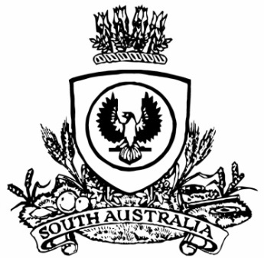
SUPPLEMENTARY GAZETTE
THE SOUTH AUSTRALIAN
GOVERNMENT GAZETTE
Published by Authority

Adelaide, Friday, 15 July 2022

Governor’s Instrument
Appointment
[Republished]
In the South Australian Government Gazette No. 49, dated 14 July 2022, on page 2221, being the second notice starting on that page, the appointment was published incorrectly and the full notice should be replaced with the following:

Department of the Premier and Cabinet
Adelaide, 14 July 2022
Her Excellency the Governor in Executive Council has been pleased to appoint the Honourable Kyam Joseph Maher, MLC, Minister for Aboriginal Affairs, Attorney-General, and Minister for Industrial Relations and Public Sector as Acting Treasurer for the period from 16 July 2022 to 20 July 2022 inclusive and 23 July 2022 to 31 July 2022 inclusive, during the absence of the Honourable Stephen Campbell Mullighan, MP.
By command,
Zoe Lee Bettison, MP
For Premier
T&F22/022CS

