No. 52 p. 2371
THE SOUTH AUSTRALIAN
GOVERNMENT GAZETTE
Published by Authority

Adelaide, Thursday, 28 July 2022

Contents

Governor’s Instruments

Appointment 2372

Proclamations—
Civil Liability (Institutional Child Abuse Liability)
Amendment Act (Commencement)
Proclamation 2022 2373
Return to Work (Scheme Sustainability) Amendment
Act (Commencement) Proclamation 2022 2374
Return to Work (Scheme Sustainability)
(Designated Day) Proclamation 2022 2375

Regulations—
Evidence Regulations 2022—No.57 of 2022 2376
Criminal Law (Clamping, Impounding and Forfeiture of Vehicles) Regulations 2022—No.58 of 2022 2379

State Government Instruments

Boxing and Martial Arts Act 2000 2383

Electoral Act 1985 2383

Housing Improvement Act 2016 2383

Justices of the Peace Act 2005 2384

Magistrates Court Act 1991 2385

Major Events Act 2013 2389

Mining Act 1971 2391

Passenger Transport Regulations 2009 2391

Petroleum and Geothermal Energy Act 2000 2392

Port Augusta Circuit Court 2393

Youth Court Act 1993 2395

Local Government Instruments

City of Charles Sturt 2397

Rural City of Murray Bridge 2397

City of Onkaparinga 2398

City of Port Adelaide Enfield 2401

City of Prospect 2417

City of Victor Harbor 2418

Adelaide Plains Council 2418

The Barossa Council 2419

Mid Murray Council 2420

The District Council of Peterborough 2421

Wattle Range Council 2422

Public Notices

Sale of Property 2424

Trustee Act 1936 2424

Governor’s Instruments

Appointment
Department of the Premier and Cabinet
Adelaide, 28 July 2022
Her Excellency the Governor in Executive Council has been pleased to appoint Naomi Mary Kereru as Coroner for a term commencing on 11 August 2022 and expiring on 10 August 2023 - pursuant to section 6(1) of the Coroners Act 2003.
By command,
Katrine Anne Hildyard, MP
For Premier
AGO0080-22CS

Proclamations
South Australia

Civil Liability (Institutional Child Abuse Liability) Amendment Act (Commencement) Proclamation 2022
1—Short title
This proclamation may be cited as the Civil Liability (Institutional Child Abuse Liability) Amendment Act (Commencement) Proclamation 2022.
2—Commencement of Act
The Civil Liability (Institutional Child Abuse Liability) Amendment Act 2021 (No 52 of 2021) comes into operation on 1 August 2022.
Made by the Governor
with the advice and consent of the Executive Council
on 28 July 2022

South Australia

Return to Work (Scheme Sustainability) Amendment Act (Commencement) Proclamation 2022
1—Short title
This proclamation may be cited as the Return to Work (Scheme Sustainability) Amendment Act (Commencement) Proclamation 2022.
2—Commencement of Act and suspension of certain provisions
(1) Subject to subclause (2), the Return to Work (Scheme Sustainability) Amendment Act 2022 (No 4 of 2022) comes into operation on 1 August 2022.
(2) The operation of the following provisions of the Act is suspended until a day or time or days or times to be fixed by subsequent proclamation or proclamations:
(a) section 3;
(b) section 4;
(c) section 5;
(d) section 8;
(e) section 9;
(f) section 10;
(g) section 11(1), (2) and (5);
(h) section 12;
(i) section 14;
(j) section 15;
(k) section 16;
(l) section 18;
(m) section 19;
(n) Schedule 1, clause 1(1), definitions of Category 1 seriously injured worker, Category 2 seriously injured worker, designated worker, interim seriously injured worker and relevant day;
(o) Schedule 1 clause 2;
(p) Schedule 1 clause 3;
(q) Schedule 1 clause 4;
(r) Schedule 1 clause 5.
Made by the Governor
with the advice and consent of the Executive Council
on 28 July 2022

South Australia

Return to Work (Scheme Sustainability) (Designated Day) Proclamation 2022
under Schedule 1 clause 1 of the Return to Work (Scheme Sustainability) Amendment Act 2022
1—Short title
This proclamation may be cited as the Return to Work (Scheme Sustainability) (Designated Day) Proclamation 2022.
2—Commencement
This proclamation comes into operation on the day on which Schedule 1 clause 6 of the Return to Work (Scheme Sustainability) Amendment Act 2022 comes into operation.
3—Designated day
For the purposes of the definition of designated day in clause 1(1) of Schedule 1 of the Return to Work (Scheme Sustainability) Amendment Act 2022, 1 August 2022 is appointed as the designated day for the purposes of clauses 6, 7 and 8 of Schedule 1.
Made by the Governor
with the advice and consent of the Executive Council
on 28 July 2022

Regulations
South Australia

Evidence Regulations 2022
under the Evidence Act 1929

Contents
1 Short title
2 Commencement
3 Interpretation
4 Domestic violence proceedings—recorded evidence
5 Identity parades
6 Prescribed South Australian courts
7 Fee for authorised news media representative
Schedule 1—Repeal of Evidence Regulations 2007

1—Short title
These regulations may be cited as the Evidence Regulations 2022.
2—Commencement
These regulations come into operation on 1 September 2022.
3—Interpretation
In these regulations—
Act means the Evidence Act 1929
4—Domestic violence proceedings—recorded evidence
(1) If a statement in a section 13BB recording is in a language other than English, that statement must be translated into English, either in the recording or in a transcript made at a later time.
(2) If a transcript is made in accordance with subregulation (1), the transcript must accompany the recording to which it relates if—
(a) the defendant elects to listen to or view the recording before it is admitted into evidence in proceedings; or
(b) the recording is admitted into evidence in proceedings.
(3) If a person translates a statement in a section 13BB recording in accordance with subregulation (1)—
(a) the person must state, in the form of an affidavit, that the statement was accurately translated into English; and
(b) if the recording is admitted into evidence in proceedings—the affidavit must accompany the recording.
(4) The court may require that a translation made in accordance with subregulation (1) be verified (in such manner as the court may direct) as an accurate translation of the relevant statement.
(5) A person who has possession of, or access to, a section 13BB recording must not allow access to the recording by another person except—
(a) for the legitimate purposes of any proceedings in which the recording has been admitted into evidence or to which the recording relates; or
(b) for use by a public official for purposes connected with their official functions; or
(c) as may be authorised by the prosecution.
Maximum penalty: $5 000.
(6) A complainant gives informed consent to the making of a recording for the purposes of the definition in section 13BB(10) of the Act if the consent is given in accordance with the following requirements:
(a) a police officer must tell the complainant—
(i) that the police officer is recording the complainant; and
(ii) that the recording may be used in court; and
(b) the complainant must indicate (whether by words or conduct) that they consent to the making of the recording.
(7) For the purposes of subregulation (6)(b) (and without limiting the manner in which a complainant may indicate that they consent to the making of a recording), a lack of objection to a recording may, in the circumstances, constitute a sufficient indication of consent to the recording.
(8) In this regulation—
public official has the same meaning as in section 67G of the Act;
section 13BB recording means a recording made by a police officer that is, or may be, admissible in proceedings for a domestic violence offence under section 13BB of the Act.
5—Identity parades
(1) For the purposes of section 34AB(2)(a)(i) of the Act, reasonable steps must be taken when making an audio visual record of an identity parade to ensure that—
(a) the witness identifying, or attempting to identify, a person alleged to have committed an offence is visible at all relevant times during the conduct of the identity parade; and
(b) if the witness indicates that a person taking part in, or whose image is included in, the parade is alleged to have committed an offence—that person or image (as the case requires) is visible at the time the witness gives the indication; and
(c) anything said by the witness, and any other person present, during the conduct of the identity parade is recorded.
(2) For the purposes of section 34AB(2)(a)(i) of the Act, the Commissioner of Police must keep an audio visual record of an identity parade relating to a person until—
(a) if the person has been charged with an offence to which the identity parade relates but is subsequently discharged—the day on which the person is so discharged; or
(b) if the person has been convicted or acquitted of an offence to which the identity parade relates—
(i) if an appeal has not been lodged within the period provided for lodging an appeal against the conviction or acquittal—the end of the period; or
(ii) if an appeal has been lodged within the period provided for lodging an appeal against the conviction or acquittal—the appeal lapses or is finally determined,
whichever is the later; or
(c) if the person to whom the record relates has not been charged with an offence to which the identity parade relates—until the end of the period within which the person can be charged with the offence.
6—Prescribed South Australian courts
Pursuant to paragraph (e) of the definition of South Australian court in section 59IA of the Act, the following courts and tribunals are South Australian courts for the purposes of Part 6C of the Act:
(a) the Environment, Resources and Development Court;
(b) the South Australian Employment Tribunal;
(c) the Youth Court of South Australia.
7—Fee for authorised news media representative
(1) The fee prescribed for the purposes of section 69A of the Act in respect of an authorised news media representative must be paid not later than 1 June in each year for the next financial year.
(2) If, however, the fee is paid for a term of less than 12 months, the fee payable is a proportion of the relevant fee, being the proportion that the number of whole months in the term bears to 12 months.
Schedule 1—Repeal of Evidence Regulations 2007
The Evidence Regulations 2007 are repealed.
Editorial note—
As required by section 10AA(2) of the Legislative Instruments Act 1978, the Minister has certified that, in the Minister's opinion, it is necessary or appropriate that these regulations come into operation as set out in these regulations.
Made by the Governor
with the advice and consent of the Executive Council
on 28 July 2022
No 57 of 2022

South Australia

Criminal Law (Clamping, Impounding and Forfeiture of Vehicles) Regulations 2022
under the Criminal Law (Clamping, Impounding and Forfeiture of Vehicles) Act 2007

Contents
1 Short title
2 Commencement
3 Interpretation
4 Forfeiture offences
5 Prescribed offences
6 Prescribed circumstances
7 Prescribed forms
8 Sale or disposal of motor vehicles
9 Service of notices
Schedule 1—Prescribed forms
Schedule 2—Repeal of Criminal Law (Clamping, Impounding and Forfeiture of Vehicles) Regulations 2007

1—Short title
These regulations may be cited as the Criminal Law (Clamping, Impounding and Forfeiture of Vehicles) Regulations 2022.
2—Commencement
These regulations come into operation on 1 September 2022.
3—Interpretation
In these regulations—
Act means the Criminal Law (Clamping, Impounding and Forfeiture of Vehicles) Act 2007.
4—Forfeiture offences
For the purposes of the definition of forfeiture offence in section 3(1) of the Act, indictable offences against Part 3 Division 6 of the Criminal Law Consolidation Act 1935 are prescribed.
5—Prescribed offences
For the purposes of the definition of prescribed offence in section 3(1) of the Act, the following offences are prescribed:
(a) an aggravated offence against section 45 of the Road Traffic Act 1961;
(b) an offence against section 44B, 45A, 46, 47, 47B, 47BA, 47E(3), 47E(3a), 47EAA(9), 47EAA(9a) or 47I of the Road Traffic Act 1961;
(c) an offence against section 17AA or 54 of the Summary Offences Act 1953;
(d) an offence against section 9 of the Graffiti Control Act 2001;
(e) an offence against section 85 of the Criminal Law Consolidation Act 1935 if the offence involves the marking of graffiti;
(f) an offence against section 9 or 102 of the Motor Vehicles Act 1959 (other than a first offence against either of those sections);
(g) an offence against section 74(2), 74(2a), 74(2ab), 74(2ac) or 91(5) of the Motor Vehicles Act 1959.
6—Prescribed circumstances
The following circumstances in which a motor vehicle is used by a person are prescribed for the purposes of sections 8(2)(a) and 11(c)(i) of the Act:
(a) the motor vehicle is being used by the person (not being the owner of the motor vehicle) in accordance with a contractual arrangement with the owner of the motor vehicle, other than a contractual arrangement that confers on the person an express or implied right or option to purchase the motor vehicle; and
(b) the owner of the motor vehicle is a person who carries on a business that consists of, or involves, hiring or otherwise supplying motor vehicles to others for business or personal use.
Examples—
A person visiting South Australia on holiday hires a car from a car hire company to use while in the State. While that person is driving the car in accordance with the hire contract, the car is being used in circumstances prescribed by this regulation.
A taxi driver drives a taxi that is owned, not by the driver, but by the taxi company for whom the driver works. While the taxi driver is using the taxi in accordance with their employment contract, the taxi is being used in circumstances prescribed by this regulation.
7—Prescribed forms
(1) For the purposes of section 14(1) of the Act, the notice set out in Schedule 1 Form 1 is prescribed.
(2) For the purposes of section 14(2) of the Act, the notice set out in Schedule 1 Form 1 is prescribed.
(3) For the purposes of section 15(1) of the Act—
(a) if the relevant authority giving the notice is a police officer—the notice set out in Schedule 1 Form 1 is prescribed; or
(b) if the relevant authority giving the notice is the Sheriff or a person authorised by the Sheriff to exercise the powers of a relevant authority—the notice set out in Schedule 1 Form 2 is prescribed.
8—Sale or disposal of motor vehicles
For the purposes of exercising a power to sell a motor vehicle under section 20 of the Act, the Sheriff or the Commissioner may—
(a) set a reserve price for the motor vehicle; and
(b) move the motor vehicle to another location within the State.
9—Service of notices
In accordance with section 23(1)(d) of the Act, a notice required or authorised to be given to, or served on, a person for the purposes of the Act may, if the person is a company or registered body within the meaning of the Corporations Act 2001 of the Commonwealth, be given to or served on the person in accordance with that Act.
Schedule 1—Prescribed forms
Form 1
To the owner of the following motor vehicle:
Registration No:
Description:
It is alleged that a relevant prescribed offence occurred as follows:
Date:
Time:
Location:
Notice under section 14 of Criminal Law (Clamping, Impounding and Forfeiture of Vehicles) Act 2007
You are prohibited from—
☐ selling or disposing of the motor vehicle
☐ intentionally damaging or altering the motor vehicle or causing or permitting another person to damage or alter the motor vehicle
The prohibition continues until—
☐ the power under Part 2 of the Criminal Law (Clamping, Impounding and Forfeiture of Vehicles) Act 2007 to clamp or impound has been exercised in relation to the relevant prescribed offence
☐ proceedings relating to the relevant prescribed offence have been finalised
It is an offence to contravene the prohibitions specified in this notice.
Notice under section 15 of Criminal Law (Clamping, Impounding and Forfeiture of Vehicles) Act 2007
You are required to produce the motor vehicle—
Between the hours of:
On:
At:
If you are unable to do so, you must contact SAPOL during business hours before that day on the following number to arrange another time:
The motor vehicle is to be produced for the purpose of a relevant authority exercising a power under the Criminal Law (Clamping, Impounding and Forfeiture of Vehicles) Act 2007 in relation to the motor vehicle.
It is an offence to refuse or fail to comply with this notice without reasonable excuse.
Issuing police officer's ID number:
Form 2
Notice under section 15 of Criminal Law (Clamping, Impounding and Forfeiture of Vehicles) Act 2007
To the owner of the following motor vehicle:
Registration No:
Description:
An order for impounding or forfeiture of the motor vehicle has been made as follows:
Court:
Name and number of proceedings:
Date:
You are required to produce the motor vehicle—
Between the hours of:
On:
At:
If you are unable to do so, you must contact the Sheriff's office during business hours before that day on the following number to arrange another time:
The motor vehicle is to be produced for the purpose of a relevant authority exercising a power under the Criminal Law (Clamping, Impounding and Forfeiture of Vehicles) Act 2007 in relation to the motor vehicle.
It is an offence to refuse or fail to comply with this notice without reasonable excuse.
Schedule 2—Repeal of Criminal Law (Clamping, Impounding and Forfeiture of Vehicles) Regulations 2007
The Criminal Law (Clamping, Impounding and Forfeiture of Vehicles) Regulations 2007 are repealed.
Editorial note—
As required by section 10AA(2) of the Legislative Instruments Act 1978, the Minister has certified that, in the Minister's opinion, it is necessary or appropriate that these regulations come into operation as set out in these regulations.
Made by the Governor
with the advice and consent of the Executive Council
on 28 July 2022
No 58 of 2022

State Government Instruments

Boxing and Martial Arts Act 2000
Revocation of Rules
TAKE NOTICE that pursuant to section 10 of the Boxing and Martial Arts Act 2000, I Kylie Taylor, Chief Executive of the Office for Recreation, Sport and Racing, as delegate for the Minister for Recreation, Sport and Racing to whom the administration of the Boxing and Martial Arts Act 2000 is committed, have revoked the rules applicable to the conduct of boxing events to cease operation on this date of publication.
The revoked rules are set out below.
Dated: 7 July 2022
Kylie Taylor
Chief Executive, Office for Recreation, Sport and Racing
as delegate for the Minister for Recreation, Sport and Racing

Boxing Australia Technical and Competition Regulations amended 2 March 2022

Boxing and Martial Arts Act 2000
Notice of Rules
TAKE NOTICE that pursuant to section 10 of the Boxing and Martial Arts Act 2000, I Kylie Taylor, Chief Executive of the Office for Recreation, Sport and Racing, as delegate for the Minister for Recreation, Sport and Racing to whom the administration of the Boxing and Martial Arts Act 2000 is committed, have approved the rules applicable to the conduct of boxing events to commence operation on this date of publication.
The approved rules are set out below.
Dated: 7 July 2022
Kylie Taylor
Chief Executive, Office for Recreation, Sport and Racing
as delegate for the Minister for Recreation, Sport and Racing

Boxing Australia Technical and Competition Regulations amended 14 June 2022

Electoral Act 1985
Results of House of Assembly By-election for the District of Bragg
A WRIT for the election of a member of the House of Assembly District of Bragg was issued on Wednesday, 1 June 2022.
Polling took place on Saturday, 2 July 2022 and the Writ was returned on Tuesday, 12 July 2022.
The results of the election are as follows:
District: Bragg
Elected Candidate: BATTY, Jack
Affiliation: Liberal Party
Pursuant to Section 96(11) of the Electoral Act 1985, the following are the votes attributed to the two unexcluded candidates in the
by-election for the District of Bragg:
District of BRAGG: Final Votes after Distribution of Preferences of Excluded Candidates
Candidate | Number | Percentage | Affiliation
BATTY, Jack (elected) | 12,204 | 55.6% | Liberal Party
ROLLS, Alice | 9,728 | 44.4% | Australian Labor Party
Dated: 28 July 2022
M. Sherry
Electoral Commissioner

Housing Improvement Act 2016
Rent Control
The Minister for Human Services Delegate in the exercise of the powers conferred by the Housing Improvement Act 2016, does hereby fix the maximum rental per week which shall be payable subject to Section 55 of the Residential Tenancies Act 1995, in respect of each house described in the following table. The amount shown in the said table shall come into force on the date of this publication in the Gazette.

Address of Premises | Allotment Section | Certificate of Title  Volume/Folio | Maximum Rental per week payable
20 Short Road, Elizabeth SA 5112 | Allotment 64 Deposited Plan 6049 Hundred of Munno Para | CT 5257/321 | $213.00
53 Old Sarum Road, Elizabeth North SA 5113 | Allotment 4 Deposited Plan 31630 Hundred of Munno Para | CT 5421/209 | $155.00
Dated: 28 July 2022
Craig Thompson
Housing Regulator and Registrar
Housing Safety Authority, SAHA
Delegate of Minister for Human Services

Housing Improvement Act 2016
Rent Control Revocations
Whereas the Minister for Human Services Delegate is satisfied that each of the houses described hereunder has ceased to be unsafe or unsuitable for human habitation for the purposes of the Housing Improvement Act 2016, notice is hereby given that, in exercise of the powers conferred by the said Act, the Minister for Human Services Delegate does hereby revoke the said Rent Control in respect of each property.
Address of Premises | Allotment  Section | Certificate of Title  Volume Folio
53 Nimitz Road, Elizabeth East SA 5112 | Allotment 140 Deposited Plan 6415 Hundred of Munno Para | CT5208/160
44 Garrin Street, Salisbury North SA 5108 | Allotment 90 Deposited Plan 10068 Hundred of Munno Para | CT6010/627
216 Smith ST, Naracoorte SA 5271 | Allotment 305 Filed Plan 199199 Hundred of Naracoorte | CT5806/810
Dated: 28 July 2022
Craig Thompson
Housing Regulator and Registrar
Housing Safety Authority, SAHA
Delegate of Minister for Human Services

Justices of the Peace Act 2005
Section 4
Notice of Appointment of Justices of the Peace for South Australia
by the Commissioner for Consumer Affairs
I, Dini Soulio, Commissioner for Consumer Affairs, delegate of the Attorney-General, pursuant to section 4 of the Justices of the Peace Act 2005, do hereby appoint the people listed as Justices of the Peace for South Australia as set out below.
For a period of ten years for a term commencing on 9 August 2022 and expiring on 8 August 2032:
David Gordon WAKELIN
Maria VARANO
Christopher David RICHER
Rodney Ian QUINN
Stacey Kaye PSARROS
Mark William PETERSON
Leon Francis O'DRISCOLL
Michael John NICOLAI
Kathryn Lee MCDOUGALL
Anastasios KOUTSANTONIS
Paula Jane KELLY
Brian Edward HEMMING
Justin Paul HAZELL
Terence Anthony FANNING
Jennifer Anne DOWDING
Nicolaas Arie DE BRUYN
Judith Lee DAVIS
Stuart William COLE
Brian William COATS
Daniel Scott CLARK
Jeffrey Eric BEARE
Dated: 20 July 2022
Dini Soulio
Commissioner for Consumer Affairs
Delegate of the Attorney-General

Magistrates Court Act 1991
South Australia
Magistrates Court (Fees) (No 2) Notice 2022
under the Magistrates Court Act 1991
1—Short title
This notice may be cited as the Magistrates Court (Fees) Notice 2022
Note—
This is a fee notice made in accordance with the Legislation (Fees) Act 2019 and revokes the Magistrates Court (Fees) Notice 2022 dated 26 May 2022 as published in the South Australian Government Gazette on 9 June 2022 p. 1361. The fee notice has been varied to align to the Magistrates Court (Fees) Notice 2021 which removed the fee for private applications for an intervention order where domestic violence is alleged. These fees are currently being waived.
2—Commencement
This notice has effect from the day on which it is published in the Gazette.
3—Interpretation
In this notice, unless the contrary intention appears—
Act means the Magistrates Court Act 1991;
corporation has the same meaning as in the Corporations Act 2001 of the Commonwealth;
not-for-profit organisation means a corporation that is not for the purpose of trading or securing a pecuniary profit for its members from its transactions;
prescribed corporation means a corporation other than—
(a) a small business; or
(b) a not-for-profit organisation;
small business means a corporation that—
(a) has less than 20 full-time equivalent employees; and
(b) is not a subsidiary of a corporation that has 20 or more full-time employees;
subsidiary has the same meaning as in the Corporations Act 2001 of the Commonwealth.
4—Fees
The fees set out in Schedule 1 are prescribed for the purposes of the Act and are payable to the Court in relation to—
(a) in the case of Part 1 of that Schedule—
(i) proceedings in the Civil (General Claims) Division; or
(ii) proceedings in the Civil (Minor Claims) Division; or
(iii) proceedings in the Civil (Consumer and Business) Division; and
(b) in the case of Part 2 of that Schedule—proceedings in the Criminal Division; and
(c) in the case of Part 3 of that Schedule—proceedings in the Petty Sessions Division; and
(d) in the case of Part 4 of that Schedule—proceedings under the Fair Work Act 2009 of the Commonwealth.
Schedule 1—Fees
Part 1—Fees in Civil (General Claims) Division and Civil (Minor Claims) Division

1 | On filing a final notice of claim—
 | (a) in the case of a notice of claim filed using the Electronic System | $24.00
 | (b) in any other case | $57.50
2 | On filing a minor civil action | $162.00
3 | On filing a cross action in the nature of a counter claim or a third party claim in a minor civil action | $162.00
4 | On filing a document to commence any other proceeding under the Magistrates Court Act 1991—
 | (a) where the claim is not for money—
 | (i) in the case of a prescribed corporation | $599.00
 | (ii) in any other case | $353.00
 | (b) where the amount claimed, or the value of the property the subject of the proceeding, exceeds $12 000.00 but does not exceed $25 000.00—
 | (i) in the case of a prescribed corporation | $599.00
 | (ii) in any other case | $353.00
 | (c) where the amount claimed, or the value of the property the subject of the proceeding, exceeds $25 000.00 but does not exceed $50 000.00—
 | (i) in the case of a prescribed corporation | $853.00
 | (ii) in any other case | $454.00
 | (d) where the amount claimed, or the value of the property the subject of the proceeding, exceeds $50 000.00—
 | (i) in the case of a prescribed corporation | $1 250.00
 | (ii) in any other case | $853.00
5 | On filing a cross action in the nature of a counter claim or third party claim in any other proceeding under the Magistrates Court Act 1991—
 | (a) where the claim is not for money—
 | (i) in the case of a prescribed corporation | $599.00
 | (ii) in any other case | $353.00
 | (b) where the amount claimed, or the value of the property the subject of the proceeding, exceeds $12 000.00 but does not exceed $25 000.00—
 | (i) in the case of a prescribed corporation | $599.00
 | (ii) in any other case | $353.00
 | (c) where the amount claimed, or the value of the property the subject of the proceeding, exceeds $25 000.00 but does not exceed $50 000.00—
 | (i) in the case of a prescribed corporation | $853.00
 | (ii) in any other case | $454.00
 | (d) where the amount claimed, or the value of the property the subject of the proceeding, exceeds $50 000.00—
 | (i) in the case of a prescribed corporation | $1 250.00
 | (ii) in any other case | $853.00
6 | For issuing and administering an investigation or examination summons under the Magistrates Court Act 1991 | $61.50
7 | On commencement of a proceeding under any other Act | $162.00
8 | On filing a cross action in the nature of a counter claim or a third party claim in any proceeding under any other Act | $162.00
9 | On setting a date for trial—
 | (a) for a minor civil action—
 | (i) where the amount claimed does not exceed $4 000.00 | $226.00
 | (ii) in any other case | $681.00
 | (b) for any other proceeding under the Magistrates Court Act 1991—
 | (i) in the case of a prescribed corporation | $1 136.00
 | (ii) in any other case | $853.00
10 | For publishing an advertisement | actual costs reasonably incurred
11 | For each request to search and/or inspect a record of the Court | $26.75
12 | For an unsealed copy of the record of the Court | $26.75
13 | For a sealed copy of the record of the Court | $84.00
14 | For copy of evidence—
 | (a) per page in electronic form | $9.05
 | (b) per page in hard-copy form | $11.50
15 | For copy of reasons for judgment—per page  Note—  1 copy will be supplied to a party to the proceeding free of charge. | $9.05
16 | For copy of any other document—per page | $5.40
17 | For production of transcript at request of a party where the Court does not require the transcript—per page | $18.20
18 | Suitors' Fund—on interest collected on funds in Court or credited to an account, payable on transfer of interest out of the fund or account or at such earlier time or times as required by the Court—
 | (a) if the interest is $10.00 or less | no fee
 | (b) in any other case | 3% of amount of interest
19 | Taxation of costs: on lodging a claim for costs in an existing proceeding (other than in a minor civil action) | $84.00
20 | For opening Registry (or Registry remaining open) after hours for urgent execution of process—for each hour or part of an hour | $431.00
21 | For opening Court (or Court remaining open) after hours for urgent hearing—for each hour or part of an hour | $1 299.00
Part 2—Fees in Criminal Division

1 | On commencement of proceedings for summary applications, summary offences, minor indictable offences or indictable offences  Note—  No fee is payable under this clause for a private application for an intervention order, pursuant to clause 2. | $303.00 plus if the information alleges more than 1 offence—$55.00
2 | For a private application for an intervention order under section 20 of the Intervention Orders (Prevention of Abuse) Act 2009, where domestic abuse is alleged | No fee
3 | For each request to search and/or inspect a record of the Court | $26.75
4 | For an unsealed copy of the record of the Court | $26.75
5 | For a sealed copy of the record of the Court | $84.00
Note—
No fee is payable under clauses 3, 4 or 5 for a request made in respect of a record relating to criminal proceedings by or on behalf of the defendant or the victim of the offence that is the subject of those proceedings.
6 | For copy of evidence—
 | (a) per page in electronic form | $9.05
 | (b) per page in hard-copy form | $11.50
7 | For copy of reasons for judgment—per page  Note—  1 copy will be supplied to a party to the proceeding free of charge. | $9.05
8 | For copy of any other document—per page | $5.40
9 | For production of transcript at request of a party where the Court does not require the transcript—per page | $18.20
Part 3—Fee in Petty Sessions Division

1 | On an application under section 23 of the Fines Enforcement and Debt Recovery Act 2017 for a review of a decision to refuse to revoke an enforcement determination | $61.50
Part 4—Fee in Commonwealth Fair Work Act 2009 jurisdiction

1 | On an application in relation to the jurisdiction of the Court under the Fair Work Act 2009 of the Commonwealth | no fee
Made by the Attorney-General
on 22 July 2022

Major Events Act 2013
Section 6B
Major Event Declaration
PURSUANT to section 6B of the Major Events Act 2013, I, Hon. Zoe Bettison MP, Minister for Tourism South Australia declare the ICC Men’s T20 World Cup 2022 matches to be held at Adelaide Oval on 2 November 2022, 4 November 2022, 6 November 2022 and 10 November 2022 to be declared major events.
By virtue of the provisions of the Major Events Act 2013, I do hereby:
1. Declare the ICC Men’s T20 World Cup 2022 matches to be held at Adelaide Oval on 2 November, 4 November, 6 November and 10 November 2022 as major events.
2. Specify the period for the events, being 2 November, 4 November and 10 November 2022 from midday to midnight, and 6 November from 8:00am to midnight.
3. Declare the major event venue to be Adelaide Oval.
4. Specify an area bounded by Festival Drive, King William Road, Kermode Street, Palmer Place, Montefiore Hill and Montefiore Road as a controlled area in relation to the event.
5. Designate T20 World Cup 2020 Ltd to be the event organiser for the event.
6. Apply section 8 of the Major Events Act to the event.
7. Apply section 10 of the Major Events Act to the event.
8. Apply section 11 of the Major Events Act to the event.
9. Apply section 12 of the Major Events Act to the event.
10. Apply section 13 of the Major Events Act to the event.
11. Apply section 14 of the Major Events Act to the event by specifying the official title as ICC Men’s T20 World Cup 2022 and the official logo as it appears below.

Map of Controlled Area for the ICC Men’s T20 World Cup 2022 matches to be held at Adelaide Oval
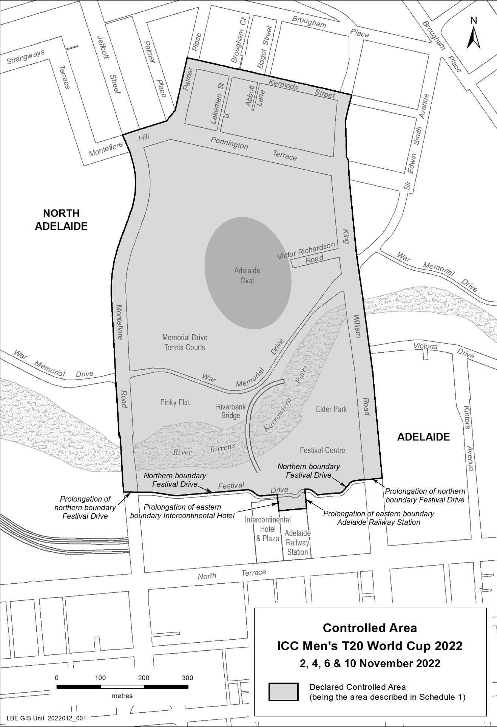
Dated: 28 July 2022
Hon. Zoe Bettison MP
Minister for Tourism, South Australia

Mining Act 1971
Section 56H
Application for a Change in Operations
Notice is hereby given in accordance with Section 56H of the Mining Act 1971, that an application for a change in operations over the undermentioned Mining Lease has been received:
Applicant: S.C. Heinrich & Co Pty. Ltd.
Operation: Farrell Flat Quarry
Mining Lease: 6198
Area: 26 hectares approximately
Location: CT 6096/3, Approximately 12 km east of Clare
Purpose: Change in Operations
Reference: T 02414
To arrange an inspection of the proposal at the Department for Energy and Mining, please call the Department on 08 8463 3103.
An electronic copy of the proposal can be found on the Department for Energy and Mining website: https://www.energymining.sa.gov.au/industry/minerals-and-mining/mining/community-engagement-opportunities
Written submissions in relation to this application are invited to be received at the Department for Energy and Mining, Mining Regulation, Attn: Business Support Officer, GPO Box 320 ADELAIDE SA 5001 or dem.miningregrehab@sa.gov.au by no later than 9 August 2022.
The delegate of the Minister for Energy and Mining is required to have regard to these submissions in determining whether to grant or refuse the application and, if granted, if there is a requirement to add, vary or revoke a term or condition of the relevant mineral tenement(s) under section 56U of the Mining Act 1971.
When you make a written submission, that submission becomes a public record. Your submission will be provided to the applicant and may be made available for public inspection.
Dated: 28 July 2022
J. Martin
Mining Registrar as delegate for the Minister for Energy and Mining
Department for Energy and Mining

Passenger Transport Regulations 2009 (“Regulations”)
Determination
Access Taxi Age Extension
I, Sarah Clark, Acting Executive Director, Road and Marine Services in the Department for Infrastructure and Transport:
- REVOKE the prior determination made under Regulation 135(2)(a)(iii) of the Regulations, published in the South Australian Government Gazette on 10 December 2020 in regards to access taxis; and
- Pursuant to Regulation 135(6) of the Regulations hereby DETERMINE that the specified age that an access taxi cannot be granted an approval for the use of an older vehicle under Regulation 135(2) to be eleven (11) years.
Interpretation: All terms italicized in this Notice have the same meaning as in the Passenger Transport Act 1994 and the Regulations.
The age of a vehicle is measured pursuant to Regulation 3(6).
This Determination shall have effect as of the date of approval and shall remain in force unless revoked by a subsequent Notice.
Dated: 22 July 2022
Sarah Clark
- A/Executive Director
- Road and Marine Services

Passenger Transport Regulations 2009 (“Regulations”)
Determination
Stretch Limousine Age Extension
I, Sarah Clark, Acting Executive Director, Road and Marine Services in the Department for Infrastructure and Transport:
Pursuant to Regulation 135(2)(b)(i) of the Regulations hereby DETERMINE that the appropriate passenger safety and comfort standards are evidenced by:
- An engineering report (valid for six (6) months from the date of issue) certifying that the vehicle’s structural integrity, including steering and suspension components, is not compromised. The engineering report must be issued by a Light Vehicle Engineering Signatory who is recognised by the Department for Infrastructure and Transport; AND
- A passed roadworthy vehicle inspection (valid for four (4) weeks from the date of issue) as undertaken by the Department for Infrastructure and Transport.
This Determination shall have effect as of the date of approval and shall remain in force unless revoked by a subsequent Notice.
Dated: 22 July 2022
Sarah Clark
A/Executive Director
Road and Marine Services

Petroleum and Geothermal Energy Act 2000
Grant of Petroleum Production Licence—PPL 275
Pursuant to section 92(1) of the Petroleum and Geothermal Energy Act 2000, notice is hereby given that the undermentioned Petroleum Production Licence has been granted under the provisions of the Petroleum and Geothermal Energy Act 2000, pursuant to delegated powers dated 29 June 2018.
No. of Licence | Licensee | Locality | Area in Km² | Reference
PPL 275 | Santos QNT Pty Ltd  Drillsearch (513) Pty Limited | Cooper Basin | 2.95 | MER-2022/0068
Description of Area
All that part of the State of South Australia, bounded as follows:
Commencing at a point being the intersection of latitude 27°48'25"S GDA 2020 and longitude 139°55'25"E GDA 2020, thence east to longitude 139°56'35"E GDA 2020, south to latitude 27°49'15"S GDA 2020, west to longitude 139°55'25"E GDA 2020 and north to the point of commencement.
AREA: 2.95 square kilometres approximately
Dated: 21 July 2022
Michael Malavazos
A/Executive Director
Energy Resources Division
Department for Energy and Mining
Delegate of the Minister for Energy and Mining

Petroleum and Geothermal Energy Act 2000
Surrender of Petroleum Exploration Licence—PEL 630 and
Associated Activities Licence—AAL 252
Notice is hereby given that I have accepted the surrender of the abovementioned licences under the provisions of the Petroleum and Geothermal Energy Act 2000, pursuant to delegated powers dated 29 June 2018-
No. of Licence | Licensee | Locality | Effective Date of Surrender | Reference
PEL 630 | Beach Energy Limited | Cooper Basin | 8 April 2022 | F2013/00457
AAL 252 | Bridgeport (Cooper Basin) Pty Ltd |  |  | MER-2017/0866
Dated: 19 July 2022
Michael Malavazos
A/Executive Director
Energy Resources Division
Department for Energy and Mining
Delegate of the Minister for Energy and Mining

Petroleum and Geothermal Energy Act 2000
Suspension of Petroleum Exploration Licences—PELs 126 and 153
Pursuant to Section 90 of the Petroleum and Geothermal Energy Act 2000, notice is hereby given that the abovementioned Petroleum Exploration Licences have been suspended for the period from 8 June 2022 until 7 September 2022 inclusive, pursuant to delegated powers dated 29 June 2018.
The expiry date of PELs 126 and 153 is now determined to be 27 October 2022.
Dated: 19 July 2022
Michael Malavazos
A/Executive Director
Energy Resources Division
Department for Energy and Mining
Delegate of the Minister for Energy and Mining

Petroleum and Geothermal Energy Act 2000
Suspension of Petroleum Retention Licences—PRLs 81, 82 and 84
Pursuant to Section 90 of the Petroleum and Geothermal Energy Act 2000, notice is hereby given that the abovementioned Petroleum Retention Licences have been suspended for the period from 11 May 2022 until 10 May 2023 inclusive, pursuant to delegated powers dated 29 June 2018.
The expiry date of PRLs 81, 82 and 84 is now determined to be 11 May 2025.
Dated: 21 July 2022
Michael Malavazos
A/Executive Director
Energy Resources Division
Department for Energy and Mining
Delegate of the Minister for Energy and Mining

Petroleum and Geothermal Energy Act 2000
Suspension of Petroleum Retention Licences—PRLs 108, 109 and 110
Pursuant to Section 90 of the Petroleum and Geothermal Energy Act 2000, notice is hereby given that the abovementioned Petroleum Retention Licences have been suspended for the following periods, pursuant to delegated powers dated 29 June 2018.
PRL 108 for the period from and including 19 May 2022 to 18 May 2023; and
PRLs 109 and 110 for the period from and including 12 May 2022 to 11 May 2023.
The expiry date of PRLs 108, 109 and 110 is now determined to be 9 May 2028.
Dated: 18 July 2022
Michael Malavazos
A/Executive Director
Energy Resources Division
Department for Energy and Mining
Delegate of the Minister for Energy and Mining

Petroleum and Geothermal Energy Act 2000
Section 25(5)(b)
Variation of Petroleum Exploration Licence—PEL 630
Notice is hereby given that under the provisions of the Petroleum and Geothermal Energy Act 2000, pursuant to delegated powers dated 29 June 2018, the conditions of the abovementioned Petroleum Exploration Licence has been varied as follows:
Condition 1 of the licence is omitted and the following substituted:
“ During the term of the licence, the Licensee shall carry out or cause to be carried out, exploratory operations on the area comprised in the licence in accordance with such work programs as are approved by the Minister from time to time. Years one to four exploratory operations are guaranteed. These exploratory operations shall include but not necessarily be limited to:
Year of Term of Licence | Minimum Work Requirements
One | - 300 km² 3D seismic acquisition; and  - 200 line km seismic reprocessing.
Two | - 400 km² passive-transient electromagnetic survey; and  - Geological and geophysical studies.
Three | - Drill 4 wells.
Four | - 100 km 2D seismic acquisition; and  - Geological and geophysical studies.
Five | - Geological and geophysical studies.
The revised work program requirements as a result of this variation would not have altered the outcome of the original competitive tender process.
Dated: 19 July 2022
Michael Malavazos
A/Executive Director
Energy Resources Division
Department for Energy and Mining
Delegate of the Minister for Energy and Mining

The District Court of South Australia
Port Augusta Circuit Court
Sheriff’s Office, Adelaide, 2 August 2022
IN pursuance of a precept from the District Court to me directed, I do hereby give notice that the said Court will sit as a Court of Oyer and Terminer and General Gaol Delivery at the Courthouse at Port Augusta on the day and time undermentioned and all parties bound to prosecute and give evidence and all jurors summoned and all others having business at the said Court are required to attend the sittings thereof and the order of such business will be unless a Judge otherwise orders as follows:
Tuesday 2 August 2022 at 10 a.m. on the first day of the sittings the only business taken will be the arraignment of prisoners in gaol and the passing of sentences on prisoners in gaol committed for sentence, the surrender of prisoners on bail committed for sentence, the surrender of persons in response to ex officio informations or of persons on bail and committed for trial who have signified their intentions to plead guilty and the passing of sentences for all matters listed for disposition by the District Court.
Juries will be summoned for 1 August 2022 and persons will be tried on this and subsequent days of the sittings.
Prisoners in H.M. Gaol and on bail for sentence and for trial at the sittings
of the Port Augusta Courthouse, commencing 2 August 2022.
Alvarez, Monique Maria |  | Application for enforcement of a breached bond. | On bail
Ashton, Michelle Renee Smith, John Charles |  | Unlawful sexual intercourse (2). | On bail  On bail
Baptiste, Daniel William |  | Maintaining an unlawful sexual relationship with a child. | On bail
Bates, Andrew Lyall |  | Maintaining an unlawful sexual relationship with a child; Unlawful sexual intercourse with a person under 14 years (4); Aggravated indecent assault (2); Gross indecency | On bail
Beaumont, Kevin Thomas Cyril |  | Indecent Assault (5); Aggravated indecent assault (3). | On bail
Bishop, Stephen Graham |  | Maintaining an unlawful sexual relationship with a child. | On bail
Buss, Joshua John |  | Arson. | In gaol
Byrne, Francis James |  | Unlawfully choking, suffocating or strangling another; Aggravated assault. | On bail
Connelly, Phillip Kunmanara |  | Intentionally cause a bushfire. | In gaol
Coombe, Simon Geoffrey |  | Unlawfully choking, suffocating or strangling another; Aggravated assault (2); Aggravated assault causing harm. | On bail
Coulthard, Troy Wapala |  | Aggravated robbery; Aggravated causing harm with intent to cause harm. | On bail
Crabbe, Peter Matthew |  | Aggravated Assault (4), Aggravated threatening life. | In gaol
Damon, Travis Blake |  | Trafficking in a large commercial quantity of a controlled drug. | On bail
Degenaro, David Reginald |  | Deception; Attempted deception. | On bail
Dodd, David Paul |  | Aggravated assault causing harm; Aggravated causing harm with intent. | On bail
Doolan, Anthony Coadie |  | Aggravated causing harm with intent to cause harm. | On bail
Evans, Daniel Peter |  | Causing harm with intent to cause harm; Aggravated causing harm with intent to cause harm; Aggravated threatening life. | On bail
Griffiths, Steven |  | Unlawfully choking, suffocating or strangling another. | In gaol
Habermann, Zackery Alexander |  | Arson; Damaging property. | On bail
Hatches, Franklin Treacle |  | Aggravated assault; Aggravated causing harm with intent to cause harm. | On bail
Haynes, Adrian Ronald |  | Trafficking in a controlled drug. | On bail
Hill, Jacsyn Douglas |  | Maintaining an unlawful sexual relationship with a child; Aggravated assault (7); Unlawful sexual relationship with a person under 17 years; Rape; Knowingly distribute invasive image of a person under 17 years. | In gaol
H, T R |  | Maintaining an unlawful sexual relationship with a child | On bail
Humphries, Caihleb James |  | Assault (2); Unlawfully chocking, suffocating or strangling another (4); Aggravated Assault (2); Assault causing harm with intent to cause harm. | On bail
Iatika, Jacques |  | Rape (3). | In gaol
Kellett, Jeffrey |  | Maintaining an unlawful sexual relationship with a child. | On bail
Kilpatrick, Tallen Douglas Kilpatrick, Dillon Brian Sims, Mark Wayne |  | Aggravated causing harm with intent to cause harm (3); Theft; Assault. | On bail On bail On bail
Kirkland, Damian Paul |  | Maintaining unlawful sexual relationship with a child. | On bail
Klingberg, Roxann Elizabeth |  | Trafficking in a large commercial quantity of a controlled drug. | On bail
Kumer, Steven Anthony |  | Aggravated indecent assault (2); Gross indecency. | On bail
Longman, Daniel Robert Wayne |  | Attempted rape; Aggravated indecent assault (2); Maintaining an unlawful sexual relationship with a child. | On bail
Longman, Daniel Robert Wayne |  | Unlawful Sexual intercourse with a person under 17 years; Rape (2). | On bail
Maher, Arley Lee  King, Zoe Marie |  | Aggravated serious criminal trespass in a place of residence; Theft. | In gaol On bail
Martin, Tegan Lee |  | Aggravated serious criminal trespass in a place of residence; Aggravated causing harm with intent. | On bail
Martin-Smith, Sumara Kate |  | Arson. | In gaol
McClelland, Jake William |  | Rape. | On bail
McCourt, Darren Wayne |  | Possess child abuse material using carriage service; Use carriage service to access child abuse material. | On bail
McGrath, James Clarence |  | Rape. | On bail
McInnis, Angus David |  | Indecent assault (4); Gross indecency; Rape (2); Unlawful sexual intercourse with a person under 17 years (2) | In gaol
McInnis, Angus David |  | Maintaining an unlawful sexual relationship with a child. | In gaol
McInnis, Angus David |  | Unlawful sexual intercourse (2). | In gaol
McKenna, Jake Yuill McQuarrie |  | Aggravated Assault (3); Unlawfully choking, suffocating or strangling another. | In gaol
Mclean, Jamahl |  | Aggravated causing harm with intent to cause harm. | In gaol
McNamee, Brian Anthony John |  | Rape. | On bail
Meaney, Hamish |  | Discharge firearm to injure, annoy or frighten a person. | In gaol
Milera, Clifford Arthur |  | Aggravated robbery; Robbery. | In gaol
Mohi, Sonny Ngawhakatoki |  | Attempting to dissuade a witness (3). | On bail
Molling, Luke Anthony |  | Aggravated recklessly causing serious harm. | On bail
O’Bryan, Ranae Elma |  | Trafficking in a controlled drug. | On bail
Olds, Mark David |  | Aggravated assault causing harm; Unlawfully choking, suffocating or strangling another (2). | On bail
Omond, Charles Anthony |  | Aggravated possess child exploitation material. | On bail
Pedler, Dylan Pace, Joel Lloyd |  | Unlawful sexual intercourse with a person under 17 years; Rape (3) | On bail On bail
Retallick, Kevin Rosslyn Retallick, Christine June |  | Indecent Assault (2); Unlawful sexual intercourse (4); Maintaining unlawful sexual relationship with a child (3). | On bail On bail
Roberts, Benjamin |  | Arson. | On bail
Robinson, David Michael |  | Trafficking in a controlled drug (13); Money Laundering (2). | On bail
Salmoni, Robert Heath |  | Unlawfully choking, suffocating or strangling another; Aggravated assault. | On bail
Schmerl, James Terrance |  | Aggravated causing harm with intent; Aggravated assault causing harm. | On bail
Simic, Andre |  | Maintaining an unlawful sexual relationship with a child. | On bail
Smart, Lionel David |  | Aggravated threatening life; Aggravated assault; Aggravated threatening to cause harm; Possess firearm without licence; Possess prescribed firearm without identifying mark. | In gaol
Smith, Shane Andrew |  | Aggravated indecent assault (2). | On bail
Steen, Kelly Jane |  | Trafficking in a controlled drug. | On bail
Tayler, Lucas |  | Trafficking in a large commercial quantity of a controlled drug. | On bail
Turnbull, Charles Dennis |  | Trafficking in a large commercial quantity of a controlled drug; Money Laundering. | On bail
Votino, Antonio |  | Trafficking in a controlled Drug; Deliver, introduce, have possession of a controlled drug in a correctional institution. | On bail
Warrior, Adrian Williams |  | Maintaining an unlawful sexual relationship with a child | In gaol
Waters, Joseph Scott |  | Aggravated assault (3); Unlawfully choking, suffocating or strangling another | In gaol
W, D A |  | Maintaining an unlawful sexual relationship with a child | In gaol
Waye, Douglas Matthew |  | Indecent assault; Rape (2) | In gaol
Whelan, Bayden |  | Maintaining an unlawful sexual relationship with a child; Unlawful sexual intercourse; Producing child exploitation material | On bail
W, J T |  | Aggravated causing serious harm; Aggravated Threatening life; Aggravated assault (2); Unlawfully choking, suffocating or strangling another. | In gaol
W, J T |  | Maintaining an unlawful sexual relationship with a child (2) | In gaol
Young, Mark Gregory |  | Maintaining an unlawful sexual relationship with a child | On bail
Prisoners on bail must surrender at 10 a.m. of the day appointed for their respective trials. If they do not appear when called upon their recognizances and those of their bail will be estreated and a bench warrant will be issued forthwith.
By order of the Court;
A. Gransden
Sheriff

Youth Court Act 1993
South Australia
Youth Court (Fees) Notice (No 2) 2022
under the Youth Court Act 1993
1—Short title
This notice may be cited as the Youth Court (Fees) Notice 2022.
Note—
This is a fee notice made in accordance with the Legislation (Fees) Act 2019 and revokes the Youth Court (Fees) Notice 2022 dated 26 May 2022 as published in the South Australian Government Gazette on 9 June 2022 p. 1448. The fee notice has been varied to align to the Youth Court (Fees) Notice 2021 which removed the fee for private applications for an intervention order where domestic violence is alleged. These fees are currently being waived.
2—Commencement
This notice has effect from the day on which it is published in the Gazette.
3—Interpretation
In this notice, unless the contrary intention appears—
Act means the Youth Court Act 1993.
4—Fees
The fees set out in Schedule 1 are prescribed for the purposes of the Act and are payable to the Court.
Schedule 1—Fees

1 | On commencement of proceedings for summary applications, summary offences, minor indictable offences or indictable offences  Note— No fee is payable under this clause for a private application for an intervention order, pursuant to clause 2. | $303.00 plus if the complaint or information alleges more than 1 offence—$55.00
2 | For a private application for an intervention order under section 20 of the Intervention Orders (Prevention of Abuse) Act 2009, where domestic abuse is alleged | No fee
3 | On application for an adoption order under the Adoption Act 1988 | $195.00
4 | For copy of evidence—
 | (a) per page in electronic form | $9.05
 | (b) per page in hard-copy form | $11.50
5 | For copy of reasons for judgment—per page  Note—  A party to proceedings is entitled to 1 copy of the reasons without charge. | $9.05
6 | For copy of any other document—per page | $5.40
7 | For production of transcript at request of a party where the Court does not require the transcript—per page | $18.20
Made by the Attorney-General
On 22 July 2022

Local Government Instruments

City of Charles Sturt
Adoption of Valuations and Declaration of Rates
NOTICE is hereby given that at its meeting held on 11 July 2022, the Council for the financial year ending 30 June 2023:
1. Adopted the most recent valuations of the Valuer-General available to the Council of the Capital Value of land within the Council’s area, totalling $42,816,204,900 (of which $41,230,116,275 is for rating purposes).
2. Declared differential general rates as follows:
(a) 0.209613845 cents in the dollar on rateable land of Category 1;
(b) 0.7677619490 cents in the dollar on rateable land of Categories 2, 3 and 4;
(c) 0.8762431000 cents in the dollar on rateable land of Categories 5 and 6;
(d) 0.5226429479 cents in the dollar on rateable land of Category 7;
(e) 0.737237120 cents in the dollar on rateable land of Category 8;
(f) 0.338984753 cents in the dollar on rateable land of Category 9.
3. Declared a minimum amount payable by way of general rates of $1109.
4. Declared a separate rate of 0.007838 cents in the dollar on all rateable land in the Council area in respect of the Regional Landscape Levy.
Dated: 11 July 2022
P. Sutton
Chief Executive Officer

Rural City of Murray Bridge
Resignation of Area Councillor
Notice is hereby given in accordance with section 54(6) of the Local Government Act 1999, that a vacancy has occurred in the office of Area Councillor for the Rural City of Murray Bridge due to the resignation of Councillor Tyson Matthews, effective 30 June 2022.
Dated: 28 July 2022
Michael Sedgman
Chief Executive Officer

City of Onkaparinga
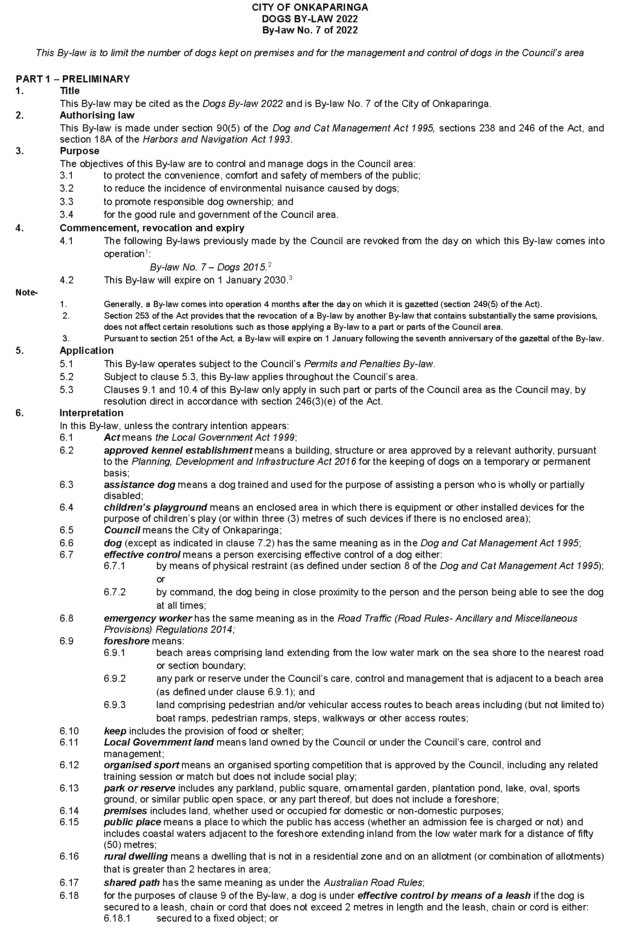
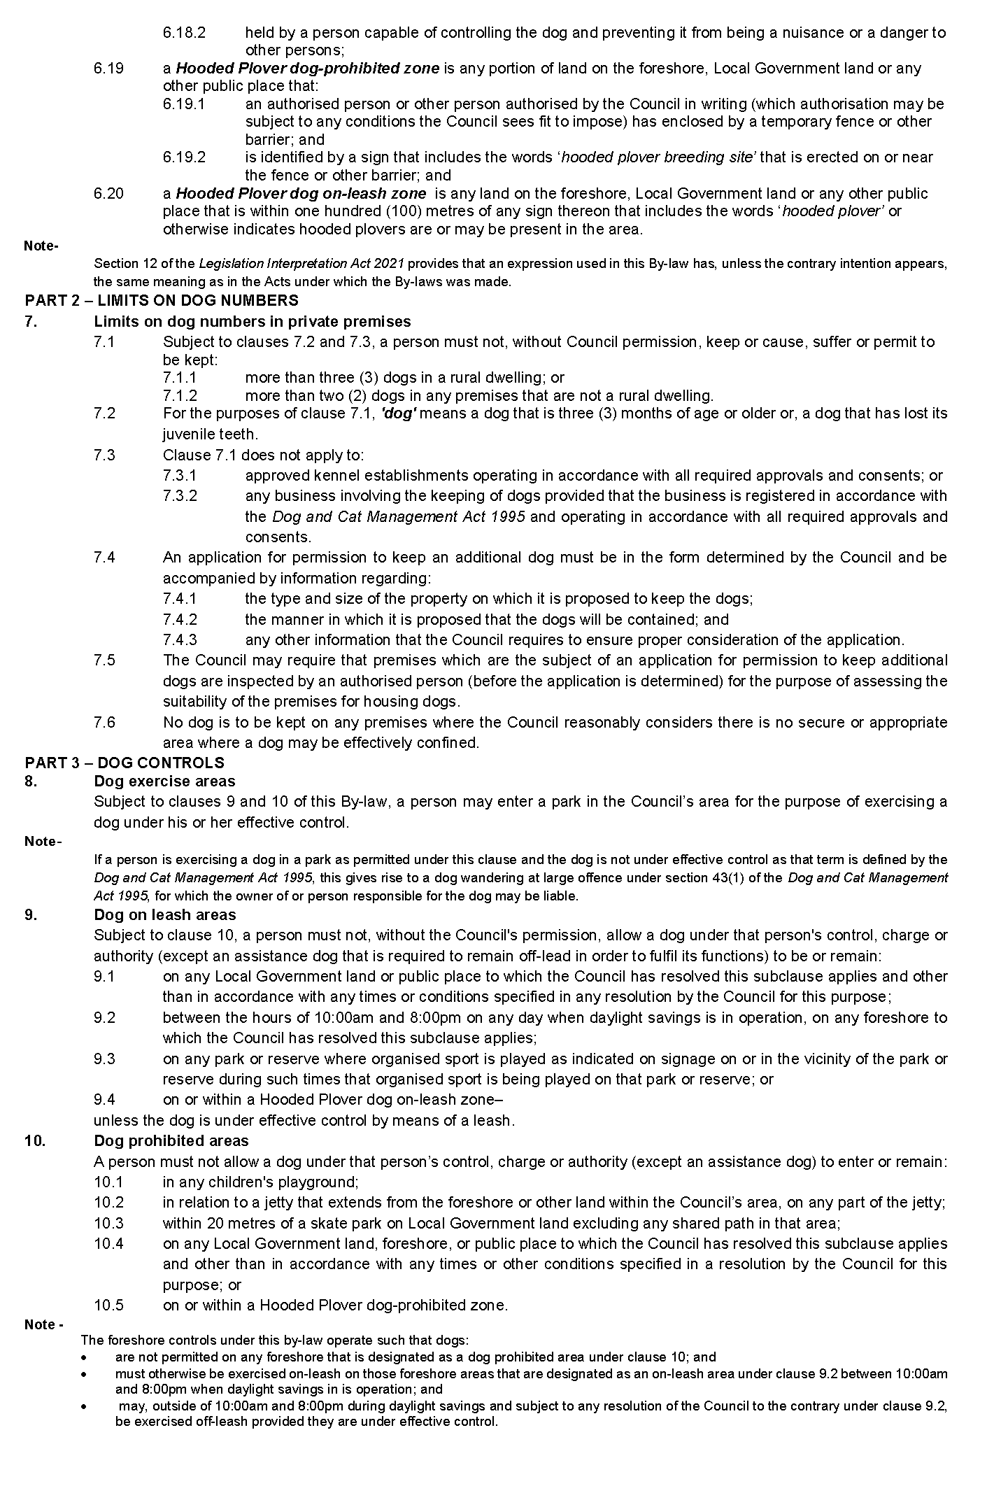
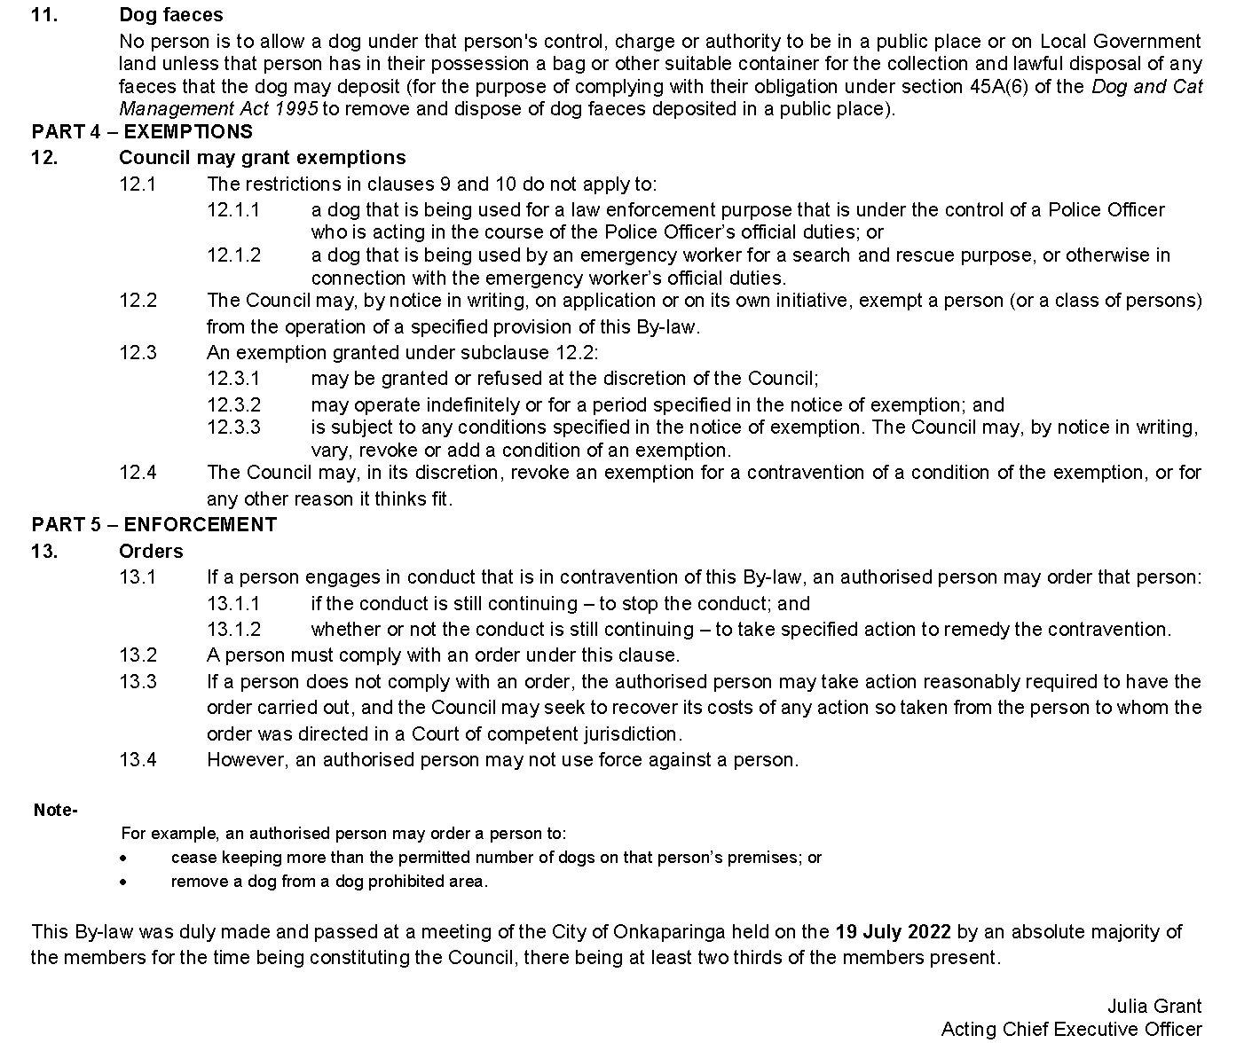

City of Port Adelaide Enfield
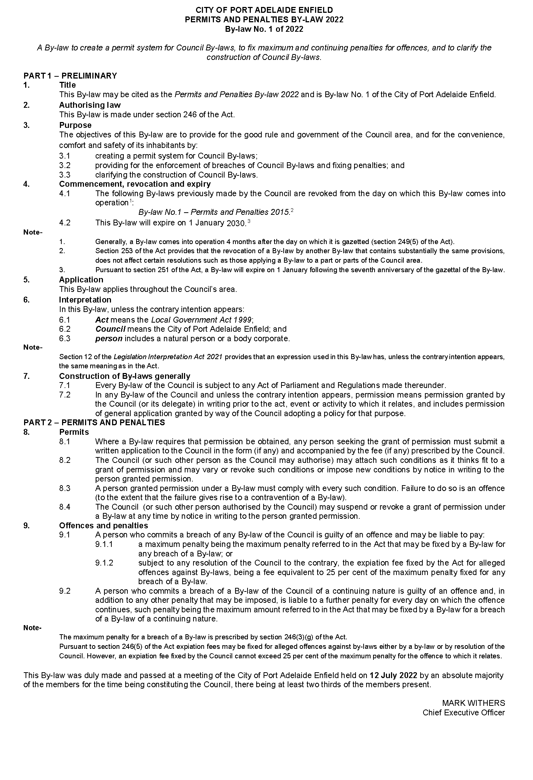
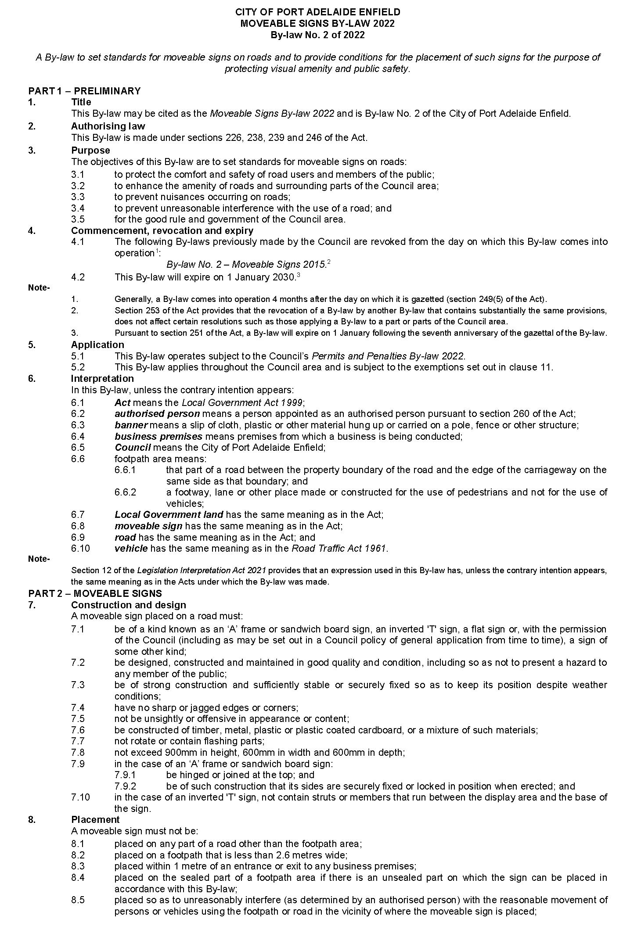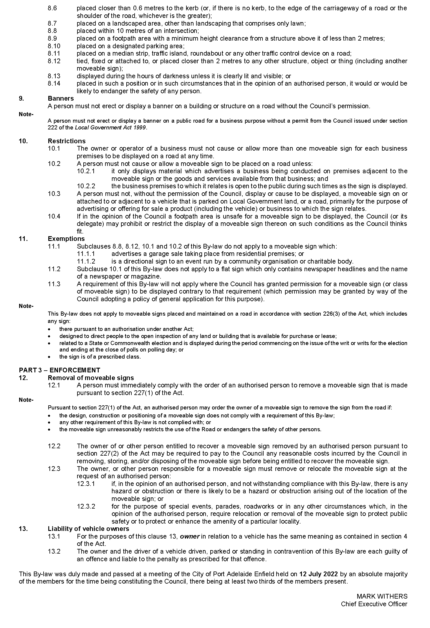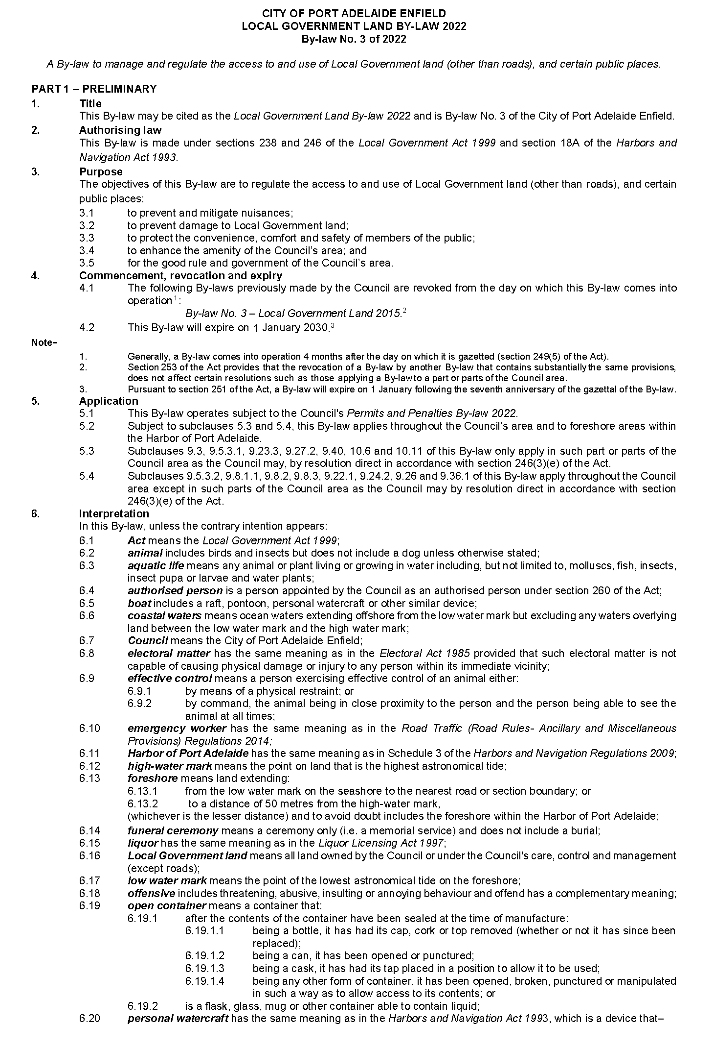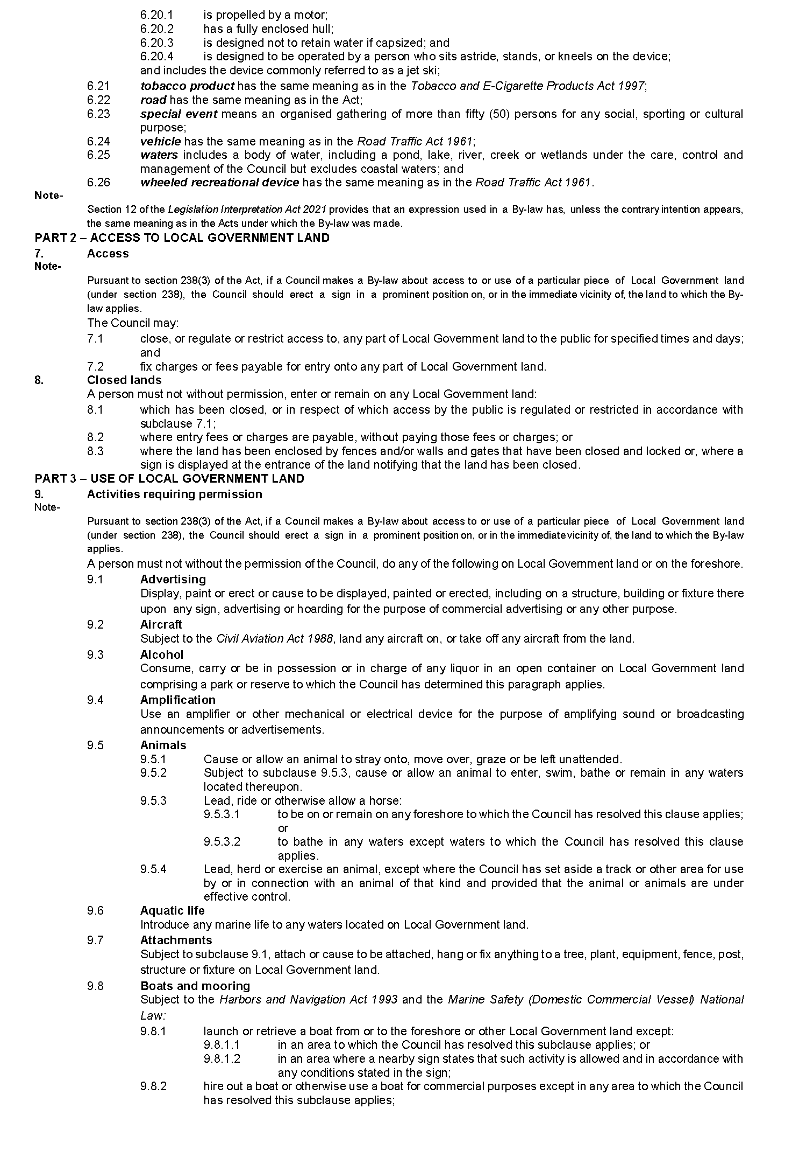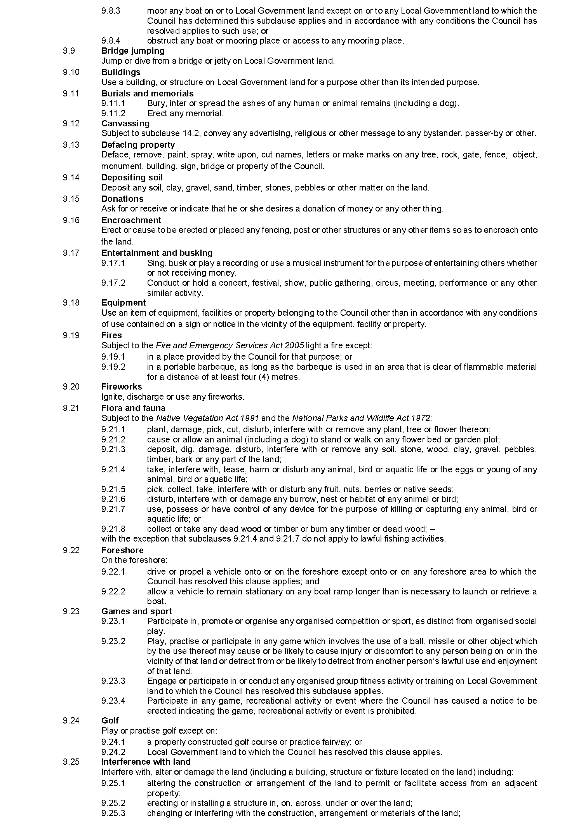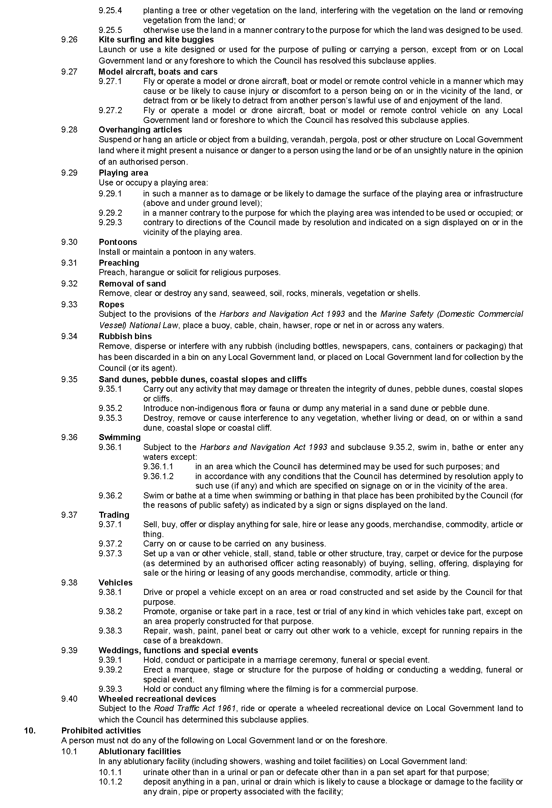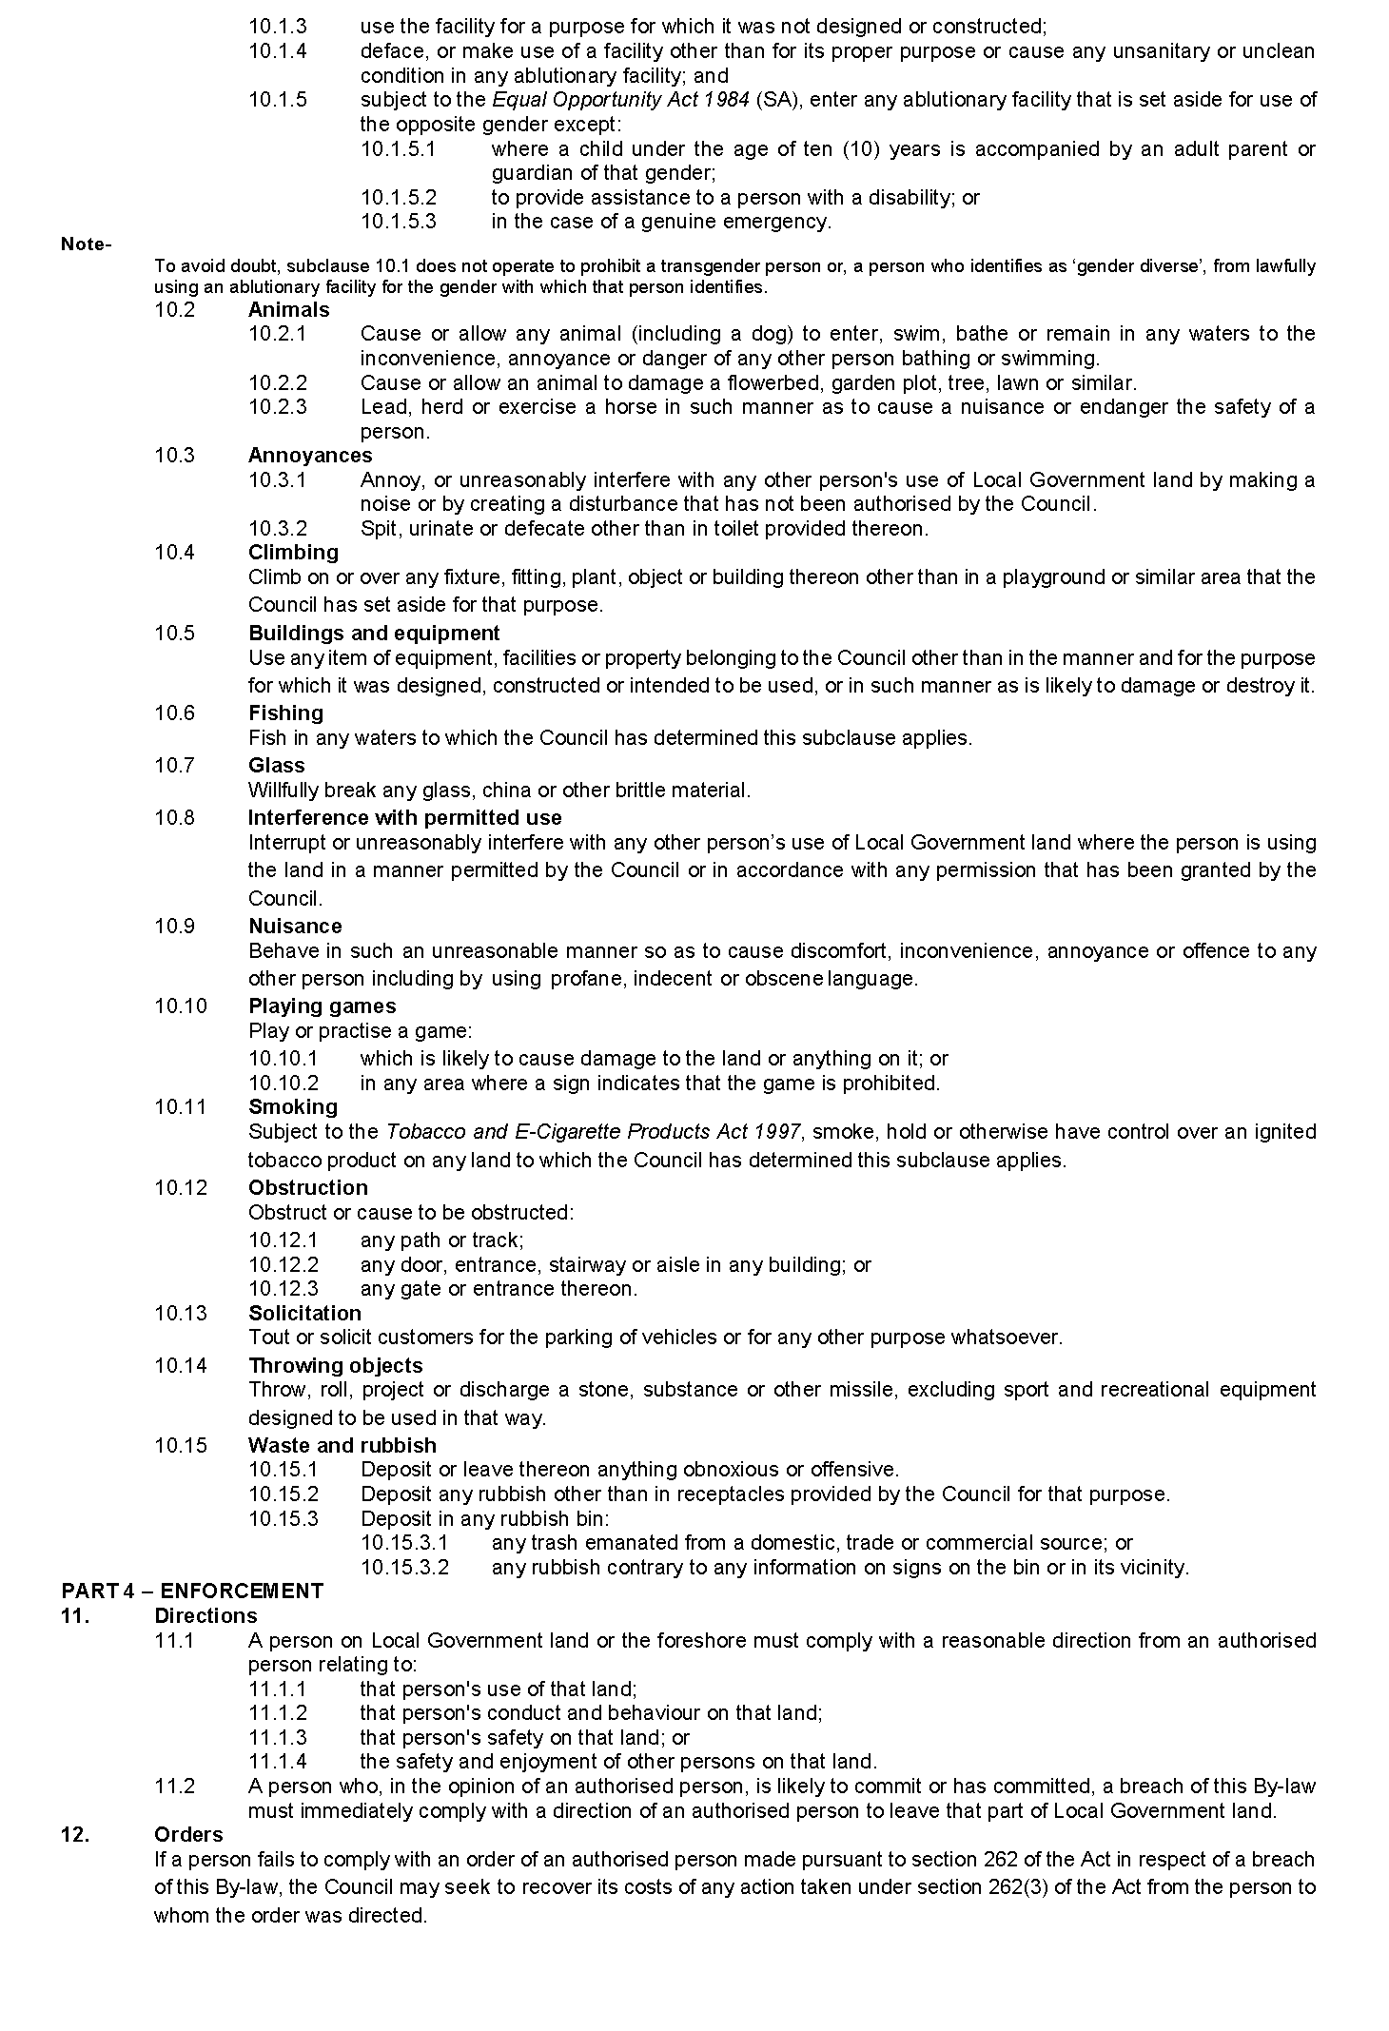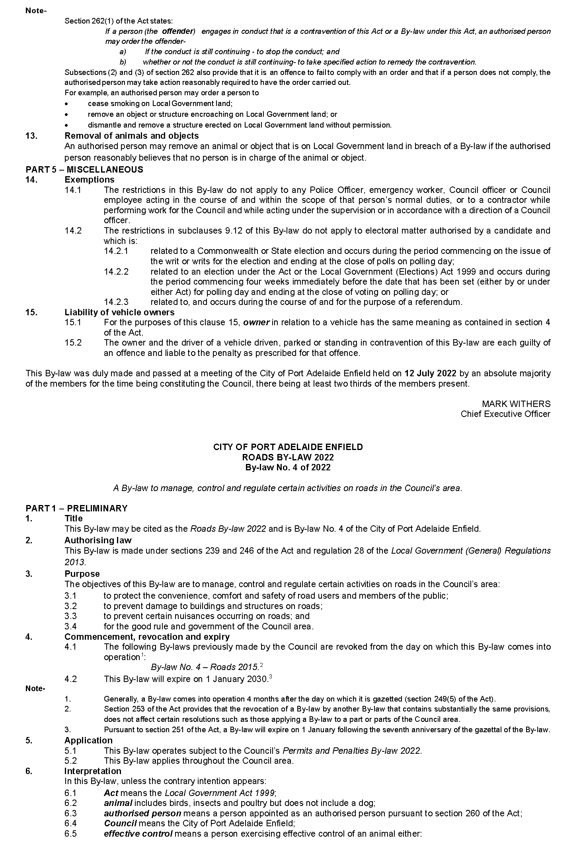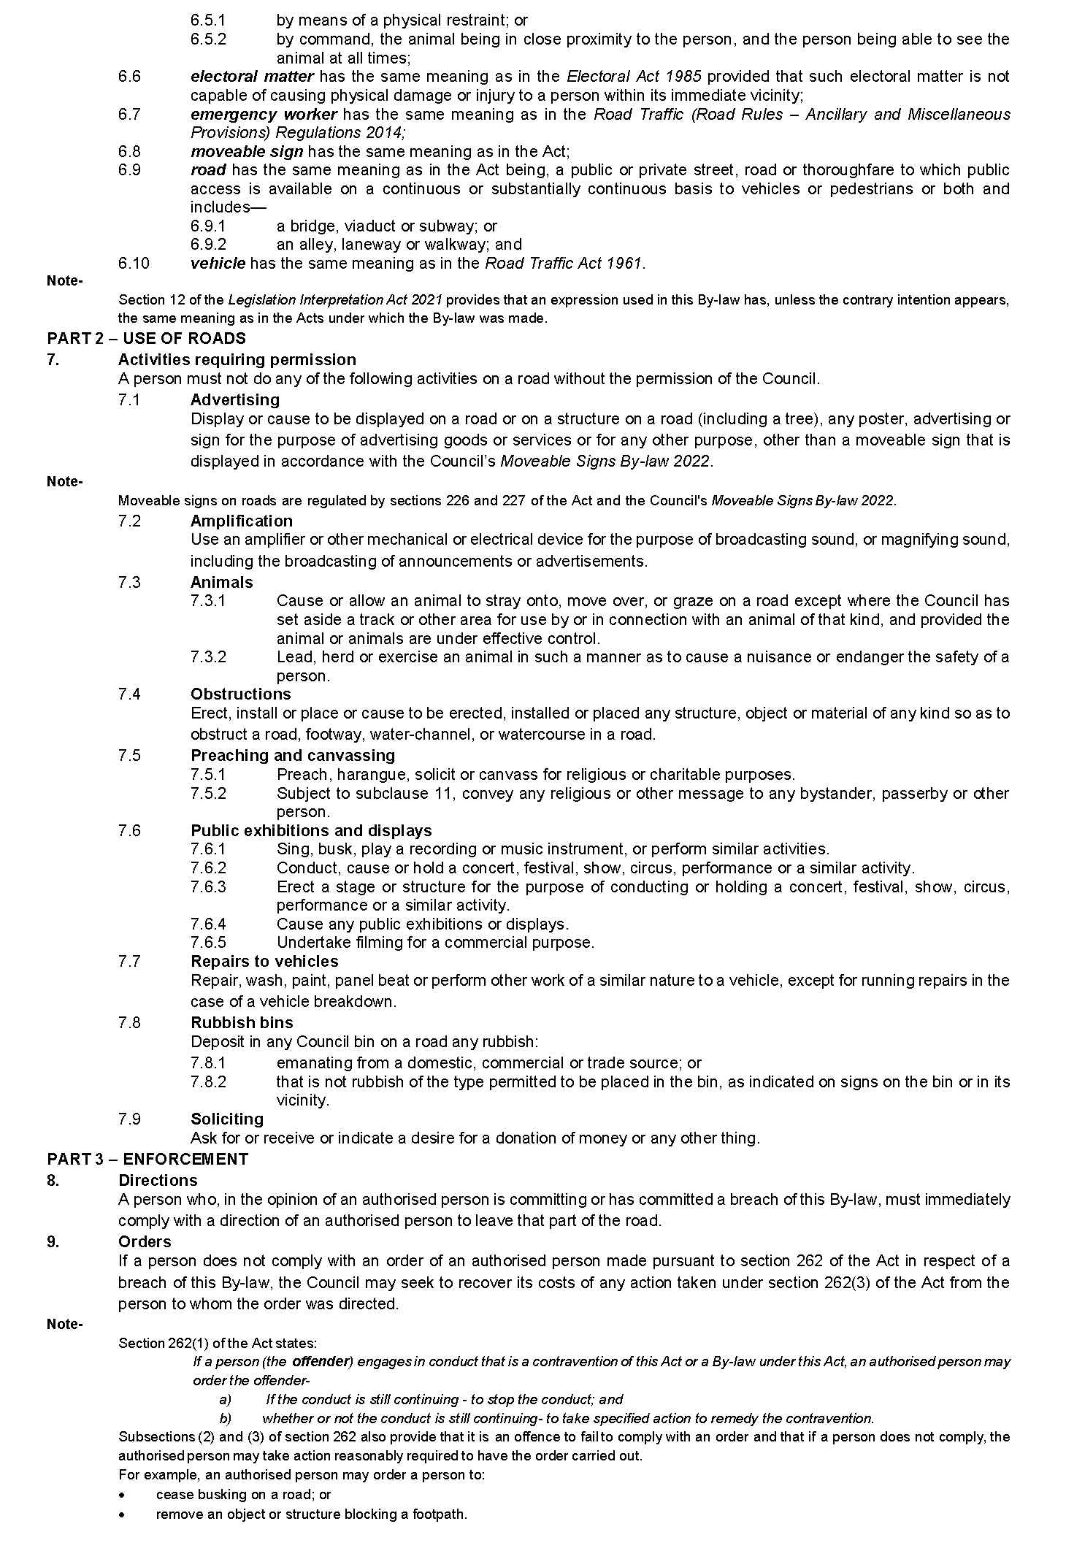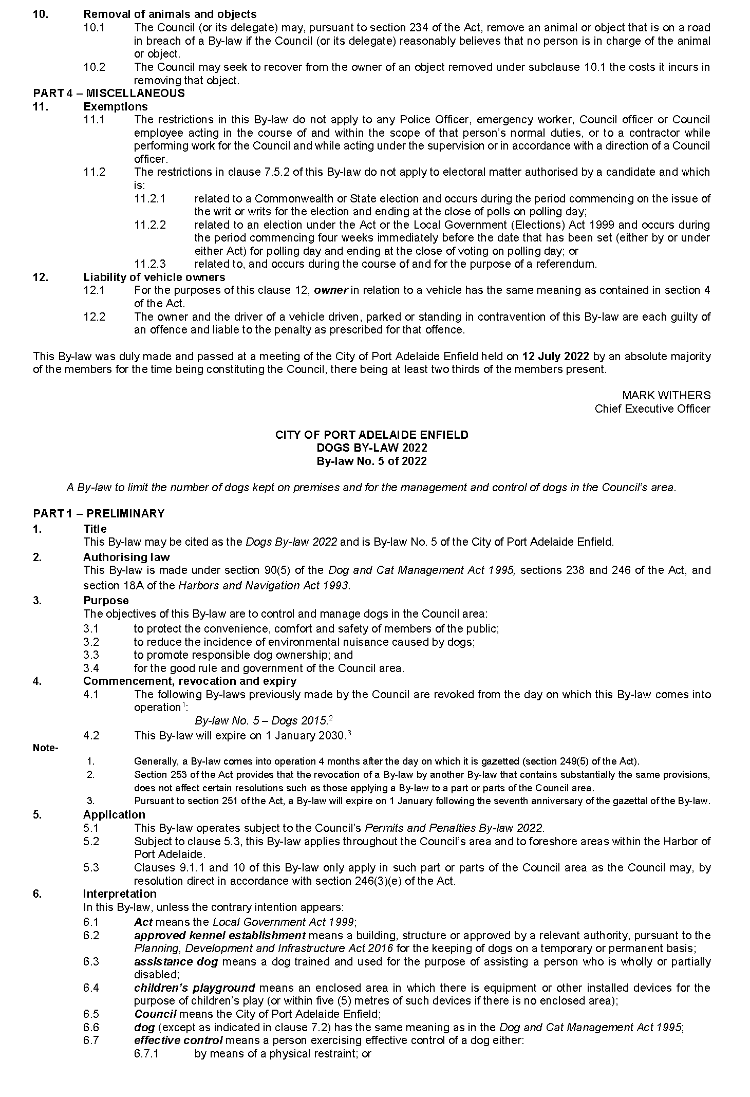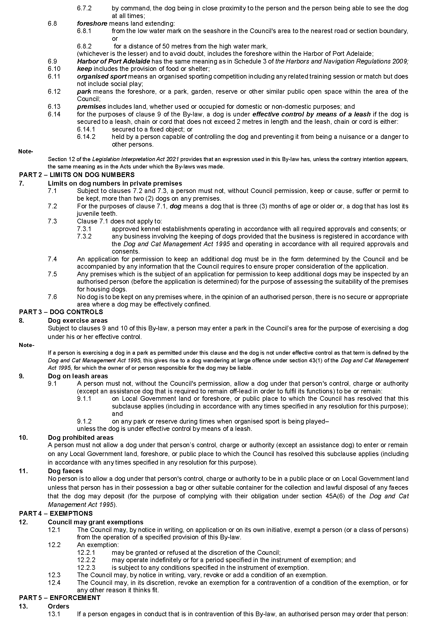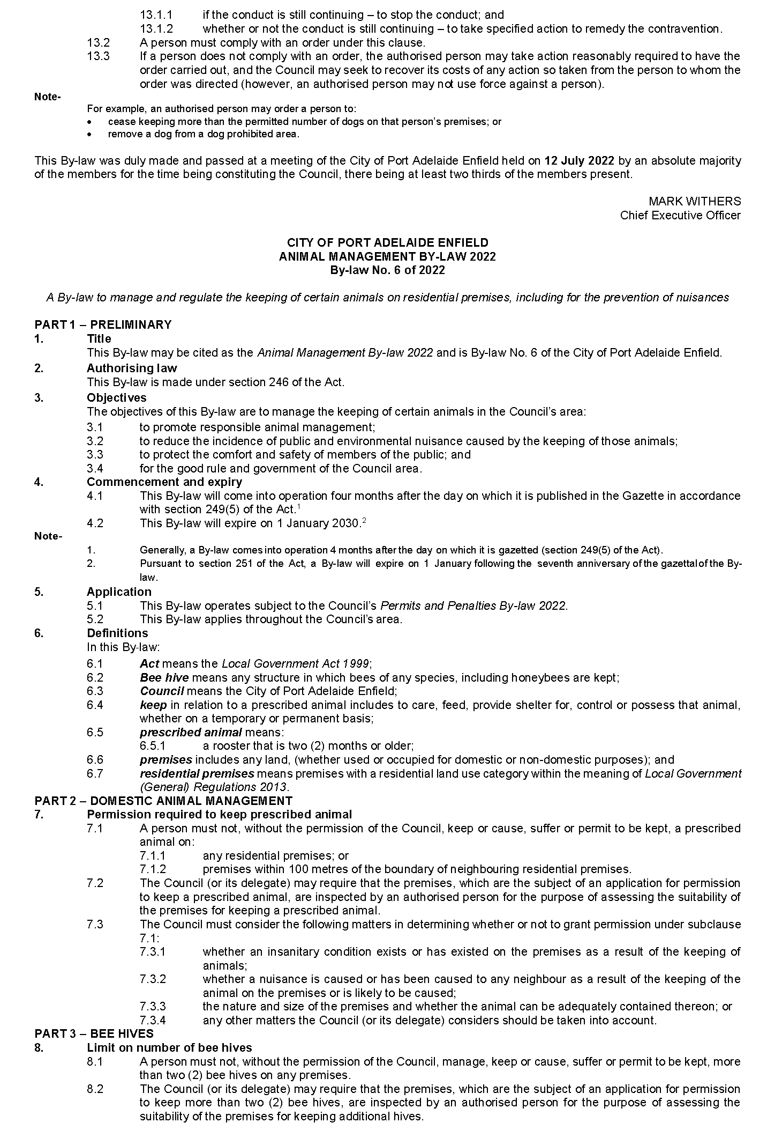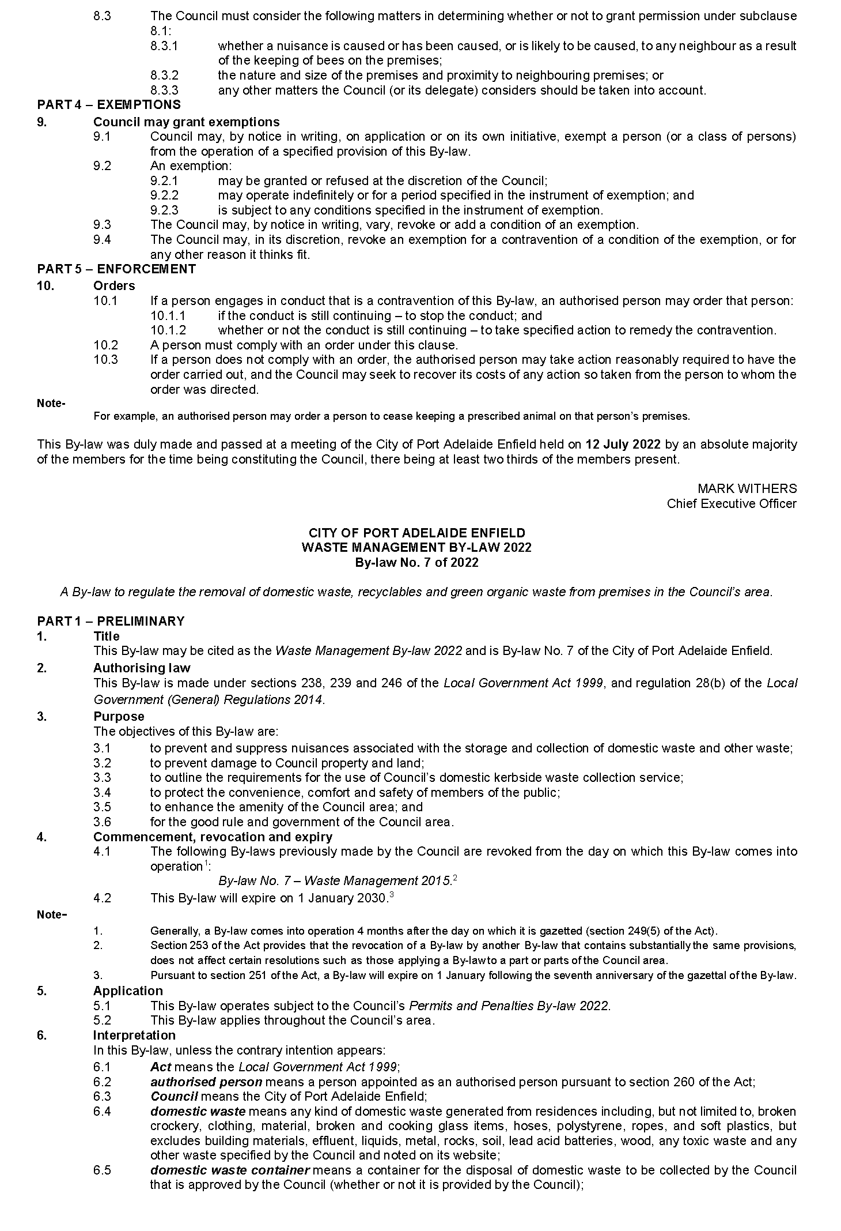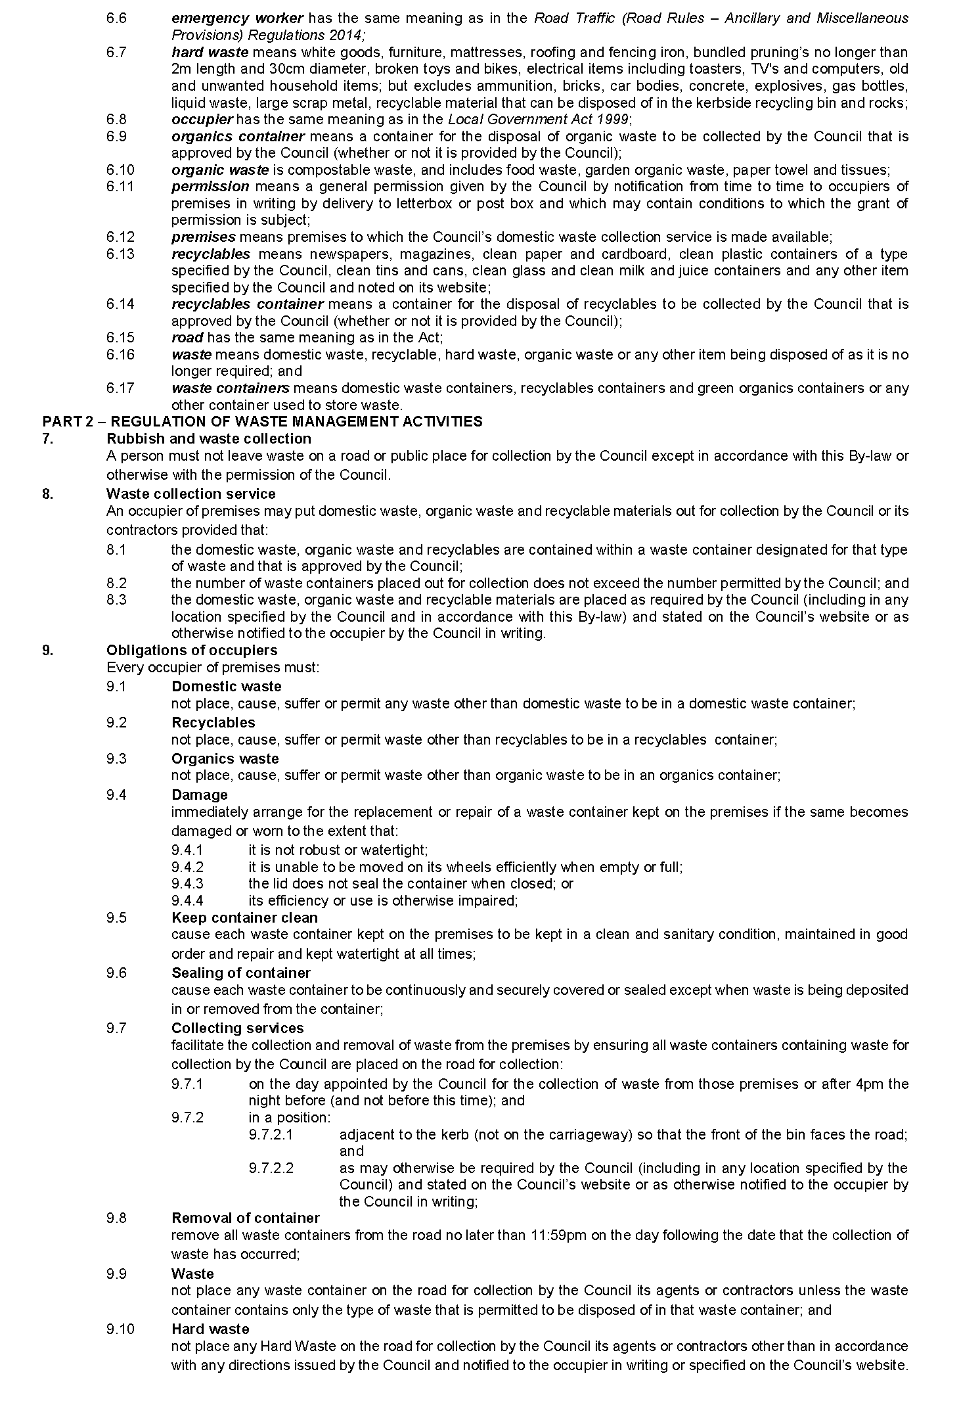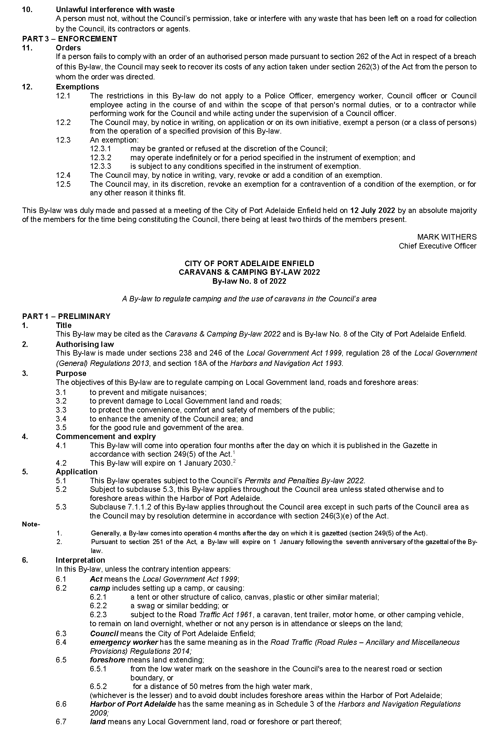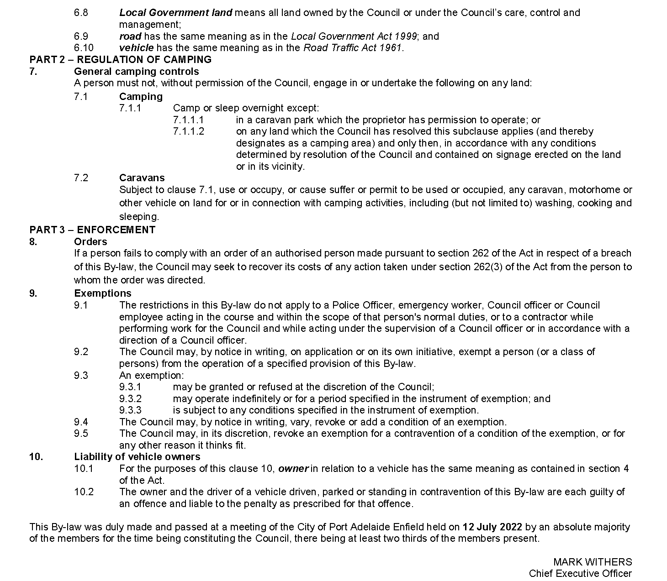

City of Prospect
Adoption of Valuation and Declaration of Rates 2022-2023
NOTICE is hereby given that City of Prospect, at a meeting of Council held on 28 June 2022 for the year ending 30 June 2023 resolved as follows:
Adoption of Valuations
That the Council of the City of Prospect, pursuant to Section 167 (2) (a) of the Local Government Act 1999, adopts valuations of capital value made by the Valuer-General in relation to the area of the Council on 1 July 2022 and specifies that the total of the values that are to apply within the area for rating purposes for the year ending 30 June 2023 is $8,409,150,600.
Declaration of Differential General Rates
That the Council of the City of Prospect, pursuant to Sections 152 (1) (a), 153 (1) (b) and 156 (1) (c) of the Local Government Act 1999, hereby declares differential general rates on rateable land within the area, which rates vary by reference to the uses of land designated by Regulation 14 of the Local Government (General) Regulations 2013.
(a) Residential: A rate of 0.244030 cents in the dollar on the capital value of such rateable land.
(b) Commercial—Shop: A rate of 0.648337 cents in the dollar on the capital value of such rateable land.
(c) Commercial—Office: A rate of 0.648337 cents in the dollar on the capital value of such rateable land.
(d) Commercial—Other: A rate of 0.648337 cents in the dollar on the capital value of such rateable land.
(e) Industry—Light: A rate of 0.648337 cents in the dollar on the capital value of such rateable land.
(f) Industry—Other: A rate of 0.648337 cents in the dollar on the capital value of such rateable land.
(g) Primary Production: A rate of 0.648337 cents in the dollar on the capital value of such rateable land.
(h) Vacant Land (Residential Planning Zone): A rate of 0.305037 cents in the dollar on the capital value of such rateable land.
(i) Vacant Land (Non-Residential Planning Zone): A rate of 0.810421 cents in the dollar on the capital value of such rateable land.
(j) Other: A rate of 0.648337 cents in the dollar on the capital value of such rateable land.

Declaration of a Minimum Amount
That the Council of the City of Prospect, pursuant to Section 158 (1) (a) of the Local Government Act 1999, hereby fixes, in respect of the year ending 30 June 2023, a minimum amount of $1,347 that shall be payable by way of general rates on rateable land within the Council’s area.
Declaration of a Separate Rate (Prospect Village Heart Marketing Fund)
City of Prospect, pursuant to Sections 154 (1) and 154 (2) (c) of the Local Government Act 1999, hereby declares separate rate by fixed charge of $150.00 on rateable land within Land Uses of 2, 3, 4, 5, 6 and 9 on Prospect Road, Prospect South Australia bordered at the North by Gladstone Road and Alpha Road and the South by Buller Street and Ballville Street.
Declaration of a Separate Rate (Regional Landscape Levy)
That pursuant to Section 69 of the Landscape South Australia Act 2019 and Section 154 of the Local Government Act 1999, Council, in order to reimburse to the Council the amount contributed to the Regional Landscape Levy of $611,946 declares for the year ending 30 June 2023 a separate rate of 0.007438 cents in the dollar on the capital valuation of all rateable properties within the area of the City of Prospect.
Payment of Rates
Notice is hereby given that pursuant to Section 181 of the Local Government Act 1999, the rates shall be payable in four equal or approximately equal instalments due and payable on 1 September 2022, 1 December 2022, 1 March 2023 and 1 June 2023.
Dated: 28 July 2022
C.WHITE
Chief Executive Officer

City of Victor Harbor
Adoption of Valuation
NOTICE is hereby given that at the Special Meeting on 13 July 2022 the City of Victor Harbor resolved for the financial year ending 30 June 2023:
- To adopt the most recent capital valuations provided by the Valuer General for land within the Council area, totaling $5,593,123,160 for rating purposes for the year ending 30 June 2023.
- To declare differential general rates as follows:
0.3831 cents in the dollar on rateable land of Category (a) (Residential) and Category (i) (Other)
0.4980 cents in the dollar on rateable land of Category (b) (Commercial-Shop), Category (c) (Commercial-Office) and Category (d) (Commercial-Other)
0.4406 cents in the dollar of rateable land of Category (e) (Industry – Light) and Category (f) (Industry-Other)
0.3448 cents in the dollar of rateable land of Category (g) (Primary Production)
0.5747 cents in the dollar of rateable land of Category (h) (Vacant Land)
- To impose a fixed charge of $421 on each separate piece of rateable land within the area of the Council.
- To declare the separate rate of 0.008446 cents in the dollar on all rateable land in the area of the council and the Hills and Fleurieu Regional Landscape Board.
Dated: 13 July 2022
Karen Rokicinski
Acting Chief Executive Officer

Adelaide Plains Council
Adoption of Valuations and Declaration of Rates
NOTICE is hereby given that the Adelaide Plains Council, at a special meeting held on 11 July 2022, in respect of the financial year ending 30 June 2023, adopted its Annual Business Plan and Budget and made the following decisions:
Adoption of Valuations
The Council adopted, for rating purposes, the most recent valuations of the Valuer-General available to the Council of the capital value of land within the Council’s area totalling $2,445,058,340, of which $2,415,462,421 is the total capital value of rateable land.
Declaration of Rates and Service Charges
General Rates
The Council declared differential general rates comprising two components:
- one being based on the capital value of rateable land within its area varying according to land use as follows:
- 0.440940 cents in the dollar on rateable land attributed with a land use category of Residential, Vacant or Other;
- 0.573182 cents in the dollar on rateable land attributed with a land use category of Commercial Shop, Commercial Office, Commercial Other, Industry Light or Industry Other;
- 0.400865 cents in the dollar on rateable land attributed with a land use category of Primary Production; and
- the other being fixed charge of $123.20 on all rateable land within its area.
Kerbside Waste Collection Annual Service Charges
The Council imposed an annual service charge of $172.00 per assessment in respect of all land (except vacant land) to which the Council provides or makes available a three-bin waste collection service within the townships of Mallala, Two Wells and Dublin, and an annual service charge of $172.00 per assessment in respect of all land (except vacant land) to which the Council provides a two-bin waste collection service outside those townships, provided that the sliding scale provided for in regulations will apply to reduce the service charge, as prescribed.

Community Wastewater Management Annual Service Charges
The Council imposed annual service charges of the following amounts in respect of all land to which the service of collecting, treating and disposing of wastewater as part of the Council’s Community Wastewater Management Systems is provided or made available:
Middle Beach  Large tank: $456.00  Small Tank: $456.00 | Mallala Township  Per Property Connection $692.00
Regional Landscape Levy
The Council declared a separate rate of 0.008204 cents in the dollar on all rateable land within its area and within the area of the Northern and Yorke Landscape Board for the purpose of raising the amount of $196,863 to reimburse the council for the amount payable to the Northern and Yorke Landscape Board.
Payment of Rates
The Council determined all rates and annual service charges shall be due in four equal or approximately equal instalments payable on 2 September 2022, 2 December 2022, 3 March 2023 and 2 June 2023.
Dated: 11 July 2022
James Miller
Chief Executive Officer

The Barossa Council
Adoption of Valuation and Declaration of Rates and Charges
1. Adoption of Valuation
Notice is hereby given that at its special meeting held on 19 July 2022 and in relation to the 2022/2023 Financial Year, Council adopts for rating purposes the Valuer-General’s most recent valuations available to the Council of the Capital Value in relation to the area of the Council, which specifies that the total of the values that are to apply within the area is $6,508,166,100 of which $6,378,772,972 is rateable.
2. Declaration of Differential General Rates
That Council declares the following differential general rates on rateable land within its area for the year ending 30 June 2023, based upon the capital value of the land which rates vary by reference to land use categories as follows:
(1) Category (a) - Residential, a rate of 0.0032650 in the dollar;
(2) Category (b) - Commercial – Shop, category (c) - Commercial – Office and category (d) - Commercial – Other, a rate of 0.0050250 in the dollar;
(3) Category (e) - Industry – Light, a rate of 0.0050500 in the dollar;
(4) Category (f) - Industry – Other, a rate of 0.0149200 in the dollar;
(5) Category (g) - Primary Production, a rate of 0.0032350 in the dollar;
(6) Category (h) - Vacant Land, a rate of 0.0061700 in the dollar;
(7) Category (i) - Other, a rate of 0.0054810 in the dollar;
3. Fixed Charge
That Council declare a fixed charge of $400.00 on each separately valued piece of rateable land within the Council area for the year ending 30 June 2023.
4. Waste Collection Service Charge
That Council provide the service of waste collection in those parts of the Council’s area described in (3) below, impose the following service charges by reference to the nature and/or level of usage of the service, for the year ending 30 June 2023:
(1) Non-recyclable Waste Collection
(a) An annual service charge of $121 for 140L General (Landfill) Waste collection receptacles;
(b) An annual service charge of $150 for 240L General (Landfill) Waste collection receptacles;
except in instances where, subject to written application to and the approval of the Council, residential households with six or more permanent residents or a special medical condition may receive a 240L receptacle at the same service charge for a 140L receptacle.
(2) Recyclable Waste Collection
(a) An annual service charge of $64 for 240L Co-mingled Recycling collection receptacle
(b) An annual service charge of $62 for 240L Green Organic Recycling collection receptacle
(3) Parts of Council Area
All Service Entitled Properties in the Designated Waste Collection Areas and along the Approved Waste Collection route as identified in the Waste Management Services Policy.
5. Community Wastewater Management Systems (CWMS) Rate and Service Charge
That Council impose a service rate and service charge for the year ending 30 June 2023, in the following areas to which Council makes available a Community Wastewater Management System (CWMS):
1. Lyndoch, Mount Pleasant, Nuriootpa, Penrice, Stockwell, Tanunda and Williamstown – Residential & Vacant Land Properties
(a) An annual service charge of $362 for occupied residential rateable and non-rateable land;
(b) An annual service charge of $110 on each assessment of vacant rateable and non-rateable land.
2. Lyndoch, Mount Pleasant, Nuriootpa, Penrice, Stockwell, Tanunda and Williamstown – Non-Residential & Non-Vacant Land Properties
A service rate of 0.0011 in the dollar of the capital value of occupied non-residential rateable land.

3. Springton – Residential & Vacant Land Properties
(a) An annual service charge of $607 (including a capital repayment contribution of $245) on assessments of occupied residential rateable land and non-rateable land;
(b) An annual service charge of $245 on assessments of occupied non-rateable land;
(c) An annual service charge of $85 on each assessment of vacant rateable and non-rateable land.
4. Springton – Non-Residential & Non-Vacant Land Properties
(a) A service rate of 0.0011 in the dollar of the capital value of occupied non-residential rateable land.
(b) An annual service charge of $245 on assessments of occupied non-rateable land;
6. Regional Landscape Levy
That Council for the year ending 30 June 2023 and in order to reimburse the Council for the amount contributed to the Northern and Yorke Landscape Board, a levy in the nature of a separate rate of 0.0000879 in the dollar of the capital value of land, be declared on all rateable land in the area of that Board.
7. Payment of Rates
(1) All rates and charges will be payable in four quarterly instalments due on 13 September 2022, 6 December 2022, 7 March 2023 and 6 June 2023; provided that in cases where the initial account requiring payment of rates is not sent at least 30 days prior to these dates, or an amended account is required to be sent, authority to fix the date by which rates must be paid in respect of those assessments affected is hereby delegated to the Chief Executive Officer;
(2) The Chief Executive Officer be delegated to enter into agreements with ratepayers relating to the payment of rates in any case where the Chief Executive Officer thinks it necessary or desirable to do so;
8. Residential Rates Cap
That Council, has determined to fix, on application of the property owner, a maximum increase in general rates (excluding fixed charge) levied upon category (a) land use (Residential) property, for the year ending 30 June 2023 which constitutes the principal place of residence of a principal ratepayer at:
(a) 7.5% over and above the general rates levied for the 2021/2022 financial year (for those eligible for a State Government concession on their Council rates including those in receipt of the Cost of Living Concession) or;
(b) 15% over and above the general rates levied for the 2021/2022 financial year (for all other such ratepayers), provided that:
(c) the property has been the principal place of residence of the principal ratepayer since at least 1 July 2021, and;
(d) the property has not been subject to improvements with a value of more than $20,000 since 1 July 2021.
9. Revaluation Initiative General Rates Cap
That Council has determined to fix an automatic maximum increase in general rates (excluding fixed charge) levied upon a (a) land use (Residential), (b)-(d)(Commercial), (e)(Industry – Light), (f) (Other Industry), (g)(primary production) and (i) (Other) property, for the year ending 30 June 2023 for properties captured or included in the “Revaluation Initiative”:
• 27% over and above the general rates levied for the 2021/2022 financial year on their Council rates, provided that the property ownership is the same principle ratepayer since at least 1 July 2020.
Properties excluded for application of the Revaluation Initiative General Rate Cap:
1. If another rate rebate has already been approved by Council, eg, Mandatory or Discretionary or the General Rate Cap; these rebates will override, and/or
2. Properties that have been transferred to/from another Local Government Category.
3. Any property that has benefited from a reduction in valuation as a consequence of a successful objection to the Valuer-General
4. Properties that have been subdivided or other change resulting in a new assessment
Dated: 19 July 2022
Martin McCarthy
Chief Executive Officer

Mid Murray Council
Adoption of Valuation & Declaration of Rates
Notice is hereby given that on 12 July 2022 Mid Murray Council, pursuant to the provisions of the Local Government Act 1999, and for the year ending 30 June 2023 made the following resolutions.
To adopt the most recent valuations of capital value made by the Valuer General for rating purposes totalling the area aggregate $3,171,452,540.00 of which $3,089,359,153.00 is the valuation of rateable land.
To declare differential general rates on the capital value of all rateable land within the area, varying according to the use of the land, as follows:-
- Residential 0.4524 cents in the dollar
- Commercial – Shop 0.4524 cents in the dollar
- Commercial – Office 0.4524 cents in the dollar
- Commercial – Other 0.4524 cents in the dollar
- Industry – Light 0.4524 cents in the dollar
- Industry – Other 0.4524 cents in the dollar
- Primary Production 0.4072 cents in the dollar
- Vacant Land 0.4524 cents in the dollar
- Other 0.4524 cents in the dollar
- Marina Berths 0.4524 cents in the dollar
To fix a minimum amount of $860.00 payable by way of general rates on rateable land within the Council area.
To declare for Regional Landscape Levy, being $566,355, a separate rate of 0.01848 cents in the dollar, based on all rateable land in the Council’s area.
To declare a Separate Rate of 37 cents per square metre for Waterfront properties (includes marina berths) and rebate of 65% for Non-waterfront properties (Net 13 cents per square metre) within the Mannum Waters development. The purpose of the Separate Rate is to meet the costs incurred by Council in financing and purchasing a permanent water entitlement, to assist in meeting Council’s evaporation loss obligations under the Landscape South Australia Act 2019.
To declare annual service charges in respect of all land to which Council provides or makes available the prescribed service of a Community Wastewater Management System in the following areas:
Big Bend area $557.00 per unit
Bowhill area $289.00 per unit
Greenways Landing area $922.00 per unit
Kroehn's Landing area $1,139.00 per unit
Seven Mile Shacks area $663.00 per unit
Scrubby Flat area $560.00 per unit
Swan Reach area $433.00 per unit
Walker Flat area $175.00 per unit
North Punyelroo area $207.00 per unit
Caloote Landing area $363.00 per unit
Bolto Reserve area $401.00 per unit
Old Teal Flat area $356.00 per unit
The Rocks area $976.00 per unit
Caurnamont area $347.00 per unit
Five Mile Shacks and Kia Marina areas $1,264.00 per unit
Pellaring Flat area $457.00 per unit
Blanchetown area $267.00 per unit
Brenda Park/Morphett Flat areas $285.00 per unit
Marks Landing area $298.00 per unit
Scotts Creek area $338.00 per unit
Teal Flat area $399.00 per unit
Pelican Point area $275.00 per unit
South Punyelroo area $310.00 per unit
North West Bend/Beaumonts areas $176.00 per unit
Idyll Acres area $425.00 per unit
Rob Loxton Road area $175.00 per unit
Julanker/Younghusband Holdings areas $719.00 per unit
Truro area $629.00 per unit
Truro area – private pumping chamber $609.00 per unit
Truro area – Aerobic Wastewater Treatment $314.00 per unit
Cowirra area $1,041.00 per unit
To declare an annual service charge in respect of all land to which Council provides the prescribed service of television transmission known as the Bowhill Multi Access Television Transmission Service of $146.00.
To declare an annual service charge in respect of each property to which Council provides the prescribed service of the treatment or provision of water known as the Bowhill Reticulated Water Supply System:-
Consumption of up to 120 kilolitres of water $256.00
All water consumed in excess of 120 kilolitres 75 cents per kilolitre
To declare an annual service charge for the Township Waste Collection (General Waste and Recyclables) Service of $286.00, based upon the nature of the service, in respect of each residential property within a township to which it makes available.
To declare an annual service charge for the Rural (non-Township) General Waste Collection Service of $200.00, based upon the nature of the service, in respect of land outside of a township which has a residential or primary production land use and upon which there is a residential dwelling and to which it makes available, noting that where the Service is not provided at the access point to the land, the annual service charge will be adjusted as required by Regulations 13 of the Local Government (General) Regulations 2013.
Dated: 12 July 2022
B. F. Scales
Chief Executive Officer

The District Council of Peterborough
Adoption of Valuation and Declaration of Rates
NOTICE is given that the District Council of Peterborough, at the Special Council Meeting held on 25 July 2022, for the financial year ending 30 June 2023 resolved:
Adoption of Capital Valuations
To adopt the most recent capital valuations of the Valuer-General available for rating purposes for its area with total valuations being $235,627,120 comprising $231,107,120 in respect of rateable land and $4,520,000 in respect of non-rateable land.
Fixed Charge/Differential General Rates
To impose a fixed charge of $390.00 on each piece of separate rateable land and to declare the following differential general rates on all rateable land, by reference to the locality of the land:
Peterborough township 0.67 cents in the dollar
Oodla Wirra township 0.51 cents in the dollar
Yongala township 0.54 cents in the dollar
Rural property 0.275 cents in the dollar
Annual Service Charge (Garbage)
To impose an Annual Service Charge of $107.50 per Mobile Garbage Bin (Wheelie Bin) in respect of all land (rateable and non-rateable) to which it provides or makes available the service of the collection and disposal of domestic and commercial waste.

Separate Rates (State Government Landscape SA Levy)
To declare a separate rate of 0.0157 cents in the dollar to reimburse the Council for the amount of $34,930 contributed to the Northern and Yorke Landscape Region Board.
Annual Service Charge (Community Wastewater Management System)
To impose an Annual Service Charge of $540.00 per Property Unit upon all land (rateable and non-rateable) to which it provides or makes available the service of the Community Wastewater Management System in the Peterborough township.
Dated: 25 July 2022
Stephen Rufus
Chief Executive Officer

Wattle Range Council
Adoption of Valuations and Declaration of Rates
Notice is hereby given that the Wattle Range Council at a meeting held on 12 July 2022 and in relation to the financial year ending 30 June 2023, adopted the 2022-2023 Annual Business Plan and Budget and resolved to:
1. Valuations
Pursuant to Section 167(2)(a) of the Local Government Act 1999, adopted the valuations that are to apply in its area for rating purposes for the 2022/23 financial year, being the capital valuations of the Valuer General, totalling $5,773,378,400.
2. Differential Rates
Pursuant to Sections 152(1)(c)(i), 153(1)(b) and 156(1)(a) of the Local Government Act 1999, declares the following differential general rates on rateable land within its area for the year ending 30 June 2023, based upon the capital value of the land which rates vary by reference to land use categories as per Regulation 14 of the Local Government (General) Regulations 2013 as follows:
(a) Residential—a differential rate of 0.3829 cents in the dollar
(b) Commercial Shop—a differential rate of 0.3525 cents in the dollar
(c) Commercial Office—a differential rate of 0.3525 cents in the dollar
(d) Commercial Other—a differential rate of 0.3525 cents in the dollar
(e) Industry Light—a differential rate of 0.3525 cents in the dollar
(f) Industry Other—a differential rate of 0.3525 cents in the dollar
(g) Primary Production—a differential rate of 0.2549 cents in the dollar
(h) Vacant Land—a differential rate of 0.4969 cents in the dollar
(i) Other—a differential rate of 0.4969 cents in the dollar
3. Minimum Rate
Pursuant to Section 158(1)(a) of the Local Government Act 1999 declared that the minimum amount payable by way of general rates on rateable land in the Council area is $610.00.
4. Service Charges
Pursuant to Section 155 of the Local Government Act 1999 imposed the following annual service charges;
(i) Waste Collection Service
based on the level of usage of the service, on all land to which the Council provides or makes available the prescribed services of the collection, treatment or disposal of waste via Council’s waste management services in respect of each set of bins, or part thereof, provided on the basis that the sliding scale provided for in Regulation 13 of the Local Government (General) Regulations will be applied to reduce the service charge payable, as prescribed.
(a) three bin normal waste, recycling and green organics collection and disposal service of $334.00; and
(b) two bin normal waste and recycling collection and disposal service of $261.00
(ii) Community Wastewater Management Systems
based on the nature of the service and varying according to the CWMS Property Units Code in accordance with Regulation 12 of the Local Government (General) Regulations 1999 on all land in the Townships of Penola, Southend, Kalangadoo and Beachport to which it provides or makes available the Community Wastewater Management Systems being prescribed services for the collection, treatment and disposal of waste.
(a) Penola, Southend and Kalangadoo—Occupied Unit $667.00
(b) Penola, Southend and Kalangadoo—Vacant Unit $499.00
(c) Beachport Occupied Unit $757.00
(d) Beachport Vacant Unit $568.00
5. Separate Rates
Pursuant to Section 69 of the Landscape South Australia Act 2019 and Section 154 of the Local Government Act 1999, in order to reimburse the Council for amounts contributed to the Limestone Coast Landscape Board declared a separate rate based on a fixed charge varying on the basis of land use categories in respect of rateable land in the Council’s area.
(i) $84.40 per assessment on rateable land categories (a), (h) and (i) (Residential, Vacant and Other);
(ii) $122.25 per assessment on rateable land categories (b), (c) and (d) (Commercial Shop, Commercial Office, Commercial Other);
(iii) $195.20 per assessment on rateable land categories (e) and (f) (Industry Light and Industry Other);
(iv) $353.30 per assessment on rateable land category (g) (Primary Production).

5. Payment of Rates
Pursuant to Section 181 of the Local Government Act 1999, rates for the year ending 30 June 2023 will fall due in four equal or approximately equal instalments on 14 September 2022, 7 December 2022, 8 March 2023 and 7 June 2023.
Dated: 28 July 2022
Ben Gower
Chief Executive Officer

Public Notices

Sale of Property
Warrant of Sale
Auction Date: Saturday, 20 August 2022 at 11:00am
Location: 41 Gawler River Road, Willaston, South Australia
Notice is hereby given that on the above date at the time and place stated, by virtue of the Warrant of Sale issued out of the Magistrates Court of South Australia, Action No. 749 of 2020 directed to the Sheriff of South Australia in an action wherein Roy and Jillian Hussey are the Applicants and Tanya Meola and Jamie Trevena are the Respondents, I Angela Gransden, Sheriff of the State of South Australia, will by my auctioneer, Inwood Real Estate, make sale of the estate, right, title or interest whatsoever it may be of the Respondent, Jamie Ryan Trevena the registered proprietor of an estate in fee simple in the following:
That piece of land situated in the area named Willaston, being 41 Gawler River Road, Willaston, Hundred of Mudla Wirra, being the property comprised in Certificate of Title Register Book Volume 5787 Folio 787.
Further particulars from the auctioneers:
Richard Inwood
Inwood Real Estate
134 Melrose Street
Mt Pleasant SA 5235
Telephone 0428 606 420
Dated: 21 July 2022
Angela Gransden
Sheriff of the State of South Australia

Trustee Act 1936
Public Trustee
Estates of Deceased Persons
In the matter of the estates of the undermentioned deceased persons:
BRICE Ruth Aileen late of 56 Monmouth Road Westbourne Park of no occupation who died 10 February 2022
DERMODY Norma Joyce late of 77 Seaview Road Port Augusta of no occupation who died 5 April 2022
GILL Lorna Marion late of 10 Morton Road Christie Downs of no occupation who died 26 March 2022
HEINRICH Alexander late of 7 Raymond Grove Glenelg retired tannery hand who died 3 February 2022
MAXWELL George late of 578-580 Brighton Road South Brighton of no occupation who died 01 May 2021
MULLIGHAN Ruth Mavis late of 47 Eve Road Bellevue Heights of no occupation who died 5 May 2022
OWEN Clive Edward late of 1-3 Charles Street West Lakes Retired fitter and turner who died 31 March 2022
PYKE Iris late of 17 Morrow Avenue Evanston Park Retired secretary who died 22 March 2022
READ Peter Charles late of 150 Reynell Road Woodcroft Retired Clerk who died 19 January 2022
Notice is hereby given pursuant to the Trustee Act 1936, the Inheritance (Family Provision) Act 1972 and the Family Relationships Act 1975 that all creditors, beneficiaries, and other persons having claims against the said estates are required to send, in writing, to the office of Public Trustee at GPO Box 1338, Adelaide, 5001, full particulars and proof of such claims, on or before the 26 August 2022 otherwise they will be excluded from the distribution of the said estate; and notice is also hereby given that all persons indebted to the said estates are required to pay the amount of their debts to the Public Trustee or proceedings will be taken for the recovery thereof; and all persons having any property belonging to the said estates are forthwith to deliver same to the Public Trustee.
Dated: 28 July 2022
N. S. Rantanen
Public Trustee

Notice Submission

The South Australian Government Gazette is published each Thursday afternoon.
Notices must be emailed by 4 p.m. Tuesday, the week of publication.
Submissions are formatted per the gazette style and a proof will be supplied prior to publication, along with a quote if applicable. Please allow one day for processing notices.
Alterations to the proof must be returned by 4 p.m. Wednesday.

Gazette notices must be submitted as Word files, in the following format:
• Title—the governing legislation
• Subtitle—a summary of the notice content
• Body—structured text, which can include numbered lists, tables, and images
• Date—day, month, and year of authorisation
• Signature block—name, role, and department/organisation authorising the notice

Please provide the following information in your email:
• Date of intended publication
• Contact details of the person responsible for the notice content
• Name and organisation to be charged for the publication—Local Council and Public notices only
• Purchase order, if required—Local Council and Public notices only

Email: governmentgazettesa@sa.gov.au
Phone: (08) 7109 7760
Website: www.governmentgazette.sa.gov.au

All instruments appearing in this gazette are to be considered official, and obeyed as such

Printed and published weekly by authority of C. McArdle, Government Printer, South Australia
$8.15 per issue (plus postage), $411.00 per annual subscription—GST inclusive
Online publications: www.governmentgazette.sa.gov.au

