No. 14 p. 655
THE SOUTH AUSTRALIAN
GOVERNMENT GAZETTE
Published by Authority

Adelaide, Thursday, 3 March 2022

Contents

Governor’s Instruments

Appointment 656

State Government Instruments

Education and Children’s Services Regulations 2020 657

Fisheries Management Act 2007 658

Fisheries Management (Prawn Fisheries) Regulations 2017 658

Housing Improvement Act 2016 661

Landscape South Australia Act 2019 661

Motor Vehicles Act 1959 662

National Parks and Wildlife Act 1972 664

Petroleum and Geothermal Energy Act 2000 665

Planning, Development and Infrastructure Act 2016 665

Professional Standards Act 2004 667

Proof of Sunrise and Sunset Act 1923 669

Roads (Opening and Closing) Act 1991 670

Wilderness Protection Act 1992 664

Local Government Instruments

The Flinders Ranges Council 672

District Council of Karoonda East Murray 685

Wakefield Regional Council 697

Public Notices

Land Acquisition Act 1969 698

National Electricity Law 700

Sale of Property 700

Unclaimed Moneys Act 1891 701

Governor’s Instruments

Appointment
Department of the Premier and Cabinet
Adelaide, 24 February 2022
Her Excellency the Governor directs it to be notified that she has approved the retention of the title 'Honourable' by:
Justice Greg Parker PSM.
By command,
Hon Steven Marshall MP
Premier of South Australia
DPC21/0008

State Government Instruments

Education and Children’s Services Regulations 2020
Notice of Policy by the Minister for Education
Capacity Management Plan—Morialta Secondary College
PURSUANT to regulation 12(1) of the Education and Children’s Services Regulations 2020, I, the Minister for Education publish the following Capacity Management Plan for the purposes of the enrolment of a child at Morialta Secondary College.
Capacity Management Plan
Morialta Secondary College
This Capacity Management Plan sets out the conditions for enrolment at Morialta Secondary College (“the school”) effective for the enrolment of a child to attend in 2023.
Morialta Secondary College zone
A school zone is a defined area from which the school accepts its core intake of students. Morialta Secondary College operates a school zone within the area bounded by:
Glynburn Road, Montacute Road, Black Hill Track, Black Hill Road, Church Road, Montacute Road, Hill Road, Montacute Road, Marble Hill Road, Moores Road, Colonial Track, Norton Summit Road, Kintyre Road, Glen Stuart Road, Koongarra Avenue, St Bernard’s Road and Shakespeare Avenue.
An online map of the Morialta Secondary College zone and a search tool to indicate if an applicant’s home address is within the school zone is available at: https://www.education.sa.gov.au/findaschool
Student Enrolment Numbers
As a new school, Morialta Secondary College will have a progressive enrolment process. This process will introduce a new Year 7 cohort at the start of each school year, beginning in 2023 until the school has all year levels in 2028.
Year 7
The student enrolment ceiling for Year 7 is limited to 200, unless there are more applications that have met the enrolment criteria below.
International Education Program
No International Education Program places will be offered at the school.
Enrolment Criteria – By Year Level
YEAR LEVEL: 7
Applications for enrolment from parents of prospective Year 7 students require that the student must be enrolled in a government or non-government school in South Australia at the time the parents apply for enrolment through the statewide registration of interest process (coordinated by the Department for Education).
The applicant must meet one of the following requirements to be eligible for a Year 7 allocation through the statewide registration of interest process for the coming school year:
- the child is living in the Morialta Secondary College zone
- the child identifies as Aboriginal and/or Torres Strait Islander through the Enter for Success program
- the child has been granted enrolment due to special or extenuating circumstances, including but not limited to a child in care where there is a custody or guardianship order made under the Children and Young People (Safety) Act 2017.
Late applications for Year 7 from students living in the school zone
Families who move into the school zone, or who are already living in the school zone but lodge their application for enrolment after the department’s registration of interest process is completed (end of term 2), will have their applications considered if or when vacancies exist.
In these cases, applications will be considered based on the distance of the child’s residence from the school and any other personal needs, such as curriculum, transportation/location convenience, and social/family links to the school.
The school will notify parents by the beginning of week 3, term 4 if a vacancy is available for their child to attend the following school year.
If no vacancies exist, the applicant will be placed on the enrolment register and the school will support the family to enrol at a neighbouring school.
Enter for Success Year 7 students
Through Enter for Success, a child that identifies as Aboriginal and/ or Torres Strait Islander will be offered a Year 7 place at the school for the following year. Families enrolling through Enter for Success can do so until the end of term 4 in the year prior to starting Year 7.
YEAR LEVEL: 8 to 12
Applications for enrolment in year levels 8 to 12 will not be accepted for 2023.
Local applicants for these year levels will be encouraged to remain at their current school or the school will support the family to enrol at a neighbouring school.
OUT OF ZONE APPLICATIONS
There is no automatic entry to the school for any year level for students who live outside of the school’s zone and have siblings who attend the school.
Applications from parents of prospective students, who live outside the school zone will only be given consideration for enrolment if the school is under its year level student enrolment numbers.
Enrolment Criteria - General
Special Circumstances
Enrolment applications for consideration based on special or extenuating circumstances, including but not limited to a child in care where there is custody or guardianship orders made under the Children and Young People (Safety) Act 2017, may be granted by the Principal in consultation with the Education Director. These applications will be assessed on a case-by-case basis.
Enrolment Process
Enrolment Register
Parents whose child’s name has been placed on the enrolment register will be contacted by the school by the beginning of week 3, Term 4 if a vacancy is available for the following school year.
The enrolment register will be reviewed and updated annually by the school.
The position that a child’s name appears on the register is confidential and will only be disclosed as required by law.
Monitoring and enforcement
It is the responsibility of the parents applying for enrolment to be able to verify to the satisfaction of the school that the information provided is true and factual.
If a child was enrolled at the school on the basis of false or misleading information (including residential address) the Chief Executive may direct that the child be instead enrolled at another Government school pursuant to section 63(1) of the Education and Children’s Services Act 2019.
The Principal is responsible for the implementation of this Capacity Management Plan and all decisions on enrolments.
This Capacity Management Plan will be reviewed as required.
Dated: 18 February 2022
John Gardner
Minister for Education

Fisheries Management Act 2007
Section 115
Exemption Number: ME9903201
TAKE NOTICE that, pursuant to section 115 of the Fisheries Management Act 2007, (the Act) the classes of persons specified in Schedule 1 are exempt from section 71 of the Act insofar as they may take, injure, damage, or otherwise harm White Sharks also known as Great White or White Pointer Sharks (Carcharodon carcharias) in an emergency (the exempted activity), in State waters, subject to the conditions specified in Schedule 2, from 2 March 2022 until 1 March 2023, unless otherwise varied or revoked. Exemption number: ME9903201
Schedule 1
- A Fisheries Officer appointed under the Fisheries Management Act 2007; or
- A Police Officer appointed under the Police Act 1998.
Schedule 2
1. Subject to the conditions of this notice, the exempted activity must not be carried out without the written authorisation and direction of one of the following officers of the Department of Primary Industries and Regions:
- Director Operations, Fisheries and Aquaculture
- Regional Manager, Fisheries and Aquaculture
- Manager Offshore Patrol Operations, Fisheries and Aquaculture
2. Authorisation to carry out the exempt activity may only be granted in such circumstances where there is a threat to human life and/or public safety and the action is in the public interest.
3. Authorisation may be verbal if the urgency of the situation requires an immediate response. In these circumstances written confirmation of the authorisation and direction must be given within 48 hours.
4. No authorisation is required if:
- The threat to human life from shark attack is considered to be so imminent that seeking authorisation is not reasonably practicable; or
- All reasonable attempts to contact the persons listed in condition 1 have been unsuccessful and immediate action is required in circumstances consistent with condition 2.
Dated: 1 March 2022
Prof Gavin Begg
Executive Director
Fisheries and Aquaculture
Delegate of the Minister for Primary Industries and Regional Development

Fisheries Management (Prawn Fisheries) Regulations 2017
Surveying in the Gulf St Vincent Prawn Fishery
TAKE notice that pursuant to regulation 10 of the Fisheries Management (Prawn Fisheries) Regulations 2017, the notice dated 23 February 2022 prohibiting fishing activities in the Gulf St Vincent Prawn Fishery is HEREBY varied such that it will not apply to the holders of a Gulf St Vincent Prawn Fishery licence issued pursuant to the Fisheries Management (Prawn Fisheries) Regulations 2017 listed in Schedule 1 or their registered master insofar as they may use prawn trawl nets in accordance with the conditions of their fishery licence for the purpose of undertaking a prawn survey during the period specified in Schedule 2, subject to the conditions contained in Schedule 3 unless this notice is varied or revoked.
Schedule 1
Licence Number | Licence Holder | Boat Name
V02 | W J Fountain Pty Ltd | Angela Kaye
V03 | Josephine K Fisheries Pty Ltd | Josephine K
V04 | Ledo Pty Ltd | Frank Cori
V06 | Todreel Pty Ltd | Anna Pearl
V14 | W J Fountain Pty Ltd | Zadar

Schedule 2
Commencing at sunset on 1 March 2022 to sunrise on 3 March 2022.
Schedule 3
- For the purposes of this notice the trawl survey areas cannot include any waters of a habitat protection zone or a sanctuary zone of a marine park established under the Marine Parks Act 2007.
- The licence holders listed in Schedule 1 or their registered master must comply with all regulations and conditions that apply to fishing activities undertaken pursuant to their licence, in addition to the conditions imposed by this notice.
- While engaged in fishing activities or unloading the survey catch, the licence holders listed in Schedule 1 or their registered master must have a copy of this notice on board the boat or near his person. This notice must be produced to a Fisheries Officer if requested.
- While engaged in fishing activities, the licence holders listed in Schedule 1 or their registered master must have an observer from the South Australian Research Development Institute (SARDI) aboard the vessel.
- No fishing activity may be undertaken between the prescribed times of sunrise and sunset for Adelaide (as published in the South Australian Government Gazette).
- The licence holders listed in Schedule 1 or their register master must not contravene or fail to comply with the Fisheries Management Act 2007, or any other regulations made under that Act except where specifically exempted by this notice.
This notice does not purport to override the provisions or operation of any other Act including, but not limited to, the Marine Parks Act 2007. The notice holder and his agents must comply with any relevant regulations, permits, requirements and directions from the Department for Environment and Water when undertaking activities within a marine park.
Dated: 23 February 2022
Craig Noell
A/Prawn Fishery Manager
Delegate of the Minister for Primary Industries and Regional Development

Fisheries Management (Prawn Fisheries) Regulations 2017
Surveying in the Spencer Gulf Prawn Fishery
TAKE notice that pursuant to regulation 10 of the Fisheries Management (Prawn Fisheries) Regulations 2017, the notice dated 5 October 2021 on page 3908 of the South Australian Government Gazette of 28 October 2021, regarding Surveying in the Spencer Gulf Prawn Fishery is HEREBY revoked.
Dated: 23 February 2022
Kelly Pyke-Tape
Executive Officer
Delegate of the Minister for Primary Industries and Regional Development

Fisheries Management (Prawn Fisheries) Regulations 2017
Surveying in the Spencer Gulf Prawn Fishery
TAKE notice that pursuant to regulation 10 of the Fisheries Management (Prawn Fisheries) Regulations 2017 the notice dated 28 September 2021 on page 3654 of the South Australian Government Gazette of 30 September 2021, prohibiting fishing activities in the Spencer Gulf Prawn Fishery is HEREBY varied such that it will not apply to the holders of a Spencer Gulf Prawn Fishery licence issued pursuant to the Fisheries Management (Prawn Fisheries) Regulations 2017 listed in Schedule 1 or their registered master insofar as they may use prawn trawl nets in accordance with the conditions of their fishery licence for the purpose of undertaking a prawn survey during the period specified in Schedule 2, subject to the conditions contained in Schedule 3 unless this notice is varied or revoked.
Schedule 1
Licence Number | Licence Holder | Boat Name
P04 | Melanie B Nominees Pty Ltd | Melanie B
P06 | Davies Nora | Lunar Sea
P08 | Blaslov – Nelligan, Nansi | Grozdana B
P12 | Fromager Pty Ltd | Brianna Rene Adele
P13 | A Lukin Nominees Pty Ltd | Kylie
P14 | Ross Hamilton Haldane | Bartalumba K
P15 | Palmer Investment Holding Pty Ltd | Millennium III
P16 | Jillandra Nominees Pty Ltd | Night Stalker
P18 | Broughton Fisheries Pty Ltd | Marija-L
P19 | Lukin Fisheries Pty Ltd | Lukina
P21 | Spencer Gulf Nominees Pty Ltd | Kylett
P24 | Thornhill Pty Ltd | Sandy S
P26 | Michelle Fisheries Pty Ltd | Michelle
P28 | Lukin and Van Doorn Pty Ltd | Skandia
P29 | Capital Seas Pty Ltd | Leila Jo
P30 | PQ Nominees Pty Ltd | Roslyn Ann
P31 | Nunan Nominees Pty Ltd | Evelyn L
P33 | Marnikol Fisheries Pty Ltd | Beauie J
P34 | Bralic Fisheries Pty Ltd | Cvita B
P38 | Tacoma Pty Ltd | Atlas HB

Schedule 2
Commencing at sunset on 23 February 2022 and ending at sunrise on 30 September 2022.
Schedule 3
- For the purposes of this notice the trawl survey areas cannot include any waters of a habitat protection zone or a sanctuary zone of a marine park established under the Marine Parks Act 2007.
- The licence holders listed in Schedule 1 or their registered master must comply with all regulations and conditions that apply to fishing activities undertaken pursuant to their licence, in addition to the conditions imposed by this notice.
- The vessels participating in a survey, either a stock assessment or spot survey, must be listed in the table attached as Table 1. Table 1 is to be completed by either the Executive Officer or the Coordinator at Sea from the Spencer Gulf and West Coast Prawn Fishermen’s Association and emailed to pirsa.fishwatch@sa.gov.au and the Prawn Fishery Manager at least one hour prior to departure of the first vessel from port to engage in the activity permitted under this notice.
- All fish, other than King Prawns, Southern Calamari and Balmain Bugs taken during the activity permitted under this notice, are to be returned to the water immediately after capture.
- While engaged in fishing activities or unloading the survey catch, the licence holders listed in Schedule 1 or their register master must have a copy of this notice on board the boat or near his person. This notice must be produced to a Fisheries Officer if requested.
- No fishing activity may be undertaken between the prescribed times of sunrise and sunset for Adelaide (as published in the South Australian Government Gazette) during the period specified in Schedule 2.
- The licence holders listed in Schedule 1 or their register master must not contravene or fail to comply with the Fisheries Management Act 2007, or any other regulations made under that Act except where specifically exempted by this notice.
- This notice does not purport to override the provisions or operation of any other Act. The notice holder and his agents must comply with any relevant regulations, permits, requirements and directions from the Department of Environment, Water and Natural Resources when undertaking activities within a marine park.
Dated: 23 February 2022
Kelly Pyke-Tape
Executive Officer
Delegate of the Minister for Primary Industries and Regional Development

Table 1: Survey report for the Spencer Gulf Prawn Fishery
Required Fields | Vessel 1 | Vessel 2 | Vessel 3 | Vessel 4 | Vessel 5 | Vessel 6 | Vessel 7 | Vessel 8 | Vessel 9 | Vessel 10
- Licence Prefix
- Licence No.
- Port Commencing from
- Earliest date leaving port
- Earliest time leaving port
- Port of return
- Activity undertaken
- Name of person conducting activity
- Dates of trawling commencement
- Times of trawling
- Where will activity take place

Fisheries Management (Prawn Fisheries) Regulations 2017
Temporary Prohibition on Fishing Activities in the Gulf St Vincent Prawn Fishery
TAKE notice that pursuant to Regulation 10 of the Fisheries Management (Prawn Fisheries) Regulations 2017, the activities of the class specified in Schedule 1 are prohibited in the waters of the Gulf St Vincent Prawn Fishery during the period specified in Schedule 2 unless this notice is varied or revoked.
Schedule 1
The act of taking or an act preparatory to or involved in the taking of King Prawns (Melicertus latisulcatus) pursuant to a Gulf St Vincent Prawn Fishery Licence.
Schedule 2
From sunset on 1 March 2022 to sunrise on 3 March 2022.
Dated: 23 February 2022
Craig Noell
A/Prawn Fishery Manager
Delegate of the Minister for Primary Industries and Regional Development

Housing Improvement Act 2016
Rent Control Revocations
Whereas the Minister for Human Services Delegate is satisfied that each of the houses described hereunder has ceased to be unsafe or unsuitable for human habitation for the purposes of the Housing Improvement Act 2016, notice is hereby given that, in exercise of the powers conferred by the said Act, the Minister for Human Services Delegate does hereby revoke the said Rent Control in respect of each property.
Address of Premises | Allotment  Section | Certificate of Title  Volume Folio
2/ 23 Gray Street, Norwood SA 5067 | Unit 2 Strata Plan 5050 Hundred of Adelaide | CT5037/90
11 Storch Lane, Hahndorf SA 5245 | Allotment 103 Deposited Plan 57891 Hundred of Noarlunga & Onkaparinga | CT4315/792, CT5459/794, CT5860/669
6 Muirkirk Street, Jamestown | Allotment 194 Filed Plan 187516 Hundred of Belalie | CT5980/740
41 Harvey Street, Nailsworth SA 5083 | Allotment 99 Filed Plan 110807 Hundred of Yatala | CT2822/100, CT5813/677
2 Harvey Avenue, Gilles Plains SA 5086 | Allotment 33 Deposited Plan 3319 Hundred of Yatala | CT5636/51
Dated: 3 March 2022
Craig Thompson
Housing Regulator and Registrar
Housing Safety Authority, SAHA
Delegate of Minister for Human Services

Landscape South Australia Act 2019
Water Allocation Plan
I, David Speirs, Minister for Environment and Water, to whom the administration of the Landscape South Australia Act 2019 is committed, hereby give notice of the determination of a new groundwater consumptive pool to be called the Aquaculture Elliston Consumptive Pool, being the fixed consumptive pool volume of 10,000 kilolitres available to be taken from the Bridgewater Formation Quaternary Limestone Aquifer in the Musgrave Prescribed Wells Area within the area indicated in the map below.
Aquaculture Elliston Consumptive Pool
This determination is made pursuant to principles 5 and 6 of the Water Allocation Plan for the Southern Basins and Musgrave Prescribed Wells Area. I confirm that scientific investigations indicate that water is available for taking by wells in the Bridgewater Formation Quaternary Limestone aquifer, and the taking of this water:
- will only present a low level of risk to the present and future health and maintenance of ecosystems that depend on water from this aquifer; and
- will not adversely affect the reliability of supply or the quality of water accessed by existing users of water from any other consumptive pool.
Dated: 17 February 2022
David Speirs MP
Minister for Environment and Water

Motor Vehicles Act 1959
South Australia
Motor Vehicles (Conditional Registration—Recognition of Motor Vehicle Clubs) Notice 2022 – South Australian Drag Racers Association Incorporated
under the Motor Vehicles Act 1959
1—Short title
This notice may be cited as the Motor Vehicles (Conditional Registration—Recognition of Motor Vehicle Clubs) Notice 2021 – South Australian Drag Racers Association Incorporated.
2—Commencement
This notice takes effect from the date it is published in the Gazette.
3—Interpretation
In this notice—

Act means the Motor Vehicles Act 1959;

Code of Practice means the ‘Code of Practice for Club Registration - a 90 day conditional registration scheme for historic, left hand drive and street rod vehicles’ published by the Department for Infrastructure and Transport;

Conditional Registration Scheme or Scheme means the scheme for conditional registration of historic, prescribed left hand drive and street rod motor vehicles under section 25 of the Act and regulations 15 and 16 of the Motor Vehicles Regulations 2010;

Department means the Department for Infrastructure and Transport;

Federation means the Federation of Historic Motoring Clubs SA Inc;

MR334 form means an ‘Approval for Registration of Vehicle on the Club Registration Scheme (MR334)’;

Prescribed log book means a log book in a form approved by the Registrar;

Registrar means the Registrar of Motor Vehicles;

Regulations means the Motor Vehicles Regulations 2010.
4—Recognition of motor vehicles clubs
The motor vehicle clubs specified in Schedule 1 are, subject to the conditions set out in clause 5, recognised for the purposes of regulation 16 of the Regulations.
5—Conditions of recognition
A motor vehicle club specified in Schedule 1 must comply with the following conditions:
  - the club must maintain a constitution approved by the Registrar;
(b) the club must nominate and have members authorised by the Registrar (authorised persons). The club’s authorised person(s) are responsible for approving applicants and motor vehicles for registration under the Scheme. This includes confirming that Scheme applicants are financial members of a club; any other details as required by the Registrar on the MR334 form; and to inspect members’ vehicles when requested to do so by the Registrar;
(c) the club must issue a prescribed log book to club members for each of their vehicles to record vehicle use;
(d) the club must cancel a member’s prescribed log book when a member resigns, must ensure that a statutory declaration is provided when a member’s log book is lost or destroyed, must keep details of members’ prescribed log book return sheets and forward copies of the same to the Registrar or Federation annually as required;
(e) the club must create and maintain records detailing all its financial members, its authorised persons, all vehicles for which an MR334 form has been issued, all statutory declarations received and prescribed log books issued and returned to the club;
(f) the club must keep records for a period of 5 years from the date of the document and these records must include all duplicate MR334 forms, all records of motor vehicle inspections undertaken in accordance with paragraph (b), all statutory declarations provided by members for the purposes of paragraphs (d), all prescribed log books issued by reference to their serial number, the member’s name and the vehicle for which it was issued, and to make all such records available for inspection or provide copies of the records at the request of the Registrar for audit purposes;
(g) the club must ensure, as far as practicable, that all members comply with the Code of Practice;
(h) the club, as far as practicable, must report to the Registrar or the Federation details of members and motor vehicles not complying with the conditions and criteria set out in the Code of Practice for the Scheme;
(i) the club must provide to the Registrar, within 2 months after the end of the club’s financial year, an annual report detailing members from that financial year with vehicles registered under the Scheme who are no longer financial members of the club;
(j) the club must notify the Registrar, in writing, within 14 days of resolution to cease operation as a club and must provide the club records specified in paragraph (f) to the Registrar within 14 days of its dissolution.
Note—
Under regulation 16(3)(c) of the Motor Vehicles Regulations 2010, the Registrar may, by notice in the Gazette, withdraw the recognition of a motor vehicle club if satisfied that the club has contravened or failed to comply with a condition applying to its recognition by the Registrar, or if there is other good cause to withdraw the recognition.

Schedule 1—Recognised motor vehicle clubs
Historic, left-hand drive and street rod motor vehicle clubs
South Australian Drag Racers Association Incorporated

Made by the Deputy Registrar of Motor Vehicles

On 28 February 2022

National Parks and Wildlife Act 1972
Cleland National Park Management Plan 2022
I, DAVID SPEIRS, Minister for Environment and Water, hereby give notice under the provisions of Section 38 of the National Parks and Wildlife Act 1972 that, on 16 February 2022, I adopted a plan of management for Cleland National Park.
Copies of the plan may be obtained from:
- https://www.environment.sa.gov.au/topics/park-management/statewide-park-strategies/park-management-plans
- Department for Environment and Water Customer Service Centre, ground floor, 81-95 Waymouth Street, Adelaide SA 5000
Dated: 16 February 2022
David Speirs
Minister for Environment and Water

National Parks and Wildlife Act 1972
Munga-Thirri—Simpson Desert National Park Management Plan 2022
I, DAVID SPEIRS, Minister for Environment and Water, hereby give notice under the provisions of Section 38 of the National Parks and Wildlife Act 1972 that, on 18 February 2022, I adopted a plan of management for Munga-Thirri—Simpson Desert National Park.
Copies of the plan may be obtained from:
- https://www.environment.sa.gov.au/topics/park-management/statewide-park-strategies/park-management-plans
- Department for Environment and Water Customer Service Centre, ground floor, 81-95 Waymouth Street, Adelaide SA 5000
Dated: 18 February 2022
David Speirs
Minister for Environment and Water

National Parks and Wildlife Act 1972
Parks of the Glenthorne National Park-Ityamaiitpinna Yarta Precinct Management Plan 2022
I, DAVID SPEIRS, Minister for Environment and Water, hereby give notice under the provisions of Section 38 of the National Parks and Wildlife Act 1972 that, on 17 February 2022, I adopted a plan of management for the Parks of the Glenthorne National Park-Ityamaiitpinna Yarta Precinct.
Copies of the plan may be obtained from:
- https://www.environment.sa.gov.au/topics/park-management/statewide-park-strategies/park-management-plans
- Department for Environment and Water Customer Service Centre, ground floor, 81-95 Waymouth Street, Adelaide SA 5000
Dated: 17 February 2022
David Speirs
Minister for Environment and Water

National Parks and Wildlife Act 1972

wilderness protection act 1992
Parks of Western and Central Kangaroo Island Management Plan 2022
I, DAVID SPEIRS, Minister for Environment and Water, hereby give notice under the provisions of Section 38 of the National Parks and Wildlife Act 1972 and Section 31 of the Wilderness Protection Act 1992 that, on 18 February 2022, I adopted a plan of management for the Parks of Western and Central Kangaroo Island.

Copies of the plan may be obtained from:
- https://www.environment.sa.gov.au/topics/park-management/statewide-park-strategies/park-management-plans
- Department for Environment and Water Customer Service Centre, ground floor, 81-95 Waymouth Street, Adelaide SA 5000
Dated: 18 February 2022
David Speirs
Minister for Environment and Water

Petroleum and Geothermal Energy Act 2000
Grant of Associated Activities Licence AAL 297
(Adjunct to Pipeline Licence PL 7)
Notice is hereby given that the undermentioned Associated Activities Licence has been granted with effect from 25 February 2022, under the provisions of the Petroleum and Geothermal Energy Act 2000, pursuant to delegated powers dated 29 June 2018.
No of Licence | Licensees | Locality | Area in km² | Reference
AAL 297 | East Australian Pipeline Pty Limited | Cooper Basin | 2.682 | MER-2021/0536
AAL 297 covers an area of approximately 2.682 square kilometres located adjacent to pipeline licence PL 7 and situated southeast of Moomba in the South Australian Cooper Basin.
A map and GIS data for the application area is available from the Department for Energy and Mining website at the following location: https://map.sarig.sa.gov.au/ or by contacting the Department for Energy and Mining, Energy Resources Division on telephone (08) 8429 2559.
Dated: 25 February 2022
Nick Panagopoulos
A/Executive Director
Energy Resources Division
Department for Energy and Mining
Delegate of the Minister for Energy and Mining

Petroleum and Geothermal Energy Act 2000
Suspension of Petroleum Exploration Licence PEL 641
Pursuant to section 90 of the Petroleum and Geothermal Energy Act 2000, notice is hereby given that the abovementioned Petroleum Exploration Licence has been suspended for the period from 4 February 2022 until 3 August 2022 inclusive, pursuant to delegated powers dated 29 June 2018.
The expiry date of PEL 641 is now determined to be 8 August 2026.
Dated: 24 February 2022
Nick Panagopoulos
A/Executive Director
Energy Resources Division
Department for Energy and Mining
Delegate of the Minister for Energy and Mining

Planning, Development And Infrastructure Act 2016
Section 76
Amendment to the Planning and Design Code
Preamble
It is necessary to amend the Planning and Design Code (the Code) in operation at 17 February 2022 (Version 2022.3) in order to make changes of form relating to the Code’s spatial layers and their relationship with land parcels. NOTE: There are no changes to the application of zone, subzone or overlay boundaries and their relationship with affected parcels or the intent of policy application as a result of this amendment.
- Pursuant to section 76(1)(a) of the Planning, Development and Infrastructure Act 2016 (the Act), I hereby amend the Code in order to make changes of form (without altering the effect of underlying policy) as follows:
- Undertake minor alterations to the geometry of the spatial layers and data in the Code to maintain the current relationship between the parcel boundaries and Code data as a result of the following:
  - New plans of division deposited in the Land Titles Office between 9 February 2021 and 22 February 2022 affecting the following spatial and data layers in the Code:
    - Zones and subzones
    - Technical and Numeric Variations
      - Building Heights (Levels)
      - Building Heights (Metres)
      - Interface Height
      - Minimum Dwelling Allotment Size
      - Minimum Frontage
      - Minimum Site Area
      - Minimum Primary Street Setback
      - Minimum Side Boundary Setback
      - Minimum Local Road Widening Setback
    - Overlays
      - Affordable Housing
      - Character Area
      - Character Preservation District
      - Defence Aviation Area
      - Environment and Food Production Area
      - Future Local Road Widening
      - Future Road Widening
      - Hazard (Acid Sulfate Soils)
      - Hazard (Bushfire - High Risk)
      - Hazard (Bushfire - Medium Risk)
      - Hazard (Bushfire - General Risk)
      - Hazard (Bushfire - Urban Interface)
      - Hazard (Bushfire - Regional)
      - Hazard (Bushfire - Outback)
      - Historic Area
      - Heritage Adjacency
      - Limited Land Division
      - Local Heritage Place
      - Noise and Air Emissions
      - Regulated and Significant Tree
      - Scenic Quality
      - State Heritage Place
      - Stormwater Management
      - Urban Tree Canopy
  - Improved spatial data for existing land parcels in the following locations (as described in Column A) that affect data layers in the Code (as shown in Column B):
Location (Column A) | Layers (Column B)
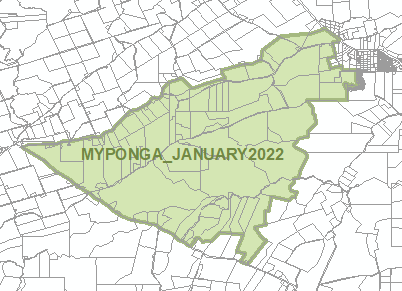  Myponga | Overlays  - Heritage Adjacency  - Local Heritage Place
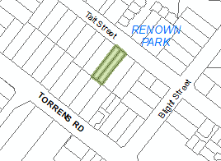  D95340 - Renown Park | Overlays  - Future Road Widening
- In Part 13 of the Code – Table of Amendments, update the publication date, Code version number, amendment type and summary of amendments within the ‘Table of Planning and Design Code Amendments’ to reflect the amendments to the Code as described in this Notice.
- Pursuant to section 76(5)(a) of the Act, I further specify that the amendments to the Code as described in this Notice will take effect upon the date those amendments are published on the SA planning portal.
Dated: 1 March 2022
Sally Smith
Executive Director, Planning & Land Use Services
Attorney-General’s Department
Delegate of Josh Teague MP, Minister for Planning and Local Government

Professional Standards Act 2004
The Law Institute of Victoria Limited Professional Standards Scheme
PURSUANT to section 14 of the Professional Standards Act 2004, I authorise the publication in the Gazette of the Law Institute of Victoria Limited Professional Standards Scheme.
Pursuant to section 15(1)(a) of the Professional Standards Act 2004, I specify 1 July 2022 as the date of commencement of the Law Institute of Victoria Limited Professional Standards Scheme.
Dated: 28 February 2022
Josh Teague
Minister for Planning and Local Government
(exercising the powers and functions of the Attorney-General)

Professional Standards Act 2003 (Vic)
Law Institute of Victoria Limited Professional Standards Scheme
PREAMBLE
- The Law Institute of Victoria Limited (“the LIV”) is an occupational association for legal practitioners (solicitors) in Victoria for the purposes of the Professional Standards Act 2003 (Vic) (“the Act”).
- The Scheme is prepared by the LIV for the purposes of limiting Occupational Liability to the extent to which such liability may be limited under the Act.
- The Scheme applies to all Participating Members, as defined in the Scheme.
- The Scheme will have force in Victoria, New South Wales, Queensland, South Australia, Western Australia, the Northern Territory, Tasmania, and the Australian Capital Territory. To the extent that the Scheme applies to limit liability in jurisdictions other than Victoria, it is subject to the professional standards legislation of those jurisdictions.
- The LIV has furnished the Council with a detailed list of the risk management strategies to be implemented in respect of its Participating Members and the means by which those strategies are to be implemented.
- The LIV has furnished the Council with details of its insurance standards and professional indemnity insurance claims monitoring process. The LIV will not amend these insurance standards while the Scheme is in force without prior approval of the Council.
- The LIV has advised its Participating Members that they must have the benefit of a professional indemnity policy that complies with the LIV’s insurance standards and that they remain liable for the amount of any difference between the amount payable to a plaintiff under the policy and the monetary ceiling specified in the Scheme
- The LIV has furnished the Council with details of its complaints system and discipline system.
- The LIV and its members to whom the Scheme applies have undertaken to comply with all reporting obligations associated with the Scheme, in furtherance of the statutory objects of improvement of the occupational standards of its members, and protection of the consumers of such members’ services.
- The LIV has undertaken to remit all fees payable under the Professional Standards Regulations 2017 (Vic) to the Council as and when these become due.
The Scheme is intended to commence on 1 July 2022 and remain in force for a period of five (5) years from its commencement, unless, prior to that time, it is revoked, its operation ceases, or it is extended.
- Sections 12GNA(2) of the Australian Securities and Investments Commission Act 2001 (Cth), 137(2) of the Competition and Consumer Act 2010 (Cth), and 1044B(2) of the Corporations Act 2001 (Cth) provide for limited liability where a Professional Standards Scheme is prescribed in the relevant regulation. The Scheme does not apply to limit any liability under a Commonwealth law unless it has been prescribed under regulations by the Commonwealth.
LAW INSTITUTE OF VICTORIA LIMITED PROFESSIONAL STANDARDS SCHEME
  - Occupational association
    - The Law Institute of Victoria Limited Professional Standards Scheme is a scheme under the Professional Standards Act 2003 (Vic) (“the Act”) prepared by the Law Institute of Victoria Limited (“the LIV”), whose business address is: Level 13, 140 William St, Melbourne, Victoria.
  - Persons to whom the Scheme applies
    - The Scheme applies to:
      - Full Members who hold a current Australian Practising Certificate who are not excluded or exempted under clauses 2.2 or 2.3 of the Scheme;
      - Incorporated Legal Practices that are not exempted under clause 2.3 of the Scheme; and
      - all persons to whom, by virtue of sections 20, 21 or 22 of the Act, the Scheme applies.
    - Despite clause 2.1, the Scheme does not apply to a Corporate Legal Practitioner or to a Government Legal Practitioner.
    - A person referred to in clause 2.1 may, on application, be exempted from participation in the Scheme by the LIV, with effect from the date specified by the LIV. This clause does not apply to persons to whom the Scheme applies by virtue of sections 20, 21 or 22 of the Act.
  - Jurisdiction
    - The Scheme applies in Victoria.
    - In addition to Victoria, the Scheme is intended to operate in New South Wales, Queensland, South Australia, Western Australia, the Northern Territory, Tasmania, and the Australian Capital Territory in accordance with the professional standards legislation of those states and territories and subject to the requirements of that legislation (“the Corresponding Laws”), so that references to a provision of the Act, the application of the Scheme to a liability, the limit of a liability under the Act, or what constitutes Occupational Liability, are intended to pick up the relevant provisions of the Corresponding Laws, applied mutatis mutandis, to the extent that is necessary for the application of the Scheme in any of those jurisdictions.
  - Limitation of liability
    - This Scheme only affects the liability for Damages arising from a single cause of action to the extent to which the liability results in Damages exceeding $1.5 million.
    - If a person who is, or was, at the time of the act or omission giving rise to Occupational Liability, a person to whom the Scheme applies, or applied, and against whom a proceeding relating to Occupational Liability is brought, is able to satisfy the Court that such person has the benefit of an insurance policy:
- of a kind which complies with the standards determined by the LIV;
- insuring such person against the Occupational Liability to which the cause of action relates; and
- under which the amount payable in respect of that Occupational Liability is not less than the applicable monetary ceiling specified in clause 4.3 of this Scheme;
then that person is not liable in Damages in relation to that cause of action above the monetary ceiling specified in clause 4.3 of this Scheme.
    - The applicable monetary ceiling is to be determined according to the table below:
Class | Description | Monetary ceiling
1 | Participating Members who were at the Relevant Time in a Law Practice consisting of up to and including 20 Principals and where the Law Practice generated Total Annual Fee Income for the Financial Year at the Relevant Time up to and including $10 million. | $1.5 million
2 | Any Participating Member which was at the Relevant Time an Incorporated Legal Practice consisting of up to and including 20 Principals and where the Law Practice generated Total Annual Fee Income for the Financial Year at the Relevant Time up to and including $10 million. | $1.5 million
3 | - Participating Members who were at the Relevant Time in a Law Practice consisting of greater than 20 Principals; or  - Participating Members who were at the Relevant Time in a Law Practice where the Law Practice generated Total Annual Fee Income for the Financial Year at the Relevant Time greater than $10 million. | $10 million
4 | - Any Participating Member which was at the Relevant Time an Incorporated Legal Practice consisting of greater than 20 Principals; or  - Any Participating Member which was at the Relevant Time a Law Practice where the Law Practice generated Total Annual Fee Income for the Financial Year at the Relevant Time greater than $10 million. | $10 million
    - Clause 4.2 does not limit the amount of Damages to which a person to whom the Scheme applies is liable if the amount is less than the amount specified for the purpose in this Scheme in relation to a person to whom the Scheme applies.
    - This Scheme limits the Occupational Liability in respect of a cause of action founded on an act or omission occurring during the period when the Scheme was in force of any person to whom the Scheme applied at the time the act or omission occurred.
    - Notwithstanding anything to the contrary contained in this Scheme if, in particular circumstances giving rise to Occupational Liability, the liability of any person who is subject to this Scheme should be capped both by this Scheme and also by any other scheme under professional standards legislation (whether of this jurisdiction or under the law of any other Australian state or territory) and, if the amount of such caps should differ, then the cap on the liability of such person arising from such circumstances which is higher shall be the applicable cap.
  - Conferral of discretional authority
    - The LIV has discretionary authority, on application by a person referred to in clause 2.1, to specify in relation to that person, a higher maximum amount of liability than would otherwise apply under the Scheme in relation to that person, either in all cases or in any specified case or class of case.
  - Commencement and Duration
    - The Scheme will commence:
      - in Victoria, New South Wales, the Northern Territory, Western Australia, Tasmania and Queensland, on 1 July 2022; and
      - in the Australian Capital Territory and in South Australia, on this same date, or such other later date, provided the date is specified in the relevant Minister’s notice in relation to the Scheme; or
      - in all other cases, subject to the statutory provisions of each applicable jurisdiction.
    - The Scheme will remain in force in all applicable jurisdictions for a period of five (5) years from its commencement in Victoria.
    - Clause 5.2 is subject to the provisions of the Corresponding Law in each jurisdiction in relation to the revocation, extension or cessation of a scheme.
  - Definitions
    - Relevant definitions for the purpose of this Scheme are as follows:
“Act” means the Professional Standards Act 2003 (Vic);
“Australian Practising Certificate” has the same meaning as it has in the Legal Profession Uniform Law (Victoria);¹
“Corporate Legal Practitioner” has the same meaning as it has in the Legal Profession Uniform Law (Victoria);²
“Corresponding Laws” means the Professional Standards Act 1994 (NSW), the Professional Standards Act 2004 (Qld), the Professional Standards Act 2004 (SA), the Professional Standards Act 1997 (WA), the Professional Standards Act 2004 (NT), Professional Standards Act 2005 (Tas), and the Civil Law (Wrongs) Act 2002 (ACT);
“Court” has the same meaning as it has in the Act;
“Damages” has the same meaning as it has in the Act;
“Financial Year” means a financial accounting period ending 30 June;
“Full Member” means an Australian legal practitioner who is a full member of the Law Institute of Victoria Limited;
“Government Legal Practitioner” has the same meaning as it has in the Legal Profession Uniform Law (Victoria);³
“Incorporated Legal Practice” means an incorporated legal practice within the meaning of the Legal Profession Uniform Law (Victoria) that is a member of the Law Institute of Victoria;⁴
“Law Practice” has the same meaning as it has in the Legal Profession Uniform Law (Victoria);⁵
“LIV” means the Law Institute of Victoria Limited;
“Occupational Liability” has the same meaning as it has in the Act;
“Participating Members” means those persons specified in clause 2.1 of the Scheme; “Person” means an individual or a body corporate;
“Principal” has the same meaning as it has in the Legal Profession Uniform Law (Victoria);⁶
“Relevant Time” means, in relation to a cause of action giving rise to Occupational Liability, the time at which an act or omission occurred upon which the cause of action was founded;
“Scheme” means the Law Institute of Victoria Limited Professional Standards Scheme constituted by this document;
“Total Annual Fee Income” means the amount charged during a Financial Year for services provided by or on behalf of a Law Practice some of whose members are Participating Members.
¹ Refer Legal Profession Uniform Law Application Act 2014 section 4.
² Refer Legal Profession Uniform Law Application Act 2014 section 4.
³ Refer Legal Profession Uniform Law Application Act 2014 section 4.
⁴ Refer Legal Profession Uniform Law Application Act 2014 section 4.
⁵ Refer Legal Profession Uniform Law Application Act 2014 section 4.
⁶ Refer Legal Profession Uniform Law Application Act 2014 section 4.

Proof of Sunrise and Sunset Act 1923
Almanac for April, May and June 2022
Pursuant to the requirements of the Proof of Sunrise and Sunset Act 1923, I Anthony David Braxton-Smith, Chief Executive, Department for Infrastructure and Transport, at the direction of the Minister for Infrastructure and Transport, publish in the Schedule hereto an almanac setting out the times of sunrise and sunset on every day for the three calendar months April, May and June 2022.
Dated: 21 February 2022
Anthony David Braxton-Smith
Chief Executive, Department for Infrastructure and Transport

Schedule

Roads (Opening and Closing) Act 1991
Section 24
Notice of Confirmation of Road Process Order
Road Closure – Anson Street, Blair Athol
BY Road Process Order made on 31 January 2022, the City of Port Adelaide Enfield ordered that:
- Portion of Anson Street, Blair Athol, situated adjoining the southern boundary of Allotment 1002 in Deposited Plan 123920, Hundred of Yatala, more particularly delineated and lettered ‘A’ in Preliminary Plan 20/0050 be closed.
- Issue a Certificate of Title to the City of Port Adelaide Enfield for the whole of the land subject to closure in accordance with the Application for Document of Title dated 31 January 2022.
- The following easement is to be granted over portion of the land subject to closure:
Grant to the South Australian Water Corporation an easement for sewerage purposes over the land marked ‘S’ in Deposited Plan 129058.
On 1 March 2022 that order was confirmed by the Minister for Planning and Local Government (exercising the powers and functions of the Attorney-General) conditionally upon the deposit by the Registrar-General of Deposited Plan 129058 being the authority for the new boundaries.
Pursuant to section 24 of the Roads (Opening and Closing) Act 1991, NOTICE of the Order referred to above and its confirmation is hereby given.
Dated: 3 March 2022
B.J. Slape
Surveyor-General
2020/21108/01

Local Government Instruments

The Flinders Ranges Council
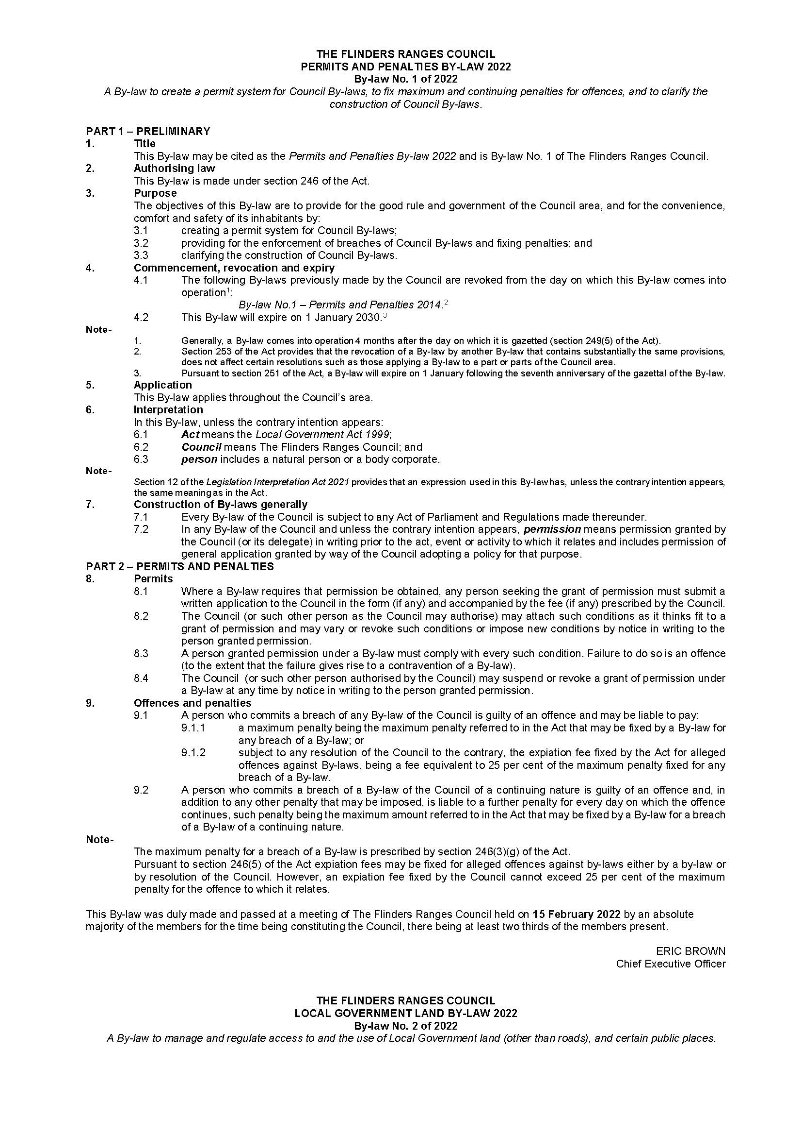
By-laws No. 1-7 of 2022
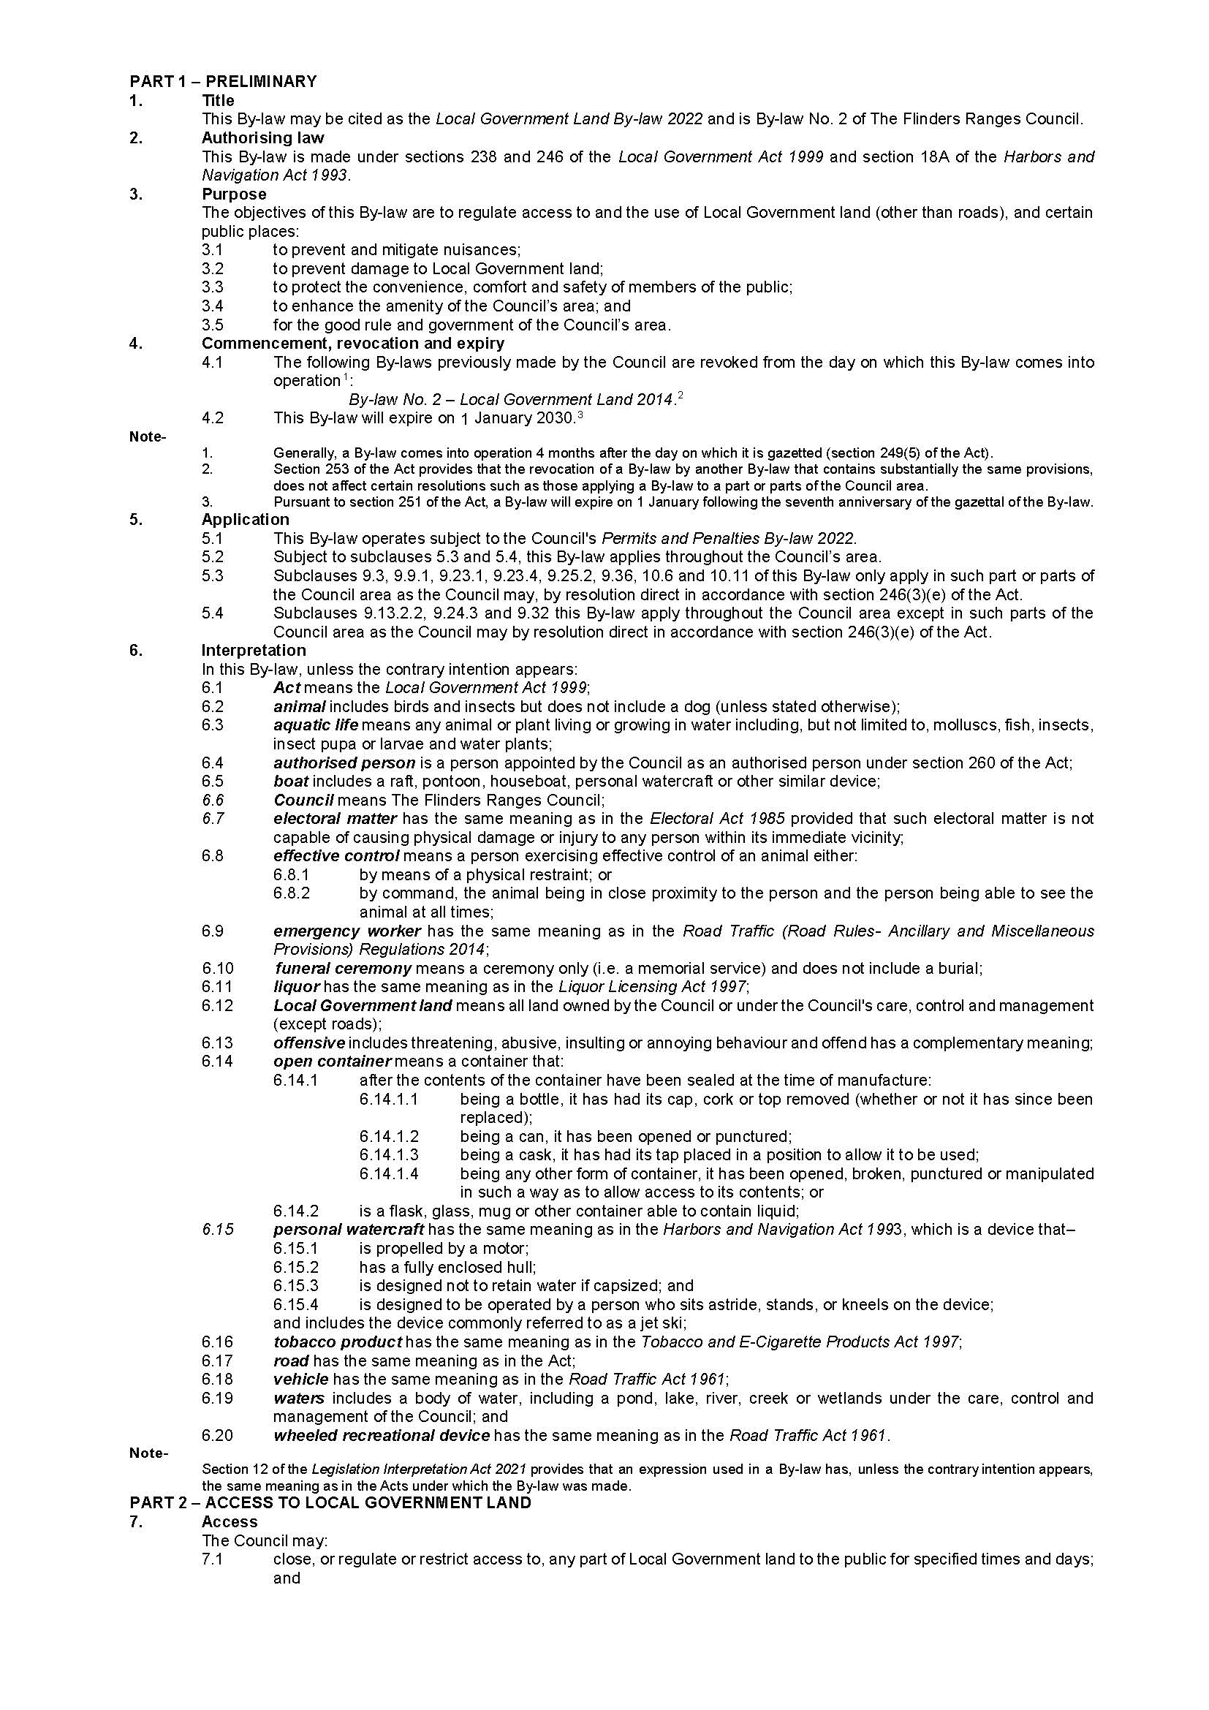
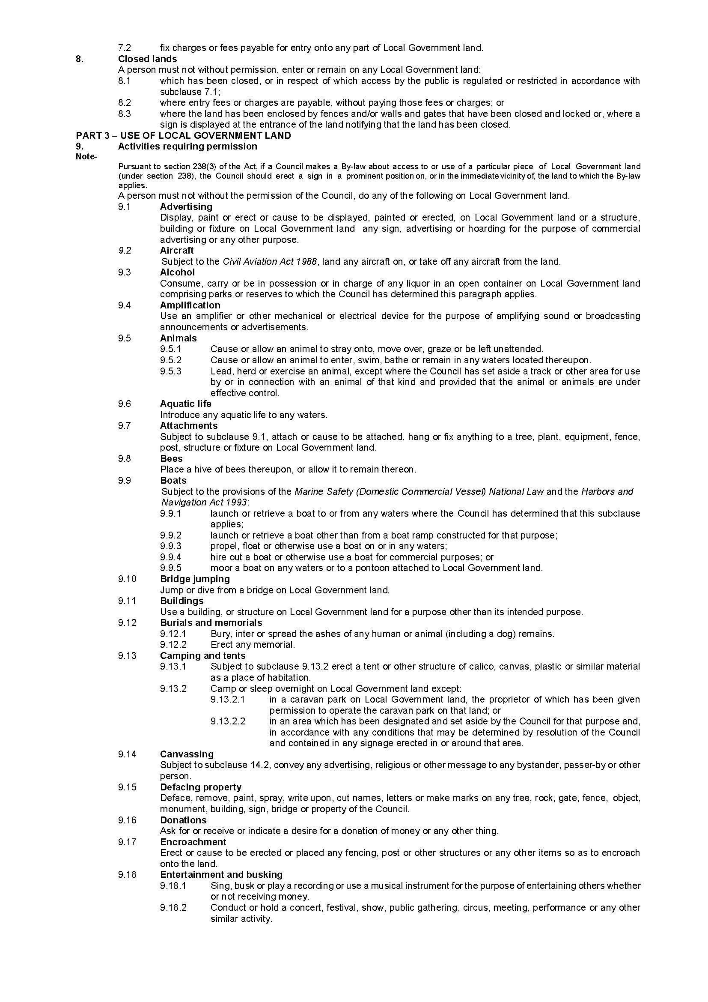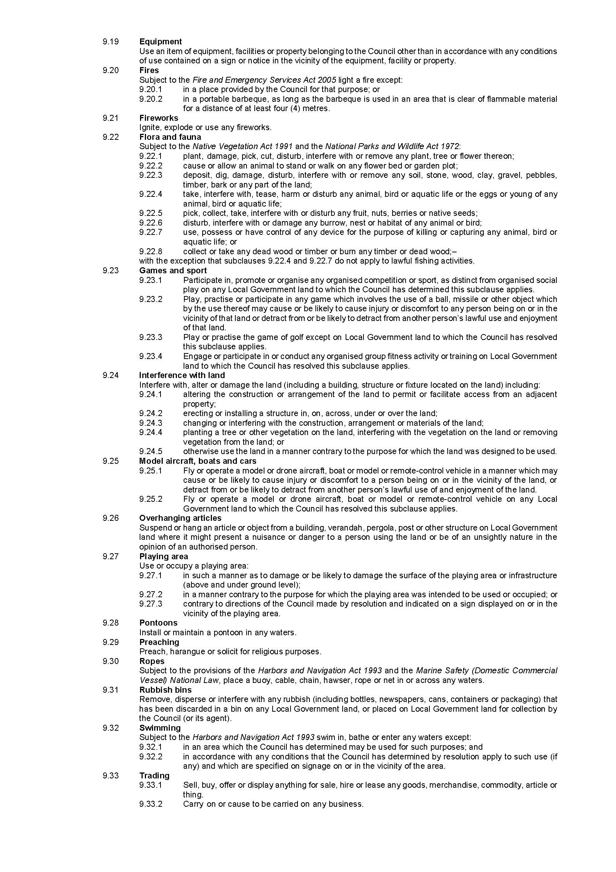

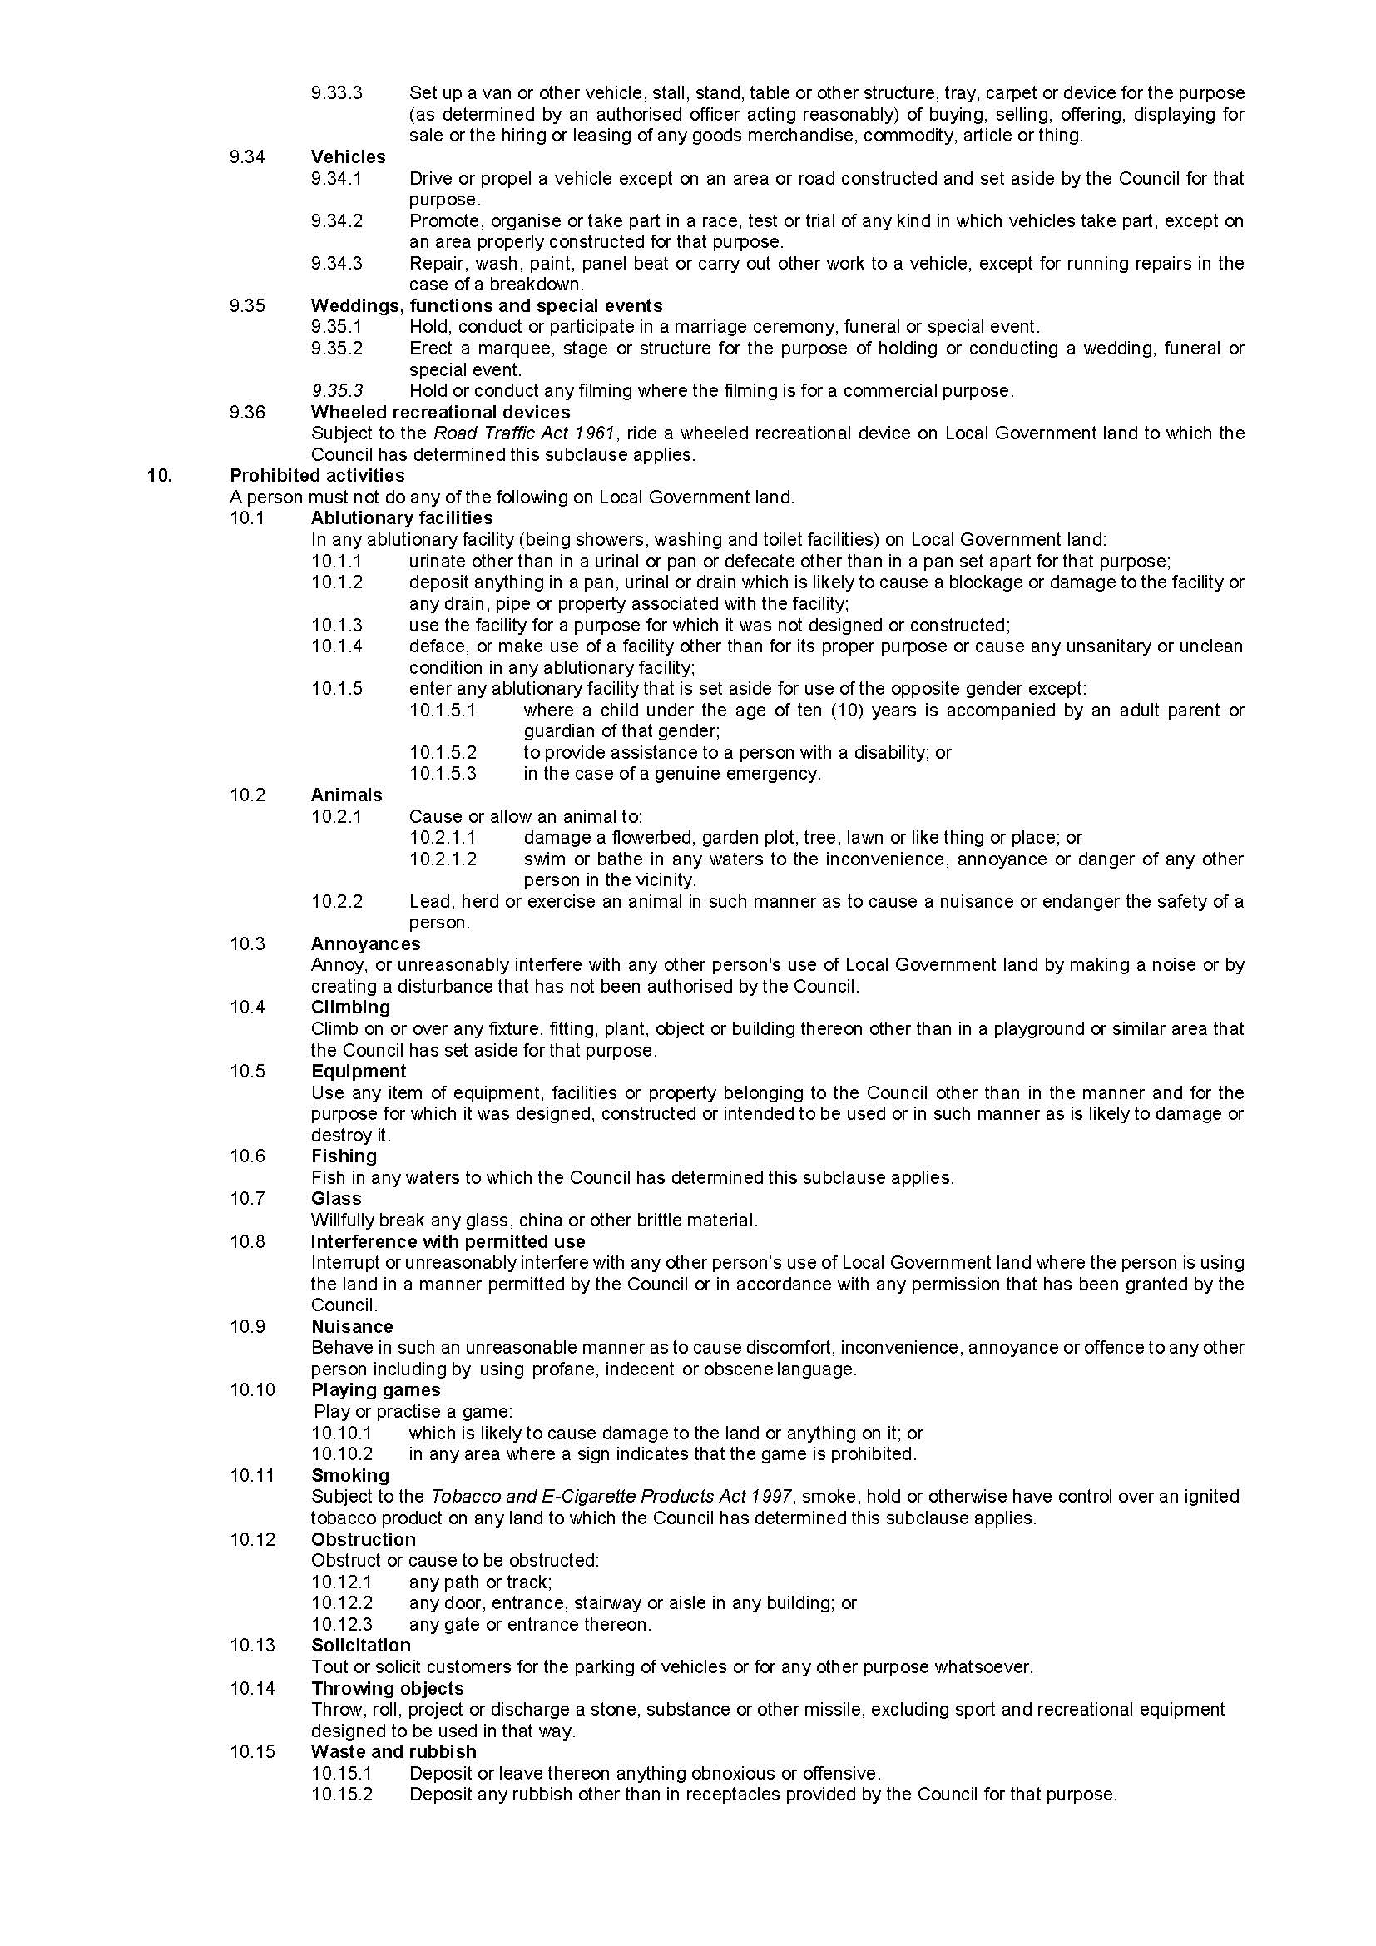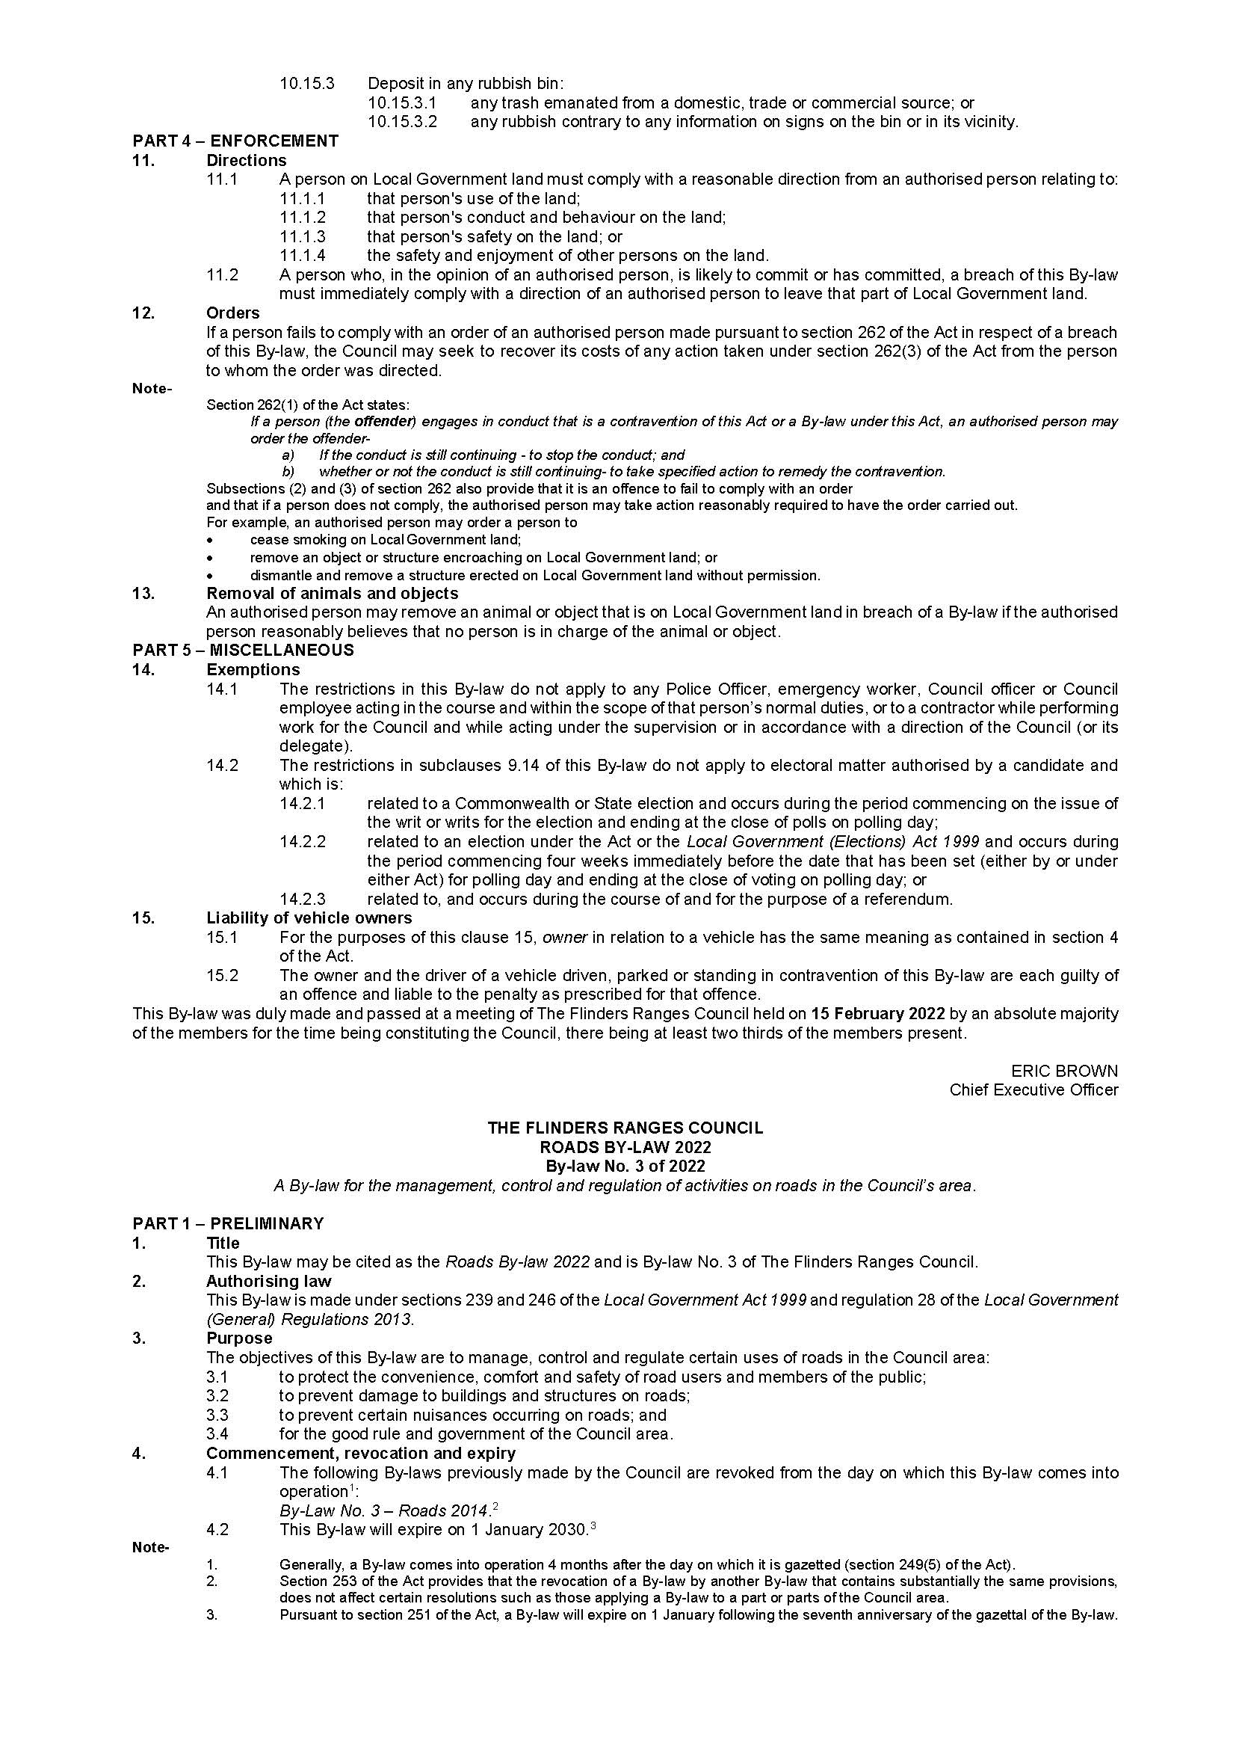

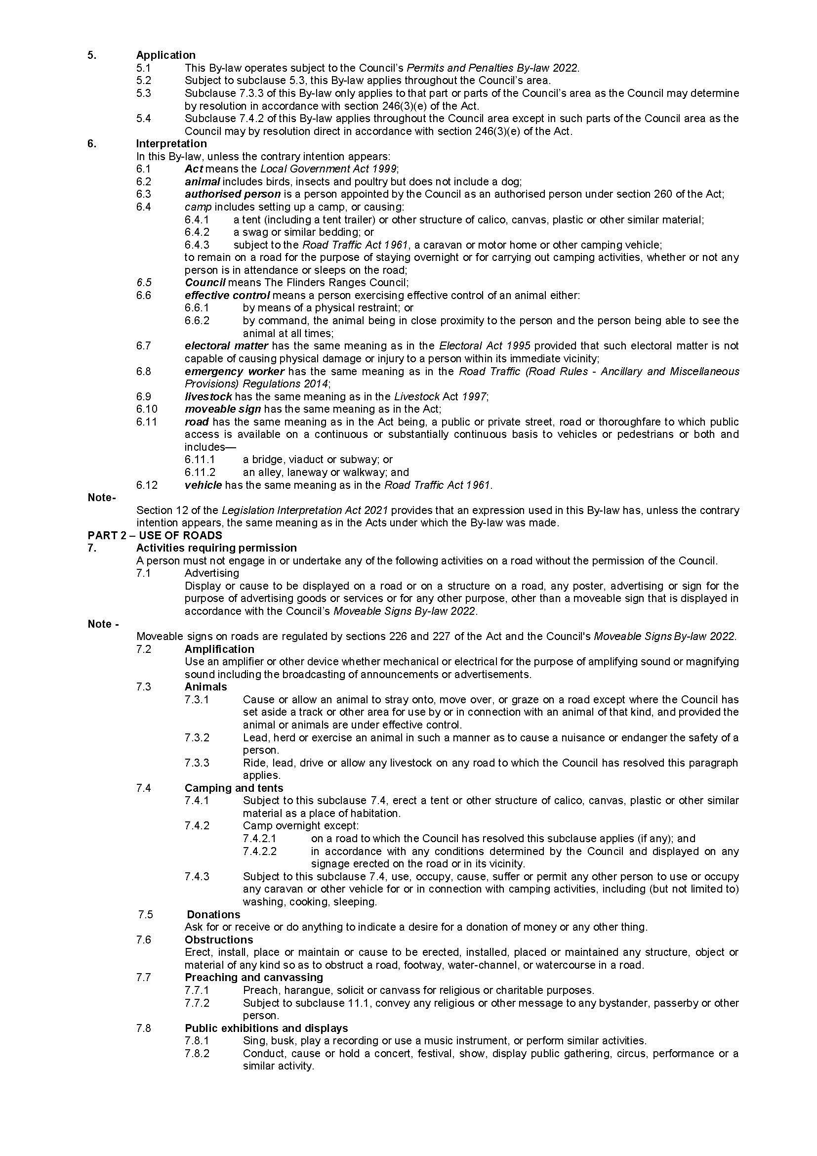

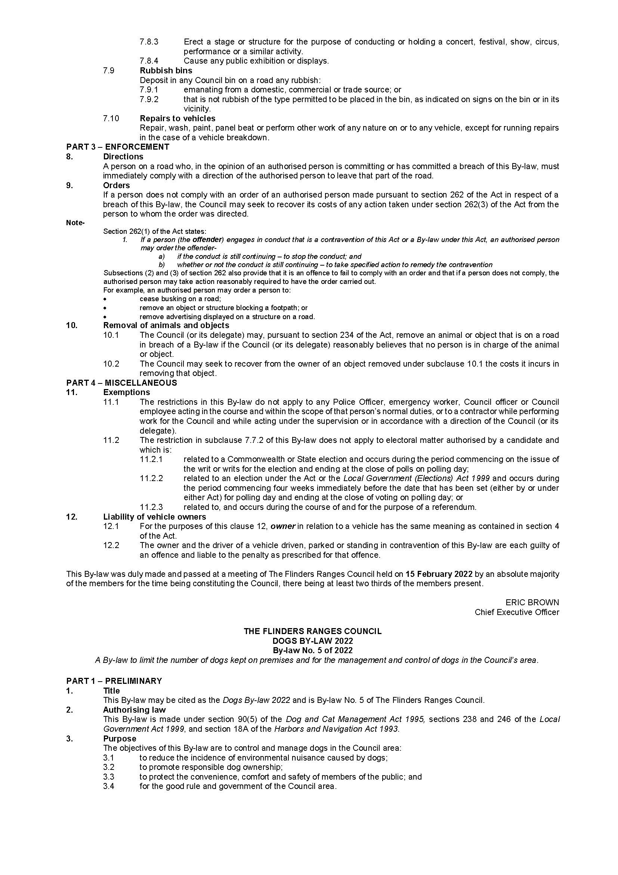

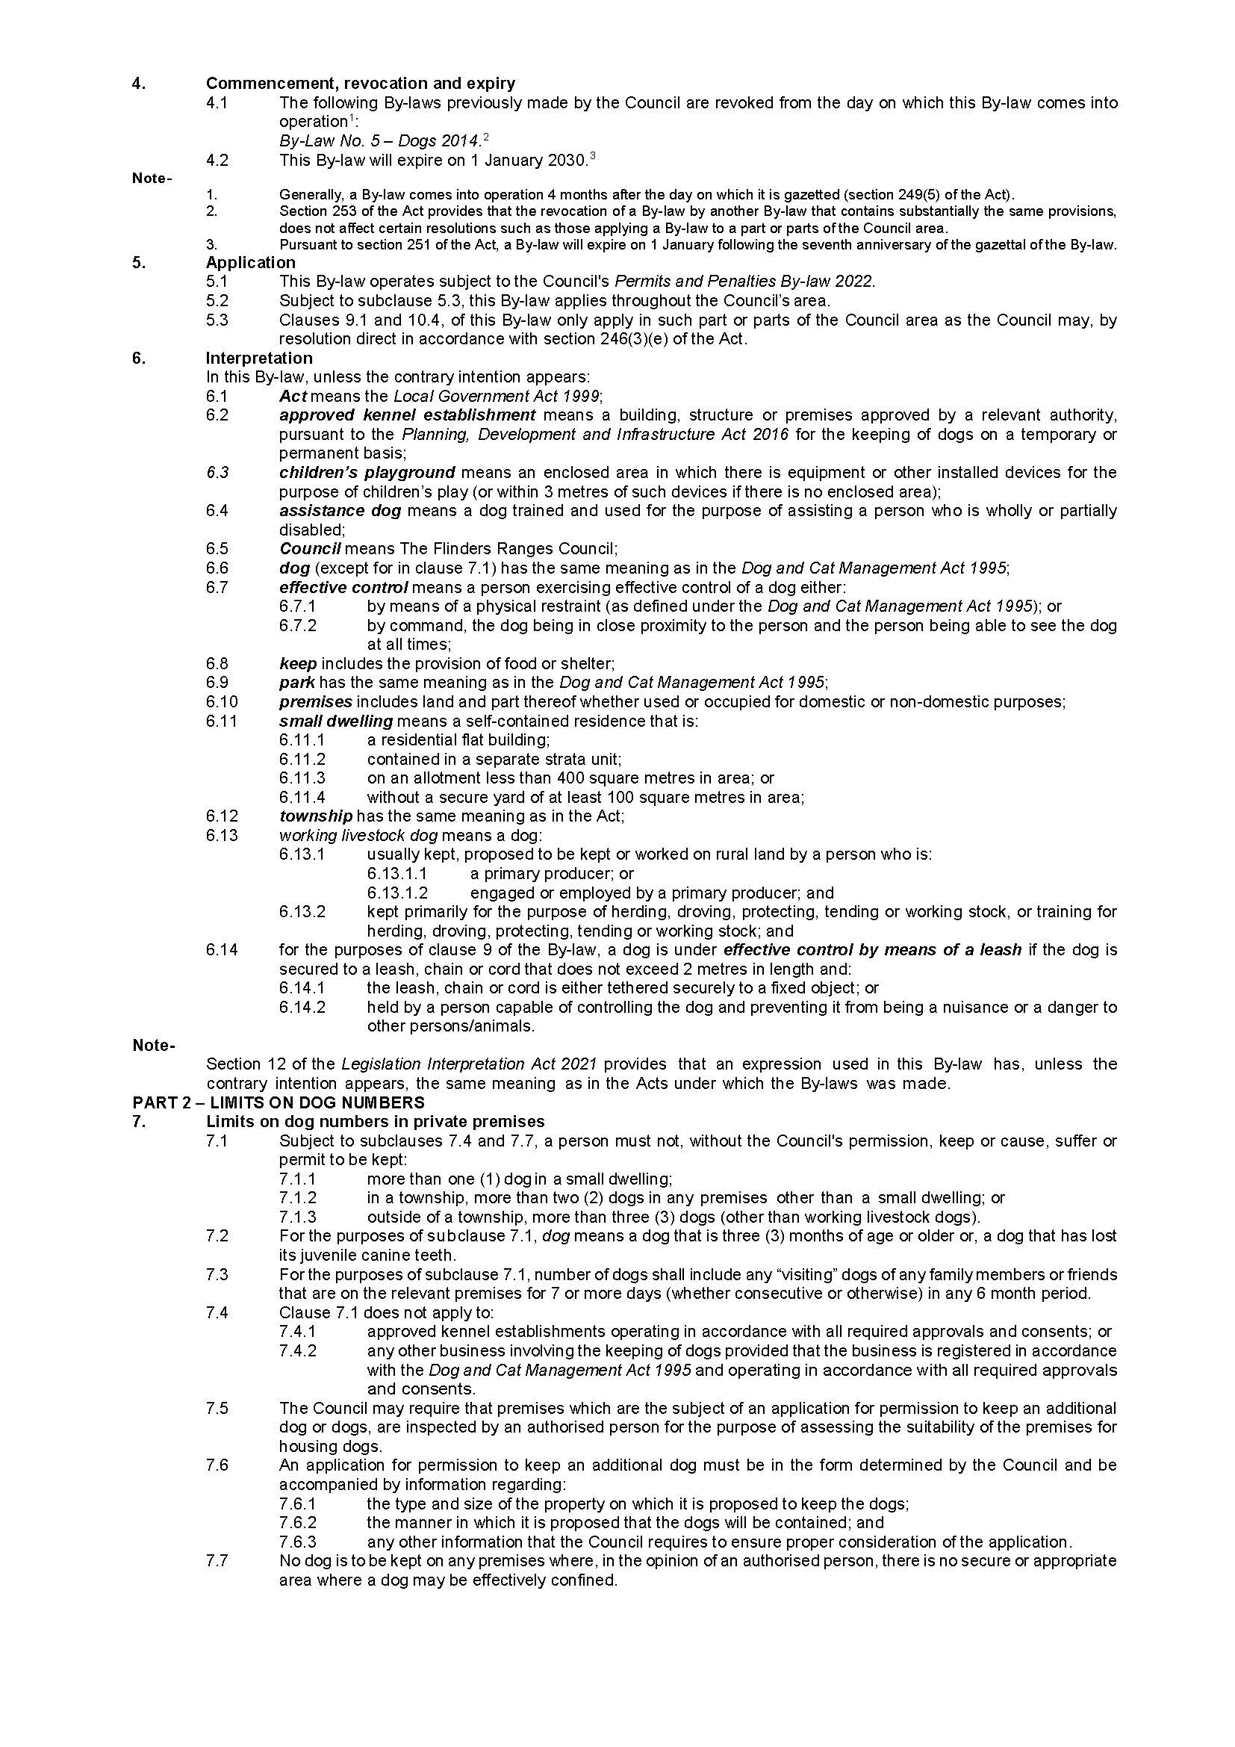

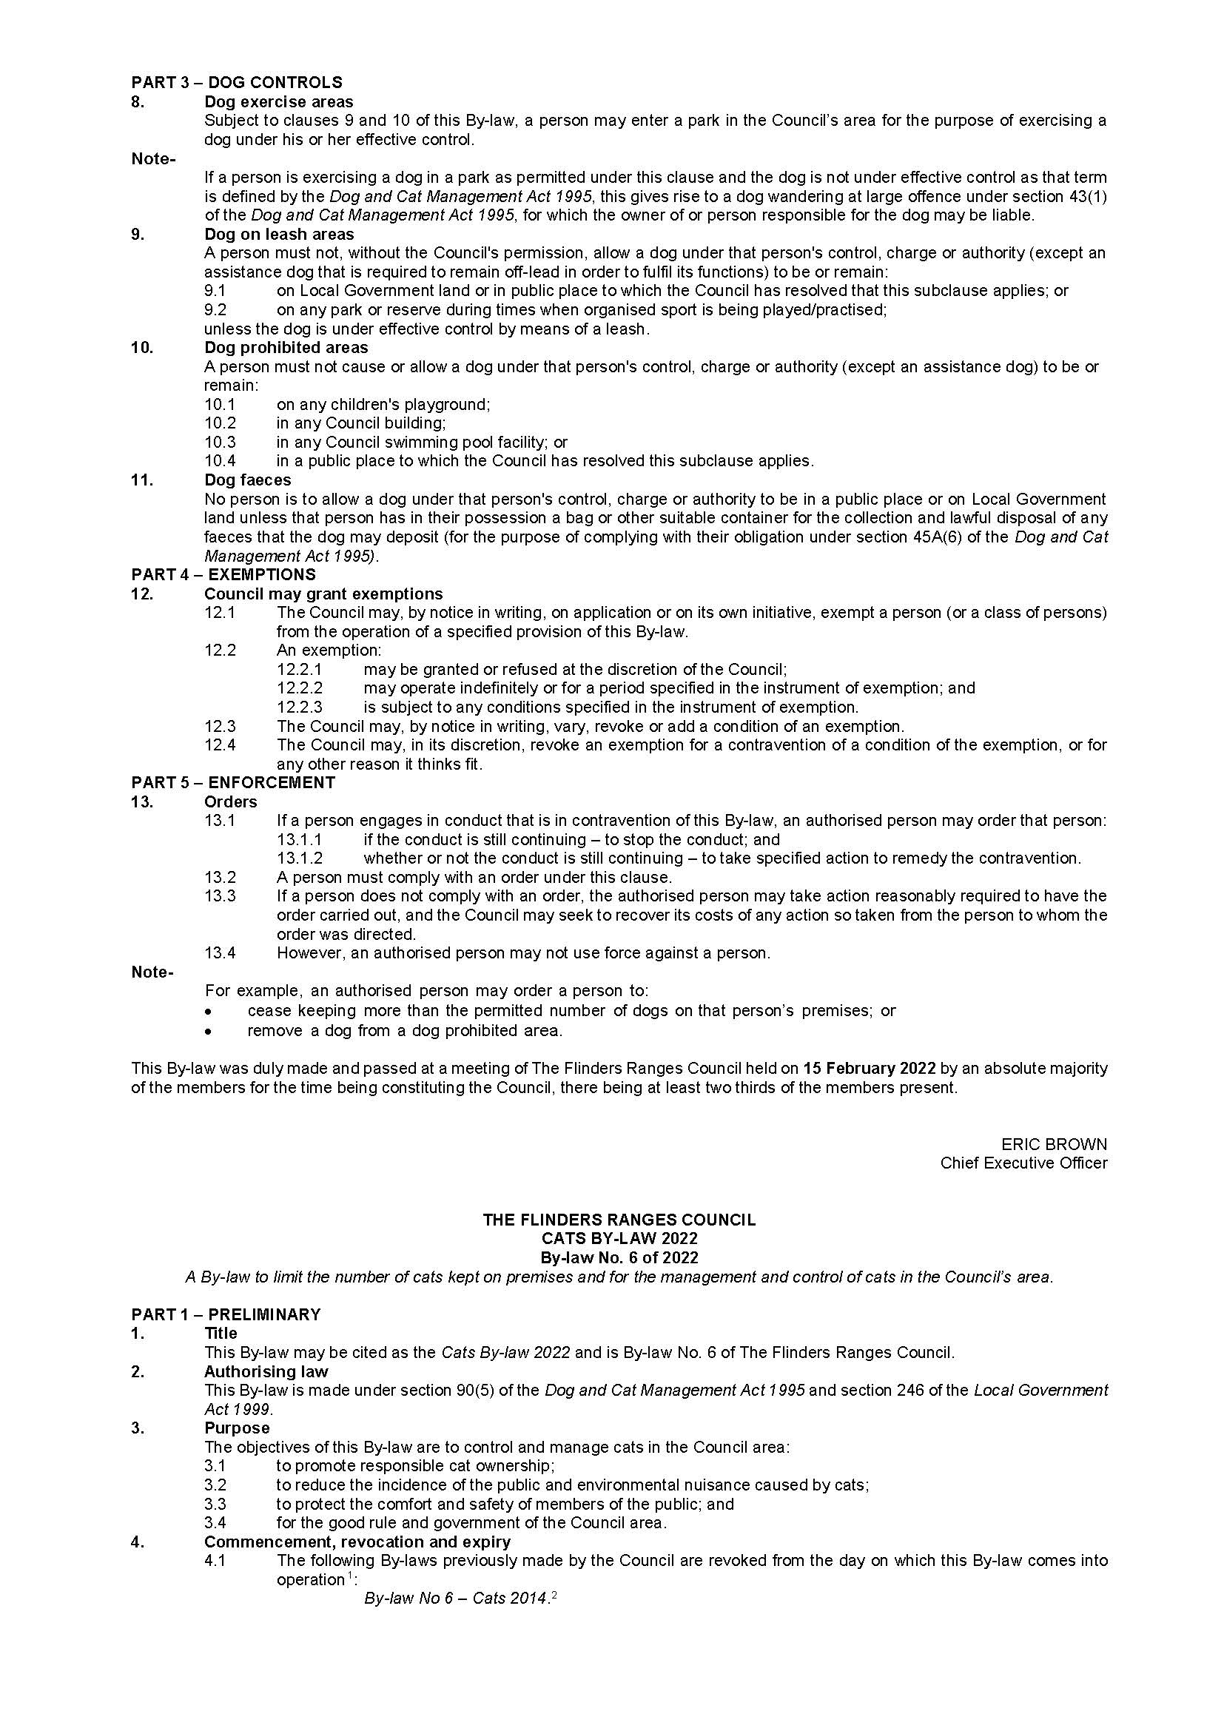

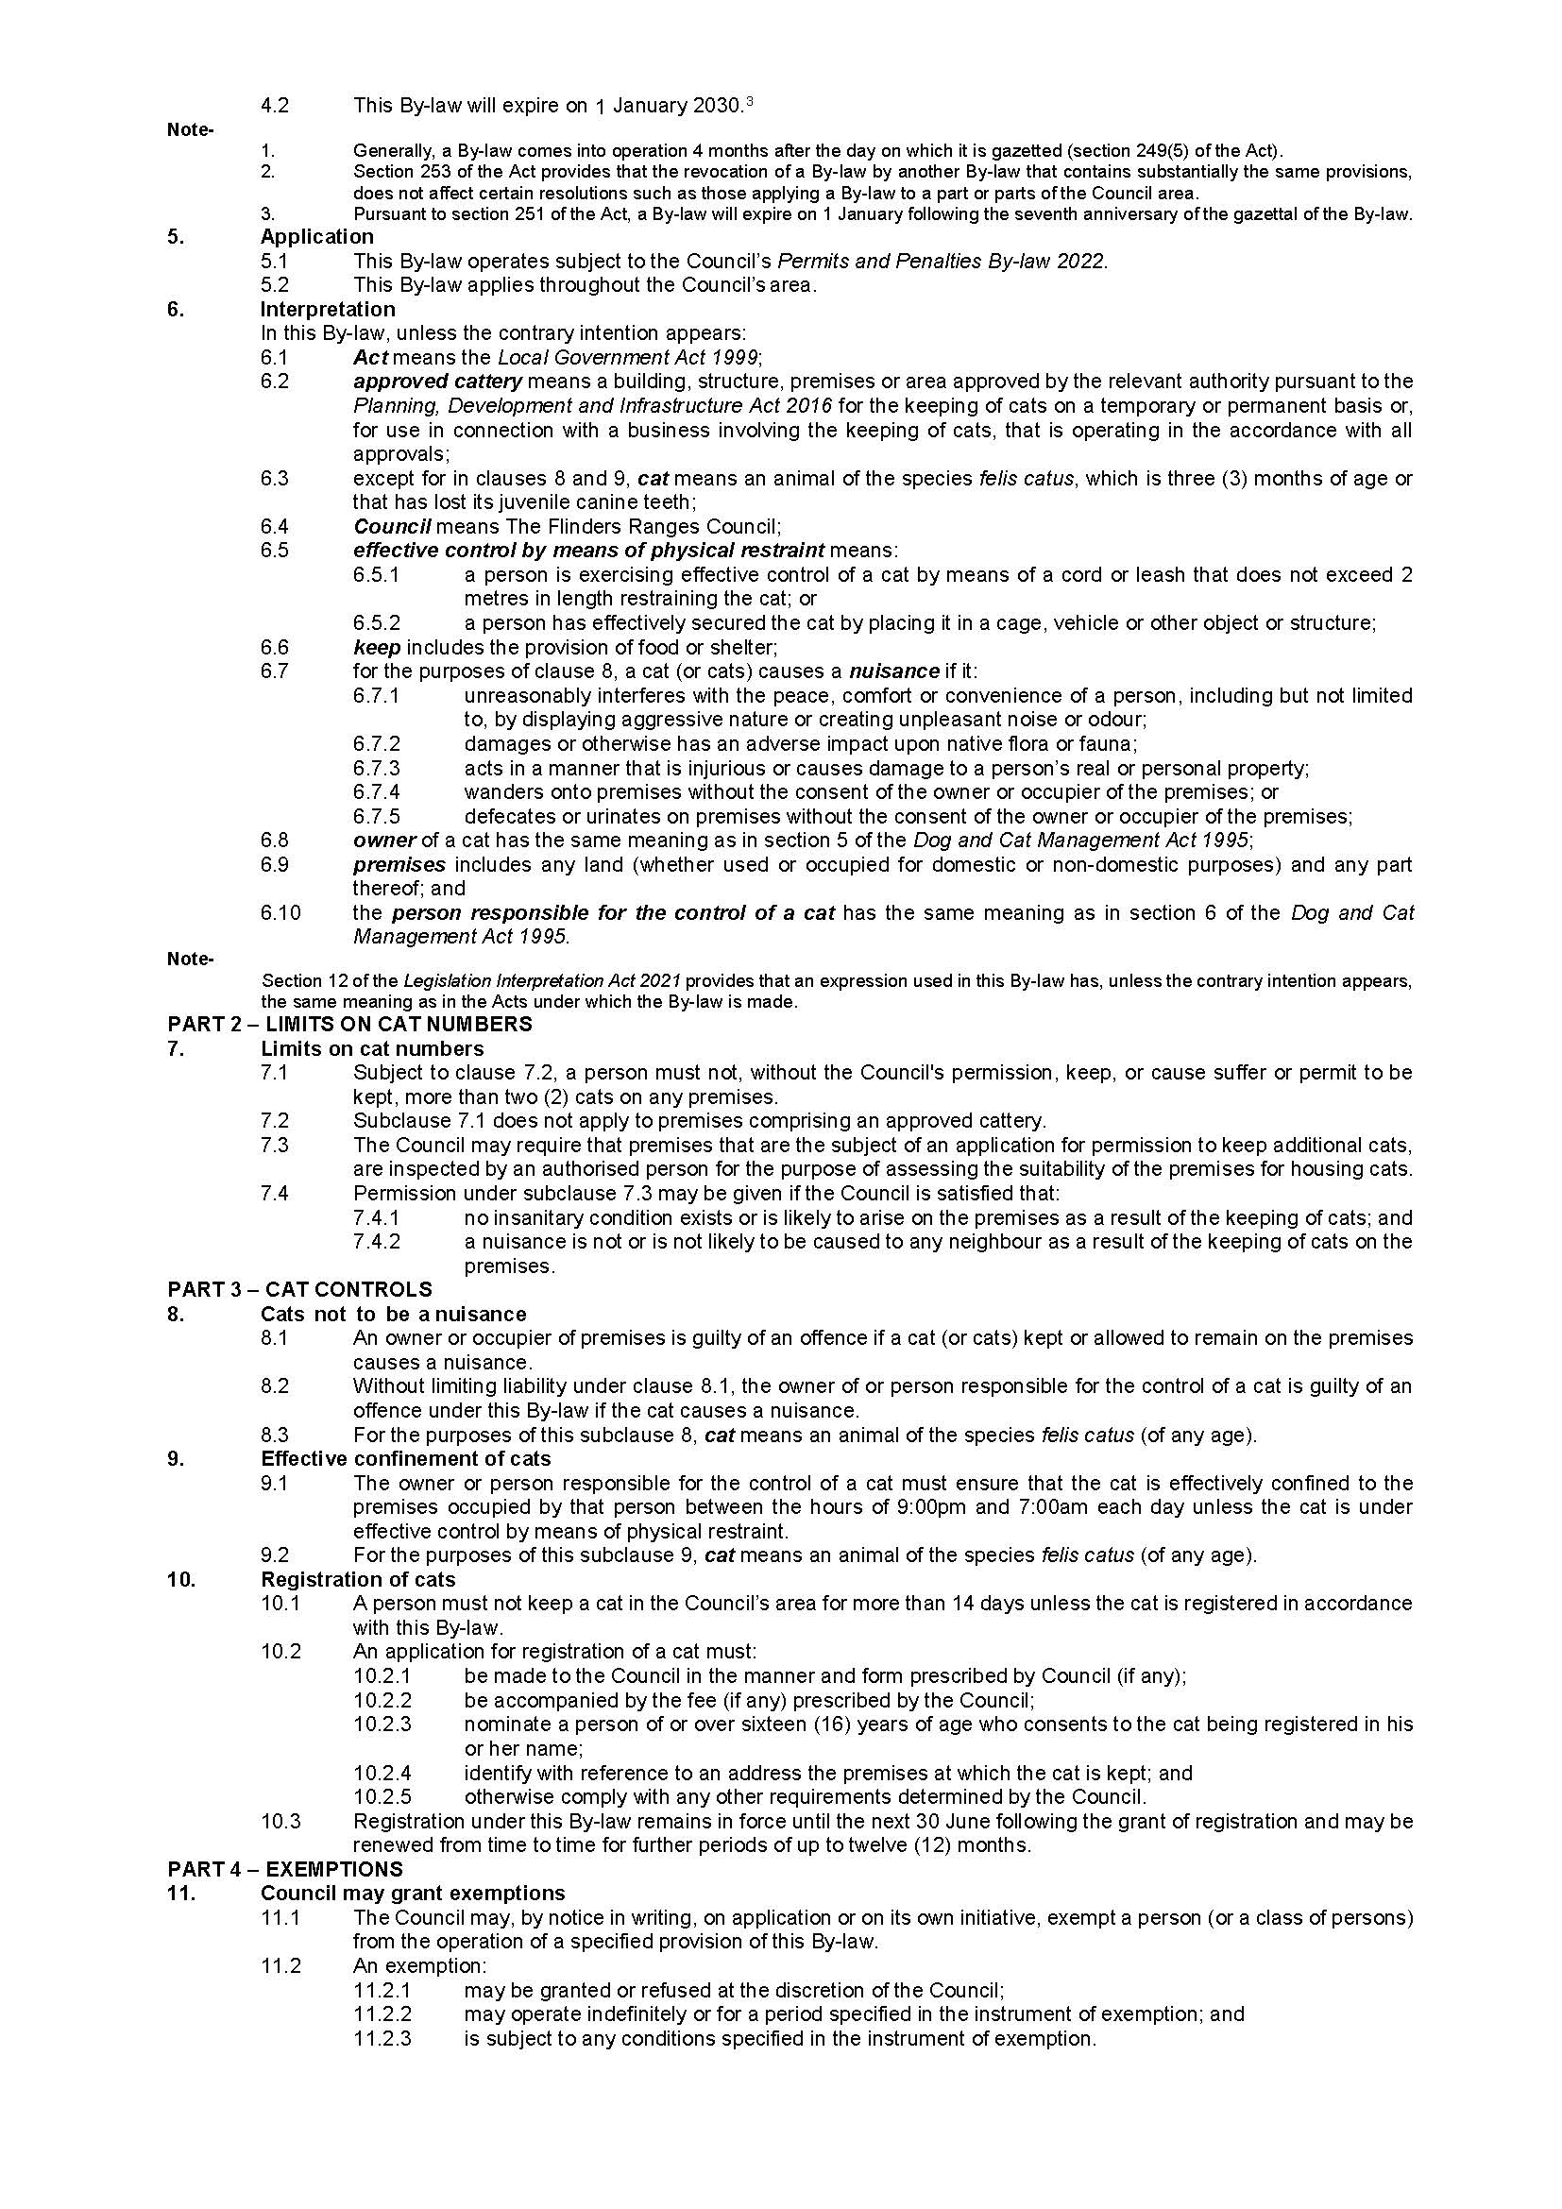
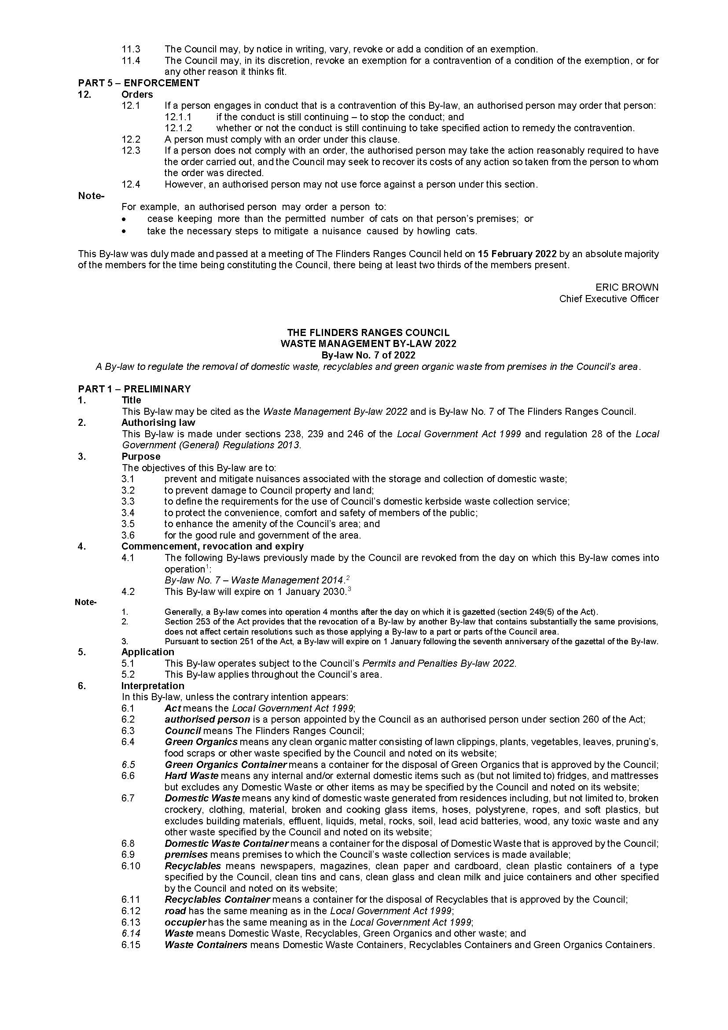
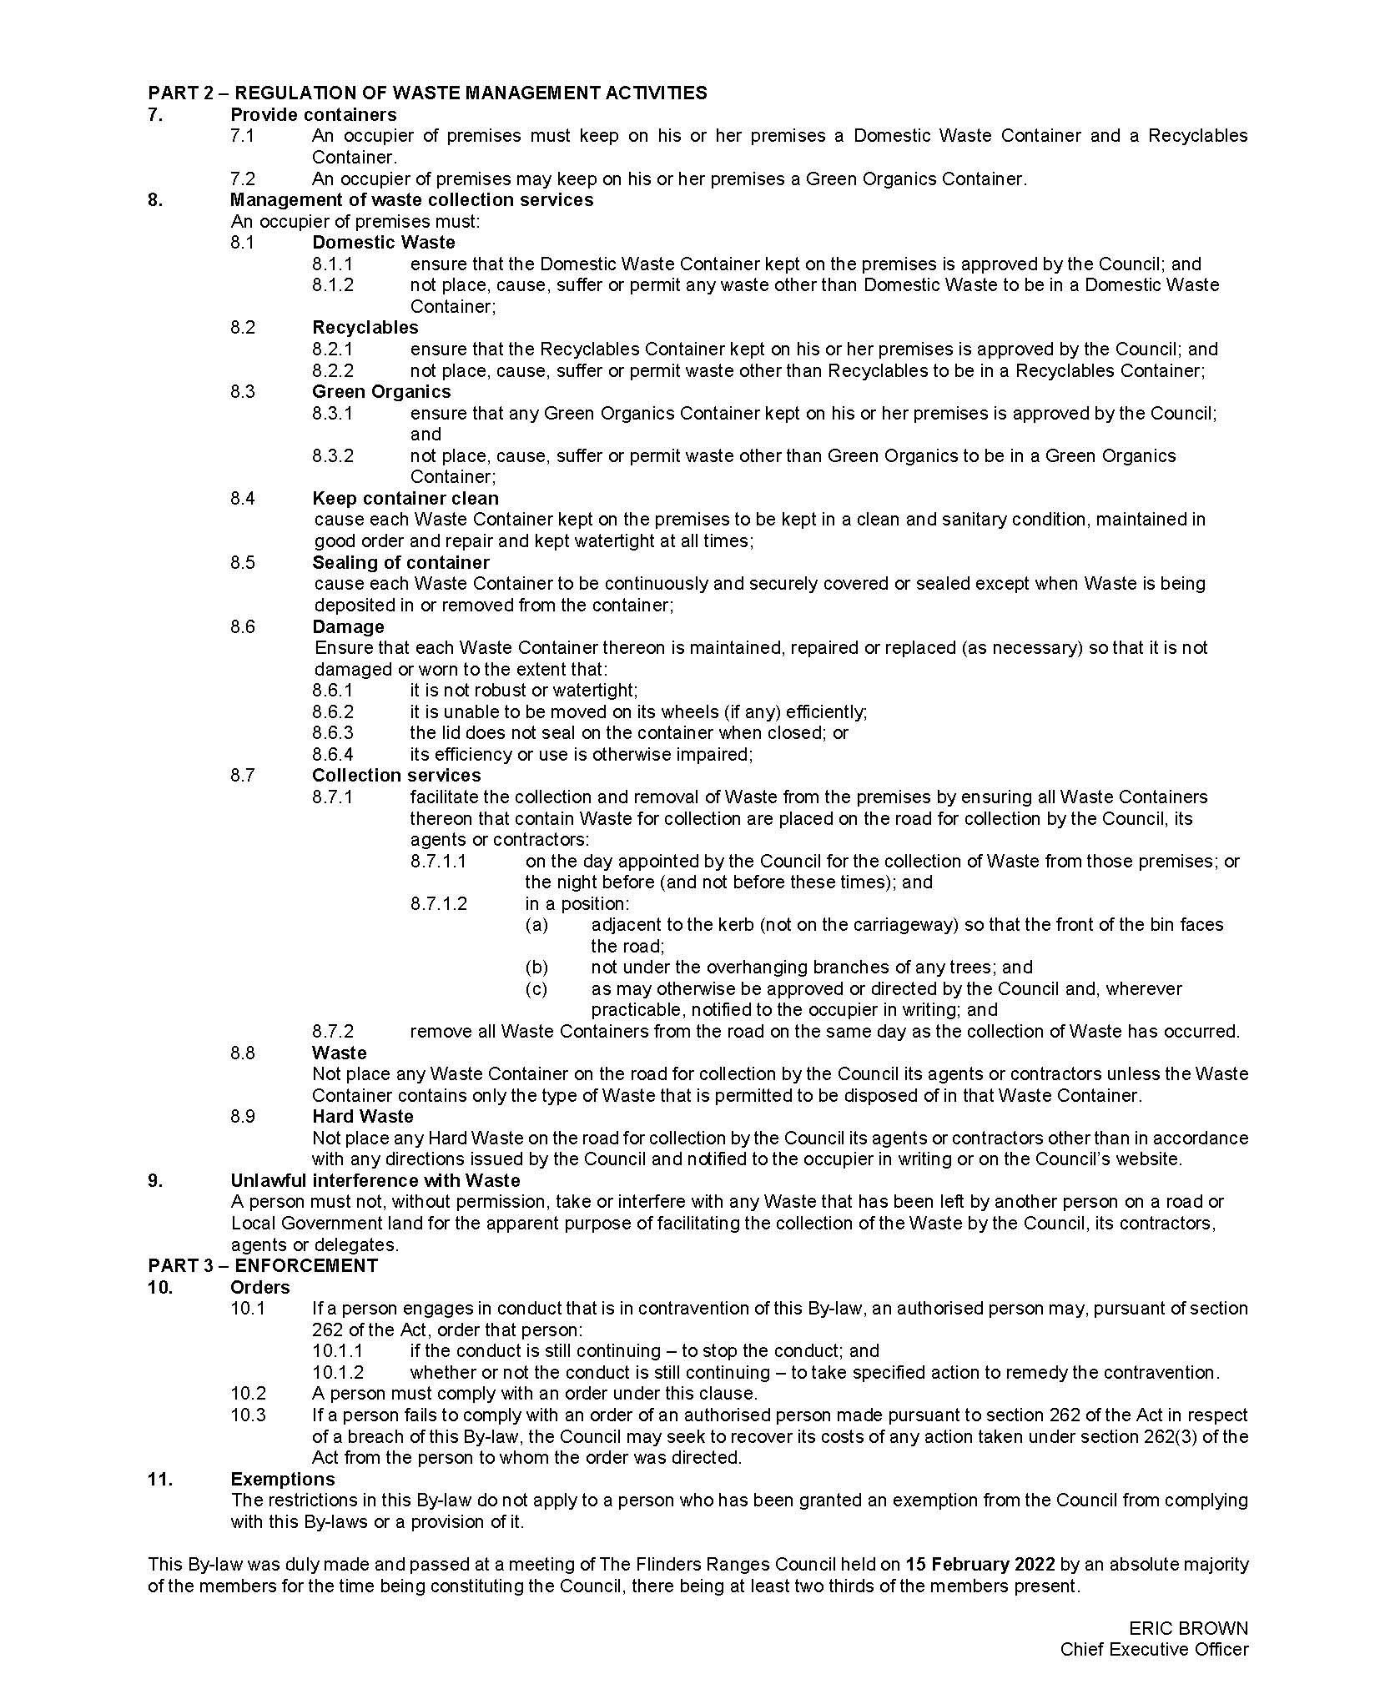

District Council of Karoonda East Murray
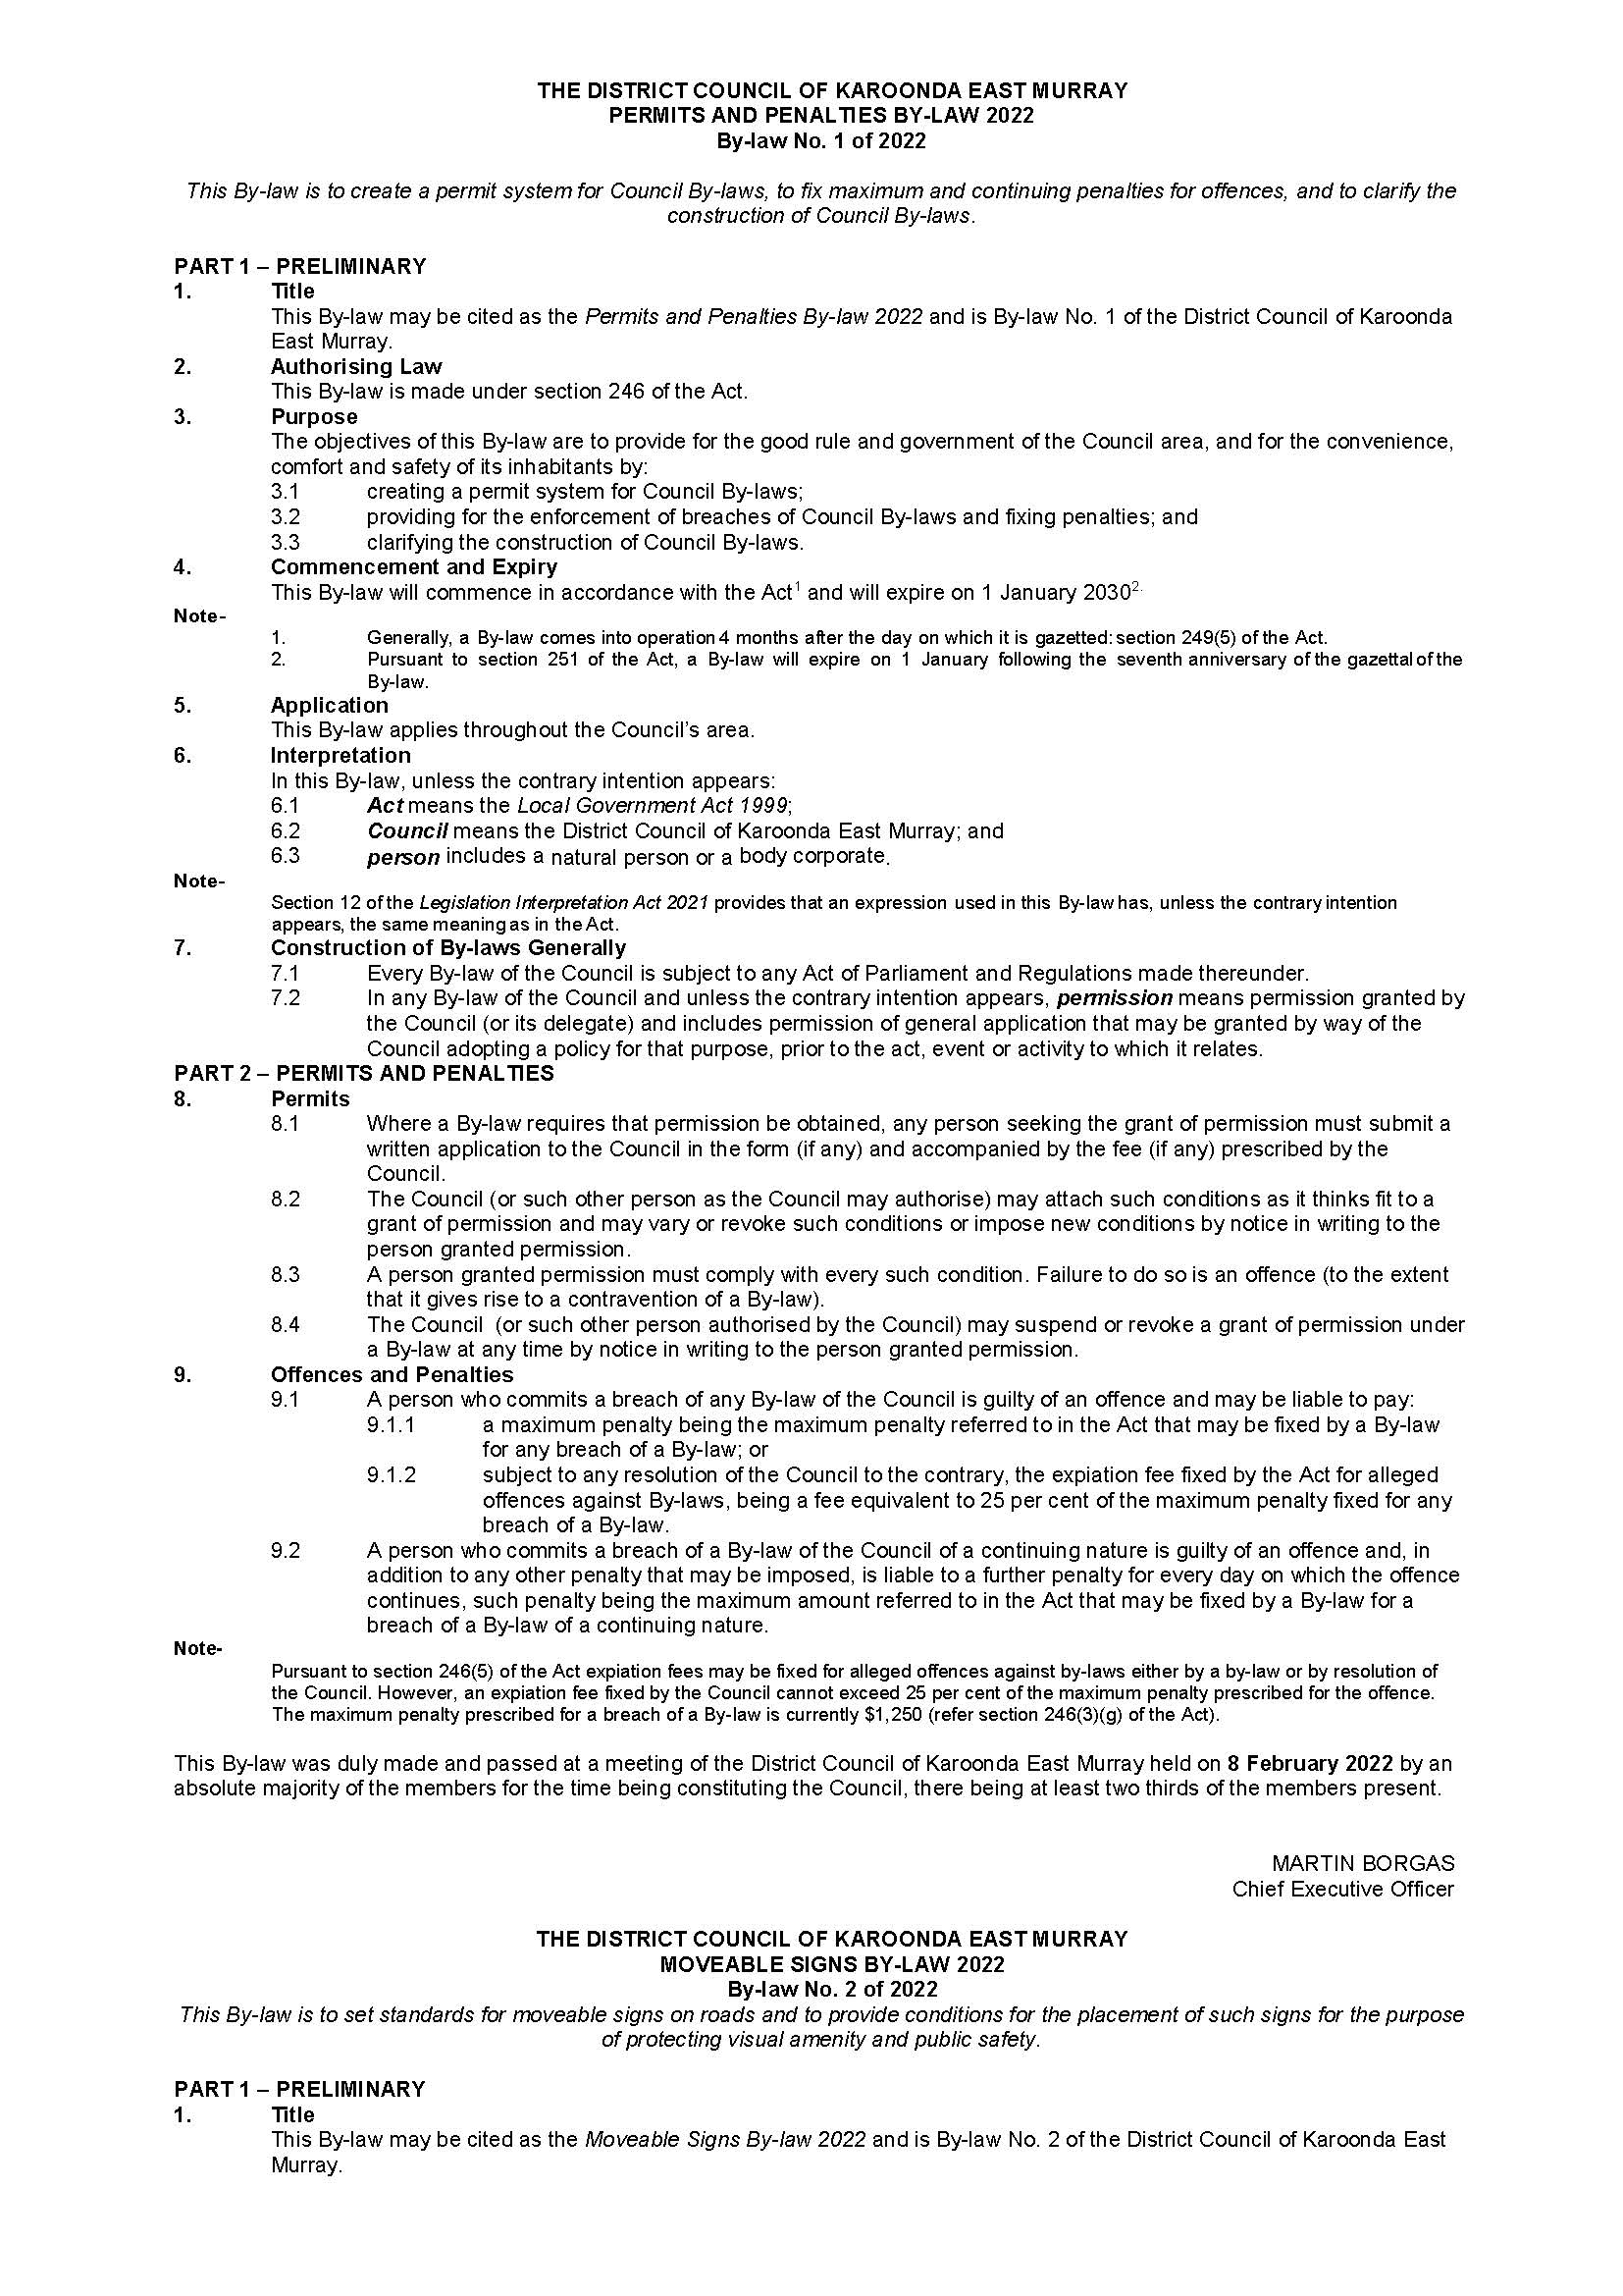
By-laws 1-6 of 2022

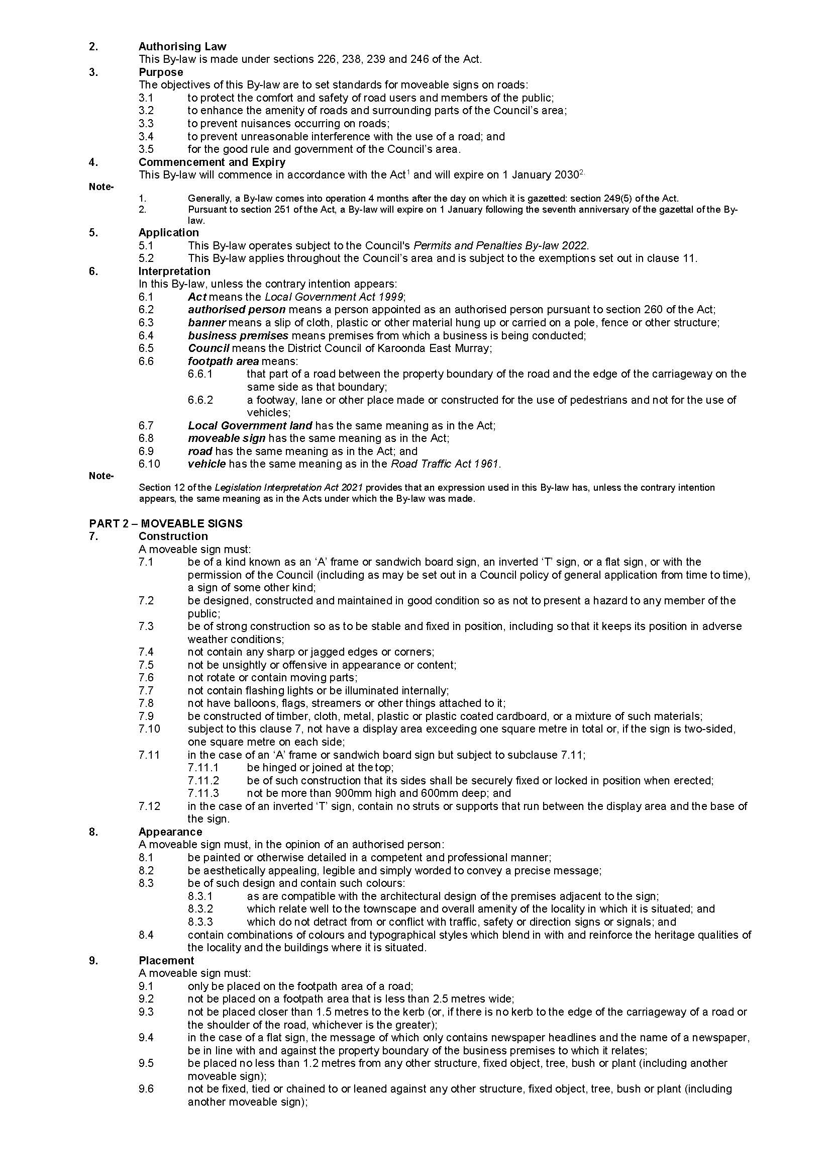
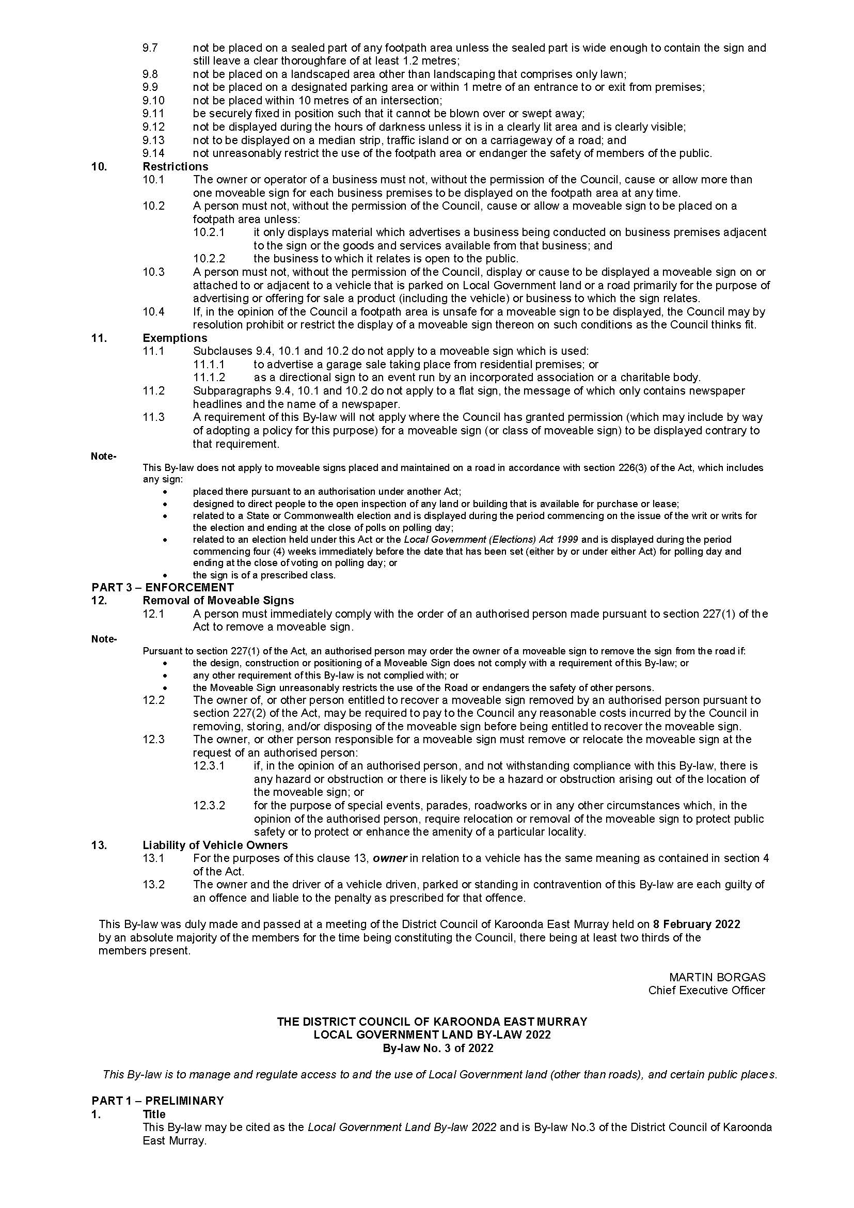
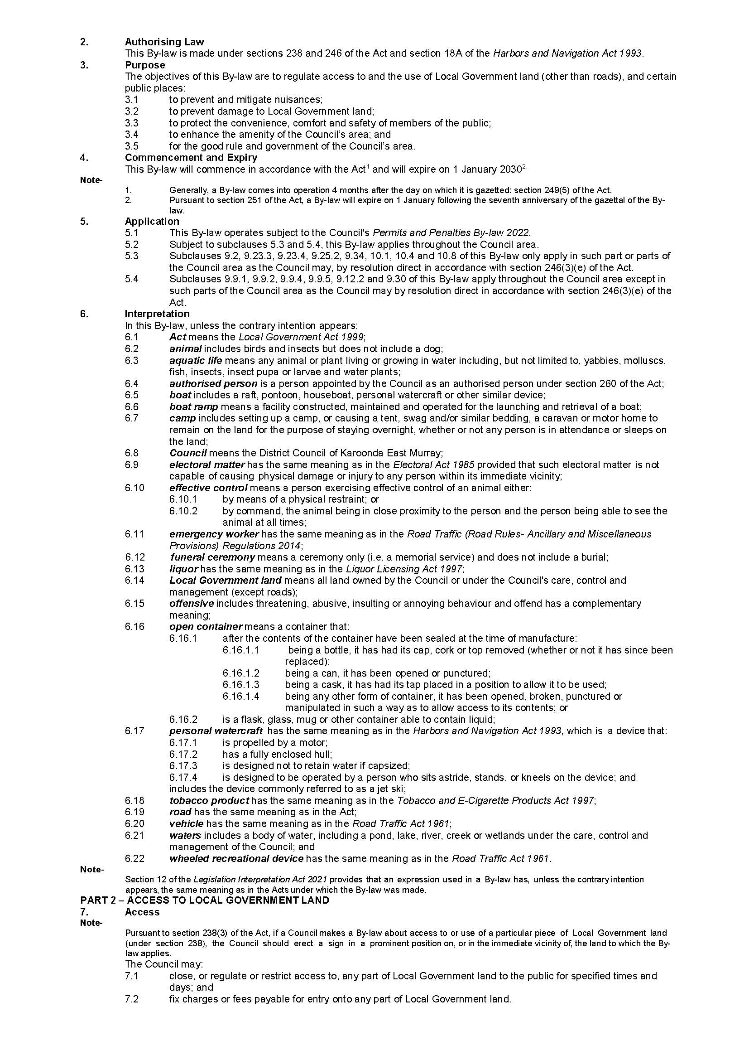
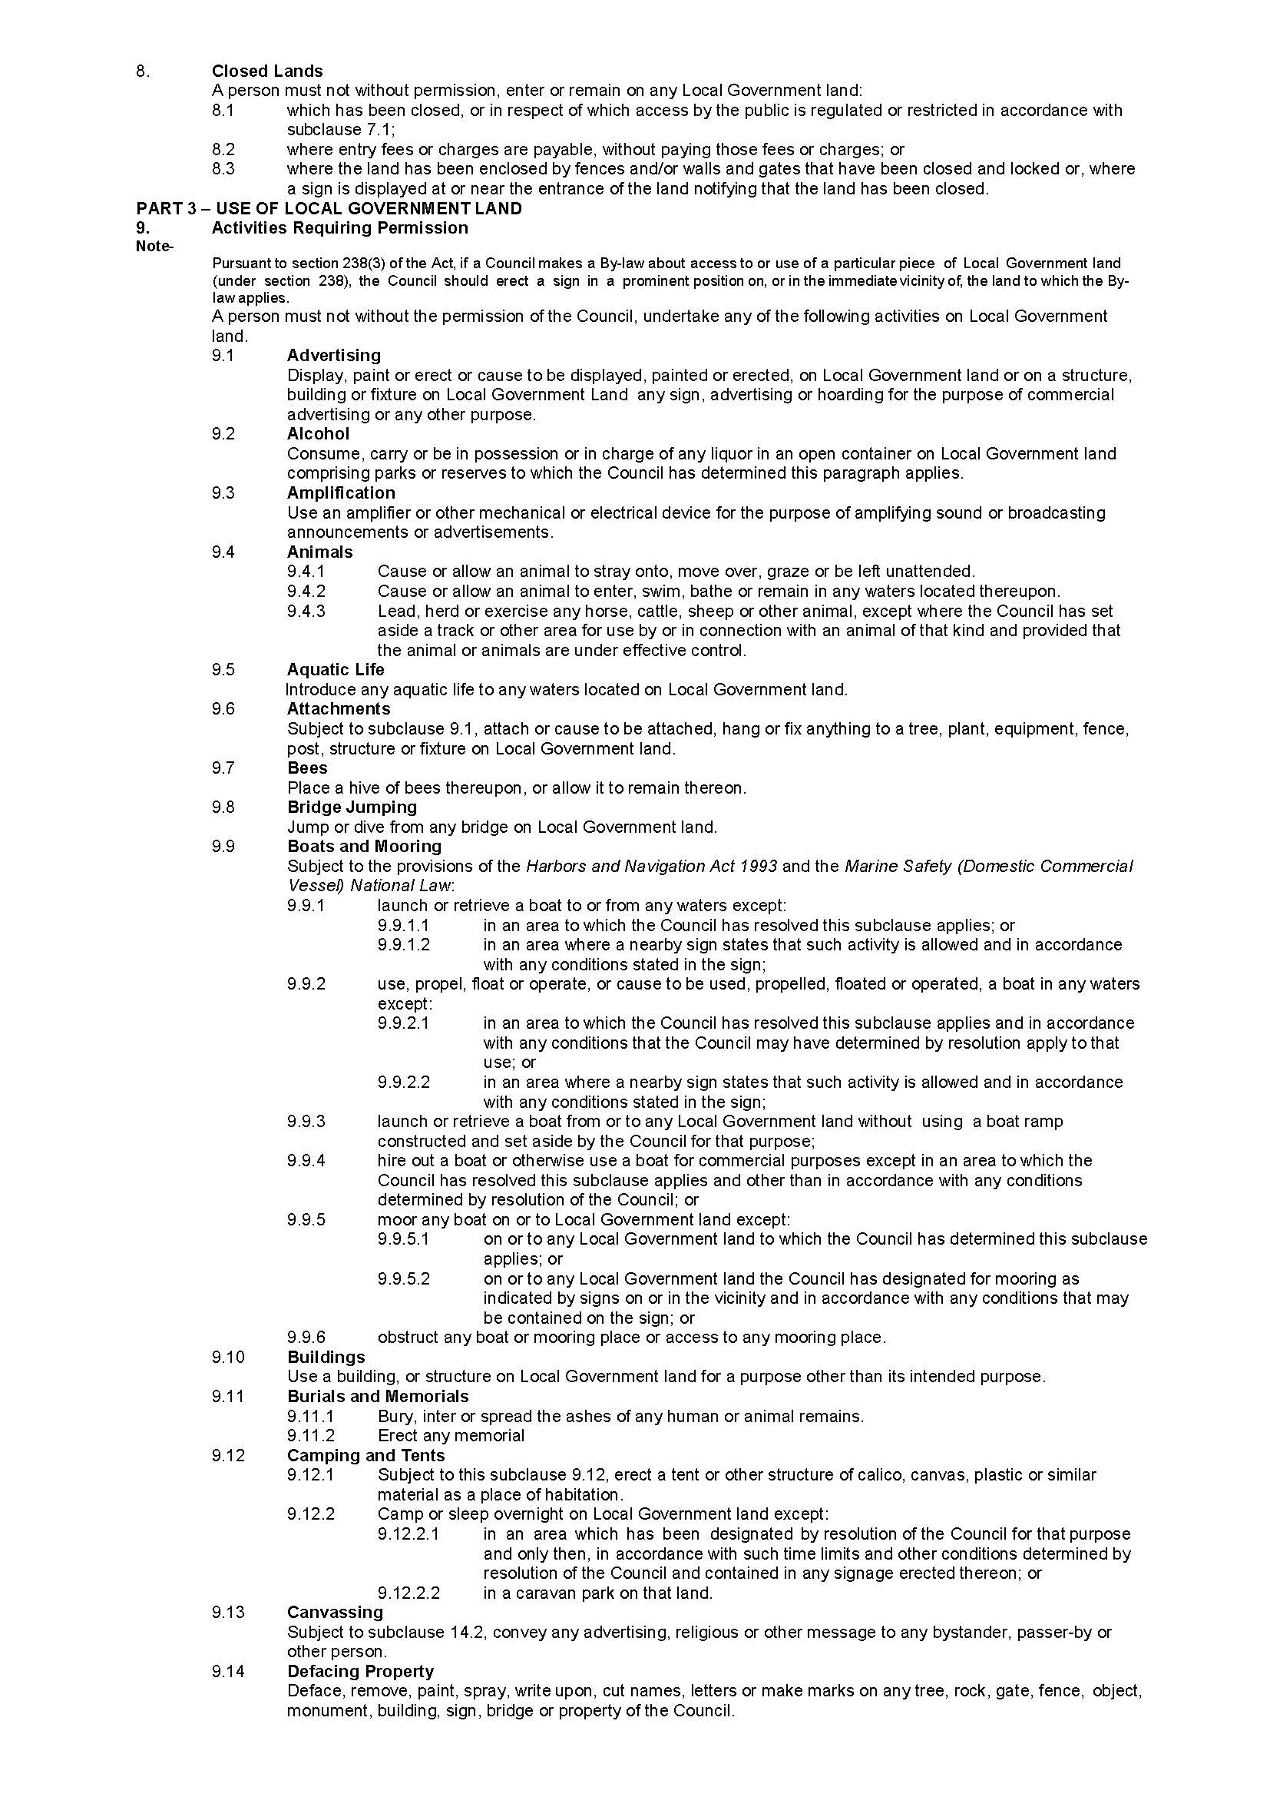
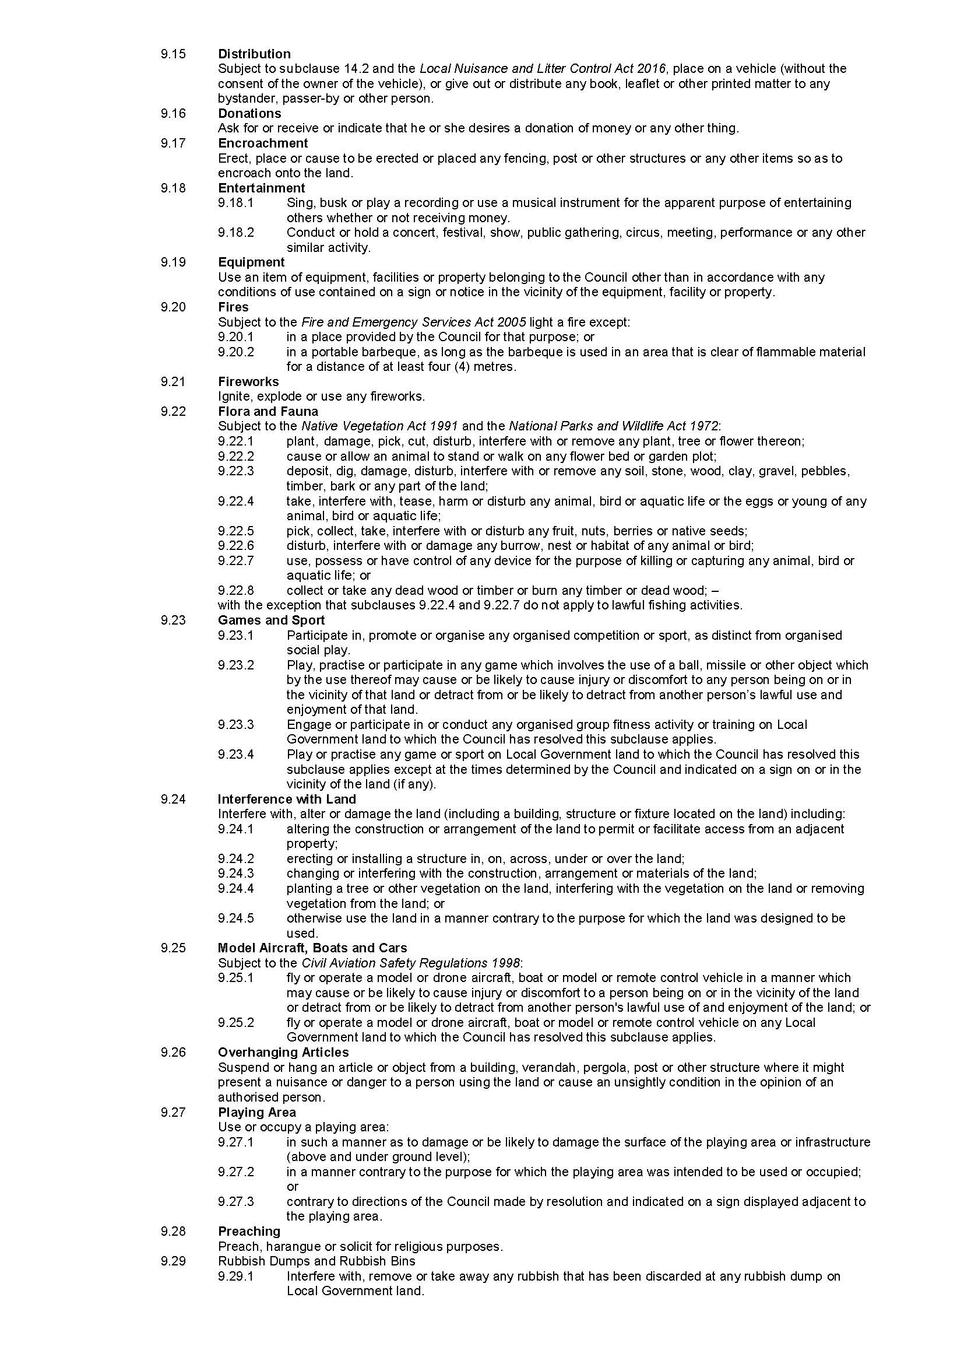
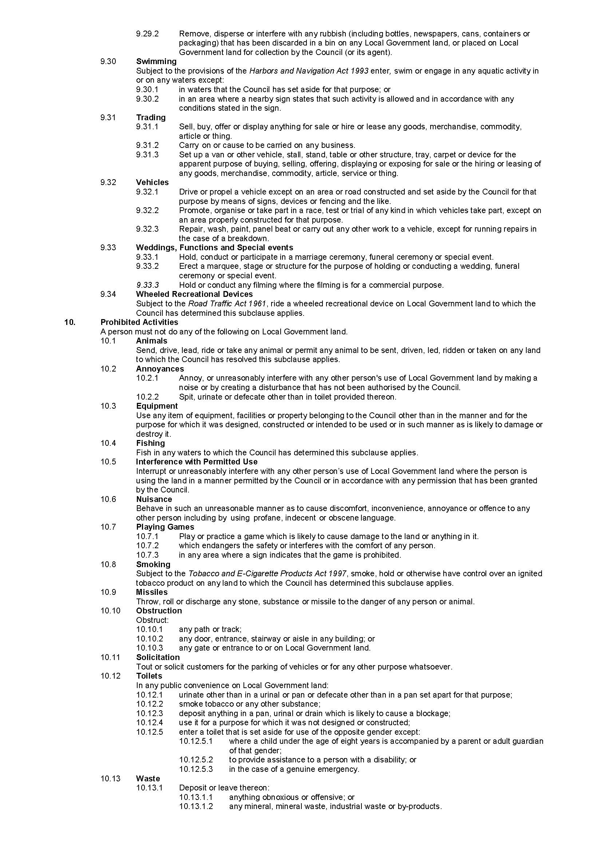

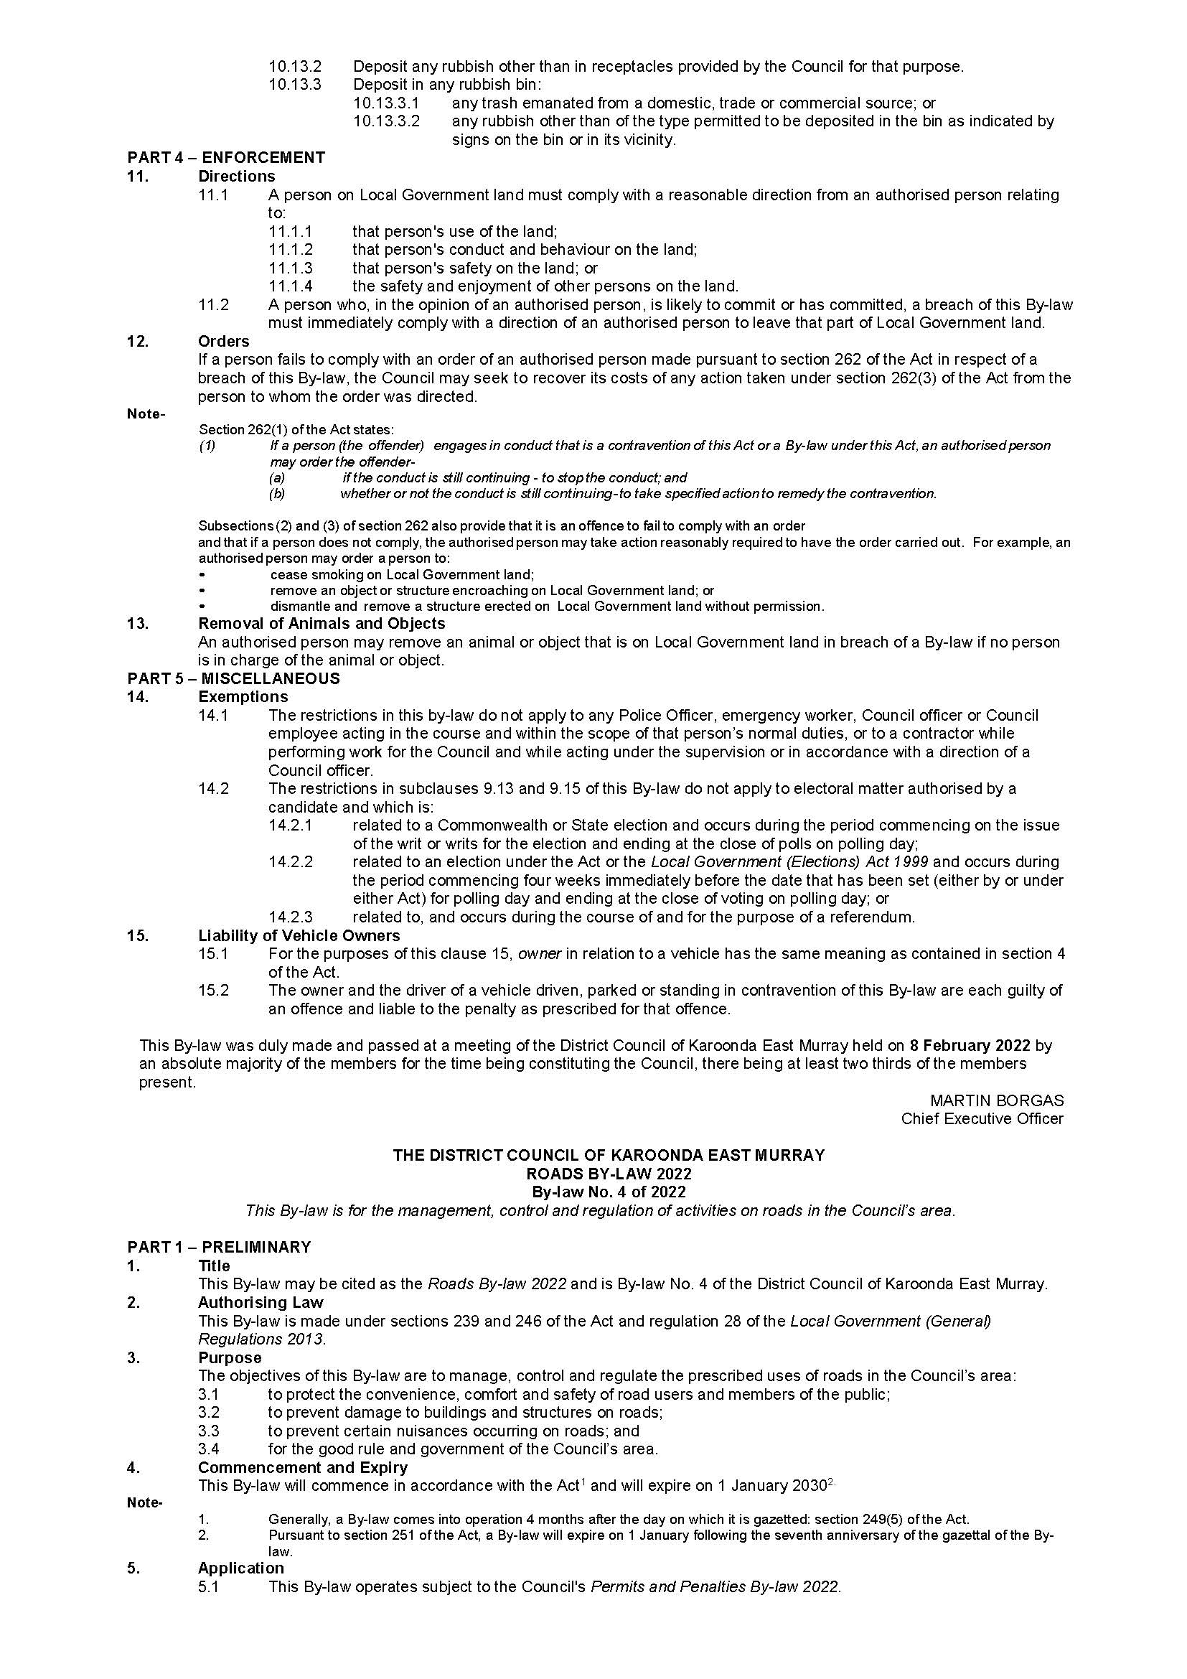
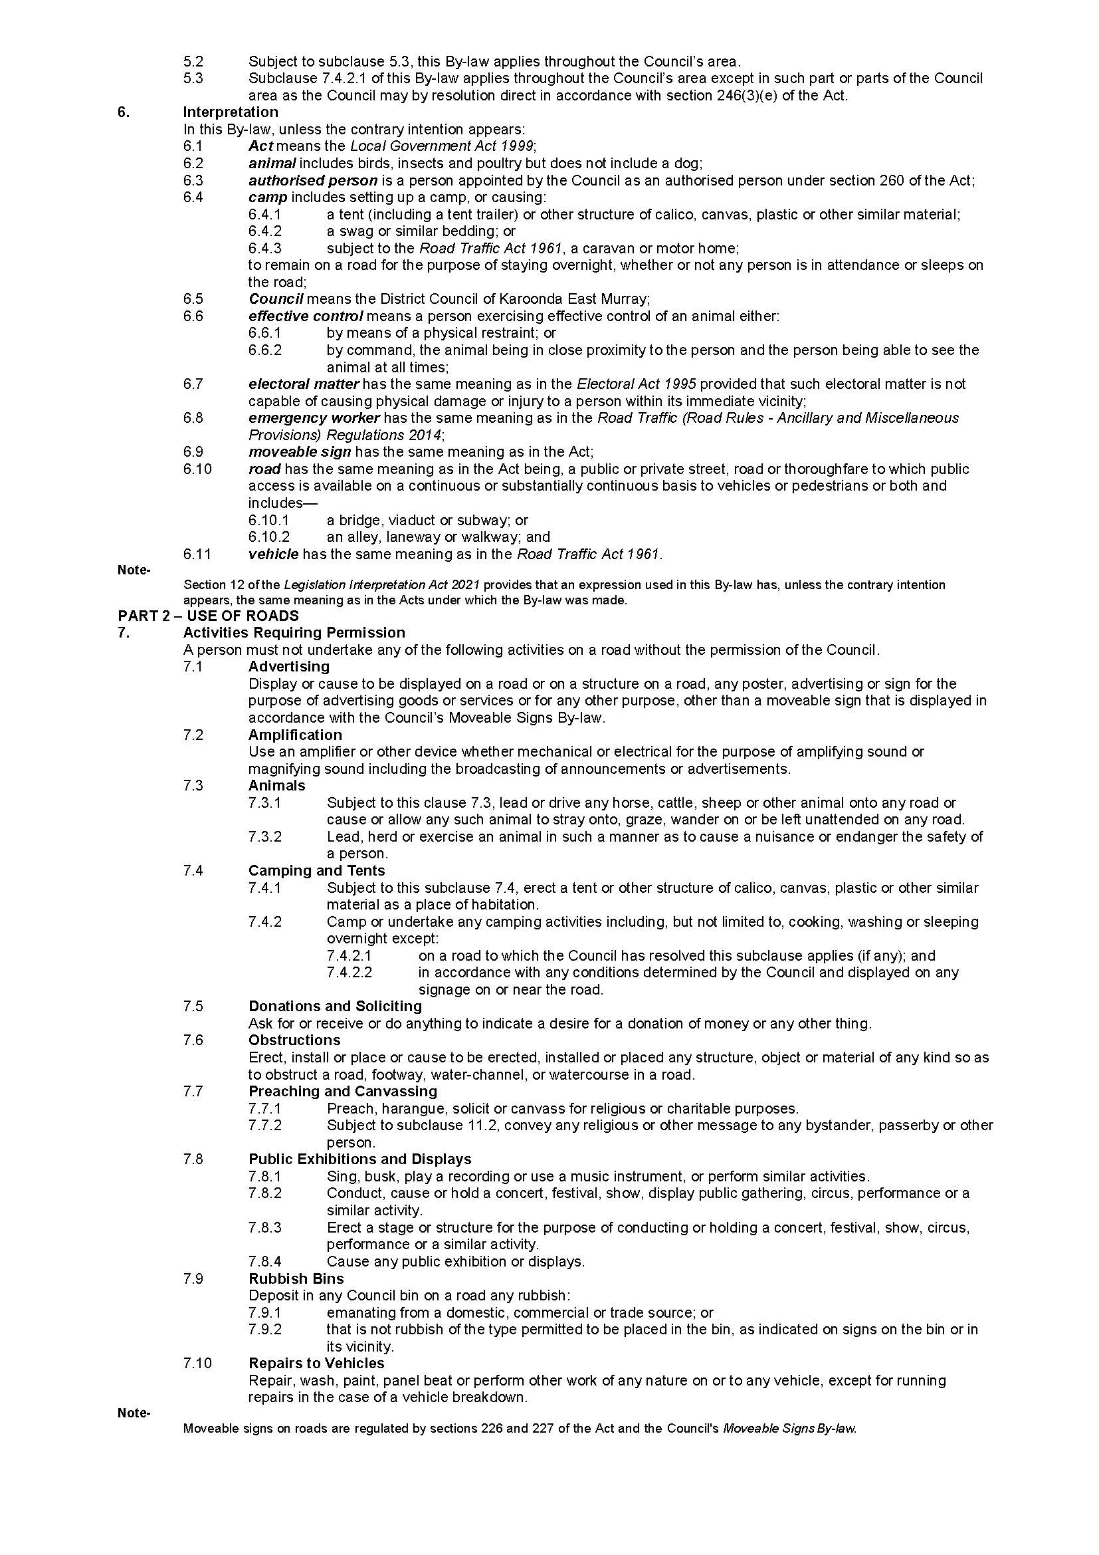
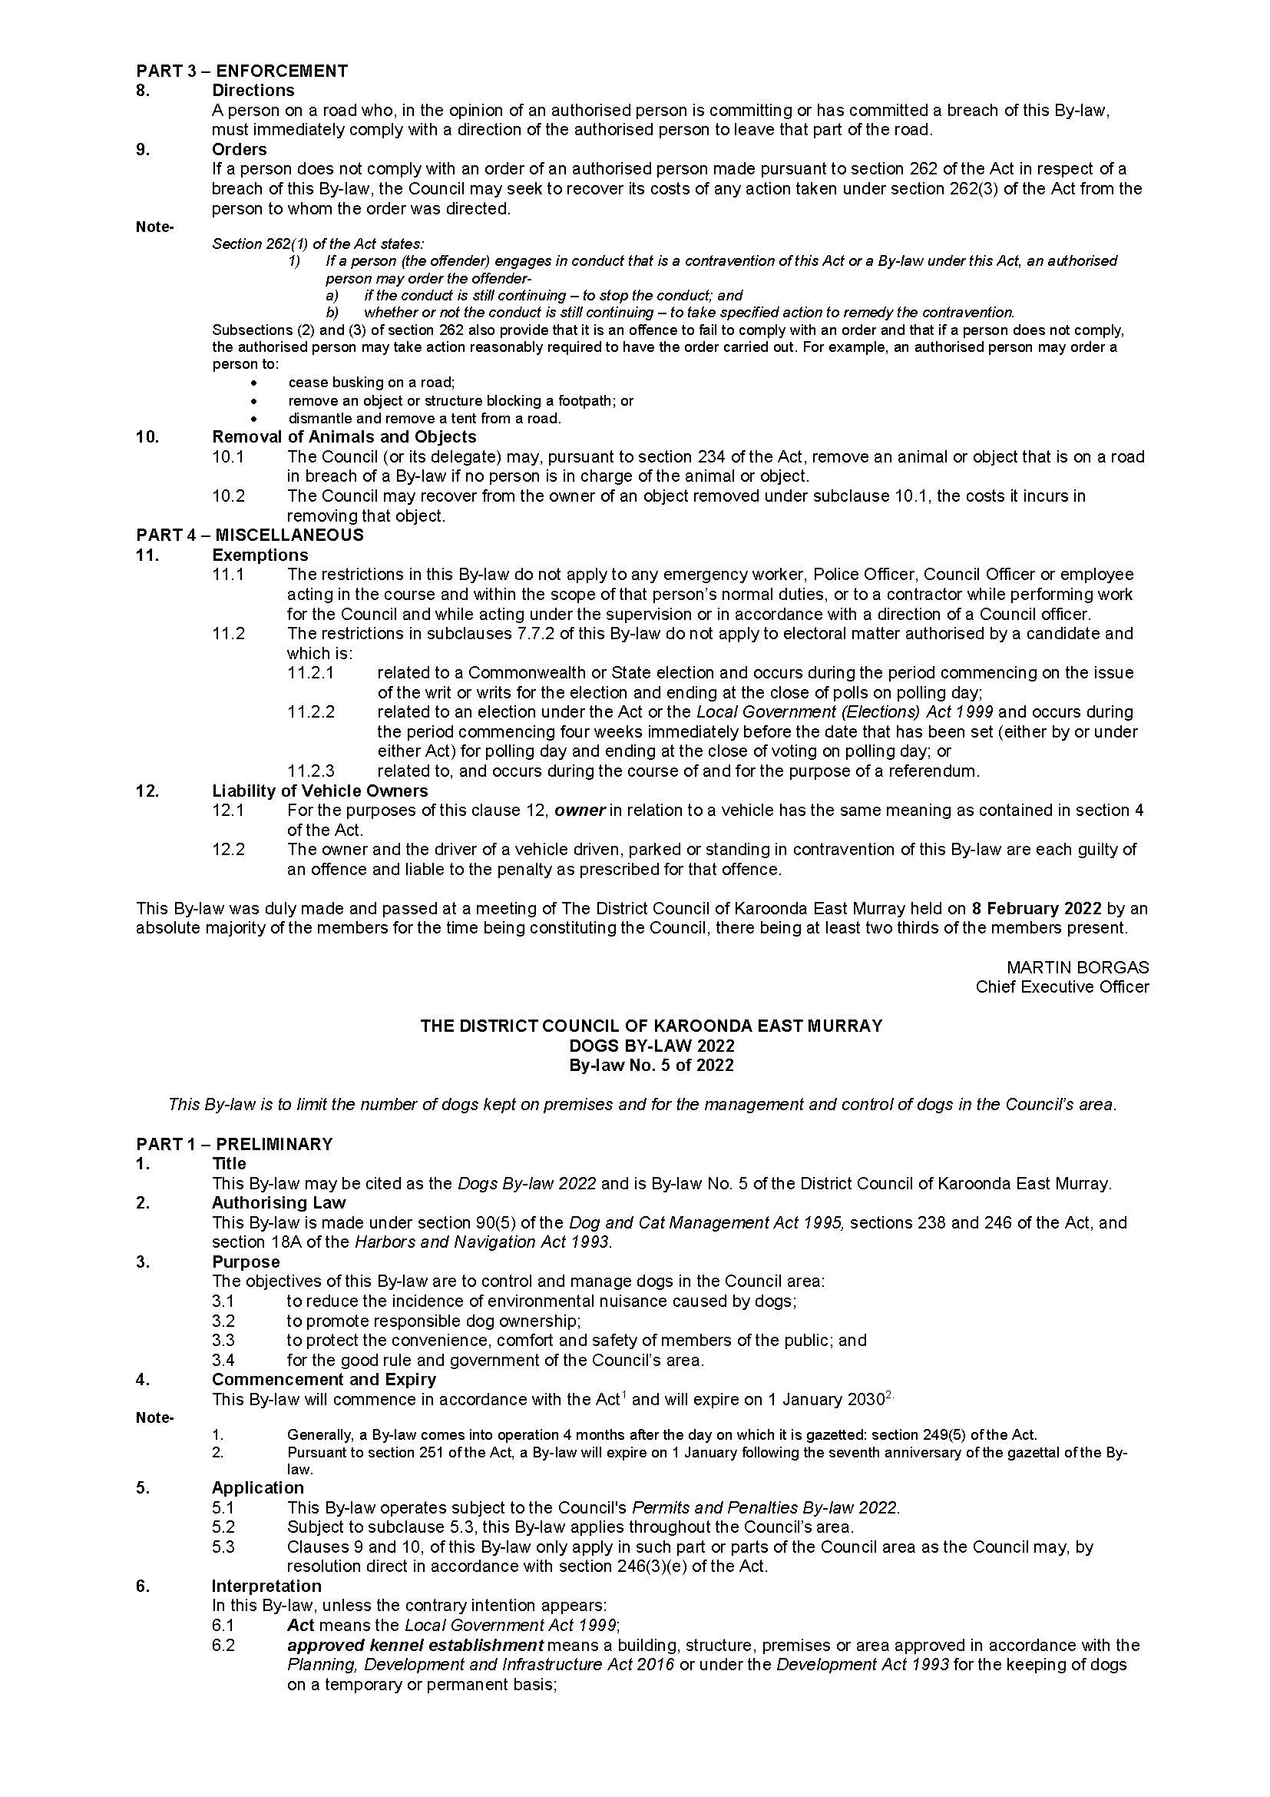
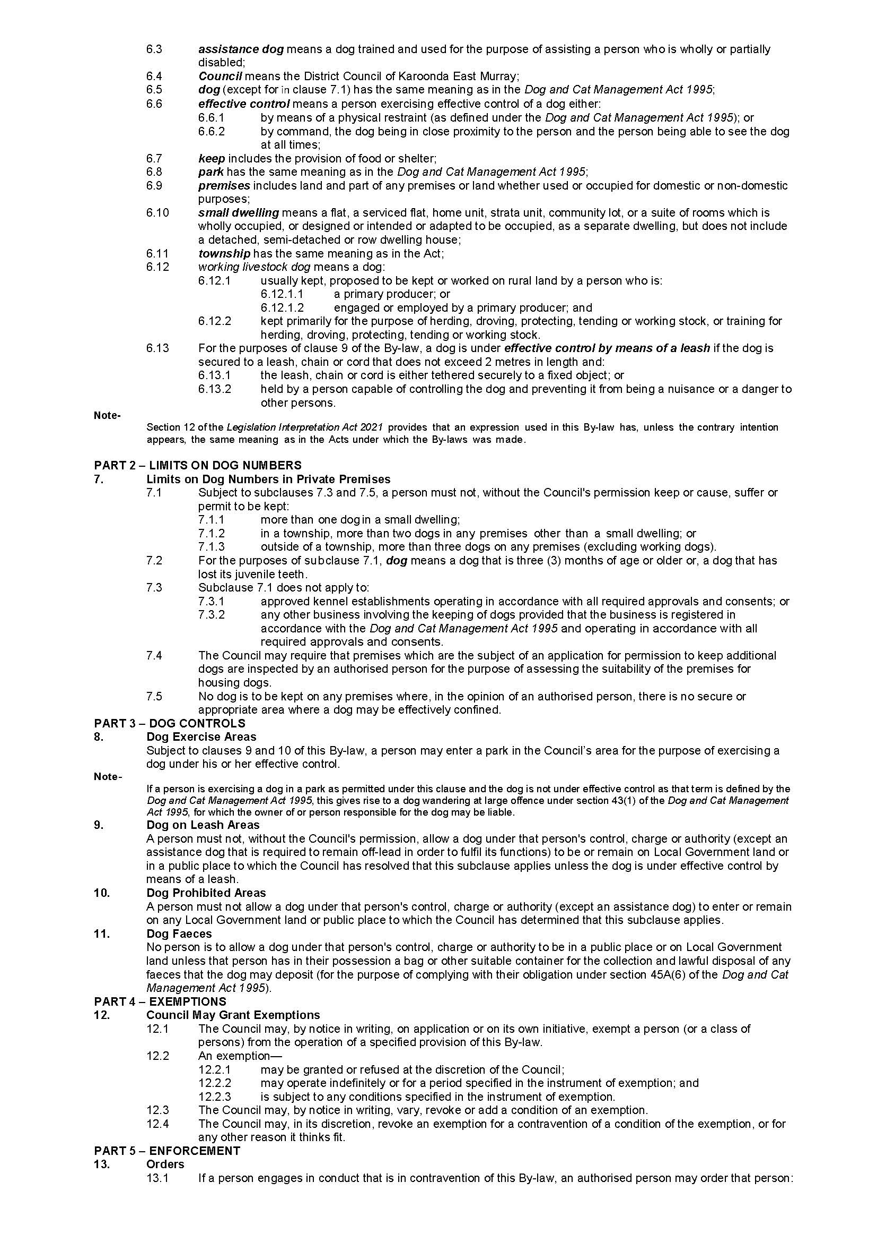
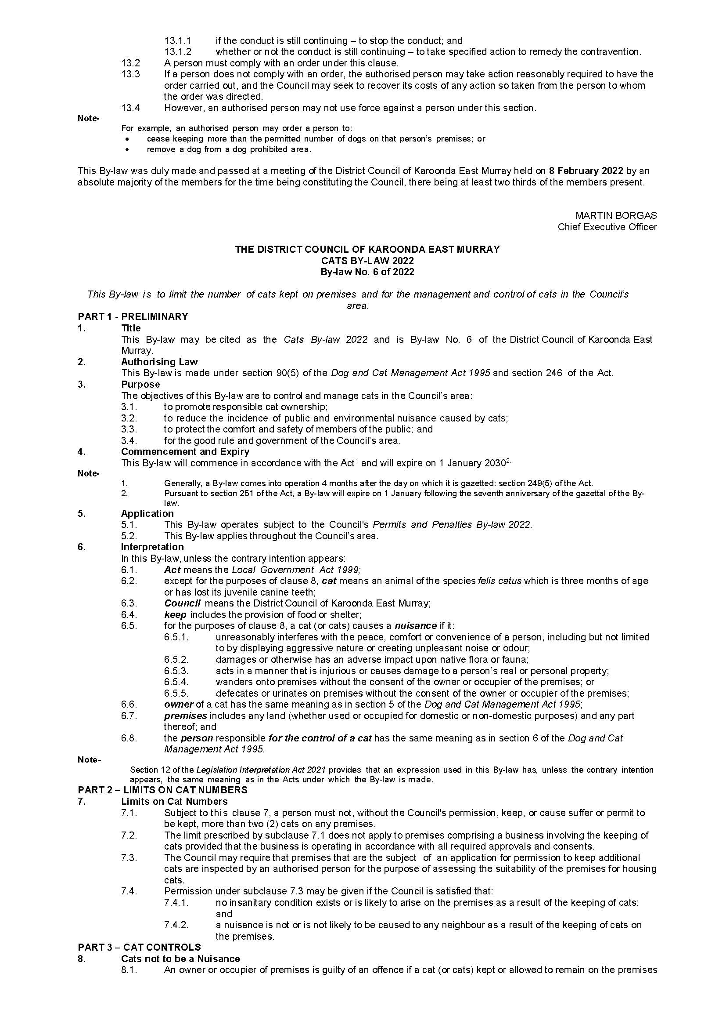

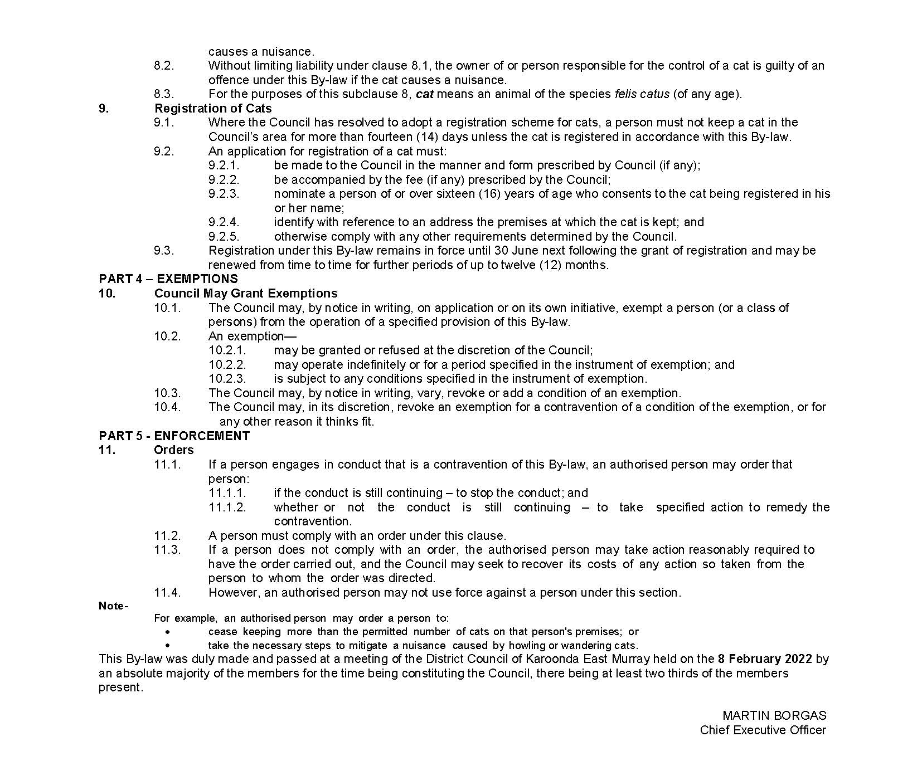

Wakefield Regional Council
Local Government Act 1999 (SA), Section 210(1)
Declaration of Public Roads
Wakefield Regional Council (Council) hereby gives notice that pursuant to section 210(1) of the Local Government Act 1999 (SA), the Council has resolved at its meeting held on 23 February 2022, to declare the following private roads within its Council area to be public roads:
The private roads are situated within Allotments 95, 96, 97, 98, 99 and 100 in Deposited Plan 1790 (Roads) and held within Certificate of Title Volume 5910 Folio 681. The Roads are known as: William Street, Dale Street, Sires Street, Yorsdale Street, Hill Street and Sandgate Street.
Dated: 23 February 2022
Andrew MacDonald
Chief Executive Officer

Public Notices

Land Acquisition Act 1969
Section 16
Form 5—Notice of Acquisition
1—Notice of acquisition
ElectraNet Pty Limited, of PO Box 7096 Hutt Street Post Office, Adelaide SA 5000 (Authority), acquires the following interests in the following land:
A full, free and unrestricted right, liberty, licence, power and authority over that portion of the land comprised in Certificate of Title Register Book Volume 5464 Folio 828 being the area marked “P” on Filed Plan 257422 (Easement Area),
for the following purpose:
- to erect, construct, place, install, suspend and lay (and to inspect, alter, maintain, repair, remove and replace):
  - under the surface of the Easement Area, any cables, ducts, pipes, conductors, telecommunications equipment and other works; and/or
  - on or over the Easement Area, poles, transmission lines, transmission towers, cables, conductors, telecommunications equipment and other related or incidental plant and equipment,
for:
  - transmitting, transforming and controlling electricity; and/or
  - sending, receiving and relaying data or telecommunication signals; and
- to enter upon and to be in or on the Easement Area and to pass and repass (either with or without materials, plant and other apparatus and motor or other vehicles) along or over the Easement Area for the purposes described in clause A; and
- to break the surface and to dig open, up and remove the surface and the subsurface of the Easement Area and to lay upon the surface of the Easement Area any material, plant and other apparatus for the purposes described in clause A.
This notice is given under section 16 of the Land Acquisition Act 1969.
2—Compensation
A person who has or had an interest consisting of native title or an alienable interest in the land that is divested or diminished by the acquisition or the enjoyment of which is adversely affected by the acquisition who does not receive an offer of compensation from the Authority may apply to the Authority for compensation.
2A—Payment of professional costs relating to acquisition (section 26B)
If you are the owner in fee simple of the land to which this notice relates, you may be entitled to a payment of $10,000 from the Authority for use towards the payment of professional costs in relation to the acquisition of the land.
Professional costs include legal costs, valuation costs and any other costs prescribed by the Land Acquisition Regulations 2019.
3—Inquiries
Inquiries should be directed to:
Mr Michael Bails, Senior Property Advisor
ElectraNet Pty Limited, PO Box 7096 Hutt Street Post Office, Adelaide SA 5000
(08) 8404 7342 / bails.michael@electranet.com.au
Dated: 23 February 2022
Tim Swaine
Senior Legal Counsel
ElectraNet Pty Limited

Land Acquisition Act 1969
Section 16
Form 5—Notice of Acquisition
1—Notice of acquisition
ElectraNet Pty Limited, of PO Box 7096 Hutt Street Post Office, Adelaide SA 5000 (Authority), acquires the following interests in the following land:
A full, free and unrestricted right, liberty, licence, power and authority over that portion of the land comprised in:
- Certificate of Title Register Book Volume 5951 Folio 34;
- Certificate of Title Register Book Volume 5295 Folio 740;
- Certificate of Title Register Book Volume 5831 Folio 550;
- Certificate of Title Register Book Volume 5550 Folio 786; and
- Certificate of Title Register Book Volume 5951 Folio 131,
being the area marked “P” on Filed Plan 257422 (Easement Area),
for the following purpose:
- to erect, construct, place, install, suspend and lay (and to inspect, alter, maintain, repair, remove and replace):
  - under the surface of the Easement Area, any cables, ducts, pipes, conductors, telecommunications equipment and other works; and/or
  - on or over the Easement Area, poles, transmission lines, transmission towers, cables, conductors, telecommunications equipment and other related or incidental plant and equipment,
for:
  - transmitting, transforming and controlling electricity; and/or
  - sending, receiving and relaying data or telecommunication signals; and
- to enter upon and to be in or on the Easement Area and to pass and repass (either with or without materials, plant and other apparatus and motor or other vehicles) along or over the Easement Area for the purposes described in clause A; and
- to break the surface and to dig open, up and remove the surface and the subsurface of the Easement Area and to lay upon the surface of the Easement Area any material, plant and other apparatus for the purposes described in clause A.
This notice is given under section 16 of the Land Acquisition Act 1969.
2—Compensation
A person who has or had an interest consisting of native title or an alienable interest in the land that is divested or diminished by the acquisition or the enjoyment of which is adversely affected by the acquisition who does not receive an offer of compensation from the Authority may apply to the Authority for compensation.
2A—Payment of professional costs relating to acquisition (section 26B)
If you are the owner in fee simple of the land to which this notice relates, you may be entitled to a payment of $10,000 from the Authority for use towards the payment of professional costs in relation to the acquisition of the land.
Professional costs include legal costs, valuation costs and any other costs prescribed by the Land Acquisition Regulations 2019.
3—Inquiries
Inquiries should be directed to:
Mr Michael Bails, Senior Property Advisor
ElectraNet Pty Limited, PO Box 7096 Hutt Street Post Office, Adelaide SA 5000
(08) 8404 7342 / bails.michael@electranet.com.au
Dated: 23 February 2022
Tim Swaine
Senior Legal Counsel
ElectraNet Pty Limited

Land Acquisition Act 1969
Section 16
Form 5—Notice of Acquisition
1—Notice of acquisition
ElectraNet Pty Limited, of PO Box 7096 Hutt Street Post Office, Adelaide SA 5000 (Authority), acquires the following interests in the following land:
A full, free and unrestricted right, liberty, licence, power and authority over that portion of the land comprised in Certificate of Title Register Book Volume 5464 Folio 828 and marked “P” on Filed Plan 257422 (Easement Area),
for the following purpose:
- to erect, construct, place, install, suspend and lay (and to inspect, alter, maintain, repair, remove and replace):
  - under the surface of the Easement Area, any cables, ducts, pipes, conductors, telecommunications equipment and other works; and/or
  - on or over the Easement Area, poles, transmission lines, transmission towers, cables, conductors, telecommunications equipment and other related or incidental plant and equipment,
for:
  - transmitting, transforming and controlling electricity; and/or
  - sending, receiving and relaying data or telecommunication signals; and
- to enter upon and to be in or on the Easement Area and to pass and repass (either with or without materials, plant and other apparatus and motor or other vehicles) along or over the Easement Area for the purposes described in clause A; and
- to break the surface and to dig open, up and remove the surface and the subsurface of the Easement Area and to lay upon the surface of the Easement Area any material, plant and other apparatus for the purposes described in clause A.
This notice is given under section 16 of the Land Acquisition Act 1969.
2—Compensation
A person who has or had an interest consisting of native title or an alienable interest in the land that is divested or diminished by the acquisition or the enjoyment of which is adversely affected by the acquisition who does not receive an offer of compensation from the Authority may apply to the Authority for compensation.
2A—Payment of professional costs relating to acquisition (section 26B)
If you are the owner in fee simple of the land to which this notice relates, you may be entitled to a payment of $10,000 from the Authority for use towards the payment of professional costs in relation to the acquisition of the land.
Professional costs include legal costs, valuation costs and any other costs prescribed by the Land Acquisition Regulations 2019.
3—Inquiries
Inquiries should be directed to:
Mr Michael Bails, Senior Property Advisor
ElectraNet Pty Limited, PO Box 7096 Hutt Street Post Office, Adelaide SA 5000
(08) 8404 7342 / bails.michael@electranet.com.au
Dated: 23 February 2022
Tim Swaine
Senior Legal Counsel
ElectraNet Pty Limited

Land Acquisition Act 1969
Section 16
Form 5—Notice of Acquisition
1—Notice of acquisition
ElectraNet Pty Limited, of PO Box 7096 Hutt Street Post Office, Adelaide SA 5000 (Authority), acquires the following interests in the following land:
A full, free and unrestricted right, liberty, licence, power and authority over that portion of the land comprised in Certificate of Title Register Book Volume 5951 Folio 34 and marked “P” on Filed Plan 257422 (Easement Area),
for the following purpose:
- to erect, construct, place, install, suspend and lay (and to inspect, alter, maintain, repair, remove and replace):
  - under the surface of the Easement Area, any cables, ducts, pipes, conductors, telecommunications equipment and other works; and/or
  - on or over the Easement Area, poles, transmission lines, transmission towers, cables, conductors, telecommunications equipment and other related or incidental plant and equipment,
for:
  - transmitting, transforming and controlling electricity; and/or
  - sending, receiving and relaying data or telecommunication signals; and
- to enter upon and to be in or on the Easement Area and to pass and repass (either with or without materials, plant and other apparatus and motor or other vehicles) along or over the Easement Area for the purposes described in clause A; and
- to break the surface and to dig open, up and remove the surface and the subsurface of the Easement Area and to lay upon the surface of the Easement Area any material, plant and other apparatus for the purposes described in clause A.
This notice is given under section 16 of the Land Acquisition Act 1969.
2—Compensation
A person who has or had an interest consisting of native title or an alienable interest in the land that is divested or diminished by the acquisition or the enjoyment of which is adversely affected by the acquisition who does not receive an offer of compensation from the Authority may apply to the Authority for compensation.
2A—Payment of professional costs relating to acquisition (section 26B)
If you are the owner in fee simple of the land to which this notice relates, you may be entitled to a payment of $10,000 from the Authority for use towards the payment of professional costs in relation to the acquisition of the land.
Professional costs include legal costs, valuation costs and any other costs prescribed by the Land Acquisition Regulations 2019.
3—Inquiries
Inquiries should be directed to:
Mr Michael Bails, Senior Property Advisor
ElectraNet Pty Limited, PO Box 7096 Hutt Street Post Office, Adelaide SA 5000
(08) 8404 7342 / bails.michael@electranet.com.au
Dated: 23 February 2022
Tim Swaine
Senior Legal Counsel
ElectraNet Pty Limited

National Electricity Law
Notice of Final Determination and Final Rule
The Australian Energy Market Commission (AEMC) gives notice under the National Electricity Law as follows:
Under ss 102 and 103, the making of the National Electricity Amendment (Extension of time and reduction in scope of the 2022 reliability standard and settings review) Rule 2022 No. 2 (Ref. ERC0336) and related final determination. All provisions commence on 10 March 2022.
Under ss 102 and 103, the making of the National Electricity Amendment (Enhancing operational resilience in relation to indistinct events) Rule 2022 No. 1 (Ref. ERC0304) and related final determination. Schedule 1 commences on 9 March 2023, Schedule 2 commences on 3 June 2024 and Schedule 3 commences on 10 March 2022.
Documents referred to above are available on the AEMC’s website and are available for inspection at the AEMC’s office.
Australian Energy Market Commission
Level 15, 60 Castlereagh St
Sydney NSW 2000
Telephone: (02) 8296 7800
www.aemc.gov.au
Dated: 3 March 2022

Sale of Property
Warrant of Sale issued out of the Magistrates Court of South Australia
Auction Date: Thursday 17 March 2022 at 12.00pm
Location: Unit 1, 22 Coast Guard Road, Seaford Meadows, South Australia
Notice is hereby given that on the above date at the time and place stated, by virtue of the Warrant of Sale issued out of the Magistrates Court of South Australia, Action No. 1991 of 2017 directed to the Sheriff of South Australia in an action wherein Strata Corporation 27033 Inc are the Plaintiffs and Craig William McIntyre is the Defendant, I Angela Gransden, Sheriff of the State of South Australia, will by my auctioneers, Griffin Real Estate, make sale of the estate, right, title or interest whatsoever it may be of the defendant, Craig William McIntyre the registered proprietor of an estate in fee simple in the following:-
That piece of land situated in the area named Seaford Meadows, being Unit 1, 22 Coast Guard Road, Seaford Meadows, Hundred of Willunga, being the property comprised in Certificate of Title Register Book Volume 6086 Folio 332.
Further particulars from the auctioneers.
Mark Griffin
Griffin Real Estate
22 Greenhill Road,
WAYVILLE SA 5034
Telephone 08 8372 7872
Dated: 28 February 2022
Angela Gransden
Sheriff of the State of South Australia

Unclaimed Moneys Act 1891
Alinta Energy Retail Sales Pty Ltd
Register of Unclaimed Moneys for the years ended 2011-15
Name | Address | Description | Amount | Date
Safi Nyiramahirwe | ST AGNES SA 5097 | Credit Balance | $24.94 | 12/02/2014
Steven Richardson | PORT AUGUSTA SA 5700 | Credit Balance | $25.00 | 5/11/2015
Phillis Miklavec | PORT AUGUSTA SA 5700 | Credit Balance | $25.00 | 18/03/2015
David Annandale | HOLDEN HILL SA 5088 | Credit Balance | $25.00 | 15/06/2015
Lynette Korcyzynski | HOLDEN HILL SA 5088 | Credit Balance | $25.00 | 3/08/2015
Lynette Korczynski | HOLDEN HILL SA 5088 | Credit Balance | $25.00 | 3/08/2015
Benjamin Skanlan | MORPHETT VALE SA 5162 | Credit Balance | $25.10 | 21/07/2014
Julie Coulls | MORPHETT VALE SA 5162 | Credit Balance | $25.14 | 5/11/2012
Darvesh Singh | HOLDEN HILL SA 5088 | Credit Balance | $25.32 | 17/09/2014
Mark Madison | BORDERTOWN SA 5268 | Credit Balance | $25.37 | 14/09/2014
Jade Williams | MORPHETT VALE SA 5162 | Credit Balance | $25.38 | 10/09/2014
Kalam Kondansingh | NORTH ADELAIDE SA 5006 | Credit Balance | $25.39 | 6/08/2013
Paul Ziersch | WINDSOR GARDENS SA 5087 | Credit Balance | $25.47 | 30/08/2012
Aaron Waru | BLAIR ATHOL SA 5084 | Credit Balance | $25.48 | 24/04/2015
Susan Stevens | ELIZABETH PARK SA 5113 | Credit Balance | $25.49 | 29/09/2013
Neetu Sharms | PLYMPTON PARK SA 5038 | Credit Balance | $25.56 | 2/06/2014
Gianna Morabito | BROOKLYN PARK SA 5032 | Credit Balance | $25.62 | 12/08/2014
Grant Jenkins | GAWLER SOUTH SA 5118 | Credit Balance | $25.63 | 12/09/2014
Michelina D'Andrea | HECTORVILLE SA 5073 | Credit Balance | $25.66 | 11/08/2013
Chris Walker | TAILEM BEND SA 5260 | Credit Balance | $25.75 | 16/01/2015
Marcia Vernon | UNLEY SA 5061 | Credit Balance | $25.81 | 13/03/2015
Denise Rendell | SALISBURY SA 5108 | Credit Balance | $25.96 | 22/04/2013
Ajit Choudhary | VALLEY VIEW SA 5093 | Credit Balance | $26.03 | 26/02/2015
Thomas Waldron | MAGILL SA 5072 | Credit Balance | $26.04 | 26/08/2015
Edward Oehlrich | LOBETHAL SA 5241 | Credit Balance | $26.05 | 17/09/2014
Tim Symonds | BROKEN HILL NSW 2880 | Credit Balance | $26.10 | 12/06/2014
Jazz Hodgess | WEST BEACH SA 5024 | Credit Balance | $26.17 | 19/09/2012
Andrew Phillips | FULHAM GARDENS SA 5024 | Credit Balance | $26.20 | 2/09/2015
Michael Clarke | THEBARTON SA 5031 | Credit Balance | $26.22 | 23/07/2015
Teresa Griffiths | TEA TREE GULLY SA 5091 | Credit Balance | $26.50 | 19/06/2012
Brett Underwood | EVANSTON PARK SA 5116 | Credit Balance | $26.51 | 5/06/2014
Jayson Fox | SEFTON PARK SA 5083 | Credit Balance | $26.66 | 3/07/2013
Helena Ukota | PORT BROUGHTON SA 5522 | Credit Balance | $26.76 | 8/12/2013
Vikki James | MORPHETT VALE SA 5162 | Credit Balance | $26.82 | 11/02/2015
Amy Lewis | WOODVILLE WEST SA 5011 | Credit Balance | $26.87 | 7/11/2014
Julie Ash | EDEN HILLS SA 5050 | Credit Balance | $27.10 | 29/10/2012
Irene Sillett | STIRLING SA 5152 | Credit Balance | $27.18 | 15/09/2014
Maureen Pike | GLENELG SA 5045 | Credit Balance | $27.22 | 12/11/2015
Adrian Vivian | MANNUM SA 5238 | Credit Balance | $27.34 | 28/10/2014
Edna Jones | MODBURY HEIGHTS SA 5092 | Credit Balance | $27.35 | 13/10/2014
Kane Cahill | NORTHFIELD SA 5085 | Credit Balance | $27.41 | 21/12/2015
Marlene Lee | MOUNT BARKER SA 5251 | Credit Balance | $27.47 | 27/01/2014
Kerry Bowden | PARALOWIE SA 5108 | Credit Balance | $27.54 | 2/06/2014
Michael Spehr | MODBURY NORTH SA 5092 | Credit Balance | $27.76 | 16/01/2015
David Helps | MODBURY NORTH SA 5092 | Credit Balance | $27.96 | 2/02/2015
Sarah Pollington | L1, 1 WILLIAM ST PERTH WA 6000 | Credit Balance | $28.04 | 10/02/2015
Patricia Clements | GILLES PLAINS SA 5086 | Credit Balance | $28.11 | 19/06/2013
Gary Dal Broi | CAMPBELLTOWN SA 5074 | Credit Balance | $28.25 | 8/05/2014
Bernadette Genua | DOVER GARDENS SA 5048 | Credit Balance | $28.43 | 18/09/2014
Leanne Power | PORT NOARLUNGA SOUTH SA 5167 | Credit Balance | $28.64 | 6/01/2015
Chris Sissis | LEWISTON SA 5501 | Credit Balance | $28.74 | 19/04/2015
John Milne | REDWOOD PARK SA 5097 | Credit Balance | $28.89 | 11/12/2015
Peter Allam | FINDON SA 5023 | Credit Balance | $29.03 | 8/09/2014
Lisa Ansell | NYPONGA SA 5202 | Credit Balance | $29.05 | 15/01/2015
Natasha Marie Singh | TANUNDA SA 5352 | Credit Balance | $29.09 | 12/11/2015
The Trustee for Patel Brothers Family Trust | SALISBURY NORTH SA 5106 | Credit Balance | $29.29 | 5/11/2015
John Linford | BALAKLAVA SA 5461 | Credit Balance | $29.33 | 17/09/2014
Maura McMillan | ST GEORGES SA 5064 | Credit Balance | $29.34 | 6/02/2014
Teresa Niedzwiedz | NORTHGATE SA 5085 | Credit Balance | $29.42 | 25/06/2012
Matilda Jansen Van Vuuren | MODBURY NORTH SA 5092 | Credit Balance | $29.55 | 21/11/2013
Maria Tsalamangos | SALISBURY EAST SA 5109 | Credit Balance | $29.57 | 12/02/2013
Timothy Durst | SEAVIEW DOWNS SA 5049 | Credit Balance | $29.82 | 17/07/2015
Lauren Ruchs | WILLASTON SA 5118 | Credit Balance | $29.84 | 11/09/2014
Yvette Jorquera | PARA HILLS SA 5096 | Credit Balance | $30.00 | 18/08/2015
Sarah Slattery | CRAIGMORE SA 5114 | Credit Balance | $30.00 | 13/07/2015
Anastasia Iommazzo | MARION SA 5043 | Credit Balance | $30.00 | 21/10/2015
Rodney Richardson | MORPHETT VALE SA 5162 | Credit Balance | $30.00 | 4/03/2015
Jade Little | GLENELG EAST SA 5045 | Credit Balance | $30.00 | 23/12/2015
Grant Watson | MORHPETT VALE SA 5162 | Credit Balance | $30.04 | 7/11/2014
Scott McConville | FLAGSTAFF HILL SA 5159 | Credit Balance | $30.16 | 25/09/2014
Bartosz Kaczynski | NORTH ADELAIDE SA 5006 | Credit Balance | $30.25 | 4/06/2015
Dale Liston | MORPHETTVILLE SA 5043 | Credit Balance | $30.56 | 18/10/2015
Quasem Tibash | CUMBERLAND PARK SA 5041 | Credit Balance | $30.62 | 30/04/2014
Ali Nowrozi | BLAIR ATHOL SA 5084 | Credit Balance | $30.76 | 17/12/2015
Adam Bailey | KADINA SA 5554 | Credit Balance | $30.78 | 27/03/2014
Ivanka Sumanovic | PASADENA SA 5042 | Credit Balance | $30.78 | 23/09/2014
Warren Frith | SALISBURY HEIGHTS SA 5109 | Credit Balance | $30.81 | 1/06/2015
Qi Tian | MAGILL SA 5072 | Credit Balance | $30.81 | 18/08/2015
Brooke Baxter | ROXBY DOWNS SA 5275 | Credit Balance | $30.85 | 28/08/2014
Clare Hart | STRATHALBYN SA 5255 | Credit Balance | $30.90 | 3/09/2014
Yalei Zhang | CAMPBELLTOWN SA 5074 | Credit Balance | $31.00 | 2/04/2015
Luke Barsley | ETHELTON SA 5015 | Credit Balance | $31.24 | 4/08/2014
Dennis Kraan | WILLASTON SA 5118 | Credit Balance | $31.42 | 8/12/2015
Jenny Vaneveld | FERRYDEN PARK SA 5010 | Credit Balance | $31.47 | 5/09/2012
Dylan Smith | WILLASTON SA 5118 | Credit Balance | $31.48 | 7/04/2014
Steven Starick | ATHELSTONE SA 5076 | Credit Balance | $31.52 | 4/11/2013
Juan Rondario | BORDERTOWN SA 5268 | Credit Balance | $31.62 | 24/10/2014
Renee Le Cornu | SEACLIFF PARK SA 5049 | Credit Balance | $31.66 | 19/11/2014
Martin Creeper | MORPHETT VALE SA 5162 | Credit Balance | $31.71 | 28/06/2015
Lu Liu | BEDFORD PARK SA 5042 | Credit Balance | $31.91 | 24/11/2014
Parivash Hesari | CAMDEN PARK SA 5038 | Credit Balance | $32.10 | 3/07/2012
Adel Alfwelam | MITCHELL PARK SA 5043 | Credit Balance | $32.22 | 10/11/2014
Kalia Yannakoudis | BLOXTON SA 5333 | Credit Balance | $32.24 | 16/12/2013
Yang Zhang | MILE END SA 5031 | Credit Balance | $32.26 | 17/06/2013
Christopher Hooper | TANUNDA SA 5352 | Credit Balance | $32.26 | 21/07/2014
Krystal Mueller | PLYMPTON PARK SA 5038 | Credit Balance | $32.32 | 27/12/2013
Sazzad Ahmed | GILLES PLAINS SA 5086 | Credit Balance | $32.43 | 23/12/2015
Teddy Jacobson | PARINGA SA 5340 | Credit Balance | $32.46 | 24/07/2013
Janelle Lawson | MCLAREN VALE SA 5171 | Credit Balance | $32.46 | 21/11/2015
Augustos Topalsavvas | FULHAM SA 5024 | Credit Balance | $32.70 | 2/05/2012
Hilary Adlam | CLARE SA 5453 | Credit Balance | $32.72 | 1/09/2015
Yvon Pierre | PARAFIELD GARDENS SA 5107 | Credit Balance | $32.97 | 29/02/2012
Jessica Paynter | ROYAL PARK SA 5014 | Credit Balance | $33.13 | 1/10/2014
Jodie Hamilton | ADELAIDE SA 5000 | Credit Balance | $33.33 | 26/09/2014
Nathan Brown | LYNTON SA 5062 | Credit Balance | $33.50 | 5/11/2014
Tan Jun Wei | BEDFORD PARK SA 5042 | Credit Balance | $33.71 | 20/01/2014
David Glenndavis | BERRI SA 5343 | Credit Balance | $33.74 | 1/10/2015
Saidakhon Rejapova | NORTHFIELD SA 5085 | Credit Balance | $33.79 | 24/03/2015
Hyunmi Bae | MODBURY HEIGHTS SA 5092 | Credit Balance | $33.90 | 1/11/2015
Jade Lauer-Smith | MINNIPA SA 5654 | Credit Balance | $33.93 | 7/01/2014
Bruno Cirillo | STIRLING SA 5152 | Credit Balance | $34.00 | 15/04/2013
Bruce Cornish | MILE END SA 5031 | Credit Balance | $34.01 | 5/05/2015
Thessa Nastor | WOODSIDE SA 5244 | Credit Balance | $34.09 | 15/09/2014
Madeline Powell | ST PETERS SA 5069 | Credit Balance | $34.29 | 17/07/2014
Suzy Rogers | VALLEY VIEW SA 5093 | Credit Balance | $34.30 | 12/08/2014
Katie Cunningham | HUNTFIELD HEIGHTS SA 5163 | Credit Balance | $34.33 | 4/01/2015
Lien Nguyen | WOODVILLE GARDENS SA 5012 | Credit Balance | $34.70 | 12/02/2014
Colleen Cruise | BEACHPORT SA 5280 | Credit Balance | $34.78 | 15/01/2014
Tammy Godfrey | WHYALLA NORRIE SA 5608 | Credit Balance | $34.95 | 9/11/2015
Paul Tuffnell | WOODSIDE SA 5244 | Credit Balance | $35.21 | 17/12/2015
Susan Thompson | HOLDEN HILL SA 5088 | Credit Balance | $35.22 | 1/09/2013
Stephen Christie | BELLEVUE HEIGHTS SA 5050 | Credit Balance | $35.36 | 10/03/2015
Steven James | VIRGINIA SA 5120 | Credit Balance | $35.43 | 23/07/2015
Tanya Knibbs | PARALOWIE SA 5108 | Credit Balance | $35.47 | 3/05/2012
Amanda Currey | MOANA SA 5169 | Credit Balance | $35.47 | 20/04/2012
Brett Jones | SALISBURY NORTH SA 5108 | Credit Balance | $35.47 | 9/05/2012
Joanne Murdock | INGLE FARM SA 5098 | Credit Balance | $35.47 | 31/01/2013
Scott Chapman | HAPPY VALLEY SA 5159 | Credit Balance | $35.47 | 6/06/2012
Sharon Mahony | MOUNT GAMBIER SA 5290 | Credit Balance | $35.47 | 22/10/2014
Bronwen Clutterbuck | GLANDORE SA 5037 | Credit Balance | $35.47 | 5/03/2013
Brian Clifford | LOCKLEYS SA 5032 | Credit Balance | $35.47 | 19/06/2013
Brooke Berry | PORT AUGUSTA WEST SA 5700 | Credit Balance | $35.47 | 11/07/2013
Sarah Hutchinson | STIRLING NORTH SA 5710 | Credit Balance | $35.47 | 9/09/2013
Cara Holt | MURRAY BRIDGE SA 5253 | Credit Balance | $35.47 | 22/07/2014
Janelle Croucher | MOUNT GAMBIER SA 5290 | Credit Balance | $35.47 | 8/12/2014
Shanta Lamsal Mudwari | PROSPECT SA 5082 | Credit Balance | $35.54 | 5/02/2015
James Salangsang | BLACKWOOD SA 5051 | Credit Balance | $35.54 | 26/06/2015
Nicholas Denison | BEDFORD PARK SA 5042 | Credit Balance | $35.67 | 10/10/2014
Jessica Dunn | NORTH ADELAIDE SA 5006 | Credit Balance | $35.74 | 25/03/2014
Jaswinder Singh | PINNAROO SA 5304 | Credit Balance | $35.84 | 13/08/2014
Frank Azzollini | PROSPECT SA 5082 | Credit Balance | $36.11 | 22/05/2015
Adrian Auri | TRANMERE SA 5073 | Credit Balance | $36.15 | 23/02/2015
Kaitlin Taylor | PORT AUGUST SA 5700 | Credit Balance | $36.20 | 20/01/2014
Robert Burt | SEAFORD MEADOWS SA 5169 | Credit Balance | $36.25 | 3/05/2015
Brock Herdman | HILLCREST SA 5086 | Credit Balance | $36.28 | 3/04/2013
Kieran Murphy | OAKLANDS PARK SA 5046 | Credit Balance | $36.65 | 18/10/2015
Peter Ladner | WALLAROO SA 5556 | Credit Balance | $36.71 | 29/01/2015
Marc Borholm | CLOVELLY PARK SA 5042 | Credit Balance | $37.10 | 26/11/2015
Mark Wehbe | NORTHFIELD SA 5085 | Credit Balance | $37.48 | 12/05/2015
Michael Sellars | DRY CREEK SA 5094 | Credit Balance | $37.50 | 15/05/2015
Joe Azzopardi | HAPPY VALLEY SA 5159 | Credit Balance | $37.59 | 22/12/2015
Emma-Jayne Gregory | CLEARVIEW SA 5085 | Credit Balance | $37.66 | 17/11/2015
Tony Stevens | RENMARK SA 5341 | Credit Balance | $37.81 | 21/09/2014
Alicia Muhovics | COWANDILLA SA 5033 | Credit Balance | $37.91 | 5/02/2014
Hassan Huraysi | SEACOMBE GARDENS SA 5047 | Credit Balance | $38.08 | 12/06/2014
Linda Baillie | CLARE SA 5453 | Credit Balance | $38.27 | 11/09/2014
Jack Phillips | MELROSE PARK SA 5039 | Credit Balance | $38.51 | 22/07/2013
Jillianne Peters | FULLARTON SA 5063 | Credit Balance | $38.63 | 5/11/2015
Brenton Holt | PETERHEAD SA 5016 | Credit Balance | $38.64 | 30/07/2014
Benjamin Sparrow | LOXTON SA 5333 | Credit Balance | $39.28 | 21/03/2014
Alex Voronov | ALBERTON SA 5014 | Credit Balance | $39.32 | 15/12/2014
Jaswinder Sidhu | WALKLEY HEIGHTS SA 5098 | Credit Balance | $39.56 | 2/09/2014
Carol Manning | MITCHELL PARK SA 5043 | Credit Balance | $39.64 | 9/07/2013
Kimberly Hill | REYNELLA EAST SA 5161 | Credit Balance | $39.87 | 26/11/2014
Betty Jury | RICHMOND SA 5033 | Credit Balance | $39.94 | 24/11/2015
Christopher Gaston | CAPE JERVIS SA 5024 | Credit Balance | $40.00 | 1/07/2015
Renai Rule | STIRLING NORTH SA 5710 | Credit Balance | $40.00 | 2/03/2015
Melanie Armstrong | FORREST RANGE SA 5168 | Credit Balance | $40.00 | 22/10/2015
Andrew Jacobs | MORPHETT VALE SA 5162 | Credit Balance | $40.00 | 23/04/2015
Shane Mason | HENDON SA 5014 | Credit Balance | $40.05 | 13/02/2014
Ben Poulton | CHRISTIES BEACH SA 5165 | Credit Balance | $40.23 | 2/12/2015
Mark Bramford | MORPHETT VALE SA 5162 | Credit Balance | $40.28 | 25/09/2014
Feiye Tian | HECTORVILLE SA 5073 | Credit Balance | $40.42 | 20/05/2015
Jonathan Schmidt | CLOVELLY PARK SA 5042 | Credit Balance | $40.47 | 21/06/2012
Chris Chinner | CLOVELLY PARK SA 5042 | Credit Balance | $40.71 | 3/03/2015
Lynette Polst | ALDINGA BEACH SA 5173 | Credit Balance | $41.00 | 16/10/2014
Patrick Brewer | MARYBOROUGH VIC 3465 | Credit Balance | $41.10 | 8/10/2015
Nigel Sharp | GLENUNGA SA 5064 | Credit Balance | $41.11 | 23/09/2015
Jaysen Collins | ANGASTON SA 5353 | Credit Balance | $41.13 | 16/07/2014
Leanne Schumacher | PORT LINCOLN SA 5606 | Credit Balance | $41.42 | 6/01/2015
Cheng Liang | HAWTHORN SA 5062 | Credit Balance | $41.95 | 12/11/2014
David Van Der Plugg | NORTH HAVEN SA 5018 | Credit Balance | $42.31 | 28/06/2015
Richard McLoughlin | MOUNT GAMBIER SA 5290 | Credit Balance | $42.44 | 23/04/2015
Johanne Brien | CHRISTIES BEACH SA 5165 | Credit Balance | $42.55 | 10/05/2015
Flinders Operating Services Pty Ltd | LEIGH CREEK SA 5731 | Credit Balance | $42.71 | 16/07/2014
Kellie Walker | PORT AUGUSTA SA 5700 | Credit Balance | $42.77 | 17/03/2014
Emily-Kate Magain | INGLEFARM SA 5098 | Credit Balance | $43.01 | 4/09/2014
Gary Clay | EDWARDSTOWN SA 5039 | Credit Balance | $43.05 | 30/11/2012
Bonnie Hunt | CHRISTIE DOWNS SA 5164 | Credit Balance | $43.42 | 3/12/2012
Joanne Alexander | PARAFIELD GARDENS SA 5107 | Credit Balance | $43.44 | 3/09/2014
Fitzsimmons Kerri Lorraine | PORT PIRIE SA 5540 | Credit Balance | $43.81 | 12/02/2015
Shavaughn Mihan | EVERARD PARK SA 5035 | Credit Balance | $43.94 | 8/12/2014
Yao Zheng | TORRENSVILLE SA 5031 | Credit Balance | $44.05 | 17/09/2014
Aleshia Harvey | MORPHETTVILLE SA 5043 | Credit Balance | $44.36 | 15/07/2014
Brad Holmes | MYLOR SA 5153 | Credit Balance | $44.64 | 25/03/2015
Lina Eriksson | MARION SA 5043 | Credit Balance | $44.68 | 6/09/2015
Susana Tibbles | MOANA SA 5169 | Credit Balance | $44.79 | 17/04/2013
Andrew Story | WHYALLA NORRIE SA 5608 | Credit Balance | $44.85 | 3/09/2013
Kate Marlais | HYDE PARK SA 5061 | Credit Balance | $44.91 | 3/12/2014
Laura Steenholdt | FERRDEN PARK SA 5010 | Credit Balance | $45.00 | 28/09/2015
Joanna Bonner | JORDAN SPRINGS NSW 2747 | Credit Balance | $45.12 | 23/12/2015
Ryan Klemasz | HOLDEN HILL SA 5088 | Credit Balance | $45.44 | 7/08/2014
Brooke Luck | MOUNT BARKER SA 5251 | Credit Balance | $45.47 | 9/05/2013
Kayla Mundy | WILLASTON SA 5118 | Credit Balance | $45.47 | 29/01/2014
Jodie Brooks | FLAGSTAFF HILL SA 5159 | Credit Balance | $45.72 | 15/10/2015
Ilija Vujnovic | FLAGSTAFF HILL SA 5159 | Credit Balance | $46.10 | 31/07/2013
Ausma Zvirgzdins | MOUNT GAMBIER SA 5290 | Credit Balance | $46.33 | 21/09/2015
Karen Bennett | BRAHMA LODGE SA 5109 | Credit Balance | $46.37 | 28/09/2015
Thomas Jordan | FORESTVILLE SA 5035 | Credit Balance | $46.49 | 6/07/2015
Mark Brown | GLENELG SA 5045 | Credit Balance | $46.80 | 14/12/2015
Sam Raslan | PARA VISTA SA 5093 | Credit Balance | $47.24 | 2/04/2015
Lee Atkins | ERSKINE WA 6210 | Credit Balance | $47.28 | 27/11/2012
Rebecca Storr | TAILEM BEND SA 5260 | Credit Balance | $47.40 | 6/06/2013
Ben Nielsen | CLOVELLY PARK SA 5042 | Credit Balance | $47.48 | 24/06/2014
Benjamin Talbot | LOCKLEYS SA 5032 | Credit Balance | $48.35 | 30/08/2015
Sylvia Goodwin | PORT AUGUSTA SA 5700 | Credit Balance | $48.39 | 14/09/2012
Karilyn White | PORT LINCOLN SA 5606 | Credit Balance | $49.06 | 3/07/2012
Rabih Sabra | BRAHAM LODGE SA 5109 | Credit Balance | $49.21 | 5/11/2013
Rebecca Gallagher | NARINE SA 5252 | Credit Balance | $49.22 | 14/08/2013
Jody Baker | OVINGHAM SA 5082 | Credit Balance | $49.58 | 30/04/2015
Ameneh Hosseini | POORAKA SA 5095 | Credit Balance | $49.97 | 10/07/2014
Fiona King | TEA TREE GULLY SA 5091 | Credit Balance | $50.00 | 17/11/2015
Naomi Mills | PORT LINCOLN SA 5606 | Credit Balance | $50.00 | 2/10/2015
Magdalena Fiedler | WEST LAKES SA 5021 | Credit Balance | $50.00 | 2/04/2015
Emma O'Malley | WILLASTON SA 5118 | Credit Balance | $50.00 | 21/12/2015
Barbara Del Monaco | OLD REYNELLA SA 5161 | Credit Balance | $50.00 | 18/03/2015
Marcus Brown | WHYALLA SA 5600 | Credit Balance | $50.00 | 17/06/2015
Suzanne Thompson | WEST LAKES SA 5021 | Credit Balance | $50.00 | 4/11/2015
Vanessa Heath | SALISBURY DOWNS SA 5108 | Credit Balance | $50.00 | 16/09/2015
Vincent Garreffa | PARKSIDE SA 5063 | Credit Balance | $50.00 | 26/10/2015
Michelle Farrell | MORPHETTVILLE SA 5043 | Credit Balance | $50.00 | 10/11/2015
Michelle Farrell | MORPHETTVILLE SA 5043 | Credit Balance | $50.00 | 10/11/2015
Margaret Milonas | BARMERA SA 5345 | Credit Balance | $50.00 | 16/09/2015
Allison Murnane | GOULD CREEK SA 5114 | Credit Balance | $50.00 | 25/06/2015
Cody Hambleton | OAKDEN SA 5086 | Credit Balance | $50.30 | 27/05/2015
Brian Hyde | WALKERVILLE SA 5081 | Credit Balance | $50.41 | 27/03/2014
Grace Hart | ALDINGA BEACH SA 5173 | Credit Balance | $50.53 | 15/10/2014
Belinda Pardella | MURRAY BRIDGE SA 5253 | Credit Balance | $50.63 | 1/12/2015
Emily Perry | HAYBOROUGH SA 5211 | Credit Balance | $51.10 | 18/08/2014
Nicholas Clemente | PARAFIELD GARDENS SA 5107 | Credit Balance | $51.22 | 1/03/2012
Danielle Hartland | WOODVILLE SA 5011 | Credit Balance | $51.44 | 9/07/2014
Joanne Searle | GREENACRES SA 5086 | Credit Balance | $51.57 | 20/04/2015
Jessica Asrawe | CLOVELLY PARK SA 5042 | Credit Balance | $51.65 | 24/02/2014
Santo Lombardo | ROYAL PARK SA 5014 | Credit Balance | $51.82 | 6/01/2014
Anneliese Thyer | BLACK FOREST SA 5035 | Credit Balance | $52.04 | 13/09/2012
Kathryn Brewer | ALDINGA BEACH SA 5173 | Credit Balance | $52.95 | 25/11/2014
Anselm Fatiaki | ANGLE VALE SA 5117 | Credit Balance | $53.07 | 3/11/2014
Cari O Connor | ROYSTON PARK SA 5070 | Credit Balance | $53.57 | 20/09/2012
Elaine Duncan | TROTT PARK SA 5158 | Credit Balance | $53.69 | 14/09/2012
Kyra Stein | MELROSE PARK SA 5039 | Credit Balance | $53.85 | 17/02/2013
Hayley Dennis | MURRAY BRIDGE SA 5253 | Credit Balance | $53.90 | 14/08/2014
Matthew Ross | WHYALLA STUART SA 5608 | Credit Balance | $53.96 | 3/06/2012
Jozsef Nemeth | GAWLER SA 5118 | Credit Balance | $53.98 | 1/09/2014
Nghiep Tran | BROOKLYN PARK SA 5032 | Credit Balance | $54.01 | 15/02/2015
Katrina Daw | WELLARD WA 6170 | Credit Balance | $54.02 | 21/10/2014
Flinders Operating Service - Residential - Vacant | LEIGH CREEK SA 5731 | Credit Balance | $54.26 | 1/12/2014
Michael Markwick | MODBURY NORTH SA 5092 | Credit Balance | $54.28 | 4/05/2015
Flinders Operating Services Pty Ltd | LEIGH CREEK SA 5731 | Credit Balance | $54.51 | 16/07/2014
Flinders Operating Services Pty Ltd | LEIGH CREEK SA 5731 | Credit Balance | $54.54 | 16/07/2014
Matthew Homewood | ELIZABETH DOWNS SA 5113 | Credit Balance | $54.91 | 7/05/2012
Patreace Amari | OWEN SA 5460 | Credit Balance | $54.91 | 14/09/2014
Rosa Nesci | WINDSOR GARDENS SA 5087 | Credit Balance | $54.99 | 18/03/2014
Mario Gervasoni | KUDLA SA 5115 | Credit Balance | $55.00 | 10/05/2013
Julie Wellington | HAHNDORF SA 5245 | Credit Balance | $55.14 | 22/07/2015
Casey Hutchinson | SALISBURY SA 5108 | Credit Balance | $55.22 | 26/08/2013
Joe Caruso | SALISBURY HEIGHTS SA 5109 | Credit Balance | $55.24 | 4/11/2014
Jessica Atze | OLD NOARLUNGA SA 5168 | Credit Balance | $55.47 | 11/10/2012
Sanni Kendrick | STURT SA 5047 | Credit Balance | $55.47 | 22/06/2012
Alexis Nsabimana | ELIZABETH SA 5112 | Credit Balance | $55.47 | 2/03/2014
Kevin Osborn | O'HALLORAN HILL SA 5158 | Credit Balance | $55.60 | 27/11/2014
Julie Brook | MAITLAND SA 5573 | Credit Balance | $55.69 | 24/08/2014
Chris Chinner | CLOVELLY PARK SA 5042 | Credit Balance | $56.08 | 3/03/2015
Flinders Operating Services Pty Ltd | LEIGH CREEK SA 5731 | Credit Balance | $56.10 | 16/07/2014
Frances Korner | LEIGH CREEK SA 5731 | Credit Balance | $56.11 | 25/02/2013
Janelle Nicholson | TORRENSVILLE PLAZA SA 5031 | Credit Balance | $56.19 | 22/05/2014
Yuxiu Chen | PORT WAKEFIELD SA 5550 | Credit Balance | $56.68 | 14/03/2013
Wayne Robert Read | MORPHETT VALE SA 5162 | Credit Balance | $57.00 | 15/12/2015
Ali Rabea | PARADISE SA 5075 | Credit Balance | $57.09 | 19/10/2015
Chantelle Sheather | HAPPY VALLEY SA 5159 | Credit Balance | $57.41 | 28/10/2015
John Dalecki | MODBURY SA 5092 | Credit Balance | $57.57 | 30/09/2013
Syed Akbari | POORAKA SA 5095 | Credit Balance | $57.68 | 9/02/2015
Jessica Swann | FULHAM SA 5024 | Credit Balance | $58.04 | 12/07/2015
Shane Sanders | KADINA SA 5554 | Credit Balance | $58.05 | 22/05/2013
Cheryl Willlsdon | GREENWITH SA 5125 | Credit Balance | $58.35 | 5/04/2013
Jacqueline Murray | BOLDER WA 6432 | Credit Balance | $58.57 | 15/06/2015
Kathleen Selvanera | SELLICKS BEACH SA 5174 | Credit Balance | $58.83 | 8/05/2013
Junhua Mo | PARA HILLS SA 5096 | Credit Balance | $58.86 | 19/02/2015
Hayley Dennis | MURRAY BRIDGE SA 5253 | Credit Balance | $58.87 | 14/08/2014
Matthew Kowald | NURIOOTPA SA 5355 | Credit Balance | $59.06 | 26/08/2014
David Todd | MAGILL SA 5072 | Credit Balance | $59.53 | 13/01/2014
Binnsu Baby | WINGFIELD SA 5013 | Credit Balance | $59.82 | 13/05/2013
Sam Kirchner | UNLEY PARK SA 5061 | Credit Balance | $59.83 | 4/12/2014
Harald Pfeifer | HALLETT COVE SA 5158 | Credit Balance | $59.93 | 8/07/2015
Devdatta Kar | WEST BEACH SA 5024 | Credit Balance | $59.95 | 28/05/2014
Jo-Ann Hein | YANKALILLA SA 5203 | Credit Balance | $60.00 | 16/09/2015
Amy Young | SMITHFIELD PLAINS SA 5114 | Credit Balance | $60.00 | 7/12/2015
Glen Pearce | CRAFERS SA 5152 | Credit Balance | $60.03 | 18/09/2014
Cassandra Scarman | HUNTFIELD HEIGHTS SA 5163 | Credit Balance | $60.47 | 18/07/2013
Eleonora Harman | GOOLWA SA 5214 | Credit Balance | $60.60 | 5/01/2015
Kim Smith | CROYDON PARK SA 5008 | Credit Balance | $60.62 | 4/09/2013
Julie-Anne Hose | BALAKLAVA SA 5461 | Credit Balance | $60.78 | 13/03/2015
Julie Clark | MOUNT BARKER SA 5251 | Credit Balance | $61.04 | 10/08/2015
Tai Le | PARALOWIE SA 5108 | Credit Balance | $61.09 | 1/07/2013
George Holt | MYRTLE BANK SA 5064 | Credit Balance | $61.72 | 17/09/2015
Judith Rem | FINDON SA 5023 | Credit Balance | $61.84 | 13/10/2014
Aleshia Harvey | MORPHETTVILLE SA 5043 | Credit Balance | $62.58 | 15/07/2014
Wayne Last | WHYALLA SA 5600 | Credit Balance | $62.62 | 15/01/2014
Ethan Thomas | RENOWN PARK SA 5008 | Credit Balance | $63.46 | 29/09/2015
Gertrude Guthrie | CLARE SA 5453 | Credit Balance | $63.85 | 5/11/2015
Raymond Healey | EXETER SA 5019 | Credit Balance | $63.94 | 15/04/2014
Allan Brown | NURIOOTPA SA 5355 | Credit Balance | $63.97 | 11/07/2012
Ryan Dew | KENSINGTON PARK SA 5068 | Credit Balance | $64.47 | 19/07/2015
Yonghua Yan | BORDERTOWN SA 5268 | Credit Balance | $64.71 | 3/05/2012
Liam Kenny | WESTBOURNE PARK SA 5041 | Credit Balance | $64.95 | 2/04/2014
Rahimi Kolsoum | FIRLE SA 5070 | Credit Balance | $65.21 | 4/03/2015
Matthew Jansch | PORT ELLIOT SA 5212 | Credit Balance | $65.28 | 5/03/2014
Nyree Giles | SALISBURY NORTH SA 5108 | Credit Balance | $65.29 | 10/09/2014
James Gall | CHRISTIE DOWNS SA 5164 | Credit Balance | $65.40 | 11/11/2015
Darryl Grenfell | SMITHFIELD SA 5114 | Credit Balance | $65.41 | 1/01/2013
Dieter Schoell | OLD REYNELLA SA 5161 | Credit Balance | $65.44 | 29/01/2015
Graham McDonald | EDWARDTOWN SA 5039 | Credit Balance | $65.47 | 4/08/2013
Monique Chilver | MARDEN SA 5070 | Credit Balance | $65.47 | 22/09/2014
Anna-Maria Fricker | PETERHEAD SA 5016 | Credit Balance | $65.47 | 3/10/2014
Tom Iannotti | LARGS NORTH SA 5016 | Credit Balance | $65.51 | 3/10/2013
Paulus Dhanarto | BEDFORD PARK SA 5042 | Credit Balance | $65.76 | 10/12/2015
Snjezana Bilic | CROYDON PARK SA 5008 | Credit Balance | $66.51 | 15/07/2012
Charlie Marafioti | ROYAL PARK SA 5014 | Credit Balance | $66.78 | 18/11/2013
Dinar Gustriandini | MAWSON LAKES SA 5095 | Credit Balance | $67.54 | 28/07/2014
Kai Yan | MAWSON LAKES SA 5095 | Credit Balance | $67.90 | 14/01/2014
Mark Doyle | MCLAREN VALE SA 5171 | Credit Balance | $68.11 | 10/12/2014
Laurel Weiss | PORT ADELAIDE SA 5015 | Credit Balance | $68.15 | 2/09/2012
John Brown | PANORAMA SA 5041 | Credit Balance | $68.51 | 21/05/2013
Christopher Boehm | POORAKA SA 5095 | Credit Balance | $68.79 | 7/04/2013
Chantal Brinkies | MAWSON LAKES SA 5095 | Credit Balance | $69.04 | 4/12/2015
Nicholas McGimley | THEBARTON SA 5031 | Credit Balance | $70.37 | 23/09/2014
Trent Young | GOLDEN GROVE SA 5125 | Credit Balance | $70.37 | 29/01/2015
David Brown | WHYALLA NORRIE SA 5608 | Credit Balance | $70.53 | 7/01/2013
Stefan Meersman | FULHAM SA 5024 | Credit Balance | $70.64 | 2/03/2015
Louise Shulver | ROSEWATER SA 5013 | Credit Balance | $70.97 | 28/12/2015
Andigoni Schwarz | RENMARK SA 5341 | Credit Balance | $70.99 | 5/11/2015
Julie Boseley | WEST BEACH SA 5024 | Credit Balance | $71.06 | 20/10/2013
Marcus Miller | ADELAIDE SA 5000 | Credit Balance | $71.08 | 11/08/2013
Andrea Timoney | NEWTON SA 5074 | Credit Balance | $71.64 | 13/12/2012
Thi Farmer | ST GEORGES SA 5064 | Credit Balance | $72.61 | 10/03/2015
Patricia Collett | GLENGOWRIE SA 5044 | Credit Balance | $73.21 | 5/09/2013
Ruth Fisher | CAVAN SA 5094 | Credit Balance | $73.24 | 23/01/2014
Amber Brooks | UNLEY PARK SA 5061 | Credit Balance | $73.36 | 6/01/2015
Cornelis Van Heusten | KADINA SA 5554 | Credit Balance | $73.45 | 31/07/2015
Jason Reedy | HACKHAM WEST SA 5163 | Credit Balance | $73.63 | 31/03/2014
Joshua Tual | PARA HILLS SA 5096 | Credit Balance | $73.66 | 30/10/2012
Julie Chetcuti | MAWSON LAKES SA 5095 | Credit Balance | $73.75 | 17/07/2013
Rebecca Virgara | DUBLIN SA 5501 | Credit Balance | $73.90 | 13/10/2015
Fay Watson | GOLDEN GROVE SA 5125 | Credit Balance | $74.07 | 4/04/2012
Naomi Christodoulous | GRANGE SA 5022 | Credit Balance | $74.70 | 29/07/2015
Alison Palk | WILLASTON SA 5118 | Credit Balance | $75.42 | 20/07/2015
Corriena Brighton | CRAIGMORE SA 5114 | Credit Balance | $75.47 | 16/07/2013
Melissa Alty | ADELAIDE SA 5000 | Credit Balance | $75.47 | 17/03/2014
Vicky Loffler | MCLAREN FLAT SA 5171 | Credit Balance | $75.65 | 6/07/2015
Rahim Yazdigolkhatmi | GILLES PLAIN SA 5086 | Credit Balance | $75.83 | 2/12/2015
George Sarantaugas | PERTH WA 6000 | Credit Balance | $75.95 | 11/11/2015
Andrea Brummelhuis | SHEIDOW PARK SA 5158 | Credit Balance | $76.42 | 22/04/2015
Flinders Operating Services Pty Ltd | LEIGH CREEK SA 5731 | Credit Balance | $76.92 | 16/07/2014
Donald Stanley May | DAVOREN PARK SA 5113 | Credit Balance | $77.45 | 29/06/2015
Geoffrey Munn | HAWTHORNDENE SA 5051 | Credit Balance | $77.71 | 23/04/2014
Julsar Scheerhoorn | MURRAY BRIDGE SA 5253 | Credit Balance | $77.89 | 19/04/2012
Faieq Drokhshan | MAWSON LAKES SA 5095 | Credit Balance | $78.38 | 29/05/2012
Benita Markham | CRAIGMORE SA 5114 | Credit Balance | $78.80 | 1/07/2014
Barry Wynands | WHYALLA JENKINS SA 5609 | Credit Balance | $79.24 | 7/02/2014
Pamela Baker | TENBY POINT VIC 3984 | Credit Balance | $79.94 | 4/03/2013
Janet Sanders | LYNDOCH SA 5351 | Credit Balance | $80.00 | 16/08/2015
Janice Webb | ROSTREVOR SA 5073 | Credit Balance | $80.16 | 9/05/2013
Daryl Smith | HIGHBURY SA 5089 | Credit Balance | $80.50 | 7/05/2014
The Trustee For Sportsmed Service Trust | STEPNEY SA 5069 | Credit Balance | $81.56 | 7/10/2015
Anna-Maria Fricker | PETERHEAD SA 5016 | Credit Balance | $82.14 | 3/10/2014
Pulis Trustee-Frank Quigley-1082608 | ADELAIDE SA 5001 | Credit Balance | $82.33 | 16/09/2013
Trystram Bovis | FINDON SA 5023 | Credit Balance | $82.94 | 29/07/2013
Carmel Christie | TORRENSVILLE SA 5031 | Credit Balance | $84.69 | 23/02/2012
Roberto Mireles Rodriguez | GLENELG SA 5045 | Credit Balance | $85.47 | 26/03/2012
James Adam Webb | ST MARYS SA 5042 | Credit Balance | $85.47 | 21/02/2013
Pamela Carroll | SALISBURY EAST SA 5109 | Credit Balance | $85.47 | 17/03/2012
Amy Kidziak | TAILEM BEND SA 5260 | Credit Balance | $85.47 | 1/12/2013
Jake Stephens | MUNNO PARA WEST SA 5115 | Credit Balance | $85.47 | 1/03/2012
Yvonne Brand | CHRISTIES BEACH SA 5165 | Credit Balance | $85.47 | 27/09/2012
Andrew McCulloch | KAPUNDA SA 5373 | Credit Balance | $85.47 | 15/07/2013
Anastasia Papaemmanouil | BROOKLYN PARK SA 5032 | Credit Balance | $85.47 | 21/04/2014
Kylie Coomblas | PORT PIRIE SA 5540 | Credit Balance | $85.72 | 15/10/2015
Jo Tolhurst | EDEN VALLEY SA 5235 | Credit Balance | $85.72 | 13/10/2015
Adam Polamka | SEAFORD SA 5169 | Credit Balance | $85.77 | 10/07/2013
Adam Cameron | PARALOWIE SA 5108 | Credit Balance | $85.88 | 5/08/2012
Jeffrey Stokes | JAMESTOWN SA 5491 | Credit Balance | $86.21 | 8/05/2014
Joseph Ellul | PARA HILLS WEST SA 5096 | Credit Balance | $86.27 | 30/01/2012
Peter Keepence | NORTH ADELAIDE SA 5006 | Credit Balance | $86.52 | 21/07/2014
Walter Jeffree | ELIZABETH VALE SA 5112 | Credit Balance | $87.48 | 11/11/2013
David MacDonald | NORTHGATE SA 5085 | Credit Balance | $88.17 | 17/09/2015
Dragica Simlesa | KLEMZIG SA 5087 | Credit Balance | $89.11 | 17/06/2012
Julian Lowery | CROYDON PARK SA 5008 | Credit Balance | $89.47 | 4/07/2014
Renee Sporne | ABERFOYLE PARK SA 5159 | Credit Balance | $90.00 | 9/12/2015
Corey Britcher | HECTORVILLE SA 5073 | Credit Balance | $90.00 | 13/08/2015
Richard Kurek | ST MARYS SA 5042 | Credit Balance | $90.80 | 24/11/2014
Cody Morris | ST CLAIRE SA 5011 | Credit Balance | $90.82 | 25/09/2015
Michael Boots | GULFVIEW HEIGHTS SA 5096 | Credit Balance | $91.32 | 8/11/2015
Nicola Freer | ANDREWS FARM SA 5114 | Credit Balance | $91.35 | 20/05/2012
Sylvia Anthoney | BELAIR SA 5052 | Credit Balance | $91.83 | 21/09/2015
Rosanna Aloi | WOODVILLE PARK SA 5011 | Credit Balance | $92.09 | 7/05/2015
Hayley Dennis | NAIRNE SA 5252 | Credit Balance | $92.22 | 14/08/2014
Michael Foureur | NORTH HAVEN SA 5018 | Credit Balance | $92.75 | 16/10/2013
Vicki Clemow | BERRI SA 5343 | Credit Balance | $93.11 | 3/07/2012
Tina Picariello | MAGILL SA 5072 | Credit Balance | $94.02 | 1/12/2015
Catherine Mullighan | PORT NOARLUNGA SOUTH SA 5167 | Credit Balance | $94.88 | 24/06/2014
Martin Henley | HUNTFIELD HEIGHTS SA 5163 | Credit Balance | $95.26 | 11/12/2013
Falina Diamond | WOODCROFT SA 5162 | Credit Balance | $96.20 | 13/06/2014
Yuchen Guo | MILE END SA 5031 | Credit Balance | $96.37 | 3/03/2014
Laavaneta Juliano | PAYNEHAM SA 5070 | Credit Balance | $96.40 | 23/11/2014
Steven Dixon | EVANSTON GARDENS SA 5116 | Credit Balance | $96.67 | 25/03/2013
Elizabeth Hudson | HAMLEY BRIDGE SA 5401 | Credit Balance | $97.86 | 28/09/2015
Peter J Bednall | COROMANDEL VALLEY SA 5051 | Credit Balance | $98.54 | 8/11/2015
Jiong Zhou | ST GEORGES SA 5064 | Credit Balance | $99.09 | 4/03/2013
Chase McPeake | HECTORVILLE SA 5073 | Credit Balance | $99.31 | 13/08/2014
Chris Tepper | PLYMPTON SA 5038 | Credit Balance | $99.57 | 4/11/2013
Donna Hocking | PORT PIRIE WEST SA 5540 | Credit Balance | $99.89 | 11/02/2015
Colin Rhind | WHYALLA STUART SA 5608 | Credit Balance | $100.00 | 25/08/2015
Simon Smith | CLARE SA 5453 | Credit Balance | $100.00 | 2/02/2015
Deborah Atkinson | MILE END SA 5031 | Credit Balance | $100.00 | 30/03/2015
Lorraine Mitchell | BALAKLAVA SA 5461 | Credit Balance | $100.00 | 11/12/2015
Steve Markovonovic | EVANSTON PARK SA 5116 | Credit Balance | $100.00 | 30/10/2015
The Trustee For Indian Wholesale Trust | MILE END SOUTH SA 5031 | Credit Balance | $100.00 | 23/12/2015
Margaret Rogers | ENFIELD SA 5085 | Credit Balance | $100.48 | 30/10/2014
Dorma Australia | DUDLEY PARK SA 5008 | Credit Balance | $100.59 | 25/08/2014
Vincenza Siviglia | WOODVILLE SOUTH SA 5011 | Credit Balance | $101.12 | 27/08/2014
Phoebe Vanden Bergh | RENMARK SA 5341 | Credit Balance | $101.30 | 9/12/2013
Catherine South | WEST BEACH SA 5024 | Credit Balance | $102.09 | 17/07/2012
Colin Gillings | FLAGSTAFF HILL SA 5159 | Credit Balance | $104.37 | 3/02/2014
Nevanka Soza | GOLDEN GROVE SA 5125 | Credit Balance | $104.73 | 2/02/2015
Eileen Wildly | MORPHETTVILLE SA 5043 | Credit Balance | $104.96 | 27/11/2014
Alexander Lewis | VICTOR HARBOR SA 5211 | Credit Balance | $105.08 | 1/12/2015
Taiya Barnes | UNDERDALE SA 5032 | Credit Balance | $105.47 | 21/07/2014
Robert Maynard | PORT PIRIE SOUTH SA 5540 | Credit Balance | $107.32 | 17/04/2013
Joshua Astridge | ALICE SPRINGS NT 870 | Credit Balance | $107.51 | 9/01/2015
Kerrin Webber | LOCKLEYS SA 5032 | Credit Balance | $107.84 | 12/05/2015
Sharon Roberts | ROSTREVOR SA 5073 | Credit Balance | $108.25 | 10/09/2012
Joseph May | ALBERTON SA 5014 | Credit Balance | $108.47 | 26/02/2014
Jennifer Doody | MOUNT GAMBIER SA 5290 | Credit Balance | $108.59 | 1/10/2015
Gary Woolger | CHRISTIE DOWNS SA 5164 | Credit Balance | $108.62 | 23/05/2014
Kylie Doering | BRAHMA LODGE SA 5109 | Credit Balance | $110.00 | 6/09/2015
Leanne Rigby | CHRISTIE DOWNS SA 5164 | Credit Balance | $110.47 | 30/12/2012
Tessa Contellis | BROMPTON SA 5007 | Credit Balance | $110.47 | 17/12/2014
Mark Piamtebosi | DOVER GARDENS SA 5048 | Credit Balance | $110.47 | 1/10/2014
Sarah Traeger | BERRI SA 5343 | Credit Balance | $111.25 | 8/10/2014
Ashley Fitzpatrick | DOVER GARDENS SA 5048 | Credit Balance | $111.78 | 4/02/2015
Uri Kim | FERRYDEN PARK SA 5010 | Credit Balance | $112.04 | 19/01/2015
Andrew Jacobs | MORPHETT VALE SA 5162 | Credit Balance | $112.16 | 23/04/2015
Timothy Pepe | ELIZABETH NORTH SA 5113 | Credit Balance | $112.22 | 25/06/2012
Lina Dorsi | HECTORVILLE SA 5073 | Credit Balance | $113.62 | 16/03/2014
Tuan Pham | ANDREWS FARM SA 5114 | Credit Balance | $113.82 | 17/04/2013
Noel Oliver | TORRENSVILLE SA 5031 | Credit Balance | $113.95 | 15/02/2012
Helen Koufos | STRATHALBYN SA 5255 | Credit Balance | $113.98 | 17/06/2014
Lincoln Badenoch | ASCOT PARK SA 5043 | Credit Balance | $114.29 | 15/05/2012
Sarah Horley | PENONG SA 5690 | Credit Balance | $114.35 | 27/07/2014
Darryl Janz | RISDON PARK SA 5540 | Credit Balance | $114.45 | 29/01/2015
Michelle Stevens | WILLUNGA SA 5172 | Credit Balance | $115.13 | 9/08/2013
Flinders Operating Service - Residential - Vacant | LEIGH CREEK SA 5731 | Credit Balance | $115.72 | 1/12/2014
Robert Carter | BERRI SA 5343 | Credit Balance | $116.41 | 25/02/2014
Ronald Peck | WHYALLA STUART SA 5608 | Credit Balance | $117.19 | 19/09/2013
Angela Pierpoint | PORT PIRIE WEST SA 5540 | Credit Balance | $117.45 | 16/07/2012
Ashley Thompson | ELIZABETH DOWNS SA 5113 | Credit Balance | $117.49 | 13/05/2015
Shaun Smith | KINGS PARK SA 5034 | Credit Balance | $118.47 | 25/10/2012
Flinders Operating Services Pty Ltd | LEIGH CREEK SA 5731 | Credit Balance | $119.25 | 16/07/2014
Parilla Premium Potatoes Pty. Ltd. | PARILLA SA 5303 | Credit Balance | $119.62 | 19/10/2015
Yvonne Fawdry | MURRAY BRIDGE SA 5253 | Credit Balance | $120.00 | 23/08/2015
Parilla Premium Potatoes Pty. Ltd. | PARILLA SA 5303 | Credit Balance | $120.30 | 19/10/2015
Eleanor Scrafton | LINDEN PARK SA 5065 | Credit Balance | $121.45 | 9/10/2014
Tyson Young | PORT ELLIOT SA 5212 | Credit Balance | $121.65 | 22/01/2015
Valda Fechner | TANUNDA SA 5352 | Credit Balance | $121.69 | 15/10/2012
Flinders Operating Service - Residential - Vacant | LEIGH CREEK SA 5731 | Credit Balance | $122.49 | 1/12/2014
Wendy Matthews | RIDGEHAVEN SA 5097 | Credit Balance | $123.04 | 21/04/2015
Steven Williams | SEMAPHORE PARK SA 5019 | Credit Balance | $124.47 | 29/07/2014
Michael Coe | ANDREWS FARM SA 5114 | Credit Balance | $125.00 | 31/03/2015
Rosemary Roghe | ADELAIDE SA 5001 | Credit Balance | $125.16 | 11/08/2014
Cheryl Olsen | MOANA SA 5169 | Credit Balance | $125.47 | 17/01/2013
Fadhil Al Aubodi | NOVAR GARDENS SA 5040 | Credit Balance | $125.50 | 23/12/2013
Robin Coles | EDWARDSTOWN SA 5039 | Credit Balance | $125.88 | 20/05/2012
Bart Pascoe | TROTT PARK SA 5158 | Credit Balance | $126.75 | 16/03/2015
Steven Noble | WEST CROYDON SA 5008 | Credit Balance | $127.58 | 26/06/2015
Scoott Walsburg | CLARE SA 5453 | Credit Balance | $127.63 | 8/12/2015
Michael Auld | LOXTON NORTH SA 5333 | Credit Balance | $127.87 | 9/09/2013
Flinders Operating Services Pty Ltd | LEIGH CREEK SA 5731 | Credit Balance | $131.43 | 16/07/2014
Janine Rechner | GOLDEN GROVE SA 5125 | Credit Balance | $132.00 | 7/09/2015
Joan Nicholson | VALLEY VIEW SA 5093 | Credit Balance | $133.51 | 6/11/2013
Sami Varpenius | LYNDOCH SA 5351 | Credit Balance | $133.53 | 9/04/2015
Matthew Cochrane | ADELAIDE SA 5000 | Credit Balance | $134.99 | 4/01/2013
Graham Ellis | PORT AUGUSTA WEST SA 5700 | Credit Balance | $135.35 | 13/11/2014
Christopher Bacon | SALISBURY SA 5108 | Credit Balance | $135.47 | 16/04/2012
Colin Morely | MILLICENT SA 5280 | Credit Balance | $135.47 | 1/05/2012
Jessica Holdcroft | DAVOREN PARK SA 5113 | Credit Balance | $135.47 | 21/10/2012
David Sinclair | NORWOOD SOUTH SA 5064 | Credit Balance | $135.47 | 30/12/2014
Zhen Wang | WOODVILLE GARDENS SA 5012 | Credit Balance | $136.88 | 17/09/2015
Jacinda Gower- Cahill | SALISBURY DOWNS SA 5108 | Credit Balance | $137.13 | 25/05/2015
Oliver-John McMinn | DULWICH SA 5065 | Credit Balance | $137.81 | 25/09/2014
Shelley Hayhurst | CLARE SA 5453 | Credit Balance | $137.90 | 25/07/2013
Amelia Lemmey | SALISBURY HEIGHTS SA 5109 | Credit Balance | $138.59 | 30/12/2015
Jajden Borg | SALISBURY NORTH SA 5108 | Credit Balance | $139.60 | 30/10/2013
Samuel Kerridge | TENNYSON SA 5022 | Credit Balance | $141.47 | 30/10/2015
Katie Ryan | SEACLIFF PARK SA 5049 | Credit Balance | $142.59 | 24/07/2014
Eric Church | DECEPTION BAY QLD 4508 | Credit Balance | $142.97 | 11/02/2015
Noel Tyler | WRATTONBULLY SA 5271 | Credit Balance | $143.00 | 8/12/2015
Huw Jones-Parry | LITTLE HAMPTON SA 5052 | Credit Balance | $143.96 | 11/11/2015
Bo Cui | INGLE FARM SA 5098 | Credit Balance | $144.17 | 9/10/2013
Damian Jones | HUNTFIELD HEIGHTS SA 5163 | Credit Balance | $144.47 | 28/09/2014
Lindy Miller | MYLOR SA 5153 | Credit Balance | $144.82 | 6/10/2015
Shane Packard | PORT AUGUSTA SA 5700 | Credit Balance | $145.37 | 19/03/2013
Graig Cavenett | NORTH ADELAIDE SA 5006 | Credit Balance | $145.47 | 17/03/2013
Jessica Holdcroft | DAVOREN PARK SA 5113 | Credit Balance | $145.47 | 21/10/2012
Samantha Robinson | STRATHALBYN SA 5255 | Credit Balance | $147.49 | 16/04/2015
Jesse Barker | PARKSIDE SA 5063 | Credit Balance | $148.05 | 1/10/2014
Wayne Squire | QUEENSTOWN SA 5014 | Credit Balance | $148.36 | 7/01/2013
Phil Black | BORDERTOWN SA 5268 | Credit Balance | $148.68 | 9/07/2015
Rob Hodgson | KENSINGTON SA 5068 | Credit Balance | $149.78 | 16/11/2015
Tracey Parker | WILLIAMSTOWN SA 5351 | Credit Balance | $150.00 | 13/08/2015
Susan Barnes | DOVER GARDENS SA 5048 | Credit Balance | $150.00 | 10/12/2015
Peter James | ROSEWATER SA 5013 | Credit Balance | $151.09 | 8/01/2015
Lisa Gleghorn | PARADISE SA 5075 | Credit Balance | $151.39 | 8/07/2014
Steven Webb | SALISBURY SA 5108 | Credit Balance | $151.78 | 13/02/2012
Stuart MacKenzie | AULDANA SA 5072 | Credit Balance | $152.01 | 15/10/2012
Vickie Possingham | BERRI SA 5343 | Credit Balance | $153.74 | 21/03/2013
Peter Leira | WHYALLA PLAYFORD SA 5600 | Credit Balance | $155.14 | 26/10/2012
Gerald Carrapiett | ABERFOYLE PARK SA 5159 | Credit Balance | $155.62 | 11/11/2013
Benjamin Coley | FLINDERS PARK SA 5025 | Credit Balance | $155.62 | 12/11/2015
Benjamin Coley | FLINDERS PARK SA 5025 | Credit Balance | $157.04 | 12/11/2015
Huaiyu Gao | WEST RICHMOND SA 5033 | Credit Balance | $157.60 | 17/06/2013
Megan Skinner | MURRAY BRIDGE SA 5253 | Credit Balance | $158.79 | 13/02/2014
Julie Mason | MOUNT GAMBIER SA 5290 | Credit Balance | $159.75 | 9/12/2014
Marion Zacher | PORT LINCOLN SA 5606 | Credit Balance | $160.24 | 24/08/2015
Wenchao Yang | BROMPTON SA 5007 | Credit Balance | $160.60 | 27/01/2015
Ashlea Kartinyeri | MURRAY BRIDGE SA 5253 | Credit Balance | $161.50 | 18/11/2011
Karen Sawyer | SOMERTON PARK SA 5044 | Credit Balance | $161.93 | 28/02/2012
David Coulthard | PORT AUGUSTA WEST SA 5700 | Credit Balance | $164.05 | 16/10/2013
Siyi Ong | CLOVELLY PARK SA 5042 | Credit Balance | $166.37 | 24/06/2015
Don DeGiglio | MARLESTON SA 5033 | Credit Balance | $166.90 | 18/10/2014
Lionel Ingerson | MORPHETT VALE SA 5162 | Credit Balance | $167.19 | 1/10/2014
Kieran Cornish | ELIZABETH GROVE SA 5112 | Credit Balance | $167.28 | 5/12/2013
Andrew Phelan | OAKDEN SA 5086 | Credit Balance | $167.85 | 17/02/2015
Eva Kozberski | EXETER SA 5019 | Credit Balance | $167.90 | 11/09/2015
Nathan Meech | ALDINGA BEACH SA 5173 | Credit Balance | $168.50 | 2/09/2015
Grant Moylan | EDINBOURGH SA 5111 | Credit Balance | $168.58 | 24/11/2015
Jonathon Deconno | HIGHBURY SA 5089 | Credit Balance | $168.62 | 3/02/2015
Ashleigh Blackman | PORT ADELAIDE SA 5015 | Credit Balance | $171.59 | 1/12/2015
Utoo | NORTH PLYMPTON SA 5037 | Credit Balance | $171.70 | 24/06/2014
Julian Zamfir | MODBURY HEIGHTS SA 5092 | Credit Balance | $172.82 | 21/12/2015
Lauren Frensham | TRINITY GARDENS SA 5068 | Credit Balance | $173.12 | 3/12/2015
Sasha Flint | WOODVILLE WEST SA 5011 | Credit Balance | $174.47 | 15/12/2014
Zaaheer MacKenzie | PORT AUGUSTA WEST SA 5700 | Credit Balance | $175.00 | 2/11/2015
Timothy Durst | SEAVIEW DOWNS SA 5049 | Credit Balance | $175.41 | 17/07/2015
Thelma Rodert | FERRYDEN PARK SA 5010 | Credit Balance | $175.43 | 8/12/2015
Virginia Gatgens | PLYMPTON SA 5038 | Credit Balance | $175.94 | 20/07/2014
Marcus Koch | PROSPECT SA 5082 | Credit Balance | $178.37 | 4/08/2014
Matthew McCartney | CRAIGMORE SA 5114 | Credit Balance | $179.32 | 2/06/2014
Troy Roberts | ADELAIDE SA 5001 | Credit Balance | $181.07 | 16/06/2015
Paula Hamilton | SEAVIEW DOWNS SA 5049 | Credit Balance | $182.47 | 17/06/2013
Qihang Zhou | ADELAIDE SA 5000 | Credit Balance | $183.07 | 25/02/2015
Hayley Webber | THEBARTON SA 5031 | Credit Balance | $184.23 | 10/09/2014
Ping Zhang | POORAKA SA 5095 | Credit Balance | $184.82 | 13/01/2012
Tracy Johnson | MORPHETT VALE SA 5162 | Credit Balance | $185.62 | 16/09/2012
Jennifer Rossiter | WOODVILLE NORTH SA 5012 | Credit Balance | $185.89 | 25/06/2015
Karna-Mia Cook-Russell | PORT ADELAIDE SA 5015 | Credit Balance | $187.20 | 13/08/2014
Bandar Almarashi | MITCHELL PARK SA 5043 | Credit Balance | $188.05 | 5/03/2012
James Herbert | WEST BEACH SA 5024 | Credit Balance | $188.14 | 16/07/2014
Thomas Mansfield | BROMPTON SA 5007 | Credit Balance | $190.00 | 4/06/2015
John Pocius | CLARENCE PARK SA 5034 | Credit Balance | $190.49 | 21/10/2015
Marija Pobran | SALISBURY SA 5108 | Credit Balance | $190.75 | 5/07/2015
Kylie Price | MORPHETT VALE SA 5162 | Credit Balance | $191.15 | 26/11/2012
Brett Hosking | WHYALLA PLAYFORD SA 5600 | Credit Balance | $191.52 | 23/02/2014
Sean McMahon | CLEARVIEW SA 5085 | Credit Balance | $191.54 | 6/02/2014
Mavis Hilton | FOLHAM SA 5024 | Credit Balance | $193.79 | 4/09/2014
Robert Tieman | GAWLER SOUTH SA 5118 | Credit Balance | $195.07 | 8/05/2014
Alexandra McQueen | GRANGE SA 5022 | Credit Balance | $195.28 | 5/06/2014
Alana Marthick | RICHMOND SA 5033 | Credit Balance | $195.78 | 6/10/2015
Leslie Humphries | MAGILL SA 5072 | Credit Balance | $196.10 | 10/10/2012
Grant Urquhart | PARALOWIE SA 5108 | Credit Balance | $198.74 | 5/03/2012
Simon Carcuro | PLYMPTON SA 5038 | Credit Balance | $199.06 | 17/02/2015
Aimee Hutchesson | MOUNT GAMBIER SA 5290 | Credit Balance | $200.00 | 2/02/2015
Breeanna Murray | GREENACRES SA 5086 | Credit Balance | $200.00 | 14/07/2015
Ashleigh McNair | STRATHALBYN SA 5255 | Credit Balance | $200.00 | 24/11/2015
Kelly Anderson | WOODVILLE SA 5011 | Credit Balance | $200.00 | 11/02/2015
Kimberley Weeks | STURLING SA 5152 | Credit Balance | $200.00 | 1/04/2015
Kate Meco | HAZELWOOD PARK SA 5066 | Credit Balance | $200.08 | 25/11/2015
Andrew Reynolds | FINDON SA 5023 | Credit Balance | $201.17 | 31/08/2015
James Worth | FULLARTON SA 5063 | Credit Balance | $201.64 | 5/04/2013
Jaslin Gardnier | WILLASTON SA 5118 | Credit Balance | $202.47 | 4/05/2015
Garry Pinchbeck | FERRYDEN PARK SA 5010 | Credit Balance | $202.97 | 2/06/2013
Jack Barker | BERRY SA 5343 | Credit Balance | $205.11 | 26/11/2013
Micheal Schuster | ELIZABETH PARK SA 5113 | Credit Balance | $205.47 | 23/08/2012
Evelyn Shaw | GRANGE SA 5022 | Credit Balance | $207.62 | 4/09/2015
Holly Haigh | PETER HEAD SA 5016 | Credit Balance | $207.97 | 12/06/2014
Positive Lead Pty. Ltd. | TEA TREE GULLY SA 5091 | Credit Balance | $213.90 | 11/09/2015
Josue Padilla Jimenez | MUNNO PARA WEST SA 5115 | Credit Balance | $214.00 | 19/06/2015
Kayne Herbert | SALISBURY NORTH SA 5108 | Credit Balance | $215.47 | 29/02/2012
Jodie Colby | HILTON SA 5033 | Credit Balance | $215.58 | 27/03/2014
Donald Clarke | KLENZIG SA 5087 | Credit Balance | $216.39 | 1/08/2014
Scott Retallick | ABERFOYLE PARK SA 5159 | Credit Balance | $217.55 | 18/08/2014
Donna Fay Penney | HILLBANK SA 5112 | Credit Balance | $217.98 | 26/11/2015
Kate Marlais | HYDE PARK SA 5061 | Credit Balance | $220.16 | 3/12/2014
Shu Huei Weilin | ADELAIDE SA 5000 | Credit Balance | $222.89 | 15/04/2015
Peter Fitzpatrick | MORPHETT VALE SA 5162 | Credit Balance | $223.39 | 9/09/2014
Neil Hite | PROSPECT SA 5082 | Credit Balance | $225.47 | 30/12/2013
Nathan Gherghetta | TUSMORE SA 5065 | Credit Balance | $226.45 | 25/02/2014
Keryn Carnell | OAKDEN SA 5086 | Credit Balance | $226.56 | 15/08/2014
Esmie Stevenson | MURRAY BRIDGE SA 5253 | Credit Balance | $232.10 | 7/03/2012
Cheryl Stepancich | MAGILL SA 5072 | Credit Balance | $234.43 | 26/03/2013
Meredith Hebestreit | NORTH BEACH SA 5556 | Credit Balance | $235.47 | 18/04/2013
Hannah Delmenico | GLENGOWRIE SA 5044 | Credit Balance | $235.67 | 15/10/2013
Antonio Festa | KILBURN SA 5084 | Credit Balance | $236.77 | 15/08/2013
Maria Radu | SALISBURY SA 5108 | Credit Balance | $241.07 | 29/01/2013
John Milne | REDWOOD PARK SA 5097 | Credit Balance | $242.00 | 11/12/2015
Jack Saffery | ALDINGA BEACH SA 5173 | Credit Balance | $243.44 | 24/07/2014
Rachel Walsh | MAWSON LAKES SA 5095 | Credit Balance | $243.52 | 2/02/2015
Liyana Kamarulzaman | BROOKLYN PARK SA 5032 | Credit Balance | $245.06 | 31/12/2014
Ashley Stanton | SEACOMBE GARDENS SA 5047 | Credit Balance | $250.02 | 5/03/2013
Faith Cook | CAMPBELLTOWN SA 5074 | Credit Balance | $254.04 | 25/07/2013
Chloe Hooper | GLENGOWRIE SA 5044 | Credit Balance | $259.74 | 3/03/2014
Yaolun Zhu | HILTON SA 5033 | Credit Balance | $266.02 | 16/04/2014
Theresa Tidy | MYPOLONGA SA 5254 | Credit Balance | $267.00 | 22/06/2015
Jason Campbell | HIGHGATE SA 5063 | Credit Balance | $267.52 | 22/03/2015
Paul Picchianti | LARGS NORTH SA 5016 | Credit Balance | $268.49 | 3/10/2013
Swee Fong Wong | NORTHGATE SA 5085 | Credit Balance | $269.03 | 14/07/2013
Terry Trotter | PORT PIRIE SOUTH SA 5540 | Credit Balance | $269.14 | 21/12/2014
Michal Samoraj | LARGS NORTH SA 5016 | Credit Balance | $270.00 | 8/11/2015
Kylie Bullen | SEACOMBE HEIGHTS SA 5047 | Credit Balance | $270.65 | 11/08/2015
Amandakaye Kolen | MORPHETTVILLE SA 5043 | Credit Balance | $276.69 | 21/12/2011
Xuesong Lin | RICHMOND SA 5033 | Credit Balance | $279.35 | 25/03/2014
Courtney Balmer | STRATHALBYN SA 5255 | Credit Balance | $280.00 | 28/01/2015
Madit Kur | DAVOREN PARK SA 5113 | Credit Balance | $285.47 | 7/02/2013
Katharine Odling Smee | CLAPHAM SA 5062 | Credit Balance | $285.48 | 10/03/2015
Dai Slon Baek | PLAINLAND QUEENSLAND 4342 | Credit Balance | $289.29 | 28/07/2014
Anne Arbon | ELIZABETH EAST SA 5112 | Credit Balance | $290.26 | 14/08/2012
Caroline Tschirpig | FREELING SA 5372 | Credit Balance | $293.83 | 8/05/2013
Paul Mayne | INGLE FARM SA 5098 | Credit Balance | $293.93 | 21/07/2015
Benjamin Cairns | LARGS BAY SA 5016 | Credit Balance | $295.92 | 10/07/2013
Conor Marron | GOODWOOD SA 5034 | Credit Balance | $296.45 | 23/12/2014
Heather Martens | GLENGOWRIE SA 5044 | Credit Balance | $297.00 | 2/07/2014
Scott Krauel | SALISBURY NORTH SA 5108 | Credit Balance | $297.91 | 15/05/2012
Paul Allen | FAIRVIEW PARK SA 5126 | Credit Balance | $300.47 | 7/03/2013
Heather Cirocco | MURRAY BRIDGE SA 5253 | Credit Balance | $304.56 | 11/02/2013
Deb Jeffries | ROSTREVOR SA 5073 | Credit Balance | $310.35 | 30/07/2015
Priscilla Berry | GLENELG SA 5045 | Credit Balance | $315.17 | 26/10/2015
Ward Francis | OTTOWAY SA 5013 | Credit Balance | $315.31 | 8/04/2015
Giovanni Santillo | NORWOOD SA 5067 | Credit Balance | $320.43 | 17/12/2015
Jarrod Bennett | INGLE FARM SA 5098 | Credit Balance | $325.32 | 19/11/2011
Gang Yao | WEST RICHMOND SA 5033 | Credit Balance | $326.61 | 10/07/2014
Stephanie Goldstien | BIRKENHEAD SA 5015 | Credit Balance | $327.85 | 21/08/2013
Michael Thill | EVANSTON PARK SA 5116 | Credit Balance | $327.91 | 21/08/2015
Barry Lands | GLANDORE SA 5037 | Credit Balance | $331.90 | 2/11/2014
Meagan Jarrad | MODBURY SA 5092 | Credit Balance | $332.17 | 8/09/2014
Joyce MacKenzie-Paige | KILBURN SA 5084 | Credit Balance | $335.42 | 10/01/2013
Paula O'Neill | ALBERTON SA 5014 | Credit Balance | $338.35 | 24/11/2014
Sharon Coombe | CRAIGMORE SA 5114 | Credit Balance | $340.47 | 13/01/2014
Troy Howard | COWANDILLA SA 5033 | Credit Balance | $343.01 | 17/06/2015
Phil Rankine | TRANMERE SA 5073 | Credit Balance | $344.44 | 5/03/2015
Rachel Mulvaney | PASADENA SA 5042 | Credit Balance | $347.20 | 19/02/2015
George Mindis | SALISBURY PARK SA 5109 | Credit Balance | $347.71 | 23/08/2015
Glen Rowan | GLENALTA SA 5052 | Credit Balance | $354.59 | 21/01/2015
Hayley Batson | WALKERVILLE SA 5081 | Credit Balance | $357.84 | 30/06/2014
Roger Schultz | PORT AUGUSTA SA 5700 | Credit Balance | $361.83 | 6/02/2015
Rodney Lawrence | LYNDOCH SA 5351 | Credit Balance | $365.47 | 3/07/2014
Ruoyu Wang | MAWSON LAKES SA 5095 | Credit Balance | $368.06 | 16/04/2015
Cheng Wang | GLENELG NORTH SA 5045 | Credit Balance | $370.78 | 15/01/2015
Andrew Beecher | MELROSE PARK SA 5039 | Credit Balance | $376.47 | 20/10/2013
Carol Moen | ELIZABETH SA 5112 | Credit Balance | $378.22 | 9/10/2014
Lailoma Shahdoost | COWANDILLA SA 5033 | Credit Balance | $379.13 | 21/07/2015
Erik Metanomski | MALVERN SA 5061 | Credit Balance | $380.28 | 19/03/2015
Li Jia | PAYMEHAM SA 5070 | Credit Balance | $383.71 | 3/03/2014
Claire Deegan | FERRYDEN PARK SA 5010 | Credit Balance | $386.02 | 2/06/2014
Simon Lake | WINDSOR VIC 3181 | Credit Balance | $387.74 | 23/10/2013
Casey Martin | ALDINGA BEACH SA 5173 | Credit Balance | $390.13 | 2/03/2015
Michael Webb | WOODVILLE WEST SA 5011 | Credit Balance | $397.74 | 25/03/2013
Nathaniel Hanson | WINDSOR GARDENS SA 5087 | Credit Balance | $398.32 | 5/11/2014
Jennifer Fox | MEADOWS SA 5201 | Credit Balance | $401.00 | 1/02/2015
David Musk | TRANMERE SA 5073 | Credit Balance | $404.78 | 20/12/2015
Kirsten Whisson | GAWLER SOUTH SA 5118 | Credit Balance | $407.50 | 21/07/2015
Zoe Klose | SALISBURY SA 5086 | Credit Balance | $414.29 | 21/12/2015
Hiroki Seki | ADELAIDE SA 5000 | Credit Balance | $417.64 | 1/10/2014
Latasha McCartney | VALLEY VIEW SA 5093 | Credit Balance | $422.97 | 23/11/2014
Tamara Gray | BARMERA SA 5345 | Credit Balance | $423.83 | 24/07/2014
Ian White | LEIGH CREEK SA 5731 | Credit Balance | $430.29 | 19/12/2015
Paul McIvor | TUMBY BAY SA 5605 | Credit Balance | $436.79 | 25/08/2014
Zicheng Liu | KLEMZIG SA 5087 | Credit Balance | $448.32 | 11/08/2014
Taya Peek | STRATHALBYN SA 5255 | Credit Balance | $450.00 | 7/12/2015
Craig Cavenett | WEST HINDMARSH SA 5007 | Credit Balance | $460.00 | 25/08/2015
Jean Wilton | PARKSIDE SA 5063 | Credit Balance | $473.79 | 18/08/2015
Flinders Operating Service - Residential - Vacant | LEIGH CREEK SA 5731 | Credit Balance | $475.80 | 1/12/2014
Kerrianne Datson | EVANSTON GARDENS SA 5116 | Credit Balance | $477.93 | 11/11/2013
Barnabus Nicola | COLONEL LIGHT GARDENS SA 5041 | Credit Balance | $485.47 | 7/08/2013
David Ireland | HAMLEY BRIDGE SA 5401 | Credit Balance | $489.46 | 25/11/2015
Decie Denholm | GLENSIDE SA 5065 | Credit Balance | $513.56 | 26/08/2015
Fang Wan Huang | NAILSWORTH SA 5083 | Credit Balance | $517.87 | 14/01/2014
Stella Dichiera | PROSPECT SA 5082 | Credit Balance | $521.93 | 27/08/2013
Raphael Alvaro | ALDINGA BEACH SA 5173 | Credit Balance | $540.45 | 11/05/2015
Tim Kroeger | BIRKENHEAD SA 5015 | Credit Balance | $541.63 | 15/11/2015
Sarah-Jane Samuel | ROSEWATER SA 5013 | Credit Balance | $557.92 | 6/06/2012
Glenn Sandford | ROSE PARK SA 5067 | Credit Balance | $574.45 | 9/10/2014
Teagan Bond | WHYALLA PLAYFORD SA 5600 | Credit Balance | $578.02 | 30/06/2015
Bingtai Huang | MURRAY BRIDGE SA 5253 | Credit Balance | $578.09 | 14/11/2013
Sonia Ropar | BLACKWOOD SA 5051 | Credit Balance | $579.41 | 8/04/2013
Parilla Premium Potatoes Pty. Ltd. | PARILLA SA 5303 | Credit Balance | $581.07 | 19/10/2015
Min Pan | HILLCREST SA 5086 | Credit Balance | $585.47 | 27/03/2013
Maurine Stevens | CAMPBELLTOWN SA 5074 | Credit Balance | $594.26 | 24/06/2012
Sharanjit Kaur | BERRIE SA 5343 | Credit Balance | $605.84 | 30/09/2015
Andrea Timoney | NEWTON SA 5074 | Credit Balance | $613.21 | 13/12/2012
Ning Zhuo Zhang | TORRENSVILLE SA 5031 | Credit Balance | $625.16 | 29/12/2014
Teleah Gregory | PARINGA SA 5340 | Credit Balance | $629.61 | 14/06/2015
Richard Fraus | HIGHBURY SA 5089 | Credit Balance | $657.86 | 6/05/2015
Luke A Newman | DAVOREN PARK SA 5113 | Credit Balance | $705.47 | 24/10/2014
Tracy Bryowsky | MORPHET VALE SA 5162 | Credit Balance | $705.96 | 26/10/2015
Steven Monks | ELIZABETH NORTH SA 5113 | Credit Balance | $758.09 | 16/05/2014
Herman Jost | PARALOWIE SA 5108 | Credit Balance | $761.06 | 16/09/2015
Kylie Bullen | SEACOMBE HEIGHTS SA 5047 | Credit Balance | $812.38 | 11/08/2015
Jingrong Kang | KURRALTA PARK SA 5037 | Credit Balance | $812.54 | 21/07/2015
Latasha McCartney | VALLEY VIEW SA 5093 | Credit Balance | $869.18 | 23/11/2014
Vivianne Trinchini | SEAFORD RISE SA 5169 | Credit Balance | $870.00 | 8/12/2015
Rebecca Heeps | PARA VISTA SA 5093 | Credit Balance | $870.71 | 30/04/2015
Anthony Neylan | CLOVELLY PARK SA 5042 | Credit Balance | $880.00 | 6/08/2015
Tony England | ADELAIDE SA 5001 | Credit Balance | $1,050.00 | 16/07/2015
Kim-Maree Snell | PORT LINCOLN SA 5606 | Credit Balance | $1,055.87 | 16/02/2015
Carol Richardson | HENLEY BEACH SA 5022 | Credit Balance | $1,123.27 | 28/05/2015
Eileen Aradestani | WOODCROFT SA 5162 | Credit Balance | $1,257.29 | 30/10/2014
Cheryl Wilson | MILLICENT SA 5280 | Credit Balance | $1,321.47 | 24/03/2014
Ruoyu Wang | MAWSON LAKES SA 5095 | Credit Balance | $1,352.16 | 16/04/2015
Adam Hameister | BORDERTOWN SA 5268 | Credit Balance | $1,448.36 | 29/04/2012
Christopher Cuddihy | WHYALLA NORRIE SA 5608 | Credit Balance | $1,562.57 | 20/01/2015
David Mungarannie | PORT AUGUSTA SA 5700 | Credit Balance | $1,701.90 | 24/11/2014
Thomas Foods International | MURRAY BRIDGE SA 5253 | Credit Balance | $1,703.31 | 26/09/2015
Malcolm Nancarrow | FITZROY SA 5082 | Credit Balance | $1,773.27 | 29/04/2013
Tricia Norris | PLYMPTON PARK SA 5038 | Credit Balance | $1,982.16 | 9/09/2015
Jake Geyer | LITTLE HAMPTON SA 5052 | Credit Balance | $2,313.21 | 12/03/2015
Peter Correl | KENSINGTON GARDENS SA 5068 | Credit Balance | $2,569.73 | 21/05/2012
Brigitte Zonta | WALKERVILLE SA 5081 | Credit Balance | $2,597.50 | 31/05/2015
Luke A Newman | DAVOREN PARK SA 5113 | Credit Balance | $2,785.47 | 24/10/2014
Natasha Hille | SEMAPHORE PARK SA 5019 | Credit Balance | $3,211.30 | 15/10/2015
Kevin Hollis | MOUNT GAMBIER SA 5290 | Credit Balance | $4,575.47 | 27/10/2013
Fiona Dix | BLAKEVIEW SA 5114 | Credit Balance | $5,985.47 | 11/09/2014

Unclaimed Moneys Act 1891
Colliers
Register of Unclaimed Moneys for the years ended 2015-16
Name | Address | Description | Amount | Date
Unknown | Unknown | Spectrum Service | $ 77.00 | 5/02/2015
Unknown | Unknown | WATSO60 HSQ | $ 285.08 | 13/08/2015
Unknown | Unknown | SH22 electricity cba | $ 152.48 | 22/02/2016
Unknown | Unknown | T58 Bank Rec Variance | $ 3.97 | 15/06/2016
Unknown | Unknown | 80016 BAD BLOOD PRODUC | $ 990.00 | 16/06/2016
Unknown | Unknown | Deposit - 1844 ANZ | $ 7,389.21 | 22/09/2016
Unknown | Unknown | RENT | $ 1,000.00 | 23/09/2016

Notice Submission

The South Australian Government Gazette is published each Thursday afternoon.
Notices must be emailed by 4 p.m. Tuesday, the week of publication.
Submissions are formatted per the gazette style and a proof will be supplied prior to publication, along with a quote if applicable. Please allow one day for processing notices.
Alterations to the proof must be returned by 4 p.m. Wednesday.

Gazette notices must be submitted as Word files, in the following format:
• Title—the governing legislation
• Subtitle—a summary of the notice content
• Body—structured text, which can include numbered lists, tables, and images
• Date—day, month, and year of authorisation
• Signature block—name, role, and department/organisation authorising the notice

Please provide the following information in your email:
• Date of intended publication
• Contact details of the person responsible for the notice content
• Name and organisation to be charged for the publication—Local Council and Public notices only
• Purchase order, if required—Local Council and Public notices only

Email: governmentgazettesa@sa.gov.au
Phone: (08) 7109 7760
Website: www.governmentgazette.sa.gov.au

All instruments appearing in this gazette are to be considered official, and obeyed as such

Printed and published weekly by authority of S. Smith, Government Printer, South Australia
$8.00 per issue (plus postage), $402.00 per annual subscription—GST inclusive
Online publications: www.governmentgazette.sa.gov.au

