No. 17 p. 869
THE SOUTH AUSTRALIAN
GOVERNMENT GAZETTE
Published by Authority

Adelaide, Thursday, 17 March 2022

Contents

State Government Instruments

Associations Incorporation Act 1985 870

Fisheries Management Act 2007 871

Housing Improvement Act 2016 874

Justices of the Peace Act 2005 874

Land Acquisition Act 1969 875

Local Government Act 1999 877

Major Events Act 2013 877

Mental Health Act 2009 879

Petroleum and Geothermal Energy Act 2000 879

Planning, Development and Infrastructure Act 2016 880

Retail and Commercial Leases Act 1995 882

The Police Act 1998 882

Local Government Instruments

The Flinders Ranges Council 884

Kangaroo Island Council 886

Public Notices

National Electricity Law 887

National Energy Retail Law 887

Trustee Act 1936 887

State Government Instruments

Associations Incorporation Act 1985
Section 43A
Deregistration of Associations
NOTICE is hereby given that the Corporate Affairs Commission approves the applications for deregistration received from the associations named below pursuant to section 43A of the Associations Incorporation Act, 1985. Deregistration takes effect on the date of publication of this notice.
ADELAIDE CONSORTIUM FOR MATHEMATICS EDUCATION INCORPORATED
ADELAIDE PISTOL ARMS COLLECTORS CLUB INCORPORATED
ADELAIDE USUI REIKI CENTRE INCORPORATED
AMAZING KIDS CHILDREN CENTRE INCORPORATED
AUSTRALIAN KABUKI SYNDROME ASSOCIATION INCORPORATED
AUSTRALIAN TAEKWONDO UNION INCORPORATED
BAY-VIEW SPORTING & SOCIAL CLUB INCORPORATED
BELAIR PARK GOLF CLUB INCORPORATED
BLACKWOOD OVER FIFTIES CLUB INCORPORATATED
BMX SA INCORPORATED
BRAMFIELD AND DISTRICTS REGROWTH ASSOCIATION INCORPORATED
COMBINED PROBUS CLUB OF EDEN HILLS INCORPORATED
COMMUNITY ACTION FOR SUSTAINABILITY INCORPORATED
CONTINENCE FOUNDATION OF AUSTRALIA - SOUTH AUSTRALIAN BRANCH INCORPORATED
EAST ROXBY NETBALL CLUB INCORPORATED
ELIZABETH SCOTTISH CLUB INCORPORATED
FLEURIEU BIENNALE INCORPORATED
FOUL PLAY INCORPORATED
FRANCES FOLK GATHERING INCORPORATED
FRIENDS OF PORT HUGHES INCORPORATED
HAPPY KIDZ PARENTS AND FRIENDS ASSOCIATION INCORPORATED
HEALTHY RIVERS INCORPORATED
HILLSVIEW VILLAGE RESIDENTS ASSOCIATION INCORPORATED
KALI BHAVAN INCORPORATED
KENSINGTON CONTRACT BRIDGE CLUB INCORPORATED
KIWANIS CLUB OF REEDBEDS INCORPORATED
LANEWAY YOUTH INCORPORATED
LIFE CENTRE TUMBY BAY INCORPORATED
LIONS CLUBS INTERNATIONAL DISTRICT 201 S1 INCORPORATED
LIVE STORY INCORPORATED
MAREMMA RESCUE SOUTH AUSTRALIA INCORPORATED
MID WEST NETBALL ASSOCIATION INCORPORATED
MITCHAM BAPTIST CHURCH INCORPORATED
MURRAY BRIDGE HOMING CLUB INCORPORATED
NATIONAL SENIORS AUSTRALIA EVENING BRANCH SA INCORPORATED
MCCRACKEN COUNTRY CLUB INCORPORATED
NATIONAL SENIORS AUSTRALIA EVENING BRANCH SA INCORPORATED
NOARLUNGA CENTRE CHURCH OF CHRIST COMMUNITY CARE INCORPORATED
NORUYELO INCORPORATED
PARADISE RAILWAY INCORPORATED
POINT TURTON SAILING CLUB INCORPORATED
PORT PIRIE & DISTRICTS ORCHID CLUB INCORPORATED
PROBUS CLUB OF VICTOR HARBOR INCORPORATED
RAW MILK ADVOCACY ASSOCIATION SA INCORPORATED
ROOH PUNJAB DI ADELAIDE INCORPORATED
ROTARY CLUB OF HALLETT COVE INCORPORATED
SAVE OUR SUBURBS- ADELAIDE INCORPORATED
STUART GROVE RETIREMENT VILLAGE RESIDENTS' ASSOCIATIONS INCORPORATED
ST. JOHN'S EVANGELICAL LUTHERAN CHURCH, TAPLAN INCORPORATED
SOUTH AUSTRALIAN INDOOR FLYERS INCORPORATED
SOUTH COAST BOATING ASSOCIATION INCORPORATED
SOUTHCOAST CHRISTIAN CHURCH INCORPORATED
SOUTHERN HILLS PONY CLUB INCORPORATED
SUPERCYCLE INCORPORATED
TAILEM INFO STATION ASSOCIAITION INCORPORATED
THE ADELAIDE DICKENS FELLOWSHIP INCORPORATED
THE FUSO DEALERS NATIONAL DEALER COUNCIL INCORPORATED
THE HEYSEN COURT VILLAGE RESIDENTS' ASSOCIATION INCORPORATED
THE KANGAROO ISLAND FLORA AND FAUNA CLUB INCORPORATED
THE MINDA COMMUNITY HOUSING ASSOCIATION INCORPORATED
THE NATIONAL ASSOCIATION OF MOBILE SERVICES FOR RURAL AND REMOTE FAMILIES AND CHILDREN INCORPORATED
THE PENGUIN CLUB OF AUSTRALIA (SOUTH AUSTRALIA) INCORPORATED
TUMBY BAY FLORAL ART GROUP INCORPORATED
UNLEY MINISTERS' FELLOWSHIP INCORPORATED
VILLAGE FOR THE LIVING ARTS INCORPORATED
WESTERN FUTURES : FUTURES CONNECT INCORPORATED
WE UNITED CARE INCORPORATED
YOGA TEACHERS INSTITUTE OF SOUTH AUSTRALIA INCORPORATED
7TH BATTALION ROYAL AUSTRALIAN REGIMENT ASSOCIATION (S.A. BRANCH) INCORPORATED
GIVEN at Adelaide.
Dated: 15 March 2022
Lauren Hilliker
Manager, Gambling and Associations
A Delegate of the Corporate Affairs Commission

Fisheries Management Act 2007
Section 115
Exemption number ME9903165
TAKE NOTICE that pursuant to Section 115 of the Fisheries Management Act 2007, Dr Russell Bradford, Senior Experimental Scientist, of CSIRO Oceans and Atmosphere, Castray Esplanade, Hobart, Tasmania 7000 (the ‘exemption holder’) or a person acting as his nominated agent, is exempt from section 70 of the Fisheries Management Act 2007 and regulation 5(a), clause 63 of schedule 6 of the Fisheries Management (General) Regulations 2017, but only insofar as the exemption holder or his agents may undertake the activity specified in Schedule 1, at the location specified in Schedule 2, subject to the conditions set out in Schedule 3 from 10 March 2022 until 30 April 2022 inclusive, unless varied or revoked earlier.
Schedule 1
Collection of Southern Bluefin Tuna (Thunnus maccoyii) as part of the CSIRO research project titled “Gene tagging Southern Bluefin Tuna”.
Schedule 2
All coastal waters adjacent to South Australia between the lines of longitude 131°47’24”E to 140°01’12”E (GDA2020) excluding sanctuary zones and restricted access zones of marine parks (unless otherwise authorised under the Marine Parks Act 2007), the Adelaide Dolphin Sanctuary and aquatic reserves.
Schedule 3
- The exemption holder will be deemed responsible for the conduct of all persons conducting the exempted activities under this notice. Any person conducting activities under this exemption must be provided with a copy of this notice, which they must have signed as an indication that they have read and understand the conditions under it.
- No more than a total of 100 Southern Bluefin Tuna specimens may be retained during the term of this notice.
- All Southern Bluefin Tuna captured and not retained pursuant to condition 2 must be immediately returned to the water upon completion of tagging.
- The exempted activity may only be undertaken aboard the vessel FV Yasmin (Vessel ID 11128). The vessel must be clearly marked with visible signage indicating the vessel is undertaking research activities.
- For the purposes of this notice, the following persons are the nominated agents of the exemption holder:
  - Matthew Lansdell, CSIRO GPO Box 1538, Hobart, Tas, 7001
  - Jason Hartog, CSIRO GPO Box 1538, Hobart, Tas, 7001
  - Emma Westlake, CSIRO Indian Ocean Marine Research Centre, Level 4, IOMRC Building 453, Crawley, WA, 6009
  - Naomi Clear, CSIRO GPO Box 1538, Hobart, Tas, 7001
  - Kylie Maguire, CSIRO GPO Box 1538, Hobart, Tas, 7001
- While engaging in the exempted activity, the exemption holder and his nominated agents must be in possession of a copy of this notice. Such notice must be produced to a Fisheries Officer immediately upon request.
- The exemption holder must not contravene or fail to comply with the Fisheries Management Act 2007 or any regulations made under that Act, except where specifically exempted by this notice.
- The exemption holder must not conduct any other fishing activity including recreational fishing whilst undertaking the exempted activity.
- The exemption holder must provide a report in writing detailing the outcomes of the tagging and collection of samples of Southern Bluefin Tuna, including the location of tagging and sample collection undertaken, pursuant to this notice to the Department of Primary Industries and Regions (PIRSA) Fisheries and Aquaculture, via email to steve.shanks@sa.gov.au within 14 days of expiry of this exemption.
- Before undertaking the exempted activity, the exemption holder or a nominated agent must contact PIRSA Fishwatch on 1800 065 522 and answer a series of questions about the exempted activity. The exemption holder or agent will need to have a copy of the exemption at the time of making the call and be able to provide information about the area and time of the exempted activity, the vehicles and/or boats involved, the number of persons undertaking the exempted activity and other related questions.
This notice does not purport to override the provisions or operation of any other Act including, but not limited to, the Marine Parks Act 2007. The exemption holder and his agents must comply with any relevant regulations, permits, requirements and directions from the Department for Environment and Water (DEW) when undertaking activities within a marine park.
Dated: 9 March 2022
Prof Gavin Begg
Executive Director
Fisheries and Aquaculture
Department of Primary Industries and Regions
Delegate of the Minister for Primary Industries and Regional Development

Fisheries Management Act 2007
Section 115
Exemption No. ME9903183
TAKE notice that the Ministerial Exemption notice made under section 115 of the Fisheries Management Act 2007 number ME9903183, provided to A/Prof Charlie Huveneers of Flinders University for research activities involving the taking of muscle samples from specified sharks and rays, dated 11 January 2022, and published in the South Australian Government Gazette dated 13 January 2022 on page 38 being the third and last notice on that page, is hereby REVOKED.
Dated: 11 March 2022
Prof Gavin Begg
Executive Director
Fisheries And Aquaculture
Delegate of the Minister for Primary Industries and Regional Development

Fisheries Management Act 2007
Section 115
Exemption No. ME9903209
TAKE NOTICE that pursuant to section 115 of the Fisheries Management Act 2007, A/Prof Charlie Huveneers (the ‘exemption holder’) of Flinders University, Sturt Road, Bedford Park, or his nominated agents, are exempt from section 70 of the Fisheries Management Act 2007, and regulation 5(a) and clauses 39(a), 74 and 104 of Schedule 6 and Schedule 7 of the Fisheries Management (General) Regulations 2017 in the waters specified in Schedule 1 but only insofar as the activities of the exemption holder are consistent with the activities of the research project specified in Schedule 2, using the gear specified in Schedule 3, (the 'exempted activity'), subject to the conditions specified in Schedule 4, from 12 March 2022 until 31 December 2022, unless varied or revoked earlier.
Schedule 1
All waters of Gulf St Vincent, South Australia, excluding aquatic reserves (unless otherwise authorised under the Act), sanctuary and restricted access zones of marine parks (unless otherwise authorised under the Marine Parks Act 2007) and the Adelaide Dolphin Sanctuary.
Schedule 2
The research project entitled “Assessing the effects of anthropogenic activity on the trophic and spatial niches of benthic shark and ray species”.
Schedule 3
- One long line with a maximum length of 2 km, maximum diameter 1.7mm leaders with not more than 200 hooks (14/0 gauge).
- Two beach seine nets (not more than 40m length, not more than 2m drop and mesh size not less than 3mm).
Schedule 4
- The exemption holder will be deemed responsible for the conduct of all persons conducting the exempted activities under this notice. Any person conducting activities under this exemption must be provided with a copy of this notice, which they must have signed as an indication that they have read and understand the conditions under it.
- The nominated agents of the exemption holder are the following employees of Flinders University:
  - Lauren Meyer
  - Chloe Roberts
  - Joshua Dennis
  - Joshua Davey
  - Thomas Clarke
- The exemption holder or nominated agent/s may only take and retain muscle samples from the following species as part of the exempted activity:
  - Port Jackson shark (Heterodontus portusjacksoni)
  - Southern eagle ray (Myliobatis tenuicaudatus)
  - School shark (Galeorhinus galeus)
  - Gummy shark (Mustelus antarcticus)
  - Smooth ray (Bathytoshia brevicaudata)
- The Ministerial exemption holder or nominated agent/s must be in attendance of a long line, at all times when a long line is in use pursuant to this notice.
- All fish, sharks and rays caught pursuant to this notice must be returned to the water as soon as practicable.
- All protected species incidentally taken while undertaking the exempted activity must be returned to the water as soon as practicable. Protected species must not be retained.
- A beach seine-net can not be used pursuant to this notice in any area of a Habitat Protection Zone of a marine park.
- The samples collected by the exemption holder are for scientific, education or research purposes only and must not be sold or consumed.
- The exemption holder must not collect samples for aquaculture research purposes pursuant to this notice.
- Any equipment used to collect and hold fish during the exempted activity must be decontaminated prior to and after undertaking the research activities.
- The Ministerial exemption holder or agent must not conduct any other fishing activity, including recreational fishing whilst undertaking the exempted activity.
- At least 1 hour before conducting an exempted activity, the exemption holder must contact the Department of Primary Industries and Regions (PIRSA) Fishwatch on telephone 1800 065 522 and answer a series of questions about the exempted activity. The exemption holder will need to have a copy of this notice in their possession at the time of making the call, and be able to provide information about the area and time of the exempted activity, the specific gear to be used, vehicles and/or boats involved, the number of exemption holders undertaking the exempted activity and other related questions.
- The exemption holder must provide a report in writing detailing the activities carried out pursuant to this notice to PIRSA, Fisheries and Aquaculture (GPO Box 1625, ADELAIDE SA 5001) within 14 days of the activity being completed with the following details:
      - the date and location of sampling;
      - the gear used;
      - the number and description of all species sampled;
      - any interactions with protected species and their fate; and
      - any other information regarding size, breeding or anything deemed relevant or of interest that is able to be volunteered.
- While engaging in the exempted activity, the exemption holder and nominated agents must be in possession of a signed copy of this notice and carry their identification card issued by Flinders University. Such notice and identification must be produced to a PIRSA Fisheries Officer if requested.
- The exemption holder, or agent must not contravene or fail to comply with the Fisheries Management Act 2007 or any regulations made under that Act, except where specifically exempted by this notice.
This notice does not purport to override the provisions or operation of any other Act including, but not limited to, the Marine Parks Act 2007, the River Murray Act 2003 or the Adelaide Dolphin Sanctuary Act 2005. The exemption holder and her agents must comply with any relevant regulations, permits, requirements and directions from the Department for Environment and Water when undertaking activities within a marine park.
Dated: 11 March 2022
Prof Gavin Begg
Executive Director
Fisheries and Aquaculture
Delegate of the Minister for Primary Industries and Regional Development

Fisheries Management Act 2007
Section 115
Exemption number ME9903197
TAKE NOTICE that pursuant to section 115 of the Fisheries Management Act 2007, Professor Stephen Donnellan of the South Australian Museum, North Terrace, Adelaide, South Australia, (the “exemption holder”), or a person acting as his agent, is exempt from sections 70, 71(1)(b) and 71(2) of the Fisheries Management Act 2007; and regulations 5, 6(1)(a) and 10; and clauses 39(a), 42, 74, 96, 97, 113 and 116 of Schedule 6 and Schedule 7 of the Fisheries Management (General) Regulations 2017, but only insofar as the exemption holder will not be guilty of an offence for the purposes of conducting research activities that include the taking of voucher specimens of specified marine and freshwater fish and invertebrates (“exempted activity”) in the waters described in Schedule 1, using the gear specified in Schedule 2, subject to the conditions specified in Schedule 3, from 11 March 2022 until 10 March 2023, unless varied or revoked earlier.
Schedule 1
South Australian State waters, including intertidal “rocky” reefs and the waters of the Adelaide Dolphin Sanctuary but excluding Sanctuary and Restricted Access zones of any marine park unless authorised under the Marine Parks Act 2007 and aquatic reserves unless otherwise authorised under the Fisheries Management Act 2007.
Schedule 2
Description of equipment that may be used to undertake the proposed activity:
- 6 bait traps – up to 60x30x30cm
- Hook and line – 1 line/person
- 1 Plankton net – 0.8 m length, 300mm diameter 250μm mesh
- 1 Cast net – up to 3m diameter
- 1 Seine net – 16m, 5mm mesh
- 1 Dredge – 0.5m (wide), 0.3m (high) 0.8m (long), 10mm mesh
- Hand-held Aquarium or dab net – 2 per person
- Prawn trawling net – operated by commercial Prawn Fishery Licence Holder
Schedule 3
- The exemption holder will be deemed responsible for the conduct of all persons conducting the exempted activities under this notice. Any person conducting activities under this exemption must be provided with a copy of this notice, which they must have signed as an indication that they have read and understand the conditions under it.
- The exemption holder or their agent/s may only collect voucher specimens of the following species:
  - Teleosts – all life stages
  - Lampreys – all life stages
  - Hagfishes – all life stages
  - Sharks (other than protected species) – all life stages
  - Rays – all life stages
  - Chimaeras – all life stages
  - Marine invertebrates
- All native fish other than those listed and retained consistent with condition 1 must be either returned to the water on completion of scientific evaluation or lodged with the South Australian Museum. All non-native fish must be destroyed and disposed of appropriately.
- A maximum of ten marine macro invertebrate and 100 micro invertebrate specimens per species may be collected and kept pursuant to this exemption from each sampling location.
- A maximum of five teleost, lamprey, hagfish, shark, ray or chimaera specimens per species may be collected and kept pursuant to this exemption from each sampling location except for species listed in clause 63, 64 and 65 of Schedule 6 of the Fisheries Management (General) Regulations 2017 where the daily bag and boat limits shall apply.
- The specimens collected by the exemption holder or his agent/s are to be used for scientific purposes only and must not be sold.
- The nominated agents of the exemption holder are the following staff of the South Australian Museum:
  - Dr Andrea Crowther - Senior Collection Manager Marine Invertebrates
  - Dr Rachael King - Senior Research Scientist Marine Invertebrates
  - Ms Shirley Sorokin - Collection Manager Marine Invertebrates
  - Mr Ralph Foster - Collection Manager Ichthyology
  - Dr Terry Bertozzi - Research Scientist Bioinformatics
  - Dr Matthew Shaw - Collection Manager Entomology
- The exemption holder or nominated agent may be assisted by 2 other employees or authorised volunteers of the SA Museum when undertaking the exempted activity but only whilst in the presence of the exemption holder or nominated agent and while working under their direction.
- Before conducting the exempted activity, the exemption holder must contact the Department of Primary Industries and Regions (PIRSA) FISHWATCH on 1800 065 522 and answer a series of questions about the exempted activity. You will need to have a copy of your exemption with you at the time of making the call, and be able to provide information about the area and time of the exempted activity, the vehicles and/or boats involved, the number of agents undertaking the exempted activity and other related issues.
- The exemption holder must provide a report in writing detailing the outcomes of the research and the collection of organisms pursuant to this notice to the Executive Director, Fisheries and Aquaculture (GPO Box 1625, ADELAIDE SA 5001) within 14 days of the expiry of this notice giving the following details:
  - the date and time of collection;
  - the description of all species collected, protected species must be clearly identified; and
  - the number of each species collected or
If no collection has occurred pursuant to this exemption, you are required to clarify this in the report.
- While engaging in the exempted activity, the exemption holder must be in possession of a copy of this notice. Such notice must be produced to a Fisheries Officer if requested.
- The exemption holder must not contravene or fail to comply with the Fisheries Management Act 2007 or any regulations made under that Act, except where specifically exempted by this notice.
This notice does not purport to override the provisions or operation of any other Act including, but not limited to, the Marine Parks Act 2007, Adelaide Dolphin Sanctuary Act 2005 and the Agricultural and Veterinary Products (Control of Use) Act 2002. The exemption holder and his agents must comply with any relevant regulations, permits, requirements and directions from the Department for Environment and Water when undertaking activities within a marine park – In particular the prohibition on use of trawl nets in Habitat Protection Zones under regulation 7(3)(e) Marine Parks (Zoning) Regulations 2012.
Dated: 11 March 2022
Prof Gavin Begg
Executive Director
Fisheries and Aquaculture
Delegate of the Minister for Primary Industries and Regional Development

Housing Improvement Act 2016
Rent Control Revocations
Whereas the Minister for Human Services Delegate is satisfied that each of the houses described hereunder has ceased to be unsafe or unsuitable for human habitation for the purposes of the Housing Improvement Act 2016, notice is hereby given that, in exercise of the powers conferred by the said Act, the Minister for Human Services Delegate does hereby revoke the said Rent Control in respect of each property.
Address of Premises | Allotment  Section | Certificate of Title  Volume Folio
7 Esplanade, Sellicks Beach SA 5174 | Allotment 180 Deposited Plan 4858 Hundred of Willunga | CT5359/435
37 Tottenham Court Road, Port Elliot SA 5212 | Allotment 91 Filed Plan 162355 Hundred of Goolwa | CT5301/576
72 Yahl Hall Road, Yahl SA 5291 | Allotment 20 Deposited plan 91539 Hundred of Mount Gambier | CT6111/518
2/ 57 Hughes Street, Mile End SA 5031 | Allotment 1 Filed Plan 111994 Hundred of Adelaide | CT5201/810
Lot 1797 The Esplanade, Middle Beach SA 5501 | Allotment 1797 Deposited Plan 55427 Hundred of Port Gawler | CT5929/29
27 Vinall Road, Modbury SA 5092 | Allotment 131 Deposited Plan 7533 Hundred Yatala | CT5186/301
Dated: 17 March 2022
Craig Thompson
Housing Regulator and Registrar
Housing Safety Authority, SAHA
Delegate of Minister for Human Services

Justices of the Peace Act 2005
Section 4
Appointment of Justices of the Peace for South Australia
Notice by the Commissioner for Consumer Affairs
I, Dini Soulio, Commissioner for Consumer Affairs, delegate of the Attorney-General, pursuant to section 4 of the Justices of the Peace Act 2005, do hereby appoint the people listed as Justices of the Peace for South Australia as set out below.
For a period of ten years for a term commencing on 5 April 2022 and expiring on 4 April 2032:
Kathryn Blain ZILM
Jennifer Lois WATKINS
John Edward TEAGUE
Margaret June TAYLOR
Wayne Gregory STEVENS
John Keith SMITH
Ivan William SHORT
Judith May SCOTT
Brendon Glenn RUTH
Angelo Raffaele PIANTADOSI
Ann PADOS
Michael MUSARRA
Anthony John MONTE
Peter Phillip MITCHELL
Terry James MCEVOY
Arthur Con MANGOS
Graham Robert LEYSON
Christina Mary KERKMAN
Johanna Elizabeth KEGEL
Gerard Michael GUERIN
Malcolm Geoffrey FATCHEN
Angela Gaye CURTIS
Judith Anne CROUCHER
Dated: 15 March 2022
Dini Soulio
Commissioner for Consumer Affairs
Delegate of the Attorney-General

Land Acquisition Act 1969
Section 16
Form 5 – Notice of Acquisition
1. Notice of acquisition
The Commissioner of Highways (the Authority), of 50 Flinders Street, Adelaide SA 5000, acquires the following interests in the following land:
Comprising an estate in fee simple in that piece of land being the whole of Allotment 68 in Filed Plan No 148104 comprised in Certificate of Title Volume 5301 Folio 393, subject to free and unrestricted right(s) of way over the land marked A.
This notice is given under section 16 of the Land Acquisition Act 1969.
2. Compensation
A person who has or had an interest consisting of native title or an alienable interest in the land that is divested or diminished by the acquisition or the enjoyment of which is adversely affected by the acquisition who does not receive an offer of compensation from the Authority may apply to the Authority for compensation.
2A. Payment of professional costs relating to acquisition (section 26B)
If you are the owner in fee simple of the land to which this notice relates, you may be entitled to a payment of up to $10 000 from the Authority for use towards the payment of professional costs in relation to the acquisition of the land.
Professional costs include legal costs, valuation costs and any other costs prescribed by the Land Acquisition Regulations 2019.
3. Inquiries
Inquiries should be directed to: Rob Gardner
GPO Box 1533
Adelaide SA 5001
Telephone: (08) 8343 2567
Dated: 15 March 2022
The Common Seal of the COMMISSIONER OF HIGHWAYS was hereto affixed by authority of the Commissioner in the presence of:
Rocco Caruso
Manager, Property Acquisition (Authorised Officer)
Department for Infrastructure and Transport
2020/04777/01

Land Acquisition Act 1969
Section 16
Form 5 – Notice of Acquisition
1. Notice of acquisition
The Commissioner of Highways (the Authority), of 50 Flinders Street, Adelaide SA 5000, acquires the following interests in the following land:
Comprising an unencumbered estate in fee simple in that piece of land being the whole of Allotment 179 in Deposited Plan No 4728 comprised in Certificate of Title Volume 5272 Folio 960.
This notice is given under section 16 of the Land Acquisition Act 1969.
2. Compensation
A person who has or had an interest consisting of native title or an alienable interest in the land that is divested or diminished by the acquisition or the enjoyment of which is adversely affected by the acquisition who does not receive an offer of compensation from the Authority may apply to the Authority for compensation.
2A. Payment of professional costs relating to acquisition (section 26B)
If you are the owner in fee simple of the land to which this notice relates, you may be entitled to a payment of up to $10 000 from the Authority for use towards the payment of professional costs in relation to the acquisition of the land.
Professional costs include legal costs, valuation costs and any other costs prescribed by the Land Acquisition Regulations 2019.

3. Inquiries
Inquiries should be directed to: Rob Gardner
GPO Box 1533
Adelaide SA 5001
Telephone: (08) 8343 2567
Dated: 15 March 2022
The Common Seal of the COMMISSIONER OF HIGHWAYS was hereto affixed by authority of the Commissioner in the presence of:
Rocco Caruso
Manager, Property Acquisition (Authorised Officer)
Department for Infrastructure and Transport
DIT 2021/04496/01

Land Acquisition Act 1969
Section 16
Form 5 – Notice of Acquisition
1. Notice of acquisition
The Commissioner of Highways (the Authority), of 50 Flinders Street, Adelaide SA 5000, acquires the following interests in the following land:
Comprising an unencumbered estate in fee simple in that piece of land being the whole of Allotment 93 in Filed Plan No 12864 comprised in Certificate of Title Volume 5100 Folio 41.
This notice is given under section 16 of the Land Acquisition Act 1969.
2. Compensation
A person who has or had an interest consisting of native title or an alienable interest in the land that is divested or diminished by the acquisition or the enjoyment of which is adversely affected by the acquisition who does not receive an offer of compensation from the Authority may apply to the Authority for compensation.
2A. Payment of professional costs relating to acquisition (section 26B)
If you are the owner in fee simple of the land to which this notice relates, you may be entitled to a payment of $10 000 from the Authority for use towards the payment of professional costs in relation to the acquisition of the land.
Professional costs include legal costs, valuation costs and any other costs prescribed by the Land Acquisition Regulations 2019.
3. Inquiries
Inquiries should be directed to: Rob Gardner
GPO Box 1533
Adelaide SA 5001
Telephone: (08) 8343 2567
Dated: 15 March 2022
The Common Seal of the COMMISSIONER OF HIGHWAYS was hereto affixed by authority of the Commissioner in the presence of:
Rocco Caruso
Manager, Property Acquisition (Authorised Officer)
Department for Infrastructure and Transport
DIT 2021/08327/01

Land Acquisition Act 1969
Section 16
Form 5 – Notice of Acquisition
1. Notice of acquisition
The Commissioner of Highways (the Authority), of 50 Flinders Street, Adelaide SA 5000, acquires the following interests in the following land:
Comprising an unencumbered estate in fee simple in that piece of land being the whole of Allotment 5 in Deposited Plan No 3775 comprised in Certificate of Title Volume 5226 Folio 232
This notice is given under section 16 of the Land Acquisition Act 1969.
2. Compensation
A person who has or had an interest consisting of native title or an alienable interest in the land that is divested or diminished by the acquisition or the enjoyment of which is adversely affected by the acquisition who does not receive an offer of compensation from the Authority may apply to the Authority for compensation.
2A. Payment of professional costs relating to acquisition (section 26B)
If you are the owner in fee simple of the land to which this notice relates, you may be entitled to a payment of up to $10 000 from the Authority for use towards the payment of professional costs in relation to the acquisition of the land.
Professional costs include legal costs, valuation costs and any other costs prescribed by the Land Acquisition Regulations 2019.
3. Inquiries
Inquiries should be directed to: Rob Gardner
GPO Box 1533
Adelaide SA 5001
Telephone: (08) 8343 2567

Dated: 15 March 2022
The Common Seal of the COMMISSIONER OF HIGHWAYS was hereto affixed by authority of the Commissioner in the presence of:
Rocco Caruso
Manager, Property Acquisition (Authorised Officer)
Department for Infrastructure and Transport
DIT 2021/12771/01

Local Government Act 1999
Section 32(1)
Notification of Outcome of Inquiries
The Minister determined on 7 September 2021 that the Boundary Adjustment—City of Marion and City of Onkaparinga in the area of Lonsdale proceed and determined to forward the proposal to the Governor with a recommendation that a proclamation giving effect to the proposal be made.
The proclamation appeared in the South Australian Government Gazette on 28 October 2021 page 3852.
This proclamation came into operation on the day on which it is made.
Pursuant to Section 32(1) of the Local Government Act 1999, NOTICE of the Minister’s determination is hereby given.
Dated: 7 March 2022
Robert Donaldson
Presiding Member
South Australian Local Government Boundaries Commission

Major Events Act 2013
Section 6b
2022 Tasting Australia
PURSUANT to section 6B of the Major Events Act 2013, I, Hon Steven Marshall MP, Premier of South Australia declare the 2022 Tasting Australia presented by RAA Travel to be held from 28 April to 8 May 2022 to be declared a major event.
By virtue of the provisions of the Major Events Act 2013, I do hereby:
- Declare the 2022 Tasting Australia presented by RAA Travel to be a major event.
- Specify the period for the event, being 28 April to 8 May 2022.
- Declare the major event venue to be the northern end of Victoria Square / Tarntanyangga.
- Designate the South Australian Tourism Commission to be the event organisers for the event.
- Apply section 8 of the Major Events Act to the event.
- Apply section 10 of the Major Events Act to the event.
- Apply section 11 of the Major Events Act to the event.
- Apply section 12 of the Major Events Act to the event.
- Apply section 13 of the Major Events Act to the event.
- Apply section 14 of the Major Events Act to the event by specifying the official title as 2022 Tasting Australia presented by RAA Travel and the official logo as it appears below.

Dated: 11 March 2022
Hon Steven Marshall MP
Premier of South Australia

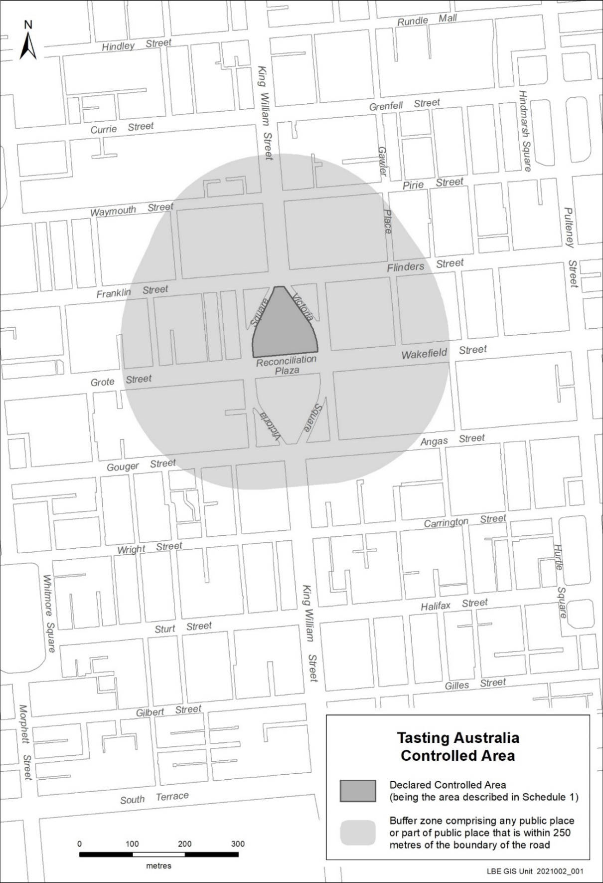
Map of Controlled Area for 2022 Tasting Australia presented by RAA Travel

Mental Health Act 2009
Authorised Mental Health Professionals
NOTICE is hereby given in accordance with Section 94(1) of the Mental Health Act 2009, that the Chief Psychiatrist has determined the following persons as Authorised Mental Health Professional:
Ingrid Cother
Elizabeth Buck
Pasqualino Vartuli
Matthew Stevens
Louise Hann
A person’s determination as an Authorised Mental Health Professional expires three years after the commencement date.
Dated: 17 March 2022
Dr J Brayley
Chief Psychiatrist

Petroleum and Geothermal Energy Act 2000
Application for Grant of Associated Activities Licence AAL 298
Pursuant to section 65(6) of the Petroleum and Geothermal Energy Act 2000 and delegation dated 29 June 2018, notice is hereby given that an application for the grant of an associated activities licence over the area described below has been received from:
Santos Limited
Delhi Petroleum Pty Ltd
Beach Energy (Operations) Limited
Vamgas Pty Ltd
Santos (NARNL Cooper) Pty Ltd
Bridge Oil Developments Pty Ltd
Alliance Petroleum Australia Pty Ltd
Basin Oil Pty Ltd
Reef Oil Pty Ltd
Santos Petroleum Pty Ltd
Santos (BOL) Pty Ltd
The application will be determined on or after 15 April 2022.
Description of application area
All that part of the State of South Australia, bounded as follows:
All coordinates MGA2020, Zone 54
447772.34mE 6887314.81mN  447782.46mE 6887358.63mN  447879.90mE 6887336.15mN  447869.79mE 6887292.32mN  448060.32mE 6887248.32mN  448453.63mE 6887128.08mN  448453.84mE 6887128.77mN  448492.09mE 6887117.08mN  448491.89mE 6887116.38mN  448781.42mE 6887027.86mN  449077.36mE 6886975.68mN  449077.48mE 6886976.40mN  449116.88mE 6886969.45mN  449116.75mE 6886968.73mN  449997.51mE 6886813.43mN  451186.69mE 6886549.80mN  451186.85mE 6886550.51mN  451225.90mE 6886541.85mN  451225.75mE 6886541.14mN  451542.06mE 6886471.01mN  451555.21mE 6886530.32mN  451750.47mE 6886487.03mN  451737.33mE 6886427.73mN  451817.97mE 6886409.85mN  452327.46mE 6886320.01mN  452666.12mE 6886241.82mN  452666.57mE 6886128.83mN  452305.51mE 6886212.19mN  451796.51mE 6886301.94mN  449976.05mE 6886705.53mN  448755.69mE 6886920.70mN  448031.83mE 6887142.01mN  444395.66mE 6887981.49mN  443712.06mE 6888177.51mN  443048.22mE 6888306.54mN  441533.30mE 6888306.54mN  441152.66mE 6888299.89mN  440772.03mE 6888306.54mN  437955.91mE 6888306.54mN  431872.53mE 6889489.02mN  430965.94mE 6889027.09mN  427313.23mE 6889090.85mN  426815.15mE 6889116.96mN  426316.48mE 6889108.25mN  425284.90mE 6889126.26mN  424252.01mE 6889096.20mN  424081.78mE 6888991.20mN  423973.59mE 6888988.05mN  423797.54mE 6889082.97mN  422378.34mE 6889041.68mN  422156.26mE 6889230.24mN  422158.03mE 6889394.84mN  422138.03mE 6889395.06mN  422140.05mE 6889582.39mN  422070.39mE 6889582.39mN  422070.39mE 6889774.74mN | 422102.97mE 6889825.89mN  422223.02mE 6889825.89mN  422223.02mE 6889775.98mN  422252.13mE 6889775.66mN  422249.21mE 6889503.87mN  422269.21mE 6889503.66mN  422266.81mE 6889280.68mN  422417.34mE 6889152.87mN  422767.42mE 6889163.06mN  422767.39mE 6889163.78mN  422807.37mE 6889164.94mN  422807.40mE 6889164.22mN  423117.73mE 6889173.25mN  423117.71mE 6889173.97mN  423157.69mE 6889175.14mN  423157.72mE 6889174.41mN  423823.81mE 6889193.79mN  423999.86mE 6889098.87mN  424049.12mE 6889100.30mN  424219.34mE 6889205.30mN  424717.05mE 6889219.78mN  424717.03mE 6889220.51mN  424757.01mE 6889221.67mN  424757.04mE 6889220.95mN  425284.25mE 6889236.28mN  426316.48mE 6889218.27mN  426817.07mE 6889227.00mN  427317.06mE 6889200.80mN  427818.38mE 6889192.05mN  427818.39mE 6889192.77mN  427858.38mE 6889192.07mN  427858.38mE 6889191.35mN  430940.44mE 6889137.55mN  431856.35mE 6889604.23mN  435547.24mE 6888886.79mN  435547.37mE 6888887.50mN  435586.64mE 6888879.87mN  435586.50mE 6888879.16mN  435645.40mE 6888867.72mN  435645.54mE 6888868.43mN  435684.80mE 6888860.80mN  435684.66mE 6888860.08mN  435939.89mE 6888810.47mN  435940.02mE 6888811.19mN  435979.29mE 6888803.55mN  435979.15mE 6888802.84mN  436126.39mE 6888774.22mN  436126.53mE 6888774.94mN  436165.80mE 6888767.30mN  436165.66mE 6888766.59mN  436234.37mE 6888753.23mN  436234.51mE 6888753.94mN  436273.78mE 6888746.31mN  436273.64mE 6888745.60mN  436332.54mE 6888734.15mN  436332.67mE 6888734.86mN | 436371.94mE 6888727.23mN  436371.80mE 6888726.52mN  436430.70mE 6888715.07mN  436430.84mE 6888715.78mN  436470.10mE 6888708.15mN  436469.96mE 6888707.44mN  436920.43mE 6888619.88mN  436920.56mE 6888620.59mN  436962.00mE 6888612.53mN  436961.87mE 6888611.82mN  437263.99mE 6888553.09mN  437264.13mE 6888553.80mN  437305.57mE 6888545.75mN  437305.43mE 6888545.03mN  437313.08mE 6888543.55mN  437313.21mE 6888544.26mN  437354.65mE 6888536.20mN  437354.52mE 6888535.49mN  437608.65mE 6888486.09mN  437608.79mE 6888486.81mN  437648.06mE 6888479.18mN  437647.92mE 6888478.47mN  437966.50mE 6888416.54mN  438591.36mE 6888416.54mN  438591.36mE 6888417.27mN  438631.36mE 6888417.27mN  438631.36mE 6888416.54mN  438991.36mE 6888416.54mN  438991.36mE 6888417.27mN  439031.36mE 6888417.27mN  439031.36mE 6888416.54mN  439491.36mE 6888416.54mN  439491.36mE 6888417.27mN  439531.37mE 6888417.27mN  439531.37mE 6888416.54mN  440772.98mE 6888416.54mN  441152.65mE 6888409.91mN  441532.34mE 6888416.54mN  443058.81mE 6888416.54mN  443737.76mE 6888284.56mN  443791.75mE 6888269.09mN  443791.96mE 6888269.78mN  443830.41mE 6888258.76mN  443830.20mE 6888258.06mN  443984.01mE 6888213.96mN  443984.21mE 6888214.65mN  444022.66mE 6888203.63mN  444022.46mE 6888202.93mN  444423.21mE 6888088.01mN  444754.71mE 6888011.49mN  444754.87mE 6888012.19mN  444793.85mE 6888003.19mN  444793.68mE 6888002.49mN  447772.34mE 6887314.81mN
AREA: 3.515 square kilometres approximately
Dated: 15 March 2022
Barry A. Goldstein
Executive Director
Energy Resources Division
Department for Energy and Mining
Delegate of the Minister for Energy and Mining

Petroleum and Geothermal Energy Act 2000
Suspension of Petroleum Retention Licences PRLs 231, 232, 233 and 237
Pursuant to section 90 of the Petroleum and Geothermal Energy Act 2000, notice is hereby given that the abovementioned Petroleum Retention Licences have been suspended for the period from 10 January 2022 to 9 January 2023 inclusive, pursuant to delegated powers dated 29 June 2018.
- PRLs 231, 232, 233 and 237 will now expire on 17 January 2025
Dated: 9 March 2022
Nick Panagopoulos
A/Executive Director
Energy Resources Division
Department for Energy and Mining
Delegate of the Minister for Energy and Mining

Planning, Development and Infrastructure Act 2016
Section 76
Amendment to the Planning and Design Code
Preamble
It is necessary to amend the Planning and Design Code (the Code) in operation at 3 March 2022 (Version 2022.4) in order to make changes:
- of form relating to the Code’s spatial layers and their relationship with land parcels. NOTE: There are no changes to the application of zone, subzone or overlay boundaries and their relationship with affected parcels or the intent of policy application as a result of this amendment.
- to correct an error with regards to the spatial application of the Minimum Frontage Technical and Numeric Variation (TNV) in the areas of Daw Park and Melrose Park.
- Pursuant to section 76 of the Planning, Development and Infrastructure Act 2016 (the Act), I hereby amend the Code in order to make changes of form (without altering the effect of underlying policy) and correct errors as follows:
- Undertake minor alterations to the geometry of the spatial layers and data in the Code to maintain the current relationship between the parcel boundaries and Code data as a result of the following:
    - New plans of division deposited in the Land Titles Office between 23 February 2021 and 8 March 2022 affecting the following spatial and data layers in the Code:
    - Zones and subzones
    - Technical and Numeric Variations
      - Building Heights (Levels)
      - Building Heights (Metres)
      - Concept Plan
      - Finished Ground and Floor Levels
      - Interface Height
      - Minimum Dwelling Allotment Size
      - Minimum Frontage
      - Minimum Site Area
    - Overlays
      - Affordable Housing
      - Coastal Areas
      - Dwelling Excision
      - Environment and Food Production Area
      - Future Road Widening
      - Hazard (Bushfire - High Risk)
      - Hazard (Bushfire - Medium Risk)
      - Hazard (Bushfire - General Risk)
      - Hazard (Bushfire - Urban Interface)
      - Hazard (Bushfire - Regional)
      - Hazard (Bushfire - Outback)
      - Heritage Adjacency
      - Local Heritage Place
      - Noise and Air Emissions
      - State Heritage Place
      - Stormwater Management
      - Urban Tree Canopy
    - Improved spatial data for existing land parcels in the following locations (as described in Column A) that affect data layers in the Code (as shown in Column B):
Location (Column A) | Layers (Column B)
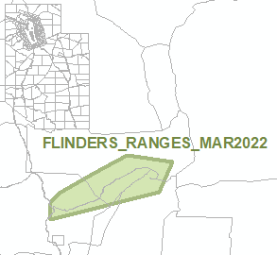  Flinders Ranges | Overlays  - Key Outback and Rural Routes
- Amending the Minimum Frontage Technical and Numeric Variation (TNV) spatial layer in the areas of Daw Park and Melrose Park by replacing the current TNV values in the ‘area affected’ identified in both Figures 1 and 2 with the following new TNV values ‘DD – 15, SD – 12, RD – 8, GD – 12, RF – 18’.
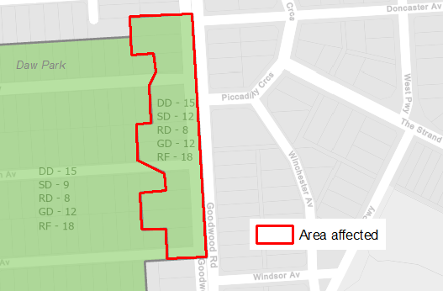
Figure 1
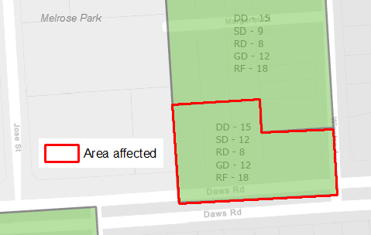
Figure 2

- In Part 13 of the Code – Table of Amendments, update the publication date, Code version number, amendment type and summary of amendments within the ‘Table of Planning and Design Code Amendments’ to reflect the amendments to the Code as described in this Notice.
- Pursuant to section 76(5)(a) of the Act, I further specify that the amendments to the Code as described in this Notice will take effect upon the date those amendments are published on the SA planning portal.
Dated: 11 March 2022
Sally Smith
Executive Director, Planning & Land Use Services,
Attorney-General’s Department
Delegate of Josh Teague MP, Minister for Planning and Local Government

Retail and Commercial Leases Act 1995
Exemption
PURSUANT to section 77(2) of the Retail and Commercial Leases Act 1995 (SA) I, Nerissa Kilvert, Acting Small Business Commissioner for the State of South Australia,
EXEMPT the Licence to be entered into in or about March 2022 between the Premier of South Australia for and on behalf of the Crown in the right of the State of South Australia and Mercury CX Incorporated trading as the Mercury Cinema in relation to the use from time to time of that portion of land defined as the ‘Licensed Area’ in the Licence which is to be entered into, being a portion of the courtyard area in the Lion Arts Centre, situated on the corner of North Terrace and Morphett Street, Adelaide in the said State.
Dated: 10 March 2022
Nerissa Kilvert
Acting Small Business Commissioner

The Police Act 1998
Authorisation to Conduct Oral Fluid Screening
I, GRANT STEVENS, Commissioner of Police, do hereby notify that on and from 7 March 2022, the following persons were authorised by the Commissioner of Police to conduct oral fluid screening as defined in and for the purposes of the:
- The Police Act 1998;
- Police Regulations 2014;
PD Number | Officer Name
73193  73893 | DEBRECINI, Karla  HARMAN, Michael
Dated: 7 March 2022
Grant Stevens
Commissioner of Police
Reference: 21/1005

THE POLICE ACT 1998
Authorisation to Conduct Urine Screening
I, GRANT STEVENS, Commissioner of Police, do hereby notify that on and from 7 January 2022, the following persons were authorised by the Commissioner of Police to conduct urine screening as defined in and for the purposes of the:
- The Police Act 1998;
- Police Regulations 2014;
PD Number | Officer Name
73193  73893 | DEBRECINI, Karla  HARMAN, Michael
Dated: 7 March 2022
Grant Stevens
Commissioner of Police
Reference: 21/3377

Local Government Instruments

The Flinders Ranges Council
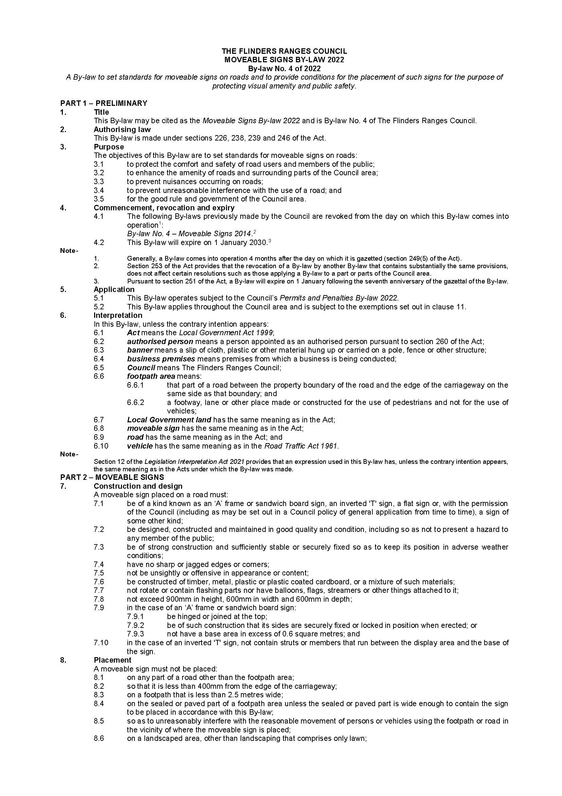
Moveable Signs By-law 2022

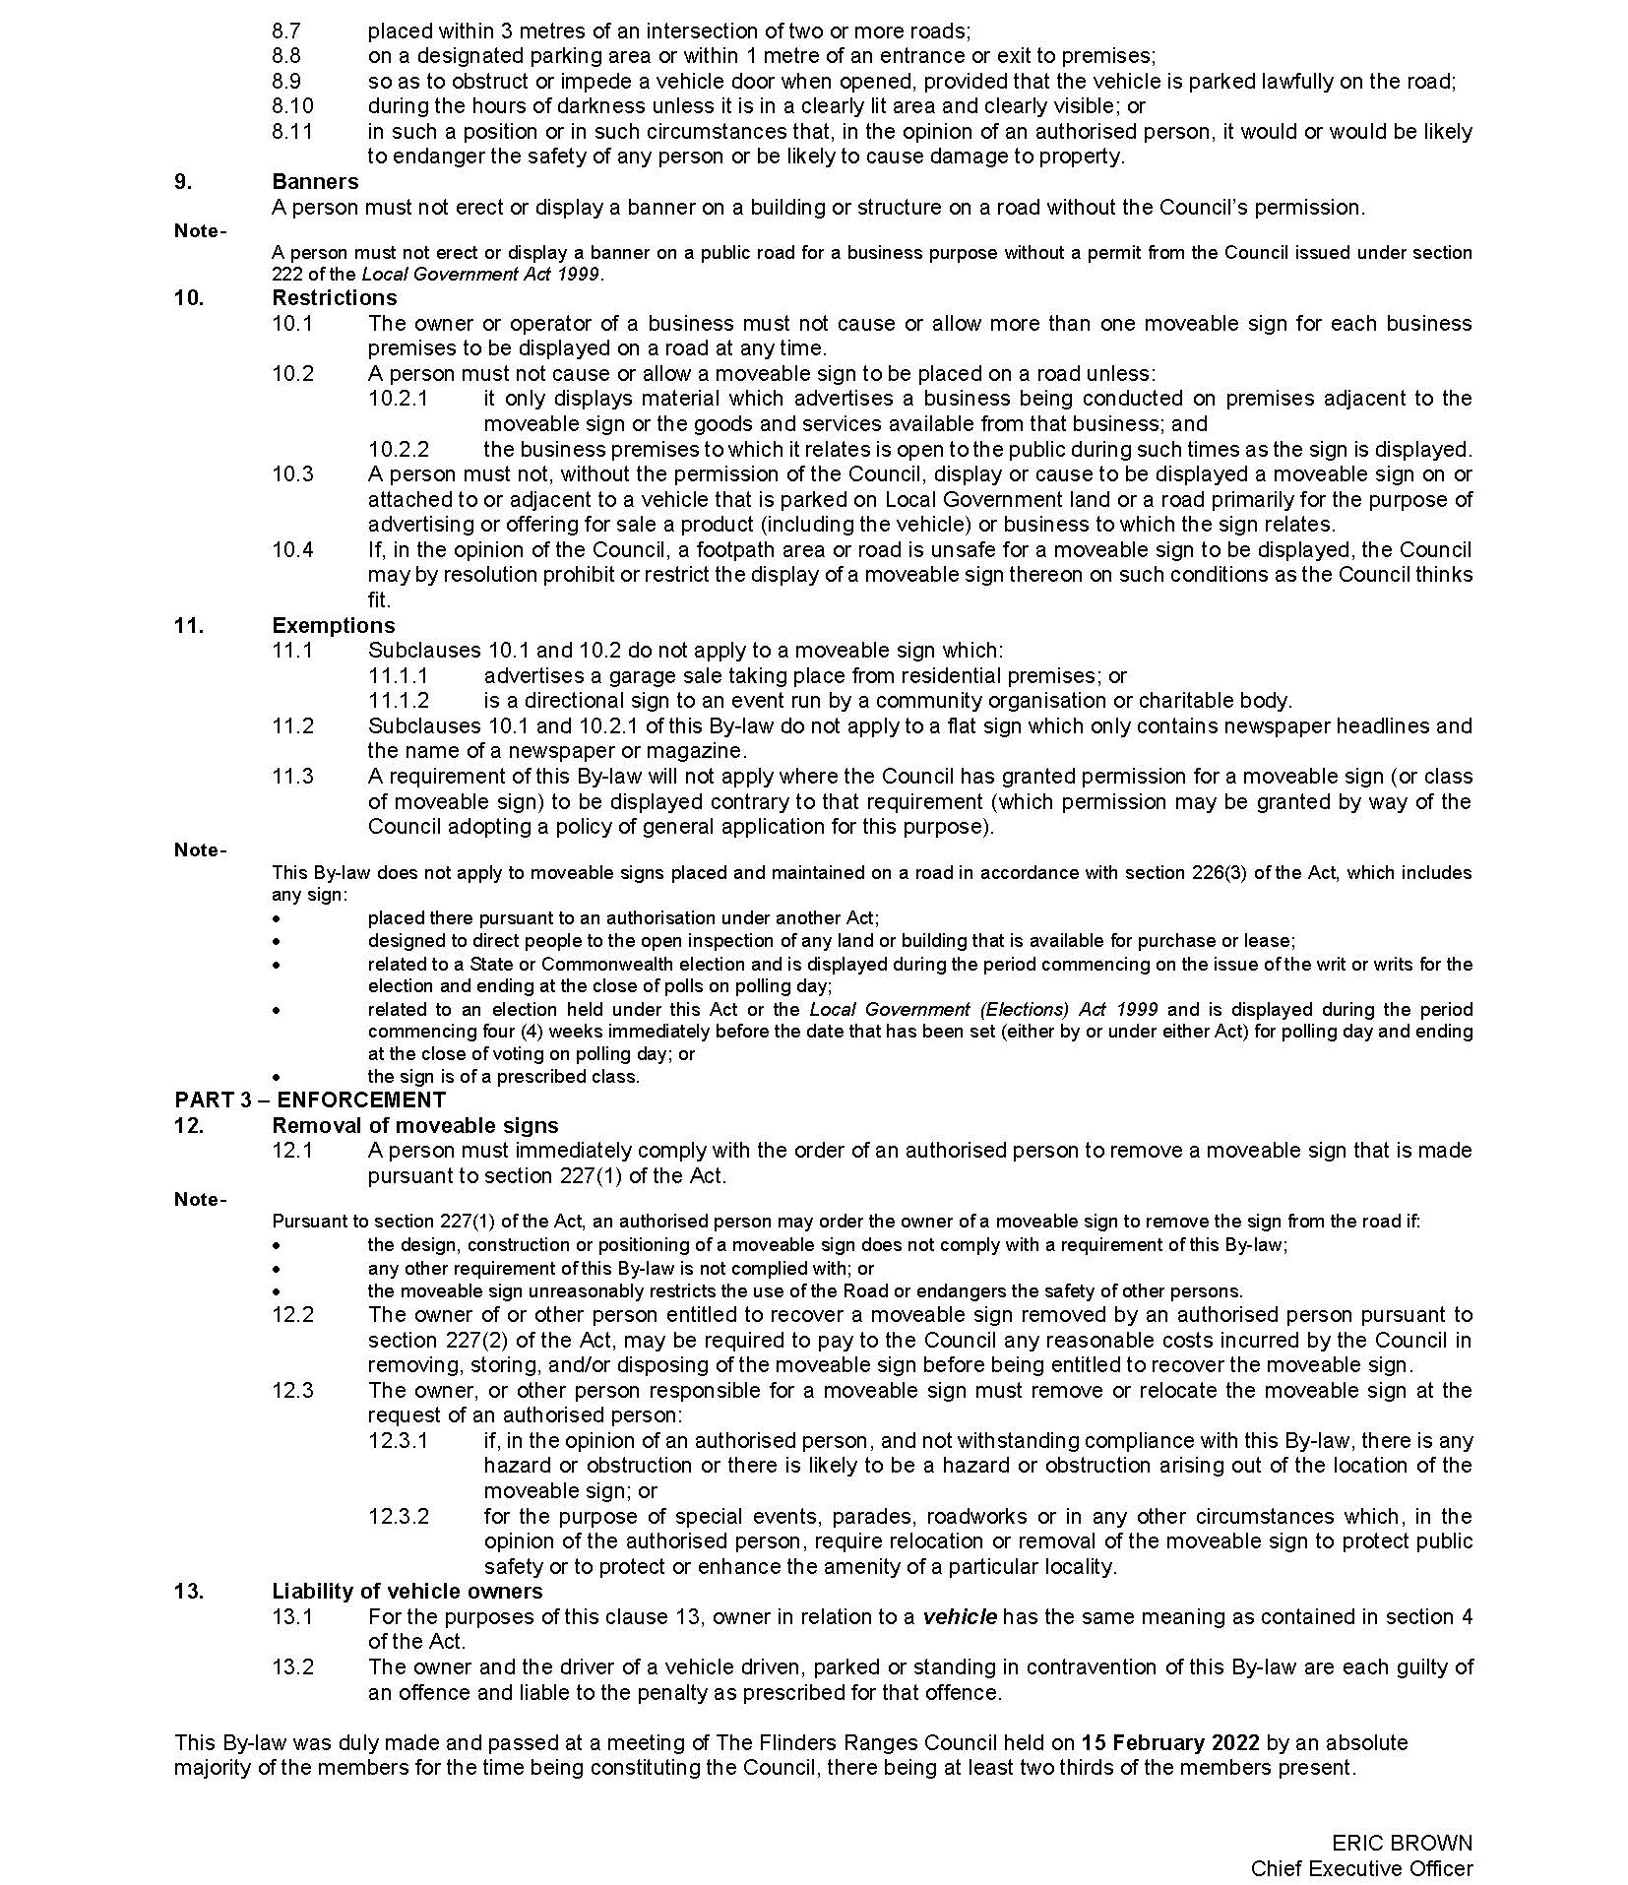

Kangaroo Island Council
Dry Zone for the New Shoots Music Festival on Kangaroo Island
Penneshaw Area
1—Extent of prohibition
The consumption of liquor is prohibited and the possession of liquor is prohibited.

2—Period of prohibition
From 10am Saturday 2nd April 2022 to 10am Sunday 3rd April 2022.

3—Description of area
The area in and surrounding the Penneshaw oval and shopping precinct as follows:
From the western boundary of Cape Willoughby Road and along the foreshore area to Cheopis Street in the east and with Mary Seymour Lane and the Penneshaw Golf Course forming the southern perimeter.
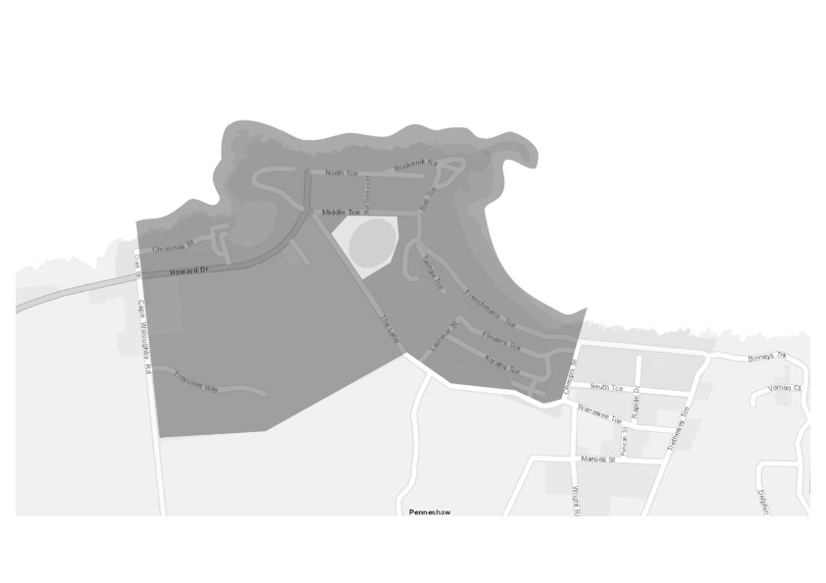
Dated: 15 March 2022
Anna Osman
Manager Community Engagement & Grants

Public Notices

National Electricity Law
Notice of Final Determination
The Australian Energy Market Commission (AEMC) gives notice under the National Electricity Law as follows:
Under s 102, the making of the final determination on the Governance of distributed energy resources technical standards (Ref. ERC0319) proposal.
Documents referred to above are available on the AEMC’s website and are available for inspection at the AEMC’s office.
Australian Energy Market Commission
Level 15, 60 Castlereagh St
Sydney NSW 2000
Telephone: (02) 8296 7800
www.aemc.gov.au
Dated: 17 March 2022

National Energy Retail Law
Notice of Final Determination
The Australian Energy Market Commission (AEMC) gives notice under the National Energy Retail Law as follows:
Under s 259, the making of the final determination on the Governance of distributed energy resources technical standards (Ref. RRC0040) proposal.
Documents referred to above are available on the AEMC’s website and are available for inspection at the AEMC’s office.
Australian Energy Market Commission
Level 15, 60 Castlereagh St
Sydney NSW 2000
Telephone: (02) 8296 7800
www.aemc.gov.au
Dated: 17 March 2022

Trustee Act 1936
Public Trustee
Estates of Deceased Persons
In the matter of the estates of the undermentioned deceased persons:
BURRIDGE Beverly late of Leighton Avenue Klemzig Retired Hairdresser who died 28 October 2021
FENNER Lindsay Max late of 8 Erin Street Broadview Retired Teacher who died 21 August 2021
JONES Stephen James late of 75 Billabong Road Ponde Retired Furniture Removalist who died 02 August 2021
LINDBLOM Thomas Raymond late of 150 Adams Road Craigmore of no occupation who died 25 May 2021
PARROTT Connie late of 9 Brenchley Grove Kingswood of no occupation who died 23 August 2021
TRUNFULL William Lewis late of 12484 Flinders Highway Sheringa of no occupation who died 21 May 2021
WAKE Brenton James late of 19A Clydesdale Avenue Glenorchy Tasmania of no occupation who died 12 April 2021
WESTOVER Ian George late of 50 Kesters Road Para Hills Retired Instrument Maker who died 22 November 2021
Notice is hereby given pursuant to the Trustee Act 1936, the Inheritance (Family Provision) Act 1972 and the Family Relationships Act 1975 that all creditors, beneficiaries, and other persons having claims against the said estates are required to send, in writing, to the office of Public Trustee at GPO Box 1338, Adelaide, 5001, full particulars and proof of such claims, on or before the 15 April 2022 otherwise they will be excluded from the distribution of the said estate; and notice is also hereby given that all persons indebted to the said estates are required to pay the amount of their debts to the Public Trustee or proceedings will be taken for the recovery thereof; and all persons having any property belonging to the said estates are forthwith to deliver same to the Public Trustee.
Dated: 17 March 2022
N. S. Rantanen
Public Trustee

Notice Submission

The South Australian Government Gazette is published each Thursday afternoon.
Notices must be emailed by 4 p.m. Tuesday, the week of publication.
Submissions are formatted per the gazette style and a proof will be supplied prior to publication, along with a quote if applicable. Please allow one day for processing notices.
Alterations to the proof must be returned by 4 p.m. Wednesday.

Gazette notices must be submitted as Word files, in the following format:
• Title—the governing legislation
• Subtitle—a summary of the notice content
• Body—structured text, which can include numbered lists, tables, and images
• Date—day, month, and year of authorisation
• Signature block—name, role, and department/organisation authorising the notice

Please provide the following information in your email:
• Date of intended publication
• Contact details of the person responsible for the notice content
• Name and organisation to be charged for the publication—Local Council and Public notices only
• Purchase order, if required—Local Council and Public notices only

Email: governmentgazettesa@sa.gov.au
Phone: (08) 7109 7760
Website: www.governmentgazette.sa.gov.au

All instruments appearing in this gazette are to be considered official, and obeyed as such

Printed and published weekly by authority of S. Smith, Government Printer, South Australia
$8.00 per issue (plus postage), $402.00 per annual subscription—GST inclusive
Online publications: www.governmentgazette.sa.gov.au

