No. 20 p. 917
THE SOUTH AUSTRALIAN
GOVERNMENT GAZETTE
Published by Authority

Adelaide, Thursday, 31 March 2022

Contents

Governor’s Instruments

Appointments 918

Emergency Management Act 2004 918

Proclamations—
Administrative Arrangements (Committal of Acts)
Proclamation 2022 920
Public Sector (Alteration of Title of Department)
Proclamation 2022 921

State Government Instruments

Fisheries Management (Prawn Fisheries) Regulations 2017 922

Housing Improvement Act 2016 924

Justices of the Peace Act 2005 925

Land Acquisition Act 1969 925

Petroleum and Geothermal Energy Act 2000 928

Planning, Development and Infrastructure Act 2016 929

The District Court of South Australia 938

Local Government Instruments

City of Charles Sturt 940

City of Onkaparinga 940

Tatiara District Council 940

Wakefield Regional Council 940

Public Notices

National Gas Law 941

Trustee Act 1936 941

University of Adelaide Act 1971 941

Governor’s Instruments

Appointments
Department of the Premier and Cabinet
Adelaide, 31 March 2022
Her Excellency the Governor in Executive Council has been pleased to appoint Dr James Muecke AM as Governor's Deputy of South Australia for the period from 8.45am on Monday, 4 April 2022 until 5.00pm on Wednesday, 6 April 2022.
By command,
Peter Bryden Malinauskas
Premier

Department of the Premier and Cabinet
Adelaide, 31 March 2022
Her Excellency the Governor in Executive Council has been pleased to appoint the Honourable Chief Justice Christopher John Kourakis as Governor’s Deputy of South Australia for the periods from 7.30am on Saturday, 9 April 2022 until 11.59pm on Saturday, 9 April 2022 and from 8.30am on Tuesday, 12 April 2022 until 6.00pm on Wednesday, 13 April 2022.
By command,
Peter Bryden Malinauskas
Premier

Department of the Premier and Cabinet
Adelaide, 31 March 2022
Her Excellency the Governor in Executive Council has been pleased to appoint the Honourable Justice Mark Christopher Livesey as Governor’s Deputy of South Australia for the period from 12.00am on Sunday, 10 April 2022 until 4.30pm on Sunday, 10 April 2022.
By command,
Peter Bryden Malinauskas
Premier

Emergency Management Act 2004
Section 23
Approval by the Governor of Extension of a Major Emergency Declaration
Recital
The State Co-ordinator declared a Major Emergency on 22 March 2020 under section 23(1) of the Emergency Management Act 2004 (the Act) in respect of the outbreak of the human disease named COVID-19 within South Australia (the Declaration).
With the advice and consent of the Executive Council and pursuant to section 23(2) of the Act, on the days and for the periods set out below, His Excellency the Governor approved an extension of the Declaration.
On 2 April 2020 for a period of 28 days to commence on 4 April 2020.
On 30 April 2020 for a period of 28 days to commence on 2 May 2020.
On 28 May 2020 for a period of 28 days to commence on 30 May 2020.
On 27 June 2020 for a period of 28 days to commence on 27 June 2020.
On 23 July 2020 for a period of 28 days to commence on 25 July 2020.
On 20 August 2020 for a period of 28 days to commence on 22 August 2020.
On 17 September 2020 for a period of 28 days to commence on 19 September 2020.
On 15 October 2020 for a period of 28 days to commence on 17 October 2020.
On 12 November 2020 for a period of 28 days to commence on 14 November 2020.
On 10 December 2020 for a period of 28 days to commence on 12 December 2020.
On 6 January 2021 for a period of 28 days to commence on 9 January 2021.
On 4 February 2021 for a period of 28 days to commence on 6 February 2021.
On 4 March 2021 for a period of 28 days to commence on 6 March 2021.
On 1 April 2021 for a period of 28 days to commence on 3 April 2021.
On 29 April 2021 for a period of 28 days to commence on 1 May 2021.
On 27 May 2021 for a period of 28 days to commence on 29 May 2021.
On 24 June 2021 for a period of 28 days to commence 26 June 2021.
On 22 July 2021 for a period of 28 days to commence 24 July 2021.
On 18 August 2021 for a period of 28 days to commence 21 August 2021.
With the advice and consent of the Executive Council and pursuant to section 23(2) of the Act, on the days and for the periods set out below, Her Excellency the Administrator approved an extension of the Declaration.
On 16 September 2021 for a period of 28 days to commence 18 September 2021.
With the advice and consent of the Executive Council and pursuant to section 23(2) of the Act, on the days and for the periods set out below, Her Excellency the Governor approved an extension of the Declaration.
On 14 October 2021 for a period of 28 days to commence 16 October 2021.
On 11 November 2021 for a period of 28 days to commence 13 November 2021.
On 9 December 2021 for a period of 28 days to commence 11 December 2021.
On 7 January 2022 for a period of 28 days to commence 8 January 2022.
On 3 February 2022 for a period of 28 days to commence 5 February 2022.
On 2 March 2022 for a period of 28 days to commence 5 March 2022.

PURSUANT to section 23(2) of the Act and with the advice and consent of the Executive Council, I NOW approve a further extension of the Declaration for a period of 28 days commencing on 2 April 2022.
Given under my hand and the Public Seal of South Australia at Adelaide on Thursday, 31 March 2022.
Governor

Proclamations
South Australia

Administrative Arrangements (Committal of Acts) Proclamation 2022
under section 5 of the Administrative Arrangements Act 1994
1—Short title
This proclamation may be cited as the Administrative Arrangements (Committal of Acts) Proclamation 2022.
2—Commencement
This proclamation comes into operation on the day on which it is made.
3—Committal of Acts
The administration of an Act referred to in Schedule 1 is committed to the Minister whose title appears at the head of the list in which the Act appears.
Schedule 1—Acts committed to Ministers
Minister for Aboriginal Affairs
Aboriginal Heritage Act 1979
Minister for Industrial Relations and Public Sector
Public Sector Act 2009
Public Sector (Data Sharing) Act 2016
Public Sector (Honesty and Accountability) Act 1995
Standard Time Act 2009
Made by the Governor
with the advice and consent of the Executive Council
on 31 March 2022

South Australia

Public Sector (Alteration of Title of Department) Proclamation 2022
under section 26 of the Public Sector Act 2009
1—Short title
This proclamation may be cited as the Public Sector (Alteration of Title of Department) Proclamation 2022.
2—Commencement
This proclamation comes into operation on the day on which it is made.
3—Alteration of title of department
The title of the Department for Climate, Environment and Water is altered to the Department for Environment and Water.
Made by the Governor
with the advice and consent of the Executive Council
on 31 March 2022

State Government Instruments

Fisheries Management (Prawn Fisheries) Regulations 2017
March 2022 Survey in the West Coast Prawn Fishery
TAKE notice that pursuant to regulation 10 of the Fisheries Management (Prawn Fisheries) Regulations 2017, the notice dated 5 October 2021 on page 3721 of the South Australian Government Gazette of 7 October 2021, prohibiting fishing activities in the West Coast Prawn Fishery is HEREBY varied such that it will not apply to the holders of a West Coast Prawn Fishery licence issued pursuant to the Fisheries Management (Prawn Fisheries) Regulations 2017 listed in Schedule 1 or their register master insofar as they may use prawn trawl nets in accordance with the conditions of their fishery licence for the purpose of undertaking a prawn survey during the period specified in Schedule 2, subject to the conditions contained in Schedule 3 unless this notice is varied or revoked.
Schedule 1
Licence Number | Licence Holder / Master | Boat Name | Trawl Survey Area
D01 | Bosanquet Bay Pty Ltd /Steve Paleologoudias | Bosanquet Bay | Venus Bay
D03 | Limnos Fishing Pty Ltd /Terry Paleologoudias | Limnos | Ceduna
Schedule 2
Commencing at sunset on 24 March 2022 and ending at sunrise on 27 March 2022.
Schedule 3
- The licence holder listed in Schedule 1 or their register master must operate within the trawl survey area nominated in the table in Schedule 1.
- For the purposes of this notice the trawl survey areas cannot include any waters of a habitat protection zone or a sanctuary zone of a marine park established under the Marine Parks Act 2007.
- The registered master must keep a ‘skippers log’ to record catch information during the survey.
- All fish, other than King Prawns, Southern Calamari, Gould’s Squid, Scallops, Octopus and Balmain Bugs taken during the exempted activity for survey purposes, are to be returned to the water immediately after capture.
- The licence holders listed in Schedule 1 or their register master must comply with all regulations and conditions that apply to fishing activities undertaken pursuant to their licence, in addition to the conditions imposed by this exemption.
- While engaged in fishing activities or unloading the survey catch, the licence holder listed in Schedule 1 or their register master must have a copy of this notice on board the boat or near his person. This notice must be produced to a Fisheries Officer if requested.
- The licence holders listed in Schedule 1 or their register master must not contravene or fail to comply with the Fisheries Management Act 2007, or any other regulations made under that Act except where specifically exempted by this notice.
This notice does not purport to override the provisions or operation of any other Act including, but not limited to, the Marine Parks Act 2007. The notice holder and his agents must comply with any relevant regulations, permits, requirements and directions from the Department for Environment and Water when undertaking activities within a marine park.
Dated: 22 March 2022
Craig Noell
A/Prawn Fishery Manager
Delegate of the Minister for Primary Industries and Regional Development

Fisheries Management (Prawn Fisheries) Regulations 2017
March/April 2022 Fishing for the West Coast Prawn Fishery
TAKE notice that pursuant to regulation 10 of the Fisheries Management (Prawn Fisheries) Regulations 2017, the notice dated 5 October 2021 on page 3721 of the South Australian Government Gazette of 7 October 2021, prohibiting fishing activities in the West Coast Prawn Fishery is HEREBY varied such that it will not be unlawful for a person fishing pursuant to a West Coast Prawn Fishery licence to use prawn trawl nets in the areas specified in Schedule 1, during the period specified in Schedule 2, and under the conditions specified in Schedule 3.
Schedule 1
The waters of the West Coast Prawn Fishery excluding Ceduna as defined in the West Coast Prawn Fishery Harvest Strategy.
Schedule 2
Commencing at sunset on 27 March 2022 and ending at sunrise on 9 April 2022.
Schedule 3
- Each licence holder of a fishing licence undertaking fishing activities pursuant to this notice must ensure that a representative sample of catch (a 'bucket count') is taken at least 3 times per night during the fishing activity.
- Each 'bucket count' sample must be accurately weighed to 7kg where possible and the total number of prawns contained in the bucket must be recorded on the daily catch and effort return.
- Fishing must cease if one of the following limits is reached:
  - A total of 14 nights of fishing are completed
  - The average catch per vessel, per night (for all 3 vessels) drops below 300 kg for two consecutive nights
  - The average 'bucket count' for all vessels exceeds 240 prawns per 7kg bucket on any single fishing night in the Coffin Bay area
  - The average 'bucket count' for all vessels exceeds 250 prawns per 7kg bucket on any single fishing night in the Venus Bay area.
- Each licence holder, or registered master of a fishing license undertaking fishing activities must provide a daily report by telephone or SMS message, via a nominated representative, to the Department of Primary Industries and Regions, Prawn Fishery Manager, providing the following information for all vessels operating in the fishery from the previous nights fishing:
  - average prawn catch; and
  - the average prawn 'bucket count'
- No fishing activity may be undertaken after the expiration of 30 minutes from the prescribed time of sunrise and no fishing activity may be undertaken before the prescribed time of sunset for Adelaide (as published in the South Australian Government Gazette pursuant to the requirements of the Proof of Sunrise and Sunset Act 1923) during the period specified in Schedule 2.
Dated: 22 March 2022
Craig Noell
A/Prawn Fishery Manager
Delegate of the Minister for Primary Industries and Regional Development

Fisheries Management (Prawn Fisheries) Regulations 2017
Variation to prohibited Fishing Activities in the Spencer Gulf Prawn Fishery
TAKE NOTE that pursuant to regulation 10 of the Fisheries Management (Prawn Fisheries) Regulations 2017, the notice dated 28 September 2021 on page 3654 of the South Australian Government Gazette on 30 September 2021 prohibiting fishing activities in the Spencer Gulf Prawn Fishery, is hereby varied such that it will not be unlawful for a person fishing pursuant to a Spencer Gulf Prawn Fishery licence to use prawn trawl nets in the areas specified in Schedule 1, during the period specified in Schedule 2, and under the conditions specified in Schedule 3.
Schedule 1
The waters of the Spencer Gulf Prawn Fishery:
- Except the Northern Closure area, which is defined as the area north of the following index points:
1. | 34 | ° | 11.00 | S |  | 137 | ° | 30.00 | E
2. | 34 | ° | 11.00 | S |  | 137 | ° | 01.00 | E
3. | 34 | ° | 14.00 | S |  | 136 | ° | 58.30 | E
4. | 34 | ° | 14.00 | S |  | 136 | ° | 55.00 | E
5. | 34 | ° | 25.00 | S |  | 136 | ° | 55.00 | E
6. | 34 | ° | 25.00 | S |  | 136 | ° | 49.00 | E
7. | 34 | ° | 29.00 | S |  | 136 | ° | 48.00 | E
8. | 34 | ° | 29.00 | S |  | 136 | ° | 44.30 | E
9. | 34 | ° | 33.50 | S |  | 136 | ° | 40.30 | E
10. | 34 | ° | 33.50 | S |  | 136 | ° | 39.00 | E
11. | 34 | ° | 10.00 | S |  | 136 | ° | 45.00 | E
12. | 34 | ° | 05.00 | S |  | 136 | ° | 45.50 | E
13. | 33 | ° | 57.60 | S |  | 137 | ° | 00.70 | E
14. | 33 | ° | 56.00 | S |  | 136 | ° | 59.00 | E
15. | 33 | ° | 57.60 | S |  | 136 | ° | 56.00 | E
16. | 33 | ° | 48.50 | S |  | 136 | ° | 46.50 | E
- Except the Cowell Closure area, which is defined as the area within the following index points:
1. | 33 | ° | 53.90 | S |  | 136 | ° | 47.60 | E
2. | 34 | ° | 00.40 | S |  | 136 | ° | 55.00 | E
3. | 34 | ° | 05.00 | S |  | 136 | ° | 45.60 | E
4. | 34 | ° | 03.30 | S |  | 136 | ° | 43.90 | E
5. | 34 | ° | 00.60 | S |  | 136 | ° | 48.30 | E
6. | 33 | ° | 56.10 | S |  | 136 | ° | 43.40 | E
7. | 33 | ° | 53.90 | S |  | 136 | ° | 47.60 | E
- Except the Wardang Closure area, which is defined as the waters contained within the following index points:
1. | 34 | ° | 10.00 | S |  | 137 | ° | 28.00 | E
2. | 34 | ° | 21.00 | S |  | 137 | ° | 12.00 | E
3. | 34 | ° | 45.00 | S |  | 137 | ° | 15.00 | E
4. | 34 | ° | 48.53 | S |  | 137 | ° | 09.45 | E
5. | 34 | ° | 48.53 | S |  | 137 | ° | 06.00 | E
6. | 34 | ° | 50.75 | S |  | 137 | ° | 06.00 | E
7. | 34 | ° | 54.00 | S |  | 137 | ° | 01.00 | E
- Except the Corny closure area, which is defined as the waters within and bounded by the following closure index points:
1. | 34 | ° | 27.00 | S |  | 136 | ° | 53.00 | E
2. | 34 | ° | 27.00 | S |  | 137 | ° | 02.00 | E
3. | 34 | ° | 35.00 | S |  | 136 | ° | 56.00 | E
4. | 34 | ° | 48.60 | S |  | 136 | ° | 52.00 | E
5. | 34 | ° | 54.00 | S |  | 136 | ° | 52.00 | E
6. | 34 | ° | 54.00 | S |  | 136 | ° | 48.50 | E
7. | 34 | ° | 49.50 | S |  | 136 | ° | 48.50 | E
8. | 34 | ° | 49.50 | S |  | 136 | ° | 40.50 | E
9. | 34 | ° | 39.50 | S |  | 136 | ° | 40.50 | E
Then back to point 1
- Except the Illusions closure area, which is defined as the waters contained within the following closure index points:
1. | 33 | ° | 28.80 | S |  | 137 | ° | 32.2 | E
2. | 33 | ° | 28.30 | S |  | 137 | ° | 33.2 | E
3. | 33 | ° | 28.85 | S |  | 137 | ° | 33.5 | E
4. | 33 | ° | 29.40 | S |  | 137 | ° | 32.5 | E
Then back to point 1

- Except the Jurassic Park closure area, which is defined as the waters contained within the following closure index points:
1. | 33 | ° | 54.90 | S |  | 137 | ° | 17.60 | E
2. | 33 | ° | 54.40 | S |  | 137 | ° | 19.40 | E
3. | 33 | ° | 54.70 | S |  | 137 | ° | 19.60 | E
4. | 33 | ° | 55.20 | S |  | 137 | ° | 17.80 | E
Then back to point 1
- Except the Estelle Star closure area, which is defined as the waters contained within the following closure index points:
1. | 33 | ° | 58.8 | S |  | 136 | ° | 49.8 | E
2. | 33 | ° | 58.2 | S |  | 136 | ° | 51 | E
3. | 33 | ° | 59.1 | S |  | 136 | ° | 51.7 | E
4. | 33 | ° | 59.8 | S |  | 136 | ° | 50.4 | E
Then back to point 1
Schedule 2
Commencing at sunset on 29 March 2022 and ending at sunrise on the 31 March 2022.
Schedule 3
- The coordinates in Schedule 1 are defined as degrees decimal minutes and are based on the World Geodetic System 1984 (WGS 84).
- No fishing activity may be undertaken between the prescribed times of sunrise and sunset for Adelaide (as published in the South Australian Government Gazette pursuant to the requirements of the Proof of Sunrise and Sunset Act 1923) during the period specified in Schedule 2.
- Fishing must cease:
  - in the fishing area known as the ‘Mid/North Gulf’ area (as described on page 40 of the Management Plan for the South Australian Commercial Spencer Gulf Prawn Fishery October 2020) if the average catch per vessel, per night (based on the best information available to the committee at sea) drops below 500kg; and
  - in the fishing area known as the ‘Southern Gulf’ area (as described on page 40 of the Management Plan for the South Australian Commercial Spencer Gulf Prawn Fishery October 2020) if the average catch per vessel over two consecutive nights (based on the best information available to the committee at sea) falls below 350kg.
- Based on the best information available from the fleet, fishing must cease in an area in the Mid/North Gulf if the average prawn bucket count exceeds 240 prawns per 7kg; or in an area in the Southern Gulf if the average prawn bucket count exceeds 260 prawns/7kg.
- No fishing activity may occur without the authorisation of Coordinator at Sea, Ashley Lukin, or other nominated Coordinator at Sea appointed by the Spencer Gulf and West Coast Prawn Fishermen’s Association.
- The authorisation of the Coordinator at Sea must be in writing, signed and record the day, date, and permitted fishing area within the waters of Schedule 1 in the form of a notice sent to the fishing fleet or vary an earlier authorisation issued by the Coordinator at Sea.
- The Coordinator at Sea must cause a copy of any authorisation for fishing activity or variation of same, made under this notice to be emailed to the Prawn Fisheries Manager immediately after it is made.
- The Spencer Gulf and West Coast Prawn Fishermen’s Association must keep records of all authorisations issued pursuant to this notice.
Dated: 29 March 2022
Ashley Lukin
Coordinator at Sea, Spencer Gulf & West Coast Prawn Fishermen’s Association Inc.
Delegate of the Minister for Primary Industries and Regional Development

Housing Improvement Act 2016
Rent Control
The Minister for Human Services Delegate in the exercise of the powers conferred by the Housing Improvement Act 2016, does hereby fix the maximum rental per week which shall be payable subject to Section 55 of the Residential Tenancies Act 1995, in respect of each house described in the following table. The amount shown in the said table shall come into force on the date of this publication in the Gazette.
Address of Premises | Allotment  Section | Certificate of Title  Volume Folio | Maximum Rental  per week payable
7 Pilsdon Street, Davoren Park SA 5113 | Allotment 2 Deposited Plan 65406  Hundred of Munno Para | CT 5952/882 | $0.00  Unfit for human habitation
Dated: 31 March 2022
Craig Thompson
Housing Regulator and Registrar
Housing Safety Authority, SAHA
Delegate of Minister for Human Services

Housing Improvement Act 2016
Rent Control Revocations
Whereas the Minister for Human Services Delegate is satisfied that each of the houses described hereunder has ceased to be unsafe or unsuitable for human habitation for the purposes of the Housing Improvement Act 2016, notice is hereby given that, in exercise of the powers conferred by the said Act, the Minister for Human Services Delegate does hereby revoke the said Rent Control in respect of each property.
Address of Premises | Allotment  Section | Certificate of Title  Volume Folio
9 Thomas Street, Aldinga Beach SA 5173 | Allotment 623 Deposited Plan 73341 Hundred of Willunga | CT5984/56
73 Oliver Road, Reeves Plains SA 5502 | Allotment 1 Deposited Plan 70881 Hundred of Port Gawler | CT5971/420
254 Survey Road, Bangor SA 5481 | Section 392 Hundred Plan 331300 Hundred of Wongyarra | CT5853/941
37 Jane Place, Tanunda SA 5352 | Allotment 110 Filed Plan 36577 Hundred of Moorooroo | CT5315/100
Unit 5/128 Sixth Avenue, Joslin SA 5070 | Unit 5 Strata Plan 3314 Hundred of Joslin | CT 5031/385
Dated: 31 March 2022
Craig Thompson
Housing Regulator and Registrar
Housing Safety Authority, SAHA
Delegate of Minister for Human Services

Justices of the Peace Act 2005
Section 4
Appointment of Justices of the Peace for South Australia
Notice by the Commissioner for Consumer Affairs
I, Dini Soulio, Commissioner for Consumer Affairs, delegate of the Attorney-General, pursuant to section 4 of the Justices of the Peace Act 2005, do hereby appoint the people listed as Justices of the Peace for South Australia as set out below.
For a period of ten years for a term commencing on 12 April 2022 and expiring on 11 April 2032:
Elizabeth Ann WILLIAMS
Jonathan Scott VASEY
Trevor William TUCKER
Pauline Joy THOMPSON
Heather Anne THOMPSON
Ramon THALBOURNE
Michael Crawford STONE
James Devron SIVIOUR
Fiona Josephine SHIGROV
Richard RASHEED
William Douglas PERRY
Joseph Dean NICOTRA
Derek William MILLIGAN
Voula MESTROS
Kym Francis LYNCH
Kith LIM
Garry John LEES
Mark Stanley HULME
Mark Anthony HEINRICH
Simon John GLIESSERT
Brenton Trevor GILL
Elle-Mae Theresa GAZZOLA
Martin Ronald FORGAN
Elaine Maureen DONALDSON
David Ian COOMBE
Joyce Lorraine BREWSTER
Ian Stanford BLUNTISH
Robert George ADAM
Dated: 24 March 2022
Dini Soulio
Commissioner for Consumer Affairs
Delegate of the Attorney-General

Land Acquisition Act 1969
Section 16
Form 5 – Notice of Acquisition
1. Notice of acquisition
The Commissioner of Highways (the Authority), of 50 Flinders Street, Adelaide SA 5000, acquires the following interests in the following land:
Comprising an estate in fee simple in that piece of land being the whole of Allotments 14, 15 and 16 in Filed Plan No 7195 comprised in Certificate of Title Volume 5595 Folio 772, subject to the right(s) of way over the within Allotment 14 (T1729922).
This notice is given under section 16 of the Land Acquisition Act 1969.
2. Compensation
A person who has or had an interest consisting of native title or an alienable interest in the land that is divested or diminished by the acquisition or the enjoyment of which is adversely affected by the acquisition who does not receive an offer of compensation from the Authority may apply to the Authority for compensation.
2A. Payment of professional costs relating to acquisition (section 26B)
If you are the owner in fee simple of the land to which this notice relates, you may be entitled to a payment of up to $10 000 from the Authority for use towards the payment of professional costs in relation to the acquisition of the land.
Professional costs include legal costs, valuation costs and any other costs prescribed by the Land Acquisition Regulations 2019.
3. Inquiries
Inquiries should be directed to: Petrula Pettas
GPO Box 1533
Adelaide SA 5001
Telephone: (08) 8343 2619
Dated: 29 March 2022
The Common Seal of the COMMISSIONER OF HIGHWAYS was hereto affixed by authority of the Commissioner in the presence of:
Rocco Caruso
Manager, Property Acquisition (Authorised Officer)
Department for Infrastructure and Transport
DIT 2021/15295/01

Land Acquisition Act 1969
Section 16
Form 5 – Notice of Acquisition
1. Notice of acquisition
The Commissioner of Highways (the Authority), of 50 Flinders Street, Adelaide SA 5000, acquires the following interests in the following land:
Comprising an unencumbered estate in fee simple in that piece of land being portion of Allotment 55 in Deposited Plan No 127009 comprised in Certificate of Title Volume 6259 Folio 127, and being the whole of the land identified as Allotment 200 in D128759 lodged in the Lands Titles Office.
This notice is given under section 16 of the Land Acquisition Act 1969.
2. Compensation
A person who has or had an interest consisting of native title or an alienable interest in the land that is divested or diminished by the acquisition or the enjoyment of which is adversely affected by the acquisition who does not receive an offer of compensation from the Authority may apply to the Authority for compensation.
2A. Payment of professional costs relating to acquisition (section 26B)
If you are the owner in fee simple of the land to which this notice relates, you may be entitled to a payment of up to $10 000 from the Authority for use towards the payment of professional costs in relation to the acquisition of the land.
Professional costs include legal costs, valuation costs and any other costs prescribed by the Land Acquisition Regulations 2019.
3. Inquiries
Inquiries should be directed to: William Ridgway
GPO Box 1533
Adelaide SA 5001
Telephone: (08) 7109 7672
Dated: 30 March 2022
The Common Seal of the COMMISSIONER OF HIGHWAYS was hereto affixed by authority of the Commissioner in the presence of:
Rocco Caruso
Manager, Property Acquisition (Authorised Officer)
Department for Infrastructure and Transport
DIT 2020/11300

Land Acquisition Act 1969
Section 16
Form 5 – Notice of Acquisition
1. Notice of acquisition
The Commissioner of Highways (the Authority), of 50 Flinders Street, Adelaide SA 5000, acquires the following interests in the following land:
Comprising an unencumbered estate in fee simple in that piece of land being the whole of Allotment 191 in Deposited Plan No 4728 comprised in Certificate of Title Volume 5652 Folio 364.
This notice is given under section 16 of the Land Acquisition Act 1969.
2. Compensation
A person who has or had an interest consisting of native title or an alienable interest in the land that is divested or diminished by the acquisition or the enjoyment of which is adversely affected by the acquisition who does not receive an offer of compensation from the Authority may apply to the Authority for compensation.
2A. Payment of professional costs relating to acquisition (section 26B)
If you are the owner in fee simple of the land to which this notice relates, you may be entitled to a payment of $10 000 from the Authority for use towards the payment of professional costs in relation to the acquisition of the land.
Professional costs include legal costs, valuation costs and any other costs prescribed by the Land Acquisition Regulations 2019.
3. Inquiries
Inquiries should be directed to: Rob Gardner
GPO Box 1533
Adelaide SA 5001
Telephone: (08) 8343 2567
Dated: 29 March 2022
The Common Seal of the COMMISSIONER OF HIGHWAYS was hereto affixed by authority of the Commissioner in the presence of:
Rocco Caruso
Manager, Property Acquisition (Authorised Officer)
Department for Infrastructure and Transport
DIT 2021/04508/01

Land Acquisition Act 1969
Section 16
Form 5 – Notice of Acquisition
1. Notice of acquisition
The Commissioner of Highways (the Authority), of 50 Flinders Street, Adelaide SA 5000, acquires the following interests in the following land:
Comprising an unencumbered estate in fee simple in that piece of land being the whole of Allotment 97 in Filed plan No 12864 comprised in Certificate of Title Volume 5682 Folio 203.
This notice is given under section 16 of the Land Acquisition Act 1969.
2. Compensation
A person who has or had an interest consisting of native title or an alienable interest in the land that is divested or diminished by the acquisition or the enjoyment of which is adversely affected by the acquisition who does not receive an offer of compensation from the Authority may apply to the Authority for compensation.
2A. Payment of professional costs relating to acquisition (section 26B)
If you are the owner in fee simple of the land to which this notice relates, you may be entitled to a payment of up to $10 000 from the Authority for use towards the payment of professional costs in relation to the acquisition of the land.
Professional costs include legal costs, valuation costs and any other costs prescribed by the Land Acquisition Regulations 2019.
3. Inquiries
Inquiries should be directed to: Rob Gardner
GPO Box 1533
Adelaide SA 5001
Telephone: (08) 8343 2567
Dated: 29 March 2022
The Common Seal of the COMMISSIONER OF HIGHWAYS was hereto affixed by authority of the Commissioner in the presence of:
Rocco Caruso
Manager, Property Acquisition (Authorised Officer)
Department for Infrastructure and Transport
DIT 2021/04774/01

Land Acquisition Act 1969
Section 16
Form 5 – Notice of Acquisition
1. Notice of acquisition
The Commissioner of Highways (the Authority), of 50 Flinders Street, Adelaide SA 5000, acquires the following interests in the following land:
Comprising an unencumbered estate in fee simple in that piece of land being the whole of Allotment 192 in Deposited Plan No 4728 comprised in Certificate of Title Volume 5263 Folio 583.
This notice is given under section 16 of the Land Acquisition Act 1969.
2. Compensation
A person who has or had an interest consisting of native title or an alienable interest in the land that is divested or diminished by the acquisition or the enjoyment of which is adversely affected by the acquisition who does not receive an offer of compensation from the Authority may apply to the Authority for compensation.
2A. Payment of professional costs relating to acquisition (section 26B)
If you are the owner in fee simple of the land to which this notice relates, you may be entitled to a payment of $10 000 from the Authority for use towards the payment of professional costs in relation to the acquisition of the land.
Professional costs include legal costs, valuation costs and any other costs prescribed by the Land Acquisition Regulations 2019.
3. Inquiries
Inquiries should be directed to: Rob Gardner
GPO Box 1533
Adelaide SA 5001
Telephone: (08) 8343 2567

Dated: 29 March 2022
The Common Seal of the COMMISSIONER OF HIGHWAYS was hereto affixed by authority of the Commissioner in the presence of:
Rocco Caruso
Manager, Property Acquisition (Authorised Officer)
Department for Infrastructure and Transport
DIT 2021/04517/01

Land Acquisition Act 1969
Section 16
Form 5 – Notice of Acquisition
1. Notice of acquisition
The Commissioner of Highways (the Authority), of 50 Flinders Street, Adelaide SA 5000, acquires the following interests in the following land:
Comprising an unencumbered estate in fee simple in that piece of land being the whole of Allotment 67 in Filed Plan No 148103 comprised in Certificate of Title Volume 5362 Folio 741, together with easement(s) over the land marked “A”.
This notice is given under section 16 of the Land Acquisition Act 1969.
2. Compensation
A person who has or had an interest consisting of native title or an alienable interest in the land that is divested or diminished by the acquisition or the enjoyment of which is adversely affected by the acquisition who does not receive an offer of compensation from the Authority may apply to the Authority for compensation.
2A. Payment of professional costs relating to acquisition (section 26B)
If you are the owner in fee simple of the land to which this notice relates, you may be entitled to a payment of $10 000 from the Authority for use towards the payment of professional costs in relation to the acquisition of the land.
Professional costs include legal costs, valuation costs and any other costs prescribed by the Land Acquisition Regulations 2019.
3. Inquiries
Inquiries should be directed to: Rob Gardner
GPO Box 1533
Adelaide SA 5001
Telephone: (08) 8343 2567
Dated: 29 March 2022
The Common Seal of the COMMISSIONER OF HIGHWAYS was hereto affixed by authority of the Commissioner in the presence of:
Rocco Caruso
Manager, Property Acquisition (Authorised Officer)
Department for Infrastructure and Transport
DIT 2021/04498/01

Petroleum and Geothermal Energy Act 2000
Suspension of Petroleum Exploration Licence PEL 138
Pursuant to Section 90 of the Petroleum and Geothermal Energy Act 2000, notice is hereby given that the abovementioned Petroleum Exploration Licence has been suspended for the period from 24 February 2022 until 23 February 2023 inclusive, pursuant to delegated powers dated 29 June 2018.
The expiry date of PEL 138 is now determined to be 15 April 2025.
Dated: 28 March 2022
Barry A. Goldstein
Executive Director
Energy Resources Division
Department for Energy and Mining
Delegate of the Minister for Energy and Mining

Petroleum and Geothermal Energy Act 2000
Suspension of Petroleum Exploration Licence PEL 143
Pursuant to Section 90 of the Petroleum and Geothermal Energy Act 2000, notice is hereby given that the abovementioned Petroleum Exploration Licence has been suspended for the period from 24 February 2022 until 23 February 2023 inclusive, pursuant to delegated powers dated 29 June 2018.
The expiry date of PEL 143 is now determined to be 15 May 2026.
Dated: 28 March 2022
Barry A. Goldstein
Executive Director
Energy Resources Division
Department for Energy and Mining
Delegate of the Minister for Energy and Mining

Petroleum and Geothermal Energy Act 2000
Suspension of Petroleum Exploration Licence PEL 499
Pursuant to Section 90 of the Petroleum and Geothermal Energy Act 2000, notice is hereby given that the abovementioned Petroleum Exploration Licence has been suspended for the period from 13 April 2022 until 12 April 2023 inclusive, pursuant to delegated powers dated 29 June 2018.
The expiry date of PEL 499 is now determined to be 13 July 2023.
Dated: 28 March 2022
Barry A. Goldstein
Executive Director
Energy Resources Division
Department for Energy and Mining
Delegate of the Minister for Energy and Mining

Planning, Development and Infrastructure Act 2016
Section 76
Amendment to the Planning and Design Code
Preamble
It is necessary to amend the Planning and Design Code (the Code) in operation at 17 March 2022 (Version 2022.5) in order to make changes:
- of form relating to:
  - the Code’s spatial layers and their relationship with land parcels. NOTE: There are no changes to the application of zone, subzone or overlay boundaries and their relationship with affected parcels or the intent of policy application as a result of this amendment
  - the inclusion of Concept Plan 119 under the heading ‘Holdfast Bay’ in Part 12 of the Code, being a concept plan that is applicable to that Council area
- to correct errors in relation to:
  - the nomination of the ‘activity centre’ in Concept Plan 119 Seacliff Park and Marino
  - a property in the area of Coles that has been incorrectly identified as a Local Heritage Place
- to align the Future Road Widening Overlay of the Code with recent amendments made to the Metropolitan Adelaide Road Widening Plan (a prescribed document for the purposes of section 76(1)(d)(ii))
- to include three provisionally listed State Heritage Places within the State Heritage Place Overlay.
- PURSUANT to section 76 of the Planning, Development and Infrastructure Act 2016 (the Act), I hereby amend the Code in order to make changes of form (without altering the effect of underlying policy), correct errors and make operational amendments as follows:
- Undertake minor alterations to the geometry of the spatial layers and data in the Code to maintain the current relationship between the parcel boundaries and Code data as a result of the following:
  - New plans of division deposited in the Land Titles Office between 9 March 2022 and 22 March 2022 affecting the following spatial and data layers in the Code:
    - Zones and subzones
    - Technical and Numeric Variations
      - Building Heights (Levels)
      - Building Heights (Metres)
      - Concept Plan
      - Interface Height
      - Minimum Dwelling Allotment Size
      - Minimum Frontage
      - Minimum Primary Street Setback
      - Minimum Side Boundary Setback
      - Minimum Local Road Widening Setback
      - Minimum Site Area
      - Site Coverage
    - Overlays
      - Affordable Housing
      - Character Area
      - Character Preservation District
      - Coastal Areas
      - Defence Aviation Area
      - Design
      - Environment and Food Production Area
      - Future Local Road Widening
      - Future Road Widening
      - Hazard (Bushfire - High Risk)
      - Hazard (Bushfire - Medium Risk)
      - Hazard (Bushfire - General Risk)
      - Hazard (Bushfire - Urban Interface)
      - Hazard (Bushfire - Regional)
      - Hazard (Bushfire - Outback)
      - Heritage Adjacency
      - Limited Land Division
      - Local Heritage Place
      - Noise and Air Emissions
      - Regulated and Significant Trees
      - State Heritage Place
      - Stormwater Management
      - Urban Tree Canopy
  - Improved spatial data for existing land parcels in the following locations (as described in Column A) that affect data layers in the Code (as shown in Column B):
Location (Column A) | Layers (Column B)
Fisherman Bay  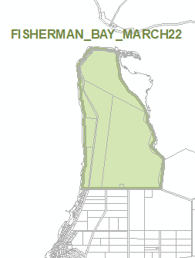 | Zones and Subzones  Technical and Numeric Variations  - Minimum Site Area  - Minimum Dwelling Allotment Size  - Finished Ground and Floor Level  Overlays  - Coastal Areas
- In Part 11 – Local Heritage Places, remove the following row from the table of Local Heritage Places, relevant to Naracoorte Lucindale:
Callendale Road LUCINDALE | Farm Group "Callendale"; Whole of exterior of Homestead, Cottage and Stables | a b | 25573
- Amend the Local Heritage Place Overlay so that it does not spatially apply to 8 Diagonal Road, Coles (Certificate of Title Volume 6029, Folio 213) and make corresponding spatial adjustment to the Heritage Adjacency Overlay to reflect this change.
- Spatially apply the State Heritage Place Overlay to the areas identified ‘SHP’ in the maps contained in Attachment A, and make corresponding spatial adjustments to the Heritage Adjacency Overlay to reflect this change.
- In Part 12:
- under the heading ‘Marion’, replace existing Concept Plan 119 Seacliff Park and Marino with updated Concept Plan 119 Seacliff Park and Marino contained in Attachment B
- insert Concept Plan 119 Seacliff Park and Marino contained in Attachment B under the heading relevant to ‘Holdfast Bay’.
- Amend the Future Road Widening Overlay to spatially include the additional properties identified in the maps contained in Attachment C.
- In Part 13 of the Code – Table of Amendments, update the publication date, Code version number, amendment type and summary of amendments within the ‘Table of Planning and Design Code Amendments’ to reflect the amendments to the Code as described in this Notice.
- PURSUANT to section 76(5)(a) of the Act, I further specify that the amendments to the Code as described in this Notice will take effect upon the date those amendments are published on the SA planning portal.
Dated: 30 March 2022
Sally Smith
Executive Director, Planning & Land Use Services,
Attorney-General’s Department
Delegate of Nick Champion MP, Minister for Planning

Attachment A
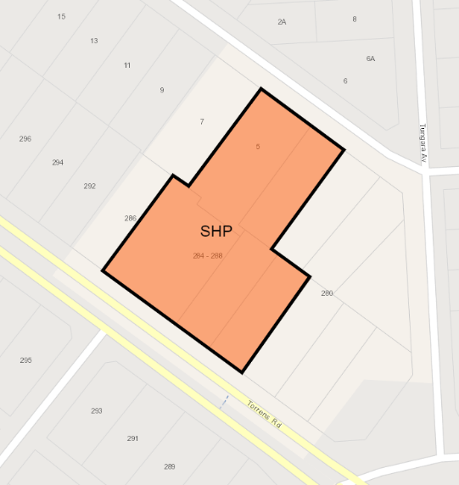
Property: St Margaret Mary's Catholic Church (Provisionally Listed) - 286 Torrens Road CROYDON PARK
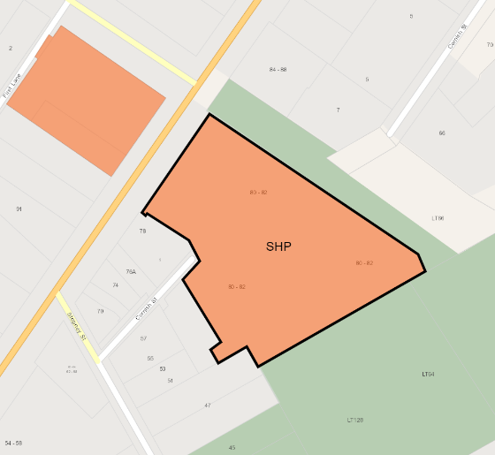
Property: Catholic Church of the Holy Name (Provisionally Listed) – 80 Payneham Road, STEPNEY
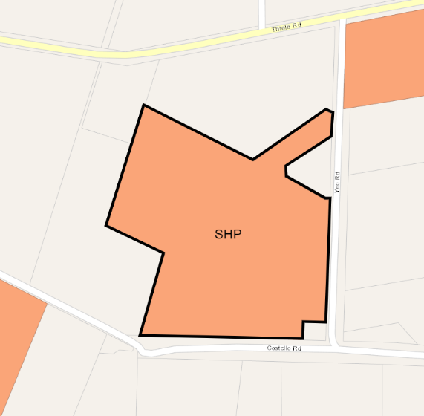
Property: Camp 10 Detention Cell Block, Loveday Internment Camp Complex (Provisionally Listed) –
Yeo Road, LOVEDAY (CT 5958/949 D69443 A8)

Attachment B
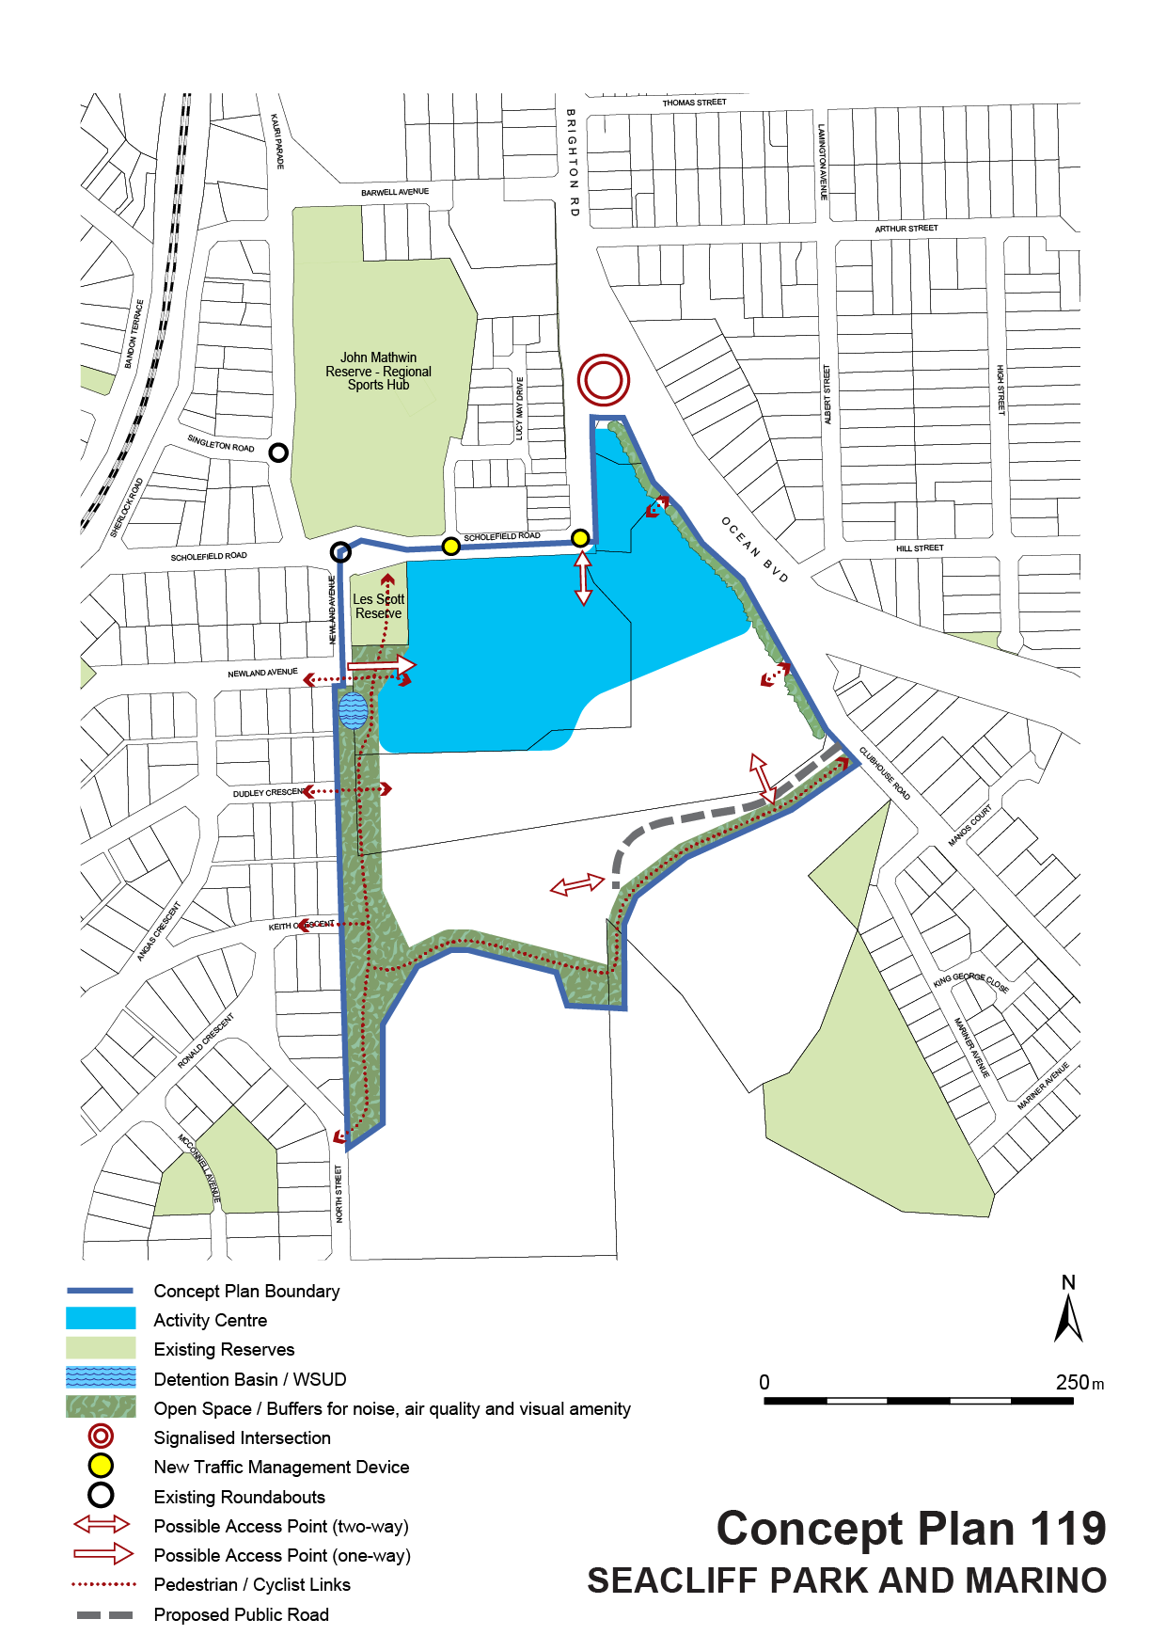

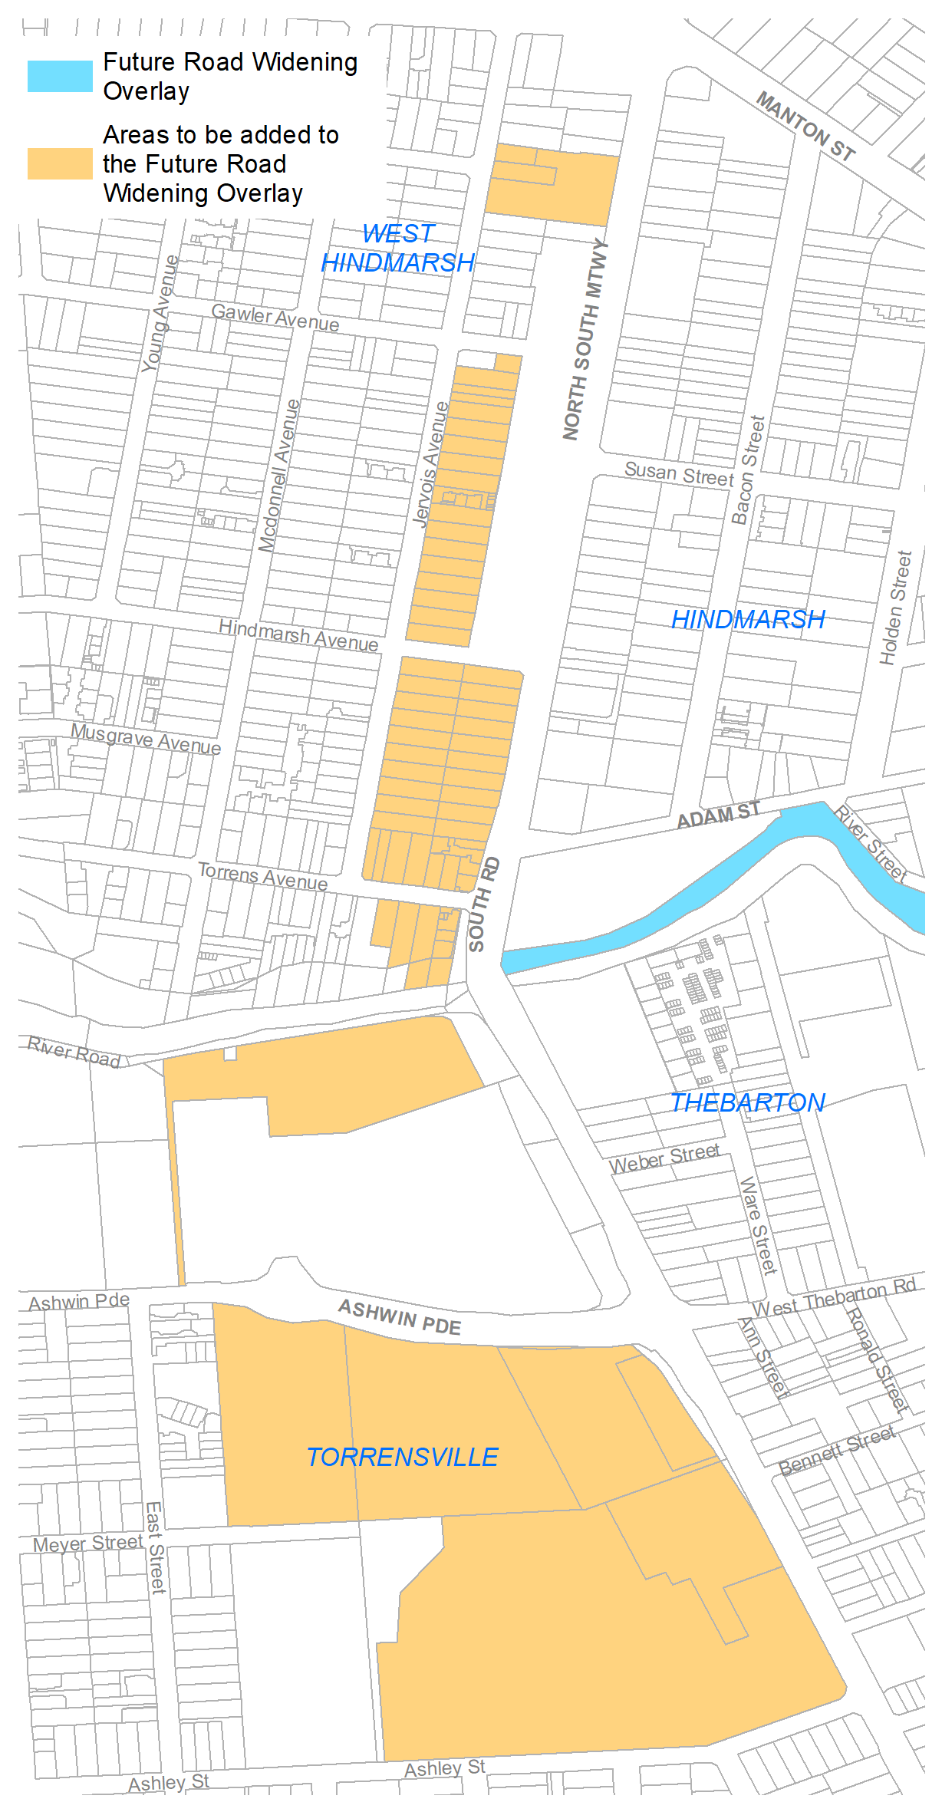
Attachment C
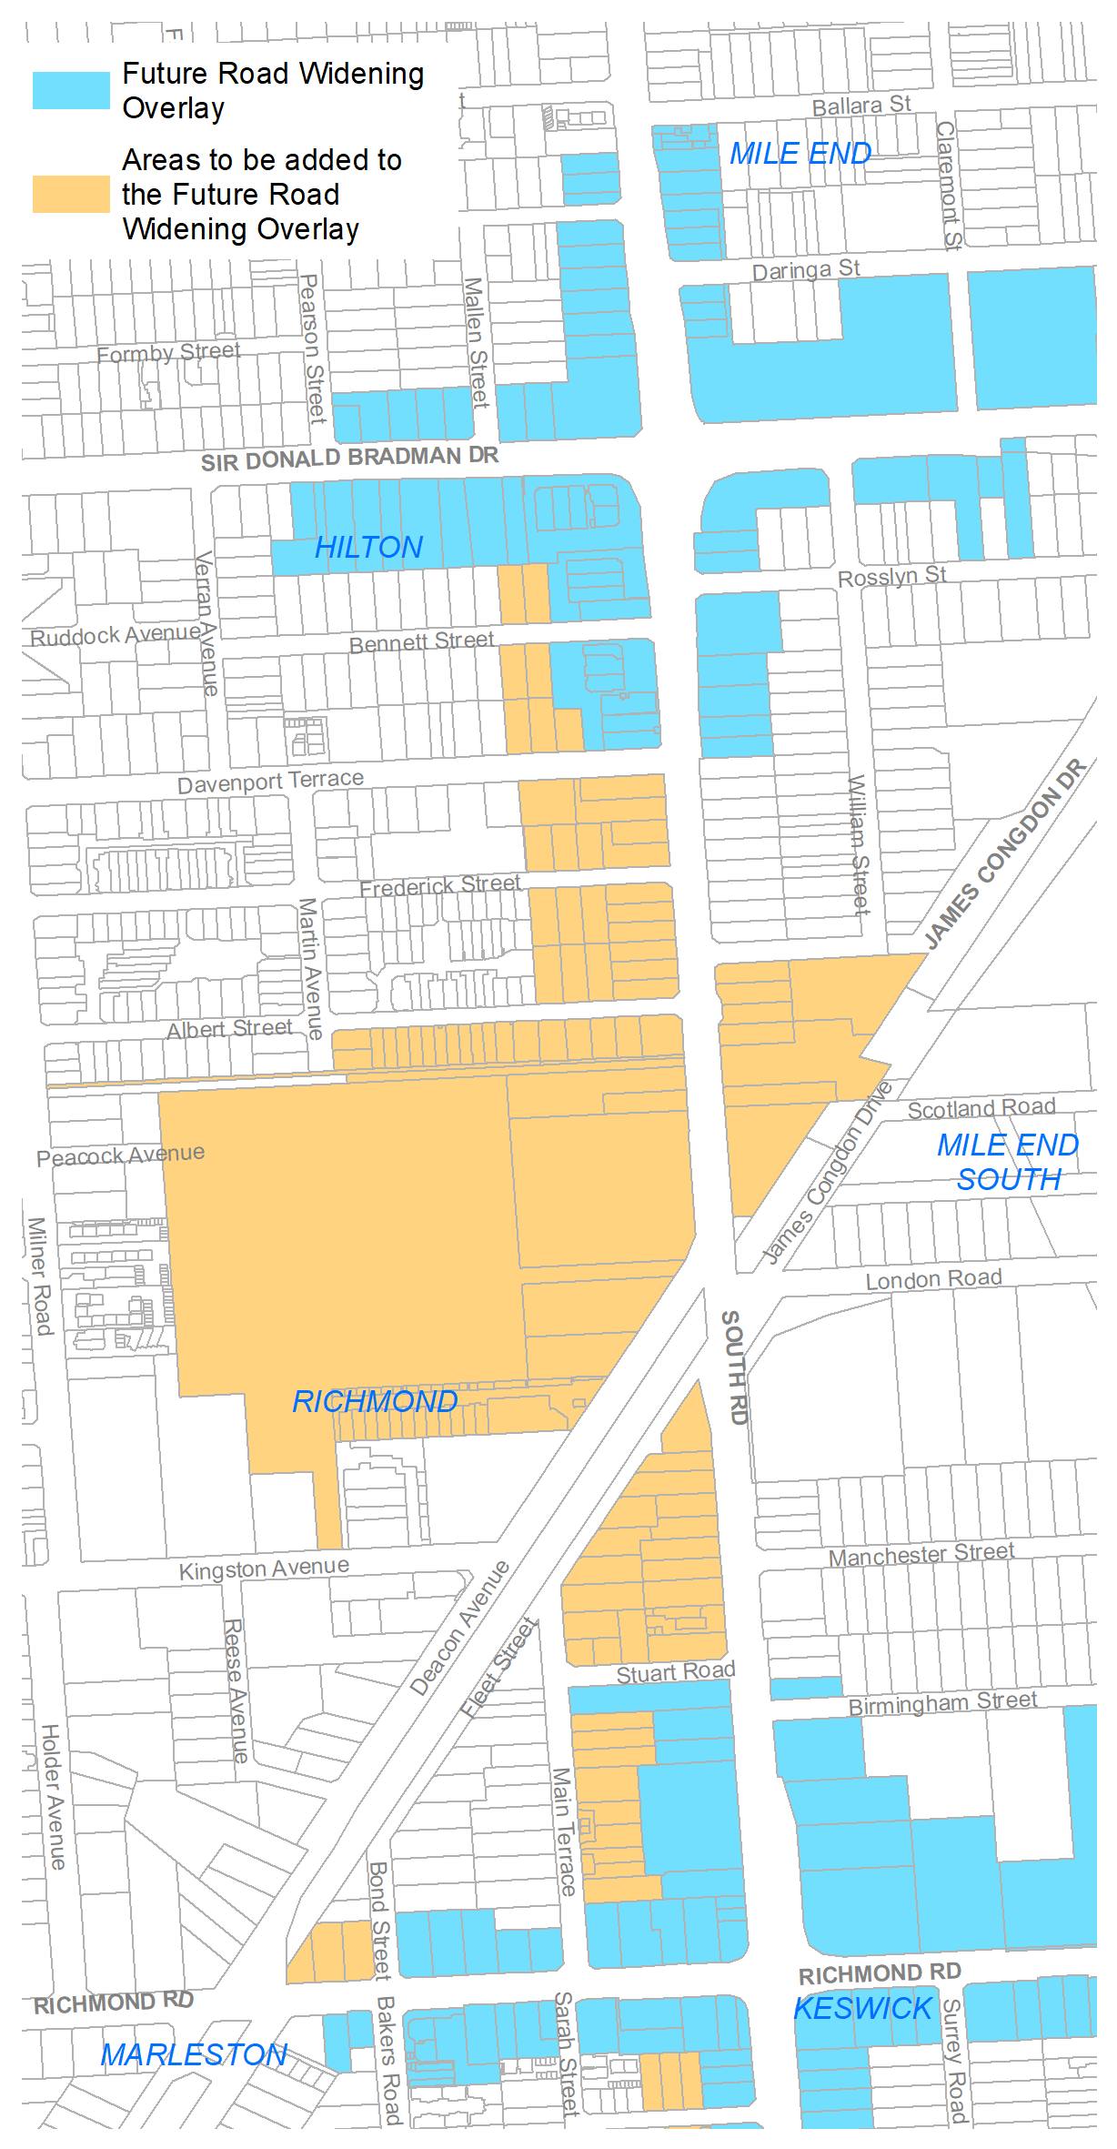
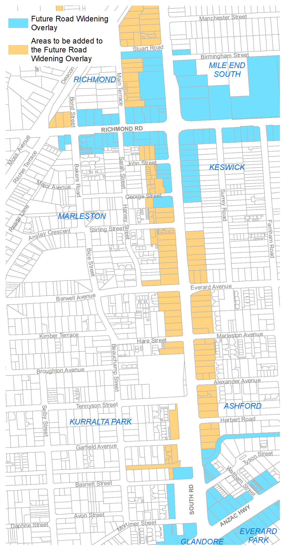
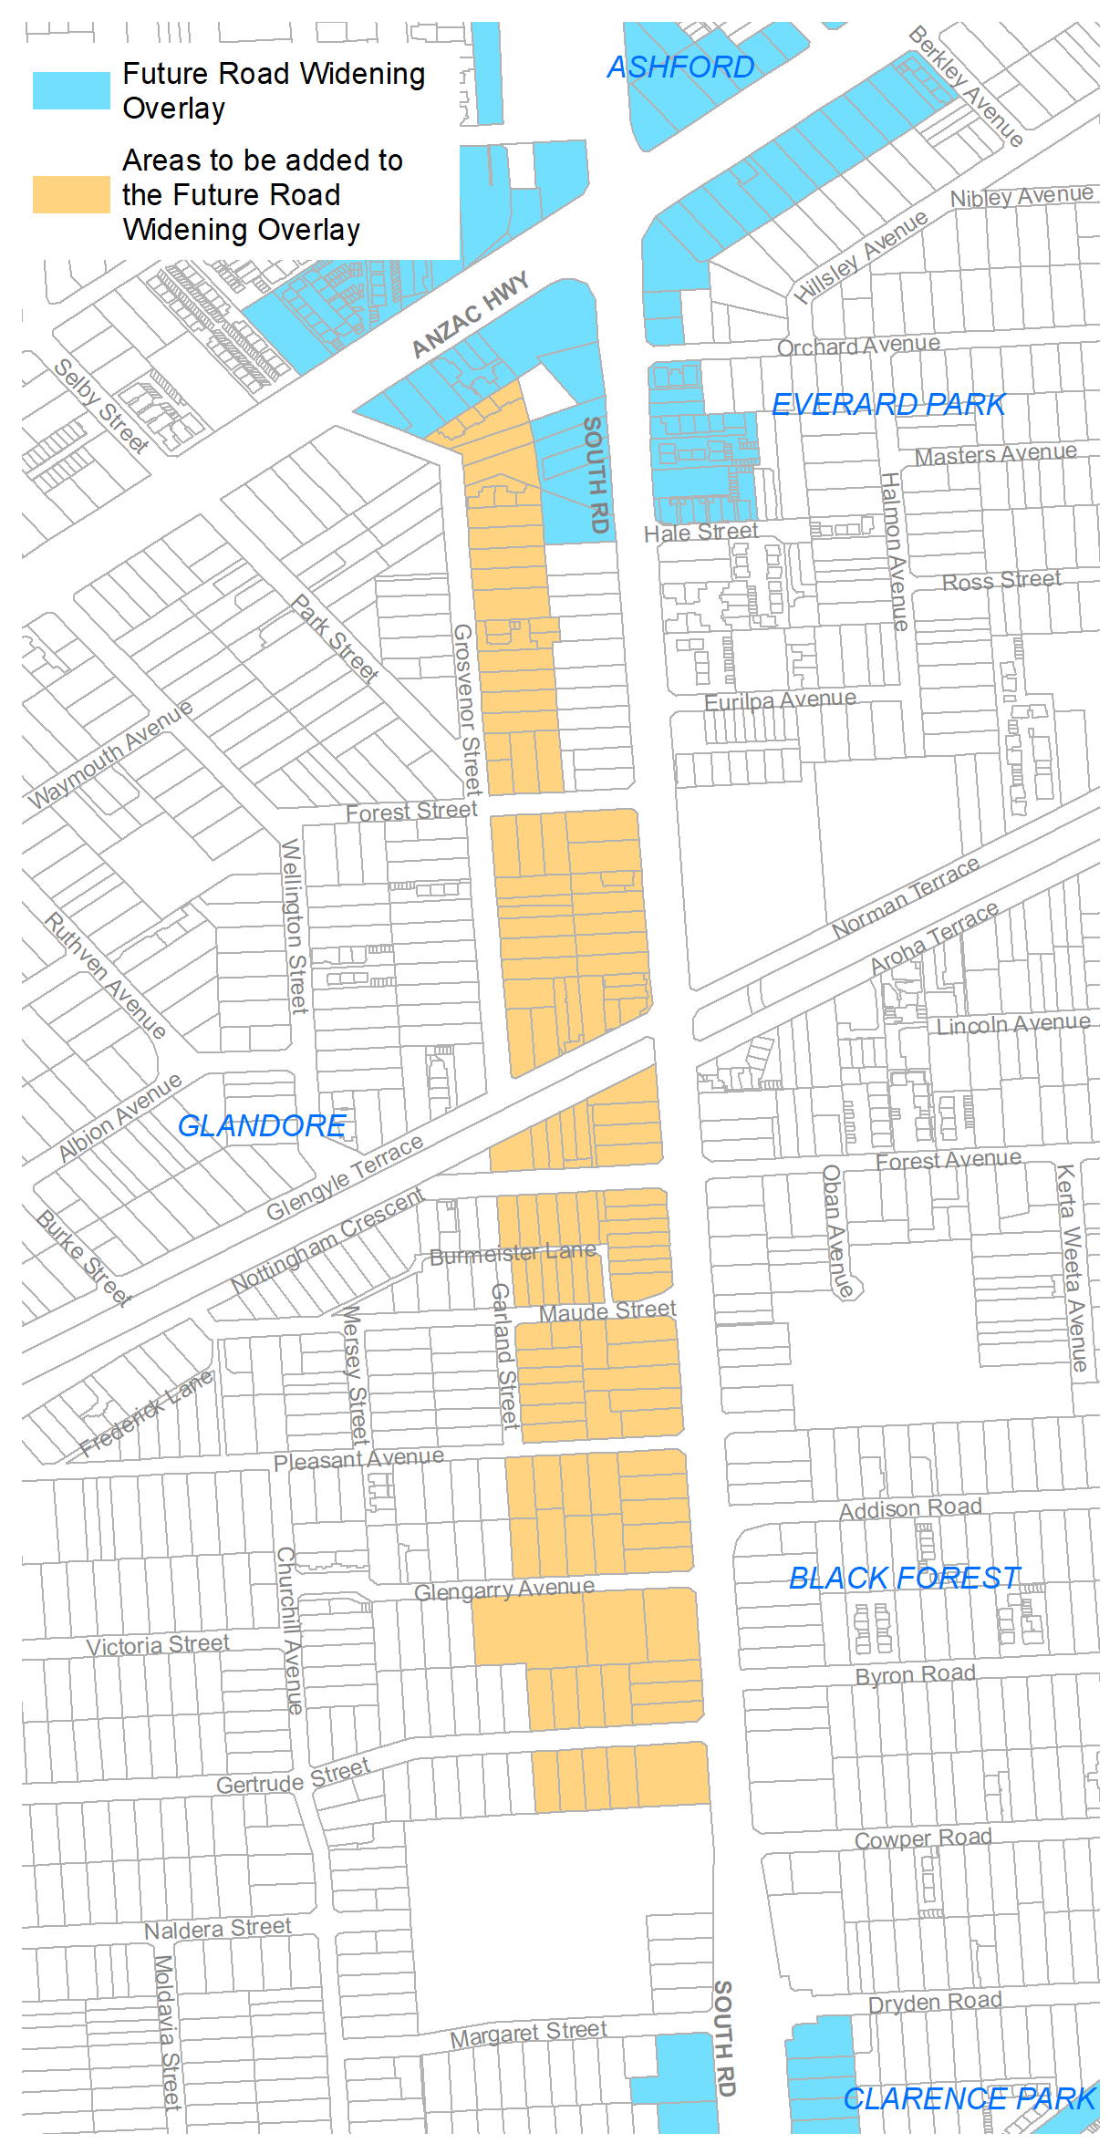
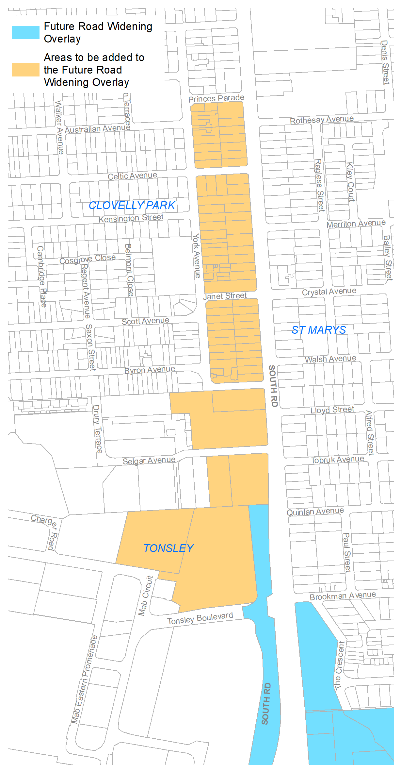

The District Court of South Australia
Port Augusta Circuit Court
Sheriff’s Office, Adelaide, 5 April 2022
IN pursuance of a precept from the District Court to me directed, I do hereby give notice that the said Court will sit as a Court of Oyer and Terminer and General Gaol Delivery at the Courthouse at Port Augusta on the day and time undermentioned and all parties bound to prosecute and give evidence and all jurors summoned and all others having business at the said Court are required to attend the sittings thereof and the order of such business will be unless a Judge otherwise orders as follows:
Tuesday 5 April 2022 at 10 a.m. on the first day of the sittings the only business taken will be the arraignment of prisoners in gaol and the passing of sentences on prisoners in gaol committed for sentence; the surrender of prisoners on bail committed for sentence; the surrender of persons in response to ex officio informations or of persons on bail and committed for trial who have signified their intentions to plead guilty and the passing of sentences for all matters listed for disposition by the District Court.
Juries will be summoned for 4 April 2022 and persons will be tried on this and subsequent days of the sittings.
Prisoners in H.M. Gaol and on Bail for Sentence and for Trial at the Sittings of the Port Augusta Courthouse, commencing 5 April 2022:
Anderson, Robert Joseph | Attempted Aggravated Robbery, Aggravated Robbery (2). | In gaol
Ashton, Michelle Renee  Smith, John Charles | Unlawful Sexual Intercourse (2). | On bail  On bail
Baptiste, Daniel William | Maintaining an unlawful sexual relationship with a child. | On bail
Barnes, Robert William Jnr | Aggravated assault (2), Aggravated causing harm with intent to cause harm, false imprisonment. | In gaol
Bates, Andrew Lyall | Maintaining an unlawful sexual relationship with a child, unlawful sexual intercourse with a person. | On bail
Byrne, Francis James | Unlawfully choking, suffocating or strangling another, aggravated assault | On bail
Coombe, Simon Geoffrey | Unlawfully choking, suffocating or strangling another, aggravated assault (2), aggravated assault causing harm. | On bail
Coulthard, Troy Wapala | Aggravated robbery, aggravated causing harm with intent to cause harm. | In gaol
Damon, Travis Blake | Trafficking in a large commercial quantity of a controlled drug. | On bail
Degenaro, David Reginald | Deception, Attempted deception. | On bail
Doak, Jared Leigh | Aggravated serious criminal trespass in a place of residence, aggravated assault, aggravated threatening to cause harm. | In gaol
Doolan, Hilda Joyce | Aggravated serious criminal trespass in a place of residence, assault. | On bail
Ed, Jonathon Gordon Clayton | Aggravated serious criminal trespass in a place of residence, aggravated threaten to kill or endanger. | In gaol
Evans, Daniel Peter | Causing harm with intent to cause harm, aggravated causing harm with intent to cause harm, aggravated threatening life, assault worker unknown. | On bail
Finlay, Hamish Cavan Lindsay | Traffic in commercial quantity of controlled drug. | On bail
Gleeson, Blake Andrew | Trafficking in a large commercial quantity of a controlled drug. | On bail
Gould, Walter John | Indecent assault (11), gross indecency (3), unlawful sexual intercourse (2). | In gaol
Habermann, Zackery Alexander | Arson, damaging property. | On bail
Hatches, Franklin Treacle | Aggravated Assault, aggravated causing harm with intent to cause harm. | On bail
Hayes, Brian Edward | Possessing a firearm without a licence, acquire, own or possess ammunition without licence, possess a prohibited weapon. | On bail
Hodgson, Kym | Indecent assault, unlawful sexual intercourse with a person 12 to 17 years. | On bail
H, TR | Maintaining an unlawful sexual relationship with a child. | On bail
Humphries, Caihleb James | Assault (2), unlawfully choking, suffocating or strangling another (4), aggravated assault (2), assault causing harm. | On bail
Hutchison, Brodie William | Unlawfully choking, suffocating or strangling another, aggravated assault, aggravated threatening life. | On bail
Kilpatrick, Tallen Douglas  Kilpatrick, Dillon Brian  Sims, Mark Wayne | Aggravated causing harm with intent to cause harm (3), theft, assault. | On bail  On bail  On bail
King, Eden Joseph Thomas | Maintaining an unlawful sexual relationship with a child, threaten to kill or endanger life (2), assault, aggravated assault, possess prescribed firearm without licence, possess an unregistered prescribed firearm. | In gaol
Kirkland, Damian Paul | Maintaining an unlawful sexual relationship with a child. | On bail
Leith, Adrian Lewallan | Maintaining an unlawful sexual relationship with a child. | In gaol
Longman, Daniel Robert Wayne | Attempted rape, aggravated indecent assault (2), maintaining an unlawful sexual relationship with a child  Unlawful sexual intercourse with a person under 17 years, rape (2). | On bail  On bail
Lydeamore, Timothy Scott | Aggravated serious criminal trespass in a place of residence (2), aggravated assault. | On bail
McCourt, Darren Wayne | Possess child abuse material using carriage service, use carriage service to access child abuse material. | On bail
McGrath, James Clarence | Rape. | On bail
McInnis, Angus David | Indecent assault (4), gross indecency, rape (2), unlawful sexual intercourse with a person under 17 years (2). | In gaol
McKenna, Jake Yuill McQuarrie | Aggravated assault causing harm, unlawfully choking, suffocating or strangling another, aggravated assault (3). | In gaol
McLean, Jamahl | Aggravated causing harm with intent to cause harm. | On bail
McNamee, Brian Anthony John | Rape. | On bail
Nelson, Thelma Lee | Aggravated causing serious harm with intent to cause serious harm. | On bail
OBryan, Renae Elma  Caldwell, Simon Andrew | Trafficking in a controlled drug. | On bail
P, JJ | Maintaining an unlawful sexual relationship with a child. | On bail
Reid, Tyson James Stuart | Aggravated causing harm with intent to cause harm. | On bail
Retallick, Kevin Rosslyn  Retallick, Christine June | Indecent assault (2), unlawful sexual intercourse (4), maintaining an unlawful sexual relationship with a child (3). | On bail  On bail
Roberts, Benjamin | Arson. | On bail
Salmoni, Robert Heath | Unlawfully choking, suffocating or strangling another. | On bail
Schmerl, James Terrance | Aggravated causing harm with intent, aggravated assault causing harm. | On bail
Schmidt, Stuart John | Maintaining an unlawful sexual relationship with a child. | On bail
Smith, Shane Andrew | Aggravated indecent assault (2). | On bail
Stainer, Robert | Indecent assault. | On bail
Steen, Kelly Jane | Trafficking in a controlled drug. | On bail
Warren, Anthony Preston | Trafficking in a controlled drug (3), delivering a prohibited item into a prison. | In gaol
Waters, Scott David | Aggravated causing harm. | On bail
Waye, Douglas Matthew | Indecent assault, rape (2). | In gaol
Whelan, Bayden | Maintaining an unlawful sexual relationship with a child, unlawful sexual intercourse, producing child exploitation material. | On bail
Wilton, Tianah Emma Kimberley | Aggravated recklessly causing serious harm. | On bail
Young, Mark Gregory | Maintaining an unlawful sexual relationship with a child. | On bail
Prisoners on bail must surrender at 10 a.m. of the day appointed for their respective trials. If they do not appear when called upon their recognizances and those of their bail will be estreated and a bench warrant will be issued forthwith.
Dated: 31 March 2022
By order of the Court,
A. Gransden
Sheriff

Local Government Instruments

City of Charles Sturt
Local Government Act 1999 (SA)
Declaration to Convert Private Road into a Public Road
The City of Charles Sturt gives notice that it proposes to make a declaration under Section 210(1) of the Local Government Act 1999 (SA) to convert the following private road into a public road:
The private road currently described as Lot 2 in FP 27210, which is commonly known as Second Street in Bowden.
The declaration will take effect no earlier than 30 June 2022.
Dated: 30 March 2022
Paul Sutton
Chief Executive Officer

City of Onkaparinga
Local Government Act 1999
Vacancy in the Office of Mayor
NOTICE is hereby given in accordance with section 54(6) of the Local Government Act 1999, that a vacancy has occurred in the office of Mayor for City of Onkaparinga, due to the election of Mayor Erin Thompson to State Parliament 29 March 2022.
Dated: 28 March 2022
Scott Ashby
Chief Executive Officer

Tatiara District Council
Roads (Opening & Closing) Act 1991
Road Closing – Eatts Road, Laffer
NOTICE is hereby given, pursuant to Section 10 of the Roads (Opening and Closing) Act 1991, that Tatiara District Council proposes to make a Road Process Order to close and merge with the adjoining Allotments 101 and 102 in D120638 and Allotment 1 in D59882 the whole of Eatts Road more particularly delineated and lettered 'A' and ‘B’ in Preliminary Plan 22/0021.
The Preliminary Plan and Statement of Persons Affected are available for public inspection at the Bordertown office of the Tatiara District Council at 43 Woolshed Street Bordertown and at the Keith office at 34 Hender Street Keith, and also at the Surveyor-General’s Office, Level 2, 101 Grenfell Street, Adelaide during normal working hours. The Preliminary Plan can also be viewed at www.sa.gov.au/roadsactproposals
Any application for easement or objection must set out the full name, address and details of the submission and must be fully supported by reasons. The application for easement or objection must be made in writing to the Council at Tatiara District Council, PO Box 346, Bordertown SA 5268 WITHIN 28 DAYS OF THIS NOTICE and a copy must be forwarded to the Surveyor-General at GPO Box 1354, Adelaide SA 5001. Where a submission is made, the Council will give notification of a meeting at which time the matter will be considered.
Dated: 9 March 2022
Anne Champness
Chief Executive Officer

Wakefield Regional Council
Local Government Act 1999
Renaming of Street
NOTICE is hereby given pursuant to Section 219 (1) of the Local Government Act 1999, and by resolution of the Wakefield Regional Council at its meeting held 23 February 2022, that the portion of East Street, from Edward Street to North Street, Port Wakefield, be renamed Port Wakefield Highway as of 31 March 2022.
Dated: 29 March 2022
Andrew MacDonald
Chief Executive Officer

Public Notices

National Gas Law
Making of Draft Determination
The Australian Energy Market Commission (AEMC) gives notice under the National Gas Law as follows:
Under s 308, the making of a draft determination and related draft rule on the DWGM distribution connected facilities (Ref. GRC0062) proposal. Written requests for a pre-determination hearing must be received by 7 April 2022. Submissions must be received by 19 May 2022.
Submissions can be made via the AEMC’s website. Before making a submission, please review the AEMC’s privacy statement on its website. Submissions should be made in accordance with the AEMC’s Guidelines for making written submissions on Rule change proposals. The AEMC publishes all submissions on its website, subject to confidentiality.
Written requests should be sent to submissions@aemc.gov.au and cite the reference in the title. Before sending a request, please review the AEMC’s privacy statement on its website.
Documents referred to above are available on the AEMC’s website and are available for inspection at the AEMC’s office.
Australian Energy Market Commission
Level 15, 60 Castlereagh St
Sydney NSW 2000
Telephone: (02) 8296 7800
www.aemc.gov.au
Dated: 31 March 2022

Trustee Act 1936
Public Trustee
Estates of Deceased Persons
In the matter of the estates of the undermentioned deceased persons:
ASHWIN Anthony Arthur late of 150 Reynell Road Woodcroft Retired Technical Officer who died 14 October 2021
BROYD William Cutler late of 50 Walkers Road Somerton Park of no occupation who died 09 October 2021
CLEMENT Raymond Keith late of 25 Joanne Street Salisbury North Retired Storeman who died 26 November 2021
EDDISON Arthur late of 30 Sussex Terrace Westbourne Park Retired Mission Worker who died 30 November 2021
LOMMAN Frederick William late of 7 Wood Street Millswood of no occupation who died 10 August 2021
MAY Philip Noel John late of Towers Road Millicent of no occupation who died 02 November 2020
McDONALD Ian Wallace late of 76 Hawson Avenue North Plympton Retired Public Servant who died 23 June 2014
OHLBACK Magreitte Estell late of 23 Moorhouse Terrace Riverton of no occupation who died 08 December 2021
SMITH Eileen Fay late of 23 Neptune Terrace Rosewater Home Duties who died 28 August 2021
WOODHOUSE Ronald George late of 14 Ronald Crescent Marino Retired Insurance Manager who died 28 September 2021
Notice is hereby given pursuant to the Trustee Act 1936, the Inheritance (Family Provision) Act 1972 and the Family Relationships Act 1975 that all creditors, beneficiaries, and other persons having claims against the said estates are required to send, in writing, to the office of Public Trustee at GPO Box 1338, Adelaide, 5001, full particulars and proof of such claims, on or before the 29 April 2022 otherwise they will be excluded from the distribution of the said estate; and notice is also hereby given that all persons indebted to the said estates are required to pay the amount of their debts to the Public Trustee or proceedings will be taken for the recovery thereof; and all persons having any property belonging to the said estates are forthwith to deliver same to the Public Trustee.
Dated: 31 March 2022
N. S. Rantanen
Public Trustee

University of Adelaide Act 1971
Rule Establishing the Alumni Council of the University of Adelaide and Prescribing it as the "Graduate Association"
- The Alumni Council of the University of Adelaide (Alumni Council) is hereby established as an advisory council for the purpose of furthering the interests of the University on matters relevant to Alumni.
- The Alumni Council is the graduate association prescribed for the purposes of the definition of "Graduate Association" in section 3 of the University of Adelaide Act 1971.
- The Alumni Council is not a separate legal entity. Neither it, nor any member of the Alumni Council has the power to bind the University to any obligation.
- The Alumni Council will be administered by its members for and on behalf of Alumni, subject to any direction from the Council of the University. Subject to any such direction, the Alumni Council may determine its own procedures for the conduct of meetings and the discharge of its functions.
- The Council of the University may, from time to time, prescribe the specific role and functions of the Alumni Council.
- The Council of the University may determine the composition of the membership of the Alumni Council and the terms of office of each member. Until otherwise determined, the Alumni Council will be comprised of up to sixteen (16) members as follows:
  - Two (2) Alumni elected, in accordance with election procedures approved by the Council of the University from time to time, to represent each Faculty (being six members in total);
  - One Alum elected, in accordance with the election procedures approved by the Council of the University from time to time, to represent the Waite campus;
  - One Alum elected, in accordance with the election procedures approved by the Council of the University from time to time, to represent the Roseworthy campus;
  - Up to six (6) Alumni appointed by the Council of the University; and
  - Two (2) representatives of the University appointed by the Vice-Chancellor and President as non-voting members.
- At least one of the two Alumni elected to represent a Faculty in accordance with paragraph 6(a) of this Rule must be a Graduate of the University.
- The presiding member of the Alumni Council shall hold the title of Chair of the Alumni Council and shall be one of the Alumni appointed by Council under paragraph 6(d) of these Rules. The presiding member shall be a Graduate of the University and is appointed, and may be removed or replaced, by the Council of the University on the recommendation of the Vice-Chancellor and President from time to time.
- The Council of the University may resolve to dissolve the Alumni Council at any time.
- In this Rule:
Alumni means, unless and until otherwise determined by the Council of the University:
  - all Graduates of the University;
  - all former students of the University who have completed at least one year of study at the University, or, in the case of study abroad, students who have completed at least one semester of study; and
  - all former academic or professional staff members of the University who completed at least 3 years' service at the University,
and Alum shall mean one of them.
Council of the University means the Council of The University of Adelaide.
Elected Voting Alumni Council Member means a member of the Alumni Council elected in accordance with paragraph 6(a), (b) or (c) of this Rule.
Faculty means a grouping of academic units of the University, being one of the following:
  - the Faculty of Sciences, Engineering and Technology;
  - the Faculty of Health and Medical Sciences; or
  - the Faculty of Arts, Business, Law and Economics.
Graduate shall have the meaning given to that term in the University of Adelaide Act 1971.
University means The University of Adelaide.
Approved by Council.
Dated: 28 March 2022
Andrew Lee
Director, Governance Services
Office of the Chancellor and Council Secretariat
The University of Adelaide

Notice Submission

The South Australian Government Gazette is published each Thursday afternoon.
Notices must be emailed by 4 p.m. Tuesday, the week of publication.
Submissions are formatted per the gazette style and a proof will be supplied prior to publication, along with a quote if applicable. Please allow one day for processing notices.
Alterations to the proof must be returned by 4 p.m. Wednesday.

Gazette notices must be submitted as Word files, in the following format:
• Title—the governing legislation
• Subtitle—a summary of the notice content
• Body—structured text, which can include numbered lists, tables, and images
• Date—day, month, and year of authorisation
• Signature block—name, role, and department/organisation authorising the notice

Please provide the following information in your email:
• Date of intended publication
• Contact details of the person responsible for the notice content
• Name and organisation to be charged for the publication—Local Council and Public notices only
• Purchase order, if required—Local Council and Public notices only

Email: governmentgazettesa@sa.gov.au
Phone: (08) 7109 7760
Website: www.governmentgazette.sa.gov.au

All instruments appearing in this gazette are to be considered official, and obeyed as such

Printed and published weekly by authority of S. Smith, Government Printer, South Australia
$8.00 per issue (plus postage), $402.00 per annual subscription—GST inclusive
Online publications: www.governmentgazette.sa.gov.au

