No. 26 p. 1019
THE SOUTH AUSTRALIAN
GOVERNMENT GAZETTE
Published by Authority

Adelaide, Thursday, 5 May 2022

Contents

Governor’s Instruments

Appointments 1020

State Government Instruments

Aged and Infirm Persons' Property Act 1940 1021

Community Titles Act 1996 1021

Controlled Substances Act 1984 1024

Controlled Substances (Poisons) Regulations 2011 1025

Fisheries Management Act 2007 1026

Fisheries Management (Prawn Fisheries) Regulations 2017 1029

Housing Improvement Act 2016 1031

Industrial Hemp Act 2017 1031

Land and Business (Sale and Conveyancing) Act 1994 1032

Landscape South Australia Act 2019 1035

Legal Practitioners Act 1981 1035

Libraries Board of South Australia 1036

Livestock Act 1997 1038

Mental Health Act 2009 1040

National Parks and Wildlife Act 1972 1040

Passenger Transport Act 1994 1045

Petroleum and Geothermal Energy Act 2000 1048

Planning, Development and Infrastructure Act 2016 1049

Plant Health Act 2009 1052

Primary Produce (Food Safety Schemes) Act 2004 1059

Real Property Act 1886 1065

Registrar-General and Valuer-General 1071

Registration of Deeds Act 1935 1071

Retail and Commercial Leases Act 1995 1072

Roads (Opening and Closing) Act 1991 1072

Strata Titles Act 1988 1073

Valuation of Land Act 1971 1075

Worker's Liens Act 1893 1076

Local Government Instruments

City of Adelaide 1078

Alexandrina Council 1078

City of Victor Harbor 1078

Kangaroo Island Council 1078

District Council of Mount Remarkable 1079

Public Notices

National Electricity Law 1115

Trustee Act 1936 1115

Governor’s Instruments

Appointments
Department of the Premier and Cabinet
Adelaide, 5 May 2022
Her Excellency the Governor in Executive Council has been pleased to appoint Timothy David Griffin as a Magistrates Court Judicial Registrar on a part-time basis for a term of seven years commencing on 5 May 2022 and expiring on 4 May 2029 – pursuant to section 7AB of the Magistrates Court Act 1991.
By command,
Peter Bryden Malinauskas
Premier
AGO0020-22CS

Department of the Premier and Cabinet
Adelaide, 5 May 2022
Her Excellency the Governor in Executive Council has been pleased to appoint Jeanette Barnes as a Magistrates Court Judicial Registrar on a part-time basis for a term of seven years commencing on 5 May 2022 and expiring on 4 May 2029 – pursuant to section 7AB of the Magistrates Court Act 1991.
By command,
Peter Bryden Malinauskas
Premier
AGO0020-22CS

State Government Instruments

Aged and Infirm Persons' Property Act 1940
South Australia
Aged and Infirm Persons' Property Act (Fees) Notice 2022
under the Aged and Infirm Persons' Property Act 1940
1—Short title
This notice may be cited as the Aged and Infirm Persons' Property Act (Fees) Notice 2022.
Note—
This is a fee notice made in accordance with the Legislation (Fees) Act 2019.
2—Commencement
This notice has effect on 1 July 2022.
3—Interpretation
In this notice, unless the contrary intention appears—
Act means the Aged and Infirm Persons' Property Act 1940.
4—Fees
The fees set out in Schedule 1 are prescribed for the purposes of the Act and are payable to the Public Trustee.
Schedule 1—Fees

1 | The fee payable by a manager for the services rendered by the Public Trustee in respect of the estate for the purposes of section 20(1) of the Act | $249.00  per hour
Made by the Attorney-General

On 27 April 2022

Community Titles Act 1996
South Australia
Community Titles (Fees) Notice 2022
under the Community Titles Act 1996
1—Short title
This notice may be cited as the Community Titles (Fees) Notice 2022.
Note—
This is a fee notice made in accordance with the Legislation (Fees) Act 2019.
2—Commencement
This notice has effect on 1 July 2022.
3—Interpretation
In this notice, unless the contrary intention appears—
Act means the Community Titles Act 1996;
regulations means the Community Titles Regulations 2011.
4—Fees
The fees set out in Schedule 1 are prescribed for the purposes of the Act and the regulations.
Schedule 1—Fees

1 | Examination of plan to be lodged with application under Act before application is lodged (section 144 of Act)—
 | (a) for application for division of land by plan of community division (section 14 of Act)—
 | (i) if there are 5 lots or less | $537.00
 | (ii) if there are more than 5 lots | $1,071.00
 | (b) for any other application | $537.00
2 | Application for division of land by plan of community division (section 14 of Act)—
 | (a) for examination of application | $447.00
 | (b) for examination of plan of community division not subject to prior approval under section 144 of Act—
 | (i) if there are 5 lots or less | $537.00
 | (ii) if there are more than 5 lots | $1,071.00
 | (c) for deposit of plan of community division | $164.00
 | (d) for each lot requiring issue of certificate of title | $97.50
 | (e) for filing of scheme description | $179.00
 | (f) for filing of by-laws | $179.00
 | (g) for filing of development contract | $179.00
3 | Application to amend schedule of lot entitlements (section 21 of Act) | $179.00
4 | Filing of copy of certified scheme description as amended (section 31 of Act) | $179.00
5 | Filing of certified copy of by-laws as varied (section 39 of Act) | $179.00
6 | Maximum fee for purchase from corporation of copy of by-laws (section 44 of Act) | $54.50
7 | Fee for purchase from Registrar-General of copy of by-laws filed with plan of community division (section 44 of Act) | $11.70
8 | Filing of certified copy of development contract as varied or agreement to terminate development contract (section 50 of Act) | $179.00
9 | Maximum fee for purchase from corporation of copy of development contract (section 51 of Act) | $54.50
10 | Fee for purchase from Registrar-General of copy of development contract filed with plan of community division (section 51 of Act) | $11.70
11 | Application for amendment of deposited community plan (section 52 of Act)—
 | (a) for examination of application | $339.00
 | (b) for examination of plan to be substituted or sheets of plan to be substituted or added if plan not subject to prior approval under section 144 of Act | $537.00
 | (c) for each lot requiring issue of certificate of title | $97.50
 | (d) for filing of amended scheme description | $179.00
12 | Application for division of development lot in pursuance of development contract and consequential amendment of community plan (section 58 of Act)—
 | (a) for examination of application | $339.00
 | (b) for examination of plan to be substituted or sheets of plan to be substituted or added if plan not subject to prior approval under section 144 of Act | $537.00
 | (c) for each lot requiring issue of certificate of title | $97.50
13 | Application for amalgamation of deposited community plans (section 60 of Act)—
 | (a) for examination of application | $339.00
 | (b) for examination of plan of community division not subject to prior approval under section 144 | $537.00
 | (c) for deposit of plan of community division | $164.00
 | (d) for each lot requiring issue of certificate of title | $97.50
 | (e) for filing of scheme description | $179.00
 | (f) for filing of by-laws | $179.00
14 | Application for cancellation of deposited community plan (sections 64 and 65 of Act)—
 | (a) for examination of application | $339.00
 | (b) if application is for cancellation of primary plan—
 | (i) for examination of plan that delineates outer boundaries of primary parcel | $537.00
 | (ii) for filing of plan | $164.00
 | (c) for each certificate of title to be issued | $97.50
15 | Application to note Court order for cancellation of community plan (sections 64 and 67 of Act)—
 | (a) for noting the order | $339.00
 | (b) if application is for cancellation of primary plan—
 | (i) for examination of plan that delineates outer boundaries of primary parcel | $537.00
 | (ii) for filing of plan | $164.00
 | (c) for each certificate of title to be issued | $97.50
16 | Filing of notice of appointment, removal or replacement of administrator (section 100 of Act) | $179.00
17 | Filing of resolution to elect to use Act (Schedule clause 2) | $179.00
18 | Submission of outer boundary plan—
 | (a) for examination of plan | $1,071.00
 | (b) for filing of plan | $164.00
19 | Fee for re-examination of plan when amended after approval for deposit is given | $164.00
20 | Lodgement of any other document required by Act | $179.00
Signed by the Attorney-General

On 27 April 2022

Controlled Substances Act 1984
South Australia
Controlled Substances (Poppy Cultivation) (Fees) Notice 2022
under the Controlled Substances Act 1984
1—Short title
This notice may be cited as the Controlled Substances (Poppy Cultivation) (Fees) Notice 2022.
2—Commencement
This notice has effect on 1 July 2022.
Note—
This is a fee notice made in accordance with the Legislation (Fees) Act 2019.
3—Interpretation
In this notice, unless the contrary intention appears—
Act means the Controlled Substances Act 1984.
4—Fees
The fees set out in Schedule 1—
(a) are prescribed for the purposes of Part 4A of the Act; and
(b) are payable to the Chief Executive.
Schedule 1—Fees

1 | On application for—
 | (a) the issue of a poppy cultivation licence | $1 989
 | (b) the renewal of a poppy cultivation licence | $1 642
 | (c) the amendment of a poppy cultivation licence—
 | (i) if the amendment relates to the specified premises described in the licence | $1 182
 | (ii) in any other case | $226
2 | On application for—
 | (a) the issue of a poppy processing licence | $2 228
 | (b) the renewal of a poppy processing licence | $1 540
 | (c) the amendment of a poppy processing licence—
 | (i) if the amendment relates to the specified premises described in the licence | $1 421
 | (ii) in any other case | $226
3 | For a probity check by SAPOL—
 | (a) of a natural person plus all associates of that person | $226
 | (b) of a partner in a partnership plus all associates of that partner | $226
 | (c) of a trustee of a trust plus all associates of that trustee | $226
 | (d) of a director of a body corporate plus all associates of that director | $226
 | (e) of any number of associates of a natural person, partner, trustee or director | $226
4 | For the recovery of compliance or administrative costs—
 | (a) related to a poppy cultivation licence (per year) | $1035
 | (b) related to a poppy processing licence (per year) | $14 208
5 | For any inspection under Part 4A of the Act (other than an inspection carried out as part of the process of determining an application for the issue, renewal or amendment of a licence)—a fee of $159 per hour, charged in blocks of $15.90 per each 6 minutes
6 | For taking or removing for examination samples of, or from, or specimens of, soil, any alkaloid poppy or poppy straw, or any other plant or crop—a fee of $159 per hour, charged in blocks of $15.90 per each 6 minutes
7 | For travel by an inspector (to and from the inspector's office) for the purposes of carrying out the activities specified in item 5 or 6—a fee of $159 per hour, charged in blocks of $15.90 per each 6 minutes
Made by the Minister for Primary Industries and Regional Development

On 29 April 2022

Controlled Substances (Poisons) Regulations 2011
Regulation 33(2)(C)
Approved Electronic Communication – Digital Image of Prescription
I, Chris Picton, Minister for Health and Wellbeing:
- Pursuant to regulation 3(1) of the Controlled Substances (Poisons) Regulations 2011, hereby determine that the electronic transmission of a digital image of a prescription is an approved electronic communication for the purpose of the definition of this term in the Regulations.
- Pursuant to regulation 33(10) of the Controlled Substances (Poisons) Regulations 2011, hereby determine that the following requirements must be complied with by a prescriber if the prescriber gives a pharmacist a prescription by an approved electronic communication which is an electronic transmission of a digital image of the prescription:
  - The prescription can only be for a patient prescribed a Schedule 4 medicine as the result of a telehealth attendance or phone attendance.
  - The prescription can only be prescribed by an approved hospital authority, or a medical practitioner employed or contracted by SA Health to provide general practitioner services during the COVID-19 pandemic.
  - The prescription given to the pharmacist by electronic transmission must be a digital image of the prescription.
  - The prescription must be given directly to the pharmacist by the prescriber (or an employee acting in accordance with the instruction of the prescriber) and cannot be given via the patient or any other intermediary.
  - The provisions of the National Health (COVID-19 Supply of Pharmaceutical Benefits) Special Arrangement 2020 made under section 100 of the National Health Act 1953 (Cth) must be complied with by the prescriber (whether or not the drug is a pharmaceutical benefit).
  - The original prescription must be retained by the approved hospital authority, or by the medical practitioner employed or contracted by SA Health to provide general practitioner services during the COVID-19 pandemic for two years.
  - The original prescription must be produced by the approved hospital authority or by the medical practitioner employed or contracted by SA Health to provide general practitioner services during the COVID-19 pandemic, at the request of an authorised officer under the Controlled Substances Act 1984.

For the purposes of this Instrument:
- digital image of a prescription means an unaltered photo image of the original prescription or an unaltered photo image of a copy of the original prescription
- phone attendance has the same meaning as in section 5 of the Health Insurance (Section 3C General Medical Services – COVID-19 Telehealth and Telephone Attendances) Determination 2020 made under subsection 3C(1) of the Health Insurance Act 1973 (Cth).
- telehealth attendance has the same meaning as in section 5 of the Health Insurance (Section 3C General Medical Services – COVID-19 Telehealth and Telephone Attendances) Determination 2020 made under subsection 3C(1) of the Health Insurance Act 1973 (Cth).
- approved hospital authority means a hospital authority for the time being approved, or deemed to be approved, under section 94 of the National Health Act 1953.
This Instrument comes into effect on the day on which it is made and continues in force until midnight on 31 March 2023 unless earlier revoked.
Dated: 12 April 2022
Hon Chris Picton
Minister for Health and Wellbeing

Fisheries Management Act 2007
South Australia
Fisheries Management (General Fees) Notice 2022
under the Fisheries Management Act 2007
1—Short title
This notice may be cited as the Fisheries Management (General Fees) Notice 2022.
Note—
This is a fee notice made in accordance with the Legislation (Fees) Act 2019.
2—Commencement
This notice has effect on 1 July 2022.
3—Interpretation
In this notice, unless the contrary intention appears—
Act means the Fisheries Management Act 2007;
eligible person—
(a) in the case of a person applying for registration as a fish processor—means the holder of a fishery authority or an aquaculture licence who applies for registration as a fish processor for the sole purpose of processing aquatic resources taken under the fishery authority or farmed under the aquaculture licence (as the case may be) for sale to a person who—
(i) is an unregistered fish processor; and
(ii) carries on a business in the course of which aquatic resources are sold or supplied as a meal or part of a meal directly to the public;
(b) in the case of a registered fish processor—means the holder of a fishery authority or an aquaculture licence who only processes aquatic resources taken under the fishery authority or farmed under the aquaculture licence (as the case may be) for sale to a person who—
(i) is an unregistered fish processor; and
(ii) carries on a business in the course of which aquatic resources are sold or supplied as a meal or part of a meal directly to the public.
4—Fees
The Fees set out in Schedule 1 are prescribed for the purposes of the Act and the regulations under the Act, as set out in the Schedule.
Schedule 1—Fees
Part 1—Commercial fishing—fishery permit application and annual fees

Application fees payable by an applicant for the issue of a fishery permit (section 54(1)(c) of Act)
1 | For a permit in respect of the Miscellaneous Broodstock and Seedstock Fishery | $435.00
2 | For a permit in respect of the Miscellaneous Developmental Fishery | $5 368.00
3 | For a permit in respect of the Miscellaneous Research Fishery | $435.00
Annual fees payable by the holder of a fishery permit (section 56(5)(a) of Act)
4 | For a permit in respect of the Miscellaneous Developmental Fishery | $2 485.00
Part 2—Commercial fishing—miscellaneous fees

1 | On application for consent to the transfer of a fishery authority | $490.00
2 | On application to vary the registration of a boat used under a fishery authority | $133.00
3 | On application to vary the registration of a master | $133.00
4 | On application to vary a quota entitlement under a fishery authority | $164.00
5 | On application to vary a rock lobster pot entitlement under a licence in respect of the Northern Zone Rock Lobster Fishery or Southern Zone Rock Lobster Fishery | $164.00
 | The fee fixed by this clause is not payable if an application to vary a rock lobster pot entitlement under a licence in respect of the Northern Zone Rock Lobster Fishery or Southern Zone Rock Lobster Fishery is made at the same time as an application to vary a giant crab or rock lobster quota entitlement under the licence.
6 | On application for registration of an additional boat under a fishery authority | $133.00
7 | On application for—
 | (a) notation of an interest in a fishery authority on the register of authorities | $214.00
 | (b) removal from the register of authorities of such a notation | $214.00
Part 3—Processing fees
Division 1—Fish processor registration application and annual fees

Registration fees payable by an applicant for registration as a fish processor (section 64(1)(d) of Act)
1 | On application for registration as a fish processor made by an eligible person | $214.00
2 | On application for registration as a fish processor made by a person other than an eligible person—
 | (a) base fee | $1 230.00
 | (b) additional fee—
 | (i) if the applicant proposes to process abalone (Haliotis spp) under the registration | $1 595.00
 | (ii) if the applicant proposes to process King Prawn (Merlicertus latisulcatus) under the registration | $1 595.00
 | (iii) if the applicant proposes to process Southern Rock Lobster (Jasus edwardsii) under the registration | $1 595.00
 | If registration is to be granted for a period of less than 12 months, the fee payable is a proportion of the fee set out above, being the proportion that the number of complete months in the term of registration bears to 12.
Annual fees payable by a registered fish processor (section 66(2)(a) of Act)
3 | Annual fee payable by a fish processor who is an eligible person | $214.00
4 | Annual fee payable by a fish processor who is not an eligible person—
 | (a) base fee | $1 230.00
 | (b) additional fee—
 | (i) if the fish processor processes abalone (Haliotis spp) under the registration | $1 595.00
 | (ii) if the fish processor processes King Prawn (Merlicertus latisulcatus) under the registration | $1 595.00
 | (iii) if the fish processor processes Southern Rock Lobster (Jasus edwardsii) under the registration | $1 595.00
Division 2—Miscellaneous fees

5 | On application by a registered fish processor to have additional premises, places, boats or vehicles specified in the certificate of registration | $37.75
Part 4—Recreational fishing fees

Application fees payable by an applicant for registration under the Fisheries Management (General) Regulations 2017 of a device to be used for recreational fishing
1 | On application for registration of a mesh net to be used by a person for recreational fishing—
 | (a) in the case of a mesh net for use in the waters of Lake George | $173.00
 | (b) in the case of a mesh net for use in any other waters—
 | (i) if the applicant produces evidence to the satisfaction of the Minister that the applicant is entitled, as the holder of a pensioner entitlement card issued under an Act or law of the Commonwealth, to travel on public transport in this State at reduced fares (for each year in the term of the registration) | $24.70
 | (ii) in any other case (for each year in the term of the registration) | $50.00
 | No fee is payable where the Minister registers a mesh net for a period of less than 1 year for the purpose of achieving a common expiry date for the registration of that mesh net and the registration of any other mesh net owned by the same person.
2 | On application for registration of a rock lobster pot to be used by a person for recreational fishing—
 | (a) for registration of 1 rock lobster pot | $82.00
 | (b) for registration of 2 rock lobster pots | $227.00
3 | On application for the issue of a replacement tag for a rock lobster pot, or a mesh net for use in the waters of Lake George, registered for recreational fishing | $33.25
Part 5—Miscellaneous fees

1 | On application for a permit under Part 6 Division 1 of the Act | $133.00
2 | On application for an exemption or a variation of an exemption under section 115 of the Act | $164.00
3 | On application for the issue of a duplicate authority under section 68 of the Act | $33.25
Made by the Minister for Primary Industries and Regional Development

On 29 April 2022

Fisheries Management (Prawn Fisheries) Regulations 2017
Surveying in the Gulf St Vincent Prawn Fishery
TAKE notice that pursuant to regulation 10 of the Fisheries Management (Prawn Fisheries) Regulations 2017, the notice dated 26 April 2022 prohibiting fishing activities in the Gulf St Vincent Prawn Fishery is HEREBY varied such that it will not apply to the holders of a Gulf St Vincent Prawn Fishery licence issued pursuant to the Fisheries Management (Prawn Fisheries) Regulations 2017 listed in Schedule 1 or their registered master insofar as they may use prawn trawl nets in accordance with the conditions of their fishery licence for the purpose of undertaking a prawn survey during the period specified in Schedule 2, subject to the conditions contained in Schedule 3 unless this notice is varied or revoked.
Schedule 1
Licence Number | Licence Holder | Boat Name
V02 | W J Fountain Pty Ltd | Angela Kaye
V03 | Josephine K Fisheries Pty Ltd | Josephine K
V04 | Ledo Pty Ltd | Frank Cori
V06 | Todreel Pty Ltd | Anna Pearl
V14 | W J Fountain Pty Ltd | Zadar
Schedule 2
Commencing at sunset on 29 April 2022 to sunrise on 1 May 2022.
Schedule 3
- For the purposes of this notice the trawl survey areas cannot include any waters of a habitat protection zone or a sanctuary zone of a marine park established under the Marine Parks Act 2007.
- The licence holders listed in Schedule 1 or their registered master must comply with all regulations and conditions that apply to fishing activities undertaken pursuant to their licence, in addition to the conditions imposed by this notice.
- While engaged in fishing activities or unloading the survey catch, the licence holders listed in Schedule 1 or their registered master must have a copy of this notice on board the boat or near his person. This notice must be produced to a Fisheries Officer if requested.
- While engaged in fishing activities, the licence holders listed in Schedule 1 or their registered master must have an observer from the South Australian Research Development Institute (SARDI) aboard the vessel.
- No fishing activity may be undertaken between the prescribed times of sunrise and sunset for Adelaide (as published in the South Australian Government Gazette).
- The licence holders listed in Schedule 1 or their register master must not contravene or fail to comply with the Fisheries Management Act 2007, or any other regulations made under that Act except where specifically exempted by this notice.
This notice does not purport to override the provisions or operation of any other Act including, but not limited to, the Marine Parks Act 2007. The notice holder and his agents must comply with any relevant regulations, permits, requirements and directions from the Department for Environment and Water when undertaking activities within a marine park.
Dated: 28 April 2022
Annabel Jones
A/Prawn Fishery Manager
Delegate of the Minister for Primary Industries and Regional Development

Fisheries Management (Prawn Fisheries) Regulations 2017
Variation to Prohibited Fishing Activities in Spencer Gulf Prawn Fishery
TAKE NOTE that pursuant to regulation 10 of the Fisheries Management (Prawn Fisheries) Regulations 2017, the notice dated 28 September 2021 on page 3654 of the South Australian Government Gazette on 30 September 2021 prohibiting fishing activities in the Spencer Gulf Prawn Fishery, is hereby varied such that it will not be unlawful for a person fishing pursuant to a Spencer Gulf Prawn Fishery licence to use prawn trawl nets in the areas specified in Schedule 1, during the period specified in Schedule 2, and under the conditions specified in Schedule 3.

Schedule 1
The waters of the Spencer Gulf Prawn Fishery:
- i. Except the Northern Closure area, which is defined as the area north of the following index points:
 | 33 | ° | 34.00 | S |  | 137 | ° | 16.00 | E
 | 33 | ° | 34.00 | S |  | 137 | ° | 30.00 | E
 | 33 | ° | 29.00 | S |  | 137 | ° | 30.50 | E
 | 33 | ° | 29.00 | S |  | 137 | ° | 34.00 | E
 | 33 | ° | 38.00 | S |  | 137 | ° | 34.00 | E
 | 33 | ° | 46.00 | S |  | 137 | ° | 44.00 | E
ii. Excluding the Stones area, which shall remain open, as defined by the area within the following index points:
 | 33 | ° | 15.00 | S |  | 137 | ° | 51.00 | E
 | 33 | ° | 15.00 | S |  | 137 | ° | 38.50 | E
 | 33 | ° | 18.00 | S |  | 137 | ° | 35.20 | E
 | 33 | ° | 23.50 | S |  | 137 | ° | 35.20 | E
- Except the Southern Closure area, which is defined as the area within the following index points:
 | 33 | ° | 41.50 | S |  | 137 | ° | 06.50 | E
 | 33 | ° | 52.00 | S |  | 137 | ° | 14.70 | E
 | 33 | ° | 54.50 | S |  | 137 | ° | 09.00 | E
 | 33 | ° | 58.50 | S |  | 137 | ° | 12.30 | E
 | 34 | ° | 14.00 | S |  | 136 | ° | 58.30 | E
 | 34 | ° | 14.00 | S |  | 136 | ° | 55.00 | E
 | 34 | ° | 25.00 | S |  | 136 | ° | 55.00 | E
 | 34 | ° | 25.00 | S |  | 136 | ° | 49.00 | E
 | 34 | ° | 29.00 | S |  | 136 | ° | 48.00 | E
 | 34 | ° | 29.00 | S |  | 136 | ° | 44.30 | E
 | 34 | ° | 33.50 | S |  | 136 | ° | 40.30 | E
 | 34 | ° | 33.50 | S |  | 136 | ° | 39.00 | E
 | 34 | ° | 10.00 | S |  | 136 | ° | 45.00 | E
 | 34 | ° | 05.00 | S |  | 136 | ° | 45.50 | E
 | 33 | ° | 57.60 | S |  | 137 | ° | 00.70 | E
 | 33 | ° | 56.00 | S |  | 136 | ° | 59.00 | E
 | 33 | ° | 57.60 | S |  | 136 | ° | 56.00 | E
 | 33 | ° | 48.50 | S |  | 136 | ° | 46.50 | E
- Except the Cowell area, which is defined as the area within the following index points:
 | 33 | ° | 53.90 | S |  | 136 | ° | 47.60 | E
 | 34 | ° | 00.40 | S |  | 136 | ° | 55.00 | E
 | 34 | ° | 05.00 | S |  | 136 | ° | 45.60 | E
 | 34 | ° | 03.30 | S |  | 136 | ° | 43.90 | E
 | 34 | ° | 00.60 | S |  | 136 | ° | 48.30 | E
 | 33 | ° | 56.10 | S |  | 136 | ° | 43.40 | E
- Except the Wardang Closure area, which is defined as the waters contained within the following index points:
1. | 34 | ° | 10.00 | S |  | 137 | ° | 28.00 | E
2. | 34 | ° | 21.00 | S |  | 137 | ° | 12.00 | E
3. | 34 | ° | 45.00 | S |  | 137 | ° | 15.00 | E
4. | 34 | ° | 48.53 | S |  | 137 | ° | 09.45 | E
5. | 34 | ° | 48.53 | S |  | 137 | ° | 06.00 | E
6. | 34 | ° | 50.75 | S |  | 137 | ° | 06.00 | E
7. | 34 | ° | 54.00 | S |  | 137 | ° | 01.00 | E
- Except the Corny closure area, which is defined as the waters within and bounded by the following closure index points:
1. | 34 | ° | 27.00 | S |  | 136 | ° | 53.00 | E
2. | 34 | ° | 27.00 | S |  | 137 | ° | 02.00 | E
3. | 34 | ° | 35.00 | S |  | 136 | ° | 56.00 | E
4. | 34 | ° | 48.60 | S |  | 136 | ° | 52.00 | E
5. | 34 | ° | 54.00 | S |  | 136 | ° | 52.00 | E
6. | 34 | ° | 54.00 | S |  | 136 | ° | 48.50 | E
7. | 34 | ° | 49.50 | S |  | 136 | ° | 48.50 | E
8. | 34 | ° | 49.50 | S |  | 136 | ° | 40.50 | E
9. | 34 | ° | 39.50 | S |  | 136 | ° | 40.50 | E
Then back to point 1
- Except the Illusions closure area, which is defined as the waters contained within the following closure index points:
1. | 33 | ° | 28.80 | S |  | 137 | ° | 32.20 | E
2. | 33 | ° | 28.30 | S |  | 137 | ° | 33.20 | E
3. | 33 | ° | 28.85 | S |  | 137 | ° | 33.50 | E
4. | 33 | ° | 29.40 | S |  | 137 | ° | 32.50 | E
Then back to point 1
- Except the Jurassic Park closure area, which is defined as the waters contained within the following closure index points:
1. | 33 | ° | 54.90 | S |  | 137 | ° | 17.60 | E
2. | 33 | ° | 54.40 | S |  | 137 | ° | 19.40 | E
3. | 33 | ° | 54.70 | S |  | 137 | ° | 19.60 | E
4. | 33 | ° | 55.20 | S |  | 137 | ° | 17.80 | E
Then back to point 1

- Except the Estelle Star closure area, which is defined as the waters contained within the following closure index points:
1. | 33 | ° | 58.80 | S |  | 136 | ° | 49.80 | E
2. | 33 | ° | 58.20 | S |  | 136 | ° | 51.00 | E
3. | 33 | ° | 59.10 | S |  | 136 | ° | 51.70 | E
4. | 33 | ° | 59.80 | S |  | 136 | ° | 50.40 | E
Then back to point 1
Schedule 2
Commencing at sunset on 28 April 2022 and ending at sunrise on the 12 May 2022.
Schedule 3
- The coordinates in Schedule 1 are defined as degrees decimal minutes and are based on the World Geodetic System 1984 (WGS 84).
- No fishing activity may be undertaken between the prescribed times of sunrise and sunset for Adelaide (as published in the South Australian Government Gazette pursuant to the requirements of the Proof of Sunrise and Sunset Act 1923) during the period specified in Schedule 2.
- Fishing must cease:
  - in the fishing area known as the ‘Mid/North Gulf’ area (as described on page 40 of the Management Plan for the South Australian Commercial Spencer Gulf Prawn Fishery October 2020) if the average catch per vessel, per night (based on the best information available to the committee at sea) drops below 500kg; and
  - in the fishing area known as the ‘Southern Gulf’ area (as described on page 40 of the Management Plan for the South Australian Commercial Spencer Gulf Prawn Fishery October 2020) if the average catch per vessel over two consecutive nights (based on the best information available to the committee at sea) falls below 350kg.
- Based on the best information available from the fleet, fishing must cease in an area in the Mid/North Gulf if the average prawn bucket count exceeds 260 prawns per 7kg; or in an area in the Southern Gulf if the average prawn bucket count exceeds 260 prawns/7kg.
- No fishing activity may occur without the authorisation of Coordinator at Sea, Ashley Lukin, or other nominated Coordinator at Sea appointed by the Spencer Gulf and West Coast Prawn Fishermen’s Association.
- The authorisation of the Coordinator at Sea must be in writing, signed and record the day, date, and permitted fishing area within the waters of Schedule 1 in the form of a notice sent to the fishing fleet or vary an earlier authorisation issued by the Coordinator at Sea.
- The Coordinator at Sea must cause a copy of any authorisation for fishing activity or variation of same, made under this notice to be emailed to the Prawn Fisheries Manager immediately after it is made.
- The Spencer Gulf and West Coast Prawn Fishermen’s Association must keep records of all authorisations issued pursuant to this notice.
Dated: 28 April 2022
Ashley Lukin
Coordinator at Sea
Spencer Gulf & West Coast Prawn Fishermen’s Association Inc.
Delegate of the Minister for Primary Industries and Regional Development

Housing Improvement Act 2016
Rent Control Revocations
Whereas the Minister for Human Services Delegate is satisfied that each of the houses described hereunder has ceased to be unsafe or unsuitable for human habitation for the purposes of the Housing Improvement Act 2016, notice is hereby given that, in exercise of the powers conferred by the said Act, the Minister for Human Services Delegate does hereby revoke the said Rent Control in respect of each property.
Address of Premises | Allotment  Section | Certificate of Title  Volume Folio
28 Dudley Street, Mansfield Park SA 5012 | Allotment 111 Plan 5579 Hundred of Yatala | CT 6164/137
Dated: 5 May 2022
Craig Thompson
Housing Regulator and Registrar
Housing Safety Authority, SAHA
Delegate of Minister for Human Services

Industrial Hemp Act 2017
South Australia
Industrial Hemp (Fees) Notice 2022
under the Industrial Hemp Act 2017
1—Short title
This notice may be cited as the Industrial Hemp (Fees) Notice 2022.
Note—
This is a fee notice made in accordance with the Legislation (Fees) Act 2019.
2—Commencement
This notice has effect on the day on which it is made.
3—Interpretation
In this notice, unless the contrary intention appears—
Act means the Industrial Hemp Act 2017.
4—Fees
The fees specified in Schedule 1 are prescribed for the purposes of the Act and payable to the Chief Executive.
Schedule 1—Fees

1 | On application for—
 | (a) the issue of a licence | $1227.00
 | (b) the renewal of a licence | $740.00
 | (c) the variation of any terms or conditions of a licence | $244.00
2 | For a probity check by SAPOL—
 | (a) of an applicant | $226.00
 | (b) of an associate of an applicant or licence holder | $226.00
 | (c) of the relatives of an applicant or licence holder | $226.00
 | (d) of a person in a position to exercise control or significant influence over the applicant or licence holder | $226.00
3 | For any inspection under the Act—a fee of $165 per hour, charged in blocks of $16.50 per each 6 minutes
4 | For taking or removing for examination samples of, or from, or specimens of, soil, or any industrial hemp—a fee of $165 per hour, charged in blocks of $16.50 per each 6 minutes
5 | For travel by an inspector (to and from the inspector's office) for the purposes of carrying out the activities specified in item 3 or 4—a fee of $165 per hour, charged in blocks of $16.50 per each 6 minutes
Made by the Minister for Primary Industries and Regional Development

On 29 April 2022

Land and Business (Sale and Conveyancing) Act 1994
South Australia
Land and Business (Sale and Conveyancing) (Fees) Notice 2022
under the Land and Business (Sale and Conveyancing) Act 1994
1—Short title
This notice may be cited as the Land and Business (Sale and Conveyancing) (Fees) Notice 2022.
Note—
This is a fee notice made in accordance with the Legislation (Fees) Act 2019.
2—Commencement
This notice has effect on 1 July 2022.
3—Interpretation
In this notice, unless the contrary intention appears—
Act means the Land and Business (Sale and Conveyancing) Act 1994.
4—Fees
The fees set out in Schedule 1 are prescribed for the purposes of the Act and are payable to a council, or a statutory authority or prescribed body, as specified in the Schedule.
Schedule 1—Contracts for sale of land or businesses—fees

1—Fees payable to councils
 | For a council search report to be provided by a council—
 | (a) for particulars in the report—
 | (i) in relation to 1 strata unit | $26.50
 | (ii) in relation to 2 strata units on the same strata plan | $53.00
 | (iii) in relation to 3 or more strata units on the same strata plan | $79.00
 | (iv) for each certificate of title to land under the Real Property Act 1886, or Crown lease, in respect of which particulars are to be provided—
 | (A) if the applicant requests that the particulars be provided within 24 hours after receipt of the request | $39.50
 | (B) in any other case | $26.50
 | (b) for documentary material in the report—the actual cost incurred by the council in producing a copy of the document.
2—Fees payable to statutory authorities or prescribed bodies
(1) | For particulars and documentary material to be provided by a statutory authority or prescribed body (other than where particulars are to be provided for the purposes of a property interest report)—
 | (a) for particulars—
 | (i) in relation to 1 strata unit | $20.00
 | (ii) in relation to 2 strata units on the same strata plan | $37.25
 | (iii) in relation to 3 or more strata units on the same strata plan | $56.50
 | (iv) in any other case—in relation to each certificate of title to land under the Real Property Act 1886, or Crown lease, in respect of which particulars are to be provided | $20.00
 | (b) for documentary material—the actual cost incurred by the statutory authority or prescribed body in producing a copy of the document.
(2) | For a property interest report or update—
 | (a) for a property interest report to be provided by the Department in relation to a certificate of title to land under the Real Property Act 1886 or a Crown lease | $329.00
 | (b) for an update of such a report (where the application is made not more than 90 days after the original report was issued) to be provided by the Department. | $164.00
(3) | For a property interest report or update for a related title—
 | (a) for a property interest report to be provided by the Department in relation to a related title | $50.00
 | (b) for an update of such a report (where the application is made not more than 90 days after the original report was issued) to be provided by the Department. | $12.50
3—Interpretation
 | In this Schedule—
 | council search report means a report by a council (whether or not wholly or partially in electronic form) that provides particulars and documentary material under the Act or the regulations under the Act for the purposes of the preparation of a vendor's statement in relation to land;
 | Crown lease means a leasehold interest granted by the Crown under an Act;
prescribed body means a body prescribed for the purposes of section 12(2) of the Act;
Note—
See regulation 16 of the Land and Business (Sale and Conveyancing) Regulations 2010.
property interest report means a report (whether or not wholly or partially in the form of an annotated version of Form 1 or Form 2 as set out in Schedule 1 of the Land and Business (Sale and Conveyancing) Regulations 2010, and whether or not wholly or partially in electronic form) produced by the Department for the purposes of the preparation of a vendor's statement in relation to land, that includes—
(a) particulars and documentary material provided by the Department under the Act or regulations under the Act for the purposes of the preparation of the statement; and
(b) a search copy of the certificate of title to the land or, in the case of a Crown lease, a copy of the lease;
related title means a certificate of title to, or a Crown lease of, land that—
(a) is contiguous with, and owned or held pursuant to a Crown lease by the same person as, land in relation to which a property interest report is to be provided by the Department; and
(b) is valued by the Valuer-General under the Valuation of Land Act 1971 conjointly with, and is to be sold at the same time as, the land in relation to which the property interest report is to be provided;
 | strata unit includes a community lot (or development lot) and strata plan includes a community plan.
Note—
The fees payable to a strata corporation or a community corporation for the provision of information are prescribed under the Strata Titles Act 1988 and the Community Titles Act 1996, respectively.
Signed by the Minister for Consumer and Business Affairs

On 24 April 2022

Landscape South Australia Act 2019
Revocation of Notice of Authorisation to Take Water from the Central Adelaide Prescribed Wells Area
Pursuant to section 105 (5) of the Landscape South Australia Act 2019, I, Ben Bruce, delegate of the Minister for Climate, Environment and Water (the Minister) to whom the Act is committed, hereby revoke the Notice of Authorisation to Take Water from the Central Adelaide Prescribed Wells Area published pursuant to Section 128 of the Natural Resources Management Act 2004 [ceased] in the Government Gazette (page 2295) on 27 June 2019.
Dated: 22 April 2022
Ben Bruce
Executive Director, Water and River Murray
Department for Environment and Water
Delegate of the Minister for Climate, Environment and Water

Legal Practitioners Act 1981
South Australia
Legal Practitioners (Fees) Notice 2022
under the Legal Practitioners Act 1981
1—Short title
This notice may be cited as the Legal Practitioners (Fees) Notice 2022.
Note—
This is a fee notice made in accordance with the Legislation (Fees) Act 2019.
2—Commencement
This notice has effect on the day on which it is made.
3—Interpretation
In these regulations, unless the contrary intention appears—
Act means the Legal Practitioners Act 1981.
4—Fees
The Fees specified in Schedule 1 are prescribed for the purposes of the Act.
Schedule 1—Fees

1 | For the issue or renewal of a practising certificate (other than a volunteer practising certificate)—
 | (a) for more than 6 months | $668 fee  $209 levy
 | (b) for 6 months or less | $374 fee  $105 levy
2 | Fee for the issue or renewal of a volunteer practising certificate (see LPEAC rule 3B: category D practising certificate) | $103 fee  $47 levy
3 | Fee to accompany written notice provided under section 23D of the Act | $30
4 | Fee to accompany written notice provided under Schedule 1 clause 4 of the Act | $30
Signed by the Attorney-General

On 3 May 2022

Libraries Board of South Australia
Fees and Charges Schedule 2022-2023
The following charges are effective from 1 July 2022:
Description of Activity | Previous Charge | Gazetted Charge | Last Assessed
* Denotes GST included - please see note at document end | 2021-22 | 2022-23
Services
Photocopying/Printing
A4 - Black & White | $0.20 | $0.20 | 4-Mar-22
A4 - Colour | $1.00 | $1.00 | 4-Mar-22
A3 - Black & White | $0.30 | $0.30 | 4-Mar-22
A3 - Colour | $2.00 | $2.00 | 4-Mar-22
Reference Queries/Customer Orders
B&W Photo quality archival paper - up to A4 size print | $19.00 | $19.00 | 4-Mar-22
B&W Photo quality archival paper - up to A3 size print | $22.00 | $22.00 | 4-Mar-22
B&W Photo quality archival paper - up to A2 size print | $30.00 | $30.00 | 4-Mar-22
Colour Photo quality archival paper - up to A4 size print | $23.00 | $23.00 | 4-Mar-22
Colour Photo quality archival paper - up to A3 size print | $26.00 | $26.00 | 4-Mar-22
Colour Photo quality archival paper - up to A2 size print | $40.00 | $40.00 | 4-Mar-22
Image downloaded and saved | $10.00 | $10.00 | 4-Mar-22
A4 microfiche / film staff operated | $2.50 | $2.50 | 4-Mar-22
A3 microfiche / film staff operated | $3.80 | $3.80 | 4-Mar-22
A2 microfiche / film staff operated | $10.00 | $10.00 | 4-Mar-22
Scan and save microfilm image | $12.00 | $12.00 | 4-Mar-22
Priority Service - 3 working days maximum | 50% | 50% | 4-Mar-22
Express Service - 1 working day maximum | 100% | 100% | 4-Mar-22
Staff operated photocopying (A4)/scanning to PDF using MFD | $0.30 | $0.30 | 4-Mar-22
Staff operated photocopying (A3) using MFD | N/A | $0.60 | 4-Mar-22
Overhead Scanner
Overhead Scanning, up to 3 | $10.00 | $10.00 | 4-Mar-22
Overhead Scanning, up to 25 | $40.00 | $40.00 | 4-Mar-22
Overhead Scanning, each additional page | $0.50 | $0.50 | 4-Mar-22
Flatbed Scanner
Scanning of undigitised material | $10.00 | $10.00 | 4-Mar-22
Rescanning (max. 2400dpi) | N/A | $20.00
Download to USB | $4.00 | $4.00 | 4-Mar-22
High-res TIFF files converted to PDF (access copies) - single files, up to 3 | $10.00 | $10.00 | 4-Mar-22
High-res TIFF files converted to PDF (access copies) - consecutive pages, up to 25 | $40.00 | $40.00 | 4-Mar-22
High-res TIFF files converted to PDF (access copies) - each additional consecutive page | $0.50 | $0.50 | 4-Mar-22
Retrieval
Retrieval for 1 item | N/A | $20.00 | 4-Mar-22
Retrieval for 5 items | N/A | $40.00 | 4-Mar-22
each subsequent item | N/A | $10.00 | 4-Mar-22
Preservation
AudioVisual
Audio cassette tapes copied from the collection (60min cassette to MP3 only) | $29.26 | $29.26 | 4-Mar-22
Audio CDs copied from the collection (Digital to MP3) | $11.64 | $11.64 | 4-Mar-22
BWF to MP3 first file/hour/GB | POA | POA | 4-Mar-22
BWF to MP3 subsequent file/hour/GB each | POA | POA | 4-Mar-22
Digital copying from collections Betacam to DVD | POA | POA | 4-Mar-22
Digital copying from collections Video to Mpeg | POA | POA | 4-Mar-22
Digital copying from collections DVD to DVD | POA | POA | 4-Mar-22
Digital
Digital scan from image up to 50Mb - original material A3 size or smaller (Jpeg or TIFF) | $16.05 | $16.05 | 4-Mar-22
Digital scan from image up to 100Mb - original material A3 size or smaller (Jpeg or TIFF) | $38.28 | $38.28 | 4-Mar-22
Digital scan from image up to 150Mb - original material A3 size or smaller (Jpeg or TIFF) | $74.18 | $74.18 | 4-Mar-22
Digital scan from image up to 200Mb - original material A3 size or smaller (Jpeg or TIFF) | $145.71 | $145.71 | 4-Mar-22
Digital scan from image up to 500Mb - original material A3 size or smaller (Jpeg or TIFF) | $172.16 | $172.16 | 4-Mar-22
Digital scan from image up to 1GB - original material A3 size or smaller (Jpeg or TIFF) | $198.62 | $198.62 | 4-Mar-22
Digital scan from image up to 1.5GB - original material A3 size or smaller (Jpeg or TIFF) | $242.79 | $242.79 | 4-Mar-22
Digital scan from image up to 2GB - original material A3 size or smaller (Jpeg or TIFF) | $251.52 | $251.52 | 4-Mar-22
120 size B&W negative - cost each item - 1 to 5 qty | $18.75 | $18.75 | 4-Mar-22
120 size B&W negative - cost each item - over 5 qty | $11.67 | $11.67 | 4-Mar-22
120 size colour negative - cost each item - 1 to 5 qty | $18.75 | $18.75 | 4-Mar-22
120 size colour negative - cost each item - over 5 qty | $11.67 | $11.67 | 4-Mar-22
35mm colour negative - cost each item - 1 to 5 qty | $11.38 | $11.38 | 4-Mar-22
35mm colour negative - cost each item - over 5 qty | $1.39 | $1.39 | 4-Mar-22
35mm B&W negative - cost each item - 1 to 5 qty | $11.38 | $11.38 | 4-Mar-22
35mm B&W negative - cost each item - over 5 qty | $1.39 | $1.39 | 4-Mar-22
120 size colour slide/transparency - cost each item - 1 to 5 qty | $33.72 | $33.72 | 4-Mar-22
120 size colour slide/transparency - cost each item - over 5 qty | $37.82 | $37.82 | 4-Mar-22
120 size colour slide/transparency - cost each item - over 10 qty | $34.64 | $34.64 | 4-Mar-22
Large Format Colour Scans - Overhead scanner
Digital scan of tabloid size newspaper | $29.46 | $29.46 | 4-Mar-22
Digital scan of Broadsheet size newspaper | $35.85 | $35.85 | 4-Mar-22
Large Format Colour Scans - Roller scanner
A2 | $30.04 | $30.04 | 4-Mar-22
A1 | $35.85 | $35.85 | 4-Mar-22
A0 | $43.06 | $43.06 | 4-Mar-22
Large Format Colour Scans - Flatbed scanner
A2 | $64.73 | $64.73 | 4-Mar-22
A1 | $207.43 | $207.43 | 4-Mar-22
A0 | $275.45 | $275.45 | 4-Mar-22
Large Format Printing
A2
Photo rag | $67.32 | $67.32 | 4-Mar-22
Photo pearl | $52.02 | $52.02 | 4-Mar-22
A1
Photo rag | $104.04 | $104.04 | 4-Mar-22
Photo pearl | $82.62 | $82.62 | 4-Mar-22
A0
Photo rag | $183.00 | $183.00 | 4-Mar-22
Photo pearl | $143.82 | $143.82 | 4-Mar-22
Printing larger than A0 cost per m2 | $221.34 | $221.34 | 4-Mar-22
Transfer file to USB flash drive | POA | POA | 4-Mar-22
Micrographic
35mm B&W microfilm positive duplicate | $77.14 | $77.14 | 4-Mar-22
16mm Microfiche duplicate | $2.82 | $2.82 | 4-Mar-22
Overhead Scanner
Overhead scanning up to 3 | $10.00 | $10.00 | 4-Mar-22
Overhead scanning up to 25 | $40.00 | $40.00 | 4-Mar-22
Overhead scanning - each additional page | $0.50 | $0.50 | 4-Mar-22
Marketing
Facilities Hire * | POA | POA | 4-Mar-22
Tours | POA | POA | 4-Mar-22
External Exhibition Loans | POA | POA | 4-Mar-22
Seminars
Hosted by SLSA | $- | $- | 4-Mar-22
Hosted by PLS | $- | $- | 4-Mar-22
Other Seminars, short courses and training sessions | POA | POA | 4-Mar-22
Directorate
Consultancies * | POA | POA | 4-Mar-22
Document Delivery**
Document Delivery from State Library Collections (for Public)
Photocopying A4 | $0.30 | $0.30 | 1-Jul-03
Photocopying A3 | $0.60 | $0.60 | 1-Jul-04
Special loans overdue fine per day | $2.00 | $2.00 | 1-Jul-89
Charges to public for items from other libraries *
Interlibrary photocopying per article (up to 25 pages)
Core - 4 working days - electronic delivery | $18.50 | $18.50 | 1-Jul-20
Rush - 24 Hours Mon to Fri - electronic delivery | $37.00 | $37.00 | 1-Jul-20
Express - 2 working hours Mon to Fri - electronic delivery | $55.50 | $55.50 | 1-Jul-20
Interlibrary photocopying each additional 25 pages | $4.00 | $4.00 | 1-Jul-20
Interlibrary Loans to Australian Libraries
Core - 4 working days - including default delivery fees for normal delivery | $28.50 | $28.50 | 1-Jul-20
Rush - 24 Hours Mon to Fri - including default delivery fees for express post | $52.00 | $52.00 | 1-Jul-20
Express - 2 working hours Mon to Fri - including default delivery fees for express post or courier | $70.50 | $70.50 | 1-Jul-20
Interlibrary Loans from Overseas Libraries | Cost Recovery | Cost Recovery | 1-Jul-05
Interlibrary Copies from Overseas Libraries | Cost Recovery | Cost Recovery | 1-Jul-05
Charges to libraries for items from State Library Collections*
Interlibrary photocopying per article (up to 25 pages)
Core - 5 working days | 28.5 | 28.5 | 1-Jul-20
Rush - AM/PM Mon to Fri | 52 | 52 | 1-Jul-20
Express - 2 working hours Mon to Fri | 70.5 | 70.5 | 1-Jul-20
Interlibrary photocopying each additional 25 pages | 4 | 4 | 1-Jul-20
Photocopying A4 & A3 for SA Public Libraries - PLASA levy (staff operated) - Maximum of $5.00 per request | 0.3 | 0.3 | 1-Jul-97
Interlibrary Loans to Australian Libraries
Core - 4 working days | 28.5 | 28.5 | 1-Jul-20
Rush - 24 Hours Mon to Fri | 52 | 52 | 1-Jul-20
Express - 2 working hours Mon to Fri | 70.5 | 70.5 | 1-Jul-20
Interlibrary Loans to Overseas Libraries | Cost Recovery | Cost Recovery | 1-Jul-05
* Note: In accordance with a GST Ruling received from the Australian Taxation Office, any supply made by the State Library, being a gift deductible entity, will be GST free where the revenue received recovers less than 75% of the cost of the service provided. Fees for services that include GST are denoted by an asterisk (*) next to the charge.
** Document Delivery charges are set by LADD & cannot be changed.
Dated: 29 April 2022
Geoff Strempel
Director, State Library of South Australia

Livestock Act 1997
South Australia
Livestock (Fees) Notice 2022
under the Livestock Act 1997
1—Short title
This notice may be cited as the Livestock (Fees) Notice 2022.
2—Commencement
This notice has effect on 1 July 2022.
Note—
This is a fee notice made in accordance with the Legislation (Fees) Act 2019.
3—Interpretation
In this notice, unless the contrary intention appears—
Act means the Livestock Act 1997.
4—Fees
The fees specified in Schedule 1 are prescribed for the purposes of the Act and the Livestock Regulations 2013.
Schedule 1—Fees

1 | Application for registration or renewal of registration under section 17 of the Act as a beekeeper | $47.50
No fee is payable under item 1 if—
(a) the beekeeper keeps less than 5 hives; or
(b) the bees are kept for the purposes of instruction in an educational institution approved by the Chief Inspector.
2 | Application for registration or renewal of registration under section 17 of the Act as a deer keeper | $95.00
 | If the term for which registration is to be granted or renewed is less than or more than 24 months, a pro rata adjustment is to be made to the amount of the fee under item 1 or 2 by applying the proportion that the number of whole months in the term bears to 24 months.
No registration fee is payable under item 2 if—
(a) the application is accompanied by an application for the allocation or renewal of a PIC for the land where the deer are or are to be kept; and
(b) the proposed term of registration is no longer than the proposed term for which the PIC will be current; and
(c) a fee is payable for the application for the allocation or renewal of the PIC that is not less than the fee that would be payable for registration apart from this provision.
3 | Application for registration or renewal of registration of an artificial breeding centre | $82.00
4 | Fee for inspection of an artificial breeding centre | $136.00 per hour plus a fee of $0.90 per kilometre travelled to and from the location of the artificial breeding centre
5 | Application for registration or renewal of registration authorising an artificial breeding procedure  (The same fee applies in relation to an applicant for, or for renewal of, registration authorising more than 1 category of artificial breeding procedure). | $82.00
6 | Application for registration or renewal of registration of a diagnostic laboratory | $512.00
7 | Late application fee for renewal of registration | $49.25
8 | Replacement certificate of registration | $41.25
9 | Application for allocation or renewal of identification code—for each code | $95.00
 | If the term for which the code is to be allocated or renewed is less than or more than 24 months, a pro rata adjustment is to be made to the amount of the fee under item 9 by applying the proportion that the number of whole months in the term bears to 24 months.
10 | Late application fee for renewal of PIC | $49.25
11 | For an extract from the register of identification codes comprised of a PIC or associated pig tattoo code and related details—
 | (a) for each PIC | $42.25
 | (b) to a maximum of | $226.00
Made by the Minister for Primary Industries and Regional Development

On 29 April 2022

MENTAL HEALTH ACT 2009
Authorised Mental Health Professional
NOTICE is hereby given in accordance with Section 94(1) of the Mental Health Act 2009, that the Chief Psychiatrist has determined the following person as an Authorised Mental Health Professional
Bernard Siebert
Jocelyn Douglass
Lynsey Johnson
A person’s determination as an Authorised Mental Health Professional expires three years after the commencement date.
Dated: 29 April 2022
Dr J Brayley
Chief Psychiatrist

National Parks and Wildlife Act 1972
South Australia
National Parks and Wildlife (Wildlife) (Fees) Notice 2022
under the National Parks and Wildlife Act 1972
1—Short title
This notice may be cited as the National Parks and Wildlife (Wildlife) (Fees) Notice 2022.
Note—
This is a fee notice made in accordance with the Legislation (Fees) Act 2019. Under section 4(3) of that Act, this notice repeals the National Parks and Wildlife (Wildlife) (Fees) Notice 2021 as published in the Government Gazette on 6 May 2021 (p 1331).
2—Commencement
This notice has effect from the day on which it is published in the Gazette.
3—Interpretation
In this notice, unless the contrary intention appears—
Act means the National Parks and Wildlife Act 1972;
repealed notice means the National Parks and Wildlife (Wildlife) (Fees) Notice 2021 as published in the Government Gazette on 6 May 2021 (p 1331);
Wildlife Regulations means the National Parks and Wildlife (Wildlife) Regulations 2019.
4—Fees
The fees set out in Schedule 1 are prescribed for the purposes of the Act and the Wildlife Regulations.

5—Royalties
Royalty in the amounts set out in Schedule 2 is declared for the purposes of the Act to be payable to the Wildlife Conservation Fund on animals of the classes specified.
Schedule 1—Fees
1—Interpretation
In this Schedule, unless the contrary intention appears—
additional, in relation to premises, means—
(a) premises in addition to single premises; or
(b) premises referred to in regulation 31(1)(b)(ii) or (1)(c)(ii) of the Wildlife Regulations;
endorsement, in relation to a permit, means an endorsement on the permit relating (whether as a limitation, restriction or condition) to the animals, carcasses, eggs, plants or other matters to which the permit applies, or the activities authorised under the permit, but does not include an endorsement that relates to the premises to which the permit applies;
Schedule 6, in relation to an animal, means an animal specified in Schedule 6 of the Wildlife Regulations.
2—Fees for permits
The following permit fees are payable on application for the permits specified:

 | Permits | Fees
(a) | Permits to take native plants under section 49 of the Act | Fee for a period of 1 year
 | Class A | $106.00
 | Class B | $106.00
 | Class C | Nil
 | Class D | $106.00
(b) | Permits to take, take and release or take, keep and release protected animals under section 53, 53 and 55 or 53, 55 and 58 of the Act | Fee for a period not exceeding 1 year
 | Permit to Destroy Wildlife (s 53) | Nil
 | Take Protected Animals from the Wild permit (s 53) | $53.00
 |  | plus $159.00 application fee
 | Trap and Release Protected Animals permit (s 53 and 55) | Nil
 | Protected Animals Rescue permit (s 53 and 55) | Nil
 |  | Fee for a period of 1 year (a period of less than 1 year but more than 6 months will be taken to be 1 year) ending on 30 June | Fee for a period of 6 months or less ending on 30 June
 | Wildlife Management (Controller) permit (s 53 and 55) | $84.50 | $42.25
 | Wildlife Rehabilitation Facility permit (s 53, 55 and 58) | Nil | Nil
 | Wildlife Carer permit (s 53, 55 and 58) | Nil | Nil
(c) | Permits to keep, sell or keep and sell protected animals, carcasses or eggs under section 58 of the Act | Fee for a period of 1 year (a period of less than 1 year but more than 6 months will be taken to be 1 year) ending on 30 June | Fee for a period of 6 months or less ending on 30 June
 | (i) Permits to keep and sell
 | Class 1 permit | $84.50 per year | $42.25
 | Class 2 permit (Schedule 6 animals only) | $795.00 per year | $397.00
 |  | plus $239.00 per year for each additional premises to which the permit applies
 | Class 2 permit (Schedule 6 and specialist animals) | $1 271 per year | $635.00
 |  | plus $239.00 per year for each additional premises to which the permit applies
 | Class 3 permit | $136.00 per year | $74.50
 | Class 4 permit | $530.00 per year | $265.00
 |  | plus $239.00 per year for each additional premises at which animals to which the permit applies are kept or displayed
 | Class 5 permit | $318.00 per year | $159.00
 |  | plus $239.00 per year for each additional premises at which animals to which the permit applies are normally kept when not temporarily relocated for display
 | Class 6 permit | $318.00 per year | $159.00
 |  | plus $239.00 per year for each additional premises to which the permit applies
 | Class 7 permit | $2 309.00 per year | $1 268.00
 | Class 8 permit | $1 153.00 per year | $635.00
 | Class 11 permit | $39.75 per year | $21.60
 | (ii) Permits to keep
 | Class 10 permit | Nil | Nil
 | Retain Protected Animals Unfit for Release permit | Nil | Nil
 | (iii) Permits to sell
 | Class 9 permit | $21.20 per year | $21.20
(d) | Permits to farm protected animals under section 60C of the Act (emus) | Fee for a period of 1 year (a period of less than 1 year but more than 6 months will be taken to be 1 year) ending on 30 June | Fee for a period of 6 months or less ending on 30 June
 | Class 12 permit | $512.00 per year | $281.00
 |  | plus $207.00 per year for each additional premises to which the permit applies
(e) | Permits to harvest protected animals under section 60J of the Act (kangaroos) | Fee for a period of 1 year (a period of less than 1 year but more than 6 months will be taken to be 1 year) ending on 30 June | Fee for a period of 6 months or less ending on 30 June
 | Class 13 permit | $580.00 per year | $317.00
 | Class 14 permit | $1 153.00 per year | $634.00
If a fee is payable in respect of additional premises under this clause, only 1 such fee is payable in respect of the premises even if the premises concerned are additional premises for more than 1 purpose under the Wildlife Regulations or a permit.
3—Other fees

(a) | On application for additional record book or return book | $12.60
(b) | On application for additional premises for selling, keeping, displaying, using or farming protected animals, or carrying on a business of dealing in protected animals, pursuant to a permit (not being additional premises already approved or authorised as additional premises under the Wildlife Regulations or a permit) (per additional premises)—
 | (i) in the case of a section 58 permit that is a class 2 or 4 permit | $286.00
 | (ii) in the case of a section 58 permit that is a class 5 or 6 permit | $243.00
 | (iii) in the case of a section 60C permit that is a class 12 permit | $243.00
(unless the additional premises are, in the opinion of the person to whom the application is made, required on a temporary basis only).
If the application is for additional premises for which a yearly fee is payable under clause 2 of this Schedule and is made at the time of application for the permit, this fee is payable instead of the fee that would be payable for the additional premises for the first year of the permit under clause 2 of this Schedule.
If a fee is payable in respect of additional premises under this paragraph, only 1 such fee is payable in respect of the premises even if the premises concerned are additional premises for more than 1 purpose under the Wildlife Regulations or a permit.
(c) | On application for a further endorsement on a permit (not being an endorsement currently included on such a permit held by the applicant) (per application) | $21.20
(d) | On application for such a further endorsement on a permit where the permit relates to animal rescue and rehabilitation | Nil
Schedule 2—Royalties
1—Royalties

Animal |  | Royalty
1. | A protected animal taken in accordance with a notice under section 52 of the Act or pursuant to a permit granted under section 53(1)(a), (b) or (d) of the Act, being—
 | (a) an animal of an endangered species (Schedule 7 of the Act) | $635.00
 | (b) an animal of a vulnerable species (Schedule 8 of the Act) | $318.00
 | (c) an animal of a rare species (Schedule 9 of the Act) | $159.00
 | (d) an animal of any other species of protected animal | $79.50
2. | A kangaroo taken for personal use pursuant to a permit granted under section 53(1)(c) of the Act | $1.60
3. | A protected animal taken pursuant to a permit granted under section 60C of the Act | Nil
4. | A protected animal taken pursuant to a permit granted under section 60J of the Act | $1.60
Schedule 3—Transitional provision
1—Transitional provision
(1) The fees prescribed in respect of an application for a permit by Schedule 1 of this notice apply where the permit is to take effect on or after 1 July 2022.
(2) The fees prescribed in respect of an application for additional premises or a further endorsement on a permit by Schedule 1 of this notice apply where—
(a) the permit in respect of which the application is made is to take effect on or after 1 July 2022; or
(b) the application is made on or after 1 July 2022.
(3) All other fees prescribed by Schedule 1 of this notice apply from 1 July 2022.
(4) All royalties declared by Schedule 2 of this notice apply from 1 July 2022.
(5) Despite this notice—
(a) the fees prescribed in respect of an application for a permit by Schedule 1 of the repealed notice apply where the permit is to take effect before 1 July 2022; and
(b) the fees prescribed in respect of an application for additional premises or a further endorsement on a permit by Schedule 1 of the repealed notice apply where—
(i) the permit in respect of which the application is made is in effect, or is to take effect, before 1 July 2022; and
(ii) the application is made before that date; and
(c) all other fees prescribed by Schedule 1 of the repealed notice apply until 1 July 2022; and
(d) all royalties declared by Schedule 2 of the repealed notice apply until 1 July 2022.
Made by the Minister for Climate, Environment and Water

On 27 April 2022

Passenger Transport Act 1994
South Australia
Passenger Transport (Fees) Notice 2022
under the Passenger Transport Act 1994
1—Short title
This notice may be cited as the Passenger Transport (Fees) Notice 2022.
Note—
This is a fee notice made in accordance with the Legislation (Fees) Act 2019. Under section 4(3) of that Act, this notice revokes the Passenger Transport (Fees) Notice 2021, as published in the Government Gazette on 6 May 2021 (p 1337).
2—Commencement
This notice has effect from the day on which it is published in the Gazette.
3—Interpretation
In this notice, unless the contrary intention appears—
Act means the Passenger Transport Act 1994;
regulations means the Passenger Transport Regulations 2009;
revoked notice means the Passenger Transport (Fees) Notice 2021, as published in the Government Gazette on 6 May 2021 (p 1337).
4—Fees
The fees set out in Schedule 1 are prescribed for the purposes of the Act and the regulations.
5—Transitional provision
(1) The fees prescribed in respect of—
(a) the issue or renewal of an accreditation under Part 4 of the Act; or
(b) a period for which an accreditation is held under that Part (a periodical fee); or
(c) the issue or renewal of a licence under Part 6 of the Act; or
(d) the grant or renewal of a consent under section 49 of the Act,

by Schedule 1 of this notice apply where the issue, grant or renewal takes effect, or the period commences, on or after 1 July 2022.
(2) All other fees prescribed by Schedule 1 of this notice apply from 1 July 2022.
(3) Despite clause 4—
(a) the fees prescribed in respect of—
(i) the issue or renewal of an accreditation under Part 4 of the Act; or
(ii) a period for which an accreditation is held under that Part (a periodical fee); or
(iii) the issue or renewal of a licence under Part 6 of the Act; or
(iv) the grant or renewal of a consent under section 49 of the Act,
by Schedule 1 of the revoked notice, as in force immediately before the commencement of this notice, continue to apply where the issue, grant or renewal is to take effect, or the period is to commence, before 1 July 2022; and
(b) all other fees prescribed by Schedule 1 of the revoked notice, as in force immediately before the commencement of this notice, continue to apply until 1 July 2022.
Schedule 1—Fees

 | Description | Fee
1 | Application fee for an accreditation under the Act—
 | (a) in respect of an accreditation under Part 4 Division 1—
 | (i) unless (ii) or (iii) applies | $494
 | (ii) in the case of a Small Passenger Vehicle (Traditional) Accreditation, a Small Passenger Vehicle (Special Purpose) Accreditation, a Small Passenger Vehicle (Non-Metropolitan) Accreditation or a Country Taxi Accreditation | $494.00 plus $99.00 for each vehicle that will initially be used for the purposes of a service operated under the accreditation
 | (iii) in the case of a Small Passenger Vehicle (Metropolitan) Accreditation | $494.00 plus $99.00 for each vehicle that will initially be used for the purposes of a service operated under the accreditation
 | (b) in respect of an accreditation under Part 4 Division 2 | nil
 | (c) in respect of an accreditation under Part 4 Division 3 | $1 099.00
2 | Periodical fee payable under section 33(1)(b) of the Act—for each prescribed period (see regulations 10(1) and 16(1) of the regulations)—
 | (a) in respect of an accreditation under Part 4 Division 1—
 | (i) unless (ii) or (iii) applies | $494.00
 | (ii) in the case of a Small Passenger Vehicle (Traditional) Accreditation, a Small Passenger Vehicle (Special Purpose) Accreditation, a Small Passenger Vehicle (Non-Metropolitan) Accreditation or a Country Taxi Accreditation | $494.00 plus $99.00 for each vehicle used (or available for use) for the purposes of a service operated under the accreditation (as at the end of the relevant period)
 | (iii) in the case of a Small Passenger Vehicle (Metropolitan) Accreditation | $494.00 plus $99.00 for each vehicle used (or available for use) for the purposes of a service operated under the accreditation (as at the end of the relevant period)
 | (b) in respect of an accreditation under Part 4 Division 3 | $1 099.00
3 | Penalty for a default under section 33(2) of the Act | $65.00
4 | Renewal fee under section 34 of the Act—
 | (a) in respect of an accreditation under Part 4 Division 1—
 | (i) unless (ii) or (iii) applies | $494.00
 | (ii) in the case of a Small Passenger Vehicle (Traditional) Accreditation, a Small Passenger Vehicle (Special Purpose) Accreditation, a Small Passenger Vehicle (Non-Metropolitan) Accreditation or a Country Taxi Accreditation | $494.00 plus $99.00 for each vehicle used (or available for use) for the purposes of a service operated under the accreditation at the time of renewal
 | (iii) in the case of a Small Passenger Vehicle (Metropolitan) Accreditation | $494.00 plus $99.00 for each vehicle used (or available for use) for the purposes of a service operated under the accreditation at the time of renewal
 | (b) in respect of an accreditation under Part 4 Division 2 | nil
 | (c) in respect of an accreditation under Part 4 Division 3 | $1 099.00
5 | Application to vary an accreditation under Part 4 Division 2 | nil
6 | Notification to the Minister of—
 | (a) the introduction of a vehicle to a service—
 | (i) unless (ii) or (iii) applies | $22.00
 | (ii) in the case of a vehicle used for the purposes of a service operated under a Small Passenger Vehicle (Traditional) Accreditation, a Small Passenger Vehicle (Special Purpose) Accreditation, a Small Passenger Vehicle (Non-Metropolitan) Accreditation or a Country Taxi Accreditation | $99.00 per vehicle
 | (iii) in the case of a vehicle used for the purposes of a service operated under a Small Passenger Vehicle (Metropolitan) Accreditation | $99.00 per vehicle
 | However, if a vehicle is introduced to a service operated under an accreditation referred to in subparagraph (ii) or (iii) during a prescribed period for that accreditation under regulation 10 of the regulations the fee payable under subparagraph (ii) or (iii) may be adjusted on a pro rata basis by applying the proportion that the number of months that are left to run to the end of that prescribed period bears to 12 months (on the basis that parts of a month count as a full month)
 | (b) the withdrawal of a vehicle from a service | $22.00
7 | Application fee for a licence under Part 6 of the Act—
 | (a) in respect of a special vehicle licence | $99.00
 | (b) in respect of any other kind of licence | $99.00
8 | Renewal fee under Part 6 of the Act | $99.00
9 | Application fee for the consent of the Minister under section 49 of the Act | $108.00
10 | Application fee for consent to the substitution of another vehicle for a licensed taxi | $45.00
11 | Fee for issue of a duplicate of an accreditation or licence that has been lost etc | $67.00
12 | Prescribed fee under section 54 of the Act—
 | (a) for a first inspection | $110.00
 | (b) for a subsequent inspection (if necessary) | $83.00
13 | Tender fee for the purposes of Schedule 2 of the regulations | $45.00
Made by the Minister for Infrastructure and Transport

On 27 April 2022

Petroleum and Geothermal Energy Act 2000
Variation of Pipeline Licence PL 6
Notice is hereby given that under the provisions of the Petroleum and Geothermal Energy Act 2000, pursuant to delegated powers dated 29 June 2018, the conditions of the abovementioned Pipeline Licence held by Australian Gas Networks (SA) Limited have been varied.
Details of the variation of Pipeline Licence PL 6 are available for viewing on the Licence Register at the Department for Energy and Mining’s website via the following link:
https://www.petroleum.sa.gov.au/licensing-and-land-access/onshore-licensing/registers
Dated: 29 April 2022
Nick Panagopoulos
A/Executive Director
Energy Resources Division
Department for Energy and Mining
Delegate of the Minister for Energy and Mining

Planning, Development and Infrastructure Act 2016
South Australia
Limestone Coast Southern Regional Assessment Panel Notice 2022
under section 84 of the Planning, Development and Infrastructure Act 2016
Part 1—Preliminary
1—Short title
This notice may be cited as the Limestone Coast Southern Regional Assessment Panel Notice 2022.
2—Commencement
This notice comes into operation on 1 July 2022.
3—Interpretation
In this notice—
Act means the Planning, Development and Infrastructure Act 2016;
panel means the assessment panel constituted under clause 4;
relevant council means a council for an area in relation to which the panel is constituted.
Part 2—Constitution of assessment panel
4—Constitution of assessment panel
(1) For the purposes of section 84(1)(a) of the Act, the Limestone Coast Southern Regional Assessment Panel is constituted.
(2) The panel is constituted in relation to the areas of the following councils:
(a) District Council of Grant;
(b) District Council of Robe;
(c) Wattle Range Council;
(d) City of Mount Gambier.
Part 3—Core provisions
5—Core provisions
The following provisions are made for the purposes of section 84(1)(e) of the Act.
6—Number of members
The panel will consist of up to five members.
7—Requirements with respect to the appointment of members
A person who is a member of the Parliament of the State is not eligible for appointment as a member of the panel.
8—Procedures for appointment
(1) The members of the panel will be appointed by the relevant councils taking into account the following requirements:
(a) only 1 member of the panel may be a member of a council; and
(b) a person appointed as a member of the panel must be an accredited professional – planning level 2.
(2) Subclause (1)(b) does not apply if –
(a) the person is a member of a council; and
(b) the relevant councils are satisfied that the person is appropriately qualified to act as member of the panel on account of the persons experience in local government.
(3) The process to be adopted for appointing a person as a member of the panel must be set out in an agreement entered into between the councils.
9—Term of office
(1) The term of office of a member of the panel will be up to 2 years.
(2) A person may continue to act as a member of the panel after the expiration of a term of office for the purpose of completing any matter before the panel at the time of the expiration of the term.
(3) A member of a panel is eligible for reappointment at the expiration of a term of office.
10—Conditions of appointment
(1) It will be a condition of appointment of a member of the panel that the member continues to be an accredited professional while holding office (unless such accreditation was not required at the time of appointment).
(2) An appointment will be subject to such other conditions (including as to their remuneration) as the relevant councils may specify at the time of the appointment of the member.
(3) The Minister may, on the recommendation of the relevant councils, remove a member of the panel from office—
(a) for breach of, or non-compliance with, a condition of appointment; or
(b) for misconduct or neglect of duty; or
(c) for failure or incapacity to carry out official duties satisfactorily; or
(d) for failing to comply with section 84(1)(f) or (g) of the Act; or
(e) on the recommendation of the Commission under regulation 11 of the Planning, Development and Infrastructure (General) Regulations 2017; or
(f) for failure to comply with a condition of appointment set out in a notice of appointment under regulation 11A of the Planning, Development and Infrastructure (General) Regulations 2017.
(4) The office of a member of the panel becomes vacant if the member—
(a) dies; or
(b) completes a term of office and is not reappointed (subject to the operation of clause 9(2)); or
(c) resigns by written notice to the relevant councils; or
(d) is convicted of an indictable offence or is sentenced to imprisonment for an offence; or
(e) becomes bankrupt or applies to take the benefit of a law for the relief of insolvent debtors; or
(f) is removed from office under subclause (3).
(5) The relevant councils will be responsible for the remuneration payable to a member of the panel under an agreement entered into between the councils.
(6) When there is a vacancy in the membership of the panel, the relevant councils must take steps to fill the vacancy at the earliest opportunity.
(7) An act or proceeding of the panel is not invalid by reason only of a vacancy in the membership of the panel.
11—Appointment of deputy members
Each member may have a deputy member and deputy members will be appointed in the same way (and be subject to the same terms and conditions) as ordinary members.
12—Appointment of presiding member and acting presiding member
(1) The presiding member of the panel will be appointed by the relevant councils.
(2) The presiding member must be an accredited professional – planning level 2.
(3) An acting presiding member may be appointed by members of the panel.
13—Procedures of panel
(1) A quorum at a meeting of the panel consists of a number ascertained by dividing the total number of members by two, ignoring any fraction resulting from the division, and adding 1 (and no business may be transacted at a meeting of the panel unless a quorum is present).
(2) A decision carried by a majority of the votes cast by members at a meeting is a decision of the panel.
(3) Each member present at a meeting of the panel is entitled to 1 vote on any matter arising for decision and, if votes are equal, the member presiding at the meeting has a second or casting vote.
(4) A meeting between members constituting a quorum by telephone or audio-visual means is a valid meeting of the panel if—
(a) a notice of the meeting is given to all members of the panel in the manner determined by the panel for the purpose; and
(b) the system of communication allows a participating member to communicate with any other participating member during the meeting.
(5) A resolution of the panel—
(a) of which notice is given to members in accordance with procedures determined or agreed by members of the panel; and
(b) in which at least the majority of members of the panel express their concurrence in writing or by electronic communication,
will be taken to be a decision of the panel.
(6) A person who is taken to be a member of the panel under section 85 of the Act is not to be counted or considered for the purposes of subclauses (2), (3) and (5)(b).
(7) Subject to this clause and any relevant provisions of regulations made under the Act, the procedures to be observed in relation to the conduct of the business of the panel will be determined by the panel.
Part 4—Sharing of costs
14—Sharing of costs
(1) This clause sets out a scheme for the purposes of section 84(1)(i) of the Act.
(2) Except as otherwise agreed between the relevant councils, the costs associated with the Assessment Manager for the panel will be borne by the relevant councils in equal shares.
(3) In the event of a claim against a member of the panel in respect of the performance, exercise or discharge (or purported performance, exercise or discharge) of their functions, powers or duties under the Act as a member of the panel, the relevant council for the area where the particular development is to be undertaken will be liable for the cost of the claim.
(4) Except as otherwise agreed between the relevant councils, all other costs will be shared between the relevant councils in equal shares.
(5) The relevant councils may enter into an agreement relating to the incurring of costs by a particular council on behalf of the other councils, and the provision of invoices for the recovery of costs.

Made by the Minister for Planning

On 27 April 2022

Plant Health Act 2009
Sections 4 and 8
Declaration of Pests
PURSUANT to Sections 4 and 8 of the Plant Health Act 2009, I, Michael McManus, Deputy Chief Inspector, delegate of the Minister for Primary Industries and Regional Development, make the following notice:
- Application
All previous notices made pursuant to Sections 4 and 8 of the Plant Health Act 2009 are hereby revoked.
- Declaration of Pests - Pursuant to Section 4 of the Act
  - The following are declared to be pests for the purposes of the Act:
    - The pests specified by common name and scientific name immediately below:
Common Name(s) | Scientific Name(s)
African citrus psyllid | Trioza erytreae
American serpentine leaf miner | Liriomyza trifolii
Anthracnose of Brassica crops | Colletotrichum higginsianum
Asian citrus psyllid | Diaphorina citri
Asian longicorn beetle | Anaplophora glabripennis
Asian subterranean termite | Cryptotermes gestroi
Australian plague locust | Chortoicetes terminifera
Bacterial wilt of potato | Ralstonia solanacearum Race 3
Barley stem gall midge | Mayetiola hordei
Barley stripe rust | Puccinia striiformis f. sp. hordei
Blueberry rust  Boil smut of maize | Thekopsora minima  Ustilago maydis
Brown marmorated stink bug | Halyomorpha halys
Browsing ant | Lepisiota frauenfeldi
Burning moth | Hylesia nigricans
Caracollina lenticula | Caracollina lenticula
Ceratocystis wilt | Ceratocystis manginecans, Ceratocystis spp. (exotic species)
Chestnut blight | Cryphonectria parasitica
Chickpea leaf miner | Liriomyza cicerina
Citrus blight | (unknown causal agent)
Citrus canker | Xanthomonas citri subsp. citri
Citrus longicorn beetle | Anaplophora chinensis
Citrus tristeza virus – sweet orange stem pitting strain | Citrus tristeza closterovirus – sweet orange stem pitting strain
Citrus variegated chlorosis | Xylella fastidiosa
Citrus red mite | Panonychus citri
Columnea latent viroid (CLVd) | Columnea latent viroid
Cucumber fruit mottle mosaic virus (CFMMV) | Cucumber fruit mottle mosaic tobamovirus
Cucumber green mottle mosaic virus (CGMMV) | Cucumber green mottle mosaic tobamovirus
Drywood termite | Cryptotermes dudleyi
Electric ant | Wasmannia auropunctata
Exotic gypsy moth | Lymantria spp. (L. dispar and sub-species, L. monacha)
Fire blight | Erwinia amylovora
European House Borer | Hylotrupes bajulus
Fruit flies | Pest species of Tephritidae family
Fusarium wilt of tomatoes | Fusarium oxysporum f.sp. lycopersicon Race 3
Giant African snail | Lissachatina fulica
Giant pine scale | Marchalina hellenica
Glassy-winged sharpshooter | Homalodisca vitripennis
Golden apple snail | Pomacea canaliculata
Grapevine leaf rust | Phakopsora euvitis
Grapevine red blotch-associated virus | Grapevine red blotch-associated geminivirus
Green snail | Cantareus apertus
Harlequin lady beetle | Harmonia axyridis
Hessian fly | Mayetiola destructor
Huanglongbing disease of citrus | ‘Candidatus liberibacter’ spp.
Karnal bunt | Tilletia indica
Khapra beetle | Trogoderma granarium
Kyuri green mottle mosaic virus (KGMMV) | Kyuri green mottle mosaic tobamovirus
Melon necrotic spot virus (MNSV) | Melon necrotic spot carmovirus
Melon thrips | Thrips palmi
Myrtle rust (exotic strains) | Austropuccinia psidii (syn. Puccinia psidii, Uredo rangelii) – exotic strains
Myrtle rust | Puccinia psidii (syn. Uredo rangelii)
Onion Smut | Urocystis cepulae
Parlatoria date scale | Parlatoria blanchardi
Phylloxera | Daktulosphaira vitifolliae
Potato blackleg and soft rot | Dickeya spp. including D. dianthicola, D. dadantii and D. solani
Potato cyst nematode | Globodera pallida
Potato cyst nematode | Globodera rostochiensis
Potato spindle tuber viroid (PSTVd) | Potato spindle tuber pospiviroid
Pepino mosaic virus (PepMV) | Pepino mosaic potexvirus
Pepper chat fruit viroid (PCFVd) | Pepper chat fruit viroid
Phoney peach disease | Xylella fastidiosa
Phytophthora blight | Phytophthora kernoviae
Pierce’s disease of grapevines | Xylella fastidiosa
Pine wilt nematode | Bursaphelenchus spp. including B. xylophilus
Pitch canker | Fusarium circinatum
Polyphagous shot hole borer | Euwallacea fornicatus
Polyphagous shot hole borer-associated fusarium wilt | Fusarium euwallaceae
Potato late blight | Phytophthora infestans (A2 mating type)
Pyriform scale | Protopulvinaria pyriformis
Red imported fire ant | Solenopsis invicta
Sawyer beetles | Monochamus spp. including M. alternatus, M. galloprovincialis, M. scutellatus, M. titillator
Serpentine leaf miner | Liriomyza huidobrensis
Sharka | Plum pox potyvirus
Small plague grasshopper | Austroicetes cruciata
Spotted-winged drosophila (fruit fly) | Drosophila suzukii
Strawberry latent ringspot virus (SLRSV) | Strawberry latent ringspot virus
Stubborn disease of citrus | Spiroplasma citri
Subterranean termite | Coptotermes formosanus
Sudden oak death | Phytophthora ramorum
Tarnished plant bug | Lygus lineolaris
Teratosphaeria canker | Teratosphaeria destructans and T. zuluensis
Tomato apical stunt viroid (TASVd) | Tomato apical stunt viroid
Tomato black ring virus (TBRV) | Tomato black ring nepovirus
Tomato brown rugose fruit virus (ToBRFV) | Tomato brown rugose fruit tobamovirus
Tomato chlorotic dwarf viroid (TCDVd) | Tomato chlorotic dwarf viroid
Tomato leaf miner | Liriomyza bryoniae
Tomato mottle mosaic virus (ToMMV) | Tomato mottle mosaic tobamovirus
Tomato planta macho viroid (TPMVd) | Tomato planta macho viroid
Tomato-potato psyllid | Bactericera cockerelli
Tropical fire ant | Solenopsis geminata
Vegetable leaf miner | Liriomyza sativae
Watermelon green mottle mosaic virus (WGMMV) | Watermelon green mottle mosaic tobamovirus
West Indian drywood termite | Cryptotermes brevis
Western plant bug | Lygus hesperus
Wheat stem rust (exotic strains) | Puccinia graminis f. sp. tritici (exotic strains)
Wheat stem sawfly | Cephus spp. (C. cinctus, C. pygmeaus)
Yellow crazy ant | Anoplolepis gracilipes
Zebra chip of potatoes, ‘yellows’ and other diseases of solanaceous and apiaceous plants | ‘Candidatus Liberibacter solanacearum’ (all Haplotypes)
Zucchini green mottle mosaic virus (ZGMMV) | Zucchini green mottle mosaic tobamovirus
    - Any emergent pest that warrants immediate application of the Act and subsequent declaration under sub-paragraph (1).
- Quarantine Areas – Pursuant to Section 8 of the Act
  - The following portions of the State are declared to be quarantine areas:
    - with respect to pest fruit flies, for the purposes of control and eradication, a “Fruit Fly Affected Area” (as defined in Section 4 of this Notice).
    - with respect to pest fruit flies, for the purpose of excluding fruit flies from the Riverland of South Australia (“Riverland Pest Free Area”):
      - the County of Hamley; and
      - the Hundreds of Bookpurnong, Cadell, Gordon, Holder, Katarapko, Loveday, Markaranka, Moorook, Murtho, Parcoola, Paringa, Pooginook, Pyap, Stuart, Waikerie, Eba, Fisher, Forster, Hay, Murkbo, Nildottie, Paisley, Ridley and Skurray.
    - the whole of Kangaroo Island with respect to the declared diseases of potato, namely bacterial wilt (Ralstonia solanacearum Race 3) and potato cyst nematodes (Globodera rostochinesis and Globodera pallida). This quarantine area is to be known as the ‘Kangaroo Island Protected Production Area’.
    - with respect to Caracollina lenticula, the following are declared to be quarantine areas:
      - 9 Creswell Road, Largs North, Certificate of Title Volume 5781 Folio 919; and
      - 10 Creswell Road, Largs North, Certificate of Title Volume 5208 Folio 532; and
      - 1- 4 / 2 Elder Road, Largs North, Certificates of Title Volume 6129 Folio 124 and Volume 6129 Folio 125.
  - Measures to be taken in Quarantine Areas
    - For the purposes of control and eradication of fruit flies, host fruit grown in, or introduced into, a Fruit Fly Affected Area must not be removed from the Fruit Fly Affected Area without approval from the Chief Inspector or delegate; and
      - The owner or occupier of any premises within a portion of the State declared to be a fruit fly outbreak zone (as defined in Section 4 of this Notice) must take the measures prescribed in the Standard for the control and eradication of such flies from a fruit fly outbreak zone; and
      - The owner or occupier of any premises within a portion of the State declared to be a fruit fly outbreak area (as defined in Section 4 of this Notice) must take the measures prescribed in the Standard for the control and eradication of such flies from a fruit fly outbreak area; and
      - The owner or occupier of any premises within a portion of the state declared to be a fruit fly suspension area (as defined in Section 4 of this Notice) must take the measures prescribed in the Standard for the control and eradication of such flies from a fruit fly suspension area.
    - The owner or occupier of any premises within the ‘Kangaroo Island Protected Production Area’ established under Section 3.1(3) must take the measures prescribed in the Standard for eradication of the declared diseases of potato.
    - Measures for the exclusion of fruit flies from the Riverland of South Australia (“Riverland Pest Free Area”):
      - Introduction of host fruits as specified under Section 7 of the Act, into the Riverland Pest Free Area is prohibited unless:
        - in transit through the Riverland Pest Free Area; or
        - if the host fruit was produced in a State or Territory other than South Australia: the host fruit complies with the treatments described within 3.2(3)(iii) below; or
        - if the host fruit was produced in any part of South Australia outside the Riverland Pest Free Area, the host fruit has been certified by an inspector as having been either;
              - grown in an area free of fruit flies as defined by the Standard; or
              - treated in compliance with the treatments described in 3.2(3)(iii) below; or
        - accompanied by an itemised retail purchase docket applicable to that produce and issued by an Approved PFA suitable retail store.
      - if the host fruit was originally produced in the Riverland Pest Free Area, but has moved outside that area and is now proposed to be re-introduced into the area, the produce must either be;
        - certified by an inspector that it has been maintained under secure conditions throughout the duration that it was outside the Riverland Pest Free Area; or
        - moved under an accreditation arrangement as approved by the Minister under Part 4 Division 2 of the Act and regulation 7 of the Plant Health Regulations 2009; or
        - Treated in compliance with the treatments described in 3.2(3)(iii) below.
      - The following treatments are prescribed for the purpose of moving produce into the Riverland Pest Free Area:
        - Treatment in accordance with Condition 9 (Area Freedom for fruit flies / secure transportation) as described in the Standard
        - Treatment in accordance with Condition 10.1 (Hard green or similar condition for Fruit Fly) as described in the Standard
        - Treatment in accordance with Condition 11 (Disinfestation by Cold Storage) as described in the Standard
        - Treatment in accordance with Condition 12 (Disinfestation using Dimethoate – Queensland fruit fly) as described in the Standard
        - Treatment in accordance with Condition 12E (Winegrapes Secure Transportation – Queensland Fruit Fly / Mediterranean Fruit Fly – Systems Approach – ICA 33) as described in the Standard
        - Treatment in accordance with Condition 13 (Disinfestation by Methyl Bromide fumigation) as described in the Standard
        - Treatment in accordance with Condition 14 (Disinfestation by Irradiation) as described in the Standard
        - Treated or consigned under conditions approved by the Chief Inspector.
    - The owner or occupier of any premises within the quarantine area with respect to Caracollina lenticula, must take the following measures
      - all outdoor areas must be treated with the following molluscicide bait treatments in accordance with label specifications:
        - a metaldehyde-based bait (e.g. Metarex Inov Slug and Snail Bait, Axcela Slug and Snail Bait) at least once during the months of March, April, May, September, October and November; and,
        - an iron-based bait (e.g. Protect Us Snail and Slug Killer, Eradicate Snail and Slug Bait) at least once during the months of June, July and August of each year.
        - bait applications must occur at regular intervals over the twelve months (e.g. every 30 days plus (+) or minus (–) 3 days).
      - all annual vegetative ground cover must be destroyed but retained within the premises.
      - any item from the quarantine area that may harbour Caracollina lenticula is prohibited from leaving the quarantine area unless it meets the conditions laid out in3.2(4)(iii)a) to 3.2(4)(iii)d) below:
        - the item is inspected by an inspector and the inspector is satisfied that the item is free of Caracollina lenticula; or
        - a staff member nominated by the affected business who is authorised by an inspector to do the inspections is satisfied that the item is free of len Caracollina lenticula, and,
        - if Caracollina lenticula are found during inspection, or the item cannot be inspected to satisfy that the item is free of Caracollina lenticula, the item must be cleaned or treated in a method approved by the Department of Primary Industries and Regions, South Australia, and,
        - the item is removed from the quarantine area immediately upon being inspected in accordance with Section 3.2(4)(iii)a) or b) above; or immediately upon being cleaned or treated in accordance with Section 3.2(4)(iii)c) above.
- In this notice:
- “the Act” means the Plant Health Act 2009
- “annual vegetation” means plants that grow for only a single year and not purposely grown for amenity reasons.
- “Approved PFA suitable retail store” means a retail store who holds an accreditation arrangement as approved by the Minister under Part 4 Division 2 of the Act and regulation 7 of the Plant Health Regulations 2009, and as having verified systems for the management and traceability of host fruit, and does not receive, display or sell any host fruit that does not meet the requirements of 3.2(3)(iii) of this notice.
- “Discovery Point” means the physical location where:
  - One or move suspect adult flies have been collected during a single inspection of a trap (regardless of whether the detection triggers and outbreak or not); or
  - Host material containing fruit fly larvae was grown.
- “Fruit Fly Affected Area” (also known as the Controlled Movement Zone) means the entire area within a circle of predetermined radius surrounding a fruit fly outbreak centre in which area freedom status is suspended and movement controls are applied.
  - The predetermined radius of the Fruit Fly Affected Area is 15 kilometres in the case of an outbreak of Queensland fruit fly.
  - The predetermined radius of the Fruit Fly Affected Area is 7.5 kilometres in the case of an outbreak of Mediterranean fruit fly.
- “fruit fly outbreak area” (also known as the Corrective Action Zone) means an area within 1.5 kilometres radius of a fruit fly outbreak centre
- “fruit fly outbreak centre” (also known as the Epicentre) means the means the location related to each single detection or grouping of detections that triggers an outbreak. An outbreak centre may be:
  - the Discovery Point where the first larvae or gravid female was detected; or
  - a location between a grouping of male flies that precipitated the outbreak.
- “fruit fly outbreak trigger” means the detection of fruit fly larvae in locally grown fruit, the detection of one gravid female fruit fly, or the detection of a pre-determined number of male fruit flies or non-gravid female fruit flies within a 1-kilometre radius within a consecutive fourteen-day period
  - The predetermined number of male fruit flies or non-gravid female fruit flies is five for Queensland fruit fly
  - The predetermined number of male fruit flies or non-gravid female fruit flies is three for Mediterranean fruit fly
- “fruit fly outbreak zone” (also known as the Delimitation Zone) means all of the land within a 200-metre radius around each fruit fly Discovery Point once the outbreak trigger has been met.
- “fruit fly suspension area” (also known as the Export Assurance Zone) means the area starting at the outer boundary of the outbreak area to the predetermined radius surrounding a fruit fly outbreak centre in which area freedom status is suspended and movement controls are applied.
  - The predetermined radius of the fruit fly suspension area is 15 kilometres in the case of an outbreak of Queensland fruit fly.
  - The predetermined radius of the fruit fly suspension area is 7.5 kilometres in the case of an outbreak of Mediterranean fruit fly.
- “host fruit” means the host fruits of fruit flies as specified under Section 7 of the Act.
- “inspector” means an inspector appointed pursuant to section 41 of the Act
- “introduced into”, for the purposes of control and eradication of fruit flies only, excludes host fruit in transit.
- an “item that may harbour Caracollina lenticula” includes any vehicle, machinery or equipment, whether or not it is a plant related product
- “the Minister” means the Minister for Minister for Primary Industries and Regional Development.
- “molluscicide” means a pesticide that will kill snails and slugs.
- “plant related product” has the same meaning as in the Act.
- “quarantine area” means the area described in Section 3 of this Notice
- “retail purchase docket” means a sales provided by an Approved PFA suitable retail store for fruit or fruiting vegetables sold to the public for personal consumption, rather than for re-sale.
- “the Standard” means the document published by Primary Industries and Regions South Australia entitled the “Plant Quarantine Standard South Australia”.
- “in transit” means the movement of securely contained plant product, either directly through South Australia or through another quarantine area for a plant pest, that is accompanied by documentation that can demonstrate both the origin and destination of product, and, whilst in South Australia or another quarantine area, is not subject to off-loading, reloading or storage.
- “securely contained” means, transported in a manner that prevents infestation of product with a quarantine pest and/or release of a quarantine pest and for fruit fly purposes meets the requirements of Condition 9 of the Standard.
This Notice will remain in force until revoked by subsequent Notice.
Dated: 26 April 2022
Michael McManus
Deputy Chief Inspector
Delegate of the Minister for Primary Industries and Regional Development

Plant Health Act 2009
South Australia
Plant Health (Fees) Notice 2022
under the Plant Health Act 2009
1—Short title
This notice may be cited as the Plant Health (Fees) Notice 2022.
Note—
This is a fee notice made in accordance with the Legislation (Fees) Act 2019.
2—Commencement
This notice has effect on 1 July 2022.
3—Interpretation
In this notice, unless the contrary intention appears—
Act means the Plant Health Act 2009.
4—Fees
The fees set out in Schedule 1 are prescribed for the purposes of the Act.
Schedule 1—Fees

1 | In this Schedule—
 | (a) inspection includes a survey inspection;
 | (b) survey inspection means an inspection by an inspector of a growing crop to determine if the crop is free from pests;
 | (c) if a charge for a service or time taken to travel to or from the site of an audit or inspection is expressed as an amount per hour—
 | (i) a charge is payable for services provided or travelling time for less than or more than an hour (with a minimum charge payable for 15 minutes for services provided or travelling time); and
 | (ii) the amount payable is to be determined by multiplying the amount per hour by the proportion that the number of minutes for which the services are provided or the time is taken to travel rounded to the nearest 6 minutes bears to 60 minutes.
2 | Application fees—
 | (a) on lodging an application for accreditation authorising the carrying out of an activity at only 1 specified premises (section 16 of the Act) | $466.00
 | (b) on lodging an application for accreditation authorising the carrying out of an activity at more than 1 specified premises (section 16 of the Act) | $466.00 plus $466.00 for each additional premises
 | (c) on lodging an application for variation of accreditation (section 22 of the Act)—
 | (i) if the variation is to authorise the carrying out of the activity authorised under the accreditation at additional specified premises | $466.00 for each additional premises
 | (ii) for any other variation  Note—  If more than 1 application for variation of the type referred to in subparagraph (ii) is made in any year, the fee is payable only on lodging the first such application. | $91.50
(d) on lodging an application for registration as importer (section 26 of the Act)—
Note—
An accredited person applying for registration is not required to pay this fee.
 | (i) if registration is restricted to the importing of diagnostic samples for testing | $67.00
 | (ii) in any other case | $183.00
 | (e) on lodging an application for variation of registration as importer (section 30 of the Act)  Note—  An accredited person applying for variation of registration is not required to pay this fee. | $50.00
 | (f) on lodging an application for review by the Minister (section 35 of the Act) | $50.00
3 | Annual fees—
 | (a) for a person whose accreditation authorises the carrying out of an activity at only 1 specified premises (section 21 of the Act) | $183.00
 | (b) for a person whose accreditation authorises the carrying out of an activity at more than 1 specified premises (section 21 of the Act) | $183.00 plus $183.00 for each additional premises
 | (c) for a registered importer (section 29 of the Act)  Note—  A registered importer who is also an accredited person is not required to pay this fee. | $100.00
4 | Penalty for default in payment of an annual fee or lodgement of an annual return—
 | (a) for an accredited person (section 21 of the Act) | $92.00
 | (b) for a registered importer (section 29 of the Act) | $50.00
5 | Fee for a book of certificates to be issued by an accredited person under the Act | $36.75
6 | Fee for issue of plant health certificate under the Act | $36.75
7 | Fees for audits and inspections—
 | (a) for an audit or inspection during ordinary business hours | $159.00 per hour
 | (b) for an audit or inspection after hours—
 | (i) on a week day | $240.00 plus $240.00 per hour
 | (ii) on a weekend or public holiday—
 | (A) if the inspection has been prearranged with the auditor or inspector | $320.00 plus $320.00 per hour
 | (B) in any other case | $400.00 plus $400.00 per hour
8 | Fees for time taken to travel to or from the site of an audit or inspection—
Notes—
1 These fees are in addition to the fees under clause 7.
2 If, on any particular trip, more than 1 site is visited for an audit or inspection, the fees under this clause will be apportioned on an equitable basis between the persons responsible for the fees charged for the relevant audits or inspections.
 | (a) for travelling time to or from the site during ordinary business hours | $159.00 per hour
 | (b) for travelling time to or from the site after hours—
 | (i) on a week day—
 | (A) if not more than 3 hours | $240.00 per hour, up to a maximum of $638.00
 | (B) if more than 3 hours  Note—  If it takes more than 3 hours to travel to or from a site, the fee for the travelling time is set at a fixed rate. | $638.00
 | (ii) on a weekend or public holiday | $320.00 per hour
9 | Fee for disposal of plants or plant related products affected by a pest | Actual cost incurred
Made by the Minister for Primary Industries and Regional Development

On 29 April 2022

Primary Produce (Food Safety Schemes) Act 2004
South Australia
Primary Produce (Food Safety Schemes) (Egg) (Fees) Notice 2022
under the Primary Produce (Food Safety Schemes) Act 2004
1—Short title
This notice may be cited as the Primary Produce (Food Safety Schemes) (Egg) (Fees) Notice 2022.
2—Commencement
This notice has effect on 1 July 2022.
Note—
This is a fee notice made in accordance with the Legislation (Fees) Act 2019.
3—Interpretation
In this notice, unless the contrary intention appears—
Act means the Primary Produce (Food Safety Schemes) Act 2004.
4—Fees
The fees set out in Schedule 1 are prescribed for the purposes of the Act and the Primary Produce (Food Safety Schemes) (Egg) Regulations 2012.
Schedule 1—Fees

1 | Application for accreditation (section 13 of Act) | $561
2 | Application for approval of a food safety arrangement other than in conjunction with an application for accreditation (regulation 9 of the Primary Produce (Food Safety Schemes) (Egg) Regulations 2012) | $561
3 | Application for variation of an approved food safety arrangement (section 18 of Act) | $561
4 | Annual fee payable by an accredited producer for an egg production business that involved at any time during the preceding annual return period (section 17 of Act)—
 | (a) less than 1 000 laying birds | $230
 | (b) 1 000 to 9 999 laying birds | $859
 | (c) 10 000 to 49 999 laying birds | $1 163
 | (d) 50 000 or more laying birds | $1 850
5 | Penalty for default in payment of an annual fee or of lodging an annual return (section 17 of Act) | $133
Made by the Minister for Primary Industries and Regional Development
following compliance with section 11(4) of the Act

On 29 April 2022

Primary Produce (Food Safety Schemes) Act 2004
South Australia
Primary Produce (Food Safety Schemes) (Meat) (Fees) Notice 2022
under the Primary Produce (Food Safety Schemes) Act 2004
1—Short title
This notice may be cited as the Primary Produce (Food Safety Schemes) (Meat) (Fees) Notice 2022.
2—Commencement
This notice has effect on 1 July 2022.
Note—
This is a fee notice made in accordance with the Legislation (Fees) Act 2019.
3—Interpretation
In this notice, unless the contrary intention appears—
Act means the Primary Produce (Food Safety Schemes) Act 2004.
4—Fees
The fees set out in Schedule 1 are prescribed for the purposes of the Act and the Primary Produce (Food Safety Schemes) (Meat) Regulations 2017.
Schedule 1—Fees

Monetary value of fee unit and administration fee
1 | Fee unit | $124
2 | Administration fee | $247
Application fees
3 | Application fee for accreditation (section 13 of Act)—
 | (i) if 6 or fewer full time equivalent positions are to be held by persons engaged in processing or handling meat under the accreditation | $184
 | (b) in any other case | $422
4 | Application fee for variation of conditions of accreditation or variation of an approved food safety arrangement (section 18 of Act)—
 | (a) if 6 or fewer full time equivalent positions are to be held by persons engaged in processing or handling meat under the accreditation | $184
 | (b) in any other case | $422
5 | Application fee for exemption from compliance with code (regulation 11 of the Primary Produce (Food Safety Schemes) (Meat) Regulations 2017) | $422
Annual fees (section 17 of Act)
6 | Annual fee for accreditation authorising a person to process or handle meat for consumption by pets only | administration fee
7 | Annual fee for accreditation authorising a person to store or transport meat only—
 | (a) | administration fee
 | plus
 | (b) if the person is authorised to store meat | 2 fee units
 | plus
 | (c) if the person is authorised to transport meat—for each vehicle used to transport meat under the accreditation during the relevant period | 1 fee unit
Note—
If a person uses more than one semi-trailer for each prime mover used to transport meat, each additional semi-trailer is, for the purposes of item 7(c) to be regarded as a separate vehicle.
8 | Annual fee for accreditation authorising a person to process or handle kangaroos in the field—
 | (a) | administration fee
 | plus
 | (b) for each tray or rack (being a tray or rack to be attached to a vehicle used for transporting kangaroo carcasses) approved for use under the accreditation | 1 fee unit
 | plus
 | (c) for each field chiller owned or leased by the person and approved for use under the accreditation | 1 fee unit
9 | Annual fee for accreditation authorising a retail meat processor and handler to undertake further processing or handling of meat that has been lawfully produced for human consumption—
 | (a) | administration fee
 | plus
 | (b) the aggregate of the fee units applicable to the each of the following types of activity carried on by the processor or handler:
 | (i) production of smallgoods by a process involving fermentation | 1 fee unit
 | (ii) production of smallgoods by a process involving cooking or curing | 1 fee unit
 | (iii) processing of raw meat (for example, boning, slicing, mincing or dicing of meat) or production of raw smallgoods (for example, sausages, patties or corned or pickled meat) within the ambit of the definition of meat (see section 6 of the Act and regulation 4 of the Primary Produce (Food Safety Schemes) (Meat) Regulations 2017) | 1 fee unit
10 | Annual fee for accreditation authorising a person to grow poultry—
 | (a) if the poultry is being grown under contract to a processing company | 1 fee unit plus $28.50 for each 1 000 m² of shed space in which the poultry is housed
 | (b) in any other case | administration fee plus 1 fee unit
11 | In any other case, the annual fee is—
 | (a) | administration fee
 | plus
 | (b) the aggregate of the fee units applicable to each of the following types of activity carried on by an accredited meat producer:
 | (i) slaughtering for human consumption using a mechanised process—
 | (A) poultry only | 8 fee units
 | (B) red meat animals only | 8 fee units
 | (C) other | 11 fee units
 | (ii) slaughtering for human consumption without using a mechanised process—
 | (A) poultry only | 4 fee units
 | (B) red meat animals only | 4 fee units
 | (C) other | 7 fee units
 | (iii) slaughtering for consumption by pets | 4 fee units
 | (iv) production of smallgoods for human consumption by a process involving cooking or curing | 4 fee units
 | (v) production of smallgoods for human consumption by a process involving fermentation | 4 fee units
 | (vi) production of smallgoods for human consumption by a process not involving cooking, curing or fermentation | 4 fee units
 | (vii) further processing or handling of meat that has been lawfully produced for human consumption (other than the production of smallgoods) (eg boning, producing primal or other cuts of meat, packing meat and offal or processing or handling of field processed kangaroo carcasses) | 4 fee units
 | plus
 | (c) the fee units applicable to the highest number of full-time equivalent positions (FTEs) held by persons engaged in producing meat under the accreditation during the relevant period as follows:
 | (i) not more than 6 FTEs | 2 fee units
 | (ii) more than 6 but not more than 11 FTEs | 6 fee units
 | (iii) more than 11 but not more than 26 FTEs | 12 fee units
 | (iv) more than 26 but not more than 40 FTEs | 20 fee units
 | (v) more than 40 but not more than 60 FTEs | 30 fee units
 | (vi) more than 60 FTEs | 40 fee units
 | plus
 | (d) if the person owns or leases a field chiller used for initially refrigerating kangaroo carcasses under the accreditation, for each field chiller | 1 fee unit
12 | Despite items 6 to 11 above, the annual fee payable by an accredited meat producer who is authorised to produce meat other than for supply to the domestic Australian market and is registered in accordance with regulations under the Export Control Act 1982 of the Commonwealth is the administration fee.
Default penalty (section 17 of Act)
13 | Penalty for default in payment of an annual fee or lodging of an annual return | $201
Made by the Minister for Primary Industries and Regional Development
following compliance with section 11(4) of the Act

On 29 April 2022

Primary Produce (Food Safety Schemes) Act 2004
South Australia
Primary Produce (Food Safety Schemes) (Plant Products) (Fees) Notice 2022
under the Primary Produce (Food Safety Schemes) Act 2004
1—Short title
This notice may be cited as the Primary Produce (Food Safety Schemes) (Plant Products) (Fees) Notice 2022.

2—Commencement
This notice has effect on 1 July 2022.
Note—
This is a fee notice made in accordance with the Legislation (Fees) Act 2019.
3—Interpretation
In this notice, unless the contrary intention appears—
Act means the Primary Produce (Food Safety Schemes) Act 2004.
4—Fees
The fees set out in Schedule 1 are prescribed for the purposes of the Act and the Primary Produce (Food Safety Schemes) (Plant Products) Regulations 2010.
Schedule 1—Fees

1 | Application for accreditation (section 13 of Act) | $408
2 | Application for approval of a food safety arrangement other than in conjunction with an application for accreditation (regulation 8 of the Primary Produce (Food Safety Schemes) (Plant Products) Regulations 2010) | $360
3 | Application for variation of an approved food safety arrangement | $360
4 | Annual fee (section 17 of Act) | $360
5 | Penalty for default in payment of an annual fee or lodging of an annual return (section 17 of Act) | $136
Made by the Minister for Primary Industries and Regional Development
following compliance with section 11(4) of the Act

On 29 April 2022

Primary Produce (Food Safety Schemes) Act 2004
South Australia
Primary Produce (Food Safety Schemes) (Seafood) (Fees) Notice 2022
under the Primary Produce (Food Safety Schemes) Act 2004
1—Short title
This notice may be cited as the Primary Produce (Food Safety Schemes) (Seafood) (Fees) Notice 2022.
2—Commencement
This notice has effect on 1 July 2022.
Note—
This is a fee notice made in accordance with the Legislation (Fees) Act 2019.
3—Interpretation
In this notice, unless the contrary intention appears—
Act means the Primary Produce (Food Safety Schemes) Act 2004.
4—Fees
The fees set out in Schedule 1 are prescribed for the purposes of the Act and the Primary Produce (Food Safety Schemes) (Seafood) Regulations 2017.
Schedule 1—Fees

Application fees
1 | Application fee for accreditation (section 13 of Act) | $576.00
2 | Application fee for approval of a food safety arrangement other than in conjunction with an application for accreditation (regulation 8 of the Primary Produce (Food Safety Schemes) (Seafood) Regulations 2017) | $576.00
3 | Application fee for variation of an approved food safety arrangement (section 18 of Act) | $576.00
Annual fees (section 17 of Act)
4 | Annual fee payable by an accredited producer who holds—
 | (a) an aquaculture licence authorising the farming in a subtidal area | $248.00 + $165.00 per hectare of the licence area
 | (b) an aquaculture licence authorising the farming in an intertidal area | $248.00 + $350.00 per hectare of the licence area
 | (c) a fishery licence authorising the taking of scallop (Family Pectinidae) | $248.00 + $304.00 per licence
 | (d) a fishery licence subject to a condition fixing a pipi quota entitlement | $517.00 + $24.70 per pipi unit under the entitlement
 | (e) a fishery licence subject to a condition fixing a vongole quota entitlement in respect of the Coffin Bay vongole fishing zone | $517.00 + $0.15 per vongole unit under the entitlement
 | (f) a fishery licence subject to a condition fixing a vongole quota entitlement in respect of the Port River vongole fishing zone | $517.00 + $24.70 per vongole unit under the entitlement
 | (g) a fishery licence subject to a condition fixing a vongole quota entitlement in respect of the West Coast vongole fishing zone | $517.00 + $8.70 per vongole unit under the entitlement
Default penalty (section 17 of Act)
5 | Penalty for default in payment of an annual fee or lodging of an annual return | $120.00
Made by the Minister for Primary Industries and Regional Development
following compliance with section 11(4) of the Act

On 29 April 2022

Real Property Act 1886
Caveat to be Lodged
WHEREAS the Applicant named at the foot hereof has for itself made application to have the land set forth and described before its name at the foot hereof brought under the operation of the Real Property Act 1886:
Notice is hereby given that unless caveat be lodged with the Registrar General by some person having estate or interest in the said land on or before the expiration of the period herein below for each case specified, the said land will be brought under the operation of the said Act as by law directed. Diagrams delineating this land may be inspected at the Land Titles Registration Office, Adelaide and in the offices of the several corporations or district councils in which the lands are situated.
The Schedule
No. of Application | Description of Property | Name | Residence | Date up to and inclusive of which caveat may be lodged
32067 | Allotment 3 FP 6040  Hundred of Yatala in the area named Houghton | Minister for Education | Adelaide SA 5000 | 6th June 2022
32068 | Allotment 1 FP 6040  Hundred of Yatala in the area named Houghton | Minister for Education | Adelaide SA 5000 | 6th June 2022
Dated: 5 May 2022
B. Pike
Chief Executive Officer Land Services SA
Acting under delegation of the Registrar-General pursuant to Sec. 17 of the Real Property Act 1886

Real Property Act 1886
South Australia
Real Property (Fees) Notice 2022
under the Real Property Act 1886
1—Short title
This notice may be cited as the Real Property (Fees) Notice 2022.
Note—
This is a fee notice made in accordance with the Legislation (Fees) Act 2019.
2—Commencement
This notice has effect on 1 July 2022.
3—Interpretation
In this notice, unless the contrary intention appears—
Act means the Real Property Act 1886.
4—Fees
The fees set out in Schedule 1 are prescribed for the purposes of the Act and are payable to the Registrar-General.
Schedule 1—Fees

1 | For the registration or entry of each instrument (irrespective of the number of folios to be endorsed)—other than any registration or entry specifically provided for | $179.00
2 | For the registration of an instrument registering a mortgage and changing name of mortgagor(s) | $344.00
3 | For registering a transfer—
 | (a) where the consideration, or the capital value of the land, (whichever is the greater)—
 | (i) does not exceed $5 000 | $179.00
 | (ii) does not exceed $20 000 | $200.00
 | (iii) does not exceed $40 000 | $220.00
 | (iv) exceeds $40 000 | $309.00
 | plus $91.50 for every $10 000 (or part of $10 000) above $50 000
 | (b) where the Commissioner of State Taxation has adjudged the transfer to be exempt from stamp duty or where no ad valorem stamp duty is payable (other than in respect of land that is qualifying land under section 105A of the Stamp Duties Act 1923) | $179.00
 | (c) that has been assessed pursuant to section 71CA, 71CB, 71CBA or 71CC of the Stamp Duties Act 1923 | $179.00
4 | On lodgment of a caveat under sections 39, 80F or 223D of the Act | $179.00
5 | On lodgment of a priority notice under section 154A of the Act | $23.70
6 | On lodgment of an application to extend the duration of a priority notice under section 154G of the Act | $11.70
7 | On lodgment of notice of withdrawal of a priority notice under section 154E of the Act | no fee
8 | For a search of the details of a priority notice | no fee
9 | For the deposit, or noting the revocation, of a duplicate or attested copy of a power of attorney | $179.00
10 | For the registration of an application to note a change of address | no fee
11 | For entry of a foreclosure order (exclusive of the cost of advertising in the Gazette) | $300.00
12 | For a certified copy of—
 | (a) a certificate of title under section 51A of the Act | $36.00
 | (b) a statement under section 51D of the Act | $36.00
13 | Unless otherwise specified—
 | (a) (except where paragraph (b) applies) for the issue of a new certificate of title | $97.50
 | (b) for the issue of a new certificate of title on the amalgamation of allotments wholly within the Mount Lofty Catchment Area | no fee
14 | For the issue of a certificate of title—
 | (a) (limited or ordinary) on the land first being brought under the Act | no fee
 | (b) to a corporation or district council for a road, street or reserve | no fee
 | (c) to effect correction or amendment of title or for the convenience of the Lands Titles Registration Office in effecting registration or redesignation | no fee
15 | For an application for the division of land—
 | (a) where deposit of the plan of division will not vest an estate or interest in land (except a street, road, thoroughfare, reserve or other similar open space that vests in a council or other authority or reverts to the Crown or an easement that will vest in an authority or entity in accordance with section 223LG of the Act) in any person | $179.00
 | (b) in all other cases | $446.00
Note—
Fees for the examination of the plan of division, deposit or acceptance for filing of the plan and for the issue of new certificates of title are payable under this Schedule in addition to this amount.
16 | For an application for the amalgamation of allotments—
 | (a) for the amalgamation of allotments that are wholly within the Mount Lofty Catchment Area | no fee
 | (b) for any other amalgamation of allotments | $179.00
Note—
Fees for the examination of the plan of amalgamation, deposit or acceptance for filing of the plan and for the issue of new certificates of title are payable under this Schedule in addition to this amount.
17 | For the deposit or acceptance for filing by the Registrar-General—
 | (a) of a plan of amalgamation of allotments wholly within the Mount Lofty Catchment Area | no fee
 | (b) of any other plan | $164.00
18 | Unless otherwise specified, for the examination—
 | (a) of a plan of survey certified correct by a licensed surveyor and lodged with or submitted to the Registrar-General (for freehold or Crown land)—  plus a further $537, payable by the surveyor, if the plan is relodged or resubmitted following rejection by the Registrar-General (however, the Registrar-General may waive or reduce the further fee if the Registrar-General considers that appropriate in a particular case having regard to the work involved in examining the relodged or resubmitted plan) | $1071.00
 | (b) of an uncertified data plan (except a plan of a kind referred to in paragraph (c)) lodged with or submitted to the Registrar-General (for freehold or Crown land) | $537.00
 | (c) of an uncertified data plan lodged with or submitted to the Registrar-General for the amalgamation of allotments wholly within the Mount Lofty Catchment Area | no fee
 | (d) of a plan lodged with or submitted to the Registrar-General for the purposes of a lease of part of an allotment | $216.00
19 | For the examination—
 | (a) of a plan of survey certified correct by a licensed surveyor and lodged with the Registrar-General for information purposes only | no fee
 | (b) of an uncertified data plan lodged with the Registrar-General for information purposes only | no fee
 | (c) of a plan of survey certified by a licensed surveyor and lodged with the Registrar-General by the Surveyor-General | no fee
 | (d) of plans submitted under the Roads (Opening and Closing) Act 1991 | no fee
20 | Unless otherwise specified, for the deposit or acceptance for filing of any plan (for freehold or Crown land) | $164.00
21 | For the deposit or acceptance for filing of a plan prepared by the Registrar-General or under the Registrar-General's authorisation | no fee
22 | For the withdrawal of any instrument, application or plan submitted for registration, deposit or acceptance for filing | $71.00
23 | For the withdrawal of any plan of survey certified correct by a licensed surveyor and lodged with or submitted to the Registrar-General for examination | $146.00
24 | For an application under section 146 of the Act (exclusive of the cost of registration of the instrument of discharge) | $237.00
25 | For searching the Register Book—
 | (a) comprising a search statement from the Registrar-General's unregistered document system, a copy of the certificate of title a check search and a historical search of the certificate of title | $32.00
 | (b) comprising a search of the electronic records of the certificate of title, the Registrar-General's unregistered document system a check search and a historical search of the certificate of title, including access to the relevant plan image and all registered instruments and dealings recorded on that certificate of title | $39.00
26 | For a copy—
 | (a) of a registered instrument | $11.70
 | (b) of a plan deposited or accepted for filing by the Registrar-General | $12.70
 | (c) of a cancelled certificate of title | no fee
 | (d) of any instrument, entry, document or record not otherwise specifically provided for | $11.70
27 | For requesting any of the following under the South Australian Integrated Land Information System (SAILIS):
 | (a) a check search of a specified certificate of title | no fee
 | (b) the details of a specified document | no fee
 | (c) the location of a specified document or plan | no fee
 | (d) the details of a specified plan | no fee
 | (e) a list of the numbers assigned to plans lodged in respect of a specified Section of land in a Hundred | no fee
 | (f) the details of the delivery of a specified item | no fee
 | (g) the details of the delivery of documents relating to—
 | (i) a specified agent code | no fee
 | (ii) a specified delivery slip | no fee
 | (h) the details of a specified agent code | no fee
 | (i) in respect of a specified document—a search of—
 | (i) the series in which the document was lodged; and | no fee
 | (ii) any other series into which the document may, subsequently, have been moved, prior to registration of the document | no fee
 | (j) a search of the location of, and the numbers assigned to, documents lodged in a specified series | no fee
 | (k) a record of all documents lodged or registered under a specified name | no fee
 | (l) a historical search of a specified certificate of title | $2.60
28 | For advertising in the Gazette—
 | (a) an application for a foreclosure | no fee
 | (b) an application under Part 4 of the Act | no fee
 | (c) an application under Part 7A of the Act | no fee
29 | For reporting to a local government authority—
 | (a) a change of ownership of land (for each change of ownership reported) | $2.50
 | (b) a converted certificate of title (for each converted certificate of title reported) | $2.50
 | (c) on the subdivision of land—details of— | $2.50
 | (i) cancelled certificates of title; and
 | (ii) newly created parcels of land and new certificates of title issued in respect of those parcels; and
 | (iii) the valuation assessment for each new certificate of title issued,
 | (for each valuation assessment reported)
30 | For reporting to the South Australian Water Corporation—
 | (a) a change of ownership of land (for each change of ownership reported) | $2.50
 | (b) on the subdivision of land—details of— | $2.50
 | (i) cancelled certificates of title; and
 | (ii) newly created parcels and new certificates of title issued in respect of those parcels,
 | (for each new certificate of title reported)
31 | For providing miscellaneous reports of changes of ownership of land to government agencies (other than the South Australian Water Corporation) | no fee
32 | For providing reports of Heritage Agreements to the administrative unit of the Public Service that is, under a Minister, responsible for the administration of the Heritage Places Act 1993 | no fee
33 | For reporting to SA Power Networks a change of ownership of land  (plus an additional fee of $5.35 for each change of ownership reported) | $38.25
34 | For a copy of any of the following documents under the Bills of Sale Act 1886:
 | (a) a document filed under section 11A of the Bills of Sale Act 1886 | $11.70
 | (b) a registered bill of sale or a discharge, extension or renewal of a bill of sale | $11.70
 | (c) any other document | $11.70
35 | For a copy of a plan under the Strata Titles Act 1988 (including provision of the unit entitlement sheet) | $12.70
36 | For a copy of a plan under the Community Titles Act 1996 (including provision of the lot entitlement sheet) | $12.70
37 | For providing a lodgement support service suite in respect of electronic lodgement (known as LSS 1) consisting of— | $16.20
 | (a) supply of title data for completion of electronic document forms
 | (a) unlimited title activity checks
 | (a) unlimited lodgement verifications for lodgements which reference title
38 | For providing a lodgement support service suite in respect of electronic lodgement (known as LSS 2) consisting of— | $12.70
 | (a) supply of title data for completion of electronic document forms
 | (a) unlimited lodgement verifications, for lodgements which reference title
39 | For providing a lodgement support service suite in respect of electronic lodgement (known as LSS3) consisting of the resupply of title data for electronic documents forms if original data for the title has already been supplied | no fee
Signed by the Attorney-General

On 27 April 2022

Registrar-General and Valuer-General
Schedule of Land Services Unregulated Enquiry and Information Products
Effective from 1 July 2022
The Registrar-General and Valuer-General provides a guaranteed system of land titling, impartial property valuation services and property information within South Australia.
The attached products offer access to information that is either related to land ownership, valuation or a combination of both.
Dated: 27 April 2022
Hon Kyam Maher MLC
Attorney-General

Annexure A
Lands Titles Office
Category | GST Exempt | 2021-22 Fee | 2022-23 Fee | $ Change
Title for Owner Name | GST Exempt | $8.35 | $8.50 | $0.15
Title Detail | GST Exempt | $11.10 | $11.30 | $0.20
Valuation Detail | GST Exempt | $11.10 | $11.30 | $0.20
Title and Valuation Detail | GST Exempt | $16.10 | $16.40 | $0.30
Building Detail | GST Exempt | $2.10 | $2.15 | $0.05
Historical Valuation Listing | GST Exempt | $11.10 | $11.30 | $0.20
Reproduction of Certificate of Title | Subject to GST | $161.00 | $164.00 | $3.00
Production of documents to Stamp Duty Office | Subject to GST | $55.50 | $56.50 | $1.00
State Valuation Office
Category | GST Exempt | 2021-22 Fee | 2022-23 Fee | $ Change
Stamp Duty Opinion | Subject to GST | $138.00 | $141.00 | $3.00
Special Valuations – General (per hour) | Subject to GST | $304.00 | $310.00 | $6.00
Special Valuations – Freeholding (per hour) | Subject to GST | $304.00 | $310.00 | $6.00
Special Valuations – Native Vegetation (per hour) | Subject to GST | $304.00 | $310.00 | $6.00
Special Valuations – Purchase /Acquisition (per hour) | Subject to GST | $304.00 | $310.00 | $6.00
Special Valuations – Rentals (per hour) | Subject to GST | $304.00 | $310.00 | $6.00
Special Valuations – Disposals (per hour) | Subject to GST | $304.00 | $310.00 | $6.00
Special Valuations – FBT (per hour) | Subject to GST | $304.00 | $310.00 | $6.00
Site History report | Subject to GST | $183.00 | $187.00 | $4.00
Travelling Time | Subject to GST | $150.00 | $153.00 | $3.00
Special Valuation – SACHA Full Inspection | Subject to GST | $452.00 | $461.00 | $9.00
Special Valuation – SAHT Sale to Tenant | Subject to GST | $452.00 | $461.00 | $9.00

Registration of Deeds Act 1935
South Australia
Registration of Deeds (Fees) Notice 2022
under the Registration of Deeds Act 1935
1—Short title
This notice may be cited as the Registration of Deeds (Fees) Notice 2022.
Note—
This is a fee notice made in accordance with the Legislation (Fees) Act 2019.
2—Commencement
This notice has effect on 1 July 2022.
3—Interpretation
In this notice, unless the contrary intention appears—
Act means the Registration of Deeds Act 1935.
4—Fees
The fees set out in Schedule 1 are prescribed for the purposes of the Act and are payable to the Registrar-General of Deeds.
Schedule 1—Fees

1 | For registering—
 | (a) an instrument of conveyance, a legal or equitable mortgage or any other instrument | $164.00
 | (b) an instrument of conveyance, mortgage or other instrument that has been dated 30 years or more prior to production for registration | No fee
2 | For depositing a deed, agreement, writing, assurance, map or plan | $24.50
3 | For enrolling an instrument | $24.50
4 | For a copy of an instrument that has been registered, deposited or enrolled | $11.70
Signed by the Attorney-General

On 27 April 2022

Retail and Commercial Leases Act 1995
Exemption
PURSUANT to section 77(2) of the Retail and Commercial Leases Act 1995 (SA) I, Nerissa Kilvert, Acting Small Business Commissioner for the State of South Australia;
EXEMPT the Lease to be entered into on or about April 2022 between the West Beach Trust and Adelaide Boat Storage Pty Ltd in relation to the construction and use of boat storage facilities on that portion of the West Beach Recreation Reserve marked ‘A’ in GP496/1999 being a portion of the land in Certificate of Title Volume 6118 Folio 954.
Dated: 29 April 2022
Nerissa Kilvert
Acting Small Business Commissioner

Roads (Opening and Closing) Act 1991
South Australia
Roads (Opening and Closing) (Fees) Notice 2022
under the Roads (Opening and Closing) Act 1991
1—Short title
This notice may be cited as the Roads (Opening and Closing) (Fees) Notice 2022.
Note—
This is a fee notice made in accordance with the Legislation (Fees) Act 2019.
2—Commencement
This notice has effect on 1 July 2022.
3—Interpretation
In this notice, unless the contrary intention appears—
Act means the Roads (Opening and Closing) Act 1991.
4—Fees
The fees set out in Schedule 1 are prescribed for the purposes of the Act and are payable to the Surveyor-General.
Schedule 1—Fees

1 | On deposit with the Surveyor-General of preliminary plan and statement under section 9 of Act | $286.00
2 | For notification of a proposed road process by the Surveyor-General under section 10 of Act (payable, on deposit of the preliminary plan and statement, by the council commencing the road process) | $803.00
3 | On deposit with the Surveyor-General of a survey plan under section 20 of Act—
 | (a) examination fee—
 | (i) where the plan is an uncertified data plan | $537.00
 | (ii) where the plan is a survey plan certified by a licensed surveyor | $1,071.00
 | plus a further $537.00, payable by the surveyor, if the plan is resubmitted following rejection by the Surveyor-General. (However, the Surveyor-General may waive or reduce the further fee if the Surveyor-General considers that appropriate in a particular case having regard to the work involved in examining the resubmitted plan.)
 | (b) administration fee (payable in addition to examination fee) | $264.00
4 | On deposit of any other document with the Surveyor-General under section 20 for which a fee is not otherwise provided in this Schedule (in addition to the fees payable in relation to the deposit of a survey plan) | $198.00 per document
5 | For notification of an order or a notice by the Surveyor-General under section 34 or section 37 of Act (payable prior to notification) | $198.00
6 | For the withdrawal of a document (other than a survey plan) submitted to the Surveyor-General | $71.00
7 | On application for a road width declaration by the Surveyor-General under section 38 | $76.00
Signed by the Attorney-General

On 27 April 2022

Strata Titles Act 1988
South Australia
Strata Titles (Fees) Notice 2022
under the Strata Titles Act 1988
1—Short title
This notice may be cited as the Strata Titles (Fees) Notice 2022.
Note—
This is a fee notice made in accordance with the Legislation (Fees) Act 2019.
2—Commencement
This notice has effect on 1 July 2022.
3—Interpretation
In this notice, unless the contrary intention appears—
Act means the Strata Titles Act 1988.
4—Fees
The fees set out in Schedule 1 are prescribed for the purposes of the Act and are payable to the Registrar-General.
Schedule 1—Fees

1 | For lodgement of an application for—
 | (a) amendment of a strata plan | $339.00
 | (b) amalgamation of 2 or more strata plans | $339.00
2 | For the examination of—
 | (a) an amendment to a strata plan | $537.00
 | (b) an amalgamation of 2 or more strata plans | $537.00
3 | For the deposit of a strata plan | $164.00
4 | For the issue of a certificate of title—
 | (a) for each unit added to a strata plan or amended by a strata plan | $97.50
 | (b) for each unit comprised in an amalgamated plan | $97.50
5 | For the amendment of a schedule of unit entitlements | $179.00
6 | Application for cancellation of a strata plan—
 | (a) for examination of application (including fees for entering necessary memorials in the Register Book) | $339.00
 | (b) for each certificate of title issued | $97.50
7 | On lodging a certified copy of a special resolution of a strata corporation amending the articles of the corporation | $179.00
8 | On lodging any other document with the Registrar-General under the Act | $179.00
9 | On giving written notice—
 | (a) of the appointment of an administrator of a strata corporation | $179.00
 | (b) of the removal or replacement of an administrator of a strata corporation | $179.00
Signed by the Attorney-General

On 27 April 2022

Valuation of Land Act 1971
South Australia
Valuation of Land (Fees) Notice 2022
under the Valuation of Land Act 1971
1—Short title
This notice may be cited as the Valuation of Land (Fees) Notice 2022.
Note—
This is a fee notice made in accordance with the Legislation (Fees) Act 2019.
2—Commencement
This notice has effect on 1 July 2022.
3—Interpretation
In this notice, unless the contrary intention appears—
Act means the Valuation of Land Act 1971.
4—Fees
The fees set out in Schedule 1 are prescribed for the purposes of the Act.
Schedule 1—Fees and allowances

1—Interpretation
 | In this Schedule—
 | residential land means—
 | (a) land designated on the valuation roll as being subject to residential land use; or
 | (b) other vacant land (not exceeding 5 000 square metres) zoned for residential purposes under a Development Plan under the Development Act 1993 or the Planning and Design Code under the Planning, Development and Infrastructure Act 2016.
2—Fees
(1) | For a copy of the valuation roll (section 21 of Act)—for each $10 000 of capital value of the land comprised in the roll for the immediate preceding general valuation calculated as at the day it came into force | 12.10 cents
(2) | On an application for a review of a valuation (section 25B of Act)—
 | (a) of land used by the applicant solely as his or her principal place of residence | $118.00
 | (b) of any other land | $295.00
(3) | For a certified copy of, or extract from, any entry in a valuation roll (section 32 of Act) | $45.00
3—Allowances for review of valuation under Valuation of Land Act 1971 (section 25A(8))
or Local Government Act 1999
(1) | Review not completed—if the panel member has received a copy of the application for review and submissions of the applicant and Valuer-General but the review is not completed because the review involves a question of law, the application for review is withdrawn or for some other reason approved by the Valuer-General | $100.00
(2) | Completed review—residential land
 | (a) ordinary review | $300.00
 | (b) complex review | $400.00
(3) | Completed review—land other than residential land
 | (a) ordinary review | $400.00
 | (b) review of some complexity | $600.00
 | (c) review of medium complexity | $800.00
 | (d) review of high complexity | $1,000.00
(4) | The complexity, or level of complexity, of a review will be determined having regard to the following:
 | (a) the nature and scale of the review (including the number of hours reasonably required to conduct the review);
 | (b) the need for consultation by the valuer with an engineer, planner, surveyor or other expert.
Signed by the Attorney-General

On 27 April 2022

Worker's Liens Act 1893
South Australia
Worker's Liens (Fees) Notice 2022
under the Worker's Liens Act 1893
1—Short title
This notice may be cited as the Worker's Liens (Fees) Notice 2022.
Note—
This is a fee notice made in accordance with the Legislation (Fees) Act 2019.
2—Commencement
This notice has effect on 1 July 2022.
3—Interpretation
In this notice, unless the contrary intention appears—
Act means the Worker's Liens Act 1893.
4—Fees
The fees set out in Schedule 1 are prescribed for the purposes of the Act and are payable to the Registrar-General.
Schedule 1—Fees

1 | For lodging a notice of lien (section 10(3)) | $179.00
2 | For entering a memorandum of cessation of lien (section 16) | $179.00
3 | If a notice of lien or an application to enter a memorandum of cessation of lien is withdrawn before the appropriate memorandum is entered, the fee payable is reduced to | $71.00
Note—
A fee is payable for entering a memorandum of withdrawal of lien under the Real Property Act 1886.
Signed by the Attorney-General

On 27 April 2022

Local Government Instruments

City of Adelaide
Adelaide Park Lands Authority (a Subsidiary of the City of Adelaide)
Notice of Appointments
The City of Adelaide, pursuant to Division 2 of Part 2 of the Adelaide Park Lands Act 2005 (the Act) and Council resolution of 8 February 2022, having undertaken the required consultation with the Minister for Planning, appoints the following person as member of the Board of Management of the Adelaide Park Lands Authority:
For the purposes of section 6 (1) (a) (ii) of the Act:
Councillor Helen Donovan
Pursuant to section 7 (2) of the Act, Council appoints the above persons for the remainder of the 2018-2022 Council term.
Dated: 5 May 2022
Clare Mockler
Chief Executive Officer

Alexandrina Council

City of Victor Harbor
Local Government Act 1999
Fleurieu Regional Aquatic Centre Authority Charter
The City of Victor Harbor and Alexandrina Council has resolved to amend the Charter for the Fleurieu Regional Aquatic Centre Authority subsidiary, established pursuant to Section 43 of the Local Government Act 1999. Pursuant to Clause 3 of Part 2 of Schedule 2 of the Local Government Act 1999, the Charter of the Fleurieu Regional Aquatic Centre Authority, as amended can be found at the following website: https://www.fleurieuaquaticcentre.com.au/about/governance/fleurieu-regional-aquatic-centre-authority
Dated: 26 April 2022
Elizabeth Williams
Acting Chief Executive Officer, Alexandrina Council
Graham Pathuis
Acting Chief Executive Officer, City of Victor Harbor

Kangaroo Island Council
Local Government Act 1999
Assignment of Name to Public Road
NOTICE is hereby given that at its meeting held 12 April 2022, Council resolved that, pursuant to the powers contained in Section 219 of the Local Government Act 1999, that the road located between CT6152/897 and CT5700/264, off Dauncey Street Kingscote be assigned the road name Daw Place. This will take effect as of 30 April 2022.
Dated: 12 April 2022
Greg Georgopoulos
Chief Executive Officer

District Council of Mount Remarkable
Local Government Act 1999
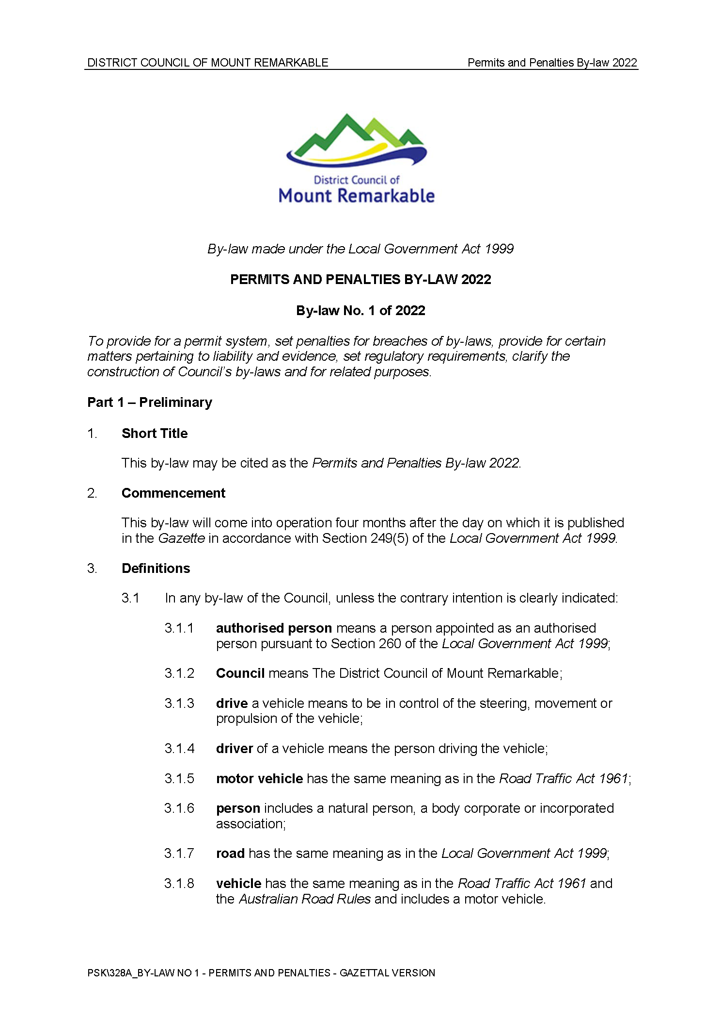
Permits and Penalties By-Law 2022—By-law No. 1 of 2022
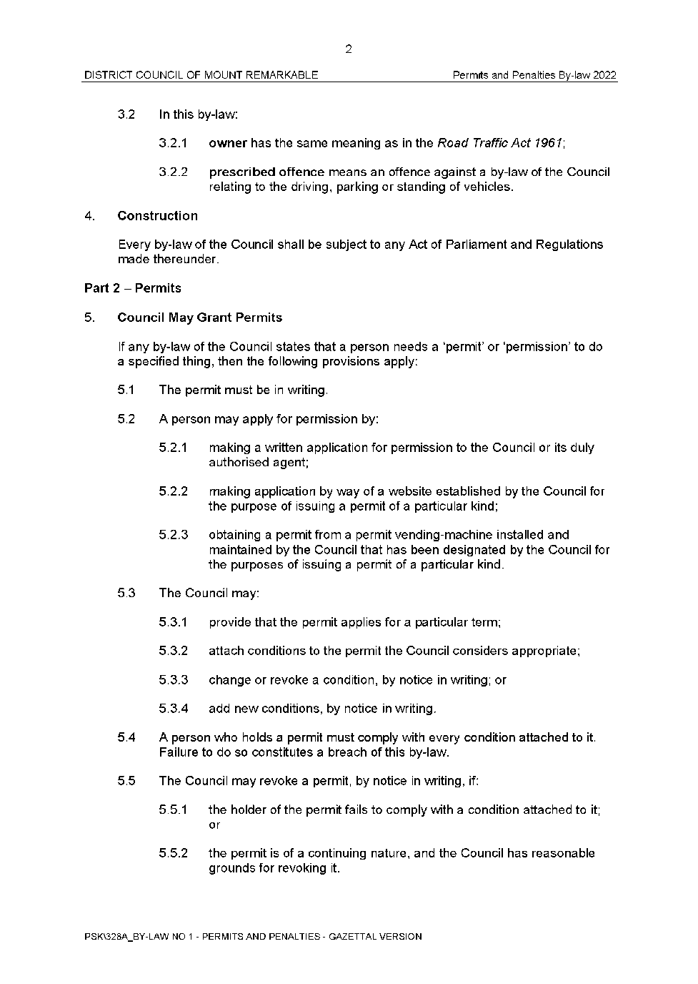
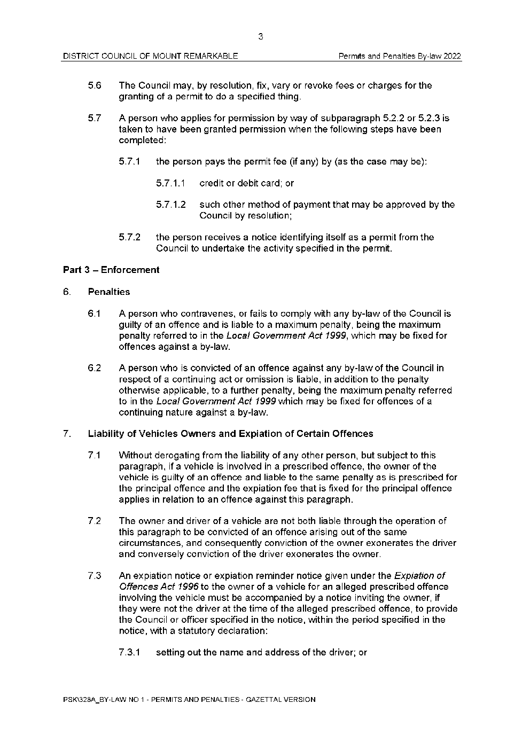
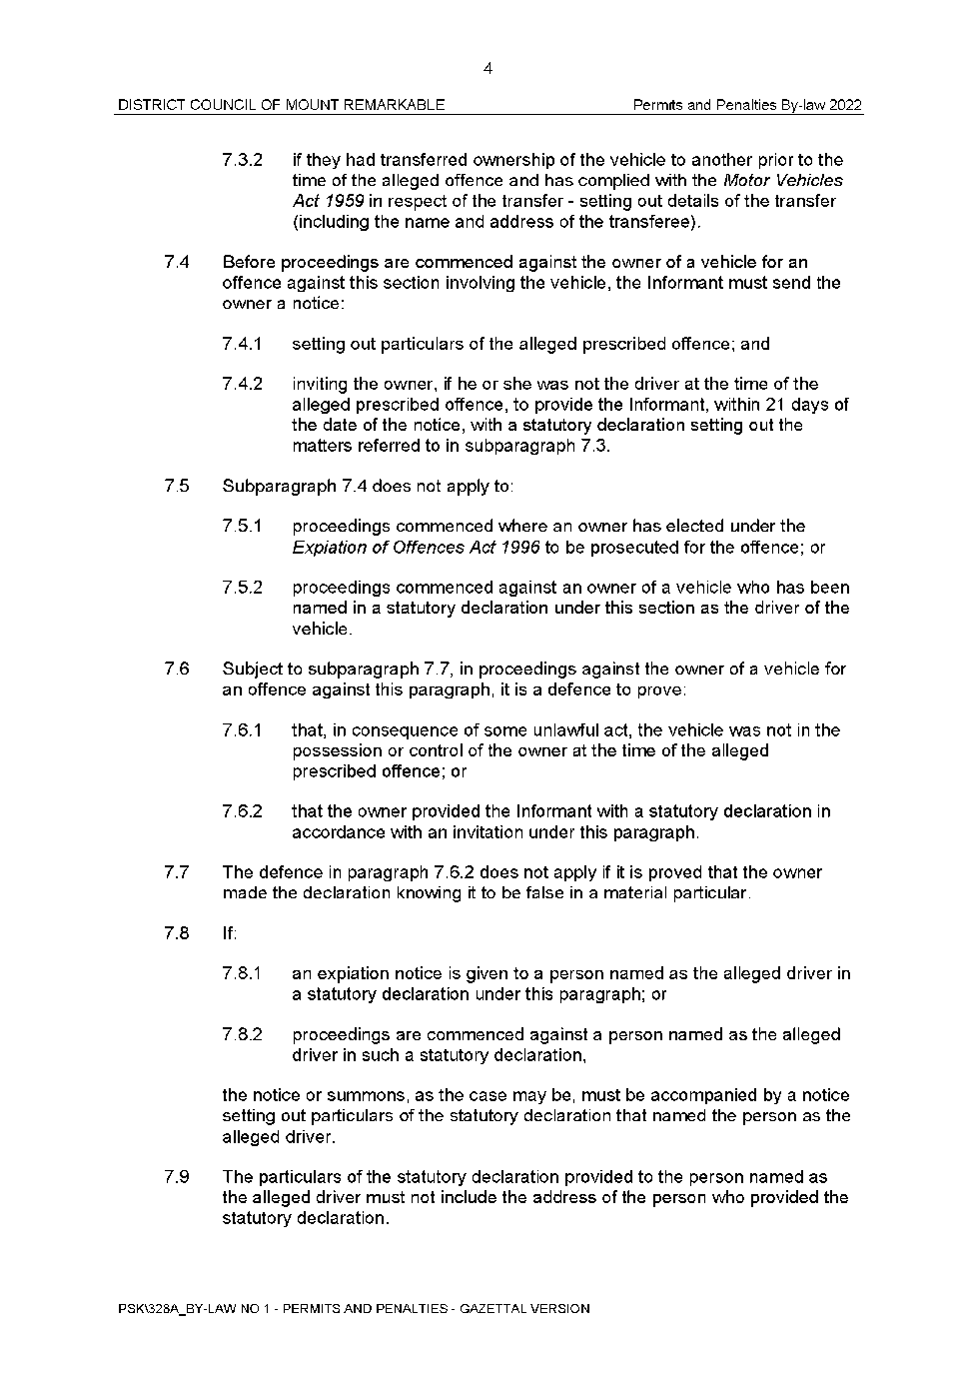
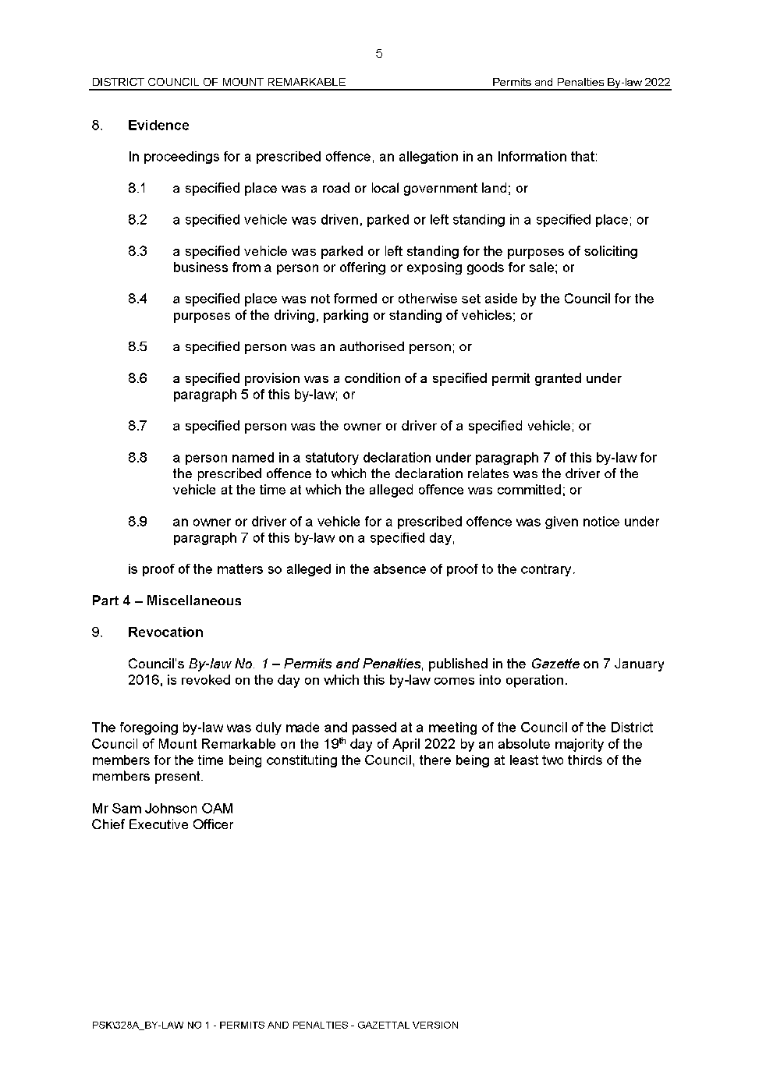

District Council of Mount Remarkable
Local Government Act 1999
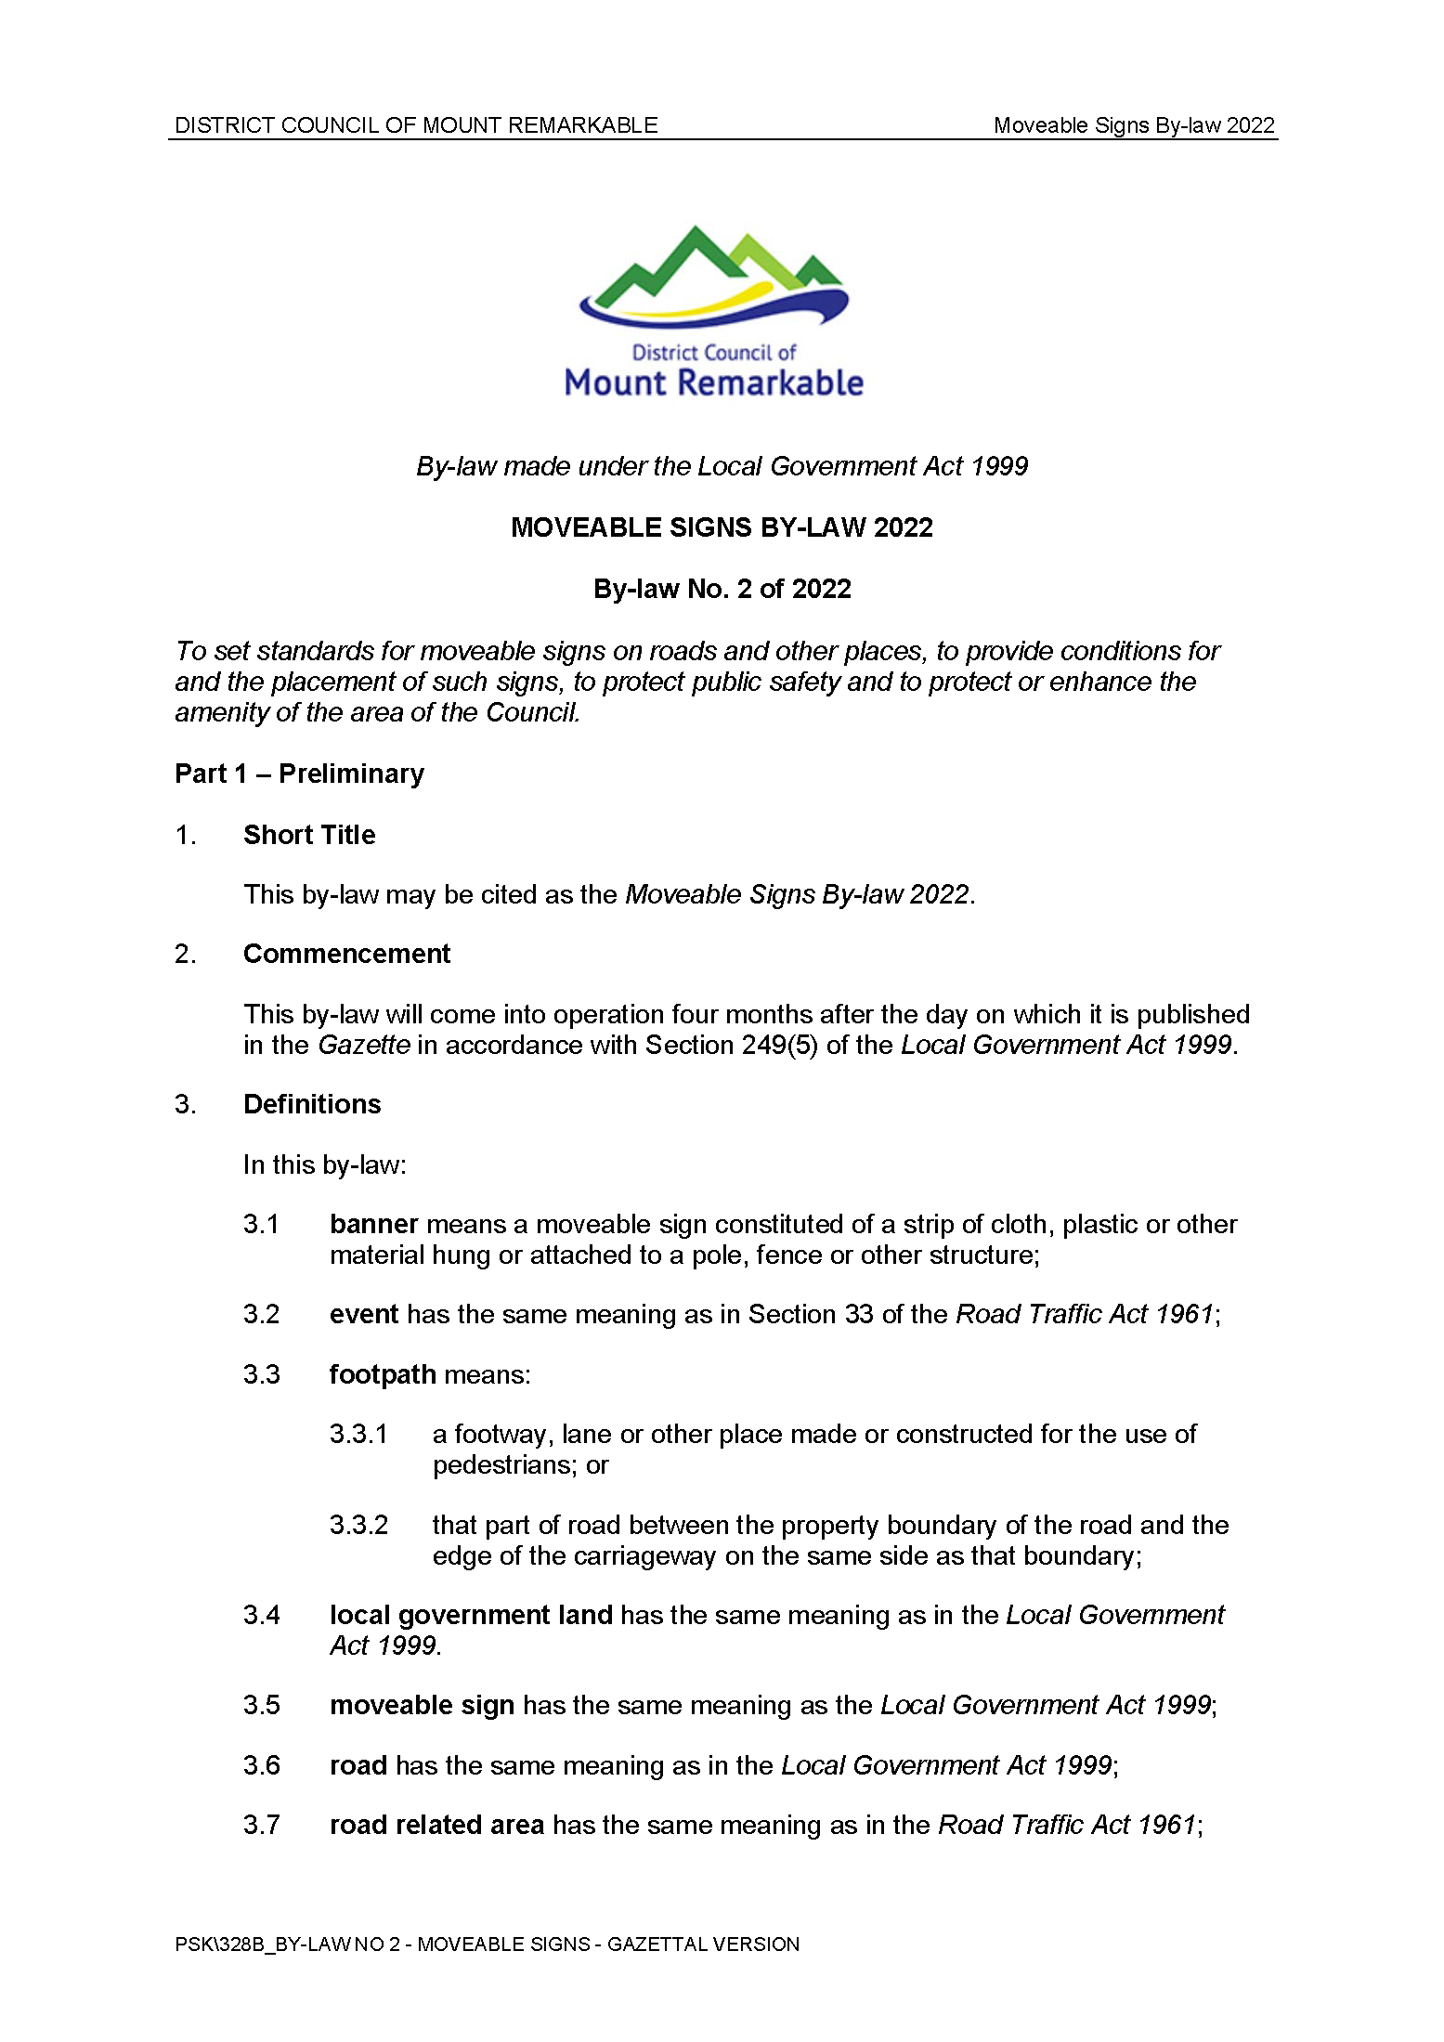
Moveable Signs By-Law 2022—By-law No. 2 of 2022
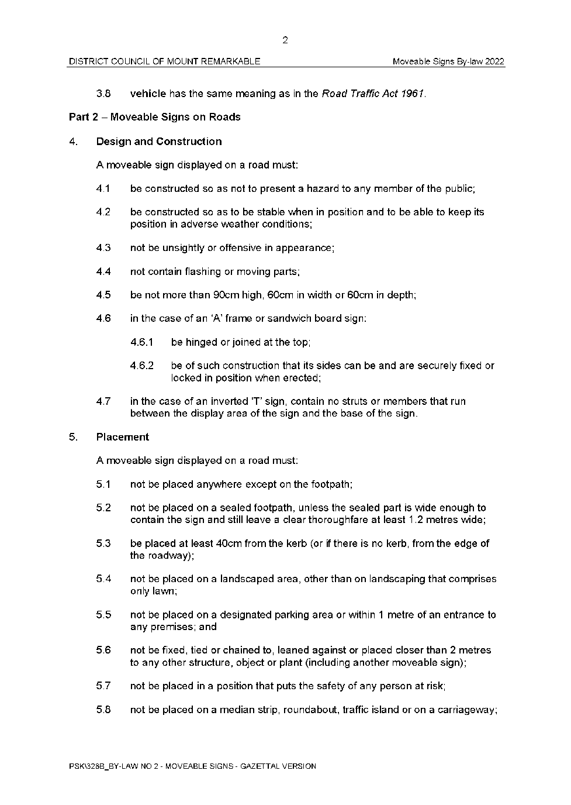
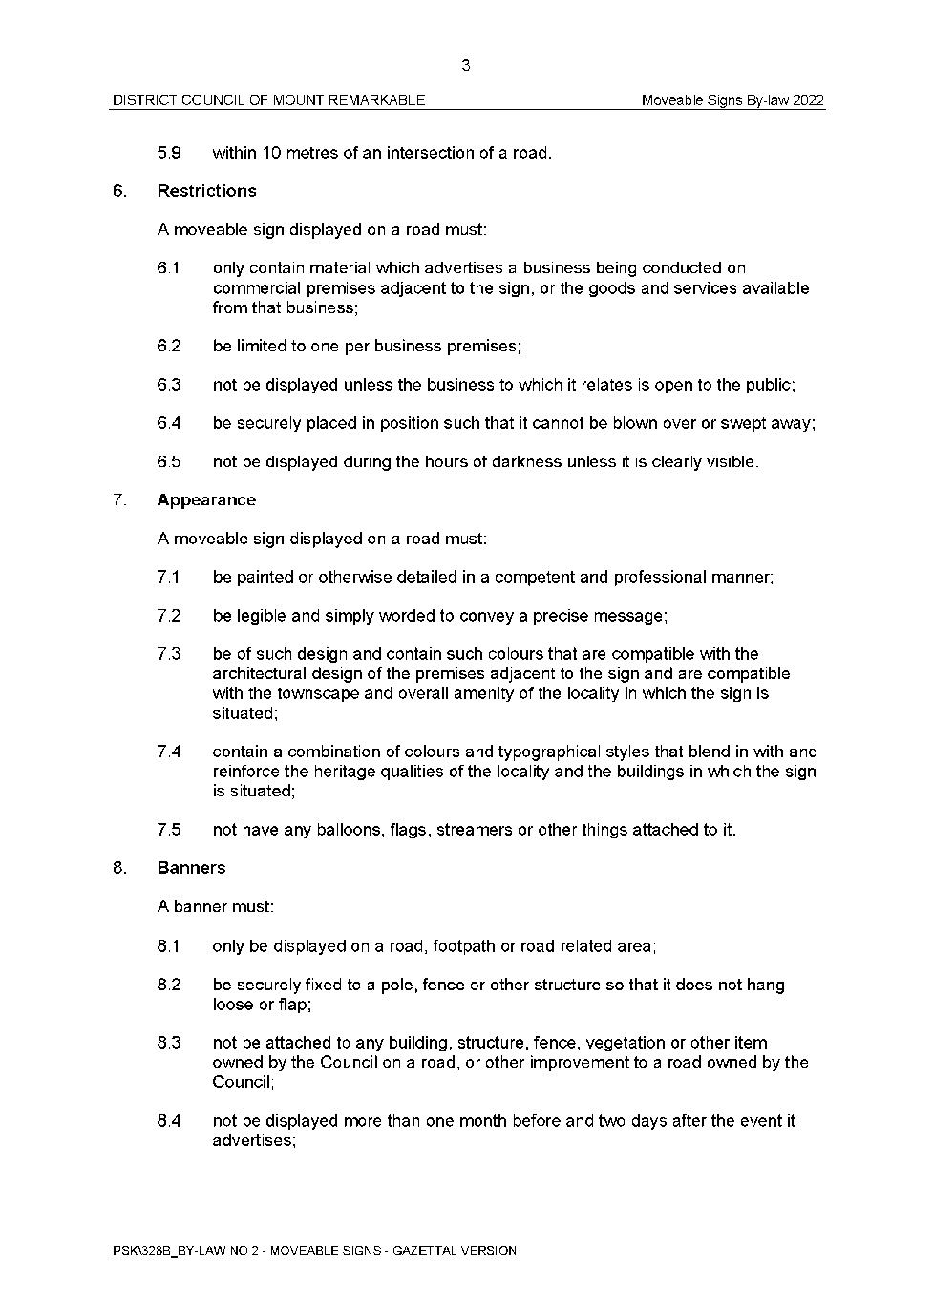
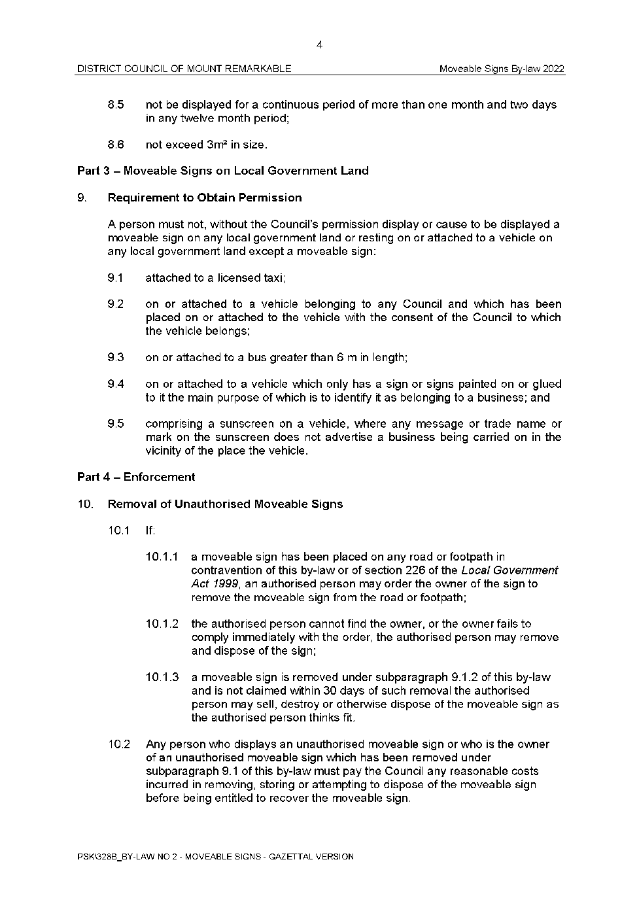
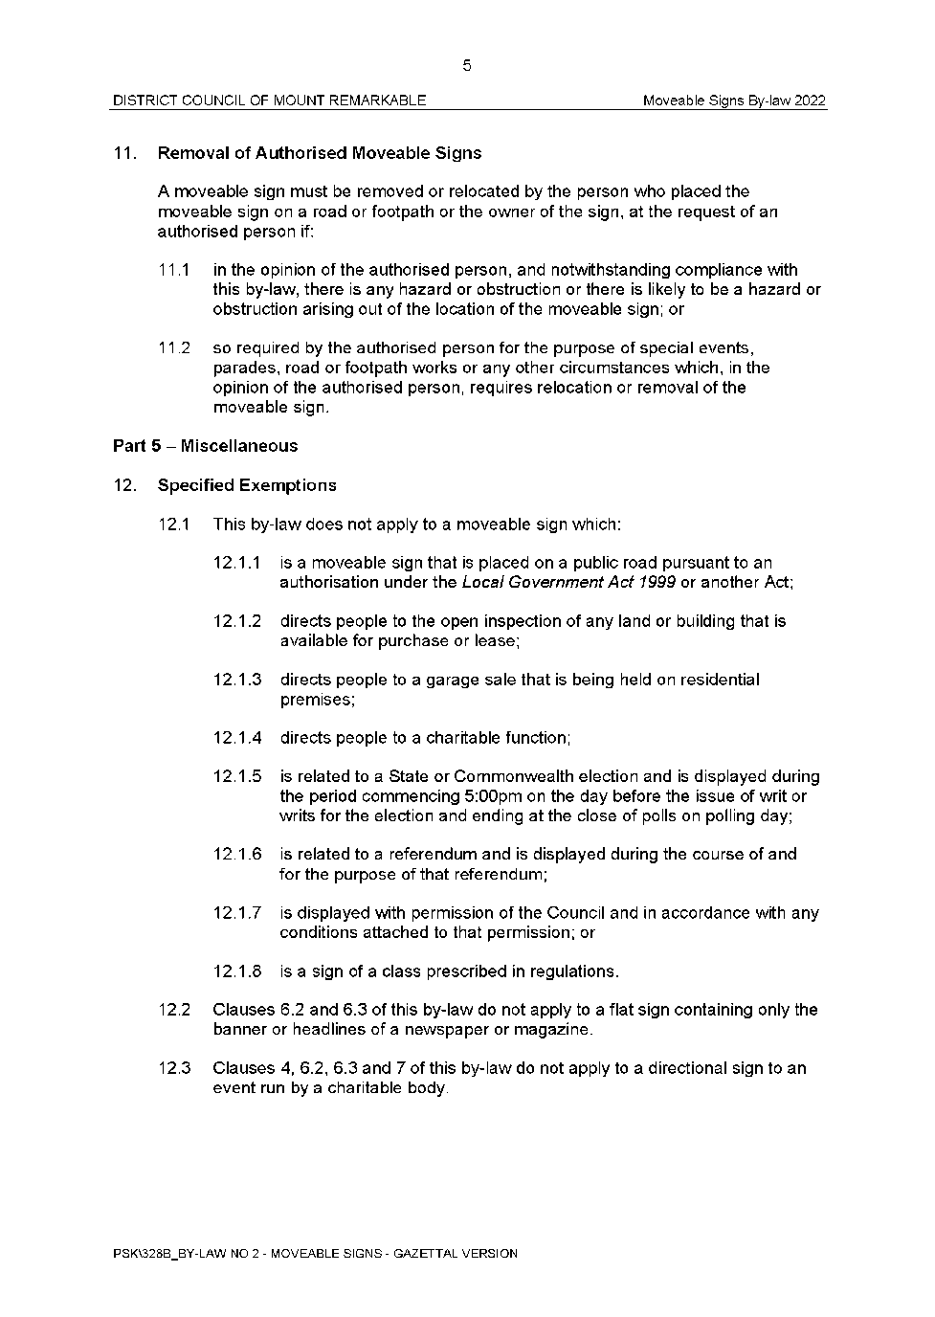
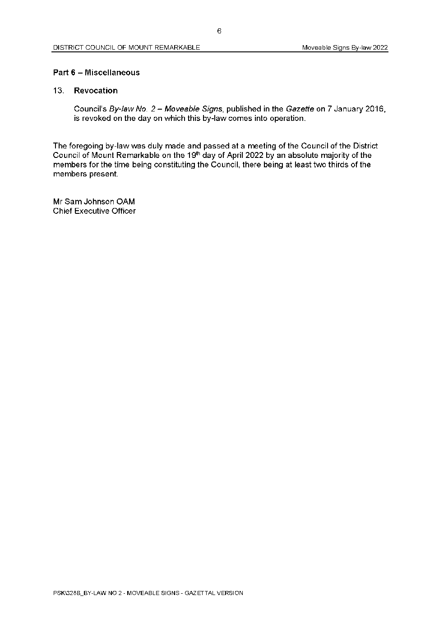

District Council of Mount Remarkable
Local Government Act 1999
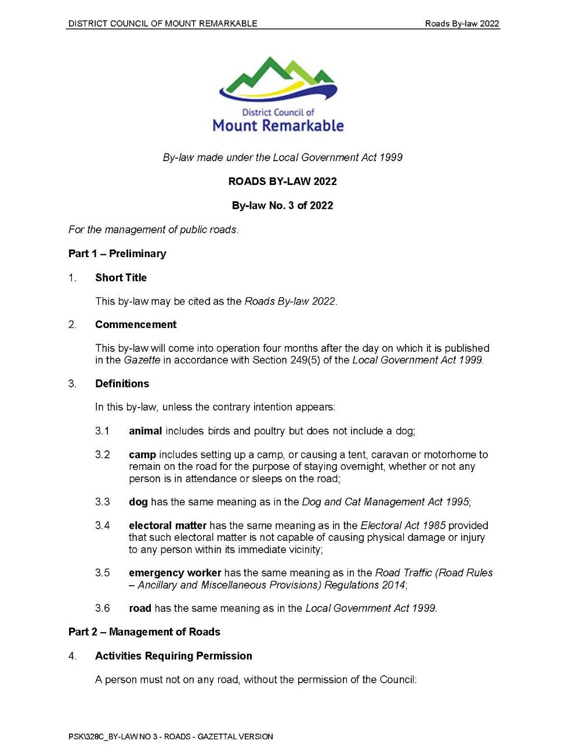
Roads By-Law 2022—By-law No. 3 of 2022
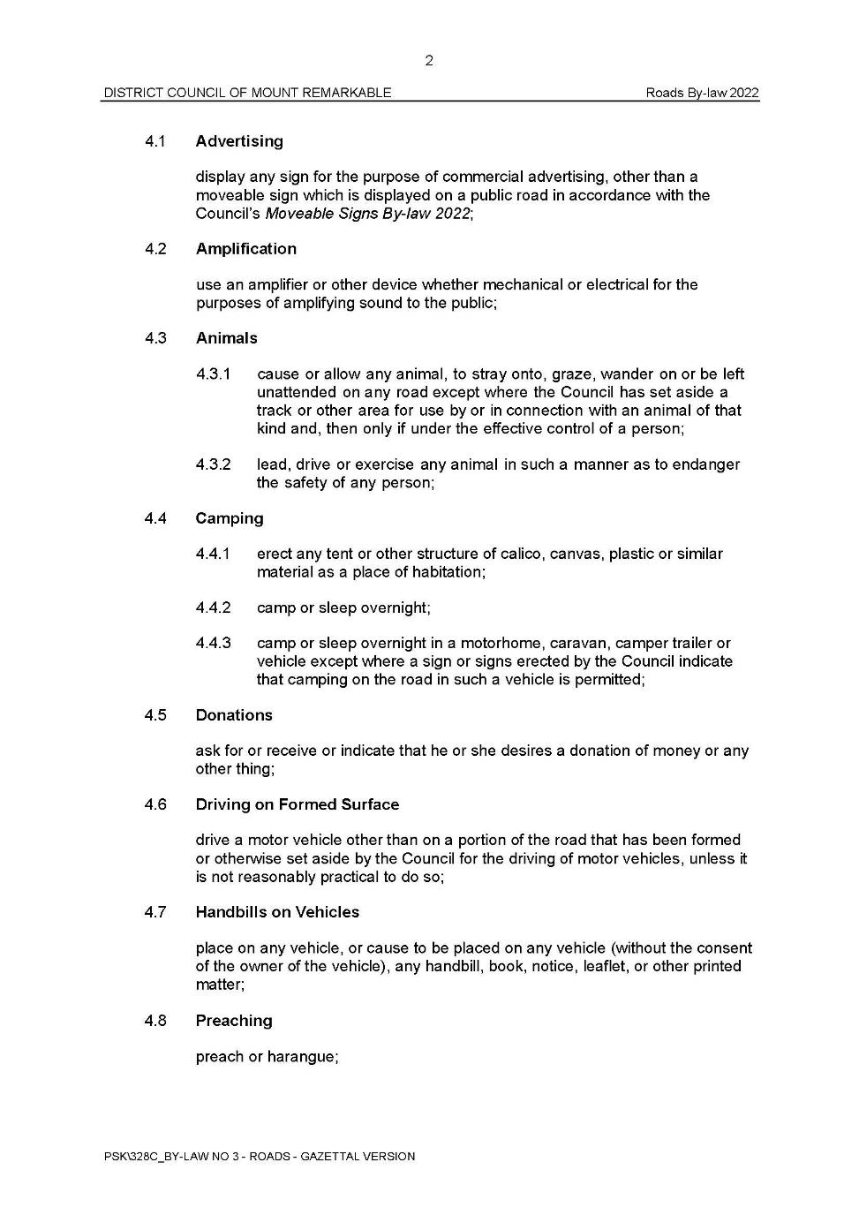
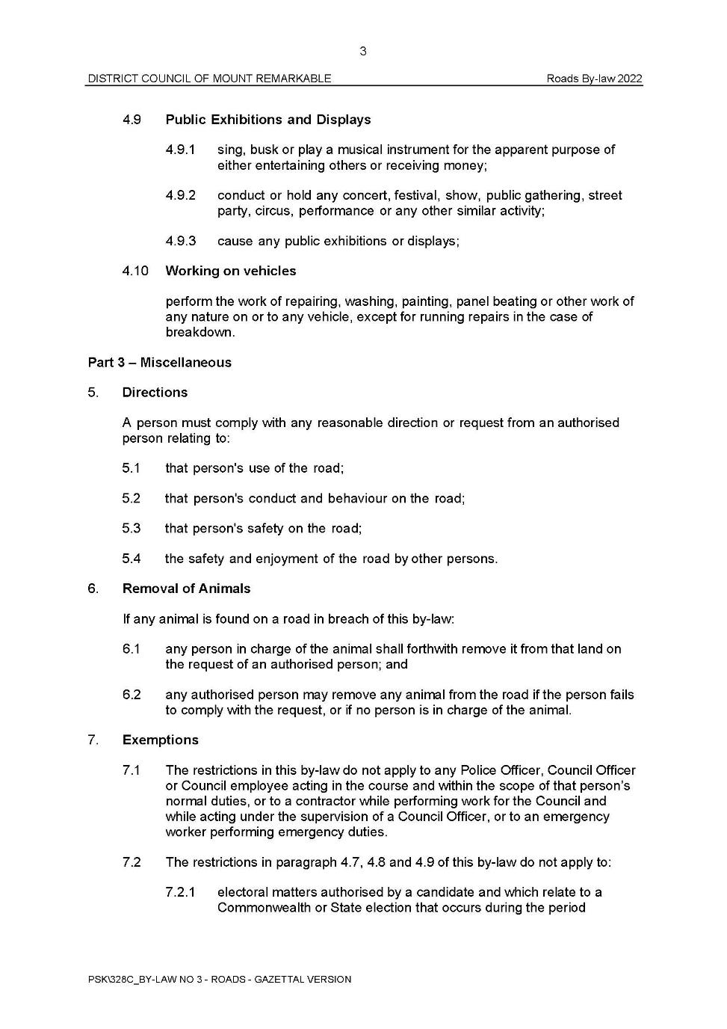
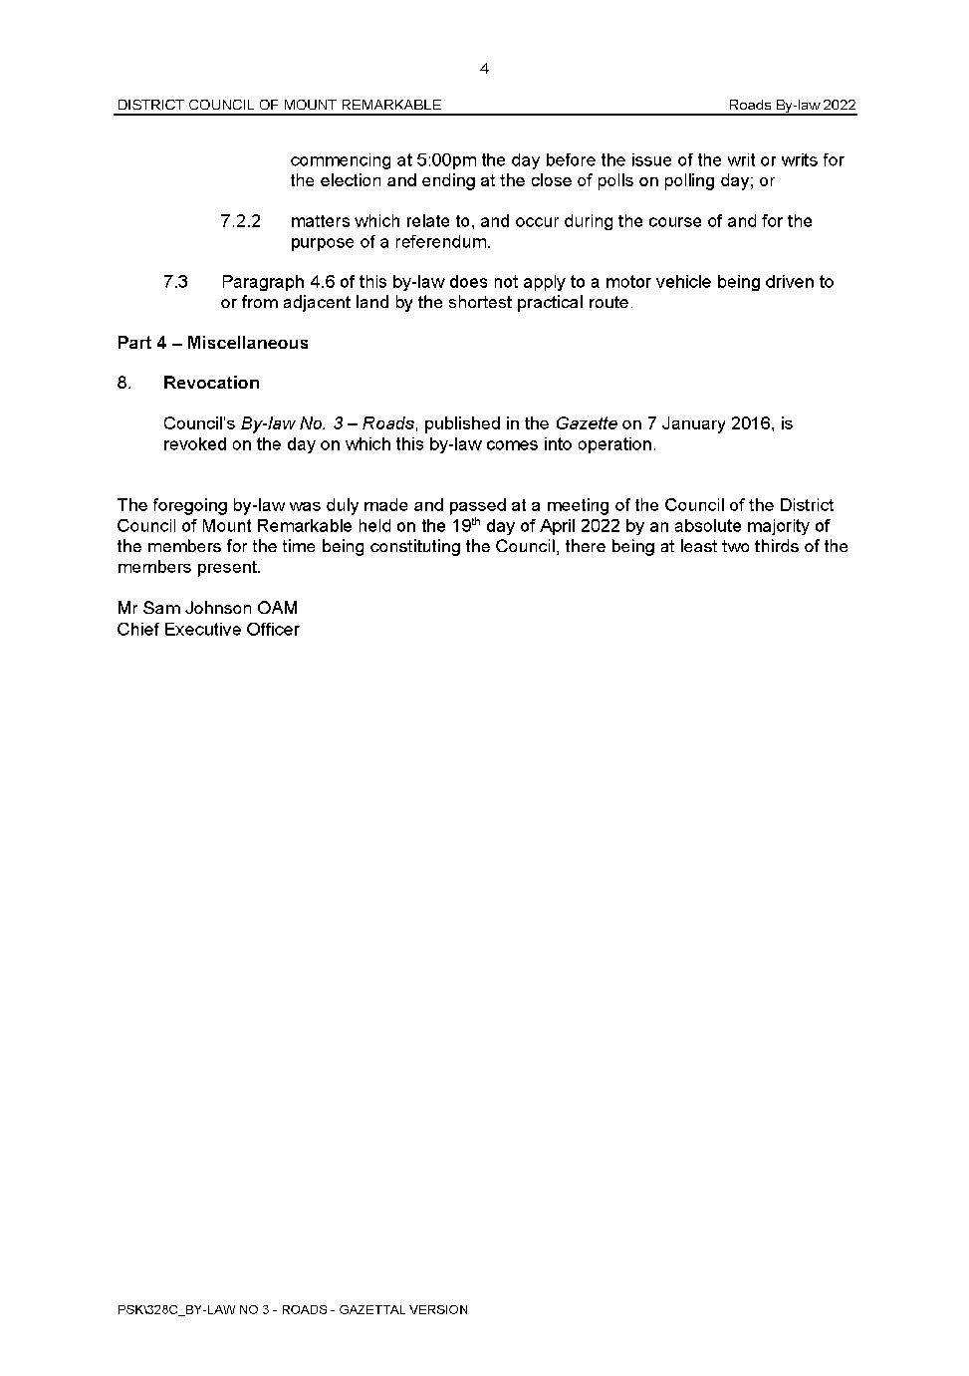

District Council of Mount Remarkable
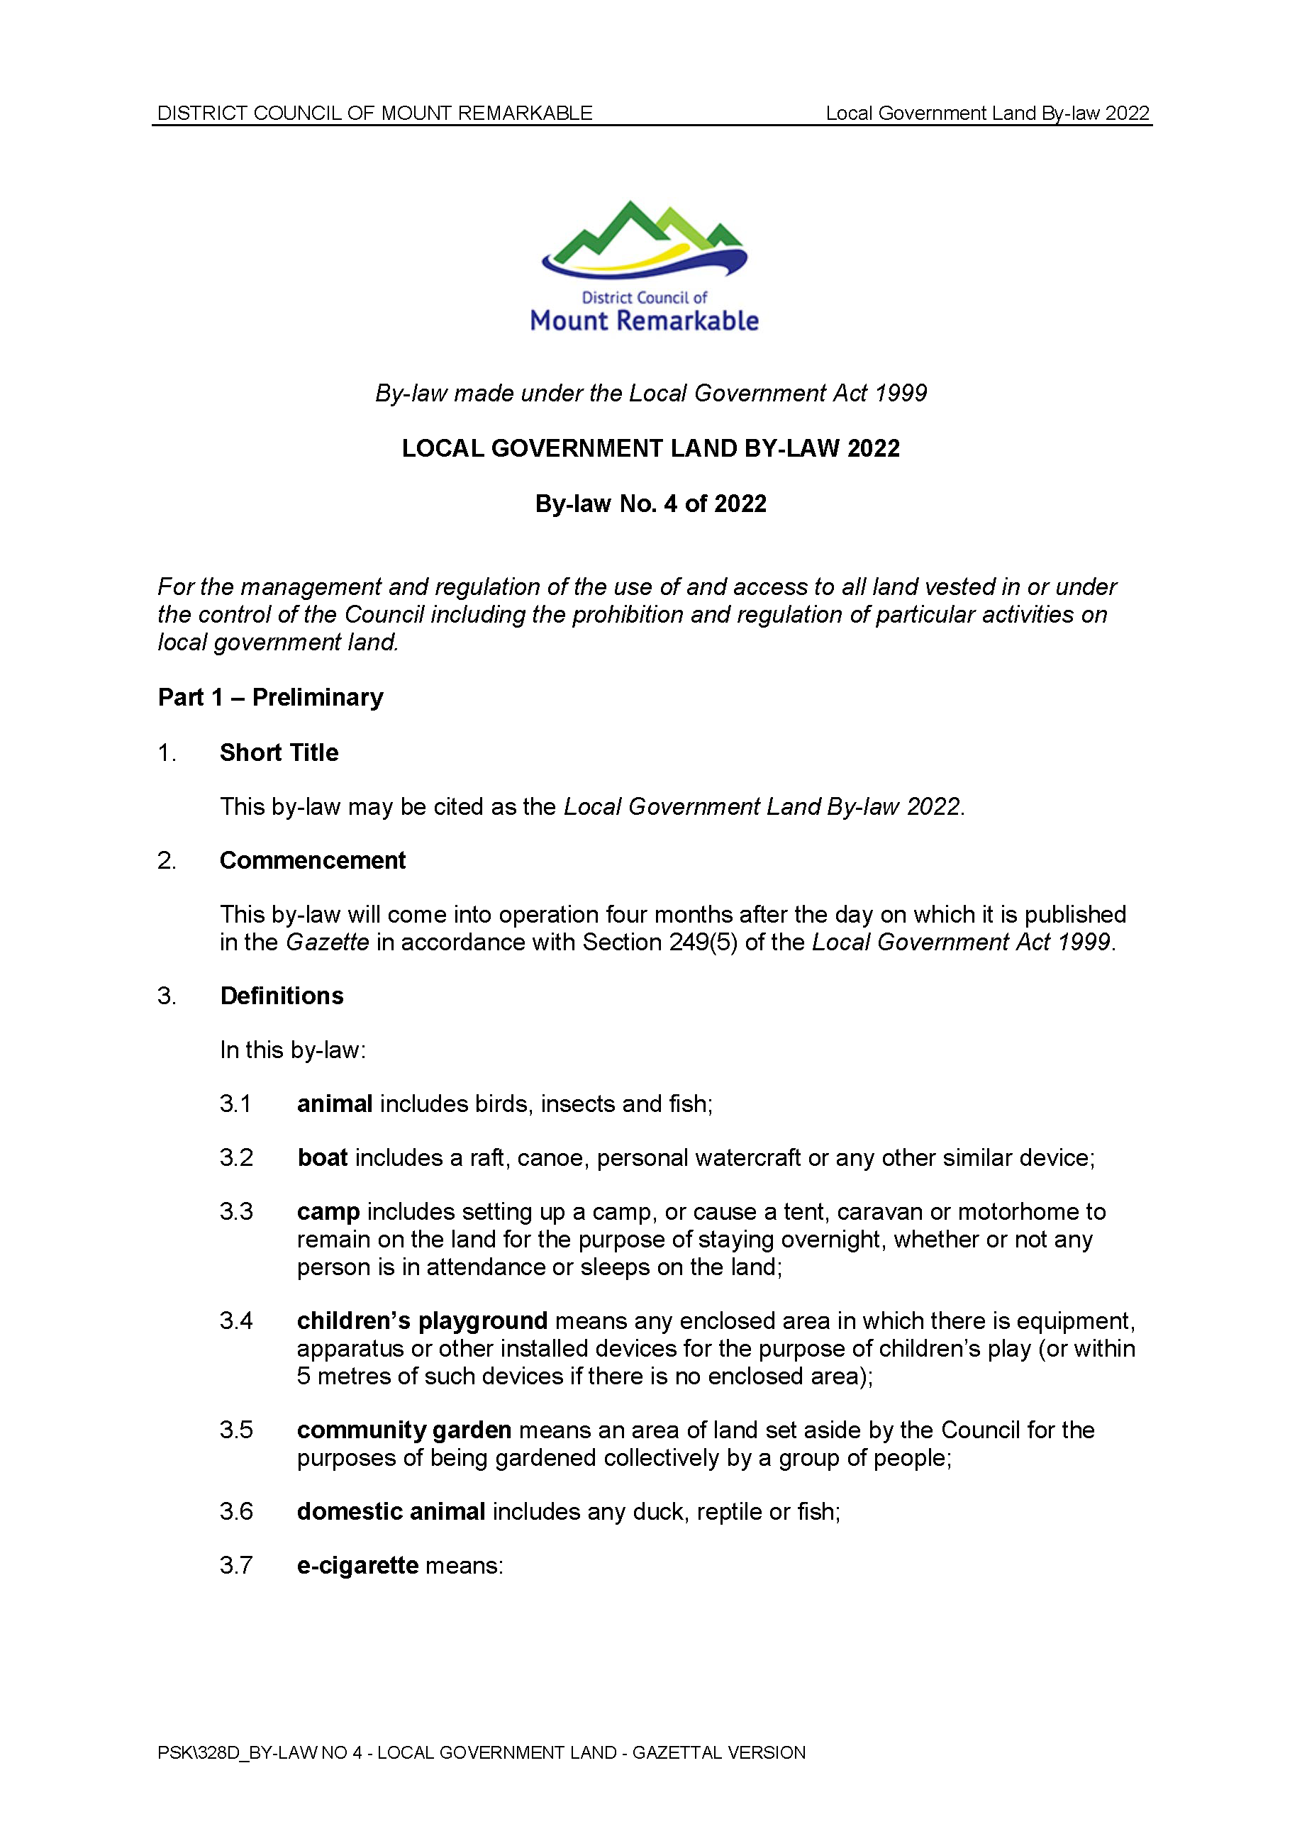
Local Government Act 1999
Local Government Land By-Law 2022—By-law No. 4 of 2022
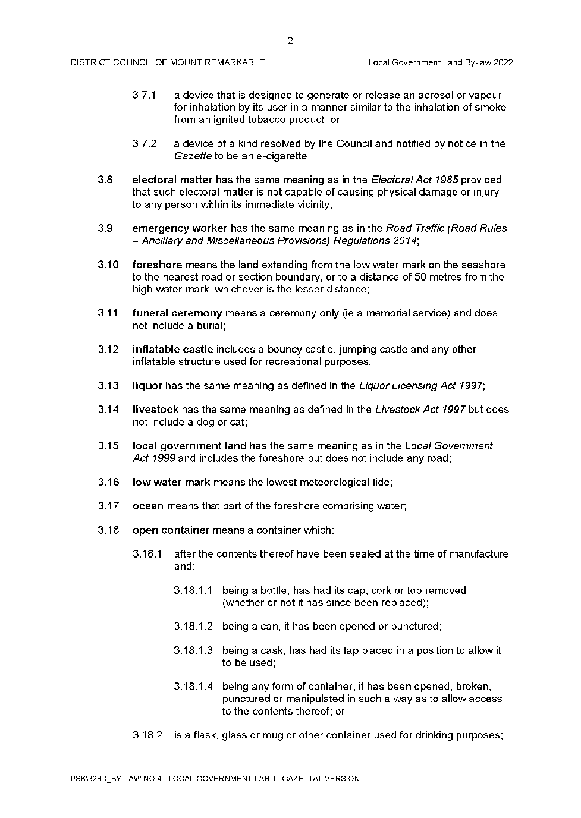
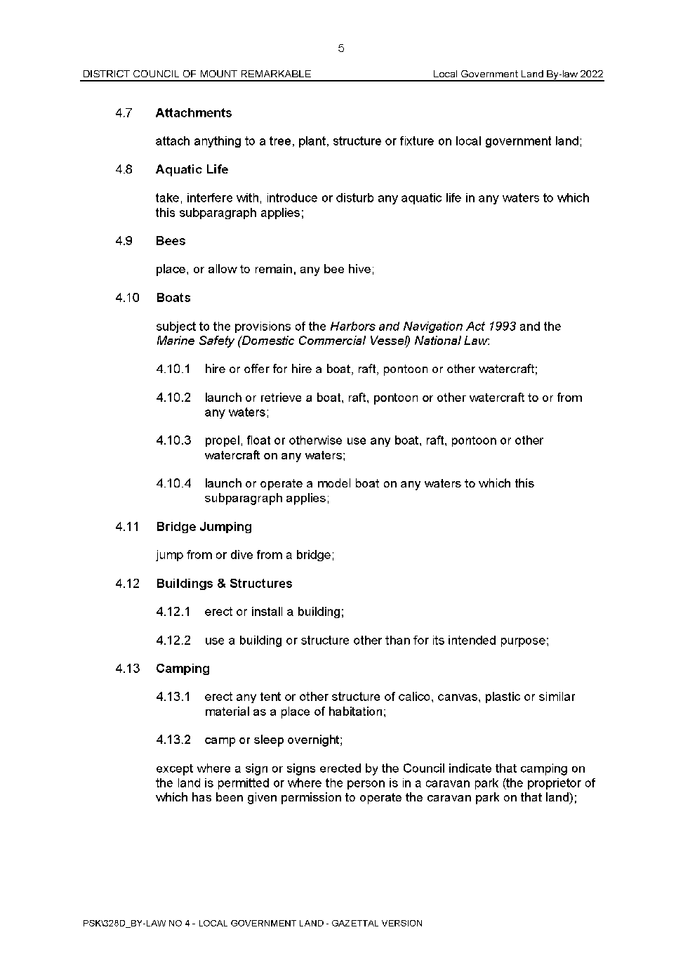
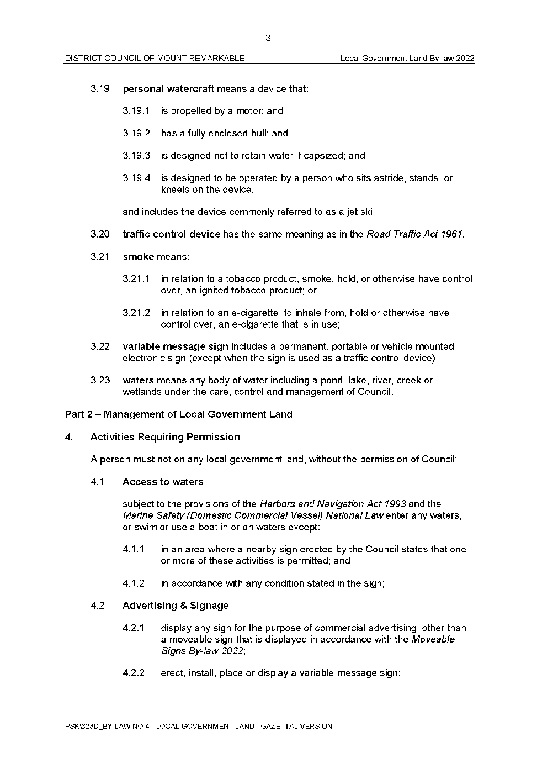
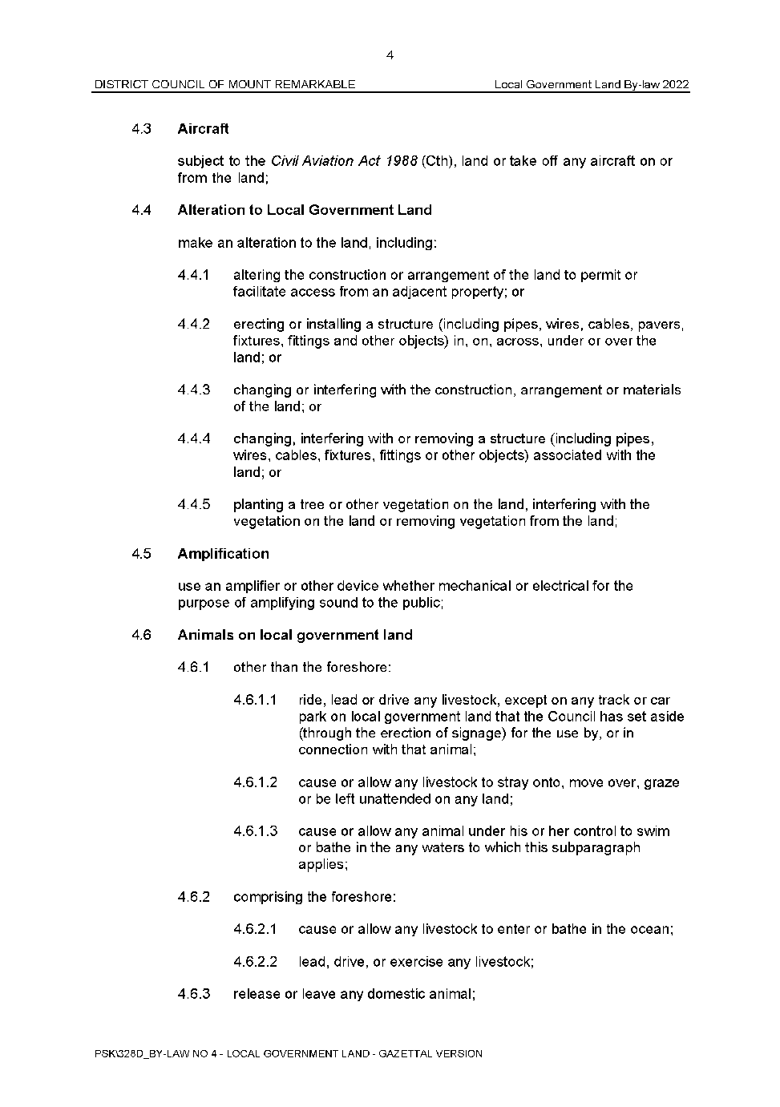
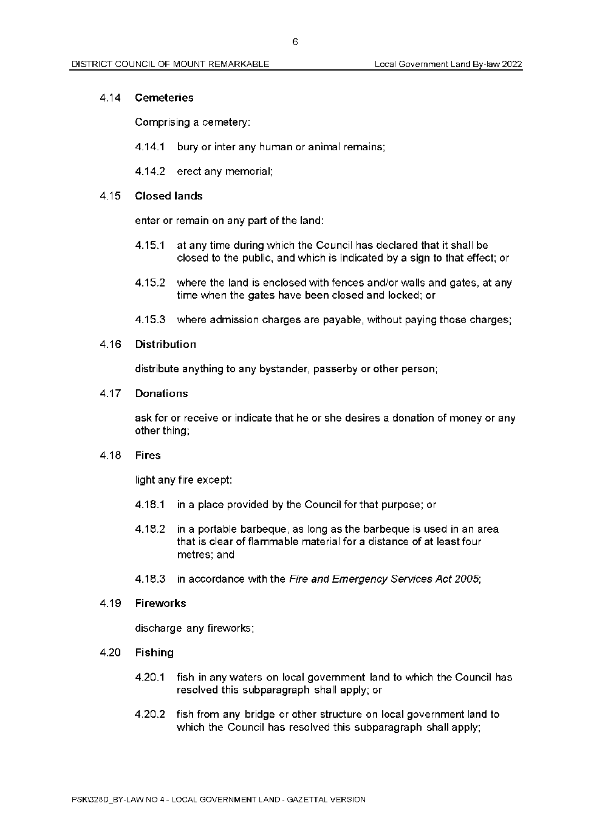
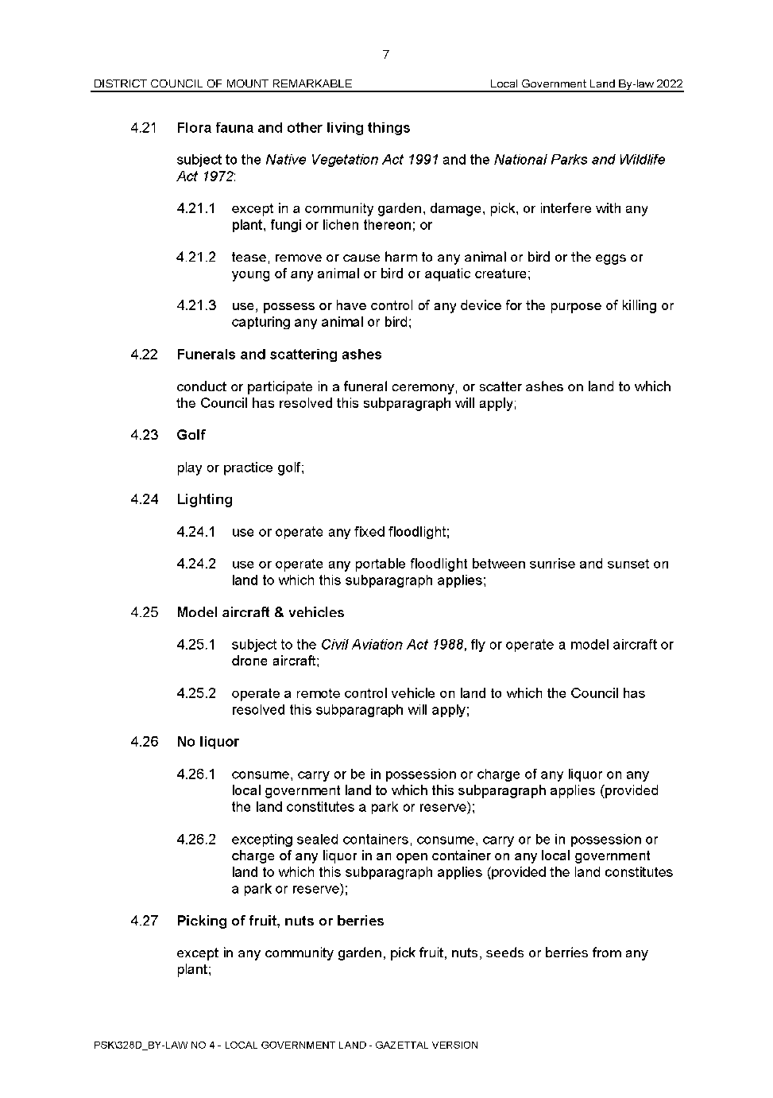
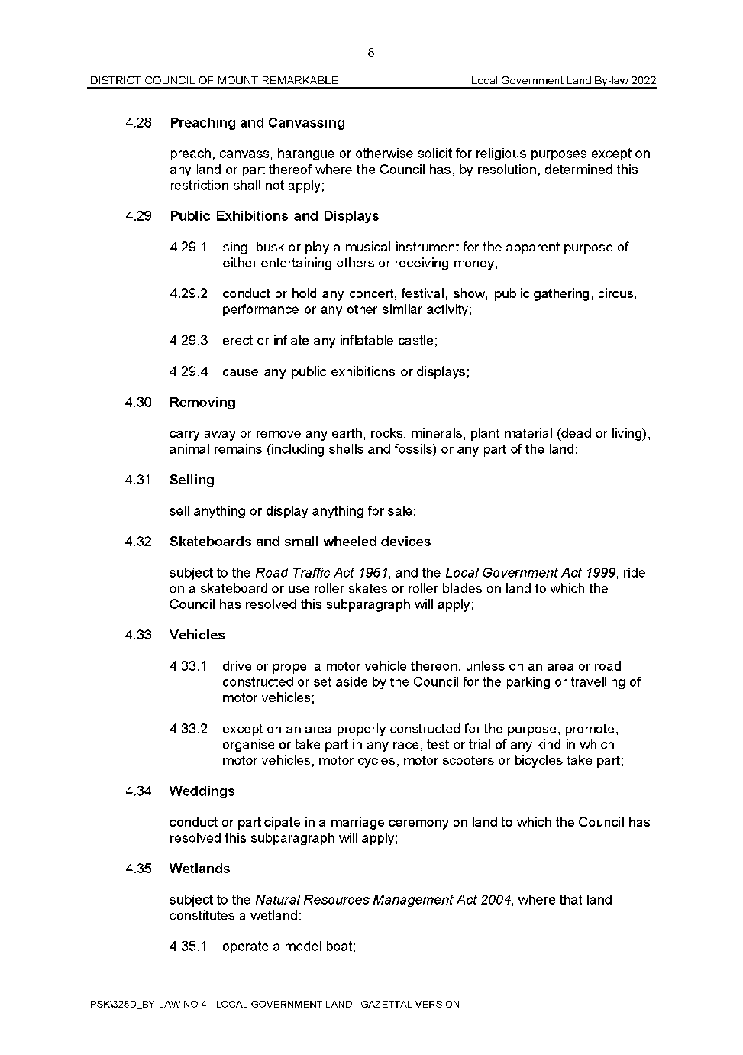
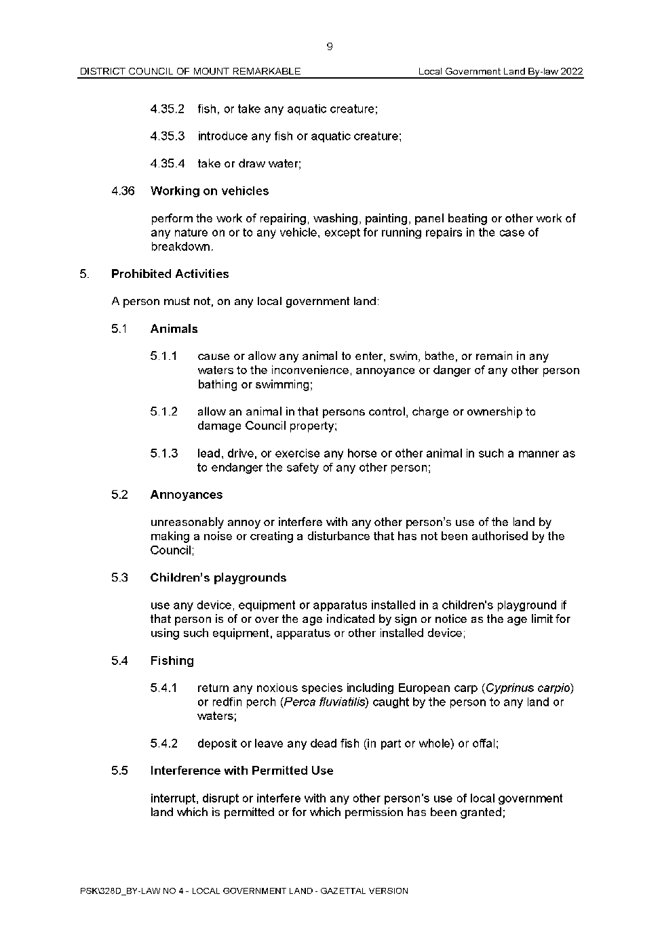
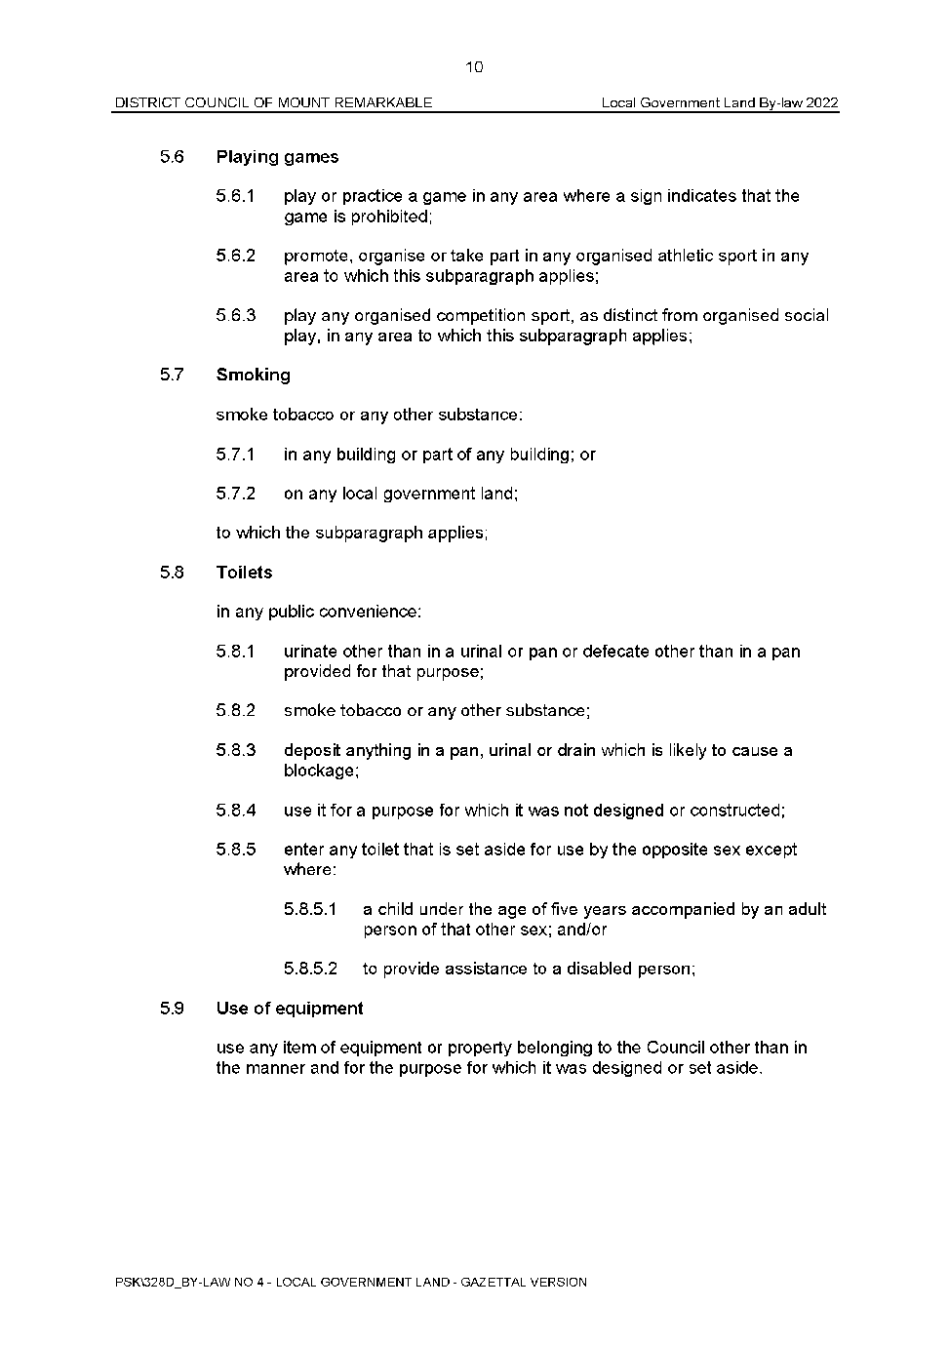
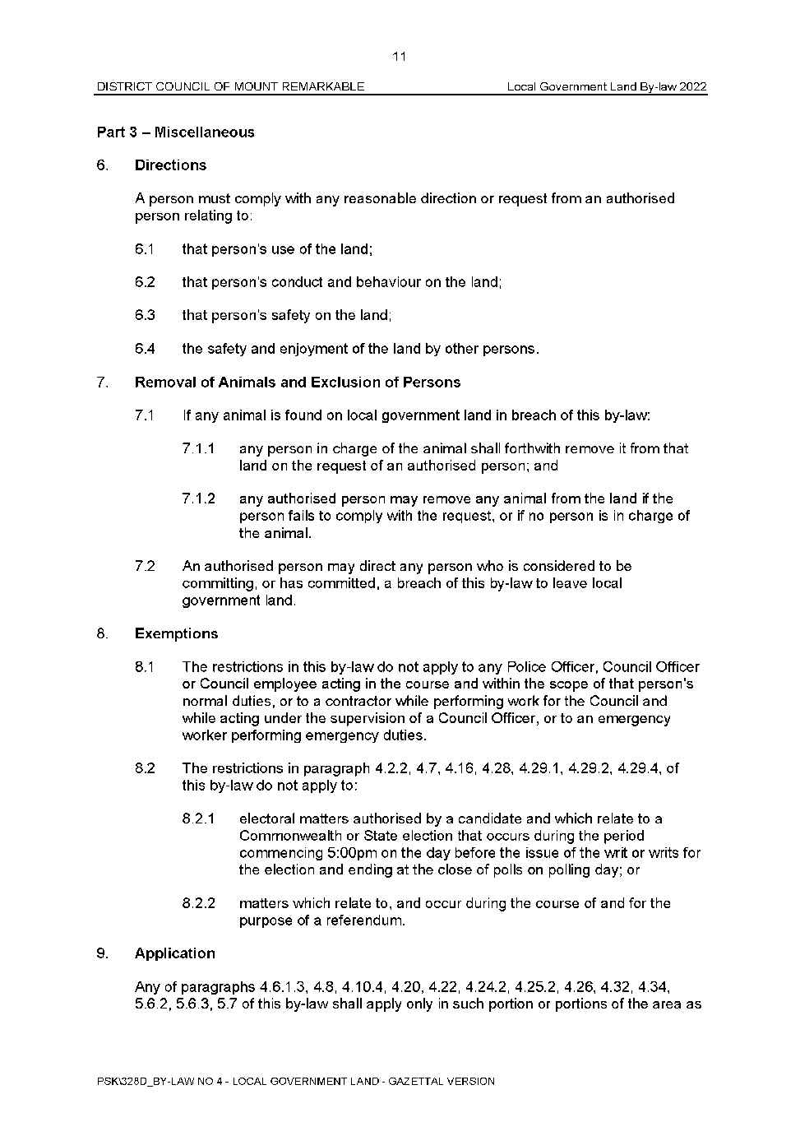
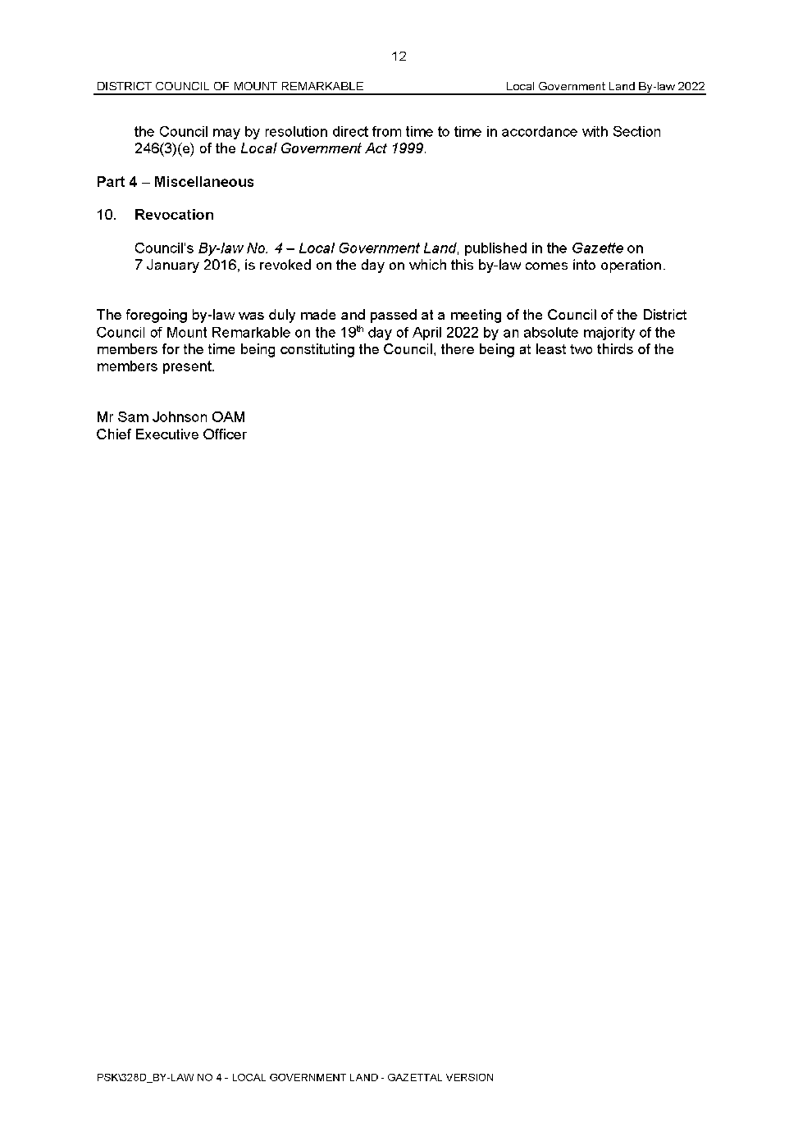

District Council of Mount Remarkable
Local Government Act 1999
Dog and Cat Management Act 1995
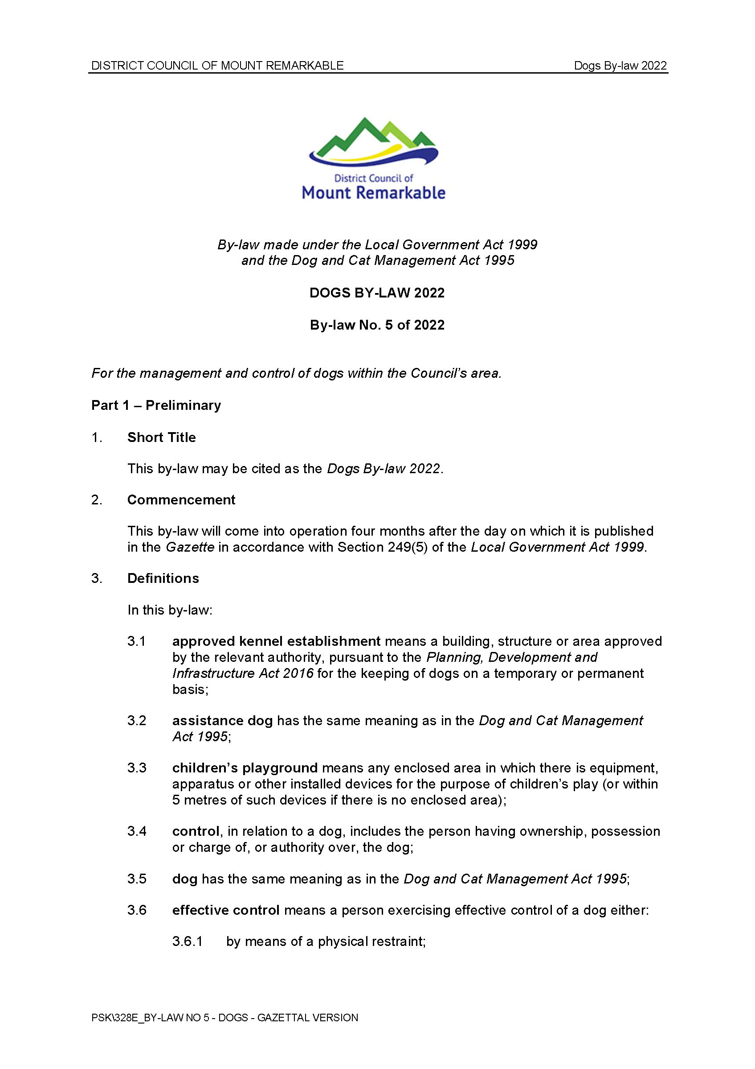
Dogs By-Law 2022—By-law No. 5 of 2022
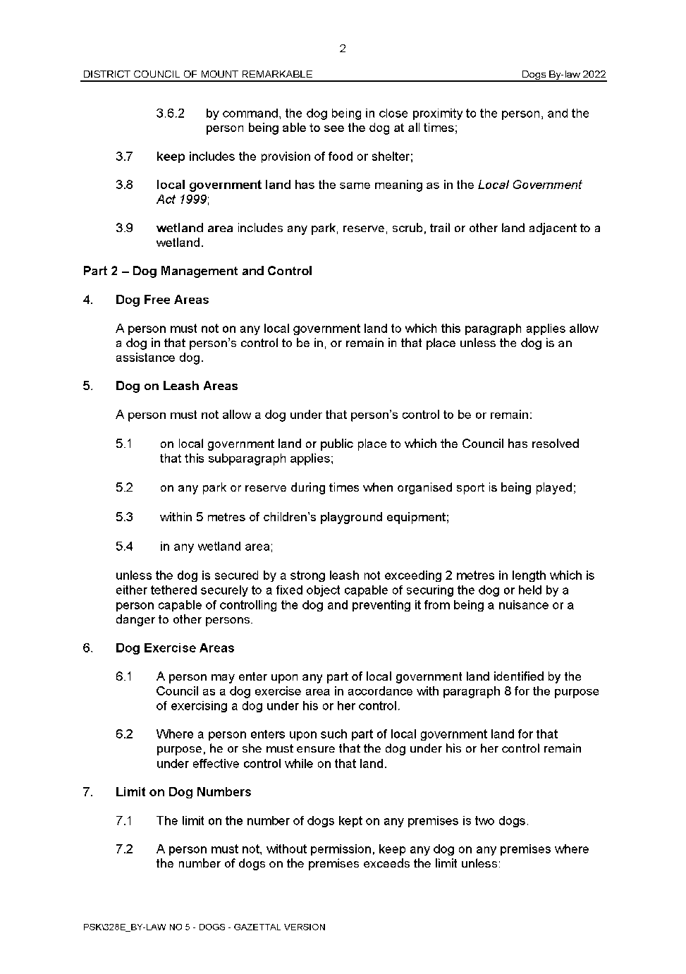
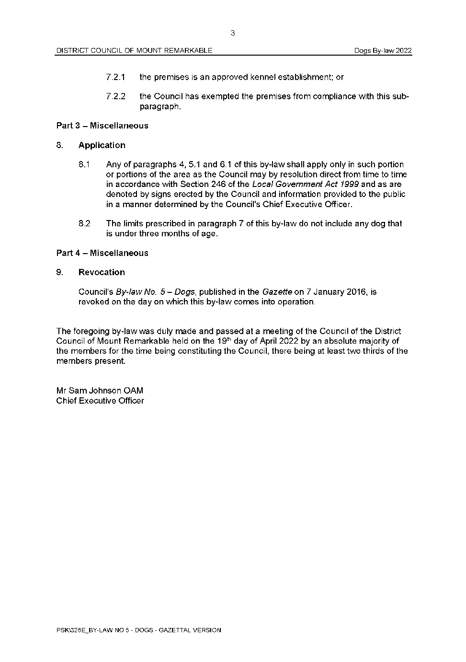

District Council of Mount Remarkable
Local Government Act 1999
Dog and Cat Management Act 1995
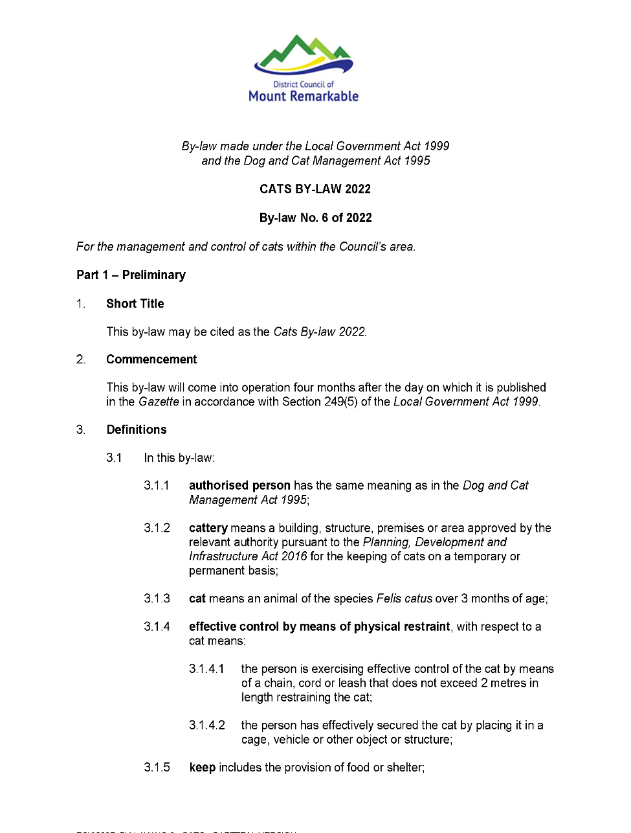
Cats By-Law 2022—By-law No. 6 of 2022
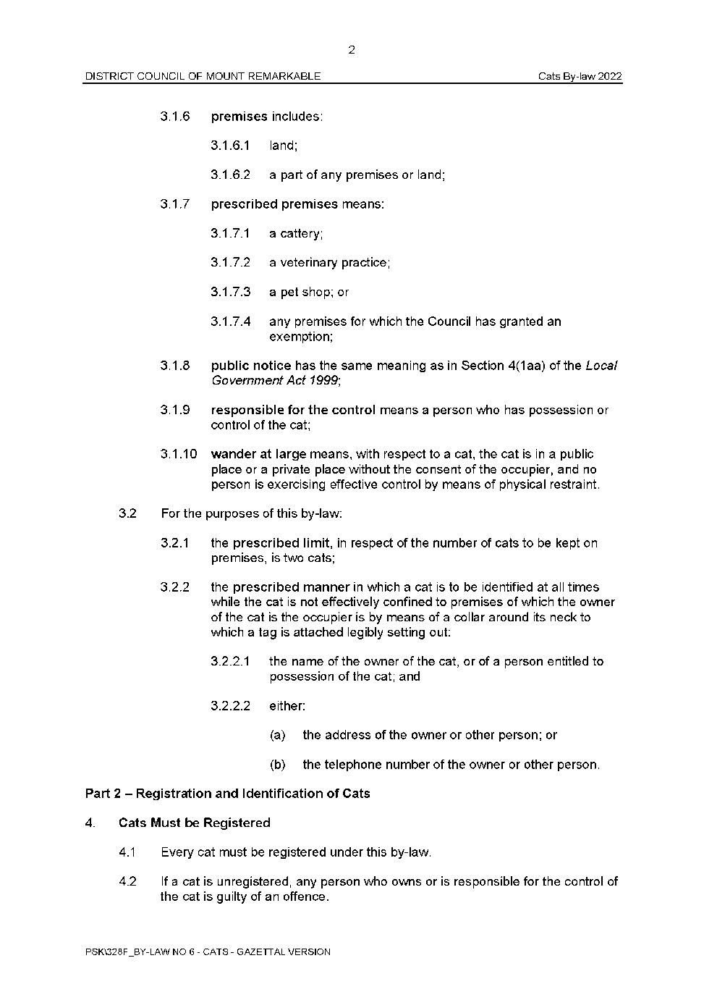
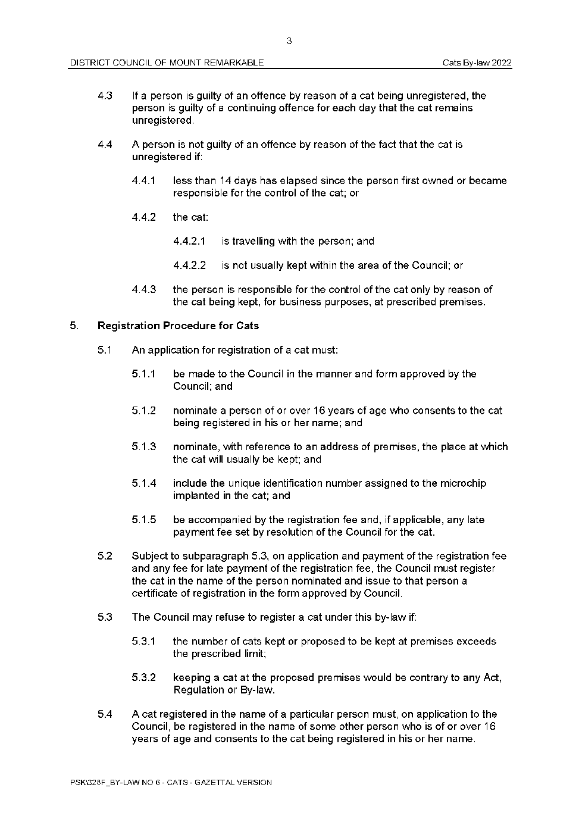
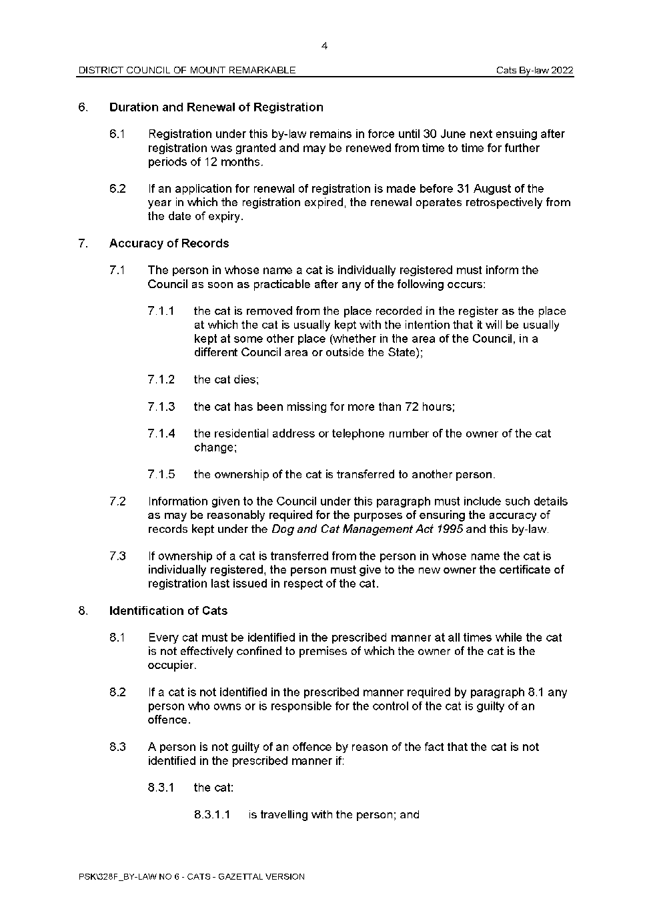
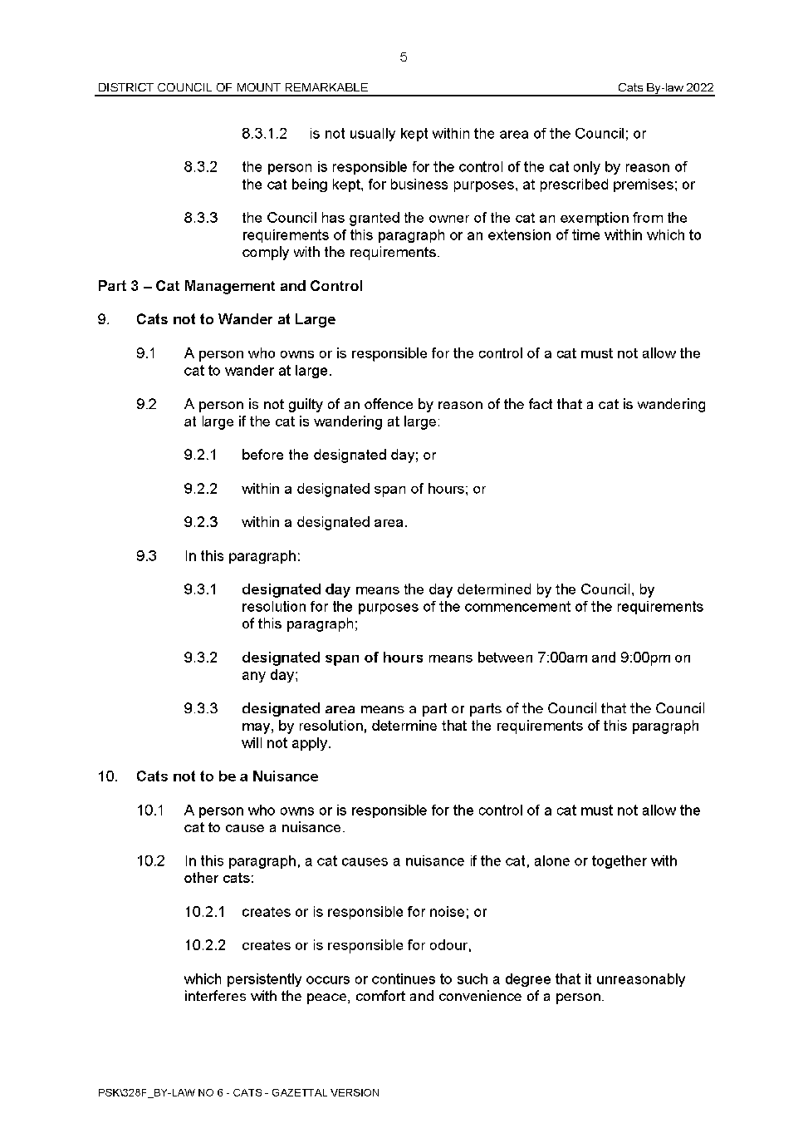
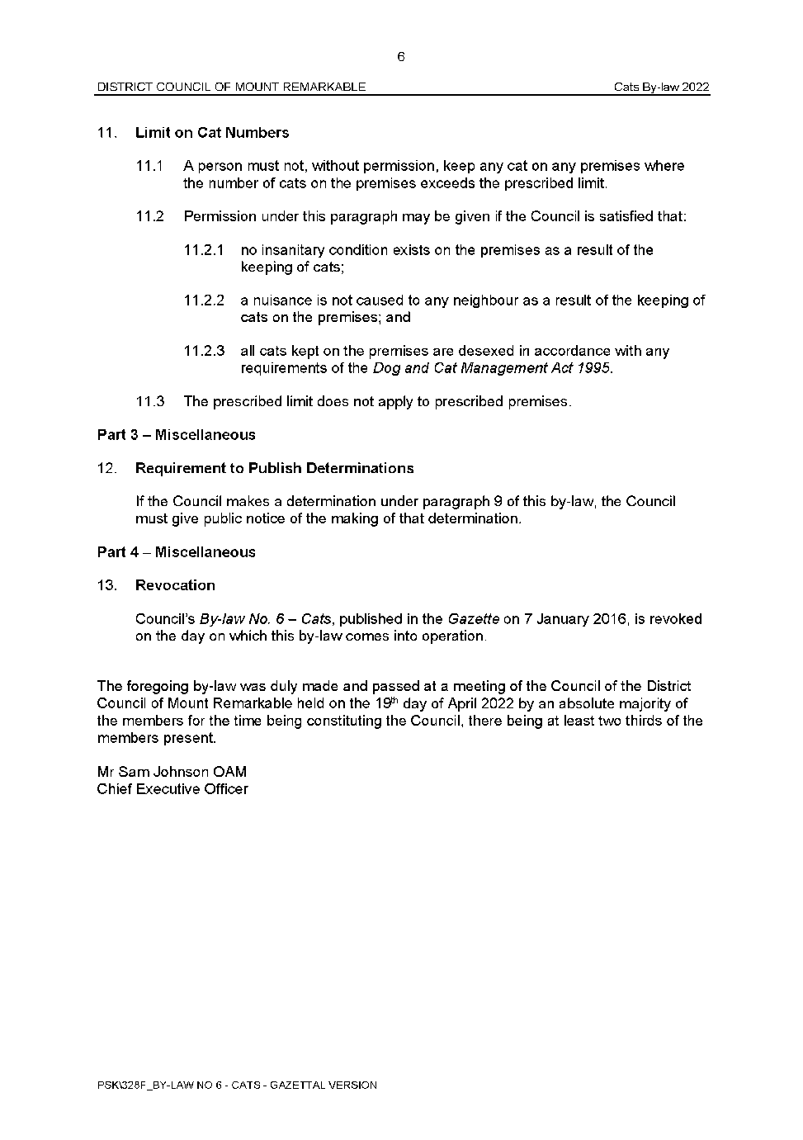

Public Notices

National Electricity Law
Notice of Amendment to Rule
The Australian Energy Market Commission (AEMC) gives notice under the National Electricity Law as follows:
Under ss 102 and 103, the making of the National Electricity Amendment (Updating Short Term PASA) Rule 2022 No. 4 (Ref. ERC0332) and related final determination. Schedule 1 commences operation on 31 July 2025. Schedule 2 commences operation on 3 June 2024. Schedule 3 commences operation on 19 May 2022.
Documents referred to above are available on the AEMC’s website and are available for inspection at the AEMC’s office.
Australian Energy Market Commission
Level 15, 60 Castlereagh St
Sydney NSW 2000
Telephone: (02) 8296 7800
www.aemc.gov.au
Dated: 5 May 2022

National Electricity Law
Notice of Initiation of Rule Change Request
The Australian Energy Market Commission (AEMC) gives notice under the National Electricity Law as follows:
Under s 95, Marinus Link Pty Ltd has requested the Establishing revenue determinations for intending TNSPs (Ref. ERC0343) proposal. The proposal seeks to enable the Australian Energy Regulator to establish a revenue determination for an intending Transmission Network Service Provider. Submissions must be received by 02 June 2022.
Submissions can be made via the AEMC’s website. Before making a submission, please review the AEMC’s privacy statement on its website. Submissions should be made in accordance with the AEMC’s Guidelines for making written submissions on Rule change proposals. The AEMC publishes all submissions on its website, subject to confidentiality.
Documents referred to above are available on the AEMC’s website and are available for inspection at the AEMC’s office.
Australian Energy Market Commission
Level 15, 60 Castlereagh St
Sydney NSW 2000
Telephone: (02) 8296 7800
www.aemc.gov.au
Dated: 5 May 2022

Trustee Act 1936
Public Trustee
Estates of Deceased Persons
In the matter of the estates of the undermentioned deceased persons:
ANDERSON Judy Dorothy late of 1071 Goolwa Road Currency Creek Chef who died 23 December 2020
BOLAND Dulcie Bertha late of 7 Grainger Road Somerton Park of no occupation who died 16 July 2021
LOVEGROVE Edwin Henry late of 103 Fisher Street Cowell Retired Printer who died 19 December 2021
MAGDALINOS Georgios late of 24 Hawdon Street Barmera of no occupation who died 27 November 2021
MEDLEY Marree Jacqualin late of 39 Beach Road Brighton of no occupation who died 25 January 2022
MONOPOLI Victoria Rose late of 1099 Grand Junction Road Hope Valley Retired Cashier who died 09 January 2022
PHILPOTT Mervyn Tasman late of 115 Bookpurnong Terrace Loxton Labourer who died 18 October 2021
RICHARDS Brian John late of 1215 Grand Junction Road Hope Valley Retired Pharmacist who died 06 January 2022
SEMMLER Hurtle Vince late of 7 Partridge Street Goolwa of no occupation who died 07 November 2020
SHAW Colin Richard late of 5 Saltram Road Glenelg Retired Sales Executive who died 30 January 2022
WRIGHT David Ian late of 19 Rhyne Avenue Salisbury of no occupation who died 25 May 2021
Notice is hereby given pursuant to the Trustee Act 1936, the Inheritance (Family Provision) Act 1972 and the Family Relationships Act 1975 that all creditors, beneficiaries, and other persons having claims against the said estates are required to send, in writing, to the office of Public Trustee at GPO Box 1338, Adelaide, 5001, full particulars and proof of such claims, on or before the 3 June 2022 otherwise they will be excluded from the distribution of the said estate; and notice is also hereby given that all persons indebted to the said estates are required to pay the amount of their debts to the Public Trustee or proceedings will be taken for the recovery thereof; and all persons having any property belonging to the said estates are forthwith to deliver same to the Public Trustee.
Dated: 5 May 2022
N. S. Rantanen
Public Trustee

Notice Submission

The South Australian Government Gazette is published each Thursday afternoon.
Notices must be emailed by 4 p.m. Tuesday, the week of publication.
Submissions are formatted per the gazette style and a proof will be supplied prior to publication, along with a quote if applicable. Please allow one day for processing notices.
Alterations to the proof must be returned by 4 p.m. Wednesday.

Gazette notices must be submitted as Word files, in the following format:
• Title—the governing legislation
• Subtitle—a summary of the notice content
• Body—structured text, which can include numbered lists, tables, and images
• Date—day, month, and year of authorisation
• Signature block—name, role, and department/organisation authorising the notice

Please provide the following information in your email:
• Date of intended publication
• Contact details of the person responsible for the notice content
• Name and organisation to be charged for the publication—Local Council and Public notices only
• Purchase order, if required—Local Council and Public notices only

Email: governmentgazettesa@sa.gov.au
Phone: (08) 7109 7760
Website: www.governmentgazette.sa.gov.au

All instruments appearing in this gazette are to be considered official, and obeyed as such

Printed and published weekly by authority of S. Smith, Government Printer, South Australia
$8.00 per issue (plus postage), $402.00 per annual subscription—GST inclusive
Online publications: www.governmentgazette.sa.gov.au

