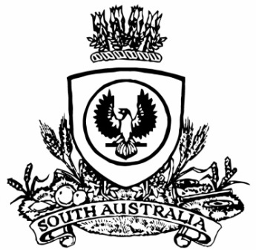
SUPPLEMENTARY GAZETTE
THE SOUTH AUSTRALIAN
GOVERNMENT GAZETTE
Published by Authority

Adelaide, Tuesday, 10 May 2022

Governor’s Instrument
Letters Patent Constituting the Office of Governor
Assumption of the Administration of the State by an Administrator
TAKE NOTICE THAT, having been notified of the temporary incapacity of Her Excellency the Governor, I have requested that His Honour the Chief Justice, Christopher John Kourakis, assume the administration of the State as Administrator from 10.00am on Tuesday, 10 May 2022, until 8.29am on Wednesday, 11 May 2022, pursuant to the Letters Patent Constituting the Office of Governor made on 14 February 1986 and the Order in Council by the Governor of the State of South Australia made on 25 October 2001.
Dated: 10 May 2022
Peter Malinauskas, MP
Premier

