No. 77 p. 6599
THE SOUTH AUSTRALIAN
GOVERNMENT GAZETTE
Published by Authority

Adelaide, Thursday, 10 November 2022

Contents

Governor’s Instruments
Acts 6600
Appointments 6600
Proclamations—
Private Parking Areas (Shopping Centre Parking Areas) Amendment Act (Commencement)
Proclamation 2022 6602
State Government Instruments
Building Work Contractors Act 1995 6603
Dog Fence Act 1946 6603
Fire and Emergency Services Act 2005 6604
Fisheries Management Act 2007 6604
Justices of the Peace Act 2005 6606
Landscape South Australia Act 2019 6607
Local Government Act 1999 6608
Mental Health Act 2009 6608
National Electricity (South Australia) Law 6608
Petroleum and Geothermal Energy Act 2000 6609
Planning, Development and Infrastructure Act 2016 6609
Roads (Opening and Closing) Act 1991 6621
South Australian Skills Act 2008 6621
Wilderness Protection Regulations 2021 6621
Local Government Instruments
City of Adelaide 6621
Public Notices
Trustee Act 1936 6621

Governor’s Instruments

Acts
Department of the Premier and Cabinet
Adelaide, 10 November 2022
His Excellency the Governor’s Deputy directs it to be notified for general information that he has in the name and on behalf of His Majesty The King, this day assented to the undermentioned Bill passed by the Legislative Council and House of Assembly in Parliament assembled, viz.:
No. 18 of 2022—Private Parking Areas (Shopping Centre Parking Areas) Amendment Bill 2022
An Act to amend the Private Parking Areas Act 1986
By command,
Hon Susan Elizabeth Close, MP
For Premier

Appointments
Department of the Premier and Cabinet
Adelaide, 10 November 2022
His Excellency the Governor’s Deputy in Executive Council has been pleased to appoint the undermentioned to the South Australian Museum Board, pursuant to the provisions of the South Australian Museum Act 1976:
Member: from 10 November 2022 until 9 November 2025
Christopher Brian Daniels
By command,
Hon Susan Elizabeth Close, MP
For Premier
ART0017-22CS

Department of the Premier and Cabinet
Adelaide, 10 November 2022
His Excellency the Governor’s Deputy in Executive Council has been pleased to appoint the Honourable Blair Ingram Boyer, MP, Minister for Education, Training and Skills, to be also Acting Minister for Industry, Innovation and Science and Acting Minister for Defence and Space Industries for the period from 7.00pm on Thursday, 10 November 2022 to Thursday, 17 November 2022 inclusive, during the absence of the Honourable Dr Susan Elizabeth Close, MP.
By command,
Hon Susan Elizabeth Close, MP
For Premier
CAB22/00074

Department of the Premier and Cabinet
Adelaide, 10 November 2022
His Excellency the Governor’s Deputy in Executive Council has been pleased to appoint the Honourable Joseph Karl Szakacs, MP, Minister for Police, Emergency Services and Correctional Services, to be also Acting Minister for Climate, Environment and Water for the period from 7.00pm on Thursday, 10 November 2022 to Thursday, 17 November 2022 inclusive, during the absence of the Honourable Dr Susan Elizabeth Close, MP.
By command,
Hon Susan Elizabeth Close, MP
For Premier
CAB22/00074

Department of the Premier and Cabinet
Adelaide, 10 November 2022
His Excellency the Governor’s Deputy in Executive Council has been pleased to appoint the Honourable Clare Michele Scriven, MLC, Minister for Primary Industries and Regional Development and Minister for Forest Industries, to be also Acting Minister for Local Government and Acting Minister for Regional Roads, from Thursday, 10 November 2022 to Sunday, 20 November 2022 inclusive, during the absence of the Honourable Geoffrey Graeme Brock, MP.
By command,
Hon Susan Elizabeth Close, MP
For Premier
22MINCAB/0011

Department of the Premier and Cabinet
Adelaide, 10 November 2022
His Excellency the Governor’s Deputy in Executive Council has been pleased to appoint the Honourable Blair Ingram Boyer, MP, Minister for Education, Training and Skills, to be also Acting Minister for Veterans Affairs, from Thursday, 10 November 2022 until Sunday, 20 November 2022 inclusive, during the absence of the Honourable Geoffrey Graeme Brock, MP.
By command,
Hon Susan Elizabeth Close, MP
For Premier
22MINCAB/0011

Department of the Premier and Cabinet
Adelaide, 10 November 2022
His Excellency the Governor’s Deputy in Executive Council has revoked the appointment of Joanne Bakas, Cathrynne Delohery Lester and Helen Ward as sessional Ordinary Members of the South Australian Civil and Administrative Tribunal effective from 10 November 2022 - pursuant to the provisions of the South Australian Civil and Administrative Tribunal Act 2013 and section 41 of the Legislation Interpretation Act 2021.
By command,
Hon Susan Elizabeth Close, MP
For Premier
AGO0156-22CS

Department of the Premier and Cabinet
Adelaide, 10 November 2022
His Excellency the Governor’s Deputy in Executive Council has been pleased to appoint Joanne Bakas and Cathrynne Delohery Lester as part-time Senior Members of the South Australian Civil and Administrative Tribunal for a term of five years commencing on 10 November 2022 and expiring on 9 November 2027 - pursuant to the provisions of the South Australian Civil and Administrative Tribunal Act 2013.
By command,
Hon Susan Elizabeth Close, MP
For Premier
AGO0156-22CS

Department of the Premier and Cabinet
Adelaide, 10 November 2022
His Excellency the Governor’s Deputy in Executive Council has been pleased to appoint Helen Ward as a sessional Senior Member of the South Australian Civil and Administrative Tribunal for a term of five years commencing on 10 November 2022 and expiring on 9 November 2027-pursuant to the provisions of the South Australian Civil and Administrative Tribunal Act 2013.
By command,
Hon Susan Elizabeth Close, MP
For Premier
AGO0156-22CS

Department of the Premier and Cabinet
Adelaide, 10 November 2022
His Excellency the Governor’s Deputy in Executive Council has been pleased to appoint the undermentioned as Ordinary Members of the South Australian Civil and Administrative Tribunal, on a sessional basis, for terms commencing on 10 November 2022 until 9 November 2027 - pursuant to the provisions of the South Australian Civil and Administrative Tribunal Act 2013:
Cinzia Aglieco
Thomas Horatio John Cadd
Julia Susan Davey
Estelle Angela Frawley
Katarina Ingrid Plevnik Grenfell
Anna Sophie Helene Kelly
Marissa Q Mackie
Franca Petrone
Sally Caroline Pfitzner
Jane Kisandra Powell
Stacey Louise Rowse
By command,
Hon Susan Elizabeth Close, MP
For Premier
AGO0155-22CS

Department of the Premier and Cabinet
Adelaide, 10 November 2022
His Excellency the Governor’s Deputy in Executive Council has been pleased to approve the amendments to the Standing Orders adopted by the House of Assembly on 6 September 2022 - pursuant to Section 55(2) of the Constitution Act 1934.
By command,
Hon Susan Elizabeth Close, MP
For Premier
DPC22/081CS

Proclamations
South Australia

Private Parking Areas (Shopping Centre Parking Areas) Amendment Act (Commencement) Proclamation 2022
1—Short title
This proclamation may be cited as the Private Parking Areas (Shopping Centre Parking Areas) Amendment Act (Commencement) Proclamation 2022.
2—Commencement of Act
The Private Parking Areas (Shopping Centre Parking Areas) Amendment Act 2022 (No 18 of 2022) comes into operation on 8 February 2023.
Made by the Governor's Deputy
with the advice and consent of the Executive Council
on 10 November 2022

State Government Instruments

Building Work Contractors Act 1995
Exemption
TAKE notice that, pursuant to section 45 of the Building Work Contractors Act 1995, I, Zoe Thomas as a delegate for the Minister for Consumer and Business Affairs, do hereby exempt the licensees named in Schedule 1 from the application of Division 3 of Part 5 of the above Act in relation to domestic building work described in Schedule 2 and subject to the conditions specified in Schedule 3.
Schedule 1
TROY SCHMIDT (BLD 183823) & AMANDA SCHMIDT (BLD 184068)
Schedule 2
Construction of a single storey detached dwelling with double garage at Lot 23 Primary Community Plan 41424 being a portion of the land described in Certificate of Title Volume 6211 Folio 369, more commonly known as Lot 23 Williamstown Rd, Sandy Creek, SA 5117.
Schedule 3
1. This exemption is limited to domestic building work personally performed by the licensee in relation to the building work described in Schedule 2.
2. This exemption does not apply to any domestic building work the licensee contracts to another building work contractor, for which that contractor is required by law to hold building indemnity insurance.
3. That the licensee does not transfer his interest in the land prior to five years from the date of completion of the building work the subject of this exemption, without the prior authorisation of Consumer and Business Services (CBS). Before giving such authorisation, CBS may require the licensee to take any reasonable steps to protect the future purchaser(s) of the property, including but not limited to:
• Providing evidence that an adequate policy of building indemnity insurance is in force to cover the balance of the five-year period from the date of completion of the building work the subject of this exemption;
• Providing evidence of an independent expert inspection of the building work the subject of this exemption;
• Making an independent expert report available to prospective purchasers of the property;
• Giving prospective purchasers of the property notice of the absence of a policy of building indemnity insurance.
Dated: 28 October 2022
Zoe Thomas
Assistant Director, Licensing
Delegate for the Minister for Consumer and Business Affairs

Dog Fence Act 1946
Statement of Receipts and Payments
Pursuant to the provision of Section 34 (3) of the Dog Fence Act 1946, the Dog Fence Board hereby publishes a copy of the receipts and payments for the financial year 2021-2022.
 | 2022 (Outflows) Inflows $’000 | 2021 (Outflows) Inflows $’000
Cash outflows from operating activities
Grants & subsidies | (783) | (732)
Payments for staffing and board expenses | (223) | (257)
Fence maintenance | (58) | (27)
Payments for supplies and services | (195) | (130)
Auditor’s remuneration | (18) | (18)
Cash used in operations | (1,277) | (1,164)
Cash inflows from operating activities
Interest received | - | 2
Rates, contribution and subsidies | 4,678 | 5,102
Commonwealth receipts | 3,000 | 3,000
Cash generated from operations | 7,678 | 8,104
Net cash provided by / (used in) operating activities | 6,401 | 6,940
Cash Flows from Investing Activities
Purchase of property, plant and equipment | (6,728) | (2,169)
Net cash provided by / (used in) investing activities | (6,728) | (2,169)
Net increase / (decrease) in cash and cash equivalents | (327) | 4,771
Cash and cash equivalents at the beginning of the reporting period | 8,789 | 4,018
Cash and cash equivalents at the end of the reporting period | 8,462 | 8,789
Dated: 2 November 2022
Geoff Power
Chair Dog Fence Board

Fire and Emergency Services Act 2005
State Emergency Service
Change of Name of Unit
NOTICE is hereby given that pursuant to section 116 of the Fire and Emergency Services Act 2005, the Bute SES Unit, a registered SASES Unit, is assigned a new name as follows:
From: Bute SES Unit
To: Copper Coast SES Unit
Dated: 9 November 2022
C. Beattie
Chief Officer

Fisheries Management Act 2007
Section 115
Ministerial Exemption ME9903212
TAKE NOTICE that pursuant to section 115 of the Fisheries Management Act 2007, I Professor Gavin Begg, Executive Director Fisheries and Aquaculture, delegate of the Minister for Primary Industries and Regional Development, hereby exempt Mr Damien John Wilksch of 137 Dunk Road, CADELL SA 5321 (the ‘exemption holder’), holder of River Fishery licence number R03, from sections 53(2) and 70 of the Fisheries Management Act 2007 and Schedule 6, Regulation 5, Clause 6, Clause 7 and Schedule 7 of the Fisheries Management (General) Regulations 2017 but only insofar as he may use the devices described in Schedule 1 to take European Carp (Cyprinus carpio) in the areas specified in Schedule 2 for the purpose of trade or business (the ‘exempted activity’), subject to the conditions set out in Schedule 3, from 4 November 2022 until 3 November 2023, unless varied or revoked earlier.
Schedule 1
- 10 x ‘Carp net’ – a gill net with a ply greater than 5, having a maximum length of 50 metres and a minimum mesh size of 10 centimetres and a maximum mesh size not exceeding 18 centimetres.
Schedule 2
- Subject to Schedule 1, the exemption holder or agent may conduct fishing activities pursuant to this licence in the following areas of the backwaters of the River Murray:
- Lake Bonney, Barmera
- Portee Creek/Lagoon, Blanchetown
- Roonka Lagoon, Blanchetown
- Weston Flat Lagoon, Cadell
- Nikalapka Flat Lagoons, Cadell
- The exemption holder or agent may conduct fishing operations in the waters listed in Schedule 2 when undertaking the ‘exempted activity’
Schedule 3
- The exemption holder or agent must not use more than the permitted number of devices under Schedule 1 at any one time.
- The exemption holder or agent must not have more than 10 Carp nets in his possession at any time when he is deploying Carp nets in the backwaters of the River Murray and may only use a boat to engage in the exempted activity if that boat is registered by endorsement on River Fishery licence number R03.
- The exempted activity may only be conducted by the exemption holder or his nominated agent, Mr Damien Wilksch.
- All native fish taken in the course of the exempted activity must be immediately returned to the water.
- Immediately prior to commencing the exempted activity, the exemption holder or agent must contact the Department of Primary Industries and Regions (PIRSA) Fishwatch on 1800 065 522 and provide the following details:
- The licence number and person(s) conducting the activity;
- The exact location(s) of the fishing activities;
- The gear type and quantity being used;
- Exemption number ME9903212
- The exemption holder or agent must ensure that the Carp nets are checked, and all fish removed at least once during any 24-hour period in the water.
- Gill nets must be removed from the water when fishing pursuant to this exemption notice ceases.
- When the exemption holder or agent moves the Carp nets more than 3 kilometres from the reported location under condition 7 or removes any of the nets from the river completely, the exemption holder or agent must provide an additional report to PIRSA Fishwatch on 1800 065 522 and provide details as required under condition 7 of this exemption notice, or report that fishing with Carp nets has ceased.
- While engaging in the exempted activity, the exemption holder or agent must be in possession of a copy of this notice. Such notice must be produced to a Fisheries Officer as requested.
- The exemption holder or agent must not contravene or fail to comply with the Fisheries Management Act 2007 or any regulations made under that Act, except where specifically exempted by this notice
Dated: 3 November 2022
Professor Gavin Begg
Executive Director, Fisheries and Aquaculture
Delegate of the Minister for Primary Industries and Regional Development

Fisheries Management Act 2007
Section 115
Ministerial Exemption ME9903219
TAKE NOTICE that pursuant to section 115 of the Fisheries Management Act 2007 (the Act), I Professor Gavin Begg, Executive Director Fisheries and Aquaculture, delegate of the Minister for Primary Industries and Regional Development, hereby exempt Mr Tom Robinson of Goolwa Pipi Co of 50 Hill Street Pt Elliot (the ‘exemption holder’), and his nominated agents, from Section 70 and section 78(2)(a)(iii) of the Fisheries Management Act 2007 and Regulation 3, clause 8 of Schedule 2 of the Fisheries Management (General) Regulations 2017, in that the exemption holder shall not be guilty of an offence when taking and releasing Pipi (Donax spp) that are less than 3.5 cm from waters as described in Schedule 1, pursuant to Miscellaneous Research Fishery Permit MRP016 subject to the conditions specified in Schedule 2 from 12.01 am on 6 November 2022 to 11:59 pm on 5 November 2023, unless varied or revoked earlier. This Ministerial Exemption is granted to allow the activity permitted under MRP016.
Schedule 1
Coastal waters of the State within Marine Fishing Areas 45 and 46 (10 to 50 kilometres from the Murray Mouth), excluding sanctuary and restricted access zones of marine parks (unless otherwise authorised under the Marine Parks Act 2007).
Marine Fishing Area 45 - the waters contained within and bounded by a line commencing at point 35°38’4.773”S, 138°30’0.000”E on the line of Mean High Water Spring, then easterly to point 35°37’3.858”S, 139°0’0.000”E, then southerly to point 36°0’0.000”S, 139°0’0.000”E, then westerly to point 36°0’0.000”S, 138°30’0.000”E, then northerly back up to point 35°38’4.773”S, 138°30’0.000”E.
Marine Fishing Area 46 - the waters contained within and bounded by a line commencing at point 35°37’3.858”S, 139°0’0.000”E on the line of Mean High Water Spring, then south easterly to point 36°0’0.000”S, 139°29’2.272”E, then westerly to point 36°0’0.000”S, 139°0’0.000”E, then northerly back up to point 35°37’3.828”S, 139°0’0.000”E.
Schedule 2
- The permit holder may undertake the permitted activity assisted by nominated agents. This permit applies to holders of Lakes and Coorong Fishery licences L27 and L45.
- The exemption holder or nominated agent may take and possess Pipi that are less than 3.5 cm in length when undertaking an activity permitted in accordance with Miscellaneous Research Fishing Permit MRP016.
- The exemption holder must record all Pipi taken within the terms of this notice using the Deckhand Logbook Software or the Research Data Form provided in conjunction with MRP016 before relocating Pipi from each day fishing occurs. The recorded information must be provided to the Department of Primary Industries and Regions (PIRSA) within 28 days of making the record.
- While engaging in the exempted activity, the exemption holder and nominated agent must be in possession of a copy of this exemption. The exemption must be produced to a PIRSA Fisheries Officer, if requested.
- The exemption holder or nominated agent must not contravene or fail to comply with the Fisheries Management Act 2007 or any regulations made under that Act, except where specifically exempted by this notice.
This notice does not purport to override the provisions or operation of any other Act including, but not limited to, the Marine Parks Act 2007, the National Parks and Wildlife Act 1972 and the Adelaide Dolphin Sanctuary Act 2005. The exemption holder and her nominated agent must comply with any relevant regulations, permits, requirements and directions from the Department for Environment and Water when undertaking activities within a marine park, national park or specially protected area.
For the purpose of this notice all lines are geodesics based on the Geocentric Datum of Australia 2020 (GDA2020). GDA2020 has the same meaning as in the National Measurement (Recognized-Value Standard of Measurement of Position) Determination 2017 made under section 8A of the National Measurement Act 1960 of the Commonwealth. All co-ordinates are expressed in terms of GDA2020.
Dated: 5 November 2022
Professor Gavin Begg
Executive Director, Fisheries and Aquaculture
Delegate of the Minister for Primary Industries and Regional Development

Fisheries Management Act 2007
Section 115
Ministerial Exemption ME9903221
TAKE NOTICE that pursuant to section 115 of the Fisheries Management Act 2007, I Professor Gavin Begg, Executive Director Fisheries and Aquaculture, delegate of the Minister for Primary Industries and Regional Development, hereby exempt Alexandra Comino of 35 Dauncey Street, KINGSCOTE SA 5223 (the ‘exemption holder’) and her nominated agents, from section 70 of the Fisheries Management Act 2007 and Clause 74 of Schedule 6, of the Fisheries Management (General) Regulations 2017 but only insofar as they may use the devices described in Schedule 1 (the ‘exempted activity’) to take approximately 100,000 juvenile native oyster (spat) (Ostrea angasi) in the areas specified in Schedule 2 for the purpose of translocation to artificial oyster reefs consistent with conditions of Ministerial Permit Number MP0186 subject to the conditions set out in Schedule 3, from 2 November 2022 until 31 October 2023, unless varied or revoked earlier.
Schedule 1
- 108 x commercial long line oyster baskets, with 5x5 mm mesh and dimensions of maximum length 600 mm, maximum width 350 mm and maximum height 120 mm. Secured with milk crates and star pickets anchored to the seabed.
Schedule 2
- The exemption holder or persons acting as their agents may conduct activities pursuant to this exemption in the waters of Nepean Bay within a 0.25ha area enclosed by the following index points (GDA94):
- Kingscote Restoration Site 35°38’53”S 137°38’48”E
- Cygnet River 35°41’58”S 137°36’20”E
- Nepean Bay Township 35°43’24”S 137°37’40”E
- Red Banks 35°43’51”S 137°43’01”E
- American River Restoration Site 35°46’50”S 137°47’49”E
- Brown Beach 35°47’28”S 137°50’49”E

Schedule 3
- The exemption holder will be deemed responsible for the conduct of all persons conducting the exempted activities under this notice. Any person acting as an agent for the exemption holder and conducting activities under this exemption must be provided with a copy of this notice, which they must have signed as an acknowledgement that they have read and understand the conditions under it.
- The exemption holder must not use more than one-hundred and eight (108) oyster baskets at any one time to collect approximately 100,000 native oysters (spat).
- The collection modules prescribed in Schedule 1 must be connected to a white buoy with a volume of no less than 4 litres, marked with the exemption holders name, contact phone number and Ministerial exemption number ME9903221.
- The collection modules prescribed in Schedule 1 may only be filled with appropriately decontaminated oyster shells sourced from South Australian Pacific Oyster growers, appropriately decontaminated scallop shells and/or ceramic settlement tiles as a settlement surface.
- The collection modules must be placed on bare sand substrate and not cover more than 2 m².
- The exempted activity may only be conducted by the exemption holder or her nominated agents:
- Paul Rogers
- Paul Jennings
- The exemption holder or her nominated agents must advise the Department for Infrastructure and Transport of the GPS coordinates of the exact location of the collecting modules prior to them being set.
- Immediately prior to commencing the exempted activity, the exemption holder must contact the Department of Primary Industries and Regions (PIRSA) Fishwatch on 1800 065 522 and provide the following details:
- The name of person(s) conducting the activity;
- The exact location(s) of the fishing activities;
- The gear type and quantity being used;
- Exemption number ME9903221
- While engaging in the exempted activity, the exemption holder must be in possession of a copy of this notice. Such notice must be produced to a Fisheries Officer as requested.
- The exemption holder must not contravene or fail to comply with the Fisheries Management Act 2007 or any regulations made under that Act, except where specifically exempted by this notice.
Dated: 1 November 2022
Professor Gavin Begg
Executive Director, Fisheries and Aquaculture
Delegate of the Minister for Primary Industries and Regional Development

Justices of the Peace Act 2005
Section 4
Notice of Appointment of Justices of the Peace for South Australia
by the Commissioner for Consumer Affairs
I, Dini Soulio, Commissioner for Consumer Affairs, delegate of the Attorney-General, pursuant to Section 4 of the Justices of the Peace Act 2005, do hereby appoint the people listed as Justices of the Peace for South Australia as set out below.
For a period of ten years for a term commencing on 22 November 2022 and expiring on 21 November 2032:
Steven John WYNNIATT
Cheryl Kaye WILLMOTT
Peter Ross WHITE
Jillian Lee WHITE
Kyriakos TSIMOPOULOS
Michael SIDDALL
Geoffrey Eric RUNDLE
Margaret Elizabeth RAGGATT
George PANTAHOS
Jeanette Marie NOBLE
Carolyn June NINNES
Dianne Elizabeth NEALE
Warren Dudley MURDOCH
Rory Dominic MOONEY
Helen MEYNELL
Robert William LINES
Andrew Keith LILLECRAPP
Michael Whayman LAST
Peter Campbell HUGHES
Tracey Lea GOLDSMITH
Brian James FOSTER
Johannes Christian EHMANN
Georgina Kay DARTER
John Arthur CAHILL
Robin Denison BENNET
Dated: 2 November 2022
Dini Soulio
Commissioner for Consumer Affairs
Delegate of the Attorney-General

Justices of the Peace Act 2005
Section 4
Notice of Appointment of Justices of the Peace for South Australia
by the Commissioner for Consumer Affairs
I, Dini Soulio, Commissioner for Consumer Affairs, delegate of the Attorney-General, pursuant to Section 4 of the Justices of the Peace Act 2005, do hereby appoint the people listed as Justices of the Peace for South Australia as set out below. It being a condition of appointment that the Justices of the Peace must take the oaths required of a justice under the Oaths Act 1936 and return the oaths of office form to Justice of the Peace Services within three months after the date of appointment:
For a period of ten years for a term commencing on 21 November 2022 and expiring on 20 November 2032:
William Mark LONGSHAW
Christine Joy LLOYD
Jacqueline Denise HUTCHINSON
Stephen Raymond HEYES
Rebecca Anne HAINES
Heather Louise GRANTHAM
Caroline Jane FISHPOOL
Kylie Denise EADON
Hafizullah DOSTIZADA
Angie D'AMATO
Dated: 4 November 2022
Dini Soulio
Commissioner for Consumer Affairs
Delegate of the Attorney-General

Landscape South Australia Act 2019
Declaration of Penalty in Relation to the Unauthorised or Unlawful Taking of Water from the
River Murray Prescribed Watercourse
PURSUANT to Section 88 (1) of the Landscape South Australia Act 2019 (‘the Act’), I, Ben Bruce, delegate of the Minister for Climate, Environment and Water and Minister to whom the Act is committed, hereby declare that the following penalties are payable in relation to the unauthorised or unlawful taking or use of water during the consumption period that corresponds to the accounting period defined in Column 1 of Schedule 1:
- Where a person who is the holder of a water allocation takes water from the River Murray Prescribed Watercourse in excess of the amount available under the allocation, the penalty declared pursuant to Section 88 (1) (a) is:
- the corresponding rate in Column 2 of Schedule 1 to this notice for all water taken in excess of the amount available under the allocation endorsed on the relevant instrument under the terms of the water licence to which the allocation is attributable, up to and including 500,000 kilolitres; and
- the corresponding rate in Column 3 of Schedule 1 to this notice for all water taken in excess of the quantity of water referred to in paragraph (a) above 500,000 kilolitres.
- Where a person who is authorised under section 105 of the Act takes water from the River Murray Prescribed Watercourse that exceeds the amount authorised under the terms of that authorisation the penalty declared pursuant to Section 88 (1) (e) is:
- the corresponding rate in Column 2 of Schedule 1 to this notice for all water taken in excess of the amount authorised by a notice under Section 105 of the Act, up to and including 500,000 kilolitres; and
- the corresponding rate in Column 3 of Schedule 1 to this notice for all water taken in excess of the quantity referred to in paragraph (a) above 500,000 kilolitres.
- Where water is taken from the River Murray Prescribed Watercourse by a person who is not the holder of a water management authorisation or who is not authorised under Section 105 of the Act to take the water, the penalty declared under Section 88 (1) (e) is the corresponding rate in Column 4 of Schedule 1 to this notice per kilolitre of water determined or assessed to have been taken in accordance with Section 79 of the Act.
- Where a person takes water from the River Murray Prescribed Watercourse in excess of the amount authorised for use under Section 109 of the Act the penalty declared pursuant to Section 88 (1) (f) is:
- the corresponding rate in Column 2 of Schedule 1 to this notice for all water taken in excess of the amount authorised for use by a notice under Section 109 of the Act, up to and including 500,000 kilolitres; and
- the corresponding rate in Column 3 of Schedule 1 to this notice for all water taken in excess of the quantity referred to in paragraph (a) above 500,000 kilolitres.
- Where water is taken from the River Murray Prescribed Watercourse subject to a notice under Section 109 of the Act by a person who is not authorised to use the water the penalty declared under Section 88 (1) (f) is the corresponding rate in Column 4 of Schedule 1 to this notice per kilolitre of water determined or assessed to have been taken in accordance with Section 79 of the Act.
- Where a person may be subject to more than one penalty under Section 88, the penalty that is the greater shall be imposed.
Schedule 1
Penalties for overuse from the River Murray Prescribed Watercourse between 1 October 2022 to 31 December 2022 inclusive:
Column 1 | Column 2 | Column 3 | Column 4
Accounting Period | Penalty for overuse up to and including 500,000 kL | Penalty for overuse above 500,000 kL | Penalty for unlawful taking or use of water
1 October 2022 to  31 December 2022 | $1.008 | $1.344 | $1.344
Unit of measure kL is the abbreviation of kilolitre.
For the purposes of this notice:
‘the River Murray Prescribed Watercourse’ means the watercourses and lakes declared to be the River Murray Proclaimed Watercourse by proclamation under Section 25 of the Water Resources Act 1976 (see Gazette 10 August 1978, p. 467)
‘accounting period’ means the period determined by the Minister from time to time by notice in the Gazette (with the period not necessarily being the same period as the accounting period under Division 2).
‘consumption period’ in relation to an accounting period means a period of approximately the same length as the accounting period that commences or terminates during the accounting period and during which water is taken or used.
Words used in this notice that are defined in the Act shall have the meanings as set out in the Act.
Dated: 4 November 2022
Ben Bruce
Executive Director, Water and River Murray
Department for Environment and Water
Delegate of the Minister for Climate, Environment and Water

Local Government Act 1999
2022 Barker Inlet Central Stormwater Management Plan
Notice is hereby given in accordance with clause 19(4) of Schedule 1A of the Local Government Act 1999 that the 2022 Barker Inlet Central Stormwater Management Plan prepared by the City of Port Adelaide Enfield and City of Prospect was approved by the Stormwater Management Authority on 31 October 2022.
Dated: 8 November 2022
Executed for and on behalf of the Stormwater Management Authority by its Presiding Member pursuant to a resolution of the Board and in the presence of:
Shanti Ditter
Presiding Member
Witness
David Trebilcock
General Manager

Local Government Act 1999
2022 West Lakes Stormwater Management Plan
Notice is hereby given in accordance with clause 19(4) of Schedule 1A of the Local Government Act 1999 that the 2022 West Lakes Stormwater Management Plan prepared by the City of Charles Sturt was approved by the Stormwater Management Authority on 31 October 2022.
Dated: 8 November 2022
Executed for and on behalf of the Stormwater Management Authority by its Presiding Member pursuant to a resolution of the Board and in the presence of:
Shanti Ditter
Presiding Member
Witness
David Trebilcock
General Manager

Mental Health Act 2009
Authorised Community Mental Health Facility
NOTICE is hereby given, in accordance with Section 97A of the Mental Health Act 2009, that the Chief Psychiatrist has determined the following specified places are Authorised Community Mental Health Facilities from 10 November 2022:
Southern Metropolitan Child and Adolescent Mental Health Services, Unit 3/209 Main South Road, Morphett Vale, 5062 SA.
Northern Metropolitan Child and Adolescent Mental Health Services, Suite 11, Sidney Chambers, 50 Elizabeth Way, Elizabeth City Centre, Elizabeth 5112 SA.
Central Metropolitan Child and Adolescent Mental Health Services (Eastern Team), 55 Watson Avenue, Enfield 5085 SA.
Central Metropolitan Child and Adolescent Mental Health Services (Western Team), 78-80 Dale Street, Port Adelaide 5015 SA.
Dated: 10 November 2022
Dr John Brayley
Chief Psychiatrist

National Electricity (South Australia) Law
Section 90AB
Notice of Making of the National Electricity Amendment (Consumer Data Right) Rule 2022
I, Tom Koutsantonis, Minister for Energy and Mining for the Crown in right of the State of South Australia, as the Minister administering the National Electricity (South Australia) Act 1996 of South Australia, hereby make the National Electricity Amendment (Consumer Data Right) Rule 2022 under section 90AB of the National Electricity (South Australia) Law on the unanimous recommendation of the Ministers of the participating jurisdictions sitting as the Ministerial Council on Energy for the purposes of that section.
This Rule has been signed by me for the purposes of identification as the National Electricity Amendment (Consumer Data Right) Rule 2022 and commences operation on 10 November 2022. It will, from the first commencement date, be publicly available on the Australian Energy Market Commission website: www.aemc.gov.au.
Dated: 3 November 2022
Hon Tom Koutsantonis MP
Minister for Energy and Mining

Petroleum and Geothermal Energy Act 2000
Designation of Competitive Tender Region
I, Hon TOM KOUTSANTONIS, Minister for Energy and Mining, pursuant to section 16 of the Petroleum and Geothermal Energy Act 2000 (the Act), hereby revoke the Designation of Competitive Tender Regions as published in the Government Gazette dated 1 October 2009, page 4751 and in substitution designate the following regions to be Competitive Tender Regions:
COMPETITIVE TENDER REGION, COOPER BASIN FOR ALL REGULATED RESOURCES
UNDER THE PETROLEUM AND GEOTHERMAL ENERGY ACT 2000
Description of Area
All that part of the State of South Australia, bounded as follows:-
Commencing at a point being the intersection of latitude 29°30'00"S AGD66 and longitude 139°00'00"E AGD66, thence north to the northern border of the State of South Australia, thence easterly along the border of the said State to the eastern border of the State of South Australia, thence southerly along the border of the said State to latitude 29°30’00” AGD66, and west to the point of commencement.
AREA: 76,402 square kilometres approximately
COMPETITIVE TENDER REGION, OTWAY BASIN FOR ALL REGULATED RESOURCES
UNDER THE PETROLEUM AND GEOTHERMAL ENERGY ACT 2000
Description of Area
All that part of the State of South Australia, bounded as follows:-
Commencing at a point being the intersection of latitude 36°51'00"S GDA94, and longitude 140°25'00"E GDA94, thence east to the eastern border of the State of South Australia, thence southerly along the border of the said State to the Territorial Sea Baseline at low water mark, Southern Ocean, thence generally northwesterly along the said baseline to latitude 37°00'00"S GDA94, east to longitude 139°50'00"E GDA94, north to latitude 36°54'00"S GDA94, east to longitude 140°00'00"E GDA94, south to latitude 36°55'00"S GDA94, east to longitude 140°25'00"E GDA94, and north to point of commencement.
AREA: 10,480 square kilometres approximately.
COMPETITIVE TENDER REGION, ARROWIE BASIN FOR ALL REGULATED RESOURCES
UNDER THE PETROLEUM AND GEOTHERMAL ENERGY ACT 2000
Description of Area
All that part of the State of South Australia, bounded as follows:-
Commencing at a point being the intersection of longitude 138°45'00"E GDA2020 and latitude 30°00'00"S GDA2020, thence east to the eastern border of the State of South Australia, then south along the border of the said State to latitude 31°45'00"S GDA2020, west to longitude 138°45'00"E GDA2020 and north to point of commencement.
AREA: 41,753 square kilometres approximately
COMPETITIVE TENDER REGION, ARCKARINGA BASIN FOR ALL REGULATED RESOURCES
UNDER THE PETROLEUM AND GEOTHERMAL ENERGY ACT 2000
Description of Area
All that part of the State of South Australia, bounded as follows:-
Commencing at a point being the intersection of longitude 133°30'00"E GDA2020 and latitude 27°00'00"S GDA2020, thence east to longitude 135°45'00"E GDA2020, south to latitude 27°30'00"S GDA2020, east to longitude 136°15'00"E GDA2020, south to latitude 29°00'00"S GDA2020, east to longitude 136°45'00"E GDA2020, south to latitude 30°45'00"S GDA2020, west to longitude 134°15'00"E GDA2020, north to latitude 30°15'00"S GDA2020, west to longitude 131°30'00"E GDA2020, north to latitude 29°00'00"S GDA2020, east to longitude 132°15'00"E GDA2020, north to latitude 28°15'00"S GDA2020, east to longitude 133°00'00"E GDA2020, north to latitude 27°45'00"S GDA2020, east to longitude 133°30'00"E GDA2020 and north to point of commencement.
AREA: 154,046 square kilometres approximately
COMPETITIVE TENDER REGION, POLDA BASIN FOR ALL REGULATED RESOURCES
UNDER THE PETROLEUM AND GEOTHERMAL ENERGY ACT 2000
Description of Area
All that part of the State of South Australia, bounded as follows:-
Commencing at a point being the intersection of the Territorial Sea Baseline at low water mark, Southern Ocean and latitude 33°15'00"S GDA2020, thence east to longitude 136°18'00"E GDA2020, south to latitude 33°48'00"S GDA2020, west to the Territorial Sea Baseline at low water mark, Southern Ocean, then generally north-westerly along the said baseline to the point of commencement.
AREA: 8,115 square kilometres approximately
This designation of competitive tender regions shall remain in effect up to and including 31 December 2023 unless revoked earlier.
Dated: 4 November 2022
Hon Tom Koutsantonis MP
Minister for Energy and Mining

Planning, Development and Infrastructure Act 2016
Section 76
Amendment to the Planning and Design Code
Preamble
It is necessary to amend the Planning and Design Code (the Code) in operation at 27 October 2022 (Version 2022.20) in order to make changes of form relating to the Code’s spatial layers and their relationship with land parcels. NOTE: There are no changes to the application of zone, subzone or overlay boundaries and their relationship with affected parcels or the intent of policy application as a result of this amendment:
- PURSUANT to section 76 of the Planning, Development and Infrastructure Act 2016 (the Act), I hereby amend the Code in order to make changes of form (without altering the effect of underlying policy), correct errors and make operational amendments as follows:
- Undertake minor alterations to the geometry of the spatial layers and data in the Code to maintain the current relationship between the parcel boundaries and Code data as a result of the following:
  - New plans of division deposited in the Land Titles Office between 19 October 2022 and 1 November 2022 affecting the following spatial and data layers in the Code:
    - Zones and subzones
    - Technical and Numeric Variations
      - Building Heights (Levels)
      - Building Heights (Metres)
      - Concept Plan
      - Interface Height
      - Minimum Frontage
      - Minimum Site Area
    - Overlays
  - Affordable Housing
  - Character Area
  - Character Preservation District
  - Design
  - Environment and Food Production Area
  - Future Road Widening
  - Hazards (Bushfire - High Risk)
  - Hazards (Bushfire - Medium Risk)
  - Hazards (Bushfire - General Risk)
  - Hazards (Bushfire - Urban Interface)
  - Hazards (Bushfire - Regional)
  - Hazards (Bushfire - Outback)
  - Heritage Adjacency
  - Historic Area
  - Interface Management
  - Limited Land Division
  - Local Heritage Place
  - Noise and Air Emissions
  - Significant Interface Management
  - State Heritage Place
  - Stormwater Management
  - Improved spatial data for existing land parcels in the following locations (as described in Column A) that affect data layers in the Code (as shown in Column B):
Location (Column A) | Layers (Column B)
Rendelsham 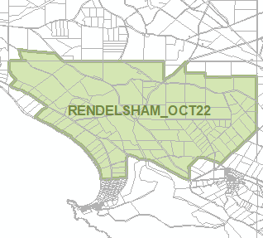 | Zones  Technical and Numeric Variations  - Minimum Dwelling Allotment Size  - Minimum Site Area  Overlays  - Coastal Areas  - Hazards (Bushfire - High Risk)  - Hazards (Bushfire - Medium Risk)  - Hazards (Bushfire - General Risk)  - Key Outback and Rural Routes

- In Part 13 of the Code – Table of Amendments, update the publication date, Code version number, amendment type and summary of amendments within the ‘Table of Planning and Design Code Amendments’ to reflect the amendments to the Code as described in this Notice.
- PURSUANT to section 76(5)(a) of the Act, I further specify that the amendments to the Code as described in this Notice will take effect upon the date those amendments are published on the SA planning portal.
Dated: 7 November 2022
Greg Van Gaans
Director, Land and Built Environment
Department for Trade and Investment
Delegate of the Minister for Planning

Planning, Development and Infrastructure Act 2016
Section 76
Amendment to the Planning and Design Code
Preamble
It is necessary to amend the Planning and Design Code (the Code) in operation at 27 October 2022 (Version 2022.20) in order to make changes:
- to remove irrelevant material in relation to the spatial application of the Hazards (Flooding – General) Overlay in 16 Local Government Areas.
- to remove irrelevant / duplicated material (the Hazard (Flooding) Overlay, Hazards (Flooding – General) Overlay and Hazard (Flooding – Evidence Required) Overlay) in 12 Local Government Areas to address an inconsistency in policy application.
- PURSUANT to section 76 of the Planning, Development and Infrastructure Act 2016 (the Act), I hereby amend the Code in order to make the following minor or operational amendments as follows:
- For the following Local Government areas, undertake minor alterations to the geometry of the Hazards (Flooding – General) Overlay to remove polygons which measure less than or equal to 10 square metres in area and which are isolated from another polygon within the respective Overlay:
    - City of Mitcham
    - Light Regional Council
    - City of Playford
    - City of Port Adelaide Enfield
    - City of Charles Sturt
    - City of Prospect
    - Town of Gawler
    - City of Victor Harbor
    - District Council of Yankalilla
    - City of Salisbury
    - City of Norwood, Payneham and St Peters
    - City of Onkaparinga
    - Mount Barker District Council
    - Alexandrina Council
    - City of Marion
    - City of Unley
- Amend the spatial layer of the Hazards (Flooding – General) Overlay within the City of Salisbury so that it does not apply to the areas shaded red in the Attachment A.
- Amend the spatial layer of Hazard (Flooding) Overlay and the Hazards (Flooding – General) Overlay within the City of Mitcham so that it does not apply to the areas shaded red in the Attachment B.
- Amend the spatial layer of the Hazards (Flooding – General) Overlay within the City of Charles Sturt so that it does not apply to the areas shaded red in the Attachment C.
- Amend the spatial layer of the Hazards (Flooding – General) Overlay within the City of Port Adelaide Enfield so that it does not apply to the areas shaded red in the Attachment D.
- Amend the spatial layer of the Hazards (Flooding – General) Overlay and the Hazard (Flooding Evidence Required) Overlay within the Town of Gawler so that it does not apply to the areas shaded red in the Attachment E.
- Amend the spatial layer of and the Hazards (Flooding – General) Overlay within the City of West Torrens so that it does not apply to the areas shaded red in the Attachment F.
- Amend the spatial layer of the Hazards (Flooding – General) Overlay within the City of Onkaparinga so that it does not apply to the areas shaded red in the Attachment G.
- Amend the spatial layer of the Hazards (Flooding – General) Overlay within the Adelaide Plains Council so that it does not apply to the areas shaded red in the Attachment H.
- Amend the spatial layer of the Hazards (Flooding – General) Overlay within the City of Playford so that it does not apply to the areas shaded red in the Attachment I.
- Amend the spatial layer of the Hazards (Flooding – General) Overlay within the City of Norwood, Payneham and St Peters so that it does not apply to the areas shaded red in the Attachment J.
- Amend the spatial layer of the Hazards (Flooding – General) Overlay and the Hazard (Flooding Evidence Required) Overlay within the Light Regional Council so that it does not apply to the areas shaded red in the Attachment K.
- Amend the spatial layer of the Hazards (Flooding – General) Overlay within the City of Unley so that it does not apply to the areas shaded red in the Attachment L.
- In Part 13 of the Code – Table of Amendments, update the publication date, Code version number, amendment type and summary of amendments within the ‘Table of Planning and Design Code Amendments’ to reflect the amendments to the Code as described in this Notice.
- PURSUANT to section 76(5)(a) of the Act, I further specify that the amendments to the Code as described in this Notice will take effect upon the date those amendments are published on the SA planning portal.
Dated: 7 November 2022
Sally Smith
Executive Director, Planning and Land Use Services
Department for Trade and Investment
Delegate of the Minister for Planning

ATTACHMENT A

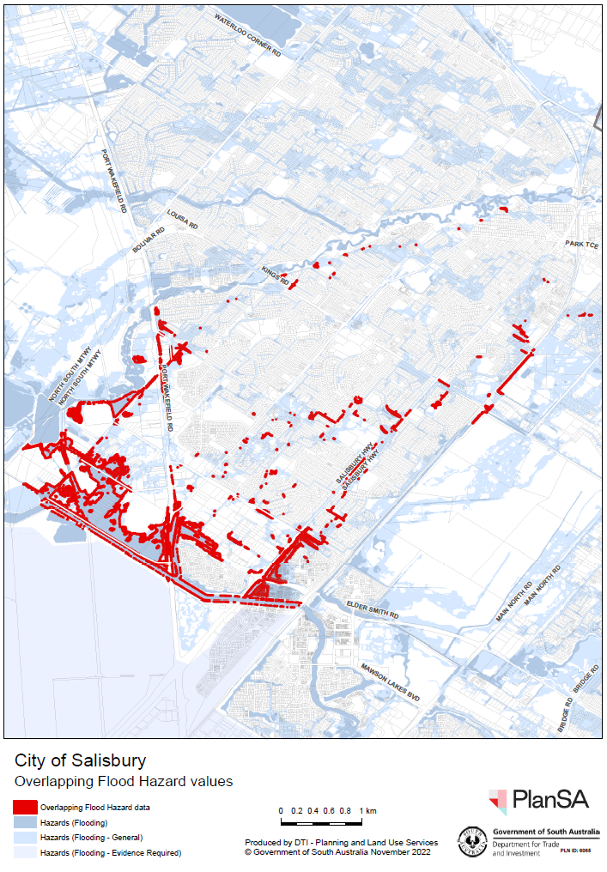
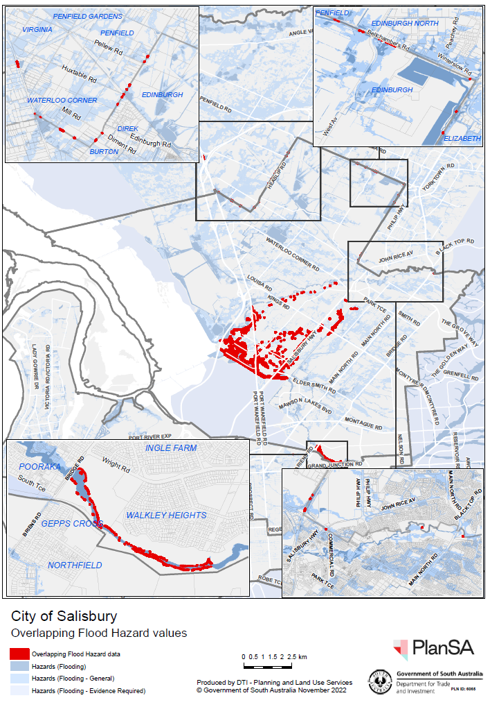

ATTACHMENT B

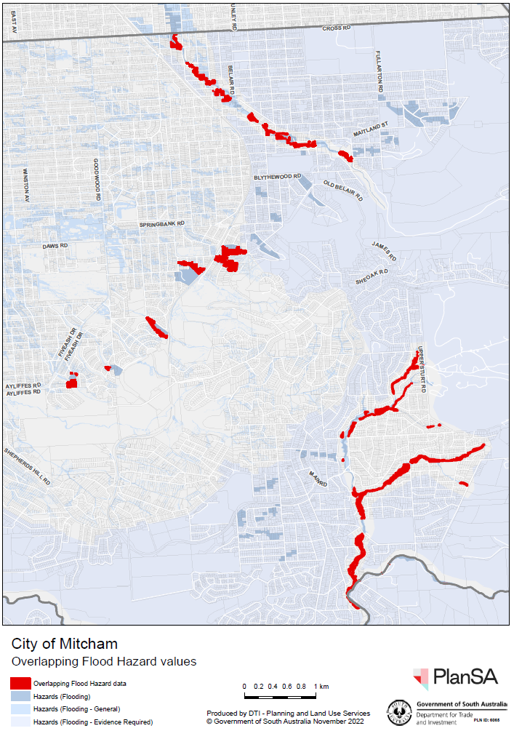

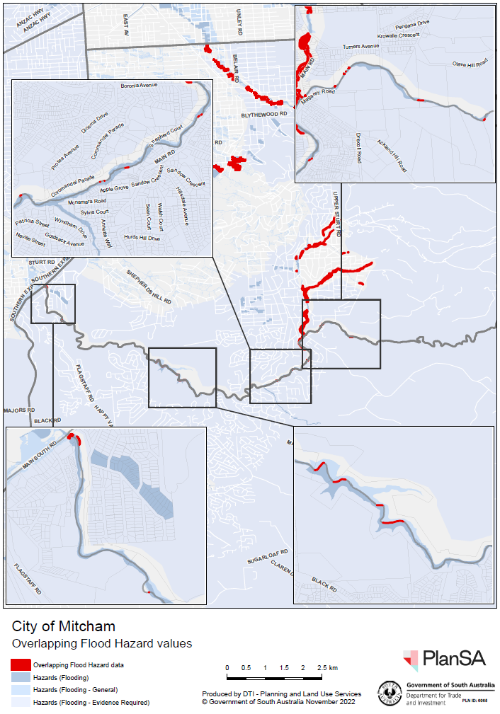

ATTACHMENT C

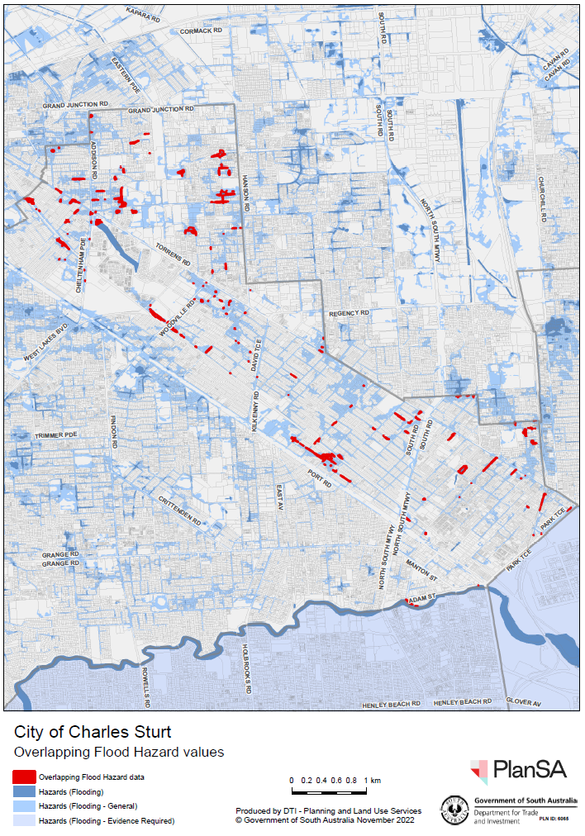

ATTACHMENT D

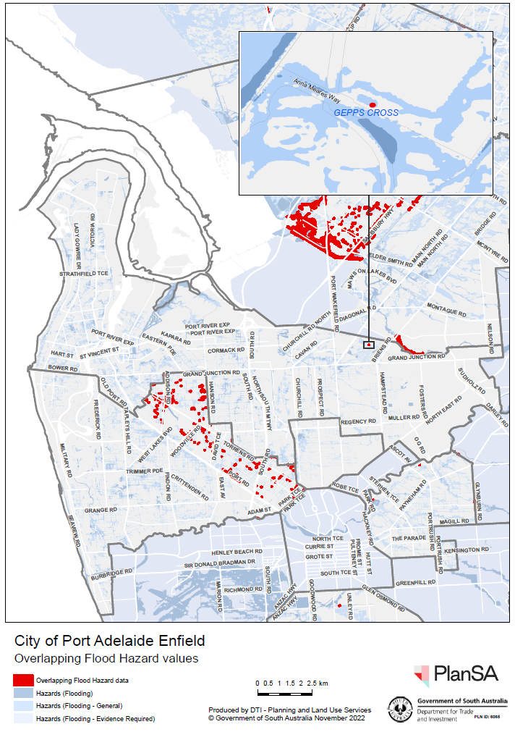

ATTACHMENT E

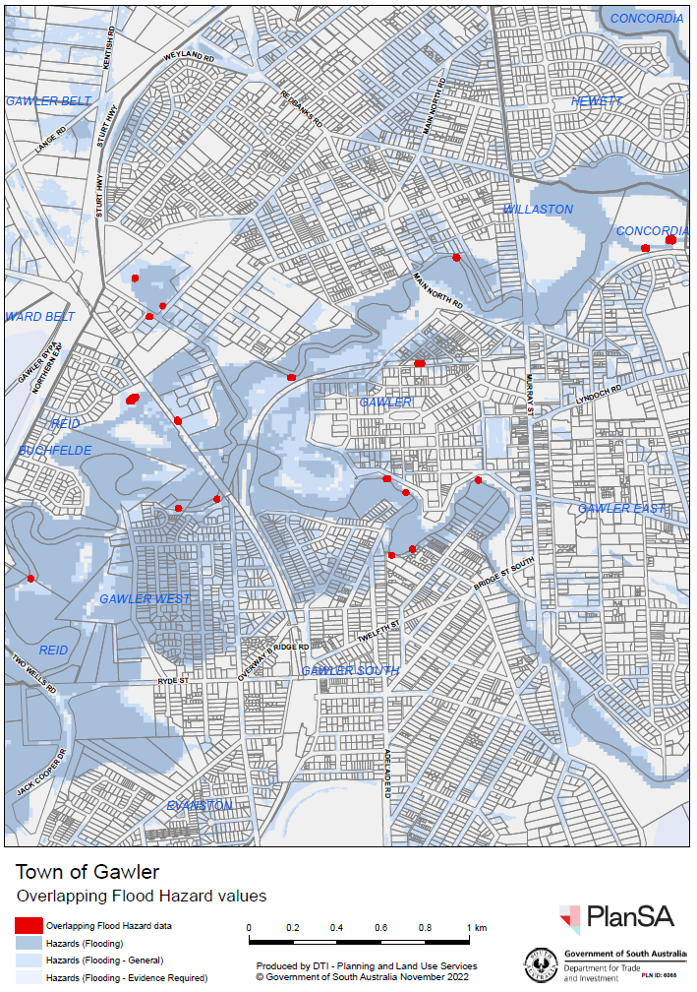

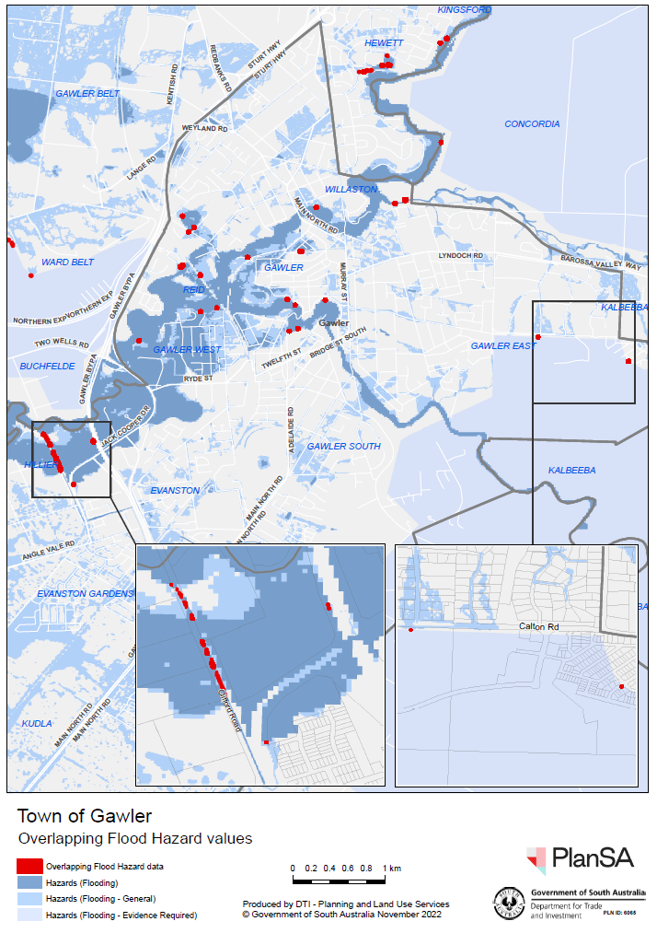

ATTACHMENT F

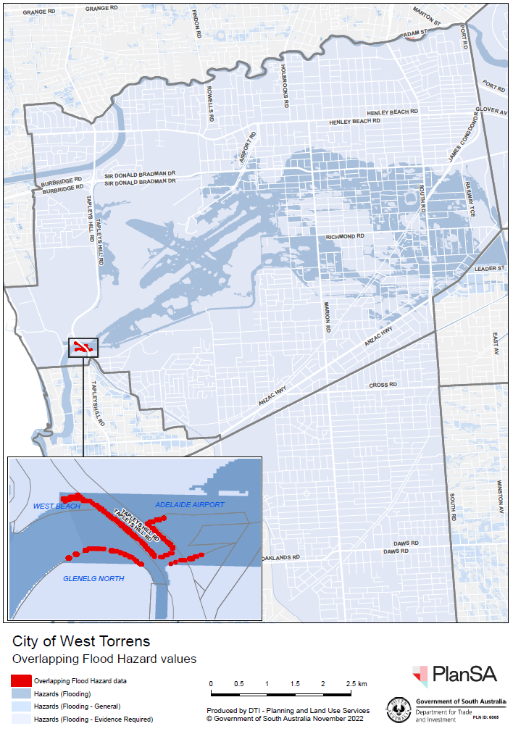

ATTACHMENT G

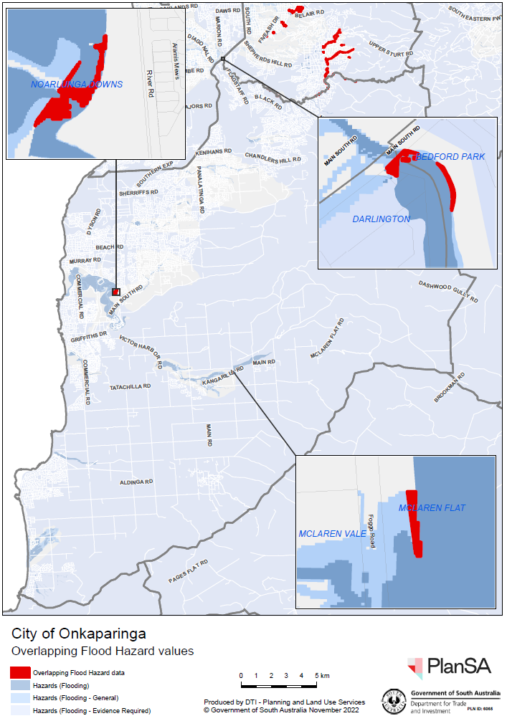

ATTACHMENT H

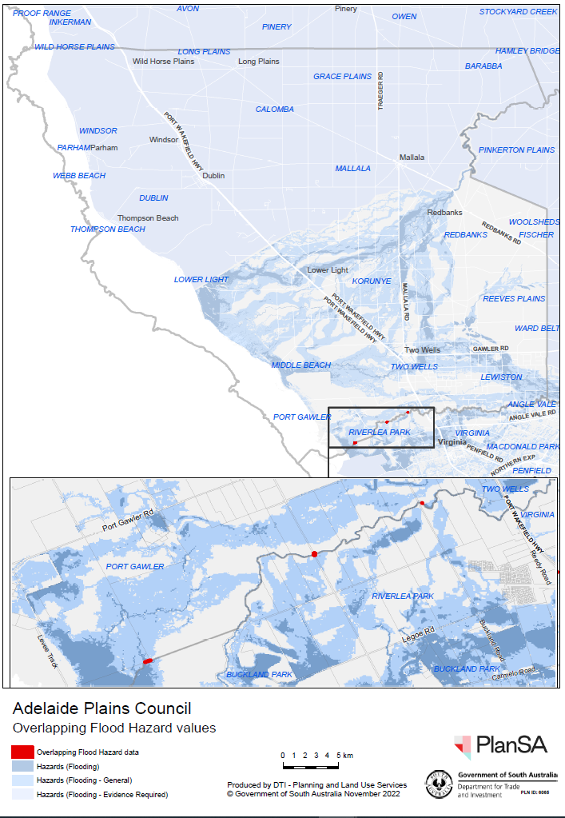

ATTACHMENT I

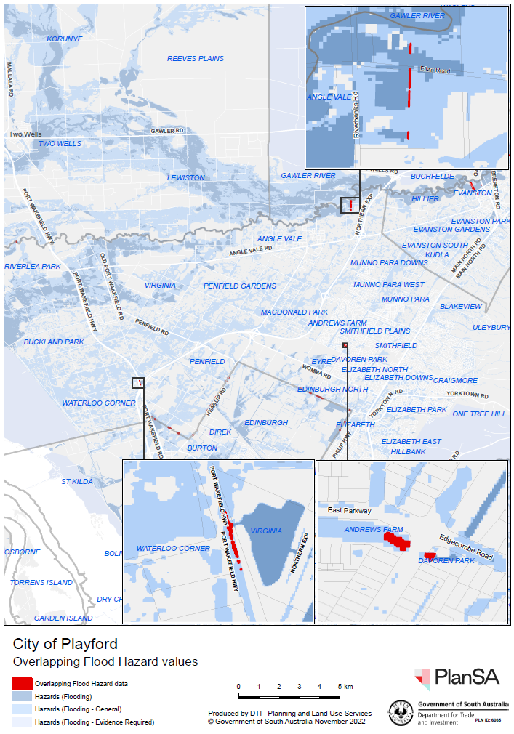

ATTACHMENT J

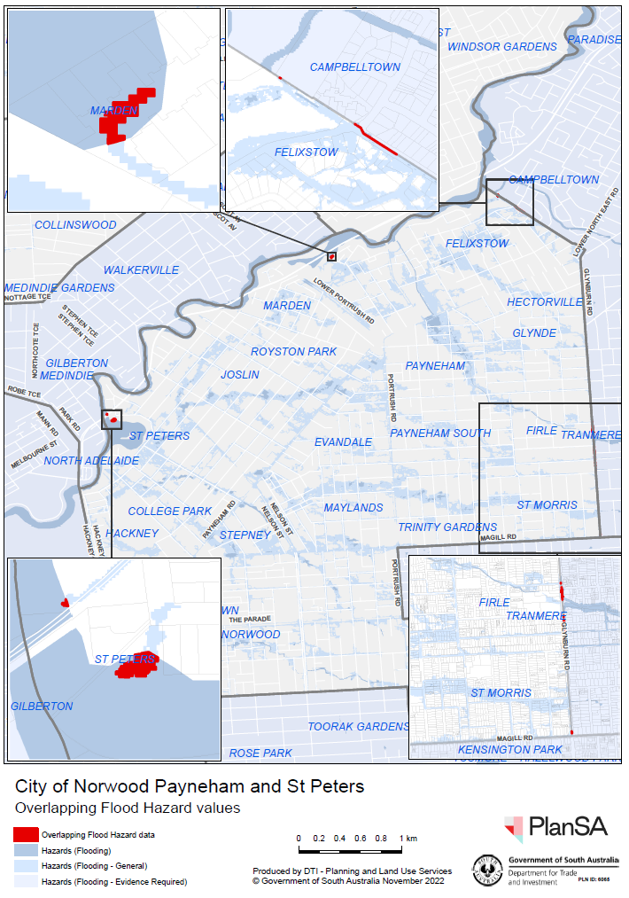

ATTACHMENT K

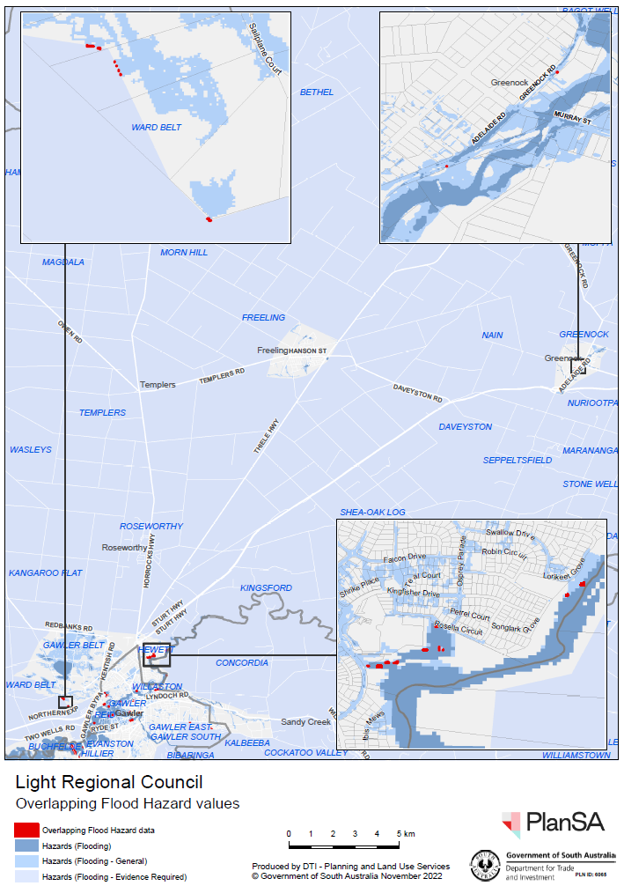

ATTACHMENT L

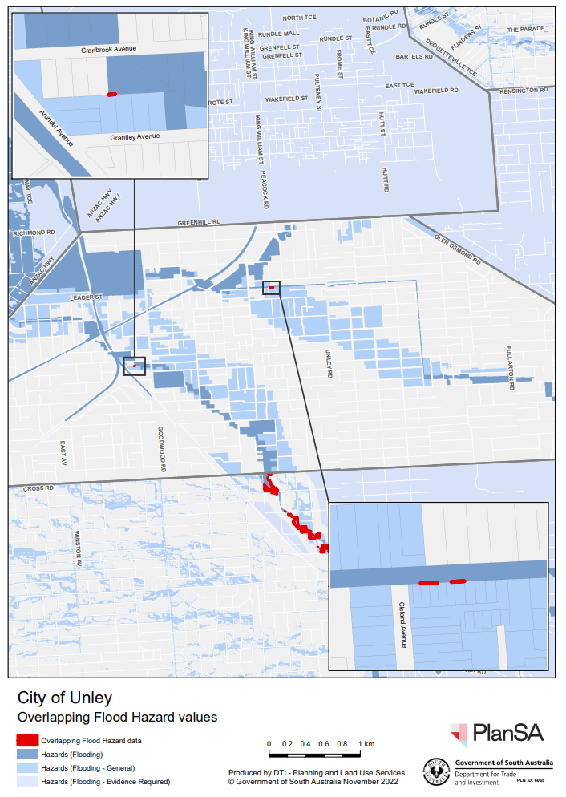

Roads (Opening and Closing) Act 1991
Section 24
NOTICE OF CONFIRMATION OF
ROAD PROCESS ORDER
Road Closure—Bay Road, Moonta
BY Road Process Order made on 1 March 2022, the Copper Coast Council ordered that:
- Portion of Bay Road, Moonta, situated at the corner of Bay Road and Frances Terrace, Hundred of Wallaroo, more particularly delineated and lettered portion of ‘A’ in Preliminary Plan 19/0040 be closed.
- Issue a Certificate of Title to the Copper Coast Council for the whole of the land subject to closure in accordance with the Application for Document of Title dated 1 March 2022.
On 8 November 2022 that order was confirmed by the Minister for Planning conditionally upon the deposit by the Registrar-General of Deposited Plan 129461 being the authority for the new boundaries.
Pursuant to section 24 of the Roads (Opening and Closing) Act 1991, NOTICE of the Order referred to above and its confirmation is hereby given.
Dated: 10 November 2022
B. J. Slape
Surveyor-General
2019/13894/01

Roads (Opening and Closing) Act 1991
Section 24
NOTICE OF CONFIRMATION OF
ROAD PROCESS ORDER
Road Closure—Follett Close, Totness
BY Road Process Order made on 19 October 2022, the Mount Barker District Council ordered that:
- Portion of Follett Close, Totness, situated adjoining Allotment 11 in Deposited Plan 13515, Hundred of Macclesfield, more particularly delineated and lettered ‘A’ in Preliminary Plan 21/0025 be closed.
- Issue a Certificate of Title to the Mount Barker District Council for the whole of the land subject to closure in accordance with the Application for Document of Title dated 19 October 2022.
On 8 November 2022 that order was confirmed by the Minister for Planning conditionally upon the deposit by the Registrar-General of Deposited Plan 130867 being the authority for the new boundaries.
Pursuant to section 24 of the Roads (Opening and Closing) Act 1991, NOTICE of the Order referred to above and its confirmation is hereby given.
Dated: 10 November 2022
B. J. Slape
Surveyor-General
2021/17849/01

South Australian Skills Act 2008
Part 4 – Apprenticeships, Traineeships and Training Contracts
PURSUANT to the provision of the South Australian Skills Act 2008, the South Australian Skills Commission (SASC) gives notice that determines the following Trades or Declared Vocations in addition to the gazette notices of:
1. 25 September 2008 | 2. 23 October 2008 | 3. 13 November 2008 | 4. 4 December 2008
5. 18 December 2008 | 6. 29 January 2009 | 7. 12 February 2009 | 8. 5 March 2009
9. 12 March 2009 | 10. 26 March 2009 | 11. 30 April 2009 | 12. 18 June 2009
13. 25 June 2009 | 14. 27 August 2009 | 15. 17 September 2009 | 16. 24 September 2009
17. 9 October 2009 | 18. 22 October 2009 | 19. 3 December 2009 | 20. 17 December 2009
21. 4 February 2010 | 22. 11 February 2010 | 23. 18 February 2010 | 24. 18 March 2010
25. 8 April 2010 | 26. 6 May 2010 | 27. 20 May 2010 | 28. 3 June 2010
29. 17 June 2010 | 30. 24 June 2010 | 31. 8 July 2010 | 32. 9 September 2010
33. 23 September 2010 | 34. 4 November 2010 | 35. 25 November 2010 | 36. 16 December 2010
37. 23 December 2010 | 38. 17 March 2011 | 39. 7 April 2011 | 40. 21 April 2011
41. 19 May 2011 | 42. 30 June 2011 | 43. 21 July 2011 | 44. 8 September 2011
45. 10 November 2011 | 46. 24 November 2011 | 47. 1 December 2011 | 48. 8 December 2011
49. 16 December 2011 | 50. 22 December 2011 | 51. 5 January 2012 | 52. 19 January 2012
53. 1 March 2012 | 54. 29 March 2012 | 55. 24 May 2012 | 56. 31 May 2012
57. 7 June 2012 | 58. 14 June 2012 | 59. 21 June 2012 | 60. 28 June 2012
61. 5 July 2012 | 62. 12 July 2012 | 63. 19 July 2012 | 64. 2 August 2012
65. 9 August 2012 | 66. 30 August 2012 | 67. 13 September 2012 | 68. 4 October 2012
69. 18 October 2012 | 70. 25 October 2012 | 71. 8 November 2012 | 72. 29 November 2012
73. 13 December 2012 | 74. 25 January 2013 | 75. 14 February 2013 | 76. 21 February 2013
77. 28 February 2013 | 78. 7 March 2013 | 79. 14 March 2013 | 80. 21 March 2013
81. 28 March 2013 | 82. 26 April 2013 | 83. 23 May 2013 | 84. 30 May 2013
85. 13 June 2013 | 86. 20 June 2013 | 87. 11 July 2013 | 88. 1 August 2013
89. 8 August 2013 | 90. 15 August 2013 | 91. 29 August 2013 | 92. 6 February 2014
93. 12 June 2014 | 94. 28 August 2014 | 95. 4 September 2014 | 96. 16 October 2014
97. 23 October 2014 | 98. 5 February 2015 | 99. 26 March 2015 | 100. 16 April 2015
101. 27 May 2015 | 102. 18 June 2015 | 103. 3 December 2015 | 104. 7 April 2016
105. 30 June 2016 | 106. 28 July 2016 | 107. 8 September 2016 | 108. 22 September 2016
109. 27 October 2016 | 110. 1 December 2016 | 111. 15 December 2016 | 112. 7 March 2017
113. 21 March 2017 | 114. 23 May 2017 | 115. 13 June 2017 | 116. 18 July 2017
117. 19 September 2017 | 118. 26 September 2017 | 119. 17 October 2017 | 120. 3 January 2018
121. 23 January 2018 | 122. 14 March 2018 | 123. 14 June 2018 | 124. 5 July 2018
125. 2 August 2018 | 126. 9 August 2018 | 127. 16 August 2018 | 128. 30 August 2018
129. 27 September 2018 | 130. 4 October 2018 | 131. 18 October 2018 | 132. 1 November 2018
133. 15 November 2018 | 134. 22 November 2018 | 135. 29 November 2018 | 136. 6 December 2018
137. 20 December 2018 | 138. 24 January 2019 | 139. 14 February 2019 | 140. 30 May 2019
141. 6 June 2019 | 142. 13 June 2019 | 143. 20 June 2019 | 144. 27 June 2019
145. 11 July 2019 | 146. 8 August 2019 | 147. 22 August 2019 | 148. 12 September 2019
149. 19 September 2019 | 150. 14 November 2019 | 151. 28 November 2019 | 152. 12 December 2019
153. 19 December 2019 | 154. 23 January 2020 | 155. 27 February 2020 | 156. 21 April 2020
157. 25 June 2020 | 158. 10 September 2020 | 159. 17 September 2020 | 160. 8 October 2020
161. 29 October 2020 | 162. 5 November 2020 | 163. 10 December 2020 | 164. 17 December 2020
165. 24 December 2020 | 166. 21 January 2021 | 167. 11 February 2021 | 168. 25 February 2021
169. 25 March 2021 | 170. 1 April 2021 | 171. 8 April 2021 | 172. 6 May 2021
173. 10 June 2021 | 174. 1 July 2021 | 175. 12 August 2021 | 176. 16 September 2021
177. 23 September 2021 | 178. 30 September 2021 | 179. 14 October 2021 | 180. 21 October 2021
181. 9 November 2021 | 182. 2 December 2021 | 183. 23 December 2021 | 184. 24 February 2022
185. 10 March 2022 | 186. 24 March 2022 | 187. 12 May 2022 | 188. 16 June 2022
189. 23 June 2022 | 190. 11 August 2022 | 191. 25 August 2022 | 192. 27 October 2022
TRADES OR DECLARED VOCATIONS AND REQUIRED QUALIFICATIONS AND TRAINING CONTRACT CONDITIONS FOR THE AGRICULTURE, HORTICULTURE AND CONSERVATION AND LAND MANAGEMENT (AHC), TOURISM, TRAVEL AND HOSPITALITY (SIT) TRAINING PACKAGE/S
*Trade/ #Declared Vocation/ Other Occupation | Qualification Code | Qualification Title | Nominal Term of Training Contract | Probationary Period | Supervision Level Rating
Horticulture # | AHC21621 | Certificate II in Landscaping | 18 | 60 | L
Horticulture # | AHC30921 | Certificate III in Landscape Construction | 48 | 90 | H
Horticulture # | AHC50621 | Diploma of Landscape Design | 48 | 90 | M
Tourism Sales Consultant # | SIT30122 | Certificate III in Tourism | 24 | 60 | M
Visitor Information Officer # | SIT30122 | Certificate III in Tourism | 24 | 60 | M
Dated: 4 November 2022
John Evangelista
Director, Traineeship and Apprenticeship Services
Department for Innovation and Skills

Wilderness Protection Regulations 2021
Wilderness Protection Areas—Fire Restrictions
PURSUANT to Regulation 13 of the Wilderness Protection Regulations 2021, I, Michael Joseph Williams, Director of National Parks and Wildlife impose fire restrictions for Wilderness Protection Areas located in the South Australian Country Fire Service Fire Ban Districts as listed in Schedule 1 below.
The purpose of these fire restrictions is to ensure the safety of visitors, and in the interests of protecting the Wilderness Protection Areas and neighbouring properties.
Dated: 7 November 2022
M. J. Williams
Director of National Parks and Wildlife

Schedule 1
- KANGAROO ISLAND
All Wilderness Protection Areas: All wood fires or solid fuel fires are prohibited throughout the year. Gas fires or liquid fuel fires are permitted other than on days of total fire ban.
For further information, please refer to the DEW website www.environment.sa.gov.au or contact the Kangaroo Island regional office (08) 8553 4409 or CFS Information Hotline 1800 362 361.
- EASTERN EYRE PENINSULA
All Wilderness Protection Areas: All wood fires or solid fuel fires are prohibited throughout the year. Gas fires or liquid fuel fires are permitted other than on days of total fire ban.
For further information, please refer to the DEW website www.environment.sa.gov.au or contact the Eyre and Far West regional office (08) 8688 3111 or CFS Information Hotline 1800 362 361.
- LOWER EYRE PENINSULA
All Wilderness Protection Areas: All wood fires or solid fuel fires are prohibited to low water mark throughout the year. Gas fires or liquid fuel fires are permitted other than on days of total fire ban.
For further information, please refer to the DEW website www.environment.sa.gov.au or contact the Eyre and Far West regional office (08) 8688 3111 or CFS Information Hotline 1800 362 361.
- MURRAYLANDS
Billiatt Wilderness Protection Area: All wood fires or solid fuel fires are prohibited from 15 November 2022 to 5 April 2023. Gas fires or liquid fuel fires are prohibited throughout the year.
For further information, please refer to the DEW website www.environment.sa.gov.au or contact the Riverland and Murraylands regional office (08) 8595 2111 or CFS Information Hotline 1800 362 361.
- NORTH EAST PASTORAL
Danggali Wilderness Protection Area: All wood fires or solid fuel fires and gas fires or liquid fuel fires are prohibited throughout the year.
For further information, please refer to the DEW website www.environment.sa.gov.au or contact the Riverland and Murraylands regional office (08) 8595 2111, Yorke and Mid North regional office (08) 8841 3400, Flinders and Outback regional office (08) 8648 5300 or CFS Information Hotline 1800 362 361.
- NORTH WEST PASTORAL
Yellabinna Wilderness Protected Area: All wood fires or solid fuel fires are prohibited from 15 November 2022 to 31 March 2023. Gas fires or liquid fuel fires are permitted other than on days of total fire ban.
For further information, please refer to the DEW website www.environment.sa.gov.au or contact the Eyre and Far West regional office (08) 8688 3111, Flinders and Outback regional office (08) 8648 5300 or CFS Information Hotline 1800 362 361.
- WEST COAST
Investigator Group Wilderness Protection Area and Nuyts Archipelago Wilderness Protection Area: All wood fires or solid fuel fires are prohibited to low water mark throughout the year. Gas fires or liquid fuel fires are permitted other than on days of total fire ban.
Nullarbor Wilderness Protection Area: All wood fires or solid fuel fires are prohibited from 15 November 2022 to 5 April 2023. Gas fires or liquid fuel fires are permitted other than on days of total fire ban.
For further information, please refer to the DEW website www.environment.sa.gov.au or contact the Eyre and Far West regional office (08) 8688 3111 or CFS Information Hotline 1800 362 361.

Local Government Instruments

City of Adelaide
South Australia
Liquor Licensing (Dry Areas) Notice 2022
under section 131(1) of the Liquor Licensing Act 1997
1—Short title
This notice may be cited as the Liquor Licensing (Dry Areas) Notice 2022.
2—Commencement
This notice comes into operation on 2 December 2022.
3—Interpretation
(1) In this notice—
principal notice means the Liquor Licensing (Dry Areas) Notice 2015 published in the Gazette on 5.1.15, as in force from time to time.
(2) Clause 3 of the principal notice applies to this notice as if it were the principal notice.
4—Consumption etc of liquor prohibited in dry areas
(1) Pursuant to section 131 of the Act, the consumption and possession of liquor in the area described in the Schedule is prohibited in accordance with the provisions of the Schedule.
(2) The prohibition has effect during the periods specified in the Schedule.
(3) The prohibition does not extend to private land in the area described in the Schedule.
(4) Unless the contrary intention appears, the prohibition of the possession of liquor in the area does not extend to—
(a) a person who is genuinely passing through the area if—
(i) the liquor is in the original container in which it was purchased from licensed premises; and
(ii) the container has not been opened; or
(b) a person who has possession of the liquor in the course of carrying on a business or in the course of his or her employment by another person in the course of carrying on a business; or
(c) a person who is permanently or temporarily residing at premises within the area or on the boundary of the area and who enters the area solely for the purpose of passing through it to enter those premises or who enters the area from those premises for the purpose of leaving the area.

Schedule 1—Bonython Park/ Tulya Wardli (Park 27)

1—Extent of prohibition
The consumption of liquor is prohibited, and the possession of liquor is prohibited.
2—Period of prohibition
From 12:01am to 11:59 pm on 2 December 2022.
3—Description of area
Bonython Park/ Tulya Wardli (Park 27) bounded on the West by Port Road, on the North by Phillips Street to the River Torrens/ Karrawirra Parri, on the East by the River Torrens/ Karrawirra Parri to Gaol Rd and on the South by Kate Cocks Park and the Road Safety Park to Port Road.
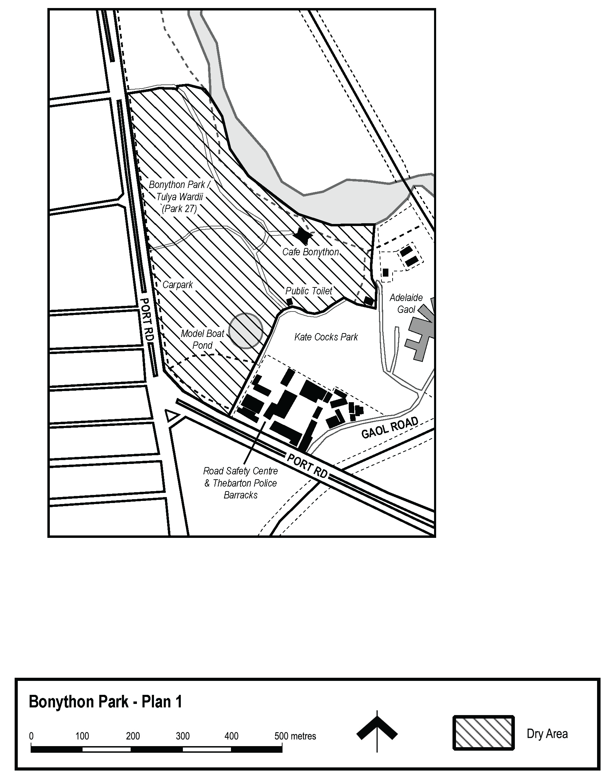
Made by the Manager, City Experience team, City of Adelaide
On 7 November 2022

Public Notices

Trustee Act 1936
Public Trustee
Estates of Deceased Persons
In the matter of the estates of the undermentioned deceased persons:
BARKER Elaine Nancy late of 70 Fifth Street Port Pirie West Retired Information Clerk who died 4 July 2022
BUTCHER Malcolm Vivien late of 110 Strathfield Terrace Largs North Retired Farm Hand who died 4 August 2022
PARSONS Kevin James late of 7 Langhorne Creek Road Strathalbyn of no Occupation who died 13 May 2022
PAYNE Allan Stanley late of 209 The Golden Way Golden Grove Retired Fitter and Turner who died 30 April 2022
PILVEN Michael John late of 4 Bristol Avenue Enfield of no Occupation who died 23 April 2022
VERRAN Beverly Marie late of 38 Nairne Road Woodside Retired Cleaner who died 27 May 2022
Notice is hereby given pursuant to the Trustee Act 1936, the Inheritance (Family Provision) Act 1972 and the Family Relationships Act 1975 that all creditors, beneficiaries, and other persons having claims against the said estates are required to send, in writing, to the office of Public Trustee at GPO Box 1338, Adelaide 5001, full particulars and proof of such claims, on or before the 9 December 2022 otherwise they will be excluded from the distribution of the said estate; and notice is also hereby given that all persons indebted to the said estates are required to pay the amount of their debts to the Public Trustee or proceedings will be taken for the recovery thereof; and all persons having any property belonging to the said estates are forthwith to deliver same to the Public Trustee.
Dated: 10 November 2022
N. S. Rantanen
Public Trustee

Notice Submission

The South Australian Government Gazette is published each Thursday afternoon.
Notices must be emailed by 4 p.m. Tuesday, the week of publication.
Submissions are formatted per the gazette style and a proof will be supplied prior to publication, along with a quote if applicable. Please allow one day for processing notices.
Alterations to the proof must be returned by 4 p.m. Wednesday.

Gazette notices must be submitted as Word files, in the following format:
• Title—the governing legislation
• Subtitle—a summary of the notice content
• Body—structured text, which can include numbered lists, tables, and images
• Date—day, month, and year of authorisation
• Signature block—name, role, and department/organisation authorising the notice

Please provide the following information in your email:
• Date of intended publication
• Contact details of the person responsible for the notice content
• Name and organisation to be charged for the publication—Local Council and Public notices only
• Purchase order, if required—Local Council and Public notices only

Email: governmentgazettesa@sa.gov.au
Phone: (08) 7109 7760
Website: www.governmentgazette.sa.gov.au

All instruments appearing in this gazette are to be considered official, and obeyed as such

Printed and published weekly by authority of C. McArdle, Government Printer, South Australia
$8.15 per issue (plus postage), $411.00 per annual subscription—GST inclusive
Online publications: www.governmentgazette.sa.gov.au

