SUPPLEMENTARY GAZETTE
THE SOUTH AUSTRALIAN
GOVERNMENT GAZETTE
Published by Authority

Adelaide, Thursday, 24 November 2022

Contents

State Government Instrument

Planning, Development and Infrastructure Act 2016—
Republished 6750

State Government Instrument
[Republished]
The notice published in the South Australian Government Gazette No. 81, dated 24 November 2022, on page 6737, was published in error and should be replaced with the following:

Planning, Development and Infrastructure Act 2016
Section 74
Amendment to the Planning and Design Code
Preamble
As Minister for Planning I have determined, by this notice, to amend the Planning and Design Code (the Code) dated 10 November 2022 in order to implement changes recommended by the Environment, Resources and Development Committee of Parliament to the Riverbank Code Amendment and to reinstate the full protection of the Adelaide Park Lands Zone to Helen Mayo Park.
PURSUANT to Section 74(9)(a) of the Planning, Development and Infrastructure Act 2016, I—
1. Amend the Code as follows:
(a) The Adelaide Park Lands Zone is reinstated to the area bounded by the dashed yellow line in ATTACHMENT 1 to restore the full protection of this Zone to Helen Mayo Park.
(b) The Entertainment Subzone is removed from the area bounded by the dashed yellow line in ATTACHMENT 1.
(c) The Concept Plan 125 – City Riverbank West is amended so that the area bounded by the dashed yellow line in ATTACHMENT 1 is identified as ‘Park Lands (Open Space)’.
(d) The Table of Planning and Design Code Amendments (Part 13 – Table of Amendments) in the Code is updated to reflect the above amendments.
(e) Any other consequential amendments are made to the Code to ensure consistency with the above amendments.
2. The amendment to the Code the subject of this notice will come into operation upon being published on the SA planning portal.
Dated: 22 November 2022
Nick Champion MP
Minister for Planning

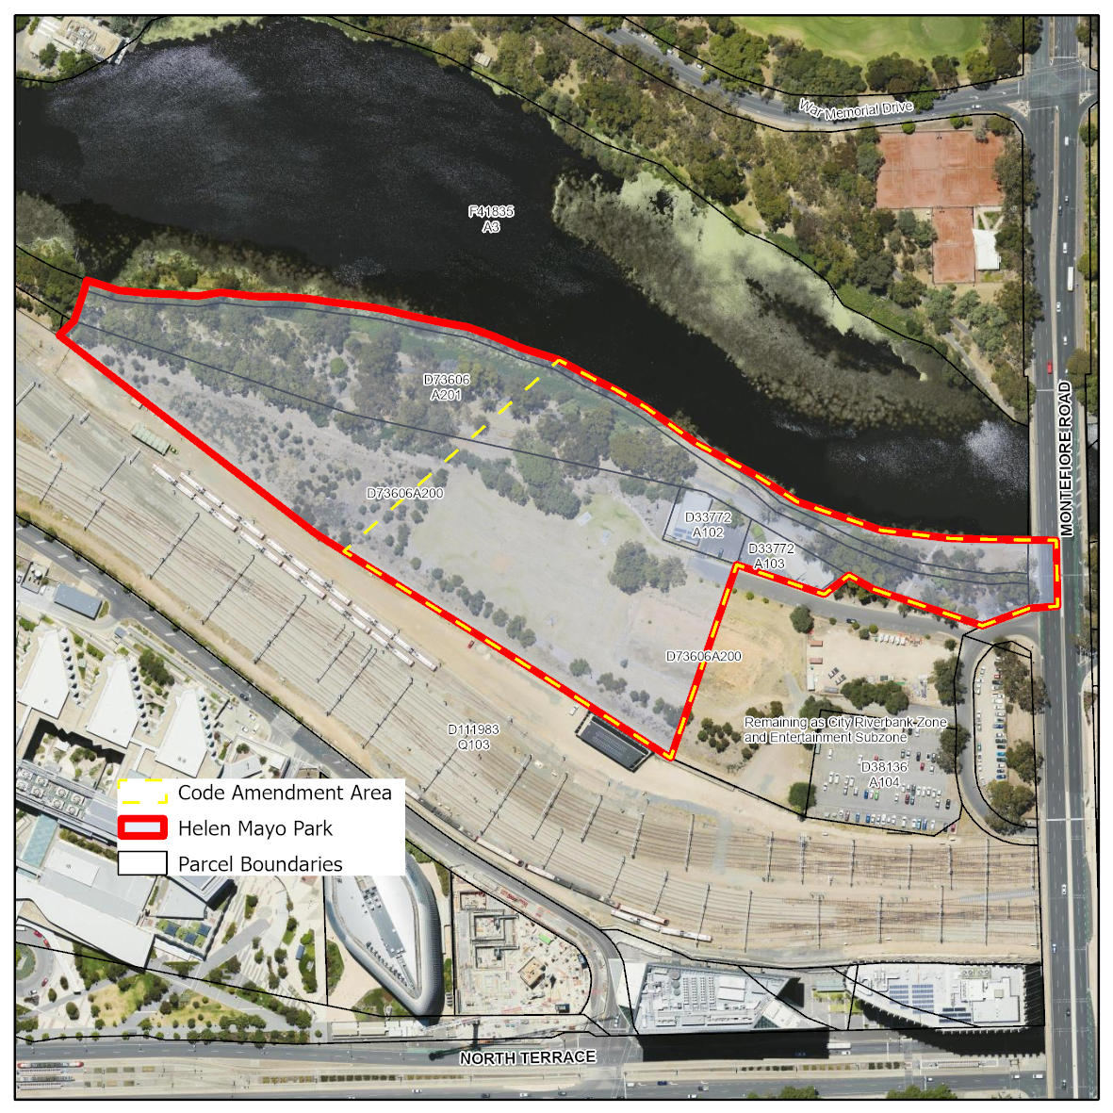
Attachment 1

All instruments appearing in this gazette are to be considered official, and obeyed as such

Printed and published weekly by authority of C. McArdle, Government Printer, South Australia
$8.15 per issue (plus postage), $411.00 per annual subscription—GST inclusive
Online publications: www.governmentgazette.sa.gov.au

