No. 60 p. 5809
THE SOUTH AUSTRALIAN
GOVERNMENT GAZETTE
Published by Authority

Adelaide, Thursday, 1 September 2022

Contents

Governor’s Instruments

Appointments 5810

Proclamations—
Suicide Prevention Act (Commencement)
Proclamation 2022 5811
Administrative Arrangements (Administration of
Suicide Prevention Act) Proclamation 2022 5811

Regulations—
Fisheries Management (Sardine Fishery) (Quota)
Amendment Regulations 2022—No. 73 of 2022 5812
Fisheries Management (Abalone Fisheries) (Quota)
Amendment Regulations 2022—No. 74 of 2022 5816
Fisheries Management (Prawn Fisheries) (Fishing
Nights Entitlements) Amendment
Regulations 2022—No. 75 of 2022 5822
Suicide Prevention Regulations 2022—No. 76 of 2022 5828
Child Safety (Prohibited Persons) Amendment
Regulations 2022—No. 77 of 2022 5831
Youth Justice Administration Amendment
Regulations 2022—No. 78 of 2022 5832

State Government Instruments

Building Work Contractors Act 1995 5833

Health Care Act 2008 5834

Housing Improvement Act 2016 5835

Justices of the Peace Act 2005 5836

Land Acquisition Act 1969 5837

Mental Health Act 2009 5838

Planning, Development and Infrastructure Act 2016 5838

Proof of Sunrise and Sunset Act 1923 5844

Road Traffic Act 1961 5845

South Australian Skills Act 2008 5846

Local Government Instruments

City of Playford 5847

City of Prospect 5865

District Council of Mount Remarkable 5879

Public Notices

National Gas Law 5881

Governor’s Instruments

Appointments
Department of the Premier and Cabinet
Adelaide, 1 September 2022
Her Excellency the Governor in Executive Council has been pleased to appoint the undermentioned to the Return to Work Minister's Advisory Committee, pursuant to the provisions of the Return to Work Act 2014:
Member: from 1 September 2022 until 30 November 2023
Andrew Anthony Tulic
By command,
Susan Elizabeth Close, mp
For Premier
AGO0103-22CS

Department of the Premier and Cabinet
Adelaide, 1 September 2022
Her Excellency the Governor in Executive Council has been pleased to appoint the undermentioned to the Motor Accident Commission Board, pursuant to the provisions of the Motor Accident Commission Act 1992:
Director: from 1 September 2022 until 30 June 2023
Jane Burton
Chair: from 1 September 2022 until 30 June 2023
Jane Burton
By command,
Susan Elizabeth Close, mp
For Premier
T&F22/039CS

Department of the Premier and Cabinet
Adelaide, 1 September 2022
Her Excellency the Governor in Executive Council has been pleased to appoint the undermentioned to the Carrick Hill Trust, pursuant to the provisions of the Carrick Hill Trust Act 1985:
Member: from 1 September 2022 until 31 August 2025
Jeffery Dean Mincham
Ilona Angelika Tamm
By command,
Susan Elizabeth Close, mp
For Premier
ART0006-22CS

Department of the Premier and Cabinet
Adelaide, 1 September 2022
Her Excellency the Governor in Executive Council has been pleased to appoint the people listed as Commissioners of the South Australian Employment Tribunal for the terms listed below - pursuant to the provisions of the South Australian Employment Tribunal Act 2014.
Appointed on a full-time basis commencing on 21 September 2022 and expiring on 20 September 2025
Anne Karen McDonald
Appointed on a full-time basis commencing on 13 September 2022 and expiring on 12 September 2023
Peter Kassapidis
By command,
Susan Elizabeth Close, mp
For Premier
AGO0084-22CS

Department of the Premier and Cabinet
Adelaide, 1 September 2022
Her Excellency the Governor in Executive Council has been pleased to appoint Michael David as the Parole Administrative Review Commissioner for a term commencing on 1 October 2022 and expiring on 30 September 2025 - pursuant to the provisions of the Correctional Services Act 1982.
By command,
Susan Elizabeth Close, mp
For Premier
22MCS0002CS

Proclamations
South Australia

Suicide Prevention Act (Commencement) Proclamation 2022
1—Short title
This proclamation may be cited as the Suicide Prevention Act (Commencement) Proclamation 2022.
2—Commencement of Act
(1) Subject to subclause (2), the Suicide Prevention Act 2021 (No 51 of 2021) comes into operation on 5 September 2022.
(2) Sections 19, 23 and 26 of the Act come into operation on 1 February 2023.
Made by the Governor
with the advice and consent of the Executive Council
on 1 September 2022

South Australia

Administrative Arrangements (Administration of Suicide Prevention Act) Proclamation 2022
under section 5 of the Administrative Arrangements Act 1994
1—Short title
This proclamation may be cited as the Administrative Arrangements (Administration of Suicide Prevention Act) Proclamation 2022.
2—Commencement
This proclamation comes into operation on the day on which it is made.
3—Administration of Act committed to Minister for Health and Wellbeing
The administration of the Suicide Prevention Act 2021 is committed to the Minister for Health and Wellbeing.
Made by the Governor
with the advice and consent of the Executive Council
on 1 September 2022

Regulations
South Australia

Fisheries Management (Sardine Fishery) (Quota) Amendment Regulations 2022
under the Fisheries Management Act 2007

Contents
Part 1—Preliminary
1 Short title
2 Commencement
Part 2—Amendment of Fisheries Management (Sardine Fishery) Regulations 2021
3 Amendment of regulation 9—Individual sardine catch quota system
Schedule 1—Transitional provision etc
1 Interpretation
2 Transitional provision etc

Part 1—Preliminary
1—Short title
These regulations may be cited as the Fisheries Management (Sardine Fishery) (Quota) Amendment Regulations 2022.
2—Commencement
These regulations come into operation on 1 January 2023.
Part 2—Amendment of Fisheries Management (Sardine Fishery) Regulations 2021
3—Amendment of regulation 9—Individual sardine catch quota system
(1) Regulation 9(1)—delete subregulation (1) and substitute:
(1) In this regulation—
following quota period, in relation to a first quota period and the holder of a licence in respect of the fishery, means the next quota period during which sardines may be taken by the holder of the licence following the first quota period.
(2) Regulation 9(3)(b) and (c)—delete paragraphs (b) and (c)
(3) Regulation 9(3)(f) to (i)—delete paragraphs (f) to (i) (inclusive) and substitute:
(f) if the total catch of sardines taken by the holder of a licence in respect of the fishery subject to a condition fixing a sardine quota entitlement in respect of a particular sardine fishing zone during a quota period (the first quota period) (being a quota period that commenced on or after 1 January 2022) is less than the sardine quota entitlement under the licence for that fishing zone and that quota period, the Minister may vary the conditions of the licence so as to increase the sardine quota entitlement in respect of that fishing zone for the following quota period (the subsequent quota period) by 1 kilogram of sardines for each kilogram by which the catch fell short of the sardine quota entitlement for the first quota period up to—
(i) —
(A) 10% of the quota entitlement for the first quota period; or
(B) such lower percentage of the quota entitlement for the first quota period, or such other lower kilogram amount of catch, as is determined by the Minister on or before the commencement of the subsequent quota period; or
(ii) if the Minister is satisfied that exceptional circumstances apply—
(A) a percentage that exceeds 10% of the quota entitlement for the first quota period; or
(B) such other greater kilogram amount of catch,
as is determined by the Minister on or before the commencement of the subsequent quota period;
(g) if the total catch of sardines taken by the holder of a licence in respect of the fishery subject to a condition fixing a sardine quota entitlement in respect of a particular sardine fishing zone during a quota period (the first quota period) (being a quota period that commences on or after 1 January 2023) exceeded the sardine quota entitlement under the licence for that fishing zone and that quota period, the conditions of the licence may be varied so as to decrease the quota entitlement in respect of that fishing zone for the following quota period (the subsequent quota period) as follows:
(i) if the catch exceeded the quota entitlement by—
(A) an amount not exceeding 10% of the quota entitlement for the first quota period; or
(B) such lower percentage of the quota entitlement for the first quota period, or such other lower kilogram amount of catch, as is determined by the Minister on or before the commencement of the first quota period,
by 1 kilogram of sardines for each kilogram taken in excess of the quota entitlement; or
(ii) if the catch exceeded the quota entitlement by—
(A) an amount greater than 10% of the quota entitlement for the first quota period; or
(B) such lower percentage of the quota entitlement for the first quota period, or such other lower kilogram amount of catch, as is determined by the Minister on or before the commencement of the first quota period,
by 2 kilograms of sardines for each kilogram taken in excess of the quota entitlement.
(4) Regulation 9(4)—delete subregulation (4) and substitute:
(4) For the purposes of—
(a) subregulation (3)(f)(i) and (ii); and
(b) subregulation (3)(g)(i) and (ii),
any increase in the quota entitlement under a licence applying during a first quota period as a result of a variation of the quota entitlement under the licence previously made under subregulation (3)(f)(i) or (ii) must be disregarded.
(4a) A variation of a quota entitlement or unit entitlement under subregulation (3)(d) must be expressed to apply only for the balance of the quota period during which the variation is made.
(4b) A variation of a quota entitlement under subregulation (3)(f) or (g) must be expressed to apply only for the quota period during which the variation is made.
(4c) An application under subregulation (3)(e) may not be made in respect of sardine units allocated to the licence under subregulation (3)(f).
Schedule 1—Transitional provision etc
1—Interpretation
In this Schedule—
principal regulations means the Fisheries Management (Sardine Fishery) Regulations 2021;
relevant day means 1 January 2023.
2—Transitional provision etc
If the total catch of sardines taken by the holder of a licence in respect of the Sardine Fishery subject to a condition fixing a sardine quota entitlement during the quota period that commenced on 1 January 2022 exceeded the quota entitlement under the licence for that quota period, then despite the deletion of regulation 9(3)(g) of the principal regulations by regulation 3(3) of these regulations, regulation 9(3)(g), as in force immediately before the relevant day, continues to apply to the licence such that the Minister may vary the conditions of the licence, in accordance with that regulation, in relation to the quota period commencing on 1 January 2023.
Editorial note—
As required by section 10AA(2) of the Legislative Instruments Act 1978, the Minister has certified that, in the Minister's opinion, it is necessary or appropriate that these regulations come into operation as set out in these regulations.
Made by the Governor
with the advice and consent of the Executive Council
on 1 September 2022
No 73 of 2022

South Australia

Fisheries Management (Abalone Fisheries) (Quota) Amendment Regulations 2022
under the Fisheries Management Act 2007

Contents
Part 1—Preliminary
1 Short title
2 Commencement
Part 2—Amendment of Fisheries Management (Abalone Fisheries) Regulations 2017
3 Amendment of regulation 10—Individual catch quota system—Central Zone
4 Amendment of regulation 11—Individual catch quota system—Southern Zone
5 Amendment of regulation 12—Individual catch quota system—Western Zone
Schedule 1—Transitional provisions etc
1 Interpretation
2 Transitional provisions etc

Part 1—Preliminary
1—Short title
These regulations may be cited as the Fisheries Management (Abalone Fisheries) (Quota) Amendment Regulations 2022.
2—Commencement
(1) Subject to subregulation (2), these regulations come into operation on 1 October 2022.
(2) Regulations 3 and 5 and Schedule 1 come into operation on 1 January 2023.
Part 2—Amendment of Fisheries Management (Abalone Fisheries) Regulations 2017
3—Amendment of regulation 10—Individual catch quota system—Central Zone
(1) Regulation 10(1)—after the definition of fishery insert:
following quota period, in relation to a first quota period and the holder of a licence in respect of the fishery, means the next quota period during which abalone may be taken by the holder of the licence following the first quota period;
(2) Regulation 10(3)(b), (c) and (d)—delete paragraphs (b), (c) and (d) and substitute:
(b) if the total catch of abalone of a particular class taken by the holder of a licence in respect of the fishery subject to a condition fixing an abalone quota entitlement during a quota period (the first quota period) (being a quota period that commenced on or after 1 January 2022) is less than the abalone quota entitlement under the licence in respect of that class of abalone and that quota period, the Minister may vary the conditions of the licence so as to increase the abalone quota entitlement in respect of that class of abalone for the following quota period (the subsequent quota period) by 1 kilogram of abalone meat for each kilogram by which the catch fell short of the abalone quota entitlement for the first quota period up to—
(i) —
(A) 10% of the quota entitlement for the first quota period; or
(B) such lower percentage of the quota entitlement for the first quota period, or such other lower kilogram amount of abalone meat, as is determined by the Minister on or before the commencement of the subsequent quota period; or
(ii) if the Minister is satisfied that exceptional circumstances apply—
(A) a percentage that exceeds 10% of the quota entitlement for the first quota period; or
(B) such other greater kilogram amount of abalone meat,
as is determined by the Minister on or before the commencement of the subsequent quota period;
(c) if the total catch of abalone of a particular class taken by the holder of a licence in respect of the fishery subject to a condition fixing an abalone quota entitlement during a quota period (the first quota period) (being a quota period that commences on or after 1 January 2023) exceeded the abalone quota entitlement under the licence in respect of that class of abalone and that quota period, the conditions of the licence may be varied so as to decrease the quota entitlement in respect of that class of abalone for the following quota period (the subsequent quota period) as follows:
(i) if the catch exceeded the quota entitlement by—
(A) an amount not exceeding 10% of the quota entitlement for the first quota period; or
(B) such lower percentage of the quota entitlement for the first quota period, or such other lower kilogram amount of abalone meat, as is determined by the Minister on or before the commencement of the first quota period,
by 1 kilogram of abalone meat for each kilogram taken in excess of the quota entitlement; or
(ii) if the catch exceeded the quota entitlement by—
(A) an amount greater than 10% of the quota entitlement for the first quota period; or
(B) such lower percentage of the quota entitlement for the first quota period, or such other lower kilogram amount of abalone meat, as is determined by the Minister on or before the commencement of the first quota period,
by 2 kilograms of abalone meat for each kilogram taken in excess of the quota entitlement.
(3) Regulation 10(3)(f)—delete "or (c)"
(4) Regulation 10(4)—delete subregulation (4) and substitute:
(4) For the purposes of—
(a) subregulation (3)(b)(i) and (ii); and
(b) subregulation (3)(c)(i) and (ii),
the following must be disregarded:
(c) any increase in the quota entitlement under a licence applying during a first quota period as a result of a variation of the quota entitlement under the licence made under subregulation (3)(aa);
(d) any increase in the quota entitlement under a licence applying during a first quota period as a result of—
(i) a variation of the quota entitlement under the licence previously made under subregulation (3)(b)(i) or (ii); and
(ii) in the case of the quota period that ends on 31 December 2022—a variation of the quota entitlement under the licence made under subregulation (3)(d)(i) as in force immediately before the commencement of this paragraph.
(4a) An application under subregulation (3)(a) may not be made in respect of abalone units allocated to the licence under subregulation (3)(b).
4—Amendment of regulation 11—Individual catch quota system—Southern Zone
(1) Regulation 11(1), definition of quota period—delete the definition and substitute:
quota period—a quota period for the fishery is—
(a) the period commencing on 1 October 2022 and ending on 31 August 2023; or
(b) the period of 12 months commencing on 1 September 2023 or on 1 September in any subsequent year;
(2) Regulation 11(1), definition of quota period 2022-2023—delete "30 September 2023" and substitute:
31 August 2023
5—Amendment of regulation 12—Individual catch quota system—Western Zone
(1) Regulation 12(1)—after the definition of fishery insert:
following quota period, in relation to a first quota period and the holder of a licence in respect of the fishery, means the next quota period during which abalone may be taken by the holder of the licence following the first quota period;
(2) Regulation 12(3)(b), (c) and (d)—delete paragraphs (b), (c) and (d) and substitute:
(b) if the total catch of abalone of a particular class taken by the holder of a licence in respect of the fishery during the quota period 2020 fell short of the quota entitlement in respect of that class of abalone and that quota period by an amount exceeding 50 kilograms of abalone meat, the Minister may vary the conditions of the licence so as to increase the quota entitlement in respect of that class of abalone for the quota periods 2021, 2022 and 2023 by up to 1 kilogram of abalone meat for each kilogram above 50 kilograms by which the total catch fell short of the quota entitlement for the quota period 2020;
(c) if the total catch of abalone of a particular class taken by the holder of a licence in respect of the fishery subject to a condition fixing an abalone quota entitlement during a quota period (the first quota period) (being a quota period that commenced on or after 1 January 2022) is less than the abalone quota entitlement under the licence in respect of that class of abalone and that quota period, the Minister may vary the conditions of the licence so as to increase the abalone quota entitlement in respect of that class of abalone for the following quota period (the subsequent quota period) by 1 kilogram of abalone meat for each kilogram by which the catch fell short of the abalone quota entitlement for the first quota period up to—
(i) —
(A) 10% of the quota entitlement for the first quota period; or
(B) such lower percentage of the quota entitlement for the first quota period, or such other lower kilogram amount of abalone meat, as is determined by the Minister on or before the commencement of the subsequent quota period; or
(ii) if the Minister is satisfied that exceptional circumstances apply—
(A) a percentage that exceeds 10% of the quota entitlement for the first quota period; or
(B) such other greater kilogram amount of abalone meat,
as is determined by the Minister on or before the commencement of the subsequent quota period;
(d) if the total catch of abalone of a particular class taken by the holder of a licence in respect of the fishery subject to a condition fixing an abalone quota entitlement during a quota period (the first quota period) (being a quota period that commences on or after 1 January 2023) exceeded the abalone quota entitlement under the licence in respect of that class of abalone and that quota period, the conditions of the licence may be varied so as to decrease the quota entitlement in respect of that class of abalone for the following quota period (the subsequent quota period) as follows:
(i) if the catch exceeded the quota entitlement by—
(A) an amount not exceeding 10% of the quota entitlement for the first quota period; or
(B) such lower percentage of the quota entitlement for the first quota period, or such other lower kilogram amount of abalone meat, as is determined by the Minister on or before the commencement of the first quota period,
by 1 kilogram of abalone meat for each kilogram taken in excess of the quota entitlement; or
(ii) if the catch exceeded the quota entitlement by—
(A) an amount greater than 10% of the quota entitlement for the first quota period; or
(B) such lower percentage of the quota entitlement for the first quota period, or such other lower kilogram amount of abalone meat, as is determined by the Minister on or before the commencement of the first quota period,
by 2 kilograms of abalone meat for each kilogram taken in excess of the quota entitlement;
(3) Regulation 12(3)(f)—delete "or (c)"
(4) Regulation 12(3a)—delete "subregulation (3)(d)(iii)" wherever occurring and substitute in each case:
subregulation (3)(b)
(5) Regulation 12(4)—delete subregulation (4) and substitute:
(4) For the purposes of—
(a) subregulation (3)(c)(i) and (ii); and
(b) subregulation (3)(d)(i) and (ii),
the following must be disregarded:
(c) any increase in the quota entitlement under a licence applying during a first quota period as a result of a variation of the quota entitlement under the licence made under subregulation (3)(b);
(d) any increase in the quota entitlement under a licence applying during a first quota period as a result of—
(i) a variation of the quota entitlement under the licence previously made under subregulation (3)(c)(i) or (ii); and
(ii) in the case of the quota period that ends on 31 December 2022—a variation of the quota entitlement under the licence made under subregulation (3)(d)(i) or (iii) as in force immediately before the commencement of this paragraph.
(4a) An application under subregulation (3)(a) may not be made in respect of abalone units allocated to the licence under subregulation (3)(c).
Schedule 1—Transitional provisions etc
1—Interpretation
In this Schedule—
principal regulations means the Fisheries Management (Abalone Fisheries) Regulations 2017;
relevant day means 1 January 2023.
2—Transitional provisions etc
(1) If the total catch of abalone of a particular class taken by the holder of a licence in respect of the Central Zone Abalone Fishery subject to a condition fixing an abalone quota entitlement during the quota period that commenced on 1 January 2022 exceeded the quota entitlement under the licence in respect of that class of abalone and quota period, then despite the deletion of regulation 10(3)(b) of the principal regulations by regulation 3(2) of these regulations, regulation 10(3)(b), as in force immediately before the relevant day, continues to apply to the licence such that the Minister may vary the conditions of the licence, in accordance with that regulation, in relation to the quota period commencing on 1 January 2023.
(2) If the total catch of abalone of a particular class taken by the holder of a licence in respect of the Western Zone Abalone Fishery subject to a condition fixing an abalone quota entitlement during the quota period that commenced on 1 January 2022 exceeded the quota entitlement under the licence in respect of that class of abalone and quota period, then despite the deletion of regulation 12(3)(b) of the principal regulations by regulation 5(2) of these regulations, regulation 12(3)(b), as in force immediately before the relevant day, continues to apply to the licence such that the Minister may vary the conditions of the licence, in accordance with that regulation, in relation to the quota period commencing on 1 January 2023.
Editorial note—
As required by section 10AA(2) of the Legislative Instruments Act 1978, the Minister has certified that, in the Minister's opinion, it is necessary or appropriate that these regulations come into operation as set out in these regulations.
Made by the Governor
with the advice and consent of the Executive Council
on 1 September 2022
No 74 of 2022

South Australia

Fisheries Management (Prawn Fisheries) (Fishing Nights Entitlements) Amendment Regulations 2022
under the Fisheries Management Act 2007

Contents
Part 1—Preliminary
1 Short title
2 Commencement
Part 2—Amendment of Fisheries Management (Prawn Fisheries) Regulations 2017
3 Amendment of regulation 9—Individual fishing nights entitlement scheme—Gulf St. Vincent Prawn Fishery

Part 1—Preliminary
1—Short title
These regulations may be cited as the Fisheries Management (Prawn Fisheries) (Fishing Nights Entitlements) Amendment Regulations 2022.
2—Commencement
These regulations come into operation on 1 November 2022.
Part 2—Amendment of Fisheries Management (Prawn Fisheries) Regulations 2017
3—Amendment of regulation 9—Individual fishing nights entitlement scheme—Gulf St. Vincent Prawn Fishery
(1) Regulation 9(1)—after the definition of fishing season insert:
following fishing season, in relation to a first fishing season and the holder of a licence in respect of the fishery, means the next fishing season during which aquatic resources may be taken by the holder of the licence following the first fishing season;
(2) Regulation 9(1), definition of unit value—before "fishing season" insert:
prescribed period in a
(3) Regulation 9(3)—delete subregulation (3) and substitute:
(3) The Minister may, for the purposes of this regulation—
(a) determine that fishing night units are to be of 2 or more classes; and
(b) determine, in respect of a particular class of fishing night units, the prescribed period or periods in a fishing season during which aquatic resources may be taken by holders of licences in respect of the fishery.
(4) Regulation 9(4)—after paragraph (b) insert:
(c) if—
(i) fishing night units allocated to a licence in respect of the fishery are of a particular class that allows for the holder of the licence to take aquatic resources under the licence during both prescribed period 1 and prescribed period 2 in a fishing season; and
(ii) in respect of the fishing night units of that class—the total number of nights on which the holder of the licence in respect of the fishery took aquatic resources during a fishing season (the first fishing season) (being a fishing season that commenced on or after 1 November 2021) is less than the fishing nights entitlement under the licence for that fishing season in respect of fishing night units of that class, the Minister may vary the conditions of the licence so as to increase the fishing nights entitlement in respect of fishing night units of that class for the following fishing season (the subsequent fishing season) by 1 fishing night for every fishing night by which the number of nights fell short of the fishing nights entitlement for the first fishing season up to—
(A) —
• 10% of the fishing nights entitlement in respect of the fishing night units of that class for the first fishing season; or
• such lower percentage of the fishing nights entitlement in respect of the fishing night units of that class for the first fishing season, or such other lower number of nights, as is determined by the Minister on or before the commencement of the subsequent fishing season; or
(B) if the Minister is satisfied that exceptional circumstances apply—
• a percentage that exceeds 10% of the fishing nights entitlement in respect of fishing night units of that class for the first fishing season; or
• such other greater number of fishing nights,
as is determined by the Minister on or before the commencement of the subsequent fishing season;
(d) if—
(i) fishing night units allocated to a licence in respect of the fishery are of a particular class that allows for the holder of the licence to take aquatic resources under the licence only during prescribed period 2 in a fishing season; and
(ii) in respect of the fishing night units of that class—the total number of nights on which the holder of the licence in respect of the fishery took aquatic resources during prescribed period 2 in a fishing season (the first fishing season) (being a fishing season that commenced on or after 1 November 2021) is less than the fishing nights entitlement under the licence for prescribed period 2 in that fishing season in respect of fishing night units of that class, the Minister may vary the conditions of the licence so as to increase the fishing nights entitlement in respect of fishing night units of that class for prescribed period 2 in the following fishing season (the subsequent fishing season) by 1 fishing night for every fishing night by which the number of nights fell short of the fishing nights entitlement for prescribed period 2 in the first fishing season up to—
(A) —
• 10% of the fishing nights entitlement in respect of the fishing night units of that class for prescribed period 2 in the first fishing season; or
• such lower percentage of the fishing nights entitlement in respect of the fishing night units of that class for prescribed period 2 in the first fishing season, or such other lower number of nights, as is determined by the Minister on or before the commencement of the subsequent fishing season; or
(B) if the Minister is satisfied that exceptional circumstances apply—
• a percentage that exceeds 10% of the fishing nights entitlement in respect of fishing night units of that class for prescribed period 2 in the first fishing season; or
• such other greater number of fishing nights,
as is determined by the Minister on or before the commencement of the subsequent fishing season;
(e) if the total number of nights on which the holder of a licence in respect of the fishery took aquatic resources during prescribed period 1 in a fishing season (the first fishing season) (being a fishing season that commences on or after 1 November 2022) exceeded the fishing nights entitlement under the licence for that period and that fishing season, the conditions of the licence may be varied so as to decrease the fishing nights entitlement for prescribed period 1 in the following fishing season (the subsequent fishing season) as follows:
(i) if the number of fishing nights exceeded the fishing nights entitlement by—
(A) an amount not exceeding 10% of the fishing nights entitlement for prescribed period 1 in the first fishing season; or
(B) such lower percentage of the fishing nights entitlement for prescribed period 1 in the first fishing season, or such other lower number of nights, as is determined by the Minister on or before the commencement of the first fishing season,
by 1 fishing night for each fishing night by which the number of nights exceeded the fishing nights entitlement; or
(ii) if the number of fishing nights exceeded the fishing nights entitlement by—
(A) an amount greater than 10% of the fishing nights entitlement for prescribed period 1 in the first fishing season; or
(B) such lower percentage of the fishing nights entitlement for prescribed period 1 in the first fishing season, or such other lower number of nights, as is determined by the Minister on or before the commencement of the first fishing season,
by 2 fishing nights for each fishing night by which the number of nights exceeded the fishing nights entitlement;
(f) if the total number of nights on which the holder of a licence in respect of the fishery took aquatic resources during prescribed period 2 in a fishing season (the first fishing season) (being a fishing season that commences on or after 1 November 2022) exceeded the fishing nights entitlement under the licence for that period and that fishing season, the conditions of the licence may be varied so as to decrease the fishing nights entitlement for prescribed period 2 in the following fishing season (the subsequent fishing season) as follows:
(i) if the number of fishing nights exceeded the fishing nights entitlement by—
(A) an amount not exceeding 10% of the fishing nights entitlement for prescribed period 2 in the first fishing season; or
(B) such lower percentage of the fishing nights entitlement for prescribed period 2 in the first fishing season, or such other lower number of nights, as is determined by the Minister on or before the commencement of the first fishing season,
by 1 fishing night for each fishing night by which the number of nights exceeded the fishing nights entitlement; or
(ii) if the number of fishing nights exceeded the fishing nights entitlement by—
(A) an amount greater than 10% of the fishing nights entitlement for prescribed period 2 in the first fishing season; or
(B) such lower percentage of the fishing nights entitlement for prescribed period 2 in the first fishing season, or such other lower number of nights, as is determined by the Minister on or before the commencement of the first fishing season,
by 2 fishing nights for each fishing night by which the number of nights exceeded the fishing nights entitlement.
(5) Regulation 9—after subregulation (4a) insert:
(4b) For the purposes of subregulation (4)(c)(ii)(A) and (B), the following must be disregarded:
(a) any increase in the fishing nights entitlement under a licence applying during a first fishing season as a result of a variation of the fishing nights entitlement under the licence made under subregulation (4)(ab);
(b) any increase in the fishing nights entitlement under a licence applying during a first fishing season as a result of a variation of the fishing nights entitlement under the licence previously made under subregulation (4)(c)(ii)(A) or (B).
(4c) For the purposes of subregulation (4)(d)(ii)(A) and (B) and subregulation (4)(f)(i) and (ii), the following must be disregarded:
(a) any increase in the fishing nights entitlement under a licence applying during prescribed period 2 in a first fishing season as a result of a variation of the fishing nights entitlement under the licence made under subregulation (4)(ab);
(b) any increase in the fishing nights entitlement under a licence applying during prescribed period 2 in a first fishing season as a result of a variation of the fishing nights entitlement under the licence previously made under subregulation (4)(d)(ii)(A) or (B).
(4d) For the purposes of subregulation (4)(e)(i) and (ii), any increase in the fishing nights entitlement under a licence applying during a first fishing season as a result of a variation of the fishing nights entitlement under the licence previously made under subregulation (4)(c)(ii)(A) or (B) must be disregarded.
(4e) A variation of a fishing nights entitlement under subregulation (4)(c), (d), (e) or (f) must be expressed to apply only for the fishing season during which the variation is made.
(4f) An application under subregulation (4)(a) may not be made in respect of fishing night units allocated to the licence under subregulation (4)(c) or (4)(d).
Editorial note—
As required by section 10AA(2) of the Legislative Instruments Act 1978, the Minister has certified that, in the Minister's opinion, it is necessary or appropriate that these regulations come into operation as set out in these regulations.
Made by the Governor
with the advice and consent of the Executive Council
on 1 September 2022
No 75 of 2022

South Australia

Suicide Prevention Regulations 2022
under the Suicide Prevention Act 2021

Contents
1 Short title
2 Commencement
3 Interpretation
4 State authorities
5 Suicide prevention action plan—prescribed State authorities
6 Information to be recorded on South Australian Suicide Register
7 Access etc to South Australian Suicide Register

1—Short title
These regulations may be cited as the Suicide Prevention Regulations 2022.
2—Commencement
These regulations come into operation on 5 September 2022.
3—Interpretation
In these regulations—
Act means the Suicide Prevention Act 2021.
4—State authorities
(1) For the purposes of paragraph (d) of the definition of State authority in section 3(1) of the Act, a person or body specified by the Minister by notice in the Gazette is declared to be a State authority.
(2) For the purposes of the definition of State authority in section 3(1) of the Act, a person or body specified by the Minister by notice in the Gazette is declared to be excluded from the ambit of that definition.
5—Suicide prevention action plan—prescribed State authorities
For the purposes of the definition of prescribed State authority in section 25(9) of the Act, a State authority specified by the Minister by notice in the Gazette is prescribed.
6—Information to be recorded on South Australian Suicide Register
(1) For the purposes of section 35(2) of the Act, the following information is required:
(a) methods used by individuals who have died by suicide in the State;
(b) demographic information about individuals who have died by suicide in the State;
(c) such of the following information relating to individuals who have died by suicide in the State as may be known to the Chief Executive:
(i) any relevant physical or mental health diagnoses;
(ii) any previous suicide attempts;
(iii) any known stressors;
(iv) any substance misuse;
(v) any justice contacts;
(vi) any prior suicidal intent;
(vii) any findings of the State Coroner in relation to the individual's death.
(2) Pursuant to section 35(3) of the Act, information referred to in subregulation (1) must be provided in a manner and form determined by the Chief Executive.
7—Access etc to South Australian Suicide Register
(1) For the purposes of section 37 of the Act, the South Australian Suicide Register may only be inspected with the permission of the Chief Executive.
(2) The Chief Executive must grant permission to inspect the South Australian Suicide Register to the Office of the Chief Psychiatrist, South Australia Police, the State Coroner, or an individual's treating health service if satisfied that disclosure of information contained in the Register is reasonably necessary to protect the lives of others, or, in the case of the Office of the Chief Psychiatrist, is reasonably necessary for the Chief Psychiatrist to perform a function under the Act or the Mental Health Act 2009.
(3) The Chief Executive must grant permission to inspect the South Australian Suicide Register to—
(a) the State Coroner, for the purposes of determining whether or not it is necessary or desirable to hold an inquest; and
(b) the Coroner's Court, for the purposes of an inquest,
and must, if requested by the State Coroner or the Coroner's Court, provide a report as to specified matters relevant to those purposes.
(4) Without limiting subregulation (2) or (3), the Chief Executive may only grant permission to inspect the information referred to in regulation 6(1)(c) if the Chief Executive is satisfied that—
(a) it is reasonably required to lessen or prevent a serious threat to the life, health or safety of a person, or a serious threat to public health or safety; or
(b) it is for medical or social research purposes, the research methodology has been approved by an ethics committee, and there is no reason to believe that disclosure of the information would be contrary to a deceased individual's best interests; or
(c) in the case of the Office of the Chief Psychiatrist, it is reasonably necessary for the Chief Psychiatrist to perform a function under the Act or the Mental Health Act 2009.
(5) In considering whether to approve the disclosure of information for the purposes of subregulation (4)(a), the Chief Executive must balance the right to privacy for the individual and any other persons who may be affected by the disclosure, with the risk of harm should the information not be disclosed.
(6) Pursuant to section 35(3) of the Act, information contained in the South Australian Suicide Register that has been de-identified may be disclosed for the purposes of reporting to—
(a) Parliament; or
(b) the Australian Institute of Health and Welfare.
Editorial note—
As required by section 10AA(2) of the Legislative Instruments Act 1978, the Minister has certified that, in the Minister's opinion, it is necessary or appropriate that these regulations come into operation as set out in these regulations.
Made by the Governor
with the advice and consent of the Executive Council
on 1 September 2022
No 76 of 2022

South Australia

Child Safety (Prohibited Persons) Amendment Regulations 2022
under the Child Safety (Prohibited Persons) Act 2016

Contents
Part 1—Preliminary
1 Short title
2 Commencement
Part 2—Amendment of Child Safety (Prohibited Persons) Regulations 2019
3 Substitution of regulation 27
27 Revocation of certain exemptions

Part 1—Preliminary
1—Short title
These regulations may be cited as the Child Safety (Prohibited Persons) Amendment Regulations 2022.
2—Commencement
These regulations come into operation on the day on which they are made.
Part 2—Amendment of Child Safety (Prohibited Persons) Regulations 2019
3—Substitution of regulation 27
Regulation 27—delete regulation 27 and substitute:
27—Revocation of certain exemptions
Pursuant to section 53(3)(c), an exemption under regulation 27 (as in force immediately before the commencement of this regulation) is, by force of this regulation, revoked.
Editorial note—
As required by section 10AA(2) of the Legislative Instruments Act 1978, the Minister has certified that, in the Minister's opinion, it is necessary or appropriate that these regulations come into operation as set out in these regulations.
Made by the Governor
with the advice and consent of the Executive Council
on 1 September 2022
No 77 of 2022

South Australia

Youth Justice Administration Amendment Regulations 2022
under the Youth Justice Administration Act 2016

Contents
Part 1—Preliminary
1 Short title
2 Commencement
Part 2—Amendment of Youth Justice Administration Regulations 2016
3 Amendment of regulation 18—Application of section 21A of Act

Part 1—Preliminary
1—Short title
These regulations may be cited as the Youth Justice Administration Amendment Regulations 2022.
2—Commencement
These regulations come into operation on the day on which they are made.
Part 2—Amendment of Youth Justice Administration Regulations 2016
3—Amendment of regulation 18—Application of section 21A of Act
Regulation 18(1a) and (1b)—delete subregulations (1a) and (1b)
Editorial note—
As required by section 10AA(2) of the Legislative Instruments Act 1978, the Minister has certified that, in the Minister's opinion, it is necessary or appropriate that these regulations come into operation as set out in these regulations.
Made by the Governor
with the advice and consent of the Executive Council
on 1 September 2022
No 78 of 2022

State Government Instruments

Building Work Contractors Act 1995
Exemption
TAKE notice that, pursuant to section 45 of the Building Work Contractors Act 1995, I, Zoe Thomas as a delegate for the Minister for Consumer and Business Affairs, do hereby exempt the licensee named in Schedule 1 from the application of Division 3 of Part 5 of the above Act in relation to domestic building work described in Schedule 2 and subject to the conditions specified in Schedule 3.
Schedule 1
DALLAS SCOTT BENNIER (BLD 217810)
Schedule 2
Addition of a pergola to an existing residential dwelling at Allotment 1 Filed Plan 125921, being a portion of the land described in Certificate of Title Volume 5241 Folio 272, more commonly known as 10 Royston Crescent, Seacombe Heights SA 5047.
Schedule 3
1. This exemption is limited to domestic building work personally performed by the licensee in relation to the building work described in Schedule 2.
2. This exemption does not apply to any domestic building work the licensee contracts to another building work contractor, for which that contractor is required by law to hold building indemnity insurance.
3. That the licensee does not transfer his interest in the land prior to five years from the date of completion of the building work the subject of this exemption, without the prior authorisation of Consumer and Business Services (CBS). Before giving such authorisation, CBS may require the licensee to take any reasonable steps to protect the future purchaser(s) of the property, including but not limited to:
- Providing evidence that an adequate policy of building indemnity insurance is in force to cover the balance of the five-year period from the date of completion of the building work the subject of this exemption;
- Providing evidence of an independent expert inspection of the building work the subject of this exemption;
- Making an independent expert report available to prospective purchasers of the property;
- Giving prospective purchasers of the property notice of the absence of a policy of building indemnity insurance.
Dated: 24 August 2022
Zoe Thomas
Assistant Director, Licensing
Delegate for the Minister for Consumer and Business Affairs

Building Work Contractors Act 1995
Exemption
TAKE notice that, pursuant to section 45 of the Building Work Contractors Act 1995, I, Zoe Thomas as a delegate for the Minister for Consumer and Business Affairs, do hereby exempt the licensee named in Schedule 1 from the application of Division 3 of Part 5 of the above Act in relation to domestic building work described in Schedule 2 and subject to the conditions specified in Schedule 3.
Schedule 1
JOSHUA NORTON (BLD 263056)
Schedule 2
Construction of a split-level detached residential dwelling at Allotment 494 Deposited Plan 114845, being a portion of the land described in Certificate of Title Volume 6186 Folio 892, more commonly known as 24 Hartley Walk, Gawler East SA 5118.
Schedule 3
1. This exemption is limited to domestic building work personally performed by the licensee in relation to the building work described in Schedule 2.
2. This exemption does not apply to any domestic building work the licensee contracts to another building work contractor, for which that contractor is required by law to hold building indemnity insurance.
3. That the licensee does not transfer his interest in the land prior to five years from the date of completion of the building work the subject of this exemption, without the prior authorisation of Consumer and Business Services (CBS). Before giving such authorisation, CBS may require the licensee to take any reasonable steps to protect the future purchaser(s) of the property, including but not limited to:
- Providing evidence that an adequate policy of building indemnity insurance is in force to cover the balance of the five-year period from the date of completion of the building work the subject of this exemption;
- Providing evidence of an independent expert inspection of the building work the subject of this exemption;
- Making an independent expert report available to prospective purchasers of the property;
- Giving prospective purchasers of the property notice of the absence of a policy of building indemnity insurance.
Dated: 24 August 2022
Zoe Thomas
Assistant Director, Licensing
Delegate for the Minister for Consumer and Business Affairs

Building Work Contractors Act 1995
Exemption
TAKE notice that, pursuant to section 45 of the Building Work Contractors Act 1995, I, Zoe Thomas as a delegate for the Minister for Consumer and Business Affairs, do hereby exempt the licensee named in Schedule 1 from the application of Division 3 of Part 5 of the above Act in relation to domestic building work described in Schedule 2 and subject to the conditions specified in Schedule 3.
Schedule 1
TERENCE JAMES HEDGES (BLD 171458)
Schedule 2
Construction of a single storey detached ancillary dwelling (colloquially referred to as a “granny flat”) at Allotment 132 in Deposited Plan 36361 being a portion of the land described in Certificate of Title Volume 5113 Folio 712, more commonly known as 12 Kernick Avenue, Willunga SA 5172.
Schedule 3
1. This exemption is limited to domestic building work personally performed by the licensee in relation to the building work described in Schedule 2.
2. This exemption does not apply to any domestic building work the licensee contracts to another building work contractor, for which that contractor is required by law to hold building indemnity insurance.
3. That the licensee does not transfer his interest in the land prior to five years from the date of completion of the building work the subject of this exemption, without the prior authorisation of Consumer and Business Services (CBS). Before giving such authorisation, CBS may require the licensee to take any reasonable steps to protect the future purchaser(s) of the property, including but not limited to:
- Providing evidence that an adequate policy of building indemnity insurance is in force to cover the balance of the five-year period from the date of completion of the building work the subject of this exemption;
- Providing evidence of an independent expert inspection of the building work the subject of this exemption;
- Making an independent expert report available to prospective purchasers of the property;
- Giving prospective purchasers of the property notice of the absence of a policy of building indemnity insurance.
Dated: 24 August 2022
Zoe Thomas
Assistant Director, Licensing
Delegate for the Minister for Consumer and Business Affairs

Health Care Act 2008
Fees and Charges
On 18 May 2021, the Minister for Health and Wellbeing hereby gave notice pursuant to Section 44 of the Health Care Act 2008, of the fees to apply to compensable patients or patients who are not Medicare patients from 1 July 2021. The Notice was published in the South Australian Government Gazette of 3 June 2021.
Pursuant to Section 44 of the Health Care Act 2008 and Section 40 of the Legislation Interpretation Act 2021, I now hereby make the following amendments to the Notice:
- Amendment of Schedule 4 - Incorporated Hospitals and Public Hospital Sites: Accommodation, Rehabilitation, Transportation and Related Fees for Compensable or Non-Medicare Patients
Replace the title of Schedule 4, clause 2 “Hampstead Rehabilitation Hospital Facility” with the title “Central Adelaide Local Health Network Incorporated Rehabilitation Facilities”.
- Amendment of Schedule 5 – Classification of Public Hospital Sites
Under the incorporated hospital ‘Central Adelaide Local Health Network Incorporated’ insert the following additional public hospital site, with the ED type for this site classified as: “Teaching” and the OP type for this site classified as: “Teaching”:
“Repatriation General Health Precinct Facility”.
All other parts of the fee Notice remain unchanged.
Dated: 1 September 2022
Chris Picton
Minister for Health and Wellbeing

Health Care Act 2008
Fees and Charges
On 31 May 2022, the Minister for Health and Wellbeing hereby gave notice pursuant to Section 44 of the Health Care Act 2008, of the fees to apply to compensable patients or patients who are not Medicare patients from 1 July 2022. The Notice was published in the South Australian Government Gazette of 16 June 2022.
Pursuant to Section 44 of the Health Care Act 2008 and Section 40 of the Legislation Interpretation Act 2021, I now hereby make the following amendments to the Notice:
- Amendment of Schedule 4 - Incorporated Hospitals and Public Hospital Sites: Accommodation, Rehabilitation, Transportation and Related Fees for Compensable or Non-Medicare Patients
Replace the title of Schedule 4, clause 2 “Hampstead Rehabilitation Hospital Facility” with the title “Central Adelaide Local Health Network Incorporated Rehabilitation Facilities”.

- Amendment of Schedule 5 – Classification of Public Hospital Sites
Under the incorporated hospital ‘Central Adelaide Local Health Network Incorporated’ insert the following additional public hospital site, with the ED type for this site classified as: “Teaching” and the OP type for this site classified as: “Teaching”:
“Repatriation General Health Precinct Facility”.
All other parts of the fee Notice remain unchanged.
Dated: 1 September 2022
Chris Picton
Minister for Health and Wellbeing

HEALTH CARE ACT 2008
Notice by the Minister
Declaration of Authorised Quality Improvement and Research Activity and Authorised Person Under Section 64
TAKE notice that I, Christopher James Picton, Minister for Health and Wellbeing, pursuant to sections 64 (1) (a) (ii) and (b) (ii) do hereby:
DECLARE the Activities described in the Schedule to this declaration (the Activities) to be authorised quality improvement and research activities to which Part 7 of the Act applies, and
DECLARE the Person or group of Persons (including a group formed as a committee) described in the Schedule to this declaration (the Persons) to be an authorised entity for the purposes of carrying out the authorised quality improvement activities to which Part 7 of the Act applies,
being satisfied that:
(a) the performance of the activities within the ambit of the declaration and the functions or activities of the person or group of persons within the ambit of the declaration, would be facilitated by the making of the declaration; and
(b) that the making of the declaration is in the public interest.
Dated: 30 August 2022
Christopher James Picton
Minister for Health and Wellbeing

Housing Improvement Act 2016
Rent Control
The Minister for Human Services Delegate in the exercise of the powers conferred by the Housing Improvement Act 2016, does hereby fix the maximum rental per week which shall be payable subject to Section 55 of the Residential Tenancies Act 1995, in respect of each house described in the following table. The amount shown in the said table shall come into force on the date of this publication in the Gazette.
Address of Premises | Allotment Section | Certificate of Title  Volume/Folio | Maximum Rental per week payable
65 Peachey Road, Davoren Park SA 5113 | Allotment 720 Deposited Plan 7394 Hundred of Munno Para | CT6156/994 | $80.00
Dated: 1 September 2022
Craig Thompson
Housing Regulator and Registrar
Housing Safety Authority, SAHA
Delegate of Minister for Human Services

Housing Improvement Act 2016
Rent Control Revocations
Whereas the Minister for Human Services Delegate is satisfied that each of the houses described hereunder has ceased to be unsafe or unsuitable for human habitation for the purposes of the Housing Improvement Act 2016, notice is hereby given that, in exercise of the powers conferred by the said Act, the Minister for Human Services Delegate does hereby revoke the said Rent Control in respect of each property.
Address of Premises | Allotment  Section | Certificate of Title  Volume Folio
72 Gascoyne AVE, HILLCREST SA 5086 | Allotment 248 Deposited Plan 4950 Hundred of Yatala | CT5593/721
93 Semaphore Road, SEMAPHORE SA 5019 | Allotment 174 Filed Plan 3352 Hundred of Port Adelaide | CT5075/860
Dated: 1 September 2022
Craig Thompson
Housing Regulator and Registrar
Housing Safety Authority, SAHA
Delegate of Minister for Human Services

Justices of the Peace Act 2005
Section 4
Appointment of Justices of the Peace for South Australia
Notice by the Commissioner for Consumer Affairs
I, Dini Soulio, Commissioner for Consumer Affairs, delegate of the Attorney-General, pursuant to section 4 of the Justices of the Peace Act 2005, do hereby appoint the people listed as Justices of the Peace for South Australia as set out below. It being a condition of appointment that the Justices of the Peace must take the oaths required of a justice under the Oaths Act 1936 and return the oaths of office form to Justice of the Peace Services within three months after the date of appointment:
For a period of ten years for a term commencing on 12 September 2022 and expiring on 11 September 2032:
Emma Kate WOHLSCHLAGER
Thi Lien VO
Kanwaldeep SINGH
Darcy William SHEPHERDSON
Timothy John ROSSER
Glenn Robert ROEBUCK
Jacqueline Louise MEANEY
Kirsty Lauren KUBENK
Alexandra Isabel JOSEPH
Madeleine Ann HARRIS
Chloe Anne FERN PRING
Johannes Christiaan DREYER
Jennifer Lorraine DEER
Beverley June Marie COUZNER
Nicole Yvonne COOPER
Stephanie Louise BRUCE
Zahra BAYANI
Nyrie Hannah BAILLIE
Sonia ADAMO
Dated: 26 August 2022
Dini Soulio
Commissioner for Consumer Affairs
Delegate of the Attorney-General

Justices of the Peace Act 2005
Section 4
Appointment of Justices of the Peace for South Australia
Notice by the Commissioner for Consumer Affairs
I, Dini Soulio, Commissioner for Consumer Affairs, delegate of the Attorney-General, pursuant to section 4 of the Justices of the Peace Act 2005, do hereby appoint the people listed as Justices of the Peace for South Australia as set out below.
For a period of ten years for a term commencing on 13 September 2022 and expiring on 12 September 2032:
Barry Malim WATTS
Desmond John WARNER
Carol Elizabeth TUNBRIDGE
Daniel Fiorino ROMEO
Robert Franklin REIMAN
Antony PEAK
Melissa Jane MULLER
James Peter MOSS
Stephen Charles MOLLOY
Robyn Anne MCPHERSON
Dominic Francis Peter MARAFIOTI
Wendy Eileen LEWIS
Joan Amelia LEE
Sherie Joy LAMB
Keith Wayne JONES
Paul Stuart JOHNSTON
Susan Kay JACKA
David George IRELAND
Robert Allan HANNANT
Thomas HAIG
Susan Michelle GREEN
Allan Thomas GOODALL
Tania Gaye GEYER
Mark Anthony FOYLE
Horst Adolf DUISBERG
Karen Joy DENTON
Ivan Peter COPLEY
Bruce Alan COCK
Julie Leeanne CAMPBELL
Dated: 30 August 2022
Dini Soulio
Commissioner for Consumer Affairs
Delegate of the Attorney-General

Land Acquisition Act 1969
Section 16
Form 5 – Notice of Acquisition
1. Notice of acquisition
The Commissioner of Highways (the Authority), of 50 Flinders Street, Adelaide SA 5000, acquires the following interests in the following land:
Comprising an easement over the whole of the land being Allotment 10 in Filed Plan 257435 and contained wholly in Certificate of Title Volume 6265 Folio 302.
Extent of Interest Vested in the Authority
A full free and unrestricted right and liberty of entry egress and regress from time to time and at all times hereafter for the Authority and its agents, servants and workmen to break the surface of, dig, open up and use the land identified as allotment 10 in Filed Plan 257435 in the plan attached hereto for the purpose of laying down, fixing, taking up, repairing, re-laying or examining cathodic protection cabling, anode wells and infrastructure above and below the ground and to enter the land at any time (if necessary with vehicles and equipment) for any of those purposes.
This notice is given under section 16 of the Land Acquisition Act 1969.
2. Compensation
A person who has or had an interest consisting of native title or an alienable interest in the land that is divested or diminished by the acquisition or the enjoyment of which is adversely affected by the acquisition who does not receive an offer of compensation from the Authority may apply to the Authority for compensation.
2A. Payment of professional costs relating to acquisition (section 26B)
If you are the owner in fee simple of the land to which this notice relates, you may be entitled to a payment of up to $10 000 from the Authority for use towards the payment of professional costs in relation to the acquisition of the land.
Professional costs include legal costs, valuation costs and any other costs prescribed by the Land Acquisition Regulations 2019.
3. Inquiries
Inquiries should be directed to: Daniel Tuk
GPO Box 1533
Adelaide SA 5001
Telephone: (08) 7109 7133
Dated: 29 August 2022
The Common Seal of the COMMISSIONER OF HIGHWAYS was hereto affixed by authority of the Commissioner in the presence of:
Rocco Caruso
Manager, Property Acquisition (Authorised Officer)
Department for Infrastructure and Transport
DIT 2022/03268/01

Land Acquisition Act 1969
Section 16
Form 5 – Notice of Acquisition
1. Notice of acquisition
The Commissioner of Highways (the Authority), of 50 Flinders Street, Adelaide SA 5000, acquires the following interests in the following land:
Comprising an estate in fee simple in that piece of land being the whole of Allotments 21 and 22 in Filed Plan No 7397 comprised in Certificate of Title Volume 6177 Folio 963, Subject to party wall right(s) over the land marked A (T 2464100) and together with party wall right(s) over the land marked B (T 2464099).
This notice is given under section 16 of the Land Acquisition Act 1969.
2. Compensation
A person who has or had an interest consisting of native title or an alienable interest in the land that is divested or diminished by the acquisition or the enjoyment of which is adversely affected by the acquisition who does not receive an offer of compensation from the Authority may apply to the Authority for compensation.
2A. Payment of professional costs relating to acquisition (section 26B)
If you are the owner in fee simple of the land to which this notice relates, you may be entitled to a payment of up to $10 000 from the Authority for use towards the payment of professional costs in relation to the acquisition of the land.
Professional costs include legal costs, valuation costs and any other costs prescribed by the Land Acquisition Regulations 2019.
3. Inquiries
Inquiries should be directed to: Petrula Pettas
GPO Box 1533
Adelaide SA 5001
Telephone: (08) 8343 2619
Dated: 31 August 2022
The Common Seal of the COMMISSIONER OF HIGHWAYS was hereto affixed by authority of the Commissioner in the presence of:
Rocco Caruso
Manager, Property Acquisition (Authorised Officer)
Department for Infrastructure and Transport
DIT 2021/15305/01

Land Acquisition Act 1969
Section 16
Form 5 – Notice of Acquisition
1. Notice of acquisition
The Commissioner of Highways (the Authority), of 50 Flinders Street, Adelaide SA 5000, acquires the following interests in the following land:
Comprising an unencumbered estate in fee simple in that piece of land being the whole of Allotment 19 in Filed Plan No 7397 comprised in Certificate of Title Volume 6177 Folio 962).
This notice is given under section 16 of the Land Acquisition Act 1969.
2. Compensation
A person who has or had an interest consisting of native title or an alienable interest in the land that is divested or diminished by the acquisition or the enjoyment of which is adversely affected by the acquisition who does not receive an offer of compensation from the Authority may apply to the Authority for compensation.
2A. Payment of professional costs relating to acquisition (section 26B)
If you are the owner in fee simple of the land to which this notice relates, you may be entitled to a payment of up to $10 000 from the Authority for use towards the payment of professional costs in relation to the acquisition of the land.
Professional costs include legal costs, valuation costs and any other costs prescribed by the Land Acquisition Regulations 2019.
3. Inquiries
Inquiries should be directed to: Petrula Pettas
GPO Box 1533
Adelaide SA 5001
Telephone: (08) 8343 2619
Dated: 31 August 2022
The Common Seal of the COMMISSIONER OF HIGHWAYS was hereto affixed by authority of the Commissioner in the presence of:
Rocco Caruso
Manager, Property Acquisition (Authorised Officer)
Department for Infrastructure and Transport
DIT 2021/15297/01

Mental Health Act 2009
Authorised Mental Health Professional
NOTICE is hereby given in accordance with Section 94(1) of the Mental Health Act 2009, that the Chief Psychiatrist has determined the following person as an Authorised Mental Health Professional:
Philip Summers
Terri Heavyside
A person’s determination as an Authorised Mental Health Professional expires three years after the commencement date.
Dated: 26 August 2022
Dr J. Brayley
Chief Psychiatrist

Planning, Development and Infrastructure Act 2016
Section 76
Amendment to the Planning and Design Code
Preamble
It is necessary to amend the Planning and Design Code (the Code) in operation at 18 August 2022 (Version 2022.15) in order to make changes of form relating to the Code’s spatial layers and their relationship with land parcels. NOTE: There are no changes to the application of zone, subzone or overlay boundaries and their relationship with affected parcels or the intent of policy application as a result of this amendment.
- PURSUANT to section 76 of the Planning, Development and Infrastructure Act 2016 (the Act), I hereby amend the Code in order to make changes of form (without altering the effect of underlying policy), correct errors and make operational amendments as follows:
- Undertake minor alterations to the geometry of the spatial layers and data in the Code to maintain the current relationship between the parcel boundaries and Code data as a result of the following:
  - New plans of division deposited in the Land Titles Office between 10 August 2022 and 23 August 2022 affecting the following spatial and data layers in the Code:
    - Zones and subzones
    - Technical and Numeric Variations
      - Building Heights (Levels)
      - Building Heights (Metres)
      - Concept Plan
      - Minimum Primary Street Setback
      - Minimum Side Boundary Setback
      - Future Local Road Widening Setback
      - Minimum Frontage
      - Minimum Site Area
    - Overlays
      - Affordable Housing
      - Character Area
      - Coastal Areas
      - Defence Aviation Area
      - Environment and Food Production Area
      - Future Local Road Widening
      - Future Road Widening
      - Hazard (Bushfire - High Risk)
      - Hazard (Bushfire - Medium Risk)
      - Hazard (Bushfire - General Risk)
      - Hazard (Bushfire - Urban Interface)
      - Hazard (Bushfire - Regional)
      - Hazard (Bushfire - Outback)
      - Heritage Adjacency
      - Historic Area
      - Limited Land Division
      - Local Heritage Place
      - Noise and Air Emissions
      - State Heritage Place
      - Stormwater Management
      - Urban Tree Canopy
  - Improved spatial data for existing land parcels in the following locations (as described in Column A) that affect data layers in the Code (as shown in Column B):
Location (Column A) | Layers (Column B)
H400600 S1011 - Tatiara  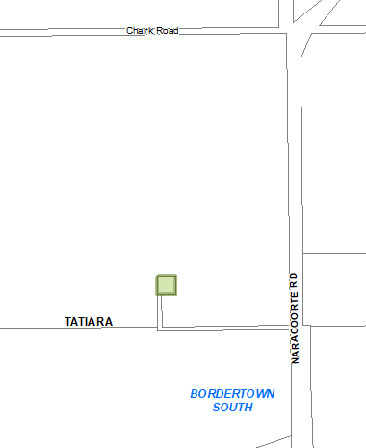 | Overlays  - Key Outback and Rural Routes

- In Part 13 of the Code – Table of Amendments, update the publication date, Code version number, amendment type and summary of amendments within the ‘Table of Planning and Design Code Amendments’ to reflect the amendments to the Code as described in this Notice.
- PURSUANT to section 76(5)(a) of the Act, I further specify that the amendments to the Code as described in this Notice will take effect upon the date those amendments are published on the SA planning portal.
Dated: 29 August 2022
Greg Van Gaans
Director, Land and Built Environment
Department for Trade and Investment
Delegate of the Minister for Planning

Planning, Development and Infrastructure Act 2016
Section 76
Amendment to the Planning and Design Code
Preamble
It is necessary to amend the Planning and Design Code (the Code) in operation at 18 August 2022 (Version 2022.15) in order to make changes:
- to correct errors in relation to:
  - the Local Heritage Place Overlay at Netherby which has been incorrectly applied to the wrong property
  - property address details for a Local Heritage Place at Coffin Bay
  - deleting a property from the Local Heritage list in Adelaide that was removed via a previous amendment (Development Plan Amendment)
  - the misapplication of the State Heritage Place Overlay / Local Heritage Place Overlay to adjacent, non-heritage, properties at North Adelaide and Adelaide.
- to remove from the Code Local Heritage Places that have been demolished at Kent Town, Tumby Bay and Joanna.
- irrelevant material (the Local Heritage Place Overlay) from new allotments (containing no items of Local Heritage value) that have been created following the subdivision of Local Heritage properties in the areas of Norwood, Marden and Mannum.
- include a new State Heritage Place at Callington.
- PURSUANT to section 76 of the Planning, Development and Infrastructure Act 2016 (the Act), I hereby amend the Code in order to make the following minor or operational amendments as follows:
- Amend the spatial layer of the Local Heritage Place Overlay so that it does not apply to 17 Finlayson Street, Netherby (Lot 9, CT5426/324) and make corresponding spatial adjustment to the Heritage Adjacency Overlay to reflect this change.
- Amend the spatial layer of the Local Heritage Place Overlay so that it applies to 1-7 Finlayson Street, Netherby (Lot 110, CT5542/298) and make corresponding spatial adjustment to the Heritage Adjacency Overlay to reflect this change
- In Part 11 of the Code, in the section applicable to ‘Mitcham’ replace the words ‘1-7 Finlayson Avenue, NETHERBY’ in the column titled ‘Property Address’ with the words ‘1-7 Finlayson Street, NETHERBY’.
- Amend the spatial layer of the Local Heritage Place Overlay at Kent Town so that it does not apply to the land bounded by the red line in Attachment A (comprising demolished Local Heritage Place formally known as 56 King William Street, Kent Town) and make corresponding spatial adjustment to the Heritage Adjacency Overlay to reflect this change
- In Part 11 of the Code, in the section applicable to ‘Norwood, Payneham and St Peters’ delete the following row in the table of Local Heritage Places:
56 King William Street KENT TOWN | Victorian Bluestone Villa | a b d | 5809
- In Part 11 of the Code, in the section applicable to ‘Tumby Bay’ delete the following row in the table of Local Heritage Places:
Tumby Bay Foreshore TUMBY BAY | Old Jetty - Tumby Bay | f | 18908
- In Part 11 of the Code, in the section applicable to ‘Naracoorte Lucindale’ delete the following row in the table of Local Heritage Places:
Langkoop Road JOANNA | Former Stables; Whole of exterior | b d | 25538
- In Part 11 of the Code, in the section applicable to ‘Lower Eyre Peninsula’ replace the words ‘Section 274, Hundred Lake Wangary COFFIN BAY’ in the column titled ‘Property Address’ with the words ‘Section 131, Hundred Lake Wangary COFFIN BAY’.
- In Part 11 of the Code, in the section applicable to ‘Adelaide’ delete the following row in the table of Local Heritage Places:
Corner North Terrace and Frome Road ADELAIDE | * Nursing School, Royal Adelaide Hospital |  | 1549
- Amend the spatial layer of the Local Heritage Place Overlay so that it does not apply to the following properties:
- 92A Osmond Terrace, Norwood (Lot 12, CT6207/360)
- 92B Osmond Terrace, Norwood (Lot 7, CT6191/3)
- 92C Osmond Terrace, Norwood (Lot 6, CT6191/2)
- 41 Church Avenue, Norwood (Lot 11, CT6191/7)
- 39 Church Avenue, Norwood (Lot 10, CT6191/6)
- 1A Broad Street, Marden (Lot 3, CT6229/507)
- 17 Edward Street, Mannum (Lot 2, CT6077/869)
- 19 Edward Street, Mannum (Lot 80, CT5914/153)
and make corresponding spatial adjustment to the Heritage Adjacency Overlay to reflect these changes.
- Amend the spatial layer of the State Heritage Place Overlay so that it does not apply to 15 Finniss Court, North Adelaide (Lot 4, CT5202/861) and make corresponding spatial adjustment to the Heritage Adjacency Overlay to reflect this change.
- Amend the spatial layer of the State Heritage Place Overlay so that it does not apply to land bounded by the red line in Attachment B (comprising properties 100 to 110 Waymouth Street, Adelaide) and make corresponding spatial adjustment to the Heritage Adjacency Overlay to reflect these changes.
- Amend the spatial layer of the State Heritage Place Overlay so that it applies to the following properties:
- Former Callington Smelting Works – Heritage Number 28123 – 20 & 36 Callington Road, Callington (CT5522/495 & CT5398/700)
and make corresponding spatial adjustment to the Heritage Adjacency Overlay to reflect these changes.
- In Part 13 of the Code – Table of Amendments, update the publication date, Code version number, amendment type and summary of amendments within the ‘Table of Planning and Design Code Amendments’ to reflect the amendments to the Code as described in this Notice.
- PURSUANT to section 76(5)(a) of the Act, I further specify that the amendments to the Code as described in this Notice will take effect upon the date those amendments are published on the SA planning portal.
Dated: 31 August 2022
Sally Smith
Executive Director, Planning and Land Use Services
Department for Trade and Investment
Delegate of the Minister for Planning

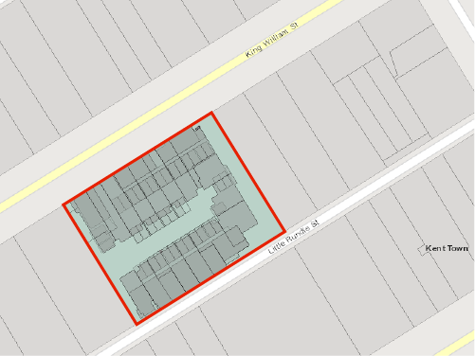
Attachment A

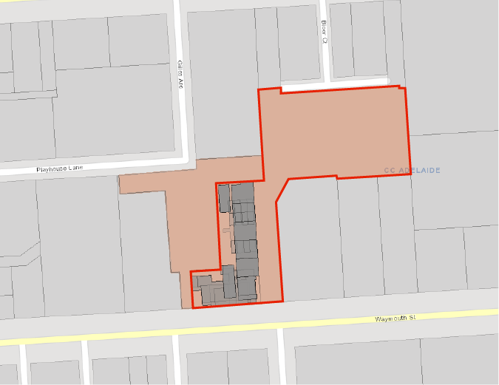
Attachment B

Planning, Development and Infrastructure Act 2016
Section 108(1)
Hawsons Iron Project
Preamble
Section 108(1)(c) of the Planning, Development and Infrastructure Act 2016 allows the Minister for Planning to apply Section 108 (impact assessed development) to a specified kind of development (either in the State generally, or in a specified part of the State) by making a declaration to that effect having taken into account principles prescribed by the regulations.
Notice
PURSUANT to section 108(1)(c) of the Planning, Development and Infrastructure Act 2016, having taken into account those principles prescribed under regulation 27(2) of the Planning, Development and Infrastructure (General) Regulations 2017 (the Regulations) and having given consideration to the matters under regulation 27(3) of the Regulations, I declare that Section 108 of the Act applies to all development of a kind specified in Schedule 1, in those parts of the State specified in Schedules 2 and 3.
Schedule 1
Specified Kinds of Development
Development for the purposes of establishing and operating a port facility north of Wallaroo at Myponie Point on Yorke Peninsula (being on the land specified in Schedule 2) and an associated pipeline infrastructure corridor from the port to the South Australian – New South Wales Border (being on the land specified in Schedules 3), including:
- development associated with the construction and operation of a deep-water port facility, in that part of the State specified in Schedule 2, including any or all of:
  - jetty and wharf structures;
  - ship loading systems;
  - navigation aids;
  - stockpile areas and materials handling systems;
  - dewatering plant and associated infrastructure;
  - water treatment plants;
  - storage tanks and associated infrastructure;
  - ancillary infrastructure, including permanent site offices, workshops, stores, amenities, parking and access;
  - temporary laydown areas, construction compounds and concrete batching plants;
  - temporary workers camps; and
  - development associated with paragraph (b)(i) – (iv).
- development associated with the construction and operation of a pipeline infrastructure corridor, in that part of the State specified in Schedule 3, including any or all of:
- slurry pipelines and return water pipelines and associated infrastructure;
- pumping stations and associated infrastructure;
- storage tanks and associated infrastructure;
- pressure relief and product storage facilities;
- temporary laydown areas, construction compounds and concrete batching plants; and
- temporary workers camps.
- development associated with any change in the use of land associated with any development within the ambit of the preceding paragraphs;
- development (including development undertaken on land in the State, inclusive of the land specified in Schedules 2 and 3) associated with the construction, installation or provision of any or all of the following infrastructure, facilities and services:
  - roads;
  - stormwater;
  - water supply;
  - power supply;
  - telecommunications; and
  - effluent treatment or disposal.
in each case, associated with any development within the ambit of the preceding paragraphs;
- development (including development undertaken on land in the State, inclusive of the land specified in Schedules 2 and 3) associated with any excavation or filling of land associated with any development within the ambit of the preceding paragraphs;
- development (including development undertaken on land in the State, inclusive of the land specified in Schedules 2 and 3) associated with the division of land associated with any development within the ambit of the preceding paragraphs; and
- any related or ancillary development (including development undertaken on land in the State, inclusive of the land specified in Schedules 2 and 3) associated with any development within the ambit of the preceding paragraphs.
Schedule 2
Specified Part of the State
The following part of the State is specified for the purposes of Schedule 1 as shown on the attached map for Schedule 2:
- The whole of the land comprised in Certificate of Title Volume 6010 Folio 6 (allotment 1034 in Deposited Plan 54962); and
- The area of water and seabed within a 5km radius of Myponie Point, approximately 11km north of Wallaroo on Yorke Peninsula, being the area described as “5km Coastal Investigations Area – Pt Myponie” on the attached map for Schedule 2.

Schedule 3
Specified Part of the State
The following part of the State is specified for the purposes of Schedule 1 as shown on the attached map for Schedule 3:
- A corridor of land running from the area described in Schedule 2(a) to a point on the South Australian – New South Wales Border approximately 41km south of Cockburn, via an alignment that passes north of the township of Spalding in the State’s mid-north, being the land described as “Pipeline Corridor (1km Investigations Area)” on the attached map for Schedule 3.
Dated: 30 August 2022
Hon Nick Champion Mp
Minister for Planning

Schedule 2
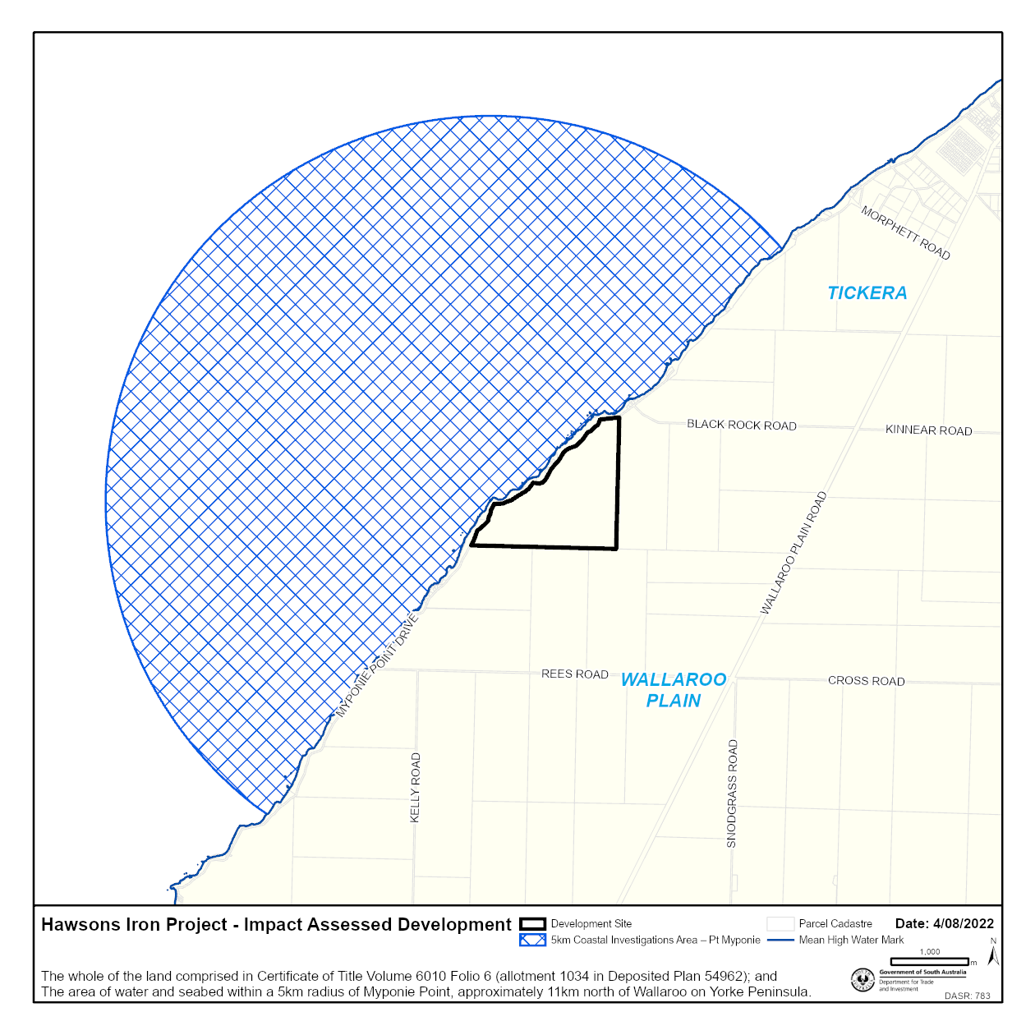

Schedule 3
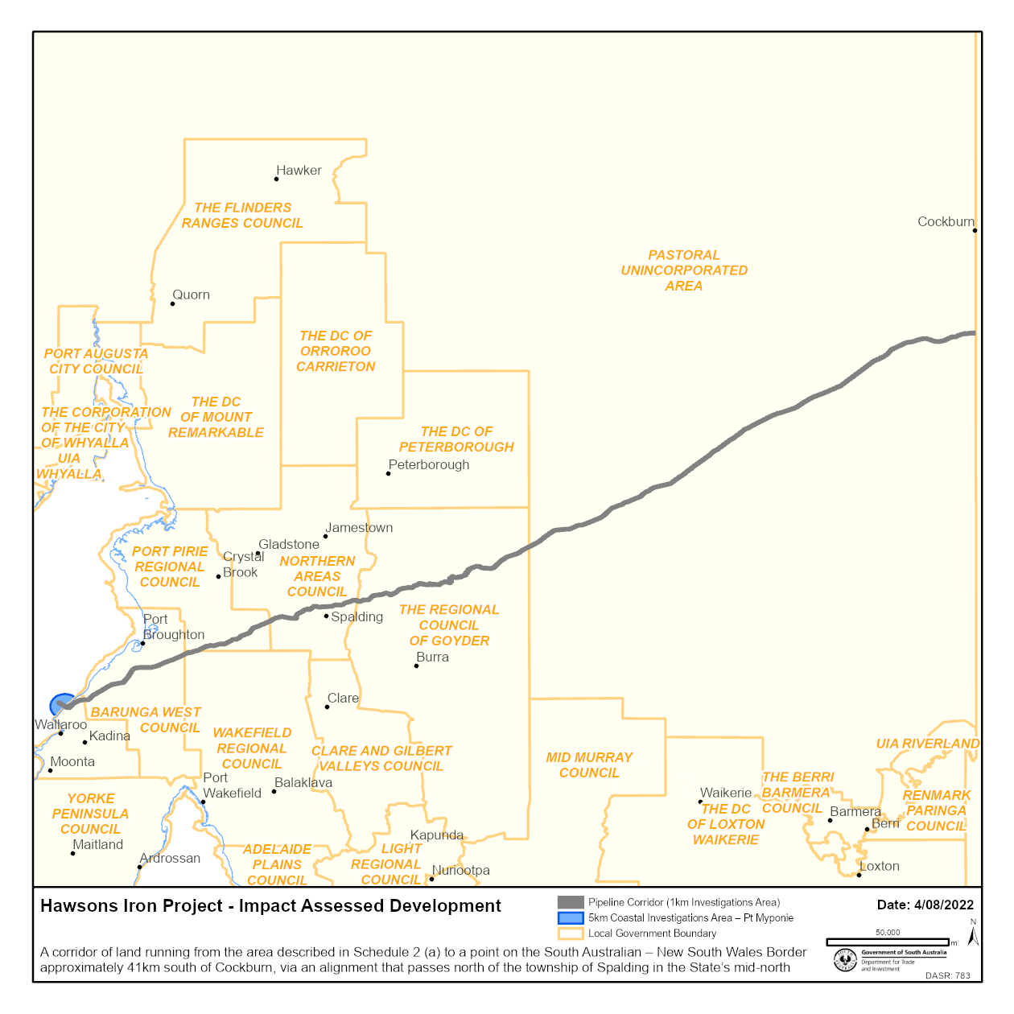

Proof of Sunrise and Sunset Act 1923
Almanac for October, November, December 2022
Pursuant to the requirements of the Proof of Sunrise and Sunset Act 1923, I Jon William Whelan, Chief Executive, Department for Infrastructure and Transport, at the direction of the Minister for Infrastructure and Transport, publish in the Schedule hereto an almanac setting out the times of sunrise and sunset on every day for the three calendar months October, November and December 2022.
Dated: 1 September 2022
Jon William Whelan
Chief Executive, Department for Infrastructure and Transport

Schedule
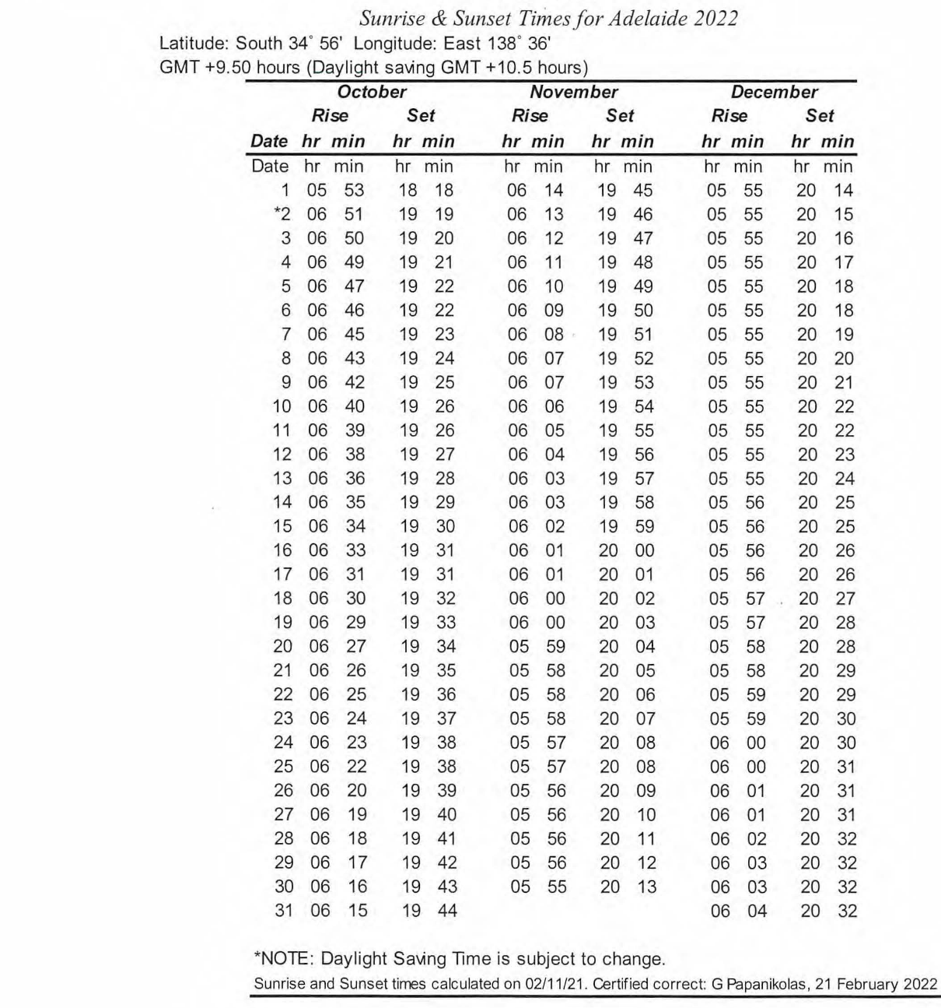

Road Traffic Act 1961
Authorisation to Operate Breath Analysing Instruments
I, GRANT STEVENS, Commissioner of Police, do hereby notify that on and from 19 August 2022, the following persons were authorised by the Commissioner of Police to operate breath analysing instruments as defined in and for the purposes of the:
Road Traffic Act 1961;
Harbors and Navigation Act 1993;
Security and Investigation Industry Act 1995; and
Rail Safety National Law (South Australia) Act 2012.
PD Number | Officer Name
10310 | BRAZIL, James Roger
77051 | LOCKWOOD, Daniel Scott
76940 | PULLEN, Allison Jane
10932 | STORTI, Emily
76941 | TANNER, Amber - Rose
11079 | WHITE, Brittany May
Dated: 1 September 2022
Grant Stevens
Commissioner of Police
Reference: 2022-0142

South Australian Skills Act 2008
Part 4 – Apprenticeships, Traineeships and Training Contracts
PURSUANT to the provision of the South Australian Skills Act 2008, the South Australian Skills Commission (SASC) gives notice that determines the following Trades or Declared Vocations in addition to the gazette notices of:
1. 25 September 2008 | 2. 23 October 2008 | 3. 13 November 2008 | 4. 4 December 2008
5. 18 December 2008 | 6. 29 January 2009 | 7. 12 February 2009 | 8. 5 March 2009
9. 12 March 2009 | 10. 26 March 2009 | 11. 30 April 2009 | 12. 18 June 2009
13. 25 June 2009 | 14. 27 August 2009 | 15. 17 September 2009 | 16. 24 September 2009
17. 9 October 2009 | 18. 22 October 2009 | 19. 3 December 2009 | 20. 17 December 2009
21. 4 February 2010 | 22. 11 February 2010 | 23. 18 February 2010 | 24. 18 March 2010
25. 8 April 2010 | 26. 6 May 2010 | 27. 20 May 2010 | 28. 3 June 2010
29. 17 June 2010 | 30. 24 June 2010 | 31. 8 July 2010 | 32. 9 September 2010
33. 23 September 2010 | 34. 4 November 2010 | 35. 25 November 2010 | 36. 16 December 2010
37. 23 December 2010 | 38. 17 March 2011 | 39. 7 April 2011 | 40. 21 April 2011
41. 19 May 2011 | 42. 30 June 2011 | 43. 21 July 2011 | 44. 8 September 2011
45. 10 November 2011 | 46. 24 November 2011 | 47. 1 December 2011 | 48. 8 December 2011
49. 16 December 2011 | 50. 22 December 2011 | 51. 5 January 2012 | 52. 19 January 2012
53. 1 March 2012 | 54. 29 March 2012 | 55. 24 May 2012 | 56. 31 May 2012
57. 7 June 2012 | 58. 14 June 2012 | 59. 21 June 2012 | 60. 28 June 2012
61. 5 July 2012 | 62. 12 July 2012 | 63. 19 July 2012 | 64. 2 August 2012
65. 9 August 2012 | 66. 30 August 2012 | 67. 13 September 2012 | 68. 4 October 2012
69. 18 October 2012 | 70. 25 October 2012 | 71. 8 November 2012 | 72. 29 November 2012
73. 13 December 2012 | 74. 25 January 2013 | 75. 14 February 2013 | 76. 21 February 2013
77. 28 February 2013 | 78. 7 March 2013 | 79. 14 March 2013 | 80. 21 March 2013
81. 28 March 2013 | 82. 26 April 2013 | 83. 23 May 2013 | 84. 30 May 2013
85. 13 June 2013 | 86. 20 June 2013 | 87. 11 July 2013 | 88. 1 August 2013
89. 8 August 2013 | 90. 15 August 2013 | 91. 29 August 2013 | 92. 6 February 2014
93. 12 June 2014 | 94. 28 August 2014 | 95. 4 September 2014 | 96. 16 October 2014
97. 23 October 2014 | 98. 5 February 2015 | 99. 26 March 2015 | 100. 16 April 2015
101. 27 May 2015 | 102. 18 June 2015 | 103. 3 December 2015 | 104. 7 April 2016
105. 30 June 2016 | 106. 28 July 2016 | 107. 8 September 2016 | 108. 22 September 2016
109. 27 October 2016 | 110. 1 December 2016 | 111. 15 December 2016 | 112. 7 March 2017
113. 21 March 2017 | 114. 23 May 2017 | 115. 13 June 2017 | 116. 18 July 2017
117. 19 September 2017 | 118. 26 September 2017 | 119. 17 October 2017 | 120. 3 January 2018
121. 23 January 2018 | 122. 14 March 2018 | 123. 14 June 2018 | 124. 5 July 2018
125. 2 August 2018 | 126. 9 August 2018 | 127. 16 August 2018 | 128. 30 August 2018
129. 27 September 2018 | 130. 4 October 2018 | 131. 18 October 2018 | 132. 1 November 2018
133. 15 November 2018 | 134. 22 November 2018 | 135. 29 November 2018 | 136. 6 December 2018
137. 20 December 2018 | 138. 24 January 2019 | 139. 14 February 2019 | 140. 30 May 2019
141. 6 June 2019 | 142. 13 June 2019 | 143. 20 June 2019 | 144. 27 June 2019
145. 11 July 2019 | 146. 8 August 2019 | 147. 22 August 2019 | 148. 12 September 2019
149. 19 September 2019 | 150. 14 November 2019 | 151. 28 November 2019 | 152. 12 December 2019
153. 19 December 2019 | 154. 23 January 2020 | 155. 27 February 2020 | 156. 21 April 2020
157. 25 June 2020 | 158. 10 September 2020 | 159. 17 September 2020 | 160. 8 October 2020
161. 29 October 2020 | 162. 5 November 2020 | 163. 10 December 2020 | 164. 17 December 2020
165. 24 December 2020 | 166. 21 January 2021 | 167. 11 February 2021 | 168. 25 February 2021
169. 25 March 2021 | 170. 1 April 2021 | 171. 8 April 2021 | 172. 6 May 2021
173. 10 June 2021 | 174. 1 July 2021 | 175. 12 August 2021 | 176. 9 September 2021
177. 23 September 2021 | 178. 30 September 2021 | 179. 14 October 2021 | 180. 21 October 2021
181. 9 November 2021 | 182. 2 December 2021 | 183. 23 December 2021 | 184. 24 February 2022
185. 10 March 2022 | 186. 24 March 2022 | 187. 12 May 2022 | 188. 16 June 2022
189. 23 June 2022 | 190. 11 August 2022 | 191. 25 August 2022
Trades or Declared Vocations and Required Qualifications and Training Contract Conditions for the
Agriculture, Horticulture and Conservation and Land Management (AHC) Training Package
*Trade / #Declared Vocation / Other Occupation | Qualification Code | Qualification Title | Nominal Term of Training Contract | Probationary Period | Supervision Level Rating
Farming # | AHC32422 | Certificate III in Irrigation Technology | 36 | 90 | M
Farming # | AHC51422 | Diploma of Agribusiness Management | 36 | 90 | M
Dated: 1 September 2022
John Evangelista
Director, Traineeship and Apprenticeship Services
Department for Innovation and Skills

Local Government Instruments

City of Playford
Local Government Act 1999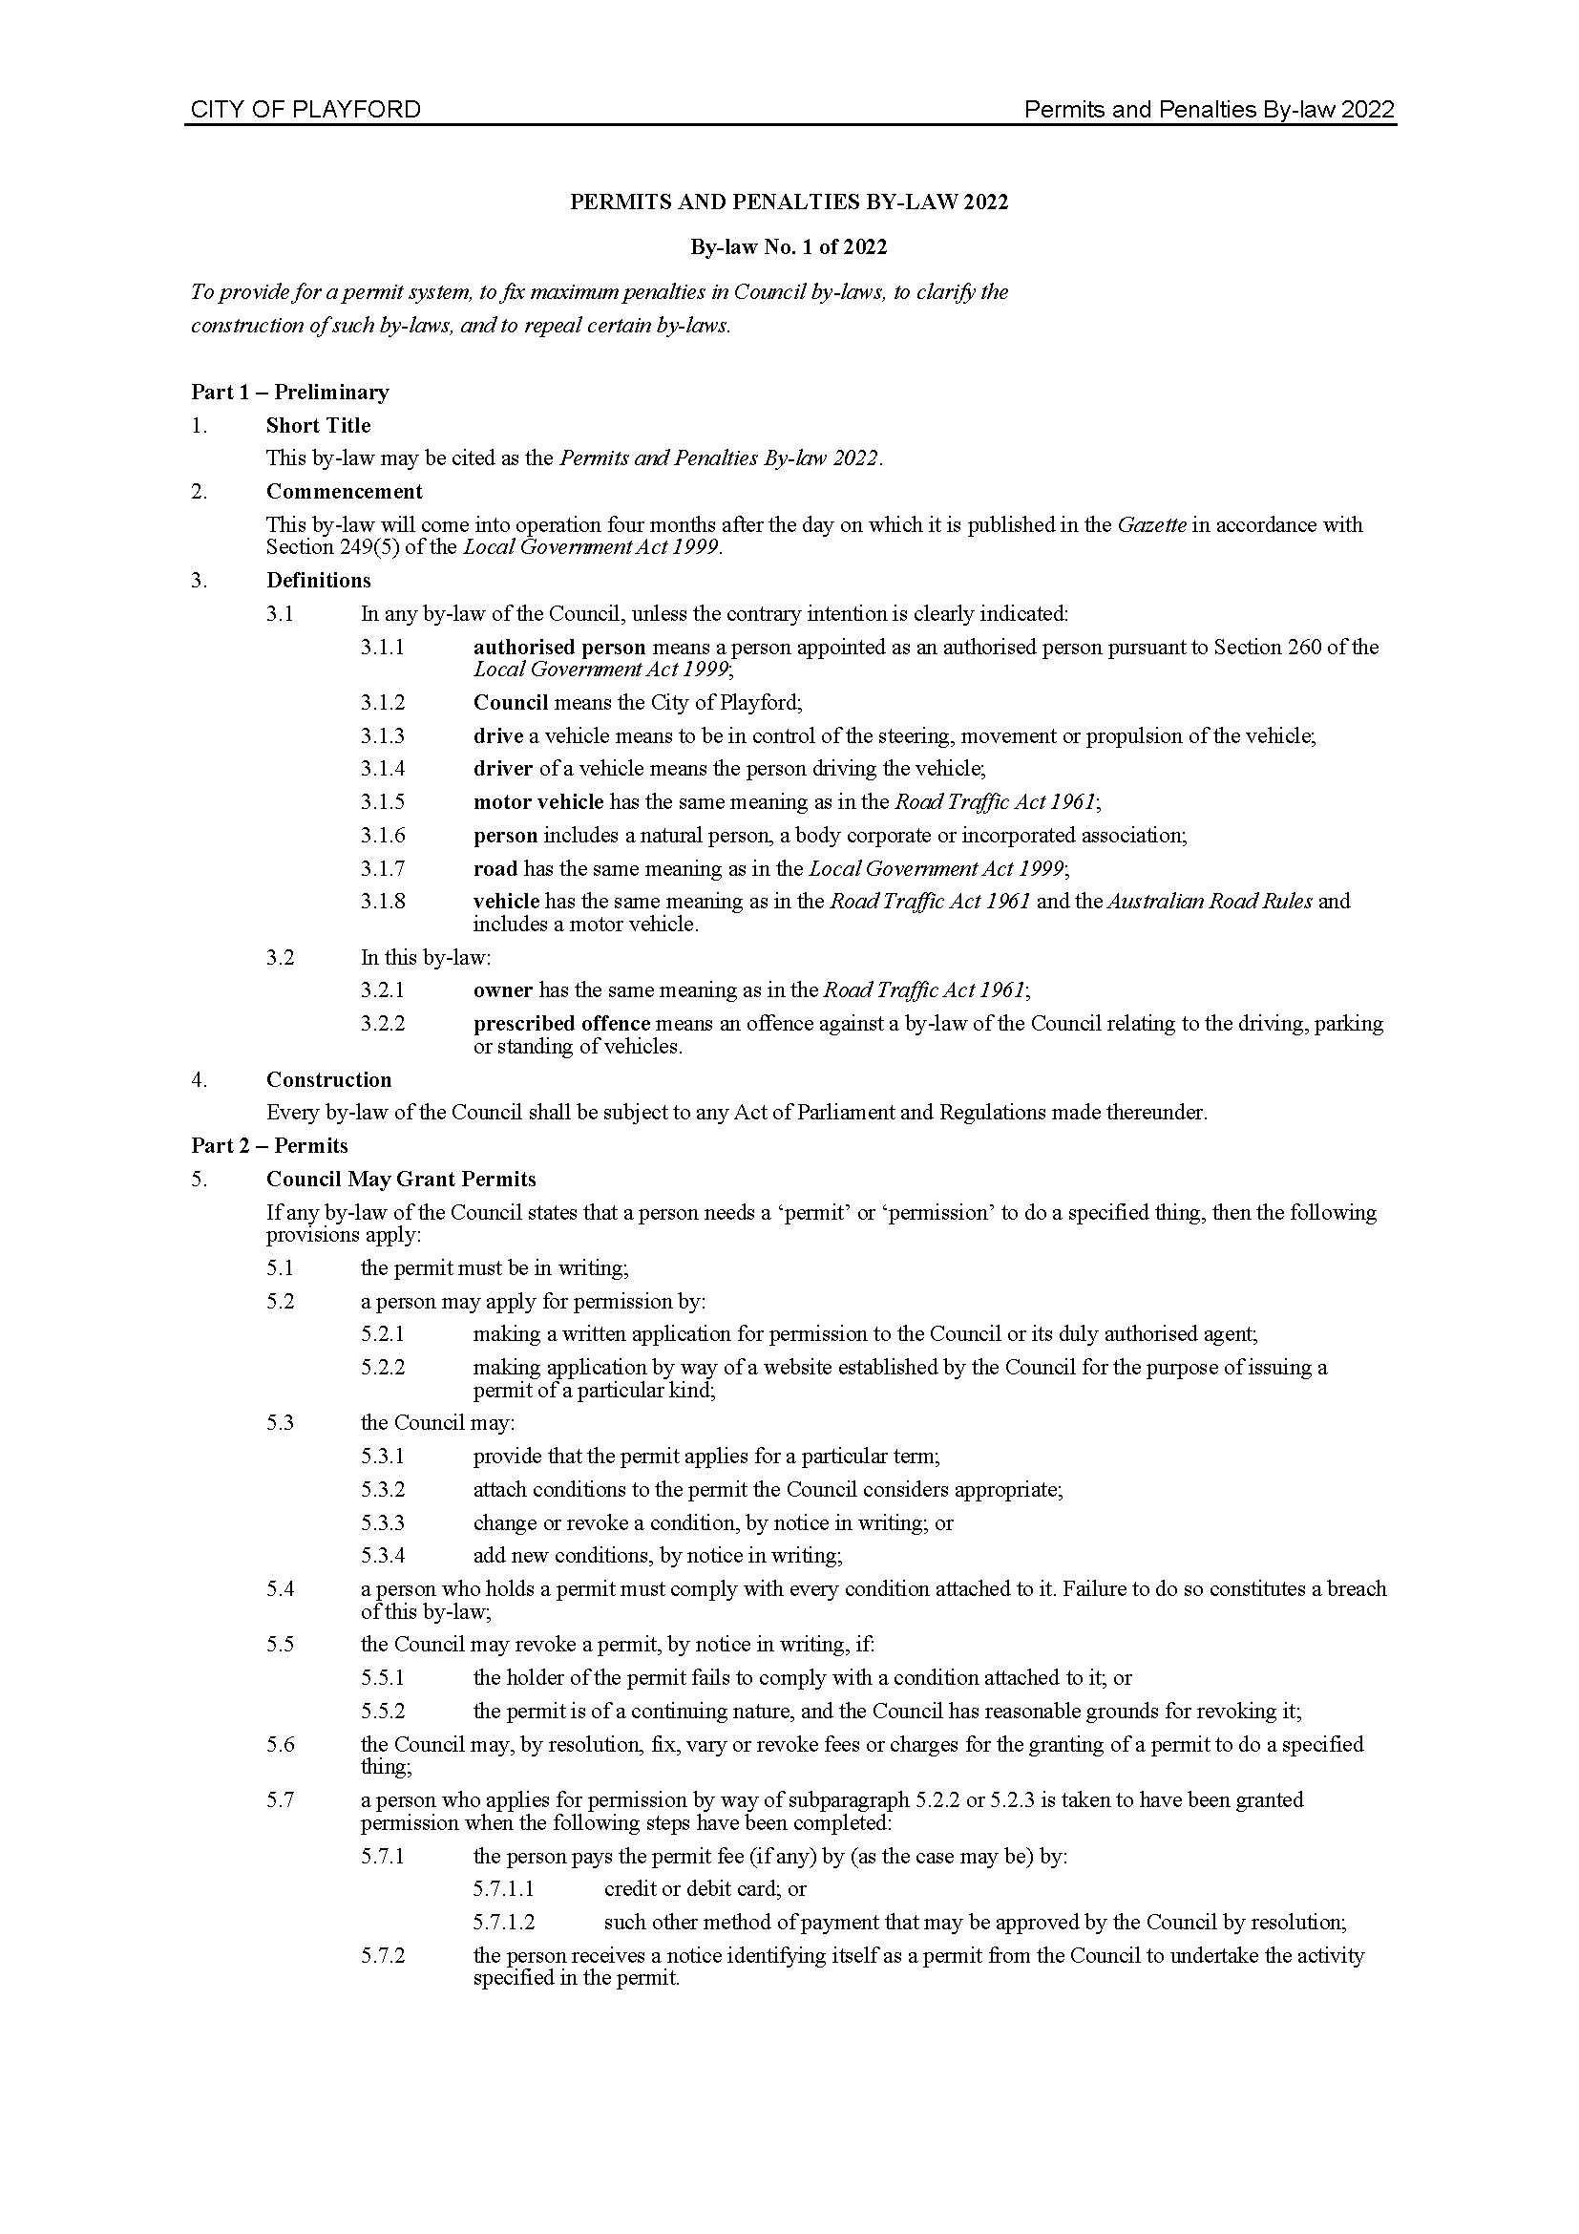
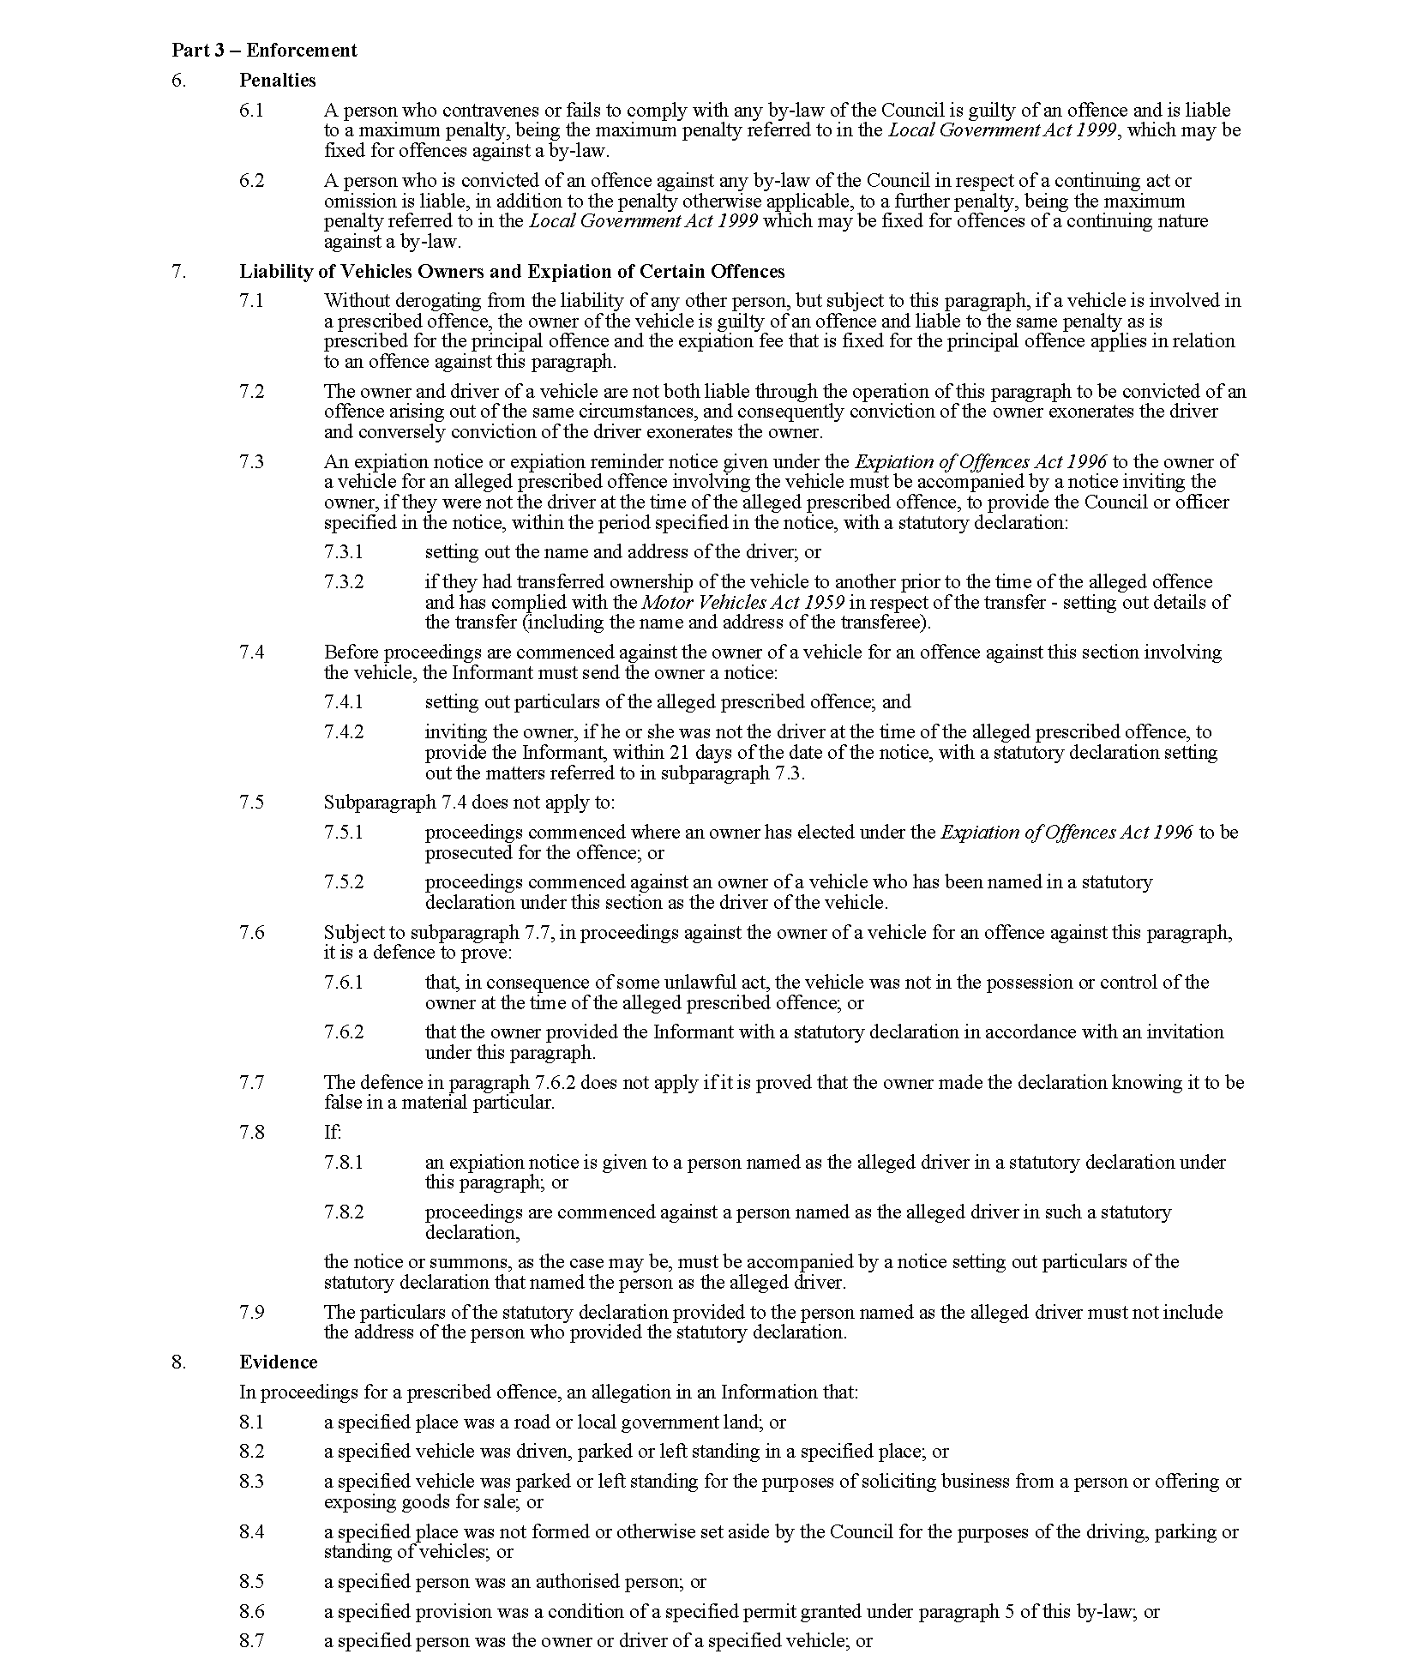

City of Playford
Local Government Act 1999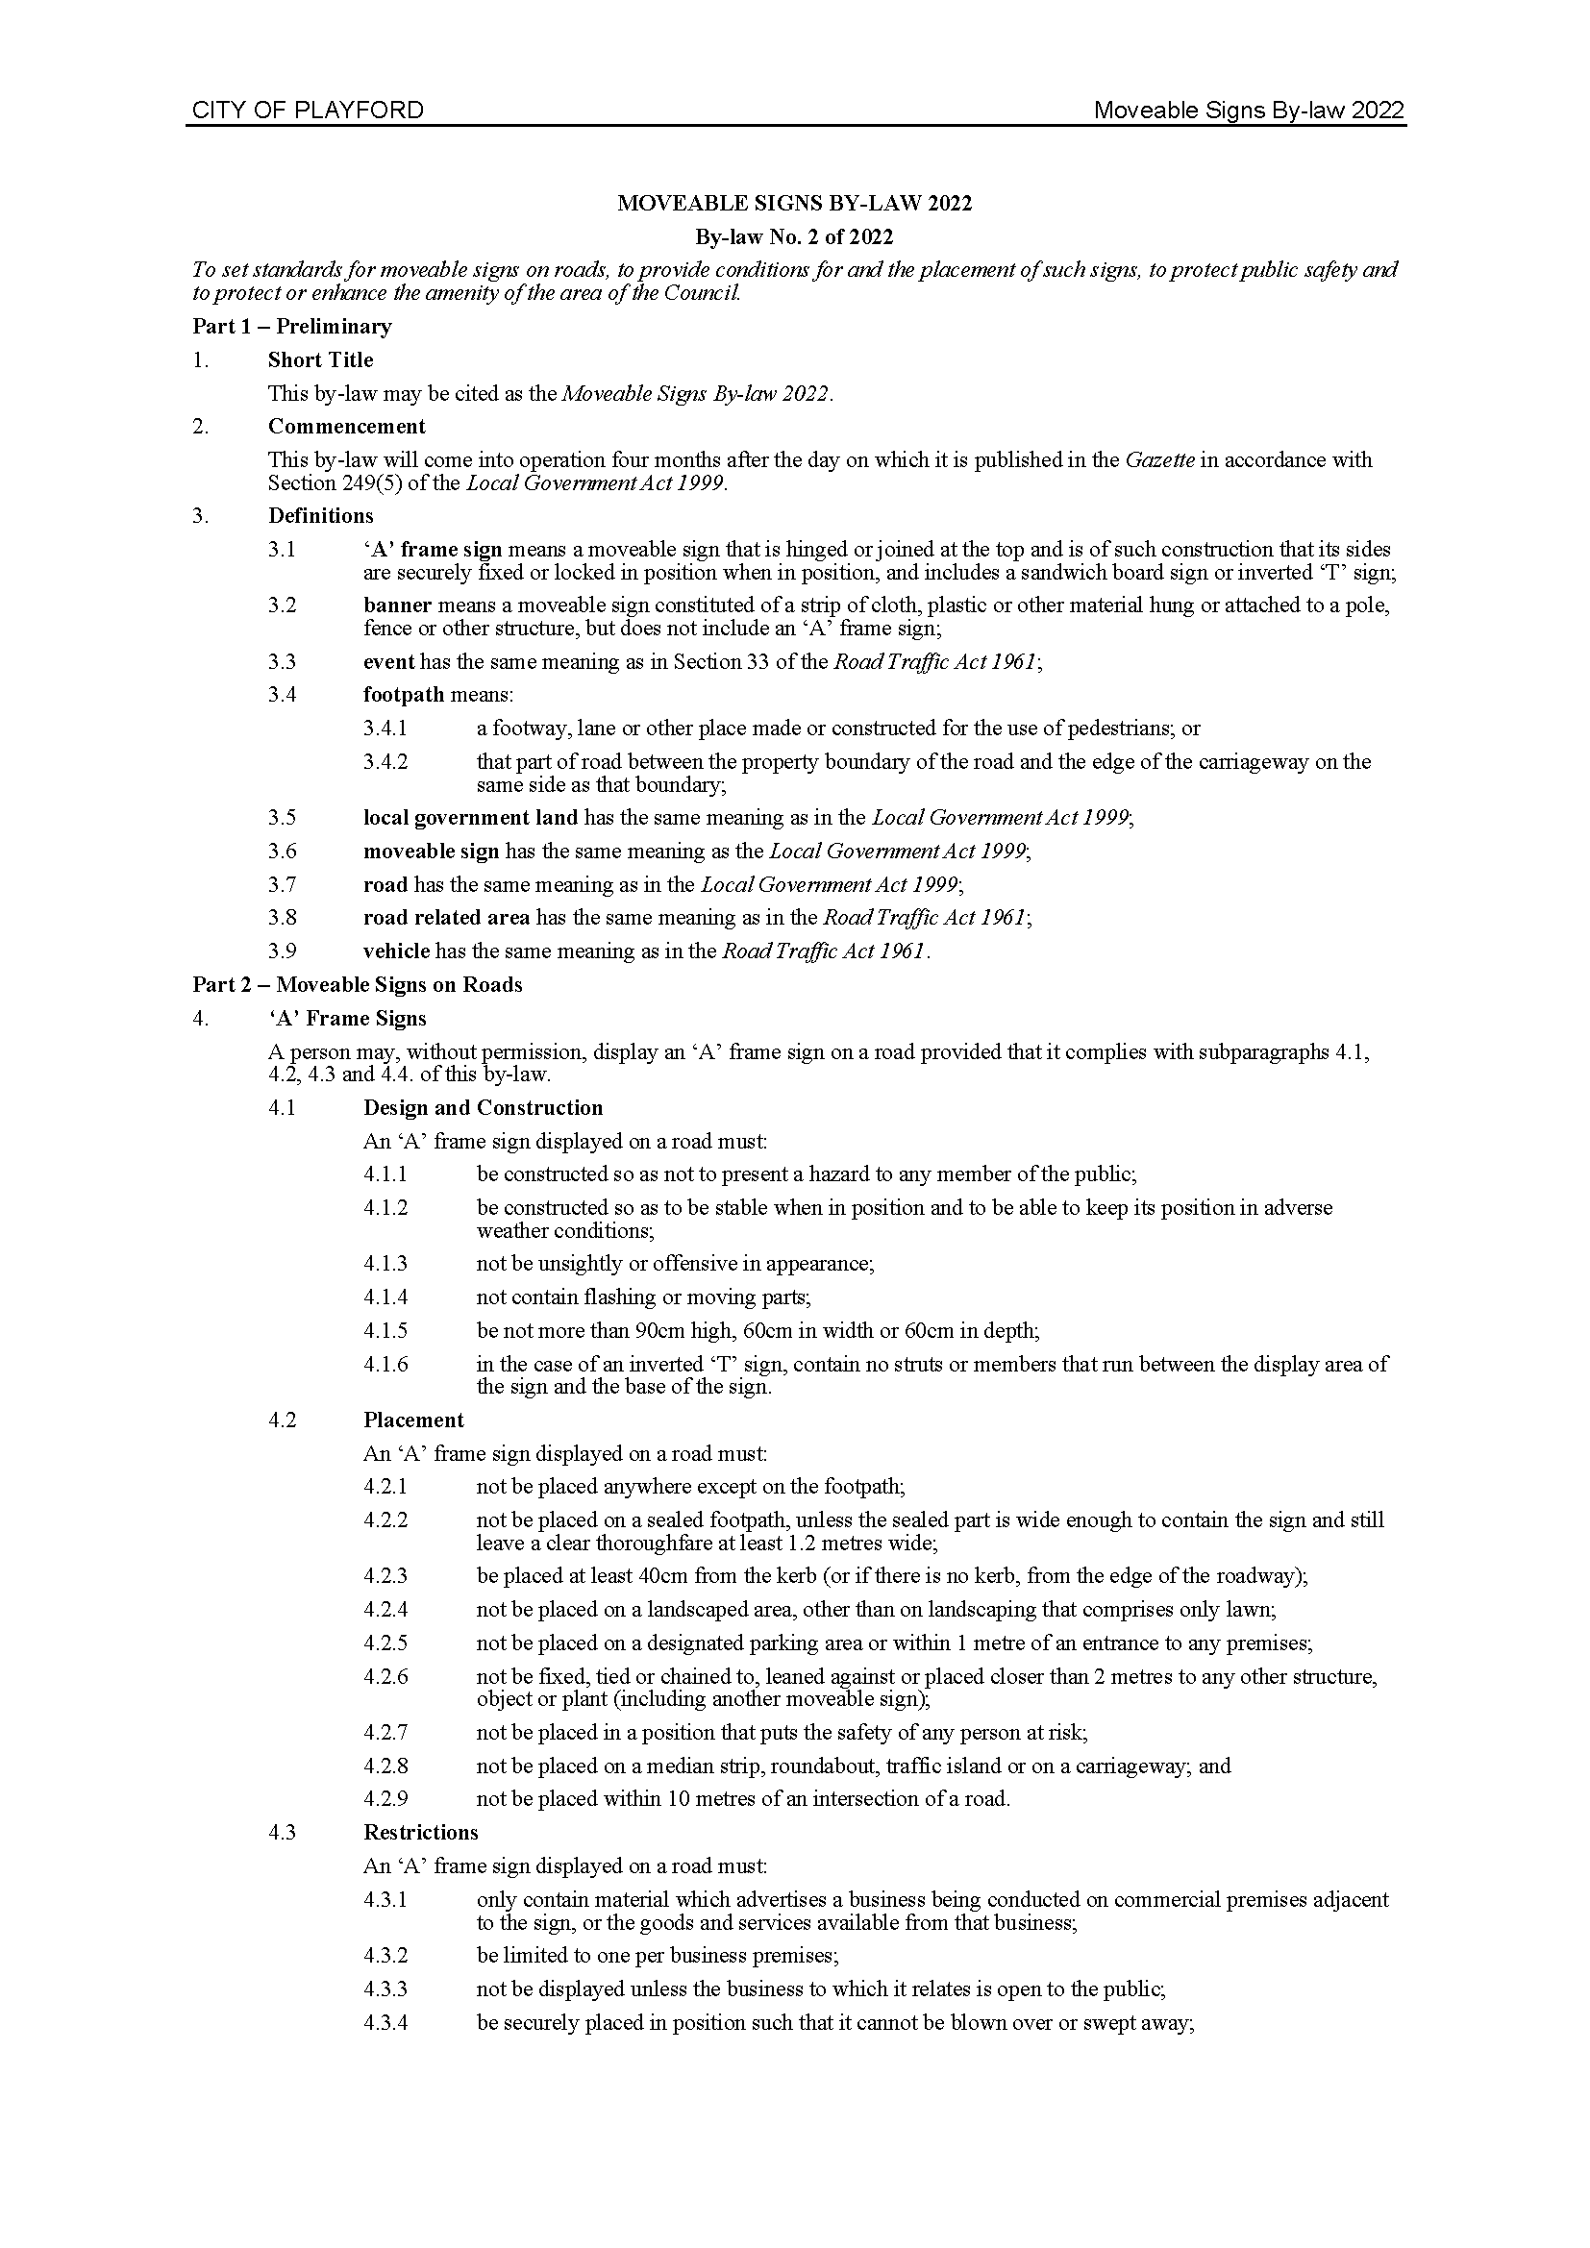
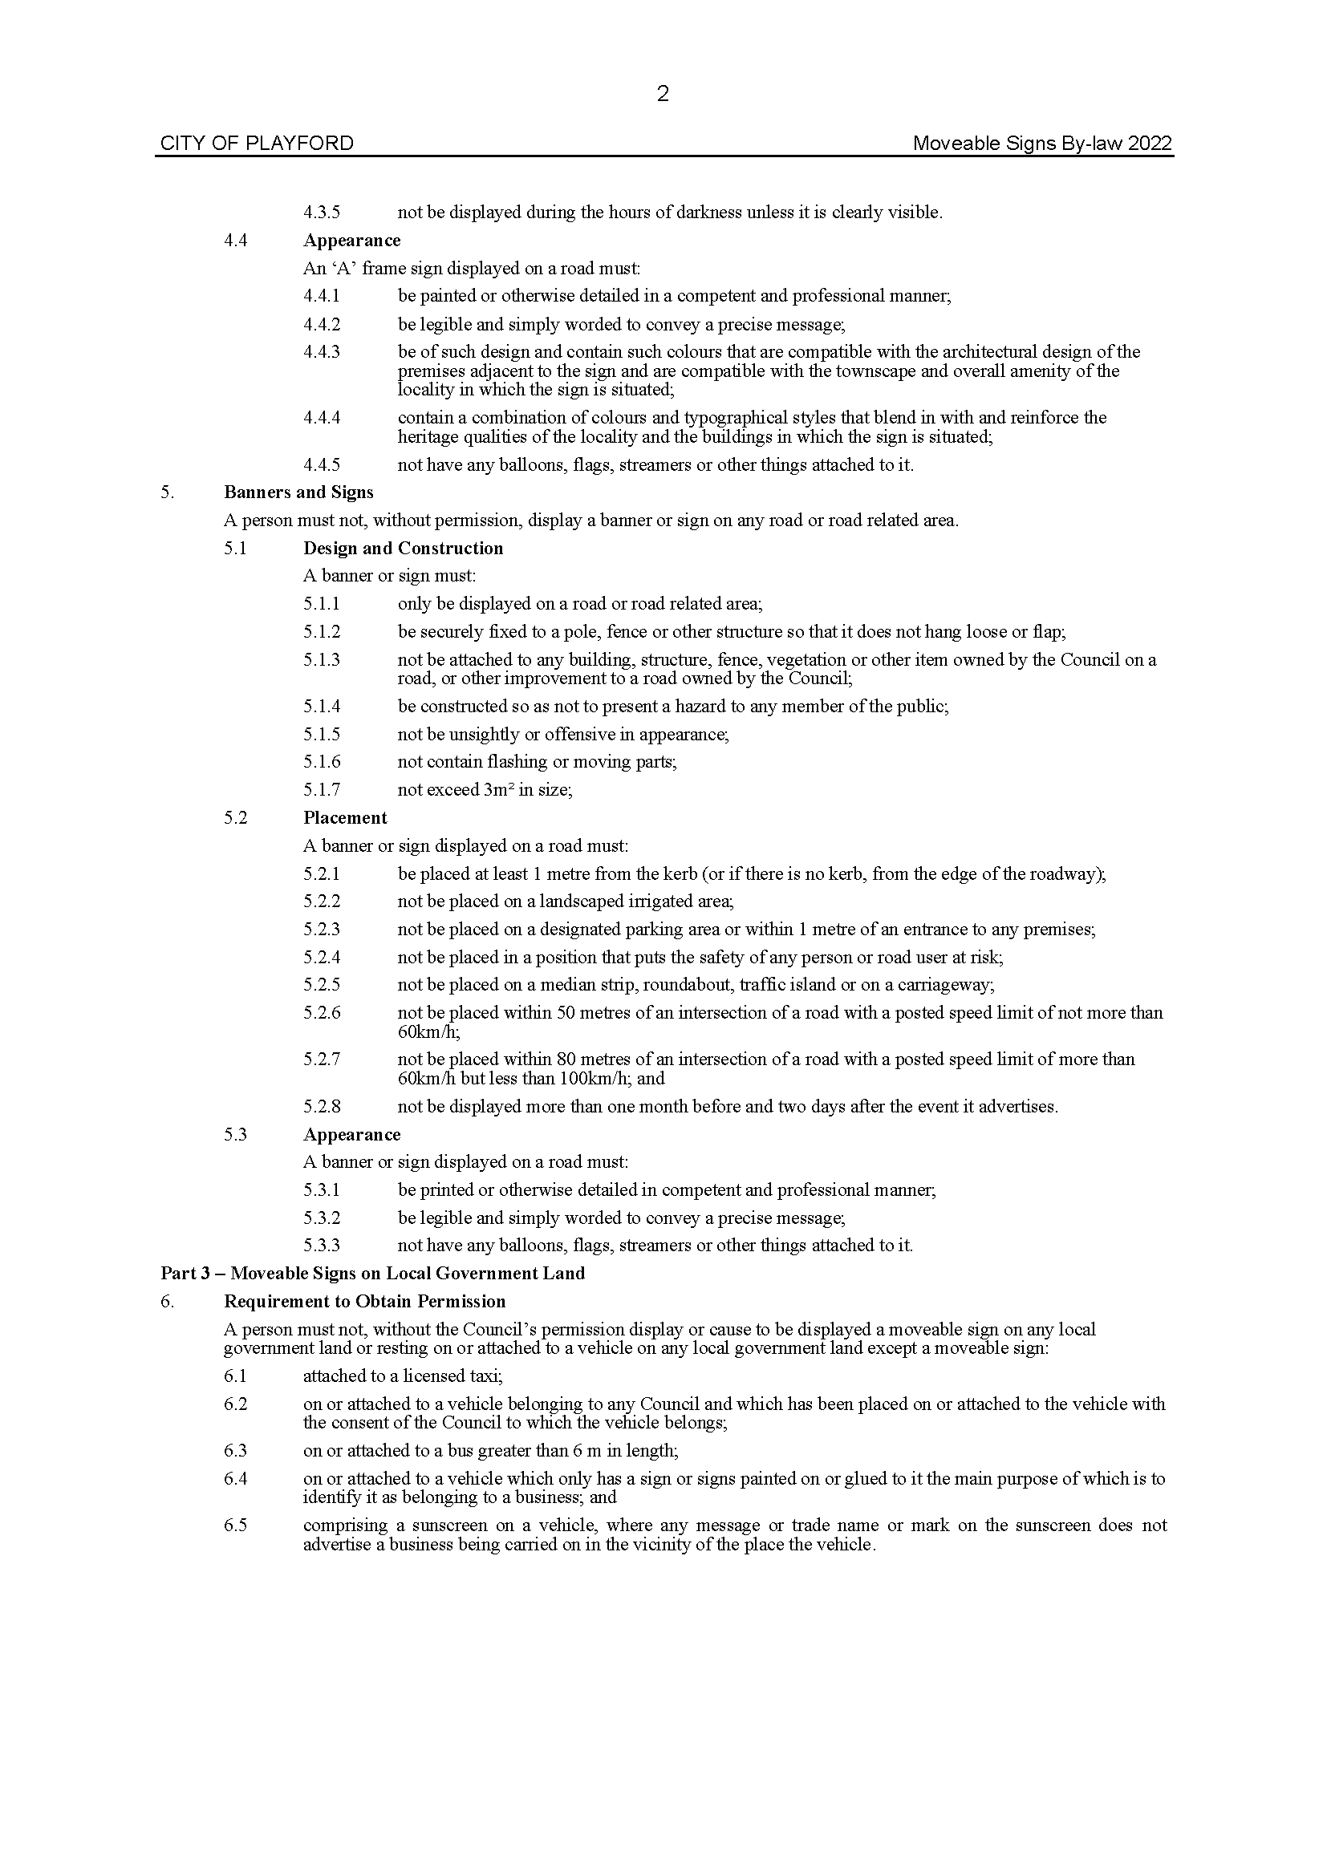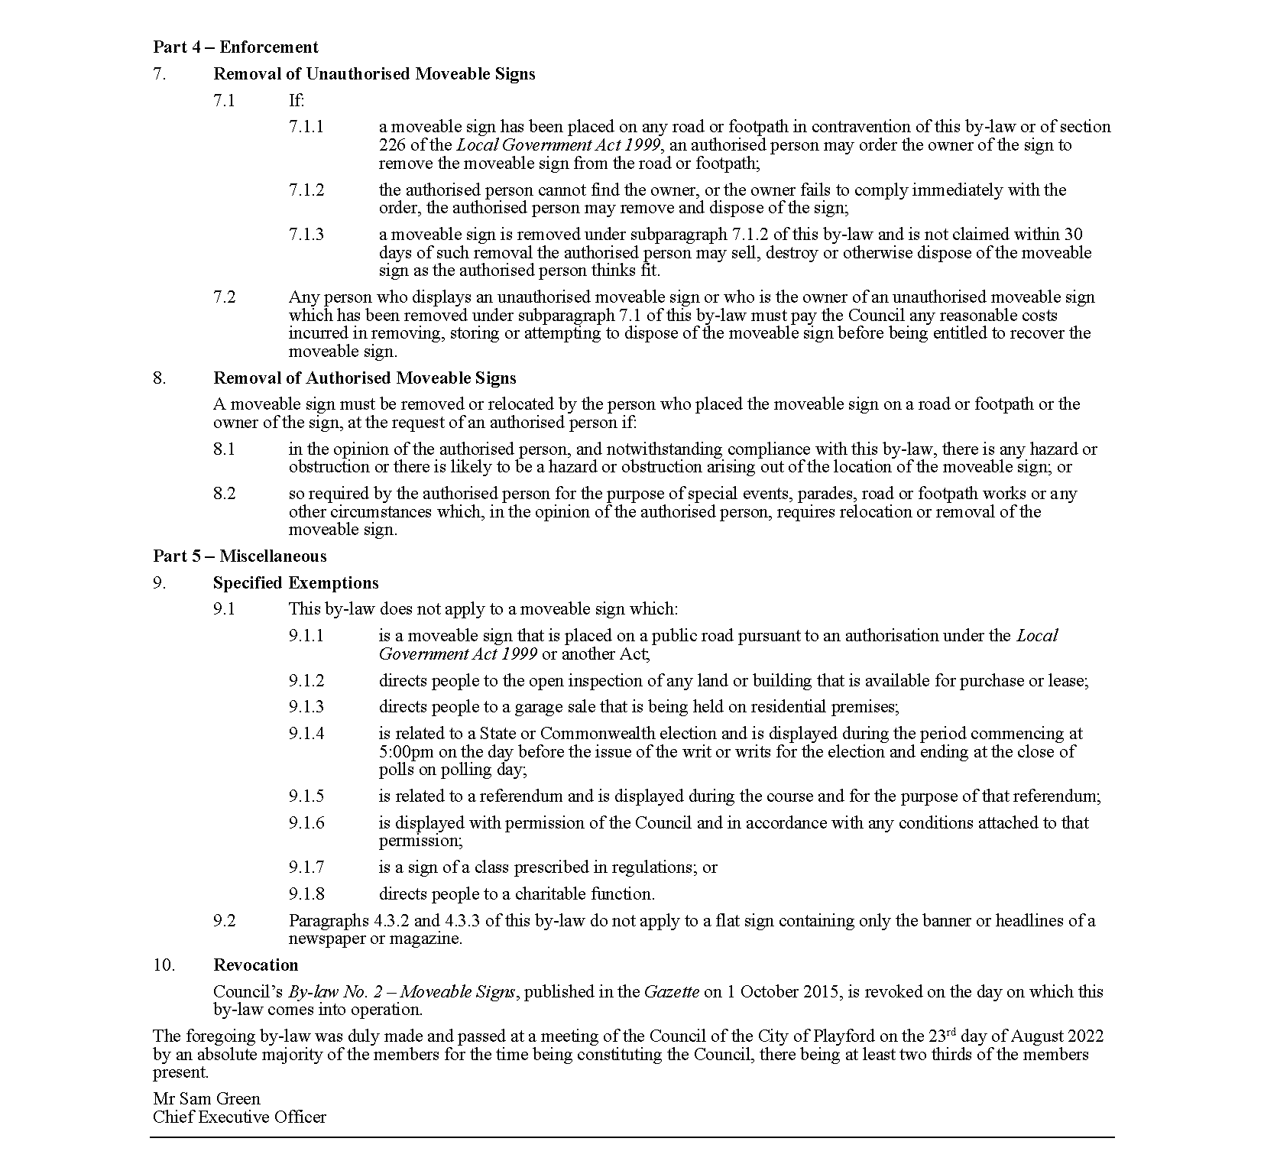

City of Playford
Local Government Act 1999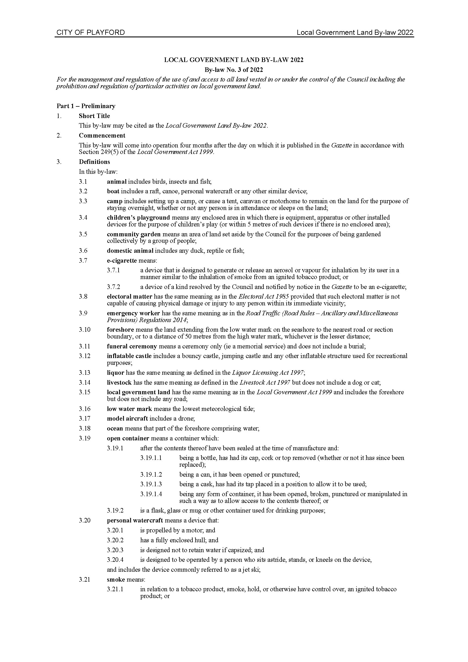
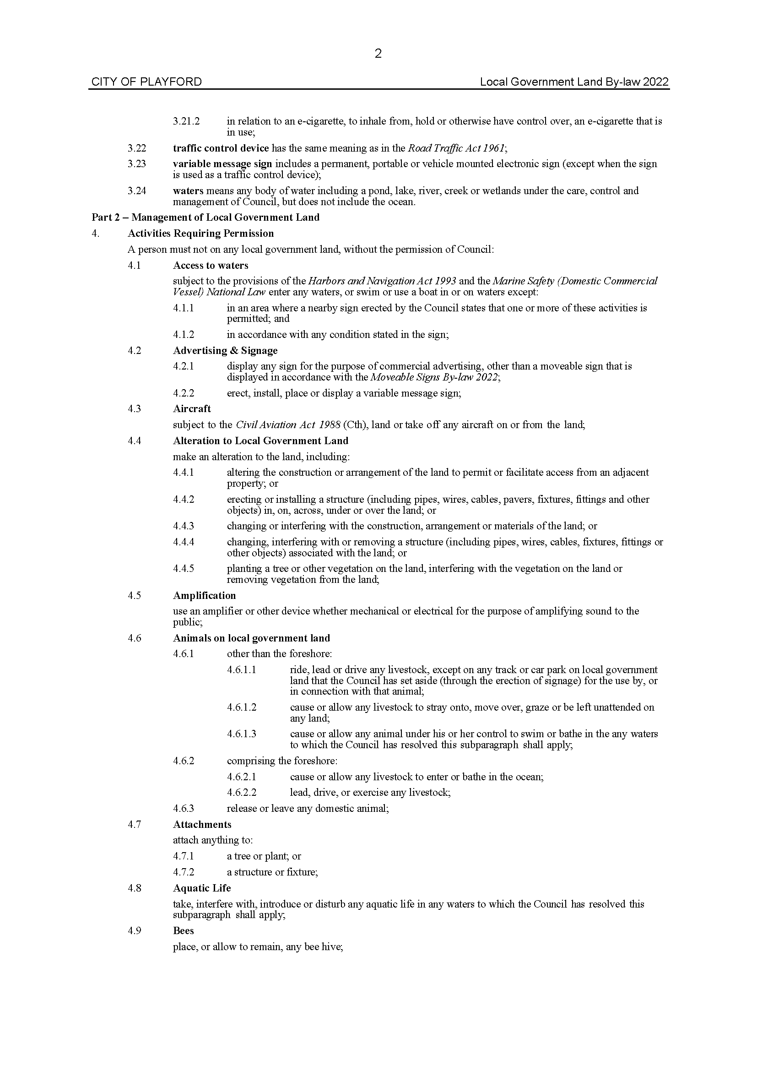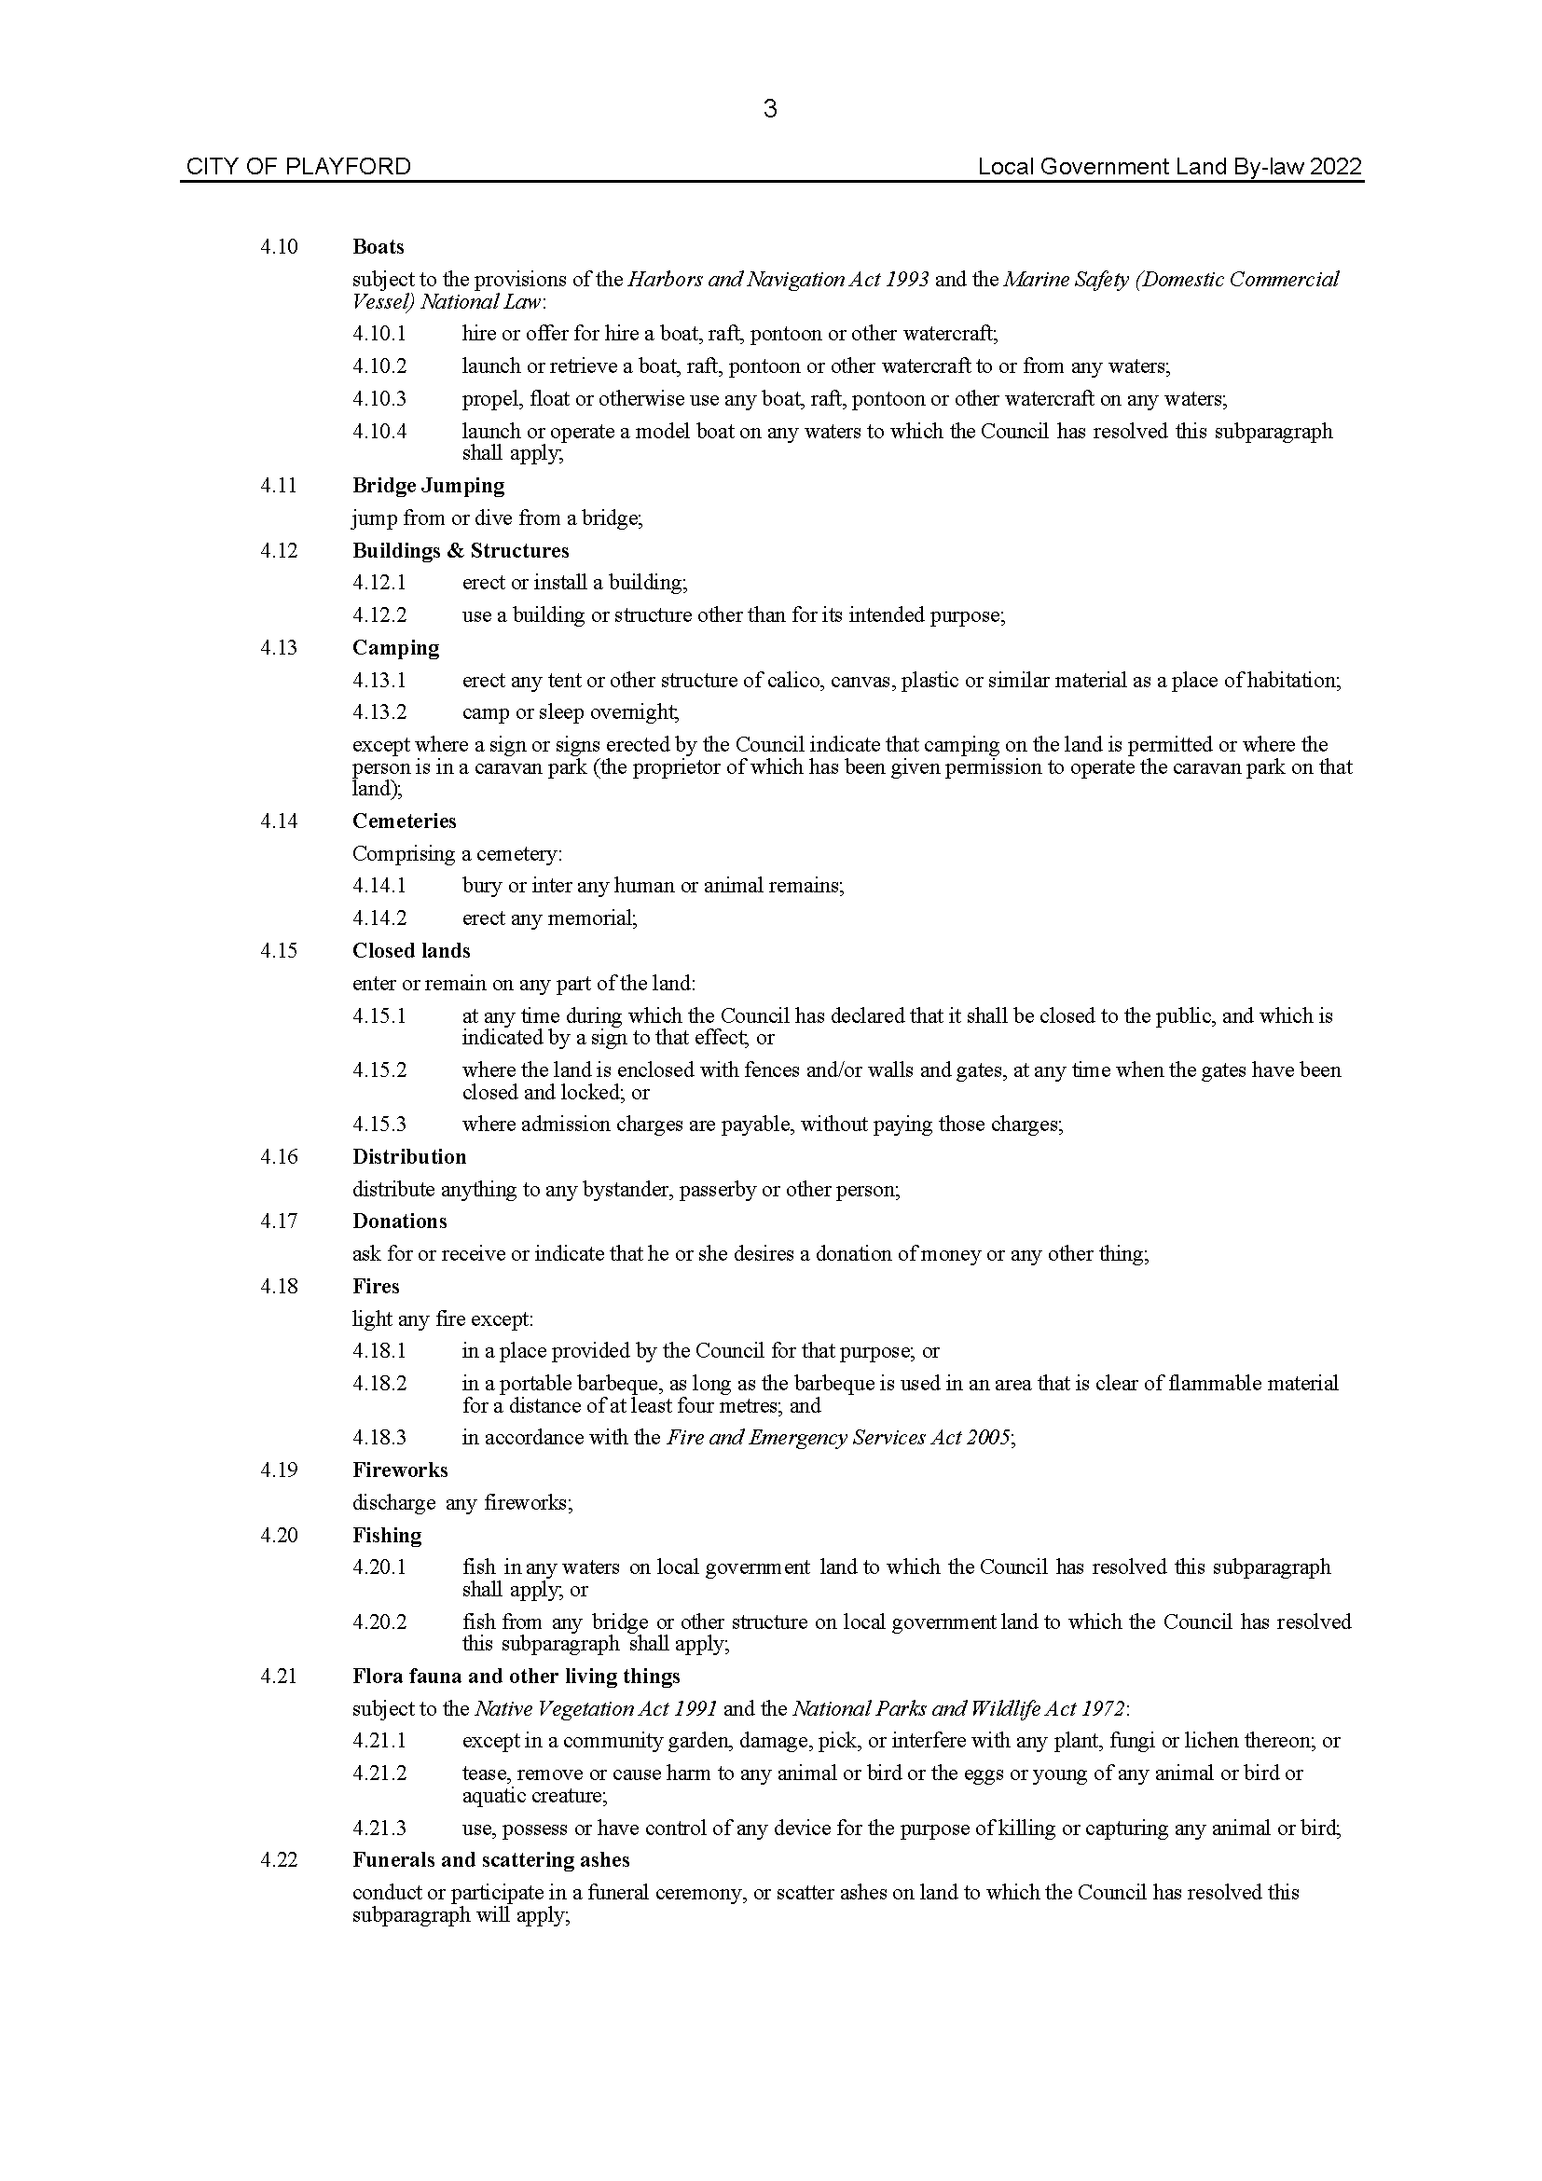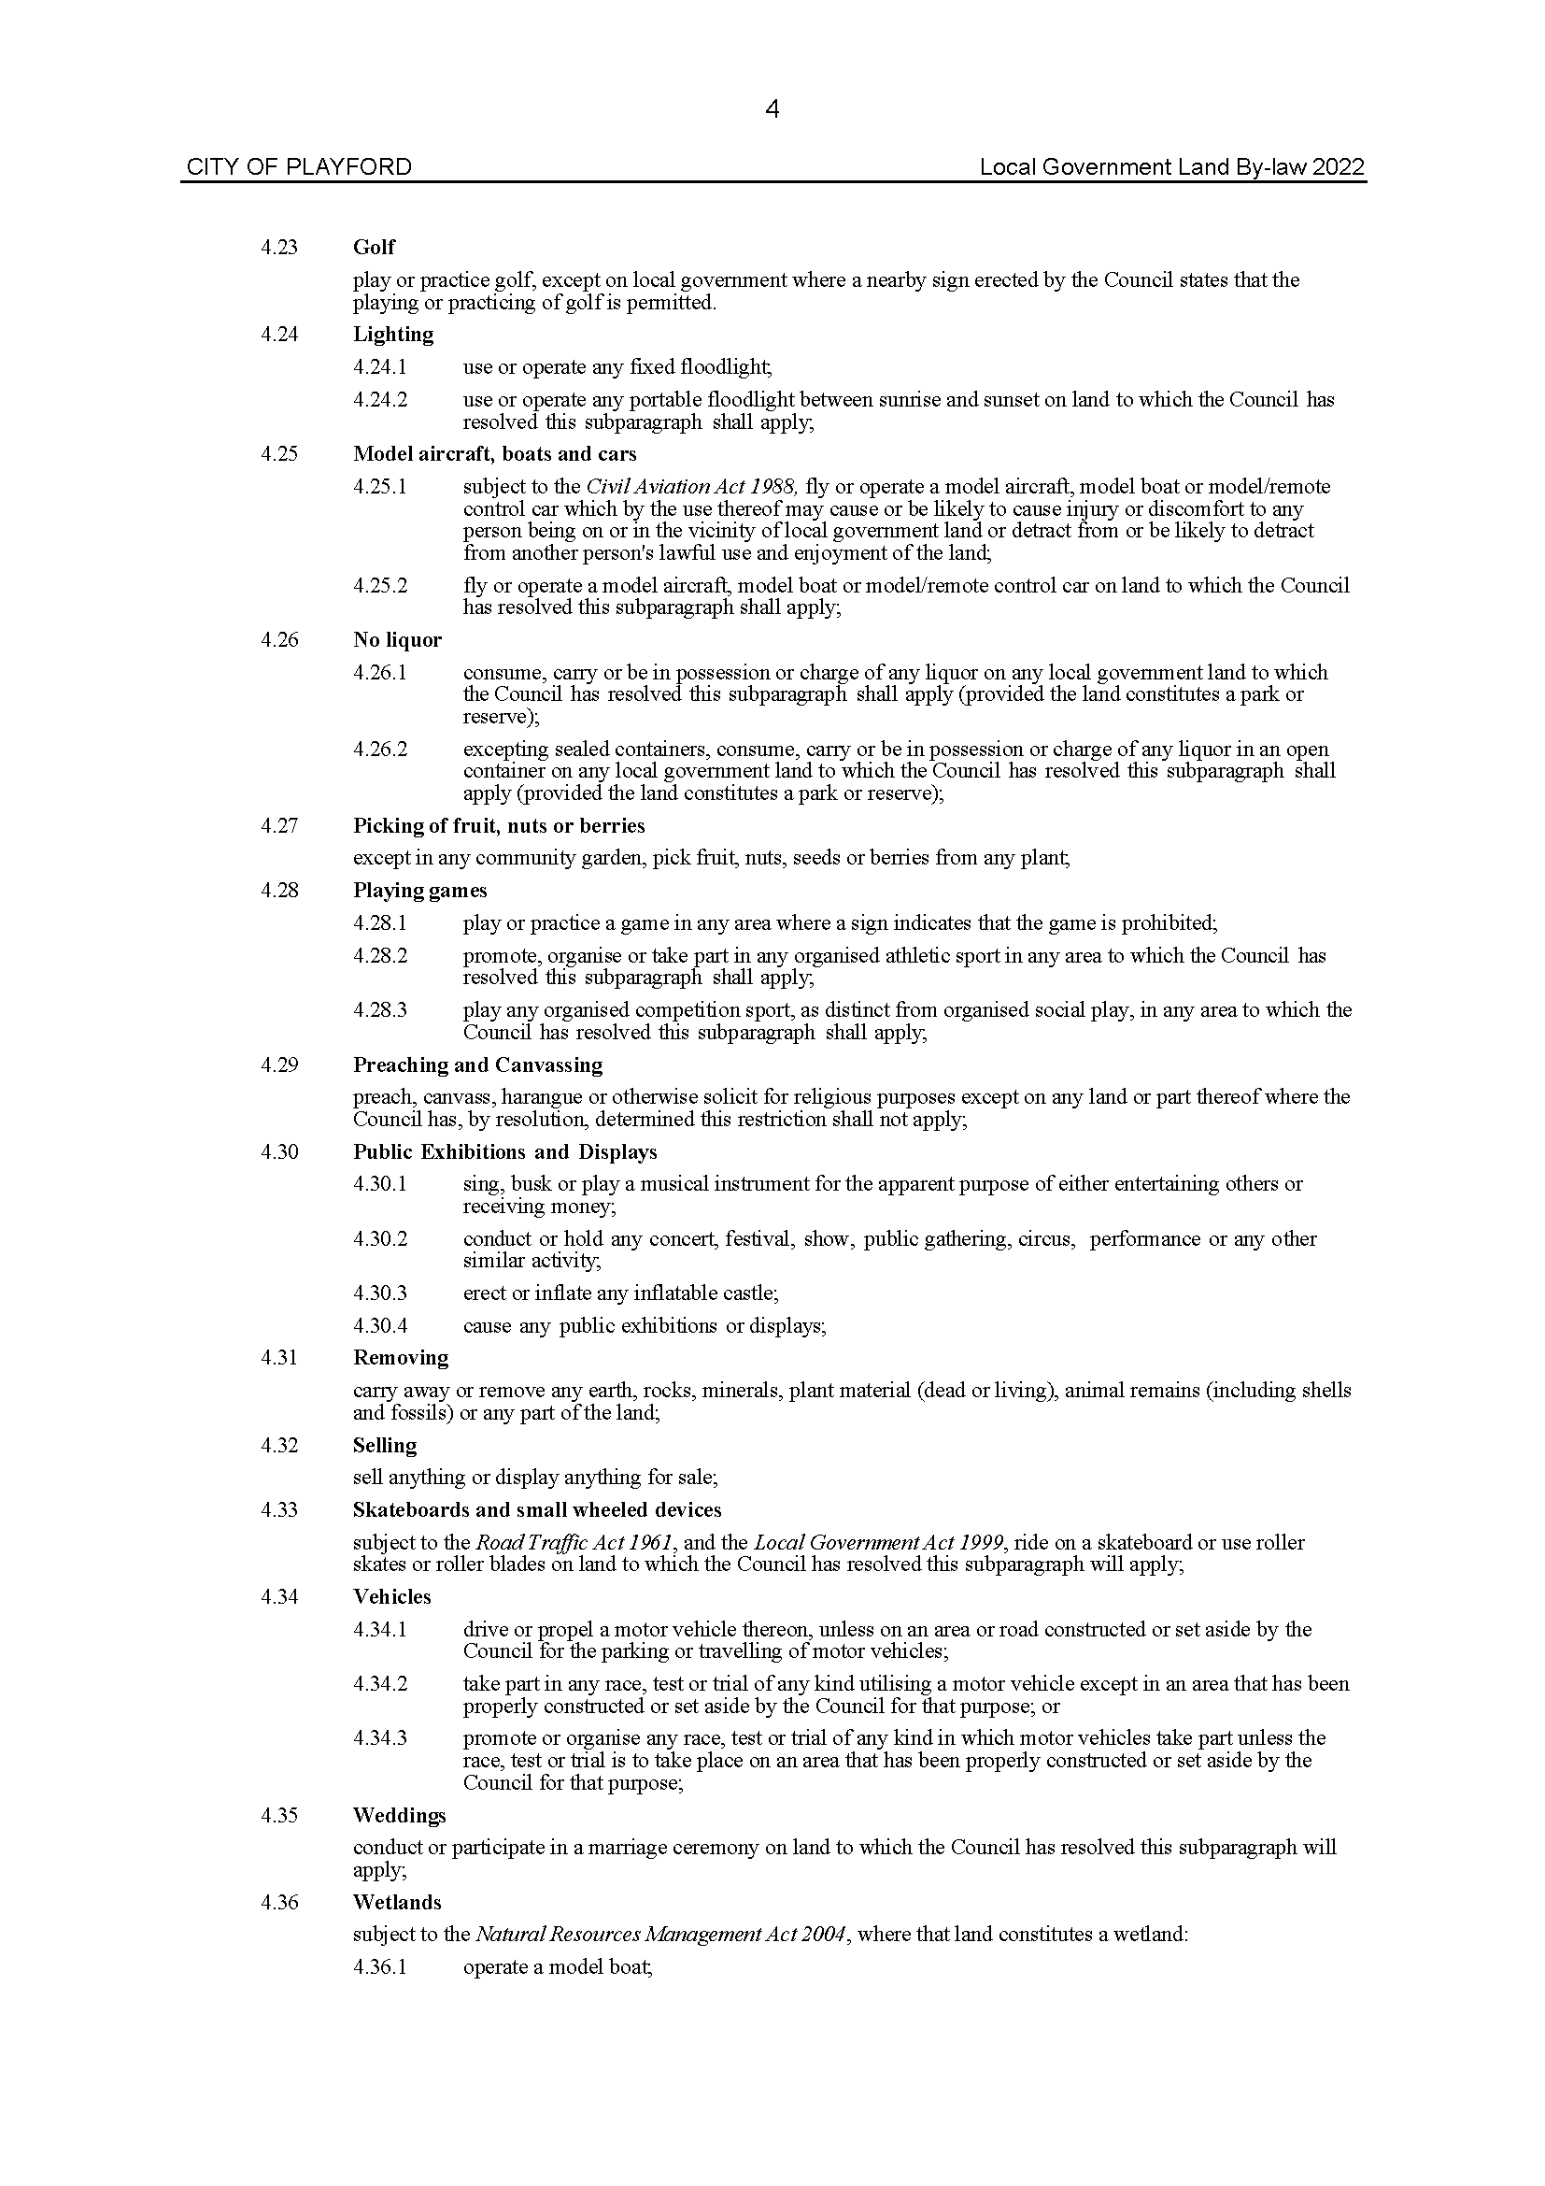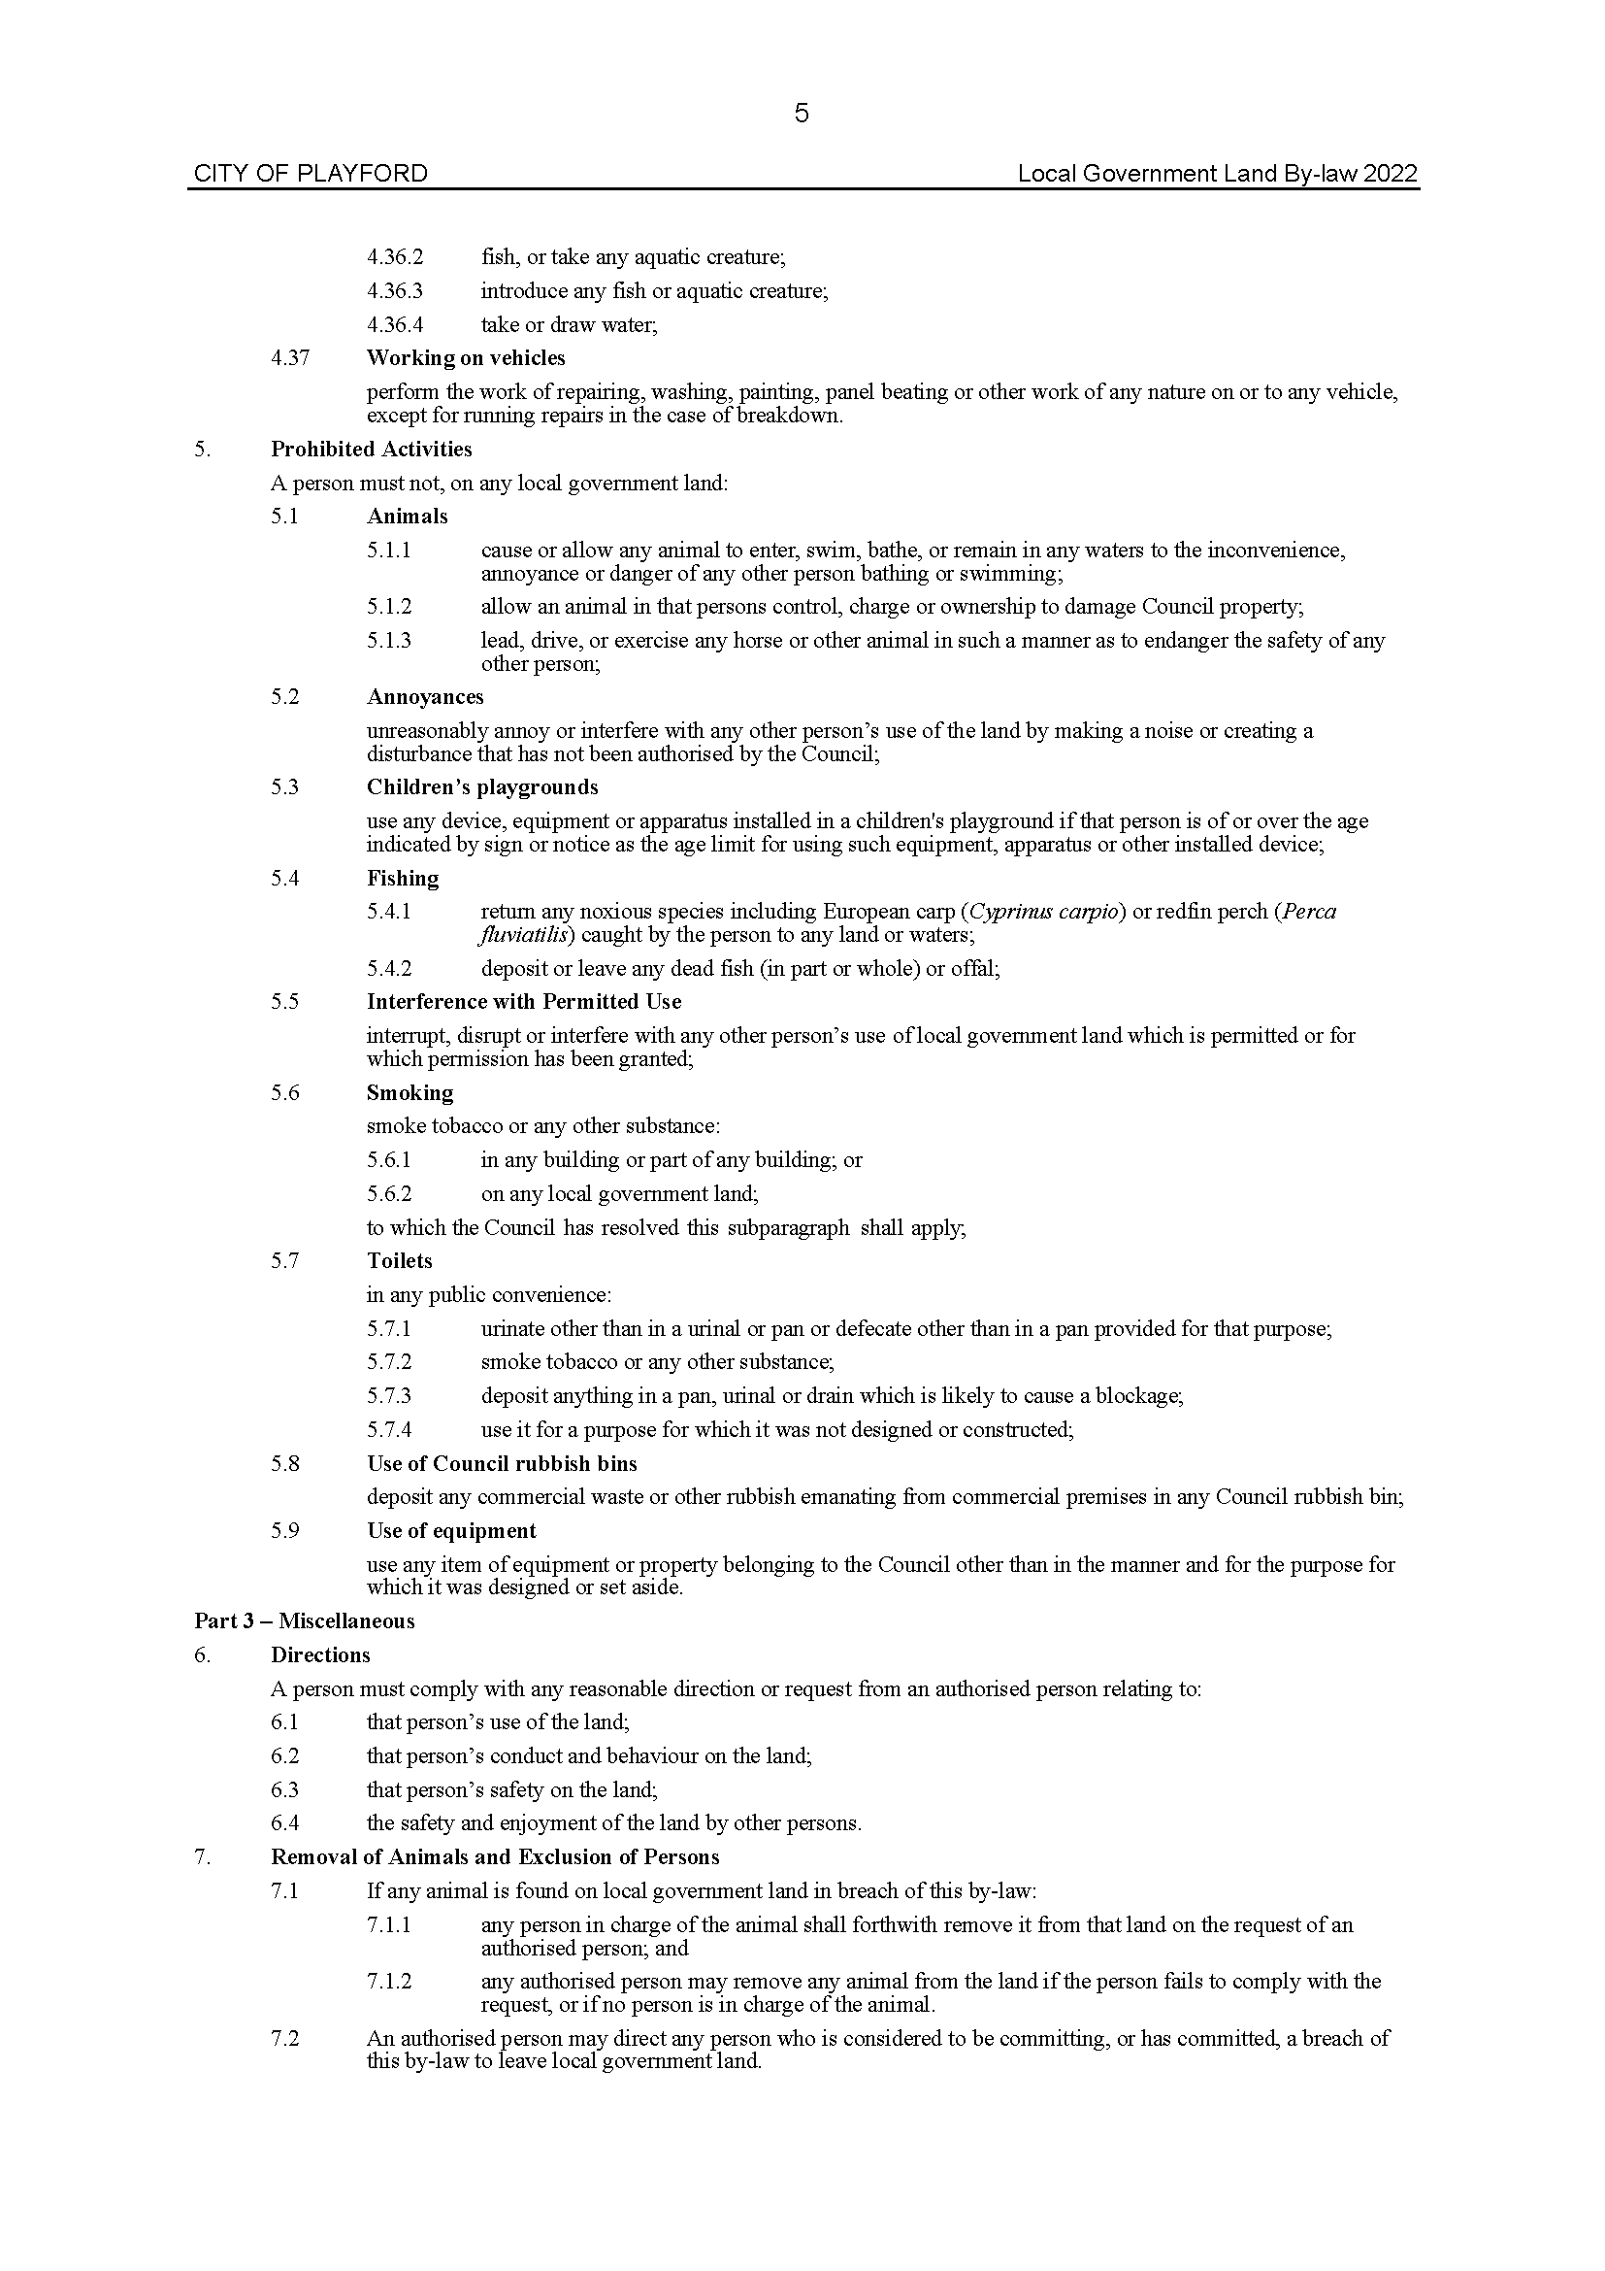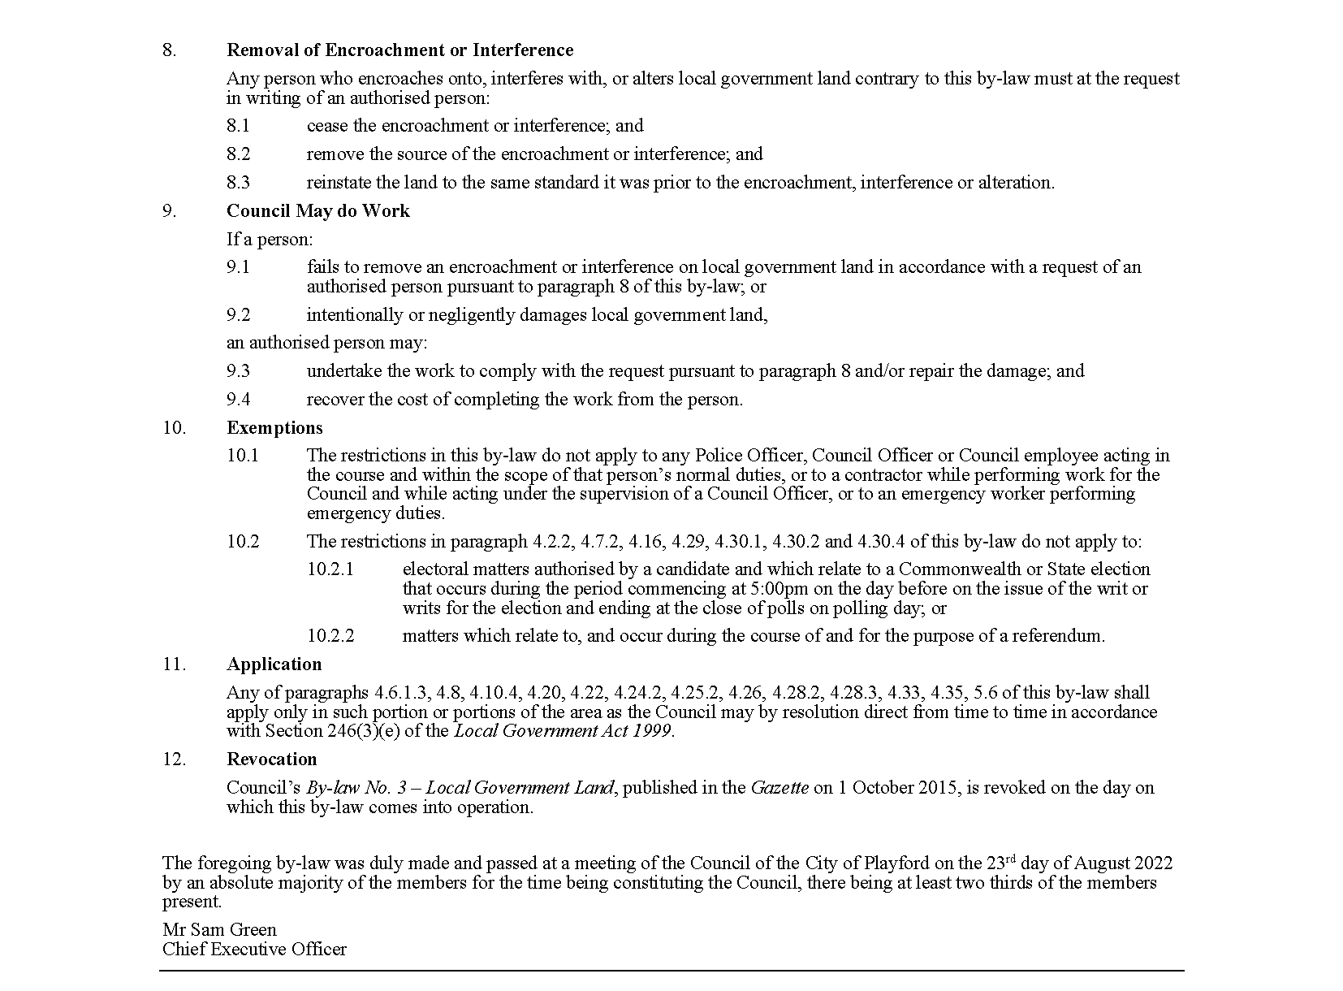

City of Playford
Local Government Act 1999
Dog and Cat Management Act 1995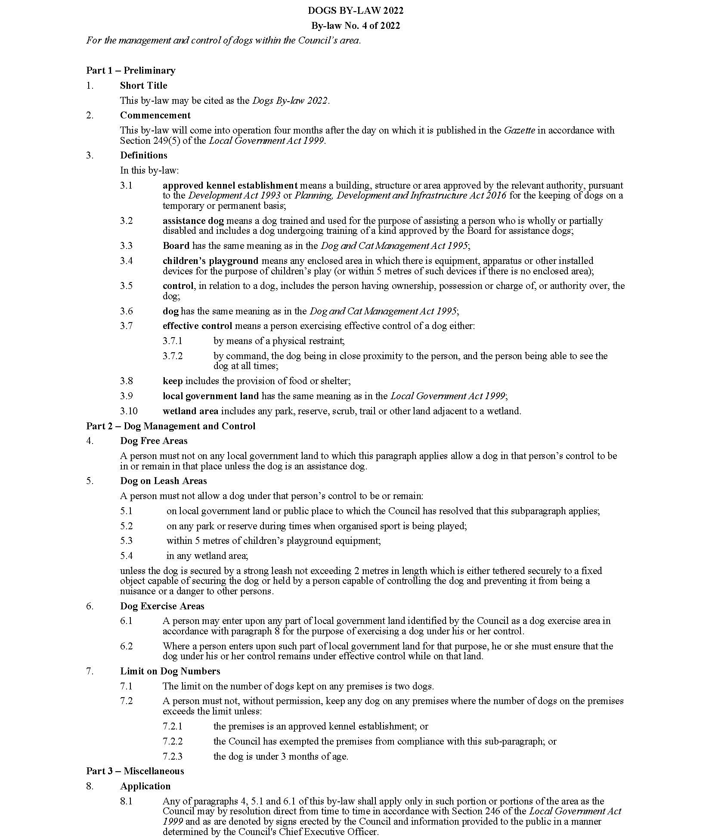

City of Playford
Local Government Act 1999
Dog and Cat Management Act 1995
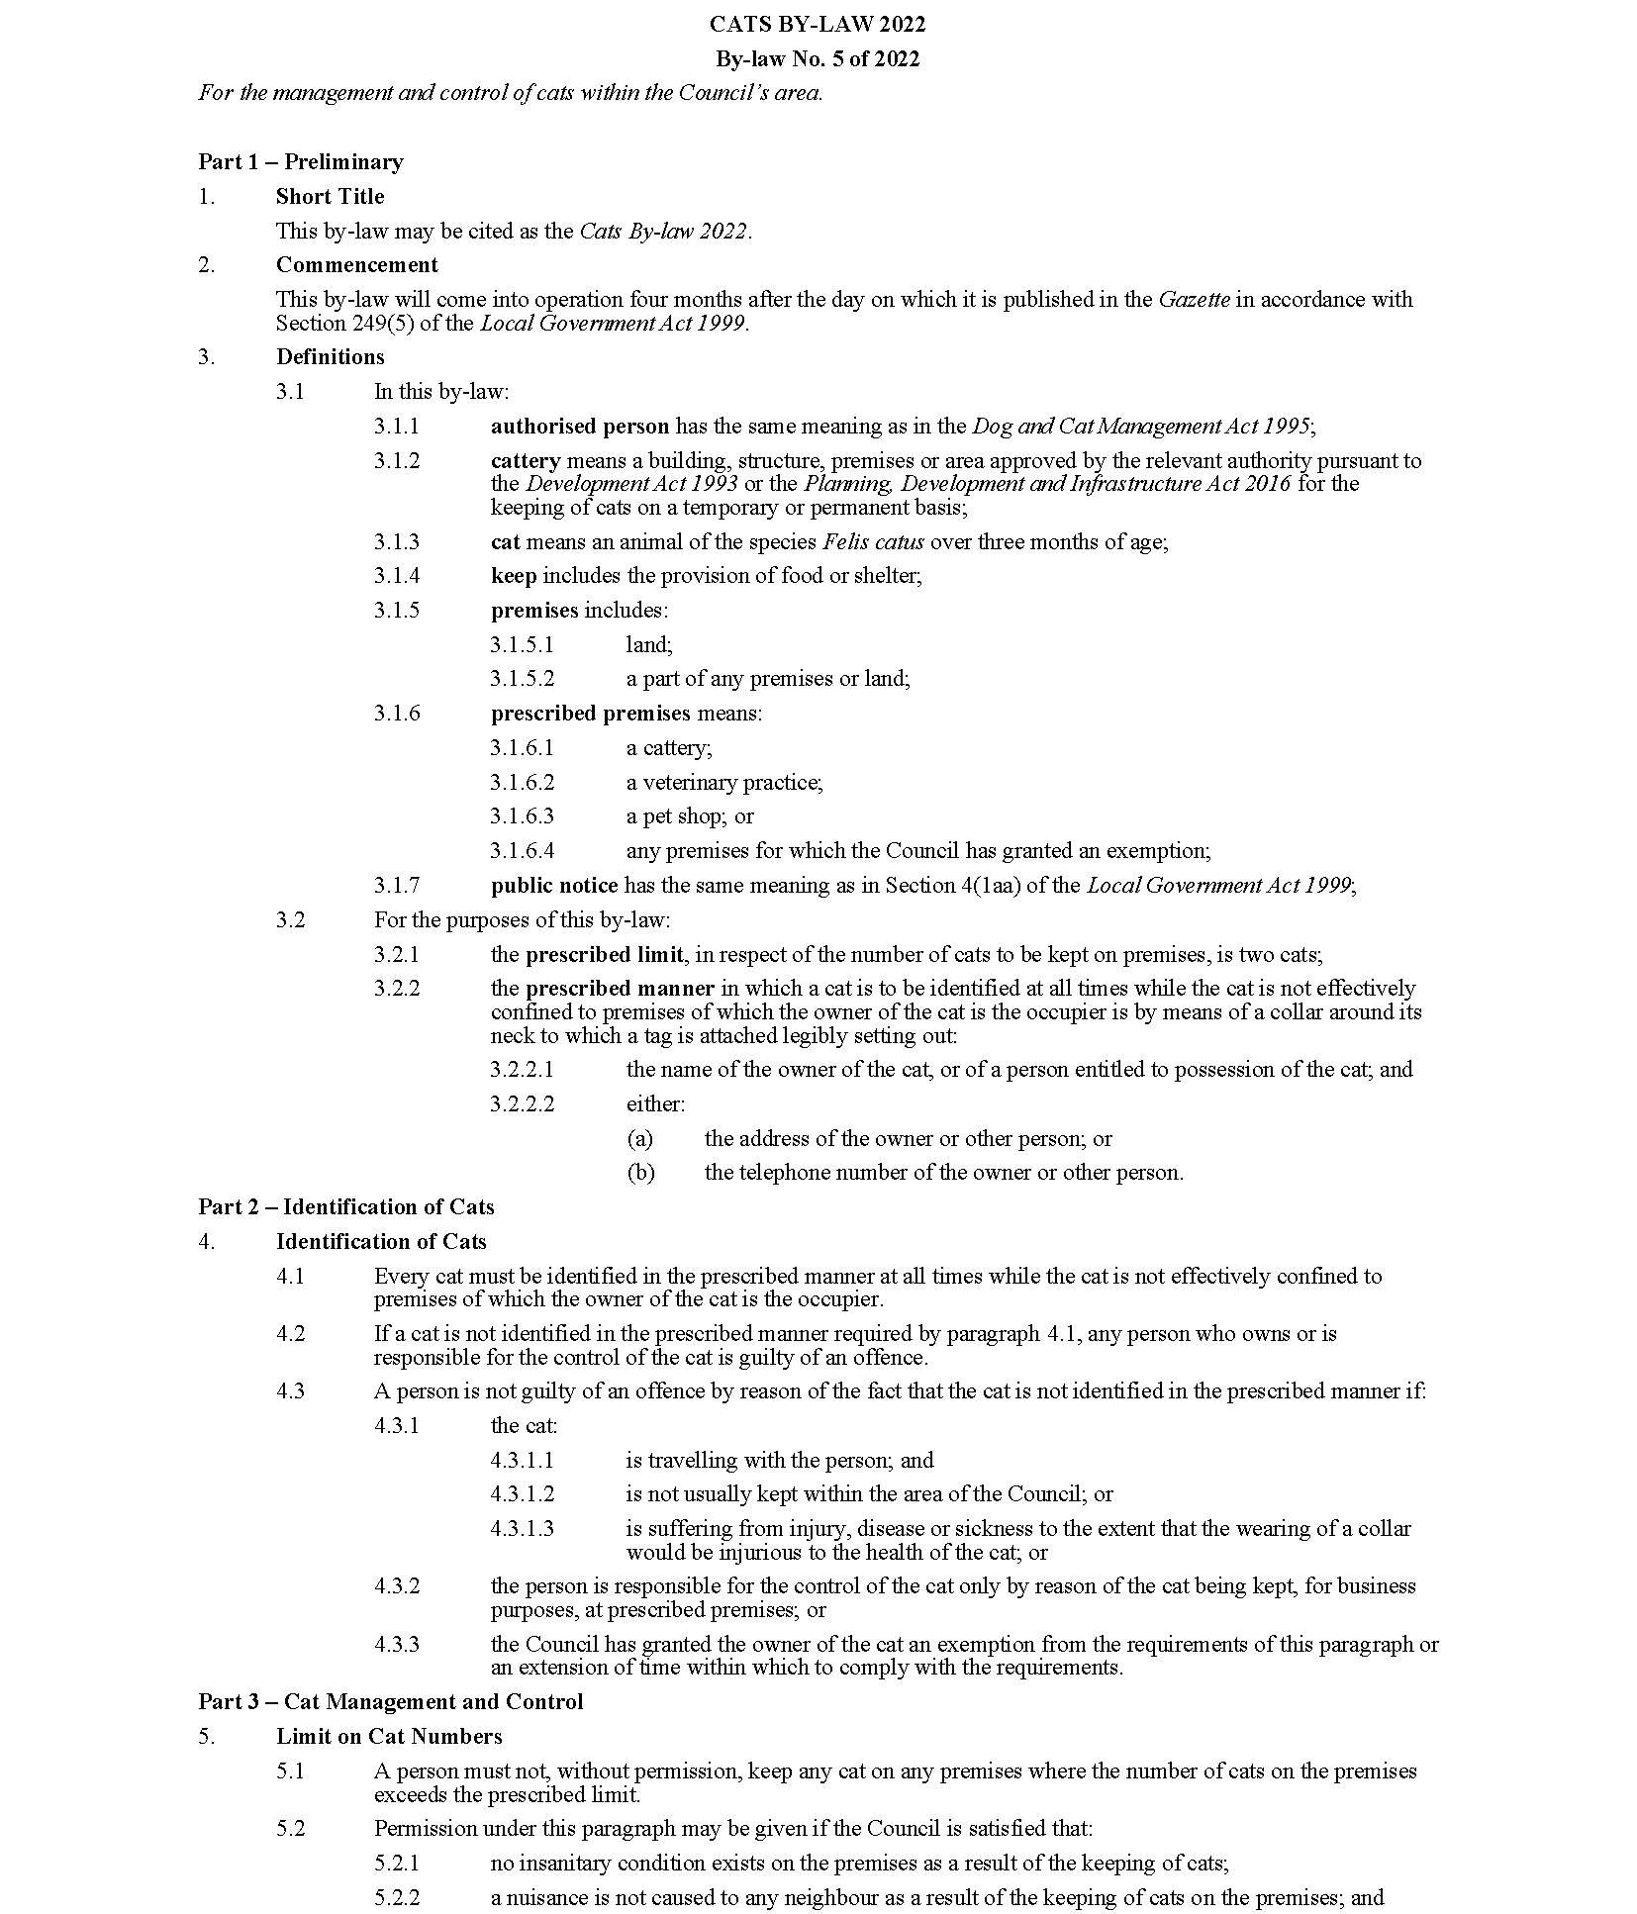

City of Playford
Local Government Act 1999
Dog and Cat Management Act 1995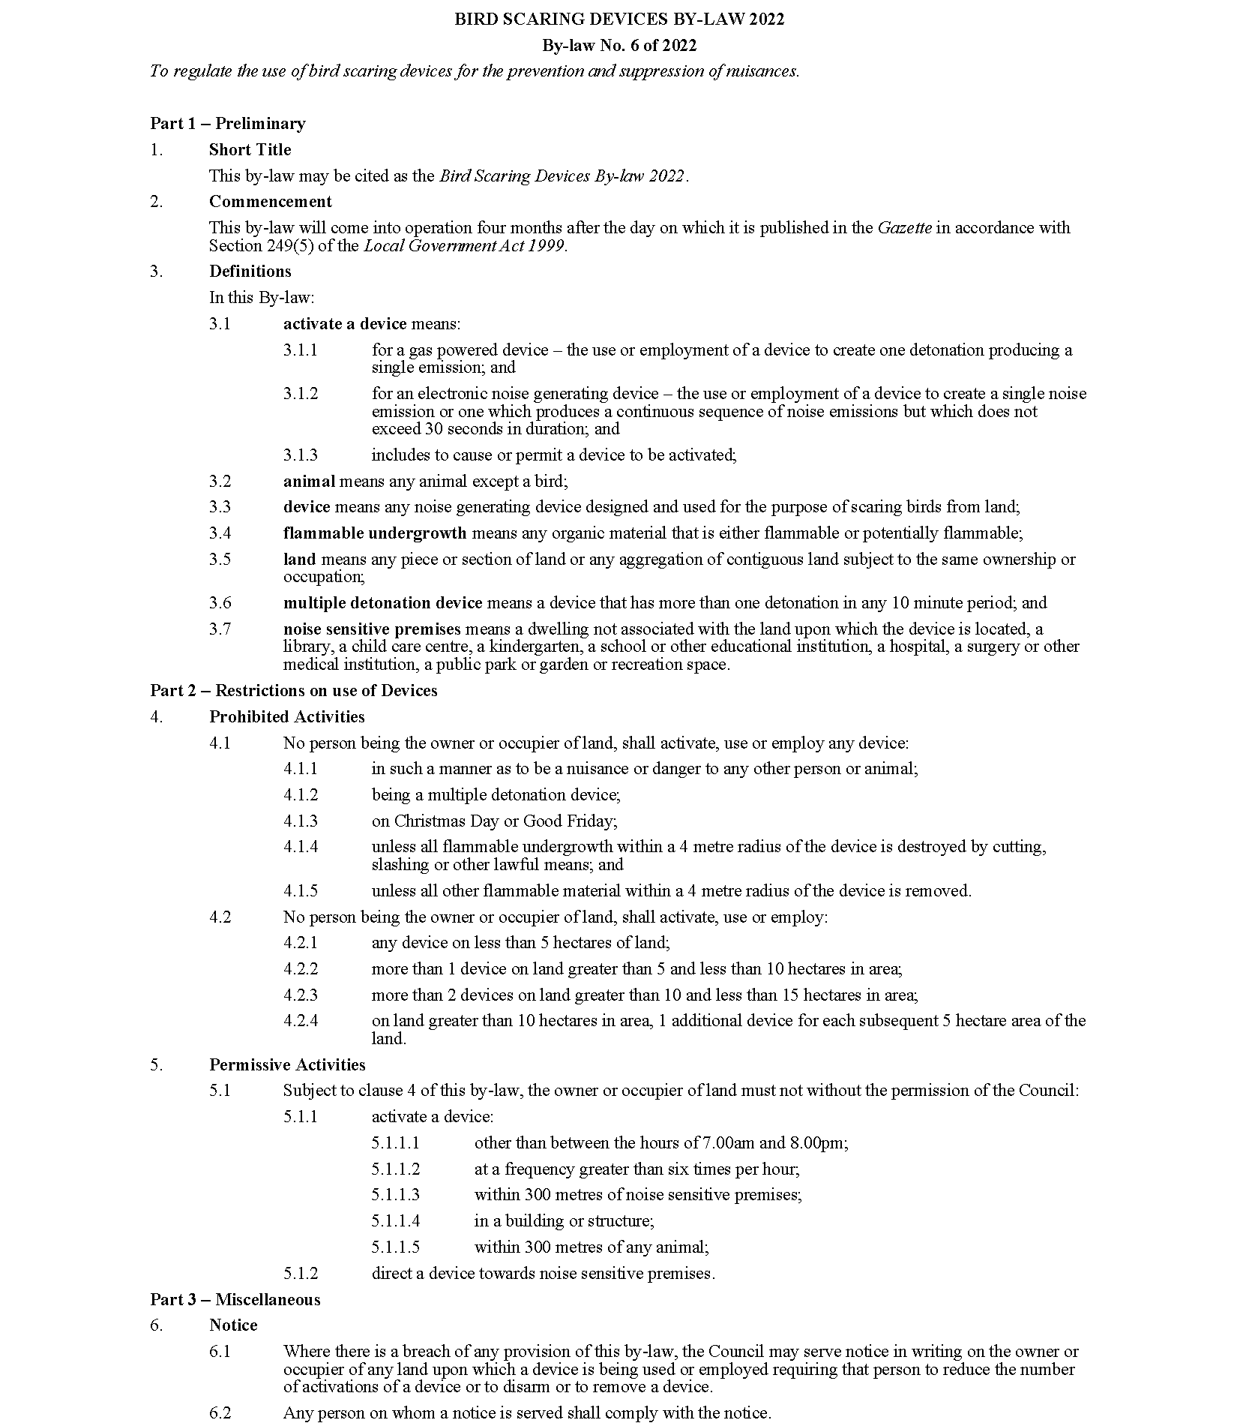
City of Playford
Local Government Act 1999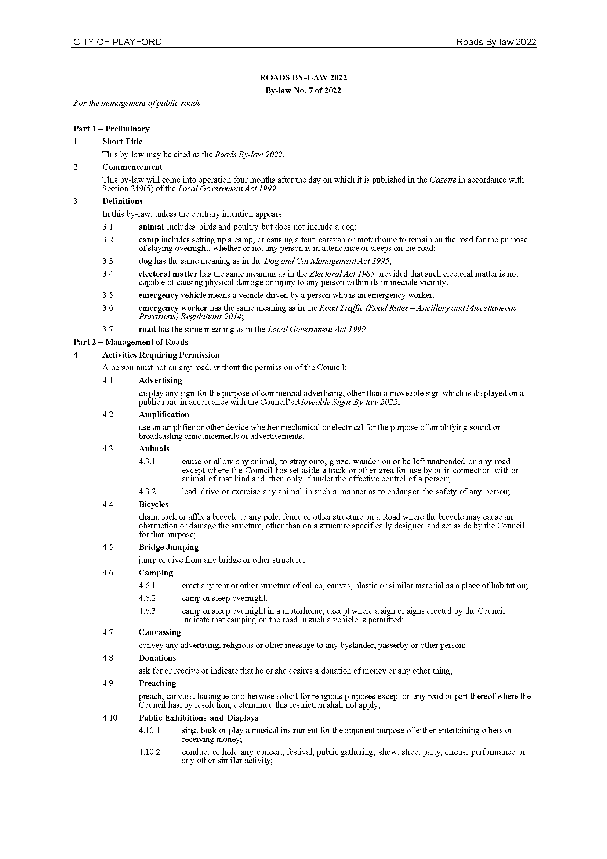
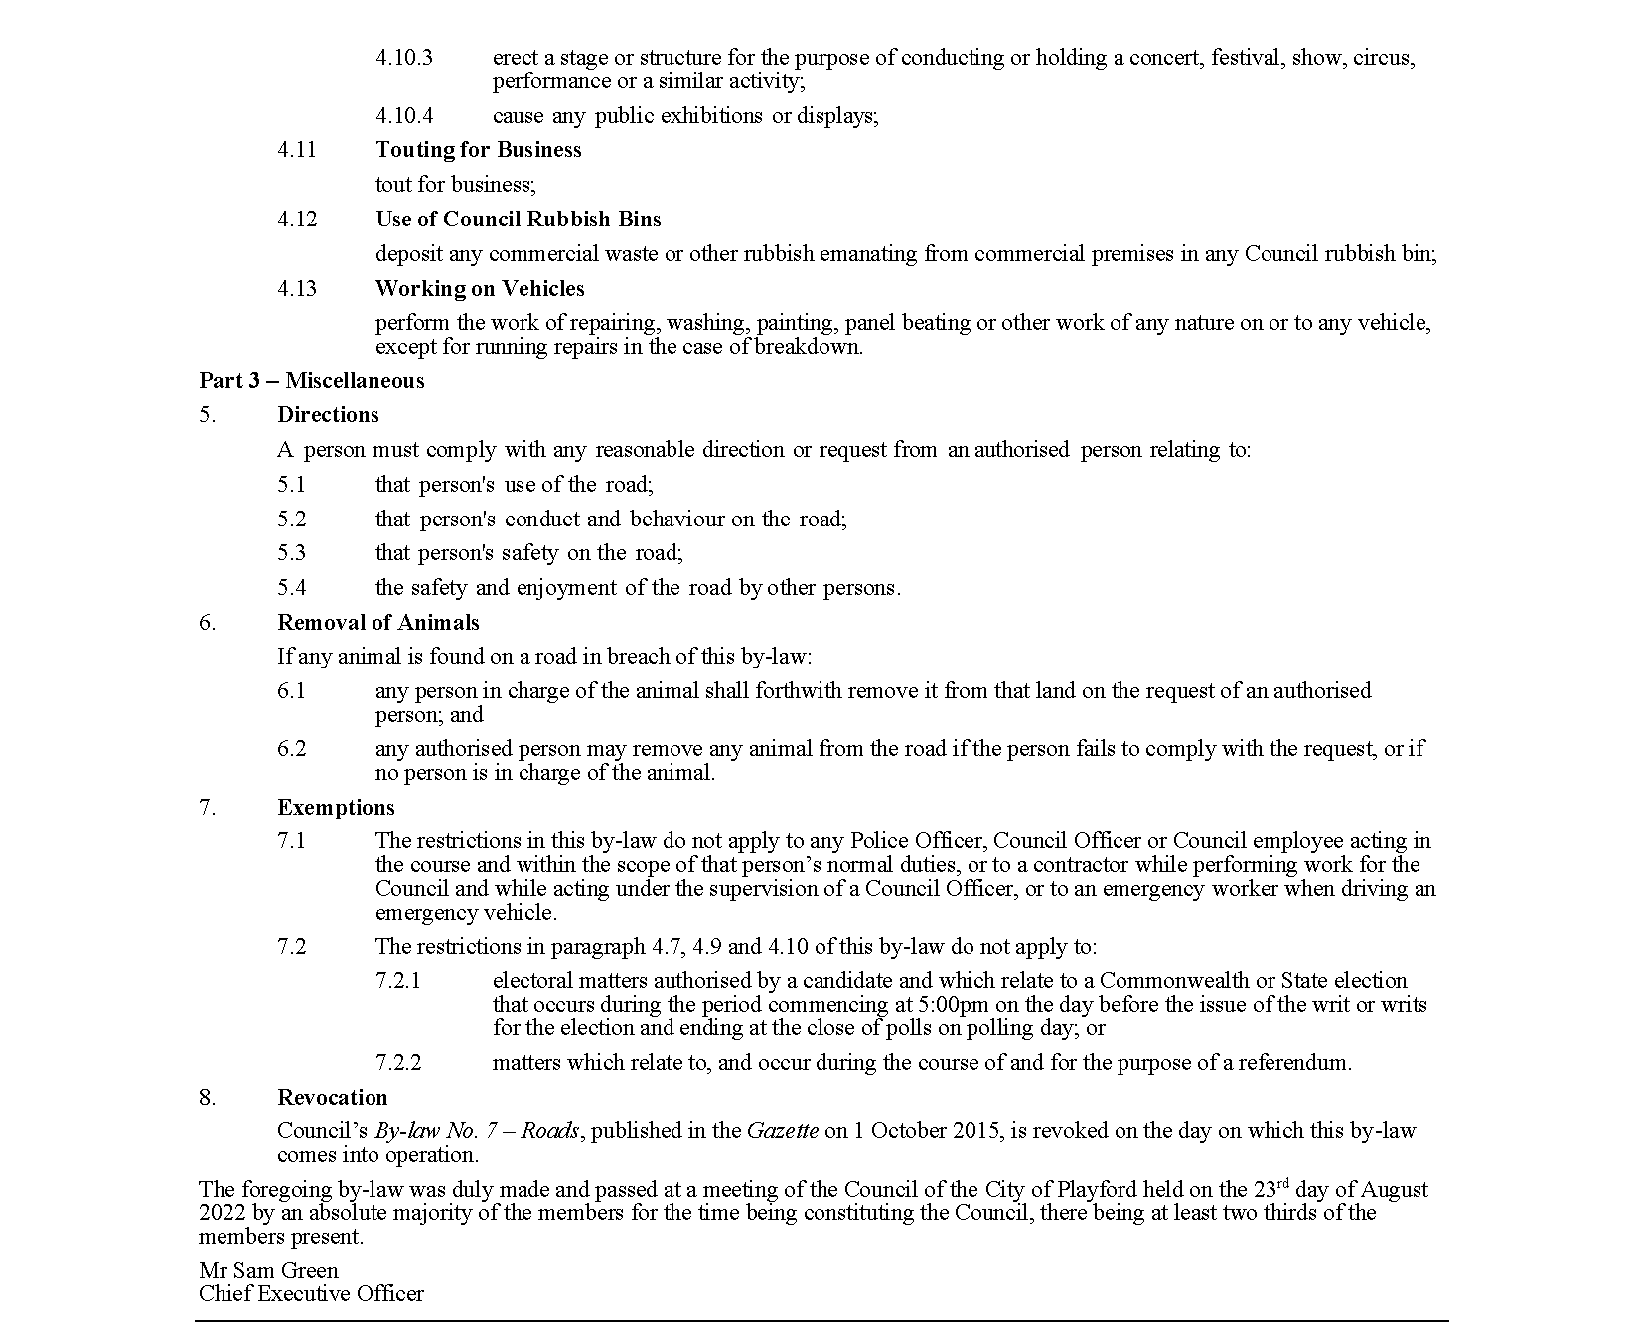

City of Playford
Local Government Act 1999

City of Prospect
Local Government Act 1999
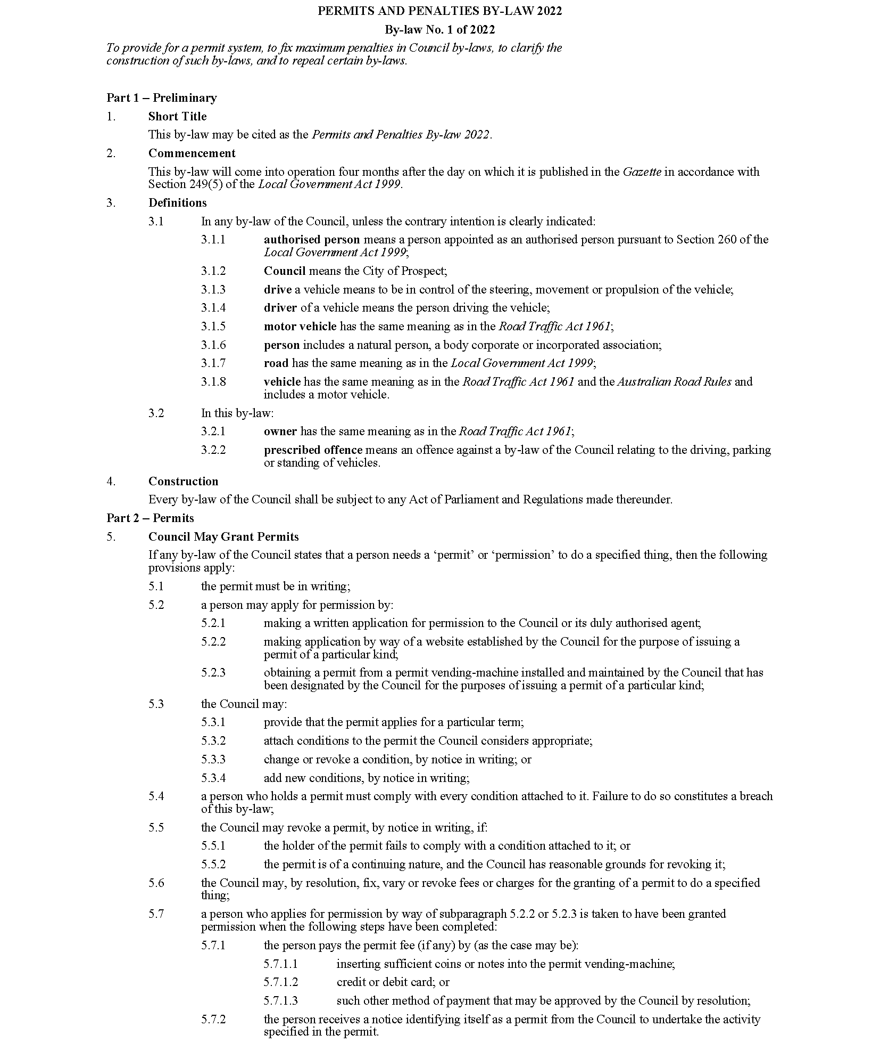
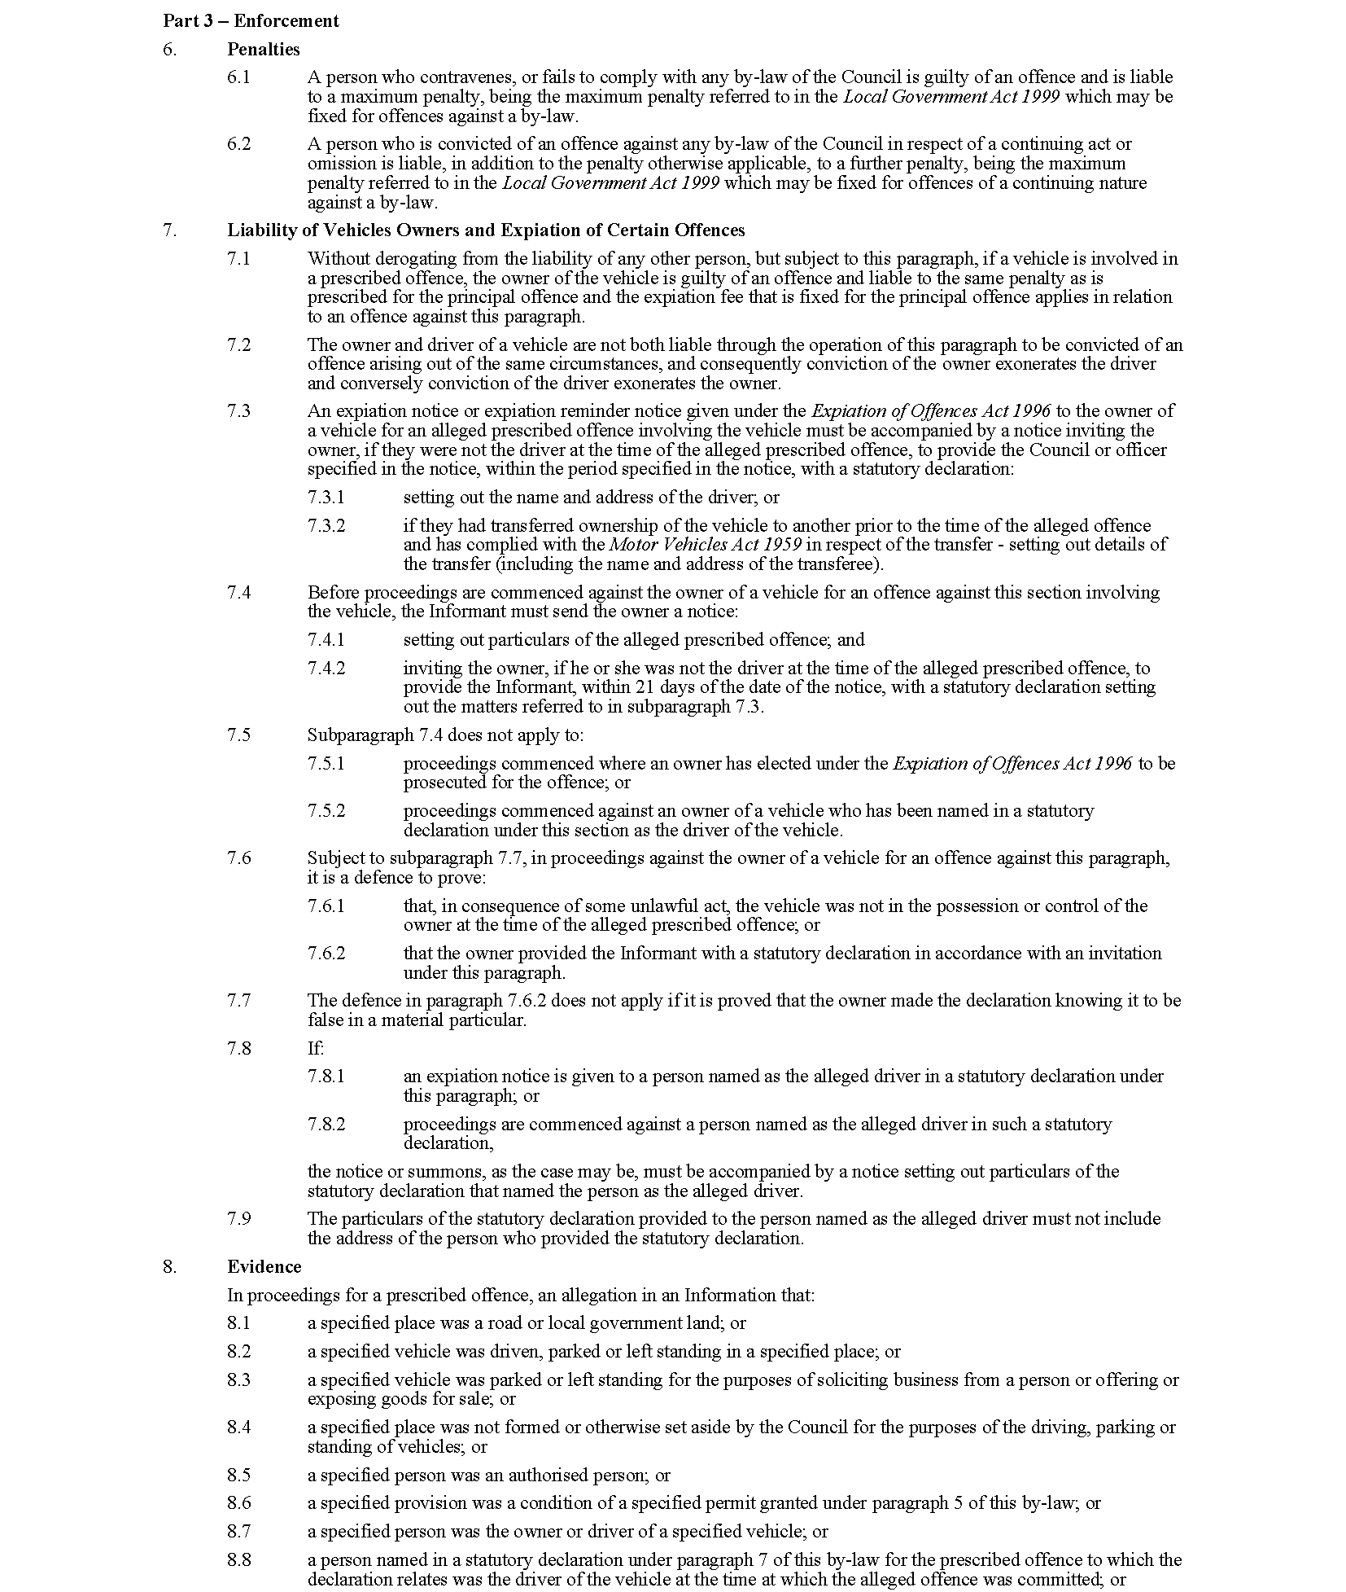

City of PROSPECT
Local Government Act 1999
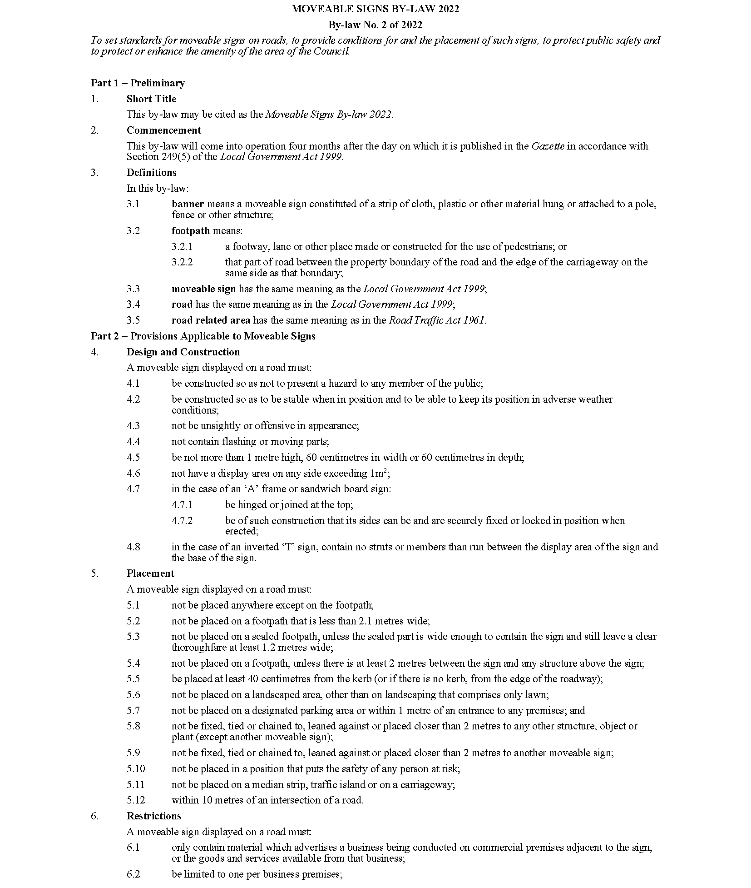
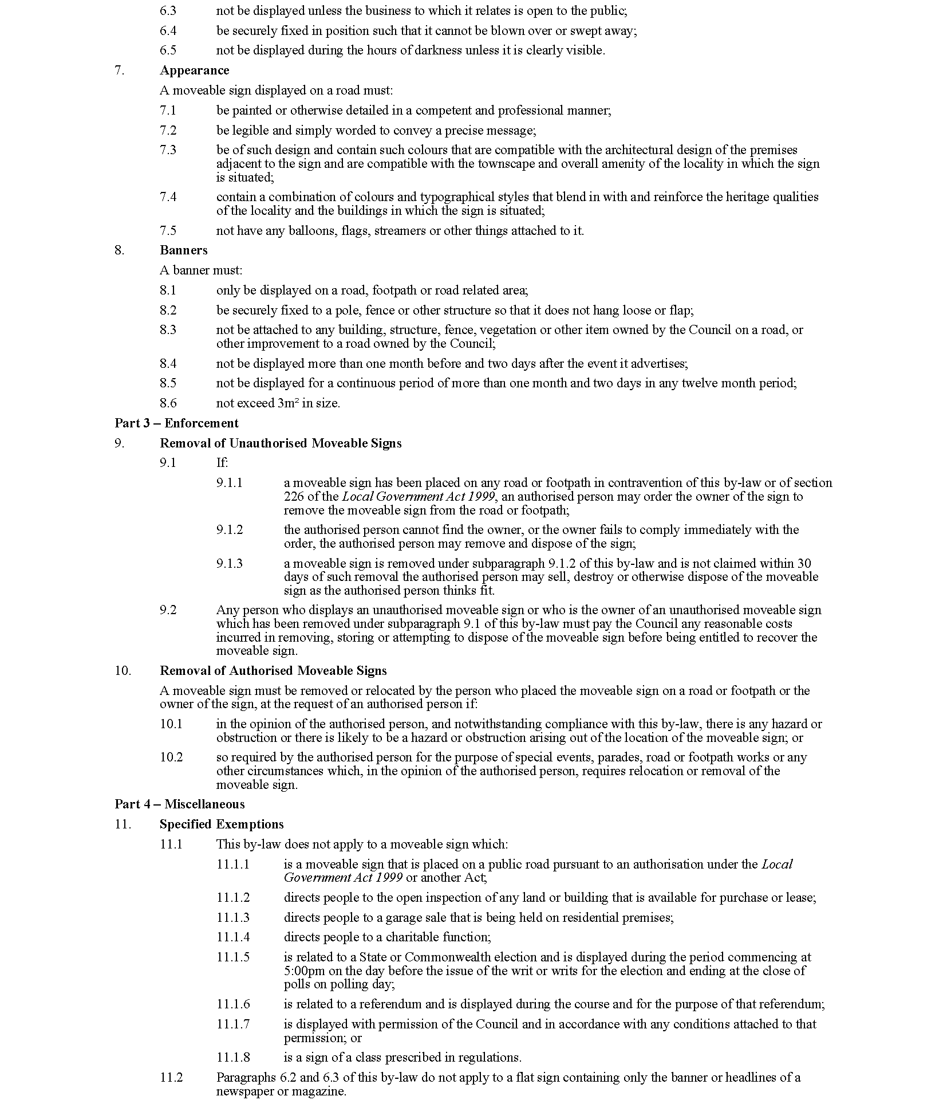

City of Prospect
Local Government Act 1999
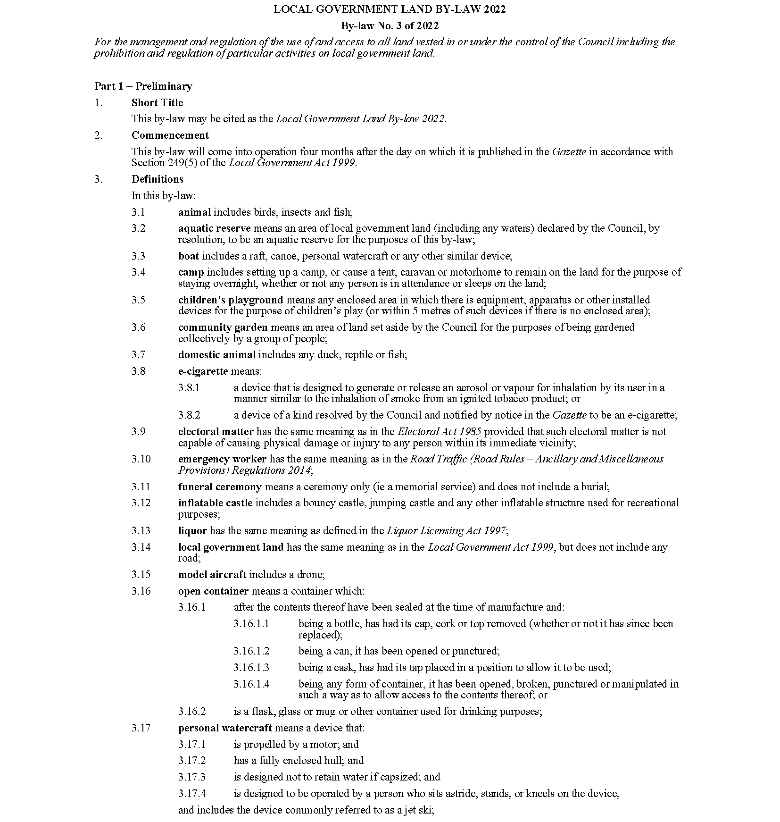
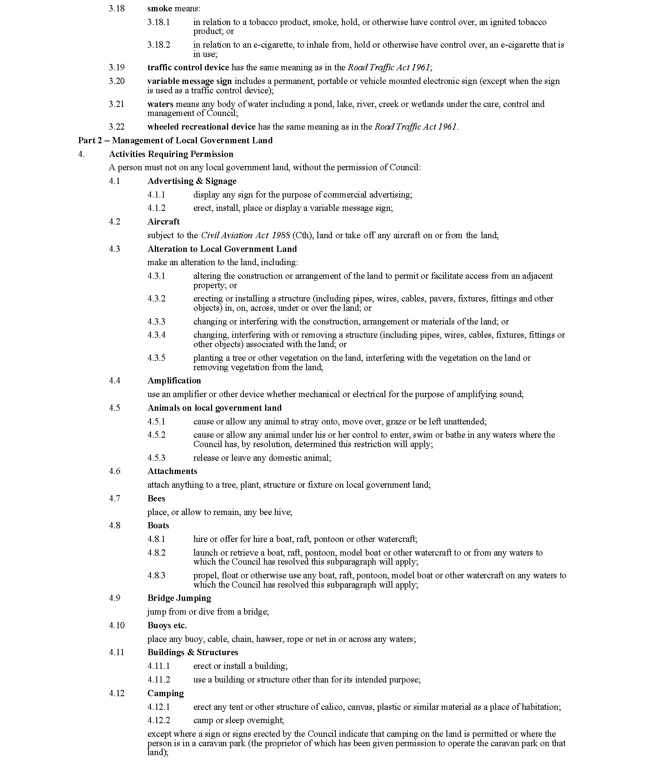
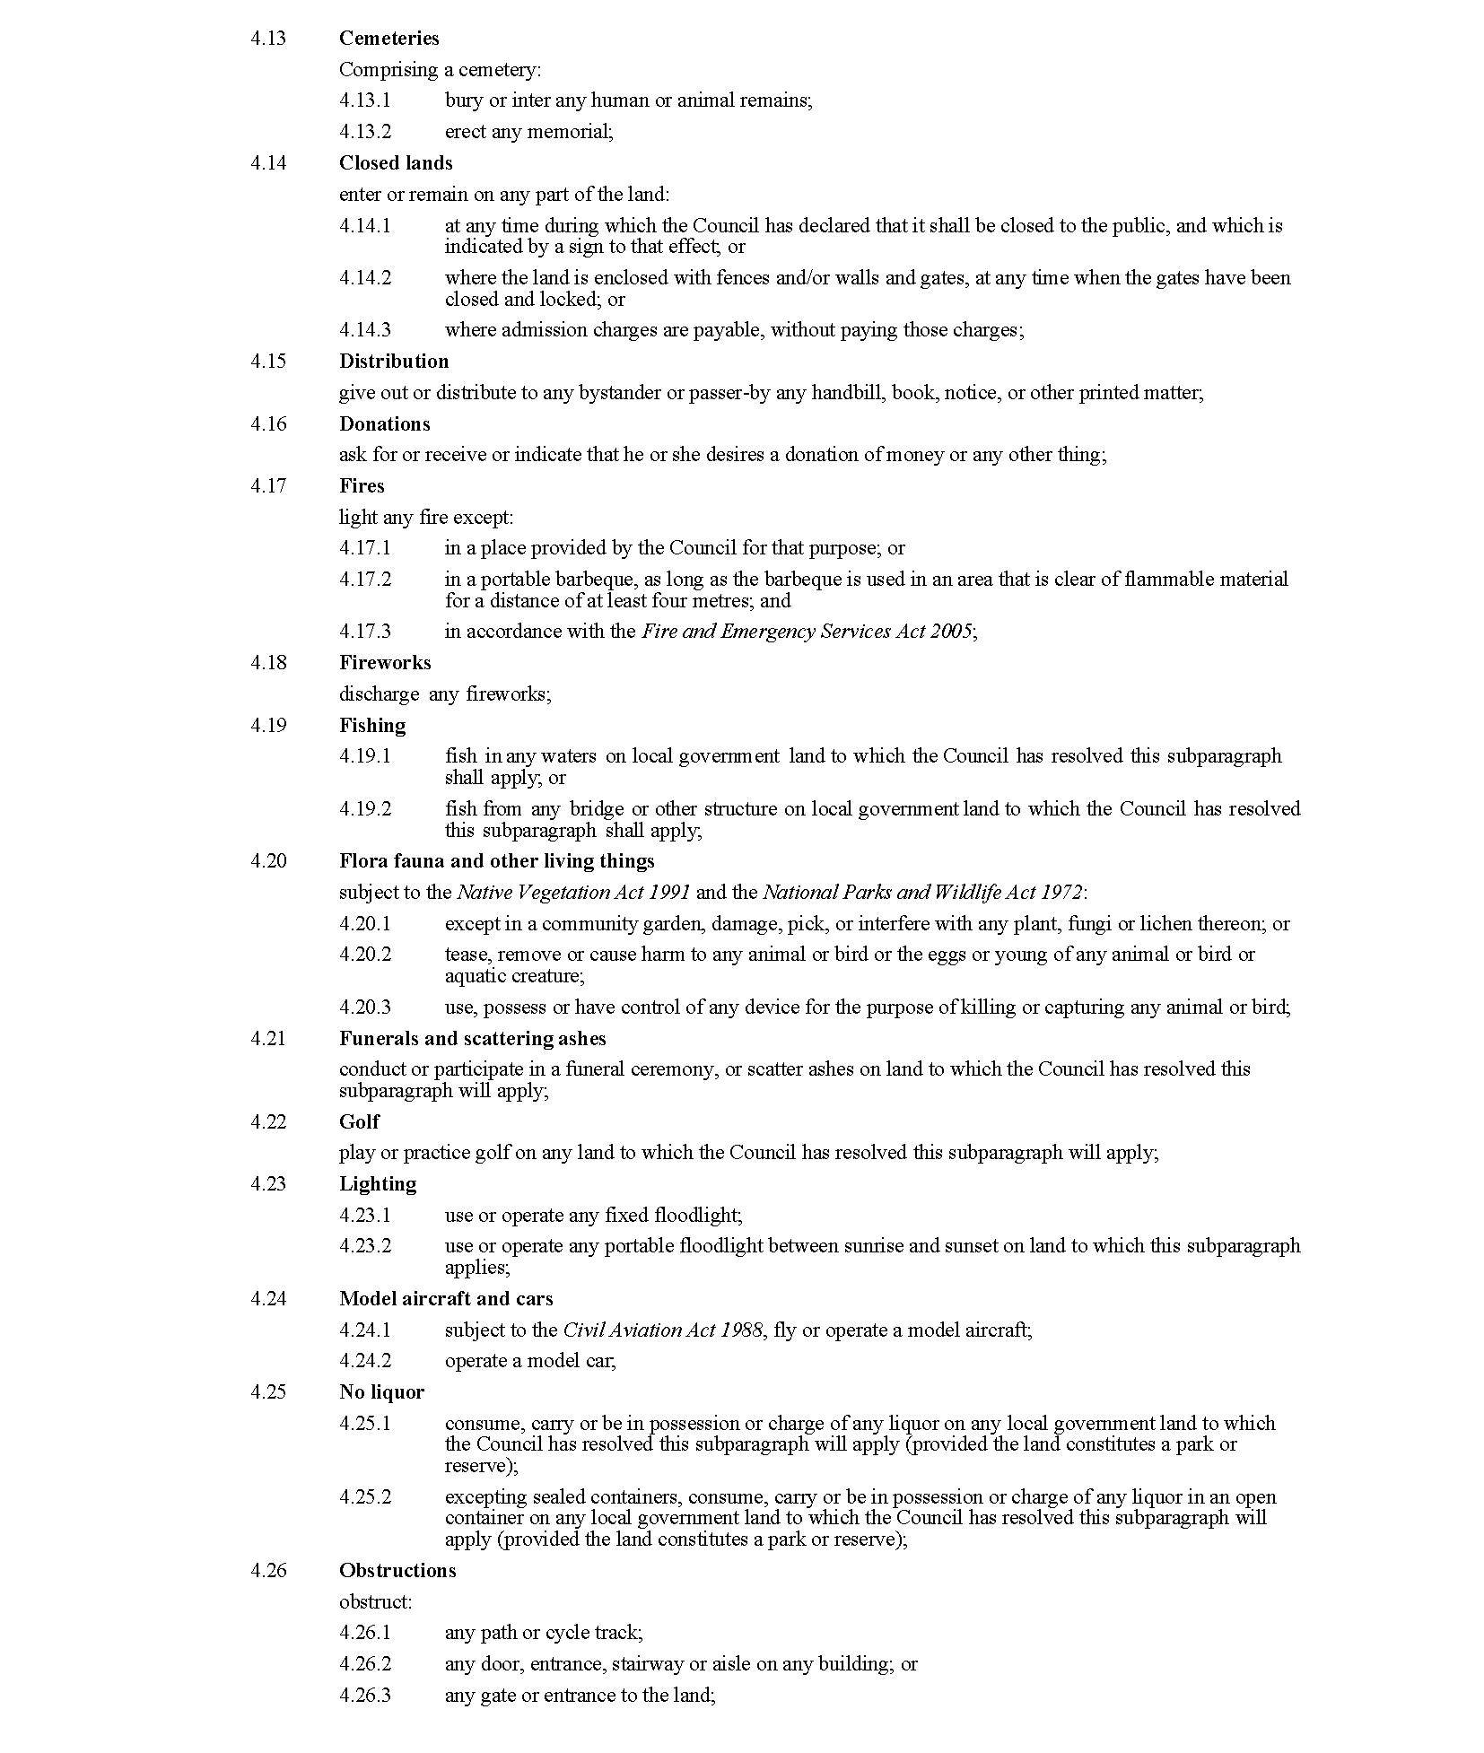
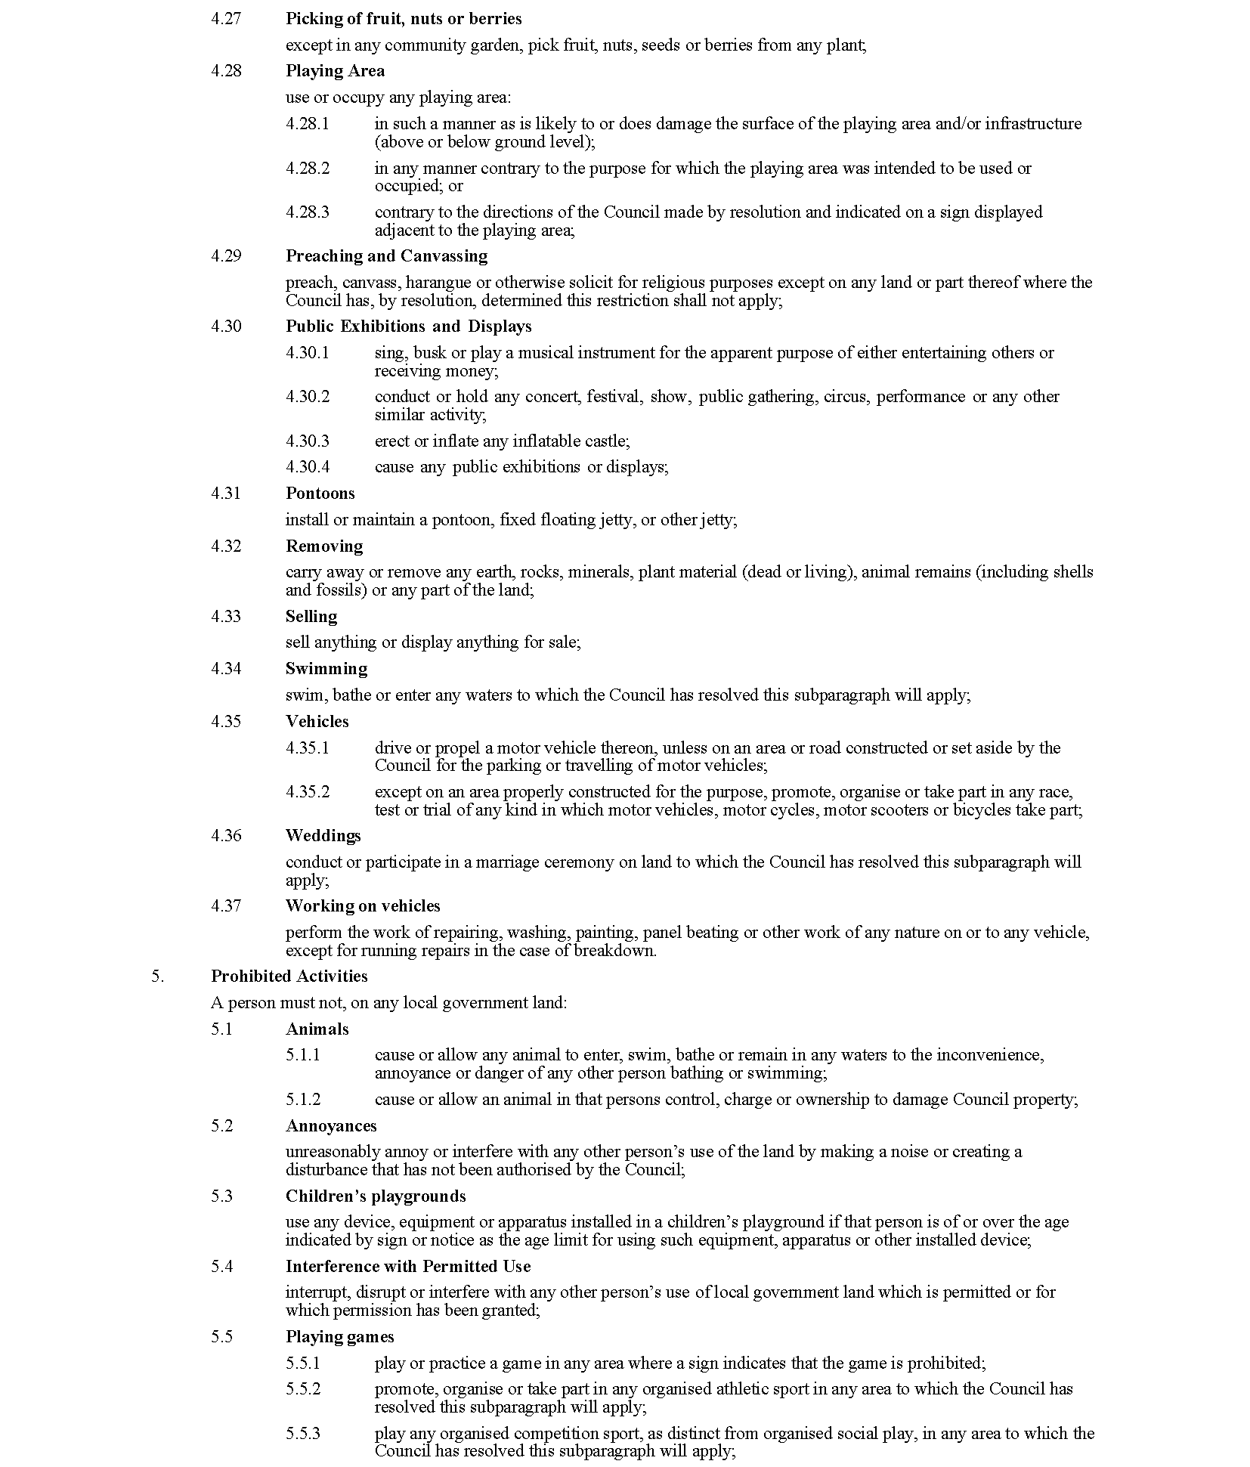
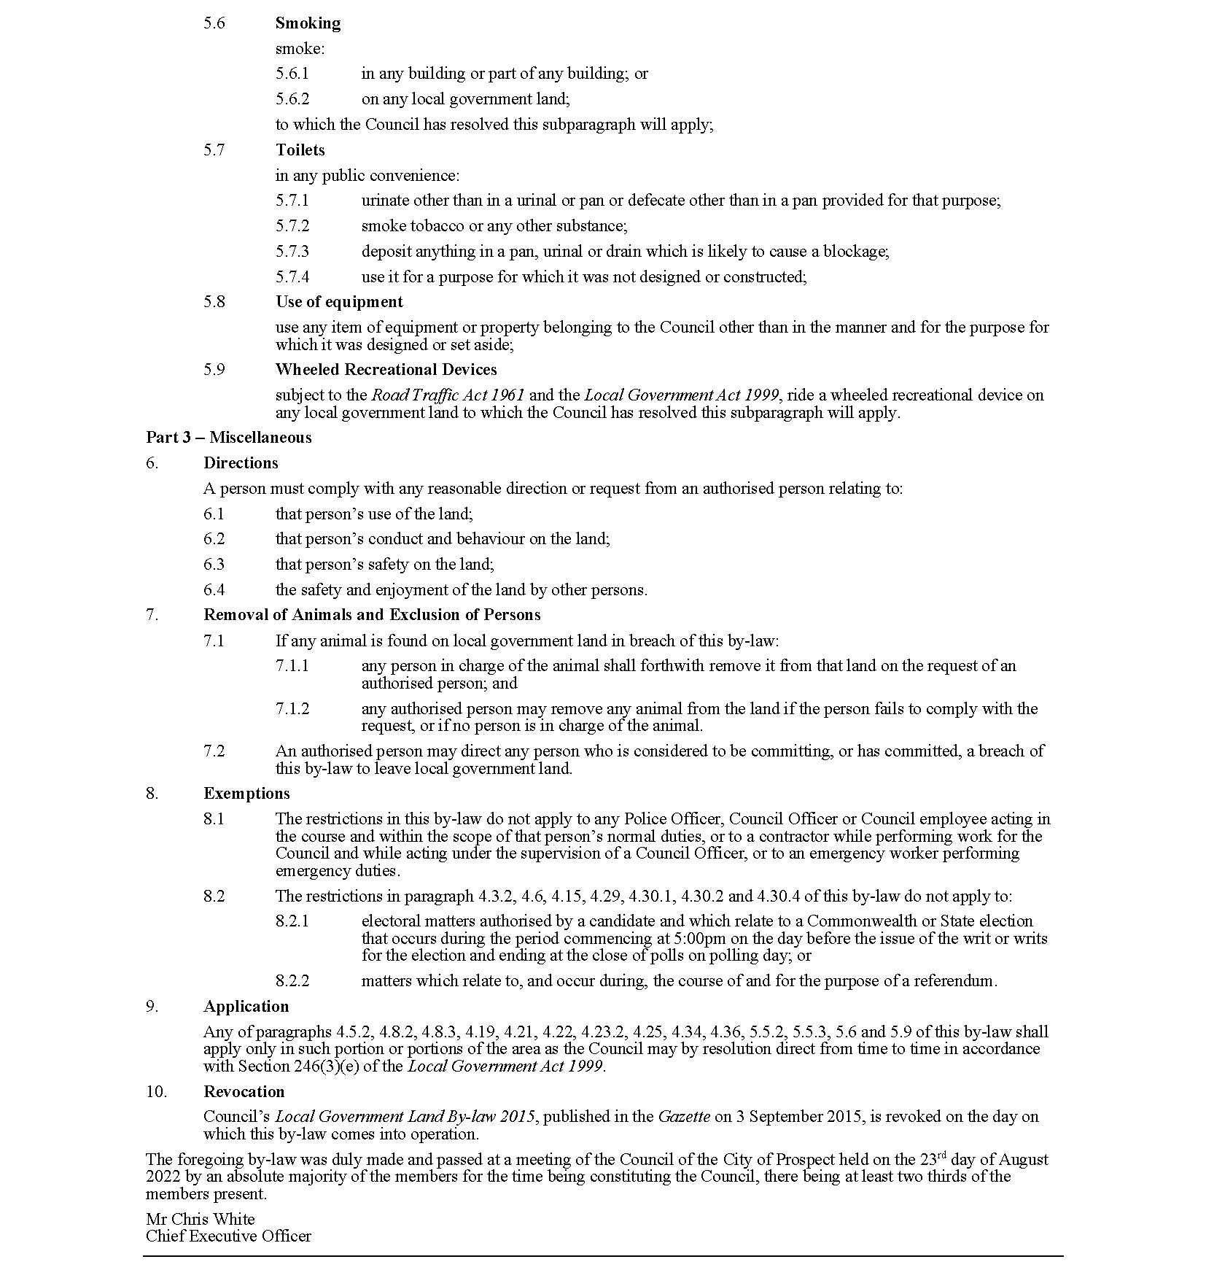

City of Prospect
Local Government Act 1999
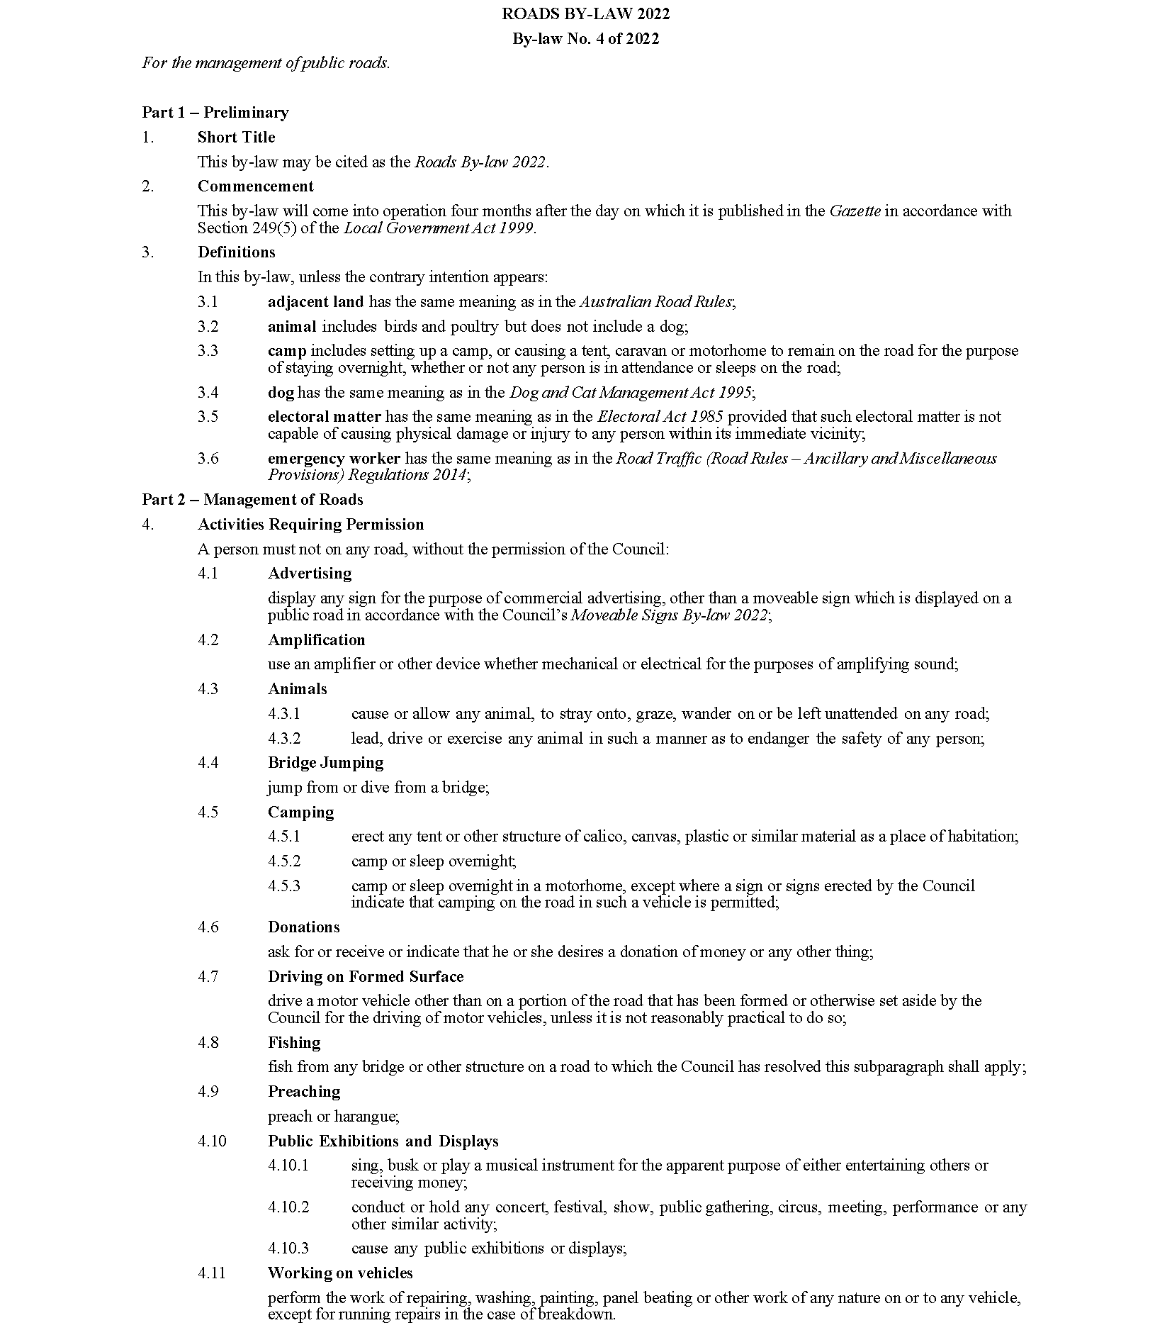

City of Prospect
Local Government Act 1999
Dog and Cat Management Act 1995
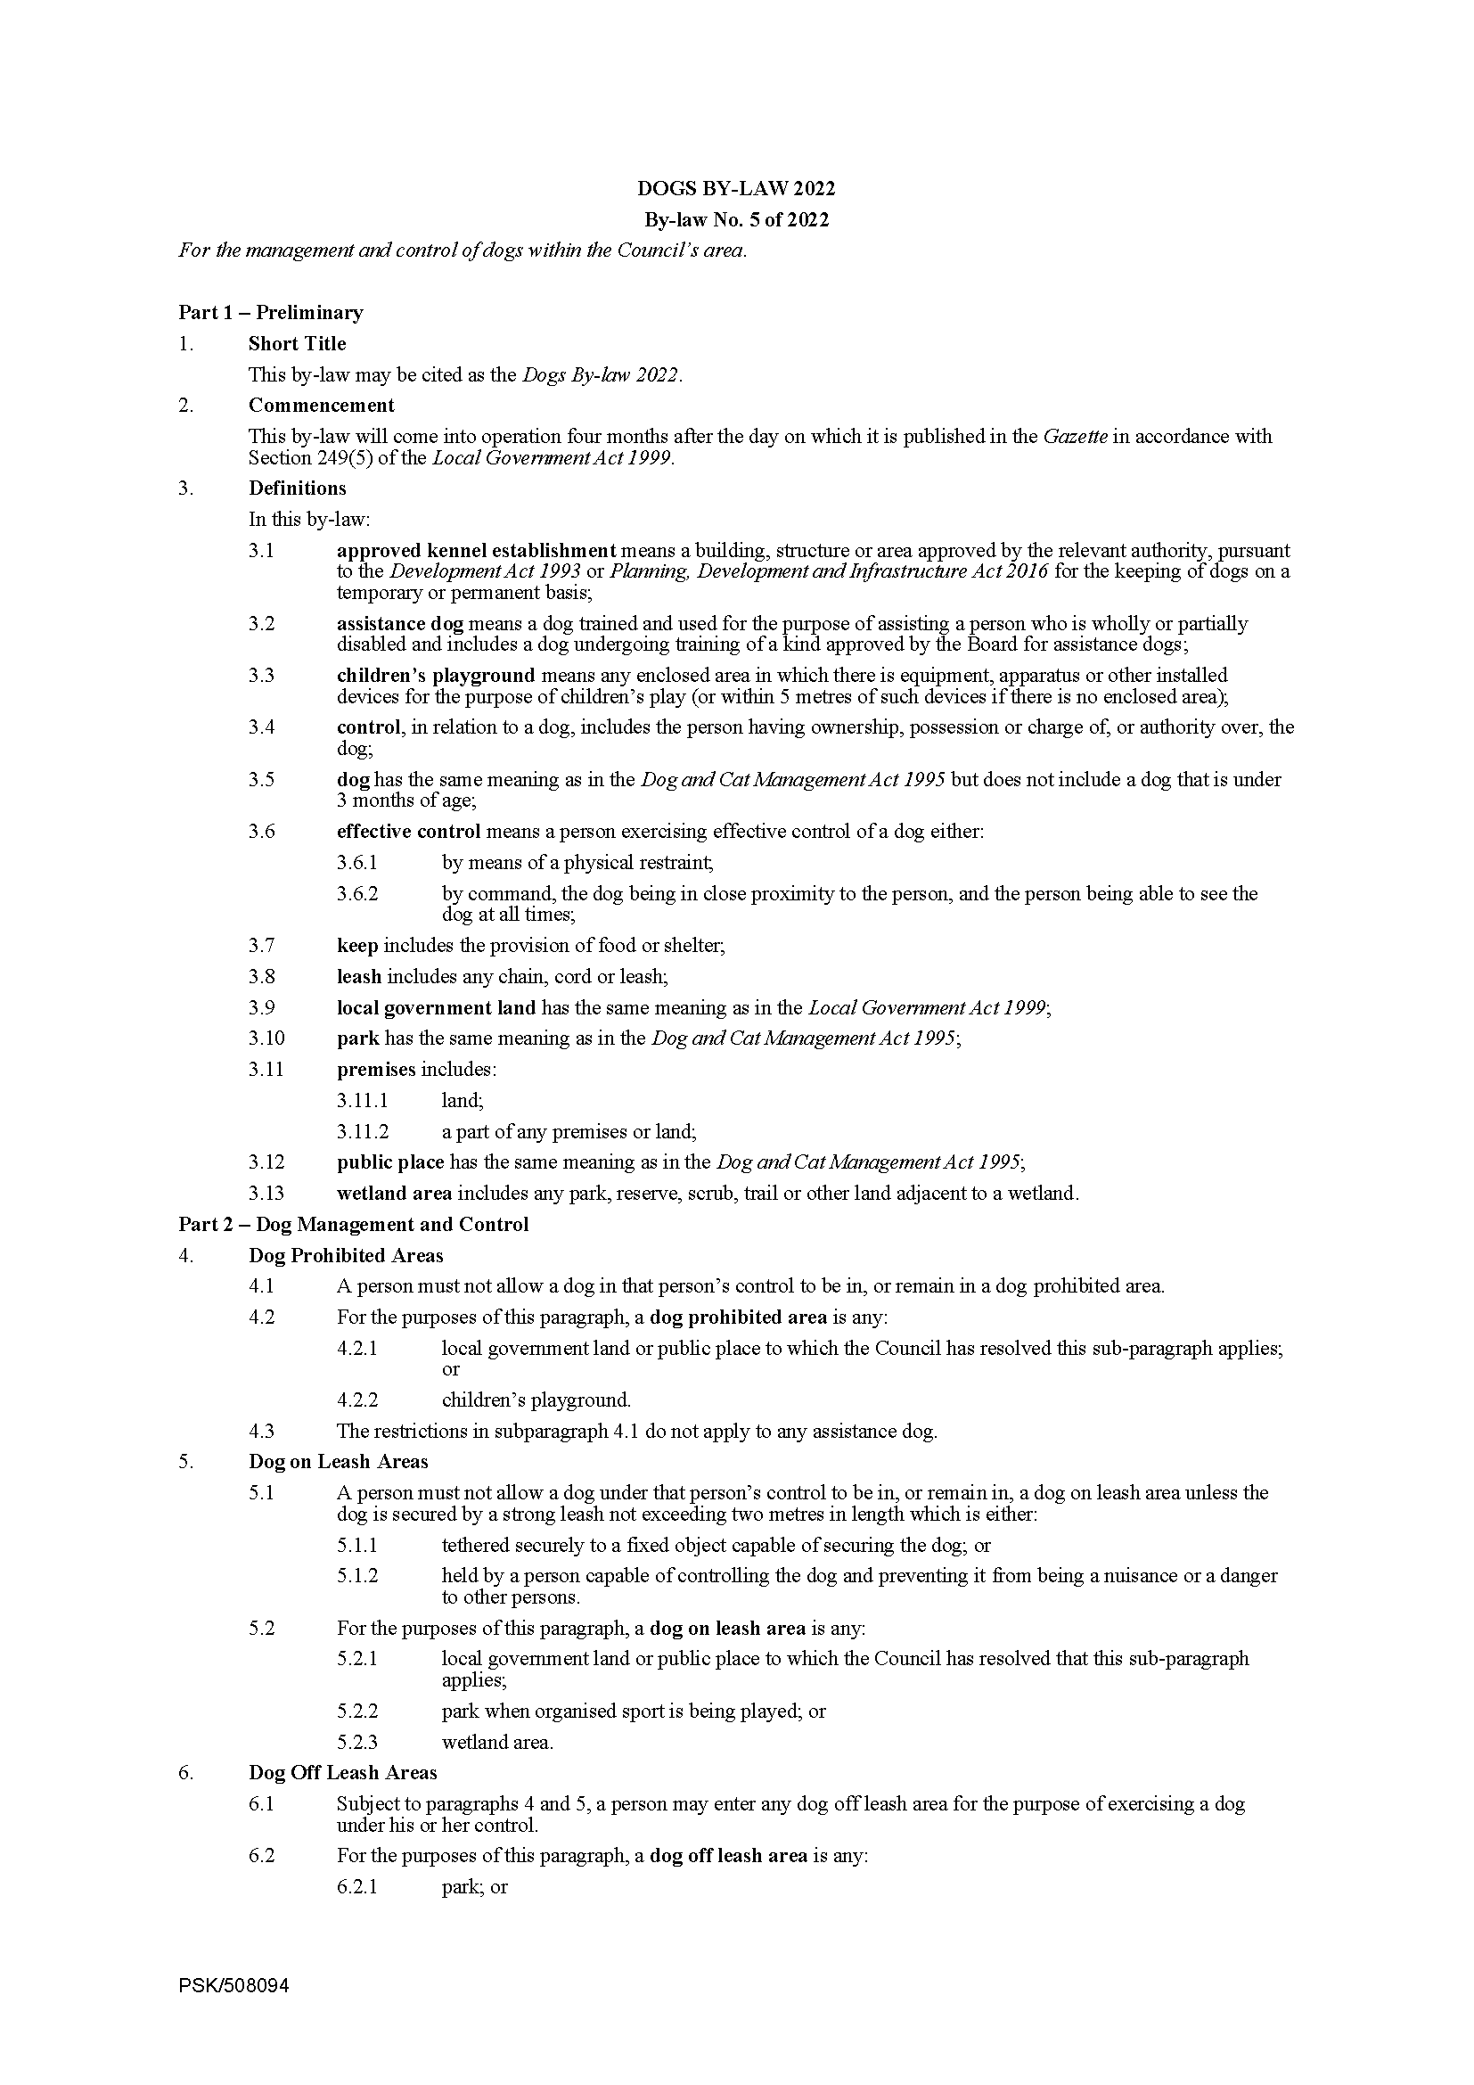

City of Prospect
Local Government Act 1999
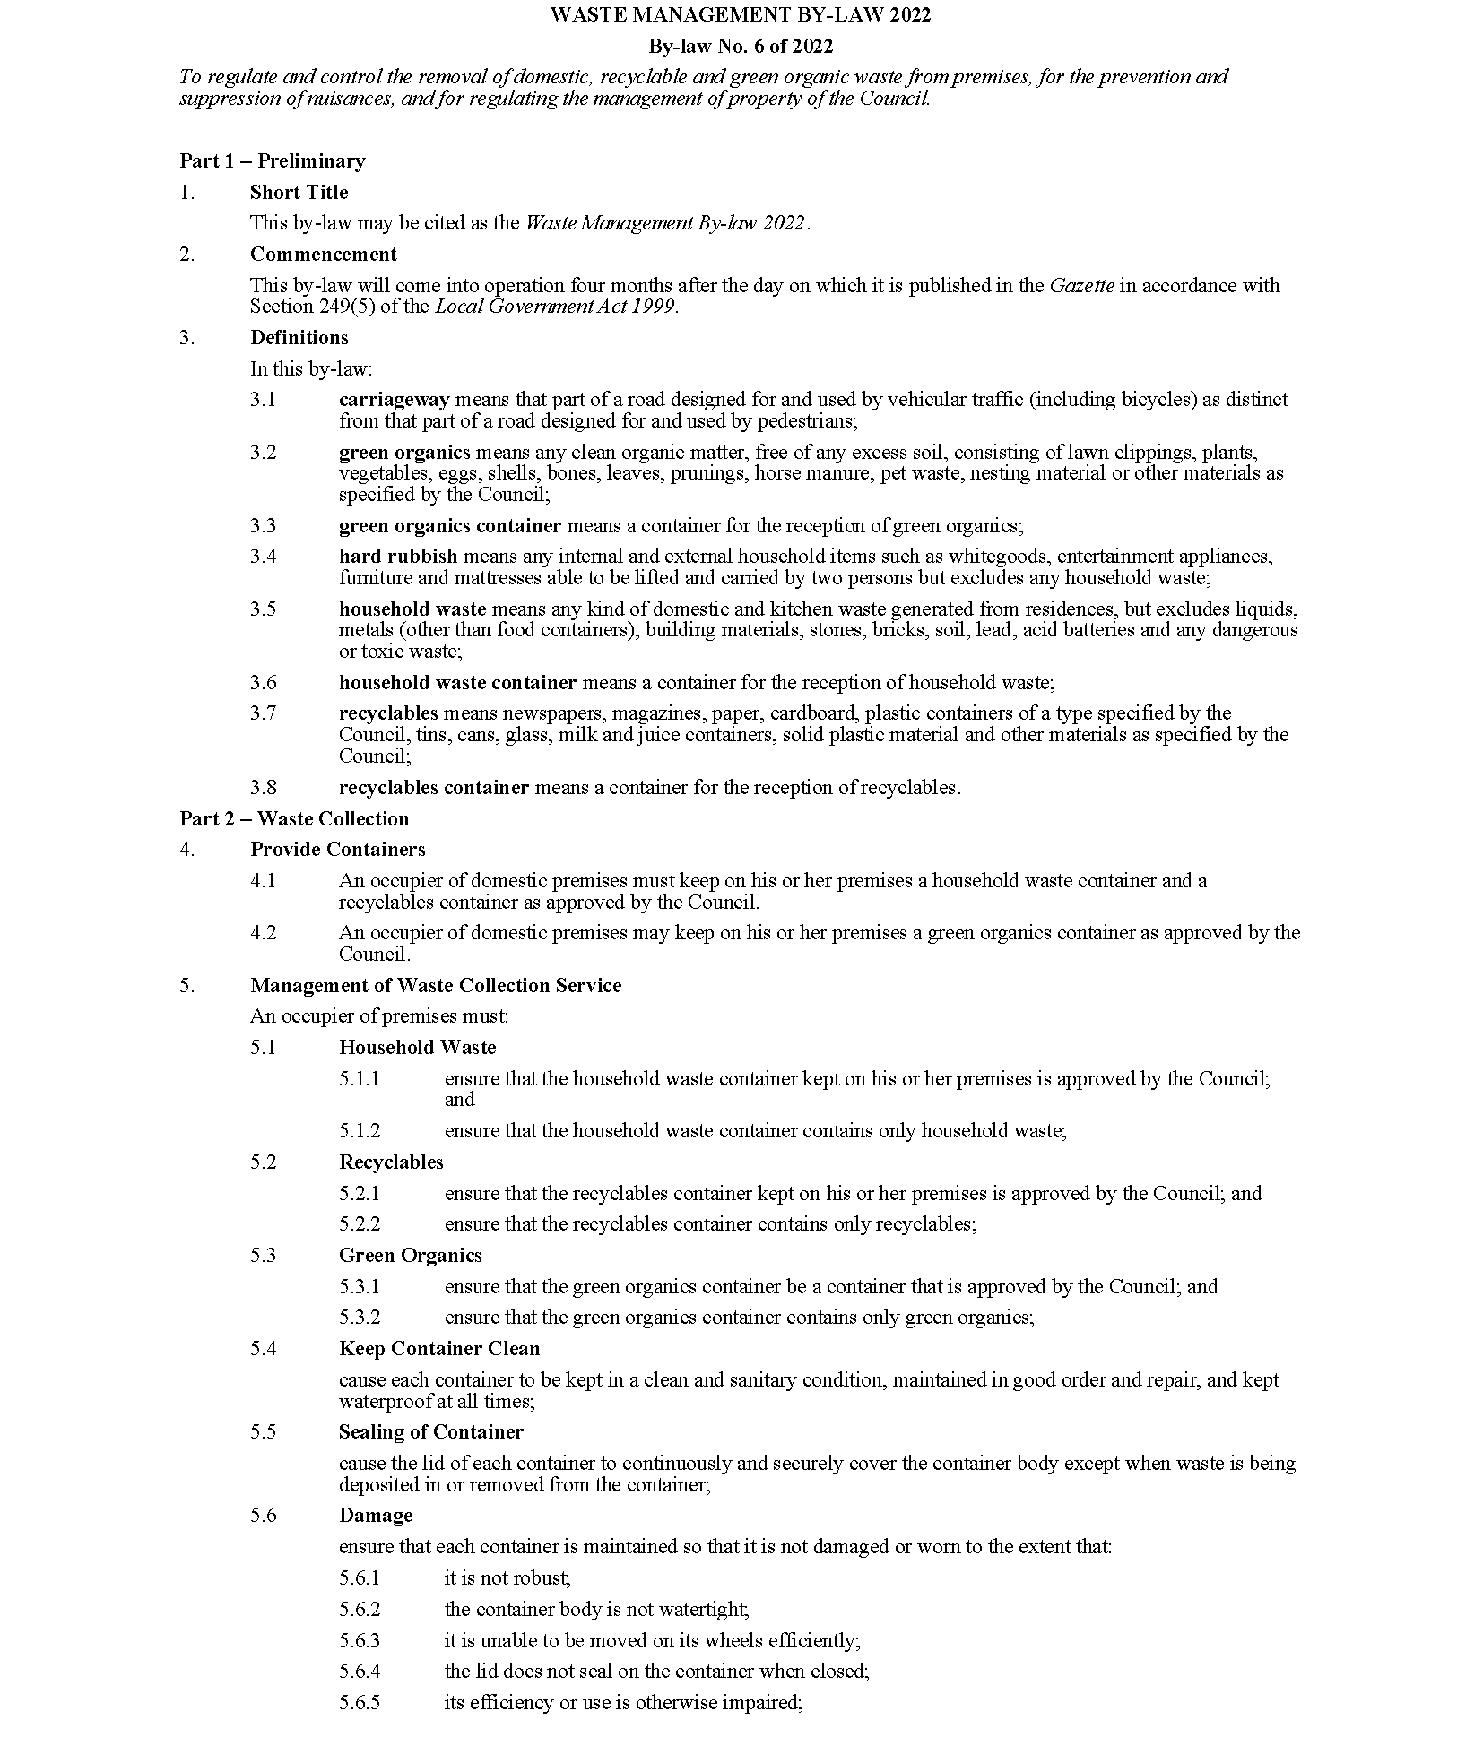
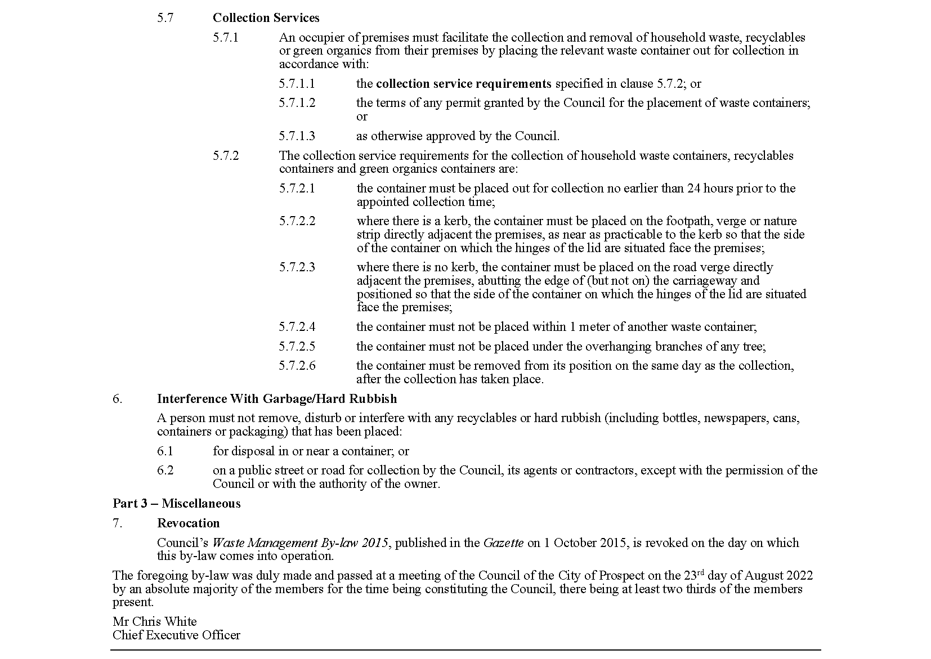

District Council of Mount Remarkable
Adoption of Valuations and Declaration of Rates 2022/2023
NOTICE is hereby given that the District Council of Mount Remarkable at a Special Meeting held on 10 August 2022 for the financial year ending 30 June 2023 adopted its Annual Business Plan and Budget and:
Adoption of Valuations
Adopted, for rating purposes, the Valuer-General’s most recent valuations of capital values applicable to land within the area of Council, which totals $1,124,420,260.
Declaration of General Rates
Declared a general rate comprising two components, one based on the value of the land subject of the rate of 0.2287 cents in the dollar and the other being a fixed charge of $365.00 upon each rateable assessment.
Declaration of Separate Rate
Regional Landscape Levy
Declared a separate rate of 0.0210 cents in the dollar on all rateable land located within the area of the Council to reimburse the Council for the amount payable to the Northern and Yorke Landscape Board.
Annual Service Charges
- Imposed an annual service charge for the collection, treatment and disposal of wastewater in respect of all assessments within the townships of Wilmington, Melrose, Booleroo Centre and Wirrabara to which Council makes available a Community Wastewater Management Scheme as follows:
Wilmington: $550.00 per unit on each assessment of land, and;
Melrose: $550.00 per unit on each assessment of land, and;
Booleroo Centre: $550.00 per unit on each assessment of land, and;
Wirrabara: $550.00 per unit on each assessment of land.
- Imposed an annual service charge of $380.00 for the weekly collection and disposal of waste in a mobile garbage bin and the fortnightly collection and disposal of recyclables and green waste in a mobile garbage bin, on:
- all occupied land in the defined townships of Appila, Booleroo Centre, Hammond, Melrose, Murray Town, Port Germein, Weeroona Island, Willowie, Wilmington and Wirrabara for which the service is provided or made available; and
- each section of land outside of the townships abutting the defined collection route on which a habitable dwelling exists for which the service is provided or made available, provided that the sliding scale set out in Regulation 13 of the Local Government (General) Regulations 2013 will apply to reduce the service charge as prescribed.
- Imposed an annual service (and supply) charge based on the nature of the service and the level of usage of the service of:
- $290.00 for the nature of the service on each assessment of rateable and non-rateable land within the township of Weeroona Island to which Council provides or makes available the ‘Weeroona Island Water Supply’; and
- Including a level of usage charge of $2.90 per kilolitre for each kilolitre of water supplied to each assessment of rateable and non-rateable land to which Council provides or makes available the ‘Weeroona Island Water Supply’.
Dated: 1 September 2022
S. Johnson
Chief Executive Officer

Public Notices

National Gas Law
Initiation of a Rule Change Request and Extension of Final Determination
The Australian Energy Market Commission (AEMC) gives notice under the National Gas Law as follows:
Under s 303, the Victorian Minister for Energy, Environment and Climate Action has requested the DWGM interim LNG storage measures (Ref. GRC0065) proposal. The proposal seeks to reduce the risks to system security and public safety and improve the reliability of supply in the Victorian declared wholesale gas market (DWGM) between winter 2023 and 2025. The AEMC intends to expedite the proposal under s 304 as it considers the proposed Rule is urgent, subject to requests not to do so. Written requests not to expedite the proposal must be received by 15 September 2022. Submissions must be received by 29 September 2022.
Under s 317, the time for the making of the final determination on the DWGM interim LNG storage measures (Ref. GRC0065) proposal has been extended to 24 November 2022.
Submissions can be made via the AEMC’s website. Before making a submission, please review the AEMC’s privacy statement on its website, and consider the AEMC’s Tips for making a submission. The AEMC publishes all submissions on its website, subject to confidentiality.
Written requests should be sent to submissions@aemc.gov.au and cite the reference in the title. Before sending a request, please review the AEMC’s privacy statement on its website.
Documents referred to above are available on the AEMC’s website and are available for inspection at the AEMC’s office.
Australian Energy Market Commission
Level 15, 60 Castlereagh St
Sydney NSW 2000
Telephone: (02) 8296 7800
www.aemc.gov.au
Dated: 1 September 2022

Notice Submission

The South Australian Government Gazette is published each Thursday afternoon.
Notices must be emailed by 4 p.m. Tuesday, the week of publication.
Submissions are formatted per the gazette style and a proof will be supplied prior to publication, along with a quote if applicable. Please allow one day for processing notices.
Alterations to the proof must be returned by 4 p.m. Wednesday.

Gazette notices must be submitted as Word files, in the following format:
• Title—the governing legislation
• Subtitle—a summary of the notice content
• Body—structured text, which can include numbered lists, tables, and images
• Date—day, month, and year of authorisation
• Signature block—name, role, and department/organisation authorising the notice

Please provide the following information in your email:
• Date of intended publication
• Contact details of the person responsible for the notice content
• Name and organisation to be charged for the publication—Local Council and Public notices only
• Purchase order, if required—Local Council and Public notices only

Email: governmentgazettesa@sa.gov.au
Phone: (08) 7109 7760
Website: www.governmentgazette.sa.gov.au

All instruments appearing in this gazette are to be considered official, and obeyed as such

Printed and published weekly by authority of C. McArdle, Government Printer, South Australia
$8.15 per issue (plus postage), $411.00 per annual subscription—GST inclusive
Online publications: www.governmentgazette.sa.gov.au

