No. 62 p. 5887
THE SOUTH AUSTRALIAN
GOVERNMENT GAZETTE
Published by Authority

Adelaide, Thursday, 8 September 2022

Contents

Governor’s Instruments

Appointments 5888

South Australian Public Health Act 2011 5890

Proclamations—
South Australian Motor Sport (Miscellaneous)
Amendment Act (Commencement) Proclamation 2022 5892
South Australian Motor Sport (Designation of
Employing Authority) Proclamation 2022 5892

Regulations—
Fisheries Management (General) (Restrictions on
Fishing in Germein Bay) Amendment
Regulations 2022—No. 79 of 2022 5893
Fisheries Management (Demerit Points) (Restrictions on
Fishing in Germein Bay) Amendment
Regulations 2022—No. 80 of 2022 5895
South Australian Motor Sport (Board Names)
Amendment Regulations 2022—No. 81 of 2022 5896

State Government Instruments

Geographical Names Act 1991 5898

Justices of the Peace Act 2005 5898

Land Acquisition Act 1969 5898

Mental Health Act 2009 5900

Mining Act 1971 5900

Motor Vehicles (Specified Event) Notice 2023 5900

Motor Vehicles Act 1959 5901

Petroleum and Geothermal Energy Act 2000 5912

South Australian Housing Trust Regulations 2010 5913

South Australian Public Health Act 2011 5914

South Australian Skills Act 2008 5914

Suicide Prevention Regulations 2022 5916

Uniform Civil Rules 2020 5916

Local Government Instruments

City of Mitcham 5917

City of Victor Harbor 5917

Alexandrina Council 5918

Light Regional Council 5919

Public Notices

National Electricity Law 5936

National Gas Law 5936

Trustee Act 1936 5936

Governor’s Instruments

APPOINTMENTS
Department of the Premier and Cabinet
Adelaide, 8 September 2022
Her Excellency the Governor in Executive Council has been pleased to appoint the undermentioned to the Police Superannuation Board, pursuant to the provisions of the Police Superannuation Act 1990:
Member: from 8 September 2022 until 29 October 2023
Julie-anne Holmes
Deputy Member: from 8 September 2022 until 29 October 2023
Julie Elizabeth Thomas (Deputy to Holmes)
By command,
Kyam Joseph Maher, MLC
For Premier
T&F22/041CS

Department of the Premier and Cabinet
Adelaide, 8 September 2022
Her Excellency the Governor in Executive Council has been pleased to appoint the undermentioned to the Art Gallery Board, pursuant to the provisions of the Art Gallery Act 1939:
Member: from 8 September 2022 until 7 September 2025
Adrian Gary Tisato
By command,
Kyam Joseph Maher, MLC
For Premier
ART0005-22CS

Department of the Premier and Cabinet
Adelaide, 8 September 2022
Her Excellency the Governor in Executive Council has been pleased to appoint the undermentioned to the Controlled Substances Advisory Council, pursuant to the provisions of the Controlled Substances Act 1984:
Member: from 12 September 2022 until 11 September 2025
Jane Marie Rusalen
Andrew Alexander Somogyi
Caroline Mary Ward
Christopher Simon Reynolds
By command,
Kyam Joseph Maher, MLC
For Premier
HEAC-2022-00022

Department of the Premier and Cabinet
Adelaide, 8 September 2022
Her Excellency the Governor in Executive Council has been pleased to appoint the undermentioned to the South Australian Motor Sport Board, pursuant to the provisions of the South Australian Motor Sport Act 1984:
Member: from 8 September 2022 until 30 June 2025
Andrew William Daniels
Carolyn Anne Mitchell
Lisa Marie Bishop
Anna Victoria Hurley
Member: from 8 September 2022 until 30 June 2024
Martin Kinnear Haese
Ish Davies
Jamieson James McClurg
Mark Francis Phelps
Michael Masi
Presiding Member: from 8 September 2022 until 30 June 2025
Andrew William Daniels
Deputy Presiding Member: from 8 September 2022 until 30 June 2025
Carolyn Anne Mitchell
By command,
Kyam Joseph Maher, MLC
For Premier
DPC22/062CS

Department of the Premier and Cabinet
Adelaide, 8 September 2022
Her Excellency the Governor in Executive Council has been pleased to appoint the Honourable Nicholas David Champion, MP, Minister for Trade and Investment, Minister for Housing and Urban Development and Minister for Planning to be Acting Minister for Industry, Innovation and Science and Acting Minister for Defence and Space Industries from 8.20pm on 9 September 2022 until 20 September 2022 inclusive, during the absence of the Honourable Susan Elizabeth Close MP.
By command,
Kyam Joseph Maher, MLC
For Premier
CAB22/00032

Department of the Premier and Cabinet
Adelaide, 8 September 2022
Her Excellency the Governor in Executive Council has been pleased to appoint the Honourable Blair Ingram Boyer, MP, Minister for Education, Training and Skills to be Acting Minister for Climate, Environment and Water from 8.20pm on 9 September 2022 until 20 September 2022 inclusive, during the absence of the Honourable Susan Elizabeth Close MP.
By command,
Kyam Joseph Maher, MLC
For Premier
CAB22/00032

Department of the Premier and Cabinet
Adelaide, 8 September 2022
Her Excellency the Governor in Executive Council has been pleased to designate Mark Richard James Warren as the Chief Executive, South Australian Motor Sport Board, for a term commencing on 8 September 2022 until 1 May 2025, or until he no longer holds his position as Chief Executive, SA Motor Sports in the Public Service, whichever is sooner - pursuant to section 16 of the South Australian Motor Sport Act 1984.
By command,
Kyam Joseph Maher, MLC
For Premier
DPC22/062CS

South Australian Public Health Act 2011
South Australia
South Australian Public Health (COVID-19 Directions) Amendment Notice 2022
under section 90C of the South Australian Public Health Act 2011
Part 1—Preliminary
1—Short title
This notice may be cited as the South Australian Public Health (COVID-19 Directions) Amendment Notice 2022.
2—Commencement
This notice comes into operation on 9 September 2022.
Part 2—Amendment of South Australian Public Health (COVID-19 Directions) Notice 2022
3—Amendment of Schedule 1—Direction requirements—COVID-19 cases and close contacts
(1) Schedule 1, clause 1(1)—delete "A person" and substitute:
Subject to this clause, a person
(2) Schedule 1, clause 1—after subclause (1) insert:
(1a) Subclause (1) ceases to apply in relation to a person who is otherwise required to isolate for a period of 7 days under that subclause if, at the end of or after the 5th day for which the person is required to isolate, the person has no symptoms of COVID-19.
(1b) A person in relation to whom subclause (1) ceases to apply in accordance with subclause (1a) must, for the remainder of the period during which the person would otherwise have been required to isolate under subclause (1), wear a single use surgical mask whenever the person is not at their usual place of residence, except—
(a) if the person has a relevant serious medical condition; or
(b) in circumstances where the ability to see the mouth is essential for communication, such as to enable communication by or with any patron who is deaf or hard of hearing; or
(c) in circumstances where removal of the mask is lawfully required for identification purposes; or
(d) when the person is eating or drinking; or
(e) if the person is a child under 12 years of age.
(1c) A person in relation to whom subclause (1) ceases to apply in accordance with subclause (1a) must not, except for the purposes of obtaining medical care, attend a Tier 1 sensitive setting or a Tier 2 sensitive setting for the remainder of the period during which the person would otherwise have been required to isolate under subclause (1).
(3) Schedule, clause 1(5)—delete subclause (5)
(4) Schedule 1, clause 2(3)—delete subclause (3)
(5) Schedule 1, clause 2(4)—after "must not attend" insert:
a Tier 1 sensitive setting or
(6) Schedule 1, clause 2(4)(b)—delete "attending the Tier 2 setting to respond" and substitute:
and is responding
Made by the Governor
with the advice and consent of the Executive Council
on 8 September 2022

Proclamations
South Australia

South Australian Motor Sport (Miscellaneous) Amendment Act (Commencement) Proclamation 2022
1—Short title
This proclamation may be cited as the South Australian Motor Sport (Miscellaneous) Amendment Act (Commencement) Proclamation 2022.
2—Commencement of Act
The South Australian Motor Sport (Miscellaneous) Amendment Act 2022 (No 5 of 2022) comes into operation on 8 September 2022.
Made by the Governor
with the advice and consent of the Executive Council
on 8 September 2022

South Australia

South Australian Motor Sport (Designation of Employing Authority) Proclamation 2022
under section 3 of the South Australian Motor Sport Act 1984
1—Short title
This proclamation may be cited as the South Australian Motor Sport (Designation of Employing Authority) Proclamation 2022.
2—Commencement
This proclamation comes into operation on the day on which the South Australian Motor Sport (Miscellaneous) Amendment Act 2022 comes into operation.
3—Designation of employing authority
For the purposes of the definition of employing authority in section 3(1) of the South Australian Motor Sport Act 1984, the Chief Executive of the South Australian Motor Sport Board is designated as the employing authority.
Made by the Governor
with the advice and consent of the Executive Council
on 8 September 2022

Regulations
South Australia

Fisheries Management (General) (Restrictions on Fishing in Germein Bay) Amendment Regulations 2022
under the Fisheries Management Act 2007

Contents
Part 1—Preliminary
1 Short title
2 Commencement
Part 2—Amendment of Fisheries Management (General) Regulations 2017
3 Insertion of regulation 23E
23E Taking of certain aquatic resources in Germein Bay

Part 1—Preliminary
1—Short title
These regulations may be cited as the Fisheries Management (General) (Restrictions on Fishing in Germein Bay) Amendment Regulations 2022.
2—Commencement
These regulations come into operation on 15 September 2022.
Part 2—Amendment of Fisheries Management (General) Regulations 2017
3—Insertion of regulation 23E
After regulation 23D insert:
23E—Taking of certain aquatic resources in Germein Bay
(1) Unless the Minister has, by notice in the Gazette, made a determination to the contrary, a person must not—
(a) take Razorfish (Pinna bicolor), Mussels (Mytilus spp) or crabs (Family Portunidae) in Germein Bay (Zone 1); or
(b) take Razorfish (Pinna bicolor) in Germein Bay (Zone 2).
Maximum penalty:
(a) for a first offence—$5 000;
(b) for a second offence—$10 000;
(c) for a third or subsequent offence—$20 000.
Expiation fee: $315.
(2) In this regulation—
Germein Bay (Zone 1) means the waters of Germein Bay contained within and bounded by a line commencing at the St. Andrews Cross located at 33°06′55.75″ South, 137°56′19.89″ East, then east north-easterly to the point south of the Weeroona Island boat ramp on mean high water springs closest to 33°06′11.85″ South, 138°01′27.02″ East, then easterly to the point on mean high water springs near Causeway Road closest to 33°06′11.85″ South, 138°02′39.21″ East, then beginning southerly along the line of mean high water springs to the point south of Second Creek closest to 33°09′41.96″ South, 137°56′19.89″ East, then northerly to the point of commencement;
Germein Bay (Zone 2) means the waters of Germein Bay contained within and bounded by a line commencing at the St. Andrews Cross located at 33°00′35.84″ South, 137°57′03.42″ East, then east north-easterly to the point on the mainland on mean high water springs closest to 33°00′18.93″ South, 137°58′00.86″ East, then beginning southerly along the line of mean high water springs to the point near Causeway Road closest to 33°06′11.85″ South, 138°02′39.21″ East, then westerly to the point on mean high water springs south of the Weeroona Island boat ramp closest to 33°06′11.85″ South, 138°01′27.02″ East, west south-westerly to the St Andrews Cross located at 33°06′55.75″ South, 137°56′19.89″ East, and northerly to the point of commencement.
(3) For the purposes of subregulation (2), all lines in spatial descriptions are geodesics and coordinates expressed in terms of GDA2020.
Editorial note—
As required by section 10AA(2) of the Legislative Instruments Act 1978, the Minister has certified that, in the Minister's opinion, it is necessary or appropriate that these regulations come into operation as set out in these regulations.
Made by the Governor
with the advice and consent of the Executive Council
on 8 September 2022
No 79 of 2022

South Australia

Fisheries Management (Demerit Points) (Restrictions on Fishing in Germein Bay) Amendment Regulations 2022
under the Fisheries Management Act 2007

Contents
Part 1—Preliminary
1 Short title
2 Commencement
Part 2—Amendment of Fisheries Management (Demerit Points) Regulations 2017
3 Amendment of Schedule 1—Demerit points offences and demerit points

Part 1—Preliminary
1—Short title
These regulations may be cited as the Fisheries Management (Demerit Points) (Restrictions on Fishing in Germein Bay) Amendment Regulations 2022.
2—Commencement
These regulations come into operation on 15 September 2022.
Part 2—Amendment of Fisheries Management (Demerit Points) Regulations 2017
3—Amendment of Schedule 1—Demerit points offences and demerit points
Schedule 1, clause 8, table—after the entries relating to regulation 23D insert:

23E(1)(a) | Taking Razorfish (Pinna bicolor), Mussels (Mytilus spp) or crabs (Family Portunidae) in Germein Bay (Zone 1)—
 | (a) if the offence is expiated | 10
 | (b) in any other case | 25
23E(1)(b) | Taking Razorfish (Pinna bicolor) in Germein Bay (Zone 2)—
 | (a) if the offence is expiated | 10
 | (b) in any other case | 25
Editorial note—
As required by section 10AA(2) of the Legislative Instruments Act 1978, the Minister has certified that, in the Minister's opinion, it is necessary or appropriate that these regulations come into operation as set out in these regulations.
Made by the Governor
with the advice and consent of the Executive Council
on 8 September 2022
No 80 of 2022

South Australia

South Australian Motor Sport (Board Names) Amendment Regulations 2022
under the South Australian Motor Sport Act 1984

Contents
Part 1—Preliminary
1 Short title
2 Commencement
Part 2—Amendment of South Australian Motor Sport Regulations 2014
3 Insertion of Part 1A
Part 1A—Provisions relating to Board
3A Prescribed names

Part 1—Preliminary
1—Short title
These regulations may be cited as the South Australian Motor Sport (Board Names) Amendment Regulations 2022.
2—Commencement
These regulations come into operation on the day on which section 28 of the South Australian Motor Sport Act 1984 (as enacted by the South Australian Motor Sport (Miscellaneous) Amendment Act 2022) comes into operation.
Part 2—Amendment of South Australian Motor Sport Regulations 2014
3—Insertion of Part 1A
After regulation 3 insert:
Part 1A—Provisions relating to Board
3A—Prescribed names
For the purposes of section 28(c) of the Act, the following names are prescribed:
(a) World Solar Challenge;
(b) SA Motor Sport;
(c) ADL500.
Editorial note—
As required by section 10AA(2) of the Legislative Instruments Act 1978, the Minister has certified that, in the Minister's opinion, it is necessary or appropriate that these regulations come into operation as set out in these regulations.
Made by the Governor
with the advice and consent of the Executive Council
on 8 September 2022
No 81 of 2022

State Government Instruments

Geographical Names Act 1991
Notice to Alter Boundaries of a Place
NOTICE is hereby given that, pursuant to section 11B(1)(b) of the Geographical Names Act 1991, I, the Honourable Nick Champion MP, Minister for Planning, Minister of the Crown to whom the administration of the Geographical Names Act 1991 is committed, DO HEREBY;
- Alter the locality boundary between Pleasant Park and Mingbool to exclude that area marked (A), highlighted in green, as shown on the plan, from the bounded locality of PLEASANT PARK and include that area in the locality of MINGBOOL.
This notice is to take effect immediately upon its publication in the Government Gazette.
This naming proposal and plan can be viewed at;
- the Office of the Surveyor-General, 101 Grenfell Street, Adelaide
- www.sa.gov.au/placenameproposals
Dated: 21 August 2022
Hon Nick Champion MP
Minister for Planning
DTI 2021/03842/01

Justices of the Peace Act 2005
Section 4
Appointment of Justices of the Peace for South Australia
Notice by the Commissioner for Consumer Affairs
I, Dini Soulio, Commissioner for Consumer Affairs, delegate of the Attorney-General, pursuant to section 4 of the Justices of the Peace Act 2005, do hereby appoint the people listed as Justices of the Peace for South Australia as set out below:
For a period of ten years for a term commencing on 20 September 2022 and expiring on 19 September 2032:
Mark Robert SUTTON
Peter Crawford STONE
Cindy Kaye SMITH
David John SMART
Thomas Alfred SISMEY
Michael Anthony James SERGI
Timothy Carl SCHWARZ
John Clifford ROSS
Lynn ROACH
Geoffrey Kenneth PENHALL
Ronald Denis MILDE
Philip Grant MELLORS
Kenneth John MEDHURST
David John MADDERN
Mervyn John LEWIS
Warwick John KOSTER
Reynaldo Dante Galura JUANTA
David Allan JEFFS
Donald Raymond HAWKING
Garry Richard HANSEN
Malcolm John HANCOCK
Julie-Anne Marie GOURD
Gerry GEUE
John Alexander ANDRE
Dated: 2 September 2022
Dini Soulio
Commissioner for Consumer Affairs
Delegate of the Attorney-General

Land Acquisition Act 1969
Section 16
Form 5 – Notice of Acquisition
1. Notice of acquisition
The Commissioner of Highways (the Authority), of 50 Flinders Street, Adelaide SA 5000, acquires the following interests in the following land:
Comprising an estate in fee simple in that piece of land being the whole of the land identified as Allotment “500” in the plan D130120 lodged at the Lands Titles Office, being:
First, portion of Allotment (Reserve) 1002 in Deposited Plan No 115188 comprised in Certificate of Title Volume 6187 Folio 461, subject to free and unrestricted Right(s) of Way over the land marked “U” on Deposited Plan 115188 appurtenant to the land comprised in Certificate of Title Volume 6222 Folio 204, and
Secondly, portion of land comprised in Certificates of Title Volume 6235 Folio 530, Volume 6246 Folio 97, Volume 6211 Folio 436, Volume 6223 Folio 239 (being the whole of the free and unrestricted Right(s) of Way and Easement(s) over the land marked “AA” and “V” on Deposited Plan 115188 appurtenant to Allotments 901, 902, 903 and 904 in the said Deposited Plan that is contained within, and forms portion of, the said land marked Allotment “500”), to the intent that the whole of the Right(s) of Way and Easement(s) will merge and be extinguished in the fee simple in the land marked Allotment “500”, and
Thirdly, portion of land comprised in Certificate of Title Volume 6233 Folio 385 (being the whole of the free and unrestricted Right(s) of Way over the land marked “AB” and “U” on Deposited Plan 115188 appurtenant to Allotment 905 in the said Deposited Plan that is contained within, and forms portion of, the said land marked Allotment “500”), to the intent that the whole of the Right(s) of Way will merge and be extinguished in the fee simple in the land marked Allotment “500”.
This notice is given under section 16 of the Land Acquisition Act 1969.
2. Compensation
A person who has or had an interest consisting of native title or an alienable interest in the land that is divested or diminished by the acquisition or the enjoyment of which is adversely affected by the acquisition who does not receive an offer of compensation from the Authority may apply to the Authority for compensation.
2A. Payment of professional costs relating to acquisition (section 26B)
If you are the owner in fee simple of the land to which this notice relates, you may be entitled to a payment of up to $10 000 from the Authority for use towards the payment of professional costs in relation to the acquisition of the land.
Professional costs include legal costs, valuation costs and any other costs prescribed by the Land Acquisition Regulations 2019.
3. Inquiries
Inquiries should be directed to: Chris Southam
GPO Box 1533
Adelaide SA 5001
Telephone: (08) 8343 2574
Dated: 6 September 2022
The Common Seal of the COMMISSIONER OF HIGHWAYS was hereto affixed by authority of the Commissioner in the presence of:
Rocco Caruso
Manager, Property Acquisition (Authorised Officer)
Department for Infrastructure and Transport
DIT 2021/14336/01

Land Acquisition Act 1969
Section 16
Form 5 – Notice of Acquisition
1. Notice of acquisition
The Commissioner of Highways (the Authority), of 50 Flinders Street, Adelaide SA 5000, acquires the following interests in the following land:
Comprising an estate in fee simple in that piece of land being the whole of the land identified as Allotment “504” in the plan D130123 lodged at the Lands Titles Office, being:
Firstly, portion of Allotment 905 in Deposited Plan No 115188 comprised in Certificate of Title Volume 6233 Folio 385, subject to free and unrestricted Right(s) of Way over the land marked “S” on Deposited Plan 115188 appurtenant to the land comprised in Certificate of Title Volume 6222 Folio 204, subject to service easement(s) over the land marked “E” on Deposited Plan 115188 for sewerage purposes to the South Australian Water Corporation (233LG RPA), subject to service easement(s) over the land marked “F” on Deposited Plan 115188 for drainage purposes to the Council for the area (223LG RPA) and expressly excluding free and unrestricted Right(s) of Way over the land marked ”AB”, “QQ” and “U” on Deposited Plan 115188, and
Secondly, portion of land comprised in Certificates of Title Volume 6235 Folio 530, Volume 6246 Folio 97, Volume 6211 Folio 436 and Volume 6223 Folio 239 (being that portion of the free and unrestricted Right(s) of Way over the land marked “Y” in Deposited Plan 115188 appurtenant to Allotments 901, 902, 903 and 904 in the said Deposited Plan that is contained within, and forms portion of, the said land marked “504”), to the intent that that portion of the Right(s) of Way will merge and be extinguished in the fee simple in the land marked “504” in plan D130123.
This notice is given under section 16 of the Land Acquisition Act 1969.
2. Compensation
A person who has or had an interest consisting of native title or an alienable interest in the land that is divested or diminished by the acquisition or the enjoyment of which is adversely affected by the acquisition who does not receive an offer of compensation from the Authority may apply to the Authority for compensation.
2A. Payment of professional costs relating to acquisition (section 26B)
If you are the owner in fee simple of the land to which this notice relates, you may be entitled to a payment of up to $10 000 from the Authority for use towards the payment of professional costs in relation to the acquisition of the land.
Professional costs include legal costs, valuation costs and any other costs prescribed by the Land Acquisition Regulations 2019.
3. Inquiries
Inquiries should be directed to: Chris Southam
GPO Box 1533
Adelaide SA 5001
Telephone: (08) 8343 2574
Dated: 6 September 2022
The Common Seal of the COMMISSIONER OF HIGHWAYS was hereto affixed by authority of the Commissioner in the presence of:
Rocco Caruso
Manager, Property Acquisition (Authorised Officer)
Department for Infrastructure and Transport
DIT 2020/20101/01

Mental Health Act 2009
Section 96
Rural and Remote High Dependency Unit (HDU) at Glenside Campus
On 30 May 2017 the Chief Psychiatrist determined, by notice in the Gazette, pursuant to section 96(1) of the Mental Health Act 2009, Glenside Campus, 226 Fullarton Road, Glenside SA 5065 to be an Approved Treatment Centre for the purposes of the Mental Health Act 2009, commencing from 5 June 2017.
The Chief Psychiatrist by subsequent notice hereby given, pursuant to section 96(2), now varies the determination made on 30 May 2017 by attaching the following conditions:
- The area now known as the Rural and Remote HDU (formerly known as “Rural and Remote PICU”) may admit patients subject to Inpatient Treatment Orders who require HDU level care. The service will create and maintain admission criteria for HDU level care that will be used for this unit, that will be lodged with the Chief Psychiatrist.
- Patients who are either subject to an order under Part 8A of the Criminal Law Consolidation Act 1935, or are prisoners (persons committed to a correctional institution pursuant to an order of a court or a warrant of commitment) subject to an Inpatient Treatment Order, would not normally be admitted to the HDU and can only be admitted to this unit by exception. This will be after an assessment of their needs against the capability of the unit and with the approval of the Clinical Director of Mental Health at the Barossa Hills Fleurieu Local Health Network.
Dated: 8 September 2022
John Brayley
Chief Psychiatrist

Mining Act 1971
Section 56H
Notice is hereby given in accordance with Section 56H of the Mining Act 1971, that an application for a Mining Lease over the undermentioned mineral claim has been received:
Applicant: A & G Willson Earthmovers (SA) Pty Ltd
Claim Number: 4516
Location: CT 5644/951, MacGillivray area, approximately 30 km south of Kingscote.
Area: 25.37 hectares approximately
Purpose: Industrial and Extractive Minerals (Limesand and Limestone)
Reference: 2021/000104
To arrange an inspection of the proposal at the Department for Energy and Mining, please call the Department on 08 8463 3103.
An electronic copy of the proposal can be found on the Department for Energy and Mining website: https://www.energymining.sa.gov.au/industry/minerals-and-mining/mining/community-engagement-opportunities
Written submissions in relation to this application are invited to be received at the Department for Energy and Mining, Mining Regulation, Attn: Business Support Officer, GPO Box 320 ADELAIDE SA 5001 or dem.miningregrehab@sa.gov.au by no later than 5 October 2022.
The delegate of the Minister for Energy and Mining is required to have regard to these submissions in determining whether to grant or refuse the application and, if granted, the terms and conditions on which it should be granted.
When you make a written submission, that submission becomes a public record. Your submission will be provided to the applicant and may be made available for public inspection.
Dated: 8 September 2022
J. Martin
Mining Registrar as Delegate for the Minister for Energy and Mining
Department for Energy and Mining

Motor Vehicles (Specified Event) Notice 2023
PURSUANT to regulation 25(4) of the Motor Vehicles Regulations 2010
1. Short title
This notice may be cited as the Motor Vehicles (Specified Event) Notice 2023.
2. Commencement
This notice will come into operation on the day it is published in the Government Gazette.
3. Specified event, period and conditions
In accordance with regulation 25(4) of the Motor Vehicles Regulations 2010, and with the concurrence of the Minister for Infrastructure and Transport (as the Minister responsible for the operation of the Motor Vehicles Act 1959), I, the Minister for Tourism:
(a) specify the Santos Tour Down Under as an event; and
(b) specify the period commencing at 12.01 a.m. on 23 December 2022 and ending at 11.58 p.m. on 27 January 2023 as the period during which motor vehicles approved by me may be driven, or caused to stand, on a road in relation to the Santos Tour Down Under; and
(c) specify that the following condition applies to driving such a motor vehicle, or causing such a motor vehicle to stand, on a road in relation to the Santos Tour Down Under:
All such vehicles must display number plate covers of a design approved by the Registrar of Motor Vehicles over their vehicle number plates at all times during the period specified in paragraph (b).
Dated: 24 August 2022
Hon Zoe Bettison MP
Minister for Tourism

2023 Santos Tour Down Under
Numberplate design. Series 001 – 200

Motor Vehicles Act 1959
South Australia
Motor Vehicles (Approval of Motor Bikes and Motor Trikes) Notice 2022 No 3
under the Motor Vehicles Act 1959
1—Short title
This notice may be cited as the Motor Vehicles (Approval of Motor Bikes and Motor Trikes) Notice 2022.
2—Commencement
This notice will come into operation on the date of publication in this Gazette.
3—Approved motor bikes and motor trikes
For the purposes of Schedules 2 and 3 of the Motor Vehicles Regulations 2010 and the transitional provisions of the Motor Vehicles Variation Regulations 2005 (No 233 of 2005), the motor bikes and motor trikes specified in Schedule 1 are approved.
Schedule 1—Approved motor bikes and motor trikes
The following are approved:
- All motor bikes and motor trikes built before December 1960 with an engine capacity not exceeding 660ml
- All motor bikes and motor trikes with an engine capacity not exceeding 260 milliliters and a power to weight ratio not exceeding 150 kilowatts per tonne, except the following:

Suzuki RGV250
Kawasaki KR250 (KR-1 and KR1s models)
Honda NSR250
Yamaha TZR250
Aprilia RS250
- All motor bikes and motor trikes with electric powered engines, with a power output not in excess of 25 kw
Motor bikes and Motor trikes with electric powered engines listed in the table below are approved:
MAKE | MODEL | VARIANT NAME | YEAR(S) | CAPACITY
EVOKE | URBAN S |  | 2020-current | Electric
 | URBAN CLASSIC |  | 2020-current | Electric
FONZARELLI | 125 | 125 | 2014-2015 | Electric
ZERO | DS | Zero DS | Unit 2015 | Electric
 | S | Zero S | Until 2015 | Electric
Motor bikes and motor trikes with an engine capacity not less than 261ml and not exceeding 660ml listed in the table below are approved:
MAKE | MODEL | VARIANT NAME | YEAR(S) | CAPACITY
AJP | PR7 | PR7 | 2017 | 600
AJS | MODEL 18 | MODEL 18 | pre 1963 | 497
 | MODEL 20 | MODEL 20 | 1955-61 | 498
APRILIA | Moto 6.5 | Moto 6.5 | 1998-99 | 649
 | M35 | SR MAX 300 | 2012 | 278
 | PEGASO 650 | DUAL SPORTS | 1994-01 | 652
 | PEGASO 650 | OUTBACK | 2000-01 | 652
 | PEGASO 650 | Factory 650 | 2007-08 | 660
 | PEGASO 650 I.E. | OUTBACK | 2001-02 | 652
 | PEGASO 650 I.E. | DUAL SPORTS | 2001-06 | 652
 | SCARABEO 300 | VRG | 2009 | 278
 | SCARABEO 400 | SCARABEO 400 | 2007 | 399
 | SCARABEO 500 | SCARABEO 500 | 2007-08 | 460
 | SPORTCITY300 | SPORTCITY300 | 2010-12 | 300
 | STRADA 650 | ROAD | 2006-08 | 659
 | STRADA 650 | TRAIL | 2006-08 | 659
 | VS (SXV 550) | SXV 550 (VSS-VSL) 14.5kW | 2006-08 | 553
 | VS (SXV 450) | SXV 450 (VSR-VSH) 14kW | 2006-08 | 449
 | VP (RXV 450) | VPV-VPT-VPH 18.3kW | 2006-10 | 449
 | VP (RXV 550) | VPZ- VPX- VPL 20kW | 2006-10 | 553
ASIAWING | LD450 | ODES MCF450 | 2011-13 | 449
ATK | 605 | 605 | 1995 | 598
BENELLI | VELVET DUSK | VELVET DUSK | 2003-05 | 383
 | LEON | Leoncino 500 | 2018-20 | 500
 | P10 | BN 302 | 2015 on | 300
 | P18 | LEONCINO 500 | 2017 on | 500
 | P18 | LEONCINO 500 TRAIL | 2018 on | 500
 | P18  P16 | BENELLI  TRK502 | 2017  2017 | 500  500
 | P16 | TRK 502X | 2018 on | 500
 | P25 | GT600 RESTRICTED | 2014-15 | 600
 | P25 | BN 600 RESTRICTED | 2013-on | 600
 | P36 | 502C | 2019 | 500
BETA | RR E3 | RR350 | 2011 | 349
 | RR E3 | RR400 | 2010-11 | 398
 | RR E3 | RR450 | 2010-11 | 449
 | RR450 | RR450 | 2008 | 448
 | RR450 | RR450 | 2000-07 | 448
 | RR E3 | RR520 | 2010-11 | 498
 | RR300 2T | RR300 2T | 2019 | 293
 | RR350 4T | RR350 4T | 2019 | 349
 | RR390 4T | RR390 4T | 2019 | 386
 | RR430 4T | RR430 4T | 2019 | 431
 | RR480 4T | RR480 4T | 2019 | 478
 | RR525 | RR525 | 2008 | 510
 | RR525 | RR525 | 2000-07 | 510
 | FUPA RR E3 | RR 2T 300 | 2012-17 | 293
 | FUPA RR E3 | RR350 20 & RR350 15 | 2016-17 | 349
 | FUPA RR E3 | RR390 31 & RR390 16 | 2016-17 | 386
 | FUPA RR E3 | RR430 32 & RR430 17 | 2016-17 | 431
 | FUPA RR E3 | RR480 33 & RR480 18 | 2016-17 | 478
 | FUPA E5 | E5 00 | 2015 | 293
 | FUPA E5 | E8/03 | 2016/17 | 293
 | BETA | FUPA RR E3 | 2018 | 293
 | BMA RR | RR350 15 | 2018 | 349
 | BMA RR | RR390 16 | 2018 | 386
 | BMA RR | RR430 17 | 2018 | 431
 | BMA RR | RR480 18 | 2018 | 478
 | XTRAINER 300 2T | XTRAINER 300 2T | 2019 | 293
BMW | C400X | 0C09/C400X | 2018-20 | 350
 | C650 | C600 SPORT | ALL | 647
 | C650 | C650 GT/Sport | All | 647
 | F650 | FUNDURO | 1995-00 | 652
 | F650CS | SCARVER | 2002-05 | 652
 | F650CS | SE ROAD | 2004-06 | 652
 | F650GS | DAKAR | 2000-08 | 652
 | F650GS | F650GS | 2000-08 | 652
 | F650ST | F650ST | 1998 | 652
 | F650 | G650 GS | 2009-2016 | 652
 | F650 | G650 GS Sertao | 2012-2016 | 652
 | G 450 X | G 450 X | 2008-10 | 450
 | G650GS | Sertao | All | 650
 | G310 | G310R-0G01 | 2016-17 | 313
 | G310GS | G310GS-0G02 | 2016 | 313
 | R45 | R45 | All | 453
 | R50 | R50 | 1969 | 499
 | R60 | R60 | 1967 | 590
 | R65 | R65 | 1981-88 | 650
 | R65LS | R65LS | 1982-86 | 650
 | R69 | R69 | 1961 | 600
BOLWELL | LM25W | FIRENZE | 2009 | 263
BRAAAP | ST | 450 | 2016-17 | 450
BRP | Can am Ryker | Rotax 600 ACE | 2018 | 599
BSA | A50 | A50 | 1964-70 | 500
 | A65 | A65 | 1966-69 | 650
 | A7 | A7 | 1961 | 500
 | B40 | B40 | 1969 | 350
 | B44 | B44 | 1967-71 | 440
 | B50 | B50 | 1971 | 495
 | B50SS GOLDSTAR | B50SS GOLDSTAR | 1971 | 498
 | GOLD STAR | GOLD STAR | 1962 | 500
 | LIGHTNING | LIGHTNING | 1964 | 654
 | SPITFIRE MKIII | SPITFIRE MKIII | 1967 | 650
 | THUNDERBOLT | THUNDERBOLT | 1968 | 499
BUELL | Blast | STREET FIGHTER | 2002-07 | 491
BUG | SEE KYMCO
BULTACO | ALPINA | ALPINA | 1974 | 350
 | FRONTERA | FRONTERA | 1974 | 360
 | SHERPA | SHERPA | 1974 | 350
CAGIVA | 360WR | 360WR | 1998-02 | 348
 | 410TE | 410TE | 1996 | 399
 | 610TEE | 610TEE | 1998 | 576
 | 650 ALAZZURA | 650 ALAZZURA | 1984-88 | 650
 | 650 ELFANT | 650 ELFANT | 1985-88 | 650
 | CANYON 500 | DUAL SPORTS | 1999-06 | 498
 | CANYON 600 | DUAL SPORTS | 1996-98 | 601
 | RIVER 600 | RIVER 600 | 1995-98 | 601
 | W16 600 | W16 600 | 1995-97 | 601
CCM | GP Series | GP450-1(A1 30kW) | 2015-16 | 450
 | GP Series | GP450-2(A1 30kW) | 2015-16 | 450
CFMOTO | CF 650 | CF650NK-LAM | 2012-16 | 649
 | CF 650 | CF650TK-LAM | 2013-17 | 649
 | CF 650 (400NK) | 400NK | 2016-17 | 400
 | CF 650 | 650NK-LAM | 2016-17 | 649
 | CF650 | 650MT | 2016-17 | 649
 | CF650 | 650GT | 2019-on | 649
COSSCK | 650 | Ural | 1974 | 649
DERBI | MULHACEN | MULHACEN | 2008 | 659
 | RAMBLA | RA 300 | 2010 | 278
DNEPR | K650 | K650 | 1972 | 650
 | K650 | K650 DNEPR | 1967-74 | 650
 | MT9 | MT9 | 1974 | 650
DUCATI | 400 MONSTER | 400 MONSTER | 2002 | 398
 | 400 SIE | 400 S I E monster |  | 398
 | 400 SS JUNIOR | 400 SS | 1989-96 | 398
 | 400SS | 400SS | 1992-95 | 398
 | 500SL | PANTAH | 1984 | 499
 | 500GTL | 500GTL | 1975-77 | 497
 | 500 DESMO | 500 Sport Desmo | 1978 | 497
 | 600 MONSTER | 600 MONSTER | 1994-01 | 583
 | 600 MONSTER | DARK | 1998-01 | 583
 | 600 S | 600 SUPERSPORT | 1994-97 | 583
 | 600M | 600M | 1994-01 | 583
 | 600SL | PANTAH | 1980-84 | 583
 | 600SS | 600SS | 1994-98 | 583
 | 620 MONSTER LITE | M620 LITE | 2003-07 | 618
 | 620 MULTISTRADA LITE | MTS620 24.5Kw | 2005-07 | 618
 | 659 Monster | Monster 659 | All | 659
 | DM 350 | 350 | pre 85 | 350
 | DM 450 | 450 | pre 85 | 448
 | DM450 | DM450 | 1972 | 450
 | DM500 | DM500 | 1981-84 | 498
 | F3 | 350 F3 | 1986-1989 | 349
 | F4 | 400 F4 | 1986 | 400
 | M4 | M620ie LITE | 2003-04 | 620
 | M5 | Monster 659 | 2011 | 659
 | KA (Scrambler) | 00AA Sixty2 | 2015-16 | 399
 | MD | 02AU | 2017 | 659
ELSTAR SHINERAY | XY400 | WB400 & WB400c | 2015-16 | 397
 | XY400 | CLASSIC C | 2018 | 397
 | XY400 | SCRAMBLER C | 2018 | 397
 | XY400 | CAFÉ RACER | 2018 | 397
 | XY400 | CAFÉ RACER F | 2018 | 397
ENFIELD | BULLET | CLASSIC | 1993-08 | 499
 | BULLET | DELUXE | 1993-08 | 499
 | BULLET | ELECTRA ROAD | 2006-08 | 499
 | BULLET 350 | DELUXE | 1988-01 | 346
 | BULLET 350 | SUPERSTAR | 1988-95 | 346
 | BULLET 350 | CLASSIC | 1993-01 | 346
 | BULLETT 500 | 500 | 1995 | 499
 | BULLET 65 | ROAD | 2003-04 | 499
 | LIGHTNING | ROAD | 2000-08 | 499
 | MILITARY | ROAD | 2002-08 | 499
 | TAURAS | DIESEL | 2001 | 325
FANTIC | TZ | EC300 | 2011-12 | 300
 | TZ | Gas Gas EC30 | 2012 | 300
 | CA50 | Flat Track | 2020-current | 449
 | CA50 | Scrambler | 2020-current | 449
 | CA50 | Rally | 2020-current | 449
GAS-GAS | 4E (IPA 48807) | EC 30 | 2018 | 299
 | 4E | EC 30 | 2017 | 299
 | 4E | EC25 | 2017 | 299
 | EC Series | EC300 | 2001-current | 293
 | EC Series | EC350F | 2021-current | 350
 | EC400 | FSE ENDURO | 2002-03 | 399
 | EC450 | FSE ENDURO | 2003-05 | 449
 | EC450 | FSE SUPERMOTARD | 2003-08 | 449
 | EC450 | FSR ENDURO | 2006-08 | 449
 | FS 400 | FS40A | 2006 | 398
 | FS 450 | FS45 | 2006 | 443
 | FS 500 | FS50 (503) | 2006-2009 | 503
 | FSE 400 | 400 | 2002 | 398
 | FSE 450 | 450 | 2003-08 | 398
 | PAMPERA | 320 TRAIL | 1998-02 | 333
 | PAMPERA | 400 TRAIL | 2006-08 | 399
 | PAMPERA | 450 | 2007-08 | 443
 | SM400 | SUPERMOTARD | 2003-08 | 399
 | SM450 | SUPERMOTARD | 2003-08 | 443
 | TT300 | EC300 | 1998-08 | 295
 | EC ENDURO | EC30 | 2016-17 | 299
 | CONTACT ES | 280 ES | 2018 | 272
GILERA | FUOCO 500 | FUOCO 500 | 2007-13 | 493
 | NEXUS 500 | NEXUS 500 | 2003-08 | 460
HARLEY DAVIDSON | SS350 | Sprint | 69-1974 | 350
 | XGS SERIES | Street 500 -XG500 16MY | 2014-15 | 494
 | XGS SERIES | Street 500 | 2016-on | 494
 | XGS SERIES | XG500 17MY | 2016-17 | 494
HONDA | 600V TRANSALP | 600V | 1988 | 583
 | BROS | BROS | 1992 | 399
 | C70 | DREAM | pre 1970 | 305
 | CB300R | CBF300NA | 2018-20 | 286
 | CB300 (FA) | CB300FA | 2014-17 | 286
 | CB350 | CB350 | 1969 | 348
 | CB350F | CB350F | 1973 | 325
 | CB360 | CB360 | 1973-75 | 360
 | CB400 | CB400 | 1981 -2013 | 395
 | CB400F | CB400F | 1975-77 | 408
 | CB400N | CB400N | 1981 | 395
 | CB400T | CB400T | 1977 | 408
 | CB400 ABS | CB400 ABS | 2008 - 2013 | 399
 | CB450 | CB450 | 1967-75 | 450
 | CB500 FOUR | CB500-FOUR K,K1,K2 | 1971-73 | 498
 | CB500 TWIN | CB500T | 1974-78 | 498
 | CB500F | CB500FA/F | 2012-19 | 471
 | CB500X | CB500XA | 2013-17 | 471
 | CB550 | CB550 | 1974-78 | 544
 | CB650F | CB650FA-LTD-16ym | 2015-2017 | 649
 | CBR650F | CBR650FA-LTD-16ym | 2015-2016 | 649
 | CB650 | CB650 | All | 650
 | CBR500R | CBR500RA | 2012-19 | 471
 | CBR650R | CBR650R | 2019 | 649
 | CBX550 | CBX550F | 1982-85 | 572
 | CX500 | CX500 | 1979 | 500
 | CMX500A | CMX500A | 2016-20 | 471
 | CJ360 | CJ360 | 1976 | 356
 | CL450 | CL450 | 1965-77 | 444
 | CRF150 | 150R/RB | All | 149
 | CRF300 | CRF300 Rally | 2020 | 286
 | CRF300 | CRF300L | 2020 | 286
 | CRF400R | CRF400R | 2013 | 399
 | CRF450L | CRF450L | 2018 | 449
 | CRF450X | CRF450X | 2005-09 | 449
 | CX500 | CX500 | 1977-82 | 495
 | DEAUVILLE | NT650V | 2002-06 | 647
 | CBR300R | CBR300R | 2014-15 | 286
 | CBR300R | CBR300RA | 2014-15 | 286
 | Fortza 300 | NSS300 Forza | All | 279
 | FJS400A | SW-T400 | 2009 | 399
 | FT500 | FT500 | 1984 | 498
 | FTS600D | SILVERWING | 2006-08 | 582
 | GB400 | GB400 | All | 399
 | GB500 | GB507 | 1987-91 | 498
 | GL400 | GL400 | 1985 | 396
 | NF02 | SH300 | 2009 | 279
 | NSS300 | NSS300 | 2013 | 279
 | NSS350 | NSS350 Forza | 2020 | 330
 | NT400 | NT400 | 1989-92 | 400
 | NT650V | DEAUVILLE | 2003-06 | 647
 | NTV650 | REVERE | 1989-92 | 647
 | NX650 | DOMINATOR | 1988-00 | 644
 | PCX150 | PCX150 | 153
 | REVERE | REVERE | 1990 | 647
 | SL350 | SL350 | 1972 | 348
 | OBI RVF400 VFR400 | OBI RVF400 Otobai import model only | All | 400
 | Steed | steed | 2002 | 398
 | VT400 | VT 400 | All | 398
 | VT400C | SHADOW | 2009 | 399
 | VT500 | VT500 | 1983-87 | 491
 | VT600C | VT600C | 1993-00 | 583
 | VT600C | SHADOW VLX | 1988-2008 | 583
 | XBR500 | XBR500 | 1986-89 | 499
 | XBR500SH | XBR500 | 1986-89 | 499
 | XL350 | XL350 | 1984-87 | 339
 | XL500 | XL500 | 1979-84 | 498
 | XL600R | XL600R | 1984-87 | 589
 | XL600RMG | XL600RMG | 1986-88 | 591
 | XL600VH | TRANSALP | 1987-89 | 583
 | XL650V | TRANSALP | 2002-08 | 647
 | XL650 | TRANSALP | 2005 | 647
 | XR250 | XR250R | All
 | XR350 | XR350 | 1983 | 339
 | XR350R | XR350R | 1983-84 | 339
 | XR350R | XR350R | 1985-86 | 353
 | XR400 | XR400 | 1996-08 | 397
 | XR400 MOTARD | XR400M | 1996-08 | 397
 | XR400R | XR400R | 1996-08 | 397
 | XR500R | XR500R | 1983-84 | 498
 | XR600R | XR600R | 1985-00 | 591
 | XR650L | XR650L/ XR650R | 2001-06 | 644
 | XR650R | XR650R Kss and Mss (only) | 2004-05 | 649
 | XR650R | XR650R (Australian version only) | 1999-2001 | 649
 | CRF450L | CRF450L2019YM | 2018 | 449
HUNTER | DD350E-6C | DAYTONA | 2010-13 | 320
 | DD350E-6C | SPYDER | 2010-13 | 320
 | DD350E-2 | BOBBER | 2011-13 | 320
HUSABERG | FE350 | ENDURO | All | 350
 | FE400 | ENDURO | All | 399
 | FE450 | ENDURO | 2008-14 | 449
 | FE501E | ENDURO | 1997-12 | 501
 | FE501 | ENDURO | 2012-14 | 510
 | FE570 | ENDURO | 2008-10 | 565
 | FE600E | ENDURO | 1997-00 | 595
 | FE650E | ENDURO | 2004-08 | 628
 | FE650E | ENDURO | 2000-04 | 644
 | FS450E | ENDURO | 2004 | 449
 | FS450 | SUPERMOTARD | 2008-10 | 449
 | FS570 | SUPERMOTARD | 2009-10 | 565
 | FS650C/E | SUPERMOTARD | 2004-08 | 628
 | FS650E | SUPERMOTARD | 2002-04 | 644
 | TE300 | TE Series | 2010-14 | 293
 | FE01 | FE450 MY05 (Ab) | 2004 | 449
 | FE01 | FS650 MY05 (Db) | 2004 | 628
HUSQVARNA | 300WR | WR300 | 2008-12 | 298
 | 310TE | TE310 A3 | 2009-13 | 303
 | 310TE | TE310 A2 | 2008-10 | 298
 | 350TE | TE350 | 1995 | 349
 | 400SM | SUPERMOTARD | 2002-04 | 400
 | 400TE | ENDURO | 2000-01 | 400
 | 410TE | ENDURO | 1998-00 | 400
 | 410TE | ENDURO | 1994-97 | 415
 | 450SM/R/RR | SUPERMOTARD | 2003-08 | 449
 | 450TC | MOTOCROSS | 2001-08 | 449
 | 450TE | ENDURO | 2001-07 | 449
 | 450TE-IE | ENDURO | 2007-08 | 449
 | 450TXC | TRAIL | 2007-08 | 449
 | A6 SMR 449 | A600AB | 2010-12 | 450
 | A6 TE 449 | A600AATE449 | 2010-13 | 450
 | A6 SMR 511 | A601AB | 2010-12 | 478
 | A6 TE 511 | A601AATE511 | 2010-13 | 478
 | A6 SMR 511 | A602AB | 2012 | 478
 | A8 | 0H11B 35kW | 2013 | 652
 | 510SM | SUPERMOTARD | 2006-10 | 501
 | 510TC | MOTOCROSS | 2004-07 | 501
 | 510TE | ENDURO | 1986-2008 | 510
 | 510TE-IE | TE510IE | 2008 | 510
 | 570TE | 570TE(RP) | 2000 | 577
 | 610SM | SUPERMOTARD | 2000-08 | 577
 | TE610 | TE610(RP), dual sports | 2000 on | 577
 | AE430 | ENDURO | 1986-88 | 430
 | SMS630 | A401AB SMS630 | 2010-on | 600
 | SMR449 | SMR449 | 2011 | 449.6
 | SMR511 | SMR511 | 2012 | 447.5
 | TE | TE300 | 2014 on | 298
 | TE | TE300 | 2016-17 | 293
 | FE | FE350 | 2014-on | 350
 | FE | FE450 | 2014 on | 449
 | FE | FE450 | 2016-17 | 450
 | FE | FE501 | 2014 on | 501
 | FE | FE501 | 2016-17 | 510
 | TE449 | Enduro 2014 | 2013 | 449.6
 | TE510 (A2) | Enduro 2013 | 2006-2013 | 477.5
 | TE630 | A401AA TE630 | 2010-on | 600
 | TR650 | TR650 Terra | 2013 | 652
 | WR260 | ENDURO | 1990-91 | 260
 | WR300 | ENDURO | 2010-13 | 293
 | WR360 | ENDURO | 1991-03 | 349
 | WR400 | ENDURO | 1984-88 | 396
 | WR430 | ENDURO | 1988 | 430
 | Pilen Series | VP 401 | 2018-on | 373
 | Pilen Series | SP 401 | 2018-on | 373
HYOSUNG | GT650 EFI | GT650EFI Lams | All | 647
 | GT650R EFI | GT650R EFI Learner | All | 647
 | GV650C/S | Lams model | All | 647
INDIAN | VELO | VELO | 1969 | 500
JAWA | 350 | 350 | 1974 | 350
 | 634 ROAD | 634 ROAD | 1984-85 | 343
 | 638 ROAD | 638 ROAD | 1985-86 | 343
JONWAY | MALIBU | MALIBU 320 | 2012 | 320
KAWASAKI | EN400 | Vulcan | 1986 | 400
 | EN450 | 450LTD | 1985-87 | 454
 | EN500 | Vulcan | 1990-02 | 500
 | ER-5 | ER500 | 1999-06 | 498
 | ER-6NL ABS | ER-6nl ABS learner model | 2012-2016 | 649
 | ER-650C | ER-6nL | 2009 | 649
 | ER-650C | ER-6nL ABS | 2009-11 | 649
 | ER650H | ER650H LAMS (Z650L) | 2016-17 | 649
 | ER650H | ER659K LAM (Z650L) | 2019 | 649
 | ER650H | ER650M LAMS (Z650RS) | 2021-on | 649
 | EX300A (Ninja 300) | EX300B Ninja/ special (A&B) | 2012-16 | 296
 | ER300B | ER300B (Z300 ABS) | 2015-on | 296
 | EX300B | EX300B | 2015-2018 | 296
 | EX400 | GPX 400R | 1987-94 | 399
 | EX400G | Ninja 400 & EX400G | 2018 - on | 399
 | EX650F | Ninja 650L (2012) | 2011 | 649
 | Ninja 650 L model | Ninja 650RL | 2009 | 649
 | Ninja 650 | Ninja 650RL ABS | 2009-11 | 649
 | Ninja 650 | Ninja 650L ABS | 2011-16 | 649
 | EX650K (LAMS) | Ninja 650 L | 2016-current | 649
 | GPZ550 | GPZ550 | 1981-90 | 553
 | GT550 | Z550 | 1984-88 | 553
 | KL600 | KLR600 | 1984-87 | 564
 | KL650 | KLR650 | 1987-99 | 651
 | KLE500 | DUAL SPORTS | 1992-08 | 498
 | KLE300C | KLE300C VERSYS-X 300 | 2017 | 295
 | KLR600 | KL600 | 1984-87 | 564
 | KLR650E | KL650E | 1987-2012 | 651
 | KL650E | KLR650 | 2013-2016 | 651
 | KLX150 | KLX150E/KLX150 L | All
 | KLX300R | KLX300R | 1996-04 | 292
 | KLX400 | KLX400 | 2003 | 400
 | KLX450R | KLX450R | 2007-16 | 449
 | KLX650 | KLX650 | 1989-95 | 651
 | KLX650R | ENDURO | 1993-04 | 651
 | KZ400 | KZ400 | 1974-84 | 398
 | KZ440 | KZ440 | 1985 | 443
 | KZ500 | KZ500 | 1979 | 497
 | KZ550 | KZ550 | 1986 | 547
 | LE650D | Versys 650L ABS | 2010 | 649
 | LE650D | Versys 650L ABS | 2011-14 | 649
 | LTD440 | LTD440 | 1982 | 443
 | LX400 | LX400 Eliminator | 1989 | 398
 | S2 | S2 | 1972 | 346
 | S3 | S3 | 1974 | 400
 | KLE500 | KLE500 | 1992-2008 | 498
 | KLE650F | Versys 650L ABS | 2014-17 | 649
 | KLE650F | KLE650F ABS L & ABS L MY17 | 2016-17 | 649
 | EN650B | Vulcan S ABS/ABS L | 2014-current | 649
 | EN650B | EN650E ABS L 1&2 | 2016-17 | 649
 | W400 | EJ400AE | 2006-09 | 399
 | Z400B2 | KZ400B2 | 1979 | 398
 | Z400D | KZ400D | 1975 | 398
 | Z500 | Z500 | 1980 | 498
 | EX400G | KAWASAKI | 2018 | 399
 | ZR550 | ZEPHYR | 1991-99 | 553
 | ZZR400 | ZZR400 | 1991 | 399
 | ZZR400 | ZZR400 | 1992 | 399
KTM | 2T-EXC | 300 EXC | 2012-2017 | 293
 | Adventure | 390 Adventure | 2020-on | 373
 | 300 exc | 300exc | All | 300
 | 390 Duke | 390 Duke | All | 390
 | 125 EXC | 125 EXC | All | 125
 | 300EXC | ENDURO | 84-2011 | 293
 | 300EXC-E | ENDURO | 2007-08 | 293
 | 300GS | ENDURO | 1990-95 | 280
 | 350EXC-F | ENDURO | 2011-on | 347
 | 350EXC Special-R | ENDURO | 2005-06 | 350
 | 360EXC | ENDURO | 1996-98 | 360
 | 380EXC | ENDURO | 2000 | 368
 | RC390 | RC390 | all | 390
 | 4T-EXC RACING | 350 EXC-F | 2012-2016 | 350
 | 4T-EXC RACING | 450 EXC | 2012-2016 | 449
 | 4T-EXC RACING | 500 EXC | 2012-2016 | 510
 | 400EXC | ENDURO | 2008-11 | 393
 | 400GS | ENDURO | 1993-99 | 400
 | 400SC | 400SC | 1996-98 | 400
 | 400TE | 400TE | 2001 | 400
 | 450EXC | ENDURO | 2002-07 | 448
 | 450EXC | ENDURO | 2005-11 | 449
 | 450EXC | ENDURO | 2011-on | 449
 | 500EXC | ENDURO | 2011-on | 510
 | 500GS | ENDURO | 1984-91 | 553
 | 510EXC | ENDURO | 1999-02 | 510
 | 520EXC | ENDURO | 2000-02 | 510
 | 525EXC | ENDURO | 2002-05 | 510
 | 525EXC-R | ENDURO | 2005-07 | 510
 | 530EXC | ENDURO | 2008-11 | 510
 | 600 ENDURO | ENDURO | 1987-93 | 553
 | 600 ENDURO INCAS | ENDURO | 1989-90 | 553
 | 625SMC | 625SMC | 2004 | 609
 | 640 4T -EGS | 640 LC4-EMY04 | 2004-05 | 625
 | 640 4T -EGS | 640 LC4-MY05 | 2004-05 | 625
 | 660 SMC | 4T-EGS | 2004 | 654
 | Freeride | Freeride (MY12 on) | 2012 | 350
 | IS DUKE | 390 DUKE (C3) | 2013 | 373
 | Rally | 450 RALLY | 2017-current | 449
 | Rally | 690 RALLY | 2017 | 654
 | IS RC | RC 390 | 2016-17 | 373
KYBURZ | DXP | KYBURZ | 2017
KYMCO | All model | All models |  | under 300
 | DT Series | DT X360/E70000 | 2021-on | 321
 | V2 | Downtown 350i (V200010, V20020, V20030, V23010-V23000, C71100)) | 2015-20 | 321
 | X-Town | KS60A (300i) | 2016-17 | 276
 | XCITING S 400 | D62001 & D62000 | 2019-20 | 400
 | AGILITY 300 | T4 (300) | 2020 | 276
LAMBRETTA | All model | Lambretta | pre 2008 | under 660
LARO | DD350E-6C | Pro Street 350 | 2011 | 320
 | SPT series | SPT350 | 2011 | 320
LAVERDA | 500 | 500 | 1979 | 497
LIFAN | All model | All models | 2009-10 | under 300
LIFENG | Regal Raptor | CRUISER 350 | 2011 | 320
MAICO | Enduro | 500E | 1984-88 | 488
MATCHLESS | G12 | G12 | pre 1966 | 646
 | G80 | HARRIS | 1988-90 | 494
 | G80 | G80 | pre 1963 | 497
MCI | All models | All models under 250 | all | 250
MBK | FALCONE | YAMAHA XT660R/X | 2005-08 | 660
MONTESA | COTA 330 | TRIAL | 1985-86 | 328
 | COTA 335 | TRIAL | 1986-88 | 327
 | COTA 348T | TRIAL | 1984-87 | 305
 | COTA 350 | TRIAL | 1984-85 | 349
MOTO GUZZI | 350 GT | 350 GT | 1992 | 350
 | Falcone | Falcone | 1972 | 498
 | V35 | V35 | 1977-90 | 346
 | V50 | V50 | 1977-79 | 490
 | V50 | Monza | 1980-85 | 490
 | V65 | V65 | 1982-94 | 643
 | V65 | Lario | 1984-89 | 643
MOTO MORINI | 3.5 ROAD | 3.5 ROAD | 1984-85 | 344
 | 350 SPORT | 350 SPORT | 1974-85 | 344
 | 500 CAMEL | TRAIL | 1984-86 | 479
 | 500 SEI | 500 SEI | 1984-85 | 479
 | 500 STRADA | 500 STRADA | 1977-85 | 479
MUZ | BAGHIRA | ENDURO | 1999-02 | 660
 | MASTIFF | SUPERMOTARD | 1999-02 | 660
 | SKORPION | REPLICA | 1998-02 | 660
 | SKORPION | SPORT | 1998-02 | 660
 | SKORPION | TRAVELLER | 1998-02 | 660
 | SKORPION | TOUR | 1998-02 | 660
MV AGUSTA | 350 | 350 | 1972-76 | 349
NORTON | 650SS | 650SS | 1961-68 | 650
 | ES2 | ES2 | pre 1963 | 490
 | MANXMAN | b | 1961 | 650
 | MODEL 50 | MODEL 50 | 1933-63 | 348
 | MODEL 88 | DOMINATOR | pre 1966 | 497
 | NAVIGATOR | NAVIGATOR | 1964 | 350
OZ TRIKE | FUN 500 | FUN 500 | pre 2008 | 500
PANTHER | MODEL 100 | 600 | pre 1963 | 598
 | MODEL 120 | 650 | pre 1966 | 645
PEUGEOT | GEOPOLIS | AEAA | 2007-08 | 399
 | SATELIS | AEAA | 2007-08 | 399
 | SATELIS | AFAA | 2007-08 | 493
 | METROPOLIS | AA | 2018 | 399
PGO | All models | All models under 220 | All | 220
PIAGGIO | All Models | All models | 2010-17 | under 350
 | PSI M59 (MP3 400) | M59101 (400ie RL) | 2006-08 | 399
 | PSI M52 | M52101 XEVO 400ie | 2006-08 | 399
QJ MOTORCYCLES | BJ60 | BJ60 | All | 600
 | P25 | BJ600 | All | 600
RICKMAN | 650 | Triumph | 1964 | 649
RIEJU | MR5E | MR300 ENDURO | 2020 | 293
RIEJU | MR5E | MR300 ENDURO PRO | 2020 | 293
RIYA | RY300T (RY) | RY300T | 2012-15 | 288
ROYAL ALLOY | GP300 | GP300 |  | 278
ROYAL ENFIELD | All models under660 | All models under 660 | till 2014
 | CNEX | CNEG | 2018 | 648
 | CNEX | CNEH | 2018 | 648
 | CNEX | CNEG (CONTINENTAL GT 650) | 2018-19 | 648
 | CNEX | CNEH (INTERCEPTOR GT 650) | 2018-19 | 648
 | UMI CONTINENTAL | CONTINENTAL GT | 2015 | 535
 | UMI BULLET | U3S | 2015-19 | 346
 | UMI BULLET | BULLET 500 CKE | 2015-19 | 499
 | D4A5C | Himalayan | 2016-2019 | 411
 | D4A5C EFI | Himalayan | 2019-20 | 411
 | Meteor | Meteor 350 | 2020-current | 349
RS HONDA | XR400M | MOTARD | 2005-08 | 397
RUDGE WHITWORTH | 650 | Rudge | pre 1961 | 650
SHERCO | S4 | ENDURO 450 | 2007-2010 | 448
 | S4 | ENDURO 510 | 2007-2010 | 510
 | S4 | ENDURO 300 | 2010 | 290
 | S6 | 300 2ST | 2016-17 | 293
 | S6 | 300 4ST | 2015-on | 303
 | S6 | 450 4ST | 2015-on | 449
 | S6 | 480ST | 2021-on | 479
SUZUKI | AN400 | BURGMAN | 2008-14 | 400
 | AN 400 | AN 400 | 2016-17 | 400
 | AN650 | BURGMAN | 2002-15 | 638
 | Burgman 650 | Burgman 650 | All | 638
 | Burgman 400ABS | Burgman 400ABS | All | 400
 | DR350 | All | 1991-98 | 349
 | DR400 | DR400 | 1999 | 400
 | DR500 | All | 1981-84 | 498
 | DR600R | DR600R | 1985-90 | 598
 | DR650 | All | 1990-08 | 644
 | DR650SE | DR650SE | 1997-19 | 644
 | DR-Z250 | DR-Z250 | All | 249
 | DR-Z400E | DR-Z400E | All | 398
 | DR-Z400S | DR-Z400S | 2005-14 | 398
 | DR-Z400SM | DR-Z400SM | 2005-17 | 398
 | DL650XAUE | V-Strom 650 XT learner approved | 2014-15 | 645
 | DL650AUE | V Strom | 2013-2015 | 649
 | DL650 | DL650 AUE & DL650X AUE | 2016-20 | 645
 | SVF650 (Market name-Gladius) | SVF650 U/UA | 2009-2014 | 645
 | SV650-3 | SV650 UA | 2015-2017 | 645
 | GN400 | GN400 | 1980-81 | 400
 | GR650 | All | 1983-88 | 651
 | GS400 | GS400 | 1976-82 | 400
 | RMX450 (market name RMX450Z) | RMX450 | 2014-15 | 449
 | GS450 | All | 1981-89 | 450
 | GS500 | GS500 | 2000-13 | 487
 | GS500E | GS500E | 1976-99 | 492
 | GS500F | GS500F | 2003-13 | 487
 | GS550 | All | 1977-82 | 549
 | GSR400 | GSR400 | 2006-08 | 398
 | GSX400 | F | 1981-04 | 398
 | GSX400 | E | 1981-84 | 398
 | GSX650F | GSX650 /FU | 2008-12 | 656
 | GT380 | GT380 | 1973-78 | 380
 | GT500 | GT500 | 1976-78 | 500
 | GT550 | GT550 | 1973-78 | 550
 | KATANA 550 | KATANA 550 | 1981-83 | 550
 | LS650 | Boulevard S40 | 2015-17 | 652
 | LS650 | SAVAGE | 1986-89 | 652
 | PE400 | PE400 | 1980-81 | 400
 | RE5 | ROTARY | 1974 | 500
 | SFV650U | SFV650U | 2009-17 | 645
 | SP370 | ENDURO | 1978 | 370
 | SV650S LAMS | SV650SU LAMs Gladdius | 2008/2013 | 645
 | MY18 | SV650 | 2018
 | MY18 | SV650AUL8 | 2018
 | T500 | T500 | 1970-74 | 500
 | TS400 | TS400 | 1976 | 400
 | XF650 | FREEWIND | 1997-01 | 644
 | LS650 | LS650 | 2018 | 652
 | DR650SE | DR650SE | 2018 | 644
 | DR-Z400E | DR-Z400E | 2018 | 398
 | DR-Z400E | DR-Z400 (2006 MY~) | 2018 | 398
 | DR-Z400E | DR-Z400 | 2018
 | AN400 | AN400 | 2018 | 400
 | LS650 | LS650 | 2018 | 652
SWM | AI | 01/AA and 01/AB | 2015-2017 | 600
 | A2 | 01/AA | 2016 | 300
 | A2 | 03/AA and 03/AB | 2016 | 500
 | A3 | 00-01-02 | 2016 | 445
 | B3 | Silver Vase, Gran Milano | 2019-20 | 445
SYM | All Models | All models under 400 | 2008-12 | 400
 | LN | GTS 300i Sport | 2015-16 | 278
TGB | All Models | All models under 300 | 2012 | 300
TM | 300E | ENDURO | 2000-08 | 294
 | 3002T | ENDURO | 2010 | 297
 | 400E | ENDURO | 2002-03 | 400
 | 450E | ENDURO | 2003-08 | 449
 | 450MX | 450MX | 2008 | 449
 | 4504T | ENDURO | 2010 | 450
 | 530E | ENDURO | 2003-08 | 528
 | 530MX | 530MX | 2008 | 528
 | 5304T | ENDURO | 2010 | 528
TRIUMPH | 21 | 21 | 1963 | 350
 | DAYTONA 500 | DAYTONA 500 | 1970 | 490
 | Street triple | LAMs Street Triple 659 L67Ls7 | 2014 | 659
 | HD Series | HD418MY | 2017 | 660
 | L Series | Trident | 2020 | 660
 | T100 | TIGER | pre-1970 | 498
 | T120 | BONNEVILLE | 1959-1974 | 649
 | TR5 | TROPHY | 1969 | 449
 | TR6 | TROPHY | 1961 - 73 | 649
 | TR7 | TIGER | 1971 | 649
 | TRIBSA | TRIBSA | 1960-70 | 650
UBCO | 2018 2X2 | UBCO | 2018
URAL | DNIEPNER | DNIEPNER | 1974 | 650
 | K650 | K650 | 1967-74 | 650
 | MT9 | MT9 | 1974 | 650
 | THRUXTON | THRUXTON | 1965-67 | 499
VESPA | All Models | All models | until 1/09/2013 | 50-300
 | PSI M45 | M45200 300 S/SS | 2016-20 | 278
 | PSI M45 | M45202 300 ABS | 2018-20 | 278
 | PSI M45 | M45710 300 S/SS | 2018-20 | 278
 | PSI M45 | M45715 300 S/TECH | 2019-20 | 278
 | PSI M45 | M45710 300 | 2018 | 278
 | PSI M45 | M45719 GTS 300 SS HPE | 2020 | 278
 | PSI M45 | M45724 GTS 300 SG | 2020 | 278
 | PSI M45 | M45200 300 S/SS M45202 300 ABS | 2016-2018 | 278
 | PSI M45 | M45202 300 ABS | 2018 | 278
 | PSI M45 | M452710 300 S/SS | Jul-05 | 278
 | PSI MA3 | MA330 300 E4 (GTS/SUPER/SS) | 2016-17 | 278
VOR | 400 ENDURO | 400 ENDURO | 2000 | 399
 | 450 ENDURO | 450 ENDURO | 2002 | 450
 | 500 ENDURO | 500 ENDURO | 2001 | 503
 | 530 ENDURO | 530 ENDURO | 2001 | 530
 | VOR ENDURO | 400SM | 2000-01 | 399
 | VOR ENDURO | 500SM | 2000-01 | 503
XINGYUE | XY400Y | XY400Y | 2008-09 | 400
YAMAHA | DT400 | DT400 | 1976-77 | 400
 | FZ6R | FZ6R | All | 600
 | FZ600 | FZ600 | All | 600
 | IT426 | IT426 | 1987 | 426
 | IT465 | IT465 | 1987 | 465
 | IT490 | IT490 | 1983 | 490
 | MT-03 | MT03 | 2011 on | 660
 | MT 07 | MT07 LAMS, MTN660-A | 2015-on | 655
 | MT 07 | MT07, MTN660 | 2015-on | 655
 | MTM660 | XSR700 | 2016-on | 655
 | MTT660-A | RM 161 | 2016-17 | 655
 | MTN320 | MTN320-A | All | 321
 | MX400 | MX400 | 1976 | 400
 | RD350 | RD350 | to 1975 | 350
 | RD400 | RD400 | 1976 | 398
 | RT2 | RT2 | 1970 | 360
 | RT350 | RT350 | 1972 | 347
 | SR400 | SR400 | All | 400
 | SR500 | SR500 | 1978-1981 | 499
 | SRX400 | SRX400 | 1985-90 | 400
 | SRX600 | SRX600 | 1986-96 | 608
 | SZR660 | SZR660 | 1997 | 659
 | Tenere | Tener | All | 660
 | Tricity 300 (MWD300) | Tricity 300 (MWD300) | 2020-current | 292
 | T MAX | Tmax 530 | All | 530
 | TT350 | TT350 | 1986-01 | 346
 | TT500 | TT500 | 1975 | 500
 | TT600 | TT600 | All | 595
 | TT600E | TT600E | All | 595
 | MT-07 | MT-07 LAMs | 2015-19 | 655
 | MTM660 | XSR700 | 2017-20 | 655
 | TT600R | TT600R | All | 595
 | TX650 | TX650 | 1976 | 653
 | WR400F | WR400F | 1998 - 2000 | 399
 | WR426F | Belgarda import ONLY | 2001 | 426
 | WR450F | WR450F | All | 450
 | WR450F | WR450F (2GC) | All | 449
 | XJ550 | XJ550 | 1981-82 | 528
 | XJ6 | XJ6FL/NL (25kW & 35kW) | All | 600
 | XJ6 | XJ6SL (25kW) | All | 600
 | XJR400 | ZJR400 | 1999 | 400
 | XJR400 | 4HM | 2003 | 399
 | XS360 | XS360 | All | 359
 | XS400 | XS400 | All | 391
 | XSR700 | RM131 | 2015-17 | 655
 | XP500 | XP500 | All | 499
 | XP500 | XP500 | All | 530
 | XS650 | XS650 | 1972-1984 | 653
 | XT250 | XT250 | All | 249
 | XT350 | XT350 | All | 346
 | XT500 | XT500 | All | 499
 | XT550 | XT550 | All | 552
 | XT600 | XT600 | All | 590
 | XT660R | XT660R | All | 659
 | XT660X | XT660X | All | 659
 | XT660Z T N R | XT660Z | All | 660
 | XTZ660 | XT660Z Tenere | All | 659
 | XV400 | XV400 Virago | 1983 | 399
 | XV535 | XV535 Virago | All years | 535
 | XVS400 | XVS400 Dragstar | 2001-08 | 399
 | XVS650A/custom | XVS650 custom and classic | All years | 649
 | XZ400 | XZ400 | 1982 | 399
 | XZ550 | XZ550 | 1982-83 | 550
 | YP400 | MAJESTY | All | 395
 | YZF R3 | YZF R3A | All | 321
 | CZD300 (X-Max300) | CZD300-A | 2016-20 | 292
ZHEJIANG | HT300T | Base | 2015 | 275
An approved motor bike and motor trike must:
- Be the standard model and variant as specified on the above list; and
- Not be modified in any way that increases its power-to-weight ratio.
Schedule 2—Revocation
- The Motor Vehicles (Approval of Motor Bikes and Motor Trikes) Notice 2022 No 2 made on 14 July 2022.
- (Gazette no.49, p.2225) is revoked.

Dated: 1 September 2022
Stuart Gilbert
DEPUTY REGISTRAR OF MOTOR VEHICLES

Petroleum and Geothermal Energy Act 2000
Temporary Cessation of Suspension
Petroleum Exploration Licence—PEL 94
Associated Activities Licence—AAL 200
Pursuant to Section 90 of the Petroleum and Geothermal Energy Act 2000, notice is hereby given that the suspension of PEL 94 and AAL 200 dated 8 October 2021 has been temporarily ceased, for a one (1) day period on 1 September 2022, pursuant to delegated powers dated 29 June 2018.
The expiry date of PEL 94 and AAL 200 remains as 4 November 2023.
Dated: 30 August 2022
Nick Panagopoulos
A/Executive Director
Energy Resources Division
Department for Energy and Mining
Delegate of the Minister for Energy and Mining

Petroleum and Geothermal Energy Act 2000
Temporary Cessation of Suspension
Petroleum Exploration Licence—PEL 95
Pursuant to Section 90 of the Petroleum and Geothermal Energy Act 2000, notice is hereby given that the suspension of PEL 95 dated 8 October 2021 has been temporarily ceased, for the period 1 September 2022 to 15 September 2022 inclusive, pursuant to delegated powers dated 29 June 2018.
The expiry date of PEL 95 remains as 29 October 2023.
Dated: 30 August 2022
Nick Panagopoulos
A/Executive Director
Energy Resources Division
Department for Energy and Mining
Delegate of the Minister for Energy and Mining

Petroleum and Geothermal Energy Act 2000
Grant of Gas Storage Exploration Licence—GSEL 759
Notice is hereby given that the undermentioned Gas Storage Exploration Licence has been granted with effect from 31 August 2022, under the provisions of the Petroleum and Geothermal Energy Act 2000, pursuant to delegated powers dated 29 June 2018.
No. of Licence | Licensees | Area Km² | Locality
GSEL 759 | 3D Oil Limited | 1.02 | Otway Basin
Description of Area
All that part of the State of South Australia, bounded as follows:-
Commencing at a point being the intersection of latitude 37°56'10"S GDA94
and longitude 140°54'09"E GDA94, thence east to longitude 140°54'50"E GDA94,
south to latitude 37°56'43"S GDA94, west to longitude 140°54'09"E GDA94,
and north to point of commencement.
AREA: 1.02 square kilometres approximately.
Date: 31 August 2022
Nick Panagopoulos
A/Executive Director
Energy Resources Division
Department for Energy and Mining
Delegate of the Minister for Energy and Mining

South Australian Housing Trust Regulations 2010
Notice under Regulation 4
Determination of Criteria for the Purposes of Affordable Housing
1. Application
This Notice applies to:
(a) assessment of applications for development approval under the Planning Development and Infrastructure Act 2016 (SA);
(b) policies under the Planning and Design Code pursuant to the Planning Development and Infrastructure Act 2016 (SA).
2. Determination of Criteria
(1) Land or a dwelling that is the subject of an application or policy to which this Notice applies will fall within the concept of affordable housing for the purposes of the South Australian Housing Trust Regulations 2010 (SA) if the developer/owner of the land or dwelling has a Legally Enforceable Obligation in place to ensure that the sale and/or purchase of the land or dwelling complies with the requirements set out in this Notice, and either:
(a) subject to paragraph 2(2), the land or dwelling is offered for sale to an Eligible Home Buyer at or below the Price; or
(b) the land or dwelling is to be provided for affordable lease or rent by an Eligible Rental Provider described in paragraphs 3(2)(b), (c), or (d) for any price; or
(c) the Minister responsible for administering the South Australian Housing Trust Regulations 2010 (SA) otherwise determines, in the Minister’s absolute discretion, that the land or dwelling constitutes affordable housing for the purposes of the South Australian Housing Trust Regulations 2010 (SA).
(2) The developer/owner may seek approval from the South Australian Housing Trust for an increase to the Price by up to 10% for any one variance, and up to 15% for any two variances combined. Available variances include where the dwelling:
- has features which make it more energy efficient and environmentally sustainable; or
- is on a small allotment within close proximity to public transport; or
- is offered for sale in conjunction with a financing product that increases an Eligible Home Buyer’s purchasing capacity as outlined in the industry guidelines published from time to time by the South Australian Housing Trust.
3. Definitions
For the purposes of this Notice:
(1) An Eligible Home Buyer is:
(a) a person who is assessed as being eligible by the South Australian Housing Trust;
(2) An Eligible Rental Provider is:
(a) the South Australian Housing Trust or a registered housing association or a registered housing co-operative under the Community Housing Providers (National Law) (South Australia) Act 2013;
(b) a person (natural or corporate) approved to provide affordable rental under the ‘National Rental Affordability Scheme’;
(c) a person (natural or corporate) subject to an affordable housing facilitation agreement with a Minister, or instrumentality of the Crown in right of the State; or
(d) any class of persons, declared from time to time by the Minister responsible for administering the South Australian Housing Trust Regulations 2010 (SA).
(3) Legally Enforceable Obligation includes:
(a) a legally binding agreement entered into between the developer/owner and a Minister, instrumentality of the Crown in right of the State or Council (constituted under the Local Government Act 1999 (SA)), and in the case of a Land Management Agreement registered against the relevant instrument of title (as defined in the Planning, Development and Infrastructure Act 2016 (SA)); or
(b) a condition imposed by a relevant authority (as defined in the Planning, Development and Infrastructure Act 2016 (SA)) in relation to a development that it consents or approves under that Act; or
(c) any other form of legally enforceable obligation approved by the Minister responsible for administering the South Australian Housing Trust Regulations 2010 (SA).
(4) Price means:
Affordability Indicators (February 2021) | Greater Adelaide* | Rest of State**
Dwelling or house and land purchase price (inclusive of GST) | $417,000 | $339,000
Land purchase price (inclusive of GST) | $187,650 | $152,550
* Greater Adelaide means: Greater Adelaide Planning Region as defined in Figure 1.1 The 30 Year Plan for Greater Adelaide 2017 Update, a volume of the South Australian Planning Strategy.
** Rest of State means: all areas in the State of South Australia excluding Greater Adelaide.
Dated: 24 August 2022
Nat Cook
Minister for Human Services
DTI 2021/03842/01

South Australian Public Health Act 2011
Expiration of Clause 7(3) and Schedule 1 of the Emergency Management
(COVID-19 Requirements) (Consolidated Measures) Direction 2022
Notice
Pursuant to subsection 90E(1)(a) of the South Australian Public Health Act 2011, I expire the following provisions of the Emergency Management (COVID-19 Requirements) (Consolidated Measures) Direction 2022 to have effect on and from 12:01am Friday 9 September 2022:
- Clause 7(3),
- Schedule 1.
Dated: 2 September 2022
Christopher James Picton MP
Minister for Health and Wellbeing

South Australian Skills Act 2008
Part 4 – Apprenticeships, Traineeships and Training Contracts
PURSUANT to the provision of the South Australian Skills Act 2008, the South Australian Skills Commission (SASC) gives notice that determines the following Trades or Declared Vocations in addition to the gazette notices of:
1. 25 September 2008 | 2. 23 October 2008 | 3. 13 November 2008 | 4. 4 December 2008
5. 18 December 2008 | 6. 29 January 2009 | 7. 12 February 2009 | 8. 5 March 2009
9. 12 March 2009 | 10. 26 March 2009 | 11. 30 April 2009 | 12. 18 June 2009
13. 25 June 2009 | 14. 27 August 2009 | 15. 17 September 2009 | 16. 24 September 2009
17. 9 October 2009 | 18. 22 October 2009 | 19. 3 December 2009 | 20. 17 December 2009
21. 4 February 2010 | 22. 11 February 2010 | 23. 18 February 2010 | 24. 18 March 2010
25. 8 April 2010 | 26. 6 May 2010 | 27. 20 May 2010 | 28. 3 June 2010
29. 17 June 2010 | 30. 24 June 2010 | 31. 8 July 2010 | 32. 9 September 2010
33. 23 September 2010 | 34. 4 November 2010 | 35. 25 November 2010 | 36. 16 December 2010
37. 23 December 2010 | 38. 17 March 2011 | 39. 7 April 2011 | 40. 21 April 2011
41. 19 May 2011 | 42. 30 June 2011 | 43. 21 July 2011 | 44. 8 September 2011
45. 10 November 2011 | 46. 24 November 2011 | 47. 1 December 2011 | 48. 8 December 2011
49. 16 December 2011 | 50. 22 December 2011 | 51. 5 January 2012 | 52. 19 January 2012
53. 1 March 2012 | 54. 29 March 2012 | 55. 24 May 2012 | 56. 31 May 2012
57. 7 June 2012 | 58. 14 June 2012 | 59. 21 June 2012 | 60. 28 June 2012
61. 5 July 2012 | 62. 12 July 2012 | 63. 19 July 2012 | 64. 2 August 2012
65. 9 August 2012 | 66. 30 August 2012 | 67. 13 September 2012 | 68. 4 October 2012
69. 18 October 2012 | 70. 25 October 2012 | 71. 8 November 2012 | 72. 29 November 2012
73. 13 December 2012 | 74. 25 January 2013 | 75. 14 February 2013 | 76. 21 February 2013
77. 28 February 2013 | 78. 7 March 2013 | 79. 14 March 2013 | 80. 21 March 2013
81. 28 March 2013 | 82. 26 April 2013 | 83. 23 May 2013 | 84. 30 May 2013
85. 13 June 2013 | 86. 20 June 2013 | 87. 11 July 2013 | 88. 1 August 2013
89. 8 August 2013 | 90. 15 August 2013 | 91. 29 August 2013 | 92. 6 February 2014
93. 12 June 2014 | 94. 28 August 2014 | 95. 4 September 2014 | 96. 16 October 2014
97. 23 October 2014 | 98. 5 February 2015 | 99. 26 March 2015 | 100. 16 April 2015
101. 27 May 2015 | 102. 18 June 2015 | 103. 3 December 2015 | 104. 7 April 2016
105. 30 June 2016 | 106. 28 July 2016 | 107. 8 September 2016 | 108. 22 September 2016
109. 27 October 2016 | 110. 1 December 2016 | 111. 15 December 2016 | 112. 7 March 2017
113. 21 March 2017 | 114. 23 May 2017 | 115. 13 June 2017 | 116. 18 July 2017
117. 19 September 2017 | 118. 26 September 2017 | 119. 17 October 2017 | 120. 3 January 2018
121. 23 January 2018 | 122. 14 March 2018 | 123. 14 June 2018 | 124. 5 July 2018
125. 2 August 2018 | 126. 9 August 2018 | 127. 16 August 2018 | 128. 30 August 2018
129. 27 September 2018 | 130. 4 October 2018 | 131. 18 October 2018 | 132. 1 November 2018
133. 15 November 2018 | 134. 22 November 2018 | 135. 29 November 2018 | 136. 6 December 2018
137. 20 December 2018 | 138. 24 January 2019 | 139. 14 February 2019 | 140. 30 May 2019
141. 6 June 2019 | 142. 13 June 2019 | 143. 20 June 2019 | 144. 27 June 2019
145. 11 July 2019 | 146. 8 August 2019 | 147. 22 August 2019 | 148. 12 September 2019
149. 19 September 2019 | 150. 14 November 2019 | 151. 28 November 2019 | 152. 12 December 2019
153. 19 December 2019 | 154. 23 January 2020 | 155. 27 February 2020 | 156. 21 April 2020
157. 25 June 2020 | 158. 10 September 2020 | 159. 17 September 2020 | 160. 8 October 2020
161. 29 October 2020 | 162. 5 November 2020 | 163. 10 December 2020 | 164. 17 December 2020
165. 24 December 2020 | 166. 21 January 2021 | 167. 11 February 2021 | 168. 25 February 2021
169. 25 March 2021 | 170. 1 April 2021 | 171. 8 April 2021 | 172. 6 May 2021
173. 10 June 2021 | 174. 1 July 2021 | 175. 12 August 2021 | 176. 9 September 2021
177. 23 September 2021 | 178. 30 September 2021 | 179. 14 October 2021 | 180. 21 October 2021
181. 9 November 2021 | 182. 2 December 2021 | 183. 23 December 2021 | 184. 24 February 2022
185. 10 March 2022 | 186. 24 March 2022 | 187. 12 May 2022 | 188. 16 June 2022
189. 23 June 2022 | 190. 11 August 2022 | 191. 25 August 2022 | 192. 8 September 2022

Trades or Declared Vocations and Required Qualifications and Training Contract Conditions for the Agriculture, Horticulture and Conservation and Land Management (AHC), Animal Care and Management (ACM), Financial Services (FNS), Forest and Wood Products (FWP), Public Sector (PSP), Transport and Logistics (TLI), Tourism, Travel and Hospitality (SIT), Furnishing (MSF), Hairdressing and Beauty Services (SHB), Racing and Breeding (RGR), Aviation (AVI) Training Package/s
*Trade/ #Declared Vocation/ Other Occupation | Qualification Code | Qualification Title | Nominal Term of Training Contract | Probationary Period | Supervision Level Rating
Animal Attendant # | ACM40322 | Certificate IV in Animal Behaviour and Training | 36 | 90 | M
Clerical Processing (Office Administration) # | PSP30122 | Certificate III in Government | 12 | 60 | L
Clerical Processing (Office Administration) # | PSP40122 | Certificate IV in Government | 24 | 60 | L
Clerical Processing (Office Administration) # | PSP50122 | Diploma of Government | 36 | 90 | H
Clerical Processing (Office Administration) # | PSP60122 | Advanced Diploma of Government | 48 | 90 | H
Customer Servicing (Financial Institutions) # | FNS41521 | Certificate IV in Life Insurance | 36 | 90 | M
Customer Servicing (Financial Institutions) # | FNS50222 | Diploma of Accounting | 36 | 90 | H
Customer Servicing (Financial Institutions) # | FNS50722 | Diploma of Superannuation | 36 | 90 | H
Customer Servicing (Financial Institutions) # | FNS50922 | Diploma of Banking Services Management | 36 | 90 | H
Customer Servicing (Financial Institutions) # | FNS60222 | Advanced Diploma of Diploma of Accounting | 48 | 90 | H
Environment Worker # | AHC31421 | Certificate III in Conservation and Ecosystem Management | 36 | 90 | M
Event Assistant # | SIT30522 | Certificate III in Events | 24 | 60 | M
Farming # | AHC30221 | Certificate III in Dairy Production | 36 | 90 | M
Food And Beverage Attendant # | SIT30622 | Certificate III in Hospitality | 24 | 60 | M
Food And Beverage Attendant # | SIT40422 | Certificate IV in Hospitality | 36 | 90 | M
Forest Products Operators # | FWP20121 | Certificate II in Forest Operations | 12 | 60 | L
Forest Products Operators # | FWP30121 | Certificate III in Forest Operations | 24 | 60 | M
Forest Products Operators # | FWP40121 | Certificate IV in Forest Operations | 36 | 90 | M
Forest Products Operators # | FWP50121 | Diploma of Forest Operations | 48 | 90 | M
Guest Services Attendant # | SIT30622 | Certificate III in Hospitality | 24 | 60 | L
Guest Services Attendant # | SIT40422 | Certificate IV in Hospitality | 36 | 90 | M
Horticulture # | AHC20621 | Certificate II in Parks and Gardens | 18 | 60 | L
Horticulture # | AHC31021 | Certificate III in Parks and Gardens | 36 | 90 | M
Rail Transport (Train Operations) # | TLI22321 | Certificate II in Rail Customer Service | 18 | 60 | L
Rail Transport (Train Operations) # | TLI33121 | Certificate III in Rail Customer Service | 24 | 60 | M
Tourism Marketing Coordinator # | SIT40122 | Certificate IV in Travel and Tourism | 36 | 90 | M
Tourism Sales Coordinator # | SIT40122 | Certificate IV in Travel and Tourism | 36 | 90 | M
Hairdressing Specialist # | SHB40216 | Certificate IV in Hairdressing | 24 | 60 | M
Supervisor - Baggage Handling # | AVI30319 | Certificate III in Aviation (Ground Operations and Service) | 24 | 60 | H
Aerodrome Operations Assistant # | AVI30319 | Certificate III in Aviation (Ground Operations and Service) | 24 | 60 | H
Aircraft Refueller # | AVI30319 | Certificate III in Aviation (Ground Operations and Service) | 24 | 60 | H
Airport Reporting Officer # | AVI30319 | Certificate III in Aviation (Ground Operations and Service) | 24 | 60 | H
Export Airfreight Operator # | AVI30319 | Certificate III in Aviation (Ground Operations and Service) | 24 | 60 | H
Senior Check-In And Passenger Service Officer # | AVI30319 | Certificate III in Aviation (Ground Operations and Service) | 24 | 60 | H
Furniture Tradesperson # | MSF20313 | Certificate II in Furniture Making | 12 | 60 | M
Horse Breeding # | RGR30619 | Certificate III in Horse Breeding | 36 | 90 | H
Dated: 8 September 2022
John Evangelista
Director, Traineeship and Apprenticeship Services
Department for Innovation and Skills

Suicide Prevention Regulations 2022
Notice to prescribe State authorities for the purposes of the Suicide Prevention Act 2021
Pursuant to regulation 5 of the Suicide Prevention Regulations 2022, I, Chris Picton, Minister for Health and Wellbeing in the State of South Australia and the Minister to whom the Suicide Prevention Act 2021 (the Act) is committed, HEREBY prescribe the State authorities listed below as prescribed State authorities for the purposes of section 25(9) of the Act.
Department for Health and Wellbeing
Department of Human Services
Department for Education
South Australian Fire and Emergency Services Commission
South Australia Police
Department for Child Protection
Department of Primary Industries and Regions
Department for Correctional Services
Department for Infrastructure and Transport
Attorney-General’s Department
Dated: 8 September 2022
Hon Chris Picton MP
Minister for Health and Wellbeing

Uniform Civil Rules 2020
Supreme Court of South Australia
Notice Pursuant to Rule 263.7(4)
Pursuant to Rule 263.7(4) of the Uniform Civil Rules 2020 (SA), I give notice that on 1 September 2022, I appointed the following persons as Senior Counsel:
- Mr Carey GOODALL SC
- Mr Nicholas FLOREANI SC
- Ms Carmen MATTEO SC
- Ms Jane ABBEY SC
- Mr Chad JACOBI SC
- Ms Gillian WALKER SC
Dated: 2 September 2022
The Honourable Mark Livesey
A/Chief Justice of South Australia

Local Government Instruments

City of Mitcham
Local Government Act 1999
Adoption of amended Community Land Management Plans
NOTICE is hereby given pursuant to Section 198(4) of the Local Government Act 1999, that the City of Mitcham at its Full Council Meeting on 23 August 2022 resolved to adopt the proposals for amended Community Land Management Plans for;
- Mortlock Park, Colonel Light Gardens
- Reade Park, Colonel Light Gardens
- Batchelor Reserve, Westbourne Park and
- Manson Oval, Bellevue Heights.
The adopted Community Land Management Plan can be viewed at www.mitchamcouncil.sa.gov.au.
Dated: 8 September 2022
Matthew Pears
Chief Executive Officer

City of Victor Harbor
Victor Harbor Horse Tram Authority
The City of Victor Harbor has resolved to amend the Charter for the Victor Harbor Horse Tram Authority subsidiary, established pursuant to Section 42 of the Local Government Act 1999.
Pursuant to Clause 3 of Part 1 of Schedule 2 of the Local Government Act 1999, the Charter of the Victor Harbor Horse Tram Authority is available on the Horse Drawn Tram website at www.horsedrawntram.com.au.
Dated: 8 September 2022
Karen Rokicinski
Acting Chief Executive Officer

Alexandrina Council
Local Government Act 1999
Dog and Cat Management Act 1995
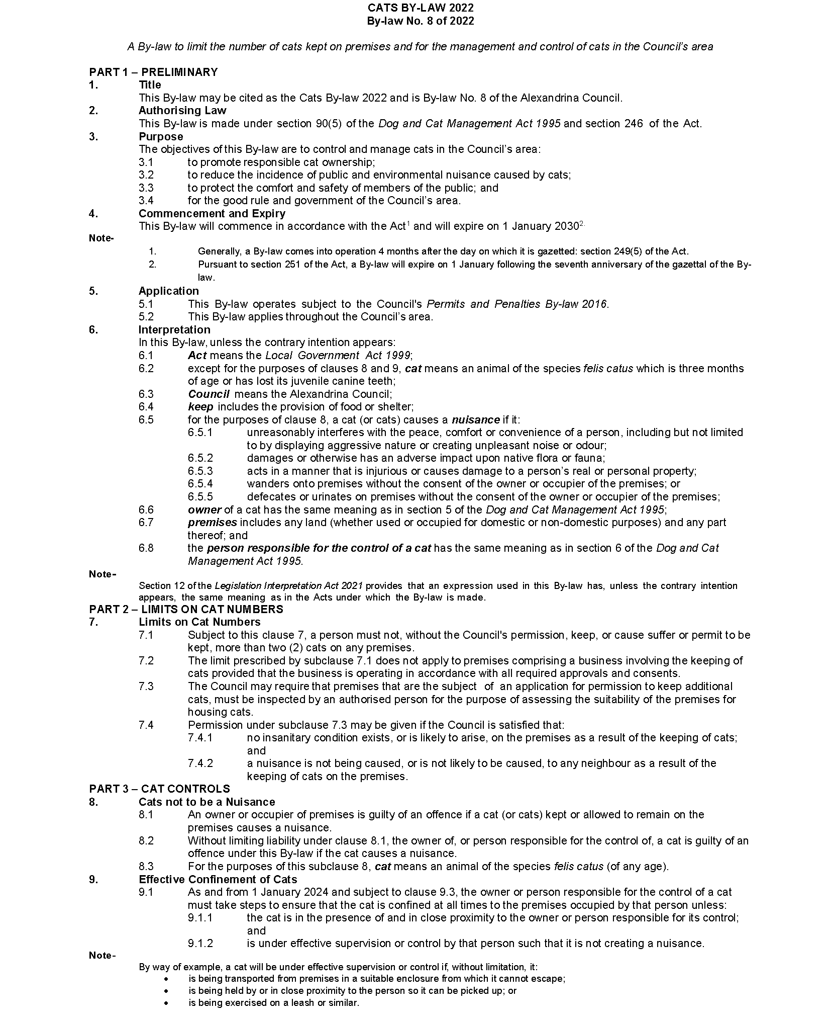
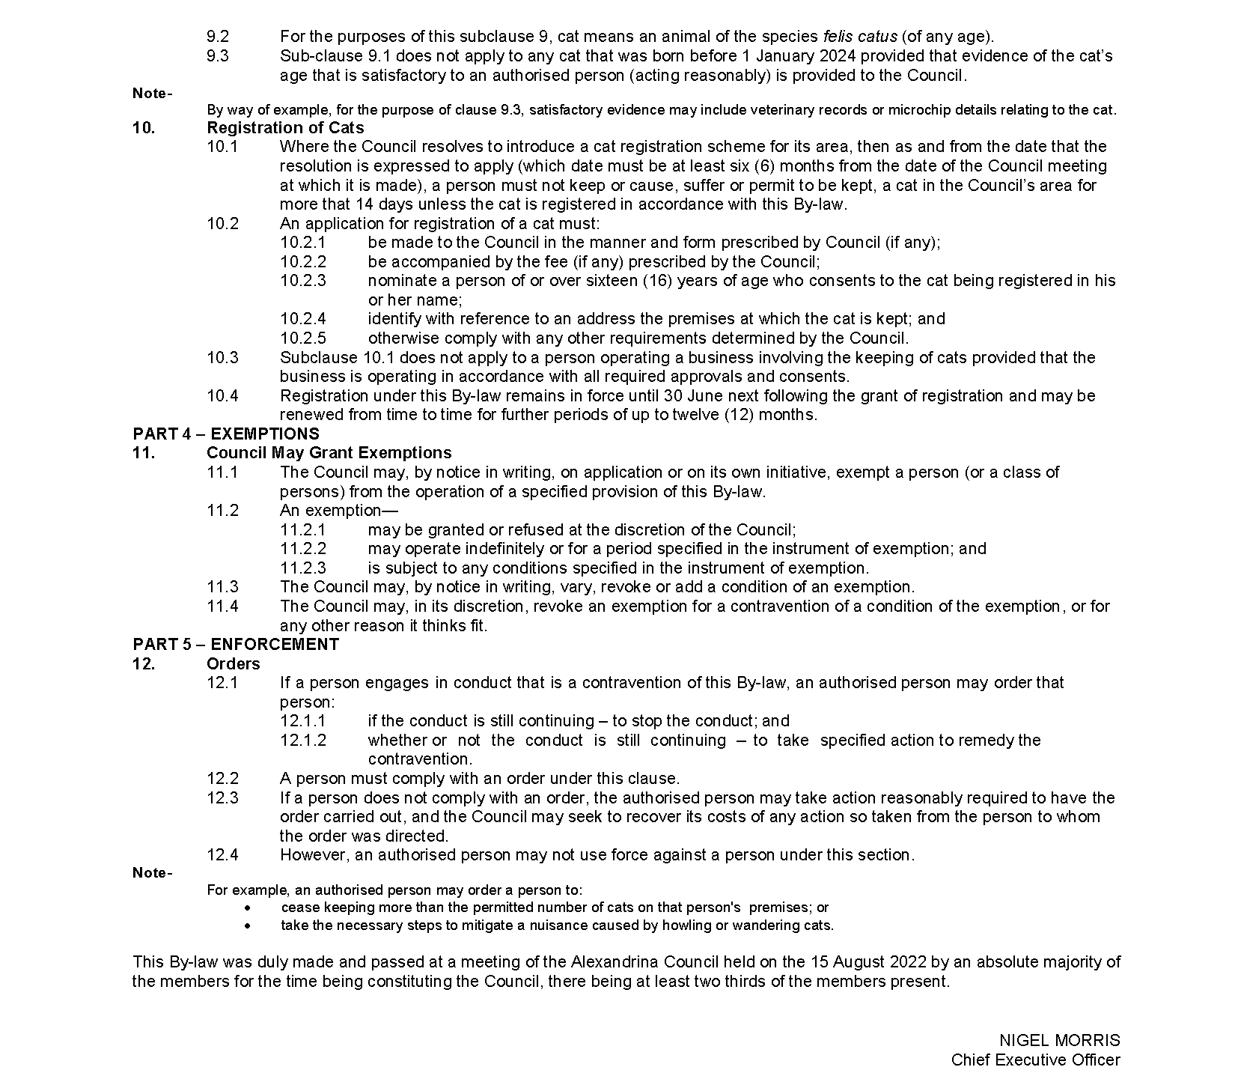

Light Regional Council
Appointment of Members to Council Assessment Panel
Pursuant to Section 83(1)(b)(i) of the Planning, Development and Infrastructure Act 2016, Council at its meeting held on 23 August 2022, resolved to appoint the following members to its Council Assessment Panel to take effect from 1 December 2022:
Presiding Member Mr Bruce Ballantyne
Independent Member Mr Kieron Barnes
Independent Member Mr Joel Taggart
Independent Member Mr Adam Squires
Council Representative Mr David Shannon
These appointments are for a four (4) month term and shall expire on 6 March 2023.
Dated: 1 September 2022
Lisa Sapio
Assessment Manager
DIT 2020/20101/01

Light Regional Council
Local Government Act 1999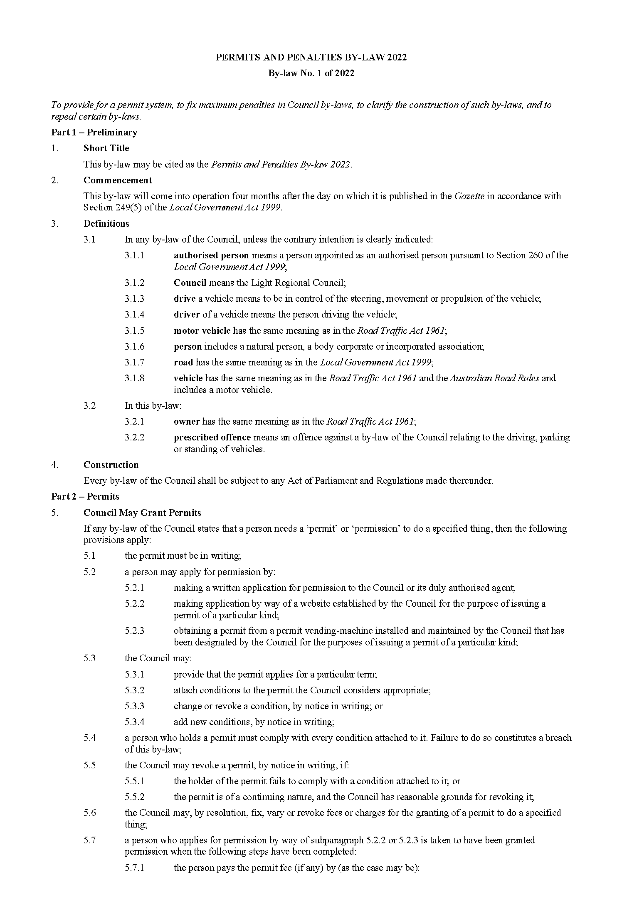
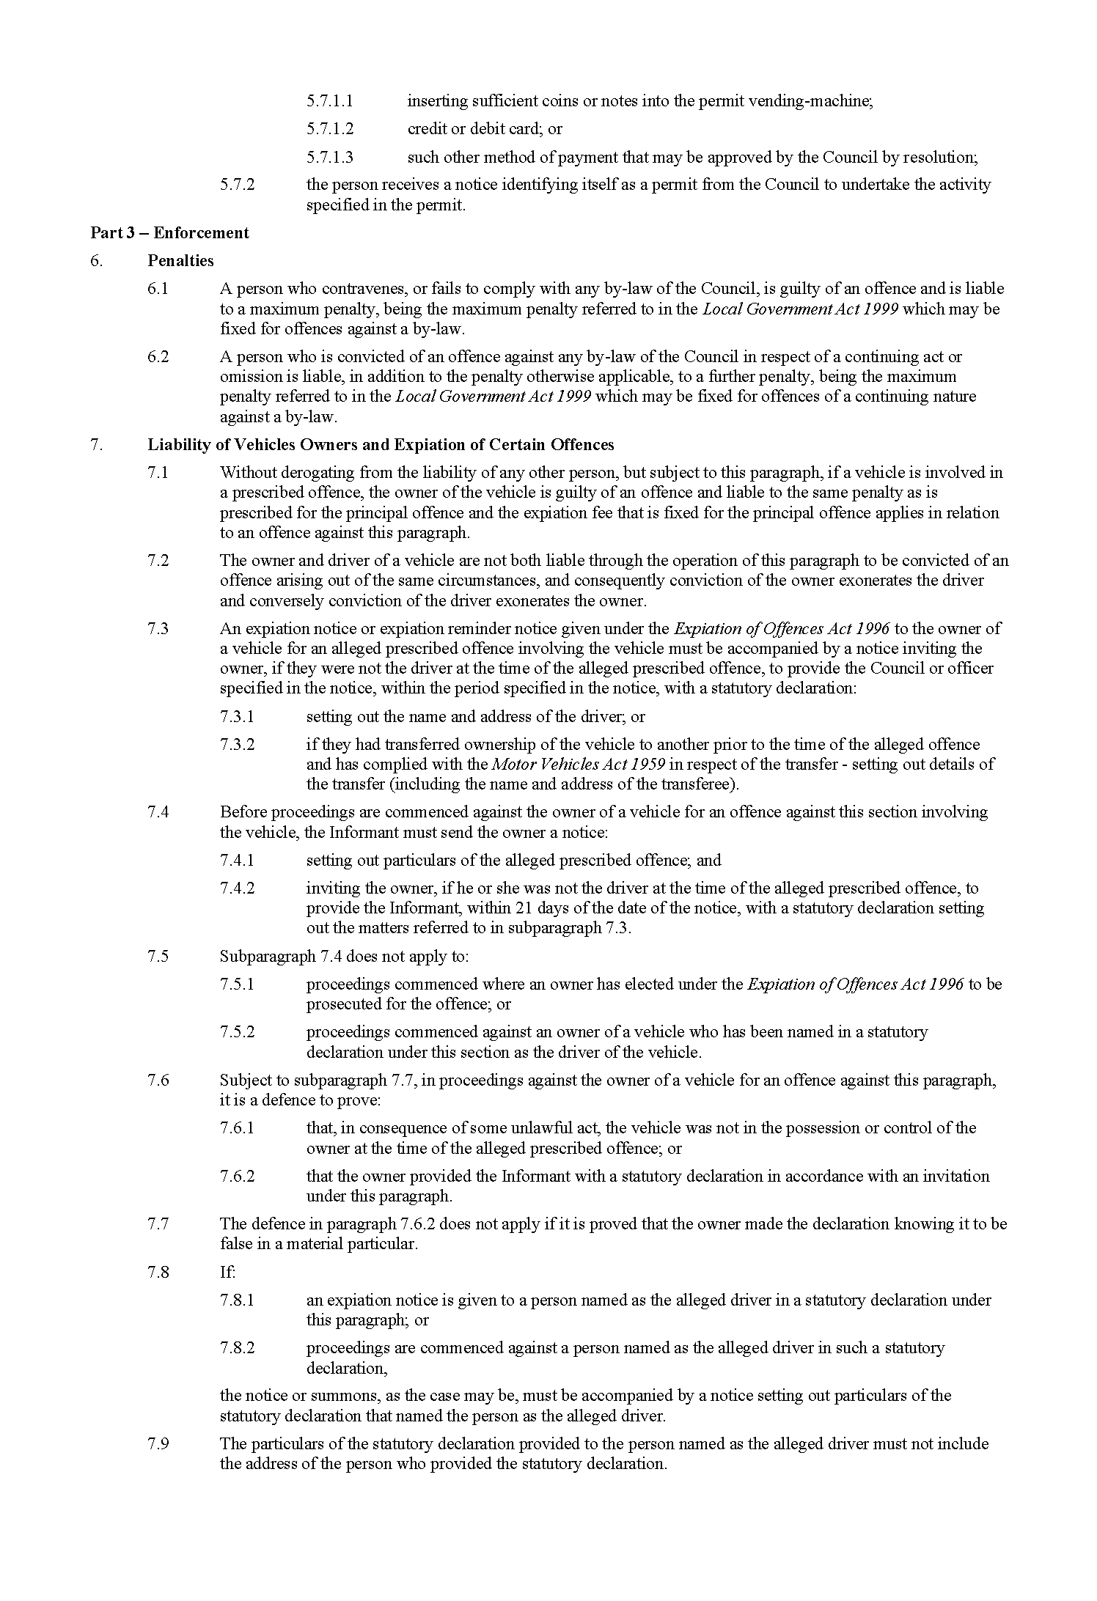

LIGHT REGIONAL COUNCIL
Local Government Act 1999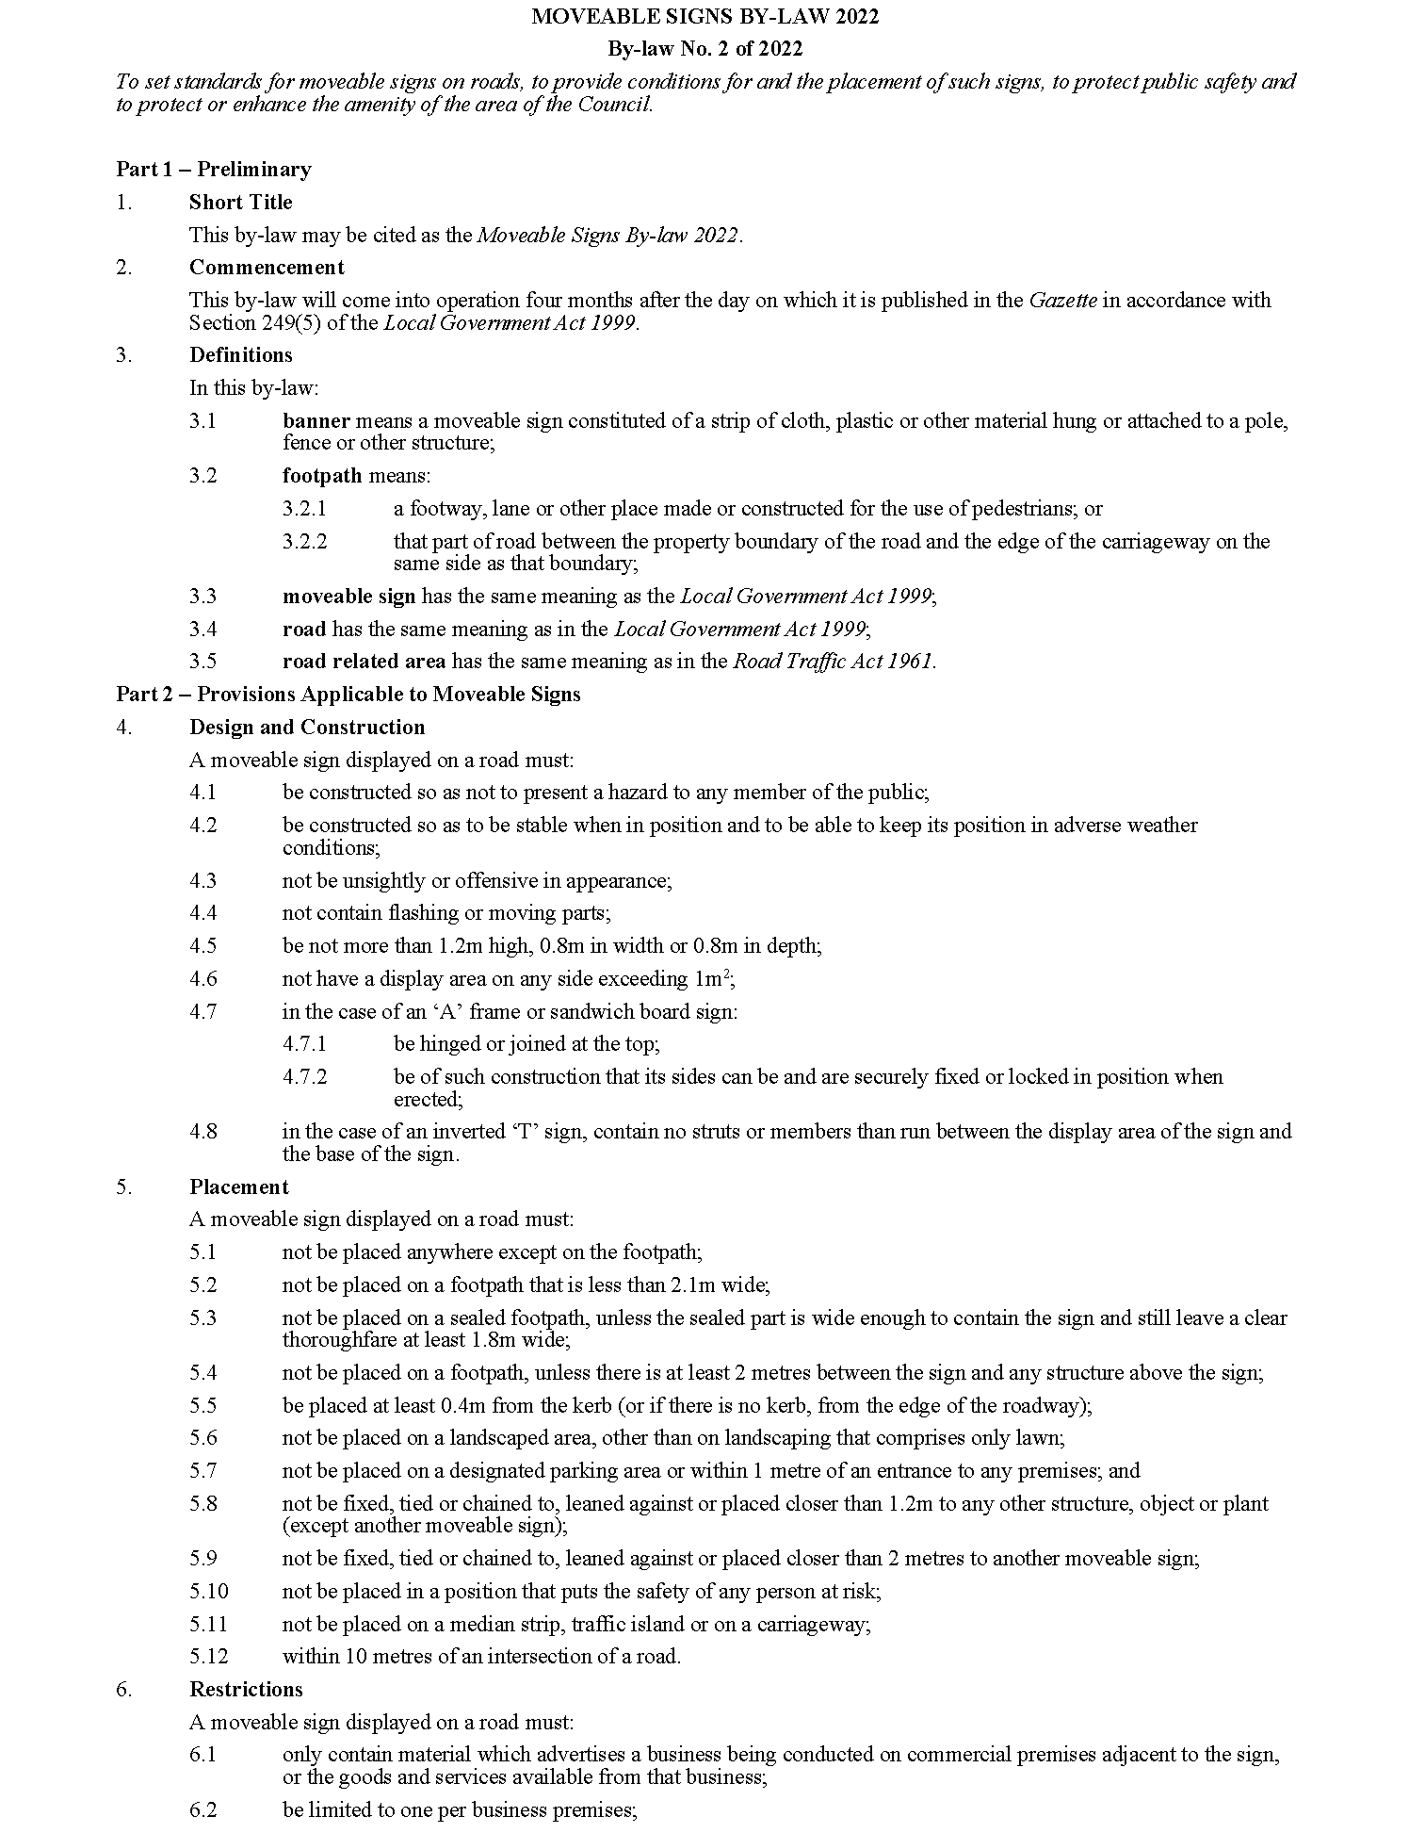
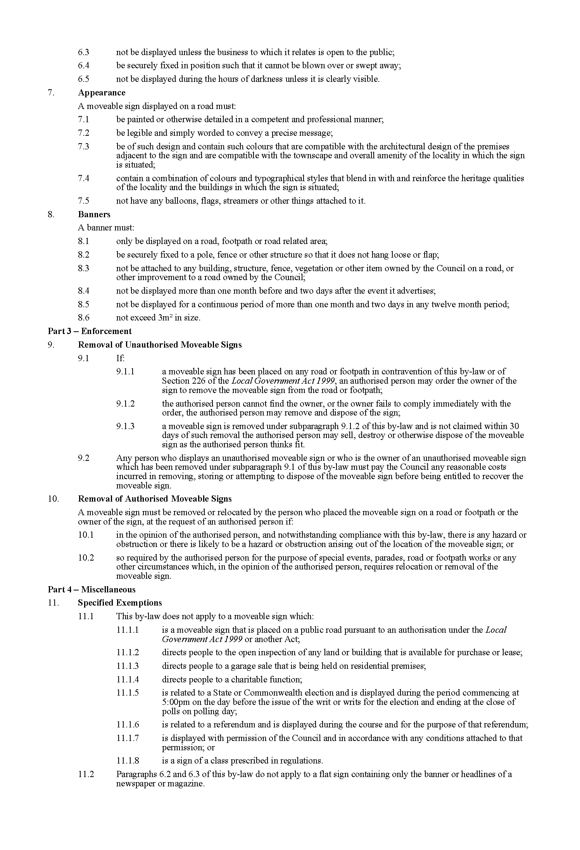

Light Regional Council
Local Government Act 1999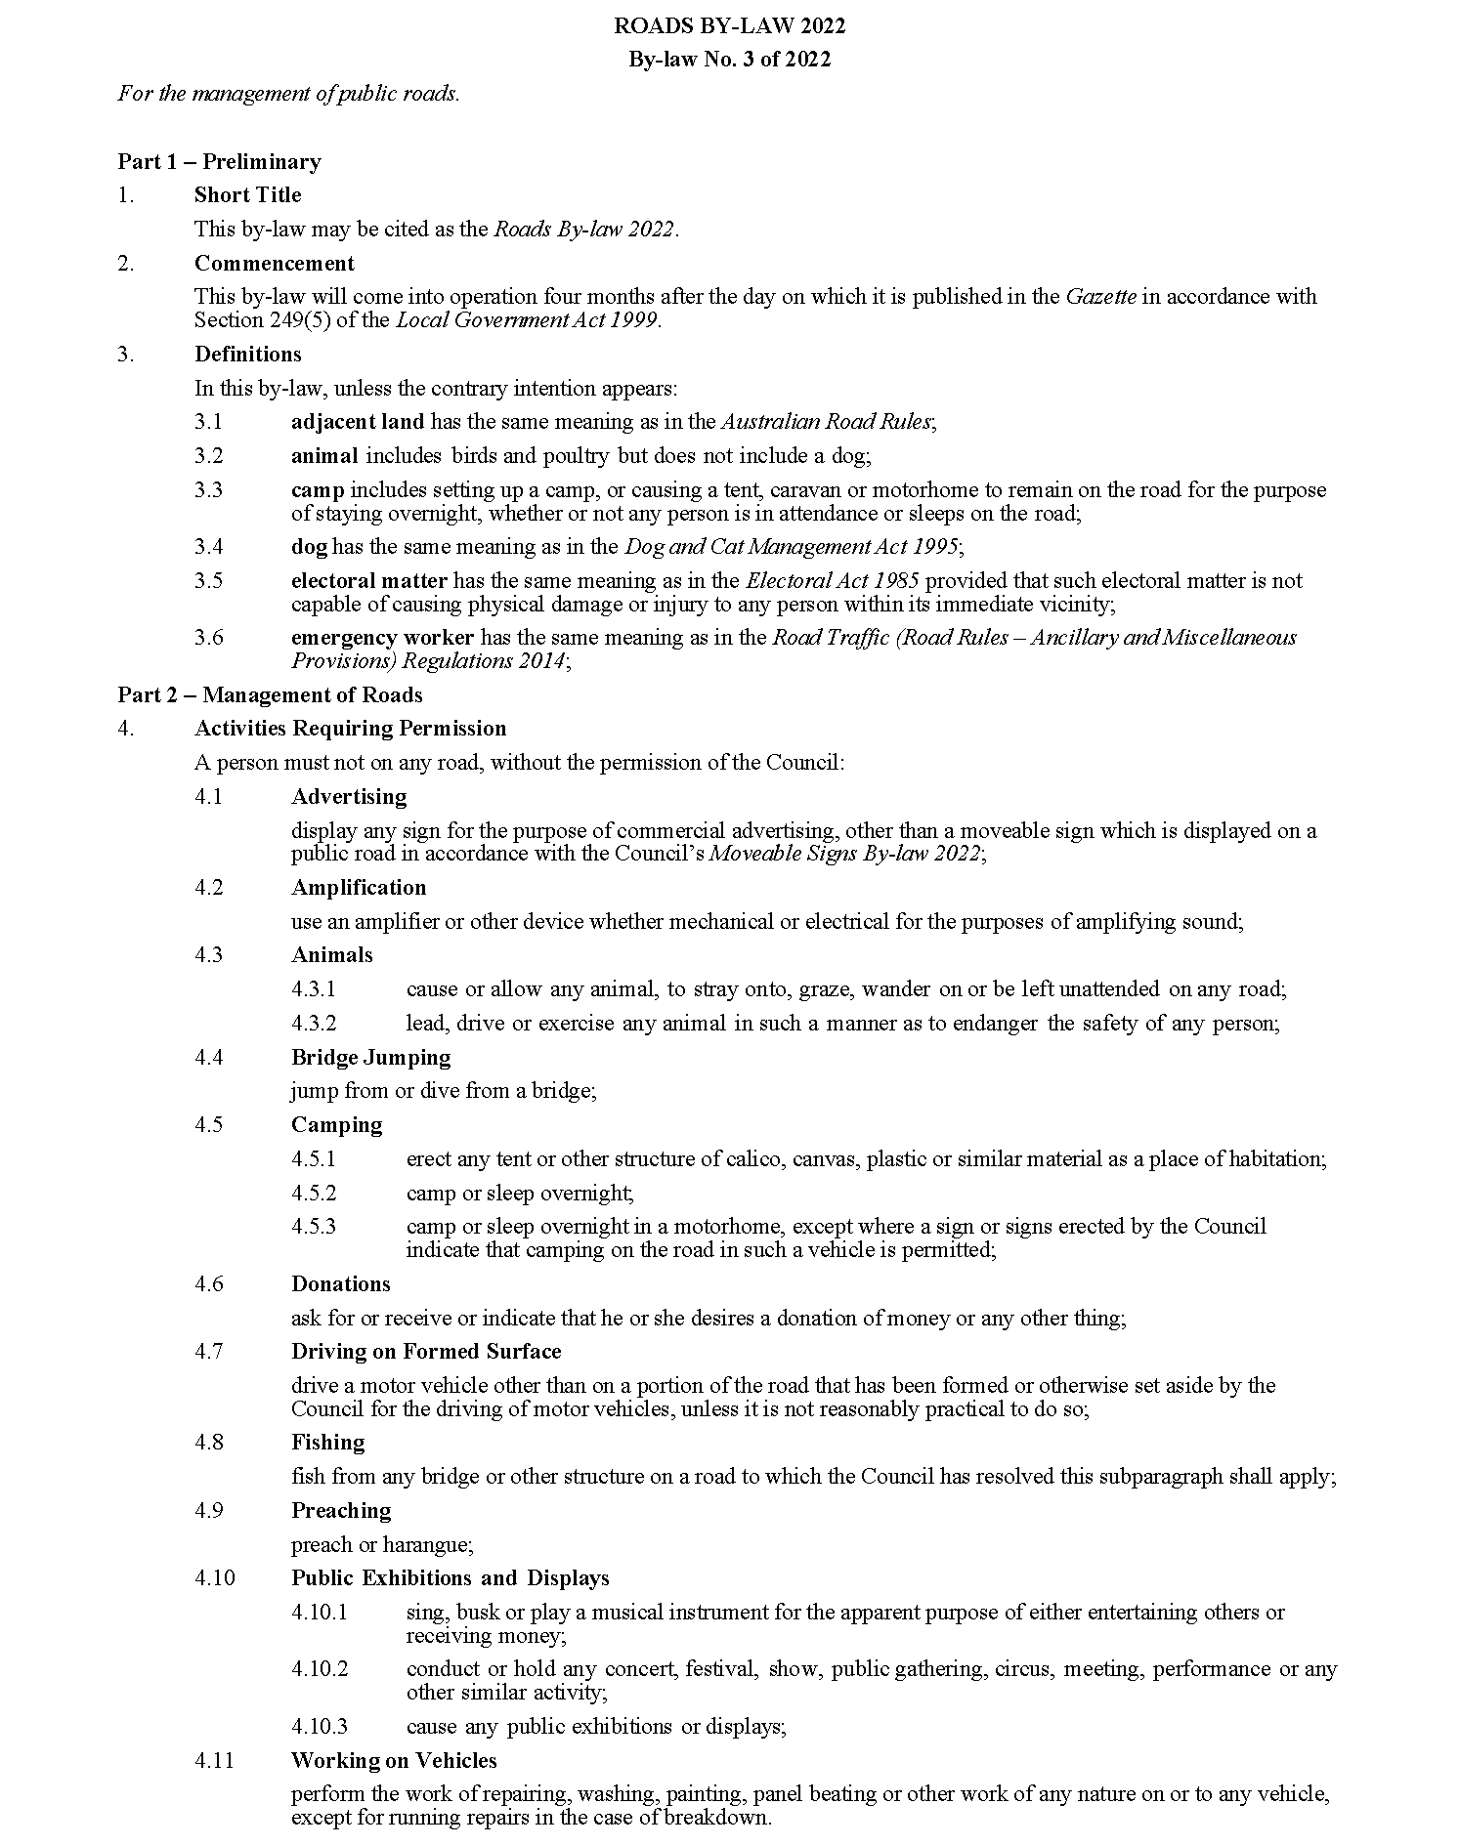
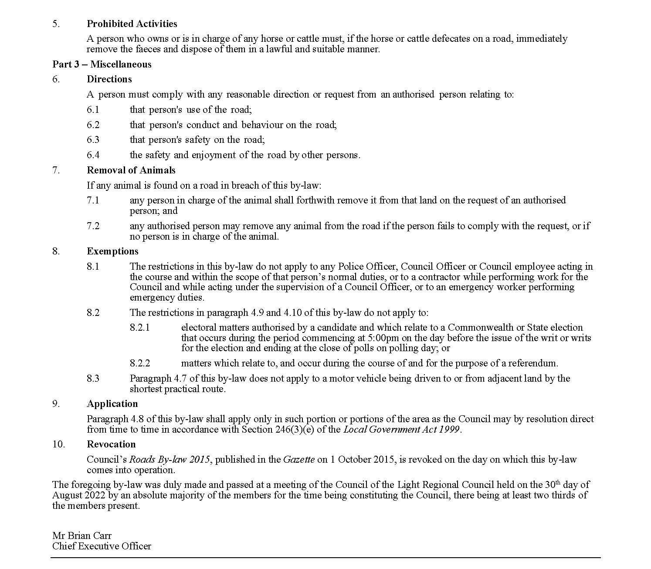

Light Regional Council
Local Government Act 1999
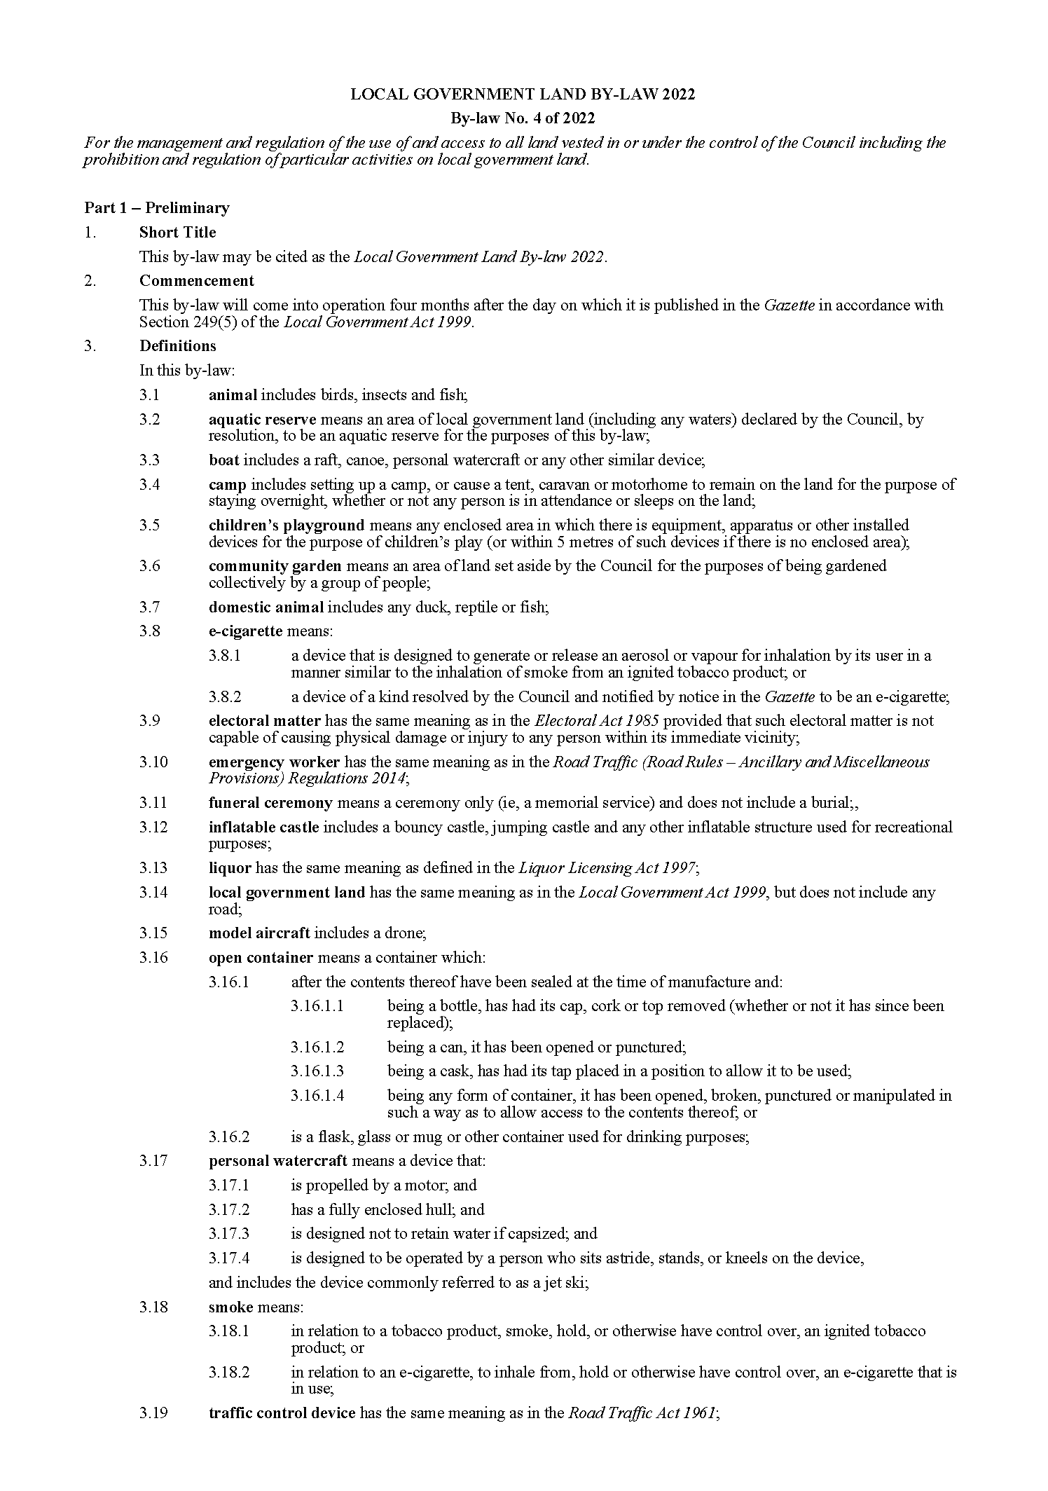
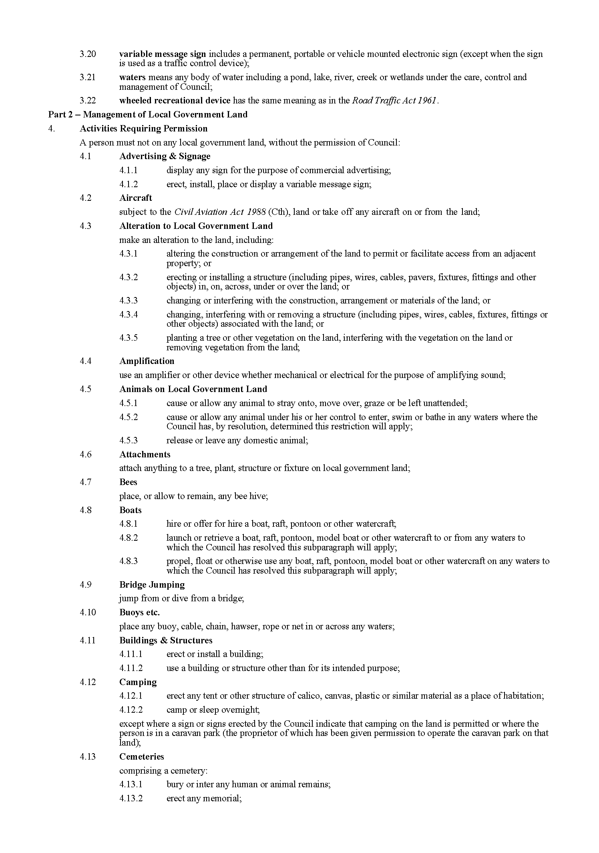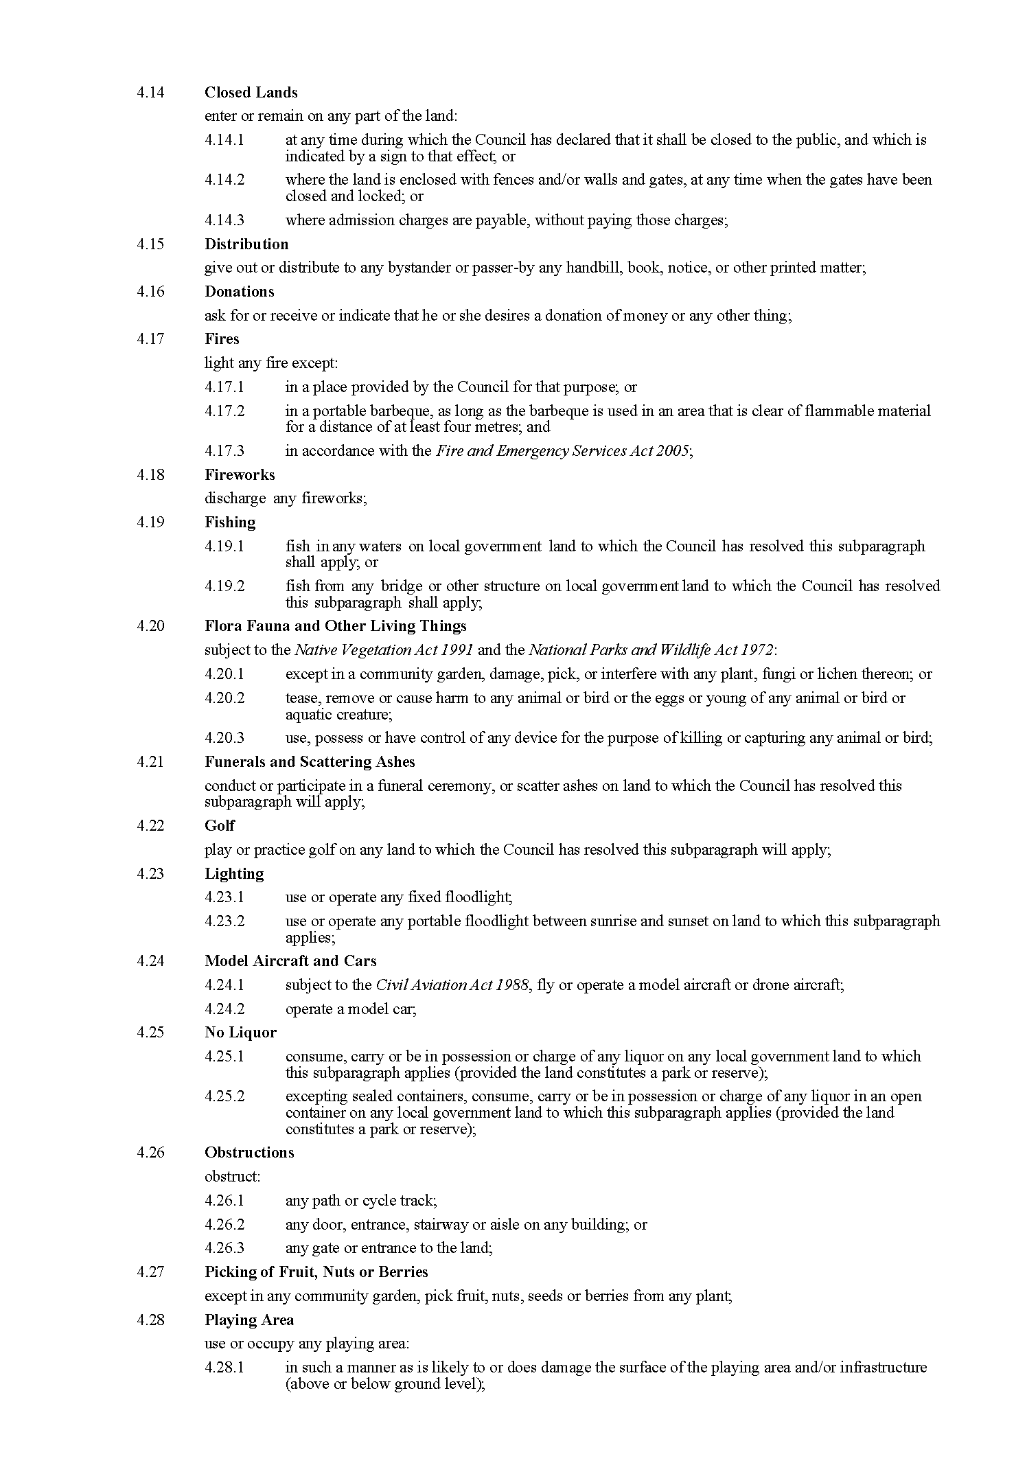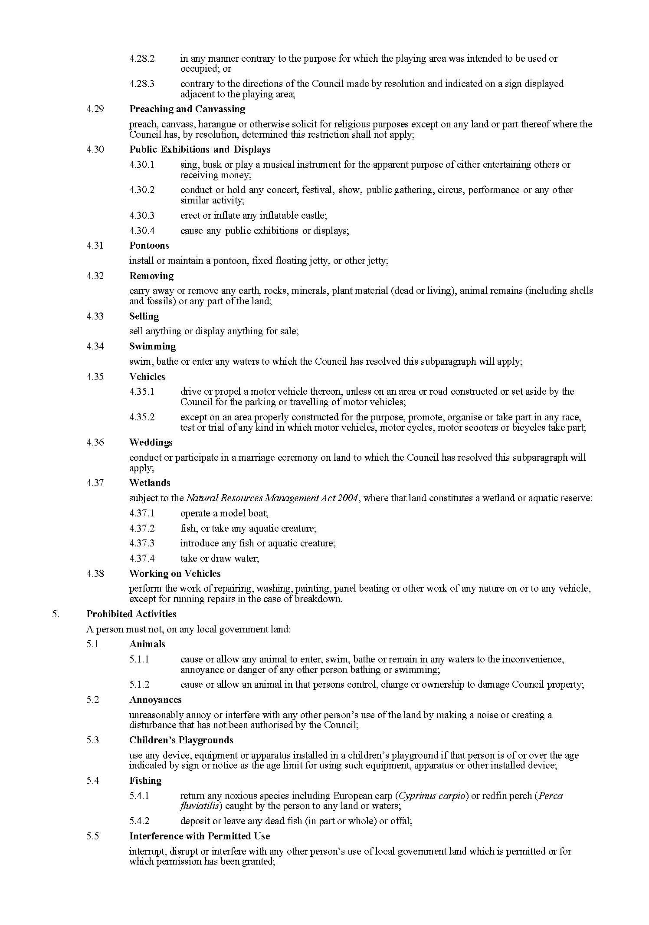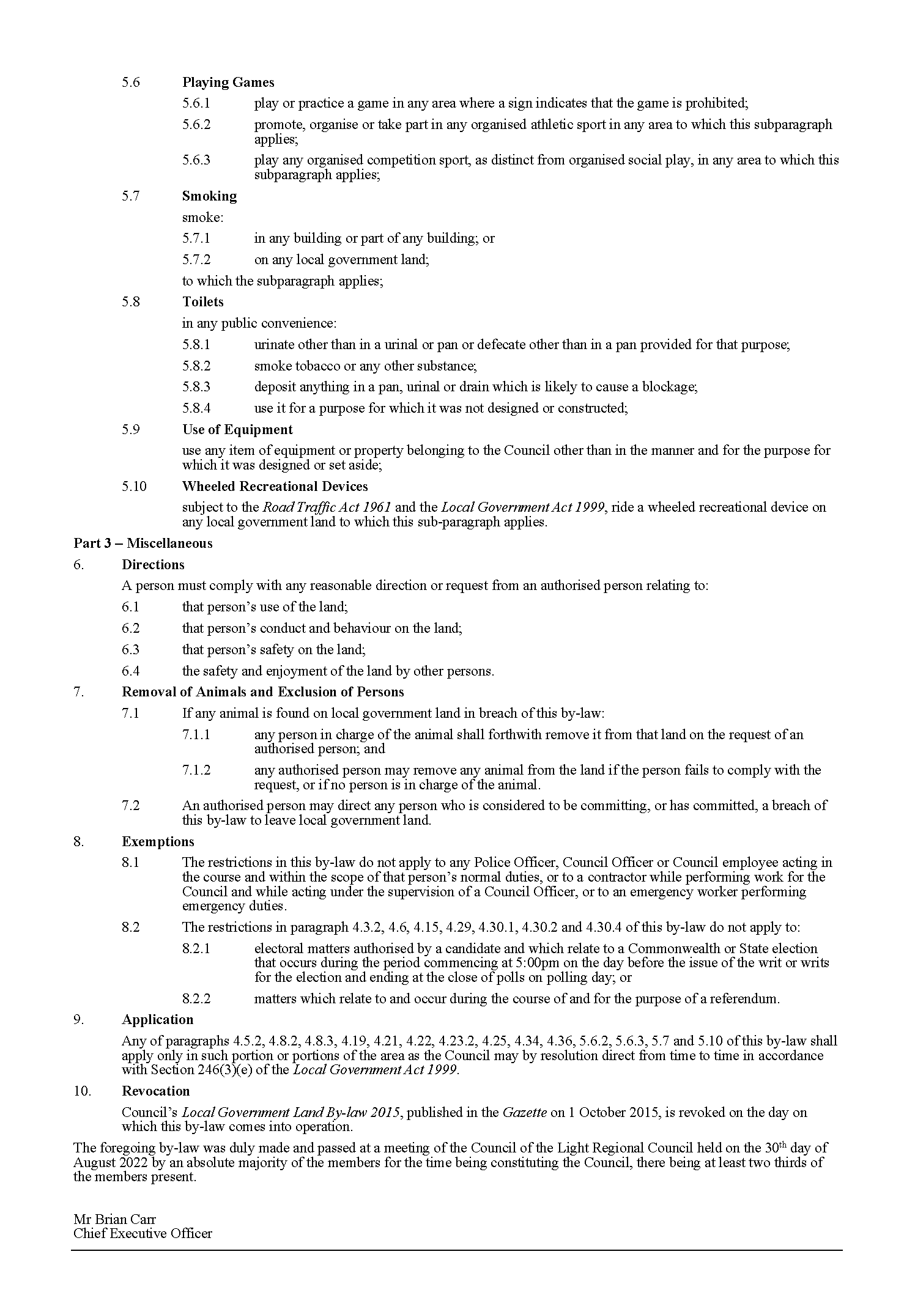

Light Regional Council
Local Government Act 1999
Dog and Cat Management Act 1995
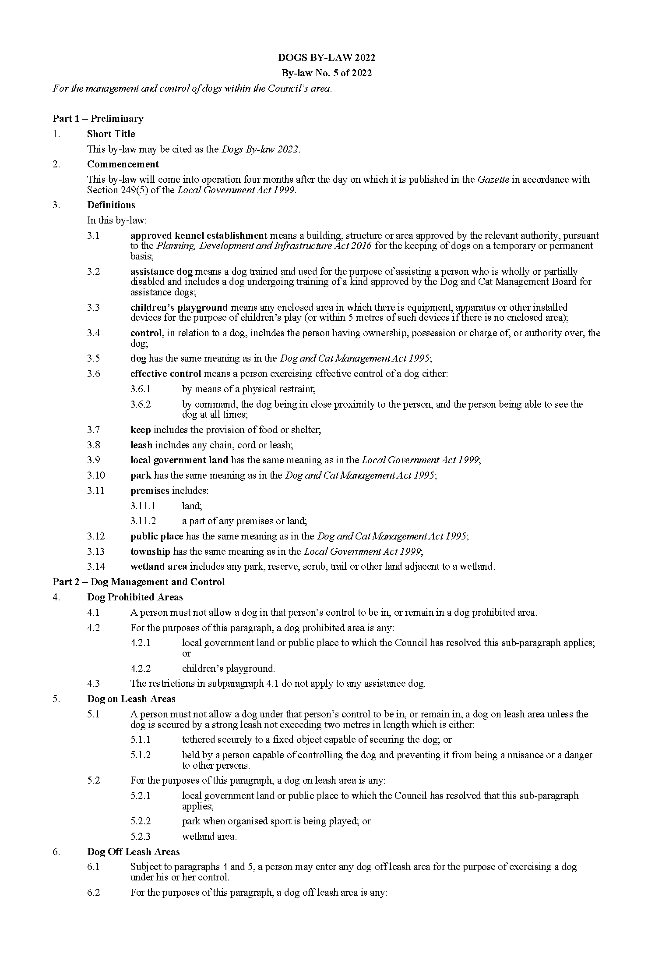
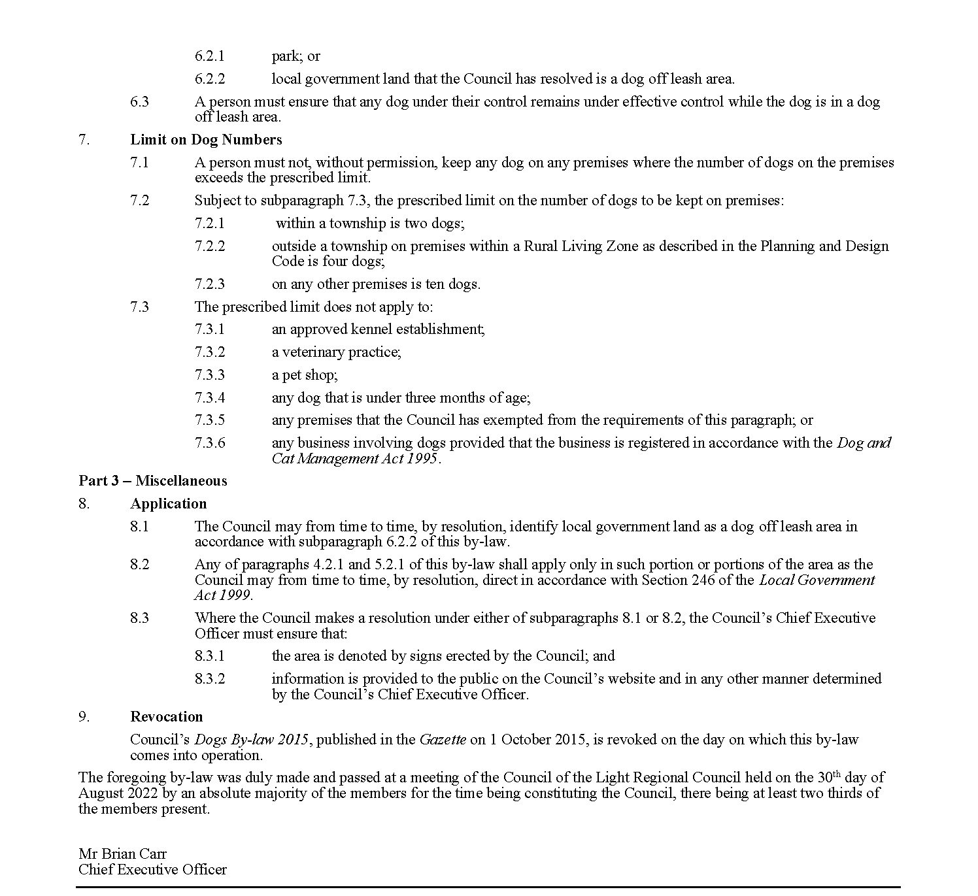

Light Regional Council
Local Government Act 1999
Dog and Cat Management Act 1995
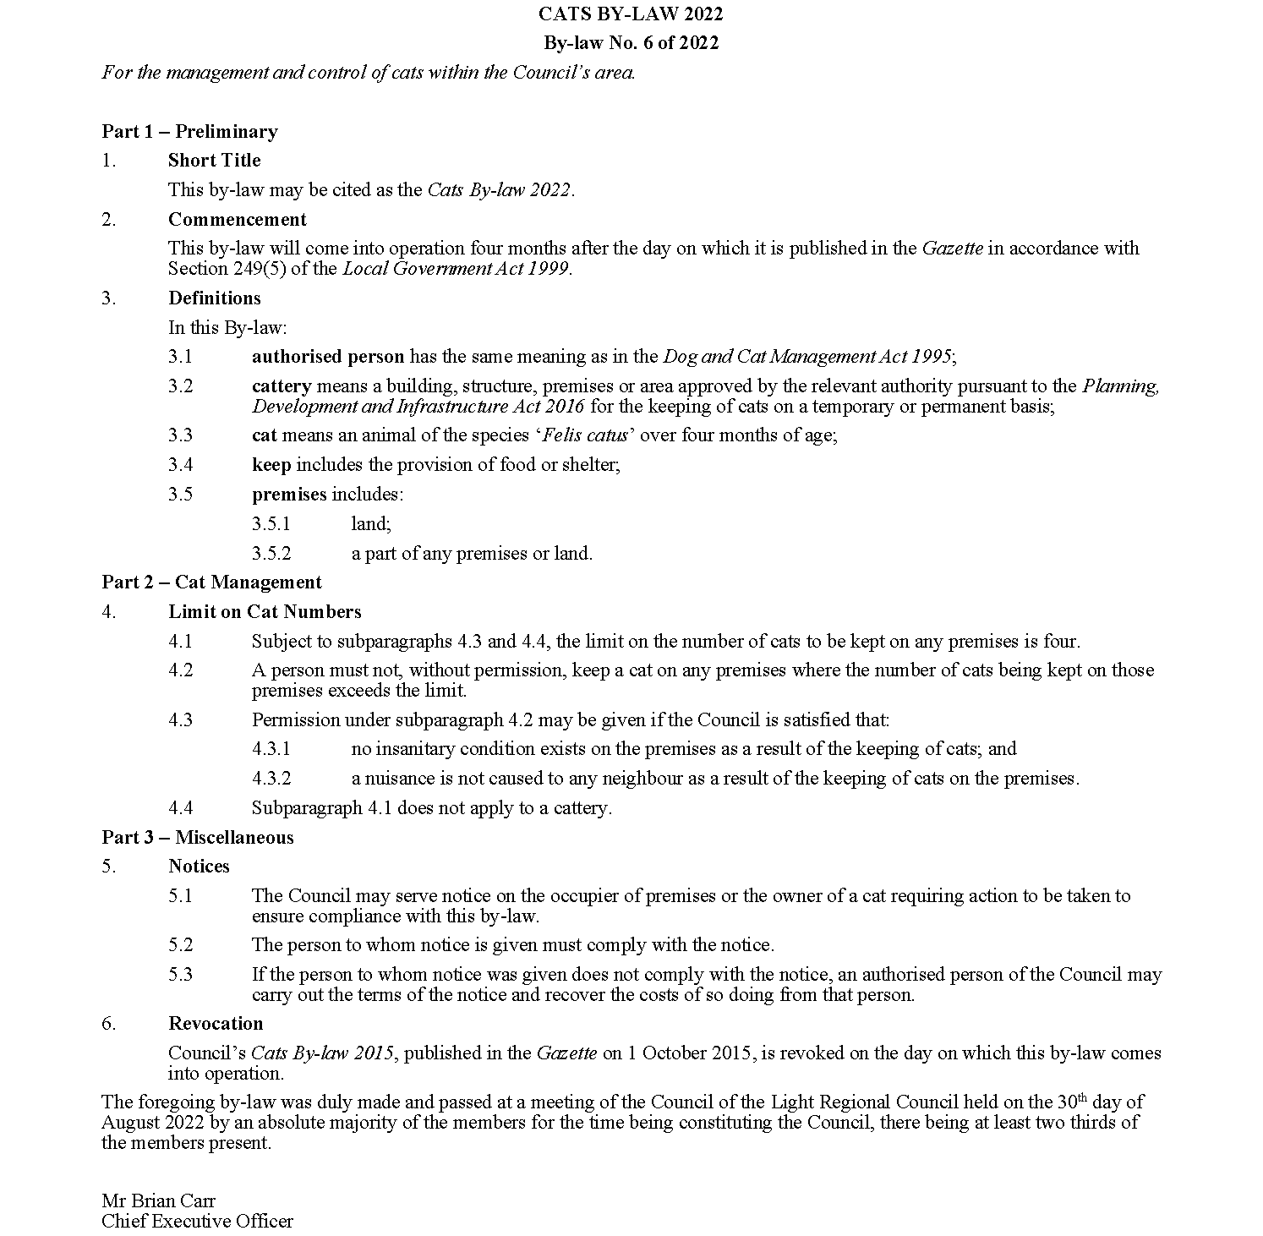

Public Notices

National Electricity Law
Making of Final Rule and Determination
Notice of Extension of Final Determination
The Australian Energy Market Commission (AEMC) gives notice under the National Electricity Law as follows:
Under ss 102 and 103, the making of the National Electricity Amendment (Primary frequency response incentive arrangements) Rule 2022 No. 8 (Ref. ERC0263) and related final determination. All provisions commence as follows Clause 7, Schedules 1, 3 and 4 of the Amending Rule commence on Thursday 8 September 2022, Schedule 2 commences on Sunday 8 June 2025.
Under s 107, the time for the making of the final determination on the Amending the administered price cap (Ref. ERC0347) proposal has been extended to 17 November 2022.
Documents referred to above are available on the AEMC’s website and are available for inspection at the AEMC’s office.
Australian Energy Market Commission
Level 15, 60 Castlereagh St
Sydney NSW 2000
Telephone: (02) 8296 7800
www.aemc.gov.au
Dated: 8 September 2022

National GAS Law
Notice of Final Rule
The Australian Energy Market Commission (AEMC) gives notice under the National Gas Law as follows:
Under ss 311 and 313, the making of the National Gas Amendment (DWGM distribution connected facilities) (Ref. GRC0062) and related final determination. Schedules 1, 2 and 3 commence on 1 May 2024. Schedule 4 commences on 1 January 2023. Schedule 5 commences on 22 September 2022.
Documents referred to above are available on the AEMC’s website and are available for inspection at the AEMC’s office.
Australian Energy Market Commission
Level 15, 60 Castlereagh St
Sydney NSW 2000
Telephone: (02) 8296 7800
www.aemc.gov.au
Dated: 8 September 2022

Trustee Act 1936
Public Trustee
Estates of Deceased Persons
In the matter of the estates of the undermentioned deceased persons:
ANDREWS Barbara Jean late of 86 Oaklands Road Glengowrie Retired Clerical Officer who died 4 May 2022
BARRY Michael Sean late of 11 Dunn Street Semaphore of no occupation who died 23 January 2022
BOLT Melva Myrtle late of 40 Cowra Street Renmark of no occupation who died 2 February 2022
GATES Dennis Malcolm late of 35 Bulkington Road Davoren Park Retired fitter and turner who died 6 April 2022
GEORGE Janice Fay late of 81 Tapleys Hill Road Hendon of no occupation who died 19 April 2022
HASKARD Meryl Patricia late of 81 Tapleys Hill Road Hendon of no occupation who died 16 December 2021
HILL Patricia Margaret late of 52 Dunrobin Road Hove of no occupation who died 10 April 2022
KALOGEROPOULOS Georgia late of 9 Winchester Street St Peters of no occupation who died 4 May 2022
LUKAC Jozo late of 1881 Aylett Street Coober Pedy opal miner who died 24 March 2022
McCOURT Patricia Ann otherwise McCOURT Patricia Anne late of 5 Heysen Avenue Hawker Retired teacher who died 24 January 2022
PARKER Sharon Kathleen Anne late of 6 Gretel Crescent Paralowie of no occupation who died 30 May 2022
ROBERTSON George late of 8 Allan Street Crystal Brook Retired service mechanic who died 5 February 2022
SPARKES Kathleen Eva late of 112 Hampstead Road Broadview of no occupation who died 20 January 2022
TREMELLING Tony Martin late of 206 Sir Donald Bradman Drive Cowandilla of no occupation who died 21 March 2022
Notice is hereby given pursuant to the Trustee Act 1936, the Inheritance (Family Provision) Act 1972 and the Family Relationships Act 1975 that all creditors, beneficiaries, and other persons having claims against the said estates are required to send, in writing, to the office of Public Trustee at GPO Box 1338, Adelaide, 5001, full particulars and proof of such claims, on or before the 7 October 2022 otherwise they will be excluded from the distribution of the said estate; and notice is also hereby given that all persons indebted to the said estates are required to pay the amount of their debts to the Public Trustee or proceedings will be taken for the recovery thereof; and all persons having any property belonging to the said estates are forthwith to deliver same to the Public Trustee.
Dated: 8 September 2022
N. S. Rantanen
Public Trustee

Notice Submission

The South Australian Government Gazette is published each Thursday afternoon.
Notices must be emailed by 4 p.m. Tuesday, the week of publication.
Submissions are formatted per the gazette style and a proof will be supplied prior to publication, along with a quote if applicable. Please allow one day for processing notices.
Alterations to the proof must be returned by 4 p.m. Wednesday.

Gazette notices must be submitted as Word files, in the following format:
• Title—the governing legislation
• Subtitle—a summary of the notice content
• Body—structured text, which can include numbered lists, tables, and images
• Date—day, month, and year of authorisation
• Signature block—name, role, and department/organisation authorising the notice

Please provide the following information in your email:
• Date of intended publication
• Contact details of the person responsible for the notice content
• Name and organisation to be charged for the publication—Local Council and Public notices only
• Purchase order, if required—Local Council and Public notices only

Email: governmentgazettesa@sa.gov.au
Phone: (08) 7109 7760
Website: www.governmentgazette.sa.gov.au

All instruments appearing in this gazette are to be considered official, and obeyed as such

Printed and published weekly by authority of C. McArdle, Government Printer, South Australia
$8.15 per issue (plus postage), $411.00 per annual subscription—GST inclusive
Online publications: www.governmentgazette.sa.gov.au

