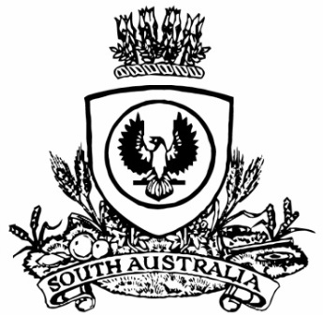
SUPPLEMENTARY GAZETTE
THE SOUTH AUSTRALIAN
GOVERNMENT GAZETTE
Published by Authority

Adelaide, Friday, 9 September 2022

Governor’s Instruments
Department of the Premier and Cabinet
Adelaide, 9 September 2022
Her Excellency the Governor directs it to be notified that she has received, with great sadness, notification from His Excellency the Governor-General of Australia, that Her Majesty Queen Elizabeth II passed away on Thursday, 8 September 2022 (UK time).
By command,
Peter Bryden Malinauskas, MP
Premier

