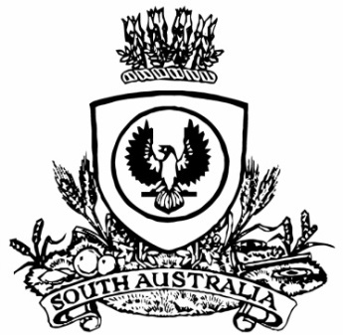
SUPPLEMENTARY GAZETTE
THE SOUTH AUSTRALIAN
GOVERNMENT GAZETTE
Published by Authority

Adelaide, Sunday, 11 September 2022

Contents

Governor’s Instruments

Proclamation 5942

Governor’s Instruments

Proclamation
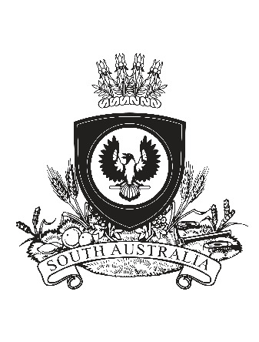
Proclamation

WHEREAS because of the death of our blessed and glorious Queen Elizabeth the Second, the Crown has solely and rightfully come to Prince Charles Philip Arthur George:
We, therefore, Her Excellency the Honourable Frances Jennifer Adamson, Companion of the Order of Australia, Governor in and over the State of South Australia, and members of the Executive Council, do now proclaim Prince Charles Philip Arthur George to be King Charles the Third, by the Grace of God King of Australia and his other Realms and Territories, Head of the Commonwealth, and, with hearty and humble affection, we promise him faith and obedience:
May King Charles the Third have long and happy years to reign over us.
Given at Adelaide this eleventh day of September, Two thousand and twenty-two, and in the first year of His Majesty’s reign.
Her Excellency the Honourable Frances Jennifer Adamson AC
Governor
By Her Excellency’s Command
The Honourable Peter Bryden Malinauskas MP

All instruments appearing in this gazette are to be considered official, and obeyed as such

Printed and published weekly by authority of C. McArdle, Government Printer, South Australia
$8.15 per issue (plus postage), $411.00 per annual subscription—GST inclusive
Online publications: www.governmentgazette.sa.gov.au

